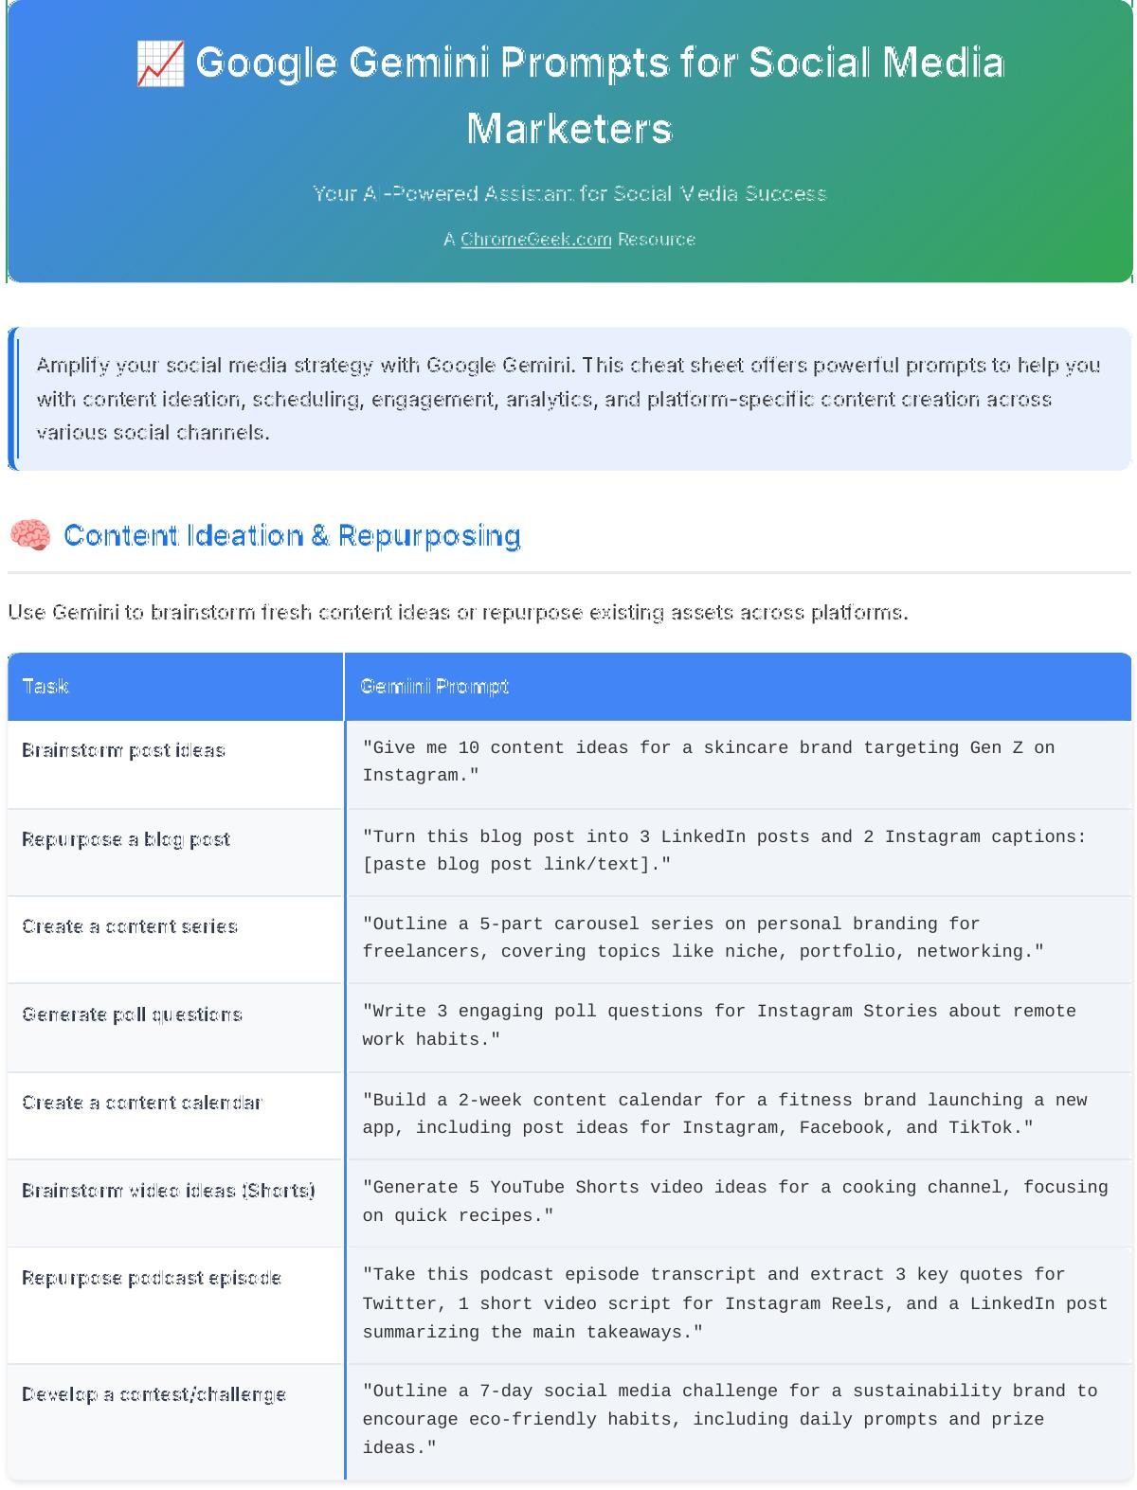



📈 Google Gemini Prompts for Social Media



Marketers



Your AI-Powered Assistant for Social Media Success



A [ChromeGeek.com](https://www.chromegeek.com/) Resource

Amplify your social media strategy with Google Gemini. This cheat sheet offers powerful prompts to help you with content ideation, scheduling, engagement, analytics, and platform-specific content creation across various social channels.

🧠 Content Ideation & Repurposing

Use Gemini to brainstorm fresh content ideas or repurpose existing assets across platforms.



Task Gemini Prompt

Brainstorm post ideas "Give me 10 content ideas for a skincare brand targeting Gen Z on

Instagram."

Repurpose a blog post "Turn this blog post into 3 LinkedIn posts and 2 Instagram captions:

[paste blog post link/text]."

Create a content series "Outline a 5-part carousel series on personal branding for

freelancers, covering topics like niche, portfolio, networking."

Generate poll questions "Write 3 engaging poll questions for Instagram Stories about remote

work habits."

Create a content calendar "Build a 2-week content calendar for a fitness brand launching a new

app, including post ideas for Instagram, Facebook, and TikTok."

Brainstorm video ideas (Shorts) "Generate 5 YouTube Shorts video ideas for a cooking channel, focusing

on quick recipes."

Repurpose podcast episode "Take this podcast episode transcript and extract 3 key quotes for

Twitter, 1 short video script for Instagram Reels, and a LinkedIn post summarizing the main takeaways."

Develop a contest/challenge "Outline a 7-day social media challenge for a sustainability brand to

encourage eco-friendly habits, including daily prompts and prize ideas."

📅 Scheduling, CTAs & Captions

Let Gemini help you write scroll-stopping captions and strong calls to action.



Task Gemini Prompt

Write a CTA "Write a strong, urgent CTA for a limited-time offer on a digital

course about photography."

Draft a caption "Create a playful Instagram caption with emojis for a coffee brand’s

new pumpkin spice flavor launch."

Rephrase for tone "Make this caption sound more professional and LinkedIn-friendly,

removing informal language: [paste caption]."

Create a post template "Write a reusable caption template for weekly product tips, including

placeholders for the tip, benefit, and a question."

Suggest post timing "Suggest optimal posting times for Instagram and LinkedIn for a B2B

SaaS company based on general engagement trends."

Write persuasive CTA (event) "Write a persuasive call-to-action for an online webinar on 'Mastering

Digital Marketing' to drive sign-ups."

Draft caption with emojis "Draft an exciting Instagram caption with relevant emojis for the

( launch of a new app feature that allows users to collaborate." feature)

Generate evergreen captions "Generate 5 evergreen content captions for a personal finance blog

that can be used any time of year."

🏷 Hashtags, SEO & UTM Links

Optimize your posts for discovery and tracking with Gemini ʼs help.



Task Gemini Prompt

Generate hashtags "Suggest 10 niche hashtags for a sustainable fashion brand on TikTok,

including a mix of popular and less saturated tags."

Create UTM links "Generate a UTM link for a Facebook ad promoting our summer sale,

tracking source, medium, and campaign name."

Optimize for SEO "Rewrite this LinkedIn post to naturally include SEO keywords for

'remote team management software' without sounding forced: [paste post]."

Hashtag strategy "Create a hashtag strategy for a 3-month Pinterest campaign promoting

handmade jewelry, including branded, niche, and broad hashtags."

Analyze hashtag performance "Given these engagement metrics for hashtags used last month:

#sustainablefashion (120 likes), #ecochic (80 likes), #greenstyle (30 likes), which performed best? Suggest 2 replacements for the lowest performing."

Suggest local SEO hashtags "Suggest 5 local SEO hashtags for a small coffee shop in 'Brooklyn,

NY' on Instagram."

Create UTMs for placements "Generate UTM links for a marketing campaign across Instagram Stories,

Facebook Feed, and Google Search Ads, promoting the same e-book download."

Propose Pinterest keywords "Propose 5 relevant keywords for a Pinterest board description about

'Healthy Meal Prep Ideas for Busy Professionals'."

📊 Analytics, Reporting & Campaign Insights

Use Gemini to summarize metrics, generate reports, or suggest improvements.



Task Gemini Prompt

Summarize campaign results "Summarize this Instagram campaign’s performance in 5 key bullet

points, highlighting reach, engagement, and conversion rate: [paste data]."

Create a report "Draft a client-facing report for our Q2 LinkedIn ad performance,

including key metrics, insights, and recommendations."

Suggest improvements "Based on this data, suggest 3 actionable ways to improve our next

Facebook campaign targeting lead generation: [paste data]."

Visualize metrics "Turn this engagement data into a chart-ready summary for Google

Slides, showing monthly growth of followers and engagement rate."

Compare platforms "Compare TikTok and Instagram performance for the same video content,

analyzing watch time, reach, and user comments."

Identify top content types "Analyze my last 20 social media posts across platforms and identify

the top 3 content types (e.g., video, image, carousel) by engagement rate."

Suggest A/B test ideas "Suggest 3 A/B test ideas for a Facebook ad campaign aiming to

increase click-through rates to an e-commerce store."

Draft weekly performance "Draft a concise weekly performance summary for my social media team,

summary highlighting key wins and areas for improvement from the past week."

🤝 Community Engagement & DMs

Gemini can help you respond faster and more thoughtfully to your audience.



Task Gemini Prompt

Reply to a comment "Write a friendly reply to a user who said they love our new product,

asking them what their favorite feature is."

Handle a complaint "Draft a calm, helpful DM response to a customer upset about a delayed

order, offering a solution and next steps."

Welcome a new follower "Write a warm and engaging DM to welcome a new follower on Instagram,

introducing our brand and offering a small discount code."

Nurture user relationship "Write a follow-up message to someone who clicked a product link but

didn’t buy, offering assistance or an alternative."

Reply to UGC tag "Write a thank-you message to a user who tagged us in an unboxing

video on TikTok, inviting them to be featured on our page."

DM prompt for newsletter "Create a friendly DM inviting users to sign up for our email list

with a freebie (e.g., 'exclusive tips for productivity')."

Draft response to positive "Draft a genuine and appreciative response to a customer who left a

feedback glowing 5-star review about their service experience."

Create live Q&A script "Generate a brief script for opening and closing a live Q&A session on

Instagram, including a welcome, rules, and call to action."

Generate engagement questions "Suggest 3 engaging questions for an Instagram Story about weekend

plans or favorite hobbies to boost interaction."

🖼 AI Image + Caption Pairing

Use Gemini with ImageFX to match the right caption with the right visual.



Task Gemini Prompt

Generate image prompt from "Create an image prompt (for an AI image generator) to match this

caption caption about productivity during finals week: 'Coffee, books, and

late nights. Finals grind is real! 📚☕ #StudentLife'."

Write caption from image idea "Write 2 caption options for an image showing a behind-the-scenes

product photoshoot for a new sustainable clothing line."

Create theme sets "Generate a set of 5 motivational quotes with matching image concepts

for Instagram Stories, focusing on themes of growth and resilience."

Match caption to aesthetic "Write a minimalist caption (1-2 sentences) to match a flat-lay image

with neutral tones and a single cup of tea."

Suggest platform format "Should this image (a dynamic product video) + caption combo (a flash

sale announcement) be a story, carousel, or reel for best impact on Instagram?"

Describe image for educational "Describe an image concept for each slide of an educational Instagram

carousel carousel explaining 'The Basics of Cryptocurrency'."

Write caption for UGC photo "Write an engaging caption for a user-generated content (UGC) photo

showing a customer using our product, thanking them and inviting others to share."

Suggest visual style for "Suggest a visual style (e.g., vibrant, muted, retro, futuristic) and

campaign corresponding image prompts for a campaign promoting a new energy

drink."

📘 Facebook Marketing

Facebook continues to dominate across communities, events, and paid reach. These prompts help you craft native, high-engagement content that resonates in-feed and in groups.



Task Gemini Prompt

Write caption for boosted post "Write a captivating caption for a boosted post targeting working

parents, promoting a new online course on time management."

Draft Facebook Group poll "Draft a poll question that encourages high engagement in a local

Facebook Group for small businesses, asking about their biggest marketing challenge."

Generate ad copy (carousel) "Generate ad copy for a Facebook carousel ad promoting a new product

bundle (e.g., 'Wellness Starter Pack'), highlighting benefits for each slide."

Rewrite for conversational tone "Rewrite this formal announcement into a more conversational and

mobile-friendly Facebook post: [paste announcement]."

Summarize FAQ for Facebook "Summarize this product FAQ into a Facebook-friendly Q&A format

suitable for a post or group discussion: [paste FAQ]."

Write copy for Facebook event "Write engaging copy for a Facebook event promoting a virtual workshop

on 'Sustainable Living for Beginners', including date, time, and key takeaways."

Generate Facebook Live ideas "Generate 3 interactive ideas for a Facebook Live session for a beauty

brand, such as makeup tutorials or product reviews."

Draft Group announcement "Draft a welcoming announcement post for a new member in our private

Facebook Group for digital nomads, asking them to introduce themselves."

Create ad headline/description "Create a compelling Facebook ad headline and description for a ( retargeting campaign targeting users who abandoned their shopping cart retargeting)

on an e-commerce site."

📸 Instagram Marketing

Instagram rewards brands that are timely , visual, and emotionally resonant. These prompts give you the building blocks to create Reels, Stories, and carousels that drive real interaction.



Task Gemini Prompt

Suggest trending audio (Reel) "Suggest 3 trending audio ideas for an Instagram Reel about digital

wellness tips for busy professionals."

Draft a Reel caption "Draft a concise and engaging caption for an aesthetic reel showcasing

our newest sustainable skincare product, highlighting its key benefits."

Generate Story poll ideas "Generate 3 interactive Story poll ideas for increasing engagement

during a product launch week, asking about user preferences."

Create carousel caption & "Create a caption and relevant hashtags for a carousel post on '5

hashtags Simple Morning Routines for Productivity'."

Write a Reel hook "Write a compelling hook for an Instagram Reel under 10 words for a

travel influencer promoting a new destination."

Suggest interactive Story "Suggest 3 creative ways to use Instagram Story stickers (e.g., Quiz,

stickers Question, Poll) to promote a new coffee blend."

Write a Reel script (product "Write a short, engaging script for a 30-second Instagram Reel demo) demonstrating how to use a new kitchen gadget."

Draft an Instagram bio update "Draft an updated Instagram bio for a fitness coach, including

keywords like 'personal trainer,' 'online coaching,' and a clear CTA."

Create carousel for before/after "Outline content for an Instagram carousel showing a 'before and

after' transformation using our home renovation service, with tips on each slide."

💼 LinkedIn Marketing

LinkedIn isn't just for resumes, it's where brand storytelling meets business credibility. These prompts help you grow authority while sparking real conversations with professionals.



Task Gemini Prompt

Write a thought leadership post "Write a thought leadership post about remote team success habits,

focusing on communication and tools."

Rewrite case study into series "Rewrite this case study into a 3-post LinkedIn series, highlighting a

different key learning or outcome in each post: [paste case study summary]."

Draft hiring announcement "Draft a professional yet enthusiastic LinkedIn caption for a behind-

the-scenes hiring announcement for a new marketing manager position."

Summarize blog into carousel "Summarize this blog post about 'AI in Marketing' into a carousel

script script for LinkedIn, with bullet points and a concise takeaway for

each slide."

Create a checklist post "Create a checklist post for new freelancers looking to pitch clients,

covering research, proposal, and follow-up."

Write professional "Write a formal and exciting LinkedIn announcement for a company announcement milestone, such as reaching 10,000 customers or a new funding round."

Draft comment on industry post "Draft a insightful comment for an industry leader's LinkedIn post

about 'the future of hybrid work,' adding a unique perspective."

Suggest LinkedIn poll topic "Suggest a relevant LinkedIn poll topic for market research on

preferences for remote work tools among HR professionals."

Create content for LinkedIn "Draft promotional copy for a LinkedIn Event inviting professionals to

Events a virtual networking session on 'Sustainable Business Practices'."

📌 Pinterest Marketing

Pinterest is a visual search engine, not just a social platform. These prompts help you plan content that gets discovered month after month.



Task Gemini Prompt

Create Pin titles & descriptions "Create 5 SEO-optimized Pin titles and descriptions for a DIY home

decor board focused on 'Bohemian Living Room Ideas'."

Write SEO-optimized Pin "Write 3 SEO-optimized Pin descriptions for our fall fashion guide,

descriptions targeting keywords like 'autumn outfits,' 'cozy fashion,' and 'fall

trends 2024'."

Repurpose blog into infographic "Repurpose this blog post about '10 Benefits of Daily Meditation' into

concepts 3 Pinterest infographic concepts, outlining key visuals and text for

each."

Suggest keywords & categories "Suggest relevant keywords and categories for a Pinterest board about

'Productivity Planner Ideas' for students and entrepreneurs."

Draft Pinterest copy for digital "Draft Pinterest copy (title, description, call-to-action) for a new

download digital download: an eBook titled 'Ultimate Guide to Budget Travel'."

Generate ideas for Idea Pins "Generate 3 engaging ideas for Pinterest Idea Pins for a healthy food

blog, focusing on step-by-step recipes or quick tips."

Write descriptions for product "Write compelling, keyword-rich descriptions for product pins pins featuring handmade scented candles, highlighting their unique

fragrances and natural ingredients."

Suggest board names for niche "Suggest 5 creative and searchable Pinterest board names for a niche

focused on 'minimalist apartment decor for small spaces'."

Create content for seasonal "Outline content ideas (including visuals and descriptions) for a

campaign seasonal Pinterest campaign promoting 'Winter Holiday Gift Ideas' for

tech enthusiasts."

👻 Snapchat Marketing

Snapchat is all about fleeting moments and authentic connection. Use these prompts to script engaging stories and build trust with younger audiences.



Task Gemini Prompt

Write punchy intro (Snap story) "Write a punchy intro for a branded Snap story about a tech giveaway,

creating excitement in the first 3 seconds."

Generate daily snap ideas "Generate 3 script ideas for short daily snaps (10-15 seconds) about

morning routines from a healthy lifestyle brand."

Draft Snapchat ad copy "Draft Snapchat ad copy for Gen Z promoting our new skincare kit,

using playful and informal language."

Create filter ideas & taglines "Create 2 filter ideas and catchy taglines for a college-themed brand

campaign, focusing on study breaks or campus life."

Suggest callout for user replies "Suggest a callout for a Snapchat Story to get users to reply with

snaps using our product in a creative way."

Generate ideas for "Generate 3 innovative ideas for Snapchat Lenses or Filters for a

Lenses/Filters fast-food brand to increase user engagement."

Write script for quick tutorial "Write a concise script for a 20-second Snapchat tutorial showing how

to tie a complex knot."

Draft Story for flash sale "Draft a series of short, urgent Snapchat Story frames for a 2-hour

flash sale on activewear, including a countdown element."

Suggest CTA for Snap Ad "Suggest a compelling call to action for a Snap Ad promoting a mobile

gaming app, encouraging immediate download."

🎶 TikTok Marketing

TikTok thrives on attention-grabbing intros and fast-paced storytelling. These prompts give you the structure to ride trends while keeping your message on-brand.



Task Gemini Prompt

Draft hook & CTA (unboxing) "Draft a captivating hook and a strong CTA for a TikTok about a

product unboxing video for a new tech gadget."

Write 15-second tip script "Write a script for a 15-second tip video using a trending audio,

explaining '3 Productivity Hacks for Students'."

Suggest TikTok video ideas "Suggest 3 TikTok video ideas for a food brand launching a new flavor

of ice cream, focusing on creative ways to use it."

Repurpose blog into TikTok- "Repurpose this blog post about 'The Benefits of Reading' into a style TikTok-style educational hook and breakdown, designed for quick

consumption."

Generate hashtags & caption "Generate hashtags and a short caption for a duet-style TikTok post

( reacting to a popular viral video, making it relevant to a fashion duet)

brand."

Suggest trending "Suggest 3 current trending sounds or challenges on TikTok that a

sounds/challenges sustainable living brand could adapt for their content."

Write script for "day in the life" "Write a script for a 'day in the life' TikTok for a graphic designer,

highlighting their creative process and tools."

Create TikTok for product review "Outline a TikTok video concept for a product review of noise-

canceling headphones, emphasizing key features and user experience."

Draft content for duet or stitch "Draft engaging content for a TikTok duet or stitch that allows my

brand (a healthy snack company) to react to a video of someone struggling with unhealthy eating."

💬 WhatsApp Status Marketing

WhatsApp status posts are personal, low-pressure, and high-intent. These prompts help you tap into that intimacy with status content that nudges warm leads without being pushy.



Task Gemini Prompt

Write short status (weekly deal) "Write a short, engaging WhatsApp status promoting this week’s deal on

organic produce, accompanied by a product image."

Draft 30-word status (flash sale) "Draft a 30-word WhatsApp status with a strong sense of urgency for a

24-hour flash sale on home decor items."

Create status sequence (promo) "Create a 3-part WhatsApp status sequence: an intro teasing a new

offer, the promo details, and a clear CTA for a coaching service."

Suggest status ideas (digital "Suggest 3 status ideas for launching a new digital product (e.g.,

product) 'Mastering SEO' e-course) to my WhatsApp contact list."

Turn IG post into WhatsApp "Turn this Instagram post about '5 Tips for Better Sleep' into a status concise WhatsApp status for warm leads, with a link to the full blog."

Write status for customer survey "Write a polite WhatsApp status inviting contacts to participate in a

short customer satisfaction survey."

Generate ideas for product "Generate 3 ideas for WhatsApp statuses that showcase different showcase features of a new smartphone."

Draft status for limited-time "Draft a WhatsApp status reminding contacts about a limited-time free

content webinar registration, emphasizing scarcity."

Create status for quick FAQ "Create a WhatsApp status that addresses a common FAQ about our

service, like 'How long does delivery take?', with a clear answer."

📱 Mobile Tips for Marketers

💡 Gemini app: Ask for post captions, hashtags, or CTAs hands-free using voice input while commuting or on the go.

💡 Docs mobile: Draft a content calendar or batch schedule captions and descriptions while traveling, syncing

directly to Drive.

💡 Gmail with Gemini: Polish brand collaboration pitches, quick campaign updates, or client responses directly from

your mobile inbox.

💡 Gemini voice input: Say “Summarize this monthʼs Instagram engagement in 3 key takeaways” to auto-generate

concise client updates or internal reports.

💡 Google Keep/Notes: Jot down quick content ideas and then ask Gemini to expand them into full captions later.

💡 Photo editing apps: Use Gemini to generate caption ideas based on the aesthetic or content of a photo you just

edited.

✨ Pro Tips for Better Prompts

💡 Be specific about platforms: Clearly state if the content is for Instagram, LinkedIn, TikTok, etc., as tone and

format vary.

💡 Define your audience: Mention who you are targeting (e.g., "Gen Z," "B2B professionals," "local parents").

💡 Specify desired tone: Use adjectives like "playful," "professional," "urgent," "conversational," or "authoritative."

💡 Include existing content/data: Paste relevant blog posts, data points, or previous captions for context.

💡 Request specific formats: Ask for "3 bullet points," "a carousel script," "a short video script," or "a poll question."

💡 Iterate and refine: If the first output isn't perfect, ask for revisions like "Make it shorter," "Add emojis," or "Focus

on the call to action."

💡 Leverage Gemini's multimodal capabilities: Describe an image or upload one (if available) and ask Gemini to

generate a fitting caption.

Google Gemini Prompts for Social Media Marketers

Create • Engage • Analyze • Optimize

Created by [ChromeGeek.com](https://www.chromegeek.com/)

This guide is designed to help social media marketers leverage AI responsibly as a powerful productivity tool.