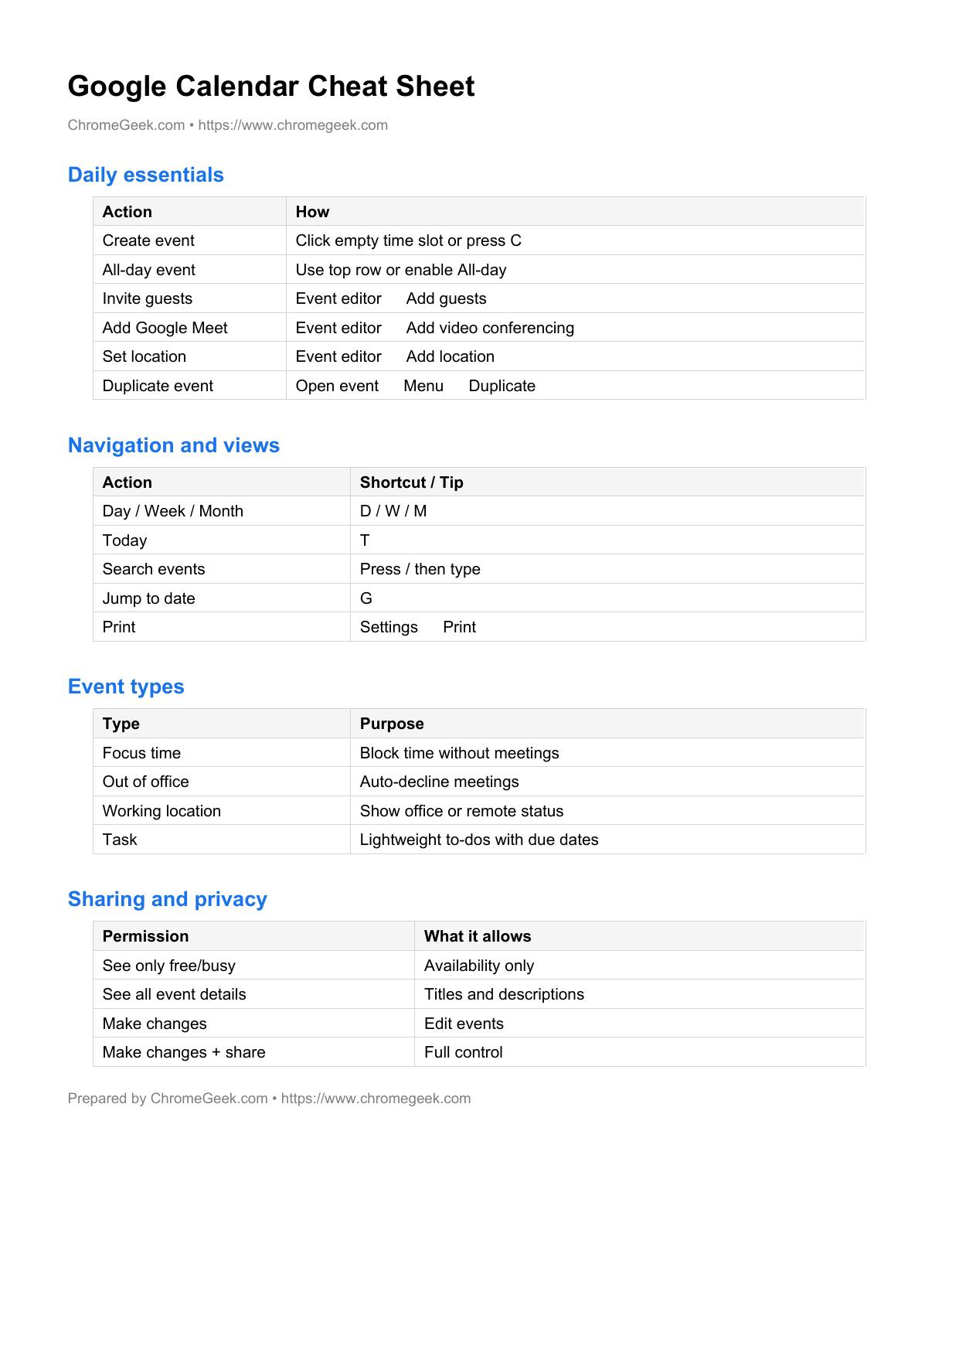
Google Calendar Cheat Sheet
ChromeGeek.com • https://www.chromegeek.com

Daily essentials
Action How
Create event Click empty time slot or press C
All-day event Use top row or enable All-day
Invite guests Event editor → Add guests
Add Google Meet Event editor → Add video conferencing
Set location Event editor → Add location
Duplicate event Open event → Menu → Duplicate

Navigation and views
Action Shortcut / Tip
Day / Week / Month D / W / M
Today T
Search events Press / then type
Jump to date G
Print Settings → Print

Event types
Type Purpose
Focus time Block time without meetings
Out of office Auto-decline meetings
Working location Show office or remote status
Task Lightweight to-dos with due dates

Sharing and privacy
Permission What it allows
See only free/busy Availability only
See all event details Titles and descriptions
Make changes Edit events
Make changes + share Full control
Prepared by ChromeGeek.com • https://www.chromegeek.com

