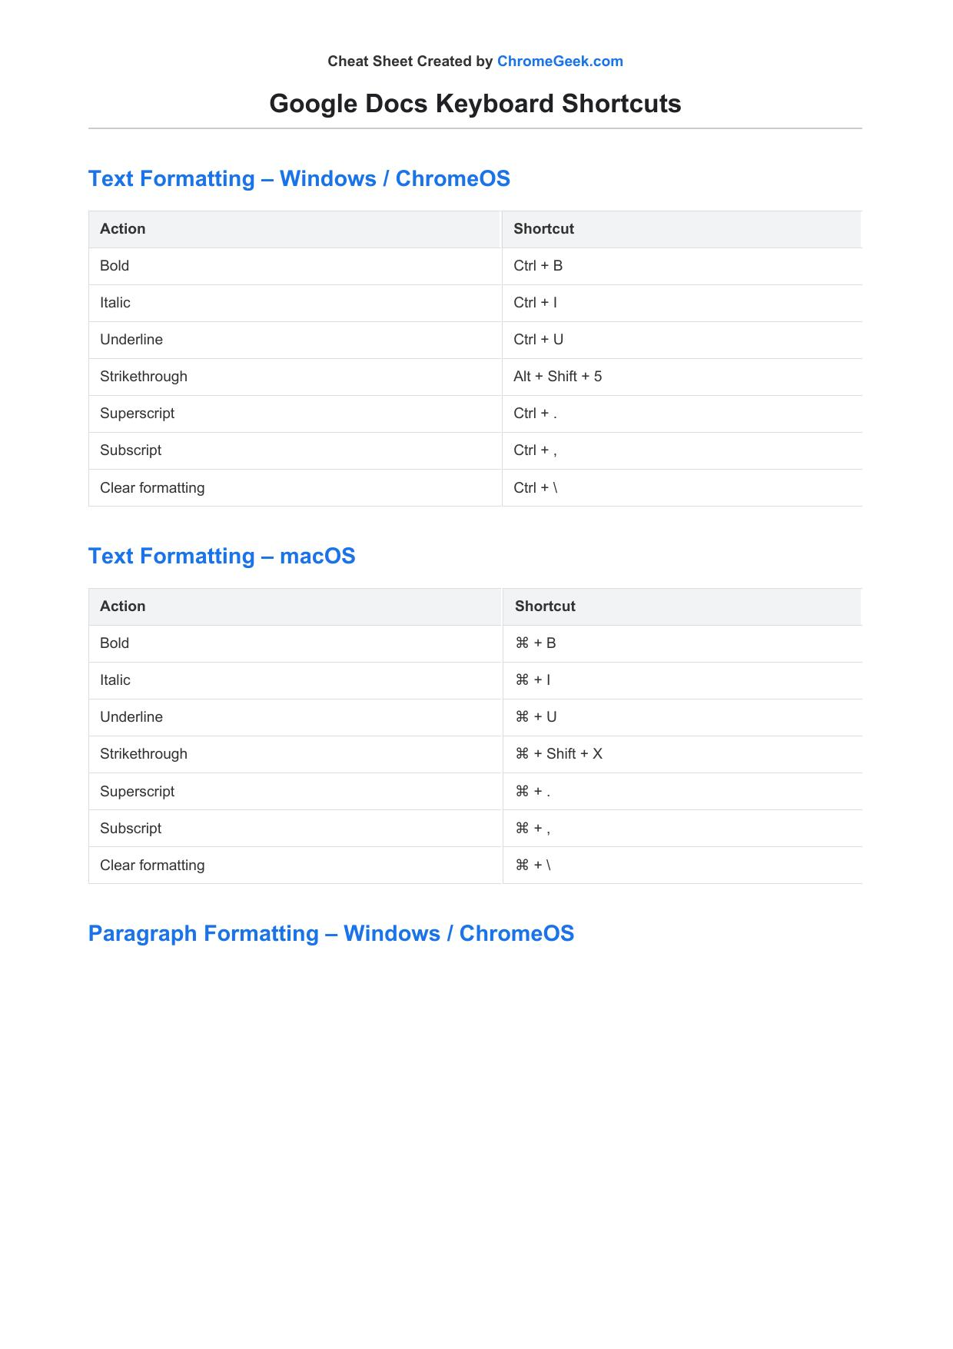

Cheat Sheet Created by [ChromeGeek.com](https://www.chromegeek.com/)

Google Docs Keyboard Shortcuts

Text Formatting – Windows / ChromeOS

Action Shortcut

Bold Ctrl + B

Italic Ctrl + I

Underline Ctrl + U

Strikethrough Alt + Shift + 5

Superscript Ctrl + .

Subscript Ctrl + ,

Clear formatting Ctrl + \

Text Formatting – macOS

Action Shortcut

Bold ⌘ + B

Italic ⌘ + I

Underline ⌘ + U

Strikethrough ⌘ + Shift + X

Superscript ⌘ + .

Subscript ⌘ + ,

Clear formatting ⌘ + \

Paragraph Formatting – Windows / ChromeOS

Action Shortcut

Increase indent Ctrl + ]

Decrease indent Ctrl + [

Align left Ctrl + Shift + L

Align center Ctrl + Shift + E

Align right Ctrl + Shift + R

Justify Ctrl + Shift + J

Numbered list Ctrl + Shift + 7

Bulleted list Ctrl + Shift + 8

Normal text style Ctrl + Alt + 0

Heading styles 1–6 Ctrl + Alt + 1–6

Paragraph Formatting – macOS

Action Shortcut

Increase indent ⌘ + ]

Decrease indent ⌘ + [

Align left ⌘ + Shift + L

Align center ⌘ + Shift + E

Align right ⌘ + Shift + R

Justify ⌘ + Shift + J

Numbered list ⌘ + Shift + 7

Bulleted list ⌘ + Shift + 8

Normal text style ⌘ + Option + 0

Heading styles 1–6 ⌘ + Option + 1–6

Editing & Navigation – Windows / ChromeOS

Action Shortcut

Undo Ctrl + Z

Redo Ctrl + Y or Ctrl + Shift + Z

Select all Ctrl + A

Find Ctrl + F

Find and replace Ctrl + H

Move to next word Ctrl + →

Move to previous word Ctrl + ←

Move to start/end of line Home / End

Move to start/end of doc Ctrl + Home / Ctrl + End

Editing & Navigation – macOS

Action Shortcut

Undo ⌘ + Z

Redo ⌘ + Shift + Z

Select all ⌘ + A

Find ⌘ + F

Find and replace ⌘ + Shift + H

Move to next word Option + →

Move to previous word Option + ←

Move to start/end of line ⌘ + ← / ⌘ + →

Move to start/end of doc ⌘ + ↑ / ⌘ + ↓

Collaboration Tools

Action Windows / ChromeOS macOS

Open comment box Ctrl + Alt + M ⌘ + Option + M

Insert comment Ctrl + Alt + Shift + A, then C ⌘ + Option + Shift + A, then C

Open discussion thread Ctrl + Alt + Shift + A, then H ⌘ + Option + Shift + A, then H

Resolve comment Ctrl + Enter (in comment) ⌘ + Enter (in comment)

Accessibility Shortcuts

Action Windows / ChromeOS macOS

Screen reader support Ctrl + Alt + Z ⌘ + Option + Z

Announce formatting at cursor Ctrl + Alt + A, then F ⌘ + Option + A, then F

Speak selection Ctrl + Alt + X ⌘ + Option + X

Open accessibility menu Alt + Shift + A ⌘ + Option + A

Mobile Shortcuts – Android

Action Gesture / Shortcut

Select text Tap and hold, then drag handles

Copy Tap copy icon on toolbar

Paste Tap where you want to paste → tap Paste

Undo Tap Undo icon

Redo Tap Redo icon

Bold / Italic / Underline Use toolbar buttons (B / I / U)

Mobile Shortcuts – iPhone / iPad

Action Gesture / Shortcut

Undo Three-finger swipe left or tap Undo

Redo Three-finger swipe right or tap Redo

Cut / Copy / Paste Select text → use toolbar or three-finger tap

Bold / Italic / Underline Use toolbar buttons (B / I / U)

Keyboard shortcuts (with external keyboard) Hold ⌘ to view available shortcuts Tip: On iPad with a physical keyboard, hold the ⌘ key to see a full list of available shortcuts in-app.

For more tips and resources, visit [ChromeGeek.com](https://www.chromegeek.com/)

© 2025 ChromeGeek.com – All rights reserved.