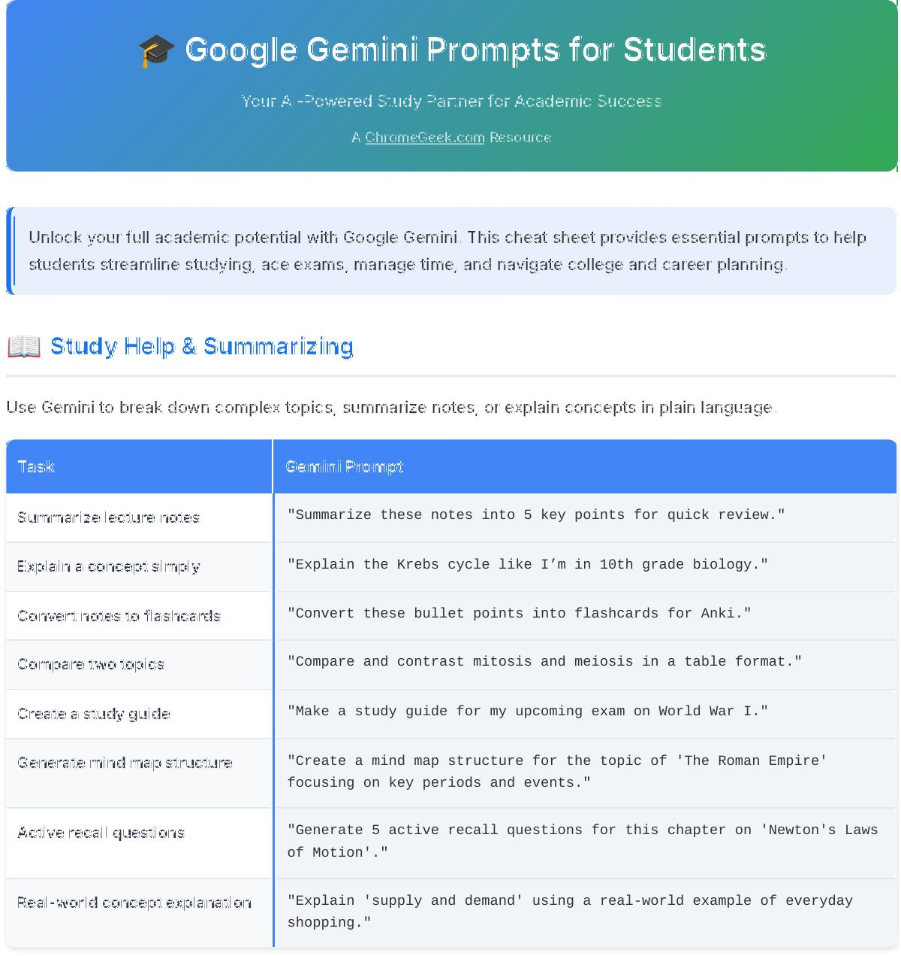



🎓 Google Gemini Prompts for Students



Your AI-Powered Study Partner for Academic Success



A [ChromeGeek.com](https://www.chromegeek.com/) Resource



Unlock your full academic potential with Google Gemini. This cheat sheet provides essential prompts to help students streamline studying, ace exams, manage time, and navigate college and career planning.

📖 Study Help & Summarizing

Use Gemini to break down complex topics, summarize notes, or explain concepts in plain language.



Task Gemini Prompt

Summarize lecture notes "Summarize these notes into 5 key points for quick review."

Explain a concept simply "Explain the Krebs cycle like I’m in 10th grade biology."

Convert notes to flashcards "Convert these bullet points into flashcards for Anki."

Compare two topics "Compare and contrast mitosis and meiosis in a table format."

Create a study guide "Make a study guide for my upcoming exam on World War I."

Generate mind map structure "Create a mind map structure for the topic of 'The Roman Empire'

focusing on key periods and events."

Active recall questions "Generate 5 active recall questions for this chapter on 'Newton's Laws

of Motion'."

Real-world concept explanation "Explain 'supply and demand' using a real-world example of everyday

shopping."

✍ Essay Writing & Editing

From brainstorming to polishing, Gemini can help you write better and faster.



Task Gemini Prompt

Brainstorm essay ideas "Give me 5 essay topics about climate change and youth activism."

Write a thesis statement "Write a strong thesis for an essay on the impact of social media on

teens."

Outline an essay "Create a 5-paragraph outline for an argumentative essay on school

uniforms."

Proofread and improve "Proofread this paragraph and suggest improvements for clarity and

tone."

Rephrase for tone "Make this paragraph sound more formal and academic."

Suggest counter-arguments "Suggest a strong counter-argument for my essay arguing that 'homework

should be abolished'."

Generate intro/conclusion ideas "Give me three different ways to start and end an essay about 'the

importance of critical thinking'."

Refine vocabulary "Replace generic words in this paragraph with stronger, more academic

synonyms: [paste paragraph]."

💡 Homework & Problem Solving

Stuck on a problem? Gemini can walk you through it step by step without just giving you the answer.



Task Gemini Prompt

Explain a math problem "Walk me through solving this quadratic equation step by step."

Break down a reading "Summarize this Shakespeare passage in modern English."

Help with citations "Cite this source in MLA format: [paste source text]."

Translate a passage "Translate this paragraph from Spanish to English with cultural

context for students."

Explain a science process "Explain how photosynthesis works using simple analogies."

Debug code "Help me debug this Python code snippet for calculating Fibonacci

sequence: [paste code]."

Analyze historical event "Explain the historical significance of 'The Battle of Gettysburg'

from both Union and Confederate perspectives."

Apply scientific method "Outline the steps of the scientific method for an experiment on

'plant growth with different light exposures'."

📝 Exam Prep & Quizzing

Use Gemini to quiz yourself , generate practice questions, or build flashcards for spaced repetition.



Task Gemini Prompt

Create flashcards "Make 10 flashcards for key terms in cellular biology."

Generate practice questions "Write 5 short-answer questions on the causes of the French

Revolution."

Quiz me "Quiz me on these notes and give feedback on my answers."

Create a mock test "Build a 20-question multiple choice test on algebra basics."

Explain wrong answers "Explain why this answer is incorrect and what the correct one is."

Break down challenging "Identify and break down the 3 most challenging concepts from my concepts 'Organic Chemistry' textbook to help me study."

Scenario-based questions "Create 3 scenario-based questions about 'economic principles' to test

my application of knowledge."

Create mnemonic devices "Suggest a mnemonic device to remember the order of the 'Planets in

our Solar System' from the sun outward."

⏱ Time Management & Study Schedules

Stay organized with Gemini 's help. Build a study plan, break down big tasks, or set priorities.



Task Gemini Prompt

Create a study schedule "Make a 2-week study plan for finals with 3 subjects per day."

Break down a big task "Break this 10-page research paper into daily writing goals for one

week."

Set priorities "Help me prioritize these 5 assignments due this week: Essay (due

Monday), Math HW (due Tuesday), Presentation (due Wednesday), Reading (due Friday), Lab Report (due Friday)."

Build a Pomodoro plan "Create a Pomodoro-style study session plan for 90 minutes of focused

work."

Create a balanced schedule "Plan a weekly study schedule that balances school, my guitar lessons,

and time for friends."

Balance multiple tasks "I have a physics problem set, a history essay, and a club meeting

this evening. Help me allocate my time effectively."

Overcome procrastination "Suggest 3 actionable strategies to overcome procrastination when I

need to start a daunting project."

Set study reminders "Draft a reminder for my phone to study for 30 minutes every evening

at 7 PM."

🚀 College & Career Planning

Gemini can help you write applications, prep for interviews, or explore your future.



Task Gemini Prompt

Write a personal statement "Help me write a personal statement for a college application in

biology, highlighting my passion for genetics."

Explore careers "Give me 3 career paths I could explore with a degree in psychology

that involve helping people."

Prepare for an interview "Give me common scholarship interview questions with example answers

for a student applying for a leadership scholarship."

Create a resume "Make a student resume for a high schooler applying for a summer

internship at a local library."

Request recommendation letter "Write a polite email asking my English teacher for a letter of

recommendation for college, reminding them of my strongest qualities."

College campus visit questions "Generate a list of 5 important questions I should ask during a

college campus visit to a science program."

Draft networking email "Draft an email to a potential mentor in the software development

field asking for an informational interview."

Scholarship search assistance "Find 3 unique scholarship opportunities for students interested in

environmental science."

📱 Mobile Tips for Students

💡 Gmail app: Get help rewording emails to teachers or staff for clarity and tone.

💡 Docs mobile app: Let Gemini polish your writing or suggest essay intros on the go.

💡 Gemini app (Android/iOS): Quiz yourself with flashcards or generate ideas between classes.

💡 Voice input: Use voice prompts like “Summarize my homework notes” to save time.

💡 Quick research: Look up definitions or quick facts during study sessions without opening multiple apps.

💡 Concept clarification: Ask Gemini to re-explain a tricky concept right after a lecture.

💡 Brainstorm on the go: Get ideas for creative projects or essays while commuting or exercising.

✨ Pro Tips for Better Prompts

💡 Be specific: Include your grade level, subject, and any constraints (e.g., "for a 10th-grade history essay," "in 200

words").

💡 Add context: Tell Gemini about your learning style, specific challenges, or previous knowledge.

💡 Ask for examples/scenarios: Request real-world applications or illustrative examples for clarity.

💡 Iterate and refine: Don't expect perfection on the first try. Ask Gemini to "make it simpler," "expand on point X," or

" give me alternatives."

💡 Define the output: Specify the format you want (e.g., "in a table," "as bullet points," "as a short paragraph").

💡 Use follow-up questions: Treat Gemini as a conversation partner. After an answer, ask "Why?" or "What's next?"

💡 Leverage your notes: Copy-paste your own notes or textbook passages directly into Gemini for context-aware

help.

Google Gemini Prompts for Students

Empower your academic journey with AI • Study smarter • Write better • Manage time effectively

Created by [ChromeGeek.com](https://www.chromegeek.com/)

This guide is designed to help students leverage AI responsibly as a powerful learning tool.