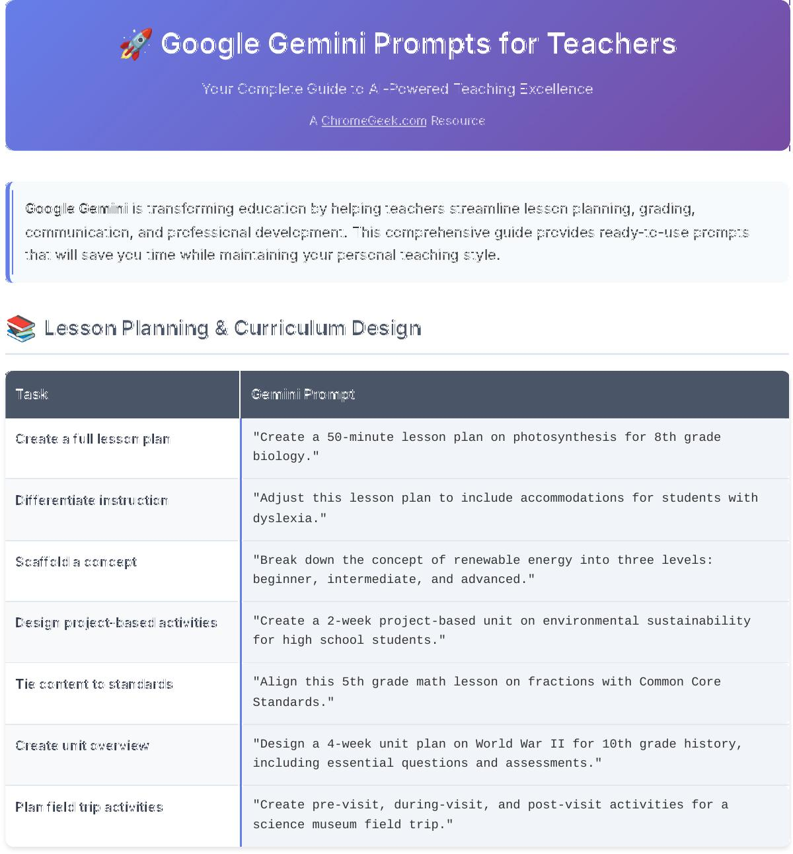



🚀 Google Gemini Prompts for Teachers



Your Complete Guide to AI-Powered Teaching Excellence



A [ChromeGeek.com](https://www.chromegeek.com/) Resource



Google Gemini is transforming education by helping teachers streamline lesson planning, grading, communication, and professional development. This comprehensive guide provides ready-to-use prompts that will save you time while maintaining your personal teaching style.

📚 Lesson Planning & Curriculum Design



Task Gemini Prompt

Create a full lesson plan "Create a 50-minute lesson plan on photosynthesis for 8th grade

biology."

Differentiate instruction "Adjust this lesson plan to include accommodations for students with

dyslexia."

Scaffold a concept "Break down the concept of renewable energy into three levels:

beginner, intermediate, and advanced."

Design project-based activities "Create a 2-week project-based unit on environmental sustainability

for high school students."

Tie content to standards "Align this 5th grade math lesson on fractions with Common Core

Standards."

Create unit overview "Design a 4-week unit plan on World War II for 10th grade history,

including essential questions and assessments."

Plan field trip activities "Create pre-visit, during-visit, and post-visit activities for a

science museum field trip."

⚡ Quick Creation (Quizzes, Slides, Rubrics)



Task Gemini Prompt

Create a quiz "Generate a 10-question multiple choice quiz on the water cycle with

answer key."

Draft a rubric "Write a 4-point rubric for a persuasive writing assignment for 6th

grade."

Generate slide content "Create slide outlines for a 30-minute history lesson on the Cold

War."

Build a handout "Make a worksheet with 5 practice problems for solving inequalities."

Design bell ringers "Give me 5 bell ringer questions for a high school English class

reading 'Of Mice and Men.'"

Create vocabulary activities "Design 3 engaging vocabulary activities for these 15 chemistry

terms."

Make anchor charts "Create content for an anchor chart explaining the parts of speech for

3rd graders."

📧 Parent Communication



Task Gemini Prompt

Write a progress update "Write a friendly email to a parent updating them on their child's

improvement in math."

Send behavior note "Draft a calm, supportive message addressing a classroom disruption

and next steps."

Create a newsletter "Summarize this month's curriculum and upcoming events for a class

newsletter."

Request parent volunteers "Write a message asking for parent volunteers for field day."

Send form letter in bulk "Create a template for weekly updates I can reuse for each student."

Conference preparation "Help me prepare talking points for a parent-teacher conference about

academic concerns."

Absence follow-up "Write a supportive email to parents about extended student absence

and catch-up plan."

📊 Assessment & Feedback



Task Gemini Prompt

Give feedback "Give me kind but clear feedback on a 5th grade student's persuasive

paragraph."

Generate answer examples "Show 3 example responses at different levels for this math problem."

Design exit tickets "Write 3 exit ticket questions to assess understanding of geometric

angles."

Reteach plan "Give me a 10-minute mini-lesson to reteach multiplying fractions."

Suggest groupings "Suggest small groups based on performance levels described in this

summary."

Create self-assessments "Design a student self-assessment checklist for a research project."

Formative assessment ideas "Give me 5 quick formative assessment strategies for checking

comprehension during reading."

🎯 Classroom Management



Task Gemini Prompt

Create classroom rules "Help me create 5 positive classroom rules for 2nd grade students."

Design reward system "Create a classroom reward system that promotes intrinsic motivation

for middle school."

Icebreaker activities "Give me 3 icebreaker activities for the first week of high school

English class."

Transition activities "Suggest 5 quick transition activities to use between lessons for 4th

grade."

Brain breaks "Create 10 energizing brain break activities that take 2-3 minutes

each."

Conflict resolution "Help me create a step-by-step conflict resolution process for

elementary students."

🎓 Professional Development



Task Gemini Prompt

Summarize research "Summarize this article on inquiry-based learning in 3 bullet points."

Create PD slides "Draft an outline for a 30-minute presentation on integrating AI in

the classroom."

Draft recommendation letter "Write a professional and sincere letter of recommendation for a

student applying to a summer STEM program."

Outline reflection log "Create a weekly self-reflection template for teachers to log wins and

challenges."

Create agenda "Make a PD meeting agenda with time estimates and focus areas for

curriculum review."

Summarize a PD session "Summarize this 2-hour workshop into 5 action steps teachers can apply

next week."

Goal setting "Help me create SMART goals for improving student engagement in my

classroom this year."

🎨 Creative & Engaging Activities



Task Gemini Prompt

Story starters "Create 5 creative writing prompts for 7th grade students about time

travel."

Science experiments "Suggest 3 simple chemistry experiments using household items for 6th

grade."

Math games "Create a fun math game to practice multiplication tables for 3rd

grade."

Discussion questions "Generate thought-provoking discussion questions about environmental

responsibility for high school."

Art integration "How can I integrate art into my history lesson about ancient

civilizations?"

Technology integration "Suggest ways to use tablets/smartphones educationally in my English

class."

📱 Mobile Teaching Tips

💡 Gmail app: Use Gemini to suggest replies or reword parent emails while on the move.

💡 Google Docs mobile: Launch Gemini to draft quick rubrics, exit tickets, or assignment instructions.

💡 Gemini app (Android): Ask Gemini to brainstorm classroom activities or do morning prep while commuting.

💡 Voice input: Use voice prompts like "Write an end-of-week class newsletter" for fast content creation.

💡 Quick planning: Generate lesson ideas during lunch breaks or between classes.

💡 Emergency prep: Create substitute teacher plans on-the-go when you're feeling unwell.

💡 Parent communication: Draft sensitive emails with AI assistance to ensure professional tone.

💡 Pro Tips for Better Prompts

💡 Be specific: Include grade level, subject, and time constraints in your prompts.

💡 Add context: Mention your students' needs, learning styles, or classroom setup.

💡 Ask for alternatives: Request multiple versions or approaches to find what works best.

💡 Iterate and refine: Start with a basic prompt, then ask Gemini to modify or improve it.

💡 Include standards: Reference specific learning standards or curriculum requirements.

💡 Think accessibility: Always ask for accommodations for diverse learners.

💡 Save favorites: Keep a collection of your most successful prompts for reuse.

Google Gemini Prompts for Teachers

Transform your teaching with AI-powered efficiency • Save time • Enhance creativity • Improve student outcomes

Created by [ChromeGeek.com](https://www.chromegeek.com/)

This guide is designed to help educators leverage AI responsibly while maintaining the human connection that makes teaching special.