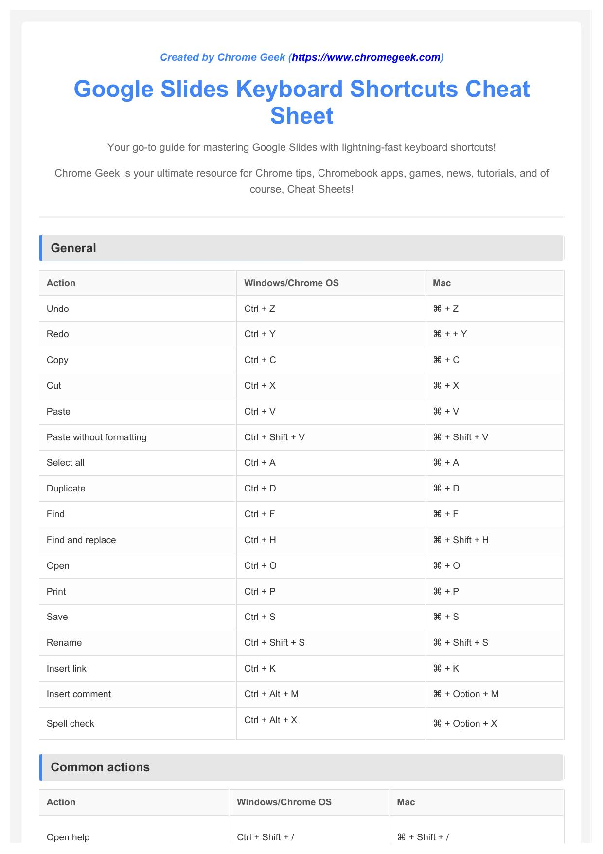

index-1_1.jpg

Created by Chrome Geek ([https://www.chromegeek.com](https://www.chromegeek.com/))

Google Slides Keyboard Shortcuts Cheat

Sheet

Your go-to guide for mastering Google Slides with lightning-fast keyboard shortcuts!

Chrome Geek is your ultimate resource for Chrome tips, Chromebook apps, games, news, tutorials, and of

course, Cheat Sheets!

General

Action Windows/Chrome OS Mac Undo Ctrl + Z ⌘ + Z Redo Ctrl + Y ⌘ + + Y Copy Ctrl + C ⌘ + C Cut Ctrl + X ⌘ + X Paste Ctrl + V ⌘ + V Paste without formatting Ctrl + Shift + V ⌘ + Shift + V Select all Ctrl + A ⌘ + A Duplicate Ctrl + D ⌘ + D Find Ctrl + F ⌘ + F Find and replace Ctrl + H ⌘ + Shift + H Open Ctrl + O ⌘ + O Print Ctrl + P ⌘ + P Save Ctrl + S ⌘ + S Rename Ctrl + Shift + S ⌘ + Shift + S Insert link Ctrl + K ⌘ + K Insert comment Ctrl + Alt + M ⌘ + Option + M Spell check Ctrl + Alt + X ⌘ + Option + X

Common actions

Action Windows/Chrome OS Mac

Open help Ctrl + Shift + / ⌘ + Shift + /

index-1_2.jpg

index-1_3.jpg

index-1_4.jpg

index-1_5.jpg

index-1_6.jpg

index-1_7.jpg

index-1_8.jpg

index-2_1.jpg

Open menus (File, Edit, View, etc.) Alt + Shift + F, E, V, I, O, T, H Ctrl + Option + F, E, V, I, O, T, H Open accessibility feedback Alt + Shift + A Ctrl + Option + A Focus sidebar Ctrl + Alt + Shift + S ⌘ + Option + Shift + S Focus ruler Ctrl + Alt + Shift + R ⌘ + Option + Shift + R Focus editor Alt + Shift + C Ctrl + Option + C Focus speaker notes Alt + Shift + S Ctrl + Option + S Focus filmstrip Ctrl + Alt + Shift + F ⌘ + Option + Shift + F Focus text area Ctrl + Alt + E ⌘ + Option + E Focus current slide Ctrl + Alt + Shift + K ⌘ + Option + Shift + K Focus toolbar Alt + Shift + T Ctrl + Option + T Open list of keyboard shortcuts Ctrl + / ⌘ + / Switch to next slide Page down or Right arrow Page down or Right arrow Switch to previous slide Page up or Left arrow Page up or Left arrow Start presentation Ctrl + F5 ⌘ + Enter Start presentation from current slide Ctrl + Shift + F5 ⌘ + Shift + Enter

Text formatting

Action Windows/Chrome OS Mac Bold Ctrl + B ⌘ + B Italic Ctrl + I ⌘ + I Underline Ctrl + U ⌘ + U Subscript Ctrl + , ⌘ + , Superscript Ctrl + . ⌘ + . Strikethrough Alt + Shift + 5 ⌘ + Shift + X Clear formatting Ctrl + \ ⌘ + \ Increase font size Ctrl + Shift + > ⌘ + Shift + > Decrease font size Ctrl + Shift + < ⌘ + Shift + <

Paragraph formatting

Action Windows/Chrome OS Mac

Align left Ctrl + Shift + L + Shift + L ⌘

index-2_2.jpg

index-2_3.jpg

index-2_4.jpg

index-2_5.jpg

index-2_6.jpg

index-2_7.jpg

index-2_8.jpg

index-3_1.jpg

Align center Ctrl + Shift + E ⌘ + Shift + E Align right Ctrl + Shift + R ⌘ + Shift + R Justify Ctrl + Shift + J ⌘ + Shift + J Indent Ctrl + ] ⌘ + ] Outdent Ctrl + [ ⌘ + [ Numbered list Ctrl + Shift + 7 ⌘ + Shift + 7 Bulleted list Ctrl + Shift + 8 ⌘ + Shift + 8

Moving through your presentation

Action Windows/Chrome OS Mac Go to next slide Page down or Right arrow Page down or Right arrow Go to previous slide Page up or Left arrow Page up or Left arrow First slide Home Home Last slide End End

Object manipulation

Action Windows/Chrome OS Mac Duplicate selected object Ctrl + D ⌘ + D Bring to front Ctrl + Shift + Up arrow ⌘ + Shift + Up arrow Send to back Ctrl + Shift + Down arrow ⌘ + Shift + Down arrow Bring forward Ctrl + Up arrow ⌘ + Up arrow Send backward Ctrl + Down arrow ⌘ + Down arrow Group selected objects Ctrl + Alt + G ⌘ + Option + G Ungroup selected objects Ctrl + Alt + Shift + G ⌘ + Option + Shift + G

Android

Action Shortcut New slide Ctrl + m Duplicate slide Ctrl + d Undo Ctrl + z Redo Ctrl + y or Ctrl + Shift + z Copy Ctrl + c Cut Ctrl + x Paste Ctrl + v Open link Alt + Enter Delete Delete Select all Ctrl + a Select none hold Ctrl + Alt, press u then a

index-3_2.jpg

index-3_3.jpg

index-3_4.jpg

index-3_5.jpg

index-3_6.jpg

index-3_7.jpg

index-3_8.jpg

index-4_1.jpg

Insert link Ctrl + k Insert comment Alt + Ctrl + m Find Ctrl + f Show common keyboard shortcuts Ctrl + / Move focus to previous slide Alt + Up arrow or Up arrow

Move focus to next slide Alt + Down arrow or Down arrow

Extend selection to previous slide Shift + Up arrow Extend selection to next slide Shift + Down arrow Move slide up Ctrl + Up arrow Move slide down Ctrl + Down arrow Move slide to beginning Ctrl + Shift + Up arrow Move slide to end Ctrl + Shift + Down arrow Move to filmstrip Ctrl + Alt + Shift + f Move to canvas Ctrl + Alt + Shift + c Open speaker notes panel Ctrl + Alt + Shift + s Present from current slide (device) Ctrl + Alt + p Present from beginning (device) Ctrl + Alt + Shift + p Present from current slide (meeting) Ctrl + Alt + h Present from beginning (meeting) Ctrl + Alt + Shift + h Exit the current mode Esc Move to next comment in the presentation hold Ctrl + Alt, press n then c

Bold Ctrl + b Italic Ctrl + i Underline Ctrl + u Subscript Ctrl + , Superscript Ctrl + .

index-4_2.jpg

index-4_3.jpg

index-4_4.jpg

index-4_5.jpg

index-4_6.jpg

index-4_7.jpg

index-4_8.jpg

index-5_1.jpg

Strikethrough Alt + Shift + 5 Clear formatting Ctrl + \ or Ctrl + Space Increase font size Ctrl + Shift + > Decrease font size Ctrl + Shift + < Left align Ctrl + Shift + l Right align Ctrl + Shift + r Center align Ctrl + Shift + e Justify Ctrl + Shift + j Increase indent Ctrl + ] Decrease indent Ctrl + [ Move paragraph down Alt + Shift + Down arrow Move paragraph up Alt + Shift + Up arrow Bulleted list Ctrl + Shift + 8 Numbered list Ctrl + Shift + 7 Next (in presentation mode) Right arrow Previous (in presentation mode) Left arrow Go to specific slide (in presentation mode) Slide's number followed by Enter

Toggle laser pointer (in presentation mode) l Show a blank black slide (in presentation mode) b or . Return to the presentation from a blank black slide Press any key Show a blank white slide (in presentation mode) w or , Return to the presentation from a blank white slide Press any key Toggle play/pause (video) k Rewind 10 seconds (video) u Fast forward 10 seconds (video) o Previous frame (video, while paused) Shift + , Next frame (video, while paused) Shift + . Seek to specific point in the video (e.g., Shift+7 for 70%) Shift + 0-9 Toggle captions on/off (video) c Duplicate selected object Ctrl + d Group selected objects Alt + Ctrl + g Ungroup selected objects Shift + Alt + Ctrl + g Send backward Ctrl + Down arrow Bring forward Ctrl + Up arrow Send to back Ctrl + Shift + Down arrow

index-5_2.jpg

index-5_3.jpg

index-5_4.jpg

index-5_5.jpg

index-5_6.jpg

index-5_7.jpg

index-5_8.jpg

index-6_1.jpg

Bring to front Ctrl + Shift + Up arrow

Select next shape Tab Select previous shape Shift + Tab Nudge up, down, left, or right Arrow keys Nudge one pixel at a time Shift + Arrow keys Rotate counterclockwise by 1° Alt + Shift + Left arrow

Rotate clockwise by 1° Alt + Shift + Right arrow

Rotate counterclockwise by 15° Alt + Left arrow Rotate clockwise by 15° Alt + Right arrow Resize larger horizontally Ctrl + Alt + b Resize larger vertically Ctrl + Alt + i

Resize smaller Ctrl + Alt + j Resize larger Ctrl + Alt + k Resize smaller horizontally Ctrl + Alt + w

iPhone/iPad

Action Shortcut Duplicate slide ⌘ + d Undo ⌘ + z Redo ⌘ + y Copy ⌘ + c Cut ⌘ + x Paste ⌘ + v Move to previous slide Up arrow Move to next slide Down arrow Move slide up ⌘ + Up arrow Move slide down ⌘ + Down arrow Move to filmstrip ⌘ + Option + Shift + f Move to canvas ⌘ + Option + Shift + c Insert comment ⌘ + Option + m Hide comment ⌘ + Alt + Shift + n Bold ⌘ + b Italic ⌘ + i Underline ⌘ + u Duplicate selected object ⌘ + d Group selected objects ⌘ + Option + g Ungroup selected objects ⌘ + Option + Shift + g

index-6_2.jpg

index-6_3.jpg

index-6_4.jpg

index-6_5.jpg

index-6_6.jpg

index-6_7.jpg

index-6_8.jpg

index-7_1.jpg

This cheat sheet was created by Chrome Geek ([https://www.chromegeek.com)](https://www.chromegeek.com/). We hope it helps you work smarter, not harder!

Find more tips, tutorials, and cheat sheets at Chrome Geek!

index-7_2.jpg

index-7_3.jpg

index-7_4.jpg

index-7_5.jpg

index-7_6.jpg

index-7_7.jpg

index-7_8.jpg