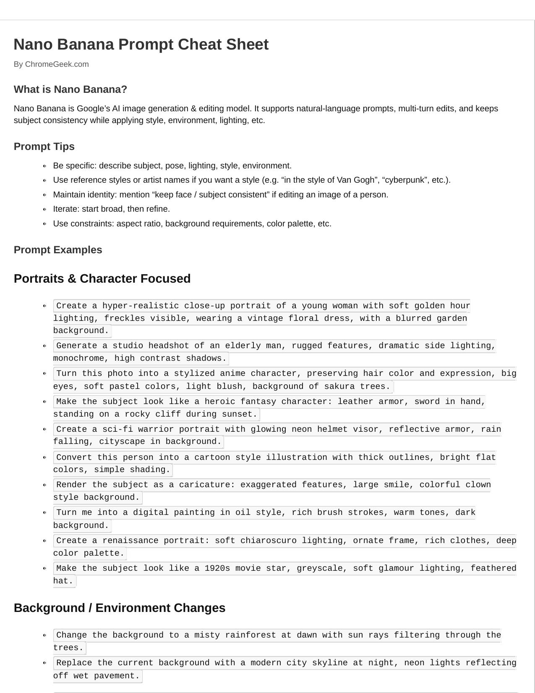

Nano Banana Prompt Cheat Sheet By ChromeGeek.com

What is Nano Banana?

Nano Banana is Google’s AI image generation & editing model. It supports natural-language prompts, multi-turn edits, and keeps subject consistency while applying style, environment, lighting, etc.

Prompt Tips

Be specific: describe subject, pose, lighting, style, environment.

Use reference styles or artist names if you want a style (e.g. “in the style of Van Gogh”, “cyberpunk”, etc.). Maintain identity: mention “keep face / subject consistent” if editing an image of a person. Iterate: start broad, then refine.

Use constraints: aspect ratio, background requirements, color palette, etc.

Prompt Examples

Portraits & Character Focused

Create a hyper-realistic close-up portrait of a young woman with soft golden hour

lighting, freckles visible, wearing a vintage floral dress, with a blurred garden background.

Generate a studio headshot of an elderly man, rugged features, dramatic side lighting,

monochrome, high contrast shadows.

Turn this photo into a stylized anime character, preserving hair color and expression, big

eyes, soft pastel colors, light blush, background of sakura trees.

Make the subject look like a heroic fantasy character: leather armor, sword in hand,

standing on a rocky cliff during sunset.

Create a sci-fi warrior portrait with glowing neon helmet visor, reflective armor, rain

falling, cityscape in background.

Convert this person into a cartoon style illustration with thick outlines, bright flat

colors, simple shading.

Render the subject as a caricature: exaggerated features, large smile, colorful clown

style background.

Turn me into a digital painting in oil style, rich brush strokes, warm tones, dark

background.

Create a renaissance portrait: soft chiaroscuro lighting, ornate frame, rich clothes, deep

color palette.

Make the subject look like a 1920s movie star, greyscale, soft glamour lighting, feathered

hat.

Background / Environment Changes

Change the background to a misty rainforest at dawn with sun rays filtering through the

trees.

Replace the current background with a modern city skyline at night, neon lights reflecting

off wet pavement.

Make the scene into a snowy mountain landscape with frozen lake, pine trees, overcast sky. Transform the background into a rustic barn interior, hay bales visible, warm lamp

lighting.

Place subject by a seaside cliff during golden hour, waves crashing, warm glow. Convert background into a fantasy castle courtyard with lanterns and soft glowing

firelight.

Make it look like the subject is in outer space: stars, nebulae, planets visible in

distance.

Change setting to an abandoned industrial warehouse, beams of light through dusty windows. Place the scene in a cozy cabin interior, fireplace glowing, snow outside window. Set the subject in a desert dune landscape at sunset, long shadows and warm tones.

Style & Art Effects

Render the image in watercolor painting style: soft edges, pastel colors, paper texture. Apply film noir style: high contrast black & white, dramatic shadows. Turn the scene into a cyberpunk city: neon blues & pinks, rainy streets, holographic

signs.

Make the photo look like a comic book panel: halftone dots, bold outlines, speech bubble

with caption “Wow!”.

Create an impressionist painting effect: loose brush-strokes, light color palette,

atmospheric.

Use a vintage 80s movie poster style: grainy film, bold typography, dramatic poses. Produce a cartoon-flat style, minimal shading, bold colors. Turn the image into a pencil sketch: visible pencil strokes, monochrome, rough texture. Make it look like a stained glass window: bold segmented colored panes, leading lines. Create glitch art effect: pixel distortion, RGB splits, digital noise.

3D Figurines / Collectibles

Create a 1/7 scale collectible figurine of the subject, realistic style, on a round

acrylic base, soft studio lighting.

Make a cute plush toy version of the subject with oversized head, fuzzy fabric texture,

against plain backdrop.

Turn subject into an anime figurine on a clear base, dynamic pose, vibrant colors, manga

background.

Create a superhero action figure version, with flowing cape, dramatic pose, packaged in

toy box mockup.

Render a photorealistic animal figurine sitting on a shelf with little accessories. Make an astronaut collectible figure in spacesuit, standing on moon surface backdrop with

starry sky.

Turn into a hologram model object, transparent layers, sci-fi stand, ambient glow. Create pop star mini-stage figurine, microphone in hand, spotlight effect. Make a fantasy character toy, holding staff or sword, magical forest base. Render this photo as a figurine, stylized wood texture base, shallow depth of field.

Editing / Transformations Remove the background clutter and replace it with soft pastel gradient, keep subject

identity intact.

Change the outfit: make me wear a leather jacket and scarf, same pose and lighting. Add a glowing halo or light ring behind the subject. Make skin smoother, adjust lighting to golden-hour glow. Add lens flare from top-right corner, subtle.

Convert image to high contrast silhouette, background colorful gradient. Adjust mood: change from sunny daytime into moody rainy evening, keep colors desaturated. Make the colors pop: adjust saturation, vibrant tones, deeper shadows. Add realistic shadow underneath subject as if standing outdoors in midday sun. Composite two images: have subject from photo A interacting with an object from photo B.

Fantasy / Concept / Storytelling

Create a mystical forest scene: subject holds a glowing orb, mist all around, fireflies in

the air.

A dragon flying overhead, subject looking up, castle ruins in background, dusk lighting. Subject riding a giant mechanical beetle through steampunk city. Portrait of a warrior queen leading troops across a battlefield at sunrise. Underwater mermaid theme: subject swimming, sunlight filtering through water, coral reefs

background.

Floating islands in sky; subject standing at edge, clouds below, magical ambience. Subject as interstellar pilot on spaceship bridge, stars outside viewport. Medieval alchemist lab with potions, candles, ancient texts, subject mixing elixirs. Post-apocalyptic setting: subject in protective gear, ruined city, overgrown plants. Subject in dreamscape: surreal shapes, soft lighting, pastel sky.

Using These Prompts Effectively

Start with one prompt, then refine via iteration (e.g. “That’s good; now add …”). Save the versions you like; sometimes subtle changes (lighting, pose) make big differences. If subject has recognizable features (face, clothes), mention “keep identity consistent”. Use reference images if allowed; some prompts work better with image + text input. :contentReference[oaicite:1]{index=1} Watch resolution & aspect ratio — define them if needed (square, portrait, landscape). Be mindful of background clutter; simpler backgrounds often help subject shine.

© ChromeGeek.com - All rights reserved.