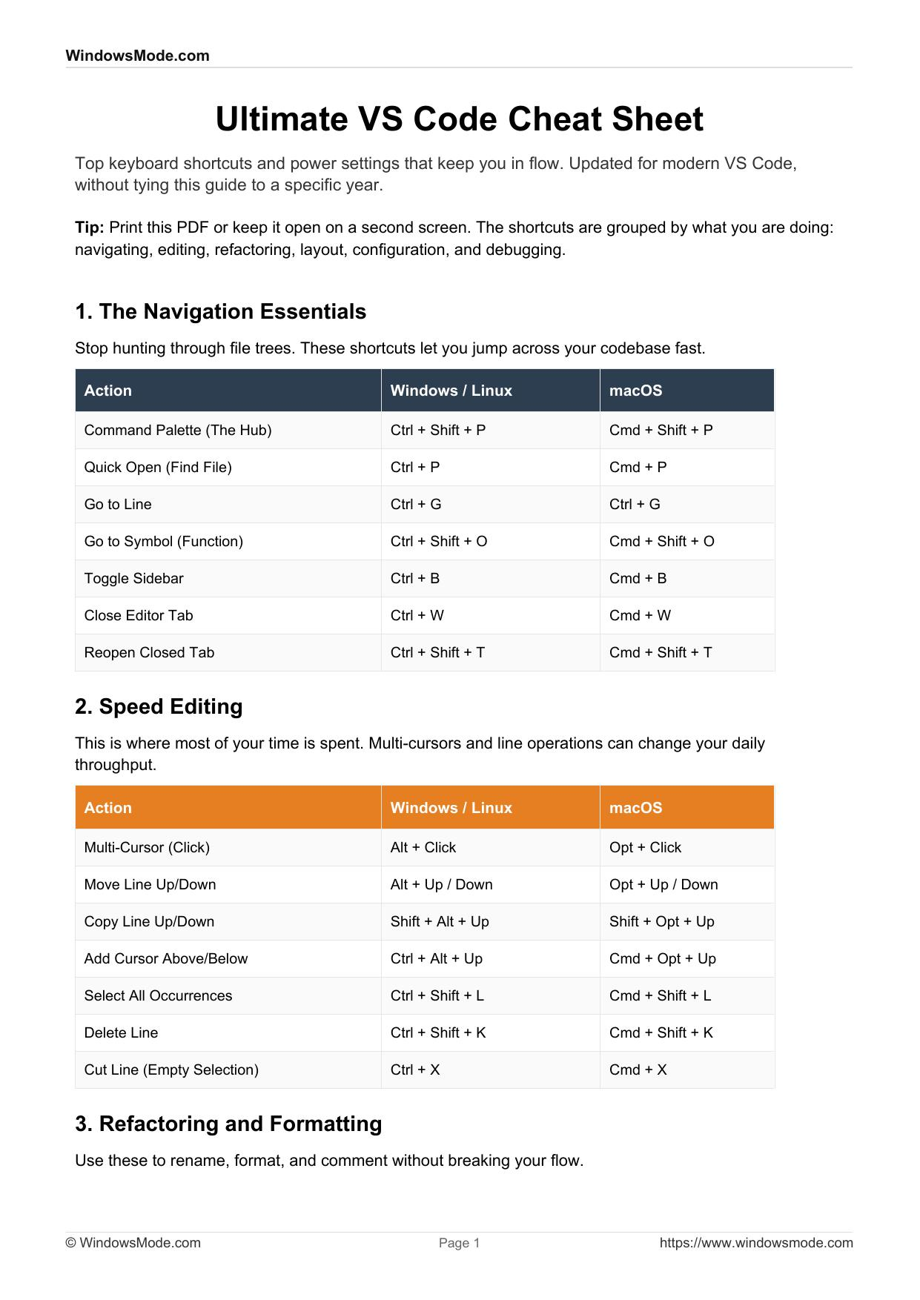

Ultimate VS Code Cheat Sheet
Top keyboard shortcuts and power settings that keep you in flow. Updated for modern VS Code,
without tying this guide to a specific year.

Tip: Print this PDF or keep it open on a second screen. The shortcuts are grouped by what you are doing:
navigating, editing, refactoring, layout, configuration, and debugging.

1. The Navigation Essentials
Stop hunting through file trees. These shortcuts let you jump across your codebase fast.

Action Windows / Linux macOS
Command Palette (The Hub) Ctrl + Shift + P Cmd + Shift + P
Quick Open (Find File) Ctrl + P Cmd + P
Go to Line Ctrl + G Ctrl + G
Go to Symbol (Function) Ctrl + Shift + O Cmd + Shift + O
Toggle Sidebar Ctrl + B Cmd + B
Close Editor Tab Ctrl + W Cmd + W
Reopen Closed Tab Ctrl + Shift + T Cmd + Shift + T

2. Speed Editing
This is where most of your time is spent. Multi-cursors and line operations can change your daily
throughput.

Action Windows / Linux macOS
Multi-Cursor (Click) Alt + Click Opt + Click
Move Line Up/Down Alt + Up / Down Opt + Up / Down
Copy Line Up/Down Shift + Alt + Up Shift + Opt + Up
Add Cursor Above/Below Ctrl + Alt + Up Cmd + Opt + Up
Select All Occurrences Ctrl + Shift + L Cmd + Shift + L
Delete Line Ctrl + Shift + K Cmd + Shift + K
Cut Line (Empty Selection) Ctrl + X Cmd + X

3. Refactoring and Formatting
Use these to rename, format, and comment without breaking your flow.

© WindowsMode.com Page 1 https://www.windowsmode.com Action Windows / Linux macOS
Rename Symbol (Refactor) F2 F2
Toggle Line Comment Ctrl + / Cmd + /
Toggle Block Comment Shift + Alt + A Shift + Opt + A
Format Document Shift + Alt + F Shift + Opt + F
Fold Code Block Ctrl + Shift + [ Cmd + Opt + [
Unfold Code Block Ctrl + Shift + ] Cmd + Opt + ]

4. Terminal and Window Layout
Manage splits, terminals, and focus modes without dragging panels around.

Action Windows / Linux macOS
Split Editor (Side-by-Side) Ctrl + \\ Cmd + \\
Toggle Terminal Ctrl + ` Ctrl + `
Create New Terminal Ctrl + Shift + ` Ctrl + Shift + `
Toggle Zen Mode (Focus) Ctrl + K then Z Cmd + K then Z
Zoom In Ctrl + = Cmd + =
Zoom Out Ctrl + - Cmd + -

5. "God Mode" Configuration
Shortcuts help, but real power lives in settings.json. Open the Command Palette and choose Open User
Settings (JSON), then paste or adapt these.

/* --- VISUAL MINIMALISM --- */
"workbench.activityBar.location": "hidden", // Hides the big left sidebar icons "workbench.statusBar.visible": false, // Hides the bottom status bar "breadcrumbs.enabled": false, // Removes top breadcrumbs "editor.minimap.enabled": false, // Disables the minimap
/* --- AUTOMATION & HYGIENE --- */
"editor.formatOnSave": true, // Never manually format again "files.trimTrailingWhitespace": true, // Cleans up your code automatically "editor.bracketPairColorization.enabled": true,
/* --- AI FEATURES (COPILOT AND CHAT) --- */
"github.copilot.editor.enableAutoCompletions": true, "chat.viewSessions.orientation": "sideBySide" // Keeps chat next to your code

6. Debugging and AI Assist

© WindowsMode.com Page 2 https://www.windowsmode.com Use the debugger for real signals, and use AI assist where it helps: quick explanations, fixes, and refactors.
Keep control of the final change.

Action Shortcut (Universal)
Toggle Breakpoint (Stop here) F9
Start / Continue Debugging F5
Step Over (Next line) F10
Step Into (Enter function) F11
New AI Chat Session Ctrl + Alt + I

Next: Want your editor to look as good as it works? Consider a curated theme list and a clean font setup. Keep it minimal and readable.
Source: https://www.windowsmode.com

© WindowsMode.com Page 3 https://www.windowsmode.com

