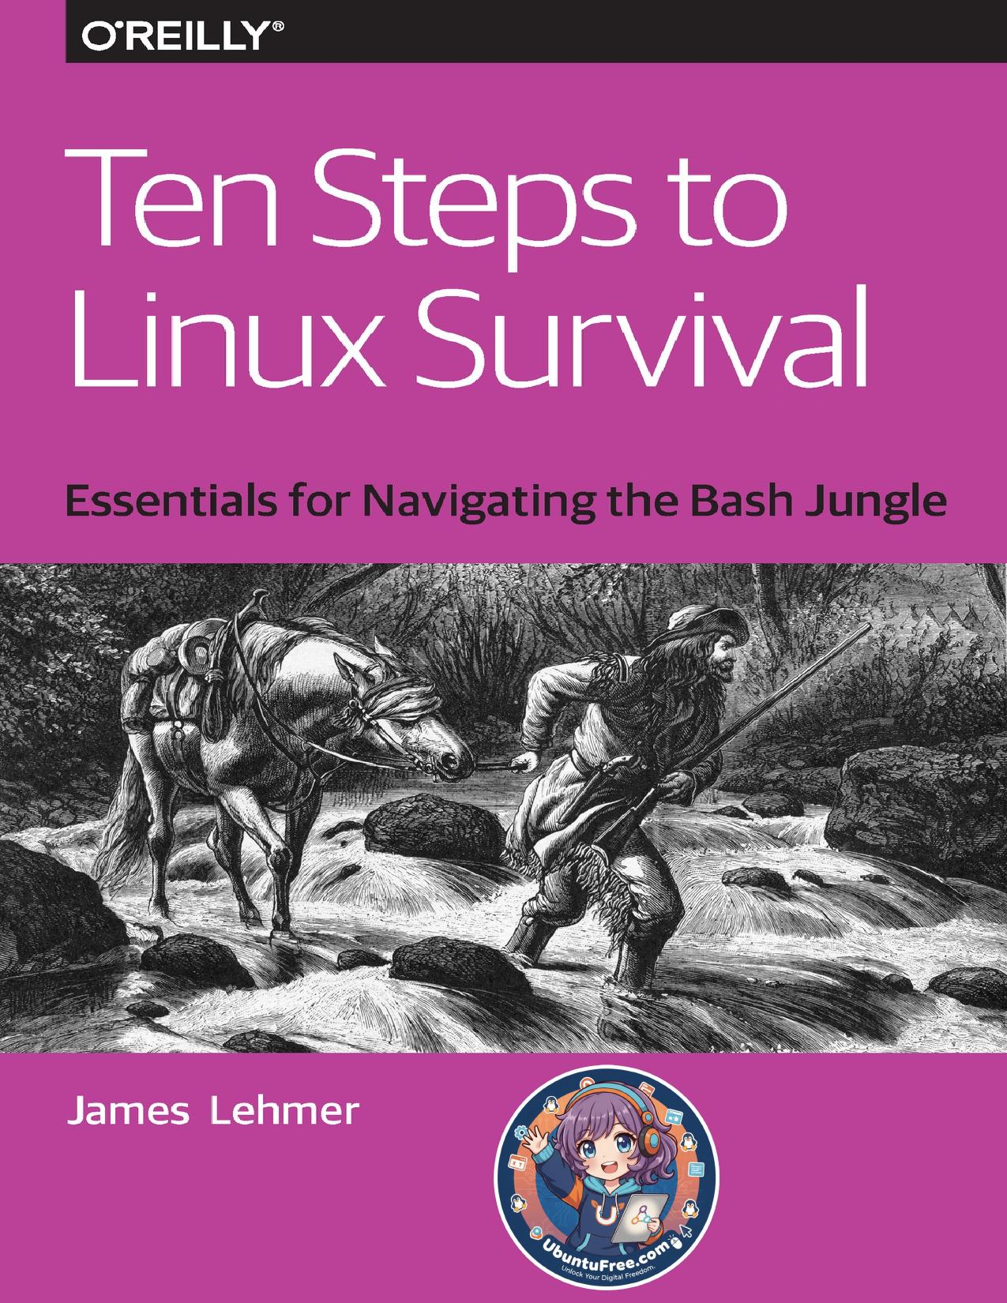

# Table of Contents

[Chapter 0. Step 0: Don’t](#Chapter_0__Step_0__Don_t)

[Chapter 1. Step 1: Getting In](#Chapter_1__Step_1__Getting_In)

[Chapter 2. Step 2: Getting](#Chapter_2__Step_2__Getting)

[Chapter 3. Step 3: Peeking](#Chapter_3__Step_3__Peeking)

[Chapter 4. Step 4: Finding](#Chapter_4__Step_4__Finding)

[Chapter 5. Step 5: Search Me](#Chapter_5__Step_5__Search_Me)

[Chapter 6. Step 6: What’s](#Chapter_6__Step_6__What_s)

[Chapter 7. Step 7:](#Chapter_7__Step_7)

[Chapter 8. Step 8:](#Chapter_8__Step_8)

[Chapter 9. Step 9: Starting](#Chapter_9__Step_9__Starting)

[Chapter 10. Step 10: Where](#Chapter_10__Step_10__Where)

[Chapter 11. The End](#Chapter_11__The_End)





Additional Resources





[OceanofPDF.com](https://oceanofpdf.com/)

Ten Steps to Linux

Survival

Essentials for Navigating the Bash Jungle

James Lehmer

[OceanofPDF.com](https://oceanofpdf.com/)

Ten Steps to Linux Survival

by James Lehmer

Copyright © 2016 O’Reilly Media, Inc. All rights reserved.

Printed in the United States of America.

Published by O’Reilly Media, Inc., 1005 Gravenstein Highway North, Sebastopol, CA 95472.

O’Reilly books may be purchased for educational, business, or sales promotional use. Online editions are also available

[for most titles (http://safaribooksonline.com). F](http://safaribooksonline.com/)or more information, contact our corporate/institutional sales department: 800-998-9938 or corporate@oreilly.com.

Editor: Dawn Schanafelt

Acquisitions Editor: Susan Conant

Production Editor: Shiny Kalapurakkel

Copyeditor: Sharon Wilkey

Proofreader: Molly Ives Brower

Interior Designer: David Futato

Cover Designer: Randy Comer

Illustrator: Rebecca Panzer

June 2016: First Edition

Revision History for the First Edition

2016-05-27: First Release

The O’Reilly logo is a registered trademark of O’Reilly Media, Inc. Ten Steps to Linux Survival, the cover image, and related trade dress are trademarks of O’Reilly Media, Inc.

While the publisher and the author have used good faith efforts to ensure that the information and instructions contained in this work are accurate, the publisher and the author disclaim all responsibility for errors or omissions, including without limitation responsibility for damages resulting from the use of or reliance on this work. Use of the information and instructions contained in this work is at your own risk. If any code samples or other technology this work contains or describes is subject to open source licenses or the intellectual property rights of others, it is your responsibility to ensure that your use thereof complies with such licenses and/or rights.

978-1-491-95918-3

[LSI]

[OceanofPDF.com](https://oceanofpdf.com/)

Introduction

And you may ask yourself, “Well, how did I get here?”

—Talking Heads, “Once in a Lifetime”

Why Are We Here?

This report grew out of a series of “lunch-and-learns” on Linux that I compiled for work. During that process, I

ended up [writing an ebook, and then condensing it into a](https://github.com/dullroar/ten-steps-to-linux-survival/releases) one-hour presentation that focuses on the essentials needed for quick problem-solving on a Linux system. I

turned that presentation into [an O’Reilly webcast, and](http://post.oreilly.com/rd/9z1z2kkrdp6dfvcu994f592tsd7a76ejd2snsbkl180) this report provides more details on those original 10 essentials.

Even in formerly “pure Windows” shops, Linux use is growing. Linux systems are everywhere! They may appear as appliances (machines) or, more likely, virtual machine (VM) images dropped in by a vendor.

Common examples of Linux systems that may appear in your shop as VMs or in the cloud include the following:

Web servers

Apache, Nginx, Node.js

Database servers

MongoDB, PostgreSQL

Mobile device management

Various MDM solutions, such as MobileIron

Security and monitoring systems

Security information and event management (SIEM)

systems, network sniffers

Source-code control systems

Git or Mercurial

As Linux use continues to grow, you need to know the basics. One day you might be the only one in the office when things go south, and you’ll have to fix them—fast. This guide will help.

In this report, I focus on diagnosing problems and getting a system back up. I don’t cover these topics:

Modifying the system, other than restarting

Forensics, other than looking at logs

Shell scripting

Distro differences—for example, Ubuntu versus CentOS

Anything in depth, as this is just to get your feet wet

Who Is This For?

The intended audience of this book is not seasoned Linux administrators, or anyone with a passing knowledge of the Bash shell. Instead, it is for people who are working in small Windows shops, where everyone has to wear various hats. It is for Windows administrators, network admins, developers, and the like who have no knowledge of Linux but may still have to jump in during a problem. Imagine your boss rushing into your office and saying this:

The main www site is down, and all the people who know

about it are out. It’s running on some sort of Linux, I

think, and the credentials and IP address are scrawled on

this sticky note. Can you get in, poke around, and see if

you can figure it out?

In this report, you’ll learn the basic steps to finding vital information that can help you quickly get the site back up. By reading this guide before disaster strikes, you will be better able to survive the preceding scenario.

How to Prepare

In small shops, sometimes things just fall on you because no one else is available. There is often no room for “It’s not my job” when production is down and the one person who knows about it is backpacking in Colorado. So you need to be prepared as the use of Linux becomes more prevalent, turning “pure Microsoft” shops more and more into hybrids. Linux is coming, whether you like it or not. Be prepared.

First, pay close attention whenever you hear the word appliance used in terms of a system. Perhaps it will be mentioned in passing in a vendor presentation. Dig in and find out what the appliance image is running.

Second, note that even Microsoft is supporting Linux, and increasing that support daily. First, it started with making Linux systems first-class citizens on Azure. Now Microsoft is partnering with Docker and Ubuntu and others, and that coordination looks like it is only going to grow.

So now is the time to start studying. This report is a quick-help guide to prepare you for limited diagnostic and recovery tasks, and to get you used to how Linux commands work. But you should dig further.

One place to turn next is [my ebook. It helps you take the](https://github.com/dullroar/ten-steps-to-linux-survival/releases) next steps of understanding how to change Linux systems in basic ways. I’ve also included some useful references at

[the end of this report. Past that, obviously, O’Reilly has](http://shop.oreilly.com/category/browse-subjects/system-administration/linux-unix.do)

[many good resources for learning Linux. And the Internet is](http://shop.oreilly.com/category/browse-subjects/system-administration/linux-unix.do) just sitting there, waiting for you.

Play with It!

The best way to learn Linux is to stand up an environment where you can explore without fear of the consequences if you mess something up. One way is to create a Linux VM; even a moderately provisioned modern laptop will comfortably run a Linux VM. You can also create one in the cloud, and many vendors make that easy, including DigitalOcean, Linode, Amazon Elastic Compute Cloud (EC2), Microsoft Azure, and Google Compute Engine. Many of these even offer a free level, perfect for playing!

Documentation and Instrumentation

To protect yourself in case you are thrown into the scenario outlined at the beginning of this report, you should make sure the following are in place at your shop:

The Linux systems are documented.

This should include their purpose, as-built

documentation outlining the distro, virtual or physical

hardware specs, packages installed, and so on.

These systems are being actively monitored.

Are they tied in to Paessler Router Traffic Grapher

(PRTG), SIEM, and other monitoring and alerting

systems? Make sure you have access to those alerts and

monitoring dashboards, as they can be a great source of

troubleshooting information.

You have access to the system credentials.

Ideally, your department uses secure vault software to

store and share system credentials. Do you have access

to the appropriate credentials if needed? You should

make sure before the need arises.

Conventions

If a command, filename, or other computer code is shown inline in a sentence, it appears in a fixed-width font:

ls --recursive \*.txt

If a command and its output is shown on a terminal session,

it appears as shown in [Figure P-1](#monitoring_dashboards__as_they_c).

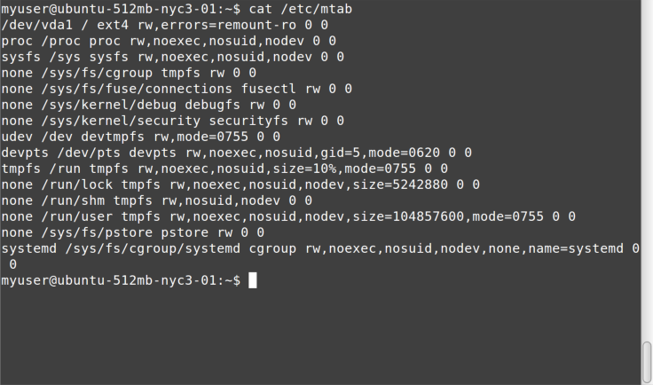

Figure P-1. cat command All such blocks have been normalized to show a maximum of only 80 x 24 characters. This is intentional. Although most modern Linux systems and terminal windows such as ssh can handle any geometry, some systems and situations still give you the same terminal size that your grandfather would’ve used. It is best to learn how to deal with these by using less, redirection, and the like. In addition, screenshots are shown from a variety of systems, to get you used to the ways that command output and terminal settings can differ, much more than under the default Windows Command Prompt.

The examples in this book typically show something like myuser@ubuntu-512mb-nyc3-01:~ $ before the command (as in the previous example). In other systems, you may simply see ~ # (when logged in as root) or % (when running under csh). These command prompts are not meant to be typed in as part of the command. Although they may seem confusing in the samples, you need to get used to looking at a terminal and “parsing” what is being displayed. And in our scenarios, you won’t have control over the command prompt format. Get used to it.

Typically, the screenshots are set up with the command entered at the prompt at the top of the screen, the command output immediately following, and in most cases a new command prompt waiting for another command at the end, as in the preceding example.

In the few places, where a Linux command is shown in comparison to a DOS command run under Windows Command Prompt, the latter is shown in all uppercase to help distinguish it from the Linux equivalent, even though Windows Command Prompt is case-insensitive. In other words, cd temp is shown for bash, and CD TEMP for CMD.EXE.

This element signifies a tip or suggestion.

This element signifies a general note.

This element indicates a warning or caution.

[OceanofPDF.com](https://oceanofpdf.com/)

# Chapter 0. Step 0: Don’t

Panic

The first, essential step is to stay calm. If you are dragged into trying to diagnose a Linux system and it isn’t your area of expertise, you can only do so much. We’re going to be careful to keep from changing system configurations, and we’re going to restart services or the system only as a last resort.

[So just try to relax, like Merv the dog (Figure 0-1](#page_15)). No one should expect miracles from you. And if you do figure out the problem, you’ll be a hero!



Figure 0-1. Merv the dog sez, Don’t panic

[OceanofPDF.com](https://oceanofpdf.com/)

# Chapter 1. Step 1: Getting In

Before I get too far, let’s talk about how to connect to a Linux system in the first place. If you have an actual physical machine, you can use the console. In today’s day and age, this isn’t likely. If you are running VMs, you can use the VM software’s console mechanism.

[But most Linux systems run OpenSSH](http://www.openssh.com/), a Secure Shell service, which creates an encrypted terminal connection via TCP/IP, typically to port 22. So, obviously, if you are connecting to an off-premise system, the appropriate firewall holes have to be in place on both sides. This allows you to connect from anywhere you want to work.

On Windows, you generally use [PuTTY](http://www.chiark.greenend.org.uk/~sgtatham/putty/) to establish SSH sessions with Linux systems. You typically need credentials as well, either from that sticky note your boss found, or preferably via your company’s secure credentials management system.

You also could connect using public/private key pairs, but that is beyond the scope of this report.

When you start PuTTY, it looks like [Figure 1-1.](#page_17)

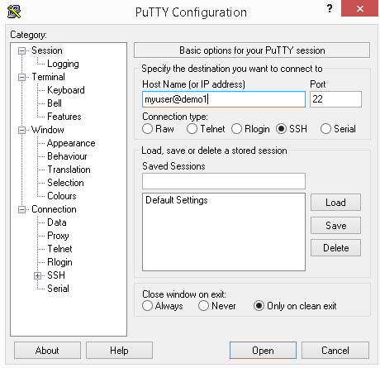

Figure 1-1. PuTTY prompt

You typically type in a user ID (in this example, myuser), followed by the at sign, @, and then the system’s domain name or IP address (in this example, demo1).

When you click the Open button, if this is the first time you are connecting via SSH to a remote system, you will

receive a warning similar to the one in [Figure 1-2.](#page_18)

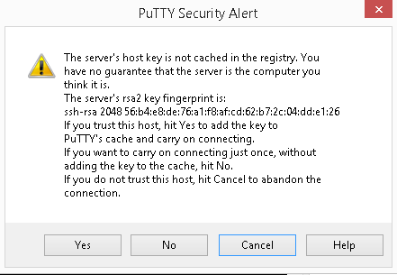

Figure 1-2. PuTTY alert

Simply click Yes, and the remote host’s key fingerprint will be stored so you don’t have to deal with this warning again. However, if you’ve already answered that prompt when connecting from your computer and you see it again for the same remote system, that means the remote machine’s IP address or other configuration has changed. That is often OK—changing the hosting provider for your public web server will trigger the warning for sure. However, if you know of no such changes, it may be indication of a system compromise, and you should abort the login and ask around.

You will then be presented with a password prompt, as

shown in [Figure 1-3.](#page_18)

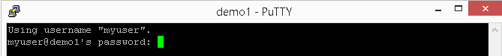

Figure 1-3. PuTTY password Type in the password and hit Enter, and you should see

something similar to [Figure 1-4.](#something_similar_to_Figure_1_4)

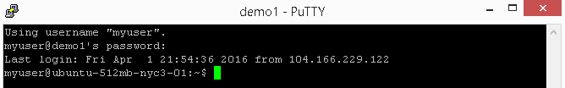

Figure 1-4. Successful login

You’re in! Congratulations (or condolences, depending on how you feel about this assignment).

“sudo make me a sandwich”

I’m going to take a brief intermission to discuss the sudo command. It stands for super-user do. If a user is in the sudo user group, that user is allowed to execute privileged commands. It is similar to doing a RUNAS command in the Windows Command Prompt to run a command under an elevated account.

Logging in remotely as root (system administrator) is frowned upon, and in fact often forbidden for security purposes. Hence, you’ll need to use sudo to run admin commands that you will see later.

When you try to run a command and get an Access Denied message, you can then try it with sudo—for example, sudo cat /var/log/dmesg . The first time you run sudo, you will get

the lecture shown in [Figure 1-5, which contains good](#page_20) words to live by anytime you are running as an administrator on any system!

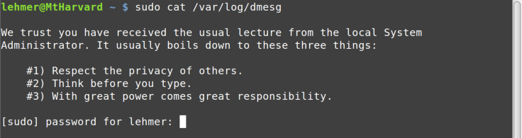

Figure 1-5. sudo lecture

Note that you have to enter your password when you invoke sudo. Be clear, this is your user ID’s password, not root’s. This is to ensure that a human being is in control and that someone else isn’t trying to hijack your terminal session while you’re getting another cup of coffee.

Now that you know about sudo, you should get the

punchline to [this comic](https://xkcd.com/149/), and hence the title of this section.

[OceanofPDF.com](https://oceanofpdf.com/)

# Chapter 2. Step 2: Getting

Around

Now that you’re logged in, the first thing you’ll want to do is inspect what is going on and how the system is configured. To do that, you need to list files and directories, and move around within the filesystem. This chapter covers these basics.

Where Am I?

Some command prompts are set to show the current directory path. Others are not, and it can be tough to remember where you are in the filesystem. The pwd (print working directory) command shows you:

bash-4.2$ pwd

/etc/init.d

Unlike in Windows, which is case-insensitive (but case-aware), in Bash and in Linux in general, case matters. By convention, most Linux commands are lowercase. If you try to type in an uppercase PWD , you will get a Command Not Found error.

Listing Files

In Bash, the ls (list) command is used to show directories and files. It is similar to the DIR command in Windows Command Prompt.

[Figure 2-1 shows a simple sample of an](#Figure_2_1_shows_a_simple_sample) ls command.



Figure 2-1. ls command

Some ssh sessions use color highlighting, as shown in these screenshots (in this case, green means the file is executable). Some do not. So don’t be surprised if you see colors!

To see a more detailed listing of the files and directories,

you can use the ls -l command, as shown in [Figure 2-2.](#Figure_2_1_shows_a_simple_sample)

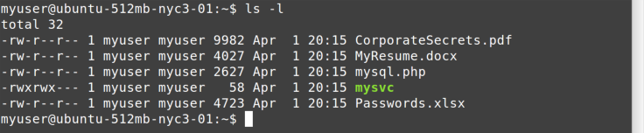

Figure 2-2. ls -l command

From left to right, you see file permissions, owner, group, size, last modified date, and finally the file or directory name. File permissions are beyond the scope of this report, but if you continue your Linux education after reading this, you can learn more about them in my ebook.

In Windows, a file is hidden by setting a file attribute (metadata) on the file. In Linux, a file is hidden if its name starts with a period, or dot. To show these dot files, you use

the ls -a [command shown in Figure 2-3](#page_23).

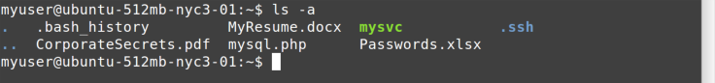

Figure 2-3. ls -a command

On the left you see . and .., which mean current directory and parent directory, respectively, just as in Windows. You also see previously hidden files such as .bash\_history and the .ssh directory (in this example, blue denotes a directory).

Finally, you can combine parameters. If you want to see a detailed listing (-l) of all files (-a), recursively descending into every child directory (-R), you simply combine them all

(ls -alR), as shown in [Figure 2-4.](#page_23)

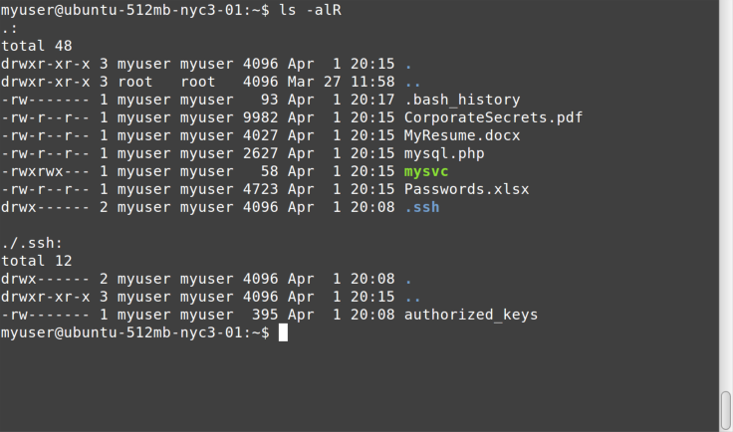

Figure 2-4. ls -alR command

Note the d in the far left column for ., .., and .ssh. This tells you they are directories, and in terminal sessions that do not use color highlighting, this d will be the only way you know which entries are files and which are directories.

Changing Directories

To change to a different directory, use the cd (change directory) command.

Linux uses the / character as the path delimiter, unlike Windows, which uses \. This will trip you up the first few times, especially because \ has a different meaning in Bash (it is an escape character).

Linux doesn’t use drive letters. Instead, all devices are mounted in a single hierarchical namespace starting at the root (/) directory. You will see examples of this later in this report.

On login, you are usually in the home directory, which is represented by ~. It is similar to the user directories under C:\Users on Windows. Hence, you will probably need to go elsewhere. Here’s a list of common directories on Linux systems that are of interest:

/etc

System configuration files (often pronounced slash-et-

see if someone is instructing you what to do over the

phone)

/var

Installed software

/var/log

Log files

/proc

Real-time system information—similar to Windows

Management Instrumentation (WMI), but easier!

/tmp

Temp files, cleared on reboots

Remember, case matters! And use /, not \!

Changing to another directory with cd is simple, as you can

see in [Figure 2-5](#_proc).

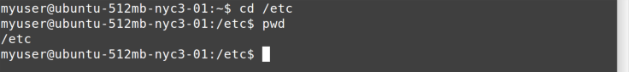

Figure 2-5. cd /etc command

Be Lazy

Most modern interactive shells like Bash and Windows Command Prompt allow for tab expansion and command history, at least for the current session of the shell. This is a good thing in a crisis situation, because it saves you typing, and thus, time.

Tab expansion is like autocomplete for the command prompt. Let’s say you have some files in a directory, as

shown in [Figure 2-6.](#page_26)

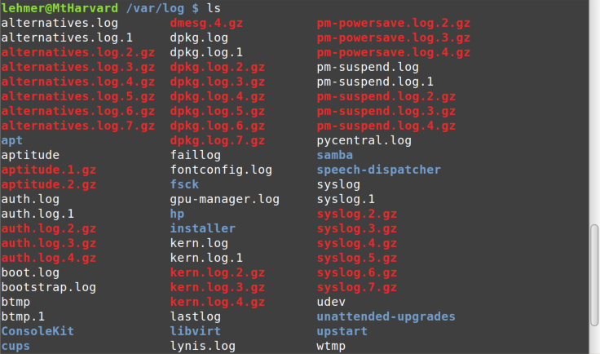

Figure 2-6. ls /var/log command

Without tab expansion, typing out something like this is slow and error-prone:

cd unattended-upgrades

But with tab expansion, you can simply type cd un[Tab], where [Tab] represents hitting the Tab key, and because only one directory starts with un, tab expansion will fill in the rest of the directory name for you.

One way that tab completion in Bash is different than in Windows Command Prompt is that in Bash, if you hit Tab and there are multiple candidates, Bash will expand as far as it can and then show you a list of files that match up to that point. You can then type in more characters and hit Tab again to complete it.

For example, in the previous example, if you wanted to list the details of the pm-powersave.log.2.gz file, instead of typing out ls -l pm-powersave.log.2.gz (27 keystrokes to type and possibly get wrong), you could use tab expansion to get it in two simple steps:

1. Type ls -l pm-p[Tab]. This would expand to ls -l pm-

powersave.log., because only the files named pm-

powersave.log. begin with pm-p. In this case, I specified

just enough characters to distinguish between pm-

powersave.log files and those beginning with pm-

suspend.log.

2. Type 2[Tab]. This would complete the rest, .gz, because

only one pm-powersave.log. file has a 2 in the next

character location.

Thus, a total of 13 keystrokes, with two tab characters, saved typing 14 more!

Tab expansion is your friend, and you should use it as often as possible. It gives at least three benefits:

Saves you typing.

Helps eliminate misspellings in long file and directory

names.

Acts as an error checker—if the tab doesn’t expand,

chances are you are specifying the beginning part of the

name wrong.

Another thing to remember about the interactive shell is command history. Both Windows Command Prompt and Bash give you command history, but Bash supports a rich interactive environment for searching for, editing, and saving command history. However, the biggest thing you need to remember in an emergency is simply that the up and down arrows work in the command prompt and bring back your recent commands so you can update them and re-execute them. This saves typing and reduces errors—use it!

[OceanofPDF.com](https://oceanofpdf.com/)

# Chapter 3. Step 3: Peeking

at Files

Now that you know how to move around in the filesystem, it is time to learn about how to inspect the content of files. In this chapter, I show a few commands that allow you to look inside files safely, without changing them.

Cool cat

The cat (concatenate) command dumps a file to the console,

as shown in [Figure 3-1](#Chapter_3__Step_3__Peeking).



Figure 3-1. cat command We will be using cat a lot in the rest of this report. Because most Linux configuration and log files are text, this command is handy for examining files, knowing that we can’t change them by accident. The CMD.EXE equivalent is the TYPE command.

less Is More

The less command paginates files or output, with each “page” based on the size of the console window.

In Bash, as in Windows Command Prompt, the output from one command can be redirected, or piped, to another command by using the | character. In Linux, where each command “does one thing, well,” it is common practice to combine multiple commands, piping the output from one command to the next to accomplish a series of tasks in sequence. For example, later in this report you will see how to use the ps command to produce a list of running processes and then pipe that output to the grep command to search for a specific process by name. To demonstrate, although less can be passed a filename directly, here’s how to pipe command output from cat to less:

~ $ cat /etc/passwd | less

The output from less clears the screen, and then shows the

first page, as you can see in [Figure 3-2.](#page_31)

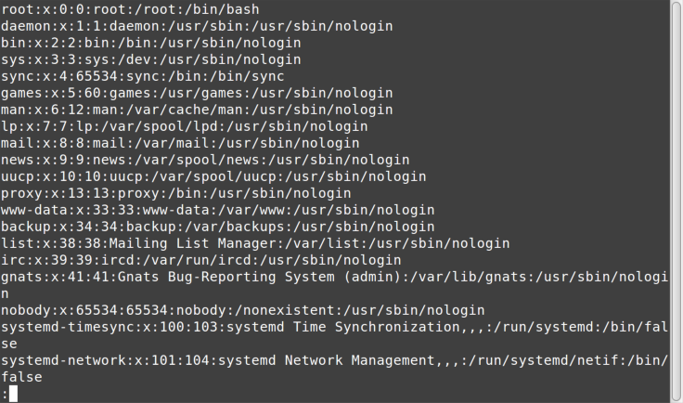

Figure 3-2. less output

The colon at the bottom of the screen indicates that less is waiting for a command. After less displays its output, you have various navigation options:

Space, Page Down, or the down arrow scrolls down.

Page Up or the up arrow scrolls up.

/ finds text searching forward (down) from the current

cursor position, until the end of the file is reached; for

example, /error.

? finds text searching backward (up) from the current

cursor position, until the beginning of the file is reached;

for example, ?error.

n finds next instance of the text you’re searching for

(note that the meaning of this is reversed when using ?).

p finds previous instance of the text you’re searching for

(note that the meaning of this is reversed when using ?).

q quits the less command and returns you to the prior

view of the console.

tail Wind

The tail command shows the last lines in a file. It is useful when you’re looking at large log files and want to see just the last lines—for example, right after an error has occurred. By default, tail will show the last 10 lines, but you can adjust the number of lines displayed with the -n

parameter. For example, [Figure 3-3](#p_finds_previous_instance_of_the) shows how to display just the last five lines.

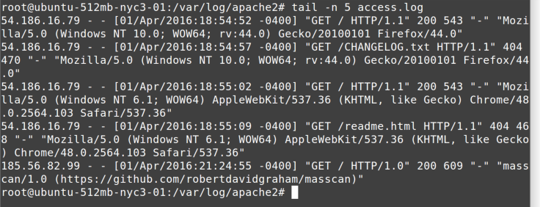

Figure 3-3. tail command

The tail command can also “follow” a file, remaining running and showing new lines on the console as they are written to the file. This is useful when you’re watching a log file for a new instance of an error message, perhaps as you are testing to see if you can trigger the condition by visiting a web page on the site that is throwing an error.

[Figure 3-4 shows an example using the](#page_33) -f parameter to follow a log file.

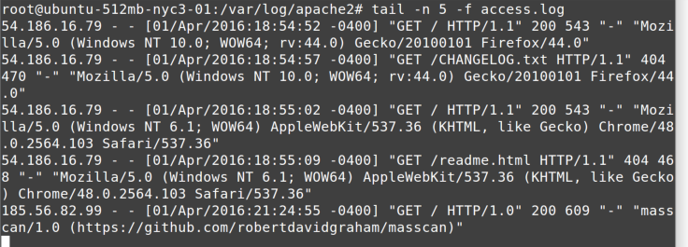

Figure 3-4. tail -f command

[OceanofPDF.com](https://oceanofpdf.com/)

# Chapter 4. Step 4: Finding

Files

In the preceding chapter, you learned how to look inside files without changing them. But how do you know which files to look at? In this chapter, I cover searching for files, which can help narrow the scope for your troubleshooting.

find Files Fast

The find command is one of the most useful commands in Linux. The command works like this:

Starting at location x

Recursively find entries that match condition(s)

Do something to each match

As a simple example, let’s say you’re in the /var/log directory, and you want to find all files that end in .log. Because there may be a lot of them, you will pipe the output to less so you can page through it. Here is the command:

/var/log# find . -name \\*.log -print | less

Remember that I said the \ has a different meaning in Bash, that it is an escape character? Notice its use in this example, where it is preventing the Bash shell from expanding the wildcard character (\*) into all matching files in the current directory. Instead, by escaping it, the \ character is telling find to expand that wildcard in the current directory and all of its children.

[Figure 4-1 shows the](#Remember_that_I_said_the___has_a) first page of the output I got from that command, awaiting our navigation via less.

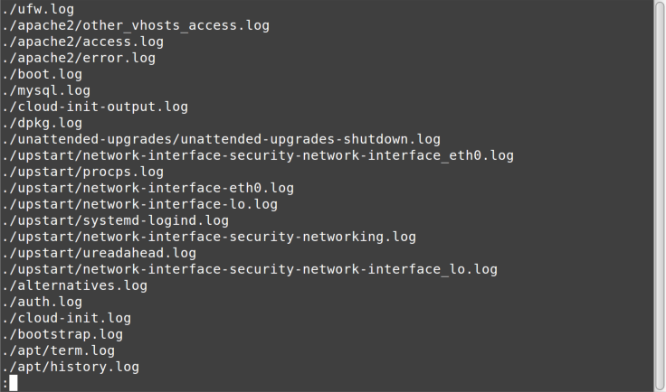

Figure 4-1. find results

The find command has a lot more power than this simple example! You can find files and directories based on creation and modification dates, file sizes, types, and much more. You can execute any variety of actions on each one as you find them, including Bash commands and shell scripts.

[Figure 4-2 shows another example, where I am looking for](#page_36) all log files in /var/log and its child directories that were modified in the last hour, using the -mmin (modified minutes) parameter set to -60 minutes. In this example no action parameter is given, so -print is implied.

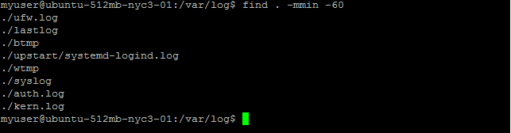

Figure 4-2. find -mmin

You can also combine multiple search conditions and multiple actions. For example, if you want to find all log files in /var/log that were modified in the last minute (-mmin-1 ), and then print its path (-print) and display the last two lines of each log file found (using tail -n 2), you use the following:

sudo find . -mmin -1 -print -exec tail -n 2 \{\} \;

I will pick that apart for you. From left to right:

sudo

Because some of the log files are protected unless you

are root.

find

Search for some files.

.

Starting in the current directory (in this example, that’s

/var/log).

-mmin -1

Find files that were modified in the last minute (-1).

-print

Print its full path.

-exec

For each file found, execute a command.

-tail -n 2

As you learned in the preceding chapter, tail shows you

the final lines of a file; by default, it shows the last 10

lines, but here I have specified that it should show only

the last 2 lines.

\{\} \;

Passing in the full path of the filename found to the tail

command.

That last little bit of magic is important, and you will do well to memorize it for using -exec with the find command. The \{\} is the syntax for “pass in the path of the file that was found” (it is actually {}, but the \ characters are escaping the brackets because they have special meaning to the Bash shell). The ; is terminating the -exec parameter, so that other action parameters could follow on the find command. It is similarly escaped by \ because the semicolon also has special meaning to Bash. The intervening space between \{\} and \; is required!

[Figure 4-3 shows it in action.](#page_38)

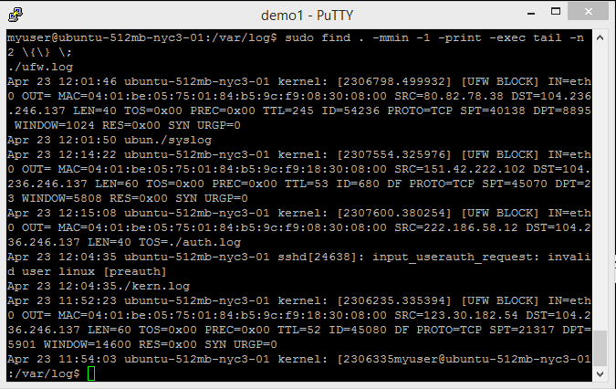

Figure 4-3. find tail

Because of the usefulness of the find command, I recommend you study it and play with it if you get a chance.

Location, Location, Location

The locate command searches a list of all the filenames on the system. The filenames are gathered periodically by a service, so it does not update in real time, but usually close enough. If you know the name of a file you are looking for, perhaps the Apache access.log file (which can change location depending on the Linux distro), you can use the locate command to quickly find it. Because locate searches a pre-built list, it is much quicker for finding files by name than using find -name.

The locate command isn’t “smart.” It is simply looking for any file or directory with the string you pass it somewhere in the path. For example, if you execute locate log | less in

the root (/) directory, you’ll see something like [Figure 4-4](#The_locate_command_isn_t__smart).

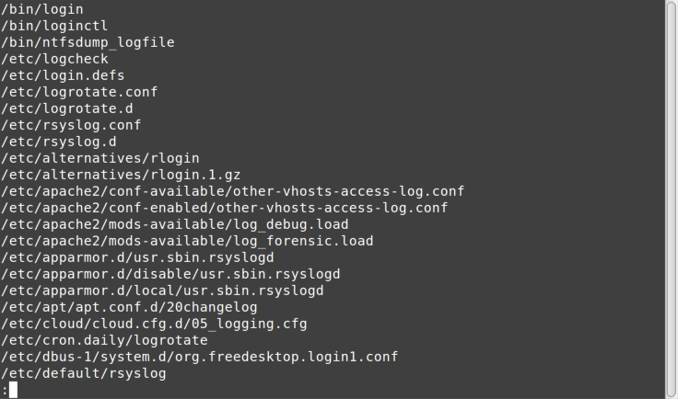

Figure 4-4. locate results

Note that log appears somewhere in each path, but doesn’t necessarily lead to log files.

[OceanofPDF.com](https://oceanofpdf.com/)

# Chapter 5. Step 5: Search Me

In the preceding chapter, you learned to search for files by their attributes, such as name, last modified time, and the like. In this chapter, I show how to search inside a file, perhaps to find a specific error message.

Getting a grep

The grep command (whose name comes from globally search a regular expression and print) searches within files. It uses regular expressions (regex) to match patterns inside the files. It can be used to search within binary files, but is most useful for finding things inside text files. There are lots of uses for this command in our crisis scenario, such as searching for certain error messages within log files, or finding every mention of a certain resource inside the source files for an entire website.

There is an old joke by Jamie Zawinski:

Some people, when confronted with a problem, think, “I

know, I’ll use regular expressions.” Now they have two problems.

Some regular expressions are simple—for example, \*, which you should recognize as a valid wildcard in Windows Command Prompt. Others can be mind-blowingly complex. For example:

^\(\*\d{3}\)\*( |-)\*\d{3}( |-)\*\d{4}$

This regular expression is an (incomplete) approach to matching US phone numbers.

Because regexes are so inscrutable, sometimes I write a regex in a program or a script, come back to it six months later, and have no idea what it is doing. (Now I have two problems.) In this chapter, you’re just going to look at a few simple examples.

Here are some samples of using regular expressions with grep. You will look at the output of some of them in the following screenshots.

grep 500 access.log

Find any occurrence of 500 in access.log

grep '\s500\s' access.log

Find 500 surrounded by whitespace (space, tab)

grep '^159.203' access.log

Find 159.203 at beginning of lines (^)

grep 'bash$' /etc/password

Find bash at end of lines ($)

grep -i -r error /var/log

Find all case-insensitive (-i) instances of error in the

/var/log directory and its children (-r)

For that first example, you know that if a web program throws a server-side error, by convention it will send an HTTP status code of 500 to the client (browser). Most web servers also write that to their logs. So let’s look for 500 in

Apache’s web log, as shown in [Figure 5-1.](#page_42)

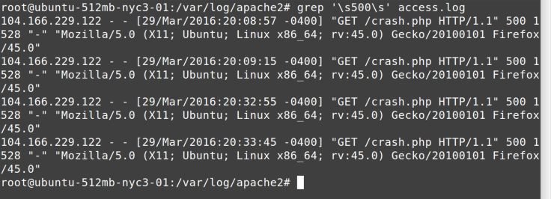

Figure 5-1. grep command

I use the '\s500\s' regular expression in this command to make sure that only instances of 500 surrounded by spaces (or tabs) are found. Web logs tend to put the HTTP status code in its own column, and I don’t want to see extraneous 500s that are part of response sizes, time-zone offsets, or whatnot.

Perhaps you’re being attacked by a block of IP addresses, maybe a bunch of botnets running on some cable modems. The IP block attacking you is 159.203, so let’s find all log lines that start with that client address, as shown in

[Figure 5-2.](#page_42)

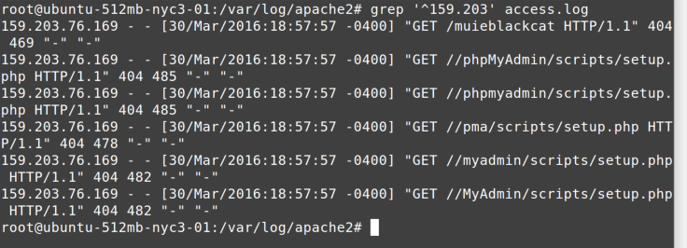

Figure 5-2. grep 159.203 command In this case, note that the regular expression starts with ^, which means to look for the following pattern only at the beginning of each line in the log file.

Similarly, you can look for patterns at the end of each line as well. The /etc/passwd file holds every user ID on a Linux system. (Don’t worry, it no longer holds the password, but once upon a time, it did!) Each user is defined by a line in the file, and the last entry on each line indicates the “shell” in which they run. Some user IDs are defined to not be allowed to have interactive logins, and so they might have something like /bin/false or /usr/sbin/nologin as their shell.

But user IDs that can log in will have bash or csh or similar. So if you want to find all user IDs that can log in

interactively, you could [use the command in Figure 5-3,](#Similarly__you_can_look_for_patt) which looks for bash at the end of the line by specifying the $ in the regular expression.

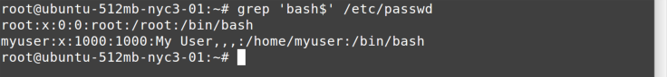

Figure 5-3. grep bash command

You then see that root and myuser are the only IDs allowed an interactive login on this system.

Finally, because you’re trying to find out what is wrong with the Linux system you’ve been thrown into, perhaps you want to see each instance of the word exception in the log files. You could do that with something like this:

grep -i -r 'exception' /var/log | less

Here’s what each part of that command does:

grep

Searches through files

-i

Ignores case (makes the search string case-insensitive)

-r

Recursively searches through all directories

'exception'

Looks for the string exception

/var/log

Starts in the /var/log directory

| less

Pipes the output through less so you can look at it one

“page” at a time

[Figure 5-4 shows the](#Searches_through_files) first page of the output.

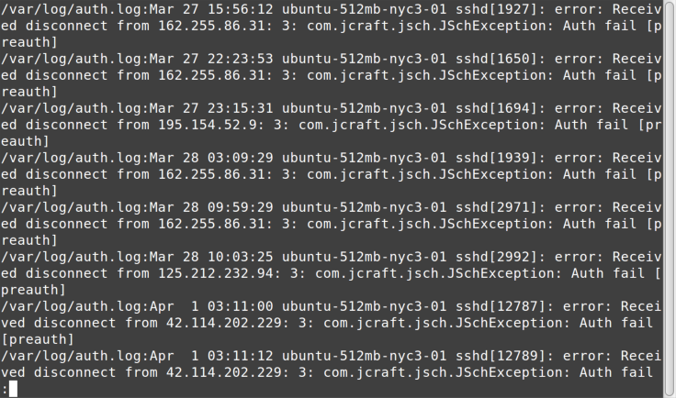

Figure 5-4. grep exception results In this case, you see a bunch of authorization failures in the first page of output from the /var/auth log. If the problem you are chasing includes an authentication error, perhaps on your website, this would show a good path to keep continuing down. Many times you have to change your search phrases multiple times and use your “tech intuition” to decide which errors are worth following further. Troubleshooting is often more of an art than a science, so “Use the Force, Luke.”

[OceanofPDF.com](https://oceanofpdf.com/)

# Chapter 6. Step 6: What’s

Going On?

You have now learned how to navigate around, look inside files, and find files and search their contents. In this chapter and the next, I show you how to determine real-time system state, with an eye toward clues that may point to underlying problems.

It’s All Part of the Process

The ps (process) command shows running processes, akin

to the Windows Task Manager[, as you can see in Figure 6-1](#It_s_All_Part_of_the_Process).

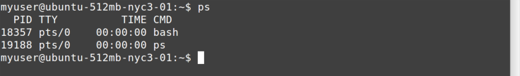

Figure 6-1. ps command

By default, ps shows only the processes for the current user. In the preceding example, the active processes are the Bash shell and the ps command itself.

If you want to see all running processes, you add the -A parameter. To make it pretty and show the hierarchical relationship between parent and child processes, you add -H :

ps -AH | less

[Figure 6-2 shows the output.](#page_48)

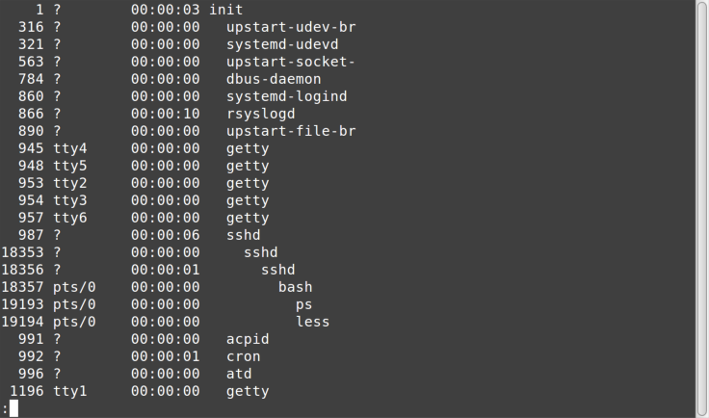

Figure 6-2. ps -AH command

Here you see many child processes running under init, which is typically the first process that runs (note that the left column shows init has a process ID of 1). Also notice that under a series of sshd (SSH daemon, or service, processes) is our bash session running ps, which is piping output to less.

Who’s on top?

The top [command (Figure 6-3](#page_49)) shows processes sorted by resource consumption. It updates every few seconds, similar to Windows Task Manager.

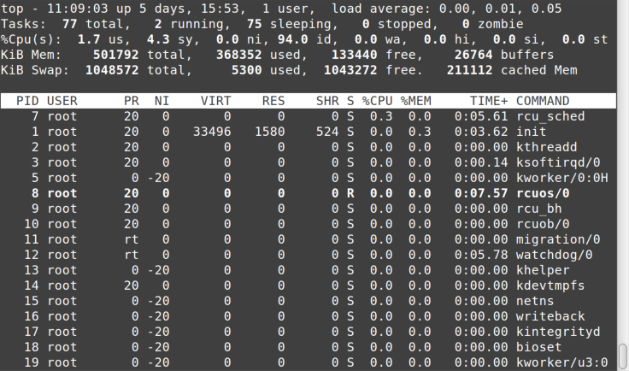

Figure 6-3. top command

Notice that the top output is divided into two sections. The, well, top section shows system-level statistics: up time, number of logged-in users, number of processes, CPU and memory utilization, and so on.

The bottom section shows the various processes running, sorted by CPU utilization. Some of the more important columns are PID (process ID), USER, VIRT (virtual memory), %CPU, %MEM, and COMMAND. Similar to less, you can quit top by typing q or hitting Ctrl-C.

If you want to have top sort its output by something other than CPU usage, you pass it the -o (order) parameter

followed by the column name. In [Figure 6-4](#page_50), the output from top -o '%MEM' is sorted by memory utilization.

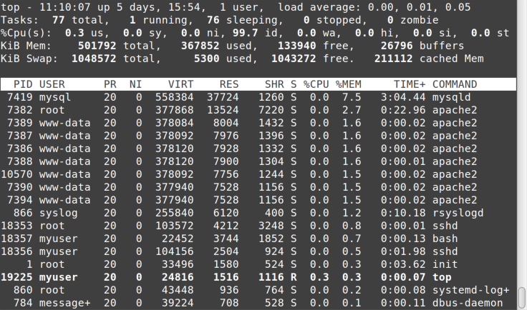

Figure 6-4. top -o command

If your symptoms seem performance-related, you can use top to see whether a process or processes are eating up all the CPU cycles or hogging memory and thus causing excessive paging. If a certain process keeps showing at or near the top of the list with every refresh, it may well be your culprit.

The /proc Directory

Linux doesn’t mount devices under drive letters as in Windows, but instead uses a single hierarchical filesystem, with different resources mounted under the root ( /) directory. In fact, because Linux uses an “everything is a file” paradigm, virtual filesystems that aren’t backed by an actual device can be mounted in the hierarchy as well.

One of the best examples of this is the /proc directory, a virtual filesystem that presents real-time system statistics as files and directories. This makes the information way easier to access than the rather opaque Windows WMI APIs. For example, you can see information on the CPUs

[being used on the system, as shown in Figure 6-5.](#being_used_on_the_system__as_sho)

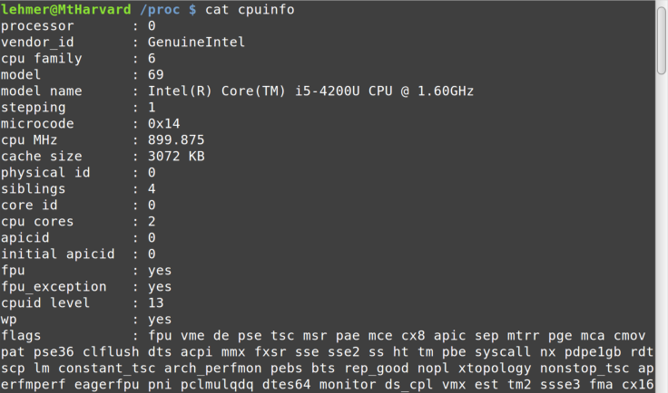

Figure 6-5. /proc/cpuinfo

This image shows just the beginning of the “file” containing information about the CPU(s) in the system. For example, with multicore processors, there are repeating sections for each core.

Similarly, memory info can be displayed as shown in

[Figure 6-6.](#page_52)

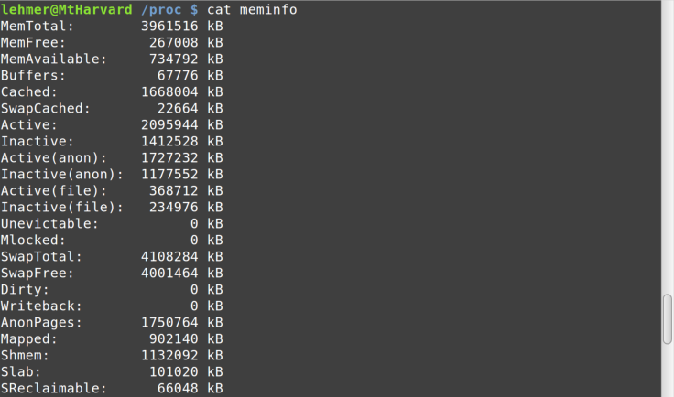

Figure 6-6. /proc/meminfo

Let’s look at a listing of the /proc directory contents in

[Figure 6-7.](#page_52)

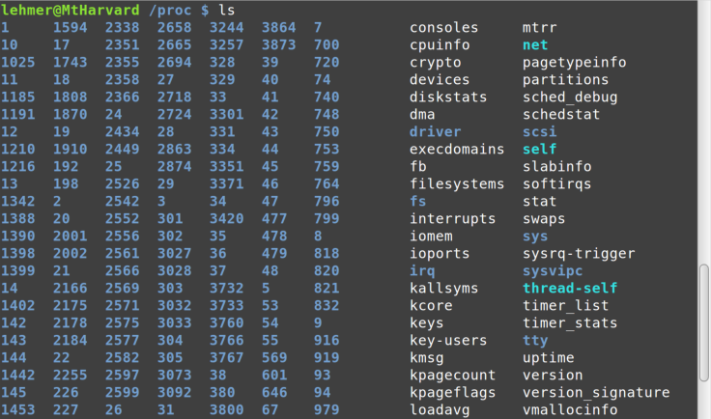

Figure 6-7. proc dir This gives an idea of all the various types of information available. The blue entries are directories containing even more data. Note the numbered directories on the left. Each of these directories contains real-time statistics for each running process, listed by process ID. If you change into one of those directories and list it, you see an incredible amount of information about that specific process, all of which will be updated in real time every time you display it,

as shown in [Figure 6-8](#as_shown_in_Figure_6_8).

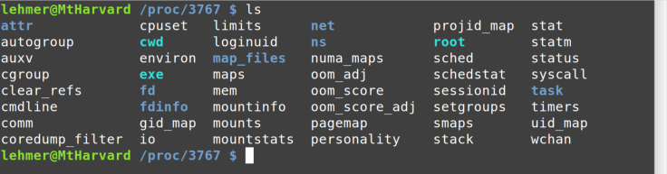

Figure 6-8. proc pid

That is just a taste of the types of useful information you can gather by looking in /proc.

Networking

The ifconfig command shows information on the system’s network interfaces (similar to the IPCONFIG command in

W[indows), as you can see in Figure 6-9.](#page_54)

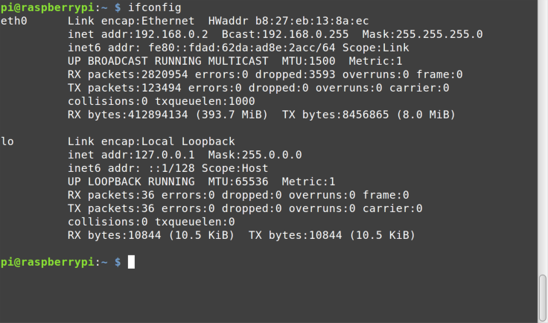

Figure 6-9. ifconfig command

Here you see that the system, my handy Raspberry Pi, has two network interfaces. The first is eth0, an Ethernet interface. The MAC address, IPv4 and IPv6 configuration, and various network statistics are shown. The second interface, lo, is the local loopback, 127.0.0.1.

Most networking commands that you may be used to in Windows are also available in Linux, such as ping, shown in

[Figure 6-10.](#page_55)

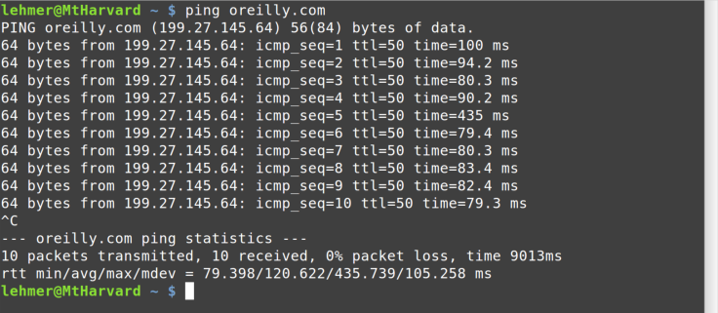

Figure 6-10. ping command

One difference between ping on Linux versus Windows is that on Linux the output does not stop until you hit Ctrl-C. This is similar to PING -T on Windows.

The traceroute command, shown in [Figure 6-11, is also](#page_55) available (note the spelling difference from TRACERT on Windows).

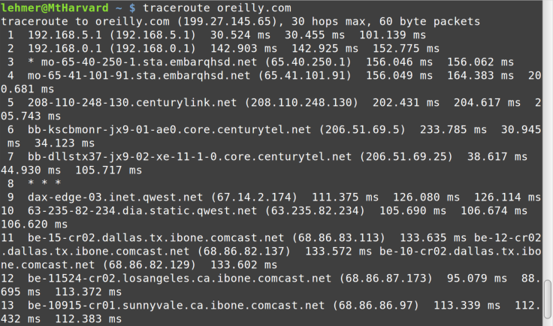

Figure 6-11. traceroute command Two other network commands you may find useful during troubleshooting are dig and whois, both of which return DNS information for domain names or IP addresses.

[OceanofPDF.com](https://oceanofpdf.com/)

# Chapter 7. Step 7:

Filesystems

You have just seen how to look at real-time system state in terms of processes, memory, and networking. Now I show how to check out the filesystems, with an eye toward disk utilization.

Displaying Filesystems

On any computer system, running out of disk space can cause many problems. On Linux, two commands are helpful in determining disk utilization.

The df (display filesystems) command shows the mounted files systems along with statistics on space usage, as you

[can see in Figure 7-1.](#Chapter_7__Step_7)

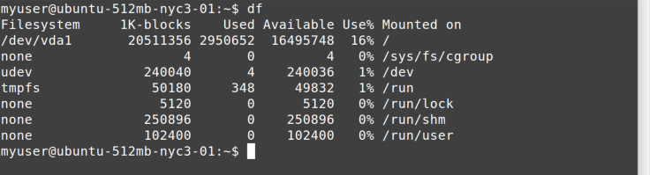

Figure 7-1. df command

The main device you’re interested in is the first one, which shows /dev/vda1 mounted on /. Note the columns showing disk size, Used, Available, and Use%.

[Figure 7-2 shows an example where disk utilization may be](#Figure_7_2_shows_an_example_wher) causing trouble.

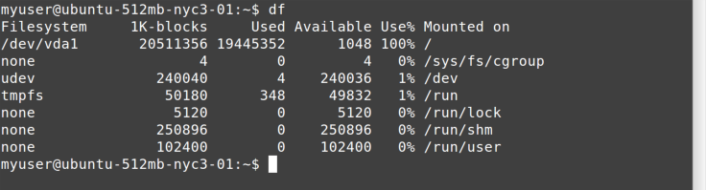

Figure 7-2. df showing full disk drive

The /dev/vda1 device is 100% full!

Where Did All the Disk Space Go?

Once you’ve seen that there may be a problem with disk space, how do you find out where it is being used? You can use the du (disk utilization) command for that. By default, it descends through every directory and shows you disk usage for every subdirectory under which it is invoked (think DIR /S on CMD.EXE). That can generate a lot of output and can take a long time to run.

What we really want to do is start at the top and narrow our search to a specific problem directory. Let’s just look at the top-level directories under /. For that, I pass in the -d 1 (depth of 1) parameter. To make the output easier to read, I also pass -BM to show blocks in megabytes. Finally, as you

[can see in Figure 7-3, I’m using](#page_59) sudo, because otherwise I wouldn’t have permission to descend into some system directories to calculate their disk space.

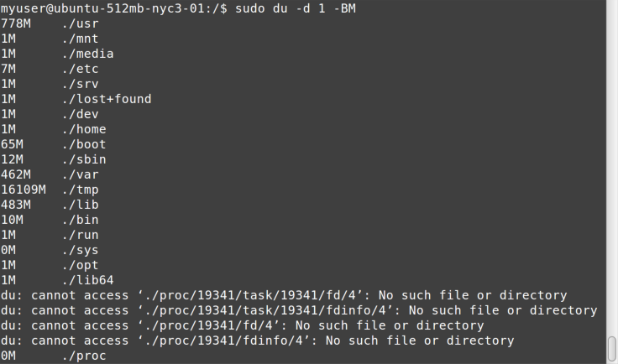

Figure 7-3. du command

You can see that /usr is using 778 MB of space, followed by some fairly inconsequential directories, but /tmp is using over 16 GB of space. It must be the culprit! From there, you can go look in /tmp (which, remember, is cleared on reboots) to see what is taking up all the space.

You can continue to use du to successively refine your search. If, instead of /tmp in this simple example, the /var directory was the one showing high disk utilization, you could cd into it and then run this du command again, and continue to traverse down the directories until you find what is using up all the space. You could remove the -d parameter and pipe the output to less, but you probably don’t want to do that because on a large system with thousands of directories, you could be paging through the output for a long time!

[OceanofPDF.com](https://oceanofpdf.com/)

# Chapter 8. Step 8:

Transferring Files

Perhaps you think you’ve found evidence of a system compromise, or you fear log files will be altered if you end up restarting services or the system itself. If you want to preserve files on another system so that someone more knowledgeable can look at them later, the commands in this chapter will come in handy.

Most commands in this report will not alter system state. However, the commands in this chapter and the next have the potential to do so. In this chapter, the commands to transfer files from the Linux system to another system for later analysis can also work in reverse —that is, transfer files to the Linux box. So be careful!

Secure Copying

The scp (secure copy) command can be used to copy files over the SSH protocol (the same protocol that you’re running your ssh terminal session over). This command allows us to copy files using an encrypted, compressed mechanism.

If you are going to copy files from Linux “down” to your Windows system, you need a program that will run on Windows. The creator of PuTTY made PSCP.EXE for precisely that purpose: to implement scp for Windows. You can

download it from the same place as [PuTTY](http://www.chiark.greenend.org.uk/~sgtatham/putty/).

The PSCP.EXE program, shown in [Figure 8-1, is meant to run](#The_PSCP_EXE_program__shown_in_F) under Windows Command Prompt (CMD.EXE). It takes the same parameters as scp.

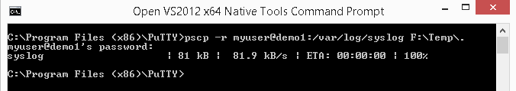

Figure 8-1. pscp command

In this example, the -r means to copy recursively. The myuser@demo1 is the user ID and machine address, exactly the same as what you specify when connecting with PuTTY. Note that immediately following that connection info (with no space) is a colon and then a path. This path is where you will be copying from—in this example, it’s /var/log/syslog. The final parameter is the to location—for example, F:\Temp\.

When you invoke PSCP.EXE, it will prompt you for the user’s password, and then transfer the file(s) specified. In our example, only one file, syslog, is transferred.

Like the Windows COPY and MOVE commands, most copy and move commands on Linux specify from as the first path and to as the second. Make sure you specify these paths in the correct order!

Copying to a Windows Share

The PSCP.EXE command can be used to pull information from Linux to your local Windows machine. If the Linux system is on the same network as a Windows file share, you can use smbclient to push files to a CIFS/SMB file share. Both machines must be on the same network for this to work; it will not work across the Internet.

The smbclient command uses similar subcommands as ftp, so if you have ever done FTP transfers from the Windows command line, it should be familiar. One difference is that, instead of specifying the subcommands one at a time after connecting, you can pass a string of commands to execute to smbclient as a parameter on the command line, as in

[Figure 8-2.](#The_smbclient_command_uses_simil)

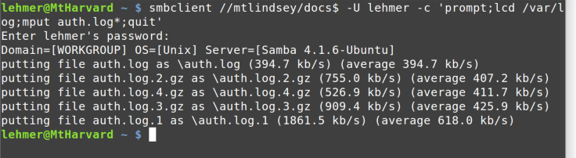

Figure 8-2. smbclient command

What’s going on here? The first parameter, //mtlindsey/docs$ , is the Windows share name. The only difference from how this is specified on Windows is the direction of the slashes. The -U parameter is the Windows user ID to use. The -c parameter then gives a list of semicolon-delimited subcommands to execute:

prompt

Turn off prompting for each file

lcd /var/log

Change the local (Linux) directory to /var/log

mput auth.log\*

Send (put) multiple files with a name pattern of

auth.log\* to the Windows share

quit

Exit the command

After being prompted for a password, you then see the results. The files ending in .gz have been compressed using

[the GNU zip algorithm.](http://www.gzip.org/)

[OceanofPDF.com](https://oceanofpdf.com/)

# Chapter 9. Step 9: Starting

and Stopping

If you are investigating a system that seems hung (perhaps the public website isn’t responding and your management wants you to “do something”), the old tried-and-true method of restarting services or the entire system itself is often your last resort. Rebooting Windows always fixes problems, so you already know one method for approaching Linux issues too! In this chapter, I show you how to restart services and reboot the system.

Most commands in this report will not alter system state. However, this chapter covers commands that start, stop, and restart Linux services and the entire system. Therefore, you could possibly stop something, and because of the situation you are investigating, not be able to restart it. So be careful!

Managing Services

Linux services (a.k.a. daemons, which is why so many Linux services end in d, such as sshd and httpd) are similar to Windows services. They are processes that run in the background, typically initiated at system startup. Examples of services include web services (Apache), database services (MySQL), and so on.

Typically, you use the service command to start, stop, and

restart services. It requires sudo[. Figure 9-1](#page_65) shows how to start the mysql service.

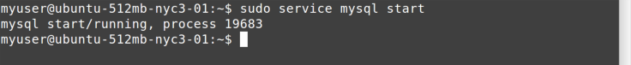

Figure 9-1. service start command

You can see that the process ID (PID) of the service is returned by the command. You stop a service the same way,

as shown in [Figure 9-2](#page_65).



Figure 9-2. service stop command

As you can likely guess, restarting a service, just as on Windows, is simply a combination of stopping and then

starting it; see [Figure 9-3.](#page_65)

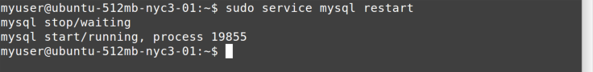

Figure 9-3. service restart command

You can check the status of a service with…wait for it…the

status [command (Figure 9-4).](#page_65)



Figure 9-4. service status command

Another way to tell whether a service is running is to use

our old friends ps and grep ([Figure 9-5](#page_66)).

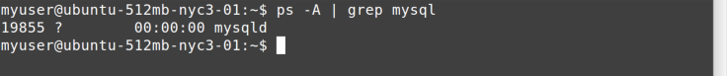

Figure 9-5. ps and grep commands

Note how I start and stop the mysql service, but under the covers it is the mysqld command (or daemon) that is running. That information can be useful when searching through log files.

When starting a service, you may get an error. Often, the output from the service command isn’t helpful. On most systems, service is just a thin wrapper around a series of scripts in /etc/init.d. You can often run one of the scripts directly from /etc/init.d and get better error information

[(Figure 9-6](#page_66)).



Figure 9-6. start mysql error

Hmmm…disk full. Does that remind you of anything? See

[Figure 9-7.](#page_67)



Figure 9-7. du command

Let’s go to /tmp[, as shown in Figure 9-8, and see if you](#page_67) notice anything wrong.

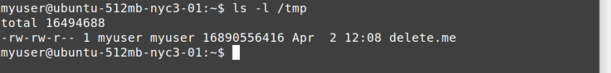

Figure 9-8. ls /tmp command

Sure enough! That’s one big file! Obviously, in real life it wouldn’t be this easy. But you now should be seeing how the tools in the previous chapters are adding up to help determine what may be going wrong.

Killing a Process

The kill command sends signals to processes. The default behavior for a process is to stop when it receives a signal, although signals can also be used to tell a service to reload its configuration file, and so forth.

Sometimes a service may hang to the point where it won’t respond to the service command. The next step is to try to

kill it. First, you need to find its process ID. In [Figure 9-9](#Sometimes_a_service_may_hang_to), we’re finding the process ID for the mysvc process.

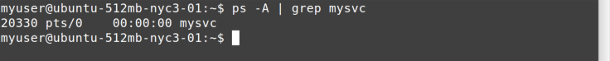

Figure 9-9. find mysvc process

After you have the process ID ( 20330 in this case), you can

try to kill [it, as shown in Figure 9-10.](#Sometimes_a_service_may_hang_to)



Figure 9-10. kill command

[Let’s look at Figure 9-11 to see if that worked.](#Sometimes_a_service_may_hang_to)

index-68_3.png

Figure 9-11. no more mysvc

Yup— ps piped through grep shows no active processes named mysvc running.

But sometimes even kill doesn’t work. For one, programs can be written to intercept most signals, enabling communication with the background process from the command line. Or the process may really be “hung hard.” In that case, you need to terminate, with prejudice, as

shown in [Figure 9-12](#page_69). The -9 (minus nine) signal is one that processes cannot trap (intercept).

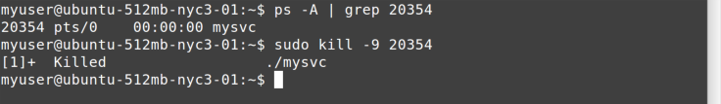

Figure 9-12. kill -9 command

You should use the kill -9 command with extreme caution. Notice that the first kill example returns Terminated, but in this case it comes back with Killed. Because the process cannot intercept a -9 signal, it has no chance of ending cleanly. There may be open files, unflushed buffers, database transactions that haven’t been committed, and other in-flight processing that will be lost when you use the kill -9 command. Invoke it only as a last resort!

When All Else Fails

Just as on Windows, sometimes a system restart is the ultimate cure. The reboot command does just what you’d expect. A shutdown command provides more options, such as waiting for a number of seconds first, but you probably won’t need it. In any case, both require sudo to run, and you will lose your ssh connection and will need to log back in again after the system comes back up to ensure everything is back in order.

[OceanofPDF.com](https://oceanofpdf.com/)

# Chapter 10. Step 10: Where

to Go for Help

This report is just a quick flyover of Linux commands and how to use them to do quick troubleshooting. Even with the commands covered in the report, I excluded many, many options to keep it simple. But sometimes, even in the heat of troubleshooting a system problem, you need a bit more help. This chapter covers where you can go to get it.

Hey, man

The man (manual page) command provides documentation on commands, system configuration files, and much more. This command is good for when you can’t access the Internet, or doing so isn’t convenient because you are on a

[machine console or similar setup. Figure 10-1 shows the](#page_71) first page of output from man reboot.

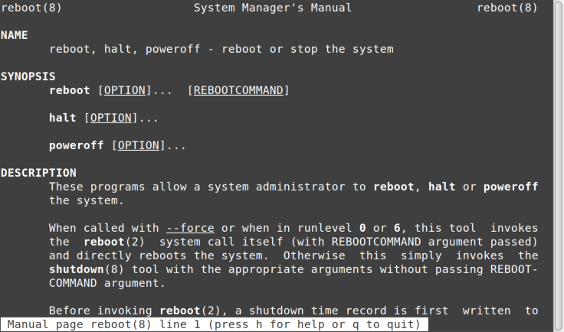

Figure 10-1. man command

The output is run through pagination similar to less, so all its navigation and find commands will work. You can, of course, find out more about how to use man by running man man.

Is That apropos?

How do you know what you don’t know? Sometimes you might not know (or remember) the name of a command. For example, you may recall that this guide mentioned disk space, but can’t remember the actual commands. Luckily, you can use the apropos command to jog your memory, as

shown in [Figure 10-2](#page_72).

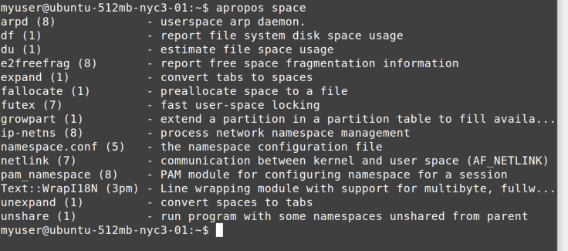

Figure 10-2. apropos command

The apropos command is simple. All it does is search through all the man page titles for the string you pass it. In this case, apropos space should be enough to help you recognize the df and du commands again.

Additional Resources

There are plenty of places to go for more help with Linux:

DuckDuckGo and Google

Search engines, with [DDG often providing direct help](https://duckduckgo.com/)

for a command as the first result

[Stack Exchange](http://unix.stackexchange.com/)

A UNIX-specific Stack Exchange site for questions

[Debian docs](https://www.debian.org/doc/)

Provides good documentation, much of it applicable

across distros

[Arch docs](https://wiki.archlinux.org/)

Ditto

[die.net](http://linux.die.net/)

Online man pages

[OceanofPDF.com](https://oceanofpdf.com/)

# Chapter 11. The End

Now you know what I know. Or at least what I keep loaded in my head versus what I simply search for when I need to know it, and you know how to do that searching, too. Hopefully, this report will help you sometime when you most need it.

Good luck, citizen!

[OceanofPDF.com](https://oceanofpdf.com/)

Appendix A. Cheat Sheet

That rug really tied the room together, did it not?

—Walter Sobchak, The Big Lebowski

This chapter lists many of the commands covered in this report. Use man or other methods outlined in the report to find more information on them.

Redirection Command

[See I/O Redirection](http://linux.die.net/abs-guide/io-redirection.html)

|

Pipe stdout from one process into stdin in another

process.

System Directory Commands

[See Important System Directories](http://linux.die.net/abs-guide/systemdirs.html)

/etc

Configuration files location

/home

Home or user profile directories

/proc

System runtime information

/root

Home directory for root user (system admin)

/tmp

Temporary files location

/var/log

Log files location

Standard User Commands

These are [“Section 1” commands,](http://linux.die.net/man/1/) normal user commands that typically don’t require any special privileges beyond permissions to access files and the like.

apropos

Search for help on commands by title

bash

The Bourne-again shell

cat

Concatenate the input files to stdout

cd

Change the current directory

cp

Copy files or directories

df

Show space utilization by filesystem

dig

Look up DNS info on an address

du

Estimate disk usage

find

Find files based on various conditions and execute

actions against the results

grep

Search for a pattern (regular expression) in files

less

Display the file one page at a time on stdout

locate

Locate files by name

ls

List directory contents

man

Display manual pages; remember, q quits

ps

List running processes

pwd

Print the current (working) directory name

scp

File copy over Secure Shell protocol

smbclient

Copy files to and from Windows using the SMB/CIFS

(Windows file share) protocol

ssh

Secure Shell terminal program and protocol

tail

Display the last lines of a file

top

List processes by resource utilization (CPU)

whois

Look up DNS ownership info on an address

System Commands

Most of these are [“Section 8” commands, and](http://linux.die.net/man/8/) may require special privileges such as sudo to run, depending on the system. Yes, some systems restrict the use of ping!

ifconfig

Display network (interface) configuration

kill

Terminate a process

ping

Test for network connectivity to an IP address

reboot

Restart the system

shutdown

Shut down or restart the system

sudo

Execute a command with elevated privileges

traceroute

Trace the route to an IP address

[OceanofPDF.com](https://oceanofpdf.com/)

About the Author

Jim Lehmer has been “in computers” for over three decades. He has held various software development roles, including programmer, systems programmer, software engineer, team lead, and architect.

Besides bragging about his wife, Leslie, his five children, and four grandchildren, his hobbies include reading, writing, running, hiking, and climbing.

Acknowledgments

Thanks to my coworkers, who inspired and attended the lunch-and-learn sessions from which my ebook, webcast, and this report grew—especially Aaron Vandegriff and Rob Harvey. I received excellent advice and promotion from Professor Allen Downey, for which I am grateful. I am thankful to my editor at O’Reilly, Dawn Schanafelt, with her eye for detail and helpful suggestions. Finally, I owe more than I can repay (as usual) to my wife, Leslie, who deserves shared credit for putting up with me during the nights and weekends I obsessed over this project.

[OceanofPDF.com](https://oceanofpdf.com/)