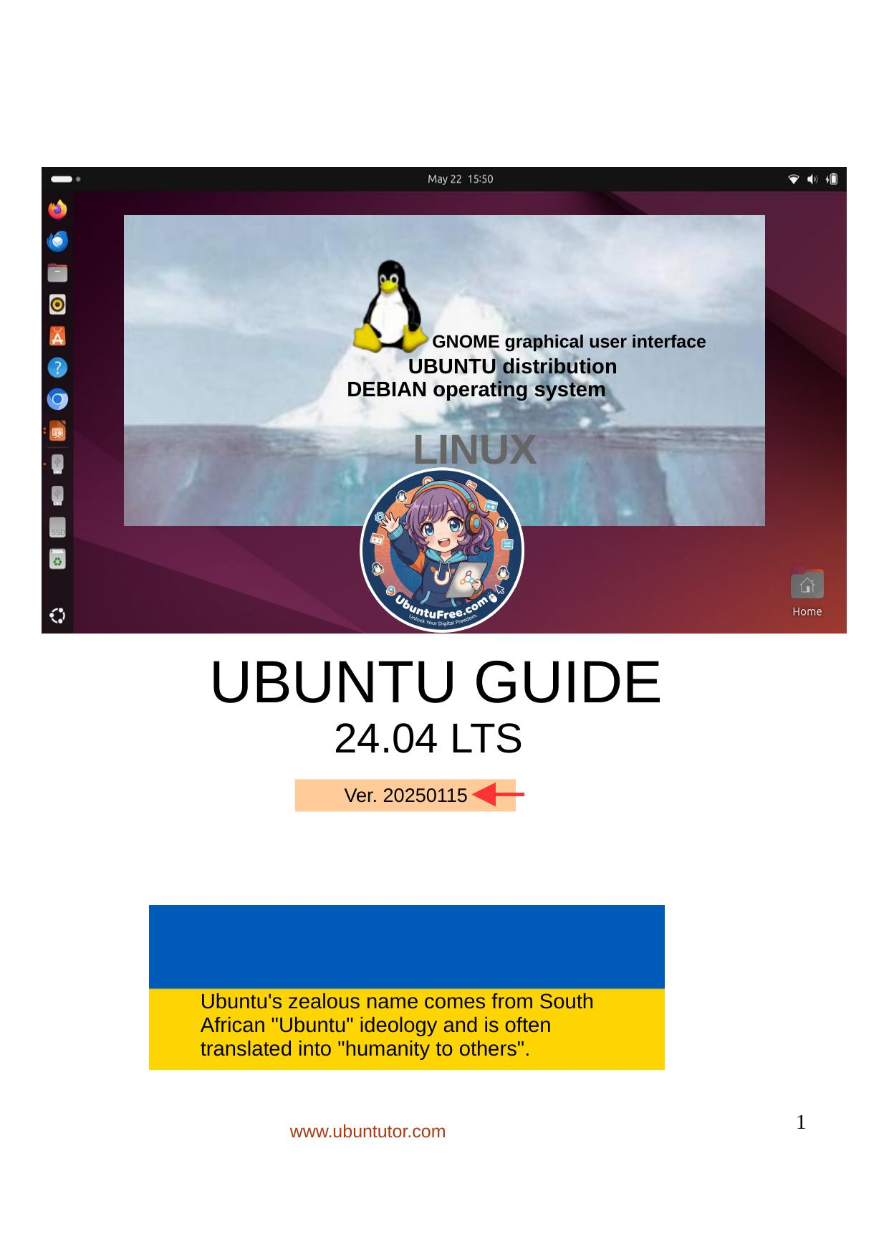
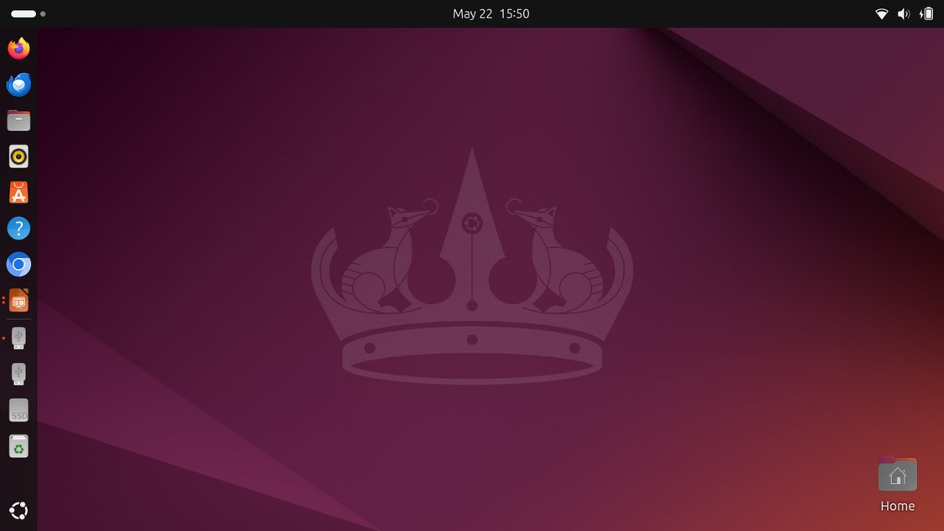
GNOME graphical user interface

UBUNTU distribution
DEBIAN operating system

LINUX

UBUNTU GUIDE
24.04 LTS
Ver. 20250115


Ubuntu's zealous name comes from South

African "Ubuntu" ideology and is often

translated into "humanity to others".

www.ubuntutor.com 1
2 Table of Contents

Page Contents
3 Introduction
General Information about Ubuntu 24.04 LTS

5 Ubuntu instructions
Presentation of Ubuntu 24.04 LTS Desktop
Pre-installed applications
Find the command ;-
Some tips
Some thoughts before going on

10 Presentation of graphical user interface (GUI)
Presentation of Folder / Directory Structure
Files Application ( Nautilus)
Files handling
USB / SD memorys
Different working areas, Windows, Several windows File handling; copy, move and paste
File handling with mouse
25 Presentation of basic settings
WiFi, Network, Bluetooth, Background, Appearance, Notifications, Search Applications, Privacy, Online Accounts, Sharing, Sound Power, Displays, Mouse & Touchpad, Keyboard Shortcuts Printers, Removable Media, Color, Region & Language, Universal Access Users, Default Applications, Date & Time, About

48 Introduction to installed Ubuntu applications
Utilities, Archive Managers, Backups, Devices & Locations, Disks, Logs System Monitor, Screenshot, Calculator, Characters Software Updater, Command Prompt (Terminal)
Install apps, LibreOffice, Shotwell, Calendar, ToDo
Deja Dup Backup

61 Appendix
gThumb image viewer / editor / sorting images, naming images Reduce the size of the images
Self-defined Screenshot area, Image Scanning
Renaming storage media ( USB / Card )
Ubuntu installation, Create a bootable Ubuntu USB stick Upgrade Ubuntu
Ubuntutor web page

Base color of new additions
2
3 Introduction
Welcome to study the Ubuntu operating system.
About Ubuntu:
It is a free operating system (cf. Windows, MacOS).
It also works well on older computers.
It needs little memory.
It can also be installed alongside your existing operating system.
Your own files (Windows, MacOS) also work in Ubuntu.
Ubuntu is Linux (also Android is Linux).
Years ago I realized that my XP Windows laptop was old. I bought an inexpensive HP Stream
laptop (2 GB central memory and 34 GB working memory). The Windows installation was 28
GB. I uninstalled Windows and installed just Ubuntu. Ubuntu needed 9 GB.
I installed Ubuntu Mate alongside Windows on an old Windows XP laptop.
With this guide, I aim to introduce the features of the Ubuntu graphical operating system to
beginners.
Here are a few examples of Ubuntu applications:
Libre Office - includes word processing, spreadsheet and presentation graphics
Document viewer - viewing and using PDF documents
Thunderbird - email
Firefox - web browser
Chromium - web browser (= Chrome)
gThumb - organizing, editing and naming photos
Google Earth - map program
Gimp - image processing
VLC Media Player - video + music
OpenShot - video editing
Skype - video calls
Dropbox - cloud services
Windows games run on Linux using the Proton tool
Attention!
This English-language guide includes a separate text file. The text of the guide is numbered
and the same numbering is in the text file. The text file is easily translated by Google
Translator into any language, which allows you to read the text of the guide in all languages.
Best regards, Hannu

Feedback: comment@ubuntutor.com
This guide book you find from www.ubuntutor.com
This work is licensed Attribution-NonCommercial-ShareAlike 4.0 International (CC BY-NC-SA 4.0) .
This guide book / file is freely copyable.


If you discover any errors in this tutorial, please notify me at comment@ubuntutor.com
3

General Information about Ubuntu
Look: Ubuntu Desktop Guide
There seem to be a lot of Linux operating systems; which operating system do I choose?
The applications that a home user needs are email, web browser, pdf file viewer, video and
music playback software as well as office program including spreadsheet, word processing and
presentation graphics. Today, cloud services, web calls and other social media applications are
also often needed.
Although Linux has many different operating systems (distros), the above mentioned
applications can be found in all these systems and look the same. In this sense, the home user
can choose any Linux operating system.
There are plenty of tutorials of Ubuntu, as well as a very useful forum where you get advice very
quickly.
The previously mentioned applications are similar in appearance on the screen, whether you are
running Windows or Ubuntu. Ubuntu does not need antivirus protection. The firewall has also
been built inside Linux itself.
Ubuntu with all its applications is free.
Ubuntu needs much less memory compared to Windows.
When you start using Ubuntu instead of Windows, perhaps the most significant difference is the
folder structure. These differences are presented in this guide.

Ubuntu is updated annually and the so-called ”Long-term support” (5 years) versions are
published every two years with the symbol of year and month and the letters LTS (long-term
support). For example, version 24.04 LTS has been released in April 2024 and will be supported
until 2029 ( 2035 ). (enterprise customers can buy an additional 2 years of coverage to make a
total of 12 years support from today — extending the Noble Numbat‘s reign to 2036!)

If you have an old computer, you can install Ubuntu Mate or Lubuntu (distros). Both are exellent
with an old PC.
You can work with Windows or with Ubuntu distros, and distros can use files from the Windows
area. Very useful! And you can use this guide with distros too!
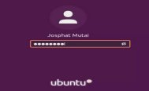

How to open Ubuntu?
To unlock your computer, raise the lock screen curtain by
dragging it upward with the cursor, or by pressing Esc or Enter. This
will reveal the login screen, where you can enter your password to
unlock. Alternatively, just start typing your password and the
curtain will be automatically raised as you type.
When you lock your screen, or it locks automatically, the lock screen is displayed. In addition to
protecting your desktop while you’re away from your computer, the lock screen displays the
date and time. It also shows information about your battery and network status.

4
Ubuntu instructions
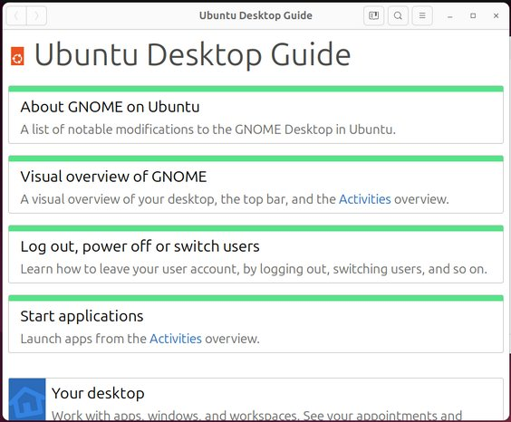

New Window
New Tab
Icon Size
Undo
Redo
Show Hidden Files
Preferences
Keyboard Shortcuts
Help
About Files

1.Every window has a HELP!
You get order to that window!
Dock!
F1 = Show HELP

2.Here are various instructions.
3.Excellent Guide in English can be found at
http://ubuntu-manual.org/ ( Ubuntu 16.04 ) The guide is in pdf format and
it can be downloaded to your computer.
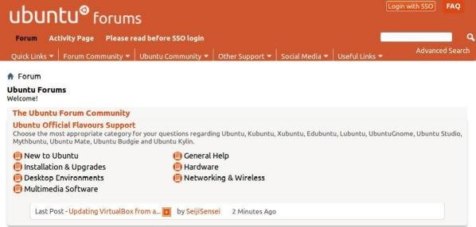

4.Ubuntu's excellent discussion forum.
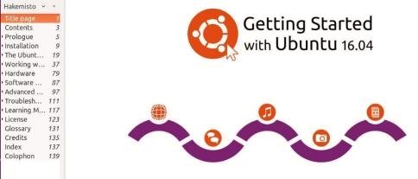
If you have a problem, look here.
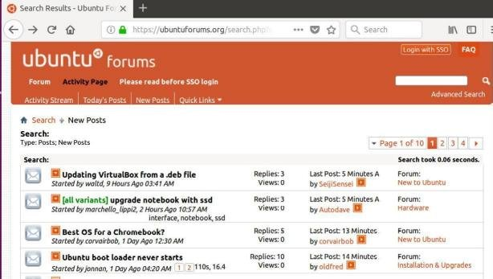
Be brave, and ask.
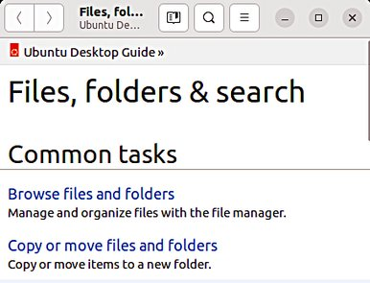
This forum is very good.
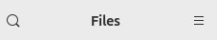
More information on the web
https://discourse.ubuntu.com/
Old one
https://ubuntuforums.org/forum.php
5. LibreOffice documentation 5
https://documentation.libreoffice.org/en/english-documentation/
6 Presentation of Ubuntu 24.04 LTS Desktop
Look Ubuntu Desktop Guide: Visual overview of GNOME
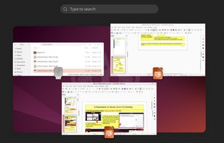

1.Click the clock on the top
bar to see the current date,
a month-by-month calendar,
a list of your upcoming
appointments and new
2.Click! One point = notifications.!
one window. You can
Display all windows.
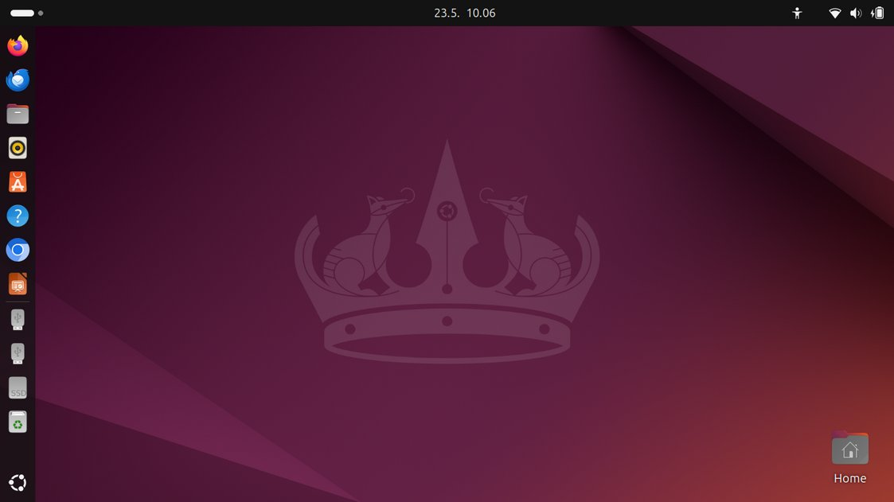

3.Clock and day of the week and tasks
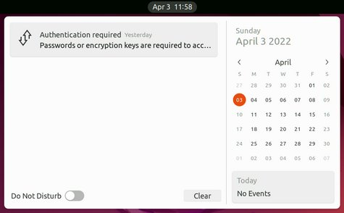
4.System Information
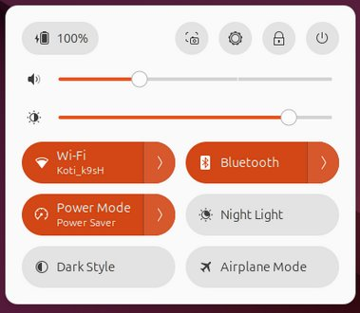
- network connections
- bluetooth, wifi
- battery charge / network
- the volume of the sound
- system preferences
- close your computer
5. Directories / Folders and files
- directories, files
- additional memory / devices
(USB, CD, DVD) 6.Image scroll bar up / down,
will appear when
7.Shopping bag mouse cursor is moved to- download new software the edge.

8.The program icons
- start the program
- icons can be added or removed
- icon size can be changed
- the sequence of icons can be changed
- the icons can be hidden
9.The Dash - the icon shows the number of windows
Selecting and starting
programs. The dash
shows you your favorite
and running applications. 10. The size of icons can be changed.
If all the icons do not fit on the screen, they are either above or below the screen (move mouse to bottom or top of bar).

11.Tip: You can zoom in to the smaller or larger screen by pressing ctrl and scrolling with your mouse.
6
Pre-installed applications
Look Ubuntu Desktop Guide: Start applications
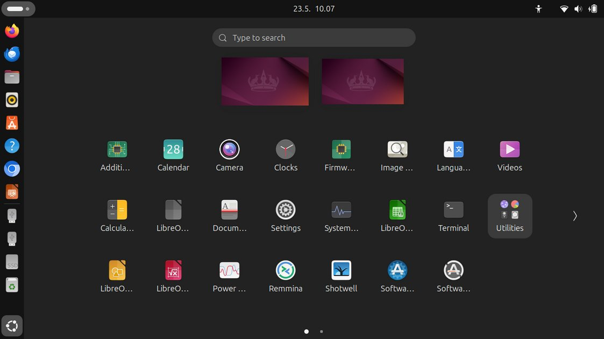

1.Two working
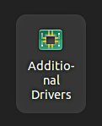
areas!
2. You can see the whole text!
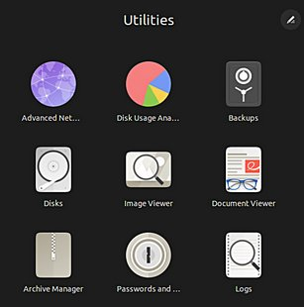

4.Two pages!
3.Click the grid button at the bottom of the dash to display
the applications overview. This shows you all the applications
installed on your computer.
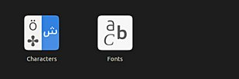

5. You can make your own groups (folder)
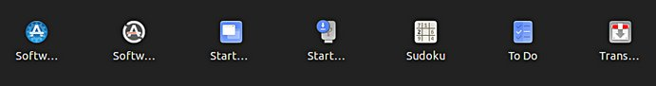
like Utilities. Move some icons together
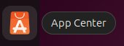
and write a name.
6. "Ubuntu Shopping Bag"
- download of new applications

7. NOTE! The icon is visible either in the dock or on the program screen, but not simultaneously in both.

7
Some tips
Look Ubuntu Desktop Guide: Your desktop

1. If you are copying or moving multiple files, or updating or installing a program, you may
not know if anything is happening on your computer?
In this case, the program progress bar may be hidden under the window.
There are also sections on the Ubuntu screen that show the progress of the event.
The icons may show a line that is not easily noticed because the bar is moving slowly.
Click on the icon for more information!

8.This has been removed

3. Program update, white bar progressing.
4. Program update, orange bar progressing.
5. Copying or transferring files, bar progressing.

6. If this does not appear, Click! click the icon!
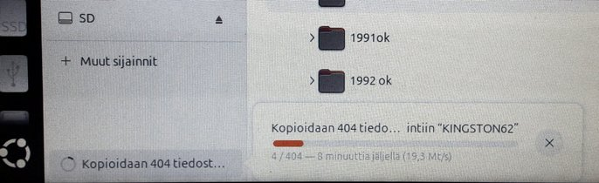

8.The sector is 7. Program installation, bar progressing. Click!
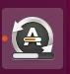
filling up!
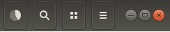

9.The progress of copying or transferring files is shown here! Watch out!
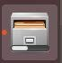

8

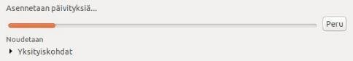
Some thoughts before going on

Ubuntu works in a little different way than Windows. This guide presents the differences.
Ubuntu does not always show the rotating arrow even though the computer is working. This is a bit embarrassing. Wait patiently and be cautious in such a situation.
Sometimes the rotating arrow may be hidden behind the active window, so it is not noticeable.
When your computer updates the program, be patient. Click Details to see the update, otherwise you do not know what is going to happen.
If the mouse does not move for a long time, the computer has apparently stopped for some reason.
Anyway, it is a good idea to take backups often.

Structure of the File System

The folder and file structure differ substantially from the corresponding structure in Windows!

A good thing compared to Windows:
All user files are located in the "Home" and ”Media” folders and in its subfolders, which essentially facilitates backup.
Ubuntu does not use letters to mark different memories (A, C etc.).
External memories (CD, DVD, USB sticks, SD cards, etc.) can be found under their own names.
In the file names big and small letters make a difference (test.txt is different from Test.txt).
In front of a hidden file name there is a dot (.sale.txt). You can make a file hidden by taping a dot.
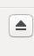
Clicking this symbol will disconnect a separate memory (eg USB, SD card).
Wait until a message appears on the screen to remove the memory!

Please wait, the USB storage
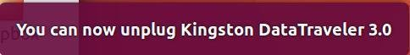
can still be written!
Disconnect when this text
has appeared!
9
Presentation of Folder / Directory Structure
Look Ubuntu Desktop Guide: Files, folders & search

go back in the folder path 2.Note 1.By clicking here you can
HOME and DESKTOP
HOME is the main folder and
all other folders are subfolders!

3.Desktop is
"Home screen"

HOME DESKTOP

DOCUMENTS

DOWNLOADS

MUSIC

PICTURES
4. SD is a memory card
USB-MUISTI is a USB Stick.
VIDEOS

DROPBOX

.MOZILLA .THUNDERBIRD
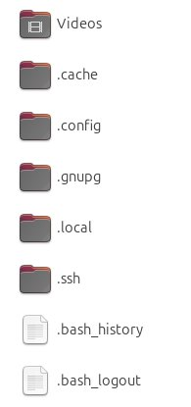

5.Hidden files, dot in front of the name.
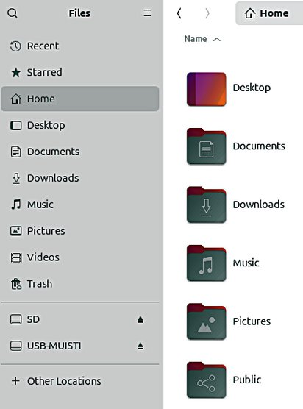
These include user bookmarks,
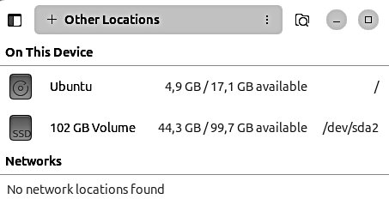
emails and addresses.
6.The HOME directory stores all user files!
Under the home directory you can see its
subdirectories (desktop etc)
Some of the directories may be hidden, in front of
them there is a dot
(.THUNDERBIRD = emails and addresses)
Attention! The directories and files in external
memory (CD, DVD, USB) are not displayed in the
HOME directory. 10
Presentation of Folder / Directory Structure
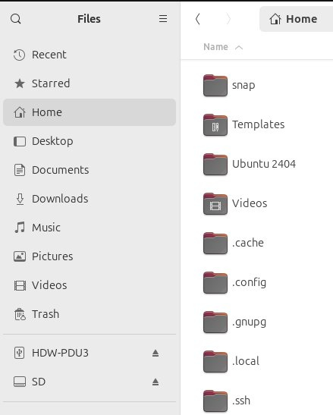

1.Home folder
is the subfolder, where
all your data is.

2.Hidden folders can be seen

3.Folder tree-structure.
The triangle open/cloce the structure

4.Media folder
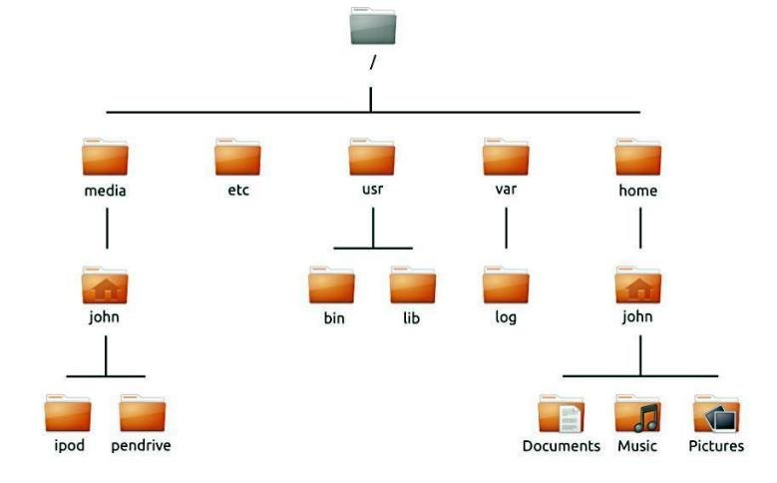
is the (home)folder, where
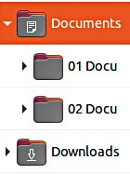
all external files are:
- usb stick and hard drive
- sd card
- cd and dvd disc
etc.

5.The file can be renamed: Edit - Rename
6.The folder can be renamed: Edit - Rename
7.USB / SD can be renamed if you format it (where all old data is deleted!) or later by the "Disks" utility. See attachement.
11
Files (Nautilus)

1.Click! You will see 2.Folders are shown here. 3.NB! There is no menu bar in the Files the Files application. Grey activated Folder. (Nautilus) app!
Use the touch pad to touch with two
fingers!
or with the mouse the right / left click.
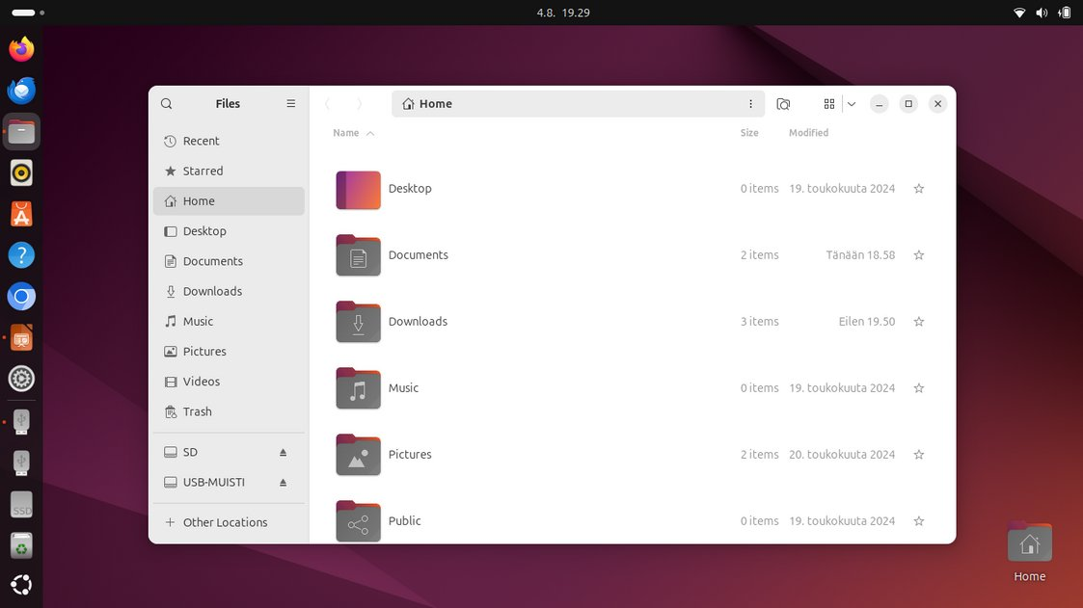

4.Window management buttons

- Hide the program from view
SQUARE Change window size X Close the program

5.Side panel.
Here are the various memory media attached to the computer, such as computer mass storage, USB sticks, SD cards, CDs / DVDs, etc.

6.Application menu, located beside the Activities button, shows the name of the active application alongside with its icon and provides quick access to windows and details of the application, as well as a quit item.

7. Note! I have added a link to Ubuntu's own instructions at the top of many pages. The instructions don't may not exactly correspond to the instructions on that page, because the processing order is different.

12
Command grouping logic

At this point, it is worth looking at how the command areas are grouped.
Commands can be directed at processing the screen or at processing the data itself,
i.e., people or files. Previously, these things were in the top bar of the screen.

1.Earlier all commands were found in the menu bar
3. The same applications are now used on computers, tablets and phones. Because of this, menu commands are not convenient and new solutions have to be developed.
The solutions are slightly different for different applications, unfortunately.

The menus in these
areas deal with display
settings, such as how
big the icons are and
how they are handled.
This does not define
individual folder or file
issues. This is good to
note!
Red area!
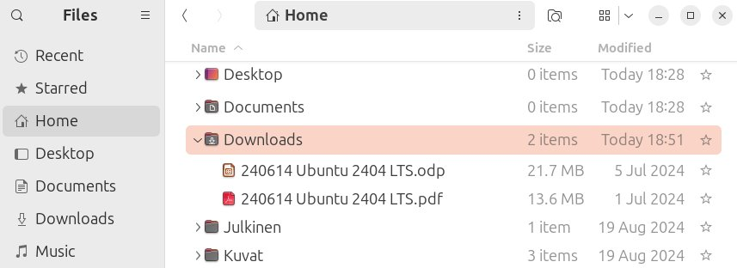

The menus in these areas deal with folders and files, e.g. moves, copies, etc.
and also their properties. Blue area!
13
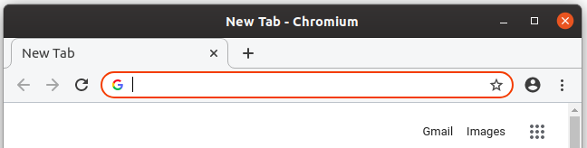
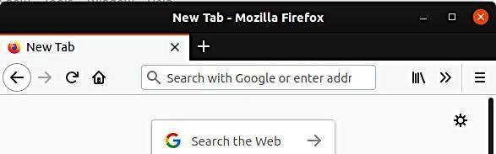
Screen layouts 1
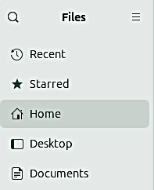

Sort
New Window
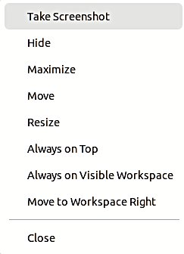
New Folder... O A-Z
New Tab
Open With … O Z-A
------------
---------- O Last
Icon Size
Reload Modified
------------
Open Add To Bookmarks O First
Undo Rename
Open in New Tab Edit Location Modified
Redo
Open in New Copy Location O Size
------------
Window -------- O Type
Show Hidden Files
----------- Open in Terminal --------------
------------
Rename -------- Visible
Preferences
----------- Properties Columns...
Keyboard Shortcuts
Properties
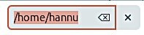
Help
About Files

Right click Left click Right click Left click

2.You can change the view by clicking.
The icons are either by side or one below the other.
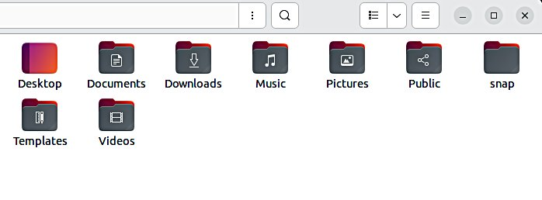

3.You can change the size
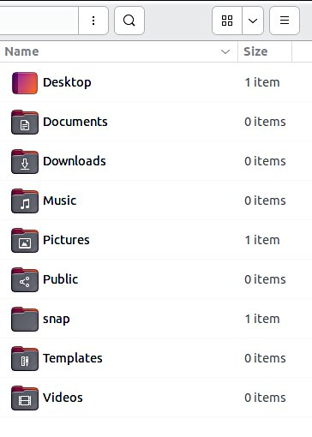
of the icons by pressing
ctrl and + or ctrl and – buttons
several times or scroll mouse.
4.Tip: You can zoom in to the smaller or
larger icon by pressing ctrl and scrolling
with your mouse.

14
Screen layouts 2
New Window
New Tab
------------
Icon Size
------------
Undo Rename
Redo
------------
Show Hidden Files
------------ 1.Two Tabs Preferences Downloads and Home
Keyboard Shortcuts
Help
About Files
Open
Open in New Tab
Open in New
Window 2. You can zoom in to the
----------- smaller or larger icon by
Rename Hidden file = dot in pressing ctrl and scrolling ----------- front of the name! with your mouse. Properties !
3.You can change the size
of the icons by pressing
ctrl and + or ctrl and
– buttons several times.
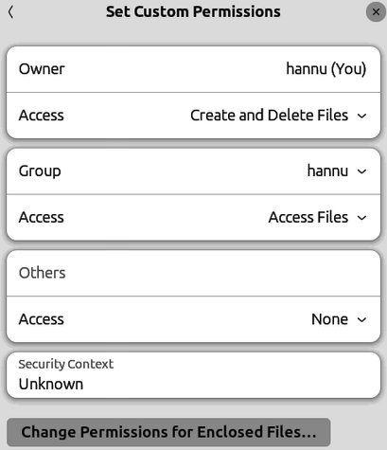

List Files Only
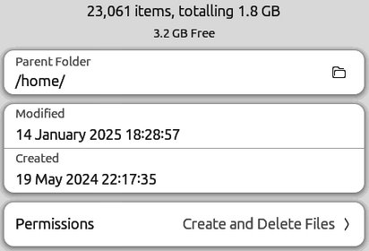
Access Files
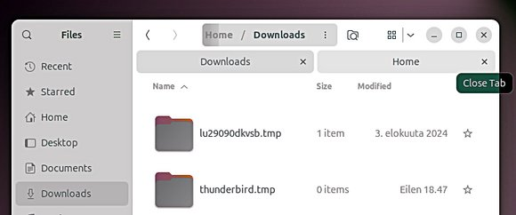
Create and Delete Files
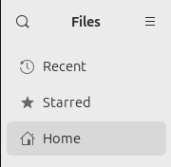
None
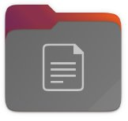
List Files Only
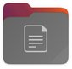
Access Files
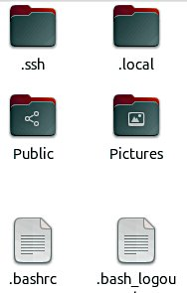
Create and Delete Files
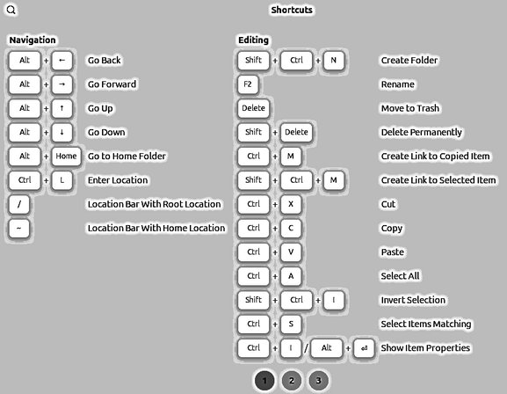
15
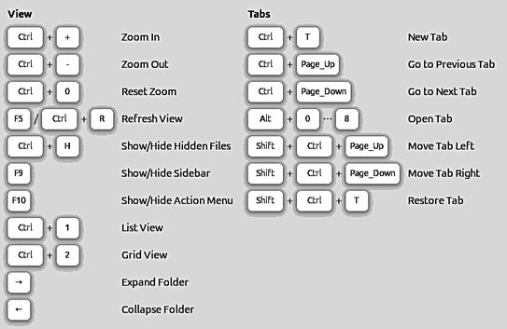
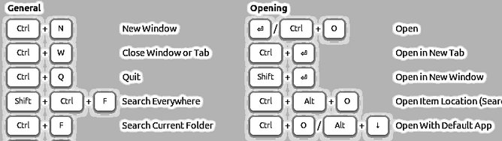
Screen layouts 3

New Window
New Tab
------------
Icon Size
------------
Undo Rename
Redo
------------
Show Hidden Files
------------
Preferences
Keyboard Shortcuts
Help
About Files
1.Displays sub folders! Triangle in front of
the folder. The tree structure!
This is very useful!

2.Click triangle!
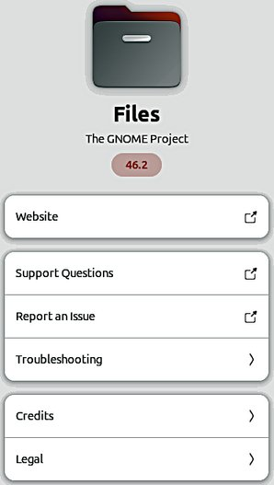

None
Size
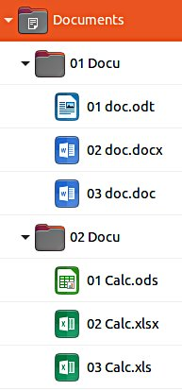
Type
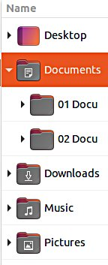
Modified
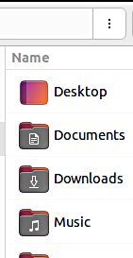
Detailed Type
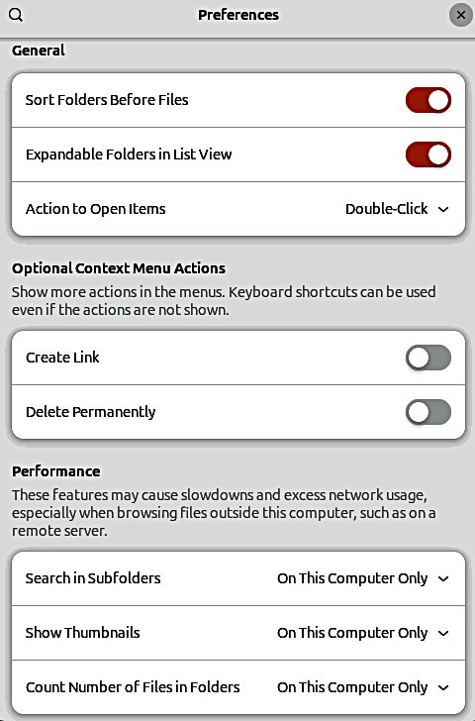
Accessed
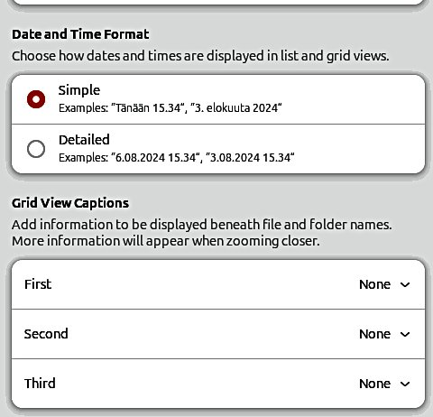
Created
Owner
Group
Permissions 16
Recency
Files (Nautilus)

Folder File

Open Open With gThumb Right click------------ Open With ... Cut ------------Copy Cut Predefined program Move to… Copy Copy to… Move to…
------------ Copy to… !
Rename... ------------Compress… Rename... Email... Compress… Move to Trash Set as Background...------------- Email… Creating an email Open in Terminal Move to Trash------------- -------------Properties Properties

Choose packaging method
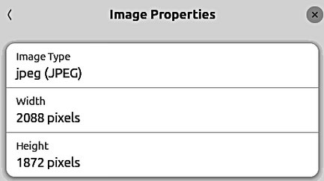

17
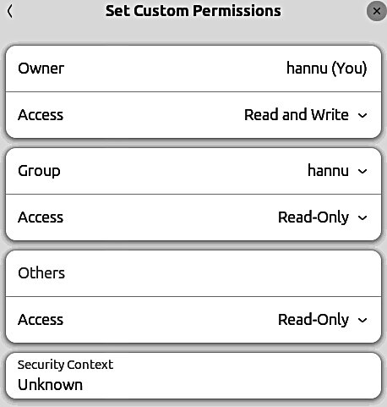
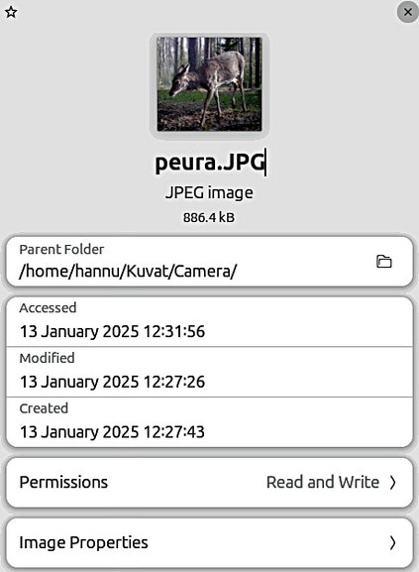
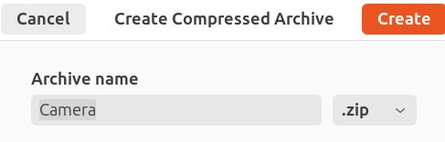
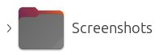
USB / SD memorys
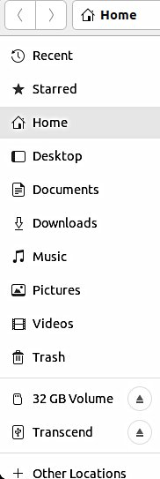

1. Click the USB/SD memory Open with mouse right Open in New Tab
Open in New
Window
2.Click Properties
. ------------
Add to Bookmarks
Rename
------------
Eject
Format…
------------
Properties

SD Card
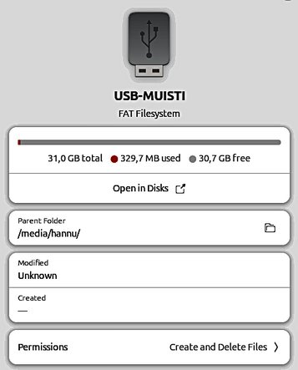
USB
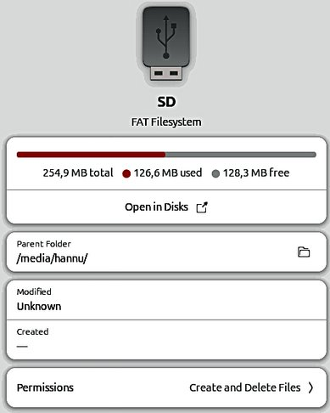

3. Remove the USB/SD

memory with a command

or from triangle, but wait
until you get permission!
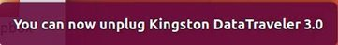

4.NOTE!
With the command
Properties you can
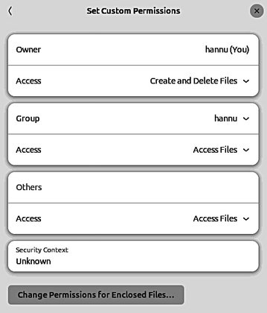
see the capacity and
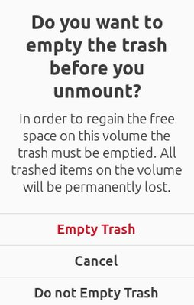
use of the memory.

5.If you are the only
user of the PC, these
are not essential things.

18

Different working areas
1.There are different "work areas" in Ubuntu, which are briefly presented here.
Workspaces = collect different app windows in the same workspace and other app windows in another workspace

Click!

2. Two Dots =>
Two different workspaces

3. Two Different workspaces

Windows = app windows in the same workspace. Maybe the most used way
4. Click Activities, 5.Different windows
you can see all
open Windows

Click!

6.Click right!

Tab = appears in the Files (Nautilus) program
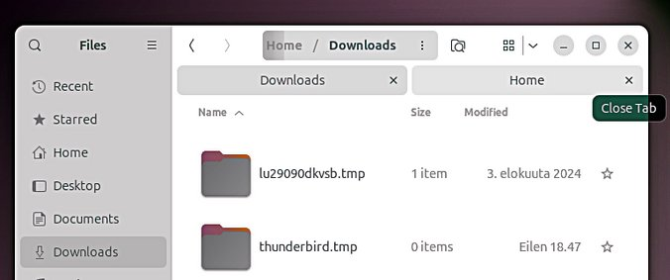

Click!
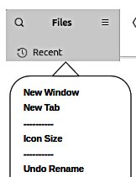
7.Different tabs
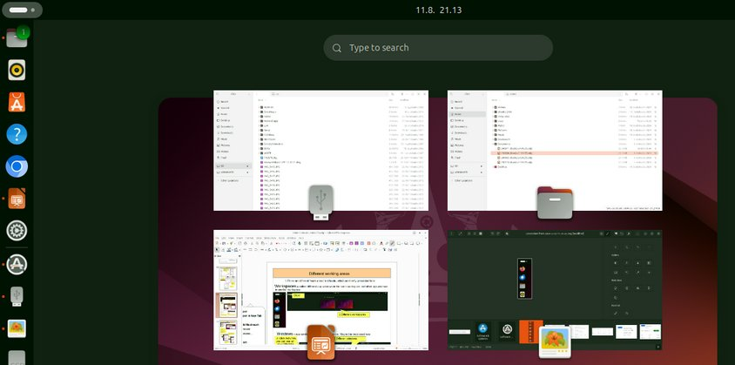

8.You should try these different methods 9.In many apps, the work area can be divided
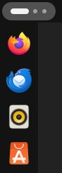
to get acquainted with them into many tabs, such as with a spreadsheet
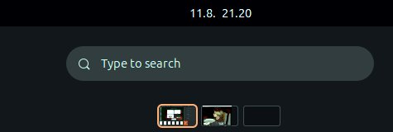
19
Click ! Windows
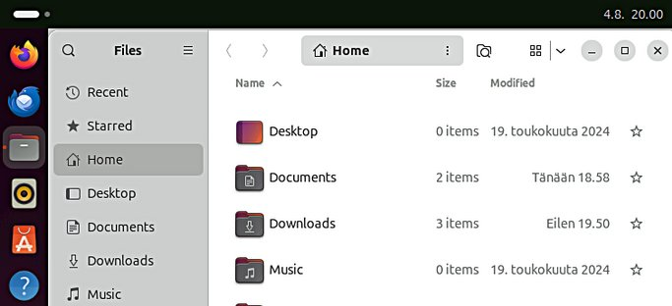

1.Add another window

2.A small dot on the left side of the
Icon indicates that there is one
window in use.
When there are two or more
windows on the screen, click
the program icon.
→ The windows are placed side
by side and you can move
to another window.
Note in the folder button two
red dots. 3.When there are two or more displays on
the screen, click the program icon.
→ The windows are placed side by side
4.Two windows and you can move to another window. two dots

5.Three windows
three dots
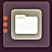

6.Here are three windows
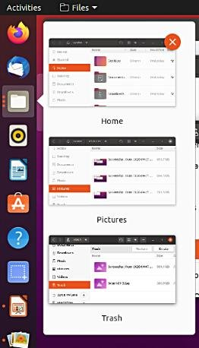
to choose from. 20
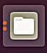
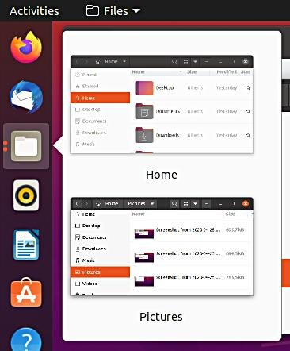
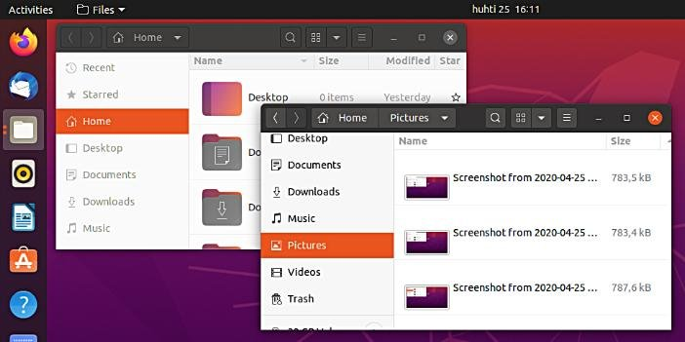
Several windows

1.If you move the window to the top of the screen,
the window will increase to full screen size.
If you drag down the full screen with the mouse,
the window returns to its original small size.
Try it!
2.If you move the window to the right edge of
the screen, the window will increase to half size
of the screen. If you then drag the window with the
mouse to the left, the window returns to its
original size. Try it!

5. If you drag the window to a corner with the mouse, you get a "corner-screen!

3.If you move two windows to the right and left edge of the screen, you get two half-size windows side by side.
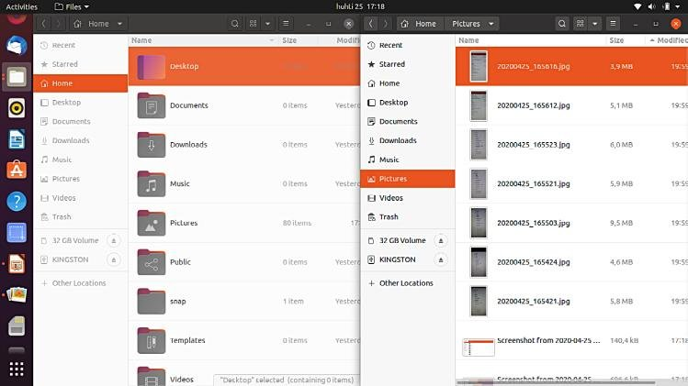

4.Two parallel windows
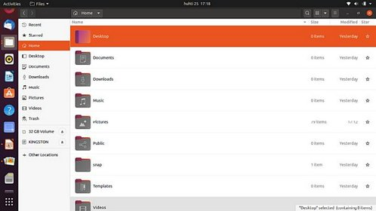

21
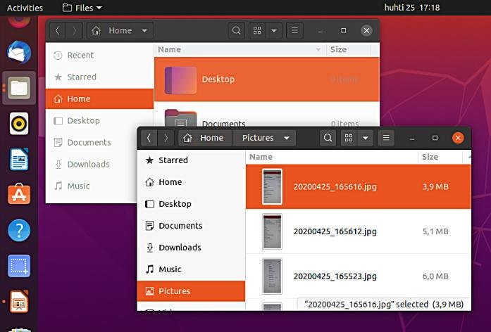
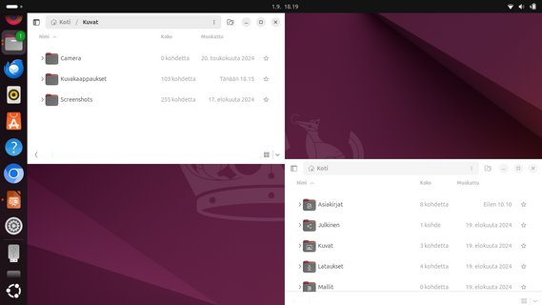
File handling; copy, move and paste
Look Ubuntu Desktop Guide: Copy or move files and folders
A file or folder can be copied or moved to a new location by dragging and dropping with the mouse, using the copy and paste commands, or by using keyboard shortcuts.

COPY AND PASTE CUT AND MOVE Select the file(s) or folder(s). Select the file(s) or folder(s). Right-click and pick Copy, or press Ctrl+C. Right-click and pick Cut, or press Ctrl+X. Navigate to another folder, where you want to Navigate to another folder, where you want
put the copy. to move. Click the menu button and pick Paste, or press Click the menu button and pick Paste, or Ctrl+V. press Ctrl+V.

DRAG WITH MOUSE THE FILE(S) OR FOLDER(S) move copy You can do this with two different windows.
Press and drag the item(s) from one window to another. This will move it if the destination is on the same device, or copy it if the destination is on a different device. Be careful!
You can force the file to be copied by holding down the Ctrl key while dragging, or force it to be moved by holding down the Shift key while dragging.

More options
You can see the menus by clicking the file with right button of the mouse. Note that the commands Copy and Copy To… (with 3 dots) have different functions.
Commands with 3 dots always open a new window to choose the target.
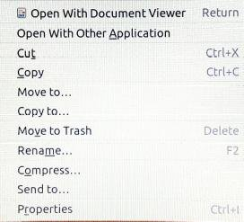

1.Move to ... or Copy to...
open a new window.
This is probably the easiest way
for the beginner.
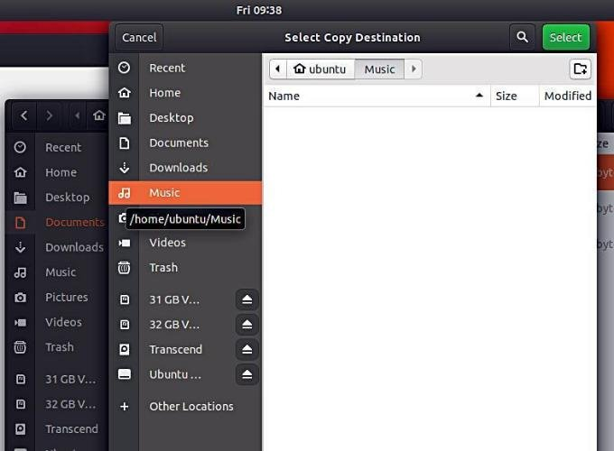

2.After selecting the destination folder
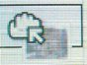
click the Select button
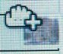
to end the Copy/Move function

22

Presentation of basic settings

Click ! Click !
1.Click these icons and see the contents.
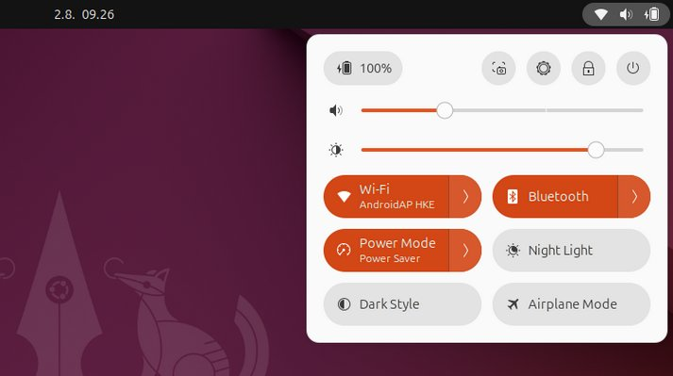

4.Close the computer
2.The following pages show
the basic settings for System
Preferences.
It's a good idea to go through
those right away. At the same
time, you should consider what
kind of settings best serve
your own use.
3.Many of these settings are specified when
installing Ubuntu, but they can be changed
later.

Click !
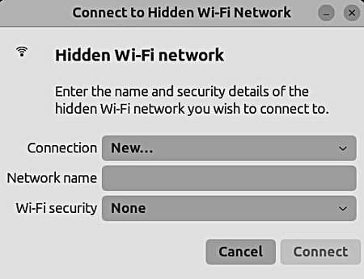

5.When you lock your screen, or it locks
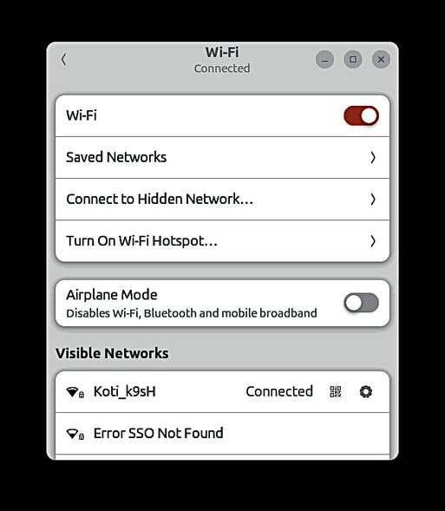
automatically, the lock screen is displayed. In
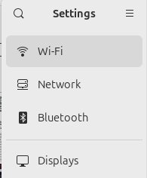
addition to protecting your desktop while you’re away
from your computer, the lock screen displays the
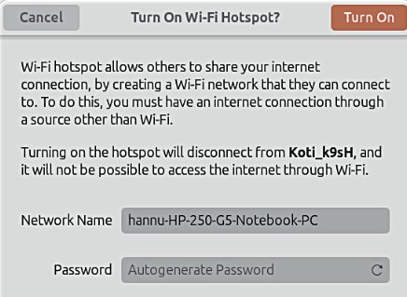
date and time. It also shows information about your
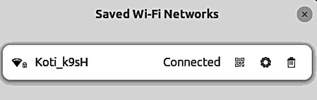
battery and network status.
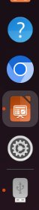

23

Basic settings
Look Ubuntu Desktop Guide: Hardware & drivers
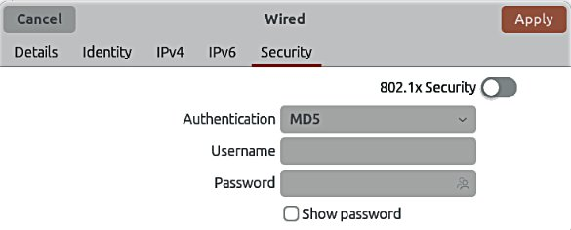

24
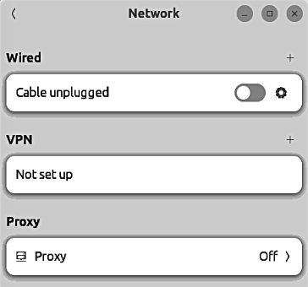
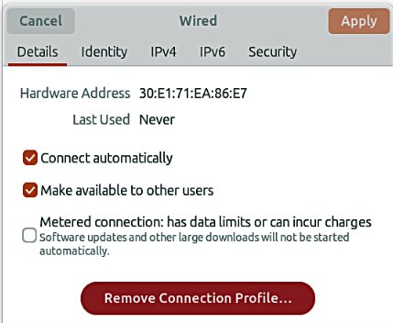
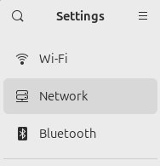
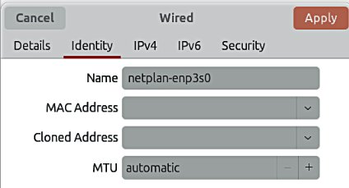
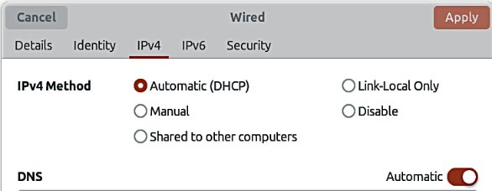
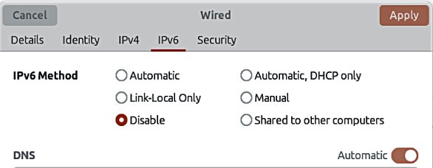
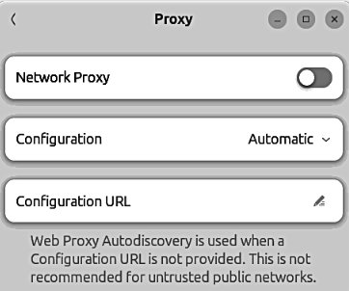

Basic settings
Look Ubuntu Desktop Guide: Sound, video & pictures
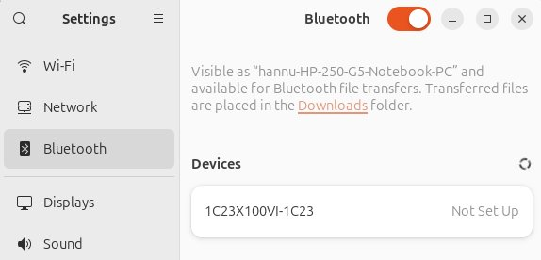

3. If the PC is connected to the TV
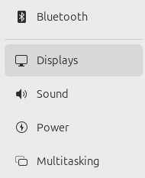
with an HDMI cable, appears
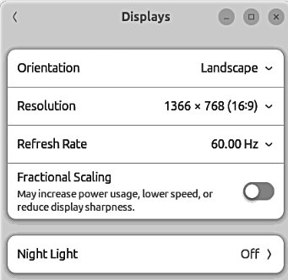
additional definitions above.
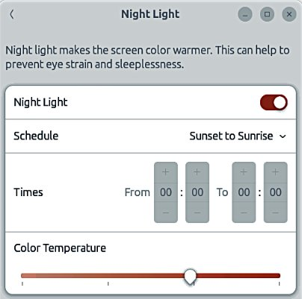
1.Define it according to your taste.
Facilitates sleeplessness in the evening.
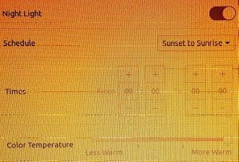

25
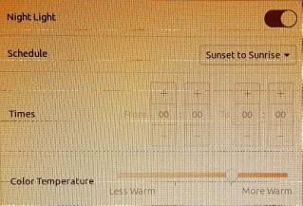
2.The night light is reddish
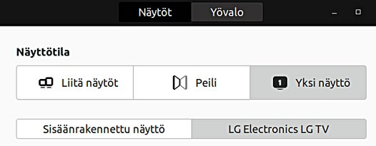
and gentle in contrast.

Basic settings
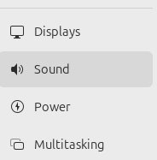

1. If no sound, check this!
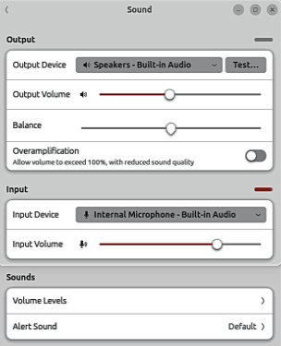

2. If you connect the TV, check
audio output to television
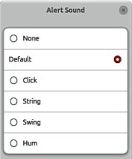

Try it!

3. Set up a video conference
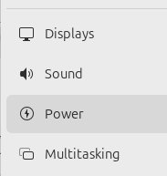
microphone sound
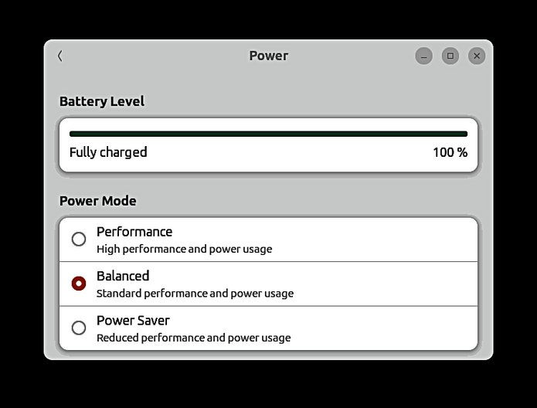
strength! Watch out for
the sound circulation
i.e. whining.

4.Power Saving,
you should define it
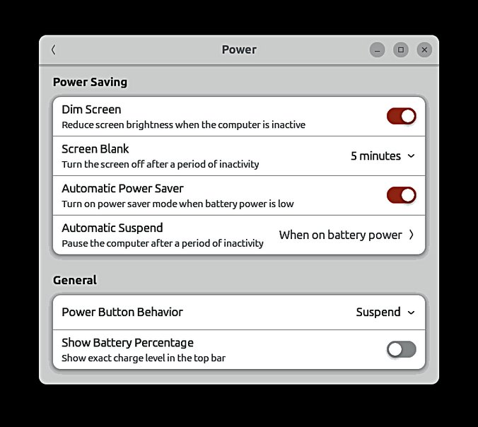
for your own needs.
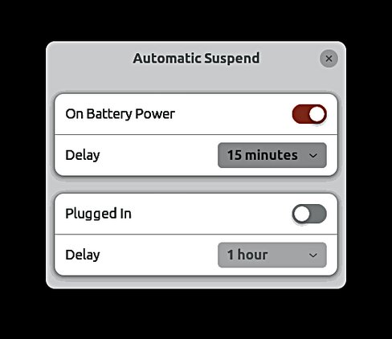

5.Power Off button, you should define it for your own needs.
Suspend; Power Off; Nothing 26

Basic settings
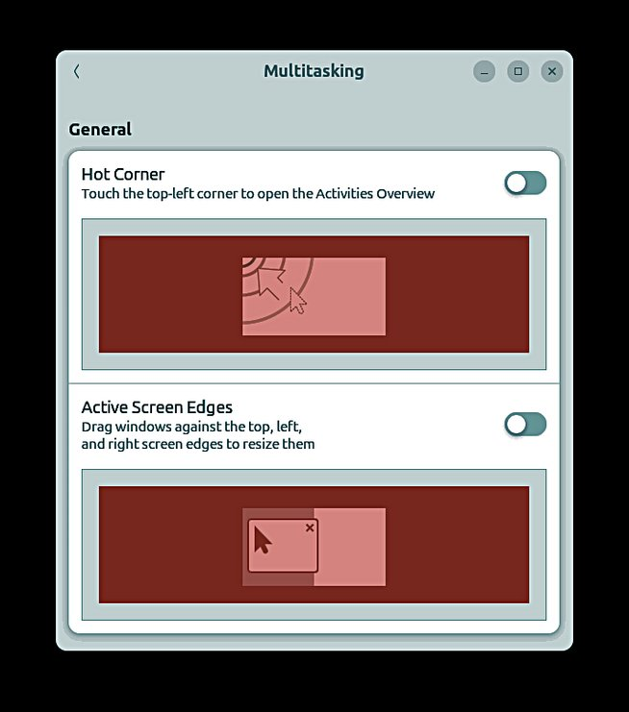

27
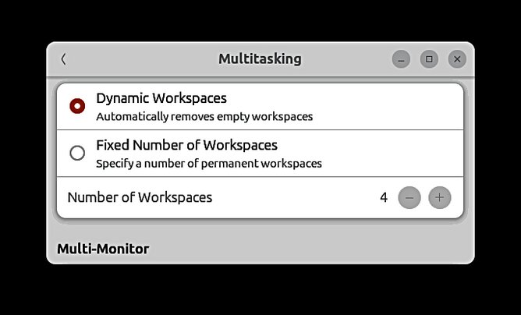
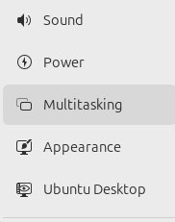
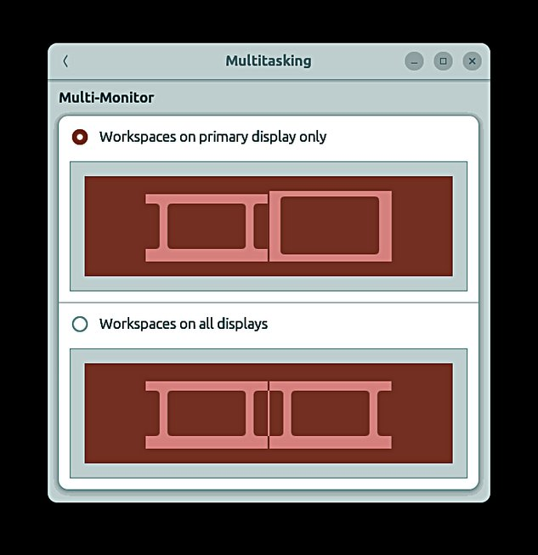
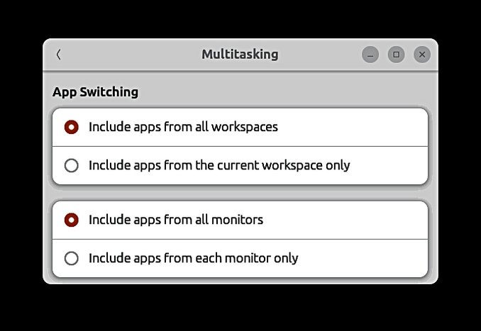

Basic settings

1.Again it is worth trying,
which setting feels the best.

2.This allows you
to adjust the size
of icons.

3.Use this to define
the location of the icons;
left, bottom, right
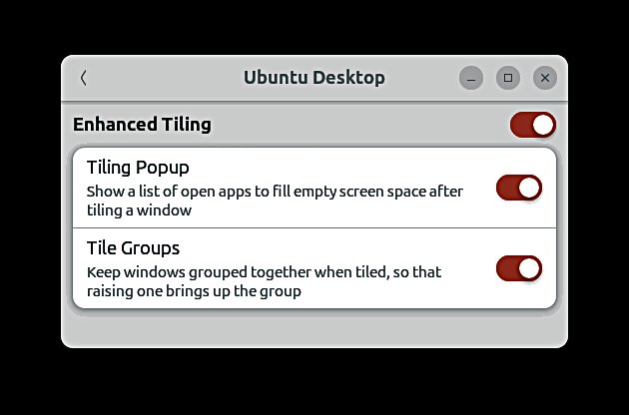

28
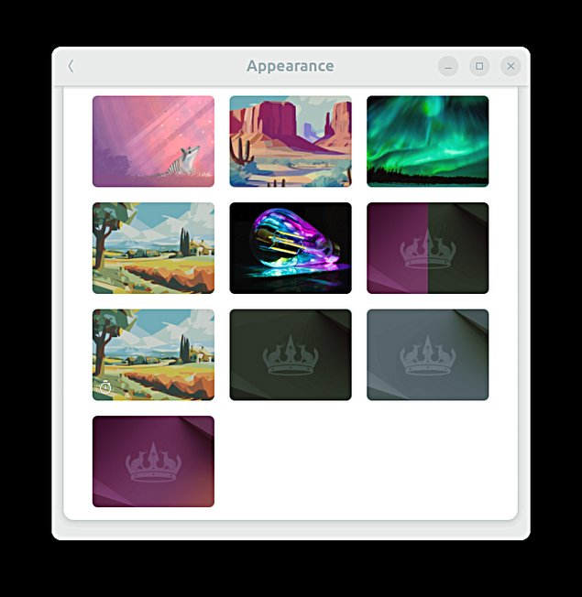
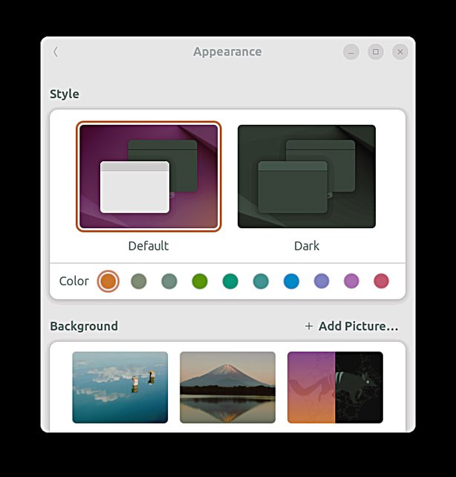
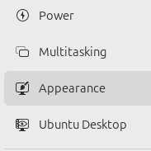
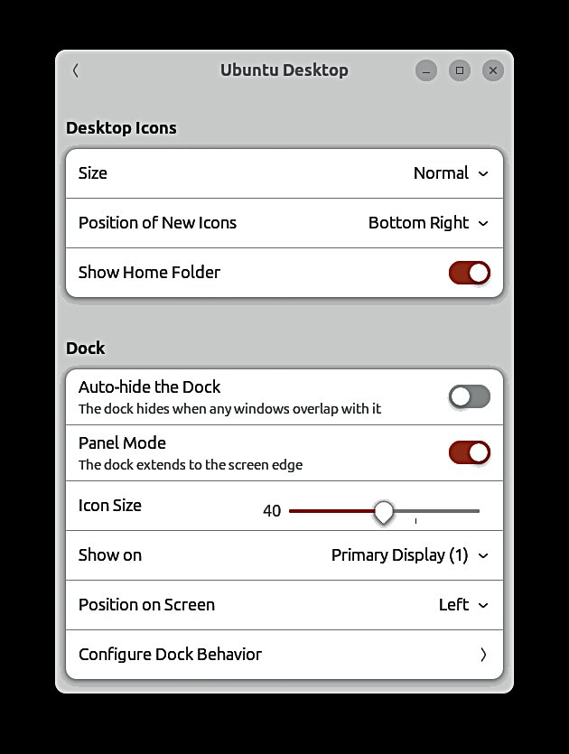
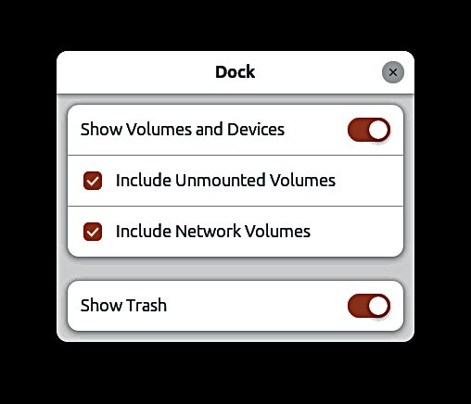

Basic settings
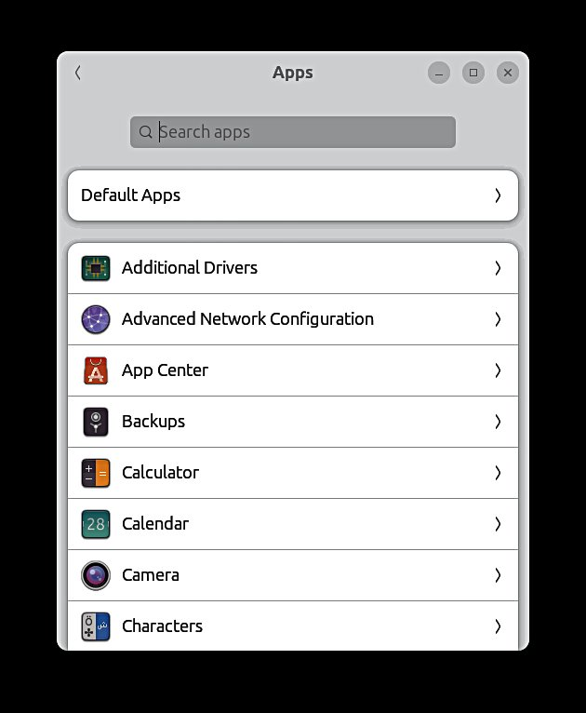

1. Try it, you will get
more information!
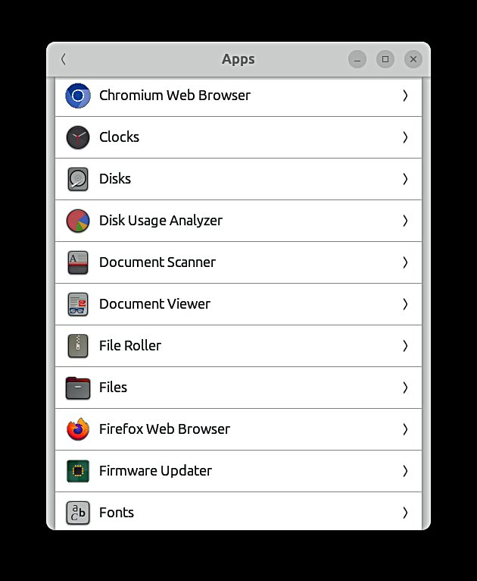

29
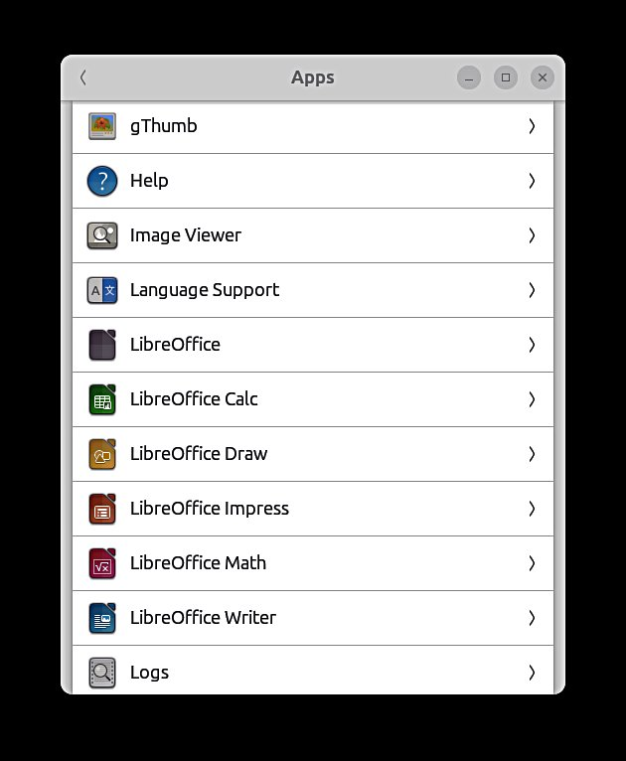
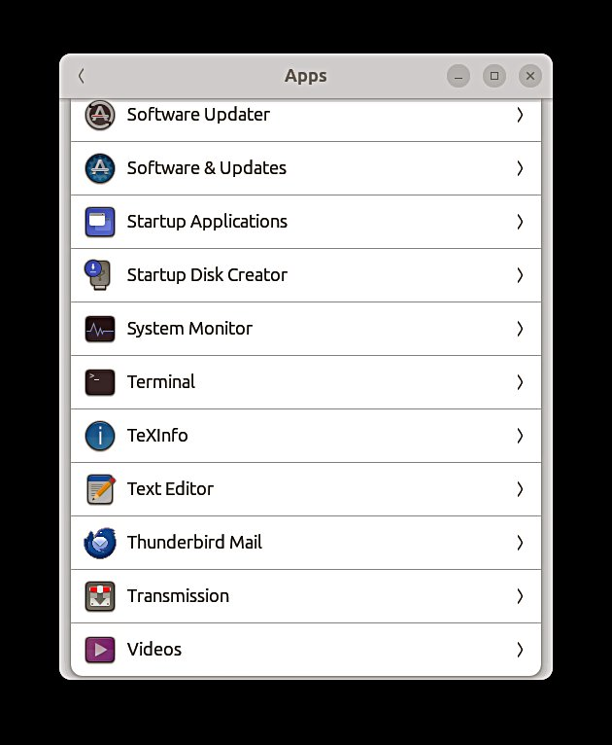
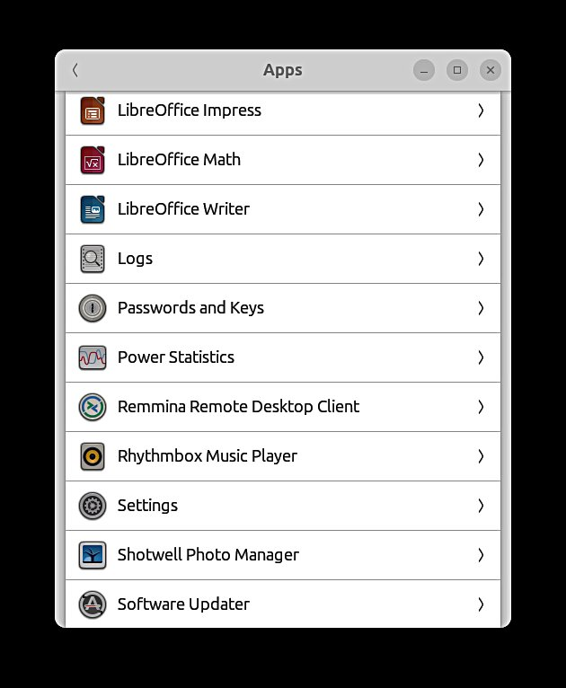
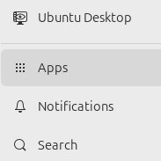
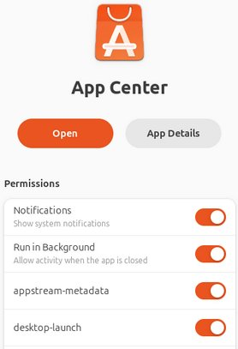

Basic settings
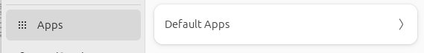

1.Select the default applications
here. When you click a file define
what application opens that file.
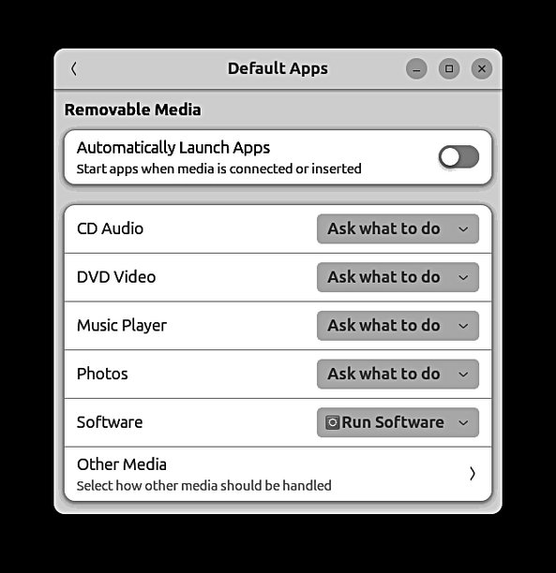

30
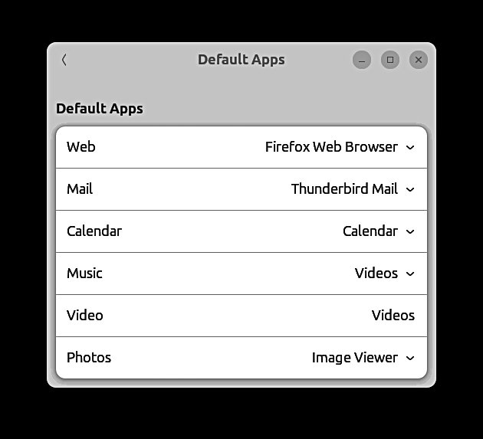
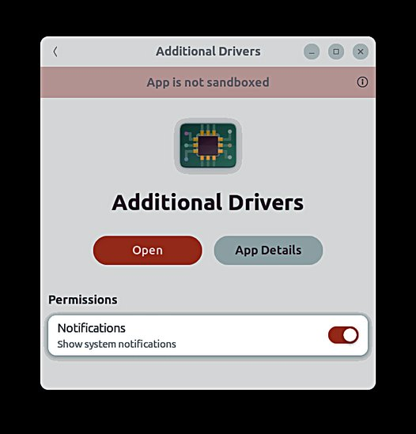
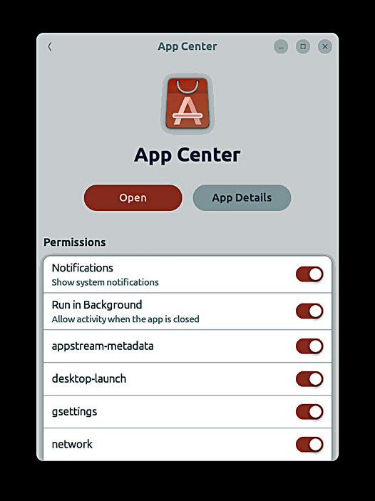
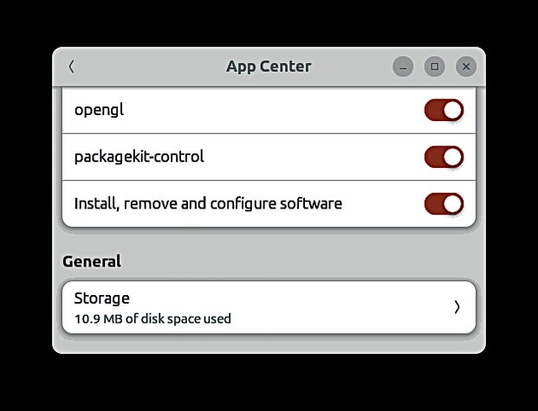

Basic settings

1. No alarm
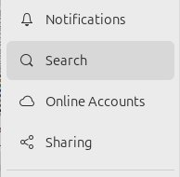

31
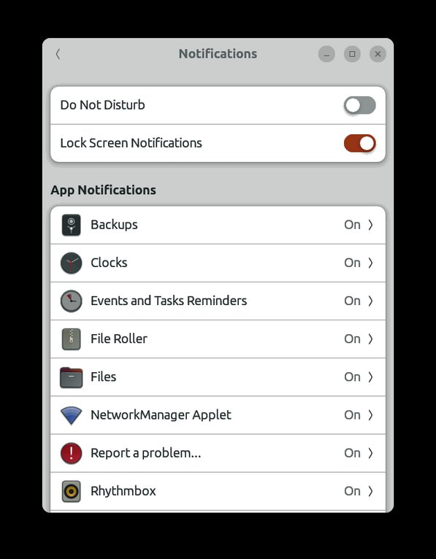
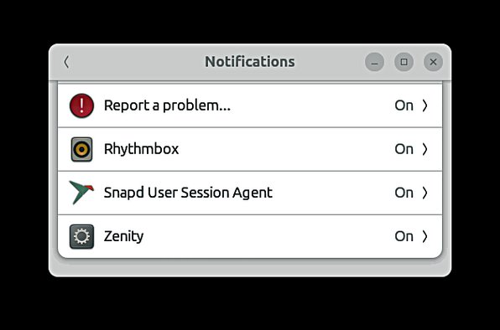
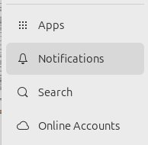
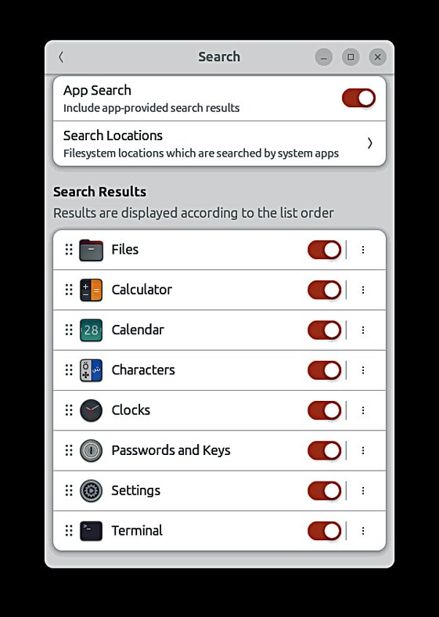
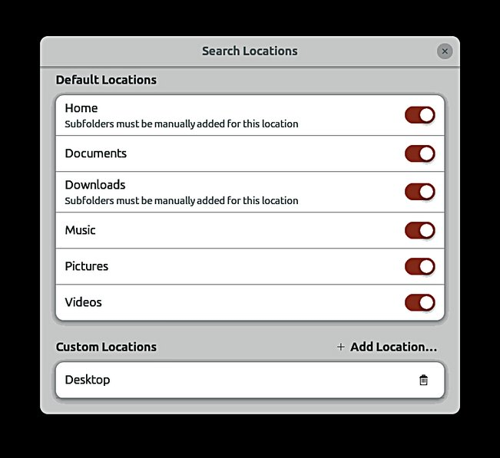
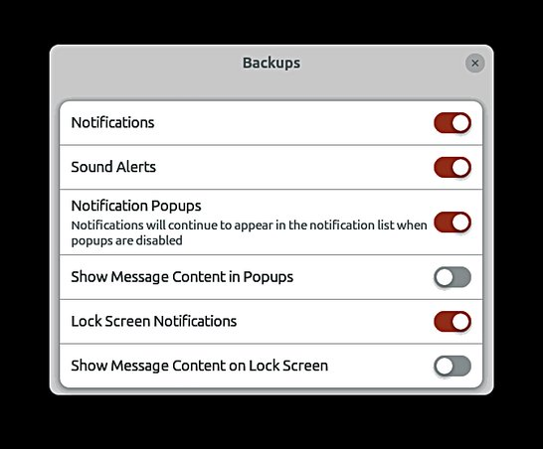
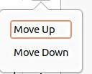

Basic settings
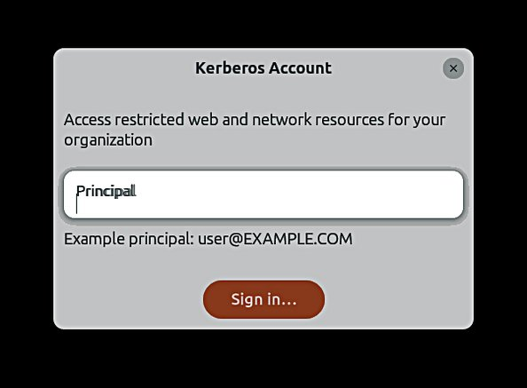

32
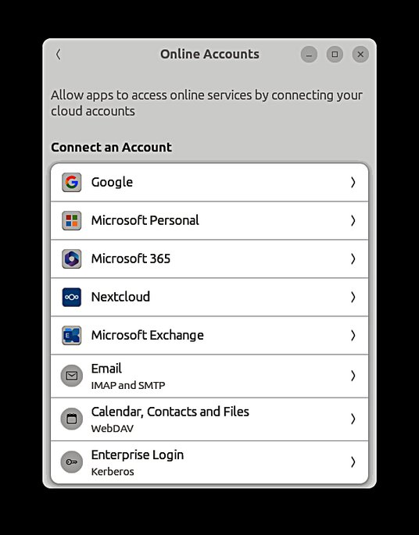
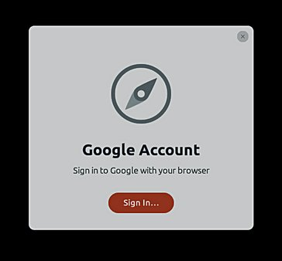
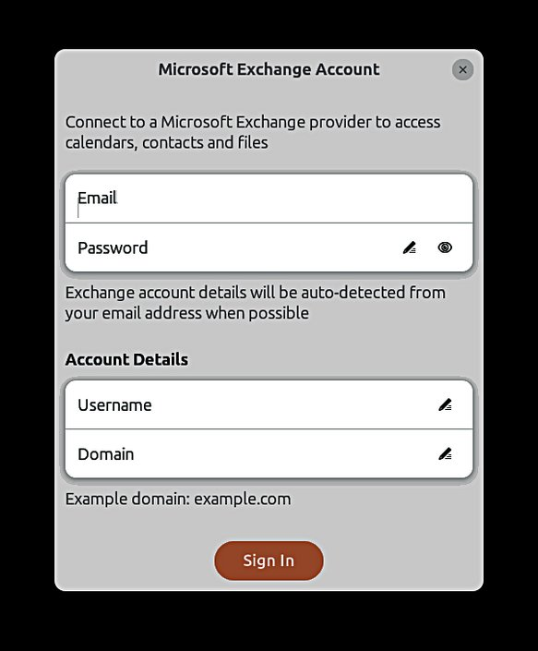
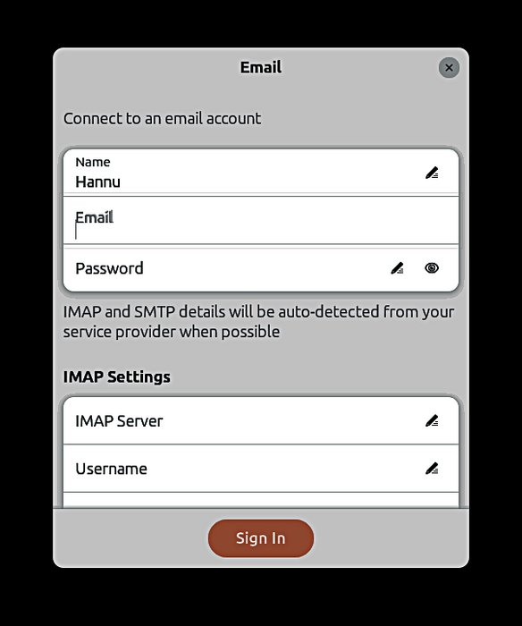
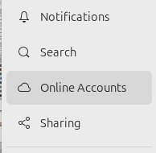
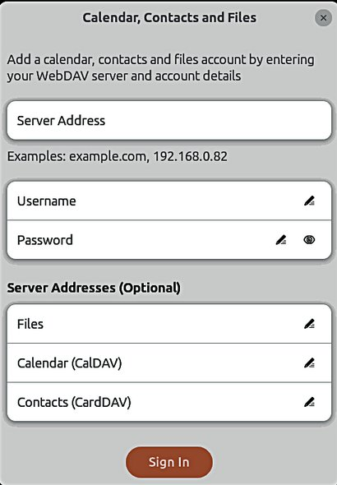

Basic settings
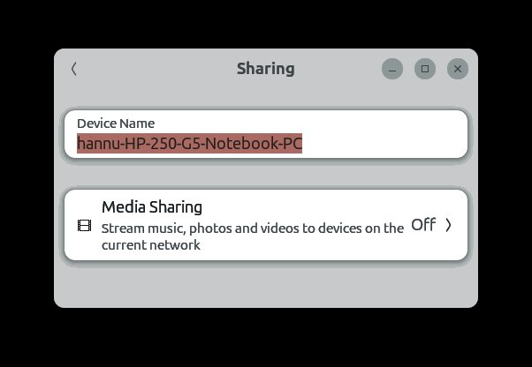

33
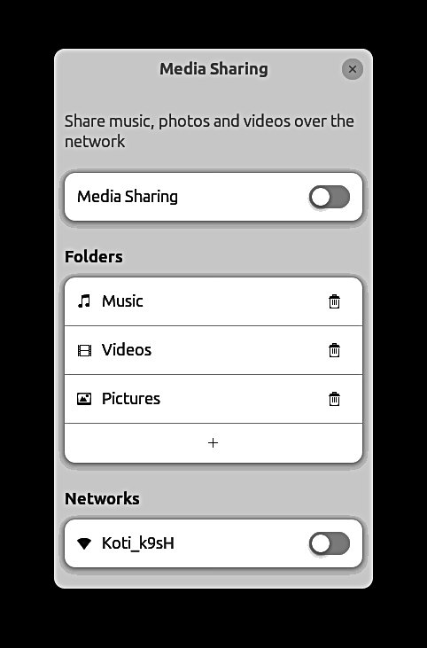
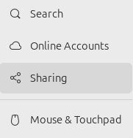
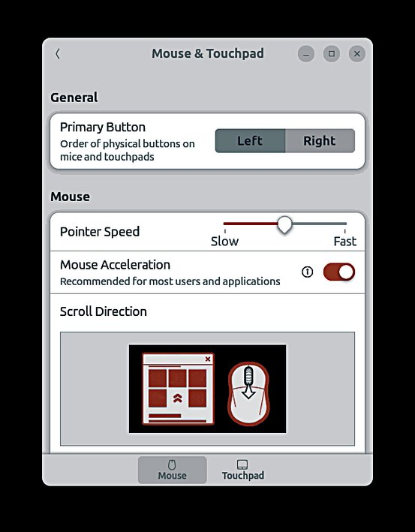
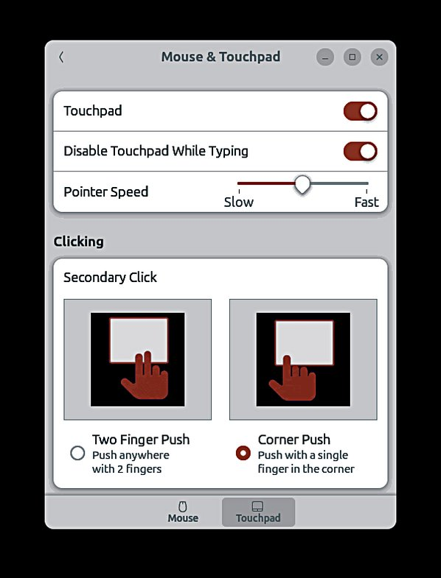
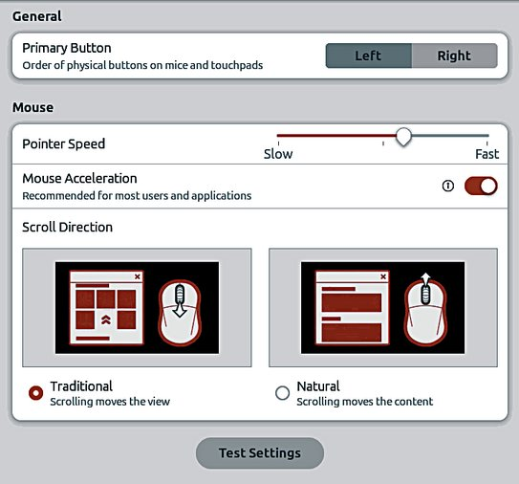
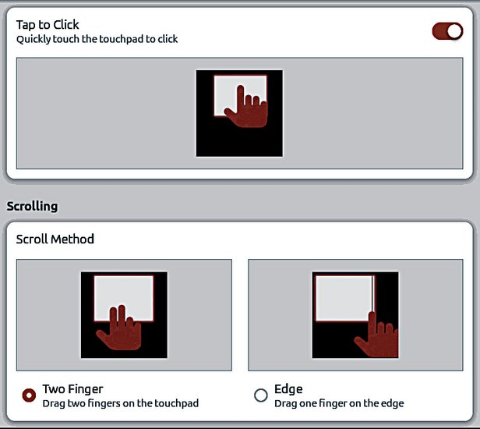

Basic settings
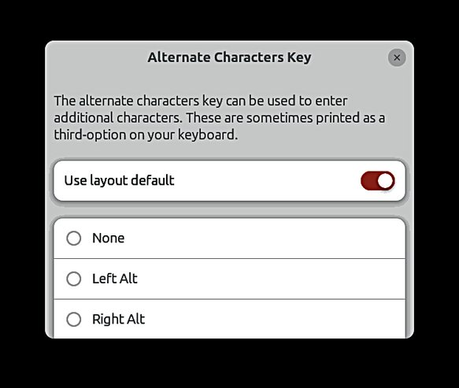

34
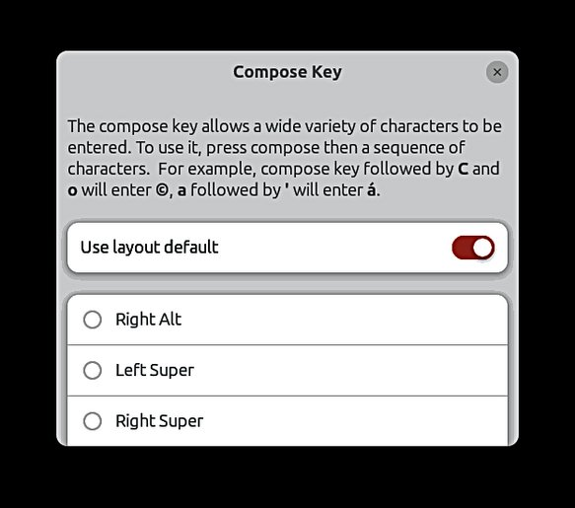
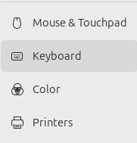
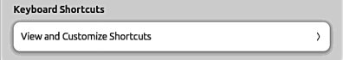
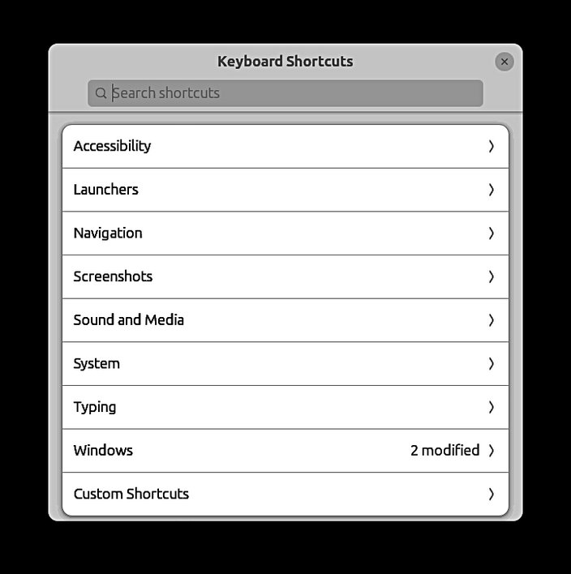
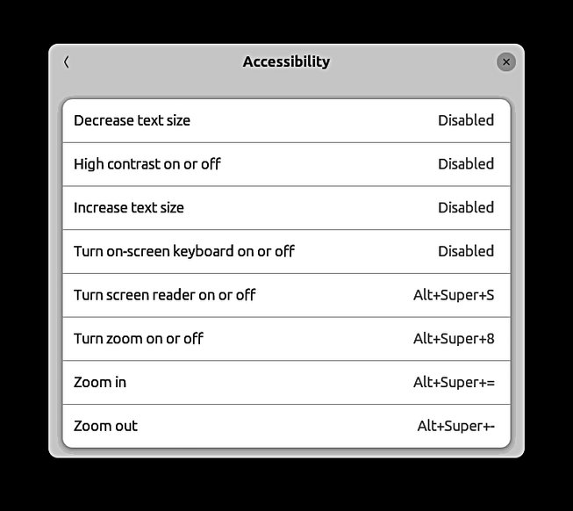
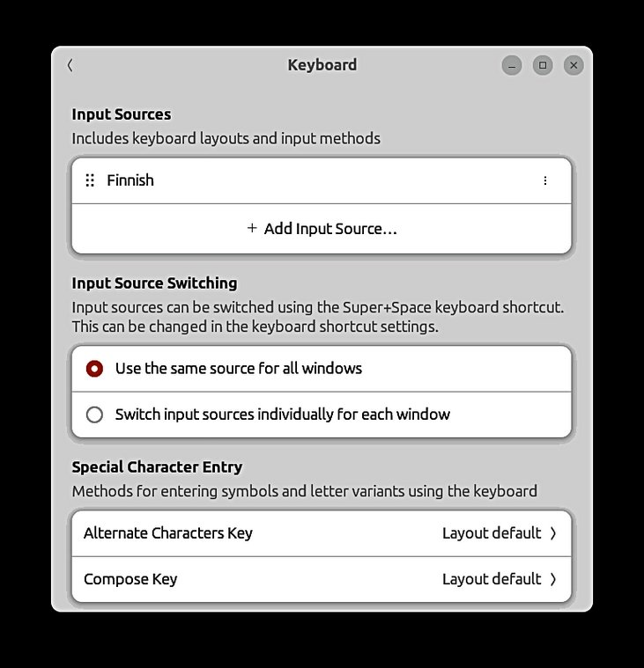

Basic settings
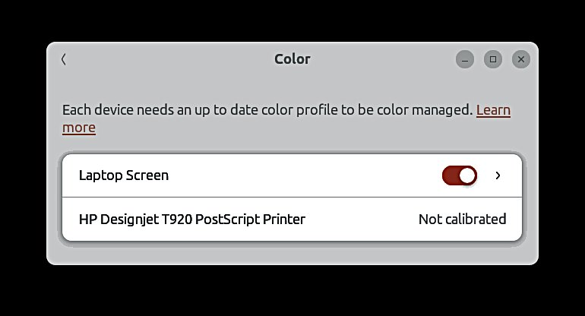

35
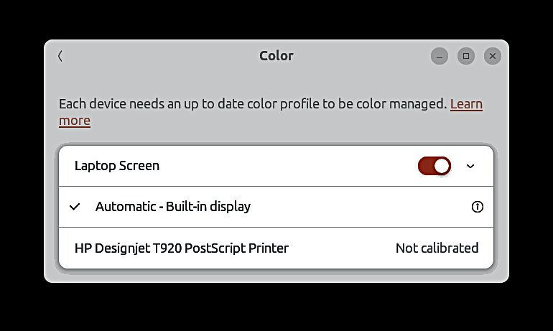
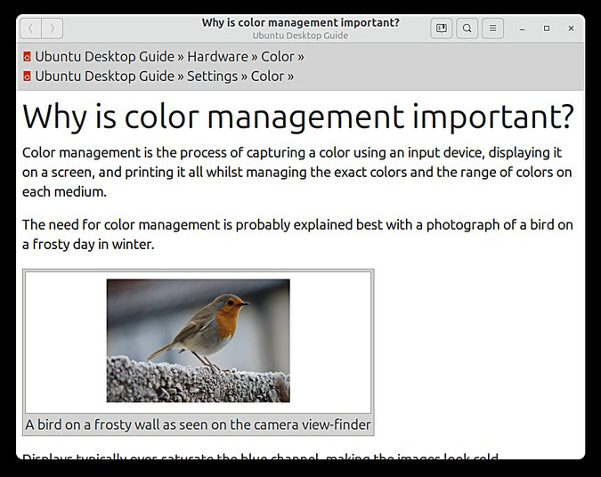
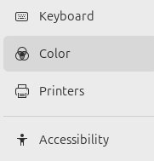
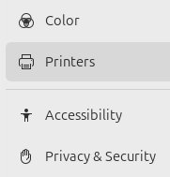
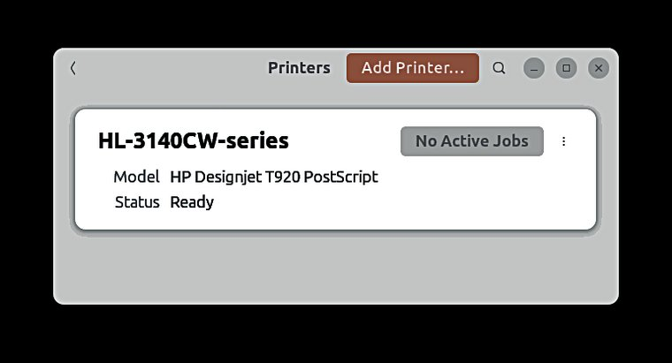

Basic settings
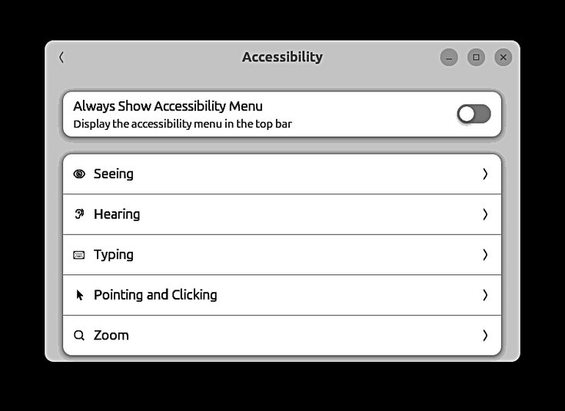

1. This is very useful, if text
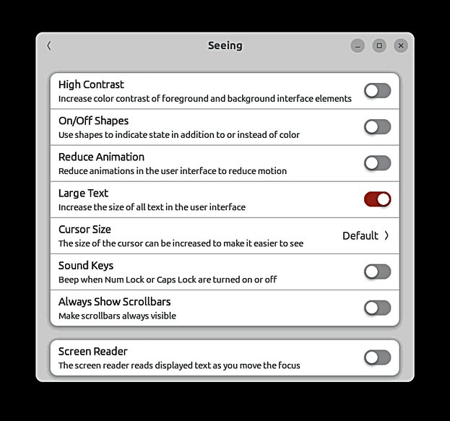
is too small. Try it!
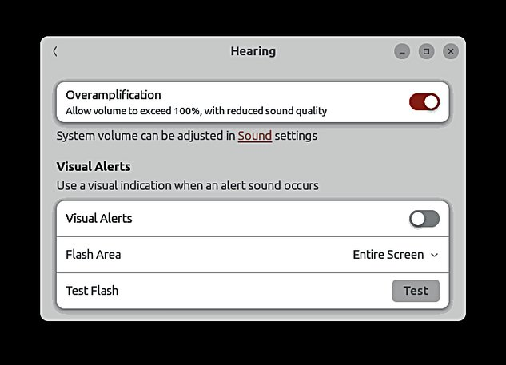

36
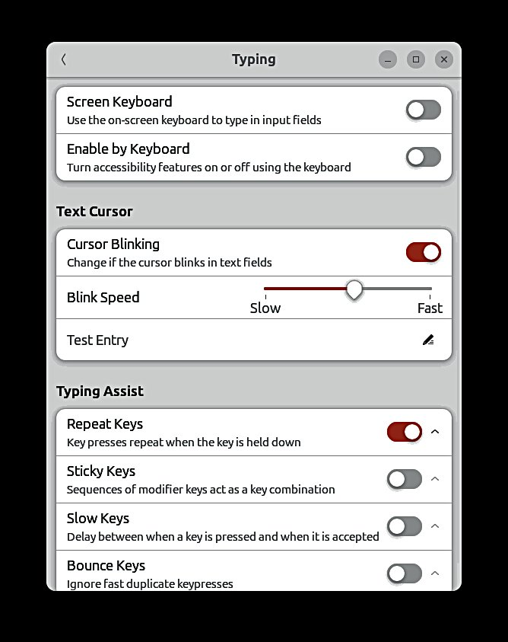
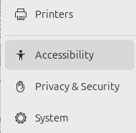
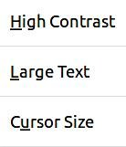
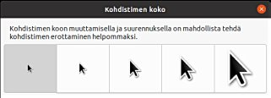
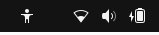

Basic settings
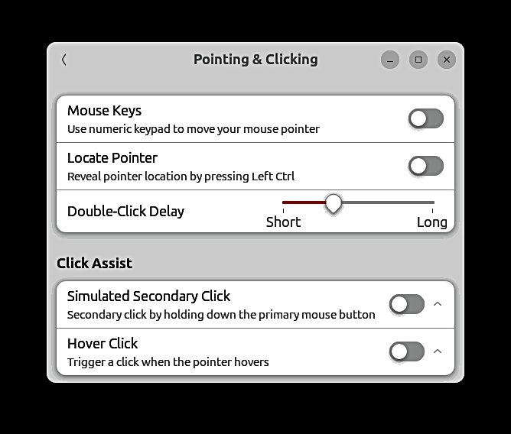

37
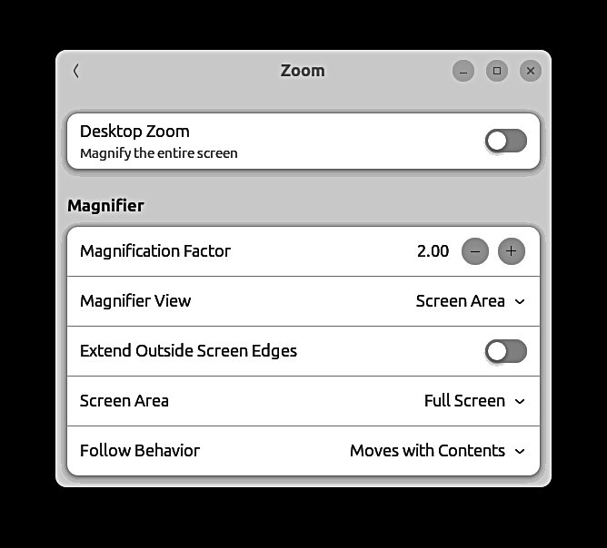
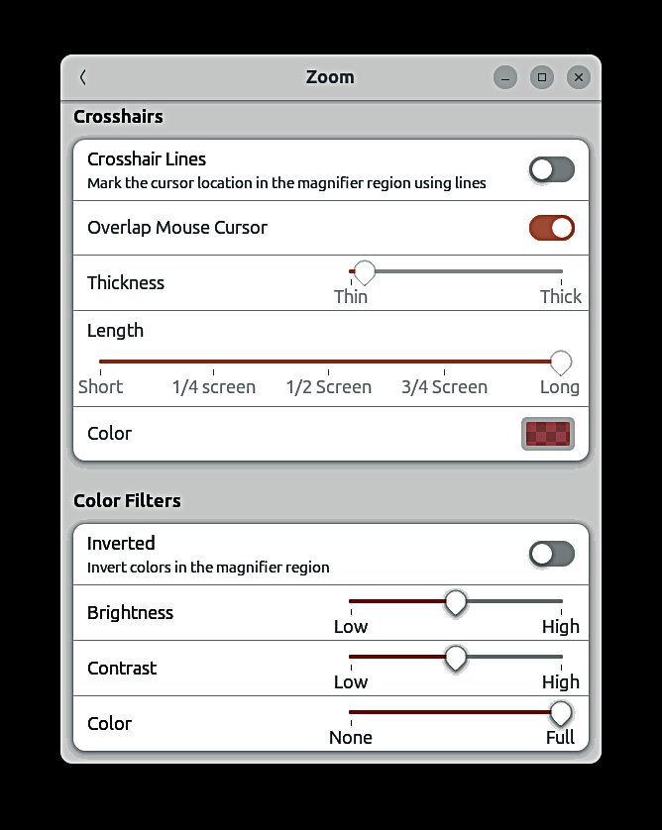

Basic settings
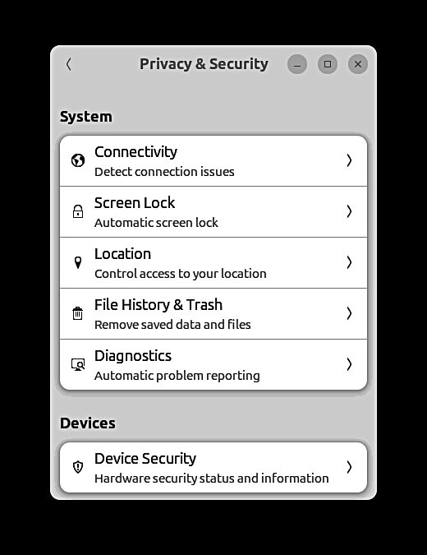

38
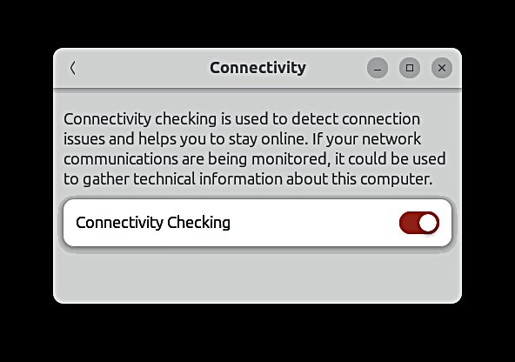
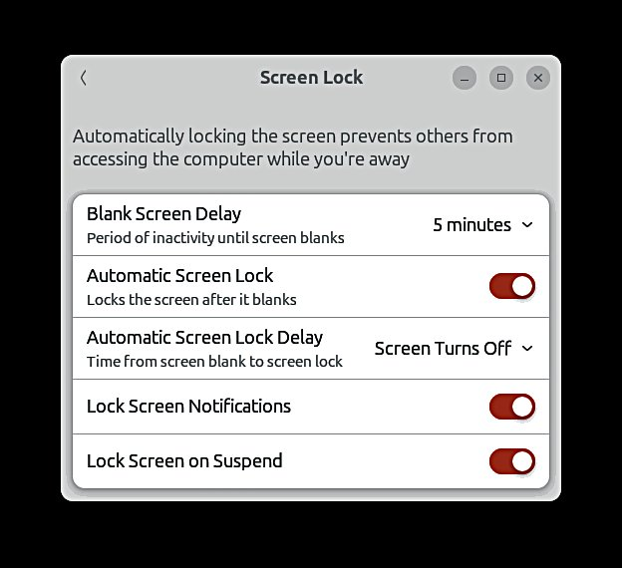
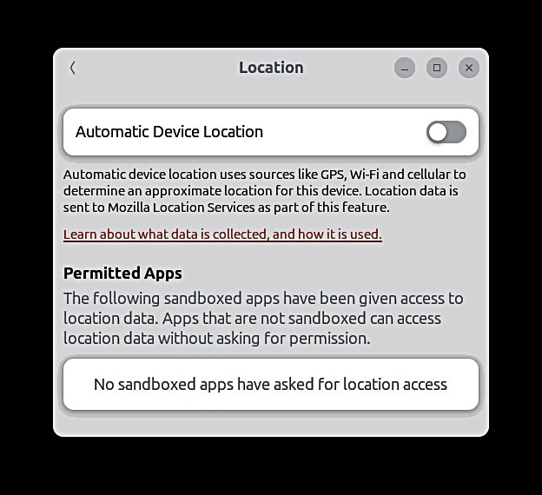
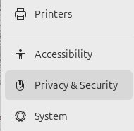

Basic settings
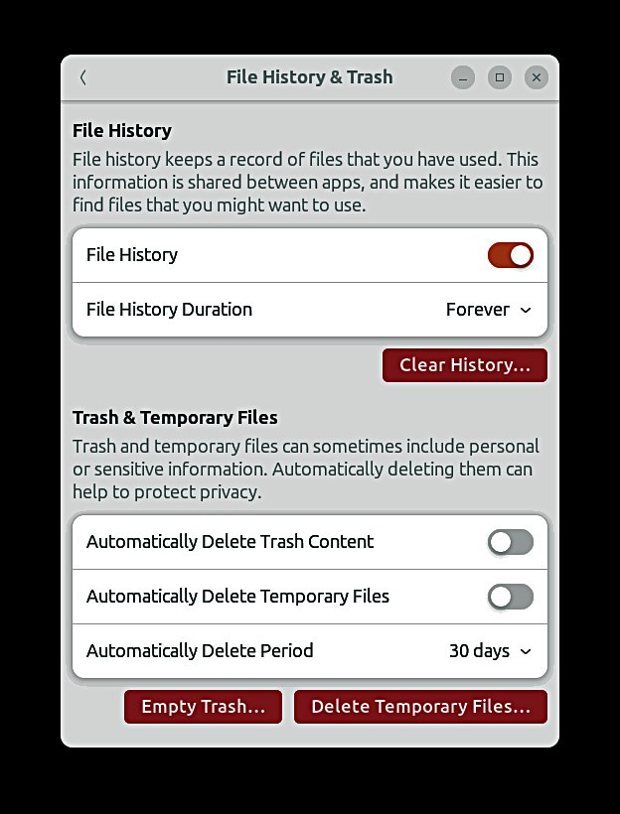

39
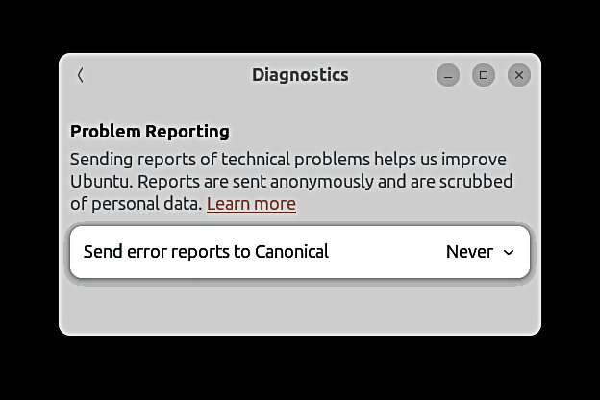
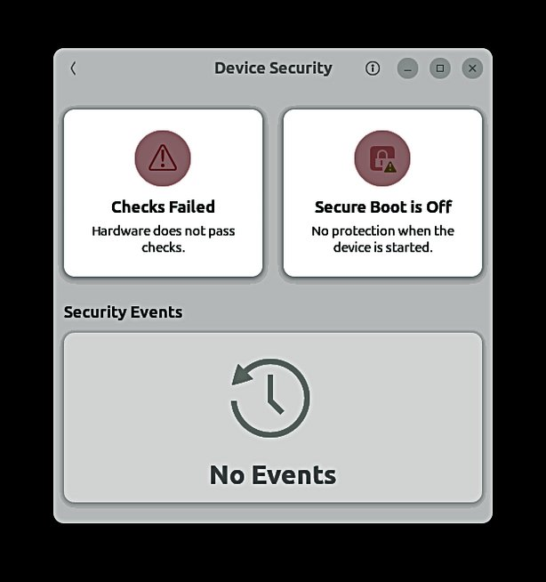
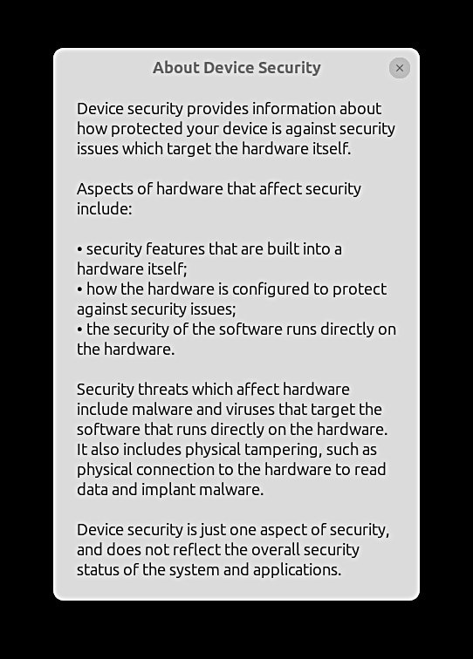
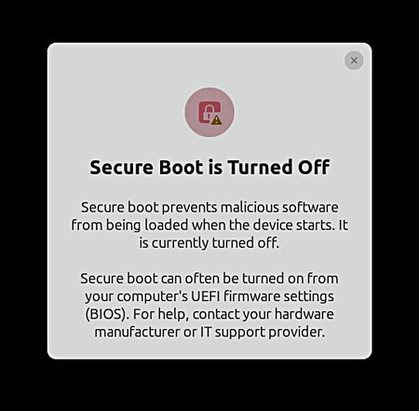
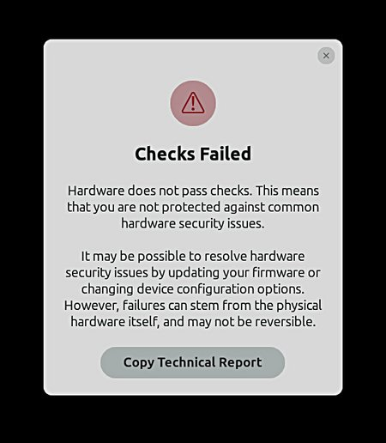

Basic settings
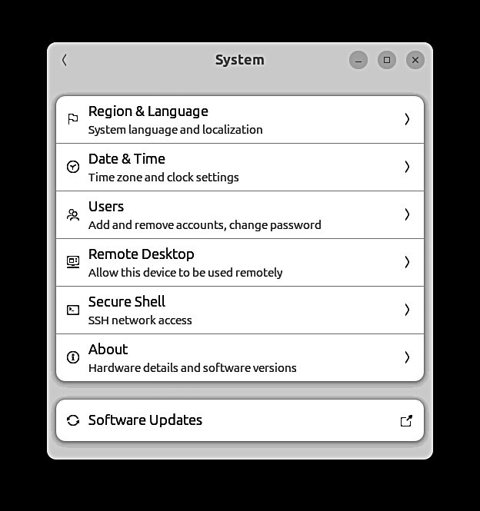

Next pages
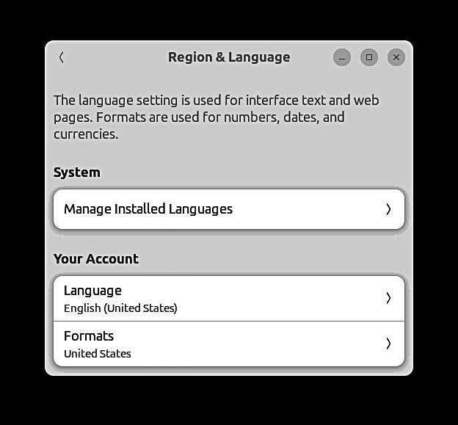

Next page
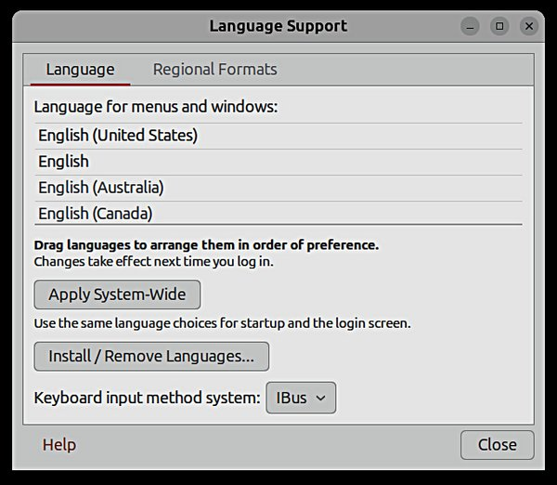

40
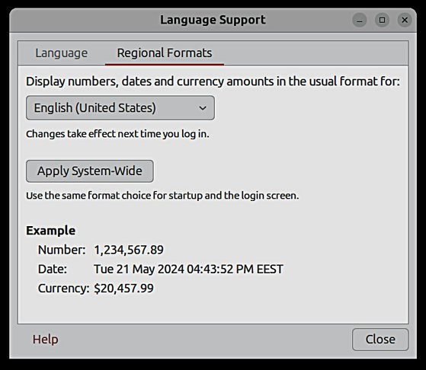
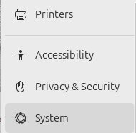

Basic settings
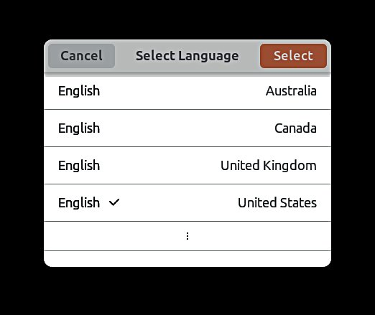

41
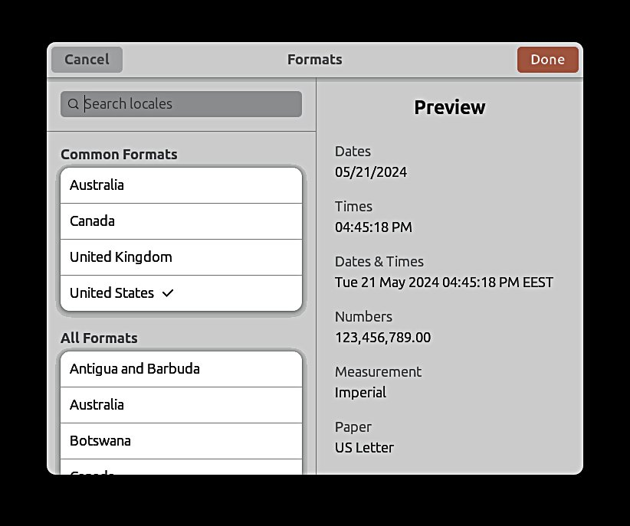
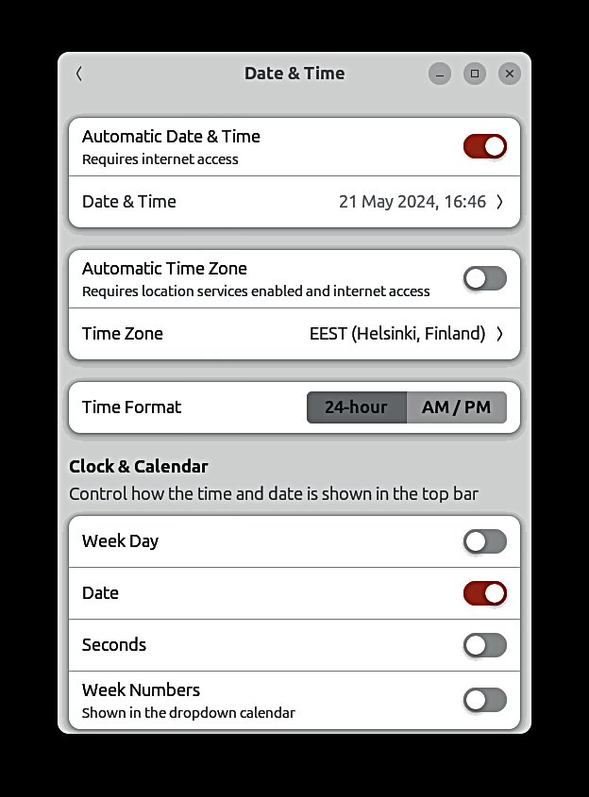

Basic settings
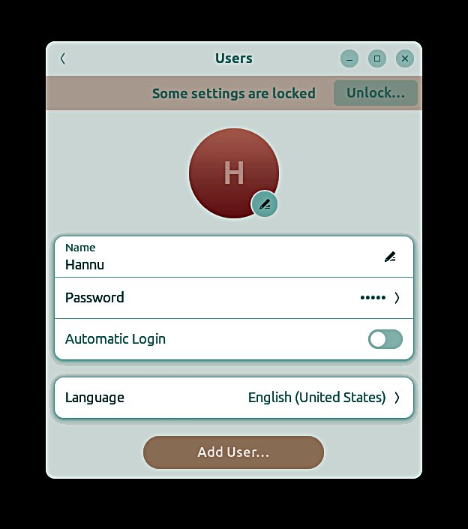

1.If you have one
user, then you are the
"Administrator" who has
great powers.
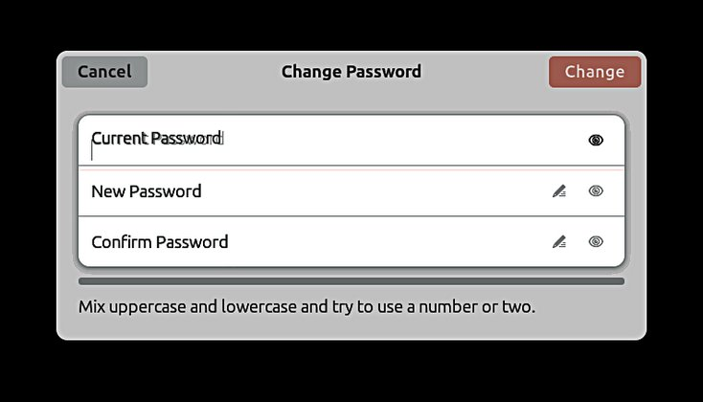

2.Password is important!
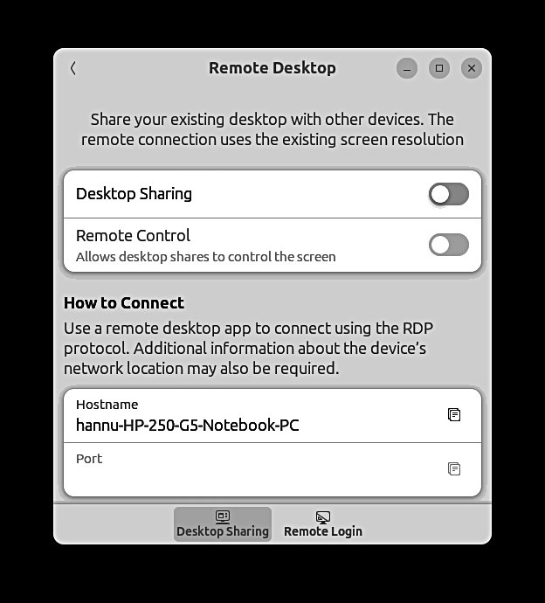

42
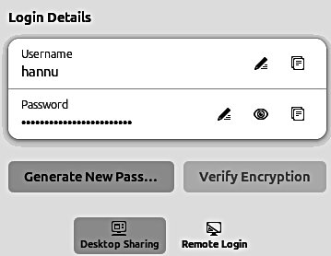

Basic settings
Look Ubuntu Desktop Guide: Log out, power off or switch users

1.Basic computer information.
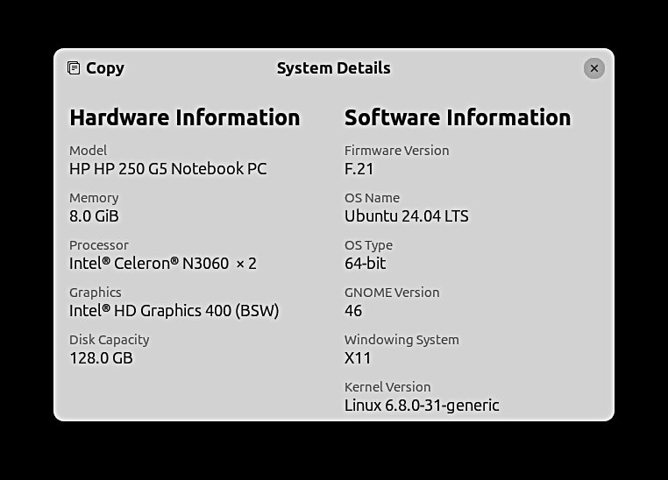

43
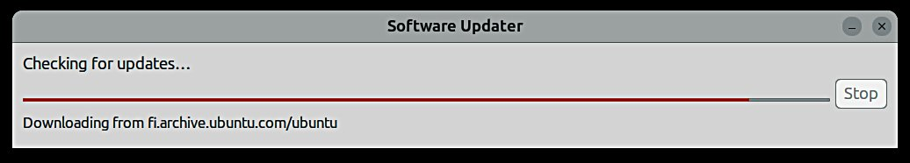
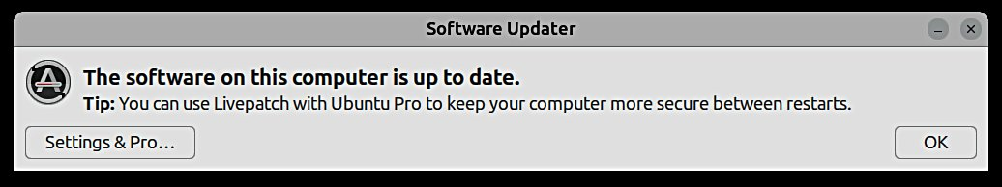
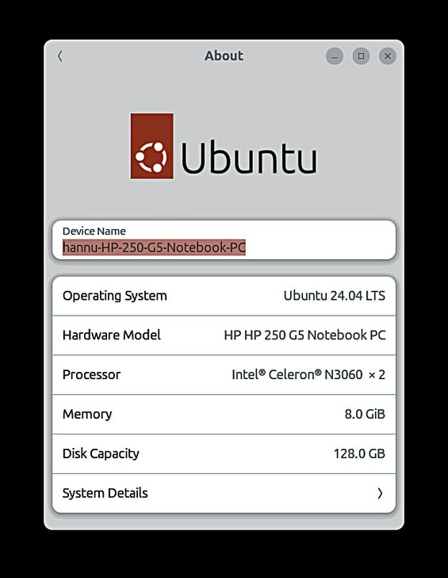
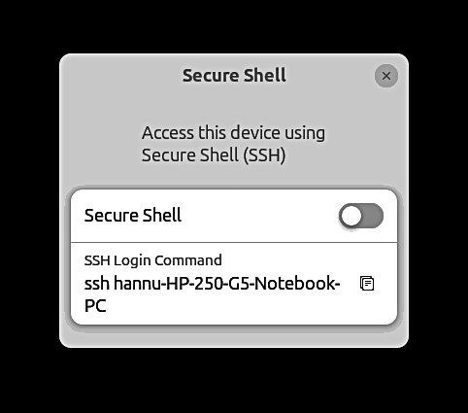

Basic settings

1.Do not change these settings unless
you know what you are doing!
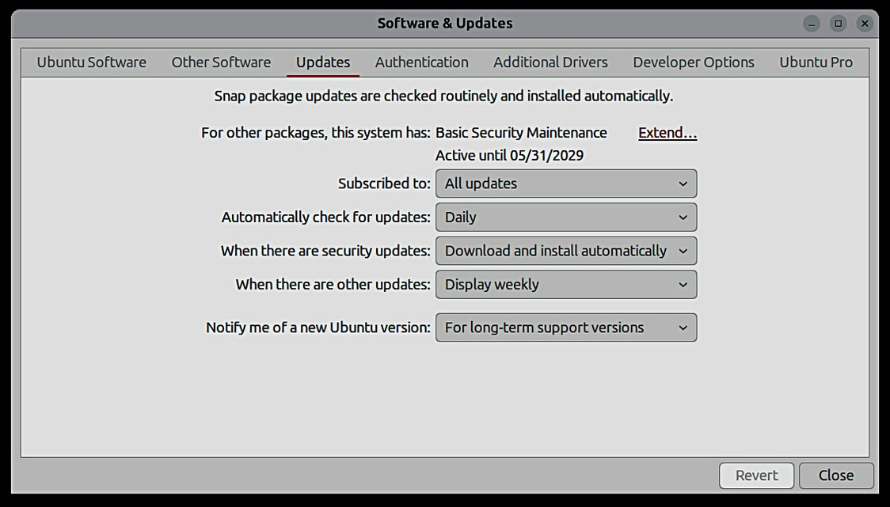

44
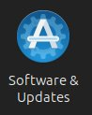
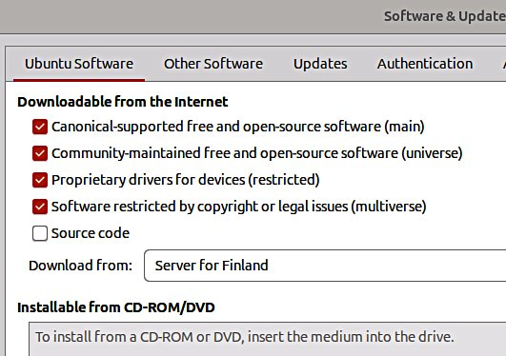

Basic settings
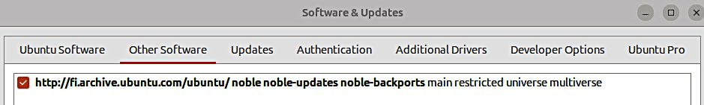

45
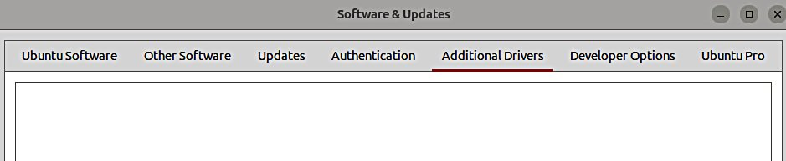
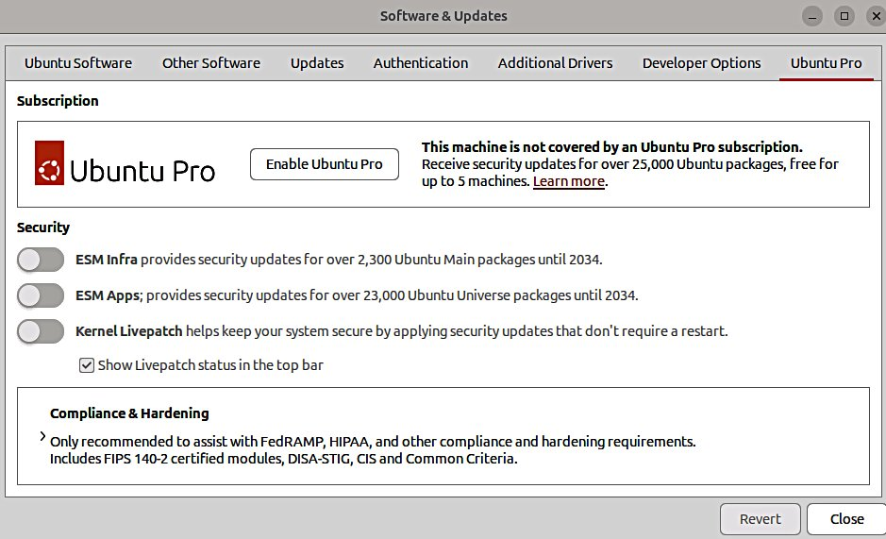
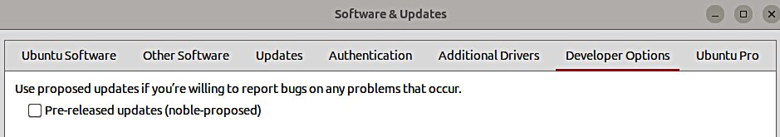
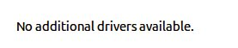
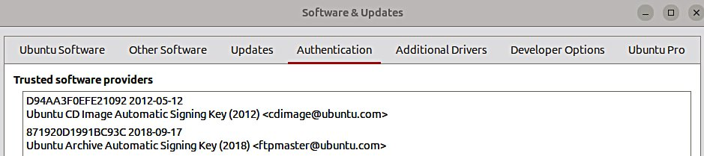
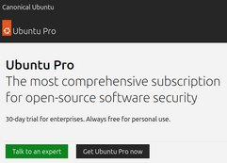

Introduction to installed Ubuntu apps

Click !
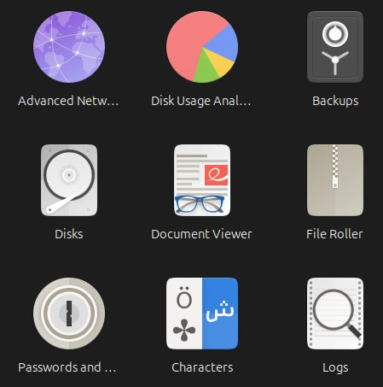

1. Backup guide is later in
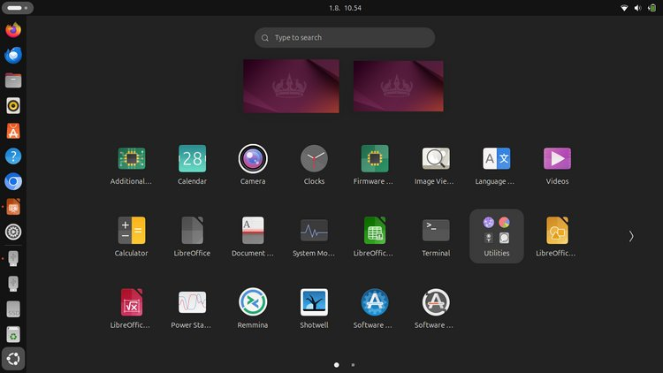
this manual.
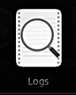

46
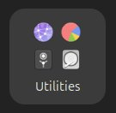
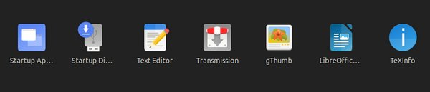

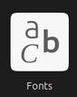
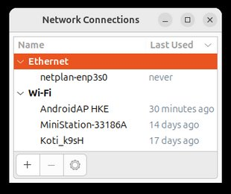
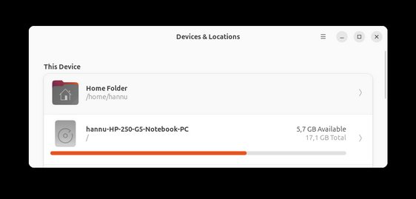
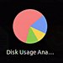
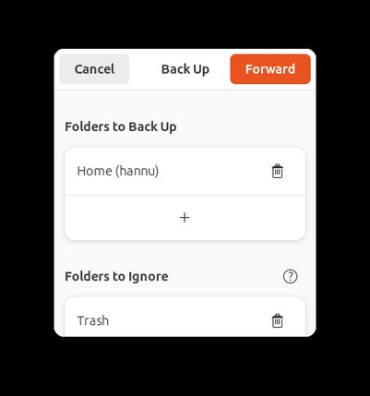
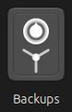
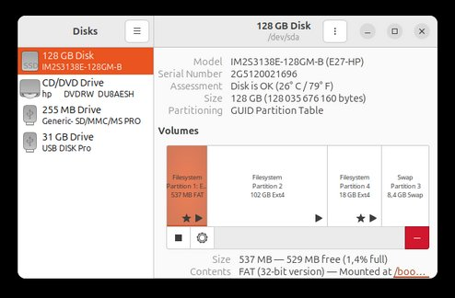
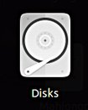
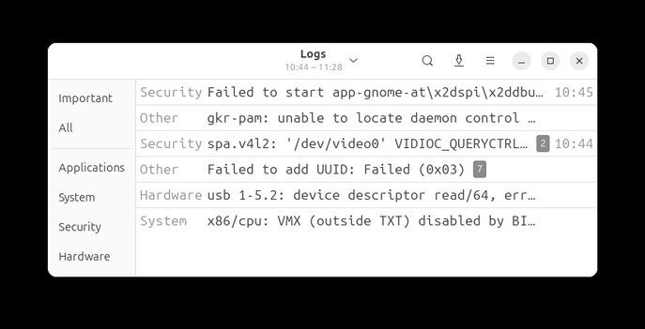

Introduction to installed Ubuntu apps
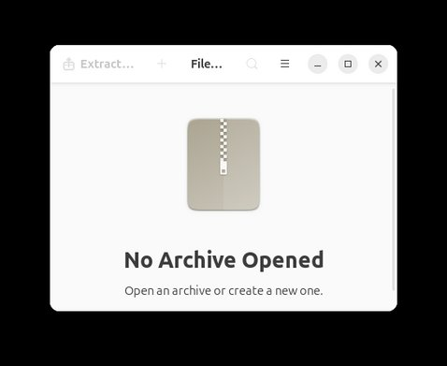

New Archive...
Open …
----------
Save as …
Manage archive files, for Password …
example, .zip or .tar files. F1 Text Integrity
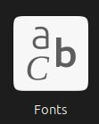
= Help Properties
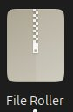
---------
View All Files
View as a Folder
Sidebar
---------
Keyboard Shortcuts
Help
About File Roller
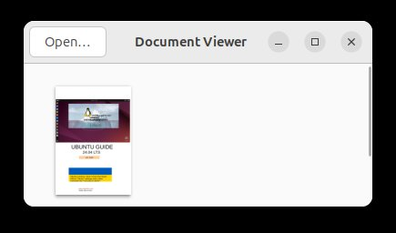

Read PDF-files
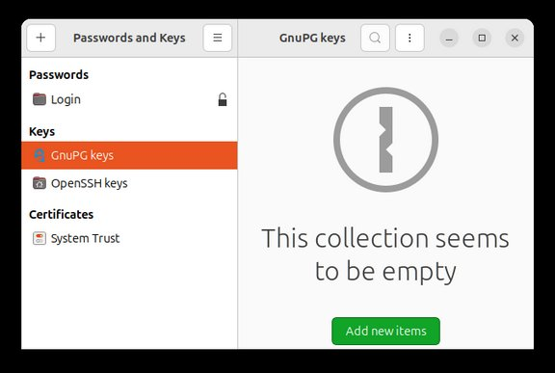

Press F1
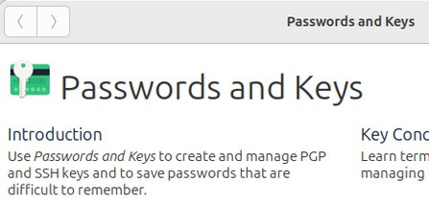

Find remote keys...
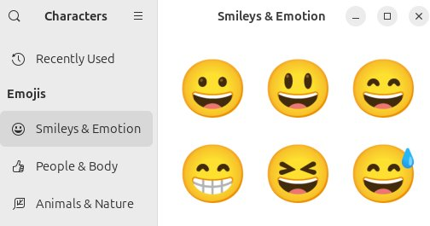
-Filter items-
Sync and puplish keys …
---------- Show personal
Show trusted
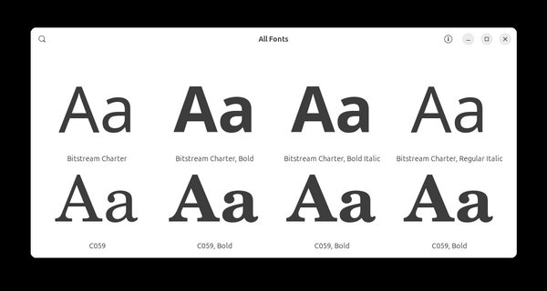
Preferences
Help Show any Keyboard Shortcuts
About Passwords and Keys

47

Introduction to installed Ubuntu apps

1.Press “prt sc”
This is very useful!
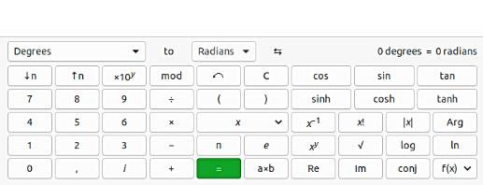

48
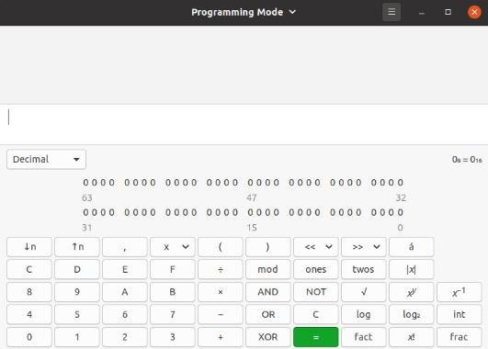
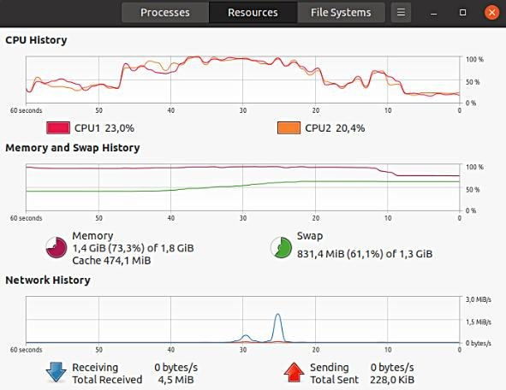
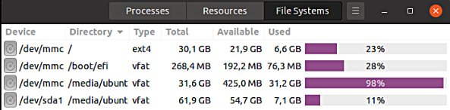
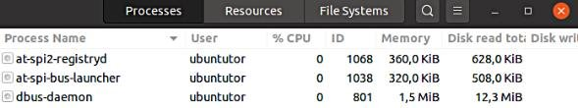
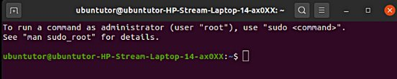
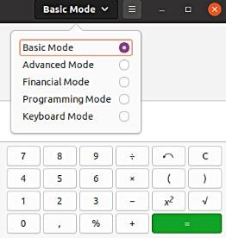
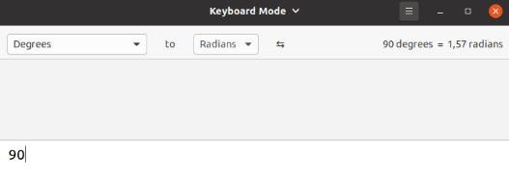
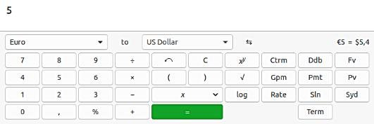

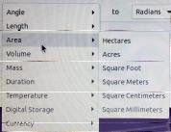
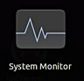
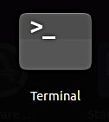
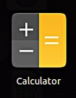
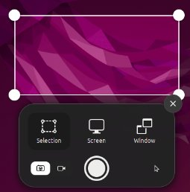
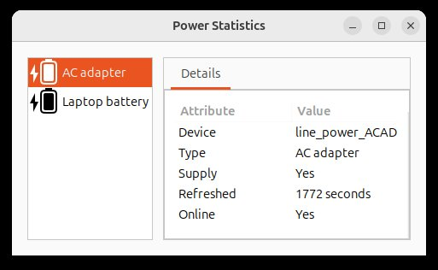
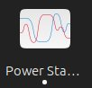

Introduction to installed Ubuntu apps

1.Ubuntu suggests updates automatically, but the user can decide on the timing of the upgrade.
For updating, Ubuntu will notify you of the Dock icon. Click the icon to start the update

2.You can also start the update
by clicking the icon

3.Updating asks for a
password.
This prevents unauthorized
updates and software
installations!
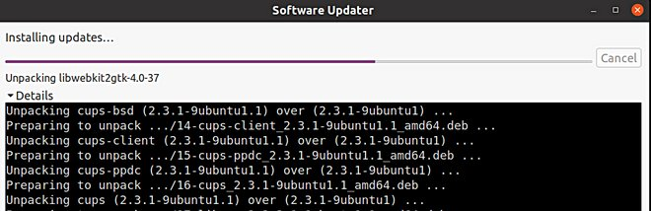

4.In the updates, you should click on
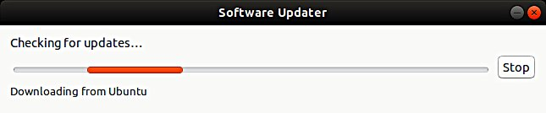
Details to see it. It's easier to track
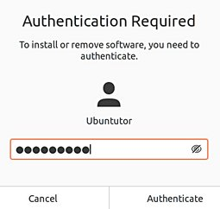
the progress of the update
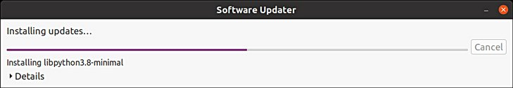

49
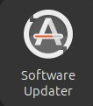
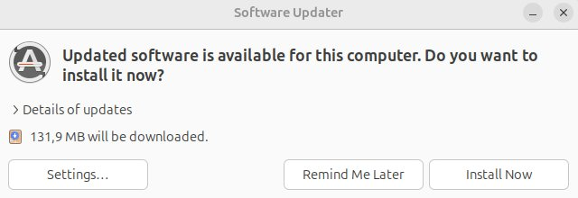
Command Prompt (Terminal)

1.The command line is one of the most powerful tools in the Linux system. If you have a problem and ask a Linux specialist, he will usually start by telling you what to do in the command line.
2.In this guide, I have not referred to the command line, because it is unfamiliar to the beginner. However, it is good to understand the basics of the mysterious command line.
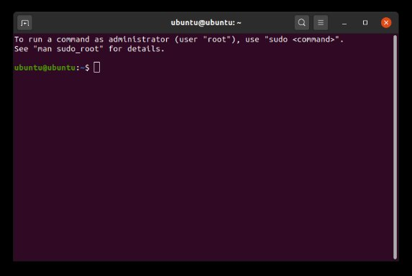

3.This is where the command is written.
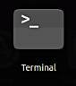
4.In particular, ”sudo" commands are required:
Start by writing the administrator password here
(note: the password cannot be seen here at all).
Press Enter.
After that you can give commands to the computer.

6. NOTE! If you start getting notifications that the machine's memory is running out, you should run the following command: sudo apt-get autoremove The program asks for a password, type it and press Enter. The program asks a couple more questions. After this procedure, the machine may have quite a bit of new free space.

5.For more information about how to use the command line, see the Help section, a couple of links below:
https://help.ubuntu.com/community/UsingTheTerminal
https://help.ubuntu.com/community/Beginners/BashScripting
https://ubuntu.com/tutorials/command-line-for-beginners#1-overview
https://techlog360.com/basic-ubuntu-commands-terminal-shortcuts-linux-beginner/
https://vitux.com/40-most-used-ubuntu-commands/
https://www.howtogeek.com/140679/beginner-geek-how-to-start-using-the-linux-terminal/

50
Install apps
Look Ubuntu Desktop Guide: Install & remove software

1.Applications that you can install
on your computer
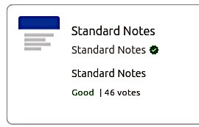

2.A more detailed presentation and
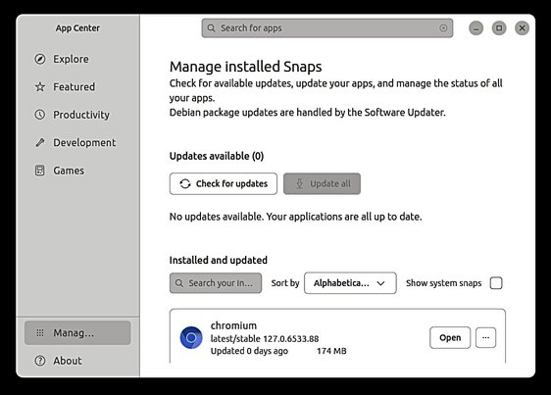
installation of the application
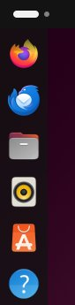

3.Programs on your computer.
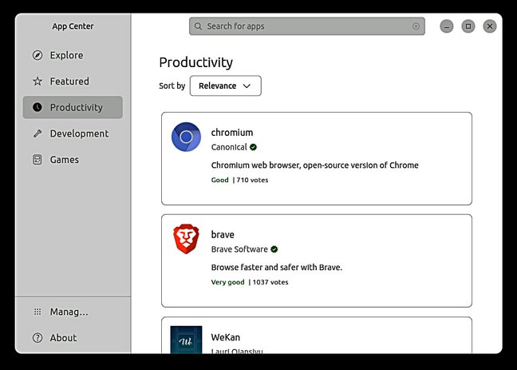
Here you can remove the application
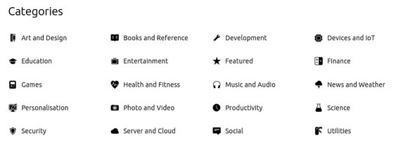

51
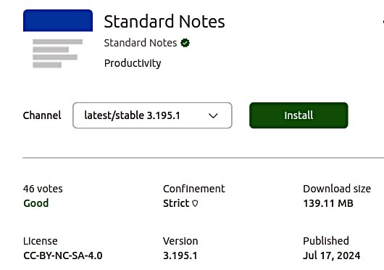
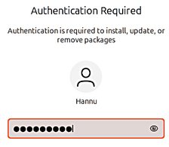
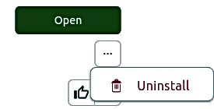
If you are planning to install a new app

Here are some tips when looking for a new application.
1. Compare different applications. Which would seem best suited to your needs.
2. Find comments and opinions about the app.
3. If you find the manual for the app, examine it. You can get good tips and ideas.
INSTALL ONLY RELIABLE SOFTWARE!

After installing the app.
1. Now you can properly explore the features and functions of the app
- if you collect a lot of data with the app, do you think the app will slow down?- can you divide the data into sections if needed so that the app works smoothly and the files are not too large.
- can you transfer older data to another storage medium.
2.Can you easily backup your data to another storage medium?
3. If you are replacing a computer, whether the app and data are successfully implemented on a new machine.
4. If the app fails, for example, it will no longer work after the update, can you access your own data files with another app.
5. Practice using the app first with training material, allowing you to figure out the features of the app and learn about its details.
6. Plan the use of the application (nomenclature, folder structures, backup, etc.).
7. When the job seems to work, start the actual use of the app.
Good luck!
----------
8. If you are unsatisfied with the app, you can easily delete it and look for a better app. In Ubuntu and Linux, this is easy. The apps are packages.

More information
How To Install Software in Ubuntu Linux: A Complete Guide for Newbie
Installing software in Ubuntu using .deb files
All the Possible Ways to Install deb Packages in Ubuntu Linux

52

Introduction to installed Ubuntu apps

LibreOffice Writer

LibreOffice Calc

LibreOffice Impress
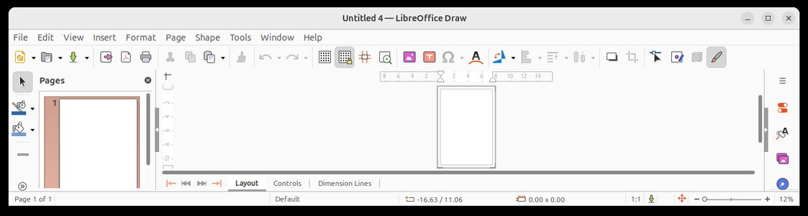

LibreOffice Draw
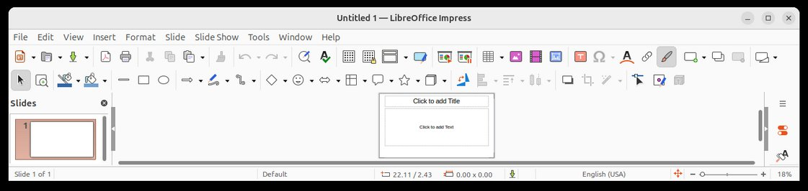
LibreOffice manual
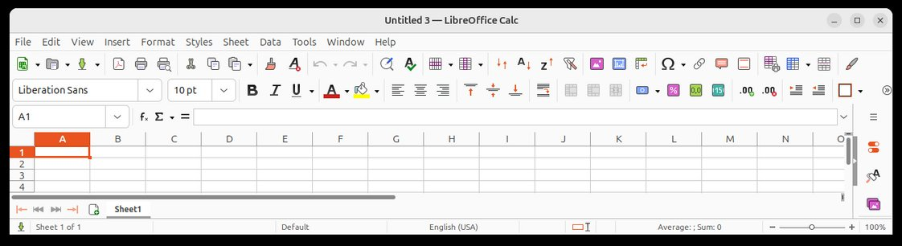
https://documentation.libreoffice.org/en/english-documentation/
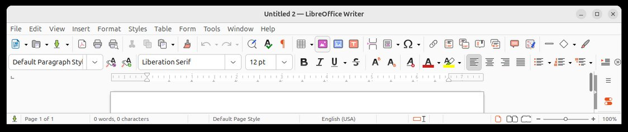
gThumb viewer (not installed, but I like it ;-) 1.Automatic color correction
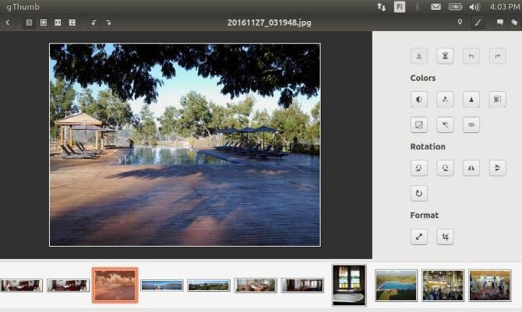

2.Automatic sharpening

3.Limiting the picture

4.The program can also
- sort the picture files
according to time
- rename and renumber
the picture files 53

Introduction to installed Ubuntu apps
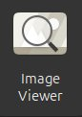

54
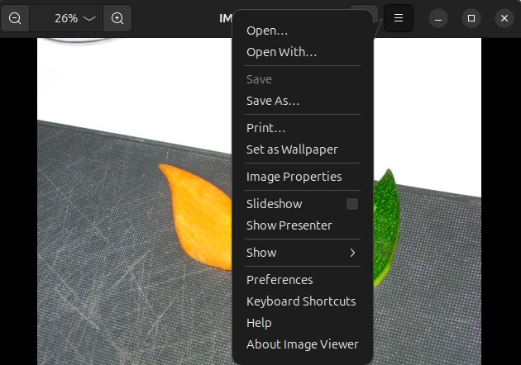
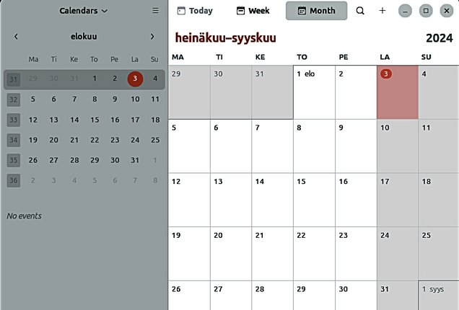
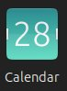
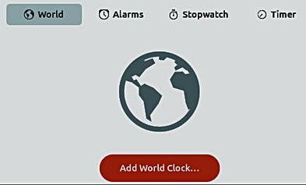
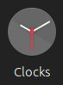
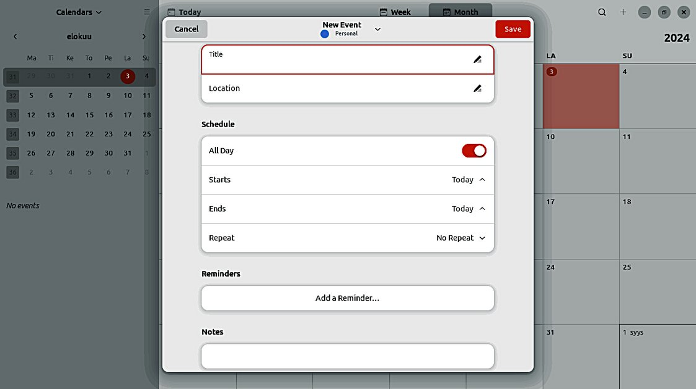
A bit about email

Ubuntu's email client is Thunderbird. When configuring your email settings, you should pay attention to the following things.
1. Do you want to keep your sent and received emails for a long time and process them easily? 2. Is it important for you to be able to read your emails easily on many different devices (phone, tablet, computer)
If point 1 is important, your choice is probably POP protocol
If point 2 is important, your choice is probably IMAP protocol.
Incoming and outgoing email

The location of the email before POP IMAP Email Server: Permanent location of emails Operators: webmail Thunderbird retrieves the messages on the server. Google: Gmail permanently to your computer. Running out of storage, buy more Storage space remains small.
Phone, pad, another pc
All devices see emails
until they are moved
to the PC, at which point Phone, pad, pc they disappear All devices see from these devices Email application: Email application: Thunderbird Thunderbird IMAP IMAP

The PC retrieves All devices can see emails Viewing method: to its own storage Phone, pad, another PC operator's email server. Emails are stored on the
Internet+webmail+
when username+password Thunderbird is opened. Messages remain on the IMAP lets you access your email Email application: operator's server until anywhere, on any device. When you Thunderbird Thunderbird is opened read an email message using IMAP, the
POP on your PC. message is not downloaded or stored on
Works abroad if your PC your computer, but is read directly from
Easy long-term is at home and your email service. This means you can storage of emails, as Thunderbird is not open. check your email on different devices, well as sorting. NOTE! If you delete a anywhere in the world: on your phone, Easy backup. message, it will be your computer, or a friend's computer.
deleted permanently
The POP setting connects to your email service and downloads all If you use your phone to handle new messages from there. Once they are downloaded to your emails, use the IMAP setting. computer, they are deleted from the email service. Once an email This way, your messages will be
message is downloaded, it can only be read on the same preserved when you change phones! computer. If you log in to your email on another device, messages
previously downloaded on the other device will not be available.
Messages are stored locally on your computer, not on the email server. More detailed instructions can be found
on the operators' websites.
REMEMBER TO MAKE A BACKUP COPY!
55
Links, nice reading for rainy days
Look Ubuntu Desktop Guide: Get more help

Ubuntu forum
https://ubuntuforums.org/ old
https://discourse.ubuntu.com/ new
Ubuntu Desktop Guide 24.04
Linux wiki
https://www.linux.org/
Using Ubuntu Linux
https://en.wikibooks.org/wiki/Using_Ubuntu_Linux
Ubuntu hardware support
https://wiki.ubuntu.com/HardwareSupport
Ubuntu help
https://help.ubuntu.com/community/TroubleShootingGuide

Ubuntu: A Beginner’s Guide
https://www.makeuseof.com/tag/ubuntu-an-absolute-beginners-guide/

The Complete Beginners Guide To Ubuntu
https://www.lifewire.com/beginners-guide-to-ubuntu-2205722

[PDF]Ubuntu Manual – Getting Started with Ubuntu 14.04
http://ubuntu-manual.org/

[Open Office manuaal PDF
https://documentation.libreoffice.org/en/english-documentation/getting-started-guide/

YOUTUBE VIDEOS YOUTUBE VIDEOS
Learning the Linux File System
https://www.youtube.com/watch?v=HIXzJ3Rz9po

OMG
https://www.omgubuntu.co.uk

HISTORY HISTORY
https://en.wikipedia.org/wiki/History_of_Linux
https://en.wikipedia.org/wiki/Ubuntu

56
Deja Dup Backup 1
1. Deja Dup backup. The program verifies everything user files. Restore restores the selected
files or all.
2. Define a backup of the HOME folder,
which includes files saved by the user
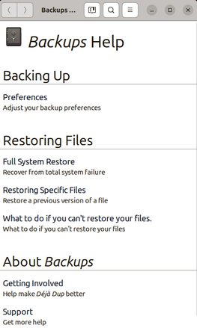
and email and browser related
user data (e-mails, addresses,
favorites etc) from Firefox and Thunderbird.

Preferences
Keyboard Shortcuts
Help
About Backups
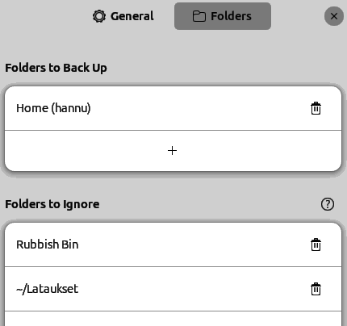

3. Define more folders!
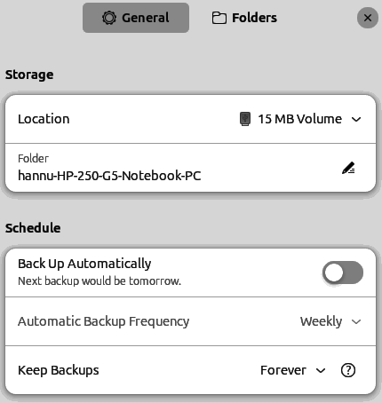

4. Define the folders you don't
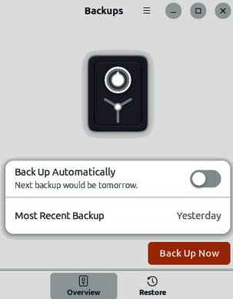
want to copy.
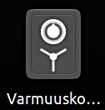

5. Start the backup.
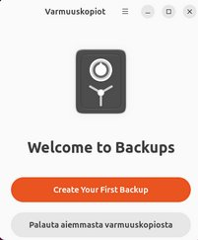

6. The backup can be located
on a hard disk or e.g. memory stick
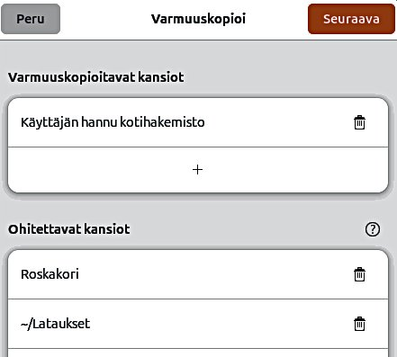

7. Choose a memory device with enough space.
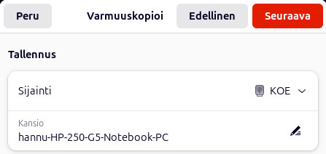
(usb disk, usb memory stick) 57
Deja Dup Backup 2

1. Automatic backup reminds
of making a backup if it doesn't
succeed automatically.
The first backup takes time
for a long time, the next ones go quite quickly.
BACKUP
NOT TO BE MISSED!
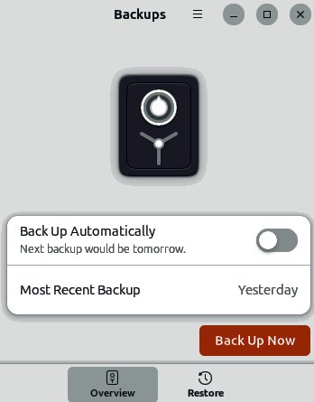

2. You can restore all
or only selected
folders and files

3. Select a return location

4. Backup folder
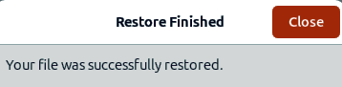

58
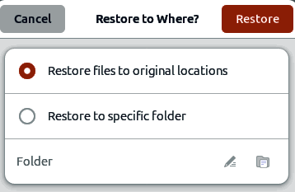
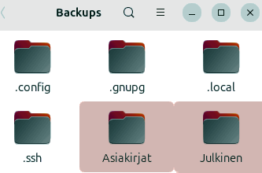
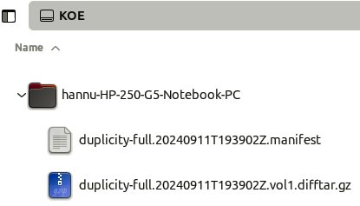
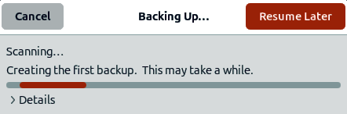
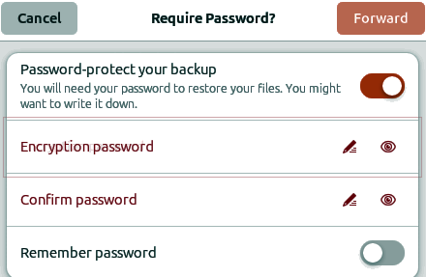
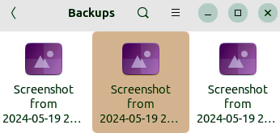
Backup strategy!
Look Ubuntu Desktop Guide: Tips & tricks

0. Remember to take backups! Here are some ideas about backing up.
1. Take a copy of the HOME folder to a memory stick or USB hard drive. Before that, check the size of the HOME folder, and check the free space in the backup memory storage.
You can change the backup HOME folder name slightly by adding the backup date to the name to find the latest backup, eg, 20180305 HOME.
NOTE! The HOME folder also contains hidden files, such as Firefox bookmarks and Thunderbird emails and email addresses.
After you have backed up your files, you should make sure that the backup was successful.
2.Keep the Ubuntu installation usb stick. Then it's easy to reinstall Ubuntu. a. Install Ubuntu first and then
b. Restore your own files with Deja Dup.

3.It is very unlikely, but … if Ubuntu will not start at all!

4.You should prepare for this by making a Boot-Repair bootable usb stick.
Boot-Repair automatically or semi-automatically fixes startup problems:
https://help.ubuntu.com/community/Boot-Repair

Guide:
1. Go to the link page
2. According to the instructions, copy the Boot-Repair iso file 3. Install Rufus (it's easier to do with Windows)
4. Make Boot-Repair bootable usb stick
5. Put the usb stick on the problem computer and boot 6. Boot-Repair will most likely repair the bug and Ubuntu is again available. 7. No user files in this operation will be lost.

On the following pages are new additions, I have attached to this guide.


I wish good Ubuntu moments!
59
A little about image processing 1.1

1. Going on a holiday trip? 2. After the trip. Multiple cameras and phone cameras? Processing and assembling images. → Same date and time for all cameras! Two phones with the same type =>
Can have the same names with files! =>
Rename images on another phone.
3. Image processing
1. Collect the images in the same folder, copy them, don't move, for security 2. Sort images by time of capture (metadata)
3. Rename images (Number order)
4. Select the best images for the new folder
5. Handle images (Crop, Improve)

gThumb image viewer
4. Install the gThumb.
It is a handy little program that can do important things.

5. gThumb, click left or right to get the menus 6. menus
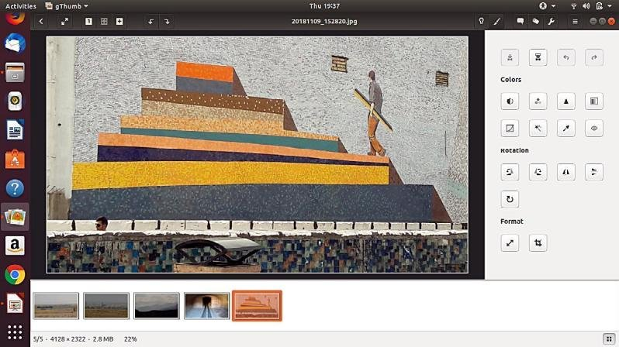

8.Next
picture 9.tools
7. return
10.Previous
picture

11.the list

12. NB! In System Preferences, you can specify Details → Default Applications → The image always opens in gThumb or ->
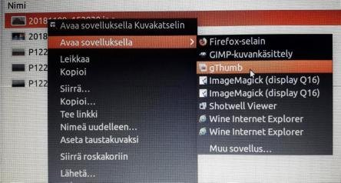

13. Click on the file on the left
Open with app
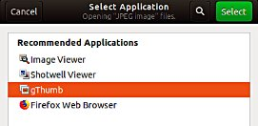
Select gThumb

60
gThumb image editor - Editing images 1.2

1. gThumb 2.Images to be processed First picture

3. Adjust the contrast, colors, and sharpness. Accept

4. If necessary, straighten the image
Use the +or- buttons to adjust the slope

5. Crop the image area
Accept all actions with the Accept button 6. Try moving the curve
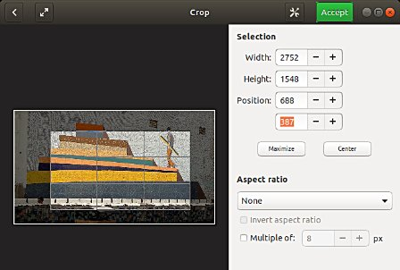

7.Save to the original 8.Save as new and
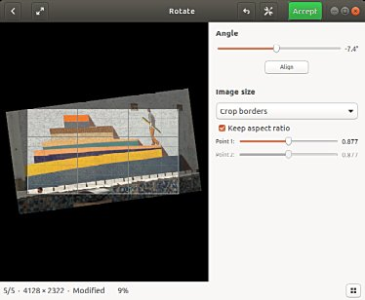
adjust the packaging
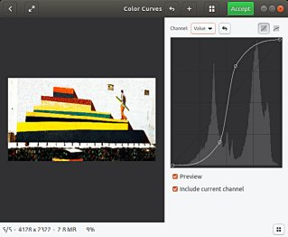

61
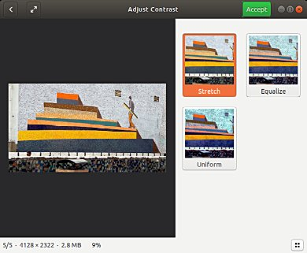
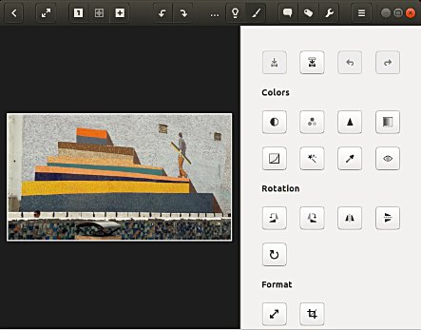
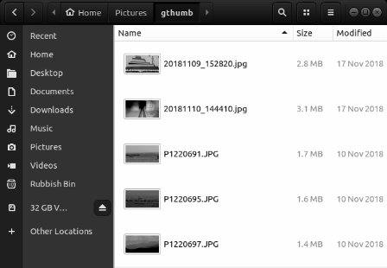
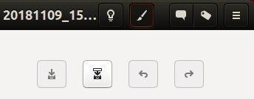
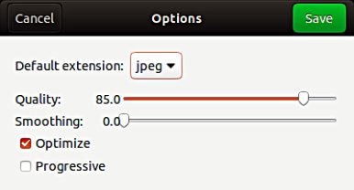
gThumb image editing software - sorting images 1.3
1.Select the first image 2.Two options for sorting, click

gThumb image editing software - naming images

3.Select the images to be named 4.Enter a new name.
You'll see the change right away.

Press F2

Click
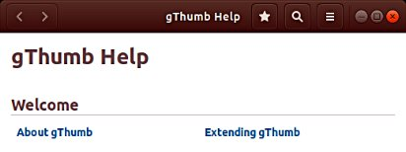

5.Instructions here
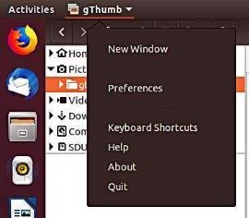
62
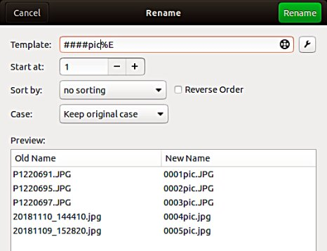
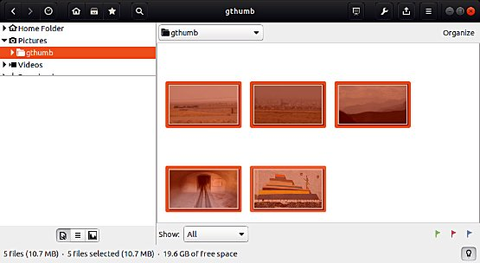
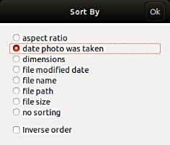
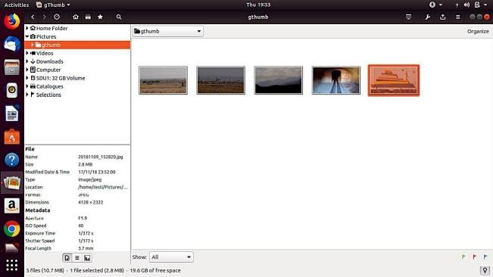
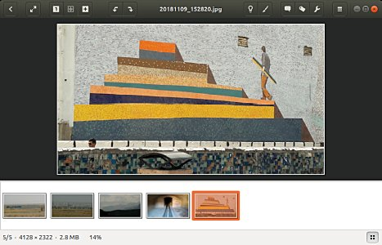
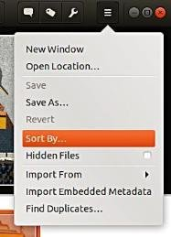
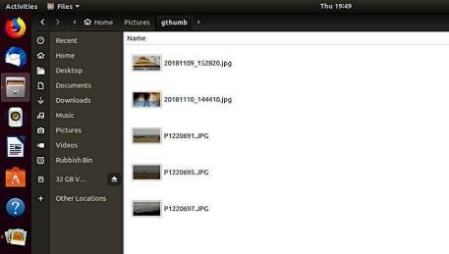
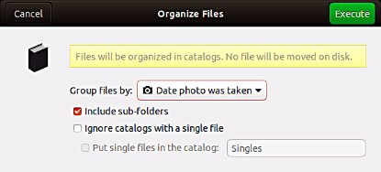
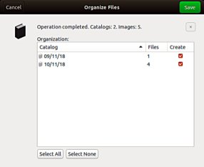
gThumb - Reduce the size of the images 1.4

1. Pictures before reduction

2. Open gThumb and highlight the files you want

3. Select tools

4. Select
Resize Images…
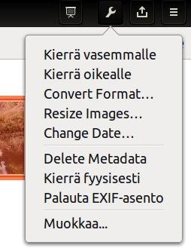

5. Decrease size with -
First try 70%
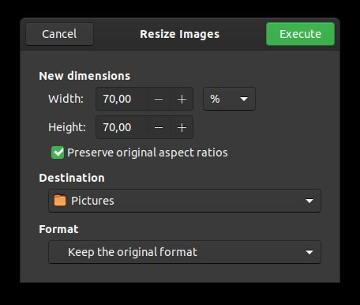

6. Select a new storage location and
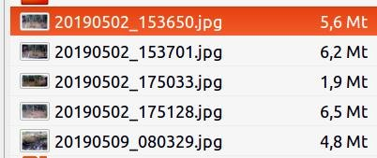
"Execute"

7. New file size. Compare the quality
of the images with the originals.
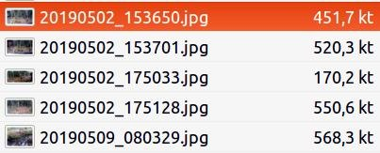

63
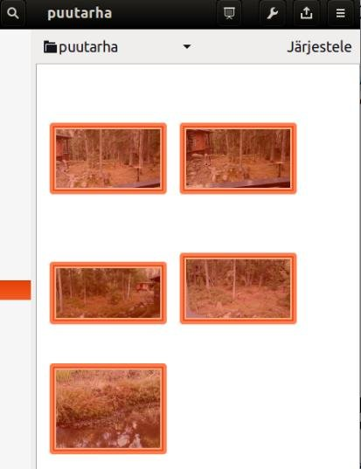
Liite 3.1
Muistivälineen (USB/Kortti) uudelleen nimeäminen

Muistiväline voidaan nimetä joko
formatoinnin ( alustuksen ) yhteydessä
tai ”Levyt” huolto-ohjelmalla
myöhemmin

Format

Uusi nimi
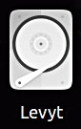

1. Käynnistä ”Levyt” ohjelma

2. Tarkista, että käsittelet oikeaa Taltiota (muistia )!
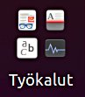

3. Pysäytä klikkaamalla 4. Klikkaa
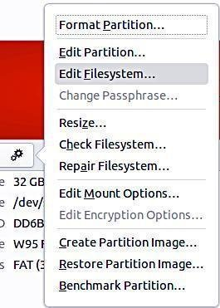

5. Valitse ”Muuta tiedostojärjestelmää…
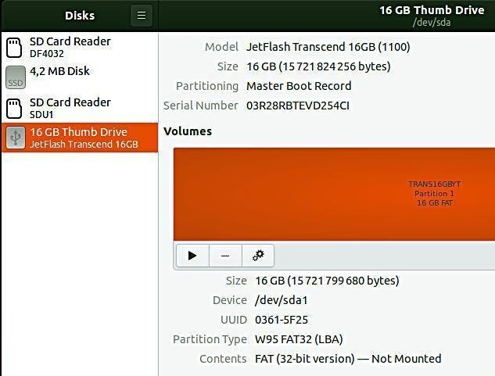
( Ohjeen loppu puuttuu,
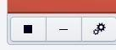
Harhaanjohtava )
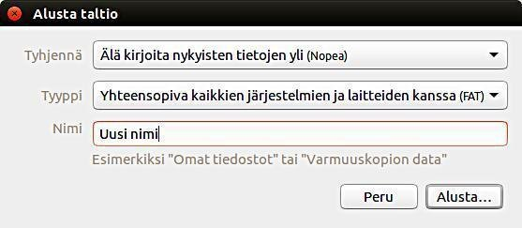
6. Kirjoita uusi nimi 64
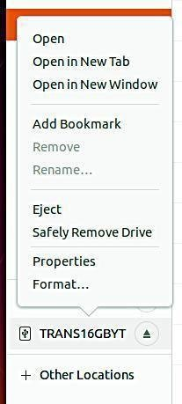
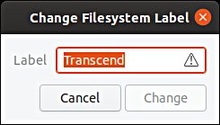
Ubuntu installation 4.1

1.Interested in Linux Ubuntu? Browse this guide

2.Prepare a USB stick for you to try Ubuntu See next pages for instructions (or CD)
The experiment does not permanently
3.Try Ubuntu with a USB stick change anything on your machine. If the
experiment fails, your machine may be too
old.
4.You decide to install Ubuntu A good decision!
First, check out the Ubuntu Forums so you
can ask for advice.

5.Do you also keep Windows? When booting, you can choose either
Windows or Ubuntu.

6.Back up your files and make Backup your files, emails, web links, etc!
reinstalling files! Also do a Windows Reinstall usb stick.

7.Perform the initial installation If you are unsure of your skills, install as
as recommended. recommended.

8.Explore and use Ubuntu. Please read this guide for details.

9.Change the settings as needed, Check out the Linux distros guide and help on the web. or explore new distros. You are becoming a Linux expert.

https://ubuntu.com/tutorials/tutorial-install-ubuntu-desktop#1-overview
https://www.linuxtechi.com/ubuntu-20-04-lts-installation-steps-screenshots/

65
Create a bootable Ubuntu USB stick 4.2
Windows computer.

0.Work on a Windows computer!
1. Go to https://www.ubuntu.com/download/desktop. 2. Select "Download Ubuntu 24.04 LTS" .
3. When downloading a program, you get an ISO file for your computer. 4. Start downloading Rufus from its web site. Install it by double-clicking the file you downloaded. Another option is Balena Etcher.
5. Insert a blank min 6 GT-usb stick into the computer. 6. Open Rufus. 7. Select USB stick
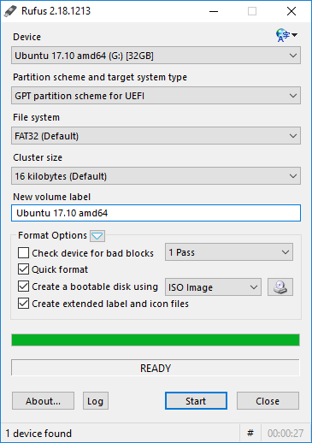

7a.Note: Bootable disk and ISO Image

8. Choose the downloaded
ISO file

9. Finally, click Start.
After that click
"Write in ISO image mode" and OK

10. Now, there should be a bootable Ubuntu USB stick ready.
11. Shut down the computer.
12. Do you know how to start your computer so that your computer open the bios?
When you succeed here, you will see a menu (make sure you do not mess with
the bios settings) from where to select the USB stick as the startup device and start the micro.
13. After that, Ubuntu should start up (it happens slowly because all the information is
downloaded from a USB stick.
14. Choose "Try Ubuntu" in the menu.
15. As a precaution, it is recommended that you keep your Ubuntu USB installer stick in
storage if for some reason you will have to install Ubuntu again.

Rufus
https://www.techspot.com/downloads/6062-rufus.html

66
Create a bootable USB stick on Ubuntu 4.3 Ubuntu computer.

0. Instructions can be found here https://en.wikipedia.org/wiki/Ubuntu#Installation 1. Go to 24.04
( Create a bootable USB stick on Ubuntu ) 2. Select "Desktop image”.
3. When downloading a program, you get an ISO file for your computer. 4. Launch the Startup Disk Creator from the Application Range. 5. Insert a blank min 6 GT-usb stick into the computer. 6. Specify a .iso file.
7. Select USB stick.
8. Finally, select "Create Startup Disk".
9. The computer creates a startup disk.
10. Now, there should be a bootable Ubuntu USB stick ready. 11. Shut down the computer.
12. Do you know how to start your machine so that your machine open the bios?
When you succeed here, you will see a menu (make sure you do not mess with the bios settings) from where to select the USB stick as the startup device and start the micro.
13. After that, Ubuntu should start up (it happens slowly because all the information is downloaded from a USB stick.
14. Choose "Try Ubuntu" in the menu.
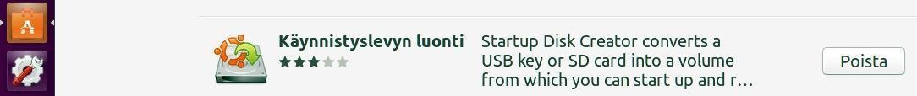

67
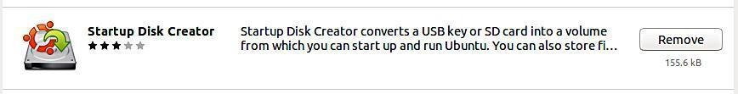
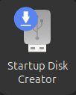
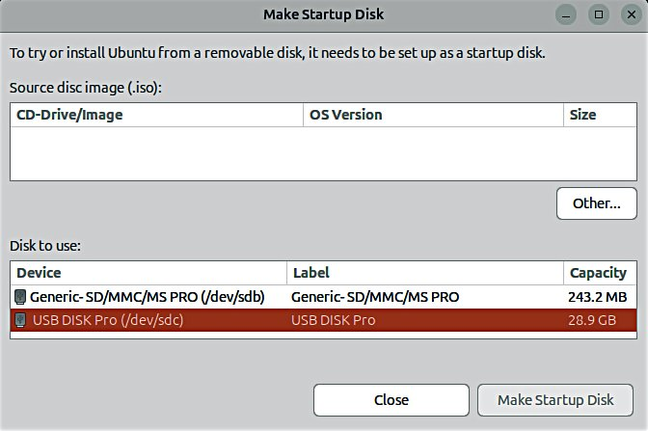
INSTALLING UBUNTU 5.1

Installing Ubuntu alongside Windows

Typical problem situations in current UEFI machines are: When you want to leave Windows alongside Ubuntu on the machine, fast startup of Windows 8/10/11 (Fast Startup)
- prevent Ubuntu installation from starting or
- starting the previously installed Ubuntu.
The problem is fixed by turning off fast startup in the power saving settings in Windows.
Uninstalling Windows Fast Startup:
Win10->settings->system->power and sleep mode->advanced power settings->select power button behavior->shutdown settings->uncheck the option: Enable fast startup.

https://www.tecmint.com/upgrade-ubuntu-22-04-to-24-04/
https://www.cyberciti.biz/faq/how-to-upgrade-from-ubuntu-22-04-lts-to-ubuntu-24-04-lts/

68
5.2
UPGRADING UBUNTU 1

Sometimes you will come across a situation where you need to update Ubuntu to a newer version.- the program informs you that a new version is available, do you want to update?- the version you are using is getting old and is no longer being updated Here are some thoughts on changing the version.
Warning: There may be long periods during the update where nothing seems to happen. See page 10 for information on monitoring the program.

A. Do you want to update to the new version according to the program recommendation ( if you have installed and removed several different programs, there may have been user data left in the memory, these will also be transferred to the new version as a "burden" ) Updates must be done in order 20.04 → 22.04 → 24.04 ), you cannot skip them! or
B. Do a completely new "clean installation" with the new version. Remember that this does not copy your own data! You will have to transfer it separately. Before installing, make a backup of your own files!
Search online for instructions on how to update.
In both cases, take the following precautions:
1. Back up all your data. Use DejaDub
backup, for example. Make backups to removable storage. ( 2. Make another backup directly to removable storage with the copy command). 3. Make a copy of the entire Firefox and Mozilla hidden folders (= emails and bookmarks). Home/.thunderbird
Home/.mozilla (firefox)
Recover the Chromium characters.
(Note! These can be found in the DejaDub backup, but it is much easier to handle them separately).
4. Make a note of all the programs you installed yourself so that you can easily reinstall them. 5. Make a note of the usernames and passwords for all your programs. You will need them when you have to reinstall programs.
6. Just to be on the safe side, make a live USB stick of the Ubuntu version you want and also of the existing version.

https://www.tecmint.com/upgrade-ubuntu-22-04-to-24-04/
https://www.cyberciti.biz/faq/how-to-upgrade-from-ubuntu-22-04-lts-to-ubuntu-24-04-lts/

How to Export, Save, and Import Chrome Bookmarks ...
https://www.hellotech.com/guide/for/how-to-export-save-import-bookmarks-in-chrome
Export Firefox bookmarks to an HTML file to back up or transfer bookmarks
https://support.mozilla.org/en-US/kb/export-firefox-bookmarks-to-backup-or-transfer
69
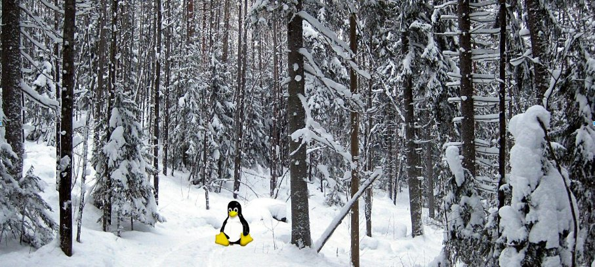
UBUNTU WEB-HOTELL 6.1

Ubuntu 24.04 & 22.04 guide (pdf) for beginner
www.ubuntutor.com
English 18.04 updated20201105 Suomeksi 24.04 uusittu 20200722
Ubuntu guide 16.04 Ubuntu ohjevihko 16.04
Ubuntu guide 18.04 Ubuntu ohjevihko 18.04 24.04 24.04
Some Linux distos
Guide 16.04 text file for Google Translator
Guide 18.04 text file for Google Translator
24.04
Visitors ubuntutor.com in October 2020 ;-)
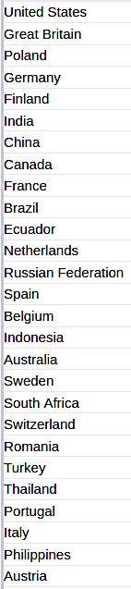

70
