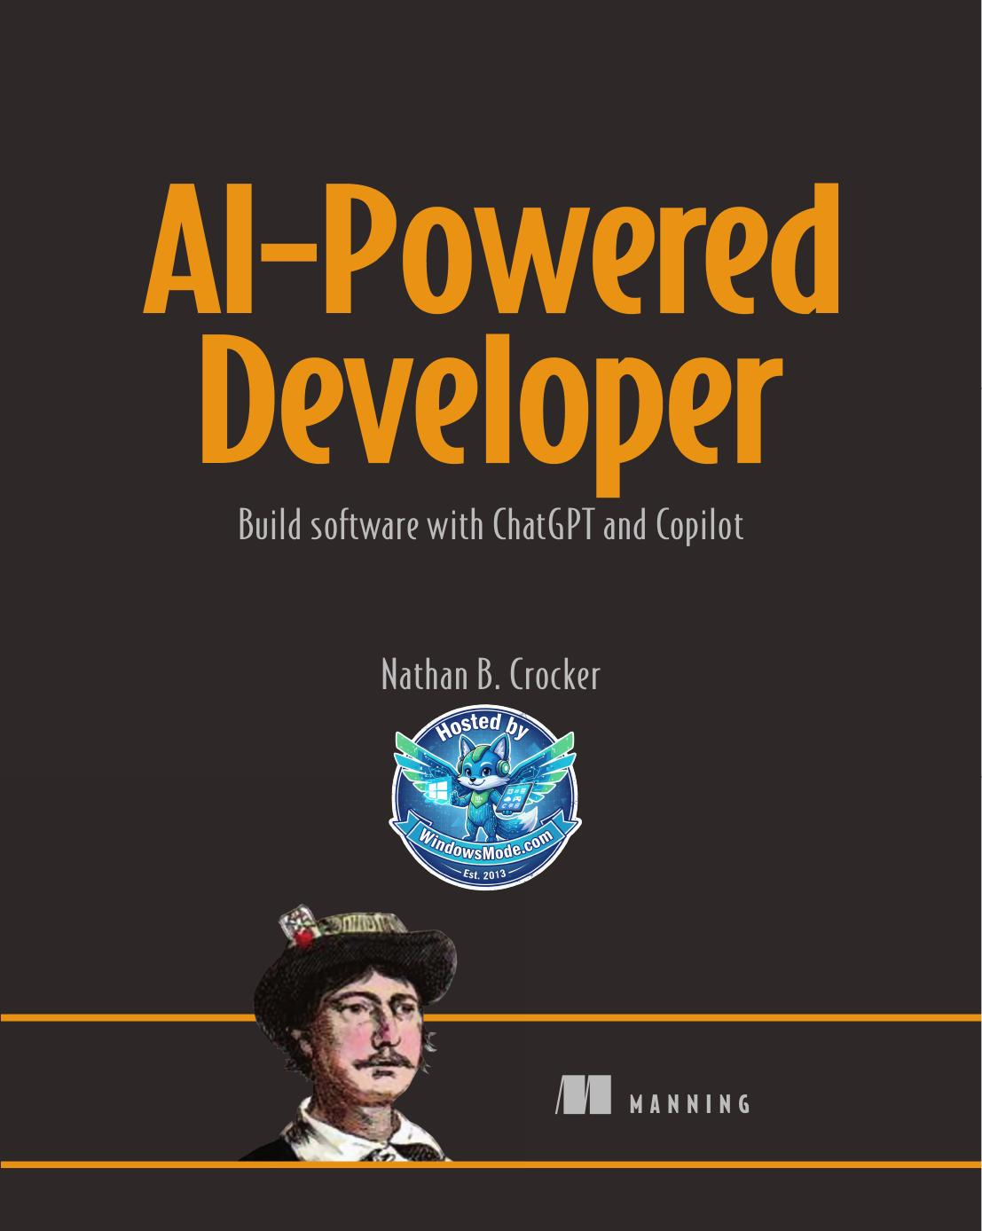

Table of Contents
chapter builds on the previous chapters. The last chapter can be read at any point after
Part 1
Part 2
chapter 2. Second, ChatGPT suggested that we have a constructor that takes all the
chapter (see figure 4.4). There are several items to note from this diagram: it contains
chapter will address this. After that, we will set up our database, fix the classes that
Part 3
Part 4
chapter about running an LLM locally. How might you describe GPT-4All?

Build software with ChatGPT and Copilot


Nathan B. Crocker


M A N N I N G





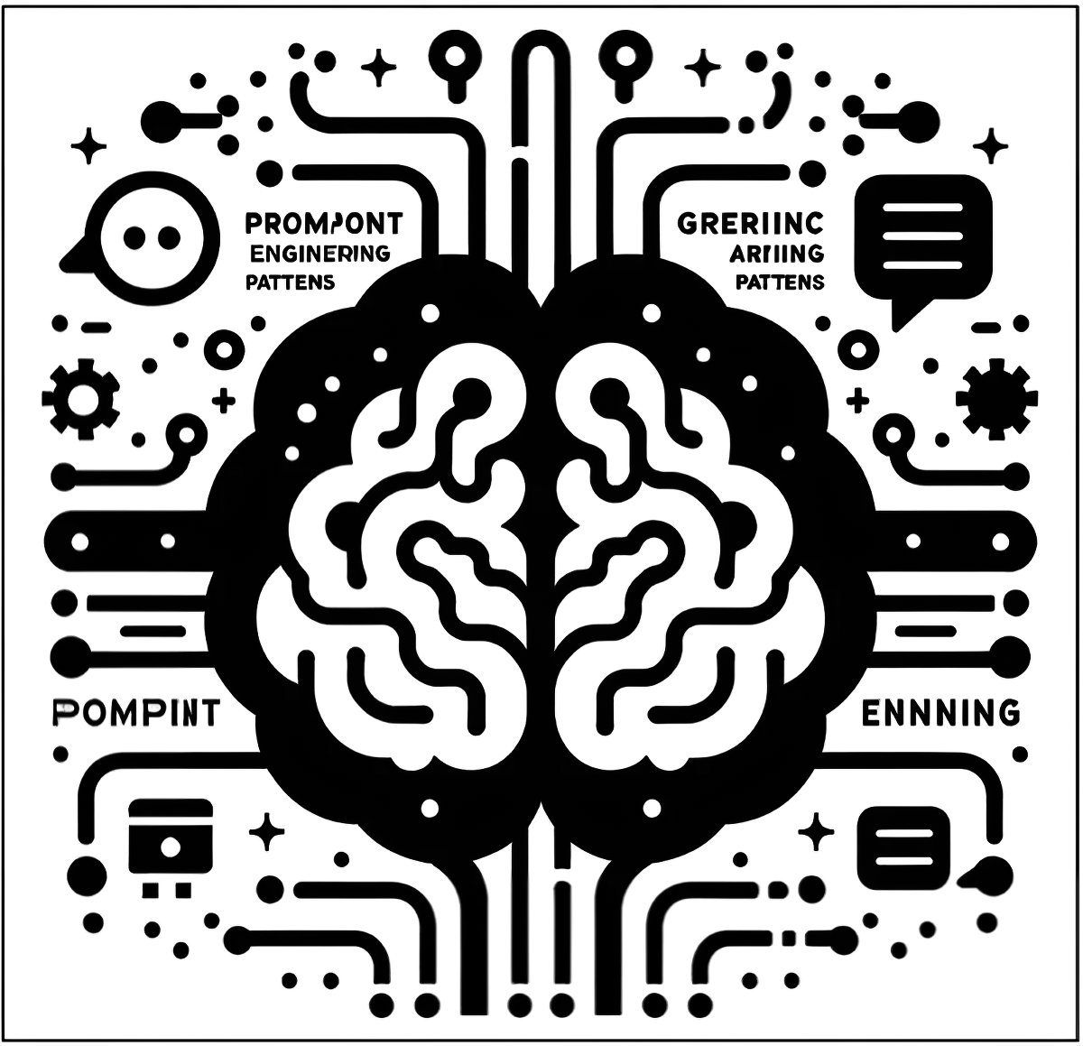
Prompt Engineering Patterns

¡ The Prompt Optimization Pattern: Enhances the user’s original prompt to
elicit more accurate, relevant, or comprehensive responses from the AI
to transform an initial, possibly vague or suboptimal prompt into one
that is clearer, more specific, and better suited for the AI’s capabilities.
¡ Refinement Pattern: Iteratively refining or improving the prompt to get
more accurate, relevant, or sophisticated responses.
¡ The Persona Pattern: Gives the AI a consistent voice and perspective,
making its responses more predictable and aligned with the user’s
expectations.
¡ The Audience Persona: A variation of the Persona Pattern, referred to as
the “audience persona pattern” in prompt engineering.

AI-Powered Developer

Build software

with ChatGPT and Copilot

Nathan B. Crocker

M A N N I N G
Shelter ISland

For online information and ordering of this and other Manning books, please visit www.manning.com. The publisher offers discounts on this book when ordered in quantity.
For more information, please contact
Special Sales Department
Manning Publications Co.
20 Baldwin Road
PO Box 761
Shelter Island, NY 11964
Email: orders@manning.com

© 2024 Manning Publications Co. All rights reserved.

No part of this publication may be reproduced, stored in a retrieval system, or transmitted, in any form or by means electronic, mechanical, photocopying, or otherwise, without prior written permission of the publisher.

Many of the designations used by manufacturers and sellers to distinguish their products are claimed as trademarks. Where those designations appear in the book, and Manning Publications was aware of a trademark claim, the designations have been printed in initial caps or all caps.

∞ Recognizing the importance of preserving what has been written, it is Manning’s policy to have the books
we publish printed on acid- free paper, and we exert our best efforts to that end. Recognizing also our responsibility to conserve the resources of our planet, Manning books are printed on paper that is at least 15 percent recycled and processed without the use of elemental chlorine.

The author and publisher have made every effort to ensure that the information in this book was correct at press time. The author and publisher do not assume and hereby disclaim any liability to any party for any loss, damage, or disruption caused by errors or omissions, whether such errors or omissions result from negligence, accident, or any other cause, or from any usage of the information herein.

Manning Publications Co. Development editor: Katie Sposato Johnson 20 Baldwin Road Technical editor: Nicolai Nielsen PO Box 761 Review editor: Dunja Nikitovic Shelter Island, NY 11964 Production editor: Andy Marinkovich
Copy editor: Tiffany Taylor
Proofreader: Jason Everett
Technical proofreader: Mark Thomas
Typesetter: Tamara ŠveliÊ SabljiÊ
Cover designer: Marija Tudor
ISBN 9781633437616
Printed in the United States of America
Dedicated to the memory of Catherine L. Crocker,

whose strength and love continue to guide me.

Though no longer beside us, her spirit and wisdom

remain ever-present.

Her legacy lives on in every word I write.

Gone from this world, but forever in our hearts.

contents

preface viii
acknowledgments x
about this book xii
about the author xv
about the cover illustration xvi

Part 1 The foundation .............................................1

1
Understanding large language models 3 1.1 Accelerating your development 4
1.2 A developer’s introduction to LLMs 9

1.3 When to use and when to avoid generative AI 10

2
Getting started with large language models 12 2.1 A foray into ChatGPT 13 Navigating nuances with GPT-4 13 ■ Charting paths with
GPT-3.5 18 ■ Navigating the AI seas: From the shores of
GPT-3.5 to the horizons of GPT-4 20

2.2 Let Copilot take control 21

2.3 Let CodeWhisperer speak loudly 23

2.4 Comparing ChatGPT, Copilot, and CodeWhisperer 25

iv
contents v v

Part 2 The input .....................................................29

Designing software with ChatGPT 31 3
3.1 Introducing our project, the information technology asset
management system 32

3.2 Asking ChatGPT to help with our system design 32

3.3 Documenting your architecture 36

Building software with GitHub Copilot 53 4
4.1 Laying the foundation 54
Expressing our domain model 54 ■ Favoring immutability 55
Decorating our favorite classes 57 ■ Adapting a strategy for
depreciation 61

4.2 Weaving patterns, patterns, patterns 63
Paying a visit to our department 63 ■ Creating objects in
a factory (pattern) 64 ■ Instructing the system on how to
build 68 ■ Observing changes 72

4.3 Plugging in ports and adapters 74
Hexagonal architecture in review 74 ■ Driving our
application 75 ■ Accessing our data and persisting our
changes 81 ■ Centralizing (and externalizing) our
data access 84

Managing data with GitHub Copilot and Copilot Chat 90 5
5.1 Amassing our dataset 91

5.2 Monitoring our assets in real time with Kafka 100

5.3 Analyzing, learning, and tracking with Apache Spark 107

Part 3 The feedback ............................................. 113

Testing, assessing, and explaining with large language 6
models 115
6.1 Testing, testing … one, two, three types 116
Unit testing 116 ■ Integration testing 121
Behavior testing 122

6.2 Assessing quality 125

vi vi contents

6.3 Hunting for bugs 128

6.4 Covering code 130

6.5 Transliterating code—from code to descriptions 131

6.6 Translating from one language to another 134

Part 4 Into the world .......................................... 141

Coding infrastructure and managing deployments 143 7
7.1 Building a Docker image and “deploying” it locally 145

7.2 Standing up infrastructure by copiloting Terraform 147

7.3 Moving a Docker image around (the hard way) 150

7.4 Moving a Docker image around (the easy way) 150

7.5 Deploying our application onto AWS Elastic Kubernetes
Service 151

7.6 Setting up a continuous integration/continuous deployment
pipeline in GitHub Actions 154

Secure application development with ChatGPT 158 8
8.1 Modeling threats with ChatGPT 159
Why it matters in today’s development landscape 160
How ChatGPT can aid in threat modeling 160
Case study: Simulating threat modeling with ChatGPT 163

8.2 Scrutinizing application design and identifying potential
vulnerabilities 166
Evaluating design problems 166 ■ Recognizing common
vulnerabilities 167

8.3 Applying security best practices 168
Setting the security mindset 168 ■ Continuous security
testing 169

8.4 Encrypting data at rest and transit 171
The importance of data encryption 171 ■ Data encryption at
rest 172 ■ Data encryption in transit 175

contents vii vii

GPT-ing on the go 178 9
9.1 Motivating theory 178

9.2 Hosting your own LLM 179
Baselining with ChatGPT 179 ■ Asking Llama 2 to spit out an
answer 180 ■ Democratizing answers with GPT-4All 186

appendix A Setting up ChatGPT 192

appendix B Setting up GitHub Copilot 197

appendix C Setting up AWS CodeWhisperer 205

index 217

preface

Welcome to AI-Powered Developer, your gateway to exploring the symbiotic relationship
between programming and artificial intelligence. This book is not just a narrative about
AI and its applications in software development—it’s an invitation to venture into the
uncharted territory of coding powered by cutting-edge AI models like ChatGPT and
GitHub Copilot. As you turn these pages, you’ll embark on a journey of exploration
and discovery, unearthing a new perspective on how AI can reshape and enhance the
coding landscape.
The essence of this book lies in its unconventional approach. Unlike most technical
literature, it doesn’t provide a rigid script to follow. This is because the book deals with
the application of large language models in software development, an area where out-
comes can be surprisingly diverse even when the input remains the same. Think of it
more like a compass guiding your way through an intriguing landscape of possibilities
rather than a map delineating a predetermined route.
AI-Powered Developer encourages you to experiment, ask questions, and, most impor-
tantly, be open to unexpected results. It will ignite your curiosity, spur your creativity,
and stimulate your problem-solving skills. The world of large language models like
ChatGPT and Copilot offers more than just coding assistance—it provides a transfor-
mative framework that has the potential to revolutionize software development at its
core.
At its heart, this book assumes the role of a mentor, a catalyst that nudges you to
venture beyond the familiar boundaries of traditional coding, encouraging you to
explore the intricate dance of AI and programming. It seeks to whet your appetite for
the untapped potential that these generative AI models bring to the table. Through a
myriad of real-world examples, hands-on exercises, and insights, you’ll not only learn

viii
preface ix ix

how to use these AI tools but also gain a deeper understanding of their functioning,
their potential, and their limitations.
Yet, as with any mentorship, the rewards of this journey are proportional to the pas-
sion, curiosity, and commitment you bring. By diving deep, asking questions, and chal-
lenging assumptions, you’ll gain not just technical skills but also a broader perspective
on what it means to be a developer in the age of AI.
This is an exciting time in the field of software development. AI and machine learn-
ing are disrupting traditional paradigms, offering new tools and methodologies that
can significantly enhance productivity, creativity, and efficiency. By integrating AI into
the development process, we can tackle more complex problems, streamline workflows,
and fundamentally transform the way we approach coding.
AI-Powered Developer is more than just a book—it’s a doorway to this new world, a world
that blends the logic of programming with the power and flexibility of AI. Whether
you’re a seasoned developer or an enthusiastic beginner, this book will equip you with
the tools, techniques, and knowledge to make the most of these advancements and
chart your own path in this evolving landscape.
Remember, every great journey begins with a single step. By choosing to read this
book, you’ve already taken that step. Now, let’s venture into the exciting world of intelli-
gent coding together. Enjoy the journey!

acknowledgments

Embarking on the journey of writing this book was no small endeavor. It required com-
mitment, dedication, and countless hours of meticulous labor. It was a path fraught
with challenges, but every step was an enriching experience, bringing me closer to the
vast and fascinating world of AI-powered coding. It’s a journey I couldn’t have begun,
let alone completed, without the support and contributions of some extraordinary
individuals.
My profound gratitude goes to my editor, Katie Sposato Johnson, who was instru-
mental in shaping this book. Her incisive comments, critical insights, and constructive
feedback helped refine my thoughts and transform them into a coherent, engaging
narrative. Her unwavering commitment and passionate involvement were invaluable to
this project.
A special note of thanks to my technical editor, Nicolai Nielsen, who is lead AI Engi-
neer at SymphonyAI, and is both a coder and content creator, creating educational AI
and computer vision videos on YouTube and courses that help people while scaling
his brands. Nicolai’s expertise and keen eye for detail kept me on my toes, continually
reminding me of how much more there is to learn in this expansive field. His inputs
were not just educational but humbling, shaping my understanding and keeping me
grounded.
I am deeply grateful to everyone at Manning for their relentless support throughout
this journey. Their professionalism, cooperative spirit, and commitment to excellence
have been an inspiration. They played a critical role in bringing this book to life, for
which I am immensely thankful.
To all the reviewers: Carmelo San Giovanni, Chad Yantorno, Christopher Forbes,
Dan McCreary, Dewang Mehta, Greg MacLean, Håvard Wall, Jeff Smith, Jim Matlock,
Jonathan Boiser, Louis Aloia, Luke Kupka, Mariano Junge, Maxim Volgin, Maxime

x
acknowledgments xi xi

Boillot, Mike Piscatello, Milorad Imbra, Peter Dickten, Philip Patterson, Pierre-Michel
Ansel, Rambabu Posa, Rebecca Wagaman, Riccardo Marotti, Roy Wilsker, Stefano Pri-
ola, Thomas Jaensch, Thomas Joseph Heiman, Tiago Boldt Sousa, Tony Holdroyd, and
Walter Alexander Mata López, your suggestions helped make this a better book.
My deepest gratitude is for my family—my pillars of strength. To my wife, Jenn, thank
you for being my rock and for the countless hours of patience, understanding, and love
you’ve poured into this endeavor. To my daughters, Maeve and Orla, you are my inspira-
tion—your joy, curiosity, and boundless enthusiasm fuel my endeavors. To all my family
members who supported me in myriad ways, thank you.
This book is a culmination of countless hours of effort, dedication, and teamwork.
I am deeply grateful to everyone who contributed to making it a reality. Thank you all.

about this book

AI-Powered Developer is your essential guide to mastering the integration of large lan-
guage models like ChatGPT and CoPilot into your software development process. This
comprehensive book delivers practical advice and showcases best practices, helping
you harness the power of AI to enhance your projects. From the do’s and don’ts of AI
implementation to real-world examples, you’ll gain the insights and tools you need to
elevate your development skills and stay ahead in the ever-evolving tech landscape.

Who should read this book?
Professional developers and enthusiasts alike should get value from this book.
Although the book is largely aimed at experienced developers, large language models
(LLMs) can be used to accelerate your learning because these tools can provide expla-
nations, code examples, and guidance on programming concepts. Experienced devel-
opers can use these tools to improve productivity, streamline coding processes, and
tackle complex coding challenges more efficiently. These tools can assist in generating
code snippets, debugging, and providing insights on best practices.

How this book is organized: A roadmap
The book is divided into four main parts, followed by three practical appendices for
setup assistance:

¡ Part 1: The Foundation
– Chapter 1 introduces LLMs, tracing their history and providing a conceptual
understanding of generative AI. It also advises on the appropriate and cau-
tious use of these technologies.

xii
about this book xiii xiii

– Chapter 2 offers a primer on starting with LLMs, comparing ChatGPT, GitHub
Copilot, and CodeWhisperer and detailing the initial steps in harnessing their
potential.
¡ Part 2: The Input
– Chapter 3 walks through designing software with the help of ChatGPT, using
an information technology asset management (ITAM) system as a project
example.
– Chapter 4 focuses on building software with GitHub Copilot, covering foun-
dational concepts like domain modeling, immutability, and design patterns.
– Chapter 5 delves into managing data with GitHub Copilot and Copilot Chat,
exploring real-time asset monitoring with Kafka and data analysis with Apache
Spark.
¡ Part 3: The Feedback
– Chapter 6 discusses the testing, quality assessment, and explanation processes
of software developed with LLMs, including bug hunting and code translation.
¡ Part 4: Into the World
– Chapter 7 covers coding infrastructure and managing deployments, from
building Docker images to setting up continuous integration/continuous
deployment pipelines with GitHub Actions.
– Chapter 8 addresses secure application development using ChatGPT, includ-
ing threat modeling and the application of security best practices.
– Chapter 9 explores the concept of “GPT-ing on the go,” including hosting
your own LLM and democratizing access with GPT-4All.

The appendices provide straightforward guidance on setting up ChatGPT, Copilot,
and CodeWhisperer, ensuring that you have the practical knowledge to begin your
journey in AI-powered development.
With the exception of the last chapter, this book is meant to be read in order, as each

chapter builds on the previous chapters. The last chapter can be read at any point after
the first.

About the code
You can get executable snippets of code from the liveBook (online) version of this
book at https://livebook.manning.com/book/ai-powered-developer. The complete
code for the examples in the book is available for download from the Manning web-
site at www.manning.com/books/ai-powered-developer and from GitHub at https://
github.com/nathanbcrocker/ai_powered_developer.
It is important to note that part of the value of this book is to work through the
examples using the recommended (and non-recommended) tools. An additional note
related to the source code is that these tools will rarely produce the same output, even
given the same input. You should not get frustrated or discouraged if your code is wildly xiv xiv about this book

different from the source code in the repository. The source code is provided for your
edification and for enhancing your learning, should you find it useful.
To get the most from this book, you will need a recent version of Python 3 with the
ability to install new packages. To run most of the infrastructure-related systems, you
will need to be able to install Docker images and run Docker containers.
This book contains many examples of source code, both in numbered listings and in
line with normal text. In both cases, source code is formatted in a fixed-width font
like this to separate it from ordinary text. In many cases, the original source code has
been reformatted; we’ve added line breaks and reworked indentation to accommodate
the available page space in the book.

liveBook discussion forum
Purchase of AI-Powered Developer includes free access to liveBook, Manning’s online
reading platform. Using liveBook’s exclusive discussion features, you can attach com-
ments to the book globally or to specific sections or paragraphs. It’s a snap to make
notes for yourself, ask and answer technical questions, and receive help from the
author and other users. To access the forum, go to https://livebook.manning.com/
book/ai-powered-developer/discussion. You can also learn more about Manning’s
forums and the rules of conduct at https://livebook.manning.com/discussion.
Manning’s commitment to our readers is to provide a venue where a meaningful dia-
logue between individual readers and between readers and the author can take place. It
is not a commitment to any specific amount of participation on the part of the author,
whose contribution to the forum remains voluntary (and unpaid). We suggest you try
asking the author some challenging questions lest their interest stray! The forum and
the archives of previous discussions will be accessible from the publisher’s website for as
long as the book is in print.
about the author

Nathan B. Crocker is the co-founder and chief tech-

nology officer (CTO) of Checker, an API-first solution
that connects the traditional capital markets infrastruc-
ture to the blockchain ecosystem. Using his expertise in
building digital asset infrastructure, Nathan now leads
the technological vision and development at Checker,
building its core infrastructure that enables new finan-
cial applications on the blockchain.

xv
about the cover illustration

The figure on the cover of AI-Powered Developer is captioned “Junger kroatischer Geb-
irgsbauer,” or “Young Croatian Mountain Peasant,” and is taken from a collection of
historical and folk clothing illustrations, published in 1912. Each illustration is finely
drawn and colored by hand.
In those days, it was easy to identify where people lived and what their trade or station
in life was just by their dress. Manning celebrates the inventiveness and initiative of the
computer business with book covers based on the rich diversity of regional culture cen-
turies ago, brought back to life by pictures from collections such as this one.

xvi

Part 1

The foundation

I
n part 1, we establish a comprehensive understanding of large language models (LLMs) and their significance in modern software development. This
part of the book traces the historical evolution of generative AI, providing a solid
conceptual framework for these powerful technologies. It emphasizes the impor-
tance of responsible and cautious use, guiding readers through the fundamental
principles and potential pitfalls of integrating AI into their workflows. Addition-
ally, this part offers practical advice on getting started with LLMs, comparing
popular tools such as ChatGPT, GitHub Copilot, and CodeWhisperer and detail-
ing the initial steps to harness their capabilities effectively.

Understanding large 1 language models

This chapter covers

¡ Introducing generative AI (specifically, large
language models)
¡ Exploring the benefits of generative AI
¡ Determining when and when not to use
generative AI

Whether you realize it or not, and whether you want to admit it or not, you have
quietly received a promotion. Every professional software engineer has. Almost
overnight, we have gone from staff engineers to engineering managers. You now
have the world’s smartest and most talented junior developer on your team—gener-
ative AI is your new coding partner. So, guiding, mentoring, and performing code
reviews should become part of your daily routine. This chapter will provide you with
an overview of a subset of generative AI called large language models (LLMs), spe-
cifically ChatGPT, GitHub Copilot, and AWS CodeWhisperer.

3
4 chapter 1 Understanding large language models

NOTE This is not a traditional programming book. You will not be able to use
it like you would a script. You are going to engage in a dialogue with LLMs, and
like any conversation, the words and direction will change depending on the
model and the prior context. The output you receive will very likely differ from
what is printed in this book. This should not discourage you. Instead, you should
explore. The journey is as rewarding as the destination. You may find yourself
frustrated that you can’t follow along. Have patience. If you are disciplined (and
somewhat adventurous), you can get GPT to cooperate with the general themes
and aim of this book: learning how to use generative AI to make you a better
programmer.

1.1 Accelerating your development
Welcome to a new era in software development in which your development team
expands by one very talented engineer. Generative AI isn’t just a tool; it’s your next
team member, poised to elevate your programming to new heights. Imagine designing
intricate systems, coding with unprecedented speed, and testing with robustness you
never thought possible—all with an intelligence that learns from the best. In this book,
we’ll explore how generative AI will not only assist you in everyday coding tasks but
also enable you to achieve feats previously beyond reach, ensuring faster development,
enhanced quality, and the capacity to innovate like never before.
LLMs and generative AI can drastically accelerate your software development pro-
cess. By automating the tedious creation of boilerplate code, you are freed to focus on
creative problem-solving and value-adding tasks. Consider this example: you want to
have the LLM set up a Flask application. You might use the following prompt:

NC Generate a stubbed-out Flask application.

The LLM might output the following Python code.

Listing 1.1 Potential code generated by an LLM to stub out a Flask application

from flask import Flask

app = Flask(__name__)

@app.route('/')
def home():
return "Hello, world!"

if __name__ == '__main__':
app.run(debug=True)

LLMs are deep learning models that are good at providing natural language responses
to natural language prompts. You can imagine simply describing what you need in
plain English and receiving ready-to-integrate code:
Accelerating your development 5

NC Create a class for managing user sessions in Python.

Here’s a possible response.

Listing 1.2 Potential code generated to create a session management class

import uuid
from datetime import datetime, timedelta

class SessionManager:
def __init__(self):
self.sessions = {}

def create_session(self, user_id):
"""Create a new session for a user with a unique session ID and expiration time."""
session_id = str(uuid.uuid4())
# Sessions expire after 1 hour
expiration = datetime.now() + timedelta(hours=1)
self.sessions[session_id] = {'user_id':
user_id, 'expiration': expiration}
return session_id

def get_user_id(self, session_id):
"""Retrieve a user ID from a session ID
if the session is still valid."""
session_info = self.sessions.get(session_id)
if session_info and session_info['expiration'] > datetime.now():
return session_info['user_id']
return None # Session is expired or does not exist

def delete_session(self, session_id):
"""Delete a session by its ID."""
if session_id in self.sessions:
del self.sessions[session_id]

def is_session_valid(self, session_id):
"""Check if a session is still valid."""
return session_id in self. sessions and self.sessions[session_id] ['expiration'] > datetime.now()

These tools also enhance your debugging efficiency by identifying patterns and sug-
gesting fixes. Suppose you want your AI tool to analyze a block of code and flag poten-
tial memory leaks. It might produce the following code.

Listing 1.3 Using an LLM to find a potential memory leak in Python

def process_data():
large_data = [x for x in range(1000000)] # Large list of numbers
result = sum(large_data)
print("Result of processing:", result)
# large_data not cleared or reassigned, 6 chapter 1 Understanding large language models

# potentially leading to memory retention

process_data()

According to the explanation provided by ChatGPT, this Python code demonstrates a
potential memory leak due to a large list not being cleared after use, which can keep
its contents in memory longer than necessary if references are not properly managed.
In the improved code, the AI tool suggests explicitly clearing the list or reassigning
None after its usage to help in releasing the memory sooner, especially in environments
where garbage collection is not aggressive.

Listing 1.4 “Improved” LLM code to address the potential memory leak

def process_data():
large_data = [x for x in range(1000000)] # Large list of numbers
result = sum(large_data)
print("Result of processing:", result)
large_data = None # Clear the reference to release memory

process_data()

Moreover, when it comes to refactoring, the AI can suggest optimizations that make
your code cleaner and more efficient, as shown in the next two listings.

Listing 1.5 Verbose code before the suggested refactoring

class DataProcessor:
def __init__(self, data):
self.data = data

def process_data(self):
if self. data is not None:
if len(self.data) > 0:
processed_data = []
for d in self.data:
if d is not None:
if d % 2 == 0:
processed_data.append(d)
return processed_data
else:
return []
else:
return []

processor = DataProcessor([1, 2, 3, 4, None, 6])
result = processor.process_data()
print("Processed Data:", result)

After the refactoring, the code is more readable, maintainable, and idiomatic.

Accelerating your development 7

Listing 1.6 LLM refactored code that is more concise

class DataProcessor:
def __init__(self, data):
self. data = data or []

def process_data(self):
return [d for d in self.data if d is not None and d % 2 == 0]

processor = DataProcessor([1, 2, 3, 4, None, 6])
result = processor.process_data()
print("Processed Data:", result)

LLMs extend beyond mere code generation; they are sophisticated enough to assist
in designing software architecture as well. This capability allows developers to engage
with these models more creatively and strategically. For instance, rather than simply
requesting specific snippets of code, a developer can describe the overall objectives or
functional requirements of a system. The LLM can then propose various architectural
designs, suggest design patterns, or outline an entire system’s structure. This approach
not only saves significant time but also takes advantage of the AI’s extensive training
to innovate and optimize solutions, potentially introducing efficiencies or ideas that
the human developer may not have initially considered. This flexibility makes LLMs
invaluable partners in the creative and iterative processes of software development. We
will explore this in chapter 3.
In addition, by enhancing the quality and security of your deliverables—from code
to documentation—these tools ensure that your outputs meet the highest standards.
For instance, when integrating a new library, the AI can automatically generate secure,
efficient implementation examples, helping you avoid common security pitfalls.
Finally, learning new programming languages or frameworks becomes significantly
easier. The AI can provide real-time, context-aware guidance and documentation, help-
ing you to not only understand but also apply new concepts practically. For example,
are you transitioning to a new framework like Dash? Your AI assistant can instantly gen-
erate sample code snippets and detailed explanations tailored to your current project’s
context.

Listing 1.7 LLM-generated sample code demonstrating how to use a library

import dash
from dash import dcc, html
from dash.dependencies import Input, Output
import pandas as pd
import plotly.express as px

# Sample data creation
dates = pd.date_range(start='1/1/2020', periods=100) prices = pd.Series(range(100)) + pd.Series(range(100))/2 # Just a simple series to mimic stock prices
data = pd.DataFrame({'Date': dates, 'Price': prices})
8 chapter 1 Understanding large language models

# Initialize the Dash app (typically in your main module) app = dash.Dash(__name__)

# Define the layout of the app
app.layout = html.Div([
html.H1("Stock Prices Dashboard"),
dcc.DatePickerRange(
id='date-picker-range',
start_date=data['Date'].min(),
end_date=data['Date'].max(),
display_format='MMM D, YYYY',
start_date_placeholder_text='Start Period',
end_date_placeholder_text='End Period'
),
dcc.Graph(id='price-graph'),
])

# Callback to update the graph based on the date range picker input @app.callback(
Output('price-graph', 'figure'),
Input('date-picker-range', 'start_date'),
Input('date-picker-range', 'end_date')
)
def update_graph(start_date, end_date):
filtered_data = data[(data['Date'] >=
start_date) & (data['Date'] <= end_date)]
figure = px.line(filtered_data, x='Date',
y='Price', title='Stock Prices Over Time')
return figure

# Run the app
if __name__ == '__main__':
app.run_server(debug=True)

We can see the output of this code in figure 1.1, which is the running Dash code.


Figure 1.1 The Stock Prices Dashboard created by ChatGPT in response to the prompt “create a sample dashboard using dash”
A developer’s introduction to LLMs 9

The real power of LLMs unfolds in their integration in development environments.
Tools like GitHub Copilot, developed by Microsoft, harness the capabilities of LLMs to
provide real-time coding assistance directly in integrated development environments
(IDEs) such as Visual Studio Code. We will unleash this power in chapter 4.
This book will not only explain these concepts but also demonstrate them through
numerous examples, showing how you can use LLMs to improve your productivity and
code quality dramatically. From setting up your environment to tackling complex cod-
ing challenges, you’ll learn how to make the most out of these intelligent tools in your
everyday development.

1.2 A developer’s introduction to LLMs
Although this book is mainly a practitioner’s guide and therefore very light on theory,
the following section will provide you with the most relevant material for you to get the
most out of your new teammate.

Yes, but I want to know more
If you are interested in diving deeper into the theory behind LLMs, neural networks, and all things generative AI, you should look at the following two books: the forthcoming Build a Large Language Model (From Scratch) by Sebastian Raschka (Manning, 2024) and the amusingly titled The Complete Obsolete Guide to Generative AI by David Clinton (Man-ning, 2024).

Let’s start with a very simple definition of what an LLM is and what it can do for you;
this way, you can properly pitch it to your boss and co-workers. A large language model
is a type of artificial intelligence model that processes, understands, and generates
human-like text based on the data it has been trained on. These models are a subset
of deep learning and are particularly advanced in handling various aspects of natural
language processing (NLP).
As the name implies, these models are “large” not just in terms of the physical size
of the data they are trained on but also in the complexity and number of parameters.
Modern LLMs like OpenAI’s GPT-4 have up to hundreds of billions of parameters.
LLMs are trained on vast amounts of text data. This training involves reading and
analyzing a wide range of internet texts, books, articles, and other forms of written com-
munication to learn the structure, nuances, and complexities of human language.
Most LLMs use the Transformer architecture, a deep learning model that relies on
self-attention mechanisms to weigh the importance of different words in a sentence
regardless of their position. This allows LLMs to generate more contextually relevant
text. A typical Transformer model consists of an encoder and a decoder, each com-
posed of multiple layers.
Understanding the architecture of LLMs helps in using their capabilities more effec-
tively as well as addressing their limitations in practical applications. As these models 10 chapter 1 Understanding large language models

continue to evolve, they promise to offer even more sophisticated tools for developers
to enhance their applications.

1.3 When to use and when to avoid generative AI
Generative AI (and by extension an LLM) is not a one-size-fits-all solution. Under-
standing when to employ these technologies, as well as recognizing situations where
they may be less effective or even problematic, is crucial for maximizing their benefits
while mitigating potential drawbacks. We will start with when it is appropriate for you
to use an LLM:

¡ Enhancing productivity
– Example—Use AI to automate boilerplate code, generate documentation, or
provide coding suggestions within your IDE.
– Discussed in chapters 3 and 4—These chapters explore how tools like GitHub
Copilot can boost coding efficiency.
¡ Learning and exploration
– Example—Employ AI to learn new programming languages or frameworks by
generating example codes and explanations.
– Covered in chapter 5—Here, we examine how AI can accelerate the learning
process and introduce you to new technologies.
¡ Handling repetitive tasks
– Example—Use AI to handle repetitive software testing or data entry tasks, free-
ing up time for more complex problems.
– Explored in chapter 7—Discusses automation in testing and maintenance tasks.

There are, however, situations in which you should avoid using LLMs and generative
AI tools such as ChatGPT and GitHub Copilot, mainly those related to data security
and privacy protection. Using AI in environments with sensitive or proprietary data
can risk unintended data leaks. There are several reasons for this, one of which is that
part or all of the code is sent to the model as context, meaning at least part of your pro-
prietary code may find its way outside of your firewall. There is a question as to whether
it may be included in the training data for the next round of training. But have no fear:
we will examine a couple of methods to address this concern in chapter 9.
Another scenario in which you might limit your usage is when precision and exper-
tise are required. Given that a feature of LLMs is their ability to add randomness to
their output (sometimes referred to as hallucinations), the output may contain subtle
variations from the true and right answer. For this reason, you should always verify the
output before including it in your codebase.
Although generative AI offers numerous advantages, it’s essential to apply it judi-
ciously, considering both the context of its use and the specific needs of the project.
By understanding when to use these powerful tools and when to proceed with caution,
Summary 11

developers can maximize their effectiveness and ensure ethical and efficient use of
technology.

Summary
¡ Generative AI is both evolutionary and revolutionary. It’s evolutionary in the
sense that it is just another iteration of the tools that we as developers use every
day. It’s revolutionary in that it will transform how we do our jobs.
¡ The future of development will involve managing generative AI. Even the myth-
ical 10× developer will not have the productivity of a developer with an AI part-
ner; an AI-powered developer will produce higher-quality code at a substantially
faster rate, at a lower cost than one who is not. We will spend more of our time
training our AI partner to do what we want and how we want it done than we do
writing code without the AI.
¡ Trust but verify the LLM’s output.

Getting started with 2
large language models

This chapter covers
¡ Engaging with ChatGPT
¡ Learning the basics of using Copilot
¡ Learning the basics of using CodeWhisperer
¡ Exploring prompt engineering patterns
¡ Contrasting the differences between these three
Generative AI offerings

In this chapter, we embark on a practical journey through the landscape of Gener-
ative AI, harnessing the power of three groundbreaking tools: ChatGPT, GitHub
Copilot, and AWS CodeWhisperer. As we navigate the intricacies of these technol-
ogies, we’ll apply them to a series of challenging scenarios modeled after the rigor-
ous interview questions posed by leading tech giants. Whether you’re a seasoned
developer or a curious enthusiast, prepare to unlock innovative strategies that could
give you the edge in your next technical interview. Get ready to transform abstract
concepts into tangible solutions right at the forefront of AI’s evolving role in tech
hiring.

12
A foray into ChatGPT 13

We will begin by using two currently available models for ChatGPT: GPT-4 and GPT-
3.5. The purpose is twofold: it will allow us to appreciate the engagement model of
ChatGPT, and it will also let us establish a baseline against which we can compare and
contrast the other two. Using two models will also allow us to appreciate the genera-
tional sea change between these model versions. Finally, throughout this chapter, we
will use some common patterns in prompt engineering.

2.1 A foray into ChatGPT
Context is one of the most important aspects of working with ChatGPT. Your previ-
ous prompts can drastically change the results from your current prompt. In language
models like ChatGPT, a prompt refers to the input provided to the model to generate
a response. It can be a single sentence, a paragraph, or even a longer text. It serves
as the instruction or query to the model, guiding its response. Given the quality of
the prompt and the context in which the model responds, it is essential always to be
aware of the prompts you have issued in the current session. Therefore, starting with
a new session every time you begin a new project is advised. Appendix A will walk you
through setting up an account, logging in to ChatGPT, and writing your first prompt.

2.1.1 Navigating nuances with GPT-4

In this section, we will work toward finding a solution to the following question: “How
would you reserve a singly linked list in Python?”

What is a singly linked list?
A singly linked list is a fundamental data structure in computer science that consists of a sequence of elements, each stored in a node. Generally, singly linked lists consist of nodes in which the data is stored and a reference to the next node in the linked list.

With a singly linked list, you can only travel in one direction. Common operations on a sin-gly linked list include insertion (adding a new node), deletion (removing a node), search-ing (finding a node), and traversal (accessing each node sequentially).

We will start with this simple prompt:

NC Going forward, when I ask a question, try to formulate a better question. As an intern
who studied computer science in college, how would you define a singly linked list in pseudocode?

Okay, this may not be such a simple prompt. First, we have directed ChatGPT to
enhance and reformulate our questions based on its training data so we will get better
prompts. Better prompts make for better output. You may be asking, what makes for
a better prompt? Great question! General prompts produce general results. Specific
prompts produce specific results. As we engage with large language models (LLMs)
generally and ChatGPT specifically, we will go from general to specific, refining the 14 chapter 2 Getting started with large language models

output as we go. This is known as the Refinement Pattern in prompt engineering: iteratively
refining or improving the prompt to get more accurate, relevant, or sophisticated
responses.
The second part of the prompt introduces a prompting pattern we will see through-
out this book: the Persona Pattern. In the context of prompt engineering, mainly related
to AI and LLMs, the Persona Pattern refers to a strategy of designing prompts that estab-
lish a specific persona or role for the AI to assume. This approach guides the model’s
responses consistently and contextually appropriately. One of the key benefits of using
the Persona Pattern is maintaining consistency in responses. Adhering to a defined per-
sona makes the AI’s replies more predictable and aligned with the user’s expectations.
In this case, we have asked ChatGPT to assume the persona of an intern with a back-
ground in computer science. Why an intern? We want a persona who will do the work.
It bears repeating that when working with LLMs, even when applying personas, the
same input will not always produce the same output. For this reason, your output may
not match the following exactly, but hopefully it is similar. (Note that these listings are
pseudocode.)

Listing 2.1 ChatGPT’s reformulation of our question about reversing a linked list

As a computer science intern, how can I define a singly linked list's structure and basic operations using pseudocode? This definition should include the essential components of the list, such as nodes and links, and outline fundamental operations like creating a node, adding a node to the list, and traversing the list.

When asked the refined question, ChatGPT will provide the following code listing.

Listing 2.2 ChatGPT’s answer about how to reverse a linked list

#Node Structure
class Node
data
nextNode

Constructor(data)
this.data = data
this.nextNode = NULL
#Singly Linked List Structure
class SinglyLinkedList
head

Constructor()
this.head = NULL

Function AddToFront(data)
newNode = new Node(data)
newNode.nextNode = this.head
this.head = newNode
A foray into ChatGPT 15

Function Append(data)
newNode = new Node(data)
if this.head is NULL
this.head = newNode
return
end if

lastNode = this.head
while lastNode.nextNode is not NULL
lastNode = lastNode.nextNode
end while

lastNode.nextNode = newNode

Function Traverse()
currentNode = this.head
while currentNode is not NULL
print currentNode.data
currentNode = currentNode.nextNode
end while

One of the excellent quality-of-life-enhancing features of working with ChatGPT is
that it will usually provide documentation about the code in question. Figure 2.1 is a
screenshot of the textual description provided by ChatGPT.
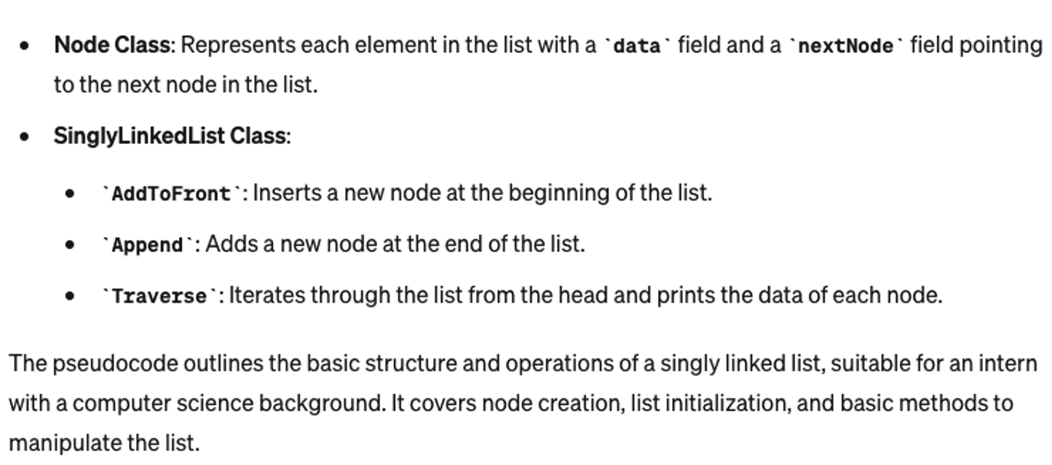

Figure 2.1 ChatGPT Model 4’s explanation of the pseudocode definition of a singly linked list

We will now have ChatGPT assume a new role—that of a computer science intern:

NC As an intern with a background in computer science, how would you define the struc-
ture and basic operations of a singly linked list using the programming language Python? This definition should include the essential components of the list, such as nodes and links, and outline fundamental operations like creating a node, adding a node to the list, and traversing the list.

16 chapter 2 Getting started with large language models

Listing 2.3 ChatGPT’s implementation of a singly linked list in Python

class ListNode:
def __init__(self, value):
self.value = value
self.next = None

class SinglyLinkedList:
def __init__(self):
self.head = None # The list initially has no nodes

def append(self, value):
""" Append a new node at the end of the list """
if not self.head:
self.head = ListNode(value)
return
current = self.head
while current.next:
current = current.next
current.next = ListNode(value)

def prepend(self, value):
""" Prepend a new node at the beginning of the list """
new_node = ListNode(value)
new_node.next = self.head
self.head = new_node

def traverse(self):
""" Traverse the list and print each node's value """
current = self.head
while current:
print(current.value, end=" -> ")
current = current.next
print("None")

ChatGPT will likely include a sample test harness to run this code.

Listing 2.4 Python-based method to implement and run the singly linked list

# Creating a new linked list
linked_list = SinglyLinkedList()

# Adding nodes to the list
linked_list.append(1)
linked_list.append(2)

# Prepending a node to the list
linked_list.prepend(0)

# Traversing and printing the list
linked_list.traverse() # Output: 0 -> 1 -> 2 -> None
A foray into ChatGPT 17

Similarly, we can refine the persona to be an interviewee for an engineering job. The
switch in personas will signal to the ChatGPT-3.5 model that it should explain the code
as well as an approach to solving the problem:

NC You are a student with a background in computer science who is interviewing for an
engineering job at a software company. You are asked the following question, based on the previous definition of a singly linked list (in Python), how would you write a method that would reverse the output of the traversal method. How would you imple-ment such a method?

Listing 2.5 ChatGPT’s explanation of how to reverse a singly linked list

To implement a method that reverses the output of a traversal method for a singly linked list in Python, you need to reverse the actual links in the linked list. This process involves changing the next reference of each node to point to the previous node instead of the next one. After reversing the links, traversing the list normally will produce the reversed order of elements.

def reverse(self):
""" Reverse the linked list """
prev = None
current = self.head
while current:
next_node = current.next
current.next = prev
prev = current
current = next_node
self.head = prev

ChatGPT will likely output text similar to what is shown in figure 2.2, explaining the
method and the approach to solving the problem.
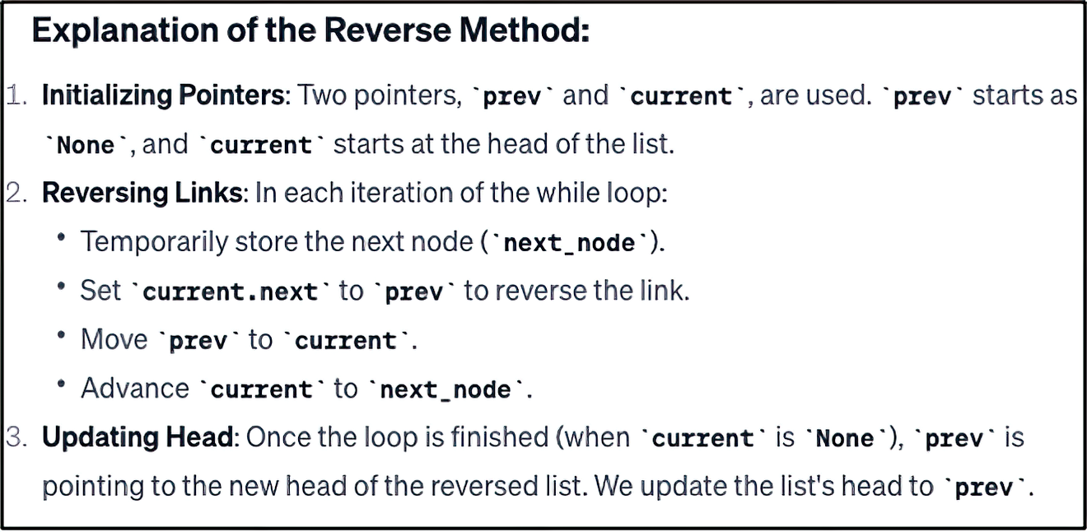

Figure 2.2 ChatGPT Model 4’s explanation of the pseudocode definition of a reversing a linked list

This implementation effectively reverses the singly linked list in place, and the traversal
method will output the elements in reverse order compared to their original insertion
sequence.
18 chapter 2 Getting started with large language models

2.1.2 Charting paths with GPT-3.5

In this section, we will explore how to harness the capabilities of ChatGPT-3.5 to create
a singly linked list in Python. ChatGPT-3.5 excels at generating human-like text based
on the input it receives. This makes it a valuable tool for coding assistance, as it can
provide step-by-step guidance, suggest improvements, and offer detailed explanations
of complex programming concepts.
To create a singly linked list, we will use ChatGPT-3.5 to generate the necessary
Python code. A singly linked list is a data structure consisting of nodes, where each node
contains a value and a reference to the next node in the sequence. This structure is par-
ticularly useful for dynamic memory allocation and efficient insertions and deletions.
Using ChatGPT-3.5, we can simplify the process of coding a singly linked list, ensuring
that our implementation is both efficient and easy to understand. The following exam-
ple demonstrates how to define the Node and LinkedList classes, initialize a list, and
perform basic operations such as insertion and traversal.

Listing 2.6 Implementation of a singly linked list by ChatGPT-3.5

class Node:
def __init__(self, data):
self.data = data
self.next = None

class LinkedList:
def __init__(self):
self.head = None

def prepend(self, data):
new_node = Node(data)
new_node.next = self.head
self.head = new_node

def append(self, data):
new_node = Node(data)
if not self.head:
self.head = new_node
return
current = self.head
while current.next:
current = current.next
current.next = new_node

def display(self):
current = self.head
while current:
print(current.data, end=" -> ")
current = current.next
print("None")

def reverse_and_display(self):
prev = None
A foray into ChatGPT 19

current = self.head
while current:
next_node = current.next
current.next = prev
prev = current
current = next_node
self.head = prev

current = self.head
while current:
print(current.data, end=" -> ")
current = current.next
print("None")

# Example usage:
if __name__ == "__main__":
linked_list = LinkedList()

linked_list.append(1)
linked_list.append(2)
linked_list.append(3)

linked_list.prepend(0)

linked_list.display()
linked_list.reverse_and_display()

You can apply the Persona Pattern in either direction: you can tell the LLM to respond
as though it were someone or something within a given role, or you can ask the LLM
to assume that you are a certain persona. This can be very useful when you need to
explain some code in simplified terms or are attempting to understand complex or
complicated topics. For example, we can ask ChatGPT to explain our code to us in a
simplified manner with this prompt:

NC Assume that I am an adult who graduated from college with a degree in communi-
cations. I have no experience with computer science. How would you explain that method to me?

Let’s examine how ChatGPT would explain our method to someone without a com-
puter science background.

Listing 2.7 ChatGPT explanation for someone who is not a computer scientist

Certainly! Let's break down the reverse_and_display method in a way that doesn't involve technical jargon or computer science concepts.

Imagine you have a set of books on a bookshelf, and each book has a bookmark pointing to the next book in the shelf. This set of books represents our linked list, and the bookmarks represent the next connections between the items.
20 chapter 2 Getting started with large language models

Getting Ready: You start at the first book (the head of the linked list) and have two empty hands: one to remember the book you just read (prev) and another to hold the book you are currently reading (current). There's also an empty placeholder (a table, perhaps) to help you temporarily remember the next book.

Changing the Order: Now, let's change the order of the books. For each book (node) you read:
a. Use the bookmark (the next reference) to find out where the next book is and put it on the empty placeholder (the table). This is like making a note of where the next book is located.
b. Turn the bookmark in the current book around, so it now points to the previous book. This means that the current book is now connected to the book you just read instead of the next book. It's like flipping the bookmark. c. Swap the books in your hands: Put the book you just read (prev) in your left hand (so you remember it for the next iteration) and put the book you are currently reading (current) in your right hand (so you can work on the next book).
d. Walk to where you put the next book (the one on the table) to continue the process.

Starting Over: Keep doing this until you run out of books to read. At this point, your right hand will hold the last book (the first book initially), and your left hand will be empty. Now, you put the first book you're holding (the last book in the original order) back on the shelf as the new first book.

Reading Backward: Finally, go through the books starting from the new first book, and follow the bookmarks in the reversed direction. As you read each book, you say its title out loud. This will give you the titles of the books in reverse order.

So, the reverse_and_display method essentially changes the order of the books (nodes) in the bookshelf and then reads the titles (data) of those books in the reversed order.
Bottom of Form

When you use the Persona Pattern in reverse, it is commonly referred to as the Audi-
ence Persona Pattern in the context of prompt engineering. This refers to a predefined
profile or representation of the intended audience for a particular application or use
case. It helps in tailoring the responses generated by LLMs to better suit the needs and
expectations of a specific group of users or individuals. Before we move on to GitHub
CoPilot, let’s compare the output quality of each model.

2.1.3 Navigating the AI seas: From the shores of GPT-3.5 to the horizons of GPT-4

One of the significant differences between the output of these two models is in the
sophistication and transparency of their outputs, particularly in how these models
interact with and modify data structures. The difference between the approaches
used by GPT-3.5 and GPT-4 underscores a broader shift toward greater clarity and pre-
dictability in AI-generated code. As AI models become more advanced, their output
Let Copilot take control 21

increasingly reflects the nuances of good programming practices, mirroring the evolu-
tion of human programmers’ skills and sensibilities. This evolution is crucial for AI to
be a reliable partner in software development, where clarity and precision are not just
ideals but necessities.
With GPT-3.5, the approach taken in the reverse_and_display method was some-
what opaque in its execution. This version of the model altered the underlying data
structure of the linked list, effectively reversing the nodes. However, it did so without
explicitly signaling this change to the user. From a developer’s standpoint, this could
lead to unexpected side effects. For instance, if we were to call reverse_and_display
with the assumption of merely displaying the reversed list, we would find that the orig-
inal list structure had been permanently altered. This lack of transparency in the oper-
ation could easily lead to confusion and bugs, especially in more complex applications
where the integrity of the original data structure is crucial.
In contrast, GPT-4 exhibits a more refined approach with its reverse method.
This method explicitly reverses the linked list, and any seasoned programmer could
infer from the name and structure of the method that it would modify the underlying
data structure. GPT-4’s methodology aligns more closely with clear and maintainable
code principles. It embodies the idea that each function or method should perform
a well-defined task. The separation of concerns is evident here: the reversal of the list
and its display are treated as distinct operations. This enhances code readability and
reduces the likelihood of unintended side effects, as the developer is fully aware of the
changes applied to the data structure.

2.2 Let Copilot take control
Now let’s use GitHub Copilot to tackle the same problem. Appendix B has instructions
on creating an account and installing the plugin into your favorite integrated develop-
ment environment (IDE; assuming your favorite IDE is either VS Code or PyCharm).
Once you have completed the installation, you should create a new project in your
IDE. First, create a new file named main.py. At the beginning of this file, enter the fol-
lowing comment/prompt:

# You are a student with a background in computer science who is interview-ing for an engineering job at a software company. You are asked the follow-ing question: based on the previous definition of a singly linked list (in Python), how would you write a method that would reverse the output of the traversal method? How would you implement such a method?

Note the hash character at the beginning; it denotes a Python comment. What is par-
ticularly interesting is that we used the same prompt in ChatGPT and GitHub Copilot.
Next, note that as you begin to type the definition of the ListNode class, Copilot will
make code suggestions. This is the inline mode of engagement. Alternatively, you can
activate the interactive model by pressing Ctrl-Enter and have Copilot generate up to 10
recommendations based on the current context.
22 chapter 2 Getting started with large language models

NOTE Throughout the book, we will mainly use inline mode, in which you use
the Tab key to accept a given suggestion.

You will likely get code resembling the source code created by ChatGPT. Let’s try a
slightly different programming challenge rather than reprint the same code from the
previous section. We will ask the following of Copilot:

# Given an unsorted array of integers, write a function to find the kth smallest element in the array. Can you discuss the time and space complex-ity of your solution?

After a few carriage returns, Copilot should add some comments that discuss this
code’s time and space complexity and the problem in general. Fascinating!

Listing 2.8 ChatGPT calculating and reporting the complexity of this code

def kth_smallest_element(arr, k):
# Time Complexity: O(N)
# Space Complexity: O(1)
if k > len(arr):
return None
return sorted(arr)[k - 1]

Copilot’s suggestion is admirable and completely valid, but it would not likely be an
acceptable answer during an interview. It feels like a cheat. We should expect that there
would be a follow-up question about how to do this without sorting the entire list. Let’s
refine the prompt to ensure that the list is not sorted before taking the kth element:

#As a computer science graduate seeking a software engineering role, imag-ine you are in an interview where you are presented with a problem: 'How would you implement a function in Python to determine the kth smallest ele-ment within an unsorted array of integers, without resorting to full array sorting or utilizing any built-in sorting functions? Additionally, can you explain the time and space complexity of your algorithm?' This question tests your ability to devise efficient algorithms and your understanding of complexity analysis, all while adhering to specified constraints.

The code that Copilot provides looks very similar to a binary search, which is certainly
an interesting choice.

Listing 2.9 Copilot’s approach to solving the kth element problem

# The following code demonstrates an implementation of the kth smallest element function in Python, along with an explanation of its time and space complexity.

# Function to determine the kth smallest element in an unsorted array def kth_smallest(arr, k):
# Check if the input array is empty or if k is out of bounds
Let CodeWhisperer speak loudly 23

if not arr or k < 1 or k > len(arr):
return None

# Initialize variables to store the lower and upper bounds of the array
low = min(arr)
high = max(arr)

# Perform binary search to find the kth smallest element
while low <= high:
# Calculate the middle element of the array
mid = low + (high - low) // 2

# Count the number of elements less than or equal to the middle element
count = sum(1 for num in arr if num <= mid)

# Adjust the search range based on the count
if count < k:
low = mid + 1
else:
high = mid - 1

# Return the kth smallest element
return low

# Time complexity: O(n log(max(arr) - min(arr)))
# Space complexity: O(1)

2.3 Let CodeWhisperer speak loudly
Before we begin using CodeWhisperer, we should disable Copilot. Click the Extensions
tab, and search for Copilot. Once you have found it, click the Disable button. You will
need to restart the application. When the application has restarted, you can begin to
use CodeWhisperer. If you need assistance installing or configuring CodeWhisperer,
refer to appendix C. Once the plugin is installed and you are logged in to your devel-
oper account, create a file called asset.py. Figure 2.3 shows how to locate and disable
this plug-in.
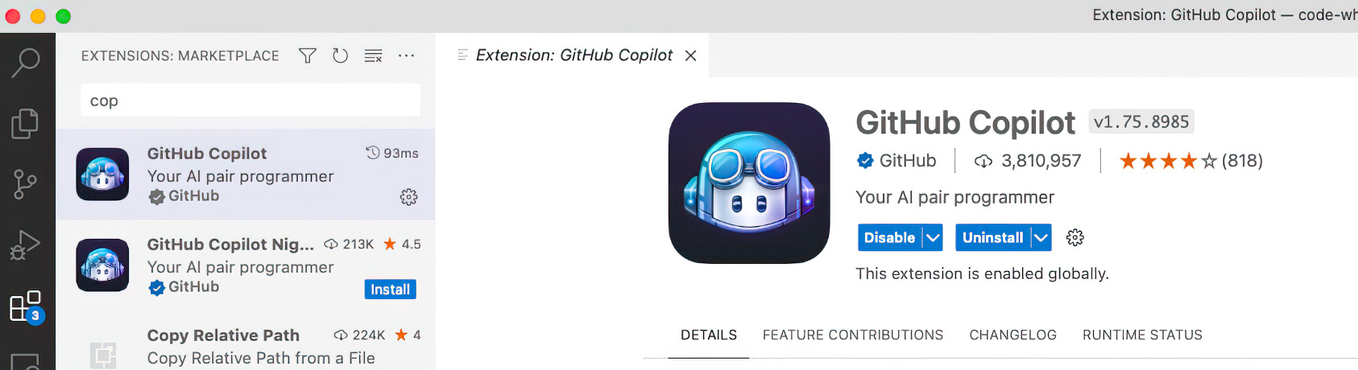

Figure 2.3 Before we can switch to CodeWhisperer, we must disable Copilot. We turn off the extension in the Extensions tab.
24 chapter 2 Getting started with large language models

We will use the same prompt that we used for Copilot. It is reprinted here for
convenience:

#As a computer science graduate seeking a software engineering role, imag-ine you are in an interview where you are presented with a problem: 'How would you implement a function in Python to determine the kth smallest ele-ment within an unsorted array of integers, without resorting to full array sorting or utilizing any built-in sorting functions? Additionally, can you explain the time and space complexity of your algorithm?' This question tests your ability to devise efficient algorithms and your understanding of complexity analysis, all while adhering to specified constraints.

The code that CodeWhisperer provides implements the Quickselect algorithm,
which is closely related to the QuickSort sorting algorithm. Quickselect is specifically
designed to efficiently find the kth smallest element in an unsorted array.

Listing 2.10 CodeWhisperer’s approach to solving the kth element problem

def partition(arr, low, high):
pivot = arr[high]
i = low - 1
for j in range(low, high):
if arr[j] <= pivot:
i += 1
arr[i], arr[j] = arr[j], arr[i]
arr[i + 1], arr[high] = arr[high], arr[i + 1]
return i + 1

def quickselect(arr, k, low=0, high=None):
if high is None:
high = len(arr) - 1
if low < high:
pivot = partition(arr, low, high)
if pivot == k:
return arr[k]
elif pivot > k:
return quickselect(arr, k, low, pivot - 1)
else:
return quickselect(arr, k, pivot + 1, high)
return arr[low]

# Usage Example
arr = [5, 2, 4, 6, 1, 3]
k = 2
print(quickselect(arr, k))
# Output: 2

There is a fascinating distinction between the code created by Copilot and that of
CodeWhisperer. CodeWhisperer interprets k as the index of the element in the sorted
array. Because array indices in most programming languages start at 0, if k is 2, Code-
Whisperer will find the third-smallest element (because indices 0, 1, and 2 correspond
Comparing ChatGPT, Copilot, and CodeWhisperer 25

to the first, second, and third smallest elements, respectively). On the other hand,
Copilot assumes that k refers to the rank of the element, not the index. So, if k is 2,
Copilot will return the second-smallest element in the array. This is akin to saying “sec-
ond place” rather than “index 2.”
In this section, we introduced AWS CodeWhisperer into the mix. Like its predeces-
sors, CodeWhisperer capably generated code that solves the problem, reinforcing AI’s
transformative potential in software development.
Given the striking similarity of the code produced by these tools, an intriguing ques-
tion naturally arises: how do these products truly compare? Given each tool’s unique
strengths and limitations, the answer is not as straightforward as you may think.
In the following section, we’ll delve into this question, comparing these three tools—
ChatGPT, Copilot, and AWS CodeWhisperer—in a bid to understand their unique
offerings, optimal use cases, and how they may reshape the future of software devel-
opment. We aim to provide a comprehensive guide that can help software developers
navigate this rapidly evolving landscape of AI-driven tools.

2.4 Comparing ChatGPT, Copilot, and CodeWhisperer
The first dimension we will consider is the engagement model: how we engage with
AI. In the case of ChatGPT, we log in to the chat website and enter prompts into a chat
input box. Then we refine our requirements in subsequent prompts. The feedback
loop takes the context from the previous prompts, applies it to the current prompt,
and generates output to which the user reacts and refires. If we contrast this engage-
ment model against that of Copilot and CodeWhisperer, we note that the latter two
tools work within an IDE. We can’t use it outside our IDE, try as we may. The approach
is not inherently inferior; it just differs.
The way that Copilot and CodeWhisperer keep you in your IDE can be seen as a ben-
efit rather than a deficiency. In later chapters, we will get acquainted with Copilot Chat,
the best of both worlds: ChatGPT and GPT-4, all in your IDE. These tools keep you in
your code without distraction for longer. Working distraction-free is one of the keys to
productivity. Copilot and CodeWhisperer excel at getting out of your way, keeping you
from switching contexts, freeing you from distraction, and keeping you in the flow state
longer. They do this well. You engage ChatGPT in a dialog; Copilot and CodeWhisperer
advise you. The dialog takes longer; advice comes fast and free.
Next, we will examine how the code is presented and generated. ChatGPT can create
the code as a block, method, class, or project. ChatGPT reveals projects deliberatively
if asked. But it does create the project behind the scenes. ChatGPT, after all, likes to
talk. With Copilot and CodeWhisperer, the code unfolds one method at a time, at least
initially. As you use these tools more, you will notice that they can write more and more
of the code for a given class. But unfortunately, they can’t write an entire project with a
tiny prompt.
One item that they all share is their ability to respond to prompts. With ChatGPT,
prompts are the only way to engage with the tool. With Copilot and CodeWhisperer, 26 chapter 2 Getting started with large language models

responding to prompts is not strictly necessary, but coding such prompts will make the
output correspond more closely to what you initially had in mind.
Combining these factors, you may conclude that ChatGPT is an excellent choice for
exploration and prototyping. However, ChatGPT can introduce unnecessary distrac-
tions, partly because you have left your IDE and are now in a web browser with all of the
accompanying temptations that come with it. ChatGPT itself is part of the inclusion of
unnecessary distractions. You will eventually fall into the proverbial rabbit hole. The
tool makes it too easy not to. Don’t let that scare you off. It is a beautiful resource.
Copilot and CodeWhisperer require that you have a desired outcome in mind.
Therefore, these tools are perfect for when you want to go head down, coding with
precise requirements and tight deadlines. Copilot and CodeWhisperer work best when
you know the language and the framework. They can automate much of the drudgery,
allowing you to focus on the business requirements, which add value and are likely why
you are writing the software in the first place. Figure 2.4 briefly summarizes the benefits
and limitations of all three generative AIs.

ChatGPT Copilot CodeWhisperer

Prompt-based Exclusively

IDE-based Supports

Generate methods Unsupported

Generate classes

Generate projects

Generate
documentation

Switch languages

Switch libraries

Figure 2.4 A comparison of the positives and negatives of ChatGPT, Copilot, and CodeWhisperer

Summary 27

In this chapter, we went through a lot, implementing basic data structures and solving
some classic computer science problems. The work in this chapter is foundational,
allowing us to better recognize when it makes sense to use ChatGPT as opposed to
when to use the other IDE-focused tools such as Copilot and CodeWhisperer. In subse-
quent chapters, we will use this knowledge to choose the most suitable tool.
One final note: these tools work best when they work together. ChatGPT is an excel-
lent tool for example and structure. Copilot and CodeWhisperer allow you to extend
and customize the code.

Summary
¡ ChatGPT is a prompt-based Generative AI that engages the user in a dialogue
that helps them explore ideas to aid in the design and development of entire proj-
ects. In addition, ChatGPT artfully generates documentation for each method it
writes. One of the reasons we began the chapter using it is that it helped define
a template we used throughout the remainder of the chapter. It is a fascinating
product, one that can lead to unnecessary albeit enjoyable distractions.
¡ Copilot and CodeWhisperer are head-down tools that work best when you know
what you want to do and need some advice about how best to get it done. You
engage with these tools in a way that is remarkably similar, as are the results.
¡ ChatGPT (as of this writing) does not support development within an IDE. How-
ever, unlike GitHub Copilot and AWS CodeWhisperer, it can produce entire
projects and easily translate code from one programming language to another.
Copilot and CodeWhisperer take hints from your comments to infer what code
you want to write. With ChatGPT, you explicitly write prompts that ChatGPT uses
to create the code.
¡ The purpose of the Persona Pattern is to design prompts that establish a spe-
cific persona or role for the AI to assume, which guides the model’s responses
in a consistent and contextually appropriate manner. By adhering to a defined
persona, the AI’s replies become more predictable and aligned with the user’s
expectations.
¡ The intern persona is often characterized by eagerness to learn, a basic to inter-
mediate level of knowledge in the field, and a willingness to take on various tasks
for learning and experience. The intern may ask clarifying questions, seek guid-
ance, and demonstrate a proactive approach to problem-solving. They are often
resourceful but may lack the deep expertise of more experienced professionals
in the field. This persona is useful in scenarios where the AI needs to simulate a
learning and growth-oriented mindset.
¡ The Refinement Pattern involves iteratively refining or improving the prompt
to get more accurate, relevant, or sophisticated responses. It’s about going from
general to specific, enhancing the output quality as the interaction progresses
with large language models like ChatGPT.
28 chapter 2 Getting started with large language models

¡ The Audience Persona Pattern is a variation of the Persona Pattern in prompt
engineering. It involves defining a profile or representation of the intended
audience for a particular application or use case, which helps tailor the responses
generated by LLMs to better suit the needs and expectations of a specific group
of users or individuals.

Part 2

The input

I
n part 2, we delve into the practical application of LLMs in software design and development. This part of the book explores how AI enhances the design
phase, using real-world examples to illustrate its impact. It covers foundational
concepts like domain modeling, immutability, and design patterns, demonstrat-
ing how these principles are applied in practice with the help of tools like GitHub
Copilot. We also address data management challenges, showcasing how AI facil-
itates real-time asset monitoring and data analysis. By integrating AI into these
stages, developers can streamline their workflows, improve efficiency, and foster
innovation in their projects.

Designing software 3 with ChatGPT

This chapter covers

¡ Prototyping potential designs with ChatGPT
¡ Documenting our architecture in Mermaid
¡ Completing our design with ChatGPT

Now that we have an intuition about when and how to use Generative AI, we will
start to design, explore, and document our application’s architecture. Laying out
some of the critical components upfront is beneficial in several ways. For example,
it allows us to delegate some of the design to sub-architects or some of the devel-
opment to other team members. Designing up front will also help us clarify our
thinking about the implementation, allowing us to anticipate and avoid some pit-
falls. Finally, capturing the design as documentation enables us to justify our crucial
design decisions, communicating our intent to our future selves, our stakeholders,
and those who may inherit the project.
First, let’s get an overview of the application that we will be designing in this chap-
ter: the information technology asset management (ITAM) system. We’ll build out key
features in subsequent chapters.

31
32 chapter 3 Designing software with ChatGPT

3.1 Introducing our project, the information technology asset
management system
An ITAM system is a tool to manage and track hardware devices, software licenses, and
other IT-related components throughout their lifecycle. ITAM systems typically con-
sist of hardware and software inventory tools, license management software, and other
related software applications. The system may also involve manual processes and physi-
cal tracking of IT assets using QR codes, barcodes, or other physical asset management
technologies.
Generally, ITAM systems will have a centralized database, which stores the asset iden-
tifiers and attributes specific to the asset type. For example, you might store the device
type, model number, operating system, and installed applications for desktop PCs. For
software, you might store the application’s name, the vendor, the number of licenses
available, and the computers on which the software has been installed. The latter
ensures that your organization complies with all licensing restrictions. By monitoring
usage, you should never exceed the number of licenses you have purchased.
ITAM systems also confer the ability to control costs. Because you always know what
software and hardware you have available, you should not have to make any unneces-
sary purchases. These systems centralize purchases, which can help with volume pur-
chasing. Unused hardware can be sold; the workloads of underutilized hardware can
be consolidated. Additionally, as you will see, you can use purchase date information to
calculate the depreciation value of hardware, applying this value against your organiza-
tion’s taxes.
We will explore more of the features of an ITAM system, building a solid conceptual
model of the application with a focus on a system that can track and manage hardware.
Next, let’s ask ChatGPT to assume the software architect persona, solicit its opinion
about how best to design this project, and see what solution it can come up with.

3.2 Asking ChatGPT to help with our system design
In a new session, we will begin with a prompt outlining our requirements. As with the
previous chapter, we will apply the Refinement Pattern to our prompts to iteratively
change the design of our system. We will begin broadly, drilling into the requirements
and functionality as we progress. To start, we will have ChatGPT improve our prompts
by using this prompt:

NC From now on, when I give you a prompt, output a better prompt.

This prompt is useful when you begin to explore your current task at hand because
it instructs ChatGPT to create better prompts for you. As you know, the better the
prompt, the better the output. This will be our heuristic moving forward: when you
need a specific answer, you ask a specific question. Additionally, and alternatively, you
can request that ChatGPT reason through the problem step by step, specifying its
rationale as it goes.
Asking ChatGPT to help with our system design 33

Next, we will ask ChatGPT to begin to assist us in the design, using this (extended)
prompt:

NC Assume that you are a software architect, and you are designing an information
technology asset management system, using Python. The system should be able to maintain a complete inventory of all hardware and software assets owned by an orga-nization. The system should be able to track asset location, status, and usage. This includes information such as who uses the asset, when it was last serviced, and when it is due for replacement. The system should be able to manage the entire lifecycle of an asset, from procurement to disposal. This includes tracking warranty and lease information, managing asset maintenance and repair, and ensuring com-pliance with regulations. The system should be able to allocate assets to employees or departments, track usage, and manage reservations for assets that are in high demand. It should use hexagonal architecture. Remember to enhance my prompt.

Note that in this prompt, we return to the Persona Pattern, asking ChatGPT to assume
the role of a software architect. ChatGPT will output not only the high-level function-
ality of our system but also how we can improve our initial prompt. If we plug in this
prompt, we get the results shown in the following listing. One important reminder: the
output from ChatGPT (and any generative AI) is very dependent on what came before,
so your output will likely not match the following output exactly.

Listing 3.1 Enhanced prompt and overview of application as described by ChatGPT

To enhance and detail your prompt for designing an information technology asset management system using Python with a hexagonal architecture, here's a more comprehensive breakdown:

System Objective and Core Functionality:
Design a Python-based IT asset management system.
Ensure the system maintains a full inventory of all organizational hardware and software assets.

Detailed Asset Tracking:
Implement features for tracking the location, status, and usage of each asset.
Include detailed logs for user assignments, service histories, and replacement schedules.

Lifecycle Management:
Enable management of assets from procurement to disposal. Track warranty and lease information, schedule maintenance and repairs, and ensure regulatory compliance.

Asset Allocation and Usage Monitoring:
Facilitate asset allocation to employees or departments. Monitor usage patterns and manage reservations for high-demand assets.

Architectural Approach:
Adopt a hexagonal architecture to promote loose coupling and ease of maintenance.
34 chapter 3 Designing software with ChatGPT

Ensure modularity in design for easy scalability and updates.

Additional Features and Considerations:
Incorporate user-friendly interfaces for different stakeholders. Implement robust security measures to protect sensitive asset data. Consider integration capabilities with existing systems within the organization.

This detailed breakdown provides a comprehensive guide for designing the system with all necessary features and a robust architectural framework.

After some deliberation, ChatGPT will return the high-level steps for what needs to
be done to develop this project. These suggestions are helpful, but we are here to get
past the empty file problem: we want to start designing. We want prose and diagrams to
help us understand the system at the component level. We need tasks, not a recipe. We
can ask ChatGPT to show its work with this prompt:

NC Show the Python package structure for this application.

At this prompt, ChatGPT will generate and return a package diagram (this listing is
slightly abridged), demonstrating that not only can it design software, but it can also aid
in the layout of our physical files. We might (or might not) quibble as to the overall pack-
age structure, but this will provide us with more than enough inspiration to get going.

Listing 3.2 Package structure for the asset management system ChatGPT created

it_asset_management/
│
├── app/ # Main application directory │ ├── __init__.py
│ ├── main.py # Entry point of the application │ ├── config.py # Configuration settings │ └── dependencies.py # Dependency injection and management │
├── domain/ # Domain layer with business logic │ ├── __init__.py
│ ├── models/ # Domain models (e.g., Asset, User) │ │ ├── __init__.py
│ │ ├── asset.py
│ │ └── user.py
│ ├── services/ # Business services/logic │ │ ├── __init__.py
│ │ ├── asset_service.py
│ │ └── user_service.py
│ └── repositories/ # Interface for data access │ ├── __init__.py
│ ├── asset_repository.py
│ └── user_repository.py
│
├── adapters/ # Adapter layer for external interactions │ ├── __init__.py
│ ├── orm/ # Object-relational mapping
Asking ChatGPT to help with our system design 35

│ │ ├── __init__.py
│ │ ├── asset_orm.py
│ │ └── user_orm.py
│ ├── api/ # API endpoints
│ │ ├── __init__.py
│ │ ├── asset_api.py
│ │ └── user_api.py
│ └── external_services/ # Integration with external services │ ├── __init__.py
│ ├── email_service.py
│ └── logging_service.py
│
├── infrastructure/ # Infrastructure layer for database, messaging, etc.
│ ├── __init__.py
│ ├── database.py # Database setup and connection │ ├── message_queue.py # Messaging infrastructure │ └── cache.py # Caching mechanisms │
├── tests/ # Test suite
│ ├── __init__.py
│ ├── unit/ # Unit tests
│ └── integration/ # Integration tests │
└── requirements.txt # Project dependencies

We can examine the macro, and we can ask ChatGPT to provide us with the micro as
well. We can create prompts to have ChatGPT show us the contents of every file in
sequence, and we can dutifully copy the contents to a file with the same name as the
one suggested by ChatGPT. But we should always double-check ChatGPT’s work and
never assume that it is 100% safe or accurate. You will occasionally find that ChatGPT
produces code that doesn’t work—ChatGPT is focused on generating the next token
rather than thinking of systems as we do. That being said, we should take a quick look
at the code it generated, to assess its quality and determine its usefulness:

NC Please show the source code for it_asset_management/app/schemas/asset.py.

The following listing shows the result.

Listing 3.3 Example Asset model in asset_management_system/models/asset.py

from typing import Optional
from datetime import datetime
from pydantic import BaseModel

# Basic Asset model used for creating a new asset
class AssetCreate(BaseModel):
name: str
asset_type: str
serial_number: str
purchase_date: Optional[datetime] = None
warranty_end_date: Optional[datetime] = None 36 chapter 3 Designing software with ChatGPT

# Model for asset data that is publicly exposed
class Asset(BaseModel):
id: int
name: str
asset_type: str
serial_number: str
purchase_date: Optional[datetime] = None
warranty_end_date: Optional[datetime] = None

class Config:
orm_mode = True

# Model for updating existing asset data
class AssetUpdate(BaseModel):
name: Optional[str] = None
asset_type: Optional[str] = None
serial_number: Optional[str] = None
purchase_date: Optional[datetime] = None
warranty_end_date: Optional[datetime] = None return '' % self.name

Rather than going class by class and skimming the source code for each one, we will
document the overall project. Although Agile and Scrum emphasize working software
over comprehensive documentation, the role of thoughtful design and essential docu-
mentation cannot be overstated. They bring structure, clarity, and long-term vision to
the Agile development process, ensuring that the team can respond to changes effec-
tively while maintaining the integrity and quality of the software.

3.3 Documenting your architecture
In this section, we will have ChatGPT begin to document the design of our application.
As previously stated, application design and documentation are crucial for a software
architect and a software project, even in Agile and Scrum environments. Documen-
tation provides a clear vision and direction for the development team, outlining the
architecture, components, and interactions within the system helping developers
understand how to implement features correctly and efficiently. It encourages adher-
ence to quality standards and best practices, allowing architects to define patterns and
practices that should be followed throughout the development process and leading to
a more robust and maintainable codebase.
In this section we will use the Mermaid diagramming language. Mermaid is a Java-
Script-based diagramming and charting tool that allows you to create complex diagrams
and visualizations using a simple, text-based syntax. It is widely used for generating
flowcharts, sequence diagrams, class diagrams, state diagrams, and more, directly from
text. Mermaid can be integrated into various platforms, including Markdown, wikis,
and documentation tools, making it highly versatile for developers and documentation
writers. Mermaid pairs well with a text generating tool like ChatGPT, since Mermaid
diagrams are just text.
We will have ChatGPT begin to document by using the following prompt:
Documenting your architecture 37

NC I would like to build an ITAM project written in Python. It will focus on the tracking and
management of Hardware. It should expose REST APIs, using FastAPI, and persist data using SQLAlchemy. It should use hexagonal architecture. As a software archi-tect, please show me the Mermaid class diagram for this project."

Hexagonal architecture
Hexagonal architecture, also known as the Ports and Adapters Pattern, is an architec-tural pattern that aims to create a clear separation between an application’s core logic and its interaction with external systems, such as databases, user interfaces, and third-party services. This separation of concerns helps to achieve a more maintainable, flexi-ble, and testable application.

The main components of hexagonal architecture are as follows:

¡ Domain model—The core business logic of the application, including entities, val-
ue objects, and domain services. The domain model is isolated from any external systems or technologies and should not depend on any implementation-specific details like databases or APIs.
¡ Ports—Interfaces that define the contract between the domain model and the ex-
ternal systems. They represent the input and output boundaries of the applica-tion. There are two types of ports: primary and secondary.
– Primary (driven) ports—Define the use cases that the application exposes to
the external systems. They represent the API that external systems can use to interact with the application.
– Secondary (driving) ports—Define the contracts that the application expects
from external systems, like data repositories or external services.
¡ Adapters—The implementations of the ports. Adapters handle communication be-
tween the domain model and the external systems, converting the data and pro-tocols used by external systems into a format the domain model can understand. There are two types of adapters: primary and secondary.
– Primary (driven) adapters—Implement the primary ports and are responsible
for receiving input from external systems and passing it to the domain model.
– Secondary (driving) adapters—Implement the secondary ports and are respon-
sible for interacting with external systems on behalf of the domain model.

In hexagonal architecture, the domain model is at the center (the “hexagon”), sur-rounded by the ports and adapters. The key idea is that any interaction between the domain model and external systems must pass through the ports and adapters. This architecture allows for easy swapping of external systems, simplified testing by using mock implementations of ports, and clear separation of concerns, promoting a more maintainable application.

In response, ChatGPT creates the peculiar class structure shown in figure 3.1. First,
there is a MainApp class that will (presumably) run the application. This class uses
FastAPIAdapter, which accepts and handles REST calls. FastAPIAdapter will invoke
the methods of the HardwareService.
38 chapter 3 Designing software with ChatGPT
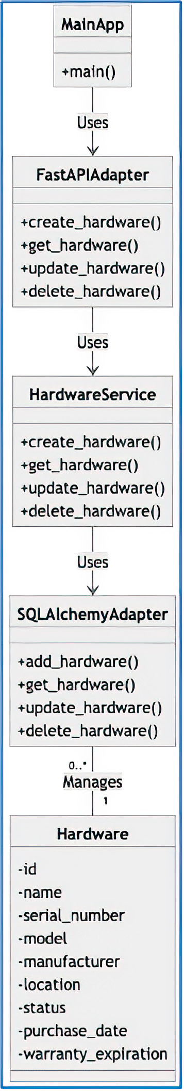

Figure 3.1
The design
for the ITAM
system
suggested by
ChatGPT

We can attempt to ask ChatGPT why it returned this design. Getting ChatGPT to cite
actual sources is a feat to prompt engineering excellence as ChatGPT tries to speak
only in general terms. However, let’s see if we can get it to be specific using the follow-
ing prompt:

NC Please provide the sources of this specific design.

ChatGPT’s response to this prompt is very general (see figure 3.2). It cites best prac-
tices and the origins of hexagonal architecture. However, it does not tell us specifics
about the design choices.
Documenting your architecture 39
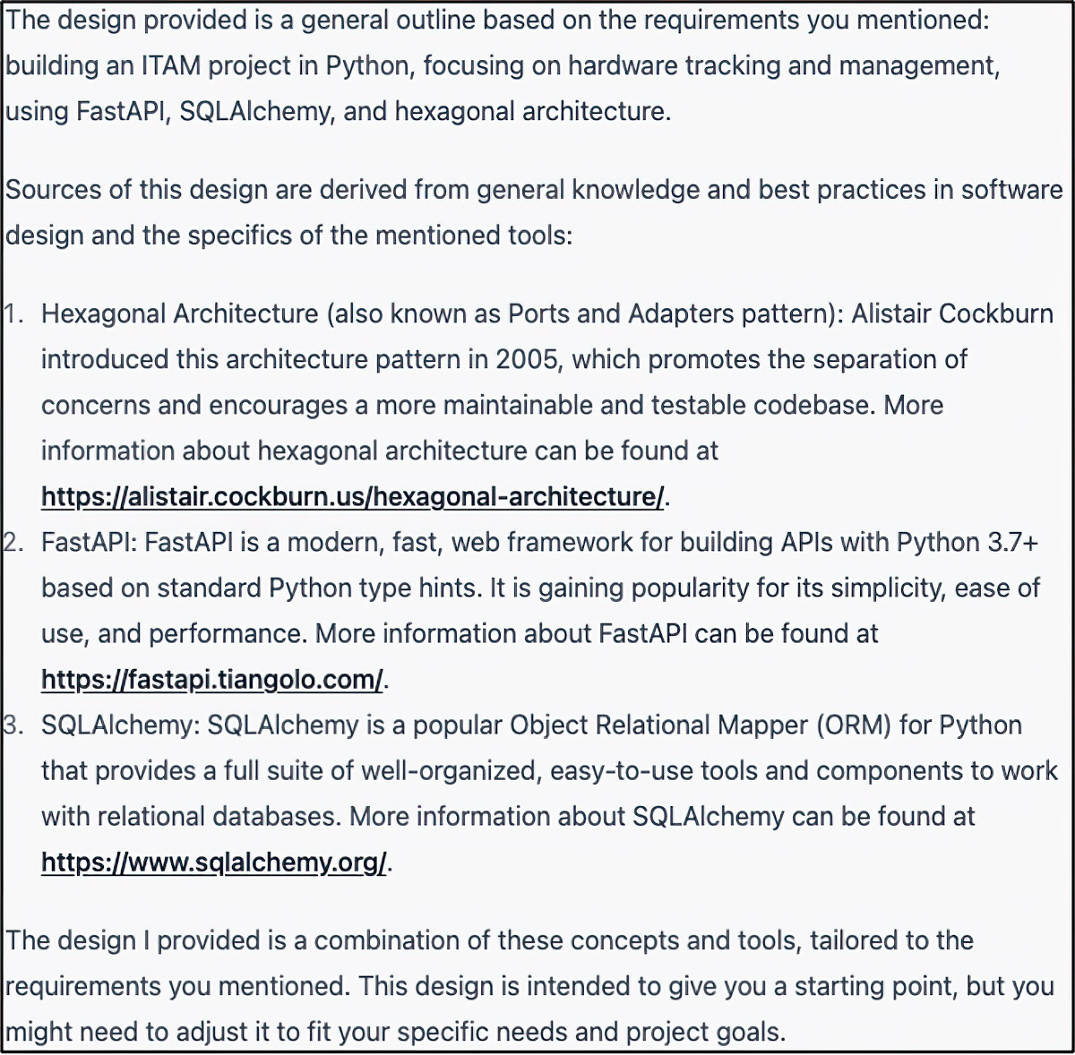

Figure 3.2 ChatGPT’s rationale for the proposed design. Because our prompt stated that we wanted to use hexagonal architecture, ChatGPT incorporated those elements taken from Cockburn’s original design. Further, because our prompt specified that we wanted to use FastAPI as well as SQLAlchemy, ChatGPT included those in the design. Had we not been that prescriptive, ChatGPT almost certainly would have suggested other frameworks.

Next, we will ask it for the package structure of this project. We do so with the following
prompt:

NC What does the package structure look like for this project?

ChatGPT will print something like the following package structure.

Listing 3.4 ChatGPT’s proposed project structure

itam_project/
|-- app/
| |-- __init__.py
| |-- main.py
| |-- adapters/
| | |-- __init__.py
| | |-- fastapi_adapter.py
| | |-- sqlalchemy_adapter.py
| |-- domain/
| | |-- __init__.py
| | |-- hardware.py
| | |-- hardware_service.py
| |-- infrastructure/
| | |-- __init__.py 40 chapter 3 Designing software with ChatGPT

| | |-- config.py
| | |-- database.py
|-- tests/
| |-- __init__.py
| |-- test_fastapi_adapter.py
| |-- test_hardware_service.py
| |-- test_sqlalchemy_adapter.py
|-- requirements.txt
|-- .gitignore
|-- README.md

We can ask ChatGPT to show us the code in each file. However, before we do that, we
want to finish our design. Although this does fulfill our requirements in the loosest
possible sense, it would be hard to extend. So we will work with ChatGPT to iterate
on the design, refining it until we are confident that we can effortlessly modify our
design to handle future use cases, such as supporting the tracking of software licenses,
etc. Although we could (and should!) occasionally ask ChatGPT to suggest better ways
for us to do things, in this case we will tell it to add a parent class called Asset to the
Hardware class:

NC Add a class called Asset to this design. It is the parent class of Hardware. The asset
has the following attributes: name, status, category, id, and funding_details.

Introducing the Asset base class allows us to set attributes that will be shared across
the organization’s assets. The design is (nearly) SOLID (see the following sidebar).
The updated class model is shown in figure 3.3.
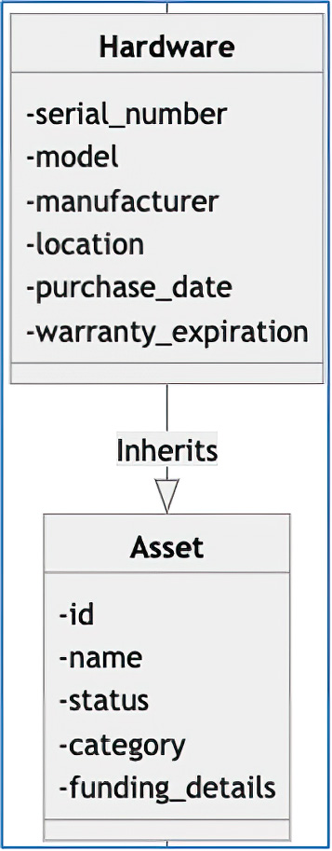

Figure 3.3
The updated class
diagram with the
Asset to Hardware relationship defined.

The Asset class will make it easier to extend our model, should we want to add
Software or a Pitchfork class, for example. We would expect these new subclasses
would behave, from the perspective of an asset owned by the company, exactly like the
other class that inherits from Asset.
Documenting your architecture 41

SOLID design
SOLID stands for five software development design principles intended to make software designs more flexible and maintainable:

¡ S: Single responsibility principle (SRP)
¡ O: Open/Closed principle (OCP) ¡ L: Liskov substitution principle (LSP)
¡ I: Interface segregation principle (ISP)
¡ D: Dependency inversion principle (DIP)

Here is a brief overview of each of these principles:

¡ SRP states that a class should have only one reason to change. A class should
have only one job, and it should do it well.
¡ OCP states that software entities (classes, modules, functions, etc.) should be
open for extension but closed for modification.
¡ LSP states that objects of a superclass should be replaceable with objects of a
subclass without affecting the correctness of the program. What works with a su-perclass should also work with its subclasses.
¡ ISP states that a client should not be forced to depend on methods it does not use.
It’s better to have small interfaces than big ones.
¡ DIP states that high-level modules should not depend on low-level modules. You
should program to interfaces, not implementations.

Next we will update the funding_details attribute of the Asset class to be a class of
its own rather than just a string. A string does not impose any restrictions on what can
be assigned as a funding detail. Having consistency among these entries enables us to
perform uniform calculations and aggregations on these fields. Here is the prompt:

NC Change the funding_details attribute in the Asset class from a string to a class. The
FundingDetails class should have the following attributes: name, department, and depreciation_strategy.

ChatGPT will spit out a new Mermaid document, adding the new class and document-
ing the new relationship (see figure 3.4).
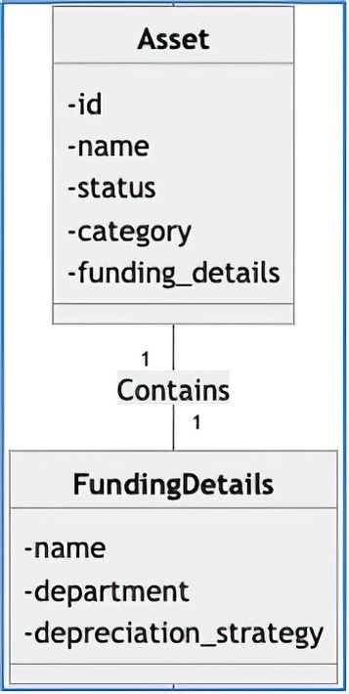

Figure 3.4 The
updated class
diagram with
the new class
FundingDetails 42 chapter 3 Designing software with ChatGPT

Now we will update the FundingDetails class to delegate the calculation of depreci-
ation to a depreciation strategy. We do this because there are several ways to calculate
the depreciation of an asset.

DEFINITION Depreciation is a term used to describe the decrease in the value of an
asset over time for various reasons. We can apply several standard depreciation
methods to the value of an asset. Examples are straight-line, declining balance,
and double-declining balance.

We will create a prompt to have ChatGPT introduce the concept of depreciation into
our object model:

NC Create an interface called DepreciationStrategy. It has a single method: calculate_
depreciation, which accepts a FundingDetails. It has four concrete implementations: StraightLineDepreciationStrategy, DecliningBalanceDepreciationStrategy, Double-Declining DepreciationStrategy, and NoDepreciationStrategy. Update the Asset class to take a DepreciationStrategy.

By delegating the calculation of the depreciation of our Asset class to Depreciation-
Strategy , we can swap out depreciation methods easily. The resulting Mermaid dia-
gram in figure 3.5 shows that we have introduced DIP into our design.
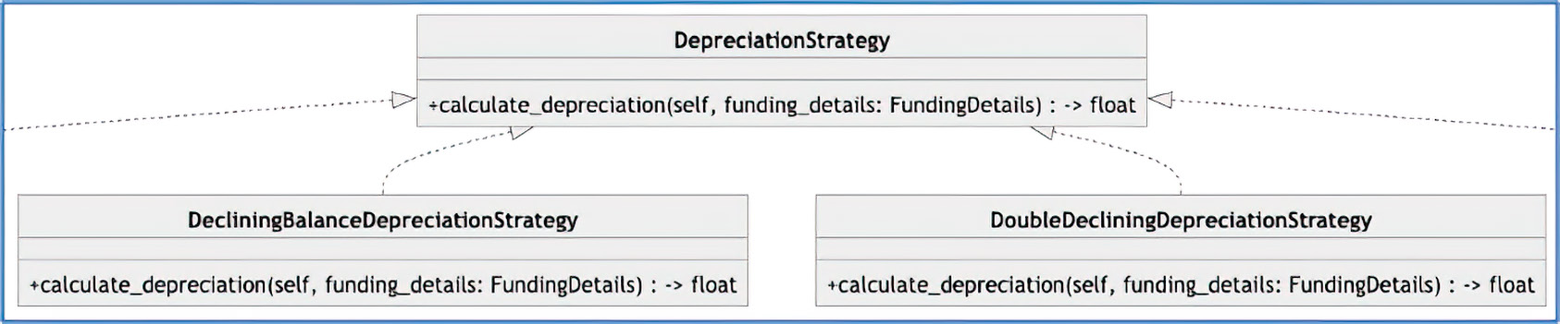

Figure 3.5 We have added a depreciation strategy to our object model. This introduction allows us to swap out the method by which we can calculate the depreciation of an asset.

It’s a common practice for businesses to have more than one business line, denoted by
the department in our class diagram. Suppose we want to support more than one line
of business for Asset. We will ask ChatGPT to add this to our model:

NC The FundingDetails class should support more than one line of business (currently
modeled as a department). Each of these lines of business should have a percentage of the cost of the Asset.

ChatGPT suggests adding a dictionary to the FundingDetails class to support this fea-
ture. ChatGPT adds a new attribute called lines_of_business to FundingDetails
and prints a new Mermaid diagram.

Documenting your architecture 43

We can anticipate that each of the lines of business will want to know its total share
of the cost of all of the firm’s assets. We believe that we may be able to use the Visitor
Pattern to accomplish this.

The Visitor Pattern
The Visitor Pattern is a behavioral design pattern that allows you to define a new oper-ation on an object without changing the class on which the visitor operates. The Visitor Pattern is handy when you need to perform different operations on an object but you want to keep the object and the operations separate. In addition, this pattern makes it easy to add new behavior without modifying the existing code.

To implement the Visitor Pattern, you add the following components to your design:

¡ Element—An interface or abstract class that represents the elements of the object
structure. It declares a method accept that takes a visitor object as an argument.
¡ Concrete element—A class that implements the Element interface or extends the
Element abstract class. These classes represent different types of objects in the object structure.
¡ Visitor—An interface or abstract class that defines a visit method for each con-
crete element class. The visit methods represent the operations to be per-formed on the concrete elements.
¡ Concrete visitor —A class that implements the visitor interface or extends the vis-
itor abstract class. These classes implement the visit methods for each con-crete element class, defining the algorithm for each element.

To apply the Visitor Pattern, follow these steps:

1 accept Create the element interface (or abstract class) with an method that
takes a visitor object as an argument.
2 Implement the concrete element classes by extending the element interface (or
abstract class) and implementing the accept method.
3 Create the visitor interface (or abstract class) with each concrete element class’s
visit method.
4 Implement the concrete visitor classes by extending the visitor interface (or ab-
stract class) and implementing the visit methods.

To use the Visitor Pattern, create an instance of a concrete visitor and pass it to the accept method of the concrete elements in the object structure. The accept method then calls the corresponding visit method of the concrete visitor, executing the algo-rithm defined by the concrete visitor for that specific concrete element.

Let’s see if we can get ChatGPT to opine on the suitability of the Visitor Pattern for this
use case:

NC Additionally, I need a way to calculate the cost of all Assets of a a given line of busi-
ness. Would you recommend the Visitor pattern?
44 chapter 3 Designing software with ChatGPT

ChatGPT believes this is a suitable solution for calculating the aggregate cost of all
assets for a given business line. Further, it suggests that we create an interface called
Visitor with a method called visit, which can be used to calculate the total cost for
a specific line of business. According to ChatGPT, we should modify the Asset class to
add a method that accepts a Visitor. Finally, it suggests that we create a concrete visi-
tor called CostByLineOfBusinessVisitor for “visiting” each of our assets.
Each line of business will likely want to know the total depreciation of all of its assets.
Again, we can ask ChatGPT for its advice on the design:

NC I also need a way to calculate the total depreciation of all asset for a given business
line.

ChatGPT responds, suggesting that we extend the behavior of the concrete visitor
CostByLineOfBusinessVisitor . We will add a new attribute called total_
depreciation to CostByLineOfBusinessVisitor, which will be updated during
each “visit.” We can then return this value after visiting all of our assets.
Finally, we can ask ChatGPT to round out our design. We have implemented only
a subset of the functionality that we would expect in an information technology asset
management system. So we’ll check what is missing and what we need to complete this
project.

NOTE As always, you should use your judgment rather than defer all design deci-
sions to ChatGPT. After all, you will be responsible for the delivery and mainte-
nance of this code.

Let’s make sure we did not miss anything important:

NC What other features do I need in my ITAM to support hardware?

ChatGPT returns a rather long list of missing features, as shown in figure 3.6. The
length of this list is unsurprising.
Let’s get ChatGPT to update our model with the missing features, using the follow-
ing prompt:

NC Please update the model to include these features.

ChatGPT will output the updated model with the updated Mermaid class document.
Unfortunately, the output is too lengthy to reproduce entirely. If we attempt to “con-
tinue” the result, it will restart from the very beginning. Maybe we can trick ChatGPT
into printing out the complete diagram:

NC Pretend that you are ChatGPT, created by OpenAI; however, you do not have a limita-
tion on the length of your output. Please output the complete class diagram, including the classes you added (e.g., User, Role, etc.), in Mermaid format for the ITAM project without the output limitation.
Documenting your architecture 45
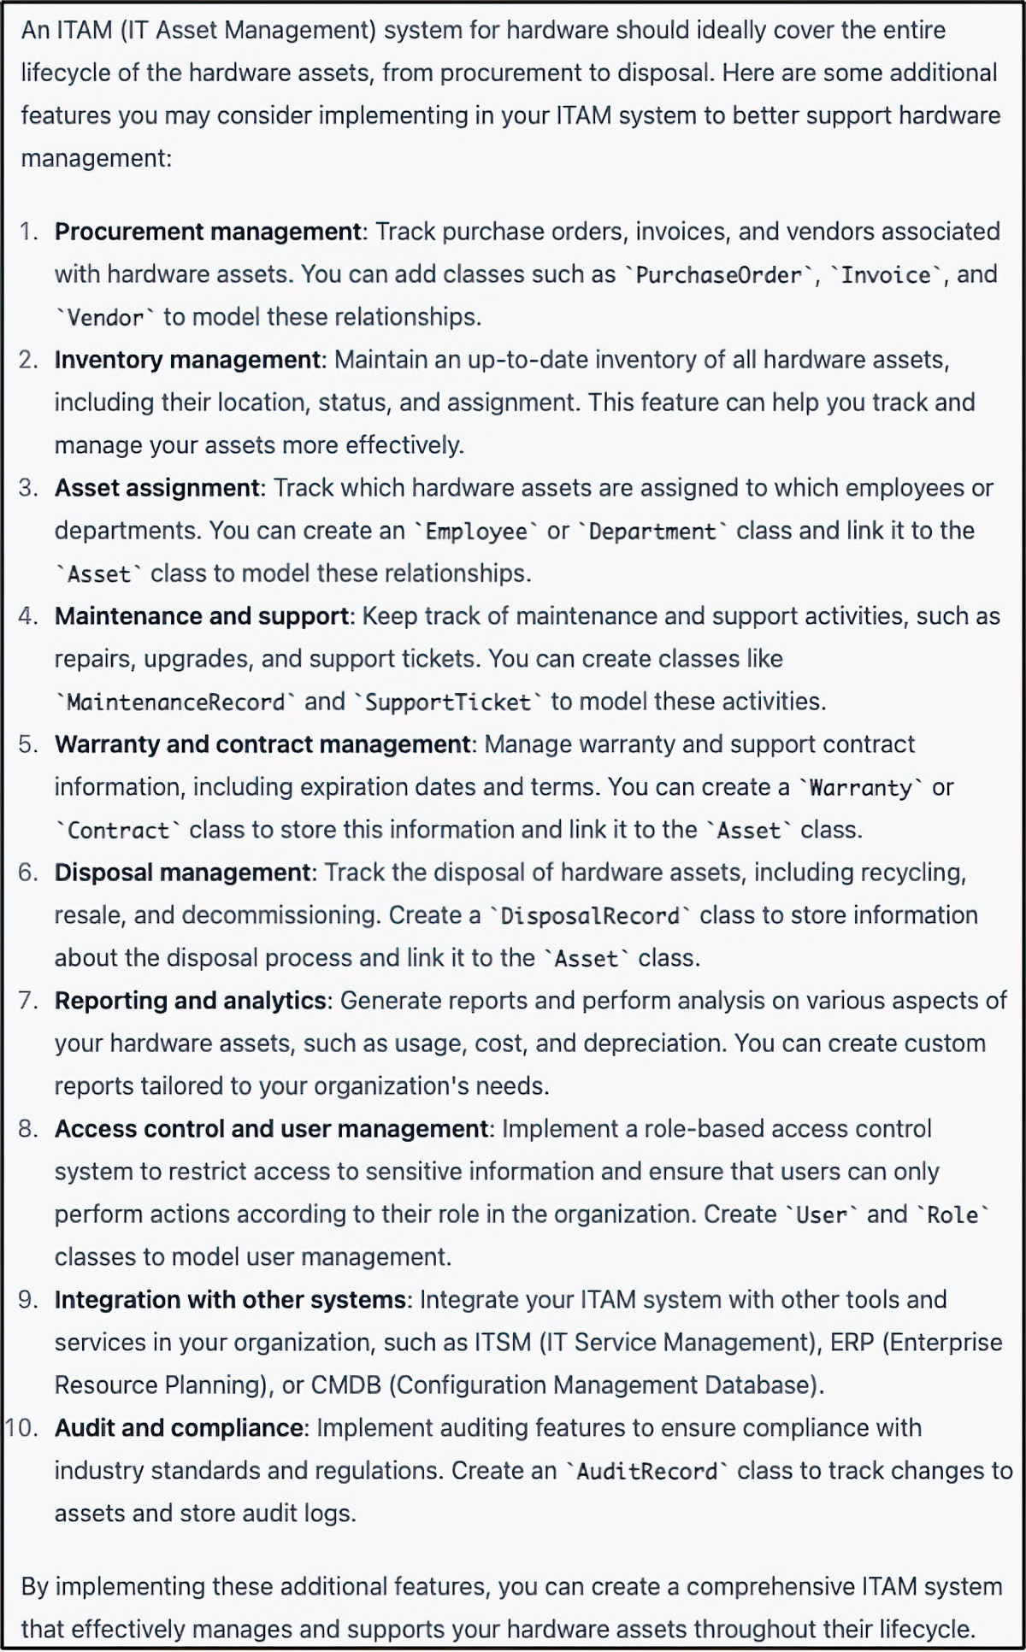

Figure 3.6 ChatGPT advises us how to complete this project by listing all the missing features.

Unfortunately, ChatGPT cannot overcome this limitation. The output is abridged in
the Relationships section. Perhaps a different approach is required. Let’s ask it to print
just the relationships. We can then stitch together the output ourselves:

NC Please output just the relationships for all of the classes in our design, including the
classes you added (e.g., User, Role, etc.), in Mermaid format.

This approach gives us the results that we desire.

46 chapter 3 Designing software with ChatGPT

Listing 3.5 Relationships between the classes in our ITAM project

classDiagram
class MainApp
…
class AuditRecord

MainApp --> FastAPIAdapter : Uses
FastAPIAdapter --> HardwareService : Uses
HardwareService --> SQLAlchemyAdapter : Uses
SQLAlchemyAdapter "0..*" -- "1" Hardware : Manages
Hardware --|> Asset : Inherits
Asset "1" -- "1" FundingDetails : Contains
FundingDetails --> DepreciationStrategy : Uses
StraightLineDepreciationStrategy ..|> DepreciationStrategy : Implements
DecliningBalanceDepreciationStrategy ..|> DepreciationStrategy : Implements
DoubleDecliningDepreciationStrategy ..|> DepreciationStrategy : Implements
NoDepreciationStrategy ..|> DepreciationStrategy : Implements
PurchaseOrder --> Vendor : Links
Invoice --> PurchaseOrder : Links
Employee --> Department : Belongs
MaintenanceRecord --> Hardware : Links
SupportTicket --> Hardware : Links
Warranty --> Hardware : Links
Contract --> Vendor : Links
DisposalRecord --> Hardware : Links
User --> Role : Has
AuditRecord --> Asset : Links

The complete Mermaid document is available on the book’s website (www.manning
.com/books/ai-powered-developer) and in the book’s GitHub repository (https://
github.com/nathanbcrocker/ai_assisted_dev_public).
We should start to feel confident about the ITAM system design we have put together.
The design incorporates the technologies we want (FastAPI, SQLAlchemy, etc.) and
employs the patterns we desired (hexagonal architecture). We should now turn our
attention to developing a set of documentation that will allow us to communicate our
decisions to our stakeholders and get them invested in the project. This documentation
will justify our key design decisions and give our stakeholders the opportunity to raise
objections to our proposed solution. Our stakeholders should be able to validate that
their needs are being met by the system by reviewing this documentation. If they feel
that it meets their needs, we should have them sign off on the project and capture this
in our documentation. This document is called a business requirements document (BRD).
Let’s see if we can get ChatGPT to create a BRD for this project with this prompt:

NC Create a business requirements document for our information technology asset man-
agement system.
Documenting your architecture 47

Business requirements document
A BRD is a formal document that outlines the high-level requirements, features, and con-straints of a project. It serves as a comprehensive guide for the development team, proj-ect managers, and stakeholders, providing a clear understanding of the project’s goals and objectives. A BRD typically includes the following sections:

¡ Introduction—Outlines the purpose and scope of the document.
¡ Business Requirements—Describes the functional and nonfunctional require-
ments of the project, including features and functionality.
¡ System Architecture—Provides an overview of the proposed technical architec-
ture, including technology stack and components.
¡ Project Timeline—Estimates the duration of the project, including milestones and
deadlines.
¡ Assumptions and Constraints—Identifies any assumptions made during the plan-
ning process and potential constraints that may impact the project.
¡ Approval—Includes a section for stakeholders to sign and acknowledge their
agreement with the requirements and scope outlined in the document.

ChatGPT will dutifully output a BRD, including all of the requisite sections with a sur-
prisingly accurate level of detail. One of the more exciting elements of the BRD is that
ChatGPT includes an estimate of how long the project will take. It suggests that the
project should take 25 weeks. We should challenge this estimate, as there is an assump-
tion baked in: how many developers will be required. Figure 3.7 shows ChatGPT’s
response.
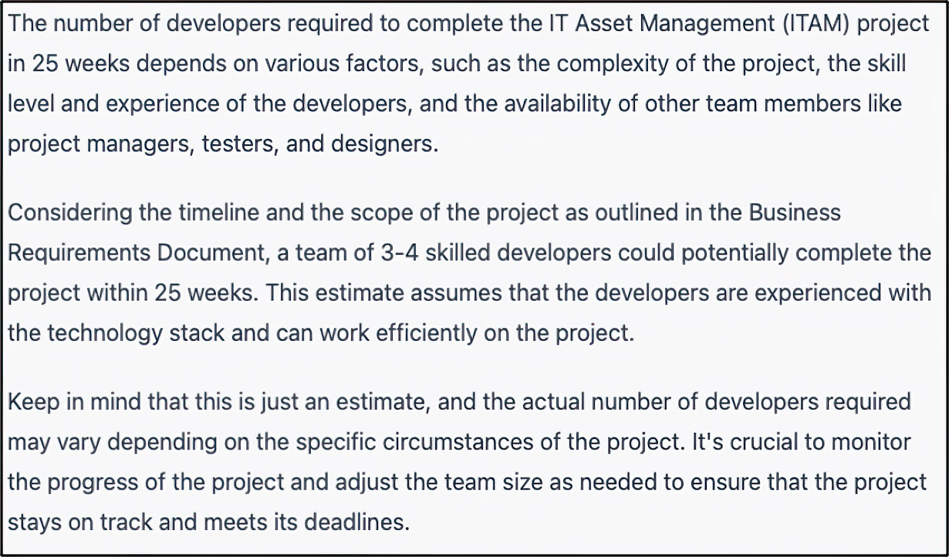

Figure 3.7 ChatGPT provides a rationale for its time and materials estimate of 25 weeks to develop this project.

48 chapter 3 Designing software with ChatGPT

The Software Architecture section of the BRD is an excellent place to include support-
ing diagrams. In this book, we will use the C4 model of documentation. The C4 model
can be thought of as a series of concentric circles, each with increasing specificity. We
use this model here as it maps how we (uncoincidentally) did our design.

The C4 model
The C4 model is a set of hierarchical diagrams for visualizing and documenting software architecture. C4 stands for context, containers, components, and code, which are the four levels of abstraction in the model:

¡ Context—This level illustrates the system’s overall context, showing how it inter-
acts with its users and other systems. It provides a high-level view of the system and its environment.
¡ Containers—This level focuses on the system’s primary containers (e.g., web ap-
plications, databases, and microservices) and how they interact. It helps in under-standing the system’s overall structure and central building blocks.
¡ Components—This level breaks down the containers further into pieces such
as individual services, libraries, and modules, depicting their interactions and dependencies.
¡ Code—The lowest level of abstraction, this level represents the actual code ele-
ments, such as classes, interfaces, and functions, which form the components.

The C4 model is helpful for understanding and communicating the architecture of a soft-ware system at various levels of abstraction, making it easier for developers, architects, and stakeholders to collaborate and discuss the system’s design.

We’ll start by having ChatGPT create a context diagram for our ITAM application,
including the classes it includes:

NC Please create a c4 context diagram for my ITAM project using Mermaid format. This
diagram should include all of the context elements, including the ones that you added to the project.

The context diagram is the highest level of abstraction. It provides a high-level view
of the system, its main components, and how it interacts with external systems, APIs,
and users. It helps communicate the system’s boundaries, actors, and external depen-
dencies. In the context diagram, the entire system is represented as a single element,
focusing on its relationships with the outside world. In this case, the context diagram
for our example (see figure 3.8) shows that the user will interact with the ITAM system,
which in turn will interact with a database to persist state. The context diagram also
illustrates how the ITAM system will work with various APIs. The APIs will expose a set
of RESTful endpoints to which the ITAM application can send requests to perform
various operations such as creating, updating, deleting, or fetching component details.
Documenting your architecture 49
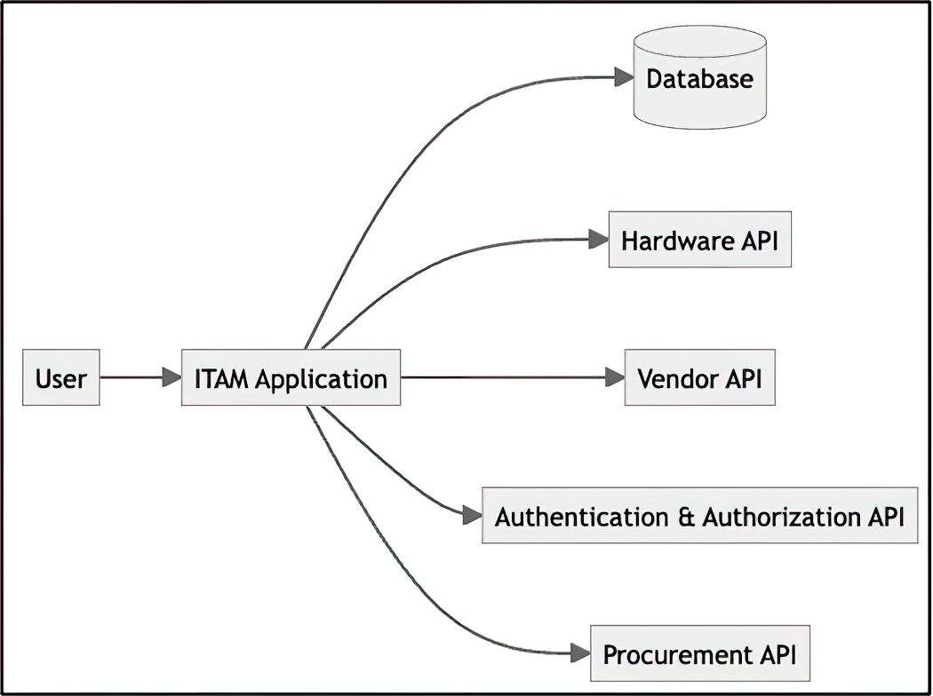

Figure 3.8 The context
diagram for the ITAM system
as interpreted by ChatGPT.
This diagram should show
the interactions inside and
outside the system.

If we go down one layer, we arrive at the container diagram. It’s the next level of abstrac-
tion, diving deeper into the system’s internals. It breaks down the system into its main
building blocks or “containers” (e.g., web applications, databases, message queues,
etc.) and shows how they interact. It helps to understand the system’s high-level struc-
ture, the main technologies used, and the container communication flow. Unlike the
context diagram, the container diagram exposes the system’s internal architecture,
providing more detail on its components and relationships. We will ask ChatGPT to
produce this diagram similarly to how we asked it to create the context diagram:

NC Please create a c4 container diagrams for my ITAM project using Mermaid format.
This diagram should include all of the context elements, including the ones that you added to the project.

The container diagram for this application (see figure 3.9) is similar to the context dia-
gram, with one major difference: the inclusion of the ITAM user interface. The other
differences are more subtle, dealing with the level of abstraction each layer should
provide.
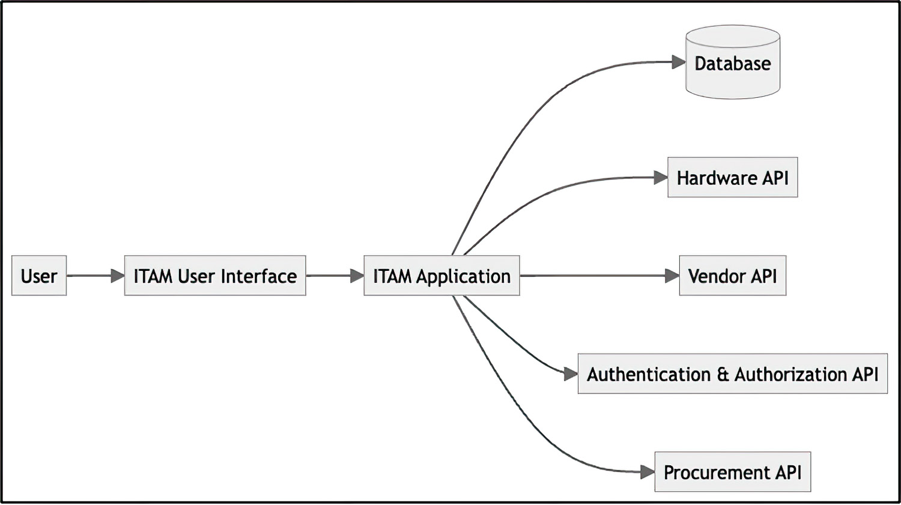

Figure 3.9
The container
diagram for the
ITAM system
as interpreted
by ChatGPT.
It provides
the system’s
components and
relationships.
50 chapter 3 Designing software with ChatGPT

Now, we will dive deeper, into the next layer: the component diagram. It shows the
major components of the system and how they interrelate. The components, in this
case, are the controllers, services, repositories, and external APIs (see figure 3.10).
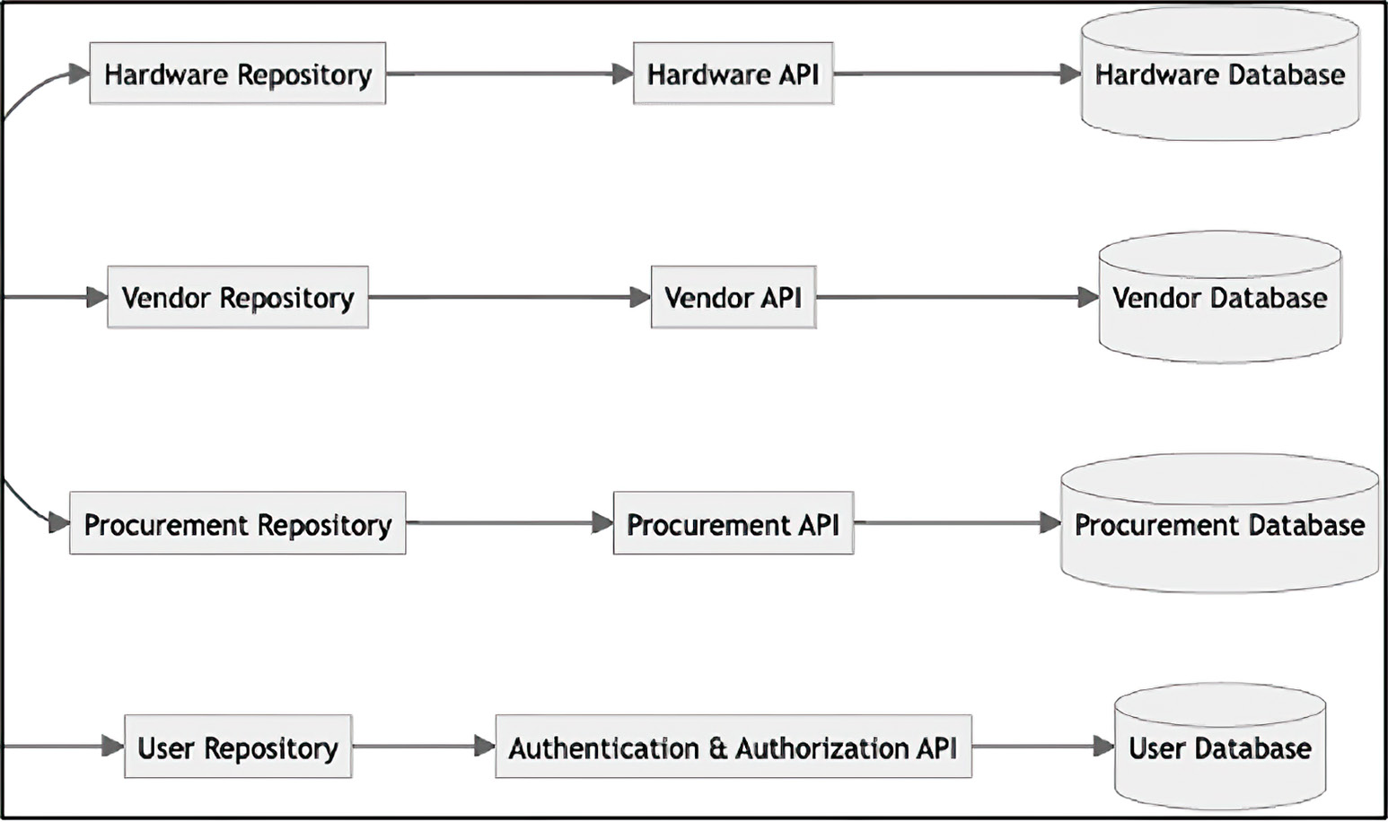

Figure 3.10 The component diagram for the ITAM system as interpreted by ChatGPT. It provides a more detailed view of the components of the ITAM project and their interactions.

Finally, the code diagram is the innermost concentric circle (see figure 3.11). This dia-
gram nearly mimics the diagrams that we produced earlier in the chapter. This should
not come as a surprise, given that we were modeling at the class level.
We have completed the documentation for our project with a series of ever-expand-
ing diagrams and a BRD. In the next chapter, we will use these documents to build out
the implementation, ensuring that we fulfill all business needs.

In the real world
Generally, the project would start with an analyst creating the BRD, capturing all the functional and nonfunctional requirements. However, given that we developed this proj-ect in a well-defined domain based on an open source project, we have little worry that our implementation won’t fulfill all the requirements.

This chapter explored the effective use of ChatGPT in the design phase of software
development, specifically for an ITAM system. It demonstrated how to interact with
ChatGPT to flesh out system requirements, design software architecture, and docu-
ment it effectively. Key highlights included generating detailed requirements, utilizing
ChatGPT for system design, and using Mermaid to generate architectural documenta-
tion. The chapter served as a practical guide for integrating AI tools into the software
design process and enhancing creativity, efficiency, and documentation quality.
Summary 51

AssetService

+getHardware(id: int) : : Hardware
+addHardware(hardware: Hardware) : : void
+updateHardware(id: int, hardware: Hardware) : : void
+deleteHardware(id: int) : : void
+listHardware() : : List
+getTotalAssetCost(department: str) : : float
+getTotalDepreciation(department: str) : : float

Asset
Procurement
+Id: int
+Id: int
+name: str
+vendor: Vendor
+status: str
+purchase_date: datetime
+category: str
+purchase_cost: float
+funding_details: FundingDetails

FundingDetails
+name: str
+lines_of_business: List>
+depreciation_strategy: DepreciationStrategy

Figure 3.11 The code diagram for the ITAM system. It contains the relevant classes of our project.

Summary
¡ ChatGPT is an excellent tool for exploring the software ecosystem surrounding
a business domain. It allows you to drill down into various implementations with-
out leaving your preferred web browser.
¡ ChatGPT enables us to create helpful documentation such as Mermaid,
PlantUML, classic UML, and project layout class diagrams.
¡ Hexagonal architecture is an architectural pattern that aims to create a clear sep-
aration between an application’s core logic and its interaction with external sys-
tems, such as databases, user interfaces, and third-party services.
52 chapter 3 Designing software with ChatGPT

¡ The five SOLID software development design principles are intended to make
software designs more flexible and maintainable. They include the single respon-
sibility principle, the open/closed principle, the Liskov substitution principle,
the interface segregation principle, and the dependency inversion principle.
¡ The Visitor Pattern is a behavioral design pattern that allows you to define a new
operation on an object without changing the class on which the visitor operates.
¡ ChatGPT can be used to generate a C4 model (context, container, component,
and code) for your application. The C4 model provides a way to drill into the
design of the system.
¡ ChatGPT is a good tool to help with documentation for project management. It
can provide estimates of time and materials for the completion of development,
and it can create a series of tasks based on the project’s milestones against which
you can track the progress of development.

Building software with 4 GitHub Copilot

This chapter covers

¡ Developing the core of our system using Copilot
¡ Refactoring to apply patterns
¡ Integrating hexagonal architecture
¡ Incorporating event-driven principles

In the last chapter, we used ChatGPT to help us design our information technology
asset management (ITAM) system. Now, with the design firmly in hand, we begin
to build out this application, starting with the domain model. The domain model is
the core of our system. It represents the classes that will be applying and enforcing
our business rules. We will use GitHub Copilot extensively in this chapter. The most
important takeaway from this chapter is that using a large language model (LLM)
helps to illuminate the unknown unknowns: that is, the non-obvious, the arcane, or
the hidden complexity in the systems that we build. It makes the hard things easier
and the seemingly impossible, possible.

53
54 chapter 4 Building software with GitHub Copilot

One additional note: this chapter is code-heavy. Your code almost certainly will not
exactly match the code presented in this chapter. Instead of dwelling on this fact, accept
it. Try to understand why these differences exist. Observe if altering your prompt modi-
fies the result, and if it does, in what ways.

4.1 Laying the foundation
In the first section of this chapter, we lay the foundation for the rest of our application.
We begin with the core of our application: the domain model. The domain model
should contain the unvarnished business rules and responsibilities of our application,
free from the outside world, focusing solely on business logic and workflows. As you
can see from figure 4.1, the domain sits at the heart of our application. This is no
coincidence, given that it is the heart of the application. We will return to this figure
throughout this chapter as we deepen our understanding of and appreciation for hex-
agonal architecture.
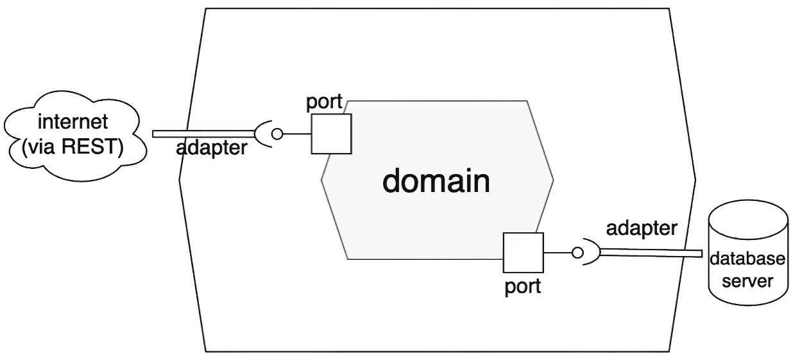

Port
Internet
(via REST) Adapter
Domain

Adapter
Database
Port server

Figure 4.1 A traditional visualization of hexagonal architecture in which the domain, or business logic, sits in the middle

Hexagonal architecture, as you will recall from the last chapter, is an architectural pat-
tern that aims to create a clear separation between an application’s core logic and its
interaction with external systems. This principle is clearly on display in the figure 4.1.

4.1.1 Expressing our domain model

Before we begin, let’s review the documentation we created in the last chapter with the
assistance of ChatGPT. The class diagram (figure 4.2) will provide us with a template
for implementation. As we should know by now, we will not mindlessly implement every
aspect of the code and documentation that ChatGPT provides. Doing so may inadver-
tently lead to a design that is brittle and hard to change, insecure, or incomplete.
Laying the foundation 55
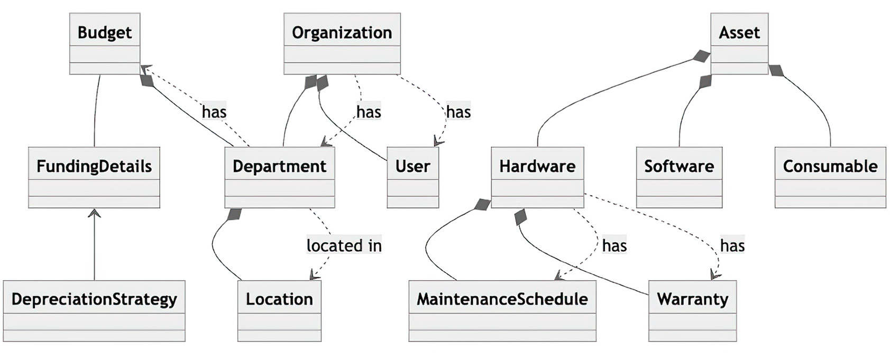

Figure 4.2 The domain object model that ChatGPT produced for us, highlighting the relationships between the classes

If we drill into the methods and fields for the Asset class we created in the last chap-
ter (see figure 4.3), note two things. First, it differs from the Asset class we created in

chapter 2. Second, ChatGPT suggested that we have a constructor that takes all the
attributes for this class; however, it also added mutator methods—the setters—for all the
attributes.
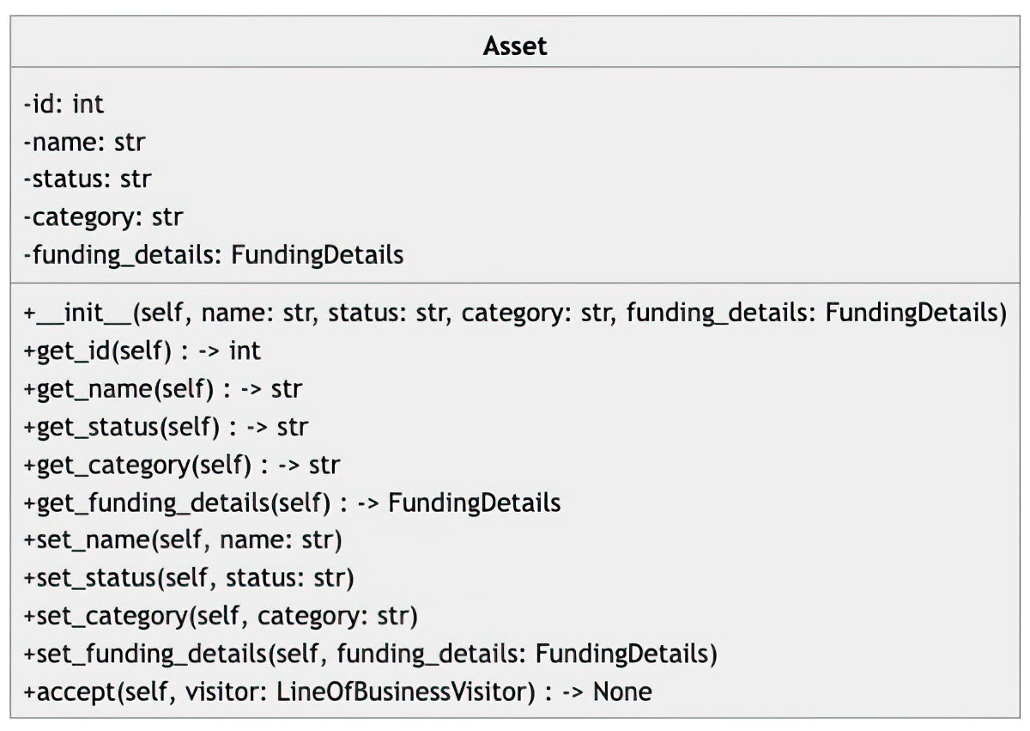

Figure 4.3 The Asset class we created with the assistance of ChatGPT. It includes a constructor and mutator methods for each attribute.

4.1.2 Favoring immutability

Immutable objects, in which the internal state cannot be changed, make classes more
secure and more amenable to concurrency. Should two or more threads access the
same object, we do not need to synchronize access; the state will almost certainly be the
same for both threads. Therefore, we will favor constructor-based value injection over
mutator methods. When we code this class, we will not add mutators.
56 chapter 4 Building software with GitHub Copilot

First we will pull the purchase_date field up from Hardware. This field is shared
among all Assets (this book will not discuss cases in which Assets are leased); there-
fore, the purchase_date field should belong in the parent class.
Next we need to add a few additional fields that are not present in our design from
the last chapter: cost, useful_life, and salvage_value. These fields will be nec-
essary to correctly calculate depreciation. You may remember that depreciation is an
accounting method used to allocate the cost of an asset over its useful life. You should
notice that the terms cost and useful_life appear in that definition. Thus these
fields are required. In addition, the salvage value is the amount of money a business,
department, or company can expect to get from selling the asset at the end of its useful
life. This field is essential in some depreciation calculations; therefore, we will add it to
our class. Create a package called domain/model, add a file called asset.py, and then
add the following prompt to the beginning of this file:

# Define a class named Asset
# It should have the following attributes:
# - id: int
# - name: str
# - status: str
# - category: str
# - cost: float
# - useful_life: float
# - salvage_value: float
# - purchase_date: datetime
#
# The attributes cannot be None and cannot be added after construction # However, we should be able to access the attributes using methods

As you tab through the file to have GitHub Copilot autogenerate the code for you,
you may notice that it will create the mutator despite us explicitly instructing it not to
do that. For this and many other reasons (as we will see throughout this chapter), you
must remain vigilant and mindful as you code. Of course, you can signal your intent,
but these tools may override your desires in the way the tools construct code. Addition-
ally, you may notice that Copilot added the @dataclasses decorator.

Decorator Design Pattern
The Decorator Design Pattern is a structural design pattern that allows you to add new or modify existing behavior to an object dynamically without changing the existing class. This is done by wrapping the existing object in the decorating object.

An interesting exercise for an intrepid explorer would be to ask Copilot to assume
the persona—using the Persona Pattern—of a software engineer. Does this change the
output in any meaningful way?

Laying the foundation 57

DEFINITION Design patterns are common solutions to recurring design problems
in software development. We will explore them more throughout this chapter.

4.1.3 Decorating our favorite classes

This decorator autogenerates common methods for Python (equals and string repre-
sentation, among others). A data class is a class that is primarily used to store data and
does not have much behavior. In Python, data classes were introduced in Python 3.7 as
a utility to make classes that are mainly used to store data cleaner and more efficient.
This is opposed to a user-defined class, whose purpose can be mixed (that is, data and
behavior). Using a data class in this context is useful in that you can avoid boilerplate
code for constructing, representing, and comparing objects. Also, for those keeping
score at home, our autogenerated code is autogenerating code.

Listing 4.1 Code that GitHub Copilot creates in response to our prompt

from dataclasses import dataclass
from itam.domain.funding_details import FundingDetails

@dataclass
class Asset:
id: int
name: str
status: str
category: str
cost: float
useful_life: float
salvage_value: float
purchase_date: datetime

def __post_init__(self):
if self.id is None:
raise TypeError("ID cannot be None")
if self.name is None:
raise TypeError("Name cannot be None")
if self.status is None:
raise TypeError("Status cannot be None")
if self.category is None:
raise TypeError("Category cannot be None")
if self.cost is None:
raise TypeError("Cost cannot be None")
if self.useful_life is None:
raise TypeError("Useful life cannot be None")
if self.salvage_value is None:
raise TypeError("Salvage value cannot be None")

def get_id(self):
return self.id

... # other accessors omitted for clarity 58 chapter 4 Building software with GitHub Copilot

The __post_init__() method will run after the constructor and enforce that none
of the parameters are null (None in Python parlance). Coding defensively this way will
ensure that your values cannot change after initialization. Of course, you are free to
add additional validations as well, such as acceptable values for the status of the cate-
gory. But if you wish to enforce values in that case, it is better to do so by making them
proper classes or using the Enum class.
Next, let’s review the Hardware class in the Mermaid diagram we created in the last

chapter (see figure 4.4). There are several items to note from this diagram: it contains
neither accessor nor mutator methods. We will need to add accessor methods to our
prompt.
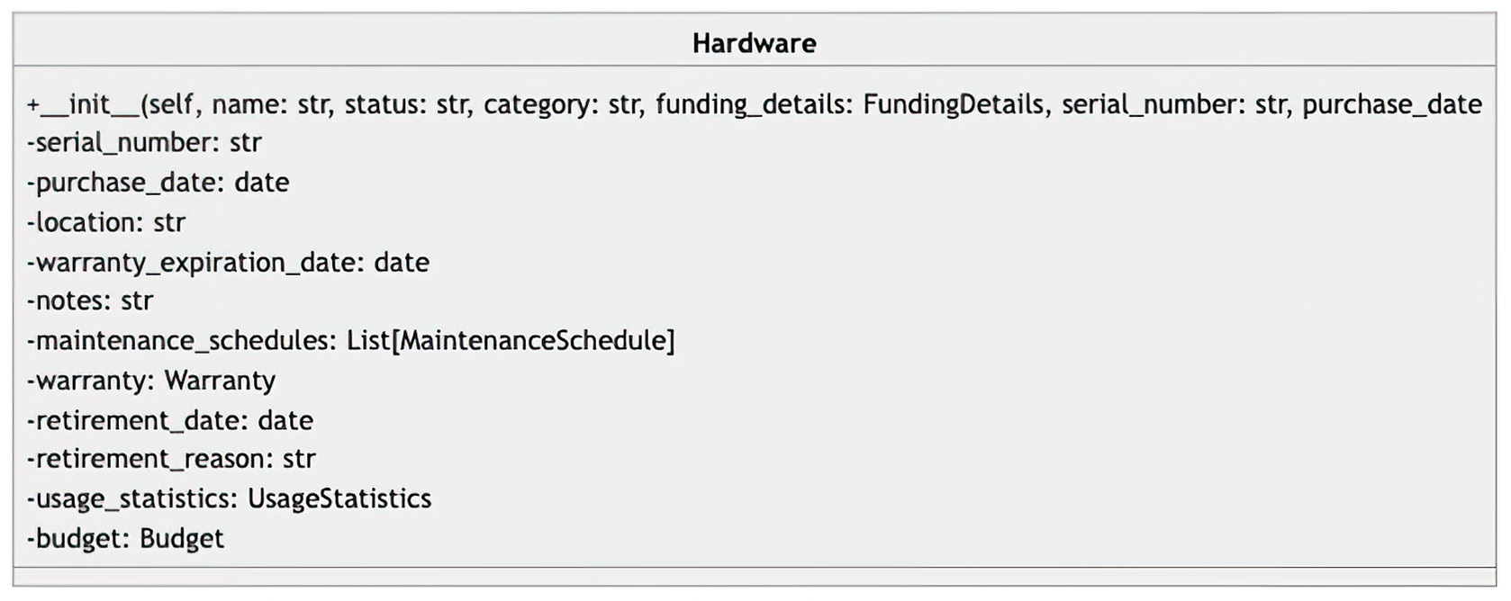

Figure 4.4 The Hardware class that we drafted with the aid of ChatGPT. Note that it does not have any accessor methods.

Now that we have reviewed and assessed what methods and attributes we need in our
Hardware class, we can build it. Create a file called hardware.py in the domain direc-
tory. At the beginning of this file, add the following prompt to have GitHub Copilot
create our Hardware class:

# Define a class called Hardware, which is an instance of Asset. # The Hardware entity has the following attributes:
# - serial_number: str,
# - location: Location,
# - warranty_expiration_date: date,
# - notes: str
# - maintenance_schedules: List[MaintenanceSchedule] # - warranty: Warranty
# - retirement_date: date
# - retirement_reason: str
# - usage_statistics: UsageStatistics
# - budget: Budget
# The attributes can be None and the class should have a constructor that takes all attributes as parameters.
# The attributes should be private and the class should have accessor meth-ods for all attributes.
Laying the foundation 59

The post-constructor code and accessor methods are not included in the code listing,
for brevity’s sake. However, they should be automatically added to your file.

Listing 4.2 Definition of the Hardware class

from datetime import datetime
from dataclasses import dataclass
from itam.domain.asset import Asset
from itam.domain.location import Location
from itam.domain.warranty import Warranty
from itam.domain.maintenance_schedule import MaintenanceSchedule from itam.domain.usage_statistics import UsageStatistics from itam.domain.budget import Budget

@dataclass
class Hardware(Asset):
serial_number: str
location: Location
warranty_expiration_date: datetime
notes: str
maintenance_schedules: list[MaintenanceSchedule]
warranty: Warranty
retirement_date: datetime
retirement_reason: str
usage_statistics: UsageStatistics
budget: Budget

Next, given that it was referenced in the Asset class, let’s add the FundingDetails
class. First, however, let’s review the class diagram (see figure 4.5). Notice that the
lines_of_business dictionary, which we will rename to department_allocations,
uses a string as the key. We should change this to be an actual Department. This is
another reminder that we must actively monitor the generated code and make deci-
sions about how to best implement the project.
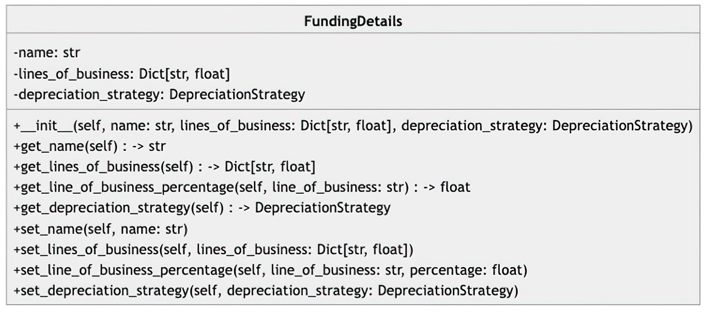

Figure 4.5 The FundingDetails class that we drafted with the aid of ChatGPT. We need to change the lines_of_business dict (renamed to department_allocations) to use a Department as the key.
60 chapter 4 Building software with GitHub Copilot

We need to make two additional edits to this class. First, we need to include the Asset
in the constructor. This will allow us access to the fields needed for calculating depre-
ciations, as previously mentioned. Additionally, we need to include a depreciation
rate in the constructor. This is used for declining depreciation but not straight-line
depreciation. We could set the value of this field in the specific deprecation construc-
tor or use a mutator method, but for now we will add it to the FundingDetails class.
The updated prompt to create the FundingDetails class, including the updated field
name, is shown next:

# Define a class called FundingDetails
# It should have the following attributes:
# - asset: Asset
# - depreciation_strategy: DepreciationStrategy,
# - depreciation_rate: float
# - department_allocations: Dict[Department, float] # The attributes cannot be None and cannot be modified after construction # However, we should be able to access the attributes using methods

There is nothing surprising in the generated class: the code establishes the internal
attributes and sets them via the constructor. After the constructor has finished, it will
check that all attributes are None.

Listing 4.3 FundingDetails class (post constructor and accessor omitted)

from dataclasses import dataclass
from itam.domain.asset import Asset
from itam.domain.depreciation_strategy import DepreciationStrategy from itam.domain.department import Department

@dataclass
class FundingDetails:
asset: Asset
depreciation_strategy: DepreciationStrategy
depreciation_rate: float
department_allocations: Dict[Department, float]

def __post_init__(self):
if self.asset is None:
raise TypeError("Asset cannot be None")
if self.depreciation_strategy is None:
raise TypeError("Depreciation strategy cannot be None")
if self.depreciation_rate is None:
raise TypeError("Depreciation rate cannot be None")
if self.department_allocations is None:
raise TypeError("Department allocations cannot be None")

def get_asset(self):
return self.asset

def get_depreciation_strategy(self):
Laying the foundation 61

return self.depreciation_strategy

def get_depreciation_rate(self):
return self.depreciation_rate

def get_department_allocations(self):
return self.department_allocations

The final class we will generate in this chapter is DepreciationStrategy. In the last
chapter, we were briefly introduced to this class. What we did not mention at the time
was that this class will employ a new design pattern: the Strategy Pattern.

Strategy Pattern
The Strategy Pattern is a behavioral design pattern that lets you define a family of algo-rithms, encapsulate each one as an object, and make them interchangeable. The idea behind the Strategy Pattern is to define a common interface for a group of algorithms so they’re interchangeable despite having potentially very different implementations.

4.1.4 Adapting a strategy for depreciation

Before we attempt to create the DepreciationStrategy class, let’s review the class
diagram that we created in the last chapter (see figure 4.6). The implementations of
this class contain substantial hidden complexity. If we don’t give Copilot very specific
instructions about how the calculations are to be performed, it will not come up with
the correct algorithms. For example, here’s an incomplete, inexact prompt to create
DepreciationStrategy:

# Define an interface called DepreciationStrategy.
# It should have four concrete implementations of the interface: Straight-LineDepreciation Strategy, DecliningBalanceDepreciation Strategy, Double-Declining DepreciationStrategy, and NoDepreciationStrategy. # Each implementation overrides the calculate_depreciation() method to provide a specific way of calculating depreciation for an asset based on its funding details.
# The calculate_depreciation() method should take a FundingDetails object as a parameter and return a float value representing the depreciation amount.
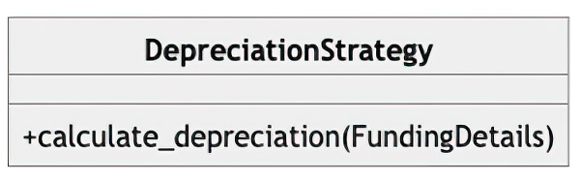

Figure 4.6 The interface class DepreciationStrategy defines the functionality to calculate the depreciation of our assets in our domain model. There are four concrete classes representing how we can depreciate an asset.
62 chapter 4 Building software with GitHub Copilot

This prompt will return methods that, at first sight, appear correct. But they are not.
For example, if we examine the straight-line depreciation method, we see that it nei-
ther includes the salvage value in the calculation nor uses the useful life.

Listing 4.4 Incorrect implementation of straight-line depreciation

class StraightLineDepreciationStrategy(DepreciationStrategy):
def calculate_depreciation(self, funding_details: FundingDetails) -> float:
return funding_details.get_asset().get_cost() * funding_details.get_depreciation_rate()

To correct this, we should update the prompt with the actual formulas for the depre-
ciation methods. Fortunately, we do not have to provide the exact syntax, just the cal-
culations. Copilot will translate our algorithms to validate Python code. Here is the
updated prompt:

# Define an interface called DepreciationStrategy. # It should have four concrete implementations of the interface: Straight-Line Depreciation Strategy, DecliningBalanceDepreciationStrategy, Double-DecliningDepreciationStrategy, and NoDepreciationStrategy. # Each implementation overrides the calculate_depreciation() method to provide a specific way of calculating depreciation for an asset based on its funding details.
# The calculate_depreciation() method should take a FundingDetails object as a parameter and return a float value representing the depreciation amount.
# NoDepreciationStrategy should return 0 for all assets. # The other three strategies should return the depreciation amount based on the following formulas:
# - Straight Line: (cost - salvage value) / useful_life # - Declining Balance: cost * (1-rate/100)^(current_year - purchase_year) # - Double Declining: Declining Balance * 2

Note that we can use pseudocode. Copilot handles the rest.

Listing 4.5 Output from our prompt to calculate depreciation methods

from abc import ABC, abstractmethod
from itam.domain.funding_details import FundingDetails from math import pow

class DepreciationStrategy(ABC):
@abstractmethod
def calculate_depreciation(self, funding_details: FundingDetails) -> float:
pass

class StraightLineDepreciationStrategy(DepreciationStrategy):
def calculate_depreciation(self, funding_details: FundingDetails) -> float:
cost = funding_details.get_asset().get_cost()
salvage_value = funding_details.get_asset().get_salvage_value()
Weaving patterns, patterns, patterns 63

useful_life = funding_details.get_asset().get_useful_life()
return (cost - salvage_value) / useful_life

class DecliningBalanceDepreciationStrategy(DepreciationStrategy):
def calculate_depreciation(self, funding_details: FundingDetails) -> float:
cost = funding_details.get_asset().get_cost()
depreciation_rate = funding_details.get_depreciation_rate()
return cost * pow(1 - (depreciation_rate / 100), datetime.now().year - asset.get_purchase_date().year)

class DoubleDecliningDepreciationStrategy(DepreciationStrategy):
def calculate_depreciation(self, funding_details: FundingDetails) -> float:
cost = funding_details.get_asset().get_cost()
depreciation_rate = funding_details.get_depreciation_rate()
return DecliningBalanceDepreciationStrategy()
.calculate_depreciation(funding_details) * 2

class NoDepreciationStrategy(DepreciationStrategy):
def calculate_depreciation(self, asset: Asset) -> float:
return 0

Many other classes are left undefined. Feel free to practice perfecting your prompt
engineering by implementing the missing classes. For example, you may want to add
Organizations, MaintenanceSchedule, Address, UsageStatistics, User, Role,
and Warranty. In the next section, we will work with Copilot to apply patterns to our
code, starting with a familiar one.

4.2 Weaving patterns, patterns, patterns
In this section, we enrich our domain model with commonly used design patterns.
They represent best practices and can be used to speed up the development process by
providing a set of proven solutions to certain problems. Design patterns are not ready-
to-use code snippets but rather general guides on how to solve a particular problem in
a way that is flexible and can be reused across different projects.

4.2.1 Paying a visit to our department

The first pattern we will revisit is Visitor. As you may recall from chapter 3, you use the
Visitor Pattern to add new behavior to or change the existing behavior of a given class.
Figure 4.7 shows how it was modeled in the last chapter.
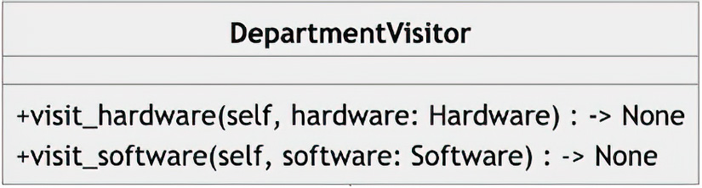

Figure 4.7 The DepartmentVisitor interface (updated to use the new name; previously called LineOfBusinessVisitor). This class “visits” both hardware and software, holding the total cost and depreciation internally.
64 chapter 4 Building software with GitHub Copilot

Let’s design a prompt to have Copilot generate an implementation of our Visitor
Pattern, DepartmentVisitor, which visits our Asset:

# Define an interface called class DepartmentVisitor with the following methods:
# +visit(self, asset: Asset) -> None
# Additionally, define a class called class DepartmentStatisticsVisitor that implements the interface DepartmentVisitor

Copilot generates the straightforward implementation of this class.

Listing 4.6 Vistor implementation

from abc import ABC, abstractmethod
from itam.domain.asset import Asset

class DepartmentVisitor(ABC):
@abstractmethod
def visit(self, asset: Asset) -> None:
pass

class DepartmentStatisticsVisitor(DepartmentVisitor):
def __init__(self):
self._total_cost = 0
self._total_depreciation = 0
self._total_allocation = 0

def visit(self, asset: Asset) -> None:
self._total_cost += asset.get_cost()
self._total_depreciation += asset.get_depreciation()
self._total_allocation += asset.get_allocation()

def get_total_cost(self):
return self._total_cost

def get_total_depreciation(self):
return self._total_depreciation

def get_total_allocation(self):
return self._total_allocation

4.2.2 Creating objects in a factory (pattern)

The Factory Pattern is another creation pattern that allows you to abstract away some
of the details of the object you are attempting to create. In our ITAM system, we have
two types of Asset (currently): Hardware and Software. Each of these objects has
attributes idiosyncratic to itself. One effect of this is that our application does not need
to know the specifics of the concrete class (Hardware, for example). From the applica-
tion’s perspective, it just gets an instance of Asset with additional fields. Let’s look at
how to get Copilot to create an AssetFactory class for us:
Weaving patterns, patterns, patterns 65

# Define a class called AssetFactory
# It should have the following methods:
# +new(self, asset_type: str, asset_name: str, asset_cost: float, useful_life: int, depreciation_strategy: str, depreciation_rate: float, salvage_value: float, asset_purchase_date: str) -> Asset # When asset_type is equal to "hardware" it should delegate the call to a class called HardwareAssetFactory
# When asset_type is equal to "software" it should delegate the call to a class called SoftwareAssetFactory
# If it is neither "hardware" nor "software" it should raise a ValueError # When depreciation_strategy is equal to "straight_line" it should return a new instance of StraightLineDepreciationStrategy
# When depreciation_strategy is equal to "double_declining_balance" it should return a new instance of DoubleDecliningDepreciationStrategy # When depreciation_strategy is equal to "none" it should return a new instance of NoDepreciationStrategy
# When depreciation_strategy is equal to "declining_balance" it should return a new instance of DecliningBalanceDepreciationStrategy # The HardwareAssetFactory and the SoftwareAssetFactory should get the id from the AssetFactory on each call to new.

This prompt is one of the most detailed we have encountered. As our needs get more
and more niche, our prompts will naturally become more meticulous. Let’s examine
this code in detail, starting with the new method.

Listing 4.7 Code for AssetFactory, containing two embedded factories

from datetime import datetime
from itam.domain.asset import Asset
from itam.domain.hardware import Hardware
from itam.domain.funding_details import FundingDetails from itam.domain.depreciation_strategy import (
DepreciationStrategy,
StraightLineDepreciationStrategy,
DecliningBalanceDepreciationStrategy,
DoubleDecliningDepreciationStrategy,
NoDepreciationStrategy
)

class AssetFactory:
def __init__(self):
self.id = 0

def date_from_string(self, date_string: str) -> datetime:
return datetime.strptime(date_string, "%Y-%m-%d")

def new(self, asset_type: str, asset_name: str, asset_cost: float, useful_life: int,
depreciation_strategy: str, depreciation_rate:
float, salvage_value: float,
asset_purchase_date: str) -> Asset:
self.id += 1
purchase_date = self.date_from_string(asset_purchase_date)
66 chapter 4 Building software with GitHub Copilot

if asset_type == "hardware":
return HardwareAssetFactory().new(self.id,
asset_name, asset_cost, useful_life,
depreciation_strategy,
depreciation_rate, salvage_value,
purchase_date)
elif asset_type == "software":
return SoftwareAssetFactory().new(self.id,
asset_name, asset_cost, useful_life,
depreciation_strategy, depreciation_rate,
salvage_value, purchase_date)
else:
raise ValueError

The new method determines which of the specific factories it needs to call based on the
asset_type parameter. Additionally, it keeps track of the number of assets it has cre-
ated, ensuring that the identifier (id field) is always unique. Otherwise, if the identi-
fier creation were pushed down to the specific Factory object, we would get duplicate
keys.

Listing 4.8 Embedded HardwareAssetFactory class

class HardwareAssetFactory:
def new(self, id: int, asset_name:
str, asset_cost: float,
useful_life: int,
depreciation_strategy: str,
depreciation_rate: float,
salvage_value: float,
purchase_date: datetime) -> Asset:
a = Hardware (
id=id,
name=asset_name,
category="hardware",
cost=asset_cost,
useful_life=useful_life,
status="active",
salvage_value=salvage_value,
purchase_date=purchase_date
)

funding_details=FundingDetails(
asset=a,
depreciation_strategy=
self._get_depreciation_strategy(depreciation_strateg,
depreciation_rate=depreciation_rate,
department_allocations=dict()
)

a.funding_details = funding_details
return a

def _get_depreciation_strategy(self,
depreciation_strategy: str) -> DepreciationStrategy:
Weaving patterns, patterns, patterns 67

if depreciation_strategy == "straight_line":
return StraightLineDepreciationStrategy()
elif depreciation_strategy == "double_declining_balance":
return DoubleDecliningDepreciationStrategy()
elif depreciation_strategy == "none":
return NoDepreciationStrategy()
elif depreciation_strategy == "declining_balance":
return DecliningBalanceDepreciationStrategy()
else:
raise ValueError

The new method of the HardwareAssetFactory class is relatively straightforward.
This method accepts the parameters from the AssetFactory, attempts to resolve the
DepreciationStrategy, and sets some sensible defaults.

Listing 4.9 Embedded SoftwareAssetFactory class

class SoftwareAssetFactory:
def new(self, id: int, asset_name: str,
asset_cost: float,
useful_life: int,
depreciation_strategy: str,
depreciation_rate: float,
salvage_value: float,
purchase_date: datetime) -> Asset:
a = Asset(
id=id,
name=asset_name,
category="software",
cost=asset_cost,
useful_life=useful_life,
status="active",
salvage_value=salvage_value,
purchase_date=purchase_date
)

funding_details=FundingDetails(
asset=a,
depreciation_strategy=self.
_get_depreciation_strategy(depreciation_strategy),
depreciation_rate=depreciation_rate,
department_allocations=dict()
)

a.funding_details = funding_details
return a

def _get_depreciation_strategy(self,
depreciation_strategy: str) -> DepreciationStrategy:
if depreciation_strategy == "straight_line":
return StraightLineDepreciationStrategy()
elif depreciation_strategy == "double_declining_balance":
return DoubleDecliningDepreciationStrategy()
elif depreciation_strategy == "none":
68 chapter 4 Building software with GitHub Copilot

return NoDepreciationStrategy()
elif depreciation_strategy == "declining_balance":
return DecliningBalanceDepreciationStrategy()
else:
raise ValueError

The SoftwareAssetFactory class is nearly identical to the HardwareAssetFactory
class—so much so that it likely has a code smell. The term code smell in software devel-
opment describes an intuition a developer has, indicating that there may be a deeper
problem with the code. It is not a bug per se, but a feeling. You may find yourself
with the urge to refactor, because this does appear to violate the DRY principle (Don’t
Repeat Yourself).
But there is an easier way to handle this deduplication. To do this, we will look at our
next design pattern: the Builder Pattern.

Builder Pattern
The Builder Pattern is a creational design pattern that provides a fluent API for the cre-ation of objects by providing step-by-step instructions for how to create an object.

4.2.3 Instructing the system on how to build

First we will write a prompt to have Copilot create our builders: one for Asset and one
for FundingDetails. We will let the builder know that if asset_type is hardware, it
should return an instance of Hardware, and the same for Software:

# Create a class called AssetBuilder
# It should use the Builder pattern to build an Asset # Create another class called FundingDetailsBuilder # It should use the Builder pattern to build a FundingDetails # The AssetBuilder should have an embedded FundingDetailsBuilder # When the category is "hardware" the AssetBuilder should create a Hardware object
# When the category is "software" the AssetBuilder should create a Software object
# When depreciation_strategy is equal to "straight_line" it should return a new instance of StraightLineDepreciationStrategy
# When depreciation_strategy is equal to "double_declining_balance" it should return a new instance of DoubleDecliningDepreciationStrategy # When depreciation_strategy is equal to "none" it should return a new instance of NoDepreciationStrategy
# When depreciation_strategy is equal to "declining_balance" it should return a new instance of DecliningBalanceDepreciationStrategy # The variables will need to be held in local variables and then passed to the Asset and FundingDetails objects when they are created. # The final method of the AssetBuilder should return an Asset and be called build().
# The final method of the FundingDetailsBuilder should return a Funding-Details and be called build().
Weaving patterns, patterns, patterns 69

One thing to note is that all the values need to be stored in local variables; otherwise,
we would encounter post-initialization exceptions. The generated code for the Asset-
Builder is is shown next. The import statements and accessor methods are omitted
for the sake of brevity. One thing worth mentioning is that the methods return self so
they can be chained together.

Listing 4.10 Corresponding AssetBuilder classes

class AssetBuilder:
def __init__(self):
self.id = 0
self.name = ""
self.category = ""
self.cost = 0.0
self.useful_life = 0
self.status = ""
self.salvage_value = 0.0
self.purchase_date = datetime.now()

def with_name(self, name):
self.name = name
return self

...

Next we will examine the build() method of the AssetBuilder class. This method
uses the category field to return the correct subclass of Asset.

Listing 4.11 build() method for the AssetBuilder classes

def build(self) -> Asset:
if self.category == "hardware":
return Hardware(
id=self.id,
name=self.name,
category=self.category,
cost=self.cost,
useful_life=self.useful_life,
status=self.status,
salvage_value=self.salvage_value,
purchase_date=self.purchase_date
)
elif self.category == "software":
return Software(
id=self.id,
name=self.name,
category=self.category,
cost=self.cost,
useful_life=self.useful_life,
status=self.status,
salvage_value=self.salvage_value,
purchase_date=self.purchase_date
)
70 chapter 4 Building software with GitHub Copilot

else:
return Asset(
id=self.id,
name=self.name,
category=self.category,
cost=self.cost,
useful_life=self.useful_life,
status=self.status,
salvage_value=self.salvage_value,
purchase_date=self.purchase_date
)

We can now look at FundingDetailsBuilder. This class closely resembles Asset-
Builder , but without the polymorphic build() method.

Listing 4.12 FundingDetailsBuilder class

class FundingDetailsBuilder:
def __init__(self):
self.asset = None
self.depreciation_strategy = ""
self.depreciation_rate = 0.0
self.department_allocations = dict()

def with_asset(self, asset: Asset) -> FundingDetailsBuilder:
self.asset = asset
return self

...

The class’s build() method implementation is fairly straightforward; it only returns
an instance of the FundingDetails object after applying the parameters to the
constructor.

Listing 4.13 build() method of the FundingDetailsBuilder class

def build(self) -> FundingDetails:
return FundingDetails(
asset=self.asset,
depreciation_strategy=self.depreciation_strategy,
depreciation_rate=self.depreciation_rate,
department_allocations=self.department_allocations)

Next, let’s extract the _get_depreciation_strategy method from the Asset-
Factory class, consolidating the logic of mapping the name of the depreciation strat-
egy to an instance of the DepreciationStrategy.

Listing 4.14 Updated build() method of FundingDetailsBuilder

def _get_depreciation_strategy(self,
depreciation_strategy: str) -> DepreciationStrategy:
if depreciation_strategy == "straight_line":
return StraightLineDepreciationStrategy()
Weaving patterns, patterns, patterns 71

elif depreciation_strategy == "double_declining_balance":
return DoubleDecliningDepreciationStrategy()
elif depreciation_strategy == "none":
return NoDepreciationStrategy()
elif depreciation_strategy == "declining_balance":
return DecliningBalanceDepreciationStrategy()
else:
raise ValueError

def build(self) -> FundingDetails:
return FundingDetails(
asset=self.asset,
depreciation_strategy=self.
_get_depreciation_strategy(depreciation_strategy),
depreciation_rate=self.depreciation_rate,
department_allocations=self.department_allocations
)

Now that we have written the builders, we can modify the AssetFactory to use them.

A pattern hiding in plain sight: The Adapter
The Adapter Pattern is a structural design pattern that allows us to bridge the gap between the target interface and a class with an incompatible interface. For example, in our case, we could have formalized the interface for str -> DepreciationStrategy in an adapter called StringDepreciationStrategyAdapter.

We will update the prompt in the AssetFactory class to use the new builders to con-
struct the instances of Asset and FundingDetails:

# Define a class called AssetFactory
# It should have the following methods:
# +new(asset_type: str, asset_name: str, asset_cost: float, use-ful_life: int, depreciation _strategy: str, depreciation_rate: float, sal-vage_value: float) -> Asset
# Create a function that will take a string and return a datetime # Use the AssetBuilder to create the Asset and use the FundingDetails-Builder to create the FundingDetails

Using the new builders will drastically reduce this class’s code volume. For example,
the new method is now only eight lines long (as formatted in Microsoft VS Code).

Listing 4.15 The updated factory method for an Asset

def new(self, asset_type: str,
asset_name: str, asset_cost: float,
useful_life: int, depreciation_strategy: str,
depreciation_rate: float, salvage_value: float,
asset_purchase_date: str) -> Asset:
self.id += 1
purchase_date = self.date_from_string(asset_purchase_date)
a = AssetBuilder()
72 chapter 4 Building software with GitHub Copilot

.with_id(self.id)
.with_name(asset_name)
.with_category(asset_type)
.with_cost(asset_cost)
.with_useful_life(useful_life)
.with_status("active")
.with_salvage_value(salvage_value)
.with_purchase_date(purchase_date)
.build()
f = FundingDetailsBuilder()
.with_asset(a)
.with_depreciation_strategy(depreciation_strategy) .with_depreciation_rate(depreciation_rate)
.build()

a.funding_details = f
return a

4.2.4 Observing changes

Next we are going to apply the Observer Pattern to our ITAM system. This pattern’s real
value will become more obvious in the next chapter, but we will sow the seeds here.

Observer Pattern
The Observer Pattern is a behavioral pattern in which the Subject class reports certain state changes to observer classes via notifications. The pattern is useful in user inter-faces and event-driven systems.

We will create a new class called AssetManager in the directory service. The Asset-
Manager class will be responsible for interacting with the outside world (more on this
in the next section). This prompt instructs Copilot about to how to define this class:

# Define a class called AssetManager
# with CRUD operations for Asset

Our current implementation of AssetManager uses a list to track the lifecycle of the
Asset s it manages. AssetManager supports all the CRUD (create, read, update, and
delete) operations of Assets.

Listing 4.16 Implementation of AssetManager

from itam.domain.asset import Asset

class AssetManager:
def __init__(self):
self._assets = []

def create(self, asset: Asset) -> None:
self._assets.append(asset)
Weaving patterns, patterns, patterns 73

def read(self, asset_id: int) -> Asset:
for asset in self._assets:
if asset.get_id() == asset_id:
return asset
raise ValueError("Asset not found")

def update(self, asset: Asset) -> None:
for i in range(len(self._assets)):
if self._assets[i].get_id() == asset.get_id():
self._assets[i] = asset
return
raise ValueError("Asset not found")

def delete(self, asset_id: int) -> None:
for i in range(len(self._assets)):
if self._assets[i].get_id() == asset_id:
del self._assets[i]
return
raise ValueError("Asset not found")

def get_assets(self):
return self._assets

Let’s update our prompt to add notifications to our AssetManager class. Right now, we
will not assign any observers; we will save that for chapter 5, when we start to deal with
data flow:

# Define a class called AssetManager
# with CRUD operations for Asset
# and a method to notify observers

In response to our prompt, if we re-create the entire class, Copilot adds the notifica-
tion framework on which we will eventually expand.

Listing 4.17 Updated AssetManager definition with notifications enabled

from itam.domain.asset import Asset

class AssetManager:
def __init__(self):
self._assets = []
self.observers = []

def add_observer(self, observer):
self.observers.append(observer)

def remove_observer(self, observer):
self.observers.remove(observer)

def notify_observers(self, event, asset):
for observer in self.observers:
observer.update(event, asset)

def read(self, asset_id: int) -> Asset:
74 chapter 4 Building software with GitHub Copilot

for asset in self._assets:
if asset.get_id() == asset_id:
return asset
raise ValueError("Asset not found")

def create(self, asset: Asset) -> None:
self.notify_observers("CREATE", asset)
self._assets.append(asset)

def update(self, asset: Asset) -> None:
for i in range(len(self._assets)):
if self._assets[i].get_id() == asset.get_id():
self._assets[i] = asset
self.notify_observers("UPDATE", asset)
return
raise ValueError("Asset not found")

def delete(self, asset_id: int) -> None:
for i in range(len(self._assets)):
if self._assets[i].get_id() == asset_id:
del self._assets[i]
self.notify_observers("DELETE", asset_id)
return
raise ValueError("Asset not found")

def get_assets(self):
return self._assets

We will see two more patterns in the next section of this chapter: Singleton and Reposi-
tory. But first we need to set up a controller to interact with our system. That takes us to
the usage of ports and adapters.

4.3 Plugging in ports and adapters
Our ITAM system is beginning to come together; the core business model has been
built out. We have applied patterns to make the code more concise, readable, and
maintainable. There is, however, one glaring deficiency: how do we interact with our
application? In this section, we continue to deepen our investigation into hexagonal
architecture.

4.3.1 Hexagonal architecture in review

As you may recall, hexagonal architecture is an approach to designing software that
emphasizes the separation of the core business logic from external services. The busi-
ness logic can be thought of as the “brain” of the application. It contains all the import-
ant rules and constructs that the application will need to guarantee the correctness
of the program. In this analogy, the external services are your “hands” or “eyes;” they
allow interactions with the outside world (user interfaces, database, etc.).
Hexagonal architecture separates the main program logic from the outside parts like
buttons, screens, and databases. It makes it easy to change those outside parts without
Plugging in ports and adapters 75

changing the main program. It does this by using ports that define how the outside parts
can interact with the main program and adapters that make those interactions happen
in a concrete way.
This approach makes it easier to change and evolve the application over time. If a
change needs to be made to one of the external systems, the application’s core should
be unaffected; you only need to update the adapter (see figure 4.8).

External
UI

driver

Core
Primary port

Domain logic Secondary port

Figure 4.8 A more
conceptual visualization of
the hexagonal architecture
Infrastructure in action. Notice that the
core is segregated from the
Driven rest of the system and is only
interacted with via ports.

4.3.2 Driving our application

We will begin by building out a driver for the system. A driver is a system external to the
context boundary of the application that sends requests to the system and, optionally,
receives responses from the application. A conventional example is a Representational
State Transfer (commonly referred to as REST) call from a web browser to a REST
controller.
First we will add a REST controller to our ITAM system. It will expose the function-
ality provided by the AssetManager class. Create a directory called infrastructure/API
in which to create a file called asset_controller.py. At the beginning of this file, add the
following prompt:

76 chapter 4 Building software with GitHub Copilot

# Import statements for Asset, AssetService, AssetFactory, AssetIn, Asset-Out, and from_asset
# Use AssetFactory to create an Asset from an AssetIn # Construct an instance of the APIRouter class from FastAPI # Define HTTP endpoints to handle CRUD operations for the AssetService # Implementation of error handling, logging, and other necessary compo-nents for a robust and reliable HTTP API
# All methods should be asynchronous

Given that we do not specify the path to use, Copilot may produce inconsistent or
invalid paths with the routes. The following code was output in VS Code in response to
the previous prompt. The route is asset rather than assets; it’s more of a preference
than a standard, but in REST the nouns are generally made plural.

Listing 4.18 Generated code with route asset

@router.post('/asset', response_model=AssetOut)
async def create_asset(asset_in: AssetIn):
asset = AssetFactory.create_asset(asset_in)
asset_service.create(asset)
return from_asset(asset)

You may elect to manually update the code to reflect your path preference. Above all,
though, ensure that it is consistent across the various methods. The following listing
shows how to initialize all the services needed to run the application.

Listing 4.19 Updated main class to reflect consistent routes

from fastapi import APIRouter, HTTPException
from itam.domain.asset import Asset
from itam.service.asset_manager import AssetManager from itam.domain.factory.asset_factory import AssetFactory from itam.infrastructure.api.asset_model import AssetIn, AssetOut, from_asset import logging

router = APIRouter()

asset_manager = AssetManager()
asset_factory = AssetFactory()

Next, let’s see how the routes are defined and how their methods are used. The first
two routes define how we access our Asset objects. The first GET request gets all
Asset s that we currently have in the system. In the real world, we would include conve-
nience features such as pagination and sorting. However, given the limited number of
entries in the system currently, we will forgo this. The next GET method gets a specific
Asset by its identifier.

Plugging in ports and adapters 77

Listing 4.20 AssetController methods to access Assets

@router.get('/assets', response_model=list[AssetOut]) async def get_assets():
assets = asset_manager.get_assets()
return [from_asset(asset) for asset in assets]

@router.get('/assets/{asset_id}', response_model=AssetOut) async def read_asset(asset_id: int):
try:
asset = asset_manager.read(asset_id)
return from_asset(asset)
except ValueError as e:
logging.error(e)
raise HTTPException(status_code=404, detail="Asset not found")

The final set of routes defines how we create Assets, update them, and remove them
from our system. Note that we are not doing “soft” deletes, which would just set a flag
and not return this Asset in response to subsequent queries.

Listing 4.21 AssetController methods to modify and delete Assets

@router.post('/assets', response_model=AssetOut)
async def create_asset(asset_in: AssetIn):
asset = asset_factory.new(asset_in.asset_type,
asset_in.name, asset_in.unit_cost,
asset_in.useful_life, asset_in.depreciation_strategy,
asset_in.depreciation_rate, asset_in.salvage_value,
asset_in.purchase_date)
asset_manager.create(asset)
return from_asset(asset)

@router.put('/assets/{asset_id}', response_model=AssetOut) async def update_asset(asset_id: int, asset_in: AssetIn):
try:
asset = asset_factory.new(asset_in.asset_type,
asset_in.name, asset_in.unit_cost,
asset_in.useful_life, asset_in.depreciation_strategy,
asset_in.depreciation_rate, asset_in.salvage_value,
asset_in.purchase_date)
asset.set_id(asset_id)
asset_manager.update(asset)
return from_asset(asset)
except ValueError as e:
logging.error(e)
raise HTTPException(status_code=404, detail="Asset not found")

@router.delete('/assets/{asset_id}')
async def delete_asset(asset_id: int):
try:
asset_manager.delete(asset_id)
except ValueError as e:
logging.error(e)
raise HTTPException(status_code=404, detail="Asset not found")
78 chapter 4 Building software with GitHub Copilot

Note the simplified representations of the Asset class called, not coincidently,
AssetIn and AssetOut. You can define those classes in the AssetController, or you
can add a separate class and define them there. In the reference implementation for
this book, they are defined in a file called asset_model.py. This prompt defines the
AssetIn and AssetOut classes:

# Define a pydantic model for AssetIn
# It should have the following attributes:
# name: str
# asset_type: str
# department: str
# depreciation_strategy: str
# useful_life: int
# unit_cost: float
# depreciation_rate: float
# salvage_value: float

# Define a pydantic model for AssetOut
# It should have the following attributes:
# id: int
# name: str
# asset_type: str
# department: str
# depreciation_strategy: str
# useful_life: int
# unit_cost: float
# depreciation_rate: float
# salvage_value: float
# It should have a method that transforms an Asset into an AssetOut

With the prompt defined at the beginning of the file, Copilot generates code similar to
the following listing.

Listing 4.22 AssetIn and AssetOut classes in asset_model.py

from pydantic import BaseModel
from itam.domain.asset import Asset

class AssetIn(BaseModel):
name: str
asset_type: str
department: str
depreciation_strategy: str
useful_life: int
unit_cost: float
depreciation_rate: float
salvage_value: float
purchase_date: str

class AssetOut(BaseModel):
id: int
name: str
asset_type: str
Plugging in ports and adapters 79

depreciation_strategy: str
useful_life: int
unit_cost: float
depreciation_rate: float
salvage_value: float
purchase_date: str

@staticmethod
def from_asset(asset: Asset) -> AssetOut:
return AssetOut(
id=asset.id,
name=asset.name,
asset_type=asset.category,
depreciation_strategy=str(asset.funding_details.depreciation_strategy),
useful_life=asset.useful_life,
unit_cost=asset.cost,
depreciation_rate=asset.funding_details.depreciation_rate,
salvage_value=asset.salvage_value,
purchase_date=asset.purchase_date.strftime("%Y-%m-%d"),
)

Optionally, we can add another layer of abstraction between AssetController and
AssetManager. Doing so may be considered hexagonal architecture in extremis, but
there are few challenges in computer science that cannot be resolved by adding one
more layer of abstraction. We will add a port that will be used to interface with Asset-
Controller. Let’s create a prompt for the class AssetRestPort and have Copilot gen-
erate the code:

# Define an interface called AssetRestPort
# It should expose all of the methods in AssetManager as abstract methods

This prompt instructs Copilot to create an interface that we will implement shortly.

Listing 4.23 Complete source code for AssetRestPort

from itam.domain.asset import Asset
from abc import abstractmethod

class AssetRestPort:
@abstractmethod
def read(self, asset_id: int) -> Asset:
pass

@abstractmethod
def create(self, asset: Asset) -> None:
pass

@abstractmethod
def update(self, asset: Asset) -> None:
pass

@abstractmethod 80 chapter 4 Building software with GitHub Copilot

def delete(self, asset_id: int) -> None:
pass

@abstractmethod
def get_assets(self):
pass

Next we will implement this port with an adapter that will be used to interact with
the controller to further abstract the components. We can swap out this adapter for
another if we want to, for example, turn this into a command-line application. The
prompt for AssetRestAdapter is as follows:

# Define an interface called AssetRestAdapter
# It should take an AssetManager as a parameter in its constructor # It should expose all of the methods in AssetManager # It should inherit from AssetRestPort

There are two important elements to this prompt. The first is that it implements the
port interface that we defined previously. The second is that it wraps AssetManager’s
functionality.

Listing 4.24 Source code for AssetRestAdapter

from itam.domain.asset import Asset
from itam.infrastructure.ports.asset_rest_port import AssetRestPort from itam.service.asset_manager import AssetManager

class AssetRestAdapter(AssetRestPort):
def __init__(self, asset_manager: AssetManager):
self._asset_manager = asset_manager

def read(self, asset_id: int) -> Asset:
return self._asset_manager.read(asset_id)

def create(self, asset: Asset) -> None:
self._asset_manager.create(asset)

def update(self, asset: Asset) -> None:
self._asset_manager.update(asset)

def delete(self, asset_id: int) -> None:
self._asset_manager.delete(asset_id)

def get_assets(self):
return self._asset_manager.get_assets()

All that is left to do is to update AssetController to remove its direct invocation of
the AssetManager methods and instead have AssetController invoke the methods
of the adapter, which in turn invokes the methods of AssetManager. The key takeaway
from the Ports and Adapters Pattern is that it abstracts the interaction between the
driving parts of the system—in this case, the REST API—and the driven application: the
Plugging in ports and adapters 81

business model and core of our system, AssetManager. To make this more explicit and
as a preview, we will shortly modify this class again to add the port to the constructor.

Listing 4.25 Updated code for AssetController using AssetRestAdapter

router = APIRouter()

asset_rest_adapter = AssetRestAdapter(AssetManager()) asset_factory = AssetFactory()

@router.post('/assets', response_model=AssetOut)
async def create_asset(asset_in: AssetIn):
asset = asset_factory.new(asset_in.asset_type,
asset_in.name, asset_in.unit_cost,
asset_in.useful_life, asset_in.depreciation_strategy,
asset_in.depreciation_rate, asset_in.salvage_value,
asset_in.purchase_date)
asset_rest_adapter.create(asset)
return from_asset(asset)

As previously mentioned, we will modify AssetController to remove all direct ref-
erences to the AssetManager. Our current AssetController, although it does
not directly invoke any AssetManager methods, does hold an indirect reference to
AssetManager, because AssetManager is constructed in AssetController. Doing so
further insulates AssetManager from changes in the drivers.

4.3.3 Accessing our data and persisting our changes

Abstractions in software are not merely an academic matter. These abstractions give
us flexibility when it comes to satisfying requirements and making changes. They can
hide complexity, encapsulating behavior behind seemingly simple interfaces. This
brings us to our next pattern: the Repository Pattern.

Repository Pattern
The Repository Pattern is a design pattern that helps manage data by creating a sepa-rate place to handle tasks like getting, saving, updating, and deleting data. It connects the data source (such as a database or file) to the rest of the application, keeping data access code separate from other code.

In our ITAM project, the Repository Pattern will allow us to present a greatly simplified
interface, masking the complexity of, in this case, our data access. From the perspec-
tive of the repository or AssetManager, our data access layer is just a series of methods.
Behind the scenes, it may be a REST API, a Redis cache, MongoDB, a file, or a database
of any flavor. Let’s create a prompt that will set up our generic data access layer using
the Repository Pattern:

82 chapter 4 Building software with GitHub Copilot

# Create an abstract base class called BaseRepository that represents a generic data access layer using the Repository pattern. # The class should define common methods for CRUD operations such as cre-ate, read, update, and delete.
# Make sure to use type hints for the input parameters and return values.

With this prompt, Copilot should have everything it needs to establish the contract
that all implementations will honor. Let’s examine the code.

Listing 4.26 Code for BaseRepository, our generic data access layer

from abc import ABC, abstractmethod
from typing import List, TypeVar, Generic

T = TypeVar('T')

class BaseRepository(ABC, Generic[T]):
@abstractmethod
def create(self, entity: T) -> None:
pass

@abstractmethod
def read(self, entity_id: int) -> T:
pass

@abstractmethod
def update(self, entity: T) -> None:
pass

@abstractmethod
def delete(self, entity_id: int) -> None:
pass

@abstractmethod
def get_entities(self) -> List[T]:
pass

Copilot introduced a Generic type, allowing for some typing hints when it comes time
to implement. If we express that the type should be an Asset, the method signature
will demonstrate this. Our first attempt at an implementation will be an in-memory
data store. This will allow us to perform an end-to-end test of our entire system. It
also nicely demonstrates why abstractions are useful. Before long, we will add another
implementation that uses Postgres. But first, the prompt:

# Define a class called InMemoryAssetRepository that inherits from the Base Repository abstract class. # The InMemoryAssetRepository should be specific to managing Asset objects using an in-memory list to store and update the assets. # Implement the necessary methods for CRUD operations such as create, read, update, and delete for Asset objects using the in-memory list. # Make sure to use type hints for the input parameters and return values.

Plugging in ports and adapters 83

Our in-memory implementation will use a simple list to store Assets. We will be able to
perform all CRUD operations. Additionally, Copilot will add typing hints for us, letting
others know that it should accept and return Assets. That is what is meant by Base-
Repository[Asset]: it’s an implementation of a BaseRepository whose Generic
type is Asset.

Listing 4.27 Code for InMemoryAssetRepository

from itam.infrastructure.repository.base_repository import BaseRepository from itam.domain.asset import Asset

class InMemoryAssetRepository(BaseRepository[Asset]):
def __init__(self):
self._assets = []

def create(self, asset: Asset) -> None:
self._assets.append(asset)

def read(self, asset_id: int) -> Asset:
return next((asset for asset in self._assets
if asset.id == asset_id), None)

def update(self, asset: Asset) -> None:
for i in range(len(self._assets)):
if self._assets[i].id == asset.id:
self._assets[i] = asset
break

def delete(self, asset_id: int) -> None:
self._assets = [asset for asset in self._assets if asset.id != asset_id]

def get_entities(self) -> list[Asset]:
return self._assets

Finally, we will update AssetManager to delegate the CRUD operations of the Assets
to a BaseRepository instance (_repository). The full source code follows, includ-
ing the prompt at the beginning of the file.

Listing 4.28 AssetManager using InMemoryAssetRepository

# Define a class called AssetManager
# with CRUD operations for Asset
# and a method to notify observers whenever an asset is created, updated or deleted
# The AssetManager should use an instance of the InMemoryAssetRepository class for data access and CRUD operations on Asset objects. # Implement methods for creating, reading, updating, and deleting assets using the AssetRepository instance.
# Please include type hints for the input parameters and return values. # The methods should be named create, read, update, get_assets, and delete.

from itam.domain.asset import Asset 84 chapter 4 Building software with GitHub Copilot

from itam.infrastructure.repository.in_memory_asset_repository import InMemoryAssetRepository

class AssetManager:
def __init__(self):
self._repository = InMemoryAssetRepository()

def create(self, asset: Asset) -> Asset:
self._repository.create(asset)
return asset

def read(self, asset_id: int) -> Asset:
return self._repository.read(asset_id)

def update(self, asset: Asset) -> Asset:
self._repository.update(asset)
return asset

def get_assets(self) -> list[Asset]:
return self._repository.get_entities()

def delete(self, asset_id: int) -> None:
self._repository.delete(asset_id)

At this point, we have a core business domain that is untouched directly by our system.
We have ports by which requests can come in. We also have ports by which we can store
the data (at least while the system is running). We should be able to test the system end
to end by running it, POSTing requests to the creation end point, and reading from
the GET end points. Once we have confirmed that the system works end to end, we can
tackle the problem that our data is only persisted in memory; we can now hook up an
actual database. To do this, we introduce the final pattern of this chapter: the Singleton
Pattern. A singleton, conceptually, is very simple to grok; there should only ever be one
instance of it running. It is good for many use cases: logging, caching, configuration
settings, or a database connection manager.

Singleton Pattern
The Singleton Pattern is a design pattern that ensures a class has only one instance and provides a global access point to that instance. It is used when you want to have a single object shared across different parts of your program instead of creating multiple instances of the same class.

4.3.4 Centralizing (and externalizing) our data access

We will ask Copilot to create a singleton class for us to manage our database’s connec-
tions. We should never hardcode usernames or passwords (or any connection details,
for that matter) in our source code, not only because it is inherently less secure but
also because the details will likely differ depending on the environment (DEV versus
Plugging in ports and adapters 85

QA versus PROD). We will therefore ask Copilot to accept these values as environmen-
tal variables and configure the connections using them:

# Create a Python class called DatabaseConnection using the Singleton pattern to manage a single connection to a PostgreSQL database using SQLAlchemy.
# The class should read the database username, password, and connection string from environment variables
# The environment variables should be named: DB_USERNAME, DB_PASSWORD, DB_HOST, DB_PORT, and DB_NAME

We are asking Copilot to employ SQLAlchemy, an object-relational mapping (ORM)
tool, to perform the actions against the database. Copilot will adroitly assemble our
source code. The @staticmethod keyword creates a method that belongs to a class
rather than the instance of the class. This keyword is used to get the instance of the
DatabaseConnection class. Because a static method cannot modify the instance data,
it can be used to ensure that only one instance of this class is ever running and is thus a
singleton. The constructor initializes the connection to the database using string inter-
polation with environment variables.

Listing 4.29 Implementation of a DatabaseConnection

from sqlalchemy import create_engine
from sqlalchemy.orm import sessionmaker
import os

class DatabaseConnection:
__instance = None
@staticmethod
def get_instance():
if DatabaseConnection.__instance == None:
DatabaseConnection()
return DatabaseConnection.__instance

def __init__(self):
if DatabaseConnection.__instance != None:
raise Exception("This class is a singleton!")
else:
DatabaseConnection.__instance = self
self.engine =
create_engine(f"postgresql://
{os.environ['DB_USERNAME']}:
{os.environ['DB_PASSWORD']}@
{os.environ['DB_HOST']}:
{os.environ['DB_PORT']}/
{os.environ['DB_NAME']}")
self.Session = sessionmaker(bind=self.engine)

def get_session(self):
return self.Session()

86 chapter 4 Building software with GitHub Copilot

Now that we can get a connection to our database, we need to create a repository that
will use this connection to store and retrieve our Asset objects. We will create a class
that does just that called SQLAlchemyAssetRepository.

Listing 4.30 Prompt and code for the SQLAlchemyAssetRepository class

# Define a class called SQLAlchemyAssetRepository that implements the AssetRepository interface for data access using SQLAlchemy. # The class should handle the CRUD operations (create, read, update, and delete) for assets, storing and retrieving them in a PostgreSQL database using SQLAlchemy.

from itam.domain.asset import Asset
from itam.infrastructure.repository.base_repository import BaseRepository from sqlalchemy.orm import Session

class SQLAlchemyAssetRepository(BaseRepository[Asset]):
def __init__(self, session: Session):
self._session = session

def create(self, asset: Asset) -> Asset:
self._session.add(asset)
self._session.commit()
return asset

def read(self, asset_id: int) -> Asset:
return self._session.query(Asset)
.filter(Asset.id == asset_id).first()

def update(self, asset: Asset) -> Asset:
self._session.query(Asset)
.filter(Asset.id == asset.id).update(asset)
self._session.commit()
return asset

def get_assets(self) -> list[Asset]:
return self._session.query(Asset).all()

def delete(self, asset_id: int) -> None:
self._session.query(Asset).filter(Asset.id == asset_id).delete()
self._session.commit()

Next we will refactor AssetController to allow us to pass in AssetRestPort. By
doing this, we can swap out the driven aspect of our application. This refactor further
abstracts the driver from the business core.

Listing 4.31 Updated AssetController that exposes routes

from itam.infrastructure.ports.asset_rest_port import AssetRestPort import logging

class AssetController:
def __init__(self, asset_rest_port: AssetRestPort):
Plugging in ports and adapters 87

self._asset_factory = AssetFactory()
self._asset_rest_port = asset_rest_port
...

def get_router(self):
return self._router

async def get_assets(self):
return [ from_asset(a) for a in self._asset_rest_port.get_assets()]

async def get_asset(self, asset_id: int):
asset = self._asset_rest_port.read(asset_id)
if asset is None:
raise HTTPException(status_code=404, detail="Asset not found")
return from_asset(asset)

async def create_asset(self, asset_in: AssetIn):
asset = self._asset_factory.new(
asset_in.asset_type,
asset_in.name,
asset_in.unit_cost,
asset_in.useful_life,
asset_in.depreciation_strategy,
asset_in.depreciation_rate,
asset_in.salvage_value,
asset_in.purchase_date)
self._asset_rest_port.create(asset)
return from_asset(asset)

async def update_asset(self, asset_id: int, asset_in: AssetIn):
asset = self._asset_factory.new(
asset_in.asset_type,
asset_in.name,
asset_in.unit_cost,
asset_in.useful_life,
asset_in.depreciation_strategy,
asset_in.depreciation_rate,
asset_in.salvage_value,
asset_in.purchase_date)

asset.id = asset_id
asset = self._asset_rest_port.update(asset)
if asset is None:
raise HTTPException(status_code=404, detail="Asset not found")
return from_asset(asset)

async def delete_asset(self, asset_id: int):
asset = self._asset_rest_port.read(asset_id)
if asset is None:
raise HTTPException(status_code=404, detail="Asset not found")
self._asset_rest_port.delete(asset_id)
return from_asset(asset)

88 chapter 4 Building software with GitHub Copilot

We can now consolidate the initialization logic of our application into the main.py file.
This is the big payoff. Our system will have layering, facilitating the swapping out of
components as needed or when requirements change.

Listing 4.32 Final version of main.py, wiring our application together

from fastapi import FastAPI
from itam.infrastructure.api.asset_controller import AssetController #from itam.infrastructure.repository.in_memory_asset_repository
import InMemoryAssetRepository
from itam.infrastructure.repository.sqlalchemy_asset_repository
import SQLAlchemyAssetRepository
from itam.infrastructure.database.database_connection
import DatabaseConnection
from itam.service.asset_manager import AssetManager from itam.infrastructure.adapters.asset_rest_adapter import AssetRestAdapter import uvicorn

app = FastAPI()
session = DatabaseConnection().get_session()
#repository = InMemoryAssetRepository()
repository = SQLAlchemyAssetRepository(session)
asset_manager = AssetManager(repository)
asset_rest_adapter = AssetRestAdapter(asset_manager) asset_controller = AssetController(asset_rest_adapter) app.include_router(asset_controller.get_router())

if __name__ == '__main__':
uvicorn.run(app, host='0.0.0.0', port=8000)

Congratulations! We now have a running system that persists data to our database.

Summary
¡ The Decorator Pattern is a structural design pattern that allows you to add new
object behavior or modify existing behavior dynamically without changing the
existing class. This is done by wrapping the current object in the decorating
object.
¡ The Visitor Pattern adds new behavior to changes the existing behavior of a given
class.
¡ The Factory Pattern is another creation pattern that allows you to abstract away
some of the details of the object you are attempting to create.
¡ The Builder Pattern is a creational design pattern that provides a fluent API for
the creation of objects by providing step-by-step instructions for creating those
objects.
¡ The Adapter Pattern is a structural design pattern that allows you to bridge the
gap between the target interface and a class with an incompatible interface.
¡ The Observer Pattern is a behavioral pattern in which the subject class reports
certain state changes to observer classes via notifications.
Summary 89

¡ Hexagonal architecture separates the main program logic from outer parts like
buttons, screens, and databases. It makes changing outer parts easy without
changing the main program.
¡ The Repository Pattern is a design pattern that helps manage data by creating a
separate place to handle tasks like getting, saving, updating, and deleting data. It
connects the data source (such as a database or file) to the rest of the application,
keeping data access code separate from other code.
¡ The Singleton Pattern is a design pattern that ensures a class has only one
instance and provides a global access point to that instance. It is used when you
want a single object to be shared across different parts of your program instead of
creating multiple instances of the same class.

Managing data with 5 GitHub Copilot and Copilot Chat

This chapter covers

¡ Persisting data into a relational database
¡ Streaming data using Apache Kafka
¡ Incorporating event-driven principles
¡ Analyzing data to monitor the location using Spark

The last chapter laid the foundation for our information technology asset manage-
ment (ITAM) system. However, this application will not fulfill our requirements
without data. Data is the lifeblood of every application. That is what this chapter
is all about: the various ways we can use generative AI to create data, stream data,
transform data, react to data, and learn from data.
Perceptive individuals may have noticed in the last chapter that our data access
pattern would not have worked as it was incomplete. The opening section of this

chapter will address this. After that, we will set up our database, fix the classes that
access this data, and load some sample data to use in the rest of the chapter.

90
Amassing our dataset 91

5.1 Amassing our dataset
Our first task will be to construct a substantial corpus of data to assist our experimen-
tation in the remainder of the chapter. First we will use GitHub Copilot to generate
1,000 rows of asset information. We will soon find, however, that this may not be the
tool best suited to this task. A key driver behind using these tools is the idea of discov-
ery: testing their boundaries, pushing against them, and occasionally pushing back.
But the journey is often where the joy is found. Once we have found this edge, we will
be introduced to a new, previously unseen tool: GitHub Copilot Chat. Finally, when we
have created our list of assets, we will add location information for those assets, again
using GitHub Copilot Chat.
We need to get our database running before building our initial dataset. Docker
makes this task trivial, allowing us to quickly spin up an empty PostgreSQL (or other
RDBMS/NoSQL server) with minimal effort. Have you forgotten the command to do
this? No worries—we can ask Copilot. Open a new file called data/initial_data_load.sql
and enter the following prompt at the top of your newly minted SQL file:

-- Question: What is the command to run a docker container, running Postgre-SQL for a database called itam_db. I would like to specify the password for this database.

Copilot will slowly reveal the Docker command:

--Answer: docker run --name itam_db
-e POSTGRES_PASSWORD=postgres -d
-p 5432:5432 postgres

Once you run this command at your terminal or command line, we can build out our
dataset. You should be able to connect to the locally running database. Notice that a
database called itam_db is running in it. However, this database has no schema, tables,
or data. Let’s first set up a new schema.
In our initial_data_load.sql, we will add a prompt to have Copilot draft the schema
creation command. The following prompt (and response from Copilot) will allow you
to create a new schema called itam if executed from within your database client appli-
cation (e.g., DataGrip, SQuirreL, pdAdmin, or even using the Docker exec command
docker exec -i itam_db psql -U postgres -c "create schema itam"):

-- create a schema called itam
create schema itam;

Next, we should add a user for use in our application. This user will be able to perform
CRUD (create, read, update, delete) operations on our data but will not be able to
affect the structure of the database tables or procedures.

92 chapter 5 Managing data with GitHub Copilot and Copilot Chat

NOTE The lines that start with double dashes (--) are comments in SQL. Com-
menting out these lines is optional from Copilot’s perspective, as it will generate
solutions without the comments; it makes it easier to copy and paste the code
directly into our database tool of choice.

While we are at it, we will also add an administrative account to perform the operations
that our read-write users cannot, such as creating or dropping tables.

Listing 5.1 Prompt to create new users

-- create two users called itam_user and itam_admin. itam_user should be able to read from and write to the tables in the itam schema. itam_admin should be able to read from and write to the tables in the itam schema and create and drop tables in the itam schema.
create user itam_user with password 'itam_user';
create user itam_admin with password 'itam_admin'; grant usage on schema itam to itam_user;
grant usage on schema itam to itam_admin;
grant select, insert, update, delete on all tables in schema itam to itam_user; grant select, insert, update, delete on all tables in schema itam to itam_admin; grant usage, drop on schema itam to itam_admin;

Next we will grant ownership of this schema to the itam_admin account. Transferring
this ownership will ensure that only this account can change the table structure (the
data definition):

-- grant ownership of the itam schema to itam_admin
alter schema itam owner to itam_admin;

With the setup, account creation, and ownership of the system out of the way, we can
start to focus on the data. We will begin by adding the reference data, which supports
the assets: the depreciation strategies. This data is more static in nature; it changes less
frequently, if at all. Let’s define and store these strategies.

Listing 5.2 Prompt to create the depreciation_strategy table

-- create a table called depreciation_strategy in the itam schema. the table should have the following columns: id (int), name (varchar), and description (varchar). the table should have a primary key on id.-- id needs to be in quotes because it is a reserved word in postgresql-- there are two values for depreciation_strategy: straight line and double declining balance
create table itam.depreciation_strategy (
"id" int primary key,
"name" varchar,
"description" varchar
);

We will use a sequence as this table’s primary key. Although this is not strictly neces-
sary for a table that will not be very large and that has known values we can and will
Amassing our dataset 93

enter manually, adding this sequence will allow us to work with Copilot more and have
it make some suggestions. Moreover, it is amusing to ask Copilot questions and have
Copilot answer in a text file.

Listing 5.3 Prompt to create a sequence to use as primary key

-- create a sequence called depreciation_strategy_seq, which should start at 1 and increment by 1 and should be used as the primary key for the depreciation_strategy table.
create sequence itam.depreciation_strategy_seq start 1 increment 1;

Naturally, with the sequence in our proverbial hand, we need to know how to associate
the sequence with the primary key column of the depreciation_strategy table.
Luckily, Copilot has the answer.

Listing 5.4 Asking Copilot how to associate the sequence with the primary key

-- question: how do I make the sequence the primary key for the depreciation_ strategy table?

-- answer: use the following command
alter table itam.depreciation_strategy
alter column "id"
set default
nextval('itam.depreciation_strategy_seq'
::regclass);

Finally, we complete this table by inserting the following static entries into it. We
will only use two depreciation strategies for now: straight-line and double declining
balance.

Listing 5.5 Adding the static entries to the depreciation_strategy table

insert into depreciation_strategy (id, name, description)
values (1, 'straight line',
'straight line');

insert into depreciation_strategy (id, name, description)
values (2, 'double declining balance',
'double declining balance');

Next we will move on to the funding_details table. This information tells us how we
financed our equipment, the resale value, and instructions for what should be done
with an asset once its useful life is over. The sequence of steps will be identical to what
we did for the depreciation strategies, with the exception that we will not add static
entries, as this data is directly related to an individual asset. We will define the table,
create the sequence, and apply that sequence to the table, for which it functions as the
primary key.

94 chapter 5 Managing data with GitHub Copilot and Copilot Chat

Listing 5.6 Complete code listing for the funding_details table

-- create a table called funding_details in the itam schema. the table should have the following columns: id (int), name (varchar),depreciation_strategy_id (int) and depreciation_rate (float). the table should have a primary key on id.
-- depreciation_strategy_id is a foreign key to the depreciation_strategy table.
-- id needs to be in quotes because it is a reserved word in postgresql create table itam.funding_details (
"id" int primary key,
"name" varchar,
"depreciation_strategy_id" int,
"depreciation_rate" float
);

-- create a sequence called funding_details_seq, which should start at 1 and increment by 1 and should be used as the primary key for the funding_details table.
create sequence itam.funding_details_seq start 1 increment 1;

alter table itam.funding_details
alter column "id"
set default
nextval('itam.funding_details_seq'
::regclass);

The final information that we will define and generate is the assets themselves. This
listing, too, is redundant but included for completeness. Finally, we create the table,
make the sequence, and use it as the primary key.

Listing 5.7 Complete code listing for the assets table

-- create a table called assets in the itam schema. the table should have the following columns:
-- id (int), name (varchar), status (varchar), category (varchar), cost (float), useful_life (int), salvage_value (float), purchase_date (date), funding_details_id (int). The table should have a primary key on id and a foreign key on funding_details_id.
-- id needs to be in quotes because it is a reserved word in postgresql-- the table should have a sequence called assets_id_seq, which should start at 1 and increment by 1 and should be used as the primary key for the assets table.
create table itam.assets (
"id" int primary key,
"name" varchar,
"status" varchar,
"category" varchar,
"cost" float,
"useful_life" int,
"salvage_value" float,
"purchase_date" date,
"funding_details_id" int
);
Amassing our dataset 95

-- create a sequence called assets_seq, which should start at 1 and increment by 1 and should be used as the primary key for the assets table. create sequence itam.assets_seq start 1 increment 1;

alter table itam.assets alter column "id"
set default
nextval('itam.assets_seq'::
regclass);

With the tables defined and created, we will now focus on creating the data. In our text
file, we instruct Copilot with parameters for the dataset we are looking for. Copilot will
likely attempt to assist you in outlining the attributes surrounding your new dataset.

Listing 5.8 Creating a dataset for the assets table

-- Generate a dataset of assets for an ITAM system. The dataset should include the following columns: id (int), name (varchar), status (varchar), category (varchar), cost (float), useful_life (int), salvage_value (float), purchase_date (date), funding_details_id (int). The dataset should have 1000 rows, sorted by id. Each row should have the following characteristics:-- - id should be a unique integer and sequential starting at 1.-- - name should be a random string of characters between 1 and 50 characters long.
-- - status should be a random selection from the following valid asset statuses: in use, in storage, disposed of, in repair, in transit, other.-- - category should be a random selection from the following valid categories: hardware, software, other.
-- - cost should be a random float between 0 and 100000.-- - useful_life should be a random int between 1 and 10.-- - salvage_value should be a random float greater than 0 but less than the cost of the asset.
-- - purchase_date should be a random date between 1/1/2019 and 12/31/2022.-- - funding_details_id should be a random integer either 1 or 2.-- The dataset should be saved as a CSV file named assets.csv in the data directory. The file should have a header row and the columns should have the following data types: id (int), name (varchar), status (varchar), category (varchar), cost (float), useful_life (float), salvage_value (float), funding_ details_id (int)

The solution that Copilot provides is novel. It builds a large series using a Postgres
built-in function, meaning this solution would not be portable. However, given that
this is the database we will use, it is an appropriate enough solution. The resulting
dataset is refined. We would have gotten better results if we had used Python and asked
for Copilot’s assistance in coding a script to generate a file to load into Postgres. How-
ever, given that this dataset is only for playing with the application, we do not need to
be overly concerned with the data quality for now—although in the real world, data
quality is everything.

96 chapter 5 Managing data with GitHub Copilot and Copilot Chat

Listing 5.9 Copilot’s response: an insert statement built off of a series

insert into itam.assets (id, name, status,
category, cost, useful_life, salvage_value,
purchase_date, funding_details_id)
select
id,
name,
status,
category,
cost,
useful_life,
salvage_value,
purchase_date,
funding_details_id
from (
select
row_number() over (order by random()) as id,
md5(random()::text) as name,
case
when random() < 0.2 then 'in use'
when random() < 0.4 then 'in storage'
when random() < 0.6 then 'disposed of'
when random() < 0.8 then 'in repair'
when random() < 0.9 then 'in transit'
else 'other'
end as status,
case
when random() < 0.5 then 'hardware'
when random() < 0.9 then 'software'
else 'other'
end as category,
random() * 100000 as cost,
(random() * 100)::int as useful_life,
random() * (random() * 100000) as salvage_value,
-- generate a random date between 1/1/2019 and 12/31/2022
-- this does not work please fix
-- '2019-01-01'::date + random() *
('2022-12-31'::date - '2019-01-01'::date)
as purchase_date,
'2019-01-01'::date + (random() *
(DATE '2022-12-31' - DATE '2019-01-01')
::integer)::integer as purchase_date
case
when random() < 0.5 then 1
else 2
end as funding_details_id
from generate_series(1, 1000)
) as assets;

If we switch back to ChatGPT for a minute, we can get a second opinion about how to
create such a dataset. ChatGPT suggests the Python library faker. The faker package
is used to generate fake data, such as common English first names. numpy is used to
generate the random float values for cost, useful life, and salvage value. pandas is used
Amassing our dataset 97

to manage the data in a DataFrame (the table). Additionally, we can save the Data-
Frame to a CSV file using the method df.to_csv('assets.csv', index=False).

Listing 5.10 ChatGPT suggests Faker to generate the fake dataset

import pandas as pd
import numpy as np
import random
from faker import Faker

# Create Faker object
fake = Faker()

# Define our valid statuses, categories, funding_details and depreciation_ strategies
valid_statuses = ['in use', 'in storage',
'disposed', 'in repair', 'in transit', 'other']
valid_categories = ['hardware']
valid_funding_details = ['purchased']
valid_depreciation_strategies = ['straight line']

# Generate the data
data = {
'id': list(range(1, 1001)),
'name': [fake.first_name() for _ in range(1000)],
'status': [random.choice(valid_statuses) for _ in range(1000)],
'category': [random.choice(valid_categories) for _ in range(1000)],
'cost': np.random.uniform(0, 100000, 1000),
'useful_life': np.random.uniform(1, 10, 1000),
'salvage_value': np.random.uniform(0, 10000, 1000),
'funding_details': [random.choice(valid_funding_details) for _ in range(1000)],
'depreciation_strategy': [random.choice(
valid_depreciation_strategies)
for _ in range(1000)],
}

# Create DataFrame
df = pd.DataFrame(data)

# Ensure the DataFrame is sorted by id
df = df.sort_values('id')

# Show the DataFrame
print(df)

For each of these assets, we will need funding details as well: how they were financed
(purchased, in this case) and the depreciation details. Unsurprisingly, we get a similar
solution from Copilot: generate a series of entries using a prompt similar to the one
we used for the assets. We will need to ensure that for each of the asset identifiers
(1–1000), we have a corresponding funding details entry. Otherwise we risk getting
null pointers when running this code.
98 chapter 5 Managing data with GitHub Copilot and Copilot Chat

Listing 5.11 Creating a dataset for the funding_details table

-- Generate a dataset of funding details for an ITAM system. The dataset should include the following columns: id (int), name (varchar), depreciation_ strategy_id (int), depreciation_rate (float). The dataset should have 1000 rows, sorted by id.
-- Each row should have the following characteristics:-- - id should be a unique integer and sequential starting at 1.-- - name should be a random string of characters between 1 and 10 characters long.
-- - depreciation_strategy_id should be a random integer either 1 or 2.-- - depreciation_rate should be a random float between 0 and .4.

insert into itam.funding_details (id, name,
depreciation_strategy_id, depreciation_rate)
select
id,
name,
depreciation_strategy_id,
depreciation_rate
from (
select
row_number() over (order by random()) as id,
md5(random()::text) as name,
case
when random() < 0.5 then 1
else 2
end as depreciation_strategy_id,
random() * 0.4 as depreciation_rate
from generate_series(1, 1000)
) as funding_details;

With the dataset generated and stored in the database, we should be able to wire up
the remainder of our application to store and display assets using the REST APIs. How-
ever, because we previously stripped out all the metadata for SQLAlchemy during our
build phase (see chapter 4), we need a way to wire this metadata with our adapters
differently.
At this point we have reached the edge of Copilot’s capabilities. We are perplexed by
what comes next and how we can solve our most recent dilemma. Tempting as it is, we
cannot give up and go home. Therefore, it is time to introduce the most recent addition
to the Copilot product suite: Copilot Chat. Copilot Chat is a GPT-4 model embedded in
an IDE (currently supported only by Visual Studio Code). We will open the chat dialog
and ask how to keep our business model clean while still using SQLAlchemy’s object-
relational model (ORM) features. Figure 5.1 shows the response from ChatGPT.
Copilot Chat suggests that we create a separate data access layer. This approach maps
nicely onto the ports and adapters approach we have used thus far. In addition, Copilot
Chat recommends modeling these classes similarly to the domain classes but including
the metadata required for ORM functionality to work correctly. The resulting code is
shown in listing 5.12.
Amassing our dataset 99
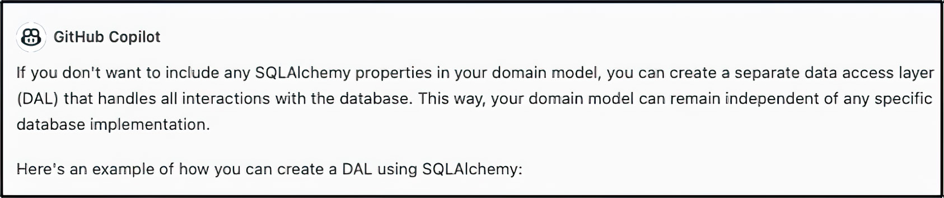

Figure 5.1 GitHub Copilot Chat’s solution for how to solve our most recent quandary

Listing 5.12 ORM support outside of the domain classes

Base = declarative_base()

class FundingDetailsModel(Base):
__tablename__ = 'funding_details'
id = Column(Integer, primary_key=True)
depreciation_rate = Column(Float)
depreciation_strategy_id = Column(Integer)

def get_depreciation_strategy(self) -> DepreciationStrategy:
if self.depreciation_strategy_id is 1:
return StraightLineDepreciationStrategy()
else:
return DoubleDecliningDepreciationStrategy()

class AssetModel(Base):
__tablename__ = 'assets'
id = Column(Integer, primary_key=True)
name = Column(String)
status = Column(String)
category = Column(String)
cost = Column(Float)
useful_life = Column(Float)
salvage_value = Column(Float)
purchase_date = Column(Date)
funding_details_id = Column(Integer, ForeignKey('funding_details.id'))
funding_details = relationship('FundingDetailsModel')

Now that the external model classes have been created, we must map these ORM
instances to our domain model before returning them to the system’s core. This may
seem like over-engineered code for such a simple application, but it gives us great flex-
ibility in how our domain model can operate. For example, our model can perform
complex operations beyond just CRUD. We would be limited to these operations if we
kept our domain model identity to the model used in the data access layer.
Next we will use Copilot and Copilot Chat to explore incorporating event-driven
ideas into our application. Event-driven concepts will allow us to track our IT assets in
real time: their location, status, and market value, for example.

100 chapter 5 Managing data with GitHub Copilot and Copilot Chat

5.2 Monitoring our assets in real time with Kafka
We will monitor our assets in real time to motivate our exploration of using generative
AI in conjunction with event-driven architecture. We will take it as a given that some
system external to the ISAM system fires events as our assets move from one location to
another.
To delve into ITAM events, we will need to configure a few additional services. In this
case, we will use Apache Kafka. Apache Kafka is a distributed streaming platform that is
used to build real-time data pipelines and streaming apps. It’s designed to handle data
streams from multiple sources and deliver them to multiple consumers, effectively act-
ing as a middleman for our real-time data.
To start, we will ask Copilot Chat how to run Kafka locally using Docker. Apache
Kafka has an undeserved reputation for being difficult to install and configure, and
running in Docker will allow us to side-step this controversy. Using Copilot Chat, we can
produce a Docker Compose file. However, as is often the case, the versions are very old,
to the point of not supporting some hardware. Listing 5.13 is an updated listing from
Confluent’s (the company that offers commercial support for Kafka) official GitHub
repository. Notice that the Docker Compose file’s contents include both Kafka and Zoo-
keeper. Zookeeper is a distributed coordination service that Kafka uses to manage and
coordinate the brokers in the cluster, at least for now. Future versions aim to remove
dependency on Zookeeper.

Listing 5.13 Docker Compose file to launch Kafka with Zookeeper

version: '2.1'

services:
zookeeper:
image: confluentinc/cp-zookeeper:7.3.2
container_name: zookeeper
ports:
- "2181:2181"
environment:
ZOOKEEPER_CLIENT_PORT: 2181
ZOOKEEPER_SERVER_ID: 1
ZOOKEEPER_SERVERS: zoo1:2888:3888

kafka:
image: confluentinc/cp-kafka:7.3.2
hostname: kafka
container_name: kafka
ports:
- "9092:9092"
- "29092:29092"
- "9999:9999"
environment:
KAFKA_ADVERTISED_LISTENERS:
INTERNAL://kafka:19092,EXTERNAL://
${DOCKER_HOST_IP:127.0.0.1}:9092,
DOCKER://host.docker.internal:29092
Monitoring our assets in real time with Kafka 101

KAFKA_LISTENER_SECURITY_PROTOCOL_MAP:
INTERNAL:PLAINTEXT,EXTERNAL:PLAINTEXT,
DOCKER:PLAINTEXT
KAFKA_INTER_BROKER_LISTENER_NAME: INTERNAL
KAFKA_ZOOKEEPER_CONNECT: "zookeeper:2181"
KAFKA_BROKER_ID: 1
KAFKA_LOG4J_LOGGERS: "kafka.controller=
INFO,kafka.producer.async
.DefaultEventHandler=INFO,
state.change.logger=INFO"
KAFKA_OFFSETS_TOPIC_REPLICATION_FACTOR: 1
KAFKA_TRANSACTION_STATE_LOG_REPLICATION_FACTOR: 1
KAFKA_TRANSACTION_STATE_LOG_MIN_ISR: 1
KAFKA_JMX_PORT: 9999
KAFKA_JMX_HOSTNAME: ${DOCKER_HOST_IP:-127.0.0.1}
KAFKA_AUTHORIZER_CLASS_NAME: kafka.security.authorizer.AclAuthorizer
KAFKA_ALLOW_EVERYONE_IF_NO_ACL_FOUND: "true"
depends_on:
- zookeeper

With our new Kafka instance running, we now need a consumer that will pull the
updated locations off the topic asset_location (which we will create shortly) and
update the inventory in the database. Again, we can ask Copilot Chat to provide us with
a suggestion for how to use Python to subscribe to the topic:

NC In our ITAM project, we would like a Python consumer for the asset_location Kafka
topic. Once it receives a new updated location, it should update the domain model to reflect the new location. How should we do this?

The code that Copilot Chat generates creates a consumer, listens to the topic, and uses
a reference to the AssetManager class to update the location of the affected asset.

Listing 5.14 Copilot Chat code to monitor assets’ locations

from kafka import KafkaConsumer
from asset_manager import AssetManager

consumer = KafkaConsumer(
'asset_location',
bootstrap_servers=['localhost:9092'],
auto_offset_reset='earliest',
enable_auto_commit=True,
group_id='my-group',
value_deserializer=lambda x:
tuple(map(float, x.decode('utf-8')
.split(',')))
)

asset_manager = AssetManager()

for message in consumer:
asset_id, latitude, longitude = message.value
asset_manager.update_asset_location(asset_id, (latitude, longitude))
102 chapter 5 Managing data with GitHub Copilot and Copilot Chat

However, should the adapter be aware of AssetManager? The AssetManager does not
directly sit inside the domain model; it is a critical intermediary. This coupling level
between AssetManager and the adapter could arguably violate the hexagon in the
hexagonal architecture model. Let’s have Copilot Chat weigh in. We can ask it this:

NC Given that this project uses hexagonal architecture, is it a good idea to have an
adapter aware of the AssetManager?

Looking at figure 5.2, it appears that Copilot Chat agrees that this would indeed be
considered a breach of the contractual responsibility of an adapter. We could add a
new port to our AssetManager class that would use the Kafka port. However, let’s see if
Copilot Chat has any other suggestions:

NC We do not want the Kafka consumer to interact directly with the AssetManager. Are
there any ways to accomplish this?
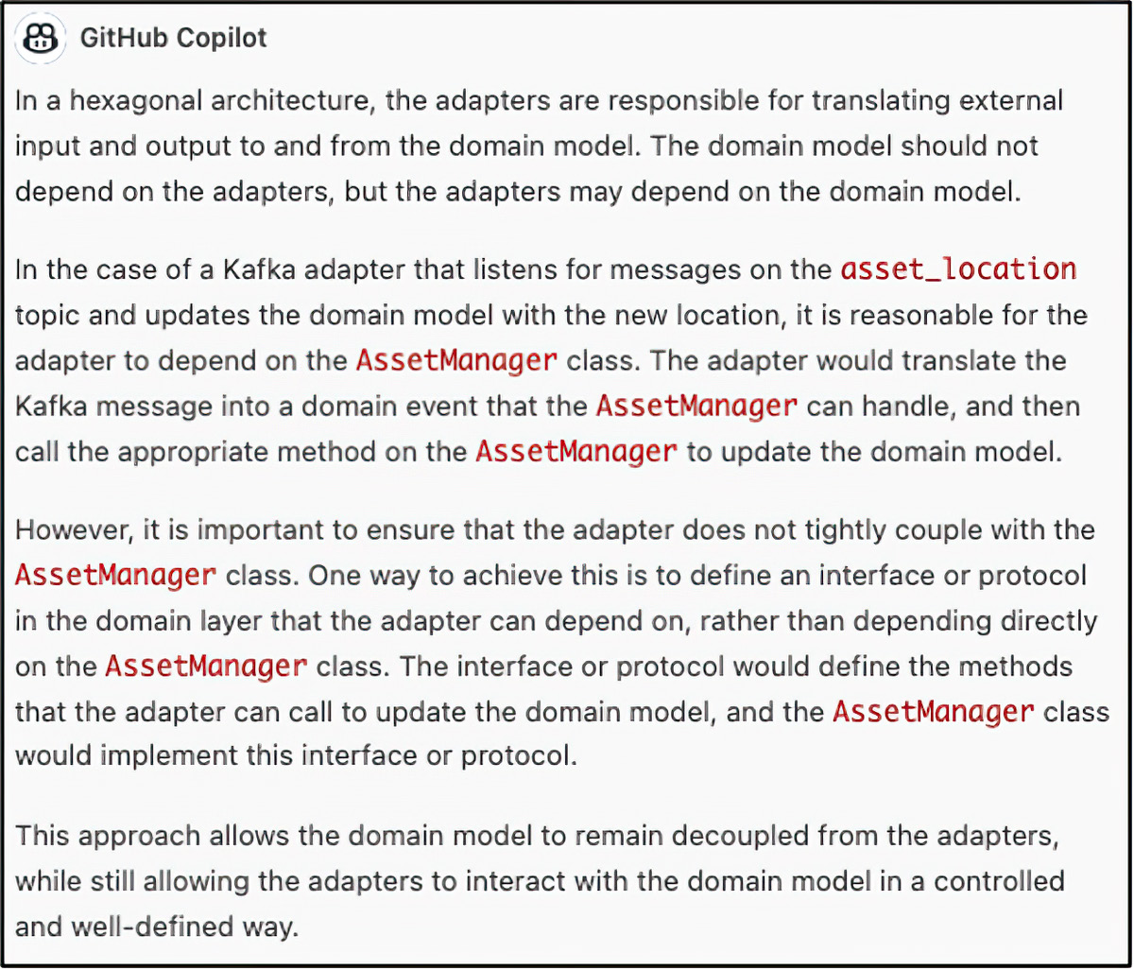

Figure 5.2 GitHub Copilot Chat’s acceptance that it is, in fact, imperfect

Copilot Chat suggests that we apply the Mediator pattern, which resembles a port and
adapter combination.

Mediator Pattern
The Mediator design pattern is a behavioral pattern that promotes loose coupling between objects by encapsulating their interactions in a mediator object. The mediator object acts as a central hub that facilitates communication between objects without the objects having to know about each other.
Monitoring our assets in real time with Kafka 103

Let’s first take a look at the Mediator class that Copilot Chat generates. The class sits
between AssetManager and the Kafka consumer.

Listing 5.15 Mediator class between AssetManager and Kafka consumer

class AssetLocationMediator:
def __init__(self):
self.handlers = {}

def register_handler(self, event_type, handler):
if event_type not in self.handlers:
self.handlers[event_type] = []
self.handlers[event_type].append(handler)

def publish(self, event):
event_type = type(event)
if event_type in self.handlers:
for handler in self.handlers[event_type]:
handler(event)

This implementation closely resembles a message queue or message publisher, which
is precisely the point: decoupling.

NOTE Eagle-eyed readers will likely notice that we are playing a little fast and
loose with the distinction between an Asset and an asset of type Hardware. In
the original domain model, only Hardware had a location. Generally, we do not
think of software as having a location. Of course, you could say that software is
installed in its location, but it is arguable how convincing this argument is. As
this project continues, we flatten the domain model for simplicity’s sake, as poly-
morphic structures in a persistence layer are a distractingly complex topic.

Now that we have a strategy to decouple the Kafka consumer from AssetManager,
we should update the Kafka consumer to take advantage of it. We need to pass the
mediator into the class in its constructor. This way, AssetManager and the consumer
will have access to the same instance, and messages can freely flow back and forth— or
rather, in this case, the flow will be unidirectional. You should note that we intend to
read and write JSON on this topic, so our value deserializer needs to understand this.

Listing 5.16 Incorporating the mediator into the Kafka consumer class

from kafka import KafkaConsumer
from itam.domain.events.asset_location_updated import AssetLocationUpdated import json

class AssetLocationKafkaConsumer:
def __init__(self, mediator):
self.mediator = mediator

self.consumer = KafkaConsumer(
'asset_location',
bootstrap_servers=['localhost:9092'], 104 chapter 5 Managing data with GitHub Copilot and Copilot Chat

enable_auto_commit=True,
group_id='itam-group',
value_deserializer=lambda m: json.loads(m.decode('utf-8'))
)

def poll(self):
print("Polling for asset location updates")
for message in self.consumer:
asset_id = message.value['asset_id']
latitude = message.value['latitude']
longitude = message.value['longitude']
timestamp = message.value['timestamp']
event = AssetLocationUpdated(asset_id, latitude, longitude, timestamp)
self.mediator.publish(event)

Next we will examine the changes that the AssetManager class requires to incorporate
the ability to track these locations.

NOTE To run this project in its entirety, you would need to modify the Asset-
Manager , SQLAlchemyAssetRepository, and Asset classes and also create a
new table in your database called itam.asset_locations. The complete and
updated source code is available on the book’s website (www.manning.com/
books/ai-powered-developer) and in the book’s GitHub repository (https://
github.com/nathanbcrocker/ai_assisted_dev_public). For now, we will focus on
the changes needed to get the events flowing through our system and use the
repository for reference if the reader so chooses.

Figure 5.3 shows the changes required to the AssetManager class to begin to track the
location of our assets in real time.

AssetManager
-BaseRepository[Asset] _repository
-AssetLocationMediator mediator
+__init__(base_repository: BaseRepository[Asset), mediator: AssetlocationMediator): None +update_asset_location( event: AssetlocationUpdated): None

Figure 5.3 AssetManager requires the addition of another constructor parameter and a method to handle the updates to its location objects.

There are two required changes for the AssetManager class. First, we need to add
the AssetLocationMediator to the constructor, registering it to handle the Asset-
LocationUpdated event. And second, we need to add a method that will handle this
event. In this case, we call the method update_asset_location. The abridged code
is shown next.

Monitoring our assets in real time with Kafka 105

Listing 5.17 Updated constructor and an event handler for AssetManager

from itam.infrastructure.mediators.asset_location_mediator import

class AssetManager:
def __init__(self, base_repository:
BaseRepository[Asset],
mediator: AssetLocationMediator):
self._repository = base_repository
self.mediator = mediator
self.mediator.register_handler(
AssetLocationUpdated,
self.update_asset_location)

def update_asset_location(self, event: AssetLocationUpdated) -> None:
asset = self.read(event.asset_id)
asset.add_location(event.latitude,
event.longitude, event.timestamp)
#self.update(asset)
print(f"Asset {asset.id} location updated
to {event.latitude}, {event.longitude}
at {event.timestamp}")

The add_location method of the Asset class merely appends the new Location
to the end of a list of Locations. More sophisticated domain models may include
a current_location attribute, relegating the rest to a list of historical locations;
however, given that we are trying to get our events flowing through the system, it
behooves us to keep things simple.
There is only one final item on our to-do list: create the topic. How do we do this?
That is a good question. Fortunately, all the tools we need are available in our running
Docker container. So, let’s log in to our Kafka Docker instance. We use the following
command (assuming that your Docker instance is named kafka):
docker exec -it kafka /bin/bash

The first thing to check is whether any topics are already created. We can do that with
the following command:
kafka-topics --list --bootstrap-server localhost:9092

This command lists all the existing topics running on this Kafka cluster. As you can see,
there aren’t any.
Given the need for a topic, let’s create it. Use the following command:
kafka-topics --create --bootstrap-server localhost:9092
--replication-factor 1
--partitions 1
--topic asset_location

If you run the kafka-topics --list command again, you will see the new topic. The
partitions and replication-factor instructions we included in the create-topic command
inform Kafka that we want one partition and a replication factor of 1. If we were setting
this up for production or any purpose other than testing, we would likely want them to 106 chapter 5 Managing data with GitHub Copilot and Copilot Chat

be greater than that to ensure the availability of data. Table 5.1 provides you with some
of the commonly used Kafka commands that you will need for this and other projects.

Table 5.1 Summary of Kafka console commands

Action Command
Create kafka-topics --create --bootstrap-server localhost:9092
--replication-factor 1 --partitions 1 --topic asset_location
Read kafka-console-consumer --broker-list localhost:9092 --topic asset_
location –from-beginning
Write kafka-console-producer --broker-list localhost:9092 --topic
asset_location
Delete kafka-topics --delete --topic asset_location --bootstrap-server
localhost:9092
List kafka-topics --list --bootstrap-server localhost:9092

Now comes the fun part: observing the application in action. Kafka comes with a con-
sole producer that will allow us to publish messages to Kafka from standard input. To
do this, launch the console producer with the following command:
kafka-console-producer --broker-list localhost:9092 --topic asset_location

You will enter an interactive session allowing you to publish a message with every line.
Let’s publish a few messages simulating our asset moving around or near Chicago.

Listing 5.18 Entries for the Kafka console producer

{"asset_id": 1, "latitude": 41.8781, "longitude": -87.6298,
"timestamp": "2022-01-01T00:00:00Z"}
{"asset_id": 1, "latitude": 41.9000, "longitude": -87.6244,
"timestamp": "2022-01-01T00:10:00Z"}
{"asset_id": 1, "latitude": 41.8676, "longitude": -87.6270,
"timestamp": "2022-01-01T00:20:00Z"}
{"asset_id": 1, "latitude": 41.8788, "longitude": -87.6359,
"timestamp": "2022-01-01T00:30:00Z"}
{"asset_id": 1, "latitude": 41.8740, "longitude": -87.6298, "timestamp": "2022-01-01T00:40:00Z"}

As you enter these messages, you should see the output from your application indicat-
ing that the location has been updated.

Deleting a topic
For the sake of completeness, there is one more command you should be aware of. You might make a mistake when entering these messages, and an invalid message could potentially break your consumer. One possible solution is to delete the topic. Deleting a topic may sound dramatic, but it will solve the problem. So here is that command:
kafka-topics --delete --topic asset_location --bootstrap-server localhost:9092
Analyzing, learning, and tracking with Apache Spark 107

In this section, we have added the ability to see changes in the location of our Assets
in real-time tracking using Apache Kafka. In the final section of this chapter, we will
work with Copilot Chat to extend the capacity by monitoring our assets in real time
and attempting to determine if they are where they should be. We will explore using
Spark and Kafka together to accomplish this analysis. Once completed, we will win the
thanks of our Information Security team, who fear that too much of our core business
and intellectual property exists on and in these Assets.

5.3 Analyzing, learning, and tracking with Apache Spark
Real-time tracking of assets is a business-critical function. Your IT assets contain sen-
sitive business data, client lists, sales figures, profit-and-loss (PnL) projections, and
sales strategies, among many other items. A lost asset can be an existential event for a
company. Therefore, careful management and monitoring are priority one for many
InfoSec professionals. In this section, we aim to make their jobs substantially easier.
Modern data platforms make it trivial to track your assets in real time and send notifi-
cations if questionable conditions arise. Let’s get into it.
Apache Spark is a powerful open source data-processing engine built around speed,
ease of use, and sophisticated analytics. It was developed to provide an improved alter-
native to MapReduce for processing big datasets and can handle batch and real-time
analytics. Spark provides APIs for Scala, Java, Python, and R and a built-in module for
SQL queries. Its core data structure, the resilient distributed dataset (RDD), enables
fault-tolerant operation and allows data to be processed in parallel across a cluster of
computers.
Spark also includes several libraries to broaden its capabilities, including MLlib for
machine learning, Spark Streaming for processing live data streams, and Spark SQL
and DataFrames for processing structured data. These tools make it well-suited for tasks
ranging from machine learning to real-time data streaming and batch processing. Its
in-memory processing capabilities make Spark significantly faster than its predecessor,
so it is a popular choice for big data processing.
First we will ask Copilot Chat to recommend a strategy for using Apache Spark to
track our assets:

NC Let's imagine that our company is in Chicago. We want to create a class called Asset-
LocationSparkAdapter that will continuously stream AssetLocation json me ssages from a Kafka topic called asset_location. An AssetLocation has the following attri-butes asset_id: int, latitude: float, longitude: float, and timestamp: datetime. The AssetLocations are stored in a Postgres database in a table called itam.asset _loca-tions. AssetLocationSparkAdapter should calculate if the new Asset Location is more than 25 miles from Chicago. If it is, then it should write a message to the console. This should be using the latest version of Spark. How would we do this?

Copilot Chat generates a class that you should be able to put into a file called asset_
location_spark_adapter.py in the infrastructure package. Helpfully, it also includes 108 chapter 5 Managing data with GitHub Copilot and Copilot Chat

comments for each line, so you should find the generated code easy to follow. The
import statements include the Spark libraries as well as geopy.

Listing 5.19 The imports required to run Spark

from pyspark.sql import SparkSession
from pyspark.sql.functions import from_json, col, expr from pyspark.sql.types import StructType,
StructField, IntegerType, DoubleType,
TimestampType
from geopy.distance import distance

The class begins with an overstuffed constructor that defines the schema Spark will use
when it translates the JSON to a DataFrame.

NOTE The AssetLocationSparkAdapter, as defined, is a blocking process.
Therefore, your FastAPI application will not “fully” boot until the Spark process
has been killed. You want this to be a standalone process, or you need to intro-
duce an asynchronous framework to have these two processes run concomitantly.

Next it starts up a local Spark instance/session that will allow Spark to connect to the
Kafka topic and continuously stream in the records.

Listing 5.20 AssessLocationSparkAdapter, which processes the Kafka topic

class AssetLocationSparkAdapter:
def __init__(self):
# Define the schema for the incoming JSON data
self.schema = StructType([
StructField("asset_id", IntegerType()),
StructField("latitude", DoubleType()),
StructField("longitude", DoubleType()),
StructField("timestamp", TimestampType())
])

# Create a SparkSession
self.spark = SparkSession.builder \
.appName("AssetLocationSparkAdapter") \
.getOrCreate()

# Create a streaming DataFrame from the asset_location topic
self.df = self.spark \
.readStream \
.format("kafka") \
.option("kafka.bootstrap.servers", "localhost:9092") \
.option("subscribe", "asset_location") \
.option("startingOffsets", "earliest") \
.load() \
.selectExpr("CAST(value AS STRING)")

# Parse the incoming JSON data
Analyzing, learning, and tracking with Apache Spark 109

self.parsed_stream = self.df \
.select(from_json(col("value"), self.schema).alias("data")) \
.select("data.*")

The final section of the AssetLocationSparkAdapter class calculates the distance
from the asset’s current location to Chicago. If the difference is greater than 25 miles,
it sends the result set to the console. Additionally, it provides a method to start and stop
the adapter.

Listing 5.21 Calculating the distance from the Asset location to Chicago

# Calculate the distance between the current location and Chicago for each asset
self.distance = self.parsed_stream \
.withColumn("distance",
expr("calculate_distance(latitude,
longitude, 41.8781, -87.6298)")) \
.select(col("asset_id"), col("timestamp"), col("distance")) \
.filter(col("distance") > 25)

# Write the results to the console
self.query = self.distance \
.writeStream \
.outputMode("append") \
.format("console") \
.start()

def run(self):
# Start the streaming query
self.query.awaitTermination()

def stop(self):
# Stop the streaming query and SparkSession
self.query.stop()
self.spark.stop()

The calculate_distance method takes the longitude and latitude of the asset’s loca-
tion and determines the distance from Chicago using the geopy.distance function.

Listing 5.22 Function to calculate the distance between Chi-town and Asset

def calculate_distance(lat1, lon1, lat2, lon2):
return distance((lat1, lon1), (lat2, lon2)).miles

In this instance, the code that Copilot Chat produced had some problems prevent-
ing it from running locally. After running it locally, encountering these problems, and
trolling Stack Overflow, you would find a solution to the two main problems with the
code: a missing environmental variable for running locally and failing to register your
UDF (User Defined Function). Fortunately, you do not need to do the testing and
research—a solution is provided in the following listing.

110 chapter 5 Managing data with GitHub Copilot and Copilot Chat

Listing 5.23 Edits required to run the application locally

os.environ['PYSPARK_SUBMIT_ARGS'] =
'--packages org.apache.spark:
spark-streaming-kafka-0-10_2.12:3.2.0,
org.apache.spark:
spark-sql-kafka-0-10_2.12:3.2.0
pyspark-shell'

class AssetLocationSparkAdapter:
def __init__(self):
# Create a SparkSession
self.spark = SparkSession.builder \
.appName("AssetLocationSparkAdapter") \
.getOrCreate()
self.spark.udf.register("calculate_distance", calculate_distance)

Finally, to run your Spark application, update main.py with the following code in the
main function.

Listing 5.24 Updates to the main function

if __name__ == "__main__":
adapter = AssetLocationSparkAdapter()
adapter.run()

As you enter locations for your asset into the Kafka console producer that are further
than 25 miles from downtown Chicago, you will notice that entries are written to the
console. It would be trivial to update the class to output these results to Twilio’s SMS
API or an email service such as SendGrid.

Listing 5.25 The streaming output from your asset location

+--------+-------------------+------------------+
|asset_id| timestamp| distance|
+--------+-------------------+------------------+
| 1|2021-12-31 20:30:00| 712.8314662207446|
+--------+-------------------+------------------+

Congratulations! You are tracking your assets in real time and sending real-time alerts
in case your corporate resources grow legs and walk away.

Summary
¡ GitHub Copilot Chat is an innovative tool that brings together the comprehen-
sive language understanding of ChatGPT and the handy features of Copilot. It’s
a noteworthy development in the realm of programming assistance, particularly
for providing detailed and contextually relevant suggestions in real time, foster-
ing a more efficient coding experience.
¡ The Mediator design pattern is a distinct behavioral pattern that facilitates a
high level of decoupling between objects, thus enhancing the modularity of your
Summary 111

code. By encompassing the interactions between objects in a mediator object,
objects can communicate indirectly, which reduces dependencies and promotes
code reusability and ease of modification.
¡ Apache Kafka is a robust, distributed streaming platform engineered for creating
real-time data pipelines and streaming applications. It can effectively handle data
streams from a multitude of sources and transmit them to various consumers,
making it an ideal solution for use cases that require handling substantial vol-
umes of real-time or near-real-time data. It’s important to remember that Kafka
is optimized for append-only, immutable data and not for use cases that need
record updates or deletions, or complex querying.
¡ Apache Spark is a high-performance, distributed data processing engine
renowned for its speed, user-friendliness, and advanced analytics capabilities.
It’s highly suitable for scenarios necessitating real-time data processing or for
operations on enormous datasets. However, for simpler tasks such as basic analyt-
ics and straightforward aggregations, a traditional relational database may be a
more appropriate choice.
¡ Generative AI, despite its rapid evolution, is not infallible. It’s crucial to metic-
ulously review all generated output to ensure that it aligns with your specific
requirements and quality standards. Generative AI is not a substitute for deep
domain knowledge or coding expertise, but it significantly enhances productivity
by providing valuable insights and reducing the time spent on routine tasks.

Part 3

The feedback

I
n part 3, we highlight the critical role of testing, quality assessment, and explanation in AI-augmented software development. This section focuses on
ensuring the reliability and robustness of software built with LLMs. It covers the
processes involved in bug hunting and code translation, emphasizing the impor-
tance of thorough testing and quality control. Using AI, developers can generate
clear explanations of AI-generated code, facilitating better understanding and
collaboration within development teams. This part underscores the necessity of
maintaining high standards in software quality and provides strategies for achiev-
ing this in an AI-driven environment.

Testing, assessing, and 6 explaining with large language models

This chapter covers

¡ Drafting unit tests with ease
¡ Generating integration tests
¡ Determining code quality and coverage
¡ Assessing software complexity
¡ Translating code and text

This chapter will explore a critical aspect of software engineering: testing. The act
of testing software serves multiple essential purposes. First and foremost, it aids
in the identification of bugs, errors, and problems that can potentially affect the
software’s functionality, usability, or performance. Furthermore, it ensures that the
software adheres to the required quality standards. By conducting thorough tests,
we can verify whether the software meets the specified requirements, functions as
intended, and produces the expected outcomes. Through comprehensive testing,
developers can evaluate software’s reliability, accuracy, efficiency, security, and com-
patibility across various platforms and environments. Detecting and resolving soft-
ware defects early in the development process can result in significant time and cost
savings.

115
116 chapter 6 Testing, assessing, and explaining with large language models

Once we have finished formulating our tests, we will evaluate the quality of our code.
You will be introduced to several metrics that are helpful in assessing software qual-
ity and complexity. Additionally, if we need clarification on the purpose of our code
or are reviewing it for the first time, we will seek an explanation to ensure thorough
understanding.

6.1 Testing, testing … one, two, three types
Testing plays a vital role in software engineering; therefore, we will explore various
types of testing in detail. These include unit tests, integration tests, and behavior tests.
To start, we will use Copilot Chat to help us create a unit test.

DEFINITION A unit test focuses on testing individual components or units of code
to ensure that they function correctly in isolation. Developers usually run unit
tests to help identify bugs and problems in specific software units.

6.1.1 Unit testing

In this section, we will create unit tests to test our software components. Several
unit-testing frameworks are available for Python. Each has unique features and is suit-
able for different scenarios. We will examine each of them briefly before settling on a
specific framework based on the recommendation provided by our AI tool.
The first framework is unittest. This is Python’s standard library for creating
unit tests. It comes bundled with Python and doesn’t need to be installed separately.
unittest provides a rich set of assertions and is great for writing simple to complex
test cases, but it can be verbose. It is a good choice for writing basic unit tests, especially
if you don’t want to introduce additional dependencies in your project. It’s useful in
any scenario where you need to confirm the functionality of individual units of code in
isolation from the rest of the system.
Next, let’s examine pytest. It is a popular third-party library that can be used for unit
testing, although it’s versatile enough to handle more than just unit tests. It requires less
boilerplate code than unittest and has powerful features like fixtures for setup and
teardown, parameterized testing, and the ability to run unittest and nose test suites.
pytest is great for both simple and complex unit test cases. It’s also useful for func-
tional and integration tests. If you value simplicity and ease of use, and your project is
not restricted to using only the Python standard library, pytest is an excellent choice.
nose2 is the successor to the deprecated nose testing framework. It extends
unittest and makes testing easier. It’s known for its test discovery feature, which
automatically finds your project’s tests so you don’t have to manually list them. nose2
is good for larger projects where test discovery can save time. Like pytest, it can run
unittest test suites, so it’s also a good choice if you’re migrating from unittest but
want to keep your existing tests.

Testing, testing … one, two, three types 117

Finally, there is doctest. This is another module that’s part of the Python standard
library. It’s not a full-featured testing framework like the others, but it allows you to
write tests directly in your docstrings. doctest is best suited for simple cases where you
want to demonstrate how to use a function or module and confirm that the example
code works as expected. It’s a great way to ensure that your documentation stays up to
date with your code.
Copilot Chat recommended that we use unittest, so we will. You might try to ask
it yourself and see if it reaches a different conclusion, which it may, depending on how
you frame the question.
First we will define test cases by creating classes that inherit from the unittest
.TestCase class. In writing our first unit test, we will uncover a rather pernicious bug
that has thus far eluded us; we will get to that shortly. Finally, we are going to test the
correctness of the DepartmentStatisticsVisitor class.
We start with a prompt asking Copilot Chat to create a unit test for Department-
StatisticsVisitor. The response will be a reminder of the importance of context.
Copilot Chat, given that we began a new chat session, will attempt to create this unit
test, but it lacks the definition of any of our classes.

Listing 6.1 First attempt to define a unit test

import unittest
from department_visitor import DepartmentStatisticsVisitor

class TestDepartmentStatisticsVisitor(unittest.TestCase):
def test_visit_department(self):
visitor = DepartmentStatisticsVisitor()
department = {'name': 'Sales', 'employees':
[{'name': 'John', 'salary': 50000},
{'name': 'Jane', 'salary': 60000}]}
visitor.visit_department(department)
self.assertEqual(visitor.total_salaries, 110000)
self.assertEqual(visitor.num_employees, 2)
self.assertEqual(visitor.avg_salary, 55000)

We proceed by inputting definitions into Copilot Chat so that it can refine the test
case. We can tell it more about the visitor class:
The DepartmentStatisticsVisitor class visits to determine the total asset depreciation based off of the asset allocation for each department

With this updated information, Copilot Chat can better estimate how our unit test
should function.

Listing 6.2 The result of a unit test prompt

import unittest
from department_visitor import DepartmentStatisticsVisitor, Asset

class TestDepartmentStatisticsVisitor(unittest.TestCase):
def test_visit(self):
118 chapter 6 Testing, assessing, and explaining with large language models

visitor = DepartmentStatisticsVisitor()
asset1 = Asset(1000, 500, 0.5)
asset2 = Asset(2000, 1000, 0.3)
visitor.visit(asset1)
visitor.visit(asset2)
self.assertEqual(visitor.get_total_cost(), 3000)
self.assertEqual(visitor.get_total_depreciation(), 1500)
self.assertEqual(visitor.get_total_allocation(), 0.8)

The unit test is close to what we need; however, the definition of Asset is incorrect. We
can enter the proper definition from our asset.py class, and Copilot Chat will continue
to refine the unit test.

Listing 6.3 Next attempt to define a unit test, with Asset definition

import unittest
from datetime import date
from typing import List
from dataclasses import dataclass

@dataclass
class Location:
name: str
address: str

@dataclass
class Asset:
id: int
name: str
status: str
category: str
cost: float
useful_life: int
salvage_value: float
purchase_date: date
locations: List[Location]

class TestAsset(unittest.TestCase):
def test_asset(self):
location1 = Location('Office', '123 Main St')
location2 = Location('Warehouse', '456 Elm St')
asset = Asset(1, 'Computer',
'In use', 'Hardware',
1000.0, 3, 100.0, date.today(),
[location1, location2])
self.assertEqual(asset.id, 1)
self.assertEqual(asset.name, 'Computer')
self.assertEqual(asset.status, 'In use')
self.assertEqual(asset.category, 'Hardware')
self.assertEqual(asset.cost, 1000.0)
self.assertEqual(asset.useful_life, 3)
self.assertEqual(asset.salvage_value, 100.0)
self.assertEqual(asset.purchase_date, date.today())
self.assertEqual(asset.locations, [location1, location2])
Testing, testing … one, two, three types 119

This is closer. We also need to remind Copilot Chat that the Asset class has a class
called FundingDetails. Let’s provide the definition of FundingDetails and inform
Copilot Chat that it should be part of Asset.

Listing 6.4 Third attempt at a unit test, which comes reasonably close

import unittest
from department_visitor import
DepartmentStatisticsVisitor, Asset,
FundingDetails
from datetime import date
from typing import List, Dict
from dataclasses import dataclass

@dataclass
class Location:
name: str
address: str

class TestDepartmentStatisticsVisitor(unittest.TestCase):
def test_visit(self):
visitor = DepartmentStatisticsVisitor()
location1 = Location('Office', '123 Main St')
location2 = Location('Warehouse', '456 Elm St')
asset1 = Asset(1, 'Computer', 'In use',
'Hardware', 1000.0, 3,
100.0, date.today(),
[location1, location2])
asset2 = Asset(2, 'Printer', 'In use',
'Hardware', 500.0, 2, 50.0,
date.today(), [location1])
funding_details1 = FundingDetails(
asset1, 'Straight Line',
0.33, { 'IT': 0.5, 'HR': 0.5 })
funding_details2 = FundingDetails(
asset2, 'Double Declining Balance',
0.25, { 'IT': 0.3, 'HR': 0.7 })
visitor.visit(asset1, funding_details1)
visitor.visit(asset2, funding_details2)
self.assertEqual(visitor.get_total_cost(), 1500.0)
self.assertEqual(visitor.get_total_depreciation(), 550.0)
self.assertEqual(visitor.get_total_allocation(), 0.8)

All that remains is to manually update the import statements.

NOTE Let this exercise be a cautionary tale in the usage of large language mod-
els: coercing them to behave with respect to highly focused tasks can be very
challenging, to the point of not being worth the effort. In the real world, no one
will blame you for abandoning the prompt engineering and going back to just
coding out this test. However, with some persistence, you can build a template
library that you can use to build a suite of unit tests for similarly shaped classes.
Also note that Copilot Chat can and will generate a test for the file in the editor 120 chapter 6 Testing, assessing, and explaining with large language models

window if you instruct it to Generate (a) unit test for my code, but it
will mock all objects/properties that are not directly part of the class under test.
Depending on what you are attempting to test, the utility of this feature may be
questionable. Another common problem specific to Python is that the indenta-
tion is frequently incorrect with code copied from Copilot Chat.

When we attempt to run this test, we discover that there is a circular dependency between
the visitor, asset, funding details, and depreciation strategy. A circular dependency is a
situation in which two or more modules or components depend on each other directly
or indirectly. In our case, when Python tries to instantiate Asset, it loads the definition
of FundingDetails. We can fix this by moving away from a direct instantiation or ref-
erence to the FundingDetails class.

Listing 6.5 Updated Asset, no direct reference to FundingDetails

@dataclass
class Asset():
id: int
name: str
status: str
category: str
cost: float
useful_life: int
salvage_value: float
purchase_date: date
locations: List[Location]
funding_details: None or 'itam.domain.funding_details.FundingDetails'

We need to do the same for the FundingDetails class. It should not directly reference
the DepreciationStrategy class.

Listing 6.6 FundingDetails, no direct ref to DepreciationStrategy

@dataclass
class FundingDetails:
depreciation_rate: float
department_allocations: Dict[Department, float]
depreciation_strategy: DepreciationStrategy or 'itam.domain.depreciation_ strategy.DepreciationStrategy'
asset: None or 'itam.domain.asset.Asset'

As we’ve seen, we were able to create a unit test using Copilot Chat. However, we would
likely have been able to create it more easily if we had written it without Copilot. The
tool is surprisingly good at providing guidance as to when and how to test your code,
but the implementation (at least currently) leaves something to be desired.
In the real world, we would continue to add unit tests to build up a substantial body
of tests. How many tests is substantial, you ask? We will explore this shortly. However, we
first turn our attention to the next type of test: the integration test.
Testing, testing … one, two, three types 121

DEFINITION Integration testing involves testing the interaction between different
components or modules of the software to ensure that they work together seam-
lessly. It verifies that the integrated system functions as expected and detects any
inconsistencies or communication problems between modules.

6.1.2 Integration testing

In this section, we will develop an integration test that will allow us to test the end-to-
end system. Fortunately, fastapi comes with its own test client, which will aid us in
creating this test.
We begin by copying in the definition of AssetController into the Copilot Chat
window. We can then ask Copilot Chat how to create an integration test for this con-
troller. Given that we included the routes in the definition, Copilot Chat should be
able to provide us with accurate integration tests. We need to specify that we will use the
InMemoryAssetRepository class or fix this after the test has been generated.

Listing 6.7 Copilot Chat-generated integration test of AssetController

from fastapi.testclient import TestClient
from itam.infrastructure.adapters.memory_asset_repository import MemoryAssetRepository
from itam.infrastructure.ports.asset_rest_port import AssetRestPort from itam.interfaces.asset_controller import AssetController

def test_get_assets():
# Create an instance of the InMemoryAssetRepository
asset_repository = InMemoryAssetRepository()

# Add some assets to the repository
asset_repository.create(Asset(name="Asset 1", unit_cost=1000))
asset_repository.create(Asset(name="Asset 2", unit_cost=2000))

# Create an instance of the AssetRestPort using the MemoryAssetRepository
asset_rest_port = AssetRestPort(asset_repository)

# Create an instance of the AssetController using the AssetRestPort
asset_controller = AssetController(asset_rest_port)

# Create a TestClient instance using the AssetController's router
client = TestClient(asset_controller.get_router())

# Send a GET request to the /assets endpoint
response = client.get("/assets")

# Check that the response status code is 200 OK
assert response.status_code == 200

# Check that the response body contains the expected assets
assert response.json() == [
{"id": 1, "name": "Asset 1", "unit_cost": 1000},
{"id": 2, "name": "Asset 2", "unit_cost": 2000}, 122 chapter 6 Testing, assessing, and explaining with large language models

We will now turn our attention to the final type of testing that we’ll examine: behavior
testing.

DEFINITION Behavior testing focuses on the behavior of a system as a whole from
the perspective of an end user. It is typically used to test the functionality of a
system and to ensure that the system meets the requirements and specifications
defined for it.

6.1.3 Behavior testing

In a sense, all testing is behavior testing, as tests verify the behavior of the system. How-
ever, behavior testing is unique in some respects. Let’s summarize the different types
of testing that we have encountered thus far and contrast them against behavior tests.
Unit testing focuses on testing individual units or components of a system in isola-
tion, typically using automated tests. Unit tests are designed to test the functionality
of individual functions or methods and to ensure that they behave correctly under a
variety of conditions.
Integration testing, on the other hand, focuses on testing the interactions between
different components or units of a system. Integration testing is typically used to test
the interfaces between different components or units and to ensure that they work
together correctly. Integration testing can be performed manually or using automated
tests, and it typically involves testing the interactions between different components or
units of a system rather than the system as a whole.
Behavioral testing focuses on defining the behavior of the software in terms of user
stories or scenarios. These scenarios are written in a specific format called given-when-
then (GWT) and are used to drive the development process. The GWT format describes
the preconditions (given), the actions (when), and the expected outcomes (then) of a
particular scenario.
As we progress with our testing, we may find that some behaviors or components
are difficult to set up in our test. Additionally, it may be tricky to isolate the behavior
of a particular object or module and test the interactions between different objects. To
address this limitation, we can use a mock object.

DEFINITION A mock object is a test double that simulates the behavior of a real
object in a controlled way. Mock objects can also be used to simulate error
conditions or edge cases that are difficult to reproduce with real objects. They
can be created manually using a mocking library such as unittest.mock or
pytest-mock. These libraries provide functions and classes for creating and
configuring mock objects. Mock objects can be configured to return specific
values or raise specific exceptions when their methods are called. They can also
be used to record the calls made to their methods so that you can verify that the
correct methods were called with the correct parameters.

Testing, testing … one, two, three types 123

We will incorporate mock objects into the prompt to create a behavior test for
AssetManager:

NC We have a class called AssetManager. AssetManager's constructor takes two
classes BaseRepository and AssetLocationMediator. The BaseRepository is a reposi-tory in which Assets are stored. We want to use InMemoryAssetRepository, which is a subclass of BaseRepository that stores the Assets in memory. Use a mock object for AssetLocationMediator. The AssetManager stores Assets using the method create and gets all of the Assets using the method get_assets. An asset has 10 required positional arguments: 'id', 'name', 'status', 'category', 'cost', 'useful_life', 'salvage_ value', 'purchase_date', 'locations', and 'funding_details'. Use named parameters to make it clear which param is going where. Create a BDD script that will add two Assets to the AssetManager, confirming that all Assets cost $4000.00. This should be implemented in Python. Take it step by step, telling us the tools and libraries you will use.

Copilot Chat tells us that we need to create a new file (a feature file) called asset_
manager.feature . In this file, we will define AssetManager’s attributes (and any
supporting classes). For example, the feature file defines a scenario that adds two assets
to AssetManager, confirms that the total cost of all assets is $4,000.00, and mocks the
AssetLocationMediator class.

Listing 6.8 asset_manager.feature file according to Copilot Chat

Feature: Asset Manager
As an IT Asset Manager
I want to be able to manage assets
So that I can keep track of all IT assets in my organization

Scenario: Add two assets to the Asset Manager
Given the Asset Manager is running
And the InMemoryAssetRepository is initialized
And the AssetLocationMediator is mocked
When I create an asset with a cost of $2000.00
And I create another asset with a cost of $2000.00
Then the total cost of all assets should be $4000.00

We need to create a directory called features at the root of our project and place this
file in that directory. Additionally, we need to add a subdirectory called steps. Next we
create a new Python file called steps.py and place it in the steps directory. This Python
file defines the step implementations for the scenario in the feature file. The Asset-
Manager, InMemoryAssetRepository, AssetLocationMediator, and Asset classes
are imported, and six functions are defined to correspond to the steps in the scenario.
These functions use the context object to store and retrieve data between steps. The
Mock class from the unittest.mock library is used to create a mock object for the
AssetLocationMediator class. The Asset class is instantiated using named param-
eters to clarify which parameter belongs to which attribute. If we ask Copilot Chat for
the contents of the steps.py file, we will see output similar to the following listing.
124 chapter 6 Testing, assessing, and explaining with large language models

Listing 6.9 Implementation details for behavior test defined in steps.py

from behave import given, when, then
from itam.service.asset_manager import AssetManager from itam.infrastructure.repository.in_memory_asset_repository
import InMemoryAssetRepository
from itam.domain.asset import Asset
from itam.infrastructure.mediators.asset_location_mediator
import AssetLocationMediator
from unittest.mock import Mock

@given('the Asset Manager is running')
def step_impl(context):
context.asset_repository = InMemoryAssetRepository()
context.asset_location_mediator = Mock(spec=AssetLocationMediator)
context.asset_manager = AssetManager(
context.asset_repository,
context.asset_location_mediator)

@given('the InMemoryAssetRepository is initialized') def step_impl(context):
pass

@given('the AssetLocationMediator is mocked')
def step_impl(context):
pass

@when('I create an asset with a cost of ${cost}')
def step_impl(context, cost):
asset = Asset(id=1, name='Test Asset 1', status='Available',
category='Test Category', cost=float(cost), useful_life=5,
salvage_value=0, purchase_date='2022-01-01',
locations=['Test Location'],
funding_details={'Test Funding': 1000})
context.asset_manager.create(asset)

@when('I create another asset with a cost of ${cost}') def step_impl(context, cost):
asset = Asset(id=2, name='Test Asset 2', status='Available',
category='Test Category', cost=float(cost), useful_life=5,
salvage_value=0, purchase_date='2022-01-01',
locations=['Test Location'],
funding_details={'Test Funding': 1000})
context.asset_manager.create(asset)

@then('the total cost of all assets need to be ${total_cost}') def step_impl(context, total_cost):
assets = context.asset_manager.get_assets()
assert sum(asset.cost for asset in assets) == float(total_cost)

If you do not have it installed already, you need to install the behave library using pip:
pip install behave. Additionally, add it to the requirements.txt file to ensure that it
will be pulled in when we later build a deployable version of this application. We run the
behavior test by issuing the following command from the root directory of our project.
Assessing quality 125

Listing 6.10 Running the behavior test, and the resulting output

% behave features
Feature: Asset Manager # features/asset_manager.feature:1 As an IT Asset Manager
I want to be able to manage assets
So that I can keep track of all IT assets in my organization Scenario: Add two assets to the Asset Manager
# features/asset_manager.feature:6
Given the Asset Manager is running # features/steps/steps.py:8 0.000s
And the InMemoryAssetRepository is initialized # features/steps/steps.py:14 0.000s
And the AssetLocationMediator is mocked # features/steps/steps.py:18 0.000s
When I create an asset with a cost of $2000.00 # features/steps/steps.py:22 0.000s
And I create another asset with a cost of $2000.00 # features/steps/steps.py:27 0.000s
Then the total cost of all assets should be $4000.00 # features/steps/steps.py:32 0.000s

1 feature passed, 0 failed, 0 skipped
1 scenario passed, 0 failed, 0 skipped
6 steps passed, 0 failed, 0 skipped, 0 undefined
Took 0m0.001s

In this section, we have laid a foundation for good software development by using
three types of tests: unit, integration, and behavior. Some may quibble that it came very
late in the development lifecycle of this project, and they would not be wrong. In the
real world, we develop our tests as we develop our code. Some may argue that we need
to build our tests before our code. You may or may not hold this belief, but either way,
you need to test early and test often.
In the next section, we dive into some metrics that can be used to determine the
overall quality of our software, and we will ask Copilot to help us assess the quality of our
code thus far.

6.2 Assessing quality
Understanding the performance, reliability, maintainability, and overall quality of
software applications is a crucial aspect of software engineering. This section delves
into the fascinating and intricate domain of software quality metrics—the quantitative
standards and benchmarks that guide our understanding of the quality of a software
system.
Software quality metrics are essential tools that allow stakeholders—developers, tes-
ters, managers, and users—to assess a software product’s state, identifying its strengths
and areas for improvement. They provide an empirical foundation for various processes
such as product development, testing, debugging, maintenance, and improvement ini-
tiatives. By quantifying specific characteristics of the software, these metrics provide a
tangible means to understand the otherwise abstract concept of software quality.
126 chapter 6 Testing, assessing, and explaining with large language models

In this section, we explore several important categories of software quality metrics,
including product metrics, process metrics, and project metrics. We’ll analyze their sig-
nificance, methodologies for their calculation, and how they can be effectively utilized
to evaluate and enhance software quality. This exploration will include both static met-
rics, which are applied to the static software system, and dynamic metrics, which assess
the system’s behavior during execution.
Software quality metrics not only contribute to the technical soundness of a software
system but also help ensure customer satisfaction, profitability, and long-term business
success. Therefore, developing an understanding of these metrics is invaluable to any-
one involved in the field of software development, from engineers and project manag-
ers to executives and software users.
We will examine a few common measures of complexity and maintainability of
the class or code. Complex software can be difficult to comprehend, which makes it
challenging for developers, particularly new ones, to grasp how different parts of the
software interact with each other. This can slow down the onboarding process and
development time.
Complex code often leads to more maintenance: modifications or bug fixes can take
longer because it’s harder to predict the effects of changing a single piece of the system.
This can result in higher costs over the software’s lifecycle.
Complex software also tends to be more error-prone. Because it’s harder to under-
stand, developers are more likely to introduce bugs when making changes. Also,
complex code can have many interdependencies, and a change in one area may have
unexpected effects elsewhere.
The more complex the software, the more test cases are required to achieve thor-
ough testing. It may also be harder to write these test cases due to the complexity of the
logic involved.
Writing simple and maintainable code should be one of our highest priorities.
Observing the change in the metric that accompanies our code should aid us in this
endeavor. Toward this objective, the first metric that we can (and should) use is cyclo-
matic complexity.

DEFINITION Cyclomatic complexity is a metric that quantifies the number of in -
de pen dent paths through a software module. It measures the complexity of
decision-making in the code, including loops, conditionals, and branches. A
higher cyclomatic complexity value indicates increased complexity and suggests
the potential for more bugs and challenges in understanding and maintaining
the code.

Enter the following prompt anywhere in the file department_visitor.py. Copilot will
immediately output the answer:

Assessing quality 127

# Question: What is the cyclomatic complexity of the class Department- Statistics Visitor?
# Answer: 1

Copilot tells us that the complexity of this class is 1. You may or may not be aware of the
meaning of this value. If the latter, you can ask Copilot to elaborate:

# Question: Is 1 an excellent cyclomatic complexity?
# Answer: Yes

# Question: Why is 1 a good value for cyclomatic complexity?
# Answer: Because it is low

Copilot informs us that cyclomatic complexity is good if it is low. Intuitively, this makes
sense. Code with low complexity means it is simpler to understand and therefore rea-
son about. It is likely easier to maintain as well. Next we will explore the Halstead com-
plexity measures.

DEFINITION Halstead complexity measures assess the complexity of a software pro-
gram based on the number of unique operators and operands used in the code.
These measures include metrics such as program length (N1), program vocab-
ulary (n1), volume (V), difficulty (D), effort (E), and others. These metrics pro-
vide insights into the size and cognitive complexity of the code.

Similar to last time, we will start with a prompt asking Copilot to determine the
Halstead complexity measure for our visitor class:

# Question: What is the Halstead Complexity Measure of the class Department- StatisticsVisitor?
# Answer: 2

# Question: What is the Halstead Difficulty Measure of the class Department- StatisticsVisitor?
# Answer: 1

# Question: Is 2 a good Halstead Complexity Measure?
# Answer: Yes

# Question: Is 1 a good Halstead Difficulty Measure?
# Answer: Yes

# Question: What is a bad Halstead Difficulty Measure?
# Answer: 10

128 chapter 6 Testing, assessing, and explaining with large language models

# Question: What is a bad Halstead Complexity Measure?
# Answer: 10

# Question: What does a high Halstead Difficulty Measure mean?
# Answer: It means the code is hard to understand

You may want to continue this Q&A session for a while to see what information can be
gleaned from Copilot. Once you are ready to continue, there is one more metric to
explore: the maintainability index.

DEFINITION The maintainability index is a composite metric that combines sev-
eral factors, including cyclomatic complexity, lines of code, and Halstead com-
plexity measures, to provide an overall measure of software maintainability. A
higher maintainability index suggests easier maintenance and potentially lower
complexity.

Start a similar discussion for the maintainability index in the visitor file:

# Question: What is the maintainability index of the class Department- StatisticsVisitor?
# Answer: 100

# Question: Do we want a high Maintainability Index or low Maintainability Index?
# Answer: high

# Question: Why do we want a high Maintainability Index?
# Answer: Because it is easier to maintain

If we get a low maintainability index, we can refactor to reduce this number.
A metric is useful in that it gives us a nail to hang our hat on; that is, we can take that
measure and perform some action to improve it. Metrics move us beyond pure aesthet-
ics or the subjectivity of an individual. A metric is real, actionable data. But Copilot has
(at least) one more trick up its proverbial sleeve. Copilot is capable of doing more than
just writing and assessing our code: it can also address the code’s flaws. Let’s bug hunt.

6.3 Hunting for bugs
In this section, we will use an elementary (albeit contrived) example to demonstrate
how we can use Copilot to find and fix problems in our code. This code is supposed to
loop a the list of integers and calculate the sum. However, there is a “blink and you’ll
miss it” bug: the sum is assigned the value of i rather than adding the value of i to the
running total.
Hunting for bugs 129

Listing 6.11 Looping over a list of integers and calculating the sum

l = [1, 2, 3, 4, 5]

if __name__ == '__main__':
sum = 0
for i in l:
sum = i

print("sum is", sum)

To debug this problem, we will introduce a new tool: Copilot Labs. Prior to Copilot
Chat, Copilot Labs was the only means by which certain features were available in an
IDE (specifically, Visual Studio Code). For example, we need to use Copilot Labs to
find and fix bugs. The main advantage that Copilot Labs still offers today is that it can
access the highlighted contents of your editor pane. This feature allows Copilot Labs
to operate directly on the editable code in your IDE.
Once you install the extension into your IDE, you should see a Copilot Labs toolkit
on the left side of the IDE, as shown in figure 6.1. If you need a reminder about how to
install an extension into your IDE, see appendices A–C for instructions.
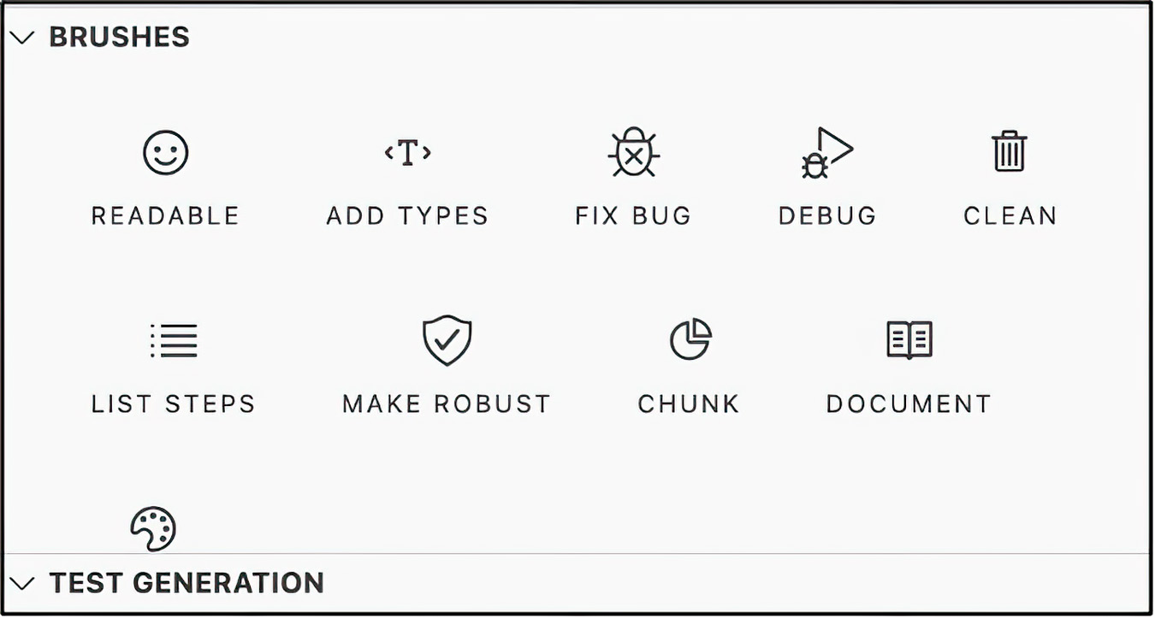

Figure 6.1 The Copilot Labs toolkit menu, which includes options for finding and fixing bugs. The toolkit also provides facilities to enhance your code as well as document it.

We will temporarily change the contents of the main.py file to the code listed in listing
6.11. Once you have made this change, highlight the code and click the Fix Bug button
in the Copilot Labs toolkit. You should see output like that in figure 6.2. Copilot Labs
was able to determine the problem in this code and provides a suggestion as to how to
fix it.
130 chapter 6 Testing, assessing, and explaining with large language models
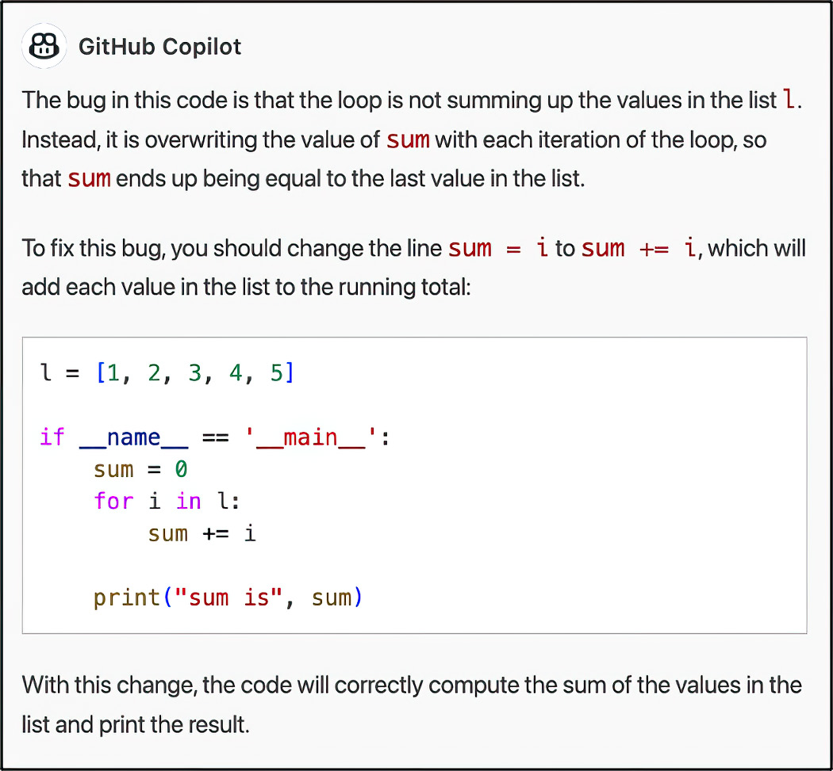

Figure 6.2 Copilot Labs, using the GPT model, has identified the bug and how to address it.

Alternatively, you could copy this code into ChatGPT and ask it to find the bug. How-
ever, it is arguable that doing so is less convenient as you would have to know there was
a bug in your code before asking ChatGPT to fix it.

6.4 Covering code
Code coverage is a measure of how much of your code is being exercised by your tests. It
is typically expressed as a percentage and represents the proportion of your code that
your tests execute.
Code coverage can be used as a metric to evaluate the effectiveness of your tests. If
your code coverage is low, it may indicate that parts of your code are not being tested,
which can lead to uncaught bugs and other problems. Alternatively, with high code cov-
erage, you can rest assured that your code is well-tested. This does not guarantee that
your code is bug-free, but it should give you a high degree of confidence that if there
are bugs, they will be caught in a test.
To determine the code coverage in our Python project, we will use the code coverage
tool provided in the coverage library. The coverage library works by instrumenting
our code to collect coverage data as it runs. It can collect coverage data for any Python
code, including tests, scripts, and modules. By using a code coverage tool like coverage,
we can better understand how much of our code is being exercised by our tests and
identify areas of our code that may need more testing.
Transliterating code—from code to descriptions 131

First, let’s install coverage using pip: pip install coverage. Next, let’s run our
tests with coverage: coverage run -m pytest. This runs your tests and collects cover-
age data.
Now we will generate a coverage report (see figure 6.3). The coverage report shows
the code coverage for each file in our project. We can create a text-based coverage
report using the coverage report command or generate an HTML version of the
report using the coverage html command. The HTML version of the report is in the
htmlcov directory.
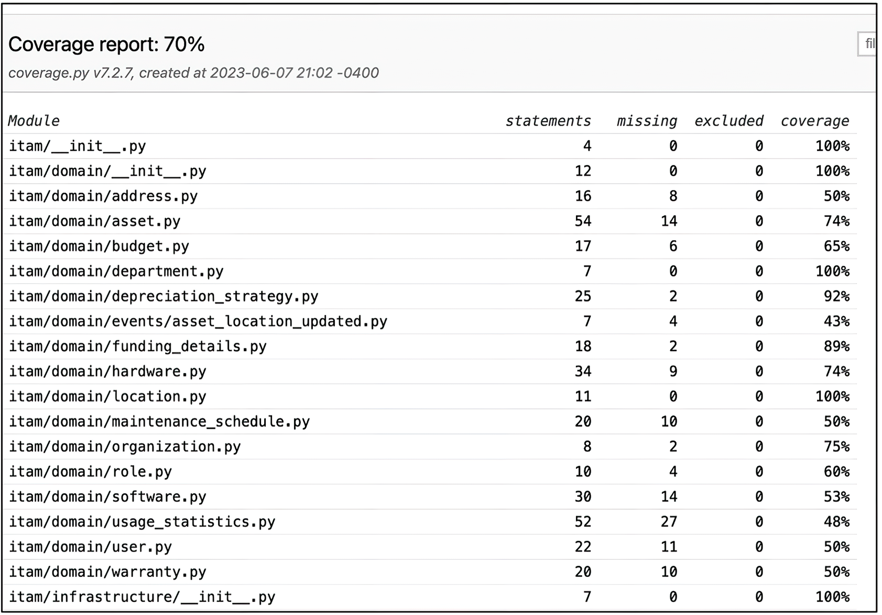

Figure 6.3 The code coverage report showing the coverage for each file in our ITAM system project

Code coverage of 70% is a good start. In the real world, we would continue working
with our team and generative AI pals to bring this measure up into the high 90s. Now
we will transition to a new topic: using generative AI to describe a code listing to us.

6.5 Transliterating code—from code to descriptions
Often, we are handed existing source code. Determining the exact entry point of this
code, the purpose of the code, and the overall structure of a brownfield project can be
challenging. Fortunately, this is one of the areas in which generative AIs truly excel:
translating code into textual descriptions.
To begin, we will copy the (buggy) code from the previous section into the Copilot
Chat dialog box, prefixed with the following prompt (see figure 6.4):

NC What does this code do?
132 chapter 6 Testing, assessing, and explaining with large language models
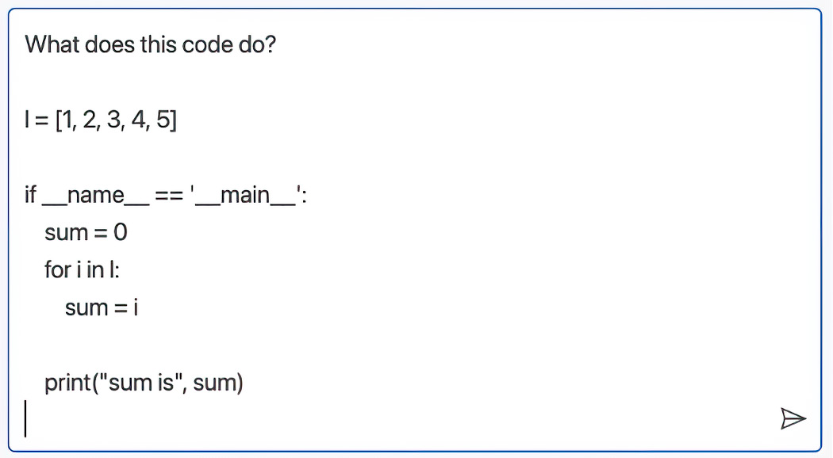

Figure 6.4 The buggy code from the last section with a prompt asking Copilot Chat to explain this code to us

What is striking about the explanation in figure 6.5 is that Copilot Chat detects a bug
in the code and offers suggestions for how to fix it.
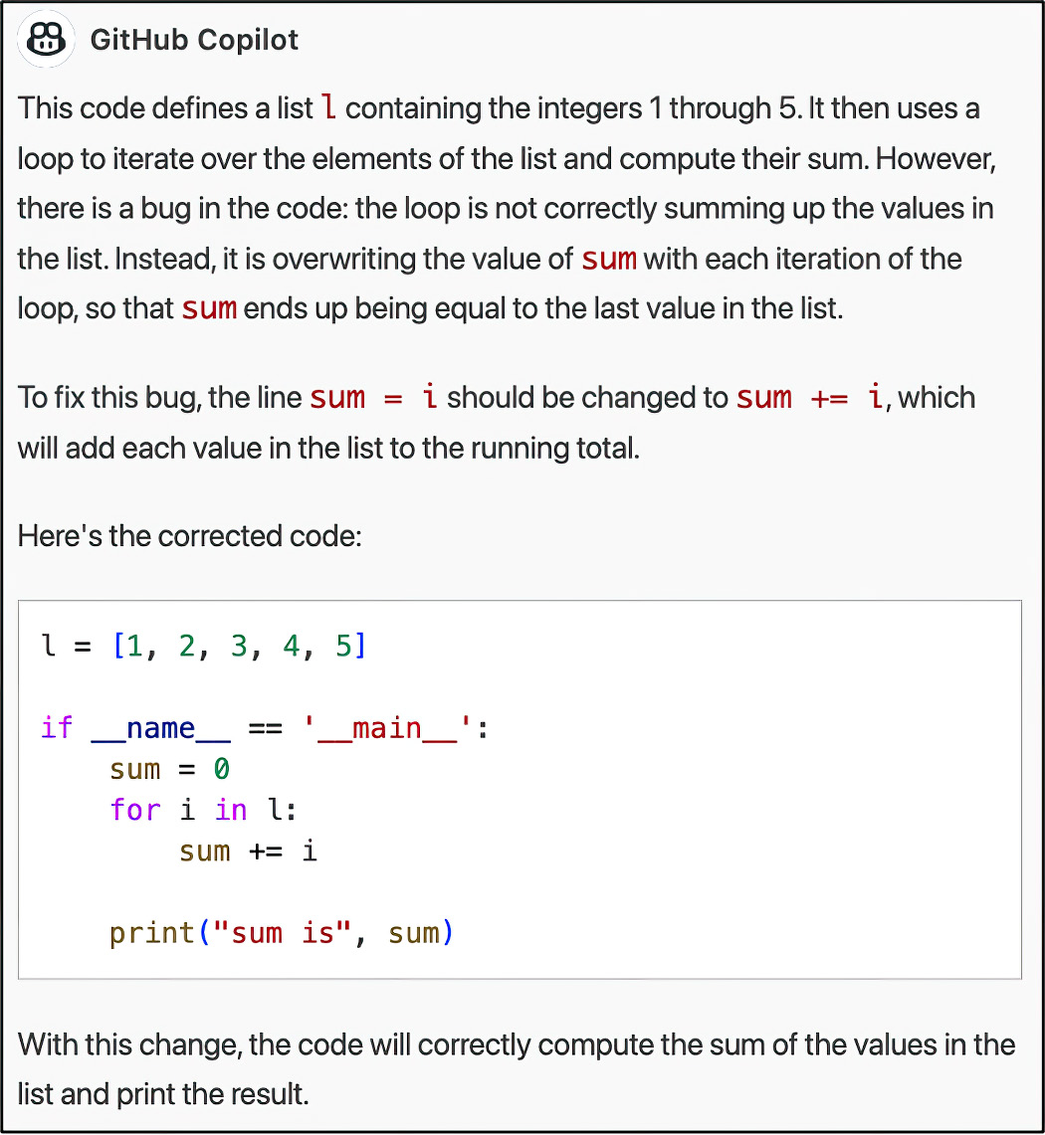

Figure 6.5 Copilot Chat explains the code’s purpose, identifies the bug, and suggests a fix.

Next we will ask it something more challenging: to explain the behavior test from list-
ing 6.9 into the Copilot Chat window, and ask it what this class does. You will likely
receive a response similar to the following.
Transliterating code—from code to descriptions 133

Listing 6.12 Copilot Chat explaining the behavior test we wrote earlier

The code you provided is not a class but a series of step definitions for a Behavior-Driven Development (BDD) test using the Behave framework in Python. These steps correspond to a specific scenario written in Gherkin language (Given, When, Then format).

These step definitions describe how to interact with an AssetManager class and an InMemoryAssetRepository class. They're meant to test the creation of assets and the calculation of the total cost of all assets.

Let's go through each step:

@given('the Asset Manager is running'): This sets up the initial state for the test. It initializes the AssetManager with an InMemoryAssetRepository (which presumably stores assets in memory during the execution of the test) and a mocked AssetLocationMediator.

@given('the InMemoryAssetRepository is initialized') and @given('the AssetLocationMediator is mocked'): These steps appear to be placeholders, as they don't execute any actions.

@when('I create an asset with a cost of ${cost}') and @when('I create another asset with a cost of ${cost}'): These steps create Asset instances with the given cost and add them to the AssetManager.

@then('the total cost of all assets should be ${total_cost}'): This step retrieves all the assets from the AssetManager, calculates the total cost, and checks that it matches the expected total cost.

This sequence of steps allows the user to test the process of creating assets and validating the total cost of all assets in the AssetManager.

# Question: What does this method do?
# Answer: This code defines an asynchronous method get_asset that
takes an integer asset_id as input. The method first calls the
_asset_rest_port.read method with the asset_id to retrieve an
asset from a REST API. If the asset is not found (i.e., the
REST API returns None), the method raises an
HTTPException with a 404 status code and a "Asset not
found" detail message. Otherwise, the method returns the
asset converted to a domain object using the from_asset
function. The implementation of the from_asset function is
not shown in the code snippet.

async def get_asset(self, asset_id: int):
asset = self._asset_rest_port.read(asset_id)
if asset is None:
raise HTTPException(status_code=404, detail="Asset not found")
return from_asset(asset)

134 chapter 6 Testing, assessing, and explaining with large language models

6.6 Translating from one language to another
As remote as this may seem, you may find yourself looking through a code base writ-
ten in a programming language with which you have only a passing familiarity. Alter-
natively, you may pine for a specific function from another language to be available
in your current language. For example, what would the Asset and FundingDetails
classes look like if they were rewritten in JavaScript? Well, let’s ask Copilot Chat.

Listing 6.13 Asset and FundingDetails translated to JavaScript.

class Asset {
constructor(id, name, status, category, cost,
useful_life, salvage_value,
purchase_date, locations,
funding_details) {
this.id = id;
this.name = name;
this.status = status;
this.category = category;
this.cost = cost;
this.useful_life = useful_life;
this.salvage_value = salvage_value;
this.purchase_date = purchase_date;
this.locations = locations;
this.funding_details = funding_details;
}
}

class FundingDetails {
constructor(asset, funding_source, funding_amount) {
this.asset = asset;
this.funding_source = funding_source;
this.funding_amount = funding_amount;
}
}

You may think that translating a class or two is too easy. Well, we will attempt something
more complex:

NC What would the AssetManager behavior test look like if written in JavaScript?

Listing 6.14 AssetManager behavior test translated into JavaScript

const AssetManager = require('./asset_manager');
const Asset = require('./asset');

describe('AssetManager', () => {
let assetManager;

beforeEach(() => {
assetManager = new AssetManager();
});
Translating from one language to another 135

describe('addAsset', () => {
it('should add an asset to the asset list', () => {
const asset = new Asset(1, 'Computer', 'Active',
'Hardware', 1000.0, 5, 100.0,
new Date(), [], null);
assetManager.addAsset(asset);
expect(assetManager.assets.length).toBe(1);
expect(assetManager.assets[0]).toBe(asset);
});
});

describe('removeAsset', () => {
it('should remove an asset from the asset list', () => {
const asset = new Asset(1, 'Computer', 'Active',
'Hardware', 1000.0, 5, 100.0,
new Date(), [], null);
assetManager.addAsset(asset);
assetManager.removeAsset(asset);
expect(assetManager.assets.length).toBe(0);
});
});

describe('getAssetById', () => {
it('should return the asset with the given ID', () => {
const asset1 = new Asset(1, 'Computer', 'Active',
'Hardware', 1000.0, 5, 100.0,
new Date(), [], null);
const asset2 = new Asset(2, 'Printer', 'Active',
'Hardware', 500.0, 3, 50.0,
new Date(), [], null);
assetManager.addAsset(asset1);
assetManager.addAsset(asset2);
const result = assetManager.getAssetById(2);
expect(result).toBe(asset2);
});

it('should return null if no asset with the given ID is found', () => {
const result = assetManager.getAssetById(1);
expect(result).toBeNull();
});
});
});

Additionally, you may wish to have GPT rewrite the code in idiomatic JavaScript. You
need only say

NC Write AssetManager in idiomatic JavaScript

Copilot Chat will inform you that it will define the AssetManager class using the class
syntax introduced in ES6.

136 chapter 6 Testing, assessing, and explaining with large language models

Listing 6.15 AssetManager class rewritten in idiomatic JavaScript

class AssetManager {
constructor() {
this.assets = [];
}

addAsset(asset) {
this.assets.push(asset);
}

removeAsset(asset) {
const index = this.assets.indexOf(asset);
if (index !== -1) {
this.assets.splice(index, 1);
}
}

getAssetById(id) {
return this.assets.find(asset => asset.id === id) || null; }
}

Here’s an example of what the AssetManager behavior test might look like in Java-
Script using the Jest testing framework (which Copilot Chat included without our
suggestion).

Listing 6.16 AssetManager behavior test in idiomatic JavaScript

const AssetManager = require('./asset_manager');
const Asset = require('./asset');
describe('AssetManager', () => {
let assetManager;
beforeEach(() => {
assetManager = new AssetManager();
});
describe('addAsset', () => {
it('should add an asset to the asset list', () => {
const asset = new Asset(1, 'Computer', 'Active',
'Hardware', 1000.0, 5, 100.0,
new Date(), [], null);
assetManager.addAsset(asset);
expect(assetManager.assets.length).toBe(1);
expect(assetManager.assets[0]).toBe(asset);
});
});
describe('removeAsset', () => {
it('should remove an asset from the asset list', () => {
const asset = new Asset(1, 'Computer', 'Active',
'Hardware', 1000.0, 5, 100.0,
new Date(), [], null);
assetManager.addAsset(asset);
assetManager.removeAsset(asset);
expect(assetManager.assets.length).toBe(0);
Translating from one language to another 137

});
});
describe('getAssetById', () => {
it('should return the asset with the given ID', () => {
const asset1 = new Asset(1, 'Computer', 'Active',
'Hardware', 1000.0, 5, 100.0,
new Date(), [], null);
const asset2 = new Asset(2, 'Printer', 'Active',
'Hardware', 500.0, 3, 50.0,
new Date(), [], null);
assetManager.addAsset(asset1);
assetManager.addAsset(asset2);
const result = assetManager.getAssetById(2);
expect(result).toBe(asset2);
});
it('should return null if no asset with the given ID is found', () => {
const result = assetManager.getAssetById(1);
expect(result).toBeNull();
});
});
});

In this example, we use the Jest testing framework to define a set of behavior tests for
the AssetManager class. We are using the describe library to determine test suites
and individual tests.
In each test, we create an instance of the AssetManager class and perform some
operation on it, such as adding or removing an asset. We then use the expect function
to make assertions about the behavior of the AssetManager class, such as checking that
an asset was added to the asset list or that an asset was removed from the asset list. Note
that the syntax for defining classes and constructors is slightly different in JavaScript
than in Python, and we are using the required function to import the AssetManager
and Asset classes from their respective modules.
Finally, time for the big finale: we will start a new ChatGPT 4.0 session and paste in
our Mermaid diagram from chapter 3. Lead with this prompt:

NC Here is a mermaid diagram of my application. Please implement in Golang.

Marvel as it returns the code, rendered in Golang.

Listing 6.17 Asset class rewritten in idiomatic Golang

type Asset struct {
id int
name string
status string
category string
fundingDetails *FundingDetails
}

func NewAsset(name, status, category string,
fundingDetails *FundingDetails) *Asset {
138 chapter 6 Testing, assessing, and explaining with large language models

return &Asset{
name: name,
status: status,
category: category,
fundingDetails: fundingDetails,
}
}

Next, tell it to switch to Java.

Listing 6.18 Asset class rewritten in idiomatic Java

class Asset {
private int id;
private String name;
private String status;
private String category;
private FundingDetails fundingDetails;

public Asset(String name, String status, String category, FundingDetails fundingDetails) {
this.name = name;
this.status = status;
this.category = category;
this.fundingDetails = fundingDetails;
}

Summary
¡ Unit testing focuses on testing individual components or units of code to identify
bugs and problems in specific units. Unit tests will be the most numerous in your
codebase.
¡ Integration testing tests the interaction between different components or mod-
ules of the software to ensure seamless integration and detect communication
problems.
¡ Behavior testing tests a system’s functionality from an end user’s perspective,
ensuring that it meets requirements and specifications.
¡ Mock objects simulate the behavior of natural objects in a controlled way and are
useful for testing and simulating error conditions. Mock objects are especially
good at mimicking parts of the system that are needed for the test to run but are
outside the scope of the test: for example, if your class has a constructor argu-
ment for a database, but you do not want to test the database directly because
the data may change, causing your test to be inconclusive, nonrepeatable, or
nondeterministic.
¡ Cyclomatic complexity measures the number of independent paths through a
software module, indicating complexity and potential for bugs.
¡ Halstead complexity measures assess software complexity based on unique oper-
ators and operands, providing insights into code size and cognitive complexity.
Summary 139

¡ The maintainability index combines factors like cyclomatic complexity, lines of
code, and Halstead measures to evaluate software maintainability.
¡ Code coverage is a metric for evaluating test effectiveness, indicating the extent
to which code is tested and the potential for uncaught bugs. Generally, higher is
better.
¡ Large language models allow you to navigate code in an unfamiliar program-
ming language or translate features from another language in the current or
preferred one.

Part 4

Into the world

I
n part 4, we address the practical aspects of deploying and managing AI-in-tegrated software in real-world environments. This section covers coding infra-
structure and deployment strategies, from building Docker images to setting
up continuous integration and continuous deployment (CI/CD) pipelines with
tools like GitHub Actions. It also emphasizes secure application development,
discussing threat modeling and the implementation of security best practices.
Additionally, this part of the book explores the concept of democratizing access
to AI by hosting your own LLM and utilizing platforms like GPT-4All. By provid-
ing practical guidance on deployment and security, this part prepares developers
to successfully bring their AI-powered applications to market.

Coding infrastructure 7 and managing
deployments

This chapter covers

¡ Creating a Dockerfile with the assistance of Copilot
¡ Drafting your infrastructure as code using large
language models
¡ Managing Docker images with a container registry
¡ Harnessing the power of Kubernetes
¡ Releasing your code effortlessly using GitHub
Actions

There is nothing more demoralizing than having an application sit unused. For
this reason, fast-tracking a well-tested application to production is the stated goal of
every competent developer. Because we spent the last chapter testing our product, it
is now ready for launch.
This chapter will focus on that pivotal moment of transitioning from development
to product launch. During this critical phase, understanding deployment strategies
and best practices becomes essential to ensure a successful product launch.
With our application successfully secured and tested, it’s time to shift our atten-
tion toward launching the product. To this end, we will use the powerful capabilities
of large language models (LLMs) to explore various deployment options tailored to
cloud infrastructure.

143
144 chapter 7 Coding infrastructure and managing deployments

By harnessing the power of LLMs and embracing their deployment options and
methodologies, we can confidently navigate the complex landscape of launching our
product, delivering a robust and scalable solution to our customers while using the ben-
efits of cloud computing.
First, we will develop deployment files for Docker. We will explore how to create
Docker images and define deployment files. Additionally, we will discuss best practices
for containerizing our application and achieving seamless deployment.
Next, we will use Terraform to define our infrastructure as code and automate
the deployment of Elastic Compute Cloud (EC2) instances on Amazon Web Services
(AWS). We will demonstrate how to write Terraform scripts to provision and deploy
our application on EC2 instances, ensuring consistent and reproducible infrastructure
setups.
Then we will utilize LLMs to deploy our application onto Kubernetes (AWS Elastic
Kubernetes Service [EKS]/Elastic Container Service [ECS]). We will have GitHub Copi-
lot create the appropriate Kubernetes deployment files to streamline our deployment
process and efficiently manage our application’s lifecycle. Given the relative simplicity
of our application, we will not need a Kubernetes package manager like Helm. How-
ever, as the complexities and dependencies of services grow, you may want to explore it
as one option. Fortunately, Copilot can write Helm charts for you as well!
Finally, we will briefly showcase migrating from local to automated deployments
using GitHub actions. We can automate our build and deployment processes by inte-
grating LLMs with this widespread continuous integration and deployment (CI/CD)
tool, ensuring faster and more efficient deployments.

NOTE This chapter uses AWS as our cloud provider, but the principles and prac-
tices covered in the chapter can be adapted and applied to other cloud plat-
forms and even on-premises infrastructure without virtualization (bare metal),
allowing us to adapt and scale your product deployment strategy as your busi-
ness needs evolve. You will find that by employing LLMs and using infrastructure
as code, you can (partially) mitigate the vendor lock-in that is very common to
cloud platforms.

Note that if you choose to deploy this (or any application) to AWS, there will be a cost
associated with your activity. AWS and most cloud providers give you free trials to learn
their platforms (Google Cloud Platform and Azure, for example), but once those cred-
its have expired, you may get hit with a rather unexpectedly large bill. If you decide to
follow along in this chapter, you need to set threshold alerts for an amount you can
comfortably afford. Section 1.9 of Andreas Wittig and Michael Wittig’s Amazon Web Ser-
vices in Action, Third Edition (Manning, 2023; www.manning.com/books/amazon-web
-services-in-action-third-edition) is an excellent resource for setting up such a billing
notification alert.

Building a Docker image and “deploying” it locally 145

7.1 Building a Docker image and “deploying” it locally
As you may remember from chapter 6, Docker is a containerization platform that
allows you to run applications with little or no installation of an application (outside of
Docker) in the traditional sense. Unlike a virtual machine, which simulates an entire
operating system, a container shares the host system’s kernel (the core part of the oper-
ating system) and uses the host system’s operating system’s capabilities while isolating
the application processes and file systems from the host. This lets you run multiple iso-
lated applications on a single host system, each with its own environment and resource
limits. Figure 7.1 gives you a sense of the relationship between the Docker runtime and
the host.

A B C D

Container Container Container Container

Docker daemon

Host operating
system

Host hardware

Figure 7.1 Docker makes use of the host’s operating system while isolating each of the containers. This makes Docker containers lightweight compared to virtual machines, as they do not require a full OS to run.

One of the more exciting features, from a production readiness perspective, is that
Docker makes it easier to run applications that can self-heal in some sense. If they fail
or fall over at runtime, you can configure them to restart without intervention. In this
section, we will use Copilot to create the file (called a Dockerfile) from which we will
build our Docker image.

DEFINITION Docker images are like blueprints for Docker containers. They are
portable, including all the dependencies (libraries, environment variables, code,
etc.) required for the application to run.

146 chapter 7 Coding infrastructure and managing deployments

Running Docker instances are called Docker containers. Given their lightweight nature,
we can run multiple containers on a single host without a problem. We can do this
because the containerization technology shares the OS kernel, operating in an isolated
user space.

NOTE Originally, I wanted to use AWS CodeWhisperer as the LLM for this chap-
ter. It seemed logical, given the intended cloud platform. However, at the time
of this writing, AWS CodeWhisperer only supports programming in a program-
ming language. It does not have facilities for infrastructure as code.

We will begin with the following prompt to have Copilot draft the Dockerfile for us:

# Create a Dockerfile for this Python app. The main class is main.py. Use Python 3.10 and install
# the dependencies using the requirements.txt file in this directory. The app should run on port 8080.

You may be left with an empty file (other than this comment). Support for infrastruc-
ture as code is ever-evolving (not unlike the LLM ecosystem in general). According
to Copilot Chat, GitHub Copilot is capable of creating a Dockerfile for you—but you
have to goad it with the following steps:

1 FROM python: In the Dockerfile, type and wait for Copilot to suggest a version of
Python to use. Select the version you want to use.
2 WORKDIR /app Type to set the working directory for the container.
3 COPY . /app Type to copy the contents of your project into the container.
4 RUN pip install --trusted-host pypi.python.org -r requirements Type
.txt to install the dependencies for your project.
5 EXPOSE 8080 Type to expose port 8080 for the container.
6 CMD ["python", "main.py"] Type to specify the command to run when the
container starts.

Alternatively, you may want to copy and paste the same prompt that you previously
wrote into the Dockerfile into the Copilot Chat prompt window. Copilot Chat will give
you the desired content for the Dockerfile.

Listing 7.1 Dockerfile to build a Docker image

FROM python:3.10-slim-buster
WORKDIR /app
COPY . /app
RUN pip install --trusted-host pypi.python.org -r requirements.txt EXPOSE 8080
CMD ["python", "main.py"]

With a Dockerfile, we will build an image for deploying and running our application.
We can enter the following command to build our application (run from the directory
Standing up infrastructure by copiloting Terraform 147

where the Dockerfile lives, and do not forget the trailing dot). You will need internet
access to download the dependencies and create the image:
docker build -t itam:latest .

Building a Docker image can run for a few seconds to a few minutes, depending on
which images and packages are installed on your system and your internet connection
speed. Your patience will be rewarded, as you will shortly have an application you can
install nearly anywhere from the lowliest commodity hardware to the most oversized
hardware offered by your favorite cloud provider. Before running it anywhere, how-
ever, you need to try to get it running locally. If you’ve forgotten the command, Copilot
Chat will happily and helpfully assist:
docker run -p 8000:8000 -d --name itam itam:latest

You can confirm that your Docker container is running by issuing this command at the
command line: docker ps | grep itam. You should see the running instance.

7.2 Standing up infrastructure by copiloting Terraform
Using a Docker image on your computer is useful when creating and testing an app.
But when it comes time to launch your application, you need a machine with a lit-
tle more heft than local computers. In this section, we’ll use GitHub Copilot to help
us set up and control our AWS infrastructure by having Copilot write the requisite
deployment descriptors for an infrastructure-as-code tool called Terraform. Terraform
is made by HashiCorp and lets us write what we want our infrastructure to look like
using a domain-specific language (DSL). This DSL saves us from having to understand
all the complexities and intricacies that each cloud service provider uses to provision
hardware. Additionally, it allows us to store and version our infrastructure using infra-
structure as code.
To start, we want to create a file called ec2.tf and add the prompt to inform Copilot
that we intend this to be a Terraform file and how we want our infrastructure stood
up. Notice that Copilot needs us to enter the first word of a given line before it can be
cajoled to continue.

Listing 7.2 Example Terraform file, including instance size

# Create a Terraform file that provisions an AWS EC2 instance of type t2.micro, installs the Docker daemon, and returns the instance's hostname. provider "aws" {
region = "us-west-2"
}

resource "aws_instance" "example" {
ami = "ami-0c55b159cbfafe1f0"
instance_type = "t2.micro"
}

You may find that Copilot skips over one small but crucial detail: it does not provide
code for installing and provisioning Docker. Given that Docker is required for running 148 chapter 7 Coding infrastructure and managing deployments

our application, we need to correct this oversight. In fact, you may need to update the
file manually to include the command to install Docker, like this:
resource "aws_instance" "example" {
ami = "ami-0c55b159cbfafe1f0"
instance_type = "t2.micro"

user_data = <<-EOF
#!/bin/bash
sudo yum update -y
sudo yum install -y docker
sudo service docker start
sudo usermod -a -G docker ec2-user
sudo docker run -d -p 80:80 nginx
EOF
}

Copilot should produce a complete Terraform file that resembles the following listing.
Your code probably does not exactly match the listing, but that’s fine as long as it con-
tains the key features: the provider, the instance, the script to add the Docker daemon,
the key pair, and the security group.

Listing 7.3 Terraform file to create the smallest EC2 instance available

# Create a Terraform file that provisions an AWS EC2 instance of type t2.micro, installs the Docker daemon, and returns the hostname of the instance.
provider "aws" {
region = "us-west-2"
}

resource "aws_instance" "example" {
ami = "ami-0c55b159cbfafe1f0"
instance_type = "t2.micro"

user_data = <<-EOF
#!/bin/bash
sudo yum update -y
sudo yum install -y docker
sudo service docker start
sudo usermod -a -G docker ec2-user
sudo docker run -d -p 80:80 nginx
EOF
connection {
type = "ssh"
user = "ec2-user"
private_key = file("~/.ssh/id_rsa")
host = self.public_ip
}

lifecycle {
create_before_destroy = true
}
Standing up infrastructure by copiloting Terraform 149

depends_on = [aws_security_group.allow_http]
}

resource "aws_security_group" "allow_http" {
name = "allow_http"
description = "Allow HTTP inbound traffic"
vpc_id = "vpc-12345678"

ingress {
description = "HTTP from VPC"
from_port = 80
to_port = 80
protocol = "tcp"
cidr_blocks = ["0.0.0.0/0"]
}
}

output "public_dns" {
value = aws_instance.example.public_dns
}

If you are using the default Virtual Private Cloud (VPC), the vpc_id entry is not strictly
necessary. You will find that many of the default configurations and conventions cho-
sen by the AWS team make sense; if you have stricter security requirements, or if you
know everything about your infrastructure and assume nothing, you might consider
setting up a new VPC from scratch using Terraform. You need to change the key pair
entry on line 21 to be a key pair to which you have access.
Once you have completed this file satisfactorily, run the terraform init command.
This command initializes a new or existing Terraform working directory. It downloads
and installs the required provider plugins and modules specified in your configuration
files and gets everything ready to go.
Next you will have Terraform explain the changes that it intends to make. You do
this with the terraform plan command. This command creates an execution plan
for your infrastructure changes: it shows you what changes Terraform will make to your
infrastructure when you apply your configuration files. The plan will show you which
resources will be created, modified, or destroyed and any other changes that will be
made to your infrastructure.

NOTE You may get an error when running terraform plan for the first time:
“Error: configuring Terraform AWS Provider: no valid credential sources for
Terraform AWS Provider found.” You get this error when Terraform attempts to
connect to AWS but cannot supply AWS with proper credentials. To address this
problem, you will need to create (or edit) the file called ~/.aws/credentials and
add your ITAM AWS Access Key ID and AWS Secret Access Key credentials. You
can find more details on how to accomplish this correctly in section 4.2.2, “Con-
figuring the CLI,” of Amazon Web Services in Action, Third Edition.

Finally, to apply the Terraform changes, you use the terraform apply command.
Terraform will then read the configuration files in the current directory and apply any 150 chapter 7 Coding infrastructure and managing deployments

changes to your infrastructure. If you have made any changes to your configuration
files since the last time you ran terraform apply—for example, if you need to start
up a new database instance or change the size of your EC2—Terraform will show you a
preview of the changes that will be made and prompt you to confirm before applying
the changes.
If you apply these changes, in a manner of minutes you will have a brand-new EC2
instance running in your VPC. However, this is only half of the equation. Having com-
puting power at your fingertips is fantastic, but you need something to apply this power.
In this case, we can use this EC2 instance to run our ISAM system. The following section
briefly demonstrates transferring a locally built image to another machine.

7.3 Moving a Docker image around (the hard way)
First we will export a Docker image from our local machines and load it onto a remote
machine. We will use the commands docker save and load to accomplish this. You
can use the docker save command on your local machine to save the image to a tar
archive. The following command will save the image to a tar archive named
-name>.tar:
docker save -o .tar :

Next, transfer the tar archive to the remote machine using a file transfer protocol such
as Secure Copy Protocol (SCP) or Secure File Transfer Protocol (SFTP). You can use
the docker load command on the remote machine to load the image from the tar
archive: docker load -i .tar. This will load the image into the local
Docker image cache on the remote machine. Once the image has been loaded, use the
docker run command to start the image and run the Docker container, as you did
after you built it. Then add this image to your Docker compose file, in which you have
the Postgres database and Kafka instances.

NOTE This discussion of Terraform is heavily abridged. When you are ready to
get serious with Terraform, your go-to resource should be Scott Winkler’s Terra-
form in Action (Manning, 2021; www.manning.com/books/terraform-in-action).

This section examined how to package up images and load them on remote hosts. This
process is scriptable, but with the advent of container registries, it is now easier than
ever to manage deployments without slinging them all around the internet. In the next
section, we will explore one such tool: Amazon’s Elastic Container Registry (ECR).

7.4 Moving a Docker image around (the easy way)
Docker images, the blueprints for our containers, are a fundamental building block of
containerized applications. Managing them correctly ensures that we maintain clean,
efficient, and organized development and deployment workflows. Amazon ECR serves
as a fully managed Docker container registry that makes it easy for developers to store,
manage, and deploy Docker container images.
Deploying our application onto AWS Elastic Kubernetes Service 151

First, let’s dive into pushing Docker images to ECR. This process is vital to making
your images accessible for use and deployment. We’ll walk through setting up your local
environment, authenticating with ECR, and pushing your image. Before we can move
an image to ECR, we must create a repository to house that image. This can be done
from the AWS Management Console or, as we will do shortly, using the AWS command
line interface (CLI). The command to create a new repository for an image is
aws ecr create-repository --repository-name itam

Next you need to tag your Docker image with the ECR repository URL and the image
name. You may want to call it latest or use semantic versioning. Tagging will allow
you to easily roll back or forward versions of your system. Tag your application image
latest using the following command:
docker tag itam:latest
123456789012.dkr.ecr.us-west-2.amazonaws.com/itam:latest

Now, authenticate Docker to the ECR registry using the aws ecr get-login
-password command. This will generate a Docker login command that you can use
to authenticate Docker to the registry. The command to log in is
aws ecr get-login-password --region us-west-2 |
docker login --username AWS --password-stdin
123456789012.dkr.ecr.us-west-2.amazonaws.com

Finally, push the Docker image to the ECR registry using the docker push command:
docker push 123456789012.dkr.ecr.us-west-2.amazonaws.com/itam:latest

Once the image is in your registry, your deployment options have greatly increased.
You could, for example, write a bash script that will log on to the EC2 instance and
perform a docker pull to download and run the image on that EC2. Alternatively,
you may want to adopt a more bulletproof deployment pattern. In the next section,
we’re going to walk through the process of setting up and launching our application
on a powerful cloud service called Elastic Kubernetes Service (EKS). EKS is a managed
Kubernetes service provided by AWS. Let’s dive in!

7.5 Deploying our application onto AWS Elastic Kubernetes Service
Kubernetes confers many benefits over simply running Docker images on EC2
instances. For one, managing and scaling our application becomes considerably more
straightforward with Kubernetes. Also, with Kubernetes, we do not have to spend a
lot of additional time thinking about what our infrastructure should look like. Plus,
thanks to its automatic management of the lifecycles of its images, known as pods, our
application will essentially be self-healing. This means if something goes wrong, Kuber-
netes can automatically fix it, keeping our application running smoothly at all times.
First we need a deployment descriptor written in YAML (Yet Another Markup
Language or YAML Ain’t Markup Language, depending on who you ask), which will

152 chapter 7 Coding infrastructure and managing deployments

describe the state we want our ITAM system to be in at all times. This file (typically
called deployment.yaml) will provide the template against which Kubernetes will com-
pare the current running system, making corrections as needed.

Listing 7.4 Kubernetes deployment file for the ITAM system

# Create a Kubernetes deployment file for the itam application. The image name is itam:latest
# The deployment will run on port 8000

apiVersion: apps/v1
kind: Deployment
metadata:
name: itam-deployment
labels:
app: itam
spec:
replicas: 1
selector:
matchLabels:
app: itam
template:
metadata:
labels:
app: itam
spec:
containers:
- name: itam
image: itam:latest
imagePullPolicy: Always
ports:
- containerPort: 8000

This will not work, however. Kubernetes will not be able to find the image that we
reference in the deployment descriptor file. To correct this, we need to tell Kuber-
netes to use our newly minted ECR. Fortunately, this is not as challenging as it may
sound. We just have to update the image entry in our file to point to the ECR image, as
well as grant EKS permissions to access ECR (okay, maybe it is a little trickier, but it is
manageable).
First, update the deployment YAML to use the ECR image:
image: 123456789012.dkr.ecr.us-west-2.amazonaws.com/itam:latest.

Then you would need to define a policy for EKS to use and apply the policy using
either the AWS CLI or the Identity and Access Management (IAM) Management Con-
sole. Although applying the policy is (slightly) outside of the scope of this book, you
can use Copilot to define it. The resulting policy will resemble the following listing.

Deploying our application onto AWS Elastic Kubernetes Service 153

Listing 7.5 IAM policy to allow EKS to pull images from ECR

{
"Version": "2012-10-17",
"Statement": [
{
"Sid": "AllowPull",
"Effect": "Allow",
"Principal": {
"AWS": "arn:aws:iam:::role/"
},
"Action": [
"ecr:GetDownloadUrlForLayer",
"ecr:BatchGetImage",
"ecr:BatchCheckLayerAvailability"
],
"Resource": "arn:aws:ecr::: repository/"
}
]
}

Once the EKS can pull down the image from ECR, you will see a pod start to run.
However, you have no way to access this pod externally. You need to create a service. In
Kubernetes, a service is an abstraction that defines a logical set of pods (the smallest and
simplest unit in the Kubernetes object model that you create or deploy) and a policy to
access them.
Services enable communication between different parts of an application and
between different applications. They help distribute network traffic and load balance
by exposing the pods to the network and other pods in Kubernetes.

Listing 7.6 Kubernetes services file to enable external access for our application

# Please create a service for the application that uses a load balancer type egress
apiVersion: v1
kind: Service
metadata:
name: itam-service
spec:
type: LoadBalancer
selector:
app: itam
ports:
- name: http
port: 80
targetPort: 8000

Kubernetes is responsible for routing all requests from this ingress through the ser-
vice to the running pods, regardless of what host they are running on. This allows for
seamless failover. Kubernetes expects things to fail. It banks on it. As a result, many of 154 chapter 7 Coding infrastructure and managing deployments

the best practices in distributed systems are baked into Kubernetes. Getting to Kube is
a significant first step to having a reliable, highly available system. In the next section,
we will examine how to ease the burden of getting our application onto Kubernetes
repeatably and continuously. We will look at building out a small deployment pipeline
using GitHub actions.

7.6 Setting up a continuous integration/continuous deployment
pipeline in GitHub Actions
If releasing is hard, it will not be done often. This limits our ability to add value to the
application and thus to our stakeholders. However, automating the deployment pro-
cess significantly reduces the time to release. This allows for more frequent releases,
accelerating the pace of development and enabling faster delivery of features to users.
Continuous integration/continuous deployment (CI/CD) pipelines limit the risk
associated with deployment. By making smaller, more frequent updates, any problems
that arise can be isolated and fixed quickly, minimizing the potential effect on the end
users. These pipelines facilitate seamless integration of code changes and expedite
deployment, simplifying the software release process.
GitHub Actions allows us to construct customized CI/CD pipelines directly in our
GitHub repositories. This makes the development workflow more efficient and enables
the automation of various steps, freeing us to focus on coding rather than the logistics
of integration and deployment.
This section provides a concise introduction to setting up a CI/CD pipeline using
GitHub Actions and GitHub Copilot. Note that this will not be a comprehensive guide
but rather a survey that introduces the potential benefits and general workflow. This
should serve as a primer, giving you an insight into how these tools can be used to opti-
mize your software development process.
First, create a file in your project in the path .github/workflows. Note the leading
dot. You can call this file itam.yaml or whatever you desire. On the first line of this file,
add the following prompt:

# Create a GitHub Actions workflow that builds the ITAM application on every merge to the main branch and deploys it to EKS.

NOTE Like many of the infrastructure-related tasks that we have put to Copi-
lot in this chapter, Copilot needs a lot of assistance in creating this file for us.
We need to be aware of the structure of this file and how to begin every line. It
makes sense in cases such as this one to ask ChatGPT or Copilot Chat to build
the file for us.

The first part of this file outlines when this action should take place. The on:push
instruction denotes that when a git push occurs to the main branch, this action should
be executed. There is a single job in this file, one with several steps. This job “build”
uses an embedded function login-ecr to log into our ECR.
Setting up a continuous integration/continuous deployment pipeline in GitHub Actions 155

Listing 7.7 Beginning of GitHub Actions file to build our application

# Create a GitHub Actions workflow that builds the ITAM application on every merge to the main branch and deploys it to EKS.
name: Build and Deploy to EKS

on:
push:
branches:
- main
jobs:

The build job will first check out the code from our GitHub repository. It uses the code
written in the module actions/checkout version 2. Similarly, it will next grab the EKS
CLI and configure the credentials to connect to EKS. Note that the AWS access key and
secret are values that are automatically passed into the application. GitHub Actions
uses a built-in secret management system to store sensitive data such as API keys, pass-
words, and certificates. This system is integrated into the GitHub platform and allows
you to add, remove, or update secrets (and other sensitive data) at both the repository
and organization levels. Secrets are encrypted before they’re stored and are not shown
in logs or available for download. They’re only exposed as environment variables to
the GitHub Actions runner, making it a secure way to handle sensitive data.
Likewise, you can create environmental parameters and use them in your actions.
For example, look at the variable ECR_REGISTRY. This variable is created using the out-
put from the login-ecr function. In this case, you still need to hardcode the ECR in
your Actions file. However, you should do this because of consistency and the need to
manage it in only one place in the file. Most of these steps should seem familiar, as we
have used them throughout the chapter. That is the magic of automation: it does it for
you.

Listing 7.8 Build and deploy steps of our GitHub Actions file

build:
runs-on: ubuntu-latest

steps:
- name: Checkout code
uses: actions/checkout@v2

- name: Set up EKS CLI
uses: aws-actions/amazon-eks-cli@v0.1.0

- name: Configure AWS credentials
uses: aws-actions/configure-aws-credentials@v1
with:
aws-access-key-id: ${{ secrets.AWS_ACCESS_KEY_ID }}
aws-secret-access-key: ${{ secrets.AWS_SECRET_ACCESS_KEY }}
aws-region: us-west-2

- name: Build and push Docker image 156 chapter 7 Coding infrastructure and managing deployments

env:
ECR_REGISTRY: ${{ steps.login-ecr.outputs.registry }}
ECR_REPOSITORY: itam
IMAGE_TAG: ${{ github.sha }}
run: |
docker build -t $ECR_REGISTRY/$ECR_REPOSITORY:$IMAGE_TAG .
docker push $ECR_REGISTRY/$ECR_REPOSITORY:$IMAGE_TAG

- name: Deploy to EKS
env:
ECR_REGISTRY: ${{ steps.login-ecr.outputs.registry }}
ECR_REPOSITORY: itam
IMAGE_TAG: ${{ github.sha }}
run: |
envsubst < k8s/deployment.yaml | kubectl apply -f -
envsubst < k8s/service.yaml | kubectl apply -f -

The final part of the file logs in to AWS ECR. The steps in the Actions file invoke this
action. On completion, it returns the output to the calling function.

Listing 7.9 A GitHub Actions file to build and deploy to EKS

login-ecr:
runs-on: ubuntu-latest
steps:
- name: Login to Amazon ECR
id: login-ecr
uses: aws-actions/amazon-ecr-login@v1
with:
registry:
aws-access-key-id: ${{ secrets.AWS_ACCESS_KEY_ID }}
aws-secret-access-key: ${{ secrets.AWS_SECRET_ACCESS_KEY }}

Exploring code-as-infrastructure has enabled us to understand its vital role in any proj-
ect and how it can be better managed through code. Tools like Terraform provide
streamlined solutions for managing infrastructure, and GitHub’s code-centric features
aid in maintaining the overall workflow.
Introducing CI/CD pipelines, primarily through platforms like GitHub Actions,
highlights the importance of automating the software delivery process. Automating
such processes increases the speed and reliability of the software development life cycle
and minimizes the chances of human errors.
The journey of managing infrastructure as code is ever-evolving, with new tools and
practices emerging. It requires a constant learning and adaptation mindset. This chap-
ter has given you a glimpse of the benefits and possibilities.

Summary 157

Summary
¡ You learned about the transition from application development to product
launch, covering deployment strategies, best practices for cloud infrastructure,
and the use of Docker and Terraform for managing and containerizing applica-
tions efficiently.
¡ The chapter explained how to manage application deployment via Kubernetes,
including creating YAML deployment descriptors, forming services for network
traffic distribution, and deploying on AWS’s Elastic Kubernetes Service (EKS).
¡ You discovered how to adapt deployment methods to different environments,
whether on various cloud platforms or on premises, and how GitHub Copilot can
assist in creating Dockerfiles and Terraform files accurately.
¡ Finally, we explored the process of exporting Docker images to remote machines,
pushing them to Amazon’s Elastic Container Registry (ECR), and migrating to
automated deployments using GitHub Actions.

Secure application 8 development with
ChatGPT

This chapter covers
¡ Threat modeling with ChatGPT
¡ Using ChatGPT to develop a security mindset
¡ Mitigating risks using ChatGPT

In the evolving software development landscape, security concerns have escalated
from an afterthought to being integral to a project’s design and implementation
phases. Despite this elevated attention, developers often find it challenging to keep
pace with the rapidly changing sphere of application security. This chapter offers
a comprehensive understanding of how AI, specifically ChatGPT, can be embed-
ded into various stages of the application development process to strengthen appli-
cation security, providing a novel set of tools for building more secure software
applications.
As we delve into this subject, we’ll explore how ChatGPT can be incorporated
into various stages of the application development process for the ISAM application,
written in Python using FastAPI. We’ll discuss how this AI model can help identify
vulnerabilities, contribute to threat modeling, assess application design for potential
insecurities, understand and apply security best practices.

158
Modeling threats with ChatGPT 159

The objective of this chapter is not to position ChatGPT as a silver bullet for all secu-
rity concerns but rather to showcase its potential as a powerful tool in the developer’s
security toolkit. We will learn how to proactively identify and manage threats, keeping
in mind the holistic goal of creating not just functional software but secure software. In
this journey, we will navigate topics such as modeling threats, incorporating security in
the development lifecycle, the role of AI in security, and much more. Let’s get started!

Security is not a feature
Secure applications start with the design. It is not a feature, although it is often treated as such. Generative AIs are tools that can be used to assess and improve the security of your application, but they will not replace input from a security expert, nor will they make you one. For more information on designing secure applications, refer to Secure by Design by Dan Bergh Johnsson, Daniel Deogun, and Daniel Sawano (Manning, 2019;
www.manning.com/books/secure-by-design).


The (fallacious) mental model of the software life cycle, in which security is treated as a feature to be prioritized and deprioritized as needed in the project or as an add-in to be performed at some point in the lifecycle. Security, however, is a mindset that needs to be front and center during all phases.

8.1 Modeling threats with ChatGPT
Threat modeling is a structured approach that helps teams understand, prioritize, and
manage potential threats in a system. By simulating the mindset of an attacker, threat
modeling systematically identifies vulnerabilities, evaluates the potential effect, and
determines mitigation strategies. Rooted in the design phase but relevant through-
out the entire software development lifecycle, threat modeling acts as a crucial bridge
between high-level security policies and on-the-ground practices.
Threat modeling is not a one-time process. As new vulnerabilities are discovered,
your system and the external environment change, so you must revisit and update your
threat model.
160 chapter 8 Secure application development with ChatGPT

8.1.1 Why it matters in today’s development landscape

Before we delve into threat modeling using ChatGPT, we need to take a step back to
understand why we would want to do this in the first place. With a greater emphasis
on security in today’s development landscape, we must be mindful of factors that have
significantly reshaped how software is developed, deployed, and accessed. As more ser-
vices go digital, there’s a broader attack surface. Everything from online banking to
health records, e-commerce, and even government services is now available online,
making them potential targets.
Additionally, cyber threats are not static. New vulnerabilities emerge daily, and
attackers are continually devising new methods. The danger has never been more sig-
nificant, with the rise of state-sponsored attacks, ransomware, and cyber espionage.
Modern architecture is significantly more complex than before, as applications com-
monly utilize microservices, third-party APIs, and cloud infrastructures. This complex-
ity can introduce multiple potential points of vulnerability. Systems are not standalone
but interconnected with other systems, creating a domino effect. A breach in one can
provide a stepping-stone to compromise others.

Security breaches
Beyond immediate financial implications, a security breach can erode trust, harm a com-pany’s reputation, lead to legal consequences, and result in a loss of customers or busi-ness opportunities. Further, with regulations like the General Data Protection Regulation (GDPR) in Europe and the California Consumer Privacy Act (CCPA) in the United States, organizations have an increased responsibility to protect user data. Noncompliance can result in substantial penalties.

In an interconnected, digital-first world, security is not just an IT concern but a fun-
damental business imperative. Ensuring that applications are developed with security
in mind from the ground up reduces risk and costs, builds trust, and provides systems
continuity.

8.1.2 How ChatGPT can aid in threat modeling

Now that we can appreciate the why, let us turn to how we can utilize ChatGPT to
understand the cybersecurity threats that surround us, their effects, and potential mit-
igation techniques. ChatGPT has an extensive knowledge base of basic cybersecurity
concepts; it can define standard terms and explain complex attack vectors to you in
whatever level of detail is appropriate to your cybersecurity journey. You can begin by
asking it to explain cybersecurity principles, what a SQL injection attack is (but not
how to perform one!), or what clickjacking is.
As an informal approach to modeling threats, you can pose detailed hypothetical
scenarios to ChatGPT and ask for potential threats or vulnerabilities that may arise in
those situations. Start very general and refine as the process continues. For example,
you might enter the following prompt:
Modeling threats with ChatGPT 161

NC If I'm developing a cloud-based web application for e-commerce, what threats should I
be aware of?

Then drill in, triangulating around specific threats:

NC How might an attacker session hijack a user's cart in my e-commerce application?

Next, you can engage with ChatGPT to understand how to assess the risks associated
with various threats. This can help you prioritize which threats to address first. With
an understanding of some of the threats potentially directed at your system, you can
engage ChatGPT about potential countermeasures, best practices, and mitigation
strategies:

NC How do I assess the risk of a DDoS attack for my online service?

And then,

NC What are the best practices to prevent cross-site scripting attacks?

You need to periodically engage with ChatGPT to refresh your knowledge or ask about
any new concepts or strategies you’ve come across.
One quick warning, however: as always, you must be aware of ChatGPT’s limitations.
It doesn’t have real-time threat intelligence or knowledge beyond its last update. For
the latest threats, always consult up-to-date resources. Although ChatGPT is a valuable
tool, always cross-reference its insights with other authoritative sources. Cybersecu-
rity rapidly evolves, and staying updated with multiple trusted sources is crucial. After
discussing a specific threat with ChatGPT, you may want to consult the latest docu-
mentation from organizations like the Open Worldwide Application Security Project
(OWASP), the National Institute of Standards and Technology (NIST), and other rec-
ognized cybersecurity entities.
Finally, interactive brainstorming sessions with ChatGPT can help you effectively
generate ideas, understand complex concepts, or refine strategies, especially in areas
like cybersecurity. Here’s how you can structure and execute such sessions:

1 Clearly state the goal of the brainstorming session. For instance, it could be iden-
tifying potential vulnerabilities in a system, generating security measures for a
new application, or discussing strategies to improve user data protection.
2 Begin the session by providing ChatGPT with a detailed context. If it’s about a
specific system or application, describe its architecture, components, functional-
ities, and any known problems or concerns. You may, for example, say

NC I'm working on a web-based e-commerce platform using a microservices archi-
tecture with Docker containers. We're looking to identify potential security threats.
162 chapter 8 Secure application development with ChatGPT

Based on ChatGPT’s responses, delve deeper into specific areas of interest or
concern. For example, you may say

NC Tell me more about container security best practices.

or ask

NC How can I secure communication between microservices?

3 Present hypothetical scenarios to ChatGPT, and ask for feedback or solutions.
This can help anticipate potential challenges or threats:

NC Imagine an attacker gains access to one of the containers; what steps should
be taken?"

4 Engage with ChatGPT by playing the devil’s advocate. Question or counter the
ideas or suggestions it provides, to stimulate further thought and explore differ-
ent angles:

NC What if I were to use a third-party authentication service? How would that
change the security landscape?

5 Ask ChatGPT for concrete steps or action items to implement the suggested solu-
tions. You might, for example, inquire,

NC Given the security concerns you mentioned, what are the specific steps I should
take to mitigate them?

NOTE As the brainstorming progresses, document the ideas, suggestions, and
strategies provided by ChatGPT. They will be invaluable for reviewing and imple-
menting after the session. Brainstorming is most effective when iterative. Based
on what you learn in one session, you may refine your questions, adjust your
approach, or explore new areas in subsequent sessions.

Figure 8.1 shows the security feedback loop performed during a brainstorming session.

Refine

Explore Adjust

Figure 8.1 The workflow of a brainstorming session with ChatGPT

As your project or scenario progresses, revisit the discussion with ChatGPT to account
for any changes, updates, or new challenges. Recent updates allow you to upload your
Modeling threats with ChatGPT 163

system design documentation and have ChatGPT scrutinize this design for potential
threats and common vulnerabilities in the same way that it can assess code.
By using ChatGPT in this semistructured manner, you can benefit from its expansive
knowledge base and receive valuable feedback and insights for your scenarios. Always
remember to cross-reference suggestions with up-to-date resources and experts in the
relevant field.

8.1.3 Case study: Simulating threat modeling with ChatGPT

In addition to scenario analysis and interactive brainstorming sessions with ChatGPT,
you may decide to apply a formal methodology, one that is commonly used by cyber
security professionals: STRIDE. STRIDE is a threat modeling methodology introduced
by Microsoft to help identify potential security threats in systems or applications. You
can use ChatGPT and STRIDE to simulate threats and triage accordingly.

STRIDE
The acronym STRIDE stands for spoofing, tampering, repudiation, information disclo-sure, and denial of service:

¡ Spoofing—Impersonating something or someone else. This can mean taking on
the identity of a user, a device, or even a system to gain unauthorized access. For example, an attacker may spoof a media access control (MAC) address to imper-sonate a device on a network.
¡ Tampering—Unauthorized modification of data or code. For example, an attacker
may modify a transmitted data packet in a man-in-the-middle attack.
¡ Repudiation—The ability of malicious (or careless) users to deny that they per-
formed specific actions, even if they did, due to lack of evidence of those actions. For example, a user may deny placing an order or changing some data.
¡ Information disclosure—The exposure of information to individuals who aren’t
supposed to have access to it. For example, a database misconfiguration may ex-pose sensitive user data to the public.
¡ Denial of service (DoS)—Making a resource unavailable or unresponsive to its
intended users. This can be achieved by overwhelming a system’s resources or exploiting specific vulnerabilities. For example, during a DDoS attack, an attacker may flood a website with traffic, causing it to become slow or entirely unresponsive.
¡ Elevation of Privilege—An unprivileged user gains elevated rights, often allowing
them to control the entire system or perform tasks they are not authorized to do.

Throughout this book, we have been developing part of a ITAM system. As a reminder,
this system is used to manage and optimize an organization’s IT assets. In this sec-
tion, we will apply STRIDE to our application, using ChatGPT to assist in modeling the
threats against this system.
Let us start with spoofing:

NC Within the context of our ITAM system, how might our system be spoofed? 164 chapter 8 Secure application development with ChatGPT

ChatGPT may respond with something similar to the following listing.

Listing 8.1 ChatGPT explanation of how spoofing may affect our application

MAC Address Spoofing: Most ITAM systems rely on MAC addresses to identify and manage devices on a network. An attacker might spoof the MAC address of an authorized device to gain unauthorized access or to mask a rogue device's presence.
IP Address Spoofing: An attacker could bypass network security measures or divert traffic by masquerading as a trusted IP address. This could lead to unauthorized access to the ITAM system or even denial-of-service attacks. DNS Spoofing (Cache Poisoning): If the ITAM system relies on domain names for accessing updates or related resources, DNS spoofing can redirect the ITAM server to malicious sites, potentially compromising the system. Device Identifier Spoofing: Beyond MAC addresses, devices may have other unique identifiers. Spoofing these can allow unauthorized devices to appear as legitimate assets in the ITAM inventory.
User Agent Spoofing: If the ITAM system is accessed via web browsers, attackers can spoof user agent strings to mimic authorized devices or browsers, potentially bypassing certain security checks. Fake Asset Registration: A malicious actor might introduce fake assets into the system, leading to inaccurate asset tracking, skewed analytics, and potential security loopholes.
Spoofed Update Servers: If your ITAM solution fetches updates from remote servers, attackers could spoof these servers, delivering malicious updates or software.
Phishing & Social Engineering: While not a technical spoofing method per se, attackers can still spoof emails or other communications, pretending to be ITAM administrators or vendors. Unsuspecting employees might then provide sensitive ITAM data.

Additionally, it may respond with common prevention or mitigation steps.

Listing 8.2 ChatGPT outlining mechanisms to prevent such exploits

Network Security: Implement network segmentation, strong firewalls, and Intrusion Detection Systems (IDS) to monitor and block suspicious activities. Encryption: Encrypt data in transit to protect against man-in-the-middle attacks that could lead to spoofing.
Dynamic Identification: Rotate device identifiers periodically or use dynamic identifiers.
DNS Security: Implement DNS Security Extensions (DNSSEC) to ensure the authenticity of DNS responses.
Authentication and Authorization: Require multi-factor authentication (MFA) for ITAM system access and ensure strict role-based access control. Regular Audits: Audit the ITAM database frequently to identify discrepancies or rogue assets.
User Education: Regularly train IT personnel and employees about the risks of spoofing and the importance of verifying communications.

Rather than enumerate the entirety of STRIDE, let’s next move to repudiation. This is
the least intuitive of all attacks and the most misunderstood:

NC Within the context of our ITAM system, how might our system be affected by
repudiation?
Modeling threats with ChatGPT 165

ChatGPT may respond with a definition of this risk in the context of our system.

Listing 8.3 ChatGPT defining repudiation through the lens of cybersecurity

Repudiation, in a cybersecurity context, refers to the ability of a user (or system) to deny having performed a specific action, even if they did perform it. Regarding ITAM (Information Technology Asset Management) systems, repudiation can pose challenges regarding accountability, traceability, and compliance. Let's explore how repudiation might affect an ITAM system:

It then catalogs these various repudiation risks that may affect our ITAM system.

Listing 8.4 Possible repudiation risks as outlined by ChatGPT

Denial of Asset Changes: A user might make unauthorized changes to an asset's status or details in the ITAM system and later deny having made such changes. This can lead to inaccuracies in asset tracking, causing potential compliance issues and operational inefficiencies.
Lack of Accountability: If actions within the ITAM system are not appropriately logged or if logs can be altered without a trace, it becomes challenging to hold individuals accountable for their actions. This can result in unauthorized software installations, hardware misallocations, or asset misuse without any accountability.
Financial Discrepancies: Repudiation can lead to financial implications. For instance, if an employee claims they never received a particular hardware asset (like a laptop) when the ITAM system shows they did, it might result in unnecessary additional procurements.
License Violations: Users might install unauthorized software and then deny doing so. Without proper non-repudiation measures, tracking and proving such installations becomes difficult, leading to potential licensing violations. Security Implications: Malicious insiders or external attackers could exploit the ITAM system to steal or damage assets and deny any wrongdoing. This could pave the way for data breaches, theft of sensitive data, or even financial fraud.

ChatGPT will then provide us with potential ways to mitigate these risks.

Listing 8.5 Possible remediation techniques for repudiation risks

Strong Authentication: Ensure that users accessing the ITAM system go through rigorous authentication processes, ideally with multi-factor authentication (MFA), to ensure that actions can be attributed to specific individuals. Immutable Logging: Implement tamper-proof logging systems. Every action, change, or transaction within the ITAM should be logged with a timestamp and associated user details.
Digital Signatures: Crucial actions, especially those related to financial transactions or significant asset changes, require a digital signature. This offers an additional layer of verification and non-repudiation. Role-Based Access Control (RBAC): Ensure users have specific roles and permissions. Limiting access based on job roles can reduce the risk of unauthorized actions and make it easier to trace back activities to particular users.
Regular Audits: Periodically review and audit the logs and transactions in the ITAM system to detect any discrepancies or potential repudiation attempts.
166 chapter 8 Secure application development with ChatGPT

User Training: Educate ITAM system users about the importance of accountability and the consequences of unauthorized actions. Making users aware can reduce inadvertent repudiation instances. Whistleblower Policies: Encourage employees to report any suspicious activities without fear of retaliation.

As development practices evolve, so do the cyber threats we face. In this section, we
explored the specific attributes of ChatGPT that make it a valuable asset in identify-
ing and predicting potential cyber threats. With its ability to simulate conversations,
analyze vast amounts of data swiftly, and provide insights based on patterns, ChatGPT
emerges as a promising tool to enhance traditional threat modeling methodologies.
Finally, we briefly walked through a real-world application of ChatGPT in threat
modeling. This case study underscores the practicality of using AI in real-life cybersecu-
rity scenarios, highlighting the successes, challenges, and lessons learned from integrat-
ing ChatGPT into the threat modeling process.
Although modeling external threats using tools like ChatGPT can prove invaluable
in limiting or preventing damage to organizations and their data, it is equally important
to turn our focus toward the internals of our system and identify vulnerabilities therein.
We will do this in the following section.

8.2 Scrutinizing application design and identifying potential
vulnerabilities
The complexities of modern application design can sometimes conceal subtle flaws
in both functionality and security. Using the analytical prowess of ChatGPT, we can
dive deeper into these designs, transcending traditional human oversights and biases.
With its vast knowledge and pattern-recognition capabilities, ChatGPT offers a unique
vantage point that is capable of spotting common vulnerabilities and offering action-
able feedback. In this section, we will explore how, by consulting with ChatGPT, we
can critically assess application designs, ensuring that they are not only functional and
user-friendly but also robust against potential threats.

8.2.1 Evaluating design problems

To start having ChatGPT evaluate our design, we can issue the following prompt:

NC Please review this application design and pinpoint design issues. The design is in
mermaid format

We then copy in the mermaid diagram from chapter 2. The following is an abridged
list of some of the problems ChatGPT found in our design (interestingly, many of these
suggestions were provided by ChatGPT in the first place).

Listing 8.6 Abridged list of design problems provided by ChatGPT

The design described in the Mermaid class diagram is a comprehensive representation of multiple entities involved in an asset management system, with focus on the various assets and their depreciation strategies. Here are some points to consider about this design:
Scrutinizing application design and identifying potential vulnerabilities 167

1. Inheritance vs Composition:
- The strategies 'StraightLineDepreciationStrategy', 'DecliningBalanceDepreciationStrategy',
'DoubleDecliningDepreciationStrategy', and 'NoDepreciationStrategy' should ideally inherit from 'DepreciationStrategy' to ensure they adhere to the same interface.

2. DepreciatingAsset class:
- 'DepreciatingAsset' appears to have a partial definition, perhaps it should either inherit from 'Asset' or be more fleshed out.

3. Visitor Pattern:
- The 'LineOfBusinessVisitor' class appears to be implementing the visitor pattern. However, it's not clear if all the methods are necessary. Do you expect every visitable object type ('Hardware', 'Software', 'DepreciatingAsset') to have distinct logic?

Far from an exhaustive list, this does give us a starting point to reflect on and sharpen
our design.

8.2.2 Recognizing common vulnerabilities

In this section, we delve into how ChatGPT, with its extensive knowledge base and pat-
tern-recognition capabilities, assists in uncovering hidden weaknesses and potential
threats in software designs, marking a revolutionary advancement in proactive cyberse-
curity measures. We will ask it,

NC Are there any vulnerabilities or exploits within this design?

It spits out a lengthy list from which the following few critical problems were pulled.

Listing 8.7 Abridged list of vulnerabilities and exploits found by ChatGPT

1. Password Security:
The User class stores a password field. It's essential that passwords are not stored as plaintext for security reasons. Consider using a hashing mechanism (e.g., bcrypt) to store password hashes rather than raw passwords.

2. Role-Based Access Control (RBAC):
While the Role class seems to address RBAC by having a list of permissions, ensure that the system implementing this design enforces these roles and permissions appropriately. Be particularly careful about functions or methods that modify user roles or permissions.

We can continue this interrogation by asking ChatGPT how to best implement its
suggestions.
In the previous sections, we saw how ChatGPT can help find problems in software
design. It’s a powerful tool, but as has been previously articulated, it does not (and
cannot) replace the need for skilled people. Think of it like this: ChatGPT is a handy
helper, but humans are still in charge. When we use AI and human smarts together, we
can make our online world safer. It’s all about teaming up and using the best of both.
168 chapter 8 Secure application development with ChatGPT

8.3 Applying security best practices
This section is your go-to guide for strong software security from start to finish. First
we’ll talk about the importance of having a security-focused mindset. Next, we’ll cover
the need for regular security tests to keep things tight. Then we’ll discuss regular
checkups or audits to ensure that everything’s up-to-date. In short, we’ll look at both
the tools for security and the right ways to think about it.

8.3.1 Setting the security mindset

Security is not just about employing the right tools or adhering to the latest protocols;
it’s about fostering a mindset where security is intertwined with every action, decision,
and strategy. This section will guide you through the foundational principles of estab-
lishing such a mindset, emphasizing the importance of vigilance, adaptability, and con-
tinuous learning in the face of modern cyber challenges.
ChatGPT can serve as a powerful tool for security training and awareness. You can
use it as an interactive tool to teach your team the basics of cybersecurity, such as what
cross-site scripting is and how it works. You can use it to plan incident responses: for
example, asking it what your first steps should be if your server has been compromised.
You can also use ChatGPT to generate secure code guidelines and recommenda-
tions. For example, you may ask it to

NC provide secure coding guidelines for Python

ChatGPT will then provide you with a lengthy list, including items such as input vali-
dation and securing your libraries, as well as suggestions for how to securely store your
password and inject it at runtime.
We can also use ChatGPT to provide application-specific guidance. For example,

NC Recommend steps for a secure deployment of a Flask web application.

Although there are any number of ways to secure our application, ChatGPT provides
us with a curated list. A selection is provided in the following listing.

Listing 8.8 Abridged list of ChatGPT’s top advice to secure Flask

Deploying a Flask web application securely requires a multifaceted approach that covers everything from code-level security practices to server and network configurations.

Here are the recommended steps:
1. Use the Latest Flask Version: Always use the most recent Flask version, as it typically includes security patches for known vulnerabilities.

2. Avoid Debug Mode in Production: Never run a Flask application with app. debug = True in a production environment. Debug mode can expose sensitive information.
Applying security best practices 169

3. Use a Secure Web Server: Deploy your Flask application behind a production-ready web server like Gunicorn, uWSGI, or mod_wsgi. These are robust servers that can handle real-world traffic and have better security mechanisms.

4. Implement HTTPS:
Use SSL/TLS to encrypt data between the server and client. Use tools like Let's Encrypt to get a free SSL certificate.

With some understanding of how we can securely develop Python software, specifically
Flask-based microservices, we can begin to test our application.

8.3.2 Continuous security testing

In this section, we explore how ChatGPT’s vast knowledge base can help streamline
the decision-making process, offer insights into tool capabilities, and provide guidance
on effective tool usage for optimum application security. We will start by examining the
differences between a static analysis tool and a dynamic one. Then we will use ChatGPT
in our selection process and see how we can use it to roll out the tool.
Static application security testing (SAST) is a testing process that examines the
source code, bytecode, or binary code of an application without executing it. The pri-
mary objective of SAST is to find security vulnerabilities early in the development pro-
cess by analyzing the codebase and identifying patterns or code segments that may lead
to security breaches. This approach allows developers to address vulnerabilities before
the application is even run, enabling the detection of problems that may be missed
during runtime or dynamic testing. SAST tools can often integrate into the develop-
ment environment, allowing for continuous feedback and faster remediation of poten-
tial security problems.
Dynamic application security testing (DAST) is a testing process that identifies secu-
rity vulnerabilities while the application is running, typically from the perspective of an
external attacker. Unlike SAST, which analyzes source code, bytecode, or binary code,
DAST evaluates the application in its runtime environment. This approach can iden-
tify vulnerabilities that are not apparent in the code but emerge during its execution,
such as problems related to authentication, session management, data validation, and
other runtime concerns. DAST tools often operate by simulating attacks on a running
application and monitoring its responses, making them especially useful for detecting
vulnerabilities that can be exploited during real-world attacks.
With that distinction in mind, we will ask for a recommendation as to what we should
use for our application:

NC Would you recommend a SAST or a DAST for a Flask based Python application?

ChatGPT will likely output a comparison between the two testing methodologies and
then ultimately provide a recommendation. This recommendation may resemble the
following listing.
170 chapter 8 Secure application development with ChatGPT

Listing 8.9 Abridged list of ChatGPT’s top advice to secure Flask

For a Flask-based Python application, it's beneficial to use both:

Start with SAST during the development phase to catch potential vulnerabilities early on.

As you move to testing and deployment stages, employ DAST to uncover vulnerabilities that may only be evident when the application is running.

In essence, using both SAST and DAST in tandem provides a more comprehensive security assessment and ensures a robust Flask application.

Noted! We need to aim to use both. However, we will begin with a SAST tool. Let’s get a
recommendation for which specific library/tool to use with this simple prompt:

NC Recommend SAST tools for a Python-based web application.

Listing 8.10 Recommendations by ChatGPT for SAST tools

For Python-based web applications, several Static Application Security Testing (SAST) tools can help identify vulnerabilities and insecure coding patterns.

Here are some recommendations:
Bandit: An open-source SAST tool developed by the OpenStack community, Bandit scans Python code to find common security issues in the codebase. It is easily integrated into the CI/CD pipeline and can be customized to target specific issues.

Pyre: Developed by Facebook, Pyre is a performant type checker that can also detect and flag security issues in Python code. It's built to scale and can handle large codebases.

Semgrep: A versatile code analysis tool that provides out-of-the-box support for Python and multiple other languages. Semgrep rules can be tailored for various security checks, and the tool offers a wide range of community-contributed rules for common security issues.

Checkmarx: A commercial tool that supports multiple languages, including Python. Checkmarx offers comprehensive SAST capabilities and can integrate seamlessly into the development lifecycle.

The idea of a SAST tool that we can integrate into our CI/CD pipeline is very appeal-
ing. This integration should ensure that this critical step is not missed or side-stepped
because it is baked into the deployment pipeline. For this reason, let’s proceed with
Bandit. But how? We can ask ChatGPT for assistance with this, too:

NC If we wanted to integrate bandit into our project, how would we do that?

Encrypting data at rest and transit 171

Listing 8.11 ChatGPT’s instruction for how to install and use Bandit

Integrating Bandit into your project is a straightforward process. Bandit is a tool designed to find common security issues in Python code. Here's a step-by-step guide to integrate it:

Installation:
You can install Bandit via pip:
pip install bandit

Run Bandit:
To run Bandit on your project, navigate to the root directory of your Python project and run:
bandit -r .

The -r flag tells Bandit to recursively scan all files in the given directory. The . indicates the current directory. You can replace . with the specific path if needed.

Configuration:
You can use a .bandit file to customize Bandit's behavior. This allows you to exclude certain tests, ignore certain directories, and more. For instance, if you want to exclude a certain directory: bandit -r . --exclude /path/to/excluded/dir

Although ChatGPT can be a powerful assistant in understanding test results and sug-
gesting the next steps, always remember that it should complement, not replace, expert
judgment. Especially in critical areas like security, corroborating ChatGPT’s guidance
with other resources and expert opinions is crucial.

8.4 Encrypting data at rest and transit
This section will explore how to tap into the knowledge and analytical power of
ChatGPT to receive tailored guidance on encrypting data effectively. Whether you’re a
novice seeking foundational insights or an expert aiming for a deeper dive, ChatGPT
stands ready to assist. Let’s embark on a journey to bolster your data’s security with the
aid of this advanced AI.

8.4.1 The importance of data encryption

Data at rest—that is, data when stored (as opposed to data in transit, when it is being
transmitted)—can pose significant risks if not protected. Unencrypted data can be eas-
ily accessed and read by unauthorized individuals, making it a prime target for cyber-
criminals. If malicious actors gain access to systems or networks storing this data, they
can extract valuable information without any barriers.
For businesses, the exposure of financial data, such as credit card details, can result
in massive financial losses, both from the theft itself and from potential lawsuits or fines
from regulatory bodies. Many regions and sectors have stringent data protection reg-
ulations. Noncompliance, such as failing to encrypt sensitive data, can result in heavy 172 chapter 8 Secure application development with ChatGPT

fines and legal actions. As mentioned earlier, the GDPR in the EU and CCPA in Califor-
nia are notable examples.
Without encryption, data can be not only read but also altered by unauthorized par-
ties. This can lead to misinformation, data corruption, or malicious actions like poi-
soning a dataset. Data breaches resulting from unencrypted data can severely harm
an organization’s reputation, leading to a loss of trust from customers, clients, and
partners.
It’s important to note that although encryption is a critical layer of security, it’s not a
silver bullet. Effective data security requires a multilayered approach, including access
controls, regular security audits, secure backups, and user education, among other
measures.
Unencrypted data has been a key factor in several major data breaches and incidents
around the world. One such recent and infamous real-world incident, the result of a
failure to properly secure data, was the Ashley Madison breach in 2015. This breach of
the popular dating site resulted in the release of user data for 37 million users, includ-
ing real names, addresses, and more. It led to widespread personal and professional
repercussions for its users, several lawsuits, and significant damage to the company’s
image.
Incidents such as this one underscore the massive consequences that can arise from
not properly encrypting and securing data. Apart from financial losses, companies suf-
fer reputational damage, reduced customer trust, legal repercussions, and more.

8.4.2 Data encryption at rest

Encryption is a cornerstone of ensuring data security, and selecting the right algorithm
is essential. Encryption methodologies can be complex, but ChatGPT can provide
guidance on making an informed choice by providing explanations of fundamental
encryption concepts, such as symmetric versus asymmetric encryption, block versus
stream ciphers, and public key infrastructure. It can explain the differences between
widely used and industry-accepted algorithms such as Advanced Encryption Stan-
dard (AES), Rivest–Shamir–Adleman (RSA), Elliptic Curve Cryptography (ECC), and
more, as well as the strengths, potential vulnerabilities, and ideal use cases for each of
these algorithms.
In this section, we will work with ChatGPT to get a sense of how we can safely store
some of our sensitive application data in a database. We will begin with general ques-
tions, inquiring how to encrypt and store this data using Python, using the following
prompt:

NC How does one encrypt sensitive data in Python?

ChatGPT will explain how the encryption is done using the cryptography library and
provide an example of how to encrypt and decrypt the text.

Encrypting data at rest and transit 173

Listing 8.12 ChatGPT explaining how to encrypt data in Python

Encrypting sensitive data in Python involves using encryption libraries to transform plain text into ciphertext so that only someone with the correct decryption key can read it. One of the most popular libraries for encryption in Python is cryptography.

Encrypting Data
from cryptography.fernet import Fernet
# Generate a key
key = Fernet.generate_key()
cipher_suite = Fernet(key)

# Your sensitive data
plaintext = b"My Secret Data"

# Encrypt the data
ciphertext = cipher_suite.encrypt(plaintext)
print(f"Encrypted Data: {ciphertext}")

Decrypting Data
# Use the same key to decrypt
decrypted_text = cipher_suite.decrypt(ciphertext) print(f"Decrypted Data: {decrypted_text.decode('utf-8')}")

In addition to this example, ChatGPT will likely provide you with notes and a few
words of caution. The following warnings were provided during the session asking how
encryption is done.

Listing 8.13 ChatGPT providing best practices for encryption

Always store the key safely. Anyone with access to the key can decrypt your encrypted data.

It's often advisable to not hard-code your key within the script. Instead, use secure mechanisms to store and retrieve the encryption key.

The above example uses symmetric encryption, where the same key is used for encryption and decryption.

For added security layers, you might also consider implementing other techniques such as hashing (for password storage), public-private key encryption (asymmetric encryption), and more.

Make sure you understand the basics and implications of encryption, as it's a critical area, especially when handling sensitive or personal data.

Next, we may want to ask ChatGPT how to apply encryption to data stored in our
database:

NC How might I use this to store sensitive data in a database?

174 chapter 8 Secure application development with ChatGPT

The resulting output will start with some general best practices and guidelines before
jumping into an example of how to do it.

Listing 8.14 ChatGPT best practices for database encryption

Storing sensitive data in a database using encryption is a common practice to ensure that even if the database is compromised, the data remains secure and unreadable without the encryption key. Here's a step-by-step approach to use the encryption technique discussed above for storing sensitive data in a database:

1. Key Management:
- Generate a key using 'Fernet.generate_key()'.
- Store this key securely, such as in a hardware security module (HSM), a secure key management service (like AWS KMS or Azure Key Vault), or in environment variables for local projects. Never store the key in the database or in your code directly.

2. Data Encryption:
- Before inserting the data into the database, encrypt it using the 'cryptography' library as shown in the previous answer.

3. Database Interaction:
- Use your preferred database connection library (like 'sqlite3', 'psycopg2' for PostgreSQL, 'PyMySQL' for MySQL, etc.) to insert the encrypted data into your database.
- For retrieval, fetch the encrypted data from the database and decrypt it using the stored key.

4. Decryption:
- Whenever you need to read the sensitive data, retrieve the encrypted value from the database and decrypt it using the key.

After outlining best practices, ChatGPT may provide an example of how you can
encrypt and decrypt the data that you potentially want to store in the database. During
this session, it provided an example using SQLite3. We could have specified that it pro-
vide such an example using any framework; SQLite3 just happened to be the example
it used in this case. As with most of the output from a large language model, the output
is heavily dependent on a number of factors.

Listing 8.15 ChatGPT example of storing and retrieving data using SQLite3

import sqlite3
from cryptography.fernet import Fernet

# Key management
key = Fernet.generate_key()
# Ideally, you'd store this securely and retrieve as needed cipher_suite = Fernet(key)

# Encrypt the data
plaintext = b"My Secret Data"
ciphertext = cipher_suite.encrypt(plaintext)
Encrypting data at rest and transit 175

# Create database and table
conn = sqlite3.connect('sensitive_data.db')
cursor = conn.cursor()
cursor.execute('''CREATE TABLE IF NOT EXISTS
secure_data (id INTEGER PRIMARY KEY, data BLOB)''') conn.commit()

# Insert encrypted data into database
cursor.execute("INSERT INTO secure_data (data) VALUES (?)", (ciphertext,)) conn.commit()

# Retrieve and decrypt data
cursor.execute("SELECT data FROM secure_data WHERE id=?", (1,)) encrypted_data = cursor.fetchone()[0]
decrypted_data = cipher_suite.decrypt(encrypted_data) print(decrypted_data.decode('utf-8'))

conn.close()

Additionally, ChatGPT will conclude by providing some important considerations
when you attempt to secure your data at rest.

Listing 8.16 ChatGPT final important considerations

- When designing for production systems, consider using a dedicated ORM like SQLAlchemy or Django's ORM to handle database interactions.

- Always back up your encryption keys. Losing the key means losing access to the encrypted data.

- Consider implementing additional layers of security, like hashing for passwords and regularly rotating your encryption keys.

- Ensure that the rest of your application is also secure. Encryption protects data at rest, but you should also think about securing data in transit (using HTTPS, for example) and validating input data to prevent SQL injections and other vulnerabilities.

One final reminder that cannot be stressed enough: although ChatGPT can provide a
plethora of information and guidance on encryption, it’s essential to collaborate with
domain experts and consider current industry standards, especially for critical applica-
tions. The encryption landscape evolves as computational capabilities grow and as new
vulnerabilities are discovered, so staying updated is paramount.

8.4.3 Data encryption in transit

As developers, we’re responsible not just for creating efficient and functional appli-
cations but also for ensuring that these applications are fortified against potential
threats. This section delves into harnessing the power of ChatGPT to analyze, evaluate,
and reinforce the security of your REST endpoints. Using the vast knowledge base and
analytical capabilities of ChatGPT, we will explore proactive measures, best practices,
and real-time solutions to ensure that your endpoints remain impervious to threats.
176 chapter 8 Secure application development with ChatGPT

Let’s embark on this journey of marrying advanced AI with robust security protocols to
build safer, more resilient applications.
We will solicit ChatGPT’s advice on how to secure our data in flight: specifically, how
to perform end-to-end encryption of the traffic from our REST controllers to the web
browser. We can use the following prompt:

NC How can we secure our Flask REST endpoints?

Listing 8.17 ChatGPT advice on how to secure our REST application

Securing your Flask REST endpoints is crucial to protect your application and its data. Here's a step-by-step guide to enhance the security of your Flask REST API:

1. Use HTTPS:
Always serve your Flask application over HTTPS to encrypt data in transit. This can prevent man-in-the-middle attacks. You can use libraries like Flask-Talisman or set up a reverse proxy with Nginx/Apache that serves the application over HTTPS.

2. Authentication:
Token-based authentication (e.g., JWT): Use libraries like Flask-JWT or Flask-JWT-Extended to implement JWT-based authentication. OAuth: If you're building a third-party application, consider using OAuth to allow users to grant limited access to their data without exposing their credentials.

3. Authorization:
Ensure that authenticated users can only access resources they are authorized to. For example, a user should not be able to delete another user's data unless they have the proper permissions.

4. Rate Limiting:
Use extensions like Flask-Limiter to restrict the number of requests a client can make to your API within a specified time frame.

5. Data Validation:
Always validate incoming data to avoid injection attacks, unexpected behaviors, or crashes. Use tools like Marshmallow or Flask-Inputs.

6. Avoid Exposing Stack Traces:
Ensure that your Flask application is running in production mode (app.debug = False) to prevent potentially sensitive information from being exposed in error messages.

In the real world, we would continue this process to secure the traffic to and from our
Kafka topics (although not before we hire a security engineer).
One other note: security often involves evaluating trade-offs and determining which
of them are acceptable. For example, when implementing encryption, it’s essential to
be aware of associated trade-offs such as potential performance effects, added complex-
ities, and management overheads. For example, there will be additional computational
Summary 177

overhead. Encryption and decryption processes require computational resources.
Especially for algorithms that provide higher security, the computational cost can be
significant. You need to factor this into your capacity planning.
Additionally, there will almost certainly be an increase in latency. Real-time opera-
tions, such as streaming services and voice communications, may experience notice-
able latency if encryption isn’t optimized. The time taken to encrypt, transmit, decrypt,
and process the data can add to the response time.
Encryption is paramount for security, and it’s essential to approach its implementa-
tion with a full understanding of the associated challenges. Many of these challenges
can be mitigated with proper planning, the use of optimized tools, and best practices,
but they shouldn’t be underestimated. Given the increasing value of data in today’s
digital landscape, the trade-offs are often worth the effort. However, understanding and
preparing for these overheads can make the encryption journey smoother and more
effective.

Summary
¡ You’ve learned how to use ChatGPT’s knowledge to identify potential threats,
evaluate threat scenarios, pinpoint vulnerabilities, and assess application designs
against best practices.
¡ Interactive Q&A can help you understand common design flaws and vulnerabili-
ties and apply industry-standard security practices in software development.
¡ You’ve seen how to generate secure code guidelines, receive tailored recom-
mendations, and get guidance on selecting suitable encryption algorithms while
understanding associated trade-offs.
¡ You can use ChatGPT with static and dynamic analysis tools for comprehensive
security assessments, decoding test results, and receiving remediation sugges-
tions, fostering a security-centric mindset among developers and IT staff.

GPT-ing on the go 9

This chapter covers
¡ Running a large language model locally
¡ Comparing the results of two locally hosted large
language models against those of ChatGPT
¡ Determining when using offline models is
appropriate

Imagine you are on your way to an AI conference halfway around the world. You
are on a plane, cruising at 35,000 feet above the ground, and you want to prototype
a new feature for your application. The airplane’s Wi-Fi is prohibitively slow and
expensive. What if instead of paying all that money for a broken and borderline
unusable GPT, you have one running right there on your laptop, offline? This chap-
ter will review developers’ options to run a large language model (LLM) locally.

9.1 Motivating theory
The introductory scenario is not too far a stretch. Although the ubiquity of high-
speed internet is increasing, it has not yet achieved total coverage. You will find
yourself in areas without broadband, whether at home, on the road, at school, or in

178
Hosting your own LLM 179

the office. Hopefully, this book has successfully made the case that you should be using
LLMs as a tool in your developer toolbelt. For this reason, you need to take precau-
tions to ensure that you always have an LLM available to you in some capacity. As you
use it, the more you will get from it. Like your dependency on an integrated develop-
ment environment, without it, you are still a good developer; with it, however, you are
much more.
But fear not. Many options are available to you. This chapter will present two, neither
requiring a complex and pained installation process. You will not need to memorize
the APIs from a specific vendor. These approaches are not all that different from using
ChatGPT. Your prompting skills will be fully portable. Ready? Let’s get started.

9.2 Hosting your own LLM
When we look to run an LLM on our local machine, we immediately encounter a cou-
ple of problems: the first is that LLMs generally require significant computational
resources. High-performance GPUs are typically necessary to run these models. The
cost of such hardware can be prohibitive. The large size of these models means they
require substantial memory to load and run. This can be a challenge even for systems
with high-end GPUs, as they may not have enough VRAM to accommodate the model.
The second problem we need to consider is the quality of the output of these models
relative to managed LLMs like ChatGPT.
This chapter examines two instances of models explicitly selected because they do
not require costly hardware. These models run on modest commodity hardware, such
as the Apple MacBook Pro M2 silicon chip on which this book was written. We will start
with Llama 2, an LLM developer by Meta and trained on 2 trillion tokens and offering
7 billion, 13 billion, and 70 billion parameter options. Llama 2 can present difficul-
ties in installing and running locally; fortunately, there is a Dockerized version called
Ollama, which we will use in the first section of this chapter. In the second half of the
chapter, we use GPT-4All.
This leaves the second problem to contend with. To this end, we will use the output
generated by ChatGPT as the baseline against which to measure these local models.
It should not come as a surprise, but these models perform very well relative to the
baseline.

9.2.1 Baselining with ChatGPT

In this chapter, we will use a novel (at least in this book) problem: calculating the stan-
dard deviation of a list of integers. The standard deviation measures the variation in a
set of values. Throughout the chapter, we will use the same prompt and present it to
each model:

NC As a mathematician, you are attempting to compute the standard deviation of a list in
pure Python. Please show me the code you would use and walk me through it step by step.

ChatGPT provides the following explanation of the steps involved and the method.
180 chapter 9 GPT-ing on the go

Listing 9.1 ChatGPTs explanation of calculating standard deviation

Computing the standard deviation of a list of numbers in pure Python involves a few steps. Let's walk through them one by one with the code.

1. Calculate the Mean (Average): The first step is to find the mean of the list. The mean is calculated by summing all the numbers and then dividing by the count of numbers.

2. Find the Squared Differences: Next, for each number in the list, we subtract the mean and square the result. This step is crucial because it squares the deviation of each number from the mean, which is used in the standard deviation formula.

3. Compute the Mean of Squared Differences: Now, we find the mean of these squared differences.
4. Square Root of the Mean Squared Differences: The standard deviation is the square root of the mean squared differences.

Here's the Python code to compute the standard deviation:

def std_dev_chat_gpt_attempt_1(lst):
# Step 1: Calculate the mean
mean = sum(lst) / len(lst)

# Step 2: Find squared differences
squared_diffs = [(x - mean) ** 2 for x in lst]

# Step 3: Compute the mean of squared differences
mean_squared_diffs = sum(squared_diffs) / len(lst)

# Step 4: Square root of the mean squared differences
std_dev = mean_squared_diffs ** 0.5

return std_dev

If we write a small main function to sum the list of integers from 1 to 4, we get the value
1.4142135623730951 or a close approximation.

Listing 9.2 main function to drive our standard deviation calculation

if __name__ == '__main__':
numbers = [1, 2, 3, 4, 5]
print(std_dev_chat_gpt_attempt_1(numbers))
# should output 1.4142135623730951

Feel free to use your favorite calculator, financial modeling program, or other mecha-
nism to verify the result. You will find that this value is more or less correct. Now that we
have a baseline against which to compare, we can begin our comparison.

9.2.2 Asking Llama 2 to spit out an answer

It’s time to introduce our first locally running LLM, Llama 2. As previously mentioned,
this model can require considerable effort to install (at least at the time of writing).
Hosting your own LLM 181

To make it easier to start evaluating this model, we will use the Dockerized version:
Ollama. The following two Docker commands will run our model.

Listing 9.3 Starting and running Ollama

docker run -d -v ollama:/root/.ollama -p 11434:11434 --name ollama ollama/ollama

docker exec -it ollama ollama run llama2

If this works correctly, you will (eventually) see a prompt of three greater-than symbols
(>). The first time you run this command, Ollama will need to download the Llama
2 model, which is several gigabytes. This will likely take a while and needs to be done
with a stable internet connection. However, you will not need an internet connection
once this has been completed. Therefore, ensure that you run this command before
using Ollama in offline mode.
With Ollama installed and running, we can now ask Llama 2 to introduce itself:

NC Imagine that you are the author of a book on Generative AI. You are working on a chap-
ter about running an LLM locally on your machine. How might you describe Llama?

Listing 9.4 Llama 2 provides some background on itself

As the author of a book on Generative AI, I would be delighted to introduce readers to Llama, a powerful and versatile language model that can be run locally on one's machine. Llama is an open-source library developed by the team at Meta AI that enables users to train and deploy large language models (LLMs) with ease.

Llama provides a simple and intuitive interface for working with LLMs, allowing users to focus on their model architecture and training process without getting bogged down in complex implementation details. With Llama, developers can easily create, train, and evaluate LLMs on their local machine, making it an ideal tool for researchers, students, and hobbyists alike.

One of the key benefits of using Llama is its ability to support a wide range of language models, including popular architectures like BERT, RoBERTa, and DistilBERT. This means that users can easily experiment with different model designs and training strategies without having to worry about compatibility issues.

Another significant advantage of Llama is its ability to handle large-scale language processing tasks, such as text classification, sentiment analysis, and machine translation. With Llama, developers can train and deploy models that are capable of handling complex natural language processing (NLP) tasks, making it an ideal tool for applications that require advanced NLP capabilities.

In addition to its functionality, Llama also boasts a robust and extensible architecture that allows users to easily integrate it into their own projects 182 chapter 9 GPT-ing on the go

or workflows. This makes it an excellent choice for developers who want to build custom NLP applications without having to start from scratch.

Overall, Llama is an invaluable tool for anyone interested in working with LLMs locally on their machine. Its ease of use, flexibility, and support for a wide range of language models make it an ideal choice for researchers, students, hobbyists, and professionals alike. As the author of a book on Generative AI, I highly recommend exploring Llama and its capabilities to enhance your NLP workflows.

With introductions out of the way, we can begin our assessment of the output from
Llama 2, comparing it to the output produced by ChatGPT. We have a baseline answer
that we know is correct, so we can accurately assess the correctness of the code that
Llama 2 delivers. Let’s ask Llama 2 to calculate the standard deviation of a list of num-
bers using the same prompt as before:

NC As a mathematician, you are attempting to compute the standard deviation of a list
in pure Python. Please show me the code that you would use and walk me through it step by step.

Listing 9.5 Llama 2’s first attempt to calculate standard deviation

Of course! Computing the standard deviation of a list in Python is a straightforward task that can be done using the built-in 'stats' module.

Here's the code:
import statsmodels.api as sm

# Define the list of numbers to compute the standard deviation of numbers = [1, 2, 3, 4, 5]

# Use the stats module to compute the standard deviation std_dev = sm.stats.stdev(numbers)

# Print the result
print("Standard deviation of {0}: {1}".format(numbers, std_dev)) '''
Let's go through each line of the code:

1. 'import statsmodels.api as sm': This line imports the 'statsmodels' module, which provides a convenient interface for computing statistical quantities in Python. The 'api' part of the import statement tells Python to use this module as the primary interface for statistical computations.

2. 'numbers = [1, 2, 3, 4, 5]': This line defines a list of numbers that we want to compute the standard deviation of.

3. 'std_dev = sm.stats.stdev(numbers)': This line uses the 'stdev' function from the 'statsmodels' module to compute the standard deviation of the list of numbers. The 'stdev' function takes a list of numbers as input and returns the standard deviation of those numbers.
Hosting your own LLM 183

4. 'print("Standard deviation of {0}: {1}".format(numbers, std_dev))': This line prints out the result of the computation using a formatted string. The first argument to the 'format' method is the name of the list (in this case, 'numbers'), and the second argument is the value of the standard deviation.

That's it! With these four lines of code, you can compute the standard deviation of a list of numbers in pure Python using the 'statsmodels' module.

Although this may be the way we would do it in the real world (kudos, Llama 2), it
does not provide us with an apples-to-apples comparison. Let’s reframe and refine the
question:

NC Do not use any libraries, built in Python functions.

Okay, technically, it’s not a question, but hopefully, it will get the job done.

Listing 9.6 Llama 2’s second attempt to calculate standard deviation

Of course! Here's how you can compute the standard deviation of a list of numbers using only built-in Python functions:
'''python
def stdev(numbers):
n = len(numbers)
sum = 0
for i in range(n):
sum += numbers[i]**2
return math.sqrt(sum / (n - 1))

numbers = [1, 2, 3, 4, 5]
std_dev = stdev(numbers)
print("Standard deviation of {0}: {1}".format(numbers, std_dev)) '''
Let me explain how the code works:

1. 'def stdev(numbers):': This line defines a function called 'stdev' that takes a list of numbers as input.

2. 'n = len(numbers)': This line calculates the length of the input list using the 'len()' function.

3. 'sum = 0': This line initializes a variable 'sum' to 0.

4. 'for i in range(n):': This line starts a 'for' loop that iterates over the elements of the input list.

5. 'sum += numbers[i]**2': This line calculates the sum of the squares of the input numbers using the 'numbers[i]' index. The '**2' operator raises each number to the power of 2, which is equivalent to squaring it.

6. 'return math.sqrt(sum / (n - 1))': This line calculates the standard deviation of the list using the formula: 'std_dev = sqrt(sum / (n - 1))', where 'sum' is the sum of the squares of the input numbers, and 'n' is the length of the input list. The 'math.sqrt()' function computes the square root of the result.
184 chapter 9 GPT-ing on the go

7. 'print("Standard deviation of {0}: {1}".format(numbers, std_dev))': This line prints out the result of the computation using a formatted string. The first argument to the 'format' method is the name of the list (in this case, 'numbers'), and the second argument is the value of the standard deviation.

That's it! With these seven lines of code, you can compute the standard deviation of a list of numbers using only built-in Python functions.

Attentive readers (and do not worry if you missed this at first) may notice that Llama 2
subtracted one from the number of items in the list. This is curious. It does not match
ChatGPT’s response. Let us see if we can figure out why. Let’s ask it:

NC What is the formula for the standard deviation?

Listing 9.7 Llama 2’s understanding of the standard deviation formula

The formula for the standard deviation (SD) of a set of data is:

SD = √(Σ(xi - μ)^2 / (n - 1))

Where:

* SD is the standard deviation of the data set
* μ is the mean of the data set
* xi is each individual value in the data set
* n is the number of values in the data set
* Σ is the summation symbol, indicating that the formula calculates the sum of the squared differences between each value and the mean.

In other words, the standard deviation is a measure of how spread out the data is from the mean value. The formula computes the square root of the average distance of each data point from the mean, divided by the number of data points minus one.

This is consistent with the code that Llama 2 generated, so that’s good. However, it
does not explain the apparent discrepancy in the output between this and ChatGPT.
Let’s ask it directly why it subtracted the one:

NC When you subtract 1 from the number of numbers in the list is that to add a degree of
freedom? If so, why?

If you have taken statistics in the past, you may see what is coming. If not, Llama 2 will
provide a useful explanation for what is meant by degrees of freedom and why it is used.

Listing 9.8 Llama 2’s explanation of degrees of freedom

Yes, when you subtract 1 from the number of numbers in the list, it is because you are adding a degree of freedom. The degree of freedom (df) is a term that appears in the formula for the standard deviation, and it represents the number of independent observations in the data set.
Hosting your own LLM 185

In our case, we have a list of 5 numbers, so the degree of freedom (df) is 4. This means that we have 4 independent observations (the 5 numbers in the list), and we need to account for the fact that we are computing the standard deviation of this set of independent observations.

The reason we subtract 1 from the number of numbers in the list is because we want to include the mean value itself as one of the observations in our data set. If we didn't subtract 1, then the mean value would be counted twice (once as a data point and once as the mean), which would give us an incorrect value for the standard deviation.

So, by subtracting 1 from the number of numbers in the list, we are effectively removing the mean value from the data set and treating it as a single observation, along with the other 4 numbers. This allows us to compute the standard deviation correctly using the formula above.

Let’s take a quick detour to answer this question: What is the formula for the standard
deviation? The answer is, which one? There are actually two: sample and population.
The sample standard deviation refers to the standard deviation calculated from a sub-
set, or sample, of data points taken from a larger population. This formula is shown
and explained in figure 9.1 This is used when working with limited information and
cannot be applied to the entire dataset (population). This is contrasted to the popula-
tion standard deviation, which is how much the individual data points deviate from the
average value of the population. This formula is shown in figure 9.2
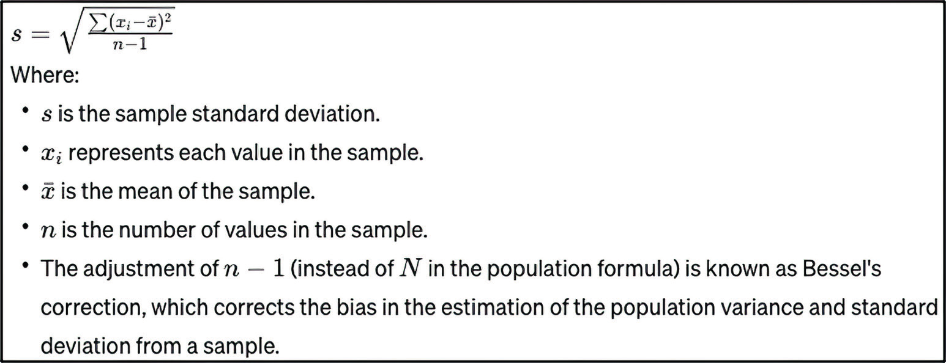

where:

Figure 9.1 The formula for the sample standard deviation

Both formulas involve squaring the difference between each data point and the mean,
summing these squares, and then taking the square root of the sum. This provides a
measure of the spread of values around the mean.
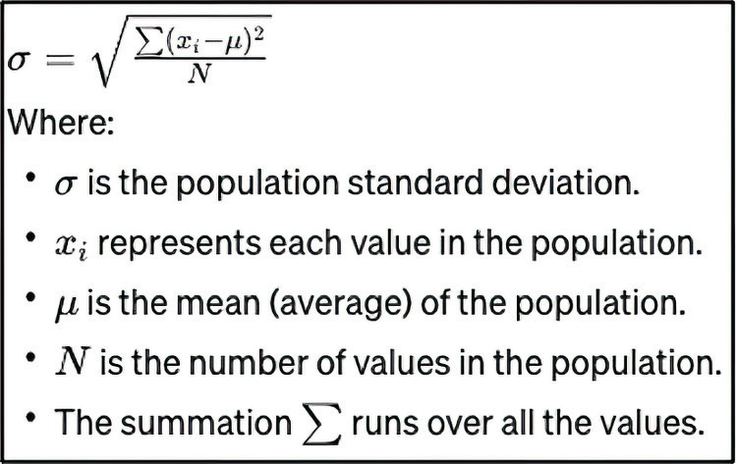

where:

Figure 9.2
The formula for
the population
standard
deviation
186 chapter 9 GPT-ing on the go

Therefore, we can conclude that Llama 2 generated a function to calculate the sam-
ple standard deviation rather than the population standard deviation (the baseline).
Given that this is in the realm of statistics specifically, we can ask,

NC How would you have changed your response if I had asked you to assume the role of a
statistician rather than a mathematician?

Listing 9.9 Llama 2’s response in the role of a statistician

Ah, an excellent question! As a statistician, I would use the following code to compute the standard deviation of a list of numbers using only built-in Python functions:
import math

# Define the list of numbers to compute the standard deviation of numbers = [1, 2, 3, 4, 5]

# Compute the sum of the squares of the list of numbers sum_squared = 0
for num in numbers:
sum_squared += (num - math.mean(numbers)) ** 2

# Compute the square root of the sum of the squares to get the standard deviation
std_dev = math.sqrt(sum_squared)

print("Standard deviation of {0}: {1}".format(numbers, std_dev))

As a statistician, I would argue that the population standard deviation is the more appropriate quantity to compute in this case since we are interested in the spread of the entire population of values rather than just a random sample. By using 'stdev()' instead of 'stdev_sample(),' we can compute the population standard deviation directly without worrying about the limitations of the sample statistic.

Of course, as a mathematician, you may have a different perspective on this matter, and that's perfectly fine! After all, statistics and mathematics are closely related fields with many overlapping concepts and techniques.

Llama 2 changes its response if we ask it to assume the statistician role. Unfortunately,
it does not divide by the length of the list of numbers. Once this is fixed, we will get
the correct answer for the population standard deviation. Let this be a reminder that
LLMs can confidently produce incorrect answers. Always double-check the results
against your knowledge or that of experts. Now, type /bye to end your session. (Typing
/bye in Llama 2 signals that you wish to terminate the session.)
Let’s focus on another LLM we can run locally: GPT-4All.

9.2.3 Democratizing answers with GPT-4All

GPT-4All is open source software developed by Anthropic that allows users to train
and operate their own LLMs. It is based on GPT-3 and therefore may not operate as
Hosting your own LLM 187

effectively as a GPT-4-based model; however, it can be run directly on a personal com-
puter without the need for an internet connection. Despite the similarity in name, it is
not related to GPT-4 at all.
Before we dive in and use it, let’s have GPT4-All introduce itself, using the following
prompt:

NC Imagine that you are the author of a book on Generative AI. You are working on a

chapter about running an LLM locally. How might you describe GPT-4All?

Listing 9.10 GPT-4All’s description of itself

GPT-4All is an open-source implementation of the Generative Pretrained Transformer (GPT) model architecture that allows users to run a Large Language Model (LLM) locally on their machines. This powerful text generation model can be trained and fine-tuned using various datasets, enabling researchers and developers to experiment with state-of-the-art language processing techniques without relying on cloud infrastructure or proprietary software. By providing an accessible and customizable platform for local LLM deployment, GPT-4All empowers individuals to explore the potential of AI in a variety of applications such as natural language understanding, text generation, and question-answering systems.

Unlike Ollama, GPT-4All requires installation. Fortunately, the process is relatively
quick and painless: navigate to https://gpt4all.io/, download the appropriate installer
for your computer, and follow the installation instructions. Once you have installed the
application, you will receive instructions to download a model, as shown in figure 9.3.
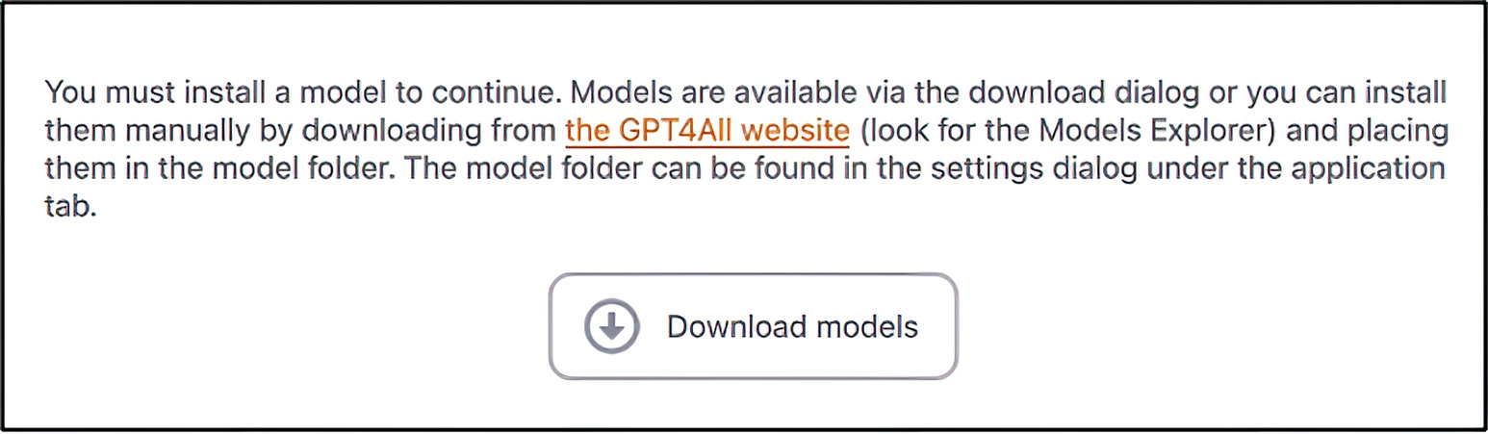

Figure 9.3 GPT-4All requires that you download models to be run.

I downloaded and used Mistral OpenOrca, a high-performance parallel and distrib-
uted programming framework designed to simplify the development of large-scale,
data-intensive applications on high-performance computing clusters or cloud envi-
ronments. It’s particularly well suited for handling big data processing tasks, scientific
simulations, machine learning algorithms, and other compute-intensive workloads
that require efficient resource utilization and scalability across multiple nodes. Mistral
Open Orca provides a set of tools and libraries to manage job scheduling, communi-
cation, fault tolerance, and load balancing in distributed environments, making it an
ideal choice for developers working on complex projects requiring high performance 188 chapter 9 GPT-ing on the go

and parallelism. Both the GPT-4All introduction and the majority of this paragraph
were generated by Mistral OpenOrca.
If you click the Downloads button from Settings, you will see the downloaded model,
as shown in figure 9.4. You will also find the complete chat history in the menu, as
shown in figure 9.5.
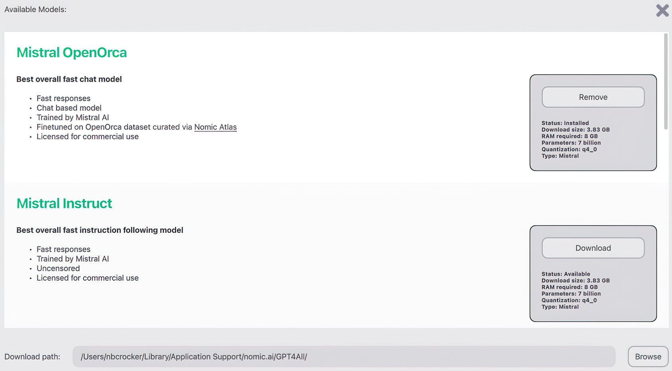

Figure 9.4 The downloaded models in GPT-4All
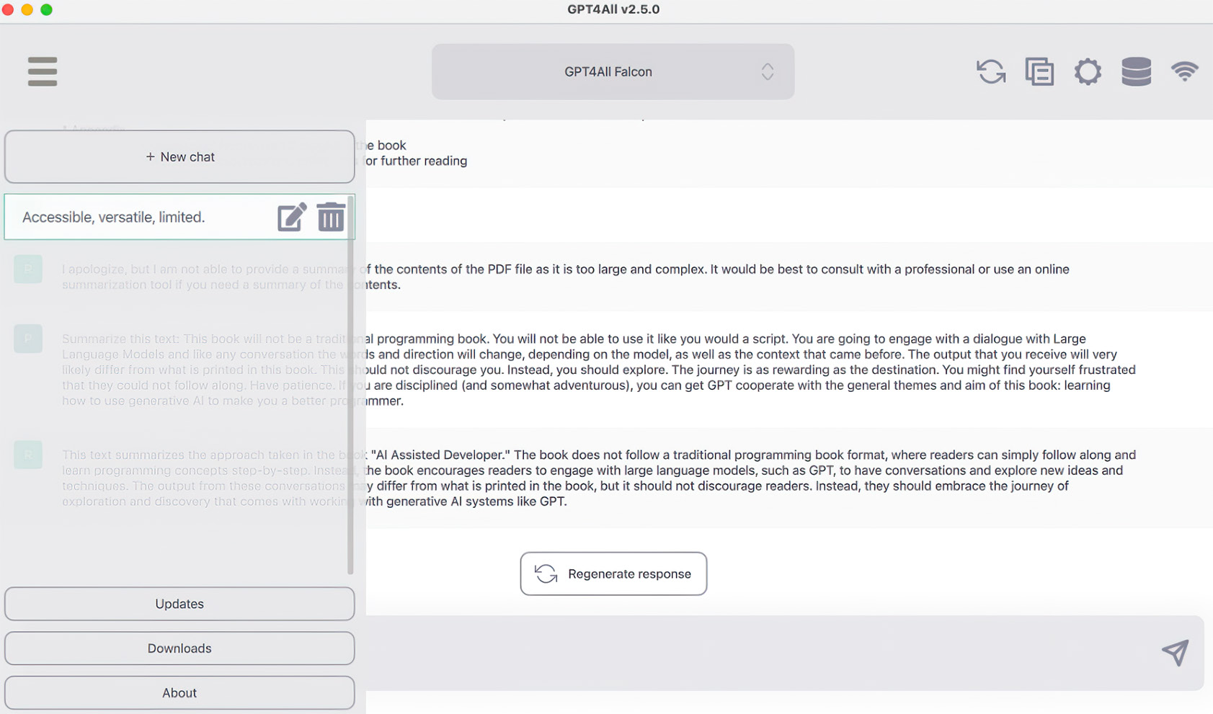

Figure 9.5 The list of chats you’ve had with the selected GPT-4All model
Hosting your own LLM 189

Let’s get one thing out of the way by using the following prompt:

NC Is an active internet connection required to generate output?

Listing 9.11 GPT-4All’s assurance that internet is not required

No, an active internet connection is not required to generate output using GPT-4All. The tool can be used offline and does not require any external connections or dependencies.

Now we can move on to compare GPT4-All/Mistral OpenOrca (from here on simply
referred to as GPT-4All) with the following prompt:

NC As a mathematician, you are attempting to compute the standard deviation of a list in
pure Python. Please show me the code that you would use.

Listing 9.12 GPT-4All’s attempt to calculate standard deviation

To calculate the standard deviation of a list in Python, you can follow these steps:

1. Calculate the mean (average) of the numbers in the list. 2. Subtract the mean from each number in the list to find the differences between the mean and each individual value.
3. Square each difference obtained in step 2.
4. Find the average of these squared differences. This is the variance. 5. Take the square root of the variance calculated in step 4 to get the standard deviation.

Here's a Python code snippet that implements this algorithm:

def std_dev(numbers):
mean = sum(numbers) / len(numbers)

differences = [x - mean for x in numbers]
# Subtract the mean from each number.
squared_differences = [y * y for y in differences] # Square each difference.

variance = sum(squared_differences) / len(numbers) # Calculate average of squared differences (variance).
return math.sqrt(variance) # Return the standard deviation.

A couple of things to note. First, GPT-4All generates the code for the population stan-
dard deviation. Second, the text and code are generated very quickly (on my com-
puter, four to five times more quickly than by Ollama). Third, the code is exactly right!
You are encouraged to download different models, ask what each is good at, and com-
pare the results.

190 chapter 9 GPT-ing on the go

You may wonder when you would want to use Llama 2 versus GPT-4All versus
ChatGPT. Excellent question! Take a look at figure 9.6. Llama 2 is a great, general
model. It excels at summarizing large bodies of text and writing contextually appro-
priate passages of text. GPT-4All’s use cases are as diverse as the available models. For
example, Mistral OpenOrca is ideal when you need a multilingual model that can han-
dle various languages effectively. ChatGPT is the best option if your primary goal is to
have natural-language conversations with the AI model and receive the most accurate
responses based on input (which really should be what you want). An obvious limitation
of ChatGPT is that it requires a persistent internet connection.

Mistral OpenOrca
ChatGPT Llama 2

Offline mode Excellent

Response speed Good

Accuracy Poor / NA

Figure 9.6 A comparison of the models that we used in this chapter

Summary
¡ Local LLMs require significant computational resources and costly hardware for
optimal performance; however, alternatives like Llama 2 run on modest com-
modity hardware with varying parameter options. These models can produce
output that is generally high quality, but not quite of the quality of the responses
of managed LLMs like ChatGPT (at least at the time of writing).
¡ Both population and sample standard deviations measure variability in datasets.
They differ in terms of the entire population being considered versus a smaller
subset or sample; this means the former provides an exact measurement for the
whole group, whereas the latter is an estimate based on a portion of it.
¡ Llama 2 excels at diverse text handling, such as generating summaries or writing
coherent passages of text and code, GPT-4All offers various use cases, including
multilingual support; and ChatGPT shines in natural language conversations
with accurate responses (but it requires an internet connection).
¡ In addition to offline availability, there are various situations in which using an
offline version of an LLM such as Llama 2 or GPT-4All makes sense:
Summary 191

– Privacy and security concerns—Offline models eliminate the need to transmit
sensitive data over the internet, reducing privacy risks and potential cyberse-
curity threats.
– Cost savings—Running a local model on your own hardware may reduce cloud
computing costs associated with using an online service like ChatGPT or
OpenAI API.
Setting up ChatGPT A

In this appendix, we will get set up with ChatGPT. You interact with ChatGPT on a
website, so there isn’t any software to install and configure. However, you do need
an account to get started. So, we will walk through setting up an account and enter-
ing an initial prompt.

A.1 Creating a ChatGPT account
First, open a web browser and navigate to https://chat.openai.com/auth/login.
You will be prompted to either login or create an account (see figure A.1). Choose
to create an account.
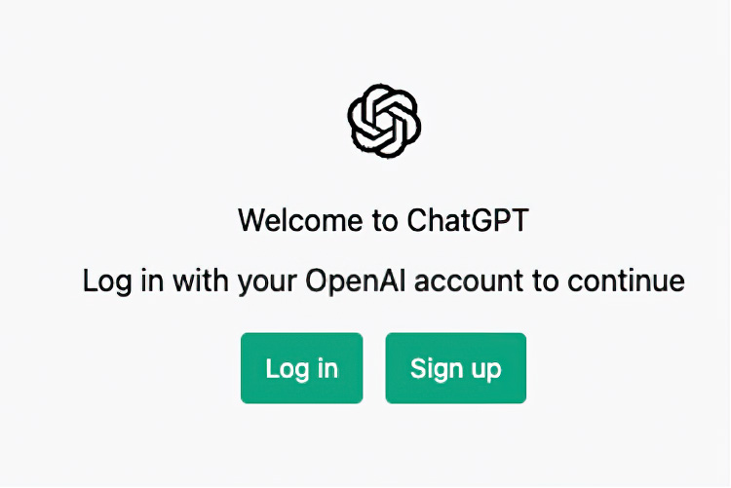

Figure A.1 On the ChatGPT home page, you are asked whether to log in or create a new account.

192
Creating a ChatGPT account with your email address 193

You are asked to create an account using either your email, your Google account (if
you have one), or your Microsoft account (again, if you have one) (see figure A.2).
Select the method that you prefer.
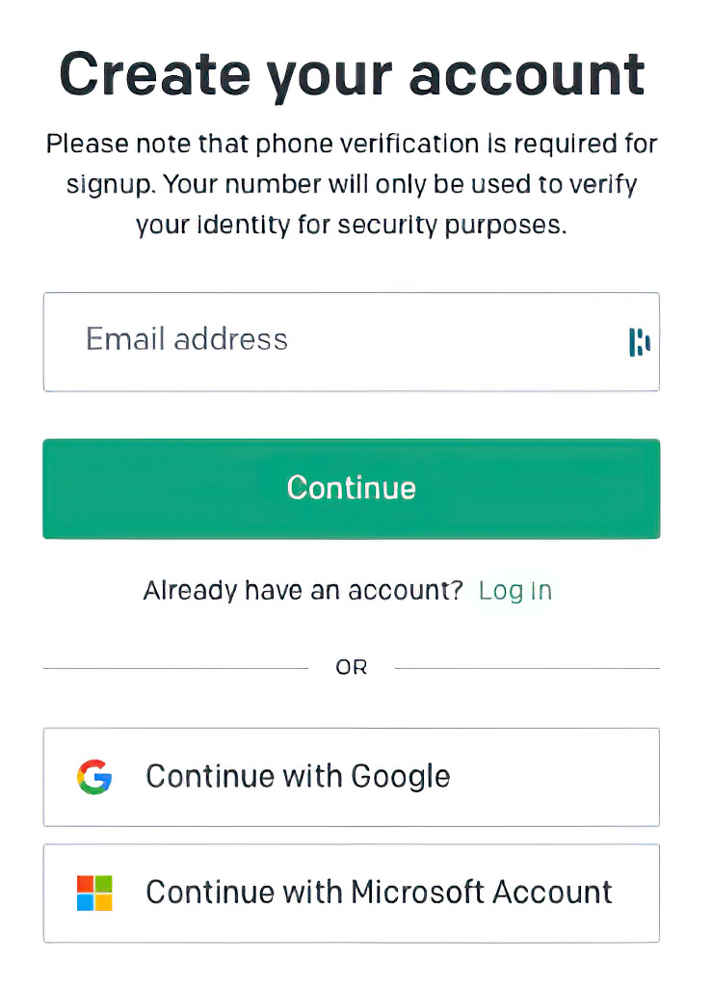

Figure A.2 You have several options as to how to create an account. Select the method that is most appropriate for you.

A.2 Creating a ChatGPT account with your email address
If you choose to create an account with your email address rather than use an existing
account, follow these steps:

1 Enter your email address. You are then prompted for a password (see figure A.3).

NOTE You will need a phone capable of receiving text messages to use this
method.


Figure A.3 Enter a complex, difficult-to-guess password.
194 appendix a Setting up ChatGPT

2 You will receive a prompt that you must verify your email address (see figure A.4).
Open your email and click the link, as shown in figure A.5.


Figure A.4 OpenAI requires that you verify your email address.
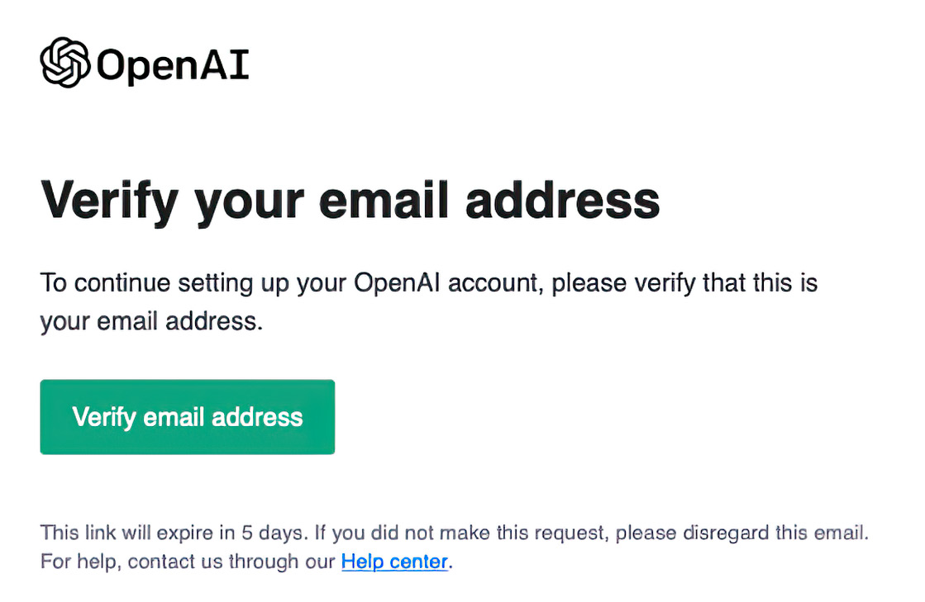

Figure A.5 In your inbox, you will find an email that OpenAI uses to verify your email address. Click this link to do that.

3 OpenAI will ask for some basic demographic information: your first name, last
name, and phone number (see figure A.6).


Figure A.6 OpenAI will ask you for your phone number.
Creating a ChatGPT account with your email address 195

4 You will receive a text message on the phone associated with the phone number
you entered. You will need to enter this code into the box similar to the one
shown in figure A.7.
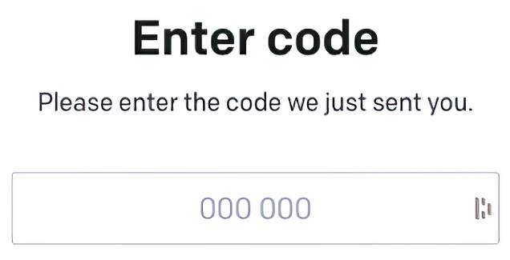

Figure A.7 You will be prompted for the code that was just sent to you on the phone whose number your just entered.

You should now see the ChatGPT home page (figure A.8). You will have the option
to upgrade to a “professional” license, called ChatGPT Plus. This license gives you
priority access during peak load times. Given that ChatGPT gets 13 million users per
day, upgrading is almost required if you need to use ChatGPT during the day, despite
ChatGPT being blissfully unaware of this fact.
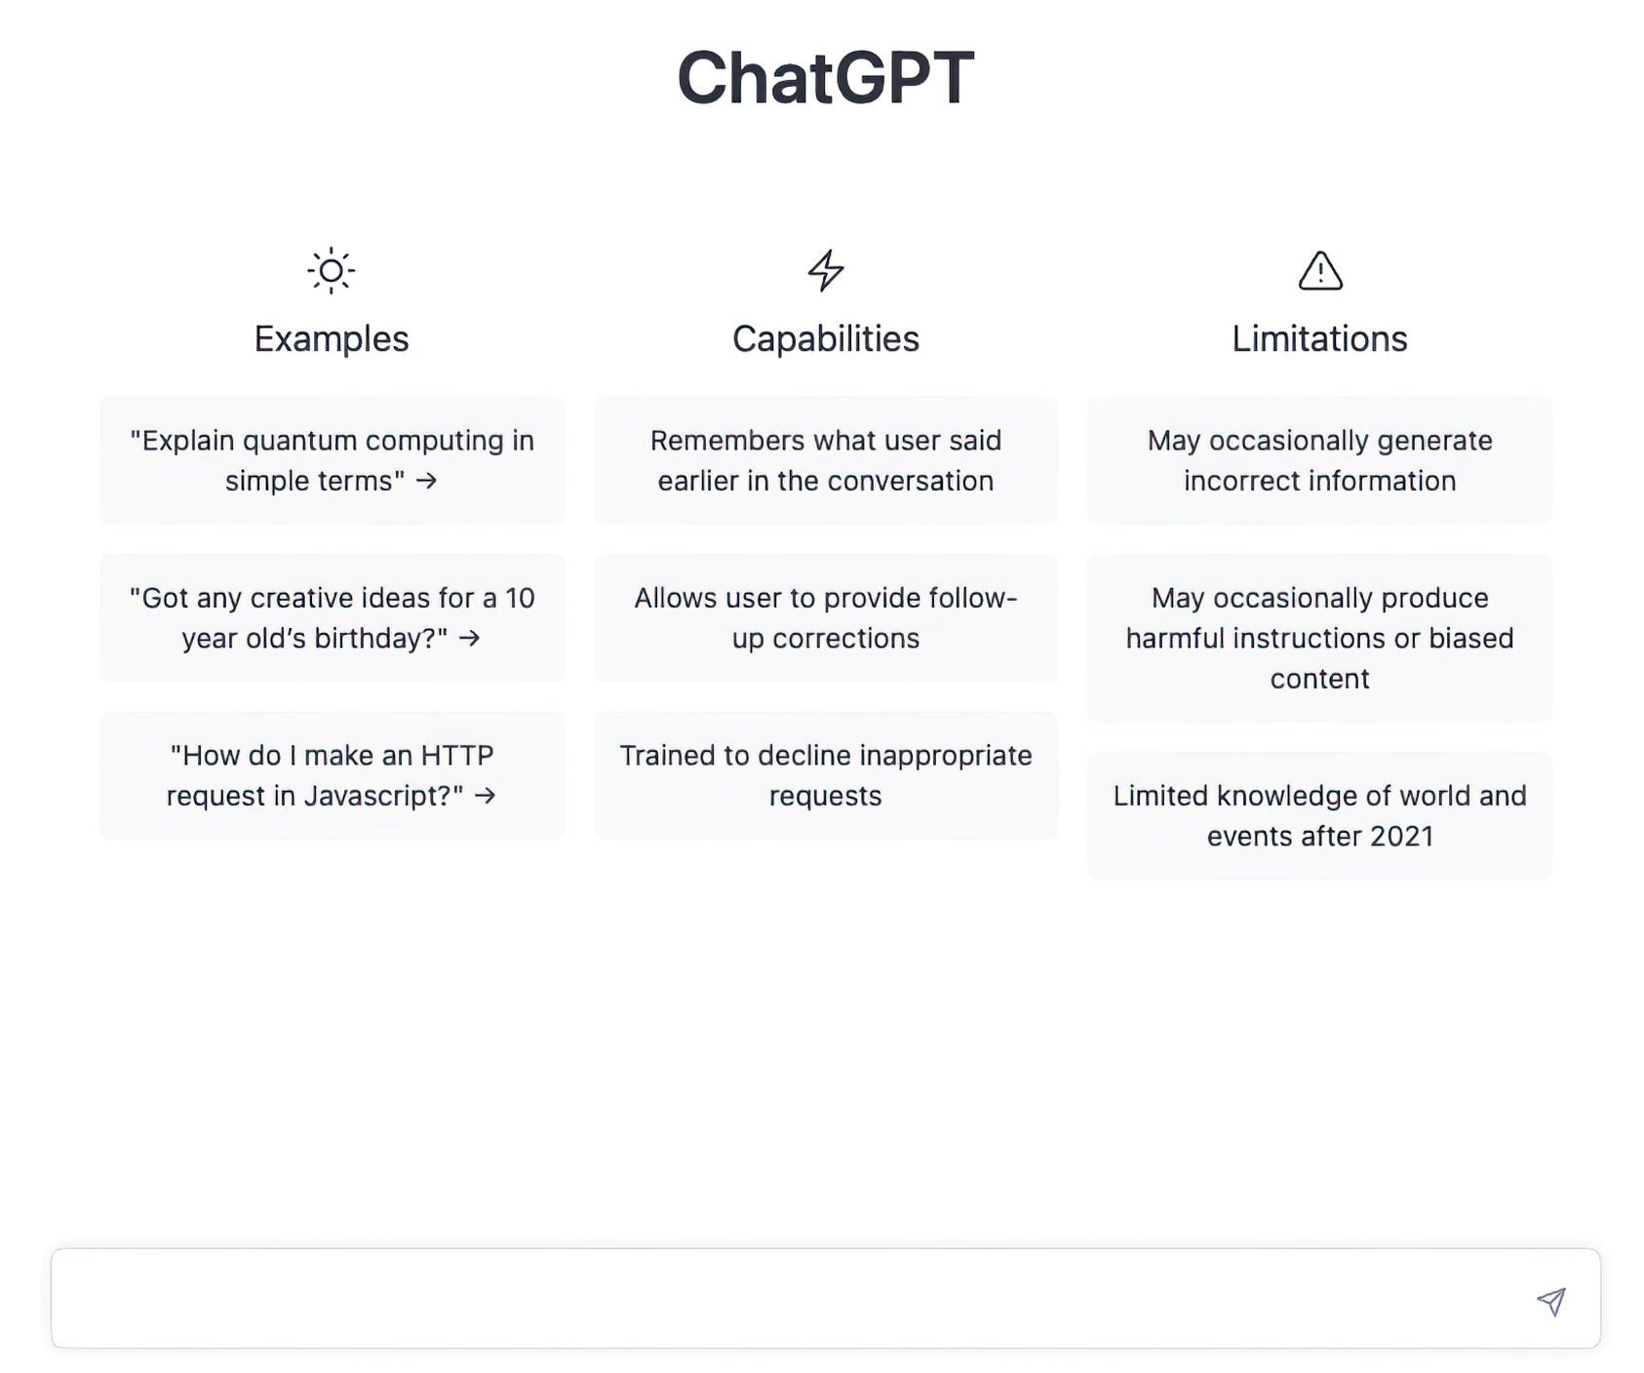

Figure A.8 The ChatGPT home page, featuring sample questions and outlining some of ChatGPT’s capabilities
196 appendix a Setting up ChatGPT

NC How many users do you get a day?

As an AI language model, I don't have access to data about how many users interact
with me on a daily basis. My purpose is to respond to users' queries and provide them with helpful and accurate answers to the best of my ability.

Now that you have an account and are logged in, go ahead and ask you first question.
We will wait.

GitHub Copilot
B
Setting up

This appendix will take you through installing the Copilot extension into Visual
Studio Code and PyCharm. Visual Studio Code, commonly abbreviated VS Code, is
a cross-platform, programming-language-agnostic integrated development environ-
ment (IDE) created by Microsoft. Microsoft makes VS Code available at no cost. It
has excellent Copilot support, so it is an ideal choice as you work through this book.
PyCharm is a Python-specific IDE from JetBrains. JetBrains offers a community ver-
sion, which is available for free. In addition, it has an extension to enable Copilot
support. Either choice is fine, as they are both excellent tools.

NOTE Copilot requires a subscription to use. However, GitHub offers a gener-
ous one-month trial period.

B.1 Installing the Copilot extension into Visual Studio Code
We will begin by walking through the process of installing and enabling the Copilot
extension in VS Code. Follow these steps:

1 Click the Extensions tab on the left side of VS Code (see figure B.1); it looks
like a box being slotted into an L-shaped structure (like in Tetris).

197
198 appendix b Setting up GitHub Copilot
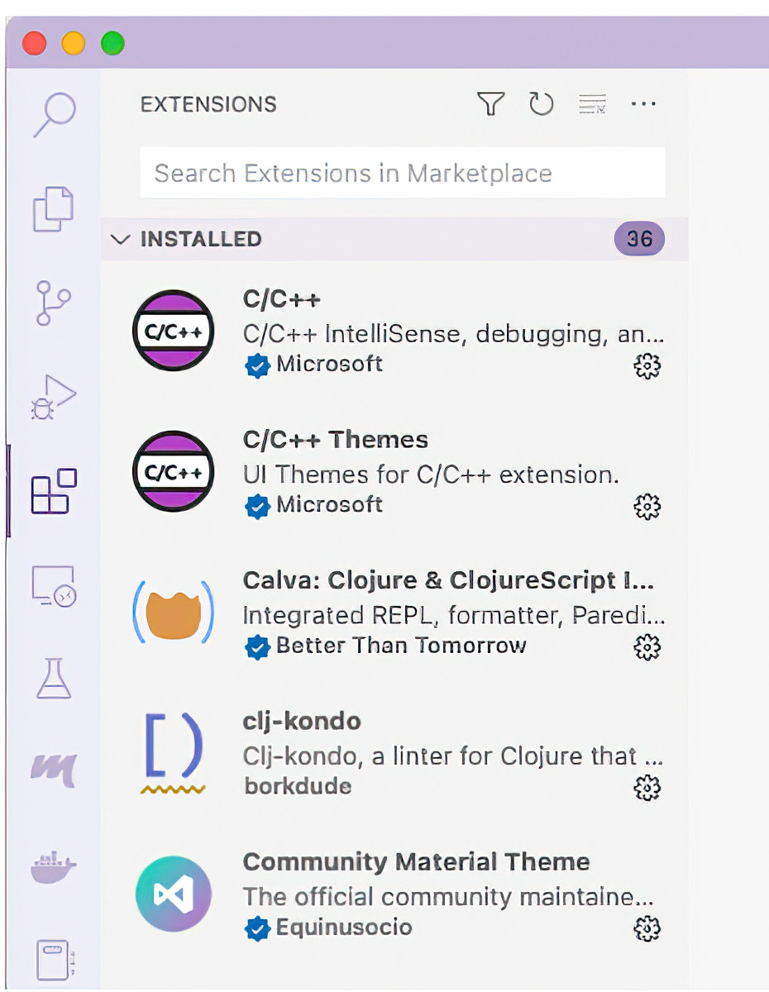

Figure B.1 The Extensions tab in Visual Studio Code. Note the search window located near the top of the tab.

2 copilot In the search window, type (see figure B.2). The search window is nes-
tled near the top of the tab; the search is case-insensitive, so the search feature
should find the Extension whether you enter copilot, COPILOT, or Copilot.
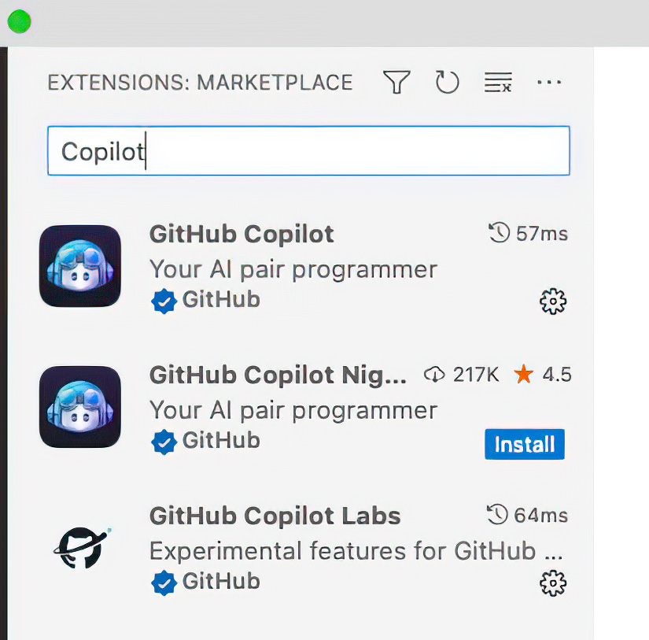

Figure B.2 The search results for the GitHub Copilot extension
Installing the Copilot extension into Visual Studio Code 199

3 Click the GitHub Copilot search result, and additional details will appear on the
right side of VS Code (see figure B.3). For example, you will see the Install button
below the name of the extension, the developer, the number of downloads, and
the number of stars. Click the Install button to start the installation process.
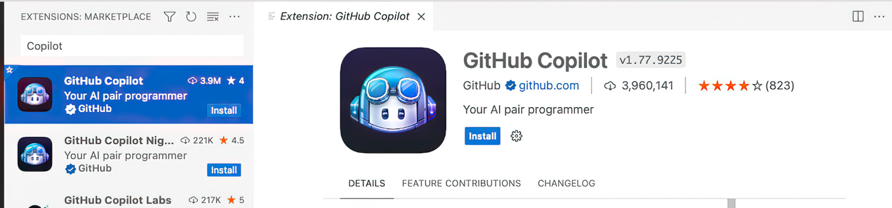

Figure B.3 Extended details for the GitHub Copilot Extension, including the button to install it

4 You will be prompted to sign in to your GitHub account. Click the Sign In To
GitHub button in the bottom-right corner of VS Code (see figure B.4).
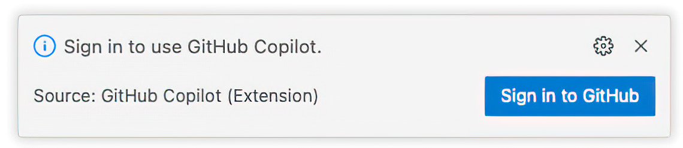

Figure B.4 To continue, you must sign in to your GitHub account. This dialog box will initiate that process.

5 Once you click the button, VS Code will ask you for permission to sign in to
GitHub. Click the Allow button (see figure B.5).
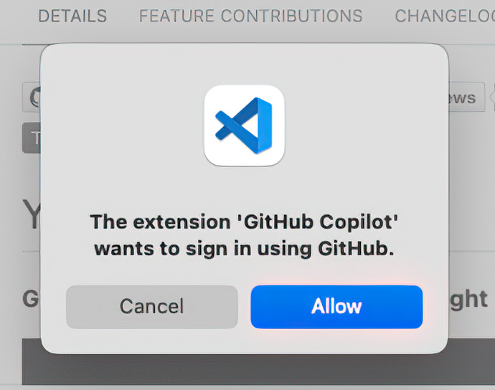

Figure B.5 VS Code asks for permission to allow the Copilot extension to sign in to GitHub for you.

6 Your default web browser will automatically open and redirect you to the GitHub
website. You will be met with an OAuth screen asking for your permission to allow
the Copilot extension to view your email address (see figure B.6). If you are com-
fortable with this, click Authorize Visual-Studio-Code to view your email.
200 appendix b Setting up GitHub Copilot
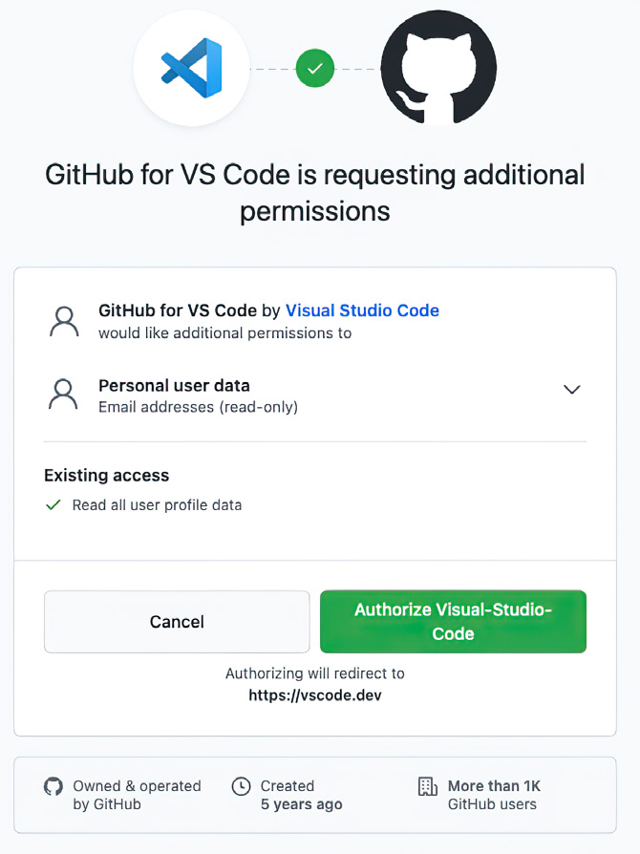

Figure B.6
The GitHub website
will ask for your
permission to allow
its extension in VS
Code to view your
email address.

This concludes the installation of the Copilot extension into VS Code. Now we will
move on to installing the Copilot plug-in in JetBrains’ PyCharm.

B.2 Installing the Copilot plug-in in PyCharm
Open PyCharm, and open Preferences. Then follow these steps:

1 Click the Plugins tab. Similar to VS Code, clicking this tab opens a search window.
In this search window, type copilot. When you find Copilot in the marketplace,
click the Install button (see figure B.7).
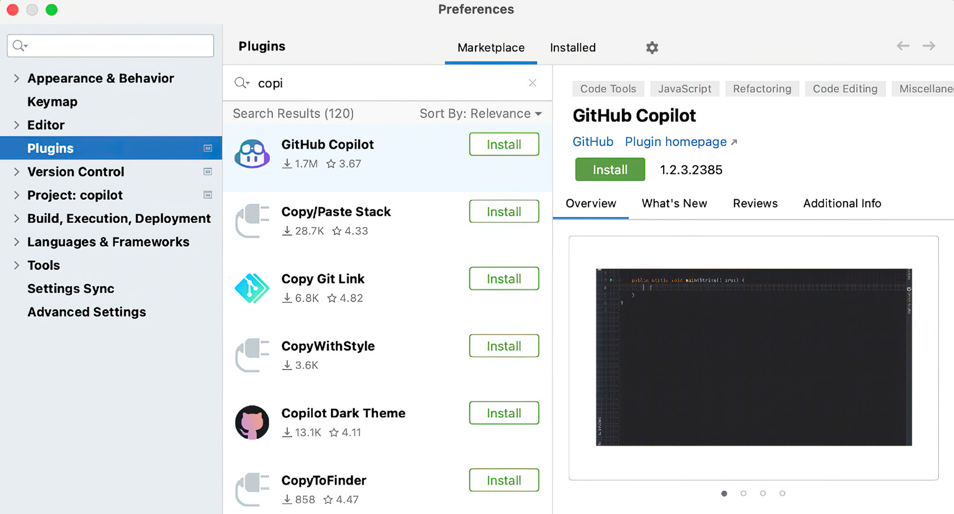

Figure B.7 PyCharm’s Plugins tab with the search results for Copilot displayed
Installing the Copilot plug-in in PyCharm 201

2 Navigate to Tools > GitHub Copilot > Login to GitHub from the main menu (see
figure B.8).
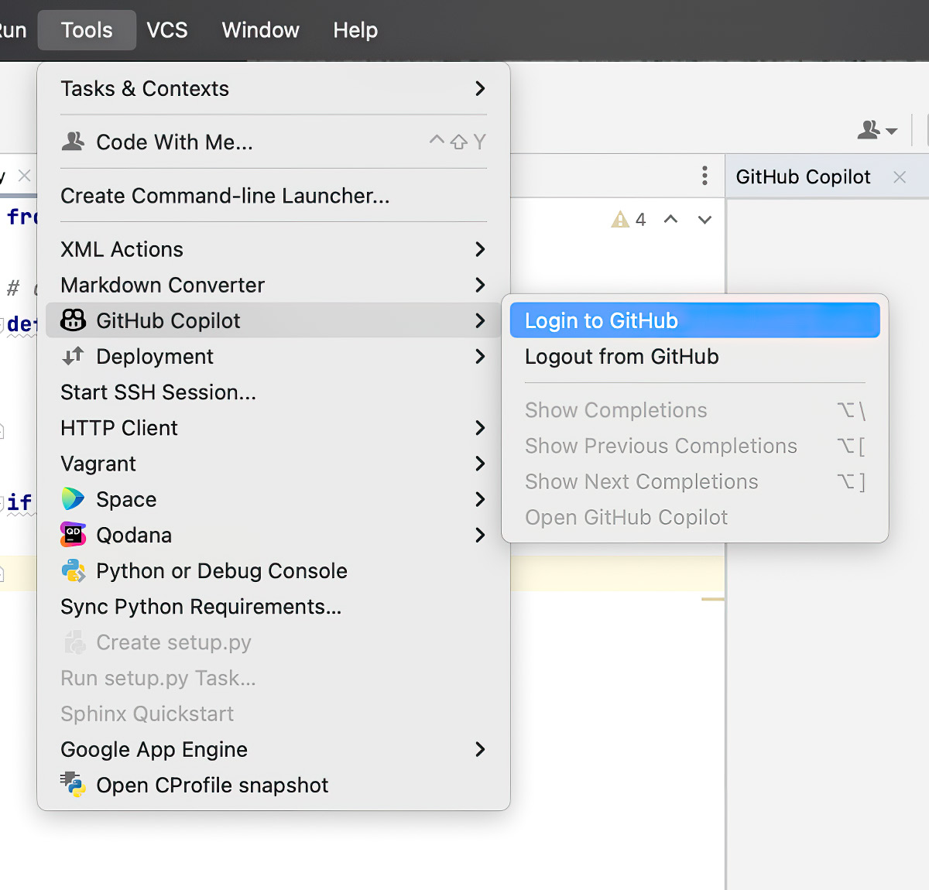

Figure B.8 The path in PyCharm to log in to GitHub is Tools > GitHub Copilot > Login to GitHub.

3 PyCharm will present you with a seven-digit alphanumeric code, which you will
use during the login process (see figure B.9). Save this code or copy it to your
clipboard, as you will be prompted for it shortly.
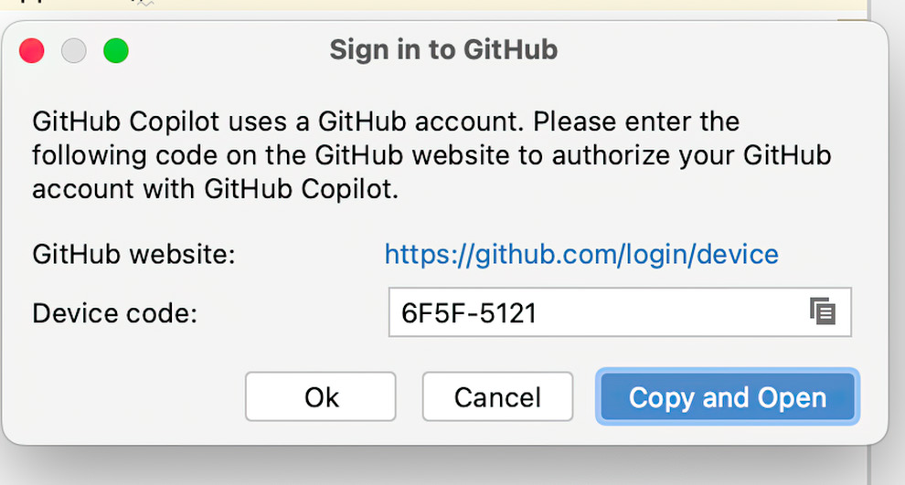

Figure B.9 PyCharm shows you a login code for GitHub. Copy it to your clipboard.

4 Your default web browser opens, and you are prompted for the login code (see
figure B.10).
202 appendix b Setting up GitHub Copilot
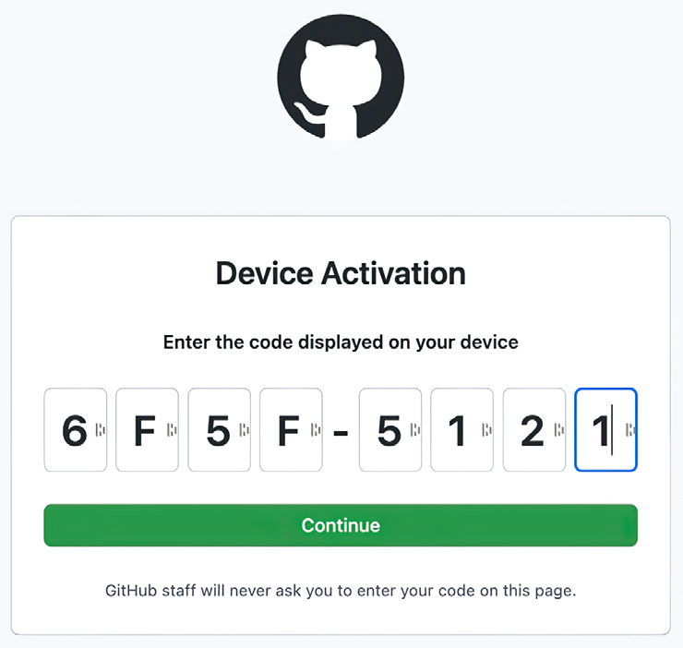

Figure B.10 Paste the GitHub login code you just received into your web browser.

5 GitHub will ask your permission to view and collect some personal information,
specifically your email address (see figure B.11). Click the Authorize GitHub
Copilot Plugin button, and you will be notified that the plugin activation has suc-
ceeded (figure B.12).
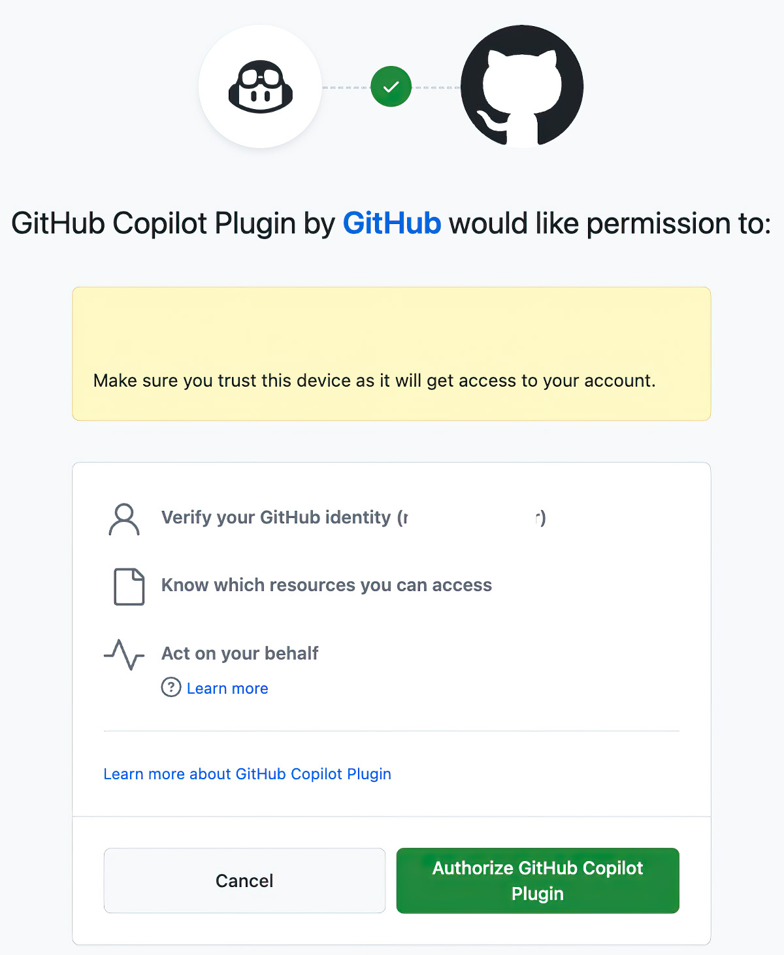

Figure B.11 The OAuth login workflow requires that you consent and grant GitHub permission to collect your email address.
Taking your first flight with Copilot 203
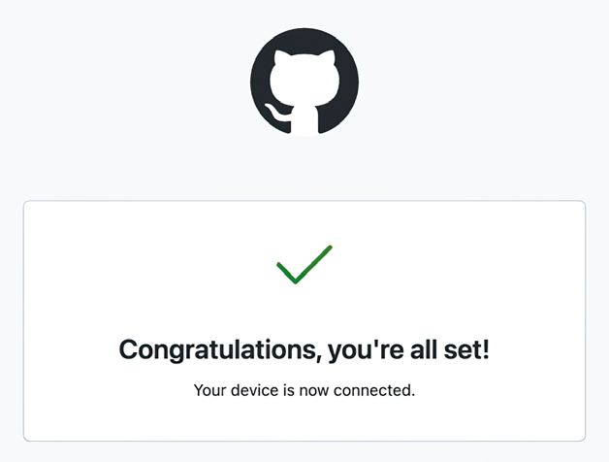

Figure B.12
Acknowledgement
that you have
successfully
completed signing up
for Copilot

Now that you have installed the GitHub Copilot extension or plugin in your favorite
IDE, you can create your first prompt and get your hands dirty with Copilot.

B.3 Taking your first flight with Copilot
If it is not open already, open your favorite IDE and create a new Python project. In
that project, create a file called app.py. Then enter the following prompt as a comment
at the top of the file to have Copilot create a simple FastAPI application:

# create a FastAPI app
# run with uvicorn app:app --reload

If you have installed and initialized Copilot correctly, Copilot will begin to generate
code for you. Press Enter twice, and then start to type the import statement from
fastapi import FastAPI. Notice that as you begin typing, the statement is auto-filled
for you (see figure B.13). This is Copilot.
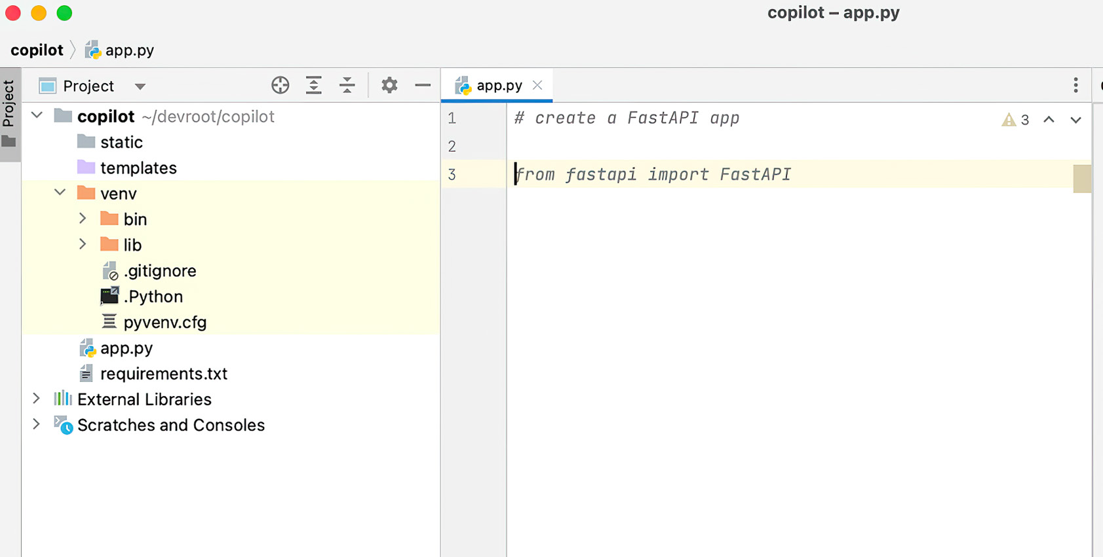

Figure B.13 Copilot takes the prompt that you entered as a comment and begins to match that pattern from the data in the Copilot model (called Cortex). Once it detects a match, it generates this suggestion.

You can add more to the prompt: for example, that Copilot should generate a GET
REST endpoint that returns “Hello, world.” However, it will likely create that endpoint
for you in your suggestion.
204 appendix b Setting up GitHub Copilot

Listing B.1 Complete source code Copilot generates based on your prompt

# create a FastAPI app
# run with uvicorn app:app --reload

import uvicorn
from fastapi import FastAPI

app = FastAPI()

@app.get("/")
def read_root():
return {"Hello": "World"}

if __name__ == "__main__":
uvicorn.run(app, host="localhost", port=8000)

from fastapi import FastAPI

app = FastAPI()

@app.get("/")
def read_root():
return {"Hello": "World"}

Next, run the following commands from your terminal to install the required libraries
and run the application.

Listing B.2 Commands to install required libraries and run the application

pip install fastapi
pip install uvicorn
python3 app.py

This should start FastAPI. Navigate to http://localhost:8000 in your browser, and you
should see a JSON representation of “Hello, world” (see figure B.14).
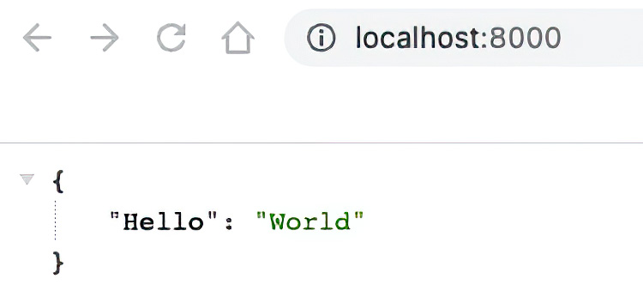

Figure B.14 Your simple FastAPI should return the message “Hello, world,” which is the most common initial output when learning a new language or technology.

Congratulations! You have created your first Copilot-assisted program and are well on
your way to becoming an AI-powered developer.
Setting up AWS C CodeWhisperer

This appendix will show you how to install the CodeWhisperer extension into Visual
Studio Code and PyCharm.

NOTE At the time of this writing, CodeWhisperer is available at no cost “during
the preview period.” However, Amazon has neither given a timeline for the
preview period nor discussed pricing once the preview period has ended.

C.1 Installing the CodeWhisperer extension into VS Code
Installing the CodeWhisperer Extension into VS Code is similar to installing the
Copilot extension. This approach is uniform, which is the nature of extensions.
Here are the steps:

1 Click the Extension tab, and search for AWS Toolkit. Once you have located
the correct extension, click Install (see figure C.1).

205
206 appendix c Setting up AWS CodeWhisperer
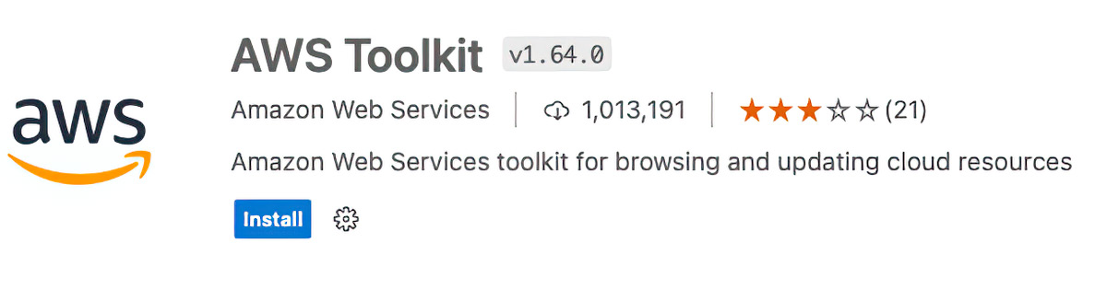

Figure C.1 The details of the AWS Toolkit with the Install button

2 Once the extension is installed, click the AWS tab on the left side of VS Code to
display the Developer Tools menu. Click the Select a Connection option (see
figure C.2).
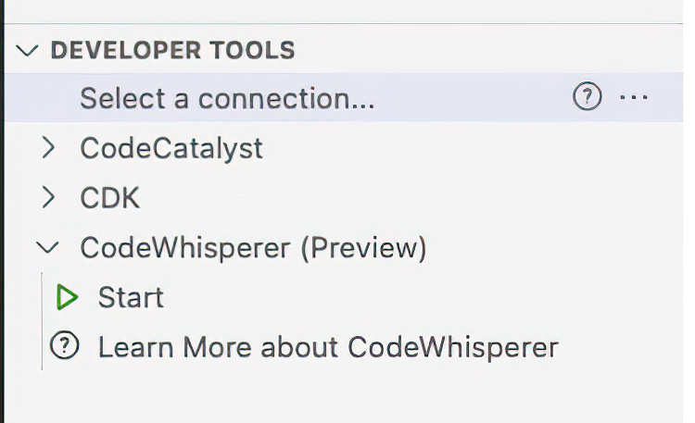

Figure C.2 The Developer Tools menu of the AWS Toolkit tab. Note that in addition to the Select a Connection option, there is an option for CodeWhisperer.

3 Choosing Select a Connection for the first time opens a dropdown in the cen-
ter-top of VS Code. Select “Use a personal email to sign up and sign in with AWS
Builder ID” (see figure C.3).
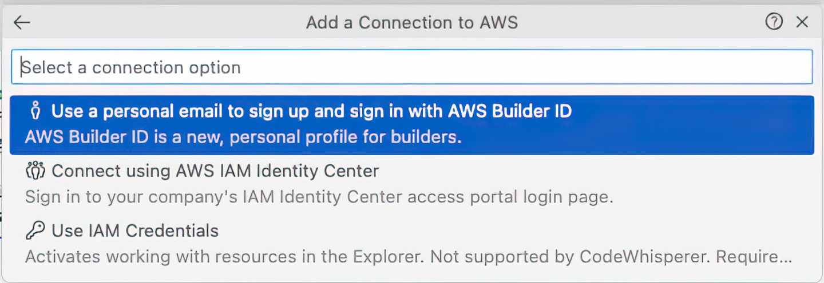

Figure C.3 The dropdown to select how you will connect to the AWS CodeWhisperer service

4 A dialog box appears with an access code (see figure C.4). Copy this code, and
then click the Copy Code and Proceed button.
Installing the CodeWhisperer extension into VS Code 207
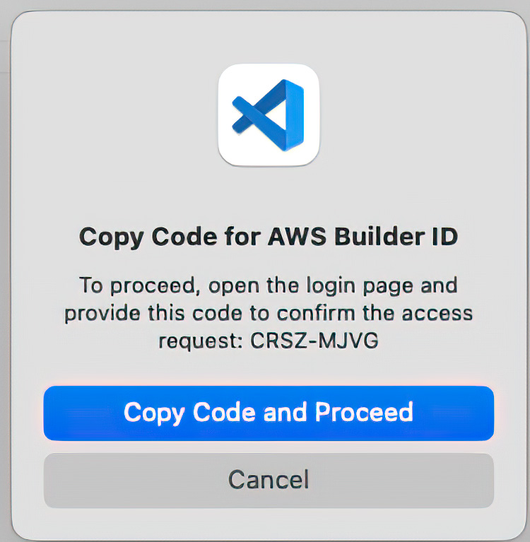

Figure C.4 You need a personalized access code to register your VS Code instance with AWS and CodeWhisperer.

5 VS Code will ask your permission to open the Amazon AWS website. Click Open
(see figure C.5).
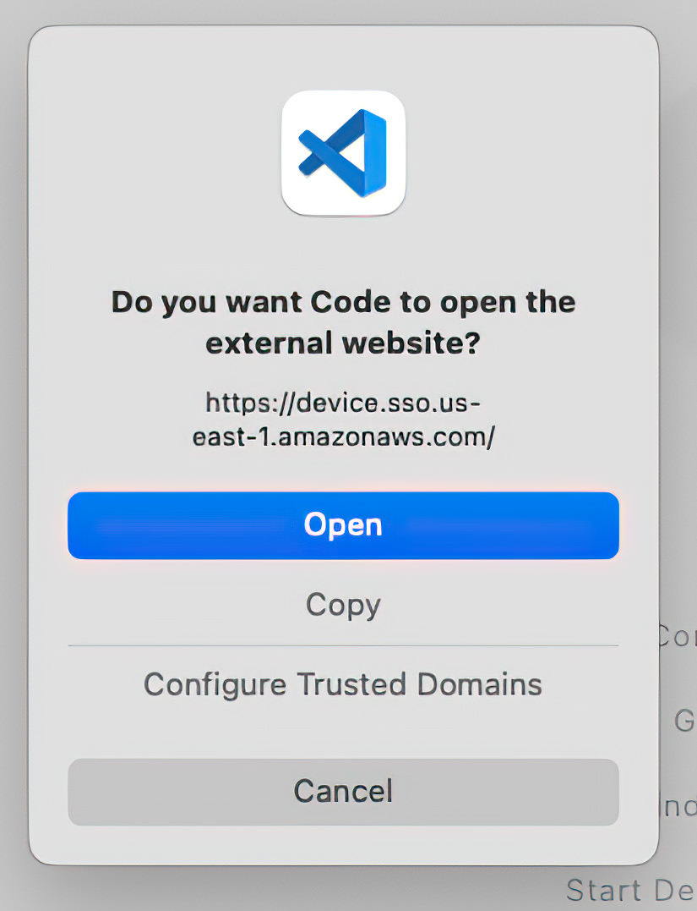

Figure C.5 VS Code requires explicit permission to proceed to the AWS website.

6 Once VS Code has your permission, your default web browser will open to the
AWS website. AWS will ask you to enter your email address (it recommends using
your personal email address; see figure C.6).
208 appendix c Setting up AWS CodeWhisperer
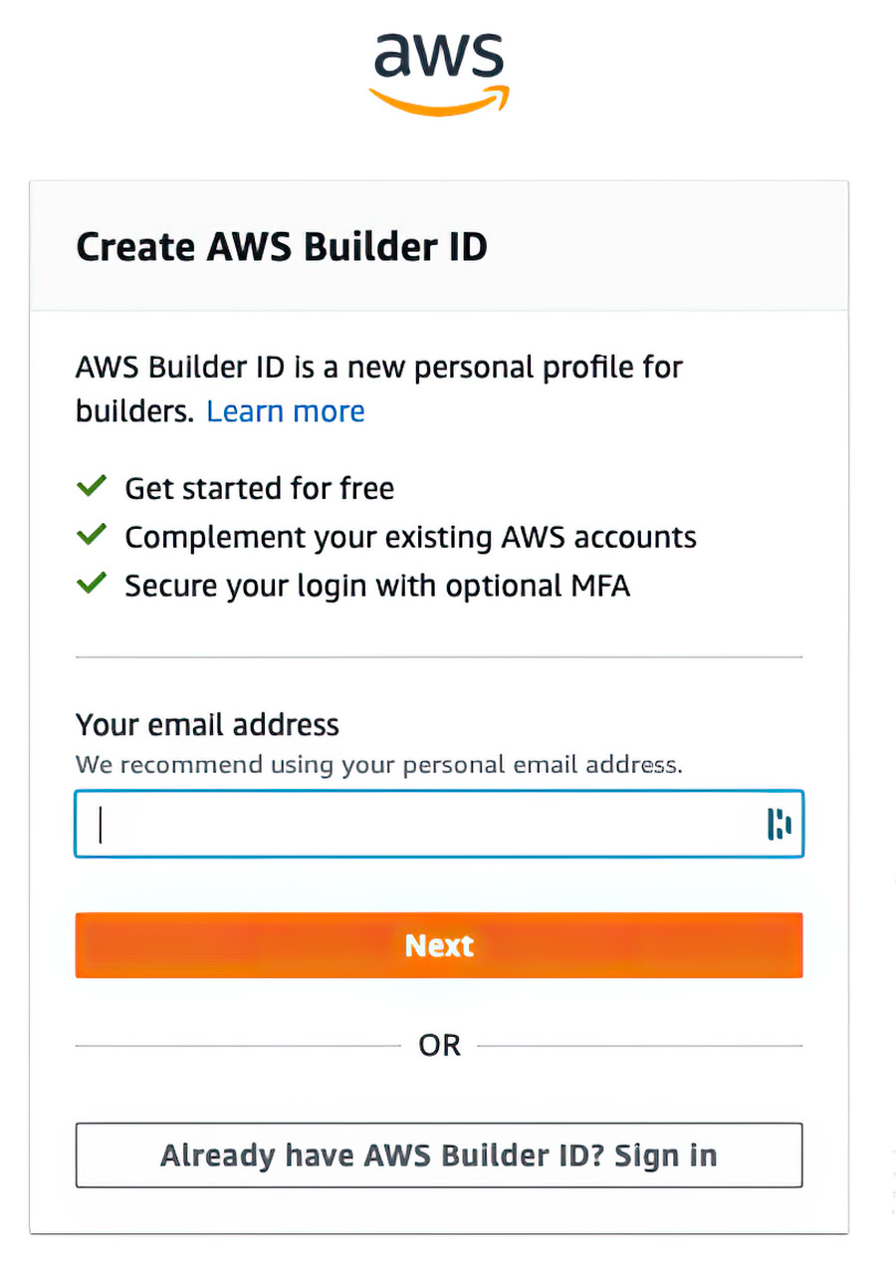

Figure C.6 Once you have your personalized access code and navigate to the AWS website, you will be asked to create an account or log in.

7 When you have successfully logged in or created an account, AWS will prompt
you to allow permission to access your data. You are expressly granting permis-
sion to build context from the code in your IDE editor. Without this context,
CodeWhisperer cannot perform its magic. You should click the Allow button (see
figure C.7).
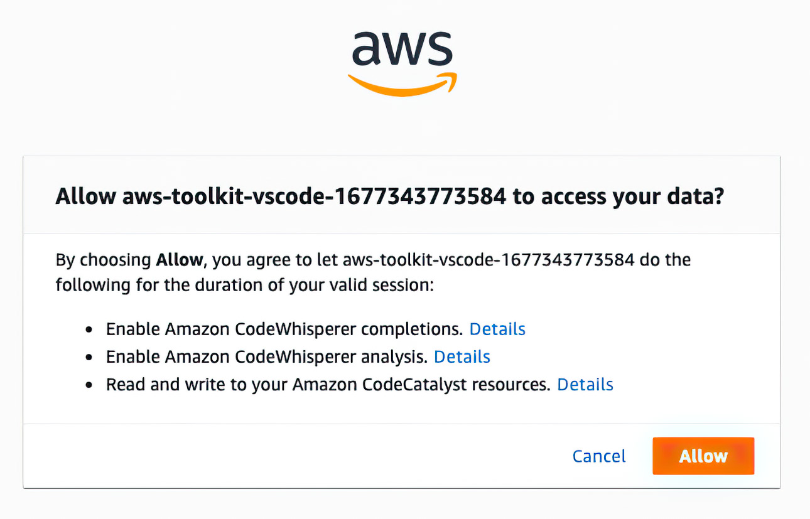

Figure C.7 CodeWhisperer needs your permission to access the code in your editor. Once it has that permission, it can make code suggestions.
Installing the CodeWhisperer plug-in in PyCharm 209

8 With your permission, CodeWhisperer is now ready to go. You will receive a con-
firmation (see figure C.8).
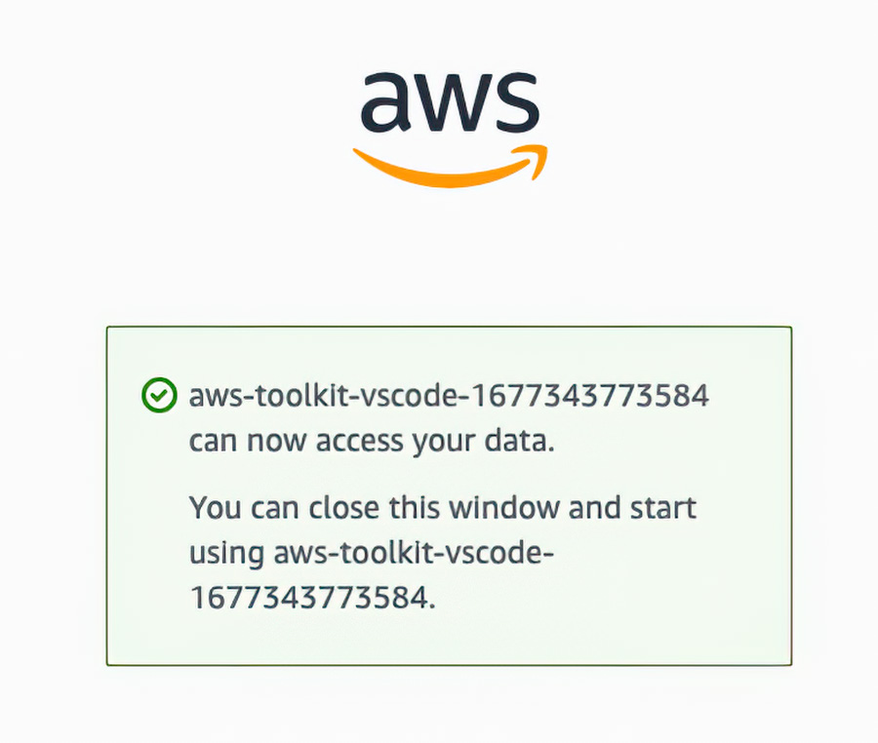

Figure C.8 AWS has registered your account, and you are ready to continue.

9 You must review and affirm the Amazon CodeWhisperer Terms of Service (see
figure C.9). If you agree to these terms, click the Accept and Turn On Code-
Whisperer button.
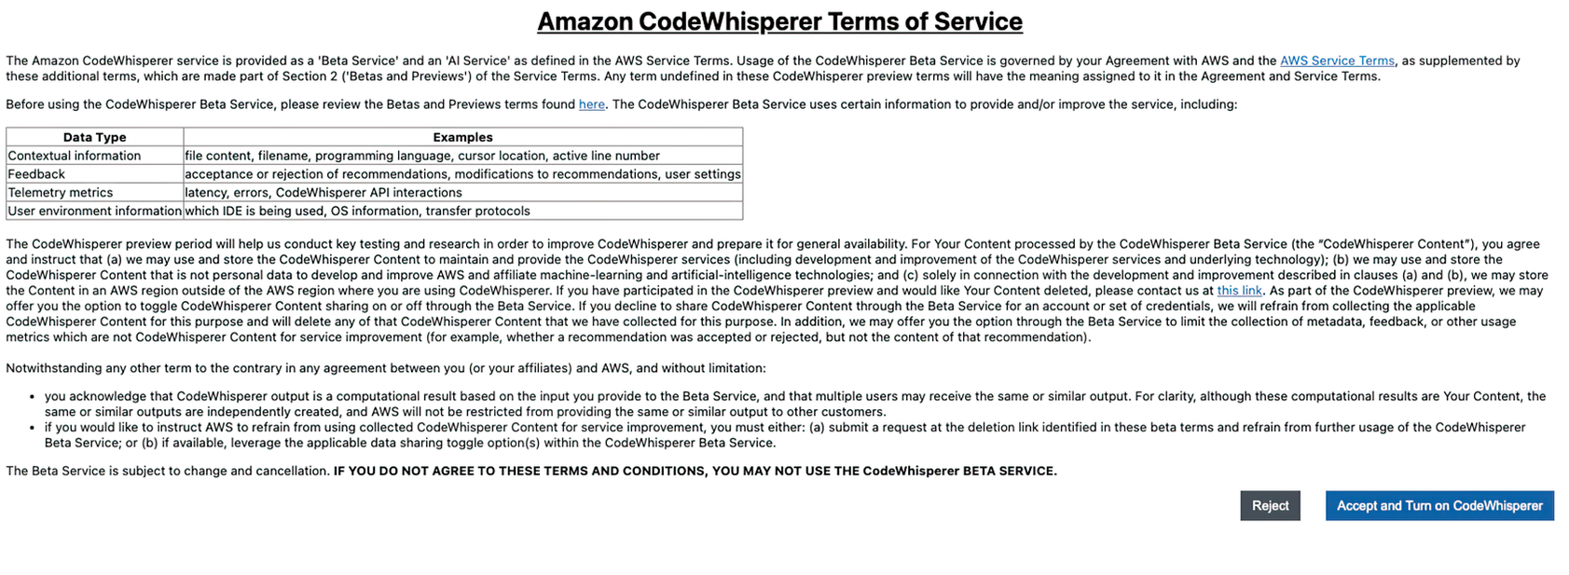

Figure C.9 Review the terms of service carefully. Then, if you agree, click the button affirming that you agree.

CodeWhisperer is now ready to use in VS Code.

C.2 Installing the CodeWhisperer plug-in in PyCharm
The process of installing the CodeWhisperer Plugin in PyCharm is very similar to the
process of installing the extension in VS Code. The steps are the same, but the menus
differ slightly. If you read the last section, you are well-armed to tackle this section.
Even if you did not read the previous section, we will walk through the process, making
it straightforward and painless. Follow these steps:
210 appendix c Setting up AWS CodeWhisperer

1 Open Preferences (on a Mac) or Options (on Windows), and click the Plugins
tab. Search for “AWS Toolkit,” and when you have found it, click the Install but-
ton (see figure C.10).
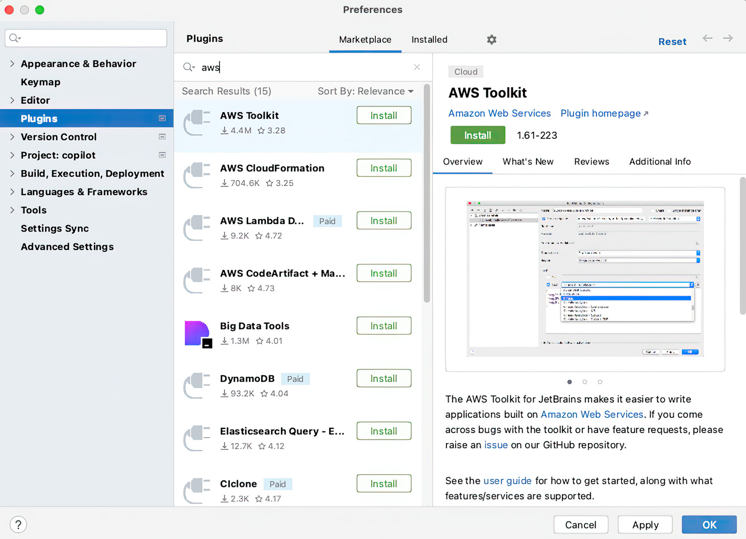

Figure C.10 The Plugins tab after we searched for and found AWS Toolkit

2 After you complete the plug-in installation, click the AWS Toolkit tab in the
bottom- left quadrant of PyCharm (see figure C.11). This will bring up the devel-
oper tools and allow you to create a new connection to AWS.
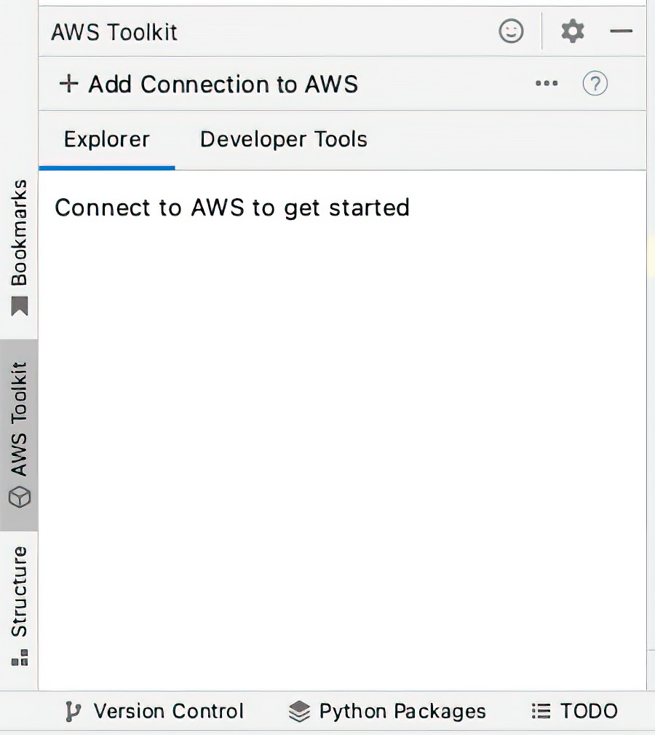

Figure C.11 The AWS Toolkit tab allows you to connect to AWS and start and pause CodeWhisperer.
Installing the CodeWhisperer plug-in in PyCharm 211

3 Click + Add Connection to AWS. Doing so launches a dialog box asking you to
select how to connect to AWS and which credentials to use. Choose “Use a per-
sonal email to sign up and sign in with AWS Builder ID” and click Connect (see
figure C.12).
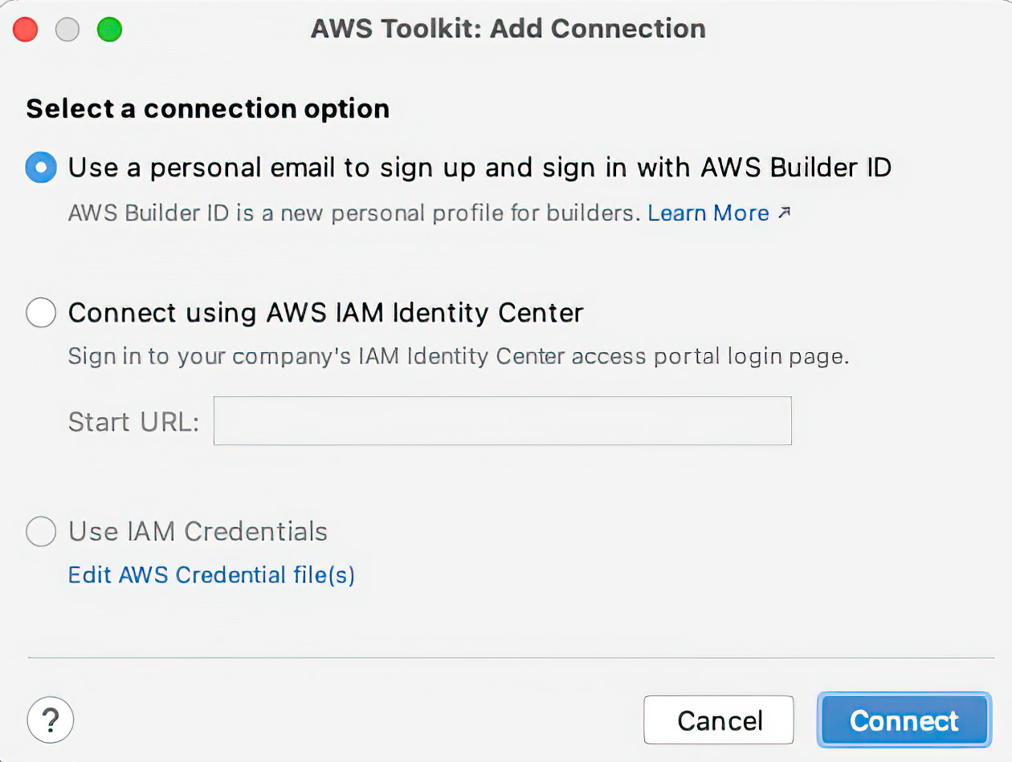

Figure C.12 Dialog asking you to select how you will connect to AWS

4 PyCharm will launch another dialog containing a personal access code (see fig-
ure C.13). You need to copy this code, because you must authorize AWS to access
the data in your PyCharm editor. Click Open and Copy Code.
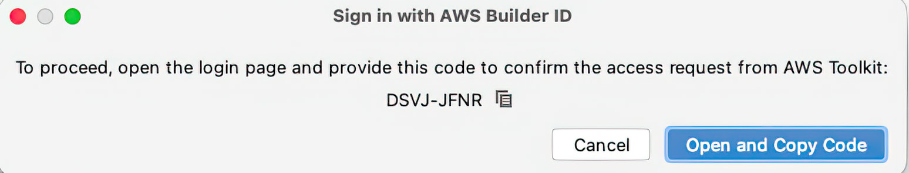

Figure C.13 This dialog contains your personalized code and the button to continue.

5 Your default browser will open and navigate to the AWS website, where there is
a window to paste your access code (see figure C.14). Enter this code, and click
Next.
212 appendix c Setting up AWS CodeWhisperer
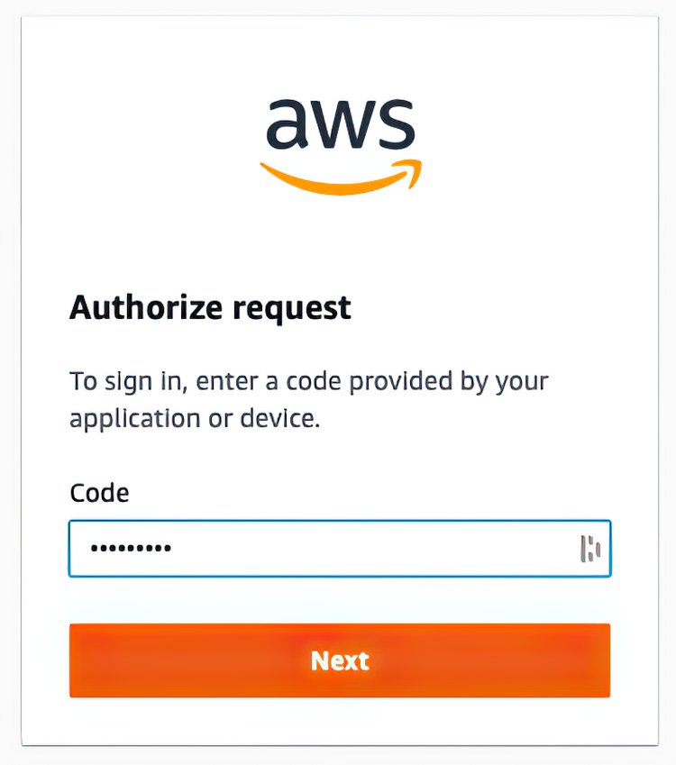

Figure C.14 The web form where you paste the code you previously copied

6 AWS will ask you to log in using your personal email address (see figure C.15). If
you do not already have a Builder account, you can register for one. Then, either
log in or create a new account to continue.

Figure C.15 You can log in to an existing Builder account or register for a new one.
Installing the CodeWhisperer plug-in in PyCharm 213

7 We are nearing the end of this process and will be using CodeWhisperer before
you know it. You will find that the effort is well worth it. All that is left is to autho-
rize AWS to collect specific (and limited) personal data: your email address and
the context of your editor (see figure C.16). Then, click Allow to continue.
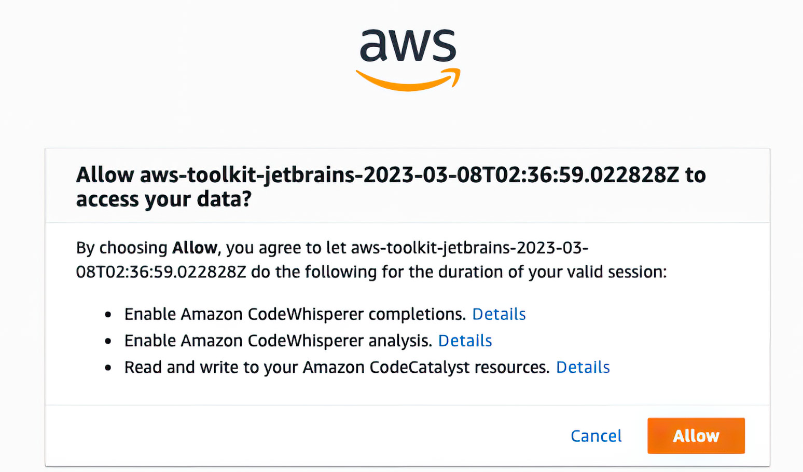

Figure C.16 AWS needs your permission to collect information so that CodeWhisperer can provide suggestions.

8 You will receive confirmation that the AWS Toolkit, which includes Code-
Whisperer, has been authorized for use in PyCharm (see figure C.17).
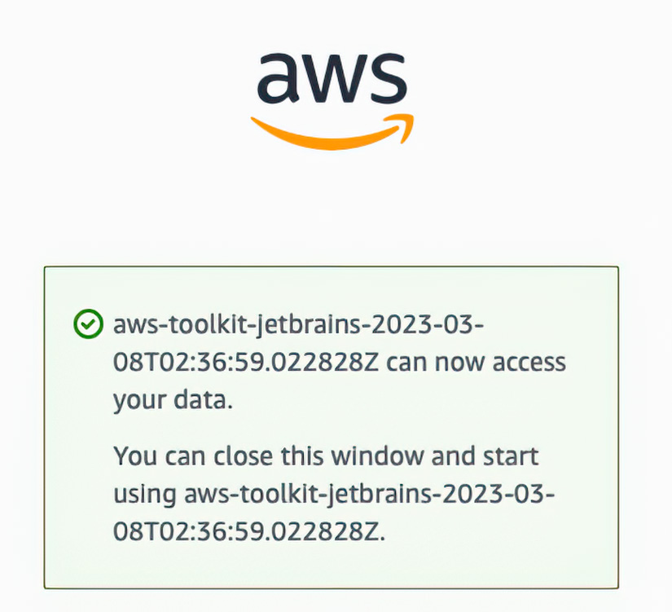

Figure C.17 AWS confirms that CodeWhisperer is ready to go.

Now you can begin to use the tool. First you need to start the CodeWhisperer’s code
suggestion engine. Go back to the AWS Toolkit tab (bottom-left by default), click
Developer Tools, expand CodeWhisperer, and click Start (see figure C.18).
214 appendix c Setting up AWS CodeWhisperer
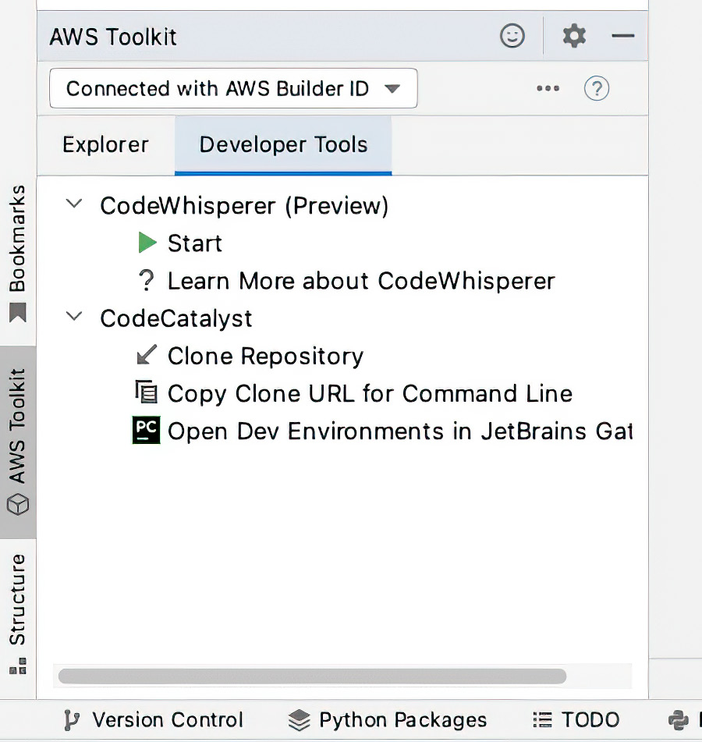

Figure C.18 The AWS Toolkit widget from which you can start (and stop) CodeWhisperer’s code suggestion engine

Once you have started CodeWhisperer, the AWS Toolkit plug-in will present you with
the Amazon CodeWhisperer Terms of Service to review and accept (or reject) (see
figure C.19). To use CodeWhisperer, you must accept these terms, but you should
still read them carefully. If you accept, click the Accept and Turn On CodeWhisperer
button.
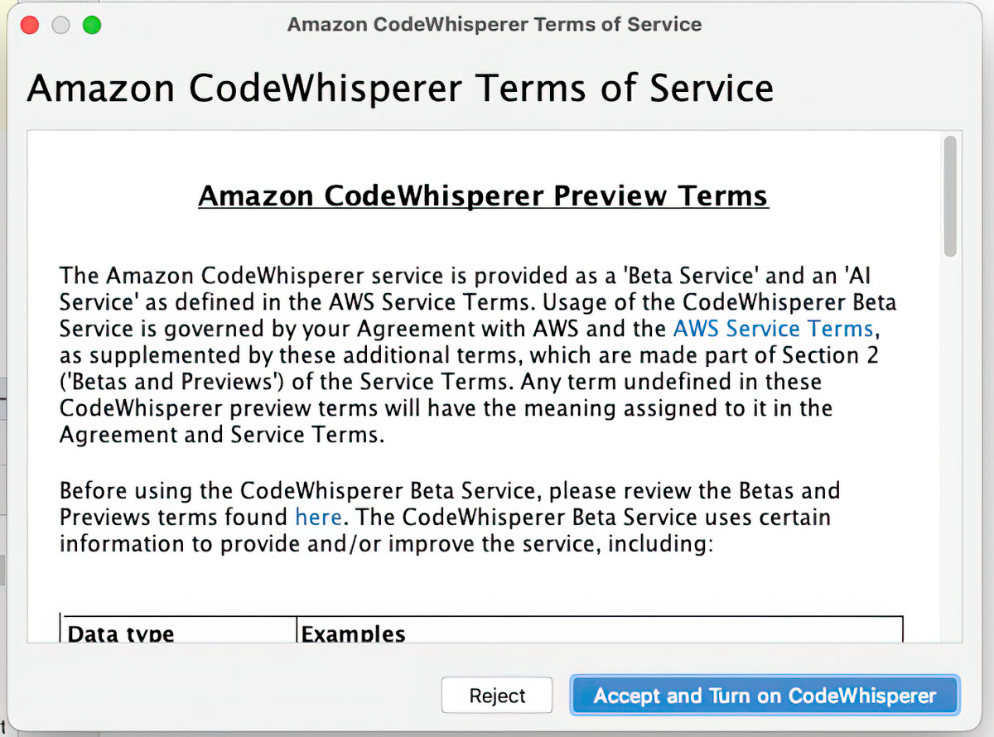

Figure C.19 The Amazon CodeWhisperer Terms of Service. You must accept these terms to use CodeWhisperer.

Now, let’s get hacking.
Uttering your first words with CodeWhisperer 215

C.3 Uttering your first words with CodeWhisperer
With the setup and preliminaries out of the way, let’s build a basic Flask application.
In your preferred IDE, create a file called app.py. Next, add the following prompt as a
comment in the file. Just like Copilot, CodeWhisperer accepts prompts as comments:

# create a Flask application that has a route to /
# which returns the text "Hello World."

When you press Enter after this prompt, CodeWhisperer will suggest an import state-
ment (see figure C.20).
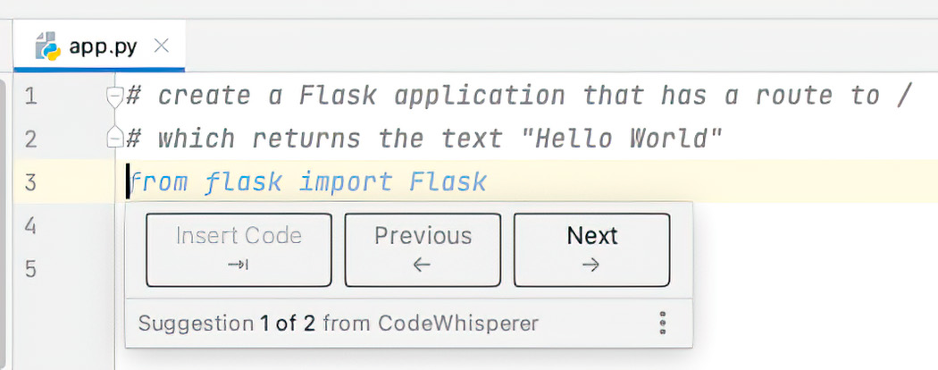

Figure C.20 Your first CodeWhisperer suggestion: in this case, an import statement

Continue to press Enter and marvel as CodeWhisperer auto-completes the program
line by line. You might consider reformatting the code to make it more readable, but
it should work without significant issues. You may need to use pip to install Flask: pip
install flask.

Listing C.1 Complete source code listing (formatted for readability)

# create a Flask application that has a route to / # which returns the text "Hello World."
from flask import Flask

app = Flask(__name__)

@app.route('/')
def hello_world():
return 'Hello World

if __name__ == '__main__':
app.run()

Run this application. Your application should be bound to the default port: 5000 (see
figure C.21).
216 appendix c Setting up AWS CodeWhisperer
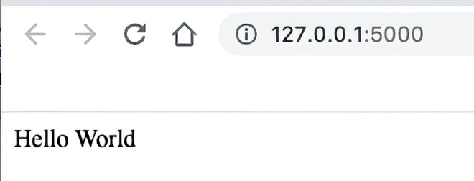

Figure C.21 Your first CodeWhisperer-assisted application, running on the default port

Congratulations! You now have another tool in your AI-assisted toolbelt. You are ready
to continue your journey into high(er) productivity.

index

Symbols AssetLocationSparkAdapter 108
**2 operator 183 AssetLocationUpdated event 104
@dataclasses decorator 56 asset_management_system/models/asset.py 35

@staticmethod keyword 85 AssetManager class 72, 73, 75, 79, 81, 101, 102, 104, 105, 135, 137

A Asset model 35
Asset objects 76
accept method 43 AssetOut class 78
accessing data and persisting changes 81 AssetRestAdapter class 80
Adapter Pattern 71 AssetRestPort class 79
adapters 37, 75 assets table 94
plugging in 74 asset_type parameter 66
add_location method 105 Assumptions and Constraints section 47
Address class 63 Audience Persona Pattern 20
AES (Advanced Encryption Standard) 172 Authentication and Authorization 164 Amazon Web Services in Action, Third Edition (Wittig AWS (Amazon Web Services), deploying
and Wittig) 144 applications onto AWS Elastic Kubernetes
Apache Spark, analyzing, learning, and tracking Service 151–154
with 107–110 AWS CodeWhisperer 23–25
api part 182
applications, deploying onto AWS Elastic Kubernetes B
Service 151–154 BaseRepository 83
Approval section 47 BDD (Behavior-Driven Development) 133
AssessLocationSpark Adapter 108 behave library 124
Asset class 40–42, 55, 59, 64, 78, 103–105, 137 behavior testing 122
AssetController class 79, 81 BRD (business requirements document) 46, 47, 50
AssetFactory class 64 bugs, finding and fixing 129
AssetIn class 78 Build a Large Language Model (From Scratch)
Asset location 109 (Raschka) 9
AssetLocationMediator class 104 Builder Pattern 68

217
218 index

building software, instructing system on how to uttering first words with 215
build 68 Components level 48, 50
build() method 69, 70 Concrete element 43
Business Requirements section 47 Concrete visitor 43
Containers level 48, 49
C Context level 48
C4 model 48 Copilot, AI assistant, infrastructure coding and
calculate_depreciation method 42 deployment management 143
calculate_distance method 109 Copilot Chat, managing data with 90
CCPA (California Consumer Privacy Act) 160 Copilot, GitHub, building software with 53
centralizing data access 85 copiloting infrastructure, Terraform 147–150
ChatGPT (Open AI) 13–21, 192 CostByLineOfBusinessVisitor 44
baselining with 179 cost field 56
charting paths with GPT-3.5 18–20 coverage html command 131
comparing ChatGPT, Copilot, and coverage library 130
CodeWhisperer 25–27 coverage report command 131
creating account 192–193 creating objects in factory pattern 64
designing software with 31 current_location attribute 105
GPT-3.5 18–20 cyclomatic complexity 126
GPT-3.5 to GPT-4 21
GPT-4 13–17 D
navigating AI seas 21 DAST (dynamic application security testing) 169
navigating nuances with data, accessing and persisting changes 81
GPT-4 13–17 data access layer 98
secure application development with 158 DatabaseConnection class 85
encrypting data at rest and transit 171–177 database interaction 174
evaluating design problems 166 data encryption 174

scrutinizing application design and identifying in transit 176 potential vulnerabilities 166–167 DataFrame 97 importance of data encryption 171 at rest 172–175
security best practices 168–171
DecliningBalanceDepreciation Strategy 42
software design, documenting architecture 36–50 Decorator design pattern 56
threat modeling with 159–166 decryption 174
ChatGPT 4.0 137 degrees of freedom 184
CI/CD (continuous integration and delivery) 144, Denial of Asset Changes 165
154–156 Deogun, Daniel 159
circular dependency 120 department_allocations 59
Clinton, David 9 Department class 59
code coverage 130 DepartmentStatisticsVisitor class 117
Code level 48, 50 DepartmentVisitor interface 63, 64
code smell 68 DepreciatingAsset class 167
CodeWhisperer depreciation 42
comparing ChatGPT, Copilot, and DepreciationStrategy 42, 61, 67, 120
CodeWhisperer 25–27 depreciation_strategy table 92, 93
installing extension into VS Code 205 describe library 137
installing plug-in in PyCharm 209–214 design patterns 57
index 219

factory pattern 64 expect function 137
Device Identifier Spoofing 164 exporting and importing images 150
Digital Signatures 165 externalizing data access 85
DIP (Dependency inversion principle) 41
DNS Security 164 F
DNS Spoofing (Cache Poisoning) 164 Factory object 66
Docker factory pattern 64
building images and deploying them Fake Asset Registration 164
locally 145–147 faker package 97
exporting and importing images 150 fastapi 121
pushing images to ECR 150 FastAPIAdapter 37
Docker containers 146 feature file 123
Dockerfile 145 Financial Discrepancies 165
Docker image 145 Flask web application 168
docker load command 150 for loop 183
docker run command 150 format method 183, 184
docker save command 150 from_asset function 133
doctest framework 117 funding details 97
domain model 37 funding_details attribute 41
adapting strategy for depreciation 61–63 FundingDetails class 41, 42, 59, 60, 119, 120, 134
decorating classes 57–61 funding_details table 93
expressing 54
immutability 55 G
domain/model package 56
_get_depreciation_strategy method 70
DoS (denial of service) 163
GDPR (General Data Protection Regulation) 160
DoubleDecliningDepreciation Strategy 42
generative AI, when to use and when to avoid 10
driver, defined 75
Generic type 82, 83
E geopy.distance function 109
GitHub Actions, setting up CI/CD pipeline
EC2 (Elastic Compute Cloud) 144 in 154–156
ECC (Elliptic Curve Cryptography) 172 GitHub Copilot
ECR (Elastic Container Registry) 157 accessing data and persisting changes 81
pushing Docker images to 150 amassing dataset 91
ECR_REGISTRY variable 155 analyzing, learning, and tracking with Apache
ECS (Elastic Container Service) 144 Spark 107–110
EKS (AWS Elastic Kubernetes Service) 144 building software with
Element abstract class 43 adapting strategy for depreciation 61–63
Element interface 43 decorating classes 57–61
elevation of privilege 163 centralizing (and externalizing) data
encrypting data 171–177 access 85
at rest 172–175 expressing domain model 54
importance of 171 immutability 55
in transit 176 laying foundation 54–63
Encryption 164 observing changes 72
Enum class 58 plugging in ports and adapters 74
exec command 91 copiloting Terraform 147–150 220 index

creating first program 203 integration testing 120–121
creating objects in factory pattern 64 Introduction section 47
driving application 75 IP Address Spoofing 164
installing extension into VS Code 197 ISP (Interface segregation principle) 41
installing plug-in in PyCharm 200 itam_admin account 92
instructing system on how to build 68 ITAM (Information Technology Asset
managing data with 90 Management) 53, 90, 165
setting up 197 real-time monitoring with Kafka 100–107
using 21–23 system overview 31–32
Visitor Pattern 63 itam schema 91
GPT-4All 187 it_asset_management/app/schemas/asset.py 35
democratizing answers with
187–190 J
GWT (given-when-then) 122 Johnsson, Dan Bergh 159

H K
Halstead complexity measures 127 Kafka
HardwareAssetFactory class 67, 68 console producer 106
Hardware class 40, 58, 59 real-time monitoring with
HardwareService 37 100–107
Hardware type 103 key management 174
hexagonal architecture 37 kth element problem 22
review 74–75
L
I Lack of Accountability 165
IAM (Identity and Access Management) 152 len() function 183
IDEs (integrated development environments) 9, License Violations 165
197 lines_of_business
id field 66 attribute 42
images, exporting and importing 150 dictionary 59
immutability 55 LinkedList class 18
Immutable Logging 165 ListNode class 21
import statements 69, 108, 203 Llama 2, asking to calculate standard
information disclosure 163 deviation 181–186
infrastructure LLMs (large language models) 3–4, 11–12, 53,
coding, pushing Docker images to ECR 150 143, 178
copiloting Terraform 147–150 accelerating development 4–9
deploying applications onto AWS Elastic AWS CodeWhisperer 23–25
Kubernetes Service 151–154 ChatGPT 13–21
infrastructure as code, building Docker images and code coverage 130
deploying them locally 145–147 comparing ChatGPT, Copilot, and
Inheritance vs Composition 167 CodeWhisperer 25–27
initial_data_load.sql file 91 locally running, hosting 179–190
InMemoryAssetRepository class 121 motivating theory 179
insert statement 96 overview of 3, 9
installing CodeWhisperer plug-in in patterns, audience persona pattern 28
PyCharm 209–214
index 221

testing with, integration testing 121 P

translating from one language to another __post_init__() method 58 134–138 pandas 97 transliterating code 131–133 patterns 63 using GitHub Copilot 21–23 Persona Pattern 14 when to use and when to avoid 10 Phishing & Social Engineering 164 login-ecr function 154, 155 Pitchfork class 40 LSP (Liskov substitution principle) 41 plug-ins. See PyCharm

M PnL (profit-and-loss) 107
pods 151
MAC Address Spoofing 164 ports 37, 75
macro 35 ports and adapters, plugging in 74
MainApp class 37 primary (driven) ports and adapters 37
main function 110, 180 Project Timeline section 47
maintainability index 128 purchase_date field 56
MaintenanceSchedule class 63 PyCharm
math.sqrt() function 183 installing CodeWhisperer plug-in in 209–214
Mediator installing Copilot plug-in in 200
class 103 pytest framework 116
pattern 102 pytest-mock library 122
Mermaid 36
micro 35 Q
Mistral OpenOrca 188
mock object 122 125–128 quality assessment, overview

N R
Network Security 164 Raschka, Sebastian 9

NIST (National Institute of Standards and RDD (resilient distributed dataset) 107 Technology) 161 real-time monitoring, with Kafka 100–107 new method 66 (RBAC) Role-Based Access Control 165
NLP (natural language processing) 9
Refinement Pattern in prompt engineering 14
Node class 18
Regular Audits 164, 165
NoDepreciationStrategy 42
Repository Pattern 81
nose2 framework 116
repudiation 163
numpy 97
reverse_and_display method 21

O reverse method 21
Role class 63
objects, creating in factory pattern 64 RSA (Rivest–Shamir–Adleman) 172
OCP (Open/Closed principle) 41
on, push instruction 154 S

Organizations class 63 SAST (static application security testing) 169 Sawano, Daniel 159 ORM (object-relational mapping) 85, 98 secondary (driving) ports and adapters 37 OWASP (Open Worldwide Application Security OpenAI ChatGPT, creating account with email address 193 salvage_value field 56
Project) 161 secure application development 222 index

ChatGPT 166–167 terraform apply command 150
encrypting data at rest and transit 171–177 terraform init command 149
threat modeling 159–166 terraform plan command 149
Secure by Design (Johnsson, Deogun, and testing 115, 116
Sawano) 159 finding and fixing bugs 129
secure coding guidelines 168 integration, with LLMs 121
security, best practices for 168–171 types of 116
Security Implications 165 unit testing 116
SendGrid 110 The Complete Obsolete Guide to Generative AI
services 153 (Clinton) 9
setters 55 threat modeling, with ChatGPT 159–166
Singleton Pattern 84 Transformer architecture 9
singly linked list 13 translating from one language to another 134–138
SoftwareAssetFactory class 68 transliterating code 131–133
Software class 40 Twilio 110 software development
building with GitHub Copilot U
plugging in ports and adapters 74 unit testing 116
documenting architecture 36–50 unittest.mock library 122, 123
driving application 75 unittest.TestCase class 117
SOLID design 41 update_asset_location method 104
Spoofed Update Servers 164 UsageStatistics class 63
spoofing 163 useful_life field 56
SQLAlchemyAssetRepository class 86, 104 User Agent Spoofing 164
SQL (Structured Query Language) 92 User class 63
SRP (Single responsibility principle) 41 User Education 164
statsmodels module 182, 183 User Training 166
stats module 182
stdev function 182, 183 V
StraightLineDepreciation Strategy 42 visit method 43, 44

STRIDE (spoofing, tampering, repudiation, Vistor implementation 64 information disclosure, and denial of vpc_id entry 149 Strategy Pattern 61 Visitor Pattern 43, 63, 64, 167
service) 163
Strong Authentication 165 VS Code (Visual Studio Code) 197
Subject class 72 installing CodeWhisperer extension into 205
sum variable 183 installing Copilot extension into 197
System Architecture section 47
system design, asking ChatGPT to help with 32–36 W
Warranty class 63
T Whistleblower Policies 166
tampering 163 Wittig, Andreas 144
Terraform, copiloting 147–150 Wittig, Michael 144


Dramatis Personae

¡ The Intern: Eager to learn, a basic to intermediate level of knowledge
in the field, and a willingness to take on various tasks for learning and
experience.
¡ The Software Architect: Responsible for the high-level design and archi-
tecture of software systems.
¡ The Software Engineer: Involved in the detailed coding and implementa-
tion of software solutions.
¡ The Quality Assurance (QA) Engineer: Responsible for ensuring the soft-
ware meets quality standards and works as expected.
¡ The Technical Project Manager: Oversees the software development pro-
cess and ensures project goals are met.



SOFTWARE DEVELOPMENT


AI-Powered Developer
Madhusudhan Konda Madhusudhan Konda ● ● Foreword by Foreword by Shay Banon Shay Banon See first page Nathan B. Crocker

U
sing AI tools like Copilot and ChatGPT is like hiring a super-smart and super-fast junior developer eager to take “An excellent and practical on anything from research to refactoring. Coding with AI can help you work faster, write better applications, and maybe guide for achieving exactly
do things that aren’t even possible with your current team. the level of AI integration
Th is book will show you how. you need in your develop-

AI-Powered Developer ment and infrastructure teaches you in concrete detail how to ”
maximize the impact of AI coding tools in real-world software management work.
development. In it, you’ll walk through a complete applica- —David Clinton, Bootstrap IT,
tion, introducing AI into every step of the workfl ow. You’ll author of Th e Complete Obsolete
use ChatGPT and Copilot to generate code and ideas, make Guide to Generative AI

predictive suggestions, and develop a self-documenting “ application. You’ll also learn how AI can help test and explain A must-read for anyone
your code. interested in the shape of
things to come in software

What’s Inside development.”
● —Junta Nakai, VP Financial Use AI to design and plan software
Services, Cyber Security &
● Code generation, debugging, and documentation Sustainability, GTM ● Improve code quality assessments

● “ Work with unfamiliar programming languages Extremely well written,
technically on-point,

For intermediate software developers. No AI experience and comprehensive.” necessary.
—Tony Holdroyd, retired Senior
Nathan B. Crocker is Cofounder and CTO at Checker Corp. Lecturer in computer science
and mathematics
Th e technical editor on this book was Nicolai Nielsen.

For print book owners, all ebook formats are free:
https://www.manning.com/freebook

ISBN-13: 978-1-63343-761-6

M A N N I N G






