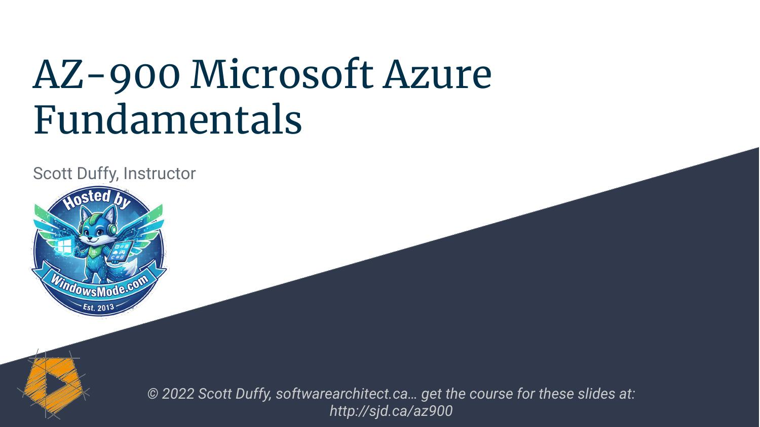

AZ-900 Microsoft Azure

Fundamentals

Scott Duffy, Instructor



© 2022 Scott Duffy, softwarearchitect.ca… get the course for these slides at:



http://sjd.ca/az900



Exam version May 2022

v3 of course

Microsoft Azure

Fundamentals “foundational level knowledge of cloud services and

how those services are provided with Microsoft Azure”

Microsoft Azure Candidates with non-technical backgrounds ●

Fundamentals

● Candidates with a technical background who

have a need to validate their foundational level

knowledge around cloud services

Microsoft Azure

Fundamentals ● Describe cloud concepts

● Describe Azure architecture

and services

● Describe Azure management

and governance

You’ll be prepared to take

and pass the AZ-900 exam





But you don’t have to, if

you just want to learn

cloud concepts





What is the Cloud?

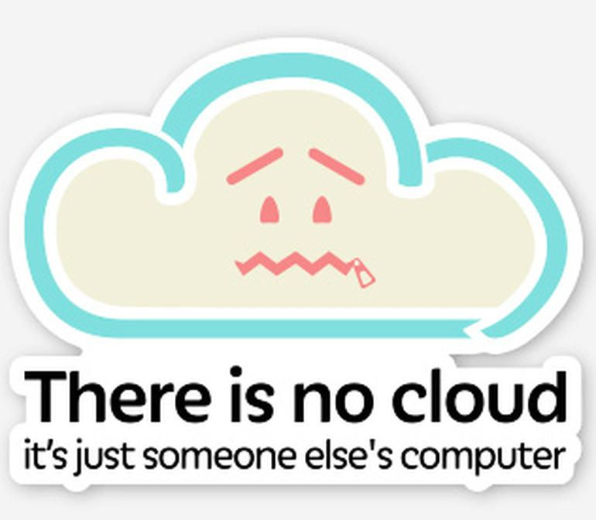

The ability to rent

computing resources -

on demand





What Does Windows and Linux Servers Unlimited File Storage

“Computing Databases

Resources” Mean? Queues

Content Delivery Network

Batch Processing Jobs





What Computing Big Data - Hadoop Media Services

Resources? Machine Learning

Chat Bots

Cognitive Services





1000+

Azure Service options

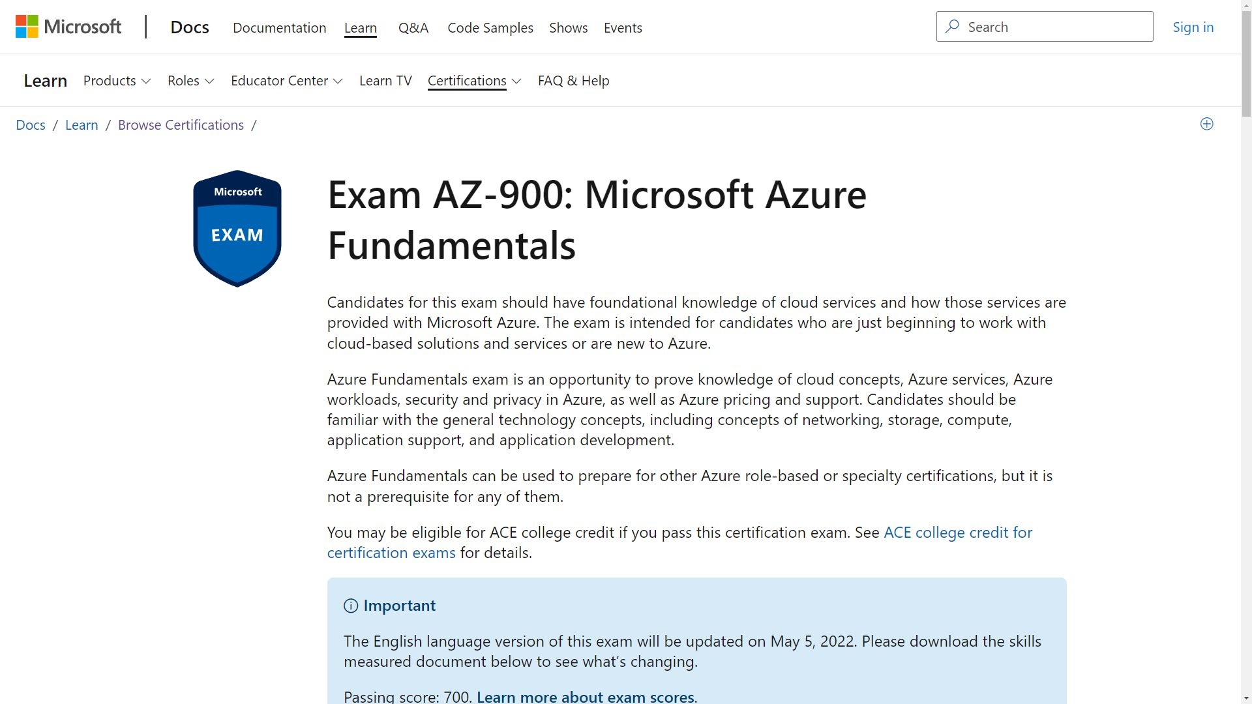

Free Study Resources Located at the end of the course:

● Free PDF Study Guide

● Download the slides and MP3 audio if you like to

study offline

● 50 question practice test

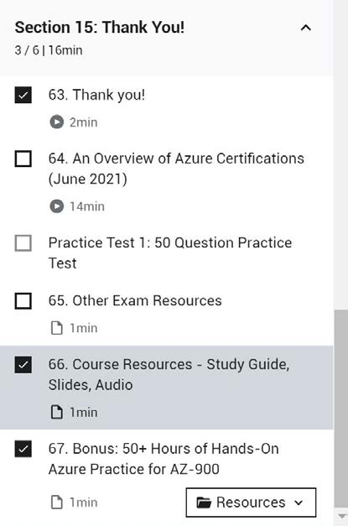



AZ-900 Microsoft Azure

Fundamentals

Scott Duffy, Instructor



© 2022 Scott Duffy, softwarearchitect.ca… get the course for these slides at:

http://sjd.ca/az900

Let’s have a look at

“The Cloud”



AZ-900 Microsoft Azure

Fundamentals

Scott Duffy, Instructor



© 2022 Scott Duffy, softwarearchitect.ca… get the course for these slides at:

http://sjd.ca/az900

Describe Cloud Concepts (25-30%)

2022

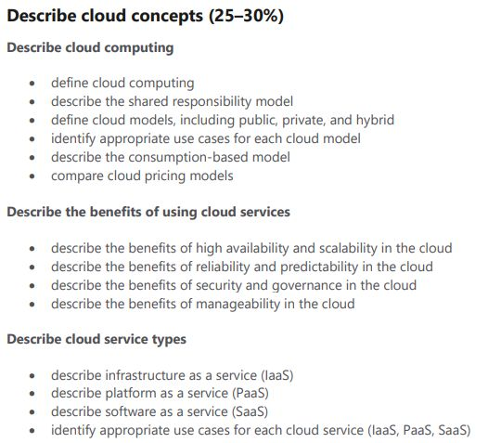

Define Cloud Computing

Shared Responsibility Model

When you run Building security

services in your own Physical network security

office… Physical computer security

Operating system patches

you are responsible Network and Firewall settings

for: Application settings

Authentication platform

User accounts

Devices

Data

When you run Building security

services in the cloud Physical network security

using a VM… Physical computer security

Operating system patches

you are responsible Network and Firewall settings

for. Application settings

Authentication platform

User accounts

Devices

Data

When you run Building security

services in the cloud Physical network security

on an App Service… Physical computer security

Operating system patches

you are responsible Network and Firewall settings (shared)

for. Application settings (shared)

Authentication platform (shared)

User accounts

Devices

Data

When you use Building security

software as a service… Physical network security

Physical computer security

you are responsible Operating system patches

for. Network and Firewall settings

Application settings

Authentication platform (shared)

User accounts

Devices

Data

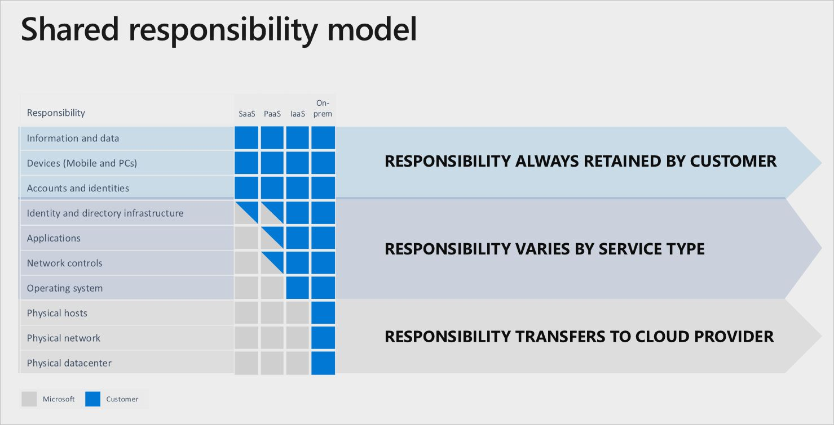

Public cloud

“The public cloud is defined

as computing services offered

by third-party providers over

the public Internet, making

them available to anyone who

wants to use or purchase

them.”

Azure owns the hardware, on

their network and

infrastructure

Private cloud

“The private cloud is defined

as computing services offered

either over the Internet or a

private internal network and

only to select users instead of

the general public.”

Looks and acts like a cloud, except

customer owns or leases or has

exclusive access to the hardware

Hybrid cloud

“A hybrid cloud… is a

computing environment

that combines a private

cloud with a public cloud.”

Combination of public and private

clouds; scale private infrastructure

to the cloud

Compare and Contrast

Public vs private vs hybrid



AZ-900 Microsoft Azure

Fundamentals

Scott Duffy, Instructor



© 2022 Scott Duffy, softwarearchitect.ca… get the course for these slides at:

http://sjd.ca/az900

Cloud Pricing Models

Cloud pricing can be

complicated

Usually any service is

priced by 2 or 3 metrics

combined

Example: Cosmos DB

Operations +

Consumed Storage +

Optional Dedicated Gateway +

Backup Storage

Example: Cosmos DB

Operations - 400 RU/s = $23.36 +

Consumed Storage - 100 GB = $25.00 +

Optional Dedicated Gateway = $277.40 +

Backup Storage - 7 backups = $60.00

1. Free services Some services are always free or have a free tier or free below a certain limit:

● Virtual network ● Private IP address ● Azure Migrate ● Inbound Internet traffic ● 5GB of outbound Internet traffic ● Azure Policy ● Azure AD ● 1 million executions Azure Functions ● Azure App Service

2. Pay for Time Certain services charge by time. Virtual machine ●

● App services ● Databases ● Load balancers ● Managed storage ● Public IP address

A very common and logical way to pay for something

Some services charge by the minute or by the hour

Varies (greatly) based on the specific service you

choose, performance, options, etc.

3. Pay per GB In addition to time, you may also have to pay per GB used.

● Database storage ● Backups ● Unmanaged disks ● Network traffic (between regions) ● Network traffic (more than 5GB/month egress

from Azure)

4. Pay for Each operation can also cost, a fraction of a penny. Unmanaged storage (reads, writes, deletes) ●

Operations ● Databases (queries)

● Messaging

Usually charged in bulk - per 10,000 requests, per

million requests, etc - for practical reasons of cost

5. Pay per execution Some serverless offers just charge you for each time the program runs

● Azure Functions (consumption model) ● Serverless Databases ● Messaging Services ● Logic Apps (consumption model)

6. Other metrics Active Directory Premium services charge per assigned user

Pricing changes between

regions



AZ-900 Microsoft Azure

Fundamentals

Scott Duffy, Instructor



© 2022 Scott Duffy, softwarearchitect.ca… get the course for these slides at:

http://sjd.ca/az900

2022



Benefits of Cloud Computing

Benefits Cost savings - both real and accounting Availability & Scalability

Reliability & Predictability

Security & Governance

Manageability

Global reach

Range of ready on-demand services

Range of tools





Cost Savings

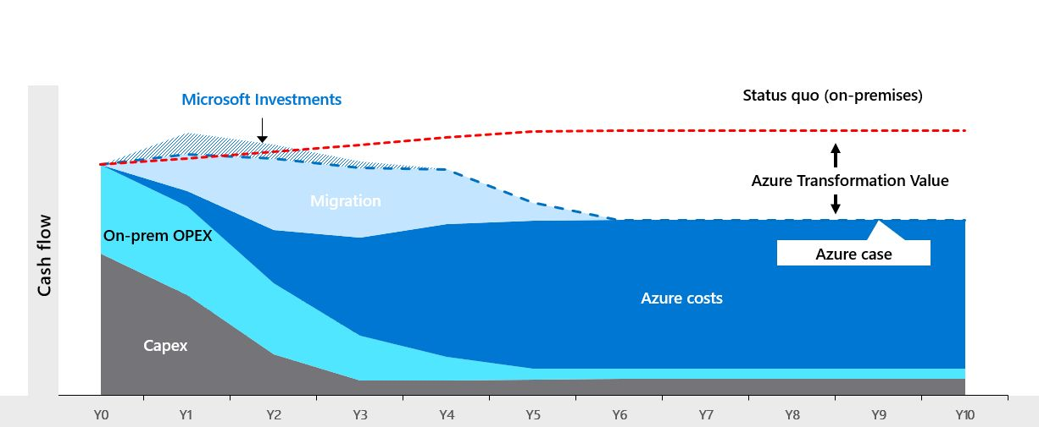

Cost Savings - Real Economies of scale Total cost of ownership (TCO) - electricity, Internet,

cooling, employees

Microsoft can run a server cheaper than anyone else with few exceptions

4 vCPU server - as low as $187/mo





You can take actions to

reduce your cost -

i.e. autoscaling





To be continued…

High Availability

Expressed as a percentage, it’s the

ability of a system to respond to

users

99.99%

Four nines, 4 minutes per month

Scalability

The ability of a system to handle

growth of users or work

App failure

Max capacity

Number of concurrent users

Elasticity

The ability of a system to

automatically grow and shrink

based on application demand

capacity

User

demand

To be continued…

Reliability & Predictability

Since you’re giving up

control of the platform,

you need the cloud to be

reliable

Microsoft publishes

“Service Level

Agreements” (SLAs) for

their services

Financial guarantee of

their performance

Azure has established

procedures for rollouts

and regional recovery

Availability Sets and Zones

Give you the tools for

backup and site recovery

Simulate failures using

Chaos Studio

Global Reach

It’s not possible for most

businesses to run data

centers in multiple

countries





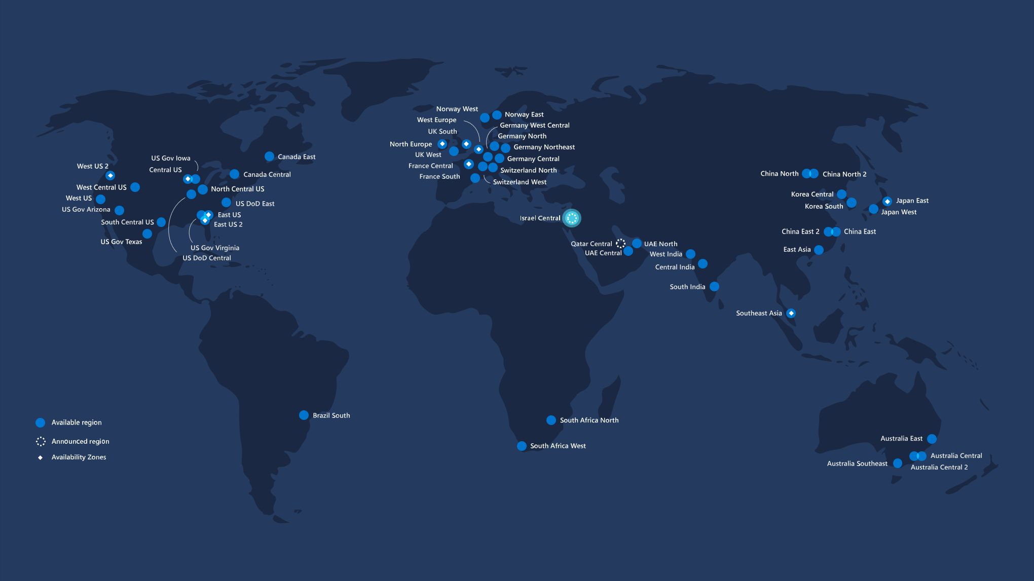

To be continued…

Security & Governance

Security is a full-time job

Use of AI/ML in products

like Azure Firewall

Identity is the number 1

attack vector; identity

protection is key

Basic DDoS protection free

Data governance

Azure Policy and

Blueprints

Monitoring is important

Automation to act on

events being monitored

without human

intervention required



AZ-900 Microsoft Azure

Fundamentals

Scott Duffy, Instructor



© 2022 Scott Duffy, softwarearchitect.ca… get the course for these slides at:

http://sjd.ca/az900

2022



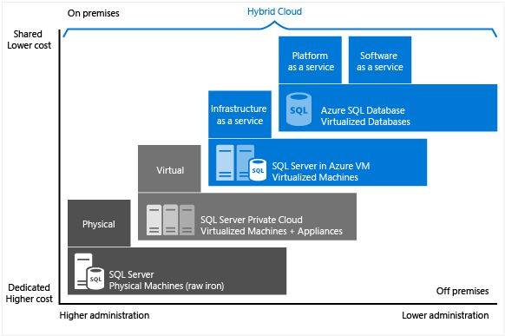



Cloud Models

Infrastructure as a Service

Platform as a Service

Software as a Service

Serverless Infrastructure-as-a-Service (IaaS)

“Infrastructure as a service

(IaaS) is a type of cloud

computing service that offers

essential compute, storage,

and networking resources on

demand, on a pay-as-you-go

basis.”

Virtual machines, networking, load

balancers, firewalls

Platform-as-a-Service (PaaS)

“Platform as a service

(PaaS) is a complete

development and

deployment environment

in the cloud”

“Like IaaS, PaaS includes

infrastructure—servers, storage, and

networking—but also middleware,

development tools, business intelligence (BI)

services, database management systems,

and more. PaaS is designed to support the

complete web application lifecycle: building,

testing, deploying, managing, and

updating.”

Upload code packages and have

them run, without access to the

hardware

Software-as-a-Service (SaaS)

“Software as a service (SaaS)

allows users to connect to and use

cloud-based apps over the

Internet. Common examples are

email, calendaring, and office tools

(such as Microsoft Office 365).”

Access to configuration only

Serverless

There are still servers…

you just don’t ever have to

deal with them





Even less access to the

server than PaaS

Even with PaaS, you have

to choose an App Service

Plan

With PaaS, scaling is your

responsibility





Serverless means not

worrying about choosing

the right plan

Serverless means not

worrying about scaling

Serverless means you

might pay $0 if you don’t

use the service

Azure Serverless Compute - Azure Functions Compute - Serverless Kubernetes (Virtual Nodes w/

Offers ACI)

Database - Azure SQL Database Serverless

Database - Cosmos DB Serverless



AZ-900 Microsoft Azure

Fundamentals

Scott Duffy, Instructor



© 2022 Scott Duffy, softwarearchitect.ca… get the course for these slides at:

http://sjd.ca/az900

Describe Azure architecture and

services (35–40%)

2022

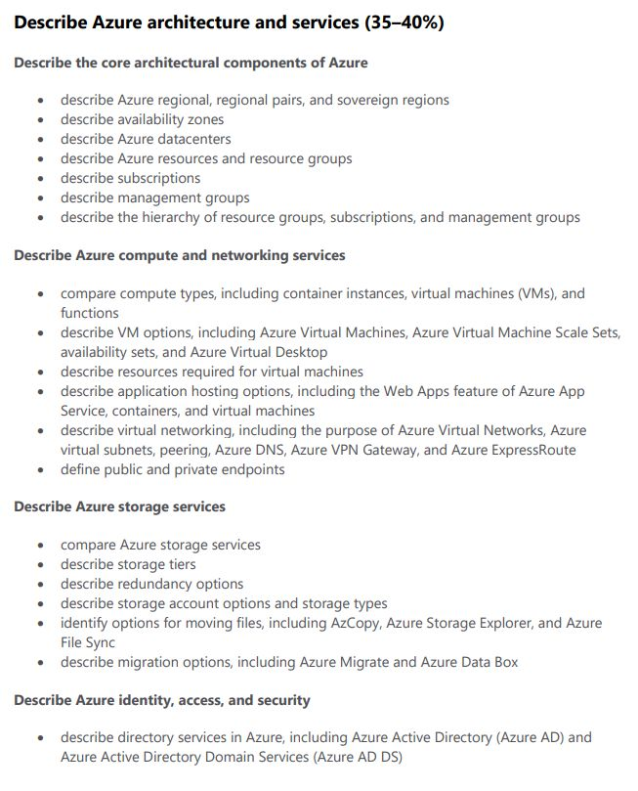

Core Azure architectural

components

Regions

60+

Regions - not all accessible by everyone

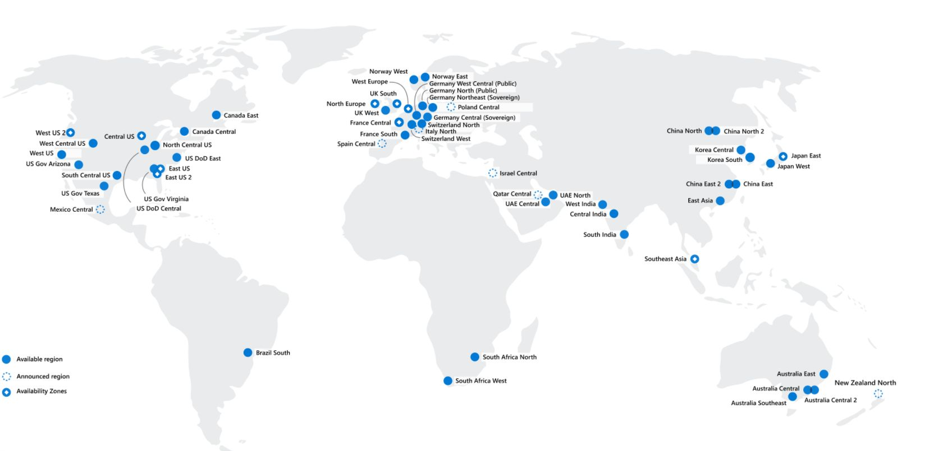

Region Pairs

What are Paired Each region has one other region which is treated as it’s “pair”

Regions? Almost always in the same geography - data storage

laws

The data connection between region pairs is the

highest speed available

Software rollouts are deployed to one region of a pair

and the other is not touched

If multiple regions go down, one region of each pair is

treated as a priority

Example Pairs Canada Canada Central - Canada East Europe North Europe - West Europe

USA East US - West US

USA East US 2 - Central US

USA North Central US - South Central US

Brazil Brazil South - South Central US

Sovereign Regions

Sovereign Regions Azure Government (US) China

Availability Zones

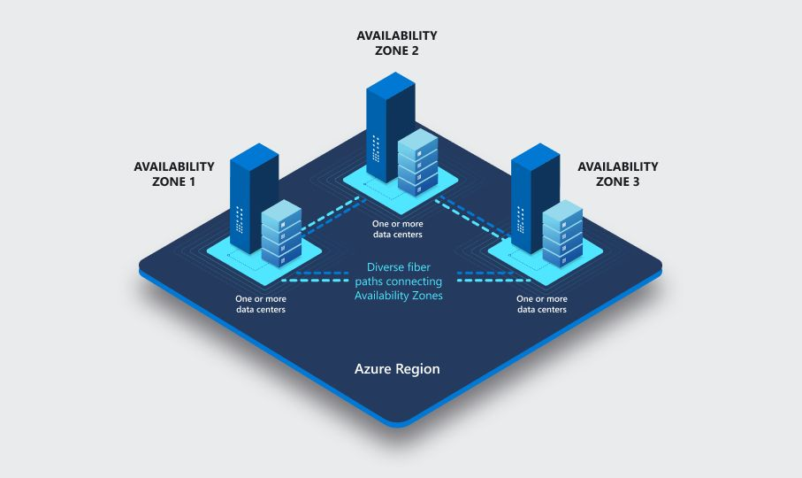

Regions with Availability Zones

The Americas Europe

Brazil South France Central

Canada Central - Canada East Germany West Central

Central US - East US - East US 2 North Europe

South Central US - West US 2 - West US 3 Norway West

US Gov Virginia UK South

West Europe

Sweden Central Regions with Availability Zones

Africa Asia Pacific

South Africa North Australia East

Central India

Japan East

Korea Central

Southeast Asia - East Asia

China North 3

Data Centers

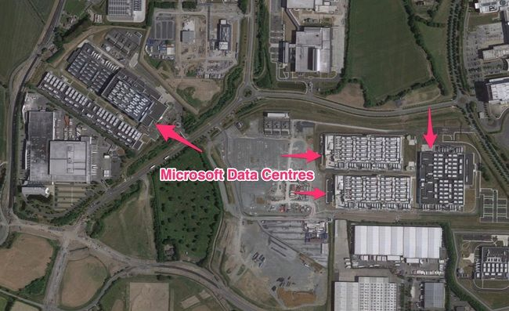

Resource Groups

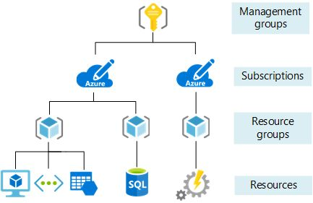

Azure Subscription

Subscription is a billing

unit

Users have access to one

or more subscriptions,

with different roles

All resources consumed by

a subscription will be

billed to the owner

Can be used to organize

resources into completely

distinct accounts

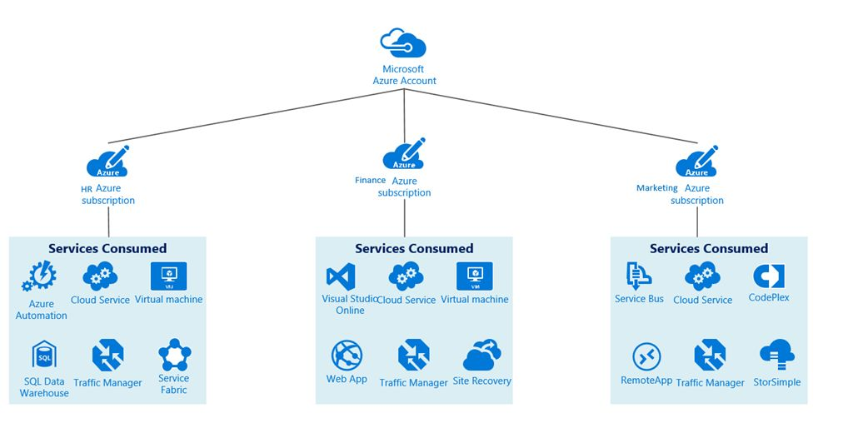

Management groups

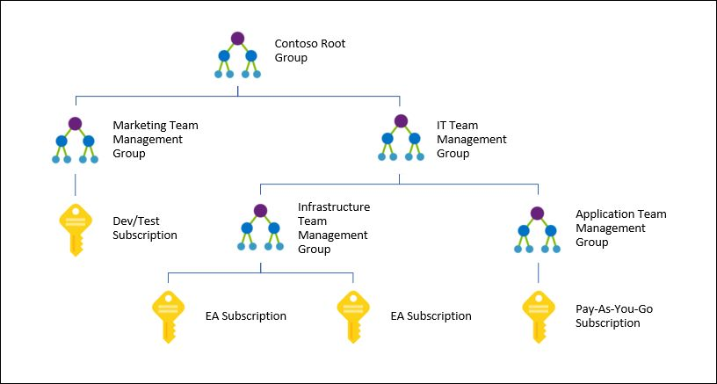





AZ-900 Microsoft Azure

Fundamentals

Scott Duffy, Instructor



© 2022 Scott Duffy, softwarearchitect.ca… get the course for these slides at:

http://sjd.ca/az900

2022



Azure Compute and Networking

Getting Deep into ● Compute services ● Networking services

the Technical ● Storage services

● Database services

Compute services ● Virtual Machines (VM) ● VM Scale Sets (VMSS)

covered ● App services (Web apps)

● Azure Container Instances (ACI)

● Azure Kubernetes Service (AKS)

● Windows Virtual Desktop





Compute -

“Executing code” in the

cloud

Virtual Machines Infrastructure as a service - IaaS Take an existing machine from your environment into

the cloud - a copy

Windows or Linux operating systems - several of each

A “slice” of a physical machine shared with other

customers

Full control over it, as if it was your machine

In AWS, a Virtual Machine is called

Elastic Compute Cloud (EC2).

Virtual Machine Over 200 to choose from Number of CPU cores, CPU speed, RAM size,

Types temporary disk size, IOPS, etc

VM Scale Sets ● Elasticity ● Two or more virtual machines running the exact

same code

● With a “load balancer” in front to direct traffic

randomly to one of the machines

● Able to add more machines as demand grows

(autoscaling)

● Able to reduce machines as demand slows

● Can handle up to 100 VMs in a single scale set

● Can be configured to increase that to 1000 VMs

in a single scale set

● If you need more, you can create more scalesets App Services A new paradigm for running code in the cloud Give your code and configuration to Azure, and they

will run it

Promise of performance but no access to hardware

Platform as a Service (PaaS)

Containers Another paradigm for running code in the cloud Containers contain everything the app needs to run in

a “container image”

Fastest and easiest to deploy

Azure Container Instance (ACI) - single instance,

quickest way to deploy a container

Azure Kubernetes Service (AKS) - runs on a cluster of

servers, enterprise-grade

Azure Virtual Desktop version of Windows that runs in the cloud You software installed, your files - available from

Desktop anywhere

Can even see your desktop on iOS and Android, or

from any web browser

Runs on Azure



AZ-900 Microsoft Azure

Fundamentals

Scott Duffy, Instructor



© 2022 Scott Duffy, softwarearchitect.ca… get the course for these slides at:

http://sjd.ca/az900

Networking Virtual Networks VPN Gateway

Services Covered VNet Peering

ExpressRoute





In AWS, a Virtual Network is called

Virtual Private Cloud (VPC).

Types of ● Connectivity Services

Networking ● Protection Services ● Delivery Services

Services ● Monitoring Services

Connectivity Virtual Network - emulating a physical network Microsoft Global Network already exists, so a virtual

network is just software configuration

Subnet - a subdivision of a virtual network, that you

control, that has its own security rules

Virtual Private Network (VPN) - connecting two

networks as if they were on the same network, uses a

Network Gateway

ExpressRoute - high-speed private connection to

Azure

DNS Services - doman name resolution

Protection - DDos Protection - Distributed Denial of Service attack protection

Security Section of Azure Firewall

the Course Network Security Groups

Private Link

Delivery - Not on Load Balancer - distribute traffic evenly between multiple backend servers

the Exam Application Gateway - a higher-level of load balancer

with an optional firewall

Content Delivery Network (CDN) - stores common

static files on the edge, closer to the users for

(perceived) improved performance

Azure Front Door Service - a load balancer, CDN and

firewall all-in-one

Monitoring - Network Watcher

Management Tools ExpressRoute Monitor

Section of the Azure Monitor

Course



AZ-900 Microsoft Azure

Fundamentals

Scott Duffy, Instructor



© 2022 Scott Duffy, softwarearchitect.ca… get the course for these slides at:

http://sjd.ca/az900

2022



Storage Services Container (Blob) Storage Disk Storage

Covered File Storage

Storage Tiers





Storage - one of the

foundational technologies

on which much is built

Container (Blob) The Azure Storage account General Purpose v2 (gpv2) is the most common type

and File Storage Blobs, Tables *, Queues *, Files

Azure Data Lake Storage Gen2

Cheapest type of storage

Pay Per GB (~1.8 cents per GB)

BLOB is a “backronym” for

Binary Large OBject.

A collection of binary data. That

binary data could be in the form of a

file (stored in a storage account) or

data stored in a database.

In AWS, a Storage Account is called

Simple Storage Service (S3).

Many, Many Access tiers - Hot, Cool, Archive Performance tiers - Standard or Premium

Options Location

Redundancy / Replication

Failover options

Disk Storage Azure Virtual Machine Disks Managed Disks

Reserve capacity in advance

Optimized to virtual hard disks



AZ-900 Microsoft Azure

Fundamentals

Scott Duffy, Instructor



© 2022 Scott Duffy, softwarearchitect.ca… get the course for these slides at:

http://sjd.ca/az900

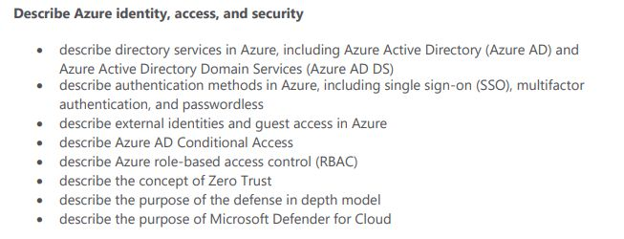

What is “Identity”?

In computing, “identity”

is a representation of a

person, application or

device





Examples of John Henry Doe johndoe@example.com

Identity Monthly Payroll Application

The laser printer at 6th Floor West

Usually requires a

password, a secret key or a

certificate to prove

Many applications require

you to log in to use some

of its functionality

How It’s Traditionally Handled

Client-Server Model

Client App

Server

Web Browser

Web Site

Mobile App

User ID , Password

DB

Traditionally, companies

have written their own

code to handle this

Some of the more famous

“hacks” have been on

custom created identity

systems





Hacks Some companies were storing the password in “plain text”

Some companies were using a simple, reversible hash

algorithm (MD5)

Some companies were storing the “salt” along with the

data

Not enforcing password change policies

Not enforcing password complexity policies

Azure provides an identity

management system based on

their popular

“Active Directory”

Azure Active Directory

(Azure AD or AAD)

Azure Active Directory

is not the same as

Active Directory

Traditional AD does not

work with Internet

protocols

Azure AD provides

“identity as a service”

Instead of having to write

code to handle users,

passwords, password reset

The AAD Model

Identity Provider

User ID , Password trust,

key

signed

token

Client App

Server

Browser

Web Server

Mobile App

signed

token

# SAML

OpenID

WS Federation



AZ-900 Microsoft Azure

Fundamentals

Scott Duffy, Instructor



© 2022 Scott Duffy, softwarearchitect.ca… get the course for these slides at:

http://sjd.ca/az900

Benefits of Azure AD

Security





Reduced development

time, easier support

More features

Centralized

administration

Only one user ID and

password

- Single Sign-On

Integration with other

Azure services



AZ-900 Microsoft Azure

Fundamentals

Scott Duffy, Instructor



© 2022 Scott Duffy, softwarearchitect.ca… get the course for these slides at:

http://sjd.ca/az900

The difference between

Authentication and Authorization

Authentication is a user

proving who they are - user id

and password

Authorization is ensuring that a

user is permitted to perform an

action

Move away from all

authenticated users

having admin access



AZ-900 Microsoft Azure

Fundamentals

Scott Duffy, Instructor



© 2022 Scott Duffy, softwarearchitect.ca… get the course for these slides at:

http://sjd.ca/az900

Azure Active Directory

Microsoft’s

preferred solution for

identity management

Azure AD Powers Azure Skype

Other Microsoft Outlook

Services OneDrive

Xbox

Office 365 - Teams, SharePoint, PowerBI, etc

Complete solution for

managing users, groups,

roles

Single-sign on

Synchronize with your

corporate AD



AZ-900 Microsoft Azure

Fundamentals

Scott Duffy, Instructor



© 2022 Scott Duffy, softwarearchitect.ca… get the course for these slides at:

http://sjd.ca/az900

Conditional Access

User A attempts to log in to

the app from within the

company office, as she

does every day

User B attempts to log in to

the app for the first time

in 4 months

Administrator C attempts

to log in to the app from

their phone

Administrator D attempts

to log in to the app from a

location 1200 miles from

the office

You can treat some access

attempts as “routine”,

and some as “not normal”

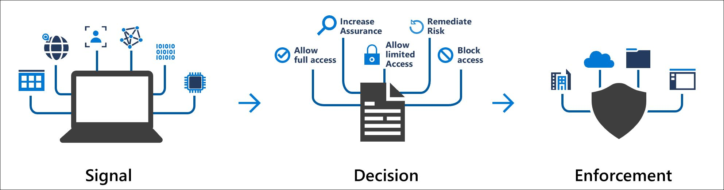



AZ-900 Microsoft Azure

Fundamentals

Scott Duffy, Instructor



© 2022 Scott Duffy, softwarearchitect.ca… get the course for these slides at:

http://sjd.ca/az900

Azure Multi-Factor Authentication

Require 2 or more pieces

of evidence (factors) in

order to log in

Three Factors Something you know - i.e password Something you have - i.e mobile phone, access to

email account

Something you are - i.e fingerprint

Your unique password

could be 1 piece of

evidence

But a second piece of

evidence is required - a

unique, time-limited code

sent to you

SMS, email, authenticator

app, phone call



AZ-900 Microsoft Azure

Fundamentals

Scott Duffy, Instructor



© 2022 Scott Duffy, softwarearchitect.ca… get the course for these slides at:

http://sjd.ca/az900

Role-Based Access Control (RBAC)

Microsoft’s preferred

solution for access control

Create roles that represent

the common tasks of the

job

Accountant

Developer

Business Lead

Assign granular

permissions to that role

Assign users to

that role

Do not assign granular

permissions to an

individual

Reader

Contributor

Owner



AZ-900 Microsoft Azure

Fundamentals

Scott Duffy, Instructor



© 2022 Scott Duffy, softwarearchitect.ca… get the course for these slides at:

http://sjd.ca/az900

Zero Trust Methodology

Don’t assume everything

behind the firewall is safe

Zero Trust ● Verify explicitly

Principles ● Use least privileged access

● Assume breach

Use every available

method to validate

identity and authorization

Just-in-time (JIT)

Just-enough-access (JEA)

Security even inside the

network; encryption,

segmentation, threat

detection

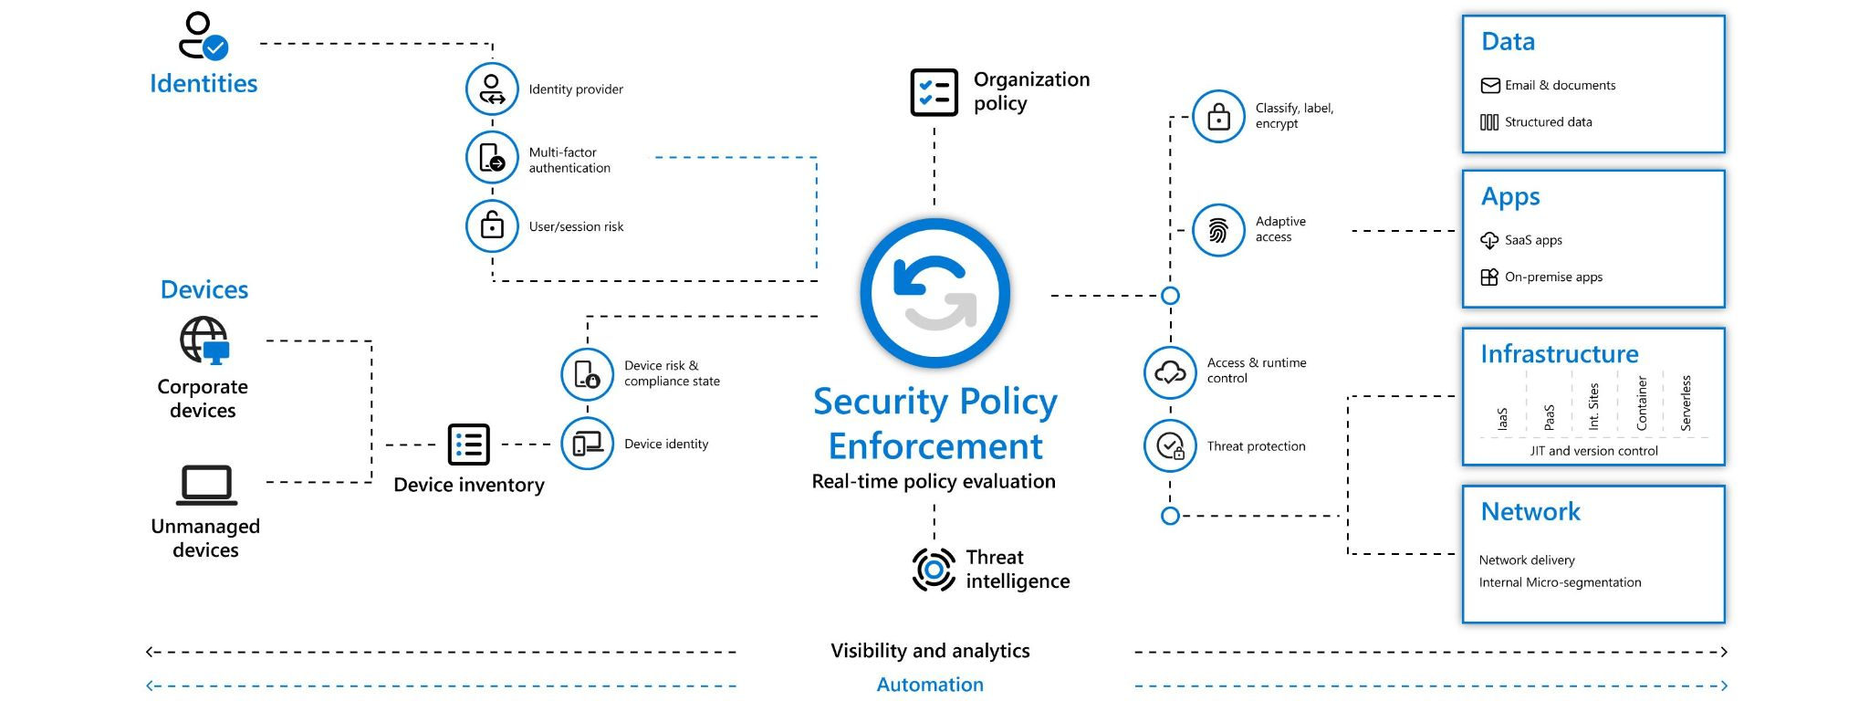

Identity: Verify and secure

each identity

Devices: ensure

compliance and health

status

Applications: appropriate

in-app permissions,

monitor user actions

Data: data-driven

protection, encrypt and

restrict access

Infrastructure: robust

monitoring to detect

attacks, block and flag

risky behavior

Network: encrypt all

communications



AZ-900 Microsoft Azure

Fundamentals

Scott Duffy, Instructor



© 2022 Scott Duffy, softwarearchitect.ca… get the course for these slides at:

http://sjd.ca/az900

Defense in Depth

Security Layers ● Data - i.e. virtual network endpoint ● Application - i.e. API Management

● Compute - i.e. Limit Remote Desktop access,

Windows Update

● Network - i.e. NSG, use of subnets, deny by

default

● Perimeter - i.e. DDoS, firewalls

● Identity & access - i.e. Azure AD

● Physical - i.e. Door locks and key cards

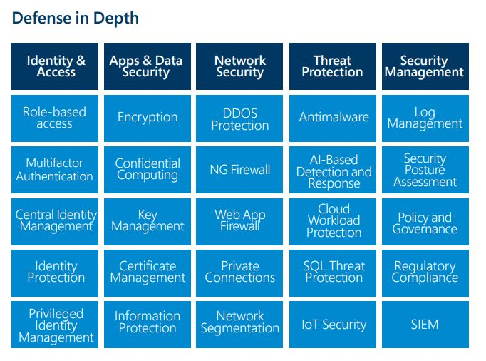



AZ-900 Microsoft Azure

Fundamentals

Scott Duffy, Instructor



© 2022 Scott Duffy, softwarearchitect.ca… get the course for these slides at:

http://sjd.ca/az900

Describe Azure management and

governance (30–35%)

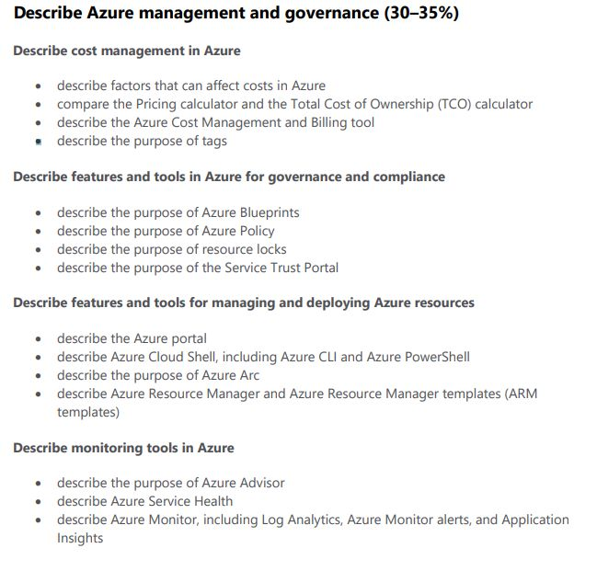

Factors affecting costs

Different services are

billed based on different

factors

Free services

Free services Resource groups Virtual network (up to 50)

Load balancer (basic)

Azure Active Directory (basic)

Network security groups

Free-tier web apps (up to 10)



Pay per usage

(consumption model)

Opportunity for Azure Functions: 1 million executions free per month ●

cost savings ● $0.20 per million executions

● Cheapest virtual machine is $20 per month

Pay per usage Functions Logic Apps

services Storage (pay per GB)

Outbound bandwidth

Cognitive Services API

Pay for time (per second)





Per second billing means

billing stops when the VM

is stopped *

Stability in pricing Pay a fixed price per month for computing power or storage capacity

Whether you use it or not

Discounts for 1-year or 3-year commitment in VM

(Reserved Instances)

Multi-tenant or isolated environment

Pay for bandwidth

First 5 GB is free

Inbound data is free

Bandwidth costs Outbound data, $0.05 to $0.0875 / GB for Zone 1 (NA and EU)

Outbound data, $0.08 to $0.12 / GB for Zone 2 (Asia,

Africa and Oceania)

Outbound data, $0.16 to $0.181 / GB for Zone 3

(Brazil)

(Availability zone pricing is different)

1 PB of data transfer =

$52,000

Pricing calculator

https://azure.microsoft.com/pricing/calculator/

Estimates are hard to

make 100% accurate

Configurable Region Tier

Options Subscription Type

Support Options

Dev/Test Pricing

Export and share the

estimate

Total Cost of Ownership (TCO)

calculator

The cost of a server is

more than just the cost of

the hardware

Other costs ● Electricity ● Cooling

● Internet connectivity

● Rack space

● Setup labor

● Maintenance labor

● Backup

https://azure.microsoft.com/pricing/tco/calculator/

Azure Cost Management

Another free tool inside

Azure to analyze spending

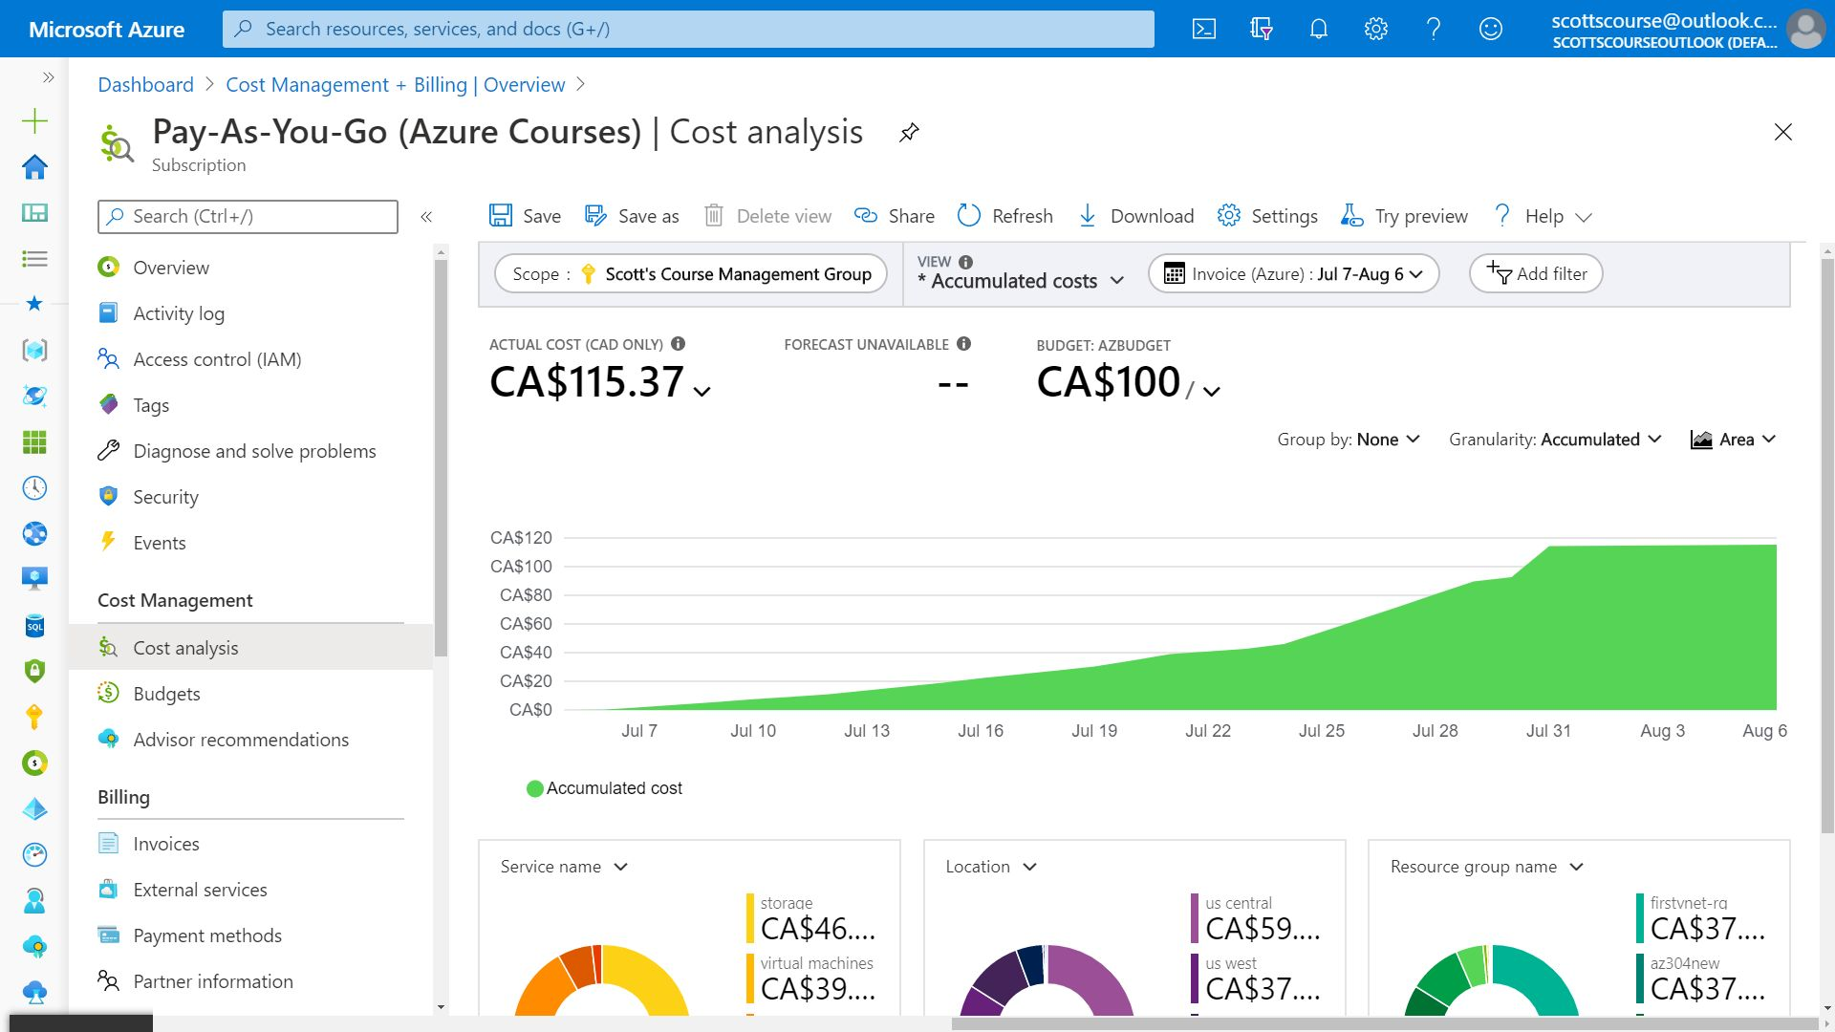

Analyze spending over

time





Tracking against budgets





All your past invoices

Schedule reports

Resource Tags

Can add metadata to Azure

resources





Helps with billing and

support issues



AZ-900 Microsoft Azure

Fundamentals

Scott Duffy, Instructor



© 2022 Scott Duffy, softwarearchitect.ca… get the course for these slides at:

http://sjd.ca/az900

Tools for Governance and

Compliance

The leaders are your

company might have

certain IT rules that they

want to implement

Example:

Always have daily backup

enabled on every server

Option 1) Send an email

with the rules and assume

everyone reads it and

remembers it

Option 2) Use Azure tools

to enforce the rules (or

simply audit compliance)

Several Tools in Azure Blueprints Azure Policy

Azure to Support Resource Locks

Governance and Service Trust Portal

Compliance

2020A

Azure Blueprints

Azure Subscription

templates with Roles and

Policies already defined

Azure Policy

Create rules across all of

your Azure resources

Evaluate compliance to

those rules





Examples of ● Require SQL Server 12.0 ● Allowed Storage Account SKUs

Built-In Policies ● Allowed Locations

● Allowed Virtual Machine SKUs

● Apply tag and its default value

● Not allowed resource types

Can create custom policies

using JSON definition

Locks

Read Only

Can Not Delete





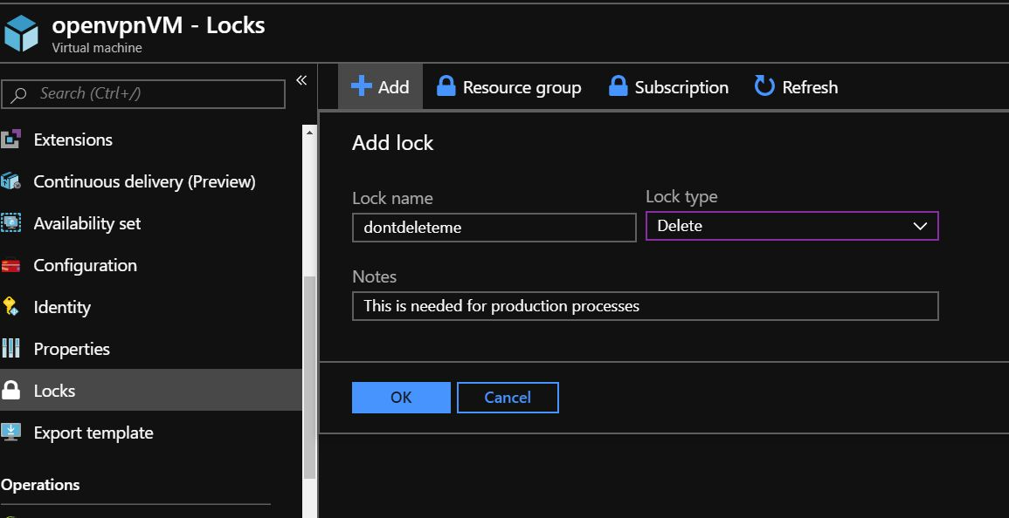

Using RBAC, you can

restrict who has access to

locks

Service Trust Portal

https://servicetrust.microsoft.com/

https://aka.ms/STP

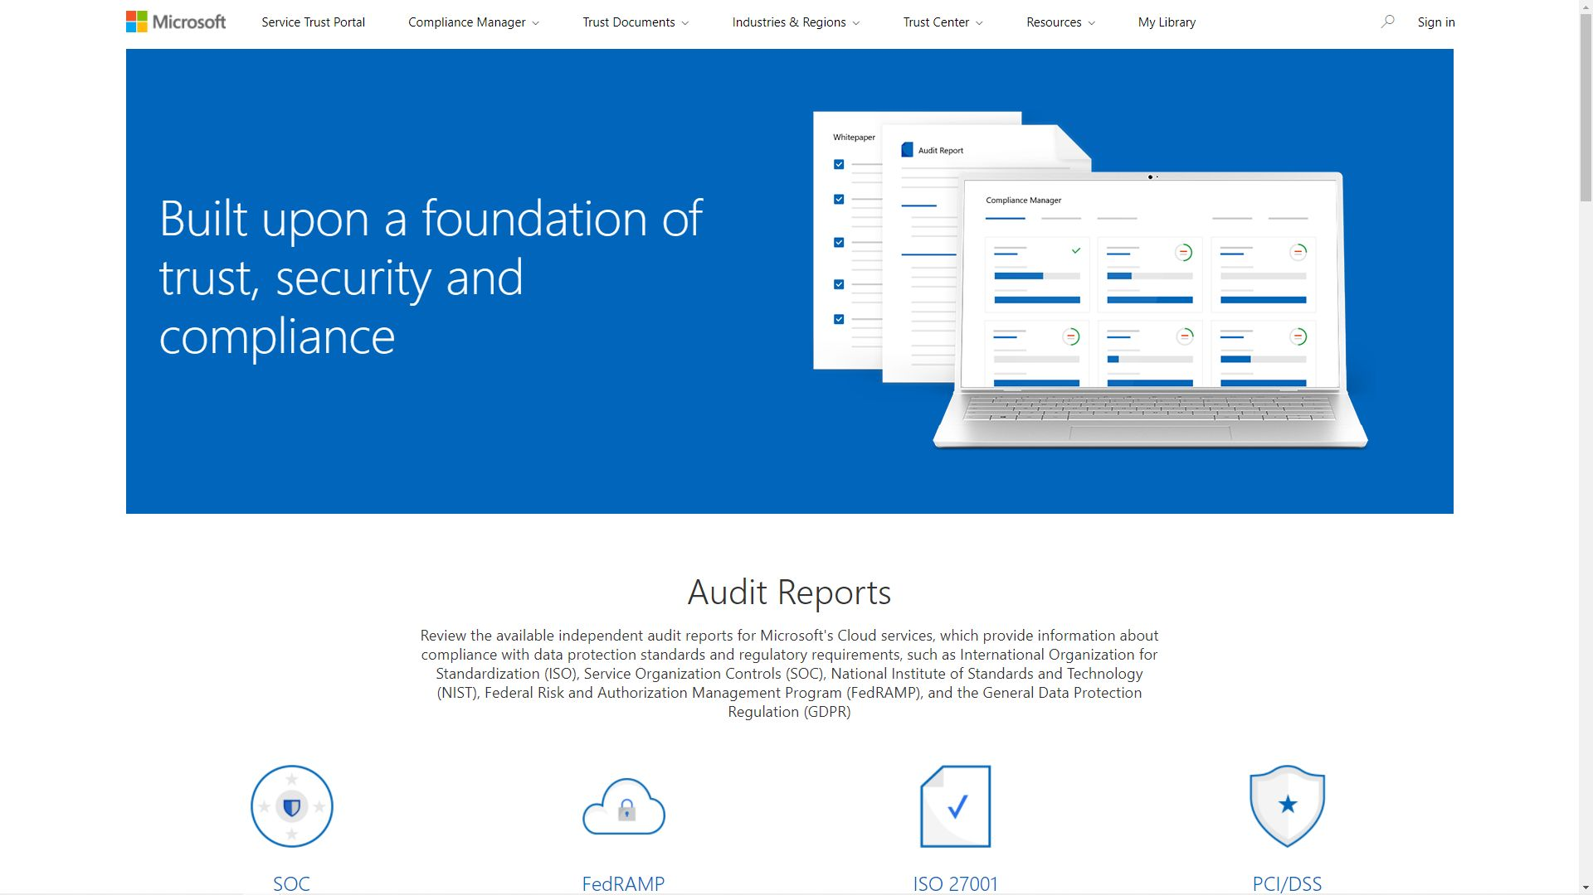

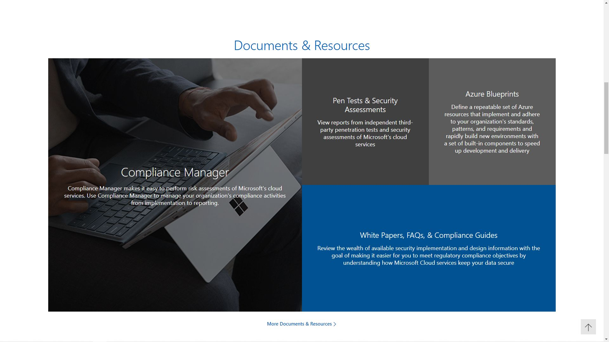



AZ-900 Microsoft Azure

Fundamentals

Scott Duffy, Instructor



© 2022 Scott Duffy, softwarearchitect.ca… get the course for these slides at:

http://sjd.ca/az900

2020A

Azure Tools Azure CLI PowerShell

Azure Portal

Azure Cloud Shell

Azure Mobile App





Azure Portal

PowerShell and CLI

Command Line

Azure Arc

A management tool that

works with your

non-Azure environments

Manage virtual machines,

Kubernetes clusters, and

databases as if they are

running in Azure.

ARM Templates

Azure Resource The deployment and management service for Azure Management layer that allows you to create, update,

Manager (ARM) and delete resources called “deployments”

All actions that you take to manage your Azure

resources goes through the ARM layer

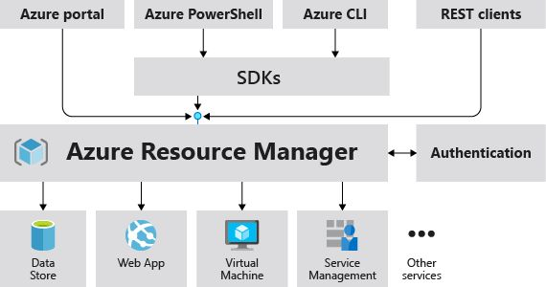

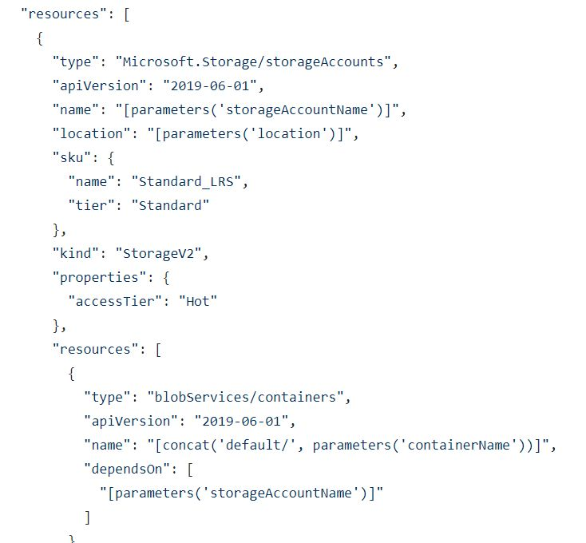





AZ-900 Microsoft Azure

Fundamentals

Scott Duffy, Instructor



© 2022 Scott Duffy, softwarearchitect.ca… get the course for these slides at:

http://sjd.ca/az900

Azure Advisor

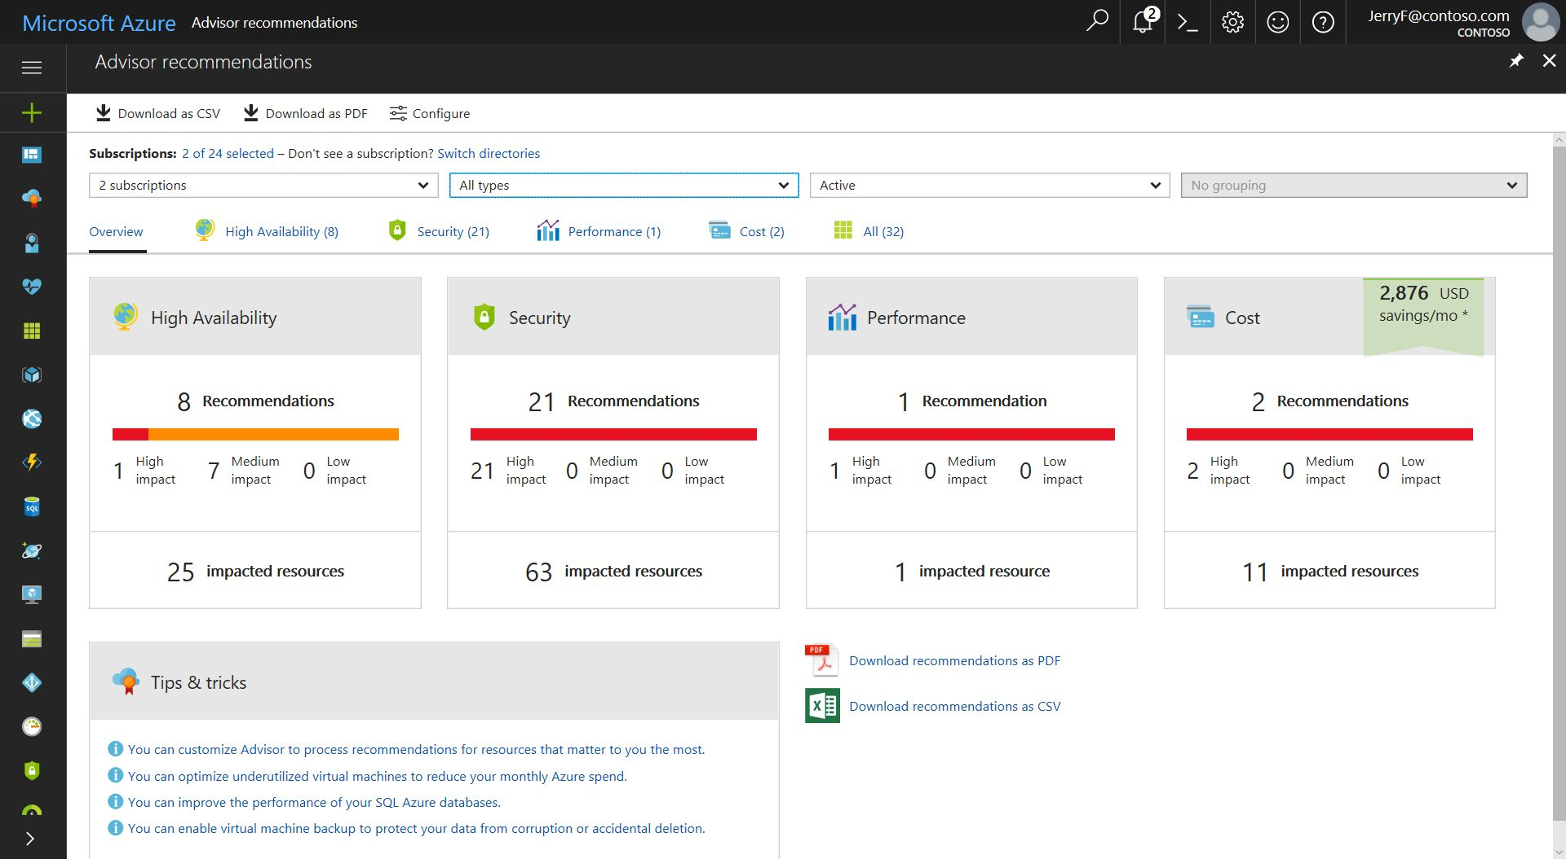

Azure Service Health

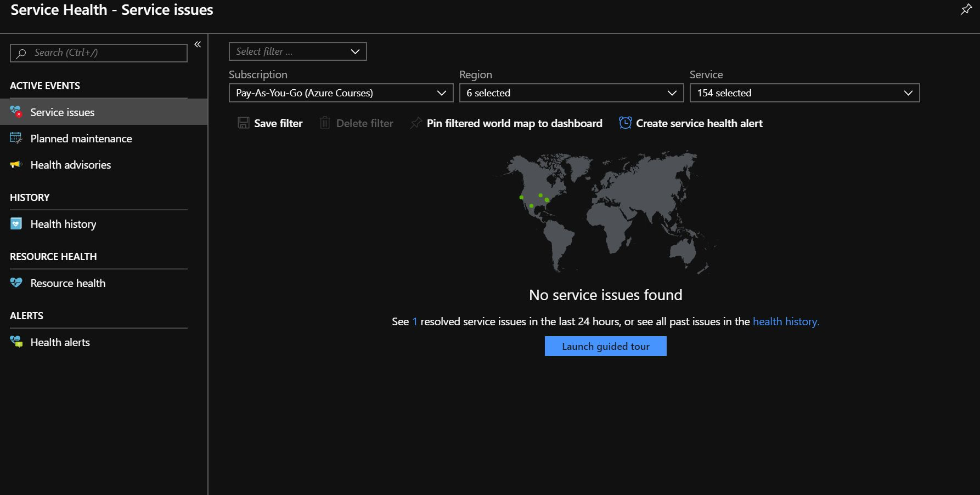

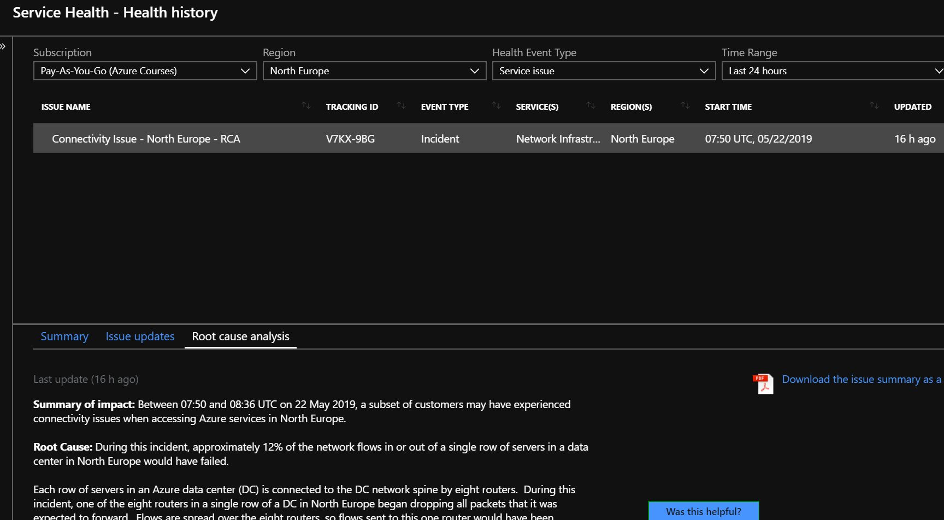

Azure Monitor

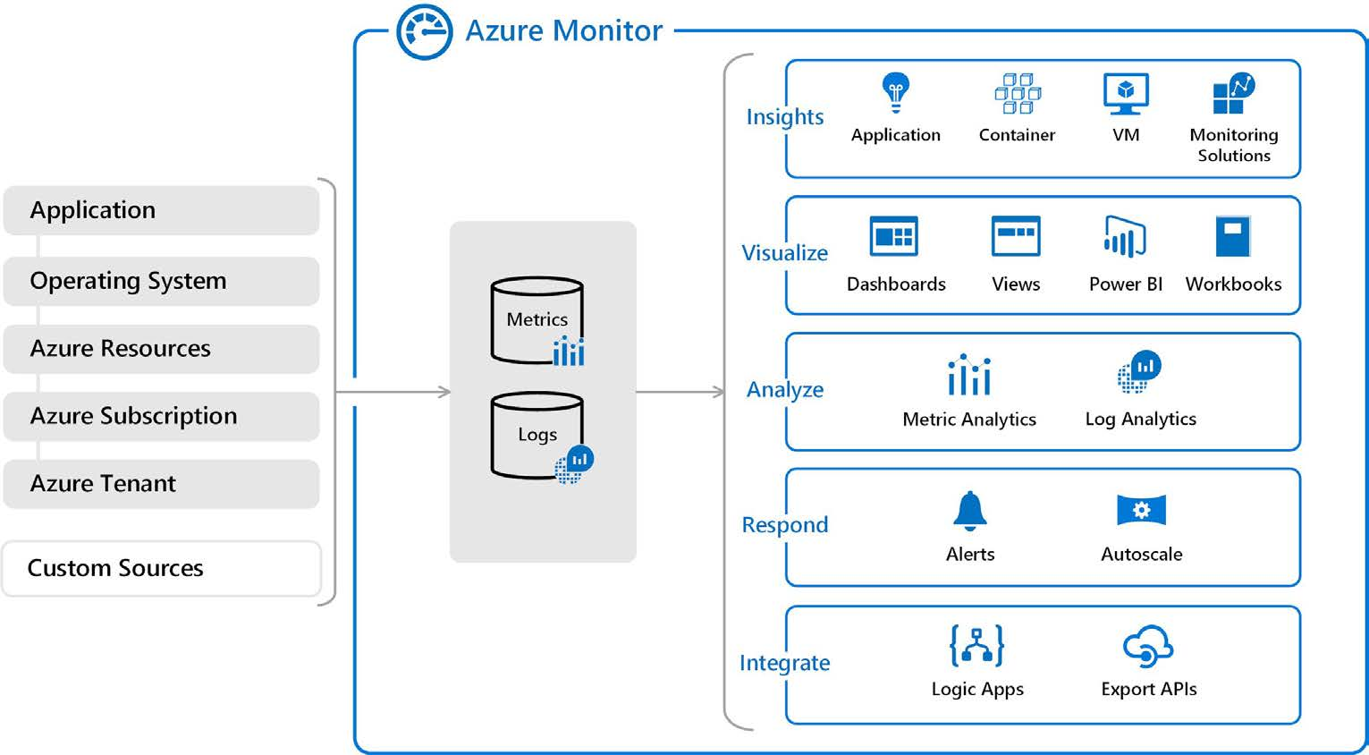



AZ-900 Microsoft Azure

Fundamentals

Scott Duffy, Instructor



© 2022 Scott Duffy, softwarearchitect.ca… get the course for these slides at:

http://sjd.ca/az900

Thank you and best of luck!



Grab Your Free

Resources Located at the end of the course:

● Free PDF Study Guide

● Download the slides and MP3 audio if you like to

study offline

● 50 question practice test

