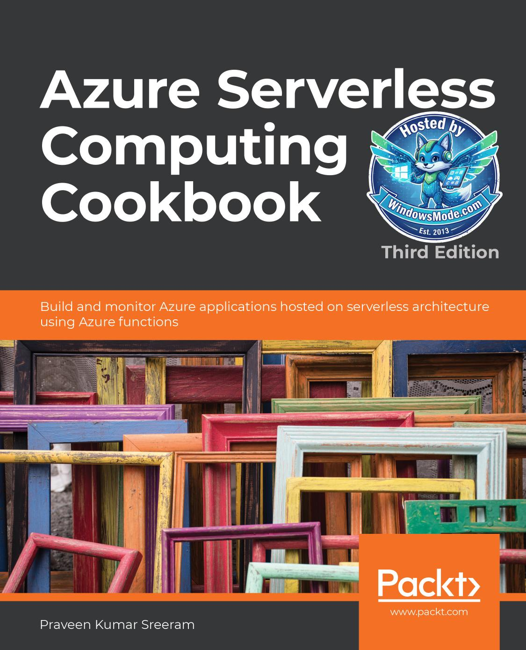

Table of Contents
Chapter 2: Working with notifications using
Chapter 3: Seamless integration of Azure Functions
Chapter 4: Developing Azure Functions using Visual Studio 111
Chapter 5: Exploring testing tools for Azure functions 145
Chapter 6: Troubleshooting and monitoring Azure Functions 183
Chapter 7: Developing reliable serverless applications
Chapter 8: Bulk import of data using Azure Durable
Chapter 9: Configuring security for Azure Functions 273
Chapter 10: Implementing best practices for Azure Functions 315
Chapter 11: Configuring serverless applications
Chapter 12: Implementing and deploying continuous
chapter don't match with what you see at https://dev.azure.com.
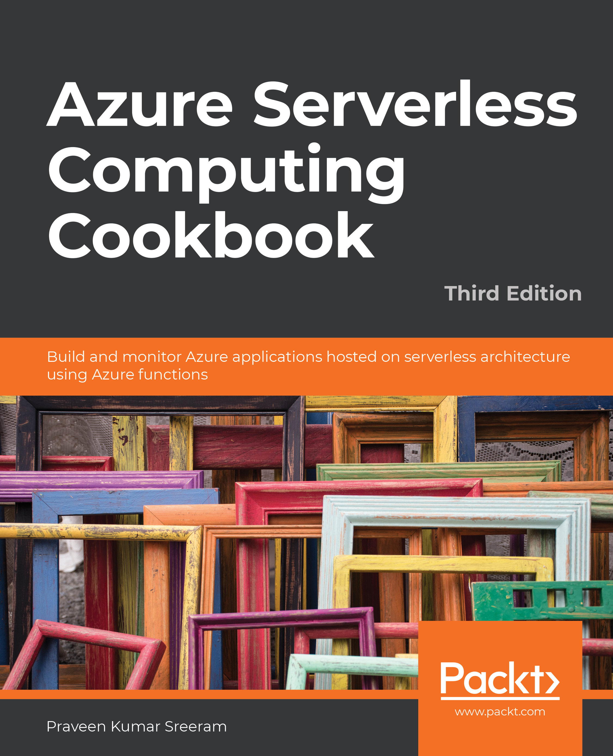

Azure Serverless

Computing Cookbook

Third Edition

Build and monitor Azure applications hosted on

serverless architecture using Azure functions

Praveen Kumar Sreeram

Azure Serverless Computing Cookbook, Third Edition
Copyright © 2020 Packt Publishing
All rights reserved. No part of this book may be reproduced, stored in a retrieval system, or transmitted in any form or by any means, without the prior written permission of the publisher, except in the case of brief quotations embedded in critical articles or reviews.
Every effort has been made in the preparation of this book to ensure the accuracy of the information presented. However, the information contained in this book is sold without warranty, either express or implied. Neither the author, nor Packt Publishing, and its dealers and distributors will be held liable for any damages caused or alleged to be caused directly or indirectly by this book.
Packt Publishing has endeavored to provide trademark information about all of the companies and products mentioned in this book by the appropriate use of capitals. However, Packt Publishing cannot guarantee the accuracy of this information.
Author: Praveen Kumar Sreeram
Technical Reviewers: Stefano Demiliani, Greg Leonardo, and Kasam Shaikh Managing Editor: Mamta Yadav
Acquisitions Editors: Rahul Hande and Suresh Jain Production Editor: Deepak Chavan
Editorial Board: Vishal Bodwani, Ben Renow-Clarke, Joanne Lovell, Arijit Sarkar, and Dominic Shakeshaft First Edition: August 2017
Second Edition: November 2018
Third Edition: May 2020
Production Reference: 1280520
ISBN: 978-1-80020-660-1
Published by Packt Publishing Ltd.
Livery Place, 35 Livery Street
Birmingham B3 2PB, UK
It would have not been possible to complete the book without the support of my best half,
my wife, Haritha, and my cute little angel, Rithwika Sreeram.
- Praveen Kumar Sreeram

function signUp( service ) {
if ( service.type === ‘Azure’&&
service.accountIsFree === true ){
return true;
}
}
signUp( Azure ); // true

Make your vision real. Get help with

Let’s go. Start experimenting with your project.
free cloud services. Talk to a Talk to a
Start free > Start free > sales specialist > sales specialist >
Table of Contents

Preface i

Chapter 1: Accelerating cloud app development
using Azure Functions 1
Introduction ............................................................................................................. 2
Building a back-end web API using HTTP triggers .............................................. 3
Getting ready .................................................................................................................. 3
How to do it… ................................................................................................................. 4
How it works… ................................................................................................................ 9
See also ........................................................................................................................... 9
Persisting employee details using Azure Table Storage output bindings ....... 9
Getting ready ................................................................................................................ 10
How to do it… ............................................................................................................... 10
How it works… .............................................................................................................. 13
Saving profile picture paths to queues using queue output bindings ........... 15
Getting ready ................................................................................................................ 15
How to do it… ............................................................................................................... 15
How it works… .............................................................................................................. 17
Storing images in Azure Blob Storage ................................................................ 17
Getting ready ................................................................................................................ 17
How to do it… ............................................................................................................... 18
How it works… .............................................................................................................. 20
There's more… .............................................................................................................. 20
Resizing an image using an ImageResizer trigger ............................................ 20

Getting ready ................................................................................................................ 21
How to do it… ............................................................................................................... 21
How it works… .............................................................................................................. 25

Chapter 2: Working with notifications using
the SendGrid and Twilio services 27
Introduction ........................................................................................................... 28
Sending an email notification using SendGrid service ..................................... 29
Getting ready ................................................................................................................ 29
Creating a SendGrid account API key from the Azure portal ................................. 29
Generating credentials and the API key from the SendGrid portal ...................... 31
Configuring the SendGrid API key with the Azure Function app ........................... 33
How to do it... ............................................................................................................... 33
Creating a storage queue binding to the HTTP trigger ........................................... 33
Creating a queue trigger to process the message of the HTTP trigger ................. 35
Creating a SendGrid output binding to the queue trigger ..................................... 36
How it works... .............................................................................................................. 38
Sending an email notification dynamically to the end user ............................ 39
Getting ready ................................................................................................................ 39
How to do it… ............................................................................................................... 39
Accepting the new email parameter in the RegisterUser function ....................... 39
Retrieving the UserProfile information in the SendNotifications trigger ............. 40
How it works... .............................................................................................................. 42
There's more... .............................................................................................................. 42
Implementing email logging in Azure Blob Storage ......................................... 43
How to do it... ............................................................................................................... 43
How it works… .............................................................................................................. 45
Modifying the email content to include an attachment .................................. 45

Getting ready ................................................................................................................ 46
How to do it... ............................................................................................................... 46
Customizing the log file name using the IBinder interface .................................... 46
Adding an attachment to the email ........................................................................... 47
Sending an SMS notification to the end user using the Twilio service .......... 48
Getting ready ................................................................................................................ 49
How to do it... ............................................................................................................... 51
How it works... .............................................................................................................. 53

Chapter 3: Seamless integration of Azure Functions
with Azure Services 55

Introduction ........................................................................................................... 56
Using Cognitive Services to locate faces in images .......................................... 56
Getting ready ................................................................................................................ 56
How to do it… ............................................................................................................... 58
There's more... .............................................................................................................. 64
Monitoring and sending notifications using Logic Apps .................................. 65
Getting ready ................................................................................................................ 66
How to do it... ............................................................................................................... 66
How it works... .............................................................................................................. 74
Integrating Logic Apps with serverless functions ............................................. 74
How to do it... ............................................................................................................... 75
There's more... .............................................................................................................. 79
Auditing Cosmos DB data using change feed triggers ..................................... 79
Getting ready ................................................................................................................ 80
How to do it... ............................................................................................................... 82
There's more... .............................................................................................................. 86
Integrating Azure Functions with Data Factory pipelines ............................... 87

Getting ready… ............................................................................................................. 88
How to do it... ............................................................................................................... 96

Chapter 4: Developing Azure Functions using Visual Studio 111
Introduction ......................................................................................................... 112
Creating a function application using Visual Studio 2019 ............................. 112
Getting ready ............................................................................................................. 113
How to do it… ............................................................................................................ 113
How it works… ........................................................................................................... 115
There's more… ........................................................................................................... 115
Debugging Azure Function hosted in Azure using Visual Studio .................. 115
Getting ready ............................................................................................................. 116
How to do it... ............................................................................................................ 116
How it works… ........................................................................................................... 120
There's more... ........................................................................................................... 120
Connecting to the Azure Storage from Visual Studio ..................................... 120
Getting ready ............................................................................................................. 121
How to do it... ............................................................................................................ 121
How it works… ........................................................................................................... 124
There's more… ........................................................................................................... 124
Deploying the Azure Function application using Visual Studio .................... 125
How to do it… ............................................................................................................ 125
There's more... ........................................................................................................... 128
Debugging Azure Function hosted in Azure using Visual Studio .................. 128
Getting ready ............................................................................................................. 129
How to do it… ............................................................................................................ 129
Deploying Azure Functions in a container ....................................................... 133

Getting ready ............................................................................................................. 133
Creating an ACR ........................................................................................................ 134
How to do it... ............................................................................................................ 135
Creating a Docker image for the function application ......................................... 136
Pushing the Docker image to the ACR ................................................................... 137
Creating a new function application with Docker ................................................ 139
How it works... ........................................................................................................... 143

Chapter 5: Exploring testing tools for Azure functions 145

Introduction ......................................................................................................... 146
Testing Azure functions ..................................................................................... 146
Getting ready ............................................................................................................. 146
How to do it… ............................................................................................................ 146
Testing HTTP triggers using Postman ..................................................................... 147
Testing a blob trigger using Storage Explorer ....................................................... 149
Testing a queue trigger using the Azure portal .................................................... 152
There's more… ........................................................................................................... 155
Testing an Azure function in a staging environment
using deployment slots ...................................................................................... 155
How to do it… ............................................................................................................ 156
There's more... ........................................................................................................... 161
Creating and testing Azure functions locally using Azure CLI tools ............. 163
Getting ready ............................................................................................................. 163
How to do it... ............................................................................................................ 163

Validating Azure function responsiveness using Application Insights ......... 166
Getting ready ............................................................................................................. 167
How to do it… ............................................................................................................ 168
How it works… ........................................................................................................... 177
There's more... ........................................................................................................... 177
Developing unit tests for Azure functions with HTTP triggers ...................... 177
Getting ready ............................................................................................................. 177
How to do it... ............................................................................................................ 178

Chapter 6: Troubleshooting and monitoring Azure Functions 183

Introduction ......................................................................................................... 184
Troubleshooting Azure Functions ..................................................................... 184
How to do it… ...................................................................................................... 184
Viewing real-time application logs .......................................................................... 185
Diagnosing the function app ................................................................................... 186
Integrating Azure Functions with Application Insights .................................. 188
Getting ready ............................................................................................................. 188
How to do it… ............................................................................................................ 188
How it works… ........................................................................................................... 190
There's more… ........................................................................................................... 191
Monitoring Azure Functions .............................................................................. 191
How to do it… ........................................................................................................... 191
How it works… ........................................................................................................... 193
Pushing custom metrics details to Application Insights Analytics ............... 194
Getting ready ............................................................................................................. 195
How to do it… ............................................................................................................ 195
Creating a timer trigger function using Visual Studio .......................................... 196
Configuring access keys ........................................................................................... 200
Integrating and testing an Application Insights query ......................................... 202

Configuring the custom-derived metric report ..................................................... 203
How it works… ........................................................................................................... 205
Sending application telemetry details via email ............................................. 205
Getting ready ............................................................................................................. 206
How to do it… ............................................................................................................ 206
How it works… ........................................................................................................... 212
Integrating Application Insights with Power BI using Azure Functions ....... 212
Getting ready ............................................................................................................. 214
How to do it... ............................................................................................................ 214
Configuring Power BI with a dashboard, a dataset, and the push URI .............. 214
Creating an Azure Application Insights real-time Power BI—C# function ......... 219
How it works… ........................................................................................................... 222
There's more… ........................................................................................................... 223

Chapter 7: Developing reliable serverless applications
using durable functions 225
Introduction ......................................................................................................... 226
Configuring durable functions in the Azure portal ........................................ 227
Getting ready ............................................................................................................. 227
How to do it… ............................................................................................................ 228
Creating a serverless workflow using durable functions ............................. 231
Getting ready ............................................................................................................. 231
How to do it... ............................................................................................................ 231
Creating the orchestrator function ........................................................................ 231
Creating an activity function ................................................................................... 233
How it works… ........................................................................................................... 234
There's more... ........................................................................................................... 234
Testing and troubleshooting durable functions ............................................ 234

Getting ready ............................................................................................................. 235
How to do it... ............................................................................................................ 235
Implementing reliable applications using durable functions ....................... 237
Getting ready ............................................................................................................. 237
How to do it... ............................................................................................................ 238
Creating the orchestrator function ........................................................................ 238
Creating a GetAllCustomers activity function ....................................................... 239
Creating a CreateBARCodeImagesPerCustomer activity function ..................... 240
How it works… ........................................................................................................... 242
There's more... ........................................................................................................... 243

Chapter 8: Bulk import of data using Azure Durable
Functions and Cosmos DB 245

Introduction ......................................................................................................... 246
Business problem ............................................................................................... 246
The durable serverless way of implementing CSV imports ........................... 247
Uploading employee data to blob storage ...................................................... 247
Getting ready ............................................................................................................. 248
How to do it... ............................................................................................................ 248
There's more… ........................................................................................................... 251
Creating a blob trigger ....................................................................................... 252
How to do it… ............................................................................................................ 252
There's more… ........................................................................................................... 255
Creating the durable orchestrator and triggering it for each CSV import ... 255
How to do it... ............................................................................................................ 255
How it works… ........................................................................................................... 259
There's more… ........................................................................................................... 259
Reading CSV data using activity functions ....................................................... 260

Getting ready ............................................................................................................. 260
How to do it... ............................................................................................................ 260
Reading data from blob storage ............................................................................. 260
Reading CSV data from the stream ........................................................................ 262
Creating the activity function .................................................................................. 263
There's more... ........................................................................................................... 265
Autoscaling Cosmos DB throughput ................................................................ 266
Getting ready ............................................................................................................. 267
How to do it... ............................................................................................................ 268
There's more... ........................................................................................................... 269
Bulk inserting data into Cosmos DB ................................................................. 269
How to do it... ............................................................................................................ 270
There's more… ........................................................................................................... 271

Chapter 9: Configuring security for Azure Functions 273

Introduction ......................................................................................................... 274
Enabling authorization for function apps ........................................................ 274
Getting ready ............................................................................................................. 274
How to do it… ............................................................................................................ 275
How it works… ........................................................................................................... 276
There's more… ........................................................................................................... 276
Controlling access to Azure Functions using function keys .......................... 276
How to do it… ............................................................................................................ 277
There's more... ........................................................................................................... 280
Securing Azure Functions using Azure Active Directory ................................ 281
Getting ready ............................................................................................................. 281
How to do it... ............................................................................................................ 281
Throttling Azure Functions using API Management ....................................... 292

Getting ready ............................................................................................................. 292
How to do it... ............................................................................................................ 294
How it works... ........................................................................................................... 299
Securely accessing an SQL database from Azure Functions
using Managed Identity ..................................................................................... 300
How to do it... ............................................................................................................ 300
Configuring additional security using IP whitelisting ..................................... 309
Getting ready… .......................................................................................................... 309
How to do it… ........................................................................................................... 310
There's more .............................................................................................................. 312

Chapter 10: Implementing best practices for Azure Functions 315

Introduction ......................................................................................................... 316
Adding multiple messages to a queue using
the IAsyncCollector function ............................................................................. 316
Getting ready ............................................................................................................. 317
How to do it... ............................................................................................................ 317
There's more... ........................................................................................................... 320
Implementing defensive applications using Azure functions
and queue triggers ............................................................................................. 320
Getting ready ............................................................................................................. 321
How to do it… ............................................................................................................ 321
Running tests using the CreateQueueMessage console application ................. 324
There's more… ........................................................................................................... 325
Avoiding cold starts by warming the app at regular intervals ...................... 325
Getting ready ............................................................................................................. 326
How to do it... ............................................................................................................ 326
Sharing code across Azure functions using class libraries ............................ 328

How to do it… ............................................................................................................ 328
There's more… ........................................................................................................... 331
Migrating C# console application to Azure functions using PowerShell ..... 332
Getting ready ............................................................................................................. 333
How to do it… ............................................................................................................ 333
Implementing feature flags in Azure functions using App Configuration ... 339
Getting ready ............................................................................................................. 340
How to do it… ............................................................................................................ 340

Chapter 11: Configuring serverless applications
in the production environment 353

Introduction ......................................................................................................... 354
Deploying Azure functions using the Run From Package feature ................ 354
Getting ready ............................................................................................................. 355
How to do it... ............................................................................................................ 356
How it works... ........................................................................................................... 358
Deploying Azure functions using ARM templates .......................................... 358
Getting ready ............................................................................................................. 358
How to do it… ............................................................................................................ 359
There's more… ........................................................................................................... 362
Configuring a custom domain for Azure functions ........................................ 362
Getting ready ............................................................................................................. 362
How to do it... ............................................................................................................ 363
Techniques to access application settings ...................................................... 368
Getting ready ............................................................................................................. 368
How to do it... ............................................................................................................ 368
Breaking down large APIs into smaller subsets using proxies ...................... 372

Getting ready ............................................................................................................. 373
How to do it... ............................................................................................................ 374
There's more... ........................................................................................................... 378
Moving configuration items from one environment to another .................. 378
Getting ready ............................................................................................................. 379
How to do it… ............................................................................................................ 380

Chapter 12: Implementing and deploying continuous
integration using Azure DevOps 385

Introduction ......................................................................................................... 386
Prerequisites ............................................................................................................. 387
Continuous integration—creating a build definition ..................................... 388
Getting ready ............................................................................................................. 388
How to do it… ............................................................................................................ 389
How it works... ........................................................................................................... 395
There's more… ........................................................................................................... 396
Continuous integration—queuing a build and triggering it manually ......... 396
Getting ready ............................................................................................................. 396
How to do it... ...................................................................................................... 397
Continuous integration—configuring and triggering
an automated build ............................................................................................ 399
How to do it… ............................................................................................................ 400
How it works… ........................................................................................................... 403
Continuous integration—executing unit test cases in the pipeline ............. 403
How to do it… ............................................................................................................ 403
There's more… ........................................................................................................... 406
Creating a release definition ............................................................................. 406

Getting ready ............................................................................................................. 406
How to do it… ............................................................................................................ 406
How it works… ........................................................................................................... 414
There's more… ........................................................................................................... 414
Triggering a release automatically ................................................................... 415
Getting ready ............................................................................................................. 415
How to do it… ............................................................................................................ 415
How it works… ........................................................................................................... 417
There's more… ........................................................................................................... 417
Integrating Azure Key Vault to configure application secrets ....................... 418
How to do it… ............................................................................................................ 418
How it works… ........................................................................................................... 427

Index 429

Preface

About
This section briefly introduces the author, the reviewers, the coverage of this cookbook, the
technical skills you'll need to get started, and the hardware and software requirements required
to complete all of the recipes.

ii | Preface

About Azure Serverless Computing Cookbook, Third Edition
This third edition of Azure Serverless Computing Cookbook guides you through the development of a basic back-end web API that performs simple operations, helping you understand how to persist data in Azure Storage services. You'll cover the integration of Azure Functions with other cloud services, such as notifications (SendGrid and Twilio), Cognitive Services (computer vision), and Logic Apps, to build simple workflow-based applications.
With the help of this book, you'll be able to leverage Visual Studio tools to develop, build, test, and deploy Azure functions quickly. It also covers a variety of tools and methods for testing the functionality of Azure functions locally in the developer's workstation and in the cloud environment. Once you're familiar with the core features, you'll explore advanced concepts such as durable functions, starting with a "hello world" example, and learn about the scalable bulk upload use case, which uses durable function patterns, function chaining, and fan-out/fan-in.
By the end of this Azure book, you'll have gained the knowledge and practical experience needed to be able to create and deploy Azure applications on serverless architectures efficiently.

About the author
Praveen Kumar Sreeram is an author, Microsoft Certified Trainer, and certified Azure Solutions Architect. He has over 15 years of experience in the field of development, analysis, design, and the delivery of applications of various technologies. His projects range from custom web development using ASP.NET and MVC to building mobile apps using the cross-platform Xamarin technology for domains such as insurance, telecom, and wireless expense management. He has been given the Most Valuable Professional award twice by one of the leading social community websites, CSharpCorner, for his contributions to the Microsoft Azure community through his articles. Praveen is highly focused on learning about technology, and blogs about his learning regularly. You can also follow him on Twitter at @PrawinSreeram. Currently, his focus is on analyzing business problems and providing technical solutions for various projects related to Microsoft Azure and .NET Core.
First of all, my thanks go to the Packt Publishing team, including Mamta Yadav, Arijit Sarkar, and Rahul Hande.
I would also like to express my deepest gratitude to A. Janardhan Setty, A. Vara Lakshmi and their family for all the support.
Thanks to Vijay Raavi, Ashis Nayak, and Manikanta Arrepu for their support in technical aspects.
About Azure Serverless Computing Cookbook, Third Edition | iii

About the reviewers
Stefano Demiliani is a Microsoft MVP in Business Applications, a Microsoft Certified DevOps Engineer and Azure Architect, and a long-time expert on Microsoft technologies. He works as a CTO for EID NAVLAB and his main activities are architecting solutions with Azure and Dynamics 365 ERP. He's the author of many IT books for Packt and a speaker on international conferences about Azure and Dynamics 365. You can reach him on Twitter or on LinkedIn.
Greg Leonardo is a veteran, father, developer, architect, teacher, speaker, and early adopter. He is currently a cloud architect helping organizations with cloud adoption and innovation. He has been working in the IT industry since his time in the military. He has worked in many facets of IT throughout his career. He is the president of TampaDev, a community meetup that runs #TampaCC, Azure User Group, Azure Medics, and various technology events throughout Tampa.
Kasam Shaikh, a Microsoft Certified Cloud Advocate, is a seasoned professional with a "can-do" attitude, having 13 years of demonstrated industry experience working as a cloud architect with one of the leading IT companies in Mumbai, India. He is the author of two best-selling books on Microsoft Azure and AI. He is also recognized as an MVP by a leading online community, C# Corner, and is also a global AzureAI speaker. He presents his tech-dose at KasamShaikh.com. He is the founder of DearAzure | Azure INDIA (AZ-INDIA) community—the fastest growing online community for learning Microsoft Azure.

Learning objectives
By the end of this book, you will be able to:
• Implement the continuous integration and continuous deployment (CI/CD) of
Azure functions.
• Develop different event-based handlers in a serverless architecture.
• Integrate Azure functions with different Azure services to develop enterprise-level
applications.
• Accelerate your cloud application development using Azure function triggers and
bindings.
• Automate mundane tasks at various levels, from development to deployment and
maintenance.
• Develop stateful serverless applications and self-healing jobs using durable
functions.
iv | Preface

Audience
If you are a cloud developer or architect who wants to build cloud-native systems and deploy serverless applications with Azure functions, this book is for you. Prior experience with Microsoft Azure core services will help you to make the most of this book.

Approach
This cookbook covers every aspect of serverless computing with Azure with a perfect blend of theory, hands-on coding, and helpful recipes. It contains several examples that use real-life business scenarios for you to practice and apply your new skills in a highly relevant context.

Hardware and software requirements
For an optimal learning experience, we recommend the following configuration:
• Visual Studio 2019
• Storage Explorer
• Azure Functions Core Tools (formerly Azure CLI Tools)
• Processor: Intel Core i5 or equivalent
• Memory: 4 GB RAM (8 GB preferred)
• Storage: 35 GB available space

Conventions
Code words in the text, database table names, folder names, filenames, file extensions, pathnames, dummy URLs, user input, and Twitter handles are shown as follows:
"In this BlobTriggerCSharp class, the Run method has the WebJobs attribute with a connection string (in this case, it is AzureWebJobsStorage)."
Here's a sample block of code:
Install-Package Microsoft.Azure.Services.AppAuthentication On many occasions, we have used angled brackets, <>. You need to replace these with the actual parameter, and not use these brackets within the commands.
About Azure Serverless Computing Cookbook, Third Edition | v

Download resources
The code bundle for this book is also hosted on GitHub at https://github.com/
PacktPublishing/Azure-Serverless-Computing-Cookbook-Third-Edition. You can find the YAML and other files used in this book, which are referred to at relevant instances.
We also have other code bundles from our rich catalog of books and videos available at
https://github.com/PacktPublishing/. Check them out!

Accelerating cloud

app development

using Azure Functions

In this chapter, we'll cover the following recipes:
• Building a back-end web API using HTTP triggers
• Persisting employee details using Azure Table storage output bindings
• Saving profile picture paths to queues using queue output bindings
• Storing images in Azure Blob Storage
• Resizing an image using an ImageResizer trigger

2 | Accelerating cloud app development using Azure Functions

Introduction
Every software application requires back-end components that are responsible for taking care of the business logic and storing data in some kind of storage, such as databases and filesystems. Each of these back-end components can be developed using different technologies. Azure serverless technology allows us to develop these back-end APIs using Azure Functions.
Azure Functions provides many out-of-the-box templates that solve most common problems, such as connecting to storage and building web APIs. In this chapter, you'll learn how to use these built-in templates. Along with learning about concepts related to Azure serverless computing, we'll also implement a solution to the basic problem domain of creating the components required for an organization to manage internal employee information.
Figure 1.1 highlights the key processes that you will learn about in this chapter:
2
Azure Table Storage

User / API 1 Register User
(HTTP Trigger)

Azure Queue Storage
3
4
6 5
ResizeProfilePictures Azure Blob Storage CreateProfilePictures

7

Azure Blob Storage

Figure 1.1: The key processes
Building a back-end web API using HTTP triggers | 3

Let's go through a step-by-step explanation of the figure to get a better understanding:
1. Client call to the API.
2. Persist employee details using Azure Table Storage.
3. Save profile picture links to queues.
4. Invoke a queue trigger as soon as a message is created.
5. Create the blobs in Azure Blob Storage.
6. Invoke the blob trigger as soon as a blob is created.
7. Resize the image and store it in Azure Blob Storage.

We'll leverage Azure Functions' built-in templates using HTTP triggers, with the goal of resizing and storing images in Azure Blob Storage.

Building a back-end web API using HTTP triggers
In this recipe, we'll use Azure's serverless architecture to build a web API using HTTP triggers. These HTTP triggers could be consumed by any front-end application that is capable of making HTTP calls.

Getting ready
Let's start our journey of understanding Azure serverless computing using Azure Functions by creating a basic back-end web API that responds to HTTP requests:
• Refer to https://azure.microsoft.com/free/ to see how to create a free Azure
account.
• Visit https://docs.microsoft.com/azure/azure-functions/functions-create-
function-app-portal to learn about the step-by-step process of creating a function
application, and https://docs.microsoft.com/azure/azure-functions/functions-
create-first-azure-function to learn how to create a function. While creating a
function, a storage account is also created to store all the files.
• Learn more about Azure Functions at https://azure.microsoft.com/services/
functions/.

Note
Remember the name of the storage account, as it will be used later in other chapters.
4 | Accelerating cloud app development using Azure Functions

• Once the function application is created, please familiarize yourself with the basic
concepts of triggers and bindings, which are at the core of how Azure Functions
works. I highly recommend referring to https://docs.microsoft.com/azure/azure-
functions/functions-triggers-bindings before proceeding.

Note
We'll be using C# as the programming language throughout the book. Most of the functions are developed using the Azure Functions V3 runtime. However, as of the time of writing, a few recipes were not supported in the V3 runtime. Hopefully, soon after the publication of this book, Microsoft will have made those features available for the V3 runtime as well.

How to do it…
Perform the following steps to build a web API using HTTP triggers:
1. Navigate to the Function App listing page by clicking on the Function Apps menu,
which is available on the left-hand side.
2. Create a new function by clicking on the + icon:
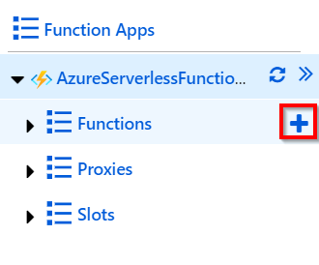

Figure 1.2: Adding a new function
Building a back-end web API using HTTP triggers | 5

3. You'll see the Azure Functions for .NET - getting started page, which prompts
you to choose the type of tools based on your preference. For the initial few
chapters, we'll use the In-portal option, which can quickly create Azure Functions
right from the portal without making use of any tools. However, in the coming
chapters, we'll make use of Visual Studio and Azure Functions Core Tools to create
these functions:
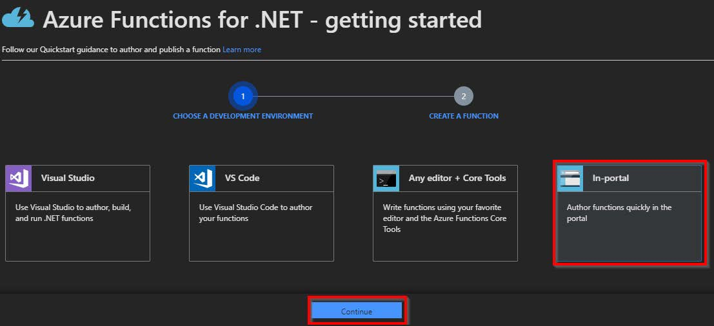

Figure 1.3: Choosing the development environment
4. In the next step, select More templates… and click on Finish and view templates,
as shown in Figure 1.4:
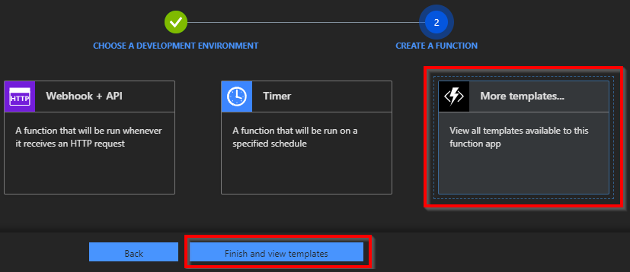

Figure 1.4: Choosing More templates… and clicking Finish and view templates 6 | Accelerating cloud app development using Azure Functions

5. In the Choose a template below or go to the quickstart section, choose HTTP
trigger to create a new HTTP trigger function:
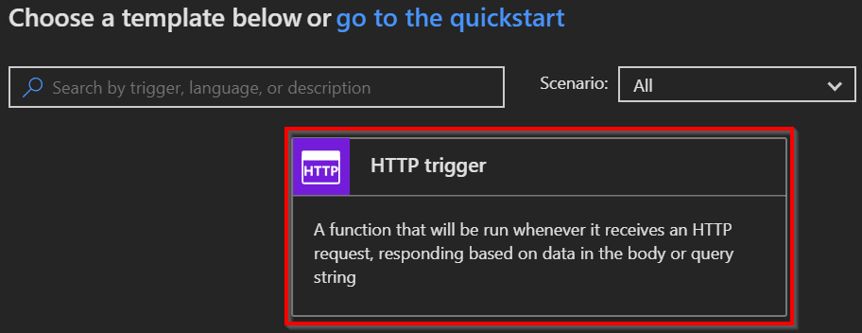

Figure 1.5: The HTTP trigger template
6. Provide a meaningful name. For this example, I have used RegisterUser as the
name of the Azure function.
7. In the Authorization level drop-down menu, choose the Anonymous option. You'll
learn more about all the authorization levels in Chapter 9, Configuring security for Azure Functions:
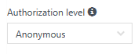

Figure 1.6: Selecting the authorization level
8. Click on the Create button to create the HTTP trigger function.
9. Along with the function, all the required code and configuration files will be
created automatically and the run.csx file with editable code will get opened. Remove the default code and replace it with the following code. In the following example, we'll add two parameters (firstname and lastname), which will be displayed in the output as a result of triggering the HTTP trigger:
Building a back-end web API using HTTP triggers | 7

#r "Newtonsoft.Json" using System.Net;
using Microsoft.AspNetCore.Mvc;
using Microsoft.Extensions.Primitives; using Newtonsoft.Json;

public static async Task Run(
HttpRequest req, ILogger log)
#r "Newtonsoft.Json"
using System.Net;
using Microsoft.AspNetCore.Mvc;
using Microsoft.Extensions.Primitives;
using Newtonsoft.Json;

public static async Task Run(HttpRequest req, ILogger log) {
log.LogInformation("C# HTTP trigger function processed a request.");
string firstname=null,lastname = null;
string requestBody = await new
StreamReader(req.Body).ReadToEndAsync();

dynamic inputJson = JsonConvert.DeserializeObject(requestBody); firstname = firstname ?? inputJson?.firstname; lastname = inputJson?.lastname;

return (lastname + firstname) != null
? (ActionResult)new OkObjectResult($"Hello, {firstname + " " + lastname}")
: new BadRequestObjectResult("Please pass a name on the query" + "string or in the request body");
}

10. Save the changes by clicking on the Save button available just above the code
editor.
11. Let's try testing the RegisterUser function using the test console. Click on the Test
tab to open the test console:
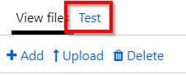

Figure 1.7: Testing the HTTP trigger 8 | Accelerating cloud app development using Azure Functions

12. Enter the values for firstname and lastname in the Request body section:
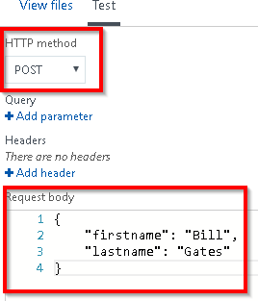

Figure 1.8: Testing the HTTP trigger with input data
13. Make sure that you select POST in the HTTP method drop-down box.
14. After reviewing the input parameters, click on the Run button available at the
bottom of the test console:
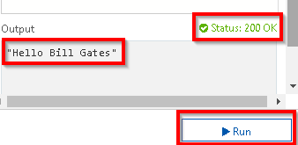

Figure 1.9: HTTP trigger execution and output
15. If the input request workload is passed correctly with all the required parameters,
you'll see Status: 200 OK, and the output in the output window will be as shown in Figure 1.9.
16. Let's discuss how it works next.
Persisting employee details using Azure Table Storage output bindings | 9

How it works…
You have created your first Azure function using HTTP triggers and have made a few modifications to the default code. The code accepts the firstname and lastname parameters and prints the name of the end user with a Hello {firstname} {lastname} message as a response. You also learned how to test the HTTP trigger function right from the Azure Management portal.

Note
For the sake of simplicity, validation of the input parameters is not executed in this exercise. Be sure to validate all input parameters in applications running in a production environment.

See also
• The Enabling authorization for function apps recipe in Chapter 9, Configuring
security for Azure Functions.
In the next recipe, you'll learn about persisting employee details.

Persisting employee details using Azure Table Storage output
bindings
In the previous recipe, you created an HTTP trigger and accepted input parameters. Now, let's learn how to store input data in a persistent medium. Azure Functions supports many ways to store data. For this example, we'll store data in Azure Table storage, a NoSQL key-value persistent medium for storing semi-structured data. Learn more about it at https://azure.microsoft.com/services/storage/tables/.
The primary key of an Azure Table storage table has two parts:
• Partition key: Azure Table storage records are classified and organized into
partitions. Each record located in a partition will have the same partition key (p1 in
our example).
• Row key: A unique value should be assigned to each row.
10 | Accelerating cloud app development using Azure Functions

Getting ready
This recipe showcases the ease of integrating an HTTP trigger and the Azure Table storage service using output bindings. The Azure HTTP trigger function receives data from multiple sources and stores user profile data in a storage table named tblUserProfile. We'll follow the prerequisites listed here:
• For this recipe, we'll make use of the HTTP trigger that was created in the previous
recipe.
• We'll also be using Azure Storage Explorer, a tool that helps us to work with data
stored in an Azure storage account. Download it from http://storageexplorer.
com/.
• Learn more about how to connect to a storage account using Azure Storage
Explorer at https://docs.microsoft.com/azure/vs-azure-tools-storage-manage-
with-storage-explorer.
• Learn more about output bindings at https://docs.microsoft.com/azure/azure-
functions/functions-triggers-bindings.

Let's get started.

How to do it…
Perform the following steps:
1. Navigate to the Integrate tab of the RegisterUser HTTP trigger function.
2. Click on the New Output button, select Azure Table Storage, and then click on the
Select button:
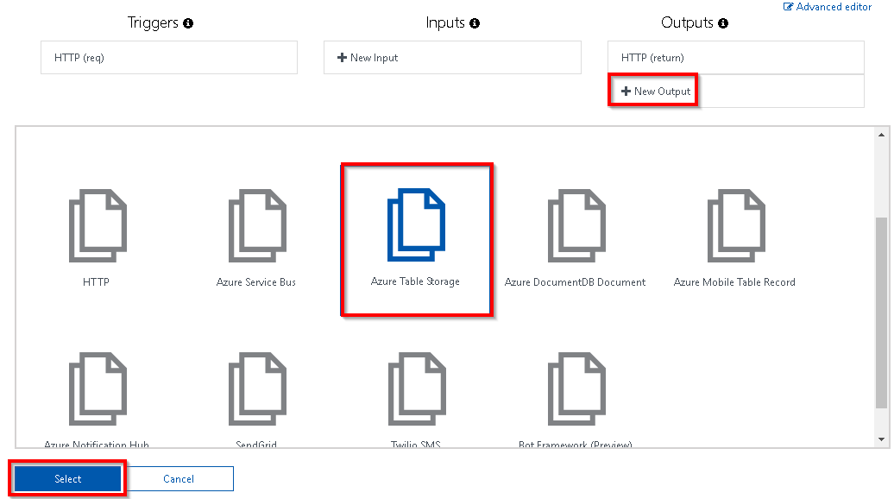

Figure 1.10: New output bindings
Persisting employee details using Azure Table Storage output bindings | 11

3. If you are prompted to install the bindings, click on Install; this will take a few
minutes. Once the bindings are installed, choose the following settings for the
Azure Table Storage output bindings:
Table parameter name: This is the name of the parameter that will be used in the
Run method of the Azure function. For this example, provide objUserProfileTable
as the value.
Table name: A new table in Azure Table storage will be created to persist the data.
If the table doesn't exist already, Azure will automatically create one for you! For
this example, provide tblUserProfile as the table name.
Storage account connection: If the Storage account connection string is not
displayed, click on new (as shown in Figure 1.11) to create a new one or to choose
an existing storage account.
The Azure Table storage output bindings should be as shown in Figure 1.11:
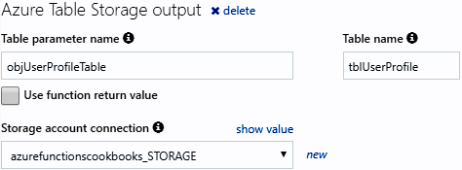

Figure 1.11: Azure Table Storage output bindings settings
4. Click on Save to save the changes.
5. Navigate to the code editor by clicking on the function name.

Note
The following are the initial lines of the code for this recipe:

#r "Newtonsoft.json"

#r "Microsoft.WindowsAzure.Storage"

The preceding lines of code instruct the function runtime to include a reference to the specified library.
12 | Accelerating cloud app development using Azure Functions

Paste the following code into the editor. The code will accept the input passed by the end user and save it in Table storage; click Save:
#r "Newtonsoft.Json"
# r "Microsoft.WindowsAzure.Storage"
using System.Net;
using Microsoft.AspNetCore.Mvc;
using Microsoft.Extensions.Primitives;
using Newtonsoft.Json;
using Microsoft.WindowsAzure.Storage.Table;
public static async Task Run( HttpRequest req,
CloudTable objUserProfileTable,
ILogger log)
{
log.LogInformation("C# HTTP trigger function processed a request.");
string firstname=null,lastname = null;
string requestBody = await new
StreamReader(req.Body).ReadToEndAsync();
dynamic inputJson = JsonConvert.DeserializeObject(requestBody); firstname = firstname ?? inputJson?.firstname; lastname = inputJson?.lastname;
UserProfile objUserProfile = new UserProfile(firstname, lastname);
TableOperation objTblOperationInsert =
TableOperation.Insert(objUserProfile);
await objUserProfileTable.ExecuteAsync(objTblOperationInsert);
return (lastname + firstname) != null
? (ActionResult)new OkObjectResult($"Hello, {firstname + " " + lastname}")
: new BadRequestObjectResult("Please pass a name on the query" + "string or in the request body");
}
class UserProfile : TableEntity
{
public UserProfile(string firstName,string lastName)
{
this.PartitionKey = "p1";
this.RowKey = Guid.NewGuid().ToString();
this.FirstName = firstName;
this. LastName = lastName;
Persisting employee details using Azure Table Storage output bindings | 13

}
UserProfile() { }
public string FirstName { get; set; }
public string LastName { get; set; }
}

6. Execute the function by clicking on the Run button of the Test tab by passing the
firstname and lastname parameters to the Request body.
7. If there are no errors, you'll get a Status: 200 OK message as the output. Navigate
to Azure Storage Explorer and view the Table storage to see whether a table
named tblUserProfile was created successfully:
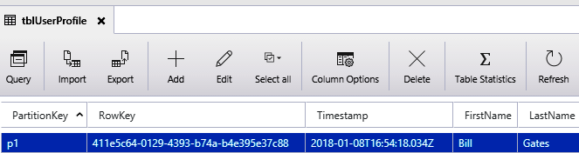

Figure 1.12: Viewing data in Storage Explorer

How it works…
Azure Functions allows us to easily integrate with other Azure services just by adding an output binding to a trigger. In this example, we have integrated an HTTP trigger with the Azure Table storage binding. We also configured an Azure storage account by providing a storage connection string and the Azure Table storage in which we would like to create a record for each of the HTTP requests received by the HTTP trigger.
We have also added an additional parameter to handle the Table storage, named objUserProfileTable, of the CloudTable type, to the Run method. We can perform all the operations on Azure Table storage using objUserProfileTable.

Note
The input parameters are not validated in the code sample. However, in a production environment, it's important to validate them before storing them in any kind of persistent medium.
14 | Accelerating cloud app development using Azure Functions

We also created a UserProfile object and filled it with the values received in the request object, and then passed it to the table operation.

Note
Learn more about handling operations on the Azure Table storage service at
https://docs.microsoft.com/azure/cosmos-db/tutorial-develop-table-dotnet.

Understanding storage connections
When you create a new storage connection (refer to step 3 of the How to do it... section of this recipe), a new App settings application will be created:
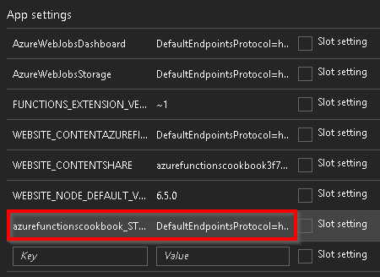

Figure 1.13: Application settings in the configuration blade
Navigate to App settings by clicking on the Configuration menu available in the General Settings section of the Platform features tab:
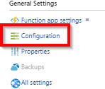

Figure 1.14: Configuration blade
You learned how to save data quickly using Azure Table storage bindings. In the next recipe, you'll learn how to save profile picture paths to queues.
Saving profile picture paths to queues using queue output bindings | 15

Saving profile picture paths to queues using queue output
bindings
The previous recipe highlighted how to receive two string parameters, firstname and lastname, in the Request body and store them in Azure Table storage. In this recipe, let's add a new parameter named ProfilePicUrl for the profile picture of the user that is publicly accessible via the internet. In this recipe (and the next), you'll learn about the process of extracting the URL of an image and saving it in the blob container of an Azure storage account.
While the ProfilePicUrl input parameter can be used to download the picture from the internet, in the previous recipe, Persisting employee details using Azure Table storage output bindings, this was not feasible due to the time required to process the large size of the image, which might hinder the performance of the overall application. For this reason, it is faster to grab the URL of the profile picture and store it in a queue, which can be processed later before storing it in the blob.

Getting ready
We'll be updating the code of the RegisterUser function that was used in the previous recipes.

How to do it…
Perform the following steps:
1. Navigate to the Integrate tab of the RegisterUser HTTP trigger function.
2. Click on the New Output button, select Azure Queue Storage, and then click on
the Select button.
3. Provide the following parameters in the Azure Queue Storage output settings:
Message parameter name: Set the name of the parameter to
objUserProfileQueueItem, which will be used in the Run method.
Queue name: Set the queue name to userprofileimagesqueue.
Storage account connection: It is important to select the right storage account in
the Storage account connection field.
4. Click on Save to create the new output binding.

16 | Accelerating cloud app development using Azure Functions

5. Navigate back to the code editor by clicking on the function name (RegisterUser
in this example) or the run.csx file and make the changes shown in the following code:
public static async Task Run( HttpRequest req, CloudTable objUserProfileTable, IAsyncCollector public static async Task Run(
HttpRequest req,
CloudTable objUserProfileTable,
IAsyncCollector<string> objUserProfileQueueItem,
ILogger log)
{....
string firstname= inputJson.firstname;
string profilePicUrl = inputJson.ProfilePicUrl; await objUserProfileQueueItem.AddAsync(profilePicUrl);
....
objUserProfileTable.Execute(objTblOperationInsert);
}
6. In the preceding code, you have added queue output bindings by adding the
IAsyncCollecter parameter to the Run method and just passing the required message to the AddAsync method. The output bindings will take care of saving ProfilePicUrl to the queue. Now, click on Save to save the code changes in the code editor of the run.csx file.
7. Let's test the code by adding another parameter, ProfilePicUrl, to the Request
body and then clicking on the Run button in the Test tab of the Azure Functions code editor window. Replace "URL here" with the URL of an image that's accessible over the internet; you'll need to make sure that the image URL provided is valid:
{
"firstname": "Bill",
"lastname": "Gates",
"ProfilePicUrl":"URL here"
}
8. If everything goes fine, you'll see the Status: 200 OK message again. Then, the
image URL that was passed as an input parameter in to the Request body will be created as a queue message in the Azure Queue storage service. Let's navigate to Azure Storage Explorer and view the queue named userprofileimagesqueue, which is the queue name that was provided in step 3.
Storing images in Azure Blob Storage | 17

9. Figure 1.15 represents the queue message that was created:
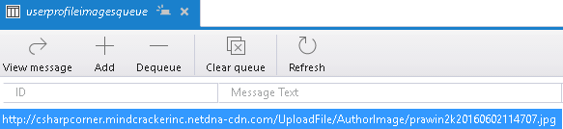

Figure 1.15: Viewing the output in Storage Explorer

How it works…
In this recipe, we added a queue message output binding and made the following changes to our existing code:
• We added a new parameter named out string objUserProfileQueueItem, which
binds the URL of the profile picture as queue message content.
• We used the AddAsync method of IAsyncCollector in the Run method that saves the
profile URL to the queue as a queue message.

In this recipe, you learned how to receive a URL of an image and save it in the blob container of an Azure storage account. In the next recipe, we'll store an image in Azure Blob Storage.

Storing images in Azure Blob Storage
The previous recipe explained how to store an image URL in a queue message. Let's learn how to trigger an Azure function (queue trigger) when a new queue item is added to the Azure Queue storage service. Each message in the queue is a URL of the profile picture of a user, which will be processed by Azure Functions and stored as a blob in the Azure Blob Storage service.

Getting ready
While the previous recipe focused on creating queue output bindings, this recipe will explain how to grab an image's URL from a queue, create a corresponding byte array, and then write it to a blob.
Note that this recipe is a continuation of the previous recipes. Be sure to implement them first.
18 | Accelerating cloud app development using Azure Functions

How to do it…
Perform the following steps:
1. Create a new Azure function by choosing Azure Queue Storage Trigger from the
templates.
2. Provide the following details after choosing the template:
Name the function: Provide a meaningful name, such as CreateProfilePictures.
Queue name: Name the queue userprofileimagesqueue. This will be monitored by the Azure function. Our previous recipe created a new item for each of the valid requests coming to the HTTP trigger (named RegisterUser) into the userprofileimagesqueue queue. For each new entry of a queue message to this queue storage, the CreateProfilePictures trigger will be executed automatically.
Storage account connection: Connection of the storage account based on where the queues are located.
3. Review all the details and click on Create to create the new function.
4. Navigate to the Integrate tab, click on New Output, choose Azure Blob Storage,
and then click on the Select button.
5. In the Azure Blob Storage output section, provide the following:
Blob parameter name: Set this to outputBlob.
Path: Set this to userprofileimagecontainer/{rand-guid}.
Storage account connection: Choose the storage account for saving the blobs and click on the Save button:
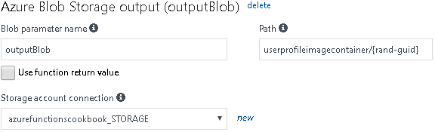

Figure 1.16: Azure Blob storage output binding settings
Storing images in Azure Blob Storage | 19

6. Click on the Save button to save all the changes.
7. Replace the default code of the run.csx file of the CreateProfilePictures function
with the following code. The code grabs the URL from the queue, creates a byte
array, and then writes it to a blob:
using System;
public static void Run(Stream outputBlob, string myQueueItem, ILogger log) {
byte[] imageData = null;
using(var wc = new System.Net.WebClient()) {
imageData = wc.DownloadData(myQueueItem); }
outputBlob.WriteAsync(imageData, 0, imageData.Length); }
8. Click on the Save button to save the changes. Make sure that there are no
compilation errors in the Logs window.
9. Let's go back to the RegisterUser function and test it by providing the firstname,
lastname, and ProfilePicUrl fields, as we did in the Saving profile picture paths to
queues using queue output bindings recipe.
10. Navigate to the Azure Storage Explorer window and look at the
userprofileimagecontainer blob container. You should find a new blob:
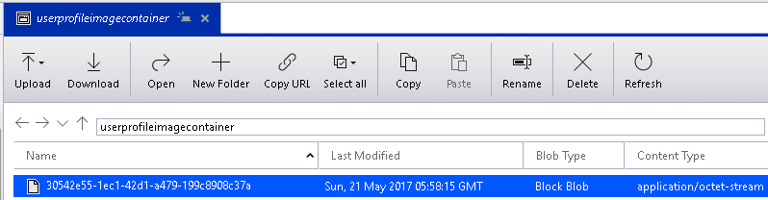

Figure 1.17: Azure Storage Explorer
The image shown in Figure 1.17 can be viewed through any image viewing tool (such as MS Paint or Internet Explorer).

20 | Accelerating cloud app development using Azure Functions

How it works…
We have created a queue trigger that gets executed when a new message arrives in the queue. Once it finds a new queue message, it reads the message, which is the URL of a profile picture. The function makes a web client request, downloads the image data in the form of a byte array, and then writes the data into the output blob.

There's more…
The rand-guid parameter will generate a new GUID and is assigned to the blob that gets created each time the trigger is fired.

Note
It is mandatory to specify the blob container name in the Path parameter of the Blob storage output binding while configuring the Blob storage output. Azure Functions creates the container automatically if it doesn't exist.

Queue messages can only be used to store messages up to 64 KB in size. To store messages greater than 64 KB, developers must use Azure Service Bus.

In this recipe, you learned how to invoke an Azure function when a new queue item is added to the Azure Storage Queue service. In the next recipe, you'll learn how to resize an image.

Resizing an image using an ImageResizer trigger
With the recent revolution in high-end smartphone cameras, it has become easy to capture high-quality pictures that tend to have larger sizes. While a good quality picture is beneficial to the consumer, for an application developer or administrator, it proves to be a pain to manage the storage of a popular website, since most platforms recommend that users upload high-quality profile pictures. Given the dilemma, it makes sense to make use of libraries that help us reduce the size of high-quality images while maintaining aspect ratio and quality.
This recipe will focus on implementing the functionality of resizing images without losing quality using one of the NuGet packages called SixLabors.ImageSharp.

Resizing an image using an ImageResizer trigger | 21

Getting ready
In this recipe, you'll learn how to use a library named SixLabors to resize an image to the required dimensions. For the sake of simplicity, we'll resize the image to the following dimensions:
• Medium with 200*200 pixels.
• Small with 100*100 pixels.

How to do it…
1. Create a new Azure function by choosing Azure Blob Storage Trigger from the
templates.
2. Provide the following details after choosing the template:
Name the function: Provide a meaningful name, such as ResizeProfilePictures.
Path: Set this to userprofileimagecontainer/{name}.
Storage account connection: Choose the storage account for saving the blobs and
click on the Save button.
3. Review all the details and click on Create to create the new function.
4. Once the function is created, navigate to the Integrate tab, click on New Output,
and choose Azure Blob Storage.
5. In the Azure Blob Storage output section, provide the following:
Blob parameter name: Set this to imageSmall.
Path: Set this to userprofilesmallimagecontainer/{name}.
Storage account connection: Choose the storage account for saving the blobs and
click on the Save button.
6. In the previous step, we added an output binding for creating a small image. In this
step, let's create a medium image. Click on New Output and choose Azure Blob
Storage. In the Azure Blob Storage output section, provide the following:
Blob parameter name: Set this to imageMedium.
Path: Set this to userprofilemediumimagecontainer/{name}.
Storage account connection: Choose the storage account for saving the blobs and
click on the Save button.
22 | Accelerating cloud app development using Azure Functions

7. Now, we need to add the NuGet package references to the Function App. In order
to add the packages, a file named function.proj needs to be created, as shown in Figure 1.18:
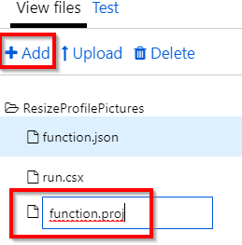

Figure 1.18: Adding a new file
8. Open the function.proj file, paste the following content to download the libraries
related to SixLabors.ImageSharp, and then click on the Save button:

netstandard2.0

Resizing an image using an ImageResizer trigger | 23

9. Once the package reference code has been added in the previous step, you'll be
able to view a Logs window similar to Figure 1.19. Note that the compiler may
throw a warning in this step, which can be ignored:
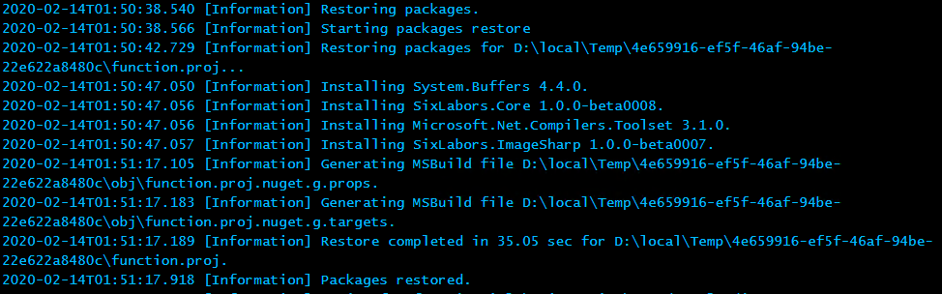

Figure 1.19: A Logs window
10. Now, let's navigate to the code editor and paste the following code:
using SixLabors.ImageSharp;
using SixLabors.ImageSharp.Formats;
using SixLabors.ImageSharp.PixelFormats;
using SixLabors.ImageSharp.Processing;
public static void Run(Stream myBlob, string name,Stream imageSmall,Stream imageMedium, ILogger log)
{
try
{
IImageFormat format;

using (Image input = Image.Load(myBlob, out format))
{
ResizeImageAndSave(input, imageSmall, ImageSize.Small, format);
}

myBlob.Position = 0;
using (Image input = Image.Load(myBlob, out format))
{
ResizeImageAndSave(input, imageMedium, ImageSize. Medium, format);
}
24 | Accelerating cloud app development using Azure Functions

}
catch (Exception e)
{
log.LogError(e, $"unable to process the blob");
}

}
public static void ResizeImageAndSave(Image input, Stream output, ImageSize size, IImageFormat format)
{
var dimensions = imageDimensionsTable[size];

input.Mutate(x => x.Resize(width: dimensions.Item1, height: dimensions.Item2));
input.Save(output, format);
}

public enum ImageSize { ExtraSmall, Small, Medium }

private static Dictionary imageDimensionsTable = new Dictionary()
{
{ ImageSize.Small, (100, 100) }, { ImageSize.Medium, (200, 200) }
};
11. Now, navigate to the RegisterUser function and run it again. If everything
is configured properly, the new containers should be created, as shown in Figure 1.20:
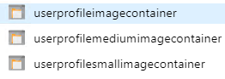

Figure 1.20: Azure Storage Explorer
Resizing an image using an ImageResizer trigger | 25

12. Review the new images created in the new containers with the proper sizes, as
shown in Figure 1.21:
Original Medium (200*200) Small (100*100)


Figure 1.21: Displaying the output


How it works…

Figure 1.22 shows how the execution of the functions is triggered like a chain:


Resize profile pictures


When a
new blob is created in the
userprofileimagecontainer
container

Create a medium picture in the Create a small picture in the
userprofilemediumimagecontainer userprofilesmallimagecontainer
container container
Figure 1.22: Illustration of the execution of the functions
We have created a new blob trigger function sample named ResizeProfilePictures, which will be triggered immediately after the original blob (image) is uploaded. Whenever a new blob is created in the userprofileimagecontainer blob, the function will create two resized versions in each of the containers— userprofilesmallimagecontainer and userprofilemediumimagecontainer—automatically.
Working with

notifications using

the SendGrid and

Twilio services

In this chapter, we will look at the following:
• Sending an email notification using SendGrid service
• Sending an email notification dynamically to the end user
• Implementing email logging in Azure Blob Storage
• Modifying the email content to include an attachment
• Sending an SMS notification to the end user using the Twilio service 28 | Working with notifications using the SendGrid and Twilio services

Introduction
One of the key features required for the smooth running of business applications is to have a reliable communication system between the business and its customers. The communication channel usually operates two-way, by either sending a message to the administrators managing the application or by sending alerts to customers via emails or SMS to their mobile phones.
Azure can integrate with two popular communication services: SendGrid for emails, and Twilio for working with text messages. In this chapter, we will learn how to leverage both of these communication services to send messages between business administrators and end users.
Figure 2.1 is the architecture that we will be using for utilizing SendGrid and Twilio Output Bindings with HTTP and queue triggers:
1. Client applications (web/mobile) make Http Requests, which trigger the Http
Trigger.
2. The Http Trigger creates a message to the Queue.
3. A Queue Trigger is invoked as soon as a message arrives at the queue.
4. Send Grid Output Bindings is executed.
5. An Email is sent to the end user.
6. Twilio Output Bindings is executed.
7. An SMS is sent to the end user:
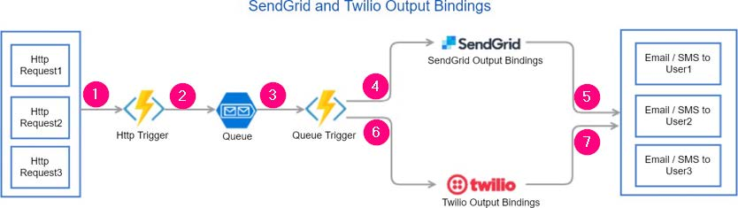

Figure 2.1: Architecture of SendGrid and Twilio output bindings
Sending an email notification using SendGrid service | 29

Sending an email notification using SendGrid service
In this recipe, we will learn how to create a SendGrid output binding and send an email notification, containing static content, to the website administrator. Since our use case involves just one administrator, we will be hard-coding the email address of the administrator in the To address field of the SendGrid output (message) binding.

Getting ready
We'll perform the following steps before moving on to the next section:
1. We will create a SendGrid account API key from the Azure portal.
2. We will generate an API key from the SendGrid portal.
3. We will configure the SendGrid API key with the Azure Function app.

Creating a SendGrid account API key from the Azure portal In this section, we'll be creating a Send service and also generate the API by performing the following steps:
1. Navigate to the Azure portal and create a SendGrid Email Delivery account by
searching for it in the marketplace, as shown in Figure 2.2:
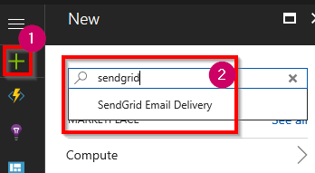

Figure 2.2: Searching for SendGrid Email Delivery in the marketplace
30 | Working with notifications using the SendGrid and Twilio services

2. In the SendGrid Email Delivery blade, click on the Create button to navigate to
Create SendGrid Account. Select Free in the Pricing Tier options, provide all the other details, and then click on the Review + Create button to review this information. Finally, click on the Create button, as shown in Figure 2.3:
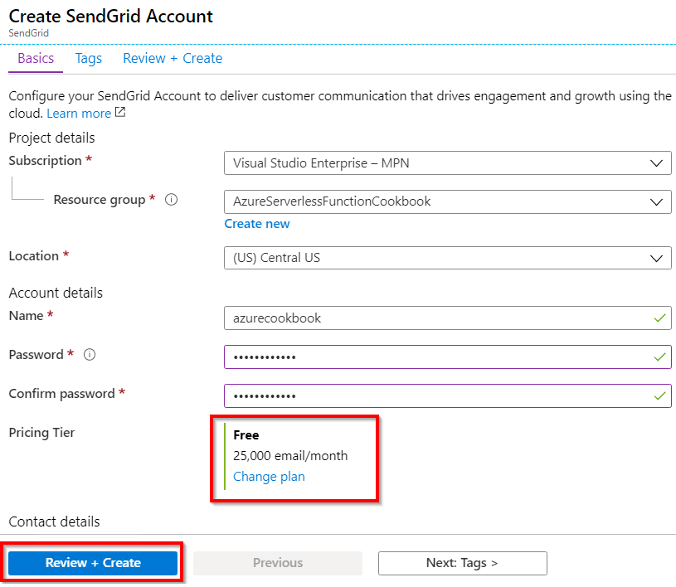

Figure 2.3: Creating a SendGrid email delivery account

Note
At the time of writing, the SendGrid free account allows you to send 25,000 free emails per month. If you would like to send more emails, then you can review and change the pricing plans based on your needs.
Sending an email notification using SendGrid service | 31

3. Make a note of the password entered in the previous step. Once the account is
created successfully, navigate to SendGrid Account. You can use the search box
available at the top.

SendGrid is not a native Azure service. So, we need to navigate to the SendGrid website to generate the API key. Let's learn how to do that next.

Generating credentials and the API key from the SendGrid portal Let's generate the API key by performing the following steps:
1. In order to utilize the SendGrid account in the Azure Functions runtime, we
need to provide the SendGrid credentials as input for Azure Functions. You can
generate those details from the SendGrid portal. Let's navigate to the SendGrid
portal by clicking on the Manage button in the Essentials blade of SendGrid
Account, as shown in Figure 2.4:
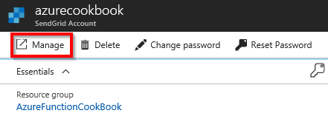

Figure 2.4: Acquiring SendGrid credentials in the Manage blade
2. In the SendGrid portal, click on the Account Details menu under Settings and
copy the username, as shown in Figure 2.5:
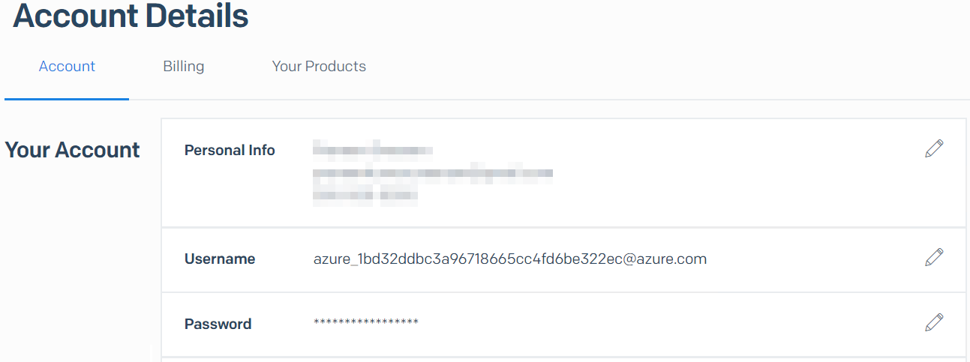

Figure 2.5: Copying the SendGrid credentials 32 | Working with notifications using the SendGrid and Twilio services

3. In the SendGrid portal, the next step is to generate the API keys. Now, click on
API Keys under the Settings section of the left-hand side menu, as shown in Figure 2.6:
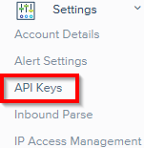

Figure 2.6: Generating API keys
4. On the API Keys page, click on Create API Key, as shown in Figure 2.7:
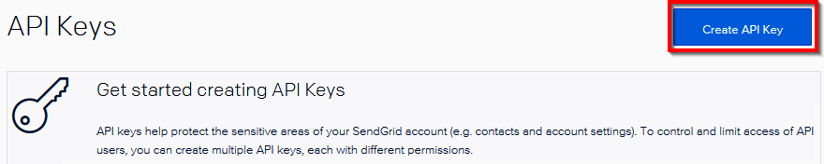

Figure 2.7: Creating API keys
5. In the Create API Key pop-up window, provide a name and choose API Key
Permissions, and then click on the Create & View button.
6. After a moment, you will be able to see the API key. Click on the key to copy it to
the clipboard, as shown in Figure 2.8:
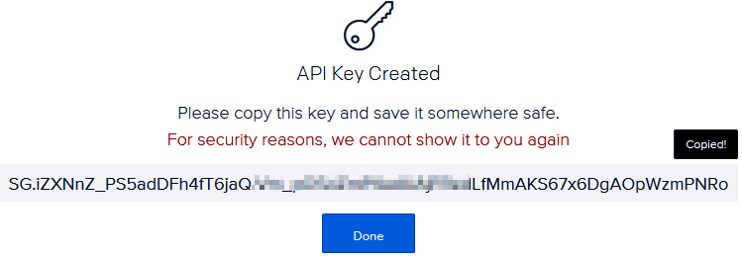

Figure 2.8: Copying the API key
Having copied the API key, we'll now configure it.
Sending an email notification using SendGrid service | 33

Configuring the SendGrid API key with the Azure Function app Let's now configure the SendGrid API key by performing the following steps:
1. Create a new App settings configuration in the Azure Function app by navigating
to the Configuration blade, under the Platform features section of the function
app, as shown in Figure 2.9:

Figure 2.9: Creating a new app setting configuration
2. Click on the Save button after adding the App settings from the preceding step.

How to do it...
In this section, we will perform the following tasks:
1. We will create a storage queue binding to the HTTP trigger.
2. We will create a queue trigger to process the message of the HTTP trigger.
3. We will create a SendGrid output binding to the queue trigger.

Creating a storage queue binding to the HTTP trigger Let's create the queue bindings now. This will allow us to create a message to be added to the queue.
Perform the following steps:
1. Navigate to the Integrate tab of the RegisterUser function and click on the New
Output button to add a new output binding.
34 | Working with notifications using the SendGrid and Twilio services

2. Choose Azure Queue Storage and click on the Select button to add the binding
and provide the values shown in Figure 2.10, and then click on the Save button. Please make a note of the Queue name (in this case, notificationqueue), which will be used in a moment:
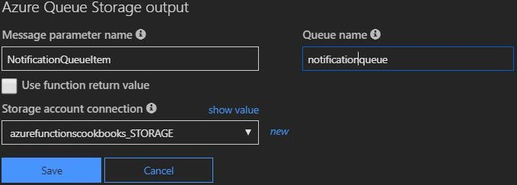

Figure 2.10: Adding a new output binding
3. Navigate to the Run method of the RegisterUser function and make the following
highlighted changes. You added another queue output binding and added an empty message to trigger the queue trigger function. For now, you have not added a message to the queue. We will make changes to the NotificationQueueItem. AddAsync(""); method in the Sending an email notification dynamically to the end user recipe of the chapter:
public static async Task Run(
HttpRequest req,
CloudTable objUserProfileTable,
IAsyncCollector objUserProfileQueueItem, IAsyncCollector<string> NotificationQueueItem, ILogger log)
{
log.LogInformation("C# HTTP trigger function processed a request."); string firstname=null,lastname = null;
...
...
await NotificationQueueItem.AddAsync("");
return (lastname + firstname) != null
? (ActionResult)new OkObjectResult($"Hello, {firstname + " " + lastname}")
: new BadRequestObjectResult("Please pass a name on the query" + "string or in the request body");
}
Let's now proceed to create the queue trigger.
Sending an email notification using SendGrid service | 35

Creating a queue trigger to process the message of the HTTP trigger In this section, you'll learn how to create a queue trigger by performing the following steps:
1. Create an Azure Queue Storage Trigger by choosing the template shown in
Figure 2.11:
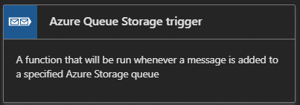

Figure 2.11: Creating an Azure Queue Storage Trigger
2. In the next step, provide the name of the queue trigger and provide the name of
the queue that needs to be monitored for sending the notifications. Once you have
provided all the details, click on the Create button to create the function:
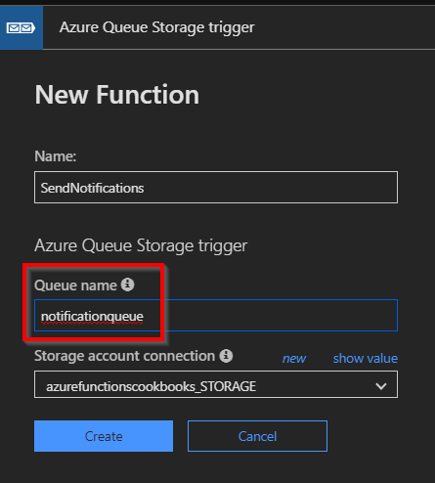

Figure 2.12: Creating a new function
3. After creating the queue trigger function, run the RegisterUser function to see
whether the queue trigger is being invoked. Open the RegisterUser function in
a new tab and test it by clicking on the Run button. In the Logs window of the
SendNotifications tab, you should see something similar to Figure 2.13: 36 | Working with notifications using the SendGrid and Twilio services
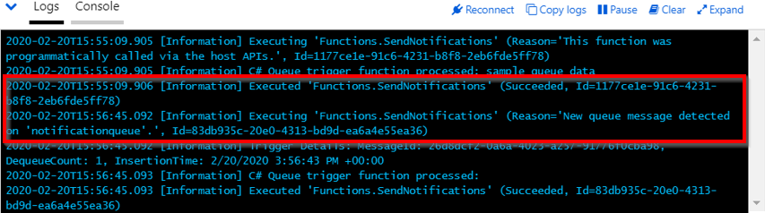

Figure 2.13: Invoking the queue trigger by running the RegisterUser function
Once we have ensured that the queue trigger is working as expected, we need to create the SendGrid bindings to send the email in the following section.

Creating a SendGrid output binding to the queue trigger Perform the following steps to create the SendGrid output bindings to send the email:
1. Navigate to the Integrate tab of the SendNotifications function and click on the
New Output button to add a new output binding.
2. Choose the SendGrid binding and click on the Select button to add the binding.
3. The next step is to install the SendGrid extensions (these are packages related
to SendGrid). Click on the Install button to install the extensions if prompted, as shown in Figure 2.14. It might take a few minutes to install the extensions:
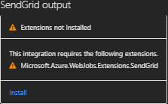

Figure 2.14: Notification to install extensions in the SendGrid bindings

Note
If there is no prompt notification, please delete the output binding and recreate it. You could also install the extensions manually by going through the instructions
mentioned in https://docs.microsoft.com/azure/azure-functions/install-update-
binding-extensions-manual.
Sending an email notification using SendGrid service | 37

4. Provide the following parameters in the SendGrid output (message) binding:
• Message parameter name: Leave the default value, which is message. We will be
using this parameter in the Run method in a moment.
• SendGrid API Key: Choose the App settings key that you created in the
Configuration blade for storing the SendGrid API Key.
• To address: Provide the email address of the administrator.
• From address: Provide the email address from where you would like to send the
email. This might be something like donotreply@example.com.
• Message subject: Provide the subject that you would like to have displayed in the
email subject.
• Message Text: Provide the email body text that you would like to have in the body
of the email.
This is how the SendGrid output (message) binding should appear after providing
all the fields:
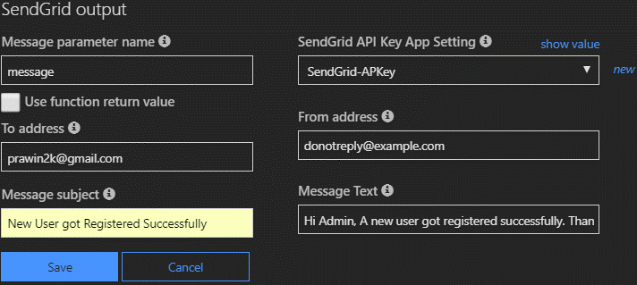

Figure 2.15: Adding details in the SendGrid output (message) binding
5. Once you review the values, click on Save to save the changes.
6. Navigate to the Run method of the SendNotifications function and make the
following changes:
• Add a new reference for SendGrid, along with the SendGrid.Helpers.Mail
namespace.
• Add a new out parameter message of the SendGridMessage type.
• Create an object of the SendGridMessage type. We will look at how to use this object
in the next recipe, Sending an email notification dynamically to the end user. 38 | Working with notifications using the SendGrid and Twilio services

7. The following is the complete code of the Run method:
#r "SendGrid"
using System;
using SendGrid.Helpers.Mail;

public static void Run(string myQueueItem,out SendGridMessage message, ILogger log)
{
log.LogInformation($"C# Queue trigger function processed: {myQueueItem}");
message = new SendGridMessage();
}
8. Now, let's test the functionality of sending the email by navigating to the
RegisterUser function and submitting a request with some test values, as follows:
{
"firstname": "Bill",
"lastname": "Gates",
"ProfilePicUrl":"URL Here"
}

How it works...
The aim of this recipe is to send an email notification to the administrator, updating them that a new registration was created successfully.
We have used one of the Azure function output bindings, named SendGrid, as a Simple Mail Transfer Protocol (SMTP) server for sending our emails by hard-coding the following properties in the SendGrid output (message) bindings:
• The "from" email address
• The "to" email address
• The subject of the email
• The body of the email

The SendGrid output (message) bindings will use the API key provided in the App settings to invoke the required APIs of the SendGrid library in order to send the emails.
Sending an email notification dynamically to the end user | 39

Sending an email notification dynamically to the end user
In the previous recipe, we hard-coded most of the attributes related to sending an email to an administrator as there was just one administrator. In this recipe, we will modify the previous recipe to send a Thank you for registration email to the users themselves.

Getting ready
Make sure that the following steps are configured properly:
• The SendGrid account is created and an API key is generated in the SendGrid
portal.
• An App settings configuration is created in the configuration of the function app.
• The App settings key is configured in the SendGrid output (message) bindings.

How to do it…
In this recipe, we will update the code in the run.csx file of the following Azure functions:
• RegisterUser
• SendNotifications

Accepting the new email parameter in the RegisterUser function Let's make changes to the RegisterUser function to accept the email parameter by performing the following steps:
1. Navigate to the RegisterUser function, in the run.csx file, and add a new string
variable that accepts a new input parameter, named email, from the request
object, as follows. Also, note that we are serializing the UserProfile object and
storing the JSON content to the queue message:
string firstname=null,lastname = null, email = null; ...
...
email = inputJson.email;
...
...
UserProfile objUserProfile = new UserProfile(firstname, lastname, string profilePicUrl,email);
...
40 | Working with notifications using the SendGrid and Twilio services

...
await NotificationQueueItem.AddAsync(JsonConvert. SerializeObject(objUserProfile))
;
2. Update the following code to the UserProfile class and click on the Save button to
save the changes:
public class UserProfile : TableEntity
{
public UserProfile (string firstname, string lastname, string profilePicUrl, string email)
{
....
....
this.ProfilePicUrl = profilePicUrl;
this.Email = email;
}
....
....
public string ProfilePicUrl {get; set;}
public string Email {get; set;}
}
Let's now move on to retrieve the user profile information.

Retrieving the UserProfile information in the SendNotifications trigger In this section, we will perform the following steps to retrieve the user information:
1. Navigate to the SendNotifications function, in the run.csx file, and add the
NewtonSoft.Json reference and also the namespace.
2. The queue trigger will receive the input in the form of a JSON string. We will use
the JsonConvert.Deserializeobject method to convert the string into a dynamic object so that we can retrieve the individual properties. Replace the existing code with the following code where we are dynamically populating the properties of SendGridMessage from the code:
Sending an email notification dynamically to the end user | 41

#r "SendGrid"
#r "Newtonsoft.Json" using System;
using SendGrid.Helpers.Mail;
using Newtonsoft.Json;
public static void Run(string myQueueItem,out SendGridMessage message, ILogger log)
{
log.LogInformation($"C# Queue trigger function processed: {myQueueItem}");
dynamic inputJson = JsonConvert.DeserializeObject(myQueueItem); string FirstName=null, LastName=null, Email = null; FirstName=inputJson. FirstName;
LastName=inputJson.LastName; Email=inputJson.Email; log.LogInformation($"Email{inputJson.Email}, {inputJson.FirstName + " " + inputJson.LastName}");
message = new SendGridMessage();
message.SetSubject("New User got registered successfully."); message. SetFrom("donotreply@example.com"); message.AddTo(Email,FirstName + " " + LastName);
message.AddContent("text/html", "Thank you " + FirstName + " " + LastName +" so much for getting registered to our site."); }
3. After making all of the aforementioned highlighted changes to the
SendNotifications function, click Save. In order to test this, you need to execute
the RegisterUser function. Let's run a test by adding a new input field email to the
test request payload of the RegisterUser function, shown as follows:
{
"firstname": "Praveen",
"lastname": "Sreeram",
"email":"example@gmail.com", "ProfilePicUrl":"A valid url here"
}
4. This is the screenshot of the email that I have received:
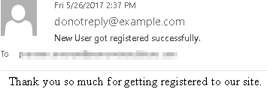

Figure 2.16: Email notification of successful registration 42 | Working with notifications using the SendGrid and Twilio services

How it works...
We have updated the code of the RegisterUser function to accept another new parameter, named email.
The function accepts the email parameter and sends the email to the end user using the SendGrid API. We have also configured all the other parameters, such as the From address, subject, and body (content) in the code so that it can be customized dynamically based on the requirements.
We can also clear the fields in the SendGrid output bindings, as shown in Figure 2.17:
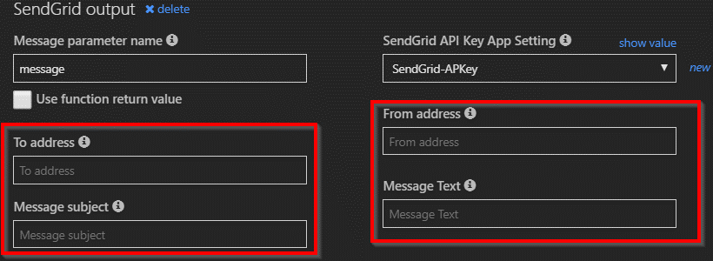

Figure 2.17: Clearing the fields in the SendGrid output bindings

Note
The values specified in the code will take precedence over the values specified in the preceding step.

There's more...
You can also add HTML content in the body to make your email look more attractive. The following is a simple example where I have just applied a bold ( <b>) tag to the name of the end user:
message.AddContent("text/html", "Thank you " + FirstName + " " + LastName +" so much for getting registered to our site.");
Implementing email logging in Azure Blob Storage | 43

Figure 2.18 shows the email, with my name in bold:
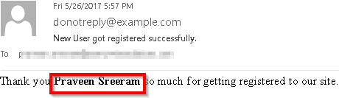

Figure 2.18: Customizing the email notification
In this recipe, you have learned how to send an email notification dynamically to the end user. Let's now move on to the next recipe.

Implementing email logging in Azure Blob Storage
Most of the business applications for automated emails are likely to involve sending emails containing various notifications and alerts to the end user. At times, it is not uncommon for users to not receive any emails, even though we, as developers, don't see any error in the application while sending such notification alerts.
There might be multiple reasons why such users might not have received the email. Each of the email service providers has different spam filters that can block the emails from the end user's inbox. As these emails may have important information to convey, it makes sense to store the email content of all the emails that are sent to the end users, so that we can retrieve the data at a later stage for troubleshooting any unforeseen issues.
In this recipe, you will learn how to create a new email log file with the .log extension for each new registration. This log file can be used as redundancy for the data stored in Table storage. You will also learn how to store email log files as a blob in a storage container, alongside the data entered by the end user during registration.

How to do it...
Perform the following steps:
1. Navigate to the Integrate tab of the SendNotifications function, click on New
Output, and choose Azure Blob Storage. If prompted, you will have to install
Storage Extensions, so please install the extensions to continue forward.
44 | Working with notifications using the SendGrid and Twilio services

2. Provide the requisite parameters in the Azure Blob Storage output section, as
shown in Figure 2.19. Note the .log extension in the Path field:
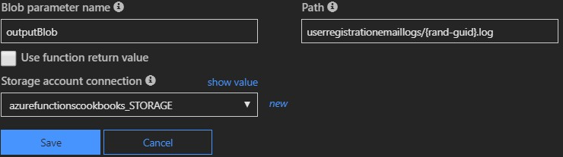

Figure 2.19: Adding details in the Azure Blob Storage output
3. Navigate to the code editor of the run.csx file of the SendNotifications function
and make the following changes:
Add a new parameter, outputBlob, of the TextWriter type to the Run method.
Add a new string variable named emailContent. This variable is used to frame the content of the email. We will also use the same variable to create the log file content that is finally stored in the blob.
Frame the email content by appending the required static text and the input parameters received in the request body, as follows:
public static void Run(string myQueueItem,out SendGridMessage message, TextWriter outputBlob, ILogger log)
....
....
string FirstName=null, LastName=null, Email = null; string emailContent;
....
....
emailContent = "Thank you " + FirstName + " " + LastName +" for your registration.
" + "Below are the details that you have provided

us
"+ "First name: " +
FirstName + "
" + "Last name: " + LastName + "
" + "Email Address: " + inputJson.Email + "
" + "Best Regards," + "
" + "Website Team";
message.AddContent(new Content("text/html",emailContent)); outputBlob.WriteLine(emailContent);
Modifying the email content to include an attachment | 45

4. In the RegisterUser function, run a test using the same request payload that we
used in the previous recipe.
5. After running the test, the log file will be created in the container named
userregistrationemaillogs:
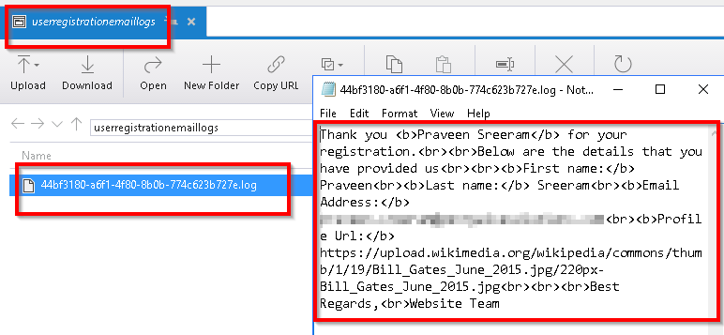

Figure 2.20: Displaying the log file created in userregistrationemaillogs

How it works…
We have created new Azure Blob Storage output bindings. As soon as a new request is received, the email content is created and written to a new .log file that is stored as a blob in the container specified in the Path field of the output bindings.

Modifying the email content to include an attachment
In this recipe, you will learn how to send a file as an attachment to the registered user. In our previous recipe, we created a log file of the email content, which we will use as an email attachment for this instance. However, in real-world applications, you might not intend to send log files to the end user.

Note
At the time of writing, SendGrid recommends that the size of the attachment shouldn't exceed 10 MB, though technically, your email can be as large as 20 MB.
46 | Working with notifications using the SendGrid and Twilio services

Getting ready
This is a continuation of the Implementing email logging in Azure Blob Storage recipe. If you are reading this first, make sure to go through the previous recipes of this chapter beforehand.

How to do it...
In this section, we will need to perform the following steps before moving to the next section:
1. Make the changes to the code to create a log file with the RowKey of the table. We
will achieve this using the IBinder interface. The IBinder interface helps us in customizing the name of the file.
2. Send this file as an attachment to the email.

Customizing the log file name using the IBinder interface Perform the following steps:
1. Navigate to the run.csx file of the SendNotifications function.
2. Remove the TextWriter object and replace it with the variable binder of the
IBinder type. The following is the new signature of the Run method:
#r "SendGrid"
#r "Newtonsoft.Json"
#r "Microsoft.Azure.WebJobs.Extensions.Storage"

using System;
using SendGrid.Helpers.Mail;
using Newtonsoft.Json;
using Microsoft.Azure.WebJobs.Extensions.Storage;

public static void Run(string myQueueItem,
out SendGridMessage message,
IBinder binder,
ILogger log)
Modifying the email content to include an attachment | 47

3. Since you have removed the TextWriter object, the outputBlob.
WriteLine(emailContent); function will no longer work. Let's replace it with the
following piece of code:
using (var emailLogBloboutput = binder.Bind(new BlobAttribute($"userregistrationemaillogs/
{ inputJson.RowKey}.log")))
{
emailLogBloboutput.WriteLine(emailContent);
}
4. In the RegisterUser function, run a test using the same request payload that we
used in the previous recipes.
5. You can see the email log file that is created using the RowKey of the new record
stored in Azure Table storage, as shown in Figure 2.21:
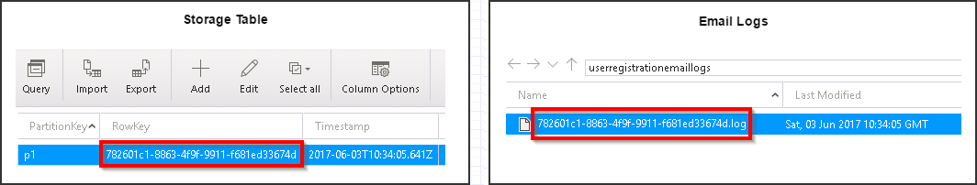

Figure 2.21: Email log file stored in Azure Table storage

Adding an attachment to the email
To add an attachment to the email, perform the following steps:
1. Add the following code to the Run method of the SendNotifications function, and
save the changes by clicking on the Save button:
message.AddAttachment(FirstName +"_"+LastName+".log", System.Convert. ToBase64String(System.Text.Encoding.UTF8.GetBytes(emailContent)), "text/plain",
"attachment",
"Logs"
);
2. Run a test using the same request payload that we used in the previous recipes.
48 | Working with notifications using the SendGrid and Twilio services

3. Figure 2.22 shows the email, along with the attachment:
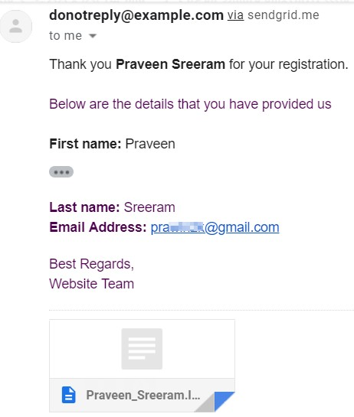

Figure 2.22: Displaying an email along with the attachment

Note
Learn more about the SendGrid API at https://sendgrid.com/docs/API_Reference/
api_v3.html.

In this recipe, you have learned how to add an attachment to the email. Let's now move on to the next recipe.

Sending an SMS notification to the end user using the Twilio
service
In most of the previous recipes of this chapter, we have worked with SendGrid triggers to send emails in different scenarios. In this recipe, you will learn how to send notifications via text messages, using one of the leading cloud communication platforms, named Twilio.
Sending an SMS notification to the end user using the Twilio service | 49

Note
Twilio is a cloud communication platform-as-a-service platform. Twilio allows software developers to programmatically make and receive phone calls, send and receive text messages, and perform other communication functions using its web
service APIs. Learn more about Twilio at https://www.twilio.com/.

Getting ready
In order to use the Twilio SMS output ( objsmsmessage) binding, you need to do the following:
1. Create a trial Twilio account at https://www.twilio.com/try-twilio.
2. Following the successful creation of the account, grab the ACCOUNT SID and
AUTH TOKEN from the Twilio Dashboard and save it for future reference, as
shown in Figure 2.23. You need to create two App settings in the Configuration
blade of the function app for both of these settings:
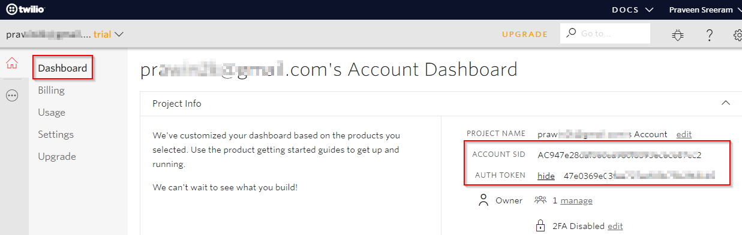

Figure 2.23: Twilio dashboard
3. In order to start sending messages, you need to create an active number within
Twilio, which will be used as the From number that you will use to send the SMS.
You can create and manage numbers in the Phone Numbers Dashboard. Navigate
to https://www.twilio.com/console/phone-numbers/incoming and click on the
Get Started button.
50 | Working with notifications using the SendGrid and Twilio services

On the Get Started with Phone Numbers page, click on Get your first Twilio phone number, as shown in Figure 2.24:
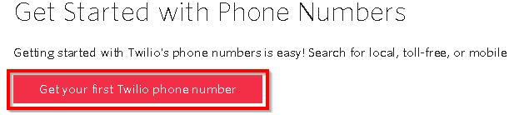

Figure 2.24: Activating your number using Twilio
4. Once you get your number, it will be listed as follows:
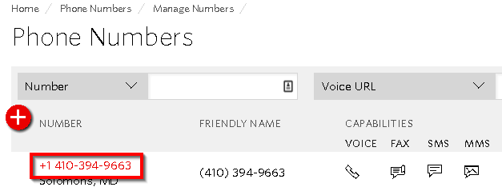

Figure 2.25: Displaying the activated number
5. The final step is to verify a number to which you would like to send an SMS. Click
on the + icon, as shown in Figure 2.26, provide your number, and then click on the Call Me button:
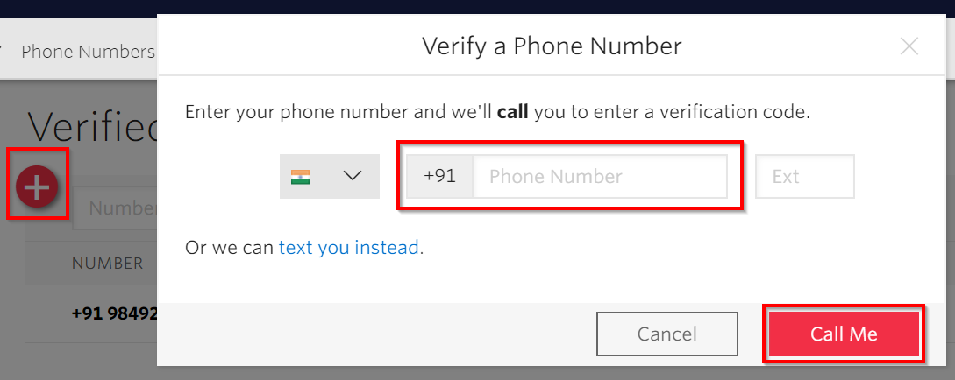

Figure 2.26: Verifying a phone number
Sending an SMS notification to the end user using the Twilio service | 51

6. You can have only one number in your trial account, which can be verified on
Twilio's verified page: https://www.twilio.com/console/phone- numbers/
verified. Figure 2.27 shows the list of verified numbers:
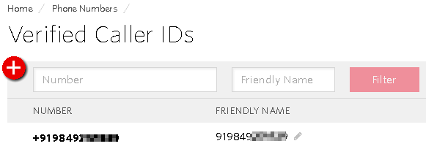

Figure 2.27: Verified caller IDs

How to do it...
Perform the following steps:
1. Navigate to the Application settings blade of the function app and add two keys
for storing TwilioAccountSID and TwilioAuthToken, as shown in Figure 2.28:
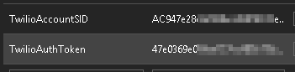

Figure 2.28: Adding two keys for storing TwilioAccountSID and TwilioAuthToken
2. Go to the Integrate tab of the SendNotifications function, click on New Output,
and choose Twilio SMS.
3. Click on Select and provide the following values to the Twilio SMS output
bindings. Please install the extensions of Twilio. To manually install the extensions,
refer to the https://docs.microsoft.com/azure/azure-functions/install-update-
binding-extensions-manual article. The From number is the one that is generated
in the Twilio portal, which we discussed in the Getting ready section of this recipe:
52 | Working with notifications using the SendGrid and Twilio services
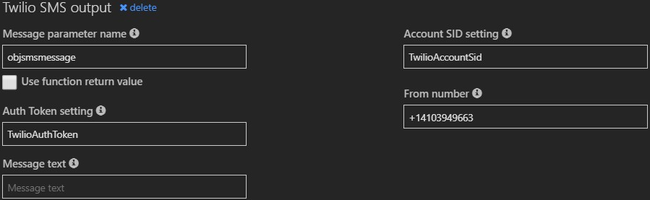

Figure 2.29: Twilio SMS output blade
4. Navigate to the code editor and add the following lines of code. In the following
code, I have hard-coded the To number. However, in real-world scenarios, you would dynamically receive the end user's mobile number and send the SMS via code:
...
...
#r "Twilio"
#r "Microsoft.Azure.WebJobs.Extensions.Twilio" ...
...
using Microsoft.Azure.WebJobs.Extensions.Twilio; using Twilio.Rest.Api. V2010.Account;
using Twilio.Types;
public static void Run(string myQueueItem,
out SendGridMessage message, IBinder binder,
out CreateMessageOptions objsmsmessage,
ILogger log)
...
...
...
message.AddAttachment(FirstName +"_"+LastName+".log", System.Convert. ToBase64String(System.Text.Encoding.UTF8.GetBytes(emailContent)), "text/plain",
"attachment",
"Logs"
);
objsmsmessage = new CreateMessageOptions(new PhoneNumber("+91 98492*****"));
objsmsmessage.Body = "Hello.. Thank you for getting registered."; }
Sending an SMS notification to the end user using the Twilio service | 53

5. Now, do a test run of the RegisterUser function using the same request payload.
6. Figure 2.30 shows the SMS that I have received:
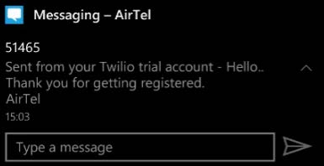

Figure 2.30: SMS received from the Twilio account

How it works...
We have created a new Twilio account and copied the account ID and app key to the App settings of the Azure Function app. The account ID and app key will be used by the function app runtime in order to connect to the Twilio API to send the SMS.
For the sake of simplicity, I have hard-coded the phone number in the output bindings. However, in real-world applications, you would send the SMS to the phone number provided by the end users.
Watch the following video to view a working implementation: https://www.youtube.
com/watch?v=ndxQXnoDIj8.

Seamless integration

of Azure Functions

with Azure Services

In this chapter, we'll cover the following recipes:
• Using Cognitive Services for face detection in images
• Monitoring and sending notifications using Logic Apps
• Integrating Logic Apps with serverless functions
• Auditing Cosmos DB data using change feed triggers
• Integrating Azure Functions with Data Factory pipelines

56 | Seamless integration of Azure Functions with Azure Services

Introduction
One of the main goals of Azure Functions is to enable developers to just focus on developing application requirements and logic and abstract everything else.
As a developer or business user, inventing and developing applications from scratch for each business requirement is practically impossible. We would first need to research the existing systems and see whether they fit business requirements. Often, it would not be easy to understand the APIs of the other systems and integrate them, especially when they have been developed by someone else.
Azure provides many connectors that can be leveraged to integrate business applications with other systems pretty easily.
In this chapter, we'll learn how to easily integrate the different services that are available within the Azure ecosystem.

Using Cognitive Services to locate faces in images
Microsoft offers Cognitive Services, which helps developers to leverage AI features in their applications.
In this recipe, you'll learn how to use the Computer Vision API (Cognitive Service) to detect faces within an image. We will be locating faces, capturing their coordinates, and saving them in different areas of Azure Table storage based on gender.
Cognitive Services apply AI algorithms, so they might not always be accurate. The accuracy returned by Cognitive Services is always between 0 and 1, where 1 means 100% accurate. You can always use the accuracy value returned by Cognitive Services and implement your custom requirements based on the accuracy.

Getting ready
To get started, we need to create a Computer Vision API and configure its API keys so that Azure Functions (or any other program) can access it programmatically.
Make sure that you have Azure Storage Explorer installed and configured to access the storage account that is used to upload the blobs.
Creating a new Computer Vision API account In this section, we'll create a new Computer Vision API account by performing the following steps:
1. Create a function app, if one has not been created already, by choosing .NET Core
as the runtime stack.
2. Search for Computer vision and click on Create.
Using Cognitive Services to locate faces in images | 57

3. The next step is to provide all the details (name, resource group, and subscription)
to create a Computer Vision API account. At the time of writing, the Computer
Vision API has two pricing tiers. For this recipe, select the free one, F0, which
allows 20 API calls per minute and is limited to 5,000 calls each month. For your
production requirements, you should select the premium instance, S1.

Having created the Computer Vision API account, we'll now move on to configure the application settings.
Configuring application settings
In this section, we'll configure the application settings of Azure Functions by performing the following steps:
1. Once the Computer Vision API account has been generated, navigate to the Keys
and Endpoint blade and copy KEY 1 into the notepad:
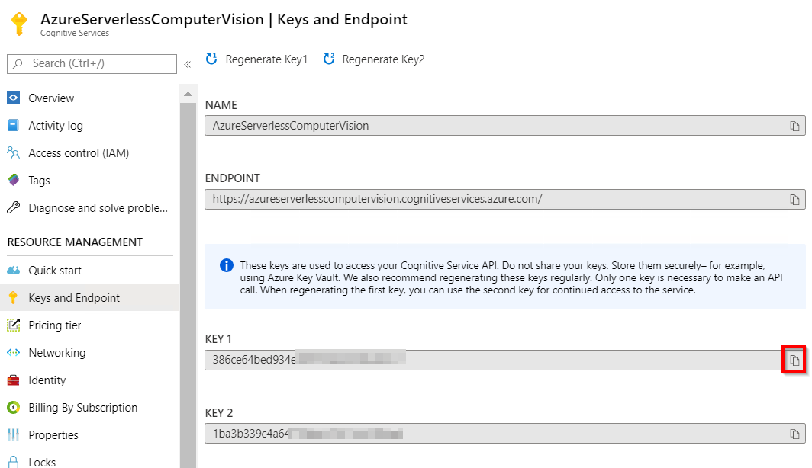

Figure 3.1: Computer Vision keys
2. Navigate to your Azure Functions app, configure Application settings with the
name Vision_API_Subscription_Key, and use any of the preceding keys as its value.
This key will be used by the Azure Functions runtime to connect to and consume
the Computer Vision Cognitive Services API.
58 | Seamless integration of Azure Functions with Azure Services

3. Make a note of the location where you are creating the Computer Vision service.
In this case, it is East US. In terms of passing the images to the Cognitive Services API, it is important to ensure that the endpoint of the API starts with the location name. It would be something like this: https://eastus.api.cognitive.microsoft. com/vision/v1.0/analyze?visualFeatures=Faces&language=en Let's now move on to the next section to learn how to develop the Azure function.

How to do it…
In this section, you are going to learn how to leverage Cognitive Services in the blob trigger by performing the following steps:
1. Create a new function using one of the default templates named Azure Blob
Storage Trigger.
2. Next, provide the name of the Azure function along with the path and storage
account connection. We will upload a picture to the Azure Blob Storage trigger (image) container (mentioned in the Path parameter in Figure 3.2) at the end of this section:
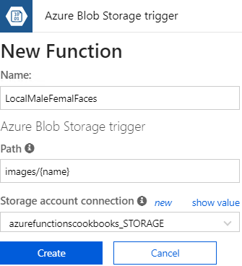

Figure 3.2: Creating an Azure Blob storage trigger
Using Cognitive Services to locate faces in images | 59

Note
While creating the function, the template creates one blob storage table output binding and allows you to provide a name for the Table name parameter. However, you can't assign the name of the parameter while creating the function. You will only be able to change it after it has been created. After reviewing all the details, click on the Create button to create the Azure function.

3. Once the function has been created, navigate to the Integrate tab, click on New
Output, choose Azure Table Storage, and then click on the Select button. Provide
the parameter values and then click on the Save button, as shown in Figure 3.3:
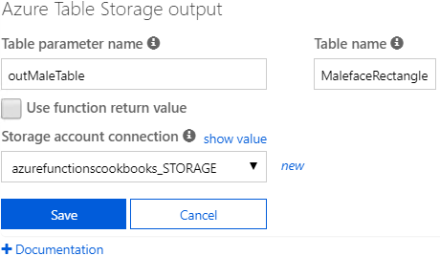

Figure 3.3: Azure Table storage output bindings
4. Let's now create another Azure Table Storage output binding to store all the
information for women by clicking on the New Output button in the Integrate tab,
selecting Azure Table Storage, and then clicking on the Select button. This is how
it looks after providing the input values:
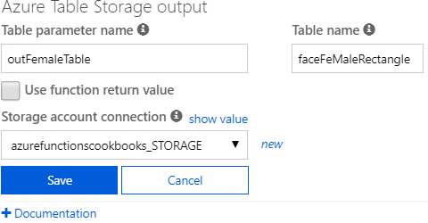

Figure 3.4: Azure Table storage output bindings 60 | Seamless integration of Azure Functions with Azure Services

5. Once you have reviewed all the details, click on the Save button to create the
Azure Table Storage output binding and store the details pertaining to women.
6. Navigate to the code editor of the Run method and copy the following code.
The code will collect the image stream uploaded to the blob, which will then be passed as an input to Cognitive Services, which will then return some JSON with all the face information, including coordinates and gender details. Once this face information is received, you can store the face coordinates in the respective table storage using the table output bindings:
#r "Newtonsoft.Json"
#r "Microsoft.WindowsAzure.Storage"

using Newtonsoft.Json;
using Microsoft.WindowsAzure.Storage.Table; using System.IO; using System.Net; using System.Net.Http;
using System.Net.Http.Headers;
public static async Task Run(Stream myBlob,
string name,
IAsyncCollector outMaleTable,
IAsyncCollector
outFemaleTable,
ILogger log)
{
log.LogInformation($"C# Blob trigger function Processed blob\n
Name:{name} \n Size: {myBlob.Length} Bytes");
string result = await CallVisionAPI(myBlob); log.
LogInformation(result);
if (String.IsNullOrEmpty(result))
{
return;
}

ImageData imageData = JsonConvert.
DeserializeObject(result);

foreach (Face face in imageData.Faces)
{
var faceRectangle = face.FaceRectangle;
faceRectangle.RowKey = Guid.NewGuid().ToString();
faceRectangle.PartitionKey = "Functions";
faceRectangle.ImageFile = name + ".jpg";
if(face.Gender=="Female")
Using Cognitive Services to locate faces in images | 61

{
await outFemaleTable.AddAsync(faceRectangle);
}
else
{
await outMaleTable.AddAsync(faceRectangle);
}
}
}
static async Task CallVisionAPI(Stream image) {
using (var client = new HttpClient())
{
var content = new StreamContent(image);
var url ="https://.api.cognitive.microsoft.com/vision/
v1.0/analyze?visualFeatures=Faces&language=en";
client.DefaultRequestHeaders.Add("Ocp-Apim-Subscription-Key",
Environment.GetEnvironmentVariable("Vision_API_Subscription_Key"));
content.Headers.ContentType = new
MediaTypeHeaderValue("application/octet-stream");
var httpResponse = await client.PostAsync(url, content);
if (httpResponse.StatusCode == HttpStatusCode.OK)
{
return await httpResponse.Content.ReadAsStringAsync();
}
}
return null;
}

public class ImageData
{
public List Faces { get; set; }
}
public class Face
{
public int Age { get; set; }
public string Gender { get; set; }
public FaceRectangle FaceRectangle { get; set; }
}

public class FaceRectangle : TableEntity
{
62 | Seamless integration of Azure Functions with Azure Services

public string ImageFile { get; set; }
public int Left { get; set; }
public int Top { get; set; }
public int Width { get; set; }
public int Height { get; set; }
}
7. The code has a condition to check the gender and, based on the gender, it stores
the information in the respective table storage.
8. Create a new blob container named images using Azure Storage Explorer, as shown
in Figure 3.5:
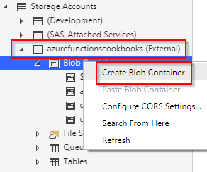

Figure 3.5: Azure Storage—Create Blob Container
9. Let's now upload a picture with male and female faces to the container named
images using Azure Storage Explorer, as shown in Figure 3.6:
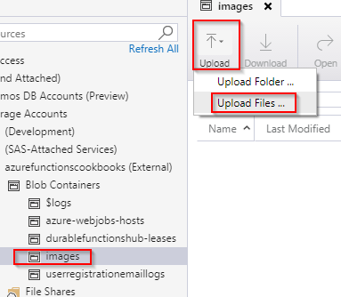

Figure 3.6: Azure Storage—Create Blob Container—Upload Files
Using Cognitive Services to locate faces in images | 63

10. The function will get triggered as soon as you upload an image. This is the JSON
that was logged in the Logs console of the function:
{
"requestId":"483566bc-7d4d-45c1-87e2-6f894aaa4c29", "metadata":{ }, "faces":[
{
"age":31, "gender":"Female",
"faceRectangle":{
"left":535,
"top":182,
"width":165,
"height":165
}
},
{
"age":33,
"gender":"Male",
"faceRectangle":{ "left":373,
"top":182,
"width":161,
"height":161
}
}
]
}

Note
A front-end developer with expertise in HTML5 and canvas-related technologies can even draw squares that locate the faces in images using the information provided by Cognitive Services.
64 | Seamless integration of Azure Functions with Azure Services

11. The function has also created two different Azure Table storage tables, as shown
in Figure 3.7:
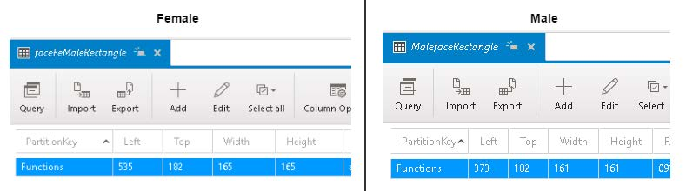

Figure 3.7: Azure Table storage—output values of the cognitive services

Note
The APIs aren't 100% accurate in identifying the correct gender. So, in your production environments, you should have a fallback mechanism to handle such situations.

There's more...
The face locator templates invoke the API call by passing the visualFeatures=Faces parameter returns information relating to the following:
• Age
• Gender
• Coordinates of the faces in the picture

Note
Learn more about the Computer Vision API at https://docs.microsoft.com/azure/
cognitive-services/computer-vision/home.

Monitoring and sending notifications using Logic Apps | 65

Use the Environment.GetEnvironmentVariable("KeyName") function to retrieve the information stored in the application settings. In this case, the CallVisionAPI method uses the function to retrieve the key, which is essential for making a request to Microsoft Cognitive Services.

Note
It's considered a best practice to store all the keys and other sensitive information in the application settings.

In this recipe, you have learned how to integrate Cognitive Services with Azure Functions. Let's now move on to the next recipe to learn how to integrate Azure Functions with Logic Apps.

Monitoring and sending notifications using Logic Apps
One of my colleagues, who works for a social grievance management project, is responsible for monitoring the problems that users post on social media platforms, including Facebook and Twitter. He was facing the problem of continuously monitoring the tweets posted on his customer's Twitter handle with specific hashtags. His main job was to respond quickly to the tweets by users with a huge follower count, say, users with more than 50,000 followers. Hence, he was looking for a solution that kept monitoring a particular hashtag and alerted him whenever a user with more than 50,000 followers tweets so that he can quickly have his team respond to that user.

Note
For the sake of simplicity, in this recipe, we will have the condition to check for 200 followers instead of 50,000 followers.

Before I knew about Azure Logic Apps, I thought it would take a few weeks to learn about, develop, test, and deploy such a solution. Obviously, it would take a good amount of time to learn, understand, and consume the Twitter (or any other social channel) API to get the required information and build an end-to-end solution that solves the problem.

66 | Seamless integration of Azure Functions with Azure Services

Fortunately, after exploring Logic Apps and its out-of-the-box connectors, it hardly takes 10 minutes to design a solution for the problem that my friend had.
In this recipe, you'll learn how to design a logic app that integrates with Twitter (for monitoring tweets) and Gmail (for sending emails).

Getting ready
You need to have the following to work with this recipe:
• A valid Twitter account
• A valid Gmail account

When working with the recipe, you'll need to authorize Azure Logic Apps to access both Twitter and Gmail accounts.
The following are the logic app concepts that we'll be using in this recipe. They are the building blocks for developing logic apps:
• Connectors: Connectors are the wrappers around APIs that any system would
provide to expose its features.
• Actions: Actions are steps in the Logic App workflow.
• Trigger: A trigger is the first step in any logic app, usually specifying the event that
fires the trigger and starts running your logic app.

Learn more about them by referring to the following link: https://docs.microsoft.com/
azure/connectors/apis-list

How to do it...
We'll go through the following steps:
1. Creating a new logic app.
2. Designing the logic app with Twitter and Gmail connectors.
3. Testing the logic app by tweeting the tweets with the specific hashtag.
Monitoring and sending notifications using Logic Apps | 67

Creating a new logic app
Perform the following steps:
1. Log in to the Azure portal, search for logic app, and select Logic App.
2. In the Create logic app blade, once you have provided the Name, Resource group,
Subscription, and Location information, click on the Create button to create the
logic app:
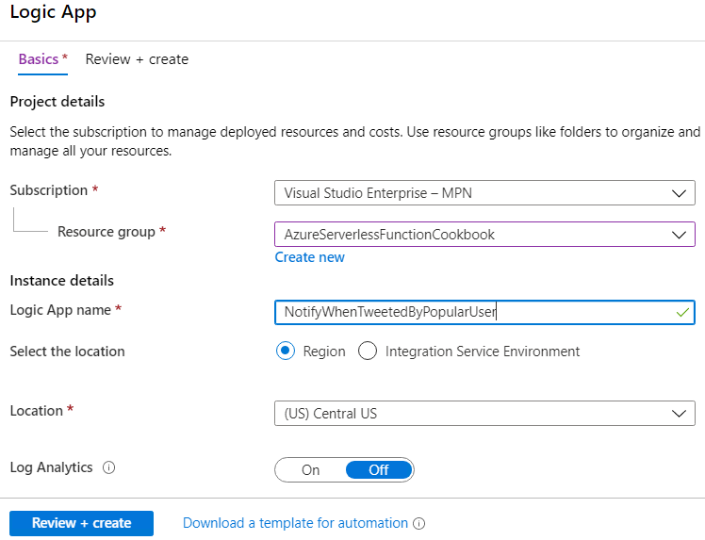

Figure 3.8: Creating a new logic app
In this section, we have created a logic app. Let's now move on to the next section.
68 | Seamless integration of Azure Functions with Azure Services

Designing the logic app with Twitter and Gmail connectors In this section, we will design the logic app by adding the required connectors and trigger, and by performing the following steps:
1. After the logic app has been created, navigate to Logic app designer and choose
Blank logic app.
2. Next, you will be prompted to choose connectors. In the connectors list, search
for Twitter and click on the Twitter connecter. This will show you the list of triggers associated with the Twitter connector, as shown in Figure 3.9. It will prompt you to connect to Twitter by asking for Twitter account credentials:
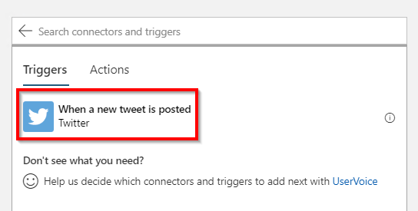

Figure 3.9: Logic app—selecting the trigger
3. Once you have clicked on the Twitter trigger, you will be prompted to provide
Search text (for example, hashtags and keywords) and the Frequency at which you would like the logic app to poll the tweets. This is how it appears after you provide the details:
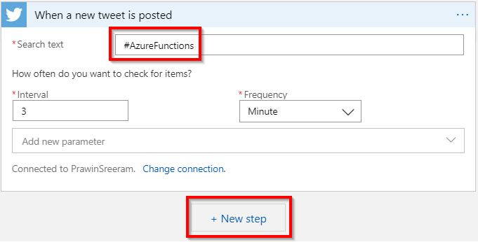

Figure 3.10: Logic app—providing the Twitter search text
Monitoring and sending notifications using Logic Apps | 69

4. Let's now add a new condition by clicking on New step, searching for control, and
clicking on it, as shown in Figure 3.11:
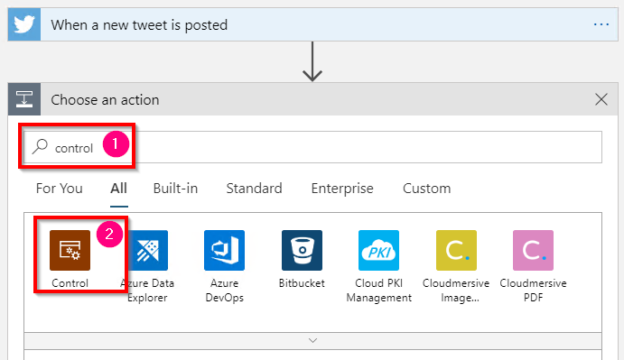

Figure 3.11: Logic app—searching for the control connector
5. It will now open Actions. Select Condition, as shown in Figure 3.12:
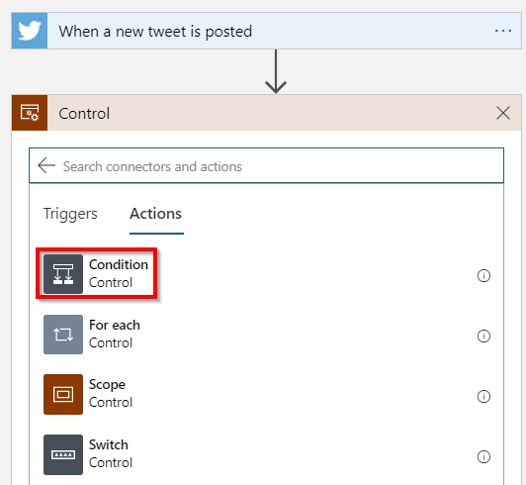

Figure 3.12: Logic app—selecting a condition 70 | Seamless integration of Azure Functions with Azure Services

6. From the previous instruction, the following screen will be displayed, where you
can choose the values for the condition and choose what you would like to add when the condition evaluates to true or false:
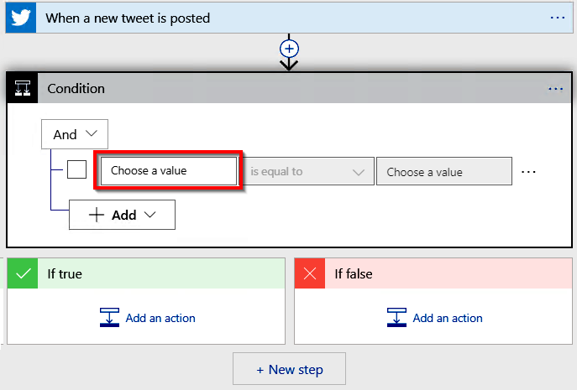

Figure 3.13: Logic app—selecting a condition—choosing a value
7. When you click on the Choose a value input field, you will get all the parameters
on which you could add a condition; in this case, you need to choose Followers count, as shown in Figure 3.14:
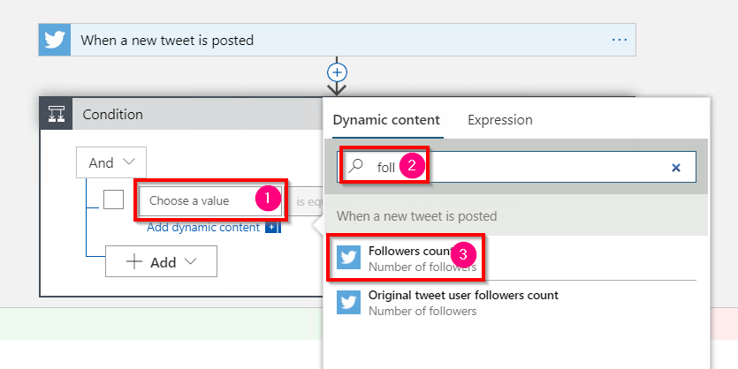

Figure 3.14: Logic app—selecting a condition—Followers count
Monitoring and sending notifications using Logic Apps | 71

8. Once you have chosen the Followers count parameter, you need to create a
condition (followers count is greater than or equal to 200), as shown in Figure 3.15:
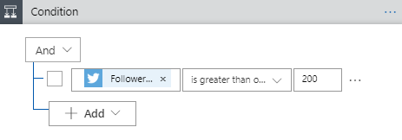

Figure 3.15: Logic app—selecting a condition—completed condition
9. In the If true section of the preceding Condition, click on the Add an Action
button, search for the Gmail connector, and select Gmail | Send email, as shown
in Figure 3.16:
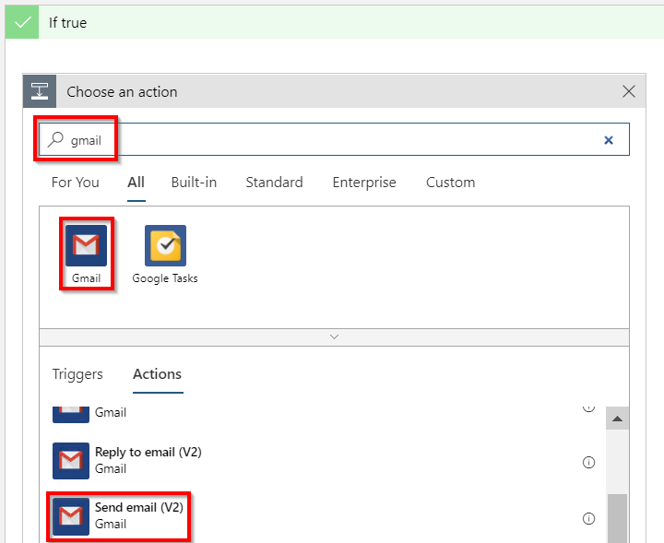

Figure 3.16: Logic app—If true action—sending an email using Gmail
10. It will ask you to log in if you haven't already done so. Provide your credentials and
authorize Azure Logic Apps to access your Gmail account.
72 | Seamless integration of Azure Functions with Azure Services

11. Once you authorize, you can add parameters by clicking on the arrow, as shown in
Figure 3.17, and selecting the Subject and Body checkboxes:
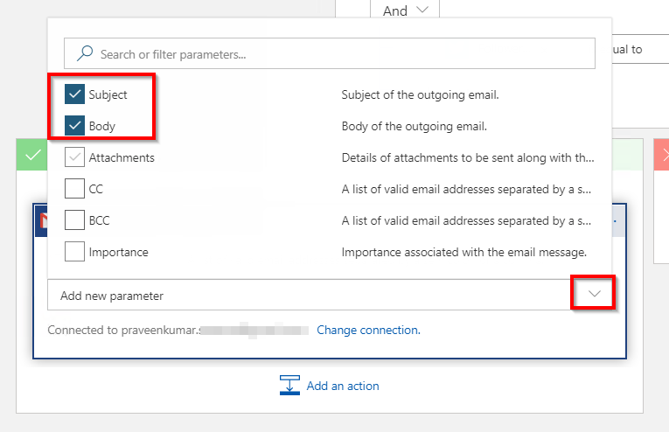

Figure 3.17: Logic app—If true action—configuring Gmail options
12. Once you have selected the fields, you can frame your email with Add dynamic
content with the Twitter parameters, as shown in Figure 3.18:
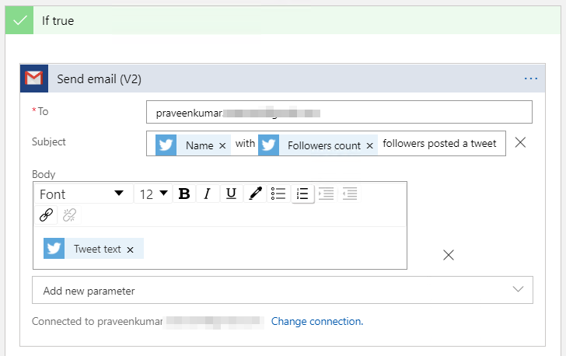

Figure 3.18: Logic app—If true action—configuring the subject and body
Monitoring and sending notifications using Logic Apps | 73

13. Once you are done, click on the Save button.

In this section, you have learned how to create a trigger that is triggered whenever a tweet is posted and you have also created a condition that sends emails using the Gmail connector if the followers count exceeds a specific value. Let's now move on to the next section to learn how to test the functionality.
Testing the logic app by tweeting the tweets with the specific hashtag In this section, you will learn how to test the logic app by performing the following steps:
1. Post a tweet on Twitter with the hashtag #AzureFunctions, as shown in Figure 3.19:
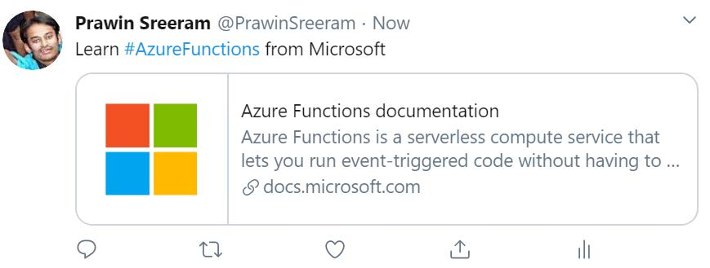

Figure 3.19: A tweet regarding the #AzureFunctions hashtag in Twitter
2. After three minutes, the logic app should have been triggered. Navigate to the
Overview blade of the logic app and view Runs history:
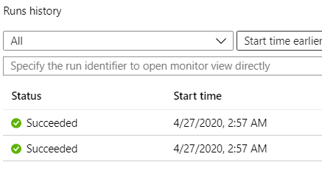

Figure 3.20: Logic app—Runs history 74 | Seamless integration of Azure Functions with Azure Services

3. It triggered for me and I received the emails. One of them is shown in Figure 3.21:
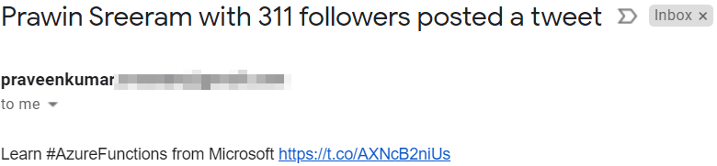

Figure 3.21: Logic app—email received following a tweet

How it works...
We have created a new logic app and have chosen the Twitter connector to monitor the tweets posted with the hashtag #AzureFunctions at three-minute intervals. If there are any tweets with that hashtag, it checks whether the follower count is greater than or equal to 200. If the follower count meets the condition, then a new action is created with a new Gmail connector that is capable of sending an email with the dynamic content being framed using the Twitter connector parameters.
In this recipe, we have designed a logic app that gets triggered whenever a tweet is posted on Twitter. You have also learned that Logic Apps allows you to add basic logic (in this recipe, a condition) without writing code. If you have some complex functionality, then it would not be possible to implement using Logic Apps. In such cases, Azure Functions would come in handy. Let's now move on to the next recipe to learn how to integrate Logic Apps with Azure Functions.

Integrating Logic Apps with serverless functions
In the previous recipe, you learned how to integrate different connectors using Logic Apps and developed a simple logic of checking whether the followers count is greater than 200. As it was a simple logic, you were able to implement that in Logic Apps itself. If you need to implement a complex logic, then it wouldn't be possible. In that case, you can implement the complex logic in Azure Functions and invoke Azure Functions from Logic Apps.
In this recipe, you will see how to integrate Azure Functions with Logic Apps. For the sake of simplicity, we will not develop a complex logic. However, we will use the same logic (followersCount > 200) in Azure Functions and invoke it from Logic Apps.
Integrating Logic Apps with serverless functions | 75

How to do it...
In this section, we'll integrate Azure Functions with Logic Apps by performing the following steps:
1. Create a new function by choosing the HTTP trigger with Authorization Level as
Anonymous, and name it ValidateTwitterFollowerCount.
2. Replace the default code with the following, as shown in Figure 3.22. You can
implement some complex logic here. The following Azure HTTP trigger accepts
two parameters:
The name of the owner of the tweet
The follower count of the owner
Just for the sake of simplicity, if the name of the user starts with the letter p, add
100 to the followers count. Otherwise, return the followers count. In your projects,
you can implement complex business logic in the HTTP trigger:
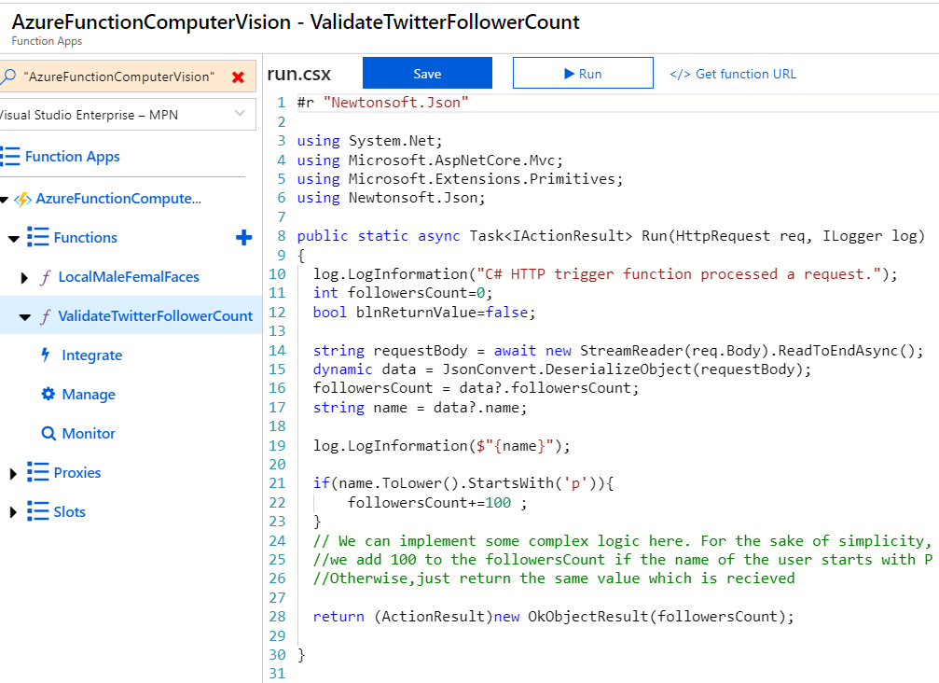

Figure 3.22: Azure Function HTTP trigger 76 | Seamless integration of Azure Functions with Azure Services

3. Navigate to the NotifyWhenTweetedByPopularUser logic app and click on Logic
App Designer to start editing the logic app.
4. Now, hover the mouse on the arrow mark to reveal a + icon, as shown in Figure
3.23. Click on it and then click on Add an action button:
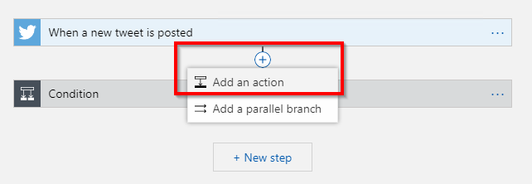

Figure 3.23: Logic app—Add an action
5. In the Choose an action section, search for Functions, click on Azure Functions,
and then click on Choose an Azure Function, as shown in Figure 3.24:
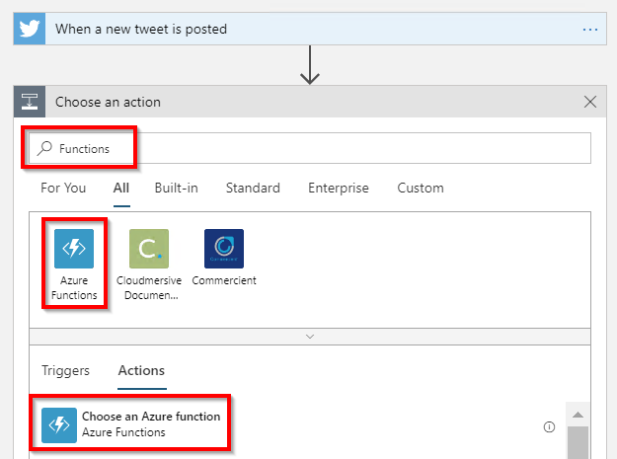

Figure 3.24: Logic app—searching for the Azure Functions connector
6. Clicking on the Choose an Azure function button in Figure 3.24 will reveal a list of
all the available Azure function apps. You can search for the function app where you have developed the ValidateTwitterFollowerCount function, as shown in Figure 3.25:
Integrating Logic Apps with serverless functions | 77
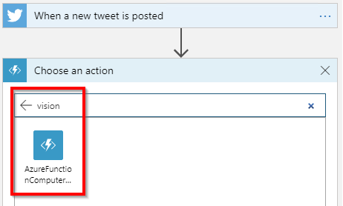

Figure 3.25: Logic app—choosing an Azure function app
7. When you choose the function app, it will show all the functions inside it. Click on
the ValidateTwitterFollowerCount function, as shown in Figure 3.26:
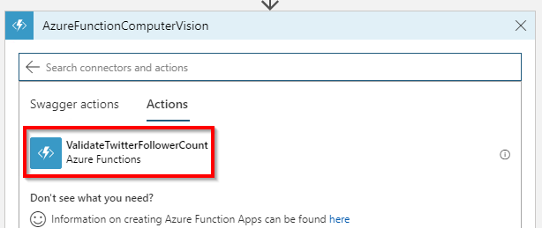

Figure 3.26: Logic app—choosing Azure Functions
8. Now, provide the input to the ValidateTwitterFollowerCount function, as shown in
Figure 3.27:
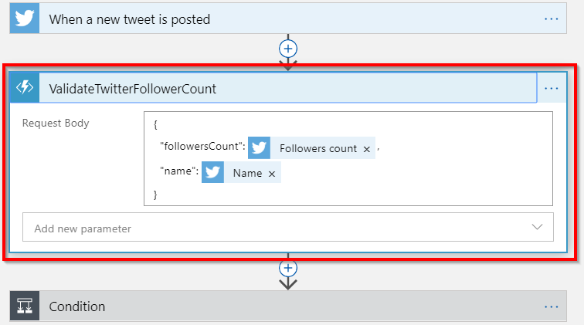

Figure 3.27: Logic app—passing inputs to Azure Functions 78 | Seamless integration of Azure Functions with Azure Services

9. In order to receive the response, open the Condition step and add the Body
variable, as shown in Figure 3.28. The Body variable contains the response body of the Azure function named ValidateTwitterFollowerCount. This means that, instead of directly comparing the Twitter follower count, we are comparing the response returned by the Azure Function HTTP trigger with the value 200:
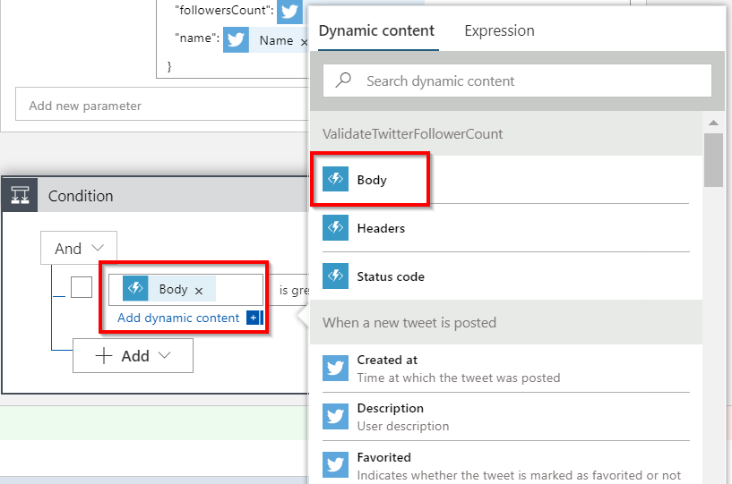

Figure 3.28: Logic app—receiving inputs from Azure Functions
10. That's it. Save the changes and go to Twitter and create a tweet with
#AzureFunctions. The following is an example where the followersCount returned by Twitter for my tweet is 310. However, the Azure function added 100 to the followers count and returned 410 in the response body:
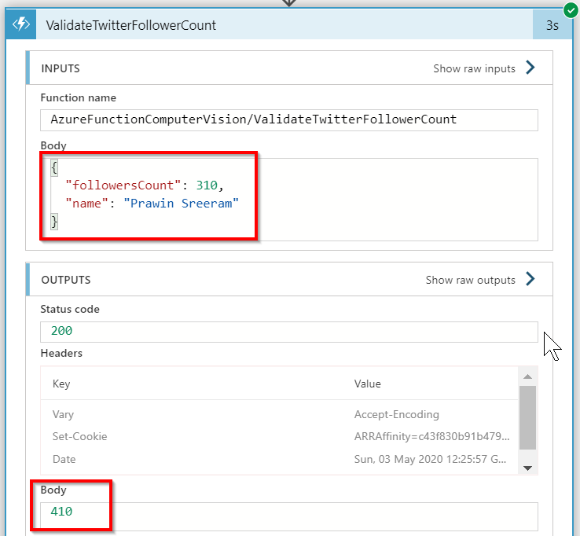

Figure 3.29: Logic app—execution history
Auditing Cosmos DB data using change feed triggers | 79

In this section, you have learned how to integrate Logic Apps with Azure Functions.

There's more...
If you don't see the intended dynamic parameter, click on the See more button, as shown in Figure 3.30:
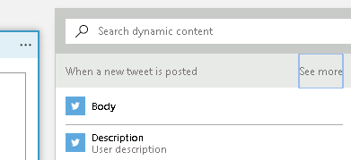

Figure 3.30: Logic app—dynamic content—see more
In this recipe, you have learned how to integrate Azure Functions with Logic Apps. In the next recipe, let's explore how to integrate Azure Functions with Cosmos DB.

Auditing Cosmos DB data using change feed triggers
You may have already heard about Cosmos DB, as it has become very popular and many organizations are using it because of the features it provides.
In this recipe, you will learn to integrate serverless Azure Functions with a serverless NoSQL database in Cosmos DB. You can read more about Cosmos DB at https://docs.
microsoft.com/azure/cosmos-db/introduction.
It might often be necessary to keep the change logs of fields, attributes, items, and other aspects for auditing purposes. In the world of relational databases, you might have seen developers using triggers or stored procedures to implement this kind of auditing functionality, where you write code to store data in a separate audit table.
In this recipe, you'll learn how easy it is to audit the changes made to Cosmos DB containers by writing a simple function that gets triggered whenever there is a change to an item in a Cosmos DB container.

Note
In the world of relational databases, a container is the same as a database table and an item is the same as a record.
80 | Seamless integration of Azure Functions with Azure Services

Getting ready
In order to get started, you need to first do the following:
1. Create a Cosmos DB account.
2. Create a new Cosmos DB container where you can store data in the form of items.

Let's begin by creating a new Cosmos DB account.
Creating a new Cosmos DB account
Navigate to the Azure portal and create a new Cosmos DB account. You will need to provide the following:
• A valid subscription and a resource group.
• A valid account name. This will create an endpoint at <<accountname>>.document.
azure.com.
• An API—set this as SQL. This will ensure that you can write queries in SQL. Feel
free to try out other APIs.

Creating a new Cosmos DB container
Create a new Cosmos DB container by performing the following steps:
1. Once the account has been created, create a new database and a container. You
can create both of them in a single step right from the Azure portal.
2. Navigate to the Overview tab and click on the Add Container button to create a
new container:
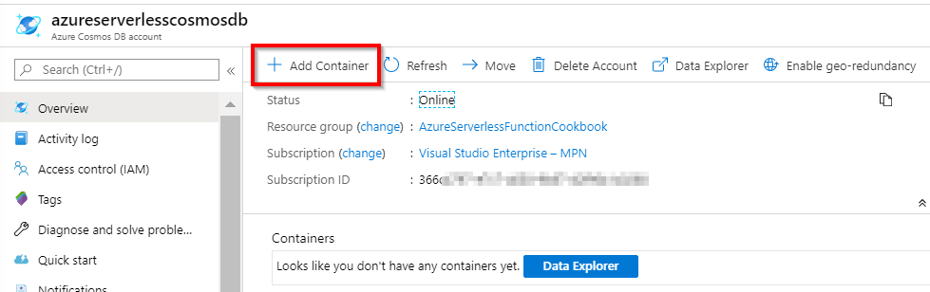

Figure 3.31: Cosmos DB account—Overview blade
3. You will now be navigated to the Data Explorer tab automatically, where you will
be prompted to provide the following details:
Auditing Cosmos DB data using change feed triggers | 81
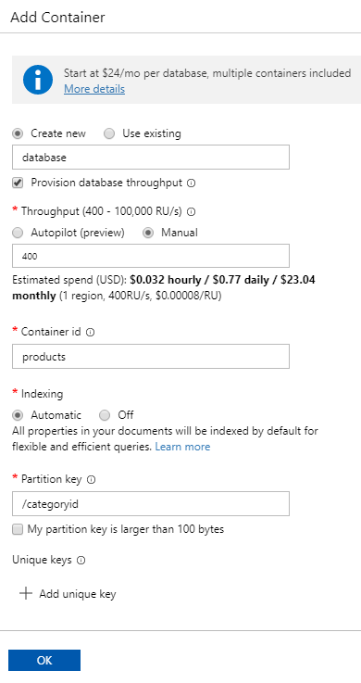

Figure 3.32: Cosmos DB—creating a container 82 | Seamless integration of Azure Functions with Azure Services

The following are the details that you'll need to add to Figure 3.32:
Field Name Value Description
Database id database Database containing multiple Cosmos DB containers. Container id products This is the name of the container where you will be storing the data.
Partition All the items of a given container will be segregated based on the
key /categoryid partition. A separate partition is created for each unique value for
the categoryid
Throughput This is the capacity of your Cosmos DB database. The performance
(400 – 400 of the reads and writes depends on the throughput that you 10,000 RU/s)
Figure 3.33: Cosmos DB—creating a container—fields
4. Next, click on the OK button to create the container. If everything went well,
you'll see something like the following in the Data Explorer tab of the Cosmos DB account:
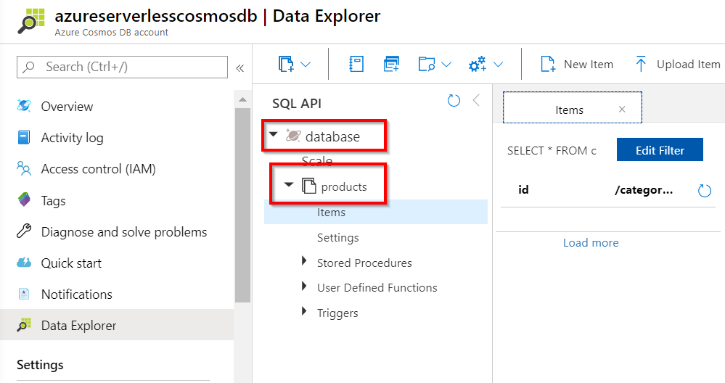

Figure 3.34: Data Explorer—Cosmos DB database and container
We have successfully created a Cosmos DB database and a container, as shown in Figure 3.34. Let's now go through how to integrate the container with a new Azure function and see how to trigger it whenever there is a change in the Cosmos DB container.

How to do it...
In this section, we'll integrate a Cosmos DB container with Azure Functions by performing the following steps:
Auditing Cosmos DB data using change feed triggers | 83

1. Navigate to the Cosmos DB account and click on the Add Azure Function menu in
the All settings blade of the Cosmos DB account, as shown in Figure 3.35:
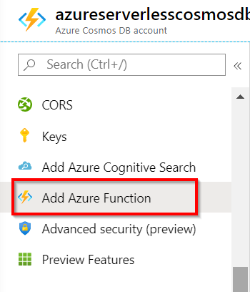

Figure 3.35: Cosmos DB—the Add Azure Function menu item
2. You will now be taken to the Add Azure Function blade, where you will choose the
Azure function app in which you would like to create a new function (Cosmos DB
trigger), as shown in Figure 3.36:
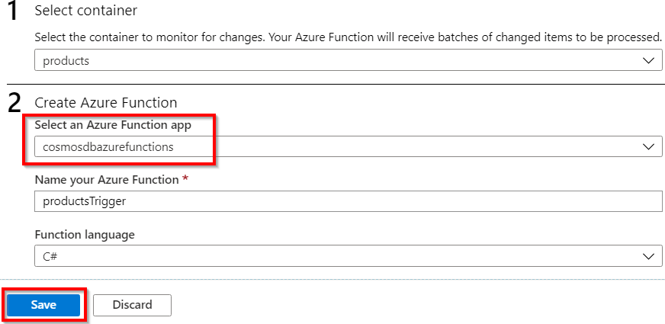

Figure 3.36: Cosmos DB—Azure function integration 84 | Seamless integration of Azure Functions with Azure Services

3. Once you have reviewed the details, click on the Save button (shown in Figure
3.36) to create the new function, which will be triggered for every change that is made in the container. Let's quickly navigate to the Azure function app (in my case, it is cosmosdbazurefunctions) and see whether the new function with the name productsTrigger has been created. Here is what the function app looks like:
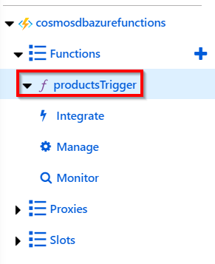

Figure 3.37: Azure Functions—Cosmos DB trigger
4. Replace the default code with the following code of the Azure Functions Cosmos
DB trigger, which gets a list of all the items that were updated. The following code just prints the count of items that were updated and the ID of the first item in the Logs console:
#r "Microsoft.Azure.DocumentDB.Core"
using System;
using System.Collections.Generic;
using Microsoft.Azure.Documents;

public static void Run(IReadOnlyList input, ILogger log) {
if (input != null && input.Count > 0)
{
log.LogInformation("Items modified " + input.Count); log. LogInformation("First Item Id " + input[0].Id); }
}
Auditing Cosmos DB data using change feed triggers | 85

5. Now, the integration of the Cosmos DB container and the Azure function is
complete. Let's add a new item to the container and see how the trigger gets fired
in action. Open a new browser window/tab (leaving the productsTrigger tab open
in the browser), navigate to the container, and create a new item by clicking on the
New Item button, as shown in Figure 3.38:
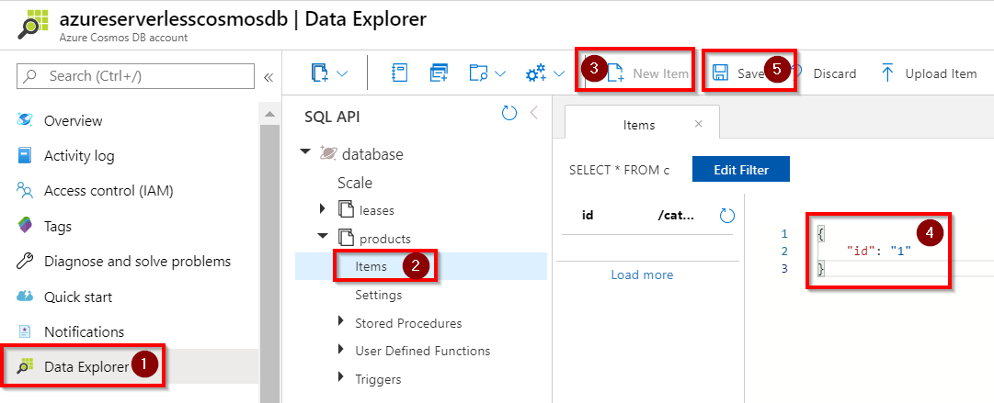

Figure 3.38: Data Explorer—creating a new item
6. Once you have replaced the default JSON (which just has an id attribute) with
the JSON that has the required attributes, click on the Save button to save the
changes and quickly navigate to the other browser tab, where you have the Azure
function open, and view the logs to see the output of the function. The following
is how my logs look, as I just added a value to the id attribute of the item. It might
look different for you, depending on your JSON structure:
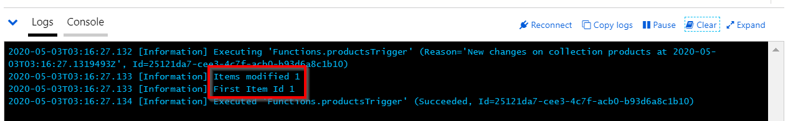

Figure 3.39: Azure function—the Logs console
In this section, you have learned how to integrate Azure Functions with Cosmos DB. Let's now move on to the next section.
86 | Seamless integration of Azure Functions with Azure Services

There's more...
While integrating Azure Functions to track Cosmos DB changes, it will automatically create a new container named leases, as shown in Figure 3.40. Be aware that this is an additional cost, as the cost in Cosmos DB is based on the request units (RUs) that are allocated for each container:
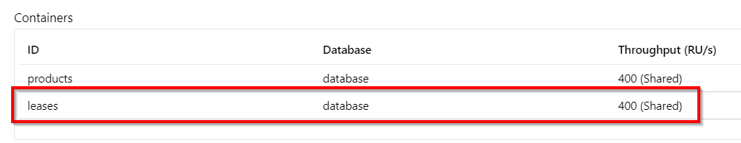

Figure 3.40: Cosmos DB—the Containers list
It's important to note that the Cosmos DB trigger wouldn't be triggered (at the time of writing) for any deletes in the container. It is only triggered for creates and updates to items in a container. If it is important for you to track deletes, and then you need to execute soft deletes, which means setting an attribute such as isDeleted to true for records that are deleted by the application and based on the value of the isDeleted attribute, implementing your custom logic in the Cosmos DB trigger.
The integration that we have done between Azure Functions and Cosmos DB uses Cosmos DB change feeds. You can learn more about change feeds here: https://docs.
microsoft.com/azure/cosmos-db/change-feed
Don't forget to delete the Cosmos DB account and its associated containers if you think you will no longer use them, because the containers are charged based on the RUs allocated, even if you are not actively using them.
If you are not able to run this Azure function or you get an error saying that Cosmos DB extensions are not installed, then try creating a new Azure Cosmos DB trigger using the templates available, which should then prompt installation.
In this recipe, we first created a Cosmos DB account and created a database and a new container within it. Once the container was created, we integrated it from within the Azure portal by clicking on the Add Azure Function button, which is available at the Cosmos DB account level. We chose the required function app in which we wanted to create a Cosmos DB trigger. Once the integration was complete, we created a sample item in the Cosmos DB container and then verified that the function was triggered automatically for all the changes (all reads and writes but not deletes) that we will make on the container.
Let's now proceed to integrate Azure Functions with Azure Data Factory.
Integrating Azure Functions with Data Factory pipelines | 87

Integrating Azure Functions with Data Factory pipelines
In many enterprise applications, the need to work with data is definitely there, especially when there are a variety of heterogeneous data sources. In such cases, we need to identify tools that help us to extract the raw data, transform it, and then load the processed data into other persistent media to generate reports.
Azure assists organizations in carrying out the preceding scenarios by using a service called Azure Data Factory (ADF).
Azure Data Factory is another cloud-native serverless solution from Microsoft Azure. ADF can be used as an Extract, Transform, and Load (ETL) tool to process the data from various data sources, transform it, and load the processed data into a wide variety of data destinations. Before we start working with the recipe, I would recommend that you learn more about Azure Data Factory and its concepts at https://docs.microsoft.
com/azure/data-factory/introduction.
When we have complex processing requirements, ADF will not let us write complex custom logic. Fortunately, ADF supports the plugging of Azure functions into ADF pipelines, where we can pass input data to Azure Functions and also receive the returned values from Azure Functions.
In this recipe, you'll learn how to integrate Azure Functions with ADF pipelines. The following is a high-level architecture diagram that depicts what we are going to do in this recipe:
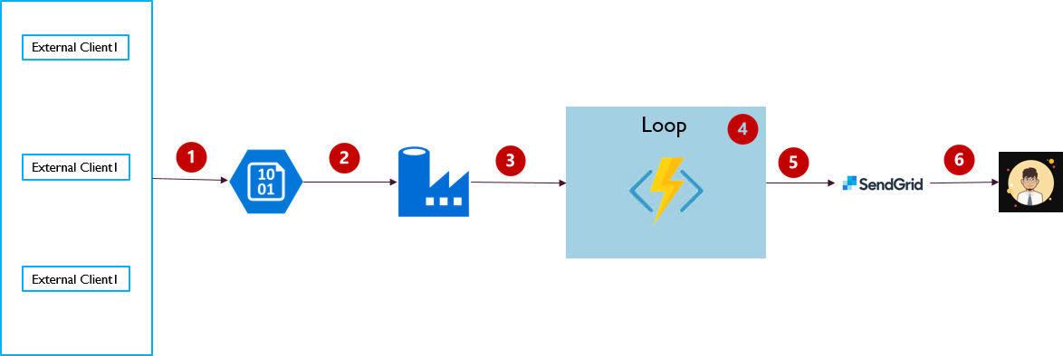

Figure 3.41: Integration of Azure Functions with an ADF pipeline
88 | Seamless integration of Azure Functions with Azure Services

As shown in the preceding architecture diagram, we are going to implement the following steps:
1. Client applications upload the employee data in the form of CSV files to the
storage account as blobs.
2. Trigger the ADF pipeline and read the employee data from the storage blob.
3. Call a ForEach activity in the Data Factory pipeline.
4. Iterate through every record and invoke Azure Function HTTP trigger to
implement the logic of sending emails.
5. Invoke SendGrid output bindings to send the emails.
6. The end user receives the email.

Getting ready…
In this section, we'll create the prerequisites to start working on this recipe. The prerequisites for this recipe are the following.
1. Upload the CSV files to a storage container.
2. Create an Azure Function HTTP trigger with the authorization level set to
Function.
3. Create a Data Factory instance.

Uploading the CSV files to a storage container Please create a storage account and a container, and upload the CSV file that contains the employee information, as shown in Figure 3.42:
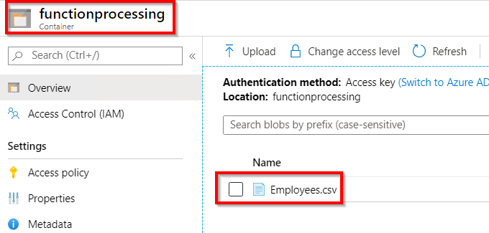

Figure 3.42: Storage container
Integrating Azure Functions with Data Factory pipelines | 89

The following is an example of the CSV file. Please make sure that there is a column named Email. We'll be using this field to pass data from the Data Factory pipeline to Azure Functions:
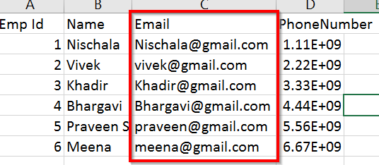

Figure 3.43: Employee data in a CSV file
Having uploaded the Employees.csv file to a storage container, let's move on to the next section.
Creating an Azure Function HTTP trigger with the authorization level set to Function In this section, we are going to create an HTTP trigger and also a linked service for the function app in the Data Factory service.
Create an HTTP function named SendMail. This receives an input name email and it also prints the values, as shown in line 18 in Figure 3.44:
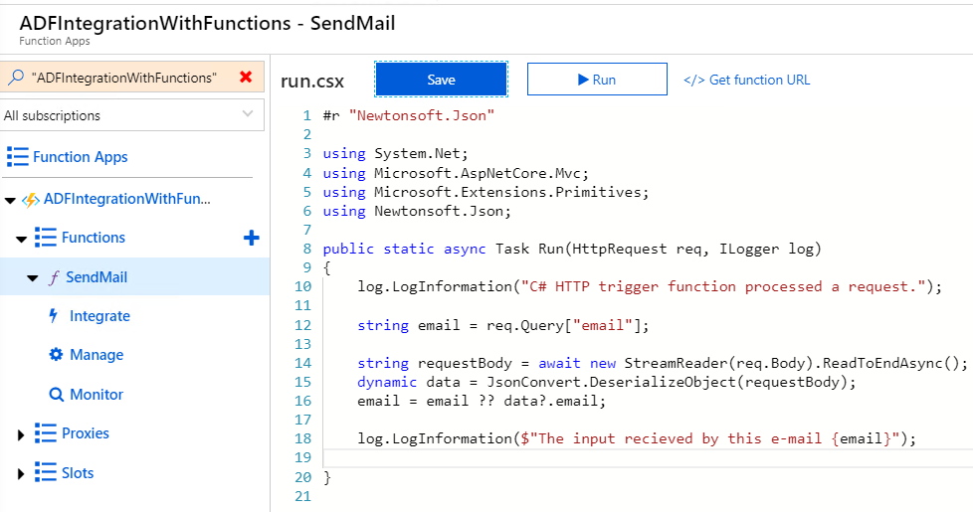

Figure 3.44: Creating an Azure function HTTP trigger 90 | Seamless integration of Azure Functions with Azure Services

In this section, we have created an Azure function with the HTTP authorization set to Function. Let's now move on to the next section to create the Data Factory instance.
Creating a Data Factory instance
In this section, we'll create a Data Factory instance by performing the following steps.
1. Click on Create a resource and search for Data Factory, as shown in Figure 3.45.
This will take you to the next step, where you must click on the Create button:
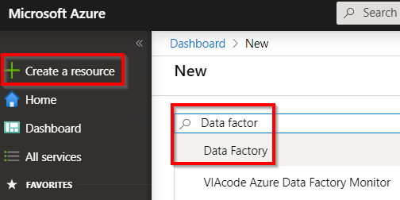

Figure 3.45: Searching for Data Factory
2. In the New data factory blade, provide the name and other details, as shown in
Figure 3.46, and click on the Create button:
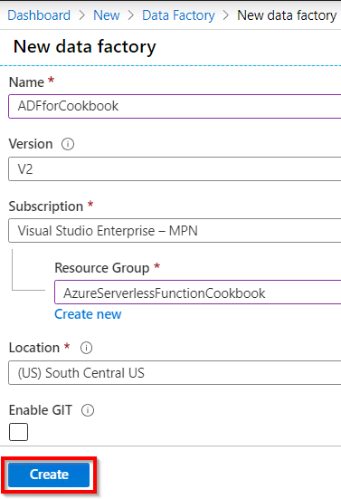

Figure 3.46: Creating a new Data Factory instance
Integrating Azure Functions with Data Factory pipelines | 91

3. Once the Data Factory service is created, click on the Author & Monitor button
available in the Overview blade, as shown in Figure 3.47:
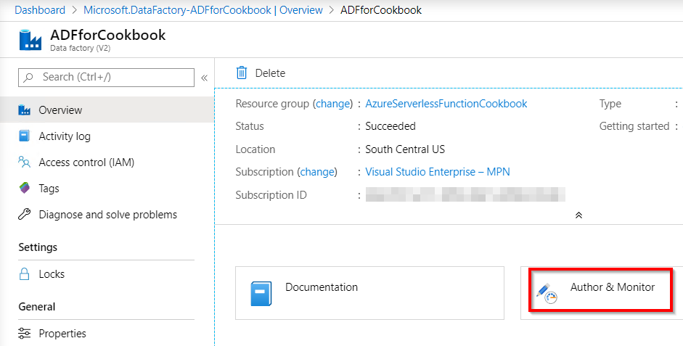

Figure 3.47: Author & Monitor
4. Now, it will open up a new browser tab and take you to the https://adf.azure.com
page, where you can see the Let's get started section.
5. In the Let's get started view, click on the Create pipeline button, as shown in
Figure 3.48, to create a new pipeline:
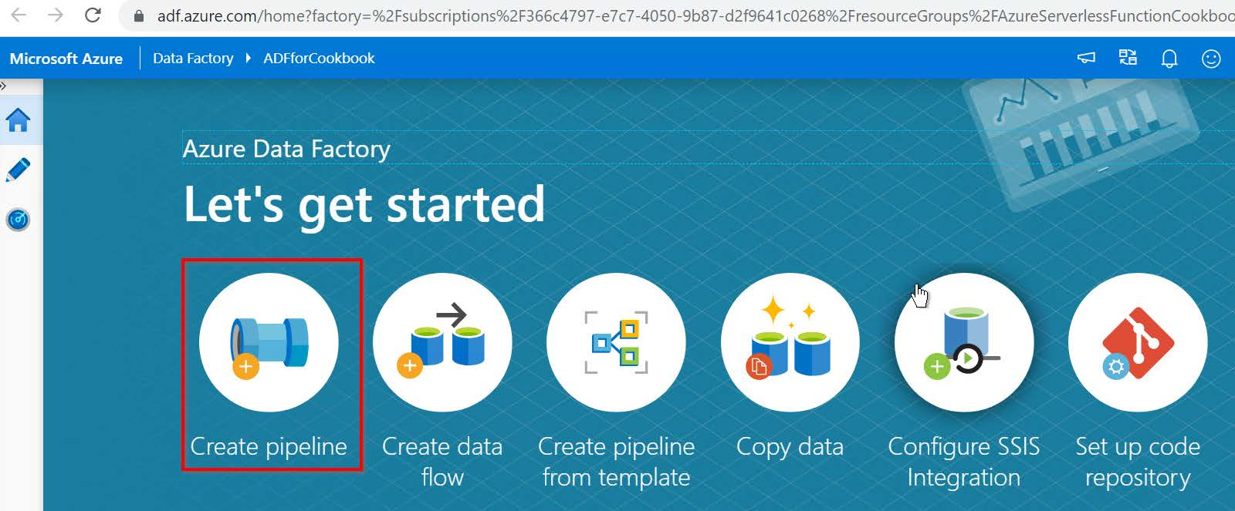

Figure 3.48: ADF—Let's Get Started 92 | Seamless integration of Azure Functions with Azure Services

6. This will take you to the Authoring section, where you can author the pipeline, as
shown in Figure 3.49:
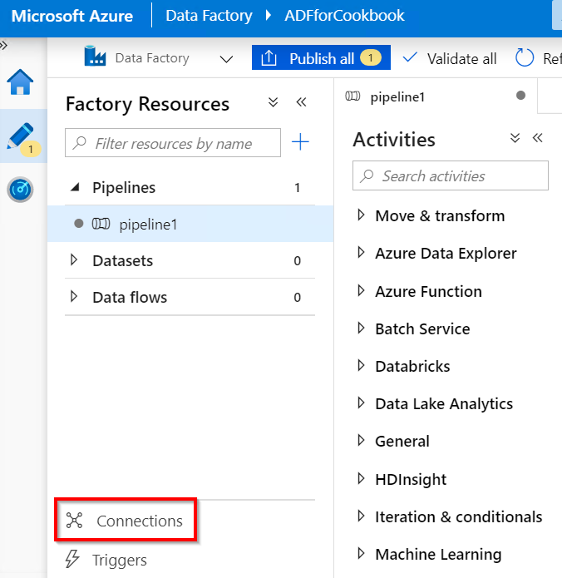

Figure 3.49: ADF—new pipeline
7. Before you start authoring the pipeline, you need to create connections to the
storage account and Azure Functions. Click on the Connections button, as shown in Figure 3.49.
8. In the Linked services tab, click on the New button, search for blob in the Data
store section, and select Azure Blob Storage, as shown in Figure 3.50:
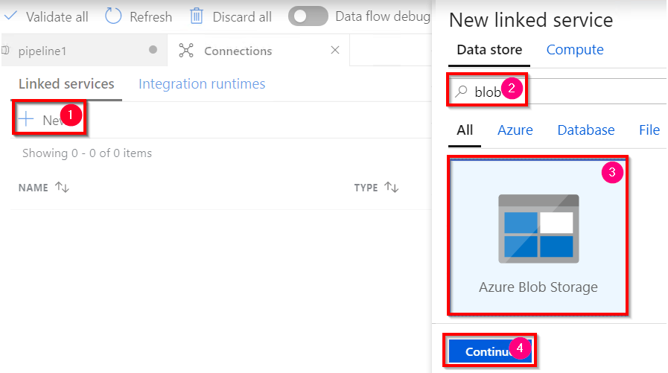

Figure 3.50: ADF—New linked service—choosing a linked service
Integrating Azure Functions with Data Factory pipelines | 93

9. In the New linked service pop-up window, provide the name of the linked service,
choose Azure subscription and Storage account name, test the connection,
and then click on the Create button to create the linked service for the storage
account, as shown in Figure 3.51:
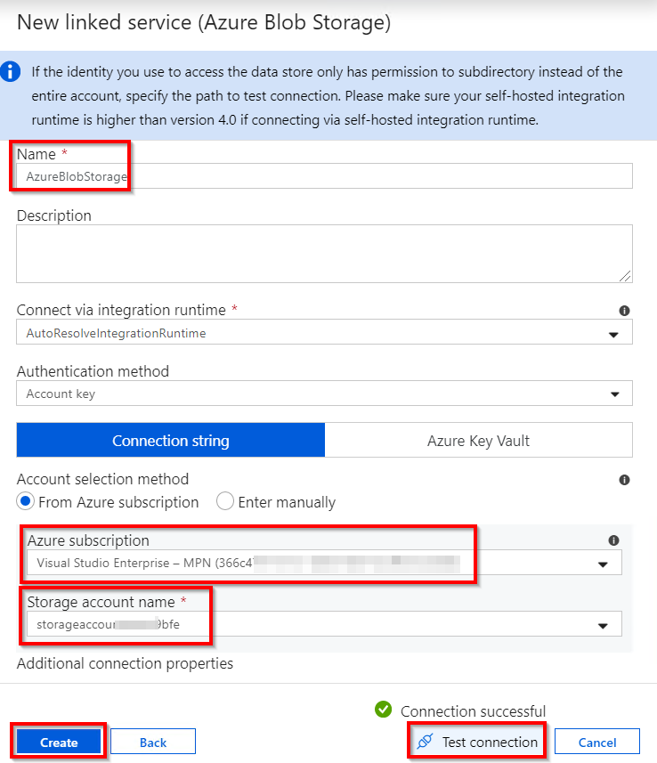

Figure 3.51: ADF—New linked service—providing connection details 94 | Seamless integration of Azure Functions with Azure Services

10. Once you click on the Create button, this will create a linked service, as shown in
Figure 3.52:
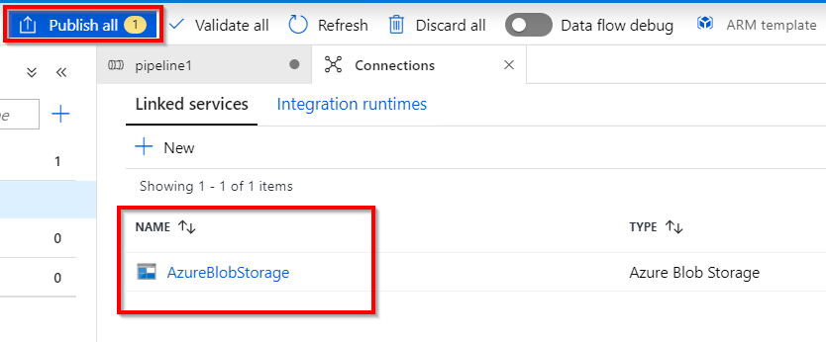

Figure 3.52: ADF—Linked services
11. After reviewing the linked service, click on Publish all to save the changes to the
Data Factory instance.
12. Now create another linked service for Azure Functions by again clicking on New
button in the Connections tab.
13. In the New linked service pop-up window, choose the Compute drop-down
option, select Azure Function, and then click on the Continue button, as shown in Figure 3.53:
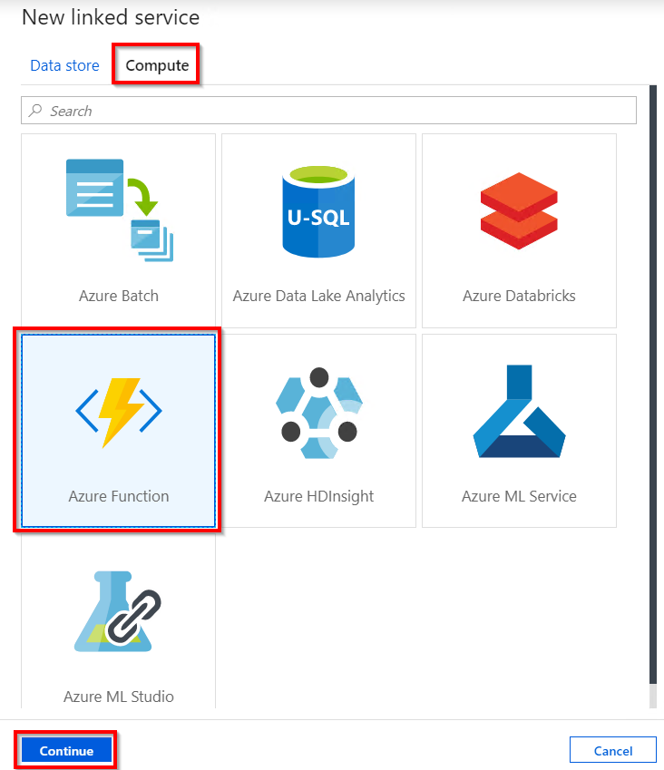

Figure 3.53: ADF—New linked service—choosing Azure Function
Integrating Azure Functions with Data Factory pipelines | 95

14. In the next step, provide a name to the linked service, choose the subscription
function app, provide the Function Key value, and then click on Create, as shown
in Figure 3.54:
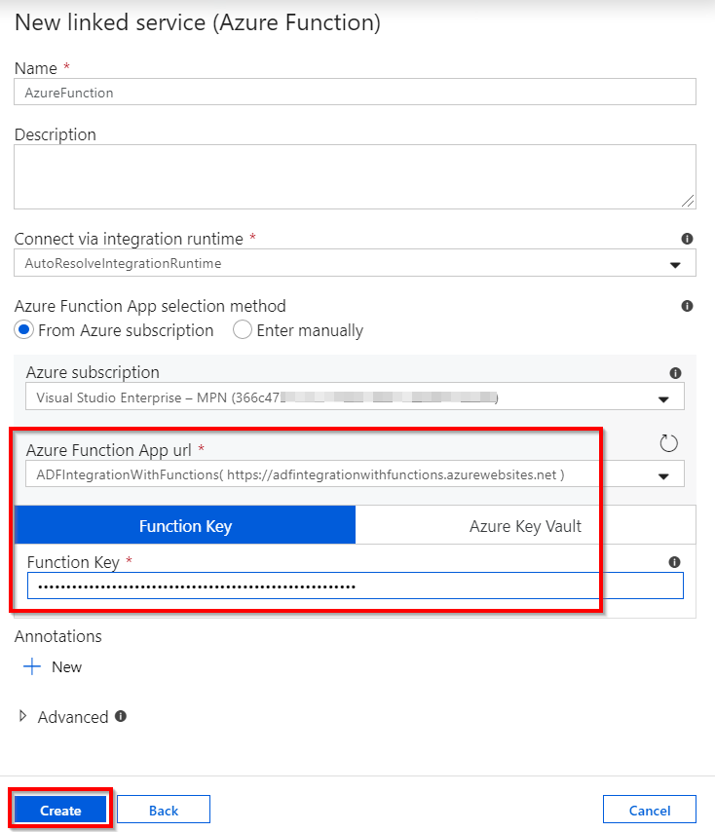

Figure 3.54: ADF—New linked service—Azure function app

Note
You can get the Function Key value from the Manage blade of the function app. Function keys are discussed in detail in the Controlling access to Azure Functions using function keys recipe of Chapter 9, Configuring security for Azure Functions. 96 | Seamless integration of Azure Functions with Azure Services

15. Once the Azure function linked service is created, you should see something
similar to Figure 3.55. Click on Publish all to save and publish the changes to the Data Factory service:
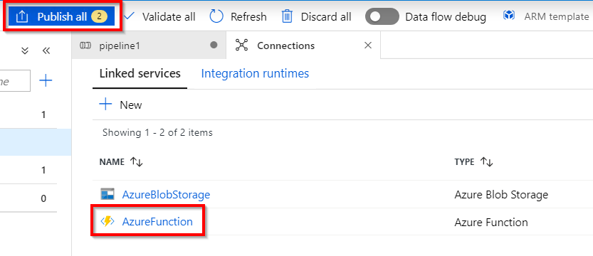

Figure 3.55: ADF—Linked services
In this section, we have created the following:
1. A Data Factory instance
2. A Data Factory pipeline
3. A linked service to the storage account
4. A linked service to Azure Functions

We will now move on to the next section to see how to build the Data Factory pipeline.

How to do it...
In this section, we are going to create the Data Factory pipeline by performing the following steps:
1. Create a Lookup activity that reads the data from the storage account.
2. Create a ForEach activity that takes input from the Lookup activity. Add an Azure
Function activity inside the ForEach activity.
3. The ForEach activity iterates based on the number of input items that it receives
from the Lookup activity and then invokes the Azure function to implement the logic of sending the emails.

Let's begin by creating the Lookup activity by performing the following steps:
1. Drag and drop the Lookup activity that is available in the General section and
name the activity as ReadEmployeeData, as shown in Figure 3.56. Learn more about the activity by clicking on the Learn more button highlighted in Figure 3.56:
Integrating Azure Functions with Data Factory pipelines | 97
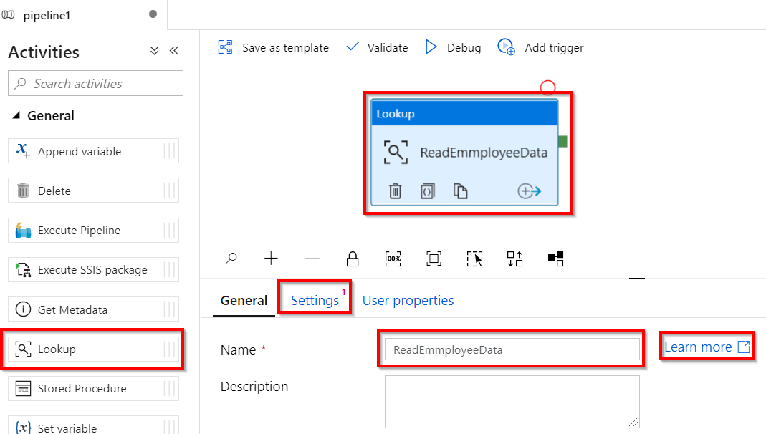

Figure 3.56: ADF—Lookup activity settings
2. Select the Lookup activity and click on the Settings button, which is available
in Figure 3.56. By default, the Lookup activity reads only the first row. Your
requirement is to read all the values available in the CSV file. So, uncheck the First
row only checkbox, which is shown in Figure 3.57:
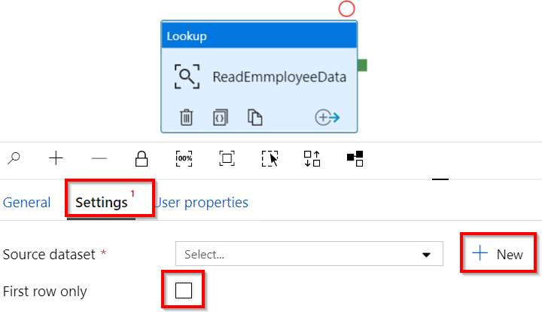

Figure 3.57: ADF—Lookup activity—new source dataset 98 | Seamless integration of Azure Functions with Azure Services

3. The Lookup activity's responsibility is to read data from a blob. The Lookup
activity requires a dataset to refer to the data stored in the blob. Let's create a dataset by clicking on the New button, as shown in Figure 3.57.
4. In the New dataset pop-up window, choose Azure Blob Storage and then click on
the Continue button, as shown in Figure 3.58:
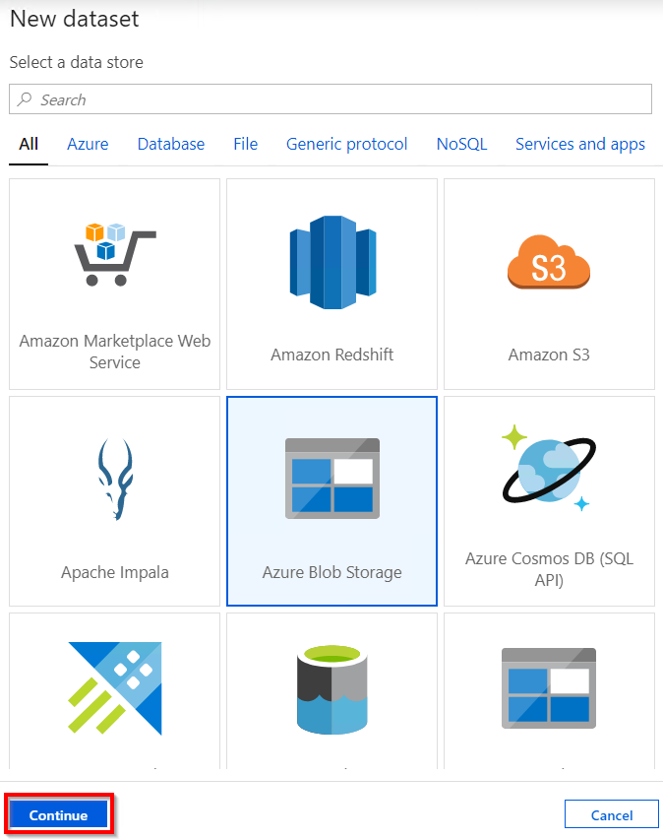

Figure 3.58: ADF—Lookup activity—new source dataset—choosing Azure Blob Storage
Integrating Azure Functions with Data Factory pipelines | 99

5. In the Select format pop-up window, click on the Delimited Text option, as shown
in Figure 3.59, and click Continue:
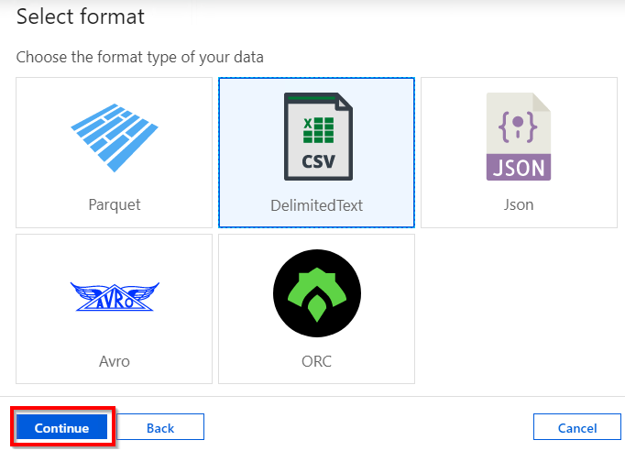

Figure 3.59: ADF—Lookup activity—new source dataset—choosing the blob format
6. In the Set properties pop-up window, choose AzureBlobStorage under Linked
service (which we created in the Getting ready section of this recipe) and click on
the Browse button, as shown in Figure 3.60:
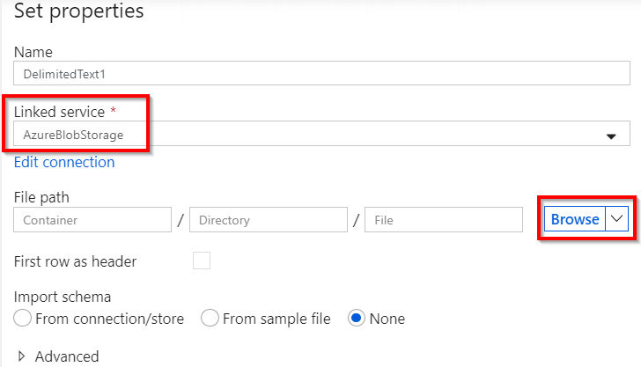

Figure 3.60: ADF—Lookup activity—new source dataset—Set properties 100 | Seamless integration of Azure Functions with Azure Services

7. In the Choose a file or folder pop-up window, double-click on the blob
container:
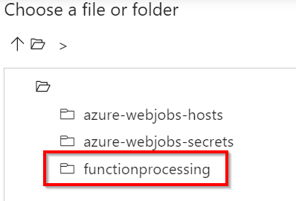

Figure 3.61: ADF—Lookup activity—new source dataset—selecting the blob container
8. This opens up all the blobs in which the CSV files reside, as shown in Figure 3.62.
Once you have chosen the blob, click on the OK button:
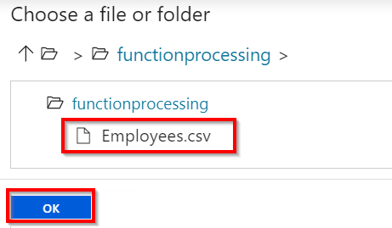

Figure 3.62: ADF—Lookup activity—new source dataset—selecting the blob
9. You'll be taken back to the Set properties pop-up window. Click on the OK button
to create the dataset.
10. Once it is created, navigate to the dataset and mark the First row as header
checkbox, as shown in Figure 3.63:
Integrating Azure Functions with Data Factory pipelines | 101
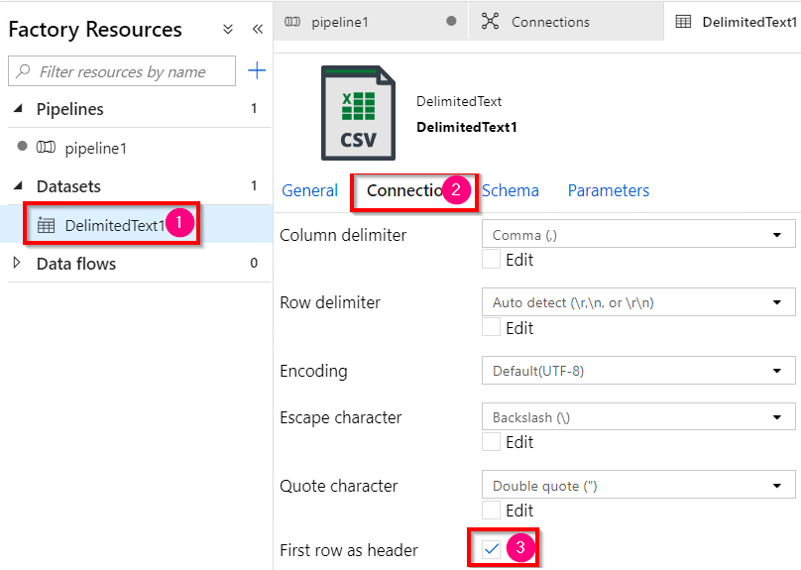

Figure 3.63: ADF—Lookup activity—new source dataset—First row as header checkbox
11. Now, the Lookup activity's Setting blade should look something like this:
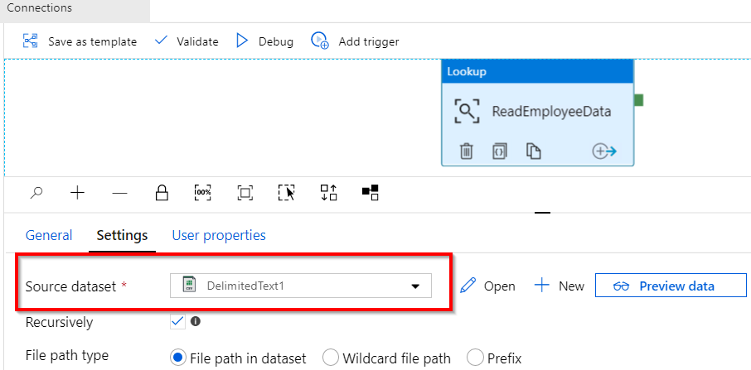

Figure 3.64: ADF—Lookup activity—selecting Source dataset 102 | Seamless integration of Azure Functions with Azure Services

12. Drag and drop the ForEach activity to the pipeline and change its name to
SendMailsForLoop, as shown in Figure 3.65:
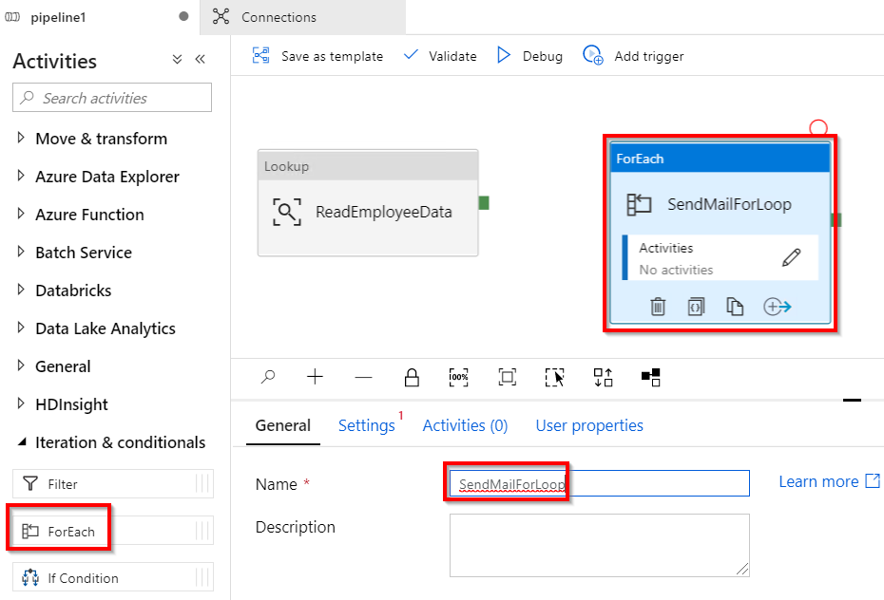

Figure 3.65: ADF—creating a ForEach activity
13. Now, drag the green box that is available in the right-hand side of the Lookup
activity and drop it on the ForEach activity, as shown in Figure 3.66, to connect them:
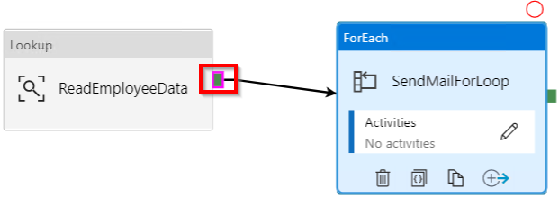

Figure 3.66: ADF—linking the Lookup and ForEach activities
Integrating Azure Functions with Data Factory pipelines | 103

14. Once the Lookup activity and the ForEach activity are connected, the Lookup
activity can send the data to the ForEach activity as a parameter. In order to
receive the data by the ForEach activity, go to the Settings section of the ForEach
activity and click on the Add dynamic content option, available below the Items
field as shown in Figure 3.67:
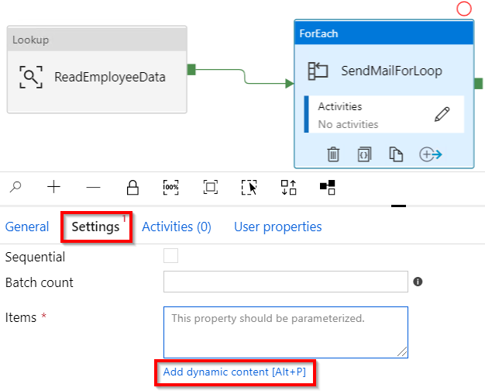

Figure 3.67: ADF—ForEach activity settings
104 | Seamless integration of Azure Functions with Azure Services

15. In the Add dynamic content pop-up window, click the ReadEmployeeData activity
output, which adds @activity('ReadEmployeeData') output to the text box. Now, append a value by typing .value, as shown in Figure 3.68, and click on the Finish button:
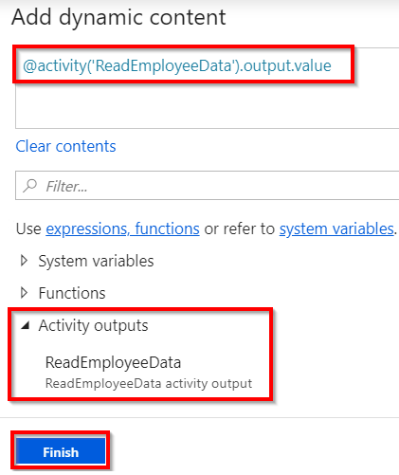

Figure 3.68: ADF—ForEach activity settings—choosing the output of the lookup activity
16. You should see something similar to what is shown in Figure 3.69 in the Items
text box:
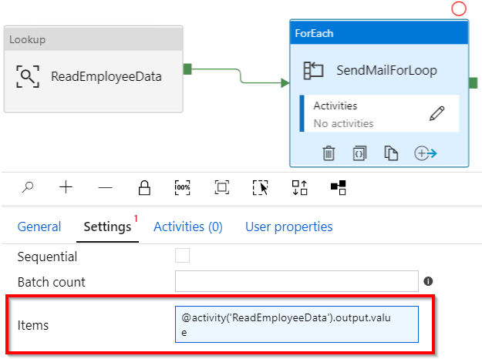

Figure 3.69: ADF—ForEach activity settings—configured input
Integrating Azure Functions with Data Factory pipelines | 105

17. Let's now click on the pen icon, which is available inside the ForEach activity as
shown in Figure 3.70:
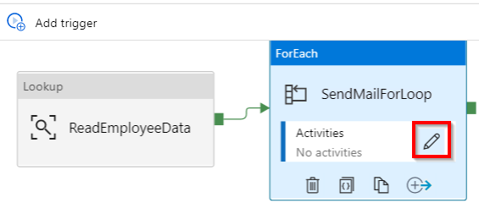

Figure 3.70: ADF—ForEach activity—editing
18. Drag and drop the Azure Function activity to the pipeline and change its name to
SendMail, as shown in Figure 3.71, and click on the Settings button:
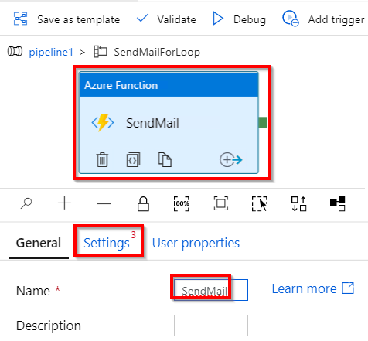

Figure 3.71: ADF—ForEach activity—adding a function activity 106 | Seamless integration of Azure Functions with Azure Services

19. In the Settings tab, choose the AzureFunction linked service that is created in the
Getting ready section of this recipe and also choose the Function name option, as shown in Figure 3.72:
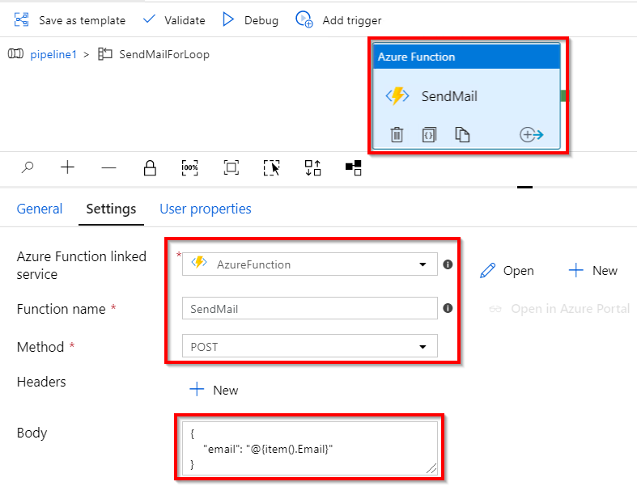

Figure 3.72: ADF—ForEach activity—passing inputs to the function activity
20. As shown in Figure 3.72, you need to provide the input to the Azure function
named SendMail, which receives email as input. The expression provided in the
Body field is called an ADF expression. Learn more about these at https://docs.
microsoft.com/azure/data-factory/control-flow-expression-language-functions.
21. Now, click on the Publish all button to save the changes.
Integrating Azure Functions with Data Factory pipelines | 107

22. Once the changes are published, click on Add trigger and then the Trigger now
button, as shown in Figure 3.73:
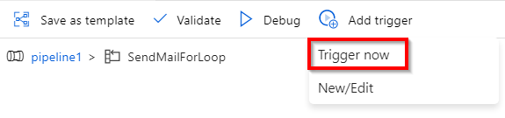

Figure 3.73: ADF—running the pipeline
23. A new pop-up window will appear, as shown in Figure 3.74. Click on OK to start
running the pipeline:
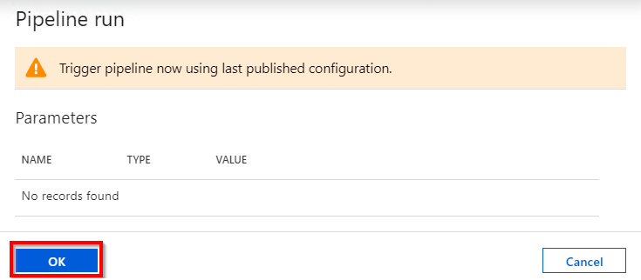

Figure 3.74: ADF—Pipeline run parameters
108 | Seamless integration of Azure Functions with Azure Services

24. Click OK and immediately navigate to the Azure function and view the logs, as
shown in Figure 3.75, to see the inputs received from the Data Factory instance:
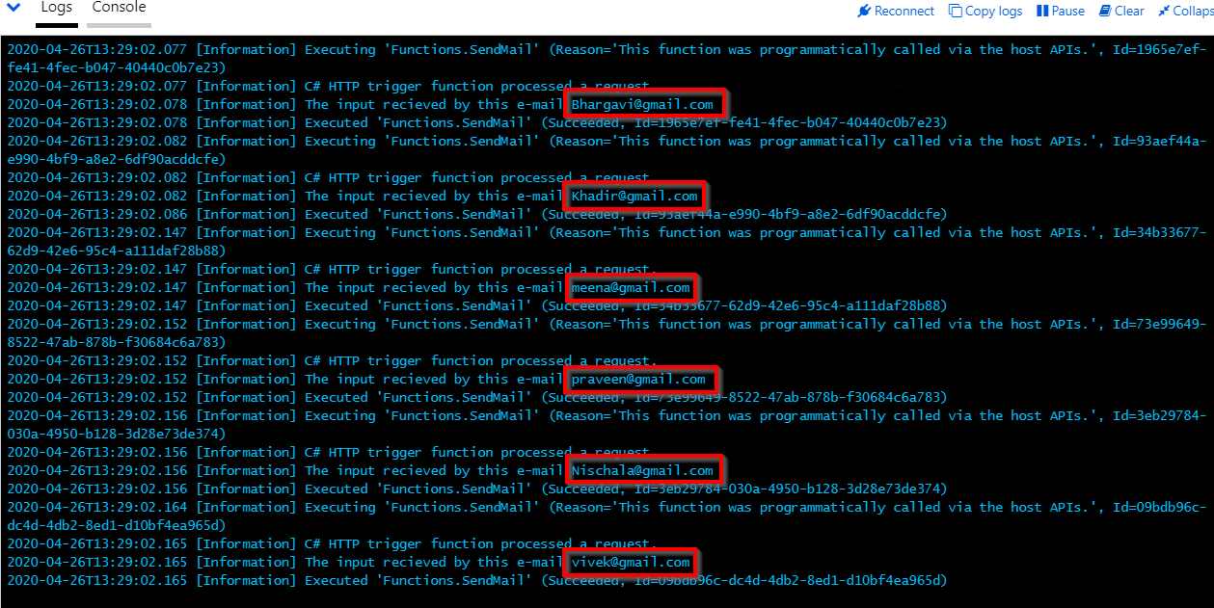

Figure 3.75: ADF—Azure Functions—console logs
That's it! You have learned how to integrate Azure Functions as an activity inside the ADF pipeline.
The next step is to integrate the functionality of sending an email to the end user based on the input received. These steps have already been discussed in the Sending an email notification dynamically to the end user recipe in Chapter 2, Working with notifications using the SendGrid and Twilio services.
You can also monitor the progress of the pipeline execution by clicking on the Monitor tab, as shown in Figure 3.76:
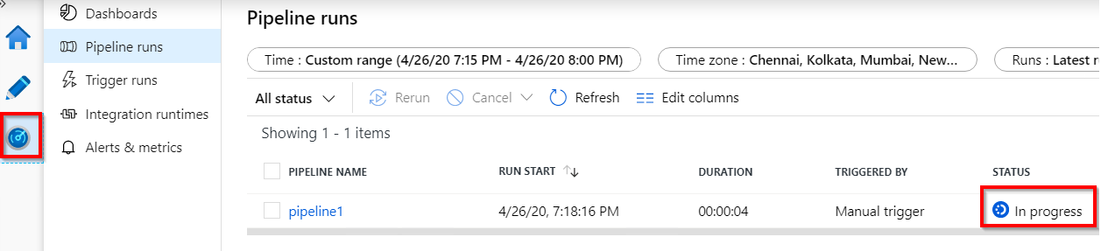

Figure 3.76: ADF—monitoring the pipeline
Integrating Azure Functions with Data Factory pipelines | 109

Click on the pipeline name to view detailed progress, as shown in Figure 3.77:
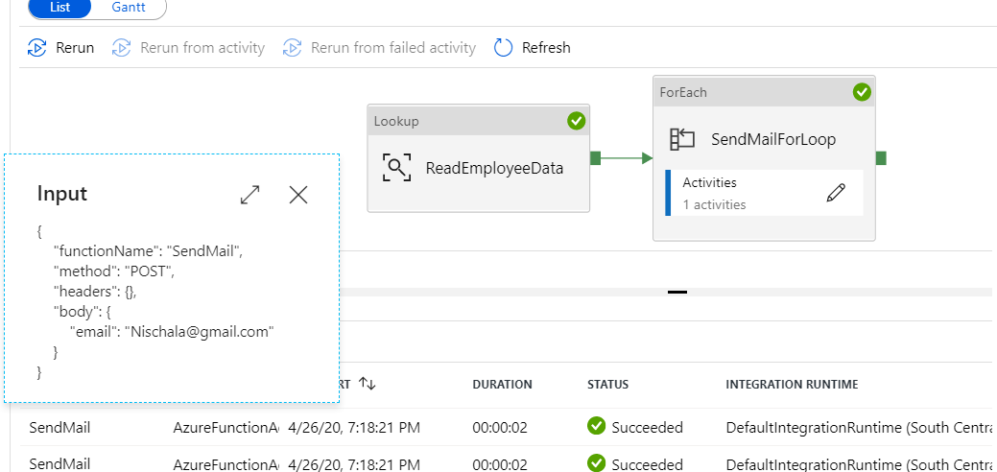

Figure 3.77: ADF—monitoring individual activities
In this recipe, you have learned how to integrate Azure Functions as an activity in an ADF pipeline.
In this chapter, you have learned how to integrate Azure Functions with various Azure services, including Cognitive Services, Logic Apps, and Data Factory.

Developing Azure

Functions using Visual

Studio

In this chapter, we'll cover the following:
• Creating a function application using Visual Studio 2019
• Debugging Azure Function hosted in Azure using Visual Studio
• Connecting to the Azure Storage from Visual Studio
• Deploying the Azure Function application using Visual Studio
• Debugging Azure Function hosted in Azure using Visual Studio
• Deploying Azure Functions in a container 112 | Developing Azure Functions using Visual Studio

Introduction
In previous chapters, you learned how to create Azure Functions right from the Azure Management portal. Here are a few of the features that we encountered:
• We can quickly create a function just by selecting one of the built-in templates
provided by the Azure Functions runtime.
• Developers need not worry about writing plumbing code or understanding how to
work with the frameworks.
• Configuration changes can be made right within the UI using the standard editor.

Despite the advantages provided by the Azure Management portal, moving over from a familiar integrated development environment (IDE) to something new can prove to be a daunting task for developers. To ease this transition, the Microsoft team has come up with a few tools that help developers to integrate Azure Functions into Visual Studio, with the aim of leveraging critical IDE features that are imperative for accelerating development efforts. Here are a few of the features:
• Developers benefit from IntelliSense support.
• The ability to debug code line by line.
• The values of variables can be quickly viewed while debugging the application.
• Integration with version control systems such as Azure DevOps (formerly known
as Visual Studio Team Services (VSTS)).

You'll learn about some of the preceding features in this chapter, and see how to integrate code with Azure DevOps in Chapter 12, Implementing and deploying continuous integration using Azure DevOps.

Creating a function application using Visual Studio 2019
In this recipe, you will learn how to create an Azure function in Visual Studio 2019 with the latest available Azure Functions runtime. You'll also discover how to provide access to anonymous users.
Creating a function application using Visual Studio 2019 | 113

Getting ready
You'll need to download and install the following tools and software:
• Download the latest version of Visual Studio 2019, which can be found here:
https://visualstudio.microsoft.com/downloads/
• During the installation, choose Azure development in the Workloads section and
then click on the Install button.

How to do it…
In this section, you'll create a function application and a HTTP function using Visual Studio by performing the following steps:
1. Open Visual Studio, choose Create a new project, select Azure in the platform
dropdown, and then choose the Azure Functions template. Once you are ready,
click on Next, as shown in Figure 4.1:
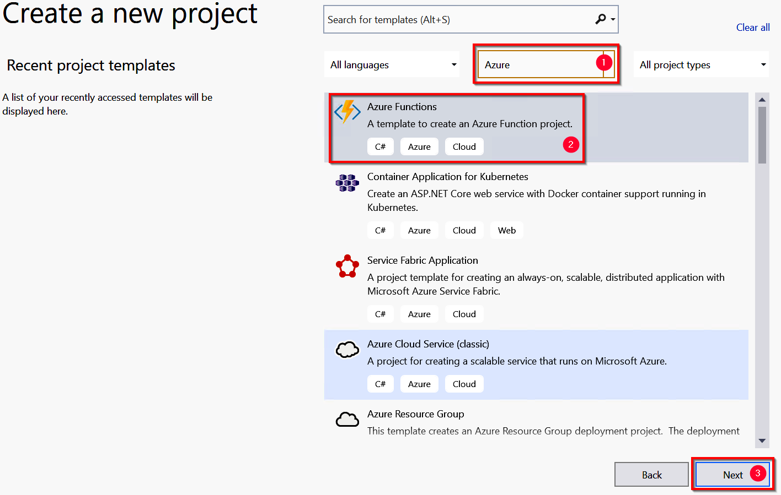

Figure 4.1: Create a new project
114 | Developing Azure Functions using Visual Studio

2. Now, you need to provide a name for the function application. Click on the Create
button to go to the next step. As shown in Figure 4.2, choose Azure Functions v3 (.NET Core) from the drop-down menu, then select Http trigger with Anonymous in the Authorization level dropdown, and click on the Create button:
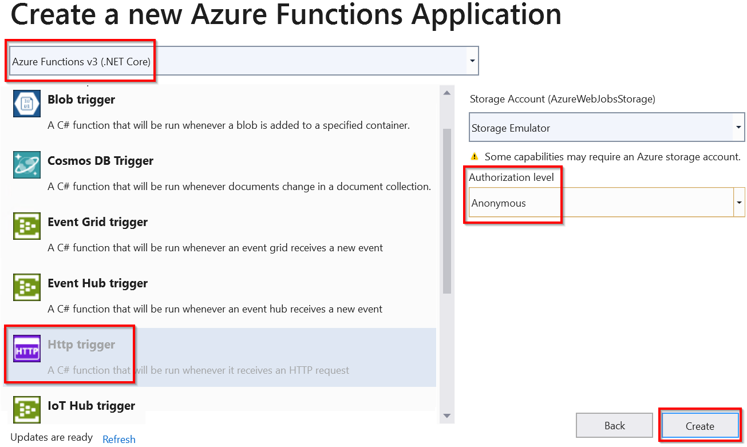

Figure 4.2: Create a new Azure Functions Application
3. You have successfully created the Azure Function application, along with an HTTP
trigger (which accepts web requests and sends a response to the client), with the name Function1. Feel free to change the default name of the function application, and also be sure to build the application to download the required NuGet packages.
4. After you create a new function, a new class will also be created, as shown in
Figure 4.3:
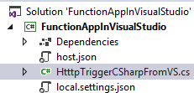

Figure 4.3: Azure Functions Solution Explorer
Debugging Azure Function hosted in Azure using Visual Studio | 115

You have now successfully created a new HTTP triggered function application using Visual Studio 2019.

How it works…
As explained earlier, Visual Studio tools for Azure Functions allow developers to use their preferred IDE, which they may have been using for years. Using the tools of Azure Functions, we can use the same set of templates that the Azure Management portal provides in order to quickly create Azure Functions and integrate them with cloud services without writing any (or minimal) plumbing code.
The other advantage of using Visual Studio tools for Functions is that we don't need to have a live Azure subscription. We can debug and test Azure Functions right in our local development environment. The Azure command-line interface (CLI) and related utilities provide us with all the required assistance to execute Azure Functions.

There's more…
One of the most common problems that developers face while developing any application in their local environment is that everything works fine on their local machine but not in the production environment. With Azure Functions, developers need not worry about this dilemma as the Azure Functions runtime provided by the Azure CLI tools is exactly the same as the runtime available on the Azure cloud.

Note
We can always use and trigger an Azure service running on the cloud, even when we are developing Azure Functions locally.

Now that you understand how to create a function application using Visual Studio 2019, in the next recipe, you'll learn about debugging C# Azure Functions.

Debugging Azure Function hosted in Azure using Visual Studio
Once the basic setup of your Function creation is complete, the next step is to start working on developing the application as per your needs. Developers end up facing numerous technical issues that require tools to identify the root cause of the problem and fix it. These tools include debugging tools that help developers to step into each line of the code to view the values of the variables and objects and get a detailed view of the exceptions.
116 | Developing Azure Functions using Visual Studio

Getting ready
Download and install the Azure CLI (if these tools are not installed, Visual Studio will automatically download them when you run your functions from Visual Studio).

How to do it...
In this section, you'll learn how to configure and debug an Azure function in a local development environment within Visual Studio.
Perform the following steps:
1. In the previous recipe, you created the HTTP trigger function using Visual Studio.
Let's build the application by clicking on Build and then clicking on Build Solution.
2. Open the HttpTriggerCSharpFromVS.cs file and create a breakpoint by pressing the
F9 key, as shown in Figure 4.4:
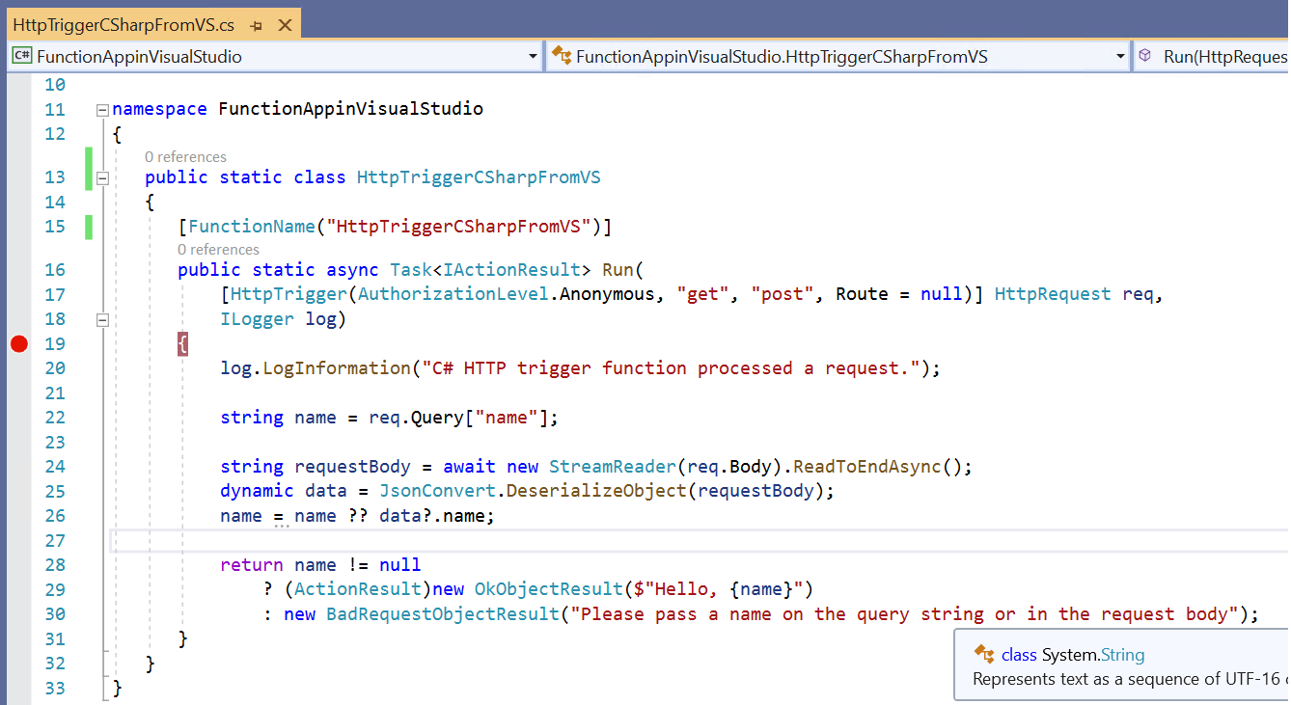

Figure 4.4: The HTTP trigger function code
3. Press the F5 key to start debugging the function. When we press F5 for the first
time, Visual Studio prompts us to download the Azure Functions CLI tools if they aren't already installed. These tools are essential for executing an Azure function in Visual Studio:
Debugging Azure Function hosted in Azure using Visual Studio | 117
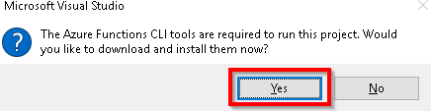

Figure 4.5: Azure Functions core tool installation

Note
The Azure Functions CLI has now been renamed Azure Functions Core Tools. Find
out more about them at https://www.npmjs.com/package/azure-functions-core-
tools.

4. Clicking on Yes, as shown in Figure 4.5, will start downloading the CLI tools. The
download and installation of the CLI tools will take a few minutes.
5. Once the Azure Functions CLI tools have been installed successfully, a job host
will be created and started. It will start monitoring requests on a specific port for
all the functions of your function application. Figure 4.6 shows that the job host
has started monitoring the requests to the function application:
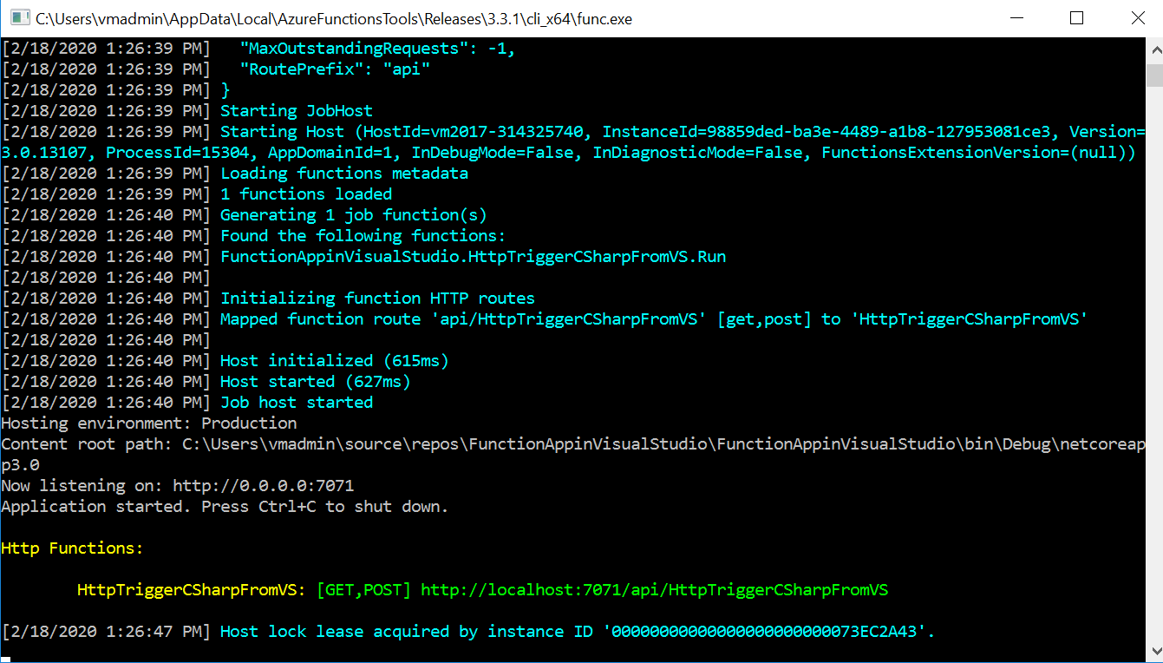

Figure 4.6: The Azure function job host 118 | Developing Azure Functions using Visual Studio

6. Let's try to access the function application by making a request to http://
localhost:7071 in any web browser:
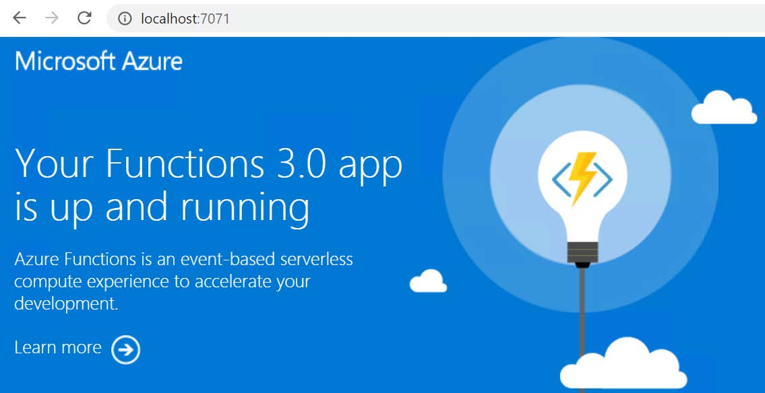

Figure 4.7: The Azure Functions 3.0 default web page
Now, type the complete URL of your HTTP trigger in the browser. The URL should look like this:
http://localhost:7071/api/HttpTriggerCsharpFromVS?name=Praveen Sreeram.
7. After entering the correct URL of the Azure function, as soon as you hit the Enter
key in the address bar of the browser, the Visual Studio debugger will hit the debugging point (if you have one), as shown in Figure 4.8:
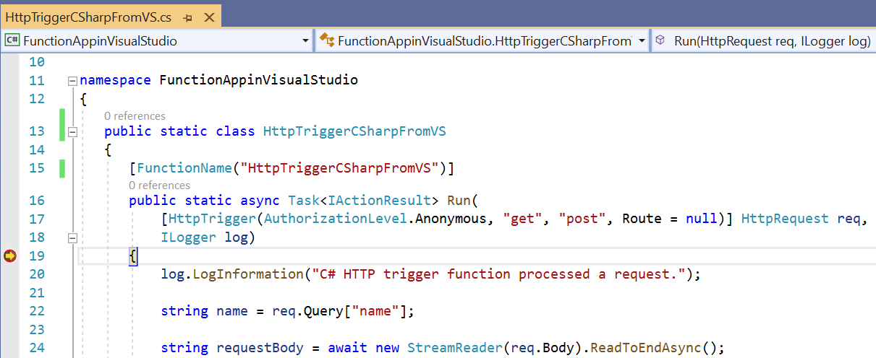

Figure 4.8: The Azure Function HTTP trigger—creating a debug point
Debugging Azure Function hosted in Azure using Visual Studio | 119

8. You can also view the data of your variables, as shown in Figure 4.9:
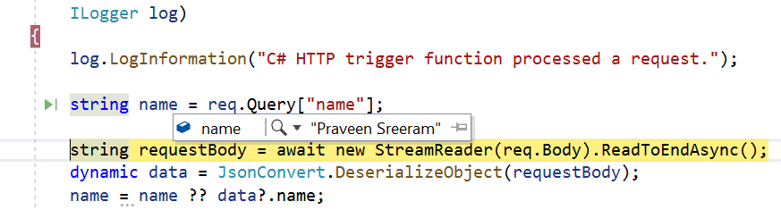

Figure 4.9: The Azure Function HTTP trigger—viewing variable values
9. Once you complete debugging, you can press the F5 key to complete the
execution process, after which, you'll see the output response in the browser, as
shown in Figure 4.10:

Figure 4.10: The HTTP trigger output
10. The function execution log will be seen in the job host console, as shown in
Figure 4.11:
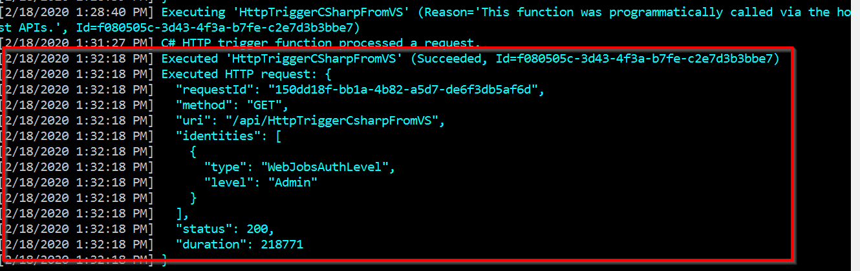

Figure 4.11: The HTTP trigger execution log
You can add more Azure Functions to the function application, if required. In the next recipe, we'll look at how to connect to the Azure Storage cloud from the local environment.
120 | Developing Azure Functions using Visual Studio

How it works…
The job host works as a server that listens to a specific port. If there are any requests to that particular port, it automatically takes care of executing the requests and sends a response.
The job host console provides us with the following details:
• The status of the execution, along with the request and response data.
• The details of all the functions available in the function application.

There's more...
Using Visual Studio, we can directly create precompiled functions, which means that when we build our functions, Visual Studio creates a .dll file that can be referenced in other applications, just as we do for our regular classes. The following are two of the advantages of using precompiled functions:
• Precompiled functions have better performance, as they aren't required to be
compiled on the fly.
• We can convert our traditional classes into Azure Functions easily, and refer to
them in other applications seamlessly.

In this recipe, you have learned how to debug Azure Functions in the local development workstation. In the next recipe, you'll learn how to connect to a storage account available in Azure.

Connecting to the Azure Storage from Visual Studio
In both of the previous recipes, you learned how to create and execute Azure Functions in a local environment. You triggered the functions from a local browser. However, in this recipe, you'll learn how to trigger an Azure function in your local environment when an event occurs in Azure. For example, when a new blob is created in an Azure storage account, we can have our function triggered on our local machine. This helps developers to test their applications upfront, before deploying them to the production environment.
Connecting to the Azure Storage from Visual Studio | 121

Getting ready
Perform the following steps:
• Create a storage account, and then a blob container named cookbookfiles,
in Azure.
• Install Microsoft Azure Storage Explorer from http://storageexplorer.com/.

How to do it...
In this section, you'll learn how to create a blob trigger that will trigger as soon as a blob is created in the storage account.
Perform the following steps:
1. Open the FunctionAppInVisualStudio Azure Function application in Visual Studio,
and then add a new function by right-clicking on the FunctionAppInVisualStudio
project. Click on Add | New Azure Function, which will open a pop-up window.
Here, for the name field, enter BlobTriggerCSharp and then click on the Add
button.
2. This will open another dialog box, where you can provide other parameters, as
shown in Figure 4.12:
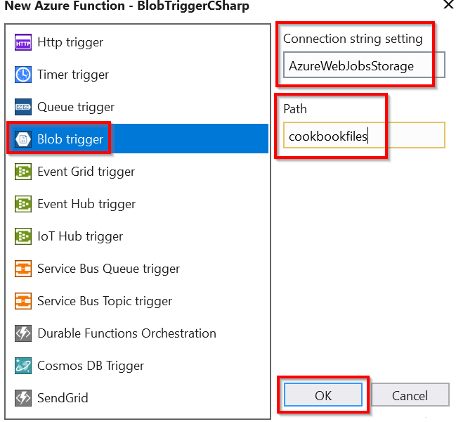

Figure 4.12: New Azure Function—HTTP trigger 122 | Developing Azure Functions using Visual Studio

3. In the Connection string setting field, provide AzureWebJobsStorage as the name
of the connection string, and also provide the name of the blob container (in this case, it is cookbookfiles) in the Path input field, and then click on the OK button to create the new blob trigger function. A new blob trigger function will be created, as shown in Figure 4.13:
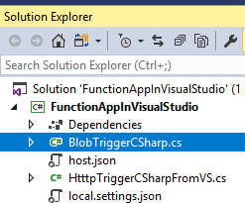

Figure 4.13: Azure Functions—Solution Explorer
4. As you learned in the Building a back-end web API using HTTP triggers recipe
from Chapter 1, Accelerating cloud app development using Azure Functions, the Azure Management portal allows us to choose between a new or existing storage account. However, the preceding dialog box is not connected to our Azure subscription. So, let's navigate to the storage account and copy the Connection string, which can be found in the Access keys blade of the storage account in the Azure Management portal, as shown in Figure 4.14:
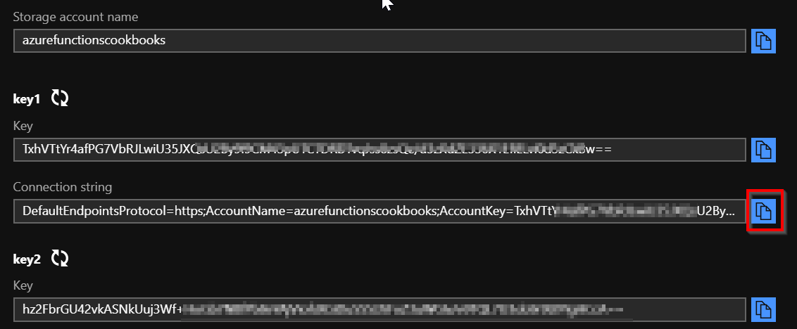

Figure 4.14: The storage account—the Access keys blade
Connecting to the Azure Storage from Visual Studio | 123

5. Paste the Connection string in the local.settings.json file, which is in the root
folder of the project. This file is created when you create the function application.
Once you add the Connection string to the key named AzureWebJobsStorage, the
local.settings.json file should look as shown in Figure 4.15:
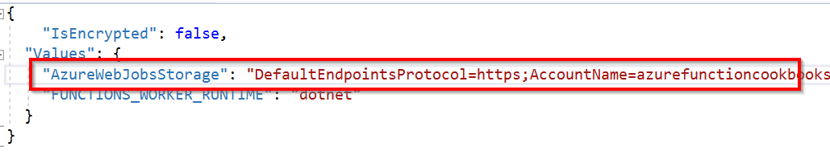

Figure 4.15: Azure Functions—application settings
6. Open the BlobTriggerCSharp.cs file and create a breakpoint, as shown in
Figure 4.16:
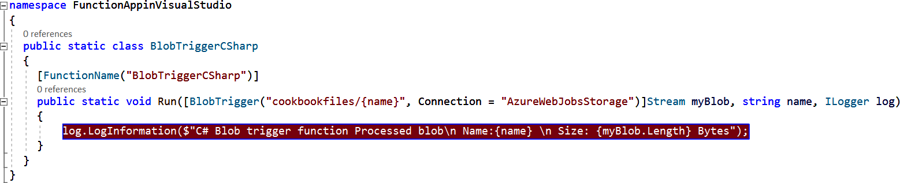

Figure 4.16: The Azure Functions blob trigger—creating a breakpoint
7. Now, press the F5 key to start the job host, as shown in Figure 4.17:
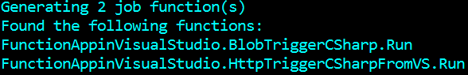

Figure 4.17: The Azure Functions host log—generating functions
8. Let's add a new blob file using Azure Storage Explorer, as shown in Figure 4.18:
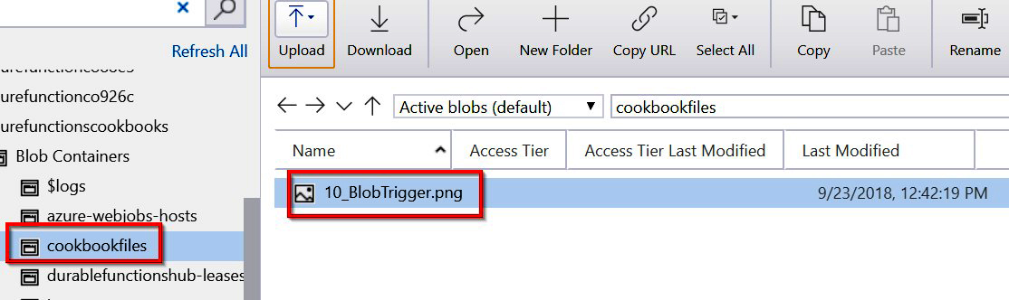

Figure 4.18: Storage Explorer
124 | Developing Azure Functions using Visual Studio

9. As soon as the blob has been added to the specified container (in this case, it is
cookbookfiles), which is sitting in the cloud in a remote location, the job host running in the local machine will detect that a new blob has been added and the debugger will hit the function, as shown in Figure 4.19:
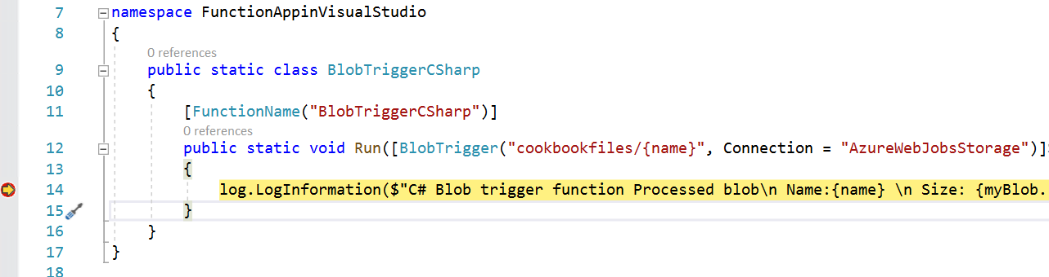

Figure 4.19: Azure Functions blob trigger—breakpoint
That's it. You have learned how to trigger an Azure function in your local environment when an event occurs in Azure.

How it works…
In this BlobTriggerCSharp class, the Run method has the WebJobs attribute with a connection string (in this case, it is AzureWebJobsStorage). This instructs the runtime to refer to the Azure Storage connection string in the local settings configuration file with the key named after the AzureWebJobsStorage connection string. When the job host starts running, it uses the connection string and keeps an eye on the storage account containers that you have specified. Whenever a new blob is added or updated, it automatically triggers the blob trigger in the current environment.

There's more…
When we create Azure Functions in the Azure Management portal, we need to create triggers and output bindings in the Integrate tab of each Azure function. However, when we create a function from the Visual Studio IDE, we can just configure WebJobs attributes to achieve this.

Note
Learn more about WebJobs attributes at https://docs.microsoft.com/azure/app-
service/webjobs-sdk-get-started.

In this recipe, you have learned how to create a blob trigger. In the next recipe, you'll learn how to deploy it to Azure.
Deploying the Azure Function application using Visual Studio | 125

Deploying the Azure Function application using Visual Studio
So far, your function application is just a regular application within Visual Studio. To deploy the function application along with its functions, you need to either create the following new resources, or select existing ones to host the new function application:
• The resource groups
• The App Service plan
• The Azure Function application

You can provide all these details directly from Visual Studio without opening the Azure Management portal. You'll learn how to do that in this recipe.

How to do it…
In this section, you'll learn how to deploy Azure Functions to Azure.
Perform the following steps:
1. Right-click on the project and then click on the Publish button to open the Pick a
publish target dialog box.
2. In the Pick a publish target dialog box, choose the Create New option and click on
the Create Profile button, as shown in Figure 4.20:
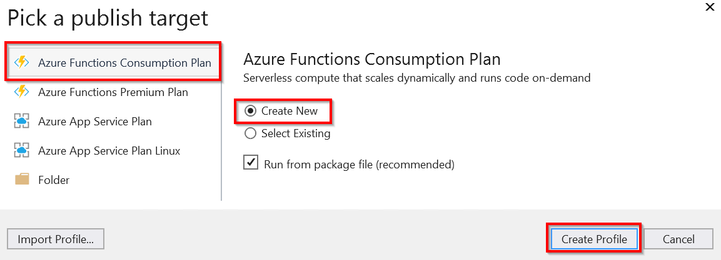

Figure 4.20: Visual Studio—Pick a publish target
126 | Developing Azure Functions using Visual Studio

3. In the Create new App Service window, you can choose from existing resources,
or click on the New… button to choose the new Resource group, the App Service plan, and the Storage Account, as shown in Figure 4.21:
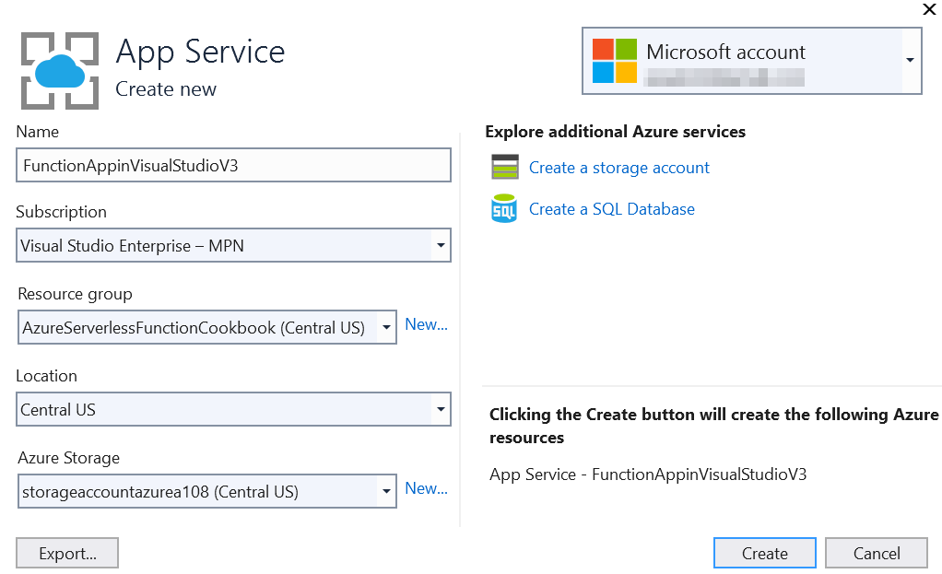

Figure 4.21: Visual Studio—creating a new App Service
4. After reviewing all the information, click on the Create button of the Create new
App Service window. This should start deploying the services to Azure.
Deploying the Azure Function application using Visual Studio | 127

5. If everything goes well, you can view the newly created Function App in the Azure
Management portal, as shown in Figure 4.22:
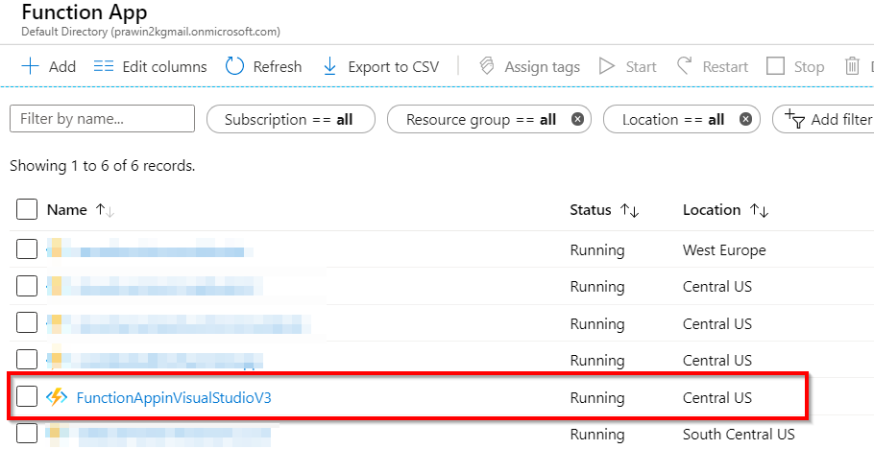

Figure 4.22: The function application listing
6. Hold on! Your job in Visual Studio is not yet done. You have just created the
required services in Azure right from the Visual Studio IDE. Your next job is to
publish the code from the local workstation to the Azure cloud. As soon as the
deployment is complete, you'll be taken to the web deploy step, as shown in Figure
4.23. Click on the Publish button to start the process of publishing the code:
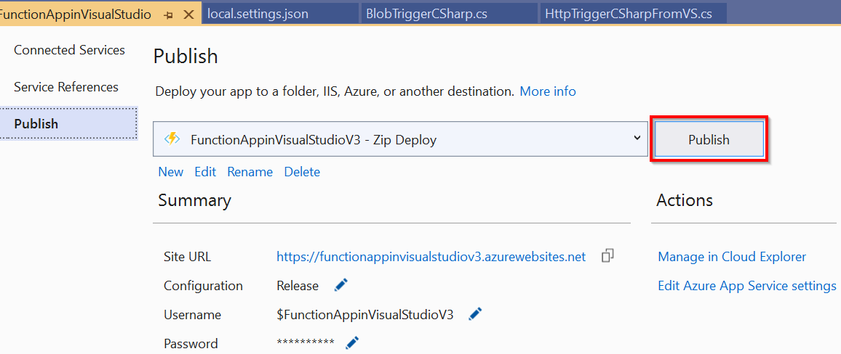

Figure 4.23: Visual Studio—Publish 128 | Developing Azure Functions using Visual Studio

7. That's it! You have completed the deployment of the Function application and its
functions to Azure right from your preferred development IDE, Visual Studio. You can review function deployment in the Azure Management portal. Both Azure Functions were created successfully, as shown in Figure 4.24:
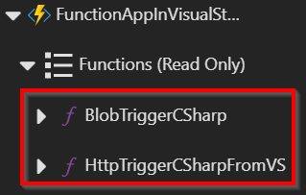

Figure 4.24: The function application—list

There's more...
Azure Functions that are created from Visual Studio are precompiled, which means that we deploy the .dll files from Visual Studio to Azure. Therefore, we cannot edit the functions' code in Azure after we deploy it. However, we can make changes to the configurations, such as changing the Azure Storage connection string and the container path. We'll look at how to do this in the next recipe.
In this recipe, we have deployed the Azure function to Azure. In the next recipe, you'll learn how to debug the Azure function from Visual Studio.

Debugging Azure Function hosted in Azure using Visual Studio
In one of the previous recipes, Connecting to the Azure Storage from Visual Studio, you learned how to connect a storage account from the local code. In this recipe, you'll learn how to debug the live code running in the Azure cloud environment. You'll perform the following steps in the BlobTriggerCSharp function of the FunctionAppinVisualStudio function application:
• Change the path of the container in the Azure Management portal to that of the
new container.
• Open the function application in Visual Studio 2019.
• Attach the debugger from within Visual Studio 2019 to the required Azure
function.
• Create a blob in the new storage container.
• Debug the application after the breakpoints are hit.
Debugging Azure Function hosted in Azure using Visual Studio | 129

Getting ready
Create a container named cookbookfiles-live in the storage account. You'll be uploading a blob to this container.

How to do it…
In this recipe, you'll make the changes in Visual Studio that will let you debug the code hosted in Azure right from the local Visual Studio.
Perform the following steps:
1. Navigate to the BlobTriggerCSharp function in Visual Studio and change the path of
the path variable to point to the new container, cookbookfiles-live:
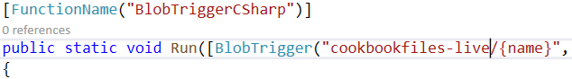

Figure 4.25: The blob trigger function
2. Now, republish it by changing the configuration to Debug | Any CPU, as shown in
Figure 4.26:
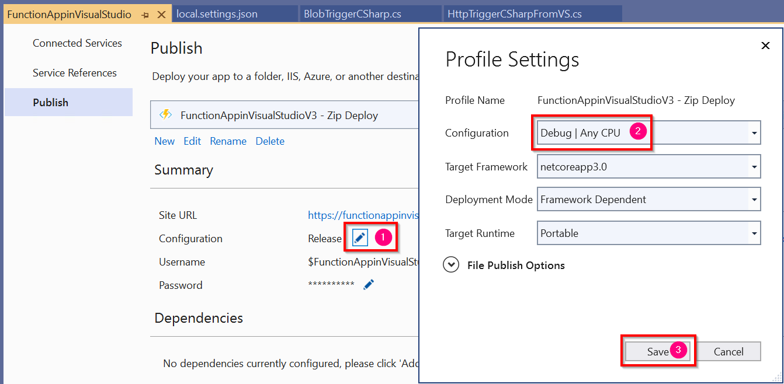

Figure 4.26: Visual Studio—Publish Profile Settings

Note
The preceding settings are to be used only in a non-production environment for testing. It's not recommended to deploy the package in Debug mode in your production environment. Once the testing is complete, you must republish the package in Release mode.
130 | Developing Azure Functions using Visual Studio

3. Once you publish it, the path of the container will look something like that shown
in Figure 4.27:
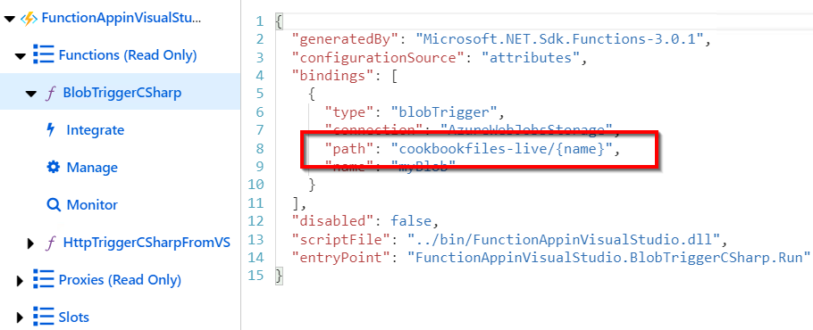

Figure 4.27: The blob trigger—Function.json
4. Open the function application in Visual Studio. Open Cloud Explorer
in Visual Studio and navigate to your Azure function; in this case, it is FunctionAppinVisualStudioV3, as shown in Figure 4.28:
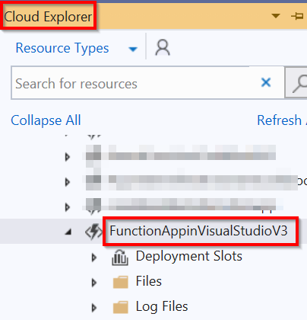

Figure 4.28: Visual Studio Cloud Explorer
Debugging Azure Function hosted in Azure using Visual Studio | 131

5. Right-click on the function and click on Attach Debugger, as shown in Figure 4.29:
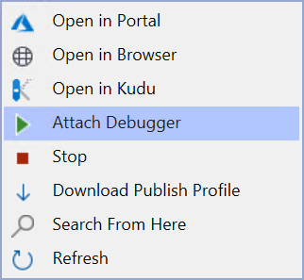

Figure 4.29: Clicking on Attach Debugger
6. Visual Studio will take some time to enable remote debugging, as shown in
Figure 4.30:
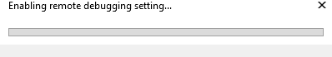

Figure 4.30: Visual Studio Cloud Explorer—enabling remote debugging
7. You can check whether the function application is working by opening it in the
browser, as shown in Figure 4.31. This indicates that your function application is
running as expected:
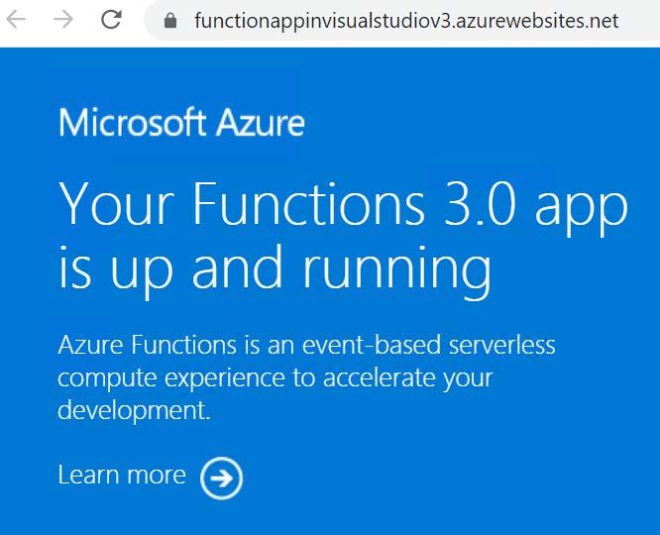

Figure 4.31: The function application default page 132 | Developing Azure Functions using Visual Studio

8. Navigate to Storage Explorer and upload a new file (in this case, I uploaded
Employee.json) to the cookbookfiles-live container, as shown in Figure 4.32:
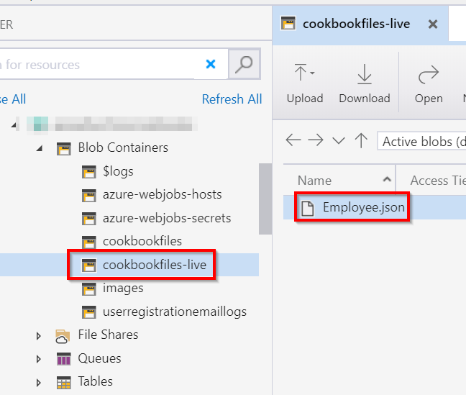

Figure 4.32: Uploading a new file
9. After a few moments, the debug breakpoint will be hit, as shown in Figure 4.33. You
can also view the file name that has been uploaded:
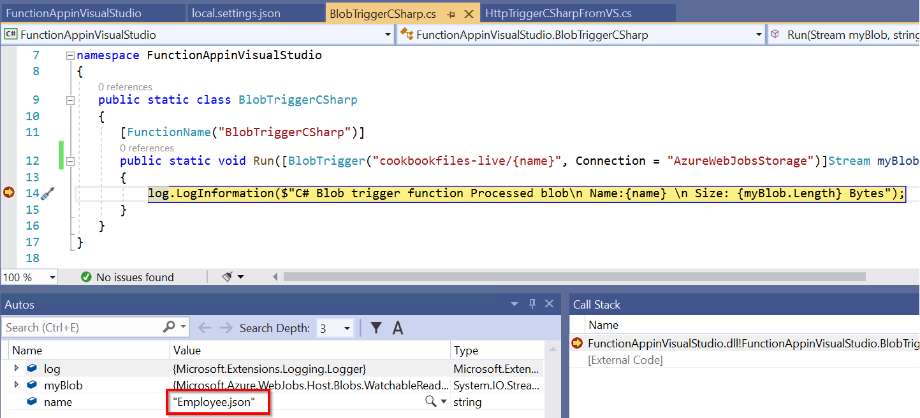

Figure 4.33: The blob trigger—the breakpoint hit
That's it. It's possible to debug the Azure Function application running in the cloud right from your IDE and you can also view the values of the variables.
In the next recipe, you'll learn how to deploy a function application as a Docker image.
Deploying Azure Functions in a container | 133

Deploying Azure Functions in a container
You have now seen some of the major use cases for Azure Functions—in short, when developing a piece of code and deploying it in a serverless environment, where a developer or administrator doesn't need to worry about the provisioning and scaling of instances to host server-side applications.

Note
You can take advantage of all the features of serverless (for example, autoscaling) only when you create your function application by choosing the Consumption plan in the Hosting Plan drop-down menu.

By looking at the title of this recipe, you might already be wondering why and how deploying an Azure function to a Docker container will help. Yes, the combination of Azure Functions and Docker containers might not make sense, as we would lose all the serverless benefits (for example, autoscaling) of Azure Functions if we deployed to Docker.
However, there may be some customers whose existing workloads might be in a cloud (be it public or private), but now they want to leverage some of the Azure function triggers and related Azure services, and so they want to deploy the Azure Functions as a Docker image. This recipe deals with how to implement this.

Getting ready
The following are the prerequisites for getting started with this recipe:
• Please install the Azure CLI core tools from https://docs.microsoft.com/cli/
azure/install-azure-cli?view=azure-cli-latest.
• Download Docker from https://hub.docker.com/editions/community/docker-ce-
desktop-windows. Ensure that you install the version of Docker that is compatible
with the operating system (OS) of your development environment.
• A basic knowledge of Docker and its commands is also required in order to build
and run Docker images. You can go through the official Docker documentation
https://docs.docker.com/ if you are not familiar with it.
• Create an Azure Container Registry (a registry to host Docker images in Azure)
by performing the following steps. This can be used as a repository for all of the
Docker images.
134 | Developing Azure Functions using Visual Studio

Creating an ACR
Azure Container Registry (ACR) is a service provided by Azure to host Docker images. It acts as a container repository. Let's create an ACR.
Perform the following steps:
1. Create a new ACR by searching for the container registry and providing the
required details, as shown in Figure 4.34:
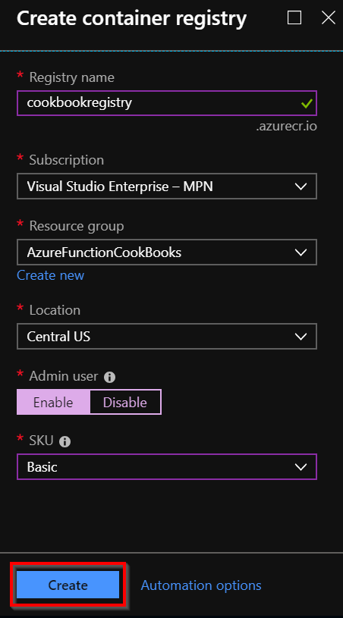

Figure 4.34: Azure Container Registry creation
Deploying Azure Functions in a container | 135

2. Once the ACR is successfully created, navigate to the Access keys blade and make
a note of the Login server, Username, and password, which are highlighted in
Figure 4.35. You'll be using them later in this recipe:
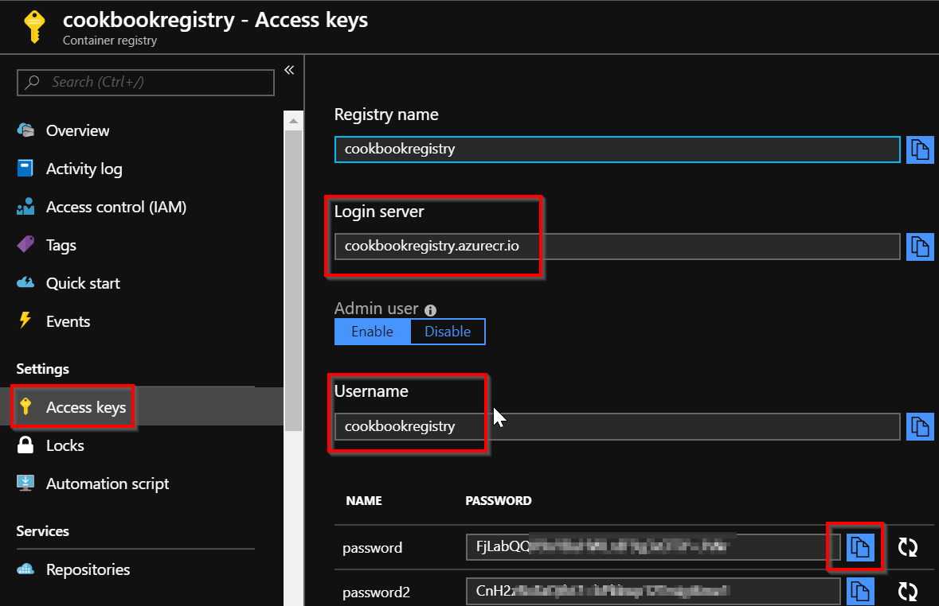

Figure 4.35: The Azure Container Registry—Access keys
Let's move on to the next section to learn how to deploy Azure Functions as a Docker image.

How to do it...
In the first three chapters, you created both the function application and functions right within the Azure Management portal. And, so far in this chapter, you have created the function application and the functions in Visual Studio itself.
136 | Developing Azure Functions using Visual Studio

Let's make a small change to the HttpTrigger so that you understand that the code is running from Docker, as highlighted in Figure 4.36. To do this, I have just added a From Docker message to the output, as follows:
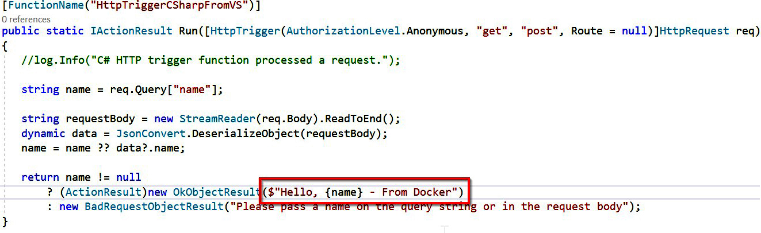

Figure 4.36: Visual Studio—HTTP trigger
Let's now move on to learn how to create a Docker image for the function application.

Creating a Docker image for the function application In this section, you'll learn how to create a Docker image and run it locally by performing the following steps:
1. The first step in creating a Docker image is to create a Dockerfile in your Visual
Studio project. Create a Dockerfile (a text file with .dockerfile as the extension) with the following content:
FROM mcr.microsoft.com/azure-functions/dotnet:3.0 COPY ./ bin/Release/netcoreapp3.0 /home/site/wwwroot
2. Then, navigate to the command prompt (to the path of the project, as shown in
Figure 4.37) and run the docker build -t functionsindocker. Docker command (taking care not to miss the period at the end of the command) to create a Docker image. Once you execute the docker build command, you should see something similar to that shown in Figure 4.37:
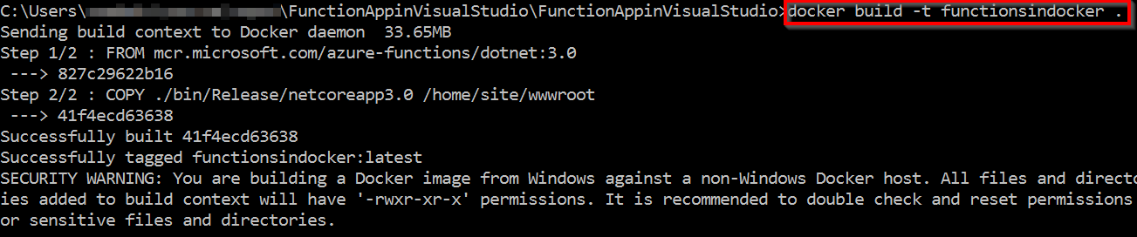

Figure 4.37: Console—the Docker command
Deploying Azure Functions in a container | 137

3. Once the image is successfully created, the next step is to run the Docker image
on a specific port. Run the docker run -p 2305:80 functionsindocker command to
execute it. You should see something like Figure 4.38:

Figure 4.38: Console—execution of the Docker build command
4. Verify that everything is working fine in the local environment by navigating to the
localhost with the right port, as shown in Figure 4.39:

Figure 4.39: Output from the HTTP function hosted as a Docker container in the local environment
Let's move on to the next section to learn how to push the image to the ACR.

Pushing the Docker image to the ACR
In this section, you'll learn how to push the Docker image to the ACR by performing the following steps:
1. The first step is to ensure that you provide a valid tag to the image using the
docker tag functionsindocker cookbookregistry.azurecr.io/functionsindocker:v1
command.
Running this command won't provide any output. However, to view your changes,
run the docker images command, as shown in Figure 4.40:
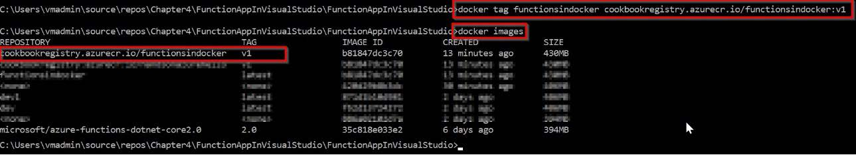

Figure 4.40: Console—execution of the Docker images command
138 | Developing Azure Functions using Visual Studio

2. In order to push the image to the ACR, you need to authenticate yourself to Azure.
For this, you can use the Azure CLI commands. Log in to Azure using the az login command. Running this command will open a browser and authenticate your credentials, as shown in Figure 4.41:
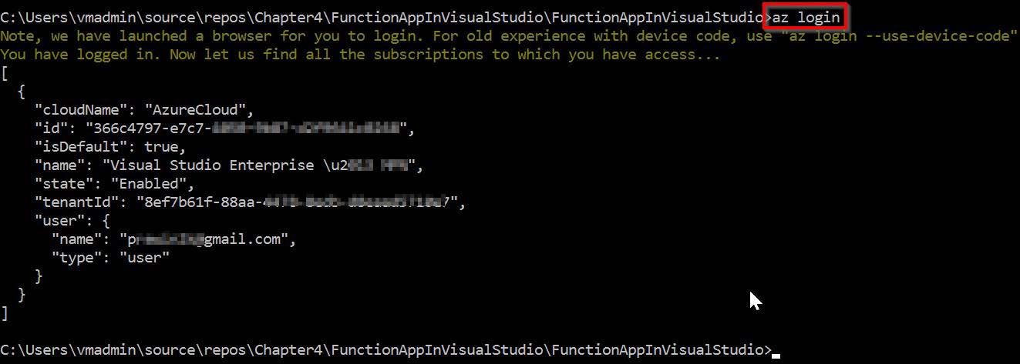

Figure 4.41: Console—logging in to Azure using az commands
3. The next step is to authenticate yourself to the ACR using the az acr login
--name cookbookregistry command. Replace the ACR name (in this case, it is cookbookregistry) with the one you have created:

Figure 4.42: Console—logging in to the ACR using az commands
4. Once you have authenticated yourself, you can push the image to the ACR by
running the docker push cookbookregistry.azurecr.io/functionsindocker:v1 command, as shown in Figure 4.43:
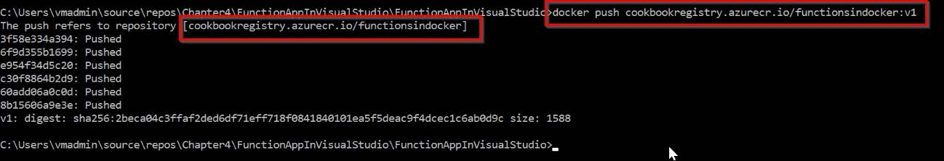

Figure 4.43: Console—execution of the Docker push command
Deploying Azure Functions in a container | 139

5. Navigate to the ACR in the Azure Management portal and review whether your
image was pushed to it properly in the Repositories blade, as shown in Figure 4.44:
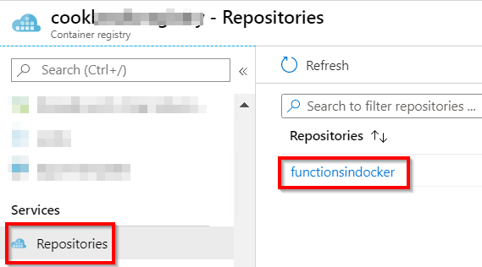

Figure 4.44: Azure ACR—Repositories view
You have successfully created an image and pushed it to the ACR. Now, it's time to create the Azure function, and refer the Docker image that was pushed to the ACR.

Creating a new function application with Docker In order to deploy the function application code as a Docker image, you need to set the Publish Type as Docker Container while creating the function application itself. Perform the following steps to create a new function application:
140 | Developing Azure Functions using Visual Studio

1. Navigate to the New | Function App blade and choose Docker Container as the
option in the Publish field, and then provide the following information under the Basics tab:
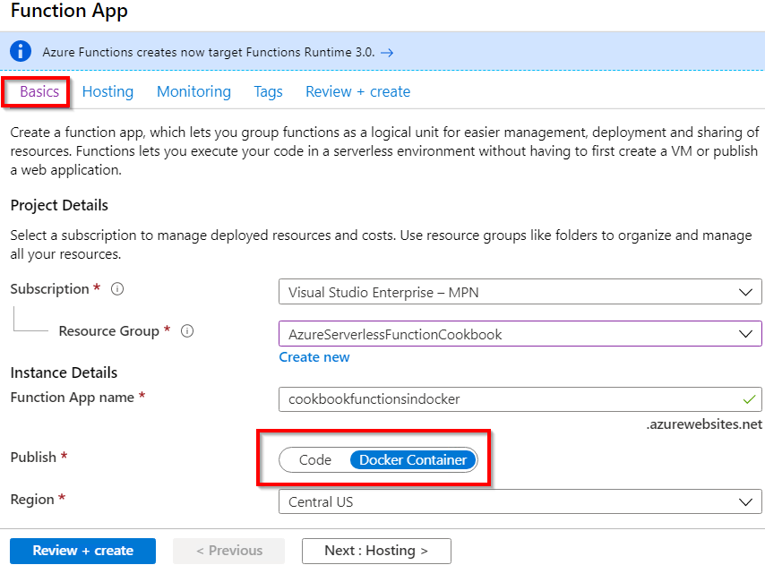

Figure 4.45: Function application creation—Basics
Deploying Azure Functions in a container | 141

2. Now, in the Hosting tab, the Linux option is selected in the OS field. Choose App
service plan in the Plan type field and then choose other fields as shown in Figure
4.46. Here, choose to create a new App service plan based on your requirements:
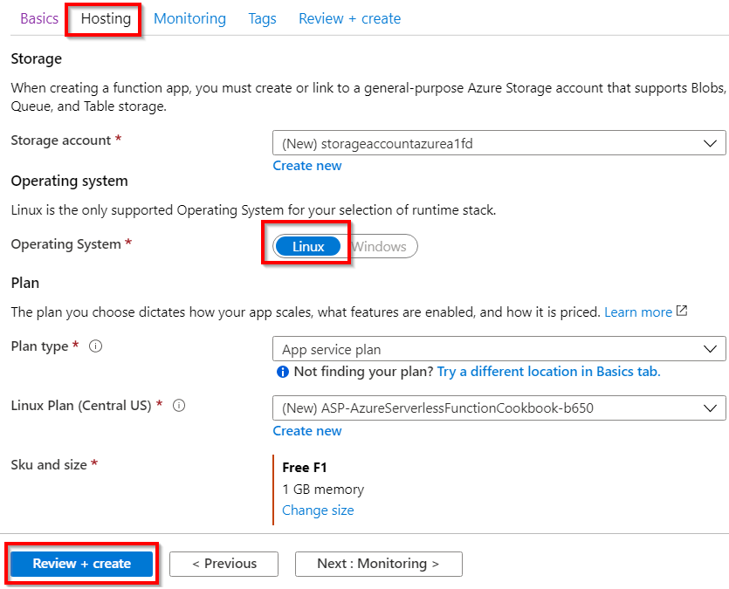

Figure 4.46: Function application creation—Hosting
3. Once you've reviewed all the details, click on the Review + create button to create
the function application.
142 | Developing Azure Functions using Visual Studio

4. The next and most important step is to refer the Docker image that you have
pushed to the ACR. This can be done by clicking on the Configure container button available in the Platform features tab and choosing Azure Container Registry, and then choosing the correct image, as shown in Figure 4.47:
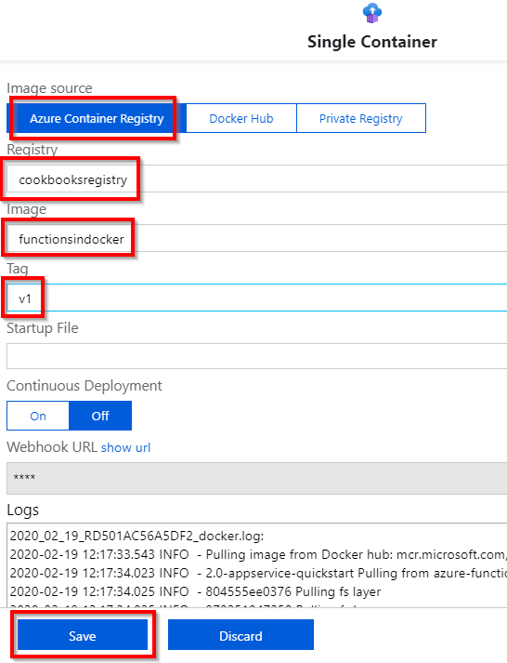

Figure 4.47: Function application creation—Docker image source
Deploying Azure Functions in a container | 143

5. That's it. You have created a function application that helped you to deploy the
Docker image by linking it to the image hosted in the Azure Container Registry.
Let's quickly test HttpTrigger by navigating to the HTTP endpoint in the browser.
The following is the output of the Azure function:

Figure 4.48: Output from the HTTP function hosted as a Docker container in the Azure environment

How it works...
In this recipe, you have done the following:
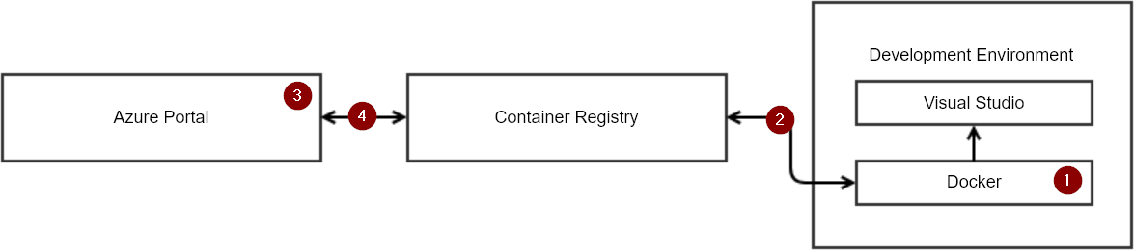

Figure 4.49: The Azure Function application as a Docker container—process diagram
The numbered points in this diagram refer to the following steps:
1. Create a Docker image of the function application that you created in this chapter
using Visual Studio.
2. Push the Docker image to the ACR.
3. From the Azure Management portal, while creating a new function application,
choose the option to publish the executable package as a Docker image.
4. Attach the Docker image from the ACR (from step 2) to the Azure function (from
step 3).

In this recipe, you have learned how to work with the Visual Studio IDE in developing Azure Functions and have also seen how to debug a local and remote version of the code from Visual Studio.

Exploring testing tools

for Azure functions

In this chapter, we'll explore different ways of testing Azure functions in detail with the following recipes:
• Testing Azure functions
• Testing an Azure function in a staging environment using deployment slots
• Creating and testing Azure functions locally using Azure CLI tools
• Validating Azure function responsiveness using Application Insights
• Developing unit tests for Azure functions with HTTP triggers

146 | Exploring testing tools for Azure functions

Introduction
Up to this point, you have learned how to develop and apply Azure functions, in addition to validating the functionality of these functions. This chapter will explore some of the popular ways of testing different Azure functions. This includes running tests of HTTP trigger functions using Postman, as well as using Azure Storage Explorer to test Azure blob triggers, queue triggers, and other storage service–related triggers.
You will also learn how to set up a test that checks the availability of your functions. This is done by continuously pinging the application endpoints on a predefined frequency from multiple locations.

Testing Azure functions
The Azure Functions runtime allows us to create and integrate many Azure services. At the time of writing, there are more than 20 types of Azure function that you can create. This recipe will explain how to test the most common Azure functions; we'll look at the following:
• Testing HTTP triggers using Postman
• Testing a blob trigger using Azure Storage Explorer
• Testing a queue trigger using the Azure portal

Getting ready
Install the following tools if you haven't already done so:
• Postman: This is a tool that will allow you to make calls to APIs. You can download
this from https://www.getpostman.com/.
• Azure Storage Explorer: You can use Storage Explorer to connect to your
storage accounts and view all the data available from different storage services, such as blobs, queues, tables, and files. You can also create, update, and delete
them directly from Storage Explorer. You can download this from http://
storageexplorer.com/.

How to do it…
In this section, we'll create three Azure functions using the default templates available in the Azure portal, and then test them with a variety of tools.
Testing Azure functions | 147

Testing HTTP triggers using Postman
When working with applications in a production environment, usually, developers would not have access to the Azure portal. Therefore, we need to rely on tools that will assist in testing the HTTP triggers. In this section, you'll learn how to test HTTP triggers using Postman.
Perform the following steps:
1. Create an HTTP trigger function that accepts the Firstname and Lastname
parameters and sends a response back to the client. Once created, make sure that
you set Authorization Level to Anonymous.
2. Replace the default code with the following. Note that, for the sake of simplicity,
we have removed the validations. Real-time applications will require the validation
of each input parameter:
#r "Newtonsoft.Json"
using System.Net;
using Microsoft.AspNetCore.Mvc;
using Microsoft.Extensions.Primitives;
using Newtonsoft.Json;

public static async Task Run(HttpRequest req, ILogger log) {
log.LogInformation("C# HTTP trigger function processed a request.");

string firstname=req.Query["firstname"];
string lastname=req.Query["lastname"];

string requestBody = await new StreamReader(req.Body). ReadToEndAsync();
dynamic data = JsonConvert.DeserializeObject(requestBody); firstname = firstname ?? data?.firstname;
lastname = lastname ?? data?.lastname;

return (ActionResult)new OkObjectResult($"Hello, {firstname + " " + lastname}");
}
148 | Exploring testing tools for Azure functions

3. Open the Postman tool and do the following:
The first step is to choose the HTTP request method. Since the HTTP trigger function accepts most methods by default, choose the GET method, as shown in Figure 5.1:
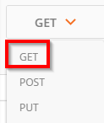

Figure 5.1: The Postman tool
The next step is to provide the URL of the HTTP trigger. Remember to replace <HttpTriggerTestUsingPostman> with the actual HTTP trigger function name, as shown in Figure 5.2:
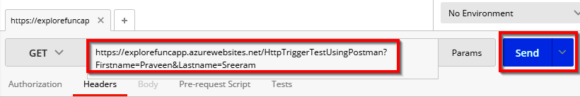

Figure 5.2: Providing the URL of the HTTP trigger
Click on the Send button to make the request. If all the details expected by the API are provided, Status: 200 OK should be visible along with the response, as shown in Figure 5.3:
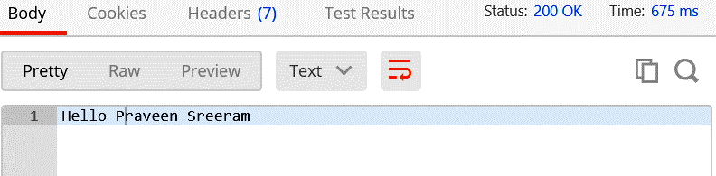

Figure 5.3: Output in the Postman tool
You have learned how to test an HTTP trigger. Let's now move on to the next section.
Testing Azure functions | 149

Testing a blob trigger using Storage Explorer In this section, we'll test a blob trigger by performing the following steps:
1. Create a new blob trigger by choosing the Azure Blob Storage trigger template, as
shown in Figure 5.4:
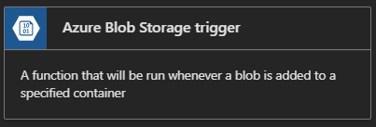

Figure 5.4: The Azure Blob Storage trigger template
2. Clicking on the template will prompt you to provide a storage account
and a container for storing the blob. Enter the storage account name as
BlobTriggerCSharpTestUsingStorageExplorer. In the Azure Blob Storage
trigger template, set the Path value to samples-workitems/{name}, and select
azurefunctionscookbooks_Storage from the Storage account connection drop-
down list, as shown in Figure 5.5:
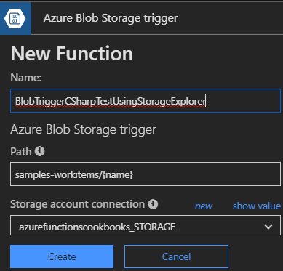

Figure 5.5: Azure Blob storage trigger creation 150 | Exploring testing tools for Azure functions

3. Let's now connect to the storage account that we'll be using in this recipe.
Open Microsoft Azure Storage Explorer and click on the Connect symbol, as highlighted in Figure 5.6, to connect to Azure Storage:
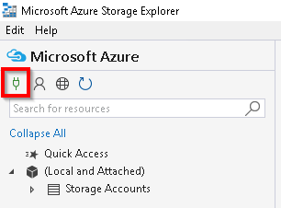

Figure 5.6: Azure Storage Explorer—connecting
4. You will be prompted to enter various details, including the storage connection
string, shared access signature (SAS), and the account key. For this recipe, let's use the storage connection string. Navigate to Storage Account, copy the connection string in the Access keys blade, and paste it in the Microsoft Azure Storage Explorer - Connect window, as shown in Figure 5.7:
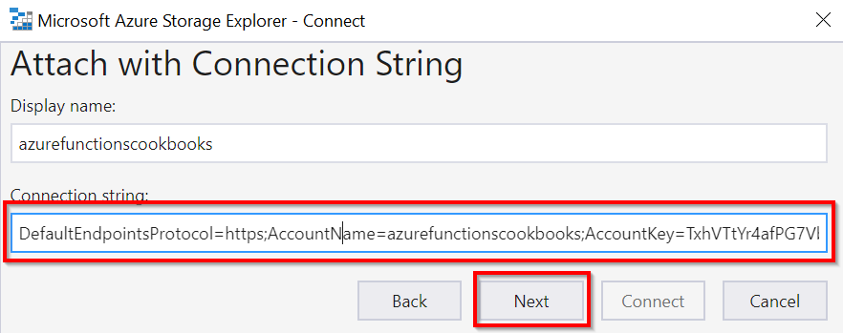

Figure 5.7: Azure Storage Explorer—Attach with Connection String
Testing Azure functions | 151

5. Clicking on the Next button, as shown in Figure 5.7, will redirect you to the
Connection Summary window, displaying the account name and other related
details for confirmation. Click on the Connect button to connect to the chosen
Azure storage account.
6. As shown in Figure 5.8, you should now be connected to the Azure storage
account, from which all Azure Storage services can be managed:
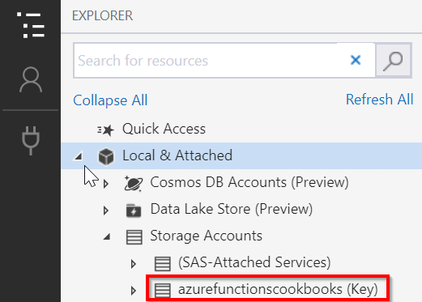

Figure 5.8: Azure Storage Explorer—connected storage account
7. Now, let's create a storage blob container named samples-workitems. Right-click
on the Blob Containers folder and click on Create Blob Container to create a new
blob container named samples-workitems. Then, click on the Upload Files… button,
as shown in Figure 5.9:
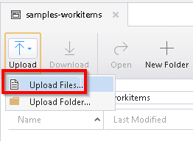

Figure 5.9: Azure Storage Explorer—Upload Files 152 | Exploring testing tools for Azure functions

8. In the Upload Files… window, choose a file to upload and then click on the Upload
button.
9. Immediately navigate to the Azure function code editor and look at the Logs
window, as shown in Figure 5.10. The log will show the Azure function being triggered successfully:
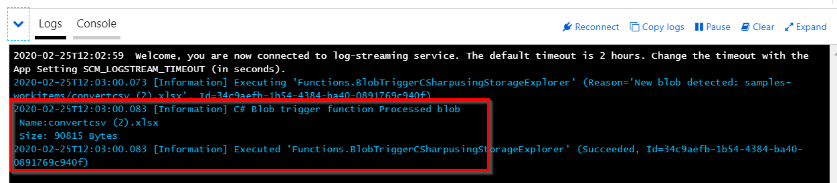

Figure 5.10: Azure Functions—blob trigger logs

Testing a queue trigger using the Azure portal In this section, you'll learn how to test a queue trigger by performing the following steps:
1. Create a new Azure Queue Storage trigger template named
QueueTriggerTestusingPortal, as shown in Figure 5.11. Make a note of the Queue name, myqueue-items, as you will need to create a queue service with the same name later using the Azure portal:
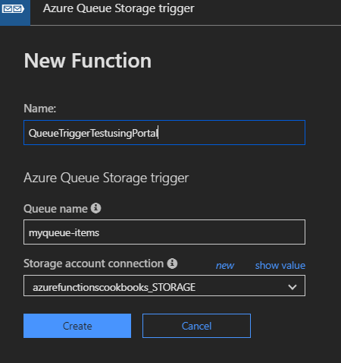

Figure 5.11: Azure Queue storage trigger creation
Testing Azure functions | 153

2. Navigate to the Storage account | Overview blade and click on Queues, as shown
in Figure 5.12:
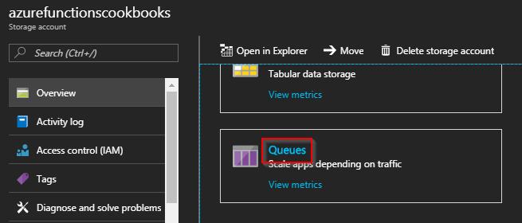

Figure 5.12: The Azure Storage Overview blade
3. In the Queues blade, click on +Queue to add a new queue:
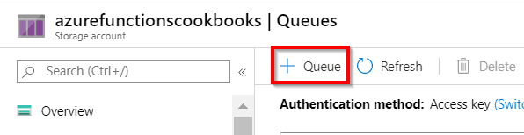

Figure 5.13: Azure Queue storage
4. Provide myqueue-items as the Queue name in the Add queue popup, as shown in
Figure 5.14. This was the same name you used while creating the queue trigger.
Click on OK to create the queue service:
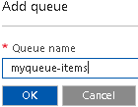

Figure 5.14: Azure Storage—adding a queue 154 | Exploring testing tools for Azure functions

5. Now, let's create a queue message. In the Azure portal, click on the myqueue-
items queue service to navigate to the Messages blade. Click on the Add message button, as shown in Figure 5.15, and then provide some message text. Lastly, click on OK to create the queue message:
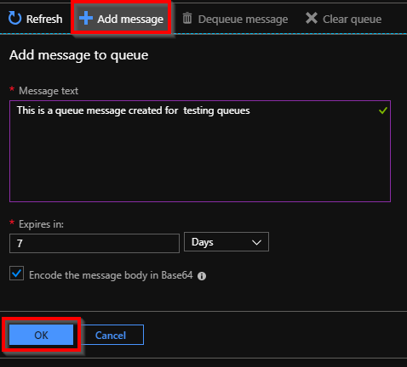

Figure 5.15: Azure Storage—adding a message to the queue
6. Immediately navigate to the QueueTriggerTestusingPortal queue trigger, and view
the Logs blade. Here, you can find out how the queue function was triggered, as shown in Figure 5.16:
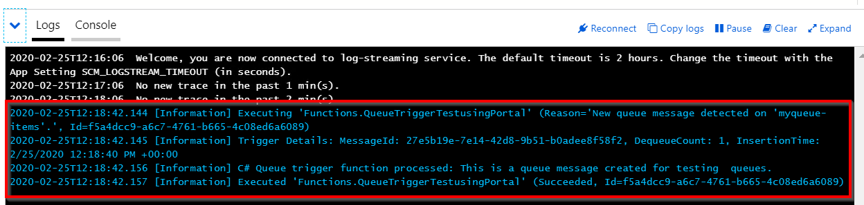

Figure 5.16: Azure queue trigger logs
Testing an Azure function in a staging environment using deployment slots | 155

There's more…
To allow API consumers to only use the POST method for your HTTP trigger, restrict it by choosing only POST in Selected HTTP methods, as shown in Figure 5.17. Navigate to this by clicking on the Integrate tab of the HTTP trigger:
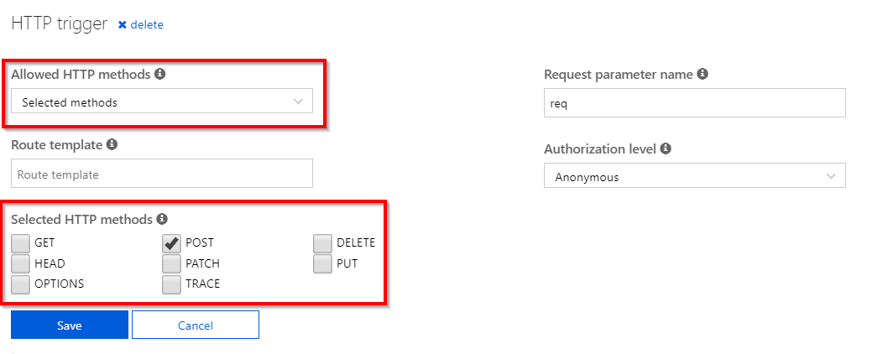

Figure 5.17: Azure HTTP trigger integration settings
This recipe explained how to test the most common Azure functions. In the next recipe, you'll learn how to test an Azure function in a staging environment.

Testing an Azure function in a staging environment using
deployment slots
In general, every application requires pre-production environments, such as staging and beta, in order to review functionalities prior to publishing them for end users. Although pre-production environments are great and help multiple stakeholders validate the application's functionality against the business requirements, there are a number of pain points associated with managing and maintaining them. These include the following:
• We need to create and use a separate environment for our pre-production
environments.
• Once the application's functionality is reviewed in pre-production and the IT
Ops team gets the go-ahead, there will be some downtime in the production
environment while deploying the code based on the new functionalities.
156 | Exploring testing tools for Azure functions

All the preceding limitations can be covered by Azure Functions using a feature called slots (known as deployment slots in the App Service service). A pre-production environment can be set up using slots. Here, developers can review all of the new functionalities and promote them (by swapping) to the production environment seamlessly based on requirements.

How to do it…
In this section, you'll create a slot and also learn how the swap works by performing the following steps:
1. Create a new function app named MyProductionApp.
2. Create a new HTTP trigger and name it MyProd-HttpTrigger1. Replace the last line
with the following:
return name != null
? (ActionResult)new OkObjectResult("Welcome to MyProd-HttpTrigger1 of Production App")
: new BadRequestObjectResult("Please pass a name on the query string or in the request body");
3. Create another new HTTP trigger and name it MyProd-HttpTrigger2. Use the same
code that was used for MyProd-HttpTrigger1—just replace the last line with the following:
return name != null
? (ActionResult)new OkObjectResult("Welcome to MyProd- HttpTrigger2 of Production App")
: new BadRequestObjectResult("Please pass a name on the query string or in the request body");
4. Assume that both functions of the function app are live on your production
environment at https://<<functionappname.azurewebsites.net>>.
5. Now, the customer has asked you to make some changes to both functions.
Instead of making the changes directly to the functions of your production function app, you may need to create a slot.
6. Let's create a new slot with all the functions in your function app, named
MyProductionApp.
Testing an Azure function in a staging environment using deployment slots | 157

7. Click on the + icon, available near the Slots section, as shown in Figure 5.18:
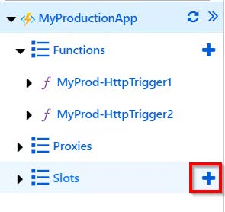

Figure 5.18: List of all functions in a function app
8. Enter a name for the new slot. Provide a meaningful name, something such as
staging, as shown in Figure 5.19:
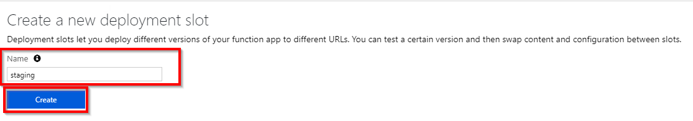

Figure 5.19: Creating a new deployment slot
9. Once you click on Create, a new slot will be created, as shown in Figure 5.20. If
the functions are read-only, you can make them read-write in the function app
settings of the staging slot:
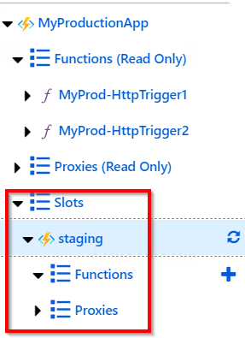

Figure 5.20: Slots view
158 | Exploring testing tools for Azure functions

10. To make the staging environment complete, copy all the Azure functions from the
production environment (in this case, the MyProductionApp application) to the new staged slot named staging. Create two HTTP triggers and copy the code of both functions (MyProd-HttpTrigger1 and MyProd-HttpTrigger2) from MyProductionApp to the new staging slot. Basically, copy all the functions to the new slot manually.
11. Change the word Production to Staging in the last line of both the functions in the
staging slot, as shown in Figure 5.21. This is useful for testing the output of the swap operation:
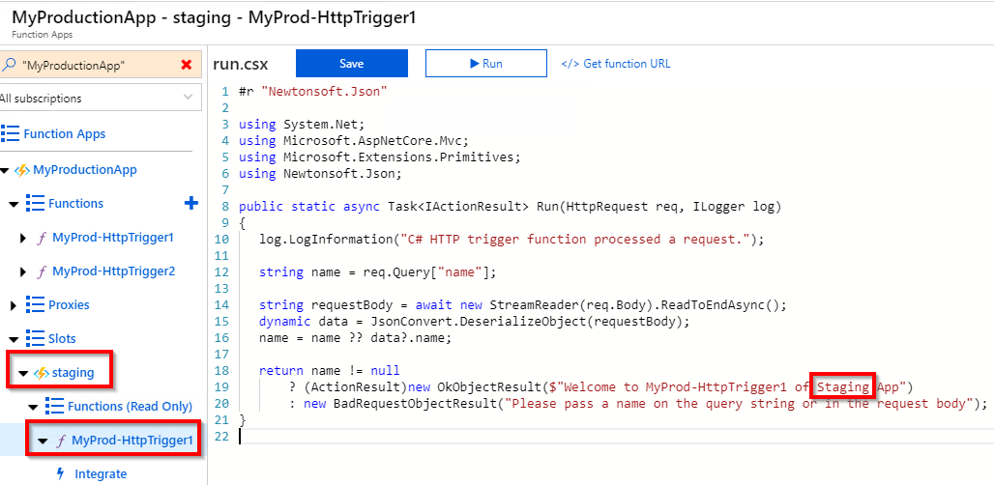

Figure 5.21: Staging slot—replacing the word "Production" with "Staging" for testing

Note
In all the slots that were created as a pre-production application, make sure that you use the same function names as those in your production environment.

12. Click on the Swap button, available in the Overview blade, as shown in Figure 5.22:
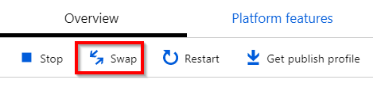

Figure 5.22: Swap operation
Testing an Azure function in a staging environment using deployment slots | 159

13. In the Swap blade, choose the following:
• Source: Choose the slot that you would like to move to production. In this case,
we're swapping staging in general, but you can also swap across non-production
slots.
• Target: Choose the production option, as shown in Figure 5.23:
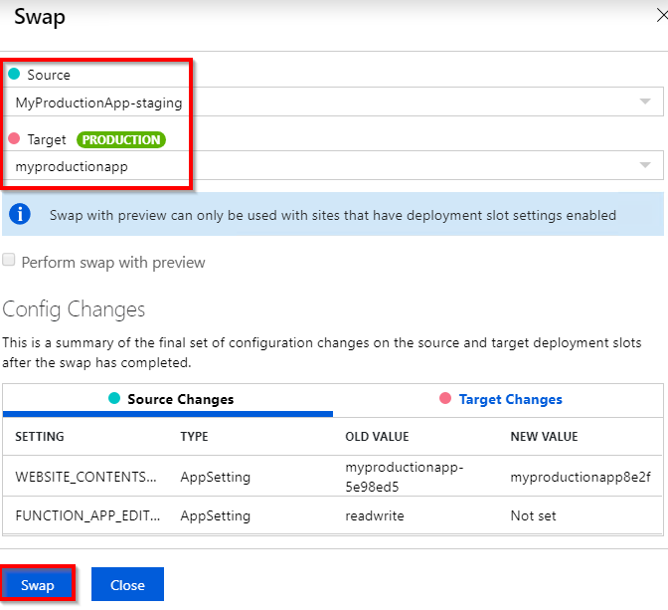

Figure 5.23: Swap operation overview with source and target slots
14. After reviewing the settings, click on the Swap button. It will take a few moments
to swap the functions. A progress bar will appear, as shown in Figure 5.24:
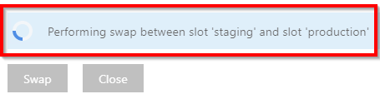

Figure 5.24: Performing the swap operation 160 | Exploring testing tools for Azure functions

15. After a minute or two, the staging and production slots have been swapped. Let's
now review the run.csx script files of the production slot:
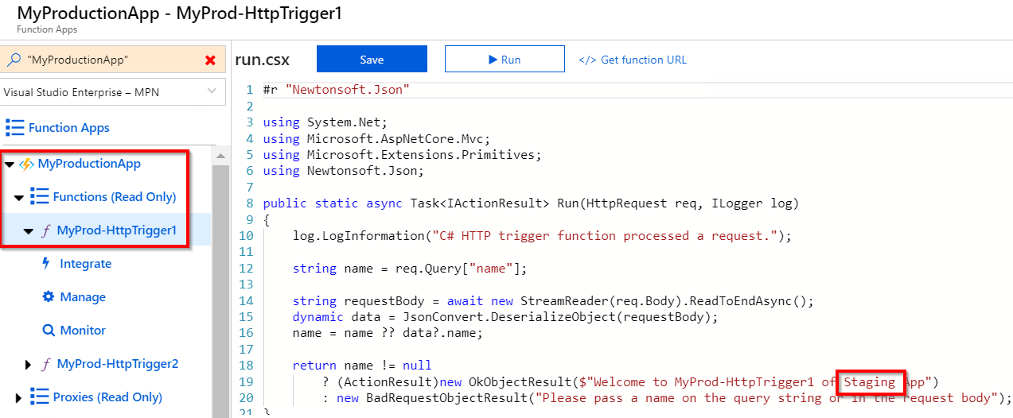

Figure 5.25: Changing the production slot's content
16. If there are no changes, click on the refresh button of the function app, as shown
in Figure 5.26:
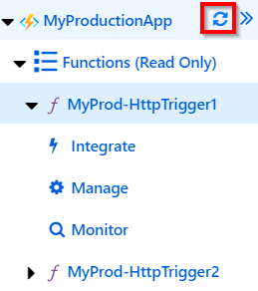

Figure 5.26: Azure function app—refresh
Testing an Azure function in a staging environment using deployment slots | 161

There's more...
Make sure that the application settings and database connection strings are marked as Slot Setting (slot-specific). Otherwise, the application settings and database connection strings will also be swapped, which could result in unexpected behavior. Mark any of these settings as such from the Configuration blade available in Platform features, as shown in Figure 5.27:
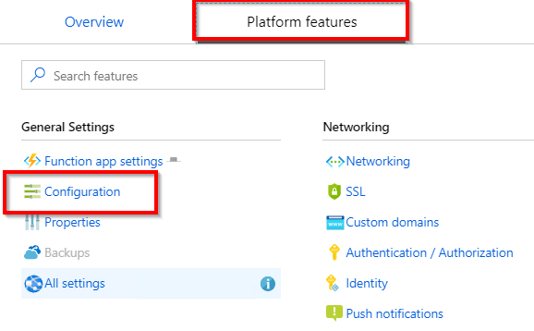

Figure 5.27: Platform features
Clicking on the Configuration blade will take you to a list of all settings. Click on the Edit button, which will open up the blade beneath, where you can mark any setting as a Deployment slot setting:
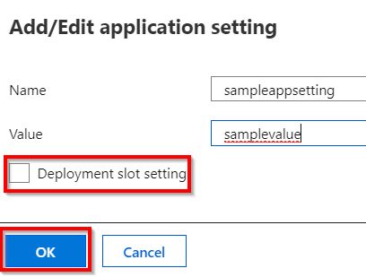

Figure 5.28: Add/Edit application setting
162 | Exploring testing tools for Azure functions

Note
All the functions in the recipe are HTTP triggers; note that we can have any kinds of triggers in a function app. The deployment slots are not limited to HTTP triggers. We can have multiple slots for each function app. The following are a few examples:

Alpha

Beta

Staging

While creating a slot without enabling the feature of deployment slots, you'll see something similar to what is shown in Figure 5.29:
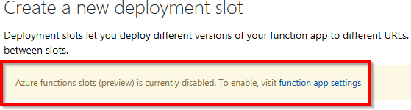

Figure 5.29: Create a new deployment slot
We need to have all the Azure functions in each of the slots that should be swapped with the production function app:
• Slots are specific to the function app, but not to the individual function.
• Once the slots' features are enabled, all the keys will be regenerated, including
the master. Be cautious if the keys of the functions are already shared with third parties. If they are already shared and the slots are enabled, all the existing integrations with the old keys will not work.

In general, while using App Services, in order to create deployment slots, have the App Services plan set to either the Standard or Premium tier.
However, we can create a slot (only one) for the function app even if it is under the Consumption (or dynamic) plan.
Creating and testing Azure functions locally using Azure CLI tools | 163

In this recipe, we have learned how to create a pre-production environment using slots, which help developers to test new releases before taking them to a production environment.

Creating and testing Azure functions locally using Azure CLI tools
Most of the recipes so far have been created using either the browser or the Visual Studio integrated development environment (IDE).
Azure also provides tools for developers who prefer to work with the command line. These tools allow us to create Azure resources with simple commands right from the command line. In this recipe, we'll learn how to create a new function app, and we'll also understand how to create a function and deploy it to Azure directly from the command line.

Getting ready
Before proceeding further with the recipe, install Node.js and the Azure CLI. The download links for these tools are as follows:
• Download and install Node.js from https://nodejs.org/en/download/.
• Download and install Azure Functions Core Tools (also known as the Azure CLI)
from https://docs.microsoft.com/azure/azure-functions/functions-run-local?ta
bs=windows%2Ccsharp%2Cbash.

How to do it...
Once the installation of the Azure CLI is complete, perform the following steps:
1. Create a new function app in the Azure CLI by running the following command:
func init
The following output should be displayed after executing the preceding command:
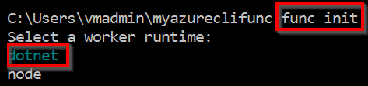

Figure 5.30: Command Prompt
164 | Exploring testing tools for Azure functions

In Figure 5.30, dotnet is selected by default. Pressing Enter will create the required files, as shown in Figure 5.31:
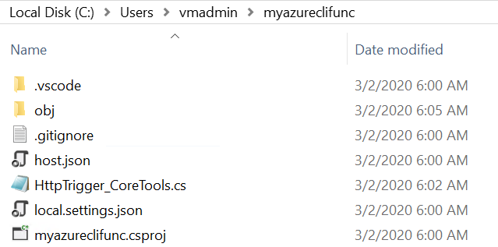

Figure 5.31: The Azure function app—project files in Windows Explorer
2. Run the following command to create a new HTTP trigger function within the new
function app that we have created:
func new
We will get the following output after executing the preceding command:
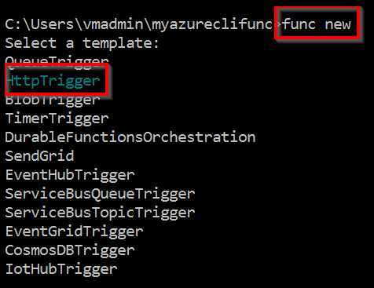

Figure 5.32: Creating a new function
3. As shown in Figure 5.32, we'll be prompted to choose the function template. For
this recipe, we have chosen HttpTrigger. Choose HttpTrigger by using the down arrow key and then hit Enter. Choose the Azure function type based on your requirements. We can navigate between the options using the up/down arrow keys on our keyboard.
Creating and testing Azure functions locally using Azure CLI tools | 165

4. The next step is to provide a name for the Azure function that we are creating.
Provide a meaningful name—here we're using HttpTrigger-CoreTools—and then
press Enter, as shown in Figure 5.33:
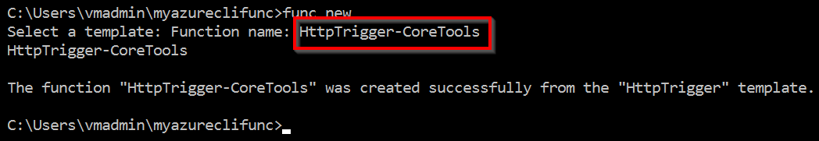

Figure 5.33: Creating a new function
5. Use your preferred IDE to edit the Azure function code. In this recipe, we'll use
Visual Studio Code to open the HttpTrigger function, as shown in Figure 5.34:
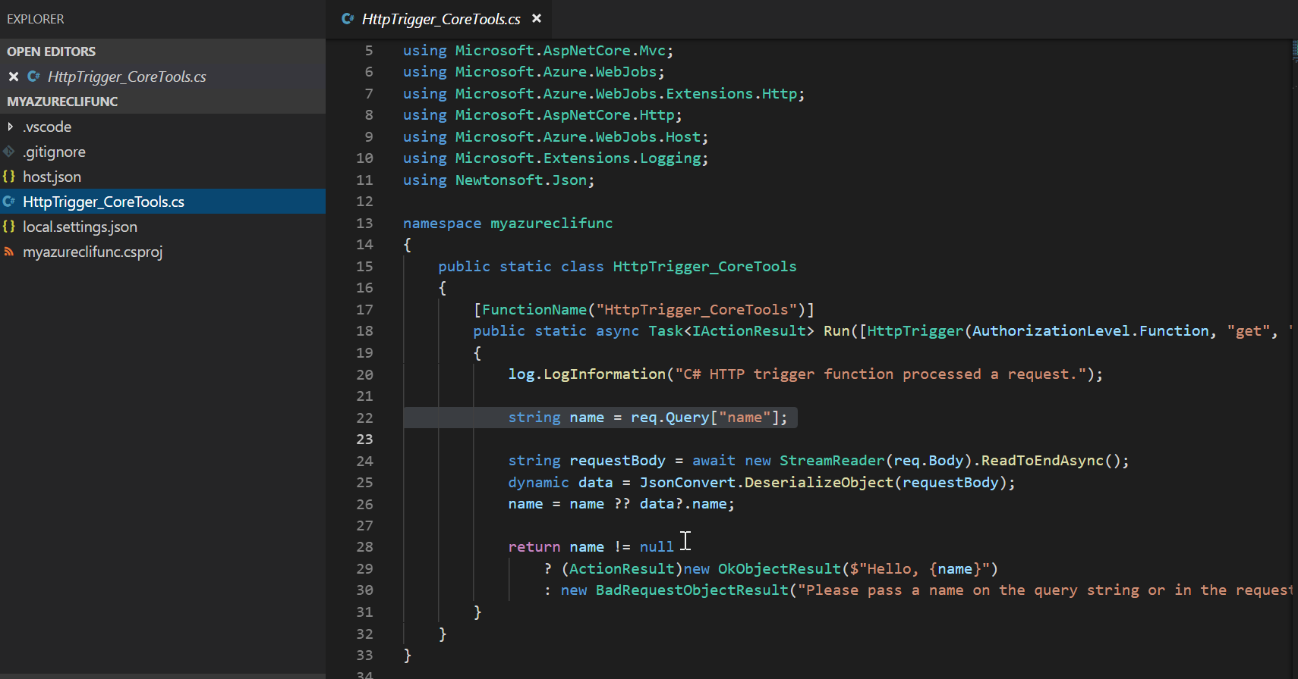

Figure 5.34: Creating a new function
6. Let's test the Azure function right from our local machine. For this, we need to
start the Azure function host by running the following command:
func host start --build
166 | Exploring testing tools for Azure functions

7. Once the host is started, you can copy the URL and test it in your browser, along
with a query string parameter name, as shown in Figure 5.35:
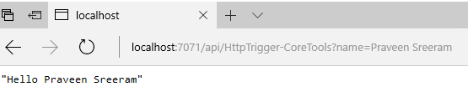

Figure 5.35: HTTP trigger output
In this recipe, we have learned how to add a new function app and a function using the Azure CLI.

Validating Azure function responsiveness using Application
Insights
An application is only useful for a business if it is up and running. Applications might go down for multiple reasons. These reasons include the following:
• Any hardware failures, such as a server crash, hard disk errors, or any other
hardware issue—even an entire datacenter might go down, although this would be very rare.
• Software errors because of bad code or a deployment error.
• The site might receive unexpected traffic and the servers may not be capable of
handling this traffic.
• There might be cases where your application is accessible from one country, but
not from others.

It is vital to be notified when your site is not available or not responding to user requests. Azure provides a few tools to help by alerting you if your website is not responding or is down. One of these is Application Insights. Let's learn how to configure Application Insights to ping our Azure function app every 5 minutes and set it to send an alert if the function fails to respond.

Note
Application Insights is an application lifecycle management (ALM) tool that allows performance tracking, exception monitoring, and also the collection of application telemetry data.
Validating Azure function responsiveness using Application Insights | 167

Getting ready
In this section, we'll create an Application Insights instance and also learn how to create an availability test by performing the following steps:
1. Navigate to the Azure portal, search for Application Insights, click on the Create
button, and then provide all the required details, as shown in Figure 5.36:
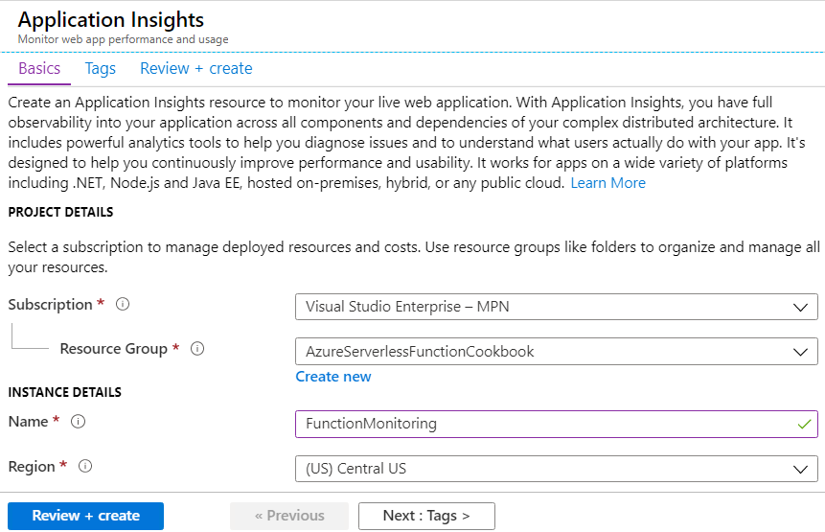

Figure 5.36: Creating a new Application Insights instance
2. Navigate to the function app's Overview blade and grab the function app URL, as
shown in Figure 5.37:
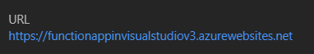

Figure 5.37: Copying the function app URL
168 | Exploring testing tools for Azure functions

How to do it…
In this section, we'll learn how to do an automated ping test to the HTTP trigger using an availability test by performing the following steps:
1. Navigate to the Availability blade in Application Insights, as shown in Figure 5.38,
and click on the Add test button:
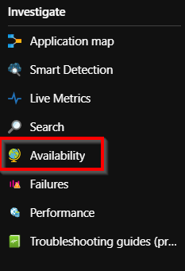

Figure 5.38: The Application Insights menu
2. In the Create test blade, we'll see the following four sections:
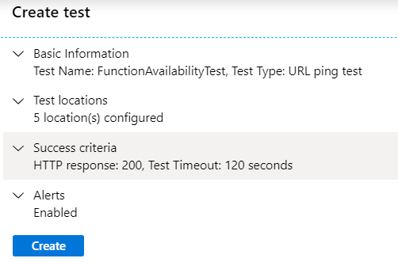

Figure 5.39: Creating an availability test
Validating Azure function responsiveness using Application Insights | 169

3. In the Basic Information section, please enter a meaningful name (in this case,
we have used FunctionAvailabilityTest) based on the requirements and paste the
function app URL, which was noted in step 2 of the Getting ready section, in the
URL field of the Basic Information section of the Create test blade.
4. In the Test Locations section, choose the locations that we want Azure to perform
ping tests for.

Note
A minimum of five locations and a maximum of 16 locations can be chosen.

5. After reviewing the details, click on the Create button to create the ping test, as
shown in Figure 5.39.
6. The next step is to configure alerts. To do so, click on …, as shown in Figure 5.40:
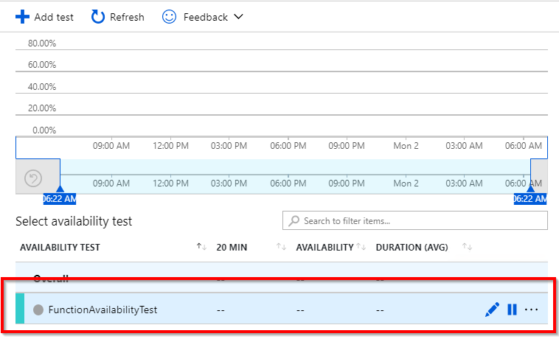

Figure 5.40: Editing the availability test
170 | Exploring testing tools for Azure functions

7. This opens up a context menu. In the context menu, select Edit alert, as shown in
Figure 5.41:
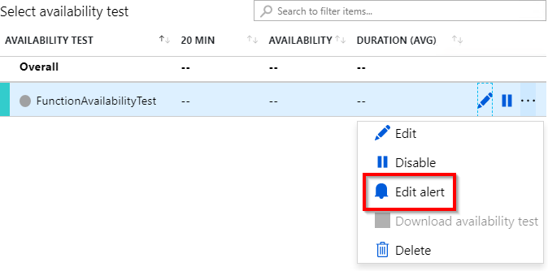

Figure 5.41: Editing the availability test—Edit alert
8. Clicking on the Edit alert button in the previous step will open up the Rules
management blade, as shown in Figure 5.42. As described in the CONDITION section, an email will be sent to the listed recipients whenever the ping test fails in three or more selected locations:
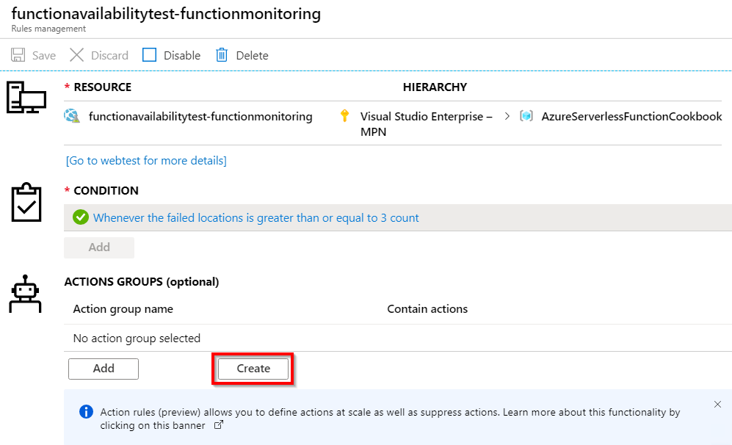

Figure 5.42: Availability tests—creating action groups
Validating Azure function responsiveness using Application Insights | 171

9. Our goal is to send a notification alert to the recipients whenever the condition
(specified in the CONDITION section) meets the criteria. At the time of writing,
Application Insights allows us to send the following types of notification:
• Email
• SMS
• Push notification
• Voice
10. Application Insights also allows us to invoke other apps/services in the event of
failure. Figure 5.43 shows the different Azure services that are currently available
to be invoked:
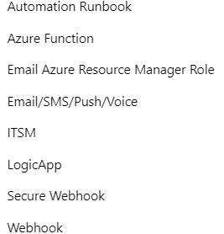

Figure 5.43: Availability tests—creating action groups—choosing a notification service
172 | Exploring testing tools for Azure functions

11. To make it simple, we'll choose to send an email alert whenever the ping test
fails for three or more locations. In order to configure this, we need to create an action group. This can be achieved by clicking on the Create button of the Rules management blade. We will then be taken to the Add action group blade, as shown in Figure 5.44. Provide a name and choose the Email/SMS/Push/Voice item in the Action Type dropdown:
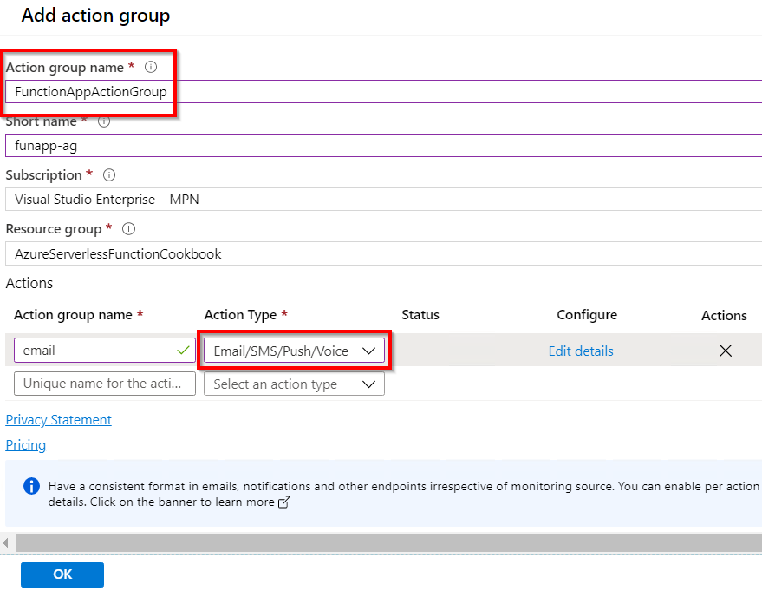

Figure 5.44: Availability tests—creating action groups
Validating Azure function responsiveness using Application Insights | 173

12. As soon as the action type is selected, we will be shown a new blade where we can
check the Email option and provide a valid email address, as shown in Figure 5.45,
and click OK:
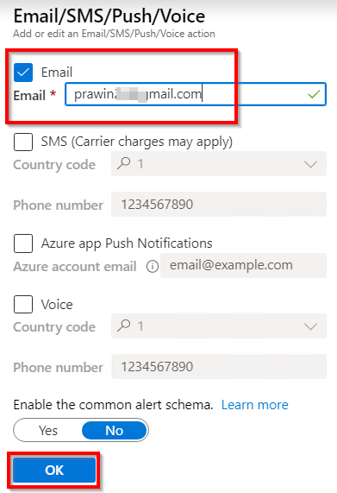

Figure 5.45: Availability tests—creating action groups—choosing email notification
13. That's it. We have now configured the action group:
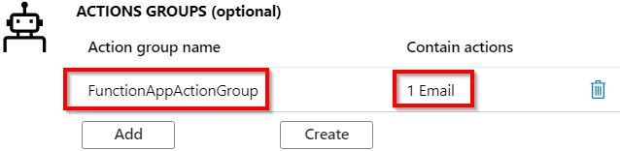

Figure 5.46: Availability tests—viewing action groups 174 | Exploring testing tools for Azure functions

14. Optionally, we can also choose the email content and severity, as shown in
Figure 5.47:
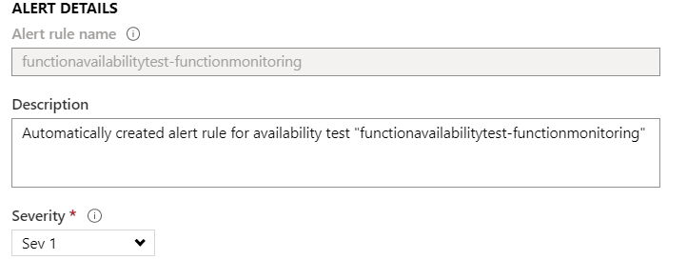

Figure 5.47: Availability tests—viewing action groups—entering email content
15. From now on, Application Insights will start doing the ping test for the locations
that we selected in step 4. The availability of the function app can be verified as shown in Figure 5.48:
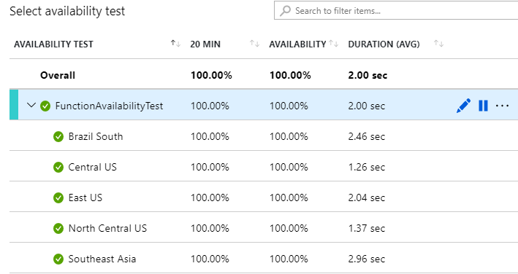

Figure 5.48: Availability tests—report
16. In order to test the functionality of this alert, let's stop the function app by clicking
on the Stop button, found in the Overview tab of the function app.
Validating Azure function responsiveness using Application Insights | 175

17. When the function app is stopped, Application Insights will try to access the
function URL using the ping test. The response code will not be Status:200 OK, as
the app was stopped, which means that the test failed. Furthermore, if it fails from
three or more locations, the result will be as shown in Figure 5.49:
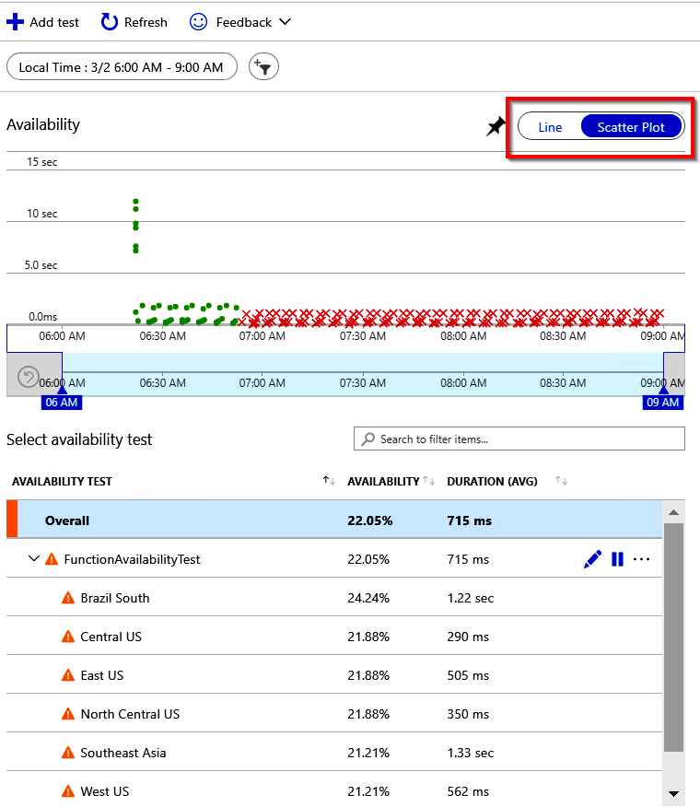

Figure 5.49: Availability tests—report—scatter plot 176 | Exploring testing tools for Azure functions

18. And finally, a notification should have been sent to the configured email, as shown
in Figure 5.50:
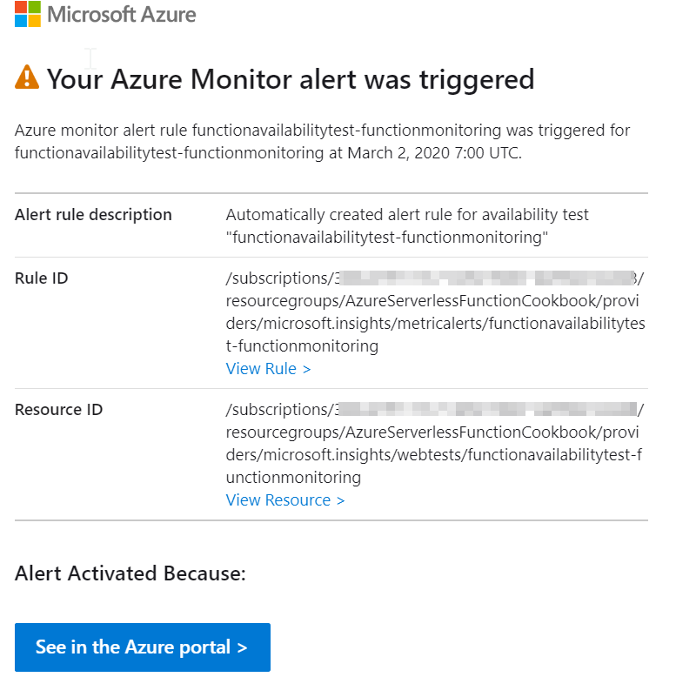

Figure 5.50: Azure Monitor—availability test—email alert

Developing unit tests for Azure functions with HTTP triggers | 177

How it works…
We have created an availability test, where our function app will be pinged once every 5 minutes from five different locations across the world. We can configure them in the Test Locations section of the Create test blade while creating the test. The default criterion of the ping is to check whether the response code of the URL is 200. If the response code is not 200, then the test has failed, and an alert is sent to the configurable email address.

There's more...
We can use a multi-step web test (using the Test Type option in the Basic Information section of the Create test blade) to test a page or functionality that requires navigation to multiple pages.
In this recipe, we have learned how to create an availability test that can be used to do a ping test to the function app and send alerts if the function app doesn't respond.

Developing unit tests for Azure functions with HTTP triggers
So far, we have created multiple Azure functions and validated their functionality using different tools. The functions that we have developed here have been straightforward but, in your real-world applications, it may not be that simple as there will likely be many changes to the code that was initially created. It's good practice to write automated unit tests that help test the functionality of our Azure functions. Every time you run these automated unit tests, you can test all the various paths within the code.
In this recipe, we'll learn how to use the basic HTTP trigger and see how easy it is to write automated unit test cases for this using Visual Studio Test Explorer and Moq (an open-source framework available as a NuGet package).

Getting ready
We'll be using the Moq mocking framework and xunit to develop automated unit test cases for our Azure function. Having a basic working knowledge of Moq is a requirement for this recipe. Learn more about Moq at https://github.com/moq/moq4/
wiki.

178 | Exploring testing tools for Azure functions

In order to make the unit test case straightforward, the lines of code that read the data from the post parameters to the Run method of HTTPTriggerCSharpFromVS HTTPTrigger have been highlighted in bold, as shown in the following code:
[FunctionName("HTTPTriggerCSharpFromVS")]
public static async Task Run(
[HttpTrigger(AuthorizationLevel.Anonymous, "get", "post", Route
= null)] HttpRequest req,
ILogger log)
{
log.LogInformation("C# HTTP trigger function processed a
request.");
string name = req.Query["name"];
//string requestBody = await new StreamReader(req.Body).
ReadToEndAsync();
//dynamic data = JsonConvert.DeserializeObject(requestBody);
//name = name ?? data?.name;
return name != null
? (ActionResult)new OkObjectResult($"Hello, {name}")
: new BadRequestObjectResult("Please pass a name on the query
string or in the request body");
}

How to do it...
In order to complete this recipe, perform the following steps:
1. Create a new unit test project by right-clicking on the solution and then selecting
Add a new project from the menu items. In the Add a new project window, choose Test in the project type list and choose xUnit Test Project (.NET Core) in the list of projects, as shown in Figure 5.51. Click Next and create the project:
Developing unit tests for Azure functions with HTTP triggers | 179
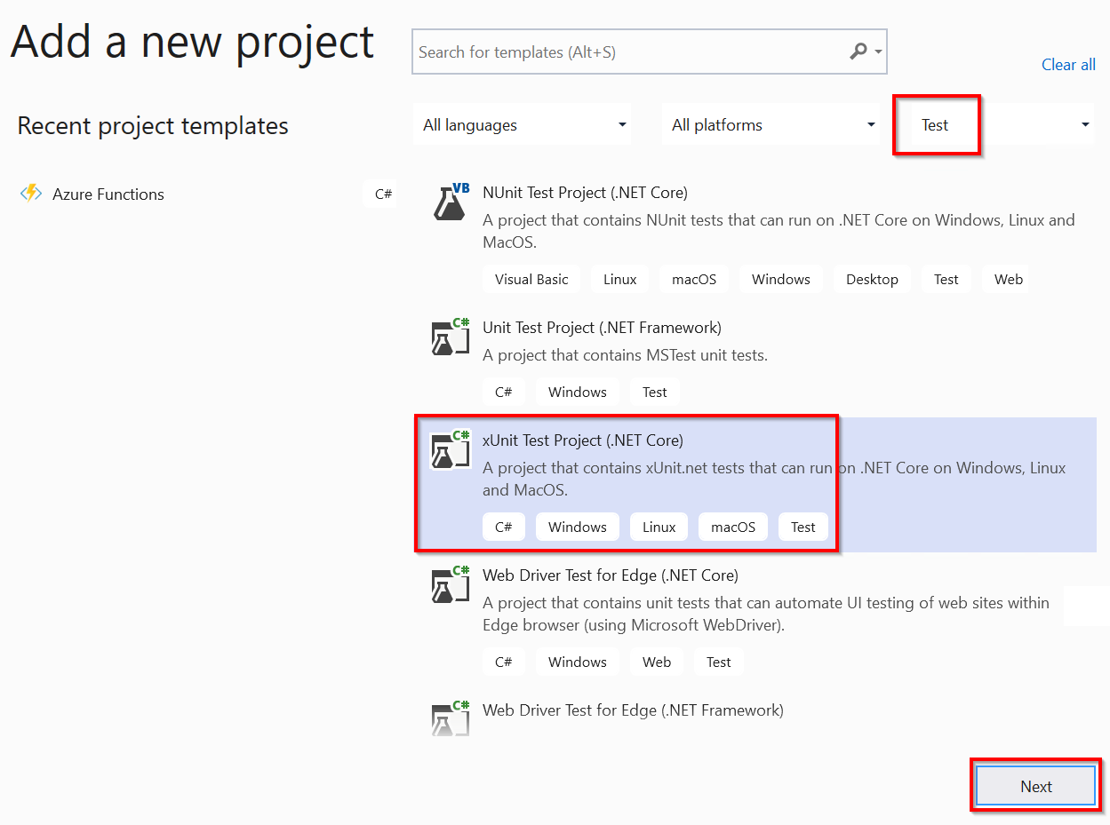

Figure 5.51: Visual Studio—adding a new xUnit project
2. Make sure that you choose xUnit Test Project (.NET Core) in the Package
Manager console and install the Moq NuGet package using the following
commands:
Install-Package Moq
In the unit test project, we also need the reference to the Azure function to run
the unit tests. Add a reference to the FunctionAppInVisualStudio application so
that we can call the HTTP trigger's Run method from our unit tests.

180 | Exploring testing tools for Azure functions

3. Add all the required namespaces to the unit test class and replace the default
code with the following code. The following code mocks the requests, creates a query string collection with a key named name, assigns a value of Praveen Sreeram, executes the function, gets the response, and then compares the response value with an expected value:
using FunctionAppInVisualStudio;
using Microsoft.AspNetCore.Http;
using Microsoft.AspNetCore.Mvc;
using Microsoft.AspNetCore.Http.Internal;
using Microsoft.Extensions.Primitives;
using Moq;
using System;
using System.Collections.Generic;
using Xunit;
using Microsoft.Extensions.Logging;
using System.Threading.Tasks;

namespace AzureFunctions.Tests
{
public class ShouldExecuteAzureFunctions
{
[Fact]
public async Task WithAQueryString()
{
var httpRequestMock = new Mock(); var LogMock = new Mock(); var queryStringParams = new Dictionary();
httpRequestMock.Setup(req => req.Query).Returns(new QueryCollection(queryStringParams));
queryStringParams.Add("name", "Praveen Sreeram"); var
result = await

HTTPTriggerCSharpFromVS.Run(httpRequestMock.Object,LogMock.Object); var resultObject = (OkObjectResult)result; Assert.Equal("Hello, Praveen Sreeram", resultObject. Value);
}
}
}
Developing unit tests for Azure functions with HTTP triggers | 181

4. Now, right-click on the unit test and click on Run Test(s), as shown in Figure 5.52:
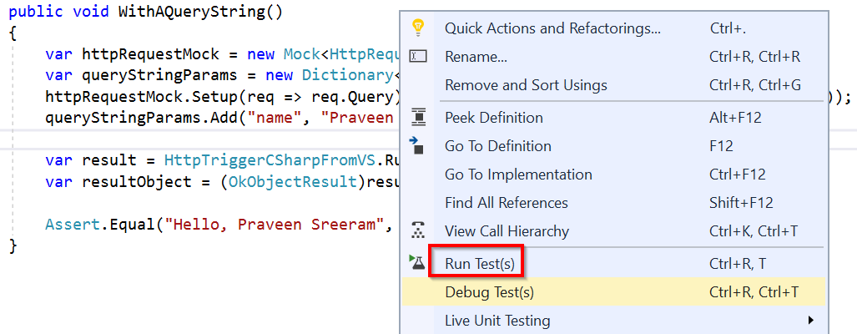

Figure 5.52: Visual Studio—running unit tests
5. If everything is set up correctly, the tests should pass, as in Figure 5.53:
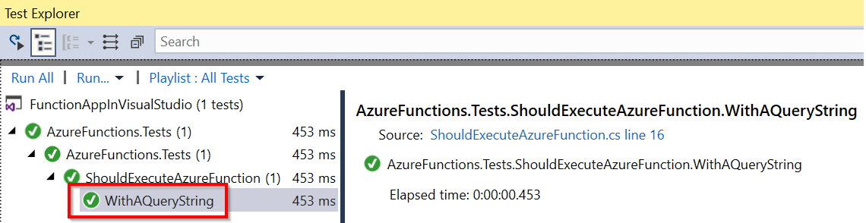

Figure 5.53: Visual Studio—viewing the unit test results
We have learned how to develop unit tests to validate Azure function code.
In this chapter, we have learned about various Azure services, tools, and features
that can be leveraged for the testing and validation of Azure function apps and the
monitoring of function app availability.
In the next chapter, we'll explore troubleshooting and monitoring function apps.

Troubleshooting and

monitoring Azure

Functions

In this chapter, you'll learn about the following:
• Troubleshooting Azure Functions
• Integrating Azure Functions with Application Insights
• Monitoring Azure Functions
• Pushing custom metrics details to Application Insights Analytics
• Sending application telemetry details via email
• Integrating Application Insights with Power BI using Azure Functions 184 | Troubleshooting and monitoring Azure Functions

Introduction
When it comes to application development, the development of a project and getting the application live is not the end of the story. It requires continuous monitoring of applications, analysis of its performance, and log reviews to predetermine issues that end users may face.
In this regard, Azure provides multiple tools to meet all of our monitoring requirements, right from the development stage through to the maintenance stage.
In this chapter, you'll learn how to utilize these tools and take the necessary action based on the information available. The following is an overview of what we'll cover in this chapter:
• Troubleshooting and fixing errors in Azure Functions
• Integrating Application Insights with Azure Functions to push the telemetry data
• Configuring email notifications to receive a summary of the errors, if any

Troubleshooting Azure Functions
In the world of software development, troubleshooting is a continuous process for identifying errors in applications. Troubleshooting is a very common practice that every developer should know how to apply in order to resolve errors and ensure that the application works as expected. Azure allows us to log information that will assist us with troubleshooting.
In this recipe, you'll learn how to view and interpret the application logs of our Function Apps using the Azure Functions log streaming feature.

How to do it…
Once we are done with development and have tested the apps thoroughly in our local environment, it's time to deploy them to Azure. There may be instances where we encounter issues after deploying an application to Azure, mainly due to incompatibility with the environment. For example, a developer might have missed out on creating app settings in the app. With a missing configuration key, the end product may not only produce faults, but it may also prove difficult to troubleshoot the error. In this recipe, you'll learn not only how to view real-time logs, but also how to use the Diagnose and solve problems feature.
How to do it… | 185

Viewing real-time application logs
In this section, we are going to view the real-time application logs using the Logs feature provided by the Azure portal. We can achieve it by performing the following steps:
1. Navigate to Platform features of the function app and click on the Log Streaming
button, where the Application logs can be seen, as shown in Figure 6.1:
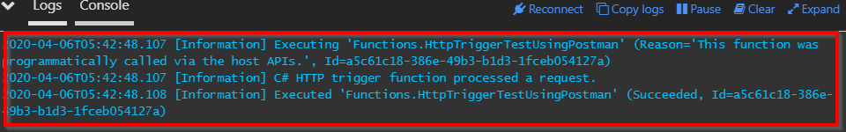

Figure 6.1: Azure Functions—Application Logs

Note
At the time of writing, web server logs provide no information relating to Azure Functions.

2. Now, let's open any of the previously created Azure functions in a new browser
tab and add a line of code that causes an exception. To make it simple (and to just
illustrate how application logs in log streaming work), I have added the following
line to the simple HTTP trigger that I created earlier, as shown in Figure 6.2:
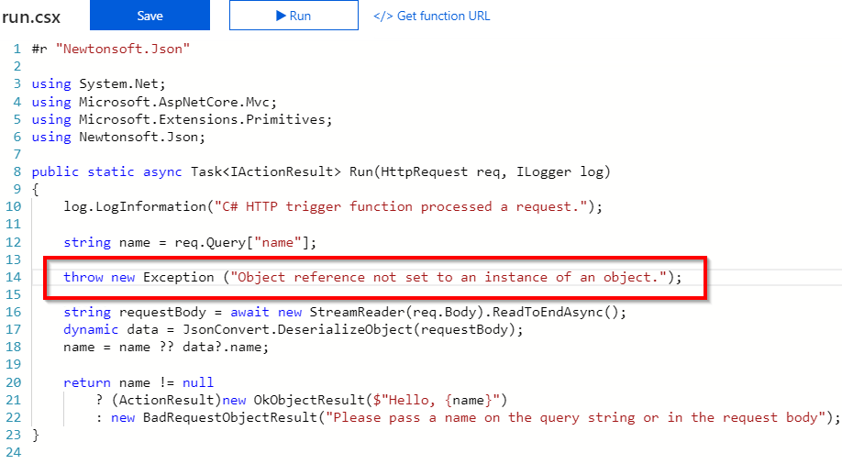

Figure 6.2: Azure Functions code editor—adding an exception 186 | Troubleshooting and monitoring Azure Functions

3. Subsequently, click on the Save button and then click on the Run button. Here, an
exception is expected along with the message in the Application logs section, as shown in Figure 6.3:
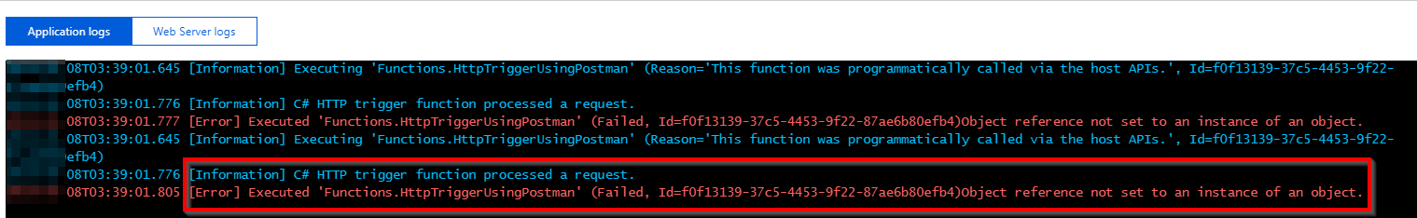

Figure 6.3: Azure Functions—Application Logs
Once you have retrieved the application log, go ahead with diagnosing and solving the problems in the function app.

Diagnosing the function app
In the preceding section, you learned how to monitor application errors in real time, which will be helpful when it comes to quickly identifying and fixing any errors that you encounter. However, it is not always possible to monitor application logs and understand the errors encountered by the end users. Addressing this specific issue, Azure Functions provides another great tool, called Diagnose and solve problems: We'll perform the following steps to diagnose the Azure Function app:
1. Navigate to Platform features and click on Diagnose and solve problems, available
in the Resource management section, as shown in Figure 6.4:
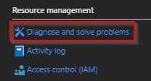

Figure 6.4: Azure Function App—Diagnose and solve problems

Note
The log window shows errors only for that particular function, and not for the other functions associated with the function app. This is where log streaming application logs come in handy, which can be used across the functions of any given function app.
How to do it… | 187

2. Soon after, we'll be taken to another pane to select the right category for the
problems to be troubleshooted. Click on 5xx Errors to view details regarding the
exceptions that end users are facing, as shown in Figure 6.5:
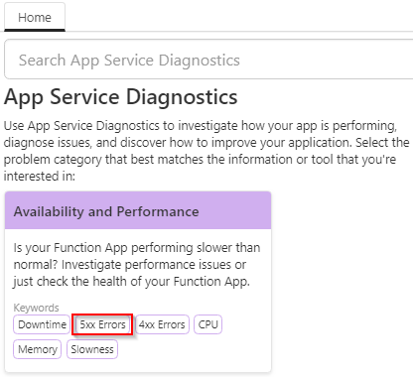

Figure 6.5: Azure App Service Diagnostics
3. From the list of tiles, click on the Messaging Function Trigger Failure tile and
then click on the Function Executions and Errors link, as shown in Figure 6.6:
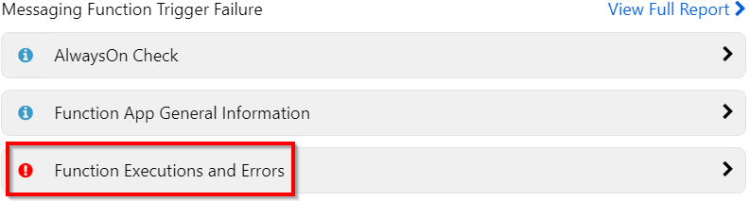

Figure 6.6: Function Executions and Errors
4. Click on Function Executions and Errors to view the detailed exceptions, as
shown in Figure 6.7:
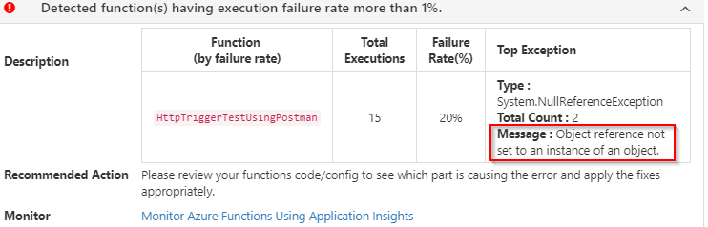

Figure 6.7: Viewing exceptions
188 | Troubleshooting and monitoring Azure Functions

In this recipe, you have learned how to use the diagnose and solve problems tool, which is available within the App Service context. Let's now move on to the next recipe to learn what Application Insights is and how to integrate it with Azure Functions.

Integrating Azure Functions with Application Insights
Application Insights is an Application Lifecycle Management (ALM) tool that assists with tracking performance, exception monitoring, and also collecting telemetry data of the applications. In order to leverage the features of Application Insights, we need to integrate Azure Functions with Application Insights. Once Application Insights is integrated into the application, it will start sending telemetry data to our Application Insights account, which is hosted on the cloud. This recipe will focus on integrating Azure Functions with Application Insights.

Getting ready
We created an Application Insights account in the Validating Azure function responsiveness using Application Insights recipe of Chapter 5, Exploring testing tools for Azure functions. Use an existing account or create an account using the following steps. If an Application Insights account was created in the previous recipe, ignore this step:
1. Navigate to Azure Management Portal, click on Create a resource, and then
select IT & Management Tools.
2. Choose Application Insights and provide all the required details.

How to do it…
Once the Application Insights account has been created, perform the following steps:
1. Navigate to the Overview tab and copy the Instrumentation Key, as shown in
Figure 6.8:
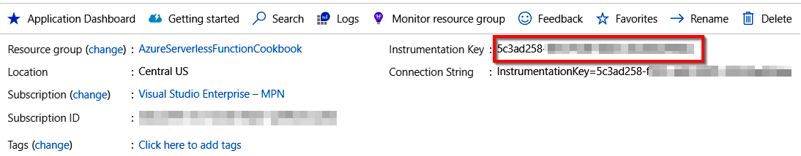

Figure 6.8: Application Insights—Overview
2. Navigate to the function apps for which you want to enable monitoring and go to
the Configuration pane.
Integrating Azure Functions with Application Insights | 189

3. Add a new key (if it doesn't exist already) with the name APPINSIGHTS_
INSTRUMENTATIONKEY and provide the instrumentation key that was copied from the
Application Insights account, as shown in Figure 6.9, and then click on Save to save
the changes:
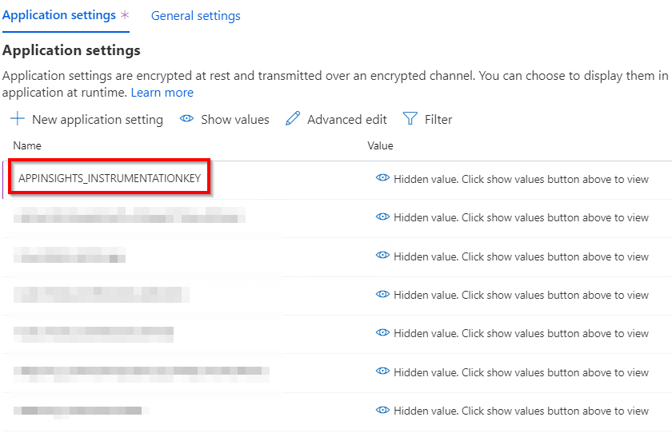

Figure 6.9: Azure Functions—Application settings
4. That's it. Let's now utilize all the features of Application Insights to monitor
the performance of our Azure functions. Open Application Insights and the
RegisterUser function in two different tabs to test how Live Metrics Stream
works.
190 | Troubleshooting and monitoring Azure Functions

Open Application Insights and click on Live Metrics Stream in the first tab of the web browser, as shown in Figure 6.10:
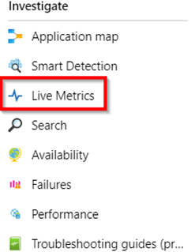

Figure 6.10: Application settings—Live Metrics menu item
Open any of the Azure functions (in my case, I have opened the HTTP trigger) in another browser tab and run a few tests to ensure that it emits some logs to Application Insights.
5. After completing the tests, go to the browser tab that has Application Insights. The
live traffic going to our function app should be displayed, as shown in Figure 6.11:
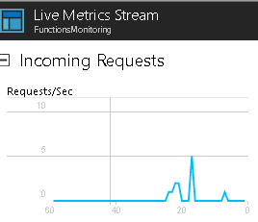

Figure 6.11: Application settings—Live Metrics Stream

How it works…
We have created an Application Insights account. Once Application Insights' Instrumentation Key is integrated with Azure Functions, the runtime will take care of sending the telemetry data asynchronously to our Application Insights account.
Monitoring Azure Functions | 191

There's more…
Live Metrics Stream also allows us to view all the instances, along with some other data, such as the number of requests per second handled by each instance.
In this recipe, you have learned how to integrate Azure Functions with the Application Insights service. You have also seen the requests in the Live Metrics Stream to confirm whether integration has been implemented properly. Let's move on to the next recipe to learn more on how to monitor Azure Functions.

Monitoring Azure Functions
Monitoring Azure Functions is important if you want to know whether there are any errors that are raised by the application during testing.
In this recipe, you will learn how to view the logs that are written to Application Insights by Azure Functions' code. As a developer, this knowledge can help troubleshoot any exceptions that may occur during application development.
Let's make a small change to the HTTP trigger function and then run it a few times with the test data.

How to do it…
In this recipe, we'll learn how to review the application traces using Application Insight's Logs. Let's perform the following steps:
1. Navigate to the HTTP trigger that we created and replace the following code. I
have moved the line of code that logs the information to the Logs console and
added the name parameter at the end of the method:
public static async Task Run(HttpRequest req, ILogger log)
{
string name = req.Query["name"];
string requestBody = await new
StreamReader(req.Body).ReadToEndAsync();
dynamic data =
JsonConvert.DeserializeObject(requestBody);
name = name ?? data?.name;
log.LogInformation($"C# HTTP trigger function processed a request
with the input value {name}");
return name != null
? (ActionResult)new OkObjectResult($"Hello, {name}")
: new BadRequestObjectResult("Please pass a name on the query
string or in the request body");
}
192 | Troubleshooting and monitoring Azure Functions

2. Now, run the HTTP trigger function by providing the value for the name parameter
with different values such as Azure Test Run 1, Azure Test Run 2, and Azure Test Run 3. This is just for demo purposes. Any input can be used. The Logs console will show the following output:
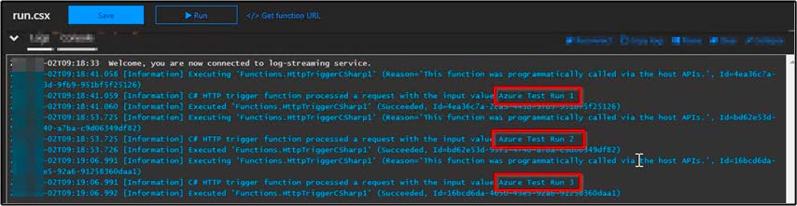

Figure 6.12: Azure Functions—log information in the console
3. The logs in the preceding Logs console are only available when we are connected
to the Logs console, which are not available offline. That's where Application Insights comes in handy. Navigate to the Application Insights instance that is integrated with the function app:
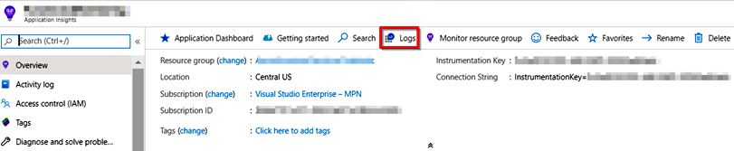

Figure 6.13: Application Insights—Overview pane
4. In the Logs query window, type the following Kusto Query Language (KQL)
command:
traces
| where message contains "Azure Test"
| sort by timestamp desc
Monitoring Azure Functions | 193

This will return all the traces sorted by date in descending order, as shown in
Figure 6.14:
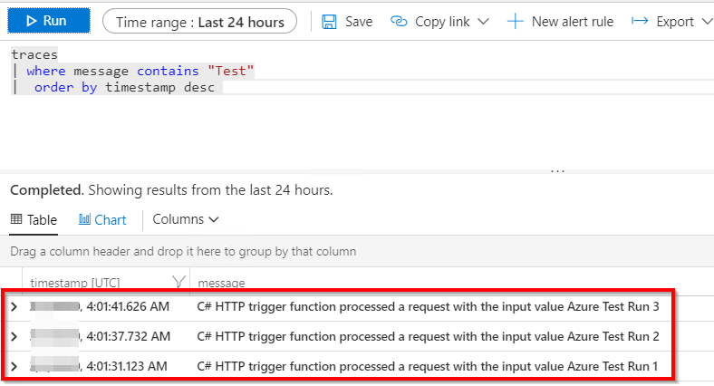

Figure 6.14: Application Insights—Logs

How it works…
In the HTTP trigger, add a log statement that displays the value of the name parameter that the user provides. In order to simulate a genuine end user, run the HTTP trigger a few times using different values. And after some time (around five minutes), click on the Logs button in the Application Insights button, which opens the analytics window. Here, we can write queries to view the telemetry data that is being emitted by Azure Functions. All of this can be achieved without writing any custom code.
In this recipe, you have seen how to monitor the logs and write queries using Application Insights. Let's now move on to the next recipe to learn how to push custom metrics to Application Insights.

194 | Troubleshooting and monitoring Azure Functions

Pushing custom metrics details to Application Insights Analytics
At times, businesses may ask developers to provide analytics reports for a derived metric within Application Insights. So, what is a derived metric? Well, by default, Application Insights provides us with many insights into metrics, such as requests, errors, and exceptions.
We can run queries on the information that Application Insights provides using its Analytics Query Language.
In this context, requests per hour is a derived metric, and to build a new report within Application Insights, we need to feed Application Insights data regarding the newly derived metric on a regular basis. Once the required data is fed regularly, Application Insights will take care of providing reports for our analysis.
We'll be using Azure Functions to feed Application Insights with a derived metric named requests per hour:
Feed application derived metrics data to App Insights using Azure functions

App Insights
Run
1 query
Get
query
Feed every request request
Track
Metric
to App
Website Insights
4
3
2

Azure
Functions

Figure 6.15: Feed Application—derived metrics to App Insights using Azure Functions

Pushing custom metrics details to Application Insights Analytics | 195

The following is a brief explanation of Figure 6.15:
1. The application (Website) feeds the request data to Application Insights for every
request.
2. Azure Function timer triggers run continuously every five minutes and submit the
query to Application Insights.
3. Azure Functions retrieves the results of the query in Application Insights.
4. This result is then used by Application Insights to calculate a custom metrics
(requests for hour), which is pushed again to Application Insights.

For this example, we'll develop a query using the Analytics Query Language for the request per hour derived metric. We can make changes to the query to generate other derived metrics based on our requirements, such as identifying requests per hour for campaigns.

Note
In this recipe, we'll use KQL to query the data of Application Insights. KQL is a kind of SQL language that is used to make read-only requests to process data and
return the results. Learn more about KQL at https://docs.microsoft.com/azure/
application-insights/app-insights-analytics-reference.

Getting ready
We'll have to perform the following steps prior to starting with the recipe:
1. Create a new Application Insights account, if you do not already have one.
2. Make sure that you have a running application that integrates with Application
Insights. Learn how to integrate an application with Application Insights at
https://docs.microsoft.com/azure/application-insights/app-insights-asp-net.

How to do it…
We'll perform the following steps to push custom telemetry details to Application Insights Analytics.
196 | Troubleshooting and monitoring Azure Functions

Creating a timer trigger function using Visual Studio In this section, we'll create an Azure Functions timer trigger that runs every minute by performing the following steps:
1. Create a new function by right-clicking on the function app project, as shown in
Figure 6.16:
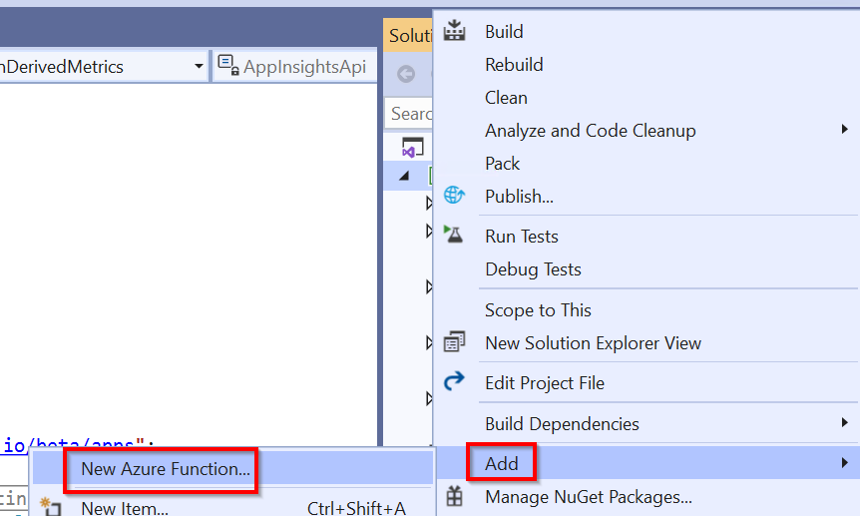

Figure 6.16: Visual Studio—adding a new Azure function
2. Now, in the New Azure Function window, choose Timer Trigger and provide the
0 */1 * * * * CRON expression in the Schedule box. The CRON expression runs every minute. It can be changed later based on the frequency with which you would like to run the timer trigger. After reviewing all the details, click on the OK button to create the function.
3. Now, enter the following code into the new timer trigger function that you have
created. The following code runs every minute (based on the CRON expression), runs a query (that you have configured) in Application Insights, and then creates a derived metric that can be used to create a custom report:
using System;
using Microsoft.Azure.WebJobs;
using Microsoft.Extensions.Logging;
using Microsoft.ApplicationInsights;
using Microsoft.ApplicationInsights.DataContracts;
Pushing custom metrics details to Application Insights Analytics | 197

using Newtonsoft.Json.Linq;
using System.Threading.Tasks;
using System.Net.Http;

namespace FunctionAppinVisualStudio
{
public class FeedAIWithCustomDerivedMetrics
{
private const string AppInsightsApi = "https://api.
applicationinsights.io/beta/apps";

private static readonly TelemetryClient TelemetryClient
= new TelemetryClient { InstrumentationKey = Environment. GetEnvironmentVariable("AI_IKEY") };
private static readonly string AiAppId = Environment.
GetEnvironmentVariable("AI_APP_ID");
private static readonly string AiAppKey = Environment.
GetEnvironmentVariable("AI_APP_KEY");

[FunctionName("FeedAIWithCustomDerivedMetrics")]
public static async Task Run([TimerTrigger("0 */1 * * * *")]
TimerInfo myTimer, ILogger log)
{
log.LogInformation($"C# Timer trigger function executed at:
{DateTime.Now}");

await ScheduledAnalyticsRun(
name: "Request per hour",
query: @"requests | where timestamp > now(-1h)| summarize
count()",
log: log);
}
public static async Task ScheduledAnalyticsRun(string name, string
query, ILogger log)
{
log.LogInformation($"Executing scheduled analytics run for
{name} at: {DateTime.Now}");

string requestId = Guid.NewGuid().ToString();
log.LogInformation($"[Verbose]: API request ID is 198 | Troubleshooting and monitoring Azure Functions

{requestId}");

try
{
MetricTelemetry metric = new MetricTelemetry { Name = name
};
metric.Context.Operation.Id = requestId;
metric.Properties.Add("TestAppId", AiAppId);
metric.Properties.Add("TestQuery", query);
metric.Properties.Add("TestRequestId", requestId);
using (var httpClient = new HttpClient())
{
httpClient.DefaultRequestHeaders.Add("x-api-key",
AiAppKey);
httpClient.DefaultRequestHeaders.Add("x-ms-app",
"FunctionTemplate");
httpClient.DefaultRequestHeaders.Add("x-ms-client-
request-id", requestId);
string apiPath = $"{AppInsightsApi}/{AiAppId}/
query?clientId={requestId}×pan=P1D&query={query}";
using (var httpResponse = await httpClient.
GetAsync(apiPath))
{

httpResponse.EnsureSuccessStatusCode();
var resultJson = await httpResponse.Content.
ReadAsAsync();
double result;
if (double.TryParse(resultJson.
SelectToken("Tables[0].Rows[0][0]")?.ToString(), out result))
{
metric.Sum = result;
log.LogInformation($"[Verbose]: Metric result
is {metric.Sum}");
}
else
{
log.LogError($"[Error]: {resultJson.
ToString()}");
throw new FormatException("Query must result
in a single metric number. Try it on Analytics before scheduling.");
}
Pushing custom metrics details to Application Insights Analytics | 199

}
}

TelemetryClient.TrackMetric(metric);
log.LogInformation($"Metric telemetry for {name} is
sent.");
}
catch (Exception ex)
{

var exceptionTelemetry = new ExceptionTelemetry(ex);
exceptionTelemetry.Context.Operation.Id = requestId;
exceptionTelemetry.Properties.Add("TestName", name);
exceptionTelemetry.Properties.Add("TestAppId", AiAppId);
exceptionTelemetry.Properties.Add("TestQuery", query);
exceptionTelemetry.Properties.Add("TestRequestId",
requestId);
TelemetryClient.TrackException(exceptionTelemetry);
log.LogError($"[Error]: Client Request ID {requestId}:
{ex.Message}");

throw;
}
finally
{
TelemetryClient.Flush();
}
}
}
}
4. Install the Application Insights Nuget package in the Azure Function app project
using the following Nuget command:
Install-package Microsoft.ApplicationInsights Now that we have added the code, let's move on to the next section to configure the keys.
200 | Troubleshooting and monitoring Azure Functions

Configuring access keys
In order to have the Azure function access Application Insights programmatically, we need to create an API key. Let's configure the access keys by performing the following steps:
1. Navigate to Application Insights' Overview pane, and copy the Instrumentation
Key. We'll be using the Instrumentation Key to create an application setting named AI_IKEY in the function app:
2. Navigate to the API Access blade and copy the Application ID. We'll be using
this Application ID to create a new app setting with the name AI_APP_ID in the function app:
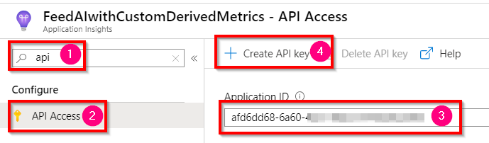

Figure 6.17: Application Insights—API Access pane
3. We also need to create a new API key. As shown in the preceding step, click on
the Create API key button to generate the new API key, as shown in Figure 6.18. Provide a meaningful name, check the Read telemetry box, and click on Generate key:
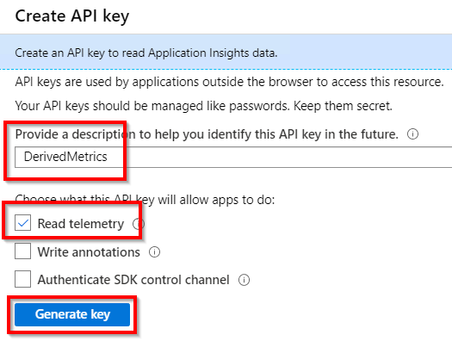

Figure 6.18: Application Insights—API Access pane—generating a new key
Pushing custom metrics details to Application Insights Analytics | 201

4. Soon after, the platform allows you to view and copy the key, as shown in Figure
6.19. We'll be using this to create a new app setting with the name AI_APP_KEY in
our function app, so be sure to store it somewhere:
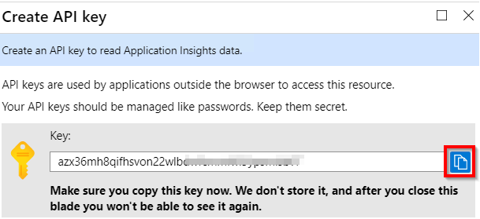

Figure 6.19: Application Insights – API Access pane—copying the new key
5. Create all three settings in the localsettings.json to perform some tests in the
local environment:
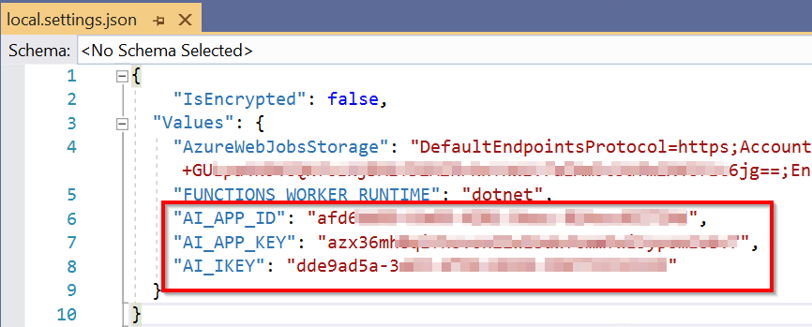

Figure 6.20: Azure Functions—configuration file
202 | Troubleshooting and monitoring Azure Functions

6. Create all three app setting keys in the Configuration pane of the function app, as
shown in Figure 6.21. These three keys will be used in our Azure function named FeedAIwithCustomDerivedMetric:
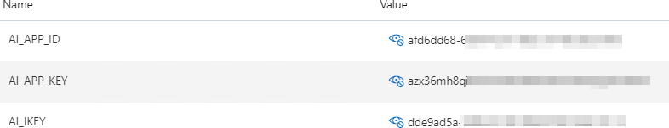

Figure 6.21: Azure Functions—configuration—App settings
We have developed the code and created all the required configuration settings. Let's now move on to the next section to test them.

Integrating and testing an Application Insights query In this section, let's run and test an Application Insights query by performing the following steps:
1. First of all, let's test the requests per hour derived metric value. Navigate to the
Overview pane of Application Insights and click on the Logs button.
2. In the Logs pane, write the following query in the Query tab, although custom
queries can be written as per your requirements. Make sure that the query returns a scalar value:
requests
| where timestamp > now(-1h)
| summarize count()
Pushing custom metrics details to Application Insights Analytics | 203

3. Once the query is written, run it by clicking on the Run button to see the number
of records, as shown in Figure 6.22:
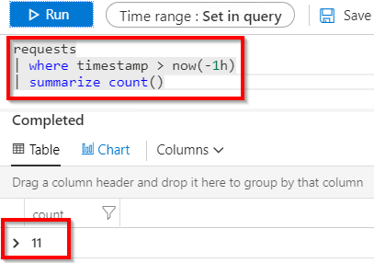

Figure 6.22: Application Insights—Logs—executing the query
4. Now, run the timer trigger for a few minutes in the local machine, which will
push some data to Application Insights. We can then view the data, as shown in
Figure 6.22.
In this section, we have learned how to develop and test an Application Insights query. Now, let's move on to the next section.

Configuring the custom-derived metric report In this section, we'll create a custom report in Application Insights by configuring the derived metric that we have created in this recipe by performing the following steps:
1. Navigate to the Application Insights' Overview tab and click on the Metrics menu,
as shown in Figure 6.23:
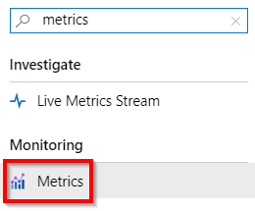

Figure 6.23: Application Insights—Metrics menu item 204 | Troubleshooting and monitoring Azure Functions

2. Metrics Explorer is where you can find analytics regarding different metrics. In
Metrics Explorer, click on the Add metric button of any chart to configure the custom metric, Thereafter, you can configure the custom metric and all other details related to the chart. In the METRIC NAMESPACE drop-down menu, choose azure.applicationinsights, as shown in Figure 6.24, and then choose the Request per hour custom metric that you created:
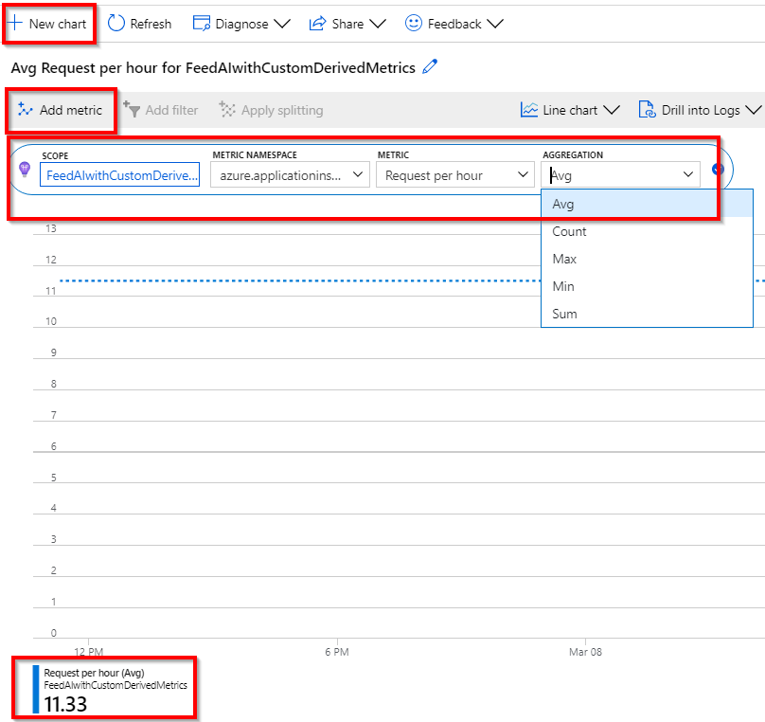

Figure 6.24: Application Insights—Metrics Explorer
Sending application telemetry details via email | 205

How it works…
This is how the entire process works:
• We created the Azure function timer trigger using Visual Studio that runs every
few minutes (one minute in this example. Feel free to change it to different values
based on requirements).
• We configured the following keys in Application settings of the Azure Function
app:
The Application Insights' instrumentation key
The application ID
The API access key
• The Azure function runtime automatically consumed the Application Insights'
API, ran the custom query to retrieve the required metrics, and fed the derived
telemetry data to Application Insights.
• Once everything in the Azure function was configured, we developed a simple
query that pulled the request count of the last hour and fed it to Application
Insights as a custom derived metric. This process is repeated every minute.
• Later, we configured a new report using Application Insights Metrics with our
custom derived metric.

Sending application telemetry details via email
One of the activities of our application, once live, will be able to receive a notification email with details regarding health, errors, response time, and so on, at least once a day.
In this recipe, we'll use the ability of Azure Functions' timer trigger to get all the required values from Application Insights and send the email using SendGrid. We'll look at how to do that in this recipe.
206 | Troubleshooting and monitoring Azure Functions

Getting ready
Perform the following steps in the first instance:
1. This recipe is dependent on the application settings created in the previous recipe,
Pushing custom metrics details to Application Insights Analytics. Please ensure to add them before running the code of this recipe.
2. Create a new SendGrid account, if you do not already have one, and get the
SendGrid API key.
3. Create a new Application Insights account, if one has not been created already.
4. Make sure that you have a running application that integrates with Application
Insights.

Note
Learn how to integrate applications with Application Insights at https://docs.
microsoft.com/azure/application-insights/app-insights-asp-net.

How to do it…
In this section, we'll create the application settings and also develop the query.
Configuring the application settings
To configure the application settings, perform the following steps:
1. Create the SendGrid API key in both the appSettings.json file of the local project
as well as Azure App Settings:
appSettings.json file:
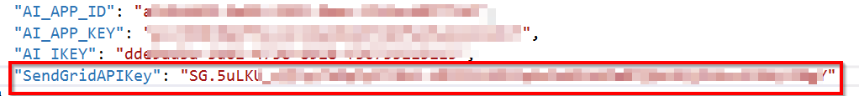

Figure 6.25: Azure Functions—local configuration file
App settings in the Configuration pane:

Figure 6.26: Azure Functions—configuration—App settings
Sending application telemetry details via email | 207

Developing and validating the KQL query In this section, we'll develop the KQL query and test it:
1. Develop the query that pulls the details regarding Total Requests, Failed Requests,
and Exceptions. The query can be changed depending on the requirements. The
following is a simple query used in this recipe:
requests
| where timestamp > ago(1d)
| summarize Row = 1, TotalRequests = sum(itemCount), FailedRequests = sum(toint(success == 'False')),
RequestsDuration = iff(isnan(avg(duration)), '------', tostring(toint(avg(duration) * 100) / 100.0)) | join (
exceptions
| where timestamp > ago(1d)
| summarize Row = 1, TotalExceptions = sum(itemCount)) on Row | project TotalRequests, FailedRequests,TotalExceptions
2. Upon running the preceding query in the Logs section of Application Insights, the
output in Figure 6.27 will be visible:
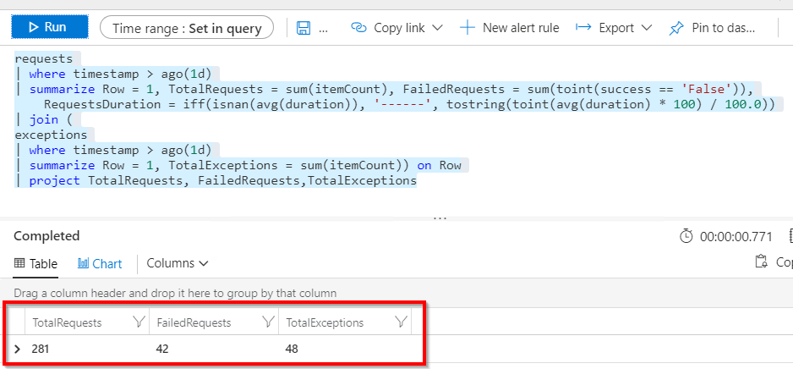

Figure 6.27: Application Insights—Logs—executing the query
We have developed the KQL query and tested it, so now let's move on to the next section.
208 | Troubleshooting and monitoring Azure Functions

Developing the code using the timer trigger of Azure Functions In this section, we'll develop the timer trigger of Azure Functions, which calls the KQL query on a certain frequency (for example, every minute):
1. Create a new timer trigger function named ApplicationInsightsScheduledDigest in
Visual Studio.
2. Add the following Nuget packages, if you don't have them already:
Microsoft.ApplicationInsights
SendGrid
3. Replace the default code with the following code. The code (as per the CRON
expression) runs every minute (to make it simple, one minute is used. CRON expressions can be changed as per our requirements) to submit the query to Azure Application Insights to get the total requests, failed requests, and the exceptions. It also sends an email with all the data returned by the query to the end user:
using System;
using Microsoft.Azure.WebJobs;
using Microsoft.Extensions.Logging;
using Newtonsoft.Json.Linq;
using SendGrid;
using SendGrid.Helpers.Mail;
using System.Threading.Tasks;
using System.Net.Http;
namespace FunctionAppinVisualStudio
{
public static class ApplicationInsightsScheduledDigest
{
private const string AppInsightsApi = "https://api.
applicationinsights.io/v1/apps";
private static readonly string AiAppId = Environment.
GetEnvironmentVariable("AI_APP_ID");
private static readonly string AiAppKey = Environment.
GetEnvironmentVariable("AI_APP_KEY");
private static readonly string SendGridAPIKey = Environment.
GetEnvironmentVariable("SendGridAPIKey");

[FunctionName("ApplicationInsightsScheduledDigest")]
public static async Task Run([TimerTrigger("0 */1 * * * *")]
TimerInfo myTimer, ILogger log)
{
Sending application telemetry details via email | 209

log.LogInformation($"C# Timer trigger function executed at:
{DateTime.Now}");

string appName = "Azure Serverless Computing Cookbook";

var today = DateTime.Today.ToShortDateString();

DigestResult result = await ScheduledDigestRun(
query: GetQueryString(),
log: log
);
SendGridMessage message = new SendGridMessage();
message.SetFrom(new EmailAddress("donotreply@example.com"));
message.AddTo("prawin2k@gmail.com");
message.SetSubject($"Your daily Application Insights digest
report for {today}");
var msgContent = GetHtmlContentValue(appName, today, result);
message.AddContent("text/html", msgContent);
var client = new SendGridClient(SendGridAPIKey);
var response = await client.SendEmailAsync(message);
log.LogInformation($"Generating daily report for {today} at
{DateTime.Now}");
}

static string GetHtmlContentValue(string appName, string today,
DigestResult result)
{
return $@"

{appName} daily

telemetry report {today}

The following data shows
insights based on telemetry from last 24 hours.

210 | Troubleshooting and monitoring Azure Functions

Total requests | {result.TotalRequests}
Failed requests | {result.FailedRequests}
Total exceptions | {result.TotalExceptions}

";
}
private static async Task ScheduledDigestRun(string
query, ILogger log)
{
log.LogInformation($"Executing scheduled daily digest run at:
{DateTime.Now}");
string requestId = Guid.NewGuid().ToString();
log.LogInformation($"API request ID is {requestId}");
try
{
using (var httpClient = new HttpClient())
{
httpClient.DefaultRequestHeaders.Add("x-api-key",
AiAppKey);
httpClient.DefaultRequestHeaders.Add("x-ms-app",
"FunctionTemplate");
httpClient.DefaultRequestHeaders.Add("x-ms-client-
request-id", requestId);
string apiPath = $"{AppInsightsApi}/{AiAppId}/
query?clientId={requestId}×pan=P1W&query={query}";
using (var httpResponse = await httpClient.
GetAsync(apiPath))
{
httpResponse.EnsureSuccessStatusCode();
var resultJson = await httpResponse.Content.
ReadAsAsync();
DigestResult result = new DigestResult
{
TotalRequests = resultJson.
Sending application telemetry details via email | 211

SelectToken("tables[0].rows[0][0]")?.ToObject().ToString("N0"),
FailedRequests = resultJson.
SelectToken("tables[0].rows[0][1]")?.ToObject().ToString("N0"),
TotalExceptions = resultJson.
SelectToken("tables[0].rows[0][2]")?.ToObject().ToString("N0")
};
return result;
}
}
}
catch (Exception ex)
{
log.LogError($"[Error]: Client Request ID {requestId}:
{ex.Message}");
throw;
}
}
private static string GetQueryString()
{
return @"
requests
| where timestamp > ago(1d)
| summarize Row = 1, TotalRequests = sum(itemCount),
FailedRequests = sum(toint(success == 'False')),
RequestsDuration = iff(isnan(avg(duration)), '------',
tostring(toint(avg(duration) * 100) / 100.0))
| join (
exceptions
| where timestamp > ago(1d)
| summarize Row = 1, TotalExceptions = sum(itemCount)) on Row
| project TotalRequests, FailedRequests,TotalExceptions
";
}
}
struct DigestResult
{
public string TotalRequests;
public string FailedRequests;
public string TotalExceptions;
}
}
212 | Troubleshooting and monitoring Azure Functions

4. Figure 6.28 is a screenshot of the email received after the timer trigger has run:
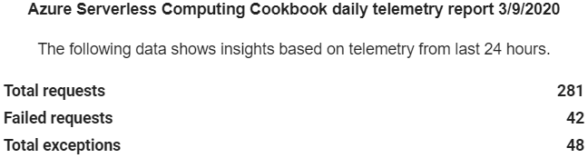

Figure 6.28: Telemetry email

How it works…
The Azure function uses the Application Insights API to run all the Application Insights Analytics queries, retrieves all the results, frames the email body with all the details, and invokes the SendGrid API to send an email to the configured email account.

Integrating Application Insights with Power BI using
Azure Functions
Sometimes, we need to view real-time data regarding our application's availability or information relating to the application's health on a custom website. Retrieving information for Application Insights and displaying it in a custom report would be a tedious job, as you might need to develop a separate website and build, test, and host it somewhere.
In this recipe, you'll learn how easy it is to view real-time health information for the application by integrating Application Insights and Power BI. We'll be leveraging Power BI capabilities for the live streaming of data, and Azure timer functions to continuously feed health information to Power BI. This is a high-level diagram of what we'll be doing in the rest of the recipe:

Integrating Application Insights with Power BI using Azure Functions | 213

Integrating real-time App Insights monitoring data with Power BI using Azure Functions

App Insights
Run
query
Get
query
Feed every request request

Website Azure Power BI Real-time updates Functions

Figure 6.29: Flowchart for integrating real-time Application Insights monitoring with Power BI using
Azure Functions
As depicted in the preceding flowchart, here is how the approach in this recipe works:
1. The website feed every request with the telemetry information to App Insights.
In this recipe, we are not going to develop the website. However, in your projects,
you will have your websites already integrated with App Insights, and this will push
the telemetry.
2. An Azure Functions timer trigger will run the query in App Insights on a certain
frequency to get query results from App Insights.
3. Once the results are received from Azure Functions, it will push the real-time
updates to Power BI.

214 | Troubleshooting and monitoring Azure Functions

Getting ready
Perform the following initial steps in order to implement the functionality of this recipe:
1. Create a Power BI account at https://powerbi.microsoft.com/.
2. Create a new Application Insights account, if one has not been created already.
3. Make sure that you have a running application that integrates with Application
Insights. Learn how to integrate applications with Application Insights at https://
docs.microsoft.com/azure/application-insights/app-insights-asp-net.
Note

Use a work or school account to create a Power BI account. At the time of writing, it's not possible to create a Power BI account using a personal email address such as Gmail and Yahoo.

Make sure to follow the steps in the Configuring access keys section of the Pushing custom metrics details to Application Insights Analytics recipe to configure the following access keys: Application Insights instrumentation key, the application ID, and the API access key

How to do it...
We'll perform the following steps to integrate Application Insights and Power BI.

Configuring Power BI with a dashboard, a dataset, and the push URI In this recipe, we'll create a streaming dataset and add it to the dashboard by performing the following steps:
Integrating Application Insights with Power BI using Azure Functions | 215

1. While using the Power BI portal for the first time, you might have to click on Skip
on the welcome page, as shown in Figure 6.30:
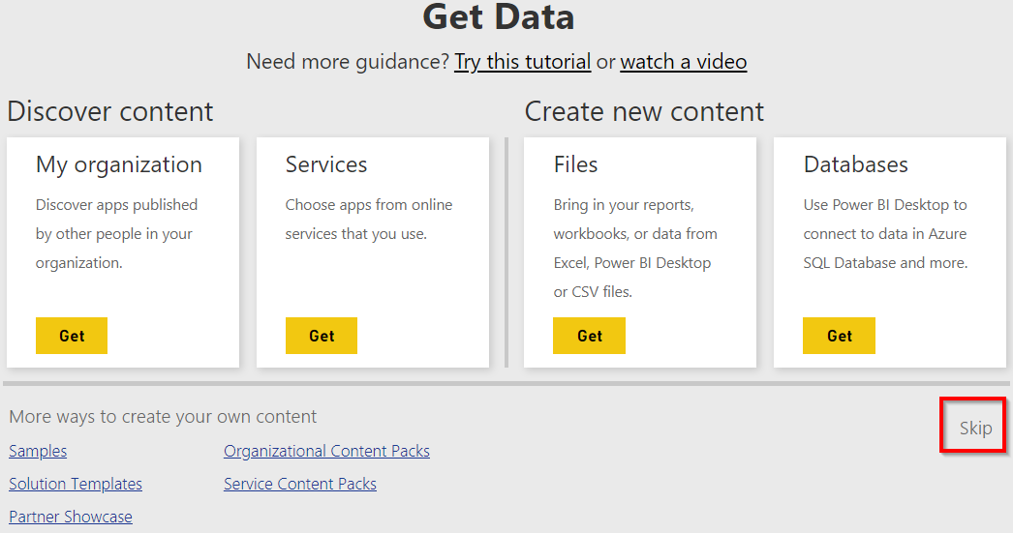

Figure 6.30: Power BI—Get Data—view
2. The next step is to create a streaming dataset by clicking on Create and then
choosing Streaming dataset, as shown in Figure 6.31:
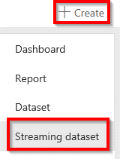

Figure 6.31: Power BI—creating a streaming dataset menu item
216 | Troubleshooting and monitoring Azure Functions

3. In the New streaming dataset step, select API and click on the Next button, as
shown in Figure 6.32:
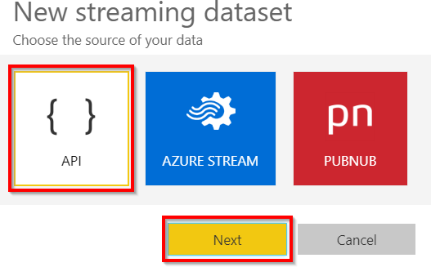

Figure 6.32: Power BI—streaming dataset—choosing the source of the data
4. In the next step, you need to create the fields for the streaming dataset. Provide
a meaningful name for the dataset and provide the values to be pushed to the Power BI. For this recipe, I created a dataset with just one field, named RequestsPerSecond, of the Number type, and clicked on Create, as shown in Figure 6.33:
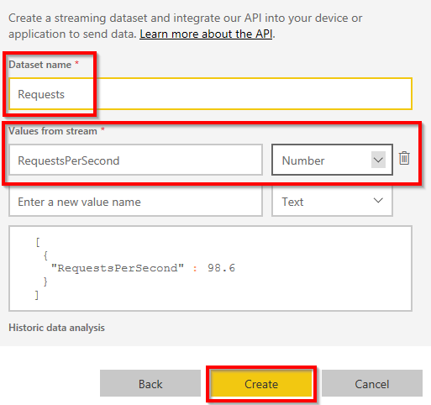

Figure 6.33: Power BI—creating a streaming dataset
Integrating Application Insights with Power BI using Azure Functions | 217

5. Once the dataset is created, you'll be prompted with a push URL, as shown in
Figure 6.34. Use this push URL in Azure Functions to push the RequestsPerSecond
data every second (or however frequently you wish) with the actual value of
requests per second. Then, click on Done:
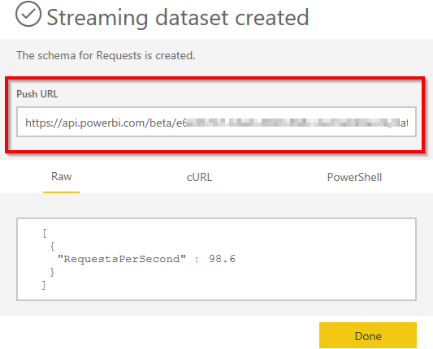

Figure 6.34: Power BI—Streaming dataset—Push URL
6. The next step is to create a dashboard with a tile in it. Let's create a new
dashboard by clicking on Create and choosing Dashboard, as shown in Figure 6.35:
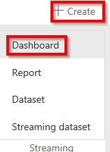

Figure 6.35: Power BI—Dashboard—creating a menu item
7. In the Create dashboard pop-up window, provide a meaningful name and click on
Create, as shown in the following Figure 6.36, to create an empty dashboard:
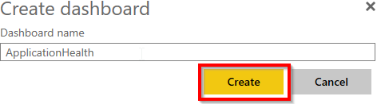

Figure 6.36: Power BI—Create dashboard 218 | Troubleshooting and monitoring Azure Functions

8. In the empty dashboard, click on the Add tile button to create a new tile. Clicking
on Add tile will open a new pop-up window, where we can select the data source from which the tile should be populated:
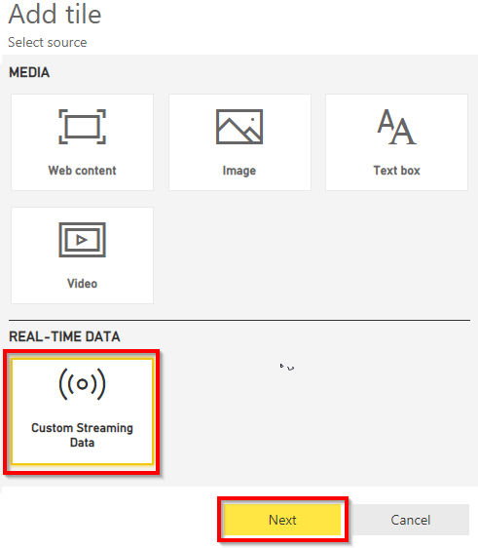

Figure 6.37: Power BI—dashboard—adding a tile
9. Select Custom Streaming Data and click on Next, as shown in Figure 6.38. In the
following step, select the Requests dataset and click on the Next button:
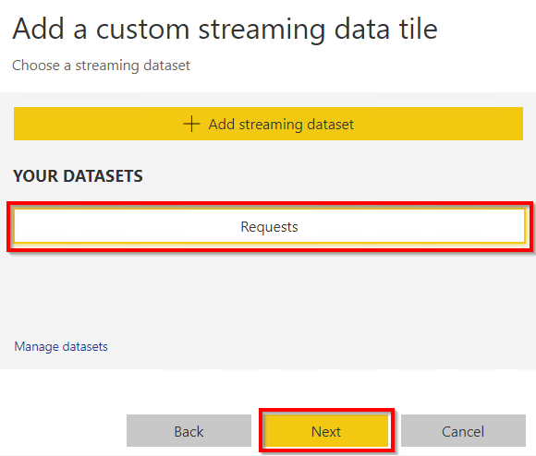

Figure 6.38: Power BI – dashboard—adding a tile—choosing the dataset
Integrating Application Insights with Power BI using Azure Functions | 219

10. The next step is to choose Visualization Type (Card in this case) and select the
fields from the data source, as shown in Figure 6.39:
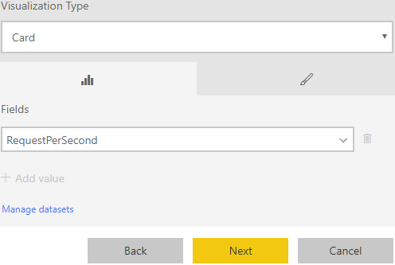

Figure 6.39: Power BI—dashboard—adding a tile—choosing the visualization type
11. The final step is to provide a name for the tile, namely, RequestsPerSecond. The
name might not make sense in this case, but feel free to provide any name as per
the project's requirements.

In this section, we have created the dashboard and dataset, and also added a tile to the dashboard.

Creating an Azure Application Insights real-time Power BI—C# function In this section, we'll create an Azure Functions timer trigger to integrate Azure Application Insights with Power BI by performing the following steps:
1. Create a new Azure Functions timer trigger. Replace the default code with the
following code. Make sure to configure the correct value for which the analytics
query should pull the data. In my case, I have provided five minutes (5m) in the
following code:
using System;
using Microsoft.Azure.WebJobs;
using Microsoft.Azure.WebJobs.Host;
using Microsoft.Extensions.Logging;
using System.Configuration;
using System.Text;
using Newtonsoft.Json.Linq;
using System.Threading.Tasks;
using System.Net.Http;
220 | Troubleshooting and monitoring Azure Functions

namespace FunctionAppinVisualStudio
{
public static class ViewRealTimeRequestCount
{
private const string AppInsightsApi = "https://api.
applicationinsights.io/beta/apps";
private const string RealTimePushURL = "https://pushurlhere";
private static readonly string AiAppId = Environment.
GetEnvironmentVariable("AI_APP_ID");
private static readonly string AiAppKey = Environment.
GetEnvironmentVariable("AI_APP_KEY");

[FunctionName("ViewRealTimeRequestCount")]
public static async Task Run([TimerTrigger("0 */5 * * * *")]
TimerInfo myTimer, ILogger log)
{
log.LogInformation($"C# Timer trigger function executed at:
{DateTime.Now}");
if (myTimer.IsPastDue)
{
log.LogWarning($"[Warning]: Timer is running late! Last
ran at: {myTimer.ScheduleStatus.Last}");
}
await RealTimeFeedRun(query: @"
requests
| where timestamp > ago(5m)
| summarize passed = countif(success == true), total =
count()
| project passed ",
log: log
);
log.LogInformation($"Executing real-time Power BI run at:{
DateTime.Now}");

}
private static async Task RealTimeFeedRun(string query, ILogger
log)
{
log.LogInformation($"Feeding Data to Power BI has started at:
{ DateTime.Now}");
string requestId = Guid.NewGuid().ToString();
using (var httpClient = new HttpClient())
Integrating Application Insights with Power BI using Azure Functions | 221

{
httpClient.DefaultRequestHeaders.Add("x-api-key",
AiAppKey);
httpClient.DefaultRequestHeaders.Add("x-ms-app",
"FunctionTemplate");
httpClient.DefaultRequestHeaders.Add("x-ms-client-
request-id", requestId);
string apiPath = $"{AppInsightsApi}/{AiAppId}/
query?clientId={requestId}×pan=P1D&query={query}";
using (var httpResponse = await httpClient.
GetAsync(apiPath))
{
httpResponse.EnsureSuccessStatusCode(); var resultJson
= await
httpResponse.Content.ReadAsAsync(); double
result;
if (!double.TryParse(resultJson.
SelectToken("Tables[0].Rows[0][0]")?.ToString(), out result))
{

throw new FormatException("Query must result in a
single metric number. Try it on Analytics before scheduling.");
}
//string postData = $"[{ \"requests\": "{ result}
"\}]";
string postData = "[{\"requests\":\"" + result +
"\"}]";
log.LogInformation($"[Verbose]: Sending data:
{postData}");

using (var response = await httpClient.
PostAsync(RealTimePushURL, new ByteArrayContent(Encoding.UTF8. GetBytes(postData))))
{
log.LogInformation($"[Verbose]: Data sent with
response:{ response.StatusCode}");
}
}
}
}
}
}
222 | Troubleshooting and monitoring Azure Functions

The preceding code runs an Application Insights Analytics query that pulls data for the last five minutes (requests) and pushes the data to the Power BI push URL. This process repeats continuously based on the preconfigured timer frequency.
2. Figure 6.40 represents a sequence of pictures showing the real-time data:
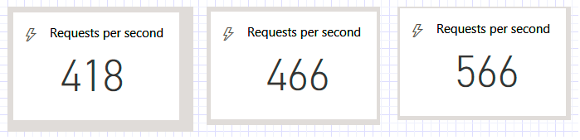

Figure 6.40: Sequence of pictures showing real-time data

How it works…
We have created the following items in this specific order:
1. A streaming dataset in the Power BI application.
2. A dashboard and new tile that can display the values available in the streaming
dataset.
3. A new Azure function that runs an Application Insights Analytics query and feeds
data to Power BI using the push URL of the dataset.
4. Once everything is done, you can view the real-time data in the Power BI tile of
the dashboard.

Integrating Application Insights with Power BI using Azure Functions | 223

There's more…
You should also be aware of the following:
• Power BI allows us to create real-time data in reports in multiple ways. In this
recipe, you learned how to create real-time reports using the streaming dataset.
• In this recipe, we developed a timer trigger that runs every minute. It runs queries
on Application Insights to view real-time data. Note that the Application Insights
API has a rate limit. Using an Application Insights service for multiple applications
may end up consuming all the capacity for that day. Take a look at https://dev.
applicationinsights.io/documentation/Authorization/Rate-limits to understand
more about API limits.

In this chapter, you have learned how to integrate Application Insights with Azure Functions, how to create custom data points, and how to create custom metrics in Application Insights. Finally, you have also learned how to integrate Application Insights with Power BI with the help of Azure Functions and how to create custom dashboards in Power BI.

Developing

reliable serverless

applications using

durable functions

In this chapter, you'll learn about the following:
• Configuring durable functions in the Azure portal
• Creating a serverless workflow using durable functions
• Testing and troubleshooting durable functions
• Implementing reliable applications using durable functions 226 | Developing reliable serverless applications using durable functions

Introduction
When developing modern applications that need to be hosted in the cloud, we need to make sure that the applications are stateless. Statelessness is an essential factor in developing cloud-aware applications. For example, we should avoid persisting any data in a resource that is specific to any virtual machine (VM) instance provisioned to any Azure service (for example, App Service, the API, and so on). Otherwise, we won't be able to leverage some services, such as autoscaling functionality, as the provisioning of instances is dynamic. If we depend on any VM-specific resources, we'll end up facing problems with unexpected behaviors.
Having said that, the downside of the previously mentioned approach is ending up working on identifying ways of persisting data in different mediums, depending on the application architecture.
Although the overall intention of this book is to have each recipe of every chapter solve at least one business problem, the recipes in this chapter don't solve any real-time domain problems. Instead, this chapter as a whole provides some quick-start guidance to help you understand more about Durable Functions and its components, along with the approach to developing durable functions.

Note
For more information about Durable Functions and its related terminology, go
through the official documentation, which is available at https://docs.microsoft.
com/azure/azure-functions/durable/durable-functions-overview?tabs=csharp.

We'll continue the topic of durable functions in the next chapter, where you'll learn how easy it is to use them to develop a workflow-based application.
Durable Functions is a new way in Azure of handling statefulness in serverless architecture, along with other features, such as durability and reliability. Durable Functions is available as an extension to Azure Functions.
Configuring durable functions in the Azure portal | 227

Configuring durable functions in the Azure portal
In this recipe, you'll learn about configuring durable functions. In order to develop durable functions, you need to create the following three functions:
• Orchestrator client: An Azure function that can manage orchestrator instances. It
works as a client that will initiate the orchestrator objects.
• Orchestrator function: The actual orchestrator function allows the development
of stateful workflows via code. This function can asynchronously call other Azure
functions (named activity functions) and can even save their return values in local
variables.
• Activity functions: These are the functions that will be called by the orchestrator
function. Activity functions are where we develop the logic as per the
requirements.
• Let's get started.

Getting ready
Download and install Postman from https://www.getpostman.com/ if you haven't already installed it. We'll be using Postman to test the durable functions.
Create a new function application if you haven't already created one. Ensure that the runtime version is ~3 in the Application settings part of the Configuration blade, as shown in Figure 7.1:
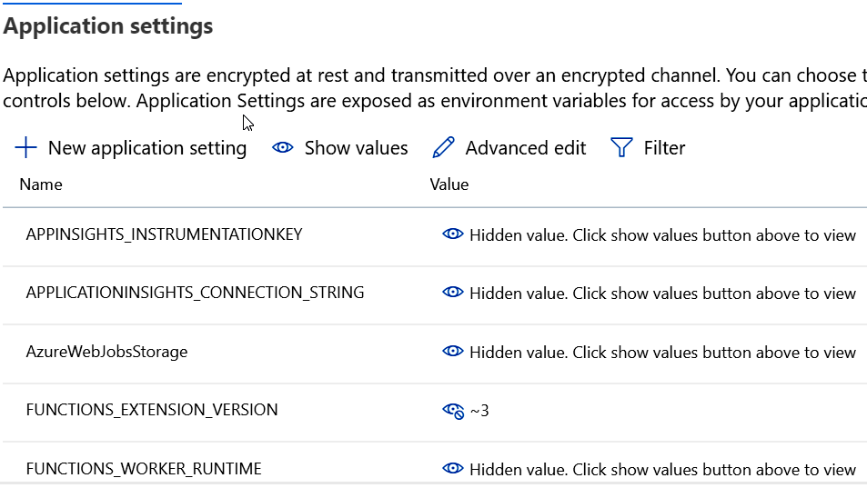

Figure 7.1: Configuration blade—Application settings 228 | Developing reliable serverless applications using durable functions

How to do it…
In this recipe, you'll learn about creating an orchestrator client by performing the following steps:
1. Click on the + button to create a new function:
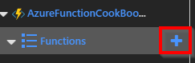

Figure 7.2: Azure Functions—listing
2. Create a new Durable Functions HTTP starter function by choosing Durable
Functions in the Scenario drop-down menu, as shown in Figure 7.3:
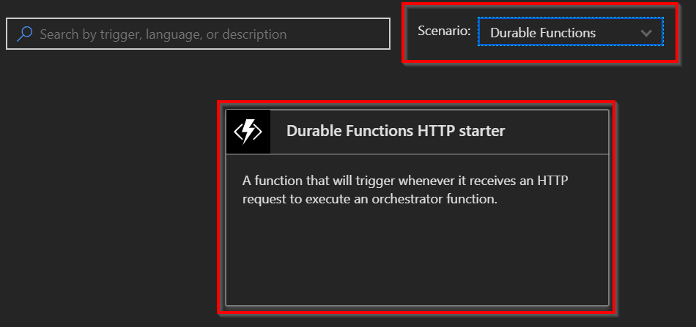

Figure 7.3: Azure Functions—templates
Configuring durable functions in the Azure portal | 229

3. Click on Durable Functions HTTP starter, which will open a new tab, as shown in
Figure 7.4. You now need to create a new HTTP function named HttpStart:
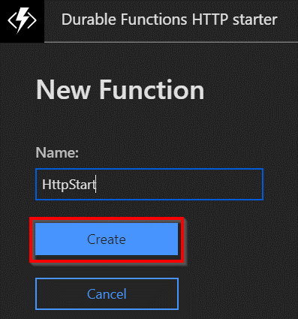

Figure 7.4: Durable Functions HTTP starter—creation
4. Soon after, you'll be taken to the code editor. The following function is an HTTP
trigger, which accepts the name of the function to be executed along with the
input. It uses the StartNewAsync method of the DurableOrchestrationClient object
to start the orchestration:
#r "Microsoft.Azure.WebJobs.Extensions.DurableTask" #r "Newtonsoft.Json"

using System.Net;

public static async Task Run( HttpRequestMessage req, DurableOrchestrationClient starter, string functionName, ILogger log)
{
// Function input comes from the request content.
dynamic eventData = await req.Content.ReadAsAsync();

string instanceId = await starter.StartNewAsync(functionName,
eventData);
log.LogInformation($"Started orchestration with ID =
'{instanceId}'.");
return starter.CreateCheckStatusResponse(req, instanceId);
}
230 | Developing reliable serverless applications using durable functions

5. Navigate to the Integrate tab and click on Advanced editor, as shown in Figure 7.5:
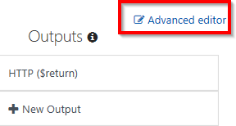

Figure 7.5: Durable Functions HTTP starter—the Integrate tab
6. In Advanced editor, the bindings should be similar to the following. If not, replace
the default code with the following code:
{
"bindings":
[
{
"authLevel": "anonymous",

"name": "req",
"type": "httpTrigger",
"direction": "in",
"route": "orchestrators/{functionName}",
"methods": [
"post",
"get"
]
},
{
"name": "$return",
"type": "http",
"direction": "out"
},
{
"name": "starter",
"type": "orchestrationClient",
"direction": "in"
}
]
}
Creating a serverless workflow using durable functions | 231

Note
The HttpStart function works like a gateway for invoking all the functions in the function application. Any request you make using the https://<durablefunctionname>>.azurewebsites.net/api/orchestrators/ {functionName} URL format will be received by this HttpStart function. This function will take care of executing the orchestrator function, based on the parameter available in the {functionName} route parameter. All of this is possible with the route attribute, defined in function.json of the HttpStart function.

In this recipe, you have created the orchestrator client. Let's move on to create the orchestrator function itself.

Creating a serverless workflow using durable functions
The orchestrator function manages the workflow via code. The function can asynchronously call other Azure functions (named activity functions), which are the stages in the workflow.
In this recipe, you'll learn about orchestrator functions and activity functions.

Getting ready
Before moving forward, you can read more about orchestrator and activity trigger bindings at https://docs.microsoft.com/azure/azure-functions/durable-functions-
bindings.

How to do it...
Here, you'll create the orchestrator function and the activity function.

Creating the orchestrator function
Complete the following steps:
1. Navigate to the Azure function templates and search for the Durable Functions
orchestrator template, as shown in Figure 7.6:
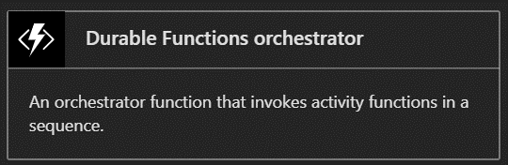

Figure 7.6: Durable Functions orchestrator—template 232 | Developing reliable serverless applications using durable functions

2. Once you click on the Durable Functions orchestrator tile, you'll be taken to the
following tab, where you need to provide the name of the function. Once you have provided the name, click on the Create button to create the orchestrator function:
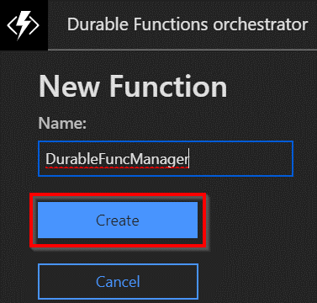

Figure 7.7: Durable Functions orchestrator—creation
3. In DurableFuncManager, replace the default code with the following, and click on the
Save button to save the changes. The following orchestrator will call the activity functions using the CallActivityAsync method of the DurableOrchestrationContext object:
#r "Microsoft.Azure.WebJobs.Extensions.DurableTask" public static async Task>
Run(DurableOrchestrationContext context)
{
var outputs = new List();
outputs.Add(await context.CallActivityAsync ("ConveyGreeting",
"Welcome Cookbook Readers"));
return outputs;
}
4. In the Advanced editor of the Integrate tab, replace the default code with the
following code:
{
"bindings": [
{
"name": "context",
"type": "orchestrationTrigger",
"direction": "in"
}
]
}
Creating a serverless workflow using durable functions | 233

Now that you have created the orchestrator function, let's move on to the next section to create an activity function.

Creating an activity function
Activity functions contain the actual implementation logic. They act as the steps in the workflow that are managed by orchestrator functions. Let's create an activity function by performing the following steps:
1. Create a new function named ConveyGreeting using the Durable Functions activity
template:
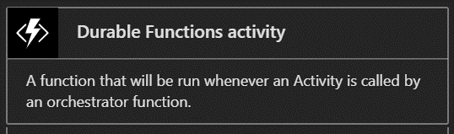

Figure 7.8: Durable Functions activity function—template
2. Replace the default code with the following code, which just displays the name,
which is provided as input, and then click on the Save button to save the changes:
#r "Microsoft.Azure.WebJobs.Extensions.DurableTask" public static string Run(string name)
{
return $"Hello Welcome Cookbook Readers!";
}
3. In the Advanced editor section of the Integrate tab, replace the default code with
the following code:
{
"bindings": [
{
"name": "name",
"type": "activityTrigger",
"direction": "in"
}
]
}
In this recipe, you have created an orchestration client, an orchestrator function, and an activity function. You'll learn how to test them in the next recipe.
234 | Developing reliable serverless applications using durable functions

How it works…
Let's take a look at the workings of the recipe:
• We first developed the orchestrator client (in our case, HttpStart) in the
Configuring durable functions in the Azure portal recipe of this chapter, which is capable of creating orchestrators using the StartNewAsync function of the DurableOrchestrationClient class. This method creates a new orchestrator instance.
• Next, we developed the orchestrator function—the most crucial part of Durable
Functions. The following are a few of the most important features of the orchestrator context:
It can invoke multiple activity functions.
It can save the output returned by an activity function and pass it to another activity function.
These orchestrator functions are also capable of creating checkpoints that save execution points, so that if there is a problem with the VMs, then the orchestrator can replace or resume service automatically.
• And lastly, we developed the activity function, which includes most of the business
logic. In our case, it's just returning a simple message.

There's more...
Durable functions are dependent on the Durable Task Framework. You can learn more about the Durable Task Framework at https://github.com/Azure/durabletask.
Let's move on to testing.

Testing and troubleshooting durable functions
In Chapter 5, Exploring testing tools for Azure functions, we discussed various ways of testing Azure functions. We can test durable functions with the same set of tools. However, the approach to testing is entirely different, as regular Azure functions implement one functionality and durable functions help us to achieve durable workflows.
In this recipe, you'll learn how to test and check the status of a durable function.
Testing and troubleshooting durable functions | 235

Getting ready
Download and install the following if you haven't done so already:
• The Postman tool, available from https://www.getpostman.com.
• Azure Storage Explorer, available from http://storageexplorer.com.
• Let's get started.

How to do it...
Perform the following steps:
1. Navigate to the code editor of the HttpStart function and copy the URL by
clicking on </>Get function URL. Replace the {functionName} template value with
DurableFuncManager.
2. Make a POST request using Postman:

Figure 7.9: Making a POST request to the durable orchestrator using Postman
3. After clicking the Send button, you'll get a response with the following:
The instance ID
The URL for retrieving the status of the function
The URL to send an event to the function
The URL to terminate the request:
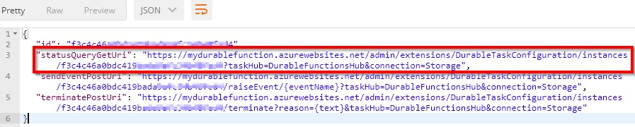

Figure 7.10: Viewing the response of the orchestrator function in Postman
236 | Developing reliable serverless applications using durable functions

4. Click on statusQueryGetUri in the preceding step to view the status of the
function. Clicking on the link in step 3 will open the query in a new tab within the Postman tool. Once the new tab is opened, click on the Send button to get the actual output:
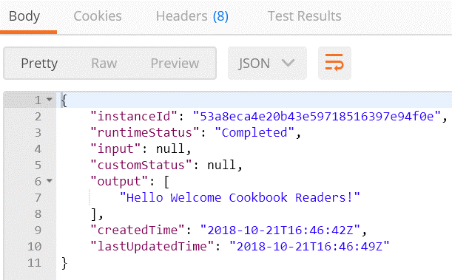

Figure 7.11: Checking the status of the durable function in Postman
5. If everything goes well, you will see runtimeStatus as Completed in Postman, as
shown in Figure 7.11. You'll also get eight records in Table storage, where the execution history is stored, as shown in Figure 7.12:
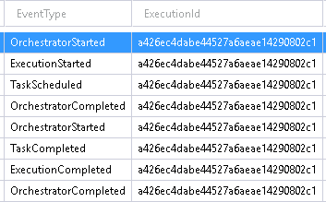

Figure 7.12: Checking the status of the durable function in Table storage
Implementing reliable applications using durable functions | 237

6. If something goes wrong, you can see the error message in the results column,
which tells you in which function the error has occurred. Then, navigate to the
Monitor tab of that function to see a detailed explanation of the error.

In this recipe, you have learned how to test a durable function. Let's move to the next recipe to learn how to develop reliable applications.

Implementing reliable applications using durable functions
One of the most commonly used ways to swiftly process data is to go with parallel processing. The main advantage of this approach is that we get the desired output pretty quickly, depending on the previously created sub-threads. This can be achieved in multiple ways using different technologies. However, a common challenge in these approaches is that if something goes wrong in the middle of a sub-thread, it's not easy to self-heal and resume from where things stopped.
In this recipe, we'll implement a simple way of executing a function in parallel with multiple instances using durable functions for the following scenario.
Assume that we have five customers (with IDs 1, 2, 3, 4, and 5, respectively) who need to generate 50,000 barcodes. It would take a lot of time to generate the barcodes owing to the involvement of image processing tasks. One simple way to quickly process this request is to use asynchronous programming by creating a thread for each of the customers and then executing the logic in parallel for each of them.
We'll also simulate a simple use case to understand how durable functions auto-heal when the VM on which they are hosted goes down or is restarted.

Getting ready
Install the following if you haven't done so already:
• The Postman tool, available from https://www.getpostman.com/.
• Azure Storage Explorer, available from http://storageexplorer.com/.

238 | Developing reliable serverless applications using durable functions

How to do it...
In this recipe, we'll create the following Azure function triggers:
• One orchestrator function, named GenerateBARCode
• Two activity trigger functions, as follows:
GetAllCustomers: To make it simple, this function just returns the array of customer IDs. In real-world applications, we would have business logic for deciding the customers' eligibility, and, based on that logic, we would return the eligible customer IDs.
CreateBARCodeImagesPerCustomer: This function doesn't actually create the barcode; rather, it just logs a message to the console, as our goal is to understand the features of durable functions. For each customer, we will randomly generate a number less than 50,000 and simply iterate through it.

Creating the orchestrator function
Create the orchestrator function by performing the following steps:
1. Create a new function named GenerateBARCode using the Durable Functions
orchestrator template. Replace the default code with the following, and click on the Save button to save the changes:
#r "Microsoft.Azure.WebJobs.Extensions.DurableTask" public static async Task Run(
DurableOrchestrationContext context)
{
int[] customers = await context.
CallActivityAsync("GetAllCustomers",null);
var tasks = new Task[customers.Length];
for (int nCustomerIndex = 0; nCustomerIndex < customers.Length;
nCustomerIndex++)
{
tasks[nCustomerIndex] = context.CallActivityAsync
("CreateBARCodeImagesPerCustomer",
customers[nCustomerIndex]);
}
await Task.WhenAll(tasks);
int nTotalItems = tasks.Sum(item => item.Result);
return nTotalItems;
}
Implementing reliable applications using durable functions | 239

The preceding code invokes the GetAllCustomers activity function, stores all the
customer IDs in an array, and then, for each customer, it again calls another
activity function that returns the number of barcodes that are generated. Finally, it
waits until the activity functions for all customers are completed and then returns
the sum of all the barcodes that are generated for all the customers.
2. In the Advanced editor section of the Integrate tab, replace the default code with
the following code:
{
"bindings": [
{
"name": "context",
"type": "orchestrationTrigger",
"direction": "in"
}
]
}
In this section, we have created the orchestrator function, which calls and manages the activity functions. Let's move on to the next section.

Creating a GetAllCustomers activity function In this section, we'll create an activity function called GetAllCustomers that returns all the customer IDs that should be processed. For simplicity, the customer IDs are hardcoded, but the customer IDs must be retrieved from a database in real time.
Perform the following steps:
1. Create a new function named GetAllCustomers using the Durable Functions
Activity template. Replace the default code with the following code, and then click
on the Save button to save the changes:
#r "Microsoft.Azure.WebJobs.Extensions.DurableTask" public static int[] Run(string name)
{
int[] customers = new int[]{1,2,3,4,5}; return customers; }

240 | Developing reliable serverless applications using durable functions

2. In the Advanced editor section of the Integrate tab, replace the default code with
the following code:
{
"bindings": [
{
"name": "name",
"type": "activityTrigger",
"direction": "in"
}
]
}
We have developed the GetAllCustomers activity function, which retrieves all the customers for which the barcode images need to be generated. Let's move on to the next section.

Creating a CreateBARCodeImagesPerCustomer activity function In this section, we will create another activity function called CreateBARCodeImagesPerCustomer, which will create the barcodes for a given customer. This activity function will be called multiple times depending on the number of customers. Perform the following steps:
1. Create a new function named CreateBARCodeImagesPerCustomer using the Durable
Functions Activity template. Replace the default code with the following, and then click on the Save button to save the changes:
#r "Microsoft.Azure.WebJobs.Extensions.DurableTask" #r "Microsoft.WindowsAzure.Storage"
using Microsoft.WindowsAzure.Storage.Blob;
public static async Task Run(DurableActivityContext customerContext,ILogger log)
{
int ncustomerId = Convert.ToInt32 (customerContext.
GetInput());
Random objRandom = new Random(Guid.NewGuid().GetHashCode());
int nRandomValue = objRandom.Next(50000);
for(int nProcessIndex = 0; nProcessIndex<=nRandomValue;
nProcessIndex++)
{
log.LogInformation($" running for {nProcessIndex}");
}
return nRandomValue;
}
Implementing reliable applications using durable functions | 241

2. In the Advanced editor section of the Integrate tab, replace the default code with
the following code:
{
"bindings": [
{
"name": "customerContext",
"type": "activityTrigger",
"direction": "in"
}
]
}
3. Let's run the function using Postman. We'll be stopping the function application
to simulate a restart of the VM where the function will be running, and to see how
the durable function resumes from where it was paused.
4. Make a POST request using Postman, as shown in Figure 7.13:
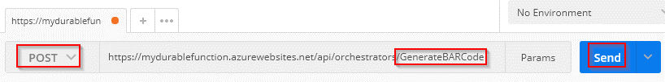

Figure 7.13: POST request to the durable function using Postman
5. Once you click on the Send button, you'll get a response with the status URL.
Click on statusQueryGetUri to view the status of the function. Clicking on the
statusQueryGetUri link will open it in a new tab within the Postman tool. Once the
new tab is opened, click on the Send button to get the progress of the function.
6. While the function is running, navigate to the function application's Overview
blade and stop the service by clicking on the Stop button:
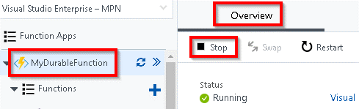

Figure 7.14: Azure function application—the Overview blade 242 | Developing reliable serverless applications using durable functions

7. The execution of the function will be stopped in the middle. Navigate to your
storage account in Storage Explorer, and open the DurableFunctionsHubHistory table to see how much progress has been made:
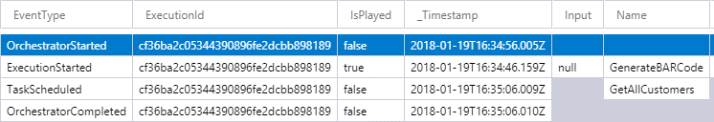

Figure 7.15: Checking the status of the durable function in Table storage
8. After some time—in my case, after just 5 minutes—go back to the Overview blade
and start the function application service. Notice that the durable function will resume from where it stopped. You didn't write any code for this; it's an out-of-the-box feature. The completed function is shown in Figure 7.16:
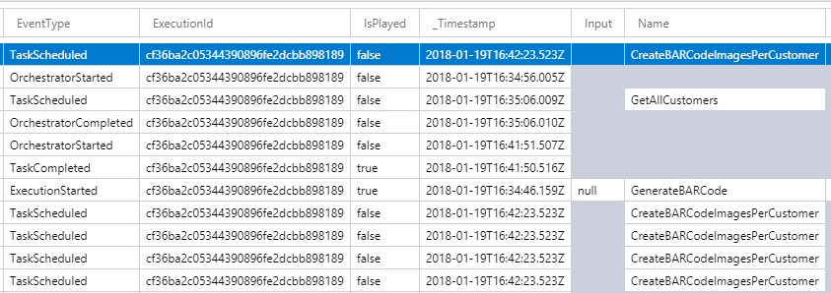

Figure 7.16: Checking the status of the durable function in Table storage

How it works…
Durable functions allow us to develop the reliable execution of our functions, which means that even if VMs crash or restart while a function is running, it automatically resumes its previous state. It does so with the help of something called checkpointing and replaying, where the history of the execution is stored in Table storage.

Note
You can learn more about the checkpointing and replaying feature at https://docs.
microsoft.com/azure/azure-functions/durable-functions-checkpointing-and-replay.
Implementing reliable applications using durable functions | 243

There's more...
• If you get a 404 Not Found response when you run the statusQueryGetUri URL,
don't worry. It will take some time, but it will eventually work when you make a
request later on.
• In order to view the execution history of your durable functions, navigate to the
DurableFunctionsHubHistory table, which resides in the storage account. The
connection string of that storage account can be found in Application settings,
and it was created while creating the function application:
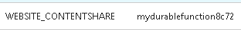

Figure 7.17: Application settings—WEBSITE_CONTENTSHARE
You can find the storage account name in Application settings, as shown in Figure 7.17.
In this recipe, we have learned how to develop reliable applications using durable functions.
In this chapter, you have learned how to develop a reliable, workflow-based application using durable functions. You have created an orchestrator function that internally calls multiple activity functions that are responsible for implementing logic. The orchestrator function takes care of managing the activity functions.

Bulk import of data

using Azure Durable

Functions and

Cosmos DB

In this chapter, we'll complete the following recipes:
• Uploading employee data to blob storage
• Creating a blob trigger
• Creating a durable orchestrator and triggering it for each CSV import
• Reading CSV data using activity functions
• Autoscaling Cosmos DB throughput
• Bulk inserting data into Cosmos DB
246 | Bulk import of data using Azure Durable Functions and Cosmos DB

Introduction
In this chapter, we'll develop a mini-project by taking a very common use case that solves the business problem of sharing data across different applications using CSV. We'll use Durable Functions, which is an extension to Azure Functions that lets you write workflows by writing a minimal amount of code.
Here are the two core features of Durable Functions that we'll be using in the recipes of this chapter:
• Orchestrator: An orchestrator is a function that is responsible for managing all
activity triggers. It can be treated as a workflow manager that has multiple steps. The orchestrator is responsible for initiating the activity trigger, passing inputs to the activity trigger, getting the output, maintaining the state, and then passing the output of one activity trigger to another if required.
• Activity trigger: Each activity trigger can be treated as a workflow step that
performs a function.

Note
You can learn more about Durable Functions at https://docs.microsoft.com/azure/
azure-functions/durable/durable-functions-overview?tabs=csharp.

Business problem
In general, every organization uses applications that are hosted on multiple platforms across different datacenters (either on the cloud or on-premises). Often, there will be a need to feed data from one application to another system. Usually, CSV spreadsheets (or, in some cases, JSON or XML files) are used to export data from one application and import it into another application.
You may think that exporting CSV files from one application to another would be a straightforward job, but if there are many applications that need to feed data to other applications, and on a weekly/monthly basis, then this process would become very tedious and there is a lot of scope for manual error. So, the solution is obviously to automate the process as far as possible.
In this chapter, we'll learn how to develop a durable solution based on serverless architecture using Durable Functions. Chapter 7, Developing reliable serverless applications using durable functions, already covers the basics of what durable functions are and how they work. In the aforementioned chapter, we implemented the solution from the portal. However, in this chapter, we'll implement a mini-project using Visual Studio 2019.
The durable serverless way of implementing CSV imports | 247

Before we start developing the project, let's try to understand the new serverless way of implementing the solution.

The durable serverless way of implementing CSV imports
The following diagram shows all the steps required to build the solution using serverless architecture:
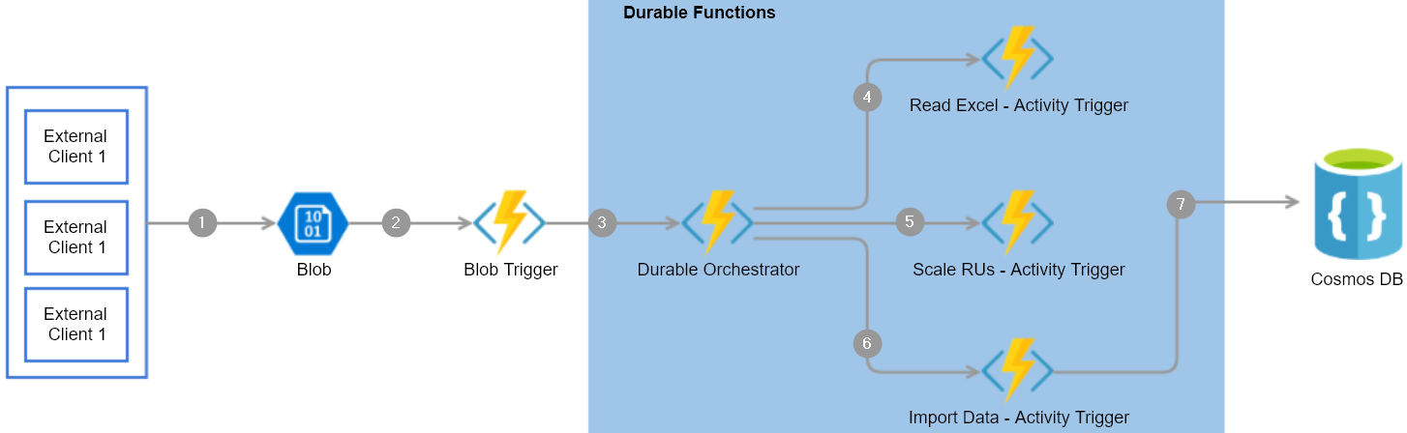

Figure 8.1: Durable Functions—architecture process flow
Here are the detailed steps pertaining to the preceding architecture diagram that will be implemented in this chapter:
1. External clients or applications upload a CSV file to blob storage.
2. A blob trigger gets triggered once the CSV file is uploaded successfully.
3. The durable orchestrator is started from the blob trigger.
4. The orchestrator invokes Read CSV - Activity Trigger to read the CSV content
from blob storage.
5. Orchestrator invokes Scale RUs - Activity Trigger to scale up the Cosmos DB
collection's throughput so that it can accommodate the load.
6. Orchestrator invokes Import Data - Activity Trigger to prepare the collection to
bulk import data.
7. Finally, Import Data - Activity Trigger loads the collection data into the Cosmos
DB collection using Cosmos DB output bindings.

Let's now start building the client application that uploads the CSV file.

Uploading employee data to blob storage
In this recipe, we'll develop a console application for uploading the CSV sheet to blob storage.
248 | Bulk import of data using Azure Durable Functions and Cosmos DB

Getting ready
Perform the following steps:
1. Install Visual Studio 2019.
2. Create a storage account and create a blob container with the name csvimports.
3. Create a CSV file with some employee data, as shown in Figure 8.2:
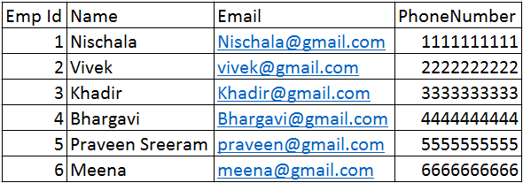

Figure 8.2: CSV file with employee data

How to do it...
In this section, we are going to create a .NET Core–based client application that uploads the csv file to the blob container by performing the following steps:
1. Create a new Console App (.NET Core) project named CSVImport.Client using
Visual Studio, as shown in Figure 8.3:
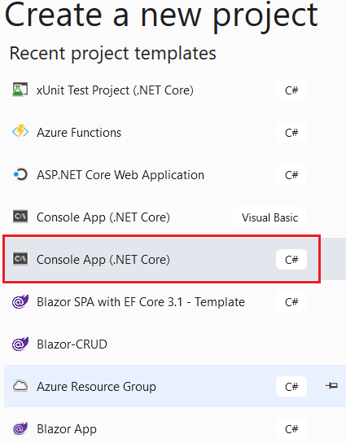

Figure 8.3: Creating a new Console App (.NET Core) project using Visual Studio
Uploading employee data to blob storage | 249

2. Once the project is created, execute the following commands in the NuGet
package manager:
Install-Package Microsoft.Azure.Storage.blob Install-Package Microsoft.Extensions.Configuration Install-Package Microsoft.Extensions.Configuration.FileExtensions Install-Package Microsoft.Extensions.Configuration.Json
3. Add the following namespaces at the top of the Program.cs file:
using Microsoft.Extensions.Configuration;
using Microsoft.Azure.Storage;
using Microsoft.Azure.Storage.blob;
using System;
using System.IO;
using System.Threading.Tasks;
4. The next step is to develop the code in a function named UploadBlob that
uploads the CSV file into the blob container that we have created. For the sake
of simplicity, the following code uploads the CSV file from a hardcoded location.
However, in a typical real-time application, this file would be uploaded by the end
user via a web interface. Copy the following code and paste it into the Program.cs
file of the CSVImport.Client application:
private static async Task UploadBlob()
{
var builder = new ConfigurationBuilder()
.SetBasePath(Directory.GetCurrentDirectory()) .AddJsonFile("appsettings.json", optional: true, reloadOnChange: true); IConfigurationRoot configuration = builder.Build(); CloudStorageAccount cloudStorageAccount =
CloudStorageAccount.Parse(configuration.
GetConnectionString("StorageConnection"));
CloudBlobClient cloudBlobClient = cloudStorageAccount. CreateCloudBlobClient();
CloudBlobContainer CSVBlobContainer = cloudBlobClient. GetContainerReference("csvimports");
await CSVBlobContainer.CreateIfNotExistsAsync(); CloudBlockBlob cloudBlockBlob = CSVBlobContainer. GetBlockBlobReference("employeeinformation" + Guid.NewGuid().ToString()); await cloudBlockBlob.UploadFromFileAsync(@"C:\ employeeinformation.csv"); }
250 | Bulk import of data using Azure Durable Functions and Cosmos DB

5. Now, copy the following code to the Main function. This piece of code just invokes
the UploadBlob function, which internally is responsible for uploading the blob:
static void Main(string[] args)
{
try
{
UploadBlob().Wait();
}
catch (Exception ex)
{
Console.WriteLine("An Error has occurred with the
message" + ex.Message);
}
Console.WriteLine("Successfully uploaded."); }
6. The next step is to create a configuration file named appsettings.json that
contains the storage account's connection string, as shown in Figure 8.4:
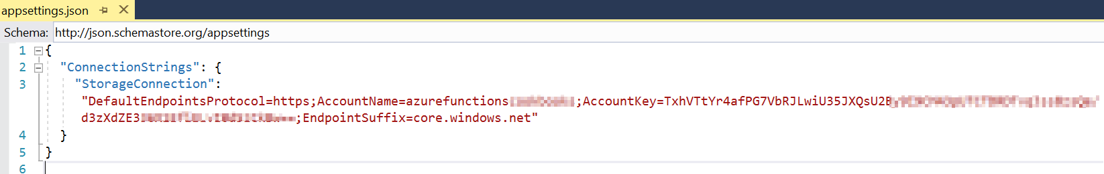

Figure 8.4: Azure Functions—local configuration file
7. Go to the properties of the appsettings.json file and change Copy to Output
Directory to Copy if newer, so that the properties can be read by the program as shown in Figure 8.5:
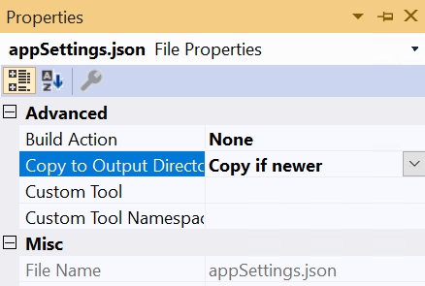

Figure 8.5: Azure Functions—appSettings.json properties—Copy if newer
Uploading employee data to blob storage | 251

8. Now, build the application and execute it. If you have configured everything
correctly, then you should see something as shown in Figure 8.6:
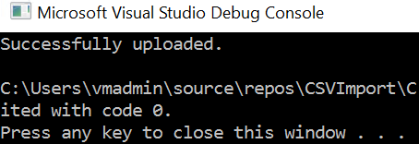

Figure 8.6: Azure Functions—console output
9. Let's now navigate to the storage account and go to the blob container named
csvimports, where the uploaded CSV file should be visible, as shown in Figure 8.7:
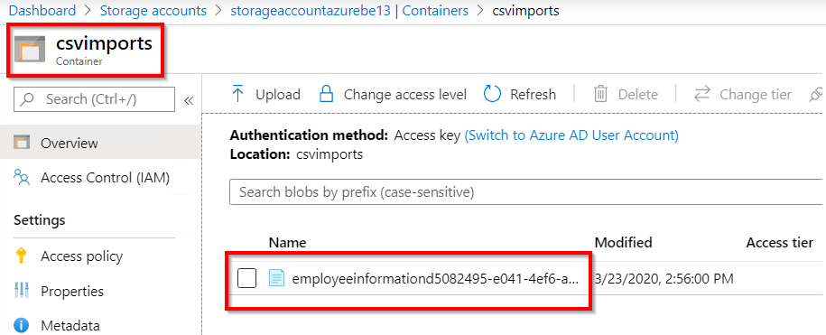

Figure 8.7: Storage container—uploaded blob
That's it. We have now developed an application that is responsible for uploading the blob.

There's more…
Make a note of the naming conventions that should be followed while creating the blob container. At the time of writing, the portal throws this error message if we do not adhere to the naming rules: This name may only contain lowercase letters, numbers, and hyphens, and must begin with a letter or a number. Each hyphen must be preceded and followed by a non-hyphen character. The name must also be between 3 and 63 characters long.
252 | Bulk import of data using Azure Durable Functions and Cosmos DB

In this recipe, we have created a console application that uses storage assemblies to upload a blob (in our case, it is just a CSV file) to the designated blob container. Note that every time the application runs, a new file will be created in the blob container. In order to upload the CSV files with unique names, we are appending a GUID. Let's move on to the next recipe.

Creating a blob trigger
In this recipe, we'll create a function app with the Azure Functions V3 runtime and learn how to create a blob trigger using Visual Studio, and we'll also see how the blob trigger gets triggered when the CSV file is uploaded successfully to the blob container.

How to do it…
Perform the following steps:
1. Add a new project named CSVImport.DurableFunctions to the existing solution by
choosing the Azure Functions template, as shown in Figure 8.8:
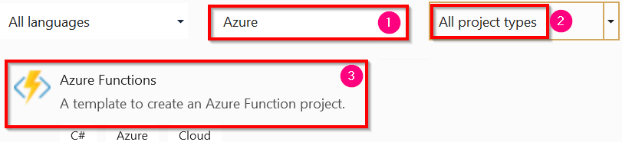

Figure 8.8: Visual Studio—creating a new Azure Functions project
2. The next step is to choose the Azure Functions runtime as well as the trigger.
Choose Azure Functions v3 (.NET Core), choose Blob trigger, and provide the following:
Storage Account (AzureWebJobsStorage): This is the name of the storage account in which our blob container resides.
Connection string setting: This is the connection string key name that refers to the storage account.
Creating a blob trigger | 253

Path: This is the name of the blob container where the CSV files are being
uploaded:
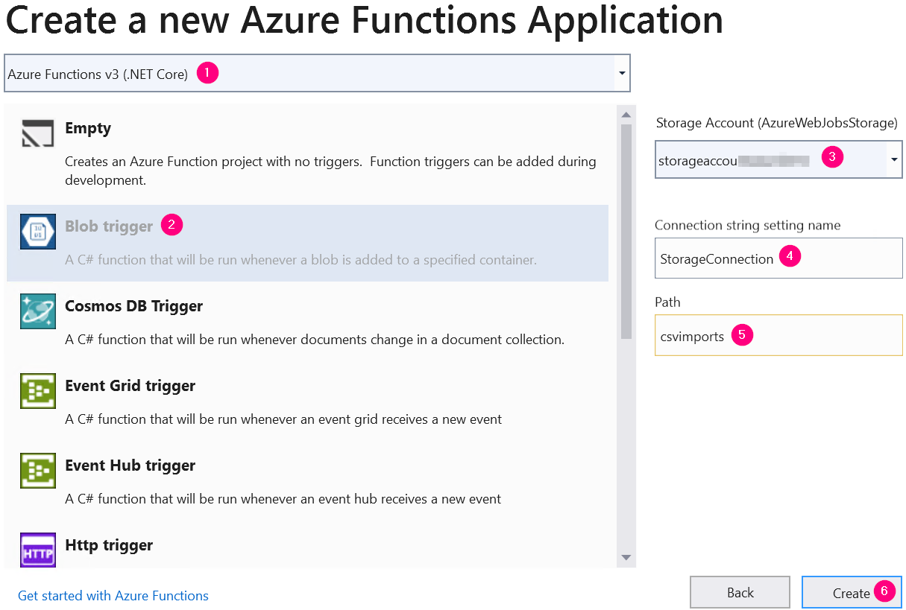

Figure 8.9: Visual Studio—creating a new function app
3. After creating the project, the structure should look something like Figure 8.10:
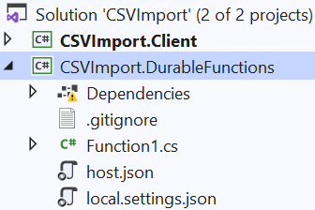

Figure 8.10: Visual Studio—function app—Solution Explorer 254 | Bulk import of data using Azure Durable Functions and Cosmos DB

4. Let's add a connection string to the DurableFunctions project with the name
StorageConnection (remember, we have used this in the connection string setting file in one of our earlier steps) to local.settings.json, as shown in Figure 8.11:
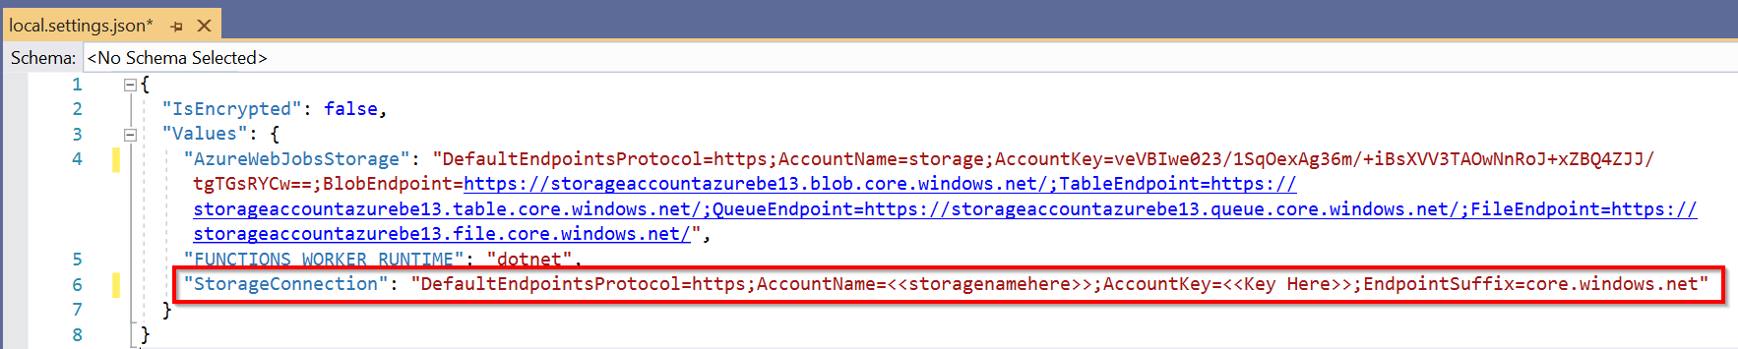

Figure 8.11: Azure Functions—configuration file
5. Now, open the Function1.cs file and rename it to CSVImportBlobTrigger, and also
replace Function1 (the name of the function) with CSVImportBlobTrigger (line 11), as shown in Figure 8.12:
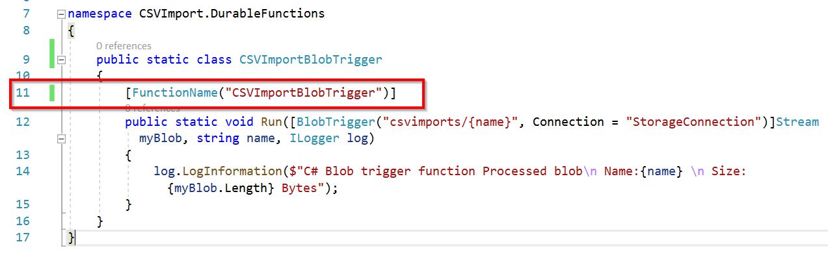

Figure 8.12: Azure Functions—blob trigger code
6. Create a breakpoint in CSVImportBlobTrigger and run the application by pressing
the F5 key. If everything is configured properly, the following should be visible on the console:

Figure 8.13: Azure Functions—console
7. Let's upload a new file by running the CSVImport.Client application. Immediately
after the file is uploaded, the blob trigger will be fired. Your breakpoints should also be hit along with this.

We are done creating the blob trigger that gets fired whenever a new blob is added to the blob container.
We'll process the blob in the upcoming recipes of this chapter.
Creating the durable orchestrator and triggering it for each CSV import | 255

There's more…
All the configurations will be taken from the local.settings.json file while running the functions in our local environment. However, when deploying the functions to Azure, all the configuration items (such as the connection string and app settings) will be referenced from the application settings of your function app. Make sure to create all the configuration items in the function app after deploying the functions.
In this recipe, we have created a new function app based on the Azure Functions V3 runtime, which is based on the .NET Core framework and can run on all platforms that support .NET Core (such as Windows and Linux OSes). We have also created a blob trigger and configured it to run when a new blob is added by configuring the connection string setting. We have also created a local.setting.json configuration file to store the config values that are used in local development. After we created the blob trigger, we ran the CSVImport.Client application to upload a file to validate the fact that the blob trigger is getting executed.
Let' move on to the next recipe to learn how to create a durable orchestrator.

Creating the durable orchestrator and triggering it for each CSV
import
This is one of the most important and interesting recipes. We'll learn how to create the durable orchestrator responsible for managing all the activity functions that we create for the different individual tasks required to complete the CSVImport project.

How to do it...
In this section, we are going to create an orchestrator and also learn how to invoke it by performing the following steps:
1. Create a new function by right-clicking on CSVImport.DurableFunctions, click on
Add, and then choose New Azure Function, as shown in Figure 8.14:
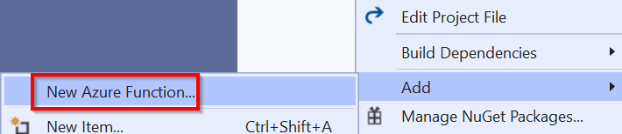

Figure 8.14: Visual Studio—adding a new function 256 | Bulk import of data using Azure Durable Functions and Cosmos DB

2. In the Add New Item popup, choose Azure Function, provide the name CSVImport_
Orchestrator, and click on Add, as shown in Figure 8.15:
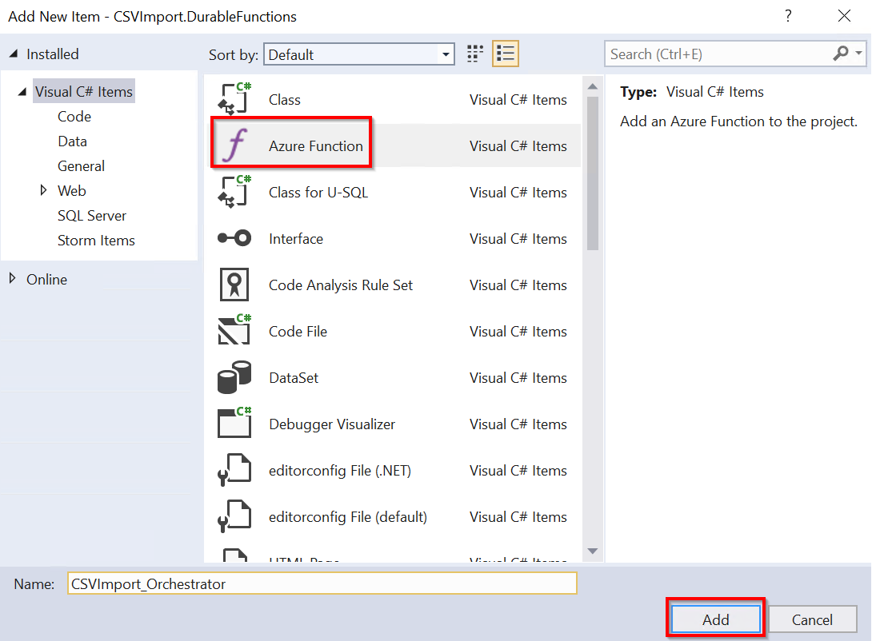

Figure 8.15: Visual Studio—adding a new function
3. In the New Azure Function popup, select the Durable Functions Orchestration
template and click on the OK button, which creates the following:
HttpStart: This is the durable function's starter function (an HTTP trigger), which works as a client that can invoke the durable orchestrator. However, in our project, we'll not be using this HTTP trigger; we'll be using the logic inside it in our CSVImportBlobTrigger blob trigger to invoke the durable orchestrator.
RunOrchestrator: This is the actual durable orchestrator that is capable of invoking and managing the activity functions.
SayHello: Visual Studio creates this simple activity function. Let's go ahead and remove this default function. Once the default activity function is created, we'll create our activity function:
Creating the durable orchestrator and triggering it for each CSV import | 257
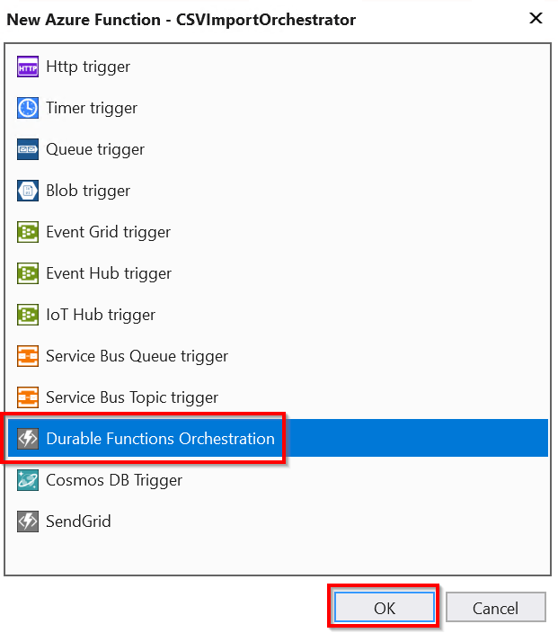

Figure 8.16: Visual Studio—adding a new Durable Functions orchestration trigger
4. In the CSVImportBlobTrigger blob trigger, let's make the following code changes to
invoke the orchestrator:
Decorate the function to be async.
Add the orchestration client output bindings by using the attribute
[DurableClient].
Call StartNewAsync using the IDurableOrchestrationClient reference.

258 | Bulk import of data using Azure Durable Functions and Cosmos DB

5. The code in the CSVImportBlobTrigger function should appear as follows after
making these changes:
using System.IO;
using Microsoft.Azure.WebJobs;
using Microsoft.Azure.WebJobs.Host
using Microsoft.Extensions.Logging;
using Microsoft.Azure.WebJobs.Extensions.DurableTask; namespace CSVImport.DurableFunctions
{
public static class CSVImportBlobTrigger
{
[FunctionName("CSVImportBlobTrigger")]
public static async void Run(
[BlobTrigger("csvimports/{name}", Connection = "StorageConnection")] Stream myBlob, string name,
[DurableClient]IDurableOrchestrationClient starter, ILogger log) {
string instanceId = await
starter.StartNewAsync("CSVImport_Orchestrator", name); log.LogInformation($"C# blob trigger function Processed blob\n Name:{name} \n Size: {myBlob.Length} Bytes");
}
}
}
6. Create a breakpoint in the CSVImport_Orchestrator function and run the
application by pressing the F5 key on the keyboard.
7. Let's now upload a new file (while CSVImport.DurableFunctions is running) by
running the CSVImport.Client function. (You can also upload the CSV file to the blob container directly from the Azure portal.) Once the file is uploaded, in just a few moments, the breakpoint in the CSVImport_Orchestrator function should be hit, as shown in Figure 8.17:
Creating the durable orchestrator and triggering it for each CSV import | 259
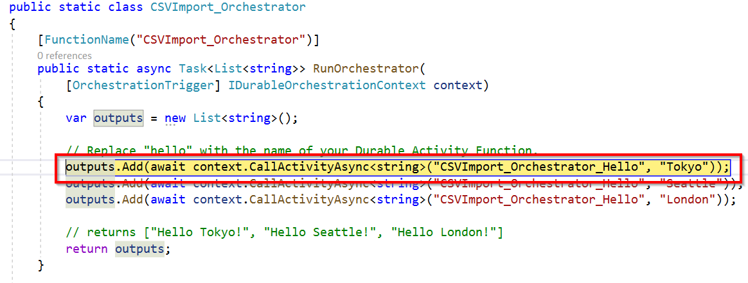

Figure 8.17: Durable Functions orchestration trigger breakpoint
We have learned how to invoke the durable orchestrator function from the blob trigger.

How it works…
We started the recipe by creating the orchestration function using Visual Studio, and then we made changes to the CSVImportBlobTrigger blob trigger by adding the OrchestratonClient output bindings to invoke the durable orchestrator function.

There's more…
In this recipe, we have used DurableClient, which understands how to start and terminate durable orchestrations.
Here are a few of the important operations that are supported:
• Start an instance using the StartNewAsync method.
• Terminate an instance using the TerminateAsync method.
• Query the status of the currently running instance using the GetStatusAsync
method.
• It can also raise an event to the instance to provide an update regarding any
external event using the RaiseEventAsync method.

Note
Learn more at https://docs.microsoft.com/azure/azure-functions/durable/durable-
functions-instance-management?tabs=csharp#sending-events-to-instances. 260 | Bulk import of data using Azure Durable Functions and Cosmos DB

In this recipe, we have learned how to create an orchestrator and how to invoke it. Let's now move on to the next recipe.

Reading CSV data using activity functions
In this recipe, we'll retrieve all the data from specific CSV sheets by writing an activity function.
Let's now make some code changes to the orchestration function by writing a new activity function that can read data from a CSV sheet located in the blob container. In this recipe, we'll create an activity trigger named ReadCSV_AT that reads the data from the blob stored in the storage account. This activity trigger performs the following jobs:
1. It connects to the blob using a function, ReadBlob, of a class named StorageManager.
2. It returns the data from the CSV file as a collection of employee objects.

Getting ready
Install the following NuGet package in the CSVImport.DurableFunctions project:
Install-Package Microsoft.Azure.Storage.blob

How to do it...
If you think of Durable Functions as a workflow, then the activity trigger function can be treated as a workflow step that takes some kind of optional input, performs some functionality, and returns an optional output. It is one of the core concepts of Azure Durable Functions.
Before we start creating the activity trigger function, let's first build the dependency functions.

Reading data from blob storage
Learn how to read data from blob storage by performing the following steps:
1. Create a class named StorageManager and paste in the following code. This code
connects to the specified storage account, reads the data from the blobs, and returns a Stream object to the caller function:
class StorageManager
{
public async static Task ReadBlob(string BlobName)
{
var builder = new ConfigurationBuilder()
.SetBasePath(Directory.GetCurrentDirectory())
Reading CSV data using activity functions | 261

.AddJsonFile("local.settings.json", optional: true,
reloadOnChange: true);
IConfigurationRoot configuration = builder.Build();

CloudStorageAccount cloudStorageAccount = CloudStorageAccount.
Parse(configuration["Values:StorageConnection"]);
CloudBlobClient cloudBlobClient = cloudStorageAccount.
CreateCloudBlobClient(); CloudBlobContainer CSVBlobContainer = cloudBlobClient.GetContainerReference("csvimports");
CloudBlockBlob cloudBlockBlob = CSVBlobContainer.
GetBlockBlobReference(BlobName);
string employeeContent;
using (var memoryStream = new MemoryStream())
{
await cloudBlockBlob.DownloadToStreamAsync(memoryStream);
employeeContent = System.Text.Encoding.UTF8.
GetString(memoryStream.ToArray());
}
return employeeContent;
}}
2. Paste the following namespace references into the StorageManager class:
using Microsoft.Extensions.Configuration;
using Microsoft.WindowsAzure.Storage;
using Microsoft.WindowsAzure.Storage.blob;
using System.IO;
using System.Threading.Tasks;
3. Finally, ensure that the connection string of the storage account is added to the
local.settings.json file, as shown in Figure 8.18:

Figure 8.18: Azure Functions—local configuration file
Build the application and ensure that there are no errors. In this section, we have learned how to read blob data. Let's now move on to the next section to parse the CSV data.
262 | Bulk import of data using Azure Durable Functions and Cosmos DB

Reading CSV data from the stream
In this section, we'll learn how to read the CSV data by performing the following steps:
1. Create a class named CSVManager and paste the following code. This class has a
method named ReadEmployeeData, which reads data from the CSV file content. It reads each row, creates an Employee object for each row, and then returns an employee collection. We'll create the Employee class in the next step:
class CSVManager
{

public static List ReadEmployeeData(string
employeesListContent)
{
List employees = new List();
var employeesList = employeesListContent.Split(Environment.
NewLine);

for (int employeeIndex = 1; employeeIndex < employeesList.
Length; employeeIndex++)
{
var employee = employeesList[employeeIndex];
if (employee != null & employee.Length > 1)
{
var employeeColumns = employee.Split(",");
employees.Add(
new Employee()
{
EmpId = employeeColumns[0],
Name = employeeColumns[1],
Email = employeeColumns[2],
PhoneNumber = employeeColumns[3],
});
}
}
return employees;
}
}
Reading CSV data using activity functions | 263

2. Now, let's create another class named Employee and copy the following code:
public class Employee
{
public string EmpId { get; set; }
public string Name { get; set; }
public string Email { get; set; }
public string PhoneNumber { get; set; }
}
3. Add the following namespaces:
using System;
using System.Collections.Generic; Building the application now, you should not experience any errors. We are done with developing the dependencies for our first activity trigger function. Let's now start building the actual activity trigger.

Creating the activity function
In this section, you are going to learn how to develop an activity function by performing the following steps:
1. Create a new activity function named ReadCSV_AT that connects to the blob using
the StorageManager class that we developed in the previous section, and then reads
the data using the CSVManager class. Copy the following code to the CSVImport_
Orchestrator class:
[FunctionName("ReadCSV_AT")]
public static async Task> ReadCSV_AT([ActivityTrigger] string name,
ILogger log)
{
log.LogInformation("ReadCSV_AT Started");
log.LogInformation("Reading the blob Started");
var EmployeeContent = await StorageManager.ReadBlob(name);
log.LogInformation("Reading the blob has Completed");
log.LogInformation("Reading the CSV Data Started");
List employees = CSVManager.
ReadEmployeeData(EmployeeContent);
log.LogInformation("Reading the blob has Completed");
log.LogInformation("ReadCSV_AT End");
return employees;
}
264 | Bulk import of data using Azure Durable Functions and Cosmos DB

2. Let's now invoke the ReadCSV_AT activity function from the orchestrator. Go to the
CSVImport_Orchestrator orchestration function and replace it with the following code. The orchestration function invokes the activity function by passing the name of the CSV that is uploaded so that the activity function reads the data from the CSV file:
[FunctionName("CSVImport_Orchestrator")]
public static async Task>
RunOrchestrator([OrchestrationTrigger] IDurableOrchestrationContext context)
{
var outputs = new List();
string CSVFileName = context.GetInput();
{
List employees = await context.
CallActivityAsync>("ReadCSV_AT", CSVFileName);
}
return outputs;
}
3. Let's run the application and then upload a CSV file. If everything is configured
properly, we should see something similar to the following in the ReadCSV_AT activity trigger function, where we can see the number of employee records being read from the CSV file as shown in Figure 8.19:
Reading CSV data using activity functions | 265
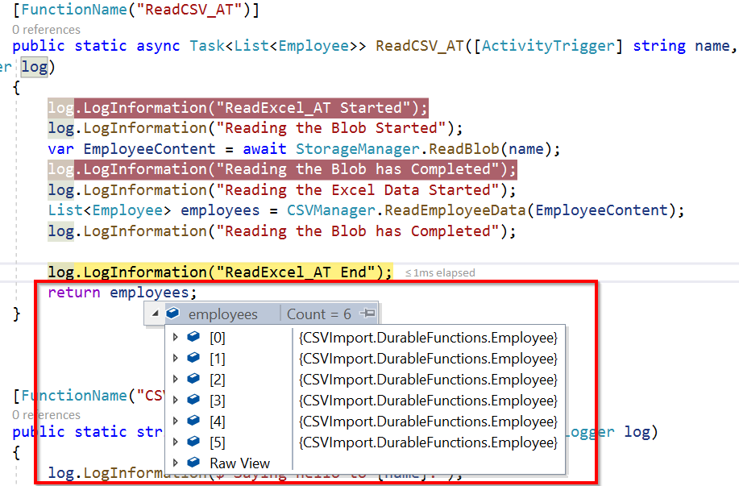

Figure 8.19: Visual Studio—employee records being read from the CSV file

There's more...
The orchestrator function receives the input using the GetInput() method of the DurableOrchestratorContext class. This input is passed by the blob trigger using the StartNewAsync method of the DurableOrchestrationClient class.
In this recipe, we have developed an activity function that reads data from a CSV file. Let's move on to the next recipe to learn how to automatically increase the throughput of Cosmos DB.

266 | Bulk import of data using Azure Durable Functions and Cosmos DB

Autoscaling Cosmos DB throughput
In the previous recipe, we read data from a CSV file and put it into an employee collection. The next step is to insert the collection into a Cosmos DB collection. However, before inserting the data into a Cosmos DB collection, we need to understand that in real-world scenarios, the number of records that we would need to import would be huge. Therefore, you may encounter performance issues if the capacity of the Cosmos DB collection is insufficient.

Note
Cosmos DB collection throughput is measured by the number of Request Units
(RUs) allocated to the collection. Read more about it at https://docs.microsoft.
com/azure/cosmos-db/request-units.

Also, in order to lower costs, for every service, it is recommended to have the capacity at a lower level and increase it whenever needed. The Cosmos DB API allows us to control the number of RUs based on our needs. As we need to do a bulk import, we'll increase the RUs before we start importing the data. Once the importing process is complete, we can decrease the RUs to the minimum level.
Cosmos DB allows us to set throughput using two methods:
1. Manual: Using this method, we can set the throughput to the required number of
RUs, either manually from the portal or programmatically. The number of RUs set will be fixed until it is changed by us.
2. Autopilot: This is a new feature and is currently in preview. It is not recommended
to be used in production applications. In this method, we can set a predefined maximum number of RUs (for example, 20,000 RUs). In this method, Cosmos DB will decide how many RUs are to be used based on the load up to the maximum limit that's set (in our example, it's 20,000).

In this recipe, we'll learn how to increase the throughput (capacity) of Cosmos DB containers so that they can take the necessary load and update data without any performance issues.
Autoscaling Cosmos DB throughput | 267

Getting ready
Perform the following steps:
1. Create a Cosmos DB account (with the Core SQL API) by following the instructions
mentioned in the article at https://docs.microsoft.com/azure/cosmos-db/
create-sql-api-dotnet.
2. Create a Cosmos database and a collection and set the RUs to 400 per second, as
shown in Figure 8.20:
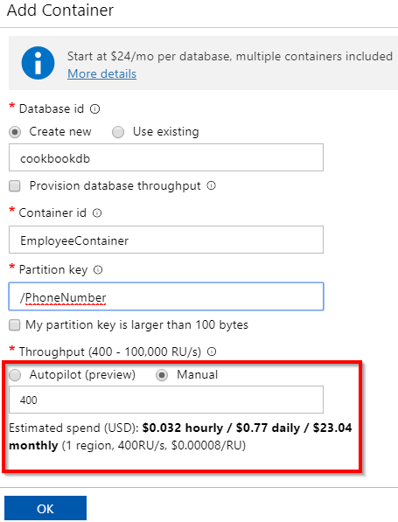

Figure 8.20: Cosmos DB—adding a container with 400 RUs
3. In the CSVImport.DurableFunctions project, run the following command in the
NuGet package manager to install the dependencies of Cosmos DB:
Install-Package Microsoft.Azure.WebJobs.Extensions.CosmosDB
268 | Bulk import of data using Azure Durable Functions and Cosmos DB

How to do it...
Perform the following steps:
1. Create a new activity trigger named ScaleRU_AT in the CSVImport_Orchestrator.cs
file. The function should look something like this, and accepts the number of RUs to be scaled up to, along with the Cosmos DB binding. Using this function, we have replaced the original throughput:
[FunctionName("ScaleRU_AT")]
public static async Task ScaleRU_AT(
[ActivityTrigger] int RequestUnits,
[CosmosDB(ConnectionStringSetting =
"CosmosDBConnectionString")]DocumentClient client )
{
DocumentCollection EmployeeCollection = await client. ReadDocumentCollectionAsync
(UriFactory. CreateDocumentCollectionUri("cookbookdb", "EmployeeContainer"));
Offer offer = client.CreateOfferQuery().Where(o => o.ResourceLink == EmployeeCollection.SelfLink).AsEnumerable().Single(); Offer replaced = await client.ReplaceOfferAsync(new OfferV2(offer, RequestUnits));
return $"The RUs are scaled to 500 RUs!";
}
2. Add the following namespaces to the CSVImport_Orchestrator.cs file:
using System.Linq;
using Microsoft.Azure.Documents;
using Microsoft.Azure.Documents.Client;
3. Create a new connection string for Cosmos DB, as shown in Figure 8.21. Copy the
connection from the Keys blade of the Cosmos DB account:
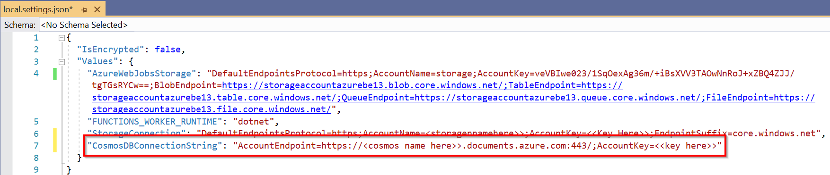

Figure 8.21: Azure Functions—local configuration file
Bulk inserting data into Cosmos DB | 269

4. Now, in the CSVImport_Orchestrator function, add the following line to invoke
ScaleRU_AT. In this example, I'm passing 500 as the RU value. You can choose your
value according to your project's requirements:
await context.CallActivityAsync("ScaleRU_AT", 500);
5. Now, upload a CSV file to trigger the orchestration, which internally invokes the
new activity trigger, ScaleRU_AT, and, if everything went well, the new capacity of
the Cosmos DB collection should be 500. Let's now navigate to Cosmos DB's Data
Explorer tab and navigate to the Scale & Settings section, where we can view 500
as the new throughput of the collection, as shown in Figure 8.22:
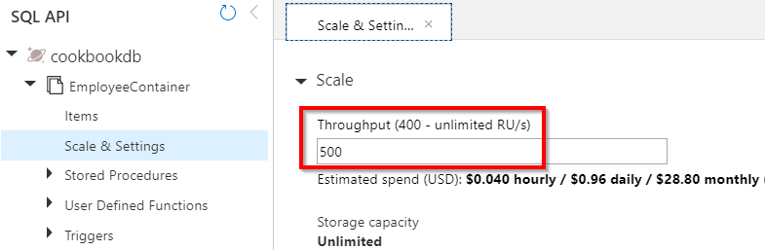

Figure 8.22: Cosmos DB—viewing the throughput in the Scale & Settings blade

There's more...
The Cosmos DB collection's capacity is represented as a resource called offer. In this recipe, we have retrieved the existing offer and replaced it with a new offer. Learn more about this at https://docs.microsoft.com/rest/api/cosmos-db/offers.

Bulk inserting data into Cosmos DB
Now that we have scaled up the collection, it's time to insert the data into the Cosmos DB collection. In this recipe, you will learn about one of the simplest ways of inserting data into Cosmos DB.
270 | Bulk import of data using Azure Durable Functions and Cosmos DB

How to do it...
Perform the following steps:
1. Create a new activity trigger named ImportData_AT, which takes an employee
collection as input and saves the data in the Cosmos DB container. Paste the following code into the new activity trigger that does the job:
[FunctionName("ImportData_AT")]
public static async Task ImportData_AT( [ActivityTrigger] List employees,
[CosmosDB(ConnectionStringSetting =
"CosmosDBConnectionString")]DocumentClient client, ILogger log) {
foreach (Employee employee in employees)
{
await client.CreateDocumentAsync(UriFactory. CreateDocumentCollectionUri("cookbookdb", "EmployeeContainer"), employee); log.LogInformation($"Successfully inserted {employee.Name}."); }
return $"Data has been imported to Cosmos DB Collection Successfully!"; }
2. Let's add the following line to the orchestration function that invokes the
ImportData_AT activity trigger:
await context.CallActivityAsync("ImportData_AT", employees);
3. Let's now run the application and upload the CSV file to test the functionality.
If everything went well, we should see all the records created in the Cosmos DB collection, as shown in Figure 8.23:
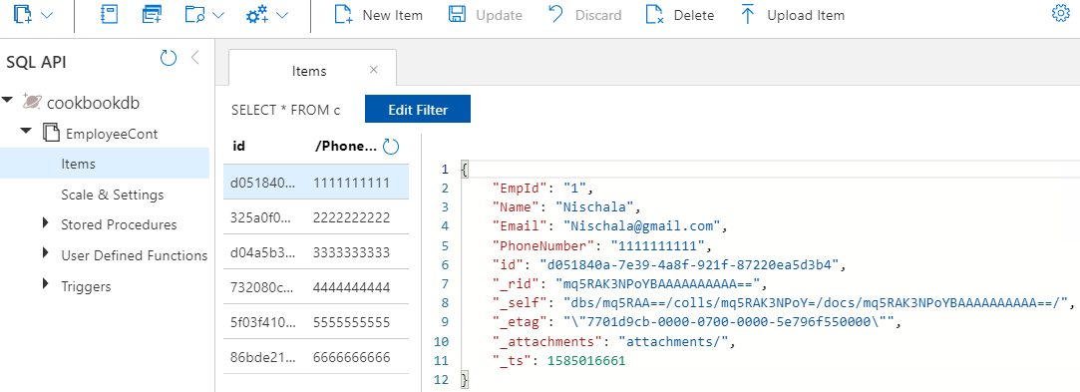

Figure 8.23: Cosmos DB—viewing documents
Bulk inserting data into Cosmos DB | 271

There's more…
The Cosmos DB team has released a library called Cosmos DB bulk executor, which can be used to perform bulk updates to a Cosmos DB container. Learn more about this at
https://docs.microsoft.com/azure/cosmos-db/bulk-executor-overview.
In this recipe, we have hardcoded the names of our collection and database. We'll have to configure them in the app settings file.
In this chapter, you have learned how to develop a reliable application that can be used to upload CSV files using Durable Functions.

Configuring security

for Azure Functions

In this chapter, we'll learn a few of the best practices that can be followed while working with Azure Functions, such as the following:
• Enabling authorization for function apps
• Controlling access to Azure Functions using function keys
• Securing Azure Functions using Azure Active Directory
• Throttling Azure Functions using API Management
• Securely accessing an SQL database from Azure Functions using Managed Identity
• Configuring additional security using IP whitelisting 274 | Configuring security for Azure Functions

Introduction
Even after the successful development of your application, and alongside continued maintenance and troubleshooting, there remains the concern of app security. Though covering all the security guidelines wouldn't be possible in just one chapter, we'll touch on a few of the techniques that every developer should follow while working with Azure Functions.

Note
The Azure Functions UI, shown in the screenshots in this chapter, is in preview at the time of writing. If this is still the case when reading this, click on the Preview the new Azure Functions management experience link as shown in Figure 9.1 to navigate to the new UI.
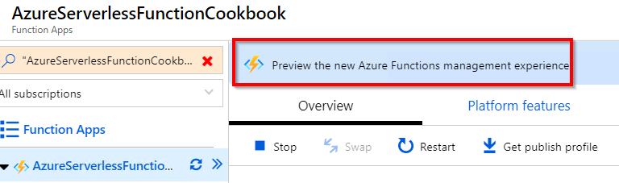

Figure 9.1: Azure Functions—Preview the new Azure Functions management experience
Let's start learning about and implementing the security best practices for Azure Functions.

Enabling authorization for function apps
If your web API (HTTP trigger) is being used by multiple client applications and you would like to provide access only to the intended and authorized applications, then you need to implement authorization in order to restrict access to your Azure function.
In this recipe, you are going to learn how to enable authorization in Azure Functions and will gain clarity on the different types of authorization.

Getting ready
You should know by now how to create an HTTP trigger function. Download the Postman tool from www.getpostman.com/. The Postman tool is used for sending HTTP requests. You can also use any tool or application that can send HTTP requests and headers.
Enabling authorization for function apps | 275

How to do it…
In this section, we'll create and test the HTTP trigger's authorization functionality by performing the following steps:
1. Create a new HTTP trigger function (or open an existing HTTP function). When
creating the function, select Function as the option in the Authorization level
drop-down menu.

Note
If you would like to change the authorization level to an existing HTTP trigger function, click on the Integrate tab, change the Authorization level to Function, and click on the Save button to save the changes.

2. In the Code Editor tab, grab the function URL by clicking on the Get Function URL
link available in the right-hand corner of the code editor in the run.csx file.
3. Navigate to Postman and paste the function URL:
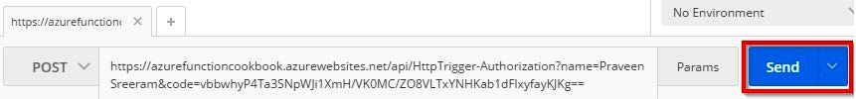

Figure 9.2: Postman—POST request to Azure Functions with the code query string parameter
4. Observe that the URL has the following query strings:
code: This is the default query string that is expected by the function runtime
and validates the access rights of the function. The validation functionality is
automatically enabled without the need for writing the code by the developer. All
of this is taken care of just by setting Authorization level to Function.
name: This is a query string that is required by the HTTP trigger function.
Let's remove the code query string from the URL in Postman and try to make a request. You will get a 401 unauthorized error.
276 | Configuring security for Azure Functions

How it works…
When clients make a request via Postman or any other tool or application that can send HTTP requests, the request will be received by the underlying Azure App Service web app (note that Azure functions are built on top of App Service) in this way:
• Azure Functions first checks for the presence of the header name code, either in
the query string collection or in the request body.
• If the value of the code parameter is valid, then the request will be authorized and
the runtime will process the request. Otherwise, a 401 unauthorized error message will be thrown.

There's more…
Note that the security key (in the form of the query string parameter named code) in this recipe is used for demonstration purposes only. In production scenarios, instead of passing the key as a query string parameter (the code parameter), add x-functions-key as an HTTP header, as shown in Figure 9.3:
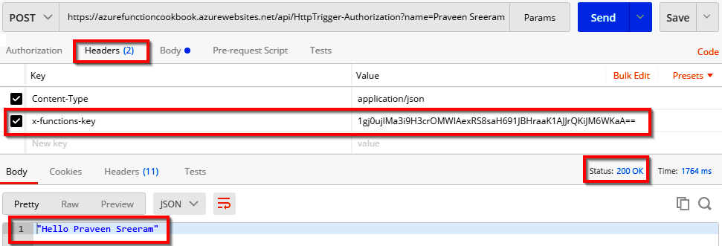

Figure 9.3: Postman—POST request to Azure Functions with the x-functions-key header
In this recipe, you have learned how to configure authorization for Azure Functions. Let's move on to the next recipe.

Controlling access to Azure Functions using function keys
You have now learned how to enable the authorization of an individual HTTP trigger by setting the Authorization level field with the Function value in the Integrate tab of the HTTP trigger function. It works well when we use only one Azure function as a back-end web API for one of the applications and we don't want to provide access to the public.
Controlling access to Azure Functions using function keys | 277

However, in enterprise-level applications, we will end up developing multiple Azure functions across multiple function apps. In those cases, we need to have fine-grained granular access to Azure Functions for our own applications or for some other third-party applications that integrate our APIs in their applications.
This recipe will focus on understanding how to work with function keys within Azure Functions.

How to do it…
Azure supports the following keys, which can be used to control access to Azure functions:
• Function keys: These can be used to grant authorization permissions to a given
function. These keys are specific to the function with which they are associated.
• Host keys: We can use these to control the authorization of all the functions
within an Azure function app.

Configuring the function key for each application When developing an API using Azure functions that can be used by multiple client applications, it's good practice to have a different function key for each client application that is going to use our functions.
Perform the following steps to configure the function key:
1. Navigate to the Functions tab, as shown in Figure 9.4:
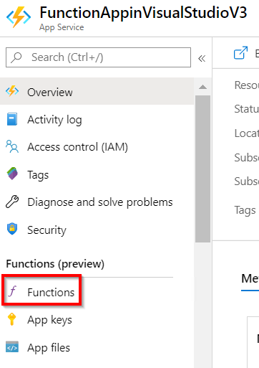

Figure 9.4: Azure Portal—link to Azure Functions 278 | Configuring security for Azure Functions

2. Now click on the Azure function (HTTP trigger) for which you would like to
generate the keys:
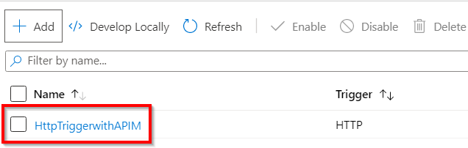

Figure 9.5: Navigate to the Azure function HTTP trigger
By default, a key with the name default will be generated for you. To generate a new key, click on the New function key button, as shown in Figure 9.6:
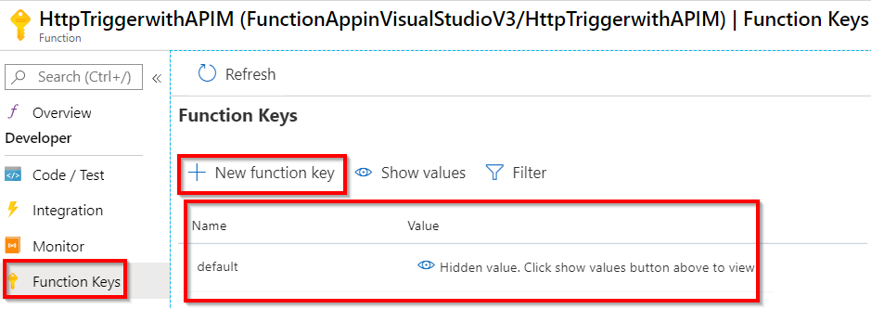

Figure 9.6: Azure function keys—creating a new function key
3. As per the preceding instructions, I have created keys for the following
applications:
WebApplication: The key name WebApplication is configured to be used for the website that uses the Azure function.
MobileApplication: The key name MobileApplication is configured to be used in the mobile app that uses the Azure function:
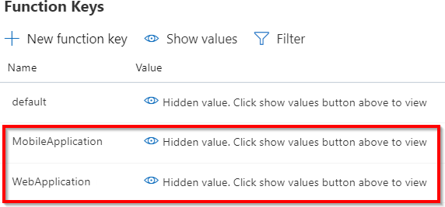

Figure 9.7: Azure function keys—list of function keys
Controlling access to Azure Functions using function keys | 279

In a similar way, you can create different keys for any other app (such as an IoT application) depending on your requirements.
The idea behind having different keys for the same function is to have control over the access permissions for the different applications that are able to use the function. For example, if you would like to revoke the permissions only to one application but not for all applications, then you would just delete (or revoke) that key. In that way, you are not impacting other applications that are using the same function.
Here is the downside of the function keys: if you are developing an application where you need to have multiple functions and each function is being used by multiple applications, then you will end up having many keys. Managing these keys and documenting them would be a nightmare. In situations like these, you can go with host keys, which are discussed next.
Configuring one host key for all the functions in a single function app Having different keys for different functions is a good practice when you have a handful of functions used by a few applications. However, things might get worse if we have many functions and client applications leveraging the same APIs. Managing the function keys in these large enterprise applications with huge client bases would be painful. To make things simple, segregate all related functions into a single function app and configure the authorization for each function app, instead of for each individual function.
Navigate to the App keys tab as shown in Figure 9.8:
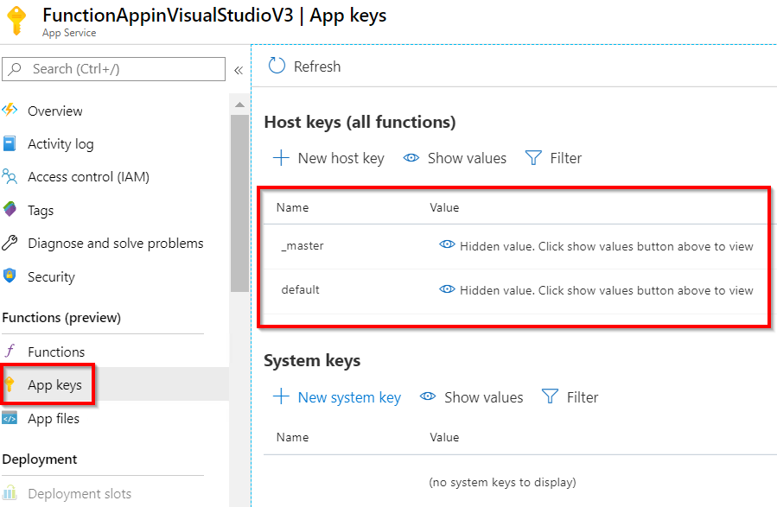

Figure 9.8: Azure Functions host keys
280 | Configuring security for Azure Functions

Note
As with the case of function keys, multiple host keys can be created if your function apps are used by multiple applications. In such cases, access to each of the function apps can be controlled by different applications using different keys.

You can create multiple host keys by following the same steps we used for creating regular function keys.

There's more...
If a key has been compromised, then you can regenerate the key at any time by clicking on the Renew button. Note that when you renew a key, all the applications that access the function will no longer work and will return a 401 unauthorized error.
The key can be deleted or revoked if it is no longer used in any applications. Here's a table with some more guidance on key usage:

type Key When should I revocable Renewable? Comments Is it
use it? (can it be
deleted)?

Master When the Use a master key for any function authorization No Yes within the function app irrespective of key level is Admin

Host key When the Use the host key for all the functions authorization Yes Yes within the function app. level is Function

Function When the Use the function key only for a given authorization Yes Yes key function. level is Function
Figure 9.9: When to use Azure Functions app keys

Note
Microsoft doesn't recommend sharing the master key, as it is also used by runtime APIs. Be extra cautious with master keys.

Securing Azure Functions using Azure Active Directory | 281

In this recipe, you have learned how to enable security for HTTP triggers using function keys and admin keys. In the next recipe, we'll secure our Azure Functions using Azure Active Directory.

Securing Azure Functions using Azure Active Directory
One of the most important Azure Services related to security is Azure Active Directory (Azure AD). Azure AD is a cloud-based identity and access management service that helps developers to authenticate end users before accessing Azure Functions HTTP triggers. Azure Functions provides an easy way to integrate Azure AD with HTTP triggers called EasyAuth.
Thanks to Azure App Service, from which the EasyAuth feature is inherited, we can integrate Azure function HTTP triggers with Azure AD without writing a single line of code.

Getting ready
In this recipe, to make things simple, let's use the default Active Directory that is created when we create an Azure account. In real-time production scenarios, however, we'd ideally have an existing Active Directory that needs to be integrated. I would recommend going over this article for more information: docs.microsoft.com/azure/
active-directory-b2c/tutorial-web-app-dotnet?tabs=applications.

How to do it...
This recipe will involve the following:
• Configuring Azure Active Directory for the function app
• Registering the client app in Azure Active Directory
• Granting the client app access to the back-end app
• Testing the authentication functionality using a JWT token
282 | Configuring security for Azure Functions

Configuring Azure Active Directory for the function app In this section, we'll integrate the default Azure Active Directory with the function app. In order to integrate Azure Active Directory, please perform the following steps:
1. Navigate to the Overview section of Azure Functions and search for
Authentication (or just auth) in the Features tab, as shown in Figure 9.10, and click on the Configure button:
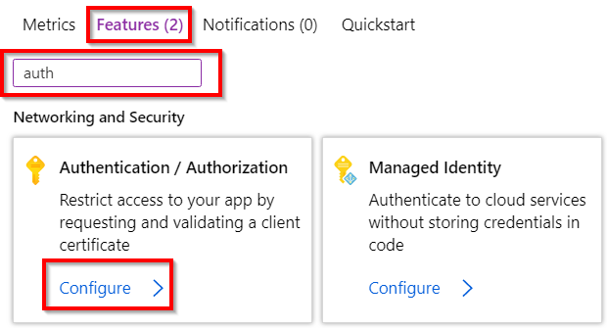

Figure 9.10: Function app overview page—searching for the authentication tile
2. In the Authentication / Authorization blade, perform the following steps to
enable Active Directory authentication:
Click on the On button to enable authentication.
Choose the Login using Azure Active Directory option in the Action to take when the request is not authorized drop-down menu.
Click on the Not Configured button of the Azure Active Directory field under the Authentication Providers section to start configuring the options, as shown in Figure 9.11:
Securing Azure Functions using Azure Active Directory | 283
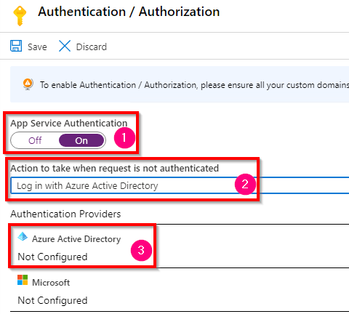

Figure 9.11: Azure function app—enabling authentication
3. The next step is to choose an existing registration or create a new registration
for the client application that you want to provide access to. This can be done
by pressing the Express button in the Management mode field, as shown in
Figure 9.12:
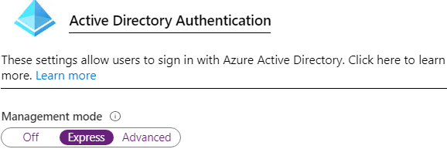

Figure 9.12: Azure function app—choosing Express mode
284 | Configuring security for Azure Functions

4. Now, choose Create New AD App and provide AzureFunctionCookbookV3 as the
name in the Create App field. Click OK to save the configurations:
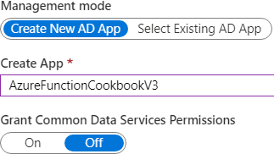

Figure 9.13: Azure function app—creating a new Azure Active Directory app
5. Now, an App registrations entry will be created for you with the name
AzureFunctionCookbookV3. This can be viewed in the App registrations blade of the Azure Active Directory service:
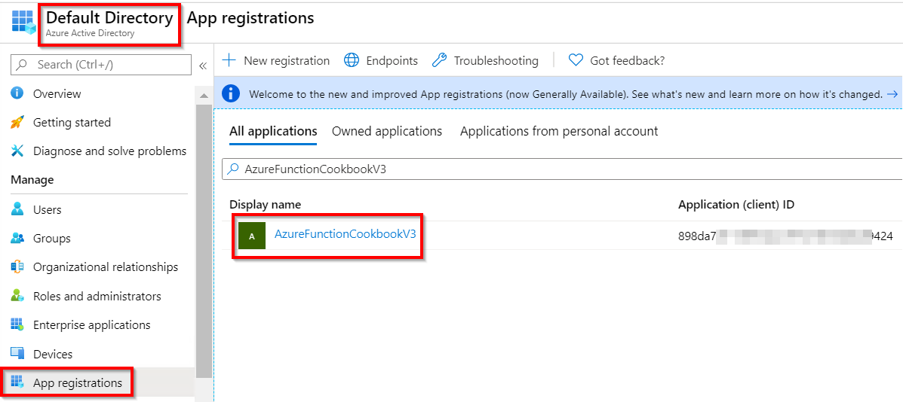

Figure 9.14: Azure Active Directory—App registrations
6. Grab the application ID, as shown in Figure 9.14, and store it in a Notepad file.
7. That's it. Without writing a single line of code, we are done with configuring an
Azure Active Directory instance that sits as a security layer and allows access only to authenticated users. Let's quickly test it by trying to access any of the HTTP triggers present in the function app. As shown in Figure 9.15, try to access the HTTP trigger function using Postman. As expected, it will redirect you to log in. Figure 9.15 shows how it looks when you try to access the HTTP trigger:
Securing Azure Functions using Azure Active Directory | 285
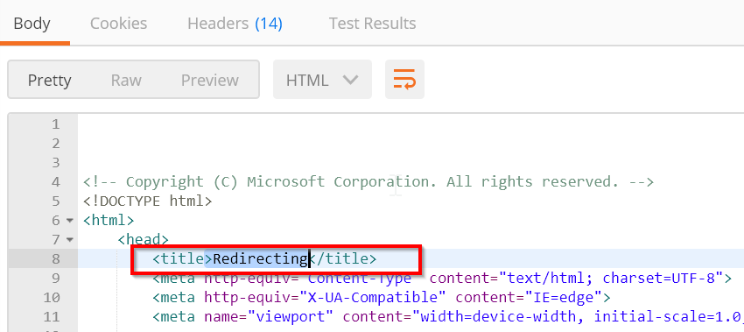

Figure 9.15: Postman—accessing the HTTP trigger
8. As you have integrated the function app with Azure Active Directory, it is not
possible to access your back-end API (HTTP trigger). In order to provide access
to the client applications that need to consume the HTTP trigger, you need to
perform the following steps:
Register the client apps in Azure Active Directory (for our example, we'll register
the Postman app).
Grant access to the client app created in Step a to access the back-end function
app.

Registering the client app in Azure Active Directory In order to provide access to a client app, you need to register the client app in Azure Active Directory and grant access to the HTTP trigger of the function app. In order to achieve this, perform the following steps:
1. Navigate to Azure Active Directory by clicking on the Azure Active Directory
button, as shown in Figure 9.16. If this option is not available in the FAVORITES list,
search in the All services blade, which is also highlighted in Figure 9.16:
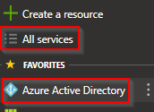

Figure 9.16: Azure portal menu—adding the Azure Active Directory link 286 | Configuring security for Azure Functions

2. In the Active Directory menu, click on App registrations and then click on the
New registration button.
3. Fill in the fields as follows and click on the Create button to complete the
registration for our Postman app. As our client app is Postman, the sign-on URL doesn't hold any importance, so just using http://localhost should be good for our example:
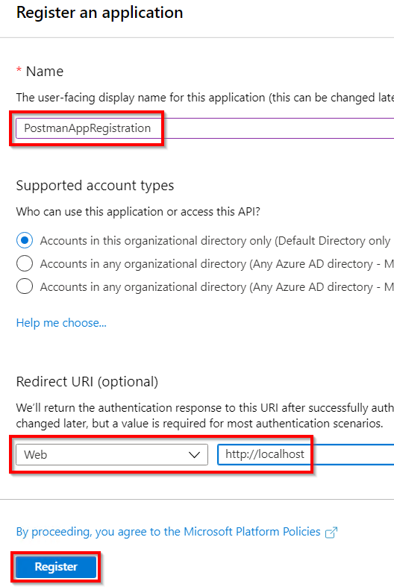

Figure 9.17: Azure Active Directory—creating an app registration
Securing Azure Functions using Azure Active Directory | 287

4. In just a moment, the app will be created, and you'll be taken to the screen shown
in Figure 9.18. Grab the application ID and save it in a Notepad file. You'll be using
it in the upcoming steps:
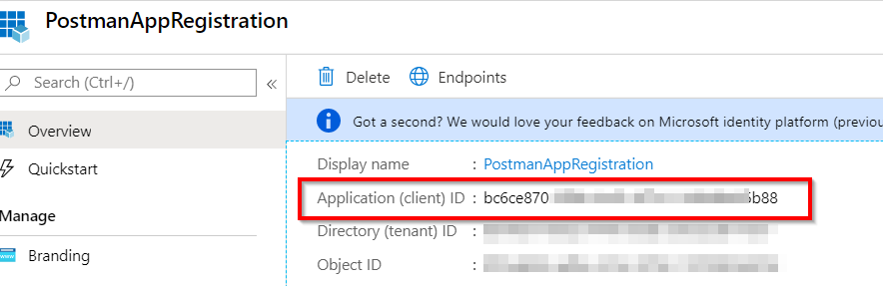

Figure 9.18: App Registration overview blade—copying the application ID
5. In the Certificates & secrets blade, click on the New client secret button item to
generate a key, which we will be passing from Postman:
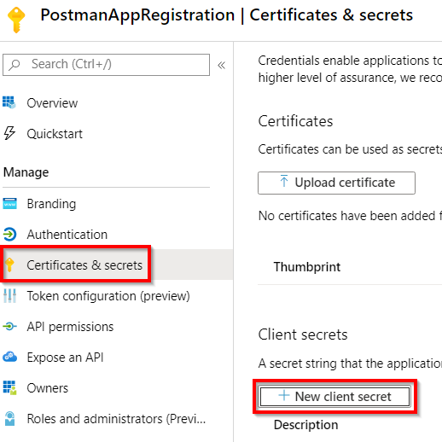

Figure 9.19: Azure app registration—Certificates & secrets
6. In the Add a client secret pop-up box, we first need to provide a description and
the duration after which the key should expire.
288 | Configuring security for Azure Functions

7. Provide the details as shown in Figure 9.20 and click on the Add button. The actual
secret will be displayed to you in the value field only once immediately after clicking on the Add button, so be sure to copy it and store it in a secure place. You'll be using this in a few moments:
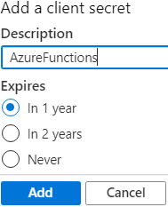

Figure 9.20: Azure app registration—creating a new secret
In this section, we created the app registration, along with a secret. Let's move on to the next section.
Granting the client app access to the back-end app Once the client application is registered, you need to provide it with access to your back-end app. In this section, you'll learn how to configure it. Perform the following steps:
1. In PostmanAppRegistration, click on API permissions, as shown in Figure 9.21:
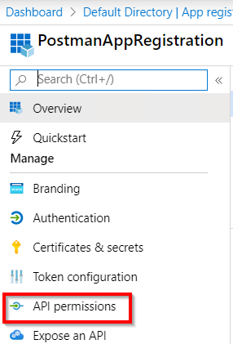

Figure 9.21: Azure app registration—API permissions
Securing Azure Functions using Azure Active Directory | 289

2. In the API permissions blade, click on the Add a permission button to
navigate to the Request API permissions blade. Now, choose the APIs my
organization uses tab and search for the app registration (in my case, it was
AzureFunctionCookbookV3), as shown in Figure 9.22. Once the app registration is
visible, click on it:
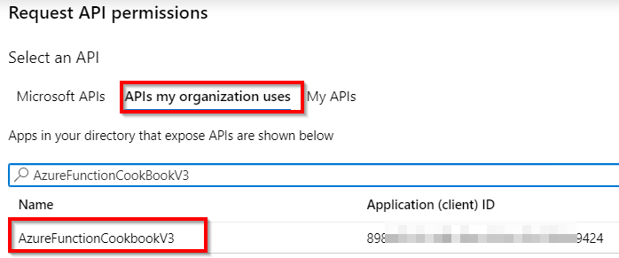

Figure 9.22: Azure app registration—the Request API permissions blade—selecting the Azure function
3. In the next step, select Delegated permissions, click on the user_impersonation
checkbox, and then click on the Add permissions button, as shown in Figure 9.23:
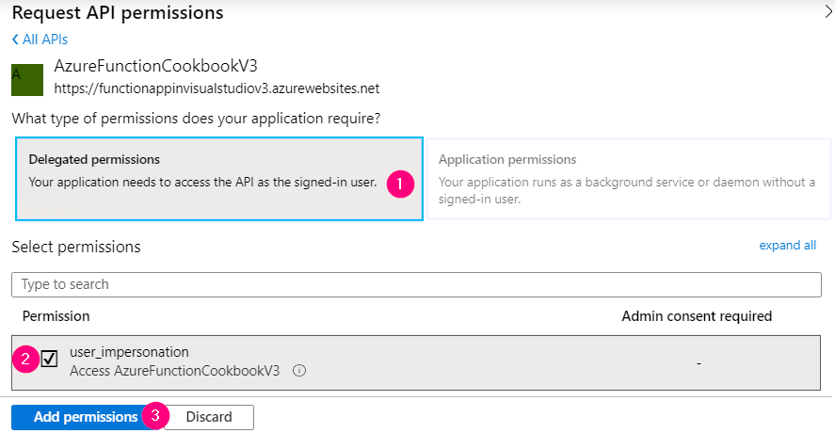

Figure 9.23: Azure app registration—the Request API permissions blade—adding permissions 290 | Configuring security for Azure Functions

4. Ensure that the following screen is visible. Clicking on the Grant admin consent
for Default Directory button will apply the changes:
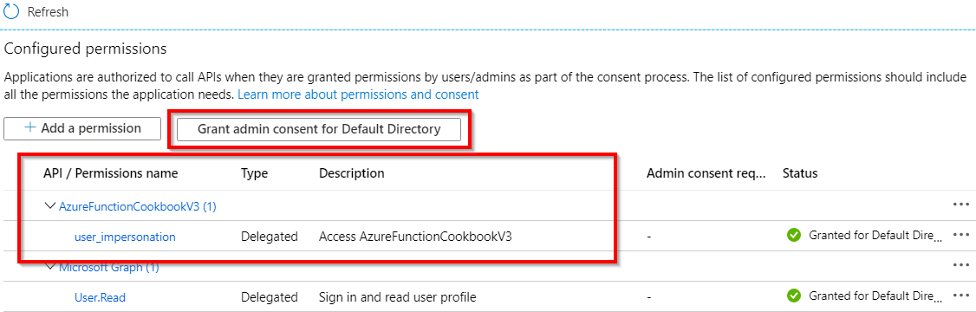

Figure 9.24: Azure app registration—Configured permissions
In this section, we granted the necessary permissions to the Azure function app. Let's move on to test the authentication functionality.
Testing the authentication functionality using a JWT token In order to test the functionality, you need to use Postman. Carry out the following steps:
1. Get the following input details:
2. OAuth 2.0 token endpoint: Get this in the Endpoints tab of Azure Active Directory
and copy the URL.
3. Grant type: A hardcoded client_credentials value.
4. Client ID of the client application: This was noted down in Step 4 of the
Registering the client app in Azure Active Directory section.
5. Secret that was generated for client application: You copied it into Notepad in
Step 6 of the Registering the client app in Azure Active Directory section.
6. Scope: The resource that you need to access. You need to pass the scope
of the back-end application. You'll pass the default scope, which will be in https://<functionappname>.azurewebsites.net/.default format.
7. Once you have all the information at hand, pass all the parameters and make a call
to the Azure Active Directory tenant, which will return the bearer token as shown in Figure 9.25. Copy the bearer token in a Notepad file:
Securing Azure Functions using Azure Active Directory | 291
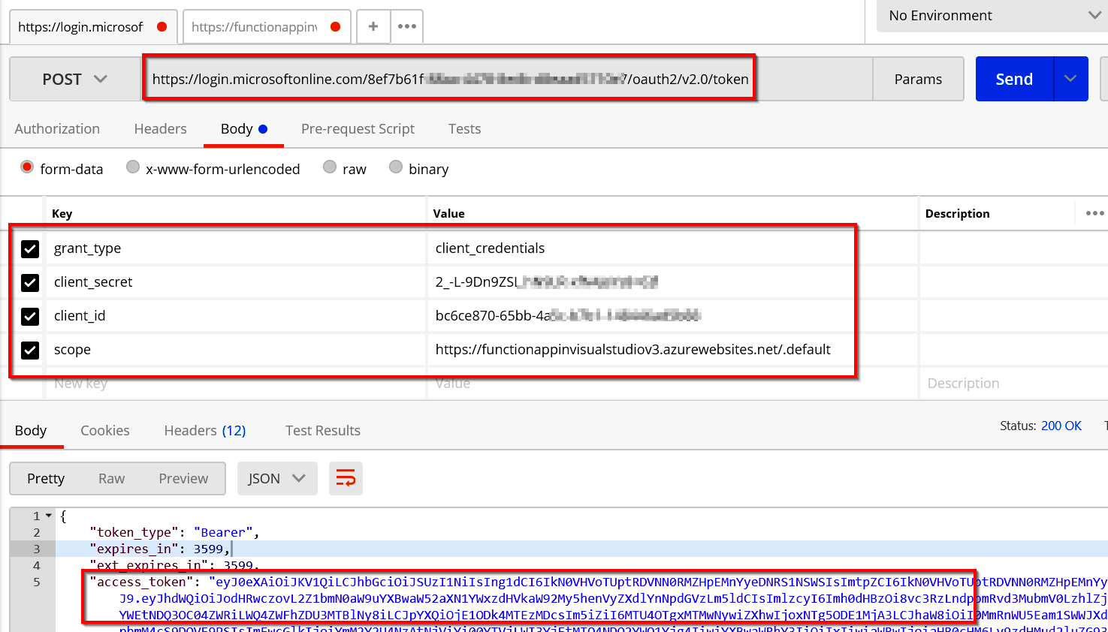

Figure 9.25: Azure Functions—requesting a bearer token
8. The next and final step is to make a call to the actual back end (the Azure function
HTTP trigger) by passing the bearer JWT token (access_token) that you copied in
the preceding step:
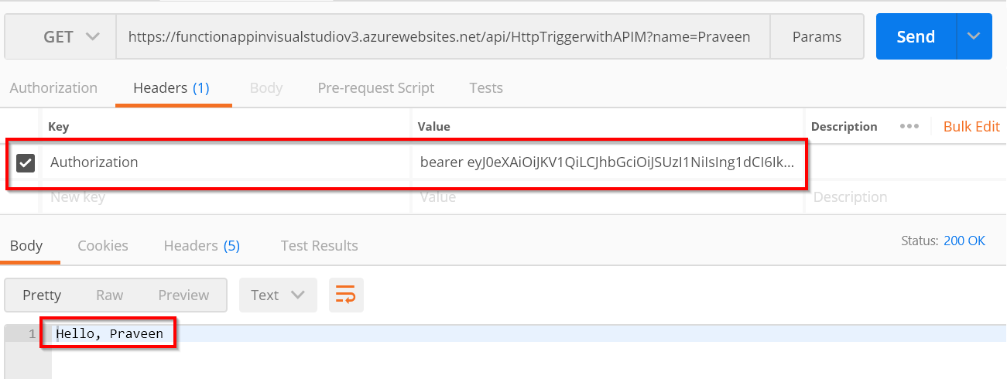

Figure 9.26: Azure function—invoking the HTTP trigger by passing a bearer token

292 | Configuring security for Azure Functions

As shown in Figure 9.26, add an Authorization header and paste the JWT token. Don't forget to provide the text bearer to the Value field.
In this recipe, you learned to configure authentication using Azure Active Directory without writing any code. In the next recipe, you'll learn how to integrate Azure API Management with Azure Functions to limit the number of requests from clients.

Throttling Azure Functions using API Management You have already learned in previous chapters that we can use Azure Functions' HTTP triggers as a back-end web API. To restrict the number of requests by client applications to, let's say, 10 requests per second, we would usually have to develop a lot of logic. Thanks to Azure API Management, we don't need to write any custom logic if we integrate Azure Functions with API Management.
In this recipe, you'll learn how to restrict clients to only one API request per minute for a given IP address. The following are the high-level steps that we'll follow:
1. Creating an Azure API Management service
2. Integrating Azure Functions with API Management
3. Configuring request throttling using inbound policies
4. Testing the rate limit inbound policy configuration

Getting ready
To get started, you need to create an Azure API Management service by performing the following steps:
1. Search for API Management and provide all the following details. In the following
example, I have chosen the Developer pricing tier. But for production applications, you need to choose non-developer tiers (Basic/Standard/Premium), as the Developer (No SLA) tier doesn't provide any SLAs. After reviewing all the details, click on the Create button:
Throttling Azure Functions using API Management | 293
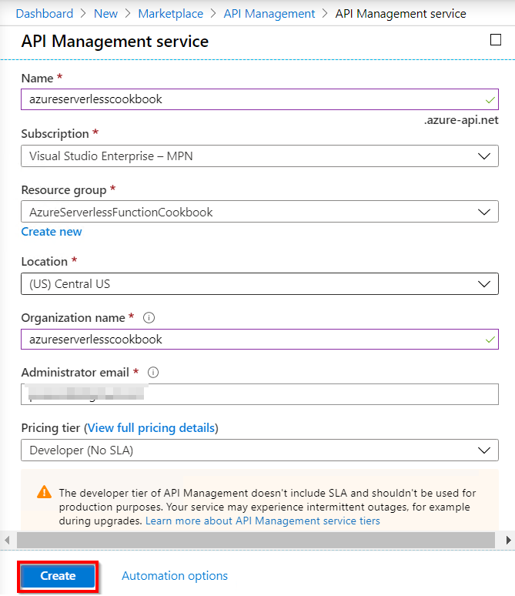

Figure 9.27: Creating an API Management service
294 | Configuring security for Azure Functions

2. At the time of writing, it takes around 30-40 minutes to create an API
Management instance. Once it has been created, the instance can be viewed in the API Management services blade:
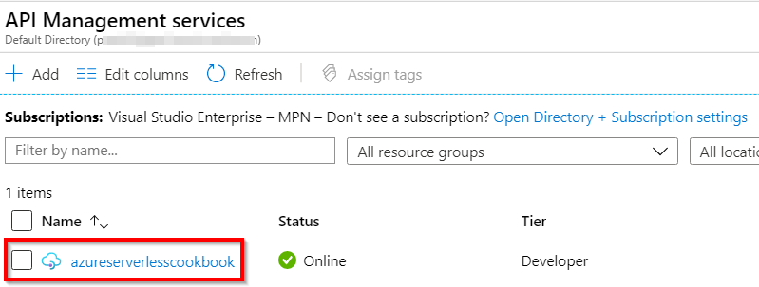

Figure 9.28: List of API Management services

How to do it...
In order to leverage the API Management capabilities, we need to integrate the service endpoints (in our case, the HTTP triggers that we have created) with the API Management service. This section talks about the steps required for integration.
Integrating Azure Functions with API Management In this section, you need to perform the following steps to integrate Azure Functions with the API Management service:
1. Navigate to the APIs blade of the API Management instance that you created, and
click on the Function App tile.
2. You'll see a Create from Function App pop-up box where you can click on the
Browse button, which will open a sidebar with the title Import Azure Functions, which is where you can configure the function apps. Click on the Configure Required Setting button to view all the function apps that have HTTP triggers in them. Once you have chosen the function app, click on the Select button.
3. The next step is to choose the HTTP trigger that you would like to integrate with
Azure API Management. After clicking on the Select button, as mentioned in the previous step, all the HTTP triggers associated with the selected function app will appear, as shown in Figure 9.29. I chose only one HTTP trigger to make things simple, and then clicked on the Select button, as shown in Figure 9.29:
Throttling Azure Functions using API Management | 295
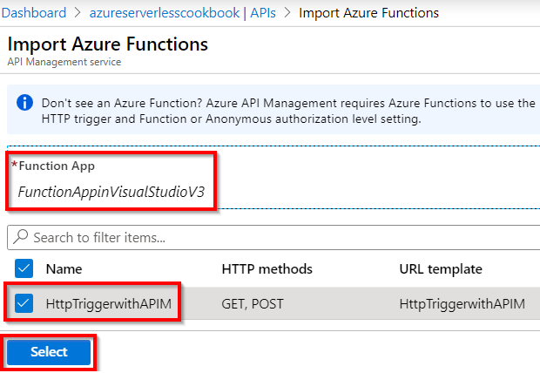

Figure 9.29: API Management services—importing Azure Functions
4. After performing all the preceding steps, the Create from Function App pop-up
box will appear, as shown in Figure 9.30. Once you have reviewed the details, click
on the Create button:
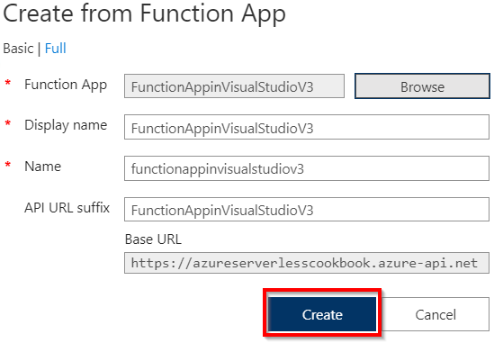

Figure 9.30: API Management services—creating APIs from Azure Functions 296 | Configuring security for Azure Functions

5. If everything goes fine, you should get something as shown in Figure 9.31. Now you
are done with integrating Azure Functions with API Management:
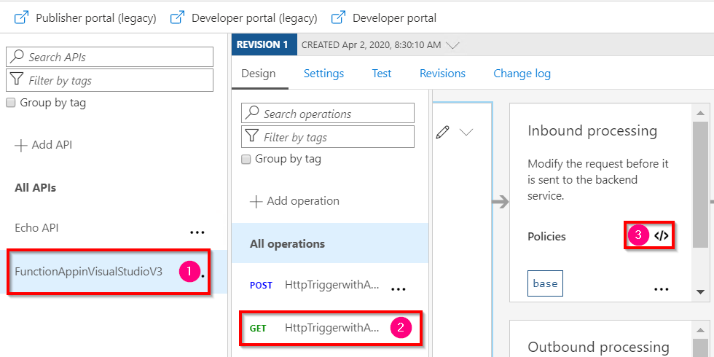

Figure 9.31: API Management services—configuring inbound policies
In this section, you learned how to import Azure Functions APIs into the API Management service. Let's move on to the next section.
Configuring request throttling using inbound policies Perform the following steps to configure throttling using inbound policies:
1. As shown in Figure 9.31, choose the required operation (GET) and click on the
inbound policy editor link (labeled 3 in Figure 9.31), which will open the policy editor.

Note
API Management allows us to control the behavior of the back-end APIs (in our case, HTTP triggers) using API Management policies. Both the inbound and
outbound request responses can be controlled. Read more about it at docs.
microsoft.com/azure/api-management/api-management-howto-policies.

2. As you need to restrict the request rate within API Management before sending
the request to the back-end function app, you need to configure the rate limit in the inbound policy. Create a new policy as shown, with a value of 1 for the calls attribute and a value of 60 (in seconds) for the renewal-period attribute. Finally, set counter-key to the IP address of the client application:
Throttling Azure Functions using API Management | 297
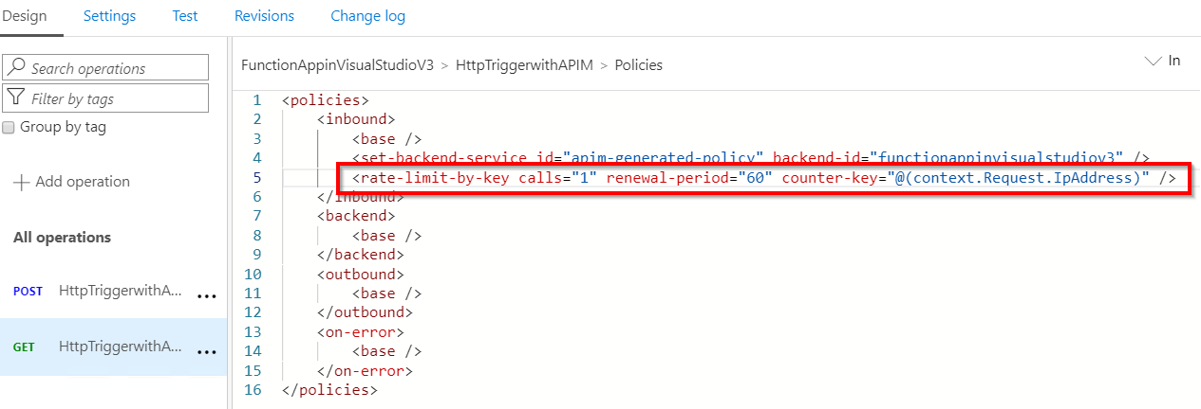

Figure 9.32: API Management services—configuring inbound policies—request throttling

Note
With this inbound policy, you are instructing API Management to restrict requests to one per minute for a given IP address.

3. Before you test the throttling, one final step is to publish the API by navigating to
the Settings tab in the preceding step and associating the API with a published
product (in your case, you have a default Starter product that is already
published). As shown in Figure 9.33, choose the required product and click on the
Save button:
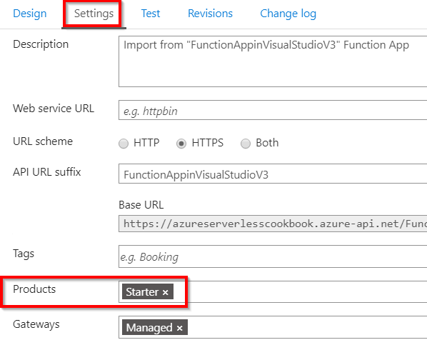

Figure 9.33: API Management services—configuring products 298 | Configuring security for Azure Functions

Note
Products in API Management are a group of APIs to which the developers of different client applications can subscribe. For more information about API
Management products, refer to docs.microsoft.com/azure/api-management/api-
management-howto-add-products.

Testing the rate limit inbound policy configuration Test the rate limit by performing the following steps:
1. Navigate to the Test tab and add any required parameters or headers that are
expected by the HTTP trigger. In my case, my HTTP trigger requires a parameter named name.
2. Now, click on the Send button that appears after completing the preceding step
to make the first request. You should see something similar to Figure 9.34 after getting a response from the back end:
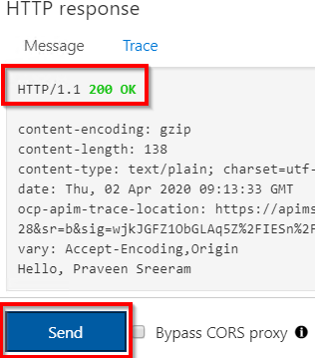

Figure 9.34: API Management services—testing the API in the console
Throttling Azure Functions using API Management | 299

3. Now, immediately click the Send button again. As shown in Figure 9.34, an error
should be returned, as our inbound policy rule is to allow only one request per
minute from a given IP address:
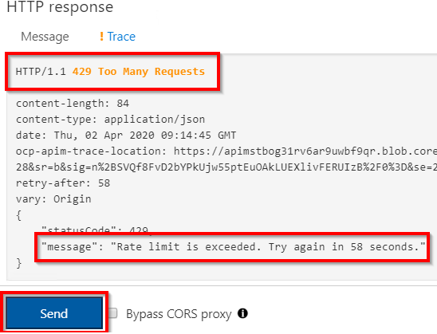

Figure 9.35: API Management services—testing rate limiting rules in the console

How it works...
In this recipe, we have created and configured an Azure API Management instance and integrated an Azure function app to leverage the API Management features. Once they were integrated, we created an inbound policy that restricts clients to just one call per minute from a given IP address. Here is a high-level diagram that depicts the whole process:
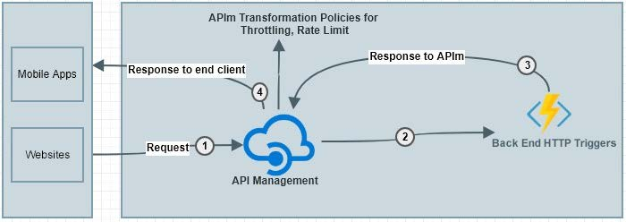

Figure 9.36: API Management integration with Azure Functions 300 | Configuring security for Azure Functions

The following is the overall process that we have configured in this recipe:
1. The API Management service receives the Request.
2. The API Management gateway forwards the request to the HTTP triggers. The
request is forwarded only if the inbound policy is adhered to. Otherwise, an error is returned immediately.
3. The HTTP triggers respond to API Management with a response.
4. Finally, the response is sent to the end user by the API Management service.

Let's move on to the next recipe.

Securely accessing an SQL database from Azure Functions using
Managed Identity
Let's say an employee has changed the password of the account as per their firm's security policy (to rotate the password every month). The applications using that account now wouldn't be able to gain access. For developers, wouldn't it be good if there was a facility where we don't need to worry about the credentials and, instead, the framework took care of authentication? In this recipe, you will learn how to access an SQL database from an Azure function (using Visual Studio) without providing a user ID or password by using a feature called Managed Service Identity.

How to do it...
In this recipe, we are going to perform the following steps:
1. Creating a function app using Visual Studio (if not done already)
2. Creating an SQL database
3. Enabling Managed Service Identity from the portal
4. Allowing SQL Server access to the new Managed Service Identity
5. Executing the HTTP trigger and testing

We'll use Visual Studio to develop an Azure HTTP trigger that connects to Azure SQL Database without providing any credentials (that is, the username and password).
Creating a function app using Visual Studio In this section, we'll develop an Azure HTTP trigger using Visual Studio that connects to the database.
Perform the following steps:
Securely accessing an SQL database from Azure Functions using Managed Identity | 301

1. Create a new function app by choosing the Azure Functions v3 runtime.
2. Create a new HTTP trigger with the name HttpTriggerWithMSI using Anonymous
Authorization level.
3. Install the NuGet package with Install-Package System.Data.SqlClient using the
package manager console.
4. Now, replace the function with the following code for the HTTP trigger:
public static class HttpTriggerWithMSI
{
[FunctionName("HttpTriggerWithMSI")]
public static async Task Run(
[HttpTrigger(AuthorizationLevel.Function, "get", "post", Route
= null)] HttpRequest req,
ILogger log)
{
log.LogInformation("C# HTTP trigger function processed
a request.");

string firstname = string.Empty,
lastname = string.Empty, email = string.Empty, devicelist = string.Empty;

string requestBody = await new StreamReader(req.Body).
ReadToEndAsync();
dynamic data = JsonConvert.DeserializeObject(requestBody);
firstname = firstname ?? data?.firstname; lastname = lastname ?? data?.lastname; email = email ?? data?.email;
devicelist = devicelist ?? data?.devicelist;

SqlConnection con = null;
try
{
string query = "INSERT INTO EmployeeInfo (firstname,lastname, email, devicelist) " + "VALUES (@firstname,@lastname, @ email, @devicelist) ";

con = new SqlConnection("Server=tcp:dbserver.database.
windows.net,1433;Initial Catalog=database;Persist SecurityInfo=False; MultipleActiveResultSets=False;Encrypt=True;TrustServerCertificate=False;
302 | Configuring security for Azure Functions

Connection Timeout=30;");
SqlCommand cmd = new SqlCommand(query, con);

con.AccessToken = (new AzureServiceTokenProvider()).
GetAccessTokenAsync("https://database.windows.net/").Result;

cmd.Parameters.Add("@firstname", SqlDbType.VarChar, 50). Value = firstname;

cmd.Parameters.Add("@lastname", SqlDbType.VarChar,50). Value = lastname;
cmd.Parameters.Add("@email", SqlDbType.VarChar, 50).Value = email;
cmd.Parameters.Add("@devicelist",SqlDbType.VarChar).Value = devicelist; con.Open();
cmd.ExecuteNonQuery();
}
catch (Exception ex)
{
throw ex;
}
finally
{
if (con != null)
{
con.Close();
}
}
return new OkObjectResult("Hello, Successfully inserted the
data");

}
}

Note
The connection string in the preceding code doesn't have any user ID or password details; it just has the server name and the database name.
Securely accessing an SQL database from Azure Functions using Managed Identity | 303

5. To retrieve the access token, run the following code:
con.AccessToken = (new AzureServiceTokenProvider()). GetAccessTokenAsync("https://database. windows.net/").Result;
6. Add the following NuGet packages to the function app:
Install-Package Microsoft.Azure.Services.AppAuthentication
7. Ensure that you have all the following namespaces in the class:
using System.Net; using System.Net.Http;
using System.Threading.Tasks;
using Microsoft.Azure.WebJobs;
using Microsoft.Azure.WebJobs.Extensions.Http; using Microsoft.Azure.WebJobs.Host;
using System.Data.SqlClient;
using System.Data;
using System;
using Microsoft.Azure.Services.AppAuthentication;
8. After ensuring that there are no build errors, publish the function app by right-
clicking on the project. Then, click on the Publish button, which will open the
Pick a publish target window, as shown in Figure 9.37. Choose Azure Functions
Consumption Plan, click on Select Existing, and then click the Create Profile
button:
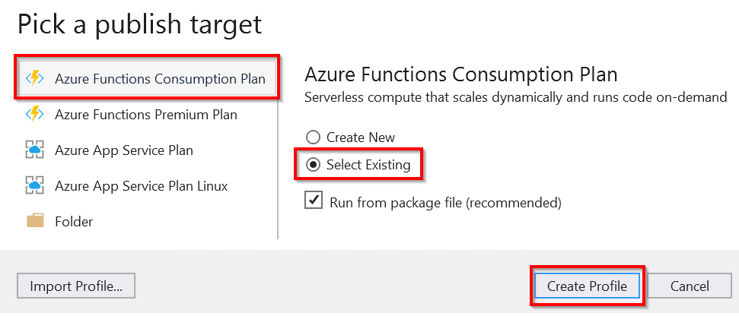

Figure 9.37: Visual Studio—picking a publish target
9. Next, provide values for Resource Group and Function App, click on the OK
button, and then click on the Publish button to publish the HTTP trigger to the
Azure function app.

In this section, we created the function app. Let's move to the next section to create the database.
304 | Configuring security for Azure Functions

Creating an SQL database
Create an SQL database by performing the following steps:
1. Click on Create a resource and search for SQL database, as shown in Figure 9.38:
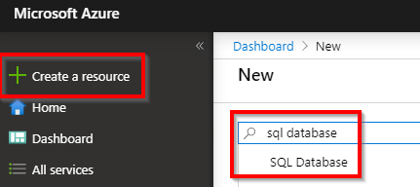

Figure 9.38: Search for SQL database in the Azure portal
2. In the Create SQL Database blade, provide all the details to create the SQL
database, as shown in Figure 9.39:
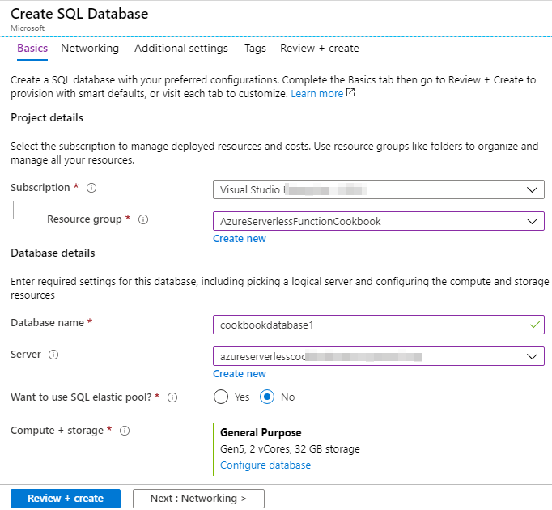

Figure 9.39: Creating an SQL database Securely accessing an SQL database from Azure Functions using Managed Identity | 305

In this section, you learned how to create an SQL database in an existing SQL server. Let's move on to the next section.
Enabling Managed Identity
Managed Identity is a feature of Azure Active Directory that will let the program authenticate the service automatically without providing any credentials. In this section, we'll enable Managed Identity for our Azure functions. Perform the following steps to do this:
1. Navigate to the Identity tab. Under the System assigned tab, click the On button
of the Status toggle button and click on Save, as shown in Figure 9.40:
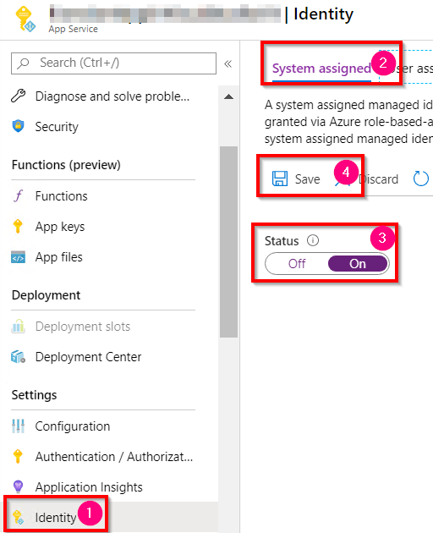

Figure 9.40: Azure Functions—enabling a system assigned managed identity
2. After clicking on the Save button, a pop-up box will be displayed, as shown in
Figure 9.41. Click on Yes:
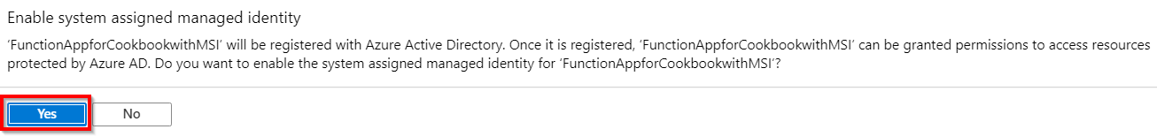

Figure 9.41: Azure Functions—enabling a system assigned managed identity—confirmation 306 | Configuring security for Azure Functions

3. Once the details are saved, the object ID will be displayed, as shown in Figure 9.42.
Grab the object ID and keep it in a Notepad file. We will use it in the following Allowing SQL Server access to the new Managed Identity service section of this recipe:
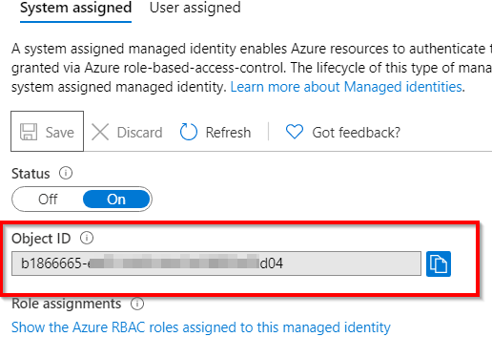

Figure 9.42: Azure Functions—system assigned managed identity—copying the object ID
In this section, we enabled the system assigned managed identity. Let's move on to the next section.
Allowing SQL Server access to the new Managed Identity service In this section, we'll create an admin user that has access to the SQL server that our function app will connect to. Perform the following steps:
1. Authenticate your Azure account's identity using the Azure CLI by running the az
login command in Command Prompt, as shown in Figure 9.43:

Figure 9.43: Command Prompt—using the az login command
Securely accessing an SQL database from Azure Functions using Managed Identity | 307

2. You'll be prompted to provide your Azure account credentials to log in to the
Azure portal. Once you have provided your credentials, it will show you the
available subscriptions in the command console.
3. Run the following command in Command Prompt by passing the object ID that
you noted in Step 3 of the previous section:
az sql server ad-admin create --resource-group <> --server-name <> --display-name sqladminuser --object-id

The following is the output of the previous command:
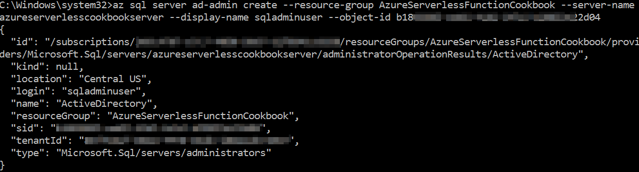

Figure 9.44: Command Prompt—running the az commands
4. Create a table named EmployeeInfo using the following script:
CREATE TABLE [dbo].[EmployeeInfo]( [PKEmployeeId] [bigint] IDENTITY(1,1) NOT NULL, [firstname] [varchar](50) NOT NULL, [lastname] [varchar](50) NULL, [email] [varchar](50) NOT NULL, CONSTRAINT [PK_EmployeeInfo] PRIMARY KEY CLUSTERED ( [PKEmployeeId]
ASC
) )
In this section, we enabled access to SQL Server using our object ID. Let's move on to the next section.
308 | Configuring security for Azure Functions

Executing the HTTP trigger and testing In order to test whether the code can connect to the database without credentials (your username and password), perform the following steps:
1. Open Postman and submit a request as shown:
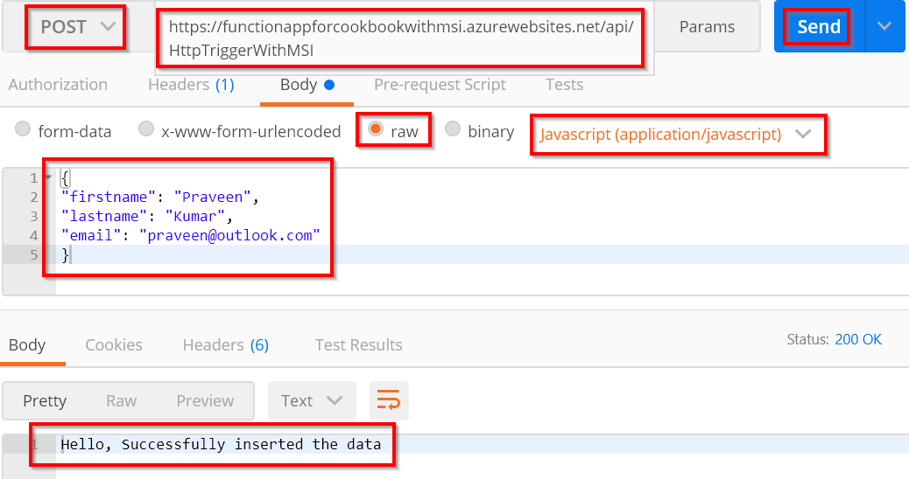

Figure 9.45: Postman—submitting a POST request to Azure Functions
2. Let's review the SQL database to see whether the record was inserted:
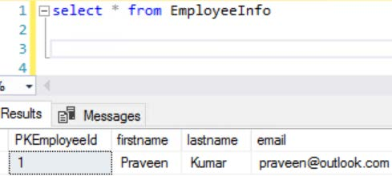

Figure 9.46: Postman—SSMS—Viewing the inserted data

Configuring additional security using IP whitelisting | 309

In this recipe, we have learned how to access Azure SQL Database from an Azure function app without providing a password by leveraging the Managed Identity feature. Let's move on to the next recipe.

Configuring additional security using IP whitelisting
In this recipe, you'll learn a technique to secure and restrict access to your Azure functions only to those clients whose IP addresses are whitelisted.
Let's say you want to restrict the function app's access to the internal organization alone, as it will be used only by the users' apps hosted internally within the organization's network. To do this, you need to whitelist one or more IP addresses (or IP address ranges) to allow access to the Azure function app.
In the recipe, we are going to create access restriction rules. Rules are nothing but instructions on whether to allow or block access based on IP addresses, IP address ranges, and even virtual networks.

Getting ready…
Please create the following services if they are not created already:
• A function app
• An HTTP trigger function
310 | Configuring security for Azure Functions

How to do it…
In this section, you'll learn how to implement the whitelisting of IP addresses for a given function app:
1. Navigate to the Azure function app, click on the Networking blade, and then click
the Configure Access Restrictions button, as shown in Figure 9.47:
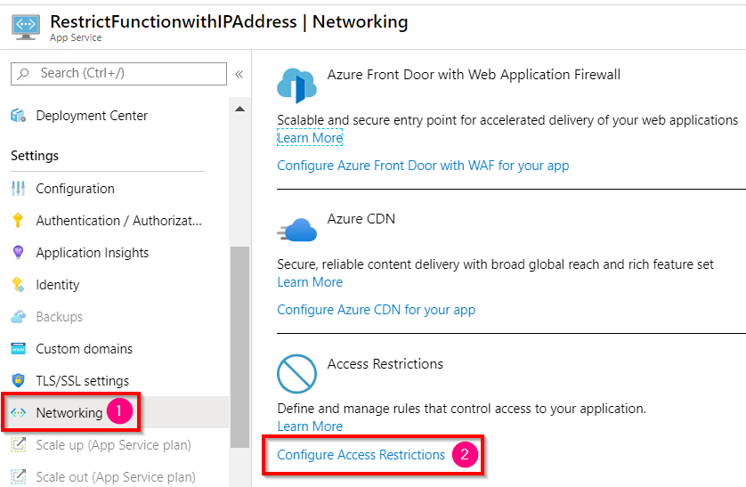

Figure 9.47: Azure Functions—Networking blade—Configure Access Restrictions
2. In the Access Restrictions blade, we can see a preconfigured rule that allows
anyone to access the function app by default:
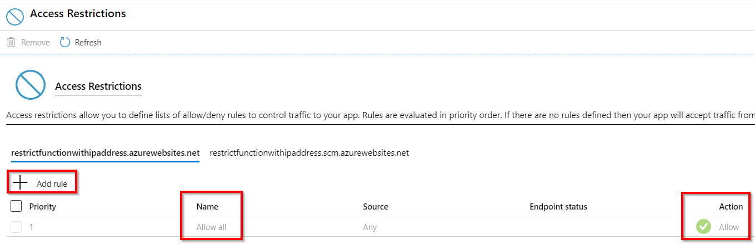

Figure 9.48: Azure Functions—Access Restrictions
Configuring additional security using IP whitelisting | 311

3. Now create a new rule by clicking on the Add rule button to whitelist an IP
address, as shown in Figure 9.49:
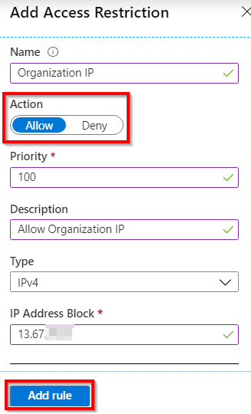

Figure 9.49: Creating a new Access Restriction rule
4. Provide a name, toggle the Action button to Allow to allow access (likewise,
Deny is used to deny access), and then provide an IP address in the IP Address
Block field. After reviewing all the required details, click the Add rule button, as
highlighted in Figure 9.49.
5. As soon as a rule is created, it will be added to the list of rules, as shown in
Figure 9.50:
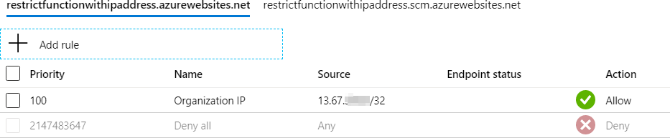

Figure 9.50: Azure Functions—list of access restrictions
6. Notice that the default Allow all rule has become a Deny all rule. This Deny all
rule will restrict access to all other IP addresses except the IP that you have
whitelisted using the Allow rule.
312 | Configuring security for Azure Functions

7. Now try to access the HTTP trigger that you created from the whitelisted IP. As
shown in Figure 9.51, you will be able to access it:

Figure 9.51: Azure Functions—testing the HTTP trigger using the browser
8. Now try it with another server that is not whitelisted. You should get an error, as
shown in Figure 9.52:
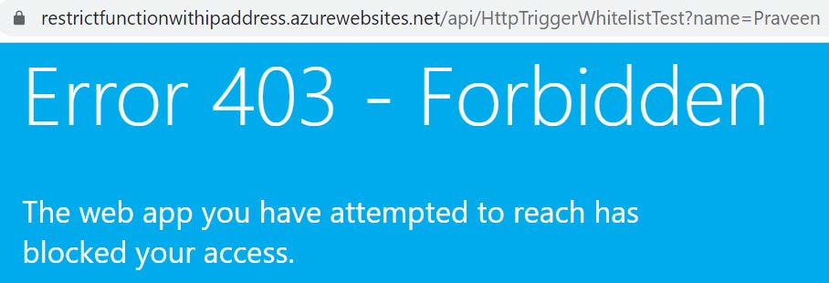

Figure 9.52: 403 forbidden error when accessing the HTTP trigger from a blocked IP

There's more
The following is some additional information regarding access restrictions:
• If you don't have any other server to test the functionality, then set the rule to
Deny, instead of Allow, as shown in Figure 9.53:
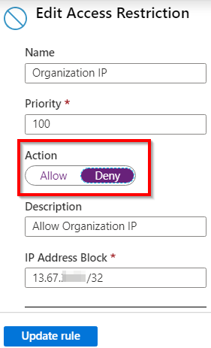

Figure 9.53: Azure Functions—Edit Access Restriction
Configuring additional security using IP whitelisting | 313

• If you need an Azure App Service (hosted on Azure) to consume an HTTP trigger
with access restrictions enabled, then whitelist all the outbound IP addresses of
that App Service. To get the outbound IP addresses of the App Service, refer to
Figure 9.54:
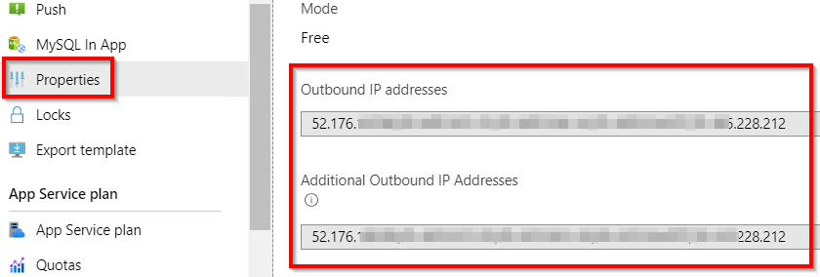

Figure 9.54: Azure App Service—Outbound IP addresses
In this recipe, you have learned how to restrict access to Azure functions and only whitelist certain IPs (such as your organization's IP addresses).
In this chapter, you have learned various ways of securing Azure functions, including:
• Securing individual HTTP triggers using authorization levels.
• Securing an entire function app using IP restrictions.
• Securing a function app based on users by using Azure Active Directory
authentication.
• Allowing a function to securely access databases using managed identities.

Depending on the real-time scenarios in your projects, you can use any of the preceding techniques to improve the security of your applications.

Implementing best

practices for Azure

Functions

In this chapter, we'll learn some of the best practices that can be followed while working with Azure functions, such as the following:
• Adding multiple messages to a queue using the IAsyncCollector function
• Implementing defensive applications using Azure functions and queue triggers
• Avoiding cold starts by warming the app at regular intervals
• Sharing code across Azure functions using class libraries
• Migrating C# console application to Azure functions using PowerShell
• Implementing feature flags in Azure functions using the App Configuration service 316 | Implementing best practices for Azure Functions

Introduction
This chapter covers some of the most important and common best practices that are followed in cloud-native applications. Along with the best practices, you will also understand how to overcome some of the limitations of Azure functions. Furthermore, you will learn how to migrate jobs from on-premises to serverless environments.

Adding multiple messages to a queue using the IAsyncCollector
function
In the Saving profile picture paths to queues using queue output bindings recipe of Chapter 1, Accelerating cloud app development using Azure Functions, you learned how to create a queue message for each request coming from the HTTP request. Now let's assume that each user is registering their devices using client applications (such as desktop apps, mobile apps, or any client websites) that can send multiple records in a single request. In these cases, the back-end application should be smart enough to handle the oncoming load; there should be a mechanism to create multiple queue messages at once and asynchronously. You will learn how to create multiple queue messages using the IAsyncCollector interface.
Let's look at a diagram that depicts the data flow from different client applications to the Back-End Web API.
At a given point of time, as shown in Figure 10.1:
• iOS App sends two messages.
• Android App sends three messages.
• Website sends four messages.

Each client app is sending multiple messages to the HTTP trigger, which could send all nine messages to Azure Queue Storage in a single call asynchronously:

iOS App
2 Devices

Android Back-end Web Azure Queue 3 Devices API 9 Queue Messages Storage App (HTTP Trigger)
4 Devices
Website

Figure 10.1: IAsyncCollector collector usage—process flow
Adding multiple messages to a queue using the IAsyncCollector function | 317

In this recipe, we'll simulate the requests using Postman, which will send the requests to the Back-End Web API (HTTP Trigger), which can create all the queue messages at once.

Getting ready
Before starting the recipe, please have the following ready to move further:
• Create a storage account using the Azure portal if you have not created one yet.
• Install Microsoft Storage Explorer from http://storageexplorer.com/ if you have
not installed it yet.

How to do it...
In this section, we'll perform the following steps to create multiple messages to the queue asynchronously using the IAsyncCollector interface:
1. Create a new HTTP trigger named BulkDeviceRegistrations by setting
Authorization Level to Anonymous.
2. Replace the default code with the following code and click on the Save button to
save the changes. The following code expects a JSON array as an input parameter
with an attribute named devices. If found, it will iterate through the array items
and then display them in the logs. Later in this recipe, we'll modify the program to
bulk insert the array elements into the queue message:
#r "Newtonsoft.Json"
using System.Net;
using Microsoft.AspNetCore.Mvc;
using Microsoft.Extensions.Primitives;
using Newtonsoft.Json;
public static async Task Run(HttpRequest req, ILogger log ) {
log.LogInformation("C# HTTP trigger function processed a request."); string requestBody = await new StreamReader(req.Body).ReadToEndAsync(); dynamic data = JsonConvert.DeserializeObject(requestBody); string Device = string.Empty;
for(int nIndex=0;nIndex
Device = Convert.ToString(data.devices[nIndex]); log. LogInformation("devices data" + Device);
}
return (ActionResult)new OkObjectResult("Program has been executed Successfully.");
}
318 | Implementing best practices for Azure Functions

3. The next step is to create an Azure Queue Storage output binding. Click on the
Save button, navigate to the Integrate tab, click on the New Output button, choose the Azure Queue Storage output binding, and click on the Select button as shown in Figure 10.2:
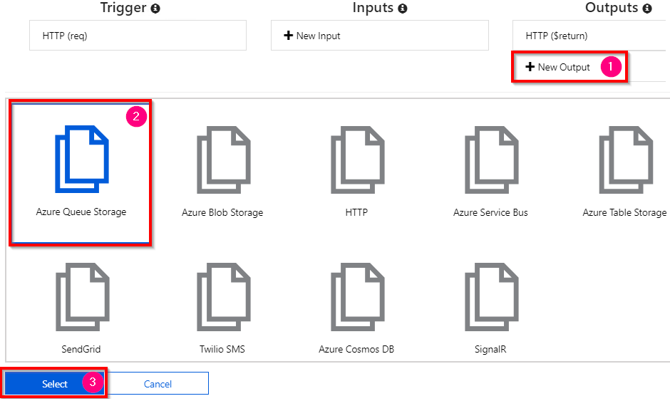

Figure 10.2: Creating a new Azure Queue Storage output binding
4. In the Azure Queue Storage output step, provide the values for Message
parameter name and Queue name, and then choose the storage account in the Storage account connection dropdown, as shown in Figure 10.3. Click on the Save button to save the changes:
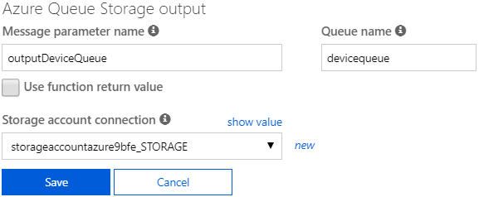

Figure 10.3: Azure Queue Storage output binding configuration
Adding multiple messages to a queue using the IAsyncCollector function | 319

5. Click on the Save button and navigate to the code editor of the Azure function.
Add the additional code required for the output binding with the queue to save the
messages, as shown in the following code. Make the highlighted changes in the
code editor and click on the Save button to save the changes:

public static async Task Run(HttpRequest req, ILogger log, IAsyncCollector outputDeviceQueue )
{
....
....
for(int nIndex=0;nIndex
Device = Convert.ToString(data.devices[nIndex]); outputDeviceQueue. AddAsync(Device);
}
....
....
6. Let's run the function from the Test tab of the portal with the following input
request JSON:

{
"devices":
[
{
"type": "laptop",
"brand":"lenovo",
"model":"T440"
},
{
"type": "mobile",
"brand":"Mi",
"model":"Red Mi 4"
}
]
}
320 | Implementing best practices for Azure Functions

7. Click on the Run button to test the functionality. Now open Azure Storage
Explorer and navigate to the queue named devicequeue. As shown in Figure 10.4, we should see two records:
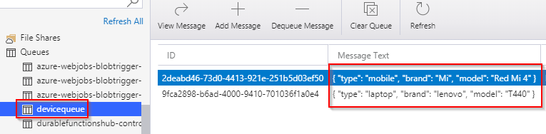

Figure 10.4: Device queue output
In this section, we have learned how to add messages to Azure Queue storage. Let's move on to the next section.

There's more...
You can also use the ICollector interface in place of IAsyncCollector if you would like to store multiple messages synchronously. These two interfaces contain the methods that can accept a collection of messages and can create them as queue messages into the queue.
In this recipe, we created a new HTTP function that has a parameter of the IAsyncCollector<string> type, which can be used to store multiple messages in a queue service at once and asynchronously. This approach of storing multiple items asynchronously will reduce the load on the instances.
Finally, we tested the invocation of the HTTP trigger from the Azure portal and also saw the queue messages being added using Azure Storage Explorer.
Let's move on to the next recipe to understand how to implement defensive applications using Azure functions.

Implementing defensive applications using Azure functions and
queue triggers
For many applications, even after performing multiple tests of different environments, there might still be unforeseen reasons that an application might fail. Developers and architects cannot predict all unexpected inputs throughout the lifespan of an application being used by business users or general users. So, it's good practice to make sure that your application alerts you if there are any errors or unexpected issues with the application.
Implementing defensive applications using Azure functions and queue triggers | 321

In this recipe, we'll learn how Azure functions help us handle (and receive alerts about) errors with minimal code.

Getting ready
Before starting the recipe, please make sure you have done the following:
• Create a storage account using the Azure portal if you have not created one.
• Install Azure Storage Explorer from http://storageexplorer.com/ if you have not
installed it yet.

How to do it…
In this section, we'll perform the following steps:
1. Develop a console application using C# that connects to the storage account and
creates queue messages in the queue named myqueuemessages.
2. Create an Azure function queue trigger named ProcessData that is fired whenever
a new message is added to the queue named myqueuemessages.
CreateQueueMessage—C# console application Perform the following steps to create messages in the queue using the console application:
1. Create a new console application using the .NET Core C# language and create
an app setting key named StorageConnectionString with your storage account
connection string. You can get the connection string from the Access keys blade
of the storage account.
2. Install the Configuration and Queue Storage NuGet packages using the following
commands:
Install-Package Microsoft.Azure.Storage.Queue Install-Package System.Configuration.ConfigurationManager Install-Package Microsoft.Extensions.Configuration Install-Package Microsoft.Extensions.Configuration.Json
3. Add the following namespaces to the program.cs file:
using Microsoft.Azure.Storage;
using Microsoft.Azure.Storage.Queue;
using System.Configuration;
using Microsoft.Extensions.Configuration;
using System.IO;
322 | Implementing best practices for Azure Functions

4. Add the following function to your console application and call it from the Main
method. The CreateQueueMessages function creates 100 messages with the index as the content of each message:
static void CreateQueueMessages()
{
var builder = new ConfigurationBuilder()
.SetBasePath(Directory.GetCurrentDirectory()).
AddJsonFile("appsettings.json", optional: true, reloadOnChange: true);
IConfigurationRoot configuration = builder.Build();
CloudStorageAccount storageAccount =
CloudStorageAccount.Parse(configuration.
GetConnectionString("StorageConnectionString") );
CloudQueueClient queueclient =
storageAccount.CreateCloudQueueClient();

CloudQueue queue =queueclient.GetQueueReference
("myqueuemessages");
queue.CreateIfNotExists();

CloudQueueMessage message = null;
for(int nQueueMessageIndex = 0; nQueueMessageIndex <=
100; nQueueMessageIndex++)
{

message = new CloudQueueMessage(Convert.ToString
(nQueueMessageIndex));
queue.AddMessage(message);
Console.WriteLine(nQueueMessageIndex);
}
}
We are done with the console application that creates the messages. We'll move on to the next section.
Implementing defensive applications using Azure functions and queue triggers | 323

Developing the Azure function—queue trigger In this section, we'll learn how to develop a queue trigger to read the messages created in the previous section. Perform the following steps:
1. Create a new Azure function named ProcessData using the queue trigger template
and provide myqueuemessages as the Queue name. This is how the Integrate tab
should look after you have created the function:
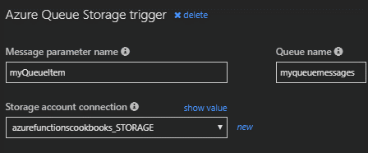

Figure 10.5: Azure Queue Storage output binding—configuration
2. Replace the default code with the following code:
using System;
public static void Run(string myQueueItem ILogger log) {
if(Convert.ToInt32(myQueueItem)>50)
{
throw new Exception(myQueueItem);
}
else
{
log.LogInformation($"C# Queue trigger function
processed: {myQueueItem}");
}
}
The preceding queue trigger logs a message with the content of the queue (it's just
a numerical index) for the first 50 messages and then throws an exception for all
the messages whose content is greater than 50.
Let's now run the console application that we built in the previous section.
324 | Implementing best practices for Azure Functions

Running tests using the CreateQueueMessage console application In this section, we'll test the functionality using the following steps:
1. Let's execute the console application by pressing Ctrl + F5, navigate to Azure
Storage Explorer, and view the queue contents.
2. In just a few moments, you should start viewing messages in the myqueuemessages
queue. Currently, both the Azure portal and Storage Explorer display the first 32 messages. You need to use the C# Storage SDK to view all the messages in the queue.

Note
Don't be surprised if the messages in myqueuemessage are vanishing. It's expected that as soon as a message is read successfully, the message is locked from the queue.

3. As shown here, you should also see a new (poison) queue named myqueuemessages-
poison (<OriginalQueuename>-Poison) with the 50 other queue messages in it. The Azure function runtime will automatically take care of creating a new queue and adding the messages that are not read properly by Azure Functions:
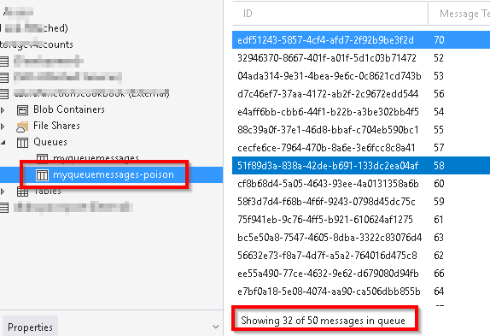

Figure 10.6: Storage Explorer—poison messages in Queue storage
Avoiding cold starts by warming the app at regular intervals | 325

So, in this section, we have learned that the Azure function runtime will ensure that unprocessed messages are automatically stored in the poison queue. It's the developer's responsibility to process messages from the poison queues as well.

There's more…
Before pushing a queue message to the poison queue, the Azure function runtime tries to pick the message and process it five times. You can learn about how this process works by adding a new dequecount parameter of the int type to the Run method and logging its value.
We have created a console application that creates messages in Azure Queue storage, and we have also developed a queue trigger that is capable of reading the messages in the queue. As part of simulating an unexpected error, we throw an error if the value in the queue message content is greater than 50.
Azure functions will take care of creating a new (poison) queue with the name <OriginalQueueName>-Poison and will insert all the unprocessed messages in the new queue. Using this new poison queue, developers can review the content of the messages and take the necessary actions to fix errors in their applications.

Note
The Azure function runtime will take care of deleting the queue message after the Azure function execution has completed successfully. If there are any problems in the execution of the Azure function, it automatically creates a new poison queue and adds the processed messages to the new queue.

In this recipe, we have learned how Azure Functions automatically understands if there are any errors while processing the queue messages. If there is any problem in processing the message, then it creates that message in the poison queue. Let's move on to the next recipe.

Avoiding cold starts by warming the app at regular intervals
By now, you might be aware of the fact that you can create Azure functions in the following three hosting plans:
• App Service plan
• Consumption plan
• Premium plan
326 | Implementing best practices for Azure Functions

One of the benefits of being serverless is the fact that you are charged based on the number of executions. This benefit is available only when you create the function app using the Consumption plan. However, one of the concerns that developers report about using the Consumption plan is something called cold starting, which refers to spinning up an Azure function to serve requests when there have been no requests for quite some time. To learn more about this topic, go to azure.microsoft.com/blog/
understanding-serverless-cold-start/?ref=msdn.

Note
The Premium plan and App Service plan have a dedicated instance reserved for us and they can always be warm even if there are no requests for quite a while. Having a dedicated instance always running can be expensive at times.

In this recipe, we'll learn a technique that can be used to always keep your instance live and warm so that all requests are served properly.

Getting ready
In order to complete this recipe, we need to have a function app with the following:
• An HTTP trigger named HttpAlive
• A timer trigger named KeepFunctionAppWarm that runs every five minutes and
makes an HTTP request to the HttpAlive HTTP trigger

If we have clearly understood what a cold start is, then it will be clear that there will be no concerns if our application has traffic regularly during the day. So, if we can ensure that our application has traffic all day, then the Azure Functions instance will not be deprovisioned and so there won't be any concerns about the Consumption plan.

How to do it...
In this recipe, we'll create a timer trigger that simulates traffic to the HTTP trigger, causing the function app to be alive all the time and the serverless instances to always be in the provisioned state.

Avoiding cold starts by warming the app at regular intervals | 327

Creating an HTTP trigger
Create a new HTTP trigger named HttpAlive and replace the default code with the following code, which just prints a message when it is executed:
using System.Net;
using Microsoft.AspNetCore.Mvc;
public static async Task Run(HttpRequest req, ILogger log)
{
return (ActionResult)new OkObjectResult($"Hello User! Thanks for keeping
me Warm");
}
We have created a simple HTTP trigger. Let's move on to the next section to create a timer trigger.
Creating a timer trigger
Create a timer trigger named KeepFunctionAppWarm that runs every five minutes and makes an HTTP request to the HttpAlive HTTP trigger by performing the following steps:
1. Click on the + icon, search for timer, and click on the Timer trigger button.
2. In the New function popup, provide the details. The Schedule here is a CRON
expression that ensures that the timer trigger gets triggered automatically every
five minutes.
3. Paste the following code in the code editor and save the changes. The following
code simulates traffic by making HTTP requests programmatically. Be sure to
replace <<FunctionAppName>> with the actual name of your function app:
using System;
public async static void Run(TimerInfo myTimer, ILogger log) {
using (var httpClient = new HttpClient())
{
var response = await httpClient.GetAsync("https ://>.azurewebsites.net/api/HttpALive"); }
}
In this recipe, we have learned how to overcome the cold-starts limitation of Azure functions. Let's move on to the next recipe to learn how to share code across the Azure functions.
328 | Implementing best practices for Azure Functions

Sharing code across Azure functions using class libraries
Let's say that we have developed a common library across various applications being used in our project, such as a web app or a Windows Presentation Foundation (WPF) application, and now we would like to re-use some functionality in an Azure function app. It's definitely possible to re-use it. In this recipe, we'll develop and create a new .dll file and we'll learn how to use the classes and their methods in Azure functions.

How to do it…
Let's create a class library by performing the following steps:
1. Create a new Class Library application using Visual Studio as shown in Figure 10.7:
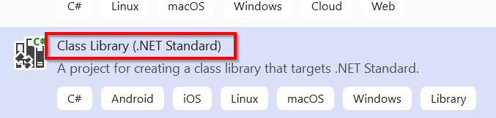

Figure 10.7: Visual Studio—creating a class library project
2. Create a new class named Helper and paste the following code in the new class file:
namespace Utilities
{
public class Helper
{
public static string GetReusableFunctionOutput()
{
return "This is an output from a Reusuable Library across
functions";
}
}
}
Sharing code across Azure functions using class libraries | 329

3. Change Build Configuration to Release and build the application to create the
.dll file, which will be used in our Azure functions.
4. Navigate to the App Service Editor of the function app (in which you would like
to use the library) by clicking on the App Service Editor button, which is available
under the Development tools section of the Platform Features tab.
5. Now create a new bin folder by right-clicking in the empty area below the files
located in WWWROOT.
6. After clicking on the New Folder item in the obtained screen, a new textbox will
appear, wherein we'll need to provide the name as bin.
7. Next, right-click on the bin folder and select the Upload Files option to upload the
.dll file that we created in Visual Studio.
8. This is how it looks after we upload the .dll file (in my case the .dll name was
Reusability.dll, which might change in your case depending on the name of the
project that you provide for the class library) to the bin folder:
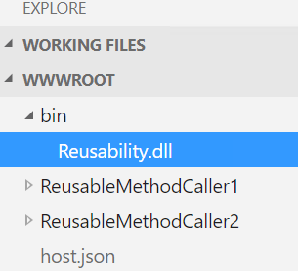

Figure 10.8: Azure Function app—App Service editor
330 | Implementing best practices for Azure Functions

9. Navigate to the Azure function in which you would like to use the shared method.
To demonstrate, I have created two Azure functions (one HTTP trigger and one timer trigger):
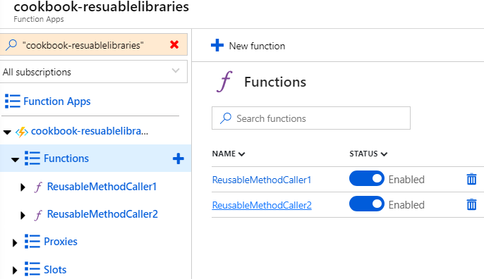

Figure 10.9: Function app—Functions list
10. Let's navigate to the ReusableMethodCaller1 function and make the following
changes.
Add a new #r directive, as follows, to the run.csx method of the ReusableMethodCaller1 Azure function. Note that .dll is required in this case:
#r "../bin/Reusability.dll"
Add a new namespace, as follows:
using Utilities;
Sharing code across Azure functions using class libraries | 331

11. We are now ready to use the GetReusableFunctionOutput shared method in our
Azure function. Now replace the code of the HTTP trigger with the following:
#r "../bin/Reusability.dll"
using Utilities;
public static async Task Run(HttpRequest req, ILogger log) {
log.LogInformation(Helper.GetReusableFunctionOutput());
}
12. When you run the application, you should see the following message in the logs:
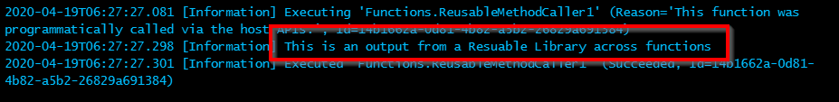

Figure 10.10: Azure Functions—console logs
13. Repeat the same steps of adding the reference and the namespace of the utilities
library for the second Azure function, ReusableMethodCaller2. If you have made the
changes successfully, you should see something like what follows:
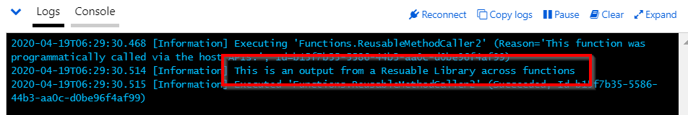

Figure 10.11: Azure functions—console logs
We have learned how to create and consume a reusable class library in Azure functions.

There's more…
If you would like to use the shared code only in one function, then you would need to add the bin folder along with the .ddl file in the required Azure function folder.

Note
Another major advantage of using class libraries is that it improves performance, as they are already compiled and ready for execution.
332 | Implementing best practices for Azure Functions

We have created a .dll file that contains reusable code and can be used in any Azure function that requires the functionality made available by the .dll file.
Once the .dll file was ready, we created a bin folder in the function app and added the .dll file to the bin folder.

Note
We have added the bin folder to the WWWROOT so that it is available to all the Azure Functions available in the function app.

In this recipe, we have learned how to reuse an existing component in our Azure Functions. Let's move on to the next recipe.

Migrating C# console application to Azure functions using
PowerShell
Currently, many business applications are being hosted in private clouds or on-premises datacenters. Some of them have started migrating their applications to Azure using various methods.
The following are just a few methods for quick migration to Azure:
• Lift and shift the legacy application to the Infrastructure as a Service (IaaS)
environment: This method should be straightforward, as you have complete control over the virtual machines that you create. You could host all your web applications, schedulers, databases, and so on without making any changes to your application code. You can even install any third-party software or libraries. Though this option provides full control for your application, it would be expensive in most cases as the background application might not be running all the time.
• Convert legacy applications to a Platform as a Service (PaaS)–compatible
environment: This method could be complex, depending on how many dependencies your applications have on other third-party libraries that are not compatible with the Azure PaaS environment. You would need to make code changes to your applications so that they are stateless and are not dependent on any of the resources of the instances where they are hosted. This option is very cost-effective as you just need to pay for the execution time of your applications.

In this recipe, we'll look at one of the easiest ways of migrating our existing background job applications developed using C# classes and console applications without making many changes to the existing application code.
Migrating C# console application to Azure functions using PowerShell | 333

Getting ready
The code provided in the recipe works well with any of the previous versions of Visual Studio. Let's use the latest version of Visual Studio 2019.

How to do it…
In this recipe, we'll do the following to migrate an existing background job to Azure Functions timer triggers using PowerShell:
• Create a .NET Framework–based application to simulate a background job.
• Create a timer trigger to execute the console application on a certain frequency.

Let's start with the development of the console application.
Developing a console application
In this section, we'll create a background job using a console application. Let's follow these steps:
1. Create a new .NET Framework console application and name it BackgroundJob
using Visual Studio.
2. In the BackgroundJob project, create a new class called UserRegistration and
replace the default code with the following code:
using System;
namespace BackgroundJob
{
class UserRegistration
{
public static void RegisterUser()
{
Console.WriteLine("Register User method of
UserRegistration has been called.");
}
}
}

334 | Implementing best practices for Azure Functions

3. Create a new class called OrderProcessing and replace the default code with the
following code:
using System;
namespace BackgroundJob
{
class OrderProcessing
{
public static void ProcessOrder()
{
Console.WriteLine("Process Order method of
OrderProcessing class has been called");
}
}
}
4. In the Program.cs file, replace the existing code with the following code:
using System;
namespace BackgroundJob
{
class Program
{
static void Main(string[] args)
{
Console.WriteLine("Main method execution has
been started");
Console.WriteLine
("======================================");
UserRegistration.RegisterUser();
OrderProcessing.ProcessOrder();
Console.WriteLine
("======================================");
Console.WriteLine("Main method execution
has been completed");
}
}
}
Build the application to create the .exe file. You can configure it to run in either debug or release mode. It is recommended that you deploy the .exe file in the release mode in your production environments. In this section, we have created a console application. Let's move on to the next section:
Migrating C# console application to Azure functions using PowerShell | 335

1. Create a new function app using Power Shell 6 by choosing Power Shell Core
in the Runtime stack dropdown while creating the function app, as shown in
Figure 10.12:
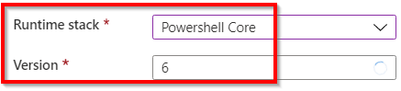

Figure 10.12: Azure Function app—runtime stack and PowerShell version
2. Once the function app is created, navigate to the Functions blade and click on
Add, as shown in Figure 10.13:
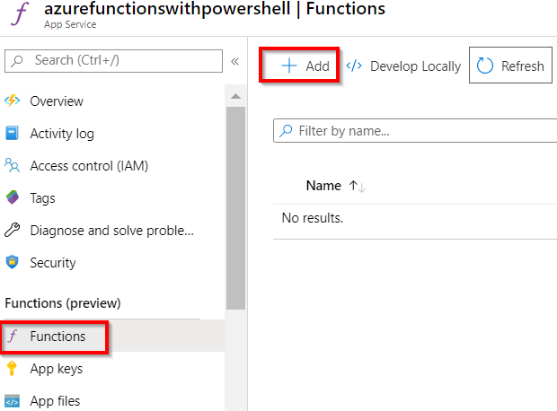

Figure 10.13: Adding a new Azure function 336 | Implementing best practices for Azure Functions

3. In the New function blade, choose the Timer trigger template, as shown in
Figure 10.14:
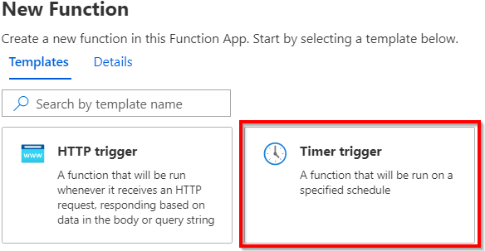

Figure 10.14: Selecting the Timer trigger template
4. In the Details view, provide the name and the schedule and click on Create
function, as shown in Figure 10.15, to create the timer trigger function:
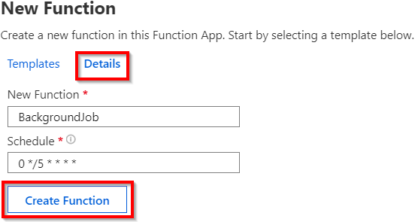

Figure 10.15: Providing Azure timer trigger details
Migrating C# console application to Azure functions using PowerShell | 337

5. Now, we need to upload the console application executable files to Azure function
timer trigger. We can upload using the App Service Editor. Click on the App
Service Editor, as shown in Figure 10.16:
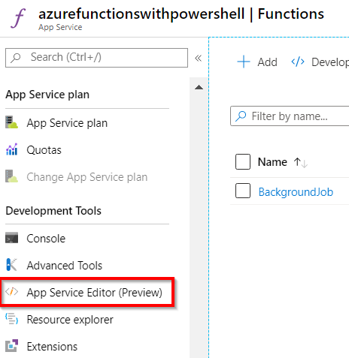

Figure 10.16: Azure Functions—App Service Editor
6. Clicking on the Go button on the next page will open up a new browser tab where
you can see the App Service Editor. As shown in Figure 10.17, right-click on the
BackgroundJob folder and create a New Folder named bin:
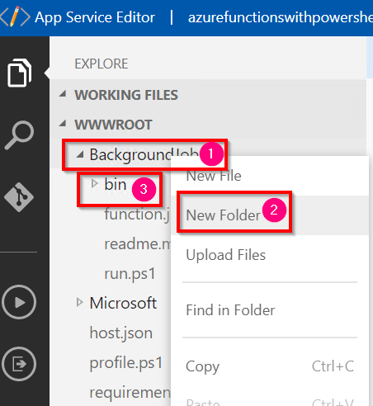

Figure 10.17: Azure Functions—App Service Editor—New Folder 338 | Implementing best practices for Azure Functions

7. Now, let's upload the .exe file along with any other dependencies, if any. In this
recipe, we just have the .exe file, as shown in Figure 10.18:
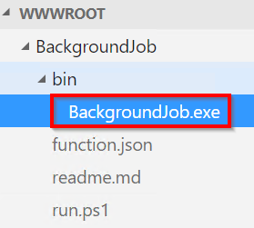

Figure 10.18: Azure Functions—App Service Editor—uploading the .exe file
8. Let's navigate to the timer trigger's Code / Test window and add the code to
invoke the BackgroundJob.exe, as shown in Figure 10.19. In the following code, we are first setting the path of the executable folder and then running the .exe file:
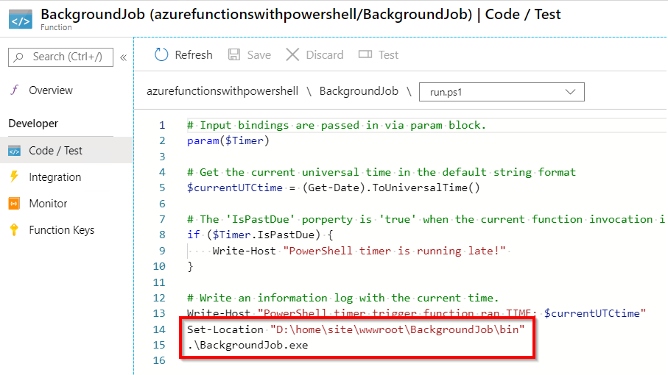

Figure 10.19: Azure Functions—invoking .exe using PowerShell
Implementing feature flags in Azure functions using App Configuration | 339

9. That's it. From now on, the timer trigger runs every five minutes. Figure 10.20
shows the output of one of its executions:
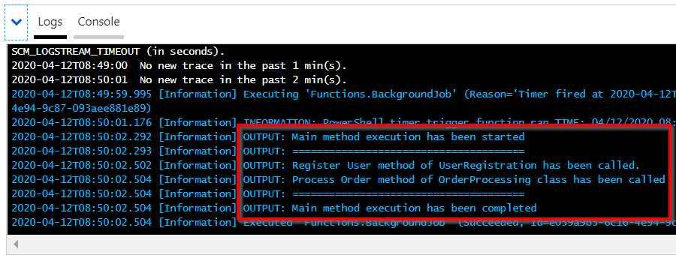

Figure 10.20: Azure Functions—console logs
In this recipe, we have learned how to migrate a .NET Framework–based console application to Azure Functions using timer triggers that run every five minutes.

Implementing feature flags in Azure functions using App
Configuration
Usually, when we are working on enterprise projects, we are working on multiple large applications where we have individual app settings stores for every application. The app settings would be either specific to an application or common across all applications.
For example, if we have one database that is used by multiple applications, then we have to have the same connection string in each of those applications. If we have to change something (such as a password) in the connection string, we would need to change it in all the configurations of all the projects.
In order to solve this problem, Azure provides a service called App Configuration, which can be used to externalize configuration items. When we take configurations out of the scope of the individual project, we can use them in multiple applications.
In this recipe, we'll learn how to do the following:
• Externalize app configurations.
• Manage functionality dynamically without code deployment.
340 | Implementing best practices for Azure Functions

Getting ready
Please create an Azure function app if you have not yet done so.

How to do it…
In this recipe, we'll do the following:
• Create the App Configuration service.
• Create a configuration key and feature management keys.
• Develop an Azure function HTTP trigger to control the application features using
feature flags.

Let's start creating the App Configuration service.
Create the App Configuration service
In this section, we'll create the App Configuration service to externalize our application configurations to reduce the downtime required and also have a one-stop solution to store all the common settings related to multiple applications. Please follow these steps:
1. Navigate to the Azure portal, click on Create a resource, search for App
Configuration, and click on the Create button, as shown in Figure 10.21:
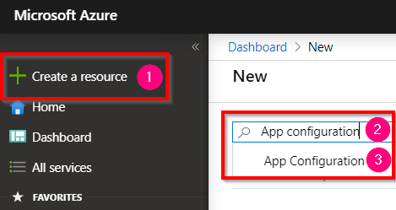

Figure 10.21: Searching for App Configuration
Implementing feature flags in Azure functions using App Configuration | 341

2. In the App Configuration blade, provide a name, choose a Pricing tier, and click
on the Create button, as shown in Figure 10.22:
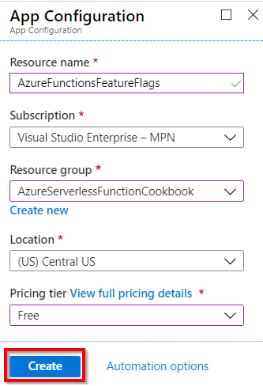

Figure 10.22: Creating a new App Configuration
3. Clicking on the Create button will create a new App Configuration service as
shown in Figure 10.23:
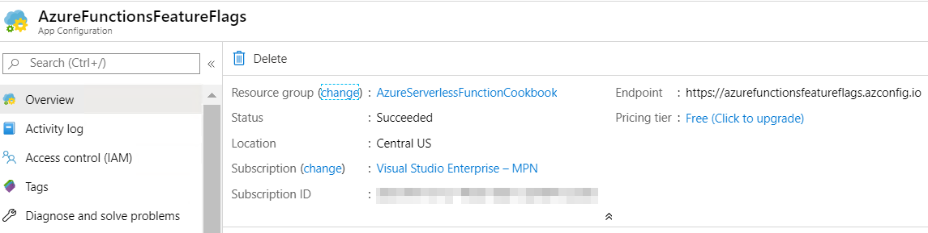

Figure 10.23: App Configuration—Overview blade
We have created the App Configuration service. In the next section, we'll learn about creating the configuration key (a key-value pair) and feature management keys.
342 | Implementing best practices for Azure Functions

Creating a configuration key and feature management keys In this section, we'll create a key-value pair using Configuration explorer and also create feature flags:
1. Navigate to the Configuration explorer blade and click on the Key-value button,
which is available under the Create button, as shown in Figure 10.24:
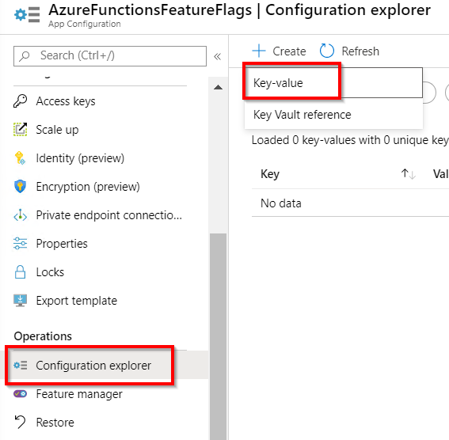

Figure 10.24: App Configuration—Configuration explorer
Implementing feature flags in Azure functions using App Configuration | 343

2. Clicking on Key-value will open up a new blade where you can create a key-value
pair, as shown in Figure 10.25:
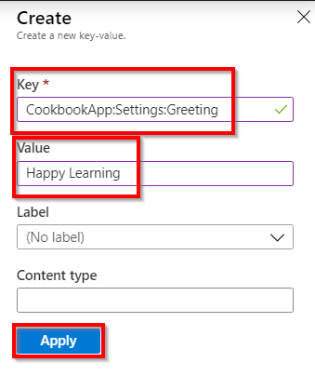

Figure 10.25: App Configuration—creating a new key-value pair
3. When you click on Apply in Figure 10.25, a key-value pair will be created, as shown
in Figure 10.26:
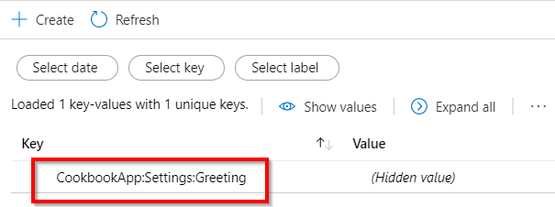

Figure 10.26: App Configuration—list of key-value pairs
344 | Implementing best practices for Azure Functions

4. Navigate to the Feature manager blade and click on Add, as shown in Figure 10.27:
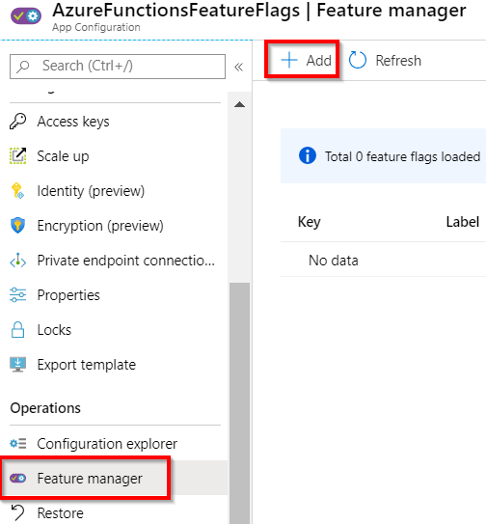

Figure 10.27: App Configuration—Feature manager
5. That opens up a blade where you can add a new feature flag. Select On and
provide a key, as shown in Figure 10.28:
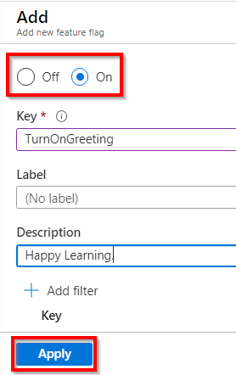

Figure 10.28: App Configuration—Feature manager—adding a new feature flag
Implementing feature flags in Azure functions using App Configuration | 345

6. Once you click on Apply in Figure 10.28, it will create a feature flag as shown in
Figure 10.29:
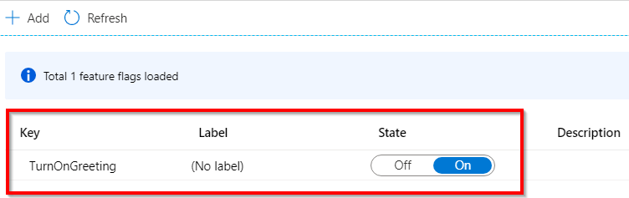

Figure 10.29: App Configuration—Feature manager —list of feature flags
7. Note that the feature flags are also configuration items. So, the TurnOnGreeting
feature flag is also shown in the Configuration explorer, as shown in Figure 10.30:
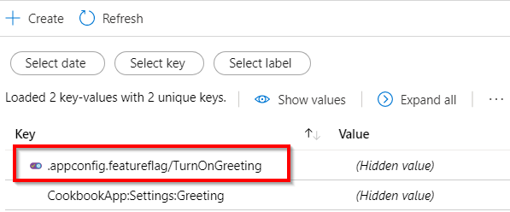

Figure 10.30: App Configuration—list of configurations
In this section, we have created configuration keys and feature flags. Let's move on to the next section.
Developing an Azure function HTTP trigger to control the application features using feature flags In this section, we'll develop an Azure function HTTP trigger and learn how to use these configuration keys and feature flags.
In this section, we'll do the following:
1. Develop the HTTP trigger.
2. Load the feature flags and key-value pairs from App Configuration using Startup.
3. Inject the feature flags and key-value pairs using dependency injection.
4. Access the feature flags and key-value pairs in the HTTP trigger.
346 | Implementing best practices for Azure Functions

Developing the HTTP trigger
In this section, we'll develop a function app named FeatureFlags, create an HTTP trigger, and configure the connection string of the App Configuration service:
1. Open Visual Studio and create an HTTP trigger with the name DisplayGreeting.
Please make the class non-static as we will be passing parameters to it later.
2. Install the following NuGet packages:
Install-Package Microsoft.Extensions.Configuration.AzureAppConfiguration Install-Package Microsoft.FeatureManagement
Install-Package Microsoft.Azure.Functions.Extensions
3. Navigate to App Configuration and copy the Connection string from the Read-
only keys tab available in the Access keys blade, as shown in Figure 10.31:
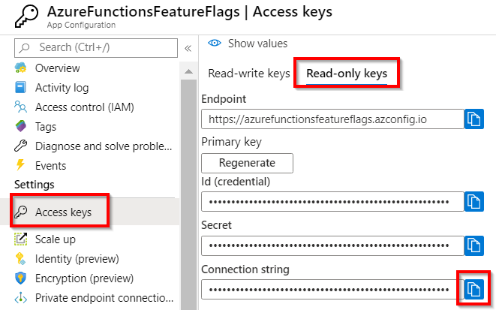

Figure 10.31: App Configuration—read-only access keys
4. Open the local.settings.json configuration file, create a connection string
named AppConfigurationConnectionString, and paste the connection string. Once you configure the connection string, it should look something like Figure 10.32:
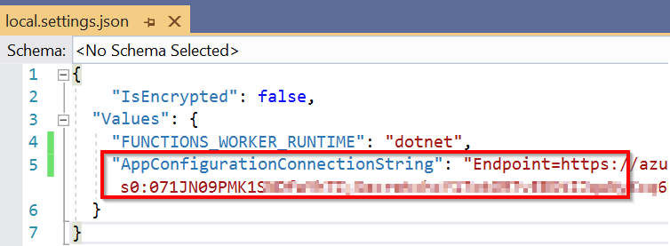

Figure 10.32: Visual Studio—local configuration file—creating the App Configuration connection string
Implementing feature flags in Azure functions using App Configuration | 347

Let's move on to the next section to develop the Startup class, which can be used to load the configurations.
Loading feature flags and key-value pairs from App Configuration using Startup In this section, we'll develop the Startup class, which is used to connect to the App Configuration service and load the configurations. You can learn more about it at docs.
microsoft.com/azure/azure-functions/functions-dotnet-dependency-injection:
1. Create a new class named Startup and replace the default code with the following
code. This code connects to the App Configuration service and loads both the
feature flags as well as the configuration key-value pairs:
using System;
using Microsoft.Azure.Functions.Extensions.DependencyInjection; using Microsoft.Extensions.Configuration;
using Microsoft.Extensions.DependencyInjection; using Microsoft.FeatureManagement;

[assembly: FunctionsStartup(typeof(FeatureFlags.Startup))]

namespace FeatureFlags
{
class Startup : FunctionsStartup
{
public override void Configure(IFunctionsHostBuilder builder)
{
ConfigurationBuilder configurationBuilder = new
ConfigurationBuilder();
configurationBuilder.AddAzureAppConfiguration(options =>
{
options.Connect(Environment.
GetEnvironmentVariable("AppConfigurationConnectionString"))
.UseFeatureFlags();
});

IConfiguration configuration = configurationBuilder.Build();
builder.Services.Configure(configuration.
GetSection("CookbookApp:Settings"));
builder.Services.AddFeatureManagement(configuration);
}
}
}
348 | Implementing best practices for Azure Functions

Note
In your projects, you might have multiple config items. You will need to create a separate property in this Settings class for each of the config items. It's called
the options pattern. Learn more about it at docs.microsoft.com/aspnet/core/
fundamentals/configuration/options?view=aspnetcore-3.1.

2. Add a new class named Settings and paste the following code. This class has only
one property, named Greeting, as we have only one key-value pair in our App Configuration.
namespace FeatureFlags
{
public class Settings
{
public string Greeting { get; set; }
}
}
We have developed the Startup class. Let's move on to the next section to inject the feature flags into the Azure function HTTP trigger.
Injecting the feature flags and key-value pairs using dependency injection In this section, we'll learn how to inject the feature flags and key-value configurations to the HTTP trigger so that we can use them in the HTTP trigger's code:
1. Create the following variables in the DisplayGreeting class that we have created:
private readonly IFeatureManagerSnapshot _featureManagerSnapshot; private readonly Settings _settings;
private readonly IConfiguration _configuration;
2. Add the following namespaces:
using Microsoft.FeatureManagement;
using Microsoft.Extensions.Configuration;
using Microsoft.Extensions.Options;

Implementing feature flags in Azure functions using App Configuration | 349

3. Add the constructor and inject the dependencies of FeatureManagement and
Configurations as follows:
public DisplayGreeting(IFeatureManagerSnapshot featureManagerSnapshot, IOptionsSnapshot settings, IConfiguration configuration)
{
_featureManagerSnapshot = featureManagerSnapshot;
_settings = settings.Value;
_configuration = configuration;
}
As we have configured everything, we can now go ahead and access the feature flags and the key-value pairs in the HTTP trigger. Let's move on to the next section to learn how to do that.
Accessing the feature flags and key-value pairs in the HTTP trigger
1. Please remove the Static keyword from the HTTP trigger definition.
2. In order to access the feature flag, add the following line of the code to get the
status of the flag named TurnOnGreeting:
bool featureEnabled = await _featureManagerSnapshot. IsEnabledAsync("TurnOnGreeting");
3. The next step is to retrieve the value of the key-value configuration named
Greeting. We can do so by accessing Settings as follows:
if (featureEnabled)
{
return new OkObjectResult($"Hello, {name}. {_settings.
Greeting}");
}
else
{
return new OkObjectResult($"Hello, {name}.");

}
The preceding code displays the greeting Happy Learning only if the feature flag is
turned on.
350 | Implementing best practices for Azure Functions

4. The following is the complete code of the HTTP trigger. Once we have verified the
code, we can execute the HTTP trigger:
[FunctionName("DisplayGreeting")]
public async Task Run(
[HttpTrigger(AuthorizationLevel.Anonymous, "get", "post",
Route = null)] HttpRequest req,
ILogger log)
{
log.LogInformation("C# HTTP trigger function processed a
request.");

string name = req.Query["name"];

string requestBody = await new StreamReader(req.Body).
ReadToEndAsync();
dynamic data = JsonConvert.DeserializeObject(requestBody);
name = name ?? data?.name;

bool featureEnabled = await _featureManagerSnapshot.
IsEnabledAsync("TurnOnGreeting");

if (featureEnabled)
{
return new OkObjectResult($"Hello, {name}. {_settings.
Greeting}");
}
else
{
return new OkObjectResult($"Hello, {name}.");

}
}
5. As shown in Figure 10.33, you will see the greeting Happy Learning as the feature
flag is turned on in App Configuration:
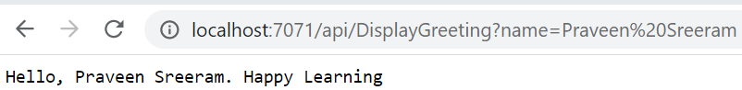

Figure 10.33: Azure Functions HTTP trigger—output when the feature flag is on
Implementing feature flags in Azure functions using App Configuration | 351

6. Let's say, for some reason, you would like to turn the flag off. To do so, you
navigate to App Configuration and set the feature flag to Off, as shown in
Figure 10.34:
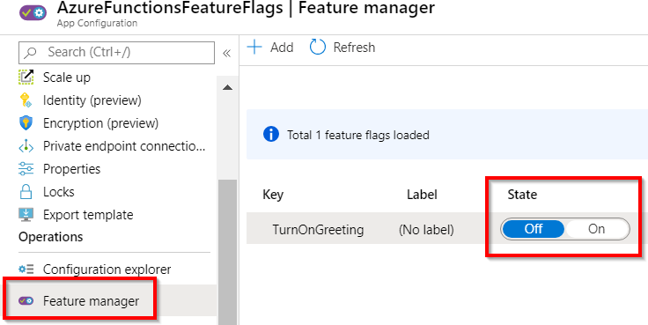

Figure 10.34: Azure Functions HTTP trigger—feature flag turned off
7. After turning it off, the next time you run and access the HTTP trigger, you will
not see the greeting, as shown in Figure 10.35:
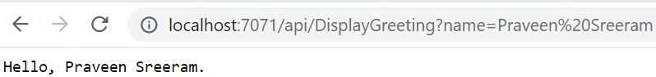

Figure 10.35: Azure Functions HTTP trigger—output when the feature flag is off
In this section, we have learned how to leverage feature flags in Azure functions.
In this recipe, we have used only one of the few services that App Configuration provides. We can also use App Configuration to externalize our application configurations to reduce the downtime required and have a one-stop solution to store all the common settings related to multiple applications that we might be working with. Here are some other features of App Configuration:
• We can compare configurations.
• We can import and export the keys from an existing configuration file easily.
• We can reload or refresh configuration changes.

Learn more about these features at docs.microsoft.com/azure/azure-app-
configuration/overview.
In this chapter, we have learned some of the best practices that help to improve the performance of our applications. We have also learned how to migrate the services from on-premises to Azure.
Configuring serverless

applications in

the production

environment

In order to learn how to deploy a function application efficiently and move configurations without making any mistakes, we will be covering the following recipes in this chapter:
• Deploying Azure functions using the Run From Package feature
• Deploying Azure functions using ARM templates
• Configuring a custom domain for Azure functions
• Accessing application settings
• Breaking down large APIs into smaller subsets using proxies
• Moving configuration items from one environment to another using resources 354 | Configuring serverless applications in the production environment

Introduction
After spending days (or months) developing the code for your serverless applications, you then need to deploy them to Azure so that other applications can access them.
As an architect or administrator, you may encounter various challenges (depending on the requirements) in deploying or promoting your function app's project files, dependencies, and related configurable items to various environments.
This chapter focuses on the configurations that we need to make in a non-development environment (such as staging, UAT, and production).

Deploying Azure functions using the Run From Package feature
We have been learning about different techniques for developing Azure functions and deploying them to the cloud.
As you may already know, each function app can have multiple functions hosted within it. All the code related to these functions is located in the D:\home\site\wwwroot folder. We'll use the Kudu app to view the binaries.
Kudu is an open-source application that lets us deploy binaries to an App Service, view the environment variables, and view processes running on the App Service's hosts. Navigate to Kudu with the URL https://<<yourfunctionappname>>.scm.azurewebsites. net.
In Figure 11.1, you can see all the binaries of the Kudu web app:
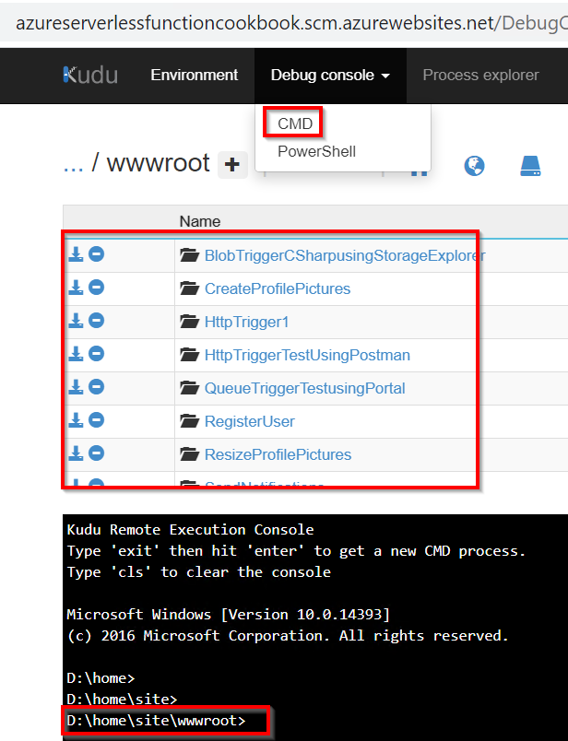

Figure 11.1: KUDU app—WWW root folder structure
Deploying Azure functions using the Run From Package feature | 355

D:\home\site\wwwroot is the location where the runtime would look for the binaries and all the configuration files that are required to execute the application.
In this recipe, we'll learn another new technique, called Run From Package (previously called Run From Zip) to deploy the Azure function as a package.
Using Run From Package, we can change the default location to an external storage account.
This Run From Package method definitely reduces the risk of file locks when copying files. Learn more about this method at https://docs.microsoft.com/azure/azure-
functions/run-functions-from-deployment-package.

Getting ready
Perform the following steps to get ready for this recipe:
1. Create one or more Azure functions using Visual Studio. For this example, I have
created one HTTP trigger and one timer trigger:
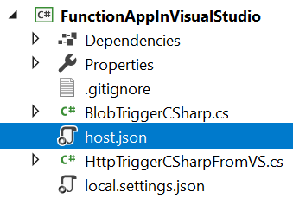

Figure 11.2: Visual Studio—function app solution explorer
2. Create an empty function app with .NET Core as the runtime stack using the
Azure portal:
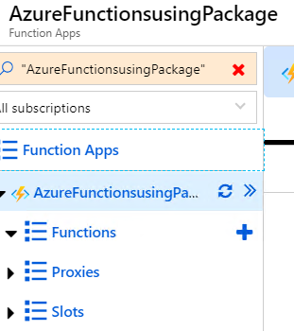

Figure 11.3: A new Azure function app in the portal 356 | Configuring serverless applications in the production environment

3. Create a new, or use an existing, storage account. This storage account will be
used to upload the package file.

How to do it...
Perform the following steps:
1. Create a package file for the application by clicking on Publish and choosing a
folder, as shown in Figure 11.4. We will make use of the same application that we created in Chapter 4, Developing Azure functions using Visual Studio:
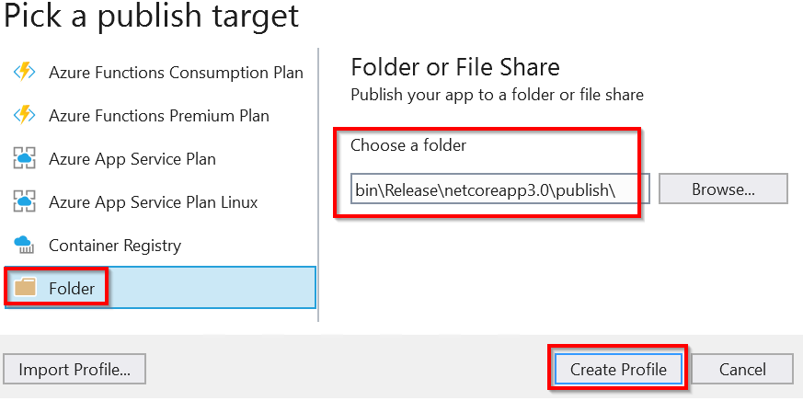

Figure 11.4: Visual Studio—picking a publish target
2. Navigate to the bin folder location that contains other files related to your
functions. Create a .zip file of the files, which is highlighted in Figure 11.5:
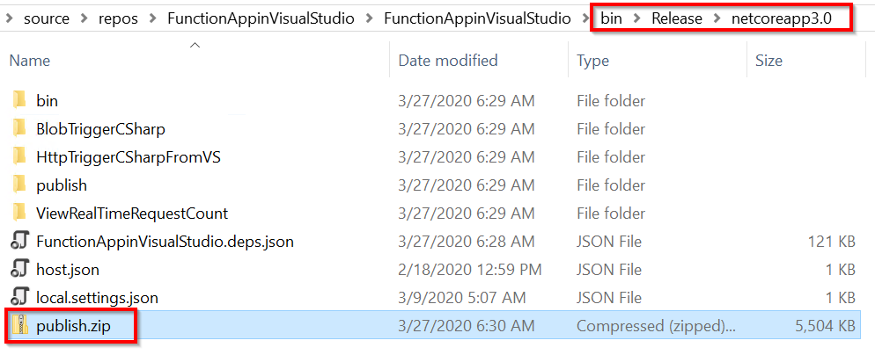

Figure 11.5: Windows Explorer—creating a .zip file from the binaries
Deploying Azure functions using the Run From Package feature | 357

3. Create a blob container (with private access) and upload the package file either
from the portal or by using Azure Storage Explorer.
4. The next step is to generate a shared access signature (SAS) token with read
permissions for the blob so that the Azure function runtime has the permission
required to access the files located in the container. You can generate an SAS
token by clicking on the Generate SAS button, as shown in Figure 11.6:
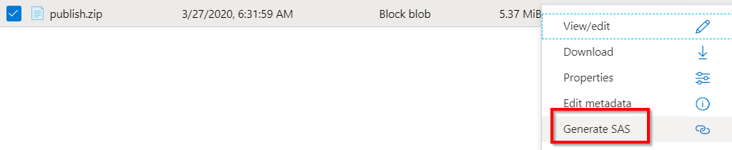

Figure 11.6: Storage blob—generating an SAS token
You can learn more about SAS at https://docs.microsoft.com/azure/storage/
common/storage-sas-overview.
5. Here is the generated URL along with the SAS token:

Figure 11.7: Storage blob—generated URL with an SAS token
6. Navigate to the Configuration pane's Application settings of the function app that
you created. Create a new app setting with the WEBSITE_RUN_FROM_PACKAGE key and
set the value to be the Blob SAS URL that you created in the previous step. Click
on Save to save the changes:

Figure 11.8: Package location in the app settings
7. That's it! After the preceding configuration, you can test the function:

Figure 11.9: HTTP trigger—output 358 | Configuring serverless applications in the production environment

How it works...
When the Azure function runtime finds an app setting with the name WEBSITE_RUN_ FROM_PACKAGE, it understands that it should look up the packages in the corresponding storage account. So, on the fly, the runtime downloads the files and uses them to launch the application.
In this recipe, we have learned how to deploy the Azure functions using Run From Package options. Let's now move on to the next recipe.

Deploying Azure functions using ARM templates
So far, we have been manually provisioning Azure functions using the Azure portal. Although it's easy to work with the portal, this approach has a number of disadvantages:
1. It is not easy to view the history of all the changes made to any service.
2. In large projects with hundreds of services, replicating the infrastructure across
new environments is not easy (in one of my engagements, we have more than 500 services). If customers ask to create a new environment (for instance, an Alpha environment), which should be similar to our production, then it might take weeks to create.

In order to resolve these challenges, it's a best practice to automate the process of infrastructure provisioning. Azure has a solution for this in the form of Azure Resource Manager (ARM) templates.
ARM templates are JSON-based files where you can define the resources that you want to be created. You can add these ARM templates to source control repositories (such as Git) so that multiple team members can collaborate using them and you can view the history of changes that you or your team has made.
In this recipe, we'll learn how to automate the process of provisioning Azure functions using ARM templates.

Getting ready
Before we start authoring the ARM templates, we need to understand the other Azure services upon which the Azure function depends. The following services are automatically created when we create a function app:
• App Service plan: This could either be a regular App Service plan or a
consumption plan.
• Storage account: An Azure function runtime uses a storage account to log
diagnostic information that we can use for troubleshooting.
Deploying Azure functions using ARM templates | 359

• Application Insights: An Application Insights account is optional. If we are not
using Application Insights, we need to create an application setting with the name
AzureWebJobsDashboard in the application settings of the function that uses the
Azure Table storage service to log diagnostic information.

Along with these services, we will obviously need to have a resource group. In this recipe, we'll assume that the resource group already exists.

How to do it…
By now, you know that while authoring Azure functions, we need to ensure that we also accommodate an App Service plan and a storage account. Let's begin by authoring the ARM template using Visual Studio:
1. Create a new project by choosing Azure and then Azure Resource Group:
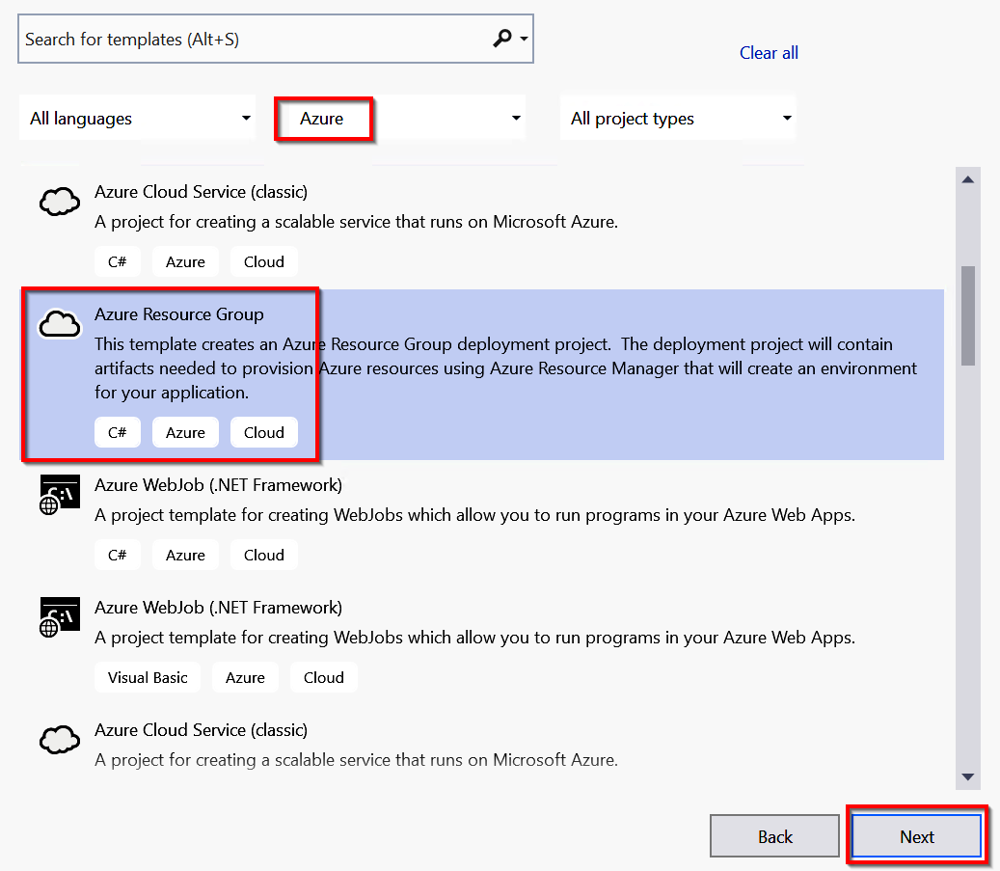

Figure 11.10: Visual Studio—creating a new Azure Resource Group project 360 | Configuring serverless applications in the production environment

2. Clicking on the Next button in the previous step will open up the Configure your
new project pane, where you can provide a name for your project. Provide a meaningful name for the project and click on the Create button to create it. In the Select Azure Template step, choose the Azure QuickStart (github.com/Azure/ azure-quickstart-templates) template:
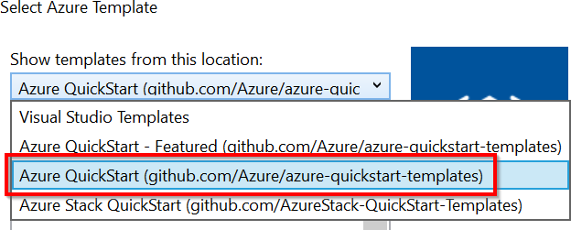

Figure 11.11: Visual Studio—selecting Azure Quickstart templates from GitHub
3. Search for the word function and click on the 101-function-app-create- dynamic
template to create the Azure function app with the consumption plan:
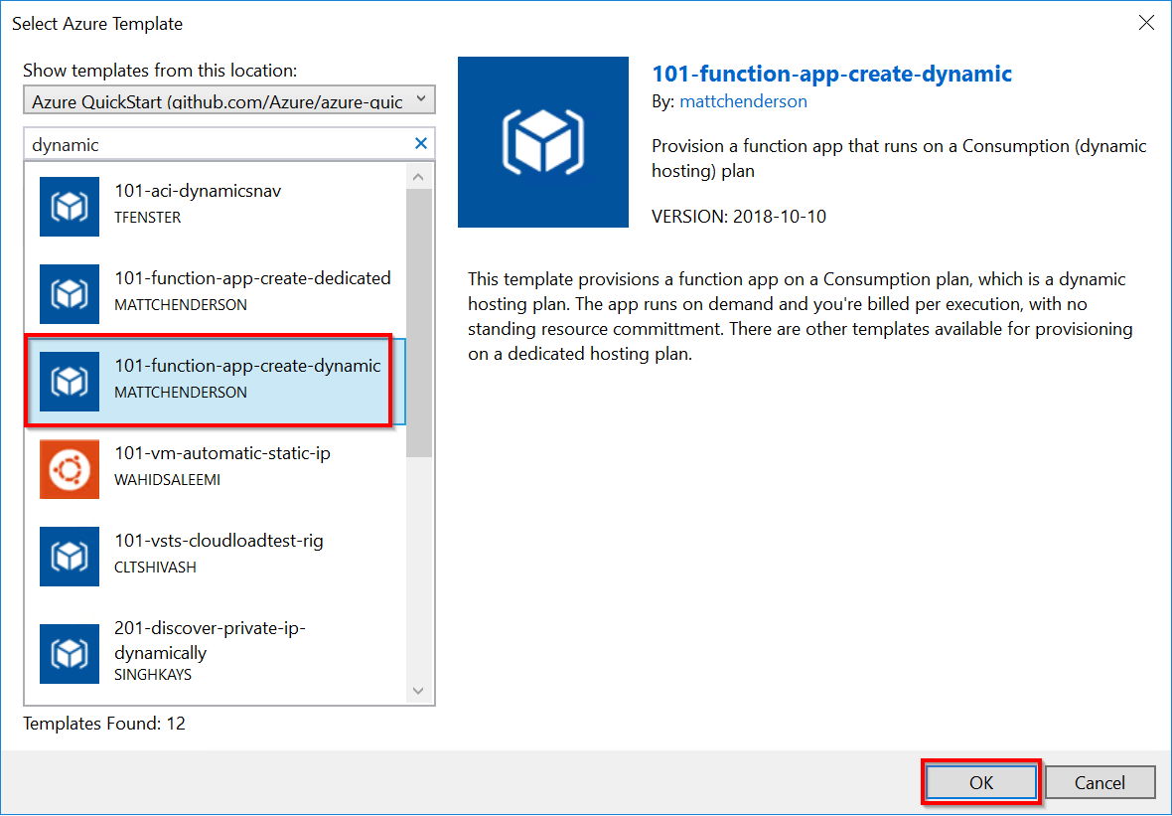

Figure 11.12: Visual Studio—selecting ARM templates from GitHub
Deploying Azure functions using ARM templates | 361

4. The required JSON template will be created in Visual Studio. Learn more about the
JSON content at https://docs.microsoft.com/azure/azure-functions/functions-
infrastructure-as-code.
5. Deploy the ARM to provision the function app and its dependent resources.
You can deploy it by right-clicking on the project name (in my case,
FunctionAppusingARMTemplate), clicking on Deploy, and then clicking on the New
button:
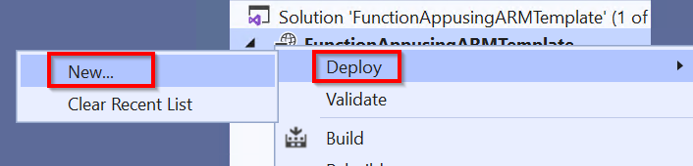

Figure 11.13: Visual Studio Azure Resource Group—new deployment
6. Choose Subscription, Resource group, and other parameters to provision the
function app. Choose all the mandatory fields and click on the Deploy button:
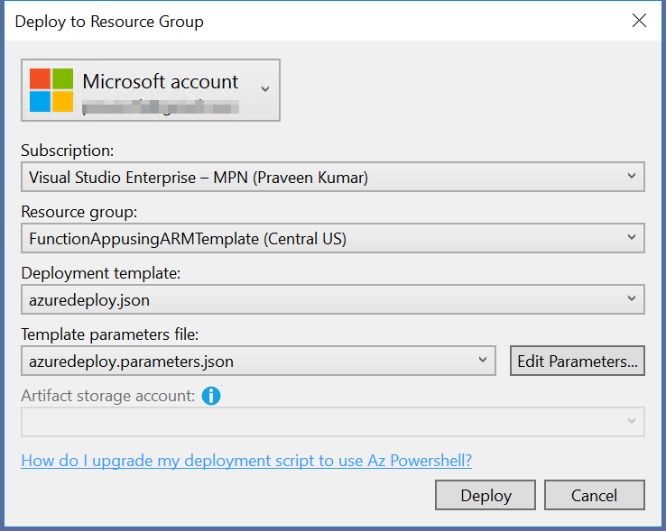

Figure 11.14: Visual Studio—Azure Resource Group—new deployment 362 | Configuring serverless applications in the production environment

7. That's it! In a few minutes, the deployment will start and each of the resources
mentioned in the ARM JSON templates will be provisioned:
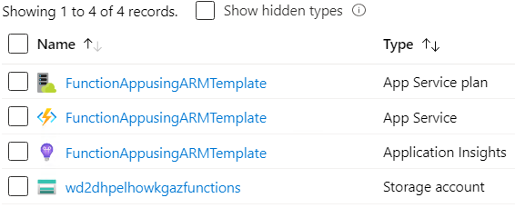

Figure 11.15: Azure portal—resources in the resource group

There's more…
Here are some of the advantages of provisioning Azure resources using ARM templates:
• By having the configurations in the JSON files, it's helpful for developers to push
the files to some kind of version-control system, such as Git or TFS, so that we can maintain the versions of the files to track all the changes.
• It's also possible to create the services in different environments quickly.
• With the ARM templates, we can automate the process of provisioning the
infrastructure to multiple environments using Continuous Integration/ Continuous Deployment (CI/CD) pipelines

In this recipe, we have learned how to automate the process of creating an Azure function using ARM templates. Let's now move on to the next recipe.

Configuring a custom domain for Azure functions
Looking at the default URL in the functionappname.azurewebsites.net format of the Azure function app, you may be wondering whether it's possible to have a separate domain instead of the default domain, as customers might have their own domains. Yes—it's possible to configure a custom domain for function apps. Let's learn how to do that in this recipe.

Getting ready
Create a domain with any of the domain registrars. You can also purchase a domain from the portal directly using the Buy Domain button, which is available in the Custom Domains pane:
Configuring a custom domain for Azure functions | 363
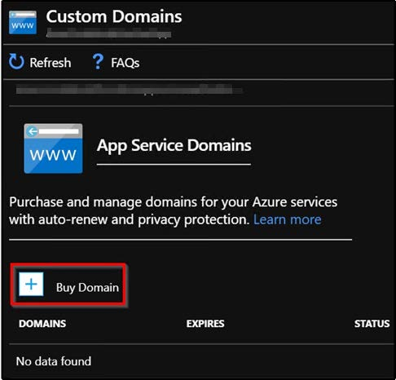

Figure 11.16: Azure Functions—purchasing a new domain
Once the domain is ready, create the following DNS records using the domain registrar:
• A record
• A CName record

How to do it...
In this section, we'll configure the custom domain for the Azure function app by performing the following steps:
1. Navigate to the Custom Domains pane of the Azure function app for which you
would like to configure a domain and make a note of the IP address along with the
default URL of the Azure function app, as shown in Figure 11.17:
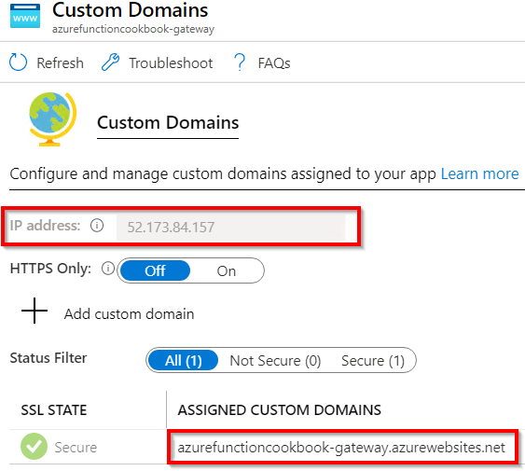

Figure 11.17: Azure Functions—custom domain details 364 | Configuring serverless applications in the production environment

2. Navigate to the App Service Domain, as shown in Figure 11.18:
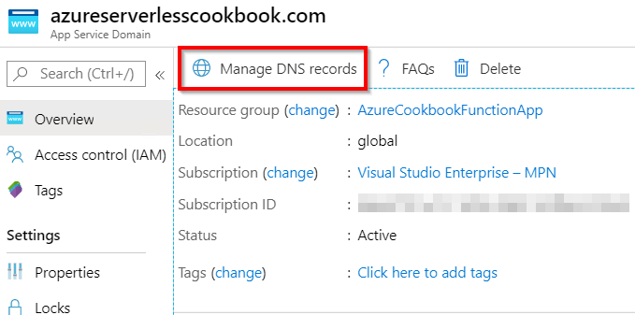

Figure 11.18: Azure App Service Domain overview
3. By clicking on the Manage DNS records button shown in Figure 11.18, you will be
taken to the page shown in Figure 11.19:
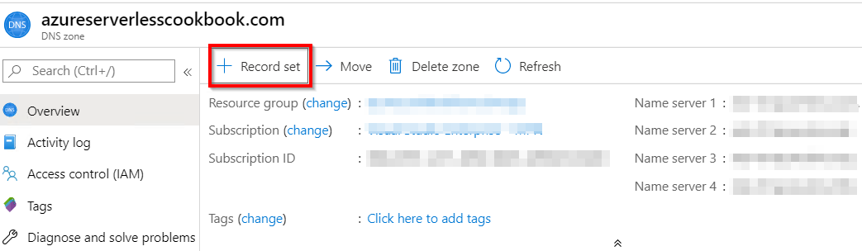

Figure 11.19: App Service Domain—DNS zone overview
Configuring a custom domain for Azure functions | 365

4. Now, click on the Record set button to add a new CName record, as shown in
Figure 11.20. You need to provide the default URL of your function app in the Alias
text box:
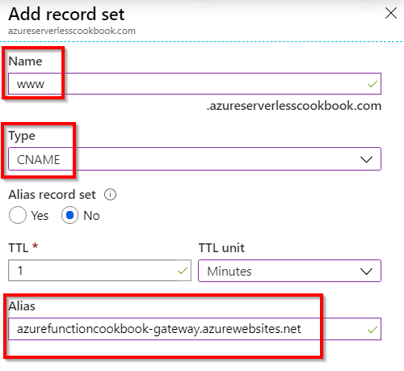

Figure 11.20: App Service Domain—adding a record set to the DNS zone
5. Once you have added the CName record, navigate to the Custom Domains pane of
your function app and click on Add custom domain, as shown in Figure 11.21:
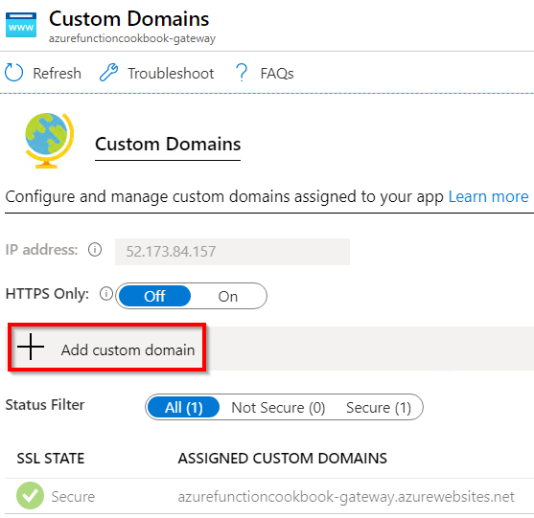

Figure 11.21: Azure Functions—custom domain details 366 | Configuring serverless applications in the production environment

6. This opens an Add custom domain pop-up window where you are prompted to
provide the Custom domain name that you want to associate with. Provide the name of the domain and click on Validate, as shown in Figure 11.22:
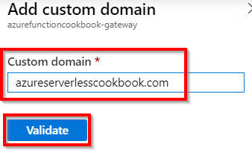

Figure 11.22: Azure Functions—adding a custom domain
7. After clicking on Validate, choose CName in the Hostname record type drop-
down menu and click on the Add custom domain button, as shown in Figure 11.23:
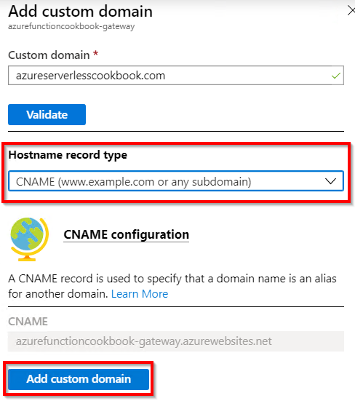

Figure 11.23: Azure Functions—adding a custom domain
Configuring a custom domain for Azure functions | 367

8. That's it! You have successfully configured a custom domain for a function app, as
shown in Figure 11.24:
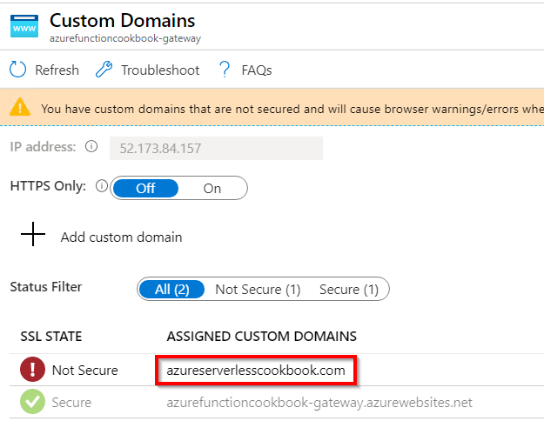

Figure 11.24: Azure Functions—Custom Domains
9. Now, open a new browser tab and access the custom domain (in my case, it is
azureserverlesscookbook.com); this should show the function app page, as shown
in Figure 11.25:
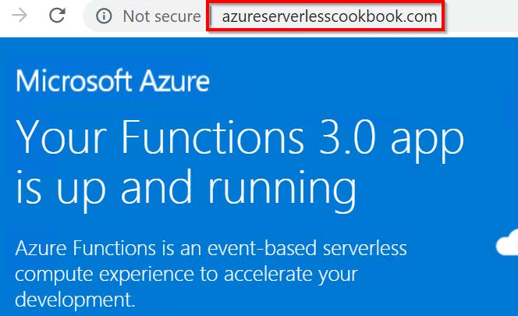

Figure 11.25: Accessing Azure Functions using a custom domain
In this recipe, we have learned how to create and configure the custom domain for a function app in order to access all the functions that you have created therein. Let's now move on to the next recipe.
368 | Configuring serverless applications in the production environment

Techniques to access application settings
In every application, you will have at least a few configuration items that you might not want to hardcode. Instead, you may want them to change in the future, after the application goes live, without touching the code.
In general, these configuration items can be classified into two categories:
• Some of the configuration items might be different across environments, for
example, the connection strings of the database and the SMTP server.
• Some of them might be the same across environments, such as some constant
numbers that are used in some calculations in the code.

Whatever the possible use of the configuration value, you need to have a place to store configuration values that need to be accessed by the application.
In this recipe, we'll learn how and where to store these configuration items and different techniques to access them from your application code.

Getting ready
Create an Azure function with the V3 Functions runtime if one has not already been created. We will use the function app that was created in Chapter 4, Developing Azure functions using Visual Studio.

How to do it...
In this recipe, we'll look at a few ways of accessing the configuration values.
Accessing application settings and connection strings in the Azure function code In this section, we'll learn how to access the configuration values using the ConfigurationBuild class by performing the following steps:
Techniques to access application settings | 369

1. Create a configuration item with the MyAppSetting key and a ConnectionStrings
with the sql_dbconnection key in the local.settings.json file. The local.settings.
json file should look something like Figure 11.26:
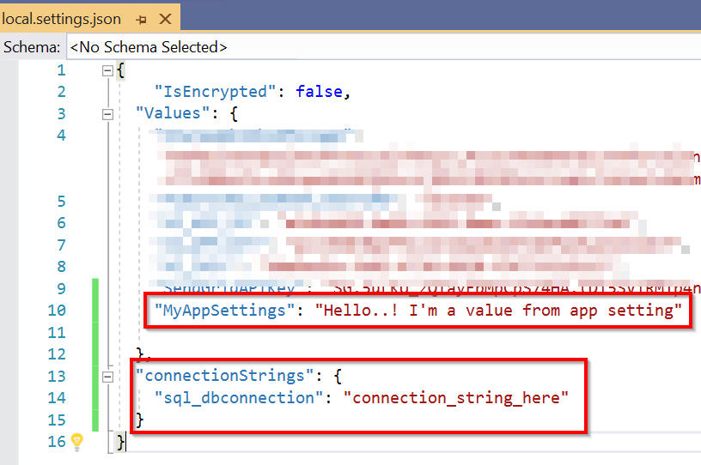

Figure 11.26: Visual Studio—local configuration file
2. Replace the existing code with the following code. We have added a few lines that
read the configuration values and the connection strings:
configuration.GetConnectionStringOrSetting("MyAppSettings")
The GetConnectionStringOrSetting method could be used to either get the value of
an app setting or the value of a connection string.
The configuration["MyAppSettings"] indexer can be used to get the value of an
app setting:
using Microsoft.AspNetCore.Mvc;
using Microsoft.Azure.WebJobs;
using Microsoft.Azure.WebJobs.Extensions.Http; using Microsoft.AspNetCore.Http;
using Microsoft.Extensions.Logging;
using Microsoft.Extensions.Configuration;
370 | Configuring serverless applications in the production environment

namespace FunctionAppinVisualStudio
{
public class HttpTriggerCSharpFromVS
{
[FunctionName("HttpTriggerCSharpFromVS")]
public static IActionResult
Run([HttpTrigger(AuthorizationLevel.Anonymous, "get", "post",
Route= null)]HttpRequest req, ILogger logger)
{
var configuration = new ConfigurationBuilder()
.AddEnvironmentVariables()
.AddJsonFile("appsettings.json", true)
.Build();

var ValueFromGetConnectionStringOrSetting = configuration.
GetConnectionStringOrSetting("MyAppSettings");
logger.LogInformation("Get Connection String Or Setting -
MyAppSettings = " + ValueFromGetConnectionStringOrSetting);

var ValueFromConfigurationIndex =
configuration["MyAppSettings"];
logger.LogInformation("Value From Configuration Index -
MyAppSettings = " + ValueFromConfigurationIndex);

var ValueFromConnectionString = configuration.
GetConnectionStringOrSetting("connectionStrings:sql_dbconnection");
logger.LogInformation("ConnectionStrings: sql_dbconnection = "
+ ValueFromConnectionString);

string name = req.Query["name"];
return name != null ? (ActionResult)new
OkObjectResult($"Hello,{ name }"): new BadRequestObjectResult("Please pass a name on the query string or in the request body");
}
}
}
3. Publish the project to Azure by right-clicking on the project and clicking on
Publish in the menu.
Techniques to access application settings | 371

4. Add the configuration key and the connection string in the Configuration pane.
Add the app setting as shown in Figure 11.27:
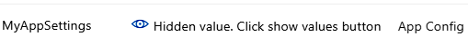

Figure 11.27: Azure Functions—adding an app setting using the configuration pane
5. Add the connection string as shown in Figure 11.28:
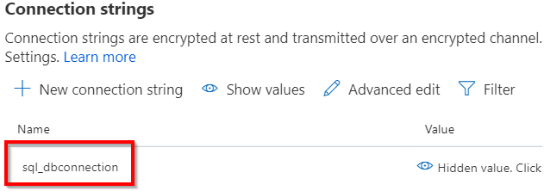

Figure 11.28: Azure Functions—adding a connection string using the configuration pane
6. Run the function by clicking on the Run button, which logs the output in the
Output window:
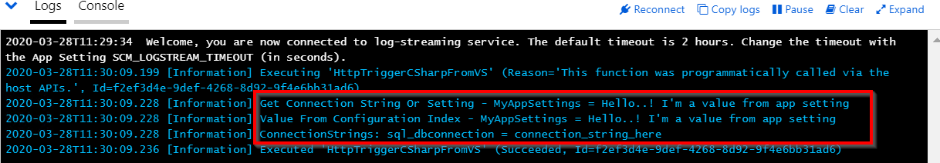

Figure 11.29: Azure Functions—viewing the app settings and connection string in the console logs
In this section, we have learned how to access configuration items using ConfigurationBuilder in the code. Let's now move on to the next section to learn about binding expressions.
372 | Configuring serverless applications in the production environment

Application settings—binding expressions In the previous section, we learned how to access configuration settings from the code. Sometimes, you might want to configure some of the declarative items, too. You could achieve that using binding expressions. You'll understand what I mean in a moment when we look at the code:
1. Open Visual Studio and make changes to the Run method to add a new parameter
to configure the QueueTrigger:
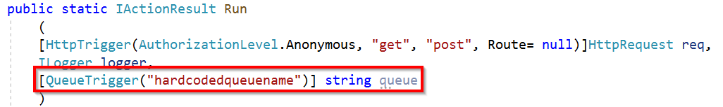

Figure 11.30: Azure Functions—QueueTrigger—"hardcodedqueuename"
2. The hardcodedqueuename parameter is the name of the queue in which messages
will be created. It's obvious that hardcoding the name of the queue is not a good practice. In order to make it configurable, you need to make use of application setting binding expressions:
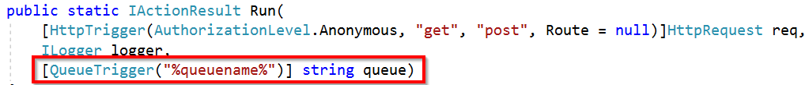

Figure 11.31: Azure Functions—QueueTrigger binding expression
3. The application setting key must be enclosed in %...% and a key with the name
queuename should be created in Application settings.
In this recipe, we have learned how to access the configuration items using both the ConfigurationBuilder class and binding expressions.

Breaking down large APIs into smaller subsets using proxies
In recent times, one of the buzzwords in the industry has been microservices, where we develop our web components as microservices that can be managed (scaling, deployment, and so on) individually without impacting the other related components. Although the subject of microservices is itself a huge one, in this recipe, we'll try to build a few microservices that can be managed individually as independent function apps. However, we'll expose them to the external world as a single API with different operations with the help of Azure function proxies.
Breaking down large APIs into smaller subsets using proxies | 373

Getting ready
In this recipe, we'll be implementing the following architecture:
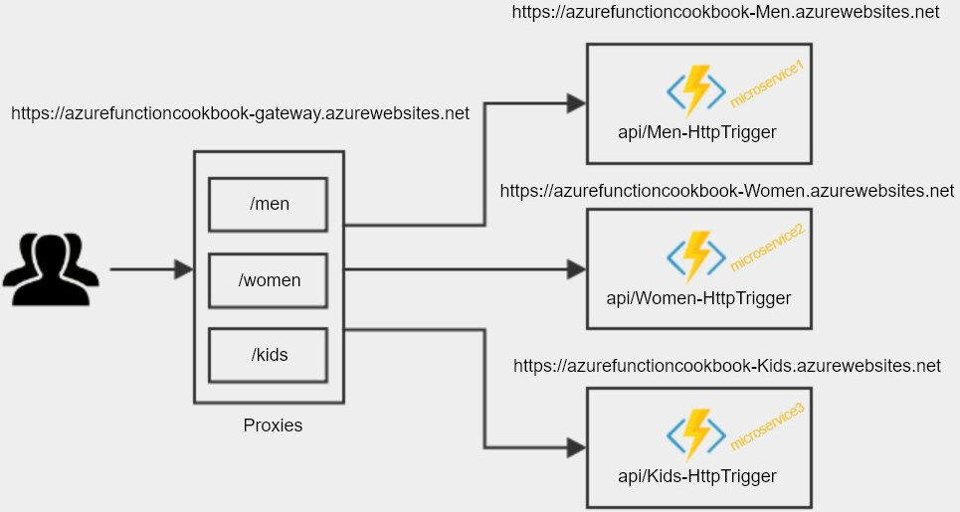

Figure 11.32: Azure function app with proxies—architecture
As depicted in the preceding architecture diagram, we are going to create three proxies in the gateway function app, which will be consumed by the client apps. Each proxy is responsible for the redirection of the request to the appropriate HTTP trigger based on the route template (/men, /women, and /kids).
Finally, the HTTP trigger is responsible for processing the request.
Let's assume that we are working for an e-commerce portal where we just have three modules (men, women, and kids) and our goal is to build the back-end APIs in a microservice architecture where each microservice is independent of the others.
In this recipe, we'll achieve this by creating the following function apps:
• A gateway component (function app) that is responsible for controlling the traffic
to the correct microservice based on the route (/men, /women, or /kids). In
this function app, we will be creating Azure function proxies that will redirect the
traffic using route configurations.
• Three new function apps, where each of them is treated as a separate
microservice.
374 | Configuring serverless applications in the production environment

How to do it...
In this recipe, we'll be performing the following steps:
1. Creating all three microservices with one HTTP trigger in each of them
2. Creating, proxying, and configuring the respective microservice
3. Testing the proxy URL

Creating the microservices
In this section, we'll create the microservices by performing the following steps:
1. Create three function apps, one for each of the microservices, as well as the
gateway function app that we have planned:
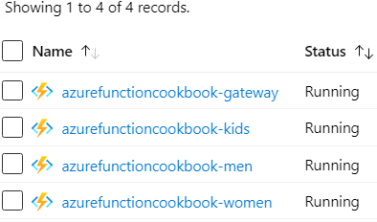

Figure 11.33: Creating four function apps (one gateway and three microservices)
2. Create the following anonymous HTTP triggers in each of the function apps, which
display a message along the lines of what is shown in Figure 11.34:
HTTP trigger name Output message
Men-HttpTrigger Hello <> - Welcome to the Men Microservice
Women-HttpTrigger Hello <> - Welcome to the Women Microservice
Kids-HttpTrigger Hello <> - Welcome to the Kids Microservice
Figure 11.34: Creating anonymous HTTP triggers
Breaking down large APIs into smaller subsets using proxies | 375

Creating the gateway proxies
Perform the following steps to create gateway proxies:
1. Navigate to the gateway function app and create a new proxy:
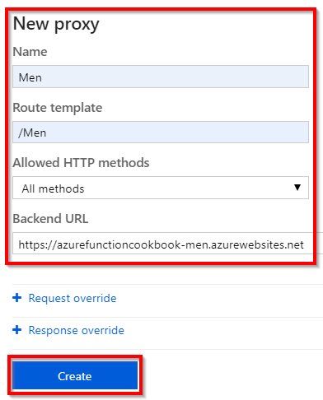

Figure 11.35: Azure function app—creating a proxy
2. You will then be taken to the details pane:
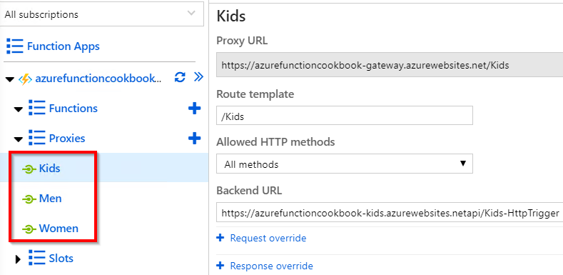

Figure 11.36: Azure function app—viewing proxies and details 376 | Configuring serverless applications in the production environment

3. Create the proxies for Women and Kids. Here are the details of all three proxies.
Note that the back-end URLs (of the function apps) may be different based on the inputs:
Proxy Route Back-end URL name template (the URLs of the HTTP triggers created in the previous step)

Men https://azurefunctioncookbook-men.azurewebsites.net/api/ /men Men-HttpTrigger

Women https://azurefunctioncookbook-women.azurewebsites.netapi/ /women Women-HttpTrigger

Kids https://azurefunctioncookbook-kids.azurewebsites.netapi/ /kids Kids-HttpTrigger
Figure 11.37: Details of all three proxies
4. Once the three proxies have been created, the list will look something like this:
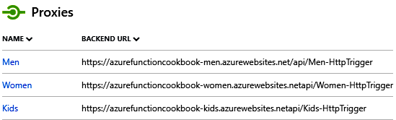

Figure 11.38: Azure Function app—viewing the proxies
5. In Figure 11.38, you can view three different domains. However, in order to share
these with the client applications, you don't need to share these URLs. All you need to do is share the URL of the proxies that you can view in the Proxies tab. Here are the proxy URLs of the three proxies we have created:
https://azurefunctioncookbook-gateway.azurewebsites.net/Men
https://azurefunctioncookbook-gateway.azurewebsites.net/Women
https://azurefunctioncookbook-gateway.azurewebsites.net/Kids
Breaking down large APIs into smaller subsets using proxies | 377

Testing the proxy URLs
As you already know, your HTTP triggers accept a required name parameter, and you need to pass the name query string to the proxy URL. Let's access the following URLs in the browser:
• Men:
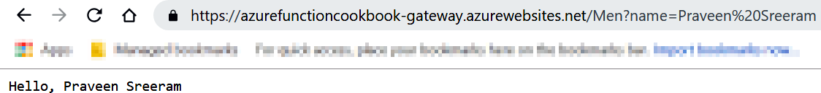

Figure 11.39: Azure function app proxy—output for the /men route template
• Women:
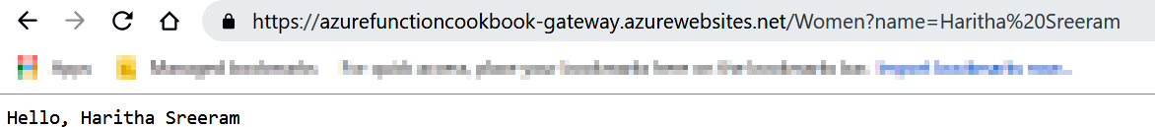

Figure 11.40: Azure function app proxy—output for the /women route template
• Kids:
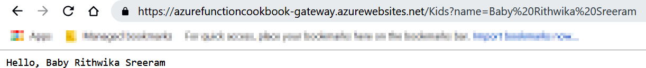

Figure 11.41: Azure function app proxy—output for /kids route template
Observe the URLs of the three preceding screenshots. You'll notice that they look like they are being served from a single application with different routes. However, they are three different microservices that can be managed individually.

378 | Configuring serverless applications in the production environment

There's more...
All the microservices created in this recipe are anonymous, which means they are publicly accessible. In order to make them secure, you need to follow either of the approaches recommended in Chapter 10, Implementing best practices for Azure Functions.
Azure function proxies also allow the interception of original requests and, if required, you can add new parameters and pass them to the back-end API. Similarly, you can add additional parameters and pass the response back to the client application. Learn more about Azure function proxies in the official documentation at https://docs.microsoft.
com/azure/azure-functions/functions-proxies.
In this recipe, we have learned how to implement a microservice kind of architecture using the feature proxies in the Azure function app. Let's now move on to the next recipe.

Moving configuration items from one environment to another
Every application that you develop will have many configuration items (such as application settings and connection strings) stored in Web.Config files for all .NET-based web applications.
In the traditional on-premises world, the Web.Config file would be located in the server and the file would be accessible to all people who have access to the server. Although it is possible to encrypt all the configuration items of Web.Config, this has its limitations, and they're not easy to decrypt every time you want to view or update them.
In the Azure PaaS world, with Azure App Services, you can still have the Web.Config files and they work as they used to in the traditional on-premises world. However, an Azure App Service provides us with an additional feature in terms of application settings, where you can configure these settings (either manually or via ARM templates), and these settings are stored in an encrypted format. But you can view them as normal text in the portal if you have access.
Depending on the application type, the number of application settings might grow to a large size, and if you want to create new environments, then creating these application settings will take quite a bit of time. In this recipe, we will learn the tip of exporting and importing these application settings from a lower environment (development, for example) to a higher environment (production, for example).
Moving configuration items from one environment to another | 379

Getting ready
Perform the following steps:
1. Create a function app (say, MyApp-Dev) if one has not been created already.
2. Create some application settings:
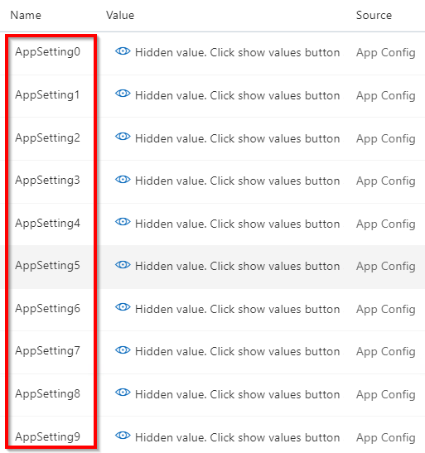

Figure 11.42: Azure function app—application settings in the configuration pane
3. Create another function app (say, MyApp-Prod).
This recipe showcases the ease of copying the application settings from one function to another. This technique will be handy when there are many application settings.
380 | Configuring serverless applications in the production environment

How to do it…
Perform the following steps:
1. Navigate to the Platform features tab of the MyApp-Dev function app and click on
Resource Explorer.
2. Resource Explorer will open, and from there you can traverse all the internal
elements of a given service:
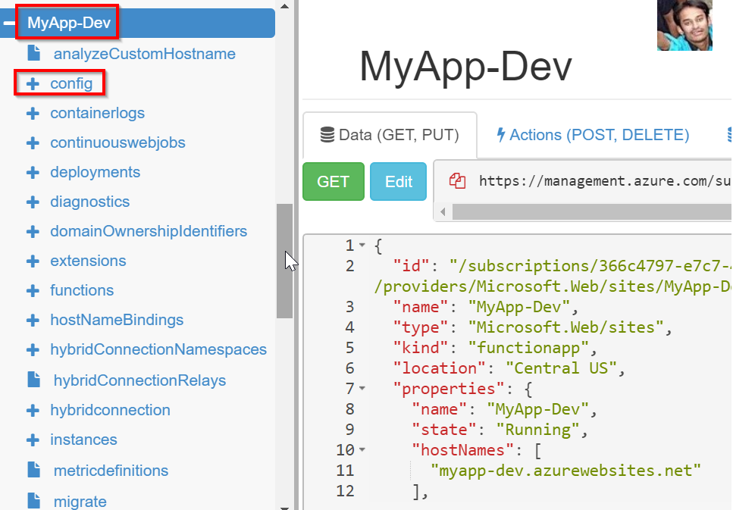

Figure 11.43: Azure resources view—selecting the config node

Note
Please be sure to open the setting in Read/Write mode (available in the top right-hand corner) in Resource Explorer.
Moving configuration items from one environment to another | 381

3. Click on the config element, as shown in Figure 11.43, which opens all the items
related to configurations:
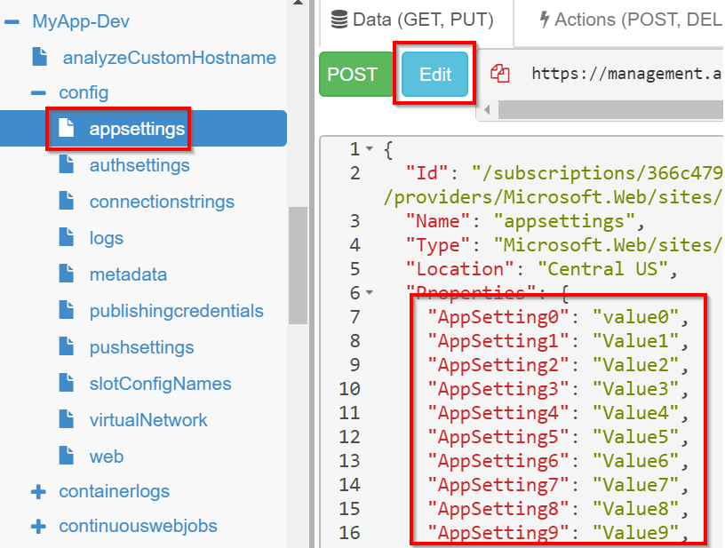

Figure 11.44: Azure resources view—editing the appsettings node
4. Resource Explorer will display all the application settings in the right-hand
window. Now, you can either edit them by clicking on the Edit button, which
is highlighted in Figure 11.44, or you can copy all the application settings from
AppSetting0 to AppSetting9.
382 | Configuring serverless applications in the production environment

5. Navigate to the MyApp-Prod function app (which won't have the application settings
highlighted in Figure 11.44), click on Resource Explorer, and then click on the config | appsettings elements to open the existing application settings. It should look something like this:
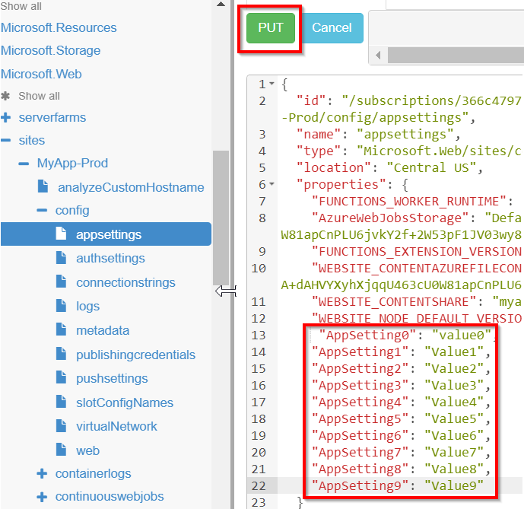

Figure 11.45: Azure resources view—updating appsettings
6. Click on the Edit button and paste the content that was copied earlier. After
reviewing the settings, click on PUT, which is shown in Figure 11.45.
Moving configuration items from one environment to another | 383

7. Navigate to the application settings pane of the MyApp-Prod function app:
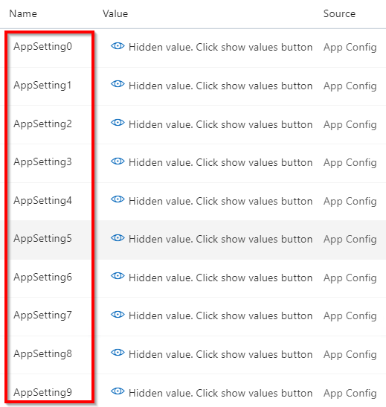

Figure 11.46: Azure function app—the configuration pane of the app settings
You should see all the application settings that we have created in Resource Explorer, as shown in Figure 11.46.
In this recipe, we have learned a quick way of copying the configuration items from one function app to another.
In this chapter, we have discussed some of the important techniques that will help a developer to improve their productivity, as well as some of the best practices that need to be followed in the production environment.

Implementing and

deploying continuous

integration using

Azure DevOps
In this chapter, you'll learn about the following topics:
• Continuous integration—creating a build definition
• Continuous integration—queuing a build and triggering it manually
• Continuous integration—configuring and triggering an automated build
• Continuous integration—executing unit test cases in the pipeline
• Creating a release definition
• Triggering a release automatically
• Integrating Azure Key Vault to configure application secrets 386 | Implementing and deploying continuous integration using Azure DevOps

Introduction
As a software professional, you may be aware of different software development methodologies that are followed across the industry. Irrespective of the methodology being followed, there will be multiple environments, such as development, staging, and production, where the application life cycle needs to be followed, with these critical stages related to development:
1. Develop the application based on the requirements.
2. Build the application and fix any errors.
3. Deploy/release the package to an environment (development/staging/
production).
4. Test against the requirements.
5. Promote the release to the next environment (from development to staging and
staging to production).

Note
For the sake of simplicity, the initial stages, such as requirement gathering, planning, designing, and architecture, are excluded, just to emphasize the stages that are relevant to this chapter.

For each change made to the software, we need to build and deploy the application to multiple environments, and it might be the case that different teams are responsible for releasing builds to different environments. As different environments and teams are involved, considering the amount of time that is spent in running the builds, deploying them in different environments would be more dependent on the processes that different teams follow.
To streamline and automate a few of the steps mentioned earlier in this chapter, we'll discuss some of the popular techniques that the industry uses in order to deliver software quickly, with minimal infrastructure.

Note
In previous chapters, most of the recipes provided us with a solution for an individual business problem. However, this chapter will try to provide a solution for the continuous integration (CI) and continuous delivery of business-critical applications.
Introduction | 387

The Azure DevOps team continuously adds new features to Azure DevOps (https://
dev.azure.com), formerly known as VSTS (https://www.visualstudio.com), and updates the user interface as well. Don't be surprised if screenshots that are provided in this

chapter don't match with what you see at https://dev.azure.com.

Prerequisites
Do the following if you haven't done so already:
1. Create an Azure DevOps organization at https://dev.azure.com and create a new
project in that account. While creating the project, either choose Git or Team
Foundation Version Control as the version control repository. Let's use Git version
control for our project:
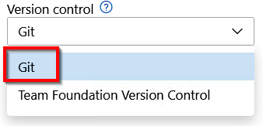

Figure 12.1: Creating an Azure DevOps project with Git version control
2. Configure the Visual Studio project that was developed in Chapter 4, Developing
Azure functions using Visual Studio, to Azure DevOps. Go to https://docs.
microsoft.com/azure/devops/organizations/accounts/set-up-vs?view=azure-
devops to follow the step-by-step process of creating a new account and project
using Azure DevOps.

Note
I will be making some small changes to the response messages embedded within the code to show different outputs. Make sure that you modify the unit tests accordingly. Otherwise, the build will fail.
388 | Implementing and deploying continuous integration using Azure DevOps

Continuous integration—creating a build definition
In this recipe, we will learn how to configure continuous integration by creating a build definition. A build definition is a set of tasks that are required to configure an automated build of software. In this recipe, we will perform the following:
1. Create the build definition template.
2. Provide all the inputs required for each of the steps to create the build definition.

Getting ready
Perform the following prerequisites:
1. Create an Azure DevOps account.
2. Create a project by choosing Git, as shown in Figure 12.2:
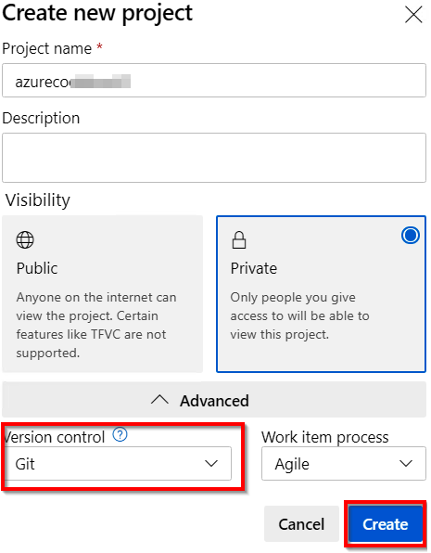

Figure 12.2: Creating a private Azure DevOps project with Git version control
Continuous integration—creating a build definition | 389

How to do it…
In order to create the build definition, we'll have to perform the following steps:
1. Navigate to the Pipelines tab in the Azure DevOps account, click on Pipelines,
and choose Create Pipeline to start the process of creating a new build definition,
as shown in Figure 12.3:
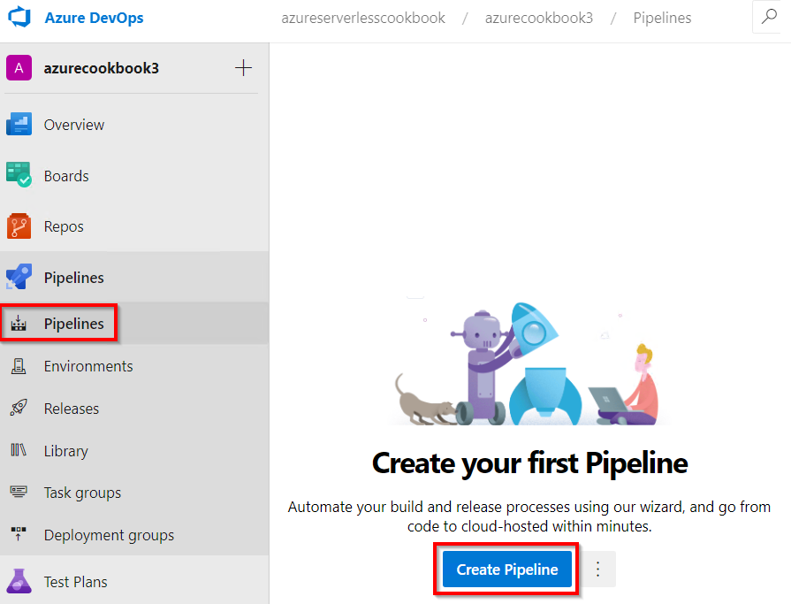

Figure 12.3: Azure DevOps—the Create Pipeline button
390 | Implementing and deploying continuous integration using Azure DevOps

2. In the next step, click on the Use the classic editor link, as shown in Figure 12.4:
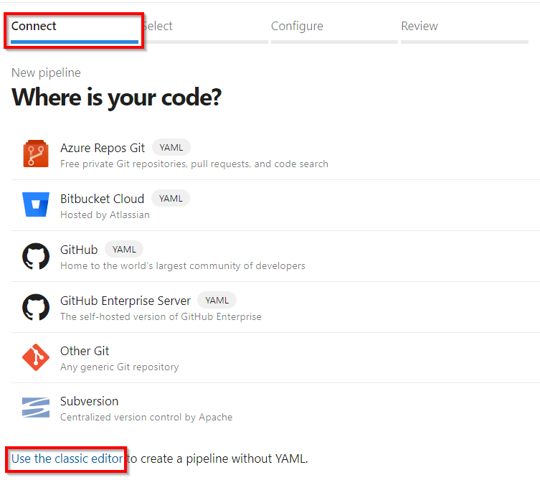

Figure 12.4: Azure DevOps—using the classic editor to create a pipeline
Continuous integration—creating a build definition | 391

3. You will be taken to the Select a source screen, where you can choose your
repository. For this example, ours is Git. As shown in Figure 12.5, select Azure
Repos Git and click on Continue. Make sure that you have chosen your project,
which in this case is azurecookbook3, and the azurecookbook3 repository:
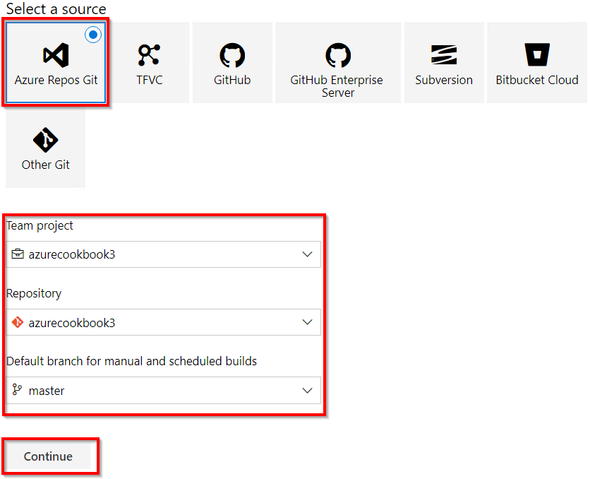

Figure 12.5: Azure DevOps—build pipelines—choosing a source
392 | Implementing and deploying continuous integration using Azure DevOps

4. You will be taken to the Select a template step, where you can choose the
template required for your application. For this recipe, let's choose Azure Functions for .NET, as shown in Figure 12.6, by clicking on the Apply button:
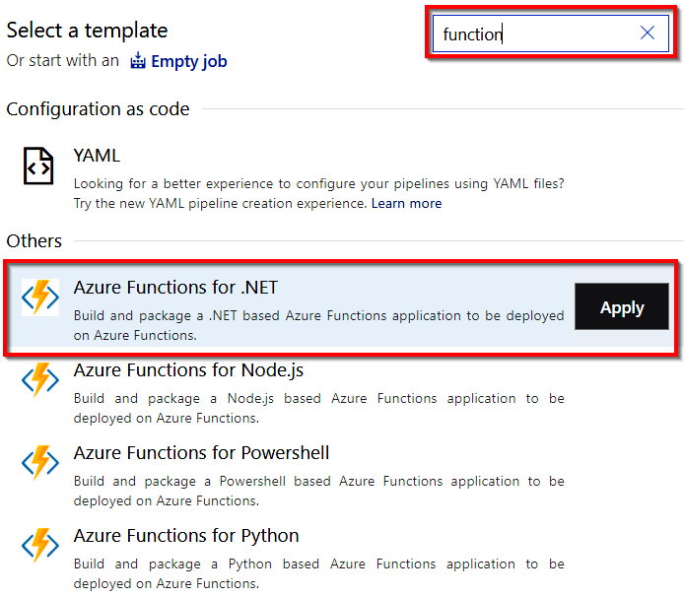

Figure 12.6: Azure DevOps—build pipelines—selecting a template
Continuous integration—creating a build definition | 393

5. The create build step is a set of steps used to define the build template, where
each step has certain attributes that we need to review, and we provide inputs
for each of those fields based on our requirements. Let's start by providing a
meaningful name in the pipeline step. Be sure to choose vs2017-win2016 in the
Agent Specification drop-down list, as shown in Figure 12.7:
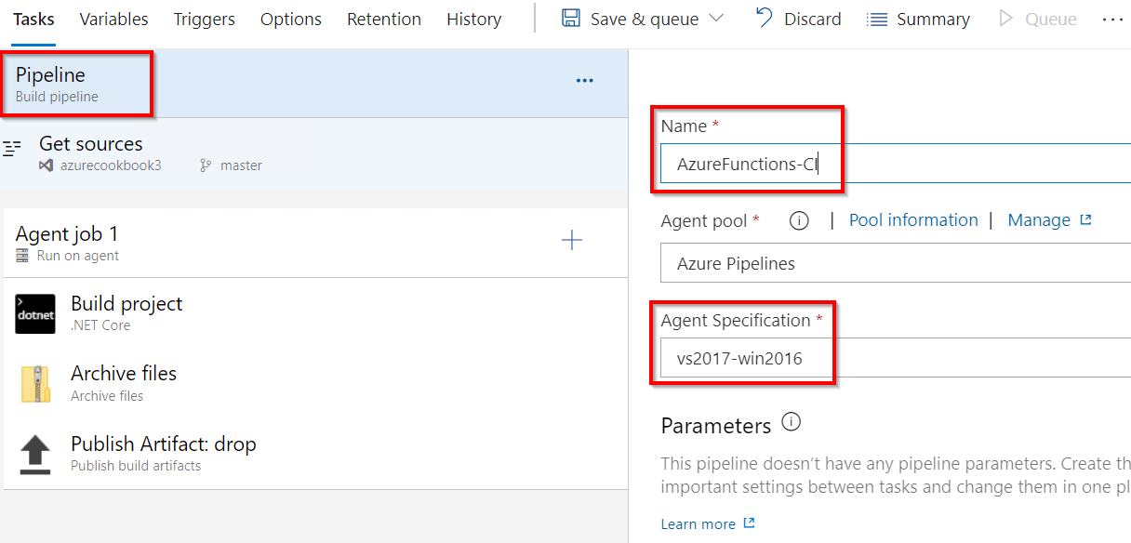

Figure 12.7: Azure DevOps—build pipelines—configuring the pipeline

Note
Agent Specification defines the agent (a virtual machine) to be used. An agent in the current context is a virtual machine that has the required tools and software pre-installed.
394 | Implementing and deploying continuous integration using Azure DevOps

6. In the Get sources step, ensure that the following are done as shown in Figure 12.8:
Select the version control system based on the project's requirements.
Choose the repository that we want to build. In this example, we have chosen azurecookbook3:
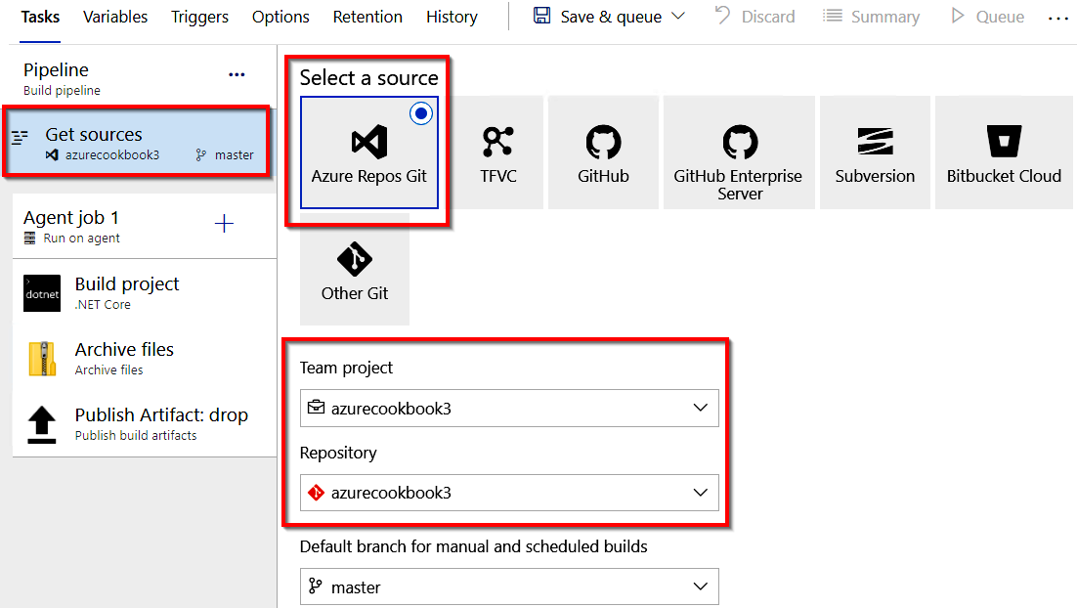

Figure 12.8: Azure DevOps—build pipelines—viewing and editing the repository
7. Once all the values in all the fields are reviewed, click on Save, as shown in Figure
12.9, and click on Save again in the Save build pipeline pop-up window:
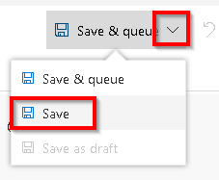

Figure 12.9: Azure DevOps—build pipelines—save pipeline
Continuous integration—creating a build definition | 395

How it works...
A build definition is just a blueprint of the tasks that are required for building a software application. In this recipe, we have used a default template to create the build definition. We can choose a blank template and create the definition by choosing the tasks available in Azure DevOps as well.
When we run the build definition (either manually or automatically, which will be discussed in the subsequent recipes), each of the tasks will be executed in the order they have been configured. The steps can also be rearranged by dragging and dropping them in the pipeline section.
The build process starts with getting the source code from the chosen repository and downloading the required NuGet packages, and then it starts the process of building the package. Once that process is complete, the build process creates a package and stores it in a folder configured for the build.artifactstagingdirectory directory (refer to the Path to publish field of the Publish artifact task).

Note
Build.ArtifactStagingDirectory is a predefined variable that contains the local path on the agent where any artifacts are copied before being pushed to their destination.

Learn more about pre-defined variables at https://docs.microsoft.com/azure/devops/
pipelines/build/variables?view=azure-devops&tabs=yaml.
396 | Implementing and deploying continuous integration using Azure DevOps

There's more…
Azure DevOps provides many tasks. Choose a new task for a template by clicking on the Add Task (+) button.
If we don't find a task that meets our requirements, we can search for a suitable one in the marketplace by clicking on the Marketplace button shown in Figure 12.10:
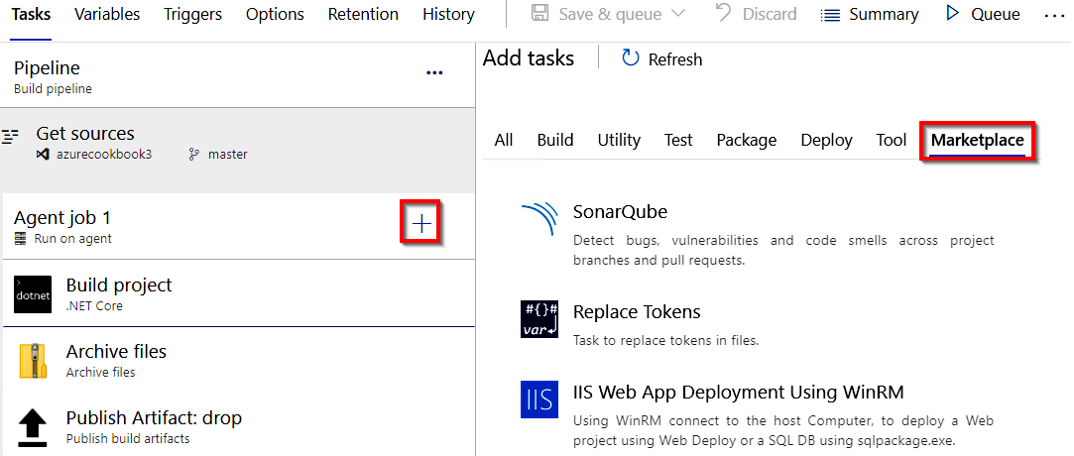

Figure 12.10: Azure DevOps—build pipelines—adding a task from Marketplace
In this recipe, we have learned how to create a build pipeline. Let's move on to the next recipe.

Continuous integration—queuing a build and triggering it
manually
In the previous recipe, you learned how to create and configure a build definition. In this recipe, you will learn how to trigger a build manually and understand the process of building an application.

Getting ready
Before we begin, make sure that you have done the following:
• Configured the build definition as mentioned in the previous recipe.
• Checked all of your source code into the Azure DevOps team project.
How to do it... | 397

How to do it...
Perform the following steps:
1. Navigate to the build definition named AzureFunctions-CI, click on the Edit
button, and then click on the Queue button available on the right-hand side, as
shown in Figure 12.11:
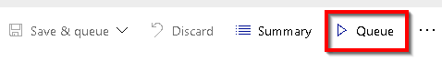

Figure 12.11: Azure DevOps—build pipelines—the Queue button
2. In the Azure Pool for AzureFunctions-CI pop-up window, make sure that the
vs2017-win2016 option is chosen in the Agent Specification drop-down list in
Visual Studio 2017 or 2019 and click on the Queue button, as shown in Figure 12.12:
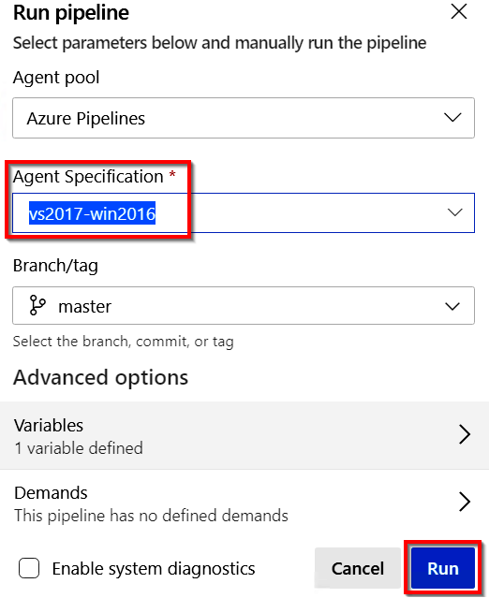

Figure 12.12: Azure DevOps—build pipelines—running a pipeline

Note
At the time of writing, the VS 2019 option is not available. While reading, if the VS 2019 option becomes available, feel free to choose that.
398 | Implementing and deploying continuous integration using Azure DevOps

3. In just a few moments, the build will be queued and the message will be displayed,
as shown in Figure 12.13:
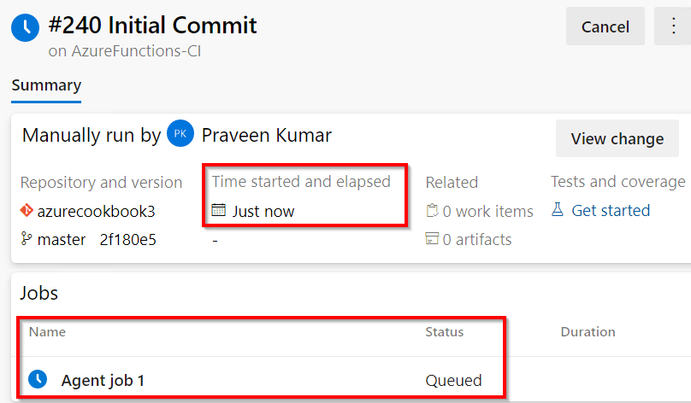

Figure 12.13: Azure DevOps—build pipelines—viewing progress
4. After a few moments, the build process will start, and in just a few minutes, the
build will be completed, and you can review the steps of the build in the logs by clicking on Agent job 1 in the preceding step. You will see the status of all the tasks, as shown in Figure 12.14:
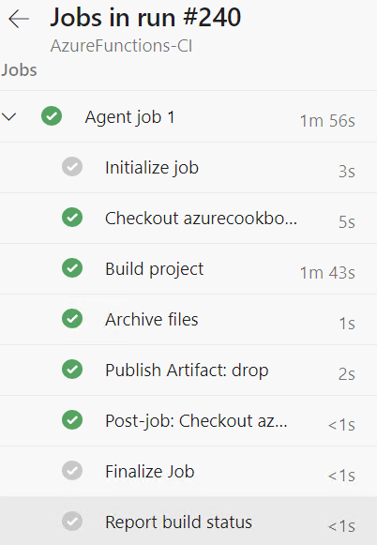

Figure 12.14: Azure DevOps—build pipelines—viewing the job summary
Continuous integration—configuring and triggering an automated build | 399

5. To view the output of the build, click on the published button highlighted in
Figure 12.15:
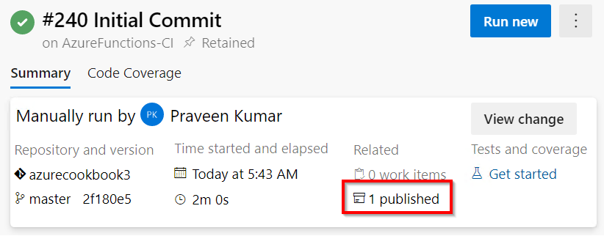

Figure 12.15: Azure DevOps—build pipelines—viewing the published artifact
6. Download the files by clicking on the download button, as shown in Figure 12.16:
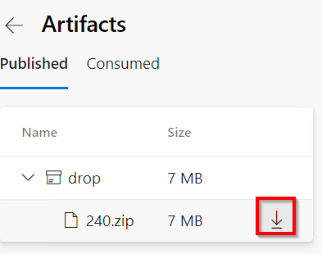

Figure 12.16: Azure DevOps—build pipelines—downloading the published artifact
In this recipe, we have configured the pipeline and also triggered it manually to test whether the pipeline is configured properly. Let's move on to the next recipe.

Continuous integration—configuring and triggering an
automated build
For most applications, it might not make sense to perform manual builds in Azure DevOps. It would make sense if we can configure continuous integration by automating the process of triggering the build for each check-in/commit done by the developers.
In this recipe, you will learn how to configure continuous integration in Azure DevOps for the team project and also trigger an automated build by making a change to the code of the HTTP trigger Azure function that we created in Chapter 4, Developing Azure functions using Visual Studio.
400 | Implementing and deploying continuous integration using Azure DevOps

How to do it…
Perform the following steps:
1. Navigate to the AzureFunctions-CI build definition by clicking on the Edit button,
as shown in Figure 12.17:
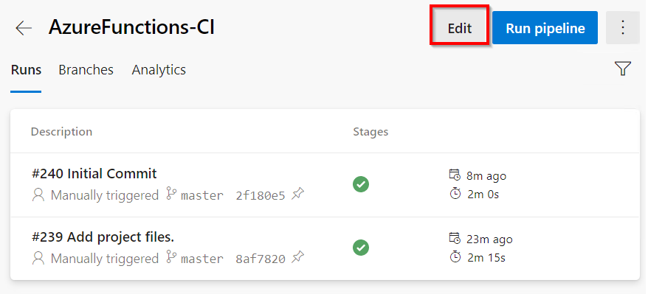

Figure 12.17: Azure DevOps—build pipelines—editing a pipeline
2. Once inside the build definition, click on the Triggers menu, as shown in
Figure 12.18:
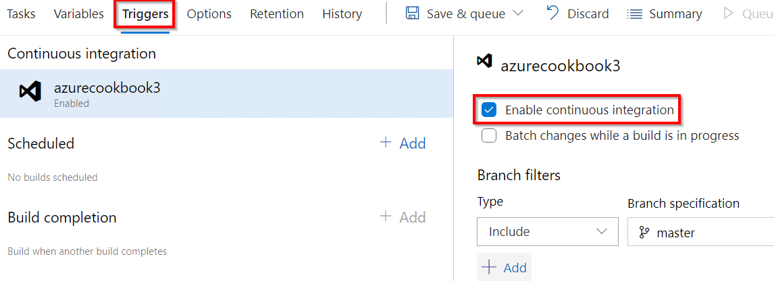

Figure 12.18: Azure DevOps—build pipelines—enabling continuous integration
Continuous integration—configuring and triggering an automated build | 401

3. Now, click on the Enable continuous integration checkbox to enable the
automated build trigger.
4. Save the changes by clicking on the arrow sign available beside the Save & queue
button and click on the Save button available in the drop-down menu shown in
Figure 12.19:
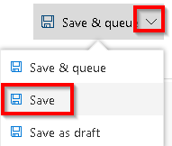

Figure 12.19: Azure DevOps—build pipelines—saving the pipeline
5. Let's navigate to the Azure function project in Visual Studio. Make a small change
to the last line of the Run function source code that is shown here. We will just
replace the word hello with Automated Build Trigger test, as follows:

return name != null ? (ActionResult)new OkObjectResult($"Automated Build Trigger test by, { name}")
: new BadRequestObjectResult("Please pass a name on the query
string or in the request body");
402 | Implementing and deploying continuous integration using Azure DevOps

6. Let's check in the code and commit the changes to the source control. As shown
in Figure 12.20, click on Commit All to commit the code and then, in the next step, push all the changes:
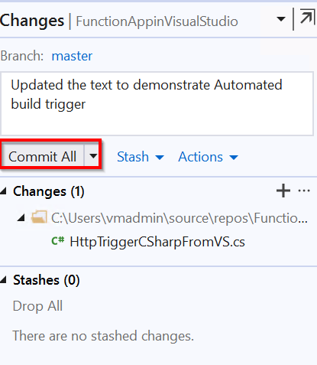

Figure 12.20: Visual Studio—Team Explorer—committing changes to Git
7. Now, immediately navigate back to the Azure DevOps build definition to see that a
new build was triggered automatically and is in progress, as shown in Figure 12.21:
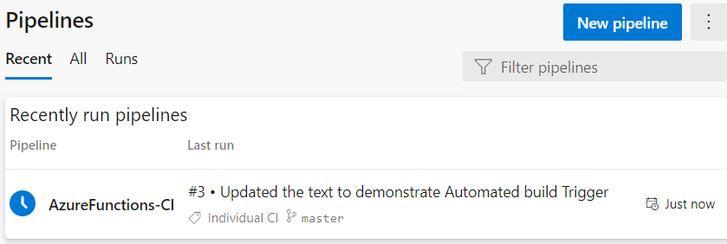

Figure 12.21: Azure DevOps—build pipelines—pipeline triggered automatically
Continuous integration—executing unit test cases in the pipeline | 403

How it works…
These are the steps followed in this recipe:
1. We enabled the automatic build trigger for the build definition.
2. We made a change to the code base and checked it into Git.
3. Automatically, a new build was triggered in Azure DevOps. The build was triggered
immediately after the code was committed to Git.

In this recipe, we have learned how to configure continuous integration for Azure Functions using Azure DevOps build pipelines. Let's move on to the next recipe.

Continuous integration—executing unit test cases in the pipeline
One of the most important steps in any software development methodology is to write automated unit tests to validate the correctness of our code. It is also important that we run these unit tests every time the developer commits new code, to provide test code coverage.
In this recipe, we will learn how to incorporate the process of building the unit tests that we developed in the Developing unit tests for Azure functions with HTTP triggers recipe of Chapter 5, Exploring testing tools for Azure functions.

How to do it…
In this recipe, we are going to add a new task to the pipeline that runs the unit test cases. Perform the following steps:
1. Edit the AzureFunctions-CI build definition and add the .NET Core task as shown
in Figure 12.22:
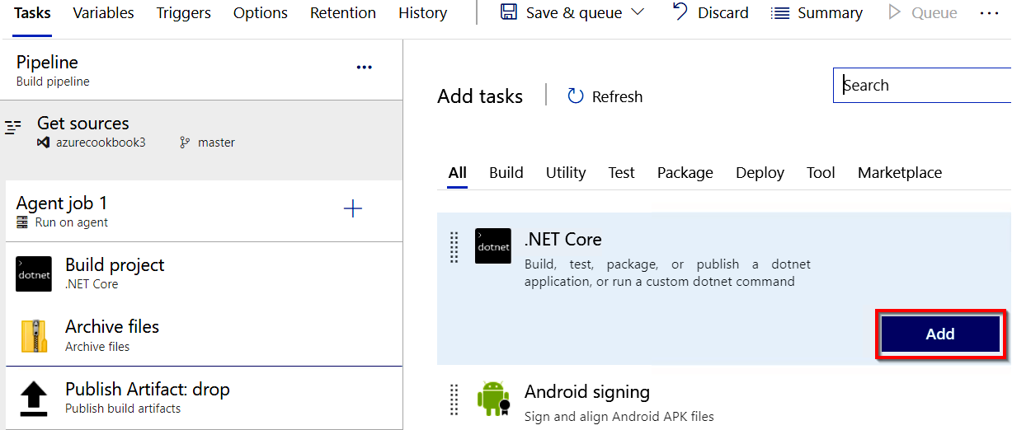

Figure 12.22: Azure DevOps—build pipelines—adding a new task 404 | Implementing and deploying continuous integration using Azure DevOps

2. Once the task is added, change the following attributes of the task:
Display Name: The name of the task. Change it to Test.
Command: This is the command to run. Please choose the test option. The command will take care of running the unit test cases.
Path to Project(s): This is the name of the unit test project. Provide **/*Test*. csproj or the actual name of the unit test project.
Arguments: The arguments for building the application. Provide --output publish_output --configuration release as the command.
3. Once all these changes are made, the Test task should look something like Figure
12.23. After reviewing everything, click on Save to save the changes:
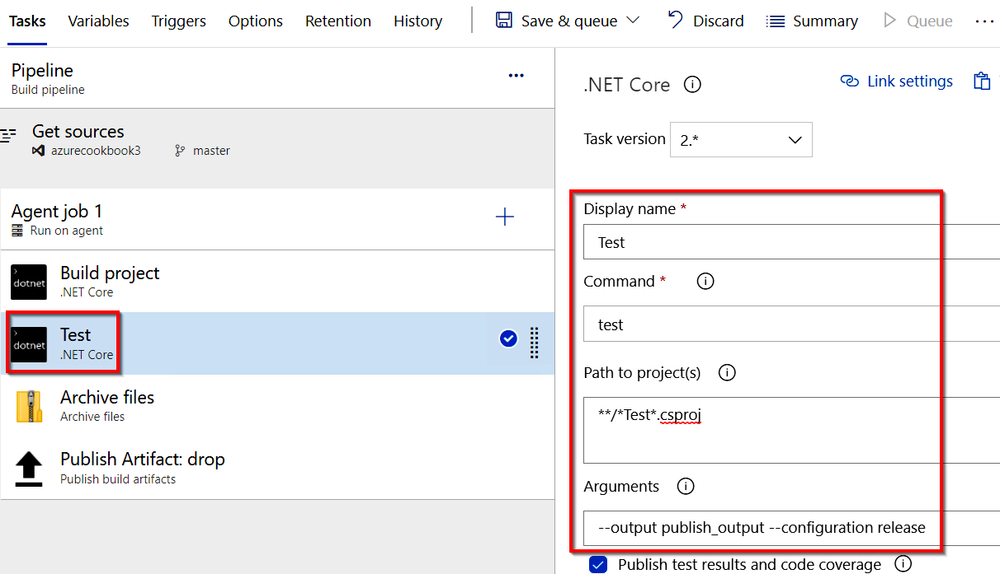

Figure 12.23: Azure DevOps—build pipelines—configuring the .NET Core Test task
Continuous integration—executing unit test cases in the pipeline | 405

4. That's it. Let's now queue the build by clicking on the Queue button after saving
the changes. After a few minutes, the build pipeline will be passed without any
warnings, as shown in Figure 12.24:
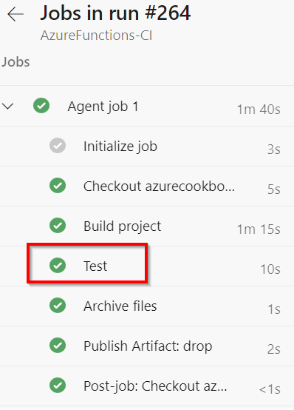

Figure 12.24: Azure DevOps—build pipelines—viewing the job status
5. Here is a summary of the test cases. Figure 12.25 is a chart that shows the
percentage of the test cases that have passed and failed:
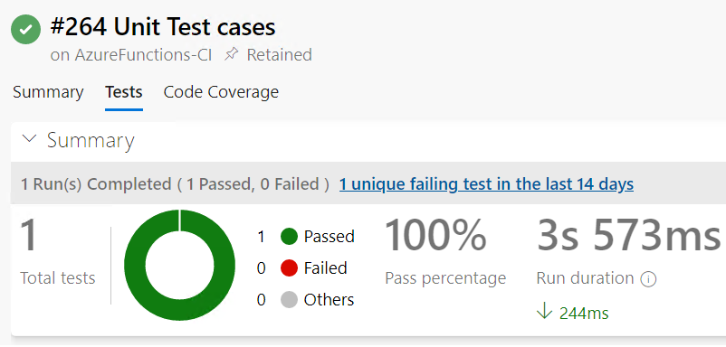

Figure 12.25: Azure DevOps—build pipelines—viewing the test case summary
406 | Implementing and deploying continuous integration using Azure DevOps

There's more…
If all the naming conventions were followed as per the instructions, then we won't face any issues with this recipe. However, we may come across issues if we have used a different name for the unit project and haven't used the word test somewhere in the name of the project (which is the same name as the generated .dll file).
In the recipe, we used * and **, which are called file matching patterns. Learn more about file matching patterns at https://docs.microsoft.com/azure/devops/pipelines/
tasks/file-matching-patterns?view=azure-devops&viewFallbackFrom=vsts.
In this recipe, we have learned how to create and configure a task for running unit test cases. Let's move on to the next recipe.

Creating a release definition
Now that we know how to create a build definition and trigger an automated build in Azure DevOps pipelines, our next step is to release or deploy the package to an environment where the project stakeholders can review it and provide feedback. In order to do that, we need to create a release definition in the same way that we created the build definitions.

Getting ready
Before working on this recipe, please make sure you have created the build definition and also ensure that you have run it successfully at least once.

How to do it…
To release and deploy the package to an environment, we'll perform the following steps:
1. Navigate to the Releases tab, as shown in Figure 12.26, and click on the New
pipeline button:
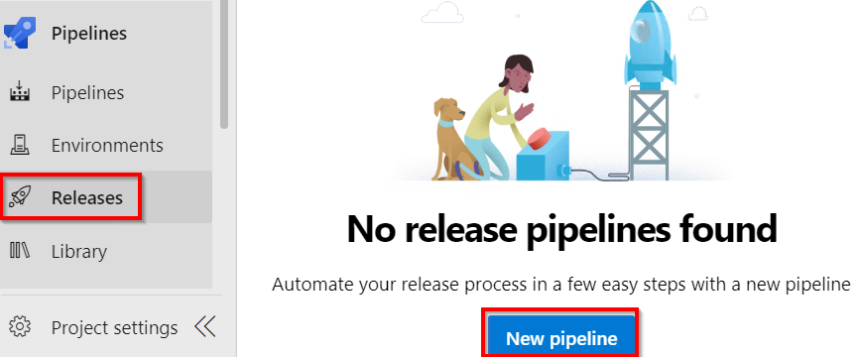

Figure 12.26: Azure DevOps—release pipelines—New Pipeline
Creating a release definition | 407

2. The next step is to choose a release definition template. In the Select a template
pop-up window, select Deploy the function app to Azure Functions and click on
the Apply button, as shown in Figure 12.27. Immediately after clicking on the Apply
button, a new environment (stage) pop-up window will be displayed. For now, just
close the Environment pop-up window:
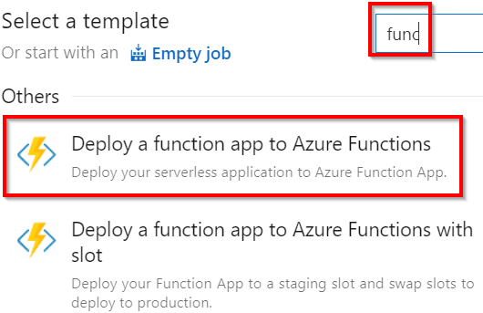

Figure 12.27: Azure DevOps—release pipelines—choosing the Deploy a function app to
Azure Functions app template
3. Click on the Add button available in the Artifacts box to add a new artifact, as
shown in Figure 12.28:
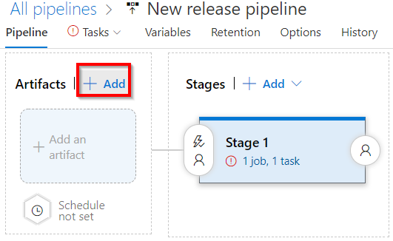

Figure 12.28: Azure DevOps—release pipelines—adding a new stage 408 | Implementing and deploying continuous integration using Azure DevOps

4. In the Add an artifact pop-up window, make sure to choose the following:
Source type: Build
Project: The team project your source code is linked to
Source (build pipeline): The build pipeline name where your builds are created
Default version: Latest:
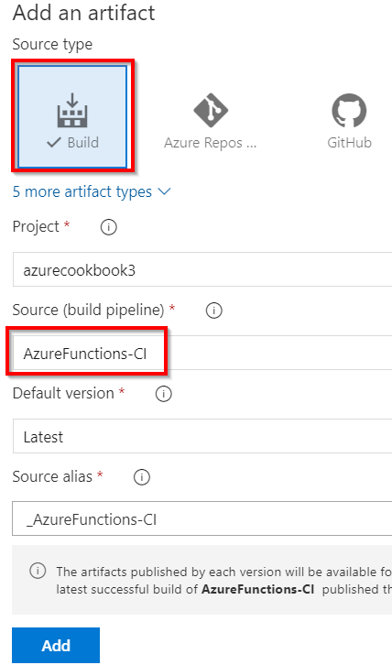

Figure 12.29: Azure DevOps—release pipelines—adding an artifact
Creating a release definition | 409

5. After reviewing all the values on the page, click on the Add button to add the
artifact.
6. Once the artifact is added, the next step is to configure the stages where the
package needs to be published. Click on the 1 job, 1 task link, shown in Figure 12.30.
Also, change the name of the release definition to release-def_stg:
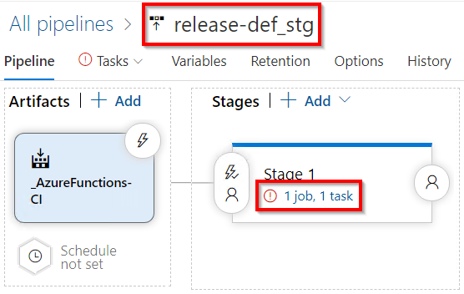

Figure 12.30: Azure DevOps—release pipelines—the configuration stage
7. You will be taken to the Tasks tab, shown in Figure 12.31. Provide a meaningful
name in the Stage name field. I have provided the name Staging Environment
for this example. Next, choose the Azure subscription to which you would like
to deploy the Azure function. You will need to click on the Authorize button to
provide the permissions:
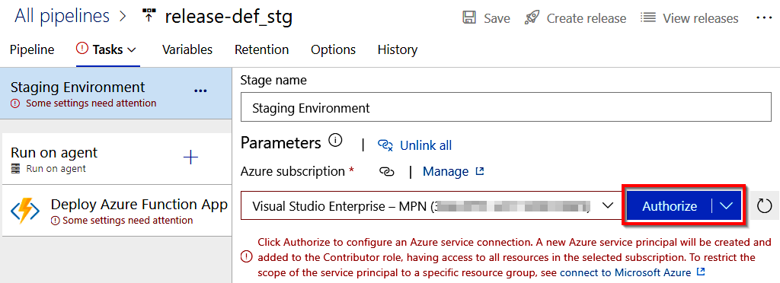

Figure 12.31: Azure DevOps—release pipelines—authorizing an Azure subscription
410 | Implementing and deploying continuous integration using Azure DevOps

8. Once you authorize the account, you will see all the available Azure functions in
the App Service name drop-down list, as shown in Figure 12.32. You can choose the one in which you would like to deploy the function app project:
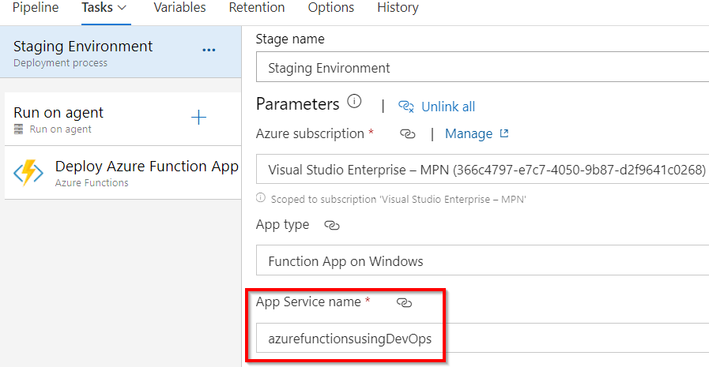

Figure 12.32: Azure DevOps—release pipelines—choosing the Azure Function App
9. Click on the Save button to save the changes. Now, let's use this release definition
and try to create a new release by clicking on Create release, as shown in Figure 12.33:
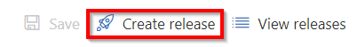

Figure 12.33: Azure DevOps—release pipelines—Create release
Creating a release definition | 411

10. Next, you will be taken to the Create a new release pop-up window where you
can configure the build definition that needs to be used. As we have only one, we
can see only one build definition. You also need to choose the right version of the
build, as shown in Figure 12.34. Once you have reviewed it, click on the Create
button to queue the release:
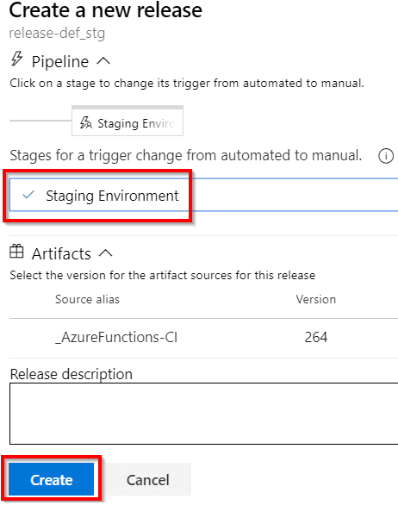

Figure 12.34: Azure DevOps—release pipelines—creating and configuring a release
412 | Implementing and deploying continuous integration using Azure DevOps

11. Once the release is created, navigate to the Pipeline tab, as shown in Figure 12.35.
Now, click on the Deploy button as shown here to initiate the process of deploying the release:
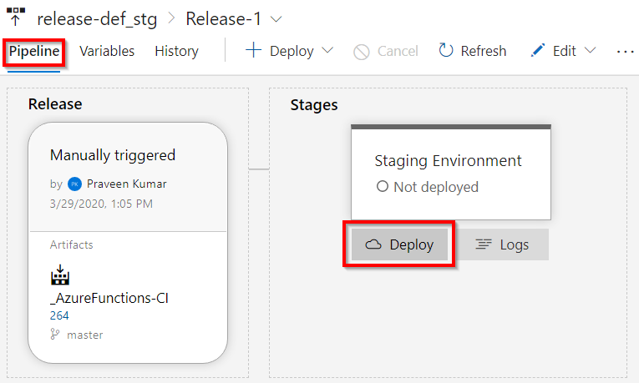

Figure 12.35: Azure DevOps—release pipelines—deploying the release
Creating a release definition | 413

12. You will now be prompted to review the associated artifacts. Upon review, click on
the Deploy button, as shown in Figure 12.36:
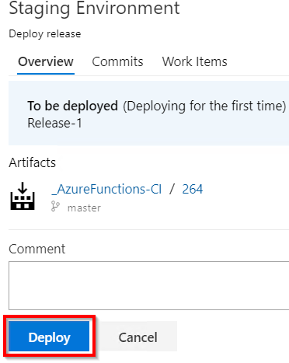

Figure 12.36: Azure DevOps—release pipelines—deploying and reviewing the release
13. Immediately, the process will start, and it will show In Progress to indicate the
progress of the release, as shown in Figure 12.37:
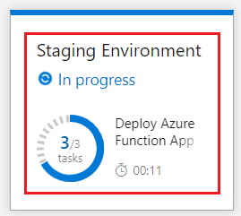

Figure 12.37: Azure DevOps—release pipelines—deployment progress 414 | Implementing and deploying continuous integration using Azure DevOps

14. Click on the In Progress link shown in Figure 12.37 to review the real-time
progress. As shown in Figure 12.38, the release process succeeded:
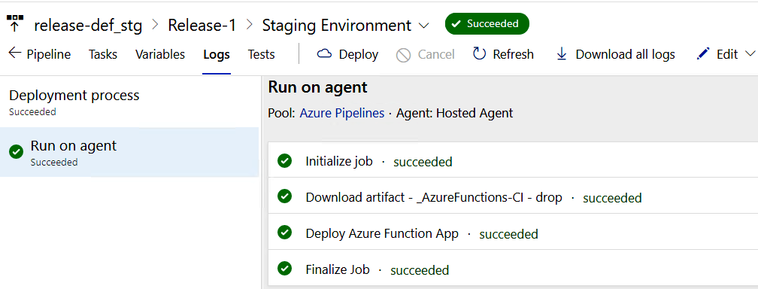

Figure 12.38: Azure DevOps—release pipelines—release summary

How it works…
In the Pipeline tab, we have created artifacts and an environment named staging and linked them together.
We have also configured the environment to have the Azure App Service related to the Azure functions that we created in Chapter 4, Developing Azure functions using Visual Studio.

There's more…
While configuring continuous deployment for the first time, we may come across a button with the text Authorize in the Azure App Service deployment step. Clicking on the Authorize button will open a pop-up window, prompting for the Azure portal's credentials.
In this recipe, we have learned how to create and configure a release pipeline. Let's move on to the next recipe.
Triggering a release automatically | 415

Triggering a release automatically
In this recipe, you will learn how to configure continuous deployment for an environment. In your project, you can configure development, staging, or any other pre-production environment and configure continuous deployment to streamline the deployment process.
In general, it is not recommended to configure continuous deployment for a production environment. However, this might depend on various factors and requirements. Be cautious and think about various scenarios before configuring continuous deployment for a production environment.

Getting ready
Download and install the Postman tool if it's not installed yet.

How to do it…
To configure continuous deployment, we'll perform the following steps:
1. By default, the releases are configured to be pushed manually. Let's configure
continuous deployment by navigating back to the Pipeline tab and clicking on the
Continuous deployment trigger button, as shown in Figure 12.39:
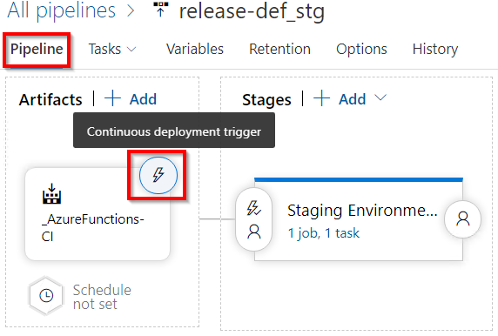

Figure 12.39: Azure DevOps—release pipelines—clicking on the Continuous deployment trigger button 416 | Implementing and deploying continuous integration using Azure DevOps

2. As shown in Figure 12.40, enable the continuous deployment trigger and click on
Save to save the changes:
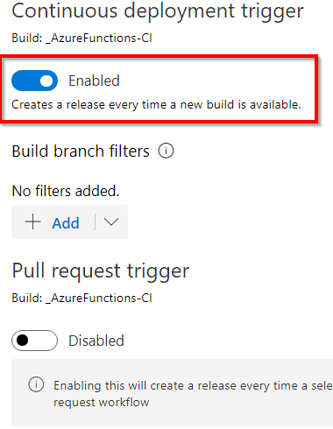

Figure 12.40: Azure DevOps—release pipelines—enabling the continuous deployment trigger
3. Navigate to Visual Studio and make some code changes, as follows:
return name != null ? (ActionResult)new OkObjectResult($"Automated Build Trigger and Release test by, { name}")
: new BadRequestObjectResult("Please pass a name on the query
string or in the request body");
4. Now, commit the code with a comment – Continuous Deployment, to commit the
changes to Azure DevOps. Soon after checking in the code, navigate to the Builds tab to see a new build get triggered, as shown in Figure 12.41:
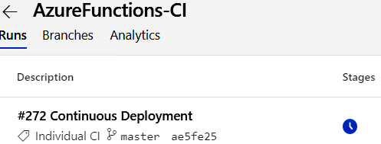

Figure 12.41: Azure DevOps—build pipelines—new build triggered automatically
Triggering a release automatically | 417

5. Navigate to the Releases tab after the build is complete to see that a new release
got triggered automatically, as shown in Figure 12.42:
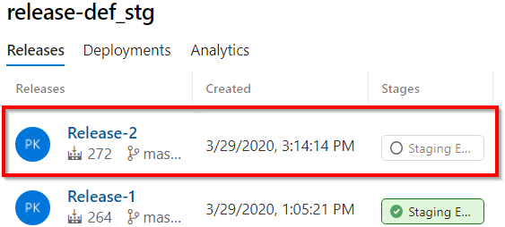

Figure 12.42: Azure DevOps—release pipelines—new release triggered automatically
6. Once the release process is complete, changes can be reviewed by making a
request to the HTTP trigger using the Postman tool:
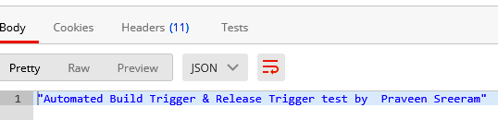

Figure 12.43: Azure DevOps—release pipelines—output in Postman

How it works…
In the Pipeline tab, we have enabled the continuous deployment trigger.
Every time a build associated with AzureFunctions-CI is triggered, the release-def_ stg release will be automatically triggered to deploy the latest build to the designated environment. We have also seen the automatic release in action by making a code change in Visual Studio.

There's more…
We can also create multiple environments and configure the definitions to release the required builds to those environments.
In this recipe, we have learned how to configure continuous deployment for Azure functions using release pipelines.
418 | Implementing and deploying continuous integration using Azure DevOps

Integrating Azure Key Vault to configure application secrets
One of the major parts of any project is handling secrets in an efficient manner to adhere to organization-wide security guidelines. It's not advised to maintain secrets (such as passwords) in code or in files that are accessible to developers or any other stakeholders. In fact, these days, all the production environment details are only accessible by a few people and the secrets are managed by various systems. One such system in Azure is Key Vault. In this recipe, we'll learn how to leverage Key Vault to manage a secret that can be accessed by the code in a function app.

How to do it…
In this recipe, we will work on the following steps:
1. Creating a secret in the Key Vault service.
2. Configuring the Azure DevOps release pipeline.
3. Configuring the access policy.

Creating a secret in the Key Vault service In this section, we will create a Key Vault service that can be used to manage secrets:
1. Create a Key Vault service as shown in Figure 12.44:
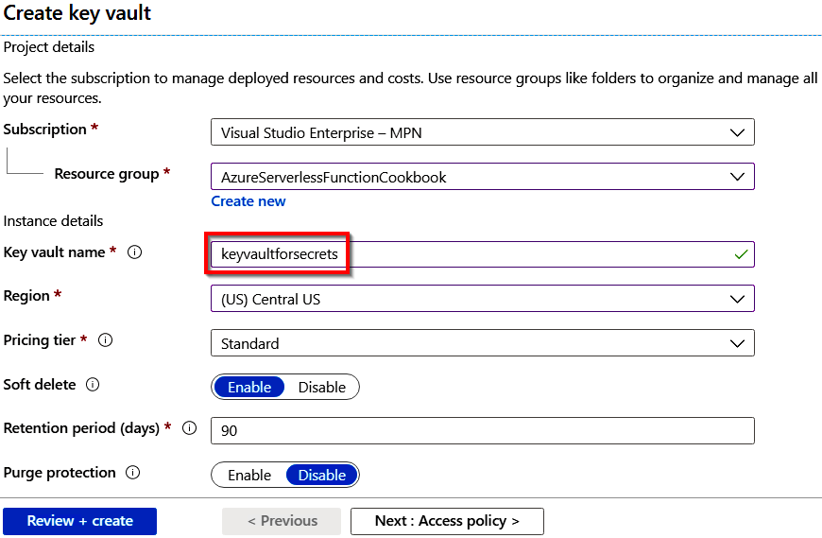

Figure 12.44: Creating a new Key Vault service
Integrating Azure Key Vault to configure application secrets | 419

2. Once the Key Vault service is created, navigate to the Secrets blade, as shown in
Figure 12.45:
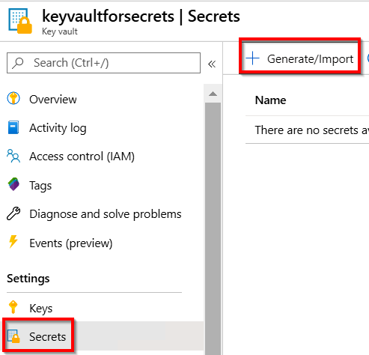

Figure 12.45: Key Vault—generating secrets
3. Click on the Generate/Import button to create a new secret.
420 | Implementing and deploying continuous integration using Azure DevOps

4. Now, provide the Name/Value pair for the secret. The Name is the variable name
that is used to refer to the secret and the Value is our actual secret to be used in the application. For example, the value would be a password or some other confidential value that needs to be stored in a secure place. As shown in Figure 12.46, provide the values, create a secret, and click on the Create button:
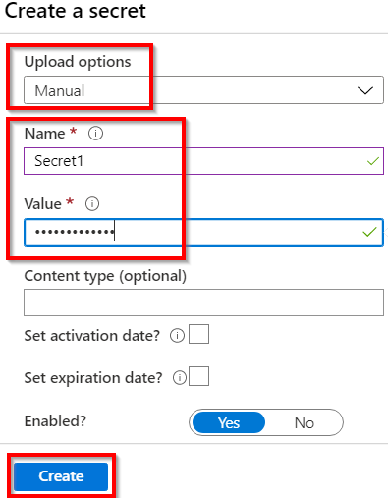

Figure 12.46: Key Vault—creating a secret
That's it. We have created a key vault service and also a secret value. We will be referring to these later in this recipe when we create an app setting in the Azure portal via the Azure DevOps release pipeline.
Integrating Azure Key Vault to configure application secrets | 421

Configuring the Azure DevOps release pipeline In this section, we'll learn how to download the secret(s) from the Key Vault service into the Release pipeline.
Perform the following steps in order to download the secrets from the Key Vault service:
1. Navigate to your Release pipeline and click on the Edit button:
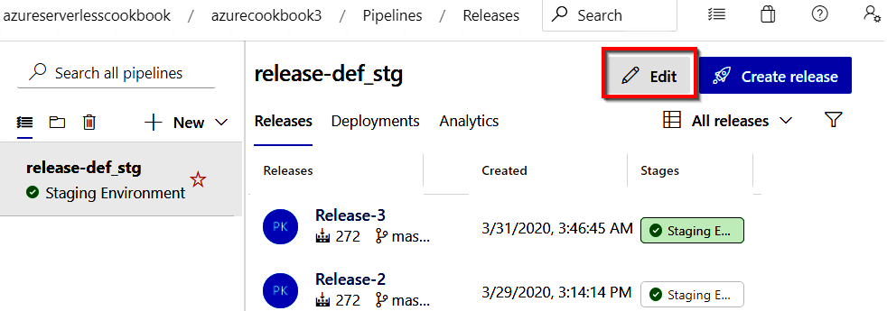

Figure 12.47: Azure DevOps—release pipelines—editing the release pipeline
2. In the Pipeline tab, click on the link to navigate to the Tasks tab:
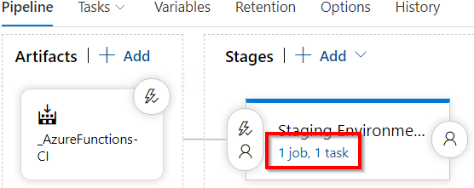

Figure 12.48: Azure DevOps—release pipelines—the editing stage
422 | Implementing and deploying continuous integration using Azure DevOps

3. In the Tasks tab, click on the Add button to add the task to the pipeline as
shown in Figure 12.49. This task downloads all the secrets from the Key Vault service. These downloaded values will be created as release variables, which can be referred to in any of the release steps. The variable names are the same as the names of the secrets. For example, we have created a secret with the name Secret1. So, we can refer to it as $(Secret1) in any of the steps in the release pipeline:
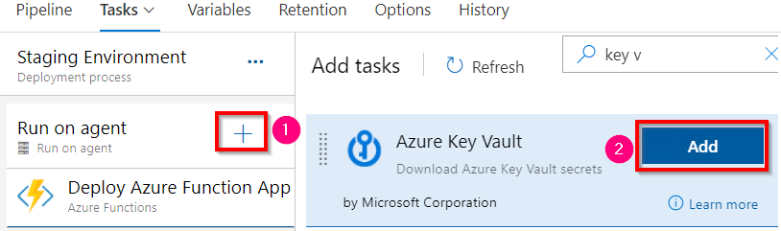

Figure 12.49: Azure DevOps—release pipelines—adding an Azure Key Vault secrets task
4. Now, in the Azure Key Vault task, choose the service connection (in the Azure
subscription field) as shown in the following figure and also choose the name of the key vault service, and then provide a filter as per the project's requirements. Providing * would download all the secrets from the Key Vault service. Please make sure you change the order of the Azure Key Vault task to run before the Deploy Azure Function App task as shown in Figure 12.50:
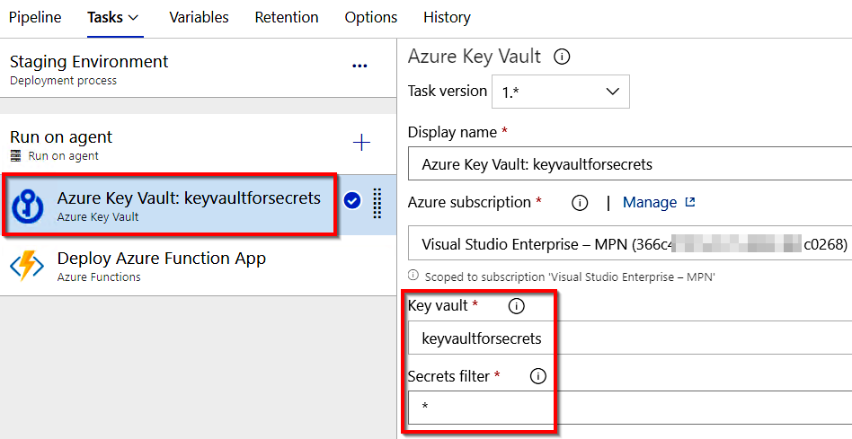

Figure 12.50: Azure DevOps—release pipelines—configuring the Azure Key Vault secrets task
Integrating Azure Key Vault to configure application secrets | 423

5. Now, our goal is to use the secret variable and create an app setting inside the
Azure Function app. Let's select the Azure function task and navigate to the
App Settings section, then add a new key-value pair as shown in Figure 12.51.
It will create a new app setting named SecretKeyName with the value that you have
in the secret:
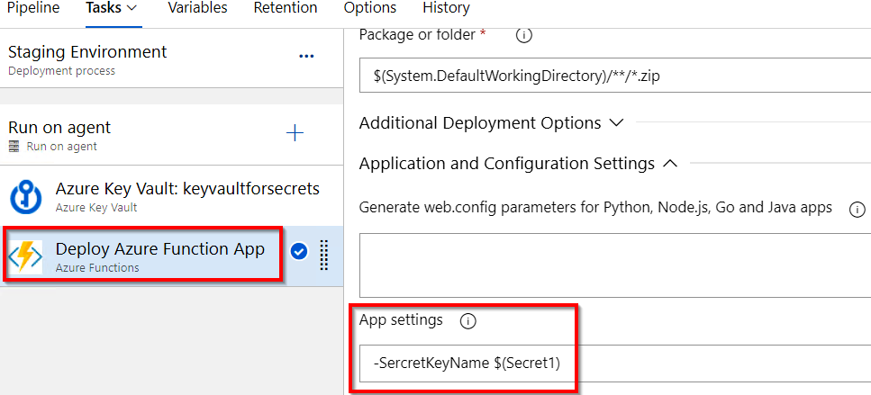

Figure 12.51: Azure DevOps—release pipelines—creating app settings in an Azure Function app
6. After reviewing the changes, please save them.

We are now done with integrating our DevOps pipeline with the Azure Key Vault service. However, it won't work as Key Vault is secured by default. So, we need to configure DevOps to access the Key Vault service explicitly. Let's do that now.
424 | Implementing and deploying continuous integration using Azure DevOps

Configuring the access policy
In this section, we will learn how to configure the access policy:
1. Navigate to the Access policies blade and view the current policy that has access
to the key vault. As you can see here, the username Praveen has access to the Key Vault service. Now, we need to provide access to the Azure DevOps service connection that we have created for our release pipeline:
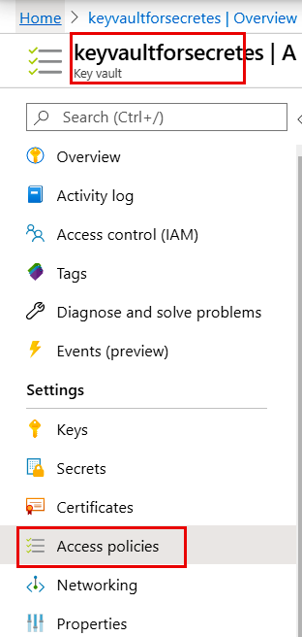

Figure 12.52: Key Vault—Access policies
Integrating Azure Key Vault to configure application secrets | 425

2. In the Access policies blade, click on Add Access Policy, which takes you to
another page for choosing the required policies:
In the Secret Permissions field, choose Get and List.
Click on Select principal.
3. In the Principal pop-up window, you have to search for the principal name as
shown in Figure 12.53. It will be in the format <azure devops organization name>-
<Project name>-<Azure Subscription Id>:
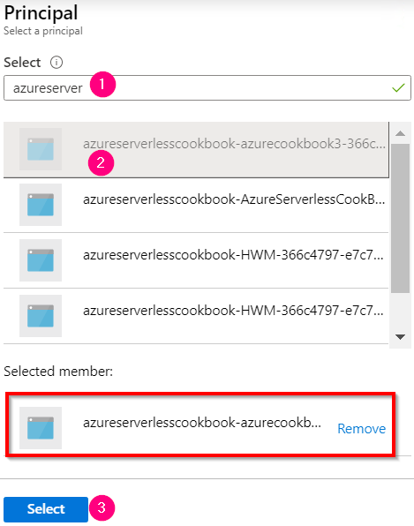

Figure 12.53: Key Vault—configuring access policies for the function app
426 | Implementing and deploying continuous integration using Azure DevOps

4. After clicking on Select, the selected permission will be displayed, as shown in
Figure 12.54:
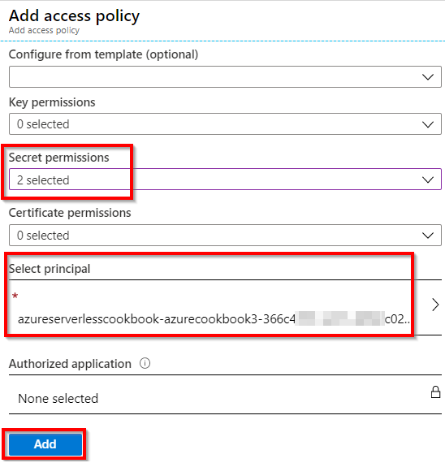

Figure 12.54: Key Vault—configuring access policies for the function app with permissions
5. In the preceding step, click on Add, which will configure the permissions between
Azure DevOps and the Key Vault service as shown in Figure 12.55. Click on the Save button to save the changes:
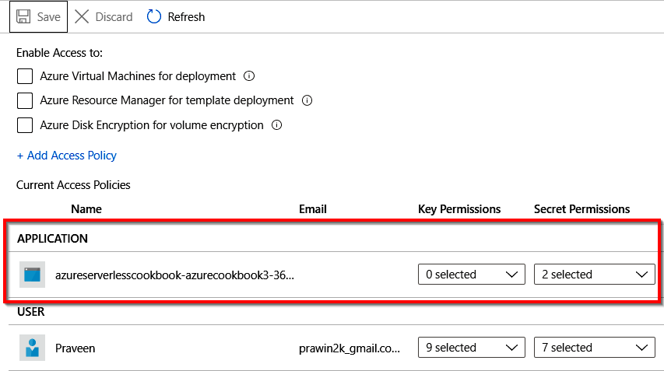

Figure 12.55: Key Vault—configuring access policies—viewing a function app with permissions
Integrating Azure Key Vault to configure application secrets | 427

6. That's it. We are now ready to run the release pipeline. Go ahead to the release
pipeline and run it. Now, navigating to the Application settings tab available in
the Configuration blade of the Azure Function app should show the secret setting
configured, as shown in Figure 12.56:
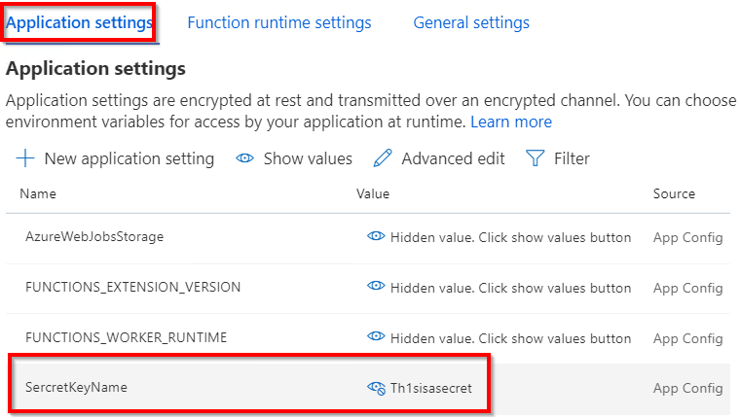

Figure 12.56: Azure Function app—app settings

How it works…
In this recipe, we have done the following:
1. We created a Key Vault service.
2. We created a secret in the Key Vault service.
3. In the Azure DevOps pipeline, we created a new task called Azure Key Vault that
is capable of downloading secrets from the key vault depending on the filters
specified in the task.
4. In the Azure Key Vault service, we configured an access policy by providing the
read (Get and List) permissions to the service principal of the Azure DevOps
service connection.
5. We created a key that refers to a secret variable, which is downloaded in the
previous task (the Azure Key Vault task).
6. When we run the release pipeline, the new app settings get created in the
Configuration blade of the Azure Function app.

In this chapter, we learned how to create a build pipeline and a release pipeline, and we learned how to configure continuous integration and continuous deployment for Azure functions using Visual Studio and Azure DevOps.
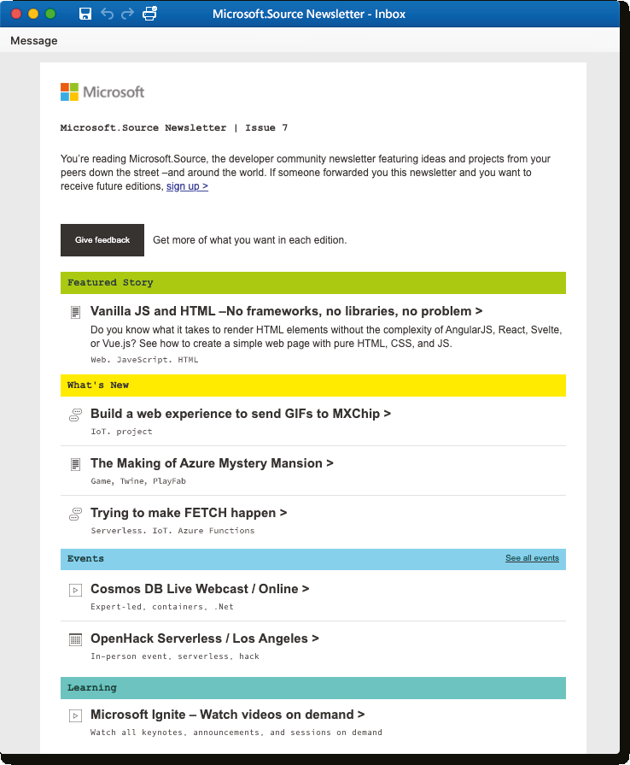
By developers, Get technical articles, sample ● Keep up on the latest code, and information on technologies

for developers upcoming events in ● Connect with your peers Microsoft.Source, the at community events Sign up curated monthly developer ● Sign up Learn with Microsoft.Source newsletter community newsletter. hands-on resources
Index

About
All major keywords used in this book are captured alphabetically in this section. Each one is
accompanied by the page number of where they appear.

A B cosmosdb: 267-268, 270 countif: 220
ad-admin: 307 bearer: 290-292 csharp: 226, 246, 259
addasync: 16-17, 34, binaries: 354-356 csvimport: 248-249, 252,
40, 61, 319 binding: 13, 15, 17-18, 254-256, 258, 260,
addcontent: 41-42, 20-21, 29, 33-34, 263-264, 267-269
44, 209 36-37, 49, 59-60, 268,
address: 29, 37-38, 318-319, 323, 371-372 D
42, 44, 118, 173, 177, blobname: 260-261 214, 292, 296-297, database: 79-80, 82,
299, 309, 311, 363 86, 161, 239, 267, C
aiappid: 197-199, 208, 271, 273, 300-305,
210, 220-221 classes: 120, 328, 332 308-309, 339, 368
aiappkey: 197-198, client: 3, 20, 28, 61, 88, dataset: 97-101,
208, 210, 220-221 114, 147, 199, 209, 211, 214-219, 222-223
algorithms: 56 227-228, 231, 233-234, debugger: 118, 124, 128, 131
allocated: 86, 266 247-249, 254-258, deploy: 65, 124-125,
analytics: 183, 193-195, 268, 270, 274, 277, 279, 127-129, 132-133, 135,
197-198, 204, 206, 212, 281, 283, 285-288, 139, 143, 163, 184, 334, 214, 219, 221-222 290, 292, 296, 298, 353-355, 358, 361, 386,
apipath: 198, 210, 221 316, 373, 376, 378 406-407, 409-410,
artifact: 395, 399, 407-409 cloudqueue: 322 412-413, 417, 422
aspnet: 348 clustered: 307 detect: 56, 124
assemblies: 252 cognitive: 55-58, devops: 112, 385,
auditing: 55, 79 60-61, 63-65, 109 387-418, 420-427
authlevel: 230 config: 255, 348, diagnose: 184, 186, 188
authoring: 92, 358-359 378, 380-382 dimensions: 21, 24
autopilot: 266 connector: 68-69, directory: 249-250,
azure-: 360 71, 73-74, 76 260, 273, 281-282,
Azure Blob Storage 1, 2, 3, container: 15, 17, 19-20, 284-286, 290, 292,
17, 18, 19, 21, 27, 43, 44, 43, 45, 58, 62, 79-82, 305, 313, 322, 395 45, 46, 58, 92, 98, 149 84-86, 88-89, 100, 111, docker: 132-140, 142-143
Azure Table Storage 1, 121-122, 124, 128-130, domain: 2, 226,
2, 3, 9, 10, 11, 13, 14, 15, 132-135, 137, 139-140, 353, 362-367 47, 56, 59, 60, 64, 359 142-143, 149, 151, dotnet: 136, 164
248-249, 251-254, 258, durable: 225-243, 245-247,
260, 267, 270-271, 357 255-257, 259-260, 271

E G inbound: 292, 296-300 inject: 345, 348-349
easyauth: 281 gateway: 231, 300, 373-375 inputjson: 7, 12, 16,
encrypt: 301, 378 getasync: 198, 210, 39, 41, 44, 47
endpoint: 57-58, 221, 327 insights: 145, 166-168,
80, 143, 290 getbytes: 47, 52, 221 171, 174-175, 183-184,
exception: 24, 166, getinput: 240, 264-265 188-196, 199-209,
185-186, 188, 199, getpostman: 146, 227, 212-214, 219,
211, 250, 302, 323 235, 237, 274 222-223, 359
getsection: 347 instance: 45, 57, 88, 90,

F getstring: 261 94, 96, 108, 167, 191-192, github: 177, 234, 360 206, 226, 234-235, 259,
foreach: 60, 88, 96, 284, 294, 299, 326, 358
102-106, 270 invoke: 3, 20, 38, 64, 74, H
function: 3-4, 6-7, 9-13, 88, 171, 234, 255-257,
15-22, 24-25, 29, 33-47, hosting: 133, 141, 325 259-260, 264, 269, 338
49, 51, 53, 56, 58-60, httpalive: 326-327 isdeleted: 86
63-65, 75-79, 82-86, httpclient: 61, 198, ispastdue: 220
88-90, 94-96, 105-106, 210, 220-221, 327
108, 111-125, 127-133, httpstart: 229, 231, J
135-137, 139-143, 234-235, 256
145-148, 152, 154-158, json-based: 358
160, 162-167, 169, jtoken: 198, 210, 221 I
174-175, 177-181, 184-192,
195-197, 199-202, 205, ibinder: 46, 52 K
208-209, 212, 219-220, icollector: 320
222, 227-229, 231-243, identity: 273, 281, 300, key-value: 9, 341-343,
246, 249-250, 252-260, 305-307, 309 345, 347-349, 423
263-265, 268-270, ilogger: 7, 12, 16, 19, 23,
273-285, 289-291, 34, 38, 41, 44, 46, 52, L
294-296, 299-301, 60, 84, 147, 178, 180,
303, 306, 309-310, 191, 197, 208, 210, 220, leases: 86
313, 315-317, 319-332, 229, 240, 258, 263, libraries: 20, 22, 315,
335-337, 340, 345-346, 270, 301, 317, 319, 323, 328, 331-332
348, 350, 353-355, 327, 331, 350, 370 localhost: 118, 137, 286
357-363, 365, 367-368, images: 1, 3, 17, 20, 25, logerror: 24, 198-199, 211
371-380, 382-383, 399, 55-56, 58, 62-63, logging: 27, 43, 46,
401, 407, 409-410, 418, 133-134, 137, 240 138, 180, 196, 208,
422-423, 425-427 import: 245-247, 255, 219, 258, 325, 369
266, 294, 296, 351, 419 lookup: 96-104
M postdata: 221 simulate: 193, 237, postman: 146-148, 241, 317, 333
methods: 148, 155, 230, 227, 235-237, 241, sqlclient: 301, 303
266, 320, 328, 332 274-276, 284-287, 290, staging: 145, 155,
metric: 194-196, 198-199, 308, 317, 415, 417 157-160, 162, 354,
202-205, 221 powerbi: 214 386, 409, 414-415
migrate: 316, 333, 339, 351 powershell: 315, status: 8, 13, 16, 120, 148,
msgcontent: 209 332-333, 335, 338 175, 234-236, 241-242,
mutate: 24 proxies: 353, 372-373, 259, 305, 349, 398, 405
375-376, 378 subsets: 353, 372
N swapping: 156, 159 nodejs: 163 Q
queues: 1, 3, 14-15, 18-19, T

O 146, 153, 316, 325 telemetry: 166, 183-184, 188, 190,
object: 14, 37, 39-40, 193, 195, 199-200, R
46-47, 180, 229, 232, 205, 209, 212-213 260, 262, 306-307 rand-guid: 18, 20 template: 6, 18, 21, 35,
outbound: 296, 313 readblob: 260, 263 59, 113, 149, 152, 164,
outputblob: 18-19, 44, 47 registry: 133-135, 142-143 231, 233, 235, 238-240,
release: 129, 136, 329, 252, 256, 323, 336,

P 334, 385-386, 404, 359-361, 373, 377, 388, 406-418, 420-424, 427 392-393, 395-396, 407
parameter: 11, 13, 15-18, repository: 133-134, testappid: 198-199
20-21, 37, 39, 42, 44, 387, 391, 394-395 text-align: 209-210 58-59, 64, 71, 79, 103, resultjson: 198, threading: 180, 197, 208, 147, 166, 191-193, 231, 210-211, 221 219, 249, 261, 303 275-276, 298, 317-318, rowkey: 12, 46-47, 60 throttling: 273, 320, 325, 372, 377 292, 296-297
pipeline: 87-89, 91-92, timestamp: 192, 197, S
96, 102, 105, 107-109, 202, 207, 211, 220 385, 389-390, 393-397, sendgrid: 27-33, 36-39, traces: 191-193 399-403, 405-406, 41-42, 45-46, 48, 88, tracking: 166, 188 408, 412, 414-415, 108, 205-206, 208, 212 traffic: 166, 190, 417-418, 420-424, 427 serverless: 2-3, 55, 326-327, 373
plugging: 87 74, 79, 87, 133, 209,
plumbing: 112, 115 225-226, 231, 246-247,
poison: 324-325 316, 326, 353-354
postasync: 61, 221
trigger: 1, 3, 6-10, 12-13, V

15, 17-18, 20-21, 25,
28, 33-36, 38, 40-41, validating: 145-146,
58, 60, 66, 68, 73, 166, 188, 207
75, 78, 82-86, 88-89, variable: 39, 44, 46,
107, 114-116, 118-124, 78, 119, 129, 395,
129-130, 132, 136, 420, 422-423, 427
146-149, 152-156, 164,
166, 168, 177-179, 185, W
187, 190-193, 196-197,
203, 205, 208-209, webclient: 19
212-213, 219-220, 223, webjobs: 46, 52, 124,
229, 231, 238, 245-247, 196, 208, 219, 229,
252, 254-260, 263-265, 232-233, 238-240,
268-270, 274-276, 278, 258, 267, 303, 369
284-285, 291, 294, 298, website: 20, 29, 31, 44,
300-301, 303, 308-309, 166, 195, 212-213, 243,
312-313, 316-317, 278, 316, 357-358
320-321, 323, 325-327, whitelist: 309, 311, 313
330-331, 333, 336-340, wwwroot: 136, 329,
345-346, 348-351, 355, 332, 354-355
357, 373-374, 396, 399,
401, 403, 406, 415-417 X
tweets: 65-66, 68, 73-74
twilio: 27-28, 48-53, 108 x-api-key: 198, 210, 221
twitter: 65-66, 68, x-ms-app: 198, 210, 221
72-74, 78

U youtube: 53 Y
uploadblob: 249-250
urifactory: 268, 270
utilities: 115, 328, 330-331

