

Table of Contents
Chapter 3 Functions and Conditional Formatting ����������������������������������������������87
Chapter 4 Selection ���������������������������������������������������������������������������������������������119
Chapter 5 Graphical Presentations ��������������������������������������������������������������������157
Chapter 6 PivotTables �����������������������������������������������������������������������������������������197
Chapter 7 Sorting and Searching �����������������������������������������������������������������������235
Chapter 8 Intermediate and Advanced Techniques ������������������������������������������283
Chapter Appendices. Each chapter ends with an appendix presenting more detail about specific topics, such as the Excel Development Screen, working with rows and columns, how to transfer data between sheets, how to locate and fix incorrectly copied formulas, and how to use a spreadsheet as a database. Instructor Resources. Instructor resources include PowerPoint slides for each chapter, video tutorials, sample syllabi, and sample tests and quizzes.
Part 1
Chapter 1 Getting Started
Chapter 2 Formulas and Formatting
Chapter 3 Functions and Conditional Formatting
Chapter 4 Selection
Part 2
Chapter 5 Graphical Presentations
Chapter 6 PivotTables
Chapter 6 presents PivotTables, which are used to easily create concise summary ta-
Part 3
Chapter 7 Sorting and Searching
Chapter 8 Intermediate and Advanced Techniques
E ® xcEl Basics


LICENSE, DISCLAIMER OF LIABILITY, AND LIMITED WARRANTY
By purchasing or using this book (the “Work”), you agree that this license grants permission to use the contents contained herein, but does not give you the right of ownership to any of the textual content in the book or ownership to any of the information or products contained in it. This license does not permit uploading of the Work onto the Internet or on a network (of any kind) without the written consent of the Publisher. Duplication or dissemination of any text, code, simula-tions, images, etc. contained herein is limited to and subject to licensing terms for the respective products, and permission must be obtained from the Publisher or the owner of the content, etc., in order to reproduce or network any portion of the textual material (in any media) that is contained in the Work.
Mercury Learning and inforMation (“MLI” or “the Publisher”) and anyone involved in the creation, writing, production, accompanying algorithms, code, or computer programs (“the software”), and any accompanying Web site or soft-ware of the Work, cannot and do not warrant the performance or results that might be obtained by using the contents of the Work. The author, developers, and the Publisher have used their best efforts to ensure the accuracy and func-tionality of the textual material and/or programs contained in this package; we, however, make no warranty of any kind, express or implied, regarding the perfor-mance of these contents or programs. The Work is sold “as is” without warranty (except for defective materials used in manufacturing the book or due to faulty workmanship).
The author, developers, and the publisher of any accompanying content, and anyone involved in the composition, production, and manufacturing of this work will not be liable for damages of any kind arising out of the use of (or the inability to use) the algorithms, source code, computer programs, or textual material con-tained in this publication. This includes, but is not limited to, loss of revenue or profit, or other incidental, physical, or consequential damages arising out of the use of this Work. The data used throughout this text, including names of persons and companies are fictional, and any connection to actual people or companies is purely coincidental. The examples and projects in this book are for instructional purposes only. They have been tested with care but are not guaranteed for any intent beyond their educational purpose.
The sole remedy in the event of a claim of any kind is expressly limited to re-placement of the book and only at the discretion of the Publisher. The use of “implied warranty” and certain “exclusions” vary from state to state, and might not apply to the purchaser of this product.

Foundations • Formulas • Graphs E ® xcEl Basics

Jeffrey Hsu, Ph.D.
Silberman College of Business
Fairleigh Dickinson University

Gary Bronson, Ph.D.
Silberman College of Business
Fairleigh Dickinson University

MERCURY LEARNING AND INFORMATION
Dulles, Virginia
Boston, Massachusetts
New Delhi
Copyright ©2021 by Mercury Learning and inforMation LLC. All rights reserved.

This publication, portions of it, or any accompanying software may not be reproduced in any way, stored in a retrieval system of any type, or transmitted by any means, media, electronic display or mechanical display, including, but not limited to, photocopy, recording, Internet postings, or scanning, without prior permission in writing from the publisher.
Publisher: David Pallai
Mercury Learning and inforMation
22841 Quicksilver Drive
Dulles, VA 20166
info@merclearning.com
www.merclearning.com
1-800-232-0223
J. Hsu and G. Bronson. Excel® Basics.
ISBN: 978-1-68392-772-3
Excel® is a registered trademark of Microsoft Corporation.
The publisher recognizes and respects all marks used by companies, manufacturers, and developers as a means to distinguish their products. All brand names and product names mentioned in this book are trademarks or service marks of their respective companies. Any omission or misuse (of any kind) of service marks or trademarks, etc. is not an attempt to infringe on the property of others.
Library of Congress Control Number: 2021944921
212223321 Printed on acid-free paper in the United States of America.
Our titles are available for adoption, license, or bulk purchase by institutions, corporations, etc. For additional information, please contact the Customer Service Dept. at 800-232-0223(toll free).
All of our titles are available in digital format at academiccourseware.com and other digital vendors. The sole obligation of Mercury Learning and inforMation to the purchaser is to replace the book, based on defective materials or faulty workmanship, but not based on the operation or functionality of the product.

To Lottie, who represents the future
for those who love science and technology!
— Jeffrey Hsu

To Serafina, Emerson, and Isaiah
— Gary Bronson

Contents

Preface ......................................................................................................................................xi Acknowledgments ...................................................................................................................xiii About the Authors ................................................................................................................... xv
PART 1 BASIC SKILLS
Chapter 1 Getting Started ��������������������������������������������������������������������������������������3
1.1 Introduction to Excel Spreadsheets .........................................................................................3
Cell Contents .................................................................................................................................5 Entering Data into a Cell ..............................................................................................................9
Exercises 1.1 .....................................................................................................................................10 1.2 Two Essential Skills – Highlighting and Copying ..................................................................11
Selecting Cells by Highlighting ...................................................................................................11 Copying Cell Contents .................................................................................................................13
Exercises 1.2 .....................................................................................................................................16 1.3 Opening, Saving, Retrieving, and Printing Spreadsheets ......................................................17
Opening a New or Existing Spreadsheet ....................................................................................17 Saving a Spreadsheet ...................................................................................................................18 Printing a Spreadsheet .................................................................................................................20
Exercises 1.3 .....................................................................................................................................22 1.4 Professional Spreadsheet Guidelines .....................................................................................24
Input and Results Sections .........................................................................................................24
1.5 Common Excel Errors ............................................................................................................26
Common Errors ...........................................................................................................................27
1.6 Chapter Appendix: The Excel Development System ............................................................27
Using Excel’s Options .................................................................................................................30 Using the Excel Ribbon Tabs Toolbar .........................................................................................30 Appendix Exercises ......................................................................................................................32
Chapter 2 Formulas and Formatting �������������������������������������������������������������������33
2.1 Formulas ..................................................................................................................................33
From Expressions to Formulas ...................................................................................................35 Graphically Selecting Cells .........................................................................................................36 Copying Formulas ........................................................................................................................39 Expression Construction Rules ...................................................................................................41
Exercises 2.1 .....................................................................................................................................42 2.2 Introduction to Excel Functions .............................................................................................46
Highlighting Selected Arguments ...............................................................................................53
Exercises 2.2 .....................................................................................................................................54 2.3 Formatting ..............................................................................................................................57 Exercises 2.3 .....................................................................................................................................62 2.4 Cash-Flow and Cash-Balance Spreadsheets ..........................................................................64
A Cash-Balance Spreadsheet .......................................................................................................66
Exercises 2.4 .....................................................................................................................................67 viii Contents

2.5 Absolute Addresses .................................................................................................................68
Case 1: Magic Numbers as Input Values ....................................................................................69 Case 2: Running Sub-Totals ........................................................................................................73
Exercises 2.5 .....................................................................................................................................74 2.6 Common Excel Errors ............................................................................................................77 2.7 Chapter Appendix: Working with Rows and Columns .........................................................78
Adjusting Column and Row Widths ............................................................................................79 Inserting and Deleting Columns and Rows ................................................................................81

Chapter 3 Functions and Conditional Formatting ����������������������������������������������87
3.1 Date, Time, and Text Functions .............................................................................................88
Text and Character Functions .....................................................................................................90
Exercises 3.1 .....................................................................................................................................92 3.2 Statistical Functions ................................................................................................................94
Standard Deviations .....................................................................................................................96
Exercises 3.2 ...................................................................................................................................100 3.3 Financial Functions ..............................................................................................................101
The PMT( ) function ..................................................................................................................101 Repayment Schedules: Amortization ........................................................................................104
Exercises 3.3 ..................................................................................................................................107 3.4 Information (IS) Functions ..................................................................................................108 3.5 Conditional Formatting ........................................................................................................109
Creating a Simple Conditional Formatting Rule ......................................................................111 Creating a User-Entered Conditional Value .............................................................................113
Exercises 3.5 ...................................................................................................................................116 3.6 Common Excel Errors ..........................................................................................................117 3.7 Chapter Appendix: Transferring Data Between Sheets ......................................................118

Chapter 4 Selection ���������������������������������������������������������������������������������������������119
4.1 Relational Expressions ..........................................................................................................119
Logical Functions.......................................................................................................................122
Exercises 4.1 ...................................................................................................................................123 4.2 The IF( ) Function ................................................................................................................125
Selecting a Text Value ................................................................................................................125 Selecting a Numeric Value ........................................................................................................127 Selecting a Calculation ..............................................................................................................128 Nested IF( ) Functions ..............................................................................................................129 Logical Conditions .....................................................................................................................130
Exercises 4.2 ...................................................................................................................................130 4.3 The VLOOKUP( ) Function .................................................................................................133
Exact Match ...............................................................................................................................137 Give It a Try ...............................................................................................................................138 Approximate (Closest) Match ....................................................................................................138
Exercises 4.3 ...................................................................................................................................140 4.4 The HLOOKUP( ) Function ...............................................................................................146
Give It a Try ...............................................................................................................................149
Exercises 4.4 ...................................................................................................................................150 4.5 Common Excel Errors ..........................................................................................................152 4.6 Chapter Appendix: Testing and Debugging.........................................................................152
Contents ix

PART 2 PRESENTATIONS

Chapter 5 Graphical Presentations ��������������������������������������������������������������������157
5.1 Introduction ...........................................................................................................................157 Exercises 5.1 ...................................................................................................................................159 5.2 Creating Column and Bar Charts .........................................................................................160
Changing a Column Chart’s and Bar Chart’s Elements and Appearance ................................161 Changing Chart Types ..............................................................................................................164
Exercises 5.2 ...................................................................................................................................165 5.3 Creating Pie Charts ...............................................................................................................167
Changing a Pie Chart’s Elements and Appearance ..................................................................168 Changing Chart Types ..............................................................................................................170
Exercises 5.3 ...................................................................................................................................171 5.4 Creating Line Graphs ...........................................................................................................173
Changing a Line Graph’s Chart Elements and Appearance ....................................................174 Changing Chart Types ...............................................................................................................176
Exercises 5.4 ...................................................................................................................................178 5.5 Trend Lines and Scatter Diagrams ......................................................................................180
Creating a Scatter Diagram .......................................................................................................181 Changing a Scatter Diagram’s Elements and Appearance .......................................................182 Adding a Trend Line ..................................................................................................................184 R2 and Selecting an Appropriate Trend Line ...........................................................................187
Exercises 5.5 ...................................................................................................................................189 5.6 Common Excel Errors ..........................................................................................................192 5.7 Chapter Appendix: Creating Histograms .............................................................................192
Procedure to Produce a Histogram in all Excel Versions .........................................................194

Chapter 6 PivotTables �����������������������������������������������������������������������������������������197
6.1 Introduction ...........................................................................................................................197
Basic PivotTable Elements ........................................................................................................200
Exercises 6.1 ...................................................................................................................................203 6.2 Creating a Basic PivotTable ..................................................................................................205
Additional Row and Summary Column Examples ...................................................................209 Single Row Field and Single Value Field ..................................................................................211 Multiple Row Fields and Single Value Fields ...........................................................................211 Single Row Fields and Multiple Value Fields ...........................................................................213 Multiple Row Fields and Multiple Value Fields.......................................................................214
Exercises 6.2 ...................................................................................................................................215 6.3 Adding Column Fields ..........................................................................................................221
Additional Column Field Examples ..........................................................................................223 A Single Set of ROW and COLUMN Fields ............................................................................224 Two Sets of Row Fields and a Single Set of Column Fields ....................................................225
Exercises 6.3 ...................................................................................................................................227 6.4 Common Excel Errors ..........................................................................................................229 6.5 Chapter Appendix: PivotTable Design Criteria ...................................................................229 x Contents

PART 3 INTERMEDIATE SKILLS

Chapter 7 Sorting and Searching �����������������������������������������������������������������������235
7.1 Records as Rows ....................................................................................................................235 Exercises 7.1 ...................................................................................................................................237 7.2 Sorting Spreadsheet Rows ...................................................................................................238
Multi-Level Sorting ...................................................................................................................240
Exercises 7.2 ...................................................................................................................................243 7.3 Creating Group Subtotals .....................................................................................................245
Nested Subtotals ........................................................................................................................250 Creating Nested Subtotals ........................................................................................................251
Exercises 7.3 ..................................................................................................................................257 7.4 Searching (Filtering) for Selected Records .........................................................................263
More Complex Searches ............................................................................................................268 OR condition .............................................................................................................................269 Multiple ANDs on the same Criteria Range Row ....................................................................270 Multiple AND Conditions on the same Criteria Range Row ..................................................270 Criteria employing both AND and OR conditions ...................................................................271
Exercises 7.4 ...................................................................................................................................272 7.5 Database Functions ...............................................................................................................276 Exercises 7.5 ...................................................................................................................................278 7.6 Common Excel Errors ..........................................................................................................280 7.7 Chapter Appendix: Spreadsheets as Databases ...................................................................280

Chapter 8 Intermediate and Advanced Techniques ������������������������������������������283
8.1 Creating Drop-Down Lists ..................................................................................................283 Exercises 8.1 ...................................................................................................................................287 8.2 Correcting Rounding Errors ................................................................................................287 8.3 Creating De-Duping Keys for Removing
Duplicate Records ................................................................................................................289
8.4 Array Functions - The SUMPRODUCT( ) Function ..........................................................289 Exercises 8.4 ...................................................................................................................................291 8.5 User-Entered Conditional Formatting Formulas ...............................................................292 Exercises 8.5 ...................................................................................................................................296 8.6 Chapter Appendix: Restricting Cell Access ........................................................................297
Appendix A Character Code Storage �����������������������������������������������������������������303
Appendix B Installing the Analysis ToolPak �������������������������������������������������������305
Index �����������������������������������������������������������������������������������������������������������������������309

PrefaCe

This book is designed to meet the needs of multiple audiences, including that of professionals and indi-viduals who are interested in becoming well versed in the basics of using Excel spreadsheets, and also for courses of various levels where the primary focus is on learning and using Microsoft Excel.
Whether in the fields of business, science, statistics, mathematics, or data analytics, there are count-less practical uses for Microsoft Excel, and this book will help to get you started in a friendly, non-tech-nical, and approachable manner. It is suitable for those who prefer to learn Excel through self-study and learning, in order to further one’s skills in analytical problem solving and decision-making using Excel as an analysis tool.
This book is also designed to be used as a textbook or supplemental reference resource for various levels and audiences, including secondary, higher education, seminars, and specialized training courses. With the recent and increased interest in STEM education, this book is an ideal choice for a broad range of audiences and courses.
This book was written to provide a firm foundation in Excel for beginning learners and students. Its intent is to present, in a clear and accessible manner, the key capabilities needed for spreadsheet appli-cations. These capabilities include knowing the basic data types and when they should be used, how to format cells, how to print spreadsheets in landscape or fit-to-page modes, how to create formulas, how to use absolute and relative addresses appropriately in copying formulas, and the basic Excel functions. This text presents topics in a clear, unambiguous, and accessible manner for beginning learners and stu-dents of Excel.
A major consideration was to give readers and students an understanding of the what and how that goes into creating spreadsheets properly, so that they avoid the mistakes commonly made by beginners. One example is in clearly and fully understanding the basic data types and when they should be used. For example, some novice users, without this understanding, would enter zip codes as numeric data, and then not understand why leading zeros were not printed. Additionally, knowing how to format a cell or how to copy a cell formula down through a column or across a row is essential. Without a clear and fo-cused understanding, many would simply retype the same general formula, over and over, using new cell references. As an understanding of these basics is essential for creating a solid foundation for beginning learners, they form the core of this book.
Interestingly, we always encountered many novice learners who claimed to have a good knowledge and experience with Excel. Many of them could actually produce acceptable and sometimes even pro-fessional-looking spreadsheets, but under closer examination were found to have noticeable gaps in their understanding. For example, when asked to present the formulas behind their spreadsheet, it was frequently discovered that many cells included manual calculator-determined results. As such, the power and versatility of Excel is not being properly utilized. To forestall the development of such habits from even starting, a central element of this text is to give readers and students a real understanding of how spreadsheets are constructed so that they develop practices that use Excel with maximum effectiveness.
To facilitate this learning process, this together with a separate Excel 2019 Project Book (Mercury Learning: Bronson and Hsu, 2021) require the student to properly create actual, practical spreadsheets. Each spreadsheet application requires either using a newly introduced capability, or reinforces one or more previously learned capabilities. This is done in incrementally and increasingly more involved and demanding ways, so that the reader gets to really understand the skill being presented. Both texts can be used independently or together.
Part One (Chapters 1-4) form the central core of this text. It is here that the basic structure of Excel is explained and the elementary but necessary features of entering data into a cell, the three types of data permitted by Excel, and saving, retrieving, and printing a spreadsheet are presented. xii PrefaCe

Additionally, formulas, functions, and formatting are explained, together with conditional formatting, specific categories of functions (statistical, financial, information, date and time, text) and a basic pro-fessional template that separates a spreadsheet into the input and result areas is presented. Specialized formulas and functions including the =IF, vertical and horizontal table lookups, and conditional expres-sions are covered. The applications discussed include car and mortgage loans calculations, repayment schedules, and text and character manipulation techniques. Finally, each chapter in this section contains a list of commonly made implementation errors and a chapter appendix providing information on less used but important concepts that users typically encounter.
Part Two (Chapters 5-6) presents Excel’s chart and graph tools (column, pie, line graphs, etc.) and the concepts and process behind creating “summary table reports” using PivotTables. Included in the charts and graphs chapter is coverage of the benefits and steps involved in creating trend lines, using correla-tions, and developing histograms. Varying approaches, structures and applications are presented in the chapter on PivotTables.
Part Three (Chapters 7-8) contains more intermediate to advanced features that include sorting and filtering (searching) Excel lists, employing database functions, created subtotaled lists, setting up drop-down lists, using array functions, and developing user-created conditional-formatting formulas.

DISTINCTIVE FEATURES OF THIS BOOK
Writing Style. The goal of this book is to present the essentials and basics of an Excel spreadsheet, in a clear and easy to understand way. The discussion is supplemented by illustrations, examples, and helpful tips.
Application Testing. Every spreadsheet in this text has been successfully developed and tested using Excel on Windows-based computers, by novice learners and students who have used both these and Apple® Mac computers. This ensures that readers and students can both experiment and extend the existing spreadsheets and more easily modify them as required by a number of end-of-section exercises.

UNIQUE FEATURES
To facilitate the goal of making Excel accessible to beginners, the following unique features have been incorporated into the text:
Application Notes. These shaded boxes in each chapter highlight important concepts, useful technical points, and developer tips and techniques used by professional spreadsheet developers. End-of-Section Exercises. Most sections of the book contain diverse skill builder and spreadsheet ex-ercises.
Common Excel Errors. Each chapter contains a section on common implementation errors typically encountered by beginning and novice users.

Chapter Appendices. Each chapter ends with an appendix presenting more detail about specific topics, such as the Excel Development Screen, working with rows and columns, how to transfer data between sheets, how to locate and fix incorrectly copied formulas, and how to use a spreadsheet as a database. Instructor Resources. Instructor resources include PowerPoint slides for each chapter, video tutorials, sample syllabi, and sample tests and quizzes.
Jeffrey Hsu, Ph.D.
Gary Bronson, Ph.D.
September 2021
aCknowledgments

We would like to express our thanks to the hard-working and dedicated staff at Mercury Learning and Information. To David Pallai, Publisher, for expressing confidence in and publishing this book, and for tirelessly working with us closely on all aspects of the publication process, from beginning to end. It is rare that authors can receive the “personal touch” from such a dedicated and experienced publishing professional, who guided us through the various intricacies and challenges of the process. To Jennifer Blaney, for her professionalism, production expertise, and in doing a great job keeping the book on schedule.
In particular, we would like to recognize the commitment to quality that has been shown by these individuals, in terms of the care shown during copyediting, resolving issues, requesting multiple rounds of page proofs, and providing us the opportunity to provide input into just about every aspect of our book and its production, marketing, and promotions. For this, we are grateful.
Jeffrey Hsu would like to express thanks to my friend, colleague, and co-author, Gary Bronson for the wonderful experience in working together. It was always stimulating and insightful, and I find that I always learn something new working with Gary. We often say to each other that “we make a good team” and indeed it is true!
Jeffrey Hsu would like to express thanks to my friend and colleague Mel Stern, who encouraged me to explore further and fully appreciate all that Excel has to offer.
Jeffrey Hsu would also like to express thanks to my niece, Lottie, who helped me select the cover design, and also to whom this book is dedicated.
Finally, to both our families, for being understanding with us during the many hours we spent working on the book, and for being ever more patient when they hear from us over and over that “we still have more work to do on the book.”

about the authors

Jeffrey Hsu, Ph.D., is a professor of information systems at the Silberman College of Business, Fairleigh Dickinson University. He is the author of numerous papers, chapters, and books, and has previous business experience in the software, telecommunications, and financial industries. His research interests include human-computer interaction, e-commerce, IS education, and mobile/ubiquitous computing. He is the editor in chief of the International Journal of e-Business Research (IJEBR). Dr. Hsu also serves as the managing editor of the International Journal of Data Analysis and Information Systems (IJDAIS), and is on the editorial board of several other journals. Dr. Hsu received his Ph.D. in information systems from Rutgers University, his M.S. in computer science from the New Jersey Institute of Technology, and an M.B.A. from the Rutgers Graduate School of Management.
Gary Bronson, Ph.D., is a professor of information systems at the Silberman College of Business, Fairleigh Dickinson University, where he was twice voted Teacher of the Year of the college and received the Distinguished Faculty Award for Research and Scholarship, of the university. He has worked as a senior engineer at Lockheed Electronics, an invited lecturer and consultant to Bell Laboratories, and a software consultant to a number of Wall Street financial firms. He is the author of the highly acclaimed A First Book of C and has authored several other successful programming textbooks on C++, Java, and Visual Basic. He is a co-author of the Excel 2019 Project Book with Jeffrey Hsu and the co-author of Mathematics for Business with Richard Bronson, and Maureen Kieff. Additionally, he is the author of a number of journal articles in the fixed-income financial and programming areas. Dr. Bronson received his Ph.D. from Stevens Institute of Technology.

Part 1
basiC skills

Chapter 1 Getting Started

Chapter 2 Formulas and Formatting

Chapter 3 Functions and Conditional Formatting

Chapter 4 Selection

C H A P T E R 1
getting started

This Chapter Contains
1.1 Introduction to Spreadsheets
1.2 Two Essential Skills – Highlighting and Copying
1.3 Opening, Saving, Retrieving, and Printing Spreadsheets 1.4 Professional Spreadsheet Formats and Guidelines
1.5 Common Excel Errors
1.6 Chapter Appendix: The Excel Development System

1.1 INTRODUCTION TO EXCEL SPREADSHEETS

At its most basic level, an Excel spreadsheet is simply a file containing sheets of individual
storage locations, as shown in Figure 1.1. In general, a spreadsheet file is called a
workbook , while the individual sheets are known as worksheets. By convention, the terms
worksheet and spreadsheet are used synonymously, and both of these terms are used
interchangeably throughout this text. Initially, and for many of your early applications,
you will only need one spreadsheet. However, for more advanced applications, it is
common to employ multiple worksheets within the same workbook.
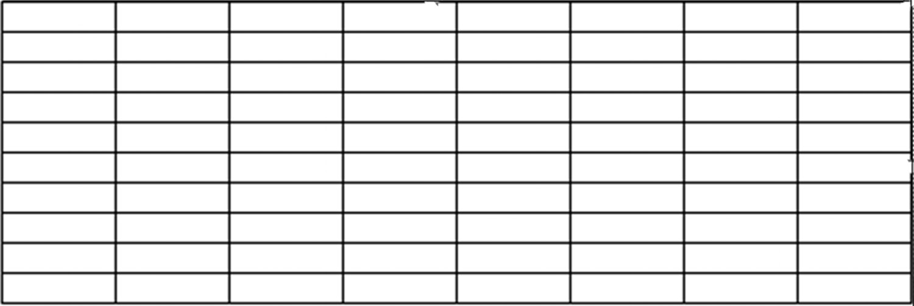

Figure 1.1 An example of an empty spreadsheet

Each individual location within a spreadsheet is referred to as a cell. To clearly locate
a cell in a spreadsheet, each cell has a column and row designation. Columns are
marked with a letter, starting with the letter A, and each row is marked with a number,
starting with the number 1, as shown in Figure 1.2. There are many cells available on 4 exCel BasiCs

Application Note
Relative, Absolute, and Mixed Cell Addresses
A cell address that consists of a column and row designation, such as A1, B24, or M256, without any
other notations or symbols included, is known as a relative cell address (or relative cell reference). The
vast majority of cell addresses you would encounter are of this type, and they are the type you typically
would use most often, especially when you first start working with Excel.
There are times, however, when a different type of address, known as an absolute cell address (or
absolute cell reference), such as ($A$1 or $B$24) or a mixed cell address (or mixed cell reference) , such
as ($A1 or B$24) is needed. The reason for these other kinds of cell addresses is explained in Section
2.5. In general, relative cell addresses allow both the column and row to change when copied, absolute
cell addresses allow neither to change, and mixed allow either the row or column to change (but not
both). For now, simply be aware that the cell addresses you are currently using are one of three types
of addresses available in Excel, and that each one serves a different purpose when copying cells.
an Excel worksheet. Excel 2019 supports over a million rows, over 16,000 columns, for
a total of more than 17 billion cells on a single worksheet.
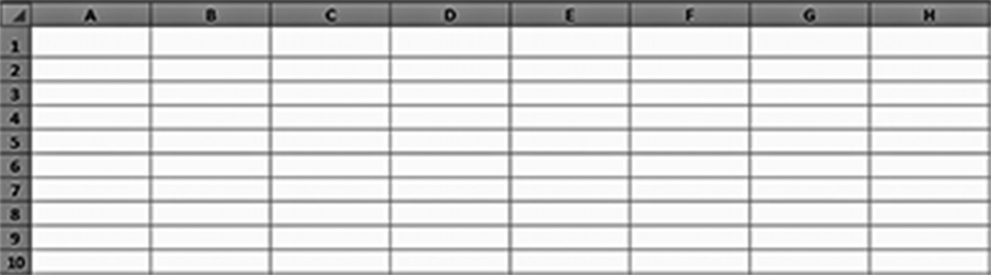

Figure 1.2 A spreadsheet with the rows and columns labeled
Every Excel spreadsheet has these same column and row markings. This permits a cell
in a spreadsheet to be uniquely located and identified by giving its column and row
designation, which together constitute the cell’s address. For example, the address
A1 refers to a spreadsheet’s leftmost and topmost cell, while the address C4 refers to
the cell located in column C and row 4. For convenience, these two cells have been
highlighted in Figure 1.3.
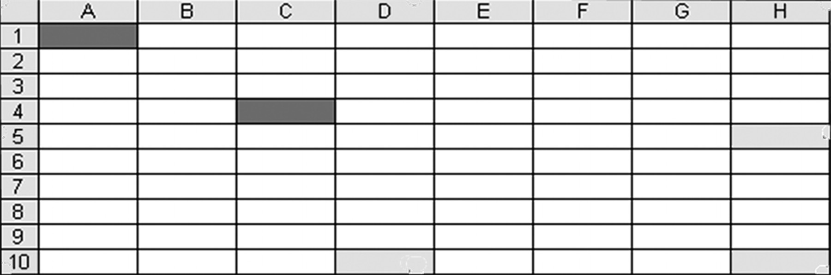

Figure 1.3 The cell addresses A1 and C4 are highlighted
GettinG started 5

In addition to providing the basic worksheet shown in Figure 1.3, what makes Excel
so useful and more than just a sheet of storage locations are its following capabilities:
●● The ability to enter, change, and delete data from individual cells and print parts
of complete spreadsheets
●● The ability to perform basic mathematical operations (such as addition or multi-
plication) on numerical data within two or more cells
●● The availability of functions that can be used to determine square roots, pay-
ments on loans, averages, standard deviations, and many other statistical opera-tions
●● The ability to change the appearance of numbers and text (style, font, size, and
color), and format numbers to appear in different ways (such as the number of decimal values to be displayed, dollar signs, and date)
●● The ability to create and print graphs and summary tables ●● The ability to change the width of individual columns and the height of indi-
vidual rows
●● The ability to use one or more worksheets that can be linked together (that is,
data in one worksheet can be accessed by another worksheet)
In fact, most of this text is focused on showing you how to use these capabilities. Your
expertise in using Excel will depend on your skill in learning and applying these capa-
bilities to your own individual projects.
Cell Contents
It is particularly important to understand that each and every spreadsheet cell can
contain only one main data entry (which may consist of various data sub-elements) at
a time. The vast majority of data elements you will enter, and the only ones that are
directly supported in Excel, must be one of the following:
1. Numbers
2. Text (sometimes referred to as labels)
3. Formulas
Excel identifies and stores each of these data types in its own internal manner as code
by recognizing the following characteristics of the data:
A number is data that includes only the following characters:
●● Numeric digits (0 through 9)
●● Special symbols (such as -, $, and .)
6 exCel BasiCs

Thus, a number, at a minimum, must contain one or more of the numeric digits 0
through 9. Additionally, a decimal point, commas, a leading dollar sign, and a lead-
ing + or – sign can, but need not, be included. By default, the content of a cell is
interpreted as a number whenever these, and only these, symbols are present, and
the cell has not been designated as holding a different type of data, which is accom-
plished using formatting (described in Section 2.4). By default, a number is dis-
played toward the right side of a cell, which is referred to as right-alignment. Each
individual number is stored using a numerical code format.
Text is any data containing a letter or character, except data recognized as a formula
or a function. Typically, text is used to create headings and labels. Thus, any cell that
contains at least one letter or non-numeric symbol (!, #, &), begins with a double-
quote ("), or the cell itself has been designated as a text cell (which is accomplished
using formatting), is considered text and stored by Excel in a character-by-character
code. Attempting to perform a mathematical operation using a cell containing text
results in an error, or no result, since text does not have any numeric value.
A formula always begins with an equal (=) sign. Thus, a cell’s contents that begin
with an equal sign are considered to be a formula, as well as if the cell contains both
operands and operators. One exception is when formatting has been used to change
the formula into text. In this latter case, the formula will not compute anything but
will display the formula as a text string.
Formulas can be user-created, such as =3*A1, which multiplies the value in A1 by
3, or =B1+B2+B3+B4, which adds the contents of cells B1, B2, B3, and B4. Typically,
however, an Excel supplied function, such as SUM( ), is used within a formula.
A formula can contain a function, such as =SUM( ). A function is a self-contained
“program” that can be used to do computations and perform operations. The ability
to use formulas and functions to create new information from existing data and keep a
spreadsheet current whenever data is changed forms the essence of what makes spread-
sheets valuable.
For example, the functions =SUM(B1:B4) and =AVERAGE(B1:B4) calculate the
sum and average, respectively, of the values in cells B1 through B4. Notice that
the notation B1:B4 used in each of these functions indicates that a range of cells,
from B1 through B4, inclusive, are used in the calculation of the sum and average,
respectively. Instead of explicitly specifying operators and operands (as in an Excel
formula), it is like a “black box” to which arguments (inputs) are fed, and the result-
ing output displayed. The result of each calculation appears in the cell containing
the formula.
Example 1
Figure 1.4 shows a section of a spreadsheet that was created using all three data types:
(numbers, text, formulas), and functions.
GettinG started 7

Application Note
The Importance of Formulas
Formulas form the backbone of all spreadsheet applications and are what distinguish an Excel
spreadsheet from a table of values prepared using a word processing program. There are two main
reasons for this.
First, when you create a spreadsheet application that has more than two or three columns and/or
rows, which is the norm for most commercial applications, typically only a single formula needs be
entered in the first cell of each column or row. This one formula is then simply copied, as needed,
to the remaining cells in the column or row. (Because of relative cell addresses, Excel automatically
adjusts cell references in the copied formula, described further in Section 2.2).
Second, when you use a spreadsheet and change any of the values used in a formula, the formula will
automatically recalculate and display the correct value for the new data. This is extremely important in
keeping a spreadsheet up-to-date and accurate for all displayed values.
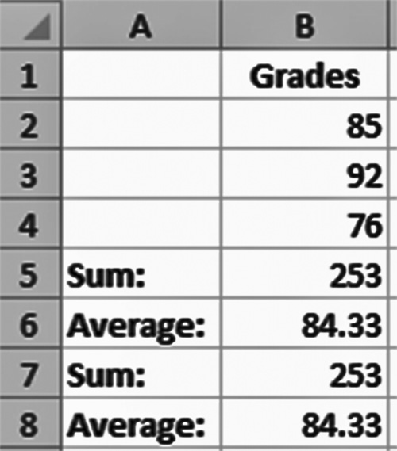

Figure 1.4 A spreadsheet that uses all three data types: (numbers, text, formulas) and functions

Figure 1.5 shows what was actually typed into each cell.
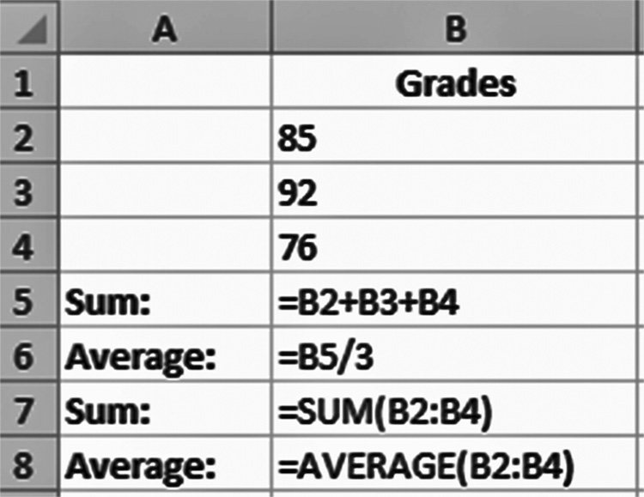

Figure 1.5 The input for Figure 1.4
As shown in Figure 1.5, cells B2 through B4 contain numbers, while cells B5 through
B8 contain formulas and functions. In cell B5, the sum is found with a formula that
uses the addition operator (+), while cell B7 uses Excel’s SUM( ) function, both of
which are explained in more detail in Chapter 2. Similarly, the average of the grades 8 exCel BasiCs

is determined in cell B6 using the division operator (/), while cell B8 uses Excel’s
AVERAGE( ) function. In all four cases, however, Excel knows these formulas and
functions are to be calculated because they begin with an equal (=) sign. Although not
shown, a function can be included within other functions and mathematical expres-
sions as in =10 * SUM(B2:B4)/3.
Notice that in Figure 1.5, cells B1 and A5 through A8 all contain text. The text in
cell B1 is referred to as a heading, as it is located at the top, or head, of a column and
identifies what the column contains. The text in cells A5 through A8 is referred to as
labels. Labels, like headings, are always text.
For the data entered in Figure 1.5, fill in the data types that you think Excel assigns
to each entered item using Figure 1.6 below.
NOTE Remember that there are three data types (number, text, formula) and functions.
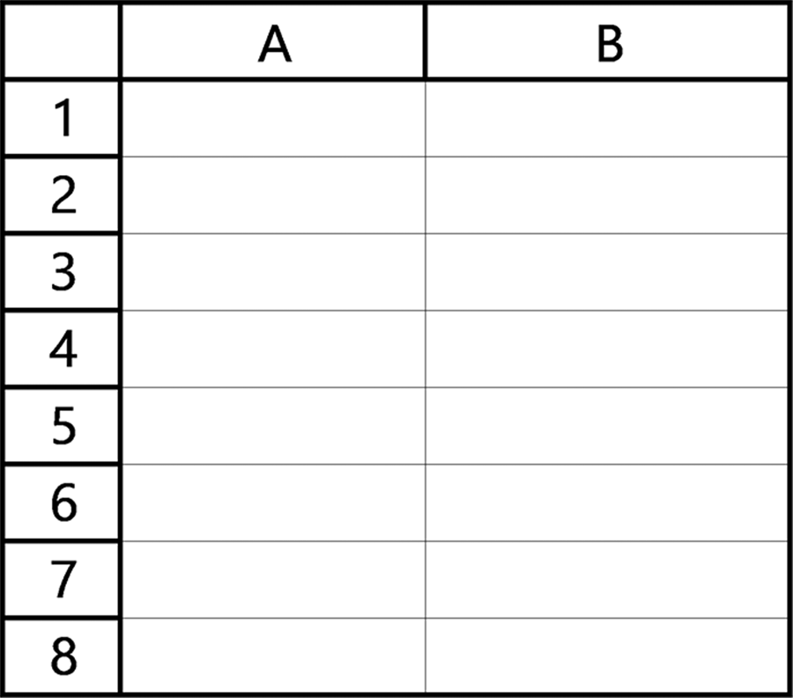

Figure 1.6 Fill in the spreadsheet with the correct data types for the data in Figure 1.5

Dates and Boolean Data
In addition to the three basic data types (numbers, text, and formulas) and functions,
there are two other data items that can be entered into a cell: dates and Boolean data.
Dates on or after 1/1/1900 are stored as consecutive integers, with the number 1 rep-
resenting January 1, 1900 (i.e., 1/1/1900), the number January 2, 1900, and so on.1
Dates prior to 1/1/1900 are stored as text, and can be changed to numbers. In all cases,
dates prior to and after 1/1/1900 can always be displayed and stored as text.
Boolean data consist of the two values, TRUE and FALSE. These are described in
detail in Section 3.3. Boolean data form the basis for comparison operations, such as “is
the value in cell A5 greater than the value in cell B5.” Internally, the Boolean TRUE and
FALSE values are stored as the numbers 1 and 0, respectively.

1 The integer numbers used to store dates on and after 1/1/1900 are referred to as Serial Numbers in Excel.
GettinG started 9

Figure 1.7 shows the appearances of dates in three of formats provided by Excel.
How these formats are selected is presented in Section 2.3.
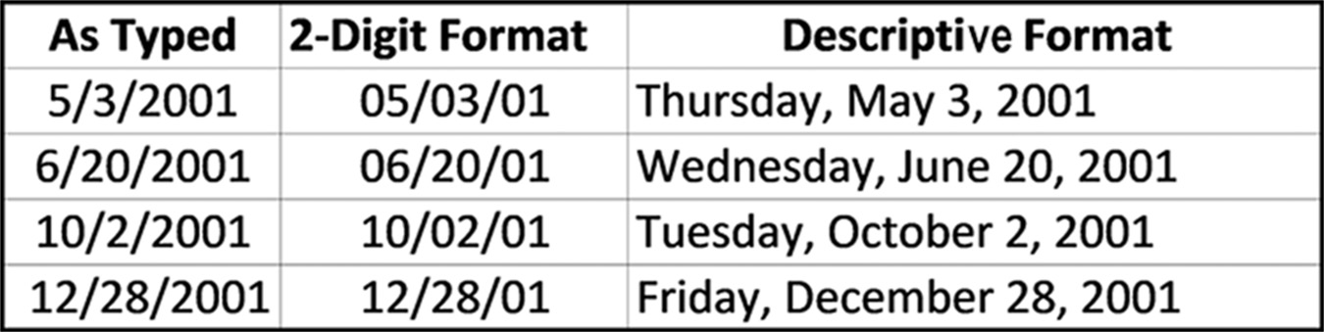

Figure 1.7 Different date appearances

Entering Data into a Cell
To enter data into a cell, first use either the mouse or the cursor arrow keys to go
to the desired location. If you use the mouse, click when you are at the designated
cell. When you do so, the cell border will appear as shown in Figure 1.8, indicating,
in this case, that cell D4 is the currently selected (active) cell. Note that the cur-
rently selected cell location also appears in the name box (this provides another way
of selecting a cell: simply type the cell location in the name box, which is also useful
when creating named ranges for more advanced needs).
When the desired cell has been selected, type the number, text, formula, or func-
tion that you want stored in the cell. As you type, the data will appear in both the cell
and in the Formula Bar. When either the enter key or one of the cursor arrow keys is
pressed, the data is stored in the cell and becomes the cell’s contents. (The shortcut
key F5 can also be used on both the PC and the Mac.)
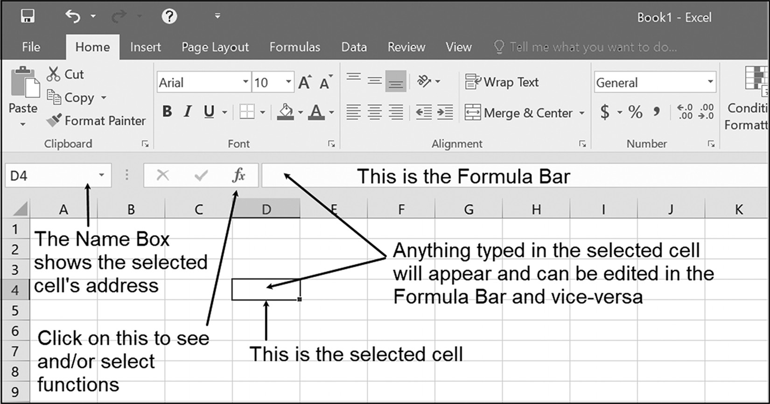

Figure 1.8 Entering data into a cell 10 exCel BasiCs

EXERCISES 1.1

1. Answer the following questions.
a. How is the location of an individual cell indicated?
b. What is the term used for the cell addresses in the form A1, G5, and M26?
2. List the three basic types of data that can be entered into a cell and how Excel
determines the data type of each item that is entered. What is a function?
3. How is a range of contiguous cells indicated in a formula?
4. Determine the data type of each of the following:
a. 121.135
b. =A1*B1
c. =M5/N5
d. ABOVE AVERAGE
e. $89.47
f. =AVERAGE(A1:A10).
5. For the data and formulas shown in the spreadsheet below, determine and fill in
the values that will be calculated and displayed in cells A5, B5, and C1 through C4.
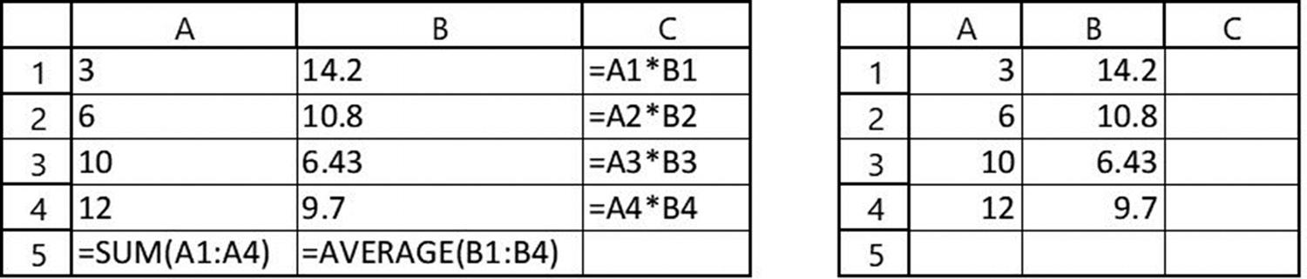

6. For the data and formulas shown in the spreadsheet below, determine and fill in
the values that will be calculated and displayed, using the spreadsheet to the right.
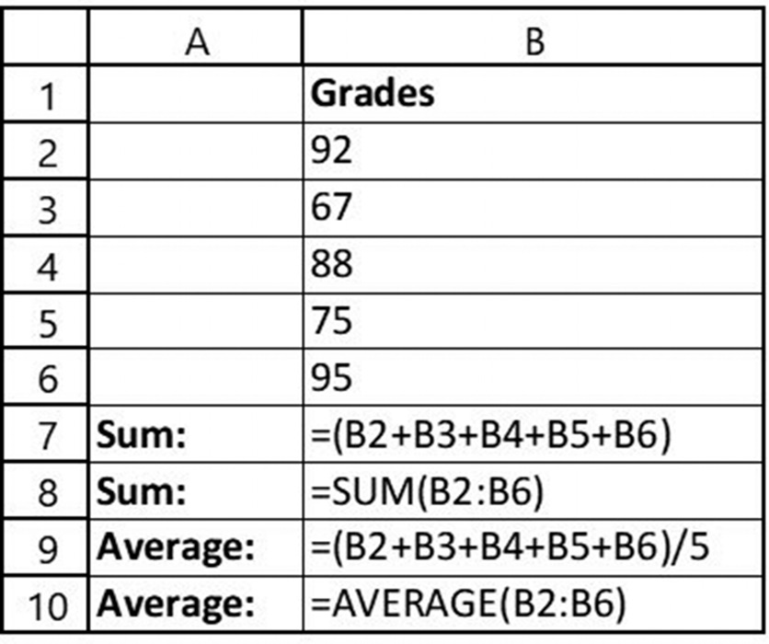
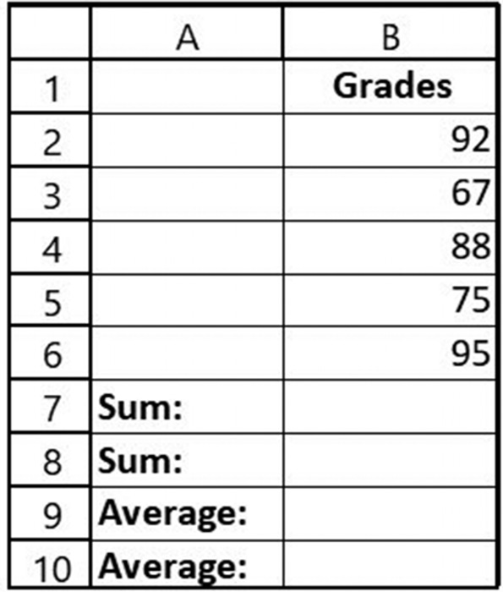
GettinG started 11

7. Follow the directions for the spreadsheets.
a. Enter the text and numbers shown in the following spreadsheet:
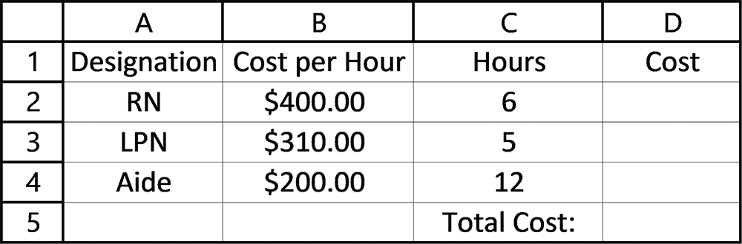

b. Enter the appropriate formulas in cells D2 through D5 and other modifcations
so that your completed spreadsheet looks as follows:
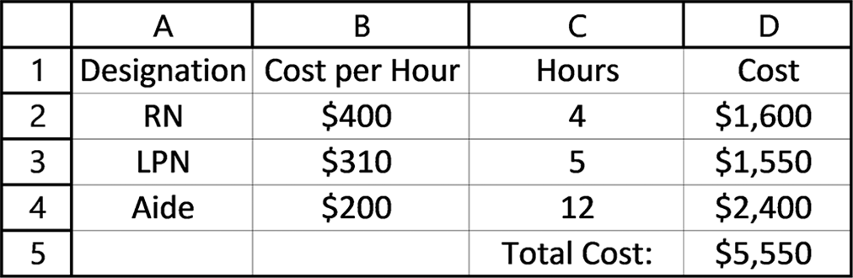

1.2 TWO ESSENTIAL SKILLS – HIGHLIGHTING AND COPYING
Once data is entered into a cell, the processing of the data can begin. In fact, most of
this text is concerned with the Excel skills needed for this processing, such as finding
the sum and/or average of the data within a range of cells, preparing the data so that it
appears correctly when displayed or printed, or calculating profit and loss statements.
These two skills are (1) highlighting a range of cells, such as a column of data whose
sum is needed, and (2) copying one or more cells. How these are accomplished is
described in this section.
Selecting Cells by Highlighting
A large portion of spreadsheet processing typically requires using a group of related
cells. For example, the sum of a column of data may be needed, or perhaps the aver-
age of grades in a row, where each row corresponding to a student’s test grades may
be required to determine a final grade. A commonly used technique for specifying a
range of cells is to highlight the cells within the range.2 While the cells are highlighted,
they form a unit that can then be processed by a formula or configured so that all indi-
vidual cell values in the group have the same format when displayed.
Note that we are not referring to highlighting a cell’s contents by changing the color
of the cell’s data. What is being highlighted is a set of one or more adjacent (that is,
touching) cells that designates them as a single unit while they are highlighted. In
Excel, a set of adjacent cells is referred to as a range of cells, or cell range, for short.
2 A second method is to list the top left-most cell address in the range, followed by a colon, followed by the lowest right-most cell address.
12 exCel BasiCs

Figure 1.9 shows a number of highlighted cell ranges. The underlying criterion
for each range is that every cell in the range is adjacent to, that is, touches, at least
one other cell in the range. Also shown under each range is how the range is desig-
nated using cell addresses. You will note that cell ranges can be horizontal, vertical, or
square/rectangular in shape.
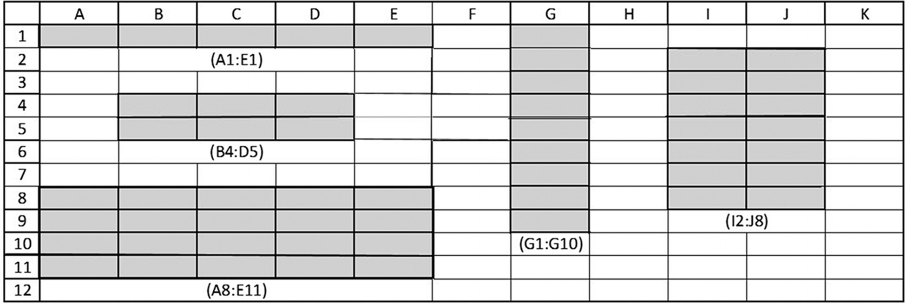

Figure 1.9 Examples of cell ranges

To highlight a range of cells, you must first select a single cell at the top or bottom
or corner cell in the desired range. For example, in Figure 1.10, the cursor has been
moved to a selected starting cell, which in this case is B4. Notice the shape of the cur-
sor in the cell.
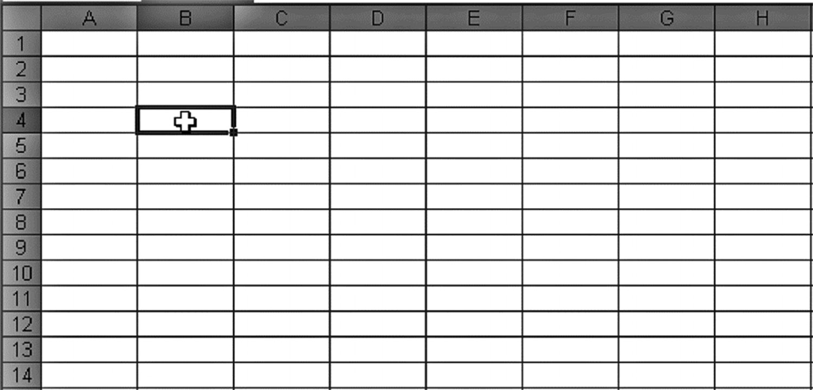

Figure 1.10 Selecting the first cell in a range of cells

Once you have selected the first cell in the desired range, you can now define the desired
group of cells by doing one of the following:
1. Press and hold the left mouse button down, starting from the first cell, and move
the mouse so that the cursor points to the desired last cell in the range. Then release the left mouse button.
GettinG started 13

2. Click and then release the left mouse button on the first cell in the desired range.
Then hold the Shift key down and click and release the left mouse button on the last cell in the desired range.
3. Click and release the left mouse button on the first cell in the desired range. Then
hold the Shift key down and use the keyboard arrow keys (← ↑ ↓ →) to go to the last cell in the desired range, and then release the Shift key.
Figure 1.11 shows how the selected cells look using the first method, where the left
mouse button has been pressed and held down as the mouse cursor is moved from its
initial position in cell B4 to cell B11, and then the left mouse button is released. The
cells, as shown in Figure 1.11, become highlighted as they are included in the range.
This same highlighting would occur if any of the other two methods are used.
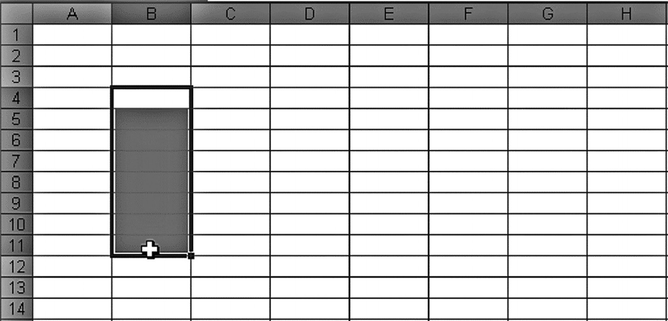

Figure 1.11 Completing the range selection
Copying Cell Contents
The contents of a single cell are copied by first moving the cursor to the lower right-
hand corner of the selected cell, as shown in Figure 1.12.
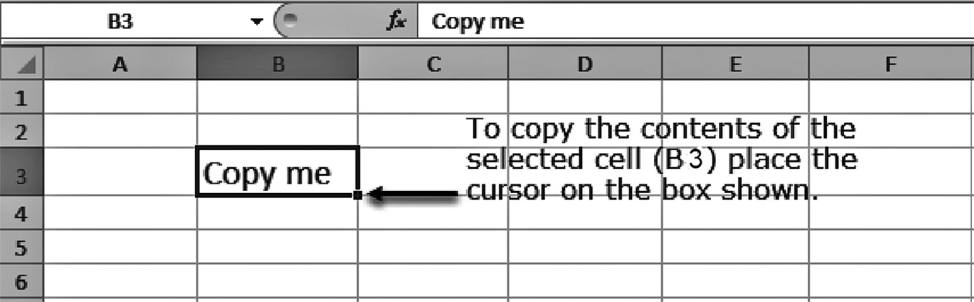

Figure 1.12 Locating the copy rectangle
When the cursor appears as a cross-hair (+), as shown in Figure 1.13, the selected cell
is ready to be copied. This is known as the fill handle.
14 exCel BasiCs
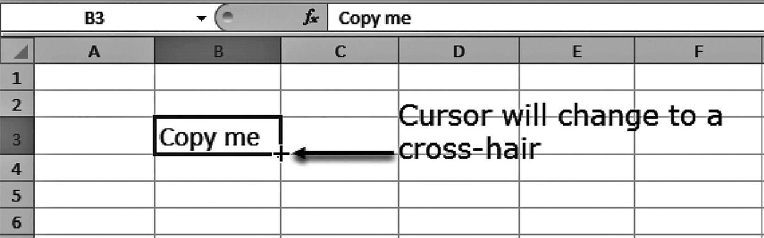

Figure 1.13 Placing the cursor on the fill handle (the cursor changes to a cross-hair)

Once the cursor has changed to a cross-hair (fill handle), press and hold the left mouse
button while you drag the cursor over the cells where you want the copy to occur. As
you do so, each cell where the copy will take place becomes highlighted, as shown in
Figure 1.14. Here, the contents of cell B3 are being copied to cells C3 through E3.
The copy takes place when the left mouse button is released.
Note that the copy could just as easily been made up or down column B, rather
than across the third row (row 3). The only restriction on this method is that the
copy is always made to adjacent (touching cells), which is usually what is required.
If a copy to non-adjacent cells is needed, standard cut-and-paste techniques should
be used.
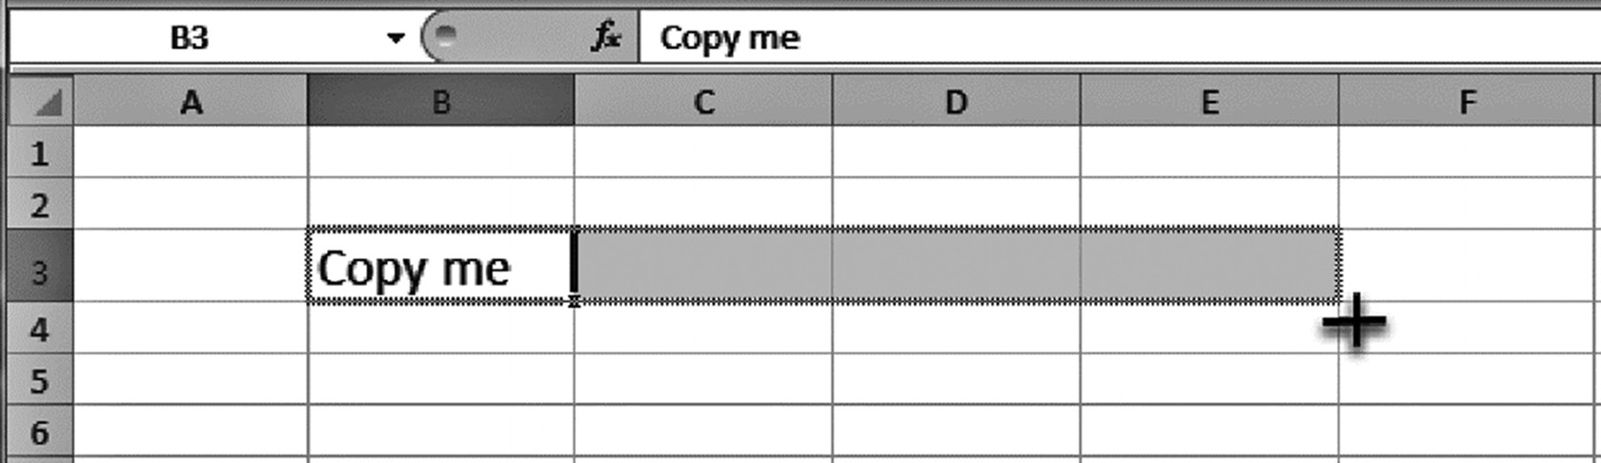

Figure 1.14 Copying cell B3 to cells C3, D3, and E3

Adaptive Pattern Matching
When copying dates, text, and numbers (and more importantly formulas, as described
in Section 2.1), Excel tries to determine if a pattern exists. Based on any detected pat-
tern, Excel places the next value in the pattern into the copied cell. This is sometimes
referred to as completing a series or sequence.
Typically, for formulas and text, (and other commonly used sequences) such as
days-of-the-week and months, Excel only requires one cell to determine the pat-
tern; for dates and numbers (and less frequently used sequences), two adjacent
cells are typically needed. For example, consider the spreadsheet segment shown in
Figure 1.15a.
GettinG started 15

Figure 1.15a The original cell contents

Now, if cell A1 is copied to cells B1 through cell F1, the spreadsheet segment will
appear as shown in Figure 1.15b. Note, as the contents of cell A1 were formatted to
be centered in the cell, the copied cells retain this format. The reason is that the Copy
feature normally brings over not just the data, but also the cell format from the source
to the destination.

Figure 1.15b The cell contents after cell A1 is copied
Give It a Try
In Figure 1.16, write in the contents that you think Excel will display when cell A1
is copied from cell B1 through F1. If you can, check your answer by using an actual
Excel spreadsheet.

Figure 1.16 Write the contents that will be displayed when cell A1 is copied from cell B1 through F1

To detect a pattern in numbers and dates, Excel requires that two adjacent cells be
highlighted and then copied. For example, consider Figure 1.17a, where a number
pattern appears in cells A2 and A3. If these two cells are highlighted and then copied,
this spreadsheet segment will appear as shown in Figure 1.17b.
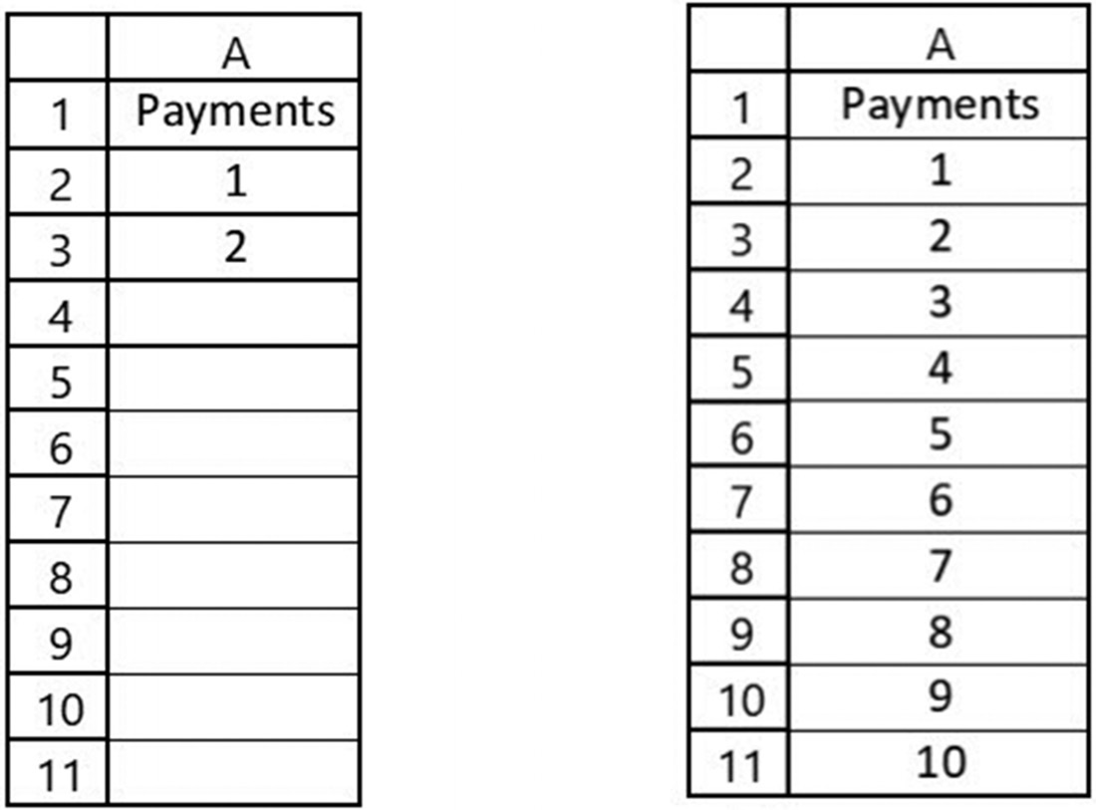

Figure 1.17a Original data Figure 1.17b Copied cell results 16 exCel BasiCs

EXERCISES 1.2

1. For each of the following spreadsheets, determine and fill in the text that will
displayed if the text in cell A1 is copied to the right.
a.

b.

c.

d.

2. For each of the following spreadsheets, determine and fill in the text that will
displayed if the text in cells A1 and A2 are first highlighted and then copied down.
a. b. c. d.
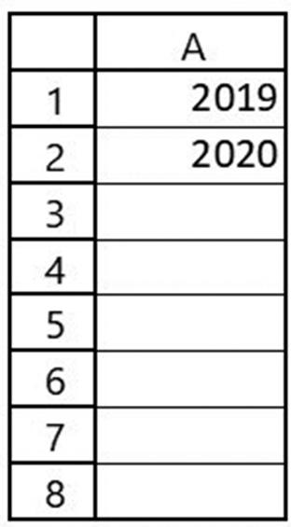

3. In Figure 1.18, write in the contents that will be displayed when cells A1 through
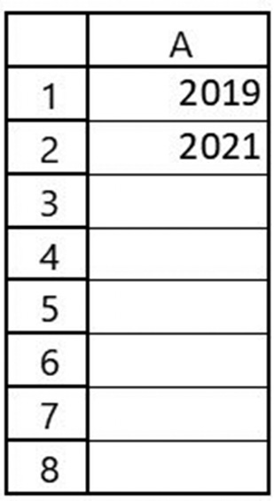
B1 are highlighted and then copied to cells C1 through H1.
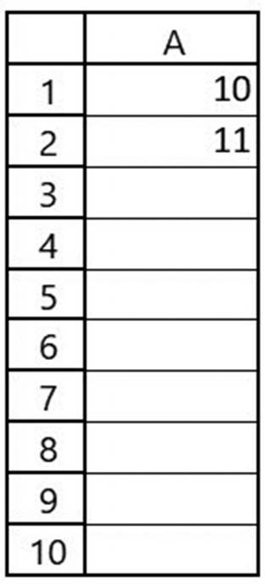

Figure 1.18 Write your answer
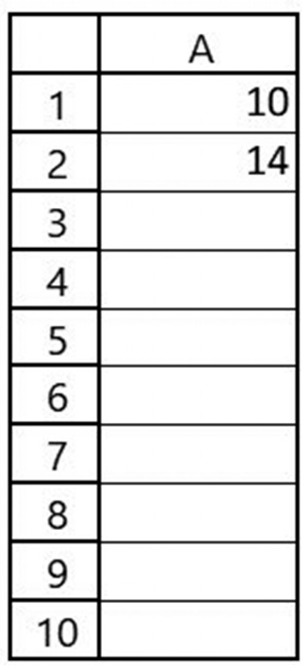
4. In Figure 1.19, write in the contents that will be displayed when cells A1 through
B1 are highlighted and then copied to cells C1 through H1.

Figure 1.19 Write your answer
GettinG started 17

1.3 OPENING, SAVING, RETRIEVING, AND
PRINTING SPREADSHEETS
Opening, saving, and printing your spreadsheets is accomplished using the Quick
Access Toolbar, which is located at the top of the Excel screen as shown in Figure
1.20, and provided in detail on Figure 1.21. These tasks can also be done using the
commands located in the Excel ribbon under the File tab.
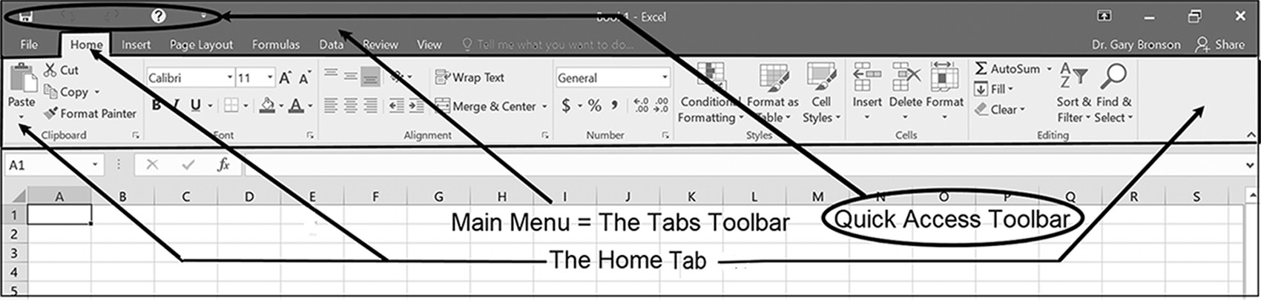

Figure 1.20 Locations of the Home tab, Tabs toolbar, and Quick Access Toolbar

The options on the Quick Access Toolbar, shown in Figure 1.21, are used to open
either a new or existing spreadsheet, to save the spreadsheet you are currently work-
ing on, and to print parts or all of the current spreadsheet. Additionally, it provides an
option for customizing the Quick Access Toolbar.
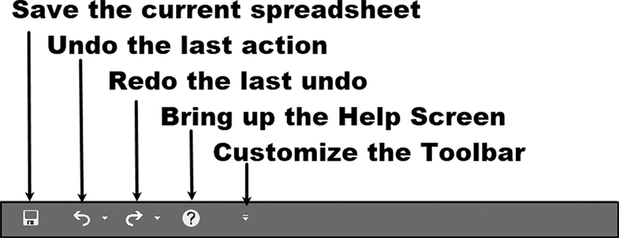

Figure 1.21 The Quick Access Toolbar

Opening a New or Existing Spreadsheet
As shown on Figure 1.22, to open a new, blank spreadsheet, select the New option
from the File tab’s submenu. This causes the window pane to the right of the menu
to appear. Within this pane, you can select a new blank workbook to be displayed,
select one of the pre-formatted spreadsheets, or search for an online spreadsheet
template. It should be pointed out that while the main focus of this book is on
creating your own spreadsheets, Excel does offer the means to help some users
get started quickly by providing pre-formatted, partially completed templates for
spreadsheets.
18 exCel BasiCs
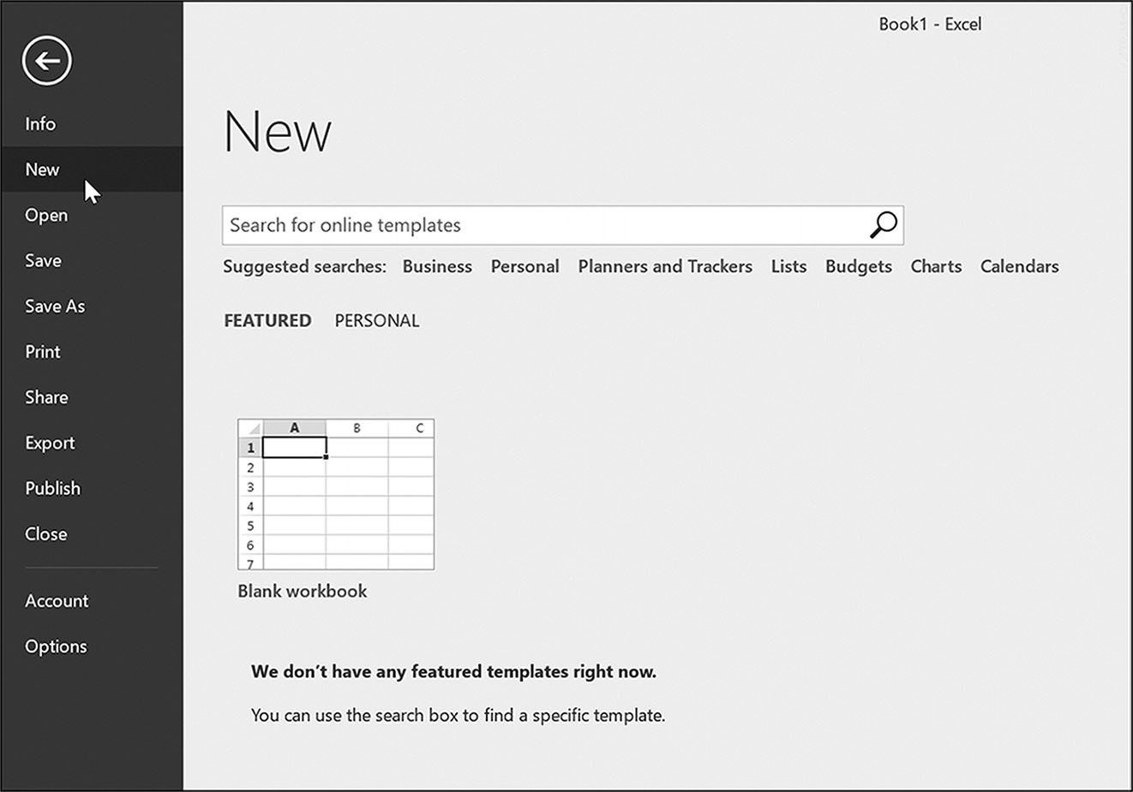

Figure 1.22 Opening a new spreadsheet

To open a previously saved spreadsheet, click on the File tab’s Open option, as shown
in Figure 1.23. Doing this automatically brings up the window pane shown to the right
of the menu. Here, a list of recently saved spreadsheets is provided. You can either
select one of the displayed spreadsheets or click on the Browse option at the bottom
of the pane and enter the location and filename of the desired saved spreadsheet.
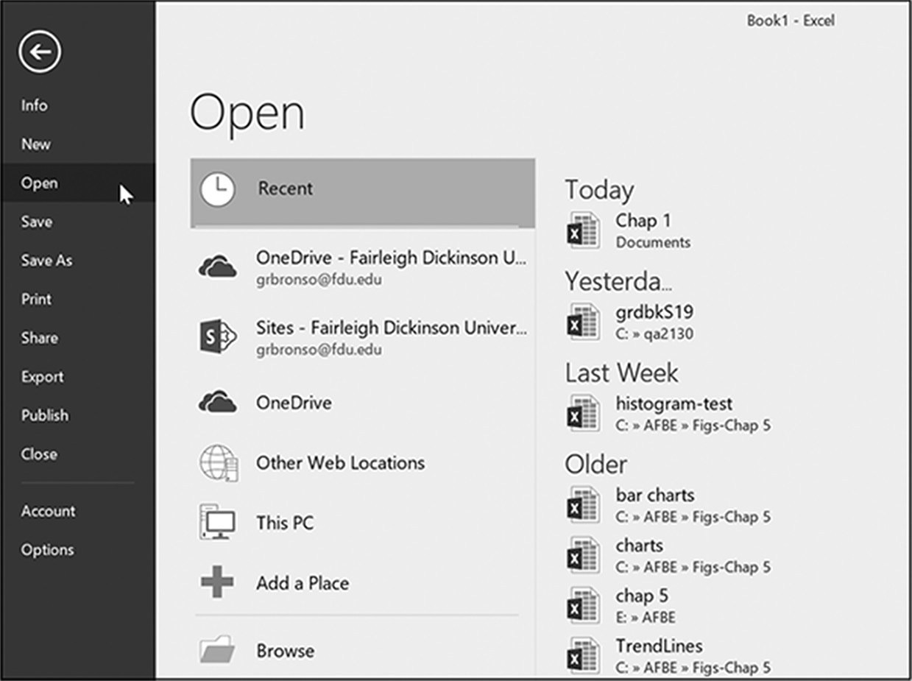

Figure 1.23 Choosing the Open option opens up another list of options
Saving a Spreadsheet
It is important to save your work and remember the location where it is saved. Fre-
quently, Excel will provide you with a list of your most recently saved files; however,
GettinG started 19

this is not always the case if you are using a public computer. Always make a note of the
directory and name of your saved spreadsheets when you save them.
There are a number of methods to save a spreadsheet. The easiest method to resave
a previously saved spreadsheet is to click on the Quick Access Toolbar’s Save option,
which is shown on Figure 1.21.
The first time you save a spreadsheet, however, you should use the File tab’s Save
As option shown in Figure 1.24 or the spreadsheet will be saved using a default name
provided by Excel.3 Clicking on this option automatically triggers the window pane
shown to the right of the menu. Selecting the Browse option at the bottom of this win-
dow pane (see figure) permits you to enter a location and filename for your spread-
sheet. Note that if you only provide a filename, the file is saved in the current direc-
tory. If you are using a public computer or classroom computer lab, the contents of the
current public directory are typically erased at the end of the day, so make sure to save
your spreadsheets, either on a directory dedicated for your use and/or a flash drive.
You need to remember that the importance of saving your Excel workbook frequently
is critical because at least part of your file may be residing in the computer’s RAM,
rather than on your hard disk, SSD, flash drive, or other storage device.
An interesting feature of the File menu’s Save option, located above the Save As
option shown in Figure 1.24, is that it this selection automatically activates the Save
As option and the screen shown in Figure 1.24. In essence, it defaults to the Save As
operation when you save your file for the first time.
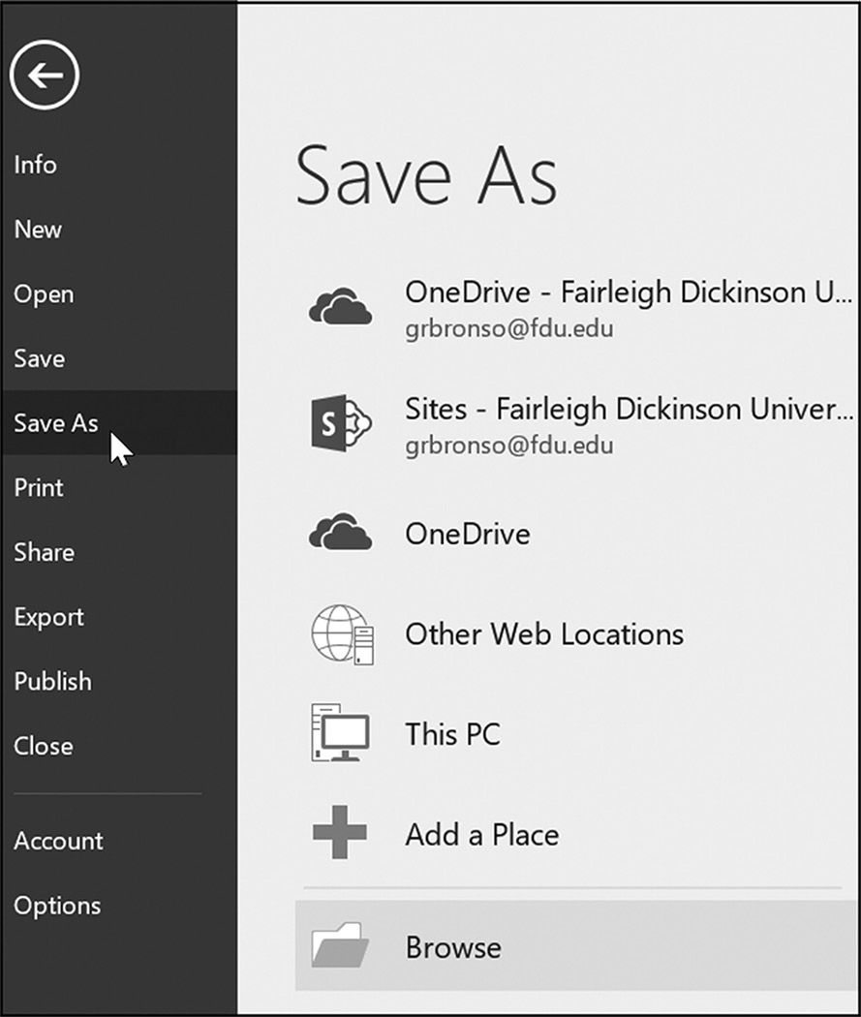

Figure 1.24 The Save As option
3 The default name is Bookn, where n is a consecutive number, starting at 1, which keeps track of the number of default spread-sheet names you have accumulated.
20 exCel BasiCs

Printing a Spreadsheet
Printing your spreadsheet requires first selecting the File tab, as shown in Figure 1.25.
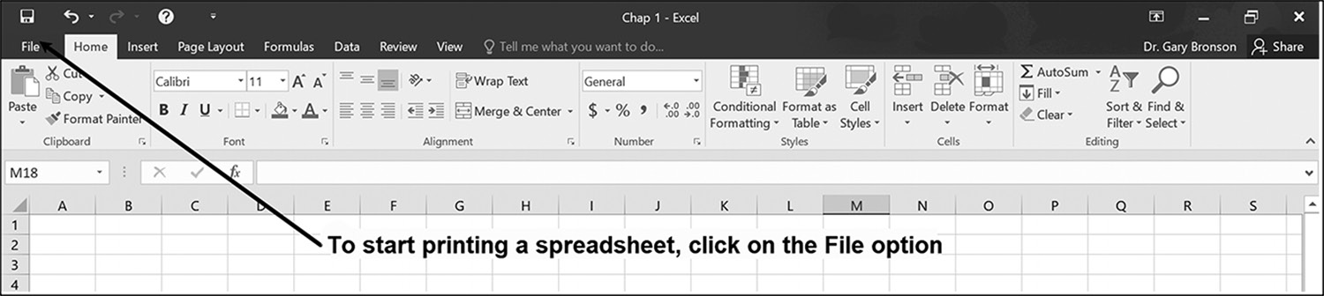

Figure 1.25 Click on the File tab

Clicking on the File option shown in Figure 1.25 brings up the File menu, shown in the
left-hand pane in Figure 1.26. From this menu, select the Print option, as indicated.
This activates the Print menu, shown in the right-hand pane of Figure 1.26. Clicking
on the Print button in this pane causes the worksheet to be printed from the top of the
spreadsheet up to and including the last row and column in which data was entered.
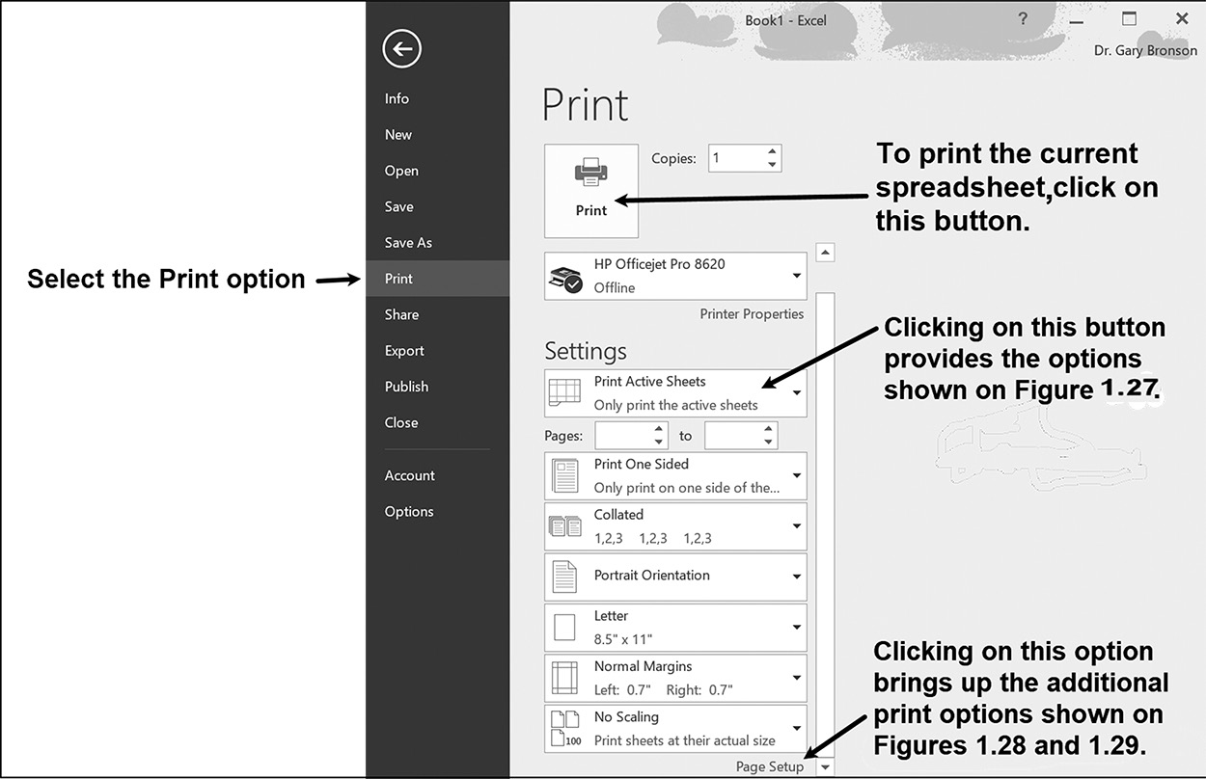

Figure 1.26 Print options

Additionally, as shown on Figure 1.26, clicking the Print Active Sheets button brings
up the dialog shown in Figure 1.27. This dialog permits you to print any section of
your worksheet that has been previously highlighted.
Extremely useful additional print options include the following:
1. Printing a worksheet in either Portrait or Landscape mode
2. Printing a worksheet to fit on a single page (using scaling or other features)
3. Printing a worksheet with gridlines that clearly delineate the rows and columns
4. Printing the worksheet with Excel’s row (1, 2, 3…) and column (A, B, C…)
headings.
GettinG started 21

These options are activated by selecting the Page Setup option shown at the bottom of
Figures 1.26 and 1.27. When this Page Setup option is selected, four sub-tabs are dis-
played, which can be seen in Figures 1.28 and 1.29. The annotations on these two fig-
ures illustrate how to activate the landscape, fit-to-page, gridlines, and row and column
headings. (These printing options are also available through the Excel ribbon’s Page
Layout Tab options).
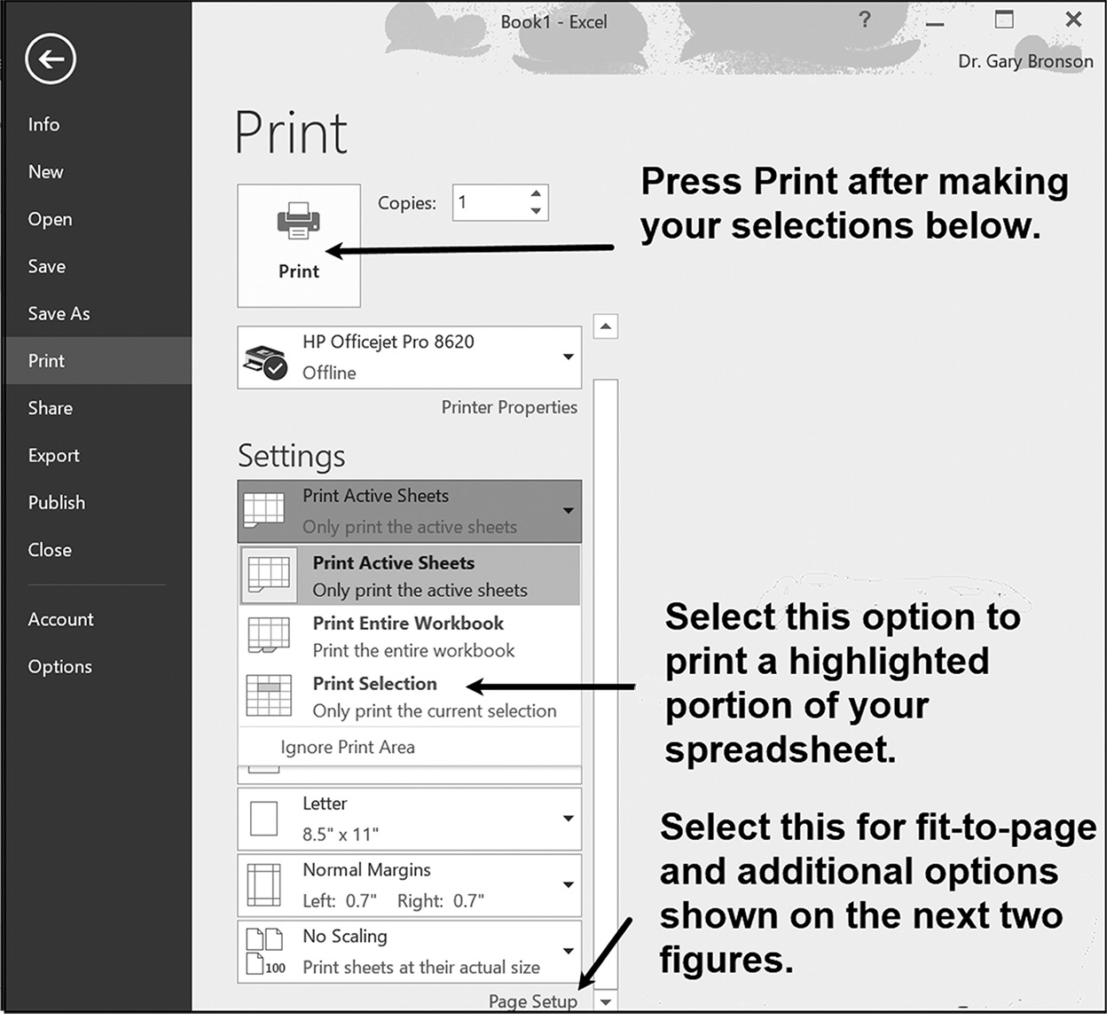

Figure 1.27 Selected print options
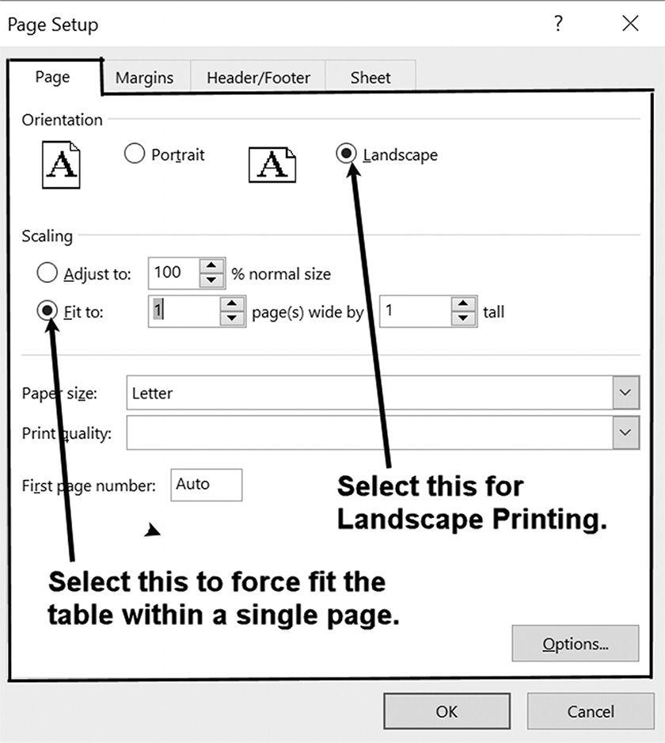

Figure 1.28 The orientation option and scaling option 22 exCel BasiCs
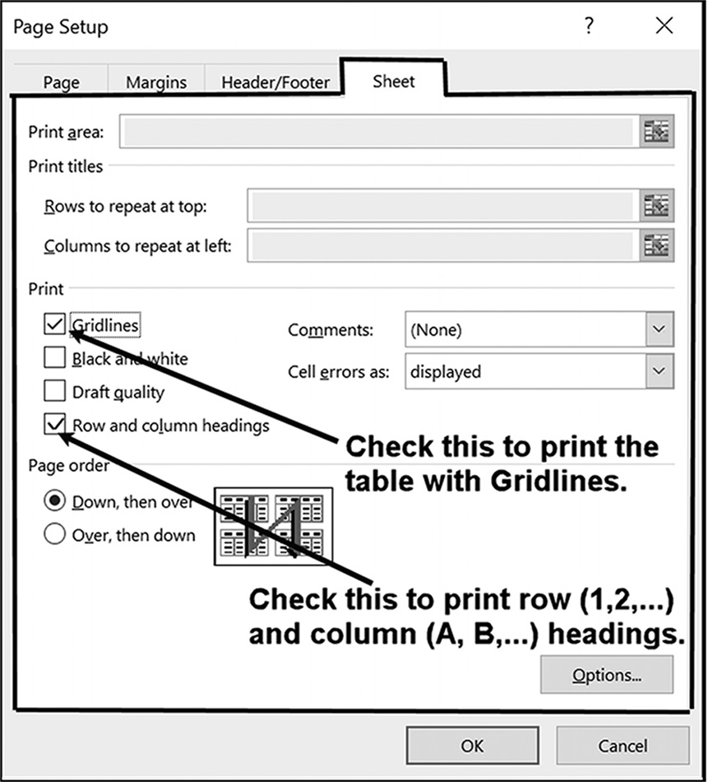

Figure 1.29 Gridline and heading options

EXERCISES 1.3

1. Follow the directions below.
a. Launch Excel, open up a blank worksheet, and create the following spreadsheet
(Boldfacing can be achieved by selecting the desired cell and pressing the Ctrl and B keys at the same time or by pressing the Home tab’s Bold icon. To con-vert the contents in cells C6, C7, and C8 to text, type them with a leading single quote, as in ‘/shift. Without the leading single quote, which forces the cell’s con-tents to be text, the division symbol will be marked as an invalid division error).
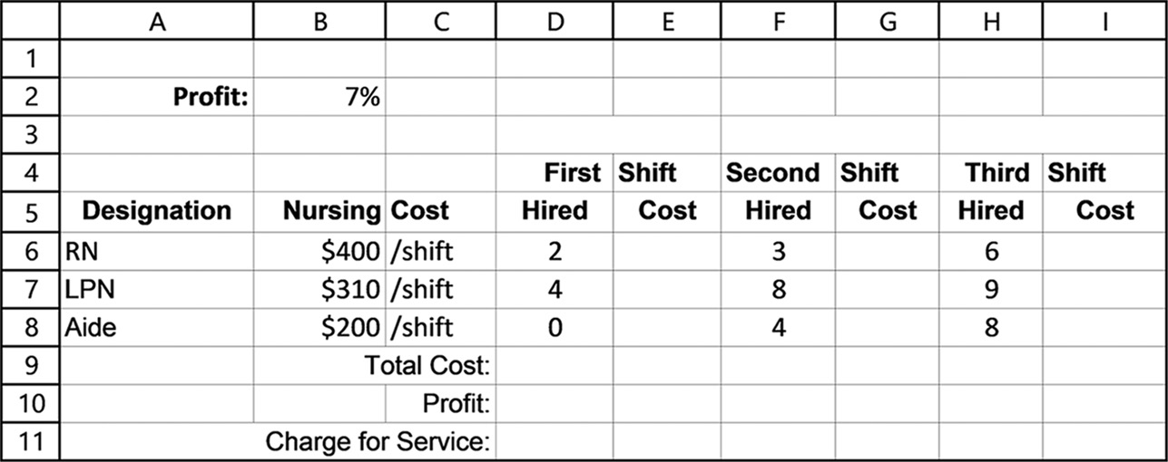

b. Print the spreadsheet you created in Exercise 1a.
c. Save the spreadsheet you created in Exercise 1a. Use the name of your choice
for the saved spreadsheet. (Hint: Use a name that is descriptive and one that you will remember later.)
d. Close the Excel program.
GettinG started 23

2. Follow the directions below.
a. Launch Excel, open up a blank worksheet, and create the following spreadsheet
(Note: Boldfacing can be achieved by selecting the desired cell and pressing the Ctrl and B keys at the same time or by pressing the Home tab’s Bold icon.).
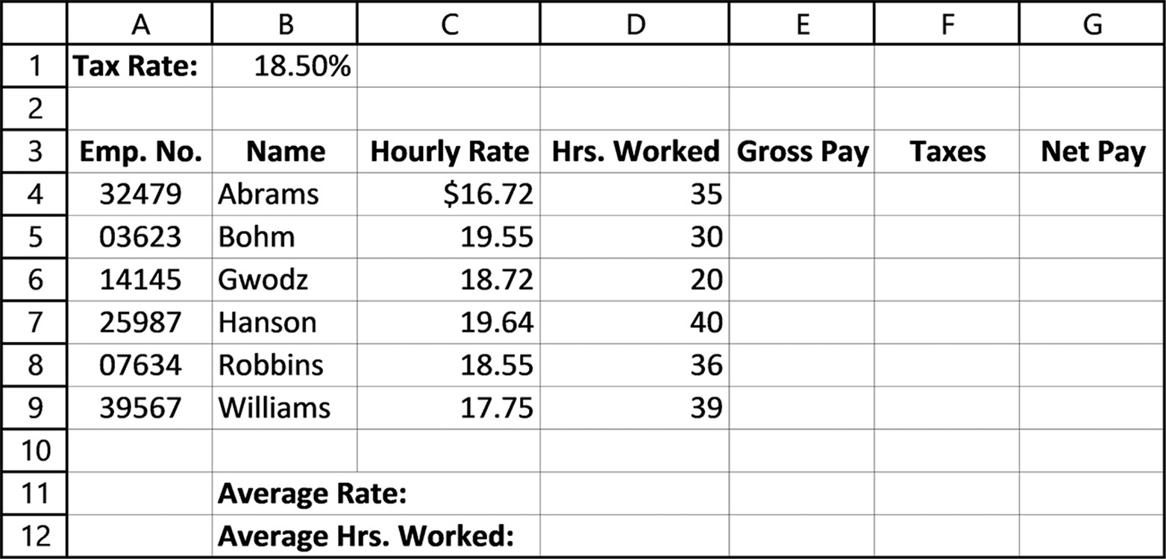

b. Print the spreadsheet you created in Exercise 2a.
c. Save the spreadsheet you created in Exercise 2a. Use the name of your choice
for the saved spreadsheet. (Hint: Use a name that is descriptive and one that you will remember in the future.)
d. Close the Excel program, then re-launch Excel and open the spreadsheet to
view it before closing Excel again.
3. Follow the directions below.
a. Launch Excel and create the following spreadsheet (Note: Boldfacing can be
achieved by selecting the desired cell and pressing the Ctrl and B keys at the same time, or by pressing the Home tab’s Bold icon.).
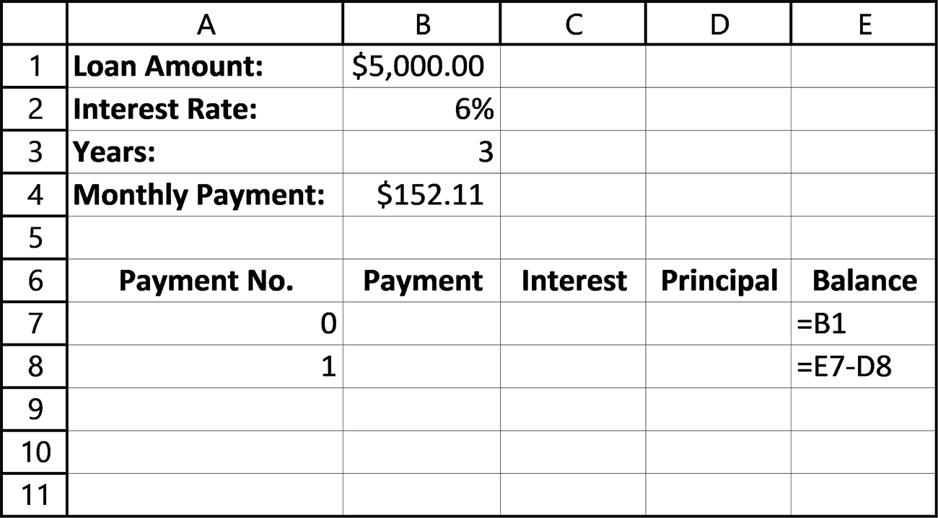
24 exCel BasiCs

b. Copy the Payment Numbers 0 and 1 down through Cell A12 and verify that Excel
enters the correct payment numbers.
c. Print the spreadsheet you created in Exercise 3a.
d. Save the spreadsheet you created in Exercise 3a. Use the name of your choice
for the saved spreadsheet. (Hint: Use a name that is descriptive and one that you will be able recall at a later date.)
e. Close the Excel program and then re-launch Excel and open the spreadsheet to
view it before closing Excel again.

1.4 PROFESSIONAL SPREADSHEET GUIDELINES4
When completing the assignments in this book, it is useful to remember that you are
acting in two distinct roles: the first is as the developer of a spreadsheet and the second
is as its end-user. In many commercial applications, these two roles are separate. That
is, one person will develop a spreadsheet for an application that will be used by one
or more other people, the end-users. To ensure that the end-users correctly use the
spreadsheet and cannot erroneously change cell values or formulas within it, two fea-
tures are typically designed into the spreadsheet by the developer.
The first of these features is to format the spreadsheet to have one or more clearly
defined input areas for data entry by the end-user. Here, cells are provided to permit
the end-user to enter the data necessary for the spreadsheet to produce its desired
calculations and results.
The second feature is to restrict the user so that they must use the designated input
areas and cannot access any other areas of the spreadsheet. This second feature is ac-
complished by password protecting all of the cells except the designated input cells.
In this section, we address the first feature, correctly formatting a spreadsheet to have
a clearly defined input data entry area. The locking of cells by password is presented
in Section 8.5.
Input and Results Sections
A professional spreadsheet layout separates the spreadsheet into two areas: an Input area
and a Results area, as shown in Figure 1.30.
The purpose of the Input area (also known as the Assumptions area) is to enable a
user to clearly see what data is needed, and then provide an area for entering the input
data. If possible, this area should be placed at the top left-hand corner of the spread-
sheet, as shown in Figure 1.30; when not possible, it is placed within columns along
the top of the spreadsheet and/or in the left-hand rows of the spreadsheet.
4 This topic can initially be omitted without loss of subject continuity.
GettinG started 25

The Results area, also illustrated in Figure 1.30, consists of two sections. One sec-
tion, placed immediately after the Input area, provides single formula results, and
example of this configuration is illustrated in Figure 1.31.
Rarely, however, does a specific application conform exactly to the configurations
shown in Figures 1.30 and 1.31.
Although all professionally constructed spreadsheets have the basic Input and Re-
sult sections shown in Figure 1.30 as their objective, not all spreadsheets will conform
to such precise separation of areas due to specific application requirements, neverthe-
less, the goal of separating your spreadsheets into clearly defined Input and Results
sections is one that you should always keep in mind.
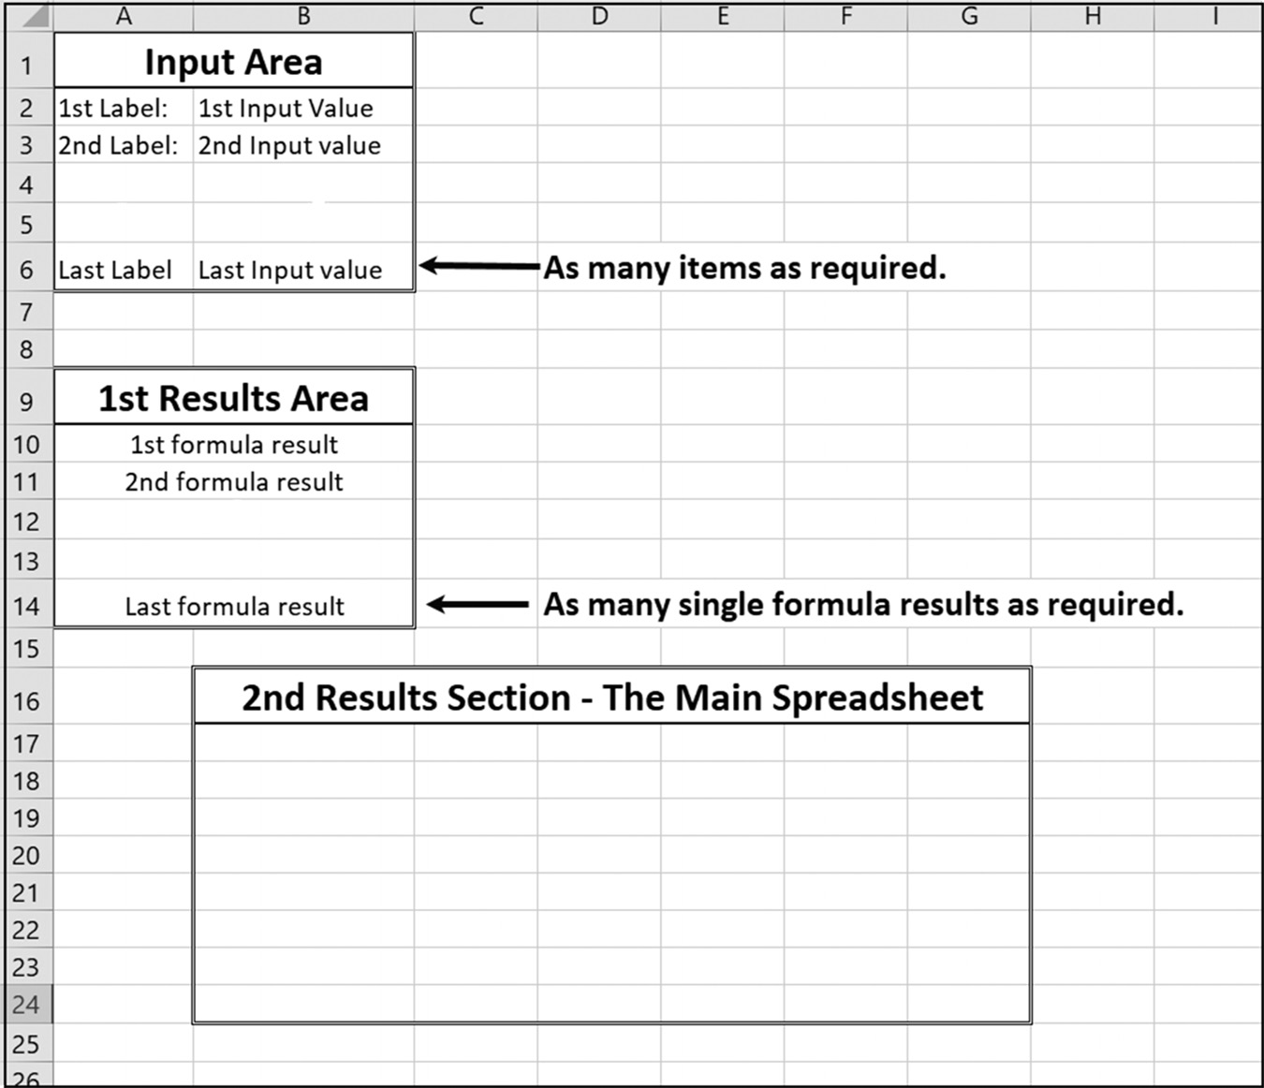

Figure 1.30 The Input area and Results area
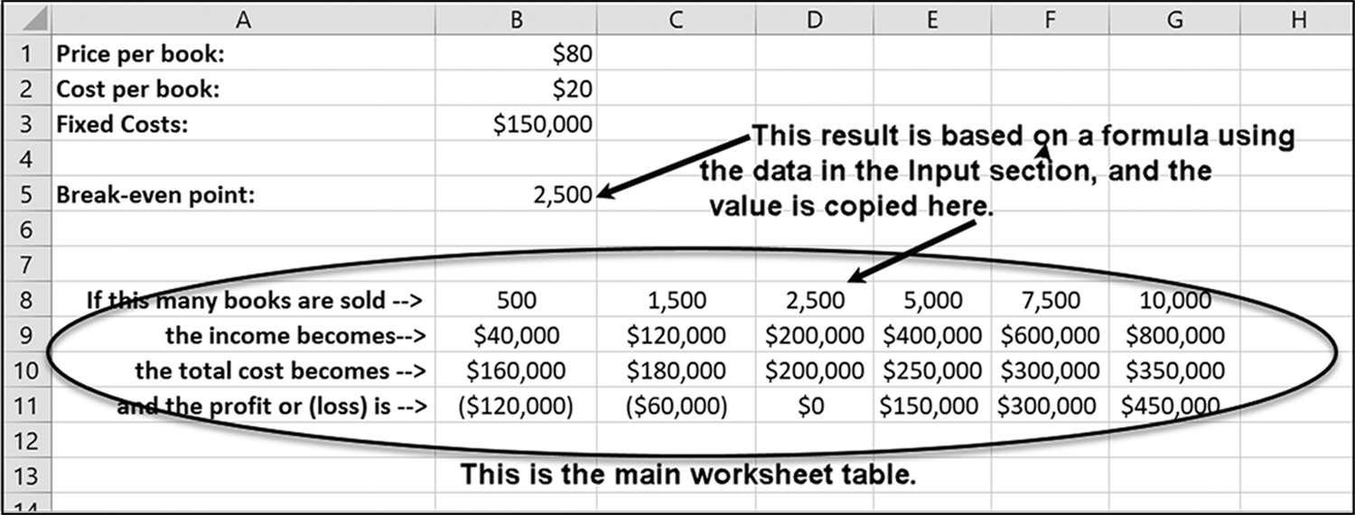

Figure 1.31 The Results area with the output from the data and the single formula results 26 exCel BasiCs

An example of an application that does not fit directly into the preferred form of
distinct Input and Results areas is the one shown in Figure 1.32. In this spreadsheet,
some of the inputs are entered in the Results area. In this spreadsheet, all of the
shaded cells contain input data. In keeping with the basic input format, however, the
tax rate is at the top of the spreadsheet and the remaining input data is contained
within the main Results area.
The type of spreadsheet illustrated in Figure 1.32 is typical of a majority of spread-
sheets you will create in your college and professional careers. This type of spread-
sheet lends itself extremely well to introducing such basic elements as entering and
copying formulas, as well as formatting cells to distinguish between text and data val-
ues. As a result, it is highly useful to be able to structure worksheets based on the
model of separate Input and Results areas shown in Figure 1.30.5
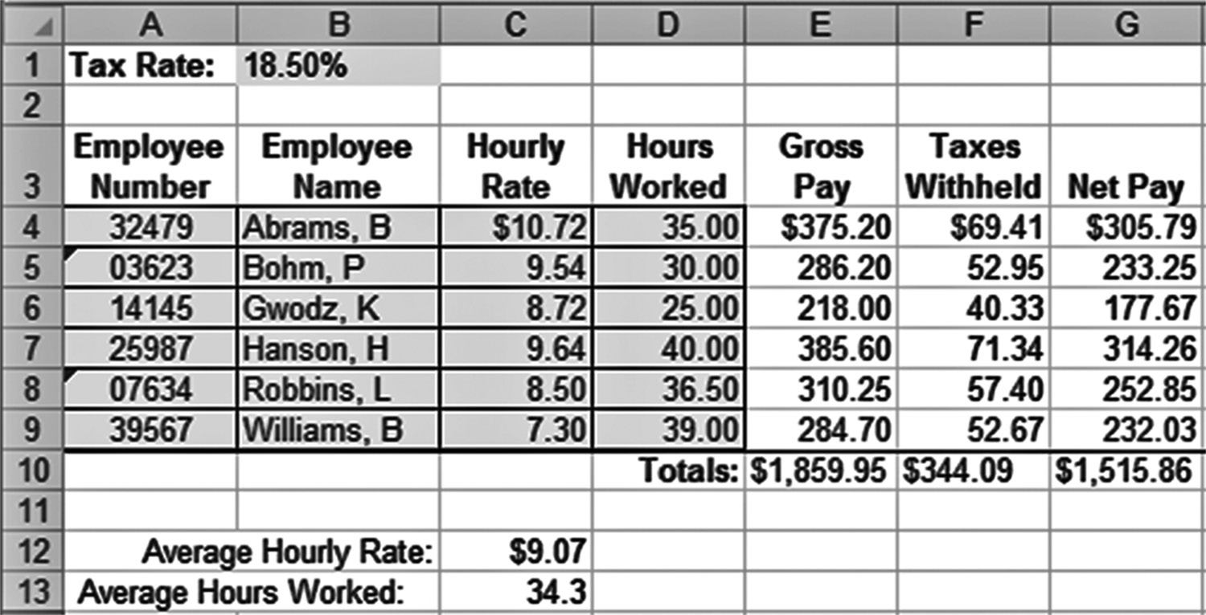

Figure 1.32 An example of a typical spreadsheet

1.5 COMMON EXCEL ERRORS

Part of learning any application software is making the elementary mistakes that begin-
ners typically make. Each program has its own set of common implementation errors
waiting for the unwary, and these mistakes can be quite frustrating. The most common
errors associated with the material presented in this chapter are listed below.
You should review these errors now and then come back to them again after you
have completed the first set of exercises. At that time, many of them will make much
more sense to you.

5 Note that this spreadsheet follows conventional accounting guidelines that stipulate that only the first currency value at the start of a column or after an underline, in addition to single currency items, receives a currency symbol, which in this case is the $ symbol.
GettinG started 27

Common Errors
1. Rushing to create a spreadsheet without spending enough time learning about
what is really needed and the relationship between the inputs and outputs. In this regard, it is worthwhile to remember the saying, “It is impossible to construct a successful spreadsheet for an application that is not fully understood.” A similar and equally valuable saying is “The sooner you start creating a spreadsheet, the longer it usually takes to complete.”
2. Forgetting to save your spreadsheet in a file that will be available to you when you
return the next day. This is especially true if you are working on a public com-puter in which the public storage area is cleared at the end of each day. The safest method is to save two copies of your work: the first copy on a dedicated section of the computer that is reserved for your personal backup files and the second copy on a removable USB flash drive.
3. Entering the same input piece of data more than once on your spreadsheet. If the
same item is needed in more than one cell, the additional cells should reference the one cell into which the data was initially entered within the spreadsheet’s Input area. This will prevent you from forgetting to change the value in the sec-ond cell when a change is made in the original cell.
4. Using a calculator to determine a value that you then enter into a cell. Rather, an
Excel formula should always be used to make all calculations.
5. Forgetting to initially check a result, using a calculator, in the first cell where a
formula is entered. Checking the result ensures that you are initially using the correct formula.
6. Assuming that all data containing only digits should be left as Excel’s default
numeric data type (such as General). For example, zip codes and identification numbers should never be considered as numeric data, as they are used for calcu-lations or generating numeric results. One of the issues that results is that leading zeroes will not be displayed, either in the spreadsheet or when the spreadsheet is printed. As a result, it is usually best to format these kinds of data as text or some other alternative format.

1.6 CHAPTER APPENDIX: THE EXCEL DEVELOPMENT SYSTEM

As noted in Section 1.1, Excel provides both a set of worksheets (within a file called a
workbook) and a set of capabilities for organizing and maintaining these worksheets.
Figure 1.33 shows the display you will see when you first launch Excel. As shown, the 28 exCel BasiCs

central and greater part of the display is a worksheet consisting of rows and columns,
which is the worksheet described and used in the previous two sections.
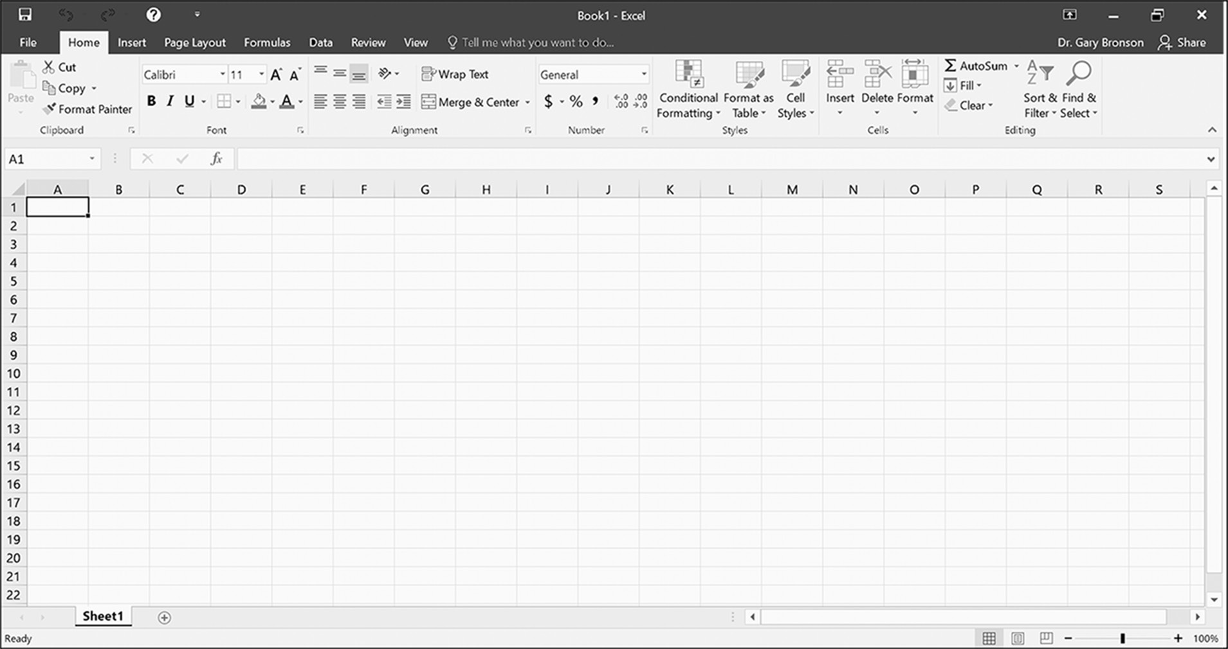

Figure 1.33 Excel’s Initial Development Screen

To make it easier to understand and use these worksheets (or sheets, for short) and
their capabilities effectively, the four key functional sections of the initial screen
shown in Figure 1.33 are highlighted in Figure 1.34. The use of these four sec-
tions, both individually and together to achieve specific results, is the purpose of
this chapter.
Figure 1.35 illustrates just the spreadsheet section shown in Figure 1.34, with ad-
ditional details of this section highlighted. As seen, the main area is the spreadsheet
presented in the previous section.
At any given time, and in the absence of using multi-window or split screen fea-
tures, Excel will display only one sheet, and even then, only a small number of the
worksheet’s rows and columns will be visible on the screen. The worksheet you see
actually can have over 16,384 columns and 1,048,576 rows, yielding over 17 billion
cells possible on a single sheet. Few users will ever use that many cells, and there are
also constraints based on the hardware of the computer you are using, the amount
of memory you have, and numerous other factors. However, the potential for a large
worksheet certainly exists. To see these other parts of the worksheet, again, in smaller
sections, you can either use the vertical row and horizontal column scroll bars (la-
belled in the right-hand bottom corner of Figure 1.35), or the keyboard cursor control
(arrow) keys.
GettinG started 29
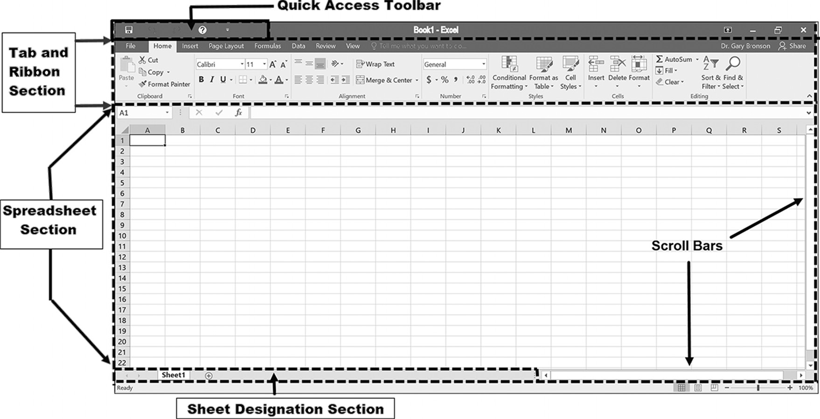

Figure 1.34 Specific Spreadsheet sections

To go directly to an individual cell, you can either click on the desired cell (use the
cursor arrows or the scroll bars shown in Figure 1.35 to move to other sections of the
spreadsheet, if needed) or enter the cell’s row and column designation at the top of
the worksheet into the name box shown in the figure. (There is also a shortcut key to
do this, F5 on the PC and Mac). To enter data into the selected cell, you can either
type directly into the selected cell or position the cursor in the area shown at the top
of the worksheet in Figure 1.35, and then type or copy the desired data.
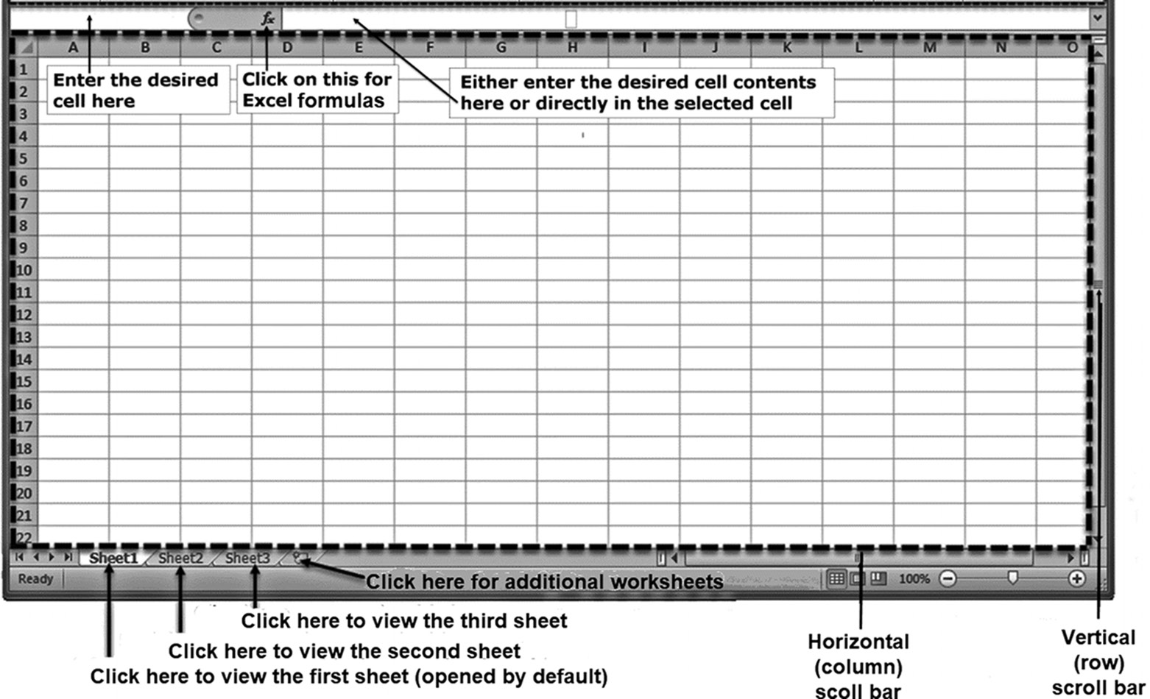

Figure 1.35 Spreadsheet features 30 exCel BasiCs

As noted in the Section 1.1, the column and row designations permit every cell in a
spreadsheet to be uniquely located and identified, and only one item can be stored in
an individual cell at a time. The stored item must be either a number, text, formula,
or function.
In addition to the currently active displayed worksheet, Excel also allows many
additional worksheets to be created, limited only by your computer’s memory. Each
worksheet initially is assigned a designated sheet number, but that can be changed on
the sheet tab to a more descriptive name� Clicking on one of the sheet numbers shown
at the bottom of Figure 1.35 causes the associated worksheet to be displayed, so you
can easily move between worksheets. By default, when Excel is first launched, Sheet 1
is activated. Thereafter, whenever Excel is launched, the last actively displayed work-
sheet is initially displayed. To add sheets to your spreadsheet, click on the + icon in
the sheet designation section.
Using Excel’s Options
In general, there are three main methods of accessing Excel’s options for maintaining
both individual worksheet cells and groups of cells. These are:
1. Using the Excel ribbon tabs shown in Figure 1.34 and then selecting one of the
options that appears in one of the tab’s groups when a tab is selected. In Figure 1.34, the Home tab is shown as having been selected.
2. Clicking on one of the options in the Quick Access Toolbar, also shown in Figure
1.34.
3. Right–clicking on the mouse when a cell or group of cells has first been high-
lighted, as presented in Section 1.2.

Using the Excel Ribbon Tabs Toolbar
Figure 1.36 illustrates the main groups of Excel options provided by the Excel ribbon
tab and its associated groups of options (command icons). All of the tabs together col-
lectively are known as the Excel ribbon� As illustrated, there are eight option groups,
with each group identified by a unique tab. When one of these eight tabs is selected,
a subset of options (sometime known as icons or buttons) associated with that tab is
displayed immediately under the tab. The one exception in terms of structure to this
tab and ribbon structure is provided by the File tab, which is presented in the next
section.
In Figure 1.36, both the Home tab and its associated groups and commands have
been outlined by a dotted line. As shown in the figure, the Home tab starts with the
Paste option at the left-end and ends with the Editing options at the right. Initially,
this is the tab that you will most often be using. At any time, however, you can click
GettinG started 31

on a different tab and see that tab’s available Groups and Options. As you will also be
using the File tab for saving, retrieving and printing your work, a pointer to this tab is
also shown.
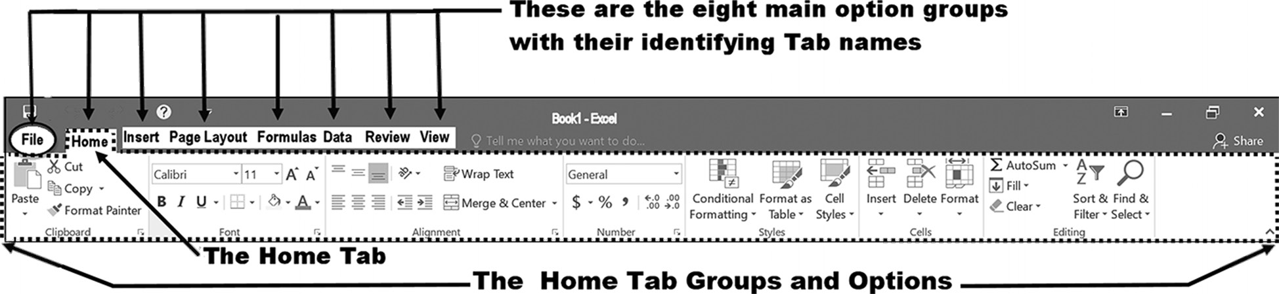

Figure 1.36 The Home tab and its options

The File tab and its use were described in Section 1.3. Each of the other tabs and
their associated groups and command icons are presented in detail in the remaining
chapters.
In addition to the Excel tabs, a second method of activating Excel options is to use
the Quick Access Toolbar� This toolbar provides a quick way of selecting frequently
used options without the need of first selecting a tab and then working your way
through the various ribbon choices to activate the desired option.
Figure 1.37, previously shown as Figure 1.21, shows the Quick Access Toolbar that
is illustrated in the top left had corner of Figure 1.34, with the purpose of each icon
listed on the figure. This toolbar can be customized by adding and deleting your own
personal selection of options. This is accomplished by clicking on the last option, the
down-facing arrow, shown on the figure. This same customization can also be accom-
plished using the File tab’s options menu.

Figure 1.37 The Quick Access Toolbar 32 exCel BasiCs

Appendix Exercises
1. List the main features that are provided by the Excel spreadsheet program
2. How many columns and rows are available in a worksheet that is displayed when
Excel is launched?
3. How many worksheets are available when Excel is launched?
4. List the four main areas provided in an Excel spreadsheet.
5. Launch the Excel program on your computer and identify the four main areas of
the displayed spreadsheet.
6. Create the following spreadsheet on your computer after you have launched
the Excel program and opened up a new blank worksheet. (Note: Boldfacing is achieved by selecting the desired cell and pressing the Ctrl and B keys at the same time or by pressing the Home tab’s B icon. To convert the contents in cells C6, C7, and C8 to text, type them with a leading quote, as in ‘/hr. Without the leading single quote, ‘, which converts the cell’s contents to text, the division symbol will be marked as an invalid division error).
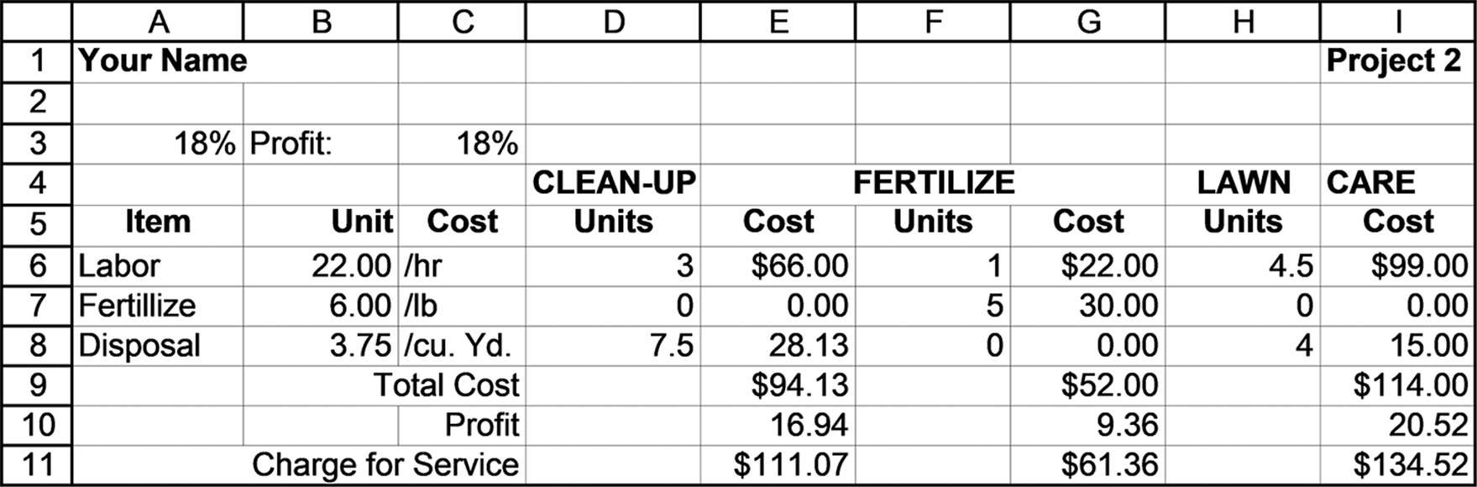

7. List the first four tabs located on the Excel ribbon.
8. What do each of the tab’s ribbons consist of?
9. Answer the following.
a. What is the purpose of the Quick Access Toolbar?
b. List three of the options provided by the Quick Access Toolbar.
C H A P T E R 2
formulas and formatting

This Chapter Contains
2.1 Formulas
2.2 Introduction to Excel Functions
2.3 Formatting
2.4 Cash Flow and Cash Balance Spreadsheets
2.5 Absolute Addresses
2.6 Common Excel Errors
2.7 Chapter Appendix: Working with Rows and Columns

2.1 FORMULAS

Formulas form the backbone of all Excel spreadsheets. They are one of the key ele-
ments that make Excel the essential tool it has become and what separates a spread-
sheet from a word processing program’s data table. Using a formula, the data in one
or more cells can be used to calculate new values or examined to make decisions. For
example, consider the following spreadsheet segment in Figure 2.1a, paying particular
attention to the formula in cell C2.
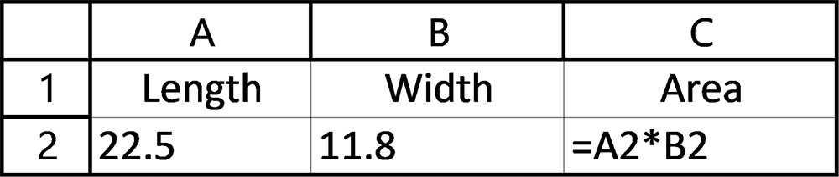

Figure 2.1a Sample spreadsheet with the original input

The display produced by this spreadsheet is shown in Figure 2.1b.
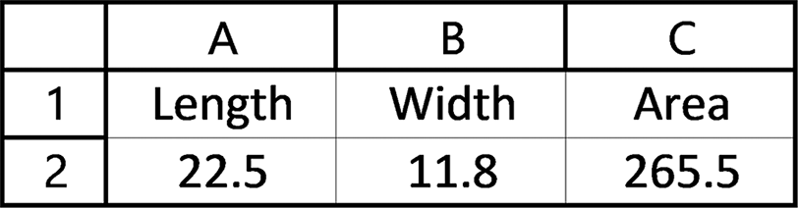

Figure 2.1b Sample spreadsheet with the results of the calculation 34 exCel BasiCs

In the spreadsheet shown in Figure 2.1b, if either the length value in cell A2 or the
width value in cell B2 were changed, the formula in cell C2 would automatically be
recalculated and a correct new value displayed in C2. The formula entered into cell
C2 follows the basic structure of all Excel formulas, and has the general form
= expression
Here, the expression is any combination of one or more operands, connected with
mathematical operators that can be evaluated to yield a result. An operand is a num-
ber, cell address, or Excel function. Examples of Excel expressions are as follows:
A1 + B1
A2 * B2 0.06 * C3 E2 /D2
(E3 – F3) / (D2 – C2)
Each of these expressions uses the primary mathematical operators ^, +, -, *, and /.
The only criterion in creating an expression is that an arithmetic symbol (+, -, *, /)
must be used between two operands, be they cell addresses and/or numeric values
and/or Excel functions, which are presented in the next section. Additionally, the mul-
tiplication symbol, *, must be used for multiplication. Thus, while A1*B2 is valid,
both A2B2 and(A2)(B2) are invalid.
The available mathematical operators in Excel are listed Table 2.1.
Table 2.1 Summary of arithmetic operators
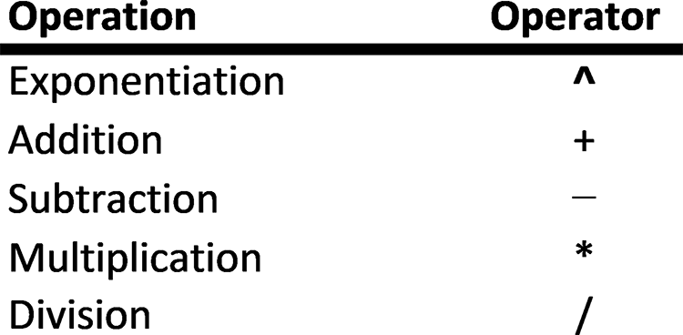

Expressions are calculated using standard arithmetic computational rules. These rules
are presented in detail at the end of this section, and summarized below:
1. Parentheses can be used to form groupings.
2. When parentheses are present, operations within parentheses are calculated first,
starting from the innermost set of parentheses to the outermost set.
3. An arithmetic symbol (^, +, -, *, /) must be used between two operands. Thus,
=A1*B1 is valid, while =A1B1 is invalid.
4. The multiplication symbol must be used for multiplication (not parentheses).
Thus, A1*B2 is valid and (A2)(B2) is invalid.
formulas and formattinG 35

5. Multiplication and division are performed before addition and subtraction, and
calculations are performed from left to right.
From Expressions to Formulas
Placing an equal sign (=) in front of an expression turns it into a formula. The for-
mula can then be entered into an individual cell. Thus, the following are valid Excel
formulas:
= A1 + B1
= A2*B2 = 0.06 *C3 = E2/D2
= (E3 – F3) / (D2 – C2)
= C5 *(D5 + E5) = C1 + D1 +(E1*F1)
The spaces around the arithmetic operators in these examples are inserted strictly for
clarity and may be omitted without affecting the value of the expression. The equal
sign causes the expression to be evaluated and then stored and displayed in the cell
containing the formula. Any cell referenced in a formula that does not contain a num-
ber is assigned a value of 0.

Example 1
Determine what each of the formulas does in the following cells:
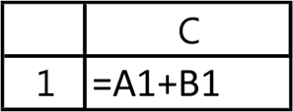

Solution: The formula in cell C1 adds the values displayed in cells A1 and B1 and
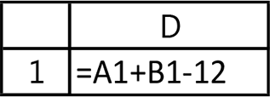
displays the sum in cell C1. It is important to note that the formula in cell D1 is a
valid entry for this cell, whether or not cells A1 and B1 have any values in them. The
formula will display a correct sum only when values actually reside in cells A1 and B1,
otherwise it displays 0.
The formula in cell D1 adds the values located in cells A1 and B1, subtracts 12 from
this sum, and displays the result in cell D1. Here, the formula in D1 could also have
been entered as =C1–12.

Example 2
Determine what the formulas do.
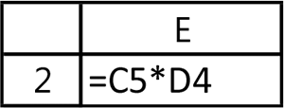
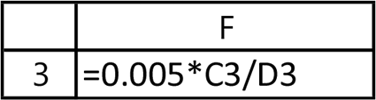
36 exCel BasiCs

Application Note
Displaying Formulas
The Excel default is to calculate and display the result in the cell wherever a formula is entered. You
can, or course, always see the formula by clicking on the cell and looking at the formula bar directly
above the spreadsheet. There is also the F2 shortcut key (or Ctrl- U on the Mac) which allows you to
do the same thing.
Another way to see all of the formulas entered into a spreadsheet is to press the Ctrl and ~ keys
together (the ~ key is at the top left-hand corner of the keyboard, directly below the Esc key). Doing
so will change the display to reveal all entered formulas.
The Ctrl ~ combination is a toggle switch; this means pressing them again will toggle the spreadsheet
back to its normal default display.

Solution: The formula in cell E2 multiplies the values in cells C5 and D4 and dis-
plays the result in cell E2.

NOTE A correct result is displayed in F2 only when cells C5 and D4 contain valid values; otherwise, cell F2 displays a 0.
The formula in cell F3 multiplies the value in cell C3 by 0.005, divides this result by
the value in cell D3, and displays the result in cell C3. A correct result is displayed in
F3 only when cells C3 and D3 contain valid values; otherwise, a value of 0 is displayed.
Give It a Try
For the spreadsheet illustrated in Figure 2.2a, determine the values displayed in the
cells containing each formula. Use Figure 2.2b to record your answers.
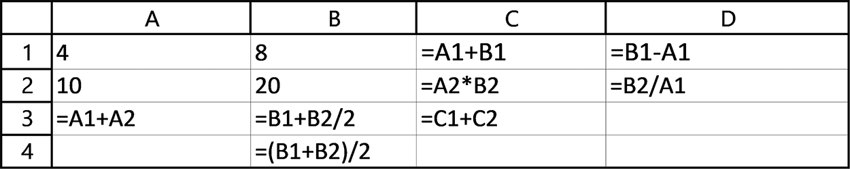

Figure 2.2a Original input for the spreadsheet
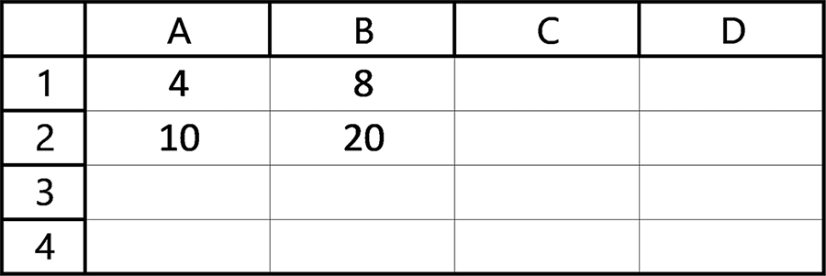

Figure 2.2b Calculate the results of the input in Figure 2.2a
Graphically Selecting Cells
Excel provides multiple ways for achieving almost anything you will need to accom-
plish. One of these alternative methods provides an extremely useful way of enter-
ing cell addresses into a formula. Using this method, you can point to and click on a
formulas and formattinG 37

desired cell rather than typing the cell’s address. This is advantageous in that it visually
shows you the referenced cells, avoids the necessity of determining the cell’s address
and, perhaps, mistyping the address in the formula.
The general procedure for selecting cells using this point and click method is as
follows:
Step 1: Type an = sign in the cell where you want the formula located.
Step 2: If the next operand is a number, type it in; otherwise, if it is a cell, move the
cursor to the desired cell and left-click the mouse.
Step 3: Type in a mathematical operator.
Step 4: If the next operand is a number, type it in; otherwise, if it is a cell, move the
cursor to the desired cell and left-click the mouse.
Step 5: Repeat Steps 3 and 4 until the formula is complete; then press the Enter key.
To see how this procedure works in practice, consider that the formula =A1+B1 is
entered in cell C1 using this point and click method.
Figure 2.3a shows how cell C1 appears after the initial = sign is entered (Step 1).
Figure 2.3b shows how the cursor looks when it is moved to cell A1, while Figure 2.3c
shows how cells A1 and C1 appear after the mouse is clicked on cell A1. Notice in
Figure 2.3c that the formula now includes cell A1.
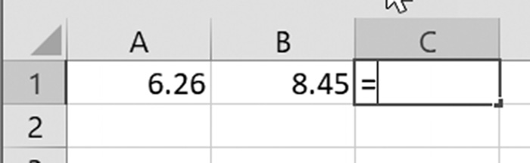

Figure 2.3a Beginning the formula in cell C1
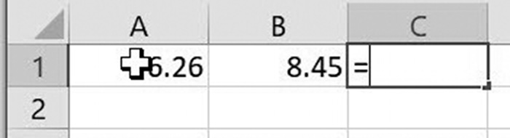

Figure 2.3b The cursor over cell A1

Once cell A1 has been included in the formula, as shown in Figure 2.3c, the multipli-
cation operator (*) is typed (Step 3, shown in Figure 2.3d).
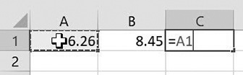

Figure 2.3c After clicking on cell A1
38 exCel BasiCs

Application Note
Formulas as Cell Contents
A formula is a valid and acceptable cell entry, whether or not the cells used in the formula contain valid
data values. However, the formula will calculate and display a correct result only when the referenced
cells contain and display valid data.
Clearly, it is more satisfying and easier to understand when an entered formula references cells
that have data in them. In that case, you can immediately check that the formula is working as you
expect. However, there will be times you will have to enter formulas before the referenced data is
available.
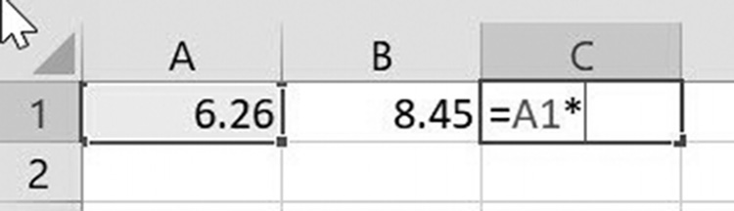

Figure 2.3d Typing the desired mathematical symbol

The selection of the second cell reference, in this case B1, is now made (Step 4, shown
in, Figures 2.3e and 2.3f). This selection follows the same procedure used in selecting
the first operand, cell A1. Notice in Figure 2.3f that the desired formula now is located
in cell C1 and the cells referenced in this formula are highlighted.
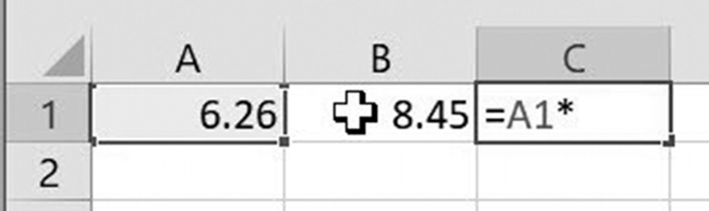

Figure 2.3e The cursor over cell B1
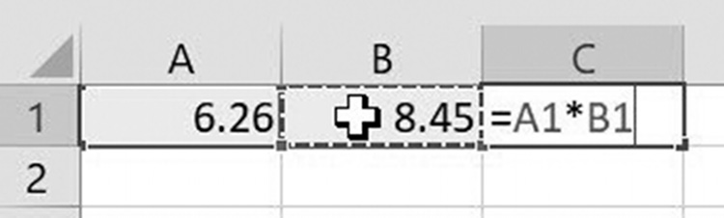

Figure 2.3f After clicking on cell B1

Once the desired formula is complete, as shown in Figure 2.3f, pressing the Enter
key (Step 5) ends the formula, which is then computed, resulting in the value shown
in Figure 2.3g. As always, because a formula is a valid cell entry, the data in any cell
referenced by the formula need not be entered prior to entering the formula.
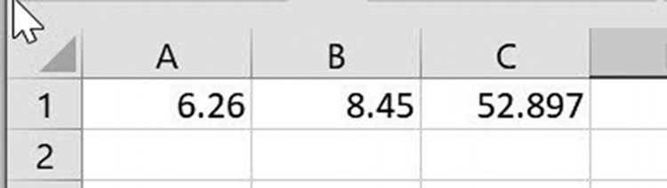

Figure 2.3g The result computed by the entered formula
formulas and formattinG 39

Copying Formulas
The contents of a range of cells can be copied using standard Windows cut and paste
techniques. In addition, Excel provides a unique technique for copying the contents
of one or more cells to other cells with one mouse movement. This technique is
extremely useful and one that will save you a tremendous amount of time in preparing
your spreadsheet.
To understand why copying a formula from a single cell to one or more cells is such
a powerful and frequently used technique, consider the spreadsheet shown in Figure
2.4a. This spreadsheet is intended to keep track of living expenses for the first six
months of the year.
Now look at cell B7, which is the selected cell in Figure 2.4a. Notice that the
value in the cell is 0, but that the cell’s formula, seen in the Formula Bar at the top
of the spreadsheet, is =B4+B5+B6. As expenses for January are entered into the
spreadsheet, the value in cell B7 will change to reflect the total of the entered ex-
penses. This leads to a very important concept, namely, that a formula may be en-
tered into a cell before any data is entered into the cells that are referenced
in the formula.
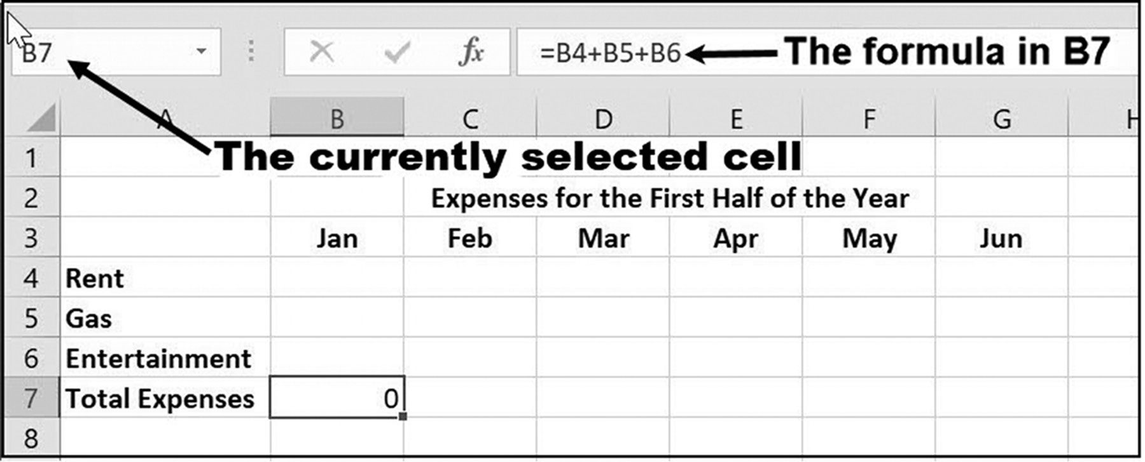

Figure 2.4a Keeping track of expenses

Now let us see how we can easily enter the formulas for cells C7 through G7, which
represent the totals for each of the months, February through June. (Again, these
formulas may be entered before or after any actual data for these months is entered.)
The correct formulas for the months February through June can be entered simply by
copying the contents of cell B7 to cells C7 through G7, using the fill handle, as shown
in Figure 2.4b.
40 exCel BasiCs
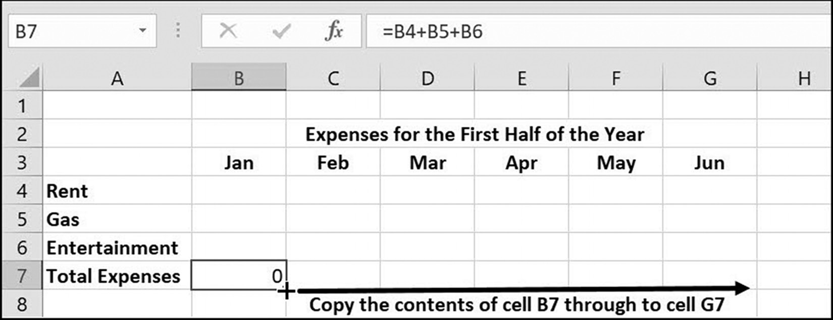

Figure 2.4b Copying the formula in cell B7

What makes this copy feature so powerful is that Excel will alter the references to the
cells in a formula as it is copied from column to column or row to row, unless explicitly
instructed not to do so. That is, it is assumed by the spreadsheet that, in this case, if
you are using cell B7 to add the contents of column B cells, that you intend to add the
equivalent C cells when the formula in B7 is copied to cell C7, and so on, for the sums
in cells D7 through G7. This result comes about when the cell references in question
have been written as relative cell references, which allows for the automatic altering
of cell references when copied to other cells. The described result can be verified by
pressing the Ctrl and ~ keys after the copy has been made, which causes all spread-
sheet formulas to be displayed. This is shown in Figure 2.4c.
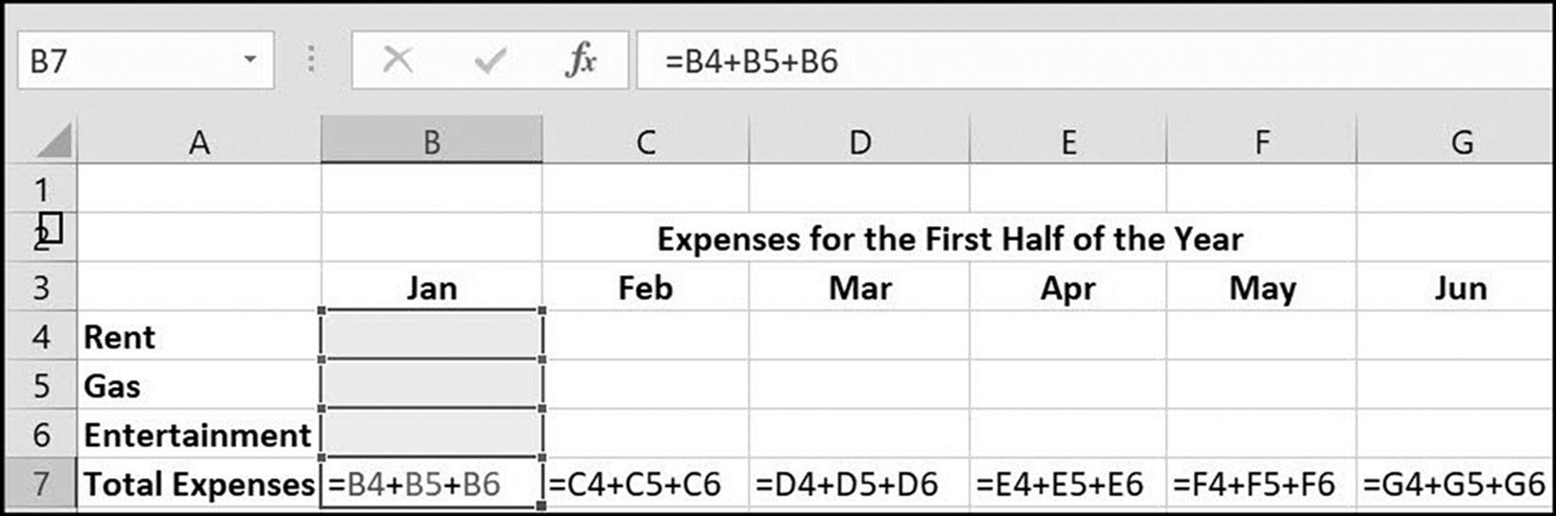

Figure 2.4c The copied formulas

Notice that as the formula was copied from column to column, the spreadsheet changed
the column designation in each cell address used in the formula. That is, the copy does
not produce an exact copy of the formula but adjusts the column designation as the for-
mula is copied from column to column. This same adjustment is made in row designa-
tions when a formula is copied up or down from row to row� This is known as relative cell
referencing (or addressing). It should be noted that for certain situations, the automatic
adjustment characteristic is not desired, and that is the reason why there are other cell
referencing methods which can be used, including absolute and mixed.
formulas and formattinG 41

Expression Construction Rules1
The formulas required for the vast majority of spreadsheet applications, such as bud-
geting, accounting, inventory, and sales, generally consist of expressions using only
a few of the most commonly used arithmetic operations. When writing more com-
plex formulas, however, you will need to be aware of the following rules, which apply
equally to all expressions, be they simple or complex:
1. Two binary operator symbols must never be placed side by side. For example,
5 */ 6 is invalid because the two operators, * and /, are placed next to each other.
2. Parentheses may be used to form groupings, and all expressions enclosed within
parentheses are evaluated first. For example, in the expression (6 + 4) / (2 + 3), the 6 + 4 and 2 +3 are evaluated first to yield 10 / 5. The 10 / 5 is then evaluated to yield 2.
3. Sets of parentheses may also be enclosed by other parentheses. For example,
the expression (2 * (3 + 7) ) / 5 is valid and evaluates to 4. When parentheses are included within parentheses, the expressions in the innermost parentheses are always evaluated first. The evaluation continues from innermost to outermost parentheses until the expressions in all parentheses have been evaluated. The number of closing parentheses must always equal the number of opening paren-theses so that there are no unpaired sets.
4. Parentheses cannot be used to indicate multiplication. The multiplication opera-
tor, *, must explicitly be used. For example, the expression (3 + 4) (5 + 1) is invalid. The correct expression is (3 + 4) * (5 + 1).
As a general rule, parentheses should be used to specify logical groupings of operands
and to indicate clearly the intended order of arithmetic operations. In the absence of
parentheses, expressions containing multiple operators are evaluated by the priority,
or precedence, of each operator. Table 2.2 lists both the precedence and associativity
of the operands considered in this section.
Table 2.2 Operator precedence and associativity
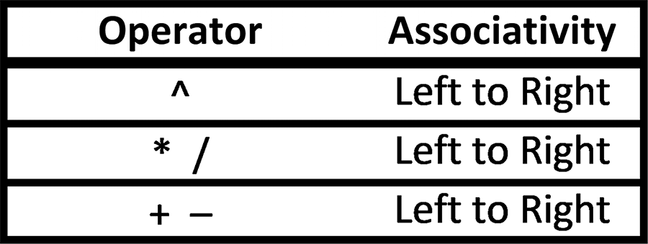

1 This topic may be omitted on first reading without loss of subject continuity.
42 exCel BasiCs

The precedence of an operator establishes its priority relative to all other operators.
The operators at the top of Table 2.2 have a higher priority than the operators at the
bottom of the table. Thus, in expressions with multiple operators, the operator with
the higher precedence is used before an operator with a lower precedence. For exam-
ple, in the expression 6 + 4 / 2 + 3, the division is done before the addition, yielding
an intermediate result of 6 + 2 + 3. The additions are then performed to yield a final
result of 11.
Expressions containing operators with the same precedence are evaluated accord-
ing to their associativity. This means that evaluation is either from left to right or from
right to left as each operator is encountered. For example, in the expression 8 + 5 *
7 / 2 * 4, the multiplication and division operators are of higher precedence than the
addition operator, and are evaluated first. Both of these operators, however, are of
equal priority. Therefore, these operators are evaluated left-to-right, yielding
8 + 5 * 6 / 2 * 4 =
8 + 30 / 2 * 4 =
8 + 15 * 4 =
8 + 60 = 68

EXERCISES 2.1

1. Use the spreadsheet shown in Figure 2.5a for the following exercises.
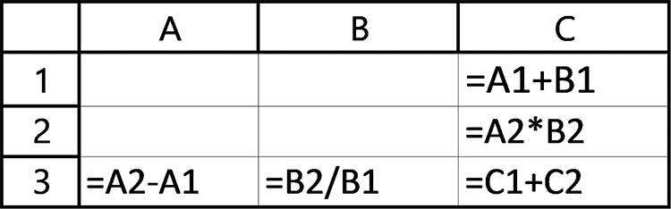

Figure 2.5a Input for the exercise in Exercise 1

a. Determine and write in the values that will be displayed in cells C1, C2, C3, A3,
and B3 for the values shown in Figure 2.5b.
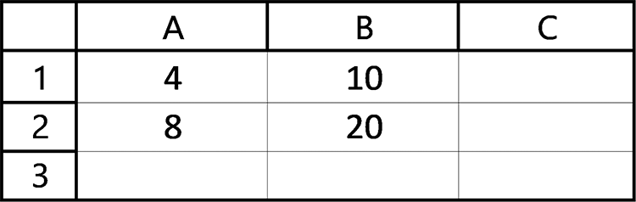

Figure 2.5b Compute and enter the answers for Exercise 1a
formulas and formattinG 43

b. Determine and write in the values that will be displayed in cells C1, C2, C3, A3,
and B3 for the values shown in Figure 2.5c.
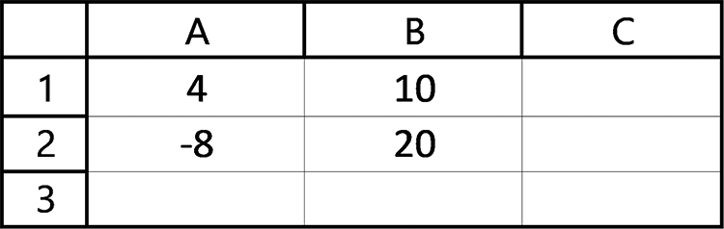

Figure 2.5c Compute and enter the answers for Exercise 1b

2. Use the spreadsheet in Figure 2.6a for the following exercises.
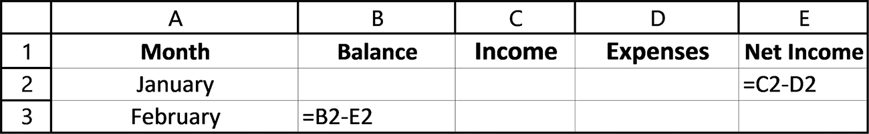

Figure 2.6a Spreadsheet for Exercise 2

a. Using the formulas shown in Figure 2.6a, determine the dollar values that will
be displayed in cells E2 and B3 for the values shown in Figure 2.6b. Assume all values have been formatted as currency, with a leading $ sign.
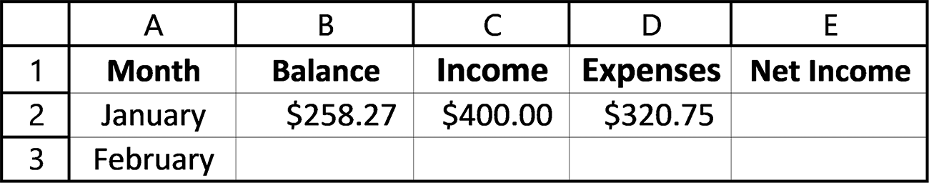

Figure 2.6b Compute and enter the answers for Exercise 2a

b. Using the formulas shown in Figure 2.6a, determine the dollar values that will
be displayed in cells E2 and B3 for the values shown in Figure 2.6c. Assume all values have been formatted as currency, with a leading $ sign.
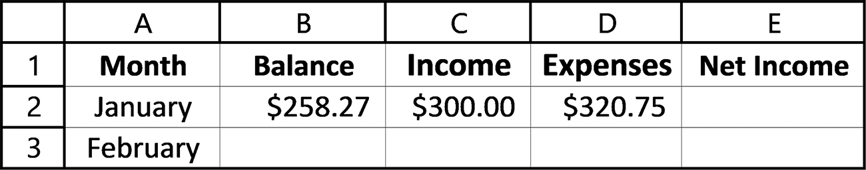

Figure 2.6c Spreadsheet to compute and enter Exercise 2b answers

3. Figure 2.7a shows how the first two payments for a 4-year loan (48 monthly pay-
ments) at 5% annual interest would be calculated and displayed in a spreadsheet. Use the formulas shown in the figure for the following problems.
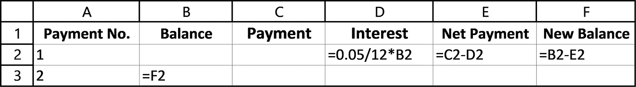

Figure 2.7a Original spreadsheet input 44 exCel BasiCs

a. Assuming that all values have been formatted as currency with a leading $ sign,
determine the dollar values that will be displayed in cells D2, E2, F2, and B3 for the values shown in Figure 2.7b. In Section 2.4, you will see how to format numbers as currency.
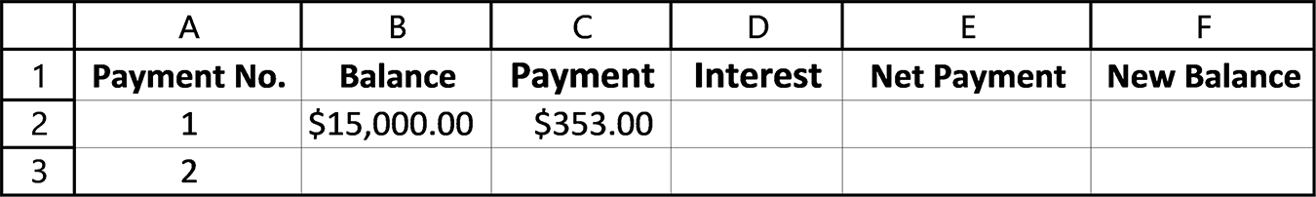

Figure 2.7b Compute and enter the answers for Exercise 3a

4. Determine the formula for cell B2 in Figure 2.8 that calculates the circumference
of a circle whose radius is entered into cell A2. The equation for determining the circumference, c, of a circle is c = 2 π radius and π equals 3.1416.
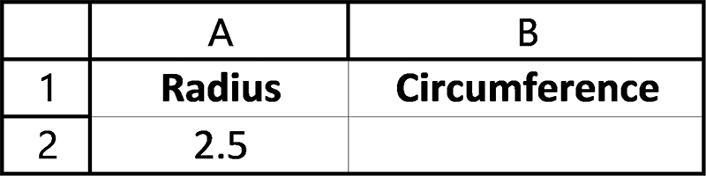

Figure 2.8 Spreadsheet for Exercise 4

5. Determine the formula for cell B2 in Figure 2.9 that calculates the area of circle
whose radius is entered into cell A2. The equation for determining the area, a, of a circle is a = πr2, where r is the radius and π equals 3.1416.
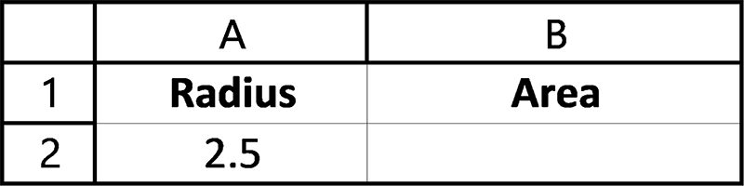

Figure 2.9 Compute and enter the answer for Exercise 5
6. Determine the formula for cell B2 in Figure 2.10 that converts the Fahrenheit tem-
perature in cell A2 to degrees Celsius. The equation for this conversion is Celsius = 5/9 (A2 - 32) .
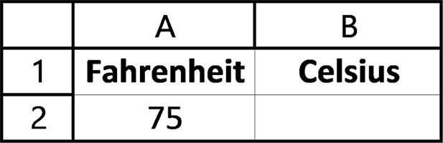

Figure 2.10 Compute and enter the answer for Exercise 6

7. Determine the formula for cell B2 in Figure 2.11 that calculates the round trip
distance of a trip whose one-way distance is in cell A2.
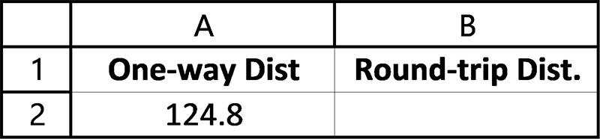

Figure 2.11 Compute and enter the answer for Exercise 7
formulas and formattinG 45

8. Determine the formula for cell C2 in Figure 2.12 to calculate the elapsed time, in
minutes, that it takes to make a trip. The equation for computing elapsed time is elapsed time = total distance / average speed. Assume that the distance, in miles, is in cell A2 and the average speed, in miles/hour, is in cell B2. Make sure to convert your answer to minutes.
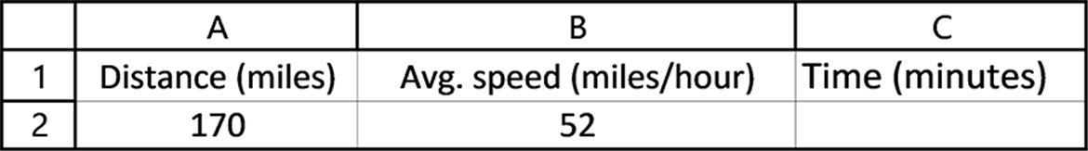

Figure 2.12 Compute and enter the answers for Exercise 8

9. Listed below are algebraic expressions and the incorrect Excel formulas corre-
sponding to them. Find the errors and write the corrected Excel formulas.
Algebra Excel Formula
a. (2)(3) + (4)(5) = (2)(3) + (4)(5
b. 6 18  = 6 + 18 / 2
2

c. 4.5 = 4.5 / 12.2 - 3.1 12.2 3.1 
d. 4.6(3.0 + 14.9) = 4.6(3.0 + 14.9)
e. (12.1 + 18.9)(15.3 - 3.8) = (12.1 + 18.9)(15.3 - 3.8)
10. If cell A1 contains the number 12, cell B1 contains the number 3, cell D4 con-
tains the number 2, and cell M5 holds the number 45, determine the value of the following formulas:
a. =A1 / B1 + 3
b. =M5 / B1 + A1 - 10 * D4
c. =M5 - 3 * A1 + 4 * D4
d. =D4 / 5
e. =18 / B1
f. =–B1 * A1
g. -M5 / 20
h. (M5 + A1) / (B1 + D4)
i. M5 + A1 / B1 + D4
46 exCel BasiCs

11. Determine the value of the following expressions, paying attention to the prece-
dence and associativity of all arithmetic operators as listed in Table 2.2.
a. 3 + 4 * 6 h. (20 - 2) / (6 + 3)
b. 3 * 4 / 6 + 6 i. 2 * 3 / 12 * 8 / 4
c. 2 * 3 / 12 * 8 / 4 j. 10 * (1 + 7 * 3)
d. 10 * (1 + 7 * 3) k. 20 - 2 / 6 + 3
e. 20 - 2 / 6 + 3 l. 20 - 2 / (6 + 3)
f. 20 - 2 / (6 + 3) m. (20 - 2) / 6 + 3
g. (20 - 2) / 6 + 3 n. (20 - 2) / (6 + 3)

2.2 INTRODUCTION TO EXCEL FUNCTIONS

As we have seen, formulas are used to perform calculations and change the contents
of the cell containing the formula. For example, the formula
= A1 * B1
multiplies the value in cell A1 times the value in cell B1 and assigns the resulting value
to the cell containing the formula. Although addition, subtraction, multiplication,
exponentiation, and division are easily accomplished using Excel’s arithmetic opera-
tors, no such operators exist for finding the square root of a number, determining cer-
tain statistical values, and other more complex, but commonly employed, calculations.
To facilitate such calculations, Excel provides standard preprogrammed functions that
you can incorporate into your formulas.
An Excel function has the general form
= Function-name(arguments)
As with all functions, the equal sign indicates to Excel that a formula is to follow. The
function-name indicates the desired function; it is followed by the required paren-
theses, which contain the data that is sent to the function. This data sent is formally
referred to as the function’s arguments. Examples of Excel formulas using functions
are as follows:
= SUM(B2:B15) ← This sums the values in cells B2 through B15
= SUM(A1:B4) ← This sums the values in cells A1 through B4
= SUM(A1,A5,B3,C4) ← This is the same as =A1+A5+B3+C4
= AVERAGE(C2:C20) ← This calculates the average of the values in cells C2
through C20
= MAX(A1:A52) ← This finds the maximum (largest) value in cells A1 through A52
formulas and formattinG 47

A complete list of Excel functions is found by clicking on the f Insert Function x
icon shown on Figure 2.13. Clicking this icon brings up the dialog box shown in
Figure 2.14.
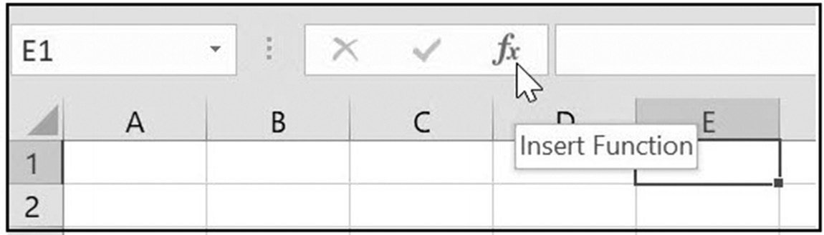

Figure 2.13 The Insert Function icon
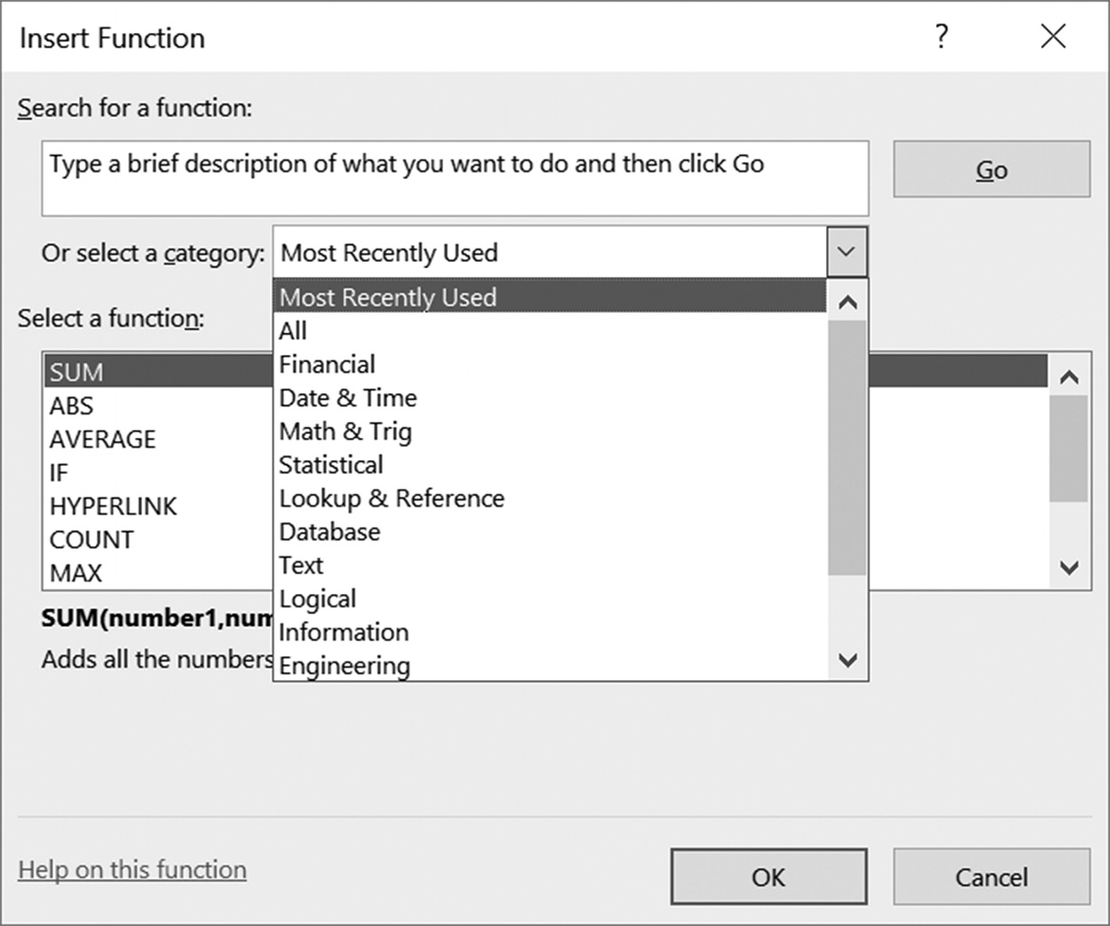

Figure 2.14 Insert Function dialog box

It is also possible to bring up the Insert Function dialog box from the Excel ribbon
Formulas tab). As seen in Figure 2.14, Excel’s preprogrammed functions can be
displayed by application type, such as Financial, Date, and Time, or all together in
alphabetical order, or by most recently used. Clicking on the desired function within
a group allows the user to enter the arguments using a menu-based dialog, followed
by the completed function being inserted in the currently active cell.
The functions that you will initially use most often in your work (except for the
PRODUCT( ) function, which is included for completeness; see the Application Note
on page 52) are listed in Table 2.1. By definition, a function calculates and displays the
value(s) obtained after processing by the function, using the arguments provided. It
should be noted that using the incorrect type, number, or data types of arguments may
bring about uncertain results, or result in the display of an error message.
48 exCel BasiCs

The examples shown in Table 2.3 illustrate that some functions, such as SQRT( ),
require a single argument, while other functions, such as SUM( ), take multiple ar-
guments, and some require no arguments at all, such as TODAY(). In addition, each
argument can be a cell reference, another function, or in some cases, a range of cell
addresses. Additionally, an expression that can be computed to yield a value of the
required data type is also valid. Thus, for example, the formula =SQRT(C2–C1) is
valid.
Table 2.3 Commonly Used Mathematical Functions
Function Name Description Example ABS( ) Absolute value =ABS(D5) AVERAGE( ) Average =AVERAGE(A2:A25) COUNT( ) Number of items =COUNT(C7:C33) MAX( ) Maximum value =MAX(A1:A10) MIN( ) Minimum value =MIN(A1:A10) PMT( ) Loan payment =PMT(.05,48,15000) POWER( ) Raise a value to a power =POWER(C2,3) PRODUCT( ) Product of two or more values =PRODUCT(A1:C1) SUM( ) Sum of one or more values =SUM(B2:B20)
=SUM(A1:A5,B2,C1)
SQRT( ) Square root of its argument =SQRT(D2)

Example 1
The spreadsheet shown in Figure 2.15a contains sales data for a six-month period.
Determine the formula, using SUM( ), needed in cell H1 to determine the six-month
total of these sales.

Figure 2.15a Spreadsheet data for Example 1

Solution: The formula that should be entered in cell H1 is =SUM(B2:G2).
Although this produces the same result as =B2+C2+D2+E2+F2+G2, this latter formula
NOTE generally should not be used. Using the longer formula both indicates a truly inexpe-
rienced developer and someone not able to use one of the most basic and commonly used Excel functions, which is SUM( ).
formulas and formattinG 49

Once the correct sum formula is entered into cell H1, the spreadsheet will appear as
shown in Figure 2.15b.

Figure 2.15b Results for Example 1

Example 2
The spreadsheet shown in Figure 2.16a contains the hourly rate and hours worked
for the employees of a local company. Determine the formula needed in cells D2
through D7 to compute each employee’s net pay, where Net Pay = (Hourly Rate)*
(Hours Worked). Provide the formula in cell D8 that will sum all of values in cells
D2 through D7.
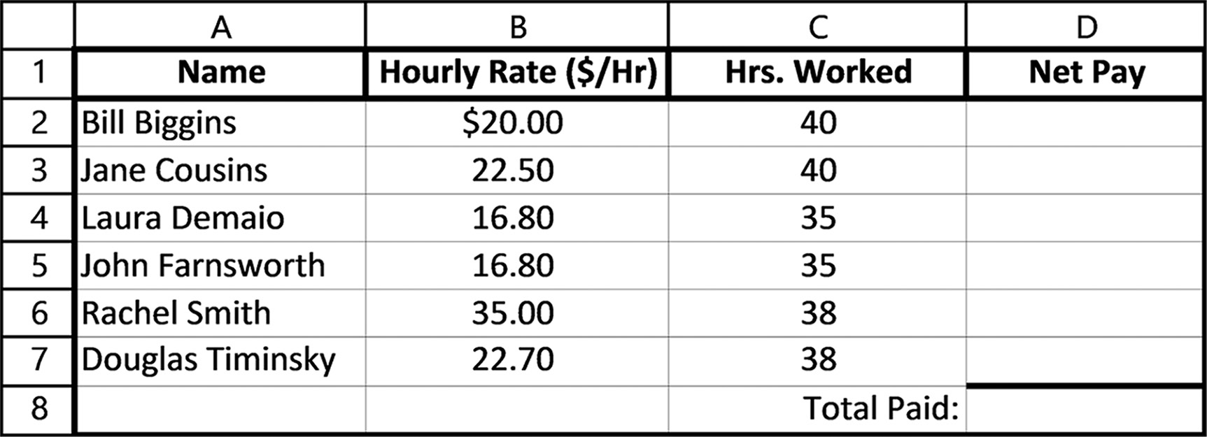

Figure 2.16a Data for Example 2

Solution: The required formulas are shown in Figure 2.16b.
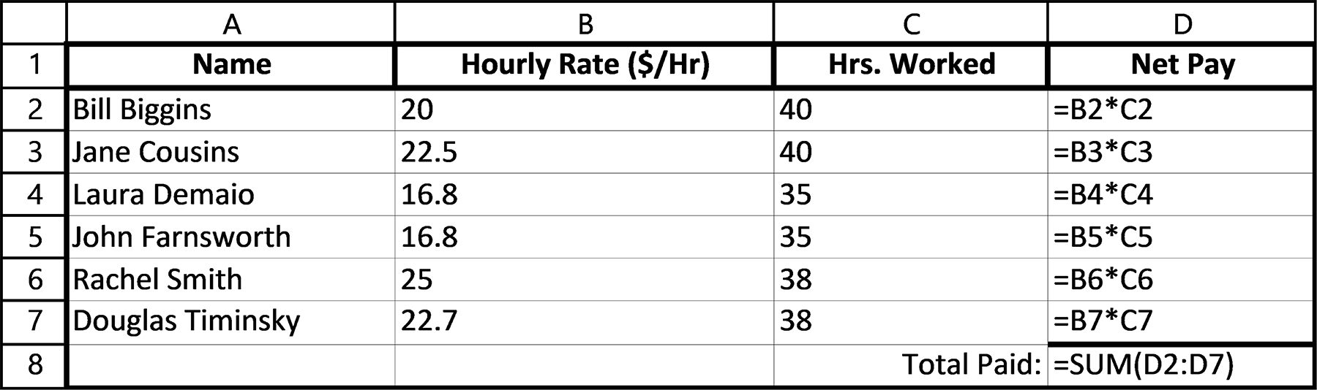

Figure 2.16b Formulas for Example 2
50 exCel BasiCs

Once the formulas shown in Figure 2.16b are entered into the spreadsheet, it will
appear as shown in Figure 2.16c.
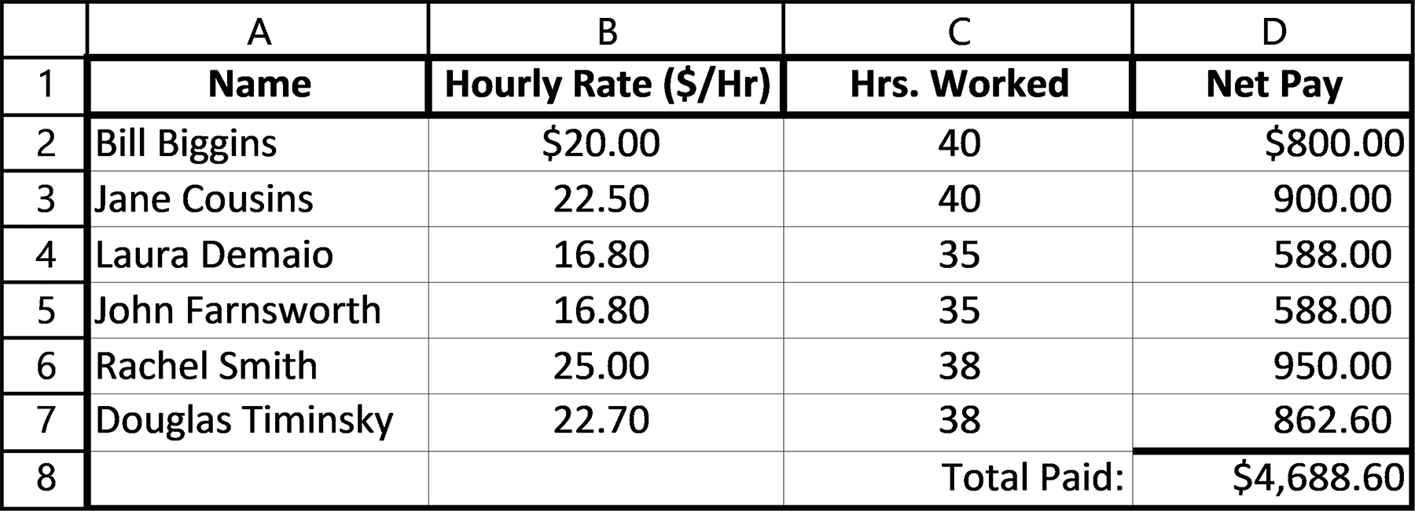

Figure 2.16c Results for Example 2

Functions may also be included as part of larger expressions. Thus, the formula
= 4 * SQRT(4.5 * B5) - 2.0
is valid. Additionally, a function’s calculated value may be included within a larger
expression, or even used as an argument to another function. For example, the nested
function
=SQRT( POWER( ABS(A1),B1 )
is also valid. Because parentheses are present, the computation proceeds from the inner
to the outer pairs of parentheses. Thus, the absolute value of cell A1 is computed first
and used as an argument to the POWER( ) function. The square root of value calculated
by this function is then computed and displayed in the cell containing the complete
formula. This is called a nested function, since it actually contains no fewer than three
functions, which are wrapped or “nested” within each other. The ABS( ) function is con-
tained within the POWER( ) function, and the entire expression is contained within the
SQRT( ) function.
Formulas containing functions are copied in the identical way as the arithmetic
formulas described in the prior section. As each formula is copied, cell referenc-
es are automatically adjusted unless absolute cell addresses are used, as shown in
Section 2.6.
As a specific example of copying a formula containing an Excel function, consider
Figure 2.17a. As shown in this formula, the correct formula has been entered into cell
B10.
Once this initial formula is entered in cell B10, the formulas for cells C10 through
G10, which represent the totals for February through June can be entered simply by
copying the contents of cell B10 to cells C10 through G10, as shown in Figure 2.17b.
formulas and formattinG 51

(Note, if you are unsure of how this copy is done, review Copying Formulas and
Figures 2.4a through 2.4c in the previous section.)
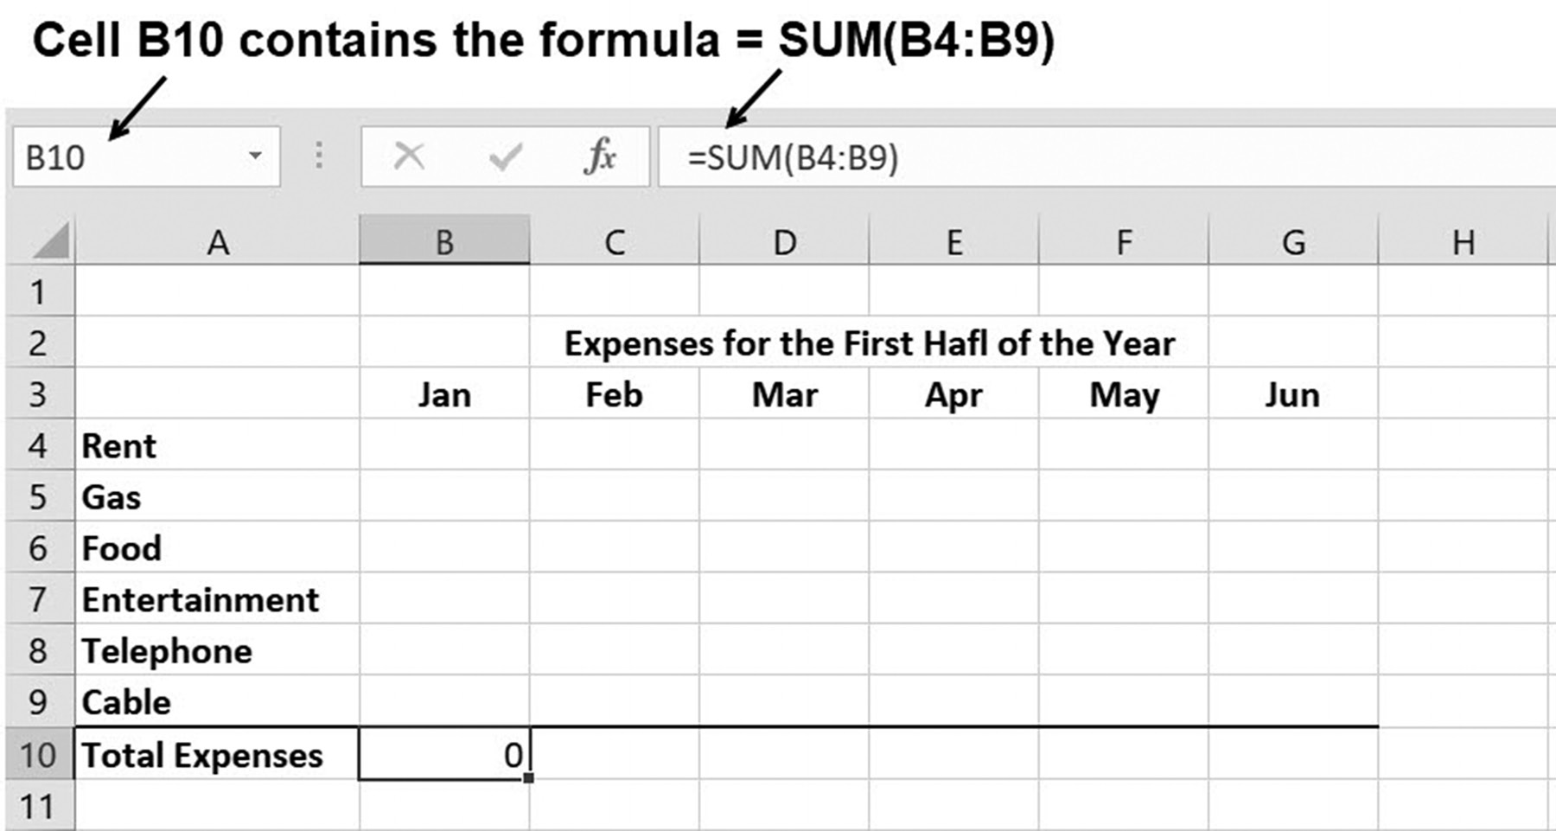

Figure 2.17a Keeping track of expenses
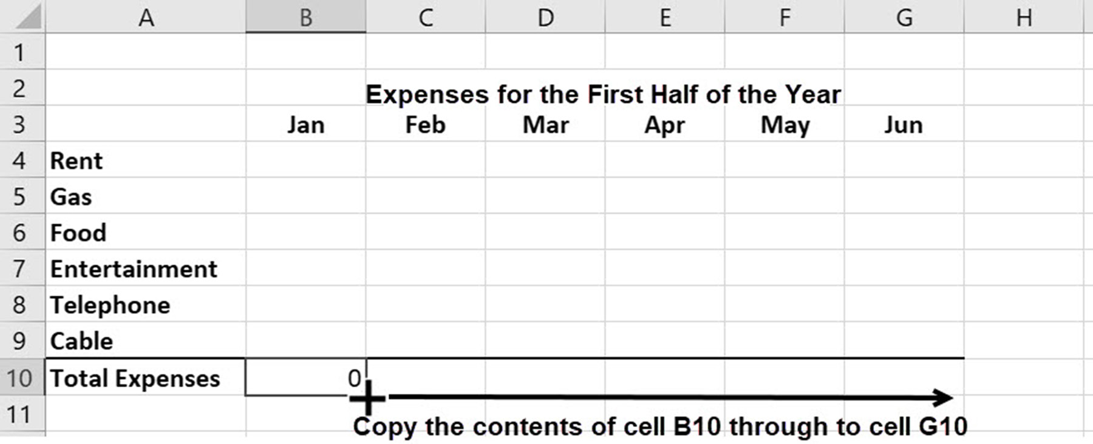

Figure 2.17b Copying the formula in cell B10

Again, as noted in Section 2.1, what makes this copy so powerful is that Excel will alter
the references to the cells in a formula as it is copied from column to column or row
to row (relative cell referencing), unless explicitly instructed not to do so. In this case,
Excel assumes that if you are using cell B10 to add the contents of column B cells, that
you intend to add the equivalent C cells when the formula in B10 is copied to cell C10, 52 exCel BasiCs

Application Note
Most and Least Commonly Used Functions
The most and least commonly used functions in Table 2.3 for basic spreadsheets are the SUM( ) and PRODUCT( ) functions, respectively. The reason for this is the same for both functions; a function should only be used to simplify development, not complicate it. In this regard, the general development rule is to only use a function when it replaces a more complicated or longer mathematical expression, or there is no other way to calculate the desired result.
As this applies to the SUM( ) and PRODUCT( ) functions, it means that if there
are only two values that have to be added or multiplied, an arithmetic expression can be used just as easily as a function. For example, the formula =A1+A2 is equally use-ful as =SUM(A1:A2); similarly, =A1*B1 can be used in lieu of =PRODUCT(A1:B1). If the number of data items to be summed or multiplied is 3 or more, it may make more sense to use the function.
The same can hold true for the POWER( ) function, for which the exponentia-
tion operator can do the exact same thing as =5^2 could be substituted for =POW-ER(5,2).
Again, for three or more arguments the respective functions are preferable (for
exactly three arguments, some developers will use SUM( ) and some will not). Cer-tainly, the formula =SUM(A1:A10) is more concise and requires less typing than the equivalent =A1+A2+A3+A4+A5+A6+A7+A8+A9+A10. In summary, for a small number of arguments, there is no hard and fast rule as to whether it is better to use a function or a formula. It is a judgment call. For larger numbers or arguments, use of a function if available is generally recommended.

and so on for the sums in cells D10 through G10. This is verified by pressing the Ctrl
and ~ keys after the copy has been made, which causes all spreadsheet formulas to be
displayed, as shown in Figure 2.17c.
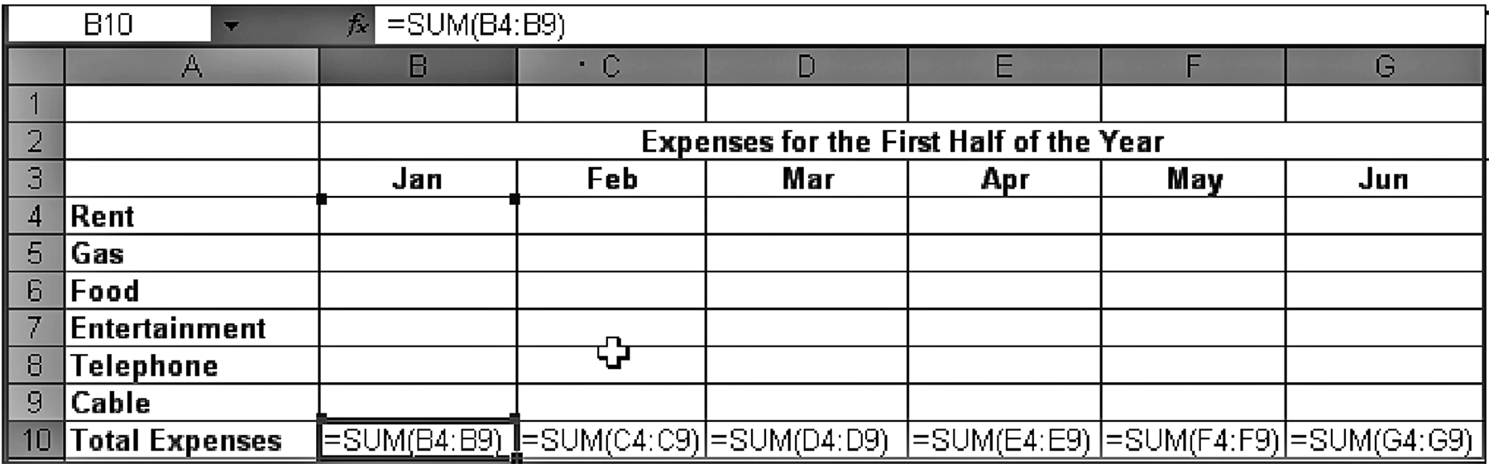

Figure 2.17c The copied formulas
formulas and formattinG 53

Note that if an absolute address is used for a cell’s referencing (see Section 2.6), the
cell so designated will not be altered in any way when the formula is copied. If mixed
references are used, it will restrict how the cell references will be copied, whether to
change by row or column, but not both. Absolute and mixed cell referencing and the
situations that require their use are described in Section 2.5.
Highlighting Selected Arguments
As always, Excel provides multiple ways of accomplishing almost anything you want
to do, including selecting function arguments. The SUM( ) function, in particular, is
so frequently used in both introductory and advanced applications that most prac-
titioners typically type in its name and then select its arguments by highlighting,
as presented in Section 1.2, rather than typing in the arguments’ addresses. For
example, consider Figure 2.15a, which is reproduced below as Figure 2.18a.

Figure 2.18a A copy of the spreadsheet in Figure 2.15a

To calculate the desired total in cell H1, the formula =SUM(B2:G2) should be used.
However, rather than typing the complete function into the cell, you can begin by
entering “=SUM(“and then highlighting cells B2 through G2. Doing this produces the
spreadsheet shown in Figure 2.18b.
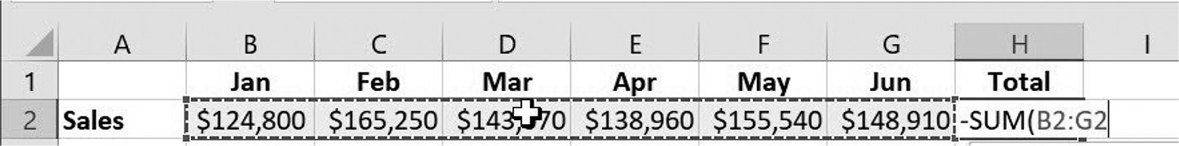

Figure 2.18b Highlighting the range after typing =SUM(

Notice that the highlighted range has automatically been provided as arguments to the
SUM( ) function in cell H2. At this point, you can type in a comma and add additional
arguments to the function or press the Enter key to complete the function. When you
press the Enter key, Excel will provide the closing parenthesis, enter and calculate the
formula, and produce the result shown in Figure 2.18c.

Figure 2.18c Results of highlighting after typing =SUM()
54 exCel BasiCs

EXERCISES 2.2

1. Write Excel functions or formulas to determine the following:
a. the square root of the contents of cell A1
b. the square root of the contents of cell A2
c. the absolute value of the contents of cell B1
d. the absolute value of the contents of cell B2
e. the value of cell D5 raised to the 4th power.
2. Use this spreadsheet for Exercise 2.
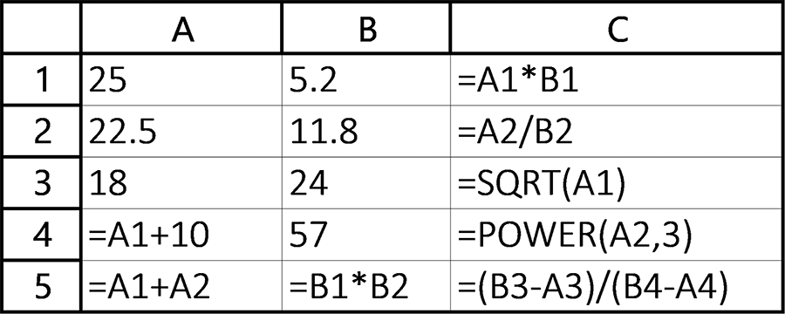

Write the values, in the following spreadsheet, that will appear in cells C1 through C5, A5, and B5.
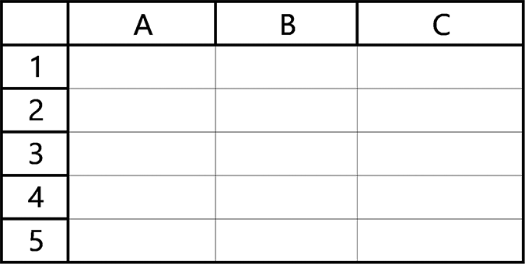

3. Using the SUM( ) function, write functions that determine the following:
a. the sum of cells A1, B5, C3, and D3.
b. the sum of cells B2, C2, D4, and E5
c. the sum of cells A3 through A10
d. the sum of cells A3 through D3
e. the sum of cells H2 through H30
f. the sum of cells B2 through B8 and D5.
formulas and formattinG 55

4. Using the AVERAGE( ) function, write functions that determine the following:
a. the average of cells A3 through A10
b. the average of cells A3 through D3
c. the average of cells H2 through H30.
5. Enter the data shown in the first spreadsheet, including the necessary function or
formula in cell H2, to verify that it produces the correct totals shown in the second spreadsheet that follows.

6. Use the data shown in the first spreadsheet to produce the results given in the
spreadsheet that follows it.
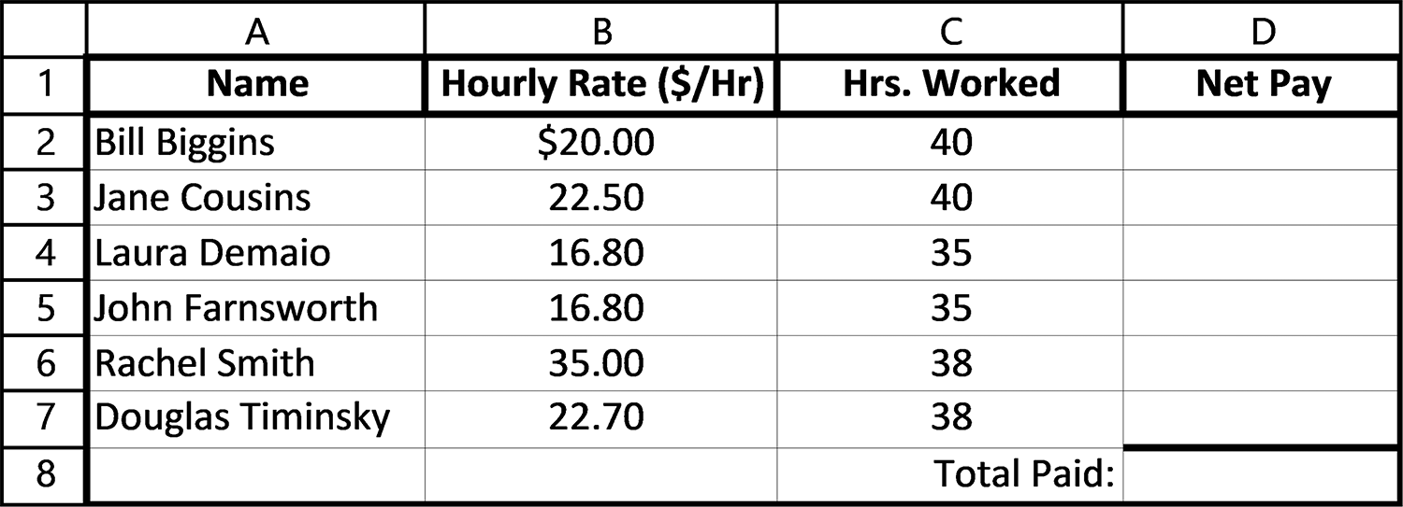

7. The spreadsheet shown in Figure 2.19 contains labels, income, and expense data
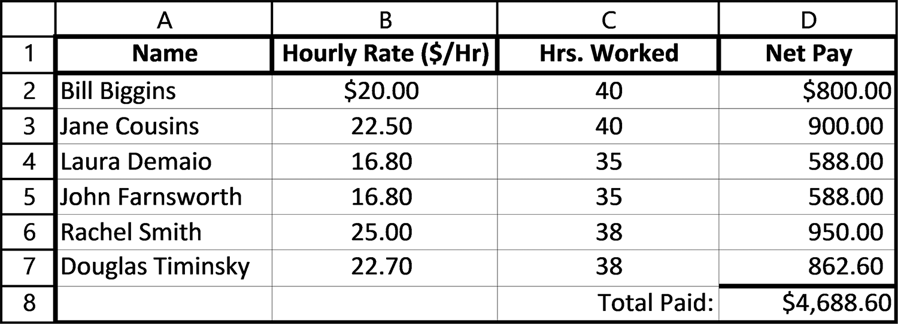
for a six-month period. In the four highlighted cells, write in the functions or for-mulas needed to calculate the indicated totals. Because the remaining totals are 56 exCel BasiCs

easily obtained by copying the functions or formulas in the highlighted cells, only the four highlighted formulas need to be entered by hand.
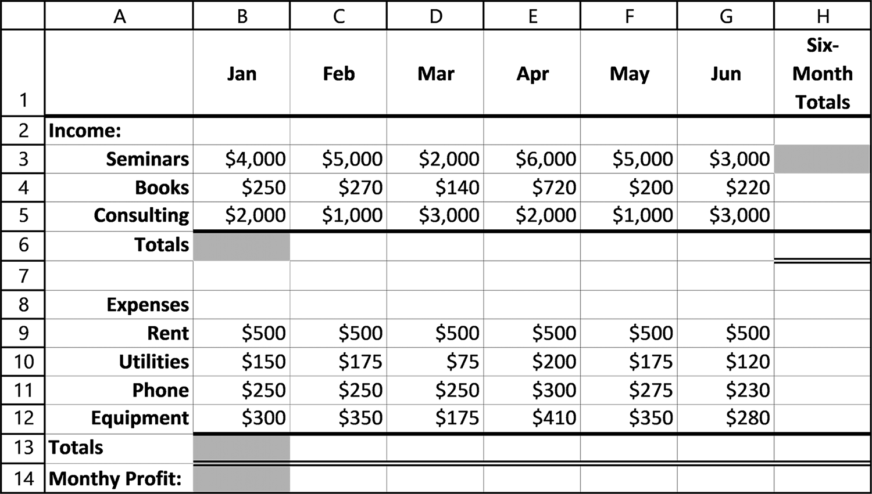

Figure 2.19 Spreadsheet data for Exercise 7

a. The spreadsheet shown in Figure 2.20 contains labels, income, and expense data
for a six-month period. Determine the functions or formulas needed to calculate the Totals indicated in column H and rows 6 and 14.
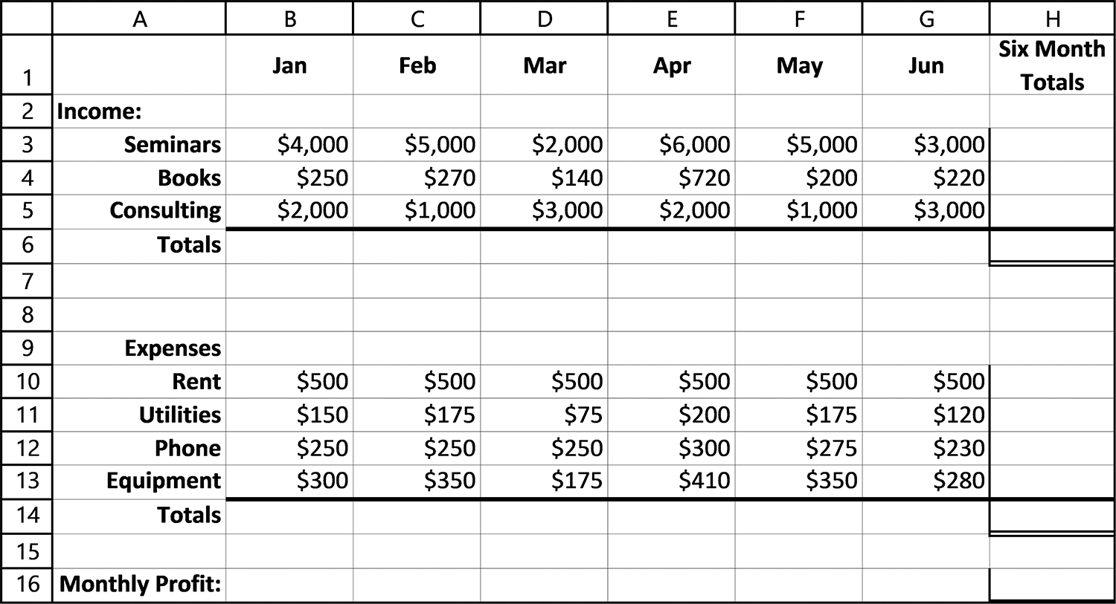

Figure 2.20 Spreadsheet for Exercise 7a

b. Using your computer, enter the spreadsheet shown in Figure 2.20 above, along
with all the required functions or formulas. Using a calculator, verify the dis-played totals. Note that you are verifying that you entered the correct function or formula, not that Excel is miscalculating the formula that you did enter.
formulas and formattinG 57

c. Print out the spreadsheet you entered in Part b.
d. In place of typing the arguments into the SUM( ) functions in cell H3, which
cells could be highlighted to provide the same result?
e. In place of typing the arguments into the SUM( ) functions in cell B6, which
cells could be highlighted to provide the same result?

2.3 FORMATTING

Besides producing correct results, it is extremely important for a spreadsheet to
display its results attractively. Most spreadsheets are judged on their perceived ease
of use, style, and presentation. Formally, a cell’s appearance and the shape and style
of its contents is referred to as its format. Formatting a cell means setting how a
cell looks (such as the border style, font color, and cell shading) and setting the
appearance of its contents, including its data type (such as number, currency, or
accounting).
For example, consider the two spreadsheets shown in Figure 2.21, both of which
present the same information. Figure 2.21a shows how the spreadsheet appears using
the default formats in effect when the information was entered; Figure 2.21b shows
the results after explicit formatting has been applied.
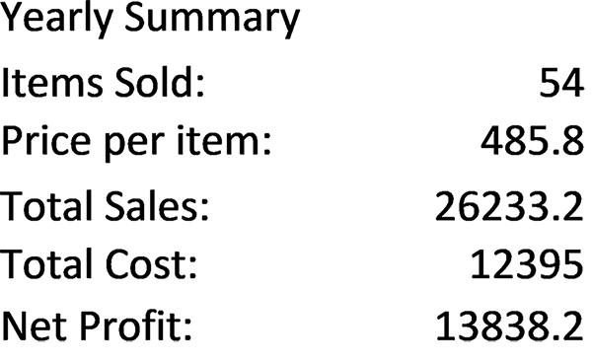

Figure 2.21a Default format Figure 2.21b With explicit formatting
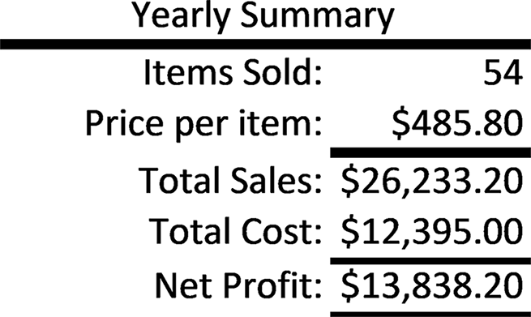

Clearly, the presentation in Figure 2.21b is preferable. This spreadsheet pres-
ents its information in a manner that is easier to read and understand than that in
Figure 2.21a.
Once a single cell or range of cells has been selected, either by clicking on a single
cell or highlighting a range of cells, formatting can be applied using one of the follow-
ing methods:
Method 1: Use the formatting tools available on the Home tab of the Excel ribbon.
Method 2: Activate the complete set of format tools by either 58 exCel BasiCs

a. Activating the Dialog box launchers on the Home Ribbon by right clicking on

the small arrow, at the lower right of the three groups of icons (Font, Align-ment, Number), or
b. Right clicking the mouse within the selected cells and selecting the Format
Cells option located toward the bottom of the dropdown menu.

Method 1
This method provides quick access to the most commonly used formatting tasks.
Figure 2.22 shows the three most used formatting groups.
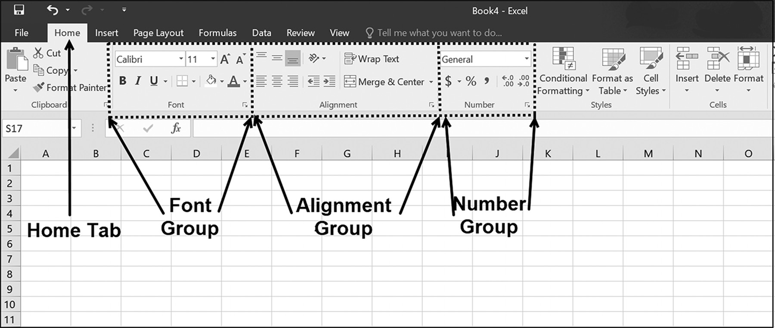

Figure 2.22 Formatting groups in the Home tab

Each group shown in Figure 2.22 specifically provides frequently needed formatting
tasks as follows:
●● Font Group – used to set font attributes, such as type, size, color, bold, italic,
underline, background, and cell borders.
●● Alignment Group – used to set both horizontal data alignment (left, right, cen-
ter), vertical alignment (top, center, bottom), merging and unmerging cells, and text wrapping within a cell or cells.
●● Number Group – used to both set the data type within a cell and the display of
numbers as currency, percent, and number of decimal values.
The quick formatting icons within each group that you will be using most often are
shown in Figure 2.23. As always, a range of one or more cells must be selected before
one of these options is selected.
formulas and formattinG 59

Application Note
What is Formatting?
Formatting allows you to change the appearance of a cell’s value – that is, how numbers, and text in a cell are displayed. Formatting can also be used to change the data types of values (for example, a number can be changed into text), but it is more generally used to simply change a displayed item’s appearance.
For example, the number 12.45 can be displayed in currency format as $12.45 or in percentage
format as 1245%. When a number is either entered or calculated, it is given the default general format, which displays as many decimal places as in the entered or calculated value. In this format, when the cell width is too small to show all of the number’s decimal values, the number is rounded to fit the cell. Should the cell be too small to fit the integer part of a number, scientific notation is displayed; when the cell is too small even for this notation, it is filled with pound symbols, ####, which is in actuality, one of Excel’s error messages). For text, the general format displays only those characters, starting from the left, that fit in the cell.
A date value, such as 1/1/2019, is actually stored as the number 43466 (the number of days elapsed
since 1/1/1900, also known as a serial number). However, using Excel’s number to date algorithm and formatting, this date can be changed to appear as 01/01/19 or Friday, November 1, 2019, or other date display presentations.
Once a format is set for a cell, this format remains in effect for all values subsequently entered
into the cell, until the format is changed or removed. While in effect, the format resides within the cell and will control the appearance of all data entered into it, even if the data changes.
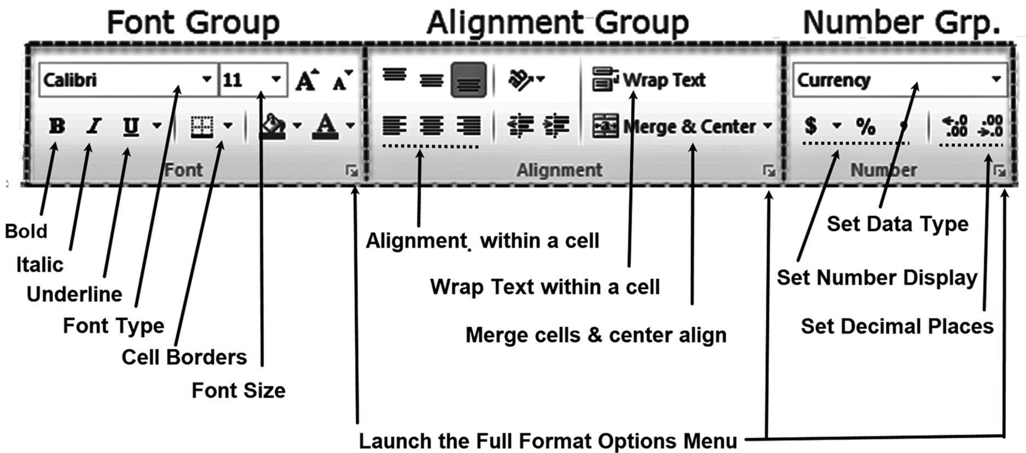

Figure 2.23 Quick Formatting options
60 exCel BasiCs

Method 2
This method provides access to the complete set of formatting options. These options
can either be activated by clicking on the Launch icons illustrated in Figure 2.23 or
right clicking on a selected cell or cell range, as shown in Figure 2.24.
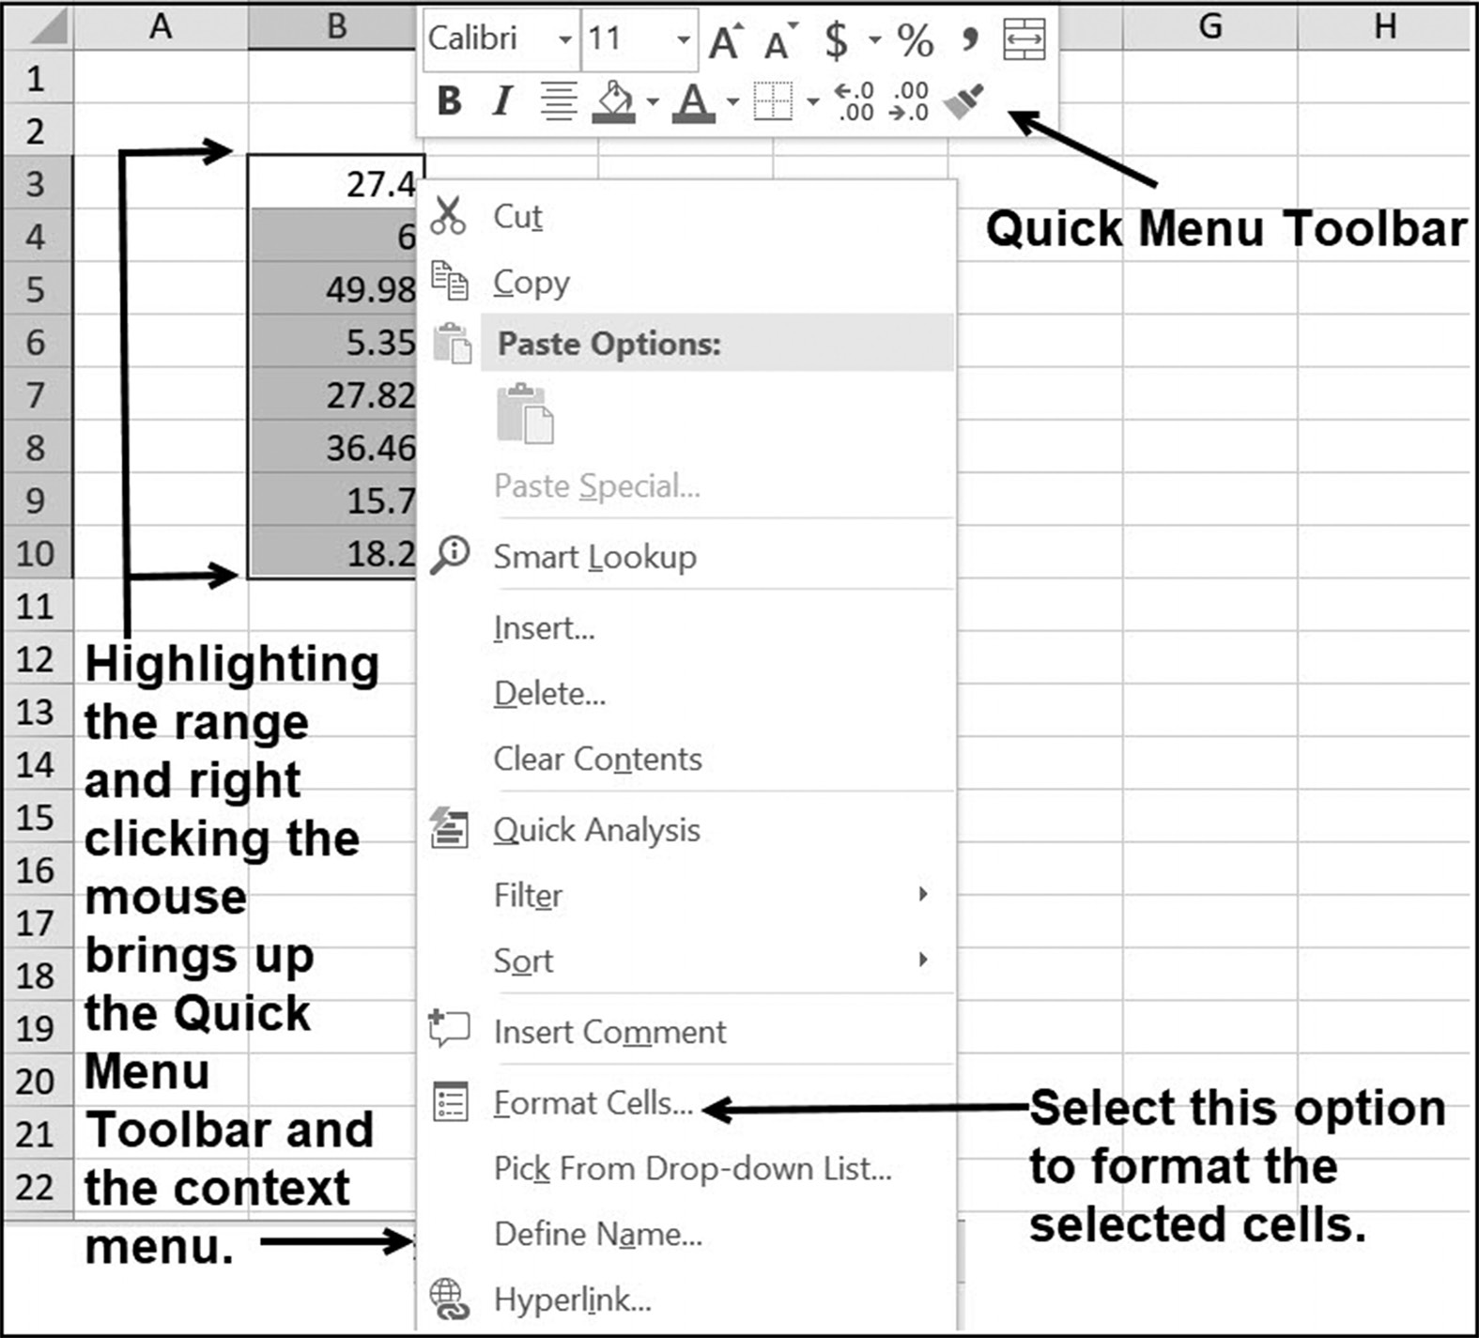

Figure 2.24 Right-clicking the mouse on a selected range

In both methods, the complete format window, as shown in Figure 2.25, appears.
This window enables the choosing of the data type of the selected cells and how
they will appear. This includes setting the number of decimal places to display for
numbers, whether to include a comma for numbers larger than 999, or whether to
display the number as currency, using a dollar ($) sign. If Text is selected, it permits
aligning the text within the cell(s) and whether the text should be wrapped around
multiple lines (word wrap) when the text does not fit within the specified width for
the cell. Additionally, provision is made for formatting text designated as date and
time data.
formulas and formattinG 61
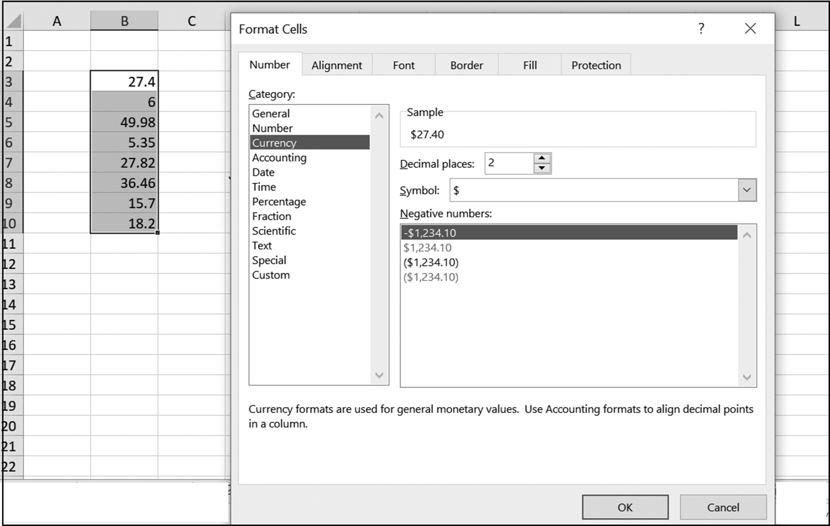

Figure 2.25 The Format Cells window (formatting numbers)

As shown in Figure 2.25, a currency format has been selected that will use the dollar
($) symbol and two decimal places. Making this selection produces the display shown
in Figure 2.26 for the selected range.
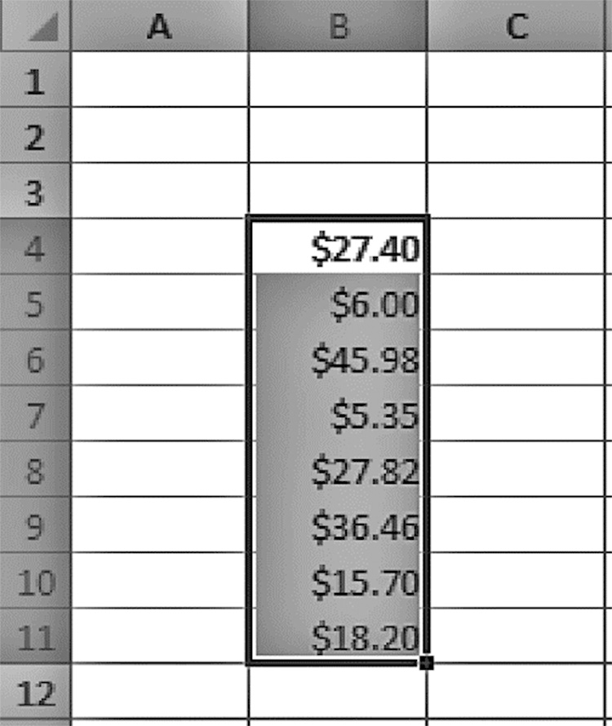

Figure 2.26 The selected cells formatted as currency 62 exCel BasiCs

EXERCISES 2.3

1. What is cell formatting and why is it important?
2. List the following:
a. the three main formatting groups in the Excel ribbon Home tab
b. the format categories available in the Number Group. Do this by clicking on the
arrow in the input box at the top of the Number Group.
3. Do parts a and b.
a. Enter the spreadsheet shown below on the left side, using the formulas
Total Sales = Items Sold * Price per item
Net Profit = Total sales – Total Cost
The Items Sold, Price per Item, and Total Cost are user-input values, and must
be entered individually. Once you have entered the required inputs and calcu-lated the Total Sales and Net Profit, make sure that the spreadsheet cells have been formatted so that they appear as shown on the right side.
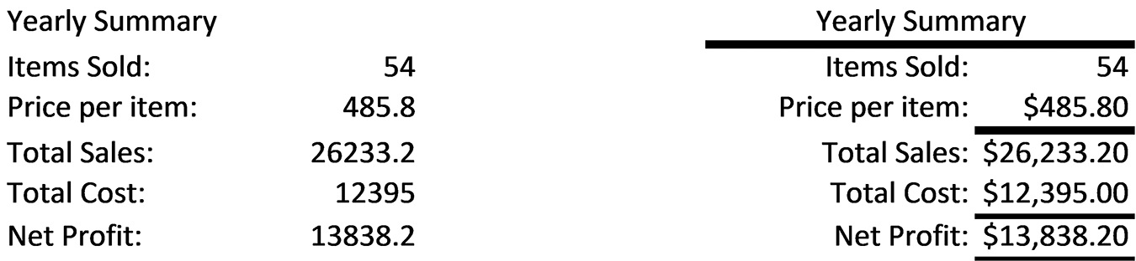

b. Could spreadsheet cells have been formatted before any data or formulas were
entered?
4. Do parts a and b.
a. Create a spreadsheet using the formula
Net Pay = Hourly Rate * Hours Worked
Use the SUM() function to determine the total amount paid in cell D8.
Once you have entered the required inputs and calculated the Total Paid, for-
mat the spreadsheet cells so that they appear as shown in the spreadsheet that follows the incomplete spreadsheet.
formulas and formattinG 63
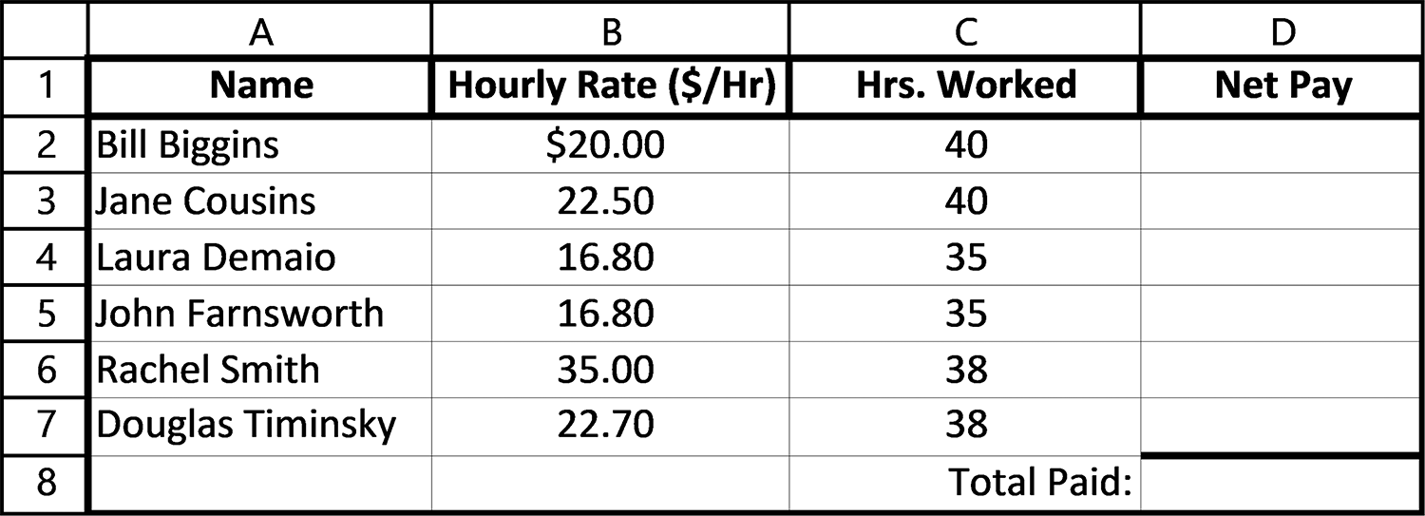

b. Could you have specified the required formats for the spreadsheet before you
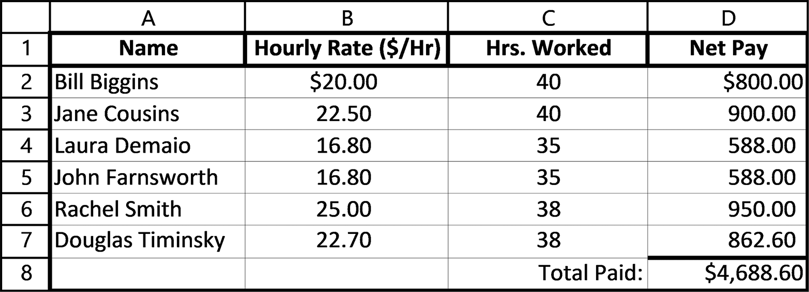
entered any data or formulas?
5. Do parts a and b.
a. Create a spreadsheet as follows, using the formulas
Gross Pay = Hourly Rate * Hours Worked
Taxes Withheld = Tax Rate * Gross Pay
Net Pay = Gross Pay – Net Pay
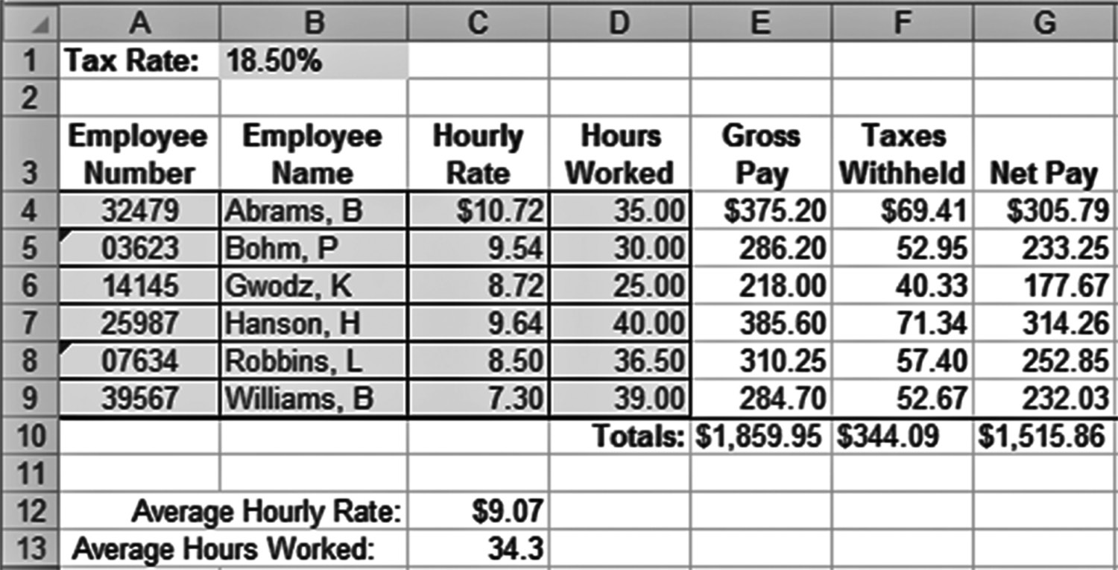
64 exCel BasiCs

Use the SUM() and AVERAGE( ) functions to determine the displayed totals
and averages. Once you have entered the required inputs and calculated the required totals and averages, format the cells so that they appear as shown in the spreadsheet.
b. Could you have specified the required formats for the spreadsheet before you
entered any data or formulas?

2.4 CASH-FLOW AND CASH-BALANCE SPREADSHEETS

One of the most common applications for Excel spreadsheets is the construction of
cash-flow and cash-balance spreadsheets. These types of spreadsheets form the basis
of many accounting applications, and they were the original driving force for com-
puter generated spreadsheets.2
A cash-flow spreadsheet is a list of the cash coming into a business, organization,
seminar, or event and the cash paid out. Such lists, typically constructed for one-time,
weekly, monthly, or yearly applications, form the basis for many Excel accounting ap-
plications. Figures 2.16, 2.19, and 2.20 are all examples of this type of spreadsheet.
Cash-flow spreadsheets are easily constructed using the Excel skills you already
have. As an example, and to familiarize yourself with the essential elements of a cash-
flow spreadsheet, consider Figure 2.27, which presents a cash-flow spreadsheet for a
student who will be working during the summer recess.
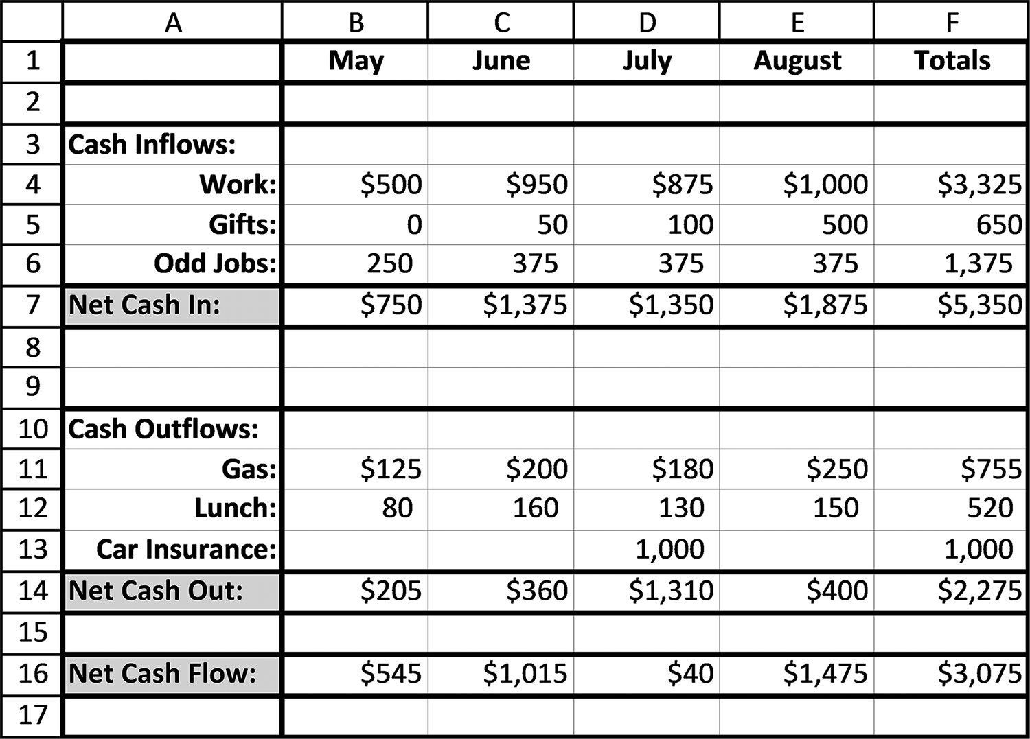

Figure 2.27 A cash-flow spreadsheet
2 Spreadsheets were in wide accounting usage prior to computer generated spreadsheets. The first computer programmed spreadsheet program, VisiCalc, introduced in 1979, originated as an accounting application.
formulas and formattinG 65

The three main categories of a cash-flow statement, highlighted in Figure 2.27, are:
1. Net Cash In: This is the total of all the listed cash inflows.
2. Net Cash Out: This is the total of all the listed cash outflows.
3. Net Cash Flow: This is Net Cash (item 1) minus the Net Cash Out (item 2).
If Net Cash In (item 1) is greater than Net Cash Out (item 2), then Net Cash Flow
(item 3) is positive. This indicates money is being accumulated; if it is negative, money
is being lost. Clearly, a healthy operation will have more money coming in than is
going out. Another way of saying this is that the Net Cash Flow is positive.
Interestingly enough, except for the individual cash inflow and cash outflow values
that must be entered, the three cash flow categories (items 1, 2, and 3) require enter-
ing only three formulas or functions in the first cash-flow column. Once the correct
three formulas or functions are entered, they can be copied to the right (using the
Copy command or fill handle), for as many cash-flow columns that are contained in
the spreadsheet. This is true for all cash balance spreadsheets, whether the columns
are delimitated in weeks, months, or years. Similarly, as we have done before, any total
formulas can also be copied. The highlighted cells in Figure 2.28 show the required
three formulas for Figure 2.27’s cash balance statement. These are the more heavily
highlighted cells in column B in Figure 2.28. Also shown are the SUM( ) formulas that
would be copied.
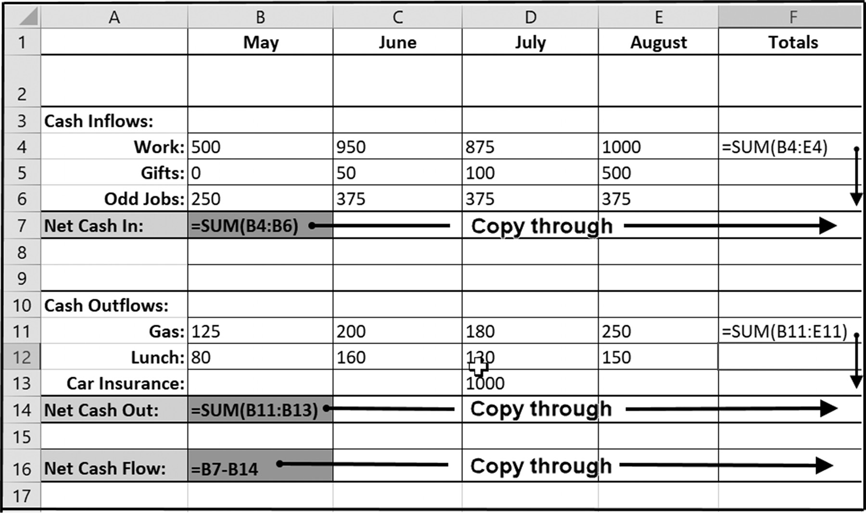

Figure 2.28 Example of a cash-flow spreadsheet 66 exCel BasiCs

A Cash-Balance Spreadsheet
A cash-balance spreadsheet is one that shows, in addition to the cash flows, the cash
balances of a business over a period of time. This type of spreadsheet is created by
adding beginning and ending cash balances to each column of a cash-flow spread-
sheet, as shown by the highlighted two rows in Figure 2.29.
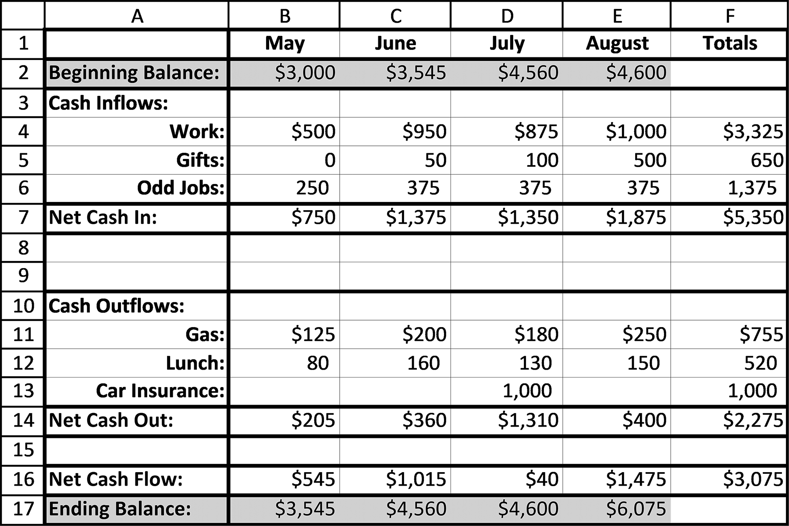

Figure 2.29 A cash-balance spreadsheet

For the first month, the Beginning Balance is a user-entered number representing the
cash on hand at the start of the month (in this case May). In Figure 2.29, the Begin-
ning Balance for May in cell B2 is $3,000. The Ending Balance is always the sum of
the Beginning Balance plus the Net Cash Flow. For Figure 2.30, the correct formula
in cell B17 is =B2 + B16. For all subsequent months, the Beginning Balance for the
month is set equal to the prior month’s Ending Balance.
As shown in Figure 2.30, the only three formulas or functions that need to be
entered for the cash-balance rows have been circled. Once the correct three formu-
las or functions are entered, two of them can be copied to the right, as shown, for
as many cash-flow columns as are contained in the spreadsheet. This is true for all
cash-balance spreadsheets, whether the columns are delimitated in weeks, months,
or years.
formulas and formattinG 67
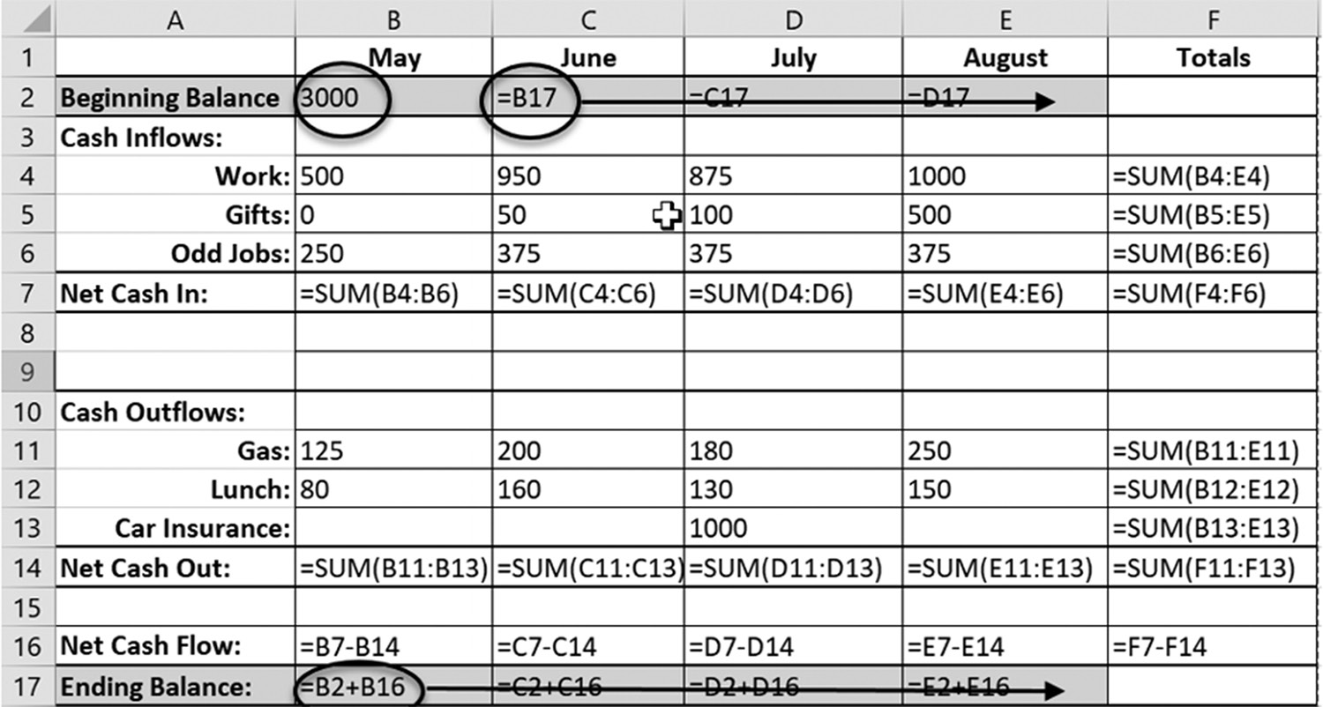

Figure 2.30 The formulas and functions needed for the cash-balance spreadsheet

EXERCISES 2.4

1. For a cash-flow spreadsheet, how is a period’s Net Cash In calculated?
2. For a cash-flow spreadsheet, how is a period’s Net Cash Out calculated?
3. For a cash-flow spreadsheet, how is a period’s Net Cash Flow calculated?
4. Create the cash-flow spreadsheet that follows; print it out.
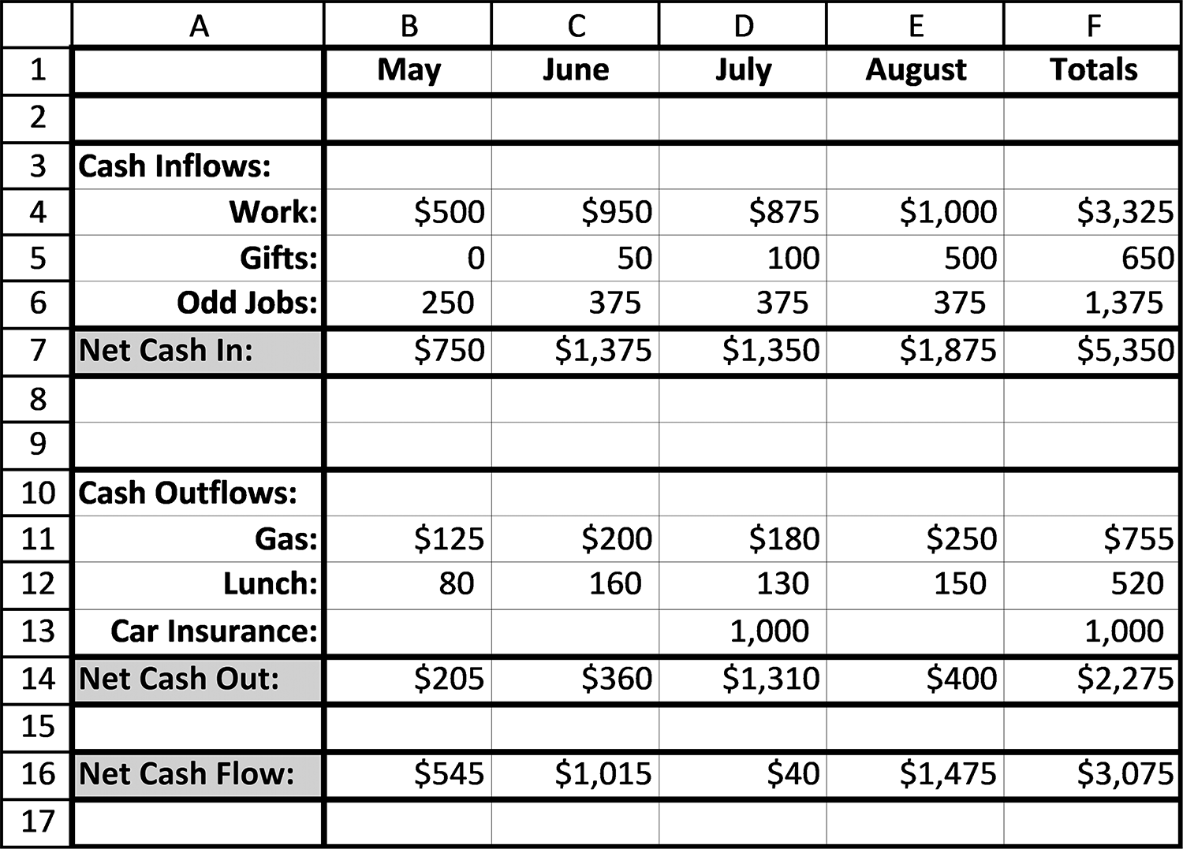
68 exCel BasiCs

5. What is the difference between cash-flow and cash-balance spreadsheets?
6. What is the relationship between each period’s Beginning Balance and the peri-
od’s Ending Balance?
7. Except for the first period’s Beginning Balance, what is the relationship between
each succeeding period’s Beginning Balance and the prior period’s Ending Balance?
8. Create and then complete the cash-flow spreadsheet that follows. Add the appro-
priate formulas/functions as needed.
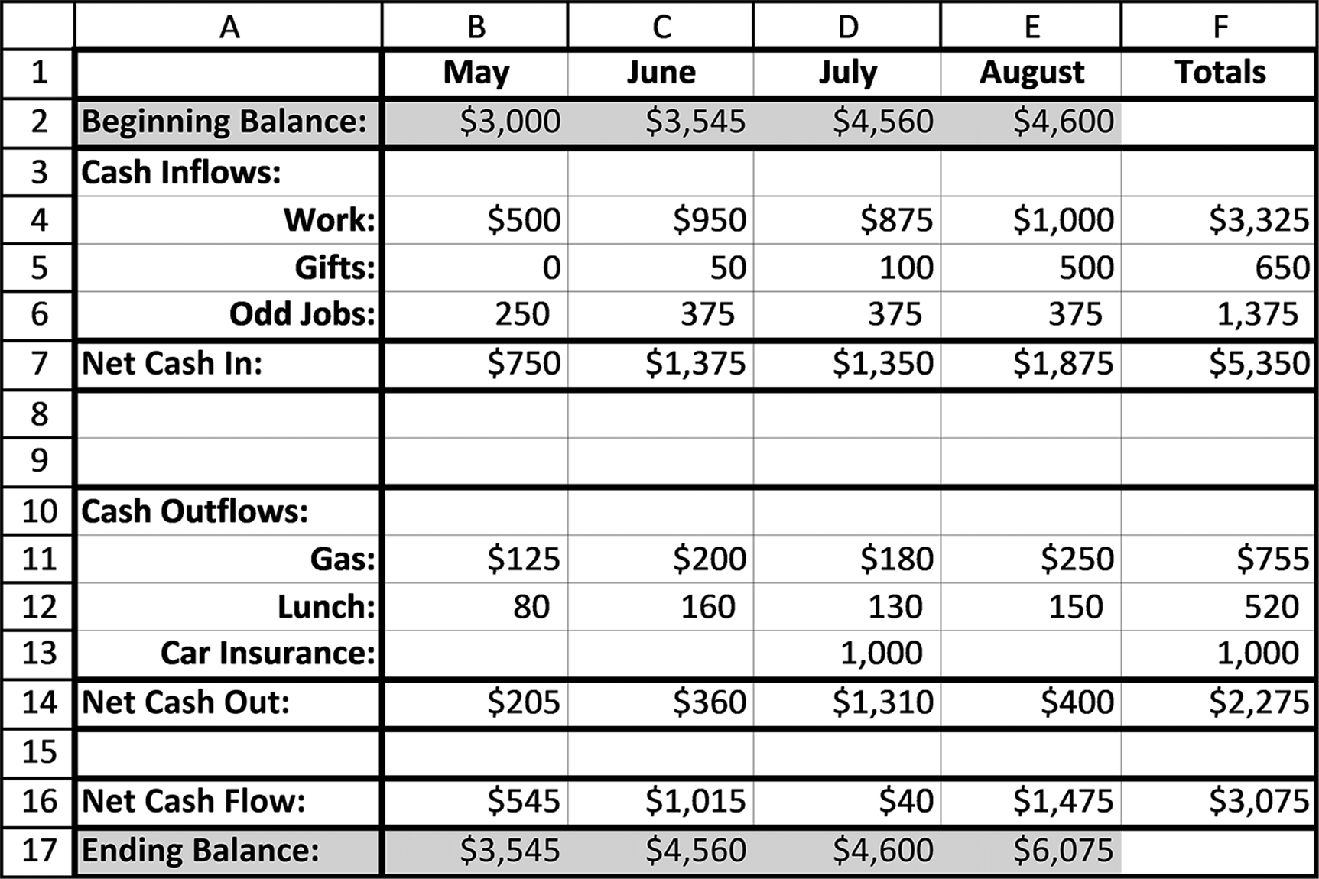

2.5 ABSOLUTE ADDRESSES
Copying formulas containing relative addresses produces the correct results for many
of the applications you will be creating. There are cases, however, where this is not
the case. One of these occurs in spreadsheets that have an input (or assumptions) sec-
tion, and this situation is presented next; the second case is less frequent, but equally
important, and is presented at the end of this section. Finally, the third case occurs in
Conditional Formatting, and is presented in Section 3.4.
formulas and formattinG 69

Case 1: Magic Numbers as Input Values

Frequently, the same number is required throughout a spreadsheet. For example,
in spreadsheets used to determine bank interest charges, the interest rate would
typically appear repeatedly throughout the spreadsheet. Similarly, in a spreadsheet
used to calculate taxes, the tax rate might appear in many individual cell formulas.
If either the interest rate or tax rate changes, and the actual number were placed
throughout the spreadsheet, you would have the cumbersome task of changing the
value everywhere it appears. Multiple changes, however, can lead to errors: If just
one rate value is overlooked and not changed, the result displayed in one or more
cells will be incorrect. Numbers that appear many times in the same spreadsheet are
referred to by developers as magic numbers. By themselves, the numbers are quite
ordinary, but in the context of a particular application they have a special (“magical”)
meaning.
To avoid the problem of having a magic number spread throughout a spread-
sheet, developers provide the user with the capability to enter the value once, in the
input section of the spreadsheet. Then, a special reference to the input cell, referred
to as an absolute cell reference address, is used throughout the program. This special
reference ensures that Excel will not alter or modify this address when it is copied.
Should the number ever need to be changed, the change is made only once in the
input cell. This ensures that both the original and any changed value is correctly
used in any formula in which it is referenced.
To create a single value that is not changed when its cell address is copied within
a formula requires the following two-step process:
1. The value should be clearly labeled in one cell and entered in an adjoining cell.
This is typically done in a recognizable Input section.
2. Whenever the cell containing the desired value is referenced, it should use abso-
lute addressing. This means placing a $ sign before the column cell reference and a $ sign before the row cell reference.3 This can be accomplished by manually editing the cell reference(s), using the shortcut key F4 on the PC, or using the shortcut key ⌘ + T on Apple Mac computers.

3 The $ sign in front of the column address locks the column reference, while the $ in front of the row address locks the row reference. Each of these can be locked separately, such as $B2 and C$3 (mixed cell referencing). One such case where this is used in presented in Section 3.5.
70 exCel BasiCs

As an example of when absolute addressing is used, consider Figure 2.31a. In the fig-
ure, the monthly growth of $1,000, placed in a bank account that pays 5% interest is
computed and displayed.
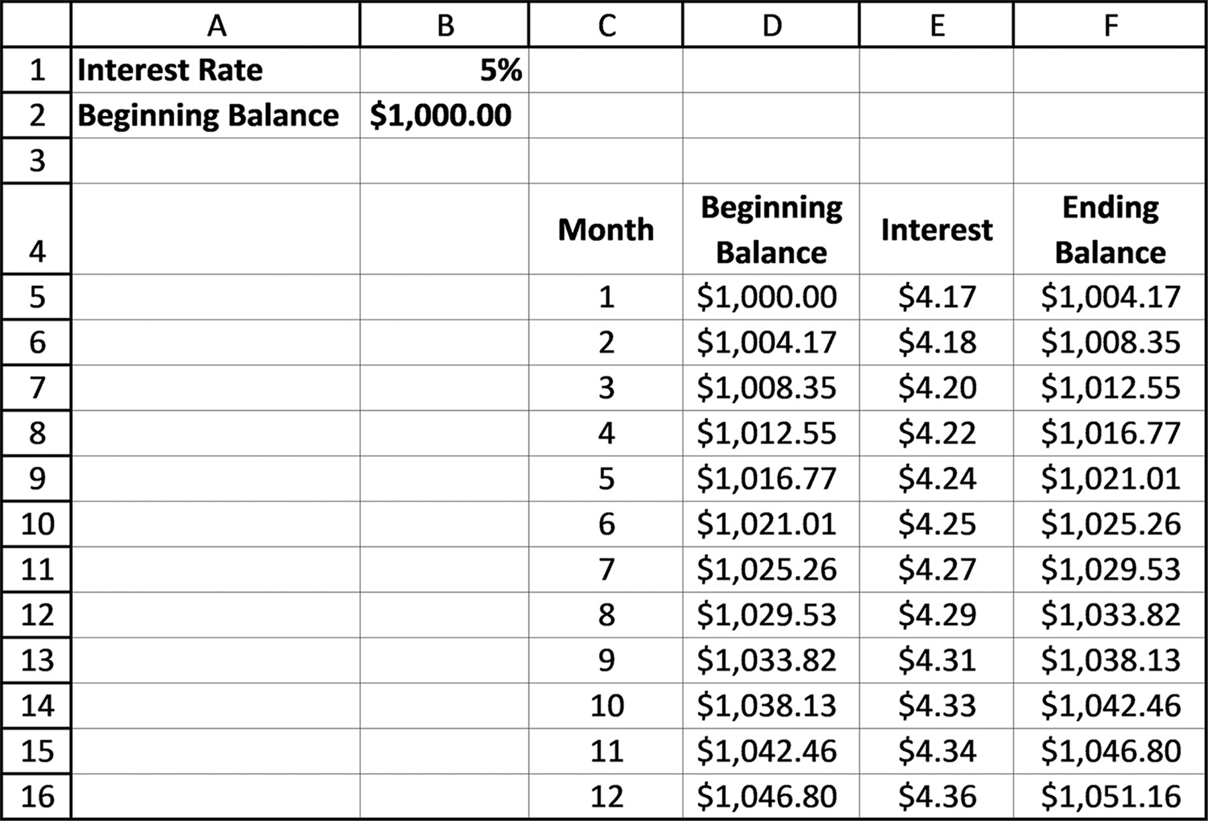

Figure 2.31a An example of absolute cell addressing usage

Figure 2.31b shows the formulas that produced Figure 2.31a. Look at the formula in
cell D5 that is used to calculate the monthly interest. This formula divides the inter-
est rate contained in cell B1 by 12 and multiples this monthly interest rate times the
beginning balance for the month. Notice that the formula in cell D5 uses the absolute
address, $B$1, to reference the interest rate. Doing this permits this formula to be
copied without changing the cell reference being changed to B2, B3, B4, and so forth
as the formula is copied.
The four highlighted cells are, in fact, the only formulas that need to be entered,
three of which can be copied as indicated by the arrows. The two dotted lines indicate
input values that have been referenced using absolute addresses in the body of the
spreadsheet. It should be noted that the absolute address used in cell C5 ($B$2) is not
necessary in this case, because this value is only used once and is not copied. Absolute
addresses must be used, however, wherever a single cell is referenced in a formula
that will be copied to other cells. As a general rule, however, you should use an
absolute address in any formula that references a number from a spreadsheet’s
input section.
formulas and formattinG 71
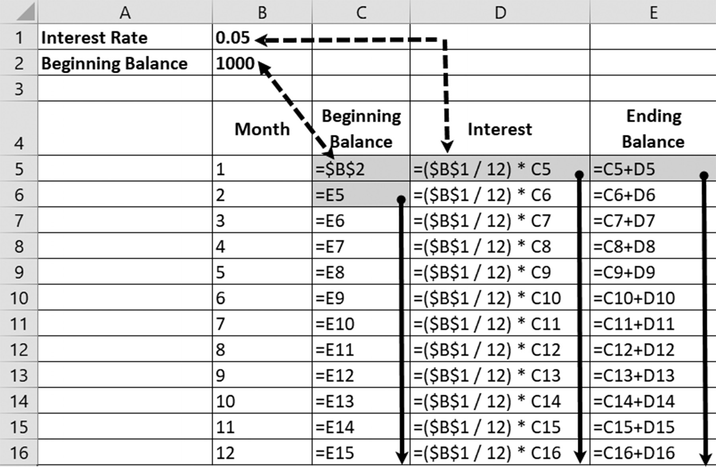

Figure 2.31b The formulas that produced Figure 2.31a

Let’s look at a slightly more complicated example. Figure 2.32a illustrates a spread-
sheet displaying the monthly payments on a three-year, $7,000 car loan. Based on an
interest rate of 3.75%, the monthly payment for this loan is $205.89 per month. Part
of each payment goes to the loan company as interest, and the remainder to paying
off the actual loan.
For example, at the start of the first month, the total balance due on the loan is
$7,000. Out of the first payment of $205.89, $21.88 is an interest payment to the loan
company, and the remaining $184.02 goes to paying off the loan (principal). Although
only the first year’s payments are displayed, continuing the spreadsheet to the 36th
month would result in a zero loan balance.
The formulas for constructing Figure 2.32a’s spreadsheet are relatively simple and
are shown in Figure 2.32b. As illustrated, only five formulas need be entered. Four of
these can be copied, either individually, or by highlighting them as a group and copy-
ing them together.
It should be noted that this area which holds the data being referenced numerous
times in both examples is also sometimes known as the input area or assumptions
area. The values themselves, whether known as “magic numbers,” “inputs”, or “as-
sumptions,” all basically refer to placing frequently-used data in a specific area to be
referenced, rather than being re-written multiple times in formulas and functions
throughout the worksheet.
72 exCel BasiCs

Application Note
Debugging Incorrectly Copied Formulas
An incorrectly copied formula that references an invalid cell almost always reveals itself by displaying text such as #VALUE!, #REF! (two kinds of Excel error messages) or an obviously incorrect numerical result. To avoid or correct this error, there is a set protocols you should always use immediately after copying a cell’s formula.
First, before copying a formula, use a calculator to verify that the function or formula produces a
correct result in the original cell. Your purpose here is not merely to check that the formula is producing a correct value, but that you are using the correct formula. Clearly, if the correct formula is being used, it will most likely produce a correct result. An incorrect value indicates an incorrect formula, and copying an incorrect formula will simply produce more incorrect formulas.
Once you are sure the original formula works, visually look at the first copy of the formula. What
you are looking for here is that cells referenced in the copied formula are correct. Many times, you will discover that one or more of the cell references, that should not have been changed, were changed. This is your signal that, most likely, absolute addressing should have been used in the original formula before it was copied. Note that frequently the offending formula is not located in the cell displaying the error, but in a preceding cell, so be sure to check prior formulas that created values used by the cell displaying the error. As you progress further on in learning Excel, you can employ the Formula Auditing features to help you with this, but at this point, it is beyond the scope of this book.
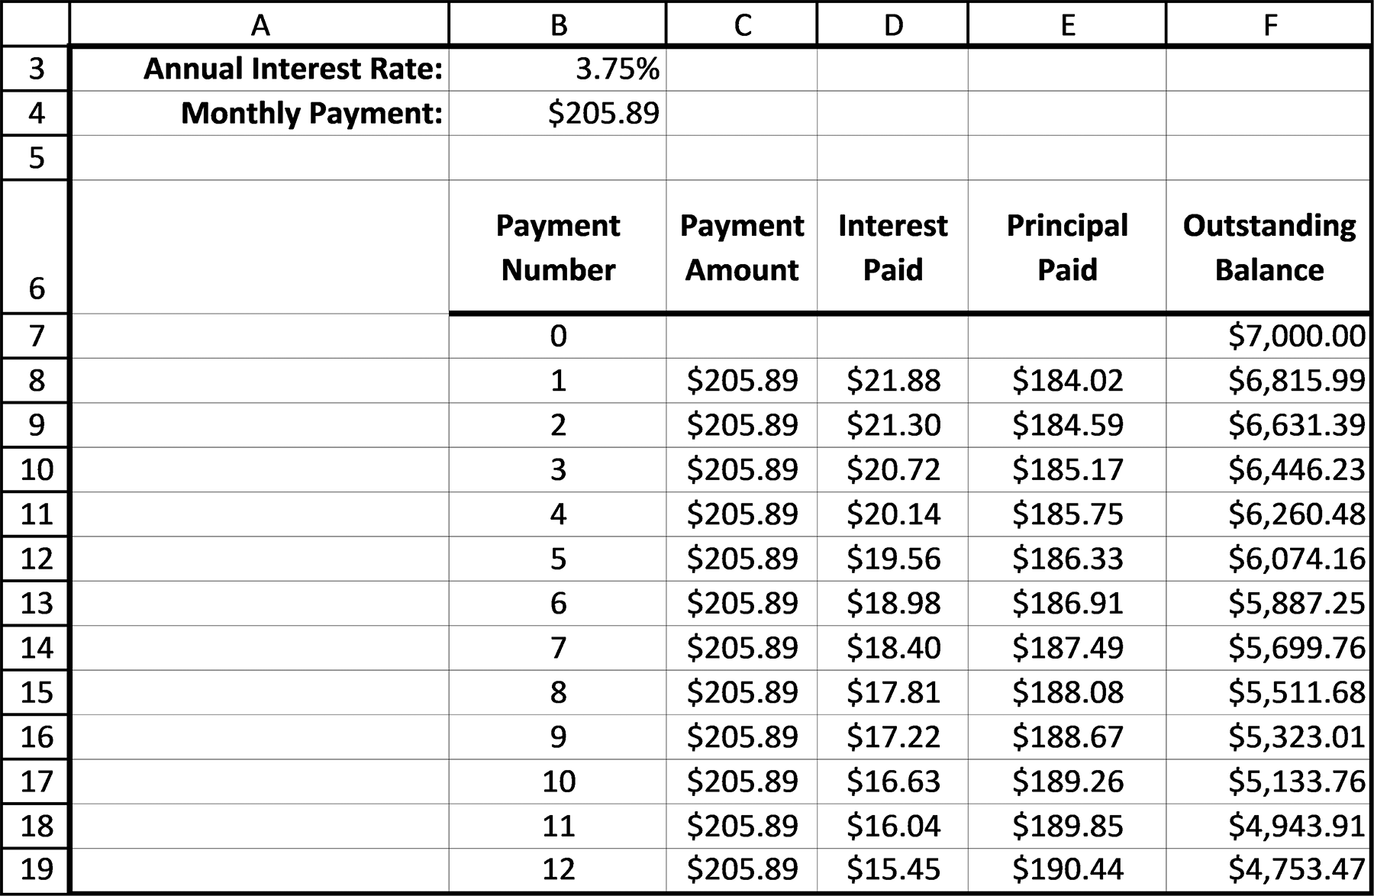

Figure 2.32a The Loan payment example results
formulas and formattinG 73
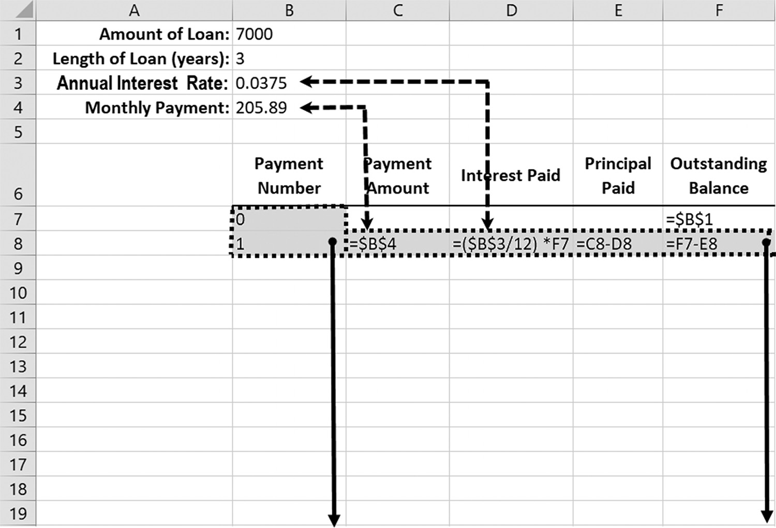

Figure 2.32b Loan payment example: interest rate and monthly payment formulas
Case 2: Running Sub-Totals
Although much less common, but equally necessary, is the use of absolute addresses in
computing running sub-totals. The requirement here is that each sub-total must start
at the same cell address. Because the formula calculating each total can be copied,
and the copies should not have a different starting address, an absolute cell address is
called for. As seen in Figure 2.33b, the range argument provided to the SUM( ) func-
tion in cell D2 is $C$2. This ensures that when the formula in this cell is copied, the
starting address remains the same and only the ending address is correctly adjusted.
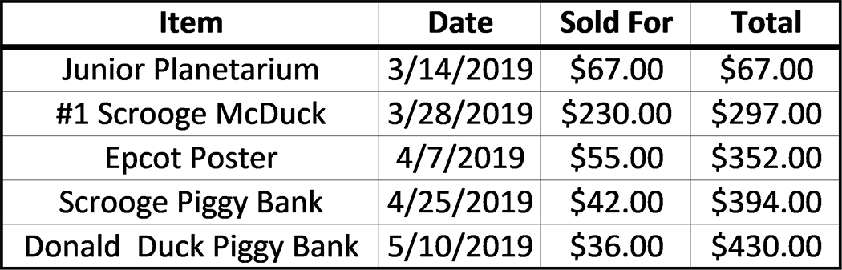

Figure 2.33a An example of running subtotals
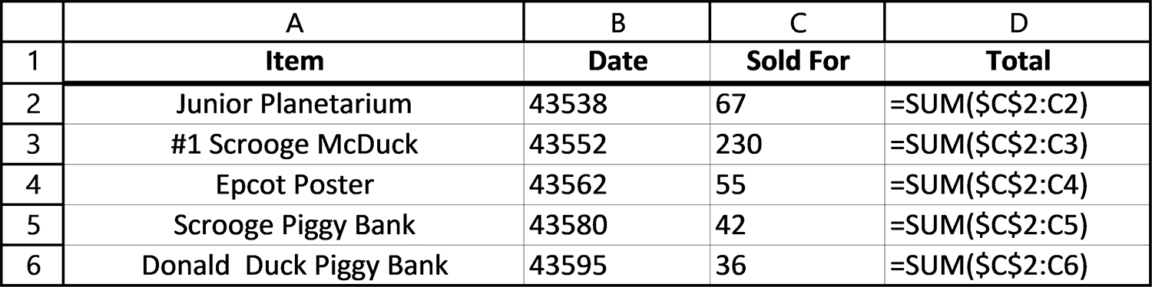

Figure 2.33b Formulas for the running subtotals 74 exCel BasiCs

EXERCISES 2.5

1. What is an absolute cell reference and how does it differ from a relative cell ref-
erence? What is a mixed cell reference?
2. What is the general rule for when an absolute cell reference should be used?
When should a mixed reference be used?
3. Complete parts a-d.
a. For the spreadsheet in Figure 2.34a, write in the formula that appears in each
of the highlighted cells when the formula in cell A4 is copied to these cells.
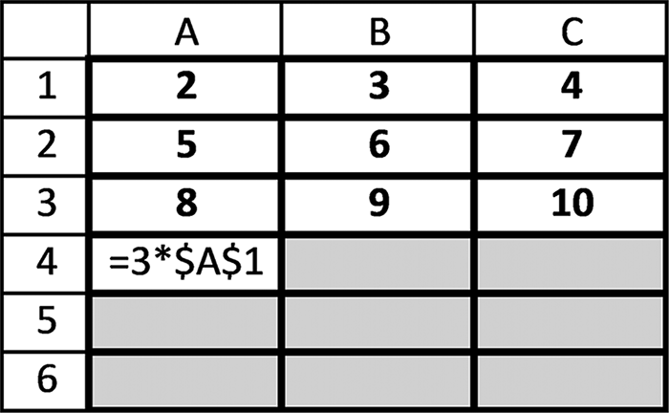

Figure 2.34a Spreadsheet for Exercise 3a

b. For the spreadsheet in Figure 2.34b, write in the formula that appears in each of
the highlighted cells when the formula in cell A4 is copied to these cells.
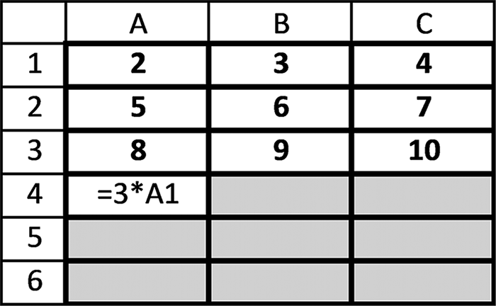

Figure 2.34b Spreadsheet for Exercise 3b

c. For the spreadsheet in Figure 2.34c, write in the formula that appears in each
of the highlighted cells when the formula in cell A4 is copied to these cells.
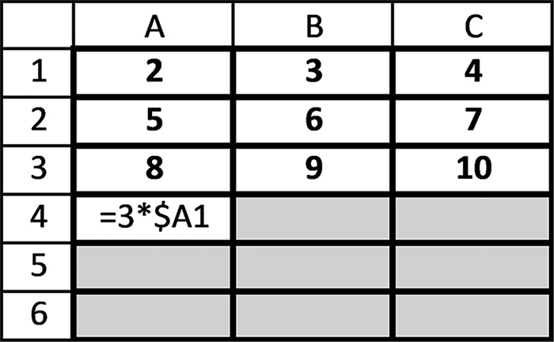

Figure 2.34c Spreadsheet for Exercise 3c
formulas and formattinG 75

d. For the spreadsheet in Figure 2.34d, write in the formula that appears in each
of the highlighted cells when the formula in cell A4 is copied to these cells.
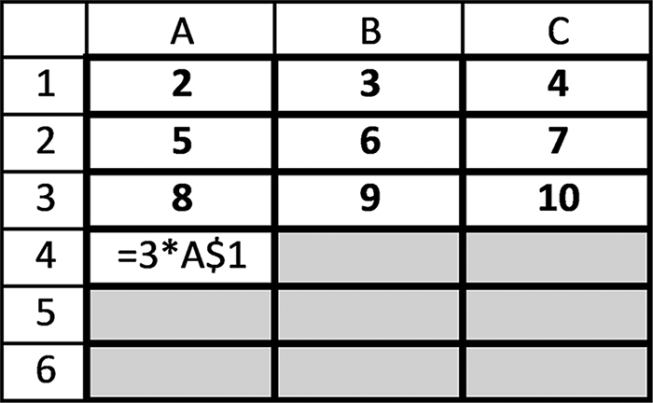

Figure 2.34d Spreadsheet for Exercise 3d

4. The spreadsheets in Figures 2.31b and 2.32b contain the number 12 throughout
their formulas. Would it be appropriate to place this number in a cell and use absolute addressing in all formulas using them?
5. Complete parts a-c.
a. Create the spreadsheet that follows on your computer.
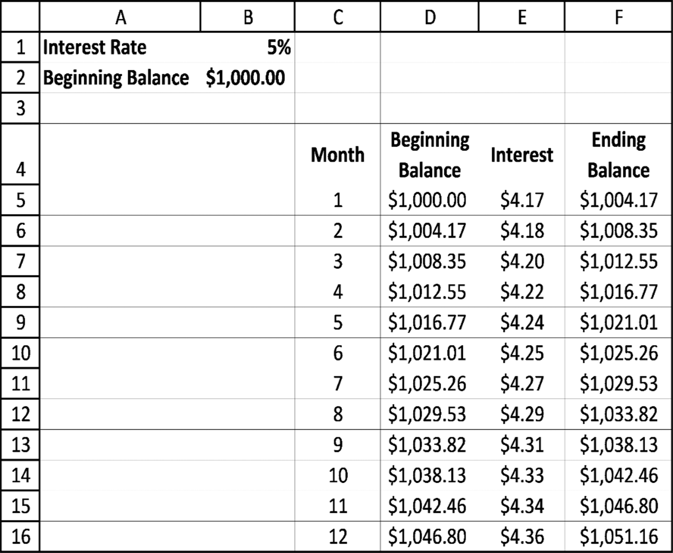

b. For the spreadsheet in Exercise 5a, change the absolute address $B$1 (interest
rate 5%) in cell D5 to the relative address B1 and then copy the resulting for-mula down through cell D16. What errors appeared in your spreadsheet from this change?
76 exCel BasiCs

c. For the spreadsheet created in Exercise 5a, change the absolute address $B$2
(beginning balance $1000) in cell C7 to the relative address B2. Why did this change not result in any errors?
6. Expand the spreadsheet shown Exercise 5a so that it displays the balances for 36
months.
7. Figure 2.35a shows the first three years for a spreadsheet that determines how an
initial bank deposit that pays 5% annual interest, paid monthly, grows at the end of each year. (Note that the ending balance for the first year is the same as that shown for month 12 in Figure 2.31a). The initial formulas for Figure 2.35a are shown in Figure 2.35b. Complete parts a-c.
a. Complete the spreadsheet shown in Figure 2.35a to display the ending yearly
balances for the first twenty years.
b. Using the spreadsheet you developed for Exercise 6a, determine in what year
the initial deposit has doubled. How close is this doubling year to the rule of 72, which states that a close approximation to when a deposit will double is obtained by dividing the interest rate into the number 72?
c. Using the spreadsheet you developed for Exercise 6a, change the interest rate
to 3%. Determine in what year the initial deposit has doubled. How close is this doubling year to that determined using the rule of 72 given in Exercise 6b? Does changing the initial deposit to $2000 change the time in which the initial deposit doubles?
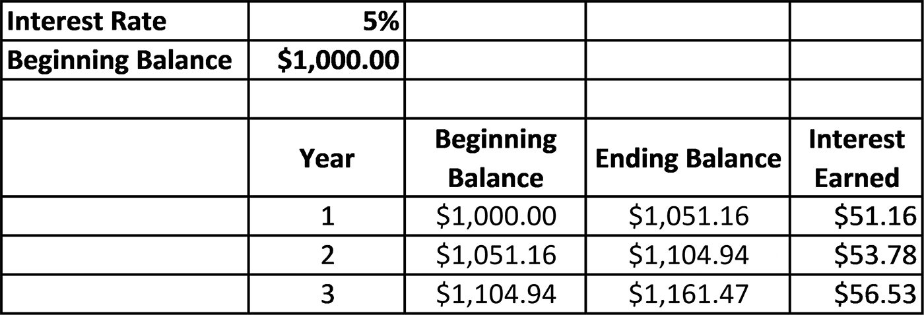

Figure 2.35a Spreadsheet for Exercise 7a
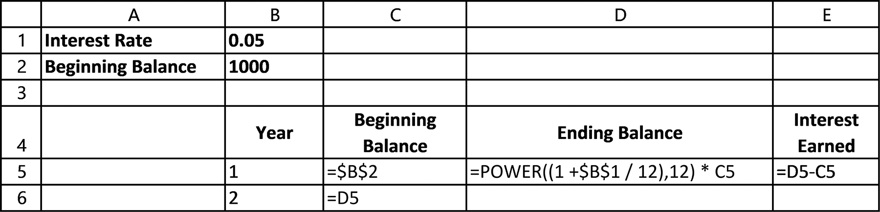

Figure 2.35b Spreadsheet with formulas and functions for Exercise 7a
formulas and formattinG 77

8. Complete parts a-b.
a. Create the following spreadsheet on your computer.
b. Expand the spreadsheet created in Exercise 8a to include 36 payments and
verify that the balance of the loan goes to zero after the last payment is made.
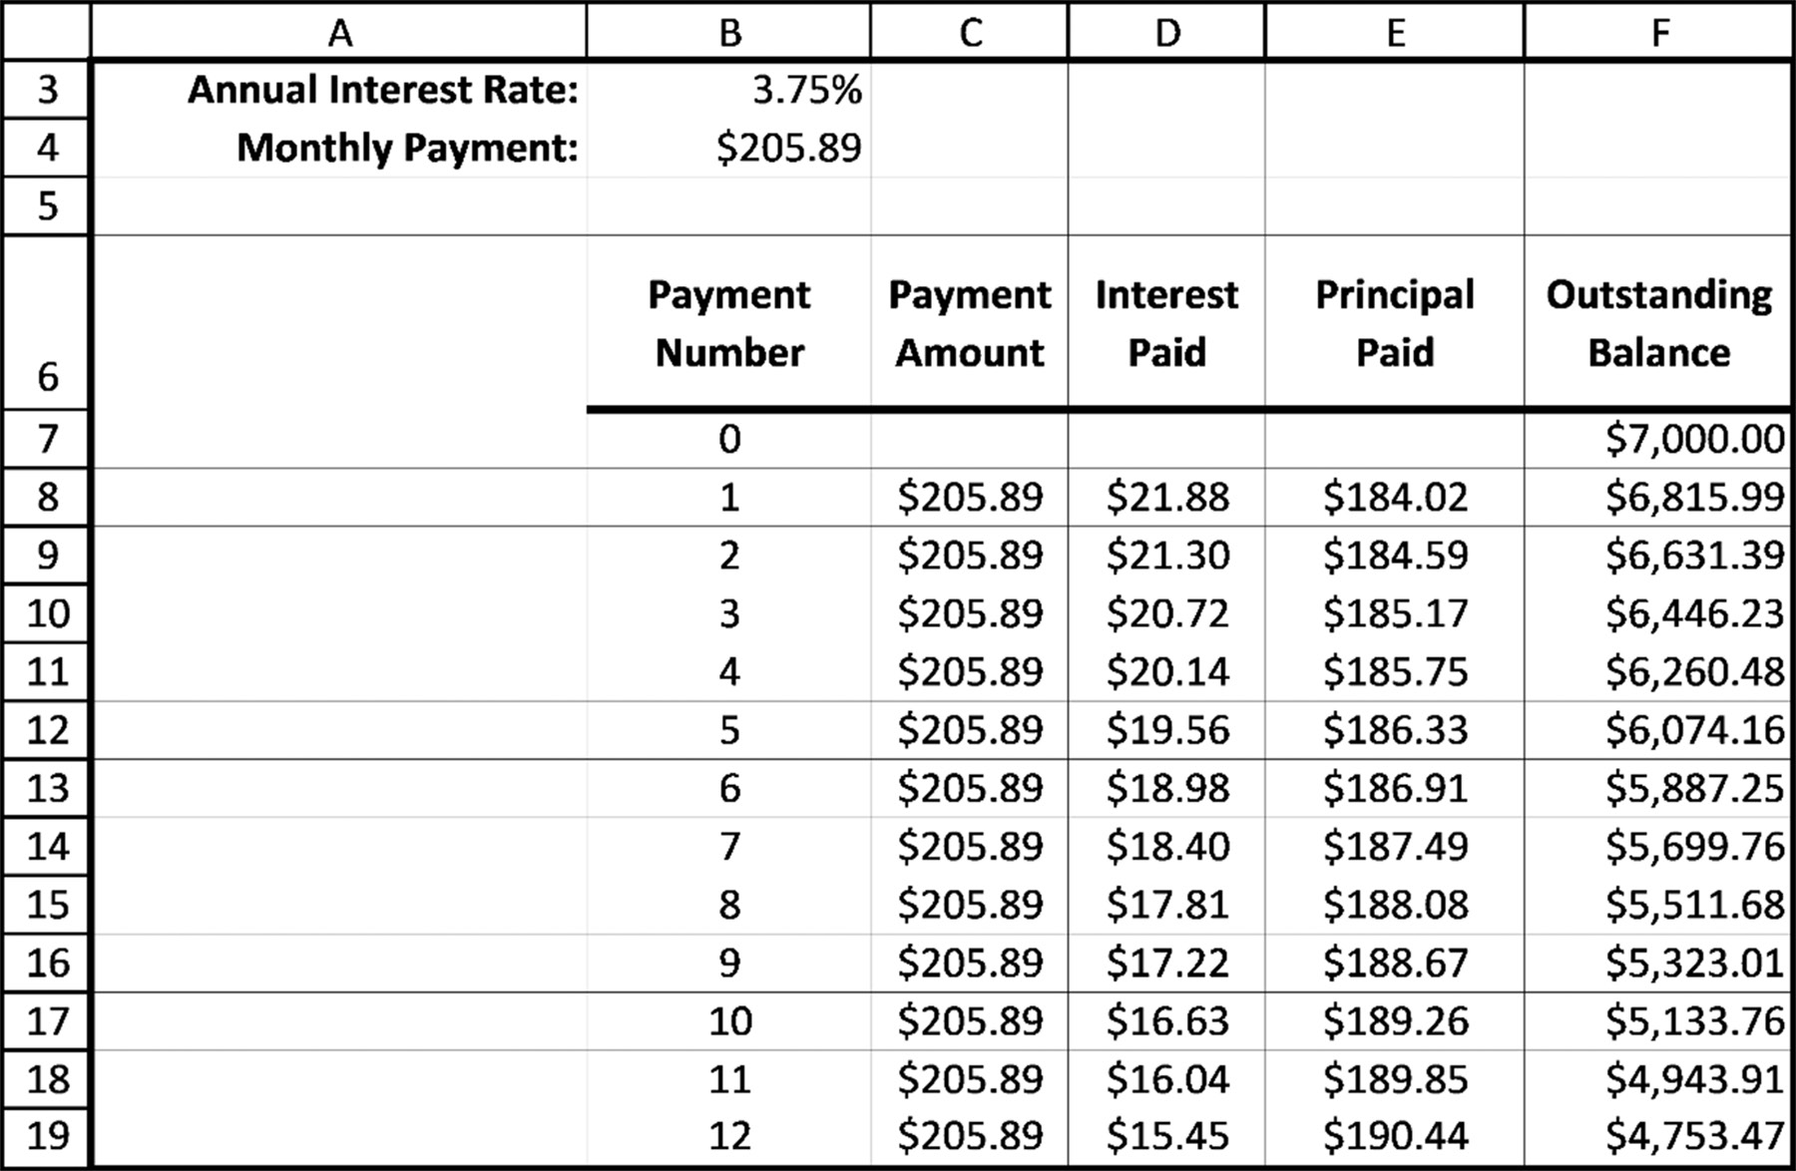

9. For the spreadsheet created in Exercise 7b, change the absolute address $B$4
in cell C7 to the relative address B4 and then copy the resulting formula down through cell C18. What errors appeared in your spreadsheet from this change?
10. For the spreadsheet created in Exercise 8a, change the absolute address $B$3
in cell D8 to the relative address B3 and then copy the resulting formula down through D18. What errors appeared in your spreadsheet from this change?

2.6 COMMON EXCEL ERRORS

1. Entering the same input data item more than once. If the same item is needed
in two or more cells, these additional values should reference the one cell into which the data was initially entered (usually using absolute addressing). The rea-son for this is that if the value needs to be changed later, it only has to be changed in the first input cell where the data was initially entered. This prevents an error 78 exCel BasiCs

from occurring when you forget to change the value in one of the additional cells requiring the same value.
2. Entering the same formula more than once in the same row or column. If you
find that you are entering the same basic formula, either in the same row or the same column, except with changes in the cells referenced in the formula, you are almost always wasting time and making a common beginner’s mistake. Formulas should be created using relative and absolute addressed operands so that they can be copied, either across a row or down a column.
3. Referencing Input Section data items using relative, rather than absolute
addresses, unless there is a reason to do so. The reason for this is that if an abso-lute address for the input data cell is used in a formula, and the formula is copied, the correct input data item will still be referenced in the copied formula. Using a relative address almost always produces an error where the wrong cell is refer-enced in the copied formula.
4. Using a calculator to determine a value that you then enter into a cell. Rather,
enter a formula into the cell so that Excel does the calculation. Then, use a calcu-lator to verify that the formula is correct as presented in the next item.
5. Not checking that the first copy of a formula is correct. When using a formula,
always check the result using a calculator, in the first cell where the formula is entered. The same is true when copying a formula; verify, using a calculator, that the first copied formula yields a correct value.
6. Not using the SUM( ) function when adding the contents of more than three cells.
Although not actually an error, it is easier and more professional to use the SUM( ) function, such as =SUM(C1:C10) rather than the equivalent formula
=C1+C2+C3+C4+C5+C6+C7+C8+C9+C10.
However, both formulas will provide the same value.
7. Using an addition operator within a SUM( ) function. For example,
=SUM(A+A2+A3+A4).
This is simply taking the sum of a sum. Either use the SUM( )function or the addition
operator, but not both together.

2.7 CHAPTER APPENDIX: WORKING WITH ROWS AND COLUMNS

There are three situations that will require you to widen a column or a row. In the first,
shown in Figure 2.36a, a numerical result is too large to fit in its cell. In this case, the
problem is indicated by a succession of displayed x’s, such as xxxxxxx (the Excel error
formulas and formattinG 79

message).4 Widening the cell permits the complete number to be displayed (Figure
2.36b).
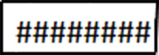

Figure 2.36a Outsized result
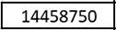

Figure 2.36b Correct fit

The second situation occurs when a text label is too small to fit within its cell margins.
As shown in Figures 2.36c through 2.36e, depending on the cell alignment (left, right,
or center) only a portion of the label is displayed.5 By widening the cell (Figure 2.36f),
the complete text is displayed.


Figure 2.36c Left aligned
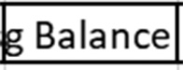

Figure 2.36d Right aligned


Figure 2.36e Center aligned
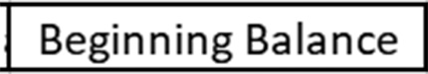

Figure 2.36f Widened

The third situation occurs when an attempt to word wrap text in a cell that is too nar-
row to accommodate more than one line of text. In case, the row must be widened.
Finally, you will occasionally have to either insert or delete a row or column within
an existing spreadsheet. How a column or row’s width is adjusted, and how columns
and rows can be inserted or deleted within a spreadsheet are described in the follow-
ing section.
Adjusting Column and Row Widths
Figure 2.37 shows the four steps required to either widen or narrow a column, in this
case column C. As indicated, in the first step the cursor must be positioned to the right
of the column being adjusted and moved until the cursor changes to the indicated
cross-hairs (Step 1).

4 This occurs only if the cell is formatted as a number. If a general format is used, the display will default to scientific notation. 5 The one exception to this is when the cells to the right of the cell are empty. In this case, the complete text is displayed until data is entered into one of the empty cells displaying the original text..
80 exCel BasiCs

Once the cross-hairs appear as shown, the left mouse is pressed and held (Step 2)
and the mouse moved right or left (Step 3) to widen or narrow the column, respec-
tively. Once the desired width is obtained, the mouse button is released (Step 4).
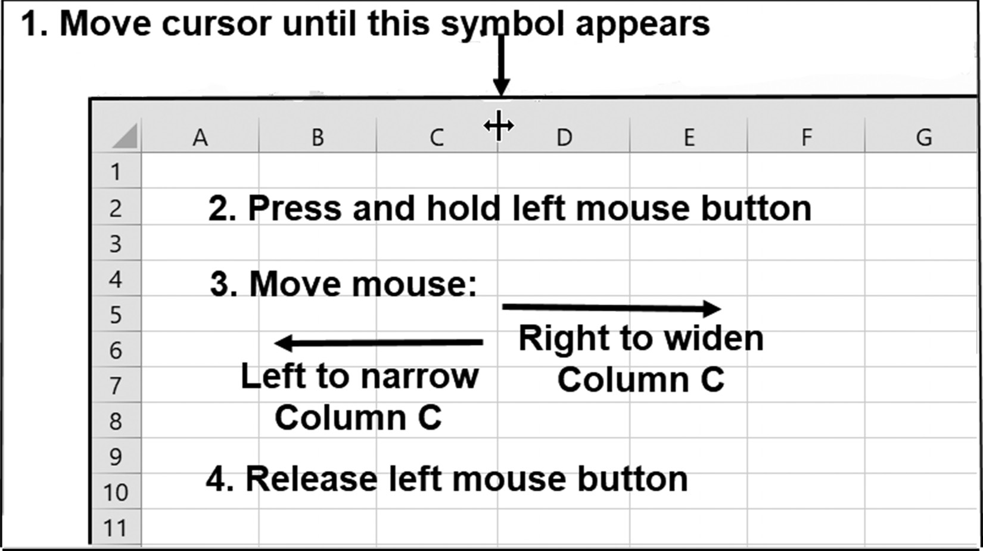

Figure 2.37 Adjusting a column’s width

The same procedure for adjusting individual column widths is used to adjust indi-
vidual row widths, as shown in Figure 2.38. The only difference is that the cross-hairs
must appear below the row being adjusted, and the mouse is moved either down to
widen, or up to narrow the selected row.
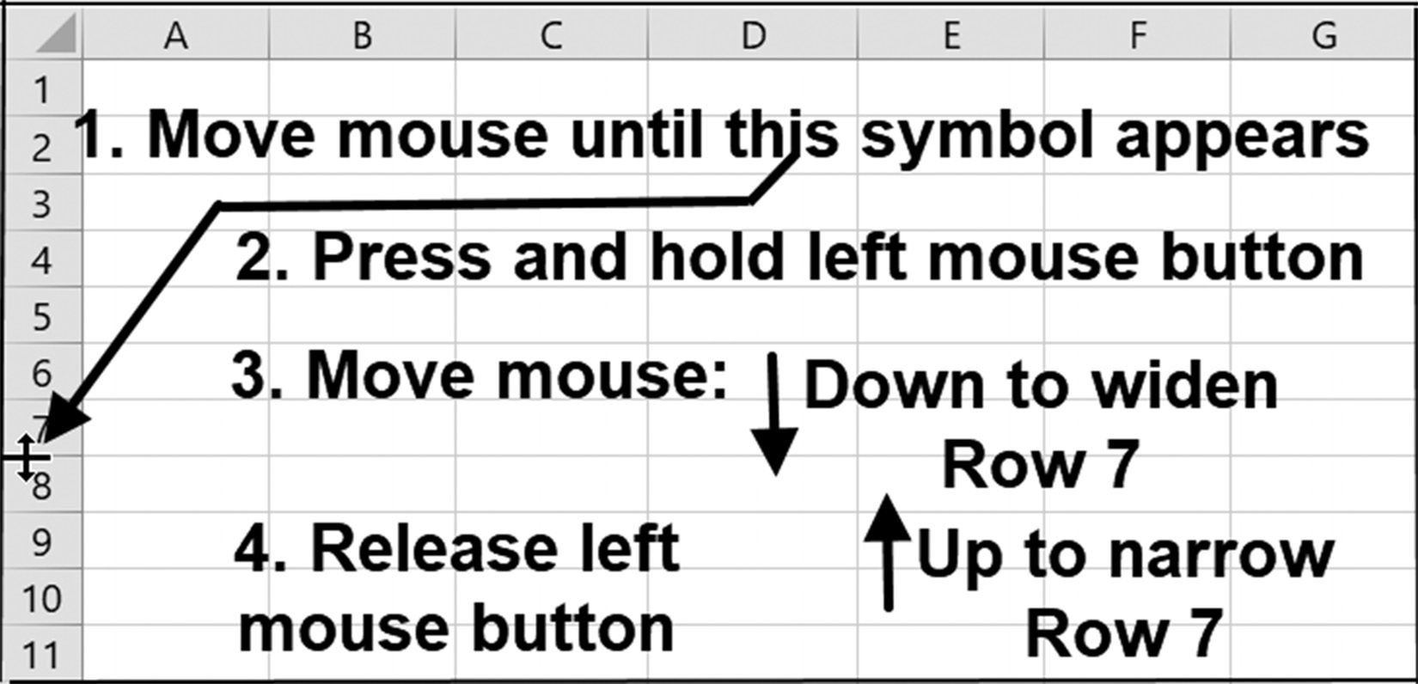

Figure 2.38 Adjusting a column’s width
formulas and formattinG 81

Adjusting Ranges of Rows and Multiple Columns
A group of adjacent rows or columns, respectively, can be widened or narrowed
together using the Home tab’s Format Cells menu option, as shown in Figure 2.39.
This requires higlighting the desired group of rows or columns, using either the Row
or Column headings.
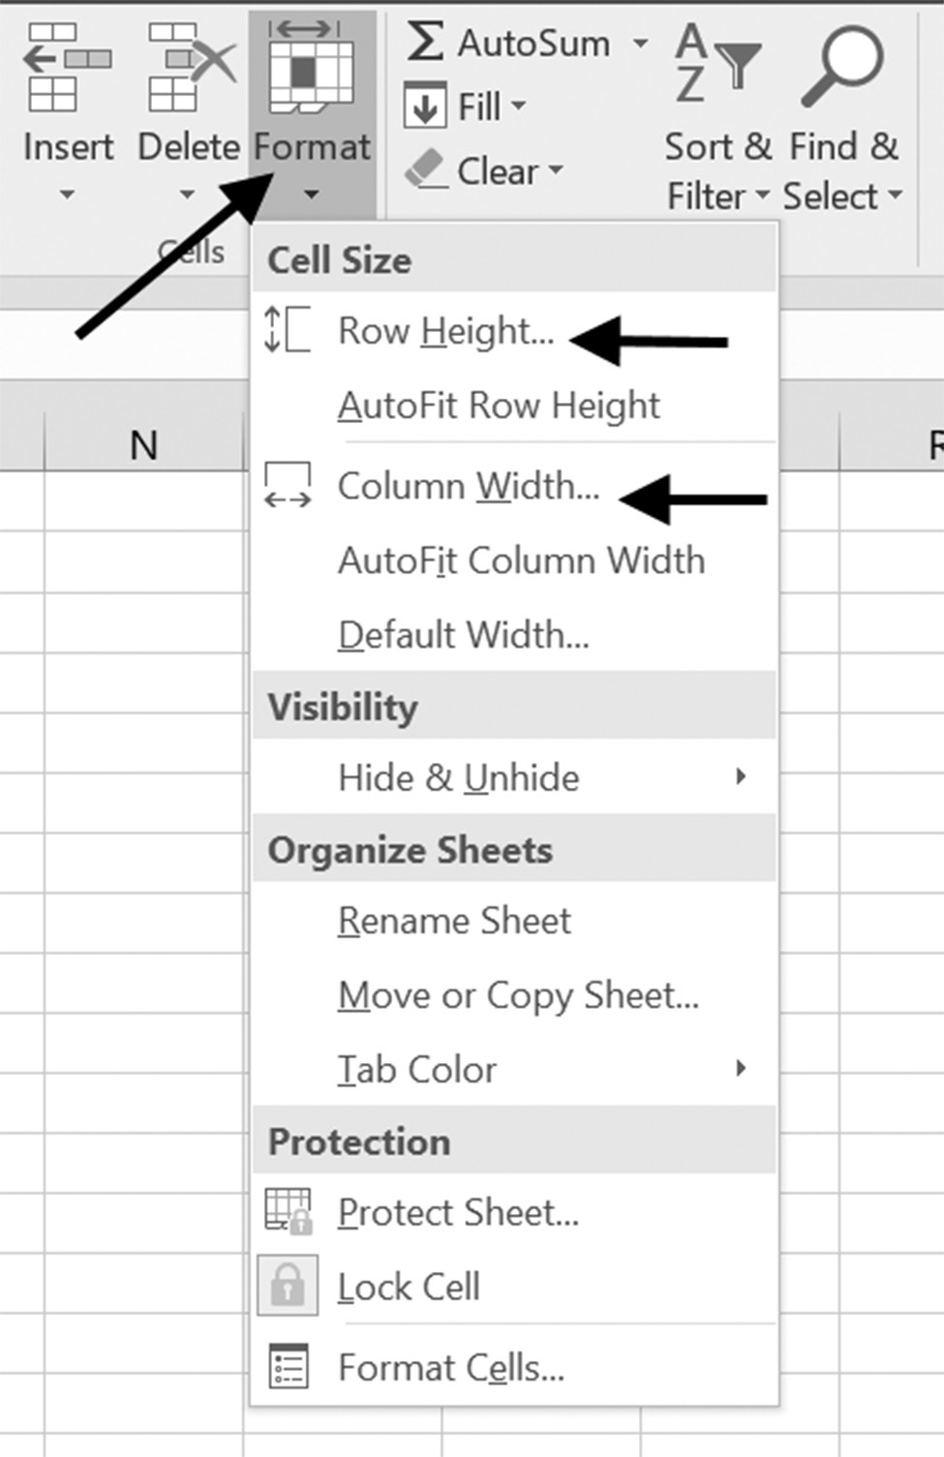

Figure 2.39 Adjusting a width or height

Inserting and Deleting Columns and Rows
A single column is inserted or deleted in front of an existing one by first position-
ing the cursor at the top of the column that will be either be deleted or moved right
to make room for a newly inserted column. When positioned correctly, the cursor
appears as shown in Figure 2.40.
At this point, right clicking the mouse will bring up the options menu shown in Fig-
ure 2.41. Selecting the Insert option results in a new column, as shown in Figure 2.42,
while selecting the Delete option will delete the selected column.
82 exCel BasiCs
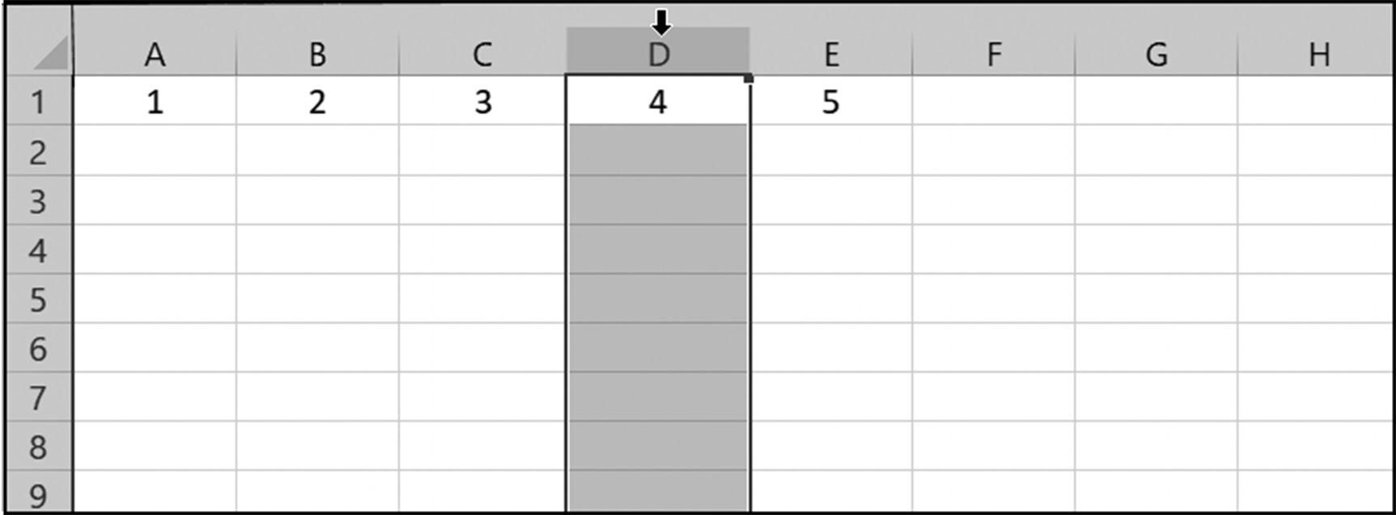

Figure 2.40 Highlighting a column
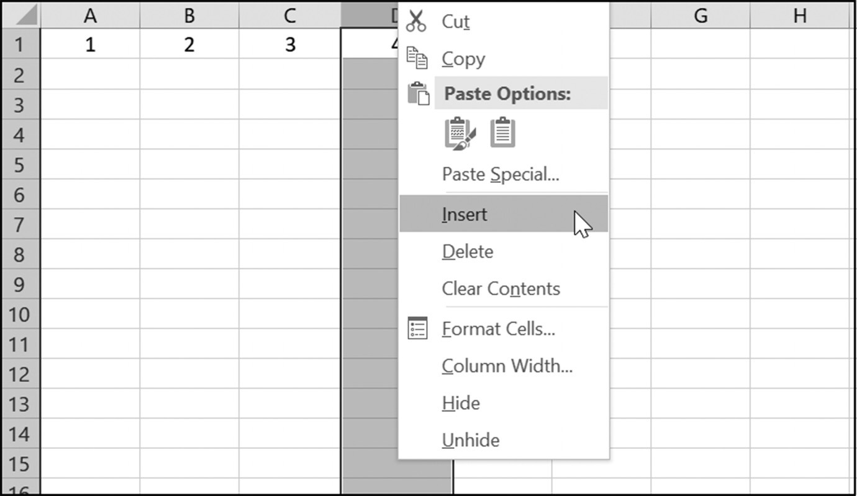

Figure 2.41 Choosing Insert
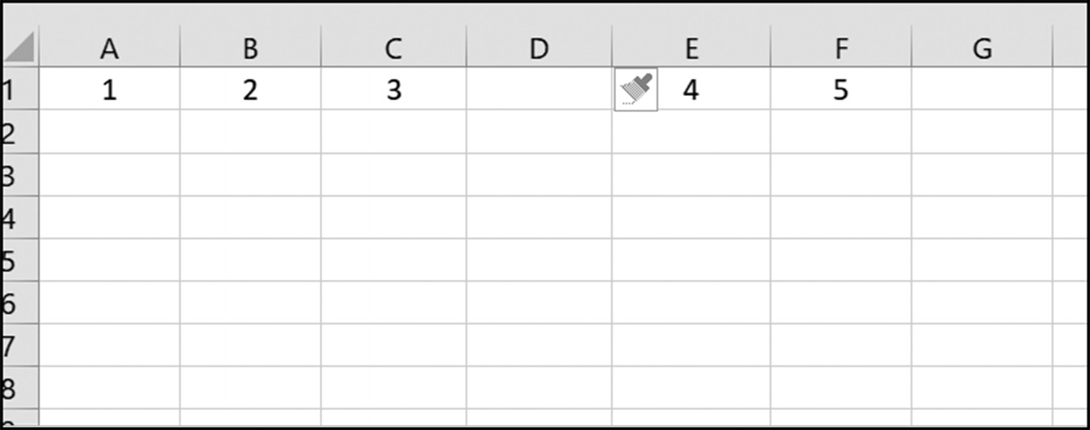

Figure 2.42 Inserted column using the previous column’s label

As illustrated in Figure 2.42, the inserted column receives the previous column’s label.
All columns to the right of the inserted column are moved right, along with their con-
tents. The moved columns have their labels changed accordingly. Thus, in Figure 2.42,
a new column inserted in place of the original column D, is labelled D, and the
formulas and formattinG 83

original columns labelled D, E, and F are re-labelled as E, F, and G. Notice that the
original contents in these moved columns have also been moved. Additionally, and
equally important, is that any formula that used the original column labels is
automatically changed to reflect the new column labels.
In reviewing Figure 2.42, notice the Format Painter icon in column E. Clicking on
this icon brings up the menu options shown in Figure 2.43. These options allow you
to set the format in the newly inserted column to be the same as either the column to
the left or the column to the right, or neither.
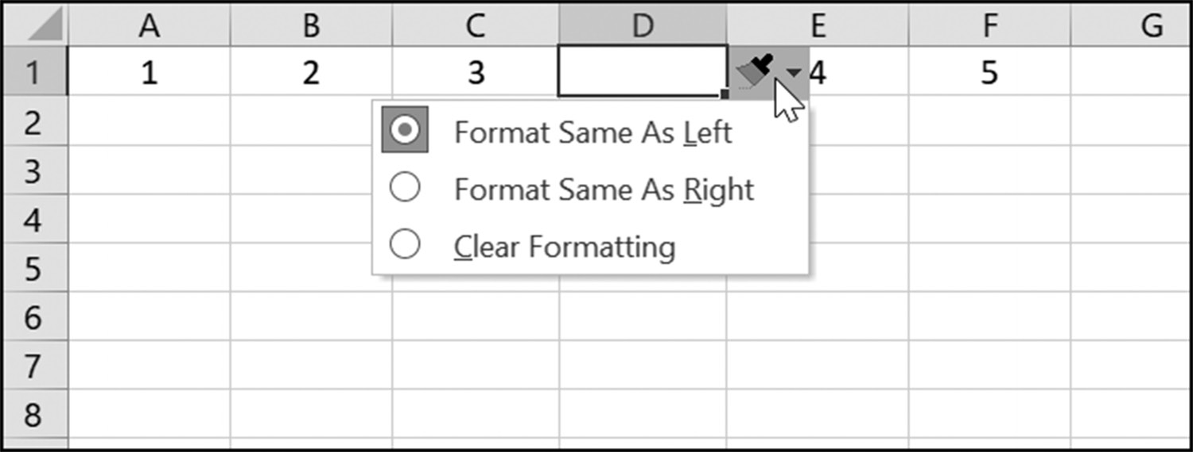

Figure 2.43 Formatting the column
Inserting or Deleting Multiple Columns
Multiple columns are inserted or deleted in the same manner as individual columns,
with one modification. Once a single column is selected, as previously shown in Fig-
ure 2.40, and before right clicking the mouse to obtain the options menus shown in
Figure 2.41, the left mouse button is held and the mouse moved either right or left
to highlight and specify how many, and where, the new columns are to be inserted
or deleted. Figure 2.44 shows how this appears when three new columns are to be
inserted or deleted where existing columns D, E, and F currently exist.
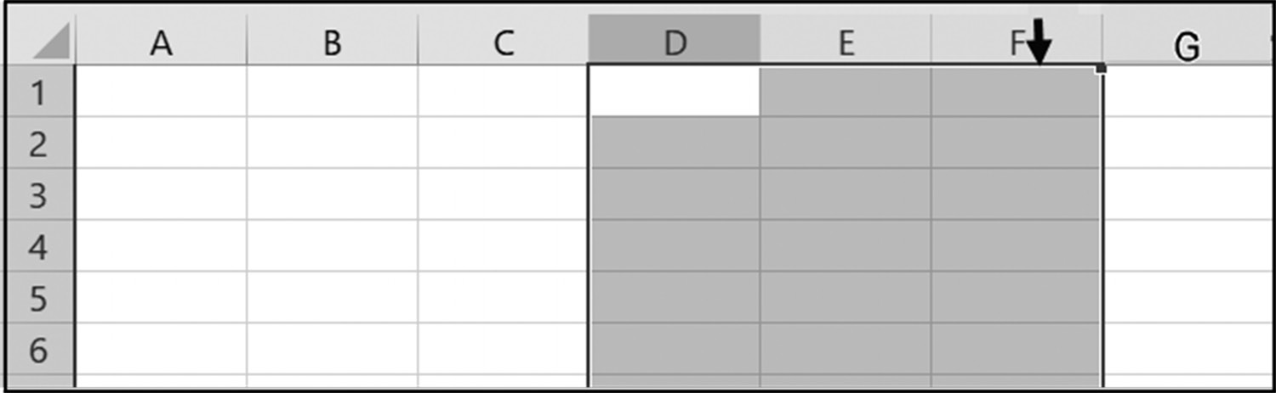

Figure 2.44 Inserting or deleting three new columns

Once the desired columns have been highlighted, releasing the left mouse button results
in an arrow (see Figure 2.44) appearing over the last highlighted column. Right click-
ing the mouse then brings up the same menu options previously shown in Figure 2.41,
from where the selected columns can either be inserted or deleted.
84 exCel BasiCs

Inserting or Deleting a Single Row
A single row can be inserted or deleted using the same procedure as that used for
individual columns. In this case, a new row will be inserted before the selected row;
for deletion, the row is deleted.
The first step to insert or delete a row is to have the cursor pointed to the row that
either will be deleted or will be moved down to make room for the inserted row. When
positioned correctly, the cursor appears as shown in Figure 2.45a.
Once the desired row has been selected, right clicking the mouse brings up the op-
tions menu shown in Figure 2.45b. Selecting the Insert option results in a new row,
as shown in Figure 2.45c, being inserted above Row 4; selecting the Delete option
would remove Row 4 from the spreadsheet. As with column insertion and deletion
and equally important, is that any formula that used the original row labels are
automatically changed to reflect the new row labels. The Format Painter icon
shown in Figure 2.45c allows an inserted row to be formatted as the same as the row
above or below it, or neither (see Figure 2.46).
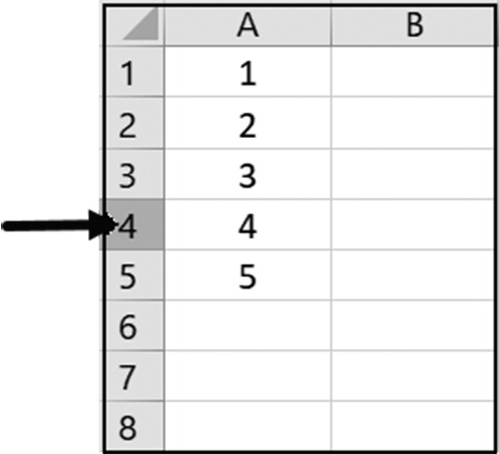

Figure 2.45a Selecting the desired row
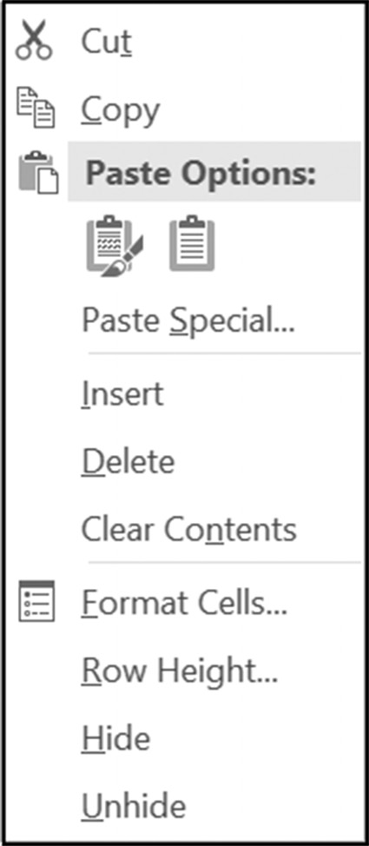

Figure 2.45b Options menu
formulas and formattinG 85
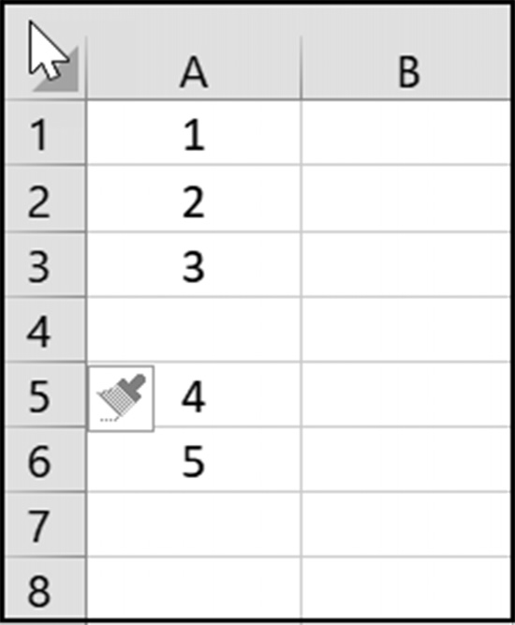

Figure 2.45c After the row insertion
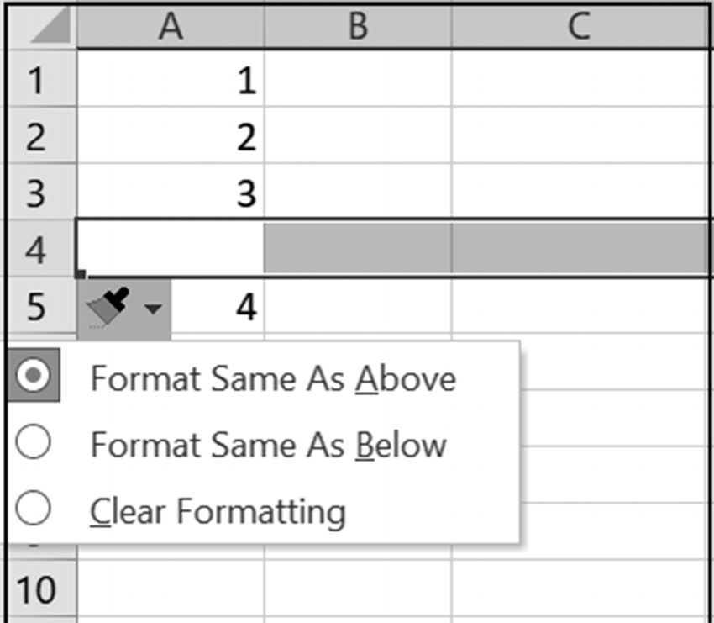

Figure 2.46 Format options for an inserted row

Inserting or Deleting Multiple Rows
Multiple rows are inserted or deleted exactly as individual rows, with one modifi-
cation. Once a single row is selected and before right clicking the mouse to insert
or delete a single row, the left mouse button is held; moving the mouse either up
or down highlights and determines how many rows will be inserted or deleted. Fig-
ure 2.47 shows how this appears when the rows 2, 3, and 4 are highlighted. Releas-
ing the left mouse button and pressing the right mouse button brings up the Options
menu previously illustrated in Figure 2.45. Selecting the Insert option results in the
spreadsheet shown in Figure 2.48, while selecting the Delete option results in that
shown in Figure 2.49.
86 exCel BasiCs
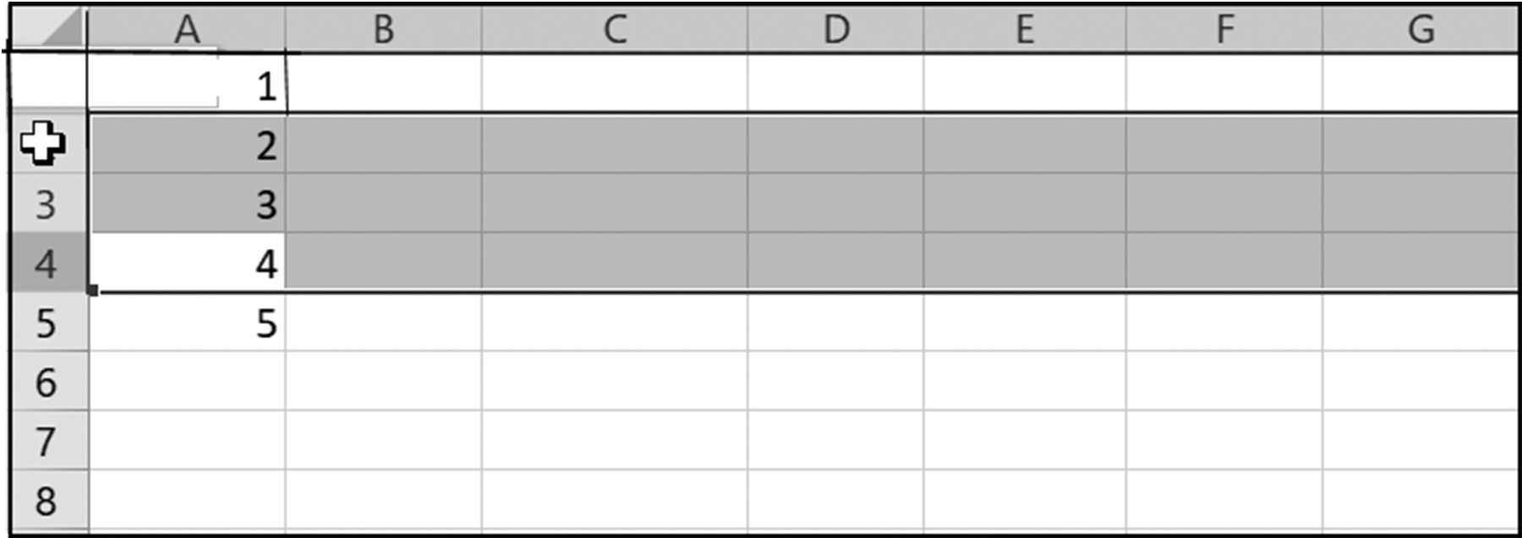

.
Figure 2.47 Highlighting 3 rows for insertion or deletion
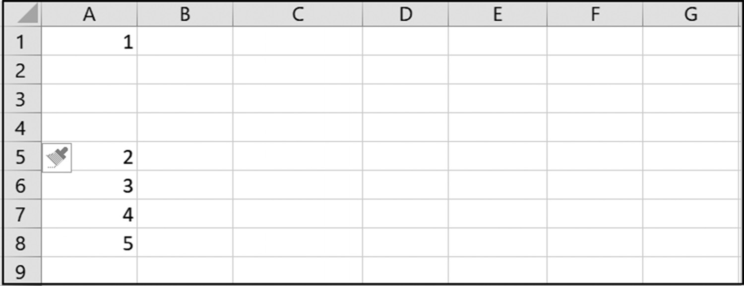

Figure 2.48 The selected 3 rows after insertion
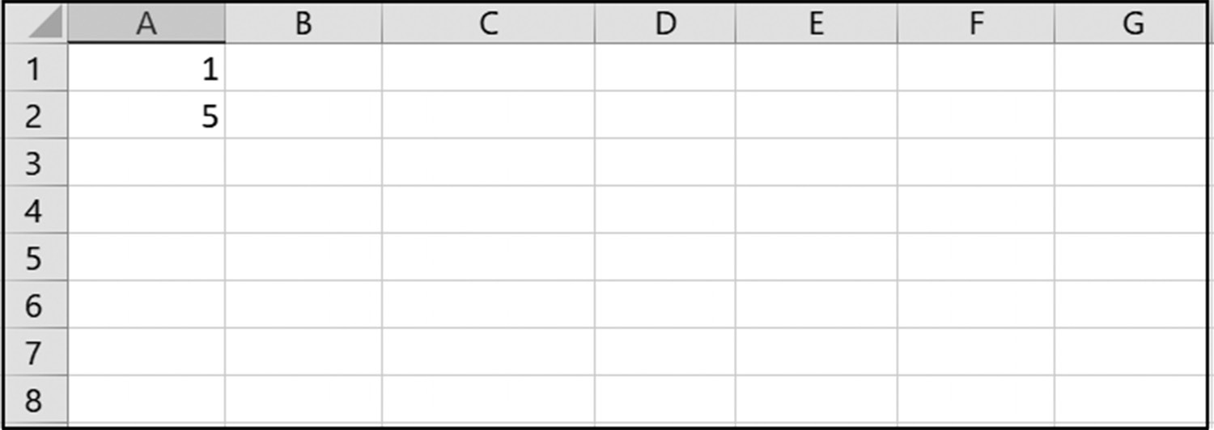

Figure 2.49 The spreadsheet after deleting the selected 3 rows
C H A P T E R 3
funCtions and Conditional

formatting

This Chapter Contains
3.1 Date, Time, and Text Functions
3.2 Statistical Functions
3.3 Financial Functions
3.4 Informational Functions
3.5 Conditional Formatting
3.6 Common Excel Errors
3.7 Chapter Appendix : Transferring Data Between Sheets

Including the mathematical functions presented in Section 2.2, Excel provides over
200 functions for performing date, time, statistical, and financial calculations. These
functions are grouped into thirteen sets organized around common types, such as,
date and time, mathematical, statistical, and financial. Additionally, one set consists
of all available functions listed in alphabetical order. These functions can be seen and
accessed by clicking on the f icon shown in Figure 3.1 and then selecting the desired x
category set from the resulting dialog box.
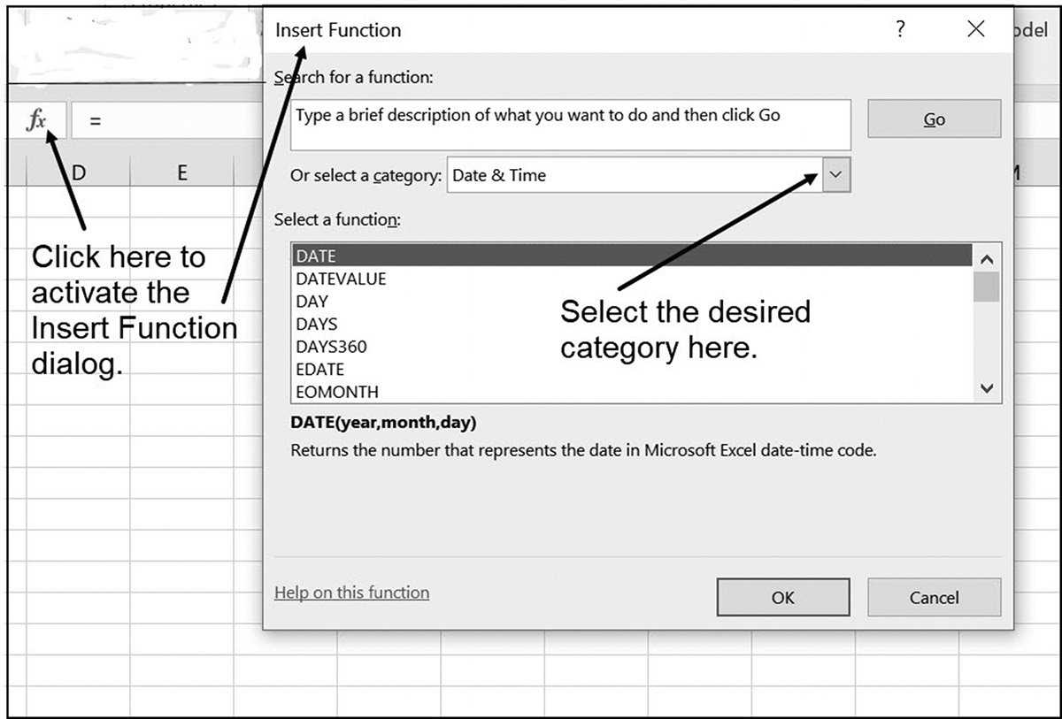

Figure 3.1 Activating the Excel function selection dialog 88 exCel BasiCs

Excel also provides conditional formatting, which permits highlighting individual cells
and rows using user-created criteria. This is helpful in isolating and pinpointing spe-
cifically relevant data in large data sets. Each of the topics in this chapter can be used
independently or can be omitted on first reading with no loss of subject continuity.

3.1 DATE, TIME, AND TEXT FUNCTIONS

There are two main uses for Excel’s Date and Time functions. The first is to place a
date and/or time value directly on a spreadsheet. This provides a reference indicating
when a spreadsheet was created or changed, and is referred to as a date and/or time
stamp.
The second usage is for location and selection purposes. For example, sorting a list
based on payment dates, or locating specific payments, such as those overdue by 30,
60, or 90 days. The selection of specific dates is typically made in conjunction with
Excel’s conditional formatting options. This option permits highlighting the selected
dates and is presented in Section 3.4.
Table 3.1 Commonly used Date functions
Function Description Examples Returns
DATE(year, month, day)) Returns a date in the =DATE(2020,12,25) 12/25/2020
cell’s date or other num-
ber format
DATEVALUE(date as text ) Returns a number =DATEVALUE(“2020/12/25”) 44190
representing a text date
in Microsoft’s date-time
code (serial number)
DAY(date) Returns a number from =DAY(“2020/7/23”) 23
1 to 31 for Microsoft’s =DAY(TODAY( )) Varies by day of date-time code (serial- month number)
DAYS(end-date, start-date) Returns the number of DAYS(“2020/8/15”,”2020/7/23”) 23
days between two dates
MONTH(date) Returns a number from 1 = MONTH(“2020/7/23”) 7
(Jan.) to 12 (Dec.) =MONTH(TODAY( )) Today’s Month
NOW( ) Returns the current date =NOW( ) The current date
and time and time
TODAY( ) Returns the current date =TODAY( ) The current date WEEKDAY(date) Returns a number from 1 =WEEKDAY(“2018/7/23”) 2
(Mon) to 7 (Sun)
YEAR(date) Returns a year from 1900 =YEAR(“2020/7/23”) 2020
to 9999 =YEAR( TODAY( )) Today’s year
Table 3.1 lists Excel’s commonly used date and time functions. Included in this table
are examples of each of these function’s usage and the value returned. When this value
is a number, it is referred to as a Microsoft serial-number. These numbers are sequen-
tial numerical values that are used for the actual date storage (number of days elapsed
funCtions and Conditional formattinG 89

since January 1, 1900). This displayed value can be changed by formatting it using one
of the available Date formats.
Figures 3.2 illustrates a spreadsheet segment using a number of these Date func-
tions.
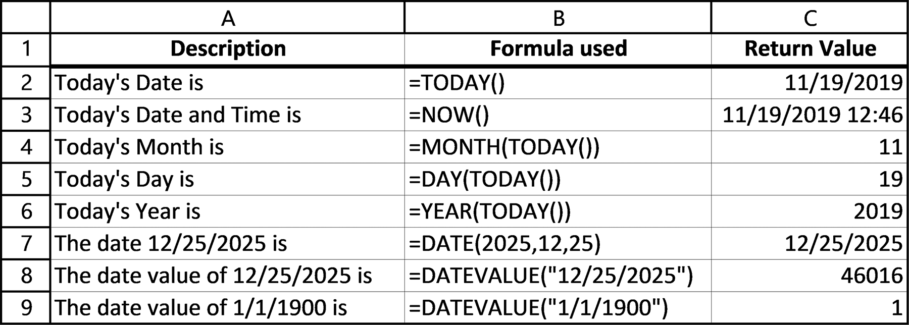

Figure 3.2 Examples using Date functions

Dates used as arguments to Excel’s Date functions must adhere to the expected data
types. For example, as seen in Table 3.1 and Figure 3.2, the DATEVALUE( ) function
requires a text argument. Thus, for this function, a date, such as 12/25/20, must be
entered as text, which requires the date be enclosed in double quotes, as “12/25/20.”
Other date functions may allow function arguments to be in either a text or numeric
form.
Dates entered into a cell need not be entered as text. Thus, a date, such as 12/25/2020
or 1/18/25, can be entered as a combination of digits and forward slashes that accu-
rately specify the date. If the provided argument to a Date or Time function is a cell
reference, the value in the cell must be formatted as a Date and Time Value.
Dates Prior to 1/1/1900
Unfortunately, Excel stores dates as numbers representing the cumulative days from
January 1st 1900, where dates before this must be stored as text. Practically, this means
that the functions listed in Table 3.1 can only be used reliably for dates on or after
1/1/1900. Dates prior to this must be user-converted to a number format. One of the
simplest conversion formulas is the following:
=Year * 10000 + Month * 100 +Day
where Year, Month, and Day are obtained using Excel’s YEAR( ), MONTH( ), and
Day( ) functions. Another alternative is to obtain a conversion routine from the
Internet.
90 exCel BasiCs

Application Note
Text Characters Are Stored as Numeric Values
In Excel, which is based on the C++ programming language, each character is stored as a unique numeric value. This permits the storage of special characters that have no printable equivalent, such as a line-feed or carriage return. These numeric codes can be represented in both binary and integer forms.
An important consequence of using integer value codes for individual characters is that they can
then be easily compared for alphabetical ordering. Because each subsequent letter in an alphabet is stored using a higher value than its preceding letter, the comparison of characters is reduced to the comparison of numeric values.
Previously , the ASCII (American Standard Code for Information Interchange) code was used to
store characters. This code was limited to representing 256 unique English language characters. To accommodate international applications using non-English character sets, Unicode was introduced in 1987. This code is now universally used and can represent 65,536 unique character codes. The first 256 Unicode characters have the same numerical values as the original 256 ASCII codes and are listed in Appendix A.
Text and Character Functions
As introduced in Chapter 1, text consists of a group of characters that can include one
or more of the following:
●● Letters
●● Numbers
●● Special Symbols (-, $, ., @, &)
Formally, a sequence of characters is referred to as a string literal. A string literal
is also referred to as a string constant or string value, and more conventionally, as a
string or text string, for short. By default, text is left aligned in a cell. Additionally, if
the first character entered is an apostrophe (‘), Excel considers the complete entry as
text; it can also be designated as text by using formatting.
Text entered directly into a cell, such as a label, is recognized by Excel as text,
just as numbers and formulas are recognized as their respective data types. However,
when used as an argument to a function, text must be enclosed in double quotes. For
example, “Pass,” “Hello world!,” and “xyz 123 *!#@&” are all examples of text strings
that are acceptable as function arguments where a text string is appropriate.
Unlike a number, which is stored using a numerical code, text is stored in a char-
acter-by-character manner, with each individual character having its own unique nu-
merical code. Table 3.2 lists the stored numeric code values and their corresponding
characters for both uppercase and lowercase English letters (see Application Note
above)1.

1 The first 256 ASCII and Unicodes can be found in Appendix A.
funCtions and Conditional formattinG 91

Table 3.2 Uppercase and lowercase numerical codes (ASCII and Unicode)
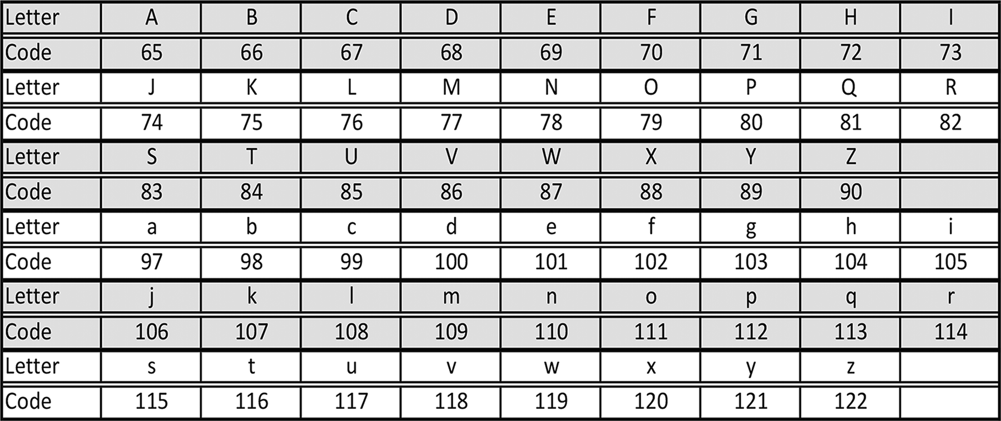

The commonly used text functions available for processing characters are presented in
Table 3.3. As previously noted for the Date and Time functions, when text is required
as an explicit argument to any of these functions, it must be enclosed in double quotes
(“string in here”). This permits a clear marking of where the string begins and ends.
If the provided argument is a cell reference, the value in the cell must be formatted
as text.
The CLEAN( ) Function
As is noted in the previous Application Note, not all characters are printable. There
are times, however, when codes for these non-printable characters become embedded
within text and are not seen when the text is displayed. For example, two names may
appear to be the same but are not because one has a hidden, non-printable character
within it. Such text can be an extremely troublesome problem when text is compared.
Examples of these situations are described in Section 4.3, where a name is used in a
look-up table or when an application must remove duplicate entries (see Section 8.5).
As a specific example, the two strings shown in cells A2 and A3 in Figure 3.3 look
the same and have the same string length. However, they are not the same. The text
in cell A2 contains two non-printable characters: one between the first and last name
and one after the last name; each one is displayed as a single space, while the text in
cell A3 uses a space character between the first and last name.
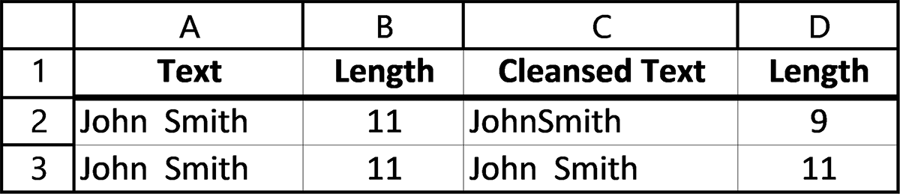

Figure 3.3 Same name, one with non-printable characters 92 exCel BasiCs

Table 3.3 Commonly used text and character functions
Function Description Example Result
CHAR(value) Returns the character corresponding to =CHAR(122) z
the ASCII code number specified
CLEAN(string ) Removes all non-printable characters from =CLEAN(“Hi”&CHAR(2)&”Ho”) HiHo
the string
& operator Join arguments into a single string. Can be =“Hi” & “ ” & “Ho” Hi Ho CONCATENATE( ) replaced by & =CONCATENATE(“Hi”,” “,”Ho”) CONCAT( ) =CONCAT(“Hi”,” “,”Ho”)
is only available for Excel
2019 and Excel 365
LEFT(string, num) Returns the specified number of charac- =LEFT(“Some Day”,4) Some
ters from the start of the string
LEN(string ) Returns the number of characters in the =LEN(“This String”) 11
string (includes spaces)
LOWER( string) Converts text string to all lowercase =LOWER(“Let’s Go”) let’s go
characters
RIGHT(string, num) Returns the specified number of charac- =RIGHT(“Some Day”,3) Day
ters from the end of the string
UPPER(string ) Converts text string to all uppercase =UPPER(“Excel”) EXCEL
characters
TRIM(string ) Removes all spaces except single spaces =TRIM(“ Hello “) Hello
between words in the string
UNICHAR(value ) Returns the character corresponding to UNICHAR(122) z
the Unicode value
UNICODE(char) Returns the Unicode value corresponding =UNICODE(“A”) 65
to the character specified

Cells C2 and C3 contain cleansed versions of the strings in cells A2 and A3, respec-
tively. The actual data and formulas used to produce Figure 3.3 are shown in
Figure 3.4.
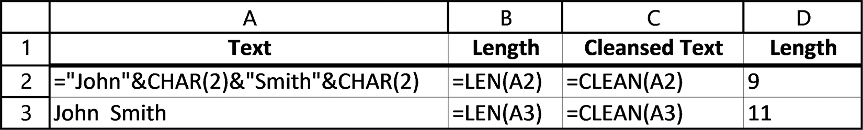

Figure 3.4 Data and formulas used to produce Figure 3.3

In comparing text values, and in cases where text examples appear to produce unpre-
dictable or “strange” results, using the CLEAN( ) function frequently clears up the
matter.

EXERCISES 3.1

1. Enter the spreadsheet segment shown below and verify the display that is pro-
duced for the date and time you entered.
funCtions and Conditional formattinG 93
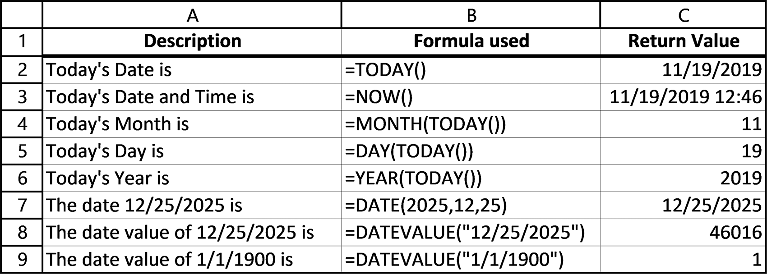

2. Write formulas for the following:
a. cell B2 displays the text in cell A2 in uppercase letters
b. cell C2 displays the text in cell A2 in lowercase letter
c. cell D2 displays the text in cell A2 with all spaces in the text removed
d. cell E2 displays the length of the text located in cell A2, after the CLEAN( )
function is applied to the text.
3. Write formulas to accomplish the following:
a. cell C2 should display the first letter in cell A2 as an uppercase letter
b. cell C2 should display the first letter in cell A2 as an uppercase letter followed
by a period and a space.
c. cell C2 should display the first letter in cell A2 as an uppercase letter, followed
by a period, a space, and the first letter in cell B2 as an uppercase letter.
4. Write an Excel formula in cell D1 that inserts the text in cell B1 into the text in
cell A1, where cell C1 contains the position where the insertion should begin.
5. The spreadsheet in Figure 3.5a contains first names in column A and last names
in column B. These need to be processed so that they appear as shown in Figure 3.5b. For this, write a formula for cell C2 that can be copied down to pro-duce the required display. (Hint: Review Exercise 3.)
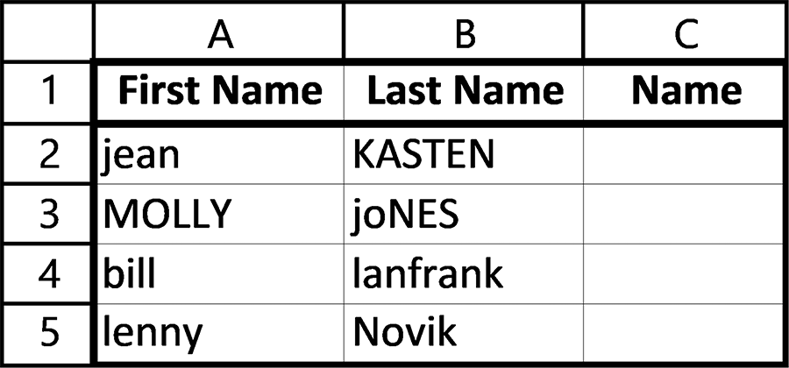

Figure 3.5a Spreadsheet for Exercise 5
94 exCel BasiCs
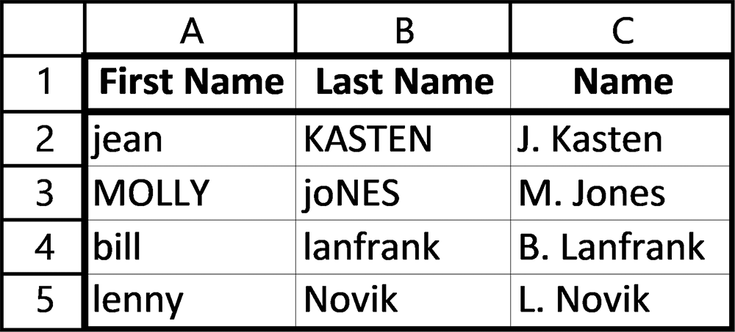

Figure 3.5b Spreadsheet results for Exercise 5

3.2 STATISTICAL FUNCTIONS
Excel provides two basic sets of statistical functions. The first set consists of descrip-
tive statistical functions, while the second set provides more advanced inferential sta-
tistical functions.
Descriptive statistics describes and summarizes the relevant features of a data set.
These include the data’s mean (that is, its average), mode, and median, which are
referred to as the data’s central tendency, as well as the data’s standard deviation, and
maximum and minimum values, which are measures of the data’s dispersion (spread).
These measures, presented in this section, together with simple graphical charts form
the basis of almost all data analysis.
Inferential statistics is the branch of statistics that draws conclusions about a popu-
lation using random data samples taken from the population. Inferential functions are
not directly included with the basic set, but can be easily added by using the Analysis
Analysis Toolpak, and the procedure to install this Add-In is provided in Appendix B.
Table 3.4 lists the five most commonly used descriptive statistical functions: the
complete set consists of 110 functions.
Table 3.4 Commonly used statistical functions
Function Description Example
AVERAGE( ) Returns the arithmetic average (mean) =AVERAGE(A2:A10)
of its arguments
COUNT( ) Returns the number of numbers in a =COUNT(A2:A10)
range or set of arguments
MAX( ) Returns the largest value in the range =MAX(A2:A10)
or set of arguments
MEDIAN( ) Returns the middle value of a range or =MEDIAN(A2:A10)
set of arguments
MIN( ) Returns the smallest value of a range or =MIN(A2:A10)
set of arguments
MODE.MULT( ) Returns a vertical array of the most =MODE.MULT(A2:A10)
frequently occurring values
funCtions and Conditional formattinG 95

Table 3.4 (continued)
Function Description Example
MODE.SNGL( ) Returns the single most frequently oc- =MODE.SNGL(A2:A10)
curring value
STDEV.P( ) Calculates the standard deviation of its =STDEV.P(A2:A10)
(Earlier Excel versions named this arguments. Considers the arguments
function STDEVP( ).) the entire population and ignores text
and logical values
STDEV.S( ) Calculates the standard deviation of its =STDEV.S(A2:A10)
(Earlier Excel versions named this arguments. Considers the arguments
function STDEV( )) a sample and ignores text and logical
values
Figure 3.6a illustrates the use of these functions as applied to the data in rows 4
through 7. The formulas used to produce the values shown are presented in
Figure 3.6b.
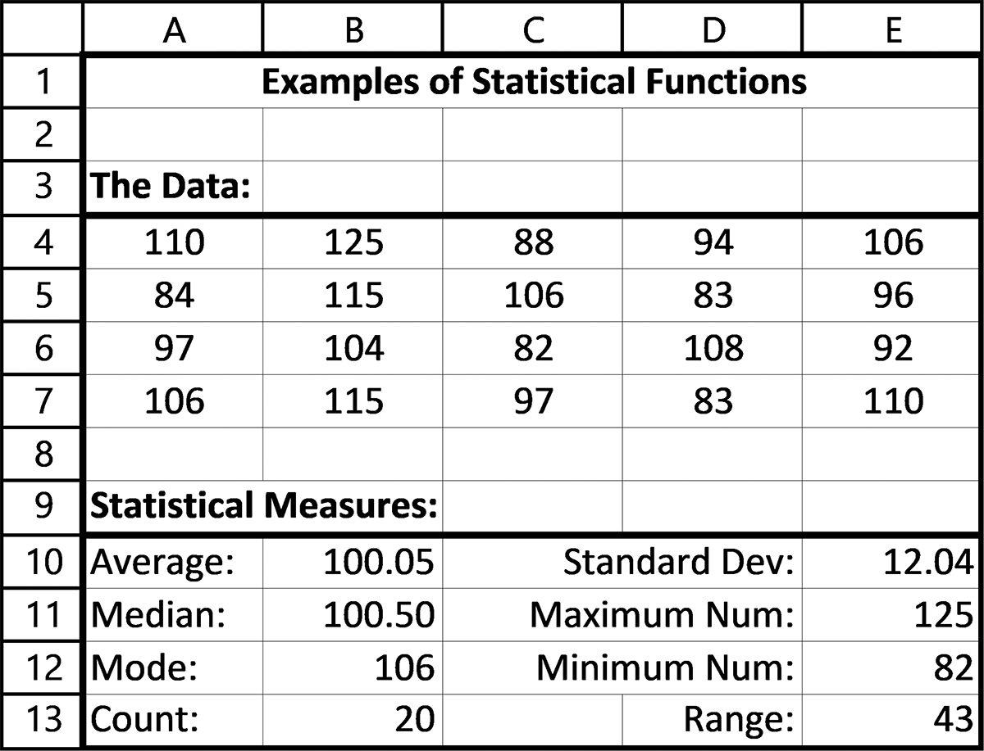

Figure 3.6a Examples of statistical functions
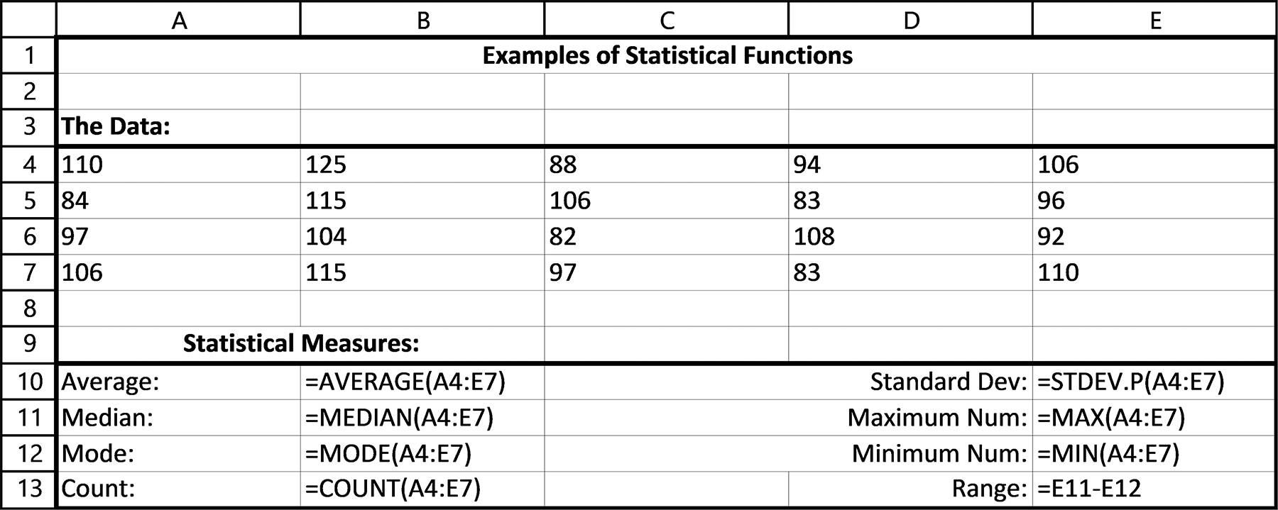

Figure 3.6b Formulas used to produce Figure 3.6a 96 exCel BasiCs

Standard Deviations
Although the average of a set of data is a commonly used statistical result, it gives no
indication of how the data is spread around the average. If the data is widely spaced,
in fact, an average value can be extremely misleading. As an example, consider the two
columns of house prices listed in Figure 3.7.
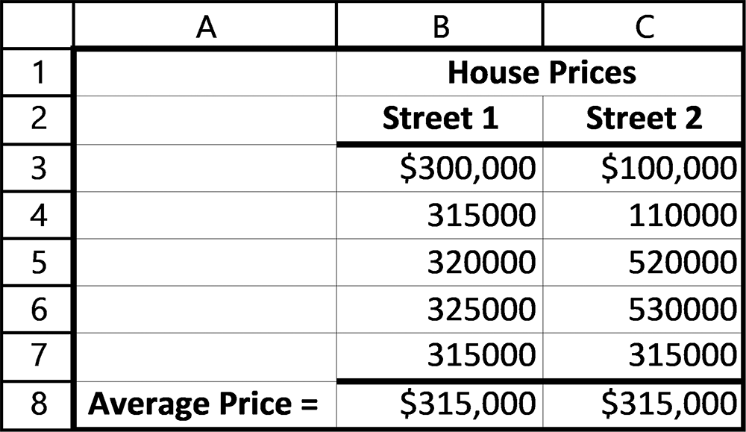

Figure 3.7 Two datasets having the same average

Notice that the average prices for the prices listed in columns B and C are the same,
but only the houses listed in column B are close to the average. Anyone expecting to
buy a house near this average price in Street 2 may be disappointed by the houses
available there.
In these situations, the standard deviation provides the missing information. In Fig-
ure 3.8, the standard deviation of each data set is listed. Notice that the standard de-
viation for the house prices in column B is $8,367, while that for the prices in column
C is $187,883. This means that, on average, a house in Street 1 will be $8,367 above
or below the average price of $315,000, while those in Street 2 will be $187,883 above
or below the average price.
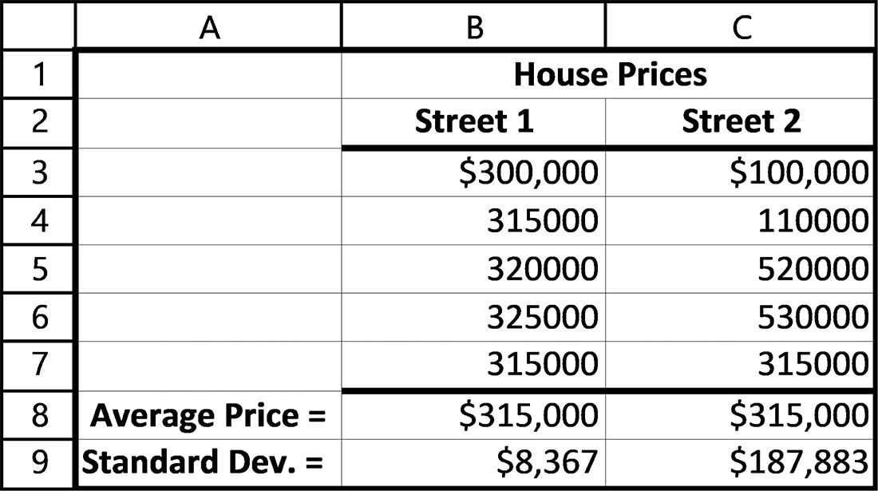

Figure 3.8 Comparing averages and standard deviations
funCtions and Conditional formattinG 97

Even more important than providing a measure of the average deviation of individual
data points from the overall average, standard deviations provide a way of
1. Comparing averages obtained at different points in time (for example, comparing
batting averages of professional baseball players across the decades)
2. A quick method, in certain situations, of determining the percentage of data con-
tained within a bracket of ranges (for example, determining the percentage of students who scored within a given range of SAT scores)
How these two situations are accomplished is described next, after we understand
how a standard deviation is obtained.
Calculating the Standard Deviation
At its most basic level, a standard deviation simply represents the typical difference
between a data point and the overall data average, as was shown in Figure 3.8. To gain
an understanding of this basic concept, consider the spreadsheet segment shown in
Figure 3.9.
As seen in Figure 3.9, the sum and average of the four data values listed in column
B are 48 and 12, respectively. The data in column C is simply the difference between
each data point from the average. Thus, the - 8 in cell C2 is obtained as 4 - 12, and it
indicates that the 4 in cell B2 is eight units below the average. Similarly, the value in
cell C5 indicates that the data point in cell B5 is eight units above the average. Notice
that the sum of all of the values in cells C2 through C5 is zero. This is always the case:
the sum of the individual deviations of each data point from the average must be zero,
because the average is calculated as the center point for all the data values. As such,
the individual deviations tell us nothing about how far away a typical value is.
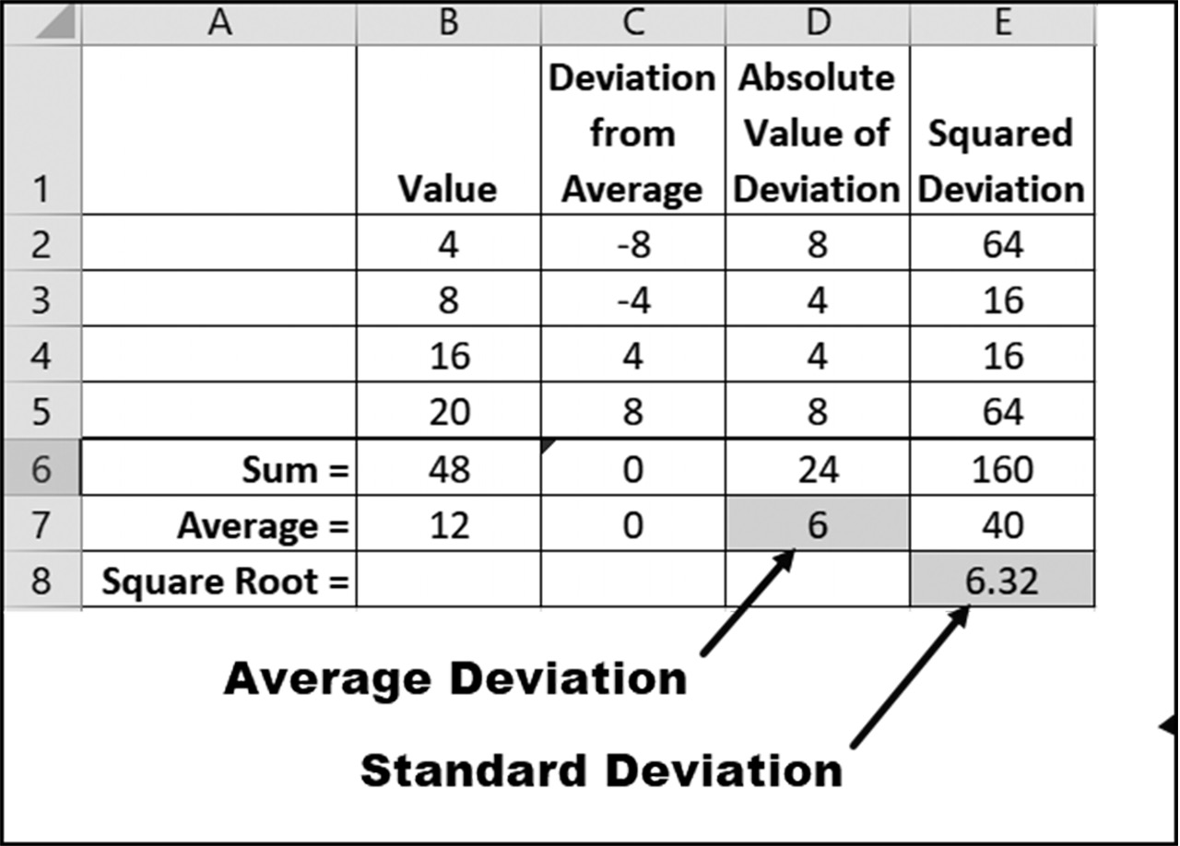

Figure 3.9 Measures of deviation from the average 98 exCel BasiCs

Taking the absolute value of each deviation, however, does provide a meaningful mea-
sure of the average deviation. As shown in column D (again, in Figure 3.9), the sum
of absolute value of each deviation is 24, and the average deviation, highlighted in cell
D7, is 6. Thus, on average, each data point is 6 units away from the average of 12.
Now notice the highlighted value in cell E8, which is 6.32. Although it does not
provide the exact average deviation of 6 in cell D7, it is very close. More importantly,
however, it provides a measure of overall data spread that is much more useful than
the exact average deviation. This number is the standard deviation of the data. As in-
dicated, it is computed as the square root of the sum of each squared deviation. This
value is computed using Excel’s STDEV.P( ) function2.
The Empirical Rule
When data is normally distributed, which means that it follows a bell-shaped curve,
the following rule, known as the Empirical Rule, can be applied. This rule states that
for normally distributed data,3
●● 68% of the data will be between ± 1 standard deviations of the data’s average
value
●● 95% of the data will be between ± 2 standard deviations of the data’s average
value
●● 99.7% of the data will be between ± 3 standard deviations of the data’s average
value

Example 1
SAT scores are normally distributed, which means they follow a bell-shaped curve.
The average SAT score in 2018 was 1060 with a standard deviation of 194. Using this
data, determine
a. the percentage of students who had scores between 866 and 1254
b. the percentage of students who had scores between 672 and 1460
Solution: Because the data is normally distributed, the Empirical Rule can be used.
c. A score of 1254 is one standard deviation (that is, 1254 - 1060 = 194) above
the average score of 1060, and a score of 866 is one standard deviation below the average score. Thus, 68% of all students had a score between these 866 and 1254.

2 STDEV.P( ) divides the sum of the deviations by n, where n is the number of data points, while STDEV.S( ) divides by n-1. The P version is for populations and the S version for samples. The corresponding versions for Excel 2007 and earlier versions were named STDEVP() and STDEV(), respectively.
3 For data that is not normally distributed, Chebyshev’s Theorem, which is beyond the scope of this text, can be used.
funCtions and Conditional formattinG 99

d. A score of 1460 is two standard deviations above the average score of 1060, and
a score of 672 is two standard deviations below the average score. Thus, 95% of all students had a score between 672 and 1460.

Example 2
A second use of the standard deviation provides a method of comparing two averages
taken at different periods of time. For example, the lifetime batting average of Tris
Speaker, who played in the 1920s, was .345, while Miguel Cabrera’s current lifetime
(at the end of the 2018 season) was .316. A direct comparison of these two averages
to see who was the better hitter is not valid, because the equipment (bats, gloves, and
baseballs) differed for these two players, and batting averages were more spread out
in the 1920s. A better comparison is to see how these two players compared relative
to their contemporary players. Doing this again requires using standard deviations to
determine how far above the mean each of these players was relative to their contem-
poraries.
Solution: In the 1920s, the average batting average was .281, with a standard devia-
tion of approximately .05, while in 2018, the average batting average of all players was
.268 with a standard deviation of approximately .04. This means that the earlier play-
ers had, on average, higher batting averages with a wider spread between the play-
ers than the current players. Comparing each player to their contemporaries reveals
that4 Tris Speaker’s batting average was (.345 - .281)/.05 = 1.28 above the average of
his contemporaries, and Miguel Cabrera’s batting average is (.316 - .268)/.04 = 1.20
above the average of his contemporaries. This indicates that both of these players are
fairly equal as far as batting averages are considered.

4 The resulting values are referred to as z-scores. A z-score represents how many standard deviations a given value is away from the average. It is most useful for bell-shaped data distributions, where 99.7% of all z-scores will lie between -3 and +3. 100 exCel BasiCs

EXERCISES 3.2

1. Using Excel, reproduce the following spreadsheet so that the result appears as the
second image (with column C). Use Excel text functions as needed.
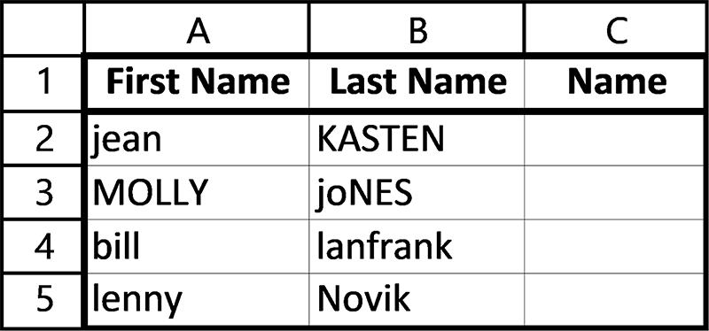

2. Using Excel, reproduce the following spreadsheet.
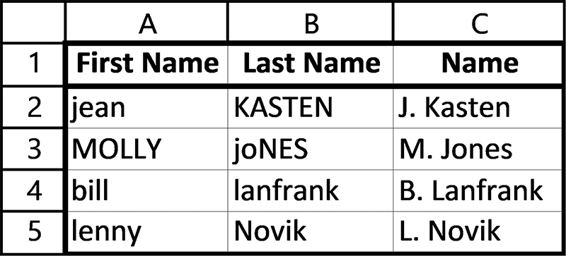

3. Reproduce the following spreadsheet, using Excel statistical functions as needed.
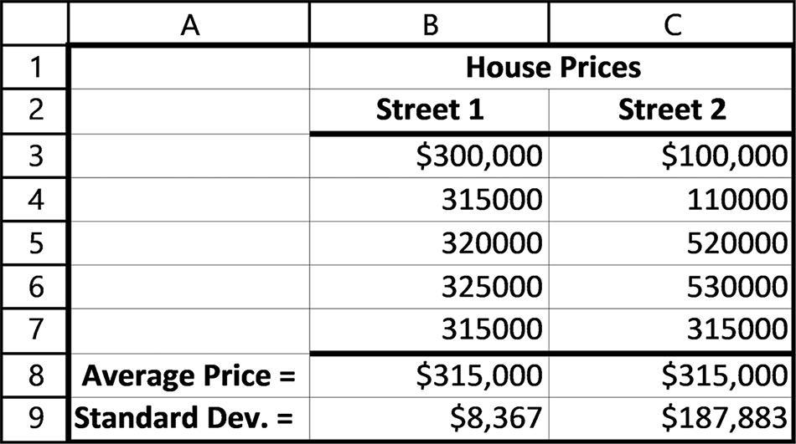
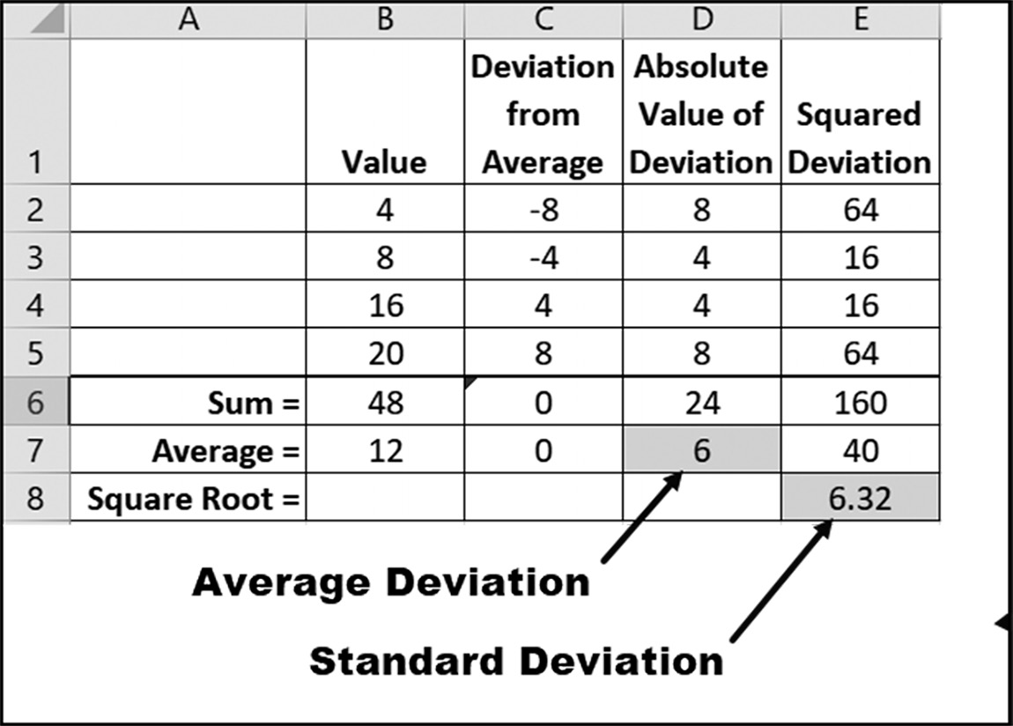
funCtions and Conditional formattinG 101

4. Complete parts a and b.
a. U sing Excel’s AVERAGE() and STDEV.P( ) functions, determine the aver-
age and standard deviations of the following salary data: $48,000, $53,000, $35,000, and $43,000.
b. Use Excel functions to determine the median, mode, minimum, maximum, and
number of salaries listed in Exercise 4a.
5. Complete parts a and b.
a. Using Excel’s AVERAGE() and STD.P( ) functions, determine the average and
standard deviations of the following test grades: 85, 74, 88, 95, 65, 72, 79, 83, 90, 78, and 62.
b. Use Excel functions to determine the median, mode, minimum, maximum, and
number of grades listed in Exercise 5a.

3.3 FINANCIAL FUNCTIONS

Excel provides numerous financial functions. Table 3.6 provides a sampling of these
functions, most of which require a knowledge of financial analyses, such as cash flows
and bonds that are beyond the scope of this text. The PMT( ) function, however, is
particularly useful in calculating loan payments, such as car loans and home mortgage
payments. As these types of loans are in common usage for financing homes and cars,
this particular function is discussed in detail.
The PMT( ) function
A loan used to buy a car or purchase a house, known as a home mortgage, or mortgage,
for short, are common examples of commercial loans. Payments for these two types
of loans are made on a monthly basis. Here, the amount of the loan, the length of the
loan, and the interest rate are fixed when the loan is taken out. Based on these three
variables, a fixed monthly required to pay off the loan can be calculated. In Excel this
payment amount is determined using the PMT( ) function.
Table 3.6 A sampling of Excel’s financial functions
Function Description
COUPDAYS( ) Returns the number of days in the coupon period that contains the settlement date CUMIPMT( ) Returns the cumulative interest paid on a loan between two specified periods CUMPRINC( ) Returns the cumulative principal paid on a loan between two specified periods DURATION( ) Returns the annual duration of a security with periodic payments
FV(rate, nper, pmt, [pv], [type]) Returns the future value of an investment assuming periodic, constant payments with a
constant interest rate
102 exCel BasiCs

Table 3.6 (continued)
Function Description
IRR( ) Returns the internal rate of return for a series of cash flows that occur at regular inter-
vals, but do not have to be the same amounts
NPV( ) Returns the Net Present Value of an investment, based on a supplied discount rate, and
a series of payments and income
PMT(rate, nper, pv, [fv], [type]) Returns the payment for a loan having constant, periodic payments at a fixed interest
rate
PPMT(rate, nper, pv, [fv], [type]) Returns the principal portion for a given period’s payment for a payment based on a
fixed interest rate and a payment schedule
PV(rate, nper, pmt, [fv], [type]) Returns the present value that a series of future payments is worth now

Figure 3.10 lists the monthly payments due for a $15,000 car loan made for four and
seven years, respectively, and for a fifteen-year and thirty-year $200,000 home mort-
gage. The interest rates for all of these loans is 5%.
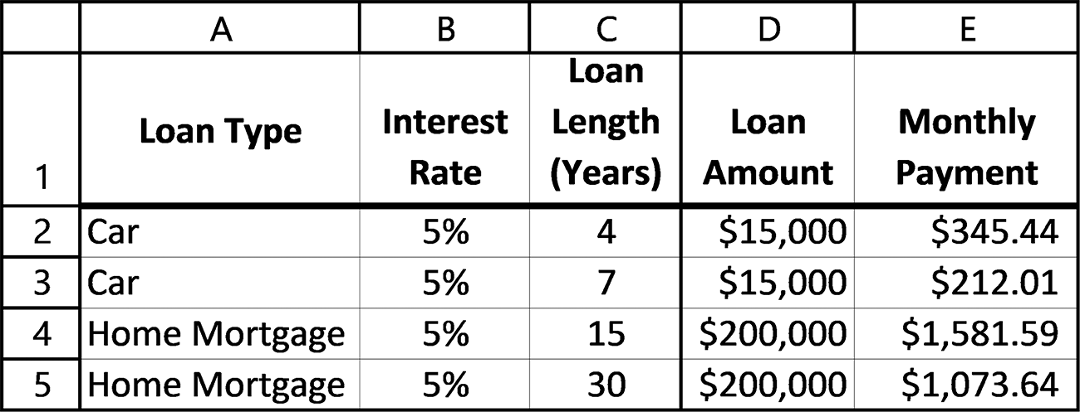

Figure 3.10 Examples of car and home mortgage loans
Figure 3.11 shows the formulas in cells E2 through E5 needed for calculating the
monthly payments. As indicated, the formula in Cell E2 can be copied down for cells
E3 through E5. In each copy, the relative row designation in the function is changed
appropriately.
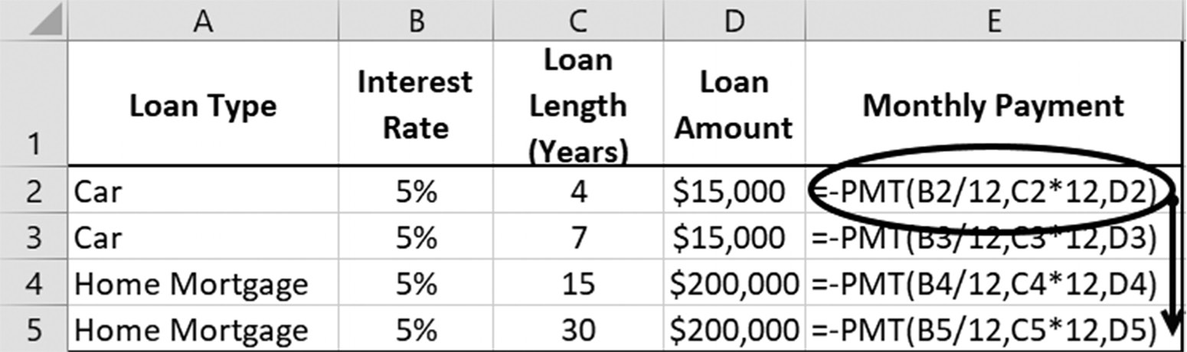

Figure 3.11 The data and formulas used to produce Figure 3.10

The PMT( ) function requires three parameters: the monthly interest rate, the length
of the loan in months, and the amount of the loan. For the spreadsheet shown in Fig-
ure 3.11, the PMT( ) entry in cell E2 is
= −PMT(B2/12, C2 *12, D2)
funCtions and Conditional formattinG 103

Because we are calculating monthly payments, the interest rate and the loan length
used in the PMT( ) function must be in months. If the interest rate is in a yearly
basis, it is necessary to divide the yearly interest rate by 12 to obtain a monthly rate.
Similarly, if the loan length is in years, then there is a need to multiply the yearly loan
length by 12.
The reason for the negative sign in front of the PMT( ) function has to do with
the convention of money flows. Positive values, such as the amount of the loan, are
considered funds that flow to the borrower. Negative values indicate funds that the
borrower pays; as such, they are considered funds that flow away from the borrower.
Thus, the PMT( ) function will report a negative amount as the monthly payment, be-
cause this is an amount that effectively flows away from the borrower. To counteract
this, the negative sign in front of the PMT( ) function forces the calculated payment
to appear as a positive value.
Note also that once a formula was entered in cell E2, it was then copied down for
cells E3 through E5, as illustrated by the arrow in Figure 3.11.
Calculating Total Interest Paid
It is both instructive and easy to determine the total interest paid on a car loan or
mortgage. The required formula is:
Total Interest Paid = (Monthly payment) *(Loan length in months)
− Original Loan Amount (Eq. 3.1)
For example, as seen in Figure 3.10, the monthly payment for a $200,000, 30-year, 5%
mortgage is $1,073.64. Using Eq. 3.1, the total interest paid on this loan is
Total Interest Paid = ($1,073.64) *(360) − $200,000 = $186,511.57
Thus, after 30 years, when the $200,000 loan has been paid off, an almost equal amount
of $186,511.57 has been paid in interest.
The highlighted columns in Figure 3.12 show the total amount and total interest
paid on each of the loans listed in Figure 3.10. The values for the Total Amounts Paid
that are listed in column F are calculated as follows:
(Monthly payment) *(Loan length in months)
Subtracting each loan’s initial amount from this value, as presented in Eq. 3.1, yields
the Total Interest Paid amounts highlighted in column G in Figure 3.12.
104 exCel BasiCs
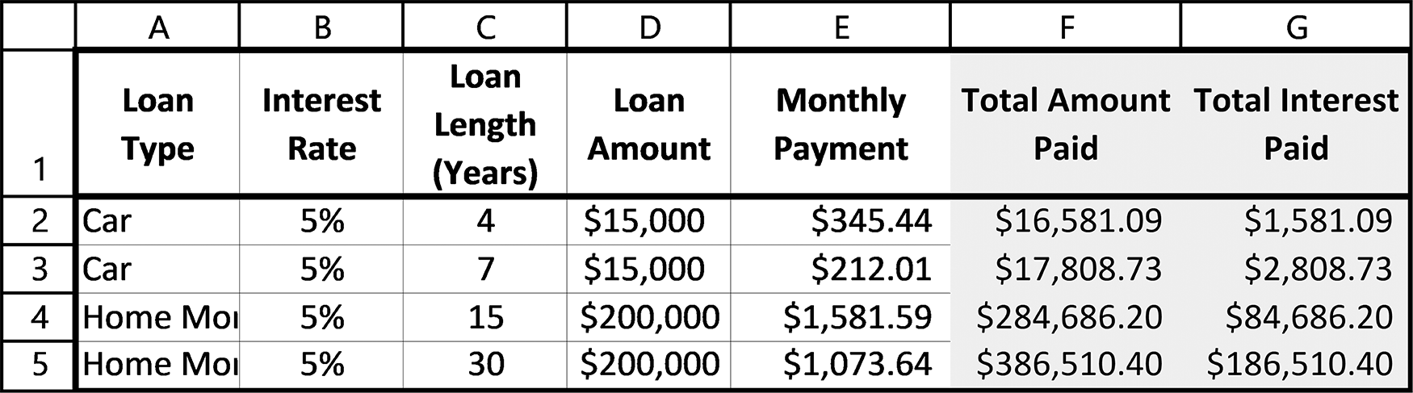

Figure 3.12 The Total Interest Paid for the loans in Figure 3.10

Notice that as the length of a loan is extended, even though the monthly payment
decreases, the total amount and total interest paid are greater for the longer loans
than for the shorter ones. This is because more payments are required for the longer
loans, which results in higher total amounts paid and higher total interest paid over
the life of the loan.
Repayment Schedules: Amortization
The repayment of a loan over time is referred to as amortization (pronounced am-or-
ti-za-tion), and loans paid over time are said to amortized. An amortization schedule
is a table that shows how the loan is being paid down before and after each payment
has been made.
Amortization schedules for car and home mortgage loans provide the monthly pay-
ments, interest paid, and remaining loan balance each month, until the loan is paid
off. Although the monthly payment is the same each month, the dollar amount of
the interest changes each month. The reason is that the interest is calculated on the
remaining loan balance, which decreases each month as the loan is paid. This means
that the dollar amount of the interest also decreases, with the remaining portion of the
monthly payment, which increases, applied to paying off the loan.5
Figure 3.13 provides an amortization schedule for a one-year loan of $1,000 made
at 5% annual interest. The required monthly payment for this loan is $85.61, which
was determined using the PMT( ) function.
In reviewing Figure 3.13, first notice that the highlighted final outstanding balance
at the end of the last column is zero, which means that the loan has been fully repaid.
Next, notice that each payment in the second column is the same monthly payment
of $85.61. This is always true, except possibly for the last payment. The reason for this
is that the last payment is adjusted, if necessary, so that the balance of the loan is zero
when the last payment is made. This can occur because of rounding to the nearest
cent in the calculations of the monthly payment and interim balances.
5 With adjustable-rate mortgages, known as ARMs, the interest rate is only fixed for an initial term, but then fluctuates with market interest rates. This provides an initially lower monthly payment than that of a traditional fixed-rate mortgage, but makes the monthly payments unpredictable after the initial term.
funCtions and Conditional formattinG 105

Notice that the outstanding balance at the end of each month, listed in column F,
is reduced with each payment. This means the interest owed each month, which is
calculated based on the outstanding balance, also declines from payment to payment.
Thus, each month, a larger portion of the monthly payment, the amounts listed in
column E, goes toward paying down the loan. The sum of these interest and principal
amounts for each months equals the monthly payment. For larger mortgages having
a longer life than the one in this example, the amount of the interest paid each pay-
ment, especially in the first few years of the mortgage, is significantly higher. In fact,
for a typical 5-year car loan or 30-year mortgage, the total interest paid can amount to
almost half of the original loan amount (see last section).
Amortization schedules are easy to create using Excel. The relevant formulas used
to create the Figure 3.13’s spreadsheet are shown in Figure 3.14. The formula used to
create Figure 3.13 follows.
The PMT( ) function in cell B4 requires, as has been described previously, three pa-
rameters: the monthly interest rate, the length of the loan in months, and the amount
of the loan. For the spreadsheet shown in Figure 3.11, the PMT( ) entry in cell E2 is
=−PMT(B2/12, C2*12, D2)
Again, as noted previously, the PMT( ) function reports a negative amount as the
monthly payment, because this is an amount that effectively flows away from the bor-
rower. To counteract this, the negative sign in front of the PMT( ) function forces the
calculated payment to appear as a positive value.
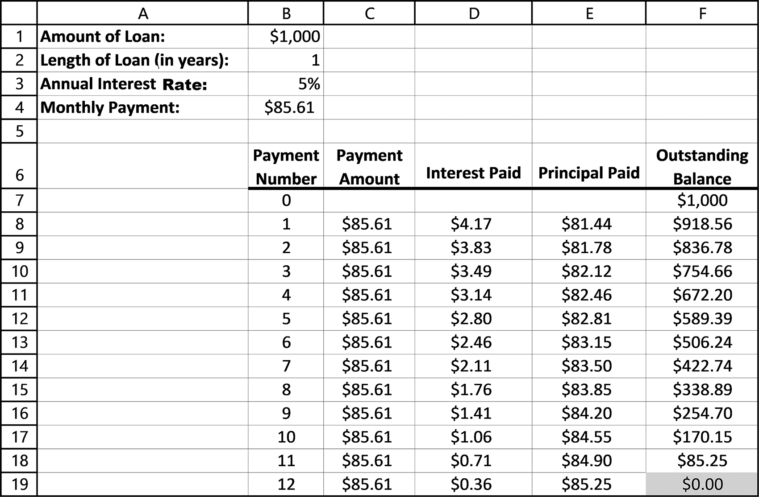

Figure 3.13 Amortization schedule for a 12-month, $1,000 loan at 5% interest 106 exCel BasiCs

The interest due each month is the monthly interest rate times the outstanding bal-
ance. Because this is a 5% annual loan, the monthly interest rate, i, is 0.05/12. Because
the initial outstanding balance is $1,000, the first month’s interest, I1, is calculated as
I1 = (0.05/12) * $1,000 = $4.17
This is the part of the $85.71 payment that is used to pay the first month’s interest on
the loan. Thus, we are left with $85.61 - $4.17 = $81.44 as the payment that is applied
to the loan itself. This leaves an outstanding balance at the end of the first month, P1 of
P1 = $1,000 - $81.44 = $918.56
For the second month the interest is again calculated as the monthly interest rate
times the outstanding balance. Now, however, the outstanding balance is $918.56.
Thus,
I2 = (0.05/12) * $918.56 = $3.83
and the amount of the payment that is left to paying the loan balance is $85.61 - $3.83 =
$81.78. With this amount applied to the loan, the new outstanding balance at the end
of the second month is
P2 = $918.56 - $81.78 = $836.78
Continuing in this manner, the complete amortization schedule shown in Figure 3.13
in Table 3.5 is generated.
Note also that once the formulas have been placed in Row 8, they can be copied
down to the end of the spread sheet, as shown by the arrowed lines in Figure 3.14. The
dashed lines illustrate the data provided by the input section of the spreadsheet. Be-
cause the initial amount in cell B1 is only used once in the main body of the spreadsheet
and is not copied, an absolute address is not required in cell F7 (see third dashed line).
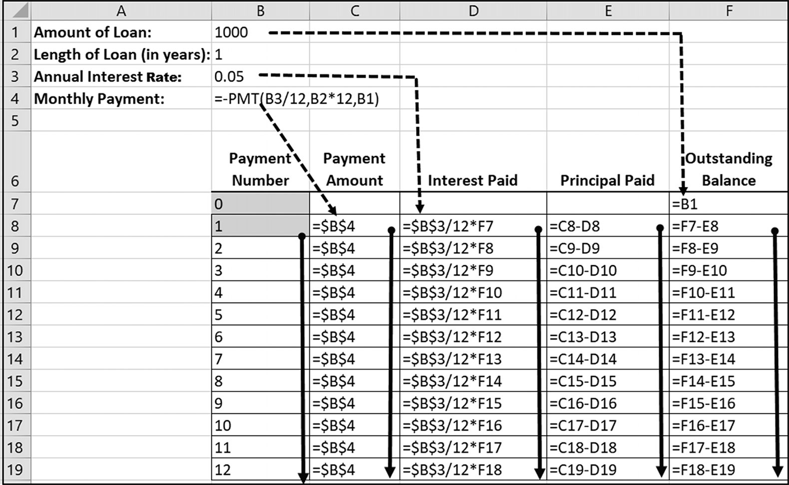

Figure 3.14 Amortization schedule
funCtions and Conditional formattinG 107

EXERCISES 3.3

1. Using Excel’s PMT( ) function, determine the monthly payment for a 30-year,
$36,000 mortgage, having a 4% annual interest rate.
2. Using Excel’s PMT( ) function, determine the monthly payment for a 25-year,
$30,000 mortgage, having an 8% annual interest rate.
3. Determine the total interest paid for the mortgage in Exercise 1.
4. Determine the total interest paid for the mortgage in Exercise 2.
5. Using Excel’s PMT( ) function, determine the sum of the individual interest pay-
ments in column D of Figure 3.10 and then verify that this same sum is obtained using the following equation:
Total Interest Paid = (Monthly payment) * (Loan length in months)
− Original Loan Amount
Total Interest Paid
6. Complete parts a-c.
a. Using Excel, create the following spreadsheet.
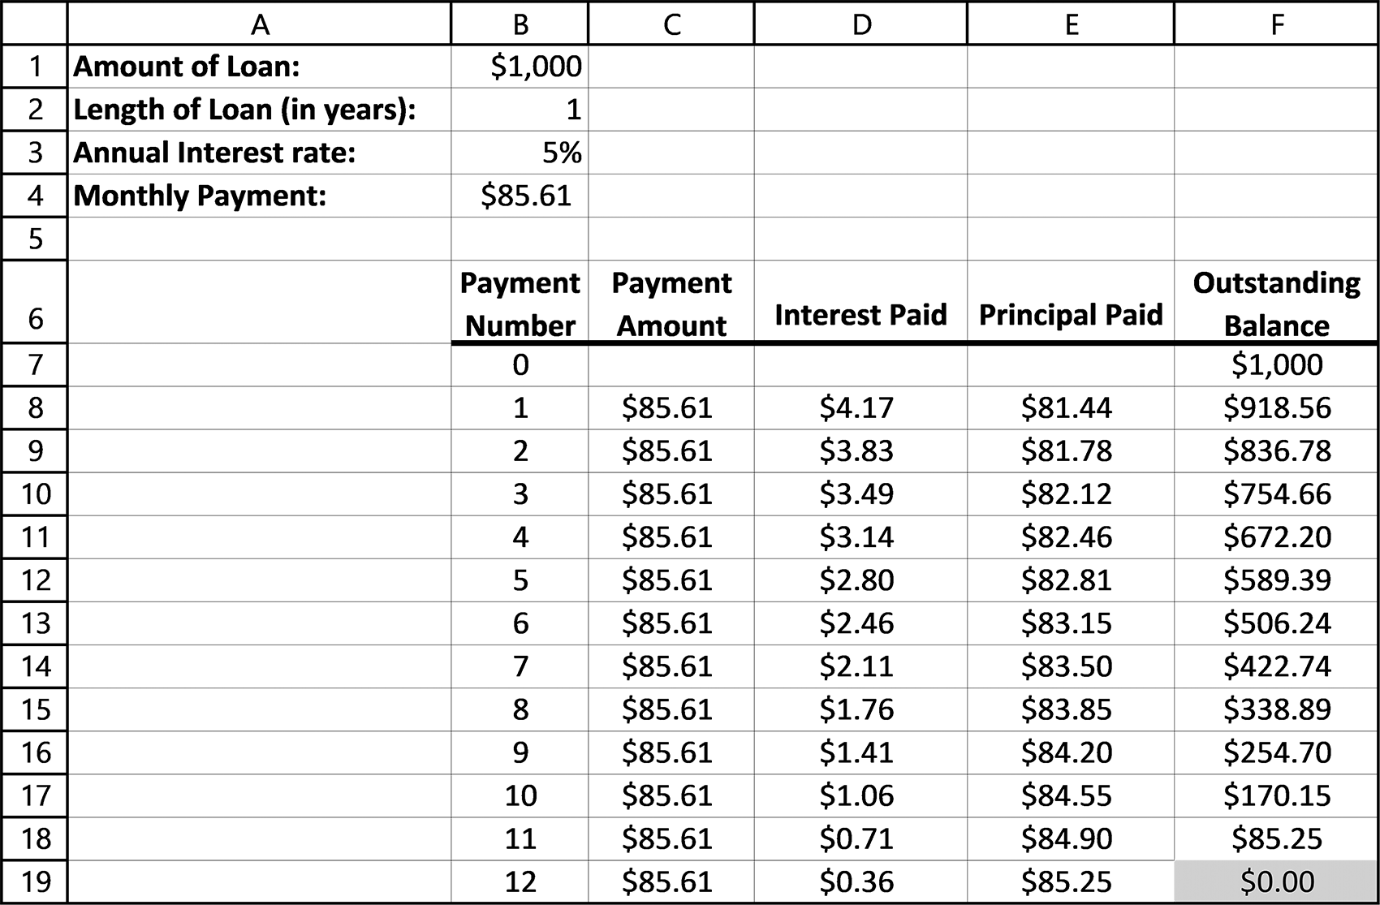

b. Replace the absolute addresses with the relative references in cells C8 and D8,
and then copy the formulas shown in Figure 3.14. Determine why the copied formulas produce incorrect results.
c. Why is an absolute address for cell B1 not needed in cell F7?
108 exCel BasiCs

7. Create an amortization table for a 5-year loan for $20,000 that is to be paid back
monthly at a 5% annual interest rate. The schedule should include totals for the payments, interest paid, and outstanding balance. Use figures 3.13 and 3.14 as a model for your amortization table.
8. Create an amortization table for a 4-year loan for $45,000 that is to be paid back
monthly at a 4% annual interest rate. The schedule should include totals for the payments, interest paid, and principal paid, and outstanding balance. Use figures 3.13 and 3.14 as a model for your amortization table.
9. Create an Excel spreadsheet that calculates the payment and produces the amor-
tization schedule for the mortgage described in Exercise 1 in this section.
10. Create an Excel spreadsheet that calculates the payment and produces the amor-
tization schedule for the mortgage described in Exercise 2 in this section.

3.4 INFORMATION (IS) FUNCTIONS6

Excel provides a set of functions that permit you to determine the data type of a cell’s
contents. All of these functions return either a Boolean value of TRUE or FALSE.
These functions are needed wherever the goal is to test values before they are included
in a formula or function. For instance, you may want to use the =ISBLANK( ) func-
tion in a situation where you want to perform an operation in a cell only if there was a
value there. If not, it would ignore that cell. This would help avoid error messages and
other problems that can develop when the wrong type of data is entered into a cell, in
conjunction with doing some kind of calculation or text manipulation in that cell, for
example. The most commonly used of Excel’s Information (sometimes referred to as
IS) functions are listed in Table 3.17.
Table 3.17 Commonly used Information (IS) functions
Function Description Example
ISBLANK(cell) Returns TRUE if the cell is blank; otherwise, returns FALSE =ISBLANK(A1)
Returns TRUE if the argument is an even number; otherwise, returns
ISEVEN(arg) =ISEVEN(B1)
FALSE. The argument must be numerical.
ISFORMULA(cell) Returns TRUE if the cell contains a formula; otherwise, returns FALSE =ISFORMULA(A1)
Returns TRUE if the argument is a Boolean value; otherwise, returns
ISLOGICAL(arg) =ISLOGICAL(A1)
FALSE
Returns TRUE if the argument is not text (blanks are not text); other-
ISNONTEXT(arg) = ISNONTEXT(A1)
wise returns FALSE
ISNUMBER(arg) Returns TRUE if argument is a number; otherwise, returns FALSE = ISNUMBER(A1)
Returns TRUE if the argument is an odd number; otherwise, returns
ISODD(arg) =ISODD(B1)
FALSE. The argument must be numerical.

6 This topic can be omitted on first reading without loss of subject continuity.
funCtions and Conditional formattinG 109

3.5 CONDITIONAL FORMATTING
Highlighting selected cells based on meeting specific criteria is extremely useful, both
for analysis and presentation purposes. For example, in a sales report, the highlighting
of salespeople who have exceeded their sales goal might be required; in an inventory
report, the highlighting of items that are below a certain quantity may be necessary;
and in a class list the instructor may want to highlight grades that are above and/or
below certain grade levels.
The highlighting of cells, using background cell color and/or font styles and color,
is accomplished by formatting. The selection of which cells to highlight, based on
meeting specified conditions, is accomplished using Excel’s Conditional Formatting
option. This option provides a complete sub-system of choices that permit you to
select (or create your own) criteria, select (or create your own) highlighting formats,
select where the conditional formats should be applied, and then permit you to add
or change any of your individual choices. Additionally, Conditional Formatting pro-
vides other more advanced options, including in-cell bar graphs (data bars), color
scales, and icon sets. In this section, we present the highlighting (Highlight Cells)
option.
Conditional Formatting has as its main the goal the creation of specific rules that
control the formatting of designated cells. This feature is activated by clicking on the
Home tab’s Conditional Formatting icon, as shown as item 1 on Figure 3.15. Although
it is preferable to select the cells you want formatted before clicking on this icon, the
cell selection can be made and changed later.
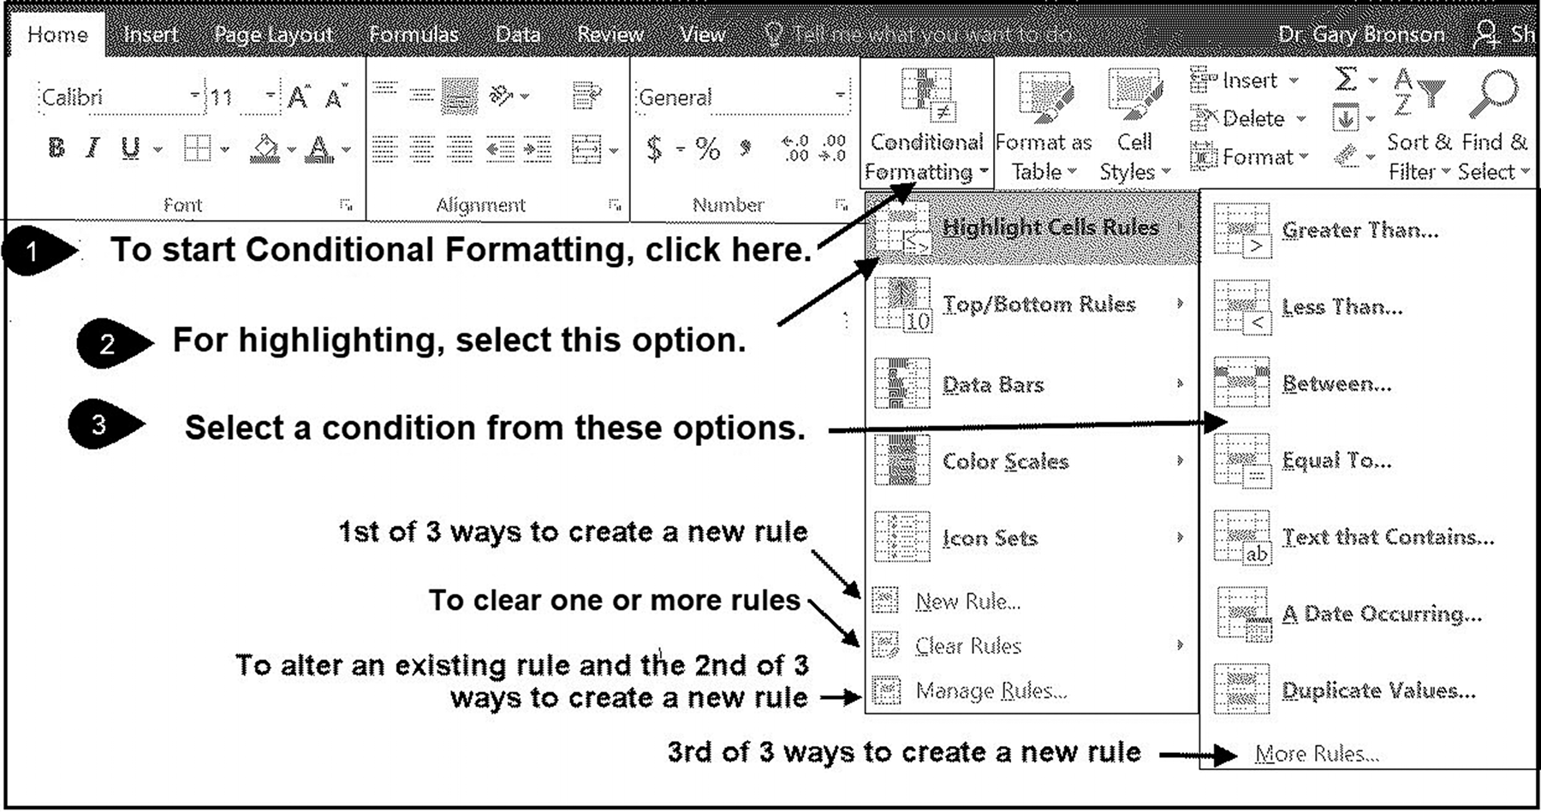

Figure 3.15 Activating Conditional Formatting 110 exCel BasiCs

Application Note
Conditional Formatting Rules
A conditional formatting rule used for highlighting requires three elements:
1. Selecting where the formatting is to be applied 2. A specification of the conditional criteria 3. Applying the format to cells meeting the condition
Each separate area (group of cells being formatted) requires at least one rule. Multiple rules can be applied to the same area. If two separate areas are designated, at least two separate and distinct conditional rules must be constructed.
If more than one rule is specified, they are applied from the last rule entered down to the first rule
entered, with each rule higher on the list having precedence over a rule lower on the list. Another way of saying this is that the last rule entered is placed on the top of the list of rules, and is applied first, and so on, until the first rule entered, which is at the bottom of the list, and is applied last. The rule order can be changed using the Manage Rules option.

When Conditional Formatting is selected, the drop-down menu shown in the figure
appears. In this section, we will choose the first option Highlight Cells Rules, which
is identified as item 2 in Figure 3.15. Selecting this option activates the second drop-
down menu in the figure, from which a condition can be selected (item 3).
Note that the icons shown in this second drop-down menu permit the construction
of simple criteria, such as cells with a value greater than (>) a certain amount, or equal
to a certain amount. Multiple criteria, such as greater than or equal to (>=), can be
created by using the Highlight Cells Rules – More Rules – Format Only Cells
that Contain and selecting compound criteria (such as <= or >=). In particular, the
More Rules option allows you to bypass the default choices in the list and create
more complex conditions. When designating multiple conditions, the conditions are
applied from the condition that was entered last on down to the condition that was
entered first. This means that the last entered condition in the list is has a higher level
of precedence (priority) compared with earlier rules.
The following three steps are those required to use the conditional formatting op-
tions shown in Figure 3.15:
1. Select the cells that are to be formatted.
2. Select one or more criteria (the conditions).
3. Select the highlighting format (how the highlighting should appear).
These three steps constitute a conditional formatting rule, and all three items (which
cells, conditions, and how) must be specified for conditional formatting to take place.
To illustrate how a conditional format rule is created and used in practice, consider
the following example.
funCtions and Conditional formattinG 111

Example 1

Creating a Simple Conditional Formatting Rule
The spreadsheet shown in Figure 3.16 provides a class list with each student’s test
grades and final average grade. Using conditional formatting, we want all final grades
greater than 90 to be highlighted.
Solution:
Step 1: Select the cells. Highlight the cells that are to be conditionally formatted. For
Figure 3.16, this requires highlighting cells F4 through F13.
Step 2: Select the conditions. From the Conditional Formatting Option, select High-
light Cells Rules and then Greater Than, as shown in both Figures 3.16 (see Figure
3.15 for more detail). This activates the Condition and Format dialog shown in Figure
3.17. In this dialog’s Condition box on the left of this dialog, enter the value 90. This
sets the condition that all the selected cells in Step 1 will be checked to see if their
value is greater than 90. The cells that meet the criteria will be formatted as set in the
next step.
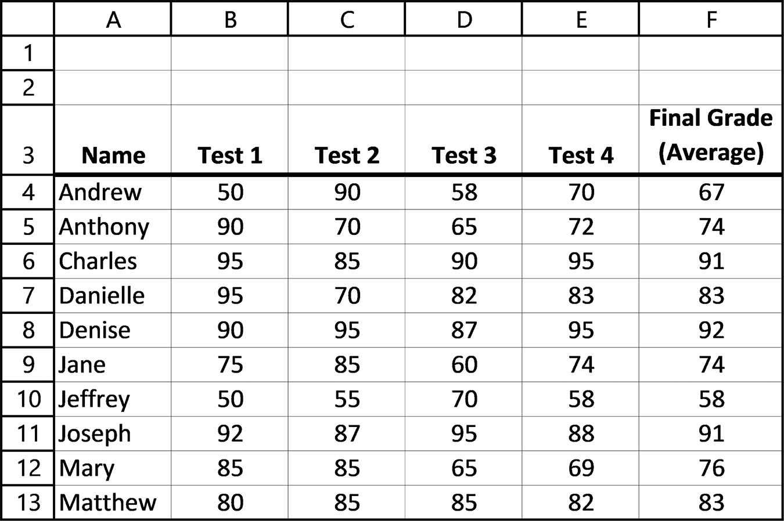

Figure 3.16 Class list and grades
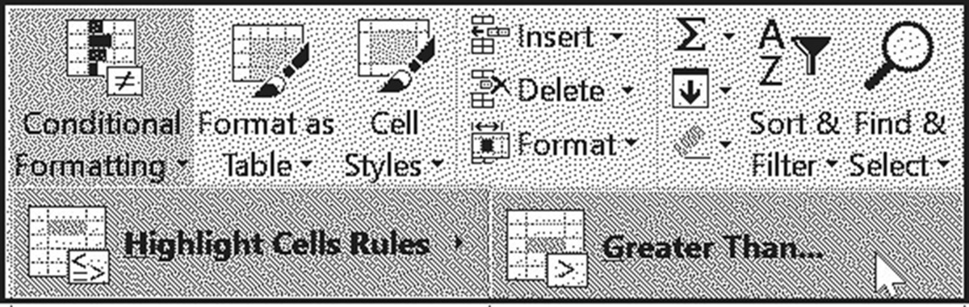

Figure 3.17 Selecting the Greater Than condition 112 exCel BasiCs

Step 3: Select the Format. In the Format box on the right of the Condition and
Dialog box shown in Figure 3.18, either select the default format shown, or click on
the drop-down button to reveal the menu shown in the figure. From this drop-down
menu, either select another default format or select the last option to create your
own format. Clicking on this last option brings up a Format dialog box in which you
can change the font style (bold, italic, or regular), font color, and cell fill color. In this
example, the font style was set as white and bold, and the fill color as dark gray.
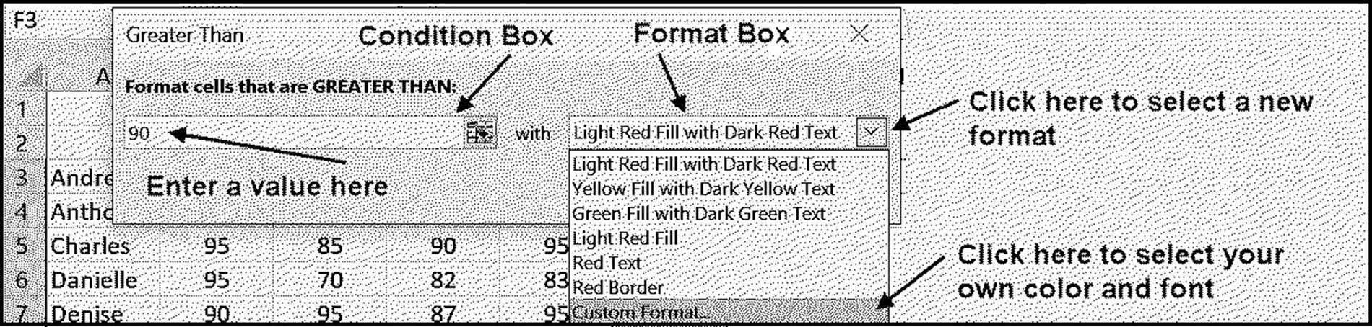

Figure 3.18 The Condition and Format dialog box
For the selections made in Steps 1 and 3,the class list will appear as shown in Figure 3.19.
Notice that the cells in column F that are above 90 have been highlighted as bold
white text on a dark gray background.
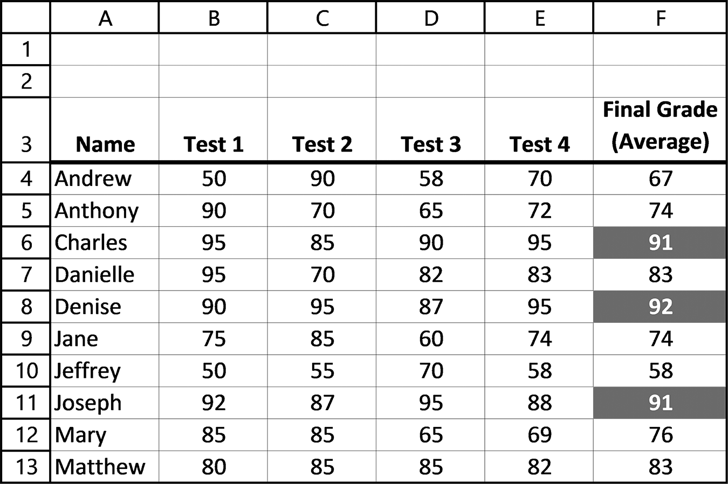

Figure 3.19 The selected and highlighted cells
Changing any or all of the three elements of a conditional formatting rule (cell selec-
tion, criteria, and format) is accomplished by clicking the Manage Rules option in the
first drop-down box activated when the Conditional Formatting icon is selected (see
Figure 3.15).
Selecting this option causes the dialog box shown in Figure 3.20 to appear. From
this dialog box, you can verify and/or change any of the three elements constituting
funCtions and Conditional formattinG 113

your conditional formatting rule. For example, to highlight all test grades above 90,
all that is required is to either click on the Edit Rule… option or directly change the
range currently in the Applies to box in Figure 3.20. To create a second rule, for ex-
ample, including all grades equal to 90, either click on the New Rule… option or click
on the Conditional Formatting icon and follow the sequence you used to create the
greater than condition rule.
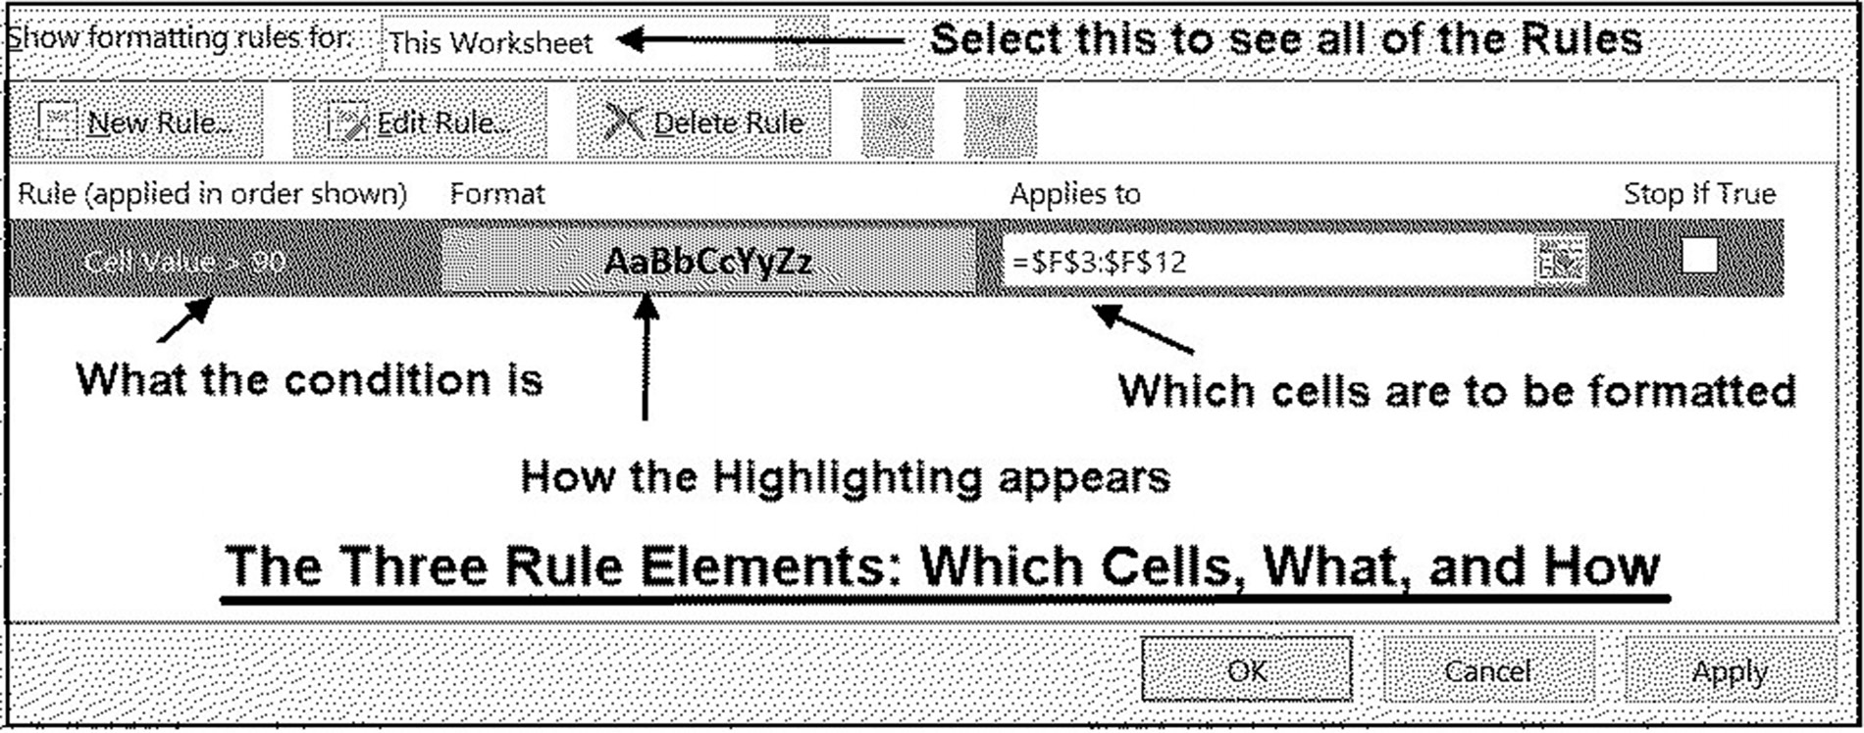

Figure 3.20 The Manage Rules dialog box
Example 2
Creating a User-Entered Conditional Value
In this example, we create a user-entered value for the greater than condition rule
developed in Example 1. Note that cell B1 is used to enter the desired high grade.
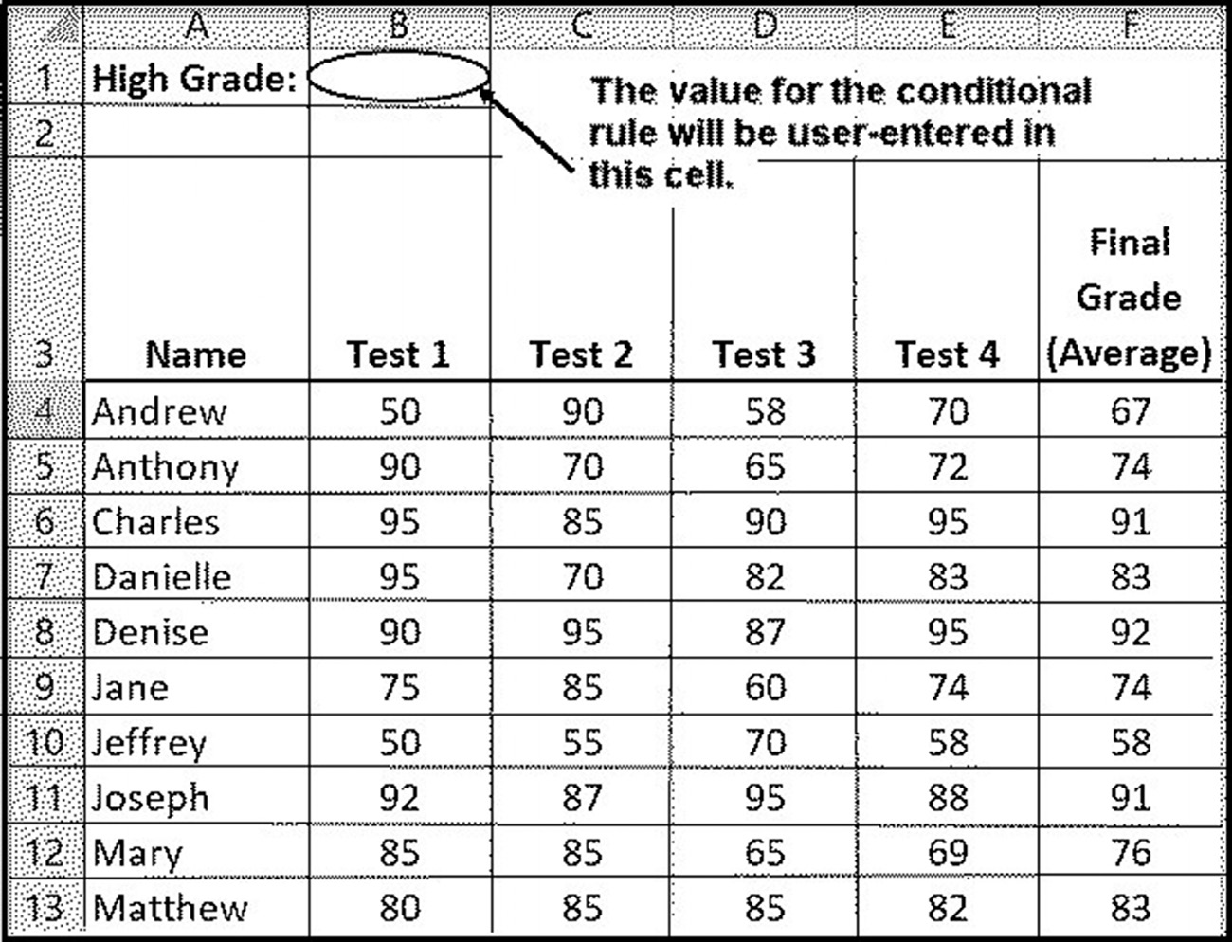

Figure 3.21 Spreadsheet for Example 2
114 exCel BasiCs

To alter the elements of the existing rule created in the previous example, click on the
Manage Rules option from the drop-down menu after selecting Conditional Format-
ting (see Figure 3.15). This brings up the Conditional Formatting Rules Manager
dialog box shown in Figure 3.22.
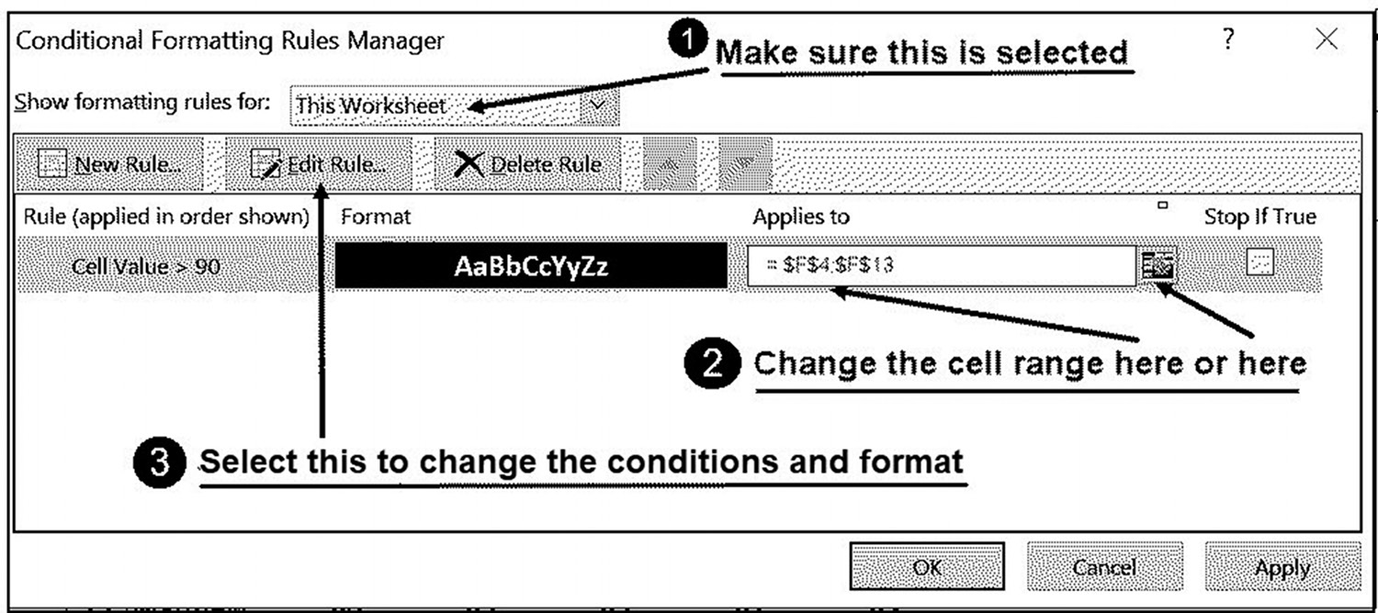

Figure 3.22 Changing the conditions, format, and cell range
Because we want to change the value in the conditional format formula from 90 to
$B$1, the absolute address where the value is to be entered (an absolute address
is necessary because the condition will be copied to each cell in the selected
range), click on the Edit Rule button shown as item 3 in Figure 3.22. This brings up
the dialog box shown in Figure 3.23.

NOTE Changing the selected formatting range can be made directly to the dialog box shown on
Figure 3.22 as item 2; this change cannot be made on the Figure 3.23’s dialog box.
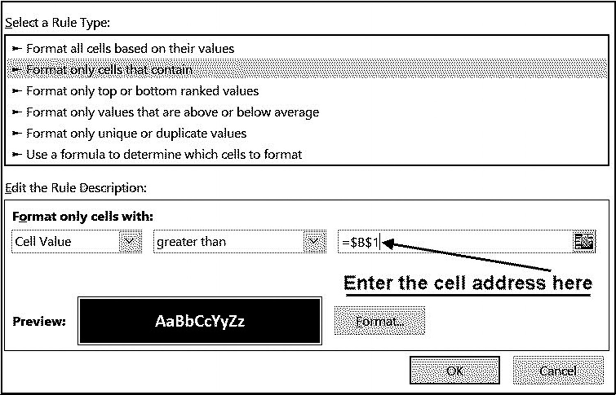

Figure 3.23 Formatting cells with a rule
funCtions and Conditional formattinG 115

Once the changes are made, clicking the OK button completes the desired changes.

Without the = sign, the address $B$1 is considered text, and will be stored surrounded by
NOTE double quotes, as “$B$1.” This will require you to activate the Manage Rules dialog and
delete the quotes.)
When this is completed, the formatted worksheet will appear as shown in Figure 3.24,
where the value 90 has been entered into cell B1.
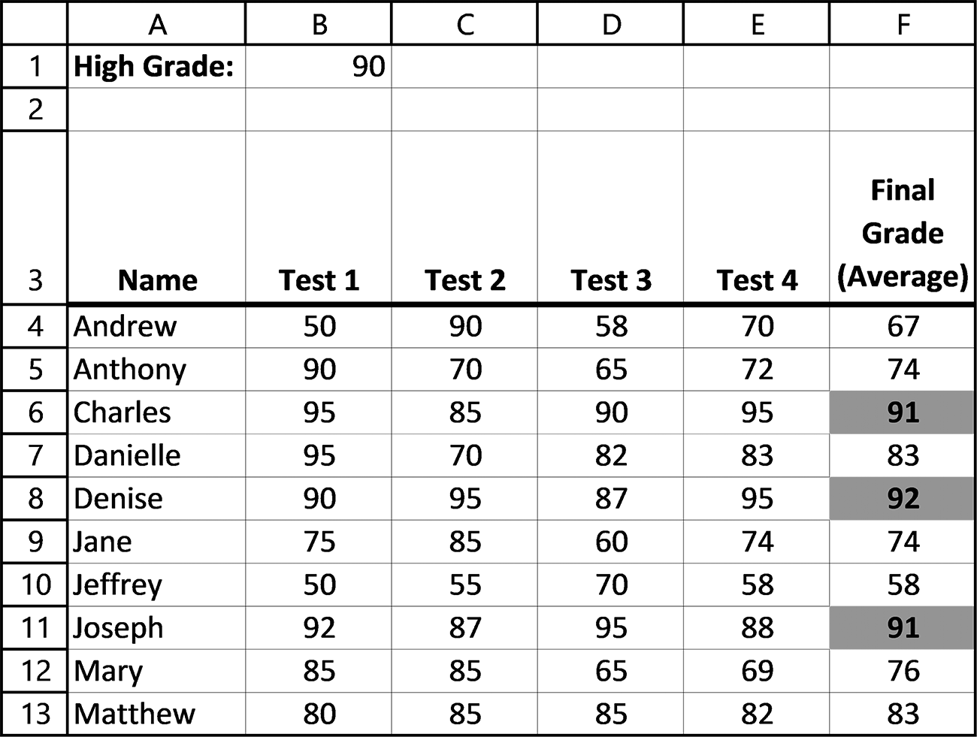

Figure 3.24 The value 90 has been entered into cell B1
116 exCel BasiCs

EXERCISES 3.5

1. Complete parts a and b.
a. List the three items that define a conditional formatting rule.
b. In what order should the three items that you listed be done?
2. Complete parts a and b.
a. Enter the following spreadsheet and conditionally format column F as is done
in Example 1.
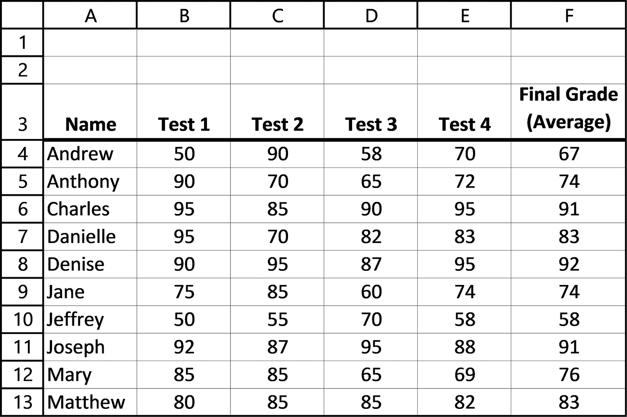

b. Put the label Low Grade: in cell A2. Then add a conditional formatting rule
that highlights all values in column F that are below a user-entered value in cell B2.
3. Complete parts a-c.
a. Enter the spreadsheet shown in Exercise 2a and conditionally format column B
to highlight all Test 1 grades that are above 90.
b. Add a second conditional rule that highlights all cells in column B that are equal
to 90.
c. Expand the selection range for both rules to include cells B4 through F13.
funCtions and Conditional formattinG 117

4. Complete parts a-c.
a. Enter the following spreadsheet and conditionally format column F, using a
user-entered value in cell B1, as is done in Example 2.
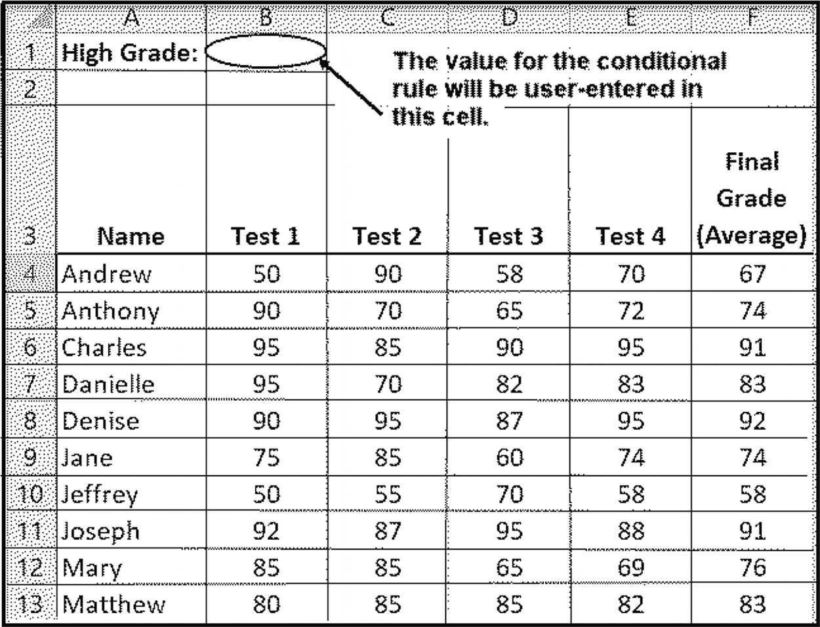

b. Put the label Low Grade: in cell A2. Then add a second conditional formatting
rule that highlights all values in column F that are below a user-entered value in cell B2.
c. Expand the selection range for both rules to include cells B4 through F13.

3.6 COMMON EXCEL ERRORS

The typical errors associated with the functions presented in this section are as follows:
1. Forgetting to use the CLEAN( ) function whenever character and/or text process-
ing functions produce unexpected results.
2. Not distinguishing between the standard deviation functions STD.P( ) and STD.S( ).
The former is used when the standard deviation of a population is required, while the latter provides the standard deviation of a sample from a population. For most situations, unless you know a sample is being used, you should use the STD.P( ) function.
3. Not placing a minus sign in front of the PMT( ) function when a positive payment
value is required.
4. When using the =PMT( ) function, forgetting to divide a yearly interest rate by
12 and/or multiply a yearly loan length by 12 when a monthly payment amount is calculated.
118 exCel BasiCs

5. Forgetting to make the payments and interest rates absolute cell addresses when
creating a loan repayment schedule.

3.7 CHAPTER APPENDIX: TRANSFERRING DATA
BETWEEN SHEETS
In applications that use more than one sheet, it is frequently necessary to transfer one
or more values from one sheet into a second sheet. This is known as consolidation, and
is accomplished by using the general formula
=SheetName-or-Num!cell-address
Unlike the standard cell reference, a consolidation reference (following the =) has as
its elements the worksheet name or number, followed by the “!” symbol, then the cell
address or range of the desired cells. As a specific example, consider Figures 3.25a
and b, which show the values and contents of a spreadsheet that resides in sheet 1.
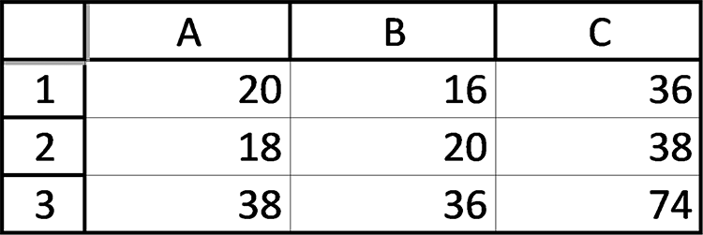

Figure 3.25a Cell values in Sheet 1’s spreadsheet
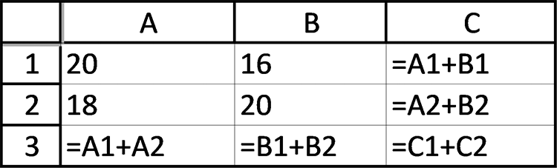

Figure 3.25b Cell contents in Sheet 1’s spreadsheet

Now, assume that the sum in cell C3 shown in Figure 3.25a is required in Sheet 2. For
purposes of illustration, assume that the value needs to appear in cell M10 in Sheet
2’s spreadsheet.
Placing the formula =sheet1!C3 into cell M10 within Sheet 2’s spreadsheet will
cause the value in cell C3 on Sheet 1 to also be placed into cell M10 on Sheet 2. This
placement is both dynamic and one-way.
That is, if the value in cell C3 on Sheet 1 changes, the new value will automatically
appear in cell M10 on Sheet 2. It does not matter if the new value in C3 is caused by
entering a new value directly or is derived from the formula currently in cell C3.
Clearly, this is a one-way transfer from Sheet 1 to Sheet 2. Any change in the con-
tents of cell M10 will not be transferred back to Sheet 1. In fact, the specific transfer
from Sheet 1 to Sheet 2 will be broken if any changes are made to the contents of cell
M10, because a change in contents will replace the formula that causes the transfer
to take place.
C H A P T E R 4
seleCtion

This Chapter Contains
4.1 Relational Expressions
4.2 The IF( ) Function
4.3 The VLOOKUP( ) Function
4.4 The HLOOKUP( ) Function
4.5 Common Excel Errors
4.6 Chapter Appendix: Testing, and Debugging

Besides providing the ability to perform mathematical operations on data and deter-
mine simple statistical operations, what makes Excel so powerful is its ability to
●● Select alternative operations based on individual data values ●● Visually display data using charts and graphs
●● Organize specific results using summary tables ●● Organize and search data using database capabilities
This chapter presents the first item in this list, Excel’s selection capabilities. This capa-
bility permits a formula in a cell to select the operation that will be performed and
the resulting value displayed in the cell, based on the outcome of a comparison. The
remaining three topics in the list are presented in the following three chapters. As
selection requires choosing between alternatives, we begin this chapter with a descrip-
tion of Excel’s selection criteria.

4.1 RELATIONAL EXPRESSIONS
Besides providing addition, subtraction, multiplication, and division capabilities, Excel
provides the ability to compare quantities. Because many seemingly “intelligent” deci-
sion-making situations can be reduced to the level of choosing between two quanti-
ties, this comparison capability can be used to create a remarkable array of intelligent 120 exCel BasiCs

decisions. Some examples of this are providing a discount on a sales amount only if a
person’s age is 60 or above, or calculating an area only if all measurements are positive,
or printing a letter grade depending on the grade’s numerical value.
The expressions used to compare quantities are called relational expressions. A simple
relational expression consists of a relational operator connecting two operands, as
shown in Figure 4.1. Each operand can be a cell address, number, or any valid Excel
expression. However, the relational operators must be one of those listed in Table 4.1.
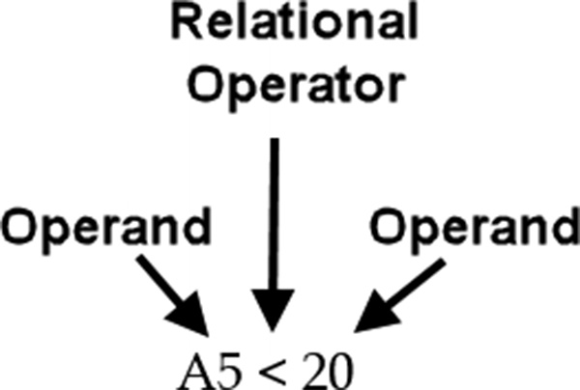

Figure 4.1 Anatomy of a simple relational expression

Table 4.1 Excel’s relational operators
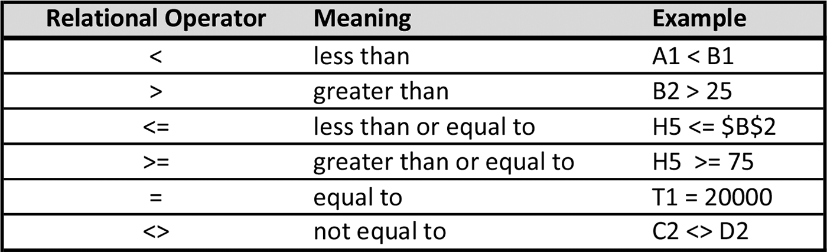

The relational operators listed in Table 4.1 may be used with numbers, dates, and
text, either as the contents of a cell or as an explicit value, but must be typed exactly
as shown. Thus, the following examples are all valid:
A2 > 65 C2 = $B$2 3 < 5 95 > G1 L2 <= 50 F4 = 1
The following are not valid:
A5 =< B5 (operator out of order) C10 << 20 (invalid operator) T6 < = 98.6 (space not allowed between < and =)
Relational expressions are commonly referred to as conditions, and we will use both
terms interchangeably. Like all Excel expressions, relational expressions are evaluated
to yield a result. In the case of relational expressions, the value can only be evaluated
as TRUE or FALSE. These are formally known as Boolean values, where a TRUE
seleCtion 121

value corresponds to “Yes, the condition is met,” and a FALSE value corresponds to
“No, the condition is not met.”1
In addition to numerical operands, character data can also be compared using re-
lational operators. In Excel, which uses Unicode, the letter A is stored using a lower
numerical value than the letter B, the numerical storage code for a B is lower in value
than the code for a C and so on2. Additionally, all of the lowercase letters have a higher
numerical code than the uppercase letters. This means that, in alphabetical order,
lowercase letters appear after the uppercase letters., Examples of relational expres-
sions using characters and their resulting Boolean values are3
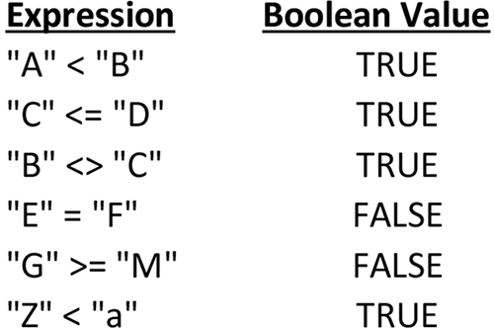

When longer text data is compared, individual characters are evaluated a pair at a
time (both first characters, then both second characters, and so on). If no differences
are found, the texts are equal; if a difference is found, the text with the first lower
character is considered the smaller text. Thus, “Hello” is greater than “Good Bye”
because the first H in “Hello” is greater than the first G in “Good Bye.” “Hello” is less
than “hello” because the first H in “Hello” is less than the first h in “hello.” “SMITH”
is greater than “JONES” because the first S in “SMITH” is greater than the first J in
“JONES.”
Relational operators have a hierarchy of execution and associativity similar to that
of the arithmetic operators. Table 4.2 lists the operators in order of precedence in
relation to the other operators we have used. The operator with the highest prece-
dence is at the top of the table, and the operator with the lowest precedence is at
the bottom.
Table 4.2 Excel operators listed from highest precedence to lowest precedence
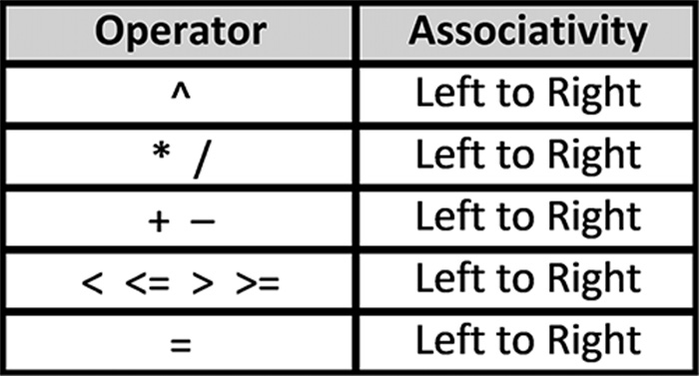

1 Internally, a TRUE value is stored as the integer 1 and a FALSE value as the number 0. 2 The numeric codes used to store characters can be found in Appendix A. 3 To yield a result, the expression must be entered in a cell as a formula, such as, =”A” > “C”. Otherwise, it will appear as text, just like any other label.
122 exCel BasiCs

The examples listed in Table 4.3 illustrate the use of precedence and associativity
to evaluate more involved relational expressions, and the results of each comparison
assuming cell A1 contains a 5, cell B1 contains a 7, and cell C1 contains a 12.
Table 4.3 Examples of Relational Expressions
Relational Expression Equivalent Expression Value
A1 + 2 = C1 – 1 (A1 + 2 )= (C1 – 1) FALSE 3 * A1 – B1 < 22 ( (3 * A1) – B1 ) < 22 TRUE A1 + 2 * B1 > C1 (A1 +( 2 * B1) ) > C1 TRUE C1 + 3 <= -B1 + 3 + A1 (C1 + 3) <= ( ( -B1) + (3 + A1) ) FALSE

As with all expressions, parentheses can be used to alter the assigned operator priority
and improve the readability of relational expressions. Expressions within parentheses
are evaluated starting with the innermost set of parentheses and working toward the
outer parentheses.
Logical Functions4
In addition to using relational expressions as conditions, more complex conditions can
be created using the logical functions AND( ), OR( ), XOR( ), and NOT( ). Note that
these are functions that require arguments, and not operators that appear between
two operands.
When the AND( ) function is used with two simple expressions, the function re-
turns a value of TRUE only if both single expressions are true by themselves.5 Thus,
the formula
=AND(A1 > 40, T2 < 10)
returns TRUE only if the contents of cell A1 is greater than 40 and the contents of cell
T2 is less than 10.
The logical OR( ) function also requires two or more expressions as arguments.6
The function returns a value of TRUE when either one or more of its arguments are
true by themselves. Thus, the formula
=OR(B1 > 40, B2 < 10)
returns TRUE if either the value in cell B1 is greater than 40, the value in cell B2 is
less than 10, or both conditions are TRUE.

4 This topic can be omitted without loss of subject continuity. 5 The AND( ) function can take up to 255 arguments; to return TRUE, each individual argument must be TRUE; otherwise, the function returns FALSE.
6 The OR( ) function can take up to 255 arguments; to return TRUE, only one of the individual arguments must be TRUE; otherwise, the function returns FALSE.
seleCtion 123

The XOR( ) function only returns TRUE if an odd number of its conditions are
TRUE; otherwise, it returns FALSE.
The last logical function, NOT( ), is used to change a single condition to its opposite
state; that is, if its argument is FALSE to begin with the function returns TRUE; if its
argument is TRUE to begin with, the function returns FALSE.

EXERCISES 4.1

1. Write relational expressions to express the following conditions:
a. a person’s age, which is located in cell A2, is equal to 20.
b. a person’s height, which is located in cell B2, is less than 6 feet.
c. a person’s temperature, which is located in cell C2, is greater than 98.6.
d. a letter, located in cell D2, is “m”.
2. Determine whether the following relational expressions are TRUE or FALSE, for
the cell contents shown in Figure 4.2:
a. A1 = 4
b. A1 <= 6
c. D1 <= 4
d. A1 = D1
e. B1 <= C1
f. B1 = C1
3. Determine whether the following relational expressions are TRUE or FALSE, for
the cell contents shown in Figure 4.2:
a. B1 * D1 < A1 * C1
b. C1/B1 > D1/A1
c. D1-C1 > C1/B1
d. A1*B1*2 = C1 *D1
e. A1*B1*C1*D1 > 200
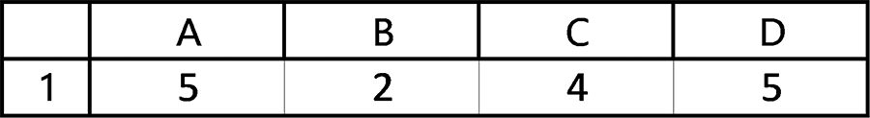

Figure 4.2 Spreadsheet for Exercise 2 and Exercise 3
124 exCel BasiCs

4. Write AND( ) functions to express the following conditions:
a. a person’s age, located in cell A2, is equal to 25 and the person’s height, located
in cell B2, is taller than 6 feet.
b. a person’s age, located in cell A2, is greater than 20 and they have been employed
at the company, located in cell B2, for more than 5 years.
c. a person’s identification number, located in cell F3, is less than 500 and the per-
son’s age, located in cell G3, is less than 25.
d. a rectangle’s length, located in cell H5, and its width, located in cell I5, are both
positive.
5. Determine whether the following relational expressions are TRUE or FALSE, for
the cell contents shown in Figure 4.3:
a. AND(B1 = 4, C1 = 2)
b. AND(A1 = 3, D1 <= 8)
c. AND(B1 = 4, C1 < 2)
d. AND(B1*C1 > 5, D1 < 6)
e. AND(B1*C1 > 5, B1*D1 < 7)
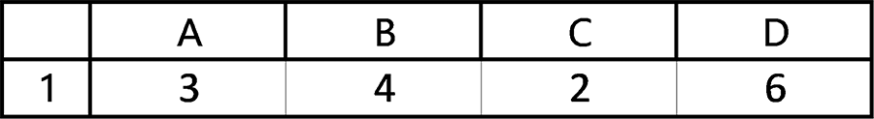

Figure 4.3 Spreadsheet for Exercise 5
6. Determine whether the following relational expressions are TRUE or FALSE, for
the cell contents shown in Figure 4.3:
a. OR(B1 = 3, C1 = 2)
b. OR(A1 = 3, D1 <= 8)
c. OR(B1 = 4, C1 < 2)
d. OR(B1*C1 > 5, D1 < 6)
e. OR(B1*C1 < 5, B1 *D1 < 7)
7. Write OR( ) functions to express the following conditions:
a. a person’s age, located in cell A2, is less than 25 or the person’s height, located
in cell B2, is taller than 6 feet.
b. a person’s age, located in cell A2, is greater than 20 or they have been employed
at the company, located in cell B2, for more than 5 years.
seleCtion 125

c. a person’s identification number, located in cell F3, is less than 500 or the per-
son’s age, located in cell G3, is less than 25.
d. the length of a fence, located in cell M3, is greater than 2 and less than 10 feet.

4.2 THE IF( ) FUNCTION

The IF( ) function directs Excel to select a value based on the result of a compari-
son. For example, in a particular Pass/Fail course, a passing grade is assigned to any
numerical grade greater than or equal to 65; otherwise, a failing grade is assigned.
The IF( ) function can be used in this situation to determine the final grade based on
whether the numerical grade is greater than or equal to 65. The general form of the
IF( ) function, used within a formula is
= IF(condition, value-1 , value-2 )

First: The condition is evaluated.

Second: This value is used when This value is used when
the condition is TRUE. the condition is FALSE.
The condition (sometimes known as a conditional test) is evaluated first. If the condi-
tion is TRUE, value-1 is displayed in the cell using the IF( ) function. If the condition
is FALSE, value-2 is displayed in the cell. Both value-1 and value-2 can be a number,
text, an expression, or a function. If an expression or function is used for these values,
they will be evaluated to yield a single value.
Note that when an IF( ) function is used by itself, it must be preceded by an equal
sign. (This may not be true when an IF( ) function is used as an argument within an-
other function or as a part of a larger expression.)
Example 1
Selecting a Text Value
Consider Figure 4.4a, which contains a list of final grade averages of the first five stu-
dents from a much larger list. A “Pass” grade is to be assigned for each final average
equal to or above 65; otherwise the grade is “Fail.”
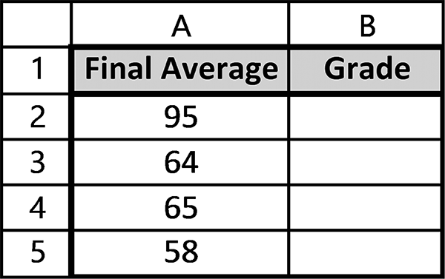

Figure 4.4a Spreadsheet for Example 1
126 exCel BasiCs

Solution: The IF( ) function, used within the formula shown in cell B2 (see Figure
4.4b) determines the correct grade (“Pass” or “Fail”). The grade is displayed in cell
B2, based on the numerical grade listed in cell A2. Here we have used the relational
operator >= to represent the condition “greater than or equal to.” If the grade in cell
A2 is greater than or equal to 65, the text string “Pass” is displayed in cell B2; other-
wise, the text string “Fail” is displayed. Note that text values used as arguments to the
IF( ) function must be included within double quotes.7
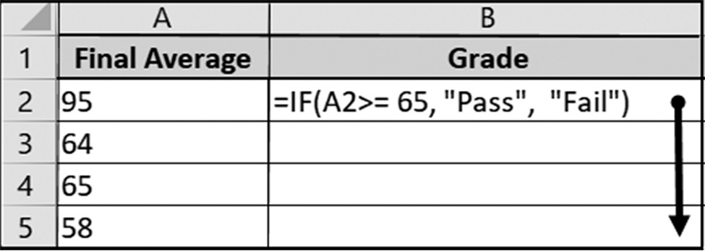

Figure 4.4b Pass and Fail appear in quotes

When the formula in cell B2 is copied down through cell B5, the following spread-
sheet is displayed:
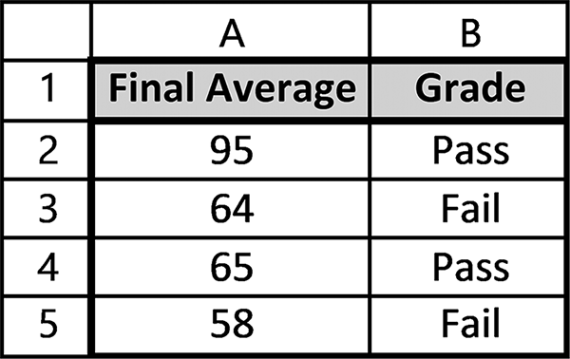

Figure 4.4c Spreadsheet showing Pass/Fail grades

The advantage of using an IF( ) function here is that a Pass/Fail determination is auto-
matically made once a grade is entered into column A. If a numerical grade changes,
the Pass/Fail determination is automatically updated. Additionally, only one formula
was entered and copied down for as many grades needed.

7 As noted previously, text that is used within an expression or as a function argument must be enclosed in double quotes. Text entered into a cell as a label or data should not be enclosed in double quotes.
seleCtion 127

Example 2
Selecting a Numeric Value
Consider Figure 4.5a, which is a partial list of people’s ages. Here, anyone 62 or older
is to be assigned a 10% discount, while anyone younger is assigned a 5% discount.
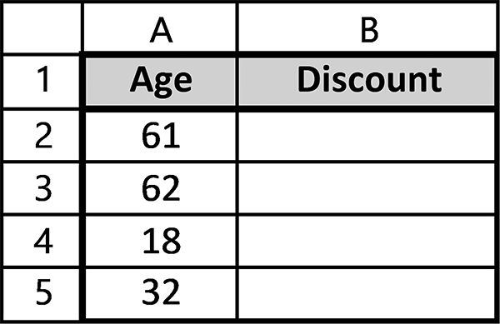

Figure 4.5a Spreadsheet for Example 2

Solution: The IF( ) function, used within the formula shown in cell B2 (see Figure
4.5b) determines the correct discount (10% or 5%) for the age listed in cell A2. Here,
we have again used the relational operator >= to represent the condition “greater than
or equal to.” If this age is greater than or equal to 62, the 10% value is displayed in cell
B2; otherwise, the 5% value is displayed.
Again, the advantage of using an IF( ) function is that should an age change, the
correct discount is automatically assigned. More importantly, however, is that only one
formula need be entered and then copied for as many additional cells as needed.
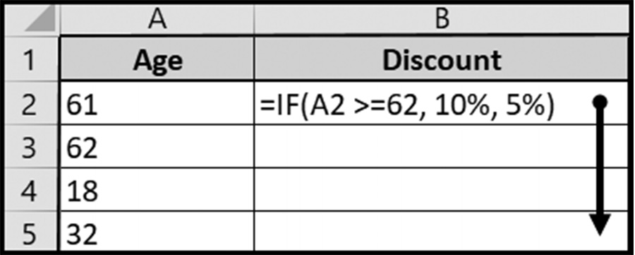

Figure 4.5b Copying the discount =IF function down

Copying cell B2’s formula down through cell B5 produces the spreadsheet display
shown in Figure 4.5c.
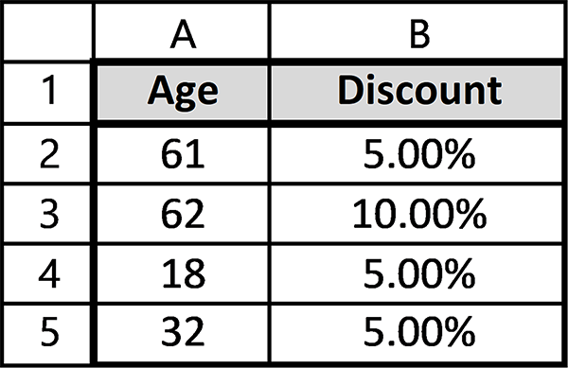

Figure 4.5c Results after applying the discount formula 128 exCel BasiCs

Unlike text, cell addresses and numbers used within the IF( ) function must not be
surrounded by quotes or contain commas; commas are used to separate the three
arguments within the IF( ) function.
In addition to using text or numeric values as IF( ) function arguments, as in the last
two examples, any expression or function that yields a value can also be used, as seen
in the next example.

Example 3
Selecting a Calculation
The personal state income tax levied in New Jersey depends on a person’s income as
follows:
If a person’s income is less than or equal to $20,000,then the State Tax is 2% of
income; Otherwise, the State Tax is $400 + 2.5% of income over $20,000.
Because one of two possible calculations must be made depending on a person’s
income, this is ideal for an IF( ) function. To illustrate the selection process in action,
consider Figure 4.6a, which shows a section of a spreadsheet containing NJ incomes
for three individuals.
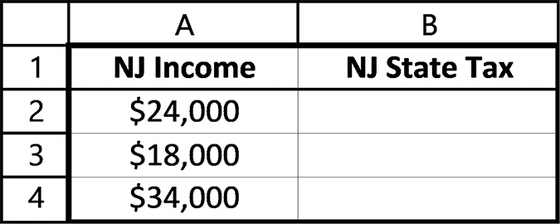

Figure 4.6a A section of a spreadsheet

An appropriate formula for determining the taxes on the income in cell A2 is
=IF(A2 <= 20000 , 0.02*A2, 400 + .025 * (A2–20000) )
Here we have used the relational operator <= to represent the condition “less than or
equal to.” The first argument in this IF( ) function tests the condition A2 <= 20000. If
the value in A2 is less than or equal to 20000, the condition is TRUE. In this case the
computation 0.02*A2, which is the second function argument, is calculated and the
resulting value displayed in cell B2. However, if the condition is FALSE, the expres-
sion 400 + .025 *(A2–20000) is evaluated and its result displayed in cell B2. The quan-
tity (A2–20000) in this calculation is the amount of income that is over the $20,000.
Placing this formula into cell B2 (note that IF can be typed in either uppercase
form, as IF, or lowercase form, as if), and copying the formula into cells B3 and B4
produces the cell formulas shown in Figure 4.6b.
seleCtion 129
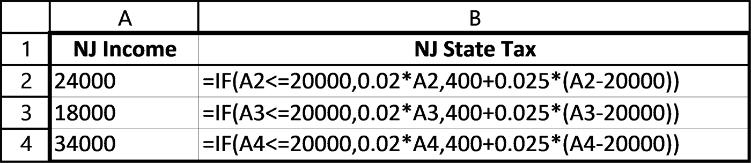

Figure 4.6b The required formulas

The values calculated and displayed by the formulas in Figure 4.6b produces the
spreadsheet display shown in Figure 4.6c.
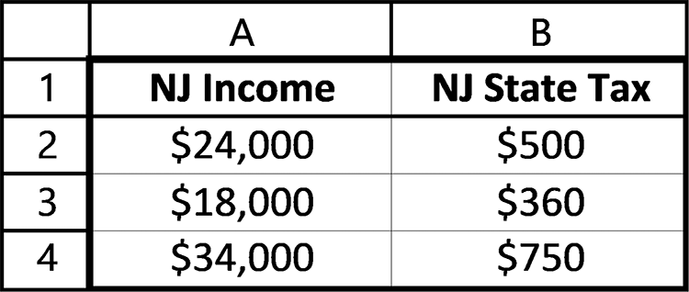

Figure 4.6c The values produced by the IF( ) statements

Because the income values in cells A2 and A4 are above $20,000, the tested condition
for these incomes is FALSE (they are not less than $20,000) and the last IF( ) func-
tion’s argument is computed and the value displayed. In cell B3, the value used in the
condition is less than $20,000, which makes the condition TRUE; thus the state tax is
computed using the expression 0.02 * A3.
Nested IF( ) Functions8
Either or both of the arguments in an IF( ) can also be an IF( ) function. Includ-
ing one or more IF( ) functions as arguments to an IF( ) function is referred to as a
nested IF .
The most useful nested IFs occurs when the nested IF( ) is used as the last IF( )
argument, which takes the form
IF(condition-1, argument-1, IF(condition-2, argument -2, argument-3)
Nested IFs rapidly become cumbersome, with three IFs in one formula usually being
a practical limit however more complex ones are possible and have been used. For
example, the following formula
=IF(C7 >= 90, “A”, IF(C7 >=80,”B”, IF(C7 >=70,”C”,”D”)))
assigns a letter grade of A, B, C, or D depending on the numerical value in cell C7.
Notice that the formula looks rather complicated.
The reason that nested =IF( ) functions are necessary in certain cases, is because
of the fact that the standard function only supports the testing of one condition, and 2
8 This topic can be omitted on first reading without loss of subject continuity.
130 exCel BasiCs

alternate choices based on whether the result is TRUE or FALSE. If more conditions
need to be tested, then one solution is to use nested =IF( ) functions.
In Excel 2019, it is possible to created nested =IFs using the =IFS ( ) function.
This is a function which allows one to create more complex multi-level IF structures
without the need for complex nesting.
While the setup and arrangements are quite different from the =IF ( ), yet another
way to examine multiple conditions is to use the vertical and horizontal lookup func-
tions.
It also should be mentioned that there is another class of functions which may be
confused with the =IF( ) and =IFS( ) functions, which are the Conditional =IF func-
tions. These are especially useful with lists and tables, and will be discussed briefly in
the section on advanced filters, later in this book.
Logical Conditions9
The conditions used in the majority of IF( ) functions are typically relational, using
the relational operators (<, <=, =, >=, and >) to compare operands. However, more
complex conditions can be created using the logical functions AND( ), OR( ), XOR( ),
and NOT( ) presented in the prior section.
For example, in the spreadsheet shown in Figure 4.7, the text “Teenager” is dis-
played in cell B2 if the value in cell A2 is between 13 and 19, inclusive, and the text
“Not a Teenager” is displayed for any other value in A2. This formula can then be
copied down into cells B3 through B5.
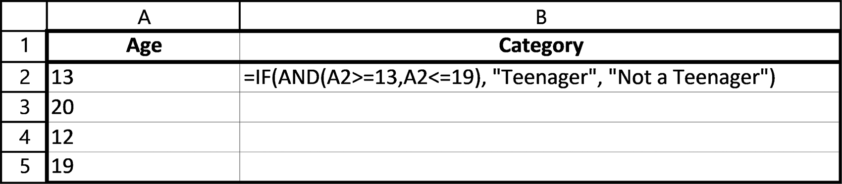

Figure 4.7 “Teenager” and “Not a Teenager” text

EXERCISES 4.2

1. Complete parts a-c.
a. How many arguments are required by an IF( ) function?
b. What must the first argument provided to the IF( ) function be?
c. What do the remaining arguments provide?

9 This topic can be omitted on first reading without loss of subject continuity.
seleCtion 131

2. Complete parts a-b.
a. Enter the data shown in the following spreadsheet (on the left) and add the
appropriate IF( ) functions to produce the spreadsheet results shown in the figure on the right. A “Pass” grade is to be assigned for each final average equal to or above 65; otherwise, the grade is “Fail”.
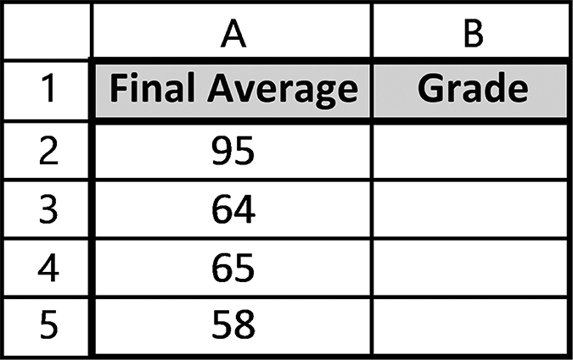

b. Change the IF( ) formula used in Exercise 2a to =IF(A2 < 65, “Fail”, “Pass”).
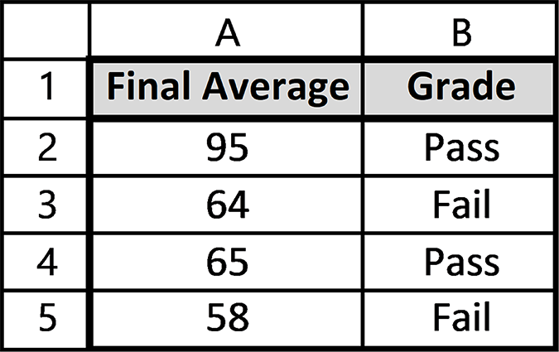
Does this produce the same results?
3. Complete parts a-b.
a. Enter the data shown in the spreadsheet on the left and add the appropriate
IF( ) functions to produce the spreadsheet results shown on the right. Anyone 62 or older is to be assigned a 10% discount, and anyone younger is assigned a 5% discount.
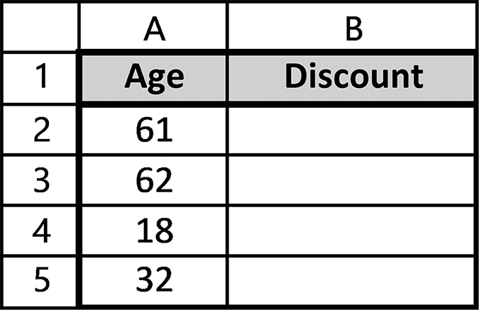

b. Change the IF( ) formula in this problem to =IF(A2 < 62, 5%, 10%). Does this
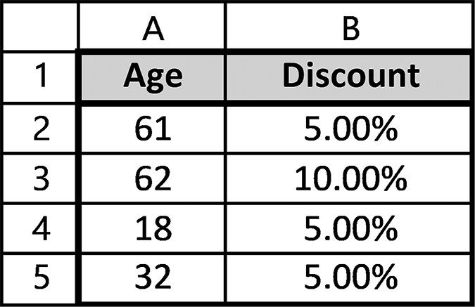
produce the same results as in Exercise 3a?
4. Enter the data shown in the spreadsheet on the left and add the appropriate IF( )
functions to produce the spreadsheet shown in the right. If a person’s income is less than or equal to $20,000, then the State Tax is 2% of the income, otherwise, the State Tax is $400 + 2.5% of the income over $20,000.
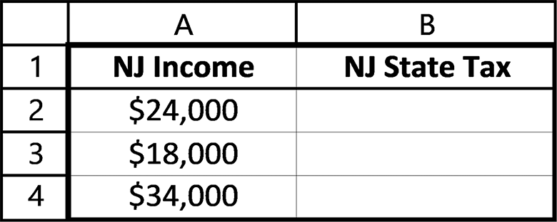
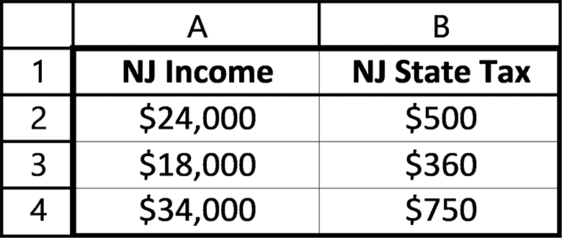
132 exCel BasiCs

5. On a blank worksheet, write IF( ) functions for the following:
a. if the value in cell C1 is 1, display “OKAY,” otherwise, display “NOT OK”
b. if the sum of the values in cells C1 through C4 is equal to 1, display “OKAY,”
otherwise, display “NOT OK”
c. if the value in cell A2 is less than 60, display “PASS,” otherwise, display “Fail”
d. if the value in cell C3 is greater than 5, display the value .045; otherwise, display
the value .035
6. On a blank worksheet, write IF( ) functions for the following:
a. If the character in cell A2 is either an “f” or an “F,” calculate the value of (5/9)
(values in cells B2 –32); otherwise, calculate the value (9/5)(value in cell B2) + 32. (Hint: the condition should check the value UPPER(A2) rather than just the value in A2.)
b. If the value in cell B2 is either an “s” or an “S,” display the value 800; otherwise,
display the value 450. (Hint: the condition should check the value UPPER(B2) rather than just the value in B2.)
7. Write an IF( ) function to calculate the overtime pay for an employee as follows:
If the hours worked, which is located in Cell D5 is greater than 40, the overtime pay is calculated as 1.5 (the value in Cell C5) times (the hours greater than 40); otherwise, the overtime pay is 0. (Hint: the hours greater than 40 is found using the expression (D5 – 40)).
8. Complete the spreadsheet shown below so that all of the ages between 13 and 19,
inclusive, are categorized as “Teenager”; otherwise they should be categorized as “Not a Teenager.”
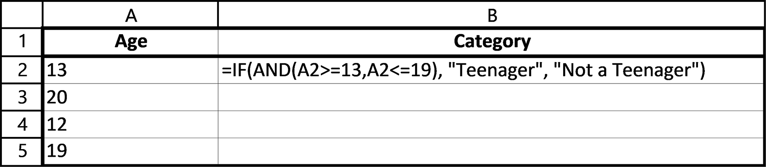

seleCtion 133

4.3 THE VLOOKUP( ) FUNCTION
Whenever a decision is based on one of two possible alternatives, an IF( ) function
should be used. However, when multiple conditions must be evaluated, using mul-
tiple IF( ) statements involving multiple levels of nesting within another can be com-
plex and prone to errors.
For example, although the following IF( ) function can be used to determine a let-
ter grade for the numerical grade contained in cell F4, it should not be used, because
it is overly complicated and not easy to understand10.
=IF(F4 < 60, “F”, IF(F4 < 70, “D”, IF(F4 < 80, “C”, IF(F4 < 90, “B”, “A”))))
or the equivalent using the =IFS( ) function.
The =IFS( ) function (Excel 2019) allows for greater flexibility in terms of doing
multi-level nested conditional tests.
The general form is as follows:
= IFS(logical_test1, Value1 [logical_test2, Value2] …, [logical_test127, Value127])
So
IFS(F4<60,”F”,F4<70,”D”,F4<80,”C”,F4<90, “B”,TRUE, ”A”)
would be the equivalent of the earlier nested function presented. Basically, the condi-
tions to be tested, up to 127, are listed as pairs, first as the conditional test, followed by
the result if TRUE. If the test evaluates to TRUE, the result is displayed. Otherwise,
it proceeds on to the next condition(s) to be tested. If it does not match any of the
other conditions, then the default choice, here listed as TRUE, gives the student the
grade of “A.” The use of this function simplifies the testing for multiple conditions.
However, it is not available in Excel 2016 and earlier versions.
For situations requiring multiple conditions that necessitate more than one IF( )
function as an argument to another IF( ) function, another viable option would be to
use the VLOOKUP( ) and HLOOKUP ( ) functions. The difference is that a VLOOK-
UP( ) function requires a range of cells consisting of at least two columns, referred
to as a vertical lookup table. This kind of lookup table lists items vertically, as the one
shown in Figure 4.8. The HLOOKUP( ) function requires a lookup table that is ori-
ented horizontally, as shown in Figure 4.9.11

10 Excel 2019 permits the nesting of up to 64 IF( ) functions. 11 Although it is formally referred to as a lookup table, this kind of table is just a range of regular spreadsheet cells. The table heading and labels form no part in the actual lookup. They are there for informational purposes only.
134 exCel BasiCs

In the majority of applications, vertical lookup tables predominate. Thus, the
VLOOKUP( ) function, which uses this type of table, tends to be used more than its
HLOOKUP( ) equivalent. The VLOOKUP( ) function is described in this section and
the HLOOKUP( ) function in Section 4.4.
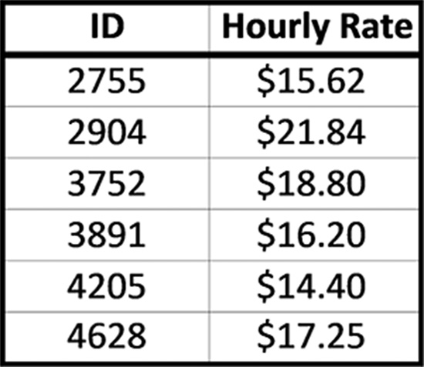

Figure 4.8 A vertical lookup table


Figure 4.9 A horizontal lookup table

The vertical lookup table needed for a VLOOKUP( ) function conceptually resembles
the index in a book.
In a book index, a topic is located in the first column and the corresponding page
number is located next to it, in the second column. As with an index, in a vertical
lookup table, it is only the table’s first column that is searched for a match. This col-
umn must list values that will be “looked up.” This first column can contain names,
ID numbers, or grade values, for example, as listed in Figure 4.8. When labels are
included in a lookup table, as they are in Figure 4.8, the labels are not included in the
search for a match.
Two major differences, however, are that in a book index, the index table is at the
back of the book, and there are only two columns. A vertical lookup table can contain
more than two columns, and its placement can be on any part of a spreadsheet, or
even on a different spreadsheet from the main application. When there are more than
two columns in the lookup table, the data in each row must be related to the item in
the row’s first column, and the table expands downward in the same manner as new
lookup items are inserted or added into the table.
The VLOOKUP( ) function accepts a numeric or text value, such as a numeric code
or name, and uses that value to locate its exact or closest match in the first column
of the lookup table. The value that is being searched for is referred to as the lookup
value. Because the lookup table’s location can be anywhere, its location must also be
provided to the VLOOKUP( ) function. Finally, because the lookup table can contain
more than two columns, the column containing the desired returned value must also
be specified.
seleCtion 135

Application Note
VLOOKUP( ) Alerts
When using VLOOKUP( ), be aware of the following:
1. VLOOKUP( ) is not case sensitive. Thus, if the looked-up value is the word “com-
puter,” a match occurs for “Computer,” “COMPUTER,” or any combination of upper- and lowercase letters in the lookup table’s first column that spell “computer.”
2. VLOOKUP( ) stops looking for a match once a match is found. This can be either
because an exact match was located or an approximate match occurred, and depends on the value of the 4th argument.
3. If the 4th argument is FALSE, an exact match (again, not case-sensitive) stops the
lookup table search, regardless if there is another match later in the table. If the 4th argument is TRUE or omitted, an approximate match stops the search (see the next Application Note for what an approximate match entails.)

As an example, consider the vertical lookup table shown in Figure 4.10. What defines
it as a vertical table is that, like an index, the item being looked for is always and only
looked for in the first column of the table.
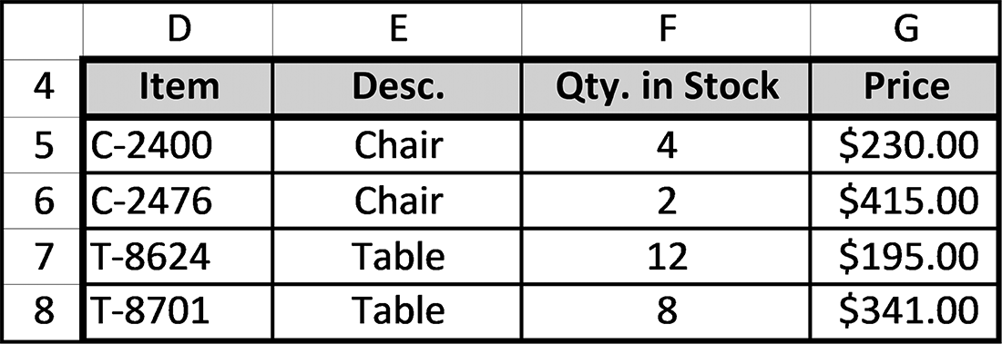

Figure 4.10 An example of a vertical lookup table

The first argument provided to the VLOOKUP( ) function is the value that the lookup
table is searched for to determine if there is a match. In the table shown in Fig-
ure 4.10, it is an item code number that the table will be searched for a match. The
remaining arguments required by the VLOOKUP( ) function tell it where the lookup
table is located, what matching value is to be returned, and whether an exact or closest
match to the lookup value is required.
For example, the table shown in Figure 4.10 is located in the range D5 through
G8. Note that the column labels are not included in the location, because they are
not included in the search. Because a lookup table can be located anywhere within a
spreadsheet, even on a different sheet than the main application, its location must be
provided to the VLOOKUP( ) function, and it is the function’s second argument.
The third argument required by the VLOOKUP( ) function is the column num-
ber of the value to be returned when a match to the looked up value is found.12 For

12 If no match is found, the return value is #N/A, which denotes Not Available.
136 exCel BasiCs

example, if the code T-8624 is searched for in Figure 4.10’s lookup table, a match is
found in cell D7. Now, the corresponding Description, Quantity in Stock, or Price can
be returned, as specified by the third argument. Finally, the last argument specifies
whether an exact or closest match is required. The general syntax of the VLOOKUP( )
function is as follows.
A lookup value or a cell address where the value is located

The location of the lookup table (use absolute addresses)

VLOOKUP( lookup value, table location, return value column, match type)

A number indicating the column of the returned value

Either TRUE (or omitted) for the closest match, or FALSE for an exact match
The return value column can also be referred to as the column index number.

To better understand the arguments required by the VLOOKUP( ) function, consider
the function
=VLOOKUP(A2, $D$5:$G$8, 3, FALSE)
in cell B2 shown in Figure 4.11. Here, the lookup value is located in cell A2, which
is VLOOKUP( )’s first argument. For any data entered into cell A2, the items in the
first column of the lookup table will be automatically searched. VLOOKUP( ) knows
where the table is, because its address, in this case $D$5:$G$8, was provided as the
function’s second argument. Notice that absolute addresses were used to specify the
table’s location. Absolute addresses should always be used in specifying the table’s
location because it ensures that if or when the VLOOKUP( ) formula is copied, the
table’s address will not change.
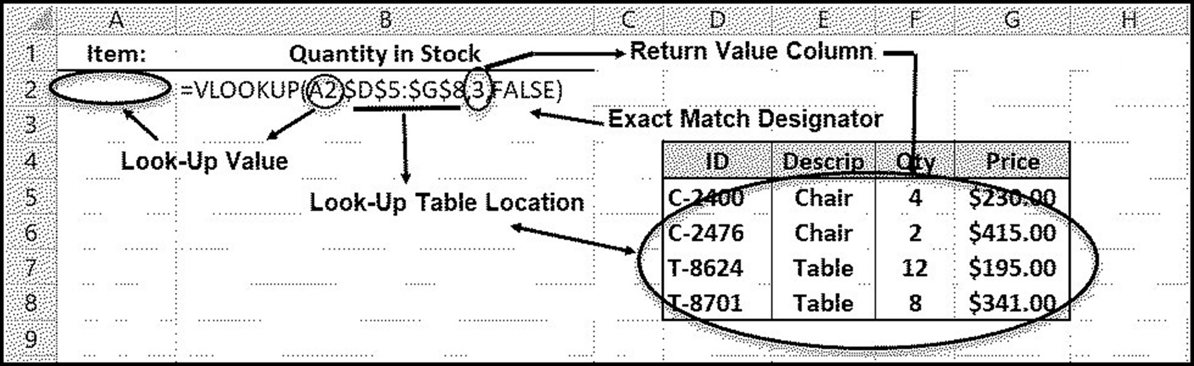

Figure 4.11 VLOOKUP table example
seleCtion 137

The search for a match always and only occurs by comparing the lookup value, pro-
vided by the function’s first argument, to each value in the in the lookup table’s first
column, one item at a time. When a match is found (the type of match is determined
by the function’s 4th argument) the search stops, and the corresponding value in the
column specified by the 3rd argument (which in this example is 3) is returned.
To see how a match is determined, a clear understanding of the function’s 4th argu-
ment is required. The simplest match criterion is provided when this 4th argument
is specified as FALSE. This indicates that an exact match is required, and it is most
useful when ID numbers or name matches are needed. Example 1 illustrates this
criterion.
When a search involves a range of values, such as a commission based on a range
of monthly sales, or postage due on a range of weights, an approximate match, also
referred to as a closest match, should be used. This type of match is selected by either
explicitly specifying the function’s 4th argument as TRUE, or omitting it altogether.
Thus, the default search, when the 4th argument is omitted, is an approximate match.
It is important to realize that this type of match requires that the data in the lookup
table’s first column be in sorted ascending order, from lowest to highest. This is neces-
sary because the search stops once a value greater than the lookup value is encoun-
tered. Example 2 illustrates this criterion.
Example 1
Exact Match
For the function, located in cell B2, determine the following:
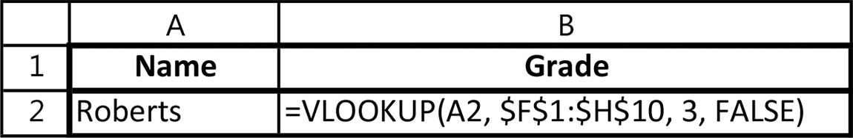

a. the location of the lookup value
b. the lookup value
c. the location of the lookup table
d. the number of columns in the lookup table
e. the lookup table’s column containing the return value, if an exact or “closest-to”
match is specified
f. the cell that displays the return value
Solution:
a. The lookup value is located in cell A2.
b. The lookup value is Roberts.
c. The lookup table is located in cells F1 through H10.
138 exCel BasiCs

d. The lookup table contains three columns (F, G, and H).
e. If a match is found, the return value is in the 3rd column of the table; otherwise,
#N/A is returned.
f. An exact match is specified because the last argument is FALSE.
g. The return value is displayed in cell B2.
Give It a Try
For the function, located in cell D3, determine the following:
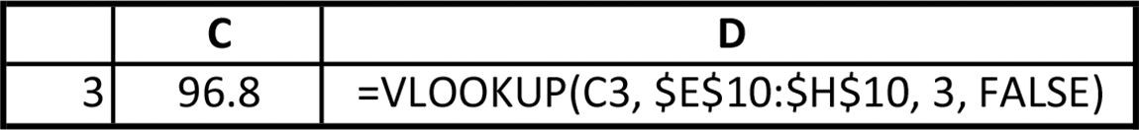

a. the location of the lookup value
b. the lookup value
c. the location of the lookup table
d. the number of columns in the lookup table
e. the lookup table’s column containing the return value, if an exact or “closest-to”
match is specified
f. the cell that displays the return value
Example 2
Approximate (Closest) Match
Consider the student list shown in Figure 4.12a. The lookup table, located in cells I2
through J6, provides the correspondence between the numerical and letter grades. It
is used as follows: a numerical grade starting at 0 and less than 60 corresponds to a
grade of F, grades from 60 to less than 70 correspond to a grade of D, and so on. Here,
the lookup table consists of two columns, which is the minimum number of columns
for a lookup table. Exact matches are not required. This ensures that a grade such as
75, which lies above 70 but below 80, will be assigned a C grade.
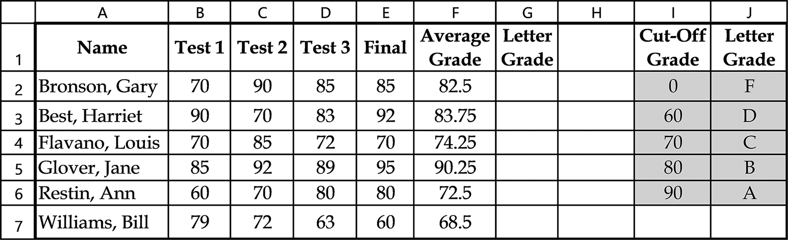

Figure 4.12a The vertical lookup table is located in the range I2 through J6
seleCtion 139

Application Note
A Requirement for Approximate Matches
When VLOOKUP( )’s fourth argument is omitted or explicitly entered as TRUE , a closest, or approximate, match criterion is used. As in an exact match, the lookup value in an approximate match is compared to each value in the lookup table’s first column, starting at the first value.
Unlike an exact match, however, an approximate match means that the search continues down the
first column until either an exact match or a value higher in value than the lookup value is encountered. In this latter case, when a value higher than the lookup value is located, the first column’s prior value is taken to be the matching value. This means that for an approximate search, the following is required:
For an approximate search, which is specified whenever VLOOKUP( )’s fourth argument is TRUE
or omitted, the lookup table’s first column values must be in sorted order, from the lowest to highest values.

Solution: The lookup table in Figure 4.12a consists of the shaded cells contained in
the range I2 through J6. This is a vertical lookup table because items of the same type
are listed vertically; all the cut-off grades (beginning of each letter grade’s range) are
in column I and their corresponding letter grades are in column J.
The letter grade for the numerical grade in cell G2, which is the first cell requiring a
function, is found using
=VLOOKUP(F2, $I$2:$J$6, 2, TRUE)
In this function, the first argument, in this case F2, tells the VLOOKUP( ) function
that it is the value in cell F2 that will be searched for in the lookup table. As with all
vertical lookups, the search for a match is always made with the data in the lookup
table’s first column. It is the second parameter in the VLOOKUP( ) function, which
in this case is $I$2:$J$6, that specifies where the lookup table is located (for conve-
nience, this range of data has been shaded in Figure 4.12a). Absolute addresses are
used to ensure that if or when the function is copied, the designation of the lookup
table’s location will not be changed. Additionally, notice that the table range does not
include the labels above the data.
This function uses cell F2’s value to search through the lookup table’s first column
for the closest match. It is the last parameter in the VLOOKUP( ) function, which in
this case is TRUE, that tells the function that if an exact match is not found in column
one, the closest value in column one that is less than the value that is being looked for
should be selected.13
The value 2, which is VLOOKUP( )’s third parameter in the VLOOKUP( ), tells the
function to return the value in the 2nd column of the table when a match is found.
In this case, the lookup table only has two columns, but in many applications, lookup
13 If this parameter is omitted, a default value of TRUE is used. Because a value of TRUE permits an approximate match that is less than the searched value, this option always requires that the values in the first column are arranged in ascending (lowest to highest order).
140 exCel BasiCs

tables with more than two columns are needed and you may have to return a value
from a column other than the second one.
If an exact match is required, the last argument would be specified as FALSE. In
this case, the values in the first column can be placed in any order, as only an exact
match is permitted. If there are more than one value in the first column that match
the lookup value, the first found match value is used. In both cases, TRUE or FALSE,
if an exact match is not found, an error value of #N/A is returned.
When the function in cell G2 is entered and copied down through cell G7, the
spreadsheet will appear as shown in Figure 4.12b. Because the lookup table’s cell ad-
dresses were written using absolute addresses, each copy of the VLOOKUP( ) func-
tion contains the correct table location.
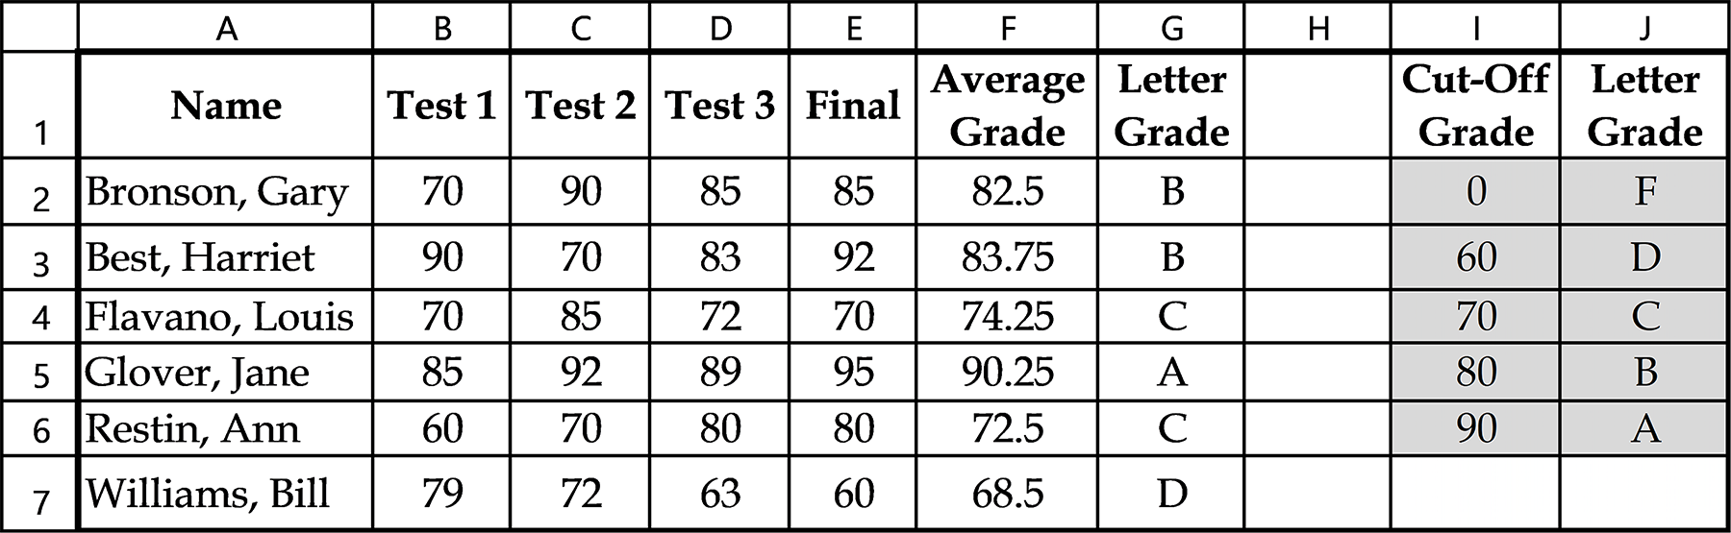

Figure 4.12b VLOOKUP( ) results for Letter Grade

EXERCISES 4.3

1. Complete parts a-d.
a. What information does the first argument of the VLOOKUP( ) function pro-
vide?
b. What information does the second argument of the VLOOKUP( ) function
provide?
c. What information does the third argument of the VLOOKUP( ) function pro-
vide?
d. What information does the fourth argument of the VLOOKUP( ) function pro-
vide?
2. For the following function, which is located in cell D2,
=VLOOKUP(A2, $H$1:$J$14, 2, TRUE),
do the following:
a. determine the location of the lookup value.
seleCtion 141

b. determine the location of the lookup table.
c. determine the column in the lookup table of the located item.
d. What cell will display the looked-up item?
3. For the following function, which is located in cell C2,
=VLOOKUP(A2, $H$1:$J$14, 3, TRUE), do the following:
a. determine the location of the lookup value.
b. determine the location of the lookup table.
c. determine the column in the lookup table of the located item.
d. What cell will display the looked-up item?
4. On a blank worksheet, write the VLOOKUP( ) function to perform the following:
a. the lookup value is in cell A2, the lookup table is located in cells C5 through D20,
the return value column is in the second column of the table, and an approxi-mate match is required. The function is to be copied from cell B2 through B10.
b. the lookup value is in cell D3, the lookup table is located in cells G1 through
H15, the return value column is in the third column of the table, and an approx-imate match is required. The function is to be copied from cell E2 through E10.
c. the lookup value is in cell B2, the lookup table is located in cells G1 through
H18, the return value column is in the second column of the table, and an exact match is required. The function is to be copied from cell C2 through C15.
d. the lookup value is in cell B2, the lookup table is located in cells G1 through
H18, the return value column is in the third column of the table, and an exact match is required. The function is to be copied from cell C2 through C15.
e. the lookup value is in cell C2, the lookup table is located in cells E5 through F25,
the return value column is in the second column of the table, and an approxi-mate match is required. The function is to be copied from cell D2 through D15.
5. Complete parts a-b.
a. Write a VLOOKUP( ) function that returns the value from column 2 of a
vertical lookup table residing in cells C10 through F25. The lookup value is located in cell A2, and an approximate data match is required.
b. Modify the function written for Exercise 5a so that the returned value is located
in column 3 of the lookup data table.
142 exCel BasiCs

6. Create the following spreadsheet and complete the spreadsheet by entering a
function in cell G2 to locate and display the correct grade from the lookup table for the data in cell A2. Copy your function down through G7 and verify that the correct grades are displayed for all of the students.
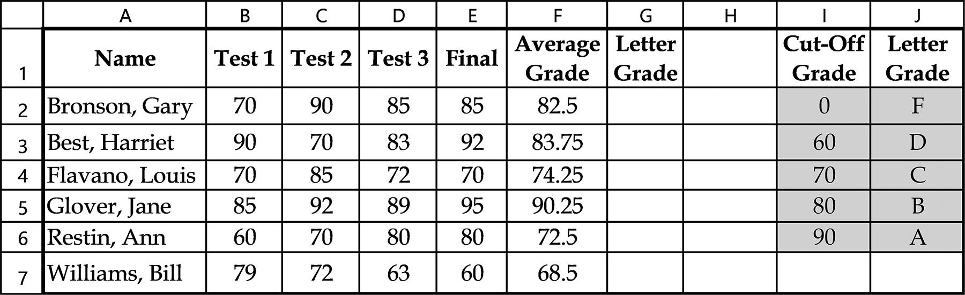

7. Replace the lookup table data in Exercise 6 with that shown below. Then, modify
the VLOOKUP( ) function used to calculate the grades for the students in the Exercise 7 spreadsheet using this new lookup table.
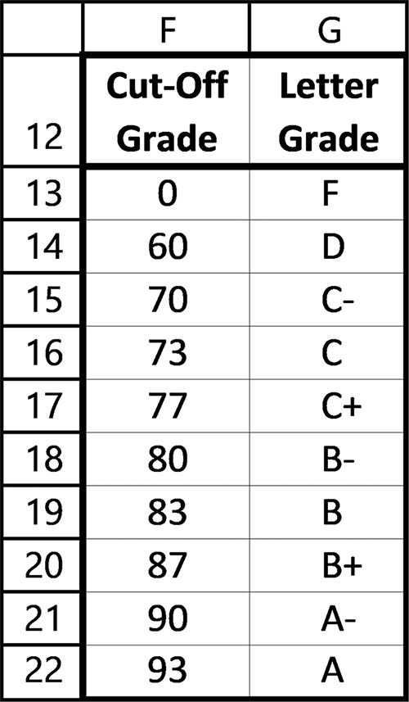

Figure 4.13 Data for Exercise 7

8. Using the spreadsheet section shown in Figure 4.14, complete parts a-d.
a. What data type can be used for a lookup value and what column is searched for
this value?
b. What is the range that should be used for the lookup table?
seleCtion 143

c. What column number (1,2,3,4, or 5) would you use if you wanted the Last
Name to be returned for the looked-up value?
d. What column number (1,2,3,4, or 5) would you use if you wanted the Grade to
be returned for the looked-up value?
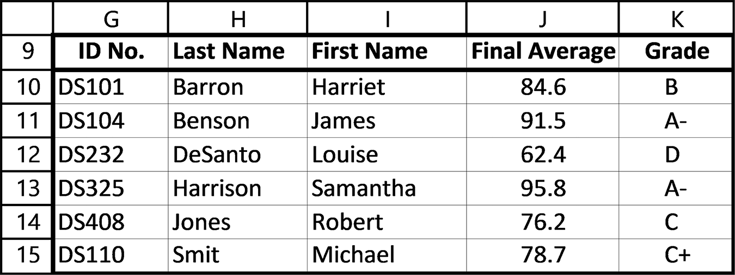

Figure 4.14 Exercise 8 spreadsheet

9. Modify the Exercise 8 data to have the data placed in Columns A through E, with
the labels placed in cells A1 through E1 (note the row and column addresses). This arrangement is shown in Figure 4.15. For any ID number entered in cell A2, the spreadsheet should use the lookup data in cell G9 through K15 to display the correct information in columns B1 though E1.
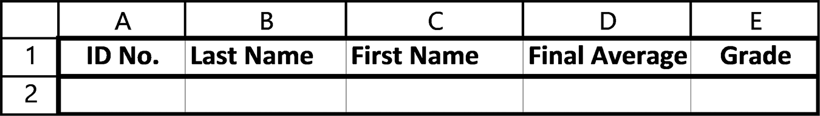

Figure 4.15 Exercise 9 spreadsheet
144 exCel BasiCs

10. Enter the spreadsheet shown in Figure 4.16. Then complete the spreadsheet by
supplying the appropriate VLOOKUP( ) functions to correctly fill-in the discount percentages in cells B2 through B8. Your lookup function should use the vertical lookup table located in cell C13 through D18.
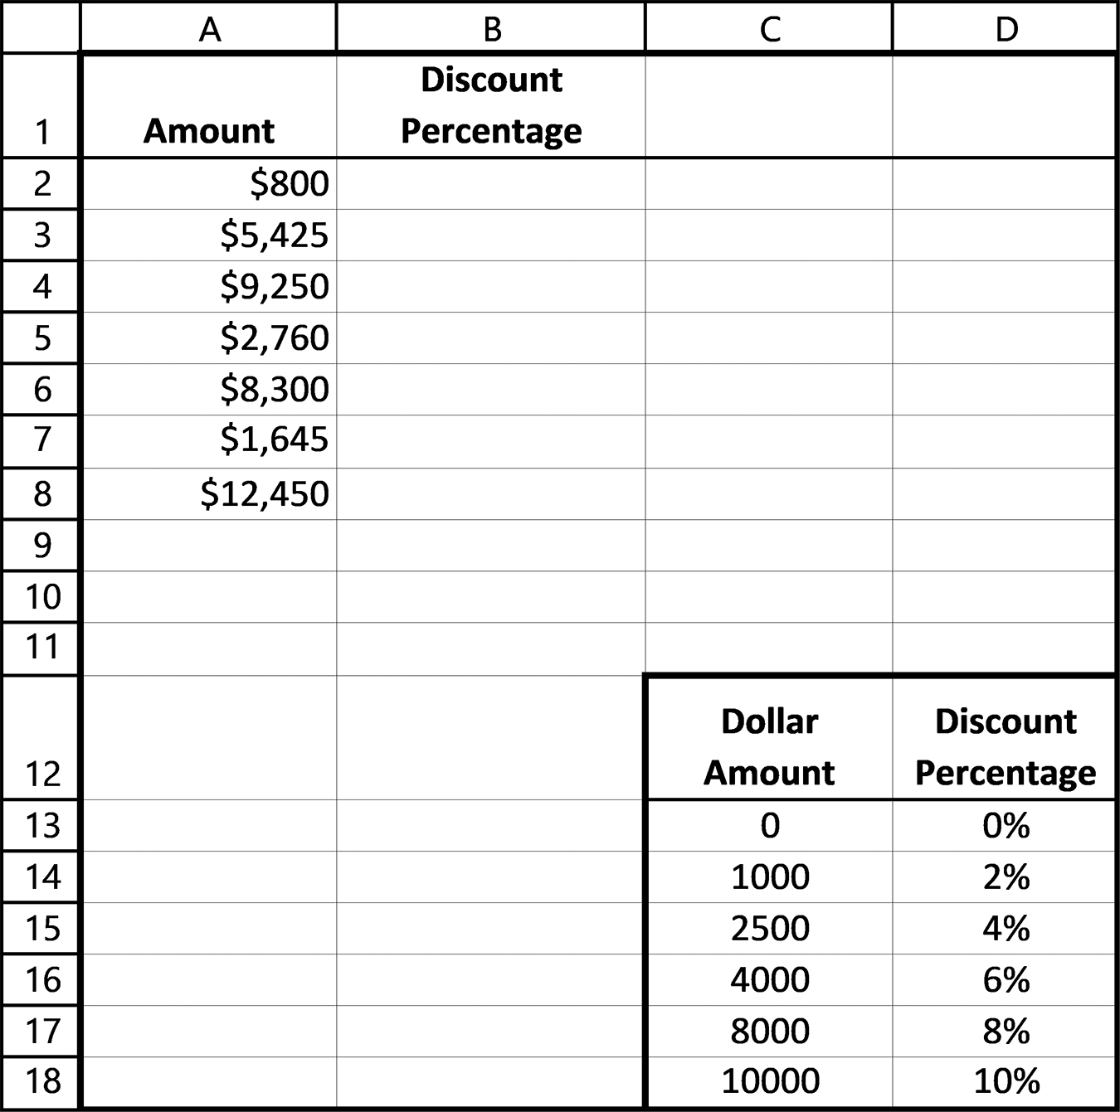

Figure 4.16 Spreadsheet for Exercise 10

11. Complete parts a-b.
a. The interest rate used on funds deposited in a bank is determined by the amount
of time the money is left on deposit. For a particular bank, the following sched-ule is used.

Time on Deposit Interest Rate Less than 1 year, but greater than 0 2% Less than 2 years, but greater than or equal to 1 year 2.5% Less than 3 years, but greater than or equal to 2 years 3% Less than 4 years, but greater than or equal to 3 years 3.5% Less than 5 years, but greater than or equal to 4 years 4% Greater than 5 years 4.5%
seleCtion 145

Using this schedule, which is included in the spreadsheet shown in Figure 4.17, determine the function that should be placed in cell C2 to check the value in cell B2 and display the corresponding interest rate in cell C2.
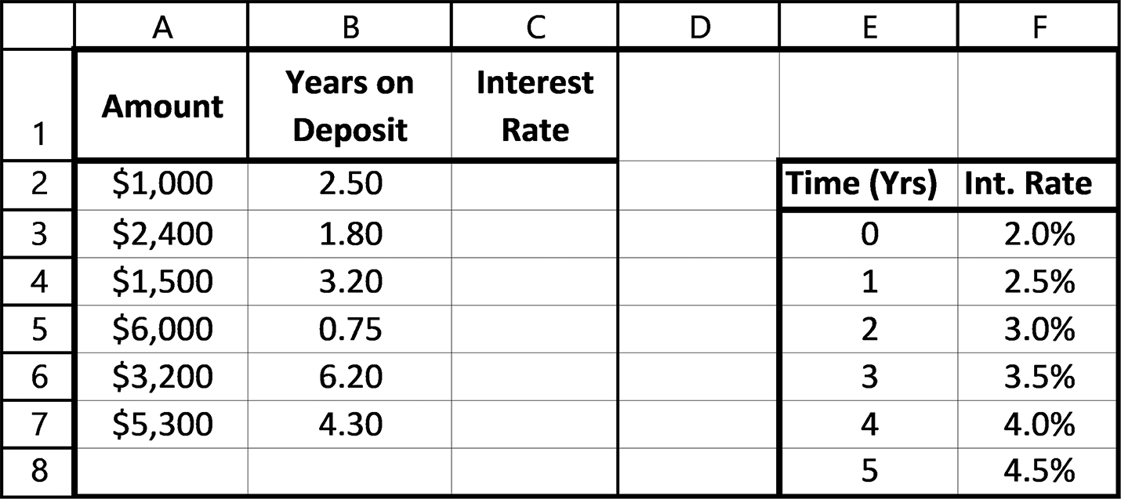

Figure 4.17 Spreadsheet for Exercise 11

b. Enter the spreadsheet shown in Figure 4.17 and complete it, using the
VLOOKUP( ) function determined in Exercise 11a, to fill in the corresponding interest rates in cells C2 through C7.
12. Complete parts a-b.
a. The monthly income of a salesperson is calculated using the following commis-
sion schedule.
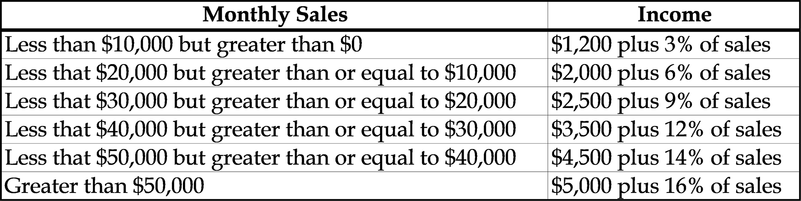

Using this schedule, which is included in Figure 4.18 as a lookup table in cells G7 through I12, determine
i. the function that should be placed in cell C2 to check the value in cell B2 and
display the corresponding Base Pay.
ii. the function that should be placed in cell D2 to check the value in cell B2 and
display the corresponding Percent of Sales.
iii. the function that should be placed in cell E2 that calculates the Net Pay, where
Net Pay = Base Pay + (Percent of Sales) * (Monthly Sales) 146 exCel BasiCs

b. Enter the spreadsheet shown in Figure 4.18 and complete it, using the func-
tions and formulas determined in Exercise 12a.
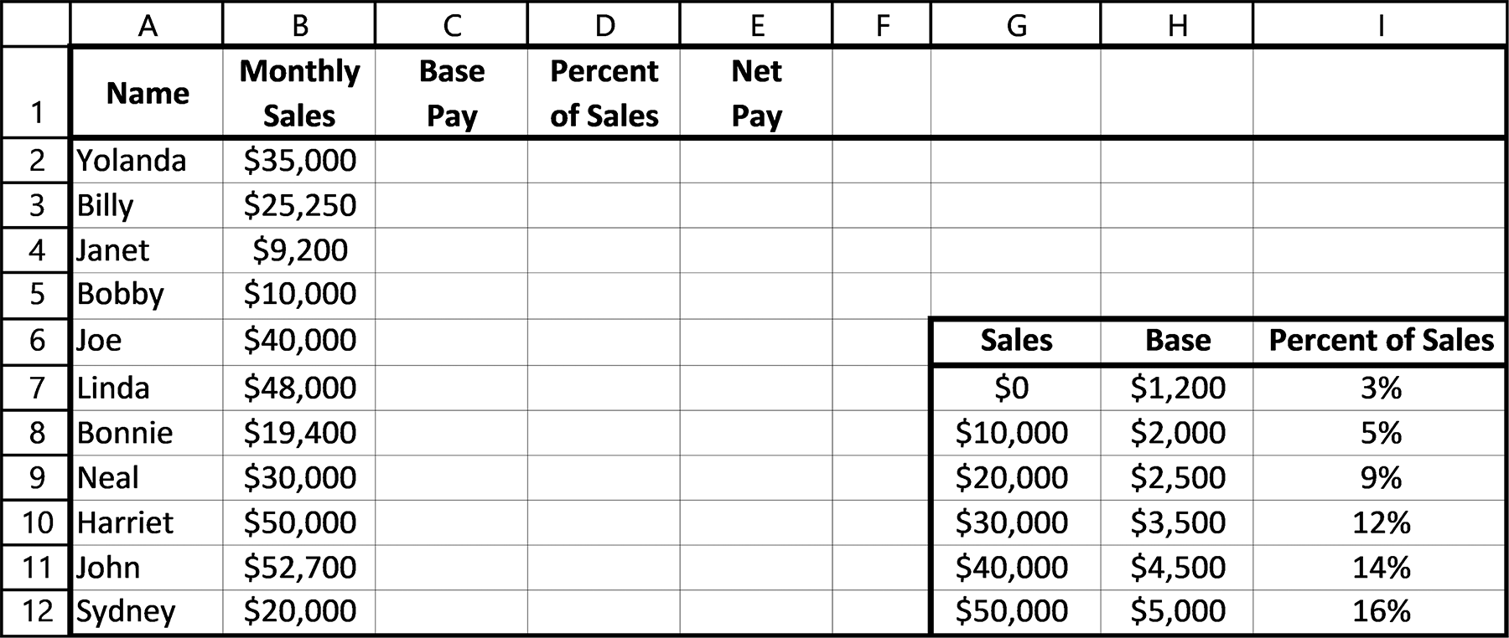

Figure 4.18 Spreadsheet for Exercise 12

4.4 THE HLOOKUP( ) FUNCTION
The IF( ) function should always be used when a decision based on one of two pos-
sible alternatives is required. Although IF( ) functions can be nested, as described at
the end of Section 4.2, this becomes cumbersome quickly, and should be avoided if
more than one IF( ) function is used as an argument within an outer IF( ) function.
For situations requiring multiple conditions that would require more than one
IF( ) function as an argument to another IF( ) function, either a VLOOKUP() or
HLOOKUP( ) function can be used. As their names imply, a VLOOKUP( ) func-
tion, as described in the previous section, requires a vertical lookup table, while the
HLOOKUP() function requires a horizontal lookup table, as shown in Figure 4.19.
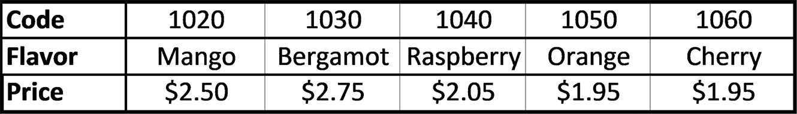

Figure 4.19 A horizontal lookup table

What defines it as a horizontal table is that data in each row are the same data cat-
egory. Thus, the items listed in Figure 4.19’s first row are code numbers, the items
listed in the second row are descriptions, and items listed in the third row are prices.
In a horizontal lookup table, the item being looked for is always, and only, looked for
in the table’s first row. The table itself can be placed anywhere on a spreadsheet, and
can contain two or more rows. However, the first row must contain values that will be
searched using the HLOOKUP( ) function.
seleCtion 147

The general syntax for the HLOOKUP( ) function is as follows:
A lookup value or a cell address where the value is located.

The location of the lookup table (use absolute addresses)

HLOOKUP( lookup value, table location, return value row, match type)

A number indicating the row of the returned value

Either TRUE (or omitted) for the closest match, or FALSE for an exact match
The return value row can also be referred to as the row index number.

The value to be looked up, which is referred to as the lookup value, is the first argu-
ment provided to the HLOOKUP( ) function. The remaining three items, provide the
location of the lookup table, the row number of the return value, and whether an exact
or approximate (closest) match to the lookup value is required.
The HLOOKUP( ) function searches the specified table’s first row looking for a
match to the lookup value (if no match if found, an error message is displayed). Once
a match is located, either exact or approximate, as specified by the fourth argument,
the third argument provides the row of the return value.
Figure 4.20 illustrates the relationship between the arguments provided to the
HLOOKUP( ) function and other cells in the spreadsheet.
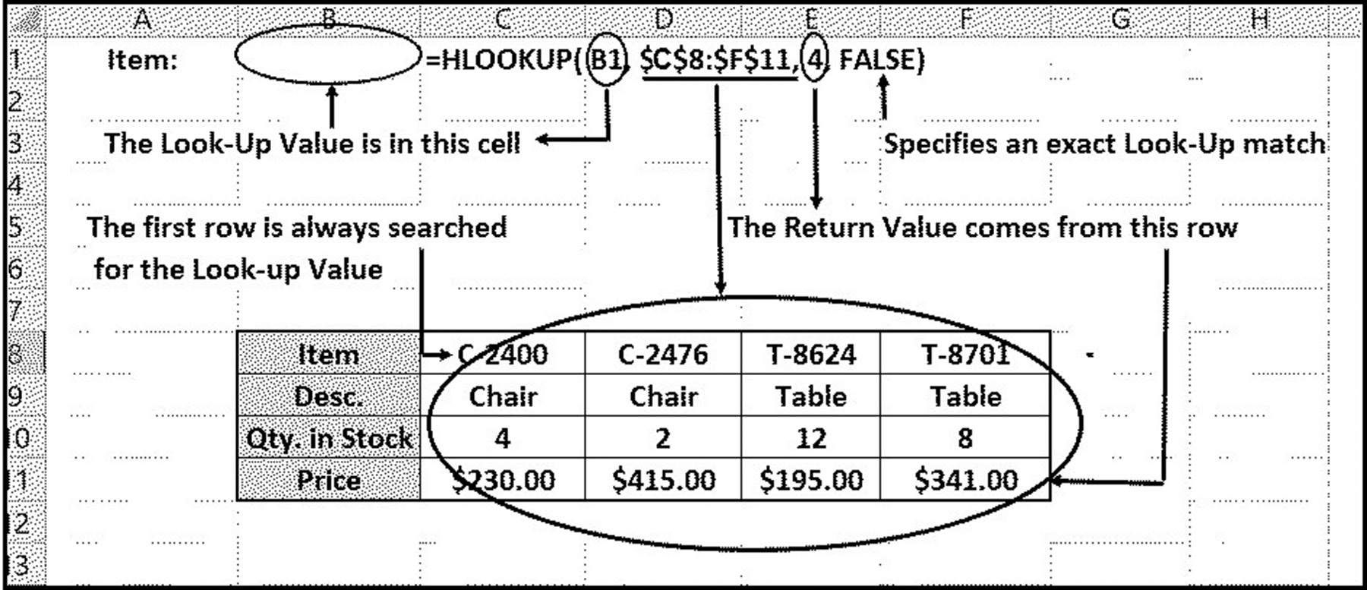

Figure 4.20 The relationship between the arguments provided to the HLOOKUP( )
function and other cells in the spreadsheet
148 exCel BasiCs

Consider the HLOOKUP( ) function in cell C1, repeated below for convenience
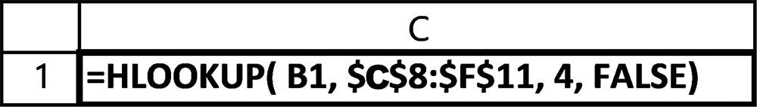

The function’s first argument specifies that the lookup value is contained in cell B1.
The next argument, $C$8:$F$11, specifies that the lookup table is located in the cell
range from C8 through F11. This is the area circled in the spreadsheet. Notice that
the lookup table does not include the highlighted row labels in cells B8 through B11.
Also notice that the cell addresses specifying the lookup table’s location use absolute
addresses. This ensures that if or when the function in cell C1 is copied, the lookup
table’s addresses will not be changed.
The search for a match always, and only, occurs by comparing the lookup value,
provided as the function’s first argument, to each value in the lookup table’s first row,
one item at a time. When a match is found (the type of match is determined by the
function’s fourth argument) the search stops, and the corresponding value in the row
specified by the third argument (which in this example is 4) is returned.
To understand how a match is determined, a clear understanding of the function’s
fourth argument is required. The simplest match criterion is provided when this fourth
argument is specified as FALSE. This indicates that an exact match is required, and it
is most useful when code numbers or name matches are needed.
When a search involves a range of values, such as the amount of commission based
on recent orders, or spending towards various loyalty program rewards categories,
an approximate match, also referred to as a closest match, should be used. This type
of match is indicated by either explicitly specifying the function’s fourth argument as
TRUE, or omitting it altogether. Thus, the default search, when the fourth argument
is omitted, is an approximate match. It is important to realize that this type of match
requires that the data in the lookup table’s first row be in sorted ascending order, from
lowest to highest. This is necessary because the search stops once a value greater than
the lookup value is encountered.

Example
For the function, located in cell D3, determine the following:
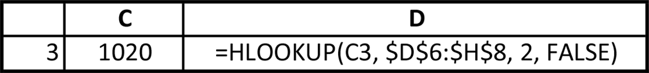

a. the location of the lookup value
b. the lookup value
c. the location of the lookup table
seleCtion 149

d. the number of rows in the lookup table
e. the lookup table’s row containing the return value, if an exact or “closest-to”
match is specified
f. the cell that displays the return value
Solution:
a. The lookup value is located in cell C3.
b. The lookup value is 1020.
c. The lookup table is located in cells D6 through H8.
d. The lookup table contains three rows (6, 7, an 8).
e. If a match is found, the return value is in the second third row of the table; oth-
erwise #N/A is displayed.
f. An exact match is specified because the last argument is FALSE.

Give It a Try
For the function, located in cell D3, determine the following:
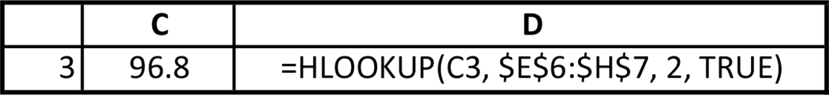

a. the location of the lookup value
b. the lookup value
c. the location of the lookup table
d. the number of rows in the lookup table
e. the lookup table’s row containing the return value, if an exact or “closest-to”
match is specified
f. the cell that displays the return value

150 exCel BasiCs

EXERCISES 4.4

1. Complete parts a-d.
a. What information does the first argument of the HLOOKUP( ) function pro-
vide?
b. What information does the second argument of the HLOOKUP( ) function
provide?
c. What information does the third argument of the HLOOKUP( ) function pro-
vide?
d. What information does the fourth argument of the HLOOKUP( ) function pro-
vide?
2. For the following function, which is located in cell D2,
=HLOOKUP(A2, $H$1:$P$3, 2, TRUE)
a. determine the location of the lookup value.
b. determine the location of the lookup table.
c. determine the row in the lookup table of the located item.
d. What cell will display the return value from the HLOOKUP( ) function?
3. For the following function, which is located in cell C2,
=HLOOKUP(A2, $H$1:$P$4, 3, TRUE)
a. determine the location of the lookup value.
b. determine the location of the lookup table.
c. determine the row in the lookup table of the located item.
d. What cell will display the return value from the HLOOKUP( ) function?
4. Use a blank worksheet to write HLOOKUP( ) functions to perform the following:
a. The lookup value is in cell A2, the lookup table is located in cells C5 through
H3, the return value row is in the second row of the table, and an approximate match is required. The function is to be copied from cell B2 through B10.
b. The lookup value is in cell D3, the lookup table is located in cells G1 through
M3, the return value row is in the third row of the table, and an approximate match is required. The function is to be copied from cell E2 through E10.
c. The lookup value is in cell B2, the lookup table is located in cells G1 through
M4, the return value row is in the second row of the table, and an exact match is required. The function is to be copied from cell C2 through C15.
seleCtion 151

d. The lookup value is in cell B2, the lookup table is located in cells G1 through
N4 the return value row is in the third row of the table, and an exact match is required. The function is to be copied from cell C2 through C15.
e. The lookup value is in cell C2, the lookup table is located in cells E5 through
M5, the return value row is in the second row of the table, and an approximate match is required. The function is to be copied from cell D2 through D15.
5. Enter the spreadsheet shown in Figure 4.21. Then complete the spreadsheet by
supplying an appropriate HLOOKUP( ) function to correctly fill-in the descrip-tion in cell D2 and the unit price in cell D2. The Total Price in cell E2 is the quantity times the unit price. Then copy the functions down to complete the spreadsheet. Make sure to check the Descriptions and Unit Prices to see that the lookup is working correctly.
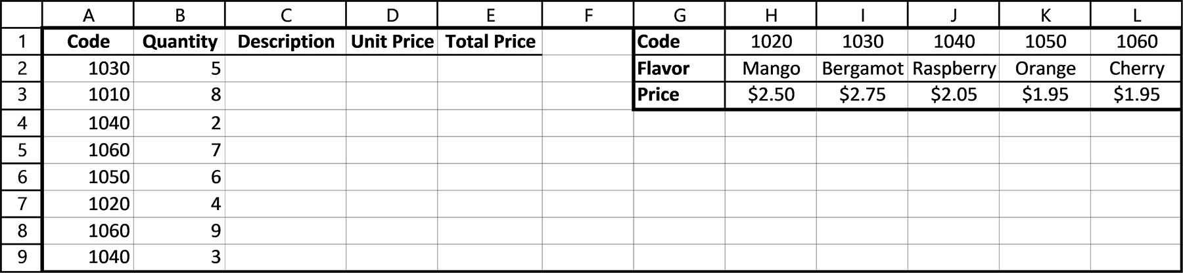

Figure 4.21 Exercise 5 spreadsheet

6. Create the spreadsheet shown in Figure 4.22. Then complete the spreadsheet
by supplying an appropriate HLOOKUP( ) function to correctly fill in the letter grades in cells C2 through C7. Your lookup function should use the horizontal lookup table located in cell C9 through G10.
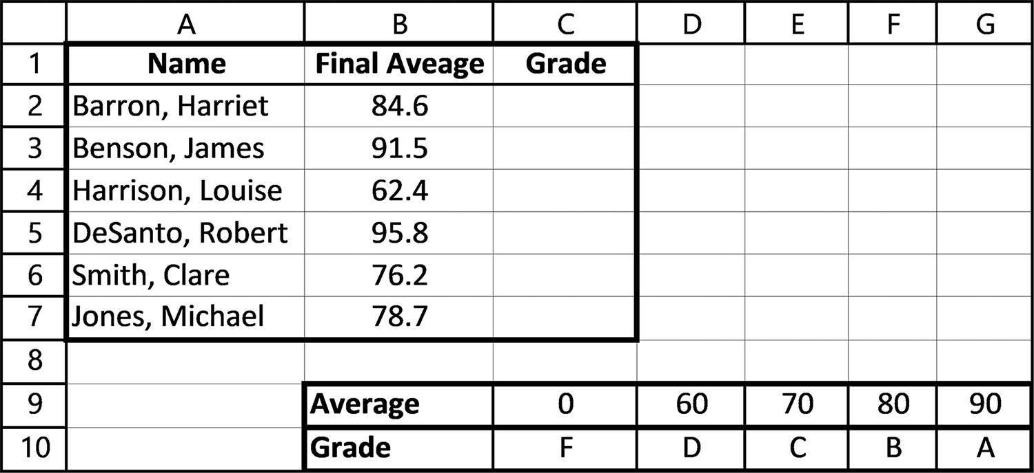

Figure 4.22 Exercise 6 spreadsheet 152 exCel BasiCs

4.5 COMMON EXCEL ERRORS
In using the material presented in this chapter, be aware of the following possible
errors:
1. Forgetting to enclose a string literal within double quotes when used as an oper-
and in a condition or as an argument within an IF( ) function. The only time dou-ble quotes should not be used is when text is user-entered into a cell. Here, Excel automatically recognizes the entry as text.
2. Assuming the IF( ) function is selecting an incorrect choice. Typically, the designer
mistakenly concentrates on the tested condition as the source of the problem. As a general rule, whenever an IF( ) function does not act as you think it should, make sure to test your assumptions about the values assigned to the cells within the tested condition. If an unanticipated value is displayed by the IF( ) function, you have at least isolated the source of the problem to the cell values being tested, rather than the structure of the IF( ) function. From there, you need to determine where and how the incorrect value or values were obtained.
3. Not listing the data in the first column of a vertical lookup table in ascending (that
is, increasing) order when an approximate match is specified. This error can cause the search for an approximate match to stop prematurely before a closer match is located. Where an approximate match is specified in a horizontal lookup table, the data in the first row must be in ascending order.
4. Forgetting to use absolute addresses for the range of cells that define a lookup
table in the VLOOKUP( ) and HLOOKUP( ) functions. This results in an error, usually #VALUE, when the function containing the lookup function is copied. The reason is that the relative addresses are changed when copied, while absolute addresses remain fixed.

4.6 CHAPTER APPENDIX: TESTING AND DEBUGGING
The ideal in creating a spreadsheet is to produce error-free applications that work
correctly and can be modified or changed with a minimum of testing. You can work
toward this ideal by keeping in mind the two main types of errors that can occur, when
they are typically detected, and how to correct them. An error is typically detected in
two situations:
1. While entering and copying formulas as the spreadsheet is being developed
2. After a spreadsheet’s results are being examined, either when it is being used or
at some later date
seleCtion 153

And clearly, in some cases, an error may not be detected at all.
By now, you have probably encountered numerous errors while developing your
spreadsheets. Although beginning developers tend to be frustrated by these errors,
experienced developers understand that detecting errors and correcting them is part
of the process of becoming an experienced Excel developer and user. Additionally,
any errors that are detected in the development stage, and not when a user is attempt-
ing to perform an important task with it, ensures that no one but the developer ever
knows they occurred; you fix them and they go away. Having someone else report an
error while they are using one of your spreadsheets not only requires you to find and
fix the error, as you would do during the development stage, but hurts your credibility
as a knowledgeable Excel designer.
Although there are no hard-and-fast rules for locating and correcting errors, some
useful techniques can be applied.
First, the primary ingredient needed for successful isolation and correction of er-
rors is the attitude and spirit you bring to the task. After you enter a formula, and copy
it, it is natural to assume it is correct. It is difficult to back away and honestly find the
cause of an error in your own spreadsheet after an error message, such as “#N/A,”
“#VALUE,” or “#NAME,” appears. As a developer, you must constantly remind your-
self that just because you think a formula is correct does not make it so. Just because
a formula produces a correct result in one cell does not ensure that it will be correct
when copied. Having an error appear in your own spreadsheet is a sobering experi-
ence, but one that will help you to become a better developer. It can also be exciting
and fun if approached as a detection problem with you as the master detective.
A second technique is purely preventative. Frequently, many errors are introduced
in a rush to create your spreadsheet without fully understanding what is required and
how the result is to be achieved. Take the time to understand what each formula is
supposed to do, and, if necessary, do a few hand calculations to ensure you know what
cell values are needed for your formula.
A third technique is to check the result, using a calculator, of the initial entry of
each formula used in your spreadsheet. Then, immediately after the formula is cop-
ied, check the first copy produced. This typically reveals whether an absolute address
should have been used or was used incorrectly.
Finally, when using cells that contain IF( ), VLOOKUP( ), or HLOOKUP( ) func-
tions, change the values in the cells being tested, so that as many as possible of the
results can be verified.

Part 2
Presentations

Chapter 5 Graphical Presentations

Chapter 6 PivotTables

Presenting results clearly, in an easily understood manner, is as important as produc-
ing correct results. In fact, your work will almost always be judged on its presentation.
Here, providing simple and clear visual aids, that is, graphs, charts, and summary
tables that highlight and quickly show appropriate relationships, are indispensable.
These permit users to focus on significant results and rapidly see and understand rel-
evant associations.
In this unit, Chapter 5 presents basic Excel charting and graphing presentations.

Chapter 6 presents PivotTables, which are used to easily create concise summary ta-
bles. Together, these represent Excel’s basic visual presentation tools.

C H A P T E R 5
graPhiCal Presentations

This Chapter Contains
5.1 Introduction
5.2 Creating Column and Bar Charts
5.3 Creating Pie Charts
5.4 Creating Line Graphs
5.5 Trend Lines and Scatter Diagrams
5.6 Common Excel Errors
5.7 Chapter Appendix: Histograms

5.1 INTRODUCTION

While the main goal of a spreadsheet is to present numerical data and the results
of calculations and analyses in a clear and logical way, often the need for presenting
numerical information in a graphical way can be highly useful and valuable. This is
especially the case if the results of the quantitative results can be presented in an
easy-to-understand manner. For instance, sales trends can be presented in the form of
appropriate charts and graphs, or the results of a firm’s performance over a past year
can be summarized in the form of a graphical dashboard display. Sometimes referred
to broadly as visualizations, the availability of charts and graphs allow for colorful and
easy-to-interpret representations of spreadsheet data.
While there are a number of chart types available in Excel, three of the most basic
and frequently used are column/bar charts, pie charts, and line graphs. Each of these
graphical presentations provide visual aids for highlighting specific relationships be-
tween data values.
A column chart presents data with rectangular bars whose lengths are proportional
to the represented values. In a column chart, the bars are plotted vertically, as shown
in Figure 5.1a. A bar chart is the same as a column chart, except that the bars are
drawn horizontally, as shown in Figure 5.1b.
158 exCel BasiCs
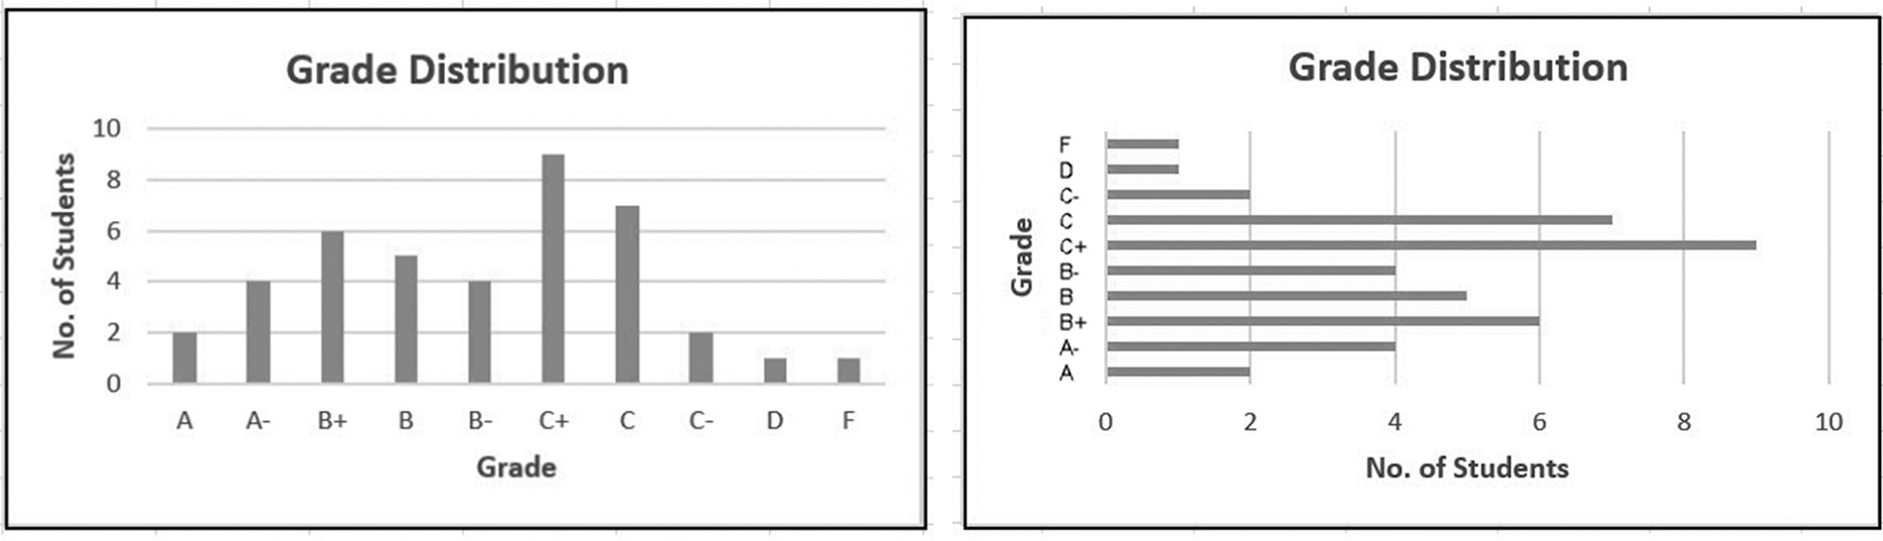

(a) (b)
Figure 5.1 Data displayed as in a (a) column chart and (b) bar chart
A pie chart is a circular pie-shaped graphic that is divided into slices. Each slice in a
pie chart, like each bar in a bar chart, is proportional to the quantity it represents. Two
pie chart examples are illustrated in Figure 5.2.
Pie charts are typically used to highlight relationships among two to ten quantities;
additional slices make the chart difficult to read.
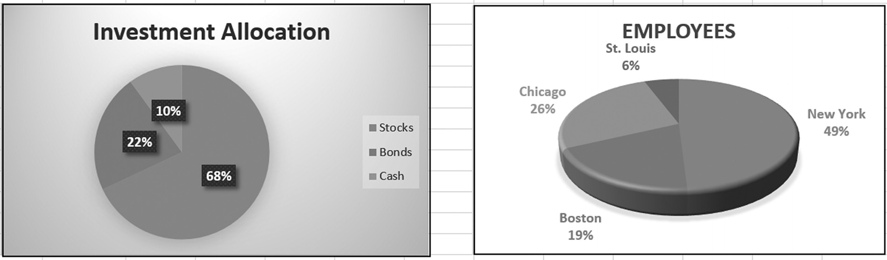

(a) (b)
Figure 5.2 Pie chart examples (a) 2-D pie chart (b) 3D pie chart
In a line graph, data points are plotted and then physically connected by straight line
segments between each successive data point. Examples of this type of graphic are
shown in Figure 5.3.
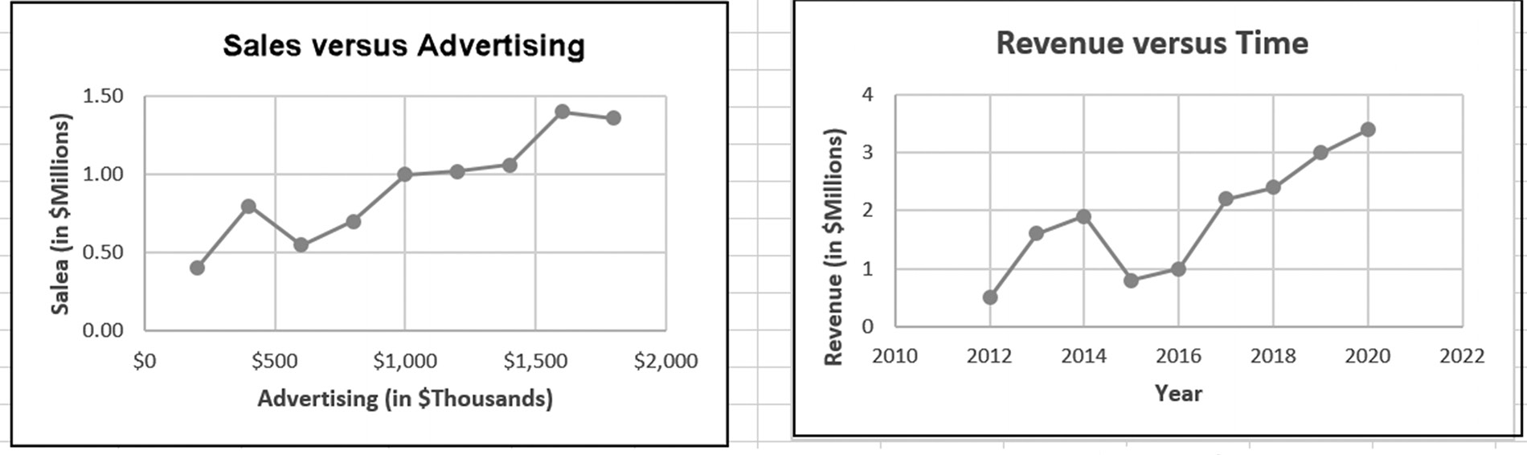

(a) (b)
Figure 5.3 Line graph examples
GraPhiCal Presentations 159

Line graphs are typically used to highlight multiple pairs of data points, as shown
in Figure 5.3. A line graph without lines connecting data points is referred to as a
scatter diagram. This type of graph is typically used when trend lines are added (see
Section 5.5).
Each of the basic chart types is presented in the following sections, and each may
be read independently. It is suggested that you initially select only one of these sec-
tions to clearly understand the basics of creating the specific visual graphic most ap-
propriate to your work, and then explore the other types as needed.

EXERCISES 5.1

1. Complete parts a-b.
a. What type of graph is typically more appropriate for displaying the relationship
between two variables?
b. What type of graphic is typically more appropriate for displaying the relation-
ship between two to ten variables?
2. Complete parts a-b.
a. Obtain at least three examples of any combination of line, pie, or bar/column
charts from the Internet, a newspaper, or magazine.
b. Did one type of chart appear more often in your response to Exercise 2a? If so,
which type of chart appeared most frequently?
3. Determine the type of chart, line, pie, or bar/column that is most appropriate for
the following:
a. the populations of the ten largest cities in the United States
b. the dollar amounts and percentages of stocks, bonds, and cash held in an indi-
vidual’s investment account
c. a supermarket’s yearly sales of raspberries, blackberries, blueberries, and straw-
berries
d. the median home price in the eight largest cities in the United States
e. an outlet’s yearly sales of shoes, dresses, and accessories
160 exCel BasiCs

5.2 CREATING COLUMN AND BAR CHARTS1
Since column and bar charts are relatively easy to create, and are widely used, they
are typically the first to be examined when learning how to create and work with Excel
charts and graphs. At this point, we are creating column and bar charts with only a
single data series, that is with one set of labels (text) and one set of numerical data
(numbers).
This is the simplest form of chart, which results in a single set of columns and bars
as a result. More complex charts may typically involve two data series, where there are
two sets of data and two sets of labels (often referred to as a multiple data series chart).
In general, the labels (text) are referred to as category labels, while the data can be
differentiated between the data series (a group of numbers being charted) and each
individual number within the series, known individually as a data point.
An important note: You don’t necessarily need to memorize these terms, since you
can easily create charts and graphs with only a basic working understanding of what
the process is based on what is detailed in this chapter. However, if you ever consult
any resources on charts and graphs and these terms are mentioned, you can under-
stand the explanations and tutorials better.
Column and bar charts are essentially the same chart with their respective displays
rotated ninety degrees. Thus, as seen in Figure 5.4, a column chart displays its data
vertically, in column form, while a bar chart displays its data horizontally, as bars across
the chart.
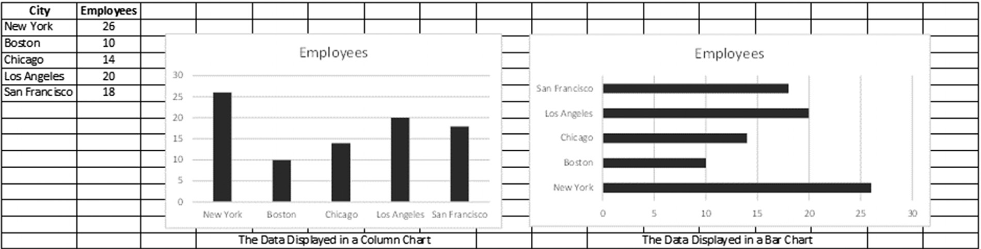

Figure 5.4 Data displayed as a column chart and bar chart

Both column and bar charts are created using the following four-step procedure, illus-
trated in Figure 5.5:
1. Highlight the data to be charted. The data can be listed in either column form
(item 1 in Figure 5.5) or in row form. In the case of the single data series chart, the set of relevant category labels (to identify the columns or bars) must be selected, together with a single row or column of numerical data.

1 This section may be read independently of any other sections in this chapter.
GraPhiCal Presentations 161

2. Select the Insert tab, (Charts Group) on the Excel ribbon (item 2 in Figure 5.5).
3. Select the Column Chart Icon (item 3 in Figure 5.5).
4. Choose either the 2-D or 3-D Column or Bar Chart display type, (item 4 in
Figure 5.5).
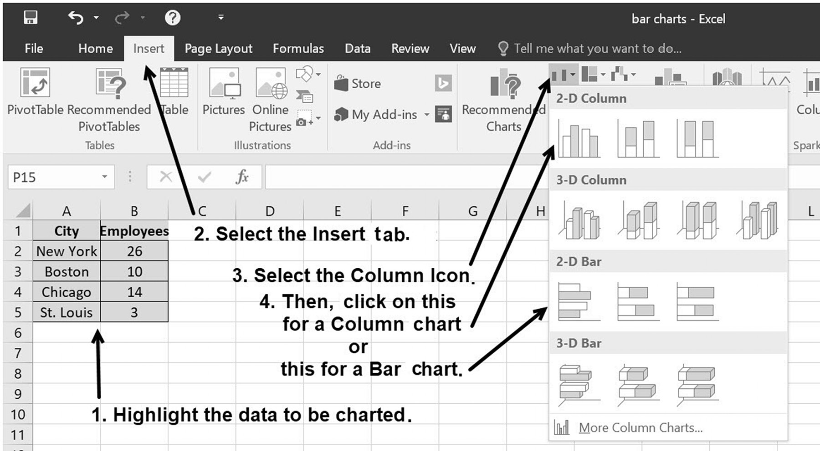

Figure 5.5 Creating a column or bar chart

In reviewing Figure 5.5, notice that selecting either the 2-D or 3-D Column icon pro-
duces a column chart, while choosing either the 2-D or 3-D Bar chart icon produces
a bar chart. Although the data charted in Figure 5.5 is listed in column form, this is
not a required data format. The data for both the column and bar charts can also be
listed in rows.
Changing a Column Chart’s and Bar Chart’s Elements and Appearance
Once you have created a chart, normally, by default, it is created as a chart object
on your spreadsheet. A chart object is a part of a worksheet, but it is also a dynamic
object that can be resized and moved, and operates as though it is “floating above” the
surface of the worksheet. It is an OLE (Object Linking and Embedding) object that
can then be shared, pasted, and exported to other Windows applications. An alternate
means of display is as a chart sheet, which is a special kind of worksheet that only holds
a chart.
Once your chart is created, and the chart is selected (highlighted), a new tab ap-
pears on the ribbon. This is known as the Chart Tools tab, below which are two sub-
menus, Design and Format. Since we are starting charts at a very basic level, we will 162 exCel BasiCs

only reference those commands on the menu which are relevant to the tasks currently
described, rather than reviewing the entire set of menus in detail.
Depending on your needs, you can make your chart as either a chart object or a
chart sheet. The way to change a chart object to a chart sheet is to use the Excel rib-
bon Chart Tools tab and Design submenu, and click on the Move Chart command.
Select the New Sheet command and click OK to convert the chart object to a chart
sheet. You will note that the chart figures given in this chapter are chart objects. A
chart sheet has a somewhat larger sized chart, laid out as a separate sheet, with an as-
signed default sheet name starting with Chart1.
The various elements which can be included in a column, bar (and for other chart
types), such as titles, legends, and the like are known as Chart Elements. The way
to add and modify chart elements to your chart is through the ribbon tab sequence
Chart Tools – Design- Chart Elements-Add Chart Elements. There, you are
given a list of the various chart elements available.
In practical terms, once a column or bar chart has been created, its title, axes
labels, data labels, and grid lines can be added, changed, or deleted using the Chart
Elements submenu. As shown in Figure 5.6, this submenu is activated by either
right or left clicking within a chart, and then selecting the displayed cross-hairs
icon.
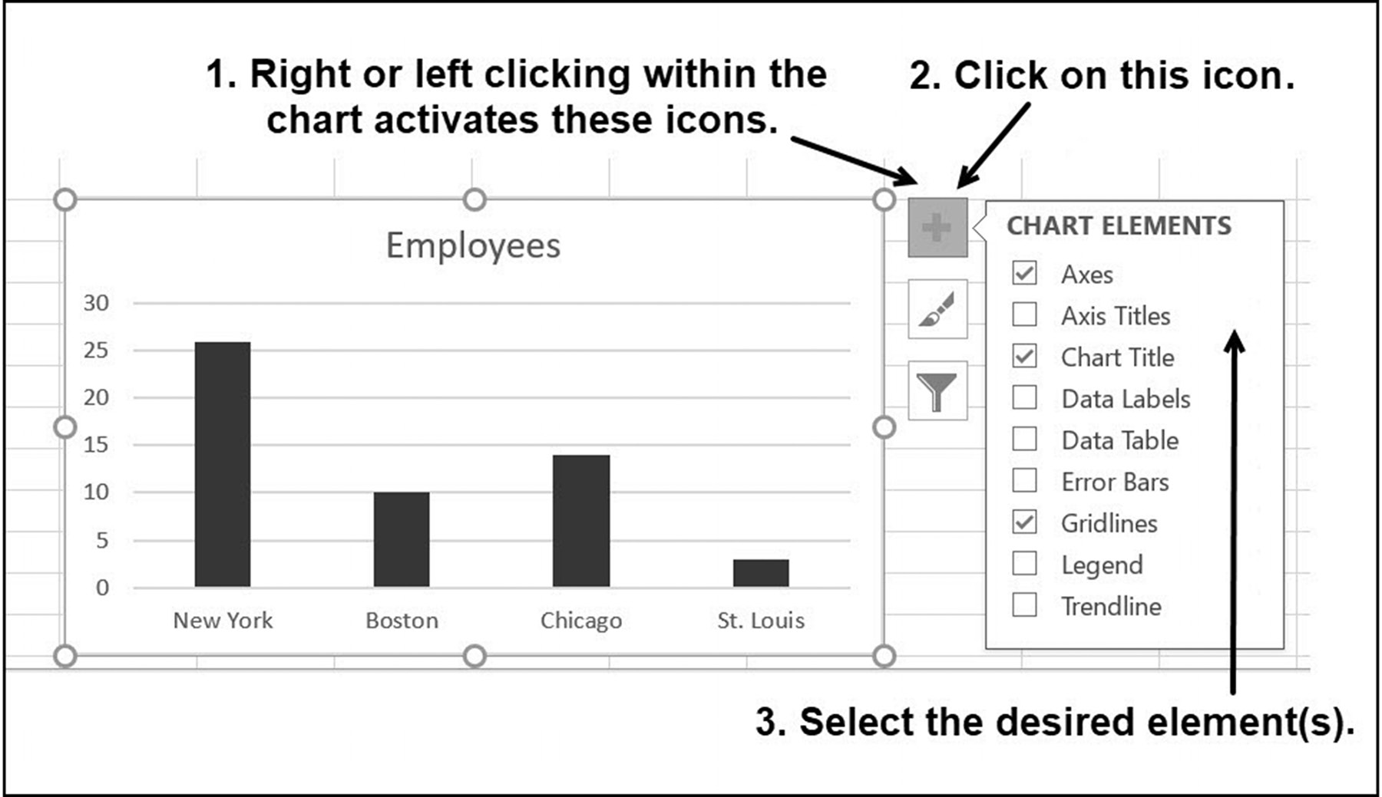

Figure 5.6 Changing the chart elements

For example, checking the Axis Titles and Legend checkboxes shown in Figure 5.6
produces the chart shown in Figure 5.7a. Simply clicking within each element allows
GraPhiCal Presentations 163

you to change the titles to those of your own choosing, including the font type and
size. This was done to produce the titles shown in Figure 5.7b.
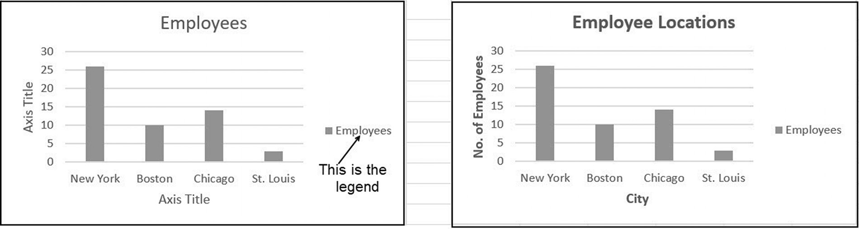

(a) (b)
Figure 5.7 Changing the chart and axes titles

In addition to changing a chart’s title and labels, a number of differing chart appear-
ances (chart styles) can be selected, such as those shown in Figure 5.8.
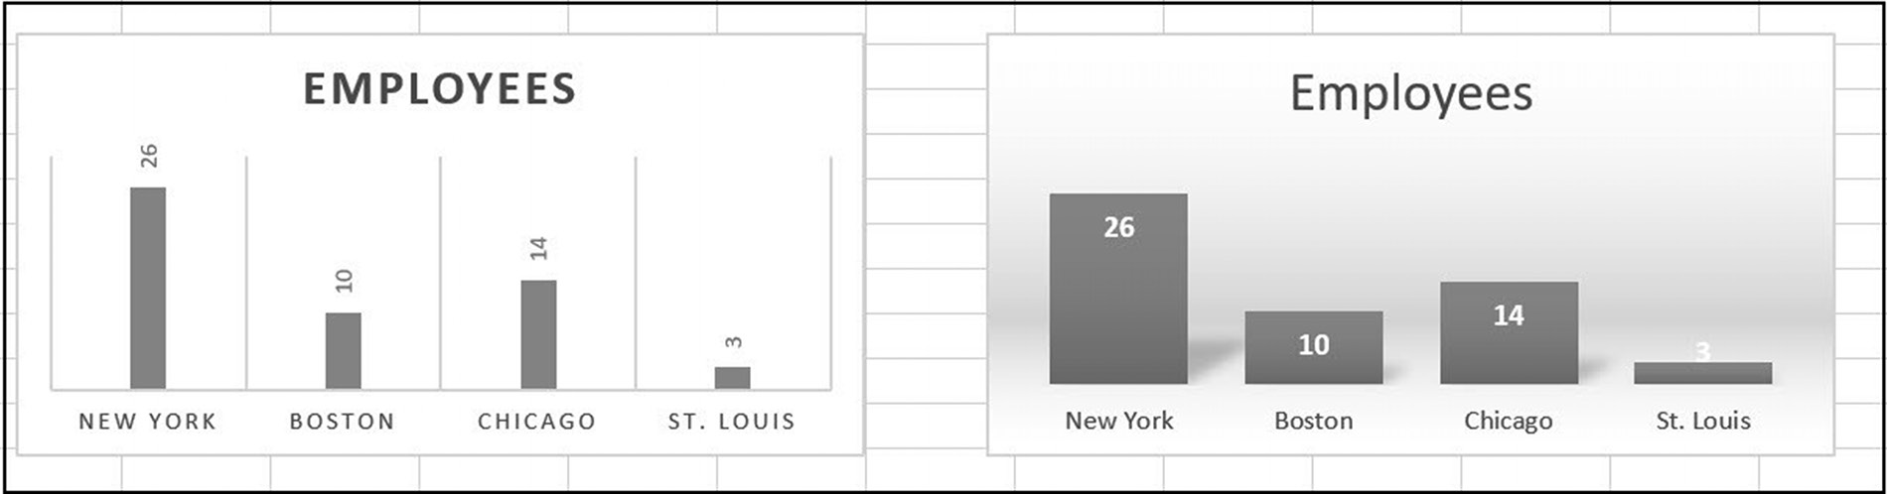

Figure 5.8 Two column chart variations

Changing a chart’s appearance is accomplished by first double-clicking anywhere
within the chart. Doing this brings up the ribbon’s Chart Tools tab, and its submenu,
Design, as shown in Figure 5.9.2 Clicking on any of the pre-constructed Chart Styles
changes the chart to the selected appearance.
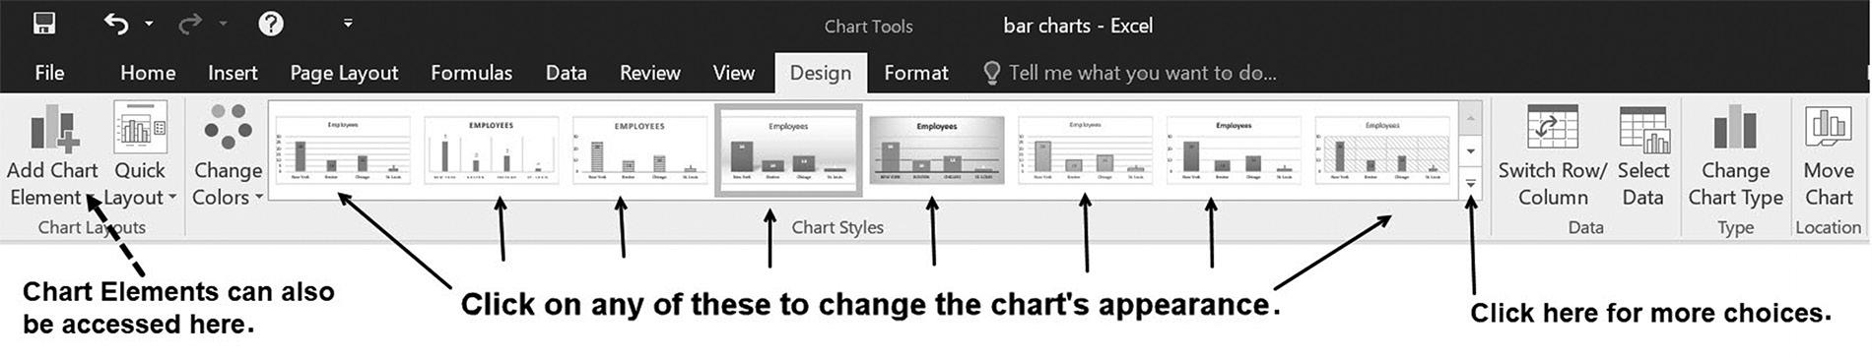

Figure 5.9 Pre-constructed chart styles

2 The Design submenu shown in Figure 5.5 can also be activated by single clicking (selecting) the chart and then selecting the Chart Tools’ Design option at the top of Figure 5.5.
164 exCel BasiCs

Notice that the chart elements previously shown in Figure 5.5 can also be accessed by
clicking on the left-most icon in the Excel ribbon Chart Tools – Design menu (see the
figure’s dotted arrow).
Changing Chart Types
Once a chart is created, it can easily be changed to a different chart type, which simply
changes how the data is displayed. For example, Figure 5.10 shows how Figure 5.4’s
data appears in a number of chart types.
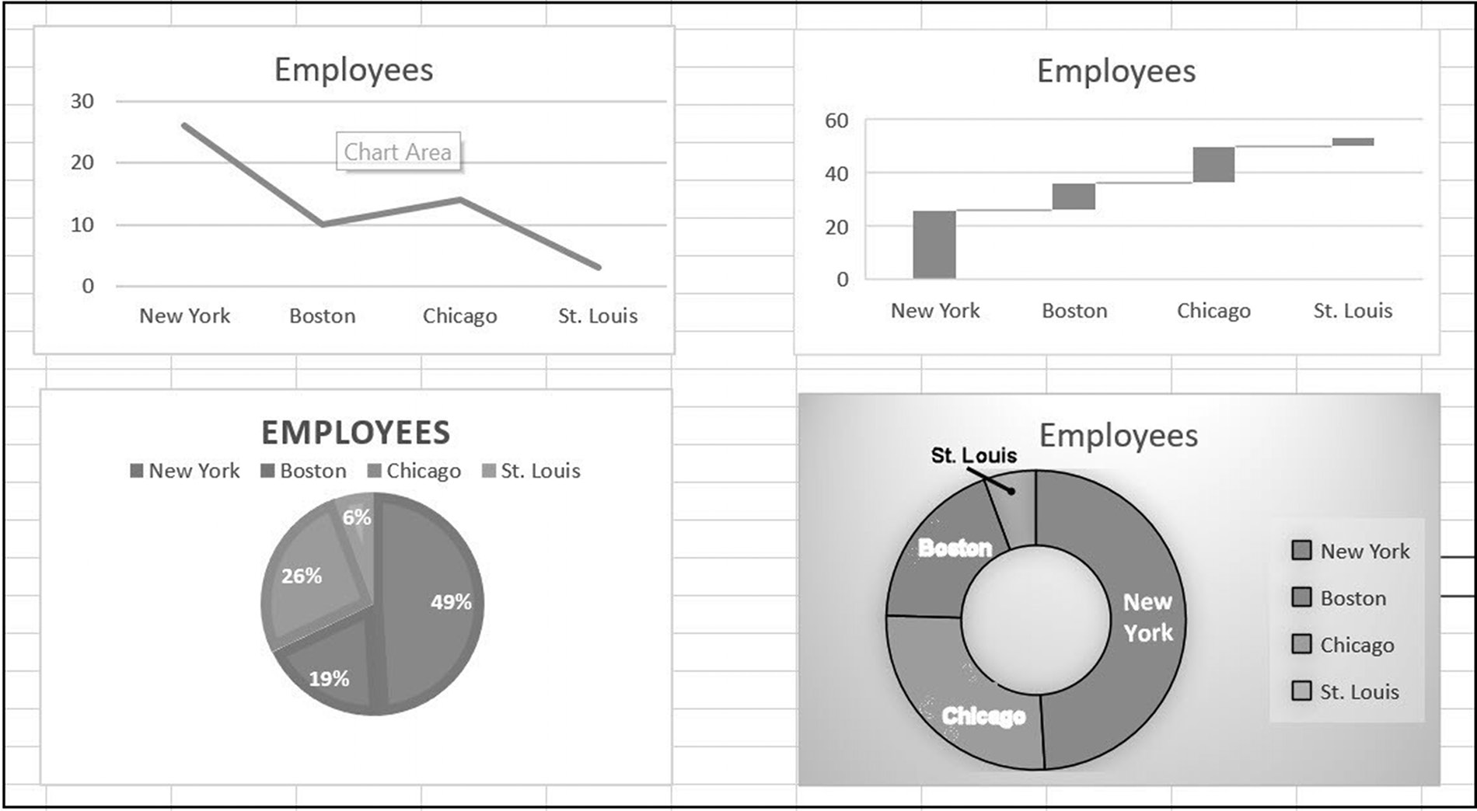

Figure 5.10 Different chart types

An existing chart’s type is changed by
1. Right-clicking within the chart (or selecting the chart)
2. Clicking on the Change Chart Type option on the pop-up submenu (or the
same option on the ribbon Chart Tools – Design).
3. Selecting the desired chart type from the resulting pop-up sub-menu (or from the
Chart Tools – Design – Type – Change Chart Type).
GraPhiCal Presentations 165

The first two steps are illustrated in Figure 5.11.
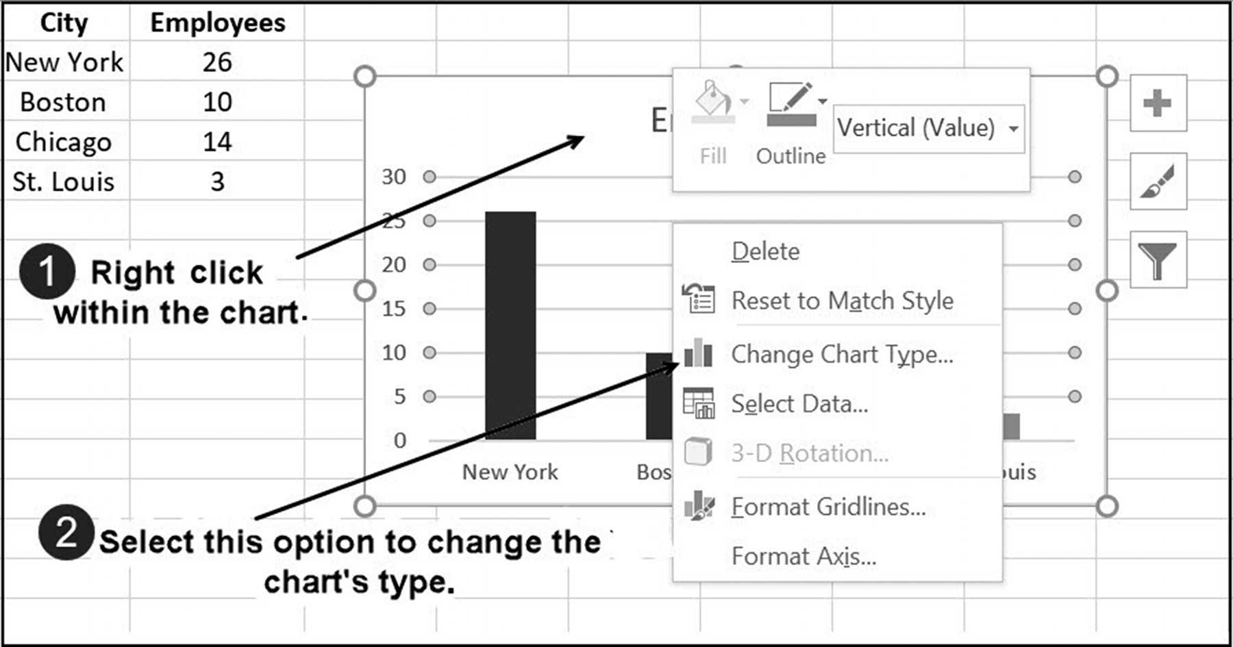

Figure 5.11 The first two steps in changing a chart’s type

EXERCISES 5.2

1. Create both the column and bar charts shown in the figure.
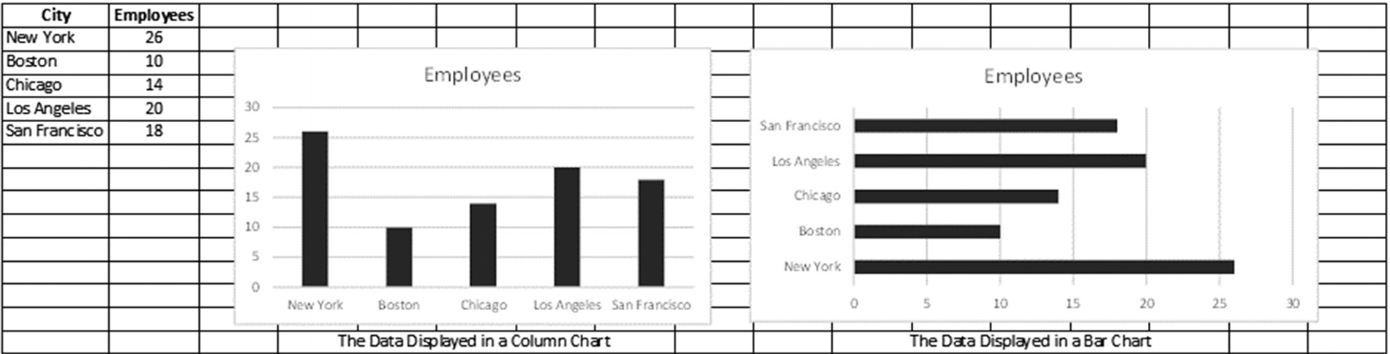
166 exCel BasiCs

2. Create the same column and bar charts shown below the data.
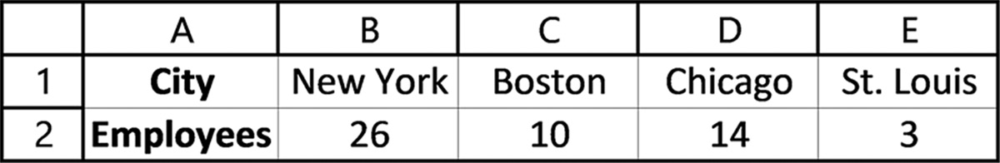

3. Construct a column chart (as a chart object) of the percentage of global Internet
users for the data listed in the table below. An Internet user is defined as someone having access to the Internet in their home, using a computer or mobile device. (Source: worldometers.info/licensing-how.php)
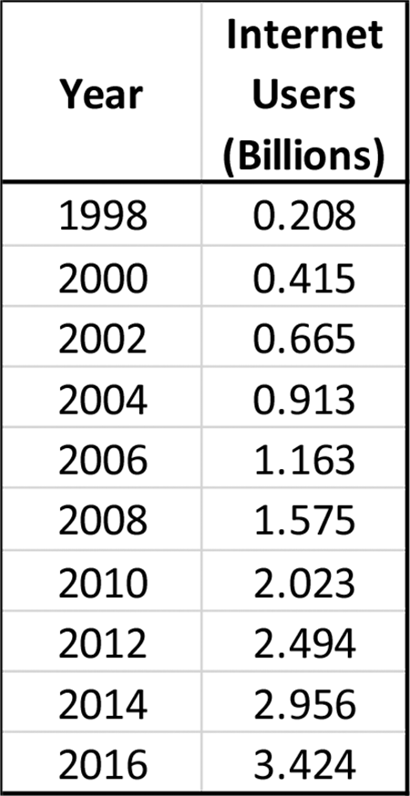
GraPhiCal Presentations 167

4. Construct a column chart as a chart sheet, for the following population data:
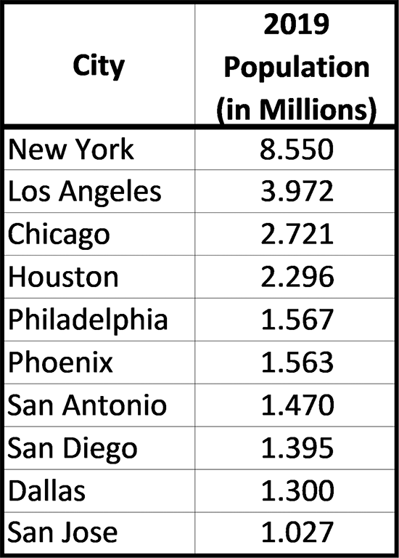

5. Construct a column chart as a chart object, for the following Median House Price
data.
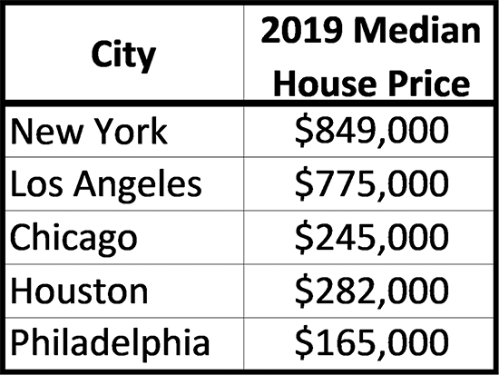

5.3 CREATING PIE CHARTS3
Figure 5.12 illustrates Excel’s two basic pie chart types (with an related alternate option
as a doughnut chart). The chart on the left is a 2-D type (short for two-dimensional),
while the one on the right is a 3-D type (short for three-dimensional).
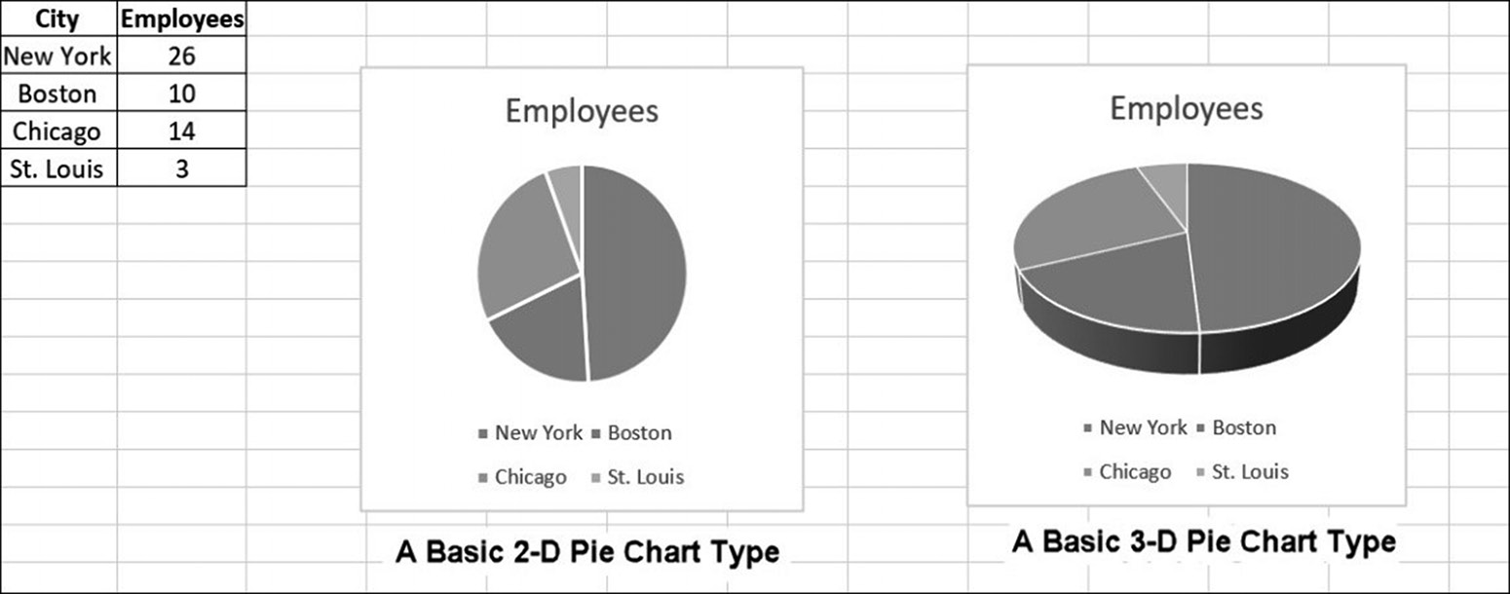

Figure 5.12 Data displayed as a pie chart
3 This section may be read independently of any other sections in this chapter.
168 exCel BasiCs

Both 2-D and 3-D pie charts are created as follows:
1. Highlight the data to be displayed (Item 1 in Figure 5.13). You need to highlight
one set of text (category labels) and one set of numerical data values (data series).
2. Select Insert from the Excel ribbon Insert tab (Item 2 in Figure 5.13).
3. Select the Charts group, and click on the Pie Chart icon (Item 3 in Figure 5.13).
4. Choose either the 2-D or 3-D chart type (Item 4 in Figure 5.13).
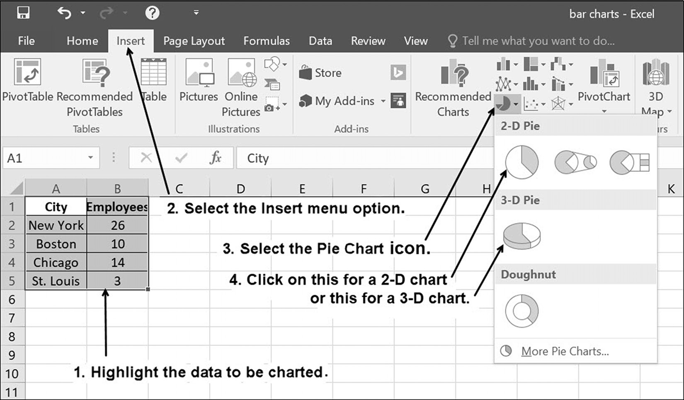

Figure 5.13 Creating a pie chart

In terms of the chart data needed (much like the data for the column and bar charts,
although the data is presented in column form), having the data in rows is also accept-
able.
Changing a Pie Chart’s Elements and Appearance
A pie chart’s title, data labels, legend, and other chart elements can be activated,
changed, or deactivated by either clicking or clearing the respective item within the
Chart Elements submenu, as shown in Figure 5.14. This submenu (item 3 in Figure
5.14) is activated by either right or left clicking within the pie chart, and then selecting
the displayed cross-hairs icon.
GraPhiCal Presentations 169
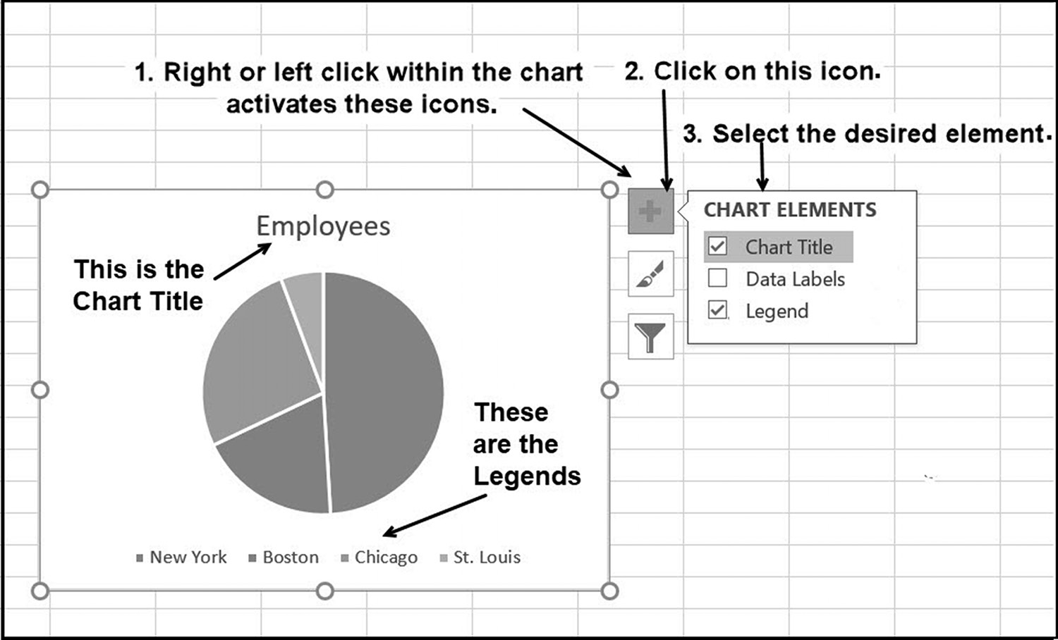

Figure 5.14 Pie Chart: Change chart elements

For example, checking the Data Labels checkbox shown in Figure 5.14 activates the
labels within each pie slice, as shown in Figure 5.15a. Here, the labels provide the
percentage of employees within each city. Note that a Chart Title and Legend are
activated by default, when the chart is created.
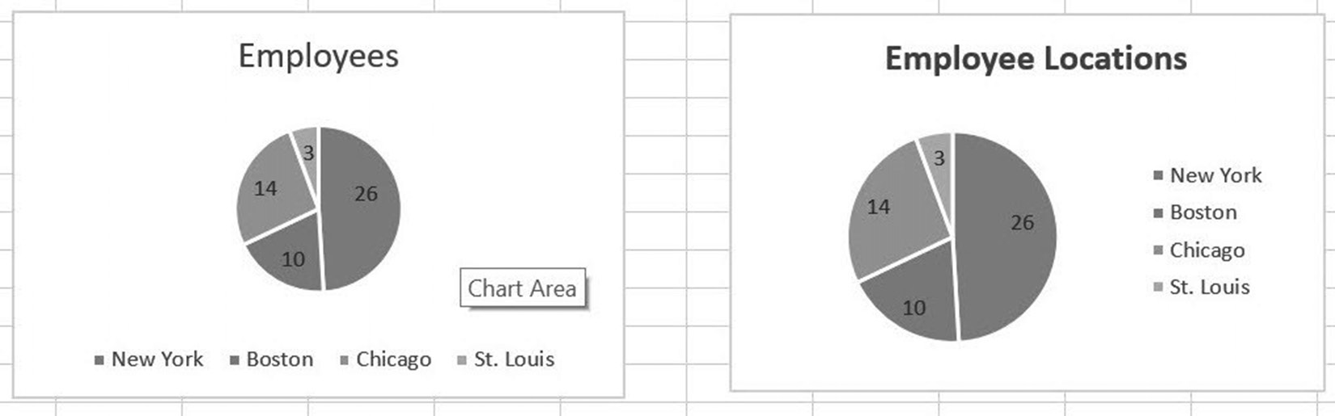

(a) (b)
Figure 5.15 Adding data labels to a pie chart
Once activated, a chart title’s text, font, and type size are changed by directly clicking
on the title. A legend’s position is changed by clicking on the Legend checkbox, and
then selecting one of the positions offered in the activated Legend submenu. These
procedures were done to produce the chart shown in Figure 5.15b.
170 exCel BasiCs

In addition to changing a chart’s title and labels, a number of different chart varia-
tions, such as those illustrated in Figure 5.16, are easily produced.
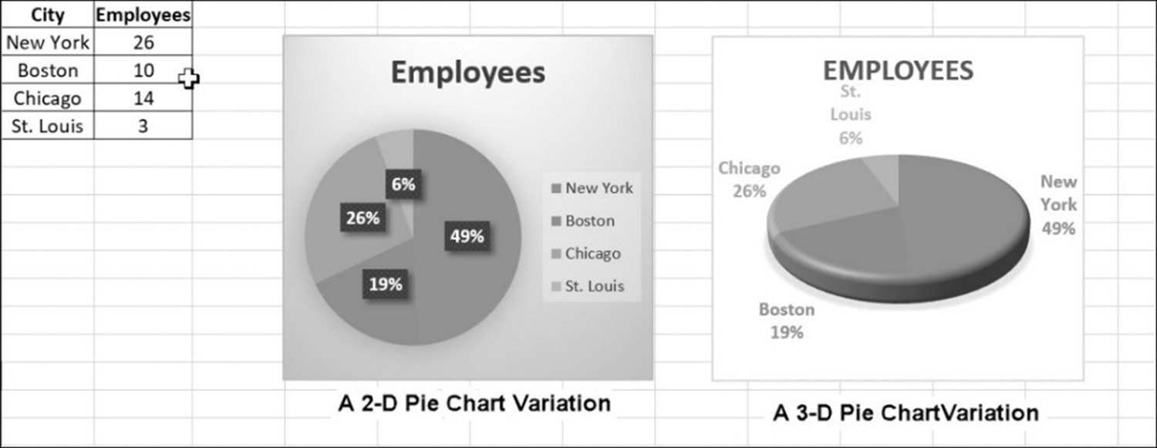

Figure 5.16 Pie chart variations
Variations in a chart’s appearance are accomplished by first double-clicking anywhere
within the chart. Doing this brings up the Chart Tools - Design menu shown in Fig-
ure 5.17. Clicking on any of the preconstructed chart styles changes the chart to the
selected appearance.4
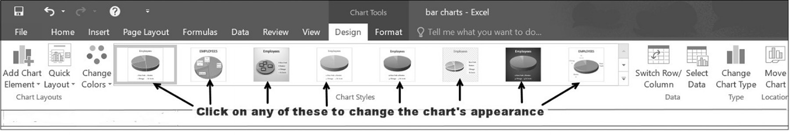

Figure 5.17 Pre-constructed pie chart styles
Changing Chart Types
Once a pie chart is created, it can easily be changed to different chart types, which
changes how the data is displayed. For example, Figure 5.18 shows how Figure 5.12’s
2-D chart appears using different chart types.
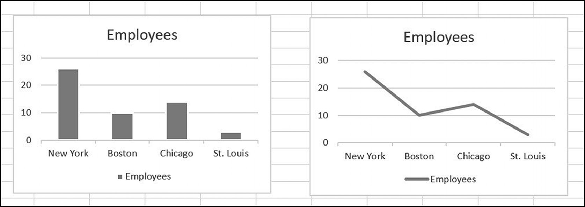

Figure 5.18 Different chart types
4 The Design submenu shown in Figure 5.17 can also be activated by single clicking within a chart and then selecting the Chart Tools’ Design option at the top of Figure 5.17.
GraPhiCal Presentations 171

A pie chart’s type is changed by
1. right-clicking within the chart (or selecting the chart)
2. clicking on the Change Chart Type option
3. selecting the desired chart type from the resulting pop-up sub-menu
The first two steps are illustrated in Figure 5.19.
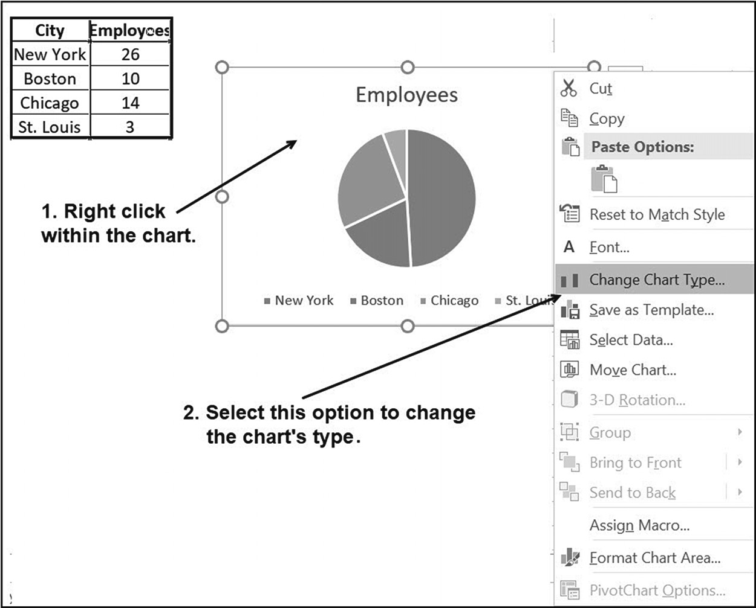

Figure 5.19 The first two steps in changing a chart’s type

The change made above can also be done through the Excel ribbon Chart Tools-
Design menu.

EXERCISES 5.3

1. Create the 2-D and 3-D pie charts shown in the figure.
172 exCel BasiCs

2. Create the same column and bar charts shown in Exercise 1 using the following
data.
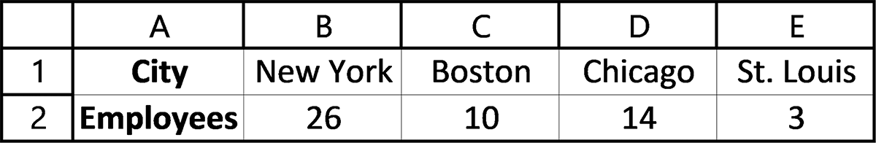

3. Complete parts a-b.
a. Construct a 2-D pie chart of the percentage of Internet users in the world for
the data listed in the following table as a chart sheet. (Source: worldometers. info/licensing-how.php)
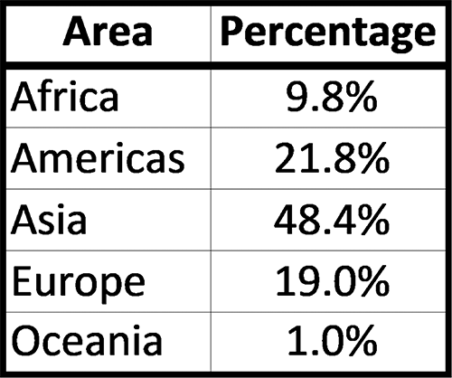

b. Convert the 2-D pie chart created for Exercise 3a into a 3-D pie chart.
4. Complete parts a-b.
a. Construct a 2-D pie chart for the following data, as a chart object.
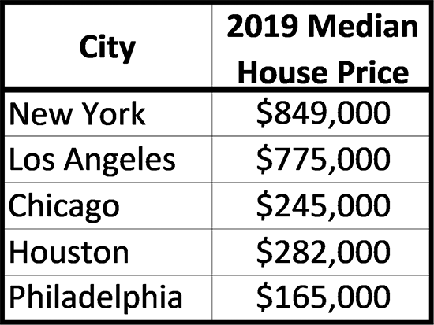

b. Convert the 2-D pie chart created for Exercise 4a into a 3-D pie-chart.
5. Construct a 3-D pie chart for the following data in its own chart sheet:
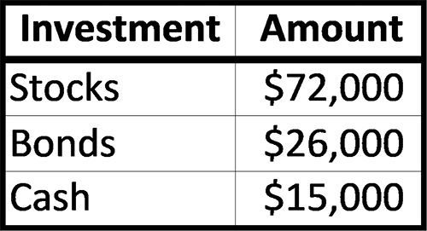
GraPhiCal Presentations 173

5.4 CREATING LINE GRAPHS5
Figure 5.20 illustrates an example of a line graph. The majority of line graphs show the
relationship between two variables, such as Sales versus Advertising or between quan-
tities, such as revenue or profit, as they change over time. Either straight or curved
lines can be used to connect individual points on the graph.6
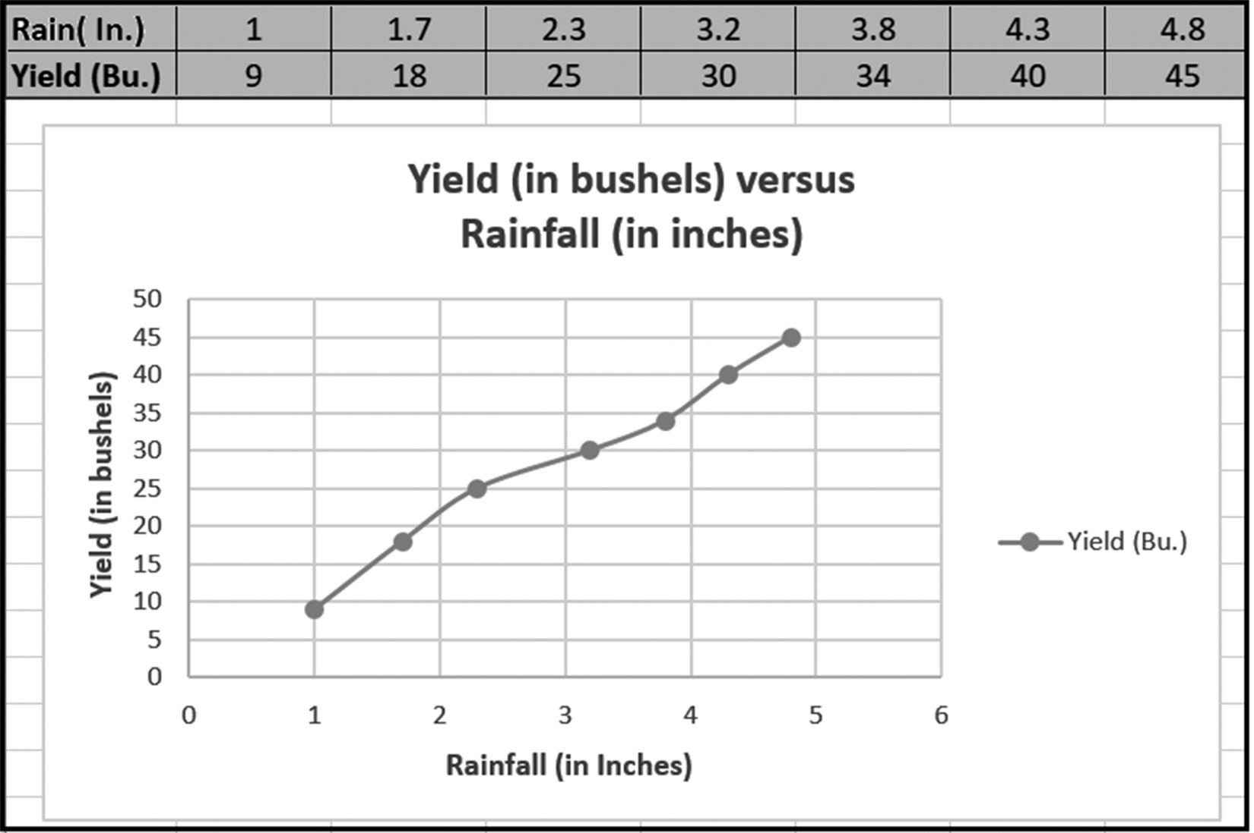

Figure 5.20 A line graph example

Creating a line graph requires that the data first be entered into either consecutive
rows, as shown in the upper-left corner of Figure 5.20, or consecutive columns. Once
entered, the data is highlighted, as shown as Step 1 in Figure 5.21, and the remaining
steps shown in the figure can then be completed.
Although any two consecutive rows or columns can be used for the data, when rows
are used, the data entered in the upper-most row become the x-axis values, and the
data in the lower row become the y-axis values. Similarly, for data listed in columns,
the data in the left-most column is plotted on the x-axis and the data in the right-most
column on the y-axis.

5 This section may be read independently of any other sections in this chapter. 6 A line graph without connecting lines between data points is a scatter diagram. Scatter diagrams are typically used with trend lines, as presented in the next section.
174 exCel BasiCs
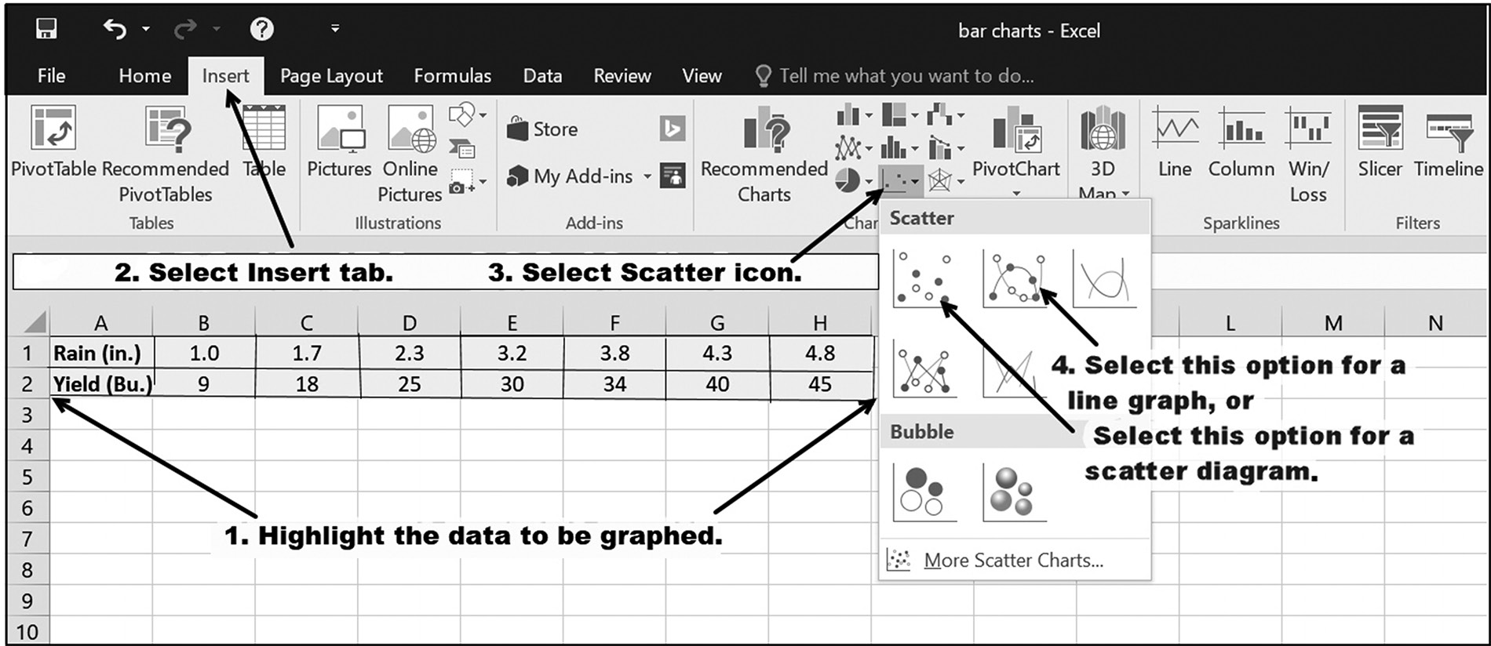

Figure 5.21 The steps needed to create a line graph

After selecting the line graph option shown as Step 4 in Figure 5.21, the line graph
shown in Figure 5.22 is automatically created. Notice that the figure has no axes titles
and that the chart’s title is a copy of the data label in cell A2, which is the y-axis data
label.
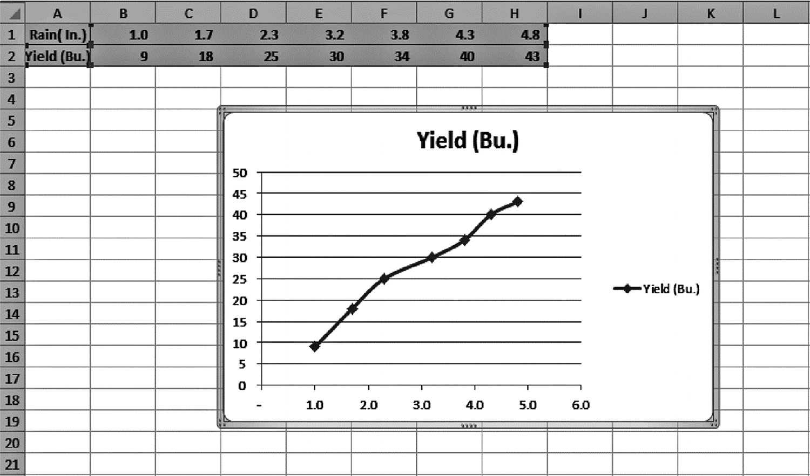

Figure 5.22 Sample line graph

Changing a Line Graph’s Chart Elements and Appearance
Figure 5.23 shows the initial position and description of the four descriptive chart
elements associated with line-graphs. These consist of a chart title, axis labels, legend,
and grid lines. When any of these textual elements are present, the text, font type and
size of each can be changed by clicking on the desired element and then entering new
text and font attributes.
GraPhiCal Presentations 175
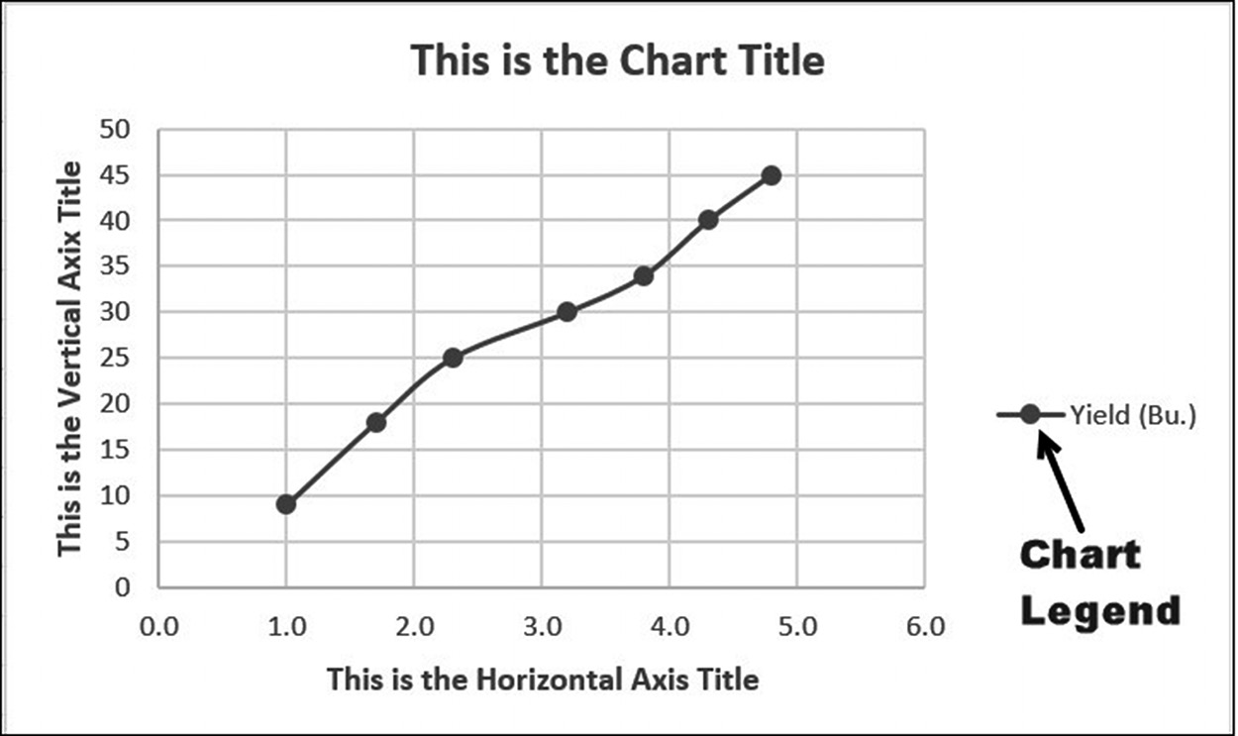

Figure 5.23 Labels for a line graph

Deleting or adding a chart element is accomplished using the Chart Elements sub-
menu shown in Figure 5.24. As shown in the figure, this submenu is activated by
either right or left clicking within the chart, and then clicking on the cross-hairs icon
and selecting the desired element.
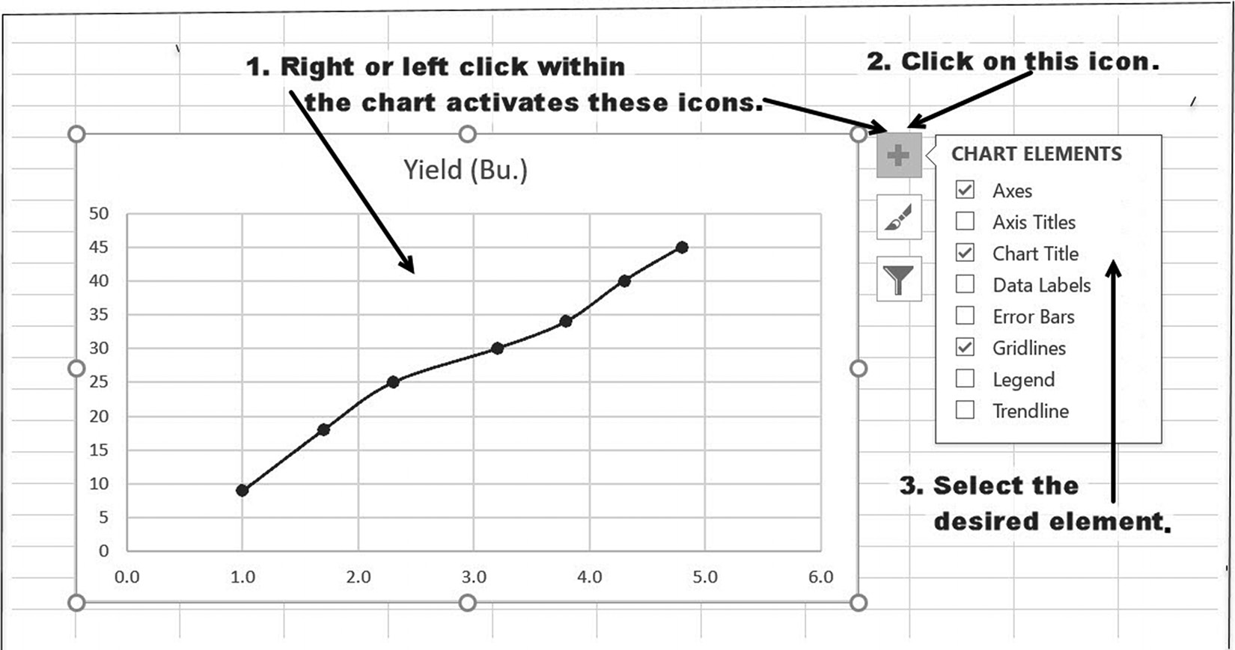

Figure 5.24 Working with a line graph
176 exCel BasiCs

Additionally, a line graph’s legends and line colors can be changed using the Change
Colors option in the Chart Tools Design menu, shown in Figure 5.25. The Design
menu is obtained by either double clicking within the chart or single clicking and then
selecting the Chart tool’s Design tab (seen at the top of Figure 5.25).
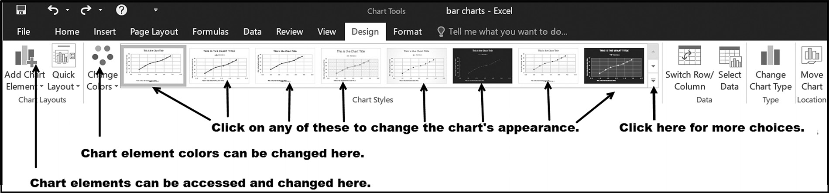

Figure 5.25 The chart Design menu options

Finally, a line graph’s appearance is changed by selecting one of the chart styles shown
within the Chart Tools - Design menu (again, see Figure 5.25). Clicking on any of the
pre-constructed styles changes the chart to the selected choice.7
Changing Chart Types
As with all Excel charts, a chart can easily be changed to a different chart type. Figure
5.26 illustrates two variations for the line graph previously illustrated in Figure 5.24.
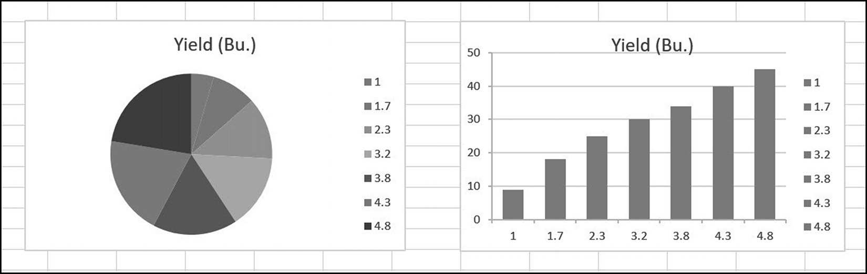

Figure 5.26 Different chart types

As with all of Excel’s charts, a line graph can be changed to another type by
1. Right-clicking within the chart
2. Clicking on the Change Chart Type option
3. Selecting the desired chart type from the resulting pop-up sub-menu (or by using
the Chart Tools – Design menu.)

7 Notice that the chart elements previously shown in Figure 5.24 can also be accessed and changed by clicking on the leftmost icon in the Chart Tools – Design menu.
GraPhiCal Presentations 177

The first two steps are illustrated in Figure 5.27.
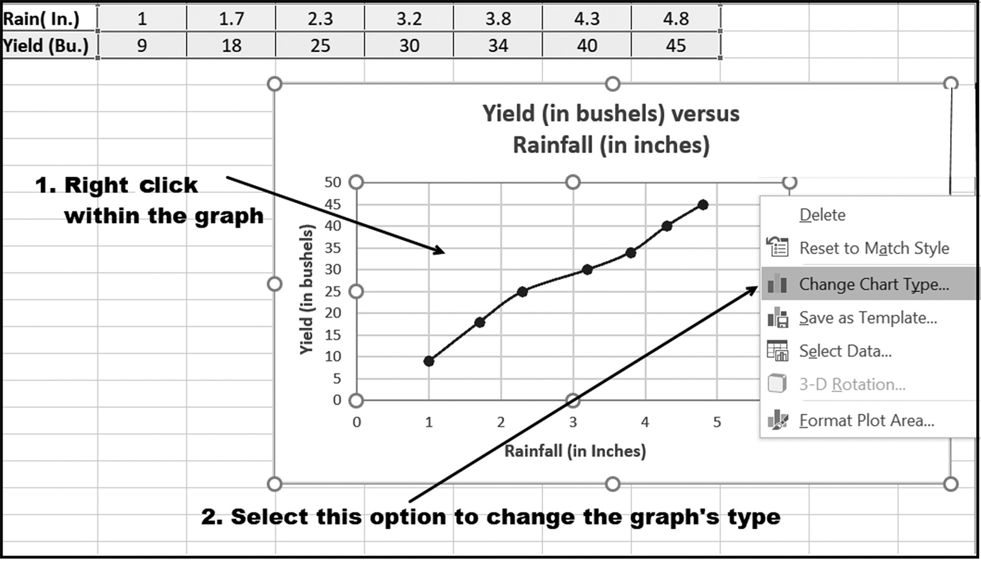

Figure 5.27 The first two steps in changing a chart’s type

In addition to creating a graph with a single line, Excel permits multiple lines to be
plotted on the same graph. The multiple line graph shown in Figure 5.28 was created
using the same technique as presented above, with the exception that all of the data in
rows 1, 2, and 3 were highlighted before selecting the line graph option.
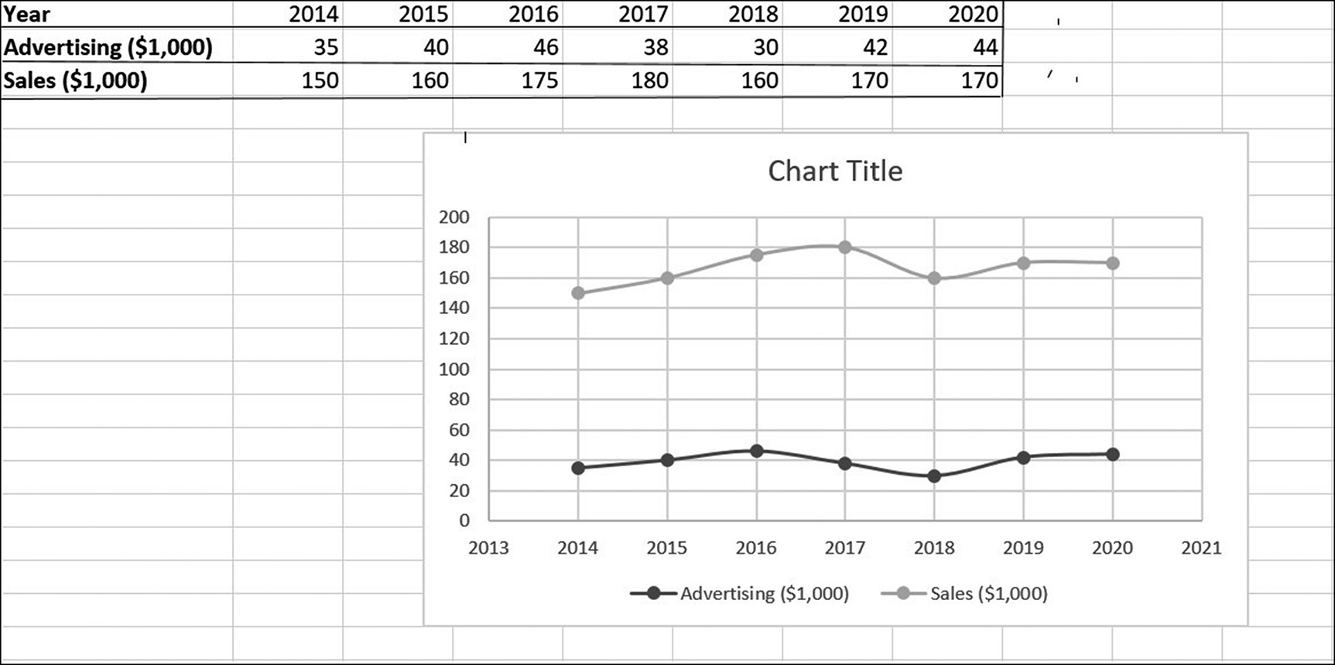

Figure 5.28 An example of a multiple line graph 178 exCel BasiCs

EXERCISES 5.4

1. Construct a line graph for the following data as a chart object.
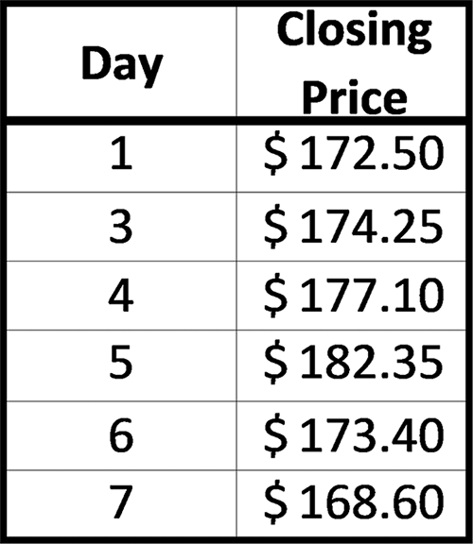

2. Construct a line graph for the following data as a chart sheet.
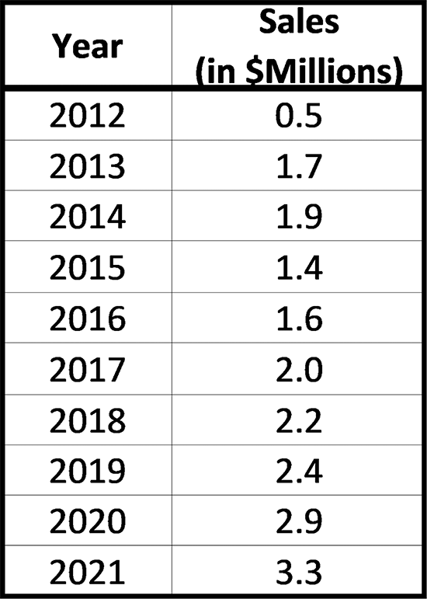

3. Complete parts a-b.
a. Construct a line graph for the following data as a chart object.

b. Add the appropriate chart and axes titles to the line graph created for Exercise 3a.
GraPhiCal Presentations 179

4. Complete parts a-b.
a. Construct a line graph for the following data in its own chart sheet.
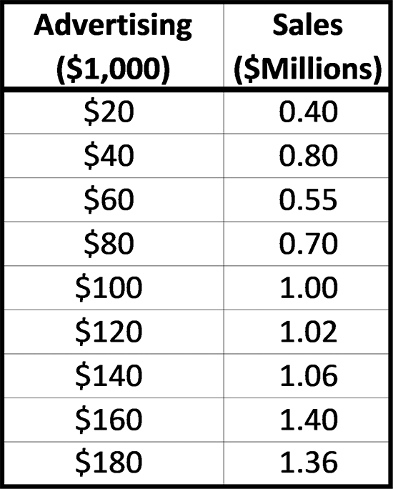

b. Add appropriate chart and axes titles to the line graph created for Exercise 4a.
5. Complete parts a-b.
a. The number of air conditioners sold each year by one department in an outlet
store is given below. Construct a line graph for this data as a chart object.

b. Add the appropriate chart and axes titles to the line graph created for Exercise 5a.
6. Complete parts a-b.
a. Construct a line graph, in its own chart sheet, for the sales data given below.

b. Add the appropriate chart and axes titles to the line graph created for Exercise
6a.
7. Complete parts a-b.
a. The share of people in the world with water available from a protected source
is given in the following table (Source: World Health Organization). Construct a line graph, as a chart object, for this data. (Hint: Code Year 1980 as 1, 1990 as 10, and so on.)

b. Add the appropriate chart and axes titles to the line graph created for Exercise 7a. 180 exCel BasiCs

8. Complete parts a-b.
a. Construct a line graph for the following data in its own chart sheet (Hint: Code
Year 2012 as 1, 2013 as 2, and so on).
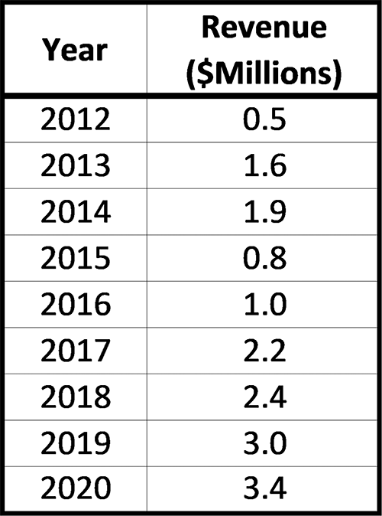

b. Add the appropriate chart and axes titles to the line graph created for Exercise 8a.

5.5 TREND LINES AND SCATTER DIAGRAMS

In business, economics, and science, a line used to fit empirically obtained data is
referred to as a trend line. A trend line can be linear, quadratic, exponential, or any
other line that best fits the data. Mathematically, a best fit is accomplished by mini-
mizing the total squared error between the trend line and the actual data.8 The dotted
line shown in Figure 5.29 is an example of a straight line trend line.
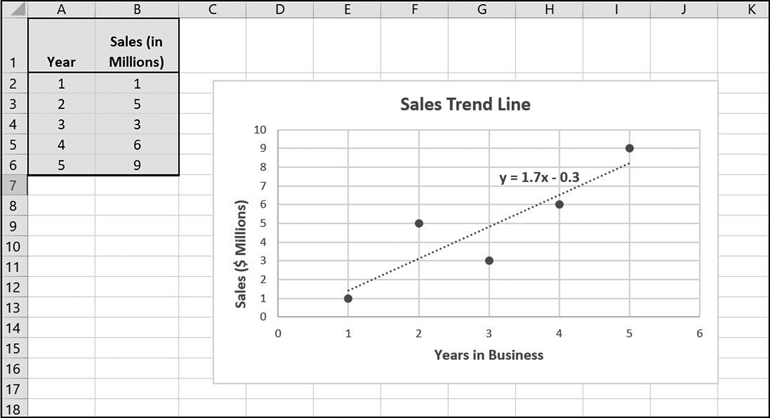

Figure 5.29 An example of a straight line trend line
8 This procedure is known as the least-squares minimization method. Refer to Mathematics for Business, by Bronson, Bronson, and Kieff for a presentation of this method.
GraPhiCal Presentations 181

In constructing a trend line, the first step is to create a scatter diagram. A scatter
diagram is a graph containing multiple data points, with no connecting lines between
the points.9 Figure 5.30 illustrates two examples of scatter diagrams. Trend lines are
graphed on the resulting scatter diagram.
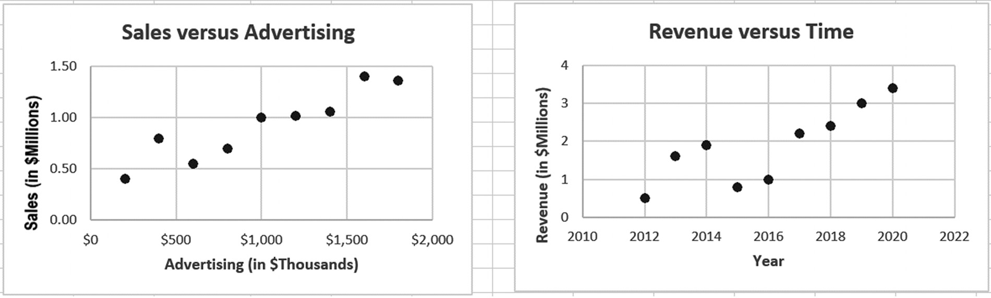

Figure 5.30 Examples of scatter diagrams

Creating a Scatter Diagram
Creating a scatter diagram requires that the data is first entered into either consecu-
tive columns, as shown in the upper-left corner of Figure 5.31, or consecutive rows.
The data is then highlighted, as shown as Step 1 in the figure, and the remaining steps
listed in the figure are then completed.
Although any two consecutive columns or rows can be used for the data, when
columns are used, the data entered in the left-most column become the x-axis values,
and the data in the right-most column become the y-axis values. For data listed in the
rows, the upper-most row data is plotted on the x axis and the lowest-row data on the
y axis.
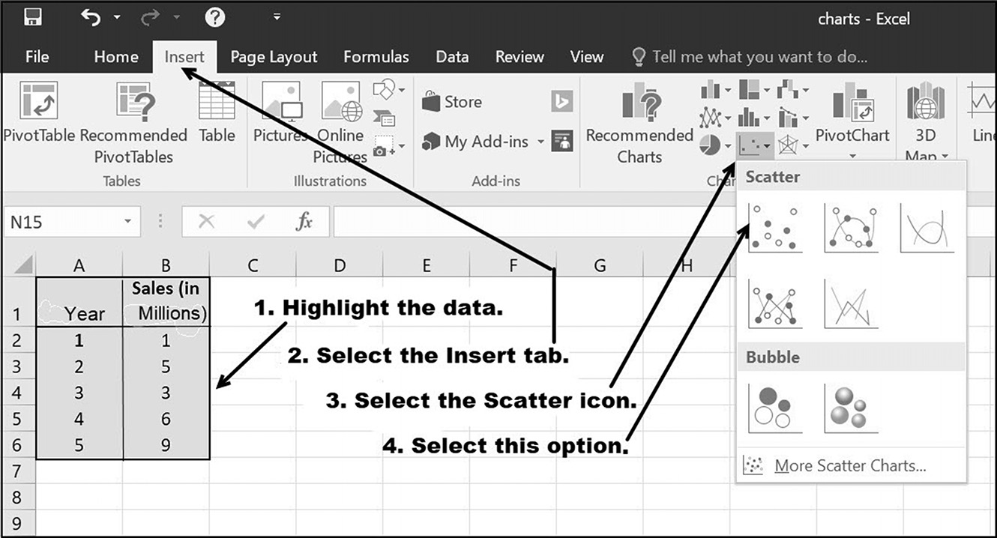

Figure 5.31 The steps required to produce a scatter diagram

9 When the data points are connected with lines between them, the scatter diagram is referred to as a line graph. Connecting lines are not used so that they do not clutter the graph and obscure the trend line.
182 exCel BasiCs

After selecting the scatter option listed as Step 4 in Figure 5.31, the scatter diagram
shown in Figure 5.32 will appear. Notice that the figure has no axes titles and that the
chart’s title is a copy of the data label in cell B2, which identifies the y-axis values.
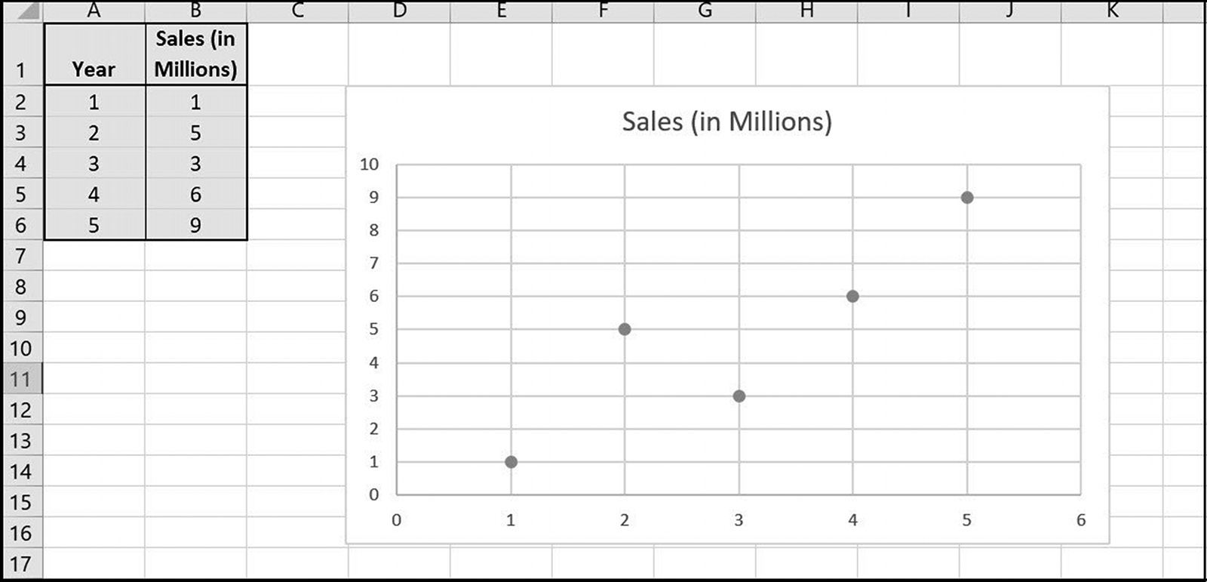

Figure 5.32 The scatter diagram created with the given data

Changing a Scatter Diagram’s Elements and Appearance
Figure 5.33 shows the initial position and description of the descriptive Chart Ele-
ments associated with line graphs. These consist of a chart title, axes labels, legend,
and grid lines. When any of the four textual elements are present (title, axes labels,
and legend) the text, font type, and size of each of these elements can be changed by
clicking on the desired element and directly entering new text and font attributes.
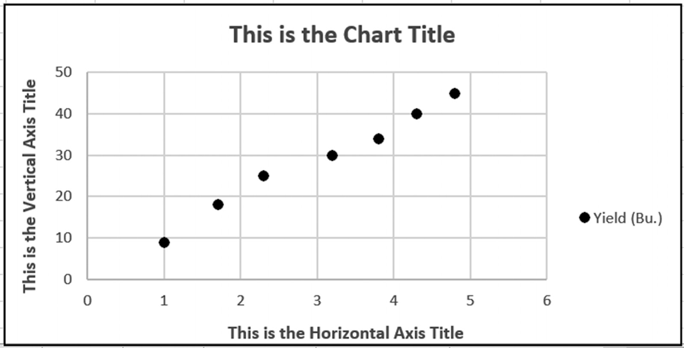

Figure 5.33 Scatter Diagram with labels
GraPhiCal Presentations 183

Adding or deleting a scatter diagram’s title, axes labels, legend, and grid lines is done
using the Chart Elements submenu shown in Figure 5.34. This submenu is activated
by either clicking on the Chart Tools – Design menu, or right or left clicking within
the chart itself (item 1 in the figure), and then selecting the cross-hairs icon (item 2 in
the figure). Clicking on a chart element within the submenu adds the element to the
chart, while clearing a checkbox removes the element.
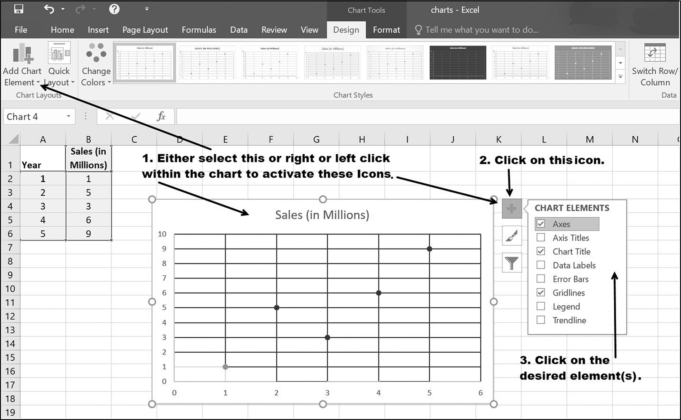

Figure 5.34 Adding or deleting chart elements

A scatter diagram’s colors can be changed using the Change Colors option in the Excel
ribbon Chart Tools Tab, Design submenu, as shown at the upper left in Figure 5.35.
The Design submenu is activated either by double clicking within the chart or single
clicking and then selecting the Design tab under the Chart Tools option (at the top of
Figure 5.35).
For example, checking the Axis Titles and Legend checkboxes shown in Figure
5.34 produces the chart shown in Figure 5.35a. Simply double clicking within each
element allows you to change the titles to those of your own choosing, including the
font type and size. This was done to produce the titles shown in Figure 5.35b.
184 exCel BasiCs
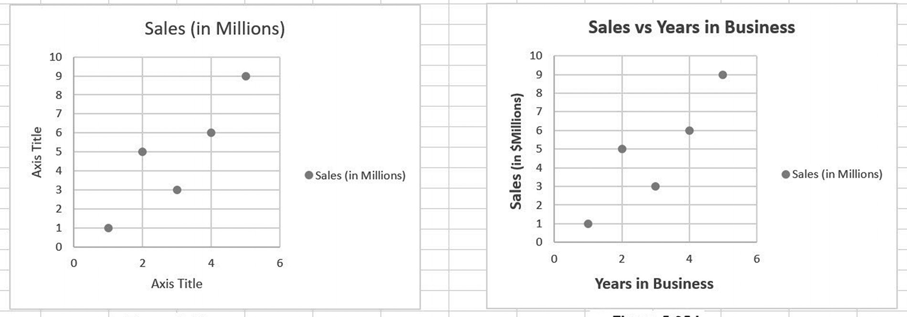

(a) (b)
Figure 5.35 Adding axes labels and a legend

A scatter diagram’s appearance is changed by selecting one of the chart styles shown
within the Chart Tools - Design menu (see Figure 5.36). Clicking on any of the pre-
constructed styles changes the chart to the selected choice. Note that the chart ele-
ments previously shown in Figure 5.34 can also be accessed and changed by clicking
on the leftmost icon in the Chart Tools - Design menu.
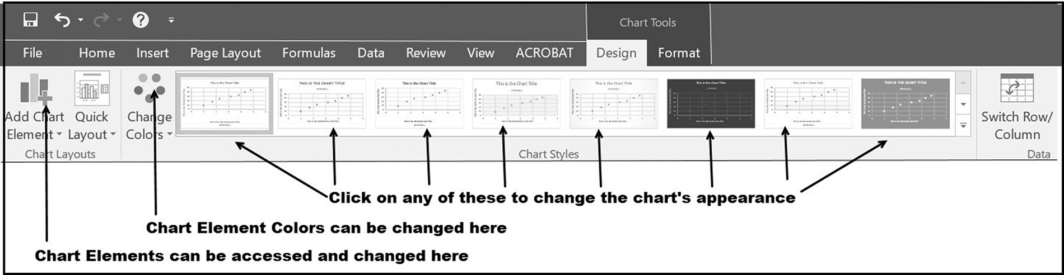

Figure 5.36 The Chart Tools Design ribbon

Adding a Trend Line
To add a trend line for the data shown on a scatter diagram, either click on the Add
Chart Elements in the Chart Tools - Design Tools menu, as shown in Figure 5.37 (if
this menu is not shown, double clicking anywhere within the scatter diagram causes
it to be displayed), or click on the Chart Elements icon (if this icon is not displayed,
either right or left clicking within the scatter diagram activates it). Either of these
actions produces the submenus shown in Figure 5.37.
GraPhiCal Presentations 185
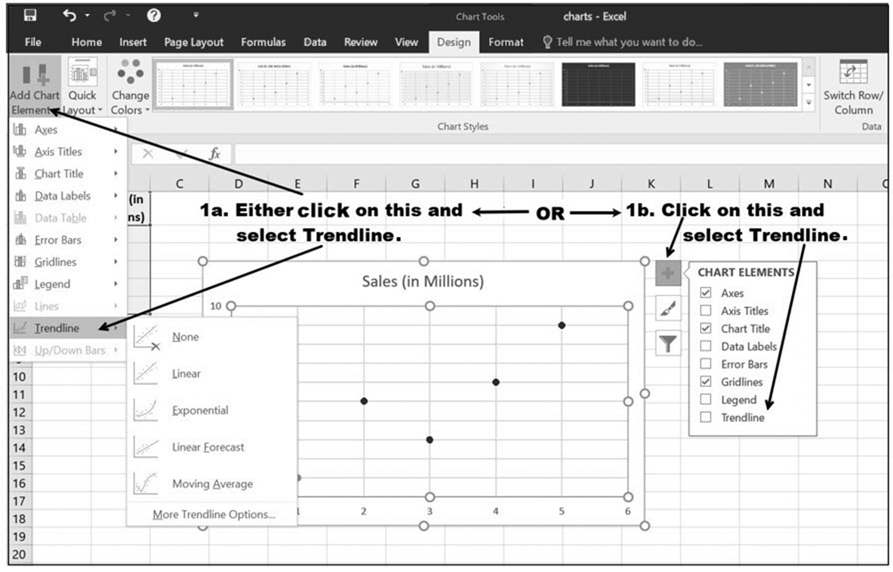

Figure 5.37 Adding a trendline

Clicking on the arrow to the right of the Trendline option from either of the submenus
displayed in Figure 5.37 (hover over the Trendline option to activate the arrow) trig-
gers the menu shown in Figure 5.38
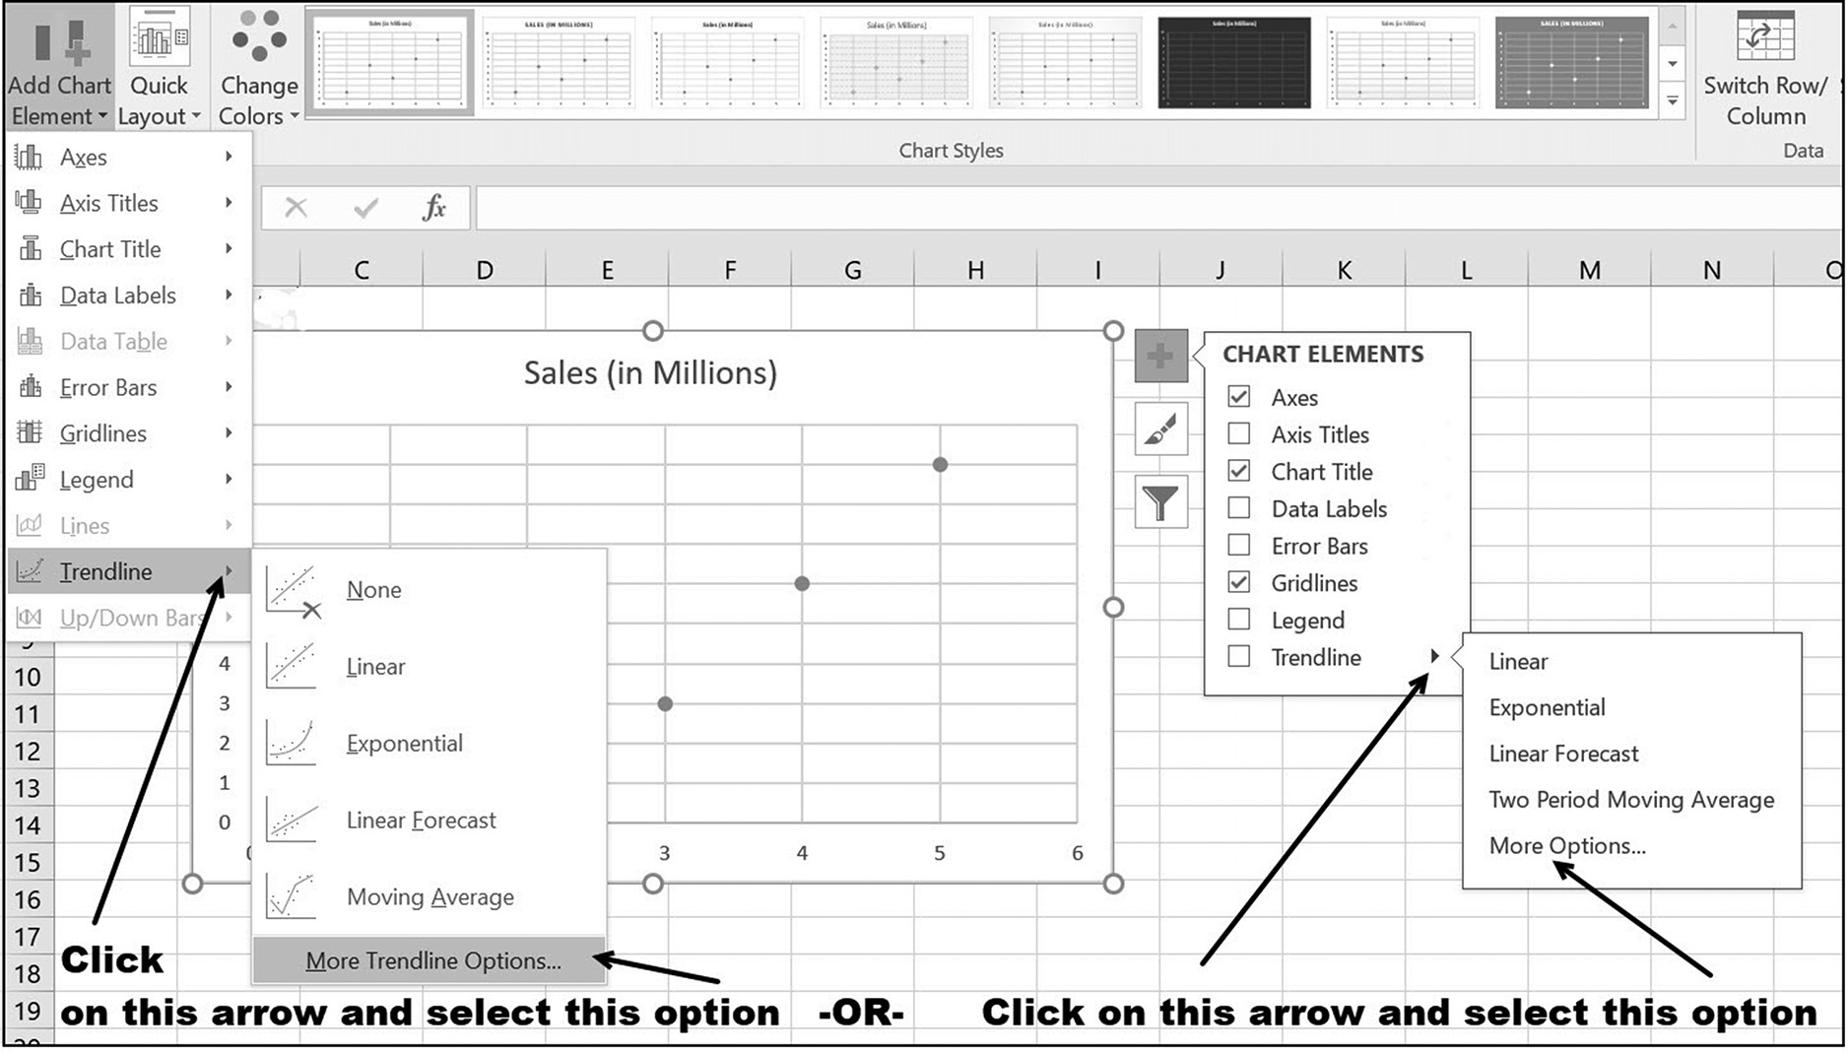

Figure 5.38 Selecting Trendline Chart Elements 186 exCel BasiCs

When the Trendline drop-down menu shown in Figure 5.38 is displayed, you are
ready to add the Trendline and its equation onto the scatter diagram. To do so, click
on the last option, which is labeled More Trendline Options. Selecting this option will
bring up the last menu needed, which is that shown on Figure 5.39.10
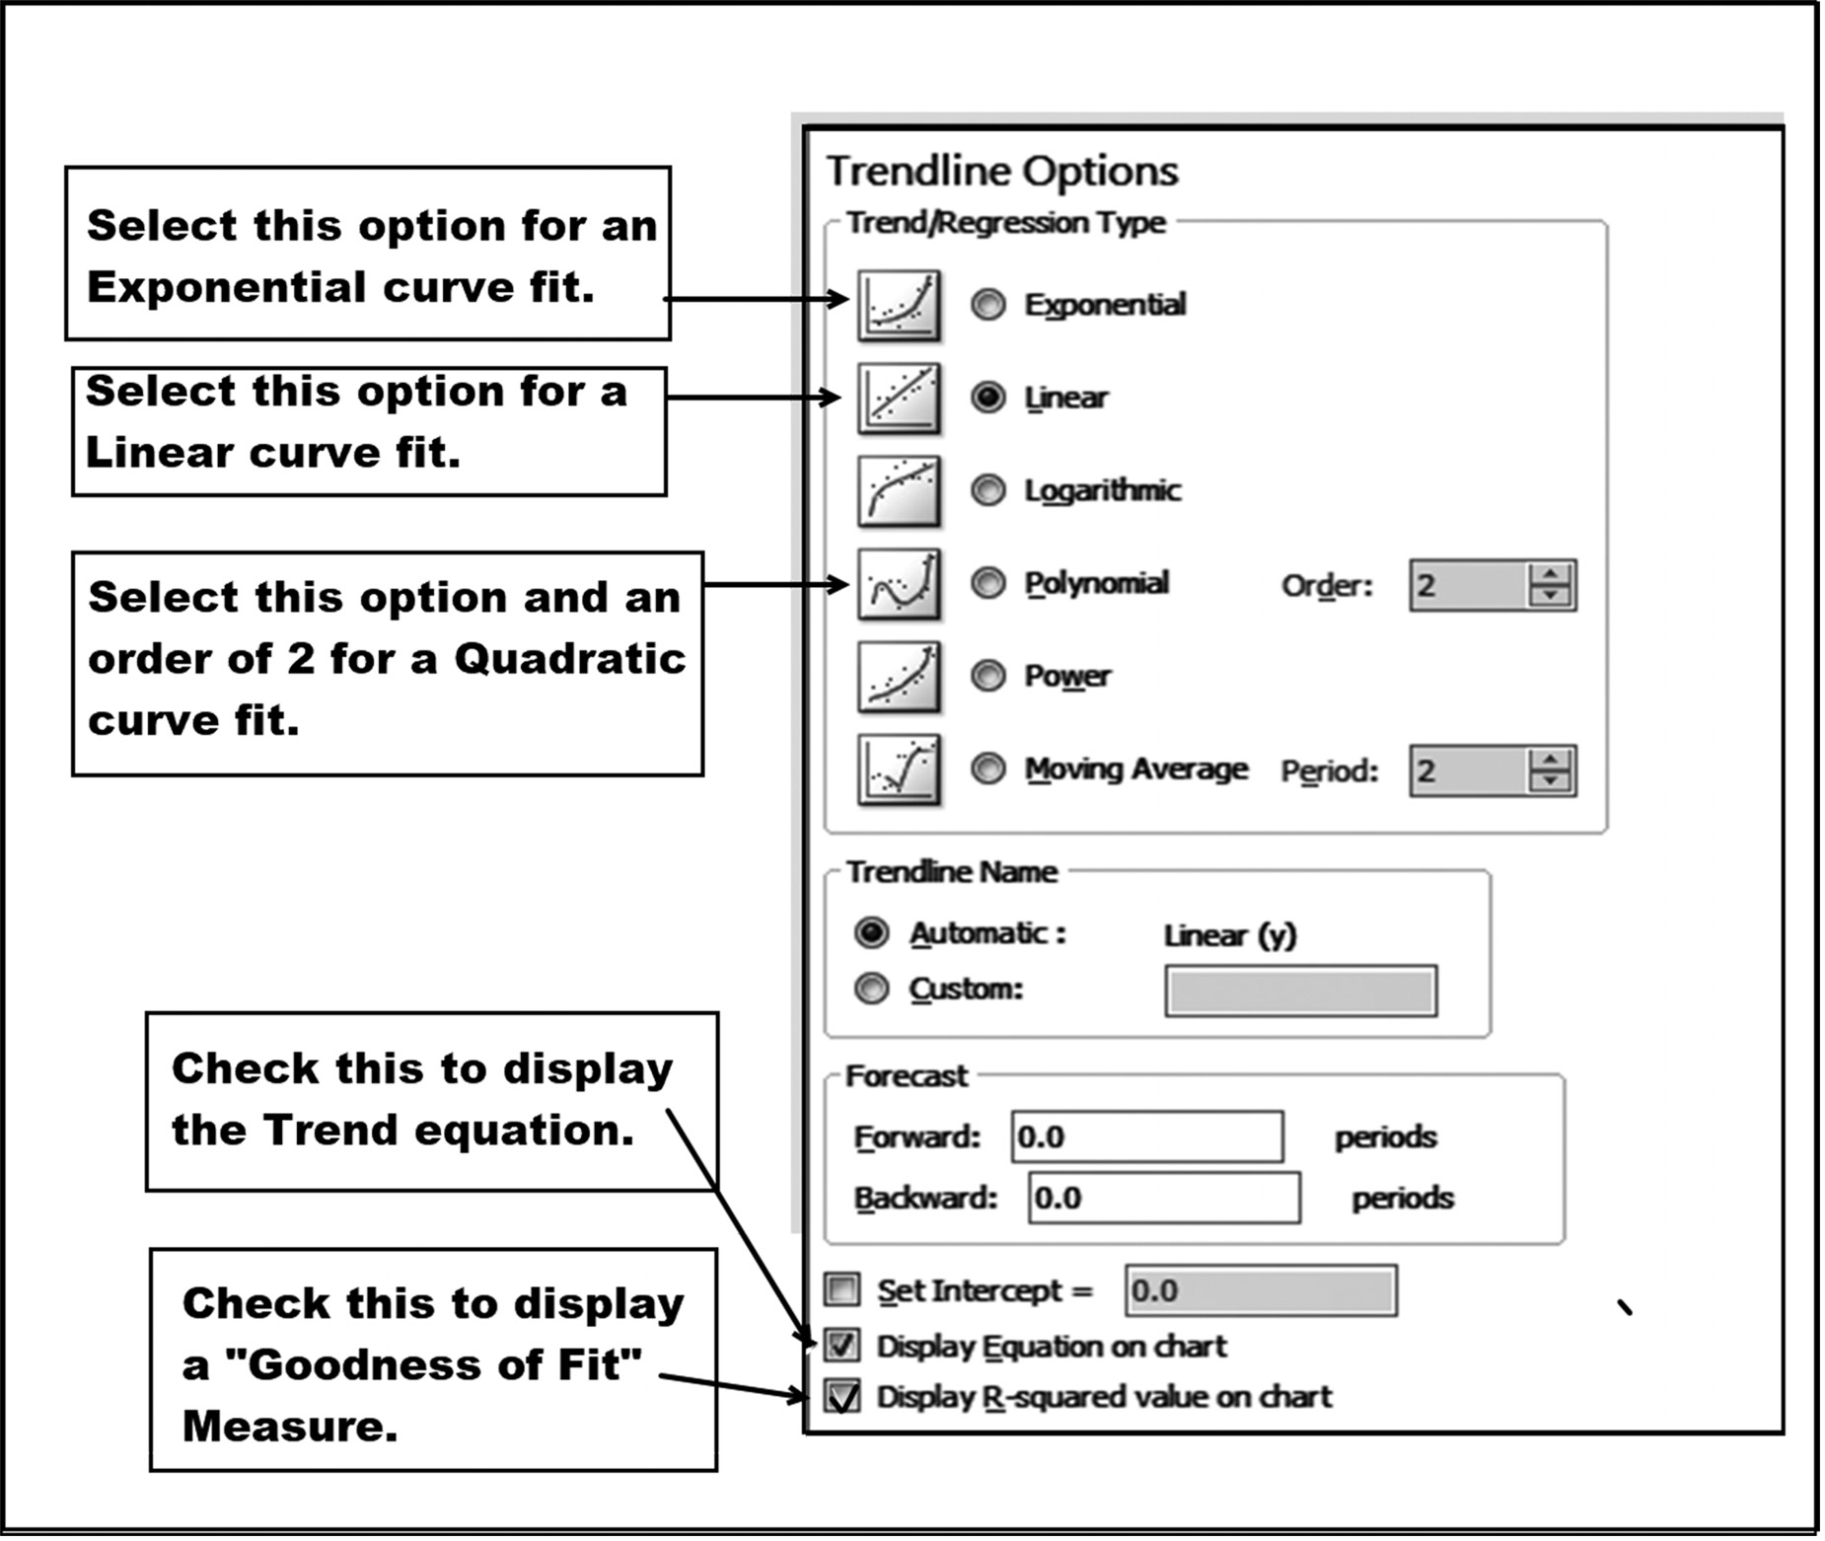

Figure 5.39 Trendline options

When the menu shown in Figure 5.39 is displayed, click on the desired trend line
type as shown in the figure. Then check the Display Equation on chart and Display
R-squared value on chart checkboxes at the bottom of the menu and click on the Close
button. This will produce a display of the chosen trend line with its associated equa-
tion and R-squared value directly on the scatter diagram. Selecting a Linear Trend
line for the Year and Sales data used throughout this example produces Figure 5.40.

10 Note: Checking the Trendline box on the Chart Elements submenu immediately produces a linear trend with no equation.
GraPhiCal Presentations 187
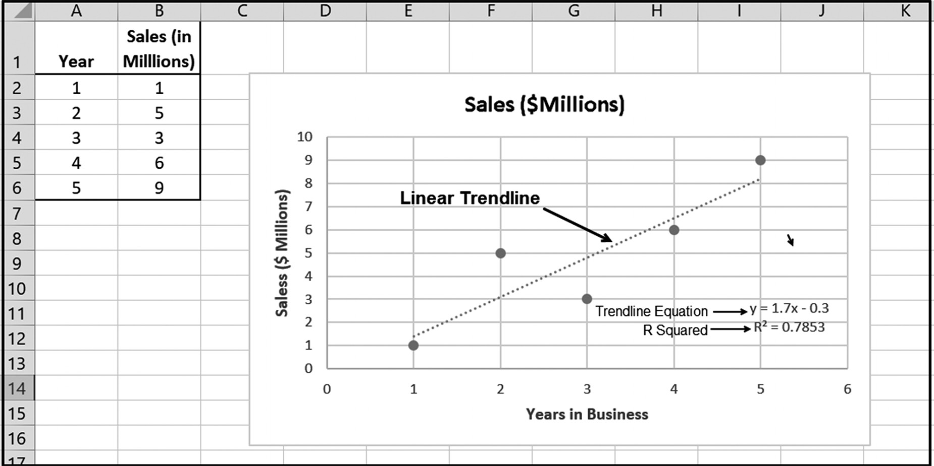

Figure 5.40 Trendline created with selected options

R2 and Selecting an Appropriate Trend Line
The example in this section illustrated modeling of the data using a linear trend line.
In practice, the choice of which trend line to use is always based on the data itself.
Thus, in practice, after a scatter diagram has been produced, the next step is to deter-
mine which, if any, of the curve types considered in this section best fits the data. The
starting point is always the same. Use a scatter diagram to plot the data and then care-
fully examine the resulting plot.
Typically, a pattern develops. Based on the emergent pattern and knowledge of var-
ious curves, a curve type that appears to fit the data reasonably well is then selected.
As shown in Figure 5.41, Excel provides a number of Trendline options.
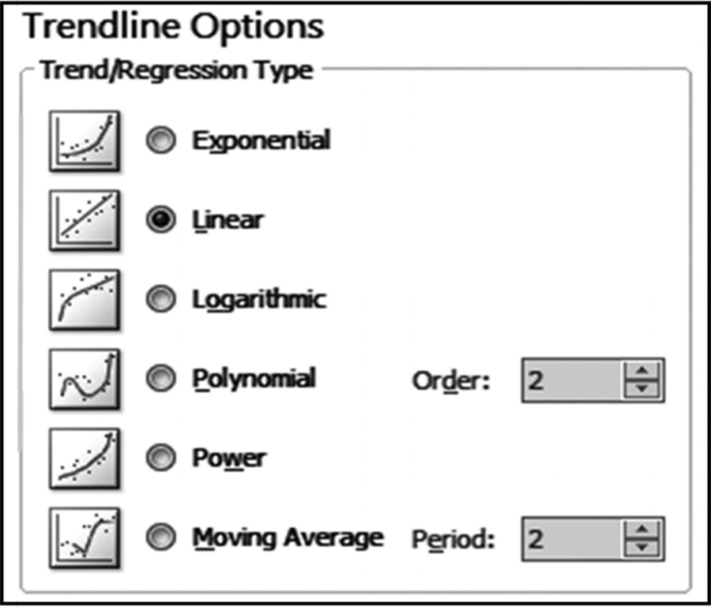

Figure 5.41 Excel’s Trendline options 188 exCel BasiCs

Once a selection has been made, the Trendline is superimposed on the scatter dia-
gram. The final step is then to determine whether the resulting line does, in fact,
adequately model the data. It is here that the R2 value, which is formally known as the
Coefficient of Determination, is used.
Mathematically, an R2 of 0 indicates that the variable plotted on the y-axis cannot
be predicted from the value plotted on the x-axis. Similarly, an R2 of 1 indicates that
the variable on the y axis can be predicted, without error, from the corresponding
value on the x axis, assuming all other variables remain the same. An R2 between 0
and 1 indicates the degree to which the y-axis variable is predictable. Thus, an R2
of 0.25 indicates that 25% of the y-axis value is predictable from x-axis value, and
an R2 of 0.80 means that 80% is predictable. In all cases, this requires that all other
variables remain constant. Interestingly, the coefficient of determination, R2, is the
square of the Correlation Coefficient between the y-axis values and x-axis values.11
An R2 value of 1 indicates a perfect correlation, while a value of 0 indicates no corre-
lation. It is important to understand that even if two quantities are perfectly
correlated, correlation does not imply causation. All that correlation implies
is that when one quantity occurs, the other quantity tends to occur to the degree
indicated by the correlation coefficient. It never means that one quantity causes the
other quantity to occur.
This chapter addressed a number of the commonly used chart types in Excel, and
how to use the chart features within Excel to create charts, change charts, and en-
hance the charts that have been created. Besides the most commonly used kinds that
were covered in detail in the chapter, there are other types available, some of which
are variations of the basic types, and others which are more advanced or for special-
ized purposes. These types include area charts, radar charts, stock charts, waterfall
charts, sunburst charts, and combo charts. You can consult various resources for more
information on these other chart types.

11 Although the correlation coefficient squared yields the coefficient of determination, the square root of the coefficient only provides the value of the correlation coefficient, not whether it is positive of negative. In addition to its value, correlation coef-ficients have a sign, either + or −, indicating either a positive or negative correlation, respectively.
GraPhiCal Presentations 189

EXERCISES 5.5

1. Construct a scatter diagram chart for the following data (chart object).
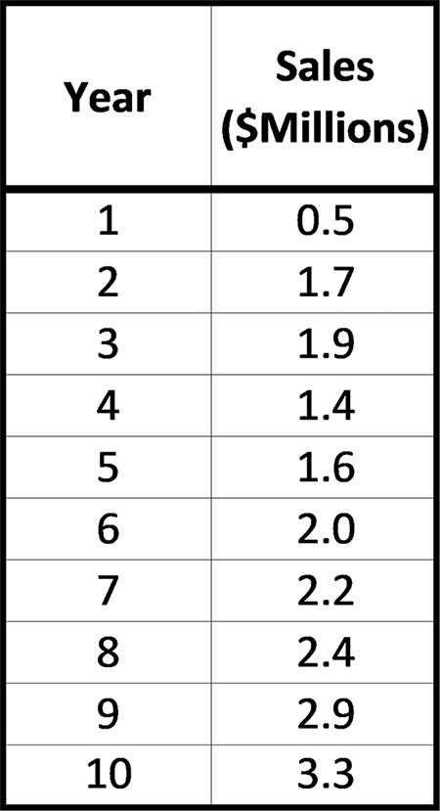

2. Complete parts a-b.
a. Construct a scatter diagram for the following sales data (chart sheet).

b. Add the appropriate chart and axes titles to the scatter diagram created for
Exercise 2a.
3. Complete parts a-b.
a. The share of people in the world with water available from a protected source
is given in the following table (Source: World Health Organization). Construct a scatter diagram chart (chart object) for this data. (Hint: Code Year 1980 as 1, 1990 as 10, and so on.)

b. Add the appropriate chart and axes titles to the scatter diagram created for
Exercise 3a.
190 exCel BasiCs

4. Complete parts a-b.
a. Construct an Excel scatter diagram and a linear trend line for the following data
(chart sheet).

b. Add the appropriate chart and axes titles to the scatter diagram created for
Exercise 4a and make sure that the trend line’s equation and R2 value are shown on the chart.
5. Complete parts a-b.
a. Construct an Excel scatter diagram and a linear trend line for the following data
(chart object).

b. Add the appropriate chart and axes titles to the scatter diagram created for
Exercise 5a and make sure that the trend line’s equation and R2 value are shown on the chart.
6. Complete parts a-b.
a. Construct an Excel scatter diagram and a linear trend line for the following data
(chart sheet).

b. Add the appropriate chart and axes titles to the scatter diagram created for Exer-
cise 6a and make sure that the trend line’s equation and R2 value are shown on the chart. (Hint: Code Year 2014 as 1, 2015 as 2, and so on.)
7. Complete parts a-b.
a. Construct an Excel scatter diagram and a 2nd order polynomial (quadratic) trend
line for the following data as a chart object.
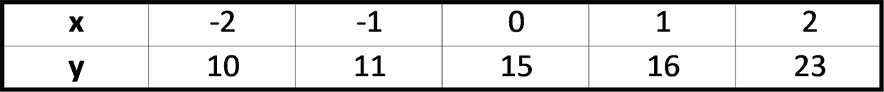

b. Add the appropriate chart and axes titles to the scatter diagram created for
Exercise 7a and make sure that the trend line’s equation and R2 value are shown on the chart.
GraPhiCal Presentations 191

8. Complete parts a-b.
a. Construct an Excel scatter diagram and a 2nd order polynomial (quadratic) trend
line for the following data as a chart sheet.

b. Add the appropriate chart and axes titles to the scatter diagram created for
Exercise 8a and make sure that the trend line’s equation and R2 value are shown on the chart.
9. Complete parts a-b.
a. Construct an Excel scatter diagram and an exponential trend line for the follow-
ing data (as a chart object).
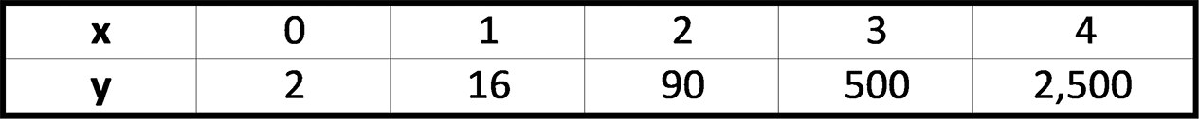

b. Add the appropriate chart and axes titles to the scatter diagram created for Exer-
cise 9a, and make sure that the trend line’s equation and R2 value are shown on the chart.
10. Complete parts a-b.
a. Construct an Excel scatter diagram and an exponential trend line for the follow-
ing data (chart sheet).

b. Add the appropriate chart and axes titles to the scatter diagram created for
Exercise 10a, and make sure that the trend line’s equation and R2 value are shown on the chart.
11. Complete parts a-c.
a. Construct an Excel scatter diagram and an exponential trend line for the follow-
ing data (chart object).
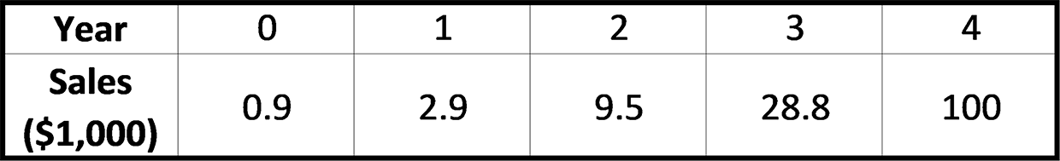

b. Add the appropriate chart and axes titles to the scatter diagram created for
Exercise 11a, and make sure that the trend line’s equation and R2 value are shown on the chart.
c. Use the trend equation found in Exercise 11a to project sales for the 6th year. 192 exCel BasiCs

12. Complete parts a-c.
a. Construct an Excel scatter diagram and an exponential trend line for the fol-
lowing data as a chart sheet (Hint: Code Year 2014 as 1, 2015 as 2, and so on).
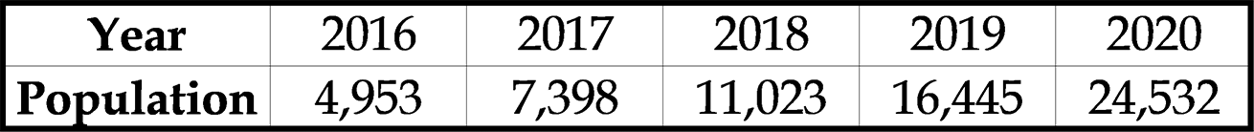

b. Add the appropriate chart and axes titles to the scatter diagram created for
Exercise 12a, and make sure that the trend line’s equation and R2 value are shown on the chart.
c. Use the trend equation found in Exercise 12a to project the population in 2022.
13. Complete parts a-b.
a. Using R2 values, determine whether a linear, quadratic, or exponential trend
line best fits the following data.

b. Use the trend line found to be best in Exercise 13a to project sales for the com-
pany’s 6th and 7th year in business.

5.6 COMMON EXCEL ERRORS
Errors common to the material presented in this section are:
1. Not realizing how much visual elements such as charts and graphs add to a pres-
entation and, thus, not making the maximum use of them.
2. Not adding the R2 value to trend lines superimposed on scatter diagrams. The R2
value provides important information as to the validity of the trend line.
3. Mistaking correlation with causation. It is extremely important to understand that
even if two variables are 100% correlated, it does not mean that one variable causes the other.

5.7 CHAPTER APPENDIX: CREATING HISTOGRAMS
A histogram is a specialized bar graph used to display the frequency (that is, how
often something happens) in successive groups of equal size, such as 10-19 or 20-29.
The individual groups are generally known as bins, and are also termed “intervals”
or “buckets.” As an example, consider Figure 5.42, which shows the distribution of
GraPhiCal Presentations 193

student ages from 17 to 21. The first column in the figure lists the ages that will be
analyzed and charted, while the second column lists the upper value of the bin. A bin’s
values are determined to be the values below the upper value, but higher than the
next upper value bin number.
In Figure 5.42, only the data and bin values are entered. The Bin/Frequency table
and histogram chart were produced using Excel’s Histogram option.
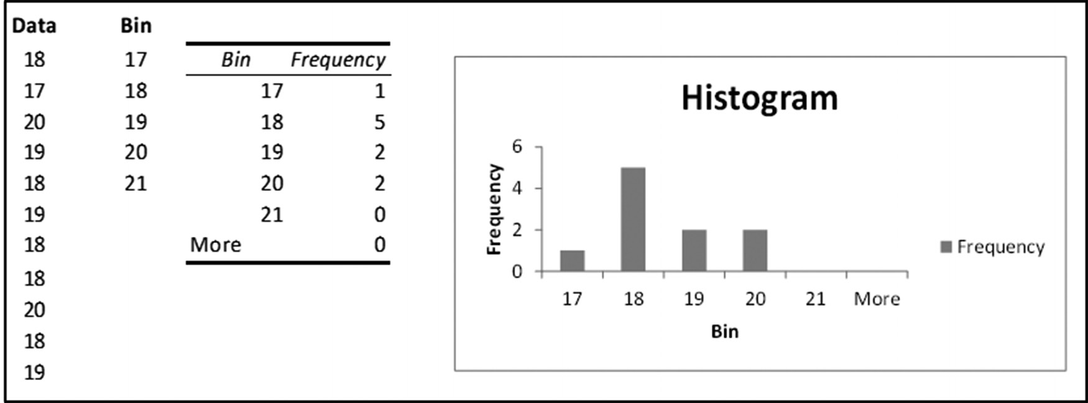

Figure 5.42 Histogram with the bin and frequency
As noted above, the only data entered in the spreadsheet used to produce Figure 5.42
are the data and bin values listed in the first two columns, one for the data and one for
the bins, and consist of the following:
●● Data Column: This is your data. It will be analyzed and displayed in the histo-
gram.
●● Bin Column: A bin value represents the upper bound for the bin. Bin values
must be in increasing order. The difference between two successive values rep-resents the bin’s range.
Each bin value sets the upper bound for the bin. When you create a histogram, a data
value is included in a bin if it is less than or equal to the bin’s value (thus, it is the bin’s
upper bound) and greater than the prior bin’s value (thus, this is the lower bound
for the current bin).12 Thus, in Figure 5.42, the first bin will contain the number of
students up to 17 years of age, the second bin will contain the number of students
between 17 and 18 years of age, and so on.
There are two procedures for creating a histogram; the first works with all Excel
versions, the second was introduced in Excel 2016. All that is required for the first
procedure are the data and bin columns, as shown in Figure 5.42. From this data, the
procedure calculates and displays both a bin and frequency table and a histogram,
examples of which are shown in Figure 5.42. The second method requires you to first

12 If a bin range is omitted, Excel will create a set of evenly distributed bins between the minimum and maximum values of the data. 194 exCel BasiCs

create a bin and frequency table and uses the data in this table to create the histogram.
As the separate creation of a bin and frequency table is typically accomplished using
Excel’s advanced array processing formulas, this method is not presented.
Procedure to Produce a Histogram in All Excel Versions
Before you can create a histogram in Excel, you need to load the Analysis ToolPak
add-in into Excel. This can be accomplished by going to the File tab on the ribbon,
selecting Options, then Add Ins on the Excel Options submenu; selecting the Analysis
ToolPak option, then click OK. When you enable this Add In, then you will be pre-
sented with a new option on the Data Tab, Analysis group, named “Data Analysis.”
Once loaded, then you will be able to start creating histograms.
The first step in creating a histogram is to click on the main menu’s Data tab and
then click the Data Ribbon’s Data Analysis option, as shown on Figure 5.43. This
activates the Data Analysis sub-menu. From this menu select the Histogram option,
noted as callout 3 in the figure.
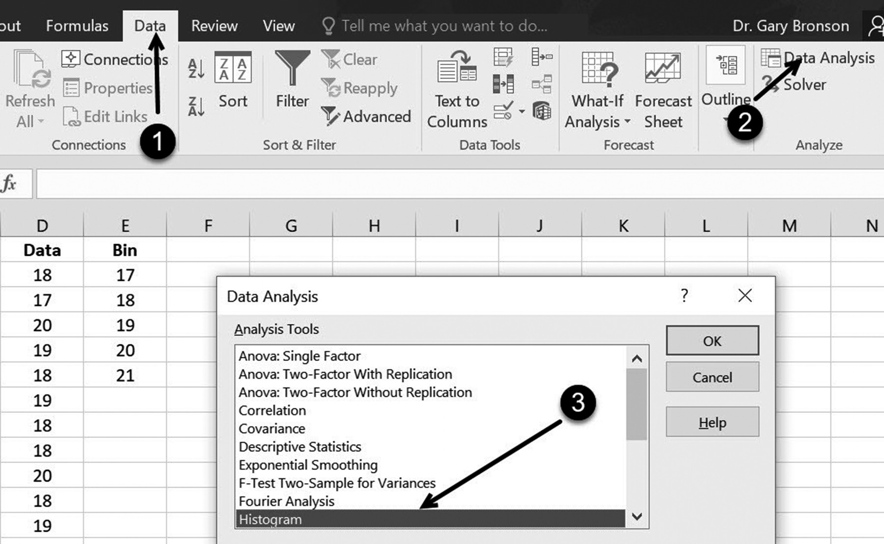

Figure 5.43 Steps to start creating a histogram

Selecting the Histogram option causes the Histogram dialog box, shown in Figure
5.44, to be displayed. It is within this dialog that the location of the input data and bin
specifications are entered. Both of these data must be located in columns. If these
columns have headers, the Labels box must be checked.
To view the histogram on the same spreadsheet as the data, both the Chart Out-
put box and Chart Output range must also be checked, as indicated in callout 3.
GraPhiCal Presentations 195

Omitting these, only the bins and the number of data points in each bin are displayed
and not the histogram chart itself. To locate the histogram, only the upper left cell of
the output needs to be entered.
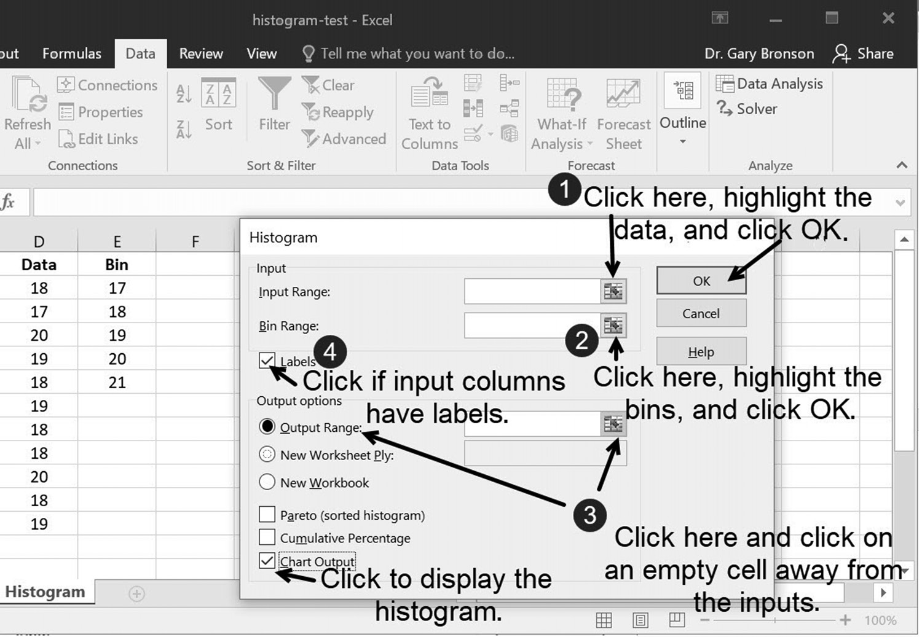

Figure 5.44 Options for the histogram
Figure 5.45 illustrates the information filled in for the Histogram dialog box that pro-
duced the display previously shown in Figure 5.42.
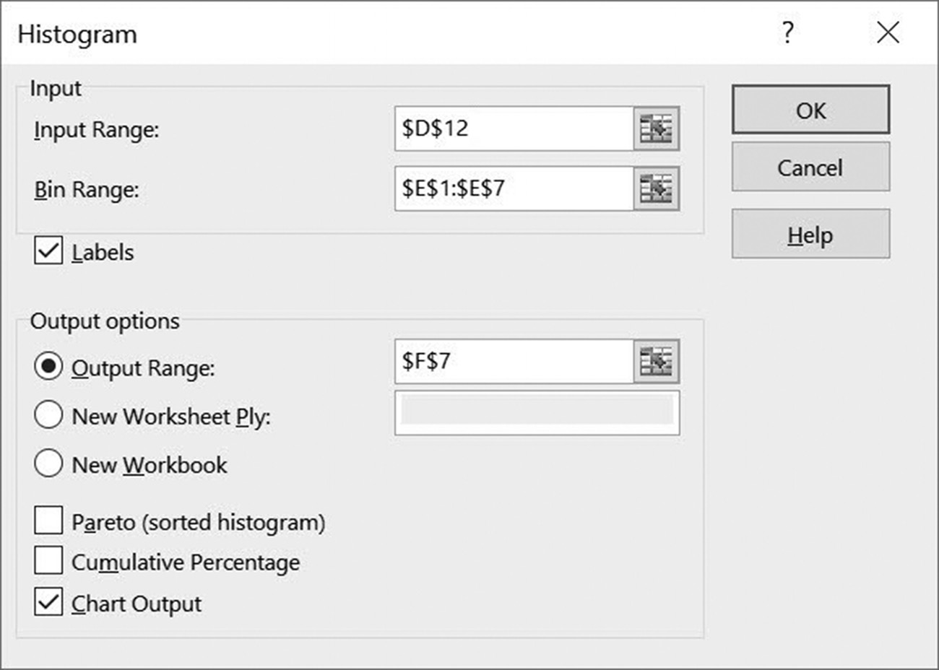

Figure 5.45 The information that produced the display in Figure 5.42
C H A P T E R 6
Pivottables

This Chapter Contains
6.1 Introduction
6.2 Constructing a Basic PivotTable
6.3 Adding Column Labels
6.4 Common Excel Errors
6.5 Chapter Appendix: PivotTable Design Criteria

In addition to visually highlighting significant relationships using graphs and charts,
the vast majority of business and scientific reports also include summary tables. In
Excel, summary tables are known as PivotTables (one word). A PivotTable can auto-
matically sort, count, sum, and average the data in one spreadsheet, and display these
summary results in a second spreadsheet. The summary tables provided by Excel’s
PivotTable option are easy to produce: two clicks start the process, and one or more
additional clicks produces a complete summary table. This chapter presents the basics
of creating and modifying PivotTables.

6.1 INTRODUCTION
One of the more powerful Excel features is its ability to quickly and easily create
summary tables. Summary tables play an important part in almost all business and
research reports for highlighting significant relationships and important details. Sum-
mary tables are essential when an underlying spreadsheet may contain hundreds of
rows and multiple columns containing several types of data, which is typical of many
business and research databases.
The ability to rapidly create comprehensive summary tables is provided by Excel’s
PivotTable option. The name itself refers to the ability to switch, or pivot, from row
summaries to column summaries. Unfortunately, the term PivotTable masks other im-
portant aspects of this feature, including the ability to quickly create convenient and
easily understood summary tables.
198 exCel BasiCs

As an example, consider the spreadsheet shown in Figure 6.1. The data is simply
a detailed listing of individual sales in date order; it does not provide any specific or
easily-understood summaries.
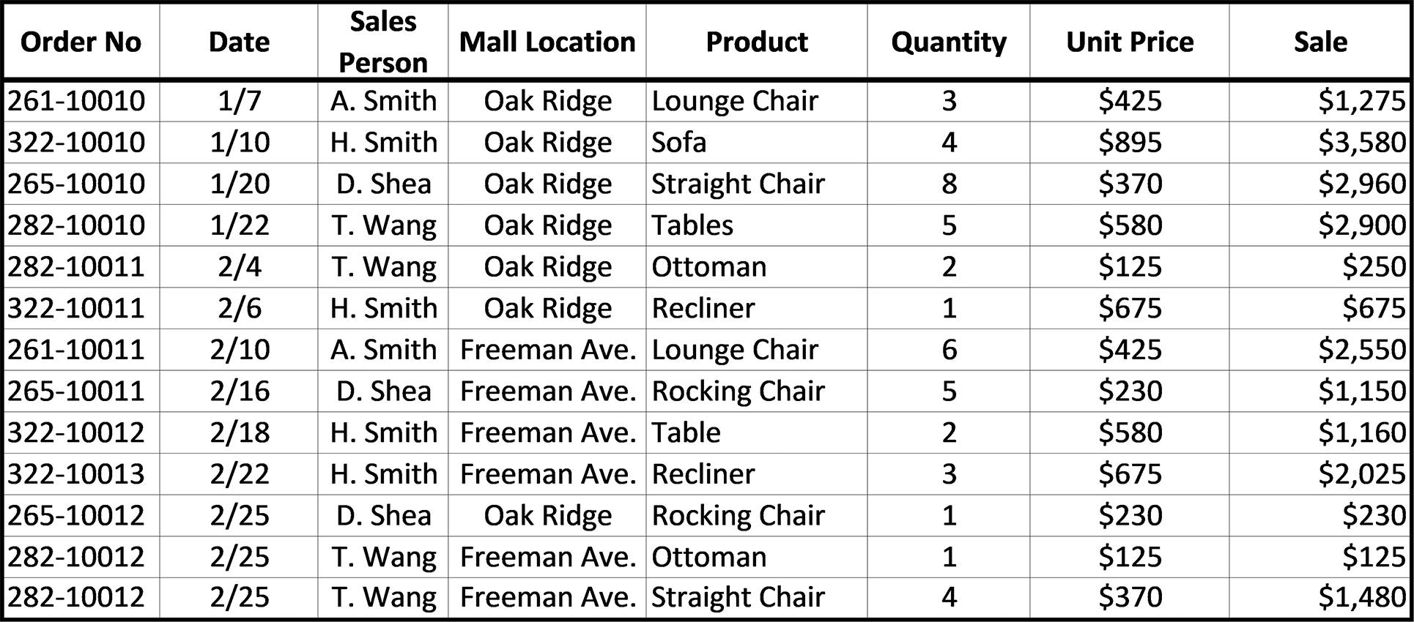

Figure 6.1 The initial sales spreadsheet

To see how various summary tables can display meaningful information from the raw
data in Figure 6.1, consider the summary tables shown in Figures 6.2 through 6.5.
Figure 6.2 provides a summary of total sales for each product. This summary table
was produced using only four mouse clicks (an additional two mouse clicks produced
the formatting of the second column).
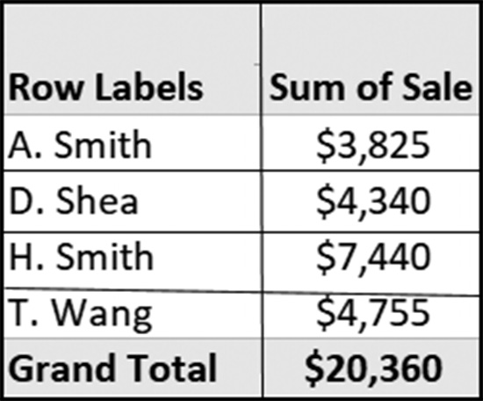

Figure 6.2 Summary of total sales by salesperson

Figure 6.3 provides a quick summary of total sales for each salesperson. Again, this
summary table was produced using only four mouse clicks, with an additional two
clicks needed for the second column’s currency formatting. The only difference in
producing Figures 6.2 and 6.3 was that in Figure 6.2, the Sales Person field was used
for the row field, while for Figure 6.3 the Product field was selected for the row
field. The Sale sums in each figure were automatically calculated to correspond to its
respective row field.
PivottaBles 199
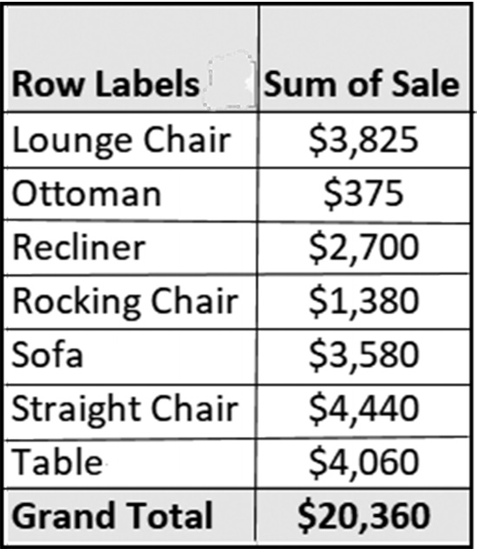

Figure 6.3 Summary of total sales by product

Although Figures 6.2 and 6.3 consist of only two columns, more complicated, but
equally easily-produced summary tables can be created. For example, with one more
mouse click, Figure 6.3 is expanded to Figure 6.4. This table not only provides total
sales for each salesperson, but additionally lists the individual products sold by the
salesperson. It should be noted that “Sum of Sale” refers to the calculation of total
sales for each combination of Sales Person and Product. The Sales Person is found in
rows, and the Product in columns.
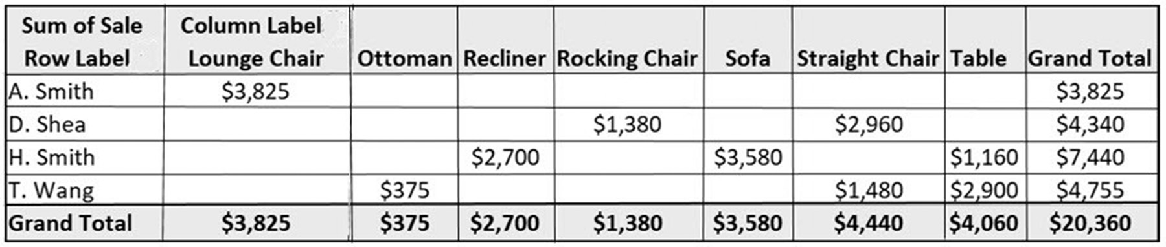

Figure 6.4 Summary of sales by salesperson and product
Again, using one more mouse click, Figure 6.4 is expanded into Figure 6.5, which
further breaks out total sales for each salesperson by mall location and product.
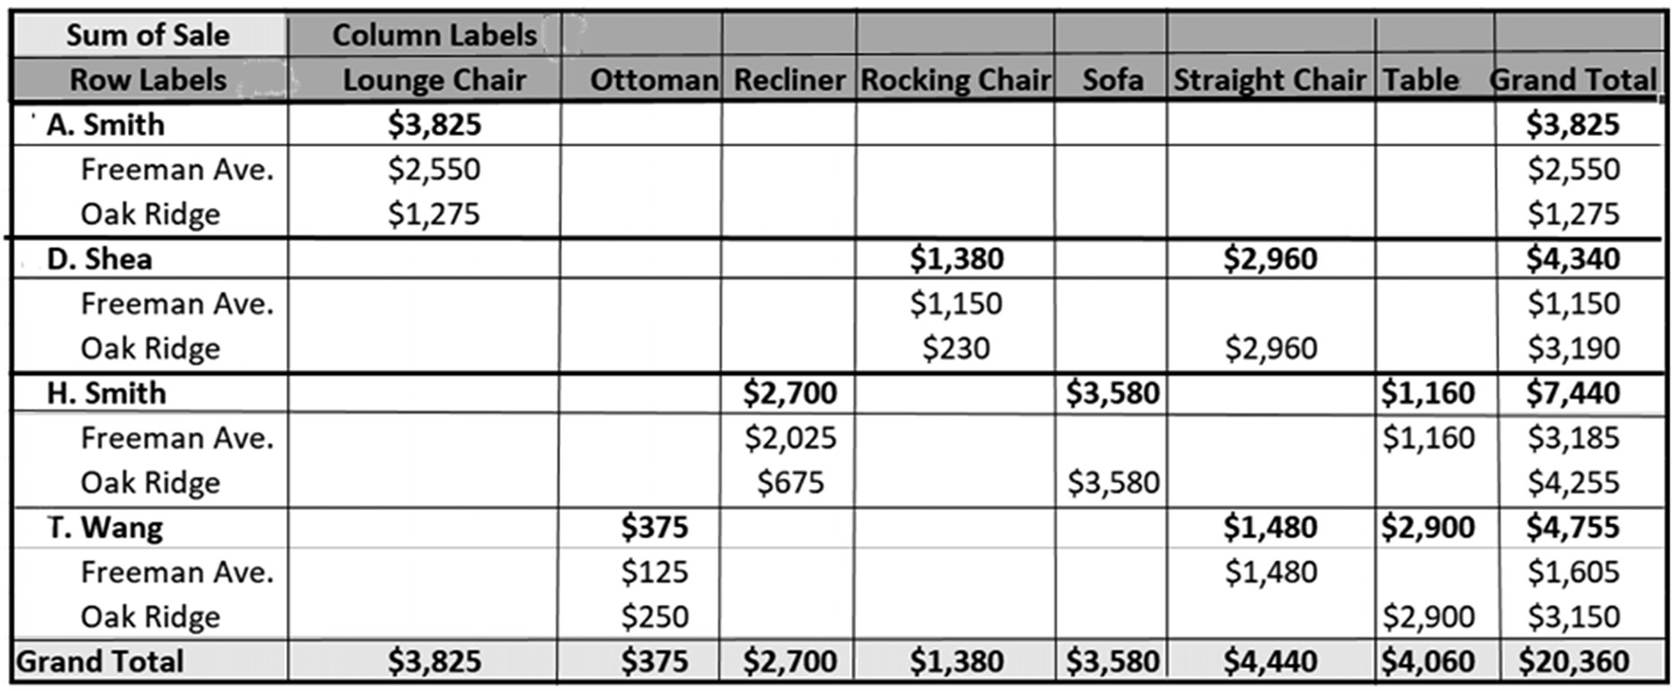

Figure 6.5 Summary of sales by salesperson, location, and product 200 exCel BasiCs

The degrees and types of summary reports that can be produced using PivotTable fea-
tures are almost endless. Interestingly, the procedures for creating PivotTables, such
as those shown in Figures 6.2 through 6.5, are not difficult or involved. In creating
basic summary tables, however, you need to understand the elements that make up a
PivotTable’s rows and columns.
Basic PivotTable Elements
There are four main elements provided for constructing PivotTables. These are
●● Row fields
●● Column fields
●● Value fields
●● Report Filter fields
The first three of these field types and how they are used to create PivotTables are
described in detail in this chapter.
Many useful, yet simple, PivotTables, such as those shown in Figures 6.2 and 6.3
can be constructed using only a single Row field and a single Value field (the third
field type, Column, is used in Figures 6.4 and 6.5 and explained in Section 6.3). From
an applications viewpoint, the two required column types for a basic PivotTable con-
sist of
●● A Row Labels column (created as a Row Field with at least one required) ●● A Summary column (created as a Value Field with at least one required)
The headings for each of these columns come from the column headings in the
original spreadsheet. These headings are formally referred to as fields. Using Excel’s
PivotTable terminology, a Row Label is a specific row field, and a Summary column is
a specific value field.
For example, if a summary table (that is, a PivotTable) is required for the spread-
sheet shown in Figure 6.6, the available fields for the PivotTable are the six column
headings shown at the top of the figure.
PivottaBles 201
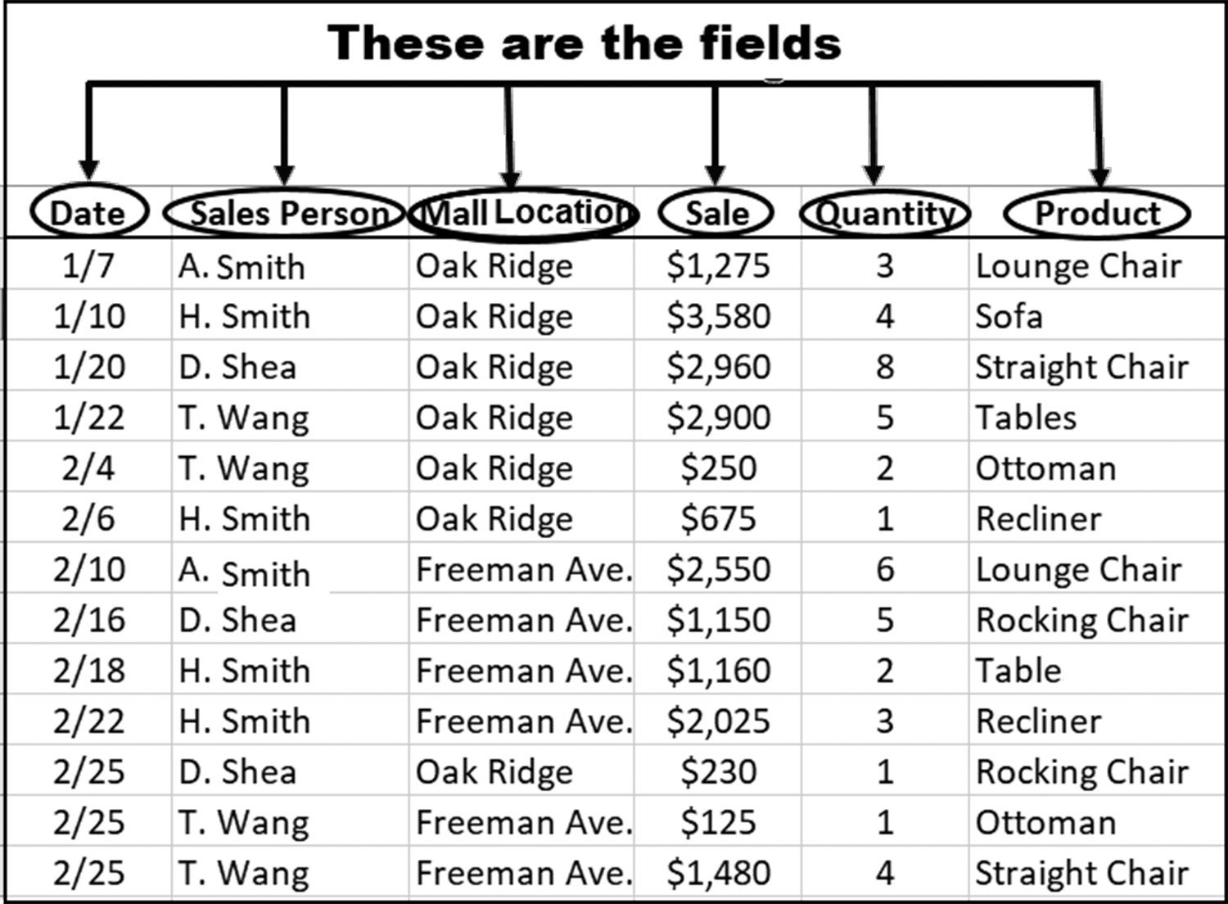

Figure 6.6 The column headings become a PivotTable’s fields

Figure 6.7 shows how two of the fields shown in Figure 6.6 become the elements of a
two column PivotTable.
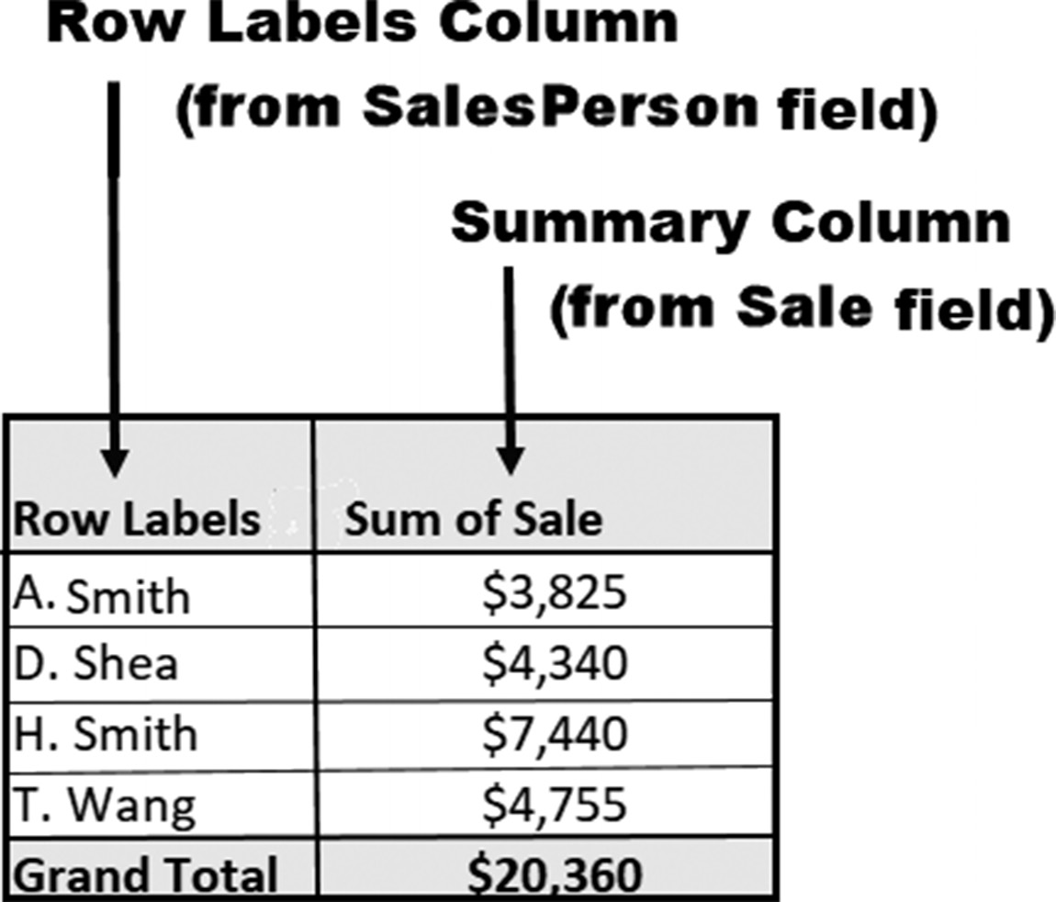

Figure 6.7 PivotTable with a Row Label and Summary column 202 exCel BasiCs

The labels in the Row Labels column (also known as a row fields column), which
is typically the first column in a basic PivotTable, consists of the data in one of the
original spreadsheet columns. A Summary column, technically referred to as a values
column, is created from the values contained in a second selected field.
Although the basic two column PivotTable shown in Figure 6.7 is useful for a wide
variety of summary tables, additional row fields, Column fields, a Report Filter field,
and Value/Summary fields can easily be included. For example, Figure 6.8 shows a
PivotTable with two Row Label fields (Sales Person and Mall Location) and two Sum-
mary columns (Sale and Quantity). Each Set of Row Label fields and each set of Sum-
mary fields requires a single mouse click selection (they may also be “dragged and
dropped,” as explained in the next section.)
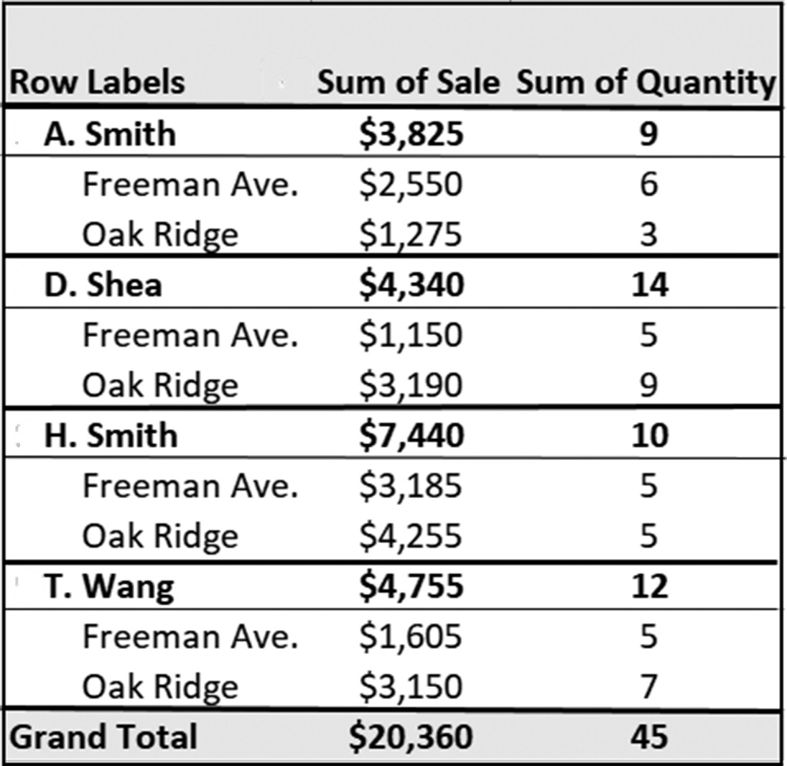

/
Figure 6.8 A two element PivotTable, each with multiple categories

The initial field in the Row Labels column is referred to as the Primary Row Field.
This distinction becomes important when more than one set of row fields is selected.
For example, notice that in Figure 6.8 there is a second set of row fields. These row
fields do not form a new column, but are indented under the Primary Row fields.
When a second set of Row Labels is included, it is referred to as a Subsidiary Row
Field (level). Figure 6.9 identifies the various elements in the expanded PivotTable
shown in Figure 6.8.
PivottaBles 203
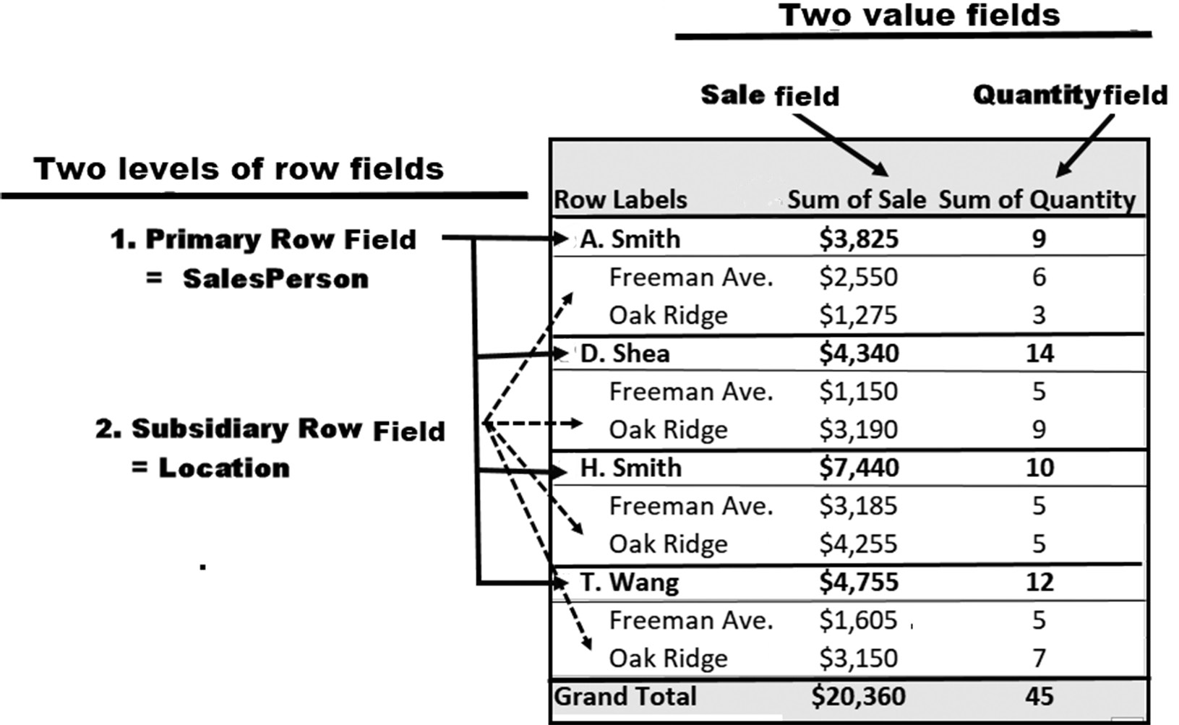

Figure 6.9 PivotTable elements

Although any number of subsidiary row field levels can be added to a PivotTable, as
a practical matter and to keep a central focus on what is being summarized, generally
no more than two subsidiary row label levels, in general, should be used. If more row
labels are needed, it may at times be better to create a second PivotTable.
Finally, notice that while a Row Label field almost always contains text (or numeric
labels like dates, for example), Summary columns generally contain numeric values
(hence, the PivotTable terminology value fields). In addition to computing totals in a
Summary/Value column, PivotTable options provide for calculating counts, averages,
maximums, minimums, and other statistical values for the summarized data.

EXERCISES 6.1

1. What is the purpose of a PivotTable?
2. In addition to the row fields used in Tables 6.2 and 6.3, list two other sets of row
fields that could have been used to summarize Total Sales shown in Figure 6.1.
3. In addition to summarizing the Total Sales of each product as shown in Tables 6.2
what additional value fields might be useful?
4. a. What is a Primary Row Field?
b. What is a Subsidiary Row Field level?
c. What type of data is summarized in the columns to the right of the row fields
column?
204 exCel BasiCs

5. Create the following spreadsheet on your computer.
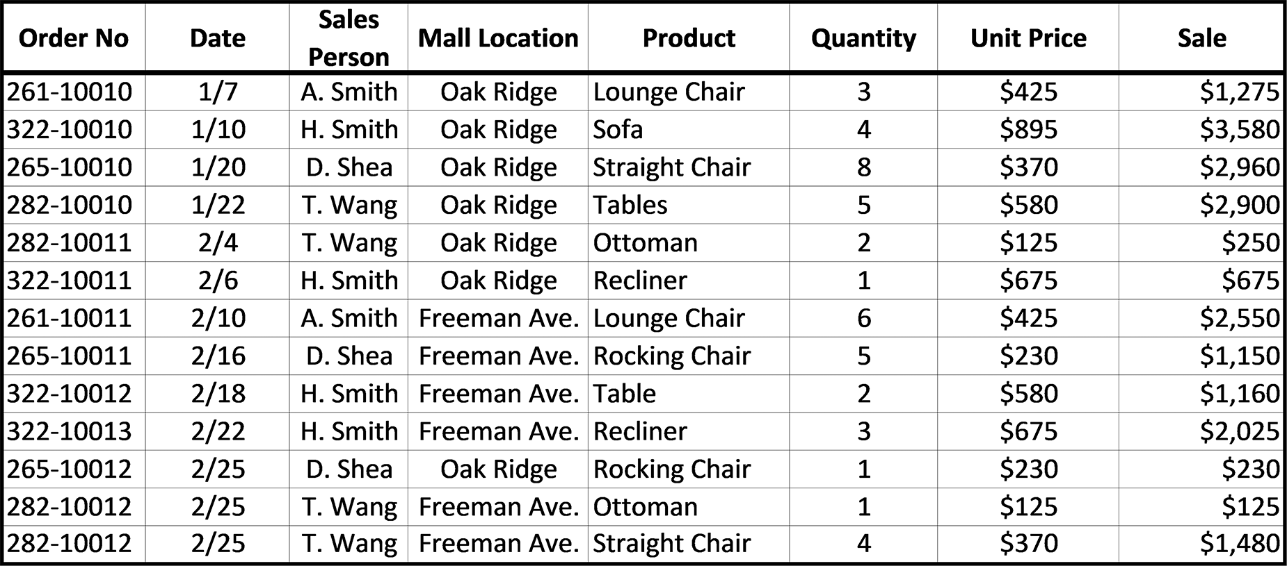

6. Using the spreadsheet created in Exercise 5, produce a table, without using Excel’s
PivotTable option, that lists each salesperson and their individual total sales. When you are done, your spreadsheet should look like the one that follows. (In the next section, you will see how easily this list is produced using Excel’s PivotTable feature.)
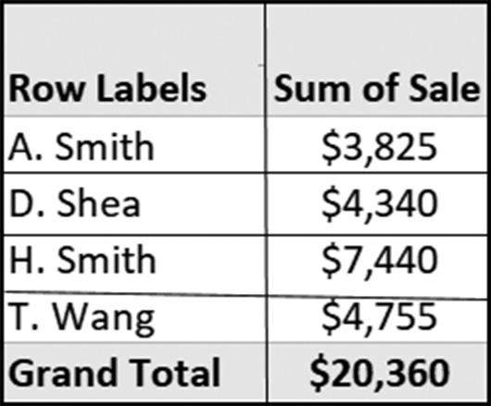

7. Using the spreadsheet created in Exercise 6, produce a table, without using Excel’s
PivotTable options, that lists each product and the total sales for each product. When you are done, your spreadsheet should look like the one that follows. (In the next section, you will see how easily this list is produced using Excel’s PivotTable feature.)
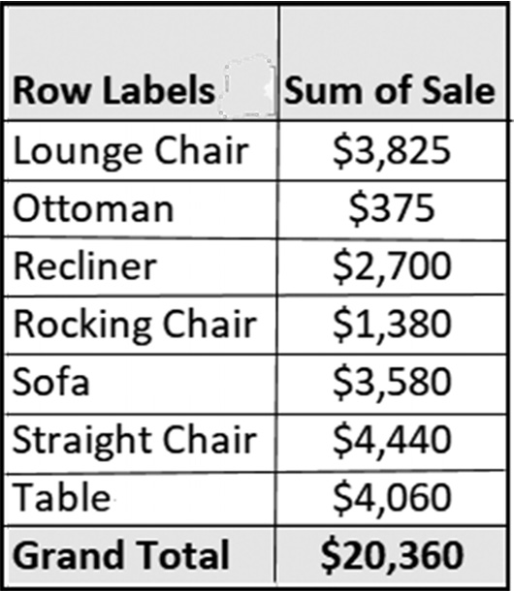
PivottaBles 205

6.2 CREATING A BASIC PIVOTTABLE
All PivotTables are created using the same three-step procedure. Once these steps
are completed, a specific PivotTable can be constructed. The initial three steps are as
follows:
Step 1: Highlight the original spreadsheet (for large spreadsheets, click on any cell
and press Ctrl-A).
Step 2: Select the PivotTable option from the Excel ribbon Insert Tab – Table
group – PivotTable, as shown in Figure 6.10.
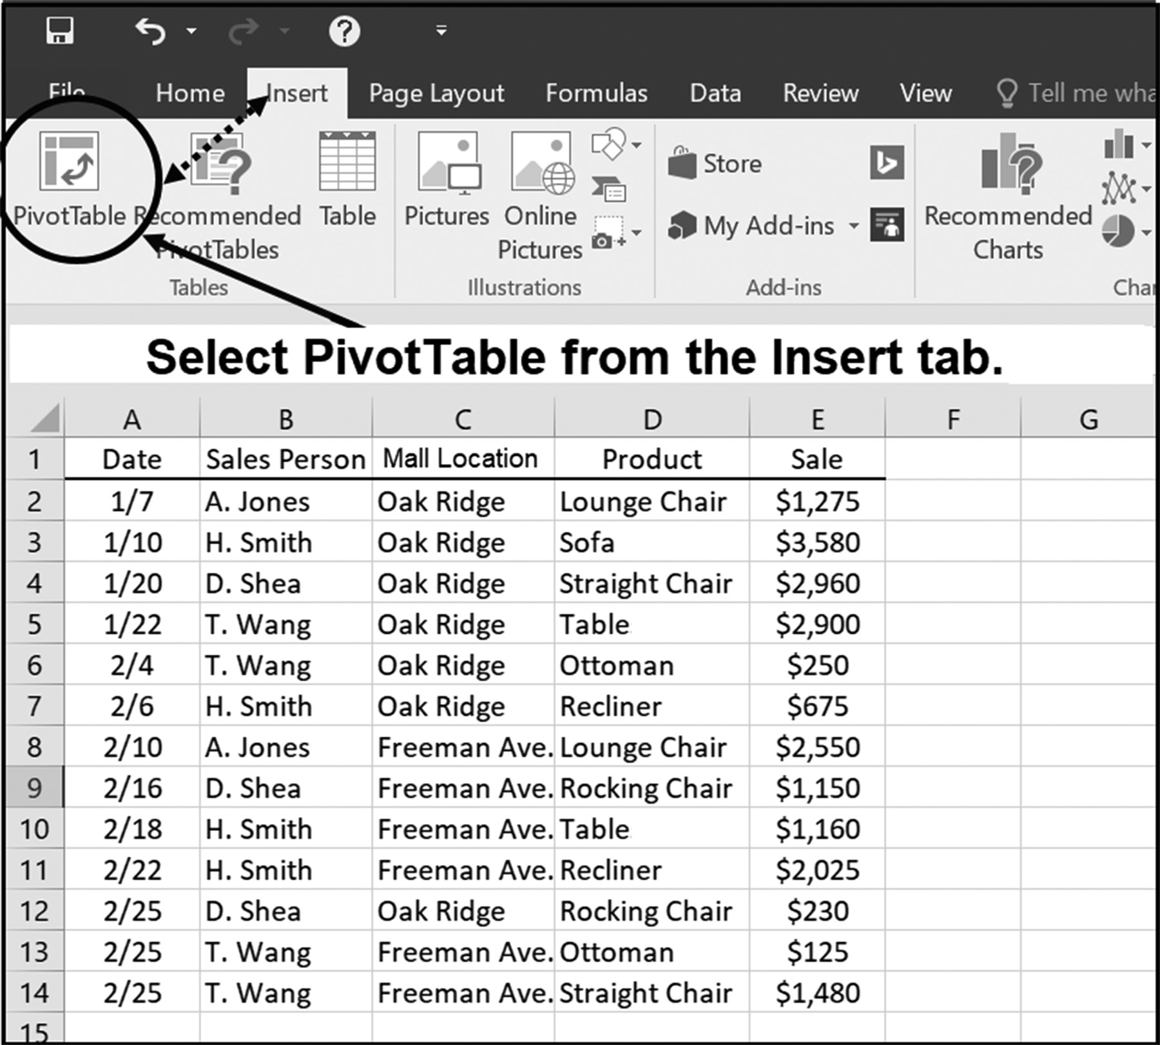

Figure 6.10 Starting to Create a PivotTable

Step 3: Fill in the PivotTable location in the Create PivotTable dialog box, as shown
in Figure 6.11.
206 exCel BasiCs
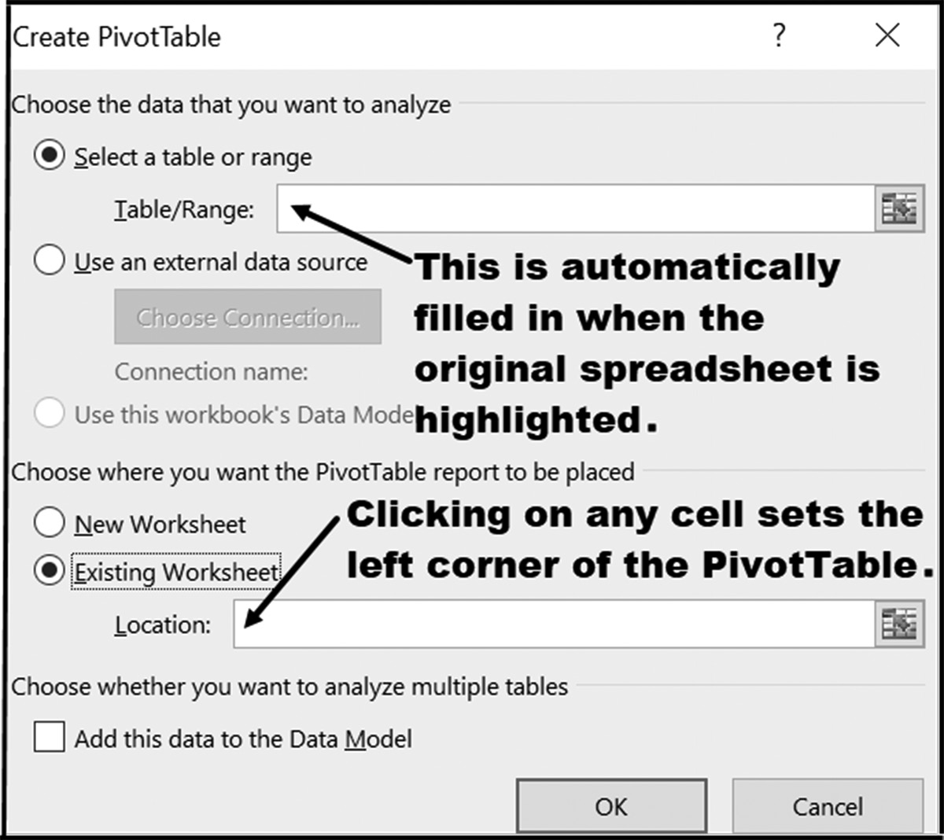

Figure 6.11 Selecting options for the PivotTable

Once the required locations are entered in the Create PivotTable dialog box shown
in Figure 6.11 and the OK button is pressed, the displays shown in Figures 6.12 and
6.13 appear.
The display shown in Figure 6.12 is a blank PivotTable located at the address previ-
ously entered into the Create PivotTable dialog box. It is a placeholder showing you
where your PivotTable will appear when completed. Except for noticing its position,
you can safely move on to the next part of the PivotTable Fields dialog.
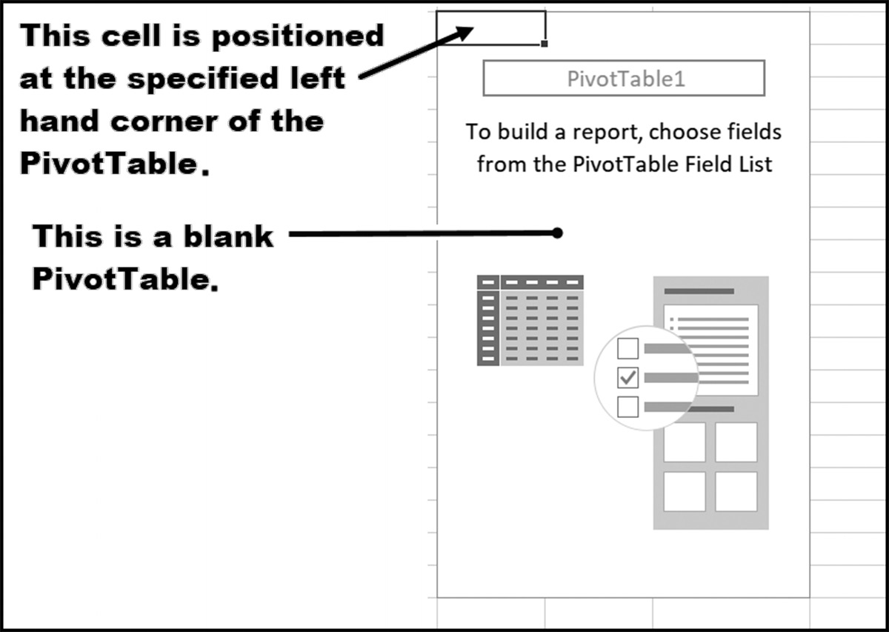

Figure 6.12 The blank PivotTable displayed on the left side of the screen
PivottaBles 207

The PivotTable Fields dialog box shown in Figure 6.13, however, is extremely impor-
tant. This dialog is where you select the fields that become your PivotTable’s Row
Labels, Summary/value columns, and Column Labels.
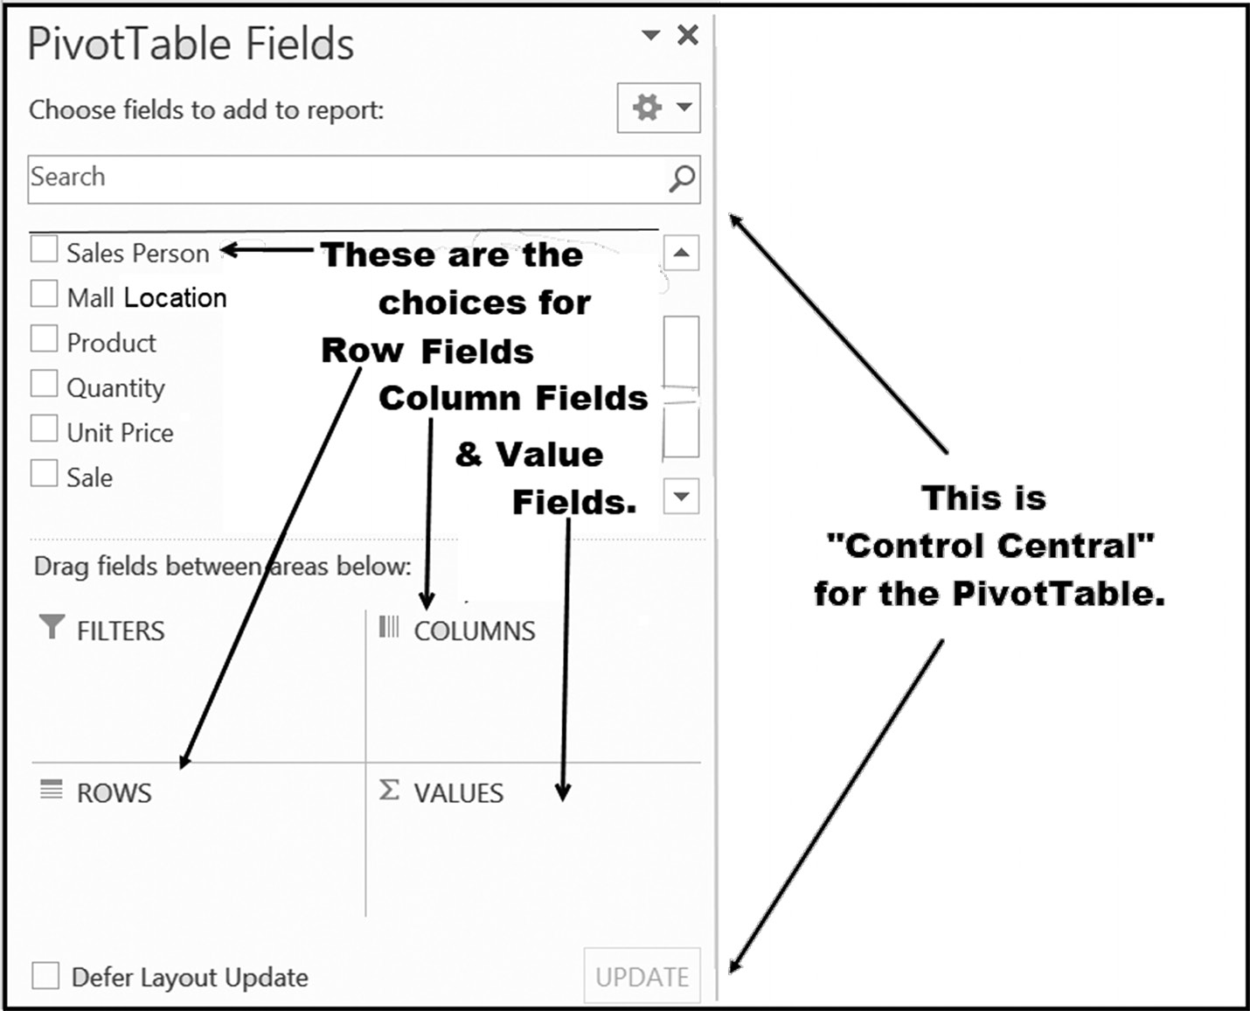

Figure 6.13 The PivotTable Fields selection dialog box displayed on the right side of the screen

To create a simple PivotTable, the only two field selection boxes required are those
circled in Figure 6.14. A single field entry into each of these boxes is sufficient to cre-
ate a simple, but meaningful PivotTable.
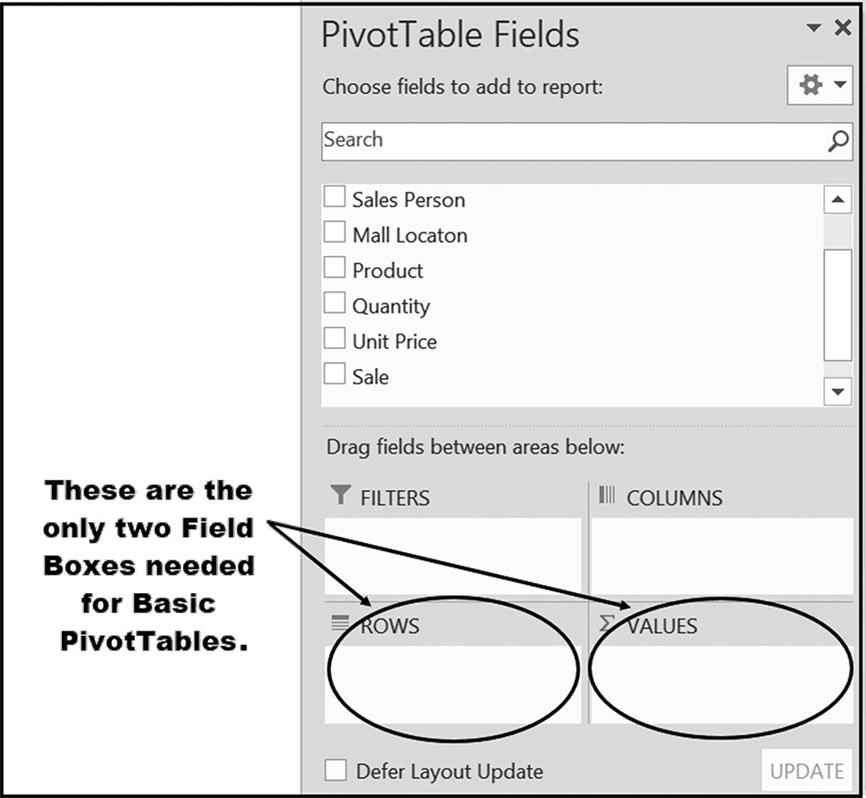

Figure 6.14 The two basic field selection boxes 208 exCel BasiCs

Application Note
Deleting a PivotTable
There will be times when, rather than modifying an existing PivotTable, you may want to simply delete the entire table and start over. The steps necessary to do this are as follows:
a. Click on any cell within the PivotTable to bring up the PivotTable
Tools menu – Analyze submenu.
b. Follow the four steps shown on the figure below. c. Click the Delete key
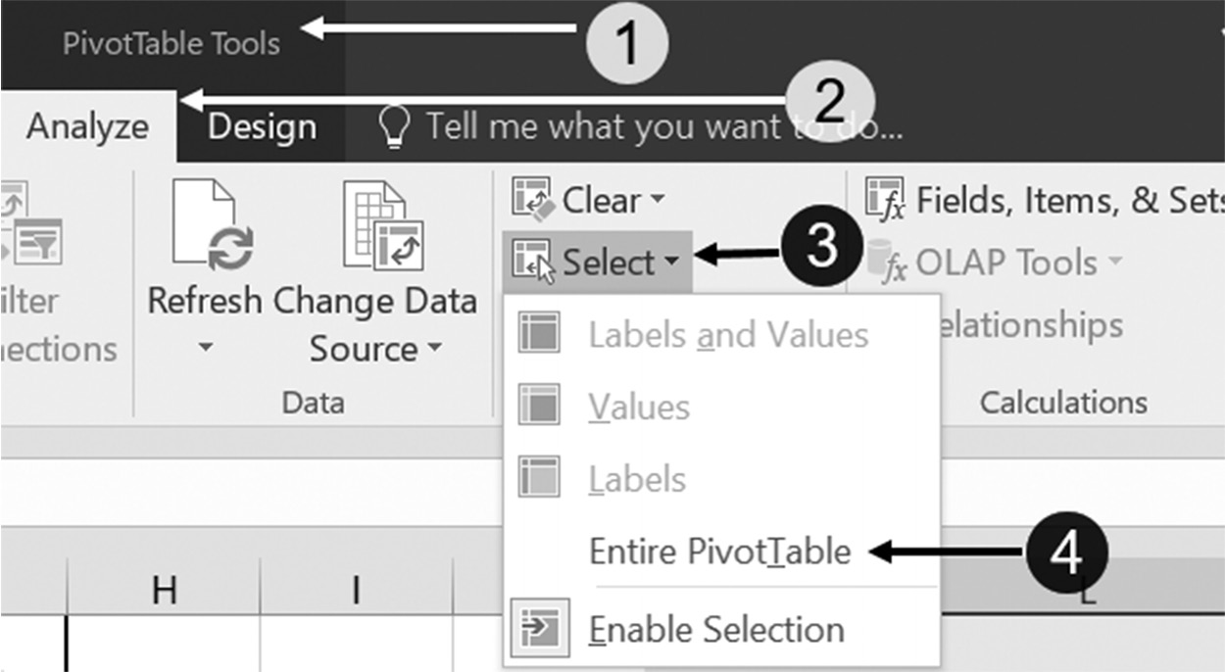

For example, the PivotTable in the left-hand corner of Figure 6.15 was created
using only two mouse clicks. Clicking on the Product Field filled in the entry in
the ROWS field selection box, while clicking in the Sale field filled in the VALUES
selection box.

The correct box is selected because Excel considers by default, all text categories as Row fields (and will place the clicked text field into the ROWS selection box) and numerical
NOTE categories as Value Fields (which will place the clicked numeric field into the VALUES
selections box). Alternatively, each of these fields could have been dragged and dropped into the desired selection box.
PivottaBles 209
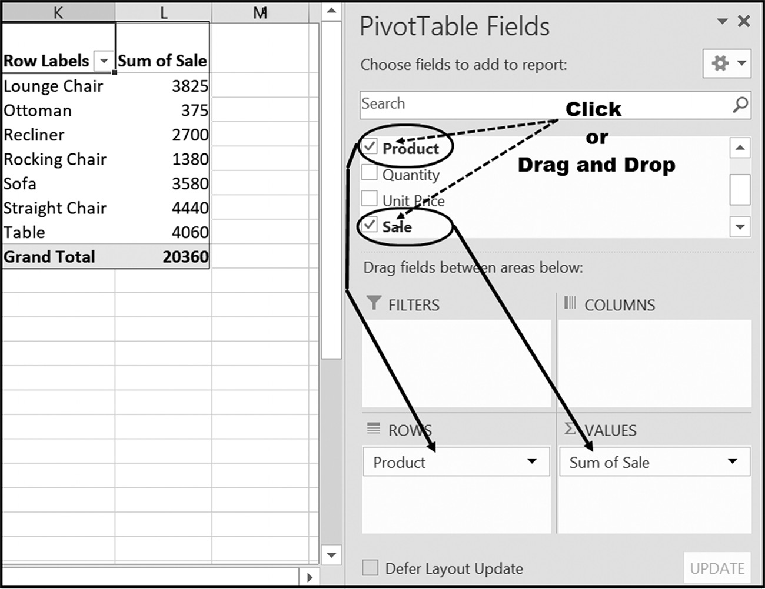

Figure 6.15 Summary of sales by product

Additional Row and Summary Column Examples
While many useful PivotTables can be produced using one or two row fields and one
or more value fields, often it is necessary to employ additional column, row, report
filter, and value fields.
Each row field is placed into a PivotTable either by clicking on a desired field or
dragging and dropping it into the row selection box, as shown in Figure 6.15. Unless
otherwise indicated, any clicked text field is considered by default to be a row field.
In the same manner as row fields, each value field is created by either clicking on
a desired field or by dragging and dropping it into the ∑ VALUES selection box, as
shown in Figure 6.15. By default, any clicked numerical field is considered to be a
value field, unless you specify otherwise.
210 exCel BasiCs
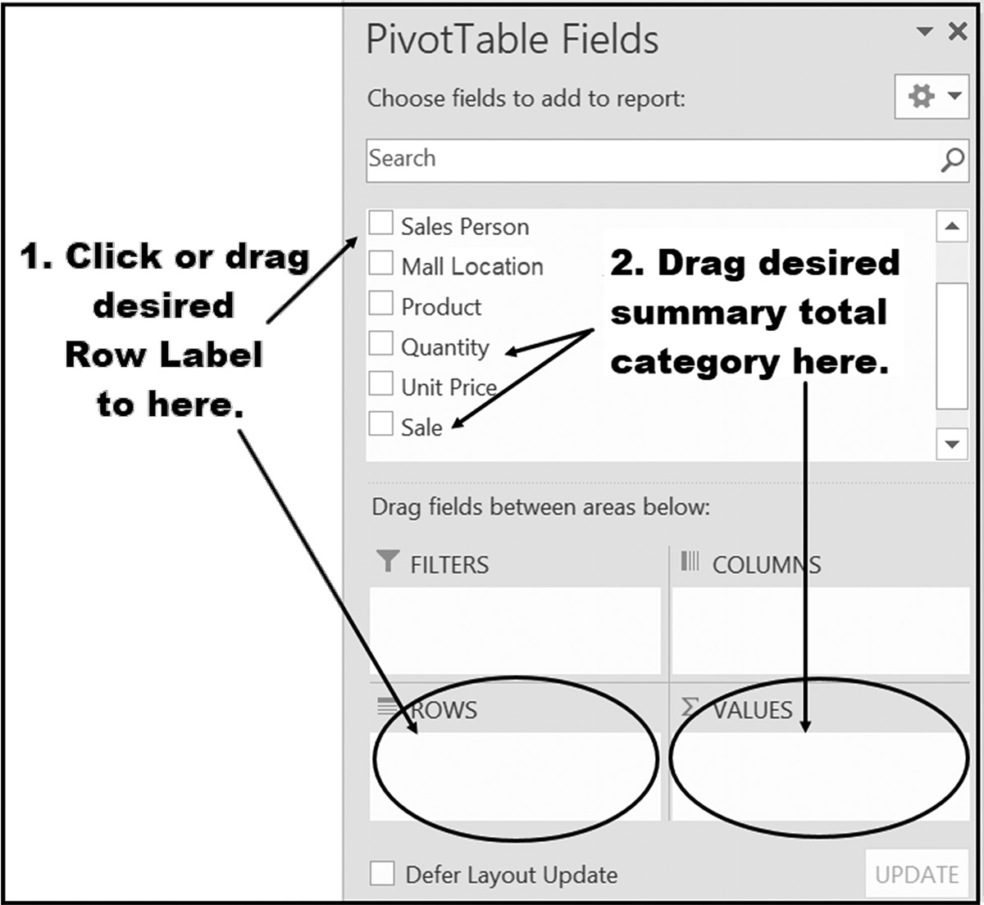

Figure 6.16 PivotTable row and value field inputs

The following are four examples of tables having differing numbers of row fields and
value fields. The first example illustrates a PivotTable having a single row field and a
single value field. The next two examples show how to add additional row fields and
value fields independently of each other. Finally, the last example illustrates a Pivot-
Table having both multiple row fields and multiple value fields.
All of the following examples summarize data from the following spreadsheet.
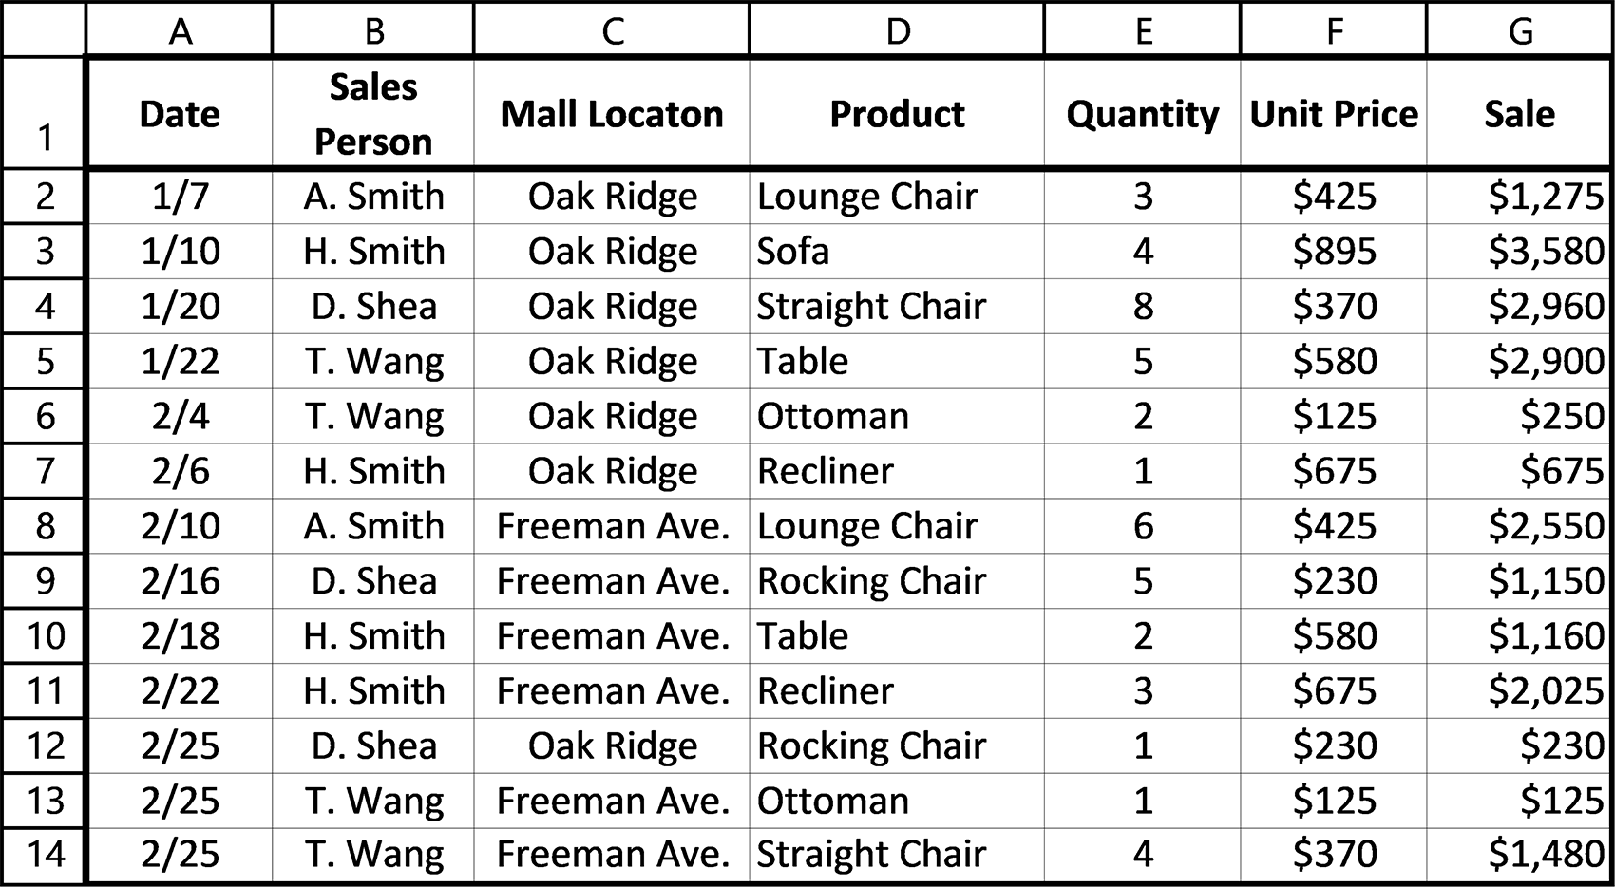

Figure 6.17 Sales data
PivottaBles 211

Example 1
Single Row Field and Single Value Field
The PivotTable shown in Figure 6.18a consists of one row field and one value field.
Determine the options in the PivotTable Fields dialog box needed to produce this
PivotTable.
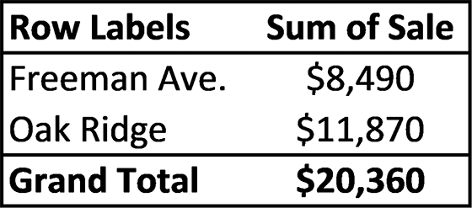

Figure 6.18a Summary of sales by mall location

Solution: Figure 6.18b shows the PivotTable Fields dialog box used to produce Fig-
ure 6.18a. Note that the Currency format, within centered columns, was produced
after creating the PivotTable, using the PivotTable Value Field Settings dialog box.
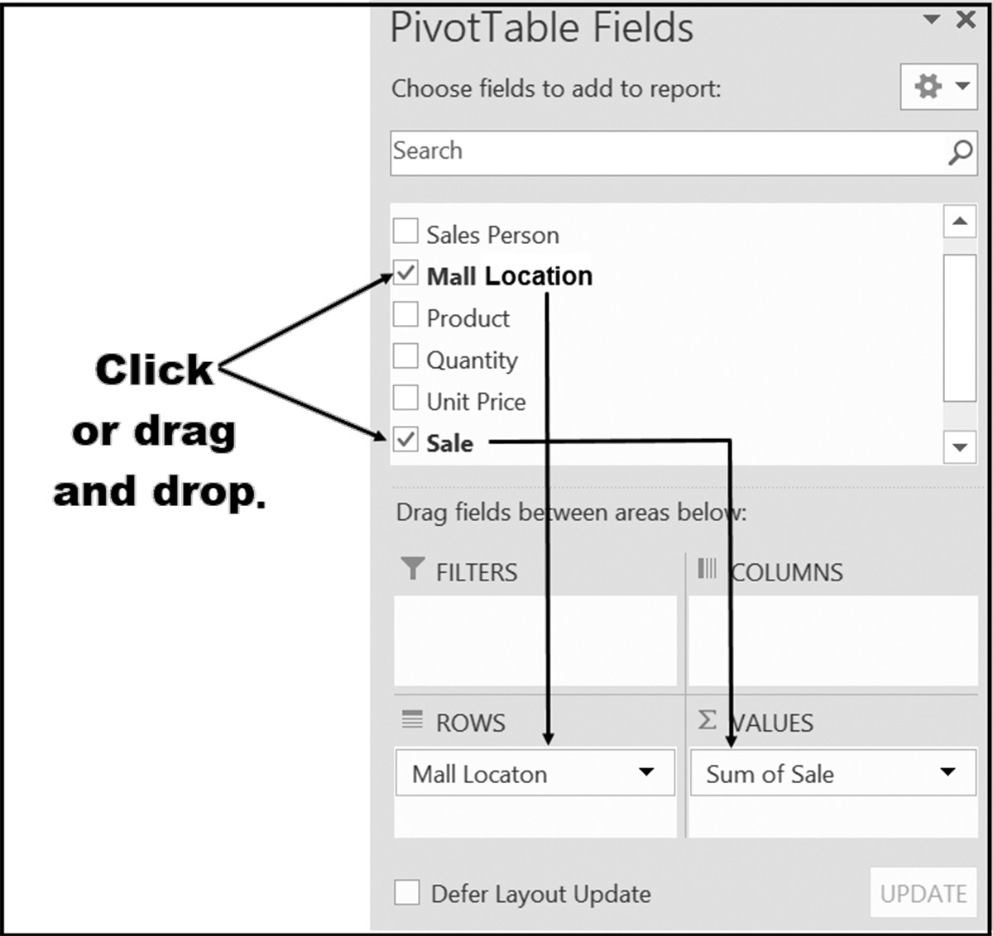

Figure 6.18b The PivotTable Fields dialog box used to create Figure 6.18a

Example 2
Multiple Row Fields and Single Value Fields
The PivotTable shown in Figure 6.19a consists of two row fields and one value field.
Determine the options in the PivotTable Fields dialog box needed to produce this
PivotTable.
212 exCel BasiCs
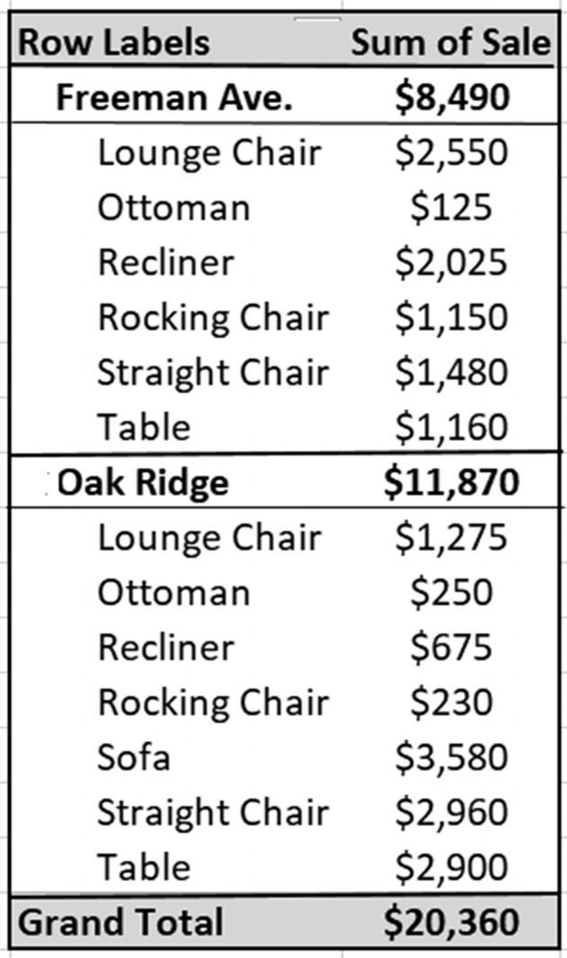

Figure 6.19a Summary of sales by mall location and product

Solution: Figure 6.19b shows the PivotTable Fields dialog used to produce Figure
6.19a. Note that the Currency format, within centered columns, was produced after
creating the PivotTable, using the PivotTable Fields dialog box.
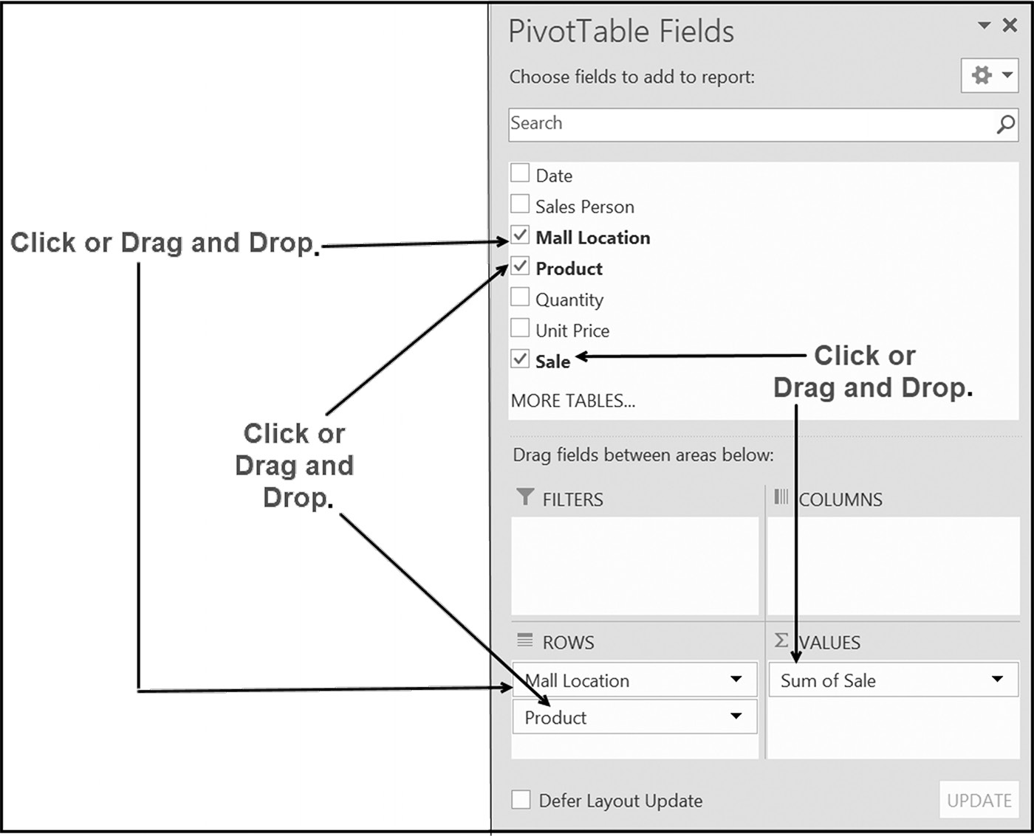

Figure 6.19b The PivotTable Fields dialog box to create Figure 6.19a
PivottaBles 213

Example 3
Single Row Fields and Multiple Value Fields
The PivotTable shown in Figure 6.20a consists of one row field and two value fields.
Determine the options in the PivotTable Fields dialog box needed to produce this
PivotTable.
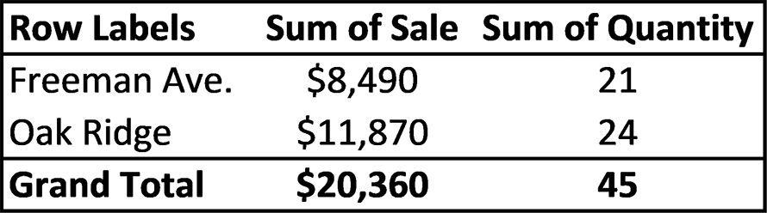

Figure 6.20a Summary of sales and quantity by mall location
Solution: Figure 6.20b shows the PivotTable Fields dialog box used to produce Fig-
ure 6.20a. Note that the Currency format, within centered columns, was produced
after creating the PivotTable, using the PivotTable Fields dialog.
While more of a PivotTable formatting issue, you will note the ∑ VALUES entry
in the Columns box below. This indicates that the two value fields are being displayed
from the columns (vertically), rather than from the rows (horizontally).
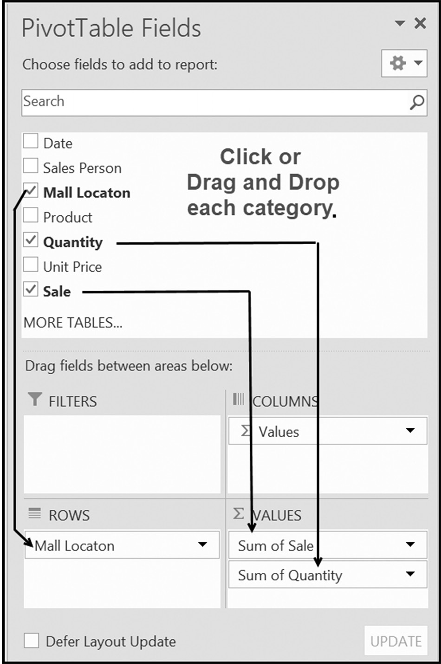

Figure 6.20b The PivotTable Fields dialog box used to create Figure 6.20a 214 exCel BasiCs

Application Note
Changing Summary Field Calculations
In addition to calculating totals, other measures, such as averages, counts, maximums, and minimums, can be summarized using the value field. These other measures are obtained by ① clicking on the drop-down arrow to the right of a selected summary field in the ∑ VALUES box, ② choosing the Value Field Settings option from the resulting drop-down menu, and ③ clicking on the desired summary measure, as shown in the Figure below.

Example 4
Multiple Row Fields and Multiple Value Fields
The PivotTable shown in Figure 6.21a consists of two sets of row fields and two value
fields. Determine the options in the PivotTable Fields dialog box needed to produce
this PivotTable.
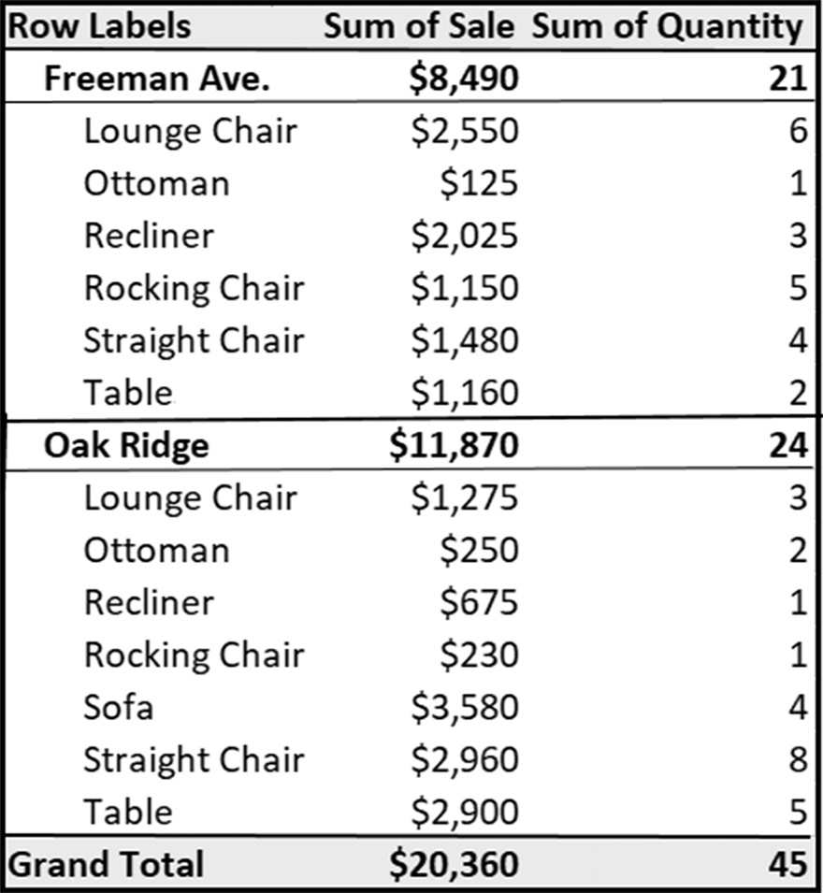

Figure 6.21a Summary of sales and quantity by mall location and product
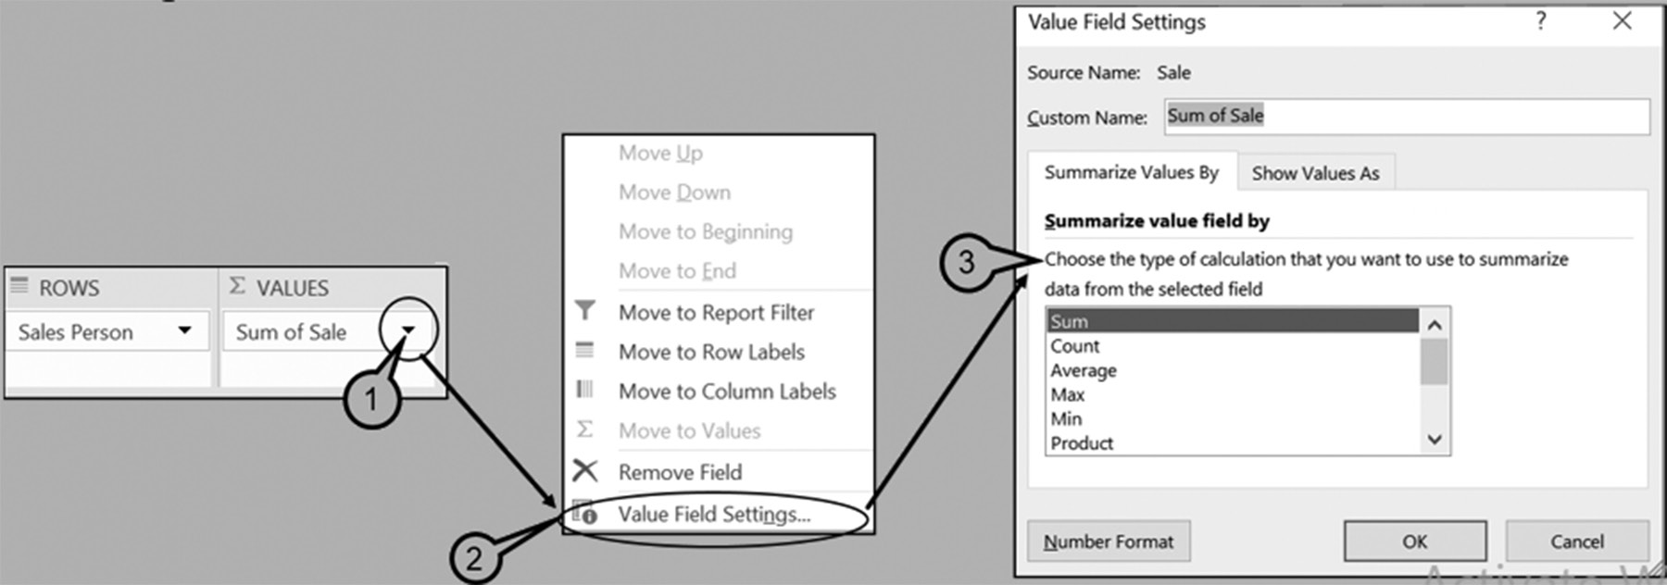
PivottaBles 215

Solution: Figure 6.21b shows the PivotTable Fields dialog used to produce Table
6.21a. Note that the Currency format, within centered columns, was employed after
creating the PivotTable using the illustrated PivotTable Fields dialog box.
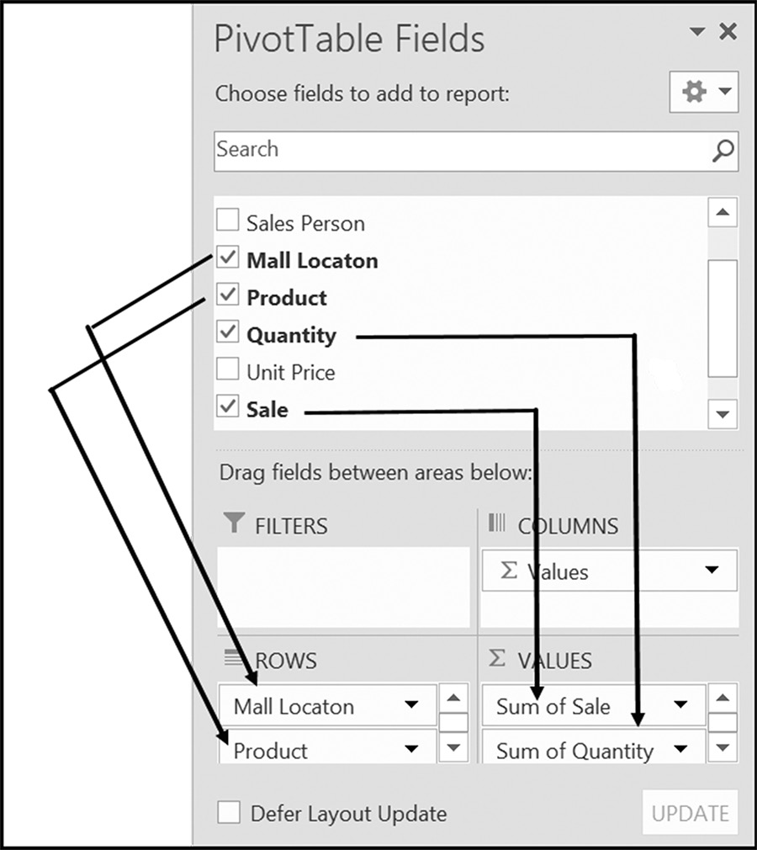

Figure 6.21b Using two row fields and two value fields

EXERCISES 6.2

1. List the three initial steps required to begin creating a PivotTable.
2. Complete parts a-b.
a. What two displays/dialogs are presented on the screen once the steps in Exer-
cise 1 have been completed?
b. Which of the displays listed in Exercise 2a is primarily informational, and which
one is essential in creating a PivotTable?
3. Complete parts a-b.
a. List the four Selection boxes provided by a PivotTable Field selection dialog
box.
b. Describe the role that each of the boxes plays when constructing a PivotTable. 216 exCel BasiCs

4. Using the following spreadsheet, place check marks in the appropriate boxes of
the following PivotTable Fields dialog box to produce the PivotTable shown in the second image.
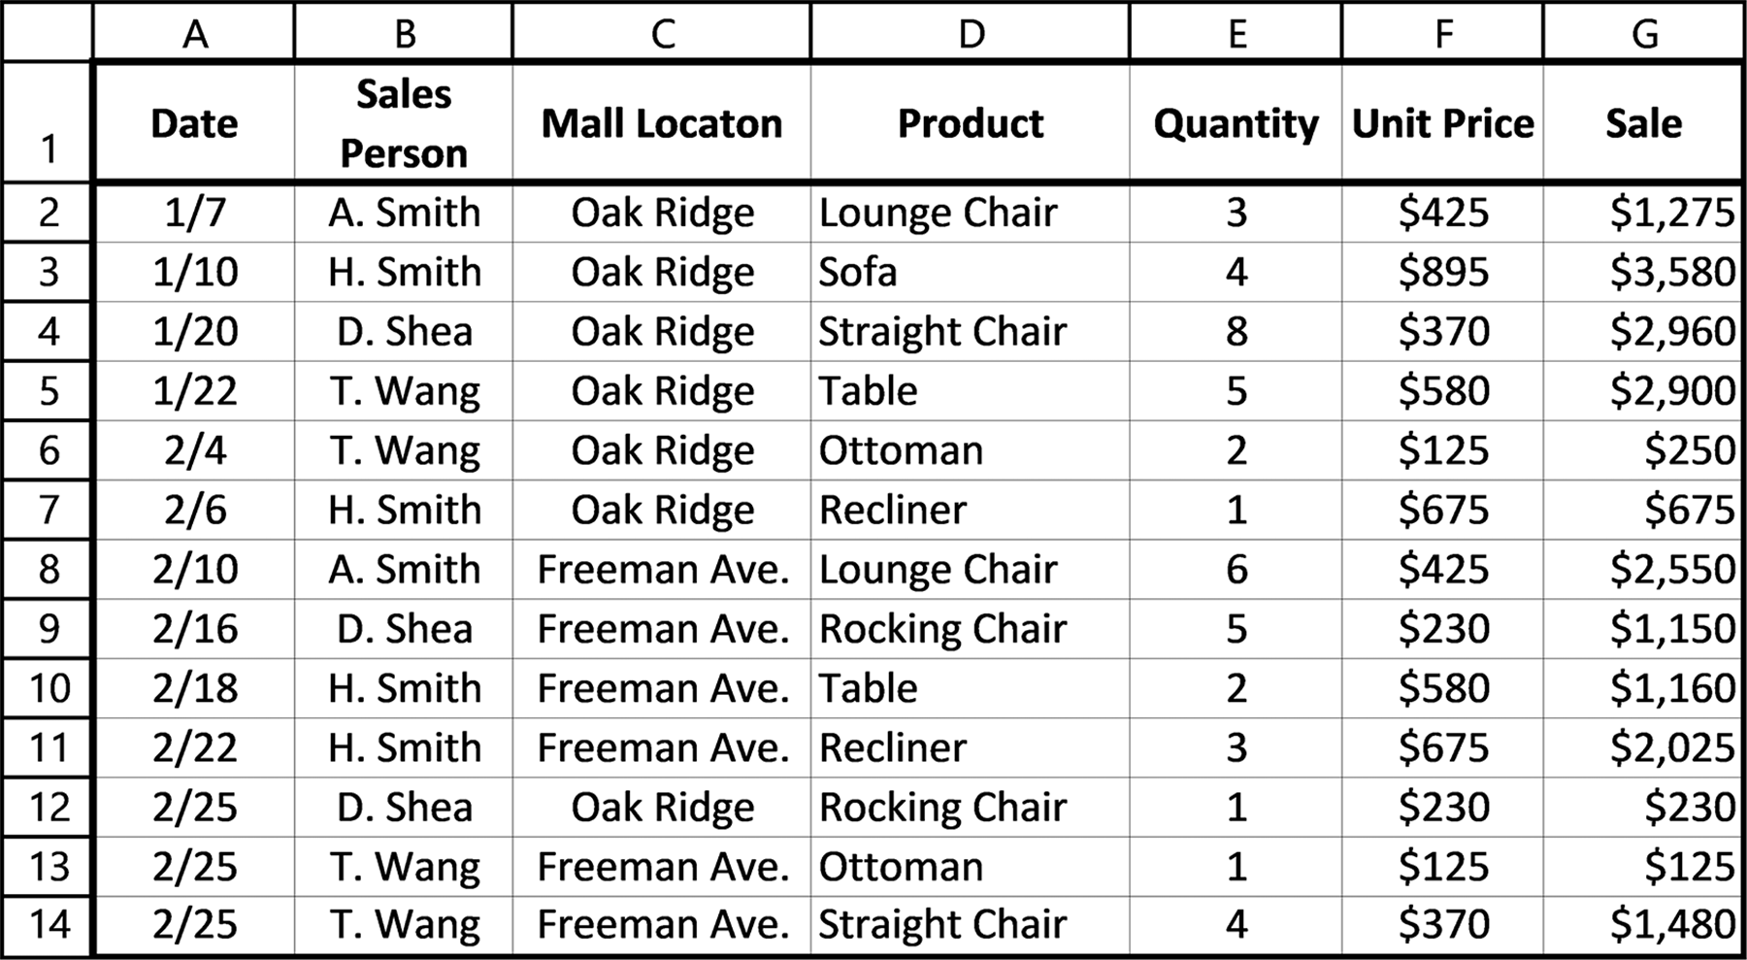
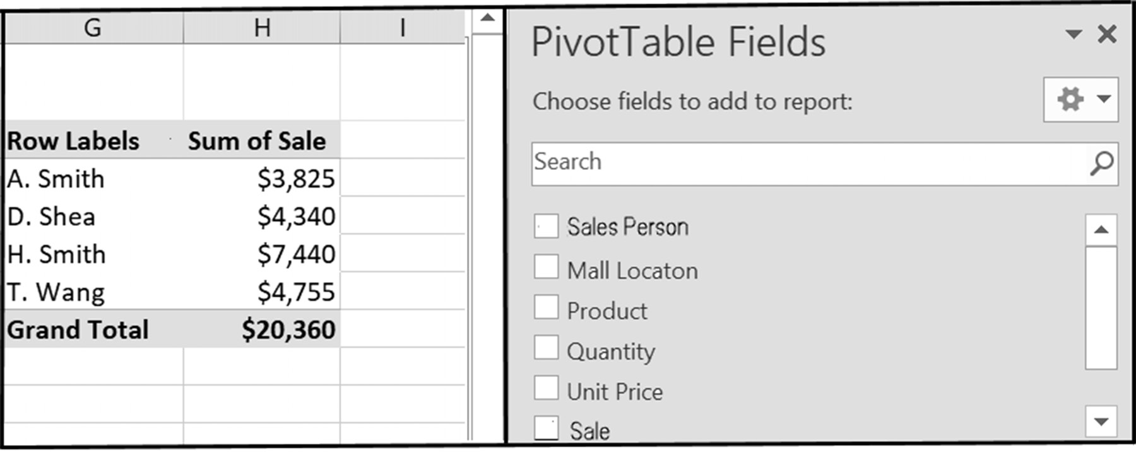
PivottaBles 217

5. Using the spreadsheet shown in Exercise 4, place check marks in the appropri-
ate boxes of the following PivotTable Fields dialog box to produce the following PivotTable.
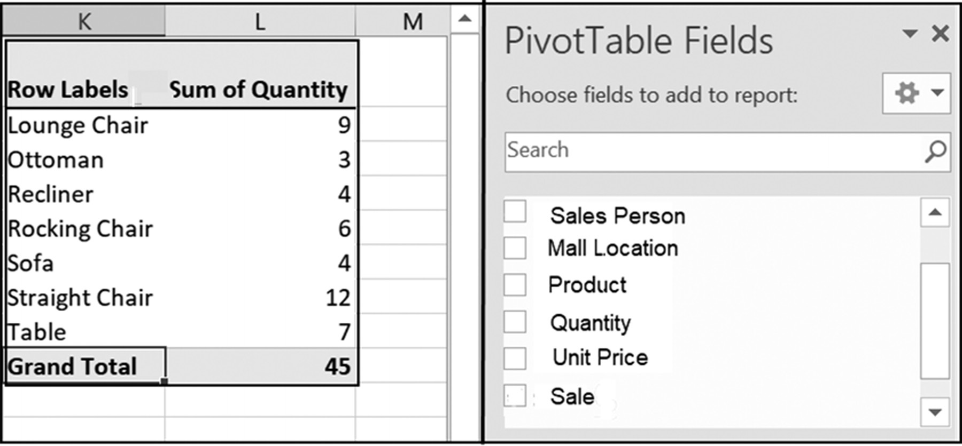

6. Use the following spreadsheet for Exercise 6.
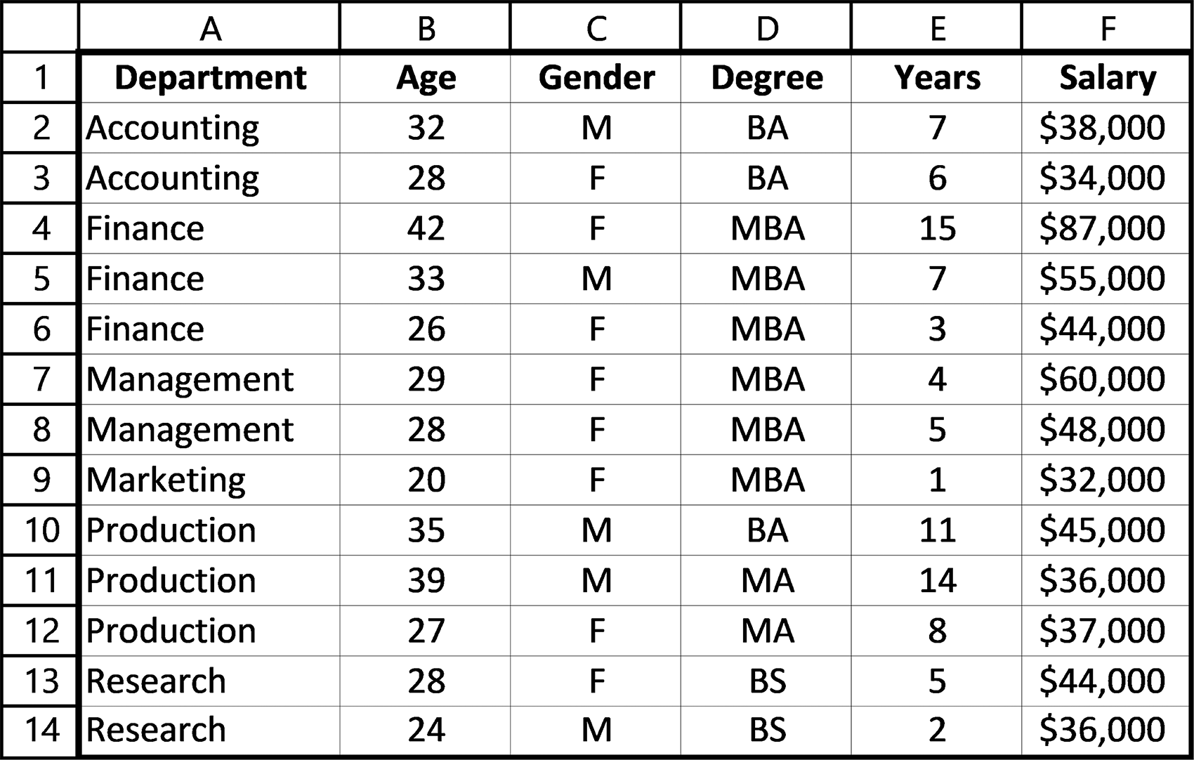

Place check marks in the appropriate boxes of the PivotTable Fields dialog box to
produce the given PivotTable.
218 exCel BasiCs
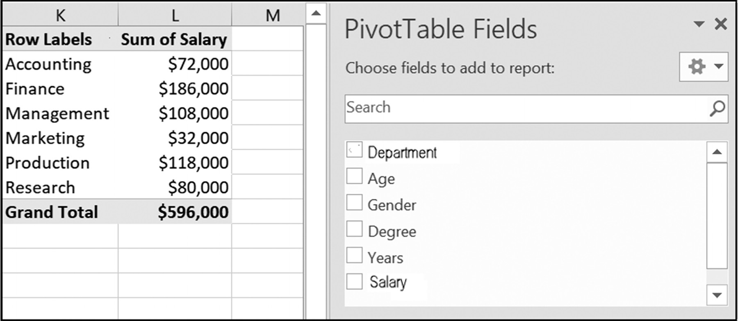

7. Refer to the spreadsheet shown in Exercise 6. Place check marks in the appropri-
ate boxes of the following PivotTable Fields dialog box to produce the PivotTable shown.
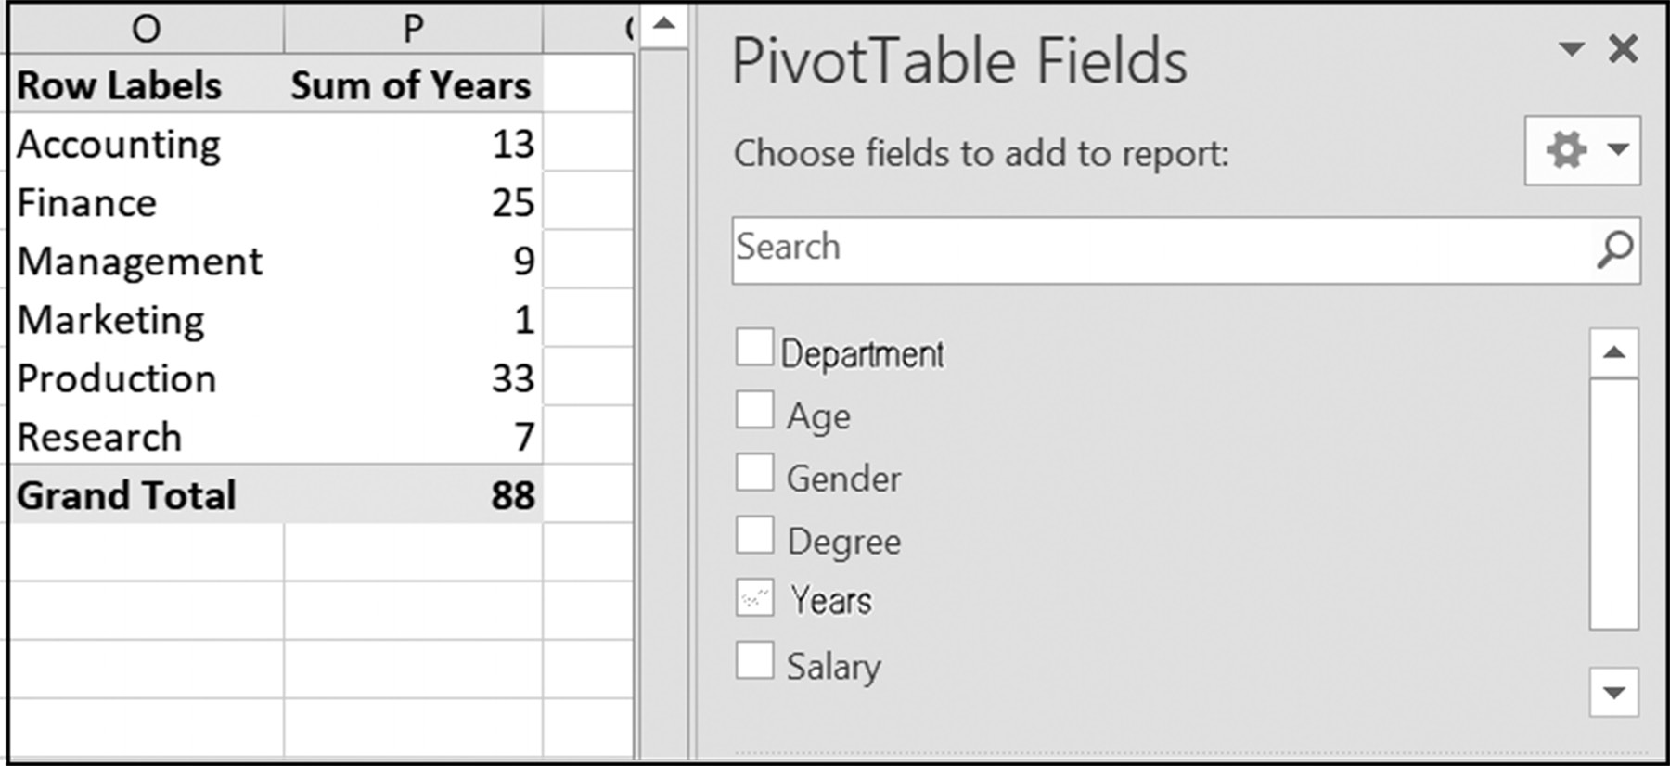
PivottaBles 219

8. Enter the following Sales data into a spreadsheet on your computer.
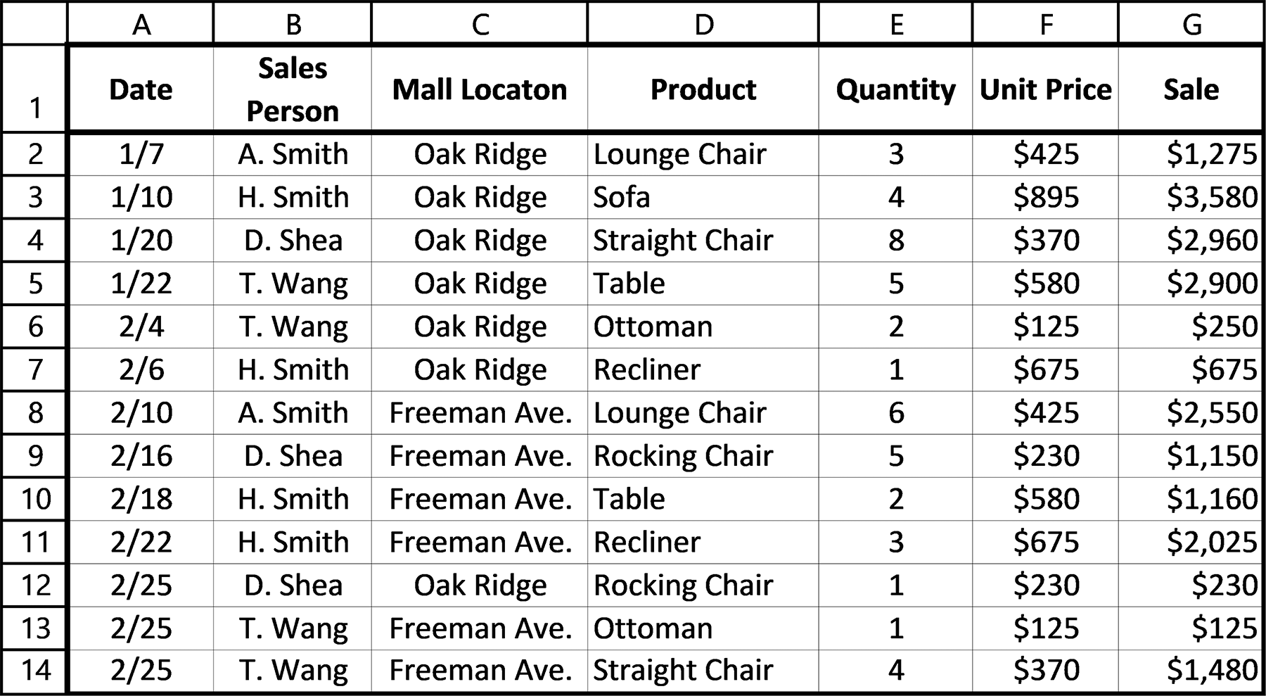

9. Using the spreadsheet from Exercise 8, create the following PivotTable.
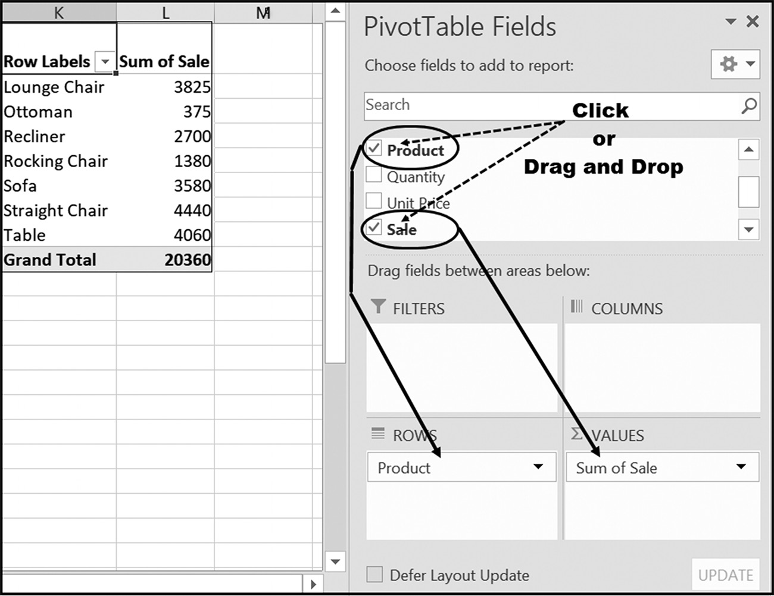

10. Using the spreadsheet from Exercise 8, create the following PivotTable.
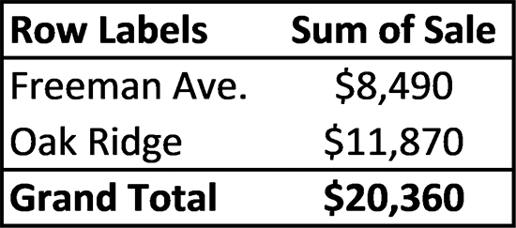
220 exCel BasiCs

11. Using the spreadsheet from Exercise 8, create the following PivotTable.
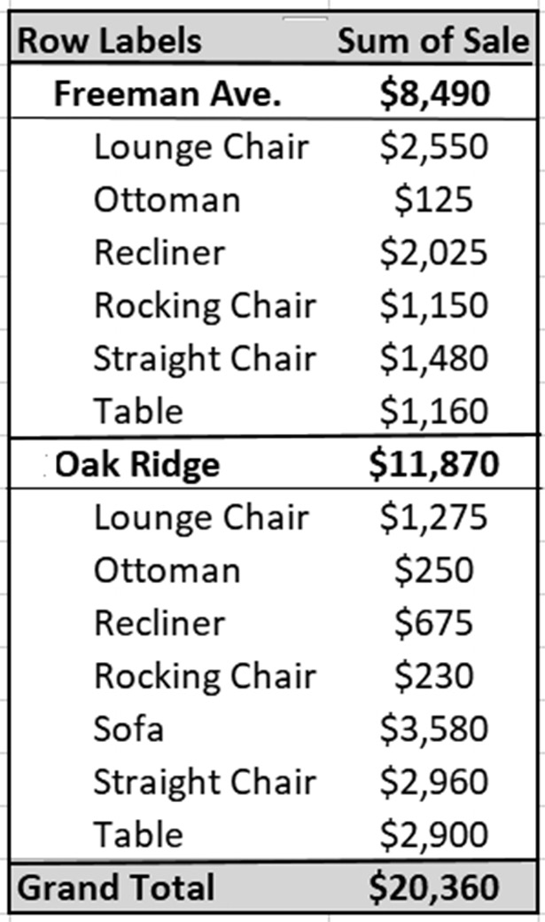

12. Using the spreadsheet from Exercise 8, create the following PivotTable.
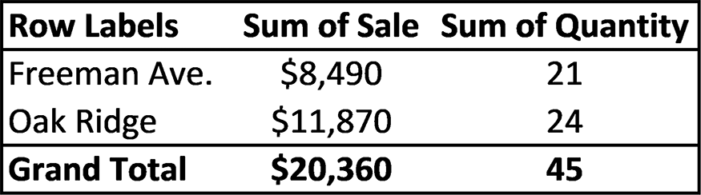

13. Using the spreadsheet from Exercise 8, create the following PivotTable.
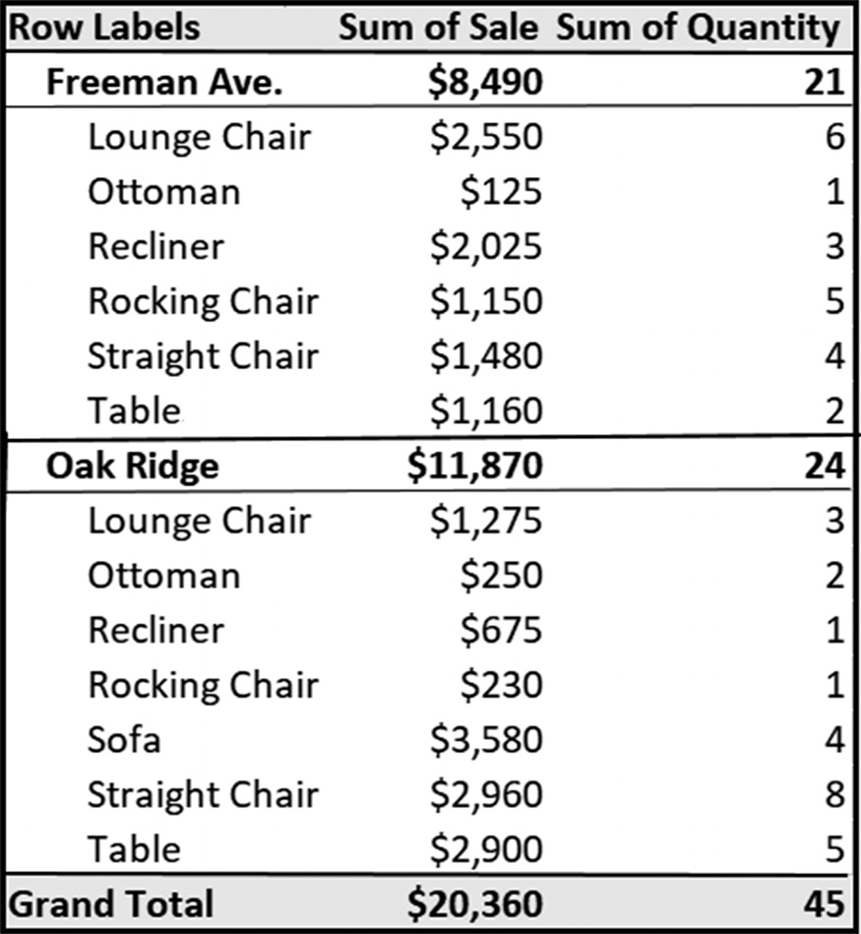
PivottaBles 221

6.3 ADDING COLUMN FIELDS
Both Figures 6.22a and 6.22b provide the same information; the difference is in the
presentation. In both figures, the primary Row Field is Sales Person. However, in
Figure 6.22a Mall Location is presented as an indented (that is, subsidiary) Row field,
while Figure 6.21b Mall Location is used a Column Field. It is a matter of preference
as to which is the better presentation.
Column Fields are added into a PivotTable in a similar manner as Row Fields,
except that they must always be dragged and dropped; they cannot be clicked in the
PivotTable Field dialog.
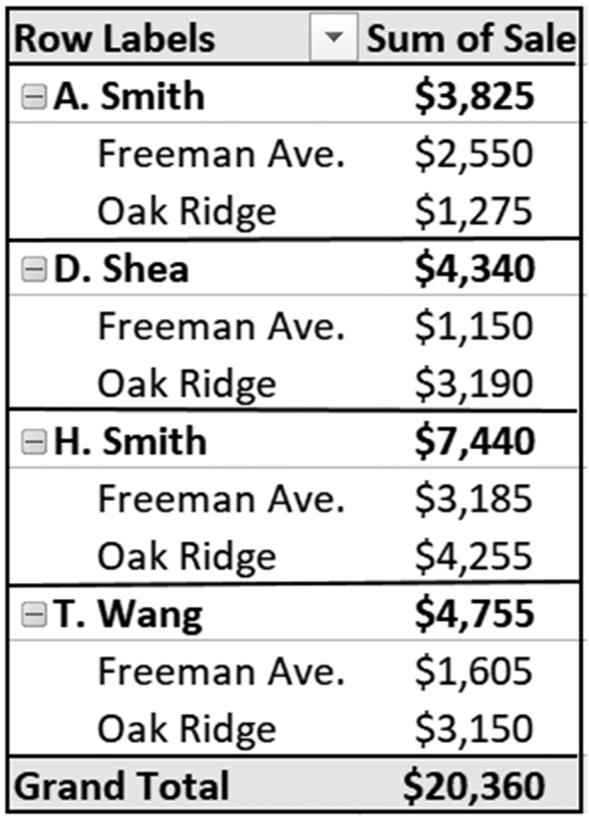

(a) (b)
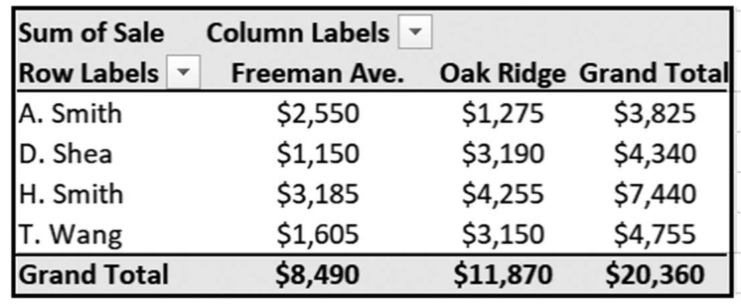
Figure 6.22 Equivalent row and column PivotTables
As an example of including a set of column fields (which are distinct from Summary
columns) consider Figure 6.23.
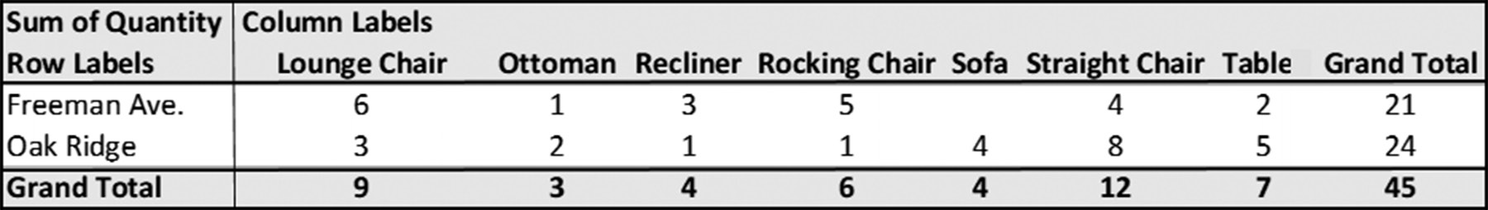

Figure 6.23 A PivotTable with one set of row fields and one set of column fields

Figure 6.23 illustrates a PivotTable having one set of row fields and one set of column
fields. In this figure, the row fields provide the Mall Location and the column fields
provide the product name. Each entry in the table lists the number of each product
sold at each Mall Location. The last column, which is a value field column, provides
the total number of items sold at each Mall Location. Because there is now a set of
column fields, a Grand Total row is also provided, which is the last row in the table.
This row provides a total for each product sold in both stores together.
222 exCel BasiCs

Application Note
Sorting and Selecting Row and Column Labels
Row and column labels can be sorted and/or selected by clicking on the arrows to the right of each label designation, as shown in the figure below.
Each arrow, as shown, provides its own drop-down menu. These sort and search options, however,
are available during PivotTable development process.

Figure 6.24 shows the PivotTable Fields dialog box used to created Figure 6.23. The
only new feature shown in Figure 6.24 is that creating a set of column fields, unlike
row fields, requires that the desired field must be dragged and dropped into the COL-
UMNS field’s selection box. Simply clicking on the desired field will create it as a
ROWS field.
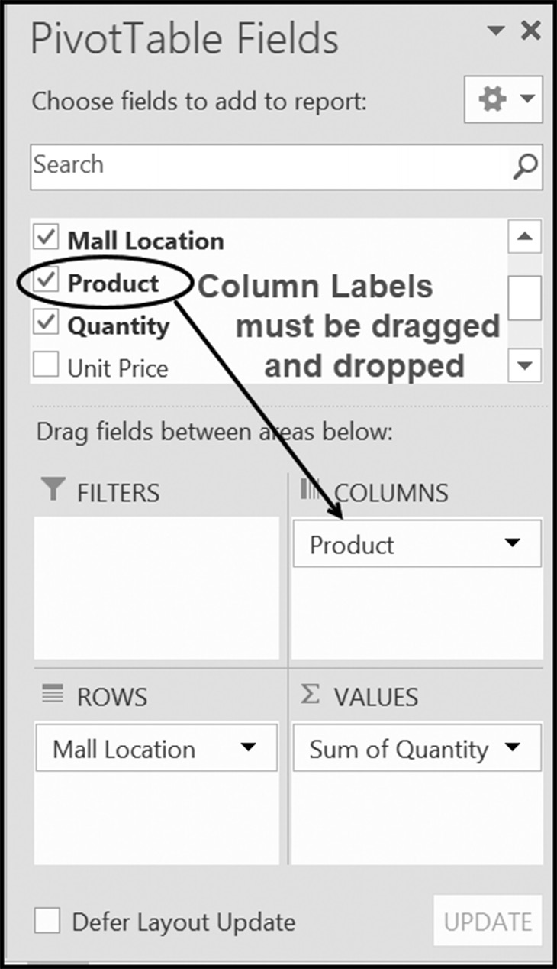

Figure 6.24 Creating a set of column labels (fields)
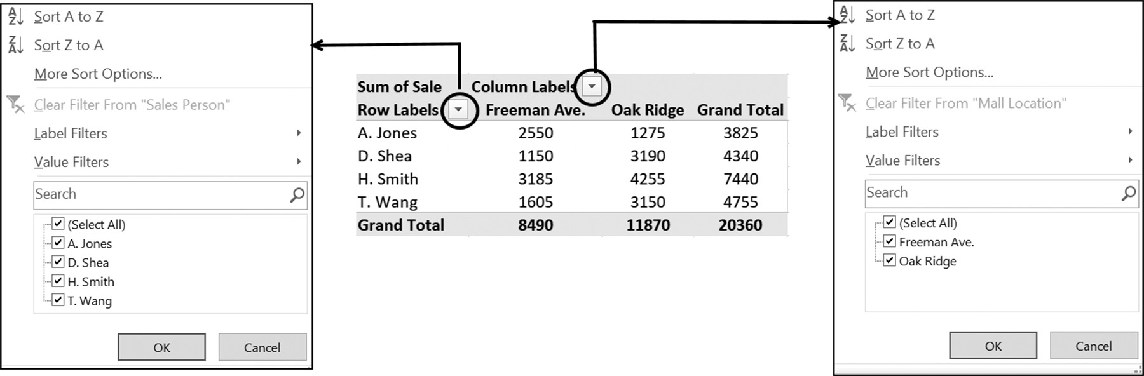
PivottaBles 223

Additional Column Field Examples
Each set of column fields (remember, these are different from Summary columns)
is placed into a PivotTable by dragging and dropping the desired label field into the
COLUMNS selection box, as shown in Figure 6.25.
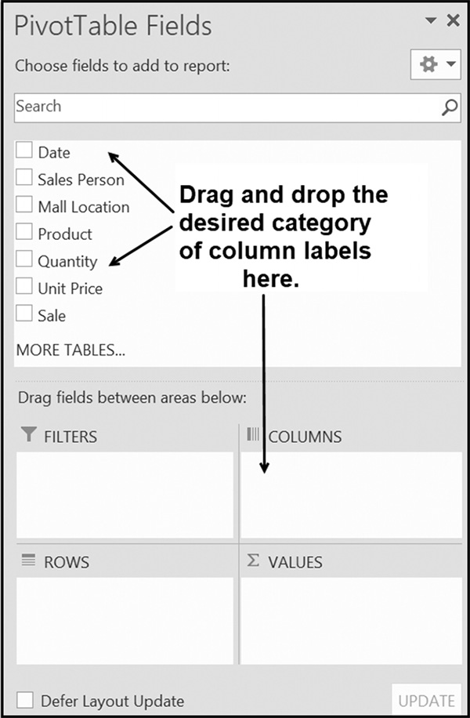

Figure 6.25 PivotTable fields
Here are two examples of creating a PivotTable with each one having a single set of
column fields. The first example illustrates a PivotTable having a single row field, a
single column field, and a single value field. The second example illustrates a table
with two row fields, a single column field, and a single value field. Both examples sum-
marize data from the spreadsheet shown in Figure 6.26.
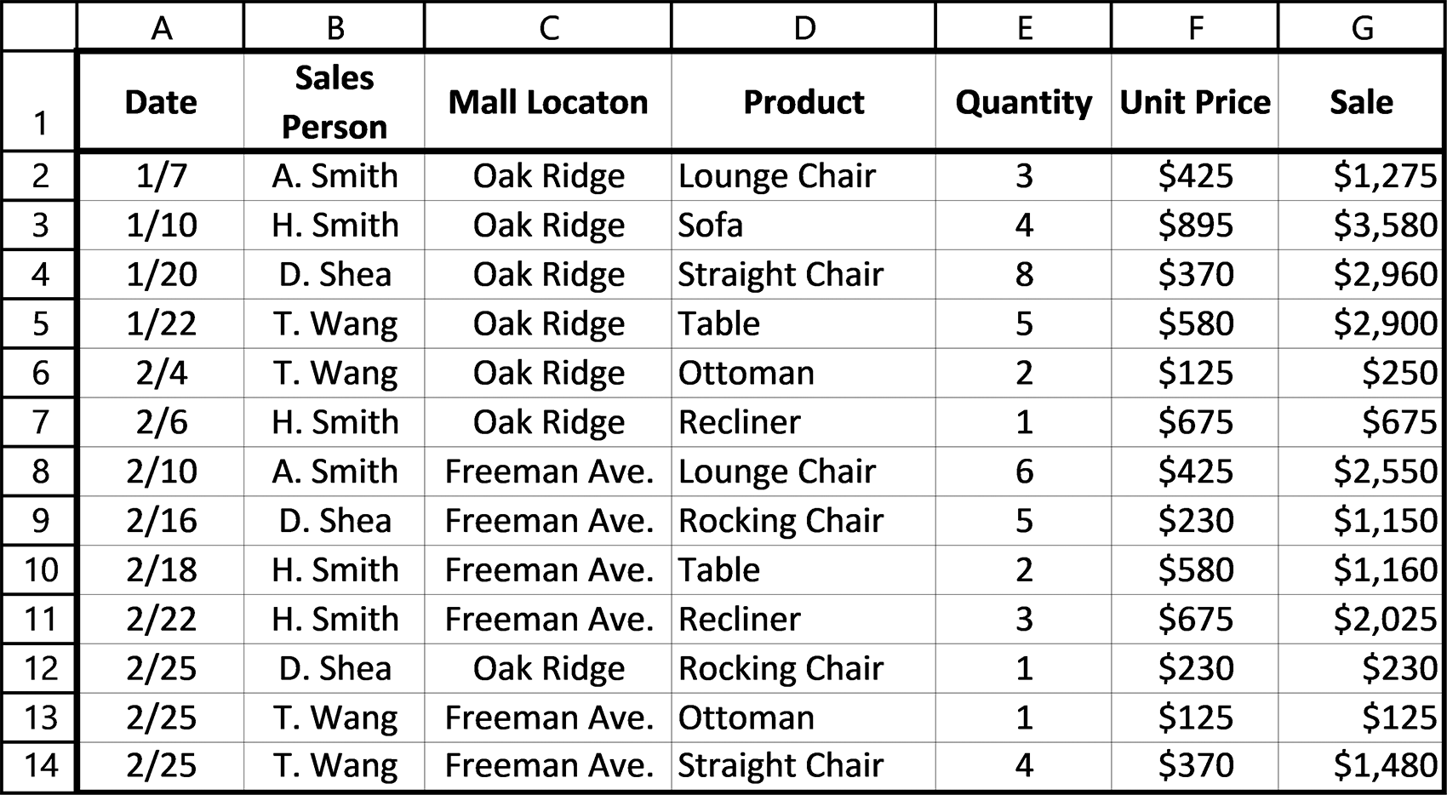

Figure 6.26 Sales data 224 exCel BasiCs

Example 1
A Single Set of ROW and COLUMN Fields
The PivotTable shown in Figure 6.27a consists of one set of row fields and one set of
column fields. Also included is a single value field. Determine options in the Pivot-
Table Fields dialog box needed to produce this PivotTable.
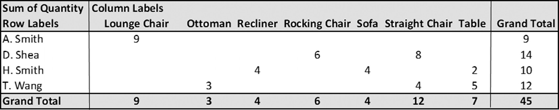

Figure 6.27a Quantity sold by product and salesperson
Solution: Figure 6.27b shows the PivotTable Fields dialog box used to produce
Figure 6.27a.
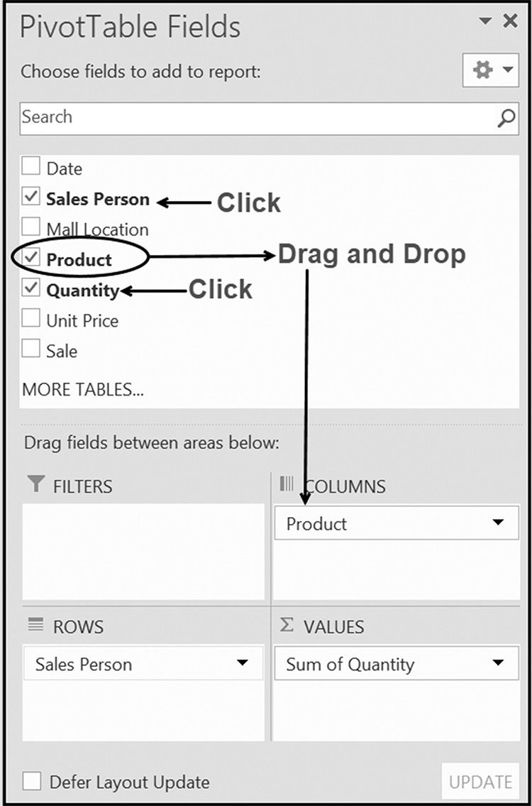

Figure 6.27b The PivotTable Fields dialog box used to create Figure 6.27a

Your initial PivotTables may contain just a single set of row and column fields. The
reason is that each additional set of column fields extends the table horizontally, which
can create a table that may not fit on a single sheet of paper.1 If two sets of column
fields are required, and printed output size is critical, one option is to create two pivot
tables, with each pivot table including one of the desired column fields.
1 Clearly, if the column labels contain two or three labels, more sets can be included in the table.
PivottaBles 225

At times, you may create a PivotTable with two row fields, and a single column field.
An example of constructing this type of PivotTable is shown in the following example.

Example 2
Two Sets of Row Fields and a Single Set of Column Fields
The PivotTable shown in Figure 6.28a consists of two sets of row fields and one set
of column fields. Also included is a single value field. Determine the options in the
PivotTable Fields dialog box needed to produce this PivotTable.
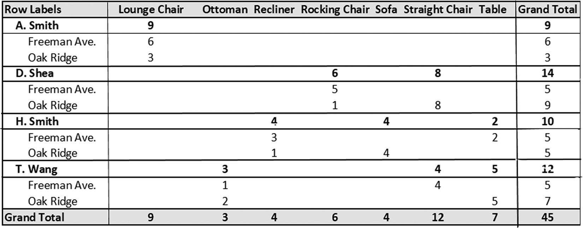

Figure 6.28a Quantity of product sold by salesperson and mall location

Solution: Figure 6.28b shows the PivotTable Fields dialog box options used to pro-
duce Figure 6.28a.
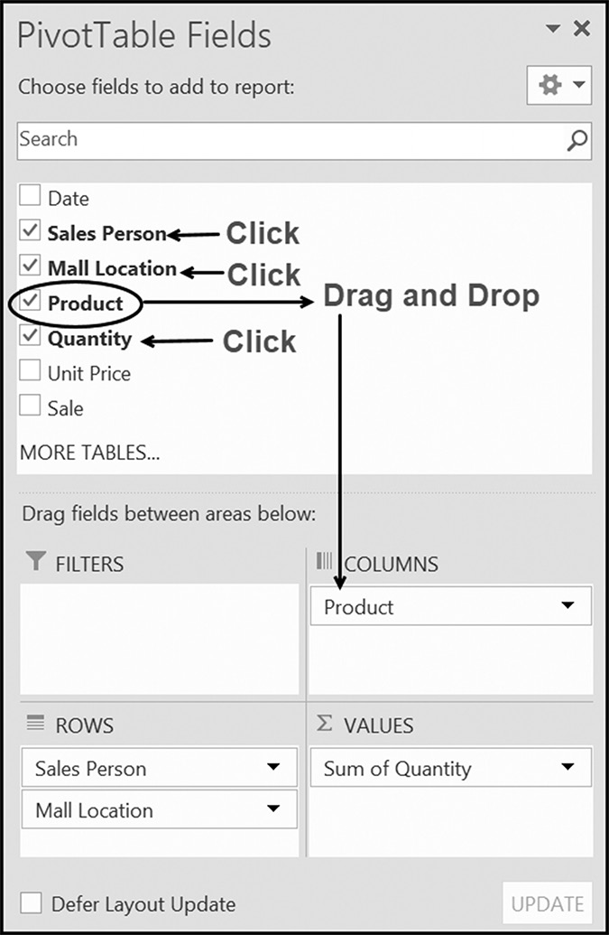

Figure 6.28b PivotTable Fields dialog box options used to create Figure 6.28a 226 exCel BasiCs

Application Note
Refreshing PivotTables
PivotTables are static, which means that they summarize the data that exists when the table was created. As such, they are not automatically updated when changes are made to the original data. To keep them current for such changes requires refreshing. This is accomplished by either
1. Pressing the Alt-F5 key combination, or
2. Selecting the Excel ribbon’s Data Tab - Queries & Connections Group - Refresh All option,
shown below (or using the menu command PivotTable Tools – Analyze – Data Group – Refresh – Refresh All)
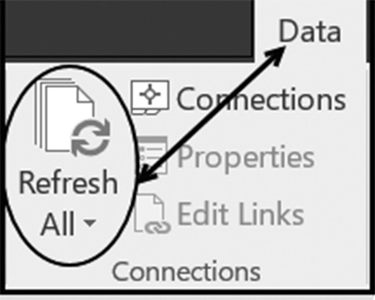

Alternatively, all PivotTables can be automatically refreshed when a spreadsheet is opened by right-clicking within any PivotTable, selecting the PivotTable Options, choosing the Data tab, selecting the Refresh data when opening the file option, and clicking “OK.”

Since the purpose of this chapter was to provide a general and basic introduction to
PivotTables, it is important to note that there is much more to what PivotTables can
offer. While it was mentioned that it is best to start simple and build your way up in
terms of complexity, there are many other features that you can explore after you
understand and have mastered the basics.
Some of the options include more complex PivotTables using multiple columns,
rows, report filters, and value fields. There is the ability to create PivotCharts, which
are based on your PivotTable data, and the charts themselves can be “pivoted.” It is
possible to filter your PivotTable using slicers and timelines. Custom fields can be de-
rived from the original fields in your spreadsheets, known as calculated fields. It is also
possible to establish relationships between multiple lists/tables, simulating a capability
found in relational databases.
There are many resources available for you to explore PivotTables in more depth,
once you have grasped the basics.
PivottaBles 227

EXERCISES 6.3

1. Enter the following spreadsheet into your computer.
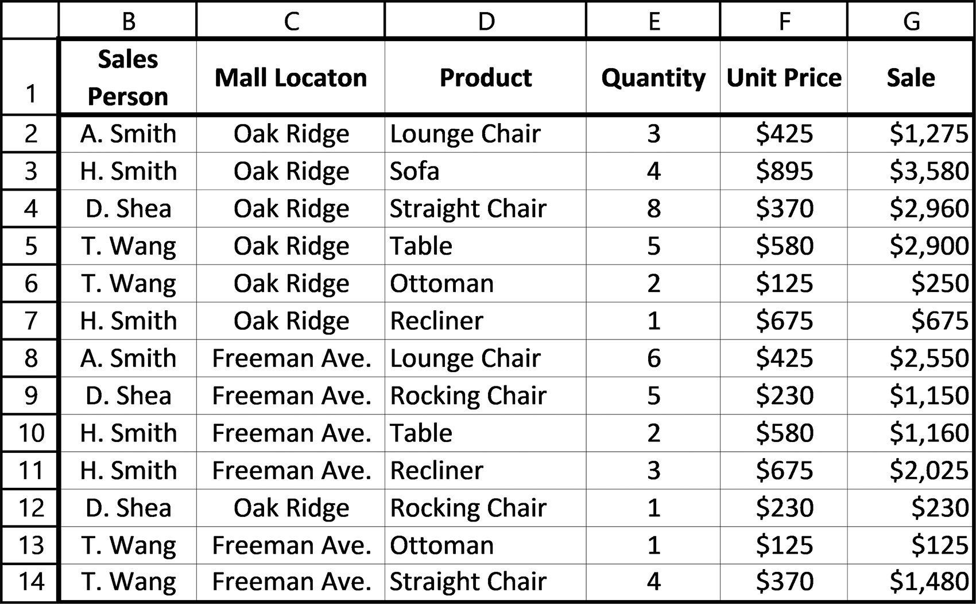

2. Using the spreadsheet created in Exercise 1, create the following PivotTable.
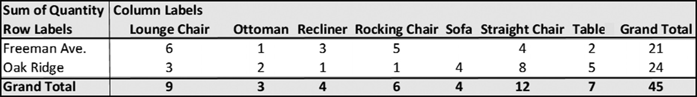

3. Using the spreadsheet created in Exercise 1, create the following PivotTable.
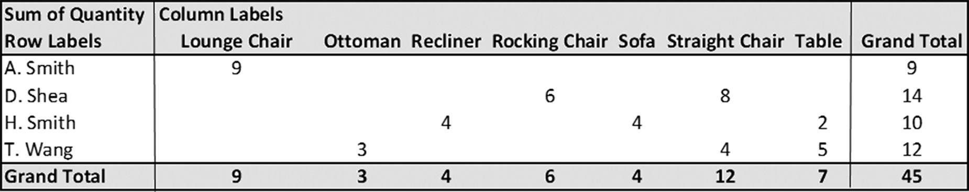
228 exCel BasiCs

4. Using the spreadsheet created in Exercise 1, create the PivotTable shown below.
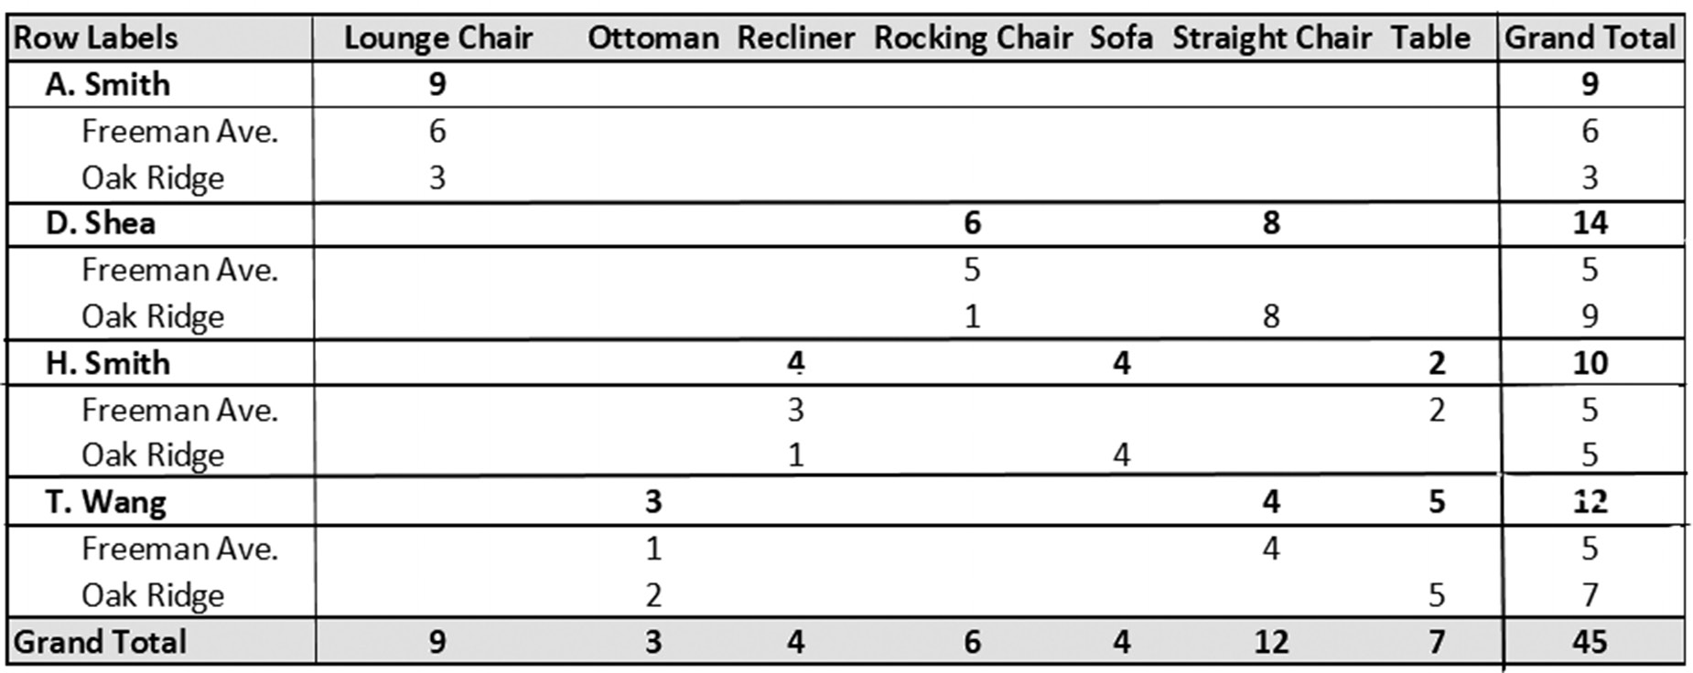

5. Using the spreadsheet created in Exercise 1, create the following PivotTable.
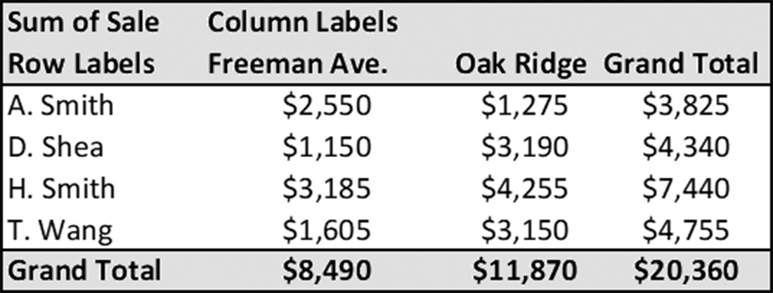

6. Using the spreadsheet created in Exercise 1, create the following PivotTable.
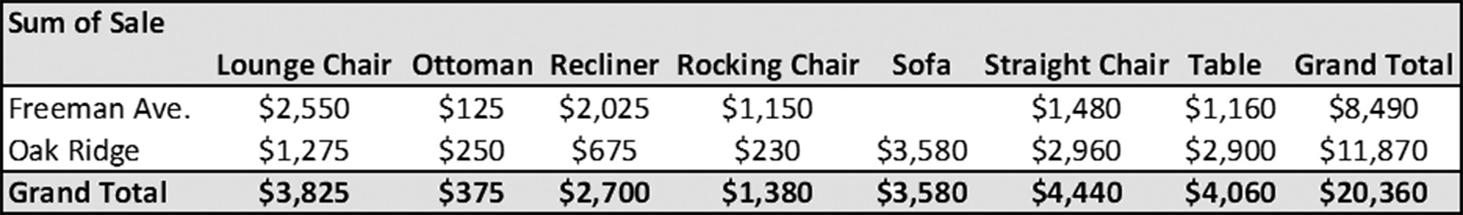

7. Using the spreadsheet created in Exercise 1, create the following PivotTable.
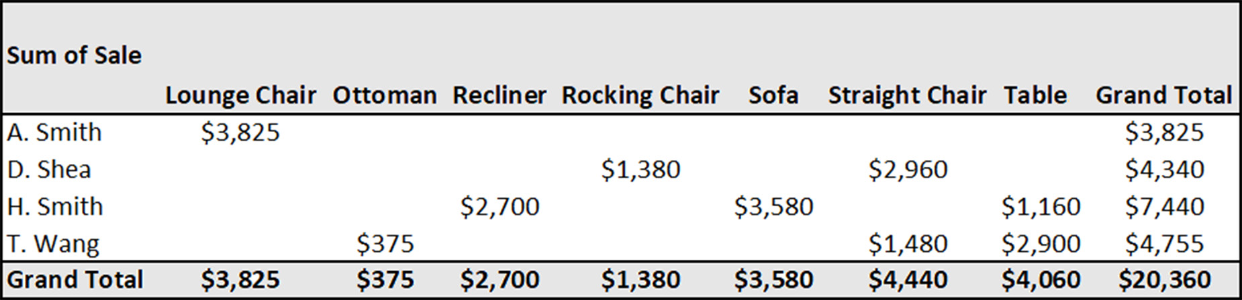
PivottaBles 229

6.4 COMMON EXCEL ERRORS
The most common errors associated with PivotTables are the following:
1. Not using PivotTables at all because you think they are difficult to create. It helps
to realize that a PivotTable is simply a summary table. With a minimum of two clicks of a mouse, a PivotTable can be created. A more complex PivotTable beyond this can also be created relatively easily.
2. Making PivotTables too complicated. It is best to create a PivotTable as simple
as possible, considering the data being analyzed, as well as the intended goal and purpose of creating it.
3. Not activating the PivotTable Tools menu to either refresh a PivotTable, change
the row and column label headings, or change the calculation method in a Pivot-Table Fields dialog box. Clicking on any PivotTable cell activates the Tools menu (see Application Notes included throughout this chapter).

6.5 CHAPTER APPENDIX: PIVOTTABLE DESIGN CRITERIA
The purpose of a PivotTable is to summarize specific aspects of a larger spreadsheet.
As such, a PivotTable should not be too large and force the viewer to focus on the
items you wish to emphasize. The following guidelines will help you achieve this goal.
There is no reason not to start with the simplest structure of a single set of row field,
and one or two value fields, as shown in Figure 6.29.
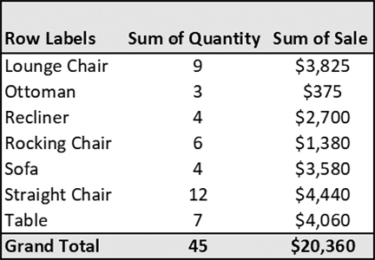

Figure 6.29 A single set of row fields and two summary columns (value fields)

PivotTables with either two sets of row fields or a single set of row and column fields
are also generally concise enough to focus a user’s attention. For example, consider
Figure 6.30, which presents sales data, classified by Sales Person and Mall Location.
Including one or more value fields to either of these figures is acceptable because
each summary column can be viewed individually and does not detract from the over-
all presentation.
230 exCel BasiCs

Application Note
Using the PivotTable’s Analyze Tab
In addition to refreshing a PivotTable and deleting one, there are a number of other useful options for changing and manipulating a table under development. The most useful of these are provided as options in the Analyze Tab under the PivotTable’s Tools menu, as shown below. Clicking on any PivotTable cell activates the PivotTable Tools menu.
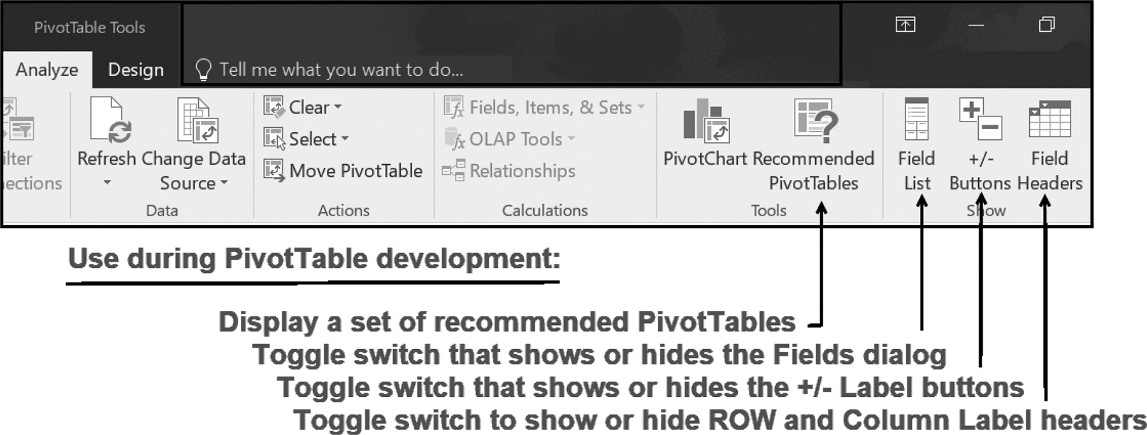

(a) (b)
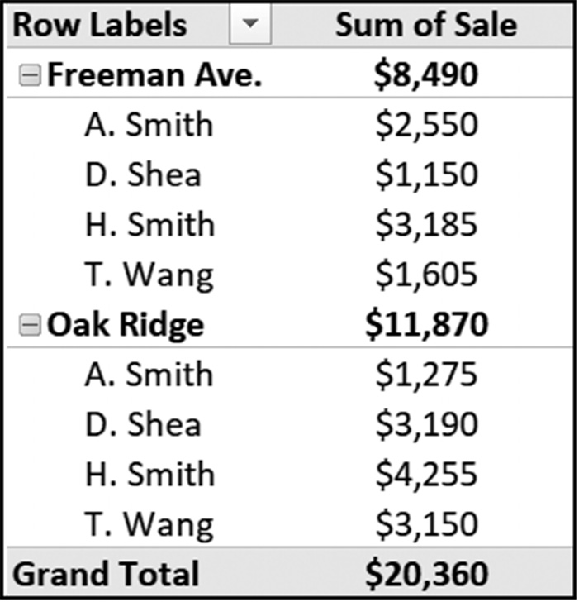
Figure 6.30 Presenting the same data in different ways
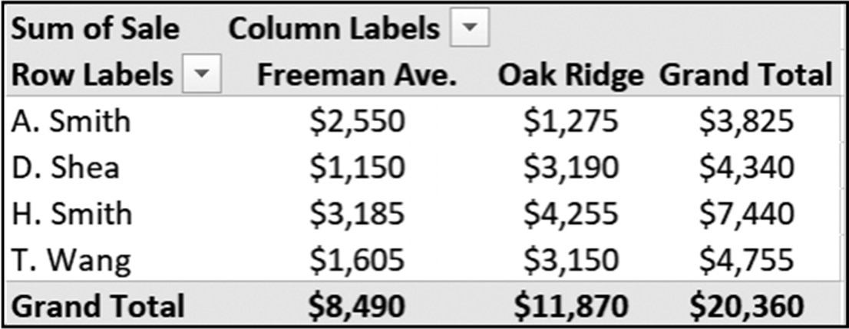

As seen in Figure 6.30a, two row label categories are used, while in Figure 6.30b, the
two row label categories are replaced by a single row and column set of fields. The
choice as to which structure is better in any given situation, is one you must make
based on your own sense of which is more appropriate for what you are intending to
present. Figures 6.31 and 6.32 illustrate two additional PivotTables using this arrange-
ment.
PivottaBles 231
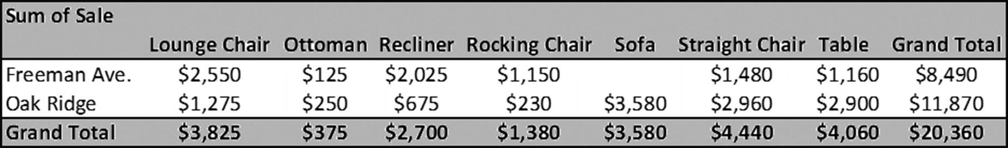

Figure 6.31 A single row field, column field, and values field PivotTable
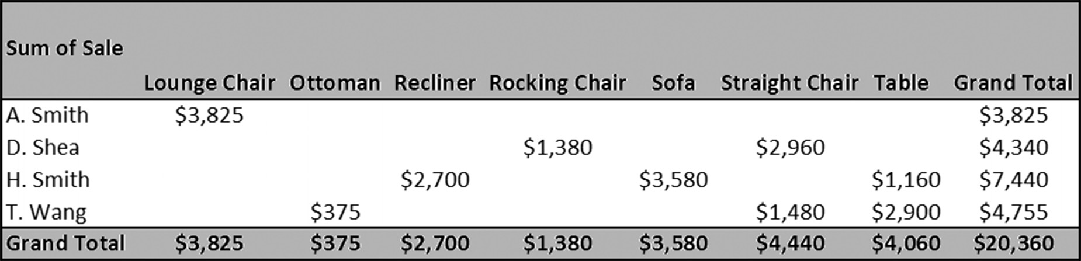

Figure 6.32 A Different single row field, column field, and value field PivotTable

More than two sets of column fields tend to produce tables that are too wide to fit
on a standard sheet of paper. Thus, in general, a basic PivotTable could comfortably
contain two sets of row fields and one set of column fields, with as many summary col-
umns (value fields) as needed. Figure 6.33 provides an example of such a PivotTable.
More complex PivotTables are of course possible, but added complexity should only
be added if the data analysis requires it.
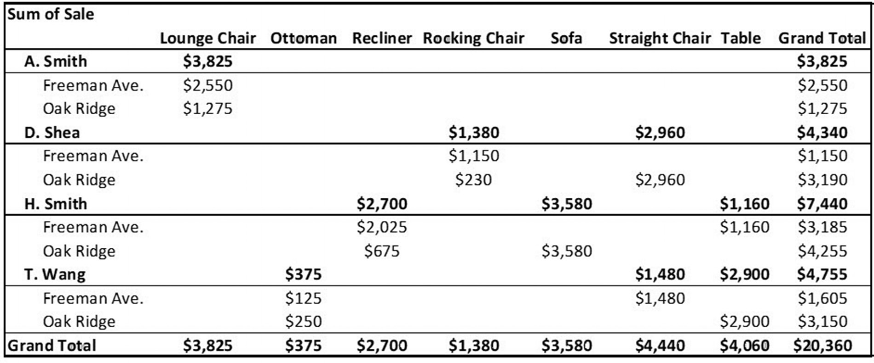

Figure 6.33 Two row fields, a column field, and a summary column (value field)

Notice in Figures 6.31 through 6.33 that the PivotTables have been formatted as Cur-
rency, with the data in each column centered, and that the headings Row Labels and
Column Labels do not appear (because the output shown is how the display is printed
and is not the development display).

Part 3
intermediate skills

Chapter 7 Sorting and Searching

Chapter 8 Intermediate and Advanced Techniques

C H A P T E R 7
sorting and searChing

This Chapter Contains
7.1 Records as Rows
7.2 Sorting Spreadsheet Rows
7.3 Creating Group Subtotals
7.4 Searching (Filtering) for Selected Records
7.5 Database Functions
7.6 Common Excel Errors
7.7 Chapter Appendix: Spreadsheets as Databases

Most Excel users encounter the need to both sort and search a list of data items at
some time in their professional careers. For example, employee identification codes
might have to be arranged in either increasing (ascending) or decreasing (descend-
ing) order. Similarly, a list of dates may have to be rearranged in ascending date order
or a list of names sorted in alphabetical (ascending) order. Similarly, a list of names
may have to be searched to find a particular name or a list of dates searched to locate
a particular date. In this chapter, the fundamentals of Excel’s sorting and searching
capabilities are presented.

7.1 RECORDS AS ROWS
Excel spreadsheets can be set up in many different ways, such as financial statements,
sets of calculations, or as organized lists and tables. In the case of Excel lists (and
tables), an example of which is in Figure 7.1, there is a set structure and organization
which guides the spreadsheet setup and the entry of data. It could be termed as a kind
of database structure in that it is an “organized collection of information” and has both
specific data items, known as fields, and collections of these fields, which makes up
what are known as records. You can take as an example an address list of customers as
the “database” with various data elements such as name, address, city, state, zip, and 236 exCel BasiCs

phone as fields. These data elements generally have an expected data type, such as
text, number, or something else. When you have a collection of associated fields, this
forms a record, which in this example would be the data for one customer. It should
be noted that Excel lists and tables are technically not databases, although they are set
up to resemble and can operate as one.
The distinction was made between lists and tables. Lists are collections of fields and
records. Tables are lists to which the Excel Table structure has been applied, which
provides additional tools for working with list data (such as sorting and filtering). The
term Excel Table should not be confused with the concept of a table in a relational
database, although if set up properly, an Excel Table can be made to resemble, and
in some aspects, simulate the workings of, a relational database. However, if an Excel
list or table can loosely be termed a “database,” then it would be best characterized
as a flat-file database, rather than a relational database, since there are normally no
relationships between the various data items.
In an organization, such as a company, university, or governmental agency, a re-
cord typically contains two or more related fields. For example, consider Figure 7.1,
which provides information on employees in a small company, where an employee
is assigned to one of two offices, Home (coded as HM) or Field (coded as FLD). In
Figure 7.1, each record is listed in a single row, with the record containing information
related to an individual employee.
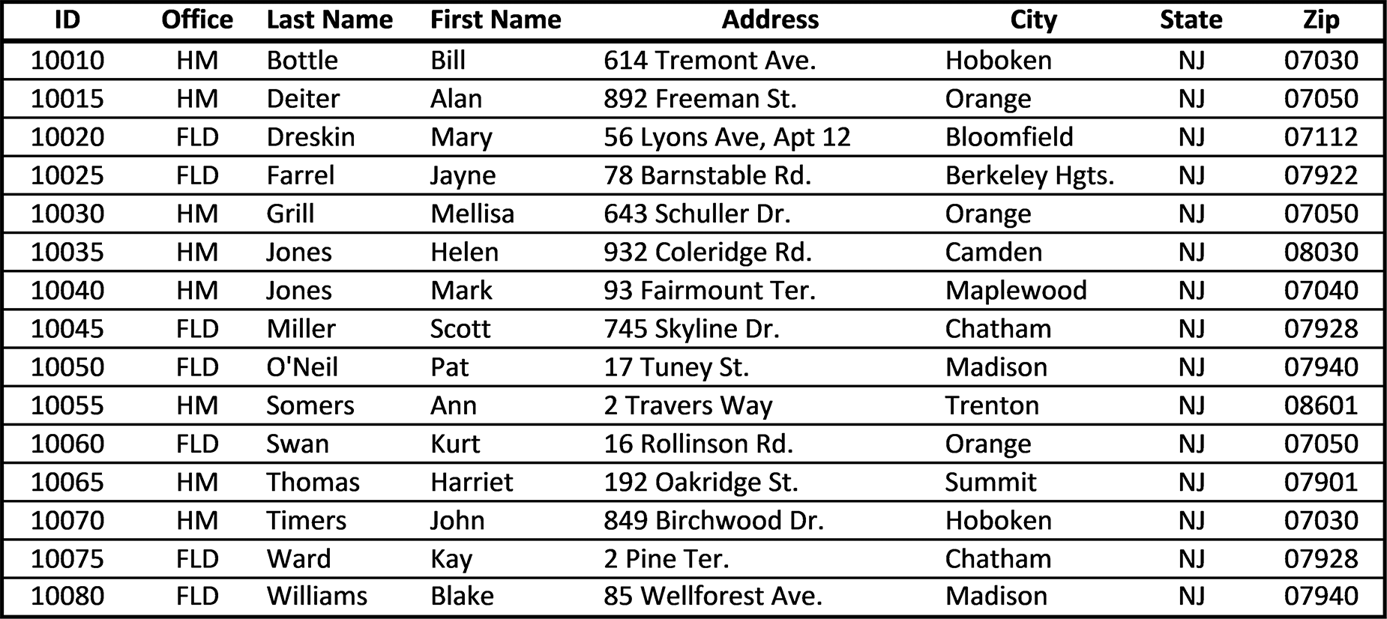

Figure 7.1 Employee data (Excel list structure)

Records can be created and stored in a number of formats, from paper to computer
files to spreadsheets. When a record (complete or partial) is stored using a spread-
sheet, it is always stored as a row. Thus, with respect to spreadsheets, the terms row
and record are frequently used interchangeably, as they will be in this chapter. From
sortinG and searChinG 237

an applications viewpoint, the term record emphasizes the data’s usage as an organized
structure of related data; from a spreadsheet viewpoint, the word row emphasizes the
data’s physical organization within the spreadsheet.
Once records are stored as rows within a spreadsheet, two operations that are fre-
quently done include
1. Sorting the records in a specific order, perhaps by name, location, or zip code (or
on a sequence of different fields)
2. Search for and select (“filter”) records meeting specific criteria.
Each of these operations involves either sorting or selecting (filtering) records based
on specific item values. As an example, in Figure 7.1, a list of employees sorted by
office location might be required. Similarly, in a list of student records, we might want
to know how many students are Liberal Arts majors, or how many students have a
Grade Pt. Average (GPA) above 3.4, or how many students have earned more than 80
credits and have a GPA above 3.4.
Sections 7.3 through 7.5 present Excel methods for sorting, counting, and search-
ing spreadsheets for records that meet the desired criteria.

EXERCISES 7.1

1. Complete parts a-h.
a. What is a database?
b. What is a field?
c. What is a record?
d. How are fields and records stored in spreadsheets?
e. What is an Excel list?
f. What is an Excel table?
g. What is the best term to describe the physical structure of an Excel “database?”
h. What kind of database can an Excel list/table be made to simulate?
2. Although a spreadsheet row can almost always be considered a record, is a record
always a spreadsheet row?
3. List two operations that can be used on Excel “database” structures. 238 exCel BasiCs

7.2 SORTING SPREADSHEET ROWS
There are times when you will need to reorganize the rows in your spreadsheet in
either ascending (from lowest to highest) or descending (highest to lowest) order
based on one or more column’s data.1 The sorting procedure based on a single crite-
rion includes the following steps:
Step 1: Click on any cell in the column that you want to be sorted
Step 2: Select the desired sort, ascending or descending, on the Excel ribbon Data
Tab, Sort & Filter Group.
When this is done, all of the rows on the spreadsheet will be reordered, based on the
item chosen for the sort. As a specific example, consider that the spreadsheet shown in
Figure 7.2 must be sorted by Department, from Accounting to Research (ascending
order, alphabetical).
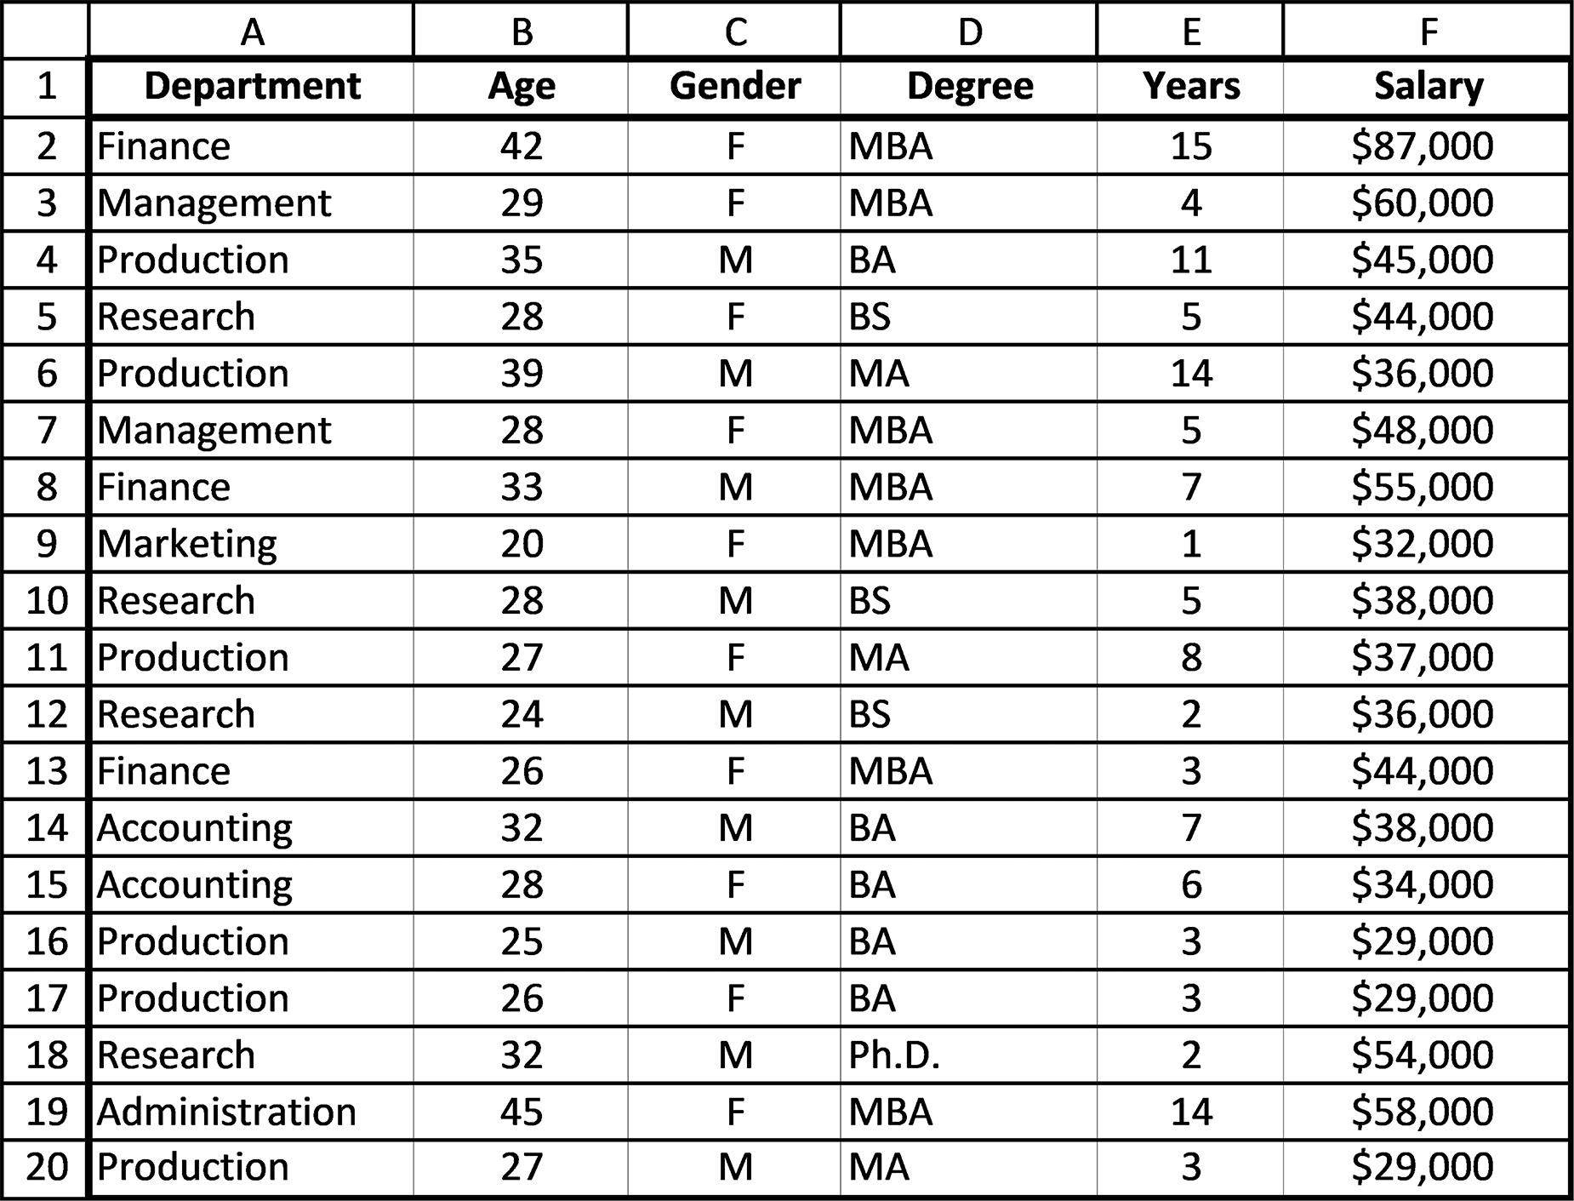

Figure 7.2 The initial spreadsheet data
1 A spreadsheet operating as a database is described more fully in the chapter appendix. In this context, a spreadsheet’s rows (records) correspond to the database’s records, and its columns (fields) correspond to the categories of items stored within a record. When viewed this way, the sorting and searching of rows (filtering) in a spreadsheet become the sorting and searching of records within a database.
sortinG and searChinG 239

The first step in performing the sort is to click on any cell within the Department
column (Step 1).
Next, select either an ascending (lowest to highest) or descending sort (highest to
lowest), from the ribbon’s Data tab (Step 2), as shown in Figure 7.3.
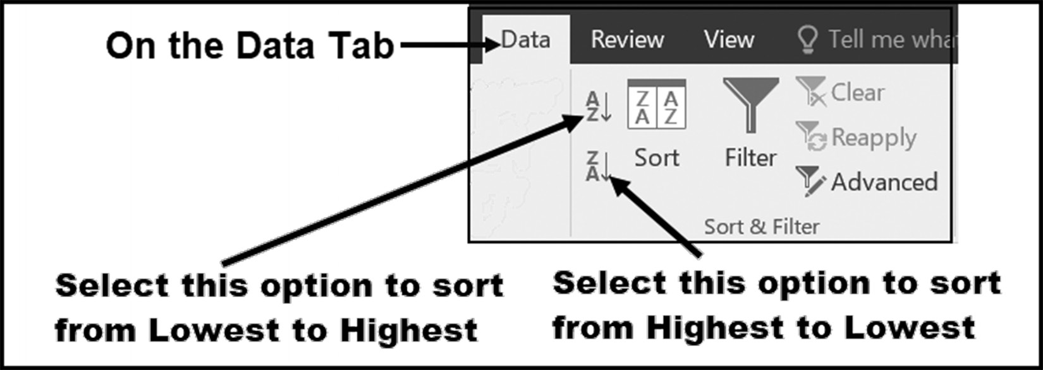

Figure 7.3 Creating a single-level sort

In this case, we want the sort of Departments in ascending order (lowest to highest).
When the A to Z option is selected, the spreadsheet will be sorted in Department
order, as shown in Figure 7.4.
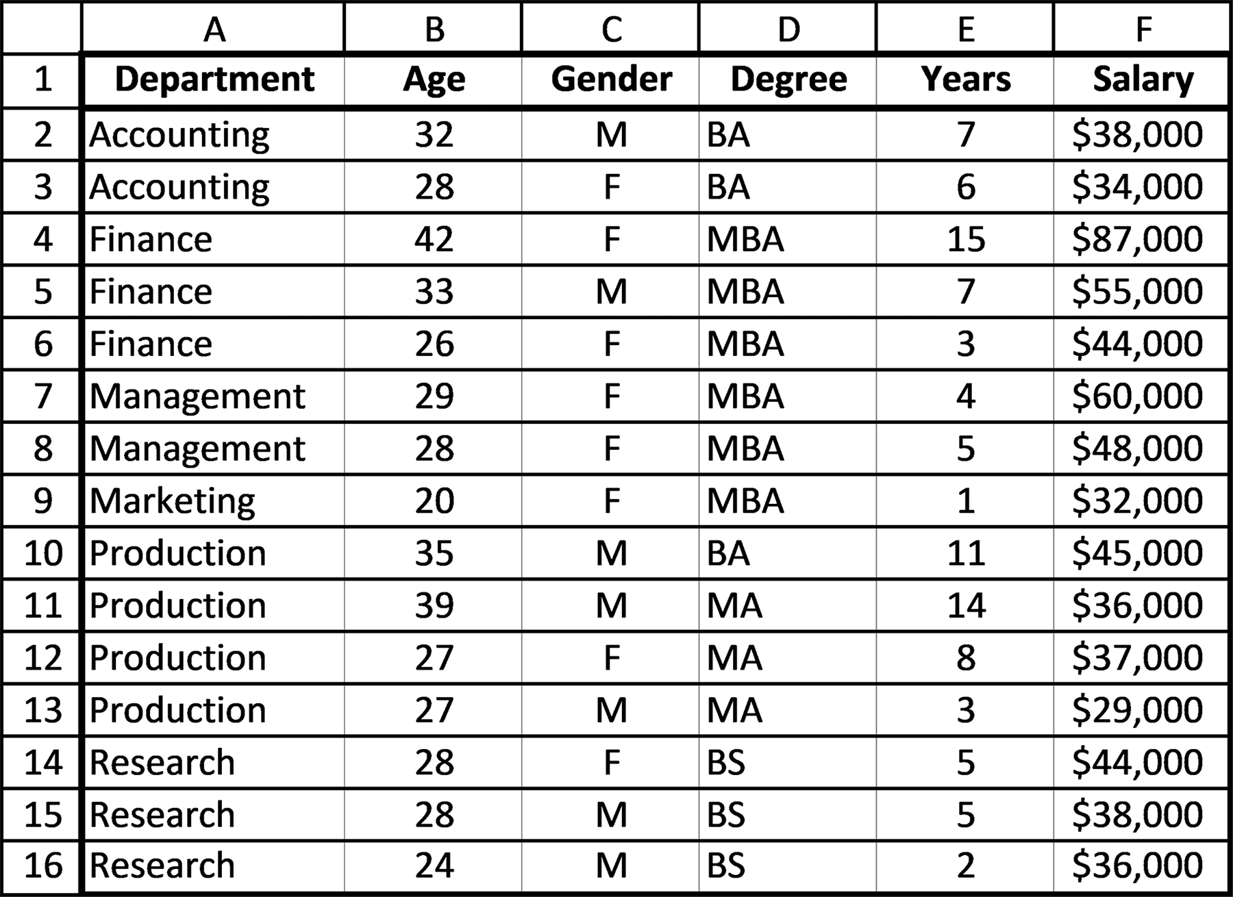

Figure 7.4 The data sorted in ascending Department order 240 exCel BasiCs

In reviewing Figure 7.4, notice that the complete spreadsheet has been reordered.
That is, while the departments were being sorted, the remaining data in each row
“follows” the new Department ordering. Thus, the data within each row remains
the same as the original data, but simply moves up or down to correspond to the
ordering of its Department value. This is known as a “single level” or “single field”
sort because it sorts all of the values in the Department field in ascending order.
This kind of sort is most useful when you only want to sort a single field. In essence,
if you do a single field sort followed by another single-field sort on another field,
then the entire list will be re-sorted based on second field specified, and so in many
ways, the earlier sort is lost and replaced by the new sorted list. If you would like to
do multiple levels of sorting without losing the results of other sorts, you need to do
multi-level sorting.
Multi-Level Sorting
In many cases, you want to do a multi-level (or multi-field sort), which does not dis-
card the previous sorts when you do several in a sequence. As such, a multi-level sort
is a sort within a sort. For example, consider the spreadsheet shown in Figure 7.4.
For example, a three-level sort of this data could be first by Department (in Ascend-
ing order, that is, A to Z order), then by Degree (again in Ascending order, or A to
Z order), and then finally by Salary (in Descending, or highest-to-lowest order). In
effect, when you finish sorting one field and move on to the next, the earlier sorts are
kept, and the new one is “added on” to the previous ones. In this example, what we
have is a Salary sort within a Degree sort within a Department sort.
To create a multilevel sort, first click on any cell within the spreadsheet and then
click the Excel ribbon’s Data tab’s Sort icon, as shown in Figure 7.5. (You should note
that the icons beside it to the left, with the arrows and letters, are the icons for the
single level sorts, so be sure you select the main Sort icon).
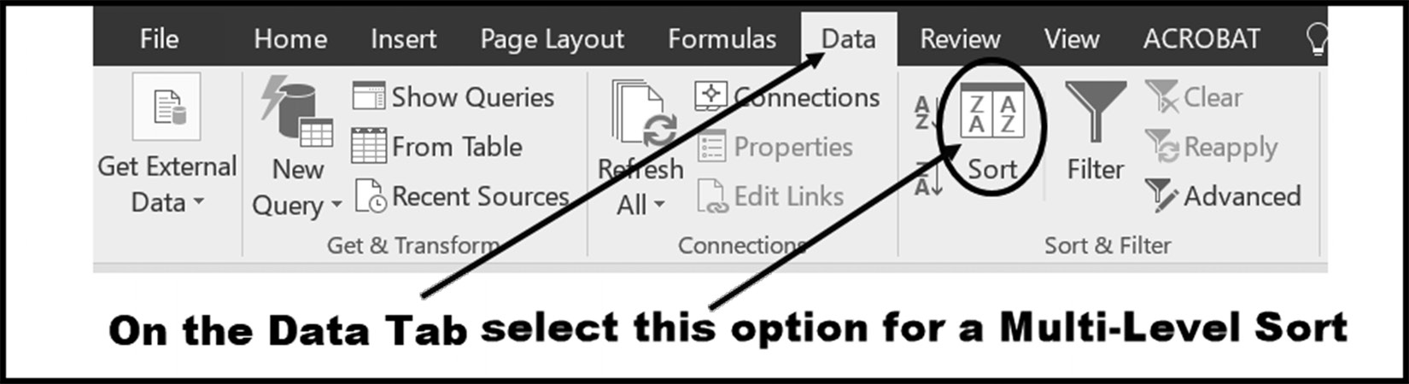

Figure 7.5 Creating a multi-level sort

After clicking on the Sort icon, the sort dialog box shown in Figure 7.6 appears. Within
this box, click on the Sort by arrow (labelled as item 1 in the figure), and then select
sortinG and searChinG 241

Department (labeled as item 2). This sets the first, or primary sort, based on Depart-
ment. (Note, at this stage, if you pressed the OK button, the single sort shown in
Figure 7.4 is produced, and you would have to click on any cell within the spreadsheet
and then click on the Sort icon to have the Sort dialog box reappear.)
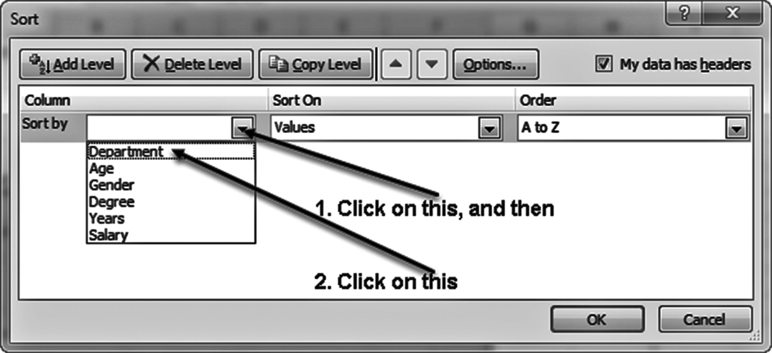

Figure 7.6 Selecting the primary sort within the Sort dialog box

To create the desired three-level sort, you will now have to add two additional sort
columns to the sort. Figure 7.6 illustrates how to add the second sort column using
the sort dialog box. After you have added the Degree column, you still have to add the
Salary column, making sure to change the sort order to Z to A.
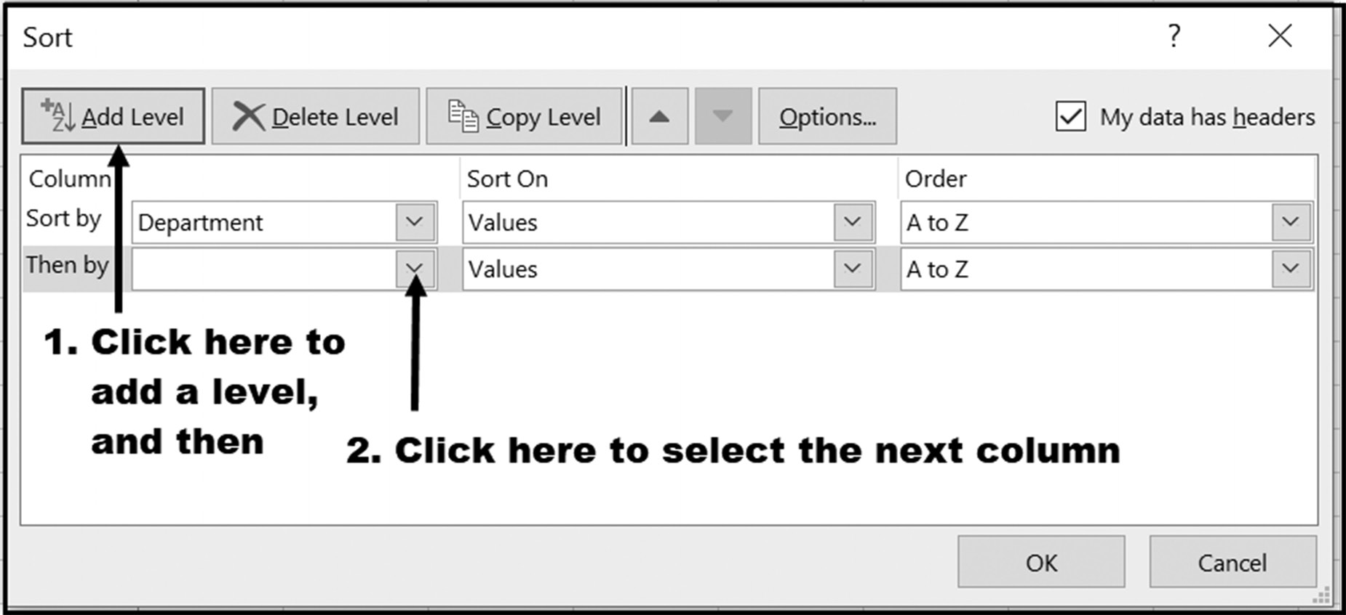

Figure 7.7 Adding a second sort column 242 exCel BasiCs

Once all three sort columns have been selected (Department, Degree, and Salary),
pressing the OK button reorganizes the spreadsheet to appear in the selected sort
order, as shown in Figure 7.8. Note, that if you wanted additional sorts within the
existing three sorts, all you have to do is repeat Steps 1 and 2 shown in Figure 7.7.
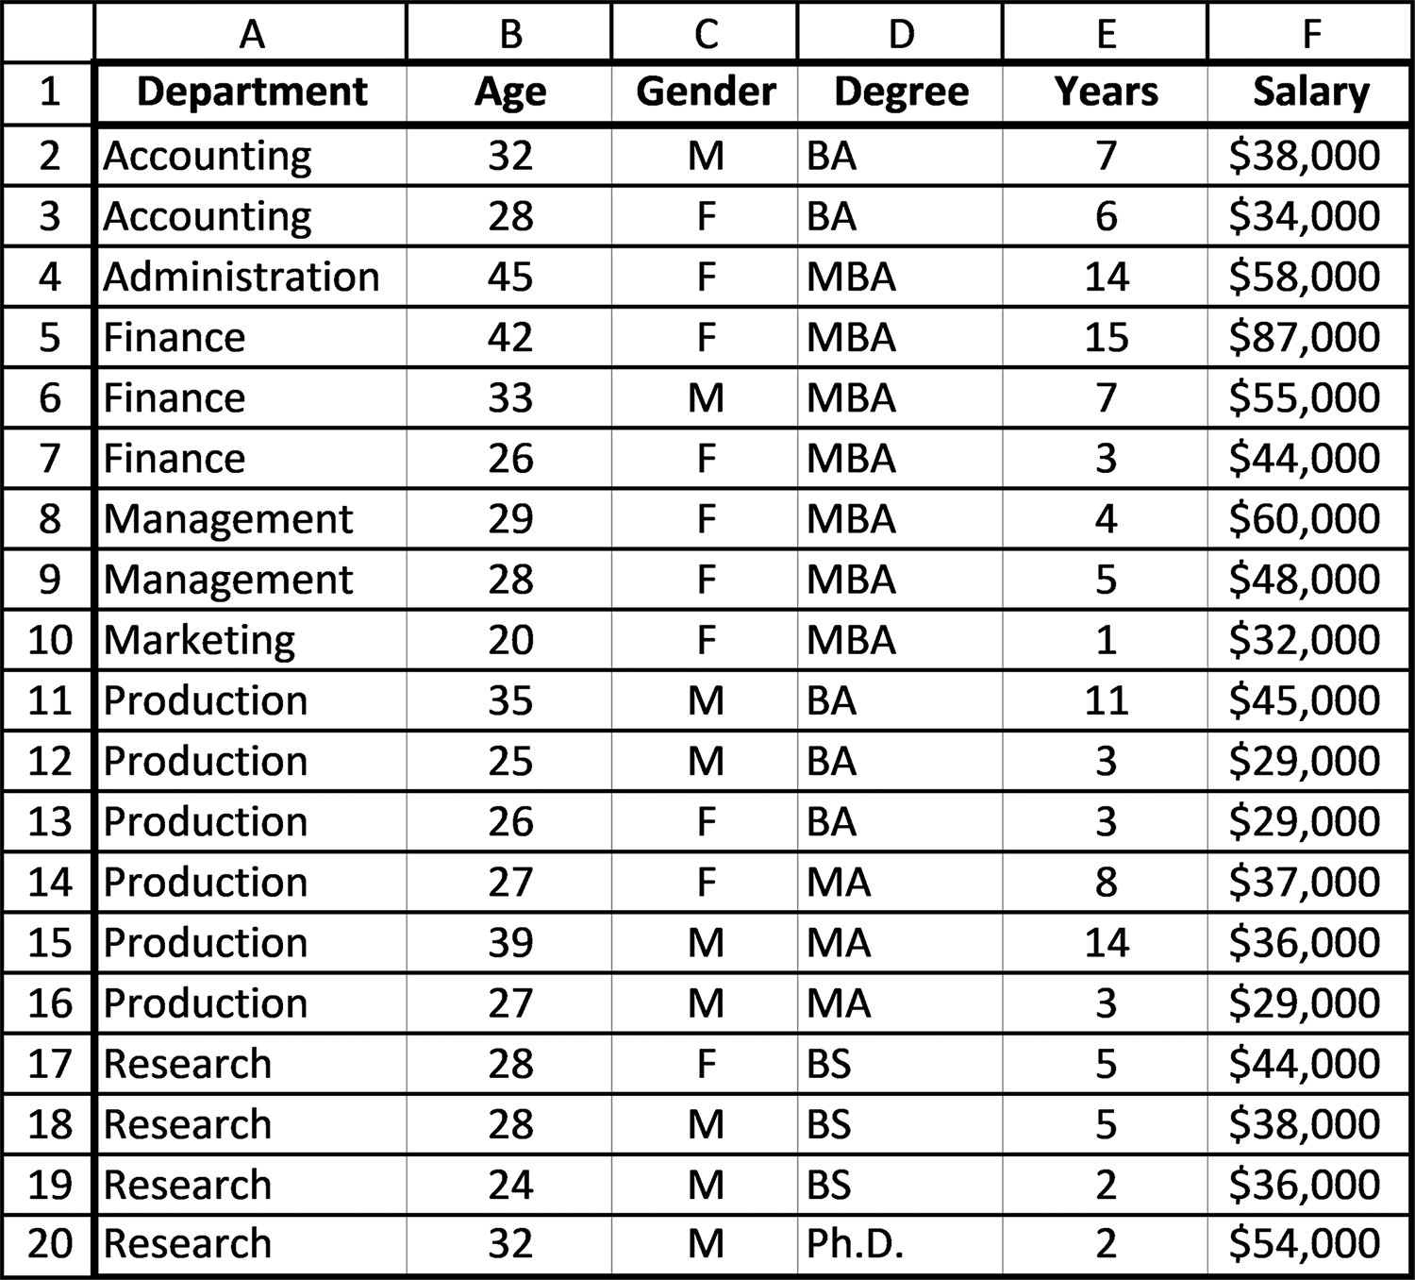

Figure 7.8 The data sorted in Department, Degree, and Salary order

In reviewing Figure 7.7, notice that the spreadsheet is sorted by Department (first
level sort, ascending), and that within each Department the rows are arranged by
Degree (second level sort, ascending). Finally, notice that within each degree cate-
gory, Salary is ordered from highest to lowest (the third level sort, descending). Again,
to continue adding additional selections, simply repeat adding sort levels, as shown in
Figure 7.7.
sortinG and searChinG 243

EXERCISES 7.2

1. Create the following spreadsheet in Excel, and sort the data by city in ascending
(A to Z) order.
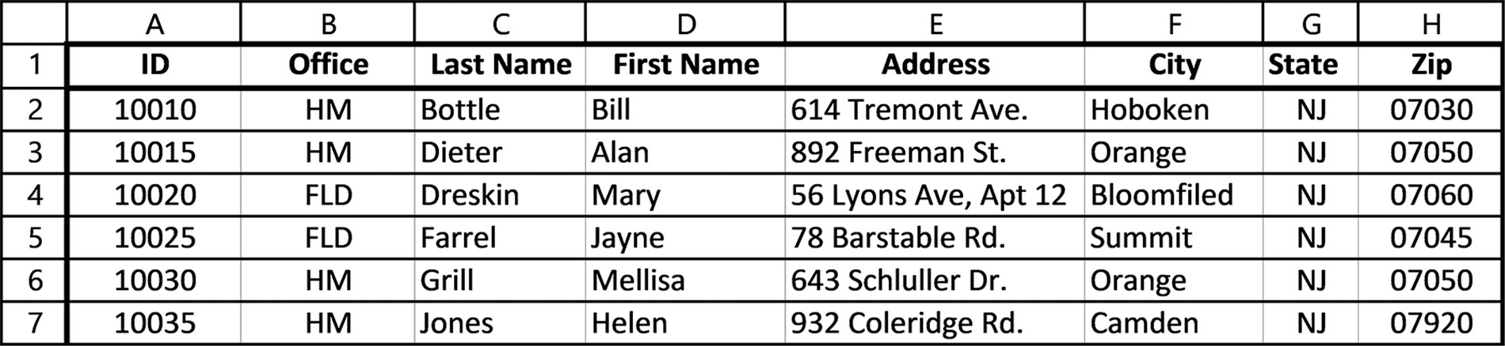

2. Using the spreadsheet entered for Exercise 1, sort the data by Office so that the
home office (HM) employees are listed before the field office (FLD) employees (descending order).
3. Create the following spreadsheet, then sort the data by Department, ascending
order.
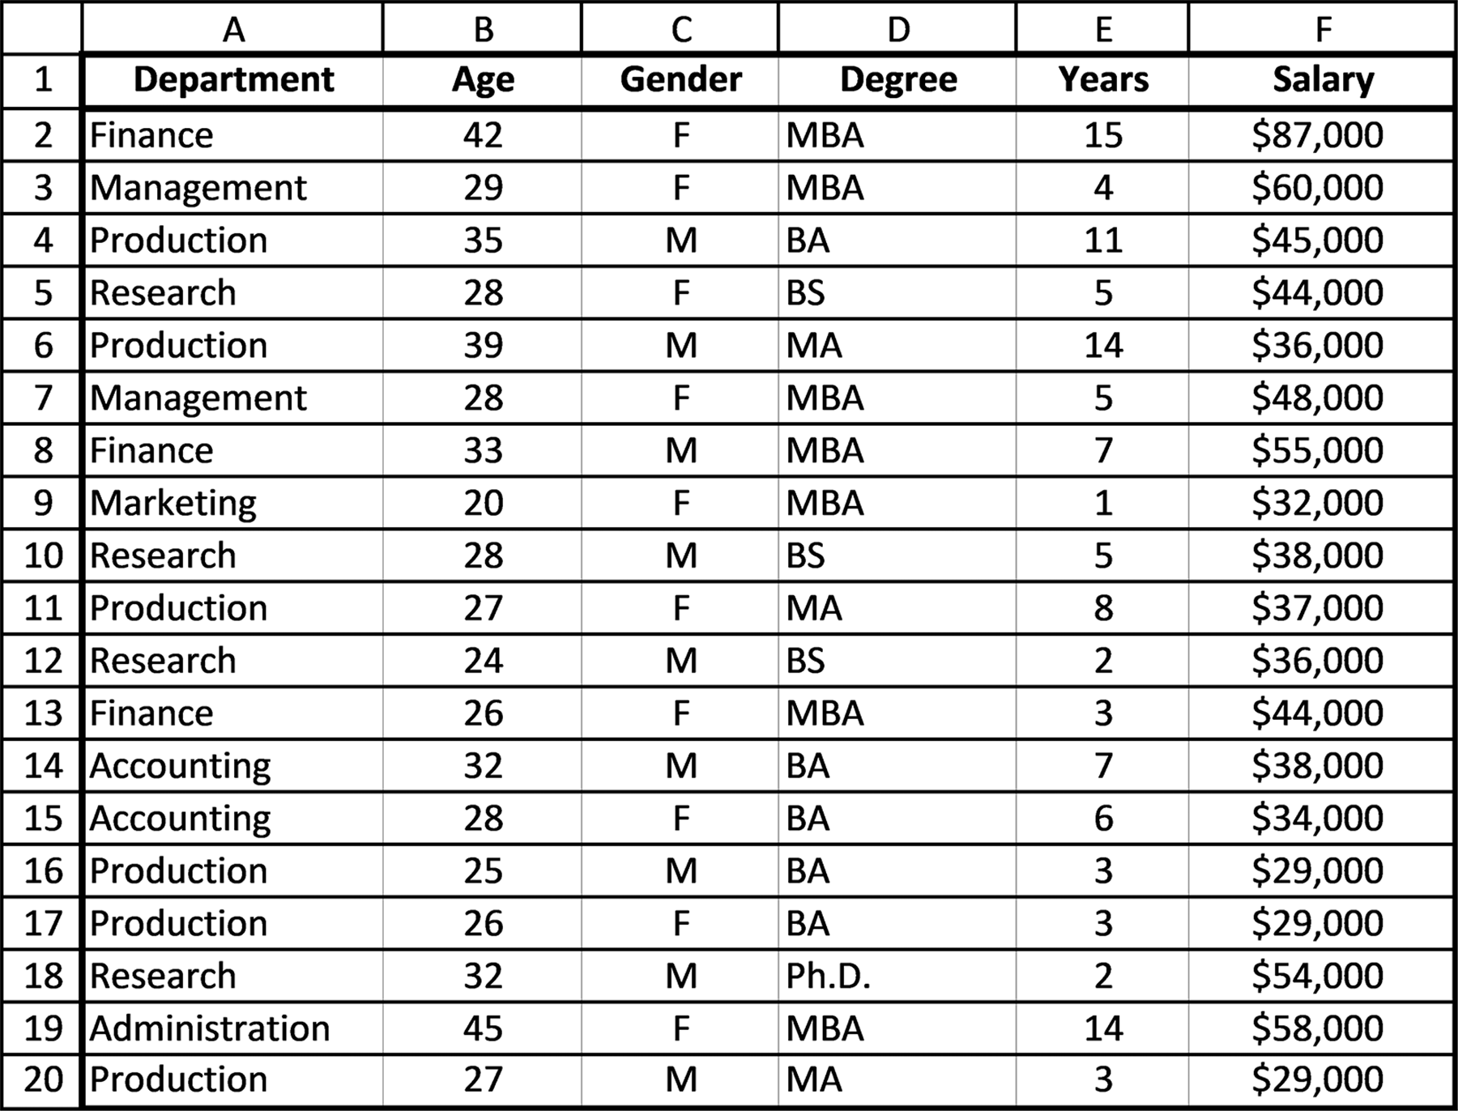
244 exCel BasiCs

4. Use the same spreadsheet you created in Exercise 3 to sort the Salary from lowest
to highest.
5. Sort the spreadsheet shown in Exercise 1 by Office and then alphabetically by
Last Name within each office. The home (HM) office employees should be listed before field office (FLD) employees (descending order).
6. Sort the spreadsheet shown in Figure 7.2 so that the final sorted spreadsheet
appears as shown in the following spreadsheet (that is, the sorted list is in ascend-ing order by Department, in ascending order by Degree within each department, and finally in Descending order by Salary within each degree).
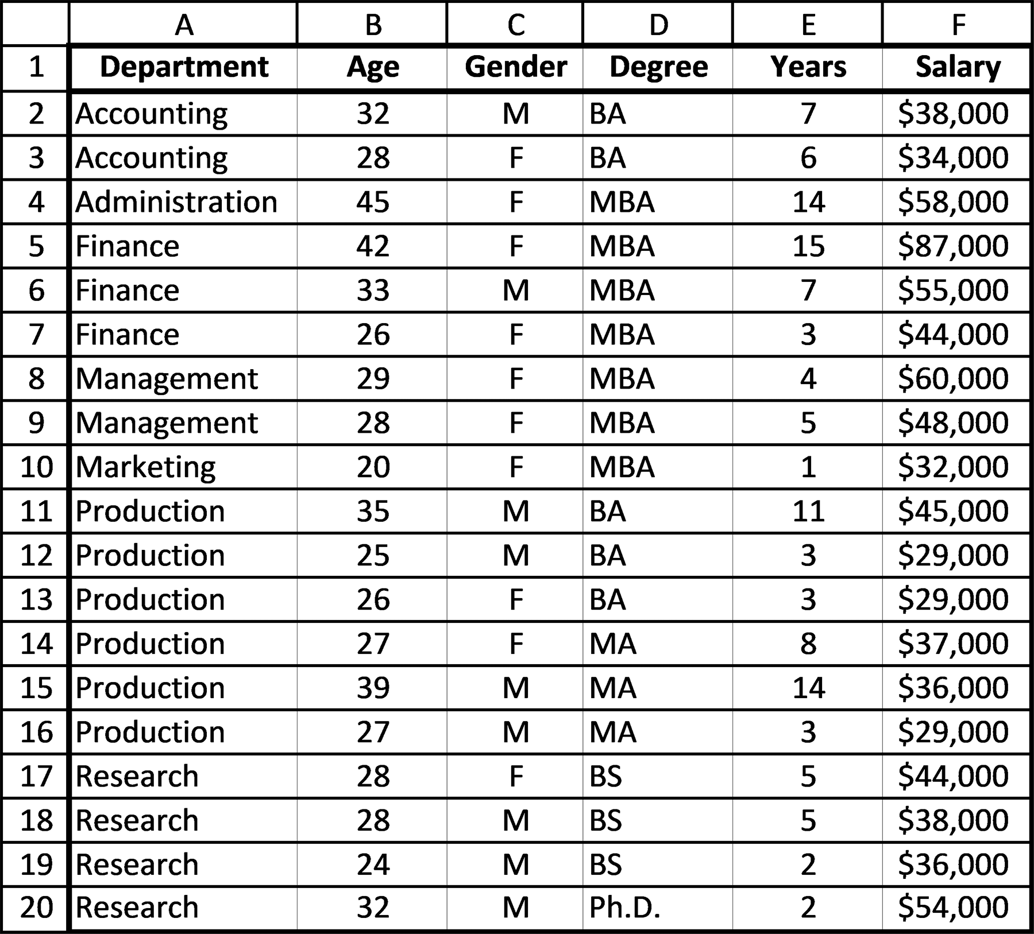
sortinG and searChinG 245

7. Create the following spreadsheet and sort the data by Sales Company, ascending
order.
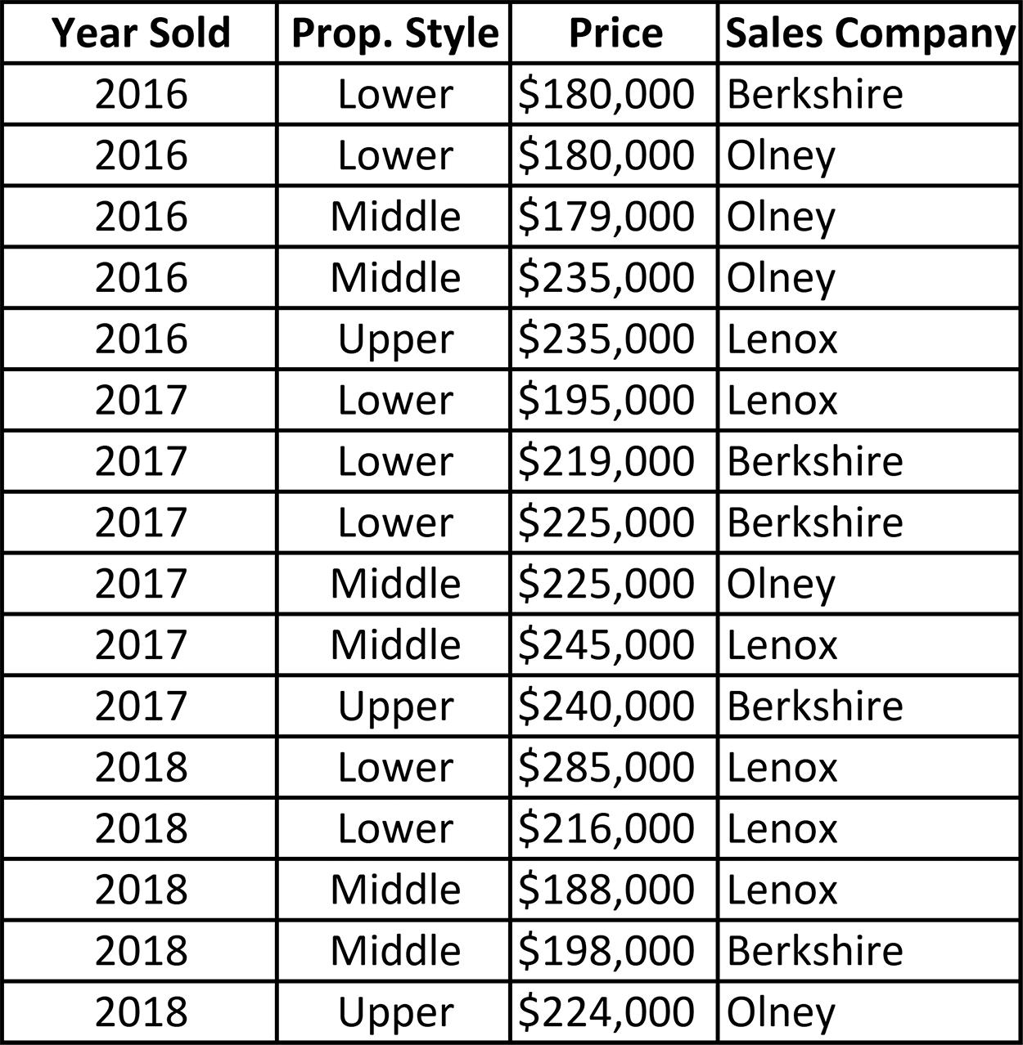

8. Use the spreadsheet created for Exercise 7. Sort the data by Price, from lowest to
highest (ascending order).
9. Use the spreadsheet created for Exercise 7. Sort the data by Prop. Style, from
Lower to Middle to Upper (ascending order).
10. Use the spreadsheet created for Exercise 7. First, sort the data by Sales Company
and then have the data, within each Company, sorted by Prop. Style. Both sort fields are in ascending order.

7.3 CREATING GROUP SUBTOTALS2
Frequently, after a spreadsheet’s data is sorted by a desired field, such as year or sales
office, subtotals of the sales or profits for each field are required. For example, con-
sider Figure 7.9, which lists the sales of three real estate companies.

2 This topic may be omitted without loss of subject continuity.
246 exCel BasiCs
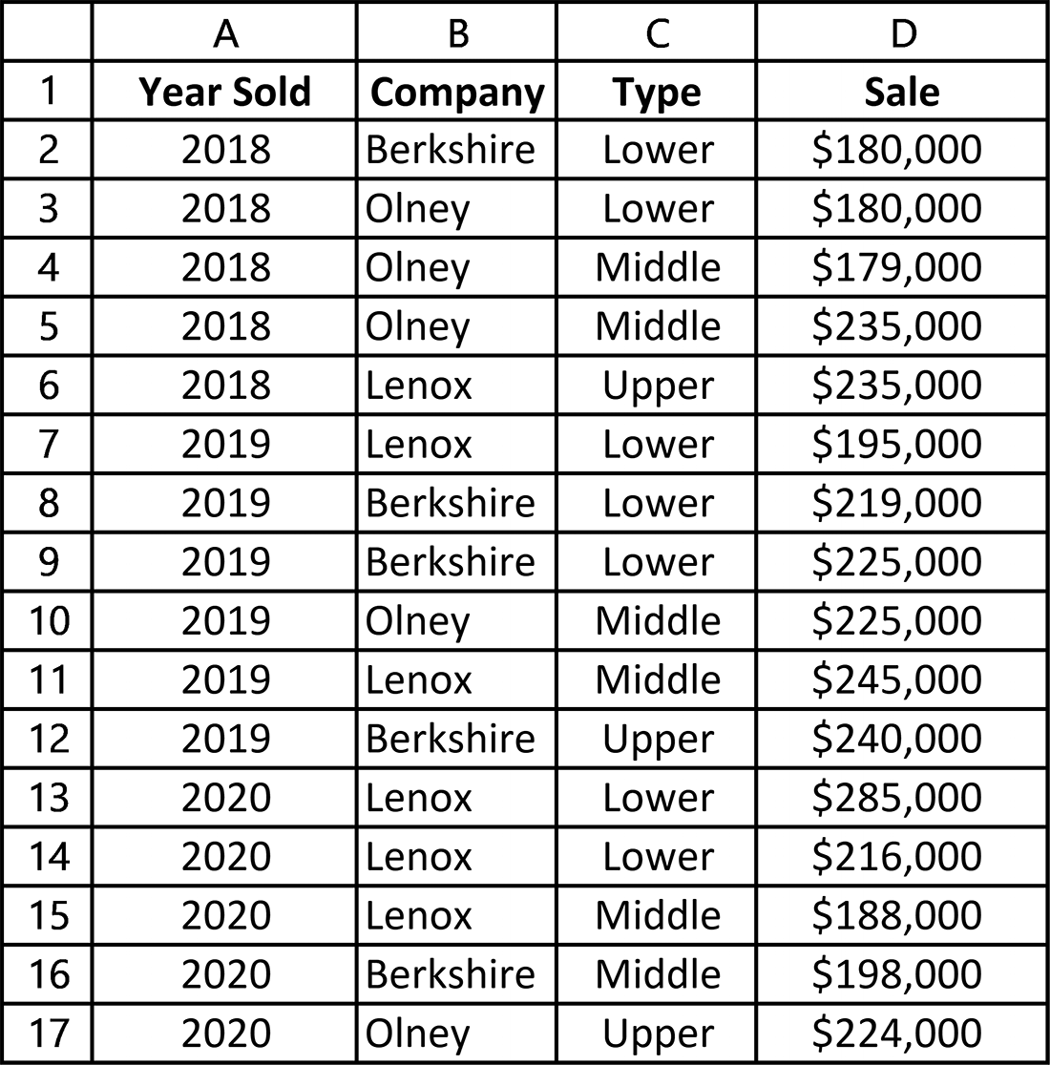

Figure 7.9 Property sales data
For this data, a logical question would be “What is the total sales from 2018 through
2020 for each of the listed companies?” To answer this question, the data must first be
sorted by company. When this is accomplished, Excel’s Subtotal option can then be
used to subtotal the sales values for each company.
The steps necessary to produce a sort of the companies, whose sales will then be
subtotaled, follow the sort procedure presented in Section 7.2, and are as shown in
Figure 7.10.
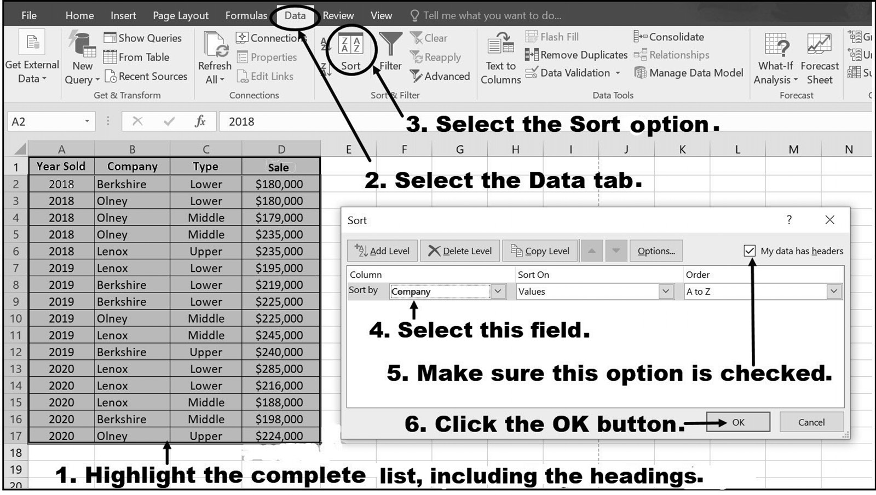

Figure 7.10 Sorting the original data by Company
sortinG and searChinG 247

Once the data has been sorted following the steps shown in Figure 7.10, the data will
appear as shown in Figure 7.11. When the data is in this sorted order, it is ready to
have the subtotals for the sales of each company computed.
It should be mentioned that Excel Subtotals can be made from Excel lists, but
Excel Subtotals cannot be made from Excel Tables. If an attempt is made to create a
Subtotal from a table, then the option would be grayed out and the operation cannot
be completed.
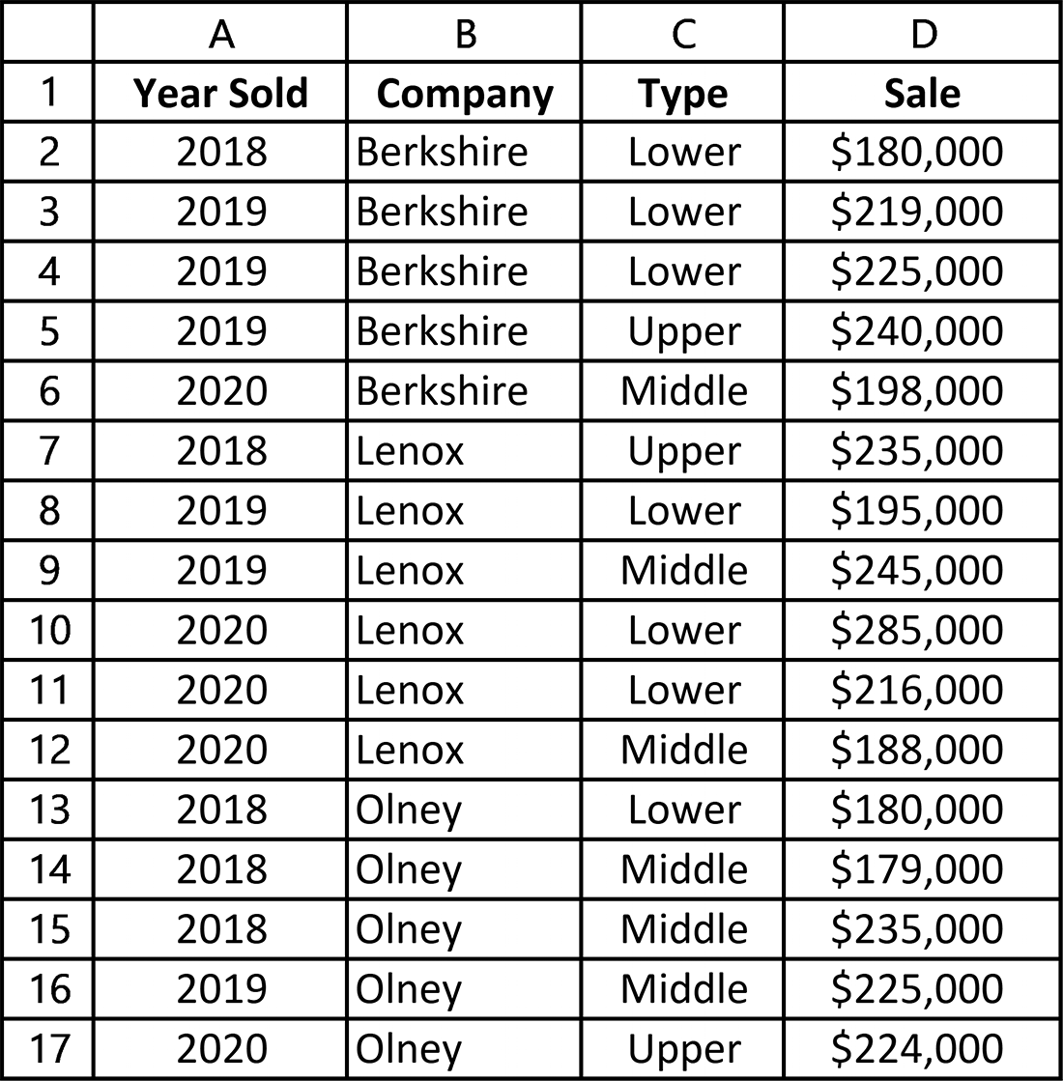

Figure 7.11 The initial data in sorted order by Company
248 exCel BasiCs

To create sales subtotals for each company, the complete spreadsheet must be
highlighted (clicking on a cell within the table and then pressing the Ctrl and A
keys at the same time will highlight the complete sheet). Once the data is high-
lighted, clicking on the Excel ribbon Data tab-Outline group-Subtotal icon in the
Data ribbon, as shown in Figure 7.12, brings up the Subtotal dialog box shown in
Figure 7.13.
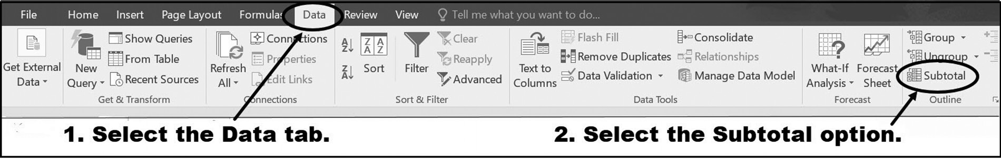

Figure 7.12 Selecting the Subtotal option
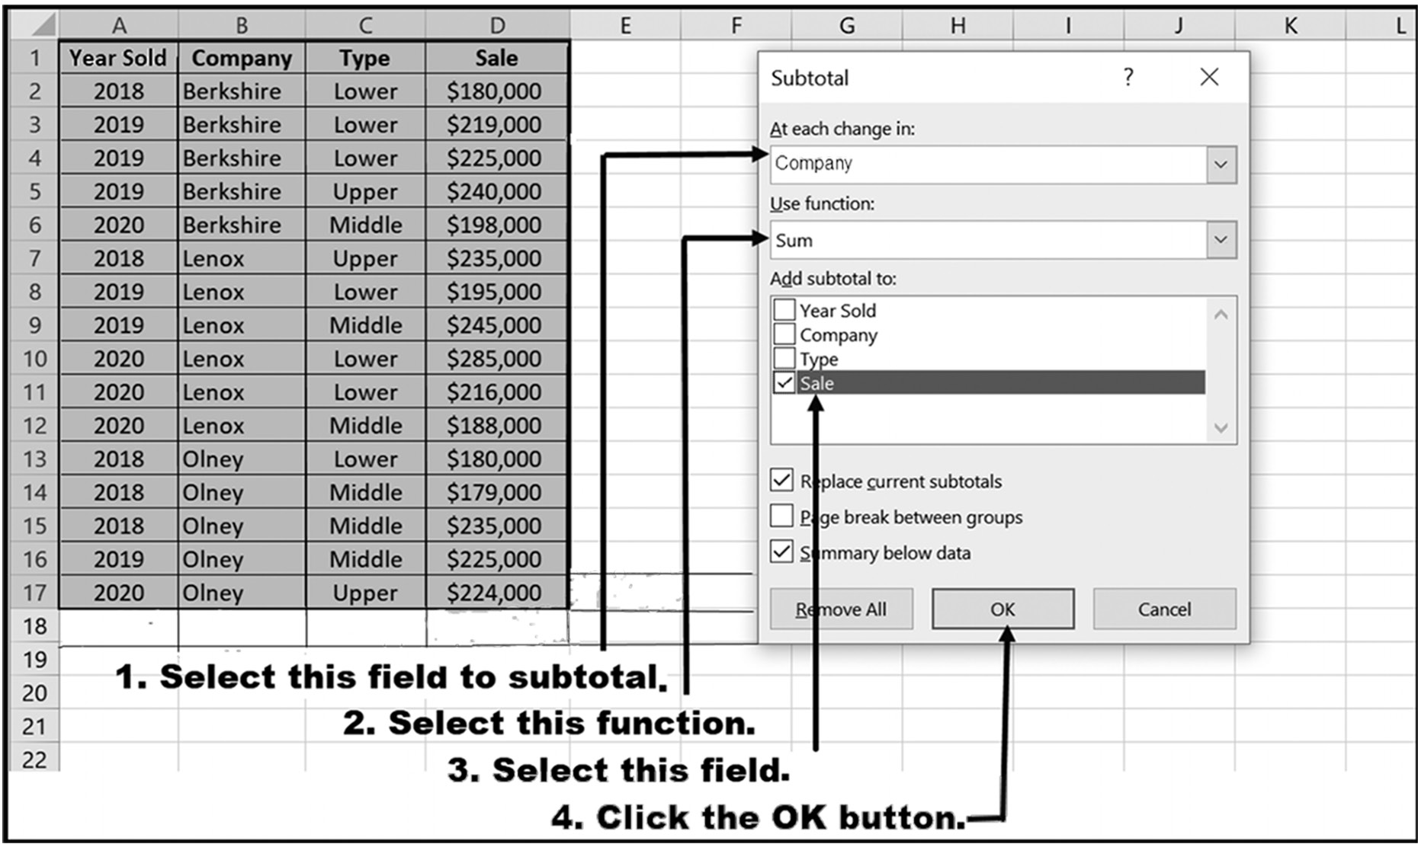

Figure 7.13 The Subtotal dialog box

Selecting the choices shown in Figure 7.13 causes the desired subtotals, by Company,
to appear, as shown in Figure 7.14. Notice that in Figure 7.14, Types are not grouped
together for each Company (see the Type listing for the Lenox subtotal, for example),
but remain in the order they appear in the original list. Although this is not a problem,
it would be preferable to have these grouped together for each Company (this can be
accomplished by initially sorting the data by Company and then by Type in the origi-
nal sort, before any subtotals are taken).
sortinG and searChinG 249
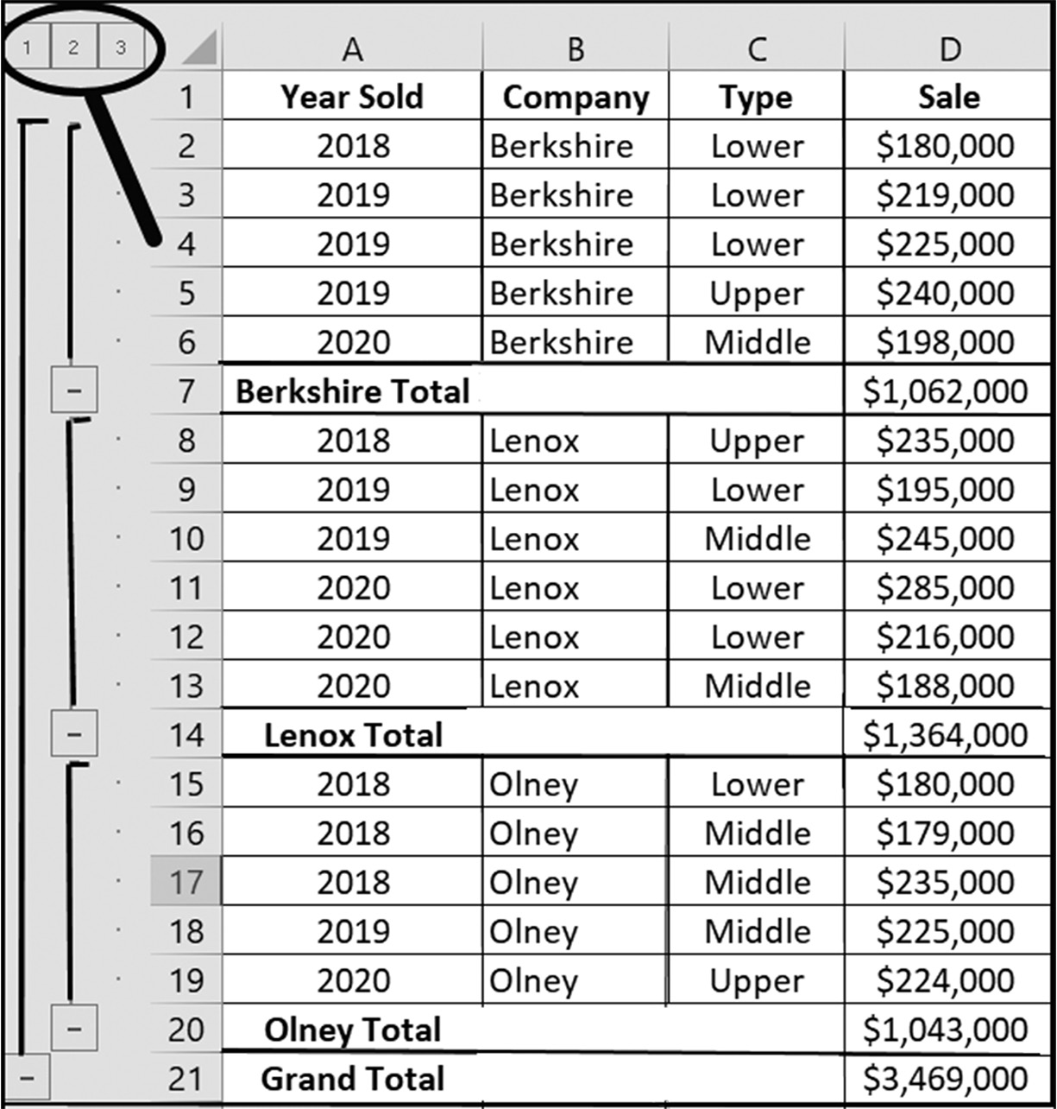

Figure 7.14 The sorted data subtotaled by Company

At this point, you will see the results of the Subtotal feature applied to the spreadsheet.
By employing features from Excel’s Outline Group feature, not only are the requested
subtotals added with new row subtotals and a Grand Total, but a new structure has
been applied to the spreadsheet. The “group” feature allows you to select different
“levels” of summary data to be displayed. The lower the number, the higher level it
is in terms of summarization, and therefore a higher number would bring about a
greater level of detail (meaning it is a higher level in terms of summary). There are
also buttons to click to contract (-) or expand (+) a specific level and the detail being
displayed. In the example shown in Figure 7.14, clicking on these allows you to con-
tract and expand the individual subtotal groups. For example, if you click on the 2 box,
the spreadsheet will appear as in Figure 7.15. Notice that you can expand individual
groups by clicking on the + icons in the 2 column or the complete spreadsheet by
clicking on the 3 box itself.
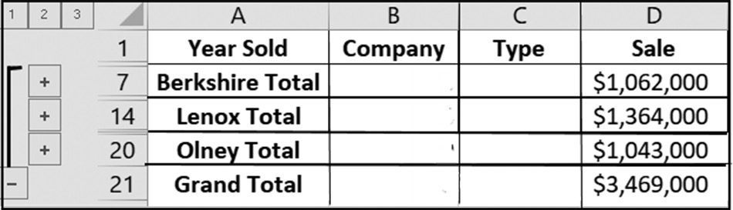

Figure 7.15 The data summarized by Company and Sale subtotals 250 exCel BasiCs

Although it is easy to visually determine that Lenox had the highest sales for the three
companies listed in Figure 7.15, for larger data sets, a final sort (in this case, based
on Sale) is frequently useful. This is accomplished by sorting the summarized spread-
sheet shown in Figure 7.15 from highest to lowest (or from lowest to highest) sales.
(see Exercise 3b).
Notice that the general rule for calculating subtotals of individual items within a
field requires that the data must first be sorted by the field under consideration. Thus,
if the subtotals of sales by salesperson is required, the data must first be sorted by
Salesperson. Similarly, as shown in Figures 7.14 and 7.15, the subtotals by company
required that the data was first sorted in Company order.
Nested Subtotals
In addition to subtotals for individual categories, or groups of data, such as the subto-
tals for Department, Salesperson, or Company, it is often necessary to have a nested
set of subtotals – that is, subtotals within subtotals. You can consider this as adding
an additional level of subtotals within a current one. For example, while Figure 7.15
provides subtotals by Company, Figure 7.16 provides subtotals for each property Type
within each Company subtotal.
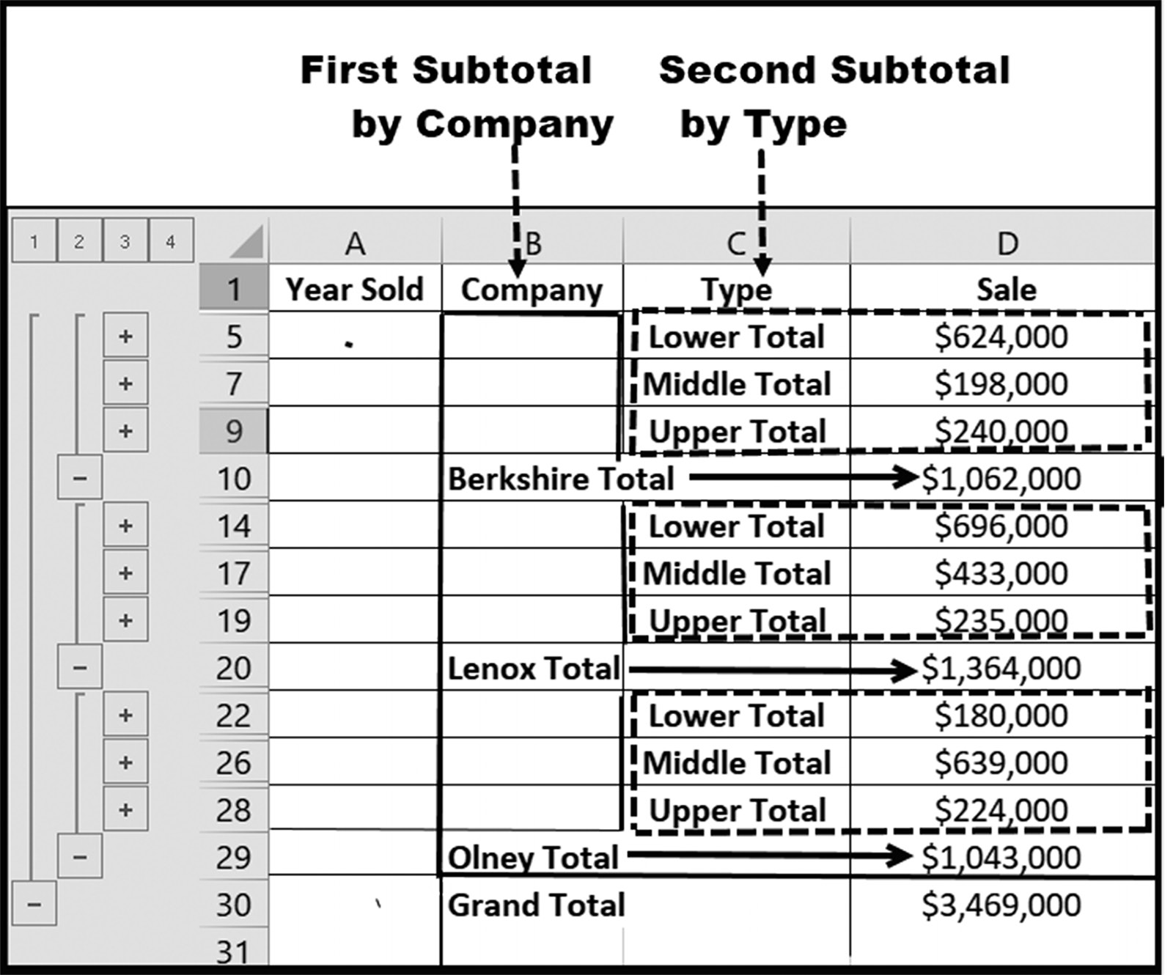

Figure 7.16 Nested subtotals of Sale by Type within each Company
sortinG and searChinG 251

Creating subtotals for individual groups (or categories) of data always requires that
the data first be sorted by the field for which subtotals are desired, and the general
rule for creating subtotals within subtotals, such as that shown in Figure 7.16 is as
follows:
General Rule for Data Sorting Prior to Creating Nested Subtotals: The data
must be sorted, using a multi-level sort, in the same order as each level of desired sub-
totals. That is, the first-level sort corresponds to the highest level desired subtotal field
(outside level) and continues to the lowest (inside level) desired subtotal field.
For example, if subtotals of Sales by Type within subtotals by Company are re-
quired, as shown in Figure 7.16, the highest, or outside level, is Company, and the
next, or interior level, is Type. Thus, the data must first be sorted by Company and
then by Type.

Example
A nested subtotal of Salary by Job Title within a Department subtotal group is desired.
What order must the data be sorted so that the desired nested subtotals can be deter-
mined?
Solution: Because the nesting is subtotals of Salary by Job Title within Departments,
the data must first be sorted by Department and then by Job Title. That is, the outside
field (i.e., group) is department and the interior, or inside group, is Job Title.

Example
A nested subtotal of Sales Calls by Salesperson within each Office Location is desired.
What order must the data be sorted so that the desired nested subtotals can be deter-
mined?
Solution: Because the nesting is subtotals of Sales Calls by Salesperson within each
Office Location, the data must first be sorted by Office Location, and then by Sales-
person. That is, the outside field (i.e., group) is Office Location and the interior, or
inside group, is Salesperson.
Creating Nested Subtotals
Once the required multi-level data sorting is complete, nested subtotals can be cre-
ated.3 These subtotals are created, one-at-a-time, in the same order that the data was
sorted.
As an example of creating a nested group of subtotals, we will use the data shown in
Figure 7.17 to create subtotals of sales by property Type within each Company.

3 The sorts must be completed prior to creating subtotals.
252 exCel BasiCs
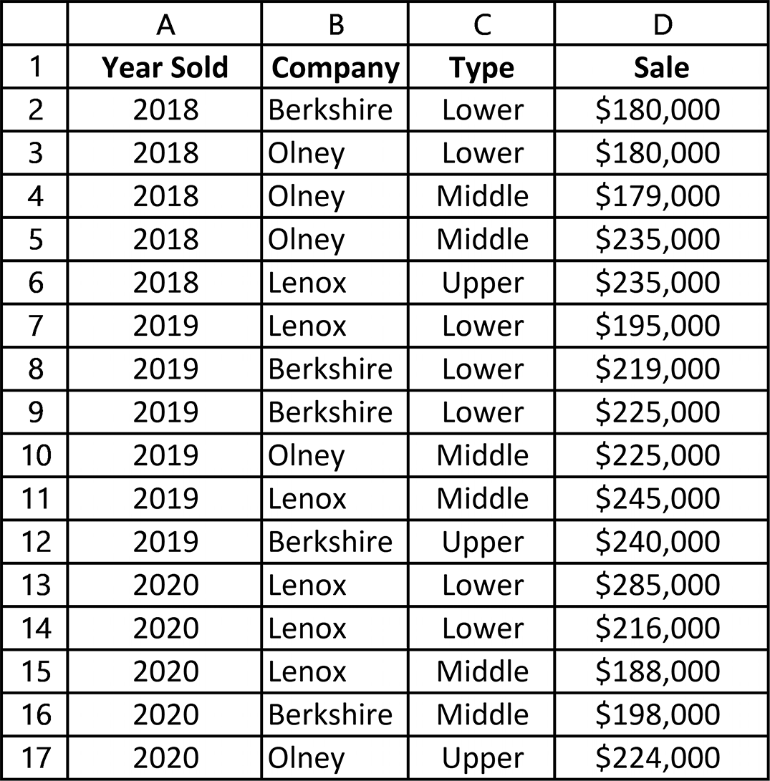

Figure 7.17 Property sales data
Because we want nested sales subtotals of property Type within each Company, the
required multi-level sort is first by Company, with the second-level by property Type.
This is accomplished using the multi-sort procedure presented in the prior section
and applied as shown in Figure 7.18.4
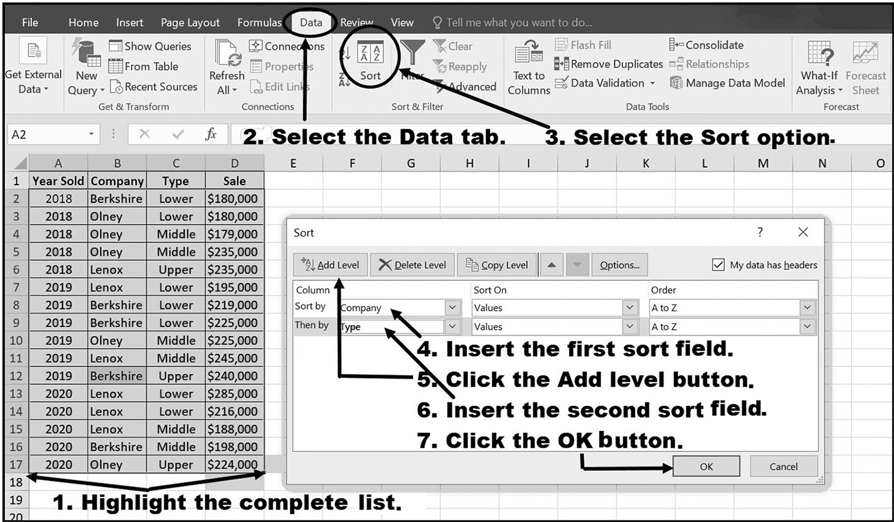

Figure 7.18 Creating the two-level sort

4 The multi-level sort can be made with any list that contains the original data; it need not be in the original list, but must contain the desired categories for which subtotals are desired.
sortinG and searChinG 253

Figure 7.19 shows the sorted list produced by following the steps listed in Figure 7.18.
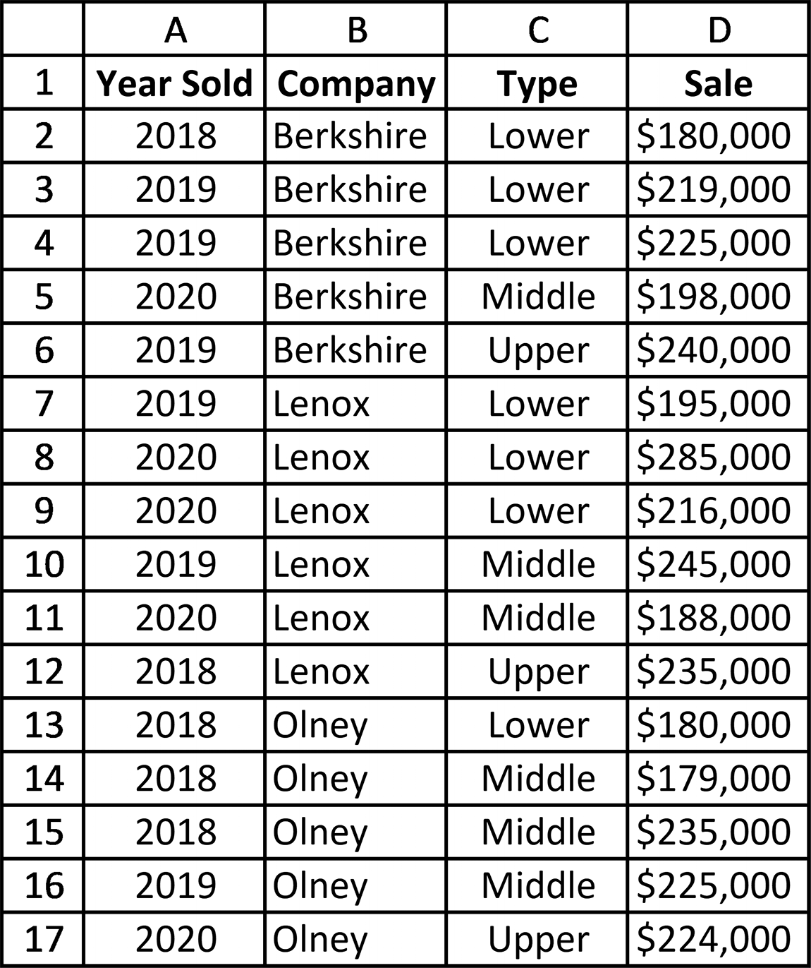

Figure 7.19 The list sorted by Company and then by Type

Once the list is in the order that corresponds to the desired subtotals, the actual nested
subtotals can be created. This is done as shown in Figure 7.20 by first highlighting the
complete worksheet (clicking within the table and then pressing the Ctrl and A keys at
the same time does this; ⌘-A for Mac Excel ), and then using the information shown
in Figure 7.20 to create the first set of subtotals. Pressing the OK button, once the
Subtotal dialog box shown in the figure is filled in correctly, creates the list shown in
Figure 7.21.
254 exCel BasiCs
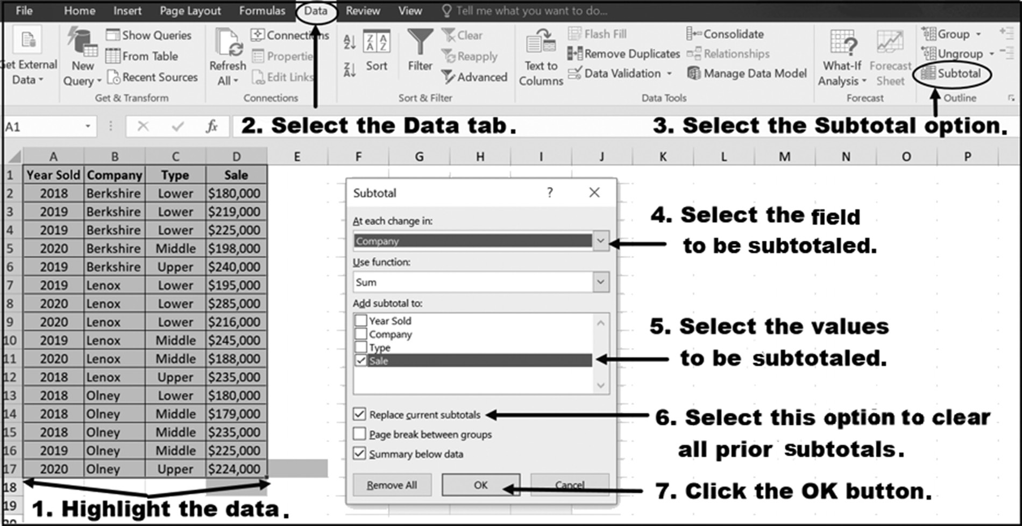

Figure 7.20 Creating the first set of subtotals by Company

Notice in Figure 7.21 that the property Types within each Company are also in sorted
order. This is the result of the original multi-level sort performed before Company
subtotals were taken. Because of this, we can now create subtotals for each property
Type while still retaining the Sales by Company subtotals.
To create the second set of subtotals, click on the Excel ribbon’s Data tab’s Sub-
total option once again and fill in the dialog box shown in Figure 7.22. Make sure to
uncheck the box labeled Replace current subtotals, so that the earlier subtotals are
not erased. When the dialog box has been completed and the OK button is pressed,
the nested list of subtotals for each property Type within each Company is produced,
as shown in Figure 7.23. The summarized, subtotaled list displaying just the subtotals
is shown in Figure 7.24. This last figure is the same as that initially shown as Figure
7.14, and is produced by clicking on the box labeled 3 at the top left corner of the
spreadsheet.
sortinG and searChinG 255
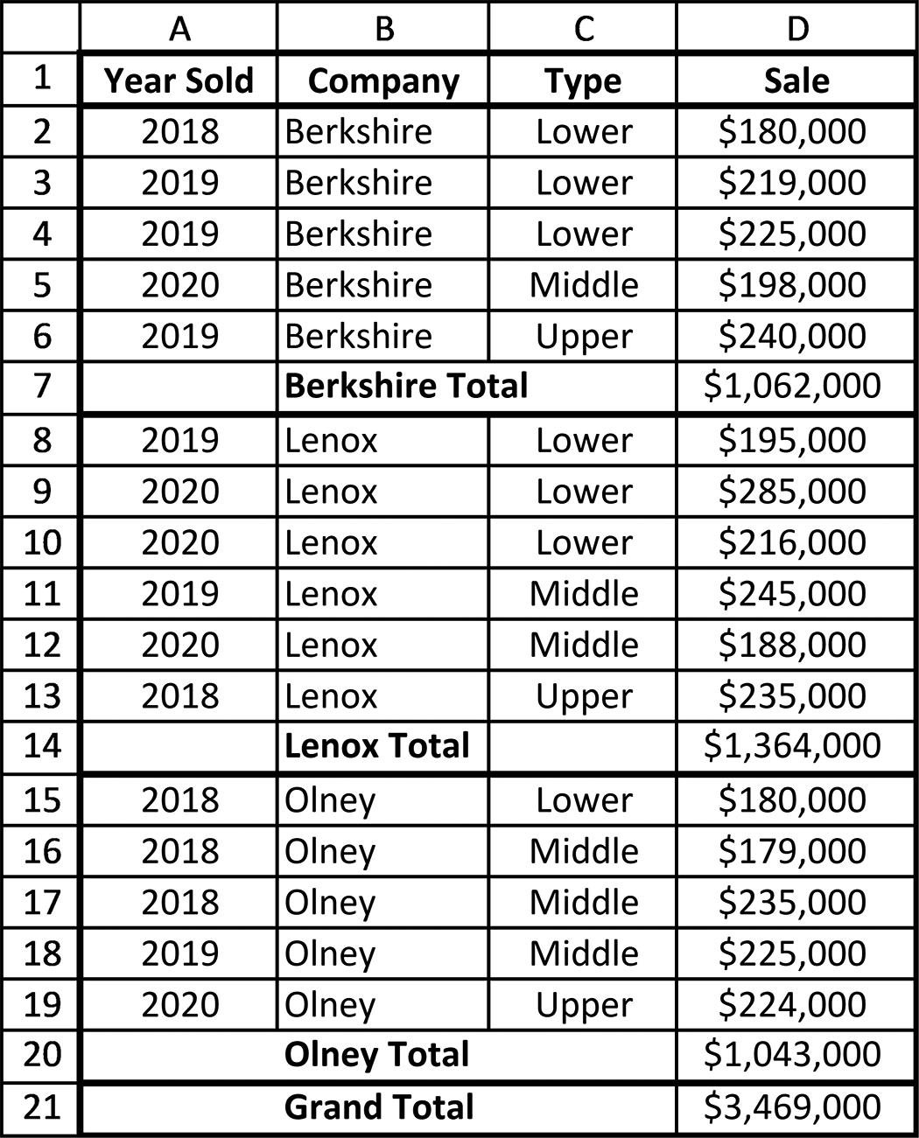

Figure 7.21 Sales data subtotaled by Company
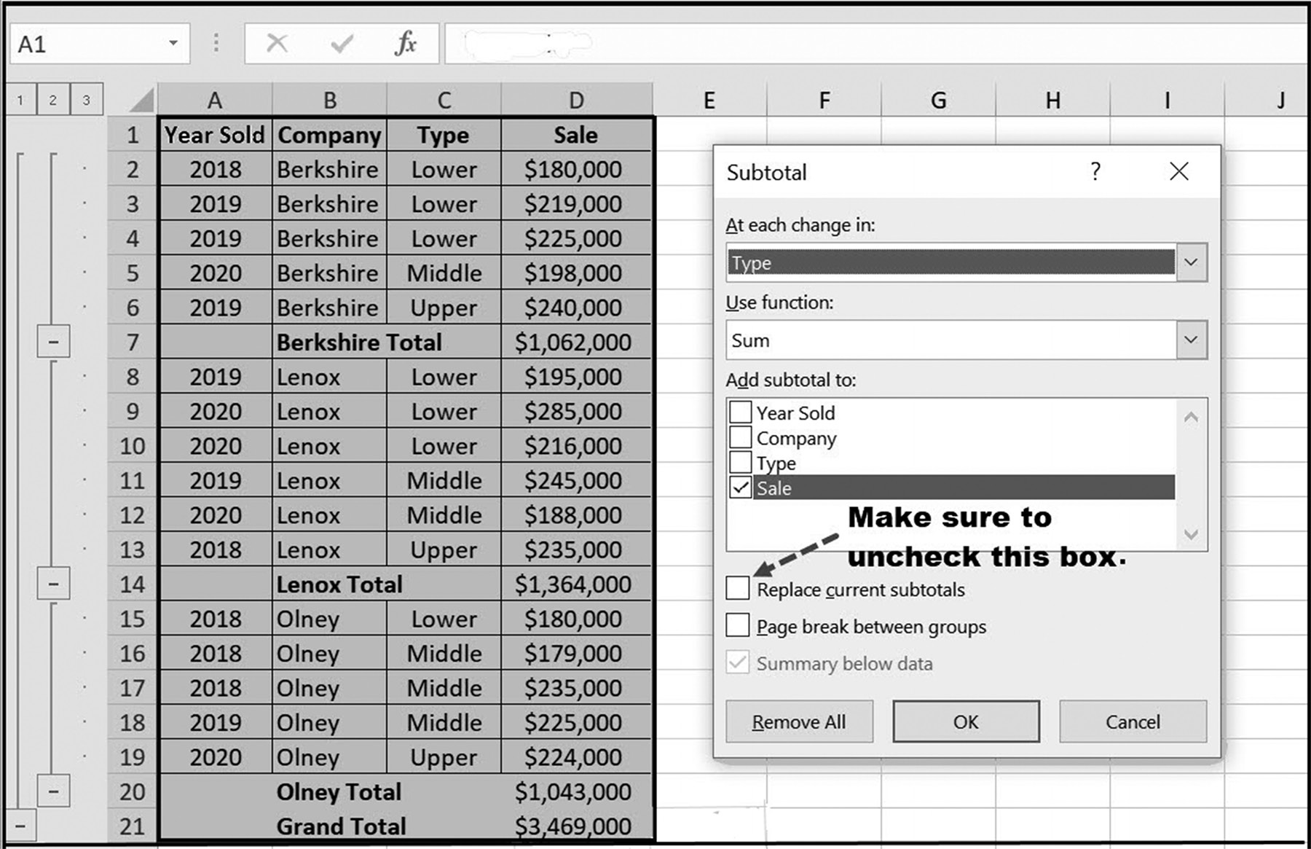

Figure 7.22 Creating the second (nested) set of subtotals 256 exCel BasiCs
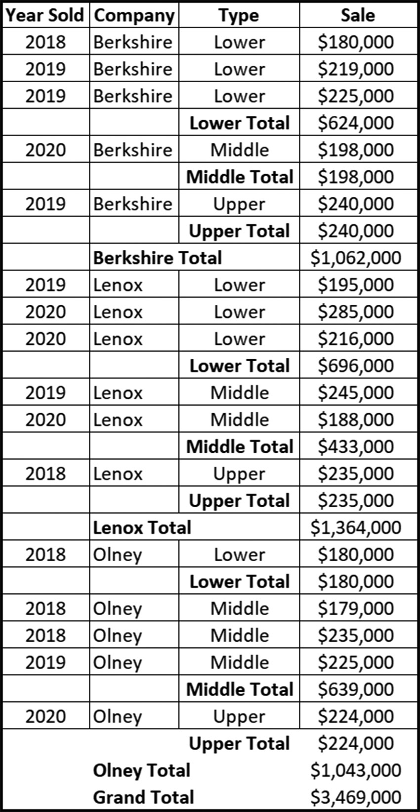

Figure 7.23 The list with Type subtotals nested within Company subtotals
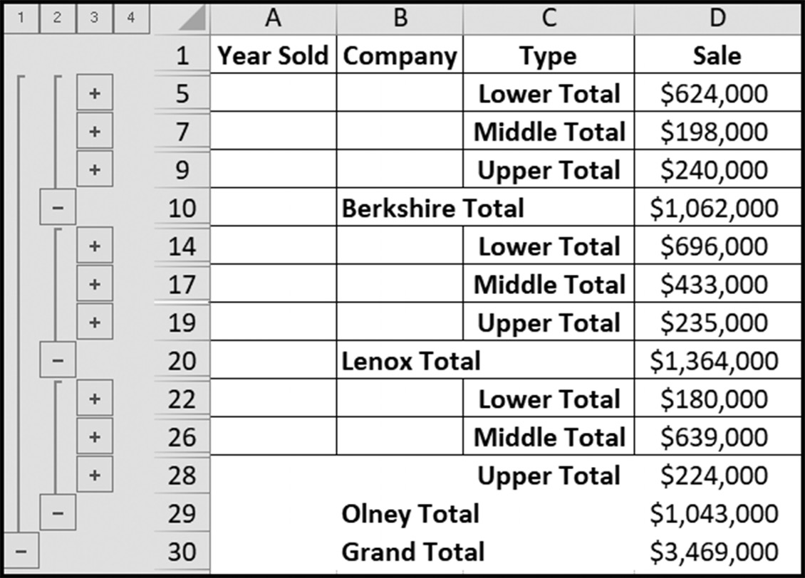

Figure 7.24 Nested subtotals of Sales by Type within each Company
sortinG and searChinG 257

EXERCISES 7.3

1. What must be done to the spreadsheet data before a subtotal can be generated?
2. For the following, identify the sort that is required before the desired subtotals
are determined.
a. Profit totals by office, for a company with multiple offices.
b. Sales totals by salesperson, for a company with multiple salespeople.
c. Number of products sold, by product type, for a company selling multiple
products.
3. Complete parts a-b.
a. Create a spreadsheet with the following data, and sort the data by company
(ascending). After your spreadsheet has been sorted, create the subtotals shown in the second figure.
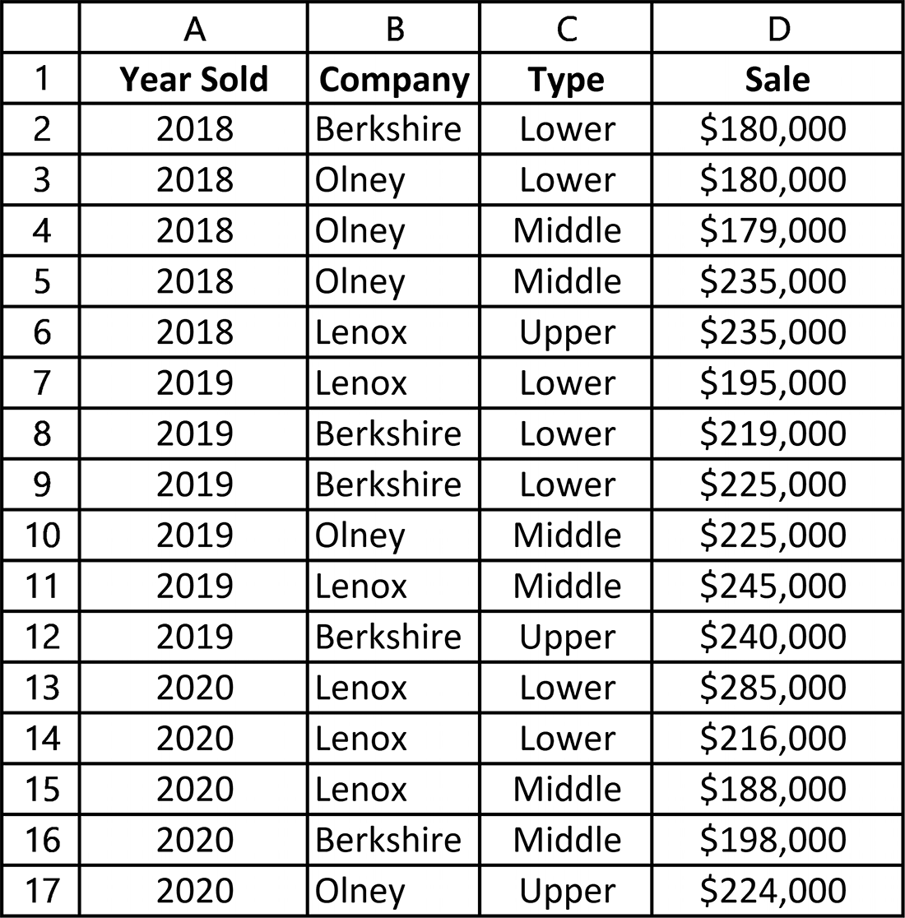
258 exCel BasiCs
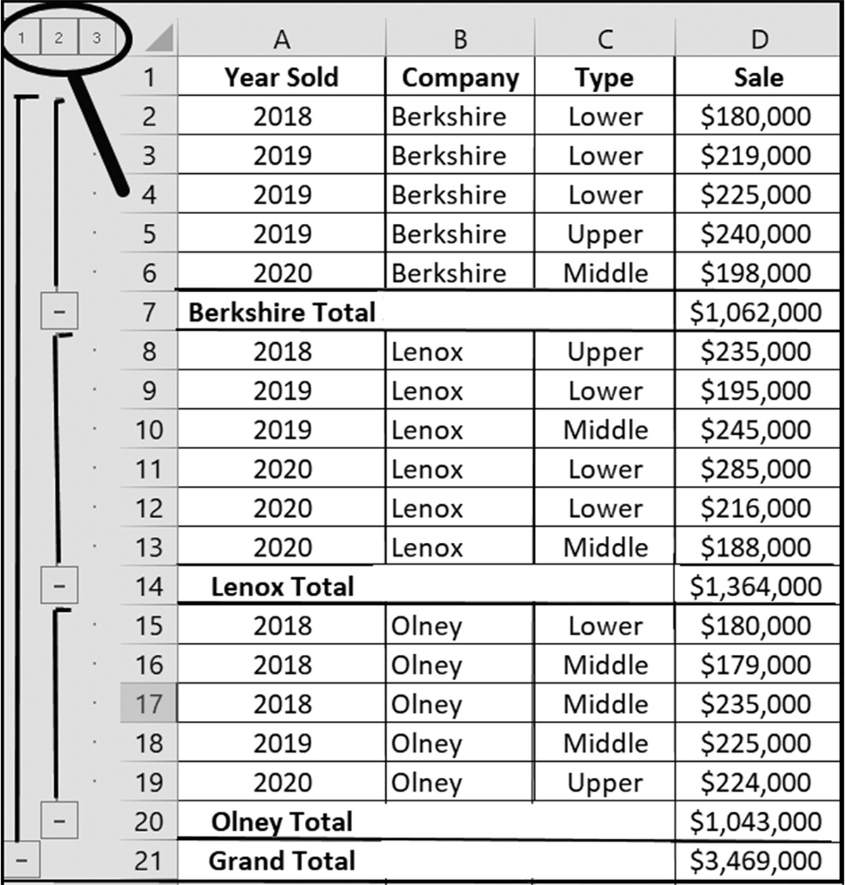

b. For the spreadsheet in Exercise 3a, produce another spreadsheet that summa-
rizes the sales, from the lowest to the highest values, as shown in the following spreadsheet.
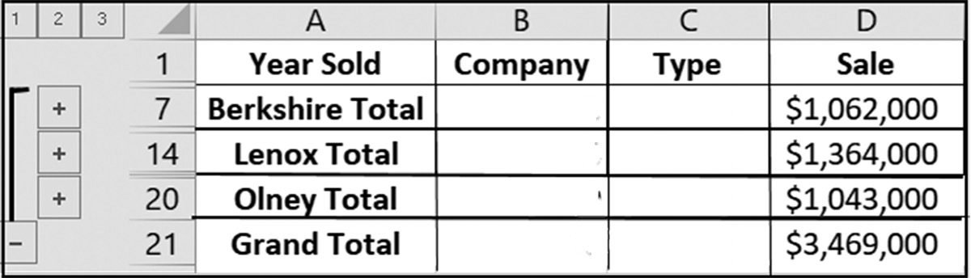

4. Complete parts a-b.
a. Using the spreadsheet created in Exercise 3a, produce a spreadsheet that pro-
vides the sales subtotals for each year, from 2018 to 2020. (Hint: First sort the spreadsheet by Year Sold.)
b. For the spreadsheet prepared for Exercise 4a, produce a spreadsheet that sum-
marizes the Sale values from lowest to highest values. (Hint: See Figures 7.15 and 7.16.)
5. Complete parts a-b.
a. Using the sales data spreadsheet created in Exercise 3a, produce another
spreadsheet that provides sales subtotals for each property type. (Hint: First sort the spreadsheet by Type.)
sortinG and searChinG 259

b. For the spreadsheet prepared for Exercise 5a, produce a spreadsheet that sum-
marizes the Sales from the lowest to the highest values. (Hint: see Figures 7.15 and 7.16.)
6. For the following spreadsheet, shown in Figure 7.25, create the salary subtotals
for each Department. Your completed spreadsheet should appear as shown in Figure 7.26.
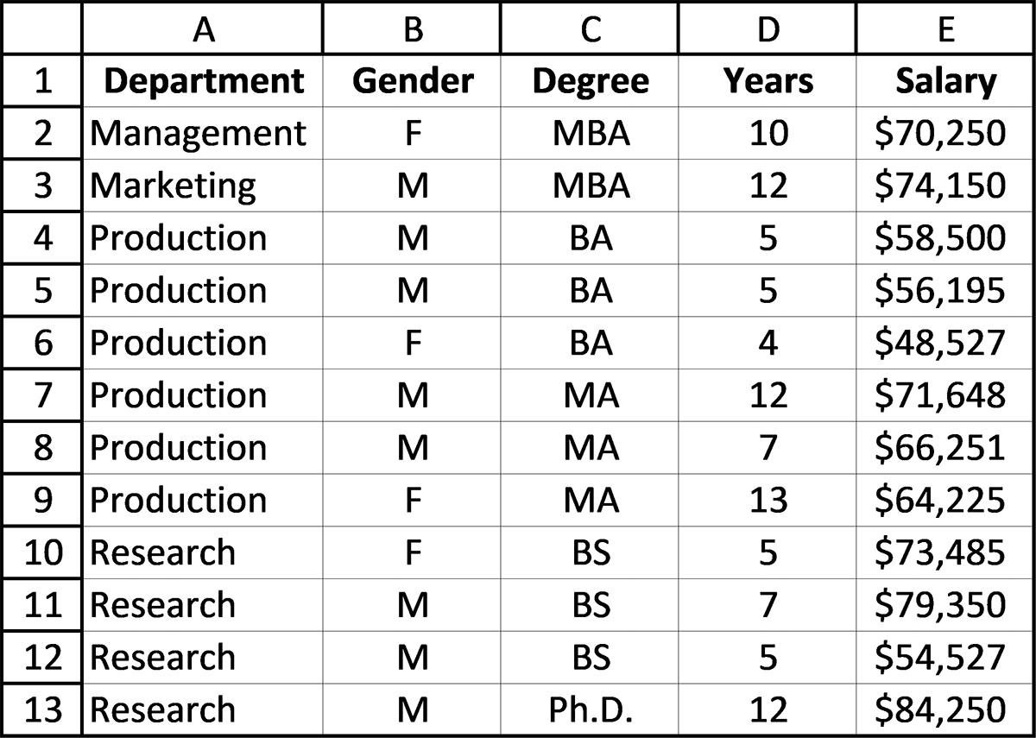

Figure 7.25 Orignal data for Exercise 6
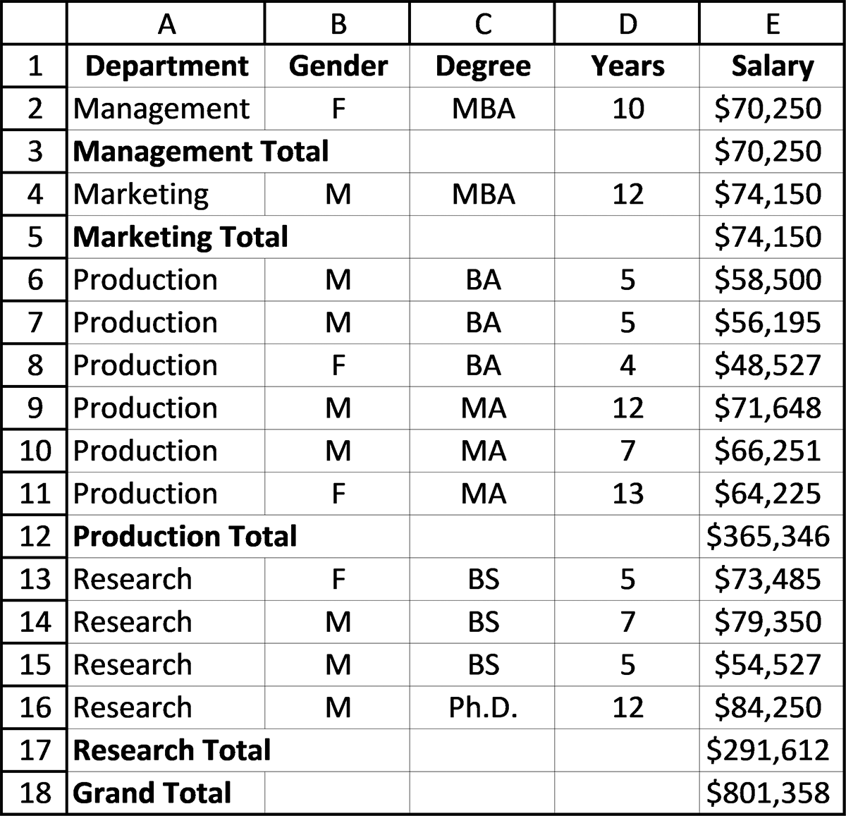

Figure 7.26 Subtotals of Salary by Department 260 exCel BasiCs

7. Figure 7.14 provides subtotals for each company. Before creating these subtotals,
perform a second sort for the Type (ascending) within each company. Your com-pleted spreadsheet should then appear as follows:
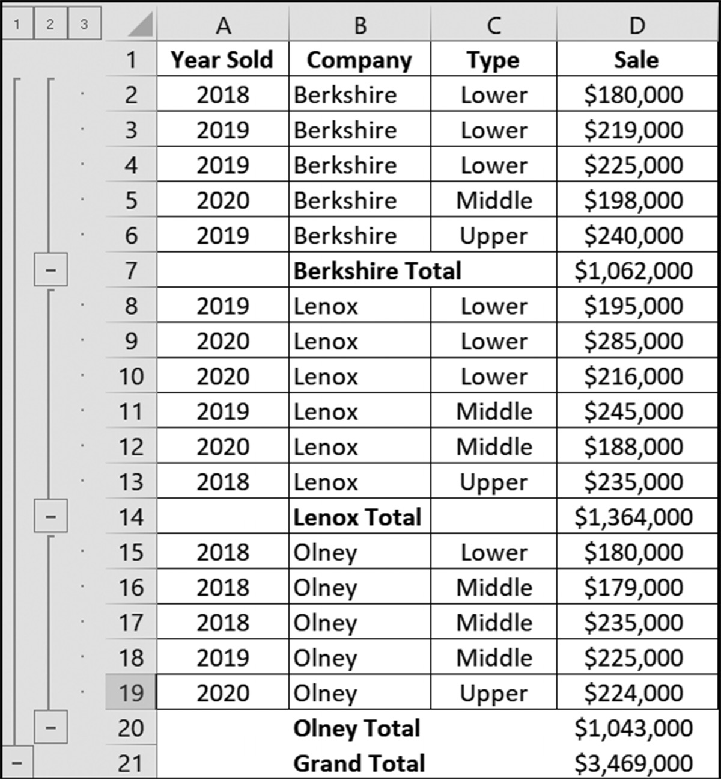

8. Complete parts a-b.
a. If a nested subtotal of salaries by profession within a Department subtotal group
is desired, what order should salary data be sorted before subtotals are deter-mined?
b. If a nested subtotal of sales calls by salesperson within an office subtotal group
is desired, what order should the sales calls be sorted before subtotals are deter-mined?
sortinG and searChinG 261

9. Starting with the spreadsheet shown in Exercise 3a, follow the steps shown in Fig-
ures 7.18 through 7.23 and reproduce the nested subtotals shown in the following spreadsheet.
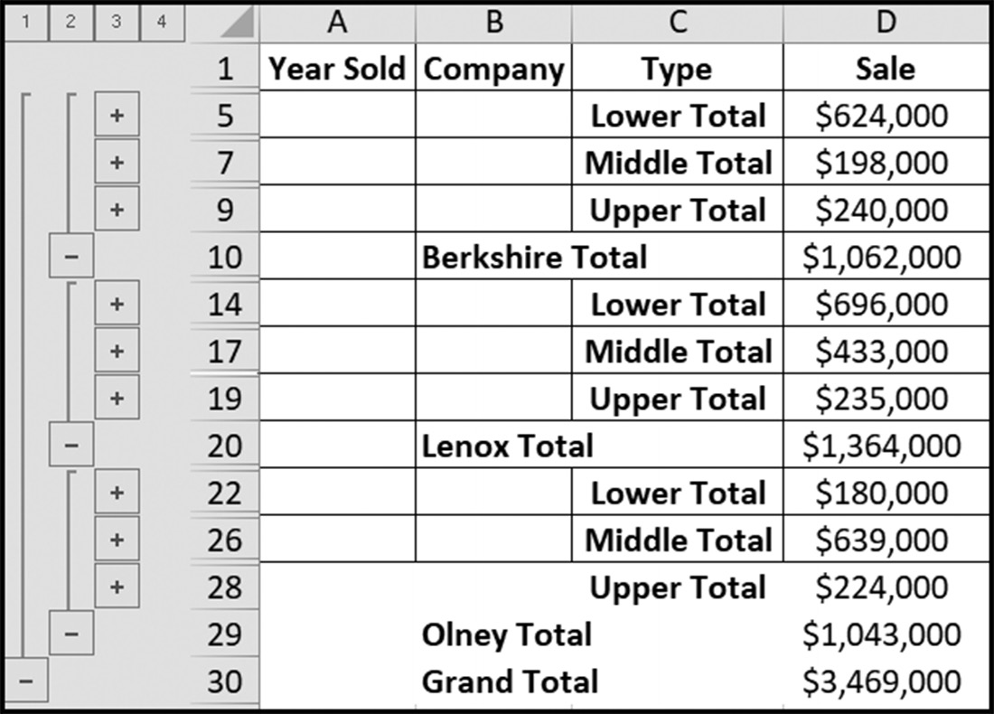

10. For the spreadsheet shown in Exercise 3a, create a spreadsheet that shows Sale
subtotals for each Type, where the Sale prices are in increasing order. When you have completed this, your spreadsheet should look like the example. (Hint: To create the summarized and sorted spreadsheet shown, you will first have to sort the original data by Type, then determine Sale subtotals for each type, and finally sort, from lowest to highest, the summarized data by Sale price.)
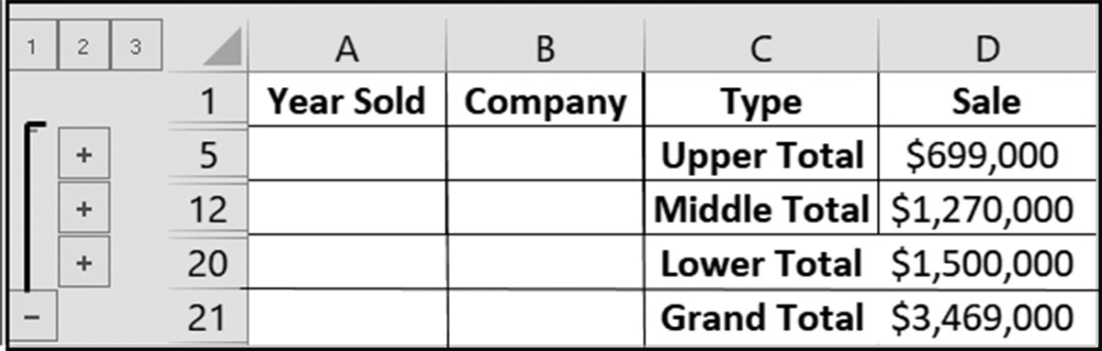
262 exCel BasiCs

11. For the spreadsheet shown in Figure 7.27, create a summary consisting of nested
salaries by Degree, within Gender, within each Department. Your completed spreadsheet should appear as shown in Figure 7.28.
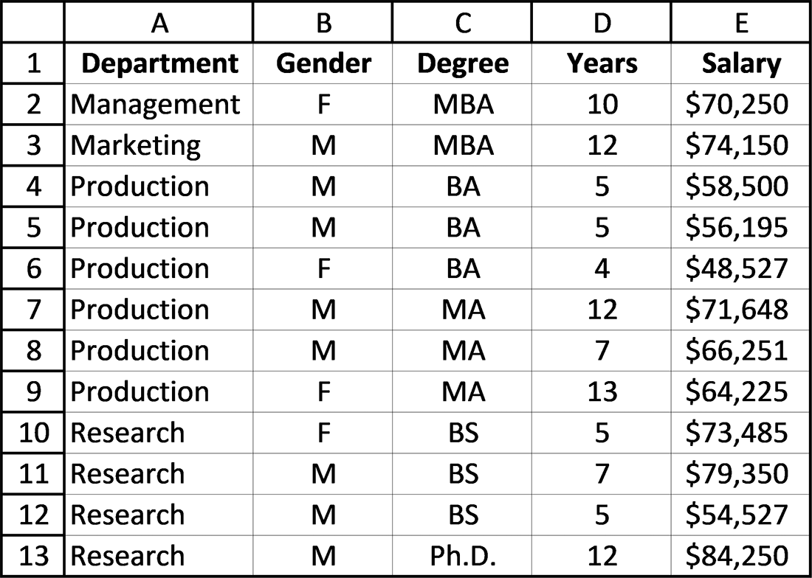

Figure 7.27 Spreadsheet for Exercise 11
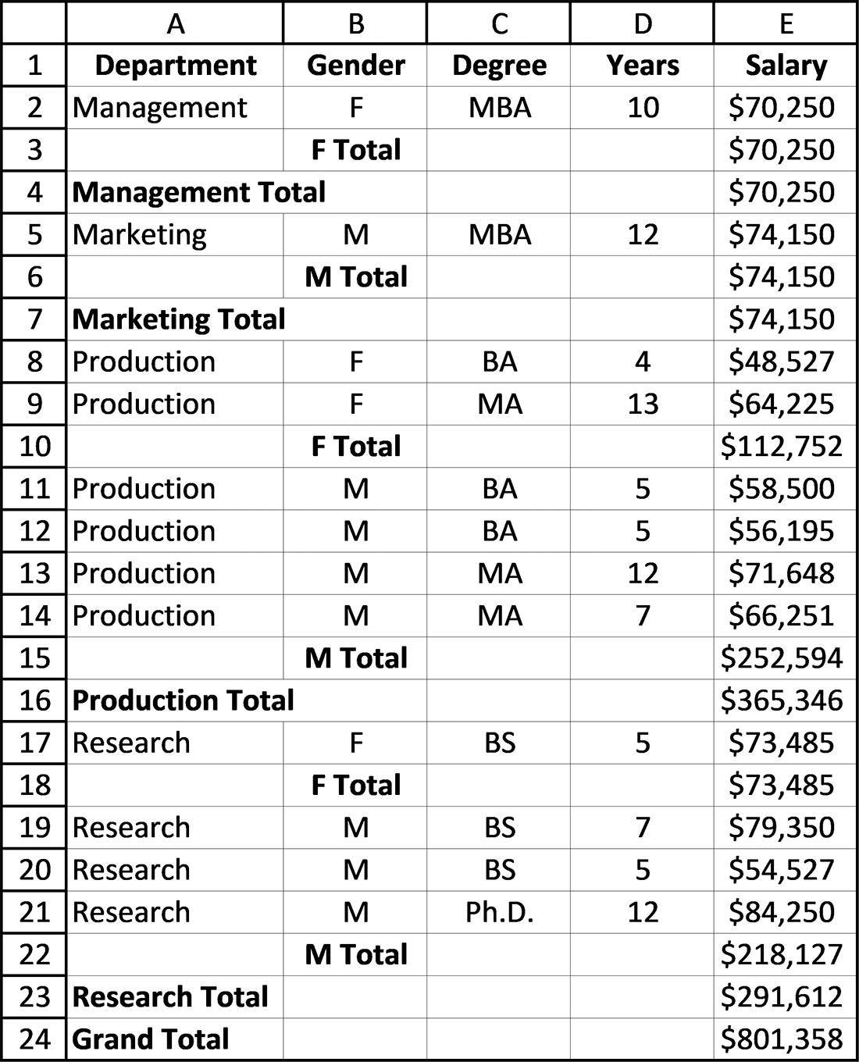

Figure 7.28 Subtotals of Salary by Gender within Department
sortinG and searChinG 263

7.4 SEARCHING (FILTERING) FOR SELECTED RECORDS
Searching a spreadsheet and displaying (also known as filtering) either the complete
row or selected items from each row containing the searched for item is accomplished
using the Excel ribbon’s Data tab’s Advanced Filter option. Essentially, each row in
the spreadsheet passes through a filter that is composed of the search criteria. Only if
one or more values in the row meets the criteria is the complete row, or desired items
from the row, displayed.
All of Excel’s relational operators, as listed in Table 7.1, are available for creating
search conditions.5
Table 7.1 Excel’s relational operators
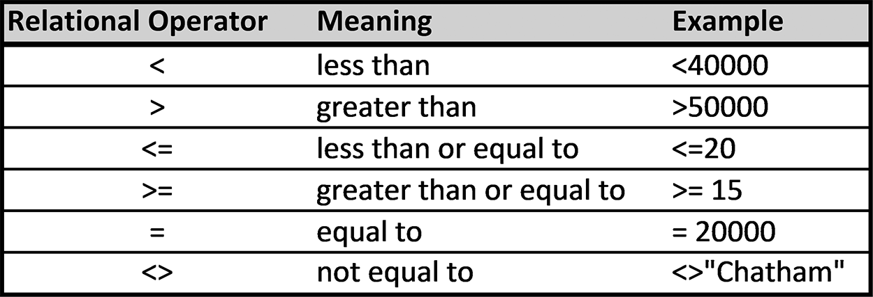

As a specific example, consider the spreadsheet shown in Figure 7.29.
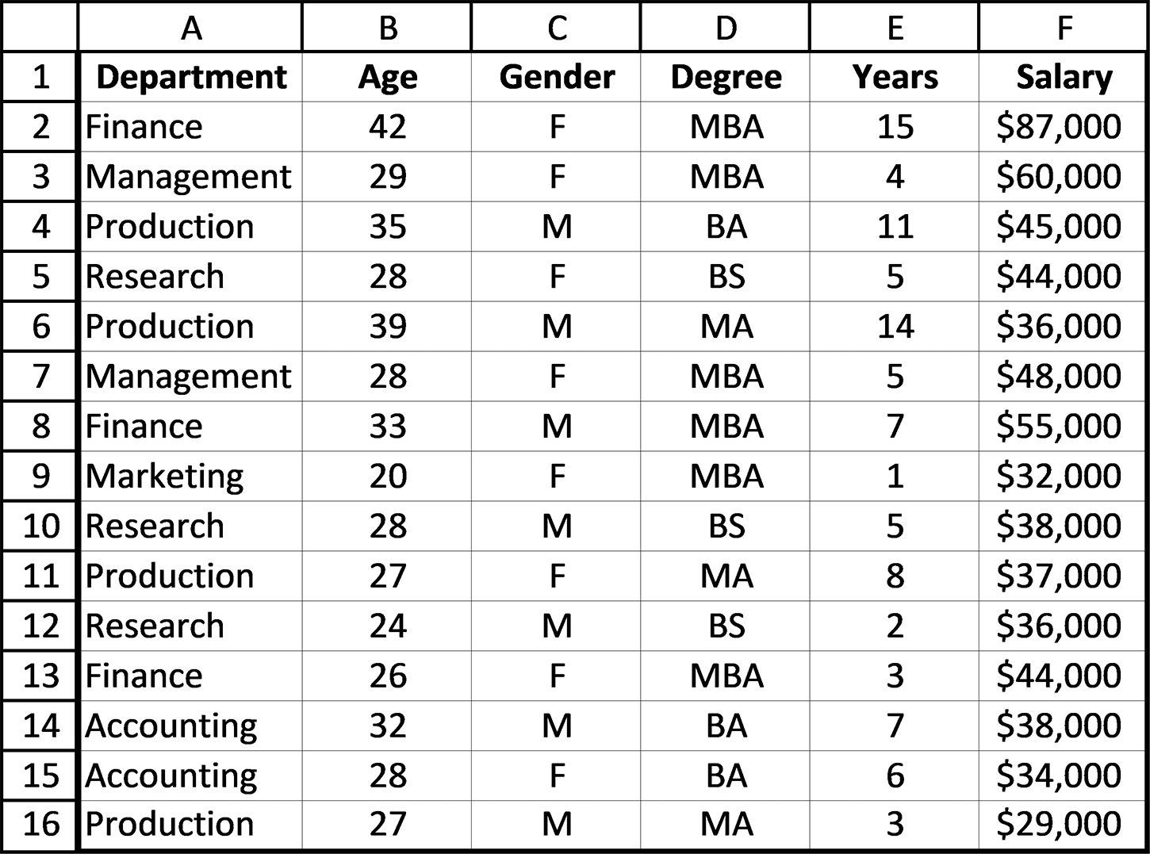

Figure 7.29 Salary data

5 These operators were initially introduced in Section 4.1.
264 exCel BasiCs

Although the search criteria can be placed anywhere within the spreadsheet (and even
on a different sheet, for convenience), by convention the search criteria are typically
placed above the data being searched. This is done by inserting at least 5 rows at the
top of the data, as shown in Figure 7.30. Initially, the top-most additional row should
contain the same headers as those in the worksheet being searched, and the other four
are initially left blank. These additional rows are used for creating both simple and
more complex searches.
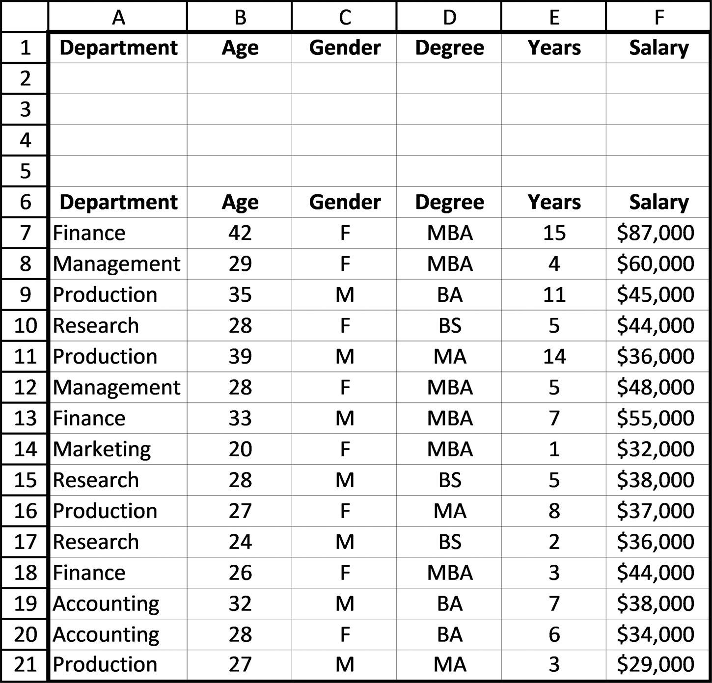

Figure 7.30 Additional rows added for the search criteria

This new area which has been created is known as the criteria range. Regardless of
where this criteria range is placed, it needs to be in the proper format to be used to do
an Advanced Filter. Once the additional rows have been added, as illustrated in Fig-
ure 7.30, the actual search criteria can be specified. It is important to understand that
all criteria entered on a single line are considered by Excel to constitute AND condi-
tions. Initially, we will illustrate a search using only one criteria line. More complex
searches using AND and OR conditions are presented at the end of this section. In all
sortinG and searChinG 265

cases, both simple and more complex searches are completed using the following
three-step search procedure:
Step 1: Fill in the criteria range with the search criteria.
Step 2: Select the Excel ribbon’s Advanced Filter option, shown in Figure 7.31.
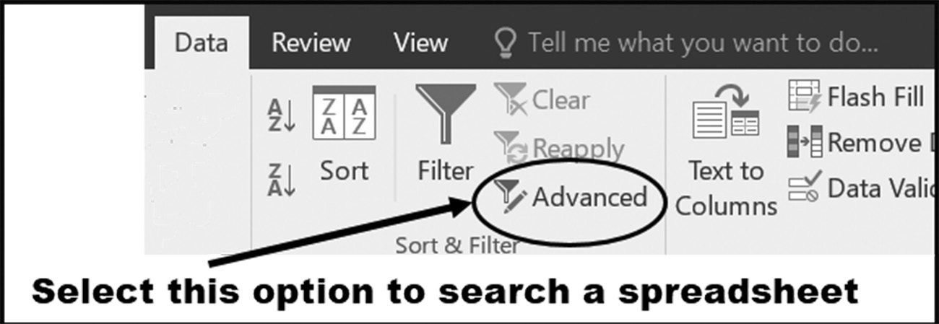

Figure 7.31 Selecting the Advanced Filter option

Step 3: Complete the Advanced Filter Dialog, shown in Figure 7.32.
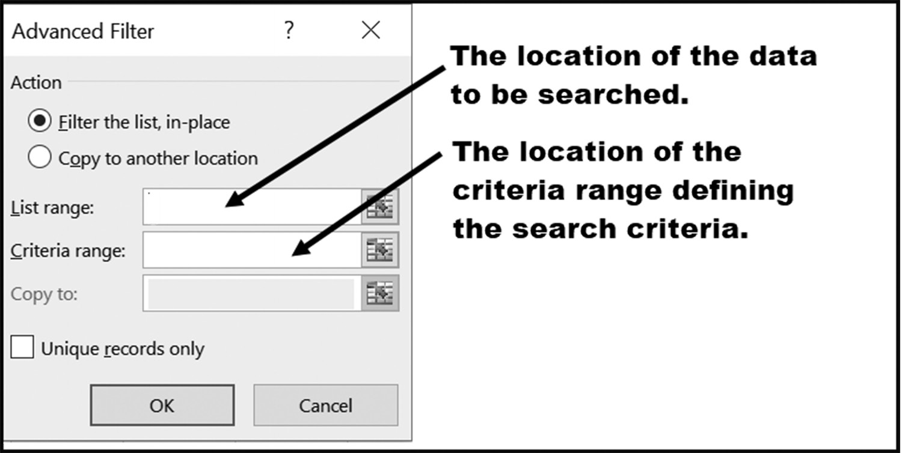

Figure 7.32 The Advanced Filter dialog box

The Filter the List, In Place action will display the filtered list superimposed over
the original list, with the filter result record numbers listed in blue, indicating that the
list is missing records due to the filter being applied. The Copy to Another Location
action will paste a copy of the filtered results to an indicated location on the spread-
sheet, which is indicated in the Copy to box (in this example, greyed out, since we are
doing a Filter in Place).
The List Range is your entire list or table of original data, including the header
row. The Criteria Range is the entire area listing your filter criteria, including the
header row.
To continue our example, we will search the spreadsheet shown in Figure 7.30 for
all employees who are over 27 years of age, are female, and have an MBA degree. To 266 exCel BasiCs

Application Note
Copying Selected Record Columns
Clicking the Advanced Filter dialog box’s Copy to another location (see Figure 7.35) button allows you to display individual records in a specified location, rather than using Filter in Place. However, in some cases, you only need a subset (not all) of the field columns in your result. The following procedure shows you how.
This is accomplished by
Step 1: Setting up your search criteria in the Criteria Range. This will restrict the output only to the
records which match your specified criteria.
Step 2: Selecting Data – Sort & Filter – Advanced Step 3: Checking the Copy to another location button in the Advanced Filter dialog. Step 4: Enter the List Range (Normally, if you use the entire list and data, you will get ALL of
the fields from the records which match the specified criteria. However, if you only want SOME of the fields (columns) to be displayed as the output, then only select those headers and fields that you want, and enter these as the List Range.)
Step 5: Enter the Criteria Range
Step 6: Provide the Copy To range
Step 7: Clicking OK to filter the list and paste the result.
This will provide the customized output in a designated location, providing a filtered list and only displaying selected field columns.
see how this is accomplished, initially add the data in cells B2 through D2, as shown
in Figure 7.33, and entered as indicated.
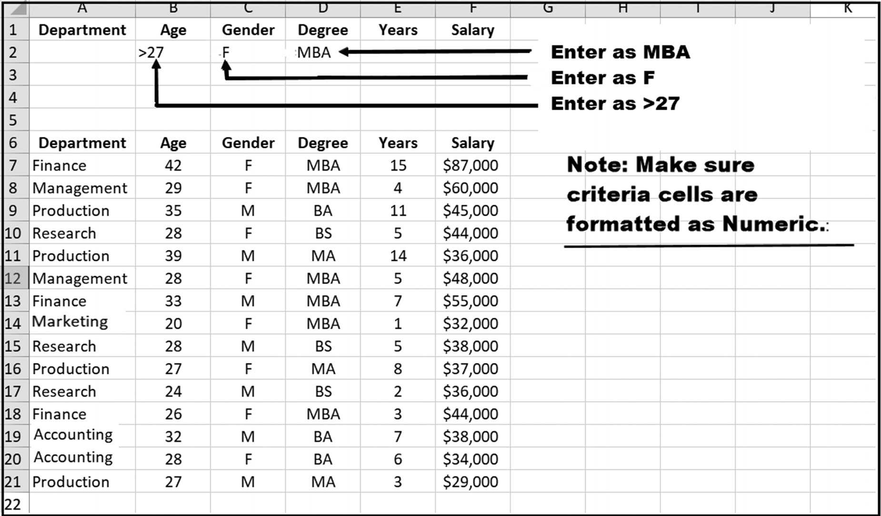

Figure 7.33 Preparing to Do an Advanced Filter
sortinG and searChinG 267

If you have a text field criteria, simply enter the text string into the appropriate loca-
tion in the Criteria range. No quotes or equals sign needed. The same applies to com-
parison expressions, where all you need is the expression. Again, neither an equals
sign or a quote is needed.
It is important, however, when using the equality operator that (1) no spaces be
added within the string (the reason is that as an exact match is being searched for and
any additional spaces changes the search value) and (2) any numeric criteria cells have
been formatted using a numeric format.
Once you have created the spreadsheet shown in Figure 7.33, select the Data Rib-
bon’s Advanced option, as shown in Figure 7.34. This will bring up the Advanced
Filter dialog box shown in Figure 7.35.
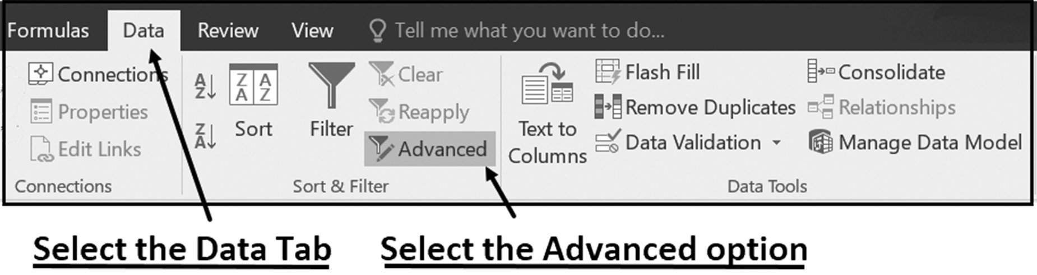

Figure 7.34 Selecting the Advanced option on the Excel Ribbon, Data tab, and Sort & Filter Group
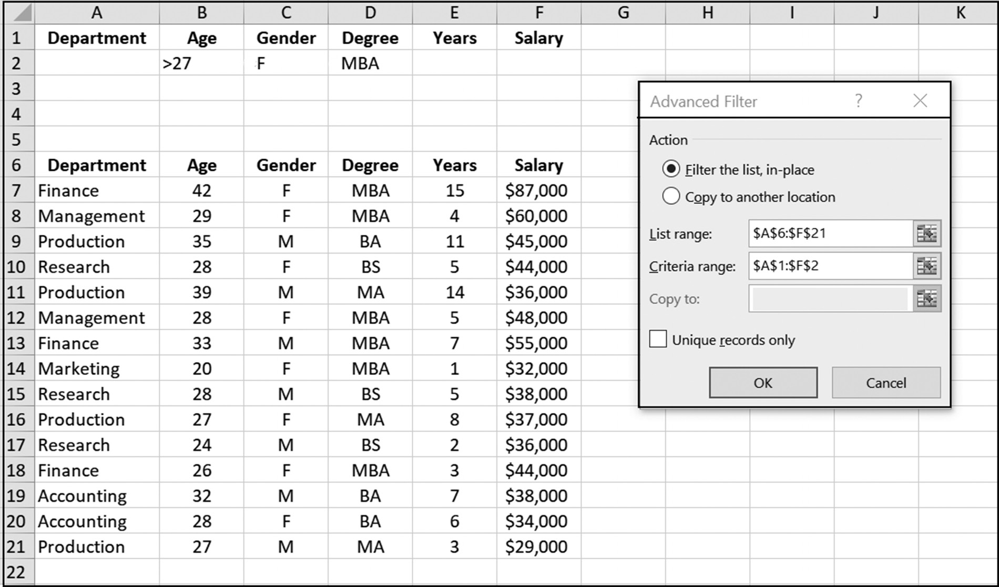

Figure 7.35 The Advanced Filter dialog box 268 exCel BasiCs

Application Note
Simple Find and Replace Searches
In addition to locating and displaying complete records, Excel also provides for simple Find and Replace searches. This search option is located in the Editing group of the Excel ribbon’s Home tab. A Find and Replace search is identical to those found in word processing programs; it locates all occurrences of a specified numeric or text value and permits replacing the value with another, if necessary.
Using the wildcard symbols presented in Section 8.4, a Find and Replace search is a powerful
method of easily correcting spelling errors or replacing simple one or two character codes with a longer text values. These techniques are presented in Section 8.4.

Filling in this dialog box, as shown in Figure 7.35, and then clicking the OK button,
creates the filtered spreadsheet as a Filter the List, in-place display, which shows the
records meeting the given criteria.
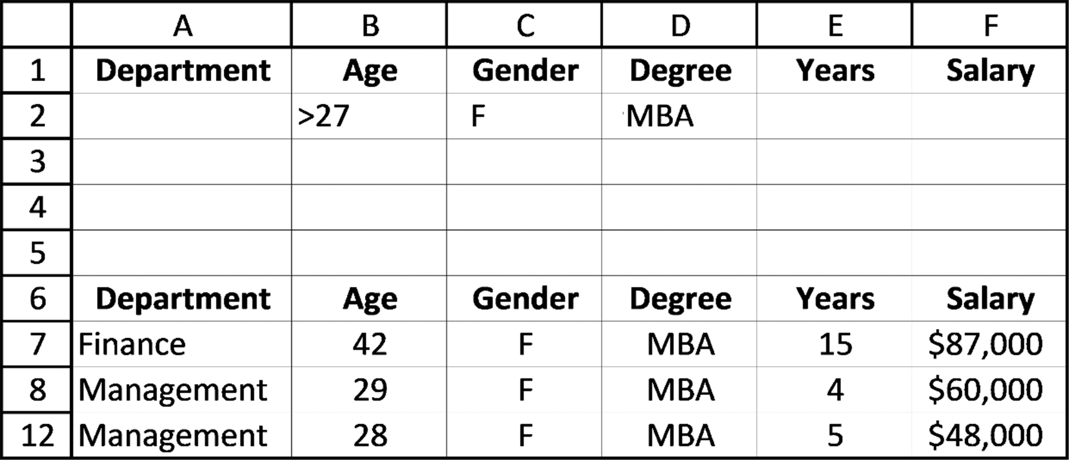

Figure 7.36 The spreadsheet data meeting the stated criteria

Pressing the Undo Button on the Quick Access Toolbar at the top of the screen will
reset the spreadsheet back to its original form. Alternatively, you can have the filtered
data output copied to a different region on the spreadsheet by clicking on the Copy
to another location button in the dialog shown on Figure 7.35, and then designating
where the selected data is to be displayed.
More Complex Searches
In creating OR conditions, it is important to remember that all criteria entered on a
single line are considered by Excel to constitute AND conditions (where all stated
conditions must evaluate to TRUE), while conditions entered on the following and
subsequent lines are considered as a new set of AND conditions within an OR condi-
tion (where at least one, but up to all, must evaluate to TRUE). This basic organiza-
tion for the first three criteria lines is shown in Figure 7.37. If a fourth criteria line is
sortinG and searChinG 269

used, the conditions on this line are put together, and then Excel uses OR with the
previous lines, and so on for all criteria lines.
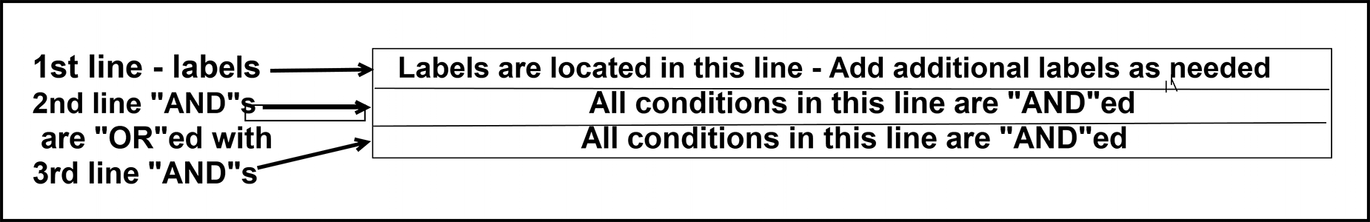

Figure 7.37 Criteria range organization

The following examples illustrate how more complex searches comprised of ORs,
multiple ANDs, and ORs with multiple AND conditions are created using the organi-
zational approach shown in Figure 7.37. For each of the following examples, the data
shown in Figure 7.35 is searched.

Example 1
OR condition
Search the spreadsheet shown in Figure 7.35 for all records where
Degree = BS OR Degree = BA
Solution: As the criteria requires an OR condition, two lines of criteria values are
required. The first criteria line following the label line specifies the criteria that
Degree = BS while the OR condition (Degree = BA ) is specified in the next line.
Figure 7.38 shows the required criteria and the resulting selected records from those
originally displayed in Figure 7.35.
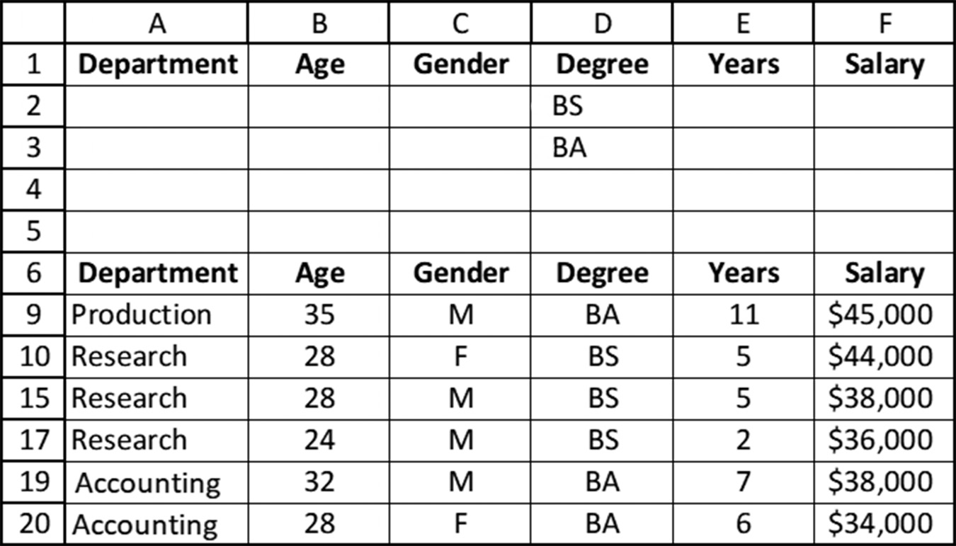

Figure 7.38 Spreadsheet for sample OR search

Note that either ranges $A1:$F3 or $D1:$D3 are valid for specifying the criteria
shown in Figure 7.38.
270 exCel BasiCs

Example 2

Multiple ANDs on the same Criteria Range Row
Search the spreadsheet shown in Figure 7.35 for all records where
Salary > 40000 AND Salary <50000
Solution: Here we have two AND conditions for Salary. Because additional criteria
can be added to the first row of the criteria range (row 2), this search criteria is accom-
plished by adding a second Salary criterion on the same criteria range row, as shown
in Figure 7.39. As such, both Salary specifications are specified on Row 2. Figure 7.39
shows the required criteria and the resulting selected records from those originally
displayed in Figure 7.35.
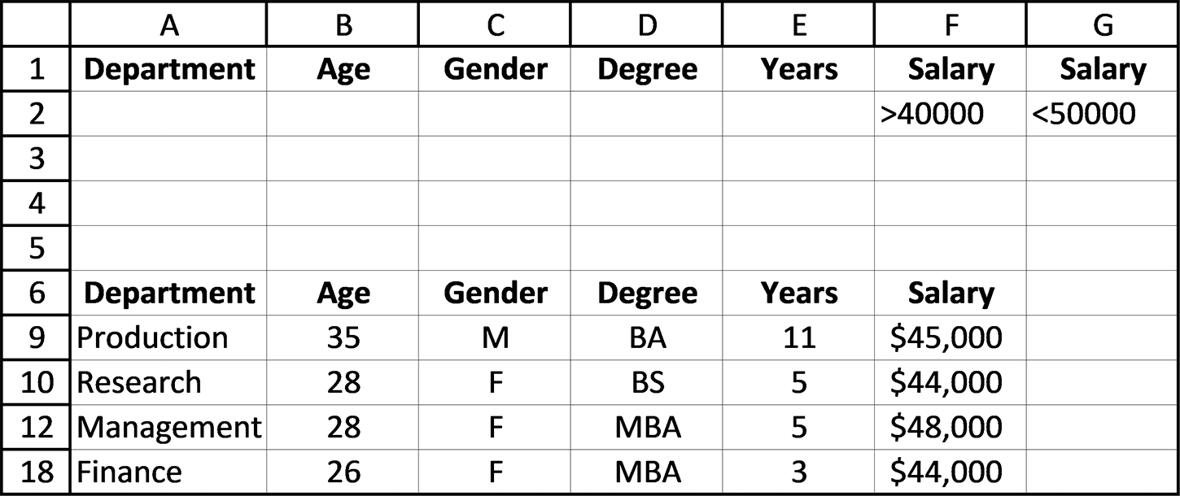

Figure 7.39 Spreadsheet for sample AND search

Note that either ranges $A1:$G2 or $F1:$G2 are valid for specifying the criteria shown
in Figure 7.39. Also, notice that if you specified the Salary criteria using three rows, as
shown in Figure 7.40, the resulting criteria becomes the OR condition Salary >40000
OR Salary <50000, which is incorrect for the specified filter.
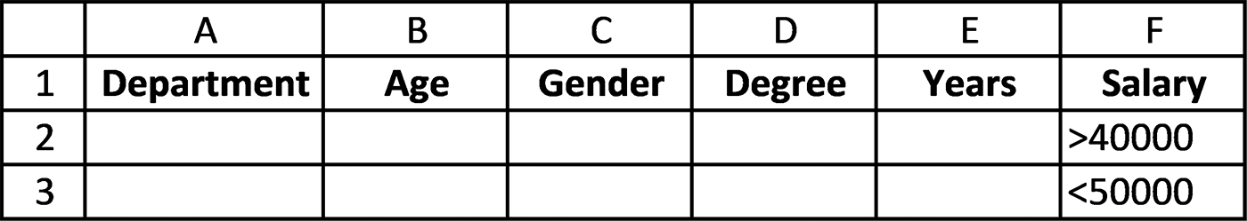

Figure 7.40 Advanced Filter Using Salary >40000 OR Salary < 50000

Example 3
Multiple AND Conditions on the same Criteria Range Row
Filter the spreadsheet shown in Figure 7.35 for all records where
Degree = BS AND Salary > 40000 AND Salary <50000
Solution: As this search consists of ANDs only, all of the criteria can be placed on the
first criteria range row following the label row. As in Example 2, because the Salary
sortinG and searChinG 271

criteria is required twice, a second Salary criterion is added to the same row. Figure
7.41 shows the required criteria and the resulting selected records from those origi-
nally displayed in Figure 7.35.
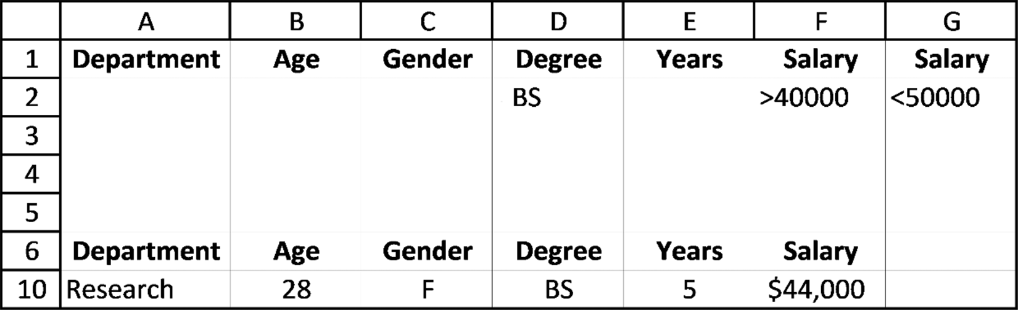

Figure 7.41 Advanced Filter Using Multiple AND conditions

Note that either ranges $A1:$G2 or $D1:$G2 are valid for specifying the criteria
shown in Figure 7.40.

Example 4
Criteria employing both AND and OR conditions
Search the spreadsheet shown in Figure 7.35 for all records where
(Salary > 40000 AND Salary <50000) OR (Degree = BS)
Solution: As this search criteria requires an OR condition, two rows of criteria range
values are needed. The first line following the header row specifies the first set of
ANDs (Salary > 40000 AND Salary <50000), while the OR condition (Degree = BS)
is specified in the next line. Figure 7.42 shows the required criteria and the resulting
selected records from those originally displayed in Figure 7.35.
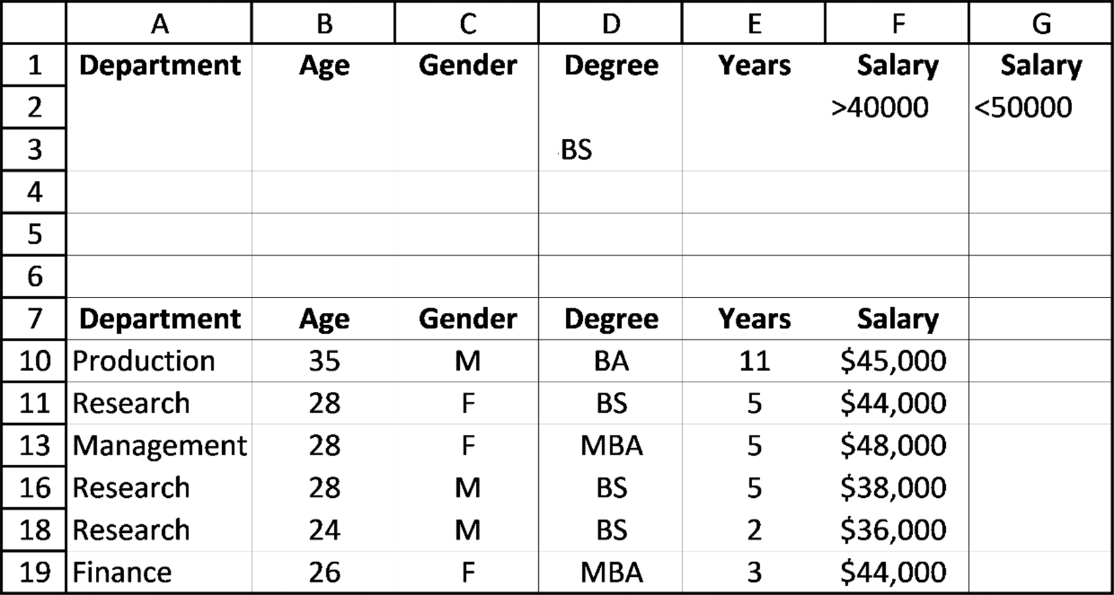

Figure 7.42 Advanced Filter Using AND and OR conditions 272 exCel BasiCs

Note that either ranges $A1:$G3 or $D1:$G3 are valid for specifying the criteria
shown in Figure 7.41.
As you have seen, the Advanced Filter is a very powerful tool for doing filter (search)
operations on an Excel list or table. It allows for detailed and complex filters to be
done relatively easily. However, for simple searches, it should be pointed out that
there is the option to use the AutoFilter feature which would allow you to do rela-
tively straightforward filters using drop-down boxes and menus. The determination as
to which one to use should be based the complexity of the filters you plan to use. More
information is readily available through various online and reference sources as to the
operation of the AutoFilter feature.

EXERCISES 7.4

1. Using the data shown in the first spreadsheet, and following the Advanced Filter
procedure presented in this section, produce the second spreadsheet shown.
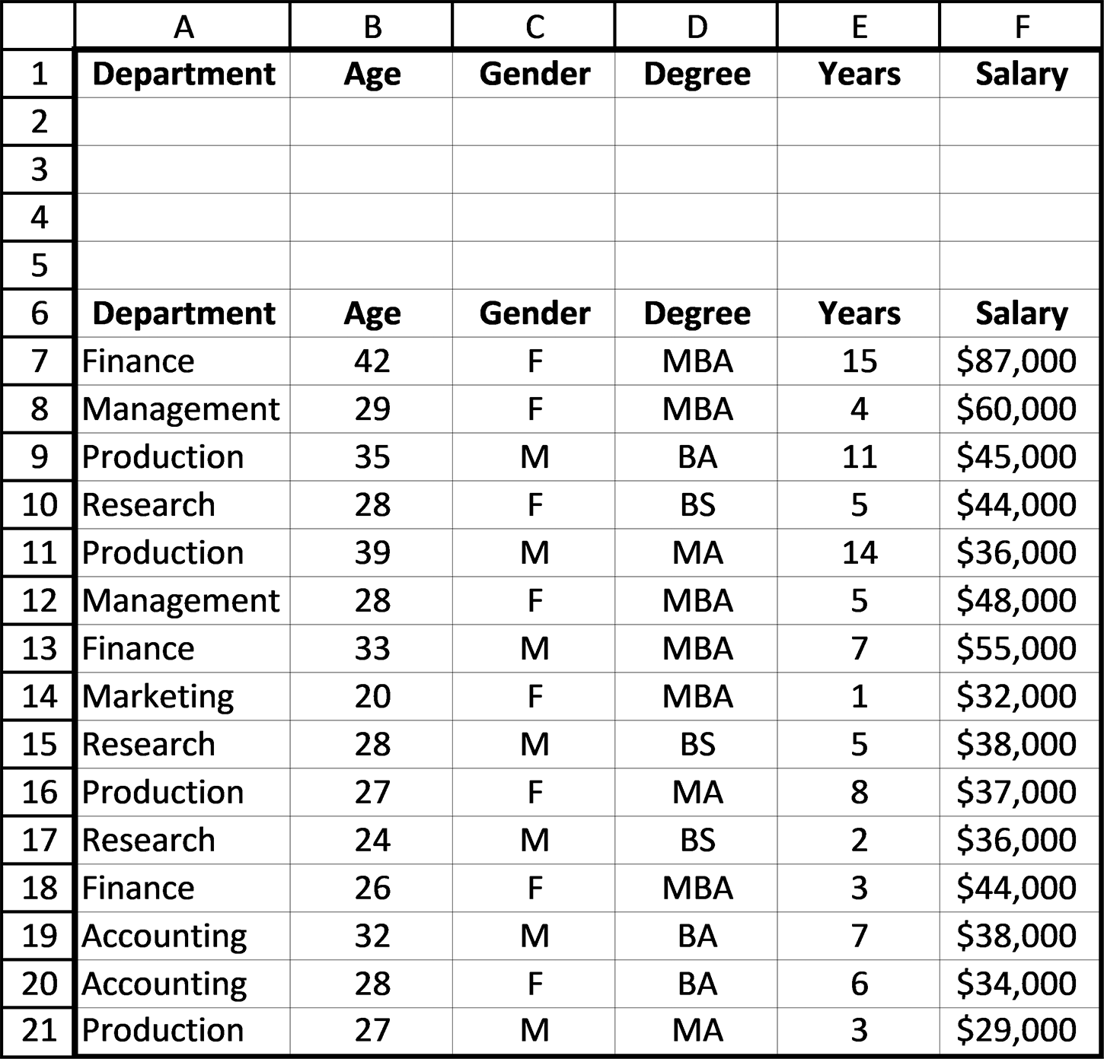
sortinG and searChinG 273
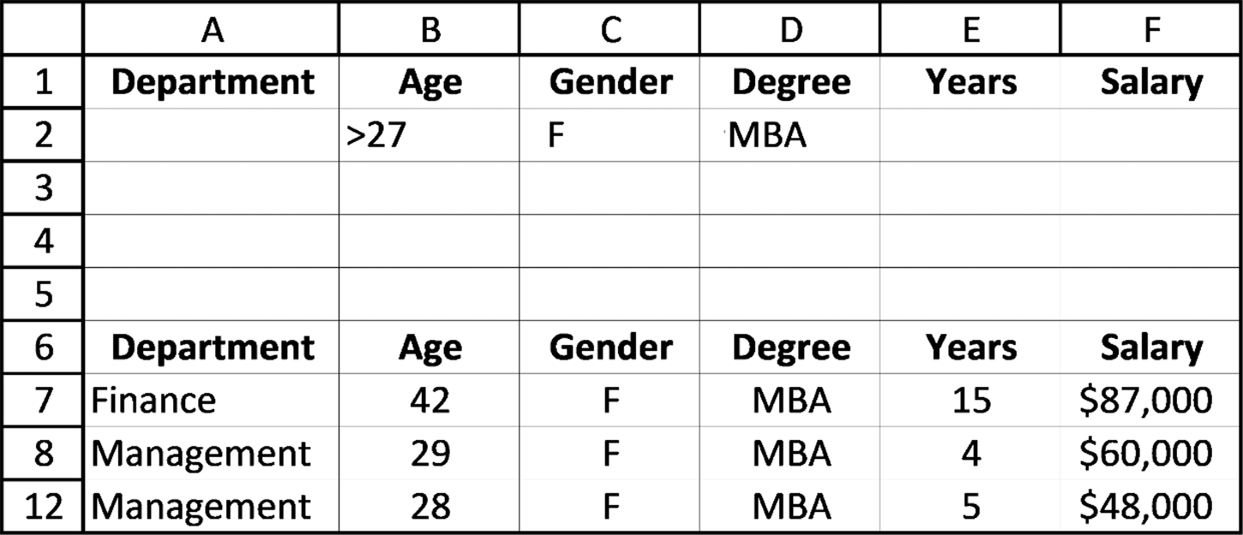

2. Create a spreadsheet, using the data in Exercise 1 that shows all personnel with a
BA degree who have been with the company for more than 2 years. At the bottom of the spreadsheet, use the SUM, AVERAGE, MAX, and MIN functions so that your spreadsheet also lists the total, average, maximum, and minimum salaries for the displayed salary data.
3. Complete parts a-b.
a. For the spreadsheet in Figure 7.43, create a filtered list that displays all Sales
values (Column D) greater than $190,000, using the Advanced Filter.
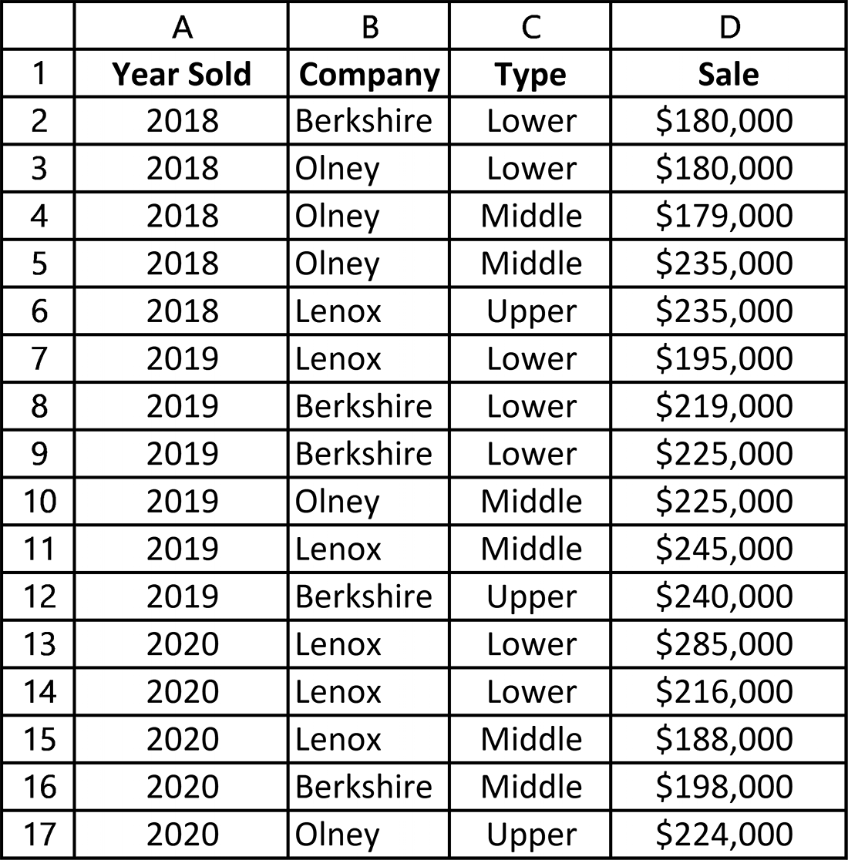

Figure 7.43 Data for Exercise 3

b. Using the spreadsheet given in Exercise 3a, create a filtered list using the
Advanced Filter showing all sales for the Lenox company that were greater than $190,000.
274 exCel BasiCs

4. Complete parts a-b.
a. Using the spreadsheet given in Exercise 3a and the Advanced Filter, create a
spreadsheet showing all sales that were between $190,000 and $230,000.
b. Using the spreadsheet given in Exercise 3a, create a filtered list using the
Advanced Filter showing all sales for the Lenox company that were between $190,000 and $230,000.
5. For the following criteria section, fill in values satisfying the given criteria:
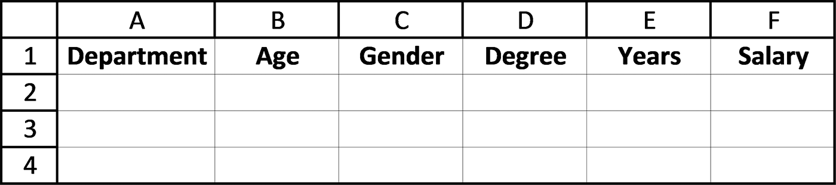

a. Age > 25 AND Years < 14
b. Gender = F and Salary > $35,000
c. Gender = M and Salary > $35,000
d. Department = Production AND Gender = F
e. Department = Finance AND Years >= 8 AND Salary > $40,000
6. For each of the criteria used in Exercise 5, provide criteria ranges that can be
used in the Advanced Filter dialog box to correctly identify the given criteria. For all parts, use the spreadsheet shown in Exercise1 to do the following:
a. Using the given criteria, filter to find the following results.
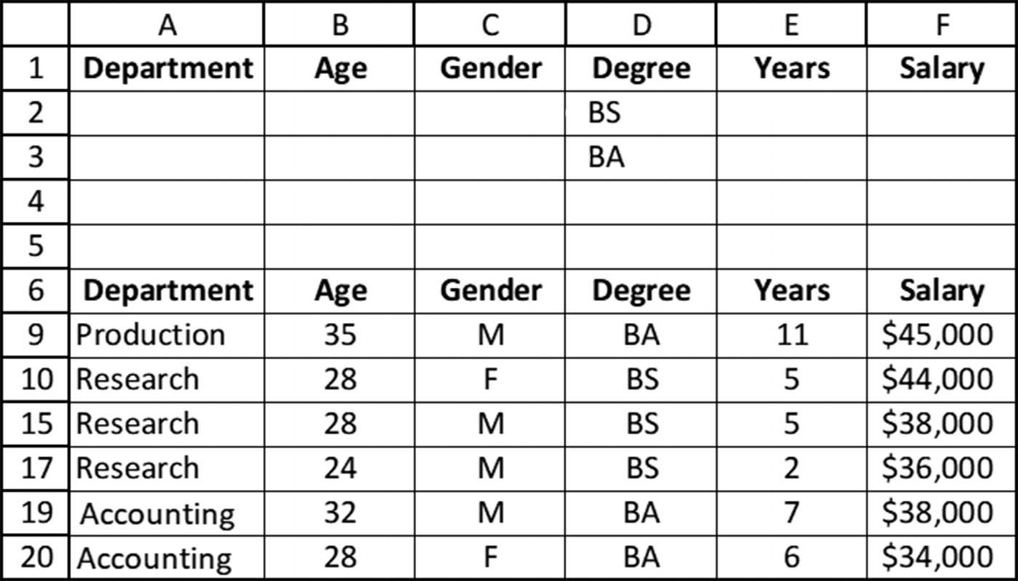
sortinG and searChinG 275

b. Using the given criteria, recreate the following filtered spreadsheet.
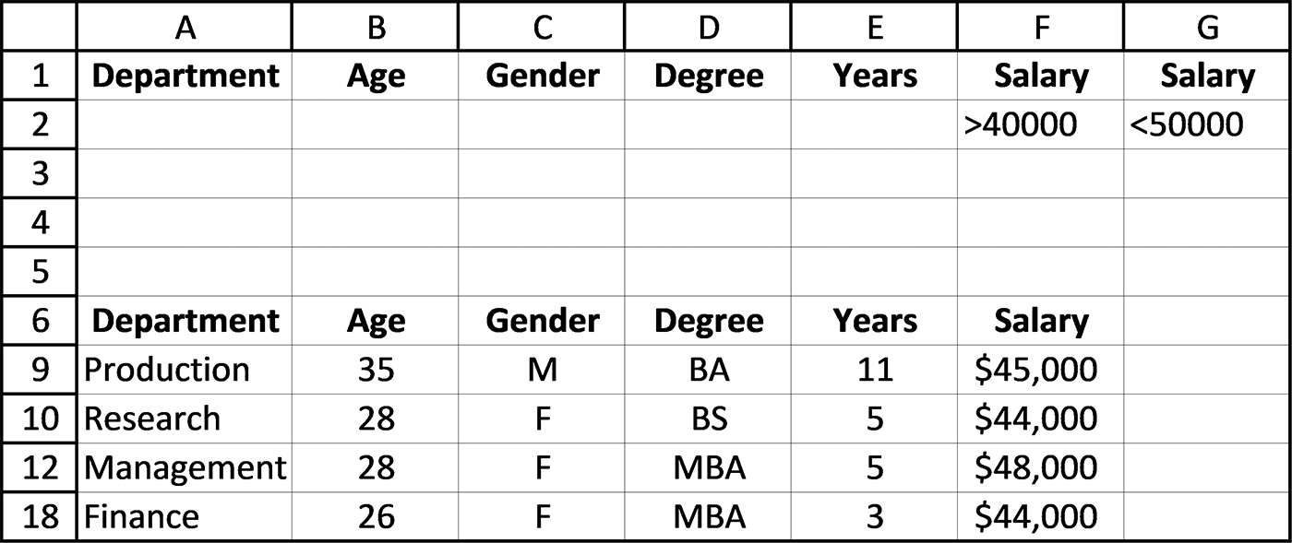

c. Using the given criteria, recreate the filter below using the Advanced Filter.
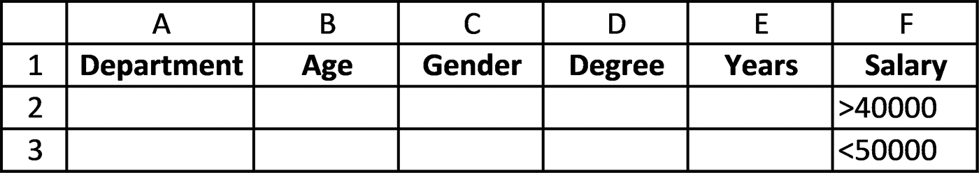

d. Using the given criteria, recreate the filter and results using the Advanced Filter.
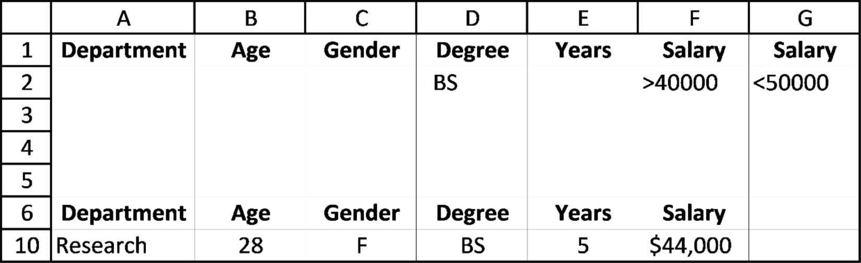

7. For the following criteria range section, fill in values satisfying the criteria pro-
vided:
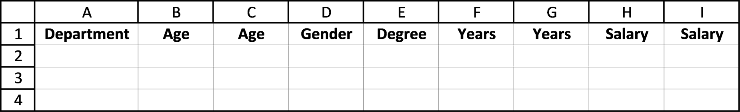

a. Age > 25 AND Age < 35
b. Years >= 8 AND Years < =14
c. Salary > $40,000 AND <= $60,000
d. Department = Finance OR =Accounting 276 exCel BasiCs

e. (Age > 25 AND Age < 35) OR (Years > 8 AND Years < 14)
f. (Age > 25 AND Age < 35) OR (Years >8 AND Years <14) OR (Salary > $40,000)
8. For each of the criteria used in Exercise 8, provide two different criteria ranges that
can be used in the Advanced Filter dialog to correctly identify the given criteria.

7.5 DATABASE FUNCTIONS

Consider the data shown in Figure 7.44 (originally shown as Figure 7.29). Filtering
this data using the criteria (Degree = BA AND Years > 1) provides the record listing
shown in Figure 7.45. The shaded sum, average, and maximum and minimum salary
figures at the bottom of the figure were created after the search was completed, using
the respective Excel formulas after the filtered data was determined.
Frequently, all that is needed in many applications is a numeric summary statistic
of selected records, such as the shaded values appearing at the bottom of Figure 7.45,
and not a complete list of the filtered records themselves. Using Excel’s database
functions, the most commonly used of which are listed in Table 7.2, such summaries
can be obtained directly. Doing so eliminates the need of first searching and listing
selected records, as is done in Figure 7.45.
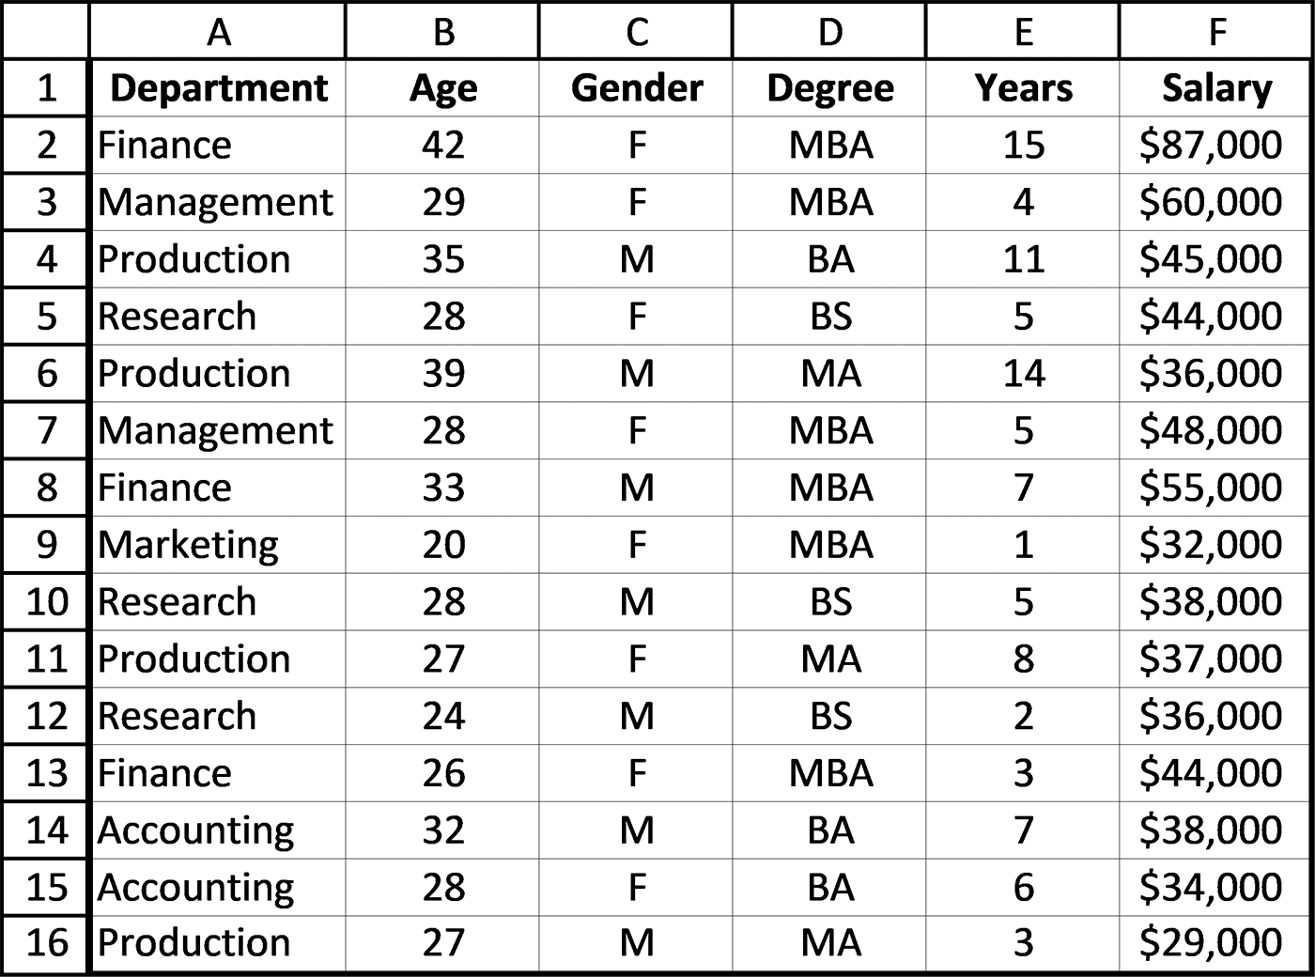

Figure 7.44 Employee Data records
sortinG and searChinG 277
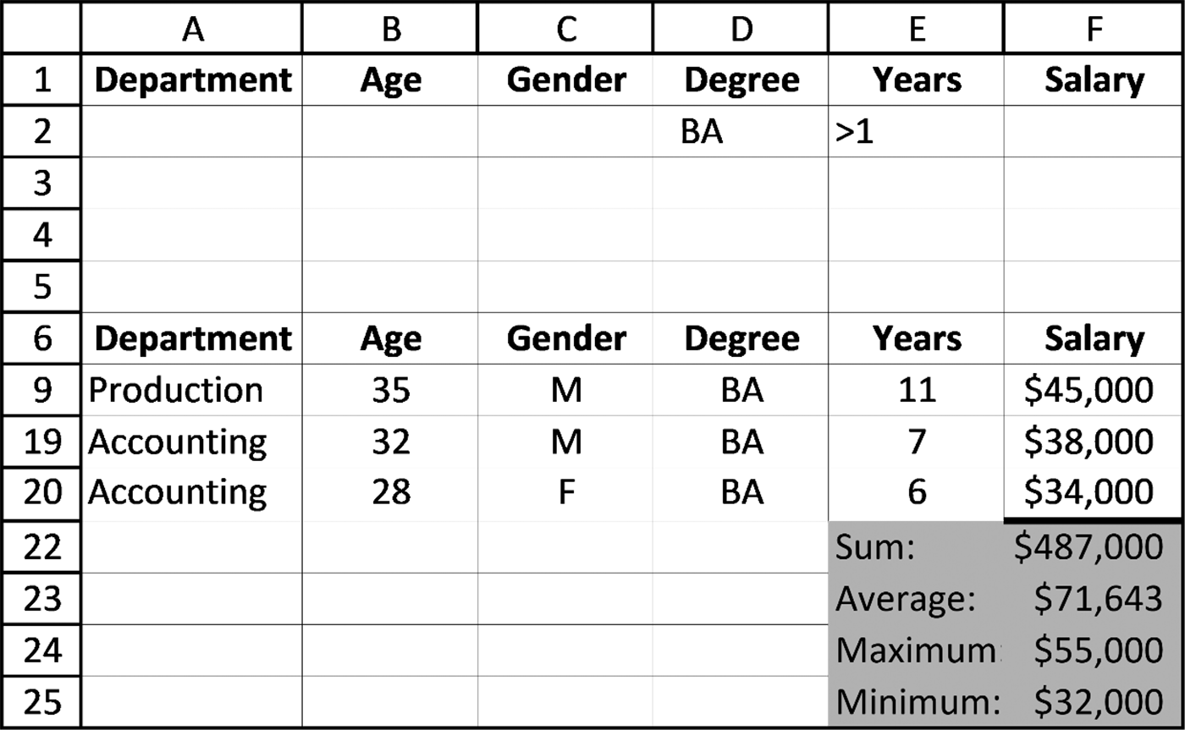

Figure 7.45 Filtered records after using the Advanced Filter (data from Figure 7.44)

Table 7.2 Commonly-used database functions
Function Description
DAVERAGE() Returns the average of the selected database entries DCOUNT() Counts the cells that contain numbers in a database DCOUNTA() Counts nonblank cells in a database DMAX() Returns the maximum value from the selected database entries DMIN() Returns the minimum value from the selected database entries DSUM() Adds the numbers in the field column of records in the database that match the criteria

All Excel database functions require three pieces of data:
1. The range where the original data is located (list range)
2. The name of the field whose data is being calculated
3. The location of the selection criteria (criteria range)
For example, the following database functions can be used to directly obtain the aver-
age and maximum and minimum salaries of the selected records shown in Figure 7.45.
=DAVERAGE(A6:F21,“Salary”,D1:E2)
=DSUM(A6:F21,“Salary”,D1:E2)
=DMAX(A6:F21,“Salary”,D1:E2)
=DMIN(A6:F21,“Salary”,D1:E2)
While database functions (DFUNCTIONS) are very useful for generating summary
statistics based on a filtered list, they do require the use of an Advanced Filter (and 278 exCel BasiCs

its associated inputs, including the list range, criteria range, and output specifica-
tions). An alternate approach to doing this would be to use Conditional =IF functions,
which generally work well with list/table data and do not require the use of neither the
Advanced Filter, nor a criteria range. By specifying the list to be worked on, the filter
criteria, and the field to be summarized, it is possible to use Conditional =IF functions
to generate a similar result to that obtained by DFUNCTIONS.
The functions include =SUMIF( ), =COUNTIF( ), and =AVERAGEIF( ) for single
criteria, and =SUMIFS( ), =COUNTIFS( ), and =AVERAGEIFS( ) for multiple sets
of criteria. Excel 2019 also introduced the =MAXIFS( ) and =MINIFS( ) functions.
These functions can be used both for a wide range of applications. It should be not-
ed that Conditional =IF functions are not the same as the =IF function, in that each
type uses a different format and works differently. There are numerous resources
which you can consult for more information on Conditional =IF functions.

EXERCISES 7.5

1. List the three arguments that must be provided to an Excel database function.
2. Create the spreadsheet data shown below. Then, using only database functions,
produce the summary data values shown in the shaded region of the following figure.
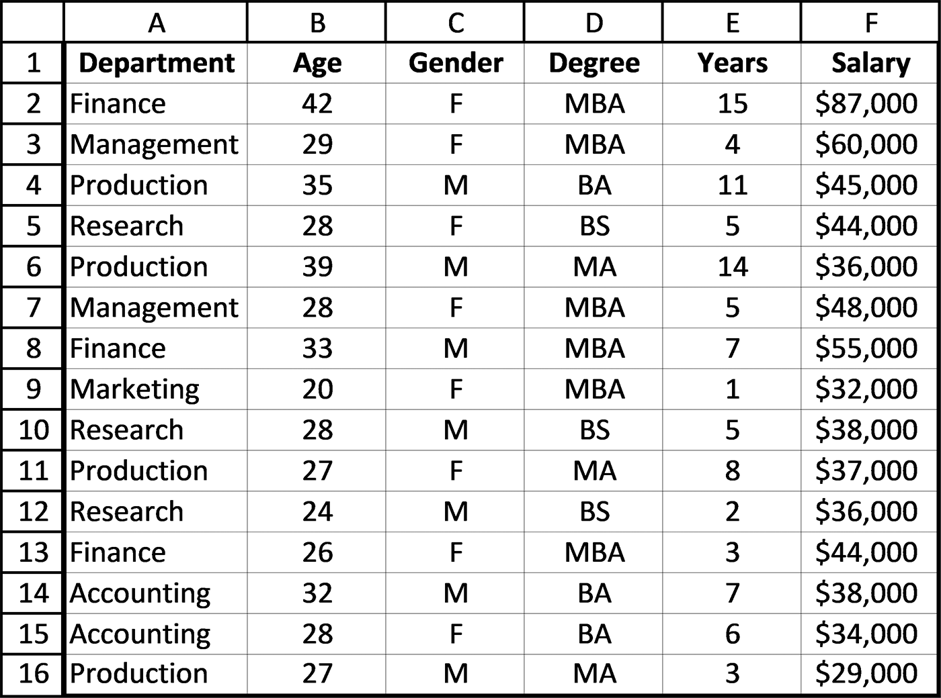
sortinG and searChinG 279
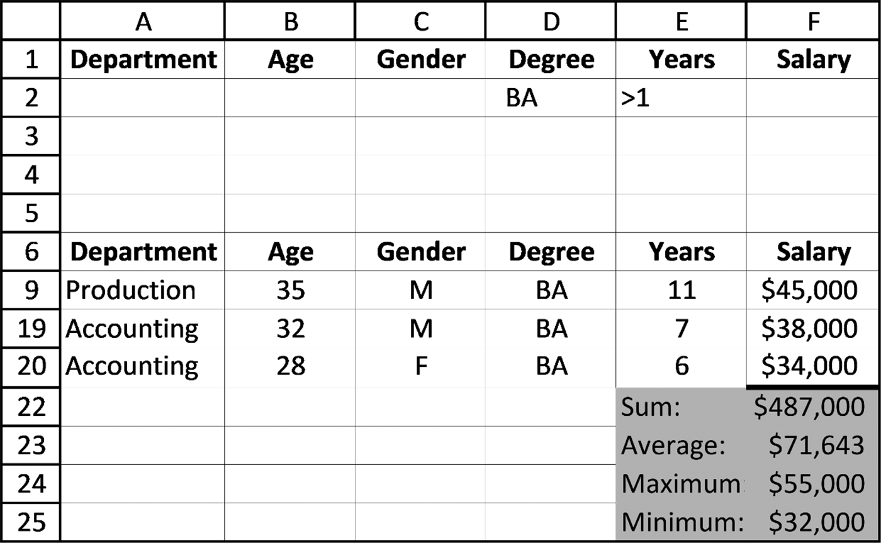

3. For the spreadsheet shown below, and using database functions only,
a. calculate and display the sum and average of all Berkshire company sales.
b. calculate and display the sum and average of all Lenox company sales.
c. calculate and display the sum and average of all Olney company sales.
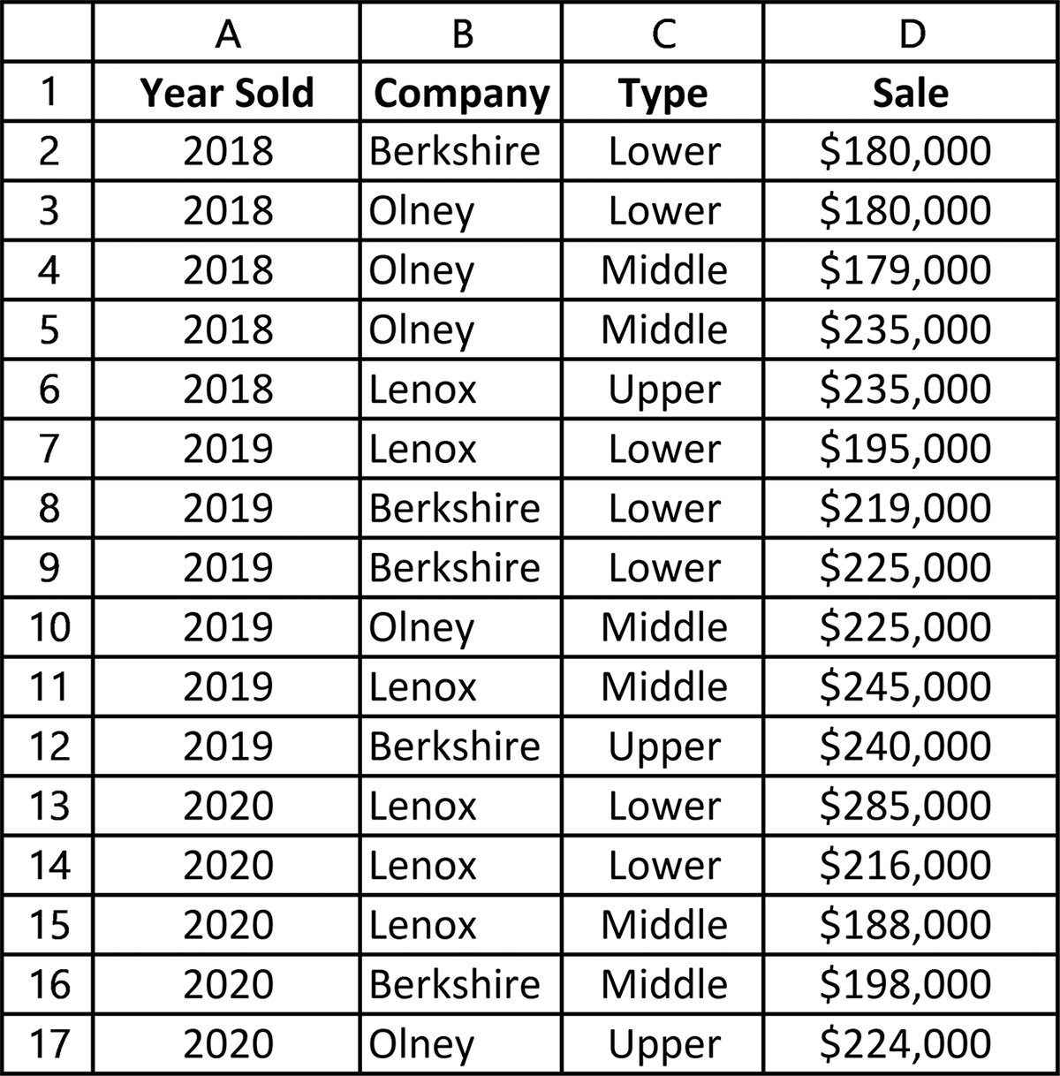
280 exCel BasiCs

7.6 COMMON EXCEL ERRORS
The errors common to sorting and searching a spreadsheet are the following:
1. Forgetting to highlight the complete spreadsheet when sorting on values in one or
more columns. If the complete spreadsheet is not highlighted, the sort will only be applied to the selected highlighted columns. This has the effect of mixing the sorted column values with the unsorted remaining columns.
2. Forgetting to uncheck the Replace current subtotals checkbox (see Figure 7.22)
when creating nested subtotals. When this checkbox is not cleared, the most recent subtotals will erase all the preceding ones.
3. Inserting extra spaces within search criteria. Generally, specific values are being
searched for, and extra spaces can make exact searches fail, especially when searching for an exact text match.

7.7 CHAPTER APPENDIX: SPREADSHEETS AS DATABASES
By definition, a database is any collection of related data, organized and stored as
fields and records, usually employing a pre-set structure.6 Databases are used to store
the following:
●● Patient data
●● Employee data
●● Customer data
●● Expense data
●● Product data
●● Sales data

6 Formally, a database is defined as a organized collection of stored information, and it can be organized to show the relation-ships among the stored items.
sortinG and searChinG 281

An example of a small database is shown in Figure 7.46 (originally shown as Figure
7.1). This information can be entered into an Excel spreadsheet, using its existing
structure, including the inclusion of a field header row.
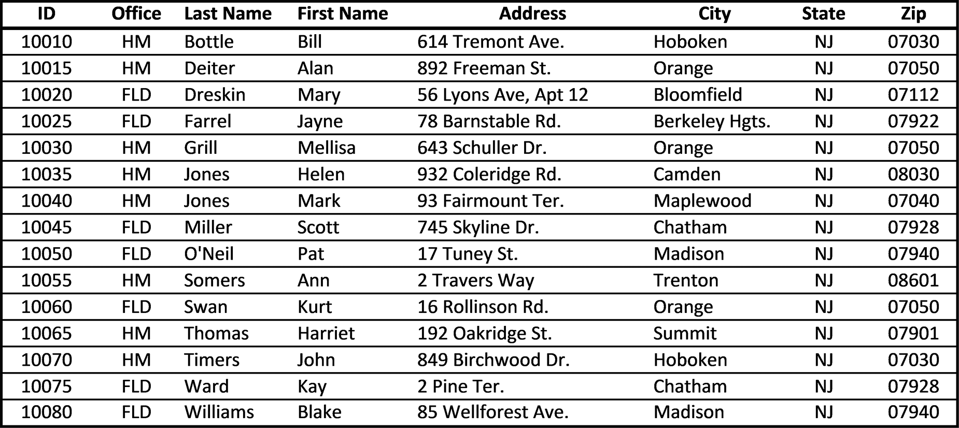

Figure 7.46 Employee location data

In Excel terminology, this is called an Excel list or an Excel table. As shown in Figure
7.46, this database is organized as a table consisting of fields and records. When the
following conditions hold, the spreadsheet operates similar to a relational database:
1. Each location in the table can contain only a single value
2. Each column (field) in the table has a unique identifying name
3. All values in a column are of the same basic data type (text, numeric, etc.)
4. The data in each row is distinct (that is, generally speaking, no two rows should
have the same data)
5. No information is lost by reordering rows
6. No information is lost by reordering columns
Each row in a database is referred to as a record, and consists of related data items
known as fields. The data items in a field correspond to the table’s columns. In Fig-
ure 7.46, for example, there are fifteen records, where each record contains eight
fields associated with a specific employee. The column headings describe what each
item represents. Although specific data values can be missing (none are in Fig-
ure 7.46), each record contains the same number and types of data, one item per
column.
282 exCel BasiCs

As another example, consider the student records shown in Figure 7.47. Here,
similar to the last example, the structure of the records as rows and fields as the indi-
vidual data items conforms to the structure of the rows and columns of a spreadsheet.
As such, a spreadsheet can operate in some ways like a database when each row in the
spreadsheet is used to store a single record, with the columns conforming to a record’s
fields. When viewed this way, the sorting and searching of rows becomes the sorting
and searching of records within a database.

Student ID Last First Major Year Credits Grade
Number Name Name Entered Earned Pt�
Average
1st ID
2nd ID
3rd ID
.
.
.
.
Last ID
Figure 7.47 A student database
C H A P T E R 8
intermediate and advanCed teChniques

This Chapter Contains
8.1 Creating Drop-Down Lists
8.2 Correcting Rounding Errors
8.3 Creating De-Duping Keys for Removing Duplicate Records 8.4 Array Functions - The SUMPRODUCT( ) Function
8.5 User-Entered Conditional Formatting Formulas 8.6 Chapter Appendix: Restricting Cell Access

8.1 CREATING DROP-DOWN LISTS

Drop-down lists are used to limit the choices that a user can enter into a cell. As
shown in Figure 8.1, the cell providing the list, in this case cell B1, has an arrow on its
right-hand side. (This arrow only appears when the cell providing the drop-down list
is selected.) Once the drop-down arrow is clicked, the user has the option of either
selecting one of the displayed list items, which is automatically entered into the cell,
or typing in the desired item.
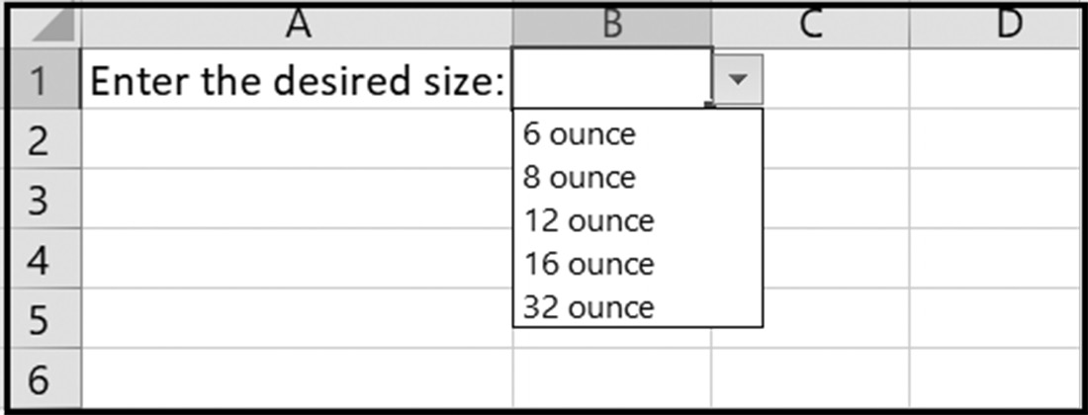

Figure 8.1 A cell with a drop-down list of choices

Attempting to type in an item not on the list results in the error message shown in
Figure 8.2.
284 exCel BasiCs
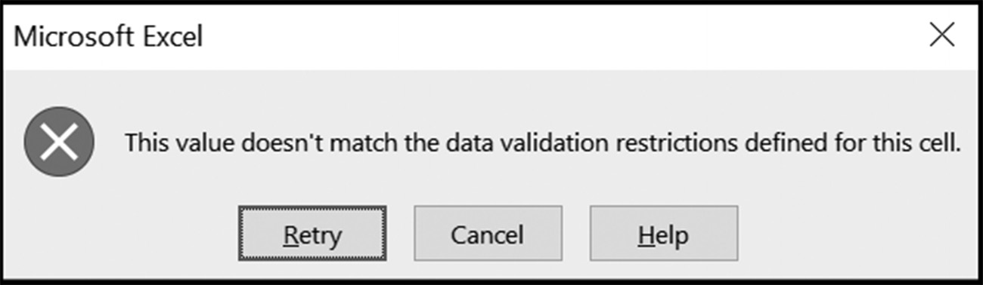

Figure 8.2 Invalid data entry error message

Creating a drop-down list requires the two elements shown in Figure 8.3: a cell to
display the list, which is cell B2 in the figure, and the drop-down list, which is stored
in cells E1 through E5.
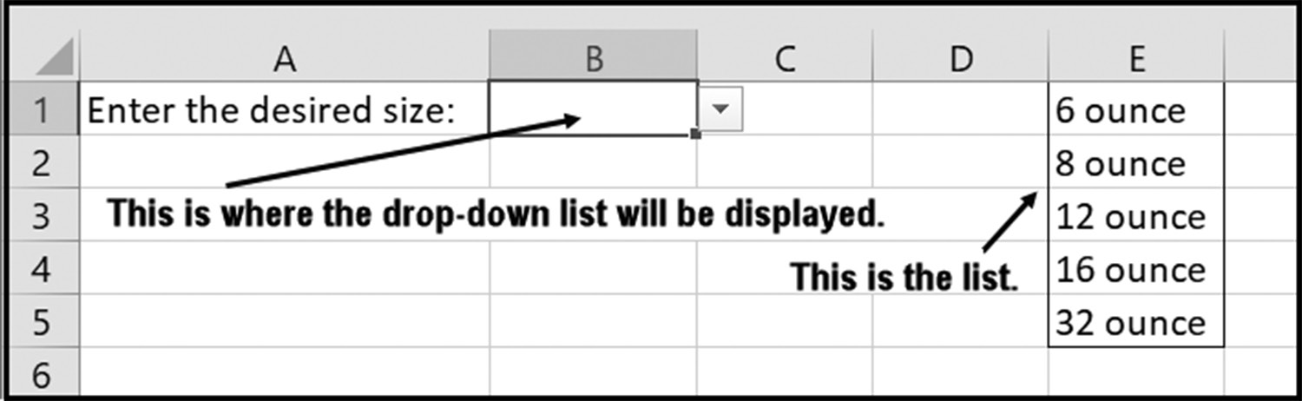

Figure 8.3 Creating a drop-down list

Drop-down lists are created through setting up the data, and employing the Data
Validation feature. The following three steps detail the complete method for creating
a drop-down list.
Step 1: Create a list of items, either in a single row or in a single column of cells.
In Figure 8.3, the list is located in cells E1 through E5. Generally, the list would be hidden on a second sheet and protected (see Section 8.6) so that it only appears when the receiving cell’s arrow is clicked and cannot be tampered with by the user.
Step 2: Click on the cell you want to receive the drop-down list. This cell is re-
ferred to as the data entry cell. In Figure 8.3, the data entry cell is B1.
Step 3: Select the Excel Data tab’s Data Validation option, as shown on
Figure 8.4.
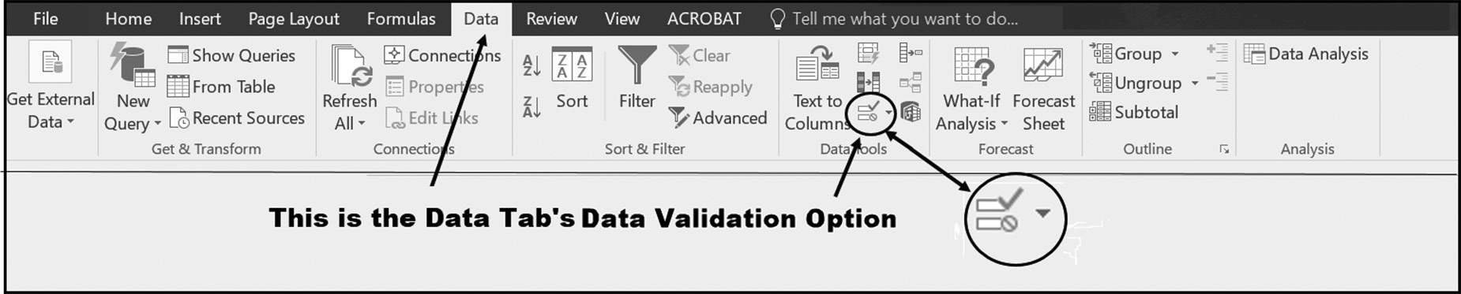

Figure 8.4 Locate and then select the Excel Data Validation option
intermediate and advanCed teChniques 285

Selecting the Data Validation option causes the dialog shown in Figure 8.5 to appear.
In this dialog, and as shown on the figure, you then click the arrow on the right-
hand side of the Allow text box. This will bring up the drop-down menu shown in
Figure 8.6.
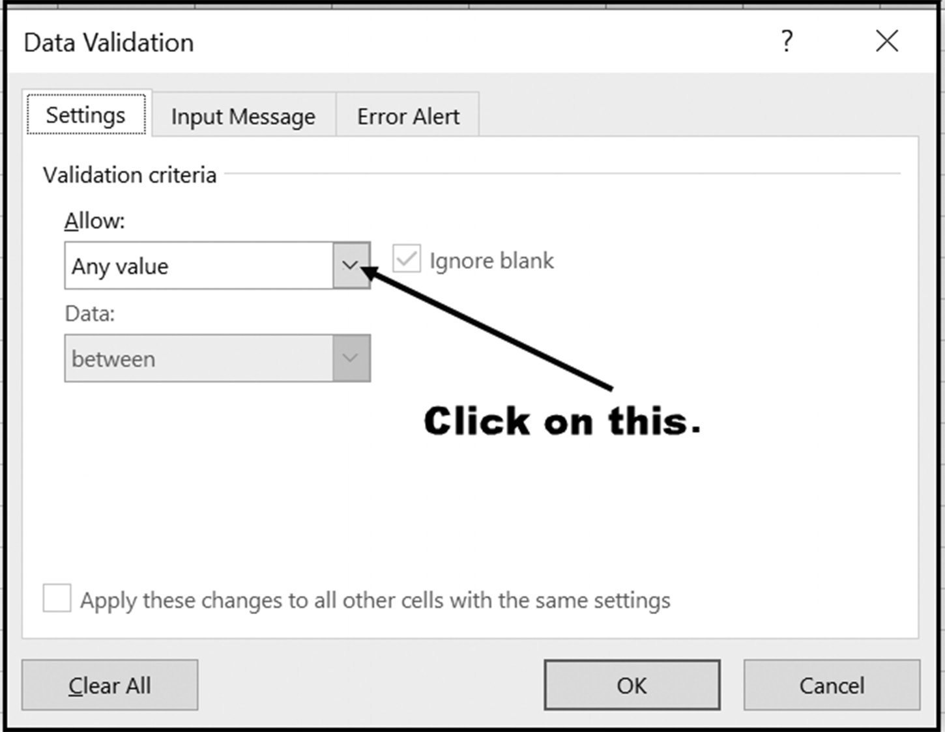

Figure 8.5 The Data Validation dialog box

For a drop-down list, select the List option shown in Figure 8.6. It is worthwhile
noticing, however, all of the other cell data validation options that are available.
While the main goal of this section is to explain how to create drop-down lists, Data
Validation also has many other uses and options which makes it a highly useful feature.
Among the capabilities of this feature include the ability to remind users about the
proper data to enter, specifying the correct and proper data type to be entered into
a cell, and restricting entry of data into the cell(s) based on specific criteria and vary-
ing levels of control. In essence, as the name suggests, there are options to attempt
to validate the data being entered, so as to ensure that only the proper type of data
is entered into a specified cell. You can consult other resources to explore the many
other uses of this feature.
286 exCel BasiCs
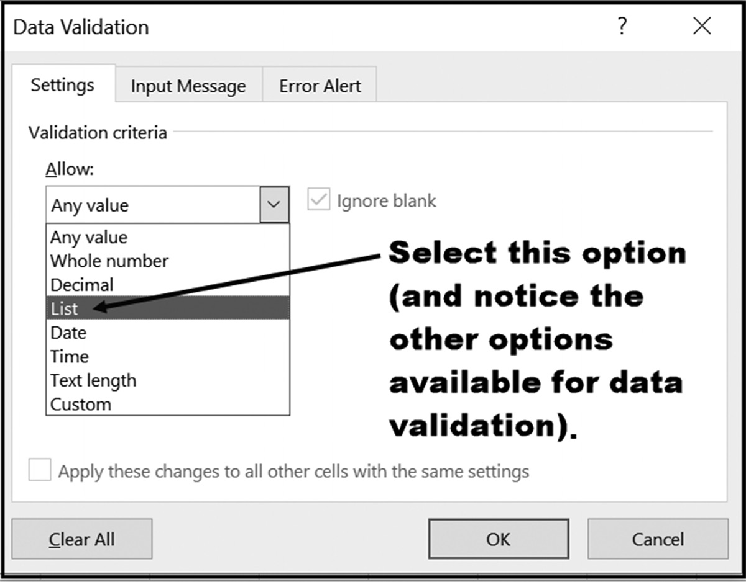

Figure 8.6 Selecting the List option

Once the List option is selected, all that remains is to designate the location of the
drop-down choice list, as shown in Figure 8.7. As our example list, previously shown
in Figure 8.3, is located in cells E1 through E5, this is the entered cell range. Note the
equal sign before the range. This sign is automatically entered if the list is entered by
highlighting, but must be typed in when the list range is entered manually.
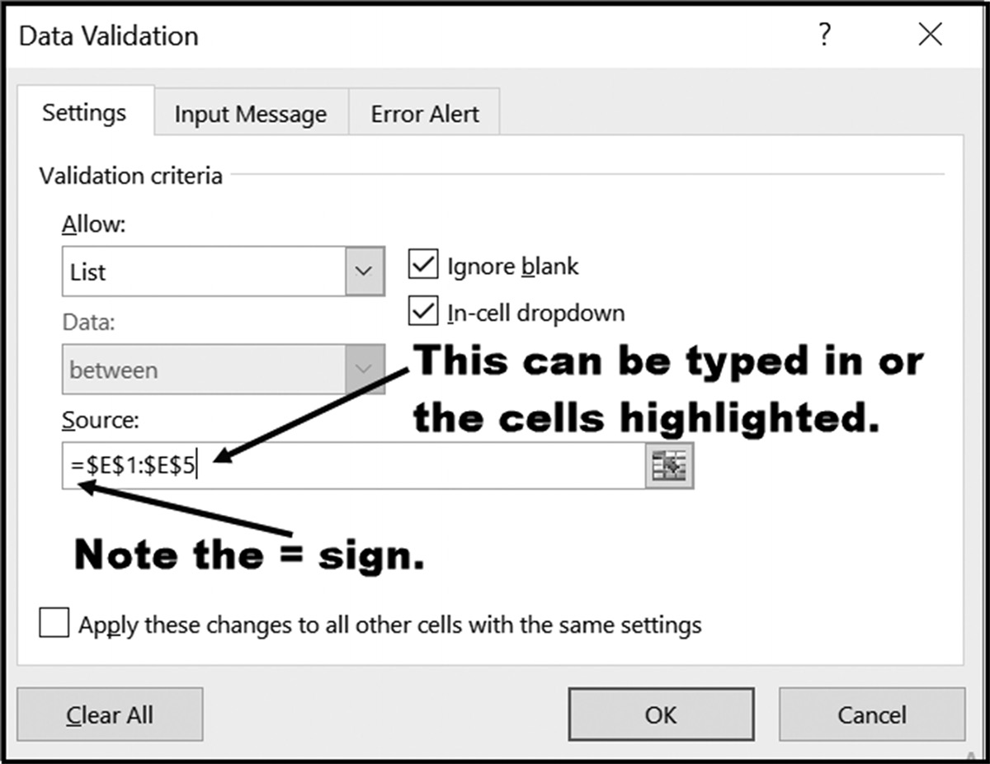

Figure 8.7 Designating the drop-down list location

After the list location is designated in the Data Validation dialog and the OK button
pressed, the drop-down list has been activated for the selected data entry cell.
intermediate and advanCed teChniques 287

EXERCISES 8.1

1. What is the primary purpose for using a drop-down list?
2. What are the two required elements needed for a drop-down list?
3. Using the three-step procedure presented in this section, create the drop-down
list shown below with the following changes: put the label currently in cell A1 in cell A4 and make B4 the data entry cell.
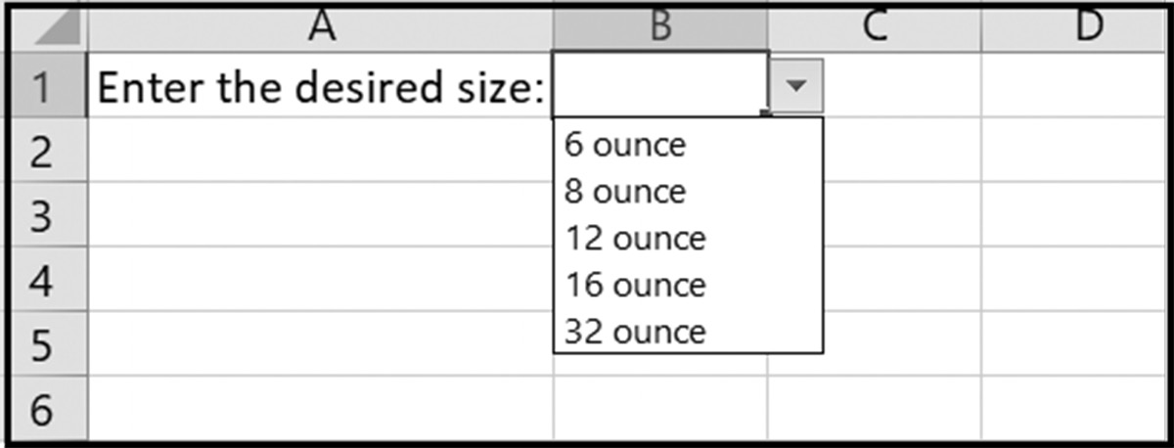

4. Add a second drop-down list to the spreadsheet created in Exercise 3 that displays
the label What drink do you want in cell A1 and creates cell B1 as the data entry cell for a drop-down list containing the seven choices: Water, Coke, Pepsi, 7-Up, Dr. Pepper, Sierra Mist, and Slurpee.
5. Create a spreadsheet that asks for a state and have a data entry cell of your choice
select from a list containing the following 10 choices: CA, CT, FL, IL, IN, KY, NJ, NY, MA, and WI.

8.2 CORRECTING ROUNDING ERRORS
Seemingly incorrect results are sometimes displayed when monetary values are dis-
played to the nearest penny or dollar. For example, consider the display shown in
Figure 8.8. The value in cell B5 was correctly calculated using the formula =B3+B4.
Clearly, however, the displayed sum is incorrect and should be $58 and not $59.
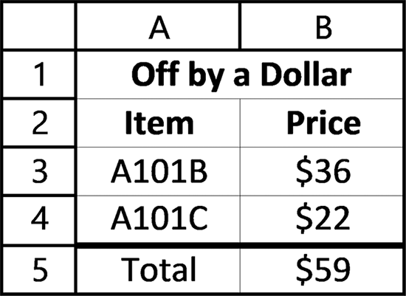

Figure 8.8 An incorrect total
The problem is that although the values in cells B3 and B4 are displayed to the nearest
dollar, the actual cell values are $36.42 and $22.25, and the value stored in cell B5 is 288 exCel BasiCs

$58.67. When rounded to the nearest dollar amount, however, this value gets rounded
up to the next highest dollar amount, which results in $59 being displayed in cell B5.
The correct total is displayed in Figure 8.9.
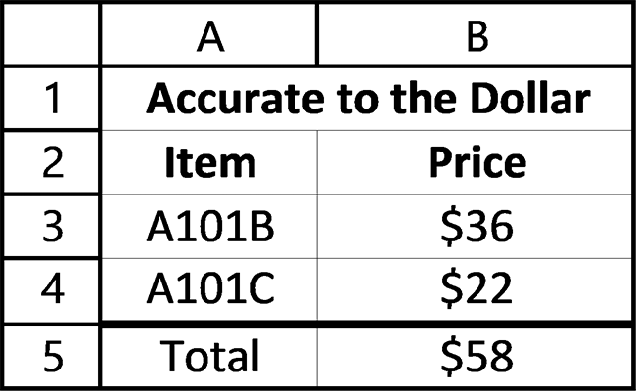

Figure 8.9 A correct total

The solution to displaying a correct total is to round the values in the cells B3 and B4
to the nearest dollar amount before they are added. This is done using the ROUND( )
function when the total is calculated. The format of the ROUND( ) function is
ROUND(value, digits)
where digits is the number of decimal digits the value is to be rounded. Figure 8.10
shows how this formula is used in cell B5 to produce the display shown in Figure 8.9.
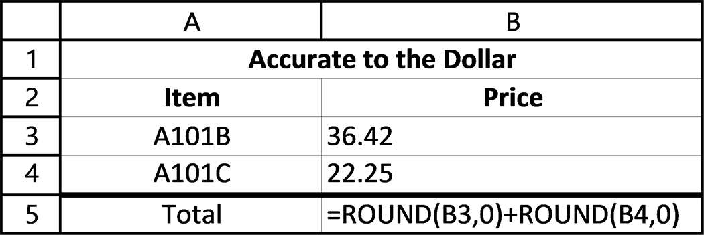

Figure 8.10 The formulas underlying Figure 8.9
In practice, for long lists of numbers, it is easier to either create a new column where
each cell in the new column contains the rounded value of the corresponding cells in
the original list of values, as shown in Figure 8.11.1
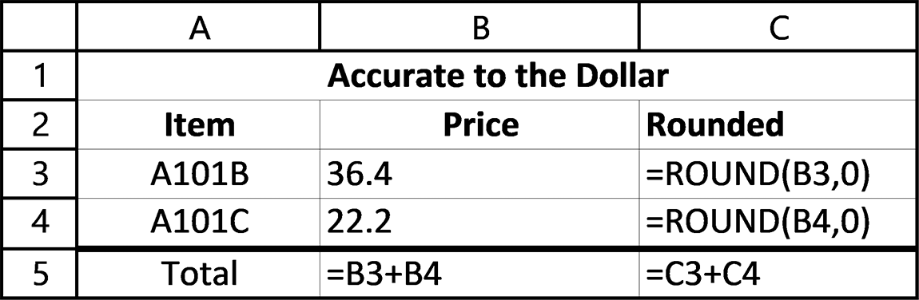

Figure 8.11 Adding a column for the rounded values

1 Additionally, a single array formula can be used to calculate the total. Array formulas are introduced in Section 8.4. Briefly, using an array formula, you would leave all cell values as they are and enter the following formula into cell B5: =SUM(ROUND(B3:B4,0)). Pressing the Shift + Ctrl + Enter keys creates the array formula. For a longer and different list of numbers, simply replace the range B3:B4 with the data range you want to round and sum.
intermediate and advanCed teChniques 289

8.3 CREATING DE-DUPING KEYS FOR REMOVING
DUPLICATE RECORDS
Deleting duplicate names and addresses in email and postal mailing lists, informally
referred to as de-duping, is a major concern for most organizations. The reason is that
duplicate entries in postal lists directly affect mailing costs, with generally no offset-
ting advantages. Similarly, duplicate emails tend to annoy the recipient, which is the
opposite of what the sender is trying to achieve.
As an example, consider the list of names illustrated in Figure 8.12. As shown, all of the entries represent the same person, but have different repre-
sentation of the names and street addresses. The general problem is that names are
frequently misspelled or nicknames used, such as Jack for John and Bob for Robert.
These all result in the same person having multiple entries in the list. Interestingly,
city and state names generally are not a problem, because they are generally entered
automatically from a look-up table based on the address zip code.
Although there is no removal method that is 100% fool-proof, a number of de-
duping methods can be used. One of the simplest and extremely effective methods is
to create a text string, referred to as a de-dup key, that extracts pertinent information
for each list item.
As an example, consider Figure 8.12 that contains five names, all of which refer to
the same person. A de-dup key for this list is displayed in column G. This de-dup key
consists of the first letter in a person’s first and last names, the first four letters of the
street address, and the zip code. This particular key relies heavily on numbers, which
typically are not mis-typed on entry, and the first letter of a name, which typically is
accurate (It will not, of course, catch a name that starts with a different letter.) The
majority of de-dup keys use this type of scheme, with specific changes in the key to
account for specifics of the list being maintained.
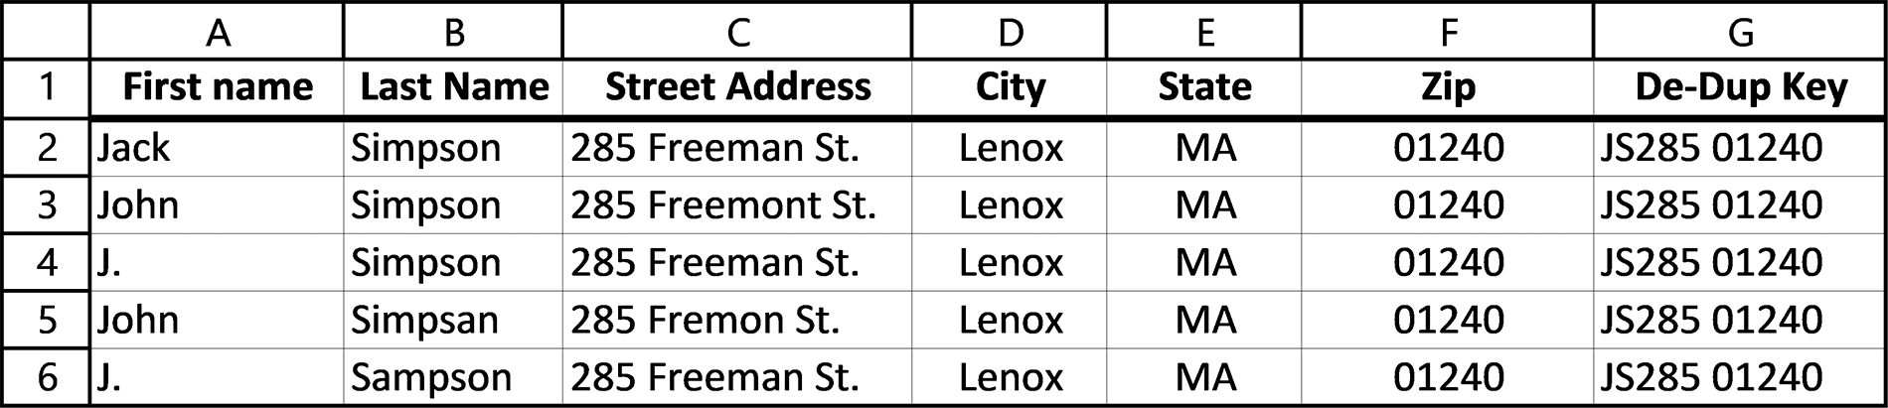

Figure 8.12 Duplicate data for the same person

8.4 ARRAY FUNCTIONS - THE SUMPRODUCT( ) FUNCTION

We have been using Excel’s functions to operate on individual cells and values, one data
item at a time. Additionally, many Excel functions can manipulate complete arrays, 290 exCel BasiCs

one array with another. Such array formulas require ranges of cells as individual argu-
ments and are entered by pressing the Ctrl-Shift-Enter keys together. Doing so places
the formula in curly braces, {formula in here}, which indicates that the formula will be
applied to each cell in the range listed in the formula. An array can be either a single
row, column, or a table consisting of rows and columns.
Although the mechanics of array processing is beyond the scope of this text, the
SUMPRODUCT( ) array function can be employed by simply entered by simply writ-
ing the function and pressing the Enter key. As such, it operates in much the same
fashion as the functions described in the prior sections. The reason that this function
is so useful is that it can be used to multiply the corresponding values of two or more
rows or columns (arrays) and sum the resulting products to find a total. The syntax for
this function is
SUMPRODUCT(range-1, range-2, … range-n)
The only requirement in using this function is that the range sizes of each argument
must be the same. If only one range is supplied, the function will sum the values in the
range; if two or more ranges are supplied, the first range values in each array will be
multiplied together, and the result then added to the total. Then, this process would
continue through all elements of the array until the end is reached, with the total
being updated after the multiplication of each corresponding set of values. The final
total would be the sum of all of the multiplications done with the arrays provided. Up
to 255 arrays(ranges) can be included as function arguments and any non-numeric
array is treated as a zero.

Example
Consider Figure 8.13, which includes the number of individual items sold and their
prices, in columns A and C, respectively. The individual revenue values in column D
are generated by multiplying the corresponding values in columns B and C, and the
total displayed in cell D8 uses the formula =SUM(D2:D7)
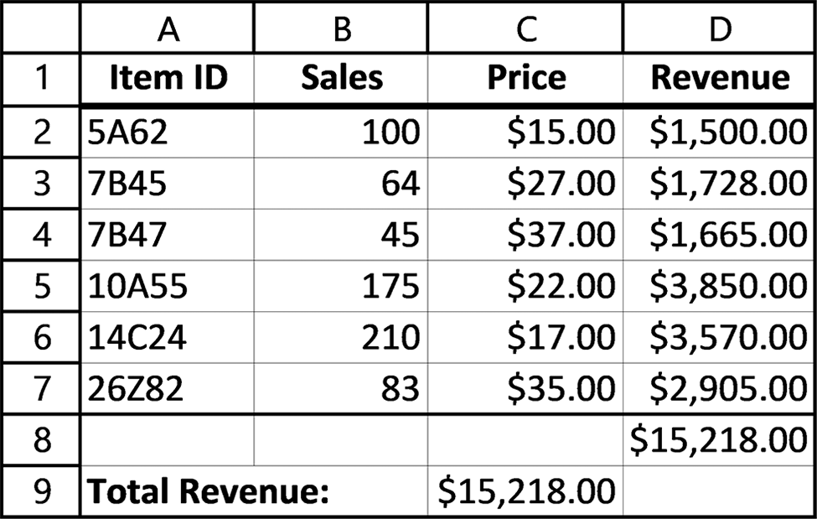

Figure 8.13 Calculating Total revenue
intermediate and advanCed teChniques 291

If, however, all that is required is the total revenue, this can be calculated directly
without the necessity of column D at all, as shown in cell C9. The formula in cell C9
computes this total using the formula =SUMPRODUCT(B2:B7,C2:C7).
The first function argument is the range B2:B7, and the second function argument
is the range C2:C7. The SUMPRODUCT( ) function multiplies each corresponding
element in these arrays; that is B2*C2, B3*C3, and so on, stores them temporarily in
an internal array, and then sums the values to provide the final result.
Although the SUMPRODUCT( ) function may be of limited use in basic spread-
sheets, it is extremely valuable in advanced applications containing hundreds of en-
tries. In these applications where total revenue, time, and other business metrics are
needed without the creation of an extra column, such as column D in Figure 8.13,
it is invaluable. Additionally, it has useful applications in Conditional Formatting, as
presented in the next section.

EXERCISES 8.4

1. Create the following spreadsheet on your computer.
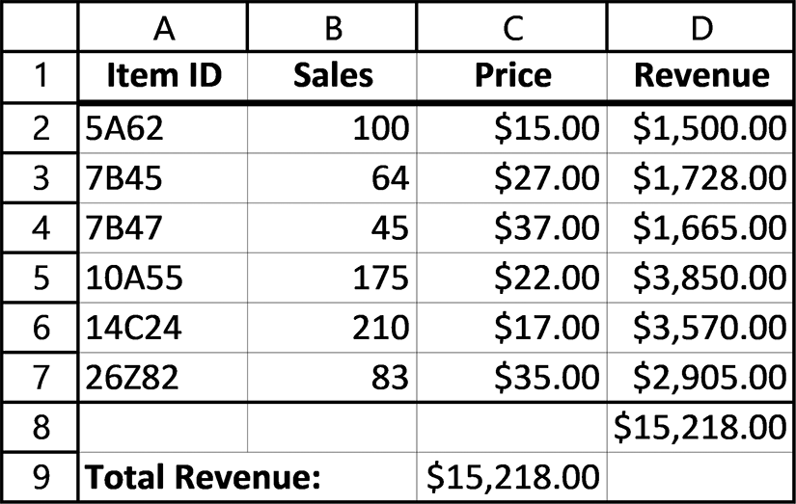

2. Eliminate Column D in Figure 8.14 below and calculate the Total Paid using
a SUMPRODUCT( ) function. The formula containing this function should be placed in cell C8 and the text Total Paid: placed in cell B8.
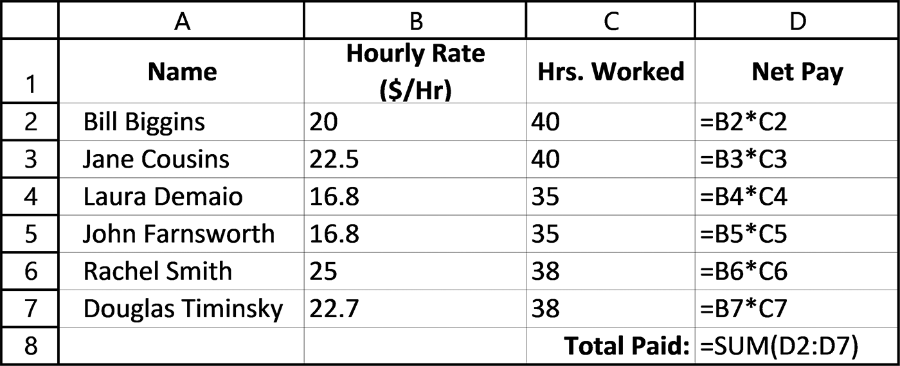

Figure 8.14 Spreadsheet for Exercise 2
292 exCel BasiCs

8.5 USER-ENTERED CONDITIONAL FORMATTING FORMULAS
Once a spreadsheet cell is highlighted, most applications also require either highlight-
ing the complete row or another item in the row containing the initially highlighted
quantity. For example, in a spreadsheet highlighting sales exceeding a given amount,
the sales person achieving this sales goal would also be highlighted.
Highlighting a complete row, or individual row items, depending on one cell’s value
in the row requires a user-entered conditional formatting rule. To see how this is ac-
complished, consider that each row in Figure 8.15 with a final grade average greater
than 90 is to be highlighted.
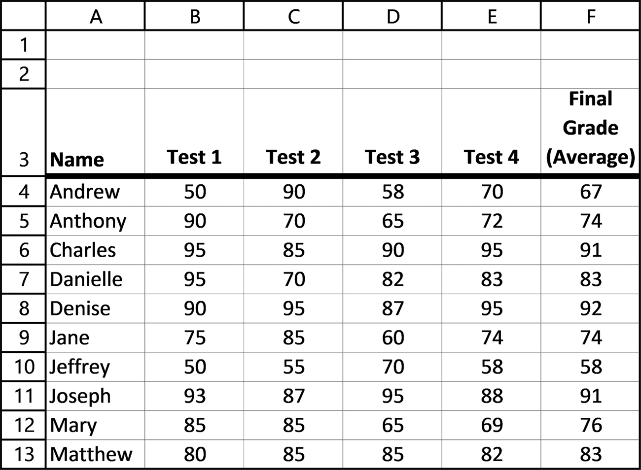

Figure 8.15 The original grade sheet

To accomplish the task of highlighting a complete row based on one cell’s value in the
row requires the following steps:
Step 1: Highlight all of the columns or rows that will be subject to the conditional
formatting. For Figure 8.15 this means highlighting the range A4 through F13.
Step 2: Activate Conditional Formatting by clicking on the Home tab, Styles Group
Conditional Formatting Icon, as shown in Figure 8.16
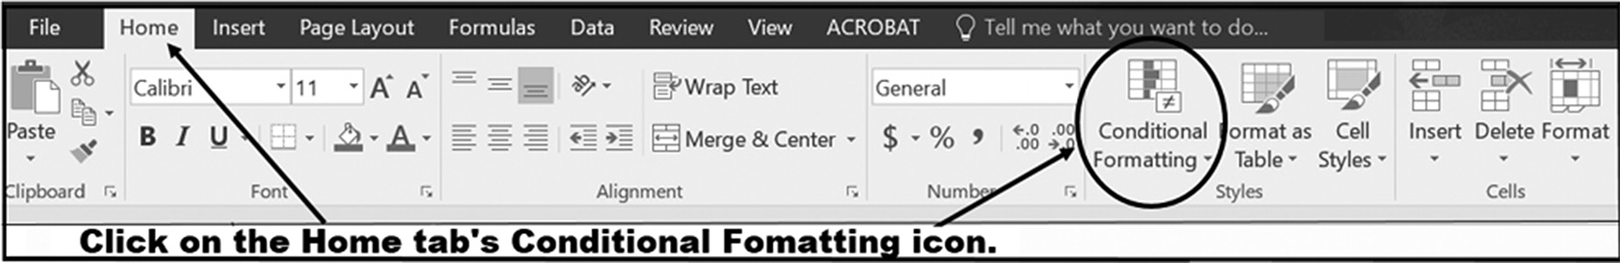

Figure 8.16 Activating conditional formatting
intermediate and advanCed teChniques 293

Step 3: Select the New Rule option from the displayed drop-down menu, as shown in
Figure 8.18, once the Conditional Formatting has been activated.
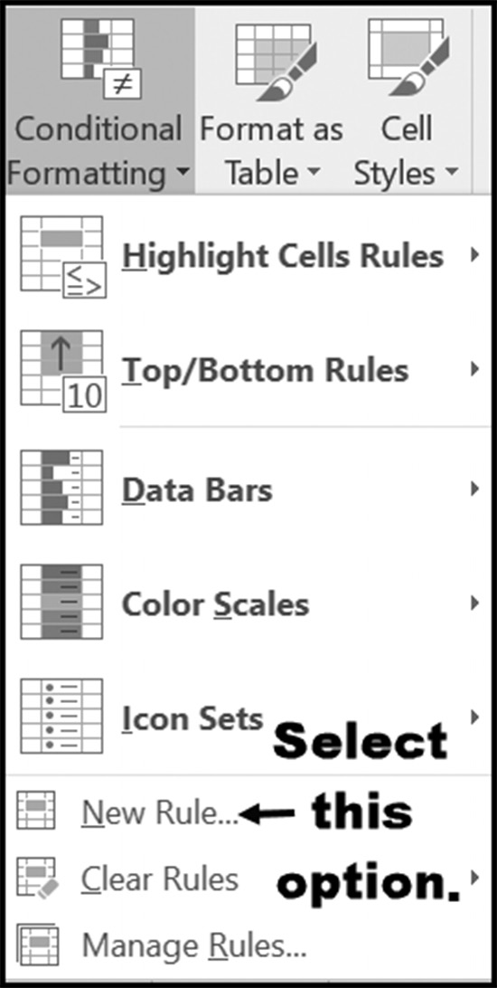

Figure 8.17 Creating a user-entered rule

Clicking the New Rule option brings up the New Formatting Rule dialog box shown
in Figure 8.18. As shown in this figure, enter the formula =$F4 > 90, and then click
the Format button to set the specifics of the conditional cell format. Once the format
has been set, click “OK” to set the conditional format.
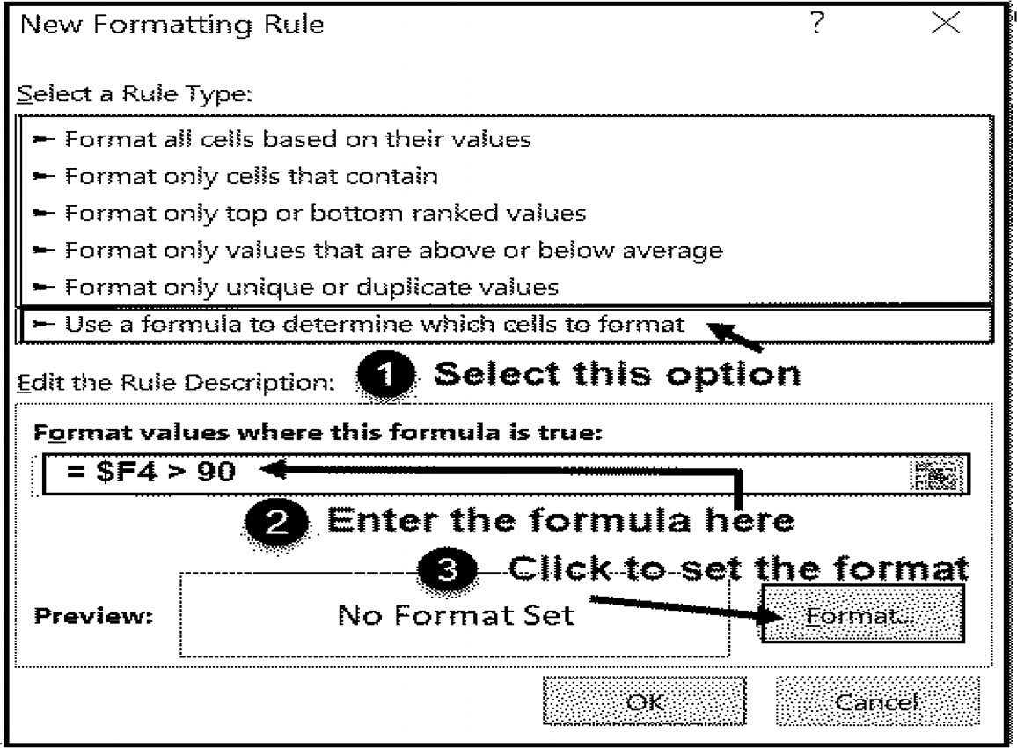

Figure 8.18 Entering Conditional Formatting (using a formula) 294 exCel BasiCs

Figure 8.19 illustrates the effect of entering the conditional formatting formula = $F4 >
90 in the Dialog Box shown in Figure 8.17 and pressing the OK button.
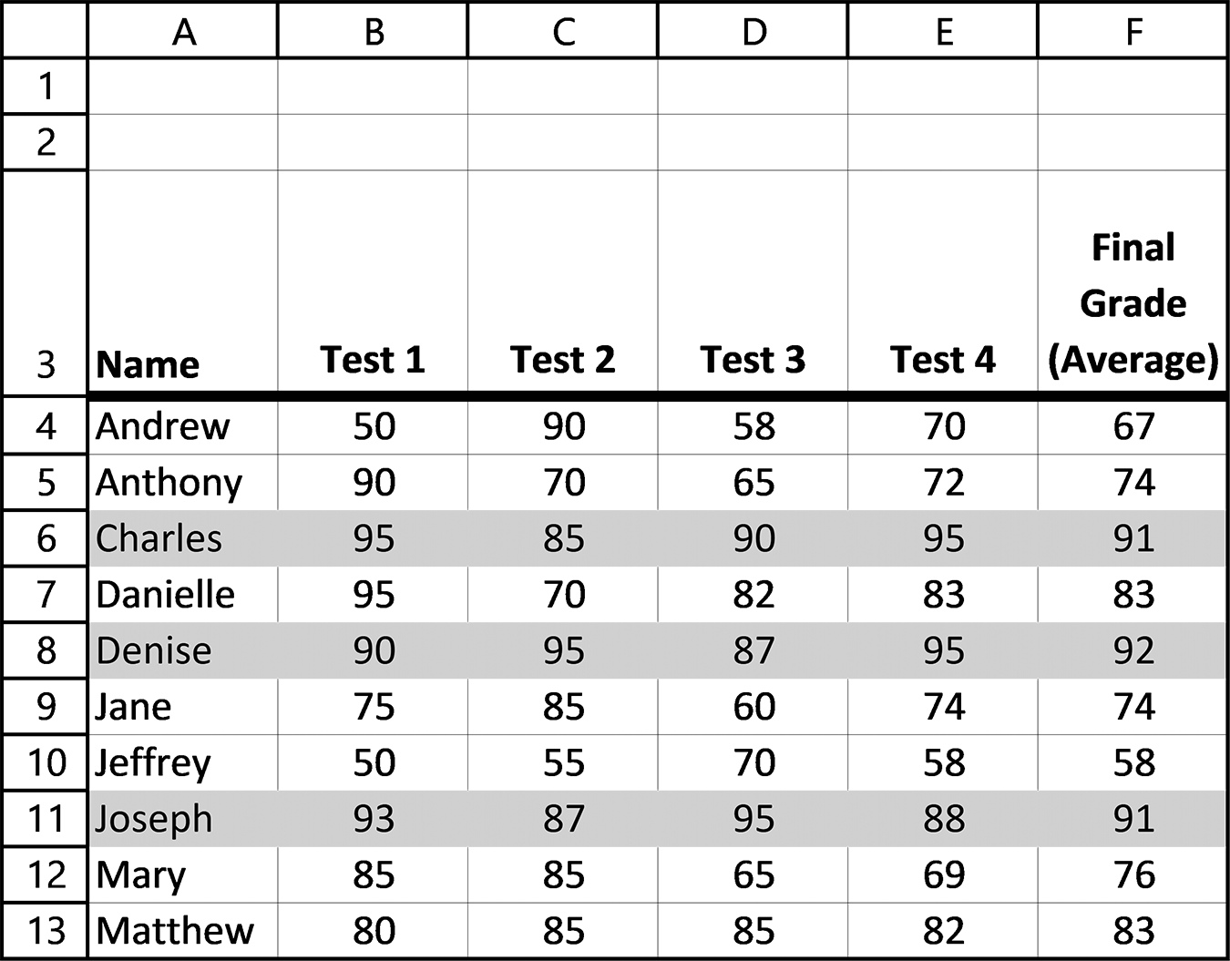

Figure 8.19 The display produced by the user-entered Conditional Format

To understand how the condition was applied, it is easier to visualize the formula as
being copied to each cell in the designated range, as is shown in Figure 8.20. The $F
designation ensures that the column letter will not be changed as the formula is cop-
ied (mixed cell referencing). However, as the formula is copied down to each row, the
row number is changed because the row number has not been locked with a $ sign.
Thus, each cell in a row will use the value in that row’s column F to determine if the
final grade for each row is greater than 90. When this condition is met, every cell in
the row has its conditional criteria met, and the cell is highlighted. Because each cell
is highlighted, it appears to make the complete row highlighted, which is the desired
effect.
This is a good example of the value of mixed cell referencing, when only one, but
not both of the components of a cell reference, is prevented from changing, and the
other can change. In this case, we wanted to ensure that the reference would continue
to be in Column F, but the row number could change.
intermediate and advanCed teChniques 295
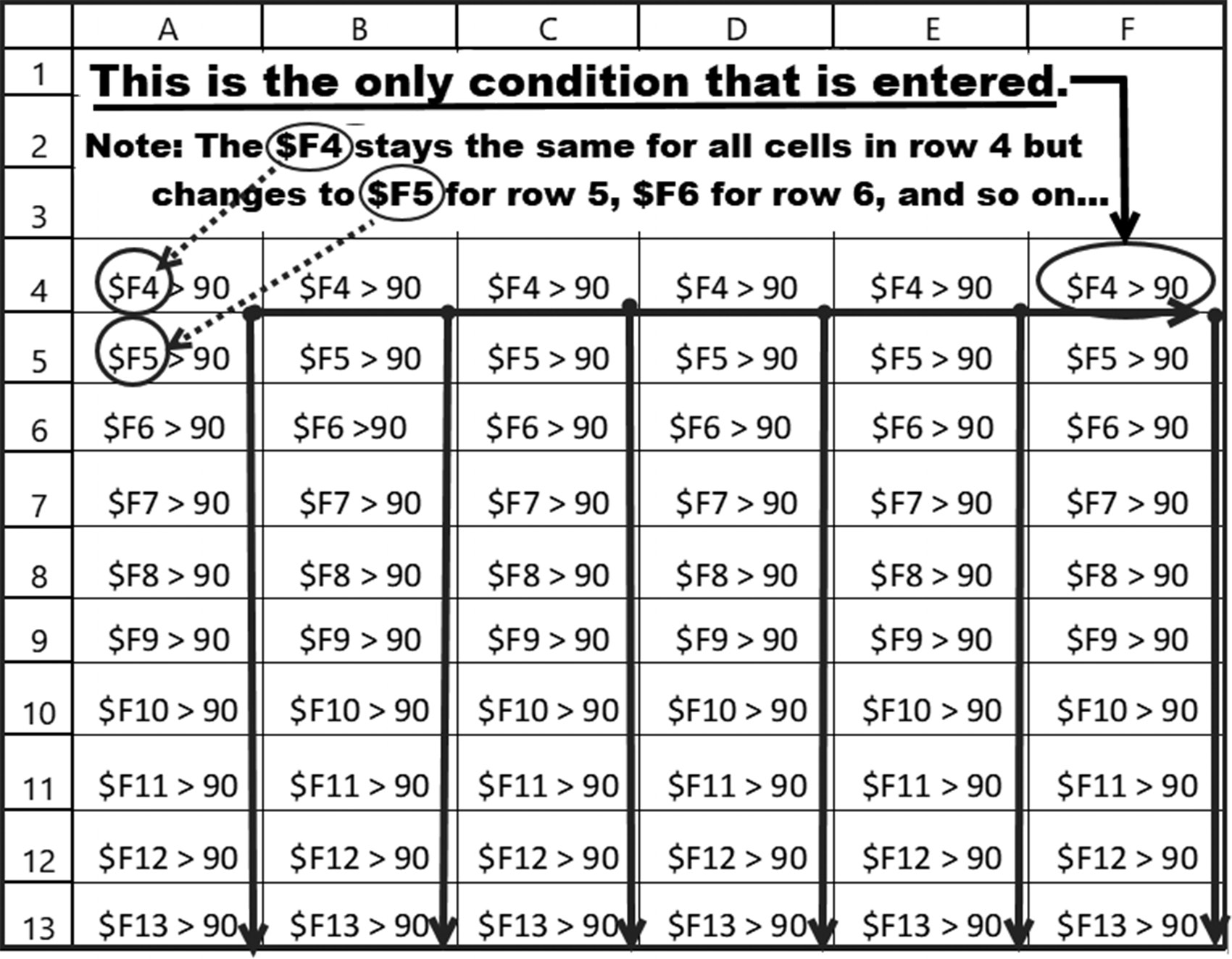

Figure 8.20 Conditional Formatting Using Mixed Cell Referencing

Conditional formatting is a very powerful and useful feature for varying the format
of cells based on the meeting of certain conditions. The use of a formula to specify
conditional formatting rules can allow increased power and capability when using this
feature. As an example, consider the case where you want to test the value in one cell
or range of cells (or maybe multiple cells or ranges of cells) as a condition for format-
ting a third cell (or range of cells). The way to do this would be to specify the condi-
tion using a formula employing AND and OR functions to check the values in certain
cells, while specifying that other cells would be formatted based on the evaluation of
the conditions.
296 exCel BasiCs

EXERCISES 8.5
1. Enter the following grade spreadsheet, and conditionally format it to produce
the spreadsheet shown in the second figure, using the condition of FINAL GRADE(AVERAGE) being greater than 90 (gray highlighting).
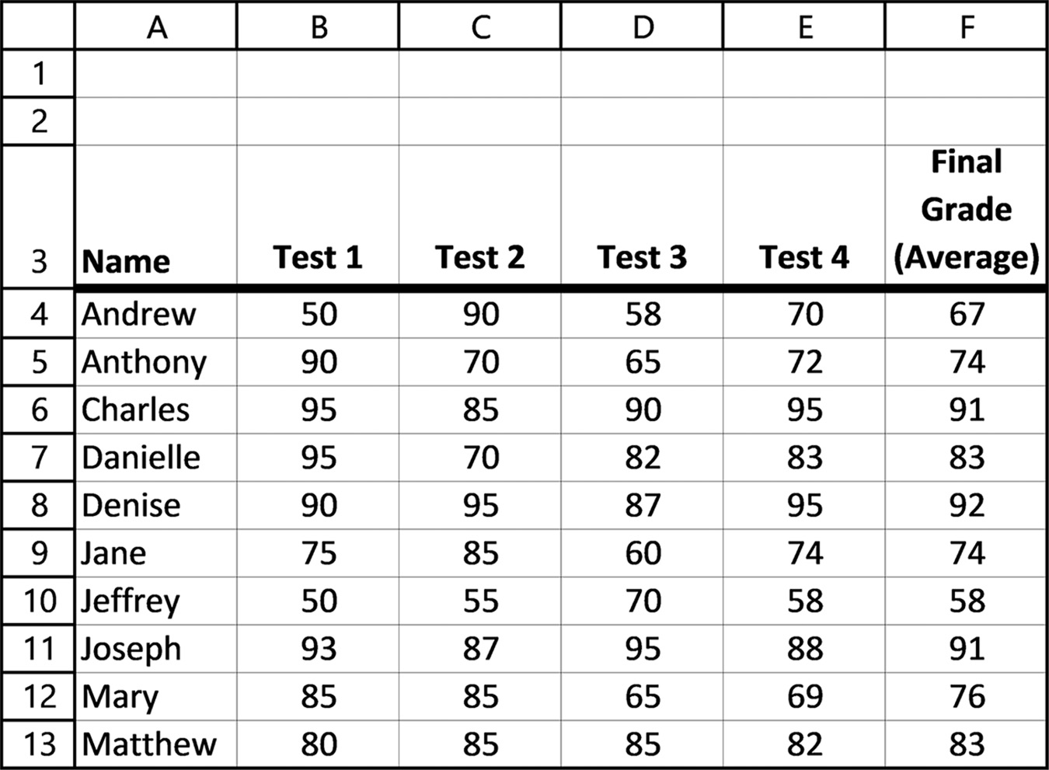
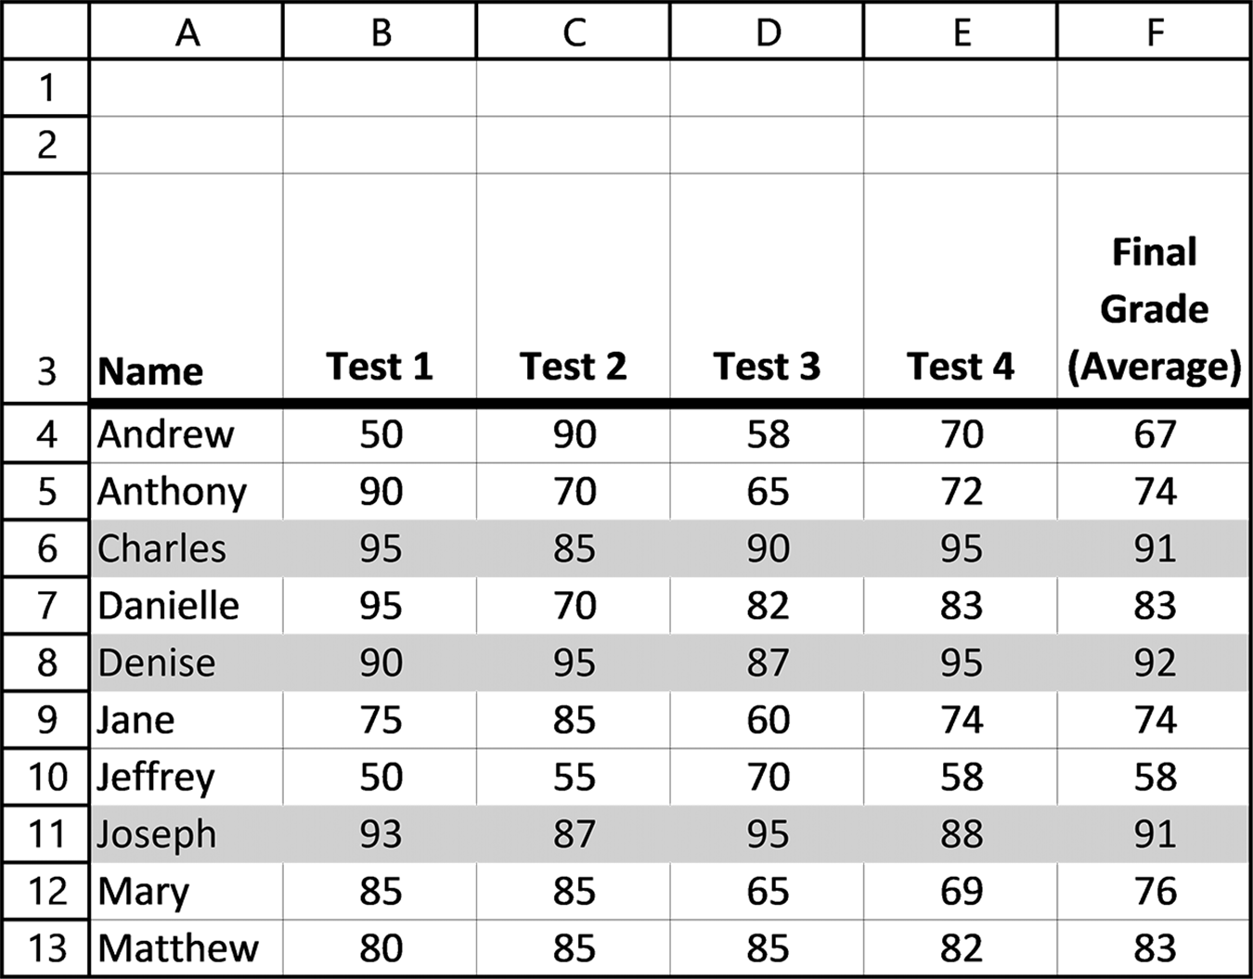
intermediate and advanCed teChniques 297

2. Remove the first two rows from the original spreadsheet shown in Exercise 1 and
then highlight all the rows with a final grade average equal to or greater than 90. Select the format of your choice.
3. Conditionally format the original Exercise 1 grade spreadsheet so that all rows
having a final grade average lower than 75 are highlighted. Select the format of your choice.

8.6 CHAPTER APPENDIX: RESTRICTING CELL ACCESS

In most professionally constructed spreadsheets, the end-user is permitted access
only to those cells that require user-input data, and is prevented from accessing any
other cells. This restriction prevents the user from accidentally or deliberately modi-
fying, deleting, or formatting any cells in the worksheet except for those that require
user input.
Two conditions must be fulfilled for a cell to be in a restricted mode (that is, it can-
not be accessed by a user): the cell itself must be formatted as locked and the spread-
sheet itself, as a whole, must be put into protected mode. When a new spreadsheet is
activated, all the cells in the worksheet are, by default, formatted as locked, but the
spreadsheet is in an unprotected mode. Thus, initially only one of the two conditions
is fulfilled and all cells in the worksheet can be accessed. To restrict user access from
one or more cells, one of the following two procedures can be used. The details of
implementing each procedure are presented in the following pages.
Procedure 1:
Step 1: Verify and/or set the entire spreadsheet into an unprotected mode.
Step 2: Verify and/or check that all cells are formatted as locked. (A locked state is
the default for a new sheet).
Step 3: Format those cells that you want a user to have access to as unlocked.
Step 4: Set the entire spreadsheet into protected mode.
Procedure 2:
Step 1: Verify and/or set the entire spreadsheet into an unprotected mode.
Step 2: Format all of the cells in the worksheet as unlocked.
Step 3: Format only those cells that you specifically want to prevent a user from
accessing as locked.
Step 4: Set the entire spreadsheet into protected mode.
In the first procedure, you are initially preventing access to all the cells in the com-
plete worksheet and then opening access only to those cells that you do want the user 298 exCel BasiCs

to access. In the second procedure, you are first opening user access to all the cells
in the worksheet and then preventing access to those cells that you do not want the
user to access.
The first procedure is more generally used because in a practical application the
user is only given access to a small number of input cells, with the remaining cells in
the worksheet (which form the majority of cells in the worksheet) effectively being
placed off-limits. Thus, it makes sense to first put all cells off-limits and then provide
open access to the few cells that you do want users to access. For completeness, the
second approach is also presented.
Procedure 1
Step 1: To ensure that the spreadsheet, as a whole, is in its unprotected mode, click
on the Excel ribbon Review tab, Protect Group, and check that the Protect Sheet
Option is as shown in Figure 8.21a. This option is a toggle switch, so if you clicked on
it as it is shown, it will protect the entire sheet and the icon will appear as shown in
Figure 8.21b. Thus, if the ribbon does appear as shown in Figure 8.21b, click on the
icon to unprotect the spreadsheet so that the ribbon appears as illustrated in Figure
8.21a.
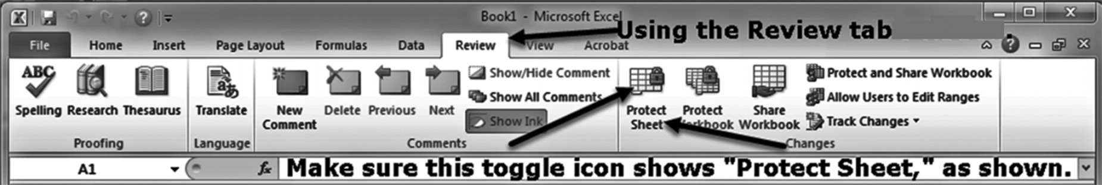

Figure 8.21a The entire worksheet is in unprotected mode
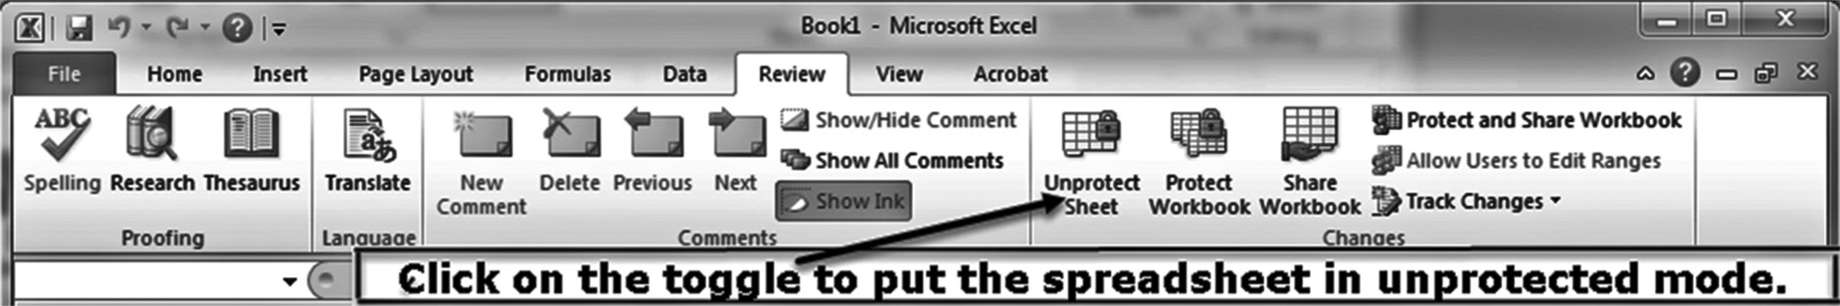

Figure 8.21b The entire worksheet is in protected mode

Step 2: To make sure that all the cells in the worksheet are Formatted as locked,
select all of the cells by left clicking the left, upper hand corner icon in the table, as
shown in Figure 8.22. Then right click the mouse to bring up the submenu shown in
Figure 8.23. From this menu, select the Format option. Because all of the cells in the
table have been selected, the format that you select will apply to all of the cells in the
worksheet.
intermediate and advanCed teChniques 299
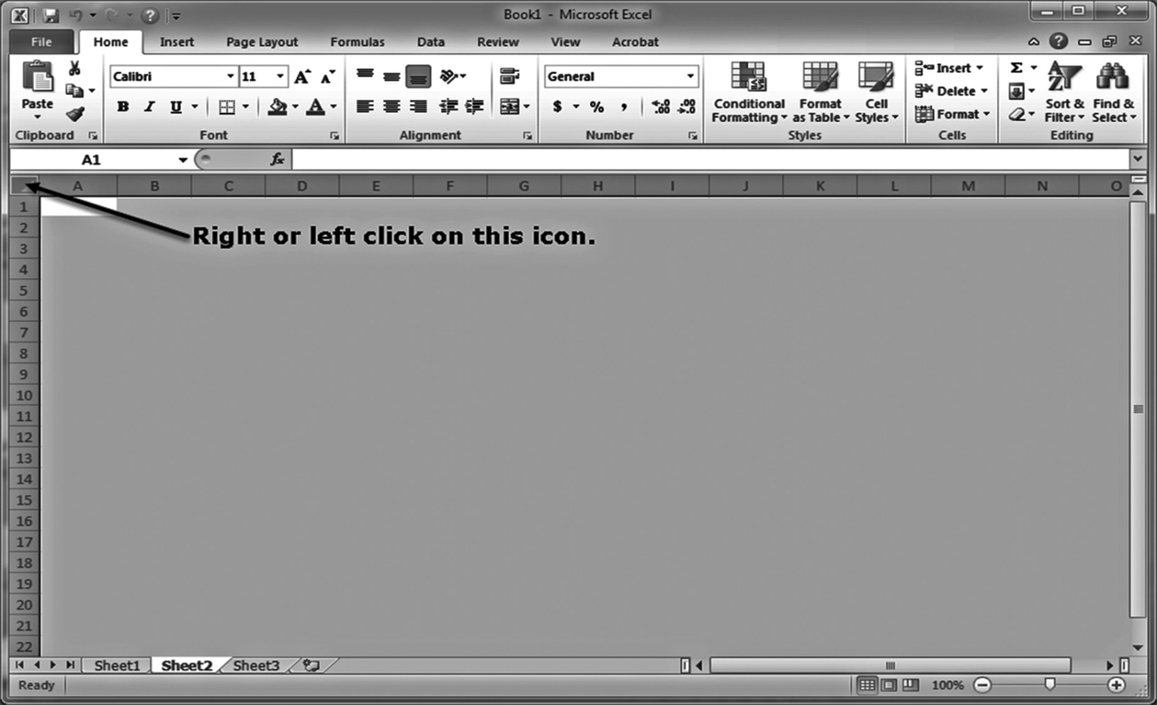

.
Figure 8.22 Selecting all of the cells in a worksheet
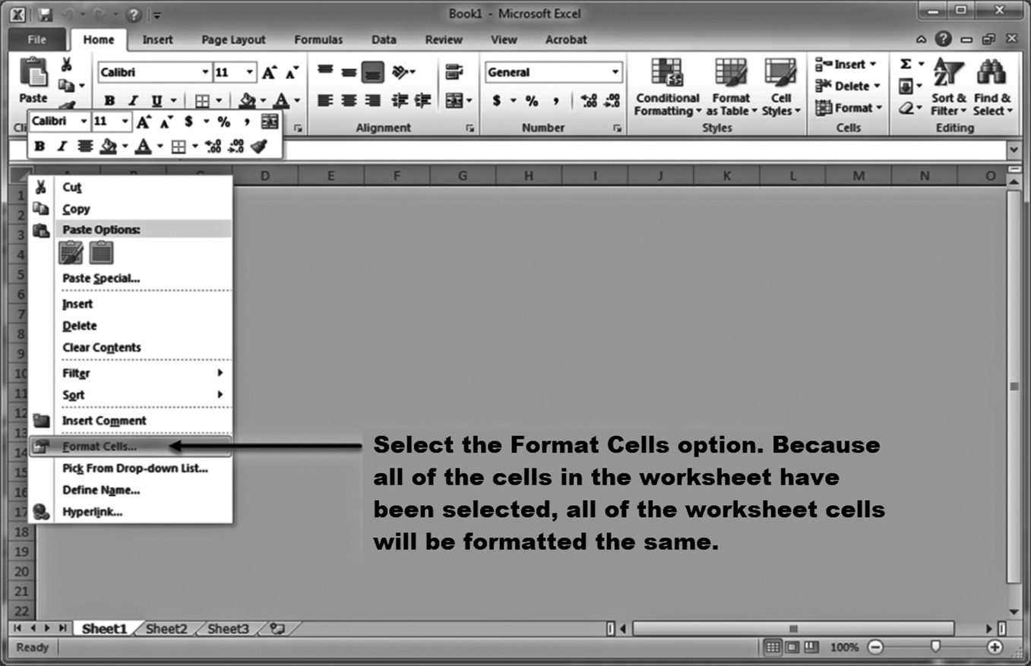

Figure 8.23 Formatting the complete worksheet 300 exCel BasiCs

Once you have selected the Format option, the dialog shown in Figure 8.24 will
appear. On this dialog, click on the Protection Tab; this will bring up the dialog shown
in Figure 8.25. Once this dialog appears, make sure the Locked box is checked (If it
isn’t, check it). Doing this will place all of the cells into a locked format. Note that this
locked cell format only becomes activated and into play when the worksheet itself is
placed in a protected mode.
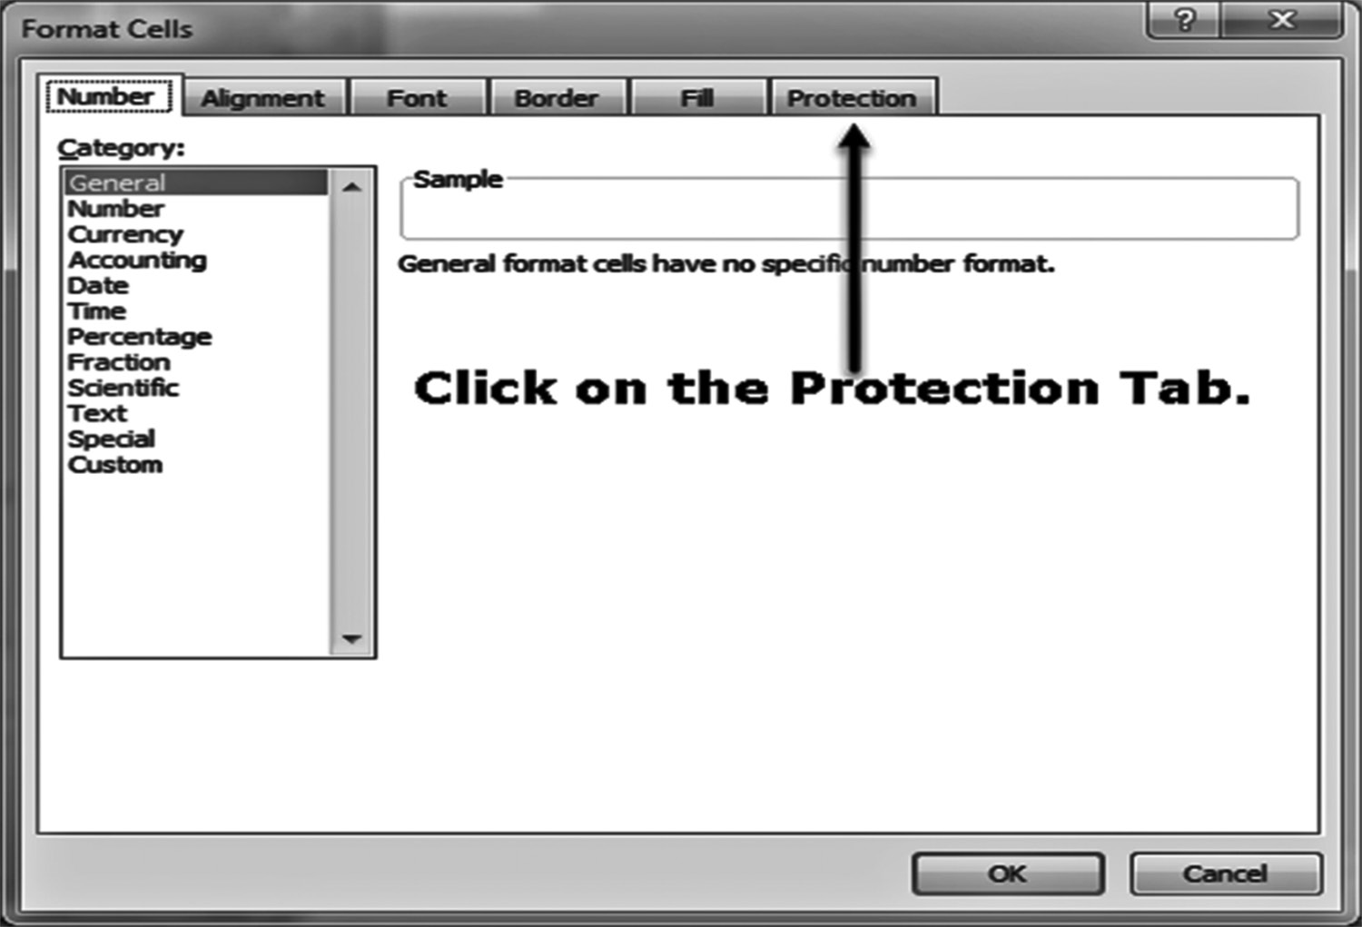

Figure 8.24 Selecting the Protection tab

Step 3: Once all of the cells in the worksheet have been formatted as locked (see Fig-
ure 8.25), you must now unlock only those cells that you want the user to have access
to. Generally, these are the input cells where you want the user to input data.
To do this, select an individual cell or a range of cells that you want to permit the
user access. Then, format these cells as unlocked by right clicking the mouse or select-
ing the Home tab’s Number Group, Format Cells menu, and Protection tab. Because
all of the cells were locked in Step 2, you will find a check mark in the Locked box
option for the cell or range of cells that you highlighted in your spreadsheet. De-select
this format by clicking on the box, so that it appears as shown in Figure 8.26. Doing
this unlocks these cells.
Repeat Step 3 for every cell or range of cells that you want the user to access. When
this process is complete, proceed to Step 4 to activate all of the locks that remain from
Step 2.
intermediate and advanCed teChniques 301
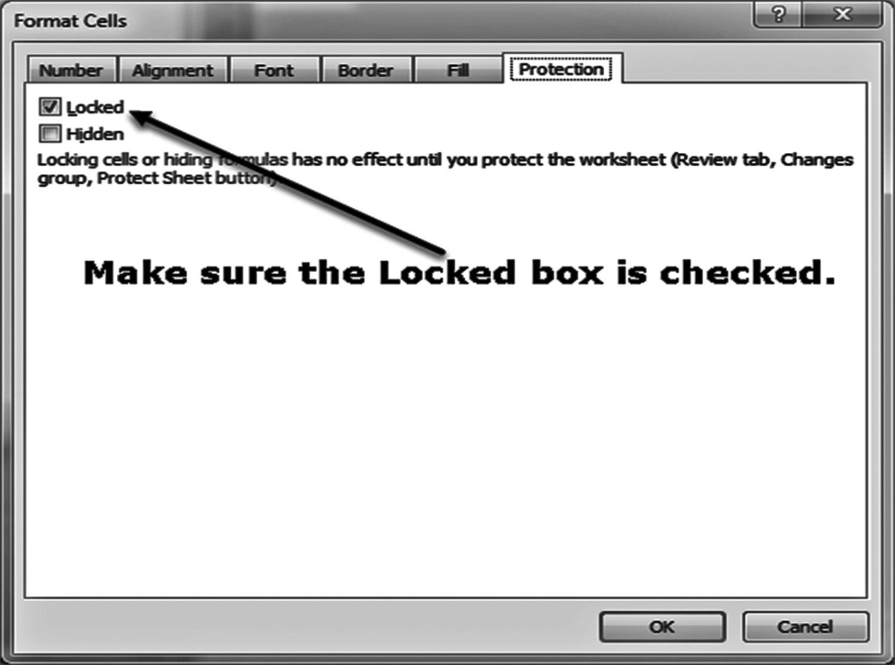

Figure 8.25 Selecting the Locked format
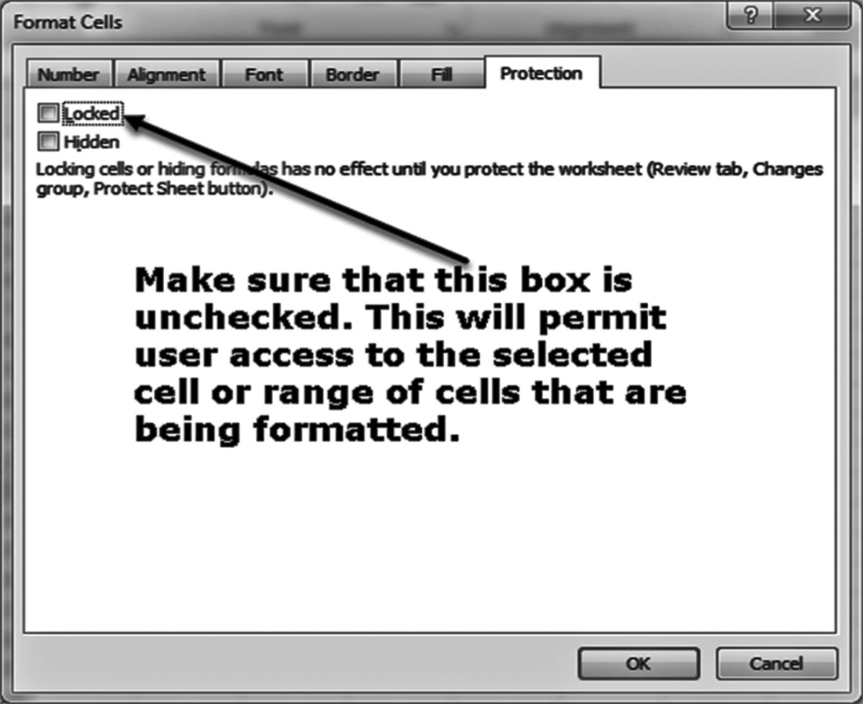

Figure 8.26 Unlocking the selected cell or range of cells 302 exCel BasiCs

Step 4: To activate all of the locks that have been put in place and leave access open
only to those cells that have been formatted as unlocked, click on the Review Tab and
check the Protect Sheet Option, as shown in Figure 8.27. You will be asked to supply
a password, and then reconfirm this password. If you do not supply a password, any
user can use the Review tab’s Protect Sheet option to unprotect the sheet by toggling
the option shown in Figure 8.21b. If you do supply a password, make sure to secure it
in a safe place, as there is no method of retrieving it if it is lost.
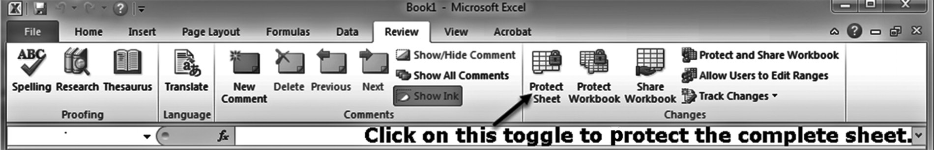

Figure 8.27 Activating all of the cell locks
1. The same procedure used to lock or unlock a cell can be used to hide the formula in a
cell. That is, by clicking the hidden option in the Protection dialog, formulas in cells designated as hidden will not appear when using the Ctrl and (`) shortcut keys. This can be set up using the Excel ribbon Home Tab, Number Group, Format Cells menu,
NOTE Protection, and checking the box for the “Hidden” cell format.
2. To undo any of the locks you have put in place, or to lock additional cells, you first
have to set the status of the complete worksheet to an unprotected state (Step 1). If you have used a password in Step 4, you will be asked to entire this password before being allowed to unprotect the spreadsheet.
Procedure 2
The only difference in procedure 2, as opposed to procedure 1, is that in procedure 2
every cell in the worksheet is first formatted as unlocked. Then, in Step 3, the formats
of those cells that you do not want the user to have access to are formatted as locked.
Steps 1 and 4 remain the same.
No matter which procedure you select to restrict user access to cells within your
spreadsheet, the combination of individually formatting a cell as locked or not, along
with the protection status of the spreadsheet as a whole remains the same. The effects
of the various combinations are summarized in Table 8.1.
Table 8.1 Effect of spreadsheet protection status and individual cell protection formats
Entire Individual Cell Result
Spreadsheet Format
Status
Unprotected Locked or Unlocked Data can be entered, changed, or formatted in every worksheet cell.
Protected Locked Data cannot be entered, changed, or formatted in
the locked cell.
Protected Unlocked Data can be entered or changed, but not formatted in the unlocked cell.
This prevents a user from locking the cell.
A P P E N D I X A
CharaCter Code storage

Prior to 1987, the ASCII (American Standard Code for Information Interchange)
code was used to store characters. This code was limited to representing 256 unique
English language characters. To accommodate international applications using non-
English character sets, Unicode was introduced in 1987. This code is now universally
used and can represent 65,536 unique character codes. The first 256 Unicodes have
the same numerical values as the original 256 ASCII codes. TableA.1 lists the numeric
code values and their corresponding characters.
An individual character’s Unicode can be seen using Table A.1 last listed Unicode
function. Thus, the formula =UNICODE(“A”) returns the number 65. Correspond-
ingly, the formula =CHAR(65) and =UNICHAR(65) both return the letter A.
304 exCel BasiCs

Table A.1 ASCII and first 128 UNICODE Codes
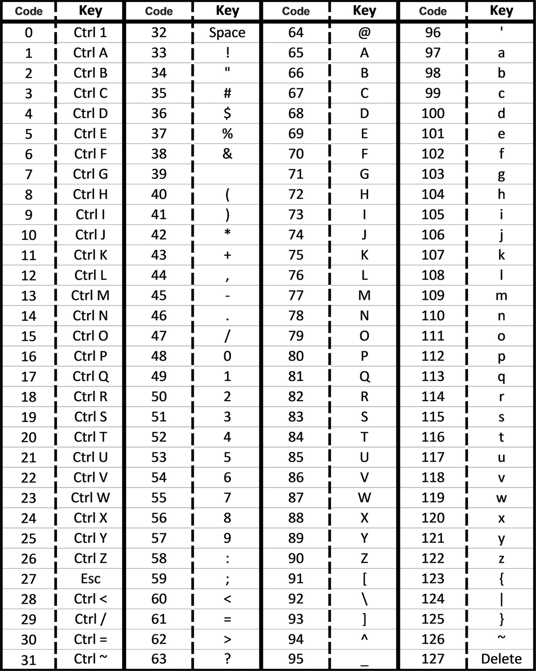
A P P E N D I X B
installing the analysis toolPak

You will need the Analysis ToolPak to create histograms and perform more extensive
statistical analyses than computing simple averages and standard deviations. Before
attempting to install the package, however, first check that it is not already installed.
This is done by seeing if the Data Analysis option, shown as item B in Figure B is
present on the Excel ribbon Data tab, Analysis Group, Data Analysis option, shown as
item A on the figure.
If the Data Analysis option is displayed, the Analysis ToolPak has already been in-
stalled; if not, the installation is begun by first clicking on the File menu option, shown
as item 1 on Figure B.1.
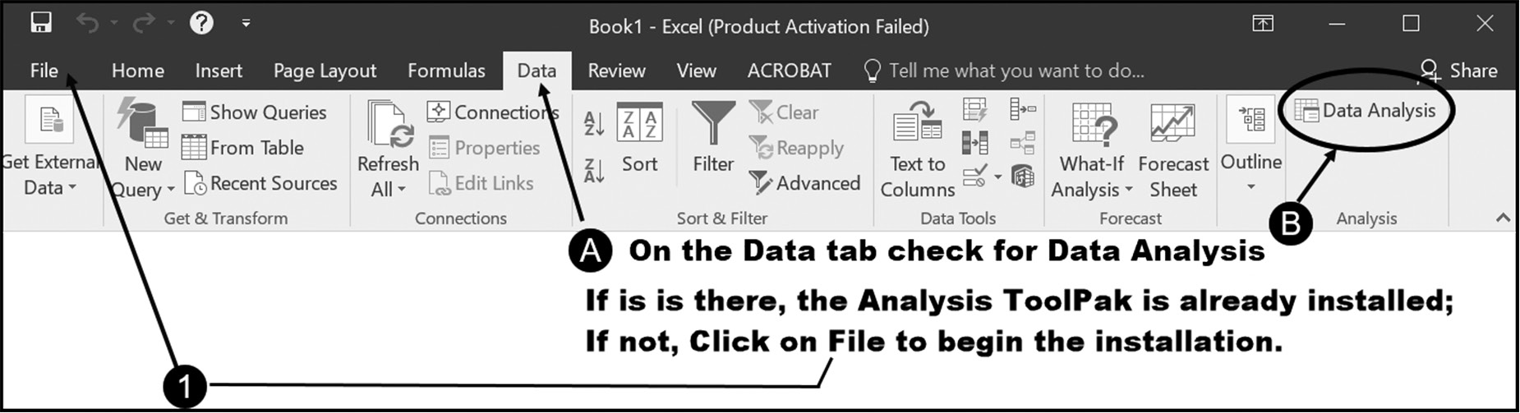

Figure B.1 Checking for the Analysis ToolPak Add-In

Clicking on the File menu option brings up the File submenu, shown in Figure B.2.
Clicking on the options button, shown as item 2 in this figure brings up the first Excel
Options dialog, which is shown in Figure B.3
306 exCel BasiCs
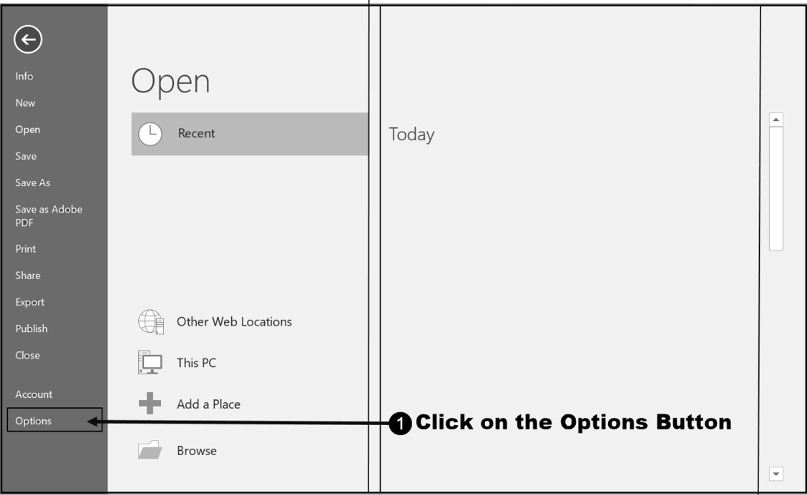

Figure B.2 Use File Options to Load an Add-In

Once the Excel Options dialog box is displayed (see Figure B.3), select the Add-
Ins choice (item 3 and press the OK button (item 4). This will cause the next Excel
Options dialog box, shown in Figure B.4, to appear.
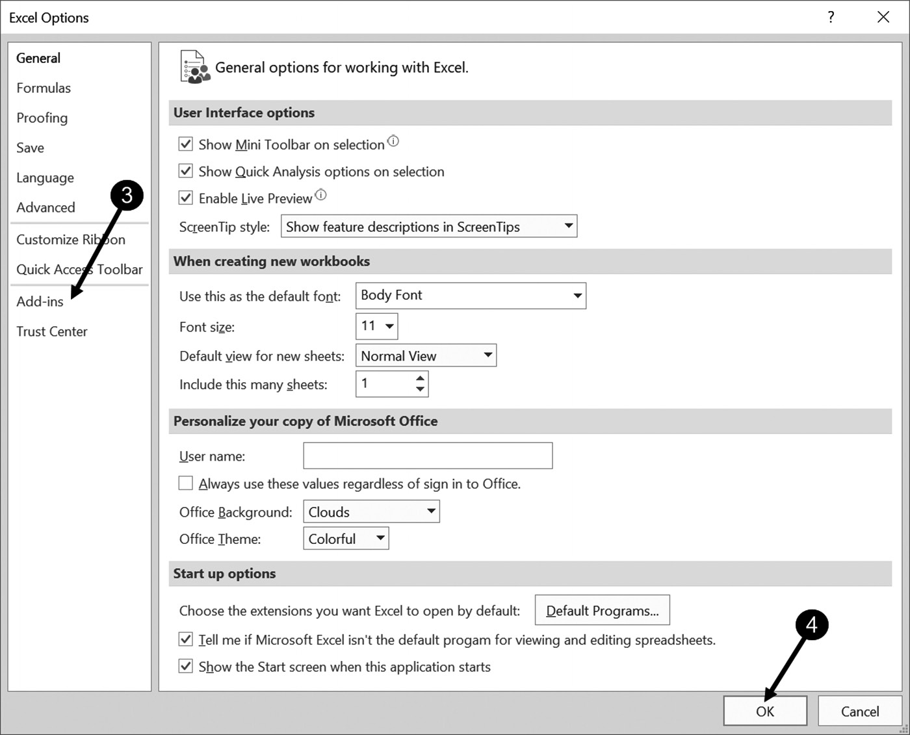

Figure B.3 The first Excel options dialog box
aPPendix B: installinG the analysis toolPak 307

When the dialog shown as Figure B.4 is displayed, click on the Analysis ToolPak (item
5) and then press the Go button (item 6) as shown in the figure� This brings up the
Add-ins dialog box shown in Figure B.5.
The final installation step is to check the Analysis ToolPak checkbox, shown as item
7 on Figure B.4, and then press the OK button (item 8). When this is completed, you
should check that the installation has been completed by rechecking that the Data
Analysis option is available, as shown in Figure B.1.
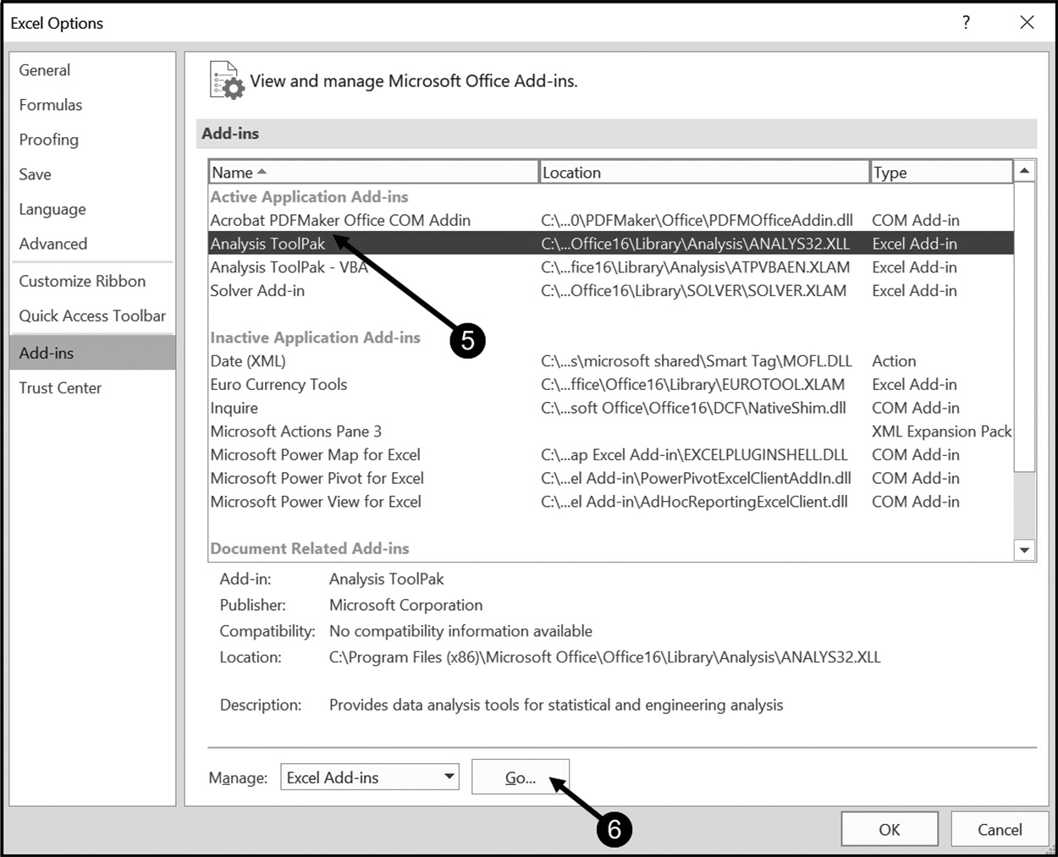

Figure B.4 The second Excel options dialog box
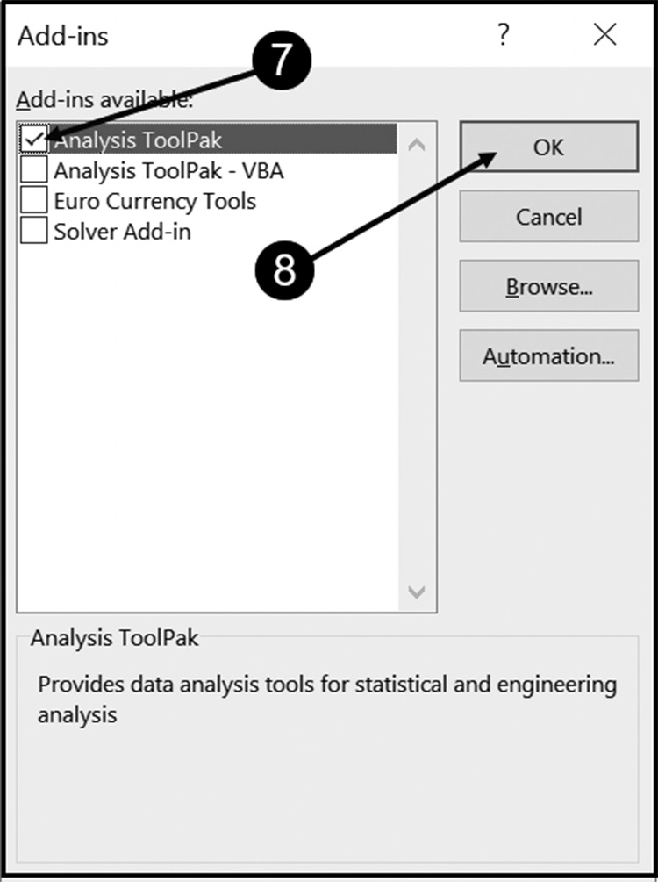

Figure B.5 The Excel Add-ins dialog box
iNDEX

A Copy command, 65

Amortization table, 104–105 Bin column, 193 Analysis toolpak, 94, 194, 305–306 Bins, 192 Array functions, 289–291 Data column, 193 Adaptive pattern matching, 14 Creating histograms Copying cell contents, 13 Associativity, 42 Frequency, 193 Assumptions area, 71
D
C

Cash-balance spreadsheet, 66 DCOUNTA, 277 Cash-flow spreadsheet DMAX, 277 Net cash flow, 65 DMIN, 277 Calculated fields, 226 DCOUNT, 277 Database functions, 277

Cell Fields, 281 Active, 9 List, 236 281 Address, 4 Record, 281 Contents Relational, 281 Formulas, 5 Table, 236, 281 Numbers, 5 Data point, 160 Category labels, 160 Net cash out, 65 Database (Spreadsheet), 280 Criteria range, 264 Net cash in, 65 DSUM, 277

Cell addressing (or cell address), 4 Range, 9 Text, 5 Data series, 160 Dates and boolean data, 8 Debugging, 72 Absolute, 4 De-duping keys, 289 Mixed, 4 Drop-down lists Relative, 4 Data validation, 284, 285 Cell Contents, 5
Cell range, 11 E Central tendency, 94
Changing chart types, 176 Empirical rule, 98 Character code storage Excel table, 236
ASCII, 303
Unicode, 303 F Chart types
Changing chart types Filter (Filtering) also referred to as Searching Fill handle, 13, 39, 65
Column chart, 166
Data point, 160 Copying selected record columns, 266 Advanced filter, 263 Data series, 160
Columns, 81 Criteria employing both AND and OR conditions, 271 Copy to another location, 265
Deleted multiple row(s), 83
Delete row(s), 81 Filter the list, in place, 265 Criteria Range, 265
Insert multiple row(s), 81, 83
Common errors, 27 Multiple AND conditions on the same List Range, 265 Common excel errors, 152, 280
Conditional formatting, 87–118, 292–294 OR condition, 264, 269 criteria range Row, 270
Formulas, 292–295
Highlight cells rules, 110 Home tab Formatting
User-entered conditional value, 113
Alignment group, 58
Consolidation, 118
310 index

Font Group, 58 COUNT, 48 Number group, 58 MAX, 48
Formula(s) MIN, 48
Bar, 9 PMT, 48
Construction rules, 41–42 POWER, 48
Copying, 39–40 PRODUCT, 48
Expressions, 35 SQRT, 48
Operator(s) SUM, 48
Associativity, 41 POWER, 50 Division, 42, 46 PRODUCT, 47 Exponentiation, 46 Statistical Multiplication, 46 AVERAGE, 94 Precedence, 41 COUNT, 94 Subtraction, 46 MAX, 94
SUM, 65 MEDIAN, 94 Function(s) MIN, 94
AVERAGE, 64 MODE.MULT, 94
CLEAN, 91 MODE.SNGL, 95
DATEVALUE, 89 STDEV.P, 95
Date functions, 88 STDEV.S, 95
DATE, 88 SQRT, 50 DATEVALUE, 88 SUM, 7, 53, 64 DAY, 88 Text MONTH, 88 CHAR, 92 NOW, 88 CLEAN, 92 TODAY, 88 CONCAT, 92 WEEKDAY, 88 CONCATENATE, 92 YEAR, 88 LEFT, 92
Financial LEN, 92
COUPDAYS, 101 LOWER, 92 CUMIPMT, 101 & operator, 92 CUMPRINC, 101 RIGHT, 92 DURATION, 101 TRIM, 92 FV, 101 UNICHAR, 92 IRR, 102 UNICODE, 92 NPV, 102 UPPER, 92 PMT, 102 VLOOKUP, 133, 135, 146 PPMT, 102
PV, 102 G
HLOOKUP, 133, 146
Graphs
Information (IS) ISBLANK, 108 Axis title, 162, 183
Bar chart, 157
ISFORMULA, 108 Category labels, 160 ISEVEN, 108
Chart elements, 168, 174–176
ISNONTEXT, 108 Chart object, 161, 162 ISLOGICAL, 108
Chart sheet, 161
ISODD, 108 Chart styles, 163, 170, 184 ISNUMBER, 108
Chart title, 169, 174, 182
Lookup Approximate (closest) match, 137, 147 Coefficient of determination, 188
Column chart, 157
Lookup value, 134, 137 Correlation coefficient, 188 Exact Match, 137, 147
Legend, 162
Return value column, 136, 147 Line chart, 158, 173–177 Match type, 136, 147
Multiple data series, 160
Mathematical OLE (Object Linking and Embedding), 161 Table location, 140, 148
Pie charts, 158, 167–172
AVERAGE, 48 Scatter diagrams, 180 ABS, 48
Single data series, 160
index 311

Trend Lines, 180–188 Value fields, 203, 209
Visualization, 157 Print(ing) Group subtotals Gridlines, 20
Nested, 250 Landscape, 20
Option, 20
H Page layout tab, 21
Highlight cells rules, 111 Portrait mode, 20 Page setup, 21 Highlighting Selected Arguments, 53
Home mortgage, 101 Row and column headings, 21 Print option, 20 I Spreadsheet, 20
Printing spreadsheets, 17–22
Inferential statistics, 94
Input area, 24, 25, 71 Q
L Quick access toolbar, 17, 19, 31 Logical conditions, 130 R

Logical functions Relational expressions, 120 AND, 122 Relative cell referencing, 40 NOT, 122 Restricting cell access OR, 122 Format Cells, 300 XOR, 122 Locked, 297 M Protected, 297
Unlocked, 297
Magic numbers, 69, 71 Unprotected, 297 Mortgage, 101 Results area, 24, 25, 26 Multiple data series, 160 Ribbon tabs, 30
Home tab, 30
N Right-alignment, 6
Name box, 9, 29 Running sub-totals, 73 Nested function, 50 Rounding errors, 287–288
S
O
Open(ing) Scatter diagram, 159, 181–182 Existing spreadsheet, 17 Saving, 18
Operand, 34, 120, 130 New spreadsheet, 17 Advanced filter, 263 Searching, 263–276
More complex, 268–269
P Single data series, 160 Simple find and replace, 268 PivotTable Sort (Sorting)
A single set of ROW and COLUMN fields, 224–225 Multi-level sorting, 240–243
Column fields, 200 Sorting spreadsheet rows, 238–241
Design criteria, 229–231 Spreadsheet, 3
Multiple row fields and multiple value fields, 214, 210 Standard deviations, 96
Multiple row fields and single value fields, 211 String
Refreshing, 226 Constant, 90
Report filter fields, 200 Literal, 90
Row fields
Primary, 202 W

Row fields (also referred to as row labels column), 200 Subsidiary, 202 Workbook, 3 Worksheet, 3 Single row field and single value field, 210
Single row fields and multiple value fields, 213–214
Two Sets of row fields and a single set of column fields,
225–226

