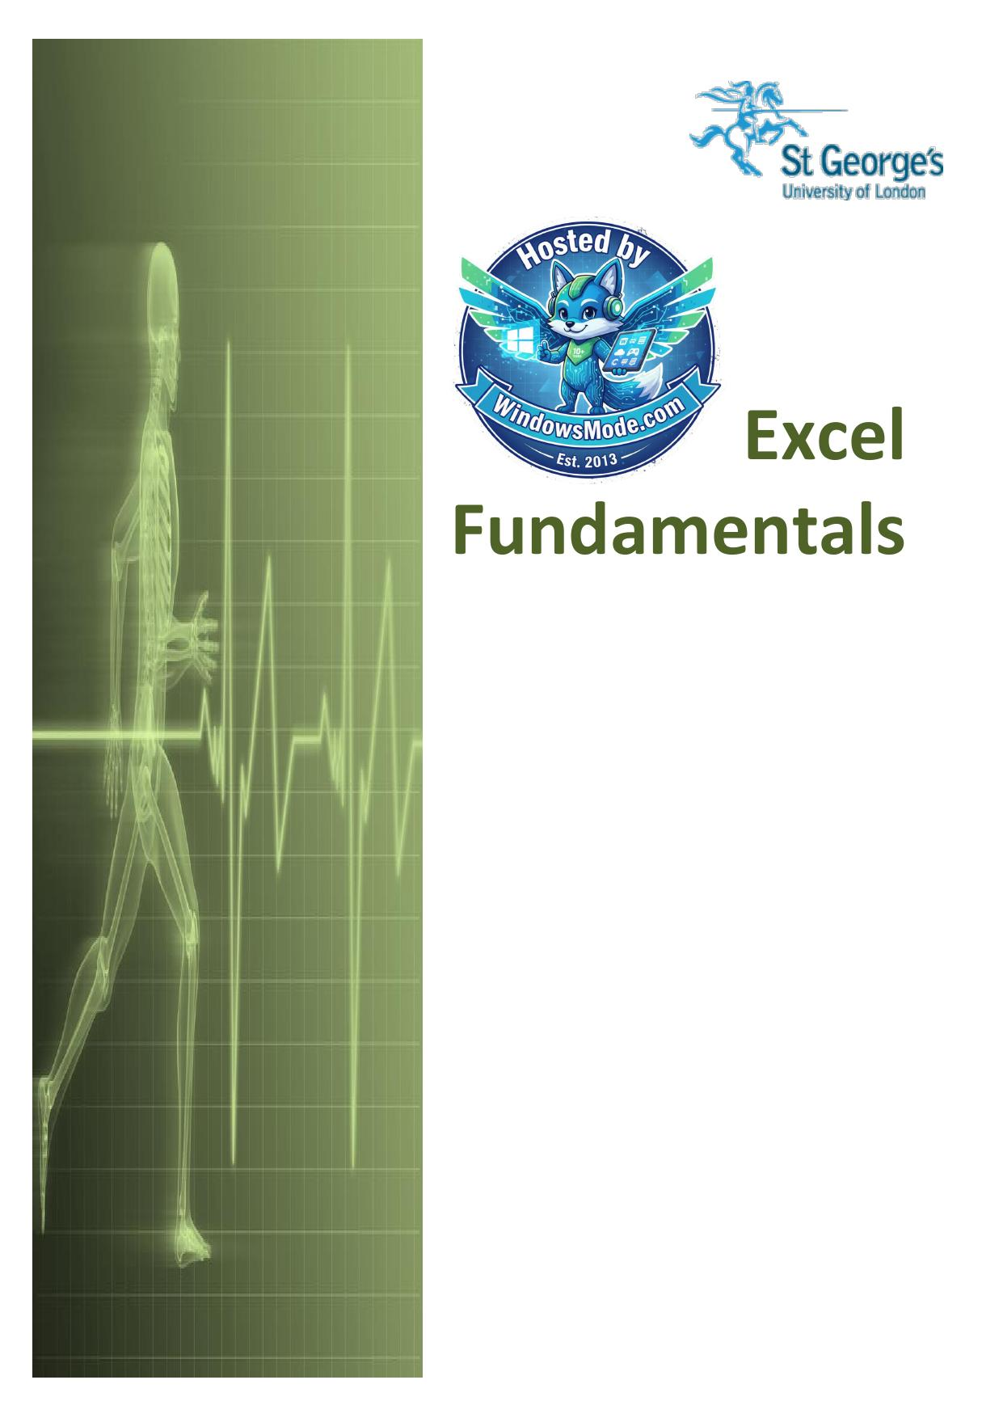

Table of Contents
Understanding Workbooks ............................................................................
Navigating in a File ...............................................................................
Typing Text or Numbers Into A Worksheet ............................................................
Typing Simple Formulas In A Worksheet ..............................................................
Filling A Series ...................................................................................
Inserting And Deleting Worksheets ..................................................................
Copying A Worksheet ................................................................................
Renaming A Worksheet ...............................................................................
Moving or Copying A Sheet To Another Workbook ......................................................
Changing Worksheet Tab Colours .....................................................................
Grouping Worksheets ................................................................................
Freezing Rows And Columns ..........................................................................
Selecting Ranges ...................................................................................
Selecting Rows .....................................................................................
Selecting Columns ..................................................................................
Understanding Formatting ...........................................................................
Applying General Formatting ........................................................................
Changing Fonts .....................................................................................
Changing Font Size .................................................................................
Understanding Borders ..............................................................................
Applying A Border To A Range .......................................................................
Wrapping And Merging Text ..........................................................................
PRACTICE EXERCISE ..................................................................................
Understanding Functions ............................................................................
Using The SUM Function To Add ......................................................................
Calculating An Average .............................................................................
Finding A Minimum Value ............................................................................
Common Error Messages ..............................................................................
Understanding Quick Analysis .......................................................................
Quick Formatting ...................................................................................
Quick Charting .....................................................................................
Quick Totals .......................................................................................
Quick Sparklines ...................................................................................
Quick Tables .......................................................................................
Printing A Worksheet ...............................................................................
The Charting Process ...............................................................................
Choosing The Right Chart ...........................................................................
Using A Recommended Chart ..........................................................................
Creating A New Chart From Scratch ..................................................................
Working With An Embedded Chart .....................................................................
Resizing A Chart ...................................................................................
Repositioning A Chart ..............................................................................
Printing An Embedded Chart .........................................................................
Creating A Chart Sheet..............................................................................
Changing The Chart Type ............................................................................
Changing The Chart Layout ..........................................................................
Changing The Chart Style ...........................................................................
Printing A Chart Sheet .............................................................................
Embedding A Chart Into A Worksheet .................................................................
Deleting A Chart ...................................................................................

Excel


Fundamentals


Microsoft Excel

Contents
Understanding Workbooks ................................................................................................................................ 1
Navigating in a File ............................................................................................................................................ 2
Typing Text or Numbers Into A Worksheet ....................................................................................................... 3
Typing Simple Formulas In A Worksheet .......................................................................................................... 4
Filling A Series ................................................................................................................................................... 5
Inserting And Deleting Worksheets ................................................................................................................... 6
Copying A Worksheet ........................................................................................................................................ 7
Renaming A Worksheet ..................................................................................................................................... 8
Moving or Copying A Sheet To Another Workbook ........................................................................................... 9
Changing Worksheet Tab Colours .................................................................................................................. 10
Grouping Worksheets ...................................................................................................................................... 11
Freezing Rows And Columns .......................................................................................................................... 12
Selecting Ranges .............................................................................................................................................................. 13
Selecting Rows ................................................................................................................................................ 14
Selecting Columns ........................................................................................................................................... 15
Understanding Formatting ................................................................................................................................................. 16
Applying General Formatting ........................................................................................................................... 17
Changing Fonts ............................................................................................................................................... 18
Changing Font Size ......................................................................................................................................... 19
Understanding Borders .................................................................................................................................... 20
Applying A Border To A Range ....................................................................................................................... 21
Wrapping And Merging Text ............................................................................................................................ 22
PRACTICE EXERCISE .......................................................................................................................................... 23
PRACTICE EXERCISE .......................................................................................................................................... 24
PRACTICE EXERCISE .......................................................................................................................................... 25
Understanding Functions .................................................................................................................................................. 26
Using The SUM Function To Add .................................................................................................................... 27
Calculating An Average ................................................................................................................................... 28
Finding A Minimum Value ................................................................................................................................ 29
Common Error Messages ................................................................................................................................ 30
PRACTICE EXERCISE .......................................................................................................................................... 31
Understanding Quick Analysis .......................................................................................................................................... 32
Quick Formatting ............................................................................................................................................. 33
Quick Charting ................................................................................................................................................. 34
Quick Totals ..................................................................................................................................................... 35
Quick Sparklines .............................................................................................................................................. 36
Quick Tables .................................................................................................................................................... 37
Practice Exercise ............................................................................................................................................. 38
Printing A Worksheet ........................................................................................................................................................ 39

St. George’s Information Services
Microsoft Excel

The Charting Process ....................................................................................................................................................... 40
Choosing The Right Chart ............................................................................................................................... 41
Using A Recommended Chart ......................................................................................................................... 42
Creating A New Chart From Scratch ............................................................................................................... 43
Working With An Embedded Chart .................................................................................................................. 44
Resizing A Chart .............................................................................................................................................. 45
Repositioning A Chart ...................................................................................................................................... 46
Printing An Embedded Chart ........................................................................................................................... 47
Creating A Chart Sheet.................................................................................................................................... 48
Changing The Chart Type ............................................................................................................................... 49
Changing The Chart Layout ............................................................................................................................ 50
Changing The Chart Style ............................................................................................................................... 51
Printing A Chart Sheet ..................................................................................................................................... 52
Embedding A Chart Into A Worksheet ............................................................................................................. 53
Deleting A Chart .............................................................................................................................................. 54
PRACTICE EXERCISE .......................................................................................................................................... 55
PRACTICE EXERCISE SAMPLE ............................................................................................................................ 56

St. George’s Information Services
Microsoft Excel

St. George’s Information Services
Microsoft Excel

UNDERSTANDING WORKBOOKS

In Microsoft Excel the data you enter, whether it sheets) that have been ruled into columns and consists of numbers, text, or formulas, is stored rows. Before using Excel it is helpful to know what

in a file known as a workbook. Workbooks are the various parts and elements that make up a
just like huge electronic books with pages (or workbook are.

1

2
4

3

5 6



A worksheet (or page) in a workbook contains 16,384 columns that are labelled using letters of the alphabet. The first column in a worksheet is labelled column A , while the last is labelled XFD



A worksheet (or page) in a workbook contains 1,048,576 rows that are labelled using numbers from 1 to 1,048,576


Where a column and row intersect we get what is known as a cell. You enter your data into these cells. Each cell in a worksheet can hold up to 32,767 characters – although it would be
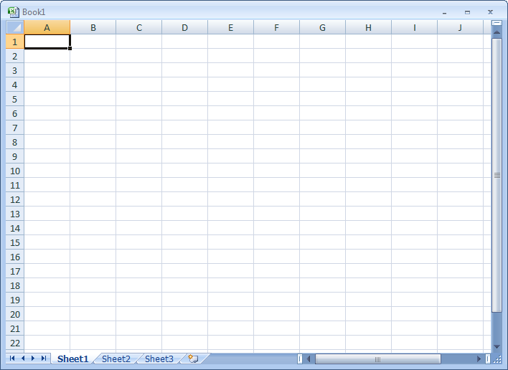
unrealistic to ever push it this far. Cells are referred to by their column and row labels. For
example, in the screen above the cell we are pointing to is C11 – this reference is known as the
cell address and is most important as it is frequently used in commands and formulas


When you start typing something, you want it to appear somewhere in the worksheet. As a consequence when the Status Bar shows Ready mode, at least one cell in the worksheet will be
highlighted – this is known as the active cell. In the screen above, the active cell is cell A1 –
notice that the column label and the row label also appears coloured to indicate the active cell.
You can have more than one active cell – when this occurs you have what is known as a range


A workbook (as you would expect) is made up of pages known as worksheets. You can have as many sheets in a workbook as your computer resources can accommodate. As a default, a new
blank workbook normally has 3 worksheets labelled Sheet1, Sheet2, and Sheet3. Of course
these labels are pretty boring and meaningless and can be changed to something more relevant


The Insert Worksheet button here will insert another worksheet into the current workbook should you need it

ITTraining@sgul.ac.uk Page 1 St. George’s Information Services
Microsoft Excel

NAVIGATING IN A FILE

Arrow Move one cell to the right, left, up or down
Keys
Tab Move once cell to the right
Ctrl+Home To beginning file
Ctrl+End To end of typed information
Home Beginning of a line
End End of a line
Page Down Down one screen

Page Up Up one screen
F5 To a specific page

Appear at the right and on the bottom of the screen. You may click
Scroll bars
the scroll arrows, drag the scroll box or click the scroll bar to move
through the document.

ITTraining@sgul.ac.uk Page 2 St. George’s Information Services
Microsoft Excel
TYPING TEXT OR NUMBERS INTO A WORKSHEET
Generally when you start a new spreadsheet you wish to enter the data active. This can be done
project, the first task is to enter some headings in a number of ways but the most common is to
into rows and columns. To type anything into a click in it first before typing. worksheet you need to make the cell into which

Try This Yourself:

that there is a blank Before you begin ensure
workbook on the screen…


Click in cell A3 to make this the active cell, type 1 2
Garden Settings and
press
3
When you press the
next cell down
automatically becomes
the active cell. By the
way, even though the text
looks like it is in cells A3
and B3 it really only is in
cell A3 – since there is
nothing in B3, Excel
allows the spill over to be
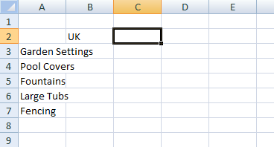
displayed giving the 4
illusion it is in 2 cells…


Type Pool Covers and press


Repeat the above steps and enter the remaining
text in column A as shown


Click in cell B2 to make this the active cell, type
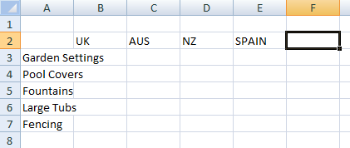
UK 5 and press
When you press the

cell to the right becomes

the active cell…
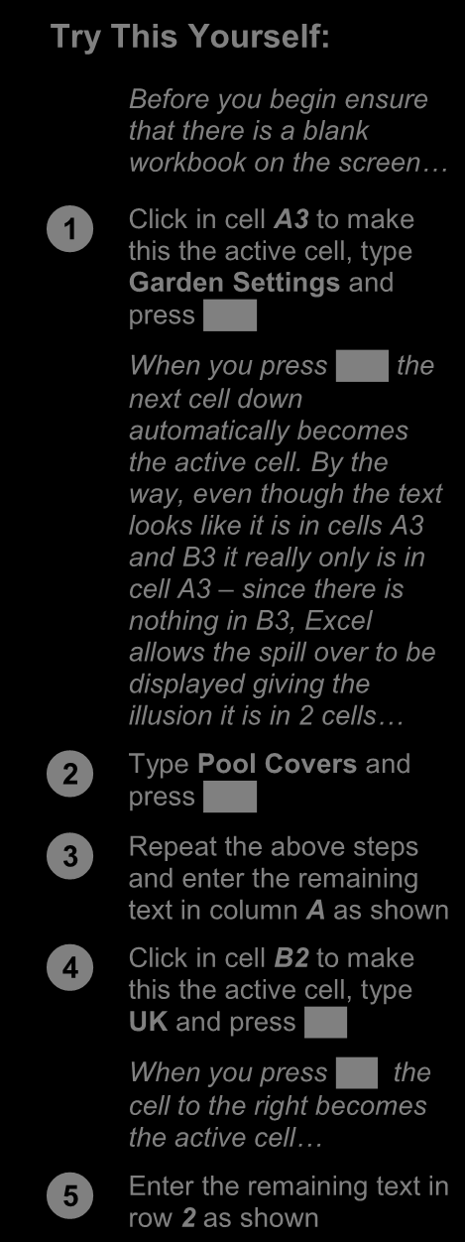


Enter the remaining text in row 2 as shown


For Your Reference… For Your Reference… Handy to Know… Handy to Know…

To To enter text save a new document : : • • You don’t have to use In the exercise above we have named the or to make

1. Click on the adjacent cells active. You can simply use the workbook Garden Department Sales and 1. Click the cell pointer on the desired cell and File Tab and select Save As

type the required information mouse and click in the cells if you want or filed it in C:\Course Files for Excel 2010 .

2. Locate the storage folder in the Navigation even press the arrow keys to move up, Each time you start Excel it will most likely 2. Press pane , an arrow key or to down, left, or right.

assume you want to file your workbooks in a

3. Type a confirm the data entry and to move the cell File name and click on [Save] folder called Documents which is associated

pointer to another cell with the user name you use on the computer.


ITTraining@sgul.ac.uk Page 3 St. George’s Information Services



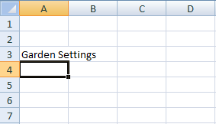
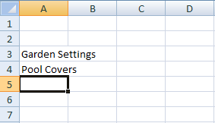
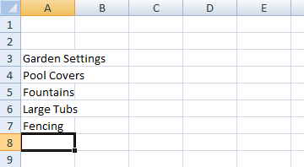

Microsoft Excel
TYPING SIMPLE FORMULAS IN A WORKSHEET
The whole idea behind Excel is to get it to even other formulas, already in the worksheet
perform calculations. In order for it to do this you using the cell addresses of these numbers rather
need to type formulas in the worksheet. Usually than the actual value in them. Formulas must be
these formulas reference existing numbers, or typed beginning with an equal sign (=).

Try This Yourself: 2
Continue using the previous
file with this exercise...


Click in cell B8 to make this the active cell


Type =B3+B4+B5+B6+B7 and examine what is happening on
the screen
3


Press to enter the formula and move to the next cell
Notice that a calculation has
now been performed. We have
entered a formula in B8 that
says “add the values in B3, B4,
B5, B6, and B7 and show them
here”…


Ensure that C8 is the active 5 cell, type =SUM(C3:C7) and
press
This is an alternative type of
formula known as a “function”.
Again a calculation will appear
in the cell…


Click in cell B8 and notice that the formula you typed appears
in the Formula Bar, while the
result of the calculation 6 appears in the worksheet


Repeat step 5 with cell C8


Click on the File Tab and select Save to save the
additions that have been made

For Your Reference… Handy to Know…
To enter a formula: Operators
1. Click the cell pointer on the desired cell and + Addition
type the formula commencing with = - Subtraction
2. Press , an arrow key or to * Multiplication
confirm the data entry and to move the cell / Division
pointer to another cell


ITTraining@sgul.ac.uk Page 4 St. George’s Information Services
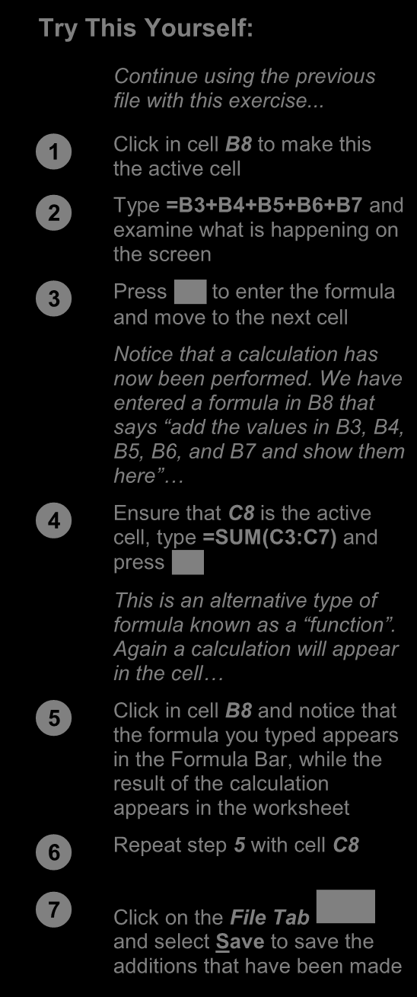




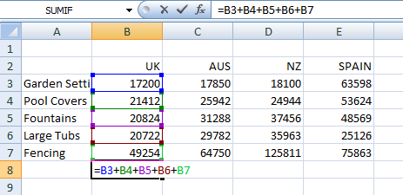
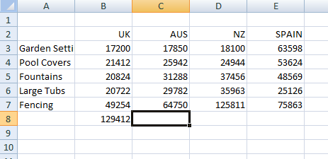
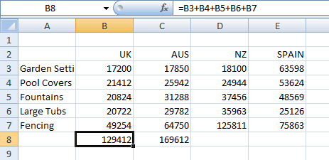
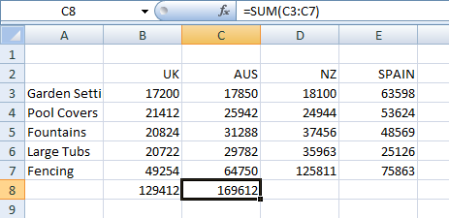
Microsoft Excel
FILLING A SERIES
A series refers to a sequence of ordered entries reducing the amount of time taken for data entry,
in adjacent cells, such as the days of the week or and ensuring that the spelling is correct. Excel
months of the year. The fill technique can be provides days and months as special built-in series used to create these in a worksheet for you, that you can access.


2
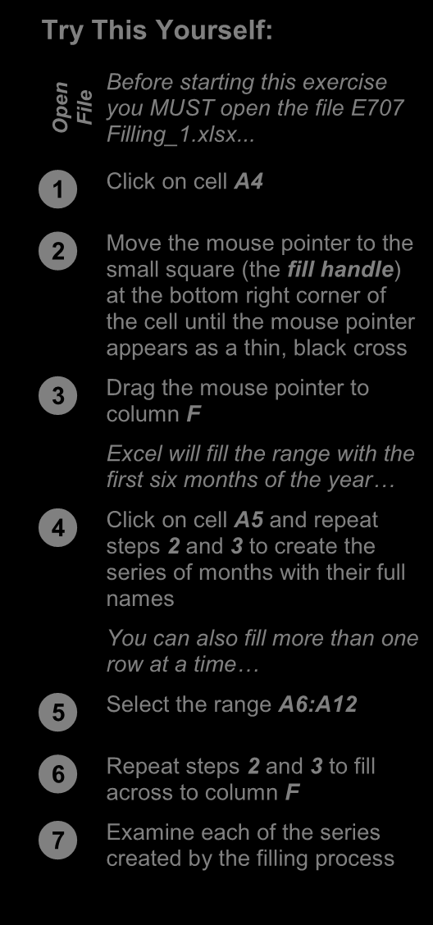
Try This Yourself:

n Before starting this exercise
pe you MUST open the file E707 File O Filling_1.xlsx...


Click on cell A4


Move the mouse pointer to the small square (the fill handle )
at the bottom right corner of
the cell until the mouse pointer 3
appears as a thin, black cross


Drag the mouse pointer to column F
Excel will fill the range with the
first six months of the year…


Click on cell A5 and repeat steps 2 and 3 to create the
series of months with their full
names
You can also fill more than one 6
row at a time…


Select the range A6:A12


Repeat steps 2 and 3 to fill across to column F


Examine each of the series created by the filling process

For Your Reference… Handy to Know…
To fill a series: • As you drag the fill handle across, a tool tip
1. Click on the first cell in the series appears below the fill pointer displaying the
current value in the series. This is really
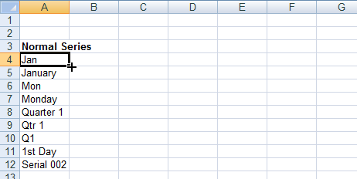
2. Drag from the fill handle across as many
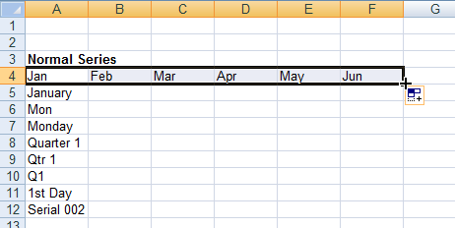
handy when you want to end on a particular
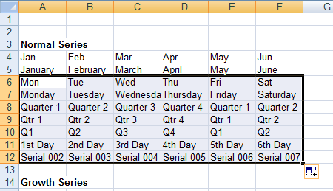
columns as required
month, day or value.

ITTraining@sgul.ac.uk Page 5 St. George’s Information Services
Microsoft Excel
INSERTING AND DELETING WORKSHEETS

Once you’ve decided on a structure for your worksheets inserted. However, remember that workbook, you may find that there are some deletion of worksheets is permanent and can’t be
worksheets that can be deleted. Alternatively, undone using Undo, so always save your you may find that you need additional blank workbook before making these changes.

1

Try This Yourself:
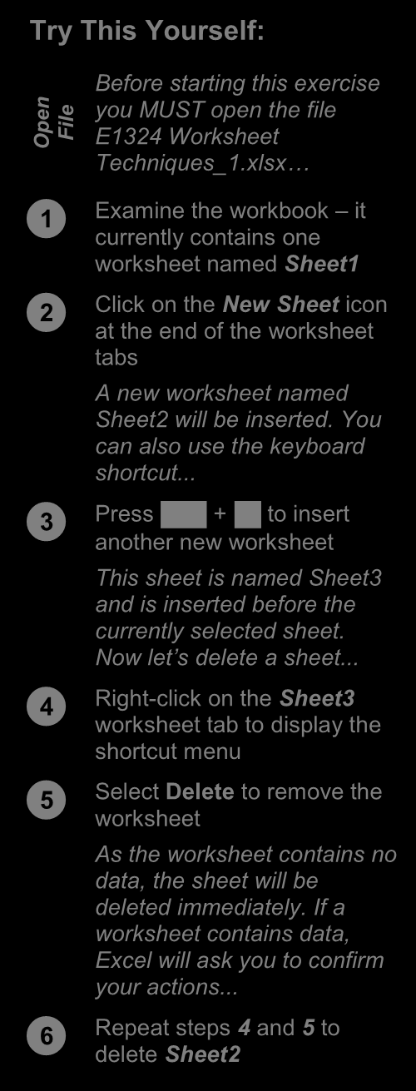

n you MUST open the file

Before starting this exercise
pe File O E1324 Worksheet
Techniques_1.xlsx…


Examine the workbook – it 2 currently contains one
worksheet named Sheet1


Click on the New Sheet icon at the end of the worksheet
tabs
A new worksheet named
Sheet2 will be inserted. You 3
can also use the keyboard
shortcut...



Press + to insert another new worksheet

This sheet is named Sheet3
and is inserted before the 4
currently selected sheet.

Now let’s delete a sheet...


Right-click on the Sheet3 worksheet tab to display the
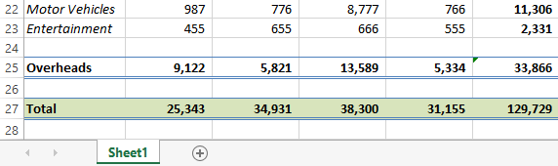
shortcut menu
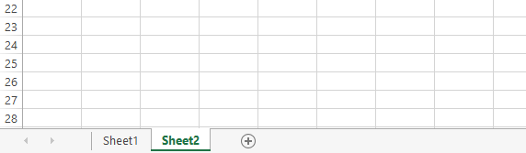


Select Delete to remove the worksheet
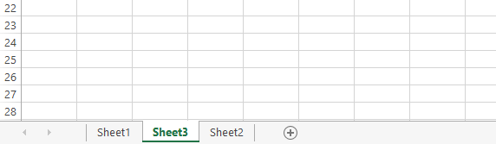
As the worksheet contains no
data, the sheet will be
deleted immediately. If a
worksheet contains data, 5
Excel will ask you to confirm
your actions...


Repeat steps 4 and 5 to delete Sheet2

For Your Reference… Handy to Know…
To insert a new worksheet into a workbook: • To insert a worksheet between existing
• worksheets, right-click on the worksheet tab Click on the New Sheet icon to the right of
the worksheet tabs before which you want to insert a new sheet,
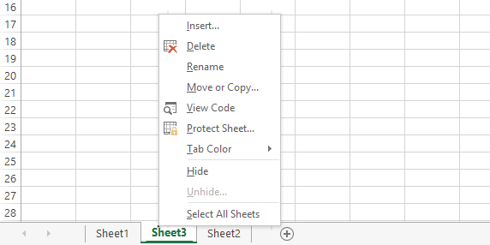
then click on Insert to display the Insert
To delete a worksheet from a workbook:
dialog box. Select Worksheet and click on
• Right click on the worksheet tab, then select [OK].
Delete

ITTraining@sgul.ac.uk Page 6 St. George’s Information Services
Microsoft Excel
COPYING A WORKSHEET
Just as you can copy the contents of cells and have a budget workbook that contains data for
ranges within a worksheet, you can duplicate several departments, you can create a worksheet
worksheets within a workbook. This technique is for the first department and then copy it to create
ideal for replicating layouts. For example, if you identical worksheets for other departments.

1

Try This Yourself:
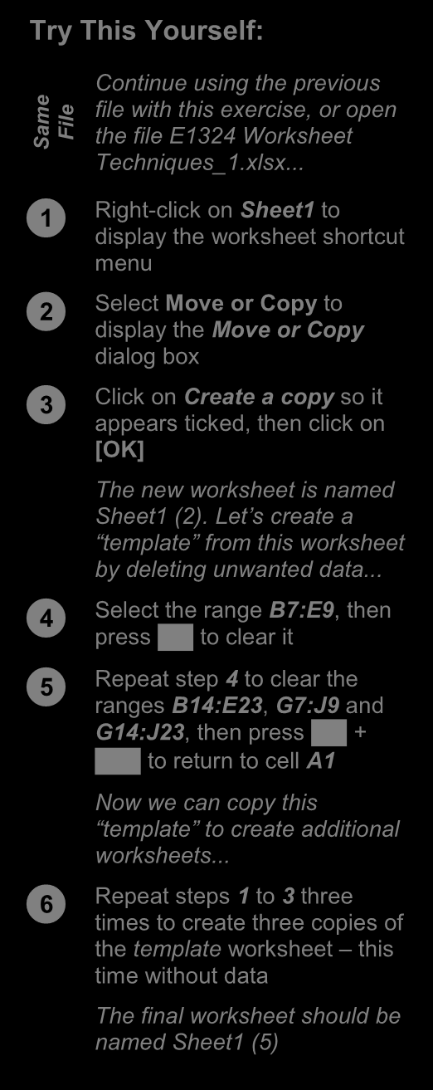

e Continue using the previous

m file with this exercise, or open
Sa File the file E1324 Worksheet
Techniques_1.xlsx...


Right-click on Sheet1 to display the worksheet shortcut
menu


Select Move or Copy to display the Move or Copy
dialog box 2


Click on Create a copy so it appears ticked, then click on
[OK]
The new worksheet is named
Sheet1 (2). Let’s create a
“template” from this worksheet
by deleting unwanted data...


Select the range B7:E9, then press to clear it



Repeat step 4 to clear the ranges B14:E23 , G7:J9 and 3 G14:J23 , then press +

to return to cell A1

Now we can copy this
“template” to create additional
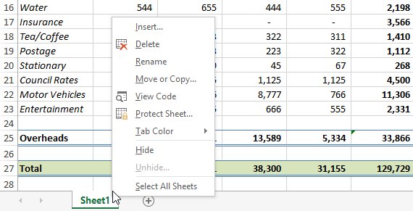
worksheets...


Repeat steps 1 to 3 three times to create three copies of 6 the template worksheet – this
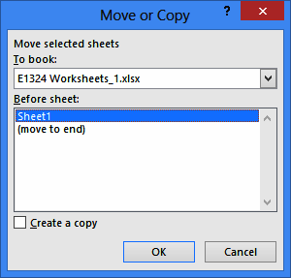
time without data
The final worksheet should be
named Sheet1 (5)


For Your Reference… Handy to Know…

To copy a worksheet: • You can copy the current worksheet using
1. Right-click on the worksheet to copy, then the HOME tab by clicking on Format in the
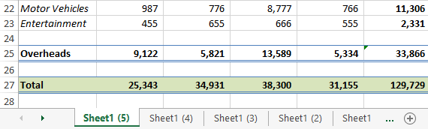
select Cells group, then clicking on Move or Copy Move or Copy
Sheet.
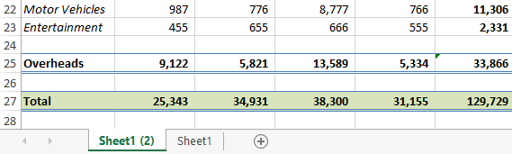
3. Click on • The Before sheet options in the Move or [OK] 2. Click on Create a copy so it appears ticked
Copy dialog box allow you to position the copied worksheet where you want.

ITTraining@sgul.ac.uk Page 7 St. George’s Information Services
Microsoft Excel
RENAMING A WORKSHEET
By default, Excel names worksheets as Sheet1, makes it much easier to understand the purpose of
Sheet2, Sheet3, etc. These names are fine if you a worksheet. You can also adjust the horizontal
are not planning to share the workbook, but scroll bar to make room for longer, more changing these to something more relevant meaningful worksheet names.

1

Try This Yourself:
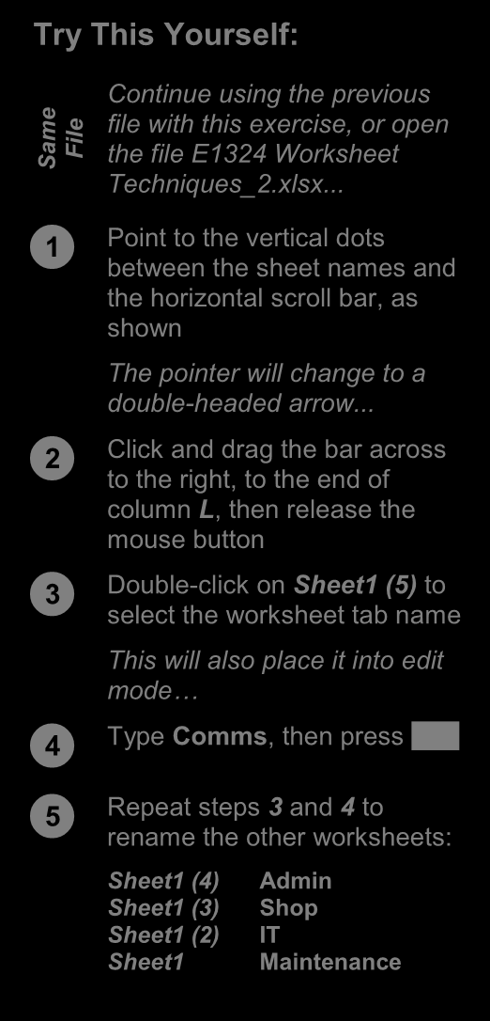

e Continue using the previous

m file with this exercise, or open
Sa File the file E1324 Worksheet
Techniques_2.xlsx...


Point to the vertical dots 3 between the sheet names and
the horizontal scroll bar, as
shown
The pointer will change to a
double-headed arrow...


Click and drag the bar across 4 to the right, to the end of
column L, then release the
mouse button


Double-click on Sheet1 (5) to select the worksheet tab name
This will also place it into edit
mode… 5


Type Comms, then press



Repeat steps 3 and 4 to rename the other worksheets:

Sheet1 (4) Admin
Sheet1 (3) Shop
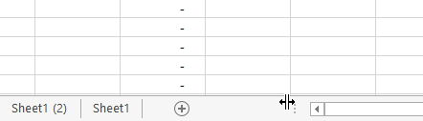
Sheet1 (2) IT
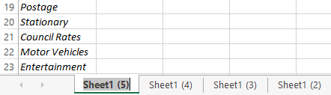
Sheet1 Maintenance
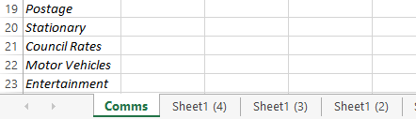

For Your Reference… Handy to Know…
To rename a worksheet: • You can rename a worksheet by
1. Double click on the current name on the right-clicking on the worksheet tab to display
worksheet tab the shortcut menu and clicking on Rename.
2. Type the new name and press • A worksheet tab name can contain up to 31

characters including spaces, but it is better to
keep it short and succinct.
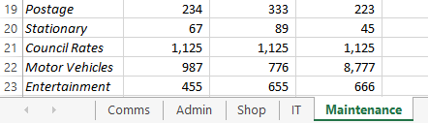

ITTraining@sgul.ac.uk Page 8 St. George’s Information Services
Microsoft Excel
MOVING OR COPYING A SHEET TO ANOTHER WORKBOOK
You can copy worksheets to other workbooks as can copy their worksheet to another workbook and
required. For example, you might need to keep send them their data only. If worksheets exist in the
records for six different divisions – rather than other workbook, you will need to determine the
send each division the entire set of records, you order in which to place the copied worksheet.


Try This Yourself:
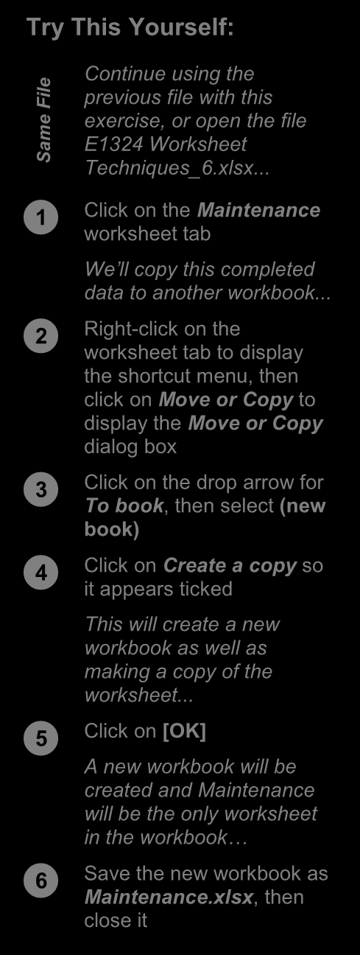
Continue using the

ile previous file with this
F
e exercise, or open the file
m E1324 Worksheet
Sa Techniques_6.xlsx...


1
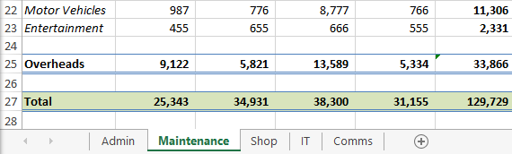
Click on the Maintenance
worksheet tab
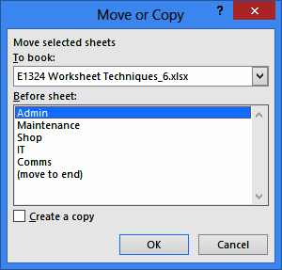
We’ll copy this completed
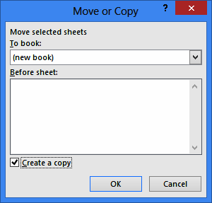
data to another workbook...


Right-click on the worksheet tab to display
the shortcut menu, then
click on Move or Copy to
display the Move or Copy
dialog box


Click on the drop arrow for To book , then select (new
book) 2 4


Click on Create a copy so it appears ticked
This will create a new
workbook as well as
making a copy of the
worksheet...


Click on [OK] A new workbook will be 5 created and Maintenance
will be the only worksheet
in the workbook…


Save the new workbook as Maintenance.xlsx , then
close it

For Your Reference… Handy to Know…
To copy a sheet to another workbook: • To copy a worksheet into an existing
1. Right click on the worksheet tab, then click workbook, make sure that you open the
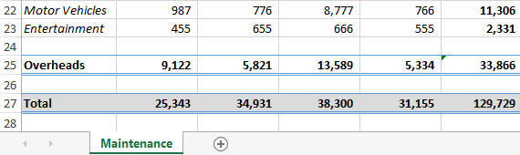
on destination workbook first to ensure that it is Move or Copy
listed in To book in the Move or Copy
2. Select either (new book) or the name of
dialog box.
another workbook in To book
3. Tick Create a copy, then click on [OK]

ITTraining@sgul.ac.uk Page 9 St. George’s Information Services
Microsoft Excel
CHANGING WORKSHEET TAB COLOURS
To make it easier for you to distinguish between financial years, departments or months. The active worksheets, Excel enables you to change the sheet appears as underlined in a gradient version colours of worksheet tabs. This allows you, for of the selected colour, while inactive tabs will example, to quickly distinguish between different display a solid colour background.

2
Try This Yourself:


e Continue using the previous
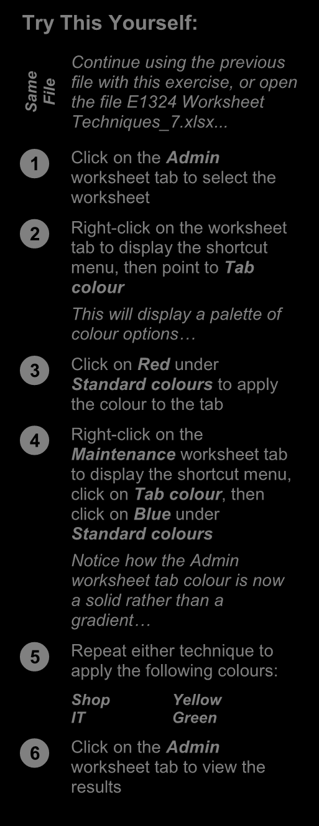
m file with this exercise, or open

Sa File the file E1324 Worksheet
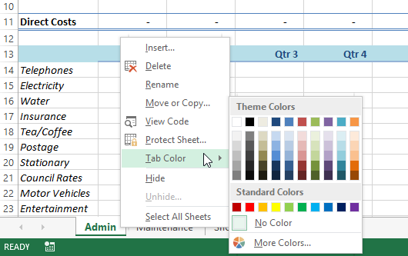
Techniques_7.xlsx...


Click on the Admin worksheet tab to select the
worksheet


Right-click on the worksheet tab to display the shortcut
menu, then point to Tab
colour
3
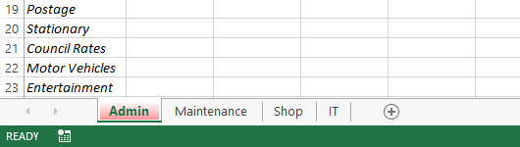
This will display a palette of
colour options…


Click on Red under Standard colours to apply
the colour to the tab


Right-click on the 4 Maintenance worksheet tab
to display the shortcut menu,
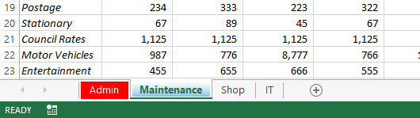
click on Tab colour, then
click on Blue under
Standard colours
Notice how the Admin
worksheet tab colour is now 5
a solid rather than a
gradient…


Repeat either technique to apply the following colours:
Shop Yellow
IT Green 6
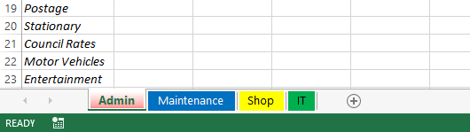


Click on the Admin worksheet tab to view the
results

For Your Reference… Handy to Know…
To change the colour of a worksheet tab: • To apply the same colour to two or more
1. Right-click on the worksheet tab to display sheets at once, select them first. Hold down

the shortcut menu to select consecutive worksheets or

hold down to select non-consecutive
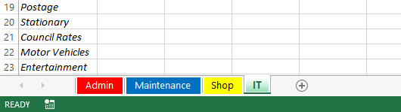
2. Point to Tab colour to display a palette of
colour options worksheets.
3. Click on the desired colour

ITTraining@sgul.ac.uk Page 10 St. George’s Information Services
Microsoft Excel
GROUPING WORKSHEETS
Worksheet grouping enables you to make the example, if you want to format the heading for
same change at once to all selected worksheets. multiple worksheets, you simply group the This feature is useful in situations where your worksheets, make a change to one worksheet and
worksheets have identical layouts or text. For the other worksheets will reflect the change also.

1

Try This Yourself:
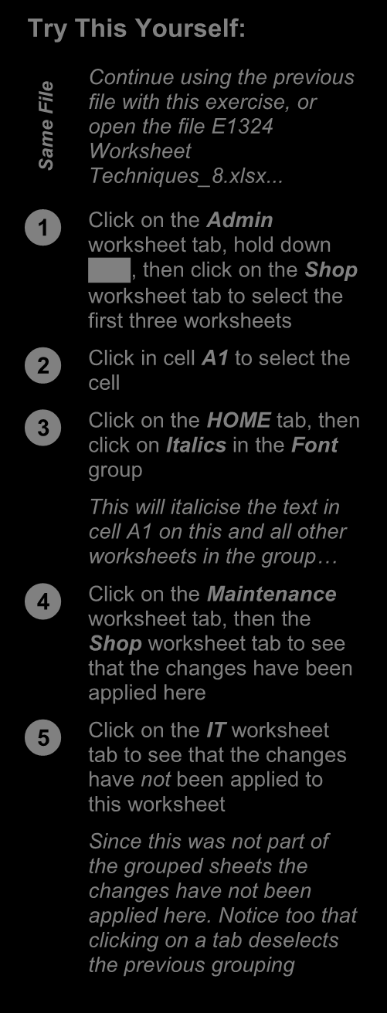
Continue using the previous

ile file with this exercise, or
F
e open the file E1324
m Worksheet
Sa Techniques_8.xlsx...


2 Click on the Admin
worksheet tab, hold down

, then click on the Shop
worksheet tab to select the
first three worksheets


Click in cell A1 to select the cell


Click on the HOME tab, then 3 click on Italics in the Font
group
This will italicise the text in
cell A1 on this and all other
worksheets in the group…


Click on the Maintenance worksheet tab, then the
Shop 4 worksheet tab to see
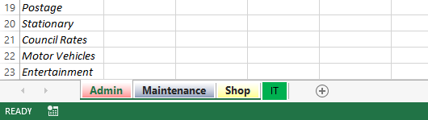
that the changes have been
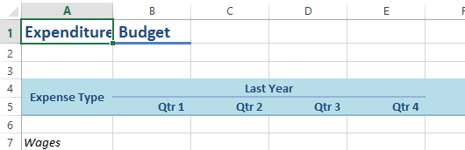
applied here
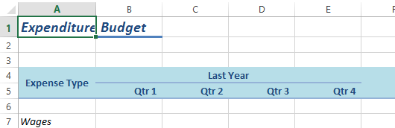


Click on the IT worksheet tab to see that the changes
have not been applied to
this worksheet
Since this was not part of
5
the grouped sheets the
changes have not been
applied here. Notice too that
clicking on a tab deselects
the previous grouping

For Your Reference… Handy to Know…
To group worksheet tabs: • To deselect a group, either click on the tab of
1. Click on the first worksheet tab a worksheet that is not in the group, or right-
click on a tab and select Ungroup Sheets.

2. Hold down , then click on the last
worksheet tab • Most formatting and text changes done on a
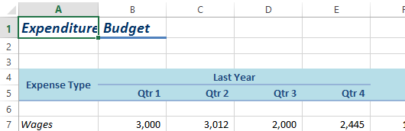
worksheet in a group will be applied to other
sheets in that grouping.

ITTraining@sgul.ac.uk Page 11 St. George’s Information Services
Microsoft Excel
FREEZING ROWS AND COLUMNS
When you lay out your data in rows and columns, scroll across or down to particular cells, the it is most likely that your headings end up at the headings scroll out of view. This problem can be
top or to the left of your data. If you have a large resolved by freezing the rows and/or columns that amount of data, you may find that when you hold the headings.


Try This Yourself:
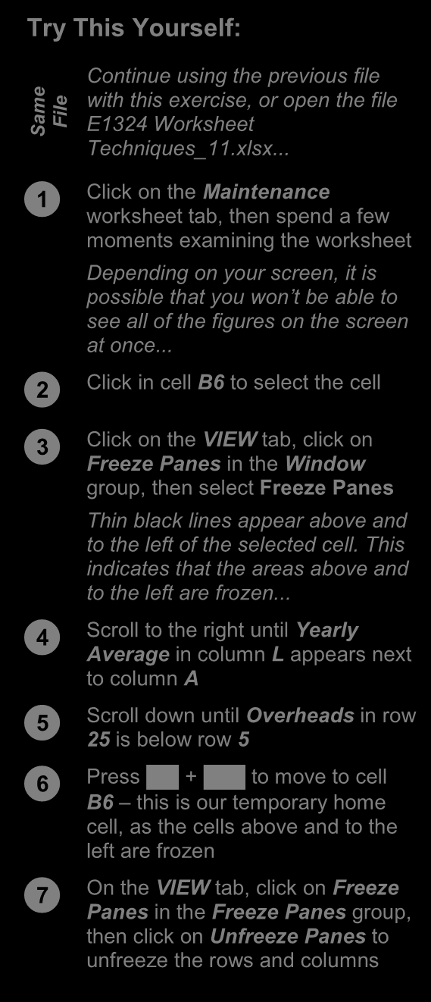

e Continue using the previous file

m with this exercise, or open the file
Sa File E1324 Worksheet
Techniques_11.xlsx...


Click on the Maintenance worksheet tab, then spend a few
moments examining the worksheet
Depending on your screen, it is
possible 3 that you won’t be able to
see all of the figures on the screen
at once...


Click in cell B6 to select the cell


Click on the VIEW tab, click on Freeze Panes in the Window
group, then select Freeze Panes
Thin black lines appear above and
to the left of the selected cell. This
indicates that the areas above and
to the left are frozen...


Scroll to the right until Yearly 4 Average in column L appears next
to column A


Scroll down until Overheads in row 25 is below row 5



Press + to move to cell B6 – this is our temporary home

cell, as the cells above and to the
left are frozen


On the VIEW tab, click on Freeze Panes in the Freeze Panes group,
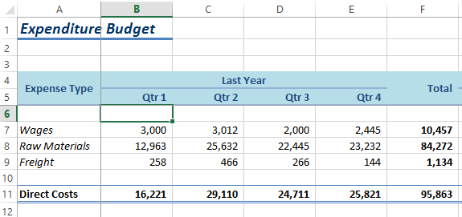
then click on Unfreeze Panes to
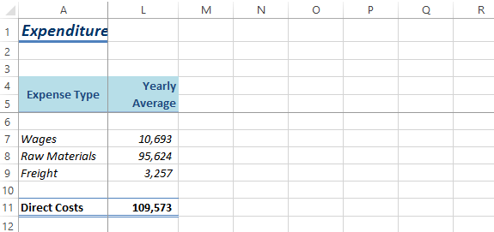
unfreeze the rows and columns
5

For Your Reference… Handy to Know…
To freeze panes in a worksheet: • If you want to freeze only the rows above the
1. Click in the cell below and to the right of the selected cell (leaving all columns unfrozen),
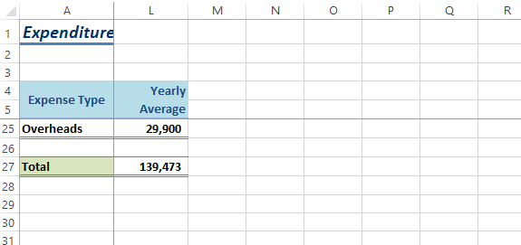
area you want to freeze/unfreeze select the cell in column A of that row – e.g.
to freeze rows 1 to 6, click in cell A7. The
2. Click on the VIEW tab
same applies to freezing only columns and
3. Click on Freeze Panes in the Window leaving the rows unfrozen: select the cell in
group, then select Freeze Panes row 1.

ITTraining@sgul.ac.uk Page 12 St. George’s Information Services
Microsoft Excel

SELECTING RANGES
A contiguous range is any group of selected mouse, the keyboard or a combination of the two.
cells that form either a square or a rectangle. A Once selected, you can use the range for input, or
single cell that is selected is also considered to apply formatting, or copy the cells as required.
be a range. Ranges can be selected using the


Try This Yourself: 1
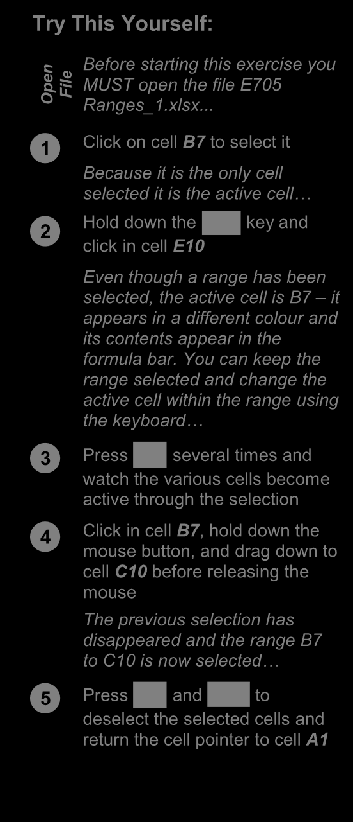
n Before starting this exercise you

pe MUST open the file E705 File O Ranges_1.xlsx...


Click on cell B7 to select it Because it is the only cell
selected it is the active cell…



Hold down the key and click in cell E10
Even though a range has been
selected, the active cell is B7 2 – it
appears in a different colour and
its contents appear in the
formula bar. You can keep the
range selected and change the
active cell within the range using
the keyboard…



Press several times and 3 watch the various cells become
active through the selection


Click in cell B7, hold down the mouse button, and drag down to
cell C10 before releasing the
mouse
The previous selection has
disappeared and the range B7 4 to C10 is now selected…



Press and to deselect the selected cells and

return the cell pointer to cell A1

For Your Reference… Handy to Know…
To select ranges with the mouse: • When a range has been selected it can be
1. Click in the left-most cell of the range used as an input range. You can then enter
data into the active cell and move the active
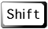
2. Hold down the key and click in the
cell to either the cell below by pressing ,

last cell, Or

or the adjacent cell by pressing .
3. Drag the mouse pointer to the bottom right
corner of the range
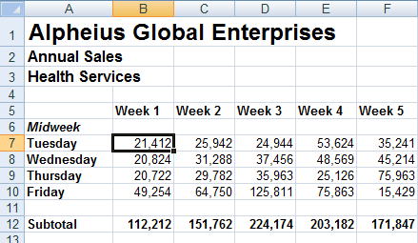

ITTraining@sgul.ac.uk Page 13 St. George’s Information Services
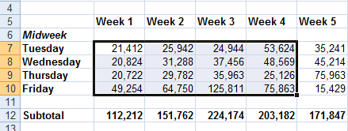
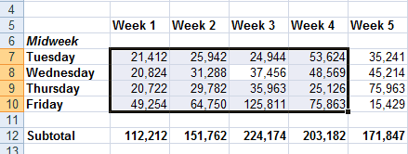
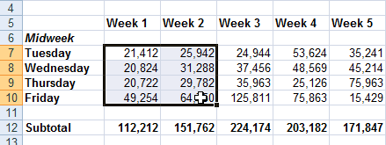
Microsoft Excel
SELECTING ROWS
If you want to make changes to an entire row, row header to the left of the row. Remember that
such as bolding all of the headings in a row or any changes you make will apply to every cell in
changing the font of all the cell entries, you must the row all the way across to column XFD, so be
first select the row. This is done by clicking on the careful!


2
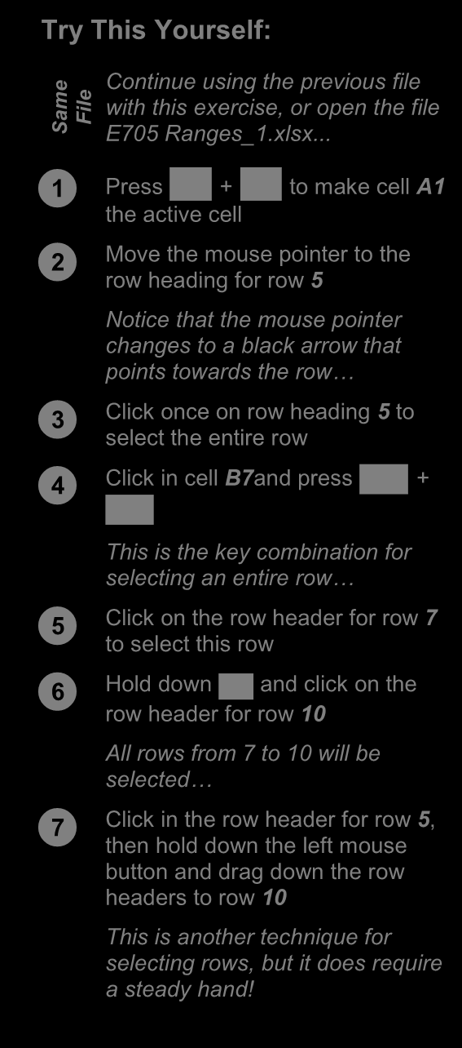
Try This Yourself:

e
Continue using the previous file
m with this exercise, or open the file File Sa E705 Ranges_1.xlsx...



Press + A1 to make cell the active cell



Move the mouse pointer to the row heading for row 5
3
Notice that the mouse pointer
changes to a black arrow that
points towards the row…


Click once on row heading 5 to select the entire row



Click in cell B7and press + 4

This is the key combination for
selecting an entire row…


Click on the row header for row 7 to select this row


Hold down 6 and click on the row header for row 10

All rows from 7 to 10 will be
selected…


Click in the row header for row 5, then hold down the left mouse
button and drag down the row 7 headers to row 10
This is another technique for
selecting rows, but it does require
a steady hand!

For Your Reference… Handy to Know…
To select an entire row: • When every cell in a row or column is
1. Click on the row header of the row that you selected, the corresponding row or column
want to select header is filled in dark blue. When only some
of the cells are selected, the row or column
OR
header is filled in orange. These indicators
1. Click in any cell in the row and press help you locate the active cell(s) on the

+ worksheet.

•

ITTraining@sgul.ac.uk Page 14 St. George’s Information Services
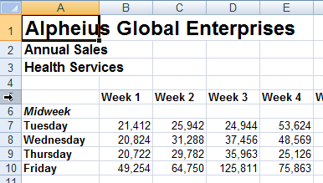
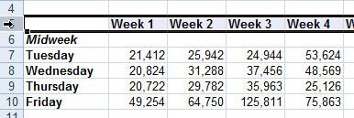
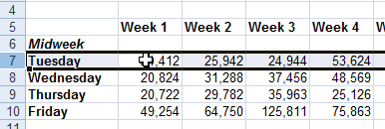
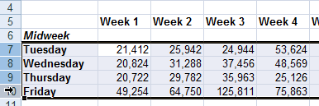
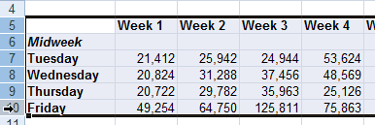
Microsoft Excel
SELECTING COLUMNS
If you want to make changes to an entire clicking on the column header directly above the
column, such as bolding all of the headings in a column. Remember that any changes you make
column or changing the font of all the cell entries, will apply to every cell in the column all the way
you must first select the column. This is done by down to row 1,048,576!


Try This Yourself: 2
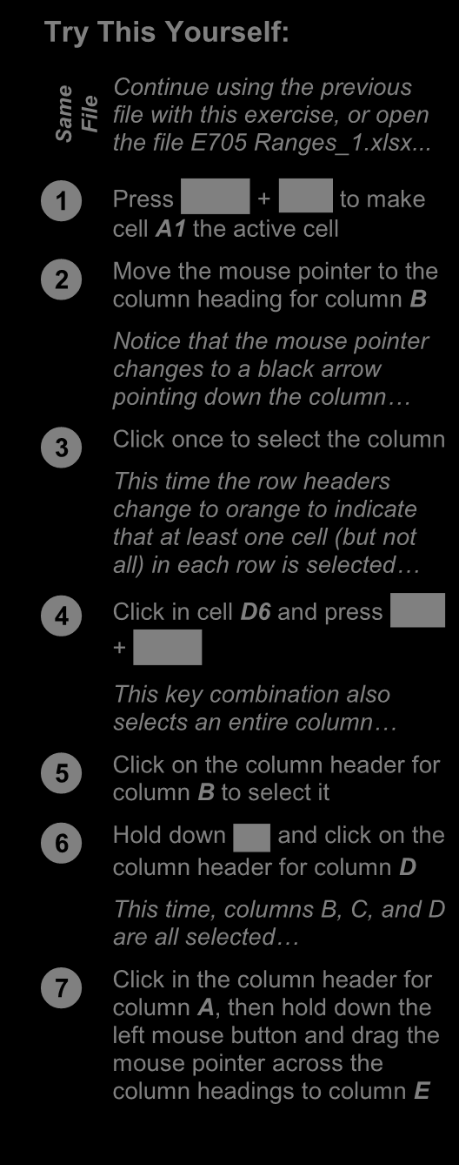
e

Continue using the previous
m file with this exercise, or open File Sa the file E705 Ranges_1.xlsx...



Press + to make 3 cell A1 the active cell



Move the mouse pointer to the column heading for column B
Notice that the mouse pointer
changes to a black arrow
pointing down the column…


Click once to select the column This time the row headers
change to orange to indicate
that at least one cell (but not 4
all) in each row is selected…



Click in cell D6 and press +

This key combination also
selects an entire co lumn…


Click on the column header for column B to select it


Hold down and click on the 6 column header for column D

This time, columns B, C, and D
are all selected…


Click in the column header for column A , then hold down the
left mouse button and drag the
mouse pointer across the
column headings to column E

For Your Reference… Handy to Know…
To select an entire column: • Make sure that you check your worksheet
1. Click on the column heading of the column carefully after you’ve made changes to entire
that you want to select columns. Remember that all of the cells in
OR that column are affected – even those in
rows below the visible area.
1. Click in any cell in the column and press

+


ITTraining@sgul.ac.uk Page 15 St. George’s Information Services
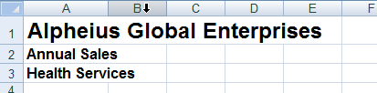
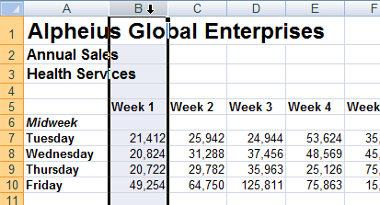
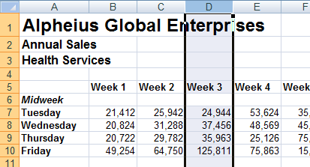
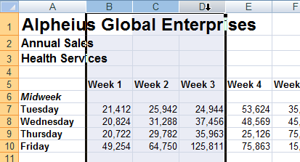
Microsoft Excel

UNDERSTANDING FORMATTING
In Excel there are always two aspects to a screen it is formatted to appear as a number with a
number: how the number presents on the screen percentage sign, whereas the real value in the cell
(known as formatting) and the underlying value is .02. of the number. Take 2% as an example – on the


Number Formatting – The Veil Placed Over Numbers
All calculations in Excel are performed using numbers – this is only logical. So, when you want to perform
a calculation, you type the numbers in various cells, then create formulas to reference those numbers.
How do you show what those numbers represent? For example, how do you show you are working with
currency, or percentages, or even dates (which in Excel are really numbers)?
Excel allows you to show these representations using number formatting. With number formatting you
change the way a number looks so that it makes immediate sense to the reader of your worksheet. The
underlying value of number, however, remains unchanged. For example, instead of showing sales tax in
a worksheet as .1 you show it as 10%, to show 12889.95 as currency it would appears $12,889.95 or
€12,889.95 (depending upon the currency you are working with), and to show 44104 as a date you show
it as 30-Sep-2020 (remember, dates are actually numbers representing the number of days from January
1, 1900).
The following worksheet contains formatted numbers:

With the formatting removed from the numbers the worksheet looks as follows:


Formatting can also be applied as you type. For example, if you type 30/9/2020 Excel will place the
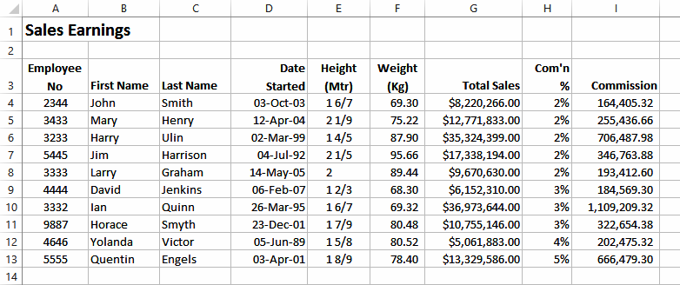
number 44104 in the cell but will format this number as a date and show it as you typed it. There are also
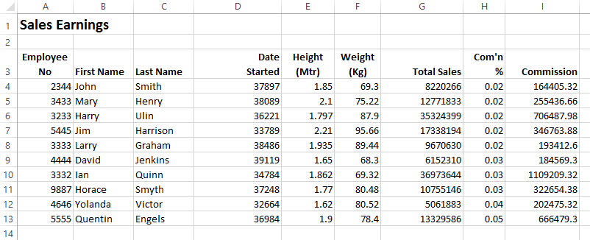
a range of number formatting options on the ribbon that allow you to apply formatting to numbers after
they have been entered into a worksheet.

ITTraining@sgul.ac.uk Page 16 St. George’s Information Services
Microsoft Excel
APPLYING GENERAL FORMATTING
The Number Format command in the Number formats easily and quickly to a selected cell or
group on the HOME tab contains a drop arrow range of cells in the worksheet. that provides a gallery of the more commonly
used number formats. You can apply these


Try This Yourself:
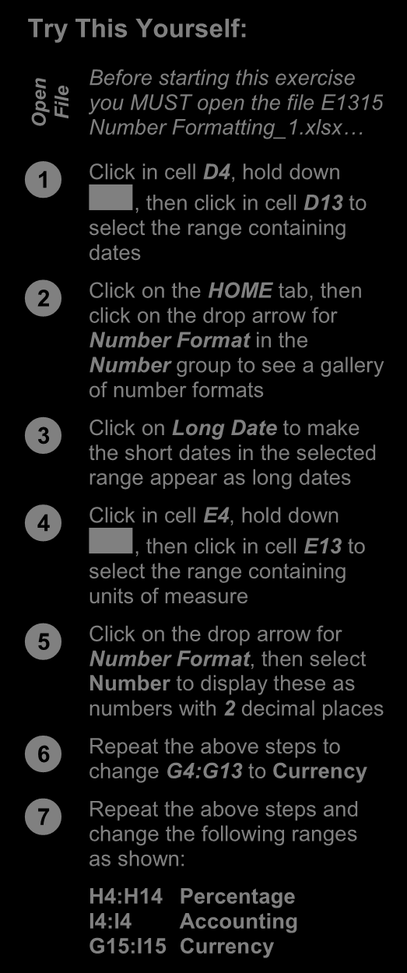
n Before starting this exercise

pe you MUST open the file E1315 File O Number Formatting_1.xlsx…


Click in cell D4, hold down , then click in cell D13 to

select the range containing
dates


Click on the HOME tab, then click on the drop arrow for
Number Format in the
Number group to see a gallery
of number formats


Click on Long Date to make the short dates in the selected
range appear as long dates


Click in cell E4, hold down , then click in cell E13 to 2

select the range containing
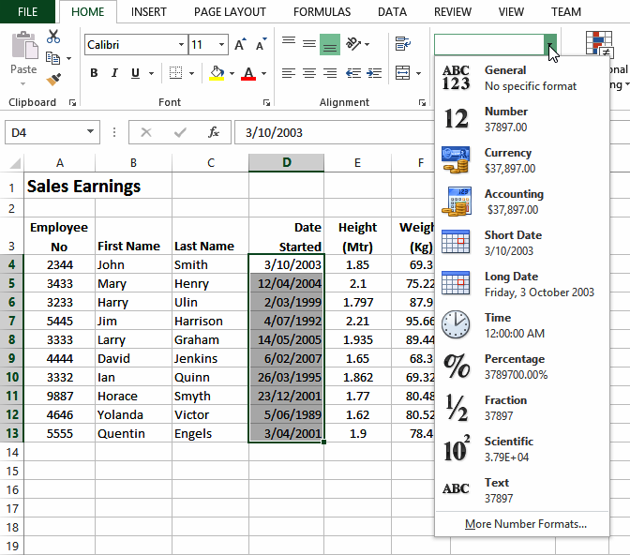
units of measure


Click on the drop arrow for Number Format , then select
Number to display these as
numbers with 2 decimal places


Repeat the above steps to change G4:G13 to Currency


Repeat the above steps and change the following ranges
as shown:
H4:H14 Percentage
I4:I4 Accounting
G15:I15 Currency

7

For Your Reference… Handy to Know…
To apply general formatting to numbers: • Excel may appear to round values up or
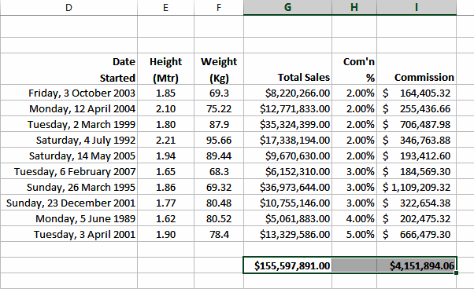
1. Select the range to format down as necessary – however, the value in

2. Click on the the cell does not change. Sometimes you’ll HOME tab, then click on the see minor rounding discrepancies. drop arrow for Number Format in the • Number group The Currency format shows the currency
format and symbol appropriate to the country
3. Click on the desired number format
your computer is configured for.

ITTraining@sgul.ac.uk Page 17 St. George’s Information Services
Microsoft Excel
CHANGING FONTS
The appearance that you choose for your text is In Excel 2007, font just refers to the typeface or referred to as the font or typeface. Font shape of the letters. Typical classic fonts include
traditionally refers to a combination of typeface, Times New Roman , Arial, Century Gothic and style and size in points (e.g. Arial Bold 12 pt). Copperplate.


1
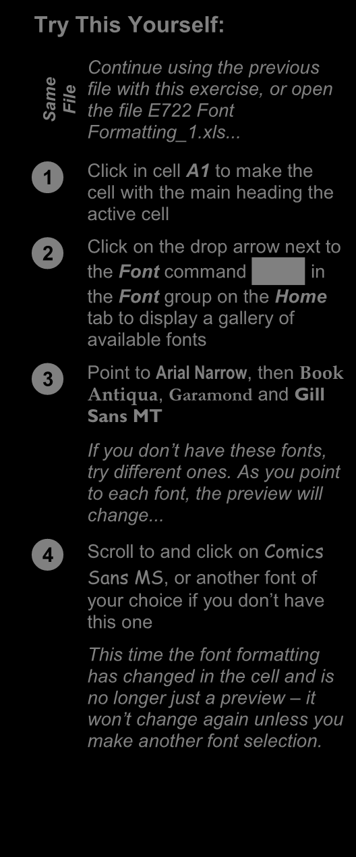
Try This Yourself:


e Continue using the previous
m file with this exercise, or open
Sa File the file E722 Font
Formatting_1.xls...


Click in cell A1 to make the cell with the main heading the
active cell


Click on the drop arrow next to the Font command in

the Font group on the Home
4
tab to display a gallery of
available fonts


Point to Arial Narrow, then Book Antiqua , Garamond and Gill
Sans MT
If you don’t have these fonts,
try different ones. As you point
to each font, the preview will
change...


Scroll to and click on Comics Sans MS , or another font of
your choice if you don’t have
this one
This time the font formatting
has changed in the cell and is
no longer just a preview – it
won’t change again unless you
make another font selection.

For Your Reference… Handy to Know…
To apply font formatting: • You can jump directly to a font. For example,
1. Select the text if you want to preview Garamond, click on the
name of the font in the Font command and

2. Click on the drop arrow for Font
press . Excel will jump to the fonts that

3. Point to a font to preview it start with G and Live Preview will display the 4. Click on the font to apply it text temporarily. Keep typing the name until
you reach the required font.
•
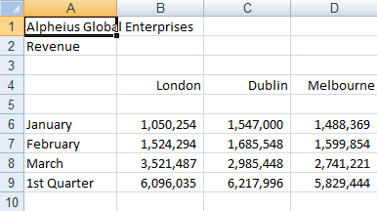
ITTraining@sgul.ac.uk Page 18 St. George’s Information Services
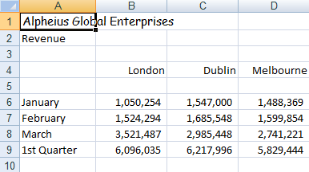
Microsoft Excel
CHANGING FONT SIZE
One way that text can be emphasised is by be changed for small detailed items, such as
changing the size of the font. For example, if comments or a caption. Main headings in a your normal text is 11 pt, you may like to make worksheet usually appear in a slightly larger font
the headings 13 pt or larger. Font size may also size compared to the rest of the data.


1
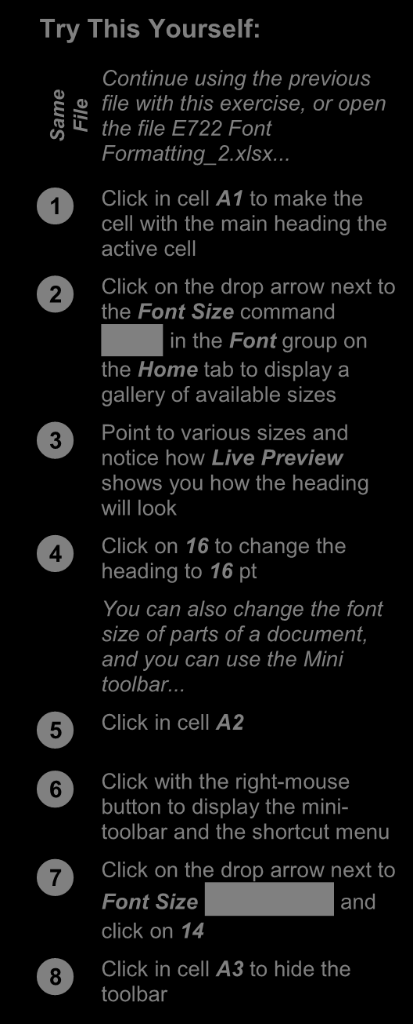
Try This Yourself:


e Continue using the previous
m file with this exercise, or open
Sa File the file E722 Font
Formatting_2.xlsx...


Click in cell A1 to make the 2 cell with the main heading the
active cell


Click on the drop arrow next to the Font Size command

in the Font group on
the Home tab to display a
gallery of available sizes


Point to various sizes and notice how Live Preview
shows you how the heading
will look


Click on 16 to change the heading to 16 pt
You can also change the font
size of parts of a document,
and you can use the Mini
8
toolbar...


Click in cell A2


Click with the right-mouse button to display the mini-
toolbar and the shortcut menu


Click on the drop arrow next to Font Size and
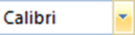
click on 14


Click in cell A3 to hide the toolbar

For Your Reference… Handy to Know…
To change font size: • You may have noticed that the text didn’t
1. Select the cell or range that you want to change size when you used the mini toolbar

2. Click on the drop arrow of size. This is because Live Preview doesn’t Font Size work with the mini toolbar. change until you actually clicked on a different font
3. Click on the required font size

ITTraining@sgul.ac.uk Page 19 St. George’s Information Services
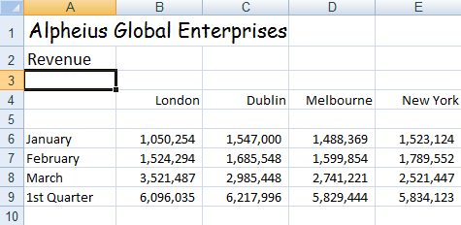
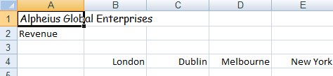
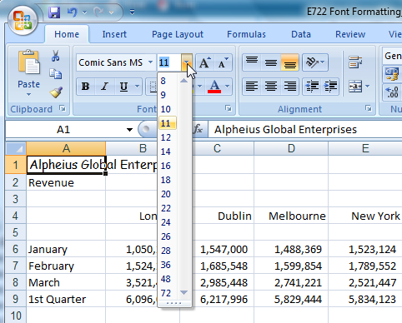
Microsoft Excel
UNDERSTANDING BORDERS
Borders are lines that are placed around the is that the lines can be used to group together data
edges of individual cells or ranges. The lines may or indicate totals, or to draw the user’s attention to
be thin, thick, solid, dashed, black or coloured, or critical cells that may need special data entry. Here
even double lines. The reason for using borders are some examples.


A Worksheet without and with Borders
Borders can be used to apply a structure. Here’s the same worksheet shown without borders and
then with borders applied. The use of borders helps to highlight the totals and separate them from
the other data.


Border Variations
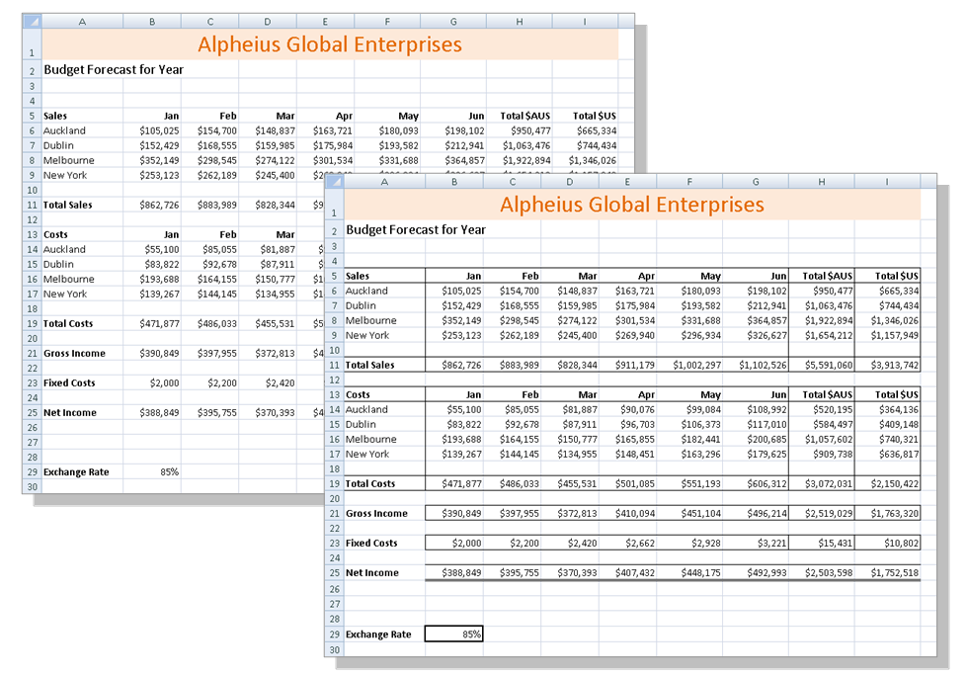
Borders can be applied to all four sides of a cell, or to individual sides of a cell. The following examples show a cell without a border, with an outside border and a top and double bottom border.
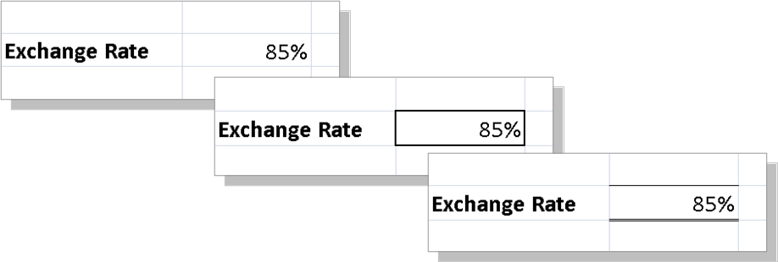

ITTraining@sgul.ac.uk Page 20 St. George’s Information Services
Microsoft Excel
APPLYING A BORDER TO A RANGE
You can apply a border to a range of cells. This indicate that they are in separate groups. Borders
allows you to place an outline around them to can be used in ranges of cells to create a more
indicate that the cells are somehow related to form-like appearance. The borders available for
each other, or to place borders between cells to single cells can also be applied to ranges.


1
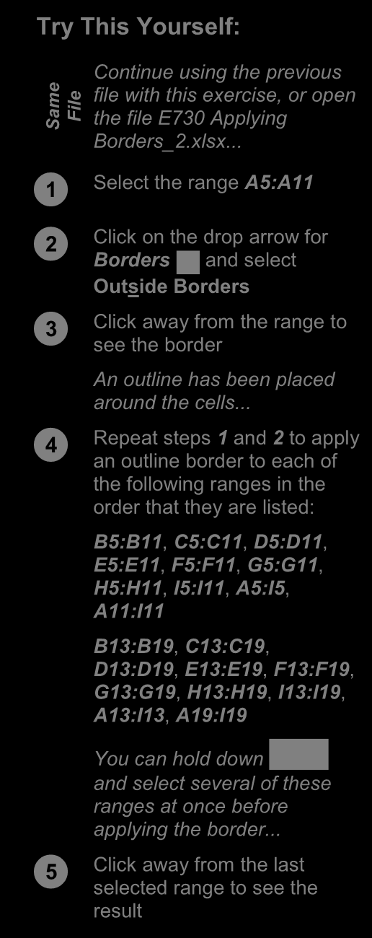
Try This Yourself:


e Continue using the previous
m file with this exercise, or open
Sa File the file E730 Applying
Borders_2.xlsx...


Select the range A5:A11


Click on the drop arrow for 3 Borders and select

Outside Borders


Click away from the range to see the border
An outline has been placed
around the cells...


Repeat steps 1 and 2 to apply an outline border to each of
the following ranges in the
order that they are listed:
B5:B11, C5:C11, D5:D11,
E5:E11, F5:F11, G5:G11,
H5:H11, I5:I11, A5:I5,
A11:I11
B13:B19, C13:C19,
D13:D19, E13:E19, F13:F19,
G13:G19, H13:H19, I13:I19,
A13:I13, A19:I19
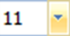
You can hold down
and select several of these
ranges at once before
applying the border...


Click away from the last selected range to see the
result
5

For Your Reference… Handy to Know…
To apply a border to a range: • You can copy a border between cells, for
1. Select the range example, from one table to another, using
Paste Special. Select the cells, click on
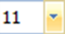
2. Click on the drop arrow for Borders
Copy , click on the first cell of the
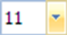
in the Font group on the Home tab
second range and click on the drop arrow for
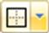
3. Click on the border option of your choice Paste . Select Paste Special, click on
Formats and then click on [OK].

ITTraining@sgul.ac.uk Page 21 St. George’s Information Services
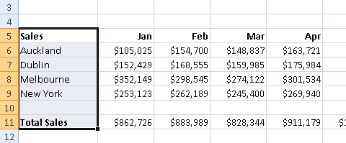
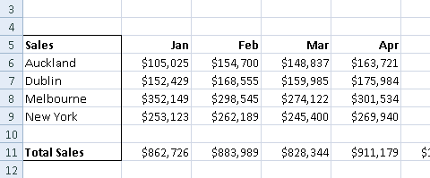
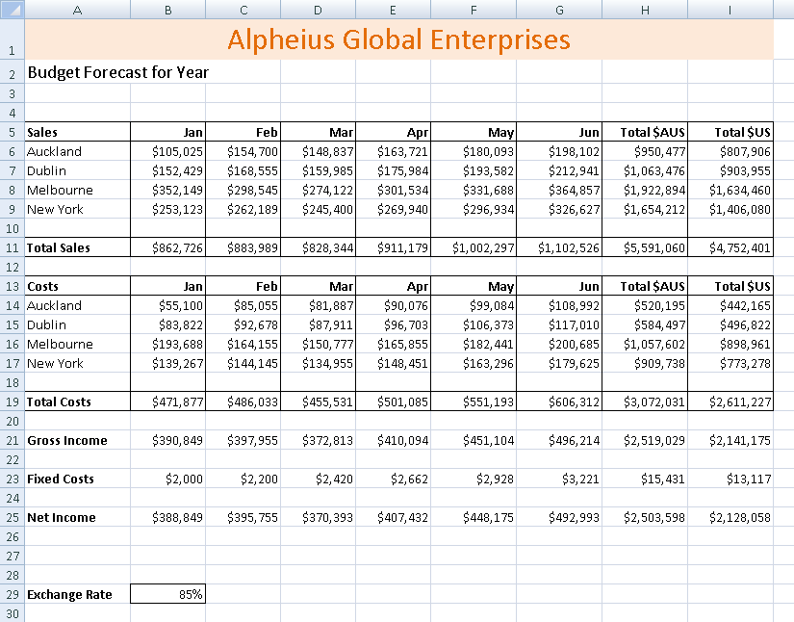
Microsoft Excel
WRAPPING AND MERGING TEXT
Microsoft Excel will allow long cell entries to spill to place long text entries in a cell you can arrange
across to other adjacent cells to the right as long for Microsoft Excel to wrap the text within the cell
as those cells are empty. If those cells contain and also merge that cell with others to data the spill-over will be chopped off. If you need accommodate the longer text entry.

1

Try This Yourself:
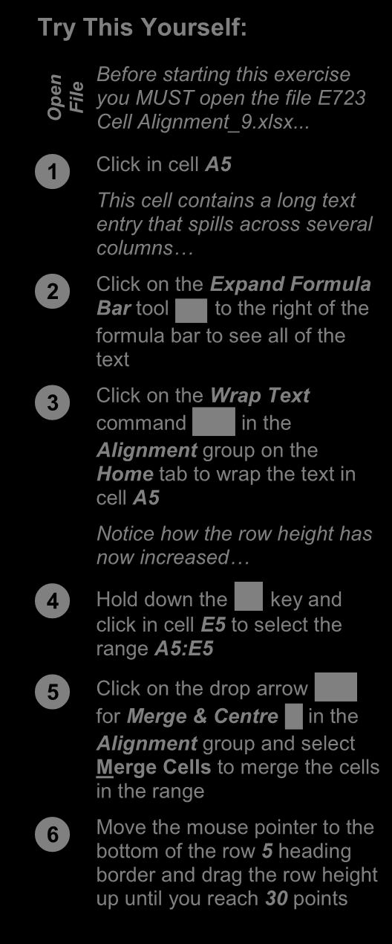
n Before starting this exercise
pe you MUST open the file E723 File O Cell Alignment_9.xlsx...


Click in cell A5 This cell contains a long text 3
entry that spills across several
columns…


Click on the Expand Formula Bar tool to the right of the

formula bar to see all of the
text


Click on the Wrap Text command in the
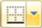
Alignment group on the
Home tab to wrap the text in
cell A5
Notice how the row height has 5 now increased…



Hold down the key and click in cell E5 to select the
range A5:E5
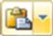


Click on the drop arrow for Merge & Centre in the
Alignment group and select
Merge Cells to merge the cells
in the range


Move the mouse pointer to the bottom of the row 5 heading
border and drag the row height
up until you reach 30 points

For Your Reference… Handy to Know…
• To wrap text - click in the cell to merge and • In the example above, wrapping forced the

click on the text into one cell and Excel expanded the Wrap Text command in the
row height so that all of the text was
Alignment group on the Home tab
• To merge text - click on the drop arrow across several horizontal cells in the exercise accommodated. We then merged the text

for above so that we could reduce the row Merge & Centre in the Alignment
group and select height to a more acceptable level. Merge Cells
•

ITTraining@sgul.ac.uk Page 22 St. George’s Information Services
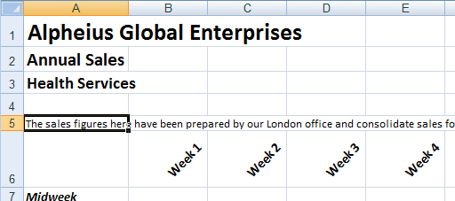
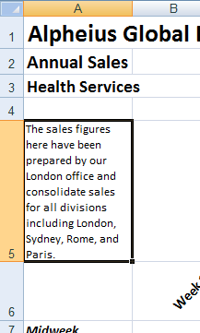
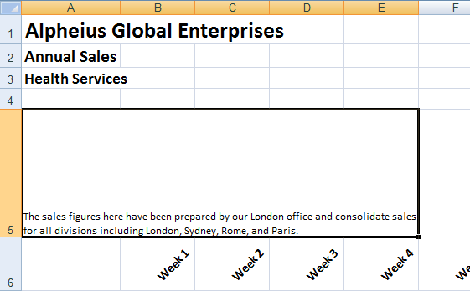
Microsoft Excel
PRACTICE EXERCISE
Font Formatting


Tasks:
Before starting this exercise you MUST have completed all of the topics in
the chapter Font Formatting…


Open the workbook called PE_Font Formatting.xlsx (it can be found in the same folder as the student files)


Format the heading in cell A1 as Cambria, 36 pt, bold, Orange Accent 2


Format the other headings as bold, italic or underline as shown on the following page


Use Orange, Accent 2, Lighter 80% to fill the area behind the headings as shown on the following page


1 Add the superscript in cell H3 and in cell B27 with the following comment 1 Fee may be reduced as the result of Government Assistance
Your completed worksheet should appear as shown on the following page...


Use the Save As command to save the workbook as PE_Font Formatting (Completed).xlsx
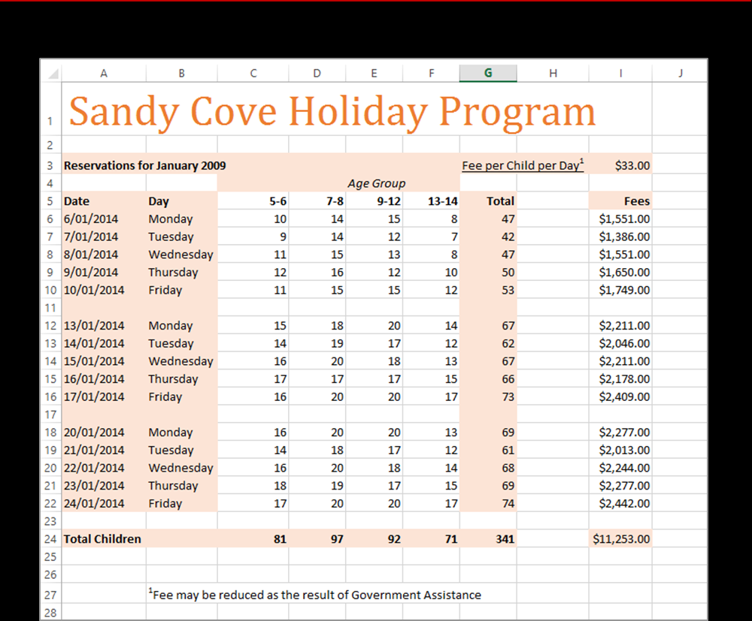

ITTraining@sgul.ac.uk Page 23 St. George’s Information Services
Microsoft Excel
PRACTICE EXERCISE
Cell Alignment

Tasks: Completed:
Before starting this exercise you MUST have completed all of the topics in
the chapter Cell Alignment…


Open the workbook called PE_Cell Alignment1.xlsx (it can be found in  the same folder as the student files)


Right-align the fees 


Left align the range B6:B21 


Centre align cells B23, B25 and B27 


Use the Save As command to save the workbook as PE_Cell Alignment1  (Completed).xlsx
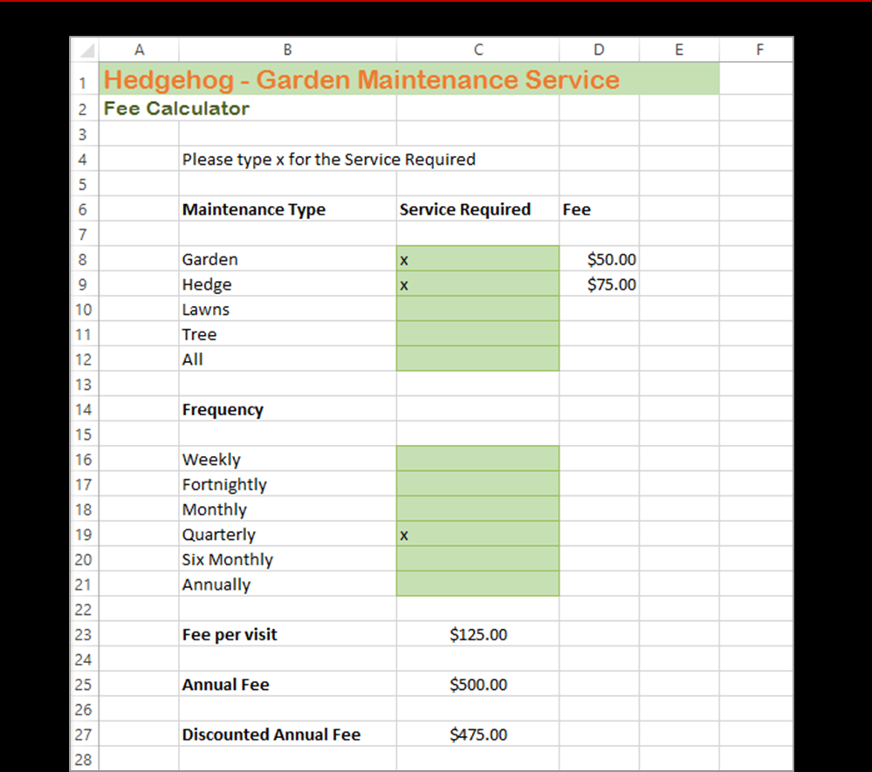

ITTraining@sgul.ac.uk Page 24 St. George’s Information Services
Microsoft Excel
PRACTICE EXERCISE
Number Formatting

Tasks: Completed:
Before starting this exercise you MUST have completed all of the topics in
the chapter Number Formatting…


Open the workbook called PE_Number Formatting.xlsx (it can be found  in the same folder as the student files)


On the Cargo worksheet, apply formatting to the dates and figures so that  they appear as shown in sample A on the next page
This will involve applying a date format, thousands separator, setting the number of decimals and applying the currency format...


On the Purchases worksheet, apply formatting so that the figures appear  as shown in sample B on the following page
The currency formats should be $, € Euro (€ 123), R English (South Africa) and ETB Amharic (Ethiopia) respectively. You’ll need to widen the columns a little to make room for the characters added by the formatting...


Use the Save As command to save the workbook as PE_Number  Formatting (Completed).xlsx
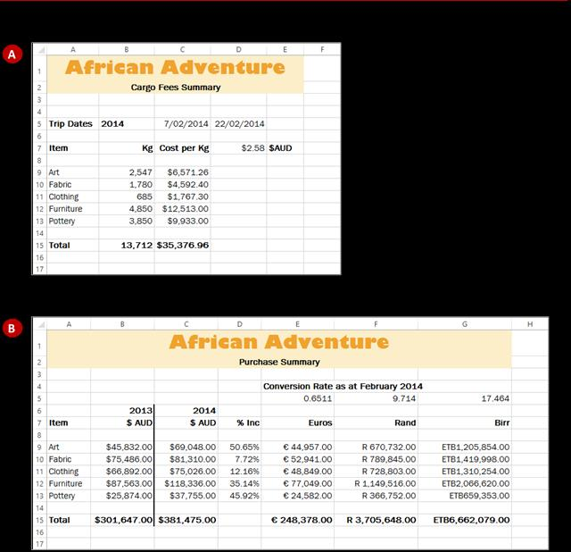

ITTraining@sgul.ac.uk Page 25 St. George’s Information Services
Microsoft Excel

UNDERSTANDING FUNCTIONS
Imagine having to create a formula that time consuming to develop. This is the role of
calculated the monthly payments on a loan, or hundreds of arithmetic functions that have been
the average of over 100 cells – these would pre-programmed in Excel for you. require complex or long formulas that would be


Functions Overview
Functions are simply pre-programmed formulas already provided for you in Excel which can perform calculations covering a wide range of categories including statistics, date and time arithmetic, financial calculations, lists, engineering, and more.
Just like normal formulas that you create, functions must start with an equal sign. The equal sign is then followed by the name of the function (usually a descriptive name which indicates the purpose of the function). Most functions also require additional information known as arguments which are supplied to the function in brackets after the function name. Functions are therefore written as follows:
=name(arguments)
The arguments are quite often cell or range references that contain values that can be used in the function. For example, the commonest function is the SUM function which, as its name suggests, is used to sum or add values together. If you wanted to add all of the values in the cells from B10 to D15 you would write this function as:
=SUM(B10:D15)
As you can see this is much simpler than writing your own referential formula which would look like: =B10+B11+B12+B13+B14+B15+D10+D11+D12+D13+D14+D15
Imagine writing and proofing a formula where you had to add 200 cells!
Typing Functions
If you are familiar with the function that you need you can type it into a cell exactly the same way you type any other formula. If you are not sure if Excel has a function or you can’t quite remember how it is written you can use the Insert Function tool on the Formula Bar to assist you. When you click on

this tool the Insert Function dialog box will be presented to you which lists the most recently used or common functions and also allows you to search for other functions that you might need.
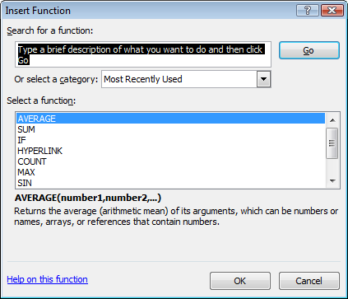

The Insert Function dialog box will also type the function out for you and then provide you with a further dialog box to guide you through the process of specifying the arguments that the function needs to perform its calculation.

ITTraining@sgul.ac.uk Page 26 St. George’s Information Services
Microsoft Excel
USING THE SUM FUNCTION TO ADD
One of the most used functions is the SUM type the function, and then use the pointing function. This function allows you to add the technique to fill in the arguments. Excel then paints
values in a range of cells. The function is written marquees around the cells involved helping you to
as: =SUM(range or ranges to add). You can track your progress.

Try This Yourself: 1
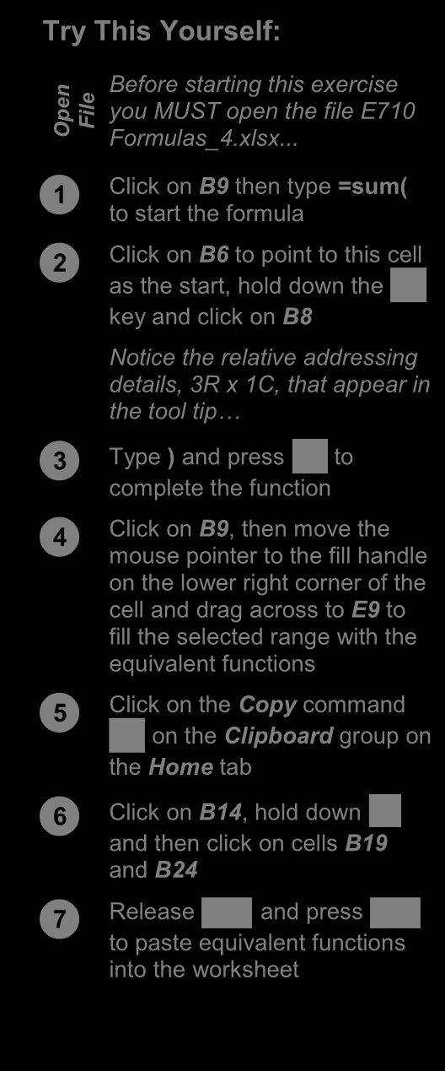
n Before starting this exercise
pe you MUST open the file E710 File O Formulas_4.xlsx...


Click on B9 then type =sum( to start the formula


Click on B6 to point to this cell as the start, hold down the

key and click on B8
2
Notice the relative addressing
details, 3R x 1C, that appear in
the tool tip…



Type ) and press to complete the function


Click on B9, then move the mouse pointer to the fill handle
on the lower right corner of the
cell and drag across to E9 to
fill the selected range with the 7
equivalent functions


Click on the Copy command Clipboard group on on the

the Home tab



Click on B14, hold down and then click on cells B19
and B24



Release and press to paste equivalent functions

into the worksheet

For Your Reference… Handy to Know…
To type a sum function for a contiguous range: • You can also use the Sum command in the
1. Type Editing group on the Home tab of the =sum(
Ribbon to have Excel automatically enter a
2. Select the range of cells
sum function based on a range of cells.
3. Type ) • You can also type the name of a function in 4. Press upper or lowercase – it is not case sensitive.


ITTraining@sgul.ac.uk Page 27 St. George’s Information Services
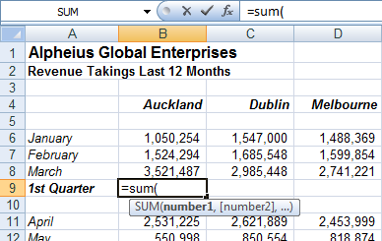
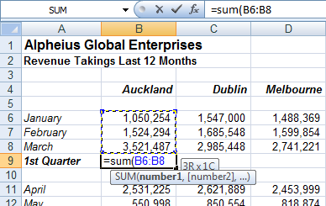
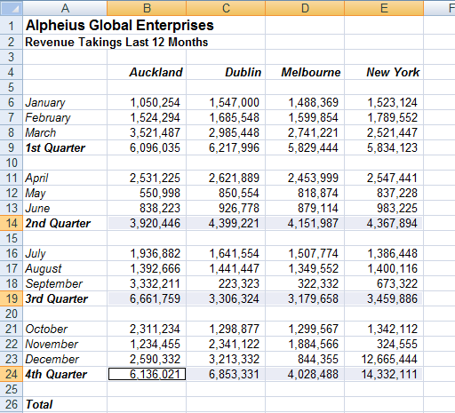
Microsoft Excel
CALCULATING AN AVERAGE
The AVERAGE function allows you to average average function can be applied using the the values in a range of cells. It is written in much Functions Wizard, a part of Excel that steps you the same way as the SUM function, for example, through the process of creating a function or you
=AVERAGE(range of cells to average). The can type it in yourself if you are comfortable with it.

1

Try This Yourself:
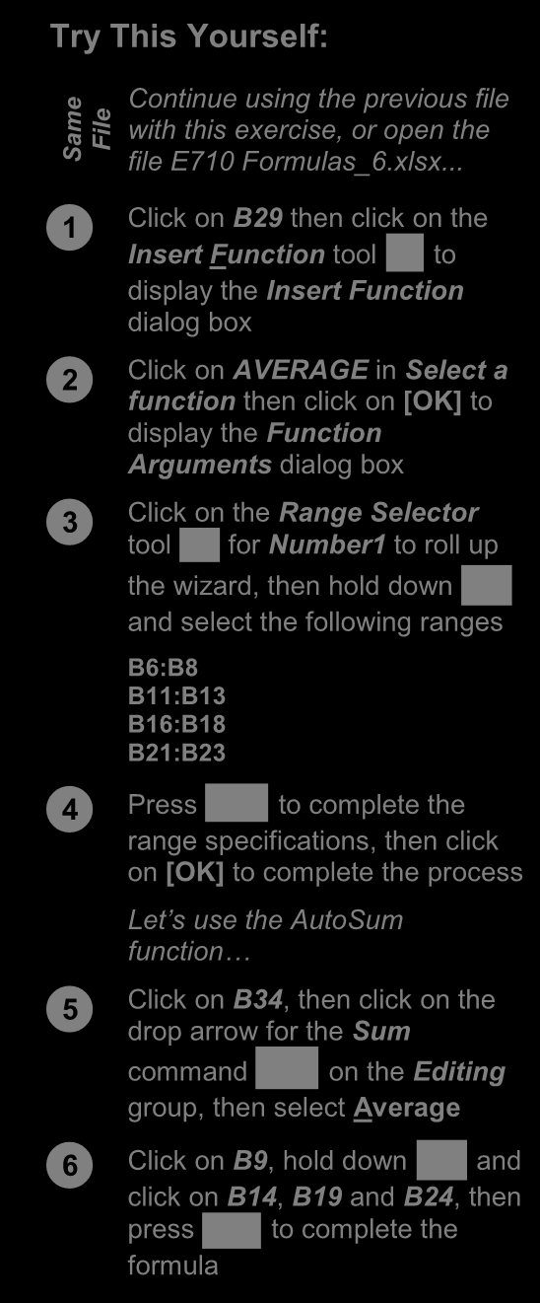
e

Continue using the previous file
m with this exercise, or open the File Sa file E710 Formulas_6.xlsx...


Click on B29 then click on the Insert Function tool to

display the Insert Function
dialog box


Click on AVERAGE in Select a function then click on [OK] to
display the Function
Arguments dialog box


Click on the Range Selector tool for Number1 to roll up

the wizard, then hold down

and select the following ranges
B6:B8
B11:B13
B16:B18
B21:B23



Press to complete the range specifications, then click
on [OK] to complete the process 3
Let’s use the AutoSum
function…


Click on B34, then click on the drop arrow for the Sum 5
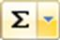
command on the Editing
group, then select Average



Click on B9, hold down and click on B14 , B19 and B24 , then

press to complete the
formula

For Your Reference… Handy to Know…
To insert an average function: • You can type queries like “How do I work out
1. Click in the cell then click on the the monthly payment for a car loan?” into the Insert

Function Search box in the Insert Function dialog tool
box. Once you have selected a function from
2. Click on AVERAGE in Select a function the Select a function list, the Function 3. Insert the required ranges then click on Arguments dialog box will help you to enter
[OK] the values into the function.
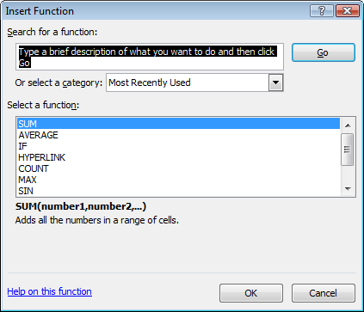
•
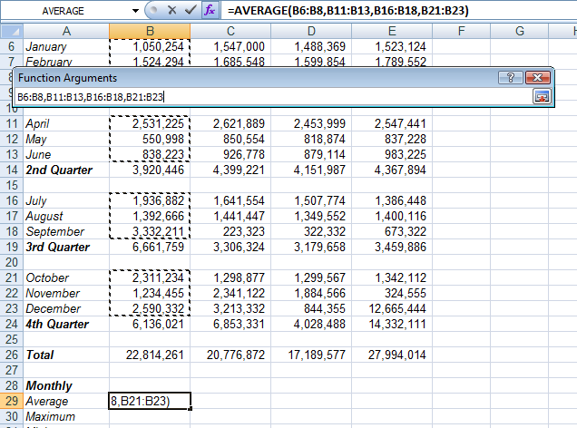

ITTraining@sgul.ac.uk Page 28 St. George’s Information Services
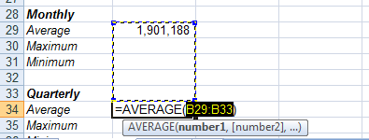
Microsoft Excel
FINDING A MINIMUM VALUE
The Minimum or MIN function allows you to The function can be applied using the Function extract the lowest value from a range of values. It Wizard, or by typing the function in detail directly is written in much the same way as the SUM into the cell. function. For example, =MIN(range of cells).

Try This Yourself:


e Continue using the previous
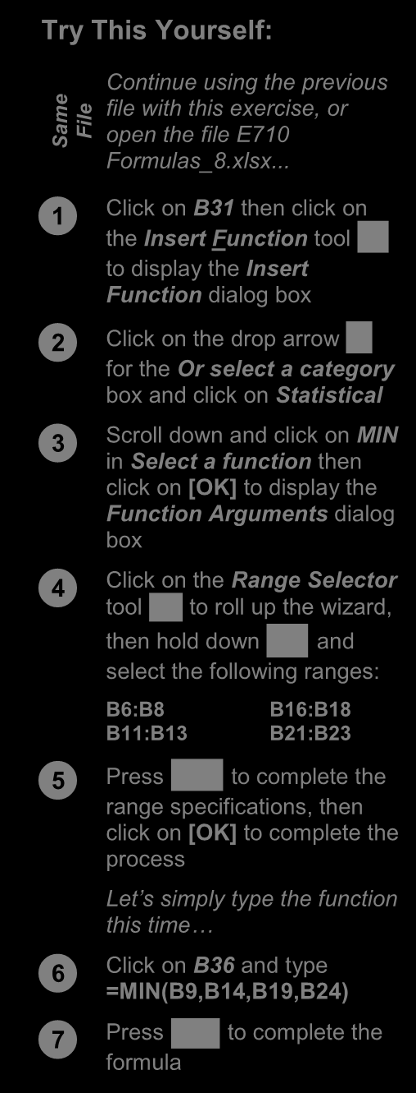
m file with this exercise, or

Sa File open the file E710
Formulas_8.xlsx...


Click on B31 then click on the Insert Function tool

to display the Insert
Function dialog box



Click on the drop arrow for the Or select a category
box and click on Statistical


Scroll down and click on MIN in Select a function then
click on [OK] to display the
Function Arguments dialog
box 4


Click on the Range Selector tool to roll up the wizard,

then hold down and

select the following ranges:
B6:B8 B16:B18
B11:B13 B21:B23



Press to complete the 6 range specifications, then
click on [OK] to complete the
process
Let’s simply type the function
this time…


Click on B36 and type =MIN(B9,B14,B19,B24)



Press to complete the 7 formula

For Your Reference… Handy to Know…
To insert a minimum function: • You might use a Minimum function in real
1. Click in the cell then click on the life to find the lowest value in a large range of Insert
Function numbers. For example, in a large inventory it tool
can be used to work out which product is the
2. Click on MIN in Select a function slowest seller. 3. Insert the required ranges then click on
[OK]
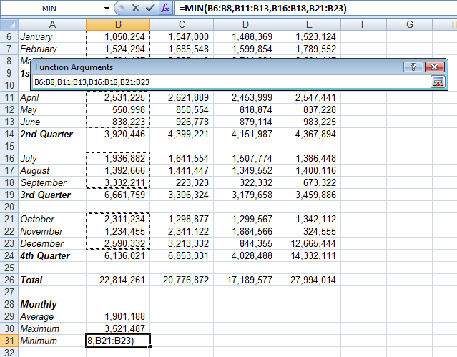

ITTraining@sgul.ac.uk Page 29 St. George’s Information Services
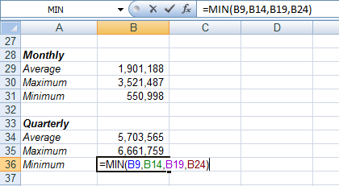
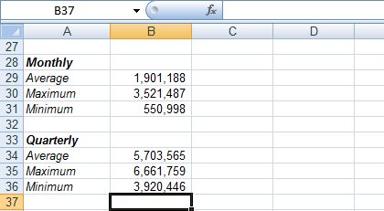
Microsoft Excel
COMMON ERROR MESSAGES
Microsoft Excel has some in-built messages that other formula cells that depend upon it. The can assist you when something goes wrong with messages are always prefixed with a hash sign (#)
a formula. These messages appear in the cell and appear with a code. The more common error
that contains the formula, and sometimes also messages are listed below.


A Line of Hash (#) Signs
Sometimes referred to as “tramlines”, a line of hash
signs usually occurs because a column is not wide
enough to display the numbers in the cell or
formula. Widening the column will correct this
problem – you can drag the column heading until the value in the cell appears as it should.


#DIV/0!
This message means you are trying to divide a value by
zero – this is mathematically impossible. In the example at the left we are trying to find the average number of
persons per household. All is fine as long as there is a
value greater than zero in cell B3 (Houses). As soon as
we change this to a zero an error message appears in
the formula cell (B5).
To prevent the error you will need to enter a value
greater than zero into cell B3, the divisor cell.

#VALUE!
In this message Excel is advising that something in the
formula is not a value and therefore a calculation can’t be made.
A close examination of the example at the left shows cell
B3 contains the word “three”. Therefore the formula in
cell B5 is trying to divide 192,664 (in cell B2) with a word,
which doesn’t make sense.
To fix the error, a value (a number) will need to be
entered in cell B3.


#NAME?
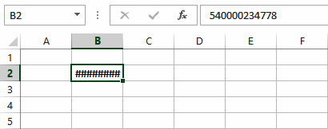
This message appears when text is found in a
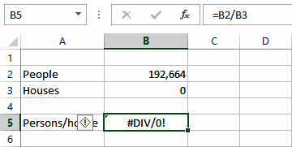
formula that can’t be matched to either a
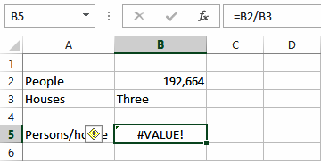
legitimate function or range name.
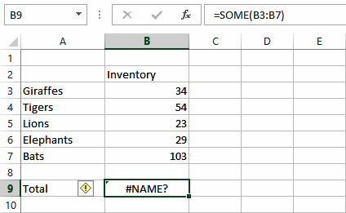
In the example to the left, the formula has been
entered as =SOME(B3:B7) – there is no such function as SOME, and presumably the author should have typed =SUM(B3:B7).

ITTraining@sgul.ac.uk Page 30 St. George’s Information Services
Microsoft Excel
PRACTICE EXERCISE
Formulas And Functions


Tasks: Completed:
Before starting this exercise you MUST have completed all of the topics in
the chapter Formulas And Functions…


Open the workbook called PE_Formulas And Functions.xlsx (it can be  found in the same folder as the student files)


Create a formula that calculates the gross pay for each employee, then use  a function to calculate the total of the gross pay
The total for Gross Pay should appear in E14...


Create a formula that calculates the tax as being 20% of the gross pay for  each employee, then create a total for the tax

  Create a formula to calculate the net pay for each employee and then a total of the net pay

  Create a formula that calculates the superannuation as being 8% of the gross pay for each employee, then create a total for superannuation

  Use functions to determine the average, maximum and minimum values for each column, setting the number of decimal places to 2
Your worksheet should appear as shown on the following page...


Use the Save As command to save the workbook as PE_Formulas And  Functions (Completed).xlsx
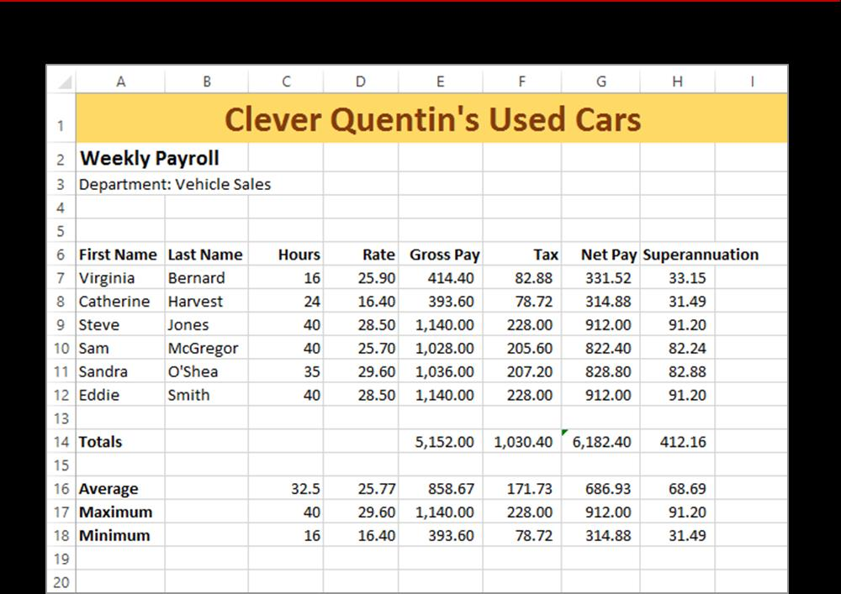

ITTraining@sgul.ac.uk Page 31 St. George’s Information Services
Microsoft Excel

UNDERSTANDING QUICK ANALYSIS
The Quick Analysis tools were developed in Live Preview with some of these tools to create response to the fact that users weren’t using or the Quick Analysis tools. even aware of the more powerful analytical tools
found in Excel. So Excel decided to combine


The Quick Analysis Button
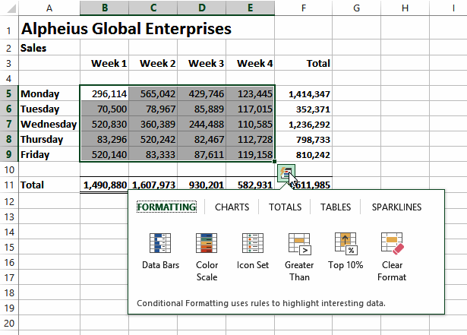
The Quick Analysis button
appears when a range is
selected in a worksheet.
Clicking on the button displays
the Quick Analysis gallery
which contains quick analysis
tools that can be applied to the
selected data.
The tools have been organised
along tabs at the top –
FORMATTING, CHARTS,
TOTALS, TABLES, and
SPARKLINES.
When you click on a tab,
options specific to that tab are
presented.


Using Quick Analysis Tools With Live
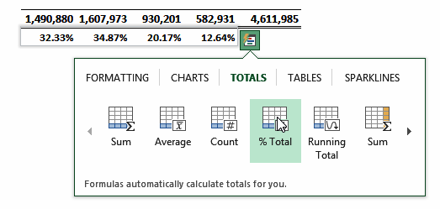
Preview
Most of the Quick Analysis tools in the
Quick Analysis gallery provide a Live
Preview of the changes in the worksheet
when you point to an option.
This is very useful if you are not sure of the
formatting or type of analysis you require as it
provides you with a preview of what the data
would look like if you selected that specific
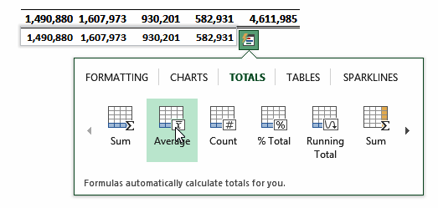
option.
At the right we have selected only the totals
from the worksheet shown above. We have
pointed to options from the TOTALS tab (% Total and Average) and from the
FORMATTING tab (Data Bars).
Live Preview has either presented another
row of analysed data or has formatted the
selection accordingly.
All of these tools are also available on the
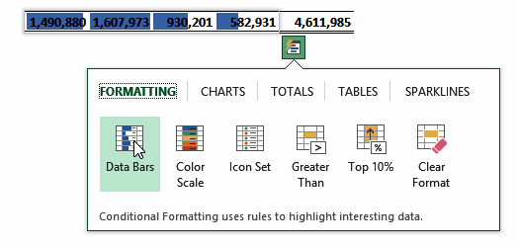
ribbon but using the Quick Analysis tools is much quicker.

ITTraining@sgul.ac.uk Page 32 St. George’s Information Services
Microsoft Excel
QUICK FORMATTING
The first tab in the Quick Analysis gallery is colouring it or presenting it in a slightly different
FORMATTING. This tab provides access to the way. In the Quick Analysis gallery you can apply conditional formatting tools of Excel. These are data bars, colour high and low values, values over
the tools that allow you to analyse data by or below a value, and more.
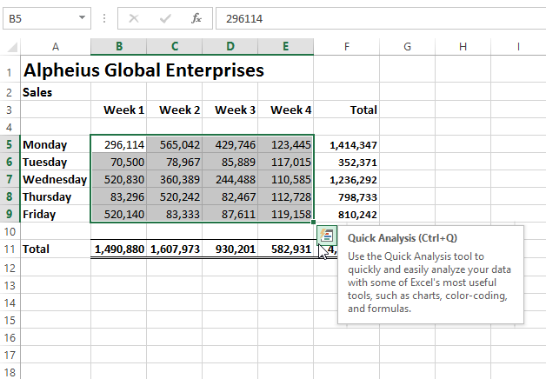

2

Try This Yourself:
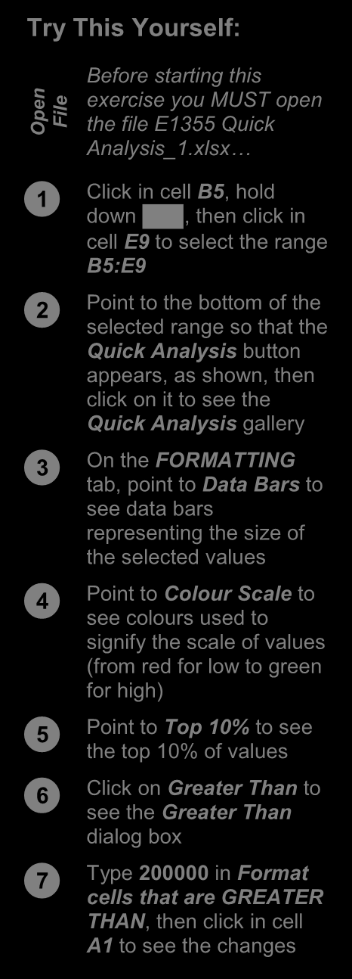

n exercise you MUST open

Before starting this
pe File the file E1355 Quick O
Analysis_1.xlsx…


Click in cell B5, hold down , then click in

cell E9 to select the range
B5:E9


Point to the bottom of the selected range so that the
Quick Analysis button
appears, as shown, then
click on it to see the
Quick Analysis gallery
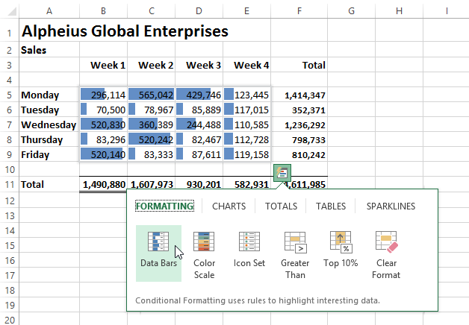
3


On the FORMATTING tab, point to Data Bars to
see data bars
representing the size of
the selected values


Point to Colour Scale to see colours used to
signify the scale of values
(from red for low to green
for high)


Point to Top 10% to see the top 10% of values


Click on Greater Than to see the Greater Than
dialog box
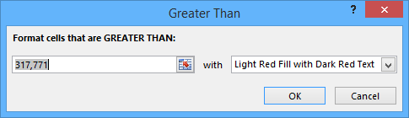


6
Type 200000 in Format
cells that are GREATER
THAN, then click in cell
A1 to see the changes

For Your Reference… Handy to Know…
To apply Quick Formatting in a worksheet: • Quick Formatting applies conditional
1. Select the range to be formatted, then click formatting, not the standard formatting.
on the Quick Analysis button • The Clear Format option in the Quick
2. Choose the desired formatting from the Analysis gallery will clear any conditional
FORMATTING tab formatting that has been applied.

ITTraining@sgul.ac.uk Page 33 St. George’s Information Services
Microsoft Excel
QUICK CHARTING
Charts aren’t all that difficult to create in Excel, tools provide a way of seeing what the different
especially with the Recommended Charts charts will look like without having to first create the
feature. However, deciding what style and type of chart. chart can be daunting. Fortunately the Charts
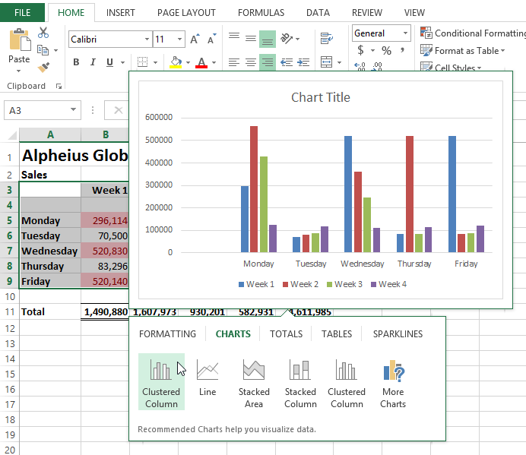

3

Try This Yourself:
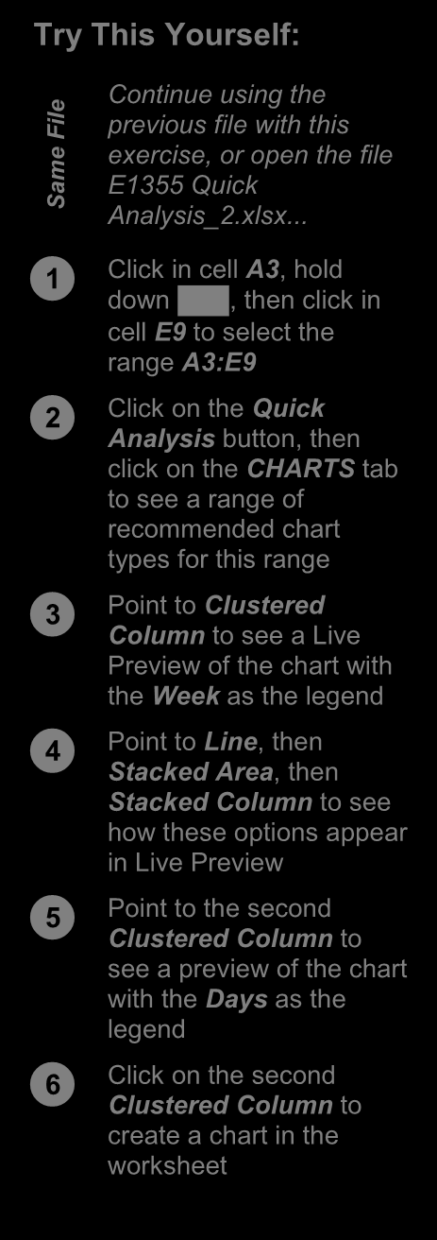
Continue using the

ile previous file with this
F
e exercise, or open the file
m
E1355 Quick
Sa Analysis_2.xlsx...


Click in cell A3, hold down , then click in

cell E9 to select the
range A3:E9


Click on the Quick Analysis button, then
click on the CHARTS tab
to see a range of
recommended chart
types for this range


Point to Clustered Column to see a Live 6
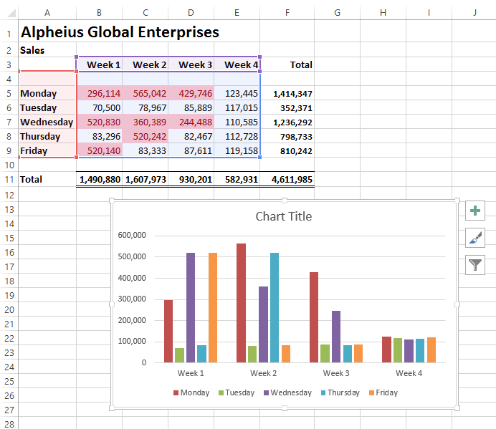
Preview of the chart with
the Week as the legend


Point to Line, then Stacked Area , then
Stacked Column to see
how these options appear
in Live Preview


Point to the second Clustered Column to
see a preview of the chart
with the Days as the
legend


Click on the second Clustered Column to
create a chart in the
worksheet

For Your Reference… Handy to Know…
To use the Quick Charting tools: • When creating a chart you’ll need to ensure
1. Select the range to be charted, then click on that the range you select includes the labels
the to be used on the chart. Quick Analysis button
2. Choose the desired option from the
CHARTS tab

ITTraining@sgul.ac.uk Page 34 St. George’s Information Services
Microsoft Excel
QUICK TOTALS
The TOTALS tab in the Quick Analysis gallery operations (e.g. AVERAGE instead of SUM) or use has some useful tools and options to help you the options to create the totals and calculations in
build your worksheet. You can use the options to the first place. analyse data and perform alternate arithmetic
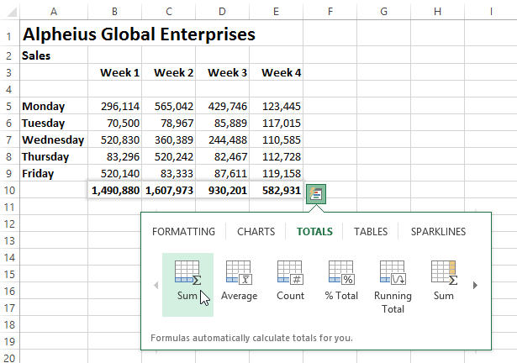

3
Try This Yourself:

n exercise you MUST

Before starting this
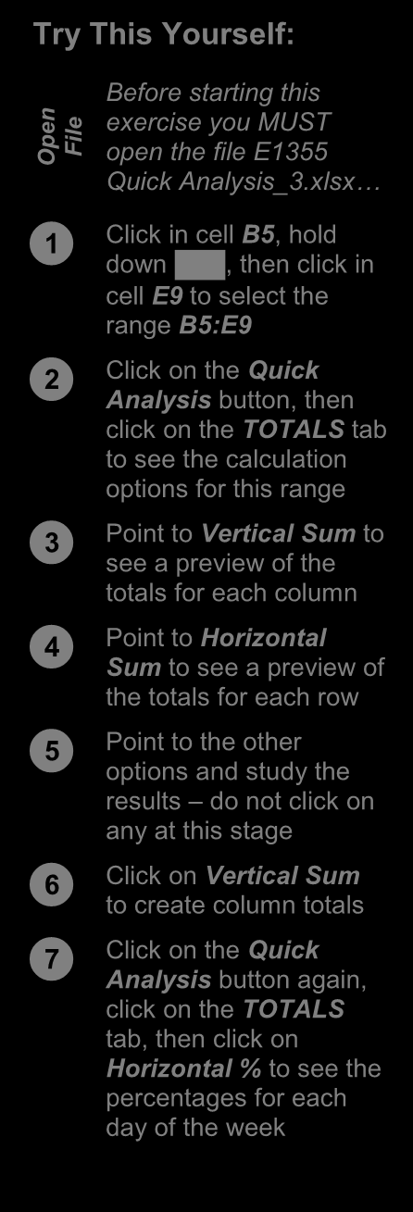
pe File open the file E1355 O

Quick Analysis_3.xlsx…


Click in cell B5, hold down , then click in

cell E9 to select the
range B5:E9


Click on the Quick Analysis button, then
click on the TOTALS tab
to see the calculation
options for this range


Point to Vertical Sum to see a preview of the 6 totals for each column
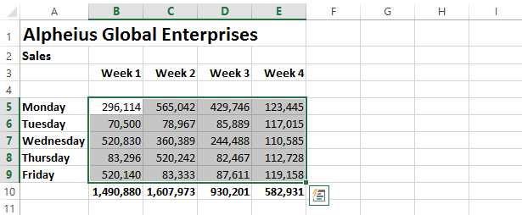


Point to Horizontal Sum to see a preview of
the totals for each row


Point to the other options and study the
results – do not click on
any at this stage


Click on Vertical Sum to create column totals
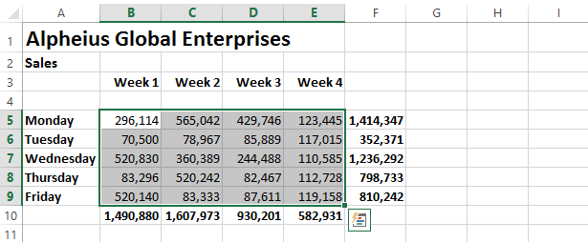


7
Click on the Quick
Analysis button again,
click on the TOTALS
tab, then click on
Horizontal % to see the
percentages for each
day of the week

For Your Reference… Handy to Know…
To create Quick Totals in a worksheet: • Always check any operation that performs
1. Select the range to be totalled/calculated and calculations and embeds formulas for you to
click on the ensure that the correct cells and ranges are Quick Analysis button
included in totals.
2. Choose the desired calculation methodology
from the TOTALS tab

ITTraining@sgul.ac.uk Page 35 St. George’s Information Services
Microsoft Excel
QUICK SPARKLINES
Sparklines are mini charts that are embedded acceptance or understanding that Microsoft would
into a worksheet, usually immediately adjacent to like. So, you’ll now find them in the Quick Analysis the data. Sparklines are only relatively new in tools where you can easily implement them without
Excel and probably haven’t gained the too much head scratching.


Try This Yourself:
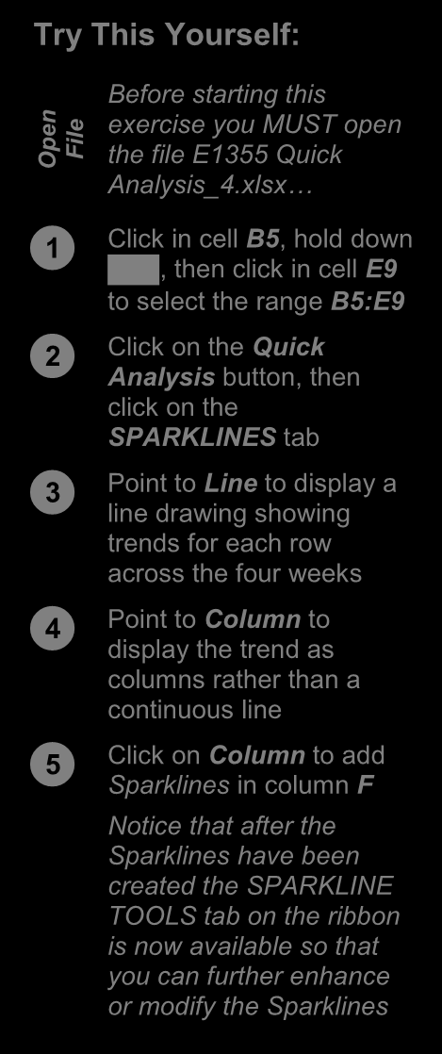

n exercise you MUST open

Before starting this
pe File the file E1355 Quick O
Analysis_4.xlsx…


Click in cell B5, hold down , then click in cell E9

to select the range B5:E9
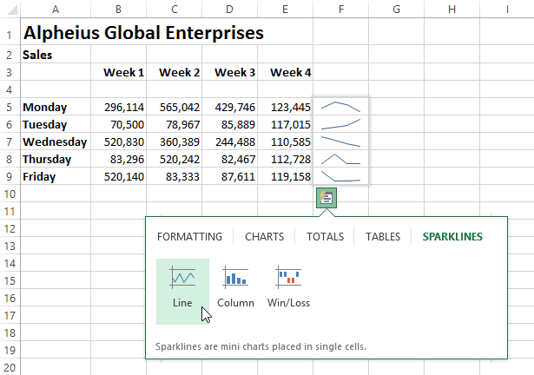


Click on the Quick Analysis button, then
click on the
SPARKLINES tab


Point to Line to display a line drawing showing
trends for each row
across the four weeks 3


Point to Column to display the trend as
columns rather than a
continuous line


Click on Column to add Sparklines in column F
Notice that after the
Sparklines have been
created the SPARKLINE
TOOLS tab on the ribbon
is now available so that
you can further enhance
or modify the Sparklines
5
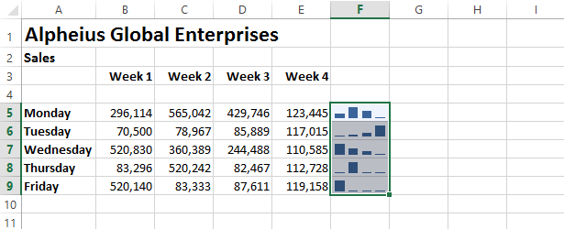

For Your Reference… Handy to Know…
To use Quick Sparklines in a worksheet: • The Win/Loss is a special type of Sparkline
1. Select the range to be analysed, then click that shows positives above an imaginary line
on the and negatives below it. You need to have Quick Analysis button
values range from the negative to the
2. Choose the desired Sparkline from the
positive to make any good use of it.
SPARKLINES tab

ITTraining@sgul.ac.uk Page 36 St. George’s Information Services
Microsoft Excel
QUICK TABLES
In computer terminology a table is created when does have columns and rows of continuous data.
data is organ ised into rows and columns. You’d But it must also have headings which provide filter
think then that a worksheet would be a table – buttons. Creating a table is not hard, but it is much
but it is not in the Excel definition. In Excel a table easier using Quick Tables.
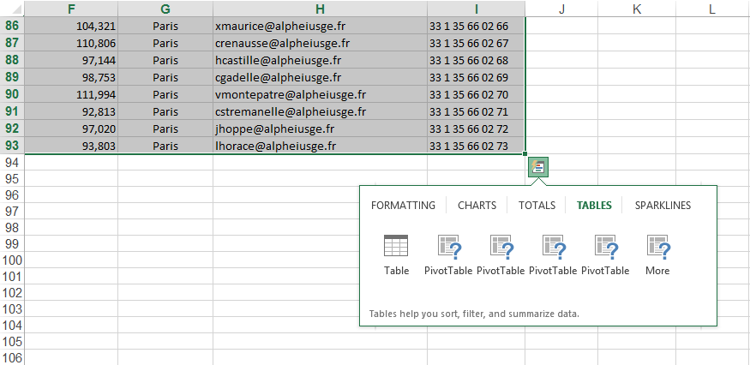

Try This Yourself:
Before starting this
le exercise you MUST

Fi
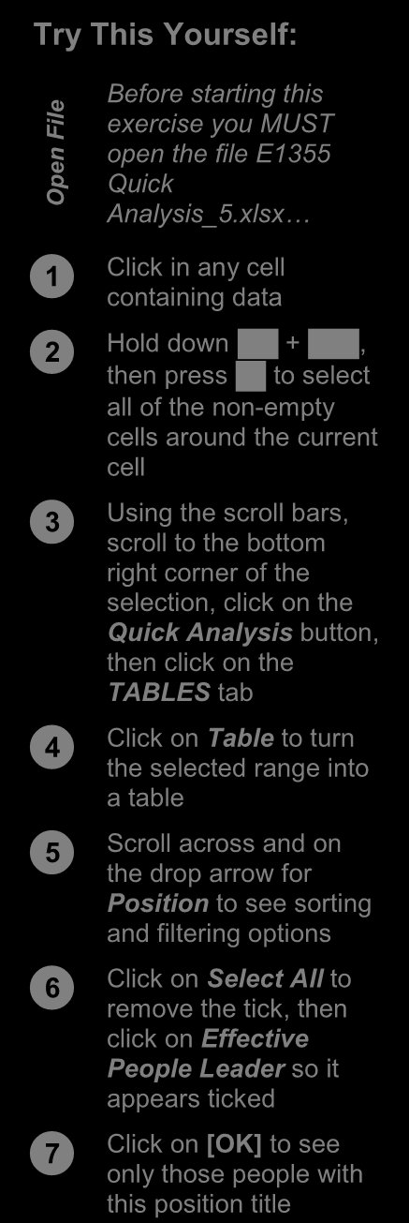
n open the file E1355

pe Quick
O Analysis_5.xlsx…


Click in any cell containing data



Hold down + , then press to select

all of the non-empty

cells around the current 3
cell
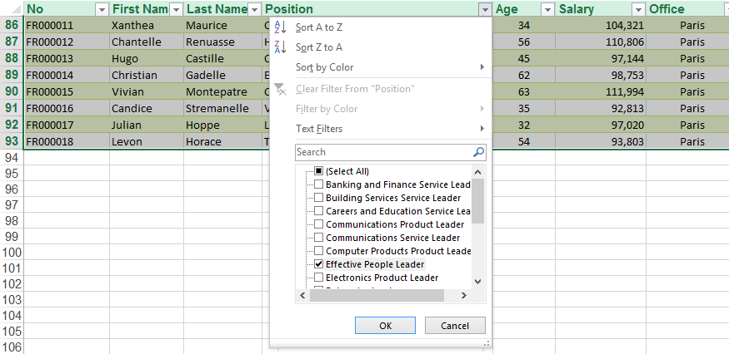


Using the scroll bars, scroll to the bottom
right corner of the
selection, click on the
Quick Analysis button,
then click on the
TABLES tab


Click on Table to turn the selected range into
a table


Scroll across and on the drop arrow for
Position to see sorting
and filtering options
6


Click on Select All to remove the tick, then
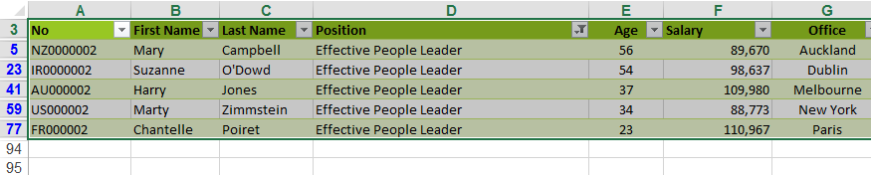
click on Effective
People Leader so it
appears ticked


Click on [OK] to see only those people with
this position title 7

For Your Reference… Handy to Know…
To use Quick Tables to create a table: • A drawback of using Quick Tables is that all
1. Select the entire data to be used as a table of the data must be selected first. Using the
normal operation to create a table (the Table
2. Click on the Quick Analysis button
command on the INSERT tab of the ribbon)
3. Click on the TABLES table, then click on only one cell in the table needs to be
Table selected.

ITTraining@sgul.ac.uk Page 37 St. George’s Information Services
Microsoft Excel
PRACTICE EXERCISE
The Quick Analysis Tools


Tasks: Completed:
Before starting this exercise you MUST have completed all of the topics in
the chapter The Quick Analysis Tools…


Open the workbook PE_Quick Analysis.xlsx (it can be found in the same  folder as the student files)


Use the Quick Analysis tools to apply a colour scale to the data in the  worksheet


Use the Quick Analysis tools to create a chart for the Overheads data.  This chart should be a clustered column chart that has the column
headings as the x axis, and displays the legend at the bottom of the chart.
Make the chart title Cost of Overheads.

  Reposition the chart below the data


Use the Quick Analysis tools to create Sparklines for the Qtr1 to Qtr4  and Total columns for Overheads
Your worksheet should appear as shown on the following page…


Use the Save As command to save the workbook as PE_Quick Analysis  (Completed).xlsx
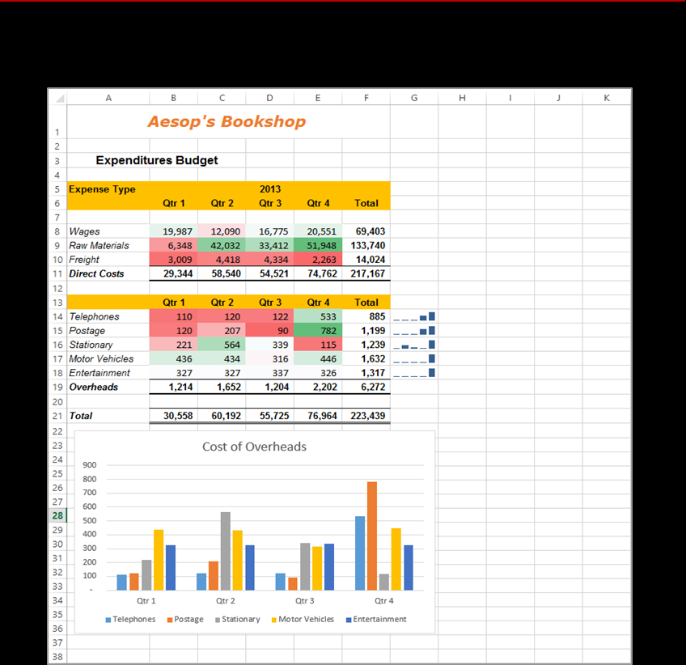

ITTraining@sgul.ac.uk Page 38 St. George’s Information Services
Microsoft Excel

PRINTING A WORKSHEET
Traditionally, printing means producing your over what and how much to print, as well as document on paper, but in today’s Web and enabling you to select the printer to use. You can
online world it might mean printing to the Web or print one or multiple copies of a document, one or
to another file. Excel gives you a lot of control multiple pages and even collate copies.


Try This Yourself: 1
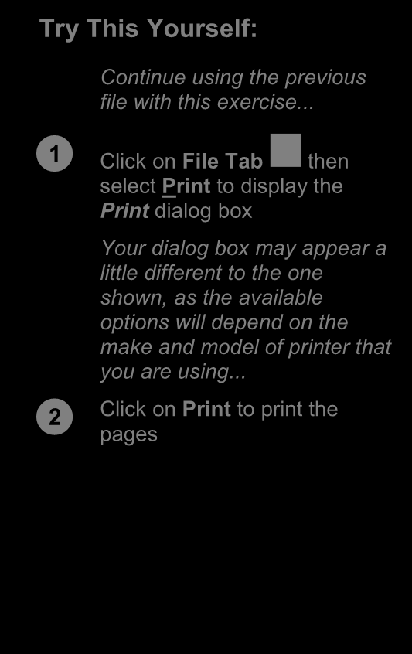
Continue using the previous

file with this exercise...
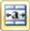


Click on File Tab then select Print to display the
Print dialog box
Your dialog box may appear a
little different to the one
shown, as the available
options will depend on the
make and model of printer that
you are using...


Click on Print to print the pages



For Your Reference… Handy to Know… For Your Reference… Handy to Know…
To close a workbook: • To print a document : • If you save your workbook using the close You can also print a document directly,
command, the workbook will be closed without opening the Print dialog box. Click

1. Click on the File Tab and select Close 1. Click on the File Tab without the prompting message above. the arrow on the Quick Access toolbar, 2. Click on Print • Click Excel allows you to have a number of Quick Print. This will send one copy of
the document directly to the printer. workbooks open at the same time. When you close a workbook when others are still open
one of the others will then appear.
•
ITTraining@sgul.ac.uk Page 39 St. George’s Information Services
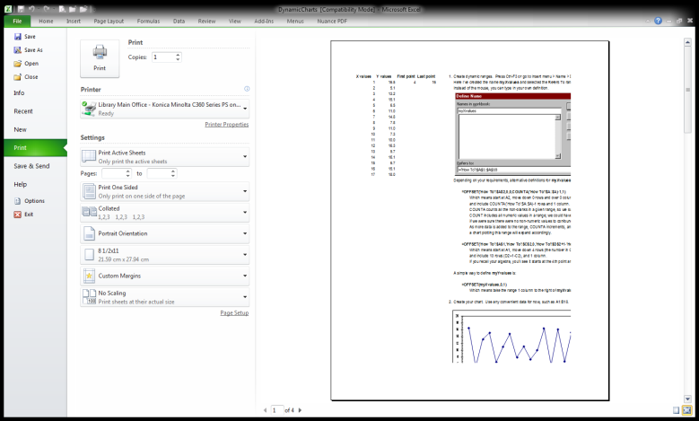
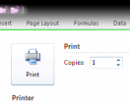
Microsoft Excel

THE CHARTING PROCESS
Charts provide a way of seeing trends in the data any of the Insert commands in the Charts group in your worksheet. The charting feature in Excel on the is extremely flexible and powerful and allows you
to create a wide range of charts from


Inserting Charts
The first step when creating a chart is to select the data from the worksheet that you want to chart. It is important to remember that the selected range (which can be either contiguous or non-contiguous), should include headings (e.g. names of months, countries, departments, etc). These become labels on the chart. Secondly, the selected range should not (normally) include totals as these are inserted automatically when a chart is created.
The second step is to create a chart using the INSERT tab on the ribbon. You can choose a Recommended Chart where Excel analyses the selected data and suggests several possible chart layouts.
Alternatively you can create the chart yourself from scratch by choosing one of the Insert commands in the Charts group. Charts that you create in Excel can be either embedded into a worksheet, or they can exist on their own sheets, known as chart sheets.

Embedded Charts
Charts that appear within a
worksheet are known as
embedded charts. A chart is
really an object that sits on
top of the worksheet – unlike
numbers and letters, charts
are not actually placed into
worksheet cells.


Chart Sheets
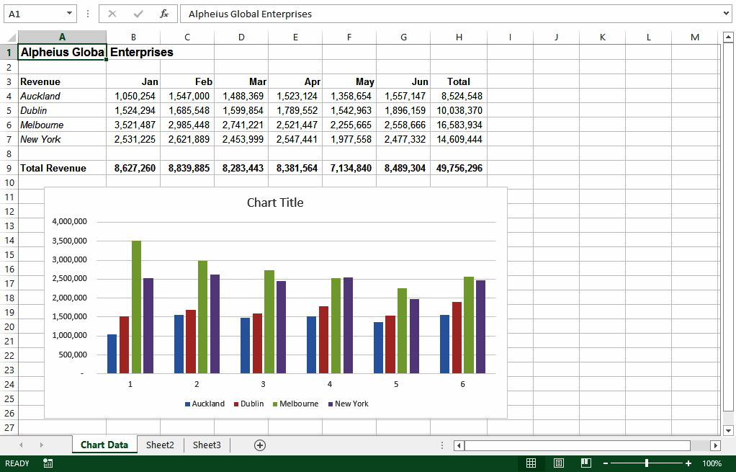
If you want to keep your
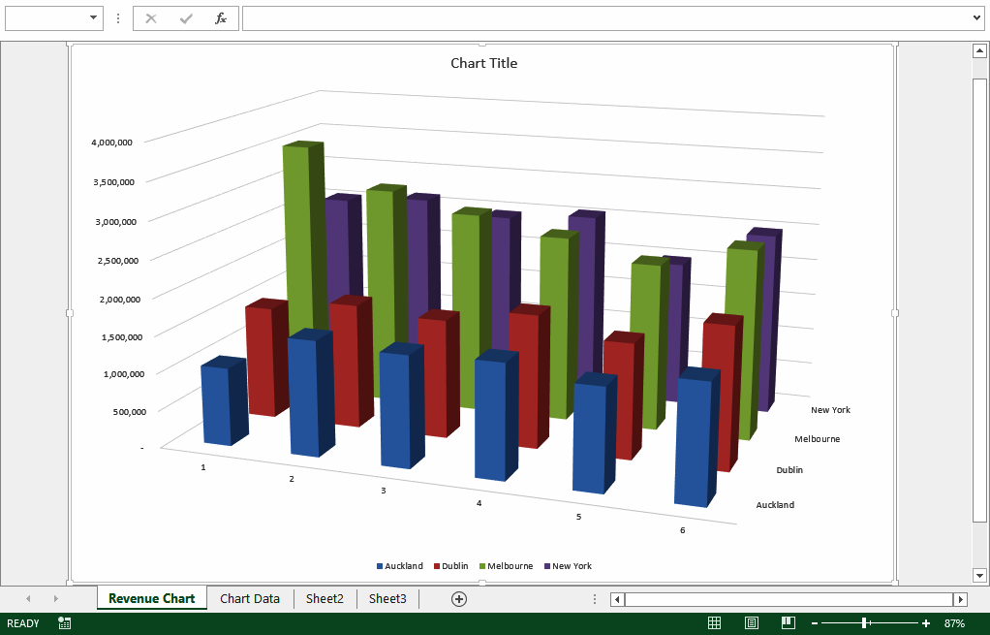
chart separate from the data

you can move the chart to
its own sheet. Chart sheets
make it easier and more
convenient to work with your
chart because you’ll see
more of it on the screen –
since the data is not there!

ITTraining@sgul.ac.uk Page 40 St. George’s Information Services
Microsoft Excel
CHOOSING THE RIGHT CHART

A chart is far more effective at communicating communicate different types of information. Some
results, outcomes or trends than a table of figures charts show simple relationships between values,
displaying the same information. Different chart while others are designed for quite technical types have been created to purposes. Here is a summary of the use of different
chart types.


Column, Bar These chart types, either in 2D or 3D, are used to
compare values across categories. For example,

they could compare the populations of different
countries.


Line, Area Lines in 2D or 3D are useful for showing trends
such as sales or employment figures. An area

chart is a line chart with the area below the line
filled in.


Surface The surface chart plots trends in two dimensions.
You could use this to plot departmental sales

figures over time. The chart then shows you the
trends between departments, as well as the sales
trends over time.
Pie, Doughnut If you want to show proportion, such as the sales
figures from different departments that make up a

total, then the pie and doughnut charts are for
you. The only variation between the doughnut
chart and the pie chart is that the doughnut chart
can display more than one series of values.
Stock The stock chart type has been designed to show
the stock figures for a day, and the trend over

time. At its simplest, you can plot the high, low
and close figures, and at its most complex, the
volume, open, high, low, and close. It can be
adapted to show the relationships between any
five sets of values.
XY (Scatter) Scatter diagrams are used to display the
relationship between two variables. For example,

you could research the age and price of a series
of cars, and plot the values you find. You could
also investigate the height and weight
relationship of a group of people.
Radar A radar diagram is designed to show the change
in values from a central point. For example, it can

be used to show mobile telephone coverage,
including multiple networks and multiple

measurements.

ITTraining@sgul.ac.uk Page 41 St. George’s Information Services
Microsoft Excel
USING A RECOMMENDED CHART
If you are undecided about the best type of chart selected data and presents you with what it for the data you have selected to graph, then you considers to be the best way to chart that data.
may wish to use Excel’s Recommended Charts Several alternatives are presented and you simply
feature. This feature analyses your choose the one you like most.


Try This Yourself:
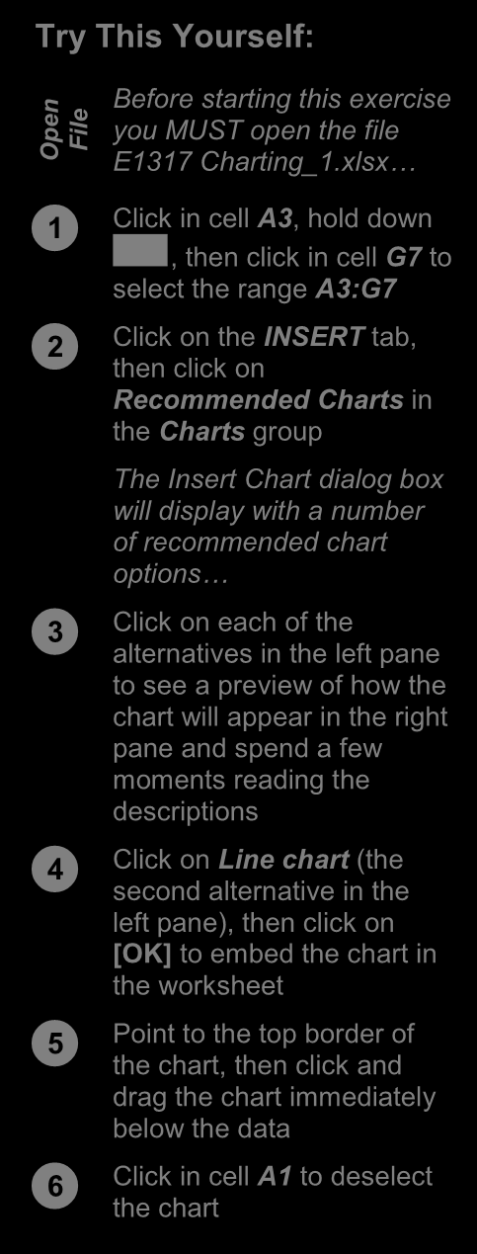
n Before starting this exercise

pe you MUST open the file File O E1 317 Charting_1.xlsx…


Click in cell A3, hold down , then click in cell G7 to 1 You can also use the Quick Analysis tool that appears at the select the range A3:G7 bottom right corner of a selected range to create a quick chart.



Click on the However, this method will not allow you to preview a wide INSERT tab, variety of charts. then click on
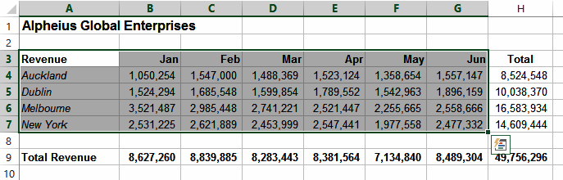
Recommended Charts in
the Charts group

The Insert Chart dialog box
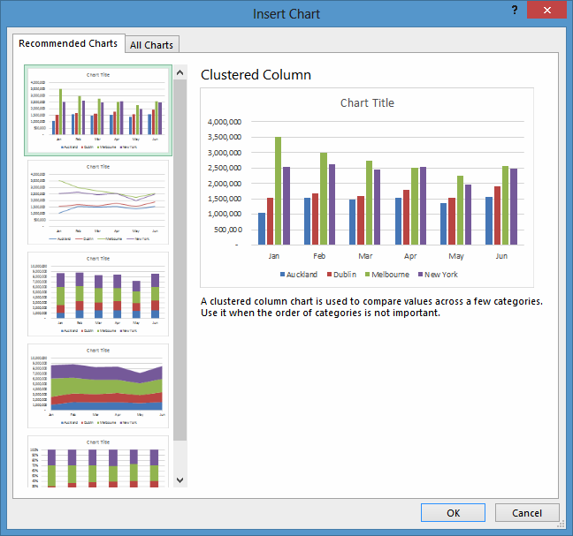
will display with a number
of recommended chart
options…


Click on each of the alternatives in the left pane
to see a preview of how the
chart will appear in the right
pane and spend a few
moments reading the
descriptions


Click on Line chart (the second alternative in the
left pane), then click on
[OK] to embed the chart in
the worksheet


Point to the top border of the chart, then click and
drag the chart immediately
below the data


Click in cell A1 to deselect 2 the chart

For Your Reference… Handy to Know…
To use the Recommended Charts feature: • When selecting data for a chart you should

1. Select the data to be charted include headings (e.g. names of the month,
regions, etc.) but not the totals derived from
2. Click on the INSERT tab, then click on
the data. In the example above the names of
Recommended Charts in the Charts group
the months and the cities are selected but
3. Click on the desired chart and click on [OK] the total revenue and the regional totals are
not.

ITTraining@sgul.ac.uk Page 42 St. George’s Information Services
Microsoft Excel
CREATING A NEW CHART FROM SCRATCH
The easiest way to create a chart is by using the INSERT tab of the ribbon. This may be faster if you Recommended Chart feature. However, you have a specific style of chart in mind. can create a chart yourself from scratch using

Try This Yourself:

n exercise you MUST open
Before starting this
pe File the file E1317 O
Charting_1.xlsx…


Click in cell A3, hold down , then click in cell G7
to select the range A3:G7
Note that we have
selected the data
including headings but 2
excluding the totalling…
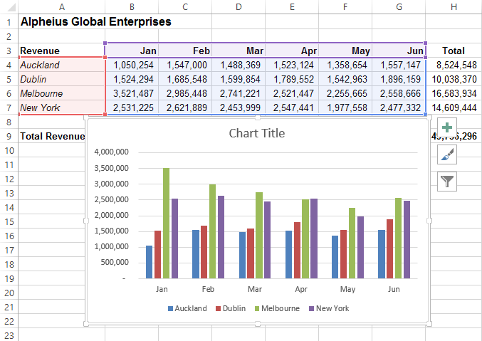


Click on the INSERT tab, then click on Insert

Column Chart in the
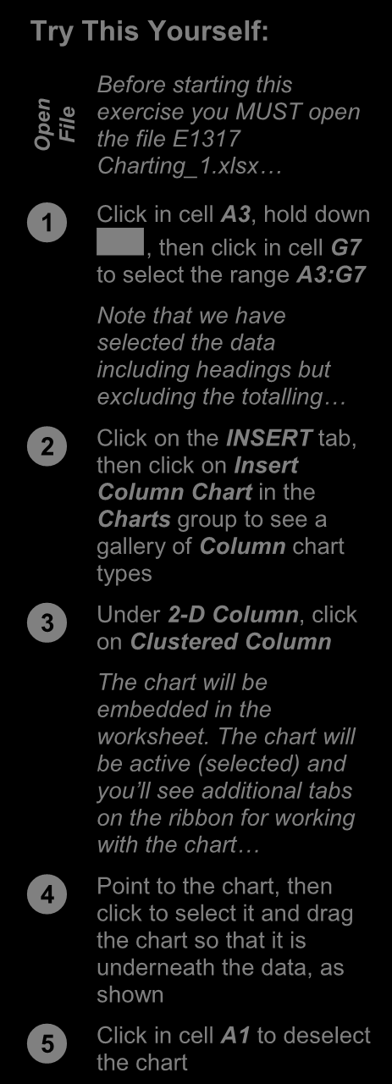
Charts group to see a

gallery of Column chart

types


Under 2-D Column, click on Clustered Column
The chart will be
embedded in the
worksheet. The chart will
be active (selected) and
you’ll see additional tabs
on the ribbon for working
with the chart…


Point to the chart, then click to select it and drag
the chart so that it is
underneath the data, as 4
shown


Click in cell A1 to deselect the chart

For Your Reference… Handy to Know…
To create a chart from scratch: • When a chart gallery appears after you’ve
1. Select the range to chart used the Insert chart command, you can
point over each image in the gallery to see a
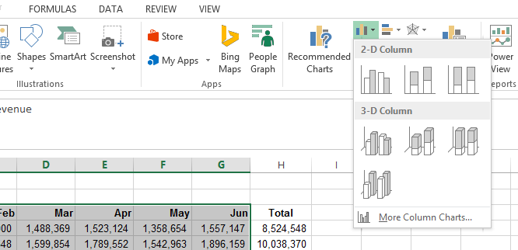
2. Click on the INSERT tab, then click on the
Live Preview of the chart in the worksheet.
appropriate Insert command in the Charts
This will help you to select the right chart for
group
your needs.
3. Click on the desired chart type

ITTraining@sgul.ac.uk Page 43 St. George’s Information Services
Microsoft Excel
WORKING WITH AN EMBEDDED CHART
By default, new charts are placed in the active want to work with a chart you must select it – this worksheet, which is usually the one that contains can be done by clicking on the chart. The chart
the data. Charts are placed over the top of the itself is made up of many objects and these too can
worksheet, embedded as objects. When you be selected by clicking on them.

Try This Yourself:

e Continue using the
m previous file with this
Sa File exercise, or open the file
E1317 Charting_2.xlsx...


Point to the border of the chart and click once to
select the chart as an
object
The border of the chart will
thicken to indicate that the
chart is selected, the
range of data used for the
chart will be coloured, the
ribbon will show
chart-specific tabs and
commands, and additional 2
tools will appear to the
right of the chart…
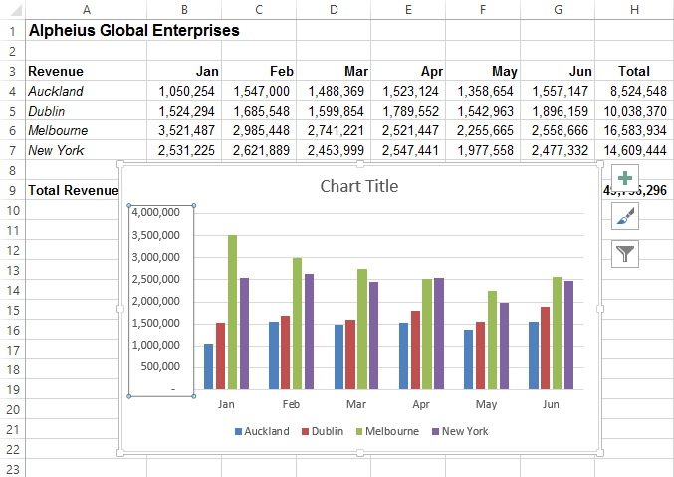


Click on the chart legend to make it the active object
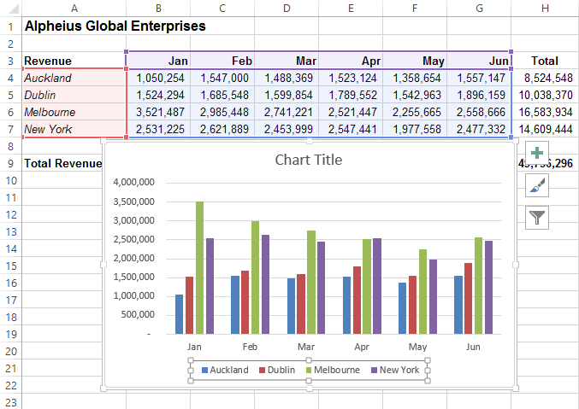
in the chart


Click on the vertical axis to make it the active object



Click on the horizontal axis to make it the active
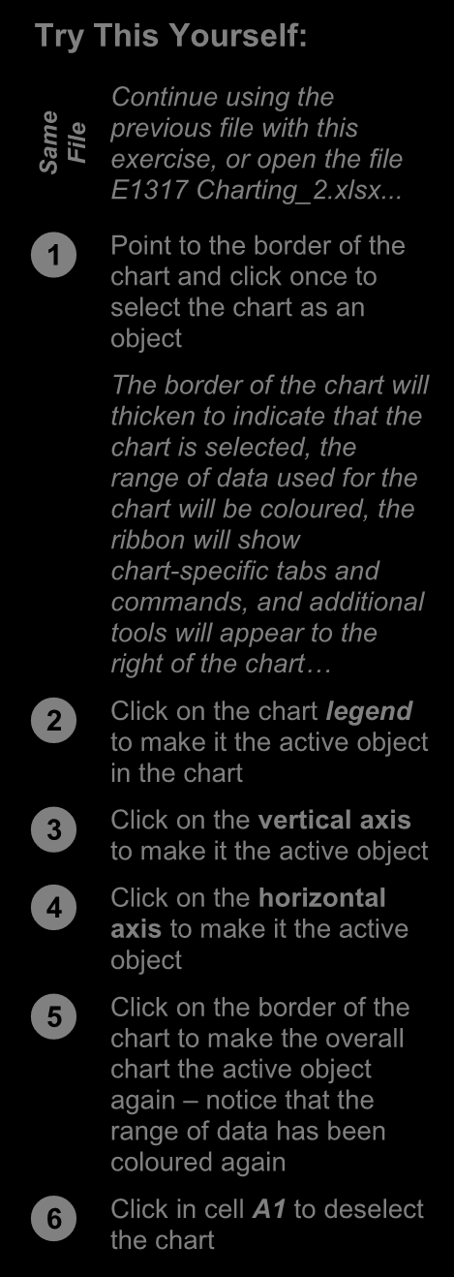
object



Click on the border of the chart to make the overall
chart the active object
again – notice that the
range of data has been
coloured again


Click in cell A1 to deselect the chart
3

For Your Reference… Handy to Know…
To select a chart and its objects: • Once an object is selected, be it a chart, a
1. Click on the border of the chart to select an legend on the chart, or the like, you can right-
embedded chart click on the object to see a shortcut menu
specific to the selected object.
2. Click on the various objects of a chart to
select them

ITTraining@sgul.ac.uk Page 44 St. George’s Information Services
Microsoft Excel
RESIZING A CHART
There are two main ways to resize a chart if you These handles appear with dots in them. You can
are not satisfied with its current size. A chart that also resize a chart using commands in the Size has been selected can be resized by dragging group on the CHART TOOLS: FORMAT tab that one of the sizing handles around its border. appears when the chart is selected.
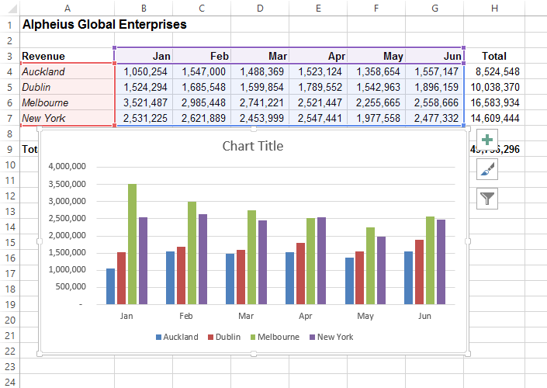

3

Try This Yourself:
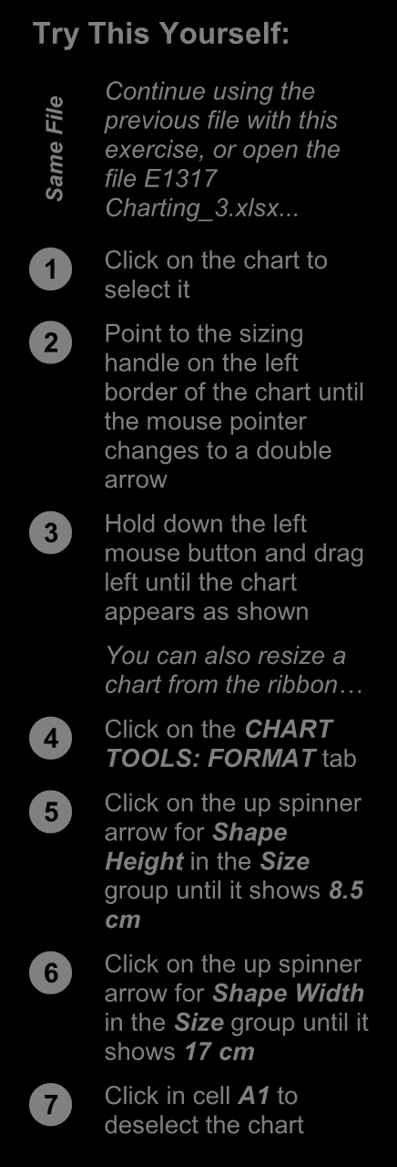
Continue using the

ile previous file with this
F
e exercise, or open the
m file E1317
Sa Charting_3.xlsx...


Click on the chart to select it


Point to the sizing handle on the left
border of the chart until
the mouse pointer
changes to a double
arrow


Hold down the left mouse button and drag
left until the chart
appears as shown
You can also resize a 4
chart from the ribbon…


Click on the CHART TOOLS: FORMAT tab


Click on the up spinner arrow for Shape
Height in the Size
group until it shows 8.5
cm


Click on the up spinner arrow for Shape Width
in the Size group until it
shows 17 cm


Click in cell A1 to deselect the chart

For Your Reference… Handy to Know…
To resize a chart: • If you wish to change the size of a chart
1. Select the chart, then click on and drag a quickly and easily, clicking on and dragging
sizing handle on the border of the chart, or the resize handles is the best option whereas
Click on the if you want to resize a chart to a specific size CHART TOOLS: FORMAT tab,
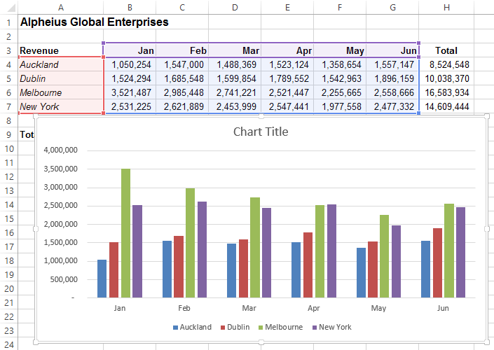
then click on up/down spinner arrows for it is best to resize the chart using the tools in
Shape the Size group on the CHART TOOLS: Height and Shape Width in the Size group FORMAT tab.

ITTraining@sgul.ac.uk Page 45 St. George’s Information Services
Microsoft Excel
REPOSITIONING A CHART
It’s unlikely that a chart embedded in the on and dragging the border of the chart to the
worksheet by Excel will be exactly where you desired location. The chart obviously must be
would like it to be. You can easily relocate a chart selected before it can be dragged to a new to a more appropriate position by clicking position.
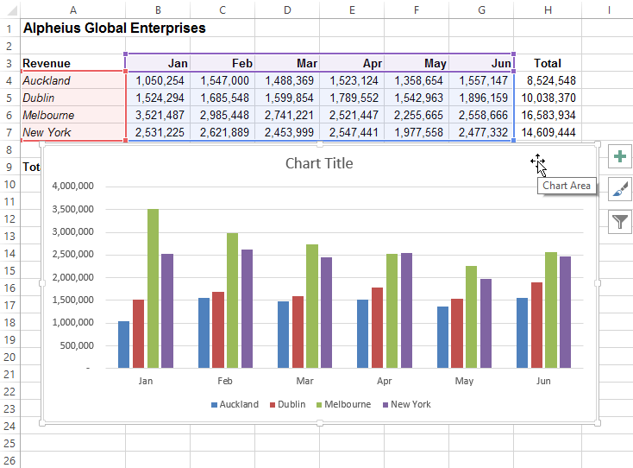

2
Try This Yourself:
Continue using the
ile previous file with this
F
e exercise, or open the
m
file E1317
Sa Charting_4.xlsx...


Click on the chart to select it


Point to the border of the chart until the
mouse pointer
changes to a four-
headed arrow


Hold down the left mouse button and
drag the chart below
the data so that the
Total Revenue row 3
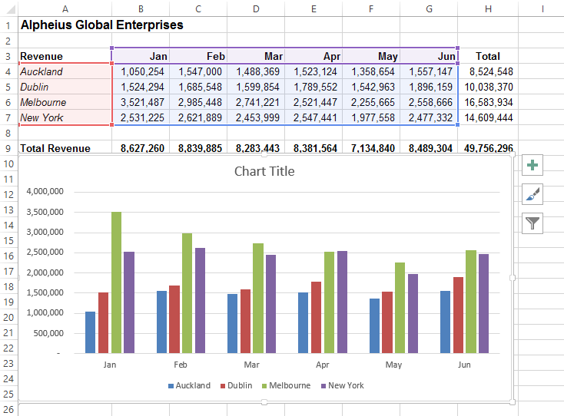
in the worksheet is

visible
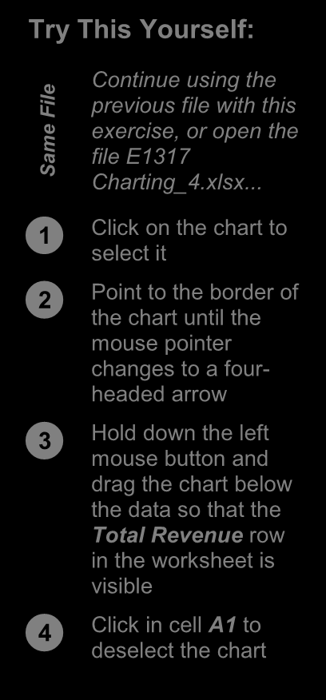


Click in cell A1 to deselect the chart


For Your Reference… Handy to Know…
To move a chart: • You can use the standard cut and paste
1. Click on the chart to select it commands to move a chart. Select the chart,
click on the HOME tab, then click on Cut in
2. Move the mouse pointer to the border of the
the Clipboard group to copy it to the
chart until the mouse pointer changes to a
clipboard. Click in a new location and, on the
four-headed arrow
HOME tab, click on Paste in the Clipboard
3. Drag the chart to a new location group to paste the chart.

ITTraining@sgul.ac.uk Page 46 St. George’s Information Services
Microsoft Excel
PRINTING AN EMBEDDED CHART
When you print a worksheet, Excel will print underlying data. All you need to do is to position
whatever is in or embedded in that worksheet the chart in the appropriate location then access
(including charts). This makes it easy and the print commands in the usual way. convenient to print both the chart and its

1

Try This Yourself:
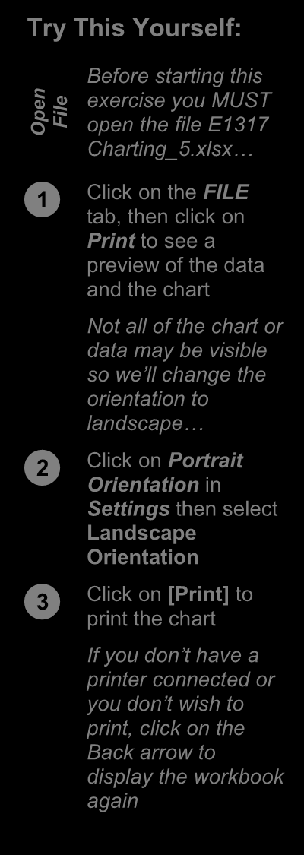

n exercise you MUST

Before starting this
pe File open the file E1317 O
Charting_5.xlsx…


Click on the FILE tab, then click on
Print to see a
preview of the data
and the chart
Not all of the chart or
data may be visible
so we’ll change the
orientation to
landscape…


Click on Portrait Orientation in
Settings then select
2
Landscape
Orientation


Click on [Print] to print the chart
If you don’t have a
printer connected or
you don’t wish to
print, click on the
Back arrow to
display the workbook
again

For Your Reference… Handy to Know…
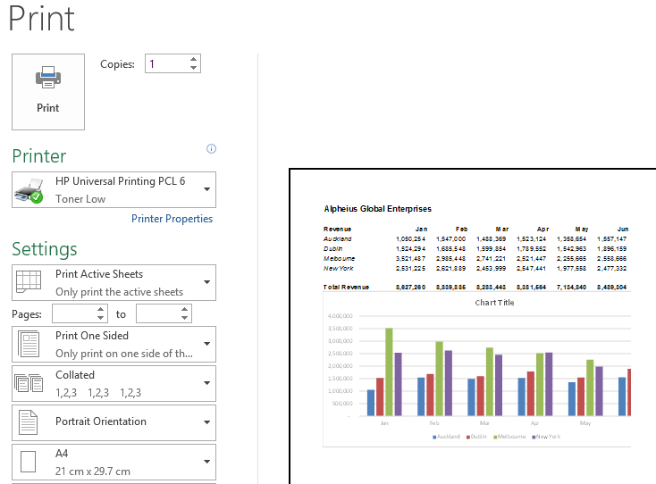
To print an embedded chart: • If you only want to print the chart and not the
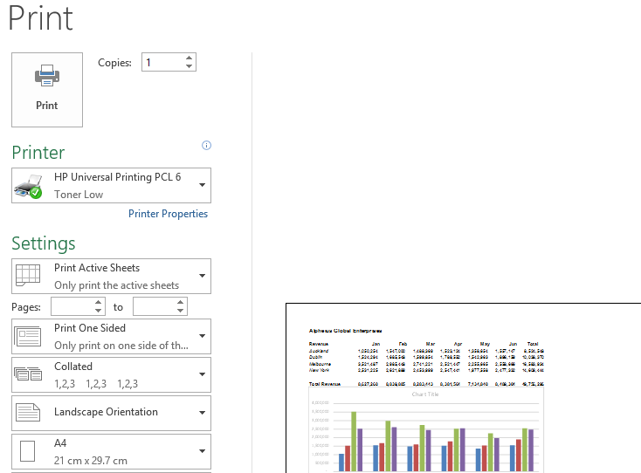
1. Click on the data, click on the chart to select it, click on FILE tab, then click on Print
the FILE tab, then click on Print. You will
2. Click on [Print]
notice that only the chart will appear in the
preview.

ITTraining@sgul.ac.uk Page 47 St. George’s Information Services
Microsoft Excel
CREATING A CHART SHEET
Charts can either be stored in a worksheet or in a are interested in printing the chart on its own page.
separate sheet of their own known as a chart Charts can be shifted back and forth between a
sheet. Chart sheets separate the chart from the worksheet and a chart sheet. underlying data and are useful especially if you

2

Try This Yourself:
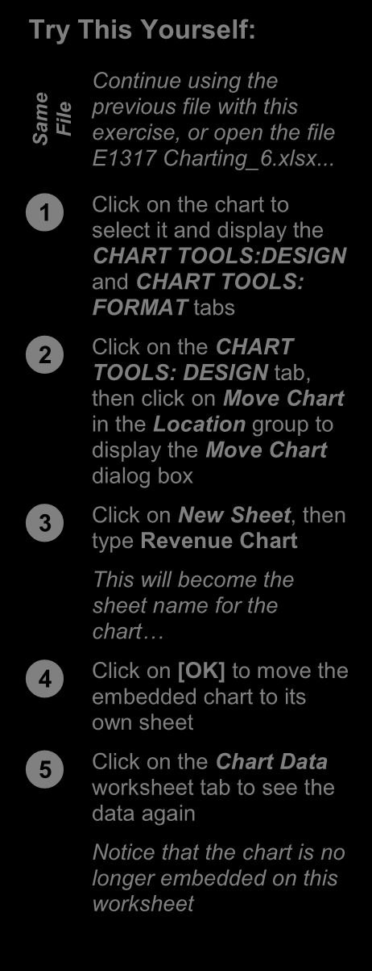

e Continue using the

m previous file with this
Sa File exercise, or open the file
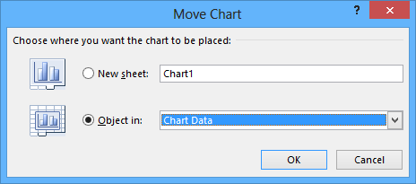
E1317 Charting_6.xlsx...


Click on the chart to select it and display the
CHART TOOLS:DESIGN
and CHART TOOLS: 3
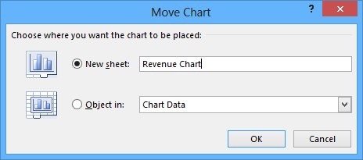
FORMAT tabs


Click on the CHART TOOLS: DESIGN tab,
then click on Move Chart
in the Location group to
display the Move Chart
dialog box


Click on New Sheet, then type Revenue Chart
This will become the
sheet name for the
chart…


Click on [OK] to move the embedded chart to its
own sheet


Click on the Chart Data worksheet tab to see the
data again
Notice that the chart is no
longer embedded on this
worksheet

4
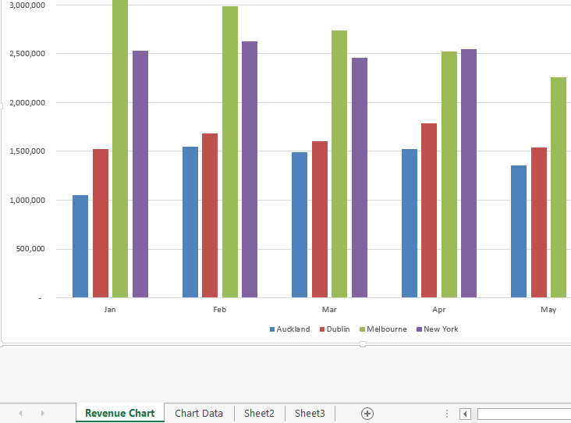

For Your Reference… Handy to Know…
To create a chart sheet: • Keeping charts on their own sheets makes
1. Click on the them easier to work with as they do not CHART TOOLS: DESIGN tab,
then click on obstruct the data. Move Chart in the Location
group
2. Click on New Sheet, type a name for the
sheet and click on [OK]

ITTraining@sgul.ac.uk Page 48 St. George’s Information Services
Microsoft Excel
CHANGING THE CHART TYPE
When you create a chart, you may not always of what each chart type is designed for and to
achieve the result that you desire. Fortunately, select the format that best suits your purpose. Just
the process for changing a chart type is quite be aware that some chart types are designed for
simple. You just need to have an understanding specialised applications.

3

Try This Yourself:
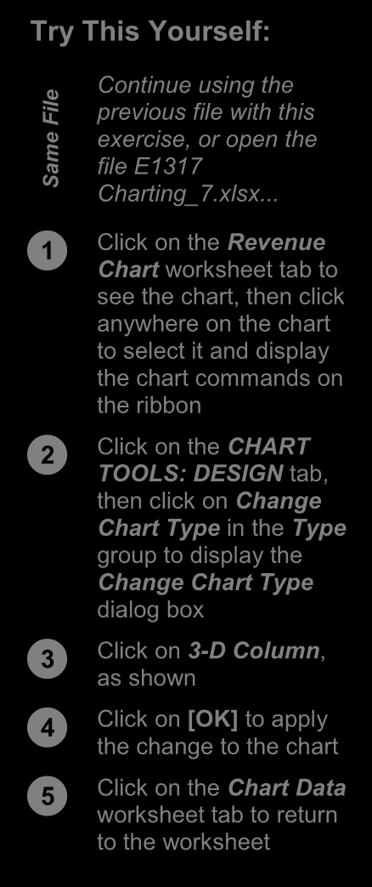
Continue using the

ile previous file with this
F
e exercise, or open the
m file E1317
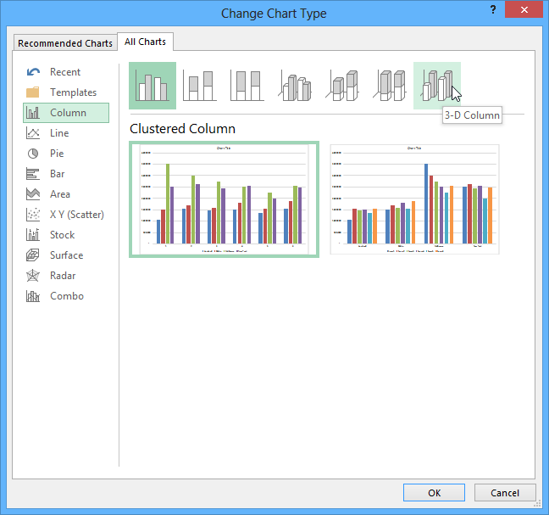
Sa Charting_7.xlsx...


Click on the Revenue Chart worksheet tab to
see the chart, then click
anywhere on the chart
to select it and display
the chart commands on
the ribbon


Click on the CHART TOOLS: DESIGN tab,
then click on Change
Chart Type in the Type
group to display the
Change Chart Type
dialog box


Click on 3-D Column, as shown


Click on [OK] to apply the change to the chart


Click on the Chart Data worksheet tab to return
to the worksheet

4

For Your Reference… Handy to Know…
To change the chart type: • You can use Change Chart Type in the
1. Ensure the chart or chart sheet is selected Type group on the CHART TOOLS:
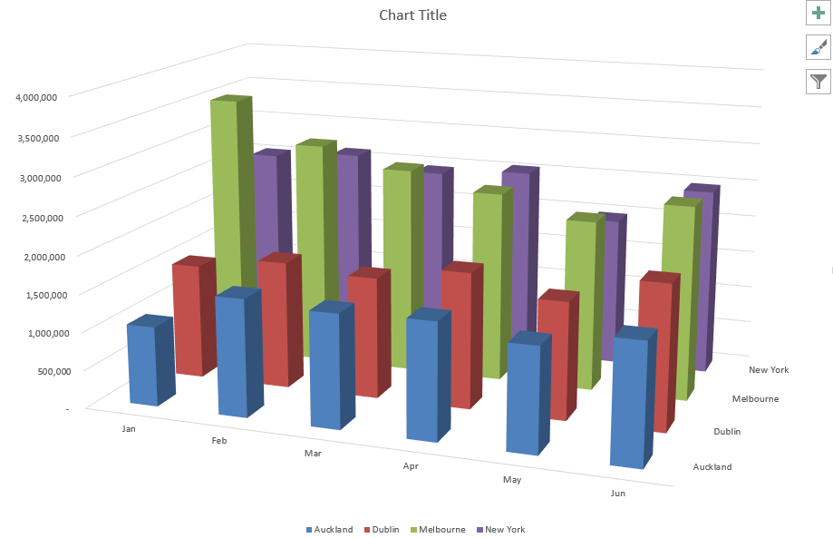
DESIGN tab for either embedded charts or
2. Click on the CHART TOOLS: DESIGN tab,
charts that have their own worksheet tabs.
then click on Change Chart Type in the Type group
3. Click on the desired chart and click on [OK]

ITTraining@sgul.ac.uk Page 49 St. George’s Information Services
Microsoft Excel
CHANGING THE CHART LAYOUT
Excel has a gallery of chart layouts that can be elements of the chart are placed within the chart.
applied to an existing and selected chart that is Different layout options can therefore change the
either in its own worksheet or embedded into the appearance of your chart and its readability.
data worksheet. Chart layouts are the way


Try This Yourself:
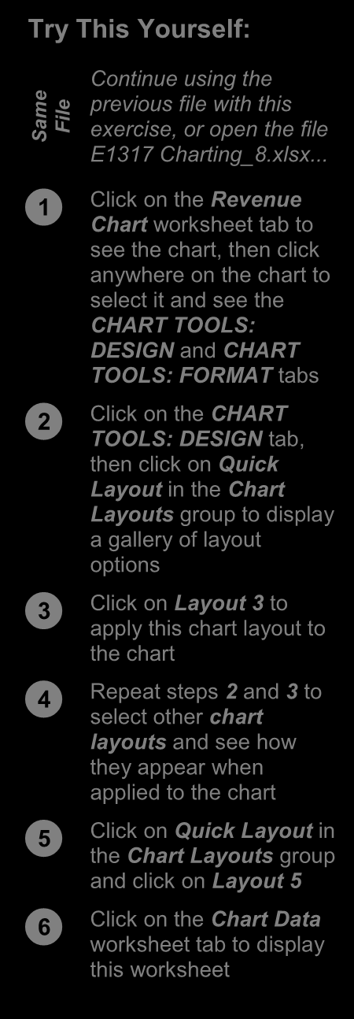

e Continue using the

m previous file with this
Sa File exercise, or open the file
E1317 Charting_8.xlsx...


Click on the Revenue Chart worksheet tab to
see the chart, then click
anywhere on the chart to
select it and see the
2
CHART TOOLS:
DESIGN and CHART
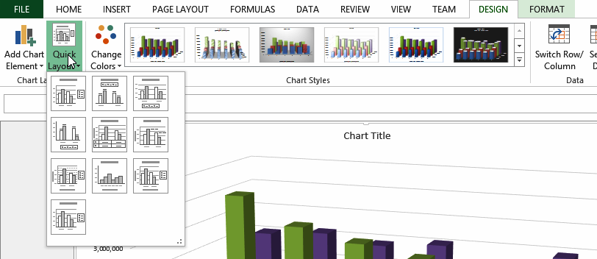
TOOLS: FORMAT tabs
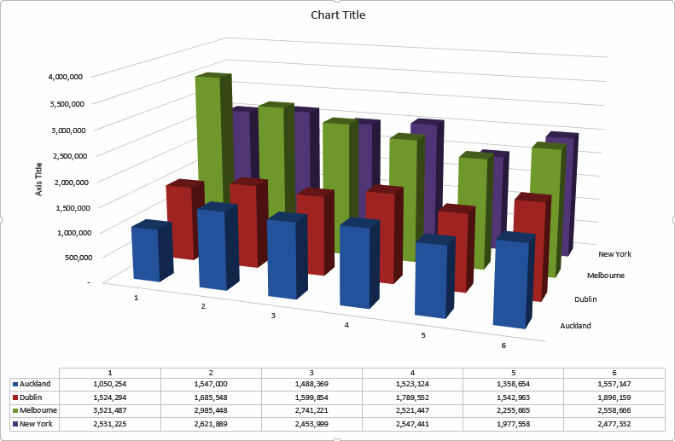


Click on the CHART TOOLS: DESIGN tab,
then click on Quick
Layout in the Chart
Layouts group to display
a gallery of layout
options


Click on Layout 3 to apply this chart layout to
the chart


Repeat steps 2 and 3 to select other chart
layouts and see how
they appear when
applied to the chart


5
Click on Quick Layout in
the Chart Layouts group
and click on Layout 5


Click on the Chart Data worksheet tab to display
this worksheet

For Your Reference… Handy to Know…
To change the chart layout: • Chart layouts are predefined themes
1. Ensure the chart or chart sheet is selected created by Microsoft. Even if you choose one
of these layouts you can still make your own
2. Click on the CHART TOOLS: DESIGN tab,
modifications to the way the elements and
then click on Quick Layout in the Chart
objects are positioned and how they appear.
Layouts group
3. Select the desired layout

ITTraining@sgul.ac.uk Page 50 St. George’s Information Services
Microsoft Excel
CHANGING THE CHART STYLE
The style of a chart refers to its colour scheme and effort. Excel also makes it easy to change
and overall appearance and can impact the chart styles if you decide the style you have chosen
clarity of the content of the chart. Choosing a is not appropriate. predefined chart style can save valuable time


Try This Yourself:
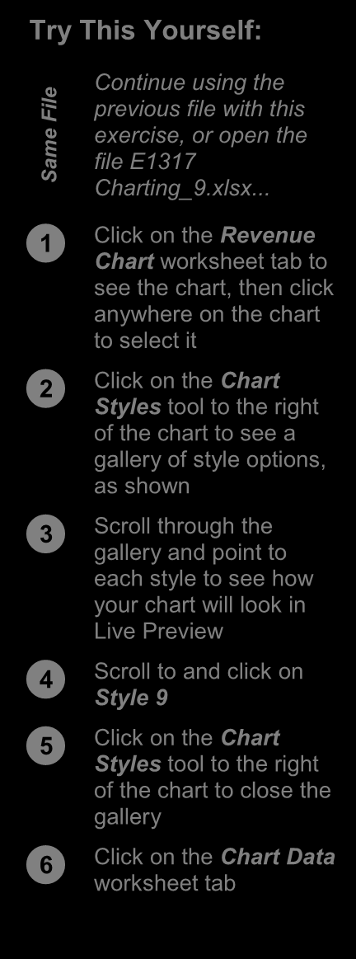
Continue using the

ile previous file with this
F
e exercise, or open the
m file E1317
Sa Charting_9.xlsx...


Click on the Revenue Chart worksheet tab to
see the chart, then click
anywhere on the chart
to select it


Click on the 2 Chart Styles tool to the right
of the chart to see a
gallery of style options,
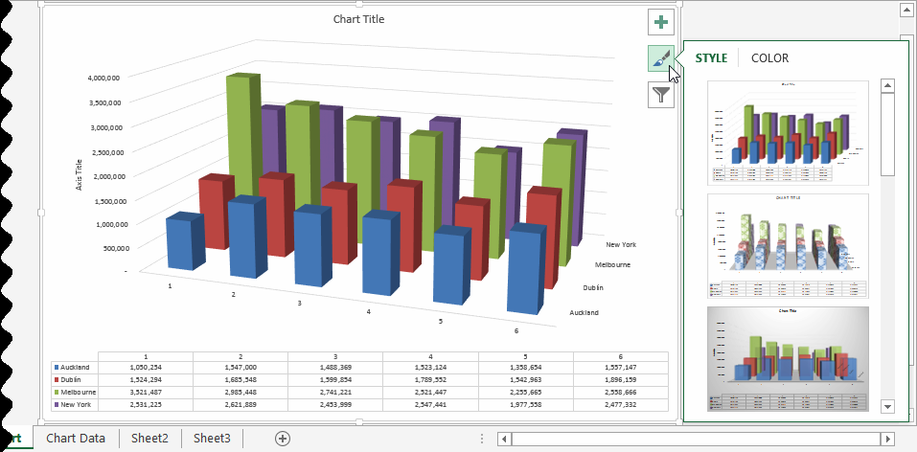
as shown
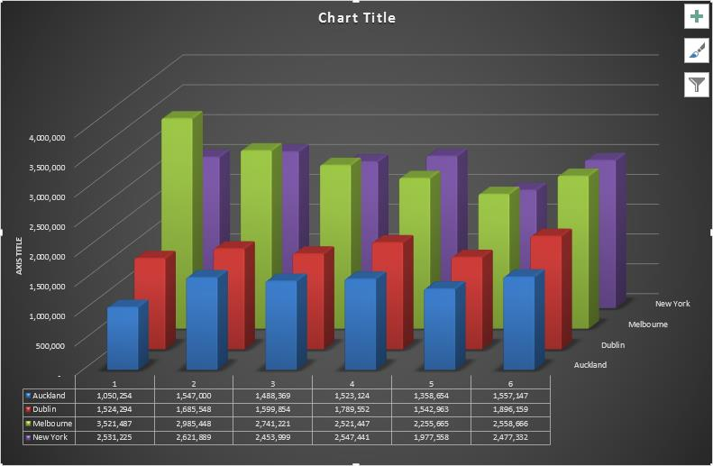


Scroll through the gallery and point to
each style to see how
your chart will look in
Live Preview


Scroll to and click on Style 9


Click on the Chart Styles tool to the right
of the chart to close the
gallery


Click on the Chart Data worksheet tab
4

For Your Reference… Handy to Know…
To change the chart style: • Instead of using the Chart Styles tool to the
1. Ensure the chart or chart sheet is selected right of the chart, you can also choose chart
styles from the CHART TOOLS: DESIGN
2. Click on the Chart Styles tool to the right of
tab on the ribbon when a chart is selected.
the chart
3. Click on the desired style

ITTraining@sgul.ac.uk Page 51 St. George’s Information Services
Microsoft Excel
PRINTING A CHART SHEET
You can print an embedded chart simply by simply ensure that the chart sheet is active, then
printing the worksheet as if it is a standard click on the FILE tab, click on Print, apply the print worksheet. You can also print a chart sheet in settings as desired and click on [Print]. exactly the same way. To print a chart sheet, the
worksheet data. But the real benefit of inserting

Try This Yourself:

e Continue using the previous
m file with this exercise, or
Sa File open the file E1317
Charting_10.xlsx...


Click on the Revenue Chart worksheet tab


Click on the Chart Title text box, select the text, then
type Revenue Chart to
change the title


Repeat step 2 to change the Axis Title to Euros


Click on the 2 FILE tab, then click on Print to see the
print options and a preview
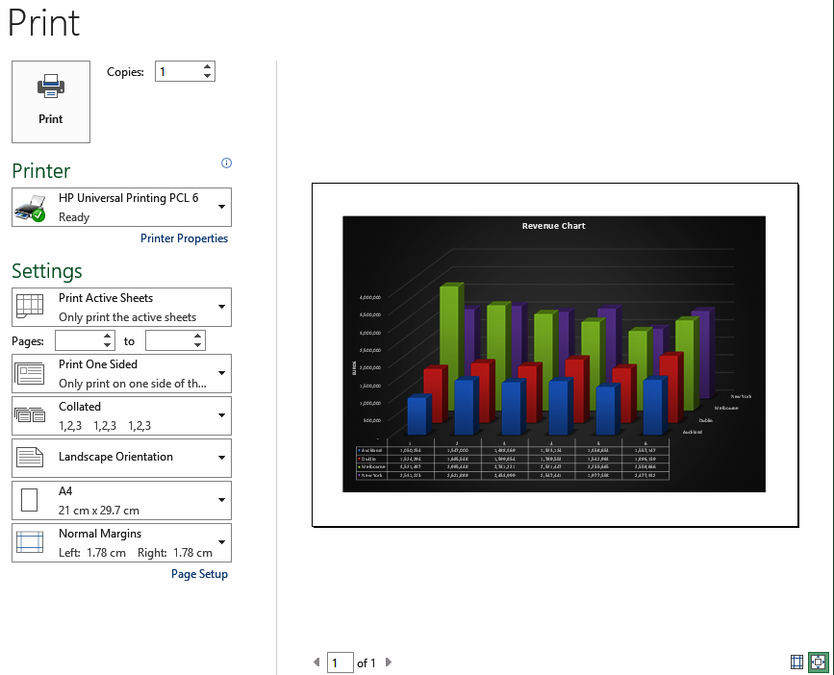
of the chart

No further adjustment is
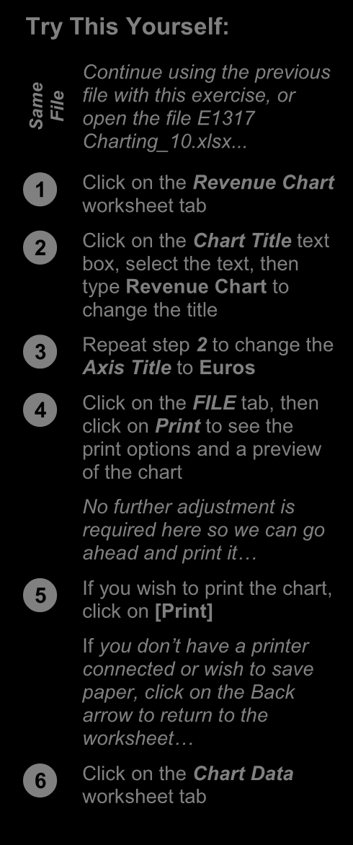
required here so we can go

ahead and print it…


If you wish to print the chart, click on [Print]
If you don’t have a printer
connected or wish to save
paper, click on the Back
arrow to return to the
worksheet…


Click on the Chart Data worksheet tab

4

For Your Reference… Handy to Know…
To print a chart sheet: • When you preview a chart prior to printing, it
1. Click on the chart sheet tab may not appear as clearly as you would like.
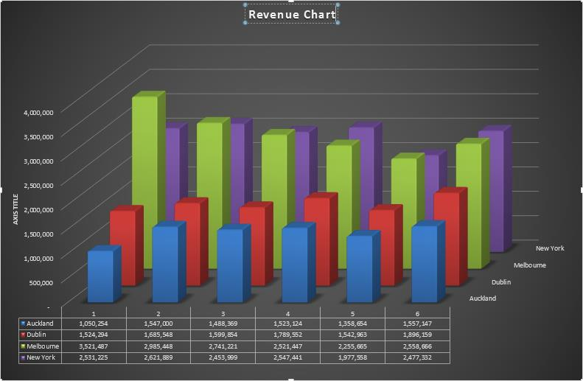
This is due to the screen resolution, not the
2. Click on the FILE tab, then click on Print
chart itself. The printed version of the chart
3. Click on [Print] will appear clearer than the preview.

ITTraining@sgul.ac.uk Page 52 St. George’s Information Services
Microsoft Excel
EMBEDDING A CHART INTO A WORKSHEET
Charts can either be presented in their own sheet and a worksheet as often as you wish without
sheets or they can be embedded into a impacting at all on the chart. Sometimes it is easier
worksheet that contains data. In fact, you can to work with a chart in its own sheet, but it may be
move a chart back and forth between its own necessary to print the chart with its data.

3

Try This Yourself:
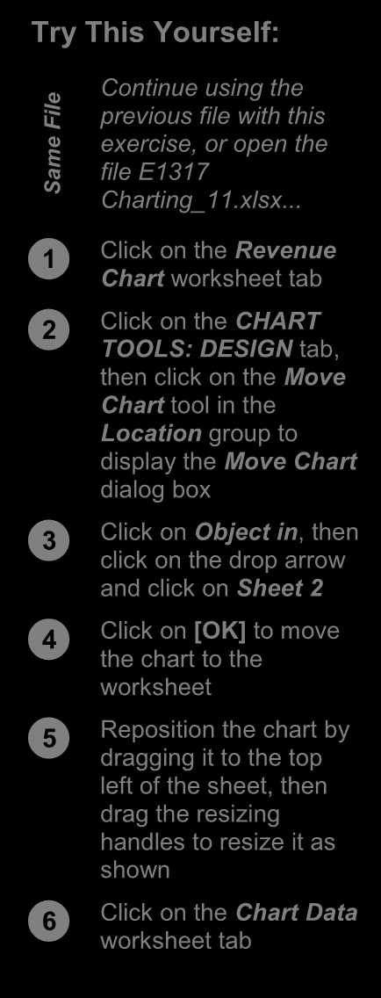
Continue using the

ile previous file with this
F
e exercise, or open the
m file E1317
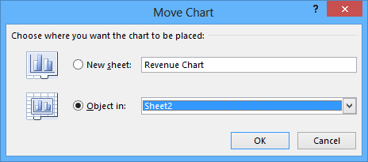
Sa Charting_11.xlsx...


Click on the Revenue 4 Chart worksheet tab


Click on the CHART TOOLS: DESIGN tab,
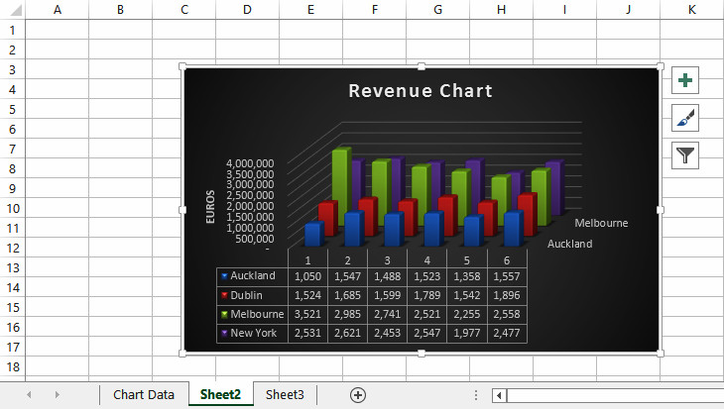
then click on the Move
Chart tool in the
Location group to
display the Move Chart
dialog box


Click on Object in, then click on the drop arrow
and click on Sheet 2


Click on [OK] to move the chart to the
worksheet
5


Reposition the chart by dragging it to the top
left of the sheet, then
drag the resizing
handles to resize it as
shown


Click on the Chart Data worksheet tab

For Your Reference… Handy to Know…
To embed a chart in a worksheet: • Embedding is normally only done when it is
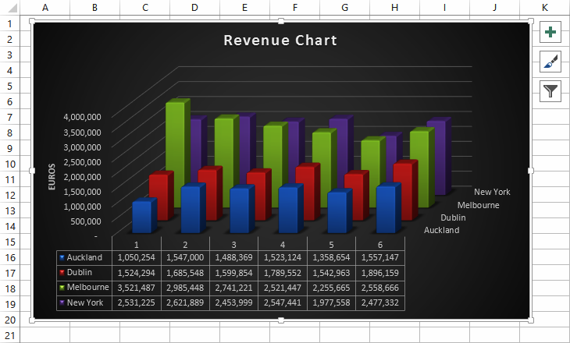
1. Click on the necessary to print the worksheet and the CHART TOOLS: DESIGN tab,
then click on data together. Move Chart in the Location group
2. Click on the drop arrow, select the sheet to
embed it into, then click on [OK]

ITTraining@sgul.ac.uk Page 53 St. George’s Information Services
Microsoft Excel
DELETING A CHART
If you no longer require a chart you can easily chart sheets you can delete the sheet by right
delete it. With embedded charts you must first clicking on the chart sheet tab and choosing the
select the chart in the worksheet and then press deletion option.
the key to delete the chart. With charts in

1

Try This Yourself:
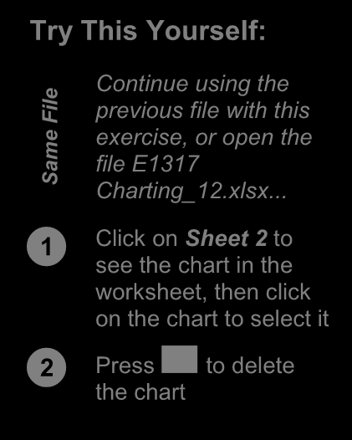
Continue using the

ile previous file with this
F
e exercise, or open the
m
file E1317
Sa Charting_12.xlsx...


Click on Sheet 2 to see the chart in the
worksheet, then click
on the chart to select it



Press to delete the chart
2

For Your Reference… Handy to Know…
To delete a chart: • Because it is so easy to delete a chart object
1. Click on the worksheet to see the chart, then it is also easy to delete it by accident!
click on the chart to select it Remember, you can use the Undo feature in
Excel to restore accidental deletions.

2. Press

ITTraining@sgul.ac.uk Page 54 St. George’s Information Services

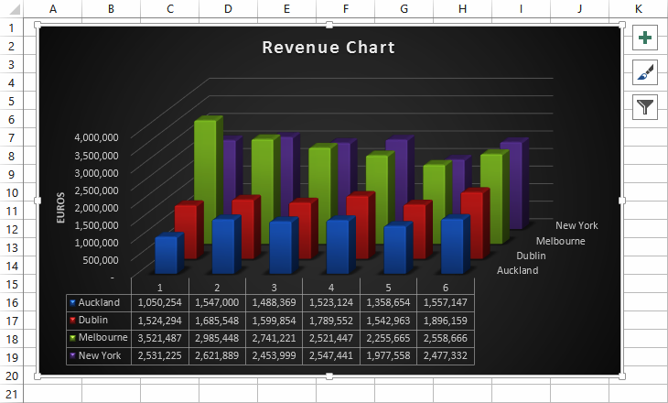
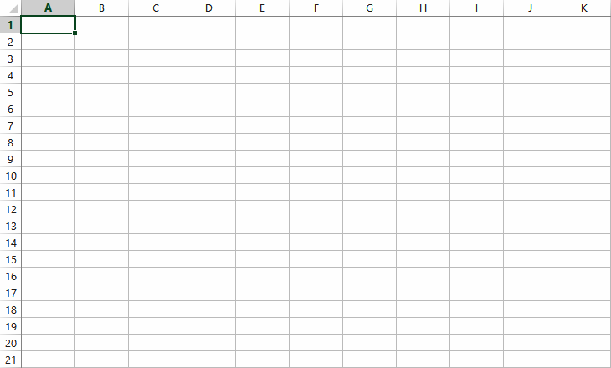
Microsoft Excel 2013 - Level 1
PRACTICE EXERCISE
Creating Charts


Tasks: Completed:
Before starting this exercise you MUST have completed all of the topics in
the chapter Creating Charts…


Open the workbook called PE_Creating Charts.xlsx (it can be found in the  same folder as the student files)

  Create a Clustered Column chart showing the sales of products for the months of January through to June

  Drag the chart down below the data and resize it so that it is the same width as the data, keeping the proportions as far as possible

  Change the chart type to 3-D Stacked Column and change the chart title to Sales
The chart should appear as shown in sample A on the following page...


Create a Pie in 3-D chart of the products and their totals then place it on its  own chart sheet called Product Sales


Change the Chart Title to Product Sales 


Change the layout to Layout 6  The chart should appear as shown in sample B on the following page...


Print the pie chart 


Use the Save As command to save the workbook as PE_Creating Charts  (Completed).xlsx


Files required for PE_Creating Charts.xlsx exercise:
Files/work created by PE_Creating Charts (Completed).xlsx, 1 printed copy of the Product Sales
student: chart
Exercise Completed: 

© Watsonia Publishing Page 55 Chapter 10 - Practice Exercise
Microsoft Excel 2013 - Level 1
PRACTICE EXERCISE SAMPLE
Creating Charts

A

B
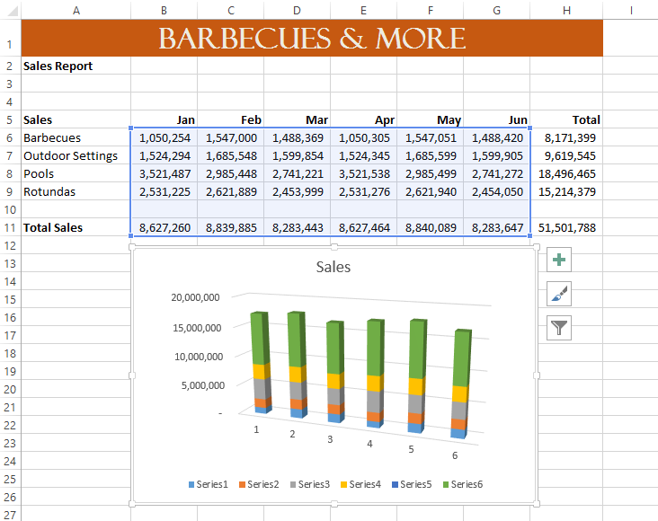

© Watsonia Publishing Page 56 Chapter 10 - Practice Exercise
