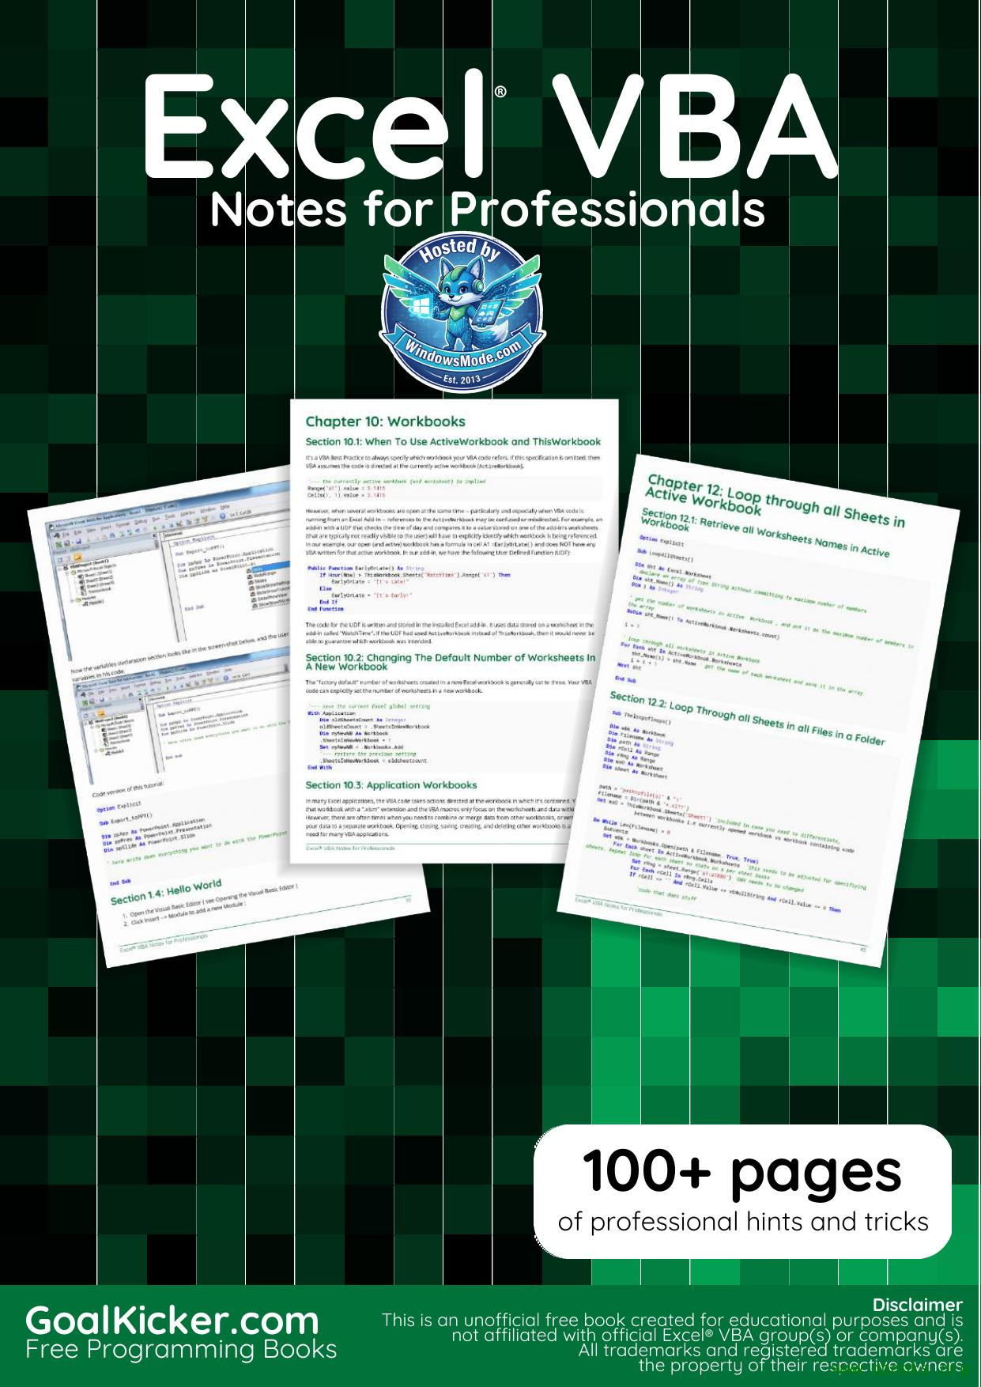

# Table of Contents

[Chapter 11: Working with Excel Tables in VBA .............................................................................................. 44](#Chapter_11__Working_with_Excel_T)

[Chapter 12: Loop through all Sheets in Active Workbook ..................................................................... 45](#Chapter_12__Loop_through_all_She)

[Chapter 13: Use Worksheet object and not Sheet object ...................................................................... 47](#Chapter_13__Use_Worksheet_object)

[Chapter 14: Methods for Finding the Last Used Row or Column in a Worksheet ..................... 48](#Chapter_14__Methods_for_Finding)

[Chapter 15: Creating a drop-down menu in the Active Worksheet with a Combo Box .......... 54](#Chapter_15__Creating_a_drop_down)

[Chapter 16: File System Object ............................................................................................................................ 57](#Chapter_16__File_System_Object)

[Chapter 17: Pivot Tables .......................................................................................................................................... 60](#Chapter_17__Pivot_Tables)

[Chapter 18: Binding .................................................................................................................................................... 64](#Chapter_18__Binding)

[Chapter 19: autofilter ; Uses and best practices ........................................................................................ 66](#Chapter_19__autofilter___Uses_an)

[Chapter 20: Application object ............................................................................................................................ 70](#Chapter_20__Application_object)

[Chapter 21: Charts and Charting ......................................................................................................................... 71](#Chapter_21__Charts_and_Charting)

[Chapter 22: CustomDocumentProperties in practice .............................................................................. 79](#Chapter_22__CustomDocumentProper)

[Chapter 23: PowerPoint Integration Through VBA .................................................................................... 82](#Chapter_23__PowerPoint_Integrati)

[Chapter 24: How to record a Macro ................................................................................................................. 83](#Chapter_24__How_to_record_a_Macr)

[Chapter 25: SQL in Excel VBA - Best Practices ............................................................................................ 85](#Chapter_25__SQL_in_Excel_VBA___B)

[Chapter 26: Excel-VBA Optimization ................................................................................................................. 87](#Chapter_26__Excel_VBA_Optimizati)

[Chapter 27: VBA Security ....................................................................................................................................... 93](#Chapter_27__VBA_Security)

[Chapter 28: Debugging and Troubleshooting ............................................................................................. 94](#Chapter_28__Debugging_and_Troubl)

[Chapter 29: VBA Best Practices ........................................................................................................................... 98](#Chapter_29__VBA_Best_Practices)

[Chapter 30: Excel VBA Tips and Tricks .......................................................................................................... 113](#Chapter_30__Excel_VBA_Tips_and_T)

[Chapter 31: Common Mistakes ........................................................................................................................... 118](#Chapter_31__Common_Mistakes)

[Chapter 1: Getting started with Excel VBA](#Chapter_1__Getting_started_with)

[Chapter 2: Arrays](#Chapter_2__Arrays)

[Chapter 3: Conditional statements](#Chapter_3__Conditional_statement)

[Chapter 4: Ranges and Cells](#Chapter_4__Ranges_and_Cells)

[Chapter 5: Named Ranges](#Chapter_5__Named_Ranges)

[Chapter 6: Merged Cells / Ranges](#Chapter_6__Merged_Cells___Ranges)

[Chapter 7: Locating duplicate values in a](#Chapter_7__Locating_duplicate_va)

[Chapter 8: User Defined Functions (UDFs)](#Chapter_8__User_Defined_Function)

[Chapter 9: Conditional formatting using](#Chapter_9__Conditional_formattin)

[Chapter 10: Workbooks](#Chapter_10__Workbooks)

[Chapter 11: Working with Excel Tables in](#Chapter_11__Working_with_Excel_T_1)

[Chapter 12: Loop through all Sheets in](#Chapter_12__Loop_through_all_She_1)

[Chapter 13: Use Worksheet object and not](#Chapter_13__Use_Worksheet_object_1)

[Chapter 14: Methods for Finding the Last](#Chapter_14__Methods_for_Finding_1)

[Chapter 15: Creating a drop-down menu in](#Chapter_15__Creating_a_drop_down_1)

[Chapter 16: File System Object](#Chapter_16__File_System_Object_1)

[Chapter 17: Pivot Tables](#Chapter_17__Pivot_Tables_1)

[Chapter 18: Binding](#Chapter_18__Binding_1)

[Chapter 19: autofilter ; Uses and best](#Chapter_19__autofilter___Uses_an_1)

[Chapter 20: Application object](#Chapter_20__Application_object_1)

[Chapter 21: Charts and Charting](#Chapter_21__Charts_and_Charting_1)

[Chapter 22: CustomDocumentProperties in](#Chapter_22__CustomDocumentProper_1)

[Chapter 23: PowerPoint Integration](#Chapter_23__PowerPoint_Integrati_1)

[Chapter 24: How to record a Macro](#Chapter_24__How_to_record_a_Macr_1)

[Chapter 25: SQL in Excel VBA - Best](#Chapter_25__SQL_in_Excel_VBA___B_1)

[Chapter 26: Excel-VBA Optimization](#Chapter_26__Excel_VBA_Optimizati_1)

[Chapter 27: VBA Security](#Chapter_27__VBA_Security_1)

[Chapter 28: Debugging and](#Chapter_28__Debugging_and)

[Chapter 29: VBA Best Practices](#Chapter_29__VBA_Best_Practices_1)

[Chapter 30: Excel VBA Tips and Tricks](#Chapter_30__Excel_VBA_Tips_and_T_1)

[Chapter 31: Common Mistakes](#Chapter_31__Common_Mistakes_1)

Excel Excel VBA Notes for Professionals ® VBA Notes for Professionals

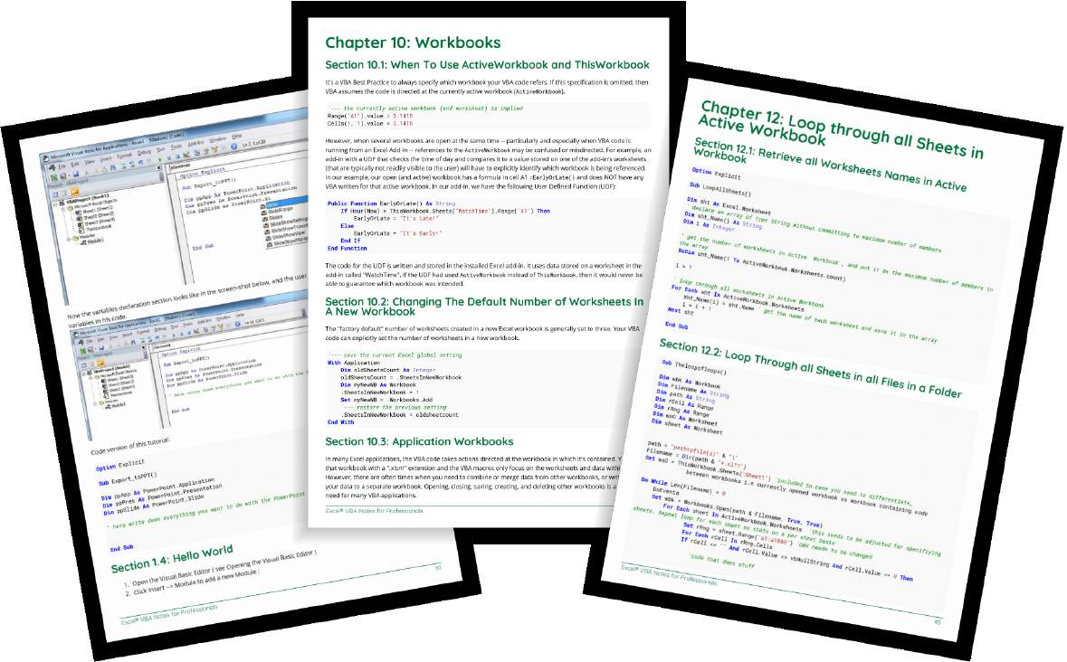

100+ pages



of professional hints and tricks

[GoalKicker.com](https://goalkicker.com) Disclaimer

This is an unocial free book created for educational purposes and is

[Free Programming Books](https://goalkicker.com) not aliated with ocial Excel® VBA group(s) or company(s).

All trademarks and registered trademarks are

[the property of their respective owners www.dbooks.org](https://www.dbooks.org/)

# Contents

[About](#About) ................................................................................................................................................................................... [1](#About)

[Chapter 1: Getting started with Excel VBA](#Chapter_1__Getting_started_with) ....................................................................................................... [2](#Chapter_1__Getting_started_with)

[Section 1.1: Opening the Visual Basic Editor (VBE)](#8____1997_01_01)  ..................................................................................................... [3](#8____1997_01_01)

[Section 1.2: Declaring Variables](#page_9) ................................................................................................................................... [5](#page_9)

[Section 1.3: Adding a new Object Library Reference](#Debug_Print_TypeName_Str______Ou)  ................................................................................................. [6](#Debug_Print_TypeName_Str______Ou)

[Section 1.4: Hello World](#page_14)  .............................................................................................................................................. [10](#page_14)

[Section 1.5: Getting Started with the Excel Object Model](#page_16) ........................................................................................ [12](#page_16)

[Chapter 2: Arrays](#Chapter_2__Arrays)  ........................................................................................................................................................ [16](#Chapter_2__Arrays)

[Section 2.1: Dynamic Arrays (Array Resizing and Dynamic Handling)](#Chapter_2__Arrays)  ................................................................. [16](#Chapter_2__Arrays)

[Section 2.2: Populating arrays (adding values)](#Chapter_2__Arrays) ....................................................................................................... [16](#Chapter_2__Arrays)

[Section 2.3: Jagged Arrays (Arrays of Arrays)](#____arrayRange_1____value_in_B1)  ........................................................................................................ [17](#____arrayRange_1____value_in_B1)

[Section 2.4: Check if Array is Initialized (If it contains elements or not)](#____arrayRange_1____value_in_B1)  ................................................................ [17](#____arrayRange_1____value_in_B1)

[Section 2.5: Dynamic Arrays [Array Declaration, Resizing]](#____arrayRange_1____value_in_B1)  ................................................................................... [17](#____arrayRange_1____value_in_B1)

[Chapter 3: Conditional statements](#Chapter_3__Conditional_statement)  ................................................................................................................... [19](#Chapter_3__Conditional_statement)

[Section 3.1: The If statement](#Chapter_3__Conditional_statement)  ...................................................................................................................................... [19](#Chapter_3__Conditional_statement)

[Chapter 4: Ranges and Cells](#Chapter_4__Ranges_and_Cells) ................................................................................................................................ [21](#Chapter_4__Ranges_and_Cells)

[Section 4.1: Ways to refer to a single cell](#Chapter_4__Ranges_and_Cells) ................................................................................................................. [21](#Chapter_4__Ranges_and_Cells)

[Section 4.2: Creating a Range](#Chapter_4__Ranges_and_Cells) ................................................................................................................................... [21](#Chapter_4__Ranges_and_Cells)

[Section 4.3: Oset Property](#For_i___1_To_10)  ....................................................................................................................................... [23](#For_i___1_To_10)

[Section 4.4: Saving a reference to a cell in a variable](#For_i___1_To_10)  ............................................................................................ [23](#For_i___1_To_10)

[Section 4.5: How to Transpose Ranges (Horizontal to Vertical & vice versa)](#For_i___1_To_10)  ...................................................... [23](#For_i___1_To_10)

[Chapter 5: Named Ranges](#Chapter_5__Named_Ranges) ..................................................................................................................................... [25](#Chapter_5__Named_Ranges)

[Section 5.1: Define A Named Range](#Chapter_5__Named_Ranges)  .......................................................................................................................... [25](#Chapter_5__Named_Ranges)

[Section 5.2: Using Named Ranges in VBA](#Chapter_5__Named_Ranges) ................................................................................................................ [25](#Chapter_5__Named_Ranges)

[Section 5.3: Manage Named Range(s) using Name Manager](#Access_a_Named_Range_with_a_Shor)  ............................................................................... [26](#Access_a_Named_Range_with_a_Shor)

[Section 5.4: Named Range Arrays](#Section_5_4__Named_Range_Arrays)  ............................................................................................................................ [28](#Section_5_4__Named_Range_Arrays)

[Chapter 6: Merged Cells / Ranges](#Chapter_6__Merged_Cells___Ranges)  ..................................................................................................................... [29](#Chapter_6__Merged_Cells___Ranges)

[Section 6.1: Think twice before using Merged Cells/Ranges](#Chapter_6__Merged_Cells___Ranges) .................................................................................. [29](#Chapter_6__Merged_Cells___Ranges)

[Chapter 7: Locating duplicate values in a range](#Chapter_7__Locating_duplicate_va) ....................................................................................... [30](#Chapter_7__Locating_duplicate_va)

[Section 7.1: Find duplicates in a range](#Chapter_7__Locating_duplicate_va)  ...................................................................................................................... [30](#Chapter_7__Locating_duplicate_va)

[Chapter 8: User Defined Functions (UDFs)](#Chapter_8__User_Defined_Function) .................................................................................................... [32](#Chapter_8__User_Defined_Function)

[Section 8.1: Allow full column references without penalty](#Chapter_8__User_Defined_Function) ...................................................................................... [32](#Chapter_8__User_Defined_Function)

[Section 8.2: Count Unique values in Range](#page_37) .............................................................................................................. [33](#page_37)

[Section 8.3: UDF - Hello World](#page_37)  ................................................................................................................................... [33](#page_37)

[Chapter 9: Conditional formatting using VBA](#Chapter_9__Conditional_formattin)  ............................................................................................. [36](#Chapter_9__Conditional_formattin)

[Section 9.1: FormatConditions.Add](#Chapter_9__Conditional_formattin)  ............................................................................................................................ [36](#Chapter_9__Conditional_formattin)

[Section 9.2: Remove conditional format](#Formatting_by_text_contains)  .................................................................................................................. [37](#Formatting_by_text_contains)

[Section 9.3: FormatConditions.AddUniqueValues](#Formatting_by_text_contains)  .................................................................................................... [37](#Formatting_by_text_contains)

[Section 9.4: FormatConditions.AddTop10](#_ColorIndex___3) ................................................................................................................. [38](#_ColorIndex___3)

[Section 9.5: FormatConditions.AddAboveAverage](#_ColorIndex___3)  .................................................................................................. [38](#_ColorIndex___3)

[Section 9.6: FormatConditions.AddIconSetCondition](#_ColorIndex___3) .............................................................................................. [38](#_ColorIndex___3)

[Chapter 10: Workbooks](#Chapter_10__Workbooks) ........................................................................................................................................... [41](#Chapter_10__Workbooks)

[Section 10.1: When To Use ActiveWorkbook and ThisWorkbook](#Chapter_10__Workbooks)  ........................................................................... [41](#Chapter_10__Workbooks)

[Section 10.2: Changing The Default Number of Worksheets In A New Workbook](#Chapter_10__Workbooks)  .............................................. [41](#Chapter_10__Workbooks)

[Section 10.3: Application Workbooks](#Chapter_10__Workbooks)  ........................................................................................................................ [41](#Chapter_10__Workbooks)

[Section 10.4: Opening A (New) Workbook, Even If It's Already Open](#Excel_by_using_the_Workbooks_pro) .................................................................... [42](#Excel_by_using_the_Workbooks_pro)

[Section 10.5: Saving A Workbook Without Asking The User](#Application_DisplayAlerts___True) ................................................................................... [43](#Application_DisplayAlerts___True)

[Chapter 11: Working with Excel Tables in VBA](#Chapter_11__Working_with_Excel_T_1)  .............................................................................................. [44](#Chapter_11__Working_with_Excel_T_1)

[Section 11.1: Instantiating a ListObject](#Chapter_11__Working_with_Excel_T_1) ....................................................................................................................... [44](#Chapter_11__Working_with_Excel_T_1)

[Section 11.2: Working with ListRows / ListColumns](#Chapter_11__Working_with_Excel_T_1)  .................................................................................................. [44](#Chapter_11__Working_with_Excel_T_1)

[Section 11.3: Converting an Excel Table to a normal range](#Chapter_11__Working_with_Excel_T_1) .................................................................................... [44](#Chapter_11__Working_with_Excel_T_1)

[Chapter 12: Loop through all Sheets in Active Workbook](#Chapter_12__Loop_through_all_She_1) ..................................................................... [45](#Chapter_12__Loop_through_all_She_1)

[Section 12.1: Retrieve all Worksheets Names in Active Workbook](#Chapter_12__Loop_through_all_She_1) ......................................................................... [45](#Chapter_12__Loop_through_all_She_1)

[Section 12.2: Loop Through all Sheets in all Files in a Folder](#Chapter_12__Loop_through_all_She_1)  .................................................................................. [45](#Chapter_12__Loop_through_all_She_1)

[Chapter 13: Use Worksheet object and not Sheet object](#Chapter_13__Use_Worksheet_object_1) ...................................................................... [47](#Chapter_13__Use_Worksheet_object_1)

[Section 13.1: Print the name of the first object](#Chapter_13__Use_Worksheet_object_1)  .......................................................................................................... [47](#Chapter_13__Use_Worksheet_object_1)

[Chapter 14: Methods for Finding the Last Used Row or Column in a Worksheet](#Chapter_14__Methods_for_Finding_1)  ..................... [48](#Chapter_14__Methods_for_Finding_1)

[Section 14.1: Find the Last Non-Empty Cell in a Column](#Chapter_14__Methods_for_Finding_1) ......................................................................................... [48](#Chapter_14__Methods_for_Finding_1)

[Section 14.2: Find the Last Non-Empty Row in Worksheet](#Chapter_14__Methods_for_Finding_1) ..................................................................................... [48](#Chapter_14__Methods_for_Finding_1)

[Section 14.3: Find the Last Non-Empty Column in Worksheet](#With_wS) ................................................................................ [49](#With_wS)

[Section 14.4: Find the Last Non-Empty Cell in a Row](#Public_Function_LastCol_0_wS_As)  .............................................................................................. [50](#Public_Function_LastCol_0_wS_As)

[Section 14.5: Get the row of the last cell in a range](#Public_Function_LastCol_0_wS_As)  ................................................................................................. [50](#Public_Function_LastCol_0_wS_As)

[Section 14.6: Find Last Row Using Named Range](#Public_Function_LastCol_0_wS_As)  ................................................................................................... [50](#Public_Function_LastCol_0_wS_As)

[Section 14.7: Last cell in Range.CurrentRegion](#Dim_LastRow_As_Long)  ........................................................................................................ [51](#Dim_LastRow_As_Long)

[Section 14.8: Find the Last Non-Empty Cell in Worksheet - Performance (Array)](#Dim_LastRow_As_Long)  ............................................... [51](#Dim_LastRow_As_Long)

[Chapter 15: Creating a drop-down menu in the Active Worksheet with a Combo Box](#Chapter_15__Creating_a_drop_down_1)  .......... [54](#Chapter_15__Creating_a_drop_down_1)

[Section 15.1: Example 2: Options Not Included](#Chapter_15__Creating_a_drop_down_1)  ......................................................................................................... [54](#Chapter_15__Creating_a_drop_down_1)

[Section 15.2: Jimi Hendrix Menu](#_adjust_the_size_of_the_cell_to) ................................................................................................................................. [55](#_adjust_the_size_of_the_cell_to)

[Chapter 16: File System Object](#Chapter_16__File_System_Object_1)  ............................................................................................................................ [57](#Chapter_16__File_System_Object_1)

[Section 16.1: File, folder, drive exists](#Chapter_16__File_System_Object_1) ........................................................................................................................... [57](#Chapter_16__File_System_Object_1)

[Section 16.2: Basic file operations](#Chapter_16__File_System_Object_1) .............................................................................................................................. [57](#Chapter_16__File_System_Object_1)

[Section 16.3: Basic folder operations](#End_Sub) ......................................................................................................................... [58](#End_Sub)

[Section 16.4: Other operations](#End_Sub) ................................................................................................................................... [58](#End_Sub)

[Chapter 17: Pivot Tables](#Chapter_17__Pivot_Tables_1)  .......................................................................................................................................... [60](#Chapter_17__Pivot_Tables_1)

[Section 17.1: Adding Fields to a Pivot Table](#Chapter_17__Pivot_Tables_1) .............................................................................................................. [60](#Chapter_17__Pivot_Tables_1)

[Section 17.2: Creating a Pivot Table](#Chapter_17__Pivot_Tables_1) .......................................................................................................................... [60](#Chapter_17__Pivot_Tables_1)

[Section 17.3: Pivot Table Ranges](#References_MSDN_Pivot_Table_Obje)  ............................................................................................................................... [63](#References_MSDN_Pivot_Table_Obje)

[Section 17.4: Formatting the Pivot Table Data](#References_MSDN_Pivot_Table_Obje) ......................................................................................................... [63](#References_MSDN_Pivot_Table_Obje)

[Chapter 18: Binding](#Chapter_18__Binding_1)  .................................................................................................................................................... [64](#Chapter_18__Binding_1)

[Section 18.1: Early Binding vs Late Binding](#Chapter_18__Binding_1)  ............................................................................................................... [64](#Chapter_18__Binding_1)

[Chapter 19: autofilter ; Uses and best practices](#Chapter_19__autofilter___Uses_an_1)  ........................................................................................ [66](#Chapter_19__autofilter___Uses_an_1)

[Section 19.1: Smartfilter!](#Chapter_19__autofilter___Uses_an_1)  .............................................................................................................................................. [66](#Chapter_19__autofilter___Uses_an_1)

[Chapter 20: Application object](#Chapter_20__Application_object_1) ............................................................................................................................ [70](#Chapter_20__Application_object_1)

[Section 20.1: Simple Application Object example: Display Excel and VBE Version](#Chapter_20__Application_object_1) .............................................. [70](#Chapter_20__Application_object_1)

[Section 20.2: Simple Application Object example: Minimize the Excel window](#Chapter_20__Application_object_1) .................................................... [70](#Chapter_20__Application_object_1)

[Chapter 21: Charts and Charting](#Chapter_21__Charts_and_Charting_1) ......................................................................................................................... [71](#Chapter_21__Charts_and_Charting_1)

[Section 21.1: Creating a Chart with Ranges and a Fixed Name](#Chapter_21__Charts_and_Charting_1)  .............................................................................. [71](#Chapter_21__Charts_and_Charting_1)

[Section 21.2: Creating an empty Chart](#page_76)  ..................................................................................................................... [72](#page_76)

[Section 21.3: Create a Chart by Modifying the SERIES formula](#Dim_sht_As_Worksheet)  ............................................................................. [73](#Dim_sht_As_Worksheet)

[Section 21.4: Arranging Charts into a Grid](#page_79)  ................................................................................................................ [75](#page_79)

[Chapter 22: CustomDocumentProperties in practice](#Chapter_22__CustomDocumentProper_1)  .............................................................................. [79](#Chapter_22__CustomDocumentProper_1)

[Section 22.1: Organizing new invoice numbers](#Chapter_22__CustomDocumentProper_1) ........................................................................................................ [79](#Chapter_22__CustomDocumentProper_1)

[Chapter 23: PowerPoint Integration Through VBA](#Chapter_23__PowerPoint_Integrati_1)  .................................................................................... [82](#Chapter_23__PowerPoint_Integrati_1)

[Section 23.1: The Basics: Launching PowerPoint from VBA](#Chapter_23__PowerPoint_Integrati_1)  .................................................................................... [82](#Chapter_23__PowerPoint_Integrati_1)

[www.dbooks.org](https://www.dbooks.org/)

[Chapter 24: How to record a Macro](#Chapter_24__How_to_record_a_Macr_1) ................................................................................................................. [83](#Chapter_24__How_to_record_a_Macr_1)

[Section 24.1: How to record a Macro](#Chapter_24__How_to_record_a_Macr_1) ......................................................................................................................... [83](#Chapter_24__How_to_record_a_Macr_1)

[Chapter 25: SQL in Excel VBA - Best Practices](#Chapter_25__SQL_in_Excel_VBA___B_1)  ............................................................................................ [85](#Chapter_25__SQL_in_Excel_VBA___B_1)

[Section 25.1: How to use ADODB.Connection in VBA?](#Chapter_25__SQL_in_Excel_VBA___B_1)  ............................................................................................. [85](#Chapter_25__SQL_in_Excel_VBA___B_1)

[Chapter 26: Excel-VBA Optimization](#Chapter_26__Excel_VBA_Optimizati_1)  ................................................................................................................. [87](#Chapter_26__Excel_VBA_Optimizati_1)

[Section 26.1: Optimizing Error Search by Extended Debugging](#Chapter_26__Excel_VBA_Optimizati_1)  ............................................................................. [87](#Chapter_26__Excel_VBA_Optimizati_1)

[Section 26.2: Disabling Worksheet Updating](#Print__lFile) ........................................................................................................... [88](#Print__lFile)

[Section 26.3: Row Deletion - Performance](#Print__lFile)  ............................................................................................................... [88](#Print__lFile)

[Section 26.4: Disabling All Excel Functionality Before executing large macros](#With_this_method__the_more_rows) ................................................... [89](#With_this_method__the_more_rows)

[Section 26.5: Checking time of execution](#If__DisplayStatusBar____Not_opt)  ................................................................................................................. [90](#If__DisplayStatusBar____Not_opt)

[Section 26.6: Using With blocks](#For_i___1_To_30)  ................................................................................................................................. [91](#For_i___1_To_30)

[Chapter 27: VBA Security](#Chapter_27__VBA_Security_1)  ....................................................................................................................................... [93](#Chapter_27__VBA_Security_1)

[Section 27.1: Password Protect your VBA](#Chapter_27__VBA_Security_1) ................................................................................................................. [93](#Chapter_27__VBA_Security_1)

[Chapter 28: Debugging and Troubleshooting](#Chapter_28__Debugging_and) ............................................................................................. [94](#Chapter_28__Debugging_and)

[Section 28.1: Immediate Window](#Chapter_28__Debugging_and) ............................................................................................................................... [94](#Chapter_28__Debugging_and)

[Section 28.2: Use Timer to Find Bottlenecks in Performance](#The_first_step_in_optimizing_for)  ................................................................................ [95](#The_first_step_in_optimizing_for)

[Section 28.3: Debugger Locals Window](#The_first_step_in_optimizing_for)  ................................................................................................................... [95](#The_first_step_in_optimizing_for)

[Section 28.4: Debug.Print](#page_100) ............................................................................................................................................ [96](#page_100)

[Section 28.5: Stop](#Selecting_View___Immediate_Windo) ........................................................................................................................................................ [97](#Selecting_View___Immediate_Windo)

[Section 28.6: Adding a Breakpoint to your code](#Selecting_View___Immediate_Windo)  ..................................................................................................... [97](#Selecting_View___Immediate_Windo)

[Chapter 29: VBA Best Practices](#Chapter_29__VBA_Best_Practices_1)  ........................................................................................................................... [98](#Chapter_29__VBA_Best_Practices_1)

[Section 29.1: ALWAYS Use "Option Explicit"](#Chapter_29__VBA_Best_Practices_1)  .............................................................................................................. [98](#Chapter_29__VBA_Best_Practices_1)

[Section 29.2: Work with Arrays, Not With Ranges ................................................................................................. 100](#page_104)

[Section 29.3: Switch o properties during macro execution](#End_Sub_1)  ................................................................................ [101](#End_Sub_1)

[Section 29.4: Use VB constants when available](#Option_Explicit) .................................................................................................... [102](#Option_Explicit)

[Section 29.5: Avoid using SELECT or ACTIVATE](#page_107) .................................................................................................... [103](#page_107)

[Section 29.6: Always define and set references to all Workbooks and Sheets .................................................. 105](#So_you_think_you_re_executing_in)

[Section 29.7: Use descriptive variable naming](#So_you_think_you_re_executing_in)  ...................................................................................................... [105](#So_you_think_you_re_executing_in)

[Section 29.8: Document Your Work](#Dim_myWB_As_Workbook)  ........................................................................................................................ [106](#Dim_myWB_As_Workbook)

[Section 29.9: Error Handling](#Else)  .................................................................................................................................... [107](#Else)

[Section 29.10: Never Assume The Worksheet](#Reset_status_bar)  ........................................................................................................ [109](#Reset_status_bar)

[Section 29.11: Avoid re-purposing the names of Properties or Methods as your variables](#Reset_status_bar)  .............................. [109](#Reset_status_bar)

[Section 29.12: Avoid using ActiveCell or ActiveSheet in Excel](#Set_address____SpecialCells_xlCe)  ............................................................................... [110](#Set_address____SpecialCells_xlCe)

[Section 29.13: WorksheetFunction object executes faster than a UDF equivalent](#a_UDF_equivalent)  ............................................ [111](#a_UDF_equivalent)

[Chapter 30: Excel VBA Tips and Tricks](#Chapter_30__Excel_VBA_Tips_and_T_1) .......................................................................................................... [113](#Chapter_30__Excel_VBA_Tips_and_T_1)

[Section 30.1: Using xlVeryHidden Sheets](#Chapter_30__Excel_VBA_Tips_and_T_1)  ................................................................................................................ [113](#Chapter_30__Excel_VBA_Tips_and_T_1)

[Section 30.2: Using Strings with Delimiters in Place of Dynamic Arrays ............................................................. 114](#Arrays)

[Section 30.3: Worksheet .Name, .Index or .CodeName](#Arrays)  ......................................................................................... [114](#Arrays)

[Section 30.4: Double Click Event for Excel Shapes](#page_120)  ................................................................................................ [116](#page_120)

[Section 30.5: Open File Dialog - Multiple Files](#This_subroutine_is_a_quick_examp)  ....................................................................................................... [117](#This_subroutine_is_a_quick_examp)

[Chapter 31: Common Mistakes ........................................................................................................................... 118](#Chapter_31__Common_Mistakes_1)

[Section 31.1: Qualifying References](#Chapter_31__Common_Mistakes_1) ......................................................................................................................... [118](#Chapter_31__Common_Mistakes_1)

[Section 31.2: Deleting rows or columns in a loop](#If_you_want_to_delete_rows__or_c)  ................................................................................................... [119](#If_you_want_to_delete_rows__or_c)

[Section 31.3: ActiveWorkbook vs. ThisWorkbook ................................................................................................... 119](#If_you_want_to_delete_rows__or_c)

[Section 31.4: Single Document Interface Versus Multiple Document Interfaces](#ActiveWorkbook_ActiveSheet_Range) ................................................ [120](#ActiveWorkbook_ActiveSheet_Range)

[Credits](#Credits)  ............................................................................................................................................................................ [122](#Credits)

[You may also like ...................................................................................................................................................... 124](#Top_of_index_html)

About

Please feel free to share this PDF with anyone for free,

latest version of this book can be downloaded from:

<https://goalkicker.com/ExcelVBABook>

This Excel® VBA Notes for Professionals book is compiled from [Stack Overflow](https://archive.org/details/documentation-dump.7z)

[Documentation](https://archive.org/details/documentation-dump.7z), the content is written by the beautiful people at Stack Overflow.

Text content is released under Creative Commons BY-SA, see credits at the end

of this book whom contributed to the various chapters. Images may be copyright

of their respective owners unless otherwise specified

This is an unofficial free book created for educational purposes and is not

affiliated with official Excel® VBA group(s) or company(s) nor Stack Overflow. All

trademarks and registered trademarks are the property of their respective

company owners

The information presented in this book is not guaranteed to be correct nor

accurate, use at your own risk

Please send feedback and corrections to web@petercv.com

[GoalKicker.com – Excel® VBA Notes for Professionals](https://goalkicker.com/) 1

[www.dbooks.org](https://www.dbooks.org/)

# Chapter 1: Getting started with Excel VBA

Microsoft Excel includes a comprehensive macro programming language called VBA. This programming language

provides you with at least three additional resources:

1. Automatically drive Excel from code using Macros. For the most part, anything that the user can do by

manipulating Excel from the user interface can be done by writing code in Excel VBA.

2. Create new, custom worksheet functions.

3. Interact Excel with other applications such as Microsoft Word, PowerPoint, Internet Explorer, Notepad, etc.

VBA stands for Visual Basic for Applications. It is a custom version of the venerable Visual Basic programming

language that has powered Microsoft Excel's macros since the mid-1990s.

IMPORTANT

Please ensure any examples or topics created within the excel-vba tag are specific and relevant to the use of VBA

with Microsoft Excel. Any suggested topics or examples provided that are generic to the VBA language should be declined in order to prevent duplication of efforts.

on-topic examples:

✓ Creating and interacting with worksheet objects

✓ The WorksheetFunction class and respective methods

✓ Using the xlDirection enumeration to navigate a range

off-topic examples:

✗ How to create a 'for each' loop

✗ MsgBox class and how to display a message

✗ Using WinAPI in VBA

VB

Version Release Date

VB6 1998-10-01

VB7 2001-06-06

WIN32 1998-10-01

WIN64 2001-06-06

MAC 1998-10-01

Excel

Version Release Date

16 [2016-01-01](https://en.wikipedia.org/wiki/Microsoft_Excel)

15 2013-01-01

14 2010-01-01

12 2007-01-01

11 2003-01-01

10 2001-01-01

9 1999-01-01

[GoalKicker.com – Excel® VBA Notes for Professionals](https://goalkicker.com/) 2

8 1997-01-01

7 1995-01-01

5 1993-01-01

2 1987-01-01

Section 1.1: Opening the Visual Basic Editor (VBE)

Step 1: Open a Workbook

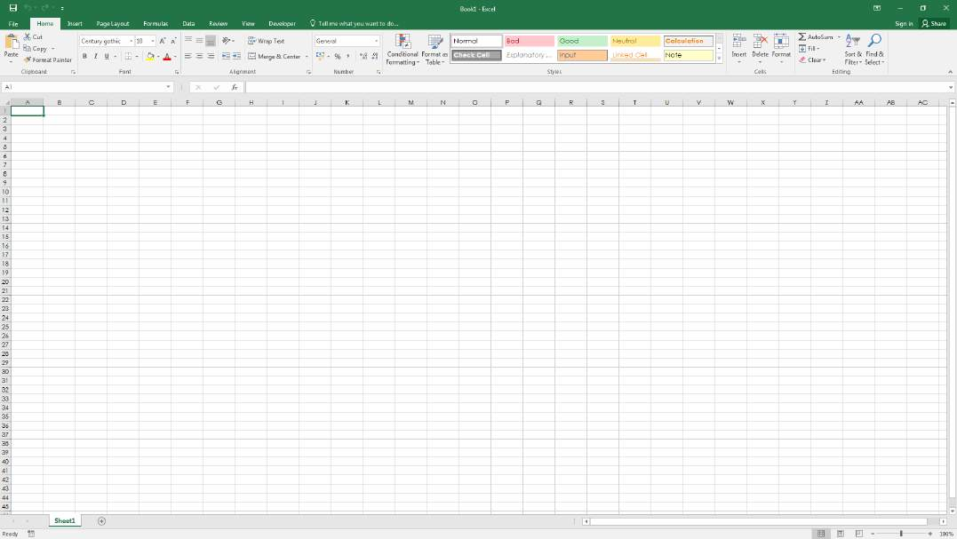

Step 2 Option A: Press Alt + F11

This is the standard shortcut to open the VBE.

Step 2 Option B: Developer Tab --> View Code

First, the Developer Tab must be added to the ribbon. Go to File -> Options -> Customize Ribbon, then check the box for developer.

[GoalKicker.com – Excel® VBA Notes for Professionals](https://goalkicker.com/) 3

[www.dbooks.org](https://www.dbooks.org/)

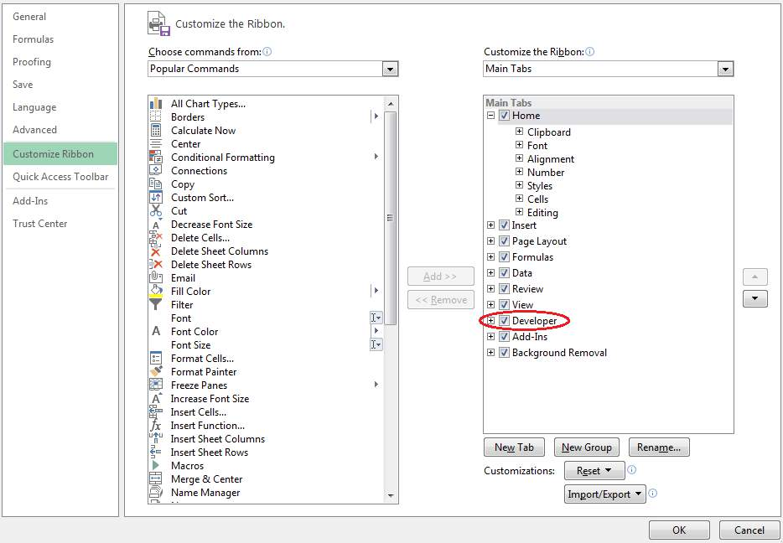

Then, go to the developer tab and click "View Code" or "Visual Basic"

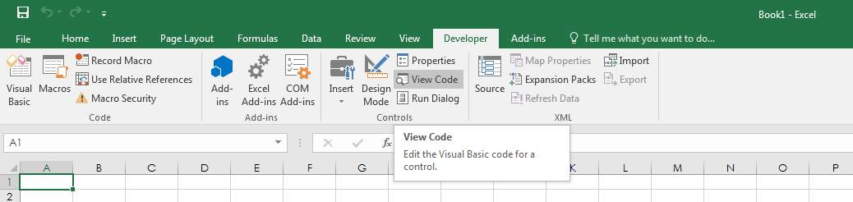

Step 2 Option C: View tab > Macros > Click Edit button to open an Existing Macro

All three of these options will open the Visual Basic Editor (VBE):

[GoalKicker.com – Excel® VBA Notes for Professionals](https://goalkicker.com/) 4

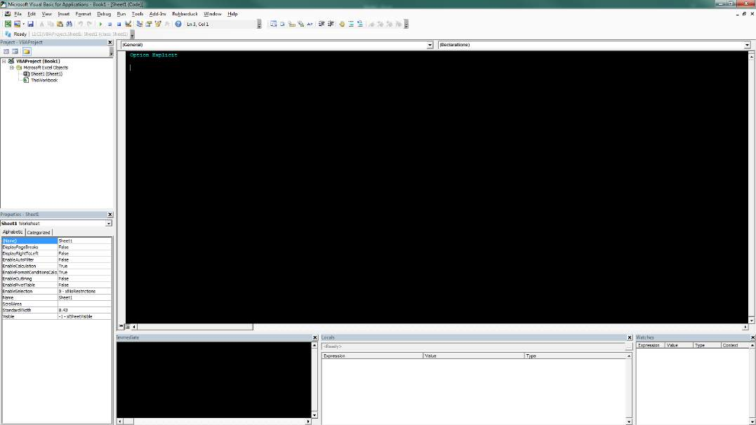

Section 1.2: Declaring Variables

To explicitly declare variables in VBA, use the Dim statement, followed by the variable name and type. If a variable is

used without being declared, or if no type is specified, it will be assigned the type Variant.

Use the Option Explicit statement on first line of a module to force all variables to be declared before usage (see

ALWAYS Use "Option Explicit" ).

Always using Option Explicit is highly recommended because it helps prevent typo/spelling errors and ensures

variables/objects will stay their intended type.

Option Explicit

Sub Example()

Dim a As Integer

a = 2

Debug.Print a

'Outputs: 2

Dim b As Long

b = a + 2

Debug.Print b

'Outputs: 4

Dim c As String

c = "Hello, world!"

Debug.Print c

'Outputs: Hello, world!

End Sub

Multiple variables can be declared on a single line using commas as delimiters, but each type must be declared

individually, or they will default to the Variant type.

Dim Str As String, IntOne, IntTwo As Integer, Lng As Long

[GoalKicker.com – Excel® VBA Notes for Professionals](https://goalkicker.com/) 5

[www.dbooks.org](https://www.dbooks.org/)

Debug.Print TypeName(Str) 'Output: String Debug.Print TypeName(IntOne) 'Output: Variant <--- !!! Debug.Print TypeName(IntTwo) 'Output: Integer Debug.Print TypeName(Lng) 'Output: Long

Variables can also be declared using Data Type Character suffixes ($ % & ! # @), however using these are

increasingly discouraged.

Dim this$ 'String

Dim this% 'Integer

Dim this& 'Long

Dim this! 'Single

Dim this# 'Double

Dim this@ 'Currency

Other ways of declaring variables are:

Static like: Static CounterVariable as Integer

When you use the Static statement instead of a Dim statement, the declared variable will retain its value between calls.

Public like: Public CounterVariable as Integer

Public variables can be used in any procedures in the project. If a public variable is declared in a standard

module or a class module, it can also be used in any projects that reference the project where the public

variable is declared.

Private like: Private CounterVariable as Integer

Private variables can be used only by procedures in the same module.

Source and more info:

[MSDN-Declaring Variables](https://msdn.microsoft.com/en-us/library/office/gg264241.aspx)

[Type Characters (Visual Basic)](https://docs.microsoft.com/en-us/dotnet/visual-basic/programming-guide/language-features/data-types/type-characters)

Section 1.3: Adding a new Object Library Reference

The procedure describes how to add an Object library reference, and afterwards how to declare new variables with

reference to the new library class objects.

The example below shows how to add the PowerPoint library to the existing VB Project. As can be seen, currently

the PowerPoint Object library is not available.

[GoalKicker.com – Excel® VBA Notes for Professionals](https://goalkicker.com/) 6

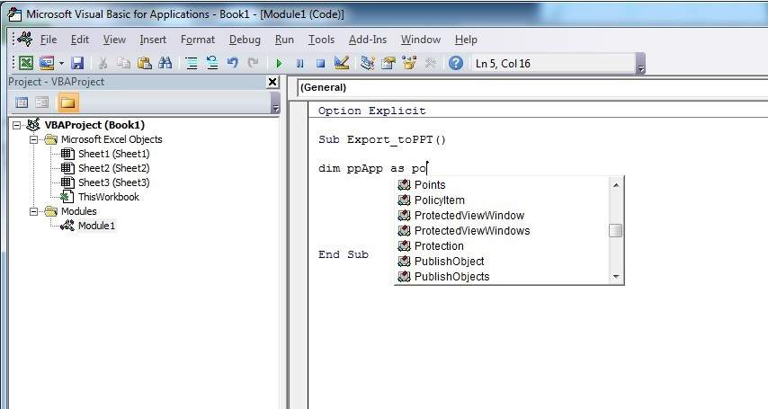

Step 1: Select Menu Tools--> References…

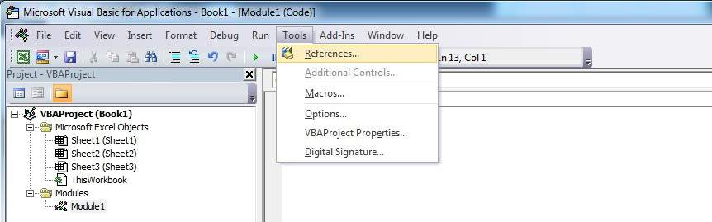

Step 2: Select the Reference you want to add. This example we scroll down to find “Microsoft PowerPoint 14.0

Object Library”, and then press “OK”.

[GoalKicker.com – Excel® VBA Notes for Professionals](https://goalkicker.com/) 7

[www.dbooks.org](https://www.dbooks.org/)

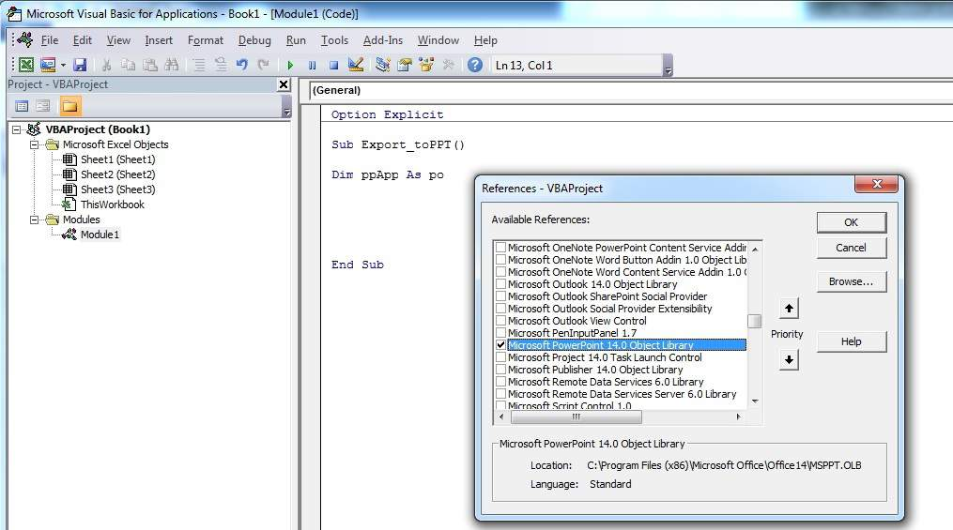

Note: PowerPoint 14.0 means that Office 2010 version is installed on the PC.

Step 3: in the VB Editor, once you press Ctrl+Space together, you get the autocomplete option of PowerPoint.

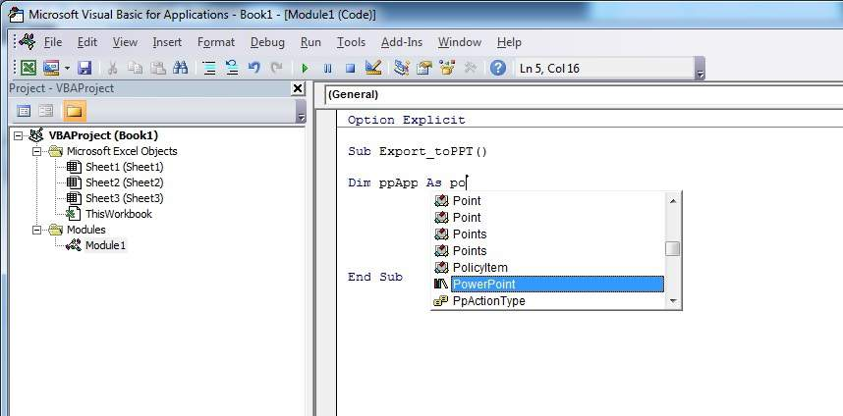

After selecting PowerPoint and pressing ., another menu appears with all objects options related to the PowerPoint

Object Library. This example shows how to select the PowerPoint's object Application.

[GoalKicker.com – Excel® VBA Notes for Professionals](https://goalkicker.com/) 8

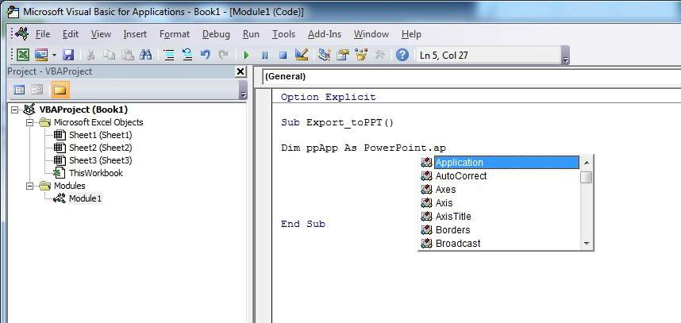

Step 4: Now the user can declare more variables using the PowerPoint object library.

Declare a variable that is referencing the Presentation object of the PowerPoint object library.

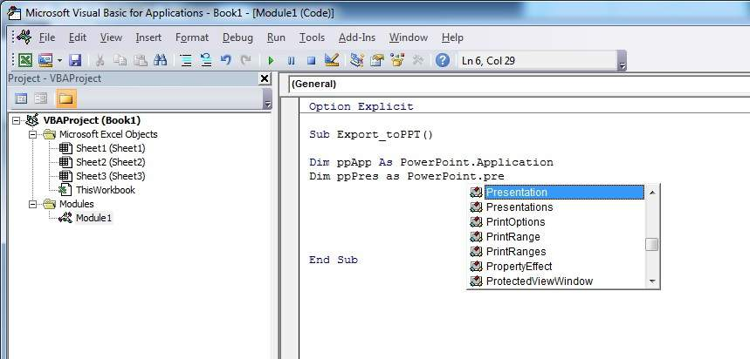

Declare another variable that is referencing the Slide object of the PowerPoint object library.

[GoalKicker.com – Excel® VBA Notes for Professionals](https://goalkicker.com/) 9

[www.dbooks.org](https://www.dbooks.org/)

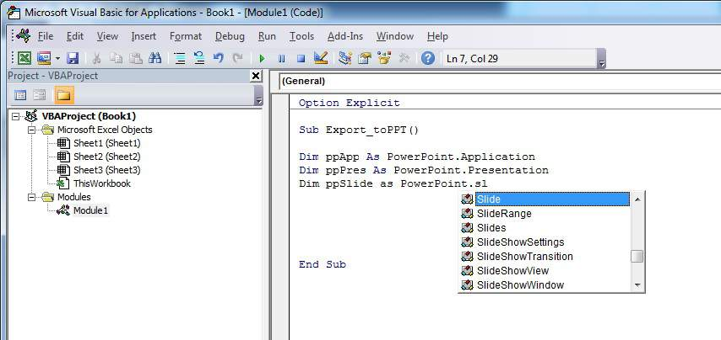

Now the variables declaration section looks like in the screen-shot below, and the user can start using these variables in his code.

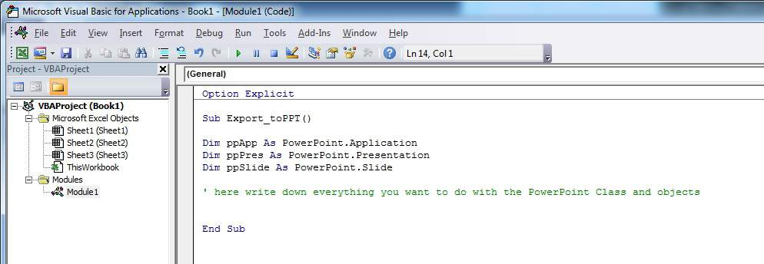

Code version of this tutorial:

Option Explicit

Sub Export\_toPPT()

Dim ppApp As PowerPoint.Application

Dim ppPres As PowerPoint.Presentation

Dim ppSlide As PowerPoint.Slide

' here write down everything you want to do with the PowerPoint Class and objects

End Sub

Section 1.4: Hello World

1. Open the Visual Basic Editor ( see Opening the Visual Basic Editor )

2. Click Insert --> Module to add a new Module :

[GoalKicker.com – Excel® VBA Notes for Professionals](https://goalkicker.com/) 10

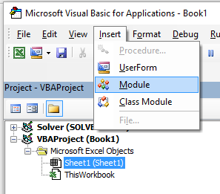

3. Copy and Paste the following code in the new module :

Sub hello()

MsgBox "Hello World !"

End Sub

To obtain :

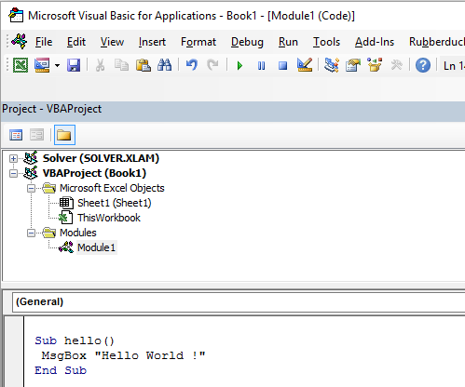

4. Click on the green “play” arrow (or press F5) in the Visual Basic toolbar to run the program:

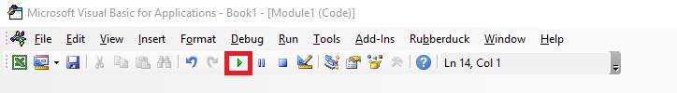

5. Select the new created sub "hello" and click Run :

[GoalKicker.com – Excel® VBA Notes for Professionals](https://goalkicker.com/) 11

[www.dbooks.org](https://www.dbooks.org/)

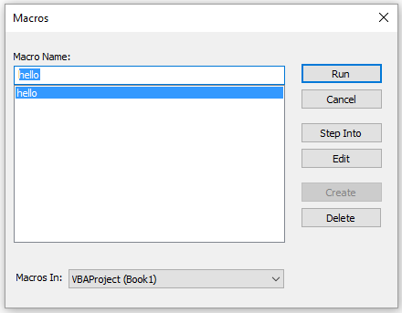

6. Done, your should see the following window:



Section 1.5: Getting Started with the Excel Object Model

This example intend to be a gentle introduction to the Excel Object Model for beginners.

1. Open the Visual Basic Editor (VBE)

2. Click View --> Immediate Window to open the Immediate Window (or ctrl + G ):

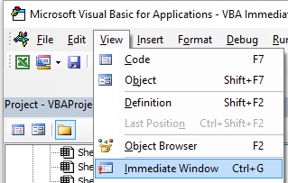

3. You should see the following Immediate Window at the bottom on VBE:

[GoalKicker.com – Excel® VBA Notes for Professionals](https://goalkicker.com/) 12

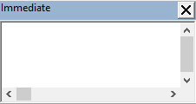

This window allow you to directly test some VBA code. So let's start, type in this console :

?Worksheets.

VBE has intellisense and then it should open a tooltip as in the following figure :

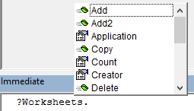

Select .Count in the list or directly type .Cout to obtain :

?Worksheets.Count

4. Then press Enter. The expression is evaluated and it should returns 1. This indicates the number of

Worksheet currently present in the workbook. The question mark (?) is an alias for Debug.Print.

Worksheets is an Object and Count is a Method. Excel has several Object (Workbook, Worksheet, Range, Chart ..)

[and each of one contains specific methods and properties. You can find the complete list of Object in the Excel VBA](https://msdn.microsoft.com/en-us/library/ff194068.aspx)

[reference. Worksheets Object is presented](https://msdn.microsoft.com/en-us/library/ff194068.aspx) [here .](https://msdn.microsoft.com/en-us/library/ff821537.aspx)

This Excel VBA reference should become your primary source of information regarding the Excel Object

Model.

5. Now let's try another expression, type (without the ? character):

Worksheets.Add().Name = "StackOveflow"

6. Press Enter. This should create a new worksheet called StackOverflow.:

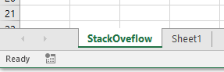

To understand this expression you need to read the Add function in the aforementioned Excel reference. You will

find the following:

Add: Creates a new worksheet, chart, or macro sheet. The new worksheet becomes the active sheet.

Return Value: An Object value that represents the new worksheet, chart,

[GoalKicker.com – Excel® VBA Notes for Professionals](https://goalkicker.com/) 13

[www.dbooks.org](https://www.dbooks.org/)

or macro sheet.

So the Worksheets.Add() create a new worksheet and return it. Worksheet(without s[) is itself a Object that can be](https://msdn.microsoft.com/en-us/library/ff194464.aspx)

[found](https://msdn.microsoft.com/en-us/library/ff194464.aspx) in the documentation and Name is one of its property (see [here). It is defined as :](https://msdn.microsoft.com/en-us/library/ff841127.aspx)

Worksheet.Name Property: Returns or sets a String value that represents the object name.

So, by investigating the different objects definitions we are able to understand this code Worksheets.Add().Name =

"StackOveflow".

Add() creates and add a new worksheet and return a reference to it, then we set its Name property to

"StackOverflow"

Now let's be more formal, Excel contains several Objects. These Objects may be composed of one or several collection(s) of Excel objects of the same class. It is the case for WorkSheets which is a collection of Worksheet

object. Each Object has some properties and methods that the programmer can interact with.

The Excel Object model refers to the Excel object hierarchy

At the top of all objects is the Application object, it represents the Excel instance itself. Programming in VBA requires a good understanding of this hierarchy because we always need a reference to an object to be able to call

a Method or to Set/Get a property.

The (very simplified) Excel Object Model can be represented as,

Application

Workbooks

Workbook

Worksheets

Worksheet

Range

A more detail version for the Worksheet Object (as it is in Excel 2007) is shown below,

[GoalKicker.com – Excel® VBA Notes for Professionals](https://goalkicker.com/) 14

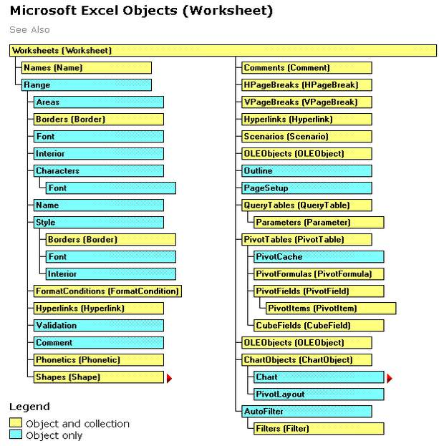

The full Excel Object Model can be found [here.](https://msdn.microsoft.com/en-us/library/ff194068(v=office.15).aspx)

Finally some objects may have events (ex: Workbook.WindowActivate) that are also part of the Excel Object Model.

[GoalKicker.com – Excel® VBA Notes for Professionals](https://goalkicker.com/) 15

[www.dbooks.org](https://www.dbooks.org/)

# Chapter 2: Arrays

Section 2.1: Dynamic Arrays (Array Resizing and Dynamic

Handling)

Due to not being Excel-VBA exclusive contents this Example has been moved to VBA documentation.

Link: Dynamic Arrays (Array Resizing and Dynamic Handling)

Section 2.2: Populating arrays (adding values)

There are multiple ways to populate an array.

Directly

'one-dimensional

Dim arrayDirect1D(2) As String

arrayDirect(0) = "A"

arrayDirect(1) = "B"

arrayDirect(2) = "C"

'multi-dimensional (in this case 3D)

Dim arrayDirectMulti(1, 1, 2)

arrayDirectMulti(0, 0, 0) = "A"

arrayDirectMulti(0, 0, 1) = "B"

arrayDirectMulti(0, 0, 2) = "C"

arrayDirectMulti(0, 1, 0) = "D"

'...

Using Array() function

'one-dimensional only

Dim array1D As Variant 'has to be type variant array1D = Array(1, 2, "A")

'-> array1D(0) = 1, array1D(1) = 2, array1D(2) = "A"

From range

Dim arrayRange As Variant 'has to be type variant

'putting ranges in an array always creates a 2D array (even if only 1 row or column) 'starting at 1 and not 0, first dimension is the row and the second the column arrayRange = Range("A1:C10").Value

'-> arrayRange(1,1) = value in A1

'-> arrayRange(1,2) = value in B1

'-> arrayRange(5,3) = value in C5

'...

'Yoo can get an one-dimensional array from a range (row or column) 'by using the worksheet functions index and transpose:

'one row from range into 1D-Array:

arrayRange = Application.WorksheetFunction.Index(Range("A1:C10").Value, 3, 0) '-> row 3 of range into 1D-Array

'-> arrayRange(1) = value in A3, arrayRange(2) = value in B3, arrayRange(3) = value in C3

'one column into 1D-Array:

'limited to 65536 rows in the column, reason: limit of .Transpose

[GoalKicker.com – Excel® VBA Notes for Professionals](https://goalkicker.com/) 16 arrayRange = Application.WorksheetFunction.Index( \_ Application.WorksheetFunction.Transpose(Range("A1:C10").Value), 2, 0) '-> column 2 of range into 1D-Array

'-> arrayRange(1) = value in B1, arrayRange(2) = value in B2, arrayRange(3) = value in B3 '...

'By using Evaluate() - shorthand [] - you can transfer the 'range to an array and change the values at the same time. 'This is equivalent to an array formula in the sheet: arrayRange = [(A1:C10\*3)]

arrayRange = [(A1:C10&"\_test")]

arrayRange = [(A1:B10\*C1:C10)]

'...

2D with Evaluate()

Dim array2D As Variant

'[] ist a shorthand for evaluate()

'Arrays defined with evaluate start at 1 not 0

array2D = [{"1A","1B","1C";"2A","2B","3B"}]

'-> array2D(1,1) = "1A", array2D(1,2) = "1B", array2D(2,1) = "2A" ...

'if you want to use a string to fill the 2D-Array:

Dim strValues As String

strValues = "{""1A"",""1B"",""1C"";""2A"",""2B"",""2C""}" array2D = Evaluate(strValues)

Using Split() function

Dim arraySplit As Variant 'has to be type variant arraySplit = Split("a,b,c", ",")

'-> arraySplit(0) = "a", arraySplit(1) = "b", arraySplit(2) = "c"

Section 2.3: Jagged Arrays (Arrays of Arrays)

Due to not being Excel-VBA exclusive contents this Example has been moved to VBA documentation.

Link: Jagged Arrays (Arrays of Arrays)

Section 2.4: Check if Array is Initialized (If it contains elements

or not)

A common problem might be trying to iterate over Array which has no values in it. For example:

Dim myArray() As Integer

For i = 0 To UBound(myArray) 'Will result in a "Subscript Out of Range" error

To avoid this issue, and to check if an Array contains elements, use this oneliner:

If Not Not myArray Then MsgBox UBound(myArray) Else MsgBox "myArray not initialised"

Section 2.5: Dynamic Arrays [Array Declaration, Resizing]

Sub Array\_clarity()

Dim arr() As Variant 'creates an empty array Dim x As Long

Dim y As Long

[GoalKicker.com – Excel® VBA Notes for Professionals](https://goalkicker.com/) 17

[www.dbooks.org](https://www.dbooks.org/)

x = Range("A1", Range("A1").End(xlDown)).Cells.Count y = Range("A1", Range("A1").End(xlToRight)).Cells.Count

ReDim arr(0 To x, 0 To y) 'fixing the size of the array

For x = LBound(arr, 1) To UBound(arr, 1)

For y = LBound(arr, 2) To UBound(arr, 2) arr(x, y) = Range("A1").Offset(x, y) 'storing the value of Range("A1:E10") from activesheet

in x and y variables

Next

Next

'Put it on the same sheet according to the declaration: Range("A14").Resize(UBound(arr, 1), UBound(arr, 2)).Value = arr

End Sub

[GoalKicker.com – Excel® VBA Notes for Professionals](https://goalkicker.com/) 18

# Chapter 3: Conditional statements

Section 3.1: The If statement

The If control statement allows different code to be executed depending upon the evaluation of a conditional (Boolean) statement. A conditional statement is one that evaluates to either True or False, e.g. x > 2.

There are three patterns that can be used when implementing an If statement, which are described below. Note that an If conditional evaluation is always followed by a Then.

1. Evaluating one If conditional statement and doing something if it is True

Single line If statement

This is the shortest way to use an If and it is useful when only one statement needs to be carried out upon a True evaluation. When using this syntax, all of the code must be on a single line. Do not include an End If at the end of

the line.

If [Some condition is True] Then [Do something]

If block

If multiple lines of code need to be executed upon a True evaluation, an If block may be used.

If [Some condition is True] Then

[Do some things]

End If

Note that, if a multi-line If block is used, a corresponding End If is required.

2. Evaluating one conditional If statement, doing one thing if it is True and doing something else if it is False

Single line If, Else statement

This may be used if one statement is to be carried out upon a True evaluation and a different statement is to be carried out on a False evaluation. Be careful using this syntax, as it is often less clear to readers that there is an

Else statement. When using this syntax, all of the code must be on a single line. Do not include an End If at the end of the line.

If [Some condition is True] Then [Do something] Else [Do something else]

If, Else block

Use an If, Else block to add clarity to your code, or if multiple lines of code need to be executed under either a

True or a False evaluation.

If [Some condition is True] Then

[Do some things]

Else

[Do some other things]

End If

Note that, if a multi-line If block is used, a corresponding End If is required.

[GoalKicker.com – Excel® VBA Notes for Professionals](https://goalkicker.com/) 19

[www.dbooks.org](https://www.dbooks.org/) 3. Evaluating many conditional statements, when preceding statements are all False, and doing something

different for each one

This pattern is the most general use of If and would be used when there are many non-overlapping conditions that

require different treatment. Unlike the first two patterns, this case requires the use of an If block, even if only one line of code will be executed for each condition.

If, ElseIf, ..., Else block

Instead of having to create many If blocks one below another, an ElseIf may be used evaluate an extra condition. The ElseIf is only evaluated if any preceding If evaluation is False.

If [Some condition is True] Then

[Do some thing(s)]

ElseIf [Some other condition is True] Then

[Do some different thing(s)]

Else 'Everything above has evaluated to False

[Do some other thing(s)]

End If

As many ElseIf control statements may be included between an If and an End If as required. An Else control

statement is not required when using ElseIf (although it is recommended), but if it is included, it must be the final control statement before the End If.

[GoalKicker.com – Excel® VBA Notes for Professionals](https://goalkicker.com/) 20

# Chapter 4: Ranges and Cells

Section 4.1: Ways to refer to a single cell

The simplest way to refer to a single cell on the current Excel worksheet is simply to enclose the A1 form of its reference in square brackets:

[a3] = "Hello!"

Note that square brackets are just convenient [syntactic sugar](https://en.wikipedia.org/wiki/Syntactic_sugar) for the Evaluate method of the Application object,

so technically, this is identical to the following code:

Application.Evaluate("a3") = "Hello!"

You could also call the Cells method which takes a row and a column and returns a cell reference.

Cells(3, 1).Formula = "=A1+A2"

Remember that whenever you pass a row and a column to Excel from VBA, the row is always first, followed by the

column, which is confusing because it is the opposite of the common A1 notation where the column appears first.

In both of these examples, we did not specify a worksheet, so Excel will use the active sheet (the sheet that is in

front in the user interface). You can specify the active sheet explicitly:

ActiveSheet.Cells(3, 1).Formula = "=SUM(A1:A2)"

Or you can provide the name of a particular sheet:

Sheets("Sheet2").Cells(3, 1).Formula = "=SUM(A1:A2)"

There are a wide variety of methods that can be used to get from one range to another. For example, the Rows method can be used to get to the individual rows of any range, and the Cells method can be used to get to

individual cells of a row or column, so the following code refers to cell C1:

ActiveSheet.Rows(1).Cells(3).Formula = "hi!"

Section 4.2: Creating a Range

A [Range](https://msdn.microsoft.com/en-us/library/office/ff838238.aspx) cannot be created or populated the same way a string would:

Sub RangeTest()

Dim s As String

Dim r As Range 'Specific Type of Object, with members like Address, WrapText, AutoFill, etc.

' This is how we fill a String:

s = "Hello World!"

' But we cannot do this for a Range:

r = Range("A1") '//Run. Err.: 91 Object variable or With block variable not set//

' We have to use the Object approach, using keyword Set: Set r = Range("A1")

End Sub

[GoalKicker.com – Excel® VBA Notes for Professionals](https://goalkicker.com/) 21

[www.dbooks.org](https://www.dbooks.org/) It is considered best practice to qualify your references, so from now on we will use the same approach here.

More about [Creating Object Variables (e.g. Range) on MSDN . More about](https://msdn.microsoft.com/en-us/library/office/gg251791.aspx) [Set Statement on MSDN.](https://msdn.microsoft.com/en-us/library/office/gg251642.aspx)

There are different ways to create the same Range:

Sub SetRangeVariable()

Dim ws As Worksheet

Dim r As Range

Set ws = ThisWorkbook.Worksheets(1) ' The first Worksheet in Workbook with this code in it

' These are all equivalent:

Set r = ws.Range("A2")

Set r = ws.Range("A" & 2)

Set r = ws.Cells(2, 1) ' The cell in row number 2, column number 1 Set r = ws.[A2] 'Shorthand notation of Range. Set r = Range("NamedRangeInA2") 'If the cell A2 is named NamedRangeInA2. Note, that this is

Sheet independent.

Set r = ws.Range("A1").Offset(1, 0) ' The cell that is 1 row and 0 columns away from A1 Set r = ws.Range("A1").Cells(2,1) ' Similar to Offset. You can "go outside" the original Range.

Set r = ws.Range("A1:A5").Cells(2) 'Second cell in bigger Range. Set r = ws.Range("A1:A5").Item(2) 'Second cell in bigger Range. Set r = ws.Range("A1:A5")(2) 'Second cell in bigger Range.

End Sub

Note in the example that Cells(2, 1) is equivalent to Range("A2"). This is because Cells returns a Range object.

[Some sources: Chip Pearson-Cells Within Ranges](http://www.cpearson.com/Excel/cells.htm)[; MSDN-Range Object;](https://msdn.microsoft.com/en-us/library/office/ff838238.aspx) [John Walkenback-Referring To Ranges In](http://spreadsheetpage.com/index.php/tip/referring_to_ranges_in_your_vba_code/)

[Your VBA Code](http://spreadsheetpage.com/index.php/tip/referring_to_ranges_in_your_vba_code/).

Also note that in any instance where a number is used in the declaration of the range, and the number itself is

outside of quotation marks, such as Range("A" & 2), you can swap that number for a variable that contains an integer/long. For example:

Sub RangeIteration()

Dim wb As Workbook, ws As Worksheet

Dim r As Range

Set wb = ThisWorkbook

Set ws = wb.Worksheets(1)

For i = 1 To 10

Set r = ws.Range("A" & i)

' When i = 1, the result will be Range("A1")

' When i = 2, the result will be Range("A2")

' etc.

' Proof:

Debug.Print r.Address

Next i

End Sub

If you are using double loops, Cells is better:

Sub RangeIteration2()

Dim wb As Workbook, ws As Worksheet

Dim r As Range

Set wb = ThisWorkbook

Set ws = wb.Worksheets(1)

[GoalKicker.com – Excel® VBA Notes for Professionals](https://goalkicker.com/) 22

For i = 1 To 10

For j = 1 To 10

Set r = ws.Cells(i, j)

' When i = 1 and j = 1, the result will be Range("A1") ' When i = 2 and j = 1, the result will be Range("A2") ' When i = 1 and j = 2, the result will be Range("B1") ' etc.

' Proof:

Debug.Print r.Address

Next j

Next i

End Sub

Section 4.3: Oset Property

Offset(Rows, Columns) - The operator used to statically reference another point from the current cell. Often

used in loops. It should be understood that positive numbers in the rows section moves right, wheres as

negatives move left. With the columns section positives move down and negatives move up.

i.e

Private Sub this()

ThisWorkbook.Sheets("Sheet1").Range("A1").Offset(1, 1).Select

ThisWorkbook.Sheets("Sheet1").Range("A1").Offset(1, 1).Value = "New Value"

ActiveCell.Offset(-1, -1).Value = ActiveCell.Value

ActiveCell.Value = vbNullString

End Sub

This code selects B2, puts a new string there, then moves that string back to A1 afterwards clearing out B2.

Section 4.4: Saving a reference to a cell in a variable

To save a reference to a cell in a variable, you must use the Set syntax, for example:

Dim R as Range

Set R = ActiveSheet.Cells(3, 1)

later...

R.Font.Color = RGB(255, 0, 0)

Why is the Set keyword required? Set tells Visual Basic that the value on the right hand side of the = is meant to be an object.

Section 4.5: How to Transpose Ranges (Horizontal to Vertical

& vice versa)

Sub TransposeRangeValues()

Dim TmpArray() As Variant, FromRange as Range, ToRange as Range

set FromRange = Sheets("Sheet1").Range("a1:a12") 'Worksheets(1).Range("a1:p1") set ToRange = ThisWorkbook.Sheets("Sheet1").Range("a1")

'ThisWorkbook.Sheets("Sheet1").Range("a1")

TmpArray = Application.Transpose(FromRange.Value)

FromRange.Clear

[GoalKicker.com – Excel® VBA Notes for Professionals](https://goalkicker.com/) 23

[www.dbooks.org](https://www.dbooks.org/)

ToRange.Resize(FromRange.Columns.Count,FromRange.Rows.Count).Value2 = TmpArray End Sub

Note: Copy/PasteSpecial also has a Paste Transpose option which updates the transposed cells' formulas as well.

[GoalKicker.com – Excel® VBA Notes for Professionals](https://goalkicker.com/) 24

# Chapter 5: Named Ranges

Topic should include information specifically related to named ranges in Excel including methods for creating,

modifying, deleting, and accessing defined named ranges.

Section 5.1: Define A Named Range

Using named ranges allows you to describe the meaning of a cell(s) contents and use this defined name in place of

an actual cell address.

For example, formula =A5\*B5 can be replaced with =Width\*Height to make the formula much easier to read and

understand.

To define a new named range, select cell or cells to name and then type new name into the Name Box next to the formula bar.

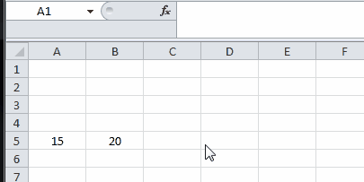

Note: Named Ranges default to global scope meaning that they can be accessed from anywhere within

the workbook. Older versions of Excel allow for duplicate names so care must be taken to prevent duplicate names of global scope otherwise results will be unpredictable. Use Name Manager from

Formulas tab to change scope.

Section 5.2: Using Named Ranges in VBA

Create new named range called ‘MyRange’ assigned to cell A1

ThisWorkbook.Names.Add Name:="MyRange", \_

RefersTo:=Worksheets("Sheet1").Range("A1")

Delete defined named range by name

ThisWorkbook.Names("MyRange").Delete

Access Named Range by name

Dim rng As Range

Set rng = ThisWorkbook.Worksheets("Sheet1").Range("MyRange") Call MsgBox("Width = " & rng.Value)

[GoalKicker.com – Excel® VBA Notes for Professionals](https://goalkicker.com/) 25

[www.dbooks.org](https://www.dbooks.org/)

Access a Named Range with a Shortcut

[Just like any other range](http://www.informit.com/articles/article.aspx?p=2021718&seqNum=4), named ranges can be accessed directly with through a shortcut notation that does not

require a Range object to be created. The three lines from the code excerpt above can be replaced by a single line:

Call MsgBox("Width = " & [MyRange])

Note: The default property for a Range is its Value, so [MyRange] is the same as [MyRange].Value

You can also call methods on the range. The following selects MyRange:

[MyRange].Select

Note: One caveat is that the shortcut notation does not work with words that are used elsewhere in the

VBA library. For example, a range named Width would not be accessible as [Width] but would work as expected if accessed through ThisWorkbook.Worksheets("Sheet1").Range("Width")

Section 5.3: Manage Named Range(s) using Name Manager

Formulas tab > Defined Names group > Name Manager button

Named Manager allows you to:

1. Create or change name

2. Create or change cell reference

3. Create or change scope

4. Delete existing named range

[GoalKicker.com – Excel® VBA Notes for Professionals](https://goalkicker.com/) 26

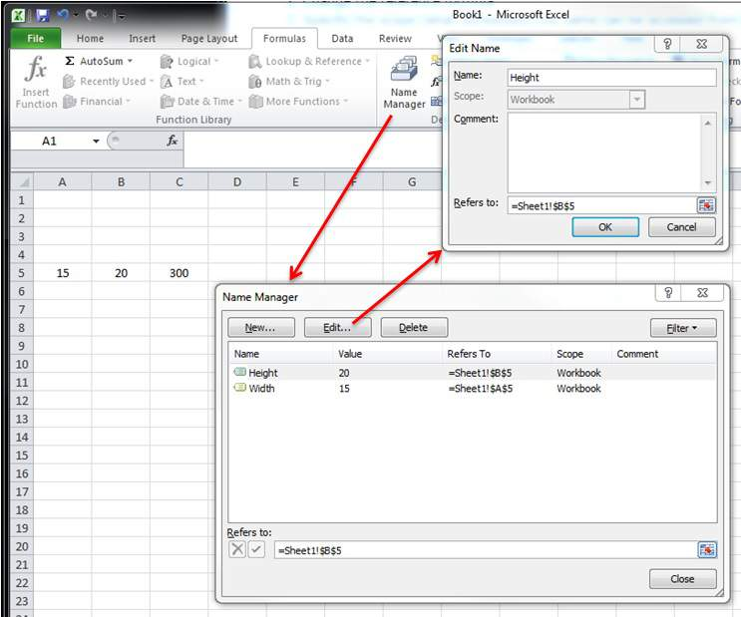

Named Manager provides a useful quick look for broken links.

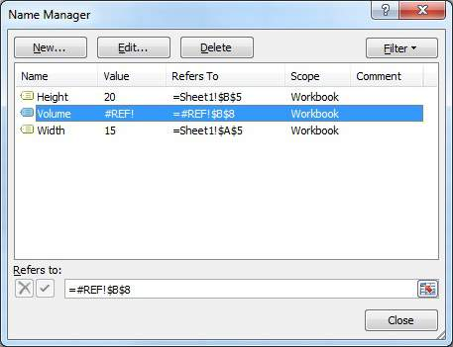

[GoalKicker.com – Excel® VBA Notes for Professionals](https://goalkicker.com/) 27

[www.dbooks.org](https://www.dbooks.org/)

Section 5.4: Named Range Arrays

Example sheet

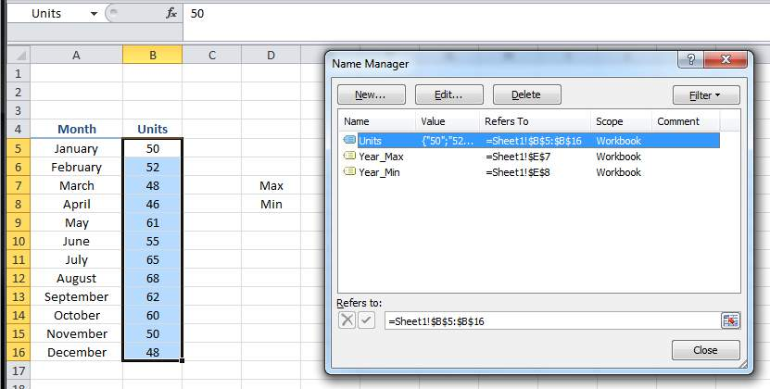

Code

Sub Example()

Dim wks As Worksheet

Set wks = ThisWorkbook.Worksheets("Sheet1")

Dim units As Range

Set units = ThisWorkbook.Names("Units").RefersToRange

Worksheets("Sheet1").Range("Year\_Max").Value = WorksheetFunction.Max(units)

Worksheets("Sheet1").Range("Year\_Min").Value = WorksheetFunction.Min(units) End Sub

Result

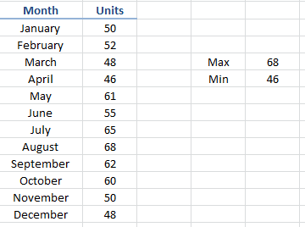

[GoalKicker.com – Excel® VBA Notes for Professionals](https://goalkicker.com/) 28

# Chapter 6: Merged Cells / Ranges

Section 6.1: Think twice before using Merged Cells/Ranges

First of all, Merged Cells are there only to improve the look of your sheets.

So it is literally the last thing that you should do, once your sheet and workbook are totally functional!

Where is the data in a Merged Range?

When you merge a Range, you'll only display one block.

The data will be in the very first cell of that Range, and the others will be empty cells!

One good point about it : no need to fill all the cells or the range once merged, just fill the first cell! ;)

The other aspects of this merged ranged are globally negative :

If you use a method for finding last row or column, you'll risk some errors

If you loop through rows and you have merged some ranges for a better readability, you'll encounter empty

cells and not the value displayed by the merged range

[GoalKicker.com – Excel® VBA Notes for Professionals](https://goalkicker.com/) 29

[www.dbooks.org](https://www.dbooks.org/)

# Chapter 7: Locating duplicate values in a

range

At certain points, you will be evaluating a range of data and you will need to locate the duplicates in it. For bigger

data sets, there are a number of approaches you can take that use either VBA code or conditional functions. This example uses a simple if-then condition within two nested for-next loops to test whether each cell in the range is

equal in value to any other cell in the range.

Section 7.1: Find duplicates in a range

The following tests range A2 to A7 for duplicate values. Remark: This example illustrates a possible solution as a

first approach to a solution. It's faster to use an array than a range and one could use collections or dictionaries or xml methods to check for duplicates.

Sub find\_duplicates()

' Declare variables

Dim ws As Worksheet ' worksheet Dim cell As Range ' cell within worksheet range Dim n As Integer ' highest row number Dim bFound As Boolean ' boolean flag, if duplicate is found Dim sFound As String: sFound = "|" ' found duplicates Dim s As String ' message string Dim s2 As String ' partial message string

' Set Sheet to memory

Set ws = ThisWorkbook.Sheets("Duplicates")

' loop thru FULLY QUALIFIED REFERENCE

For Each cell In ws.Range("A2:A7")

bFound = False: s2 = "" ' start each cell with empty values

' Check if first occurrence of this value as duplicate to avoid further searches

If InStr(sFound, "|" & cell & "|") = 0 Then

For n = cell.Row + 1 To 7 ' iterate starting point to avoid REDUNDANT SEARCH

If cell = ws.Range("A" & n).Value Then

If cell.Row <> n Then ' only other cells, as same cell cannot be a duplicate

bFound = True ' boolean flag

' found duplicates in cell A{n}

s2 = s2 & vbNewLine & " -> duplicate in A" & n

End If

End If

Next

End If

' notice all found duplicates

If bFound Then

' add value to list of all found duplicate values

' (could be easily split to an array for further analyze)

sFound = sFound & cell & "|"

s = s & cell.Address & " (value=" & cell & ")" & s2 & vbNewLine & vbNewLine

End If

Next

' Messagebox with final result

MsgBox "Duplicate values are " & sFound & vbNewLine & vbNewLine & s, vbInformation, "Found duplicates"

End Sub

Depending on your needs, the example can be modified - for instance, the upper limit of n can be the row value of

last cell with data in the range, or the action in case of a True If condition can be edited to extract the duplicate

[GoalKicker.com – Excel® VBA Notes for Professionals](https://goalkicker.com/) 30 value somewhere else. However, the mechanics of the routine would not change.

[GoalKicker.com – Excel® VBA Notes for Professionals](https://goalkicker.com/) 31

[www.dbooks.org](https://www.dbooks.org/)

# Chapter 8: User Defined Functions (UDFs)

Section 8.1: Allow full column references without penalty

It's easier to implement some UDFs on the worksheet if full column references can be passed in as parameters. However, due to the explicit nature of coding, any loop involving these ranges may be processing hundreds of

thousands of cells that are completely empty. This reduces your VBA project (and workbook) to a frozen mess while unnecessary non-values are processed.

Looping through a worksheet's cells is one of the slowest methods of accomplishing a task but sometimes it is unavoidable. Cutting the work performed down to what is actually required makes perfect sense.

The solution is to truncate the full column or full row references to the [Worksheet.UsedRange property](https://msdn.microsoft.com/en-us/library/office/ff840732.aspx) with the

[Intersect method. The following sample will loosely replicate a worksheet's native SUMIF function so the](https://msdn.microsoft.com/en-us/library/office/aa195772.aspx)

criteria\_range will also be resized to suit the sum\_range since each value in the sum\_range must be accompanied by a value in the criteria\_range.

[The Application.Caller for a UDF used on a worksheet is the cell in which it resides. The cell's](https://msdn.microsoft.com/en-us/library/office/ff193687.aspx) [.Parent](https://msdn.microsoft.com/en-us/library/office/aa224980.aspx) property is the worksheet. This will be used to define the .UsedRange.

In a Module code sheet:

Option Explicit

Function udfMySumIf(rngA As Range, rngB As Range, \_

Optional crit As Variant = "yes")

Dim c As Long, ttl As Double

With Application.Caller.Parent

Set rngA = Intersect(rngA, .UsedRange) Set rngB = rngB.Resize(rngA.Rows.Count, rngA.Columns.Count)

End With

For c = 1 To rngA.Cells.Count

If IsNumeric(rngA.Cells(c).Value2) Then

If LCase(rngB(c).Value2) = LCase(crit) Then

ttl = ttl + rngA.Cells(c).Value2

End If

End If

Next c

udfMySumIf = ttl

End Function

Syntax:

=udfMySumIf(\*sum\_range\*, \*criteria\_range\*, [\*criteria\*])

[GoalKicker.com – Excel® VBA Notes for Professionals](https://goalkicker.com/) 32

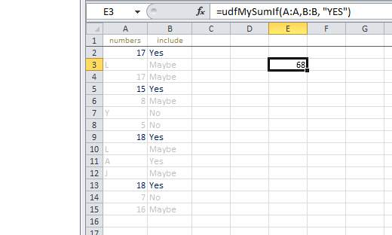

While this is a fairly simplistic example, it adequately demonstrates passing in two full column references (1,048,576 rows each) but only processing 15 rows of data and criteria.

Linked official MSDN documentation of individual methods and properties courtesy of Microsoft™.

Section 8.2: Count Unique values in Range

Function countUnique(r As range) As Long

'Application.Volatile False ' optional

Set r = Intersect(r, r.Worksheet.UsedRange) ' optional if you pass entire rows or columns to the

function

Dim c As New Collection, v

On Error Resume Next ' to ignore the Run-time error 457: "This key is already associated with

an element of this collection".

For Each v In r.Value ' remove .Value for ranges with more than one Areas c.Add 0, v & ""

Next

c.Remove "" ' optional to exclude blank values from the count

countUnique = c.Count

End Function

Collections

Section 8.3: UDF - Hello World

1. Open Excel

2. Open the Visual Basic Editor ( see Opening the Visual Basic Editor )

3. Add a new module by clicking Insert --> Module :

[GoalKicker.com – Excel® VBA Notes for Professionals](https://goalkicker.com/) 33

[www.dbooks.org](https://www.dbooks.org/)



4. Copy and Paste the following code in the new module :

Public Function Hello() As String

'Note: the output of the function is simply the function's name Hello = "Hello, World !"

End Function

To obtain :

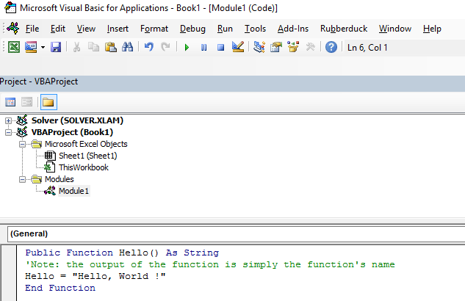

5. Go back to your workbook and type "=Hello()" into a cell to see the "Hello World".

[GoalKicker.com – Excel® VBA Notes for Professionals](https://goalkicker.com/) 34

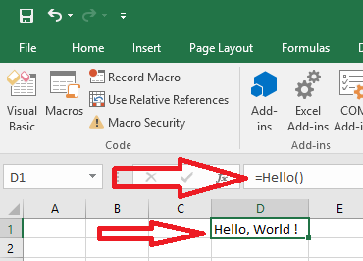

[GoalKicker.com – Excel® VBA Notes for Professionals](https://goalkicker.com/) 35

[www.dbooks.org](https://www.dbooks.org/)

# Chapter 9: Conditional formatting using

VBA

Section 9.1: FormatConditions.Add

Syntax:

FormatConditions.Add(Type, Operator, Formula1, Formula2)

Parameters:

Name Required / Optional Data Type

Type Required XlFormatConditionType

Operator Optional Variant

Formula1 Optional Variant

Formula2 Optional Variant

XlFormatConditionType enumaration:

Name Description

xlAboveAverageCondition Above average condition

xlBlanksCondition Blanks condition

xlCellValue Cell value

xlColorScale Color scale

xlDatabar Databar

xlErrorsCondition Errors condition

xlExpression Expression

XlIconSet Icon set

xlNoBlanksCondition No blanks condition

xlNoErrorsCondition No errors condition

xlTextString Text string

xlTimePeriod Time period

xlTop10 Top 10 values

xlUniqueValues Unique values

Formatting by cell value:

With Range("A1").FormatConditions.Add(xlCellValue, xlGreater, "=100")

With .Font

.Bold = True

.ColorIndex = 3

End With

End With

Operators:

Name

xlBetween

xlEqual

xlGreater

xlGreaterEqual

xlLess

xlLessEqual

xlNotBetween

xlNotEqual

[GoalKicker.com – Excel® VBA Notes for Professionals](https://goalkicker.com/) 36 If Type is xlExpression, the Operator argument is ignored.

Formatting by text contains:

With Range("a1:a10").FormatConditions.Add(xlTextString, TextOperator:=xlContains, String:="egg")

With .Font

.Bold = True

.ColorIndex = 3

End With

End With

Operators:

Name Description

xlBeginsWith Begins with a specified value.

xlContains Contains a specified value.

xlDoesNotContain Does not contain the specified value.

xlEndsWith Endswith the specified value

Formatting by time period

With Range("a1:a10").FormatConditions.Add(xlTimePeriod, DateOperator:=xlToday)

With .Font

.Bold = True

.ColorIndex = 3

End With

End With

Operators:

Name

xlYesterday

xlTomorrow

xlLast7Days

xlLastWeek

xlThisWeek

xlNextWeek

xlLastMonth

xlThisMonth

xlNextMonth

Section 9.2: Remove conditional format

Remove all conditional format in range:

Range("A1:A10").FormatConditions.Delete

Remove all conditional format in worksheet:

Cells.FormatConditions.Delete

Section 9.3: FormatConditions.AddUniqueValues

Highlighting Duplicate Values

With Range("E1:E100").FormatConditions.AddUniqueValues

.DupeUnique = xlDuplicate

With .Font

.Bold = True

[GoalKicker.com – Excel® VBA Notes for Professionals](https://goalkicker.com/) 37

[www.dbooks.org](https://www.dbooks.org/)

.ColorIndex = 3

End With

End With

Highlighting Unique Values

With Range("E1:E100").FormatConditions.AddUniqueValues

With .Font

.Bold = True

.ColorIndex = 3

End With

End With

Section 9.4: FormatConditions.AddTop10

Highlighting Top 5 Values

With Range("E1:E100").FormatConditions.AddTop10

.TopBottom = xlTop10Top

.Rank = 5

.Percent = False

With .Font

.Bold = True

.ColorIndex = 3

End With

End With

Section 9.5: FormatConditions.AddAboveAverage

With Range("E1:E100").FormatConditions.AddAboveAverage

.AboveBelow = xlAboveAverage

With .Font

.Bold = True

.ColorIndex = 3

End With

End With

Operators:

Name Description

XlAboveAverage Above average

XlAboveStdDev Above standard deviation

XlBelowAverage Below average

XlBelowStdDev Below standard deviation

XlEqualAboveAverage Equal above average

XlEqualBelowAverage Equal below average

Section 9.6: FormatConditions.AddIconSetCondition

[GoalKicker.com – Excel® VBA Notes for Professionals](https://goalkicker.com/) 38

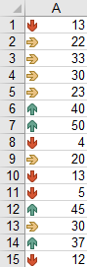

Range("a1:a10").FormatConditions.AddIconSetCondition With Selection.FormatConditions(1)

.ReverseOrder = False

.ShowIconOnly = False

.IconSet = ActiveWorkbook.IconSets(xl3Arrows)

End With

With Selection.FormatConditions(1).IconCriteria(2)

.Type = xlConditionValuePercent

.Value = 33

.Operator = 7

End With

With Selection.FormatConditions(1).IconCriteria(3)

.Type = xlConditionValuePercent

.Value = 67

.Operator = 7

End With

IconSet:

Name

xl3Arrows

xl3ArrowsGray

xl3Flags

xl3Signs

xl3Stars

xl3Symbols

xl3Symbols2

xl3TrafficLights1

xl3TrafficLights2

xl3Triangles

xl4Arrows

xl4ArrowsGray

xl4CRV

xl4RedToBlack

xl4TrafficLights

xl5Arrows

[GoalKicker.com – Excel® VBA Notes for Professionals](https://goalkicker.com/) 39

[www.dbooks.org](https://www.dbooks.org/)

xl5ArrowsGray

xl5Boxes

xl5CRV

xl5Quarters

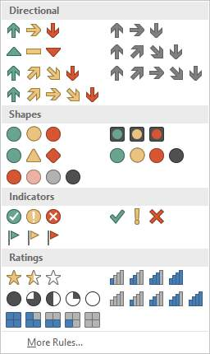

Type:

Name

xlConditionValuePercent

xlConditionValueNumber

xlConditionValuePercentile

xlConditionValueFormula

Operator:

Name Value

xlGreater 5

xlGreaterEqual 7

Value:

Returns or sets the threshold value for an icon in a conditional format.

[GoalKicker.com – Excel® VBA Notes for Professionals](https://goalkicker.com/) 40

# Chapter 10: Workbooks

Section 10.1: When To Use ActiveWorkbook and ThisWorkbook

It's a VBA Best Practice to always specify which workbook your VBA code refers. If this specification is omitted, then VBA assumes the code is directed at the currently active workbook (ActiveWorkbook).

'--- the currently active workbook (and worksheet) is implied Range("A1").value = 3.1415

Cells(1, 1).value = 3.1415

However, when several workbooks are open at the same time -- particularly and especially when VBA code is

running from an Excel Add-In -- references to the ActiveWorkbook may be confused or misdirected. For example, an add-in with a UDF that checks the time of day and compares it to a value stored on one of the add-in's worksheets

(that are typically not readily visible to the user) will have to explicitly identify which workbook is being referenced. In our example, our open (and active) workbook has a formula in cell A1 =EarlyOrLate() and does NOT have any

VBA written for that active workbook. In our add-in, we have the following User Defined Function (UDF):

Public Function EarlyOrLate() As String

If Hour(Now) > ThisWorkbook.Sheets("WatchTime").Range("A1") Then EarlyOrLate = "It's Late!"

Else

EarlyOrLate = "It's Early!"

End If

End Function

The code for the UDF is written and stored in the installed Excel add-in. It uses data stored on a worksheet in the add-in called "WatchTime". If the UDF had used ActiveWorkbook instead of ThisWorkbook, then it would never be

able to guarantee which workbook was intended.

Section 10.2: Changing The Default Number of Worksheets In

A New Workbook

The "factory default" number of worksheets created in a new Excel workbook is generally set to three. Your VBA

code can explicitly set the number of worksheets in a new workbook.

'--- save the current Excel global setting

With Application

Dim oldSheetsCount As Integer

oldSheetsCount = .SheetsInNewWorkbook

Dim myNewWB As Workbook

.SheetsInNewWorkbook = 1

Set myNewWB = .Workbooks.Add

'--- restore the previous setting

.SheetsInNewWorkbook = oldsheetcount

End With

Section 10.3: Application Workbooks

In many Excel applications, the VBA code takes actions directed at the workbook in which it's contained. You save that workbook with a ".xlsm" extension and the VBA macros only focus on the worksheets and data within.

However, there are often times when you need to combine or merge data from other workbooks, or write some of

your data to a separate workbook. Opening, closing, saving, creating, and deleting other workbooks is a common need for many VBA applications.

[GoalKicker.com – Excel® VBA Notes for Professionals](https://goalkicker.com/) 41

[www.dbooks.org](https://www.dbooks.org/) At any time in the VBA Editor, you can view and access any and all workbooks currently open by that instance of

Excel by using the Workbooks property of the Application [object. The MSDN Documentation explains it with](https://msdn.microsoft.com/en-us/library/office/ff820765.aspx)

references.

Section 10.4: Opening A (New) Workbook, Even If It's Already

Open

If you want to access a workbook that's already open, then getting the assignment from the Workbooks collection is straightforward:

dim myWB as Workbook

Set myWB = Workbooks("UsuallyFullPathnameOfWorkbook.xlsx")

If you want to create a new workbook, then use the Workbooks collection object to Add a new entry.

Dim myNewWB as Workbook

Set myNewWB = Workbooks.Add

There are times when you may not or (or care) if the workbook you need is open already or not, or possible does not exist. The example function shows how to always return a valid workbook object.

Option Explicit

Function GetWorkbook(ByVal wbFilename As String) As Workbook

'--- returns a workbook object for the given filename, including checks ' for when the workbook is already open, exists but not open, or ' does not yet exist (and must be created)

' \*\*\* wbFilename must be a fully specified pathname Dim folderFile As String

Dim returnedWB As Workbook

'--- check if the file exists in the directory location

folderFile = File(wbFilename)

If folderFile = "" Then

'--- the workbook doesn't exist, so create it

Dim pos1 As Integer

Dim fileExt As String

Dim fileFormatNum As Long

'--- in order to save the workbook correctly, we need to infer which workbook ' type the user intended from the file extension

pos1 = InStrRev(sFullName, ".", , vbTextCompare)

fileExt = Right(sFullName, Len(sFullName) - pos1)

Select Case fileExt

Case "xlsx"

fileFormatNum = 51

Case "xlsm"

fileFormatNum = 52

Case "xls"

fileFormatNum = 56

Case "xlsb"

fileFormatNum = 50

Case Else

Err.Raise vbObjectError + 1000, "GetWorkbook function", \_

"The file type you've requested (file extension) is not recognized. " & \_ "Please use a known extension: xlsx, xlsm, xls, or xlsb."

End Select

Set returnedWB = Workbooks.Add

Application.DisplayAlerts = False

returnedWB.SaveAs filename:=wbFilename, FileFormat:=fileFormatNum

[GoalKicker.com – Excel® VBA Notes for Professionals](https://goalkicker.com/) 42

Application.DisplayAlerts = True

Set GetWorkbook = returnedWB

Else

'--- the workbook exists in the directory, so check to see if ' it's already open or not

On Error Resume Next

Set returnedWB = Workbooks(sFile)

If returnedWB Is Nothing Then

Set returnedWB = Workbooks.Open(sFullName)

End If

End If

End Function

Section 10.5: Saving A Workbook Without Asking The User

Often saving new data in an existing workbook using VBA will cause a pop-up question noting that the file already

exists.

To prevent this pop-up question, you have to suppress these types of alerts.

Application.DisplayAlerts = False 'disable user prompt to overwrite file myWB.SaveAs FileName:="NewOrExistingFilename.xlsx" Application.DisplayAlerts = True 're-enable user prompt to overwrite file

[GoalKicker.com – Excel® VBA Notes for Professionals](https://goalkicker.com/) 43

[www.dbooks.org](https://www.dbooks.org/)

# Chapter 11: Working with Excel Tables in

VBA

This topic is about working with tables in VBA, and assumes knowledge of Excel Tables. In VBA, or rather the Excel

Object Model, tables are known as ListObjects. The most frequently used properties of a ListObject are ListRow(s), ListColumn(s), DataBodyRange, Range and HeaderRowRange.

Section 11.1: Instantiating a ListObject

Dim lo as ListObject

Dim MyRange as Range

Set lo = Sheet1.ListObjects(1)

'or

Set lo = Sheet1.ListObjects("Table1")

'or

Set lo = MyRange.ListObject

Section 11.2: Working with ListRows / ListColumns

Dim lo as ListObject

Dim lr as ListRow

Dim lc as ListColumn

Set lr = lo.ListRows.Add

Set lr = lo.ListRows(5)

For Each lr in lo.ListRows

lr.Range.ClearContents

lr.Range(1, lo.ListColumns("Some Column").Index).Value = 8 Next

Set lc = lo.ListColumns.Add

Set lc = lo.ListColumns(4)

Set lc = lo.ListColumns("Header 3")

For Each lc in lo.ListColumns

lc.DataBodyRange.ClearContents 'DataBodyRange excludes the header row

lc.Range(1,1).Value = "New Header Name" 'Range includes the header row Next

Section 11.3: Converting an Excel Table to a normal range

Dim lo as ListObject

Set lo = Sheet1.ListObjects("Table1")

lo.Unlist

[GoalKicker.com – Excel® VBA Notes for Professionals](https://goalkicker.com/) 44

# Chapter 12: Loop through all Sheets in

Active Workbook

Section 12.1: Retrieve all Worksheets Names in Active

Workbook

Option Explicit

Sub LoopAllSheets()

Dim sht As Excel.Worksheet

' declare an array of type String without committing to maximum number of members Dim sht\_Name() As String

Dim i As Integer

' get the number of worksheets in Active Workbook , and put it as the maximum number of members in the array

ReDim sht\_Name(1 To ActiveWorkbook.Worksheets.count)

i = 1

' loop through all worksheets in Active Workbook

For Each sht In ActiveWorkbook.Worksheets

sht\_Name(i) = sht.Name ' get the name of each worksheet and save it in the array

i = i + 1

Next sht

End Sub

Section 12.2: Loop Through all Sheets in all Files in a Folder

Sub Theloopofloops()

Dim wbk As Workbook

Dim Filename As String

Dim path As String

Dim rCell As Range

Dim rRng As Range

Dim wsO As Worksheet

Dim sheet As Worksheet

path = "pathtofile(s)" & "\"

Filename = Dir(path & "\*.xl??")

Set wsO = ThisWorkbook.Sheets("Sheet1") 'included in case you need to differentiate\_

between workbooks i.e currently opened workbook vs workbook containing code

Do While Len(Filename) > 0

DoEvents

Set wbk = Workbooks.Open(path & Filename, True, True)

For Each sheet In ActiveWorkbook.Worksheets 'this needs to be adjusted for specifiying

sheets. Repeat loop for each sheet so thats on a per sheet basis

Set rRng = sheet.Range("a1:a1000") 'OBV needs to be changed For Each rCell In rRng.Cells If rCell <> "" And rCell.Value <> vbNullString And rCell.Value <> 0 Then

'code that does stuff

[GoalKicker.com – Excel® VBA Notes for Professionals](https://goalkicker.com/) 45

[www.dbooks.org](https://www.dbooks.org/)

End If

Next rCell

Next sheet

wbk.Close False

Filename = Dir

Loop

End Sub

[GoalKicker.com – Excel® VBA Notes for Professionals](https://goalkicker.com/) 46

# Chapter 13: Use Worksheet object and not

Sheet object

Plenty of VBA users consider Worksheets and Sheets objects synonyms. They are not.

Sheets object consists of both Worksheets and Charts. Thus, if we have charts in our Excel Workbook, we should be careful, not to use Sheets and Worksheets as synonyms.

Section 13.1: Print the name of the first object

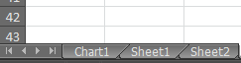

Option Explicit

Sub CheckWorksheetsDiagram()

Debug.Print Worksheets(1).Name

Debug.Print Charts(1).Name

Debug.Print Sheets(1).Name

End Sub

The result:

Sheet1

Chart1

Chart1

[GoalKicker.com – Excel® VBA Notes for Professionals](https://goalkicker.com/) 47

[www.dbooks.org](https://www.dbooks.org/)

# Chapter 14: Methods for Finding the Last

Used Row or Column in a Worksheet

Section 14.1: Find the Last Non-Empty Cell in a Column

In this example, we will look at a method for returning the last non-empty row in a column for a data set.

This method will work regardless of empty regions within the data set.

However caution should be used if merged cells are involved, as the End method will be "stopped" against a merged

region, returning the first cell of the merged region.

In addition non-empty cells in hidden rows will not be taken into account.

Sub FindingLastRow()

Dim wS As Worksheet, LastRow As Long

Set wS = ThisWorkbook.Worksheets("Sheet1")

'Here we look in Column A

LastRow = wS.Cells(wS.Rows.Count, "A").End(xlUp).Row

Debug.Print LastRow

End Sub

To address the limitations indicated above, the line:

LastRow = wS.Cells(wS.Rows.Count, "A").End(xlUp).Row

may be replaced with:

1. for last used row of "Sheet1":

LastRow = wS.UsedRange.Row - 1 + wS.UsedRange.Rows.Count .

2. for last non-empty cell of Column "A" in "Sheet1":

Dim i As Long

For i = LastRow To 1 Step -1

If Not (IsEmpty(Cells(i, 1))) Then Exit For

Next i

LastRow = i

Section 14.2: Find the Last Non-Empty Row in Worksheet

Private Sub Get\_Last\_Used\_Row\_Index()

Dim wS As Worksheet

Set wS = ThisWorkbook.Sheets("Sheet1")

Debug.Print LastRow\_1(wS)

Debug.Print LastRow\_0(wS)

End Sub

You can choose between 2 options, regarding if you want to know if there is no data in the worksheet :

NO : Use LastRow\_1 : You can use it directly within wS.Cells(LastRow\_1(wS),...)

YES : Use LastRow\_0 : You need to test if the result you get from the function is 0 or not before using it

[GoalKicker.com – Excel® VBA Notes for Professionals](https://goalkicker.com/) 48 Public Function LastRow\_1(wS As Worksheet) As Double

With wS

If Application.WorksheetFunction.CountA(.Cells) <> 0 Then

LastRow\_1 = .Cells.Find(What:="\*", \_

After:=.Range("A1"), \_

Lookat:=xlPart, \_

LookIn:=xlFormulas, \_

SearchOrder:=xlByRows, \_

SearchDirection:=xlPrevious, \_

MatchCase:=False).Row

Else

LastRow\_1 = 1

End If

End With

End Function

Public Function LastRow\_0(wS As Worksheet) As Double

On Error Resume Next

LastRow\_0 = wS.Cells.Find(What:="\*", \_

After:=ws.Range("A1"), \_

Lookat:=xlPart, \_

LookIn:=xlFormulas, \_

SearchOrder:=xlByRows, \_

SearchDirection:=xlPrevious, \_

MatchCase:=False).Row End Function

Section 14.3: Find the Last Non-Empty Column in Worksheet

Private Sub Get\_Last\_Used\_Row\_Index()

Dim wS As Worksheet

Set wS = ThisWorkbook.Sheets("Sheet1")

Debug.Print LastCol\_1(wS)

Debug.Print LastCol\_0(wS)

End Sub

You can choose between 2 options, regarding if you want to know if there is no data in the worksheet :

NO : Use LastCol\_1 : You can use it directly within wS.Cells(...,LastCol\_1(wS)) YES : Use LastCol\_0 : You need to test if the result you get from the function is 0 or not before using it

Public Function LastCol\_1(wS As Worksheet) As Double

With wS

If Application.WorksheetFunction.CountA(.Cells) <> 0 Then

LastCol\_1 = .Cells.Find(What:="\*", \_

After:=.Range("A1"), \_

Lookat:=xlPart, \_

LookIn:=xlFormulas, \_

SearchOrder:=xlByColumns, \_

SearchDirection:=xlPrevious, \_

MatchCase:=False).Column

Else

LastCol\_1 = 1

End If

End With

End Function

The Err object's properties are automatically reset to zero upon function exit.

[GoalKicker.com – Excel® VBA Notes for Professionals](https://goalkicker.com/) 49

[www.dbooks.org](https://www.dbooks.org/)

Public Function LastCol\_0(wS As Worksheet) As Double

On Error Resume Next

LastCol\_0 = wS.Cells.Find(What:="\*", \_

After:=ws.Range("A1"), \_

Lookat:=xlPart, \_

LookIn:=xlFormulas, \_

SearchOrder:=xlByColumns, \_

SearchDirection:=xlPrevious, \_

MatchCase:=False).Column End Function

Section 14.4: Find the Last Non-Empty Cell in a Row

In this example, we will look at a method for returning the last non-empty column in a row.

This method will work regardless of empty regions within the data set.

However caution should be used if merged cells are involved, as the End method will be "stopped" against a merged

region, returning the first cell of the merged region.

In addition non-empty cells in hidden columns will not be taken into account.

Sub FindingLastCol()

Dim wS As Worksheet, LastCol As Long

Set wS = ThisWorkbook.Worksheets("Sheet1")

'Here we look in Row 1

LastCol = wS.Cells(1, wS.Columns.Count).End(xlToLeft).Column

Debug.Print LastCol

End Sub

Section 14.5: Get the row of the last cell in a range

'if only one area (not multiple areas):

With Range("A3:D20")

Debug.Print .Cells(.Cells.CountLarge).Row

Debug.Print .Item(.Cells.CountLarge).Row 'using .item is also possible End With 'Debug prints: 20

'with multiple areas (also works if only one area): Dim rngArea As Range, LastRow As Long

With Range("A3:D20, E5:I50, H20:R35")

For Each rngArea In .Areas

If rngArea(rngArea.Cells.CountLarge).Row > LastRow Then

LastRow = rngArea(rngArea.Cells.CountLarge).Row

End If

Next

Debug.Print LastRow 'Debug prints: 50

End With

Section 14.6: Find Last Row Using Named Range

In case you have a Named Range in your Sheet, and you want to dynamically get the last row of that Dynamic

Named Range. Also covers cases where the Named Range doesn't start from the first Row.

Sub FindingLastRow()

[GoalKicker.com – Excel® VBA Notes for Professionals](https://goalkicker.com/) 50 Dim sht As Worksheet

Dim LastRow As Long

Dim FirstRow As Long

Set sht = ThisWorkbook.Worksheets("form")

'Using Named Range "MyNameRange"

FirstRow = sht.Range("MyNameRange").Row

' in case "MyNameRange" doesn't start at Row 1

LastRow = sht.Range("MyNameRange").Rows.count + FirstRow - 1

End Sub

Update:

A potential loophole was pointed out by @Jeeped for a a named range with non-contiguous rows as it generates

unexpected result. To addresses that issue, the code is revised as below. Asumptions: targes sheet = form, named range = MyNameRange

Sub FindingLastRow()

Dim rw As Range, rwMax As Long

For Each rw In Sheets("form").Range("MyNameRange").Rows

If rw.Row > rwMax Then rwMax = rw.Row

Next

MsgBox "Last row of 'MyNameRange' under Sheets 'form': " & rwMax End Sub

Section 14.7: Last cell in Range.CurrentRegion

[Range.CurrentRegion](https://msdn.microsoft.com/en-us/library/office/ff196678.aspx) is a rectangular range area surrounded by empty cells. Blank cells with formulas such as =""

or ' [are not considered blank (even by the ISBLANK Excel function).](https://support.microsoft.com/en-us/kb/823838)

Dim rng As Range, lastCell As Range

Set rng = Range("C3").CurrentRegion ' or Set rng = Sheet1.UsedRange.CurrentRegion Set lastCell = rng(rng.Rows.Count, rng.Columns.Count)

Section 14.8: Find the Last Non-Empty Cell in Worksheet -

Performance (Array)

The first function, using an array, is much faster

If called without the optional parameter, will default to .ThisWorkbook.ActiveSheet If the range is empty will returns Cell( 1, 1 ) as default, instead of Nothing

Speed:

GetMaxCell (Array): Duration: 0.0000790063 seconds GetMaxCell (Find ): Duration: 0.0002903480 seconds

.Measured with [MicroTimer](https://msdn.microsoft.com/en-us/library/office/ff700515(v=office.14).aspx#Anchor_5)

Public Function GetLastCell(Optional ByVal ws As Worksheet = Nothing) As Range

Dim uRng As Range, uArr As Variant, r As Long, c As Long Dim ubR As Long, ubC As Long, lRow As Long

[GoalKicker.com – Excel® VBA Notes for Professionals](https://goalkicker.com/) 51

[www.dbooks.org](https://www.dbooks.org/)

If ws Is Nothing Then Set ws = Application.ThisWorkbook.ActiveSheet Set uRng = ws.UsedRange

uArr = uRng

If IsEmpty(uArr) Then

Set GetLastCell = ws.Cells(1, 1): Exit Function

End If

If Not IsArray(uArr) Then

Set GetLastCell = ws.Cells(uRng.Row, uRng.Column): Exit Function

End If

ubR = UBound(uArr, 1): ubC = UBound(uArr, 2)

For r = ubR To 1 Step -1 '----------------------------------------------- last row

For c = ubC To 1 Step -1

If Not IsError(uArr(r, c)) Then

If Len(Trim$(uArr(r, c))) > 0 Then

lRow = r: Exit For

End If

End If

Next

If lRow > 0 Then Exit For

Next

If lRow = 0 Then lRow = ubR

For c = ubC To 1 Step -1 '----------------------------------------------- last col

For r = lRow To 1 Step -1

If Not IsError(uArr(r, c)) Then

If Len(Trim$(uArr(r, c))) > 0 Then

Set GetLastCell = ws.Cells(lRow + uRng.Row - 1, c + uRng.Column - 1) Exit Function

End If

End If

Next

Next

End Function

'Returns last cell (max row & max col) using Find

Public Function GetMaxCell2(Optional ByRef rng As Range = Nothing) As Range 'Using Find

Const NONEMPTY As String = "\*"

Dim lRow As Range, lCol As Range

If rng Is Nothing Then Set rng = Application.ThisWorkbook.ActiveSheet.UsedRange

If WorksheetFunction.CountA(rng) = 0 Then

Set GetMaxCell2 = rng.Parent.Cells(1, 1)

Else

With rng

Set lRow = .Cells.Find(What:=NONEMPTY, LookIn:=xlFormulas, \_

After:=.Cells(1, 1), \_

SearchDirection:=xlPrevious, \_

SearchOrder:=xlByRows)

If Not lRow Is Nothing Then

Set lCol = .Cells.Find(What:=NONEMPTY, LookIn:=xlFormulas, \_

After:=.Cells(1, 1), \_

SearchDirection:=xlPrevious, \_

SearchOrder:=xlByColumns)

Set GetMaxCell2 = .Parent.Cells(lRow.Row, lCol.Column)

End If

End With

End If

[GoalKicker.com – Excel® VBA Notes for Professionals](https://goalkicker.com/) 52 End Function

.

[MicroTimer:](https://msdn.microsoft.com/en-us/library/office/ff700515(v=office.14).aspx#Anchor_5)

Private Declare PtrSafe Function getFrequency Lib "Kernel32" Alias "QueryPerformanceFrequency" (cyFrequency As Currency) As Long

Private Declare PtrSafe Function getTickCount Lib "Kernel32" Alias "QueryPerformanceCounter" (cyTickCount As Currency) As Long

Function MicroTimer() As Double

Dim cyTicks1 As Currency

Static cyFrequency As Currency

MicroTimer = 0

If cyFrequency = 0 Then getFrequency cyFrequency 'Get frequency

getTickCount cyTicks1 'Get ticks

If cyFrequency Then MicroTimer = cyTicks1 / cyFrequency 'Returns Seconds

End Function

[GoalKicker.com – Excel® VBA Notes for Professionals](https://goalkicker.com/) 53

[www.dbooks.org](https://www.dbooks.org/)

# Chapter 15: Creating a drop-down menu in

the Active Worksheet with a Combo Box

This is a simple example demonstrating how to create a drop down menu in the Active Sheet of your workbook by

inserting a Combo Box Activex object in the sheet. You'll be able to insert one of five Jimi Hendrix songs in any activated cell of the sheet and be able to clear it, accordingly.

Section 15.1: Example 2: Options Not Included

This example is used in specifying options that might not be included in a database of available housing and its attendant amenities.

It builds on the previous example, with some differences:

1. Two procedures are no longer necessary for a single combo box, done by combining the code into a single

procedure.

2. The use of the LinkedCell property to allow for the correct input of the user selection every time

3. The inclusion of a backup feature for ensuring the active cell is in the correct column and an error prevention

code, based on previous experience, where numeric values would formatted as strings when populated to

the active cell.

Private Sub cboNotIncl\_Change()

Dim n As Long

Dim notincl\_array(1 To 9) As String

n = myTarget.Row

If n >= 3 And n < 10000 Then

If myTarget.Address = "$G$" & n Then

'set up the array elements for the not included services

notincl\_array(1) = "Central Air"

notincl\_array(2) = "Hot Water"

notincl\_array(3) = "Heater Rental"

notincl\_array(4) = "Utilities"

notincl\_array(5) = "Parking"

notincl\_array(6) = "Internet"

notincl\_array(7) = "Hydro"

notincl\_array(8) = "Hydro/Hot Water/Heater Rental"

notincl\_array(9) = "Hydro and Utilities"

cboNotIncl.List = notincl\_array()

Else

Exit Sub

End If

With cboNotIncl

'make sure the combo box moves to the target cell

.Left = myTarget.Left

.Top = myTarget.Top

[GoalKicker.com – Excel® VBA Notes for Professionals](https://goalkicker.com/) 54

'adjust the size of the cell to fit the combo box

myTarget.ColumnWidth = .Width \* 0.18

'make it look nice by editing some of the font attributes

.Font.Size = 11

.Font.Bold = False

'populate the cell with the user choice, with a backup guarantee that it's in column G

If myTarget.Address = "$G$" & n Then

.LinkedCell = myTarget.Address

'prevent an error where a numerical value is formatted as text

myTarget.EntireColumn.TextToColumns

End If

End With

End If 'ensure that the active cell is only between rows 3 and 1000

End Sub

The above macro is initiated every time a cell is activated with the SelectionChange event in the worksheet module:

Public myTarget As Range

Private Sub Worksheet\_SelectionChange(ByVal Target As Range)

Set myTarget = Target

'switch for Not Included

If Target.Column = 7 And Target.Cells.Count = 1 Then

Application.Run "Module1.cboNotIncl\_Change"

End If

End Sub

Section 15.2: Jimi Hendrix Menu

In general, the code is placed in the module of a sheet.

This is the Worksheet\_SelectionChange event, which fires each time a different cell is selected in the active sheet.

You can select "Worksheet" from the first drop-down menu above the code window, and "Selection\_Change" from

the drop down menu next to it. In this case, every time you activate a cell, the code is redirected to the Combo Box's code.

Private Sub Worksheet\_SelectionChange(ByVal Target As Range)

ComboBox1\_Change

End Sub

Here, the routine dedicated to the ComboBox is coded to the Change event by default. In it, there is a fixed array, populated with all the options. Not the CLEAR option in the last position, which will be used to clear the contents of

a cell. The array then is handed to to the Combo Box and passed to the routine that does the work.

[GoalKicker.com – Excel® VBA Notes for Professionals](https://goalkicker.com/) 55

[www.dbooks.org](https://www.dbooks.org/)

Private Sub ComboBox1\_Change()

Dim myarray(0 To 5)

myarray(0) = "Hey Joe"

myarray(1) = "Little Wing"

myarray(2) = "Voodoo Child"

myarray(3) = "Purple Haze"

myarray(4) = "The Wind Cries Mary"

myarray(5) = "CLEAR"

With ComboBox1

.List = myarray()

End With

FillACell myarray()

End Sub

The array is passed to the routine that fills the cells with the song name or null value to empty them. First, an integer variable is given the value of the position of the choice that the user makes. Then, the Combo Box is moved

to the TOP LEFT corner of the cell the user activates and its dimensions adjusted to make the experience more fluid.

The active cell is then assigned the value in the position in the integer variable, which tracks the user choice. In case the user selects CLEAR from the options, the cell is emptied.

The entire routine repeats for each selected cell.

Sub FillACell(MyArray As Variant)

Dim n As Integer

n = ComboBox1.ListIndex

ComboBox1.Left = ActiveCell.Left

ComboBox1.Top = ActiveCell.Top

Columns(ActiveCell.Column).ColumnWidth = ComboBox1.Width \* 0.18

ActiveCell = MyArray(n)

If ComboBox1 = "CLEAR" Then

Range(ActiveCell.Address) = ""

End If

End Sub

[GoalKicker.com – Excel® VBA Notes for Professionals](https://goalkicker.com/) 56

# Chapter 16: File System Object

Section 16.1: File, folder, drive exists

File exists:

Sub FileExists()

Dim fso as Scripting.FileSystemObject

Set fso = CreateObject("Scripting.FileSystemObject") If fso.FileExists("D:\test.txt") = True Then

MsgBox "The file is exists."

Else

MsgBox "The file isn't exists."

End If

End Sub

Folder exists:

Sub FolderExists()

Dim fso as Scripting.FileSystemObject

Set fso = CreateObject("Scripting.FileSystemObject") If fso.FolderExists("D:\testFolder") = True Then

MsgBox "The folder is exists."

Else

MsgBox "The folder isn't exists."

End If

End Sub

Drive exists:

Sub DriveExists()

Dim fso as Scripting.FileSystemObject

Set fso = CreateObject("Scripting.FileSystemObject") If fso.DriveExists("D:\") = True Then

MsgBox "The drive is exists."

Else

MsgBox "The drive isn't exists."

End If

End Sub

Section 16.2: Basic file operations

Copy:

Sub CopyFile()

Dim fso as Scripting.FileSystemObject

Set fso = CreateObject("Scripting.FileSystemObject")

fso.CopyFile "c:\Documents and Settings\Makro.txt", "c:\Documents and Settings\Macros\" End Sub

Move:

Sub MoveFile()

Dim fso as Scripting.FileSystemObject

Set fso = CreateObject("Scripting.FileSystemObject")

fso.MoveFile "c:\\*.txt", "c:\Documents and Settings\" End Sub

Delete:

Sub DeleteFile()

Dim fso

Set fso = CreateObject("Scripting.FileSystemObject")

fso.DeleteFile "c:\Documents and Settings\Macros\Makro.txt"

[GoalKicker.com – Excel® VBA Notes for Professionals](https://goalkicker.com/) 57

[www.dbooks.org](https://www.dbooks.org/)

End Sub

Section 16.3: Basic folder operations

Create:

Sub CreateFolder()

Dim fso as Scripting.FileSystemObject

Set fso = CreateObject("Scripting.FileSystemObject")

fso.CreateFolder "c:\Documents and Settings\NewFolder" End Sub

Copy:

Sub CopyFolder()

Dim fso as Scripting.FileSystemObject

Set fso = CreateObject("Scripting.FileSystemObject")

fso.CopyFolder "C:\Documents and Settings\NewFolder", "C:\" End Sub

Move:

Sub MoveFolder()

Dim fso as Scripting.FileSystemObject

Set fso = CreateObject("Scripting.FileSystemObject")

fso.MoveFolder "C:\Documents and Settings\NewFolder", "C:\" End Sub

Delete:

Sub DeleteFolder()

Dim fso as Scripting.FileSystemObject

Set fso = CreateObject("Scripting.FileSystemObject")

fso.DeleteFolder "C:\Documents and Settings\NewFolder" End Sub

Section 16.4: Other operations

Get file name:

Sub GetFileName()

Dim fso as Scripting.FileSystemObject

Set fso = CreateObject("Scripting.FileSystemObject")

MsgBox fso.GetFileName("c:\Documents and Settings\Makro.txt") End Sub

Result: Makro.txt

Get base name:

Sub GetBaseName()

Dim fso as Scripting.FileSystemObject

Set fso = CreateObject("Scripting.FileSystemObject")

MsgBox fso.GetBaseName("c:\Documents and Settings\Makro.txt") End Sub

Result: Makro

Get extension name:

Sub GetExtensionName()

Dim fso as Scripting.FileSystemObject

Set fso = CreateObject("Scripting.FileSystemObject")

MsgBox fso.GetExtensionName("c:\Documents and Settings\Makro.txt")

[GoalKicker.com – Excel® VBA Notes for Professionals](https://goalkicker.com/) 58 End Sub

Result: txt

Get drive name:

Sub GetDriveName()

Dim fso as Scripting.FileSystemObject

Set fso = CreateObject("Scripting.FileSystemObject")

MsgBox fso.GetDriveName("c:\Documents and Settings\Makro.txt") End Sub

Result: c:

[GoalKicker.com – Excel® VBA Notes for Professionals](https://goalkicker.com/) 59

[www.dbooks.org](https://www.dbooks.org/)

# Chapter 17: Pivot Tables

Section 17.1: Adding Fields to a Pivot Table

Two important things to note when adding fields to a Pivot Table are Orientation and Position. Sometimes a developer may assume where a field is placed, so it's always clearer to explicitly define these parameters. These

actions only affect the given Pivot Table, not the Pivot Cache.

Dim thisPivot As PivotTable

Dim ptSheet As Worksheet

Dim ptField As PivotField

Set ptSheet = ThisWorkbook.Sheets("SheetNameWithPivotTable") Set thisPivot = ptSheet.PivotTables(1)

With thisPivot

Set ptField = .PivotFields("Gender")

ptField.Orientation = xlRowField

ptField.Position = 1

Set ptField = .PivotFields("LastName")

ptField.Orientation = xlRowField

ptField.Position = 2

Set ptField = .PivotFields("ShirtSize")

ptField.Orientation = xlColumnField

ptField.Position = 1

Set ptField = .AddDataField(.PivotFields("Cost"), "Sum of Cost", xlSum)

.InGridDropZones = True

.RowAxisLayout xlTabularRow

End With

Section 17.2: Creating a Pivot Table

One of the most powerful capabilities in Excel is the use of Pivot Tables to sort and analyze data. Using VBA to

create and manipulate the Pivots is easier if you understand the relationship of Pivot Tables to Pivot Caches and how to reference and use the different parts of the Tables.

At its most basic, your source data is a Range area of data on a Worksheet. This data area MUST identify the data

columns with a header row as the first row in the range. Once the Pivot Table is created, the user may view and change the source data at any time. However, changes may not be automatically or immediately reflected in the

Pivot Table itself because there is an intermediate data storage structure called the Pivot Cache that is directly connected to the Pivot Table itself.

[GoalKicker.com – Excel® VBA Notes for Professionals](https://goalkicker.com/) 60

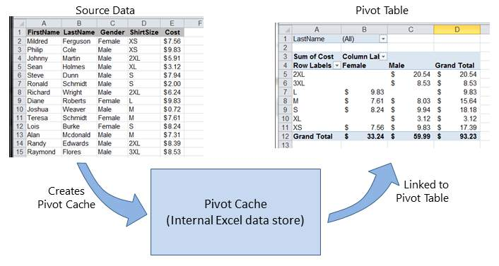

If multiple Pivot Tables are needed, based on the same source data, the Pivot Cache may be re-used as the internal data store for each of the Pivot Tables. This is a good practice because it saves memory and reduces the size of the

Excel file for storage.

[GoalKicker.com – Excel® VBA Notes for Professionals](https://goalkicker.com/) 61

[www.dbooks.org](https://www.dbooks.org/)

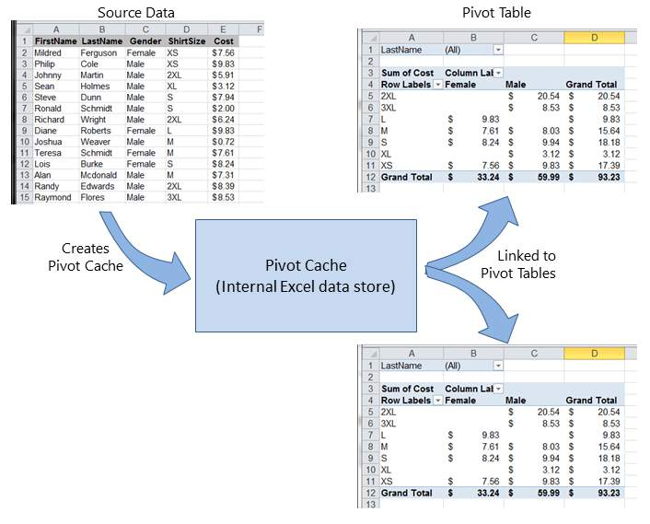

As an example, to create a Pivot Table based on the source data shown in the Figures above:

Sub test()

Dim pt As PivotTable

Set pt = CreatePivotTable(ThisWorkbook.Sheets("Sheet1").Range("A1:E15"))

End Sub

Function CreatePivotTable(ByRef srcData As Range) As PivotTable

'--- creates a Pivot Table from the given source data and ' assumes that the first row contains valid header data ' for the columns

Dim thisPivot As PivotTable

Dim dataSheet As Worksheet

Dim ptSheet As Worksheet

Dim ptCache As PivotCache

'--- the Pivot Cache must be created first...

Set ptCache = ThisWorkbook.PivotCaches.Create(SourceType:=xlDatabase, \_

SourceData:=srcData)

'--- ... then use the Pivot Cache to create the Table Set ptSheet = ThisWorkbook.Sheets.Add

Set thisPivot = ptCache.CreatePivotTable(TableDestination:=ptSheet.Range("A3")) Set CreatePivotTable = thisPivot

End Function

[GoalKicker.com – Excel® VBA Notes for Professionals](https://goalkicker.com/) 62

References [MSDN Pivot Table Object](https://msdn.microsoft.com/en-us/library/office/ff837611.aspx)

Section 17.3: Pivot Table Ranges

These excellent reference sources provide descriptions and illustrations of the various ranges in Pivot Tables.

References

[Referencing Pivot Table Ranges in VBA - from Jon Peltier's Tech Blog](http://peltiertech.com/referencing-pivot-table-ranges-in-vba/)

[Referencing an Excel Pivot Table Range using VBA](http://www.globaliconnect.com/excel/index.php?option=com_content&view=article&id=154:referencing-an-excel-pivot-table-range-using-vba&catid=79&Itemid=475) - from globaliconnect Excel VBA

Section 17.4: Formatting the Pivot Table Data

This example changes/sets several formats in the data range area (DataBodyRange) of the given Pivot Table. All

formattable parameters in a standard Range are available. Formatting the data only affects the Pivot Table itself, not

the Pivot Cache.

NOTE: the property is named TableStyle2 because the TableStyle property is not a member of the PivotTable's object properties.

Dim thisPivot As PivotTable

Dim ptSheet As Worksheet

Dim ptField As PivotField

Set ptSheet = ThisWorkbook.Sheets("SheetNameWithPivotTable") Set thisPivot = ptSheet.PivotTables(1)

With thisPivot

.DataBodyRange.NumberFormat = "\_($\* #,##0.00\_);\_($\* (#,##0.00);\_($\* "-"??\_);\_(@\_)"

.DataBodyRange.HorizontalAlignment = xlRight

.ColumnRange.HorizontalAlignment = xlCenter

.TableStyle2 = "PivotStyleMedium9"

End With

[GoalKicker.com – Excel® VBA Notes for Professionals](https://goalkicker.com/) 63

[www.dbooks.org](https://www.dbooks.org/)

# Chapter 18: Binding

Section 18.1: Early Binding vs Late Binding

Binding is the process of assigning an object to an identifier or variable name. Early binding (also known as static binding) is when an object declared in Excel is of a specific object type, such as a Worksheet or Workbook. Late

binding occurs when general object associations are made, such as the Object and Variant declaration types.

Early binding of references some advantages over late binding.

Early binding is operationally faster than late binding during run-time. Creating the object with late binding in run-time takes time that early binding accomplishes when the VBA project is initially loaded.

Early binding offers additional functionality through the identification of Key/Item pairs by their ordinal position.

Depending on code structure, early binding may offer an additional level of type checking and reduce errors. The VBE's capitalization correction when typing a bound object's properties and methods is active with early

binding but unavailable with late binding.

Note: You must add the appropriate reference to the VBA project through the VBE's Tools → References

command in order to implement early binding.

This library reference is then carried with the project; it does not have to be re-referenced when the VBA project is distributed and run on another computer.

'Looping through a dictionary that was created with late binding¹ Sub iterateDictionaryLate()

Dim k As Variant, dict As Object

Set dict = CreateObject("Scripting.Dictionary")

dict.comparemode = vbTextCompare 'non-case sensitive compare model

'populate the dictionary

dict.Add Key:="Red", Item:="Balloon"

dict.Add Key:="Green", Item:="Balloon"

dict.Add Key:="Blue", Item:="Balloon"

'iterate through the keys

For Each k In dict.Keys

Debug.Print k & " - " & dict.Item(k)

Next k

dict.Remove "blue" 'remove individual key/item pair by key

dict.RemoveAll 'remove all remaining key/item pairs

End Sub

'Looping through a dictionary that was created with early binding¹ Sub iterateDictionaryEarly()

Dim d As Long, k As Variant

Dim dict As New Scripting.Dictionary

dict.CompareMode = vbTextCompare 'non-case sensitive compare model

'populate the dictionary

dict.Add Key:="Red", Item:="Balloon"

dict.Add Key:="Green", Item:="Balloon"

[GoalKicker.com – Excel® VBA Notes for Professionals](https://goalkicker.com/) 64

dict.Add Key:="Blue", Item:="Balloon"

dict.Add Key:="White", Item:="Balloon"

'iterate through the keys

For Each k In dict.Keys

Debug.Print k & " - " & dict.Item(k)

Next k

'iterate through the keys by the count

For d = 0 To dict.Count - 1

Debug.Print dict.Keys(d) & " - " & dict.Items(d)

Next d

'iterate through the keys by the boundaries of the keys collection For d = LBound(dict.Keys) To UBound(dict.Keys) Debug.Print dict.Keys(d) & " - " & dict.Items(d) Next d

dict.Remove "blue" 'remove individual key/item pair by key

dict.Remove dict.Keys(0) 'remove first key/item by index position

dict.Remove dict.Keys(UBound(dict.Keys)) 'remove last key/item by index position

dict.RemoveAll 'remove all remaining key/item pairs

End Sub

However, if you are using early binding and the document is run on a system that lacks one of the libraries you have referenced, you will encounter problems. Not only will the routines that utilize the missing library not function

properly, but the behavior of all code within the document will become erratic. It is likely that none of the document's code will function on that computer.

This is where late binding is advantageous. When using late binding you do not have to add the reference in the Tools>References menu. On machines that have the appropriate library, the code will still work. On machines

without that library, the commands that reference the library will not work, but all the other code in your document will continue to function.

If you are not thoroughly familiar with the library you are referencing, it may be useful to use early binding while writing the code, then switch to late binding before deployment. That way you can take advantage of the VBE's

IntelliSense and Object Browser during development.

[GoalKicker.com – Excel® VBA Notes for Professionals](https://goalkicker.com/) 65

[www.dbooks.org](https://www.dbooks.org/)

# Chapter 19: autofilter ; Uses and best

practices

Autofilter ultimate goal is to provide in the quickest way possible data mining from hundreds or thousands of rows

data in order to get the attention in the items we want to focus on. It can receive parameters such as "text/values/colors" and they can be stacked among columns. You may connect up to 2 criteria per column based in

logical connectors and sets of rules. Remark: Autofilter works by filtering rows, there is no Autofilter to filter columns (at least not natively).

Section 19.1: Smartfilter!

Problem situation

Warehouse administrator has a sheet ("Record") where every logistics movement performed by the facility is stored, he may filter as needed, although, this is very time consuming and he would like to improve the process in

order to calculate inquiries faster, for example: How many "pulp" do we have now (in all racks)? How many pulp do

we have now (in rack #5)? Filters are a great tool but, they are somewhat limited to answer these kind of question in matter of seconds.

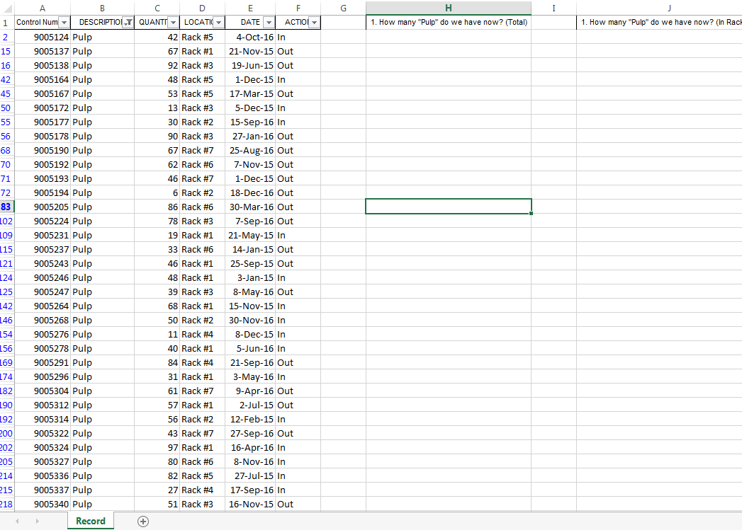

Macro solution:

The coder knows that autofilters are the best, fast and most reliable solution in these kind of scenarios since the

data exists already in the worksheet and the input for them can be obtained easily -in this case, by user input-.

The approach used is to create a sheet called "SmartFilter" where administrator can easily filter multiple data as

needed and calculation will be performed instantly as well. He uses 2 modules and the Worksheet\_Change event for this matter

[GoalKicker.com – Excel® VBA Notes for Professionals](https://goalkicker.com/) 66 Code For SmartFilter Worksheet:

Private Sub Worksheet\_Change(ByVal Target As Range) Dim ItemInRange As Range

Const CellsFilters As String = "C2,E2,G2"

Call ExcelBusy

For Each ItemInRange In Target

If Not Intersect(ItemInRange, Range(CellsFilters)) Is Nothing Then Call Inventory\_Filter Next ItemInRange

Call ExcelNormal

End Sub

Code for module 1, called "General\_Functions"

Sub ExcelNormal()

With Excel.Application

.EnableEvents = True

.Cursor = xlDefault

.ScreenUpdating = True

.DisplayAlerts = True

.StatusBar = False

.CopyObjectsWithCells = True

End With

End Sub

Sub ExcelBusy()

With Excel.Application

.EnableEvents = False

.Cursor = xlWait

.ScreenUpdating = False

.DisplayAlerts = False

.StatusBar = False

.CopyObjectsWithCells = True

End With

End Sub

Sub Select\_Sheet(NameSheet As String, Optional VerifyExistanceOnly As Boolean)

On Error GoTo Err01Select\_Sheet

Sheets(NameSheet).Visible = True

If VerifyExistanceOnly = False Then ' 1. If VerifyExistanceOnly = False

Sheets(NameSheet).Select

Sheets(NameSheet).AutoFilterMode = False

Sheets(NameSheet).Cells.EntireRow.Hidden = False

Sheets(NameSheet).Cells.EntireColumn.Hidden = False

End If ' 1. If VerifyExistanceOnly = False If 1 = 2 Then '99. If error

Err01Select\_Sheet:

MsgBox "Err01Select\_Sheet: Sheet " & NameSheet & " doesn't exist!", vbCritical: Call ExcelNormal: On Error GoTo -1: End

End If '99. If error

End Sub

Function General\_Functions\_Find\_Title(InSheet As String, TitleToFind As String, Optional InRange As Range, Optional IsNeededToExist As Boolean, Optional IsWhole As Boolean) As Range Dim DummyRange As Range

On Error GoTo Err01General\_Functions\_Find\_Title If InRange Is Nothing Then ' 1. If InRange Is Nothing Set DummyRange = IIf(IsWhole = True, Sheets(InSheet).Cells.Find(TitleToFind, LookAt:=xlWhole),

Sheets(InSheet).Cells.Find(TitleToFind, LookAt:=xlPart))

Else ' 1. If InRange Is Nothing

Set DummyRange = IIf(IsWhole = True, Sheets(InSheet).Range(InRange.Address).Find(TitleToFind,

LookAt:=xlWhole), Sheets(InSheet).Range(InRange.Address).Find(TitleToFind, LookAt:=xlPart))

End If ' 1. If InRange Is Nothing

Set General\_Functions\_Find\_Title = DummyRange

[GoalKicker.com – Excel® VBA Notes for Professionals](https://goalkicker.com/) 67

[www.dbooks.org](https://www.dbooks.org/)

If 1 = 2 Or DummyRange Is Nothing Then '99. If error

Err01General\_Functions\_Find\_Title:

If IsNeededToExist = True Then MsgBox "Err01General\_Functions\_Find\_Title: Ttile '" &

TitleToFind & "' was not found in sheet '" & InSheet & "'", vbCritical: Call ExcelNormal: On Error GoTo -1: End

End If '99. If error

End Function

Code for module 2, called "Inventory\_Handling"

Const TitleDesc As String = "DESCRIPTION"

Const TitleLocation As String = "LOCATION"

Const TitleActn As String = "ACTION"

Const TitleQty As String = "QUANTITY"

Const SheetRecords As String = "Record"

Const SheetSmartFilter As String = "SmartFilter" Const RowFilter As Long = 2

Const ColDataToPaste As Long = 2

Const RowDataToPaste As Long = 7

Const RangeInResult As String = "K1"

Const RangeOutResult As String = "K2"

Sub Inventory\_Filter()

Dim ColDesc As Long: ColDesc = General\_Functions\_Find\_Title(SheetSmartFilter, TitleDesc, IsNeededToExist:=True, IsWhole:=True).Column Dim ColLocation As Long: ColLocation = General\_Functions\_Find\_Title(SheetSmartFilter, TitleLocation, IsNeededToExist:=True, IsWhole:=True).Column Dim ColActn As Long: ColActn = General\_Functions\_Find\_Title(SheetSmartFilter, TitleActn, IsNeededToExist:=True, IsWhole:=True).Column Dim ColQty As Long: ColQty = General\_Functions\_Find\_Title(SheetSmartFilter, TitleQty, IsNeededToExist:=True, IsWhole:=True).Column Dim CounterQty As Long

Dim TotalQty As Long

Dim TotalIn As Long

Dim TotalOut As Long

Dim RangeFiltered As Range

Call Select\_Sheet(SheetSmartFilter)

If Cells(Rows.Count, ColDataToPaste).End(xlUp).Row > RowDataToPaste - 1 Then

Rows(RowDataToPaste & ":" & Cells(Rows.Count, "B").End(xlUp).Row).Delete

Sheets(SheetRecords).AutoFilterMode = False

If Cells(RowFilter, ColDesc).Value <> "" Or Cells(RowFilter, ColLocation).Value <> "" Or

Cells(RowFilter, ColActn).Value <> "" Then ' 1. If Cells(RowFilter, ColDesc).Value <> "" Or Cells(RowFilter, ColLocation).Value <> "" Or Cells(RowFilter, ColActn).Value <> ""

With Sheets(SheetRecords).UsedRange

If Sheets(SheetSmartFilter).Cells(RowFilter, ColDesc).Value <> "" Then .AutoFilter

Field:=General\_Functions\_Find\_Title(SheetRecords, TitleDesc, IsNeededToExist:=True, IsWhole:=True).Column, Criteria1:=Sheets(SheetSmartFilter).Cells(RowFilter, ColDesc).Value

If Sheets(SheetSmartFilter).Cells(RowFilter, ColLocation).Value <> "" Then .AutoFilter

Field:=General\_Functions\_Find\_Title(SheetRecords, TitleLocation, IsNeededToExist:=True, IsWhole:=True).Column, Criteria1:=Sheets(SheetSmartFilter).Cells(RowFilter, ColLocation).Value

If Sheets(SheetSmartFilter).Cells(RowFilter, ColActn).Value <> "" Then .AutoFilter

Field:=General\_Functions\_Find\_Title(SheetRecords, TitleActn, IsNeededToExist:=True, IsWhole:=True).Column, Criteria1:=Sheets(SheetSmartFilter).Cells(RowFilter, ColActn).Value

'If we don't use a filter we would need to use a cycle For/to or For/Each Cell in range 'to determine whether or not the row meets the criteria that we are looking and then 'save it on an array, collection, dictionary, etc

'IG: For CounterRow = 2 To TotalRows

'If Sheets(SheetSmartFilter).Cells(RowFilter, ColDesc).Value <> "" and

Sheets(SheetRecords).cells(CounterRow,ColDescInRecords).Value= Sheets(SheetSmartFilter).Cells(RowFilter, ColDesc).Value then

'Redim Preserve MyUnecessaryArray(UnecessaryNumber) ''Save to array:

(UnecessaryNumber)=MyUnecessaryArray. Or in a dictionary, etc. At the end, we would transpose this

[GoalKicker.com – Excel® VBA Notes for Professionals](https://goalkicker.com/) 68 values into the sheet, at the end

'both are the same, but, just try to see the time invested on each logic. If .Cells(1, 1).End(xlDown).Value <> "" Then Set RangeFiltered = .Rows("2:" &

Sheets(SheetRecords).Cells(Rows.Count, "A").End(xlUp).Row).SpecialCells(xlCellTypeVisible)

'If it is not <>"" means that there was not filtered data! If RangeFiltered Is Nothing Then MsgBox "Err01Inventory\_Filter: No data was found with the

given criteria!", vbCritical: Call ExcelNormal: End

RangeFiltered.Copy Destination:=Cells(RowDataToPaste, ColDataToPaste)

TotalQty = Cells(Rows.Count, ColQty).End(xlUp).Row

For CounterQty = RowDataToPaste + 1 To TotalQty If Cells(CounterQty, ColActn).Value = "In" Then ' 2. If Cells(CounterQty, ColActn).Value = "In"

TotalIn = Cells(CounterQty, ColQty).Value + TotalIn

ElseIf Cells(CounterQty, ColActn).Value = "Out" Then ' 2. If Cells(CounterQty, ColActn).Value =

"In"

TotalOut = Cells(CounterQty, ColQty).Value + TotalOut

End If ' 2. If Cells(CounterQty, ColActn).Value = "In" Next CounterQty

Range(RangeInResult).Value = TotalIn

Range(RangeOutResult).Value = -(TotalOut)

End With

End If ' 1. If Cells(RowFilter, ColDesc).Value <> "" Or Cells(RowFilter, ColLocation).Value <>

"" Or Cells(RowFilter, ColActn).Value <> ""

End Sub

Testing and results:

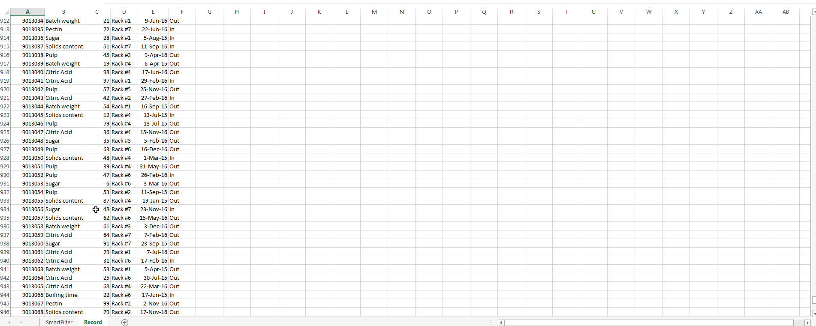

As we saw in the previous image, this task has been achieved easily. By using autofilters a solution was provided

that just takes seconds to compute, is easy to explain to the user -since s/he is familiar with this command- and

took a few lines to the coder.

[GoalKicker.com – Excel® VBA Notes for Professionals](https://goalkicker.com/) 69

[www.dbooks.org](https://www.dbooks.org/)

# Chapter 20: Application object

Section 20.1: Simple Application Object example: Display Excel

and VBE Version

Sub DisplayExcelVersions()

MsgBox "The version of Excel is " & Application.Version

MsgBox "The version of the VBE is " & Application.VBE.Version

End Sub

The use of the Application.Version property is useful for ensuring code only operates on a compatible version of Excel.

Section 20.2: Simple Application Object example: Minimize the

Excel window

This code uses the top level Application object to minimize the main Excel window.

Sub MinimizeExcel()

Application.WindowState = xlMinimized

End Sub

[GoalKicker.com – Excel® VBA Notes for Professionals](https://goalkicker.com/) 70

# Chapter 21: Charts and Charting

Section 21.1: Creating a Chart with Ranges and a Fixed Name

Charts can be created by working directly with the Series object that defines the chart data. In order to get to the Series without an exisitng chart, you create a ChartObject on a given Worksheet and then get the Chart object

from it. The upside of working with the Series object is that you can set the Values and XValues by referring to Range objects. These data properties will properly define the Series with references to those ranges. The downside

to this approach is that the same conversion is not handled when setting the Name; it is a fixed value. It will not adjust with the underlying data in the original Range. Checking the SERIES formula and it is obvious that the name is

fixed. This must be handled by creating the SERIES formula directly.

Code used to create chart

Note that this code contains extra variable declarations for the Chart and Worksheet. These can be omitted if

they're not used. They can be useful however if you are modifying the style or any other chart properties.

Sub CreateChartWithRangesAndFixedName()

Dim xData As Range

Dim yData As Range

Dim serName As Range

'set the ranges to get the data and y value label

Set xData = Range("B3:B12")

Set yData = Range("C3:C12")

Set serName = Range("C2")

'get reference to ActiveSheet

Dim sht As Worksheet

Set sht = ActiveSheet

'create a new ChartObject at position (48, 195) with width 400 and height 300 Dim chtObj As ChartObject

Set chtObj = sht.ChartObjects.Add(48, 195, 400, 300)

'get reference to chart object

Dim cht As Chart

Set cht = chtObj.Chart

'create the new series

Dim ser As Series

Set ser = cht.SeriesCollection.NewSeries

ser.Values = yData

ser.XValues = xData

ser.Name = serName

ser.ChartType = xlXYScatterLines

End Sub

Original data/ranges and resulting Chart after code runs

Note that the SERIES formula includes a "B" for the series name instead of a reference to the Range that created it.

[GoalKicker.com – Excel® VBA Notes for Professionals](https://goalkicker.com/) 71

[www.dbooks.org](https://www.dbooks.org/)

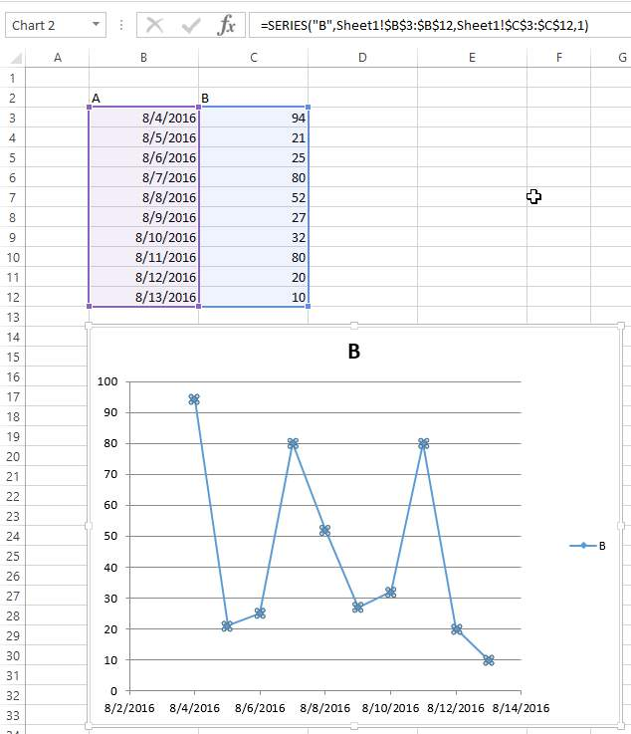

Section 21.2: Creating an empty Chart

The starting point for the vast majority of charting code is to create an empty Chart. Note that this Chart is subject to the default chart template that is active and may not actually be empty (if the template has been modified).

The key to the ChartObject is determining its location. The syntax for the call is ChartObjects.Add(Left, Top, Width, Height). Once the ChartObject is created, you can use its Chart object to actually modify the chart. The

ChartObject behaves more like a Shape to position the chart on the sheet.

Code to create an empty chart

Sub CreateEmptyChart()

'get reference to ActiveSheet

[GoalKicker.com – Excel® VBA Notes for Professionals](https://goalkicker.com/) 72

Dim sht As Worksheet

Set sht = ActiveSheet

'create a new ChartObject at position (0, 0) with width 400 and height 300 Dim chtObj As ChartObject

Set chtObj = sht.ChartObjects.Add(0, 0, 400, 300)

'get refernce to chart object

Dim cht As Chart

Set cht = chtObj.Chart

'additional code to modify the empty chart

'...

End Sub

Resulting Chart

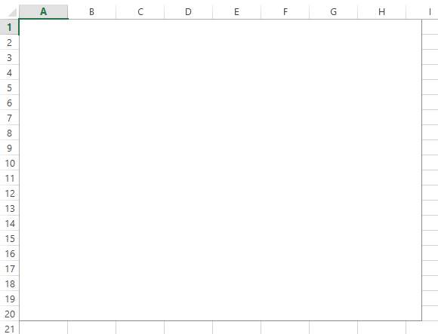

Section 21.3: Create a Chart by Modifying the SERIES formula

For complete control over a new Chart and Series object (especially for a dynamic Series name), you must resort to modifying the SERIES formula directly. The process to set up the Range objects is straightforward and the main

hurdle is simply the string building for the SERIES formula.

The SERIES formula takes the following syntax:

=SERIES(Name,XValues,Values,Order)

These contents can be supplied as references or as array values for the data items. Order represents the series

position within the chart. Note that the references to the data will not work unless they are fully qualified with the sheet name. For an example of a working formula, click any existing series and check the formula bar.

[GoalKicker.com – Excel® VBA Notes for Professionals](https://goalkicker.com/) 73

[www.dbooks.org](https://www.dbooks.org/)

Code to create a chart and set up data using the SERIES formula

Note that the string building to create the SERIES formula uses .Address(,,,True). This ensures that the external

Range reference is used so that a fully qualified address with the sheet name is included. You will get an error if

the sheet name is excluded.

Sub CreateChartUsingSeriesFormula()

Dim xData As Range

Dim yData As Range

Dim serName As Range

'set the ranges to get the data and y value label

Set xData = Range("B3:B12")

Set yData = Range("C3:C12")

Set serName = Range("C2")

'get reference to ActiveSheet

Dim sht As Worksheet

Set sht = ActiveSheet

'create a new ChartObject at position (48, 195) with width 400 and height 300 Dim chtObj As ChartObject

Set chtObj = sht.ChartObjects.Add(48, 195, 400, 300)

'get refernce to chart object

Dim cht As Chart

Set cht = chtObj.Chart

'create the new series

Dim ser As Series

Set ser = cht.SeriesCollection.NewSeries

'set the SERIES formula

'=SERIES(name, xData, yData, plotOrder)

Dim formulaValue As String

formulaValue = "=SERIES(" & \_

serName.Address(, , , True) & "," & \_

xData.Address(, , , True) & "," & \_

yData.Address(, , , True) & ",1)"

ser.Formula = formulaValue

ser.ChartType = xlXYScatterLines

End Sub

Original data and resulting chart

Note that for this chart, the series name is properly set with a range to the desired cell. This means that updates will propagate to the Chart.

[GoalKicker.com – Excel® VBA Notes for Professionals](https://goalkicker.com/) 74

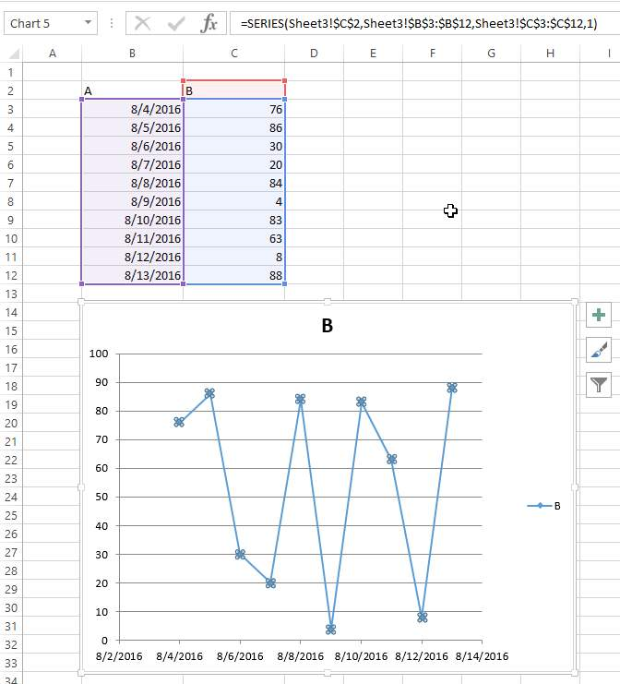

Section 21.4: Arranging Charts into a Grid

A common chore with charts in Excel is standardizing the size and layout of multiple charts on a single sheet. If

done manually, you can hold down ALT while resizing or moving the chart to "stick" to cell boundaries. This works for a couple charts, but a VBA approach is much simpler.

Code to create a grid

This code will create a grid of charts starting at a given (Top, Left) position, with a defined number of columns, and a defined common chart size. The charts will be placed in the order they were created and wrap around the edge to

form a new row.

Sub CreateGridOfCharts()

[GoalKicker.com – Excel® VBA Notes for Professionals](https://goalkicker.com/) 75

[www.dbooks.org](https://www.dbooks.org/)

Dim int\_cols As Integer

int\_cols = 3

Dim cht\_width As Double

cht\_width = 250

Dim cht\_height As Double

cht\_height = 200

Dim offset\_vertical As Double

offset\_vertical = 195

Dim offset\_horz As Double

offset\_horz = 40

Dim sht As Worksheet

Set sht = ActiveSheet

Dim count As Integer

count = 0

'iterate through ChartObjects on current sheet

Dim cht\_obj As ChartObject

For Each cht\_obj In sht.ChartObjects

'use integer division and Mod to get position in grid

cht\_obj.Top = (count \ int\_cols) \* cht\_height + offset\_vertical

cht\_obj.Left = (count Mod int\_cols) \* cht\_width + offset\_horz

cht\_obj.Width = cht\_width

cht\_obj.Height = cht\_height

count = count + 1

Next cht\_obj

End Sub

Result with several charts

These pictures show the original random layout of charts and the resulting grid from running the code above.

Before

[GoalKicker.com – Excel® VBA Notes for Professionals](https://goalkicker.com/) 76

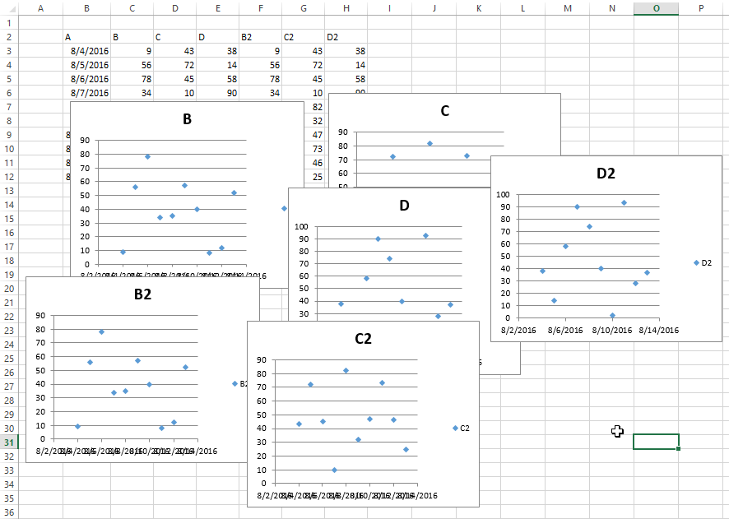

After

[GoalKicker.com – Excel® VBA Notes for Professionals](https://goalkicker.com/) 77

[www.dbooks.org](https://www.dbooks.org/)

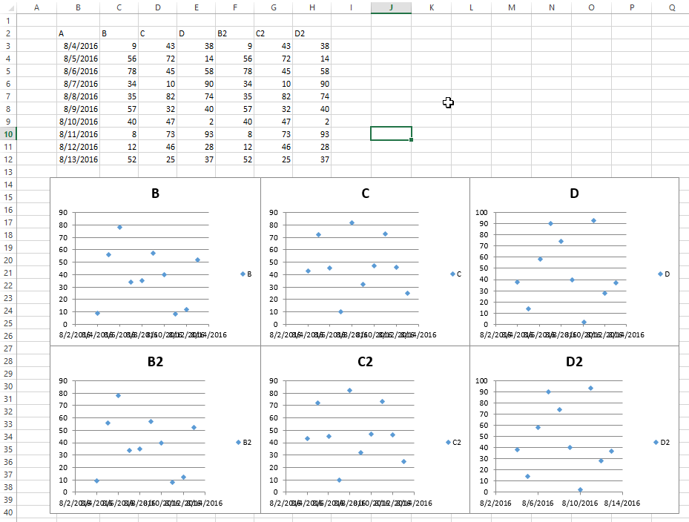

[GoalKicker.com – Excel® VBA Notes for Professionals](https://goalkicker.com/) 78

# Chapter 22: CustomDocumentProperties in

practice

Using CustomDocumentProperties (CDPs) is a good method to store user defined values in a relatively safe way

within the same work book, but avoiding to show related cell values simply in an unprotected work sheet \*).

Note: CDPs represent a separate collection comparable to BuiltInDocumentProperties, but allow to create user

defined property names of your own instead of a fixed collection.

\*) Alternatively, you could enter values also in a hidden or "very hidden" workbook.

Section 22.1: Organizing new invoice numbers

Incrementing an invoice number and saving its value is a frequent task. Using CustomDocumentProperties (CDPs) is

a good method to store such numbers in a relatively safe way within the same work book, but avoiding to show

related cell values simply in an unprotected work sheet.

Additional hint:

Alternatively, you could enter values also in a hidden worksheet or even a so called "very hidden" worksheet (see

Using xlVeryHidden Sheets. Of course, it's possible to save data also to external files (e.g. ini file, csv or any other type) or the registry.

Example content:

The example below shows

a function NextInvoiceNo that sets and returns the next invoice number, a procedure DeleteInvoiceNo, that deletes the invoice CDP completely, as well as

a procedure showAllCDPs listing the complete CDPs collection with all names. Not using VBA, you can also list

them via the workbook's information: Info | Properties [DropDown:] | Advanced Properties | Custom

You can get and set the next invoice number (last no plus one) simply by calling the above mentioned function, returning a string value in order to facilitate adding prefixes. "InvoiceNo" is implicitly used as CDP name in all

procedures.

Dim sNumber As String

sNumber = NextInvoiceNo ()

Example code:

Option Explicit

Sub Test()

Dim sNumber As String

sNumber = NextInvoiceNo()

MsgBox "New Invoice No: " & sNumber, vbInformation, "New Invoice Number" End Sub

Function NextInvoiceNo() As String

' Purpose: a) Set Custom Document Property (CDP) "InvoiceNo" if not yet existing ' b) Increment CDP value and return new value as string ' Declarations

Dim prop As Object

[GoalKicker.com – Excel® VBA Notes for Professionals](https://goalkicker.com/) 79

[www.dbooks.org](https://www.dbooks.org/)

Dim ret As String

Dim wb As Workbook

' Set workbook and CDPs

Set wb = ThisWorkbook

Set prop = wb.CustomDocumentProperties

' -------------------------------------------------------' Generate new CDP "InvoiceNo" if not yet existing

' -------------------------------------------------------

If Not CDPExists("InvoiceNo") Then

' set temporary starting value "0"

prop.Add "InvoiceNo", False, msoPropertyTypeString, "0"

End If

' --------------------------------------------------------' Increment invoice no and return function value as string ' --------------------------------------------------------

ret = Format(Val(prop("InvoiceNo")) + 1, "0")

' a) Set CDP "InvoiceNo" = ret

prop("InvoiceNo").value = ret

' b) Return function value

NextInvoiceNo = ret

End Function

Private Function CDPExists(sCDPName As String) As Boolean ' Purpose: return True if custom document property (CDP) exists ' Method: loop thru CustomDocumentProperties collection and check if name parameter exists ' Site: cf.

http://stackoverflow.com/questions/23917977/alternatives-to-public-variables-in-vba/23918236#23918236 ' vgl.:

https://answers.microsoft.com/en-us/msoffice/forum/msoffice\_word-mso\_other/using-customdocumentproper ties-with-vba/91ef15eb-b089-4c9b-a8a7-1685d073fb9f

' Declarations

Dim cdp As Variant ' element of CustomDocumentProperties Collection Dim boo As Boolean ' boolean value showing element exists For Each cdp In ThisWorkbook.CustomDocumentProperties

If LCase(cdp.Name) = LCase(sCDPName) Then

boo = True ' heureka

Exit For ' exit loop

End If

Next

CDPExists = boo ' return value to function End Function

Sub DeleteInvoiceNo()

' Declarations

Dim wb As Workbook

Dim prop As Object

' Set workbook and CDPs

Set wb = ThisWorkbook

Set prop = wb.CustomDocumentProperties

' ----------------------

' Delete CDP "InvoiceNo"

' ----------------------

If CDPExists("InvoiceNo") Then

prop("InvoiceNo").Delete

End If

End Sub

[GoalKicker.com – Excel® VBA Notes for Professionals](https://goalkicker.com/) 80 Sub showAllCDPs()

' Purpose: Show all CustomDocumentProperties (CDP) and values (if set) ' Declarations

Dim wb As Workbook

Dim cdp As Object

Dim i As Integer

Dim maxi As Integer

Dim s As String

' Set workbook and CDPs

Set wb = ThisWorkbook

Set cdp = wb.CustomDocumentProperties

' Loop thru CDP getting name and value

maxi = cdp.Count

For i = 1 To maxi

On Error Resume Next ' necessary in case of unset value

s = s & Chr(i + 96) & ") " & \_

cdp(i).Name & "=" & cdp(i).value & vbCr

Next i

' Show result string

Debug.Print s

End Sub

[GoalKicker.com – Excel® VBA Notes for Professionals](https://goalkicker.com/) 81

[www.dbooks.org](https://www.dbooks.org/)

# Chapter 23: PowerPoint Integration

Through VBA

Section 23.1: The Basics: Launching PowerPoint from VBA

While there are many parameters that can be changed and variations that can be added depending on the desired functionality, this example lays out the basic framework for launching PowerPoint.

Note: This code requires that the PowerPoint reference has been added to the active VBA Project. See

the References Documentation entry to learn how to enable the reference.

First, define variables for the Application, Presentation, and Slide Objects. While this can be done with late binding, it is always best to use early binding when applicable.

Dim PPApp As PowerPoint.Application

Dim PPPres As PowerPoint.Presentation

Dim PPSlide As PowerPoint.Slide

Next, open or create a new instance of the PowerPoint application. Here, the On Error Resume Next call is used to

avoid an error being thrown by GetObject if PowerPoint has not yet been opened. See the Error Handling example of the Best Practices Topic for a more detailed explanation.

'Open PPT if not running, otherwise select active instance On Error Resume Next

Set PPApp = GetObject(, "PowerPoint.Application") On Error GoTo ErrHandler

If PPApp Is Nothing Then

'Open PowerPoint

Set PPApp = CreateObject("PowerPoint.Application")

PPApp.Visible = True

End If

Once the application has been launched, a new presentation and subsequently contained slide is generated for

use.

'Generate new Presentation and slide for graphic creation Set PPPres = PPApp.Presentations.Add

Set PPSlide = PPPres.Slides.Add(1, ppLayoutBlank)

'Here, the slide type is set to the 4:3 shape with slide numbers enabled and the window 'maximized on the screen. These properties can, of course, be altered as needed

PPApp.ActiveWindow.ViewType = ppViewSlide

PPPres.PageSetup.SlideOrientation = msoOrientationHorizontal PPPres.PageSetup.SlideSize = ppSlideSizeOnScreen

PPPres.SlideMaster.HeadersFooters.SlideNumber.Visible = msoTrue PPApp.ActiveWindow.WindowState = ppWindowMaximized

Upon completion of this code, a new PowerPoint window with a blank slide will be open. By using the object variables, shapes, text, graphics, and excel ranges can be added as desired

[GoalKicker.com – Excel® VBA Notes for Professionals](https://goalkicker.com/) 82

# Chapter 24: How to record a Macro

Section 24.1: How to record a Macro

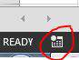

The easiest way to record a macro is the button in the lower left corner of Excel looks like this:

When you click on this you will get a pop-up asking you to name the Macro and decide if you want to have a

shortcut key. Also, asks where to store the macro and for a description. You can choose any name you want, no spaces are allowed.

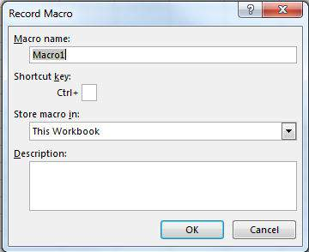

If you want to have a shortcut assigned to your macro for quick use choose a letter that you will remember so that

you can quickly and easily use the macro over and over.

You can store the macro in "This Workbook," "New Workbook," or "Personal Macro Workbook." If you want the

macro you're about to record to be available only in the current workbook, choose "This Workbook." If you want it saved to a brand new workbook, choose "New Workbook." And if you want the macro to be available to any

workbook you open, choose "Personal Macro Workbook."

After you have filled out this pop-up click on "Ok".

Then perform whatever actions you want to repeat with the macro. When finished click the same button to stop

recording. It now looks like this:

index-87_3.jpg

Now you can go to the Developer Tab and open Visual Basic. (or use Alt + F11)

[GoalKicker.com – Excel® VBA Notes for Professionals](https://goalkicker.com/) 83

[www.dbooks.org](https://www.dbooks.org/)

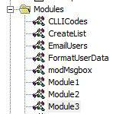

You will now have a new Module under the Modules folder.

The newest module will contain the macro you just recorded. Double-click on it to bring it up.

I did a simple copy and paste:

Sub Macro1()

'

' Macro1 Macro

'

'

Selection.Copy

Range("A12").Select

ActiveSheet.Paste

End Sub

If you don't want it to always paste into "A12" you can use Relative References by checking the "Use Relative

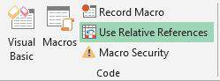

References" box on the Developer Tab:

Following the same steps as before will now turn the Macro into this:

Sub Macro2()

'

' Macro2 Macro

'

'

Selection.Copy

ActiveCell.Offset(11, 0).Range("A1").Select

ActiveSheet.Paste

End Sub

Still copying the value from "A1" into a cell 11 rows down, but now you can perform the same macro with any starting cell and the value from that cell will be copied to the cell 11 rows down.

[GoalKicker.com – Excel® VBA Notes for Professionals](https://goalkicker.com/) 84

# Chapter 25: SQL in Excel VBA - Best

Practices

Section 25.1: How to use ADODB.Connection in VBA?

Requirements:

Add following references to the project:

Microsoft ActiveX Data Objects 2.8 Library

Microsoft ActiveX Data Objects Recordset 2.8 Library

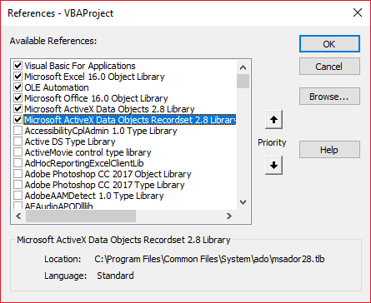

Declare variables

Private mDataBase As New ADODB.Connection

Private mRS As New ADODB.Recordset

Private mCmd As New ADODB.Command

Create connection

a. with Windows Authentication

Private Sub OpenConnection(pServer As String, pCatalog As String)

Call mDataBase.Open("Provider=SQLOLEDB;Initial Catalog=" & pCatalog & ";Data Source=" & pServer

& ";Integrated Security=SSPI")

mCmd.ActiveConnection = mDataBase

End Sub

b. with SQL Server Authentication

Private Sub OpenConnection2(pServer As String, pCatalog As String, pUser As String, pPsw As String)

Call mDataBase.Open("Provider=SQLOLEDB;Initial Catalog=" & pCatalog & ";Data Source=" & pServer

& ";Integrated Security=SSPI;User ID=" & pUser & ";Password=" & pPsw)

mCmd.ActiveConnection = mDataBase

End Sub

Execute sql command

[GoalKicker.com – Excel® VBA Notes for Professionals](https://goalkicker.com/) 85

[www.dbooks.org](https://www.dbooks.org/)

Private Sub ExecuteCmd(sql As String)

mCmd.CommandText = sql

Set mRS = mCmd.Execute

End Sub

Read data from record set

Private Sub ReadRS()

Do While Not (mRS.EOF)

Debug.Print "ShipperID: " & mRS.Fields("ShipperID").Value & " CompanyName: " & mRS.Fields("CompanyName").Value & " Phone: " & mRS.Fields("Phone").Value

Call mRS.MoveNext

Loop

End Sub

Close connection

Private Sub CloseConnection()

Call mDataBase.Close

Set mRS = Nothing

Set mCmd = Nothing

Set mDataBase = Nothing

End Sub

How to use it?

Public Sub Program()

Call OpenConnection("ServerName", "NORTHWND") Call ExecuteCmd("INSERT INTO [NORTHWND].[dbo].[Shippers]([CompanyName],[Phone]) Values ('speedy

shipping','(503) 555-1234')")

Call ExecuteCmd("SELECT \* FROM [NORTHWND].[dbo].[Shippers]") Call ReadRS

Call CloseConnection

End Sub

Result

ShipperID: 1 CompanyName: Speedy Express Phone: (503) 555-9831

ShipperID: 2 CompanyName: United Package Phone: (503) 555-3199

ShipperID: 3 CompanyName: Federal Shipping Phone: (503) 555-9931

ShipperID: 4 CompanyName: speedy shipping Phone: (503) 555-1234

[GoalKicker.com – Excel® VBA Notes for Professionals](https://goalkicker.com/) 86

# Chapter 26: Excel-VBA Optimization

Excel-VBA Optimization refers also to coding better error handling by documentation and additional details. This is

shown here.

Section 26.1: Optimizing Error Search by Extended Debugging

Using Line Numbers ... and documenting them in case of error ("The importance of seeing Erl")

Detecting which line raises an error is a substantial part of any debugging and narrows the search for the cause. To

document identified error lines with a short description completes a successful error tracking, at best together with the names of module and procedure. The example below saves these data to a log file.

Back ground

The error object returns error number (Err.Number) and error description (Err.Description), but doesn't explicitly

respond to the question where to locate the error. The Erl function, however, does, but on condition that you add

\*line numbers ) to the code (BTW one of several other concessions to former Basic times).

If there are no error lines at all, then the Erl function returns 0, if numbering is incomplete you'll get the procedure's last preceding line number.

Option Explicit

Public Sub MyProc1()

Dim i As Integer

Dim j As Integer

On Error GoTo LogErr

10 j = 1 / 0 ' raises an error

okay:

Debug.Print "i=" & i

Exit Sub

LogErr:

MsgBox LogErrors("MyModule", "MyProc1", Err), vbExclamation, "Error " & Err.Number Stop

Resume Next

End Sub

Public Function LogErrors( \_

ByVal sModule As String, \_

ByVal sProc As String, \_

Err As ErrObject) As String

' Purpose: write error number, description and Erl to log file and return error text

Dim sLogFile As String: sLogFile = ThisWorkbook.Path & Application.PathSeparator &

"LogErrors.txt"

Dim sLogTxt As String

Dim lFile As Long

' Create error text

sLogTxt = sModule & "|" & sProc & "|Erl " & Erl & "|Err " & Err.Number & "|" & Err.Description

On Error Resume Next

lFile = FreeFile

Open sLogFile For Append As lFile

Print #lFile, Format$(Now(), "yy.mm.dd hh:mm:ss "); sLogTxt

[GoalKicker.com – Excel® VBA Notes for Professionals](https://goalkicker.com/) 87

[www.dbooks.org](https://www.dbooks.org/)

Print #lFile,

Close lFile

' Return error text

LogErrors = sLogTxt

End Function

'Additional Code to show log file

Sub ShowLogFile()

Dim sLogFile As String: sLogFile = ThisWorkbook.Path & Application.PathSeparator & "LogErrors.txt"

On Error GoTo LogErr

Shell "notepad.exe " & sLogFile, vbNormalFocus

okay:

On Error Resume Next

Exit Sub

LogErr:

MsgBox LogErrors("MyModule", "ShowLogFile", Err), vbExclamation, "Error No " & Err.Number Resume okay

End Sub

Section 26.2: Disabling Worksheet Updating

Disabling calculation of the worksheet can decrease running time of the macro significantly. Moreover, disabling

events, screen updating and page breaks would be beneficial. Following Sub can be used in any macro for this purpose.

Sub OptimizeVBA(isOn As Boolean)

Application.Calculation = IIf(isOn, xlCalculationManual, xlCalculationAutomatic)

Application.EnableEvents = Not(isOn)

Application.ScreenUpdating = Not(isOn)

ActiveSheet.DisplayPageBreaks = Not(isOn) End Sub

For optimization follow the below pseudo-code:

Sub MyCode()

OptimizeVBA True

'Your code goes here

OptimizeVBA False

End Sub

Section 26.3: Row Deletion - Performance

Deleting rows is slow, specially when looping through cells and deleting rows, one by one

A different approach is using an AutoFilter to hide the rows to be deleted

Copy the visible range and Paste it into a new WorkSheet

Remove the initial sheet entirely

[GoalKicker.com – Excel® VBA Notes for Professionals](https://goalkicker.com/) 88

With this method, the more rows to delete, the faster it will be

Example:

Option Explicit

'Deleted rows: 775,153, Total Rows: 1,000,009, Duration: 1.87 sec

Public Sub DeleteRows()

Dim oldWs As Worksheet, newWs As Worksheet, wsName As String, ur As Range

Set oldWs = ThisWorkbook.ActiveSheet

wsName = oldWs.Name

Set ur = oldWs.Range("F2", oldWs.Cells(oldWs.Rows.Count, "F").End(xlUp))

Application.ScreenUpdating = False

Set newWs = Sheets.Add(After:=oldWs) 'Create a new WorkSheet

With ur 'Copy visible range after Autofilter (modify Criteria1 and 2 accordingly) .AutoFilter Field:=1, Criteria1:="<>0", Operator:=xlAnd, Criteria2:="<>" oldWs.UsedRange.Copy

End With

'Paste all visible data into the new WorkSheet (values and formats) With newWs.Range(oldWs.UsedRange.Cells(1).Address) .PasteSpecial xlPasteColumnWidths

.PasteSpecial xlPasteAll

newWs.Cells(1, 1).Select: newWs.Cells(1, 1).Copy

End With

With Application

.CutCopyMode = False

.DisplayAlerts = False

oldWs.Delete

.DisplayAlerts = True

.ScreenUpdating = True

End With

newWs.Name = wsName

End Sub

Section 26.4: Disabling All Excel Functionality Before

executing large macros

The procedures bellow will temporarily disable all Excel features at WorkBook and WorkSheet level

FastWB() is a toggle that accepts On or Off flags

FastWS() accepts an Optional WorkSheet object, or none

If the ws parameter is missing it will turn all features on and off for all WorkSheets in the collection

A custom type can be used to capture all settings before turning them off

At the end of the process, the initial settings can be restored

Public Sub FastWB(Optional ByVal opt As Boolean = True)

With Application

.Calculation = IIf(opt, xlCalculationManual, xlCalculationAutomatic)

If .DisplayAlerts <> Not opt Then .DisplayAlerts = Not opt

[GoalKicker.com – Excel® VBA Notes for Professionals](https://goalkicker.com/) 89

[www.dbooks.org](https://www.dbooks.org/)

If .DisplayStatusBar <> Not opt Then .DisplayStatusBar = Not opt If .EnableAnimations <> Not opt Then .EnableAnimations = Not opt If .EnableEvents <> Not opt Then .EnableEvents = Not opt If .ScreenUpdating <> Not opt Then .ScreenUpdating = Not opt

End With

FastWS , opt

End Sub

Public Sub FastWS(Optional ByVal ws As Worksheet, Optional ByVal opt As Boolean = True)

If ws Is Nothing Then

For Each ws In Application.ThisWorkbook.Sheets

OptimiseWS ws, opt

Next

Else

OptimiseWS ws, opt

End If

End Sub

Private Sub OptimiseWS(ByVal ws As Worksheet, ByVal opt As Boolean)

With ws

.DisplayPageBreaks = False

.EnableCalculation = Not opt

.EnableFormatConditionsCalculation = Not opt

.EnablePivotTable = Not opt

End With

End Sub

Restore all Excel settings to default

Public Sub XlResetSettings() 'default Excel settings

With Application

.Calculation = xlCalculationAutomatic

.DisplayAlerts = True

.DisplayStatusBar = True

.EnableAnimations = False

.EnableEvents = True

.ScreenUpdating = True

Dim sh As Worksheet

For Each sh In Application.ThisWorkbook.Sheets

With sh

.DisplayPageBreaks = False

.EnableCalculation = True

.EnableFormatConditionsCalculation = True

.EnablePivotTable = True

End With

Next

End With

End Sub

Section 26.5: Checking time of execution

Different procedures can give out the same result, but they would use different processing time. In order to check out which one is faster, a code like this can be used:

time1 = Timer

For Each iCell In MyRange

iCell = "text"

Next iCell

[GoalKicker.com – Excel® VBA Notes for Professionals](https://goalkicker.com/) 90 time2 = Timer

For i = 1 To 30

MyRange.Cells(i) = "text"

Next i

time3 = Timer

debug.print "Proc1 time: " & cStr(time2-time1) debug.print "Proc2 time: " & cStr(time3-time2)

[MicroTimer:](https://msdn.microsoft.com/en-us/library/office/ff700515(v=office.14).aspx#Anchor_5)

Private Declare PtrSafe Function getFrequency Lib "Kernel32" Alias "QueryPerformanceFrequency" (cyFrequency As Currency) As Long

Private Declare PtrSafe Function getTickCount Lib "Kernel32" Alias "QueryPerformanceCounter" (cyTickCount As Currency) As Long

Function MicroTimer() As Double

Dim cyTicks1 As Currency

Static cyFrequency As Currency

MicroTimer = 0

If cyFrequency = 0 Then getFrequency cyFrequency 'Get frequency

getTickCount cyTicks1 'Get ticks

If cyFrequency Then MicroTimer = cyTicks1 / cyFrequency 'Returns Seconds

End Function

Section 26.6: Using With blocks

Using with blocks can accelerate the process of running a macro. Instead writing a range, chart name, worksheet,

etc. you can use with-blocks like below;

With ActiveChart

.Parent.Width = 400

.Parent.Height = 145

.Parent.Top = 77.5 + 165 \* step - replacer \* 15

.Parent.Left = 5

End With

Which is faster than this:

ActiveChart.Parent.Width = 400

ActiveChart.Parent.Height = 145

ActiveChart.Parent.Top = 77.5 + 165 \* step - replacer \* 15 ActiveChart.Parent.Left = 5

Notes:

Once a With block is entered, object can't be changed. As a result, you can't use a single With statement to

affect a number of different objects

Don't jump into or out of With blocks. If statements in a With block are executed, but either the With or

End With statement is not executed, a temporary variable containing a reference to the object remains

in memory until you exit the procedure

Don't Loop inside With statements, especially if the cached object is used as an iterator

You can nest With statements by placing one With block within another. However, because members of outer

[GoalKicker.com – Excel® VBA Notes for Professionals](https://goalkicker.com/) 91

[www.dbooks.org](https://www.dbooks.org/)

With blocks are masked within the inner With blocks, you must provide a fully qualified object reference in an inner With block to any member of an object in an outer With block.

Nesting Example:

This example uses the With statement to execute a series of statements on a single object.

The object and its properties are generic names used for illustration purposes only.

With MyObject

.Height = 100 'Same as MyObject.Height = 100.

.Caption = "Hello World" 'Same as MyObject.Caption = "Hello World".

With .Font

.Color = Red 'Same as MyObject.Font.Color = Red.

.Bold = True 'Same as MyObject.Font.Bold = True.

MyObject.Height = 200 'Inner-most With refers to MyObject.Font (must be qualified

End With

End With

[More Info on MSDN](https://msdn.microsoft.com/en-us/vba/language-reference-vba/articles/with-statement)

[GoalKicker.com – Excel® VBA Notes for Professionals](https://goalkicker.com/) 92

# Chapter 27: VBA Security

Section 27.1: Password Protect your VBA

Sometimes you have sensitive information in your VBA (e.g., passwords) that you don't want users to have access to. You can achieve basic security on this information by password-protecting your VBA project.

Follow these steps:

1. Open your Visual Basic Editor (Alt + F11)

2. Navigate to Tools -> VBAProject Properties...

3. Navigate to the Protection tab

4. Check off the "Lock project for viewing" checkbox 5. Enter your desired password in the Password and Confirm Password textboxes

Now when someone wants to access your code within an Office application, they will first need to enter the password. Be aware, however, that even a strong VBA project password is trivial to break.

[GoalKicker.com – Excel® VBA Notes for Professionals](https://goalkicker.com/) 93

[www.dbooks.org](https://www.dbooks.org/)

# Chapter 28: Debugging and

Troubleshooting

Section 28.1: Immediate Window

If you would like to test a line of macro code without needing to run an entire sub, you can type commands directly into the Immediate Window and hit ENTER to run the line.

For testing the output of a line, you can precede it with a question mark ? to print directly to the Immediate Window. Alternatively, you can also use the print command to have the output printed.

While in the Visual Basic Editor, press CTRL + G to open the Immediate Window. To rename your currently selected sheet to "ExampleSheet", type the following in the Immediate Window and hit ENTER

ActiveSheet.Name = "ExampleSheet"

To print the currently selected sheet's name directly in the Immediate Window

? ActiveSheet.Name

ExampleSheet

This method can be very useful to test the functionality of built in or user defined functions before implementing

them in code. The example below demonstrates how the Immediate Window can be used to test the output of a function or series of functions to confirm an expected.

'In this example, the Immediate Window was used to confirm that a series of Left and Right 'string methods would return the desired string

'expected output: "value"

print Left(Right("1111value1111",9),5) ' <---- written code here, ENTER pressed value ' <---- output

The Immediate Window can also be used to set or reset Application, Workbook, or other needed properties. This can be useful if you have Application.EnableEvents = False in a subroutine that unexpectedly throws an error,

causing it to close without resetting the value to True (which can cause frustrating and unexpected functionality. In that case, the commands can be typed directly into the Immediate Window and run:

? Application.EnableEvents ' <---- Testing the current state of "EnableEvents" False ' <---- Output Application.EnableEvents = True ' <---- Resetting the property value to True ? Application.EnableEvents ' <---- Testing the current state of "EnableEvents" True ' <---- Output

For more advanced debugging techniques, a colon : can be used as a line separator. This can be used for multi-line

expressions such as looping in the example below.

x = Split("a,b,c",","): For i = LBound(x,1) to UBound(x,1): Debug.Print x(i): Next i '<----Input this and press enter

a '<----Output

b '<----Output

c '<----Output

[GoalKicker.com – Excel® VBA Notes for Professionals](https://goalkicker.com/) 94 Section 28.2: Use Timer to Find Bottlenecks in Performance

The first step in optimizing for speed is finding the slowest sections of code. The Timer VBA function returns the

number of seconds elapsed since midnight with a precision of 1/256th of a second (3.90625 milliseconds) on

Windows based PCs. The VBA functions Now and Time are only accurate to a second.

Dim start As Double ' Timer returns Single, but converting to Double to avoid start = Timer ' scientific notation like 3.90625E-03 in the Immediate window ' ... part of the code

Debug.Print Timer - start; "seconds in part 1"

start = Timer

' ... another part of the code

Debug.Print Timer - start; "seconds in part 2"

Section 28.3: Debugger Locals Window

The Locals window provides easy access to the current value of variables and objects within the scope of the function or subroutine you are running. It is an essential tool to debugging your code and stepping through

changes in order to find issues. It also allows you to explore properties you might not have known existed.

Take the following example,

Option Explicit

Sub LocalsWindowExample()

Dim findMeInLocals As Integer

Dim findMEInLocals2 As Range

findMeInLocals = 1

Set findMEInLocals2 = ActiveWorkbook.Sheets(1).Range("A1")

End Sub

In the VBA Editor, click View --> Locals Window

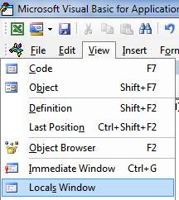

Then by stepping through the code using F8 after clicking inside the subroutine, we have stopped before getting to assigning findMeinLocals. Below you can see the value is 0 --- and this is what would be used if you never assigned

it a value. The range object is 'Nothing'.

[GoalKicker.com – Excel® VBA Notes for Professionals](https://goalkicker.com/) 95

[www.dbooks.org](https://www.dbooks.org/)

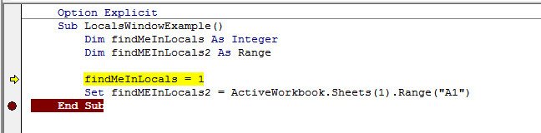

If we stop right before the subroutine ends, we can see the final values of the variables.

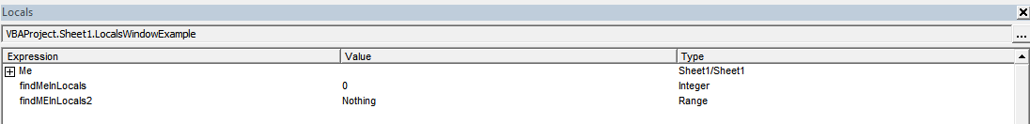

We can see findMeInLocals with a value of 1 and type of Integer, and FindMeInLocals2 with a type of Range/Range.

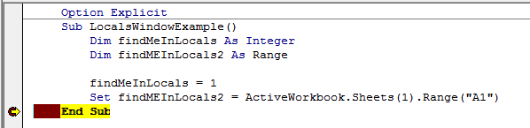

If we click the + sign we can expand the object and see its properties, such as count or column.

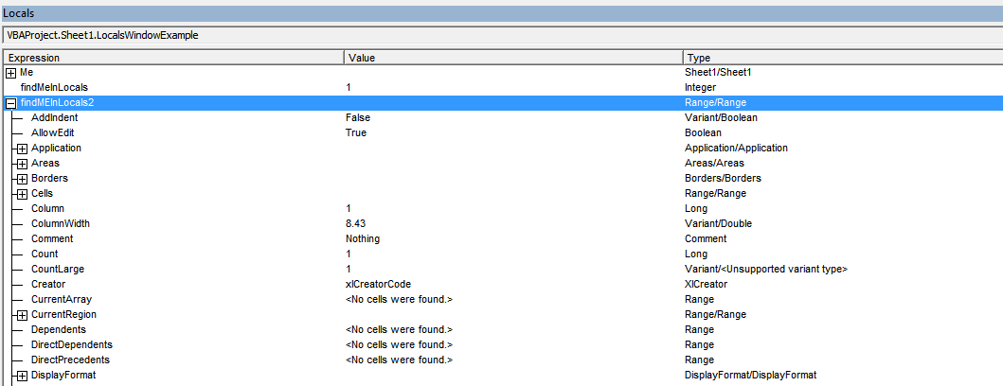

Section 28.4: Debug.Print

To print a listing of the Error Code descriptions to the Immediate Window, pass it to the Debug.Print function:

Private Sub ListErrCodes()

Debug.Print "List Error Code Descriptions"

For i = 0 To 65535

e = Error(i)

If e <> "Application-defined or object-defined error" Then Debug.Print i & ": " & e

Next i

End Sub

[GoalKicker.com – Excel® VBA Notes for Professionals](https://goalkicker.com/) 96 You can show the Immediate Window by:

Selecting View | Immediate Window from the menu bar

Using the keyboard shortcut Ctrl-G

Section 28.5: Stop

The Stop command will pause the execution when called. From there, the process can be resumed or be executed step by step.

Sub Test()

Dim TestVar as String

TestVar = "Hello World"

Stop 'Sub will be executed to this point and then wait for the user

MsgBox TestVar

End Sub

Section 28.6: Adding a Breakpoint to your code

You can easily add a breakpoint to your code by clicking on the grey column to the left of the line of your VBA code

where you want execution to stop. A red dot appears in the column and the breakpoint code is also highlighted in

red.

You can add multiple breakpoints throughout your code and resuming execution is achieved by pressing the "play" icon in your menu bar. Not all code can be a breakpoint as variable definition lines, the first or last line of a

procedure and comment lines cannot be selected as a breakpoint.

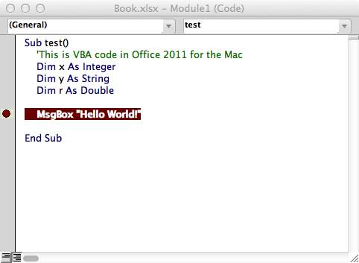

[GoalKicker.com – Excel® VBA Notes for Professionals](https://goalkicker.com/) 97

[www.dbooks.org](https://www.dbooks.org/)

# Chapter 29: VBA Best Practices

Section 29.1: ALWAYS Use "Option Explicit"

In the VBA Editor window, from the Tools menu select "Options":

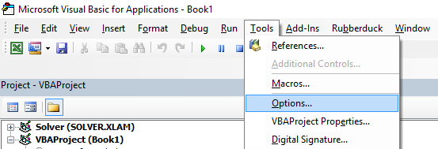

Then in the "Editor" tab, make sure that "Require Variable Declaration" is checked:

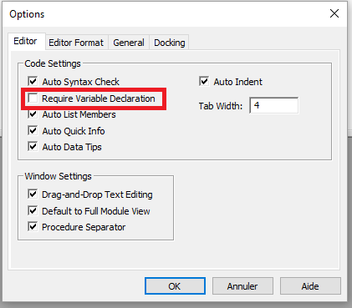

Selecting this option will automatically put Option Explicit at the top of every VBA module.

Small note: This is true for the modules, class modules, etc. that haven't been opened so far. So if you

already had a look at e.g. the code of Sheet1 before activating the option "Require Variable Declaration",

Option Explicit will not be added!

Option Explicit requires that every variable has to be defined before use, e.g. with a Dim statement. Without Option Explicit enabled, any unrecognized word will be assumed by the VBA compiler to be a new variable of the

Variant type, causing extremely difficult-to-spot bugs related to typographical errors. With Option Explicit

enabled, any unrecognized words will cause a compile error to be thrown, indicating the offending line.

Example :

[GoalKicker.com – Excel® VBA Notes for Professionals](https://goalkicker.com/) 98 If you run the following code :

Sub Test()

my\_variable = 12

MsgBox "My Variable is : " & myvariable

End Sub

You will get the following message :

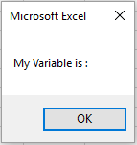

You have made an error by writing myvariable instead of my\_variable, then the message box displays an empty

variable. If you use Option Explicit , this error is not possible because you will get a compile error message indicating the problem.

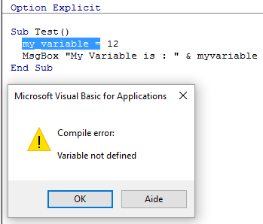

Now if you add the correct declaration :

Sub Test()

Dim my\_variable As Integer

my\_variable = 12

MsgBox "My Variable is : " & myvariable

End Sub

You will obtain an error message indicating precisely the error with myvariable :

[GoalKicker.com – Excel® VBA Notes for Professionals](https://goalkicker.com/) 99

[www.dbooks.org](https://www.dbooks.org/)

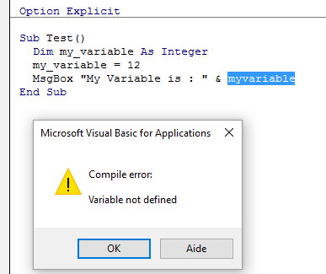

Note on Option Explicit and Arrays ([Declaring a Dynamic Array):](https://msdn.microsoft.com/en-us/vba/language-reference-vba/articles/declaring-arrays#declaring-a-dynamic-array)

You can use the ReDim statement to declare an array implicitly within a procedure.

Be careful not to misspell the name of the array when you use the ReDim statement

Even if the Option Explicit statement is included in the module, a new array will be created

Dim arr() as Long

ReDim ar() 'creates new array "ar" - "ReDim ar()" acts like "Dim ar()"

Section 29.2: Work with Arrays, Not With Ranges

[Office Blog - Excel VBA Performance Coding Best Practices](https://blogs.office.com/2009/03/12/excel-vba-performance-coding-best-practices/)

Often, best performance is achieved by avoiding the use of Range as much as possible. In this example we read in an entire Range object into an array, square each number in the array, and then return the array back to the Range.

This accesses Range only twice, whereas a loop would access it 20 times for the read/writes.

Option Explicit

Sub WorkWithArrayExample()

Dim DataRange As Variant

Dim Irow As Long

Dim Icol As Integer

DataRange = ActiveSheet.Range("A1:A10").Value ' read all the values at once from the Excel grid, put into an array

For Irow = LBound(DataRange,1) To UBound(DataRange, 1) ' Get the number of rows.

For Icol = LBound(DataRange,2) To UBound(DataRange, 2) ' Get the number of columns. DataRange(Irow, Icol) = DataRange(Irow, Icol) \* DataRange(Irow, Icol) ' cell.value^2 Next Icol

Next Irow

[GoalKicker.com – Excel® VBA Notes for Professionals](https://goalkicker.com/) 100 ActiveSheet.Range("A1:A10").Value = DataRange ' writes all the results back to the range at once

End Sub

More tips and info with timed examples can be found in [Charles Williams's Writing efficient VBA UDFs (Part 1)](https://fastexcel.wordpress.com/2011/05/25/writing-efficient-vba-udfs-part-1/) and

[other articles in the series](https://fastexcel.wordpress.com/page/2/?s=writing+efficient).

Section 29.3: Switch o properties during macro execution

It is best practice in any programming language to avoid premature optimization. However, if testing reveals that

your code is running too slowly, you may gain some speed by switching off some of the application’s properties

while it runs. Add this code to a standard module:

Public Sub SpeedUp( \_

SpeedUpOn As Boolean, \_

Optional xlCalc as XlCalculation = xlCalculationAutomatic \_

)

With Application

If SpeedUpOn Then

.ScreenUpdating = False

.Calculation = xlCalculationManual

.EnableEvents = False

.DisplayStatusBar = False 'in case you are not showing any messages

ActiveSheet.DisplayPageBreaks = False 'note this is a sheet-level setting

Else

.ScreenUpdating = True

.Calculation = xlCalc

.EnableEvents = True

.DisplayStatusBar = True

ActiveSheet.DisplayPageBreaks = True

End If

End With

End Sub

[More info on Office Blog - Excel VBA Performance Coding Best Practices](https://blogs.office.com/2009/03/12/excel-vba-performance-coding-best-practices/)

And just call it at beginning and end of macros:

Public Sub SomeMacro

'store the initial "calculation" state

Dim xlCalc As XlCalculation

xlCalc = Application.Calculation

SpeedUp True

'code here ...

'by giving the second argument the initial "calculation" state is restored 'otherwise it is set to 'xlCalculationAutomatic'

SpeedUp False, xlCalc

End Sub

While these can largely be considered "enhancements" for regular Public Sub procedures, disabling event

handling with Application.EnableEvents = False should be considered mandatory for Worksheet\_Change and

Workbook\_SheetChange private event macros that change values on one or more worksheets. Failure to disable event triggers will cause the event macro to recursively run on top of itself when a value changes and can lead to a

"frozen" workbook. Remember to turn events back on before leaving the event macro, possibly through a "safe exit" error handler.

[GoalKicker.com – Excel® VBA Notes for Professionals](https://goalkicker.com/) 101

[www.dbooks.org](https://www.dbooks.org/)

Option Explicit

Private Sub Worksheet\_Change(ByVal Target As Range)

If Not Intersect(Target, Range("A:A")) Is Nothing Then

On Error GoTo bm\_Safe\_Exit

Application.EnableEvents = False

'code that may change a value on the worksheet goes here

End If

bm\_Safe\_Exit:

Application.EnableEvents = True

End Sub

One caveat: While disabling these settings will improve run time, they may make debugging your application much

more difficult. If your code is not functioning correctly, comment out the SpeedUp True call until you figure out the

problem.

This is particularly important if you are writing to cells in a worksheet and then reading back in calculated results

from worksheet functions since the xlCalculationManual prevents the workbook from calculating. To get around this without disabling SpeedUp, you may want to include Application.Calculate to run a calculation at specific

points.

NOTE: Since these are properties of the Application itself, you need to ensure that they are enabled again before

your macro exits. This makes it particularly important to use error handlers and to avoid multiple exit points (i.e. End or Unload Me).

With error handling:

Public Sub SomeMacro()

'store the initial "calculation" state

Dim xlCalc As XlCalculation

xlCalc = Application.Calculation

On Error GoTo Handler

SpeedUp True

'code here ...

i = 1 / 0

CleanExit:

SpeedUp False, xlCalc

Exit Sub

Handler:

'handle error

Resume CleanExit

End Sub

Section 29.4: Use VB constants when available

If MsgBox("Click OK") = vbOK Then

can be used in place of

If MsgBox("Click OK") = 1 Then

in order to improve readability.

[GoalKicker.com – Excel® VBA Notes for Professionals](https://goalkicker.com/) 102 Use Object Browser to find available VB constants. View → Object Browser or F2 from VB Editor.

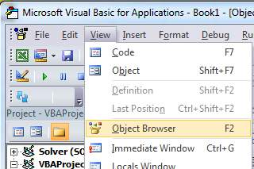

Enter class to search

index-107_2.png

View members available

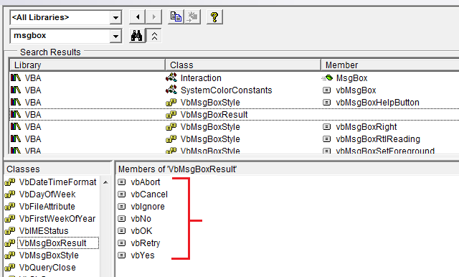

Section 29.5: Avoid using SELECT or ACTIVATE

It is very rare that you'll ever want to use SELECT or Activate in your code, but some Excel methods do require a

worksheet or workbook to be activated before they'll work as expected.

If you're just starting to learn VBA, you'll often be suggested to record your actions using the macro recorder, then

go look at the code. For example, I recorded actions taken to enter a value in cell D3 on Sheet2, and the macro code looks like this:

Option Explicit

Sub Macro1()

[GoalKicker.com – Excel® VBA Notes for Professionals](https://goalkicker.com/) 103

[www.dbooks.org](https://www.dbooks.org/)

'

' Macro1 Macro

'

'

Sheets("Sheet2").Select

Range("D3").Select

ActiveCell.FormulaR1C1 = "3.1415" '(see \*\*note below)

Range("D4").Select

End Sub

Remember though, the macro recorder creates a line of code for EACH of your (user) actions. This includes clicking

on the worksheet tab to select Sheet2 (Sheets("Sheet2").Select), clicking on cell D3 before entering the value (Range("D3").Select), and using the Enter key (which is effectively "selecting" the cell below the currently selected

cell: Range("D4").Select).

There are multiple issues with using .Select here:

The worksheet is not always specified. This happens if you don't switch worksheets while recording, and

means that the code will yield different results for different active worksheets.

.Select() is slow. Even if Application.ScreenUpdating is set to False, this is an unneccessary operation to

be processed.

.Select() is unruly. If Application.ScreenUpdating is left to True, Excel will actually select the cells, the

worksheet, the form... whatever it is you're working with. This is stressful to the eyes and really unpleasant to

watch.

.Select() will trigger listeners. This is a bit advanced already, but unless worked around, functions like

Worksheet\_SelectionChange() will be triggered.

When you're coding in VBA, all of the "typing" actions (i.e. SELECT statements) are no longer necessary. Your code

may be reduced to a single statement to put the value in the cell:

'--- GOOD

ActiveWorkbook.Sheets("Sheet2").Range("D3").Value = 3.1415

'--- BETTER

Dim myWB As Workbook

Dim myWS As Worksheet

Dim myCell As Range

Set myWB = ThisWorkbook '\*\*\* see NOTE2 Set myWS = myWB.Sheets("Sheet2")

Set myCell = myWS.Range("D3")

myCell.Value = 3.1415

(The BETTER example above shows using intermediate variables to separate different parts of the cell reference.

The GOOD example will always work just fine, but can be very cumbersome in much longer code modules and more difficult to debug if one of the references is mistyped.)

\*\*NOTE: the macro recorder makes many assumptions about the type of data you're entering, in this case entering a string value as a formula to create the value. Your code doesn't have to do this and can simply assign a numerical

value directly to the cell as shown above.

\*\*NOTE2: the recommended practice is to set your local workbook variable to ThisWorkbook instead of

ActiveWorkbook (unless you explicitly need it). The reason is your macro will generally need/use resources in whatever workbook the VBA code originates and will NOT look outside of that workbook -- again, unless you

[GoalKicker.com – Excel® VBA Notes for Professionals](https://goalkicker.com/) 104 explicitly direct your code to work with another workbook. When you have multiple workbooks open in Excel, the ActiveWorkbook is the one with the focus which may be different from the workbook being viewed in your VBA Editor.

So you think you're executing in a one workbook when you're really referencing another. ThisWorkbook refers to

the workbook containing the code being executed.

Section 29.6: Always define and set references to all

Workbooks and Sheets

When working with multiple open Workbooks, each of which may have multiple Sheets, it’s safest to define and set reference to all Workbooks and Sheets.

Don't rely on ActiveWorkbook or ActiveSheet as they might be changed by the user.

The following code example demonstrates how to copy a range from “Raw\_Data” sheet in the “Data.xlsx” workbook

to “Refined\_Data” sheet in the “Results.xlsx” workbook.

The procedure also demonstrates how to copy and paste without using the SELECT method.

Option Explicit

Sub CopyRanges\_BetweenShts()

Dim wbSrc As Workbook Dim wbDest As Workbook Dim shtCopy As Worksheet Dim shtPaste As Worksheet

' set reference to all workbooks by name, don't rely on ActiveWorkbook Set wbSrc = Workbooks("Data.xlsx")

Set wbDest = Workbooks("Results.xlsx")

' set reference to all sheets by name, don't rely on ActiveSheet Set shtCopy = wbSrc.Sheet1 '// "Raw\_Data" sheet Set shtPaste = wbDest.Sheet2 '// "Refined\_Data") sheet

' copy range from "Data" workbook to "Results" workbook without using Select

shtCopy.Range("A1:C10").Copy \_

Destination:=shtPaste.Range("A1")

End Sub

Section 29.7: Use descriptive variable naming

Descriptive names and structure in your code help make comments unnecessary

Dim ductWidth As Double

Dim ductHeight As Double

Dim ductArea As Double

ductArea = ductWidth \* ductHeight

is better than

Dim a, w, h

a = w \* h

[GoalKicker.com – Excel® VBA Notes for Professionals](https://goalkicker.com/) 105

[www.dbooks.org](https://www.dbooks.org/) This is especially helpful when you are copying data from one place to another, whether it's a cell, range, worksheet, or workbook. Help yourself by using names such as these:

Dim myWB As Workbook

Dim srcWS As Worksheet

Dim destWS As Worksheet

Dim srcData As Range

Dim destData As Range

Set myWB = ActiveWorkbook

Set srcWS = myWB.Sheets("Sheet1")

Set destWS = myWB.Sheets("Sheet2")

Set srcData = srcWS.Range("A1:A10")

Set destData = destWS.Range("B11:B20")

destData = srcData

If you declare multiple variables in one line make sure to specify a type for every variable like:

Dim ductWidth As Double, ductHeight As Double, ductArea As Double

The following will only declare the last variable and the first ones will remain Variant:

Dim ductWidth, ductHeight, ductArea As Double

Section 29.8: Document Your Work

It's good practice to document your work for later use, especially if you are coding for a dynamic workload. Good

comments should explain why the code is doing something, not what the code is doing.

Function Bonus(EmployeeTitle as String) as Double

If EmployeeTitle = "Sales" Then

Bonus = 0 'Sales representatives receive commission instead of a bonus

Else

Bonus = .10

End If

End Function

If your code is so obscure that it requires comments to explain what it is doing, consider rewriting it to be more

clear instead of explaining it through comments. For example, instead of:

Sub CopySalesNumbers

Dim IncludeWeekends as Boolean

'Boolean values can be evaluated as an integer, -1 for True, 0 for False. 'This is used here to adjust the range from 5 to 7 rows if including weekends.

Range("A1:A" & 5 - (IncludeWeekends \* 2)).Copy

Range("B1").PasteSpecial

End Sub

Clarify the code to be easier to follow, such as:

Sub CopySalesNumbers

Dim IncludeWeekends as Boolean

Dim DaysinWeek as Integer

If IncludeWeekends Then

DaysinWeek = 7

[GoalKicker.com – Excel® VBA Notes for Professionals](https://goalkicker.com/) 106

Else

DaysinWeek = 5

End If

Range("A1:A" & DaysinWeek).Copy

Range("B1").PasteSpecial

End Sub

Section 29.9: Error Handling

Good error handling prevents end users from seeing VBA runtime errors and helps the developer easily diagnose

and correct errors.

There are three main methods of Error Handling in VBA, two of which should be avoided for distributed programs

unless specifically required in the code.

On Error GoTo 0 'Avoid using

or

On Error Resume Next 'Avoid using

Prefer using:

On Error GoTo 'Prefer using

On Error GoTo 0

If no error handling is set in your code, On Error GoTo 0 is the default error handler. In this mode, any runtime

errors will launch the typical VBA error message, allowing you to either end the code or enter debug mode, identifying the source. While writing code, this method is the simplest and most useful, but it should always be

avoided for code that is distributed to end users, as this method is very unsightly and difficult for end users to understand.

On Error Resume Next

On Error Resume Next will cause VBA to ignore any errors that are thrown at runtime for all lines following the

error call until the error handler has been changed. In very specific instances, this line can be useful, but it should be avoided outside of these cases. For example, when launching a separate program from an Excel Macro, the On

Error Resume Next call can be useful if you are unsure whether or not the program is already open:

'In this example, we open an instance of Powerpoint using the On Error Resume Next call Dim PPApp As PowerPoint.Application

Dim PPPres As PowerPoint.Presentation

Dim PPSlide As PowerPoint.Slide

'Open PPT if not running, otherwise select active instance On Error Resume Next

Set PPApp = GetObject(, "PowerPoint.Application") On Error GoTo ErrHandler

If PPApp Is Nothing Then

'Open PowerPoint

Set PPApp = CreateObject("PowerPoint.Application")

PPApp.Visible = True

End If

[GoalKicker.com – Excel® VBA Notes for Professionals](https://goalkicker.com/) 107

[www.dbooks.org](https://www.dbooks.org/) Had we not used the On Error Resume Next call and the Powerpoint application was not already open, the GetObject method would throw an error. Thus, On Error Resume Next was necessary to avoid creating two

instances of the application.

Note: It is also a best practice to immediately reset the error handler as soon as you no longer need the On Error

Resume Next call

On Error GoTo <line>

This method of error handling is recommended for all code that is distributed to other users. This allows the programmer to control exactly how VBA handles an error by sending the code to the specified line. The tag can be

filled with any string (including numeric strings), and will send the code to the corresponding string that is followed by a colon. Multiple error handling blocks can be used by making different calls of On Error GoTo . The

subroutine below demonstrates the syntax of an On Error GoTo call.

Note: It is essential that the Exit Sub line is placed above the first error handler and before every subsequent error

handler to prevent the code from naturally progressing into the block without an error being called. Thus, it is best practice for function and readability to place error handlers at the end of a code block.

Sub YourMethodName()

On Error GoTo errorHandler

' Insert code here

On Error GoTo secondErrorHandler

Exit Sub 'The exit sub line is essential, as the code will otherwise

'continue running into the error handling block, likely causing an error

errorHandler:

MsgBox "Error " & Err.Number & ": " & Err.Description & " in " & \_

VBE.ActiveCodePane.CodeModule, vbOKOnly, "Error"

Exit Sub

secondErrorHandler:

If Err.Number = 424 Then 'Object not found error (purely for illustration) Application.ScreenUpdating = True

Application.EnableEvents = True

Exit Sub

Else

MsgBox "Error " & Err.Number & ": " & Err.Desctription

Application.ScreenUpdating = True

Application.EnableEvents = True

Exit Sub

End If

Exit Sub

End Sub

If you exit your method with your error handling code, ensure that you clean up:

Undo anything that is partially completed

Close files

Reset screen updating

Reset calculation mode

Reset events

Reset mouse pointer

Call unload method on instances of objects, that persist after the End Sub

[GoalKicker.com – Excel® VBA Notes for Professionals](https://goalkicker.com/) 108

Reset status bar

Section 29.10: Never Assume The Worksheet

Even when all your work is directed at a single worksheet, it's still a very good practice to explicitly specify the

worksheet in your code. This habit makes it much easier to expand your code later, or to lift parts (or all) of a Sub or Function to be re-used someplace else. Many developers establish a habit of (re)using the same local variable

name for a worksheet in their code, making re-use of that code even more straightforward.

As an example, the following code is ambiguous -- but works! -- as long the developer doesn't activate or change to

a different worksheet:

Option Explicit

Sub ShowTheTime()

'--- displays the current time and date in cell A1 on the worksheet

Cells(1, 1).Value = Now() ' don't refer to Cells without a sheet reference! End Sub

If Sheet1 is active, then cell A1 on Sheet1 will be filled with the current date and time. But if the user changes worksheets for any reason, then the code will update whatever the worksheet is currently active. The destination

worksheet is ambiguous.

The best practice is to always identify which worksheet to which your code refers:

Option Explicit

Sub ShowTheTime()

'--- displays the current time and date in cell A1 on the worksheet Dim myWB As Workbook

Set myWB = ThisWorkbook

Dim timestampSH As Worksheet

Set timestampSH = myWB.Sheets("Sheet1")

timestampSH.Cells(1, 1).Value = Now()

End Sub

The code above is clear in identifying both the workbook and the worksheet. While it may seem like overkill, creating a good habit concerning target references will save you from future problems.

Section 29.11: Avoid re-purposing the names of Properties or

Methods as your variables

It is generally not considered 'best practice' to re-purpose the reserved names of Properties or Methods as the name(s) of your own procedures and variables.

Bad Form - While the following is (strictly speaking) legal, working code the re-purposing of the [Find method as well](https://msdn.microsoft.com/en-us/library/office/ff839746.aspx)

as the [Row,](https://msdn.microsoft.com/en-us/library/office/ff196952.aspx) [Column and](https://msdn.microsoft.com/en-us/library/office/ff198200.aspx) [Address](https://msdn.microsoft.com/en-us/library/office/ff837625.aspx) properties can cause problems/conflicts with name ambiguity and is just plain

confusing in general.

Option Explicit

Sub find()

Dim row As Long, column As Long

Dim find As String, address As Range

find = "something"

With ThisWorkbook.Worksheets("Sheet1").Cells

[GoalKicker.com – Excel® VBA Notes for Professionals](https://goalkicker.com/) 109

[www.dbooks.org](https://www.dbooks.org/)

Set address = .SpecialCells(xlCellTypeLastCell)

row = .find(what:=find, after:=address).row '< note .row not capitalized

column = .find(what:=find, after:=address).column '< note .column not capitalized

Debug.Print "The first 'something' is in " & .Cells(row, column).address(0, 0)

End With

End Sub

Good Form - With all of the reserved words renamed into close but unique approximations of the originals, any

potential naming conflicts have been avoided.

Option Explicit

Sub myFind()

Dim rw As Long, col As Long

Dim wht As String, lastCell As Range

wht = "something"

With ThisWorkbook.Worksheets("Sheet1").Cells

Set lastCell = .SpecialCells(xlCellTypeLastCell)

rw = .Find(What:=wht, After:=lastCell).Row '◄ note .Find and .Row

col = .Find(What:=wht, After:=lastCell).Column '◄ .Find and .Column

Debug.Print "The first 'something' is in " & .Cells(rw, col).Address(0, 0)

End With

End Sub

While there may come a time when you want to intentionally rewrite a standard method or property to your own

specifications, those situations are few and far between. For the most part, stay away from reusing reserved names for your own constructs.

Section 29.12: Avoid using ActiveCell or ActiveSheet in Excel

Using ActiveCell or ActiveSheet can be source of mistakes if (for any reason) the code is executed in the wrong place.

ActiveCell.Value = "Hello"

'will place "Hello" in the cell that is currently selected Cells(1, 1).Value = "Hello"

'will always place "Hello" in A1 of the currently selected sheet

ActiveSheet.Cells(1, 1).Value = "Hello"

'will place "Hello" in A1 of the currently selected sheet Sheets("MySheetName").Cells(1, 1).Value = "Hello" 'will always place "Hello" in A1 of the sheet named "MySheetName"

The use of Active\* can create problems in long running macros if your user gets bored and clicks on another worksheet or opens another workbook.

It can create problems if your code opens or creates another workbook. It can create problems if your code uses Sheets("MyOtherSheet").Select and you've forgotten which sheet

you were on before you start reading from or writing to it.

[GoalKicker.com – Excel® VBA Notes for Professionals](https://goalkicker.com/) 110 Section 29.13: WorksheetFunction object executes faster than

a UDF equivalent

VBA is compiled in run-time, which has a huge negative impact on it's performance, everything built-in will be faster, try to use them.

As an example I'm comparing SUM and COUNTIF functions, but you can use if for anything you can solve with WorkSheetFunctions.

A first attempt for those would be to loop through the range and process it cell by cell (using a range):

Sub UseRange()

Dim rng as Range

Dim Total As Double

Dim CountLessThan01 As Long

Total = 0

CountLessThan01 = 0

For Each rng in Sheets(1).Range("A1:A100") Total = Total + rng.Value2

If rng.Value < 0.1 Then

CountLessThan01 = CountLessThan01 + 1

End If

Next rng

Debug.Print Total & ", " & CountLessThan01 End Sub

One improvement can be to store the range values in an array and process that:

Sub UseArray()

Dim DataToSummarize As Variant

Dim i As Long

Dim Total As Double

Dim CountLessThan01 As Long

DataToSummarize = Sheets(1).Range("A1:A100").Value2 'faster than .Value

Total = 0

CountLessThan01 = 0

For i = 1 To 100

Total = Total + DataToSummarize(i, 1)

If DataToSummarize(i, 1) < 0.1 Then

CountLessThan01 = CountLessThan01 + 1

End If

Next i

Debug.Print Total & ", " & CountLessThan01 End Sub

But instead of writing any loop you can use Application.Worksheetfunction which is very handy for executing

simple formulas:

Sub UseWorksheetFunction()

Dim Total As Double

Dim CountLessThan01 As Long

With Application.WorksheetFunction

Total = .Sum(Sheets(1).Range("A1:A100"))

CountLessThan01 = .CountIf(Sheets(1).Range("A1:A100"), "<0.1")

End With

[GoalKicker.com – Excel® VBA Notes for Professionals](https://goalkicker.com/) 111

[www.dbooks.org](https://www.dbooks.org/)

Debug.Print Total & ", " & CountLessThan01 End Sub

Or, for more complex calculations you can even use Application.Evaluate:

Sub UseEvaluate()

Dim Total As Double

Dim CountLessThan01 As Long

With Application

Total = .Evaluate("SUM(" & Sheet1.Range("A1:A100").Address( \_

external:=True) & ")")

CountLessThan01 = .Evaluate("COUNTIF('Sheet1'!A1:A100,""<0.1"")")

End With

Debug.Print Total & ", " & CountLessThan01 End Sub

And finally, running above Subs 25,000 times each, here is the average (5 tests) time in milliseconds (of course it'll

be different on each pc, but compared to each other they'll behave similarly):

1. UseWorksheetFunction: 2156 ms

2. UseArray: 2219 ms (+ 3 %)

3. UseEvaluate: 4693 ms (+ 118 %)

4. UseRange: 6530 ms (+ 203 %)

[GoalKicker.com – Excel® VBA Notes for Professionals](https://goalkicker.com/) 112

# Chapter 30: Excel VBA Tips and Tricks

Section 30.1: Using xlVeryHidden Sheets

Worksheets in excel have three options for the Visible property. These options are represented by constants in the xlSheetVisibility enumeration and are as follows:

1. xlVisible or xlSheetVisible value: -1 (the default for new sheets) 2. xlHidden or xlSheetHidden value: 0

3. xlVeryHidden xlSheetVeryHidden value: 2

Visible sheets represent the default visibility for sheets. They are visible in the sheet tab bar and can be freely

selected and viewed. Hidden sheets are hidden from the sheet tab bar and are thus not selectable. However, hidden sheets can be unhidden from the excel window by right clicking on the sheet tabs and selecting "Unhide"

Very Hidden sheets, on the other hand, are only accessible through the Visual Basic Editor. This makes them an incredibly useful tool for storing data across instances of excel as well as storing data that should be hidden from

end users. The sheets can be accessed by named reference within VBA code, allowing easy use of the stored data.

To manually change a worksheet's .Visible property to xlSheetVeryHidden, open the VBE's Properties window

( F4 ), select the worksheet you want to change and use the drop-down in the thirteenth row to make your selection.

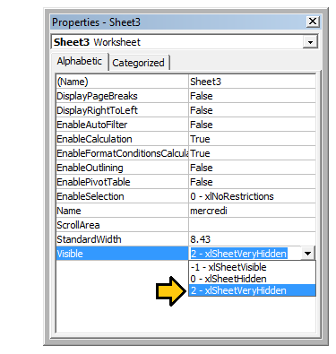

To change a worksheet's .Visible property to xlSheetVeryHidden¹ in code, similarly access the .Visible property and

assign a new value.

with Sheet3

.Visible = xlSheetVeryHidden

end with

¹ Both xlVeryHidden and xlSheetVeryHidden return a numerical value of 2 (they are interchangeable).

[GoalKicker.com – Excel® VBA Notes for Professionals](https://goalkicker.com/) 113

[www.dbooks.org](https://www.dbooks.org/) Section 30.2: Using Strings with Delimiters in Place of Dynamic

Arrays

Using Dynamic Arrays in VBA can be quite clunky and time intensive over very large data sets. When storing simple data types in a dynamic array (Strings, Numbers, Booleans etc.), one can avoid the ReDim Preserve statements

required of dynamic arrays in VBA by using the Split() function with some clever string procedures. For example, we will look at a loop that adds a series of values from a range to a string based on some conditions, then uses that

string to populate the values of a ListBox.

Private Sub UserForm\_Initialize()

Dim Count As Long, DataString As String, Delimiter As String

For Count = 1 To ActiveSheet.UsedRows.Count

If ActiveSheet.Range("A" & Count).Value <> "Your Condition" Then RowString = RowString & Delimiter & ActiveSheet.Range("A" & Count).Value Delimiter = "><" 'By setting the delimiter here in the loop, you prevent an extra occurance

of the delimiter within the string

End If

Next Count

ListBox1.List = Split(DataString, Delimiter)

End Sub

The Delimiter string itself can be set to any value, but it is prudent to choose a value which will not naturally occur

within the set. Say, for example, you were processing a column of dates. In that case, using ., -, or / would be

unwise as delimiters, as the dates could be formatted to use any one of these, generating more data points than you anticipated.

Note: There are limitations to using this method (namely the maximum length of strings), so it should be used with

caution in cases of very large datasets. This is not necessarily the fastest or most effective method for creating dynamic arrays in VBA, but it is a viable alternative.

Section 30.3: Worksheet .Name, .Index or .CodeName

We know that 'best practise' dictates that a range object should have its parent worksheet explicitly referenced. A worksheet can be referred to by its .Name property, numerical .Index property or its .CodeName property but a

user can reorder the worksheet queue by simply dragging a name tab or rename the worksheet with a double-click on the same tab and some typing in an unprotected workbook.

Consider a standard three worksheet. You have renamed the three worksheets Monday, Tuesday and Wednesday in that order and coded VBA sub procedures that reference these. Now consider that one user comes along and

decides that Monday belongs at the end of the worksheet queue then another comes along and decides that the worksheet names look better in French. You now have a workbook with a worksheet name tab queue that looks

something like the following.

index-118_1.jpg

If you had used either of the following worksheet reference methods, your code would now be broken.

'reference worksheet by .Name

with worksheets("Monday")

[GoalKicker.com – Excel® VBA Notes for Professionals](https://goalkicker.com/) 114

'operation code here; for example:

.Range(.Cells(2, "A"), .Cells(.Rows.Count, "A").End(xlUp)) = 1 end with

'reference worksheet by ordinal .Index

with worksheets(1)

'operation code here; for example:

.Range(.Cells(2, "A"), .Cells(.Rows.Count, "A").End(xlUp)) = 1 end with

Both the original order and the original worksheet name have been compromised. However, if you had used the worksheet's .CodeName property, your sub procedure would still be operational

with Sheet1

'operation code here; for example:

.Range(.Cells(2, "A"), .Cells(.Rows.Count, "A").End(xlUp)) = 1 end with

The following image shows the VBA Project window ([Ctrl]+R) which lists the worksheets by .CodeName then by

.Name (in brackets). The order they are displayed does not change; the ordinal .Index is taken by the order they are displayed in the name tab queue in the worksheet window.

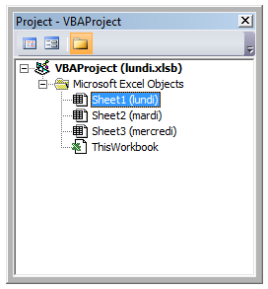

While it is uncommon to rename a .CodeName, it is not impossible. Simply open the VBE's Properties window ([F4]).

[GoalKicker.com – Excel® VBA Notes for Professionals](https://goalkicker.com/) 115

[www.dbooks.org](https://www.dbooks.org/)

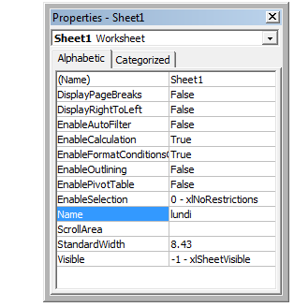

The worksheet .CodeName is in the first row. The worksheet's .Name is in the tenth. Both are editable.

Section 30.4: Double Click Event for Excel Shapes

By default, Shapes in Excel do not have a specific way to handle single vs. double clicks, containing only the

"OnAction" property to allow you to handle clicks. However, there may be instances where your code requires you to act differently (or exclusively) on a double click. The following subroutine can be added into your VBA project

and, when set as the OnAction routine for your shape, allow you to act on double clicks.

Public Const DOUBLECLICK\_WAIT as Double = 0.25 'Modify to adjust click delay Public LastClickObj As String, LastClickTime As Date

Sub ShapeDoubleClick()

If LastClickObj = "" Then

LastClickObj = Application.Caller

LastClickTime = CDbl(Timer)

Else

If CDbl(Timer) - LastClickTime > DOUBLECLICK\_WAIT Then

LastClickObj = Application.Caller

LastClickTime = CDbl(Timer)

Else

If LastClickObj = Application.Caller Then

'Your desired Double Click code here

LastClickObj = ""

Else

LastClickObj = Application.Caller

LastClickTime = CDbl(Timer)

End If

End If

End If

End Sub

This routine will cause the shape to functionally ignore the first click, only running your desired code on the second

click within the specified time span.

[GoalKicker.com – Excel® VBA Notes for Professionals](https://goalkicker.com/) 116 Section 30.5: Open File Dialog - Multiple Files

This subroutine is a quick example on how to allow a user to select multiple files and then do something with those

file paths, such as get the file names and send it to the console via debug.print.

Option Explicit

Sub OpenMultipleFiles()

Dim fd As FileDialog

Dim fileChosen As Integer

Dim i As Integer

Dim basename As String

Dim fso As Variant

Set fso = CreateObject("Scripting.FileSystemObject") Set fd = Application.FileDialog(msoFileDialogFilePicker)

basename = fso.getBaseName(ActiveWorkbook.Name)

fd.InitialFileName = ActiveWorkbook.Path ' Set Default Location to the Active Workbook Path

fd.InitialView = msoFileDialogViewList

fd.AllowMultiSelect = True

fileChosen = fd.Show

If fileChosen = -1 Then

'open each of the files chosen

For i = 1 To fd.SelectedItems.Count

Debug.Print (fd.SelectedItems(i))

Dim fileName As String

' do something with the files.

fileName = fso.getFileName(fd.SelectedItems(i))

Debug.Print (fileName)

Next i

End If

End Sub

[GoalKicker.com – Excel® VBA Notes for Professionals](https://goalkicker.com/) 117

[www.dbooks.org](https://www.dbooks.org/)

# Chapter 31: Common Mistakes

Section 31.1: Qualifying References

When referring to a worksheet, a range or individual cells, it is important to fully qualify the reference.

For example:

ThisWorkbook.Worksheets("Sheet1").Range(Cells(1, 2), Cells(2, 3)).Copy

Is not fully qualified: The Cells references do not have a workbook and worksheet associated with them. Without an explicit reference, Cells refers to the ActiveSheet by default. So this code will fail (produce incorrect results) if a

worksheet other than Sheet1 is the current ActiveSheet.

The easiest way to correct this is to use a With statement as follows:

With ThisWorkbook.Worksheets("Sheet1")

.Range(.Cells(1, 2), .Cells(2, 3)).Copy

End With

Alternatively, you can use a Worksheet variable. (This will most likely be preferred method if your code needs to

reference multiple Worksheets, like copying data from one sheet to another.)

Dim ws1 As Worksheet

Set ws1 = ThisWorkbook.Worksheets("Sheet1")

ws1.Range(ws1.Cells(1, 2), ws1.Cells(2, 3)).Copy

Another frequent problem is referencing the Worksheets collection without qualifying the Workbook. For example:

Worksheets("Sheet1").Copy

The worksheet Sheet1 is not fully qualified, and lacks a workbook. This could fail if multiple workbooks are

referenced in the code. Instead, use one of the following:

ThisWorkbook.Worksheets("Sheet1") '<--ThisWorkbook refers to the workbook containing

'the running VBA code

Workbooks("Book1").Worksheets("Sheet1") '<--Where Book1 is the workbook containing Sheet1

However, avoid using the following:

ActiveWorkbook.Worksheets("Sheet1") '<--Valid, but if another workbook is activated

'the reference will be changed

Similarly for range objects, if not explicitly qualified, the range will refer to the currently active sheet:

Range("a1")

Is the same as:

ActiveSheet.Range("a1")

[GoalKicker.com – Excel® VBA Notes for Professionals](https://goalkicker.com/) 118 Section 31.2: Deleting rows or columns in a loop

If you want to delete rows (or columns) in a loop, you should always loop starting from the end of range and move

back in every step. In case of using the code:

Dim i As Long

With Workbooks("Book1").Worksheets("Sheet1")

For i = 1 To 4

If IsEmpty(.Cells(i, 1)) Then .Rows(i).Delete

Next i

End With

You will miss some rows. For example, if the code deletes row 3, then row 4 becomes row 3. However, variable i

will change to 4. So, in this case the code will miss one row and check another, which wasn't in range previously.

The right code would be

Dim i As Long

With Workbooks("Book1").Worksheets("Sheet1")

For i = 4 To 1 Step -1

If IsEmpty(.Cells(i, 1)) Then .Rows(i).Delete

Next i

End With

Section 31.3: ActiveWorkbook vs. ThisWorkbook

ActiveWorkbook and ThisWorkbook sometimes get used interchangeably by new users of VBA without fully

understanding which each object relates to, this can cause undesired behaviour at run-time. Both of these objects belong to the Application Object

The ActiveWorkbook object refers to the workbook that is currently in the top-most view of the Excel application object at the time of execution. (e.g. The workbook that you can see and interact with at the point when this object is

referenced)

Sub ActiveWorkbookExample()

'// Let's assume that 'Other Workbook.xlsx' has "Bar" written in A1.

ActiveWorkbook.ActiveSheet.Range("A1").Value = "Foo"

Debug.Print ActiveWorkbook.ActiveSheet.Range("A1").Value '// Prints "Foo"

Workbooks.Open("C:\Users\BloggsJ\Other Workbook.xlsx")

Debug.Print ActiveWorkbook.ActiveSheet.Range("A1").Value '// Prints "Bar"

Workbooks.Add 1

Debug.Print ActiveWorkbook.ActiveSheet.Range("A1").Value '// Prints nothing

End Sub

The ThisWorkbook object refers to the workbook in which the code belongs to at the time it is being executed.

Sub ThisWorkbookExample()

'// Let's assume to begin that this code is in the same workbook that is currently active

ActiveWorkbook.Sheet1.Range("A1").Value = "Foo"

Workbooks.Add 1

[GoalKicker.com – Excel® VBA Notes for Professionals](https://goalkicker.com/) 119

[www.dbooks.org](https://www.dbooks.org/)

ActiveWorkbook.ActiveSheet.Range("A1").Value = "Bar"

Debug.Print ActiveWorkbook.ActiveSheet.Range("A1").Value '// Prints "Bar"

Debug.Print ThisWorkbook.Sheet1.Range("A1").Value '// Prints "Foo"

End Sub

Section 31.4: Single Document Interface Versus Multiple

Document Interfaces

Be aware that Microsoft Excel 2013 (and higher) uses Single Document Interface (SDI) and that Excel 2010

(And below) uses Multiple Document Interfaces (MDI).

This implies that for Excel 2013 (SDI), each workbook in a single instance of Excel contains its own ribbon UI:

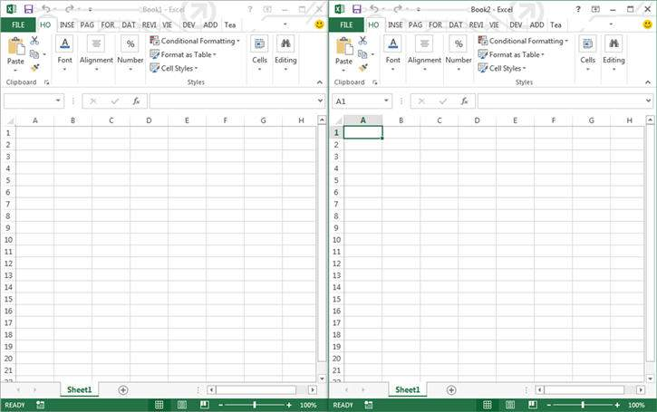

Conversely for Excel 2010, each workbook in a single instance of Excel utilized a common ribbon UI (MDI):

[GoalKicker.com – Excel® VBA Notes for Professionals](https://goalkicker.com/) 120

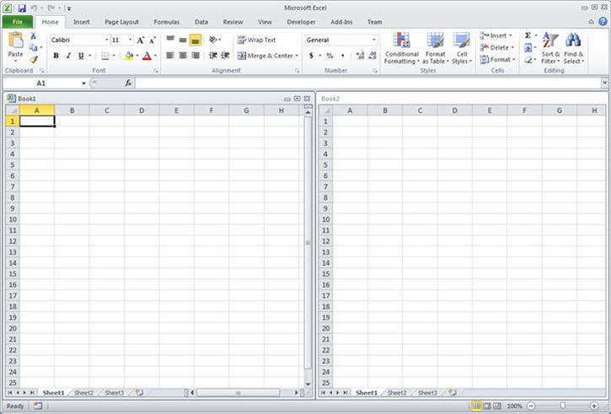

This raise some important issues if you want to migrate a VBA code (2010 <->2013) that interact with the Ribbon.

A procedure has to be created to update ribbon UI controls in the same state across all workbooks for

Excel 2013 and Higher.

Note that :

1. All Excel application-level window methods, events, and properties remain unaffected.

(Application.ActiveWindow, Application.Windows ... )

2. In Excel 2013 and higher (SDI) all of the workbook-level window methods, events, and properties now

operate on the top level window. It is possible to retrieve the handle of this top level window with Application.Hwnd

To get more details, see the source of this example: [MSDN.](https://msdn.microsoft.com/fr-fr/library/office/dn251093.aspx)

This also causes some trouble with modeless userforms. See [Here for a solution.](http://www.jkp-ads.com/Articles/keepuserformontop.asp)

[GoalKicker.com – Excel® VBA Notes for Professionals](https://goalkicker.com/) 121

[www.dbooks.org](https://www.dbooks.org/)

Credits

Thank you greatly to all the people from Stack Overflow Documentation who helped provide this content,

more changes can be sent to web@petercv.com for new content to be published or updated

[Adam](https://stackoverflow.com/users/1126985/) Chapter 4

[Alexis Olson](https://stackoverflow.com/users/765226/) Chapter 29

[Alon Adler](https://stackoverflow.com/users/908624/) Chapter 2

[Andy Terra](https://stackoverflow.com/users/447485/) Chapters 5 and 30

[Branislav Kollár](https://stackoverflow.com/users/4636801/) Chapters 1, 4 and 29

[Byron Wall](https://stackoverflow.com/users/4288101/) Chapter 21

[Captain Grumpy](https://stackoverflow.com/users/6803420/) Chapters 18 and 20

[Chel](https://stackoverflow.com/users/2146688/) Chapters 27 and 29

[Cody G.](https://stackoverflow.com/users/2446254/) Chapters 1, 28, 29 and 30

[Comintern](https://stackoverflow.com/users/4088852/) Chapter 29

[curious](https://stackoverflow.com/users/6037536/) Chapter 14

[Doug Coats](https://stackoverflow.com/users/5009293/) Chapters 1, 4 and 12

[EEM](https://stackoverflow.com/users/4892468/) Chapter 1

[Egan Wolf](https://stackoverflow.com/users/5722505/) Chapter 31

[Etheur](https://stackoverflow.com/users/4927169/) Chapter 28

[Excel Developers](https://stackoverflow.com/users/1523914/) Chapter 11

[FreeMan](https://stackoverflow.com/users/2344413/) Chapter 29

[genespos](https://stackoverflow.com/users/4293613/) Chapter 29

[Gordon Bell](https://stackoverflow.com/users/16473/) Chapters 1 and 31

[Gregor y](https://stackoverflow.com/users/4496560/) Chapter 28

[Hubisan](https://stackoverflow.com/users/1365754/) Chapters 2, 14 and 29

[Jeeped](https://stackoverflow.com/users/4039065/) Chapters 8, 18, 29 and 30

[jlookup](https://stackoverflow.com/users/5216265/) Chapter 18

[Joel Spolsky](https://stackoverflow.com/users/4/) Chapters 1, 4 and 20

[Julian Kuchlbauer](https://stackoverflow.com/users/6588969/) Chapter 28

[Kaz](https://stackoverflow.com/users/4169411/) Chapter 1

[Kyle](https://stackoverflow.com/users/4043845/) Chapters 28 and 29

[Máté Juhász](https://stackoverflow.com/users/4721734/) Chapter 29

[Macro Man](https://stackoverflow.com/users/4240221/) Chapters 1, 29, 30 and 31

[Malick](https://stackoverflow.com/users/3205529/) Chapters 1, 8, 18, 29 and 31

[Masoud](https://stackoverflow.com/users/6461462/) Chapter 26

[Miguel\_Ryu](https://stackoverflow.com/users/3005534/) Chapter 2

[Mike](https://stackoverflow.com/users/2911241/) Chapter 24

[Miqi180](https://stackoverflow.com/users/3648187/) Chapter 14

[Munkeeface](https://stackoverflow.com/users/2992687/) Chapter 29

[paul bica](https://stackoverflow.com/users/4914662/) Chapters 14, 26 and 29

[PeterT](https://stackoverflow.com/users/4717755/) Chapters 10, 17 and 29

[Portland Runner](https://stackoverflow.com/users/2521004/) Chapters 5 and 29

[P ʜ](https://stackoverflow.com/users/3219613/) Chapter 29

[quadrature](https://stackoverflow.com/users/6254385/) Chapters 7 and 15

[R3uK](https://stackoverflow.com/users/4628637/) Chapters 6 and 14

[RGA](https://stackoverflow.com/users/6408573/) Chapters 1, 14, 23, 28, 29 and 30

[Robby](https://stackoverflow.com/users/5298189/) Chapter 24

[Ron McMahon](https://stackoverflow.com/users/2205331/) Chapter 28

[Sgdva](https://stackoverflow.com/users/3221380/) Chapter 19

[Shahin](https://stackoverflow.com/users/7769242/) Chapter 2

[Shai Rado](https://stackoverflow.com/users/6344363/) Chapters 1, 12, 14 and 29

[GoalKicker.com – Excel® VBA Notes for Professionals](https://goalkicker.com/) 122

[Slai](https://stackoverflow.com/users/1383168/) Chapters 8 and 14

[Stefan Pinnow](https://stackoverflow.com/users/5776000/) Chapter 29

[SteveES](https://stackoverflow.com/users/7648526/) Chapter 3

[Steven Schroeder](https://stackoverflow.com/users/1197635/) Chapters 28 and 29

[SWa](https://stackoverflow.com/users/1240154/) Chapter 31

[T.M.](https://stackoverflow.com/users/6460297/) Chapters 7, 22 and 26

[TheGuyThatDoesn'tKnowMuch](https://stackoverflow.com/users/3918993/) Chapter 27

[ThunderFrame](https://stackoverflow.com/users/5757159/) Chapter 29

[Toast](https://stackoverflow.com/users/4747836/) Chapters 1, 28 and 31

[user3561813](https://stackoverflow.com/users/3561813/) Chapter 8

[Vegard](https://stackoverflow.com/users/4604845/) Chapters 4 and 8

[Verzweifler](https://stackoverflow.com/users/4600127/) Chapter 29

[Vityata](https://stackoverflow.com/users/5448626/) Chapter 13

[Zsmaster](https://stackoverflow.com/users/5829910/) Chapters 9, 16 and 25

[GoalKicker.com – Excel® VBA Notes for Professionals](https://goalkicker.com/) 123

[www.dbooks.org](https://www.dbooks.org/)