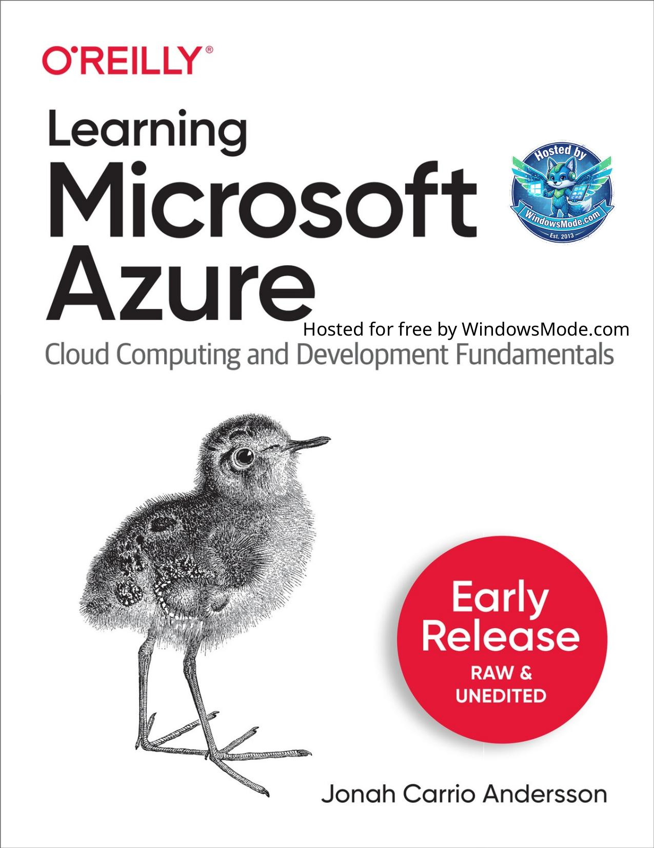

# Table of Contents

Chapter 1 provides an introduction to the important concepts of cloud computing, how it works, the different types of its deployment models, understanding the types of cloud, what is CapEx and OpEx in cloud computing, and the benefits of utilizing cloud computing in businesses, IT organizations, society and software engineering.

Chapter 2 focuses deeper into the theoretical and technical concepts of Microsoft Azure as a public cloud platform. Learn about the Microsoft Azure core components and the different cloud services categorized by its purpose.

Chapter 3 explores some of the Microsoft Azure compute services such as Azure Virtual Machines, container services like Azure Container Instances, Azure Container Registry, Azure Container Apps, Azure App services for web and mobile applications, serverless cloud solutions with Azure Functions, Azure Static Web App, and more.

Chapter 4 covers cloud networking and services in Microsoft Azure including Azure VNet, DNS, Azure Firewall, Azure Front Door, ExpressRoute, Virtual Network, VPN Gateway, Application Gateway, Load Balancer and Internet Analyzer.

Chapter 5 provides a technical overview of the different cloud storage and databases (both SQL and NoSQL) in Microsoft Azure. You will learn about cloud storage concepts, services, create databases and find useful best practices for Azure SQL Databases, Azure Cosmos DB, Database for MySql, Azure SQL Servers, Redis Cache in Azure, Azure Storage, Data Share and Manage Disks.

Chapter 6 focuses on the useful concepts you need to know about Artificial Intelligence(AI), Cognitive Services, Bot Services, and Machine Learning Services in Microsoft Azure.

Chapter 7 dives into identity and security services in Azure, such as Azure Active Directory and Azure AD - B2C, B2E. Azure security services like Azure Key Vault, Azure Sentinel, Azure Defender, and Azure Security Center and Information Protection will also be explored.

Chapter 8 explores the Big Data, Reporting and Analytical Services in Microsoft Azure. This chapter will include what you need to know about data analytics, big data, and reporting services in Power BI, Stream Analytics, Data Lake Analytics, Event Hubs, HD Insights and more.

Chapter 9 covers the different Azure solutions for IoT (Internet of Things), Machine Learning (ML) and Maps Services and Cognitive services in Azure. You will learn about what Azure IoT Hub, IoT Edge, Azure Maps, Azure Spheres, and Remote Rendering services. Using Azure Developer IoT Starter Kit to get started with IoT development with Microsoft Azure.

Chapter 10 focuses on Microsoft Azure integrations with other services within the platform and even external services. You will learn about Continuous Delivery/Continuous Integration (CI/CD) in Azure for automatic processes what will help you and your team using Azure DevOps suite. This chapter will also include API management in communicating with different APIs, Event Grid, Azure Logic Apps, Notification Hubs, and Azure Web PubSub.

Chapter 11 guides on how to develop systems or applications using important organization suite service like Azure DevOps for team collaboration for developers and IT operations. Automating development processes using CI/CD and source code version control, what are Azure Pipelines, Github Actions with Azure DevOps. How to monitor and troubleshoot Azure resources using Application Insights. You will also get to know about other cloud technology services like Azure DevTestLabs, App Configuration, Azure Biceps, ARM Templates and more. Know what Infrastructure as a Code (IaC) is and how it helps with automation of deployments.

Chapter 12 walks you through the important concepts you should know when it comes to cloud management and cloud governance in Microsoft Azure. For example, how it works with automation in the cloud, Azure Advisor, backup using Azure Backup, Azure Blueprints, Azure Policy, Azure Monitor and other known solutions for hybrid and multi-cloud.

Chapter 13 discusses about cloud migration, cloud transformation, and architectural concepts in Microsoft Azure. You will learn about the vital facts you need to learn when you are adopting, transforming or migrating to Azure. Find out the best practices and useful list of tools you can use when moving on-premises and legacy old application.This chapter also highlights the importance of having a Microsoft Azure’s Well-Architected Framework.

Chapter 14 is more focused on the cloud engineering and software development in Microsoft Azure. This chapter aims to introduce you, the reader, to the different languages you can use to get started with cloud engineering and software development with Microsoft Azure.

Chapter 1. Cloud Computing

Chapter 2. Microsoft Azure

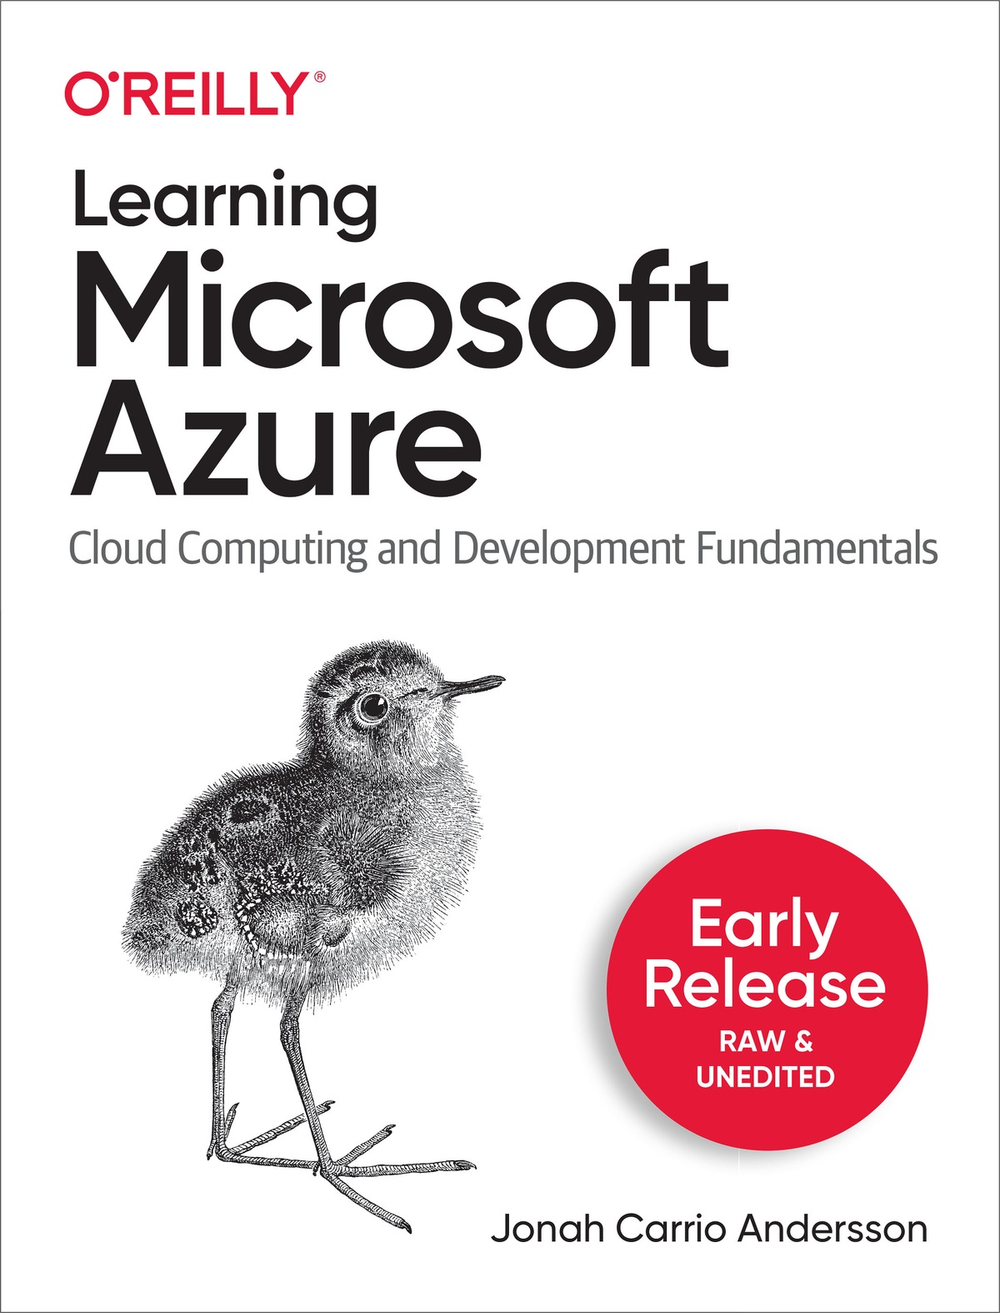

Hosted for free by WindowsMode.com



Learning Microsoft Azure

The Fundamentals of Cloud and Microsoft Azure

With Early Release ebooks, you get books in their earliest form—the author’s raw and unedited content as they write—so you can take advantage of these technologies long before the official release of these titles.

Jonah Carrio Andersson

Learning Microsoft Azure

by Jonah Carrio Andersson

Copyright © 2022 Jonah Carrio Andersson. All rights reserved.

Printed in the United States of America.

Published by O’Reilly Media, Inc., 1005 Gravenstein Highway North, Sebastopol, CA 95472.

O’Reilly books may be purchased for educational, business, or sales promotional use. Online editions are also available for most titles

([http://oreilly.com](http://oreilly.com/)). For more information, contact our corporate/institutional sales department: 800-998-9938 or corporate@oreilly.com.

Editors: Jennifer Pollock and Jill Leonard

Production Editor: Beth Kelly

Interior Designer: David Futato

Cover Designer: Karen Montgomery

Illustrator: Kate Dullea

June 2023: First Edition

Revision History for the Early Release

2022-02-11: First Release

See <http://oreilly.com/catalog/errata.csp?isbn=9781098113322> for release details.

The O’Reilly logo is a registered trademark of O’Reilly Media, Inc. Learning Microsoft Azure, the cover image, and related trade dress are trademarks of O’Reilly Media, Inc.

The views expressed in this work are those of the authors, and do not represent the publisher’s views. While the publisher and the authors have used good faith efforts to ensure that the information and instructions contained in this work are accurate, the publisher and the authors disclaim all responsibility for errors or omissions, including without limitation responsibility for damages resulting from the use of or reliance on this work. Use of the information and instructions contained in this work is at your own risk. If any code samples or other technology this work contains or describes is subject to open source licenses or the intellectual property rights of others, it is your responsibility to ensure that your use thereof complies with such licenses and/or rights.

978-1-09811-325-4

[FILL IN]

Preface

Hello, Readers of Learning Microsoft Azure!

As the author, I would like to personally thank you for choosing to read this book for learning Microsoft Azure.

Software engineering with cloud technologies has been one of the most exciting experiences in this modern era! From mainframe computers to massive modern resources and technologies on the cloud. As much as the industrial revolution forever changed the manufacturing industry and our access to consumer goods, digitization has transformed the way we live and work.

Microsoft Azure is a cloud computing platform that has been close to my heart. In the past severals years working as a software engineer who is developing solutions to the cloud, I have gained a lot of learning, hands-on experience and technical insights and inspirations about Azure.

Azure is a modern and powerful cloud service provider that is technologically evolving with our digitalization. As one of the largest cloud computing platforms, Microsoft Azure is a cloud provider serving millions of organizations, customers, applications and modern applications globally.

Azure brings powerful benefits not just to the business but to all members of the organization - from the leadership, project managers, clients and to engineering teams.

As a software engineer, building and maintaining applications or enterprise systems is part of my daily work routine. My experience in the software engineering industry and working with cloud platform Microsoft Azure have helped me broaden my technical knowledge.

I was once involved in a cloud migration project to Azure. I had a mission to move an old legacy.NET application that was on on-premise servers. I had full responsibility to move it alone to the cloud. I was like a superwoman on a cloud mission. From designing the system architecture, re-structuring the databases, fixing the technical debts, fixing data quality issues, programming and even creating documentation. I put my heart into it but that cloud migration project was a fiasco just like some other software engineering projects. After trying different migration alternatives such as lift and shift, refactoring code and re-architect the infrastructure, we determined that the system needed to be re-built as though it was a new system. Unfortunately,this process was stopped due to lack of cloud migration strategy, awareness of the great benefits of it, knowledge about cloud, and other factors.

It was a project that didn’t make it to the finish line but it was one of the greatest experience in my engineering career. No regrets, just lessons learned.

I do not want other developers nor organizations to make the same mistakes we did in that cloud migration project. This is one of the reasons why I am very passionate about sharing knowledge of the cloud and Azure through public speaking engagements, tech conferences, meetups, and with our clients even when these opportunities are in my spare time and on weekends.

I am excited to share great and useful information about Microsoft Azure in this book. I hope that the contents of this book will come in handy in your work, your career development, your cloud migration journey, and your contribution to the cloud engineering projects in your organization.

Why I Wrote This Book

When I was studying Computer Science back in the end of the 1990’s, my first thesis was about how the invention of Internet technology helped local communities and our society. Since then I became fascinated with how new technologies help us in our daily routines and work.

As a software engineer, I create, build and develop technical solutions with modern technologies. The more solutions I solve and build, the more I improve my technical skills and knowledge in à jour or up to date along with the evolving modern technologies we have these days.

I am passionate about sharing this knowledge with others - especially to those who want to gain a fundamental learning of cloud computing and Microsoft Azure. This book aims to help those that are getting started into cloud computing and Azure as well as help IT professionals, project teams, software developers, cloud engineers in choosing the right service to use Microsoft Azure to solve their customer use-cases and business requirements in your organizations.

Who Should Read This Book

This book is essential learning reference book for anybody who wants to learn about the important cloud concepts and cloud computing services provided by Microsoft Azure - both Beginner and Intermediate levels.

The information and technical knowledge shared on this book will will help you in planning, designing, developing applications and modern technical solutions to the cloud using Microsoft Azure platform.

This book diversely open for anybody with technical background with career roles like Software Developers, Cloud Engineers, Cloud Solution Architects, IT Project Managers, Technical Sales Managers, Scrum Masters and teams who are used to working with the standard on-premise and legacy applications or systems will be able to gain important insight into designing and developing solutions in the cloud platform through Microsoft Azure service and its technical overview.

This book is also ideal to those IT Professionals, Software Developers and

[aspiring Cloud Engineers who wants to prepare for the AZ-900 Microsoft](https://docs.microsoft.com/en-us/learn/certifications/exams/az-900?WT.mc_id=AZ-MVP-5004251)

[Azure Fundamentals Certifications and the AZ-204 Developing Solutions](https://docs.microsoft.com/en-us/learn/certifications/exams/az-900?WT.mc_id=AZ-MVP-5004251)

[for Microsoft Azure.](https://docs.microsoft.com/en-us/learn/certifications/exams/az-204?WT.mc_id=AZ-MVP-5004251)

What You Will Learn By the end of this book, you will be able to gain knowledge of the following:

The important concepts you need to know about cloud computing

The fundamentals of Microsoft Azure as a public cloud service provider

The different Microsoft Azure technologies that will help you and your organization develop, transform, and migrate to modern cloud environments

A wide and useful overview of the different cloud technologies in Microsoft Azure that will help you choose the right cloud service for your demands, use-cases, software development and cloud development projects

A jump-start guide on how you can start developing cloud solutions and accelerate your career as an Azure Developer or Cloud Engineer

Start developing cloud services, applications, and solutions in Microsoft Azure environments using your desired and supported programming languages, frameworks and tools

Learn how you can integrate cloud technologies with other services, APIs and third-party services

Get practical options and learn from best practices on the important things you need to consider when you migrate existing legacy applications to cloud platform like Microsoft Azure

NOTE

Learning Microsoft Azure is your guide as you work with Microsoft Azure. I always believe in Learn By Doing. So, kindly invest time not just in learning the fundamental concepts but also do some hands-on.

Navigating This Book

PART I Fundamentals of Cloud Computing and Microsoft Azure

In this introductory part of the book, you will learn about the Cloud Computing and Microsoft Azure Fundamentals.

# Chapter 1 provides an introduction to the important concepts of cloud computing, how it works, the different types of its deployment models, understanding the types of cloud, what is CapEx and OpEx in cloud computing, and the benefits of utilizing cloud computing in businesses, IT organizations, society and software engineering.

# Chapter 2 focuses deeper into the theoretical and technical concepts of Microsoft Azure as a public cloud platform. Learn about the Microsoft Azure core components and the different cloud services categorized by its purpose.

By the end of reading Part I, you already have gained vital knowledge and foundational concepts of Cloud Computing and Microsoft Azure.

PART II The Cloud Computing Services in Microsoft Azure

This second part of the book and its chapters focus on giving you an in depth of the different technologies in Microsoft grouped into its categories.

# Chapter 3 explores some of the Microsoft Azure compute services such as Azure Virtual Machines, container services like Azure Container Instances, Azure Container Registry, Azure Container Apps, Azure App services for web and mobile applications, serverless cloud solutions with Azure Functions, Azure Static Web App, and more.

# Chapter 4 covers cloud networking and services in Microsoft Azure including Azure VNet, DNS, Azure Firewall, Azure Front Door, ExpressRoute, Virtual Network, VPN Gateway, Application Gateway, Load Balancer and Internet Analyzer.

# Chapter 5 provides a technical overview of the different cloud storage and databases (both SQL and NoSQL) in Microsoft Azure. You will learn about cloud storage concepts, services, create databases and find useful best practices for Azure SQL Databases, Azure Cosmos DB, Database for MySql, Azure SQL Servers, Redis Cache in Azure, Azure Storage, Data Share and Manage Disks.

# Chapter 6 focuses on the useful concepts you need to know about Artificial Intelligence(AI), Cognitive Services, Bot Services, and Machine Learning Services in Microsoft Azure.

# Chapter 7 dives into identity and security services in Azure, such as Azure Active Directory and Azure AD - B2C, B2E. Azure security services like Azure Key Vault, Azure Sentinel, Azure Defender, and Azure Security Center and Information Protection will also be explored.

# Chapter 8 explores the Big Data, Reporting and Analytical Services in Microsoft Azure. This chapter will include what you need to know about data analytics, big data, and reporting services in Power BI, Stream Analytics, Data Lake Analytics, Event Hubs, HD Insights and more.

# Chapter 9 covers the different Azure solutions for IoT (Internet of Things), Machine Learning (ML) and Maps Services and Cognitive services in Azure. You will learn about what Azure IoT Hub, IoT Edge, Azure Maps, Azure Spheres, and Remote Rendering services. Using Azure Developer IoT Starter Kit to get started with IoT development with Microsoft Azure.

By the end of reading Part II, you already have learned some technical knowledge and hands-on experience with the different technologies in Microsoft Azure. These will help you choose what Azure technology to use for what you need in your business requirements and develop solutions with them.

PART III Azure Integration, Continuous Delivery/Continuous Integration (CI/CD), Infrastructure as Code and DevOps in Microsoft Azure

In this third section of the book, you will learn how you can integrate the different Azure technologies with to other services, infrastructure as a code solutions, and setup your application using Azure’s deployment technologies.

# Chapter 10 focuses on Microsoft Azure integrations with other services within the platform and even external services. You will learn about Continuous Delivery/Continuous Integration (CI/CD) in Azure for automatic processes what will help you and your team using Azure DevOps suite. This chapter will also include API management in communicating with different APIs, Event Grid, Azure Logic Apps, Notification Hubs, and Azure Web PubSub.

# Chapter 11 guides on how to develop systems or applications using important organization suite service like Azure DevOps for team collaboration for developers and IT operations. Automating development processes using CI/CD and source code version control, what are Azure Pipelines, Github Actions with Azure DevOps. How to monitor and troubleshoot Azure resources using Application Insights. You will also get to know about other cloud technology services like Azure DevTestLabs, App Configuration, Azure Biceps, ARM Templates and more. Know what Infrastructure as a Code (IaC) is and how it helps with automation of deployments.

After reading the chapters in Part III, you already have gained knowledge and development skills to help you work effectively as a cloud developer using the cloud integration and automation options you have. You and your agile team in your organization will also be able to collaborate and work effectively using the great features of Microsoft Azure DevOps and DevTest Labs.

PART IV Cloud Management, Governance, Migration and Architecture in Microsoft Azure

The fourth section of this book will give you insights in adopting and migrating successfully to the cloud.

# Chapter 12 walks you through the important concepts you should know when it comes to cloud management and cloud governance in Microsoft Azure. For example, how it works with automation in the cloud, Azure Advisor, backup using Azure Backup, Azure Blueprints, Azure Policy, Azure Monitor and other known solutions for hybrid and multi-cloud.

# Chapter 13 discusses about cloud migration, cloud transformation, and architectural concepts in Microsoft Azure. You will learn about the vital facts you need to learn when you are adopting, transforming or migrating to Azure. Find out the best practices and useful list of tools you can use when moving on-premises and legacy old application.This chapter also highlights the importance of having a Microsoft Azure’s Well-Architected Framework.

After reading the chapters in Part IV, you already have gained understanding and important knowledge cloud governance and cloud management in Microsoft Azure. These are important in designing and developing cloud solutions. You will also captured a broad understanding about the Microsoft Cloud Adoption Framework (CAF), Azure Migrate and Microsoft Assessment tools that can assist in your cloud migration projects. You will also learned from lessons I learned from a cloud migration project experience in migration old .NET Legacy On-Premise applications to Microsoft Azure.

PART V The Cloud Computing Service in Microsoft Azure

The fifth and final section of useful list of resources.

# Chapter 14 is more focused on the cloud engineering and software development in Microsoft Azure. This chapter aims to introduce you, the reader, to the different languages you can use to get started with cloud engineering and software development with Microsoft Azure.

Further Useful Resources is the final chapter with my recommended learning resources, recommended Microsoft certifications for cloud platform Azure and starting a career as a cloud engineer.

Check Self-Knowledge

In the end of each chapter mentioned, I will be providing a short list of learning check questions related to the topics discussed. These questions will be a useful review challenge for you to check what you have learned.

Learning Resources and Further Readings

Learning Microsoft Azure aims to provide the most important foundational knowledge you need to know. With consideration that we have different levels of experience and knowledge, you probably want to explore in more depth the discussed topic further. Therefore, on the end of each chapter, I will be providing a short list of recommended learning and further reading resource related to the topics discussed. Most the references are linked to the most recent documentation of Microsoft for specific technology or resource mentioned in this book.

What This Book Is Not

This book is not an advanced level book for each cloud technology service in Microsoft Azure.

Conventions Used in This Book

The following typographical conventions are used in this book:

Italic

Indicates new terms, URLs, email addresses, filenames, and file extensions.

Constant width

Used for program listings, as well as within paragraphs to refer to program elements such as variable or function names, databases, data types, environment variables, statements, and keywords.

Constant width bold

Shows commands or other text that should be typed literally by the user.

Constant width italic

Shows text that should be replaced with user-supplied values or by values determined by context.

TIP

This element signifies a tip or suggestion.

NOTE

This element signifies a general note about the topic discussed.

WARNING

This element indicates a warning or caution.

Using Code Examples

Supplemental material (code examples, exercises, etc.) is available for

download at [https://github.com/jonahandersson/learning-microsoft-azure.](https://github.com/jonahandersson/learning-microsoft-azure)

If you have a technical question or a problem using the code examples,

please send email to bookquestions@oreilly.com.

This book is here to help you get your job done. In general, if example code is offered with this book, you may use it in your programs and documentation. You do not need to contact us for permission unless you’re reproducing a significant portion of the code. For example, writing a program that uses several chunks of code from this book does not require permission. Selling or distributing examples from O’Reilly books does require permission. Answering a question by citing this book and quoting example code does not require permission. Incorporating a significant amount of example code from this book into your product’s documentation does require permission.

We appreciate, but generally do not require, attribution. An attribution usually includes the title, author, publisher, and ISBN. For example: “Book Title by Some Author (O’Reilly). Copyright 2012 Some Copyright Holder, 978-0-596-xxxx-x.”

If you feel your use of code examples falls outside fair use or the

permission given above, feel free to contact us at permissions@oreilly.com.

O’Reilly Online Learning

NOTE

[For more than 40 years, O’Reilly Media has provided technology and business training,](http://oreilly.com/) knowledge, and insight to help companies succeed.

Our unique network of experts and innovators share their knowledge and expertise through books, articles, and our online learning platform. O’Reilly’s online learning platform gives you on-demand access to live training courses, in-depth learning paths, interactive coding environments, and a vast collection of text and video from O’Reilly and 200+ other

publishers. For more information, visit [http://oreilly.com](http://oreilly.com/).

How to Contact Us

Please address comments and questions concerning this book to the publisher:

O’Reilly Media, Inc.

1005 Gravenstein Highway North

Sebastopol, CA 95472

800-998-9938 (in the United States or Canada)

707-829-0515 (international or local)

707-829-0104 (fax)

We have a web page for this book, where we list errata, examples, and any additional information.

Email bookquestions@oreilly.com to comment or ask technical questions about this book.

For news and information about our books and courses, visit

[http://oreilly.com](http://oreilly.com/).

[Find us on Facebook: http://facebook.com/oreilly](http://facebook.com/oreilly)

Follow us on T[witter: http://twitter.com/oreillymedia](http://twitter.com/oreillymedia)

Watch us on YouT[ube: http://www.youtube.com/oreillymedia](http://www.youtube.com/oreillymedia)

Acknowledgments

I would like to acknowledge and give thanks to those who helped me, supported me, and assisted me in making this book a success from start to finish.

This book is not made possible without the support of my family, friends and the awesome people in the tech and cloud communities who helped me and assisted me.

Thanks Jill Leonard, Jennifer Pollock and to all of the O’Reilly Media, team. Special mention to people who helped me through the journey of this book.

NOTE: Acknowledgement to be updated until the book is finished.

Chapter 1. Cloud Computing

Fundamentals

A NOTE FOR EARLY RELEASE READERS

With Early Release ebooks, you get books in their earliest form—the author’s raw and unedited content as they write—so you can take advantage of these technologies long before the official release of these titles.

This will be the 1st chapter of the final book. Please note that the GitHub repo will be made active later on.

If you have comments about how we might improve the content and/or examples in this book, or if you notice missing material within this

chapter, please reach out to the editor at jleonard@oreilly.comL.

I don’t need a hard disk in my computer if I can get to the server faster… carrying around these non-connected computers is byzantine by comparison.

—Steve Jobs, late Co-founder, CEO and Chairman, Apple

Inc (1997)

What is Cloud Computing

Before we can dive into learning Microsoft Azure, we first need to understand cloud computing. Learning the foundational principles of cloud will help you and your organization in developing solutions with Azure.

Cloud computing is one of the great technology innovations we have in this era. In its simple definition, cloud computing is the delivery of different computing services delivered through the Internet. These different services are composed of the important resources like web servers, databases, data storage, virtual machines, applications, network infrastructure, security tools, software, and other IT infrastructure.

It is called cloud computing because all the data and information we need are being remotely stored and are accessed in a virtual space through the Internet.

Cloud computing makes life easier for us. A good and practical example of this is the possibility of saving our photos, videos and files into a cloud storage virtually with unlimited capacity instead of saving it on a local storage device with limited storage. Another good benefit is virtualizing web servers and databases instead of having physical infrastructures or servers.

Benefits of Cloud in Software Engineering and IT

Software engineering along with the power cloud development is evolving rapidly. The evolution of cloud computing has increased the demand for software developers, cloud engineers and IT professionals. This means that we, working in this software or cloud engineering field must keep ourselves up to date with the modern technologies.

Cloud computing enables software developers or cloud engineers to create, build, test and deploy technical cloud solutions productively, effectively, and securely. Software engineering teams who do not use cloud computing systems will have great challenges working on the traditional on-premises infrastructure. Cloud engineering provides better speed of development, testing, maintainability and scalability.

With the advancement of different methods like Infrastructure as a Code (IaC) becoming available for cloud infrastructures, benefits such as automation are making things easier for developers. Low-Code/No-Code solutions on the cloud also helps IT professionals with less programming skills experience to build applications quickly on demand.

Additionally, project managers can easily manage their projects and teams by working agile with available modern collaboration tools in the cloud. For example, Microsoft Azure DevOps which is a DevOps all-in-one collaboration suite that enables DevOps capabilities and has features that covers the entire application lifecycle - from agile project planning, source code version control, CI/CD (Continuous Integration/ Continuous Delivery), testing plans and integrations. Learn more about Azure DevOps in Chapter 11 of this book.

Overall, the innovation brought by cloud computing has helped us advance in our society, as well as improve the way we live our daily lives. Digitalization and modernization comes with great benefits; however, it also comes its challenges. Challenges to prepare, to transform and to adapt to the fast-changing and evolving technologies. These challenges can be handled by learning the foundations of cloud computing which you will learn by reading through this first chapter.

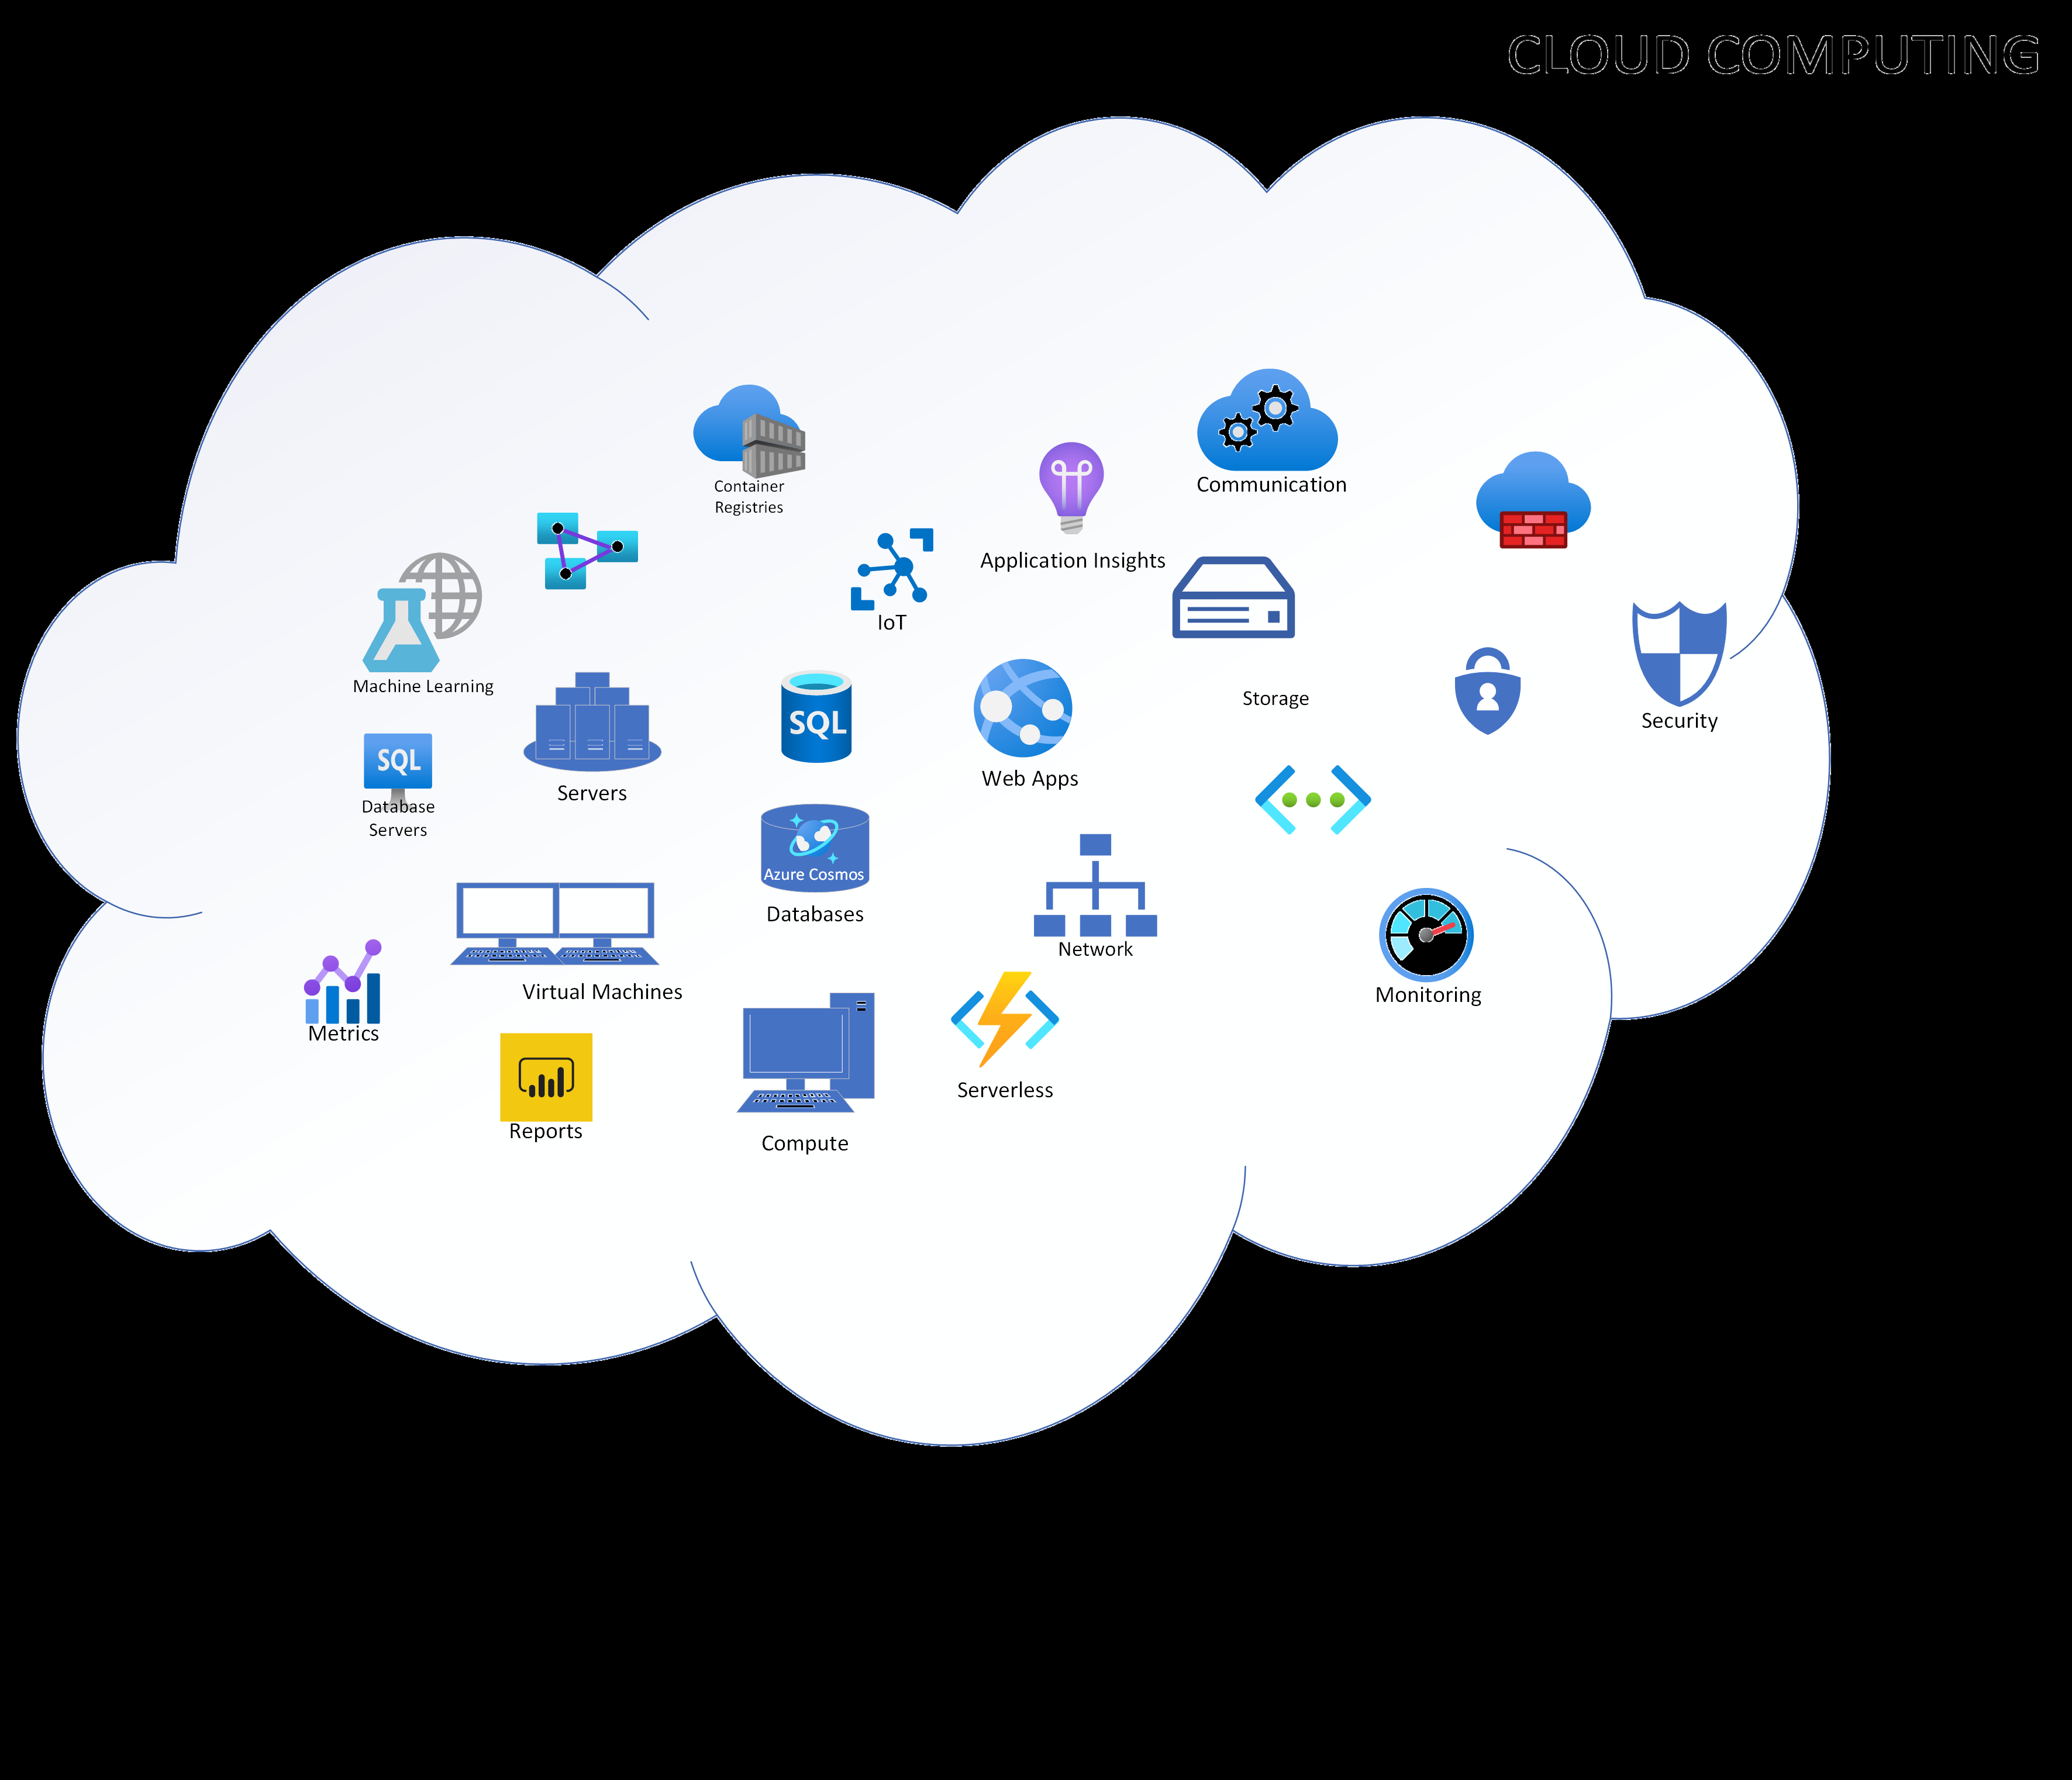

Figure 1-1. Overview of Cloud Computing

Instead of having our resources like the databases, applications, servers or infrastructure physical data centers or on-premise, we have these resources

on the cloud or Internet, as shown in Figure 1-1.

Businesses and organizations consider cloud computing technology as a primary and smart option. Speed, reliability, financial savings, productivity, efficiency, security, performance and more. By the end of this chapter, you will learn the specific benefits cloud computing has for different categories.

Cloud computing applications and why it is a popular option for people and businesses for reasons including cost savings, increased productivity, speed and efficiency, performance, and security.

How Cloud Works? Cloud Computing vs. Virtualization

Cloud Computing and virtualization both create useful virtual environments from abstract resources. Therefore it is easy to confuse cloud computing and virtualization as the same. Hosting resources on the cloud or over the Internet does not mean that it exactly the similar to having a virtual machine for a web server or databases hosted on an on-premise environment.

The cloud is an environment while virtualization is a technology. Virtualization is type of technology that enables us to virtualize a hardware to create and simulate several machines or dedicated resources. On the other hand, the cloud is an IT environment that pools and share scalable resources across a network. Cloud environments are created to activate the great capabilities of cloud computing like running workloads within it.

CLOUD ENVIRONMENT FOR CLOUD COMPUTING

Cloud computing is a modern approach to provide on-demand resources for compute, storage, network, platform, web applications and infrastructure over the internet or cloud. These are pools of virtual services and resources that are hosted on the cloud which is accessible by its users anywhere in the world. These cloud resources can be managed through self-service administrative portals. For example Microsoft Azure Portal for Microsoft cloud resources.

Cloud Hypervisor - The Key to Virtualization in the Cloud

The powerful technology of hypervisor is emerging to be a vital tool in virtualizing resources and is driving modern innovation in the cloud environments. Hypervisors make resources and applications in the cloud available to its users remotely. The ability to access and manage cloud resources over the Internet gives organizations and IT better control in managing their systems, applications, data and infrastructure in the cloud

environment. Hypervisor technology is illustrated in Figure 1-2 in a simple way.

The emerging transformation to digitalization and rising demand of better service expectations of customers are resulting in building more modern and reliable applications. For such reasons, organizations are still considering migrating or already migrating their enterprise applications from on-premise virtual machines to the cloud environments.

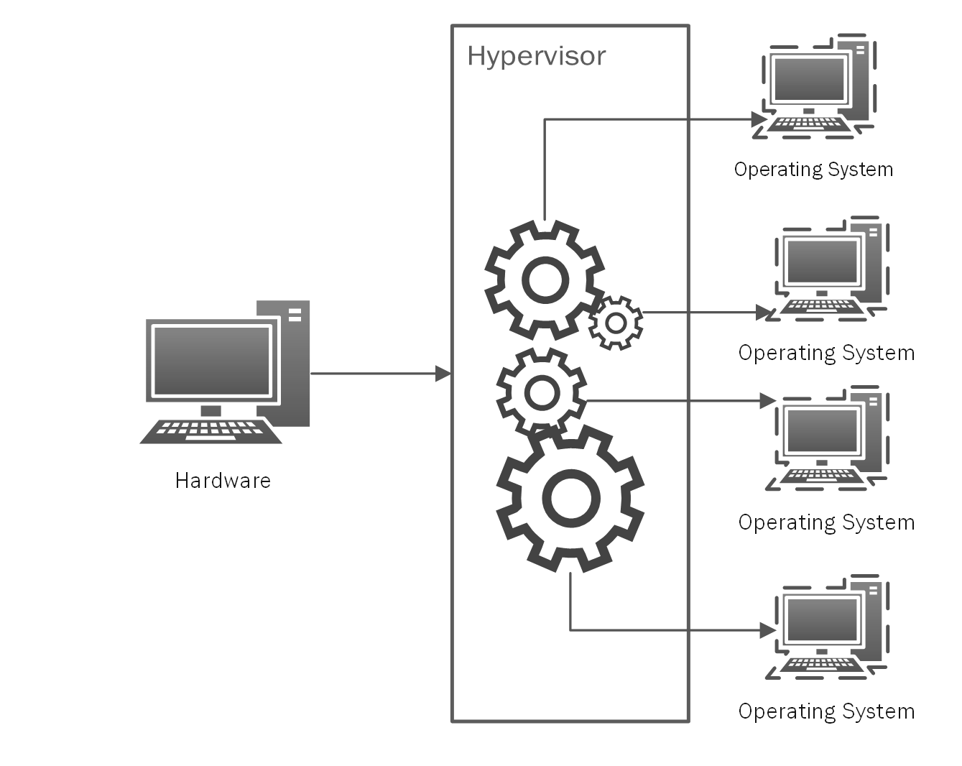

Figure 1-2. Hypervisor Technology

However, even with all of the benefits we’ve just described, migrating existing enterprise applications to the cloud is not an easy quick-fix journey. It requires careful planning, implementation of good strategy and more resources to re-architect and re-write systems or applications for cloud upgrade. With the help of virtualization with hypervisor, it is possible to migrate existing on-premise applications to the cloud faster while investing less time, money and resources.

THE TECHNOLOGY OF VIRTUALIZATION

Virtualization technology simulates resources and environments from a single physical

hardware system. Behind this technology is the software emulated called [hypervisor has](https://en.wikipedia.org/wiki/Hypervisor) the super capability to distribute a system into secure and distinct environments known as Virtual Machines (VMs). The Virtual Machines that we are using on our traditional web servers these days rely on the ability of hypervisor.

In Chapter 13, you will learn more about cloud migration and cloud transformation concepts and solutions in Microsoft Azure.

Evolution of Cloud Computing

Earlier computing technologies were mainframe computers which provided the large computational facilities. Mainframes were powerful, highly reliable specialized for large data movements and massive I/O operations. They were mostly used by large organizations for bulk data processing. Mainframes worked on batch processing. There are different stages of the earlier computing before we started using the modern and dynamic cloud platform like Microsoft Azure.

The earlier cloud computing technologies of have evolved through time to create today’s more dynamic technology solutions and offerings like the cloud platform, Microsoft Azure.

As shown on Figure 1-3, the different earlier computing have evolved since the big mainframe computers in the 1960s to our modern and dynamic cloud computing today.

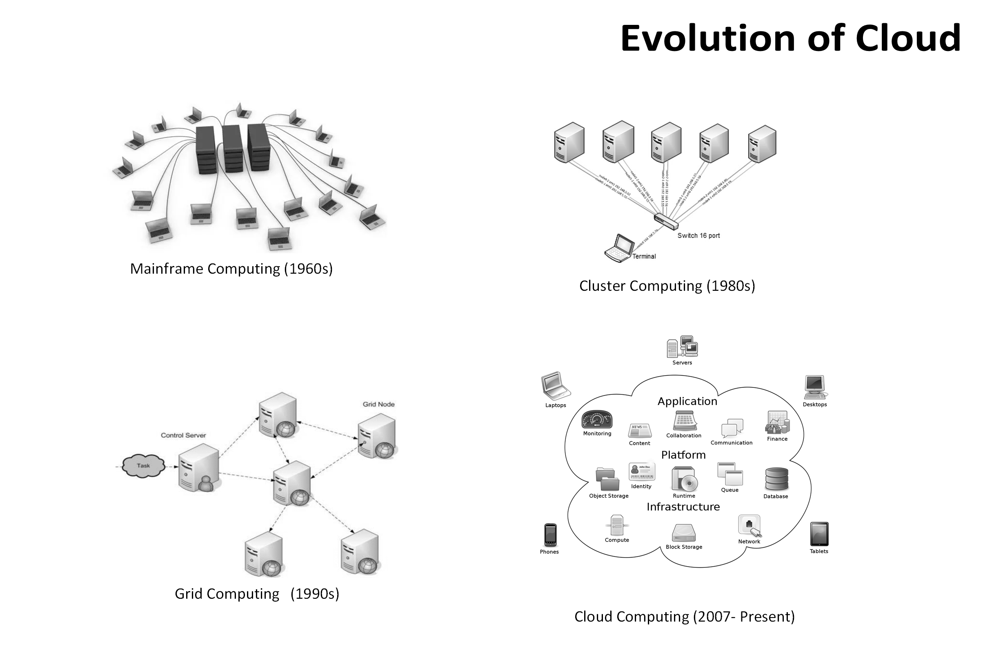

Figure 1-3. Evolution of Cloud Computing

Cluster Computing

Cluster computing, as shown on Figure 1-4, consists of tightly coupled computers (also known as Nodes) that work together to reach a single goal -to execute tasks. The components of cluster are connected with each other through a fast. When multiple computers are clustered they share the computation tasks like a distributed system.

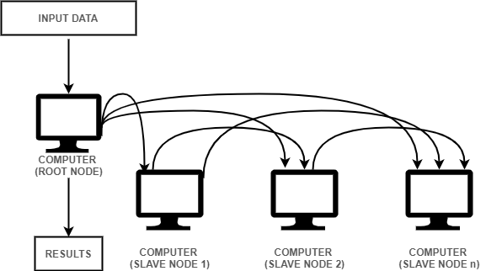

Figure 1-4. Example of Cluster Computing Architecture

There are several types of cluster computing which are commonly used for implementations of business requirements, optimization of performance, high availability clusters (HA Clusters), high performance clusters (HP clusters) and load balancing clusters.

Cost effectiveness, scalability, high-availability and speed processing are some of the benefits of using cluster computing. Cluster computing are implemented in different real-life use cases like the search engines and

[earthquake simulation and weather forecasting system.](https://citeseerx.ist.psu.edu/viewdoc/download?doi=10.1.1.329.5706&rep=rep1&type=pdf)

The earthquake simulation is interesting and useful because the earthquake dynamics is big and challenging in geophysics and computer modeling because of extreme non-linear nature. To learn more about these interesting earthquake simulation studies with the help of cluster computing, please

[read NaradaBrokering: A Distributed Middleware Framework and](https://www.researchgate.net/publication/221461234_NaradaBrokering_A_Distributed_Middleware_Framework_and_Architecture_for_Enabling_Durable_Peer-to-Peer_Grids)

[Architecture for Enabling Durable Peer-to-Peer Grids and Study Uses](https://www.researchgate.net/publication/221461234_NaradaBrokering_A_Distributed_Middleware_Framework_and_Architecture_for_Enabling_Durable_Peer-to-Peer_Grids)

[Supercomputers to Advance Dynamic Earthquake Rupture Models.](https://www.hpcwire.com/off-the-wire/study-uses-supercomputers-to-advance-dynamic-earthquake-rupture-models/)

Cluster computing are composed of multiple computer systems considered nodes. All these nodes are used altogether to execute tasks. This type of

[computing has expanded greatly in our modern days. Azure has high-](https://azure.microsoft.com/en-us/solutions/high-performance-computing/#intro)

[performance computing (HPC) which includes a great set of integration of](https://azure.microsoft.com/en-us/solutions/high-performance-computing/#intro) resources from storage, computing and networking with workload orchestration ideal for HPC systems.

Grid Computing

Grid computing is a subset of parallel and distributed computing in which clusters of computers and a loosely coupled computer performs a huge task. The computer resources can be geographically spread out in different locations or in several computing clusters that forms acts as the grid. The advantage of this is that data is processed quickly with speed because the

data are stored all computers in the the data grid, as shown on Figure 1-5.

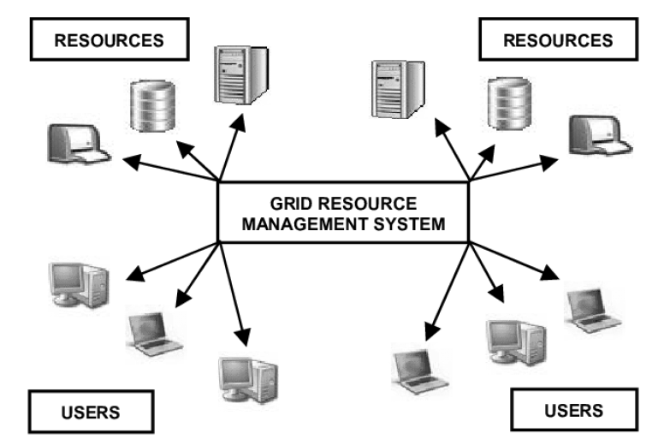

Figure 1-5. Grid Computing Example - A Grid Resource Management System The computer systems that are on the grid in the same network work together and serves as a virtual supercomputer. All systems in the grid contribute compute resources like storage capacity and processing power.

Cloud Computing

As is evident cloud computing has emerged as fifth-generation computing. The evolution of mainframe computing, grid computing and cluster computing created a big path of accelerated innovation that drove and enabled the cloud that we have today. The technology of cloud computing,

as shown on Figure 1-6, is widely used nowadays and we are continually exploring more of its capabilities in our modern digitalization.

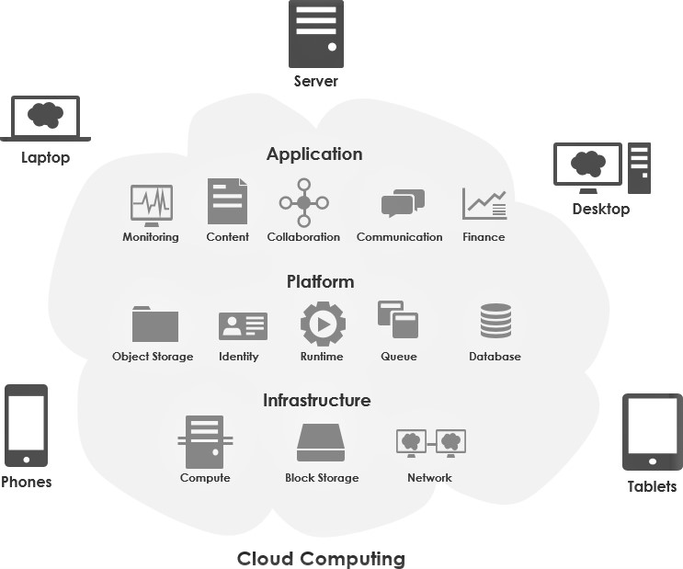

Figure 1-6. Cloud Computing Overview

Our Journey to use Modern Cloud

One of the most amazing and impactful innovation in our history are modernization and digitalization. When I was studying Computer Science in the 1990s, I had to a long stack of floppy disks to save data. Nowadays, we have enormous capacity to store data that is portable and is accessible anywhere. Portability of accessing data, getting the information we need and doing what we have to do through the Internet gives huge benefits and practicality.

We live in the era of modern cloud computing that delivers reliability, scalability, agility, cost savings, portability to our applications and resources globally.

Different of Types of Cloud Computing

Deployment Models

The different cloud computing deployment models give us a descriptive overview of cloud computing platform in its different categories and parts. It also helps in identifying the important facts like who has access to it, how it is hosted and what is implemented.

As shown in Figure 1-7, there are different types of cloud deployment models that are known - Public Cloud, Private Cloud , and Hybrid Cloud. There are also other deployment models such as Community Cloud and Multi-Clouds that have been trending and in demand these days. These deployment models works the same way by using the technology of virtualization of servers’s computing power into segmented applications with speed, reliability, scalability and storage capacities.

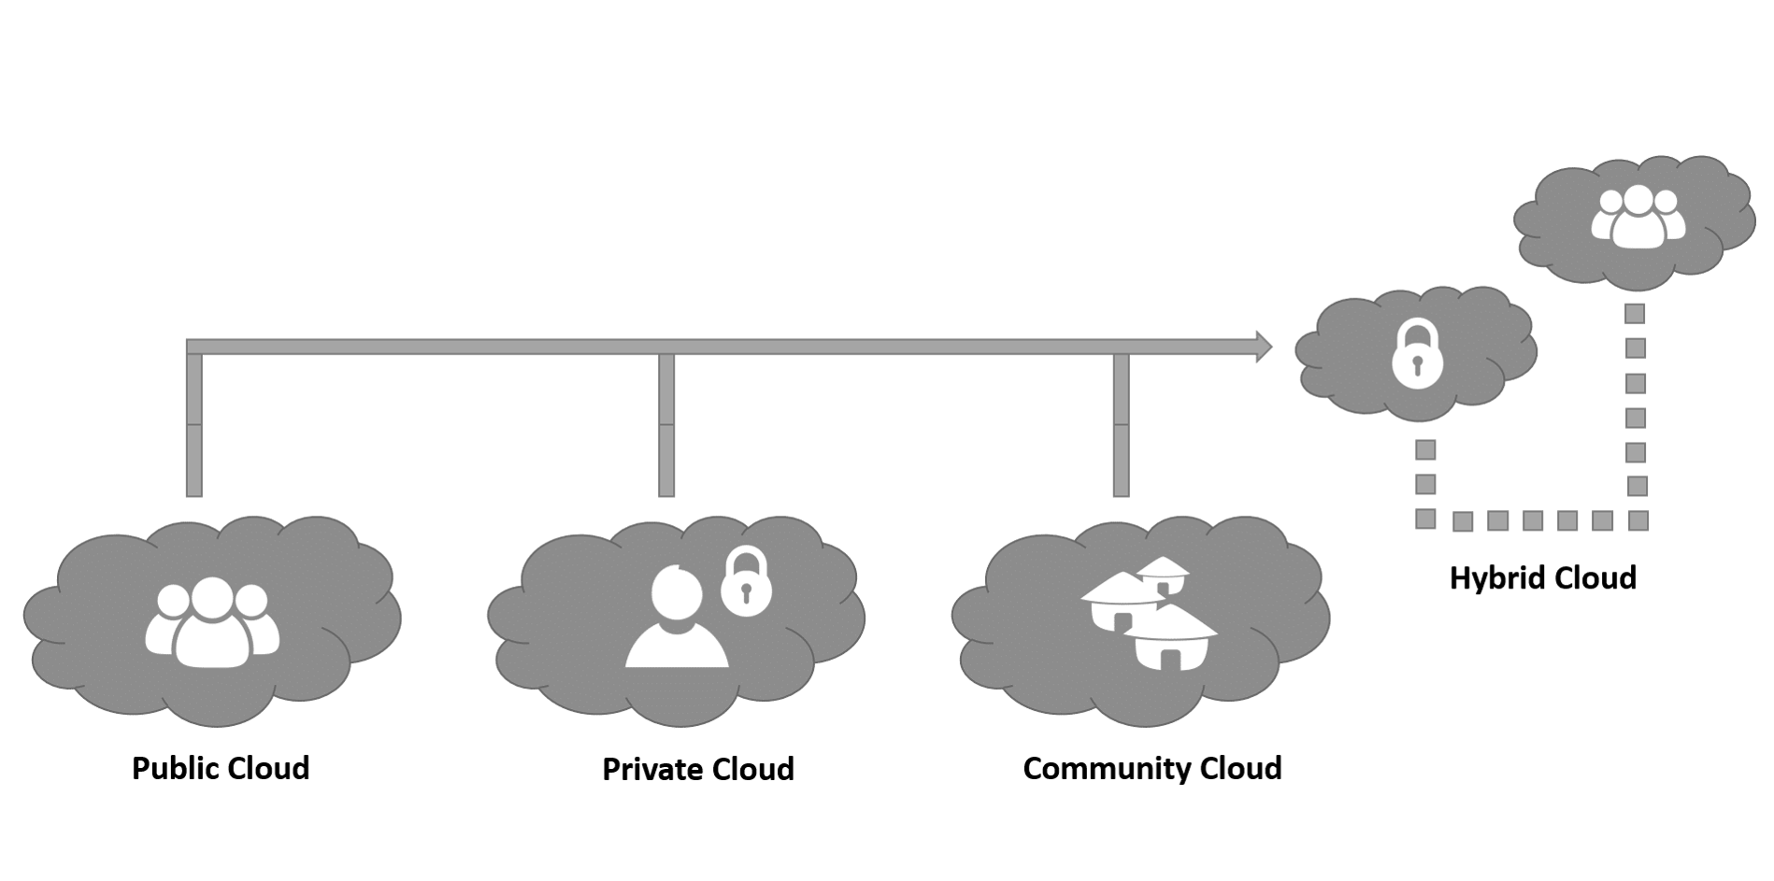

Figure 1-7. Different Types of Cloud Computing Models

Public Cloud

Public Cloud is a type of deployment model where the cloud infrastructure is available to the public or any organization using or selling cloud services. A public cloud platform is a service provided by cloud provider like Microsoft for Azure. The public cloud vendors provide cloud storage and computing resources (Operating Systems, CPU, Memory, Storage, Web Servers, Applications, or Databases) that are securely shared among its customers, with other organizations or other tenants of the cloud. Using public cloud are usually offered to its users for a subscription fee or Pay-Per-Use basis.

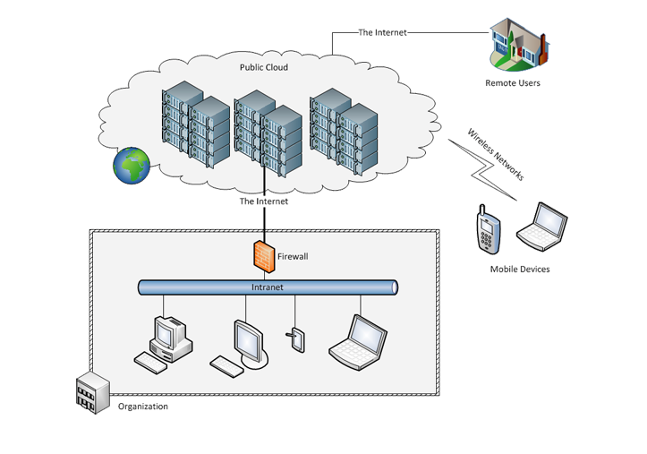

Figure 1-8. An example of several organizations using Public Cloud

There are many organizations globally that have adopted and evolved in using public cloud as their main platform for IT infrastructure and services,

as illustrated on Figure 1-8. In particular, organizations that have the business requirement of having the workloads of their applications in public cloud can make use of this type of cloud.

The Advantages of using Public Cloud

We are in the modern era of technology with rapid acceleration around improvement and innovation. Along with this continuous shift towards digitalization, organizations must focus on delivering quality products and solutions to their customers. Organizations also want to be competitive in the global market by going beyond the geographical barriers. They want to modernize their solutions and services by investing on large-scale cloud solutions.

Whether your business is currently focused on cost reduction, aiming for global scale, better administrative management, or want modern solutions with enhanced security, there are many great benefits to moving to the public cloud. A list of some of the services available by migrating to the cloud are as follows.

Cost Effectiveness and Cost Management

On-Demand Services and Portability

Scalability and Reliability

Sophisticated and modern solutions

Flexibility in administration through self-service cloud management portals

Monitoring, Analytics and Reports Visualization

Resource Pooling

Security and Privacy

Disaster Recovery and Geo-location

Private Cloud

Private cloud is a type of cloud infrastructure that is operated and owned by one organization - on premise or off premise. An organization that is utilizing private clouds make use of the cloud computing technology with considerations to privacy and the importance of security. This means that the access to the resources in the IT infrastructure within the organization is centralized. The organization’s administration of private cloud are defined by trust boundaries.

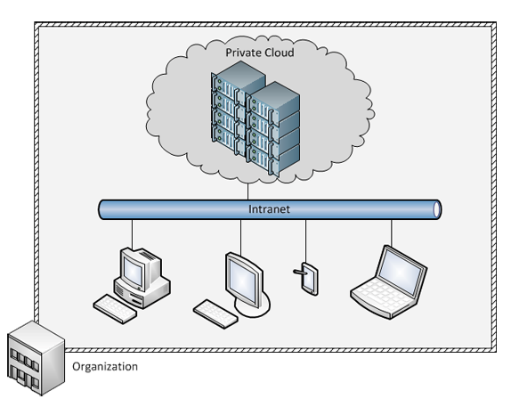

Figure 1-9. Private Cloud Example

In private clouds as shown in Figure 1-9, the infrastructure and its resources are managed on the organization’s private cloud on a virtual private network.

Organizations or institutions that have special requirements and IT policies that require enhanced security and control over the cloud infrastructure are commonly using private clouds. Financial institutions, government agencies, and organizations that require advanced security and strict privacy usually prefers this type of cloud.

The Advantages of using Private Cloud

Enhanced privacy and security since resources are not shared with others

Increased control over the infrastructure and owned resources

Compliance to business-critical security and regulatory compliance requirements

Flexibility to customize the environments based on the on-demand requirements of the organization or business

Community Cloud

Community Cloud is a hybrid form of private cloud. They are multi-tenant platforms that enable different organizations to work on a shared platform.

Community cloud is not often mentioned publicly but it is used widely and it exists. This type of cloud infrastructure is unique and special with its collaborative purpose. The infrastructure of the the community cloud supports and aims for a specific community with shared missions, compliance and security, jurisdictions, etc. Community cloud, as shown on

Figure 1-10 can be managed by a community or organization that can be managed or hosted internally or externally. In other words, it’s an on-premise of off-premise community-shared infrastructure.

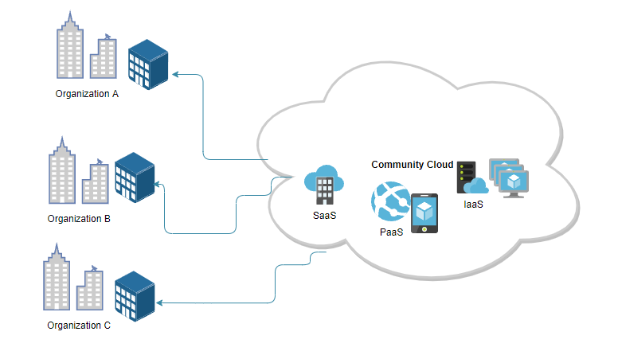

Figure 1-10. Community Cloud Example Illustration

Hybrid Cloud

Hybrid Cloud as its name describes it is a type of cloud infrastructure that is composed of multiple clouds, a combination of private, public or

community cloud as shown on Figure 1-11. In hybrid clouds unique entities are kept but are bound together by standardized technology which allows portability of application and data. For example load-balancing between clouds through cloud bursting.

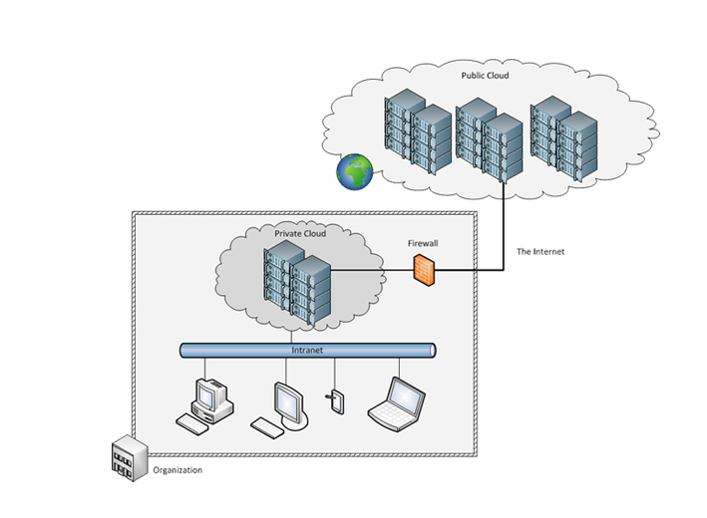

Figure 1-11. Hybrid Cloud Example

Cloud bursting is common in hybrid cloud, as shown on Figure 1-12. It is technique in application deployment in which an application is running in a on-premise data center or private cloud and bursts into a public cloud when the computing capacity demands arises. This technique on the cloud computing grants access to more computing resources when needed.

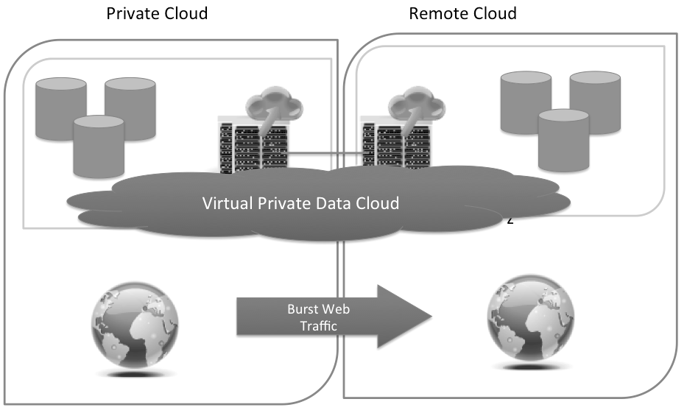

Figure 1-12. An illustration of Cloud Bursting in the Cloud

What is Multi-Cloud?

There are different cloud terms you hear these days. Aside from the hybrid cloud, there’s also a term called “Multi-cloud”.

Multicloud is one of the recent approaches in cloud engineering. As the word itself describes, it means implementing cloud solutions with several cloud providers. Multi-cloud infrastructure usually involves both public and private cloud providers. Because of its nature, multi-cloud infrastructures are confused as hybrid cloud environments.

For example, an enterprise organization invests in expanding a cloud infrastructure. They decided to move from on-premise physical servers to virtualization-based workloads; however, their existing infrastructure requires implementation of different workloads and services from different public cloud providers. The multi-cloud option would be ideal for such use case scenario.

There are some benefits of using multi-clouds. One of the huge advantages of multi-cloud strategy for organizations is preventing the risks of cloud vendor lock-ins and risk management. Risk management in cloud deployment in case one of the cloud providers fail, it is easier to switch to another provider.

Hybrid Cloud vs. MultiClouds

What’s the difference between multicloud and hybrid cloud?

While multi-cloud refers to the presence of more than 1 cloud deployment of the same type (public or private), sourced from different vendors, hybrid cloud refers to the presence of multiple deployment types (public or private) with some form of integration or orchestration between them.

A multicloud approach could involve two public cloud environments or two private cloud environments. A hybrid cloud approach could involve a public cloud environment and a private cloud environment with infrastructure facilitating workload portability.

These cloud approaches are mutually exclusive: You can’t have both, simultaneously because the clouds will either be interconnected (hybrid cloud), or not (multicloud). Having multiple cloud deployments, both public and private, is becoming more common across enterprises as they seek to improve security, reliability, scalability and performance through an expanded portfolio of environments.

Accordingly, it’s important to understand the differences between these types deployments so you are aware of the benefits and limitations.

Public Cloud Computing Providers

This book is about learning Microsoft Azure, however, since we are learning about cloud computing and multi-cloud in this chapter, it is important to learn what are the other public cloud providers in the market too.

Migration on-premise applications or systems to the cloud is not an easy process. It requires serious planning, strategy and preparation.

It is difficult to say that one cloud provider is better than the other. However, choosing the appropriate cloud provider for your organization and your teams really depends on the type of IT infrastructure you currently have, what business problems you need to solve, and your organization’s business motivations. Every cloud solution and implementation should be aligned with the purpose and goal of a business.

Microsoft Azure

Microsoft Azure is one of the fastest-growing cloud provider platform

offered by [Microsoft. Even though Azure started years after its competitors](https://www.microsoft.com/) but it is one of the leading cloud computing providers globally.

Azure offers a wide variety of cloud services in different categories including Artificial Intelligence, Machine Learning, Analytics, Blockchain, Compute, Containers, Serverless Computing, Databases, Developer Tools, DevOps, Identity Management, Integration, Internet of Things (IoT), Management, Media, Microsoft Azure Stack, Migration, Mixed Reality, Mobile, Networking, Security, Storage, Web, and Windows Virtual Desktop.

What makes Azure one of the most attractive and intelligent solutions is its exclusive offering of Microsoft’s products and integration of services in the cloud. Azure provides the most advanced and maximum number of intelligent products and services.

Amazon (AWS)

AWS (Amazon Web Services) is the cloud platform of Amazon which offers a variety of services. Some of these cloud services on AWS include Virtual Private Cloud, EC2, AWS Data Transfer, Simple Storage Service, DynamoDB, Elastic Compute Cloud, AWS Key Management Service, AmazonCloudWatch, Simple Notification Service, Relational Database Service, Route 53, Simple Queue Service, CloudTrail, and Simple Email Service.

AWS is one of the top comprehensive and broadly adopted cloud platforms. This cloud platform is offering over 200 fully featured services from data centers globally. Millions of customers—including the fastest-growing startups, largest enterprises, and leading government agencies—are using AWS to lower costs, become more agile, and innovate faster.

Google Cloud Platform

Google Cloud Platform (GCP) is Google’s cloud and is also one of the top public cloud providers available. Similar to AWS and Microsoft Azure, GCP also offers similar services in various categories, including compute, storage, identity, security, database, AI and machine learning, virtualization, DevOps and more. Google Cloud Services are available in 20 regions, 61 zones, and 200+ countries.

GCP is a platform that delivers a wide variation of IT products that IT professionals, businesses and software developers can take advantage of to work more efficiently and gain more flexibility.

Oracle Cloud

Oracle cloud platform is the cloud offering of Oracle corporation. Oracle cloud offers IaaS, PaaS, SaaS, and Data as a Service (DaaS). Oracle SaaS offerings are CX, HCM, ERP, SCM, EPM, IoT, Analytics, Data, and Blockchain Applications. Oracle DaaS is the Oracle Data Cloud.

Alibaba Cloud

Alibaba Cloud, founded in 2009, is not often heard in some parts of the world but is also a big public cloud provider. Alibaba Cloud is the largest cloud provider in China. Alibaba is registered and headquartered in Singapore and it was initially built to serve Alibaba’s own e-commerce ecosystem. Nowadays, they also offer public cloud services.

Alibaba offers various products and services in various categories, including Elastic Computing, Storage and CDN, Networking, Database Services, Security, Monitoring and Management, Domains and Websites, Analytics and Data Technology, Application Services, Media Services, Middleware, Cloud Communication, Apsara Stack, and Internet of Things.

There are more cloud computing vendors that are coming but the ones that I mentioned are widely recognized as top providers.

Cloud Computing Service Models

There are different cloud service models in the cloud. These are the Infrastructure as a Service (IaaS), Platform as a Service (PaaS), Software as a Service (SaaS), as shown on Figure 1-13.

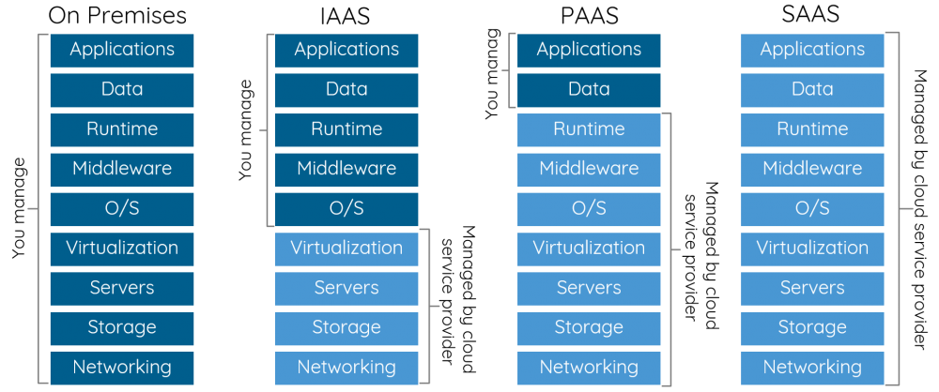

Figure 1-13. The Different Cloud Computing Models showing the different scope of what are

managed by the cloud provider and what is managed by the cloud user or organization

Infrastructure as a Services (IaaS)

Infrastructure as a Service (IaaS) is a type of computing model where cloud provider like Microsoft Azure provides infrastructure as a service. Unlike the traditional infrastructure on-premises in one physical location, they are instead provided by the public cloud vendors. Infrastructure like web servers, database servers, storage, networking and computing hardware are available to its uses on-demand. IaaS in the cloud allows its users to not worry about maintenance costs of having infrastructure on-promises. The cloud provider takes care of the maintenance, monitoring, security and loading balance.

Platform as a Services (PaaS)

PaaS is a cloud service where the third-party vendor provides the hardware and software components to users to build application supporting platforms that they need to run on the cloud. PaaS users don’t need to replace their entire IT infrastructure, rather just use the vendor’s hosted infrastructure services over a web browser.

Software as a Services (SaaS)

SaaS is a software on-demand cloud model, where the cloud service providers give the users access to a fully developed application created specifically for distribution. The software updates are rolled out for all users uniformly and organizations can use their own tools with the vendor provided application programming interfaces (APIs).

If we were to compare these main tree the cloud computing service models in the real world, we can look one of our favorite foods, pizza.

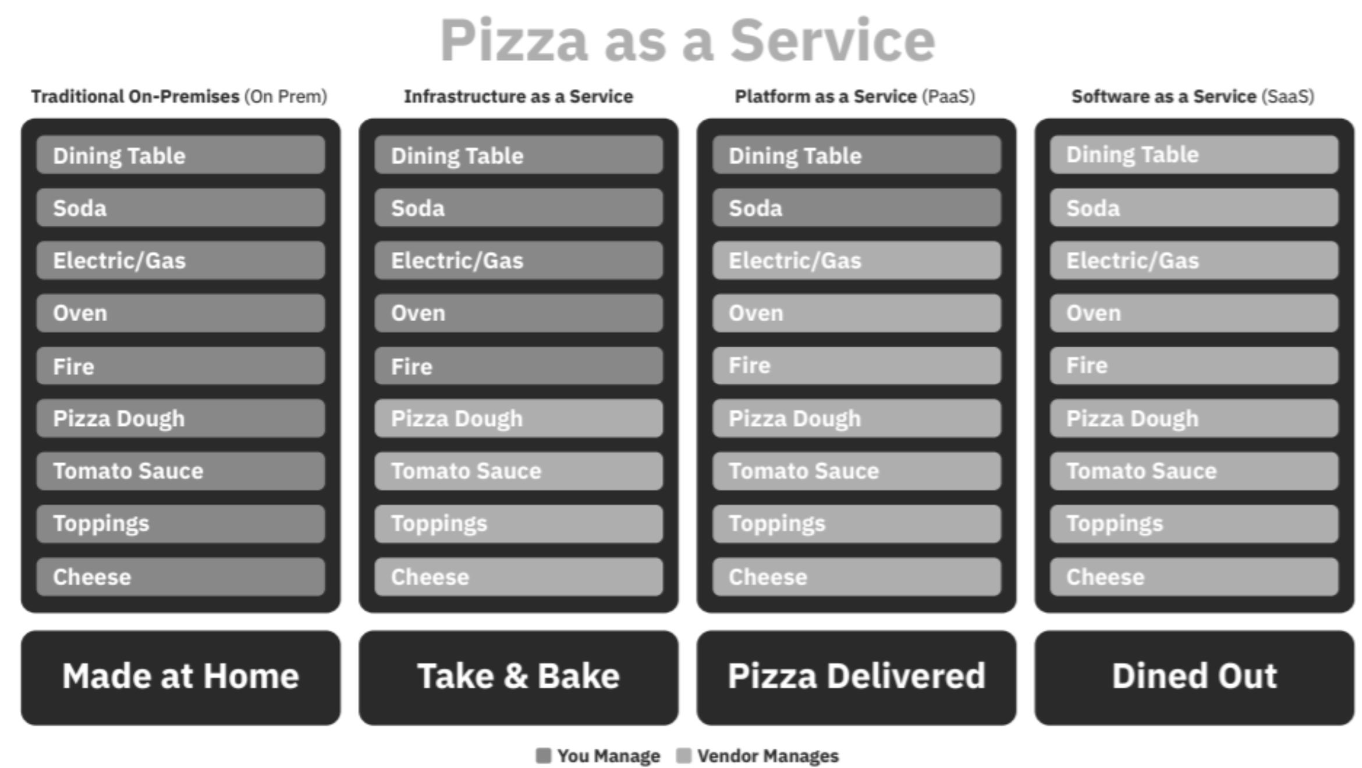

Figure 1-14. An example of cloud computing as Pizza as a Service illustration

In the Pizza example on Figure 1-14, we can find similarity of baking our own pizza as having our tradition on-premises IT infrastructure. Shopping a ready-pizza from the store and bake it at home is like Infrastructure as a Service (IaaS). Pizza delivery is like Platform as a Service (PaaS) and dining out at a restaurant to order pizza is like the Software as a Service (SaaS) offered by the cloud provider.

Aside from IaaS, PaaS, and SaaS, there are other cloud computing service models are available. These other service models are Serverless, Function as a Service (FaaS), Backend as a Service (BaaS), and more. It will not be a surprise that someday there will anything X as a Service available for us.

Serverless Computing - Function as a Service and Backend as a Service

Recently, Serverless, FaaS and BaaS are some of the terms that gained its popularity and interests in the cloud computing field.

Serverless is a method of computing where backend services are provided a cloud service by a cloud service provider. Technically, it is not really server-less but “less” in this term means the servers and underlying infrastructure are abstracted. There are actually servers behind a serverless function or serverless cloud service, only that the cloud provider or serverless provider is taking it of it for its users. Cloud services on serverless usually have consumption type of pricing models where the users are only charged on the usage and execution.

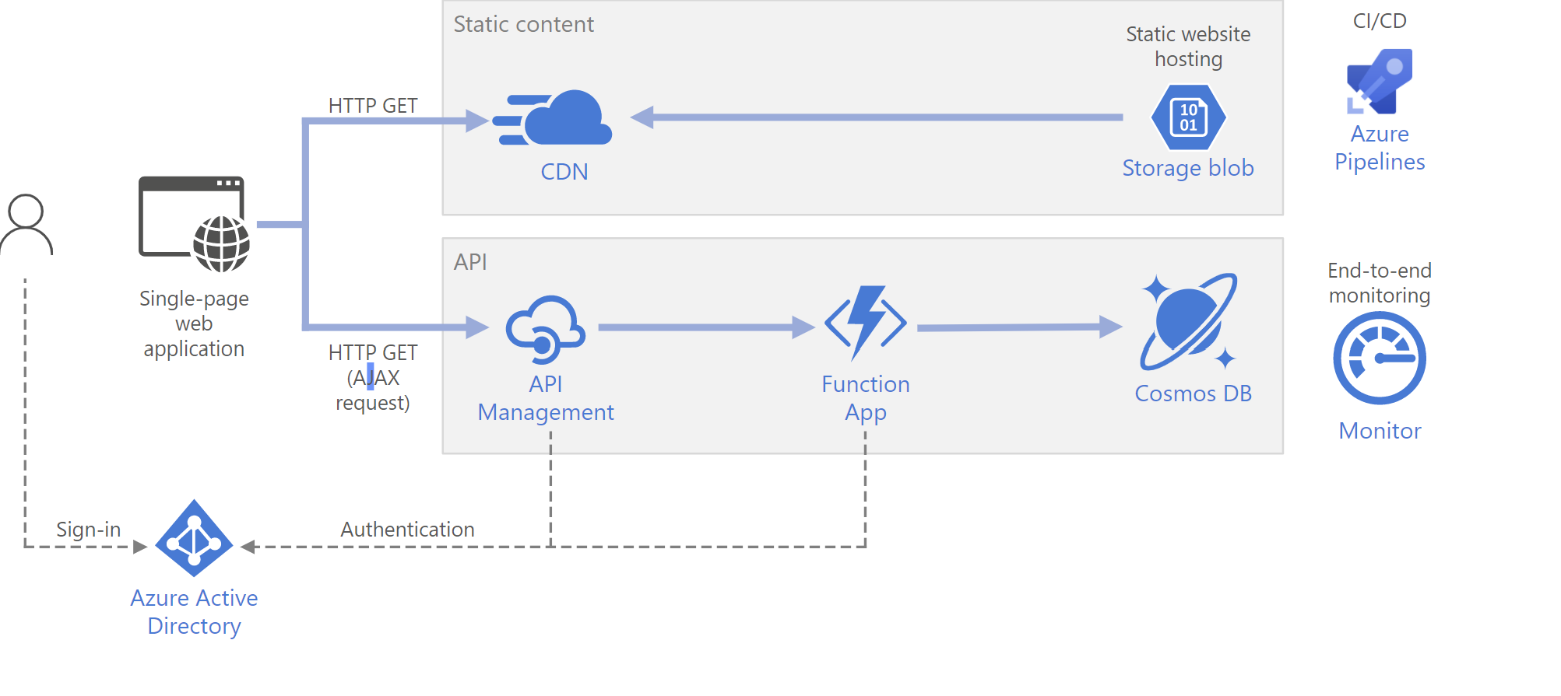

Figure 1-15. [Example of a Serverless Architecture in Microsoft Azure, Image Source: Microsoft](https://docs.microsoft.com/en-us/)

[Documentation](https://docs.microsoft.com/en-us/) Function as a Service is a relatively newer concept that aims to offer developers the freedom to create software functions in a cloud environment

easily, as shown on a serverless architecture example on Figure 1-15. In this method, the developers will still create the application logic, yet the code is executed in stateless compute instances that are managed by the cloud provider. FaaS provides an event-driven computing architecture where functions are triggered by a specific event such as message queues, HTTP requests, etc. Some of the FaaS options available through leading cloud providers include:

In Microsoft Azure, there are different serverless solutions available. There are Azure serverless compute, serverless containers in Kubernetes and serverless application environments.

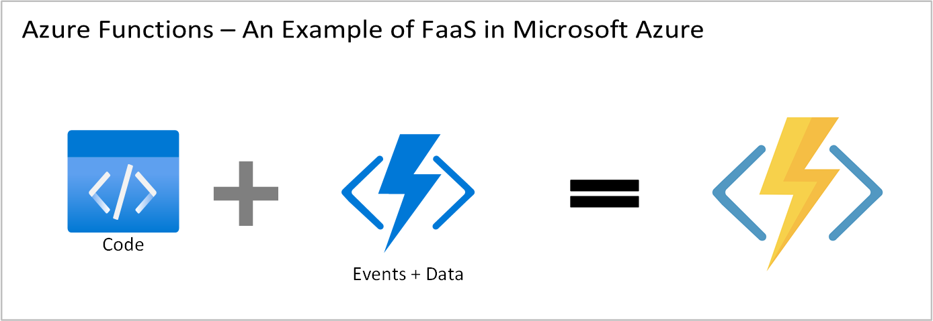

Figure 1-16. Microsoft Azure Functions as Function as a Service (FaaS)

Microsoft Azure compute services like Azure Functions, as shown on Figure 1-16, allow its users to build applications faster by eliminating the hassles of managing servers and infrastructure. It enables software developers or programmers to focus on the productivity of your development teams and only pay when the code runs. Developers can focus on developing event-driven applications using the supported language of their choice.

Implementing serverless and FaaS solutions have several benefits, especially to the software development team. In the world of software engineering, we, developers, want to focus on delivering solutions, solving problems and build applications. Developers and engineers do not want to spend time maintaining the servers and infrastructures. With Serverless, FaaS or Backend as a Service (BaaS), software developers or cloud engineers can focus more on being productive. Which means speed of delivery helping the project process. Aside from developer benefits, the opportunity of solving problems with complex applications can be solved. Organizations can also benefit on the speed of delivery and productivity. Other benefits also includes automatic scaling, reliability, consumption-based pricing model,

Serverless architecture is one of the key software architecture design patterns. Developers need not worry about infrastructure i.e. the server software and the hardware.

The developer writes the code and leverages the infrastructure of cloud provider services and other third-party services which is primarily called BaaS (Backend as a Service). BaaS is a cloud service that takes care of the cloud infrastructure and primarily focuses on the automation of backend side development.

In Chapter 3, serverless solutions in Azure will be covered in details.

Containers as a Service

When container development is discussed, great features of it comes up. Containers as a Service (CaaS) or development with containers is an interesting solution. By utilizing containers, you get Platform as a Service (PaaS) benefits without the overhead of Infrastructure as a Service (IaaS).

Containerization in simple terms is deploying your applications into container. A container is a runtime that contains the basic compute resources needed to run an application. The core part of the host operating system (also known as Kernel) and its shared resources like storage across a host. The shared kernel allows containers to be lightweight and faster. When hosts running, the containers in it can be quickly started. Quick starts means high availability and resiliency of the applications in the container. One example of Container as a Service offering is Docker, which is one of the more popular providers of container services.

Container solutions have different advantages.

Containers can run in cross-platform environments

Containers are lightweight and portable

Containers are self-contained and no need to install dependencies

Containers have good scalability and high availability

Containers are quick to restart

Containers and other compute services in Azure will be covered in the Chapter 3 of this book.

Data as a Service(DaaS)

Every website, application, system, mobile app and anything involving tech products we use have data in it. Sensitive data are being protected through data protection policies because data in this modern era is a treasured gem. This is the reason why like the other service models, data is also

Data as a Service (DaaS) focuses on providing data as a business asset by implementing data management strategies. By using this cloud service

model organizations get better agility in their business. As listed on Table 1-

1, DaaS provides organizations modern, effective and smart strategies on how to handle, manage and visualize huge and massive data that is generated everyday.

T

a

b

l

e

1

-

1

.

B

e

n

e

f

## i

t

s

o

f

D

a

t

a

a

s

a

S

e

r

## v

## i

c

e

(

D

a

a

S

)

a

s

a

C

l

o

u

d

S

e

r

## v

## i

c

e

M

o

d

e

l

Benefit How?

Data-Driven DaaS enable organizations organize and manage their increasing data by using

Culture the datasets that are reusable, easier to analyze and visualize

Innovation and DaaS put data as a vital key driver in the business which open opportunities to

Business Growth growth and innovation. Data-driven strategies drives innovation and growth

without creating huge risks

Scalability, Cloud solutions usually offer DaaS solutions that are flexible and scalable

Reliability and

Flexibility

Data Monetization Solving data operation problems and complexity can be also beneficial in

monetization of the useful data available

Cost Savings DaaS solutions can help organizations save cost of expenses by allocating the

appropriate workloads for their data in the cloud.

Maintenance Tasks DaaS providers have platform and tools that automate maintenance tasks Automation which helps the end users to self-manage their DaaS services on demand

The Challenges of Data as a Service (DaaS)

Although Data as Service (DaaS) offers great benefits to an organization, it has some known challenges.

Risks of solving data complexity problems especially for old and unstructured data sets

Implementing a data-driven culture with DaaS require an top-down organizational and business strategy

Higher demand for management of data privacy and security because of the different data privacy regulations and compliances

Shared Responsibility in Cloud Computing

Considering and evaluating cloud services on any public cloud providers require careful planning and strategy for an organization. It is critical to learn and understand the shared responsibility model. The shared responsibility model helps both parties (the user and cloud vendor) share the trust and responsibility of hosting applications and resources to the cloud.

The shared responsibility model illustrates shared trust and responsibility that helps in cloud security and protection of resources. For example, it helps identify which security tasks are handled by the cloud provider and which tasks are handled by the public cloud user. The shared responsibility for the workload vary depending on whether the workload is hosted on Software as a Service (SaaS), Platform as a Service (PaaS), Infrastructure as a Service (IaaS), or in an on-premises data center.

With Microsoft’s example of Cloud Enabled Shared Responsibility Model for all cloud deployment types, you own your data and identities. As public cloud user (private individual or organization) is responsible for protecting the security of the data and identities, on-premises resources, and the cloud components that the user control. What cloud services or components they are depends on the type of service model chosen within the cloud vendor.

Regardless of the type of deployment, the following responsibilities are always retained by you: data, endpoints, accounts, identities, and access management

Shared Responsibility Model offers Cloud Security Advantages

The cloud offers significant advantages for solving long standing information security challenges. In an on-premises environment, organizations likely have unmet responsibilities and limited resources available to invest in security, which creates an environment where attackers are able to exploit vulnerabilities at all layers.

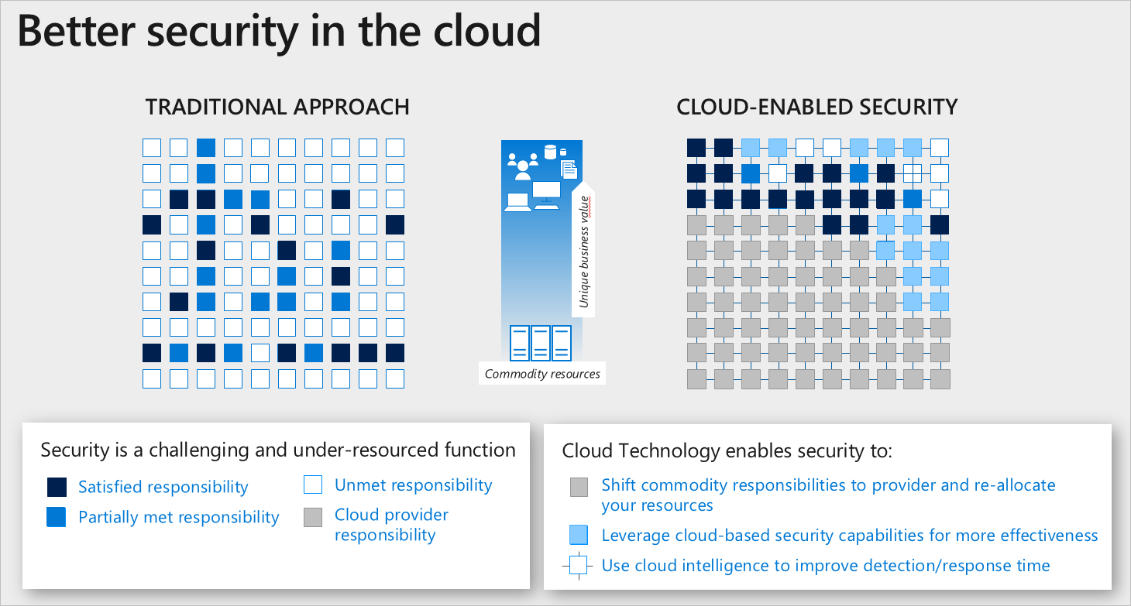

Figure 1-17. Example of Microsoft’s Cloud Enabled Shared Responsibility Model (Image Credit:

[Microsoft Documentation)](https://docs.microsoft.com/en-us/)

As shown on Figure 1-17, a traditional approach where many security responsibilities are unmet due to limited resources. In the cloud-enabled approach, you are able to shift day to day security responsibilities to your cloud provider and reallocate your resources.

Capital Expeditures and Operational

Expeditures

It is not possible for an organization to just migrate on-premises resources to the cloud without knowing about benefits of it for Capital Expeditures (CapEx) and Operational Expeditures (OpEx). It is vital to identify the benefits of the comparison of these two when considering cloud computing solutions for businesses or organizations.

Capital Expenditure (CapEx)

CapEx is defined as business expenses incurred in order to create long-term benefits in the future, such as purchasing fixed assets like a building or equipment. Some examples of IT items that fall under this category would be whole systems and servers, printers and scanners, or air conditioners and generators. You buy these items once and they benefit your business for many, many years. Maintenance of such items is also considered CapEx, as it extends their lifetime and usefulness.

Operational Expenditure (OpEx)

OpEx is your operating costs, the expenses to run day-to-day business, like services and consumable items that get used up and are paid for according to use. This includes printer cartridges and paper, electricity, and even yearly services like website hosting or domain registrations. These things are necessary for your business’s success but are not considered major long-term investments like CapEx items.

Typically, organizations started with traditional on-premises physical servers and data centers that requires expensive CapEx. Expenses for data center physical space, hardwares, equipments and employees to manage the everything in place - security, maintenance, etc. can be very costly.

Cloud computing solutions offer organization the option to eliminate the hassles of traditional infrastructure on-premise by providing services with OpEx alternatives.

Benefits of Adopting and Transformation to

Modern Cloud Technologies

Cloud adaptation and transformation is a complex and long process. It is not a quick-fix solution to modernize on-promise and legacy applications quickly to the cloud. However, when properly planned with smart strategies, there are a great list of benefits of it.

Cloud Computing for Businesses

How does an organization or business benefit from cloud computing? Regardless of the size of the business or organization, cloud computing helps in saving resources, time, and finances by accelerating innovation, collaboration, modernization and productivity in different teams within the organization.

Cloud Computing for IT Companies

IT Companies and organizations gain many benefits in using cloud compute solutions as the following.

Data Access Management and Portability

Cloud Computing enables businesses to access their important business-related data portably - anywhere on any device. This capability allows the entire organization to work effective and productively by focusing on deliverables. The technology of cloud storage and servers on the cloud, employees in the organization do not need to be at the office intranet to work and collaborate. Instead, information is available securely at anytime on-demand.

Cost management and efficiency

Buying and maintaining server equipment requires time, expertise and money. Rather than building your own bespoke server, which can be prone to downtime, a cloud computing provider stores data for you without all the downsides. Prices for business-oriented cloud services are still a monthly expense, but it’s a manageable and predictable expense in many aspects.

Convenient Data Backup Management

Catastrophic data loss can happen at any time. Whether that loss occurs from natural disasters, power surges, or hardware failure, affected companies are at increased risk of bankruptcy within the same year as the data loss. And while most companies have adopted backup plans, it helps to have additional contingencies in place. By utilizing the cloud to store important data, business owners can rest easy knowing that important files are safe even if hardware fails.

High-Level Cloud Security and Data Privacy

Security and privacy is vital and critical part of decision-making process when it comes to using cloud computing services. The public cloud

computing provider and the user or organization have shared responsibility. Hosting applications and servers on the cloud are built on trust. This is the reason setting clear expectations and being familiar with the shared responsibility model. Cloud providers take high priority on security and data privacy for their clients and consumers. They use different and strategical ways of cloud security controls to protect the resources of their users. Identity management, high-level physical security on data centers, strict personal security, and ensuring data privacy for sensitive data are taking seriously. There are dedicated security expert teams who work on scanning the cloud for possible vulnerabilities internally and externally. Performing cloud penetration testing and scanning inside and outside the cloud must be strictly authorize. Cloud providers do not tolerate any security breaches. Termination of services in case of violation of security and use policies are implemented. It may not be noticeable to many but Cloud computing is advancing our society around the world. It is also impacting our lives - daily routines, work, home, school in so many ways. It has improved our facilities for healthcare, education, communities and it is continually changing for our digitalization world wide.

Digitalization and Modernization

Digitalization and modernizations of many computer systems in different sectors were made possible because of the advancement of our technologies hosted on the cloud over the internet. Institution in different sectors like healthcare, governments, community, schools and organizations are using cloud to modernize their services and products. The ability to make things easier through technology is an advantage.

Remote and Flexible Education and Digital Literacy

Aside from digitalization and modernization in different sectors in our society that benefits us widely, cloud computing also helped widely in getting better education worldwide. Cloud computing with the power of Internet not just only enable us to work from home or anywhere, but it

also activates the capability and power of online collaborative and self-

paced modern learning environments . Remote locations with internet 1 access facilities give opportunity for literacy through online education.

Summary

In this chapter, you have learned about the fundamentals of cloud computing, its different types and its deployment models that gives you an understanding what cloud really is. You also have learned about the history and evolution of cloud computing that helped shape the modern cloud that helps our society today. You saw an overview of the different types of clouds like public, private, hybrid, community and multi-cloud - and know the differences between them. The different types deployment models such IaaS, PaaS, SaaS, CaaS, DaaS, FaaS, and Serverless which is useful for you when choosing the right cloud service to use in a cloud platform.

In this chapter, you got insights and learned about the advantages and the benefits of cloud computing in businesses, IT companies, our society worldwide, and also in the field of software engineering.

In the next chapter, we will dive into learning more about the important concepts you need to know about Microsoft Azure as a cloud platform. We will learn what cloud solutions Azure has to offer to help you and your organization.

KEY POINTS FROM THIS CHAPTER

Cloud computing is the delivery of different services (eg. servers, data storage, databases, networking, applications, networking)through the Internet Cloud-based services make it possible and easier for us users to access data, storage, applications anywhere virtually on demand

Virtualization and Cloud Computing are not really the same. Virtualization is a technology while cloud is an environment over the internet to perform cloud computing

Different Cloud Deployment models include Infrastructure as a Service (IaaS), Platform as a Service (PaaS), Software as a Service (SaaS), Function as a Service (FaaS), Data as a Service (DaaS), Containers as a Service (CaaS) Shared Responsibility Model in cloud computing is vital to understand especially for cloud security and cloud management. The responsibilities for the workloads depend on the type of cloud and deployment model is implemented

Cloud computing helps business in any form or sizes operate more effectively by improving their productivity, cost-efficiency and remote collaboration

Check Your Knowledge

1. What is cloud computing?

2. What is the difference between private cloud and public cloud?

3. Why is it important to understand the shared responsibility model

in the cloud?

4. What is the different between hybrid cloud and multi-cloud?

5. What is CapEx and OpEx?

Answers

To find the answers to the Check Your Knowledge, turn to back of the book in Appendix A Answers section view answers for Chapter 1.

1 The Computer Society, “Cloud Technologies in the Education System"by James Riddle,

[https://www.computer.org/publications/tech-news/build-your-career/cloud-technologies-in-the-](https://www.computer.org/publications/tech-news/build-your-career/cloud-technologies-in-the-education-system)

[education-system](https://www.computer.org/publications/tech-news/build-your-career/cloud-technologies-in-the-education-system)

Chapter 2. Microsoft Azure

Fundamentals

A NOTE FOR EARLY RELEASE READERS

With Early Release ebooks, you get books in their earliest form—the author’s raw and unedited content as they write—so you can take advantage of these technologies long before the official release of these titles.

This will be the 2nd chapter of the final book. Please note that the GitHub repo will be made active later on.

If you have comments about how we might improve the content and/or examples in this book, or if you notice missing material within this

chapter, please reach out to the editor at jleonard@oreilly.comL.

We’re building everything that we are doing across Azure with openness. There is Windows and Linux as first-class. Java and .NET is [sic] first-class. SQL Server 2016 and Postgres are first-class. Red Hat, VMware, Oracle, all of these applications and infrastructure can be first-class on Azure.

—- Satya Nadella, CEO, Microsoft, Microsoft Inspire

2019

Previously, we learned about the important concepts you need to know

about Cloud Computing, which is a great technology that allow us to share cloud computing resources on a Pay-As-You-Go model in a global scale with flexibility and security.

In this chapter, you will enhance what you learned about cloud computing by digging deeper into the world of Microsoft’s greatest cloud computing platform, Azure. You will learn about the core concepts of what Azure is as a cloud provider. How Azure start, what is its purpose and how it can technically and can inspire you be innovate as you build smart, innovative and great technology solutions for your organization’s demands and requirements.

You will learn about Azure Geographies, Regions and Availability Zones which gives you an overview of Azure’s cloud infrastructure. Also, you learn more about of resource management using Azure Resource Manager.

This chapter will give you a comprehensive overview of the core services in Azure. Each of those core Azure services will be explained in detail with its uses and examples in the upcoming chapters of this book.

NOTE

Public cloud is a type of deployment model where the cloud infrastructure is available to the public or any organization and the resources are shared with other organizations or other cloud provider tenants.

Microsoft Azure as a Public Cloud Provider

Microsoft’[s computing platform is called Microsoft Azure](https://azure.microsoft.com/), also known as Azure. The term Azure means sky blue color. Although, there is no documentation about why Microsoft named their cloud platform Azure; however, it is obvious that the name relates to the cloud.

NOTE

Windows Azure became Microsoft’s foundation of cloud and was commercially available to the public. Windows Azure became Microsoft’s great and powerful cloud platform. In 2014, it was renamed to Microsoft Azure. Originally, Azure was a project called Project Red Dog.

Azure’s flexibility of being able to create, build, deploy, and manage organizations’ applications on a global scale made it one of the top cloud providers worldwide. Microsoft Azure, grew to become a public cloud

[provider used by 95% of Fortune 500 companies.](https://www.extremetech.com/deals/307468-microsoft-azure-is-used-by-95-percent-of-fortune-500-companies-learn-to-use-their-cloud-services-now)

Microsoft Azure Helps Organizations with Minimize Upfront Costs

Public cloud has its features that are useful to many. These features include not requiring upfront costs for Capital Expenditures (CapEx) to scale up resources, quick provisioning and de-provisioning of applications and flexibility for organizations to only pay for what they use.

Azure is a public cloud provider but they also offer private, hybrid and multicloud solutions to its users. Cloud services in Azure are designed to help its users build new and innovative cloud solutions that help solve our challenges in different areas.

It allows us to build, develop, manage, and run resources like servers, databases, storages or applications in multiple cloud environments. You can use it for different use-case scenarios in the cloud using the tools, programming languages and frameworks that you prefer to use.

Microsoft Azure has more than 200 services and products for its users. These cloud services are available in different cloud service deployment models like Infrastructure as a Service (IaaS), Platform as a Service (PaaS), Software as a Service (SaaS), Serverless, Function as Service (Faas), Containers, and more. Azure also provide edge computing, AI and Machine Learning (ML) services that enables you to create smart and intelligent solutions with your existing or new applications. Without the technology of cloud computing this would not be possible.

Benefits of a Cloud Provider

There are several benefits that a cloud provider has over the traditional on-premise physical environment, as shown on Table 2-1.

T

a

b

l

e

2

-

1

.

T

h

e

l

## i

s

t

o

f

k

n

o

w

n

b

e

n

e

f

## i

t

s

Benefit Description

High availability Microsoft Azure provides high availability and redundancy across all of its

worldwide data centers offering a service-level agreement that ensures 99.95% availability

Geo-distribution Azure helps in the global enterprises by providing geo-distribution features.

Geography-specific endpoints enables international enterprises comply to the regional compliance and regulations

Scalability On- When demand for complexity, traffic and data expands, there should be a

demand flexible and quick way to handle such need

Reliability The system or application hosted should function correctly even in the face of

adversity (hardware or software faults, and even human error)

Elasticity A capability to automatically scale cloud resources based on configuration or

demand

Disaster recovery When your applications, data and systems are hosted in Azure, you can be

assured of secured end-to-end backup and disaster recovery solution

Flexibility Cloud services in Azure gives organizations flexibility by allowing them to

use consumption pricing plans and full self-service management accessible anywhere

Cost Management There are tools available for cost management in Azure and users can also set

Tools budget alerts for their resource groups and resources

Advanced Azure takes information security and compliance seriously with high Compliance standards to serve best its users

High Level Cloud Azure protect all stored data with world-class and advance security. Data

Security stored in Azure are protected with advanced encryption technologies. All data

centers of Microsoft are equipped with extreme security with biometric scanners, multi-level authentication and more

OpEx vs. CapEx Hosting to cloud means an organization can save money from Capital

Expenditures (CapEx) and only pay for Operational Expenditures (OpEx)

Consumption-based Azure gives its users the flexibility of cost management by offering pricing model consumption-based (Pay-As-You-Go) pricing model in most of its cloud

services.

No deep technical You and your organization do not need to be very skilled technically to get

skills required started using the cloud platform. Azure provide a flexible and diverse options

to give ease of use for its users

Azure Portal

The self-managed portal of Microsoft’s cloud platform is called Azure Portal, which can be accessed by Azure users on their web browsers or via the Azure Mobile App.

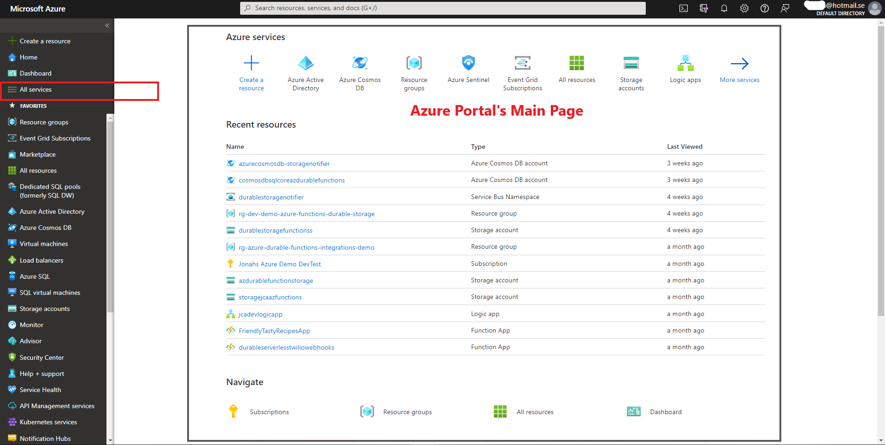

Figure 2-1. Example homepage of Azure Portal accessed on a web browser

TIP

Access Microsoft Azure Portal using Azure Mobile App. If you don’t have it,

you may download it using the instructions on the link [Get Azure Mobile App](https://azure.microsoft.com/en-us/get-started/azure-portal/mobile-app/)

<https://azure.microsoft.com/en-us/get-started/azure-portal/mobile-app/> Access Microsoft Azure Portal using your favorite web browser using the link

<https://portal.azure.com/>

Azure Portal is a web-based administration website for all types of Azure users. It is where you can manage your Azure cloud services for your organization. It is a powerful portal of cloud administration tools and resources you need. For example, in Azure Portal, you can manage your resource groups, resources in it, Azure subscriptions, security, monitoring and more, as shown on Figure 2-1. It has all the services available that you can use for your cloud computing solutions.

It is built to be resilient, portable and accessible from anywhere in the world as long as you have an Internet connection. Figure 2-2 shows the user interface of the Azure Mobile App which you can use to manage your Azure subscriptions and services on the go.

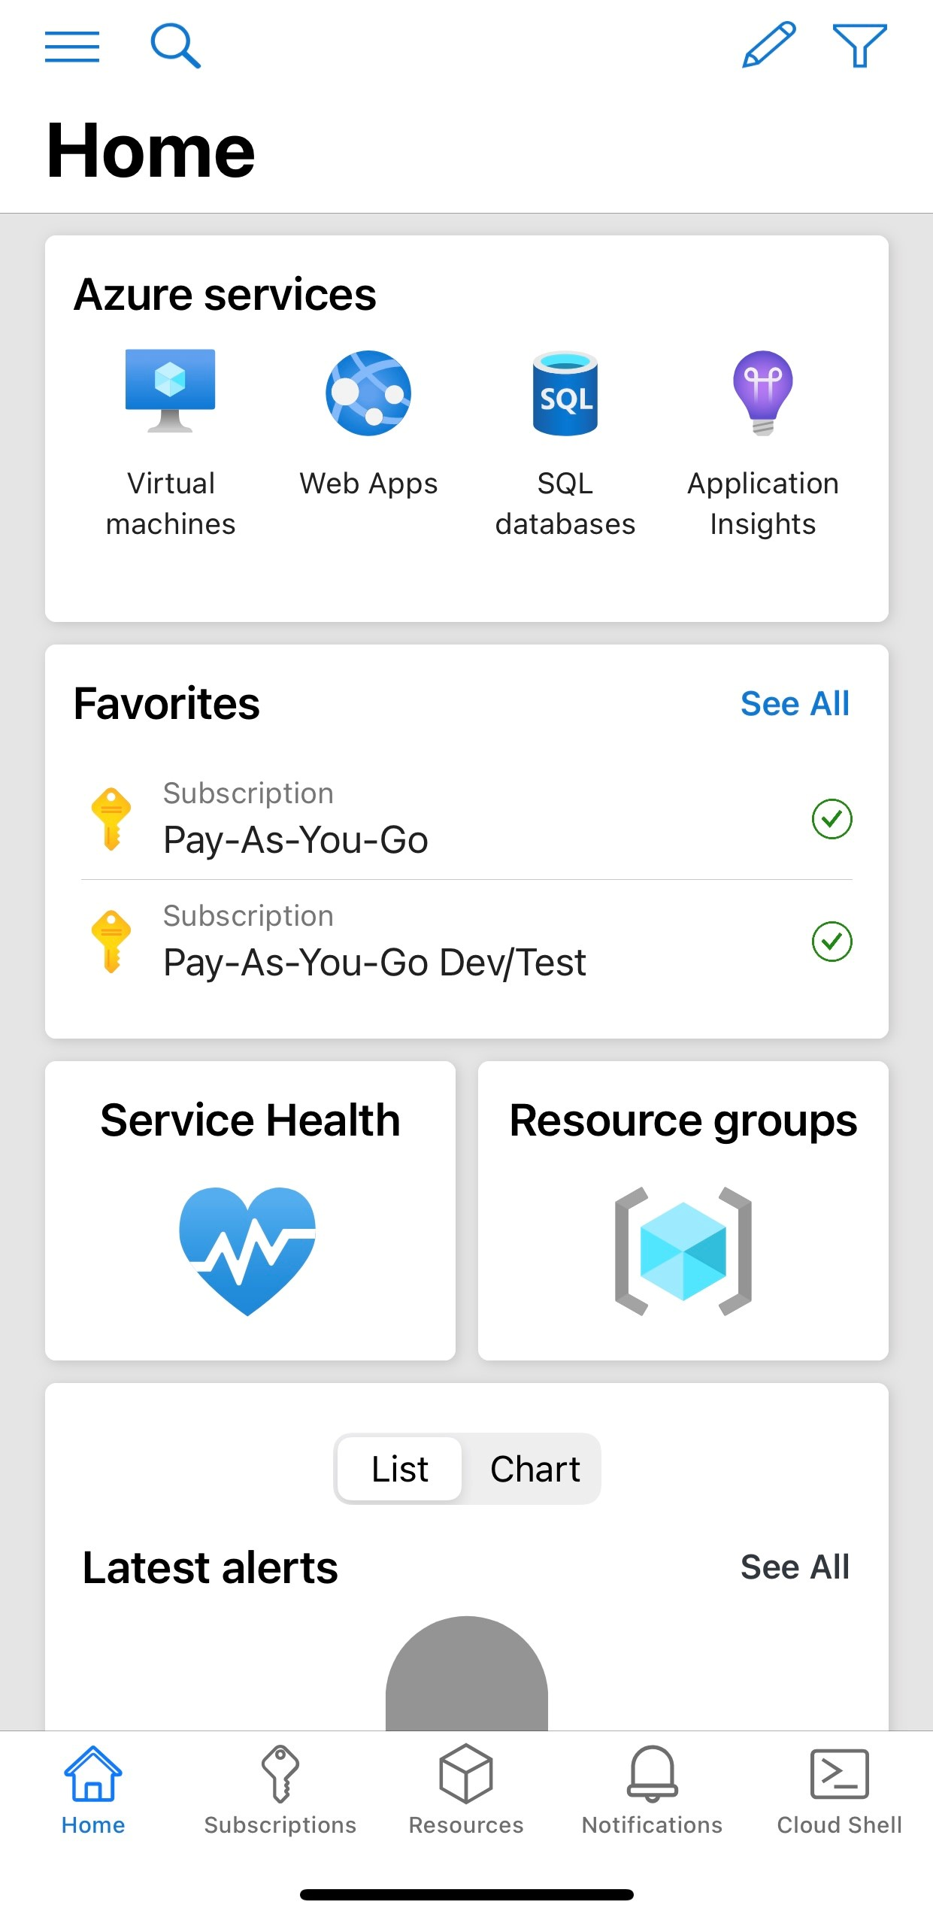

Figure 2-2. Start page of Azure Mobile App (iOS or iPhone)

TIP

The website URL of the Azure Portal is specific to the cloud where your organization is deployed in Microsoft Azure.

For commercial use: [https://portal.azure.com](https://portal.azure.com/)

[For United States government: https://portal.azure.us](https://portal.azure.us/)

Germany: [https://portal.microsoftazure.de](https://portal.microsoftazure.de/)

Features of Azure Portal The Azure Portal has numerous of features for all types of Azure users. Organization can take control of cloud resources by governing their cloud resources on-demand globally. Software developers or cloud engineer can build, manage and monitor any type of cloud applications - from simple to complex ones regardless of architecture or programming languages.The following are some of the known features of the Azure Portal.

Create, build, manage and monitor Azure services and cloud resources all in one place at anytime and anywhere at your own convenience

Use command line tools and cloud shell for quick

Manage and organize Azure Subscriptions and create management groups that helps in structuring and governing Azure resources

Azure Active Directory (Azure AD) as a great tool for the management of identity, access, and permissions to resources

Configure and manage privacy, data, security, policies and compliance which is vital for the organization’s governance

Customization of portal’s dashboards helps in getting a quick overview of the status of resources right after you logged in

Take control of monthly costs by monitoring resources through spending limits and budget alerts using using Azure Cost Management in the Azure Portal

Search everything you need to know, create, build and manage

[using the Global Search feature in the portal](https://www.youtube.com/watch?v=nZ7WwTZcQbo)

Send [Azure Support requests](https://docs.microsoft.com/en-us/azure/azure-portal/supportability/how-to-create-azure-support-request#create-a-support-request) directly when you need assistance or help

TIP

[Azure Marketplace](https://azuremarketplace.microsoft.com/en-us/marketplace/) is a marketplace for Azure customers to search, purchase and try-out applications and services from other service providers including Microsoft partner companies. All services on Azure Marketplaces are verified and certified to work with the Azure cloud platform.

Microsoft Azure Services

[As of writing this book, all Azure services are divided into 21 categories](https://azure.microsoft.com/en-us/services/) according to their purpose. As a developer or a solution architect in an organization, or even as a beginner, it might be overwhelming to see a lot of cloud services in a cloud platform such as Azure. However, each Azure service has its unique purpose and is built to solve specific technical problems. Azure services can be seamlessly integrated with other services and even external ones.

Each category for the Azure services helps you build and integrate cloud solutions based on your business requirements or need. For example, building a web application with integrations of API, cognitive services and reporting features would need several Azure services in categories Artificial Intelligence/Machine Learning, Compute, Analytics, Databases, Integrations, Developer Tools, etc.

T

a

b

l

e

2

-

2

.

O

## v

e

r

## v

## i

e

w

o

f

M

## i

c

r

o

s

o

f

t

A

z

u

r e

s

e

r

## v

## i

c

e

s

## i

n

s

o

m

e

k

n

o

w

n

c

a

t

e

g

o

r

## i

e

s Category Category What are these categories? Azure services What are these categories? Azure services

Artificial Build the modern Azure Boot Service, Azure Cognitive Services Azure Intelligence (AI) + and next generation Machine Learning, Anomaly Detector, Azure Machine Learning of applications DataBricks, Azure Open Datasets, Computer Vision , (ML) using artificial Face API, Azure Immersive Reader, Azure Form

intelligence Recognizer, Kinect DK, Microsoft Genomics, Azure

capabilities for any Health Boot, Azure Applied AI Services, Azure Percept, developer and any Speech Services, etc. scenario

Analytics Gather and Azure Analysis Services, Azure Data Explorer, Azure

visualize any time Data Lake Storage, Azure Data Share, Azure of data regardless Databricks, Azure Stream Analytics, HDInsight, of its volume or PowerBI Embedded, Azure Synapse Analytics, Data

velocity Factory, Event Hubs, R Server for HDInsight, Microsoft

Graph Data Connect, Azure Purview, etc.

Compute Access cloud API Apps, App Service, Azure Cycle Cloud, Azure

compute capacity Functions, Azure Kubernetes Service (AKS), Azure

and scale on Quantum Preview, Azure Spot Virtual Machines, Azure

demand and only Spring Cloud, Azure VMware Solution, Azure Batch,

pay for the Cloud Services, Linux Virtual Machines, Azure resources you use Container Instances, Azure Static Web Apps, VM Scale

Sets, Azure Virtual Machines, Azure Virtual Desktop,

Web Apps, Azure Dedicated Host, Azure VM Image

Builder, etc.

Containers Create, build, Azure Kubernetes Services (AKS), Azure Container

develop and Instances, Azure Container Registry, Azure Service

manage Fabric, Web App for Containers containerized

applications with

modern integration

tools

Databases Fully managed and Azure SQL Database, Azure Cosmos DB, Azure Cache

secure cloud for Redis, Azure Database for PostgresSQL, Azure database services Database for MySQL, Apache Cassandra MI, SQL

Server on Virtual Machines, Azure Database Migration

Service, Table Storage, Azure API for FHIR, Azure SQL

Database Edge, etc.

Developer Tools Build, manage, and Azure DevOps, Azure DevTest Labs, App

continuously Configuration, Azure SDKs, Azure Lab Services, deliver cloud Azure Pipelines, Visual Studio, Visual Studio Code

applications—using

any platform or

language

Integration Seamlessly API Management, Azure Event Grid, Azure Service

integrate on- Bus, Azure Logic Apps, Azure Web PubSub Preview,

premises and Azure Healthcare APIs Preview cloud-based

applications, data,

and processes

across your

enterprise

Networking Connect cloud and Application Gateway, Azure Bastion, Azure DNS, Azure

on-premises Express Route, Azure Content Delivery Network, Load

infrastructure and Balancer, Azure Front Door, Azure Firewall, Internet

resources using Analyzer, Azure Orbital, Private Link, VPN Gateway,

networking Virtual WAN, Virtual Network, Traffic Manager services

Internet of Things Create cloud Azure IoT Hub, Azure IoT Central, Azure Sphere, Azure (IoT) solutions with IoT IoT Edge, Azure RTOS

services

Identity + Security Protect resources, Azure Active Directory, Azure AD B2C, Azure

data and identity on Defender, Azure Security Center, Azure Key Vault, the cloud Azure Sentinel, Information Protection, DDoS

Protection, etc.

Table 2-2, describes some of the common known Azure services in different categories. To view the updated list of services per category, please visit

website <https://azure.microsoft.com/en-us/services/>

Some of the important Azure services in several categories will be covered in the other chapters of this book.

Overview of the Core Services of Microsoft Azure

Microsoft consistently creates new solutions, continuously updates and improve Azure services all the time.

Compute Services in Azure

Compute is usually the term used for computing resources. Compute services hosted in Azure provides computing resources like the operating systems, networking, disks, processors, networking and memory. These compute resources are available quickly and on-demand by its users. Every application is unique. An application can have many workloads that needs more than one compute services.

Currently, Azure has about 27 compute services available. The Azure Compute services in Azure enable us to build web and mobile applications, deploy and manage virtual machines, build apps in containers in the cloud, create batch jobs, and more. Figure 2-3 shows an overview of compute services on Azure Portal.

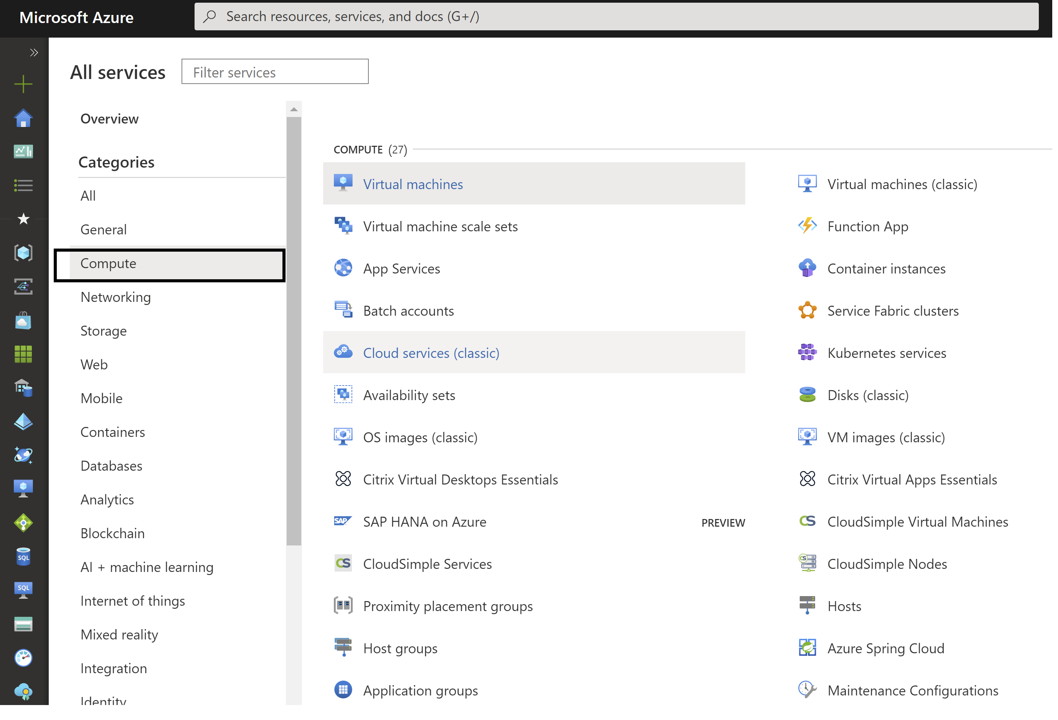

Figure 2-3. An overview of Compute services in Microsoft Azure Portal

Table 2-3 gives us an overview of some of the common Azure Compute services and their purpose.

T

a

b

l

e

2

-

3

.

O

## v

e

r

## v

## i

e

w

o

f

A

z

u

r

e

C

o

m

p

u

t

e

S

e

r

## v

## i

c

e

s

Azure Compute What is it for?

Azure App Service Build and develop web and mobile apps in a fully managed cloud

environment

Azure Static Web Develop modern full stack web application quickly to Azure from a code

Apps repository

Azure Virtual Quick, easy and manageable provisioning of Virtual Machines (Azure VMs)

Machines in different operating systems like Windows or Linux

Azure Virtual Create and provision multiple and thousands of Virtual Machines(Azure VMs)

Machine Scale Sets with high availability advantage

Azure Spot Virtual Save money when you provision compute capacity you don’t use for your Machines workloads

Azure Functions Develop serverless, modern, event-driven applications, and stateful workflows

Azure Container Build and deploy fully-managed modern apps and microservices using Apps serverless containers

Azure Kubernetes Build managed Kubernetes containers on the cloud Service(AKS)

Azure Container Cloud-scale job scheduling and compute management with the ability to scale

Instances to tens, hundreds, or thousands of virtual machines

Service Fabric Build microservices and perform containers orchestration in different

operating systems like Windows and Linux The technical details, use cases, and how you can get started developing with Azure compute services are covered in Chapter 3, Microsoft Azure Cloud Compute

Networking Services in Azure

Networking in the cloud is important in all aspects of cloud hosting. Networking services help secure both private and public cloud infrastructure. Users can customize their cloud networking setup and manage their network resources on demand.

Azure Networking services allow Azure users to meet the demands of their infrastructure’s workloads on-premises, hybrid or on the cloud with high

availability and enterprise-level [Microsoft Zero Trust](https://www.microsoft.com/en-us/security/business/zero-trust) based security on networking services.

Table 2-4 shows some of the common Azure Networking services.

T

a

b

l

e

2

-

4

.

O

## v

e

r

## v

## i

e

w

o

f

A

z

u

r

e

N

e

t

w

o

r

k

## i

n

g

s

e

r

## v

## i

c

e

s

Azure Networking What is it for?

Azure Virtual Connect virtual machines using VPN connections Network

Azure Bastion Secure and easy access to your virtual machines using private RDF and SSH

that are fully managed

Azure Private Link Access cloud Azure-hosted services with privacy

Azure Firewall Protect your resources in the cloud with high availability and low maintenance

firewall

Azure Load Load balance your application connections and requests - both inbound and

Balancer outbound

Azure Create private network connections between Azure data centers and on-ExpressRoute premises infrastructure

Azure Traffic Choose to route your network traffic for better performance Manager

Azure VPN Create secure private network connections in the cloud VPN Gateway Learn more about the technical details and how you can get started with Azure networking on Chapter 4, Microsoft Azure Cloud Networking

Core Azure Storage Services

The storage services in Azure offers great storage for any types of data objects, Azure Virtual Machine disk storage, reliable messaging storage, and other modern data types that needs to be stored. They provide the benefits of high availability, durability, security, accessibility and manageability.

Table 2-5 shows some of the common Azure Storage services.

T

a

b

l

e

2

-

5

.

O

## v

e

r

## v

## i

e

w

o

f

A

z

u

r

e

S

t

o

r

a

g

e

s

e

r

## v

## i

c

e

s

Azure Storage service What is it for?

Azure Blobs Store scalable binary data, text or Data Lake Storage Gen2 big data analytics

Azure Files Fully manageable file shares for deployments on-premises or for the cloud.

Accessible anywhere through Server Message Block (SMB) Protocol

Azure Queues Store large numbers of messages that you access via authenticated HTTP calls

Azure Managed Store block-level volumes for Azure Virtual Machines Disks

Each of the core Azure storage service need to be integrated and associated with an Azure Storage account. A storage account in Azure is a container, as shown on Figure 2-4, of all Azure storage data like the blobs, files, tables and queues.

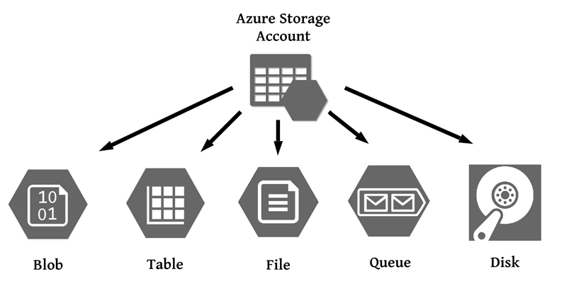

Figure 2-4. An Azure Storage Account is needed for any of the core Azure storage services

Core Azure Database Services

Azure have great collection of database services to choose from depending on the the type data structure you need for your organization. The different types of database services in Azure are fully managed. There are appropriate database for your data - relational, NoSQL, in-memory databases, and other modern databases.

Table 2-6 shows some of the common Azure Database services.

T

a

b

l

e

2

-

6

.

O

## v

e

r

## v

## i

e

w

o

f

A

z

u

r

e

D

a

t

a

b

a

s e

s

e

r

## v

## i

c

e

s

Azure Database service What is it for?

Azure SQL Database Cloud-hosted SQL databases that are fully-managed, intelligent

and secure

Azure Cosmos DB Create and migrate no NoSQL workloads to the cloud like

Cassandra, MongoDB, and other NoSQL databases

Azure Cache for Redis DB Build fast and scalable applications with Redis in-memory data

store

Azure Database for PostgreSQL, Create fully managed and scalable databases for PostgresSQL, MySQL, and MariaDB MySQL and MariaDB

Azure SQL Edge Build IoT edge-optimized SQL database engine with built-in AI

Learn more about the other storage and database solutions as well as its technical details on Chapter 5, Microsoft Azure Cloud Storage Services and Databases

Identity Management and Security Services

Secure your organization’s cloud resources against advanced modern threats using the identity management and security services in Azure.

Table 2-7 shows some of the common identity management and security services in Azure.

T

a

b

l

e

2

-

7

.

O

## v

e

r

## v

## i

e

w

o

f

A

z

u

r

e

## I

d

e

n

t

## i

t

y

a n

d

S

e

c

u

r

## i

t

y

s

e

r

## v

## i

c

e

s

Azure Identity or Security service What is it for?

Azure Active Secure identity and protect users of the entire organization using SSO and

Directory (Azure multi-factor authentication AD)

Azure Active Join Azure virtual machines to a domain without domain controllers Directory Domain

Services

Azure Information Protect your sensitive information on the cloud Protection

Azure Active Consumer identity and access management in the cloud Directory External

Identities

Azure Key Vault Keep control and secure your keys, connection strings and secrets

Azure Defender Protect and detect threats for your workloads in Azure, on premises, and even

in other cloud providers

Microsoft Sentinel Get intelligent security security information event management (SIEM) and

security orchestration automated response (SOAR) solution to protect your resources

Azure DDoS Protect applications in Azure from Distributed Denial of Service (DDoS)

Protection attacks

Learn more about the technical details and how you can get started with Azure user identity platform and security services on Chapter 7, Microsoft Azure Identity and Security

Developer Tools, Monitoring, and DevOps Services

Azure have different tools and services for cloud development, troubleshooting, monitoring, DevOps practices, Infrastructure as a Code (IaC), and Continuous Integration/Continuous Delivery (CI/CD).

Table 2-8 shows some of the common Azure developer tools, monitoring and DevOps services.

T

a

b

l

e

2

-

8

.

O

## v

e

r

## v

## i

e

w

o

f

A

z

u

r

e

d

e

## v

e

l

o

p

e

r t

o

o

l

s

,

m

o

n

## i

t

o

r

## i

n

g

a

n

d

D

e

## v

O

p

s

s

e

r

## v

## i

c

e

s

Azure service What is it for?

Azure DevOps All-in-one tool with great DevOps services for teams to collaborate better,

share code, track work, and deliver software projects

Azure DevTestLabs Quickly create environments using reusable templates and artifacts

Azure Information Protect your sensitive information on the cloud Protection

App Configuration Store your application’s configuration using scalable parameters

Visual Studio Develop, debug, deploy, manage, and diagnose cloud-scale applications on

Azure, using a full-featured IDE

Visual Studio Code Write and debug code with a lightweight and fast code editor that runs on

different operating systems like macOS, Linux, and Windows

The different core developer tools, supported programming languages for Azure, Monitoring, troubleshooting steps and DevOps services will be discussed in details on Chapter 11, Developing with Microsoft Azure, Troubleshooting, Monitoring, DevOps, Automation, CI/CD

Cloud Migration and Hybrid + Multicloud Cloud Services

Azure has migration and hybrid solutions that helps organizations in their cloud adoption and migration journey.

Table 2-9 shows some of the common Azure migration, hybrid and multicloud services.

T

a

b

l

e

2

-

9

.

O

## v

e

r

## v

## i

e

w

o

f

A

z

u

r

e

s

e

r

## v

## i

c

e

s

f o

r

m

## i

g

r

a

t

## i

o

n

,

m

u

l

t

## i

-

c

l

o

u

d

a

n

d

h

y

b

r

## i

d

c

l

o u

d

Azure service What is it for?

Azure Database Get guidance and useful tools for migrating databases from different on-

Migration Service premise resources to Azure

Azure Data Box Device solution for data transfer of large amounts of data to Azure and

edge compute

Azure Migrate All in one place for all the guides and tools you need to migrate to

Azure

Azure Arc Combine and unify on-premises, hybrid, and multicloud infrastructure

Azure Stack Build and run innovative hybrid apps across cloud boundaries

Learn more about the technical details and how you can get started with Azure migration and hybrid cloud solutions on Chapter 13, Microsoft Cloud Migration and Hybrid Cloud Architecture Solutions

Those are the core services in Microsoft Azure in different major categories. Each of them along with some of the categories listed in Table 2-2 will be described in details with examples in the upcoming chapters of this book.

Core Architecture and Resource

Management Concepts in Microsoft Azure

An organization in Microsoft Azure would need their Azure administrators to properly setup the core structure of the organization in the resource management. This is the first and top structure that is required before you can add cloud resources in the cloud platform. An organization with different departments with members in different roles would find this beneficial.

There are four levels for organizing your organization’s resources in Microsoft Azure. As shown on Figure 2-5, from top to down, these are the Azure Management Groups, Azure Subscriptions, Resource Groups and Resources.

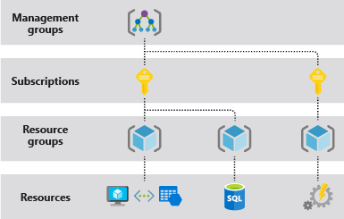

Figure 2-5. The top-down structure of the four levels in organizing Azure resources

Azure Management Groups

Azure Management Groups is the top level of the core structure of managing your cloud resources in Azure. It is useful in organizing and structuring your resources in Microsoft Azure. The management groups is where Azure administrators manage everything about user access, compliance and policies for subscriptions. The subscriptions within a management group automatically inherit the settings, conditions and restrictions added in the group.

Azure Role-based Access Control (RBAC) for all resources and role definitions are supported in the management groups. A person in the organization with any Azure role can be assigned to the Azure management group. Those who have access and rights to the management group can group Azure Subscriptions, see organization’s management groups hierarchy and most of all can control any access to any Azure service or resource by creating and applying governance control and policies.

Azure Subscriptions

Subscriptions in Azure is like a big container for all accounts of users and what resources they have accessed or used within the subscription. Every subscription usually has amount limit of resources that a certain user can create and use. As an organization, you can use subscriptions to control the monthly bill and resources costs in your organization or your own Azure account. Using Azure subscription, the organization can also control what resources the users create, update, or delete.

Azure Resource Groups

Azure users can group their services or resources using Azure Resource Groups. A resource group in Microsoft Azure acts as logical container where resources like servers, web applications, databases, storage, monitoring, etc. are deployed, managed, and stored. Do not confuse a

Resource Group for Availability Set in Azure. The [Availability Set is the](https://docs.microsoft.com/en-us/azure/virtual-machines/availability-set-overview) logical group for Virtual Machines (VMs).

Azure Resources

The databases, servers, virtual machines or web applications you create on Azure platform are considered Azure resources. All resources or services you create must be in added in a Resource Group. which acts as the logical container. In a resource group, you can have your web apps, servers, monitoring, compute services, etc. in one place.

When you are creating an Azure resource as shown on Figure 2-6, you would need to select an Azure Subscription, a Resource Group and the Azure Region for example, North Europe, where you want to add your resources.

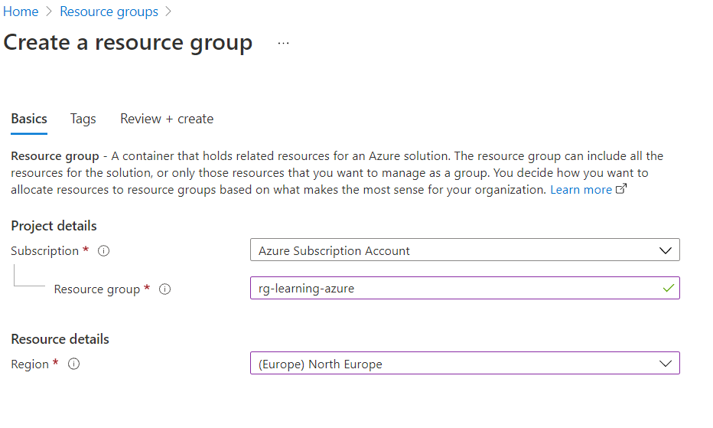

Figure 2-6. Creating Azure Resource in Azure Portal

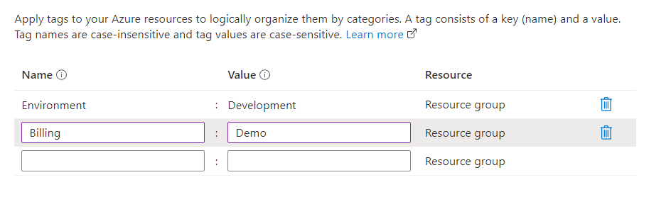

Figure 2-7. Using tag to categorize Azure resources

You can also organize your Azure resources in categories by adding [tags](https://docs.microsoft.com/en-us/azure/azure-resource-manager/management/tag-resources?) as shown on Figure 2-7. These resource tags are key-value pair set that are composed of name of your tag and the value. You can set tags for categorizing your resources for billing purposes. For example, you can apply tags for your resources for different environments like resources in Dev, Test, UAT, or Production.

Azure Resource Manager

Azure Resource Manager (ARM) is also an important element in managing resources in Azure. ARM is the management and deployment service that provides users the capability to add, edit and delete resources in Azure. By using ARM, the organization can manage user access control and organize resources securely even after deployment.

Azure Resource Manager templates (ARM templates) are commonly used

to automate deployments and to implement [Infrastructure as Code (IaC).](https://docs.microsoft.com/en-us/devops/deliver/what-is-infrastructure-as-code) Azure provides support for IaC using the ARM templates in Azure Resource Manager. It creates a great advantage and it enables a good deployment automation of the infrastructure in the cloud.Using Infrastructure as Code you can automate your deployment by generating templates for the same environment every time.Infrastructure as Code process minimizes the problems of environment drift during development releases.

Azure provide third-party support for other automated IaC platforms like

[Terraform](https://docs.microsoft.com/en-us/azure/developer/terraform)[, RedHat,](https://www.ansible.com/products/automation-platform) [Chef Automate](https://docs.chef.io/azure_marketplace/)[, and Pulumi](https://www.pulumi.com/azure).

Azure Geographies, Regions, Region Pairs,

and Azure Availability Zones

The Microsoft Azure infrastructure is built to deliver the best resiliency and high availability of cloud resources to its users. Azure infrastructure is composed of its geographies, regions, and availability zones. Knowing where to provision your resources in the right location in Azure’s global infrastructure will hugely help in an organization’s cloud resources management, compliance, security, and speed.

Azure Geographies

As of writing this book, Microsoft Azure have data centers worldwide in 140 countries. The data centers of Azure are secured physical buildings that

[are located all over the world. The entire global infrastructure of Azure](https://infrastructuremap.microsoft.com/) is huge and widely available globally. The data centers and infrastructure of Microsoft’s cloud platform are important in providing reliable, secure and innovative smart cloud solutions to its users. Learn more about the Azure

data centers nearest to you by checking out [Azure Geographies.](https://azure.microsoft.com/en-us/global-infrastructure/geographies/#overview)

Azure Regions

As you can see on the Azure geographies, there are data centers all over the globe in different regions and countries. Azure regions play a vital role in cloud computing for adaptability because each country or region have its unique and different restrictions, policies, compliance, and rules. Figure 2-8 shows an example of an Azure Region with three Availability Zones.

Of all the leading cloud providers globally, Azure has the most global geographical regions. Creating your resources in the nearest Azure geographical region is an advantage. With the global and international market we have these days, being able to choose the location and geography of your resources give flexibility and reliability. Choosing the right Azure region is also vital especially when it comes to compliance and data policies

like Europe’s [General Data Protection Regulation (GDPR)](https://docs.microsoft.com/en-us/compliance/regulatory/gdpr)

Before adding resource in Azure, your organization can check first if there are any legal standards or compliance that you need to comply in your

geographical area. Microsoft Azure have a [list of compliance of](https://docs.microsoft.com/en-us/azure/compliance)ferings for different sectors globally that you can review and learn more.

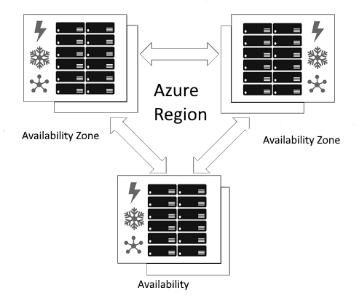

Figure 2-8. Example of an Azure Region with three Availability Zones Azure Region Pairs

Typically, availability zones are created by using one or multiple data centers There is a minimum of three availability zones within a region. However, what if two of the zones goes down because of a huge outage? Two data centers in outage in the same Azure region would be risky to keep the resource in operation. This is the reason why users also have the option to use Azure Region Pairs.

Azure Region Pair, as shown on Figure 2-9, means pairing a region with another region within the same geography. By pairing regions within the same geography, users can replicate their resources like servers, virtual machines, databases and storage in another location in case of big power outages, nature calamities, etc.

If a region in a pair goes down, the services would failover automatically to the other region in its region pair.

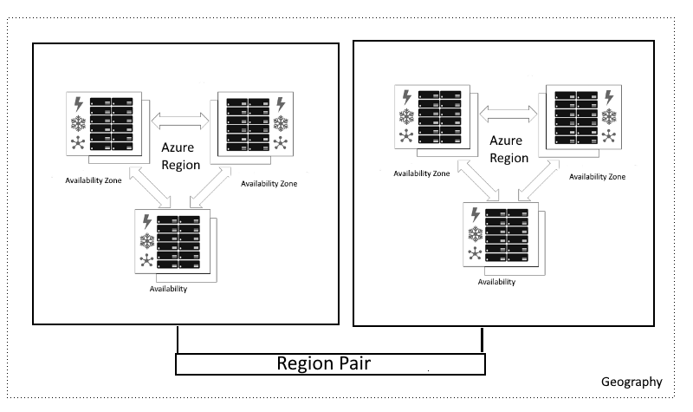

Figure 2-9. Example of Azure Region Pair

An Azure region, as shown on Figure 2-9 is often pared with another region in the same geography. For example if the region is in Europe, then it is expected that its region pair is also located within Europe or at least 300 miles away. When it is possible, Azure prefers this minimum distance of between physical data centers in a regional pair in case of natural disasters, power outages, etc. The Azure regional pair should be within the same region to for reliability in case of unexpected interruptions.

BEST PRACTICES IN AZURE REGION PAIR

Check out Azure’s Business continuity and disaster recovery (BCDR) for Azure Paired

[Regions on https://docs.microsoft.com/en-us/azure/best-practices-availability-paired-](https://docs.microsoft.com/en-us/azure/best-practices-availability-paired-regions)

[regions](https://docs.microsoft.com/en-us/azure/best-practices-availability-paired-regions)

Azure Availability Zones

If your organization wants to make sure that your applications and cloud resources in Azure are redundant in case of failure or problems, Azure Availability Zones is your right solution.

Availability Zones are physically isolated data centers that are located

within the same Azure region, as shown on Figure 2-10.

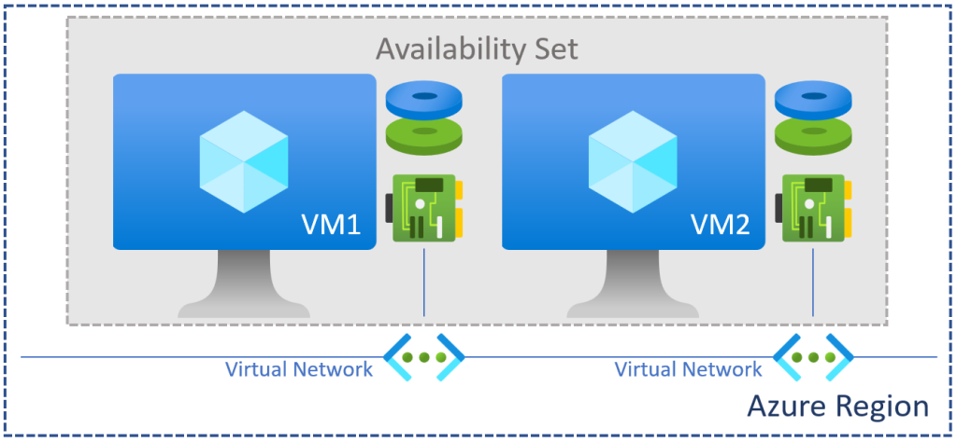

Figure 2-10. An example of Availability set of Azure Virtual Machines in an Azure Region. Photo

Cr[edit: Microsoft Documentation](https://docs.microsoft.com/en-us/)

An availability zone is usually composed of one or multiple data centers with independent facilities for power, networking, cooling and support. The purpose of this isolation is that to make sure that in case one of the zones stops working properly, the other zone continues to run in operation. These availability zones are connected and equipped with secure high speed networks which is important in running mission-critical resources for your compute, networking, storage and data.

Availability Zones [has a similarity to Availability Sets in Virtual Machines.](https://docs.microsoft.com/en-us/azure/virtual-machines/availability#availability-sets) In contrary, there is an obvious difference between them. Availability zones are used to protect resources from complete system failures in an Azure data center while Availability sets are used to protect applications from hardware failures within an Azure data center.

NOTE

If your organization has the requirement, you can replicate or transfer your data or

[resources into another availability zone for a cost in Azure. For example, Azure VMs](https://docs.microsoft.com/en-us/azure/site-recovery/move-azure-vms-avset-azone)

[can be moved to an availability zone in a different region.](https://docs.microsoft.com/en-us/azure/site-recovery/move-azure-vms-avset-azone)

Cost Management in Microsoft Azure

Aside from organizing cloud resources using Azure Management, Resource Groups, Azure tags, and making sure that that your resources are on the right Azure region, it you can also manage the financial aspect of your organization’s cloud consumption.

Azure’s cost management tools help organization’s monitor their expenses on their cloud resources consumed. These can be done by setting budget alerts, notifications to appropriate billing or accounting team, and also estimate possible monthly or yearly costs beforehand which aids in cost planning and budgeting.

Azure Cost Management + Billing

[An administrative section in Microsoft Azure where billing and](https://docs.microsoft.com/en-us/azure/cost-management-billing/cost-management-billing-overview)

[management of costs can be controlled and monitored.](https://docs.microsoft.com/en-us/azure/cost-management-billing/cost-management-billing-overview)

Total Cost of Ownership (TCO) Calculator

A great tool that helps organization estimate the cost savings by |https://azure.microsoft.com/en-us/pricing/tco/calculator/[migrating workloads to Azure estimations].

Azure Pricing Calculator

[A dedicated website where you can configure and estimate the costs for](https://azure.microsoft.com/en-us/pricing/calculator/)

[Azure products and features based on your use case scenarios in our](https://azure.microsoft.com/en-us/pricing/calculator/) projects. You can save, export and share these cost estimations, shown in Figure 2-10

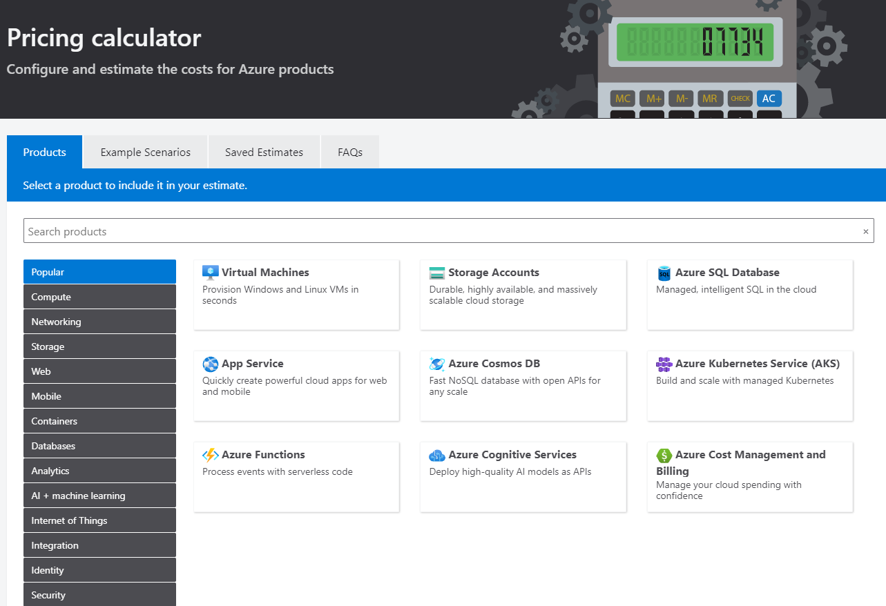

Figure 2-11. Estimate costs for Azure services or resources using Azure Pricing Calculator

LEARN MORE ABOUT MANAGING COSTS IN

AZURE

Get an overview and learn some of the best practices in Azure billing and cost

[management by visiting the Microsoft Documentation https://docs.microsoft.com/en-](https://docs.microsoft.com/en-us/azure/cost-management-billing/)

[us/azure/cost-management-billing/](https://docs.microsoft.com/en-us/azure/cost-management-billing/)

Basic Concepts of User Identities, Roles,

Active Directories in Azure

In addition to structuring cloud resources using Management Groups, Subscriptions and Resource Groups, it is also important to control user identities and access to these resources.

Azure Active Directory (Azure AD) as shown on Figure 2-12 is the identity and user access management service of Microsoft. The users of Azure AD can manage their users identities, their roles, logins and access to internal resources as well as permissions to external services like Azure Portal, Office 365, and other applications.

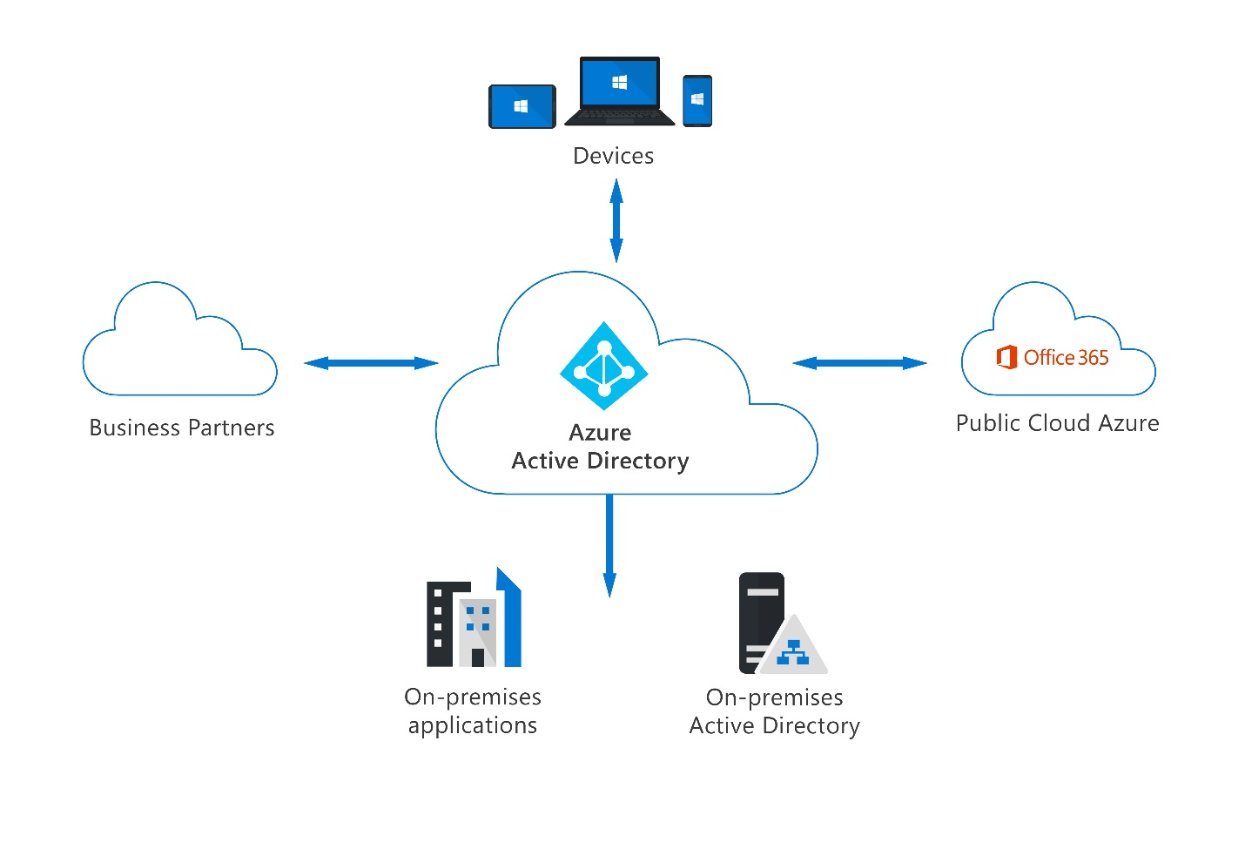

Figure 2-12. [A basic example overview of how Azure Active Directory (Image Credit: Microsoft](https://docs.microsoft.com/en-us/)

[Documentation)](https://docs.microsoft.com/en-us/)

Azure Role-Based Access Control (Azure RBAC)

It’s important for any organization to be able to manage the user access for cloud resources and resource groups in Microsoft Azure. The Azure Role-based Access Control(RBAC) helps in user access management of resources in Azure. RBAC helps in controlling what users can do.

Azure RBAC is a system for authorization and access management of resources within the Azure platform. You can filter what a certain group of users can do and cannot do depending on the type of role they have in the organization.

For example, allow database administrators to only manage (create, read, update and delete) resources related to databases within a resource group. The access can be set up for developers or software engineers who works with application development in the platform.

[To learn more about Azure RBAC, watch this video Azure RBAC : The](https://www.youtube.com/watch?v=1OBi93apLdo)

[deep dark secrets of role based access control.](https://www.youtube.com/watch?v=1OBi93apLdo)

Azure Roles

In order to control access to resources in Azure, you need to set up and enforce user permissions by assigning Azure Roles. A role assignment has elements such as Security Principal, Role Definition, and Scope, as shown on Figure 2-11.

Security Principal

A security principal is an object that represents a user, group, service principal, or managed identity that is requesting access to Azure resources. You can assign a role to any of these security principals.

Role Definition

A role definition is a list of permissions or actions to allow a user. Such permissions can be any or a combination of actions like creating, reading, updating and deleting resources. Roles can be specific or can be in different levels.

Scope

Scope as its term describes is the group of resources that the access applies to. When you assign a role to a user in Azure, you can define the scope to limit some tasks or actions by a user or role. This is helpful if you want to make someone a contributor, but only for a certain resource group.

As described in the previous section, the four levels of scope are management group, subscription, resource group, or resource. Also described in details on previous section Architecture and Resource Management Concepts in Microsoft Azure are scopes structured from top to bottom and follows the inheritance of parent-child relationship.

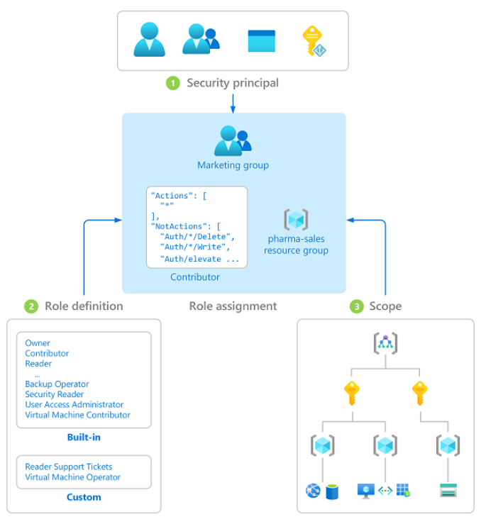

Figure 2-13. Photo Cr[edit: Microsoft Documentation](https://docs.microsoft.com/en-us/azure/role-based-access-control/) Example of the important elements of Azure

Role Based Access (Azure RBAC)

Learn by Doing (Try it out!)

Now that you have learned about the cloud service in Azure, let’s take things a step further by checking it out for real by testing Microsoft Azure Portal.

Microsoft Azure Portal Hands-On

1. If you already have an Microsoft Azure Subscription, visit

[https://portal.azure.com](https://portal.azure.com/)

2. If you don’t have a subscription yet, register for free Azure account

on link <https://azure.microsoft.com/en-us/free/>

3. Explore the Azure Portal’s Home Page, as shown in Figure 2-14 is

where you will see the left side bar with the default list of Azure Services and the main page has the dashboard and search bar. On the upper-right of the portal, you will be able to access the Cloud Shell, Directories + Subscriptions, Notifications, Settings, Help and Manage your Azure Account.



Figure 2-14. Example of how the page of the Microsoft Azure Portal look like when you signed up for

an Azure account and have logged in

1. Click on All Services on the left panel and explore the cloud

services in different categories as shown in Figure 2-15.

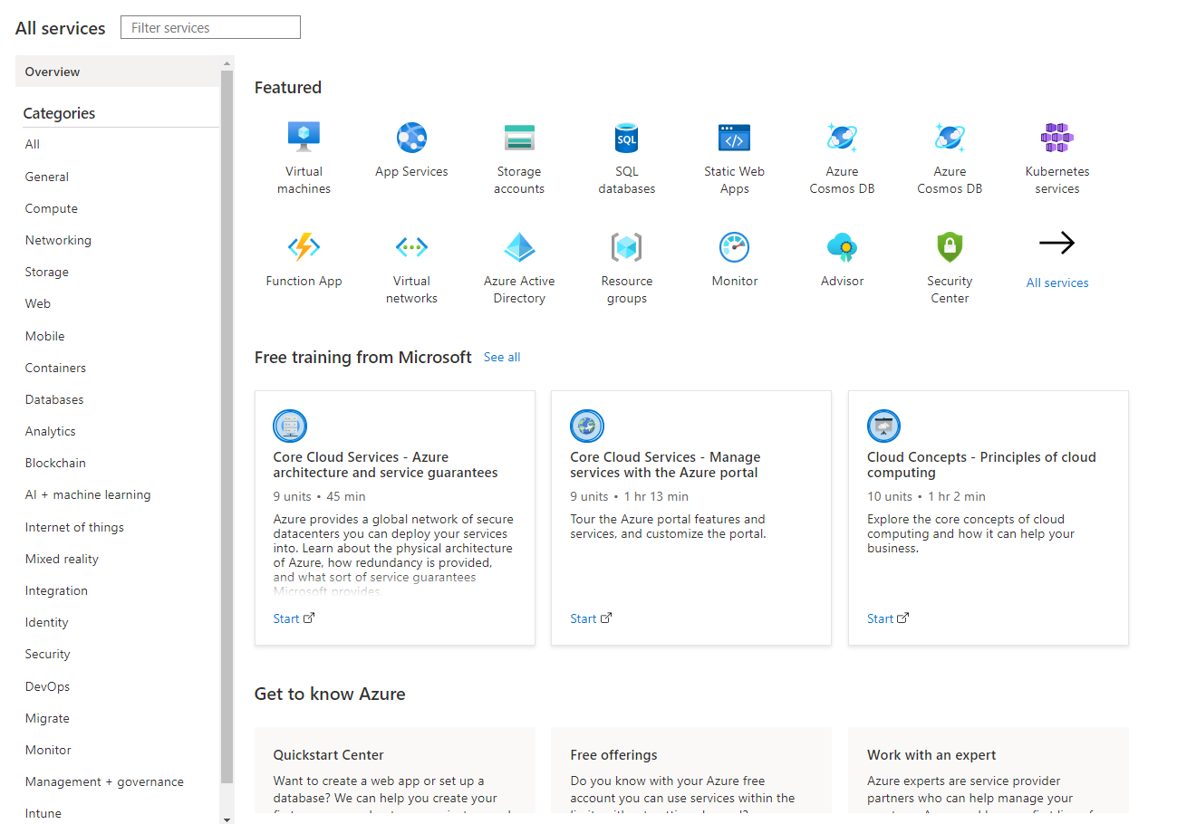

Figure 2-15. All services in Microsoft Azure Portal in different categories

1. Find Free Offerings in Microsoft Azure in the same page or visit

[https://portal.azure.com/#blade/Microsoft_Azure_Billing/FreeServi](https://portal.azure.com/#blade/Microsoft_Azure_Billing/FreeServicesBlade)

[cesBlade Explore the free Azure services available for you for 12](https://portal.azure.com/#blade/Microsoft_Azure_Billing/FreeServicesBlade) months with your Azure free account.

Summary

In this chapter, you have learned the fundamentals of public cloud provider, Microsoft Azure. You learned about the different Azure services in different categories and their purpose. You also learned how you can organize your resources in Azure, manage your costs, protect your resources in case of outages using availability zones and azure region pairs. Azure Active Directory (Azure AD) allows you to manage users and identifies to control operations of your Azure resources.

The core Azure services mentioned on this chapter will be described in detail in other chapters of this book.

Key Points

There are hundreds of cloud services in Azure divided into different categories like Compute, Storage, Networking, Databases, Developer Tools, and more

Cloud resources in Azure can be organized and structured in scopes - Azure Management Groups, Subscriptions and Resource Group

Azure Role-based Access Control (Azure RBAC) is the user access control management for cloud resources in Azure

A role assignment is composed of three important elements -security principal, role definition, and scope

Azure Resource Manager templates are used for automation of deployments to Azure and implementing Infrastructure as a Code model

Check Your Knowledge

1. Can you have two Azure region pairs in different geography? (True

or False)

2. Azure Marketplace is where Azure users can purchase and try-out

applications and services from other service providers and Microsoft partner companies. (True or False)

3. What are the top categories of core services in Azure?

4. Azure Virtual Machine Scale Sets is the compute service you need

if you want to develop event-driven applications in serverless environment. (True or False)

5. What is the difference between Azure Region vs. Availability Set? Answers

To find the answers to Check Your Knowledge, turn to back of the book in Appendix A Answers section view answers for Chapter 2.

Recommended Resources

[Azure Global Infrastructure https://azure.microsoft.com/en-](https://azure.microsoft.com/en-us/global-infrastructure/)

[us/global-infrastructure/](https://azure.microsoft.com/en-us/global-infrastructure/)

[Microsoft Learn Modules Azure Fundamentals Learning Path](https://docs.microsoft.com/en-us/learn/paths/az-900-describe-cloud-concepts/?WT.mc_id=AZ-MVP-5004251)

[Microsoft Learning Module Create an Azure Account](https://docs.microsoft.com/en-us/learn/modules/create-an-azure-account/?WT.mc_id=AZ-MVP-5004251)

[Microsoft Learn - Control and organize Azure resources with](https://docs.microsoft.com/en-us/learn/modules/control-and-organize-with-azure-resource-manager/?WT.mc_id=AZ-MVP-5004251)

[Azure Resource Manager](https://docs.microsoft.com/en-us/learn/modules/control-and-organize-with-azure-resource-manager/?WT.mc_id=AZ-MVP-5004251)

Directory of all Microsoft Azure Services

<https://azure.microsoft.com/en-us/services/>

Azure Charts <https://azurecharts.com/>

Quickstart: Check access for a user to Azure resources

[https://docs.microsoft.com/en-us/azure/role-based-access-](https://docs.microsoft.com/en-us/azure/role-based-access-control/check-access)

[control/check-access](https://docs.microsoft.com/en-us/azure/role-based-access-control/check-access)

Microsoft Learning Path - Build a cloud governance strategy on

[Azure https://docs.microsoft.com/en-gb/learn/modules/build-](https://docs.microsoft.com/en-gb/learn/modules/build-cloud-governance-strategy-azure/)

[cloud-governance-strategy-azure/](https://docs.microsoft.com/en-gb/learn/modules/build-cloud-governance-strategy-azure/)

[Azure Blob Storage Documentation https://docs.microsoft.com/en-](https://docs.microsoft.com/en-us/azure/storage/blobs/)

[us/azure/storage/blobs/](https://docs.microsoft.com/en-us/azure/storage/blobs/)

Microsoft Learning Path - Describe Azure Core Services

[https://docs.microsoft.com/en-us/learn/paths/az-900-describe-core-](https://docs.microsoft.com/en-us/learn/paths/az-900-describe-core-azure-services/)

[azure-services/](https://docs.microsoft.com/en-us/learn/paths/az-900-describe-core-azure-services/)

O’Reilly Book, “Designing Data Intensive Applications” by Martin Kleppmann,

[https://learning.oreilly.com/library/view/designing-data-intensive-](https://learning.oreilly.com/library/view/designing-data-intensive-applications/9781491903063/)

[applications/9781491903063/]](https://learning.oreilly.com/library/view/designing-data-intensive-applications/9781491903063/)