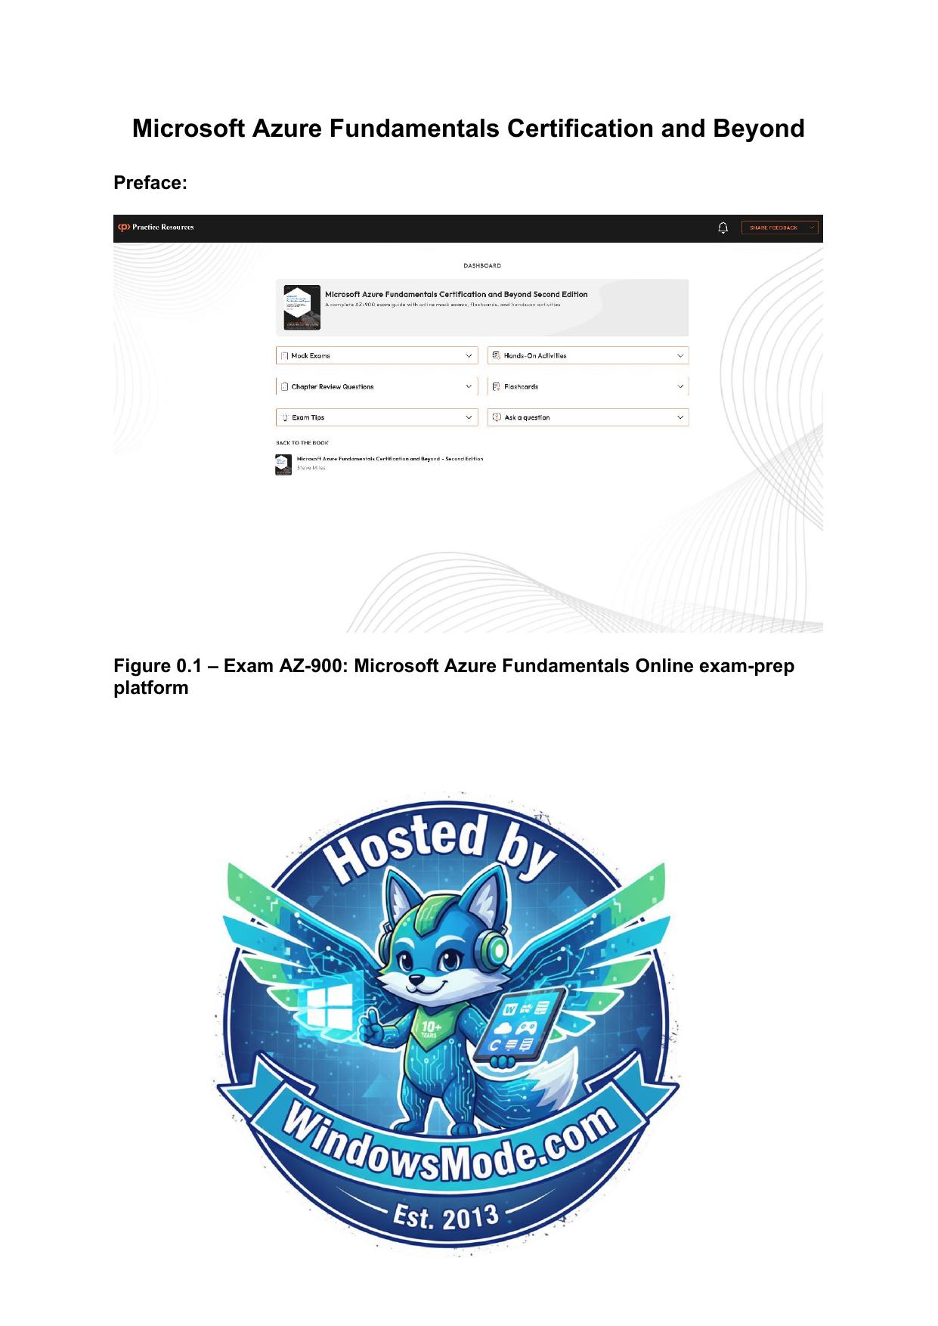

Table of Contents
Chapter 1: Introduction to Cloud Computing
Chapter 2: Benefits of Using Cloud Services Figure 2.1 – Cloud computing as a digital transformation enabler Figure 2.2 – Digital transformation triggers
Chapter 3: Azure Core Architectural Components Figure 3.1 – Azure global infrastructure key component topology Figure 3.2 – Azure regions and geographies relationship
Chapter 4: Azure Core Resources
Chapter 5: Azure Identity and Access
Chapter 6: Azure Security
Chapter 7: Azure Cost Management
Chapter 8: Azure Governance and Compliance Figure 8.1 – Azure Policy scope level
Chapter 9: Azure Resource Deployment and Management
Chapter 10: Azure Monitoring and Tools
Chapter 11: Accessing the online practice resources
Microsoft Azure Fundamentals Certification and Beyond
Preface:
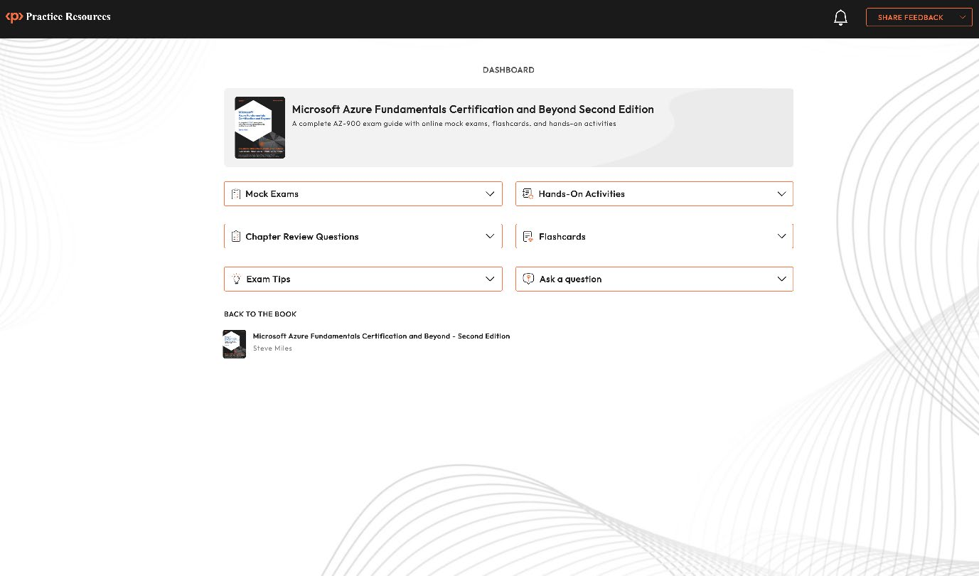
Figure 0.1 – Exam AZ-900: Microsoft Azure Fundamentals Online exam-prep platform


Chapter 1: Introduction to Cloud Computing
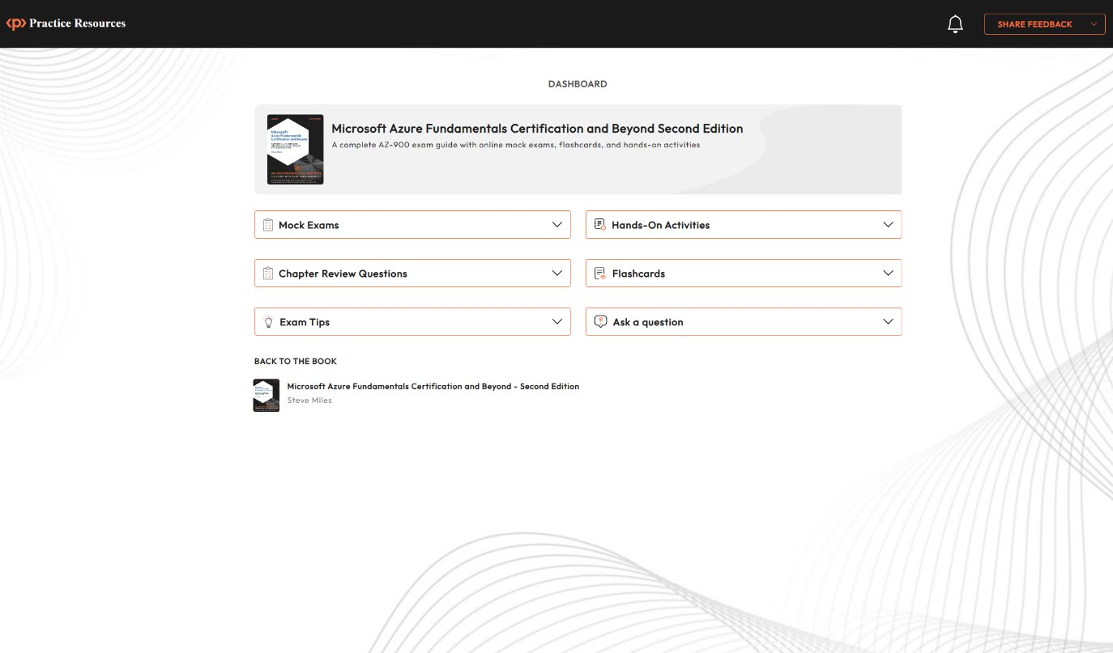
Figure 1.1: Dashboard interface of the online practice resources Figure 1.2 – Evolution of cloud computing
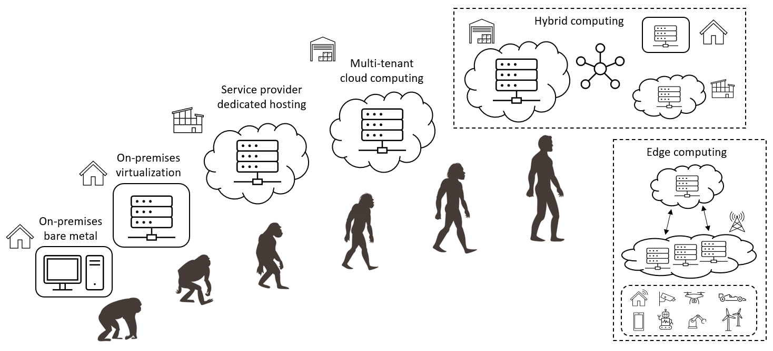
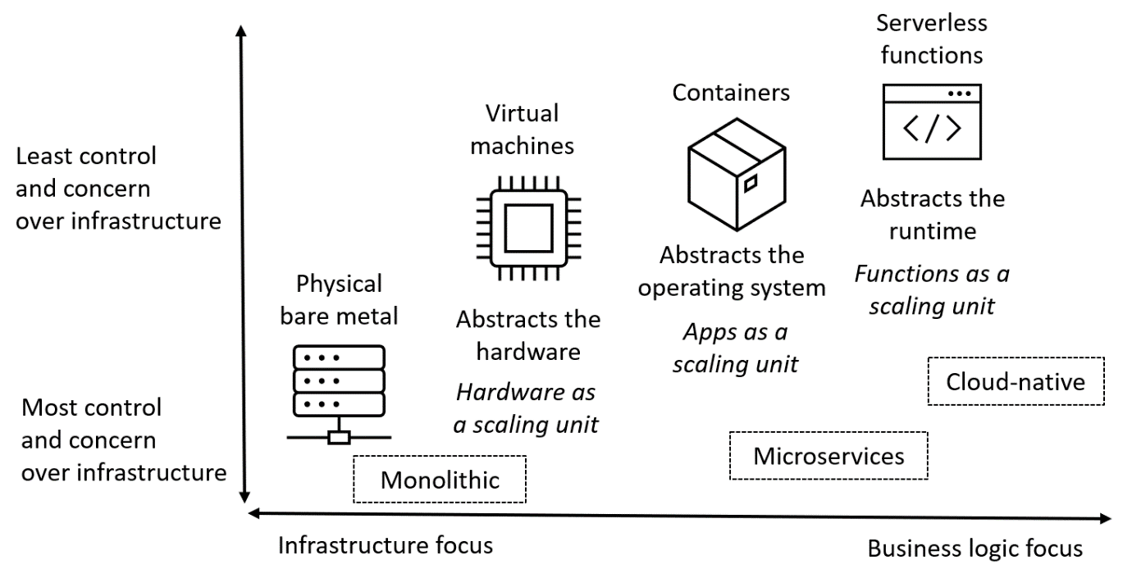
Figure 1.3 – Cloud computing architectures
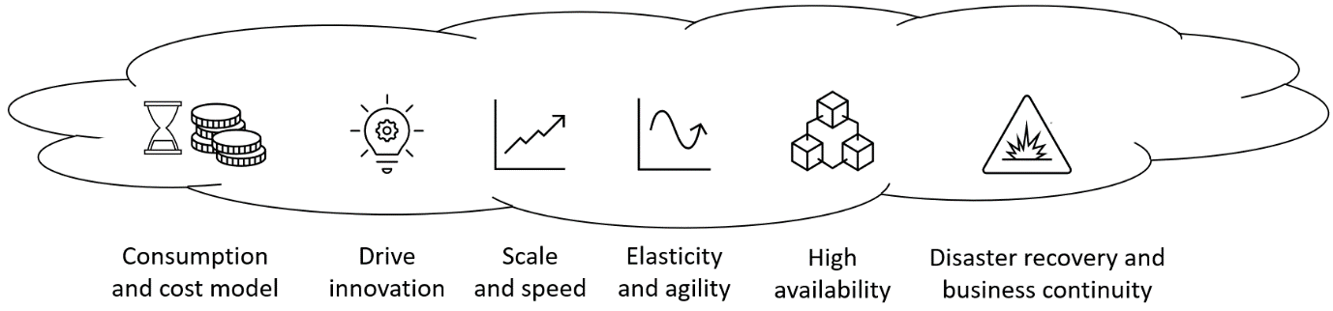
Figure 1.4 – Benefits of cloud computing
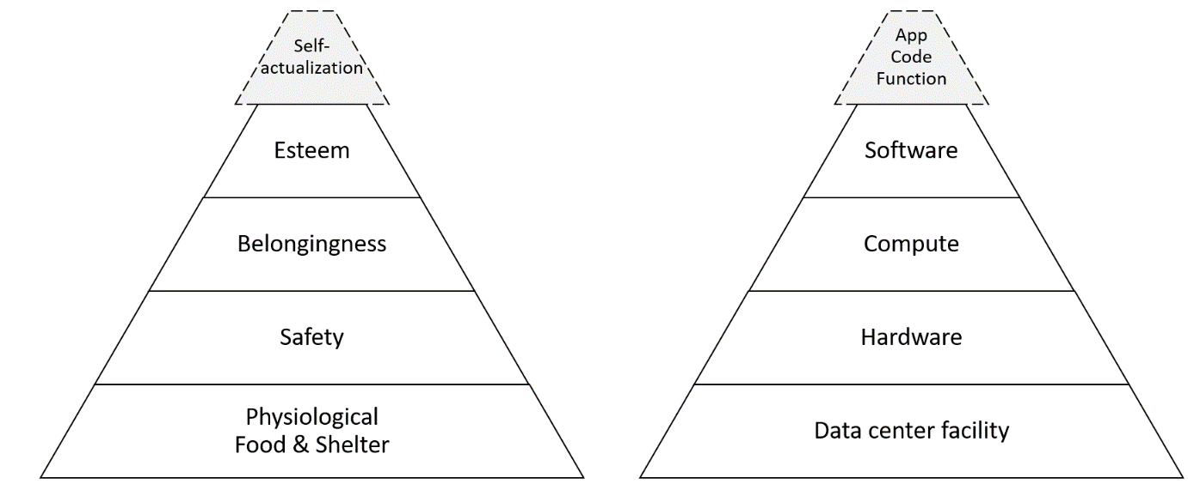
Figure 1.5 – Maslow’s hierarchy versus the cloud computing hierarchy of needs
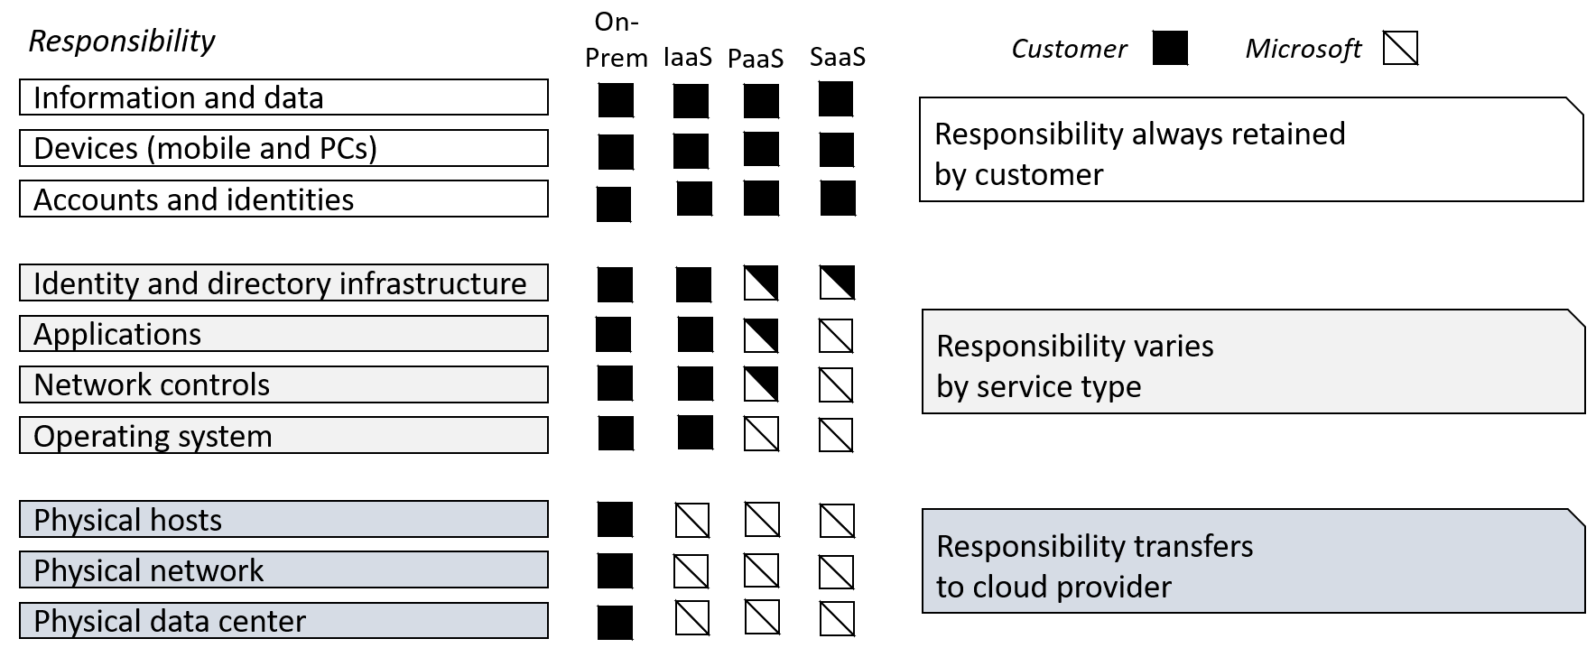
Figure 1.6 – Shared responsibility model
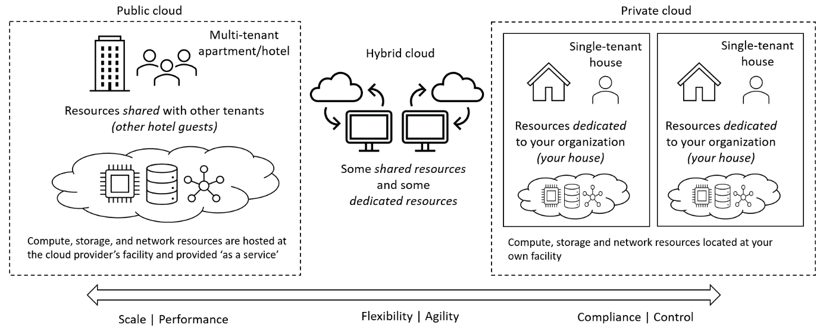
Figure 1.7 – Cloud computing delivery models
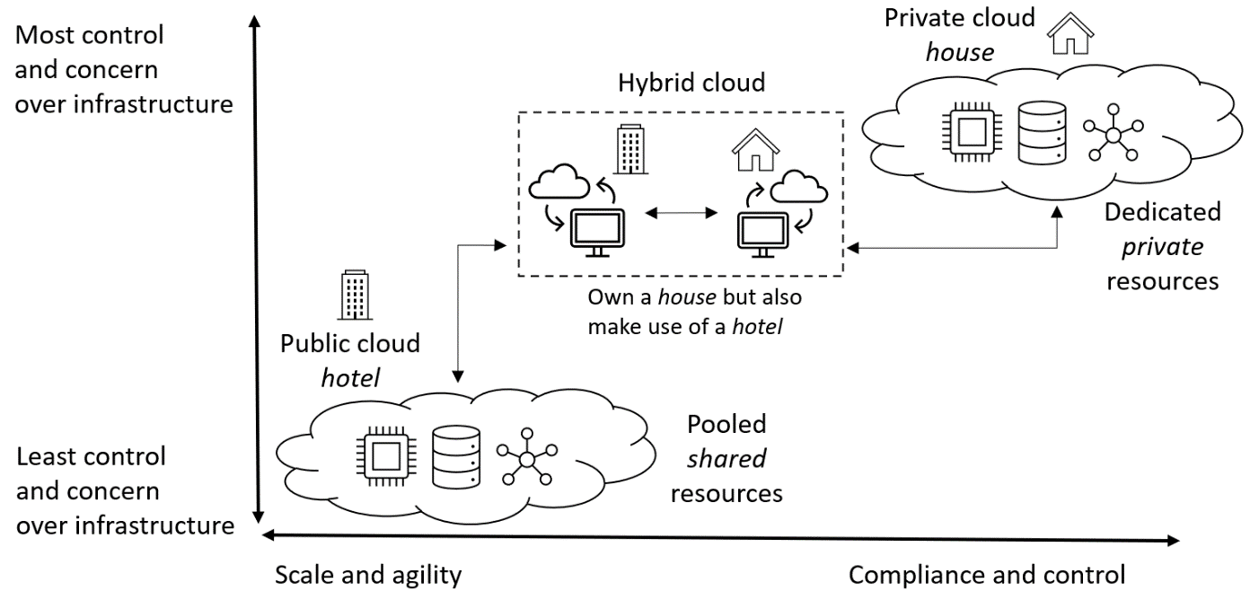
Figure 1.8 – Comparing cloud computing delivery models
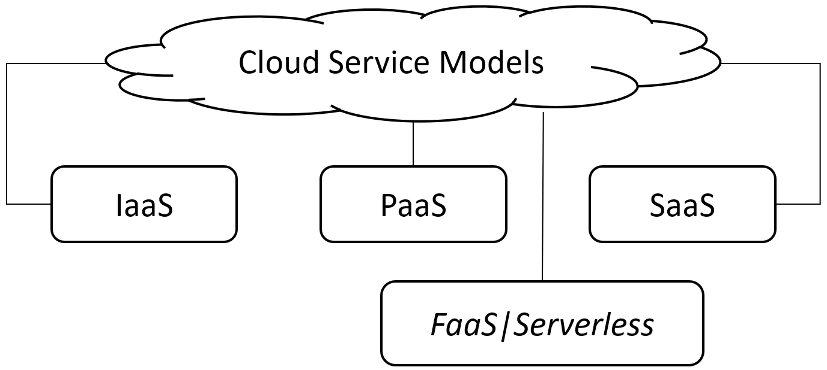
Figure 1.9 – Cloud computing service models
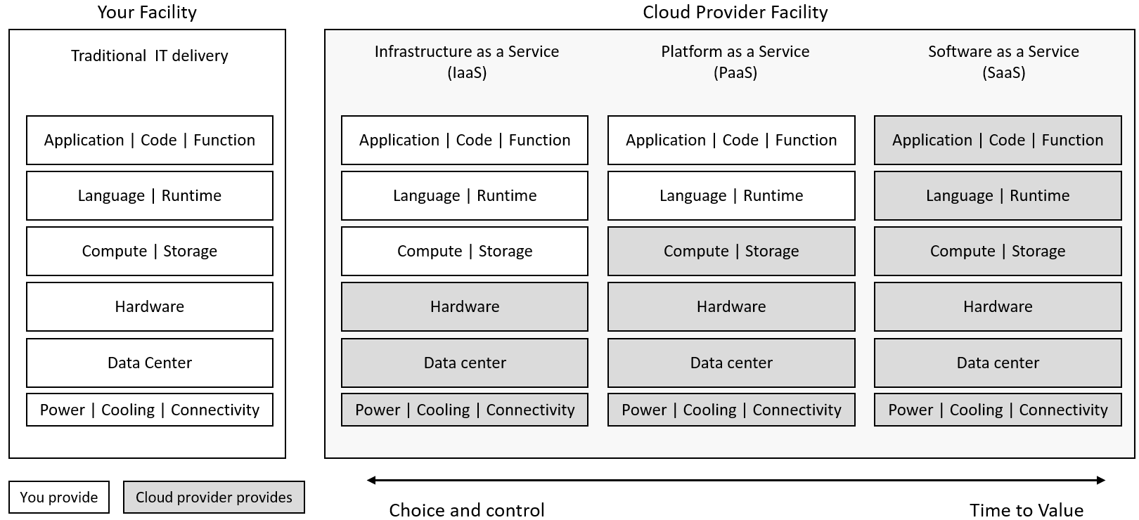
Figure 1.10 – Cloud computing service models—layer providers Figure 1.11 – Cloud computing service models—layer analogy of pizza processing
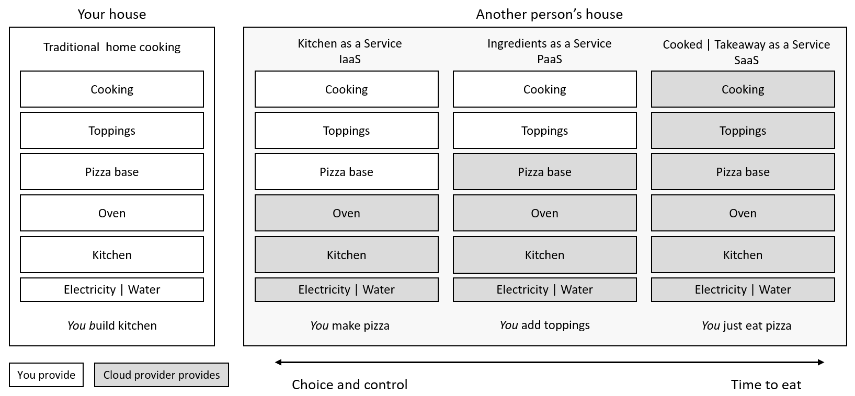
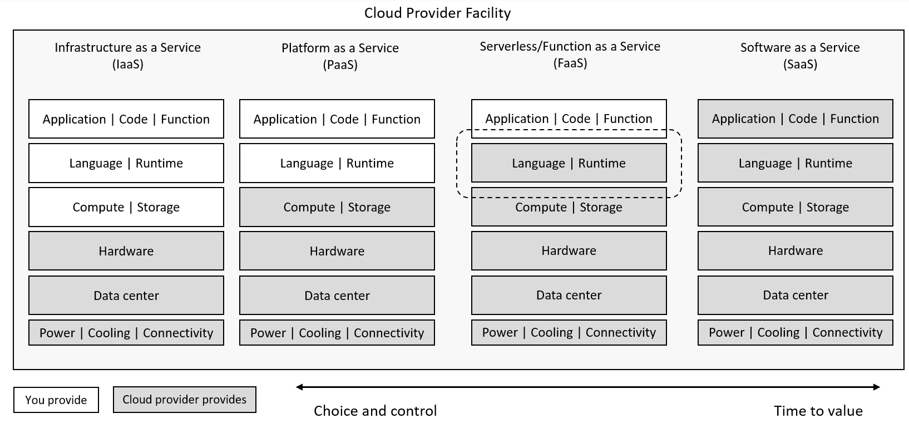
Figure 1.12 – Cloud computing service models—compare and contrast Figure 1.13 – Chapter Review Questions for Chapter 1
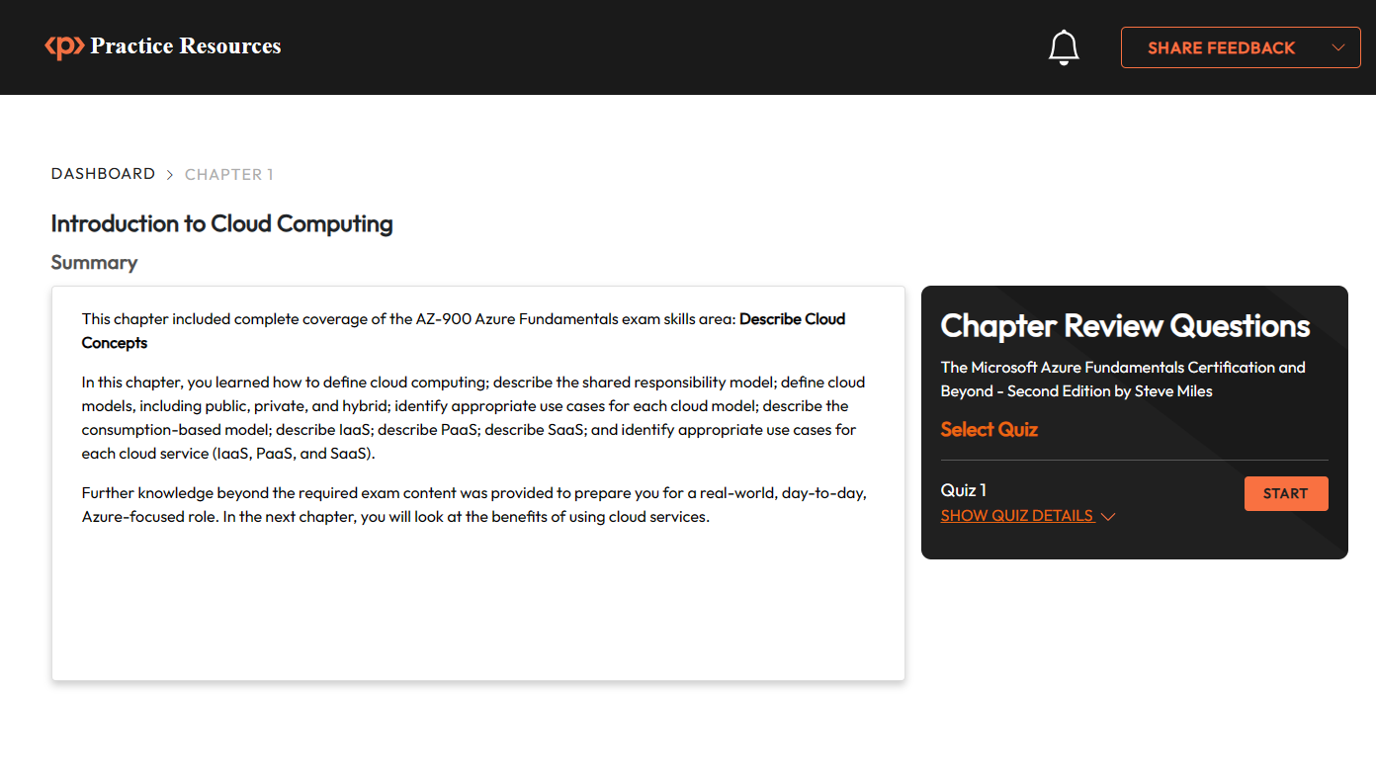

Chapter 2: Benefits of Using Cloud Services Figure 2.1 – Cloud computing as a digital transformation enabler Figure 2.2 – Digital transformation triggers
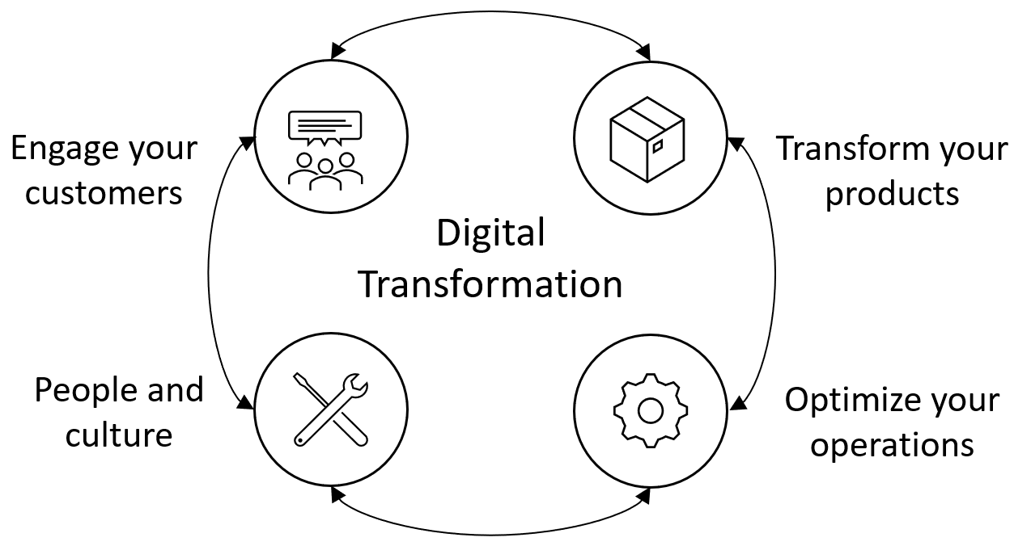
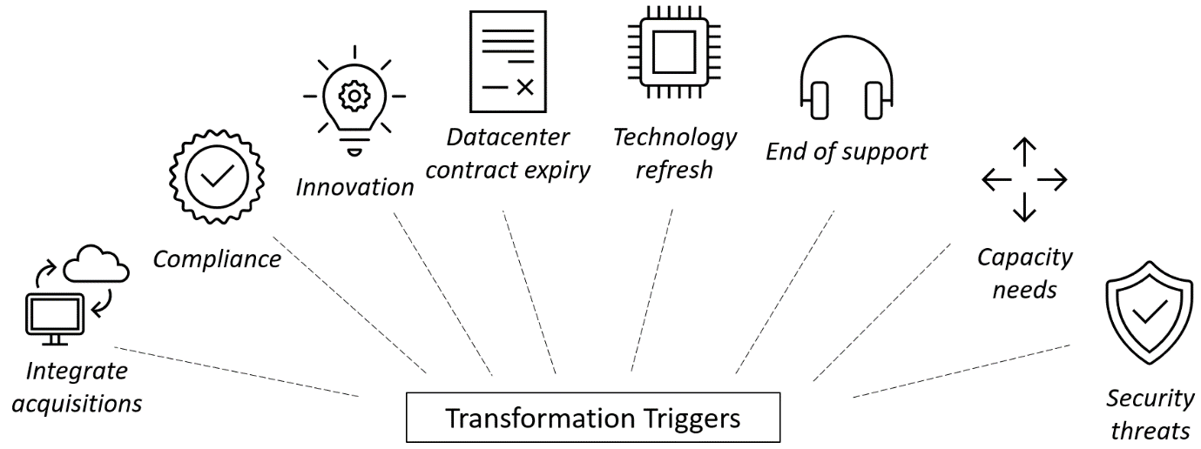
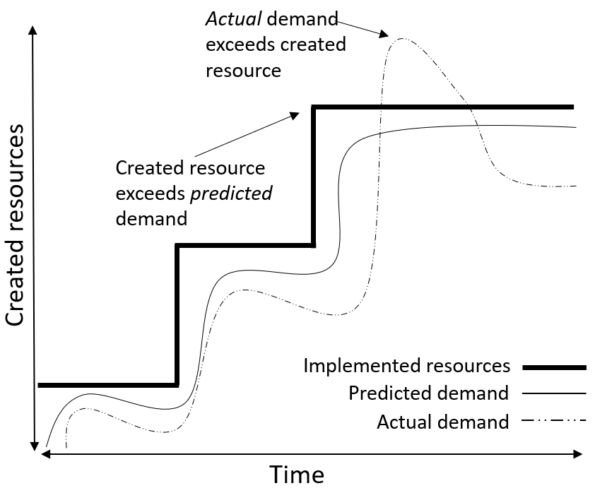
Figure 2.3 – Cloud computing resource demand model Figure 2.4 – RTO and RPO

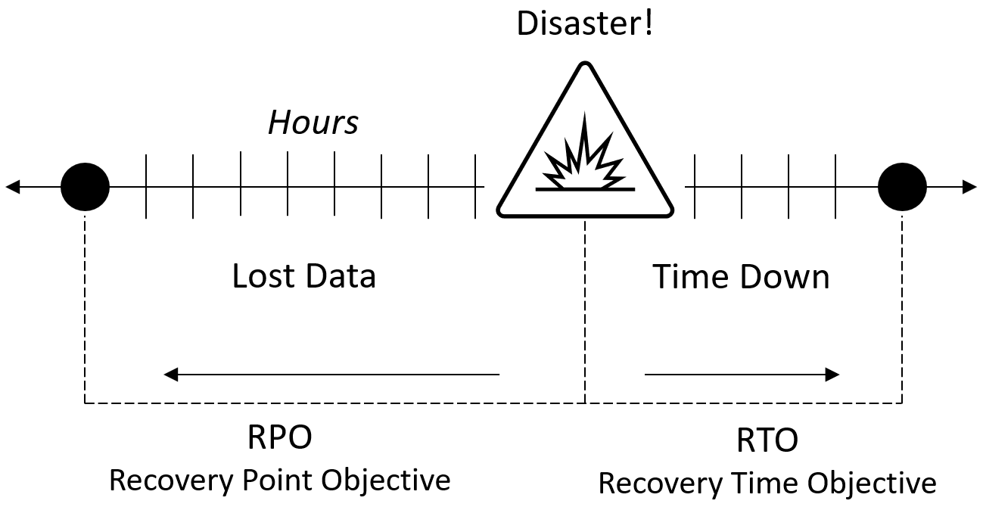
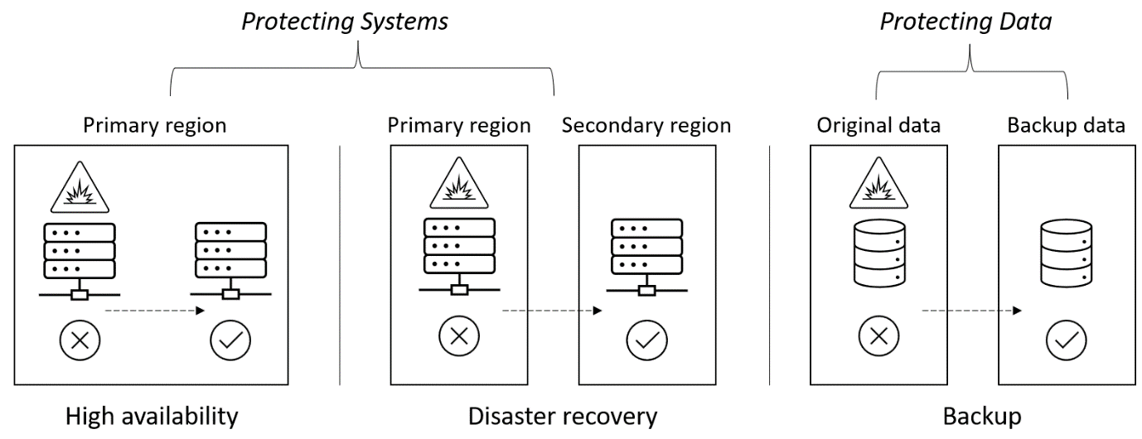
Figure 2.5 – Comparing backup, high availability, and disaster recovery Figure 2.6 – Challenges to implementing business continuity Figure 2.7 – Cost expenditure models
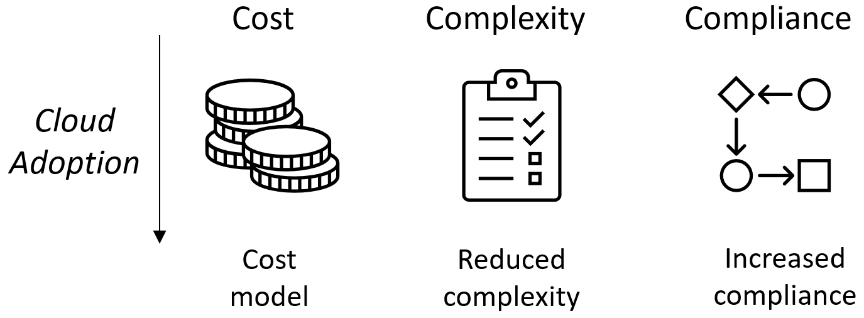
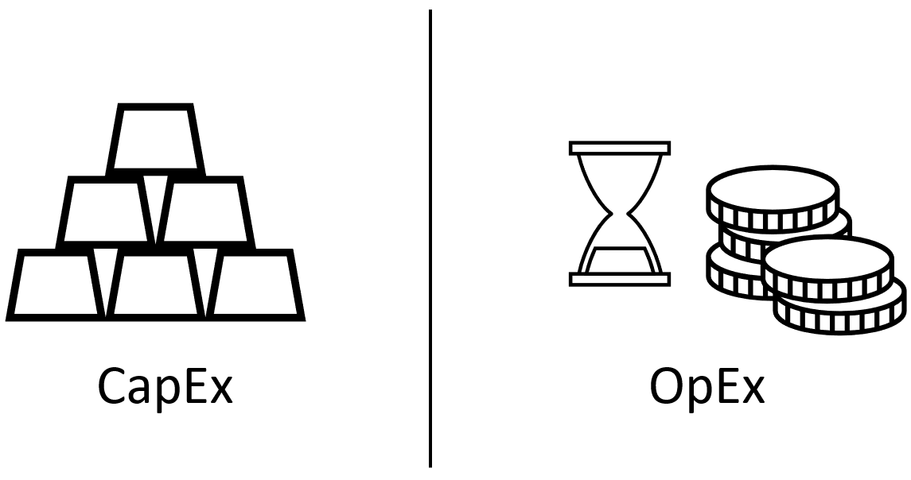
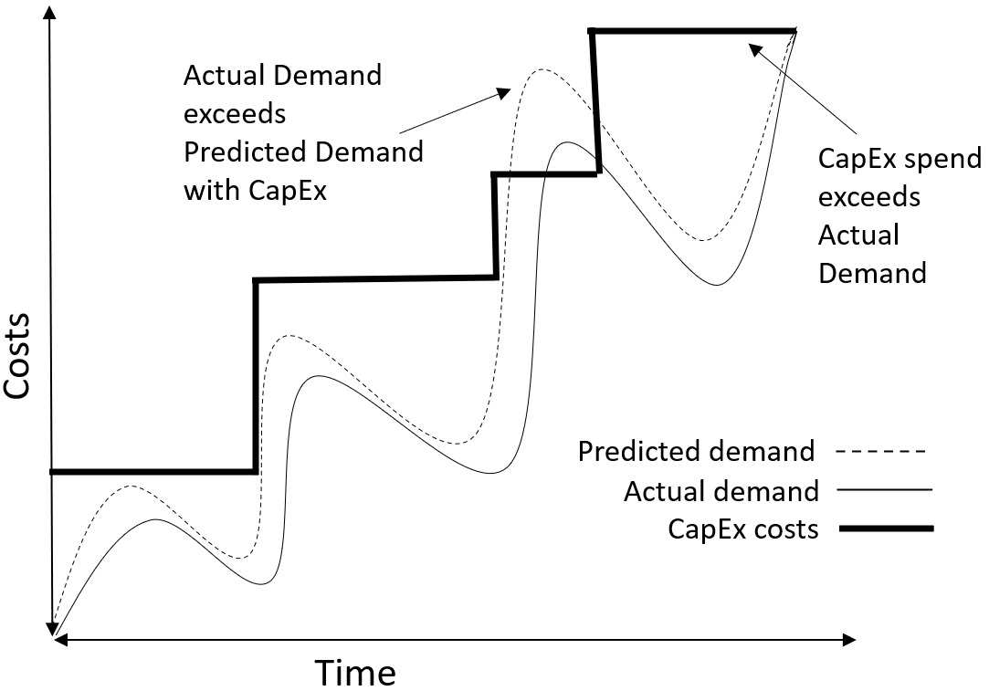
Figure 2.8 – Application of cost expenditure models Figure 2.10 – Chapter Review Questions for Chapter 2

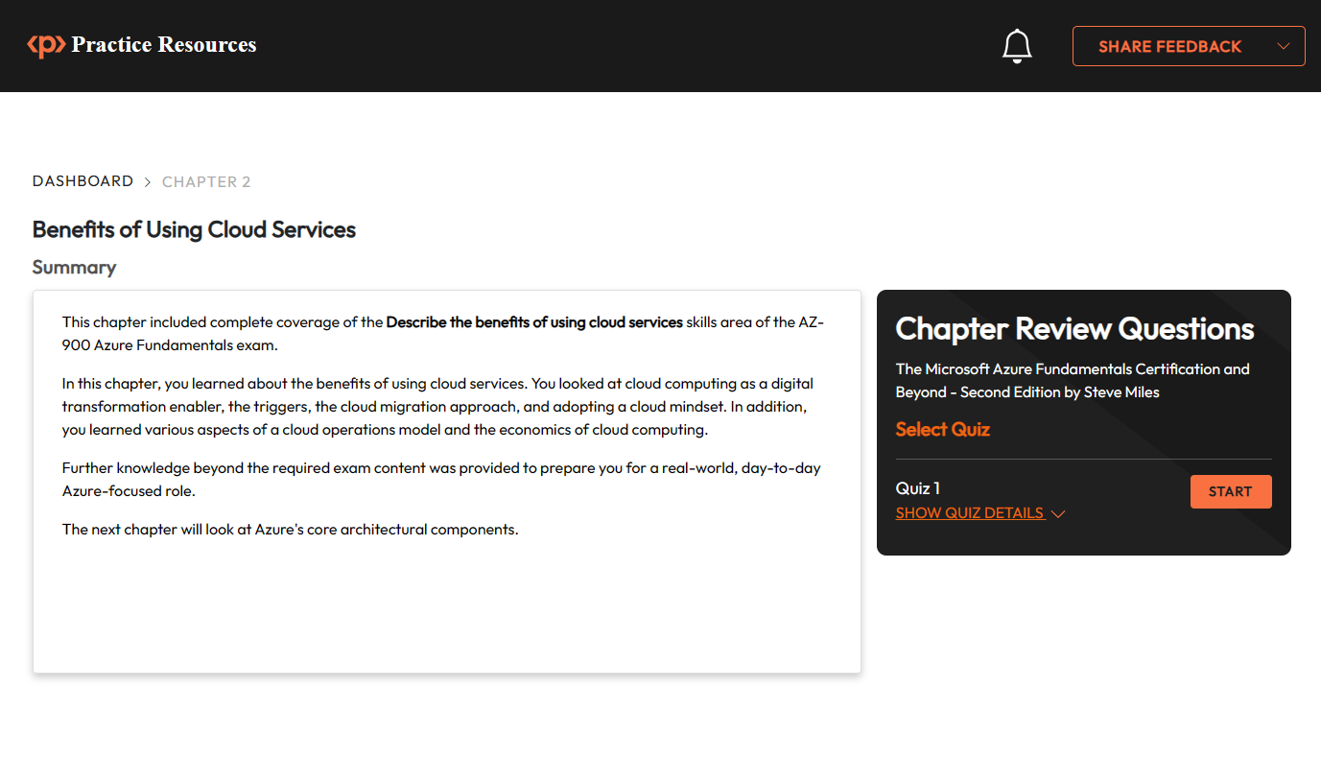

Chapter 3: Azure Core Architectural Components Figure 3.1 – Azure global infrastructure key component topology Figure 3.2 – Azure regions and geographies relationship
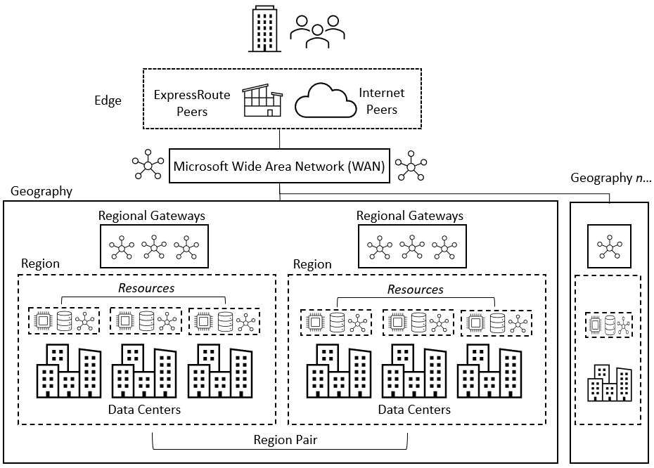
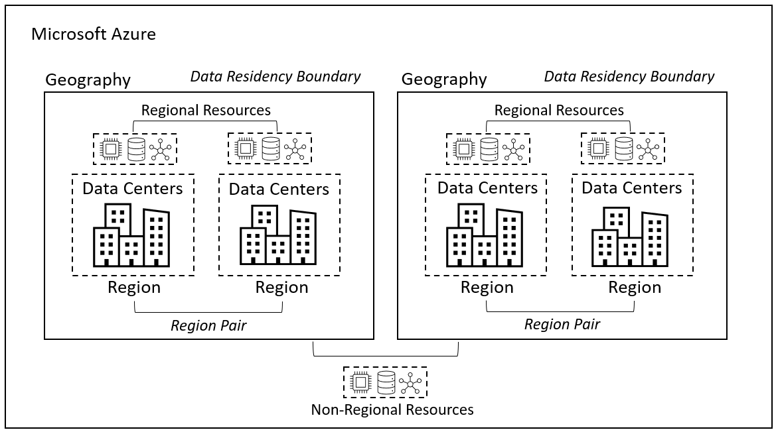
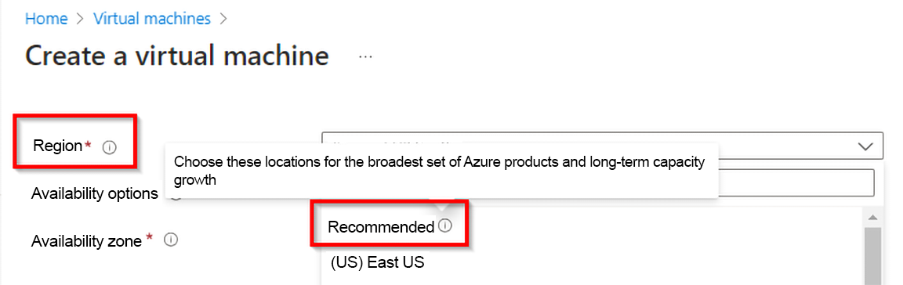
Figure 3.3 – Azure region selection for creating resources Figure 3.4 – Azure Edge Zone relationships
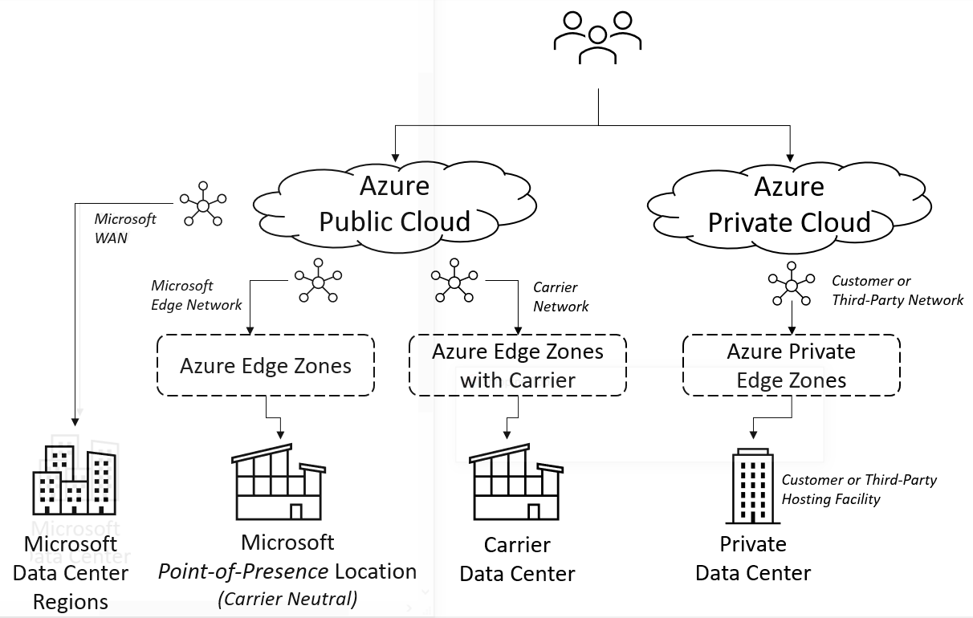
Figure 3.5 – Provided Azure sovereign regions
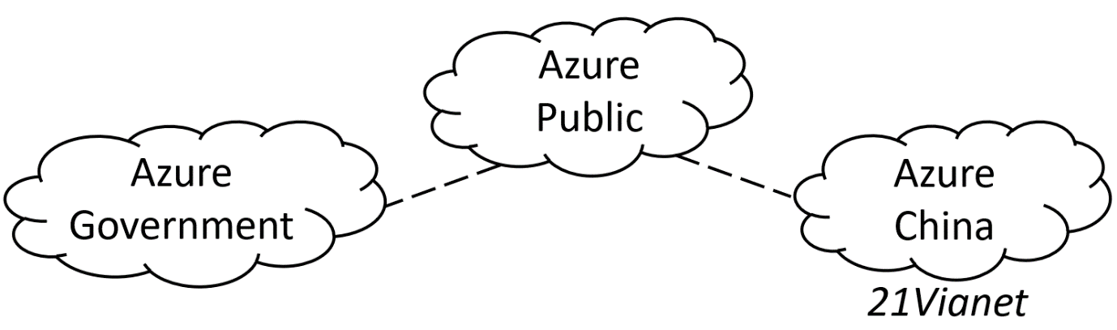
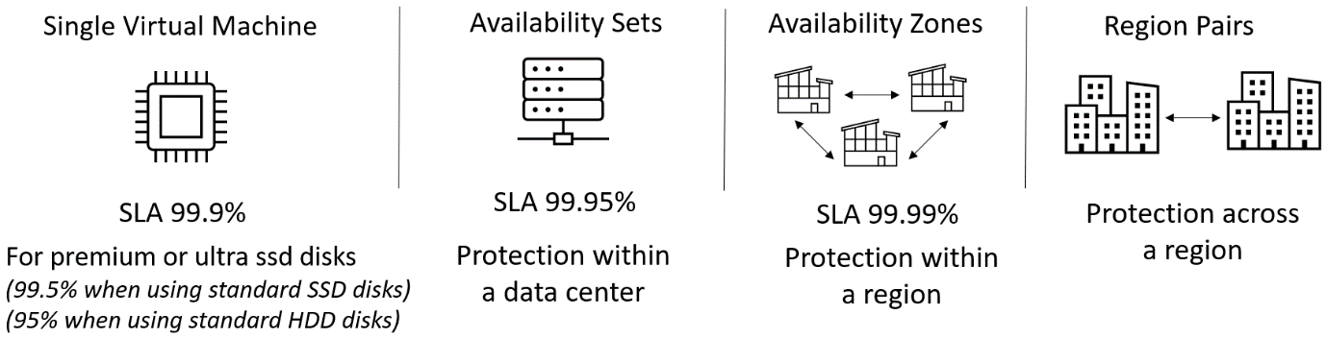
Figure 3.6 – Azure availability components relationship
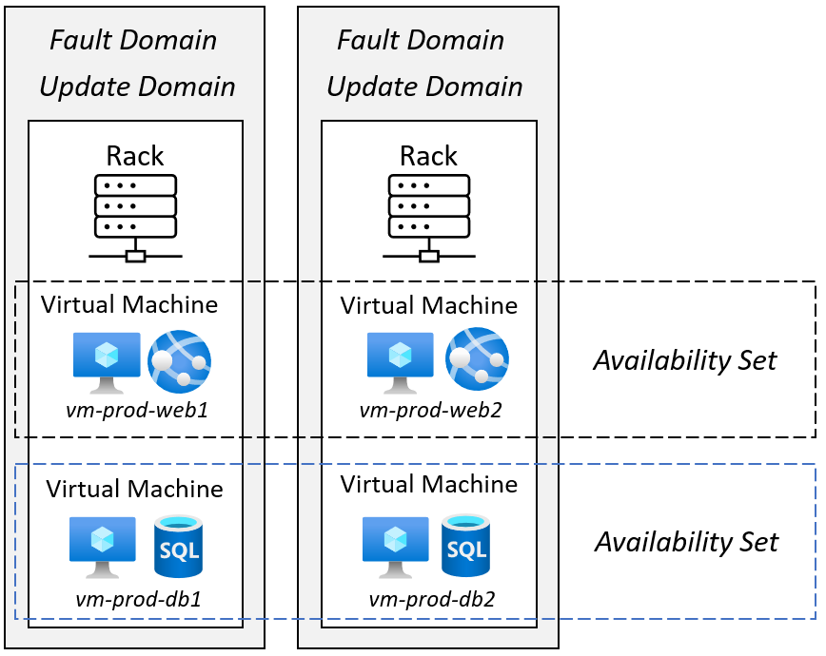
Figure 3.7 – Providing Azure availability set functionality in a solution
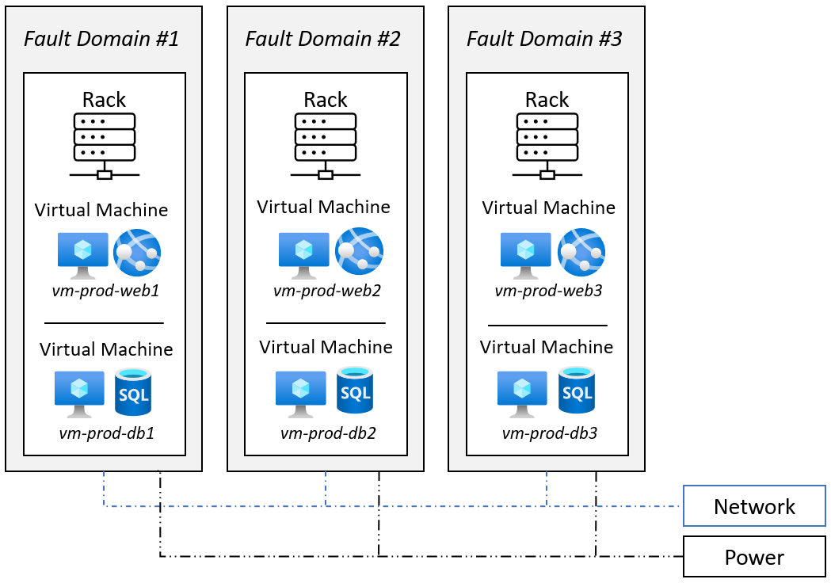
Figure 3.8 – Providing availability set fault domain functionality in a solution

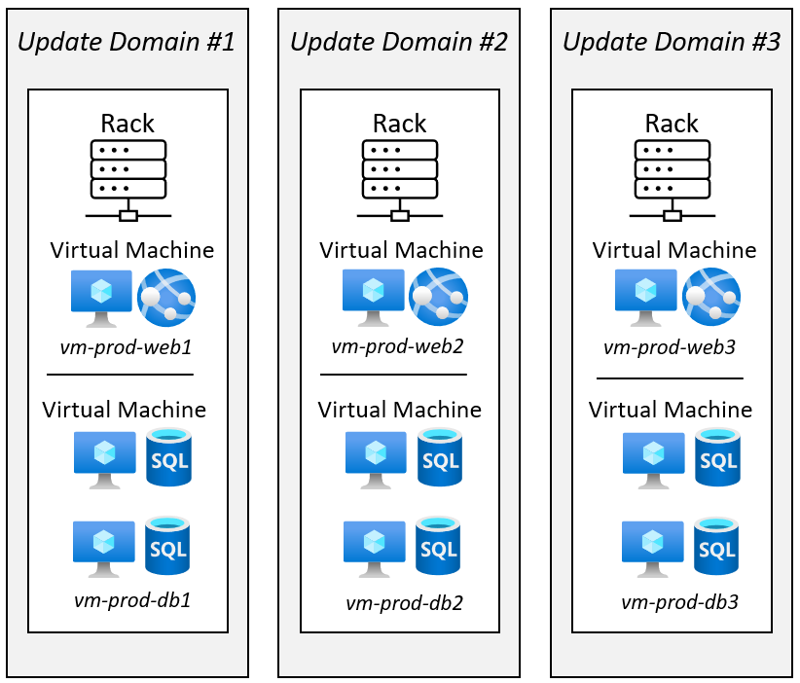
Figure 3.9 – Providing availability set update domain functionality in a solution Figure 3.10 – Azure availability zones providing redundancy within a region

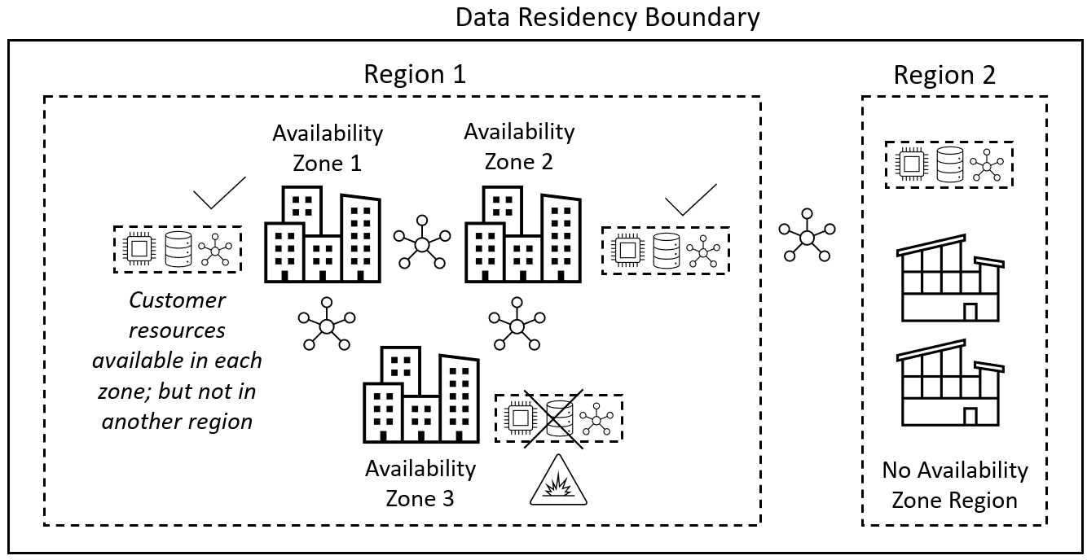
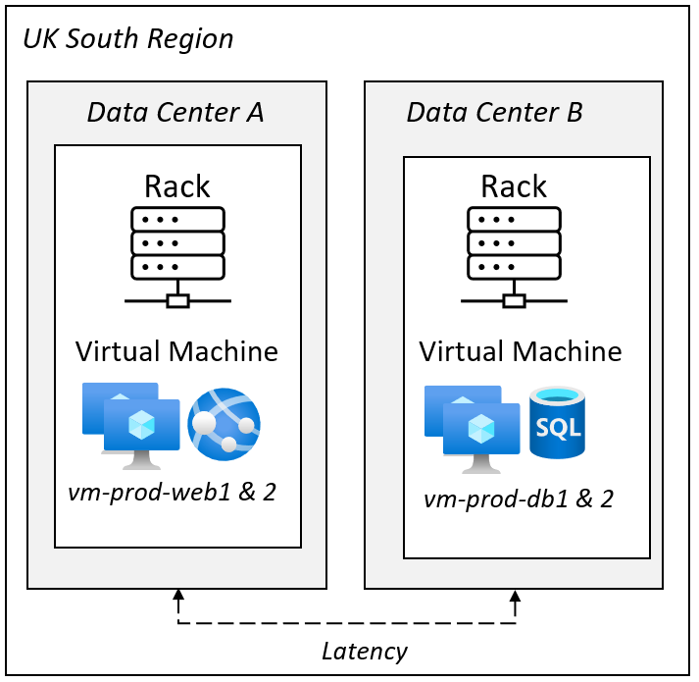
Figure 3.11 – Providing virtual machine placement without proximity placement groups in a solution

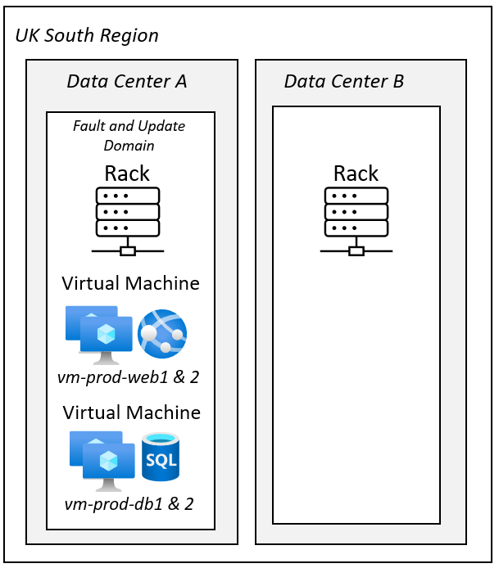
Figure 3.12 – Providing virtual machine placement with proximity placement groups in a solution

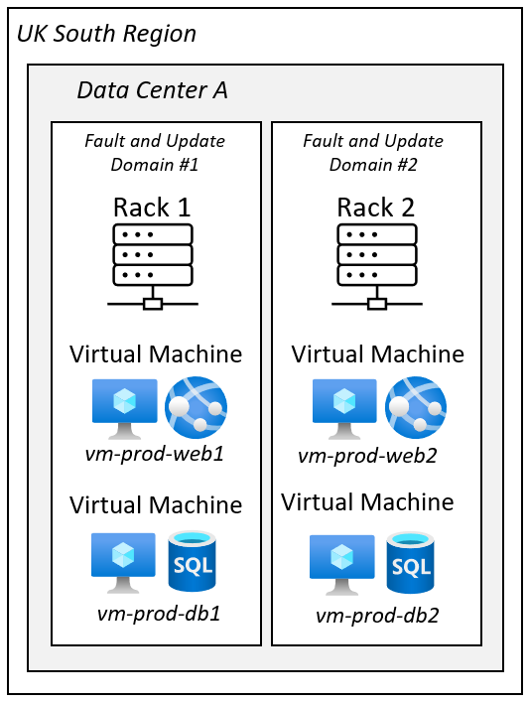
Figure 3.13 – Providing proximity placement groups and availability sets in a solution

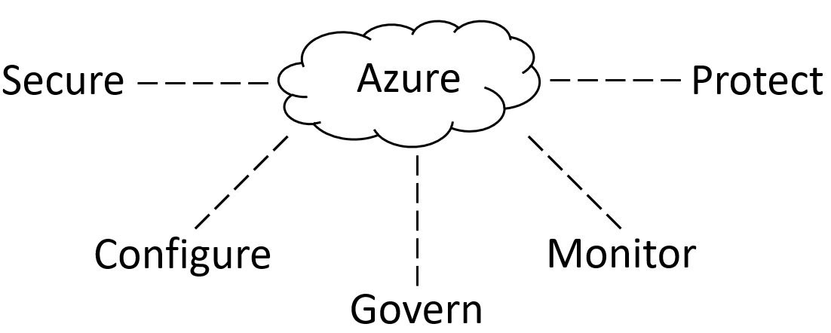
Figure 3.14 – Azure resource management
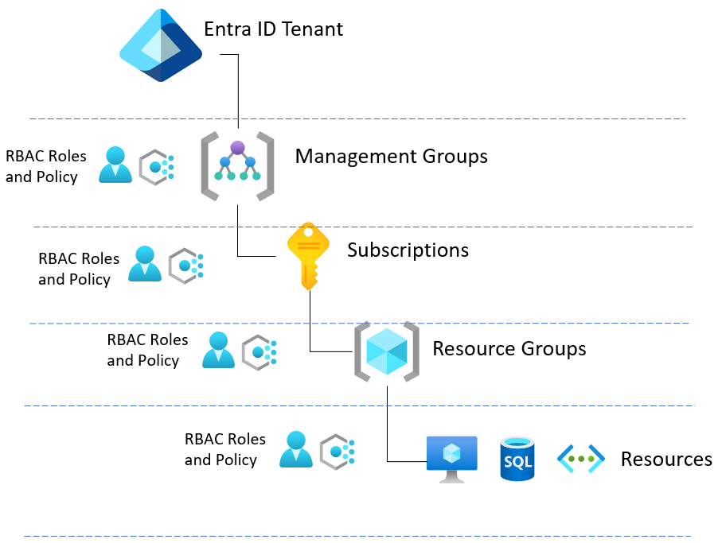
Figure 3.15 – Azure management scopes relationship Figure 3.16 – Azure management group and subscription relationships

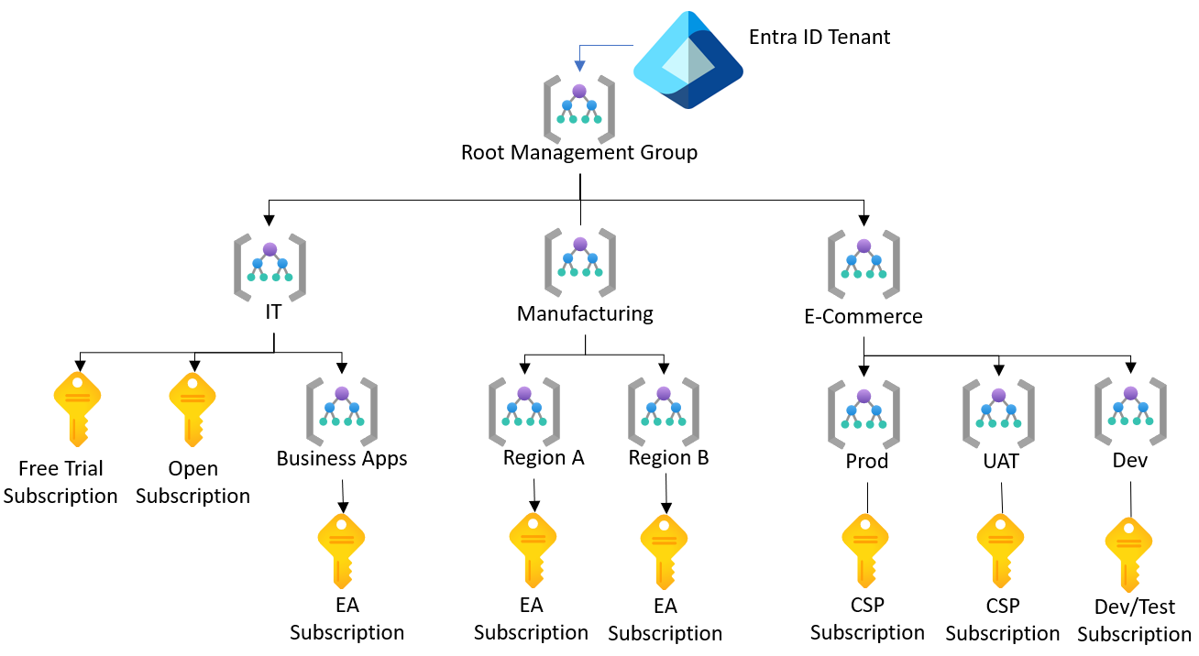
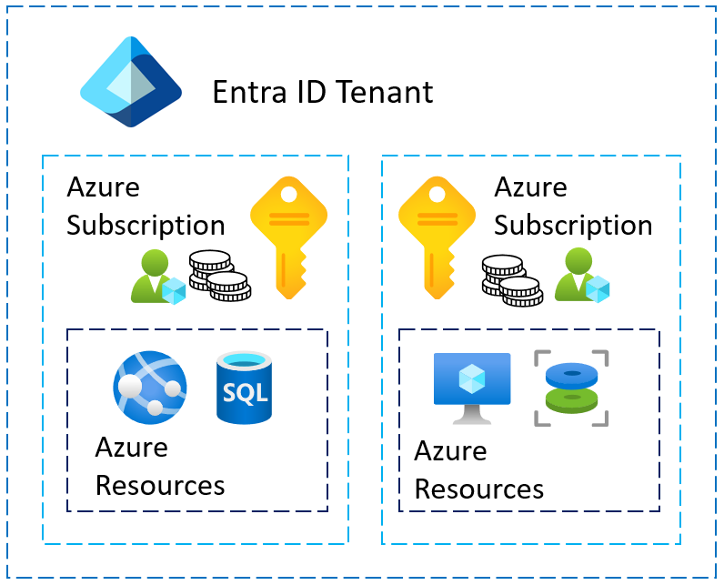
Figure 3.17 – Relationship between Azure subscriptions and resources within a tenant Figure 3.18 – Azure subscription and tenant relationship Figure 3.19 – Multiple Azure subscriptions

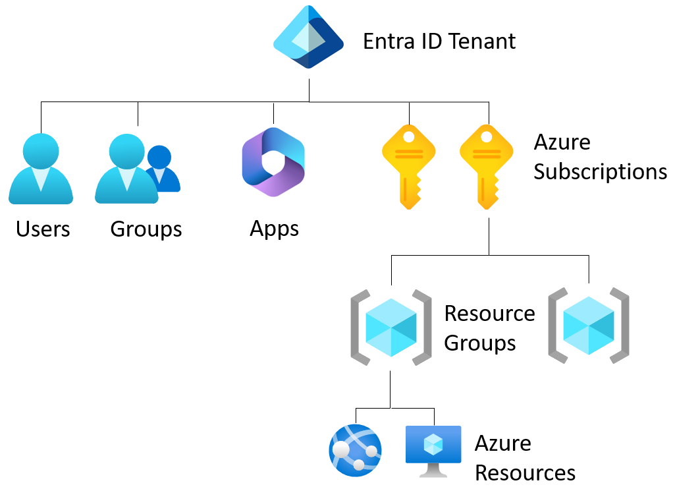
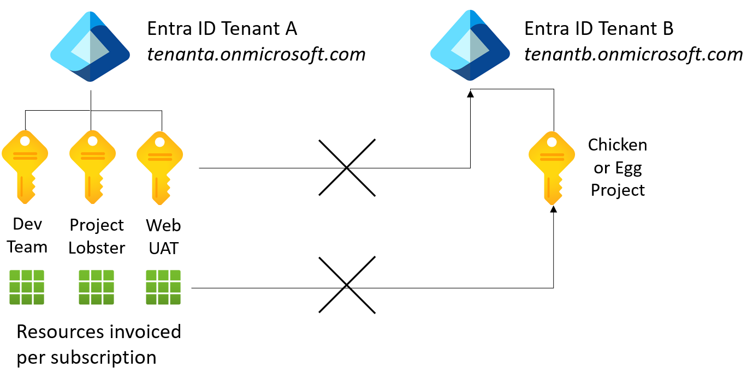
Figure 3.20 – ARM architecture showing the relationship between its components 8
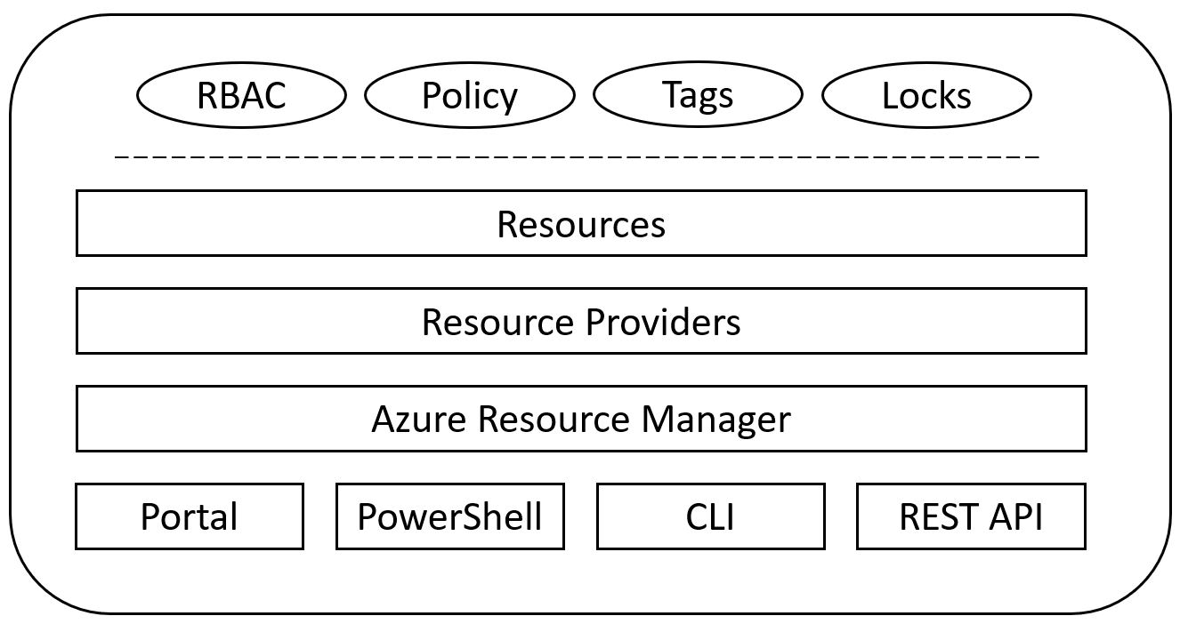
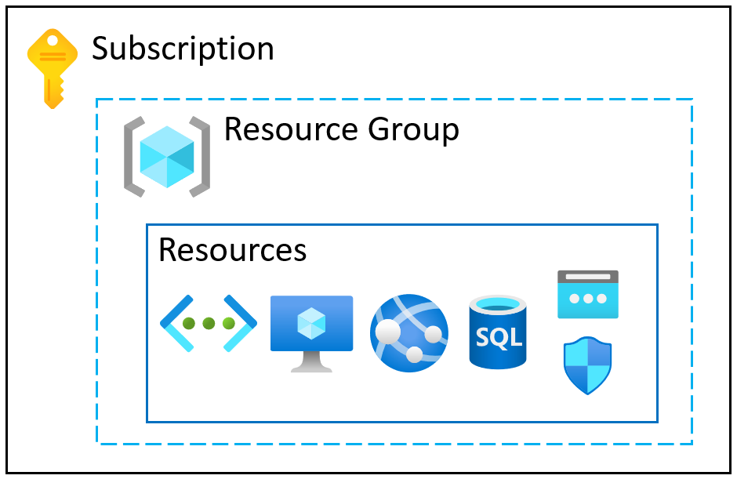
Figure 3.21 – Azure resource group relationships Figure 3.22 – Azure resource group organization showing grouping methodologies
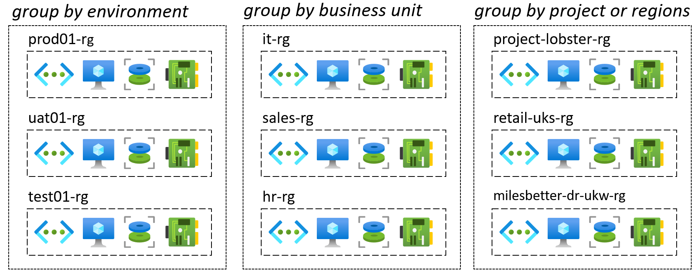
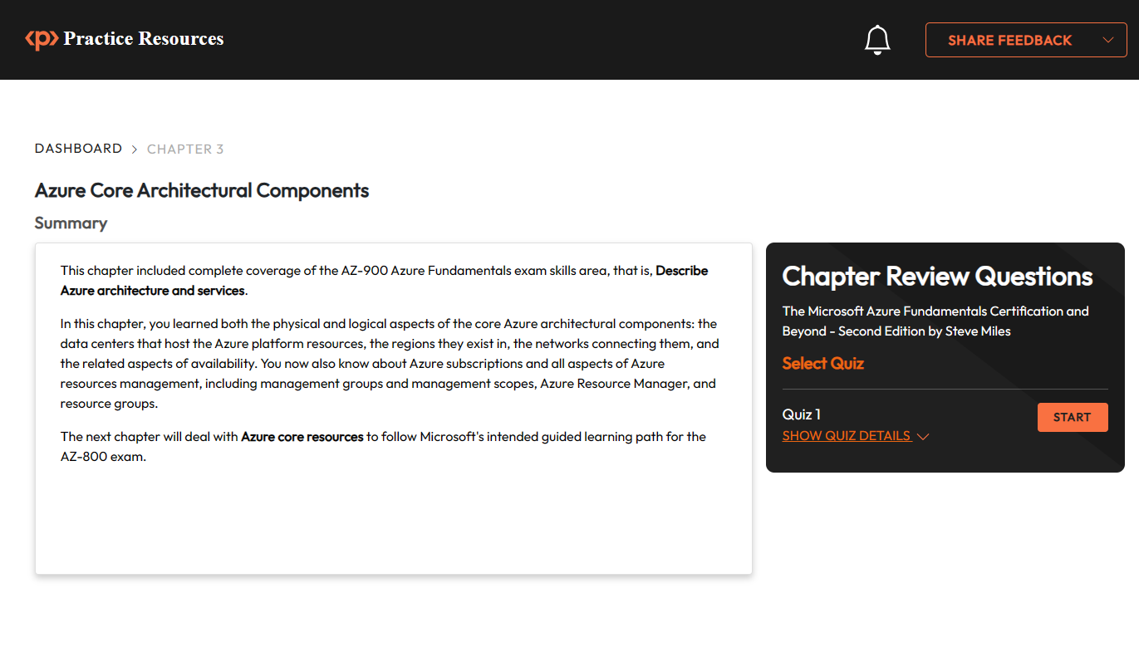
Figure 3.23 – Chapter Review Questions for Chapter 3 Figure 3.25: Tasks in Azure Subscriptions activity
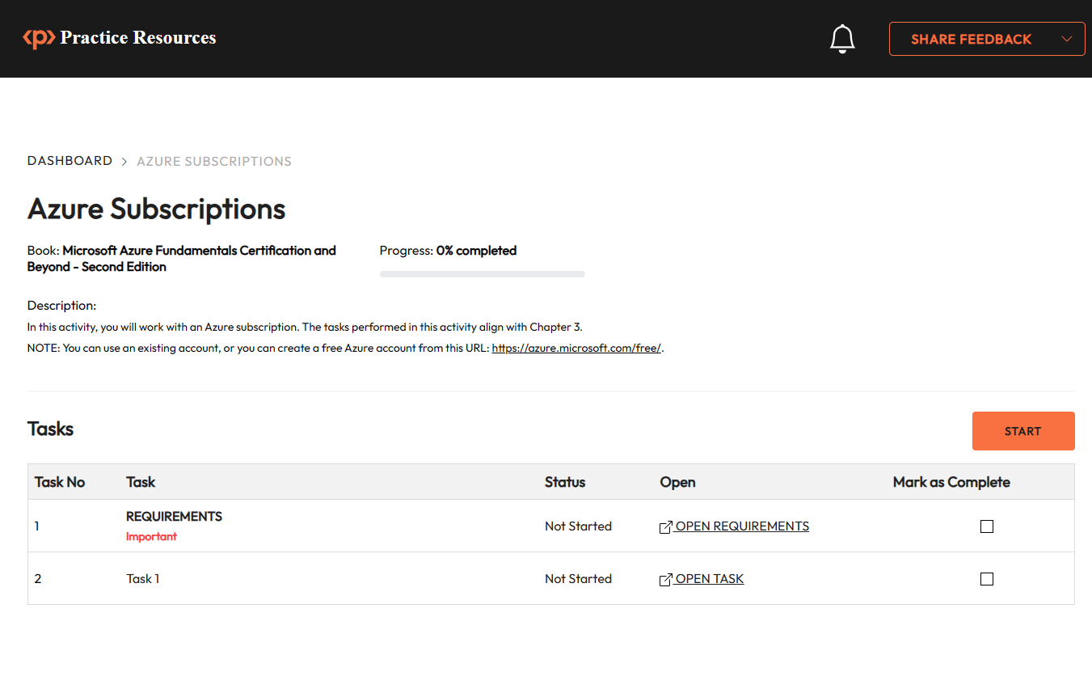

Chapter 4: Azure Core Resources
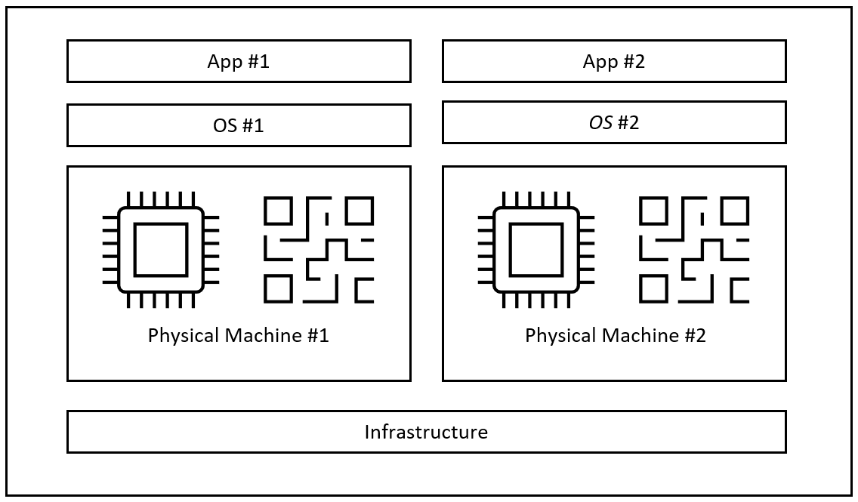
Figure 4.1 – Traditional approach supporting a single app per physical machine
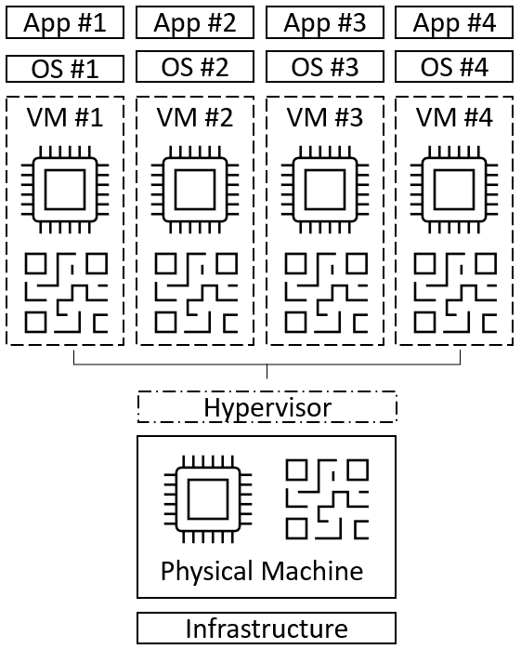
Figure 4.2 – Virtualization approach supporting multiple apps per physical machine

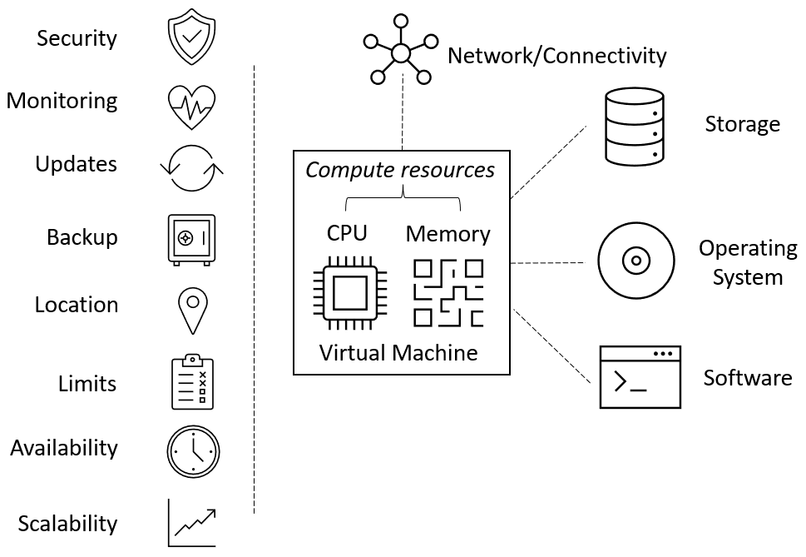
Figure 4.3 – VM components and considerations Figure 4.4 – Concept differences in traditional versus virtualization versus containerization

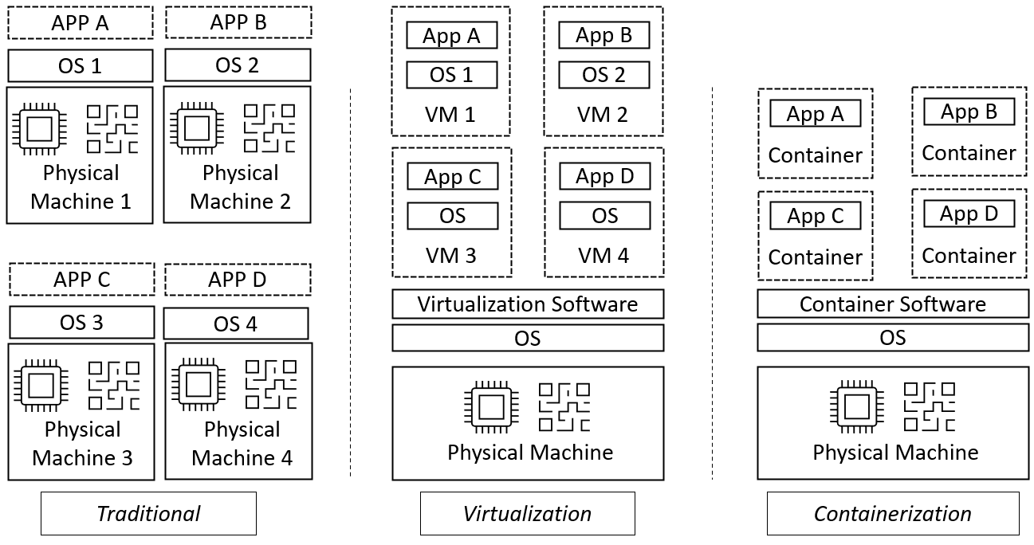
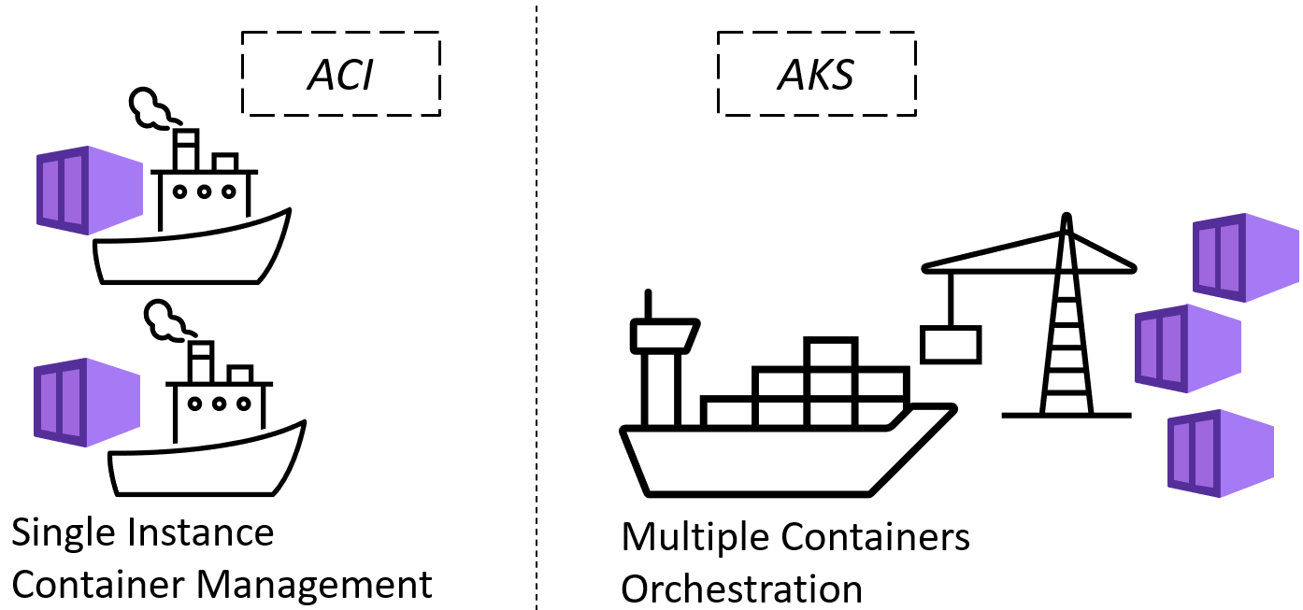
Figure 4.5 – ACI versus AKS for containerization compute services Figure 4.6 – AKS high-level service architecture showing Microsoft’s responsibilities versus the customer-managed components
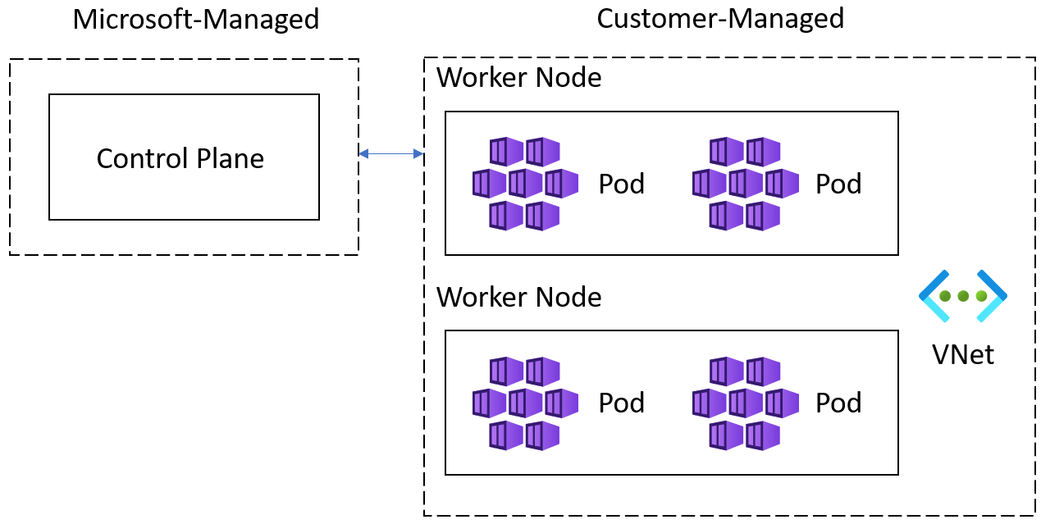
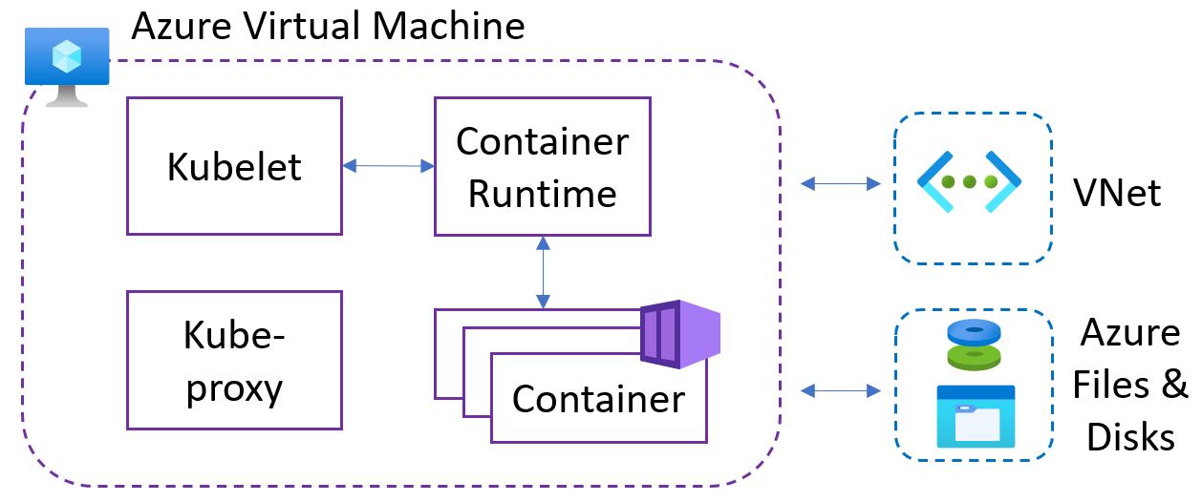
Figure 4.7 – Worker node high-level service architecture Figure 4.8 – IaaS hosting with Azure VM versus PaaS hosting with Azure App Service]bt6ygh
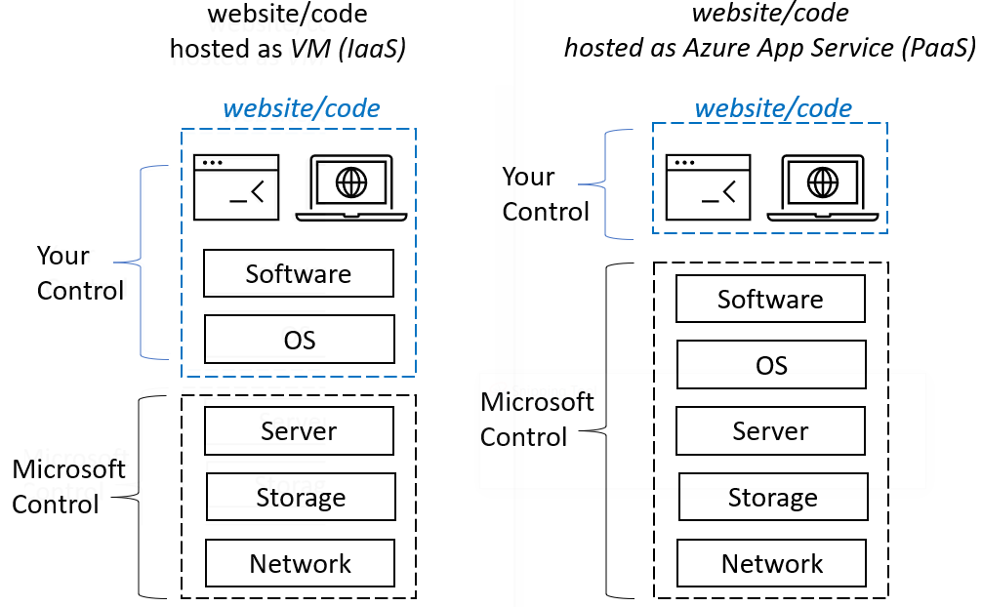
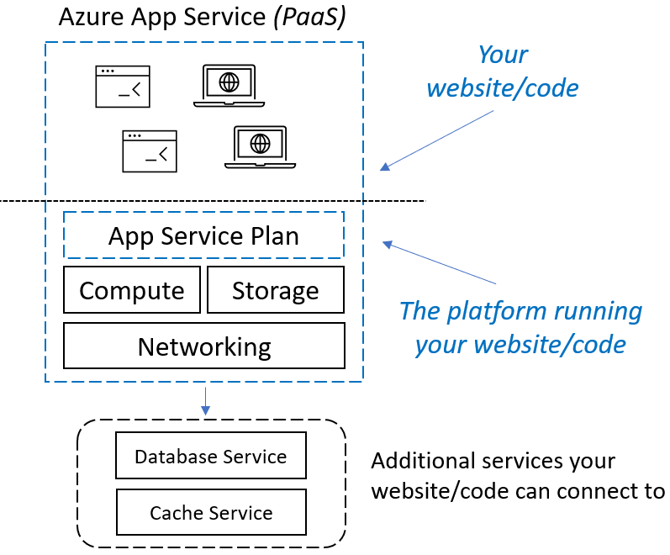
Figure 4.9 – Azure App Service plan components relationship Figure 4.10 – Azure Virtual Desktop service providing access from virtually anywhere

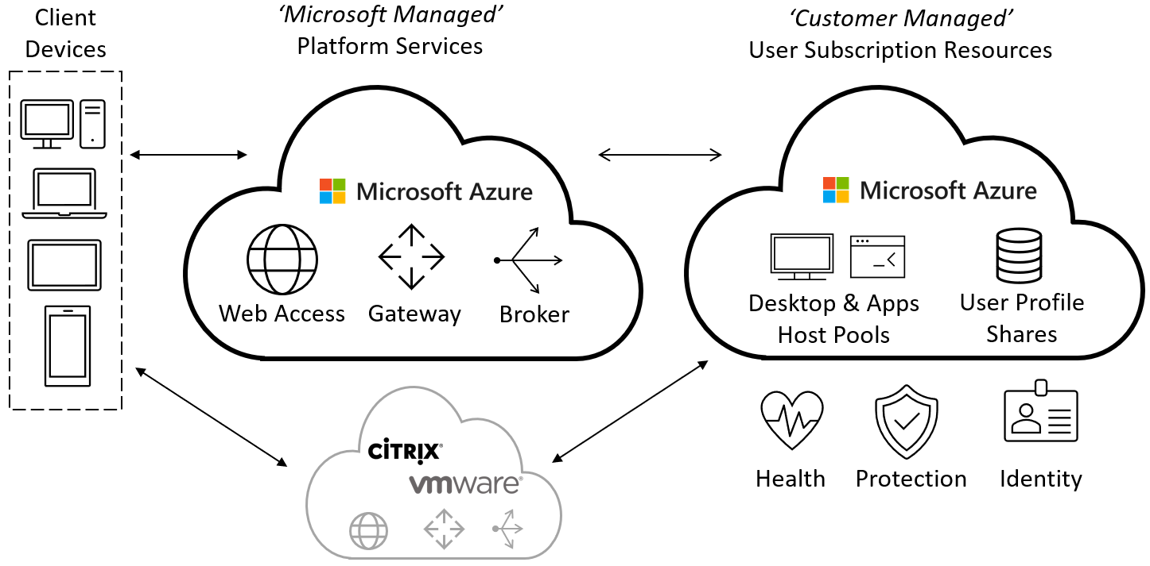
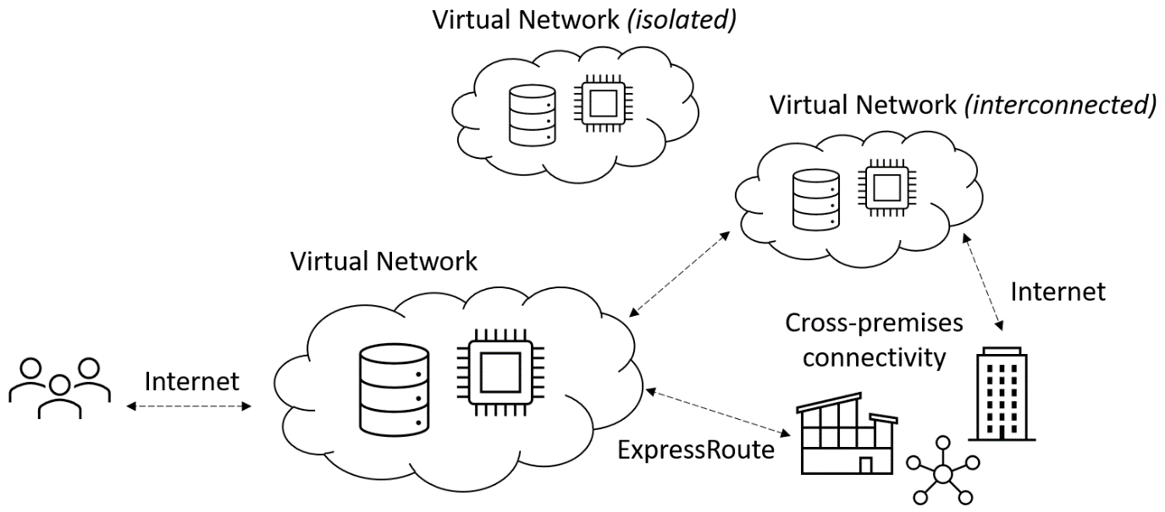
Figure 4.11 – Azure virtual networks schema showing communication between resources
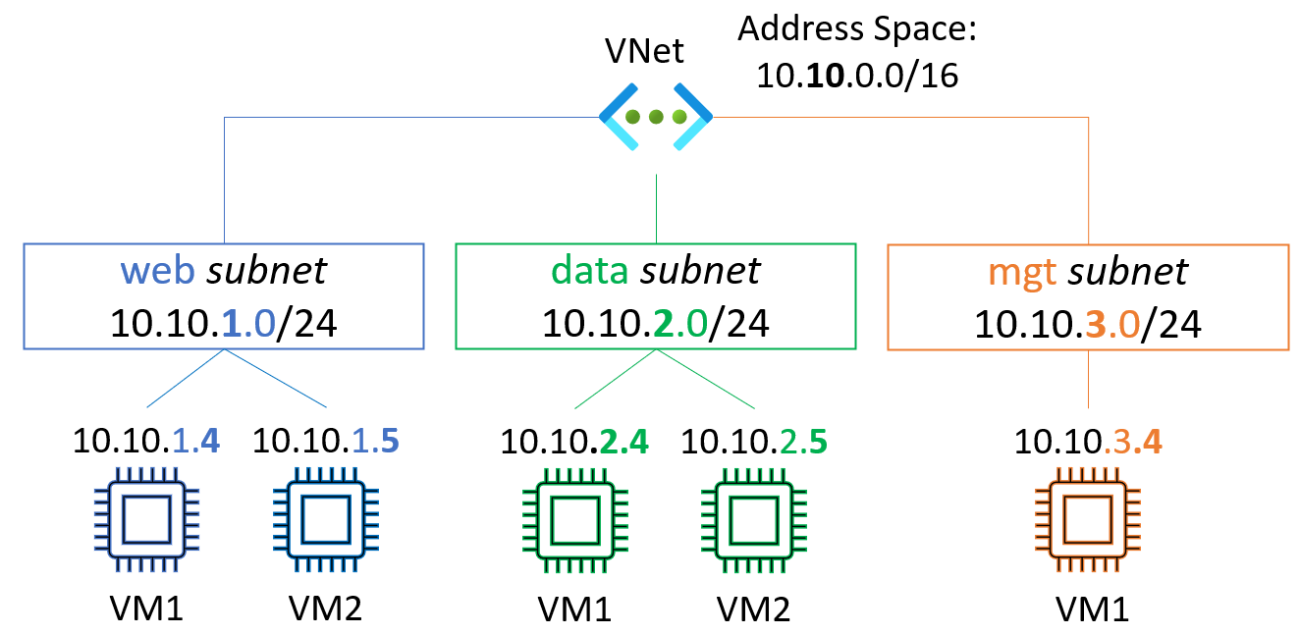
Figure 4.12 – The concept of segmenting a VNet into subnets
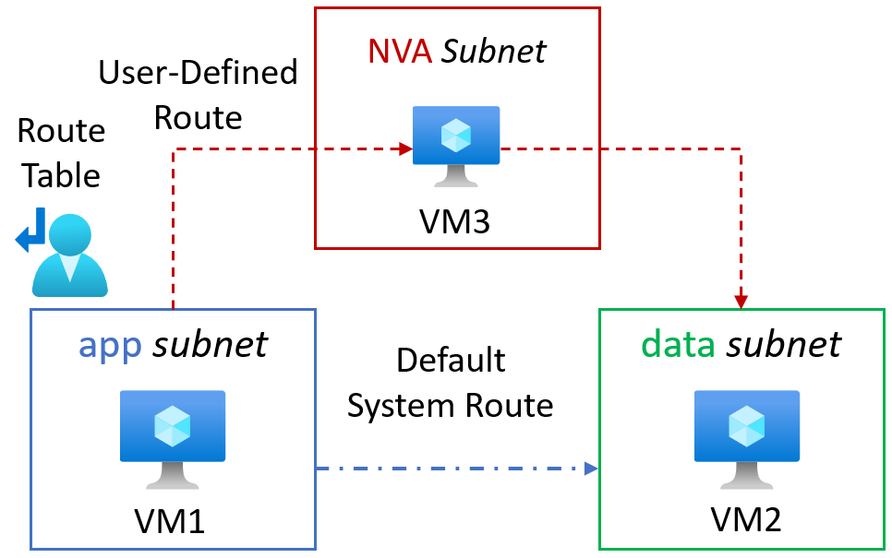
Figure 4.13 – VNet showing internal routing and segmentation through the use of an NVA
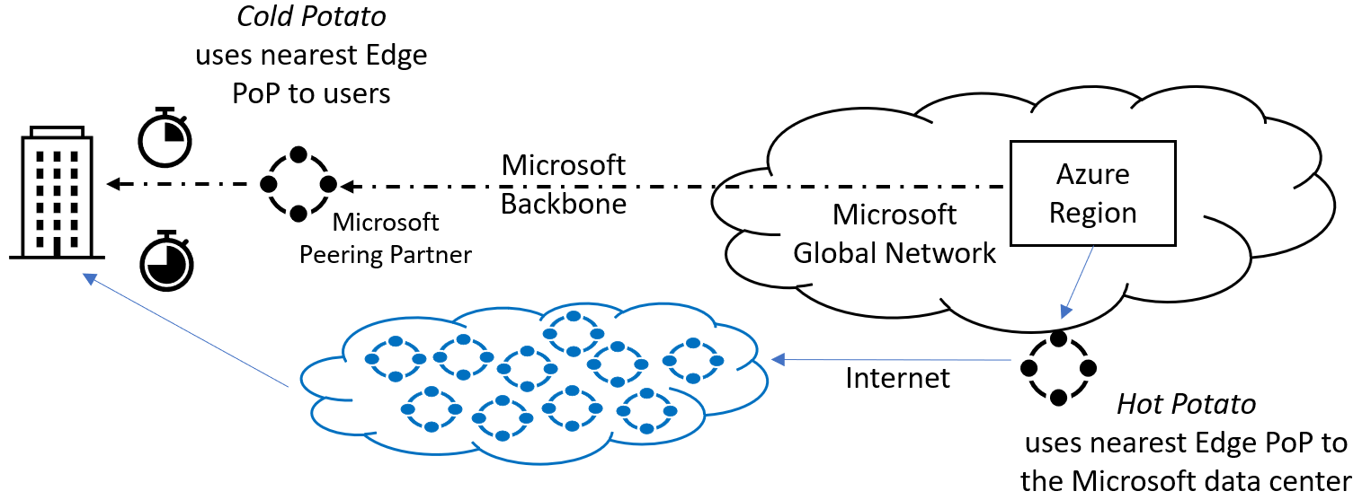
Figure 4.14 – Hot- versus cold-potato routing to carry traffic to its destination
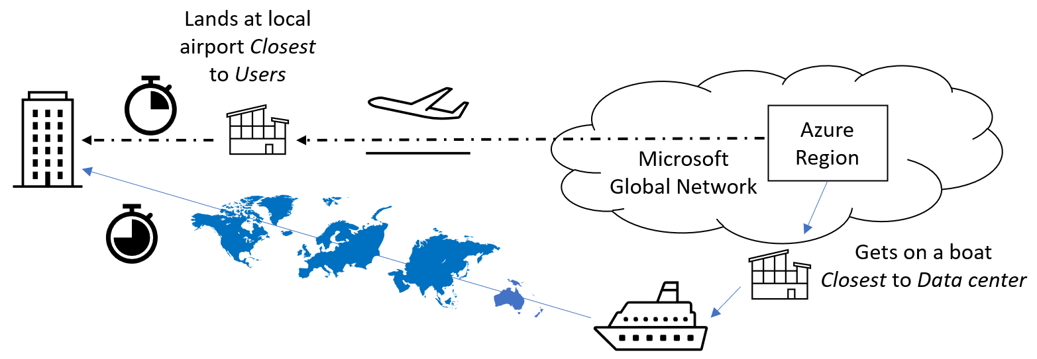
Figure 4.15 – Air travel versus shipping routes—similar to hot- versus cold-potato routing
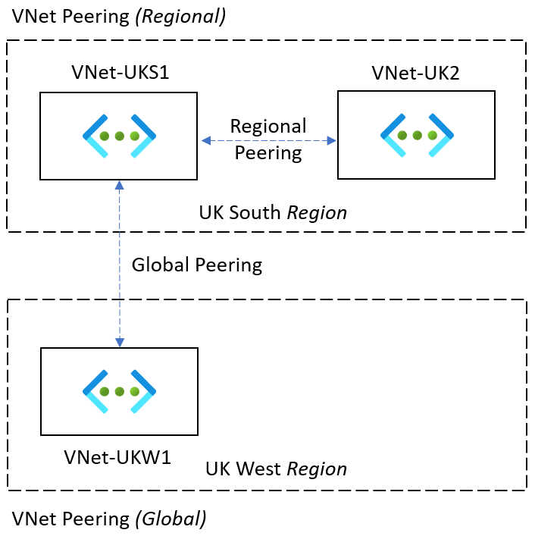
Figure 4.16 – Inter-VNet connectivity shown using peering
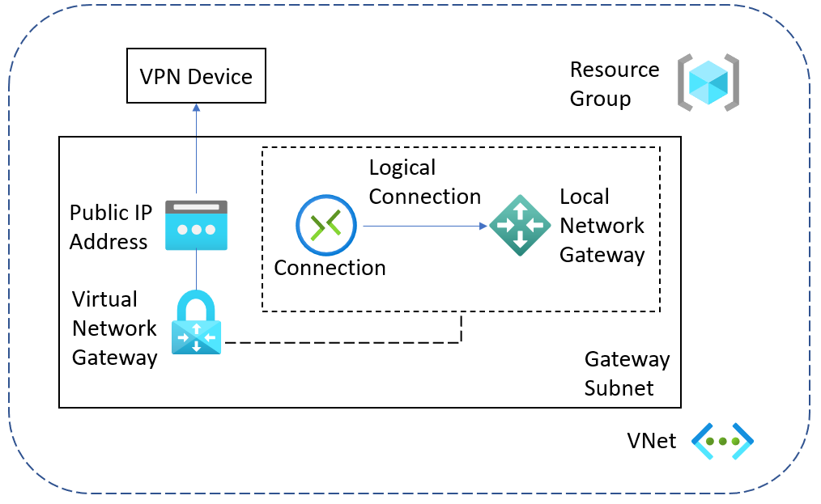
Figure 4.17 – VPN gateway resources allowing encrypted traffic to be sent through secure connections
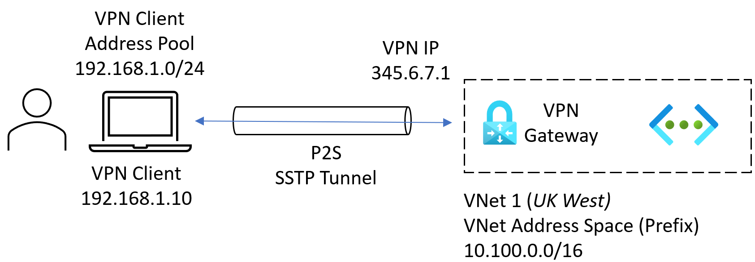
Figure 4.18 – Point-to-Site VPN
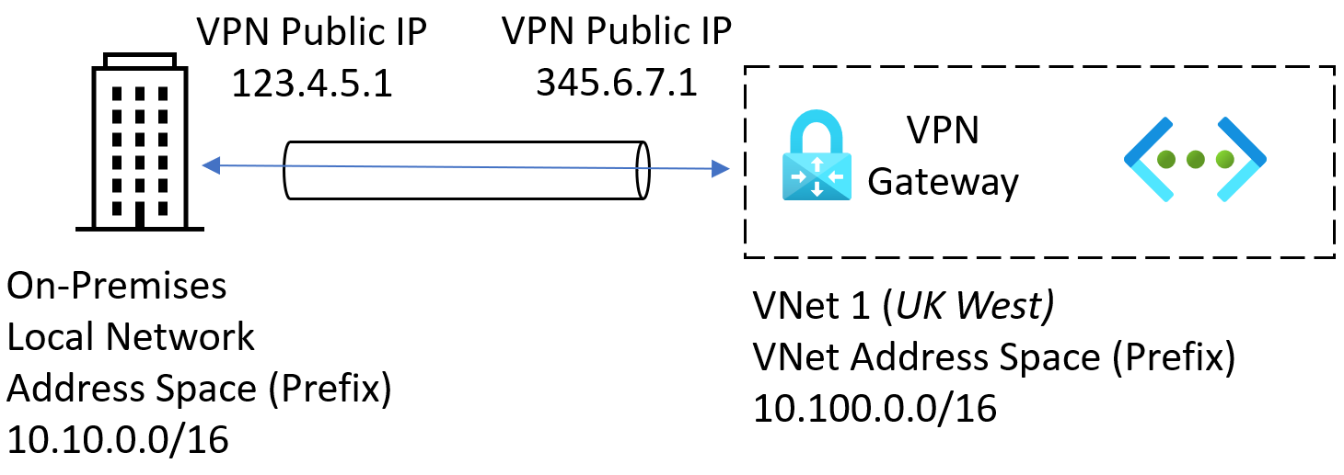
Figure 4.19 – Site-to-Site VPN
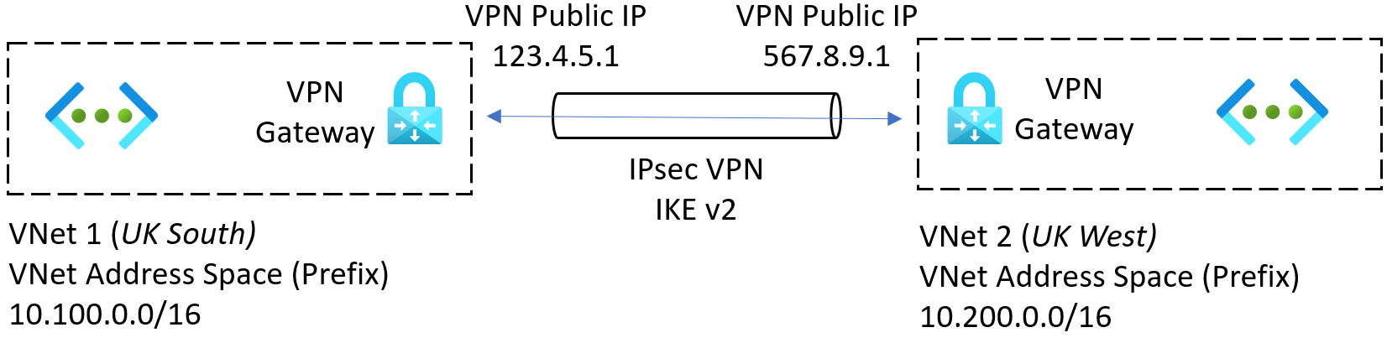
Figure 4.20 – VNet-to-VNet VPN
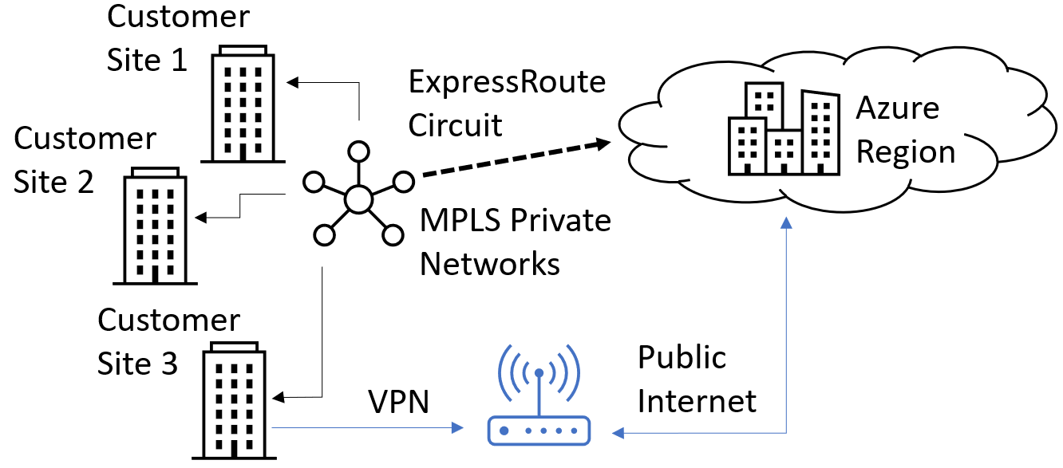
Figure 4.21 – ExpressRoute showing the connection for cross-premises to Azure resources
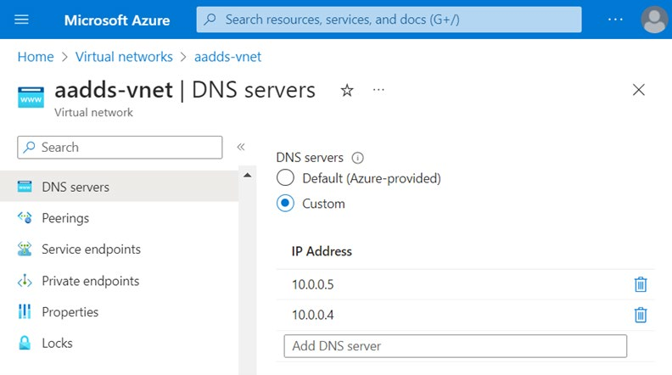
Figure 4.22 – Custom DNS server setting
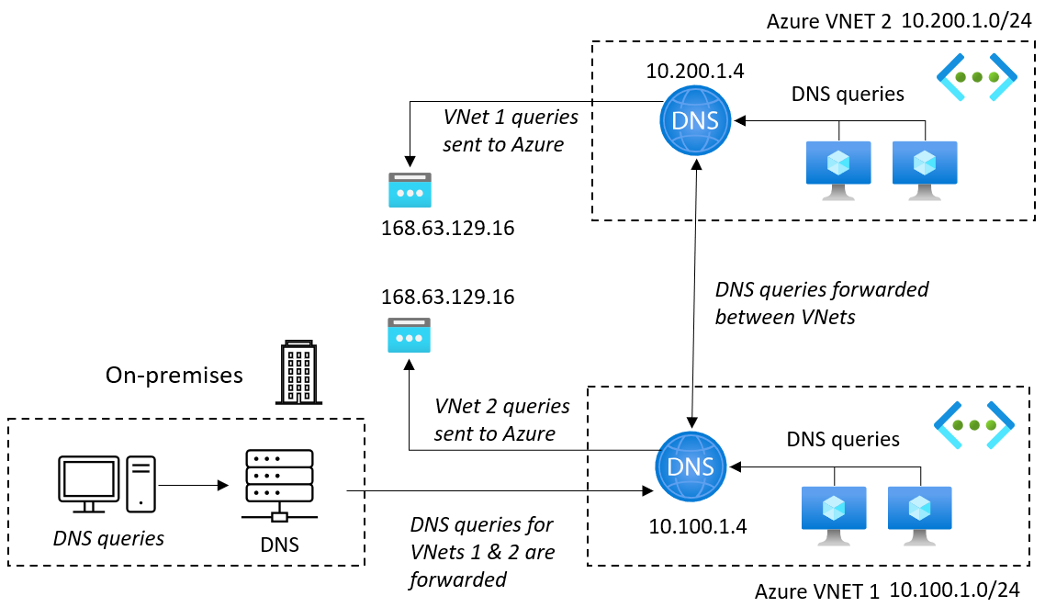
Figure 4.23 – An example solution demonstrating the hybrid name resolution approach
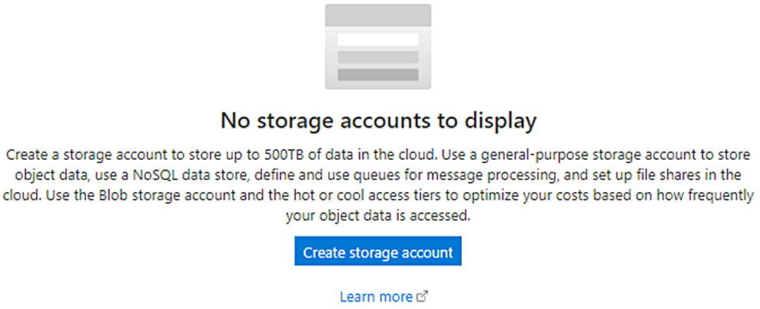
Figure 4.24 – Creating a storage account in Azure Figure 4.25 – Storage account types
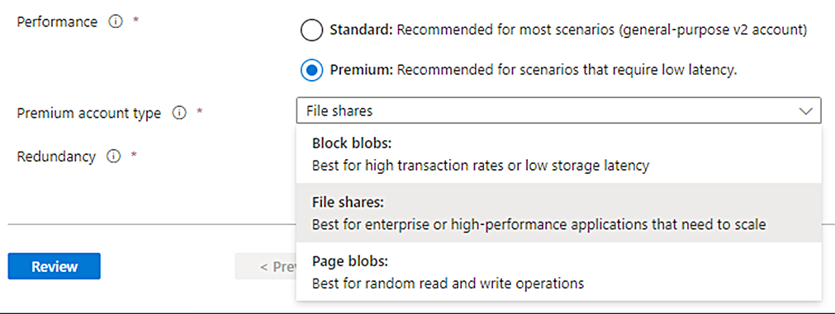
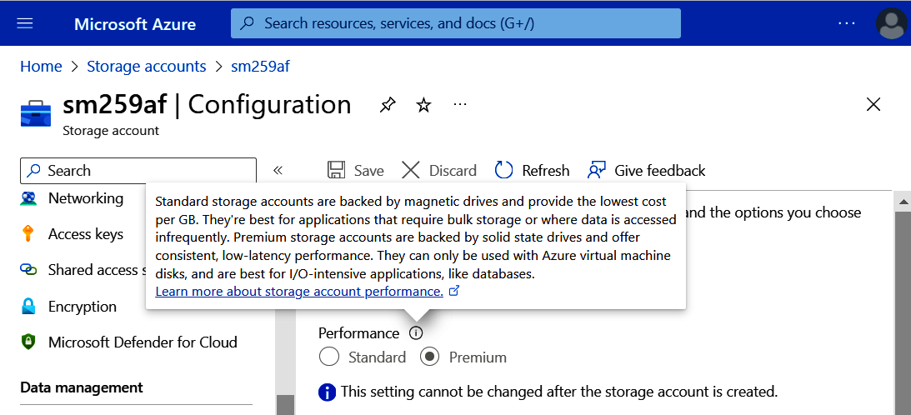
Figure 4.26 – Storage account performance type setting Figure 4.27 – The flow for choosing a data store
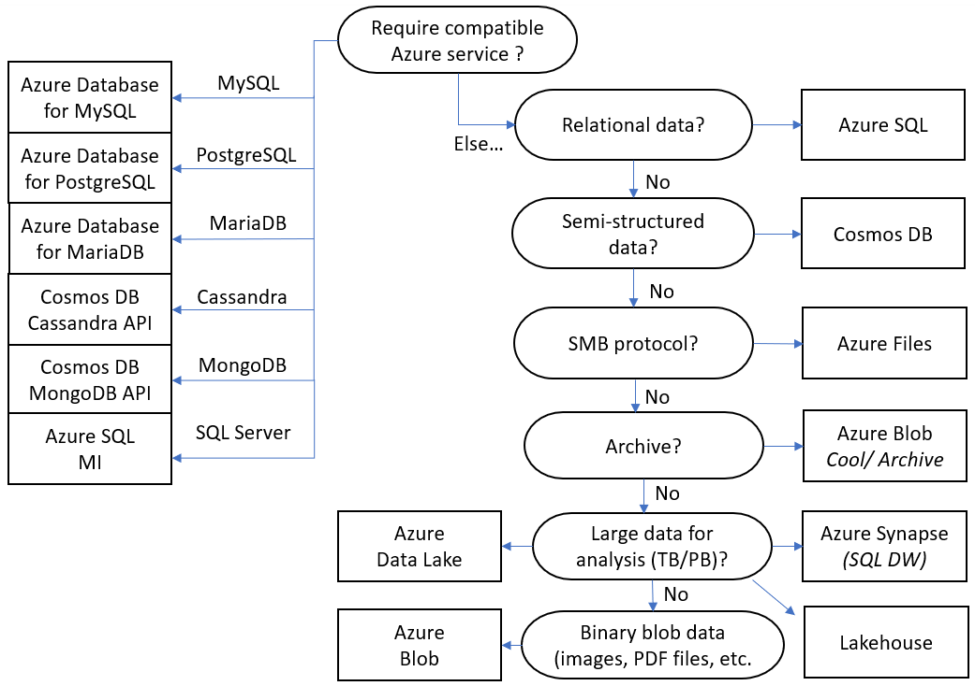
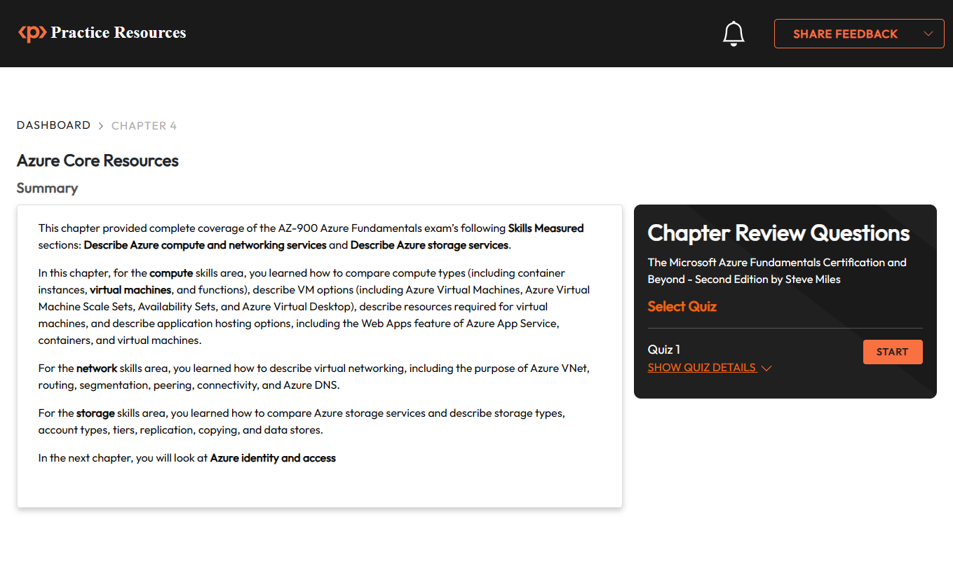
Figure 4.28 – Chapter Review Questions for Chapter 4 Figure 4.29: Tasks in Virtual Networks (VNets) activity
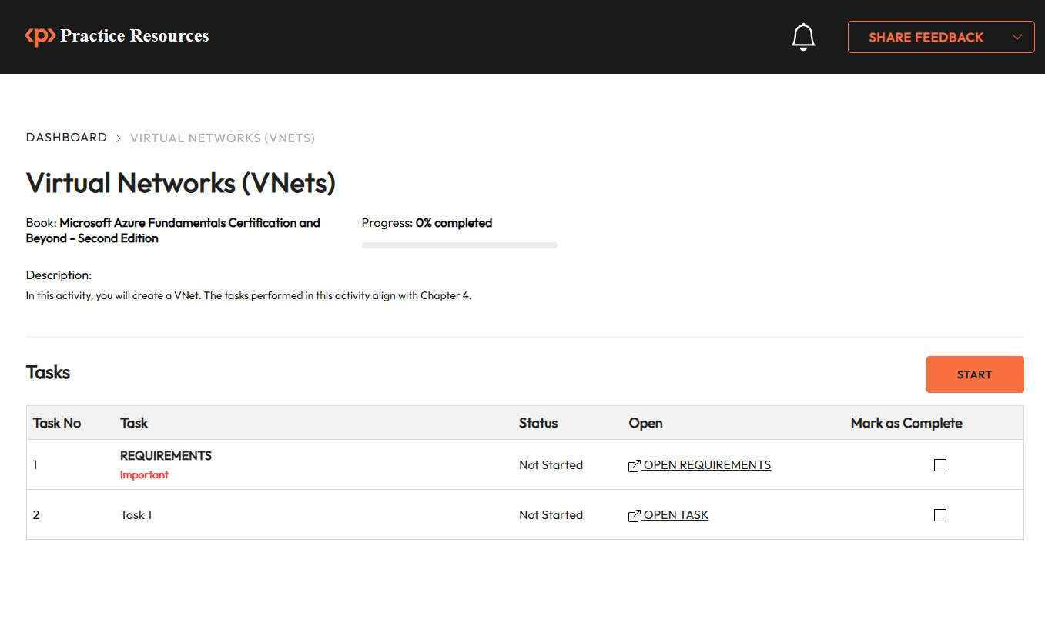

Chapter 5: Azure Identity and Access
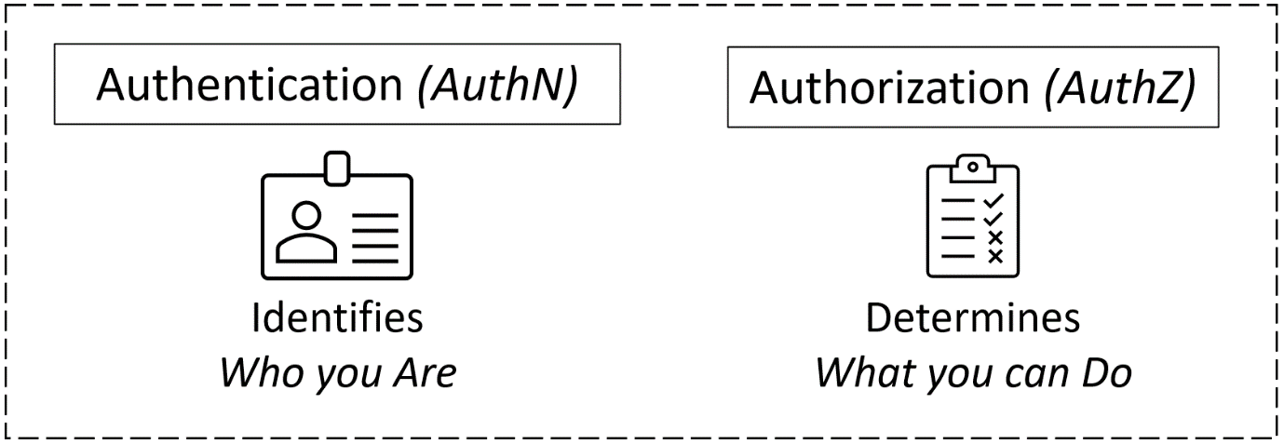
Figure 5.1 – The concepts of authentication and authorization Figure 5.2 – Microsoft Entra ID as a centralized cloud IDP
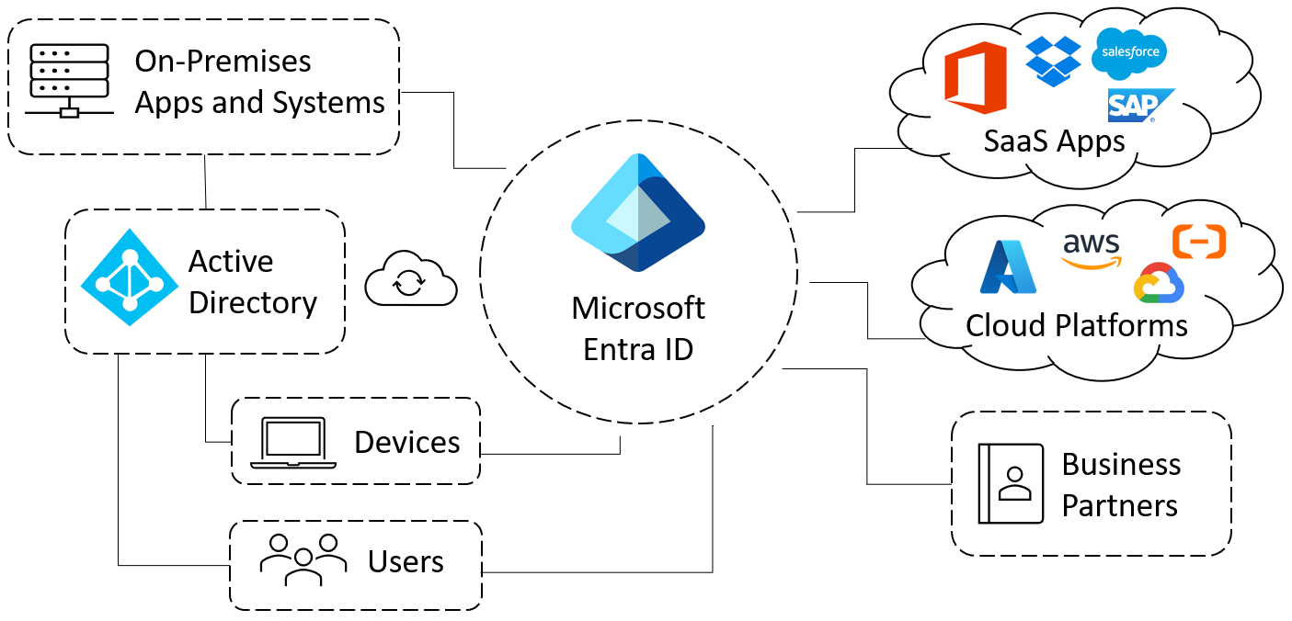
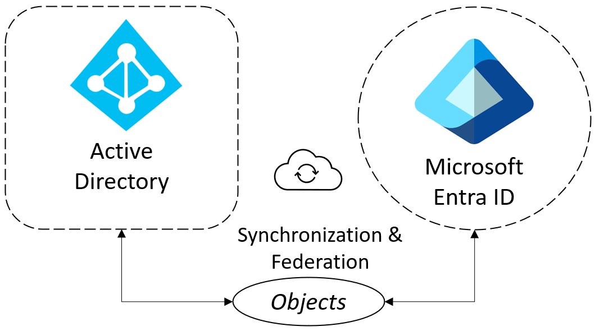
Figure 5.3 – Connection between AD and Microsoft Entra ID
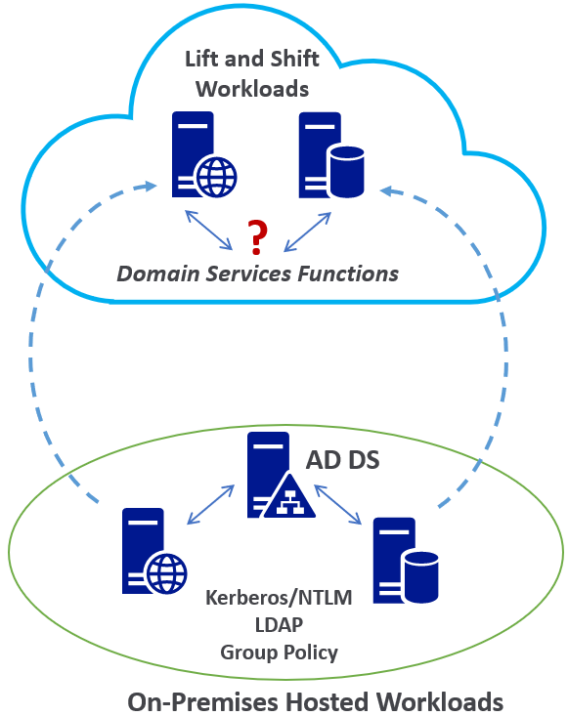
Figure 5.4 – Providing AD Domain Services functions for Azure workloads Figure 5.5 – Making changes effective by synchronizing Microsoft Entra ID to the managed domain

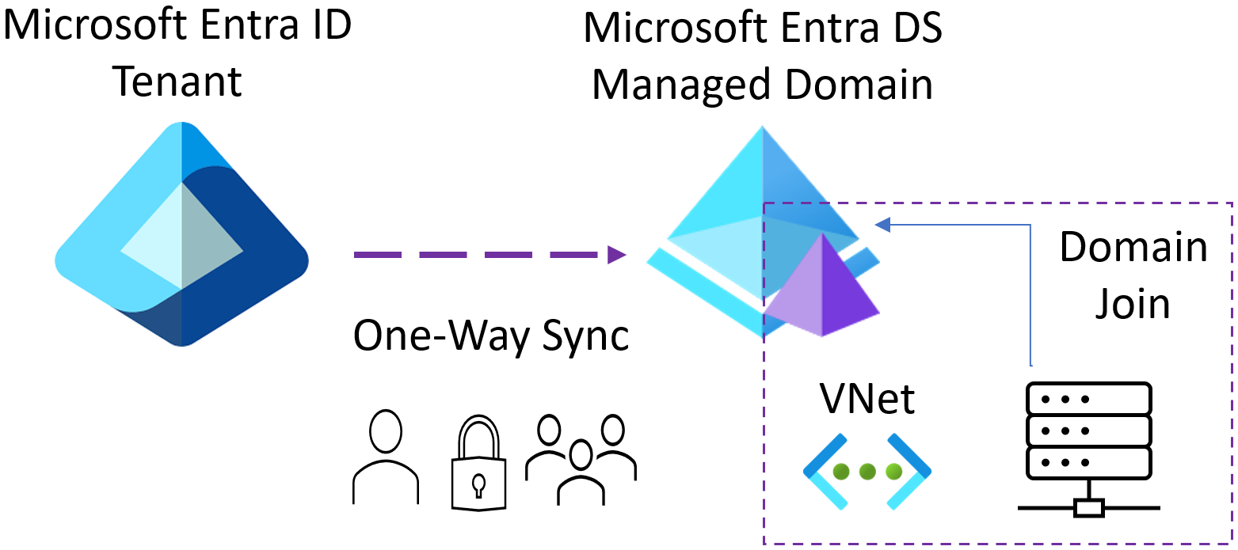
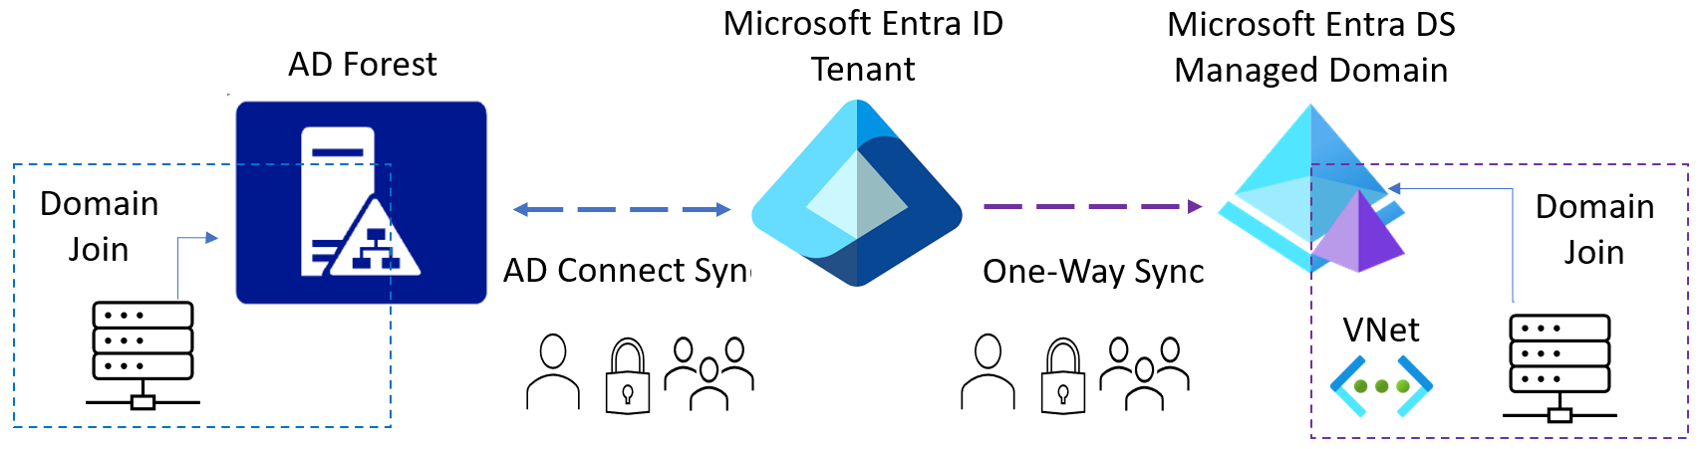
Figure 5.6 – Hybrid identity scenario showing the connection between AD, Microsoft Entra ID, and the Microsoft Entra DS managed domain Figure 5.7 – Granting access using conditional access based on the information collected from the sign-in process
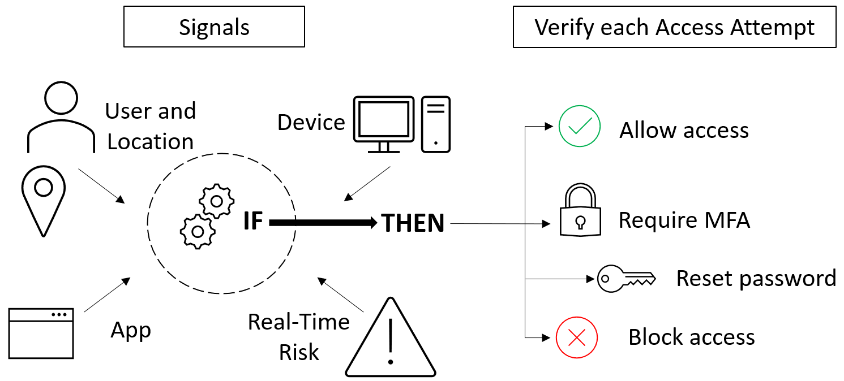
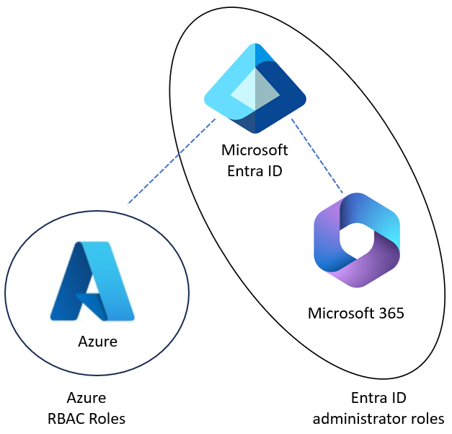
Figure 5.8 – Managing access with authentication from Microsoft Entra ID, and authorization from Azure RBAC

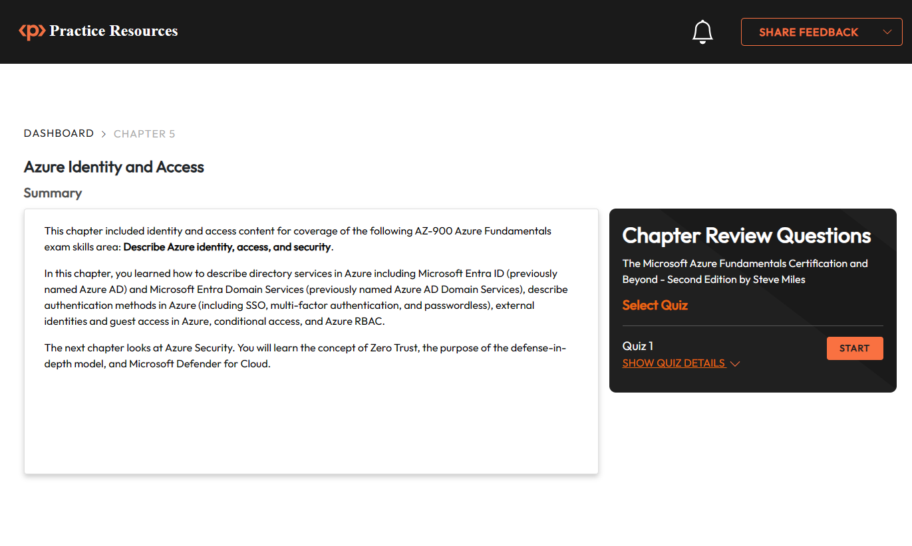
Figure 5.9 – Chapter Review Questions for Chapter 5
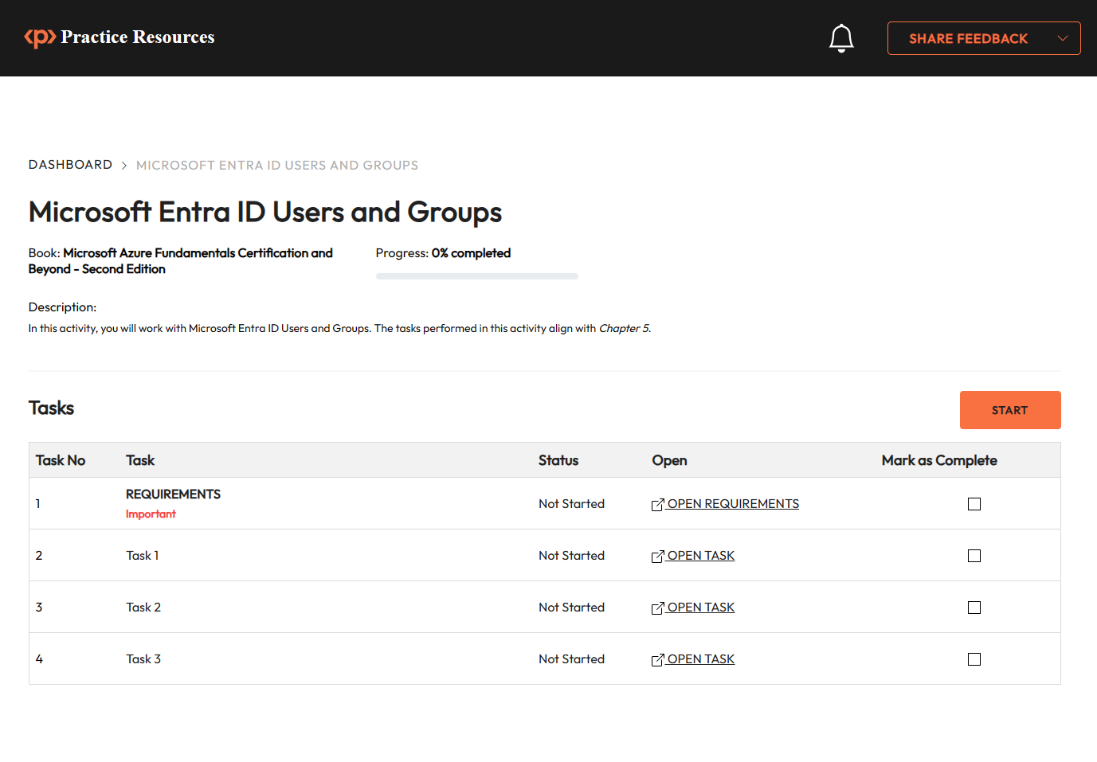
Figure 5.10: Tasks in Microsoft Entra ID Users and Groups activity

Chapter 6: Azure Security
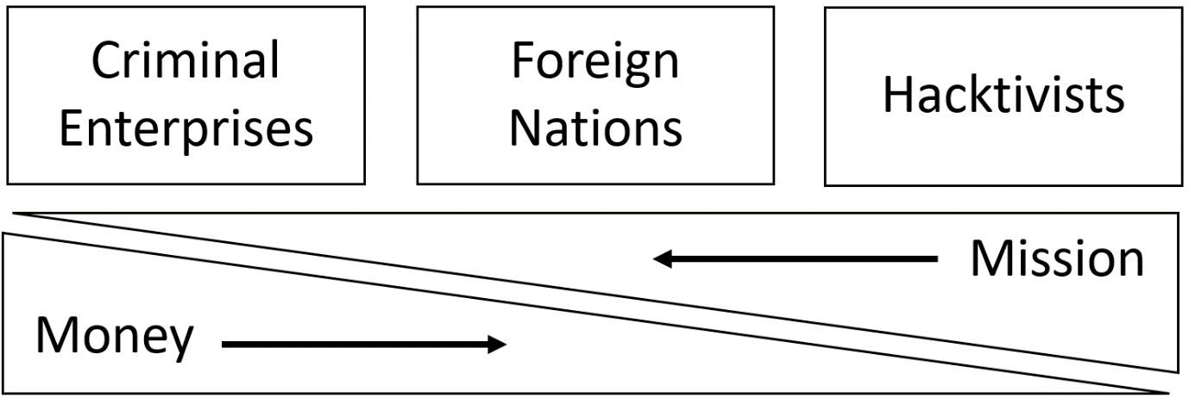
Figure 6.1 – Attack motivations
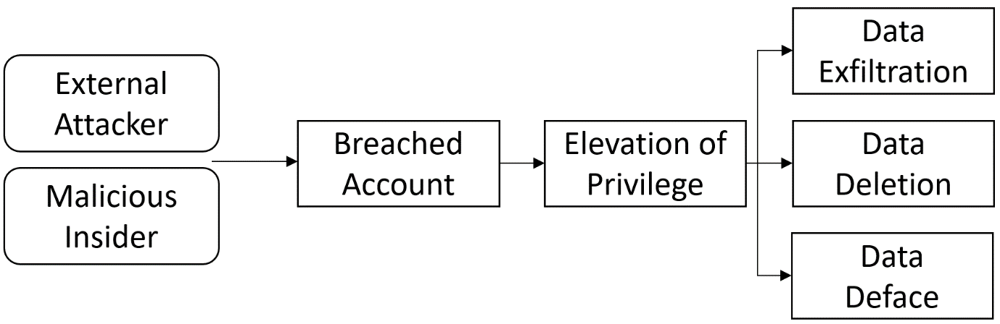
Figure 6.2 – An attack chain showing the sequence of an attack Figure 6.3 – Threat priority model showing the adopted risk solution based on risk priority
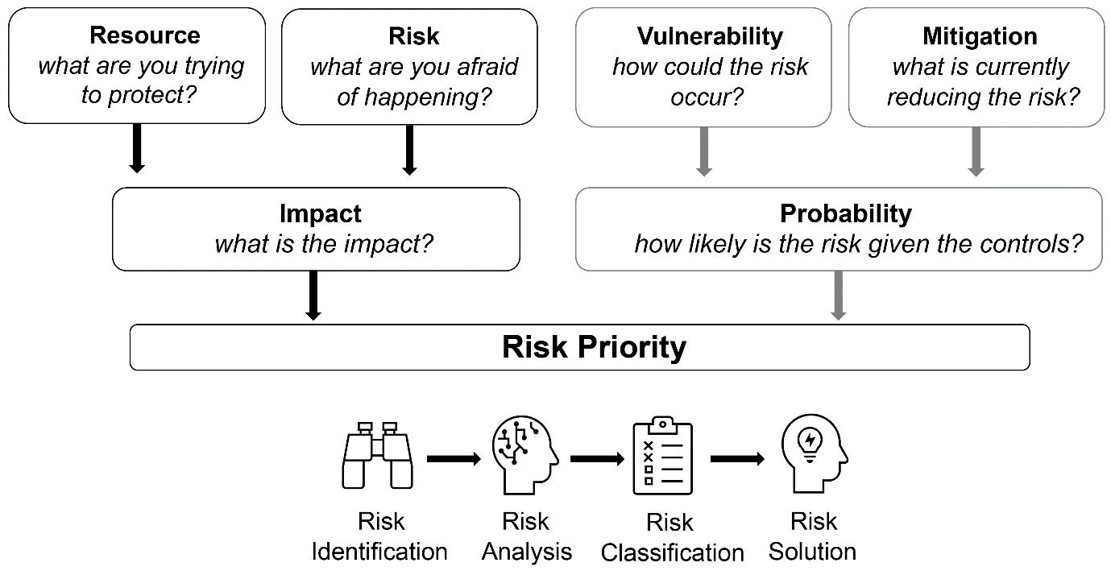
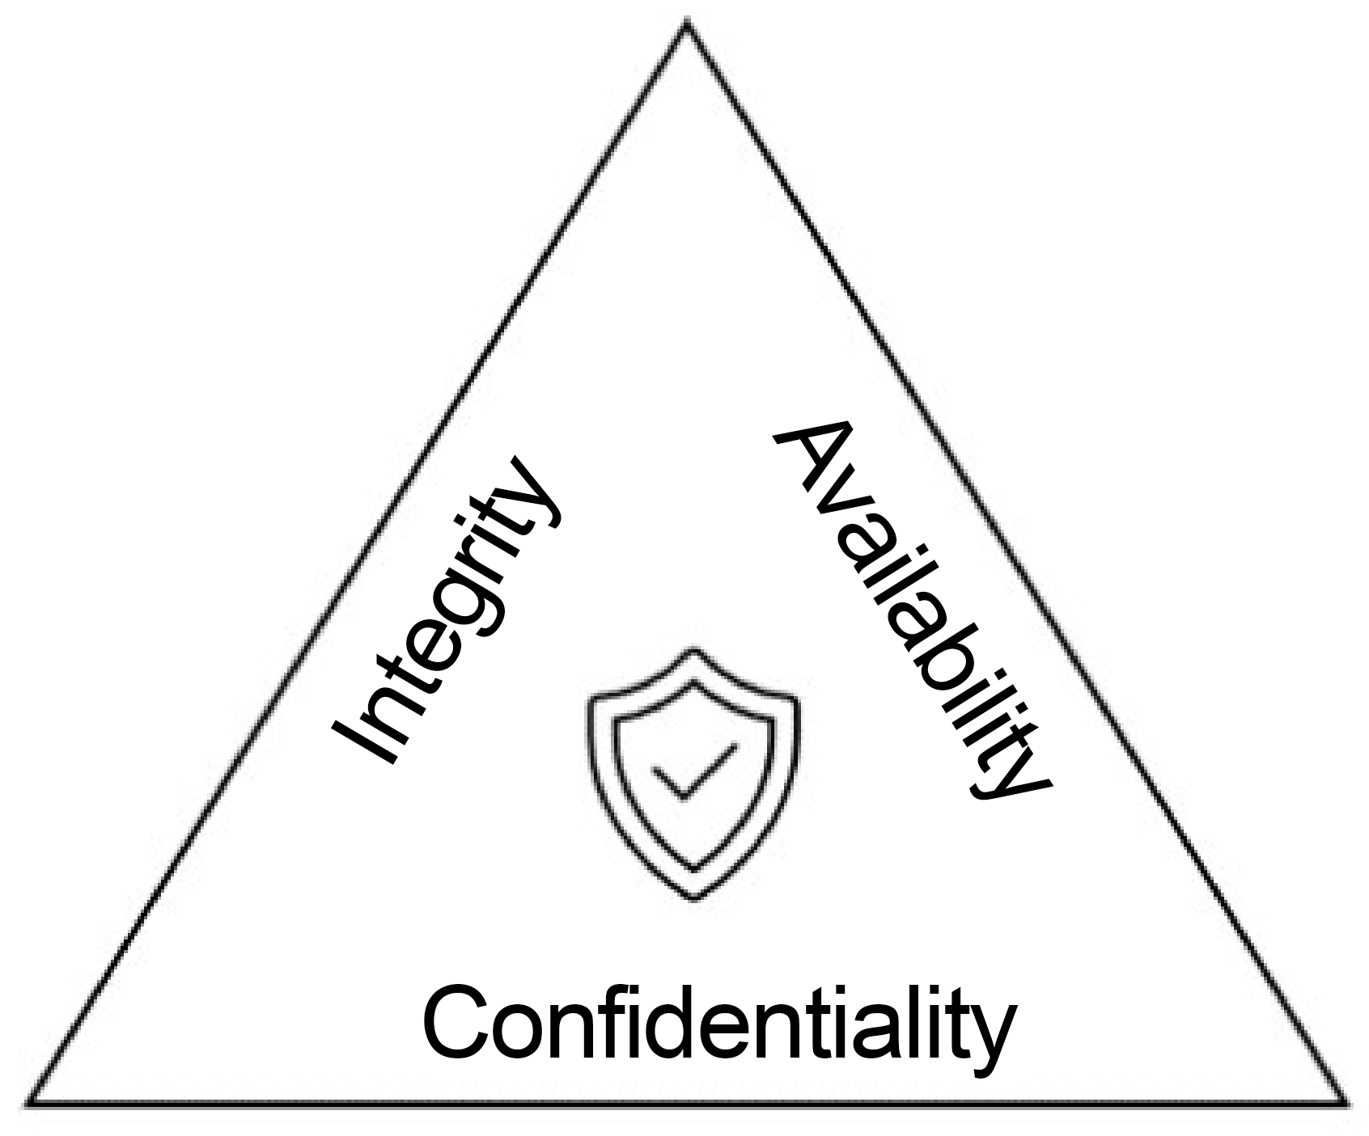
Figure 6.4 – A security posture CIA triangle

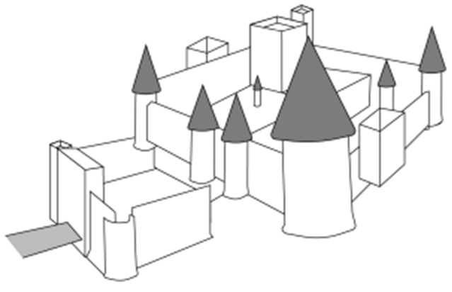
Figure 6.5 – The medieval castle defense approach
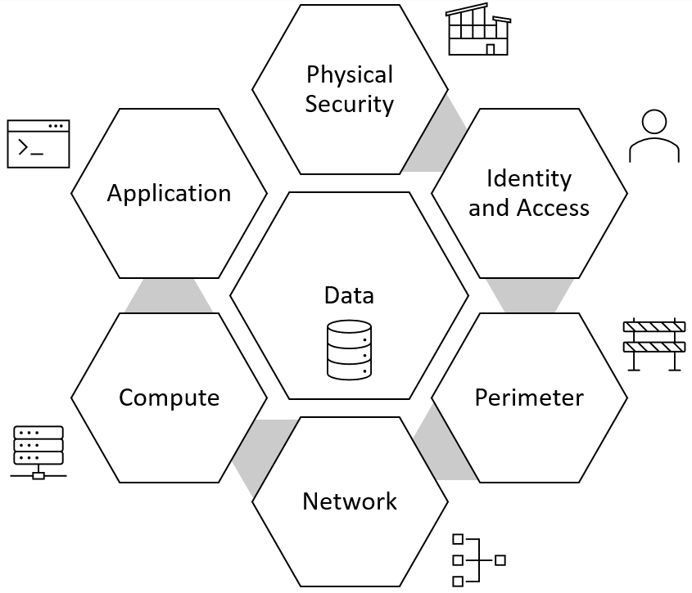
Figure 6.6 – The DiD approach layers

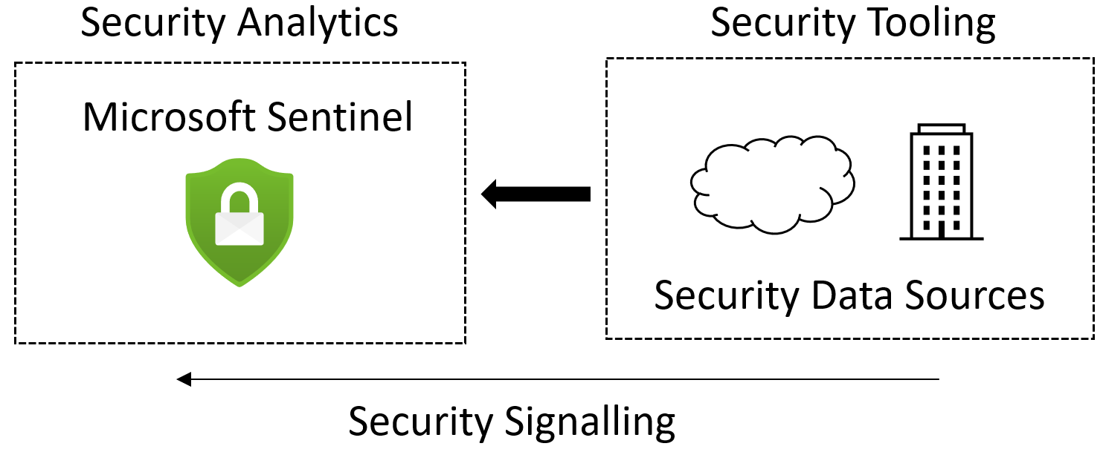
Figure 6.7 – The relationship between the security analytics of Microsoft Sentinel and the security signalling
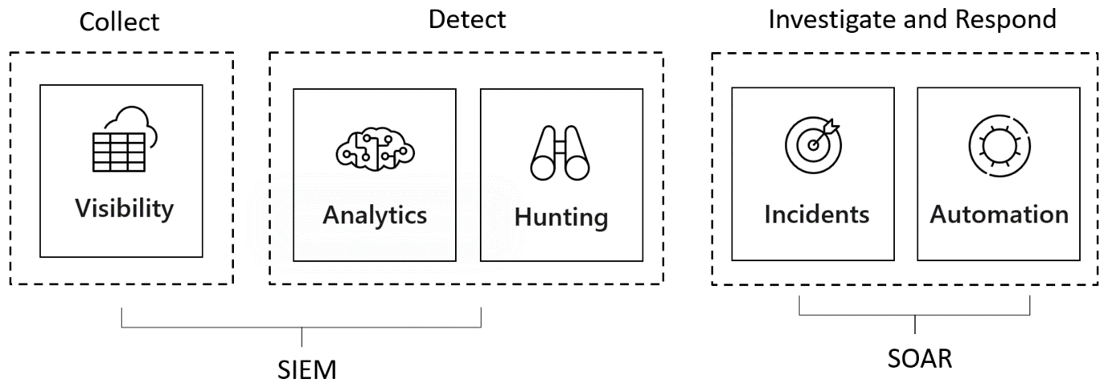
Figure 6.8 – A Sentinel security operations proposition Figure 6.9 – Chapter Review Questions for Chapter 6
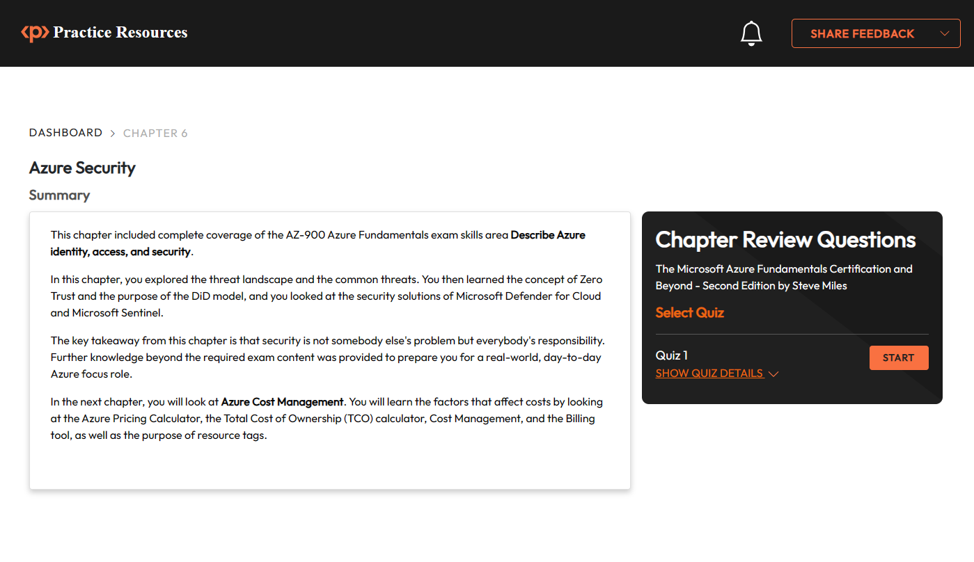
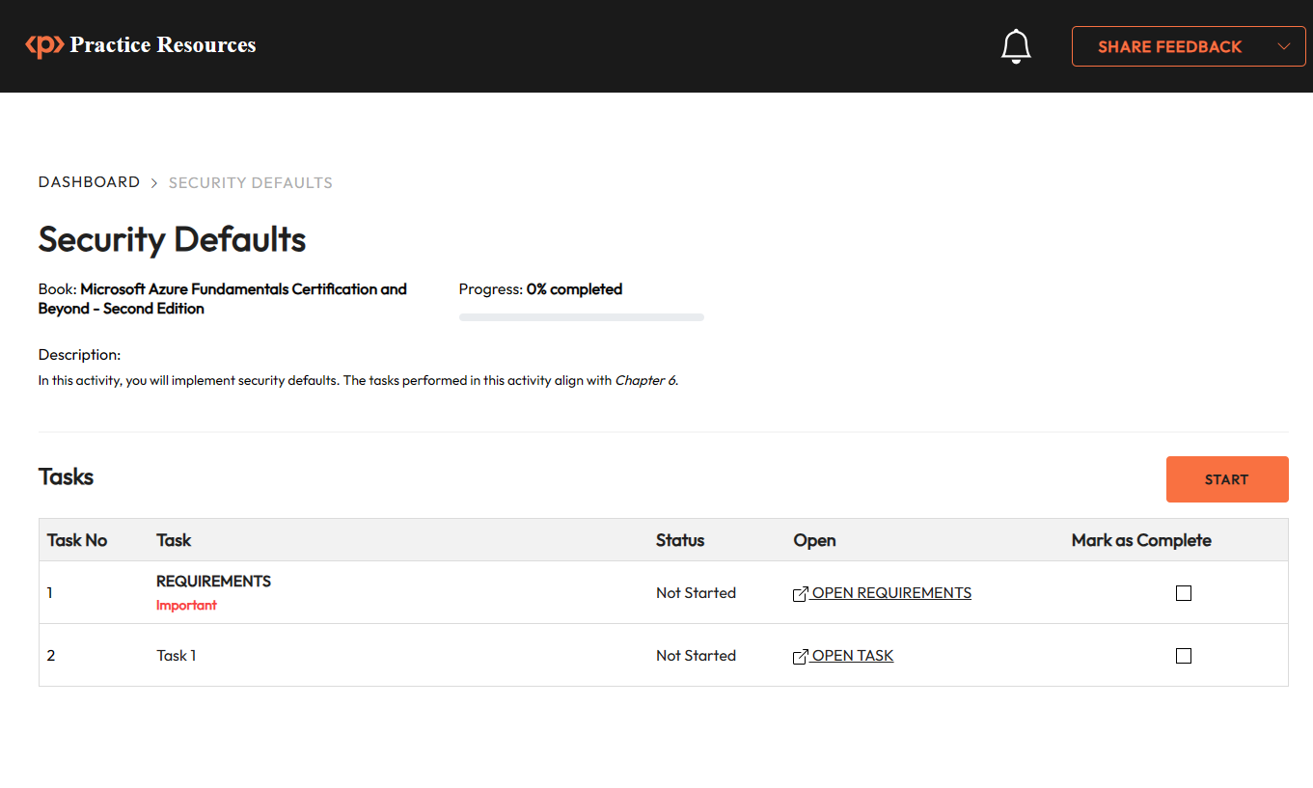
Figure 6.10: Tasks in Security Defaults activity

Chapter 7: Azure Cost Management
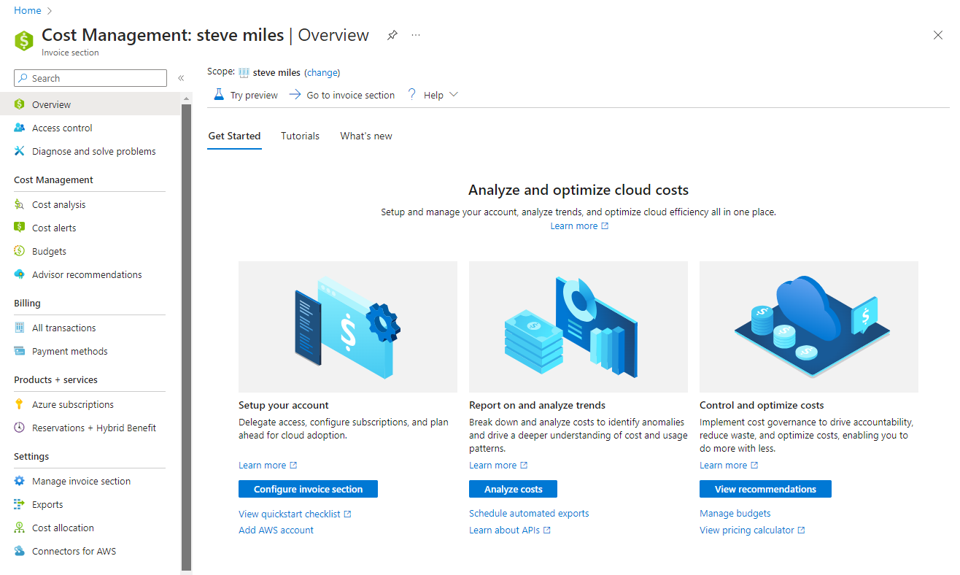
Figure 7.1 – Managing costs associated with Azure services using Azure Cost Management
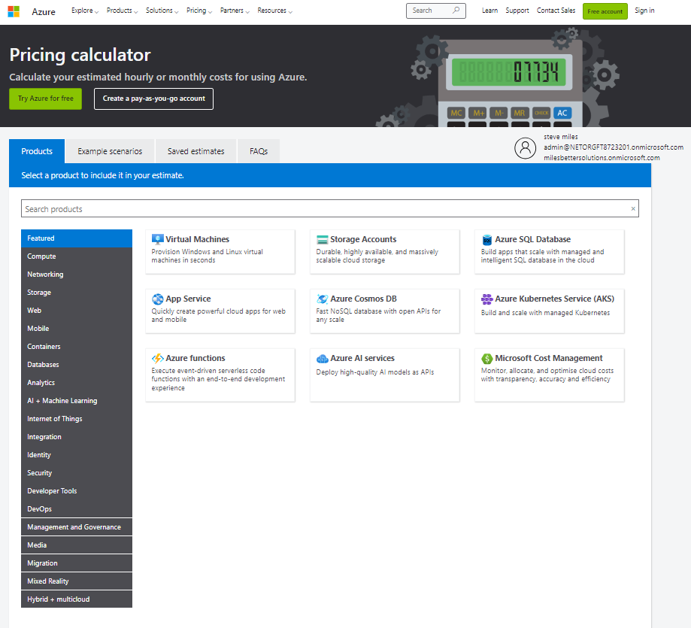
Figure 7.2 – Azure pricing calculator showing categorized resources

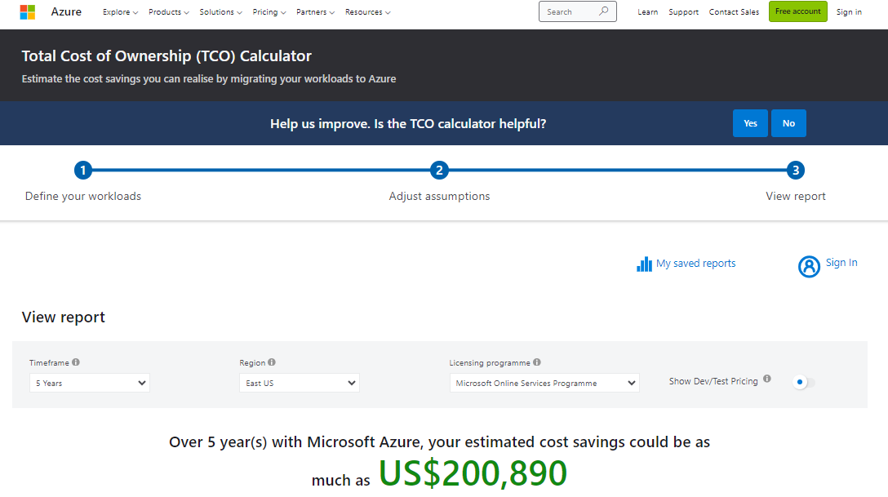
Figure 7.3 – Azure TCO calculator providing estimates using industry-average operational costs
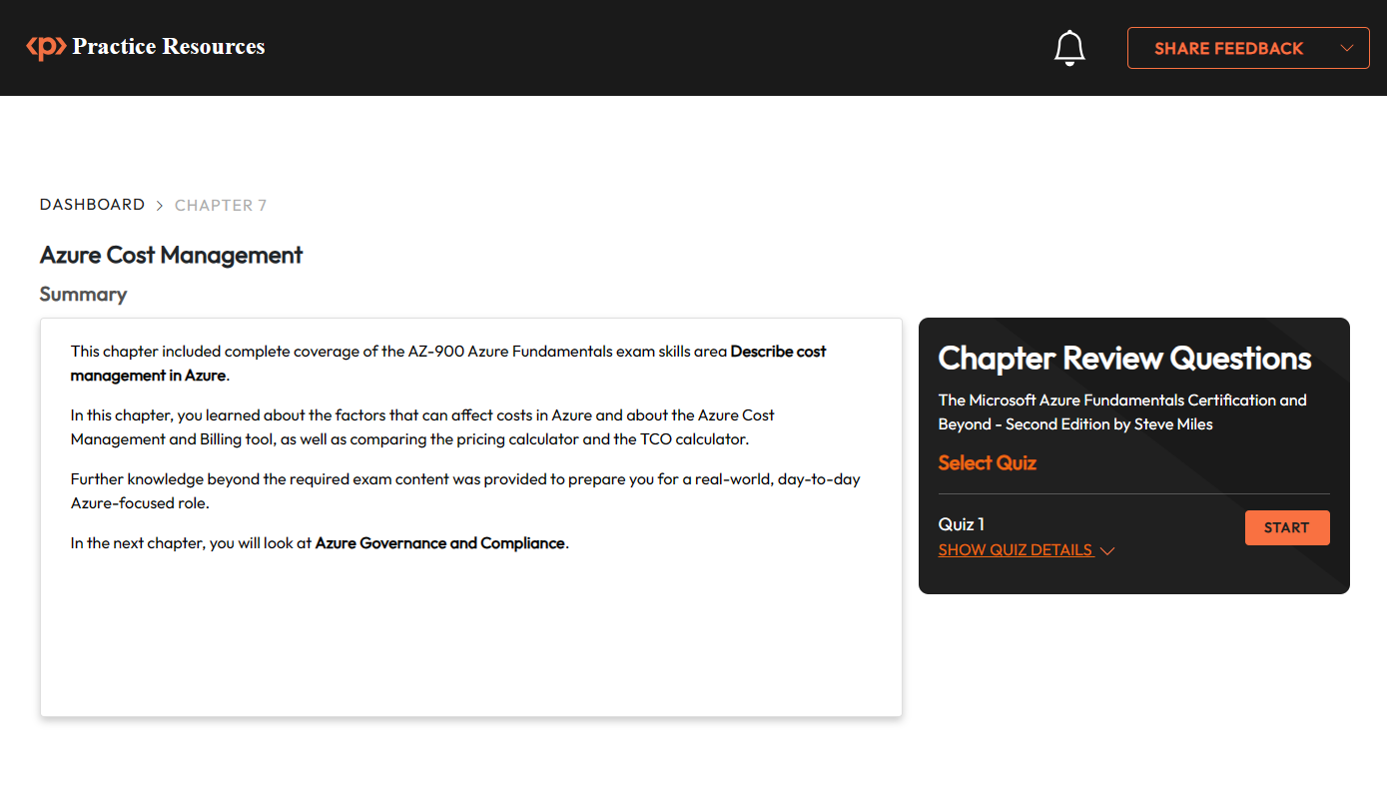
Figure 7.4 – Chapter Review Questions for Chapter 7

Chapter 8: Azure Governance and Compliance Figure 8.1 – Azure Policy scope level
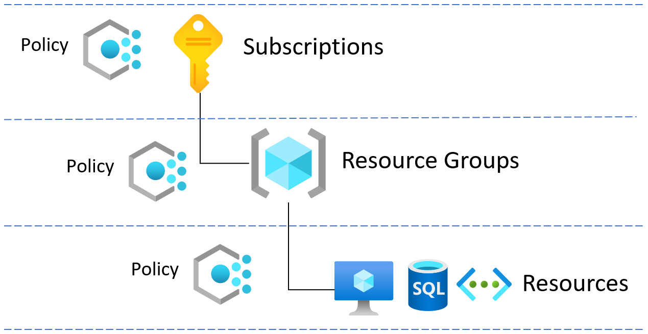
Figure 8.2 – Azure resource locks preventing accidental deletion of resources
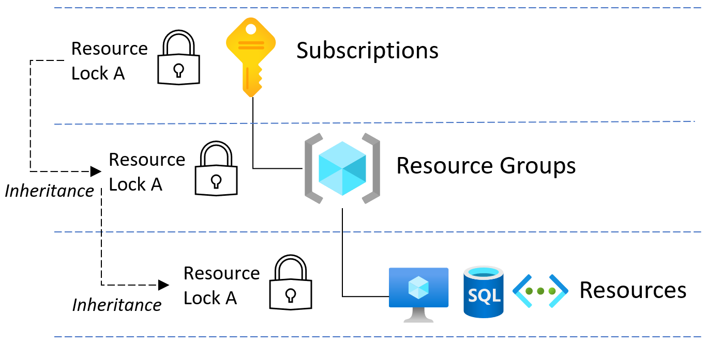
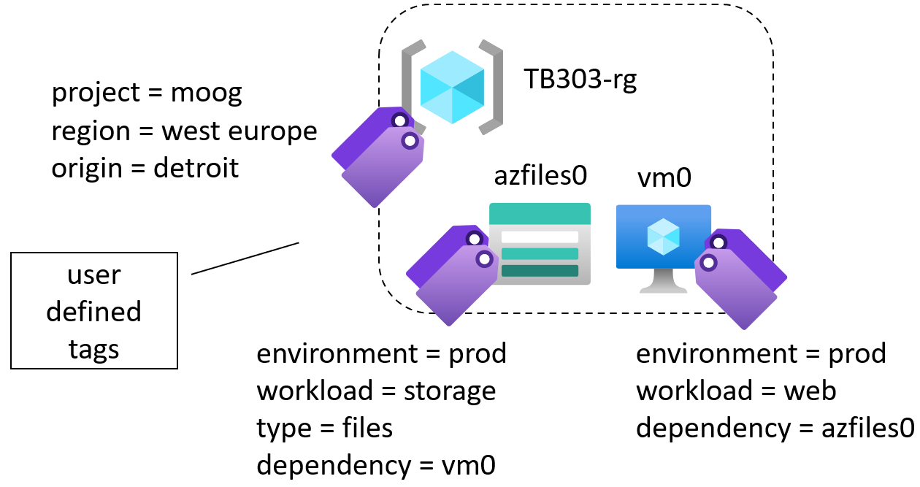
Figure 8.3 – Tags used for resource metadata
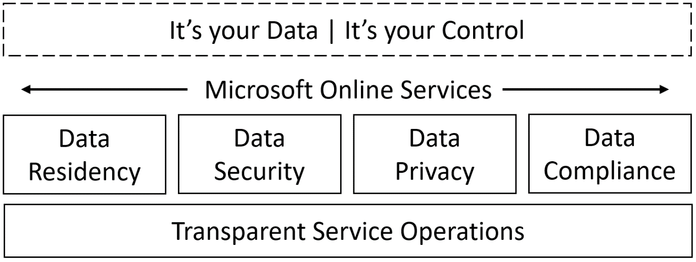
Figure 8.4 – Microsoft trusted cloud principles
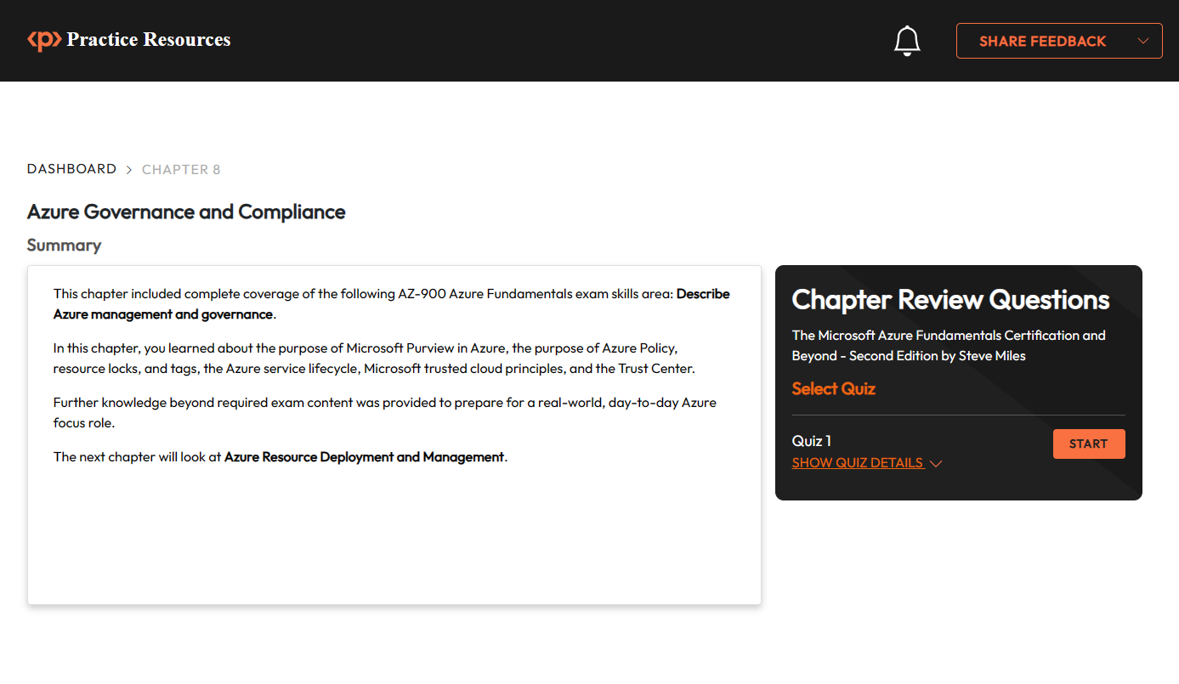
Figure 8.5 – Chapter Review Questions for Chapter 8 Figure 8.6: Tasks in Azure Policy activity.
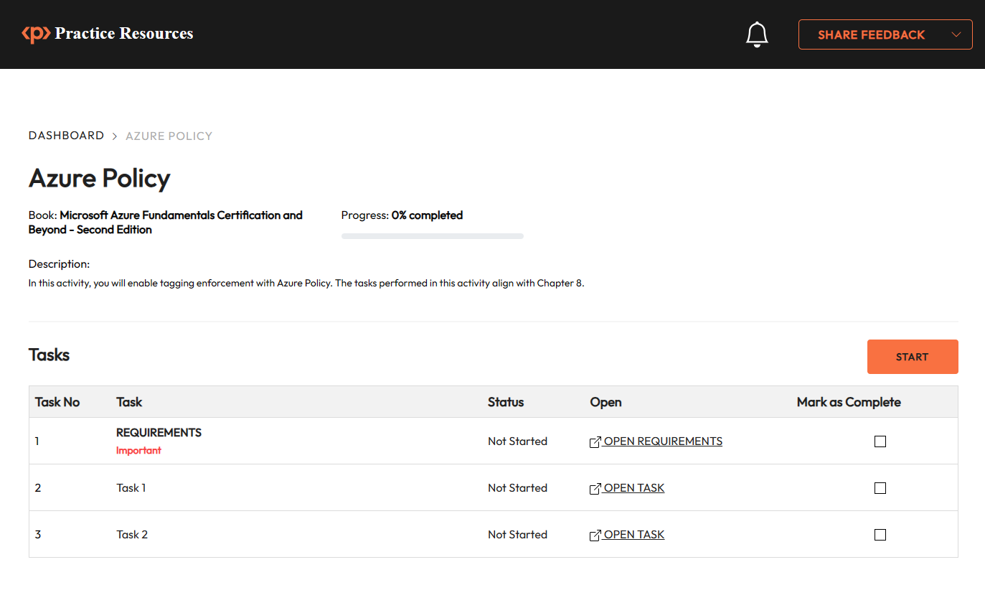

Chapter 9: Azure Resource Deployment and Management
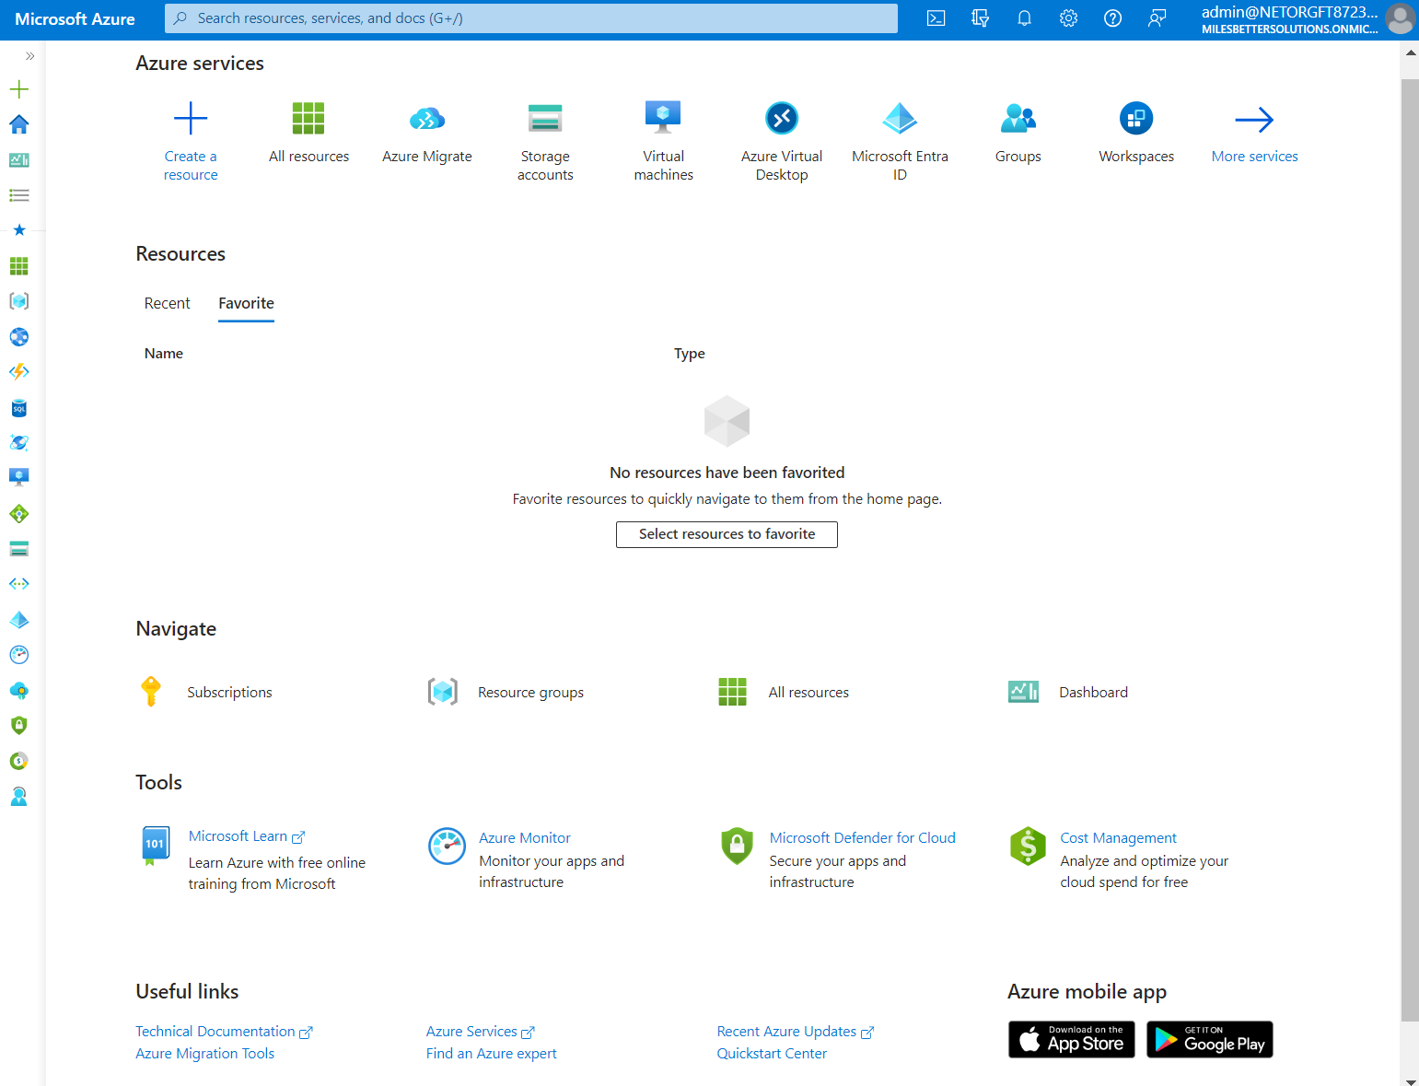
Figure 9.1 – The Azure portal
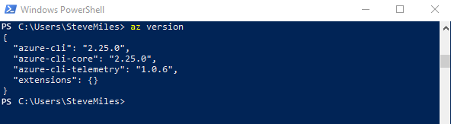
Figure 9.2 – The azure-cli version command in PowerShell Figure 9.3 – The azure-cli version command in Windows Command Prompt
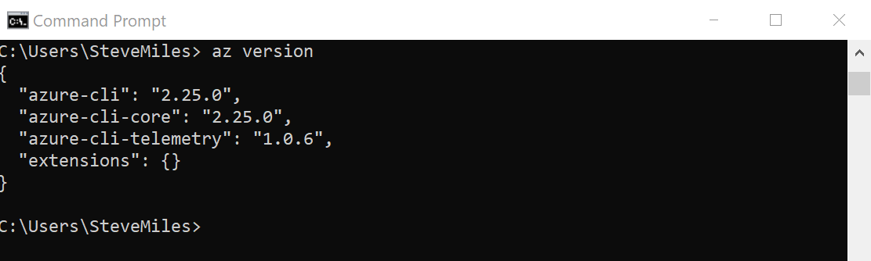
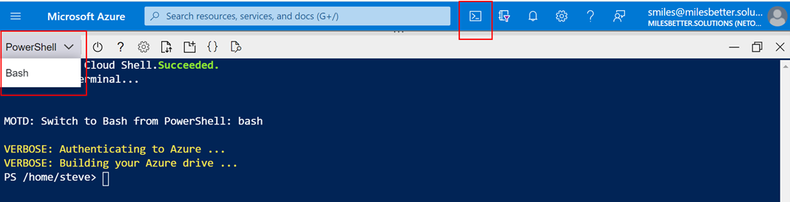
Figure 9.4 – Azure Cloud Shell with the PowerShell interface via the Azure portal
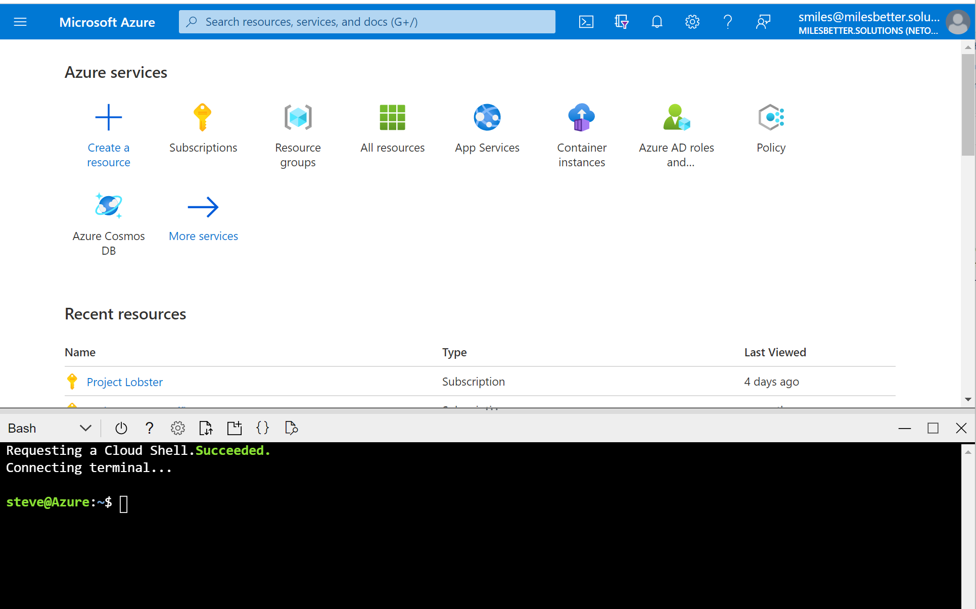
Figure 9.5 – Azure Cloud Shell with the Bash interface via the Azure portal Figure 9.6 – ARM template declarative approach Figure 9.7 – Azure Arc for servers
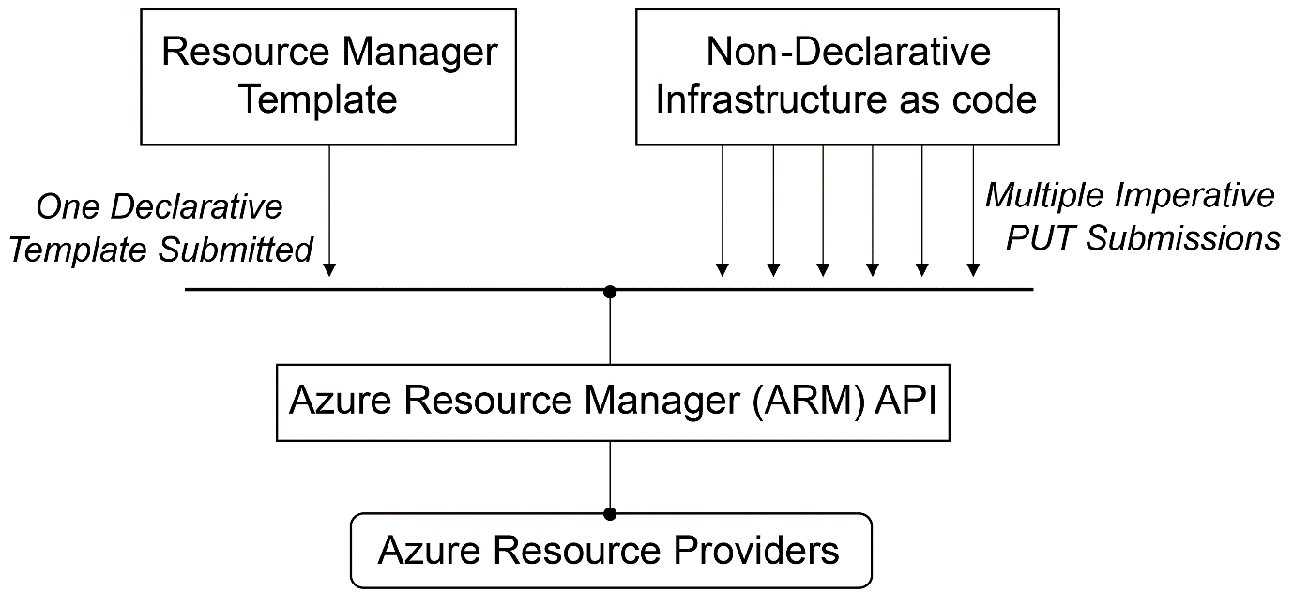
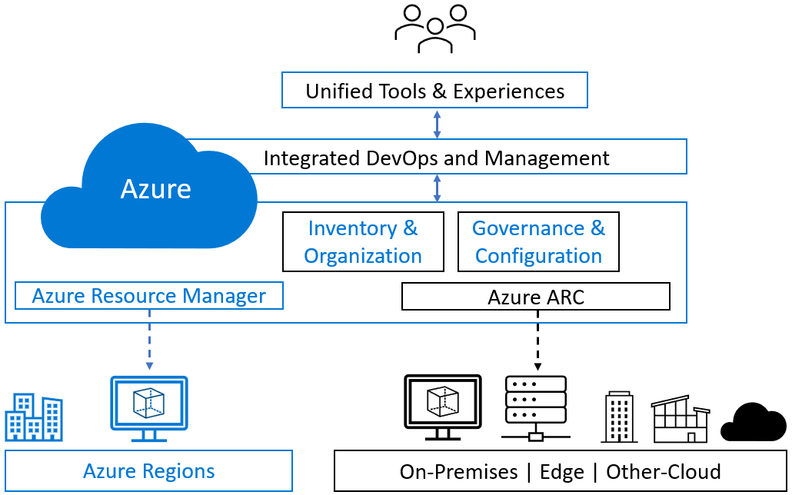
Figure 9.8 – Chapter Review Questions for Chapter 9
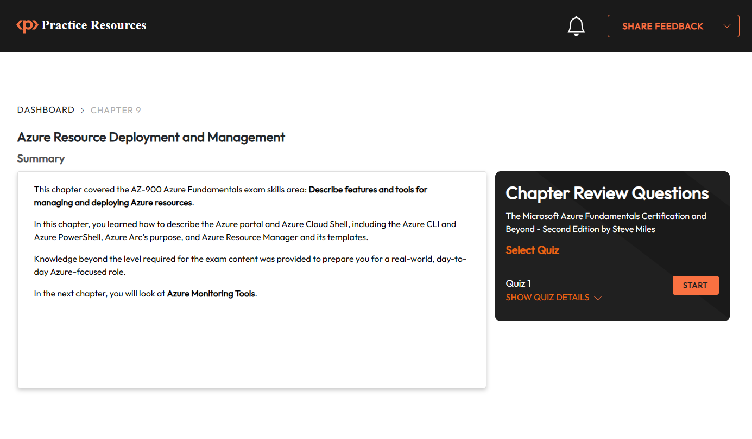

Chapter 10: Azure Monitoring and Tools
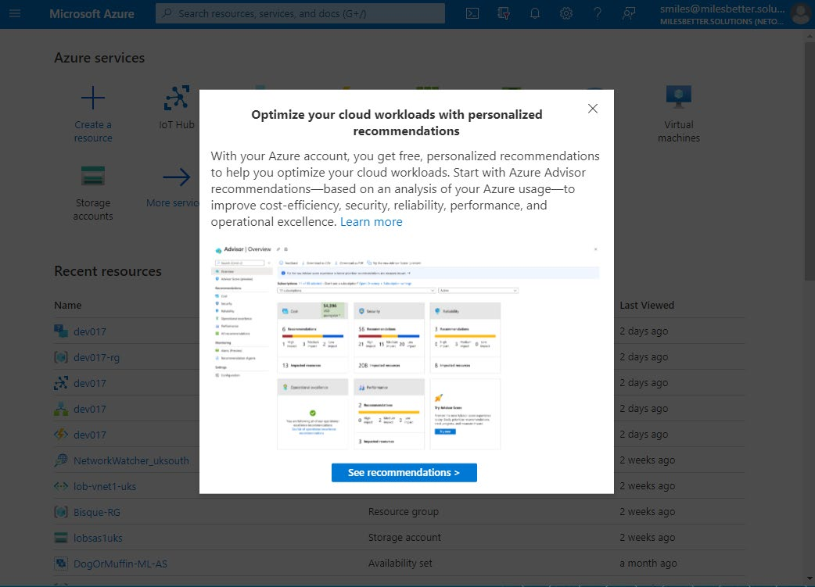
Figure 10.1 – Azure Advisor recommendations prompt screen
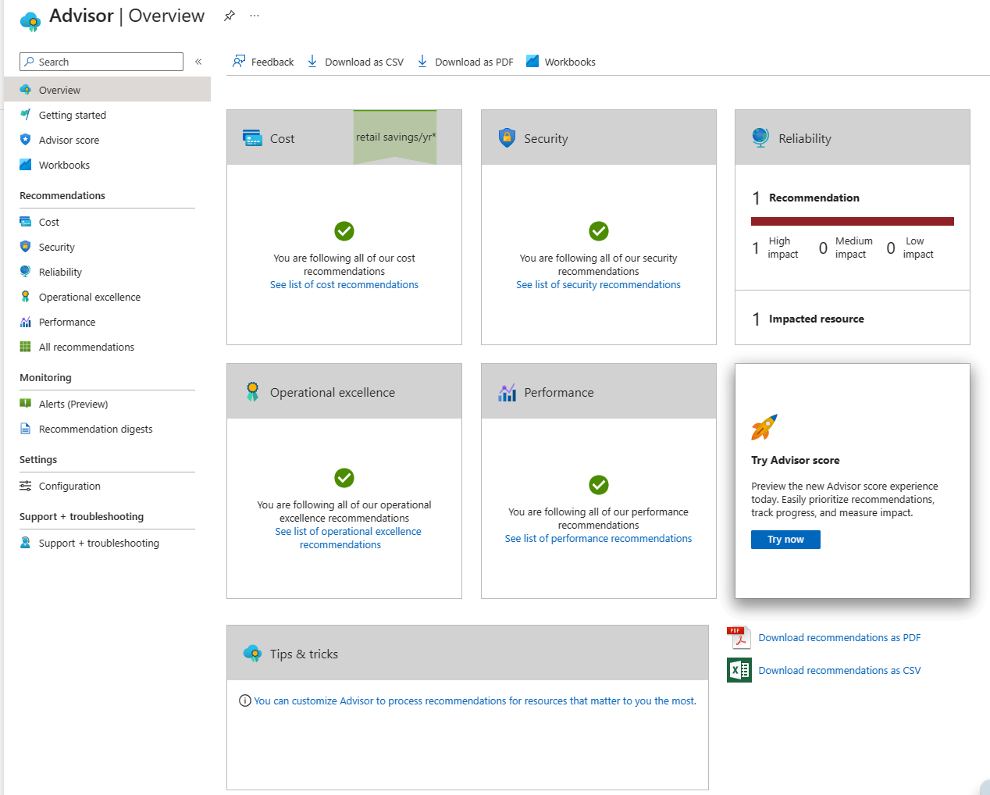
Figure 10.2 – Azure Advisor recommendations being displayed on the dashboard

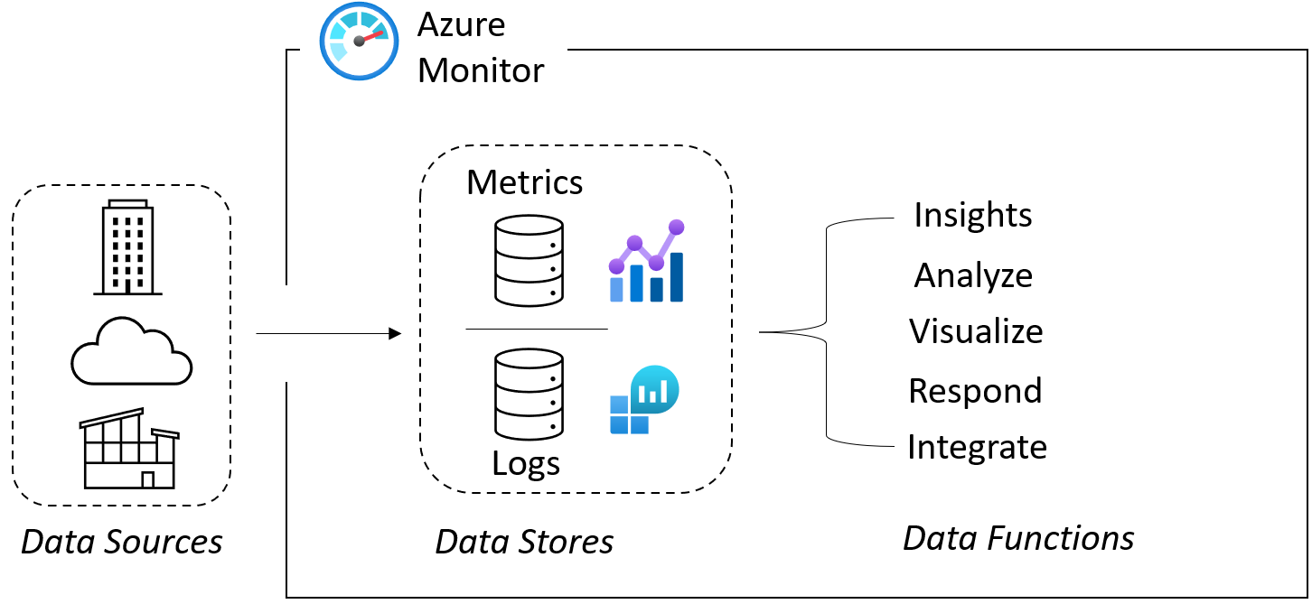
Figure 10.3 – Azure Monitor components architecture
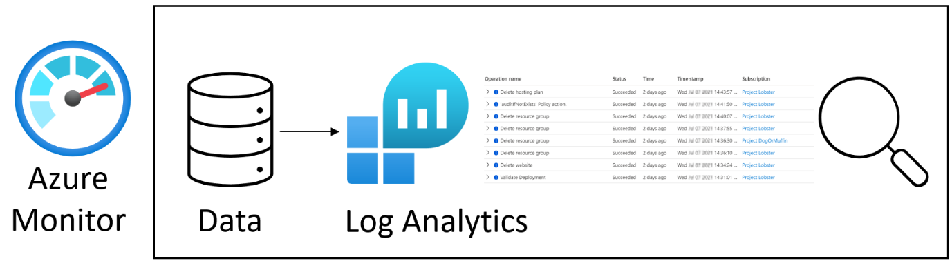
Figure 10.4 – Azure Monitor log analytics showing ingested log data Figure 10.5 – Azure Monitor service metrics showing ingested metrics data Figure 10.6 – Application Insights dashboard showing application performance and health at a glance
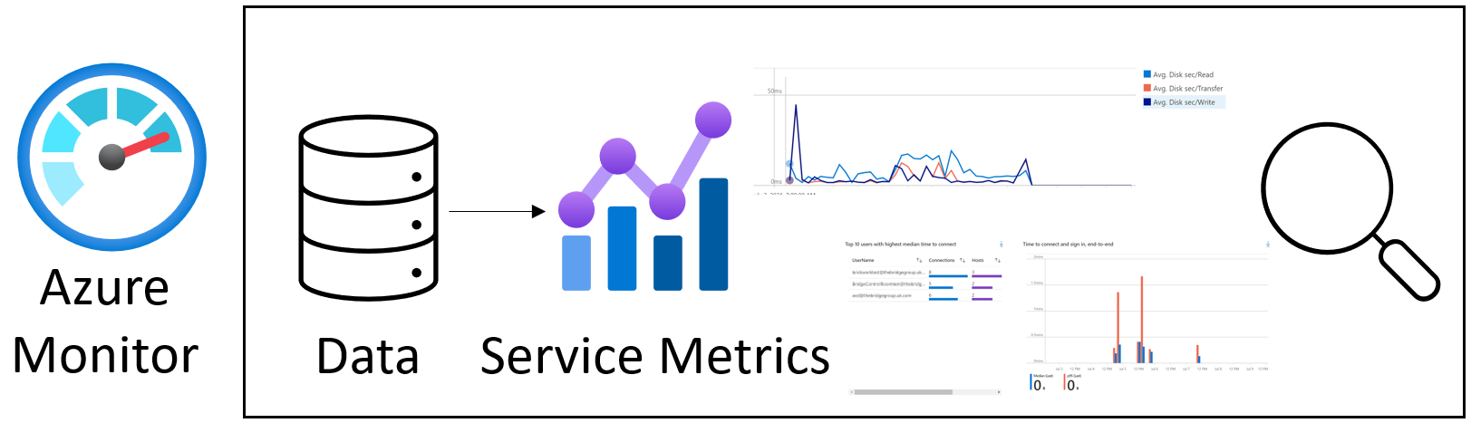
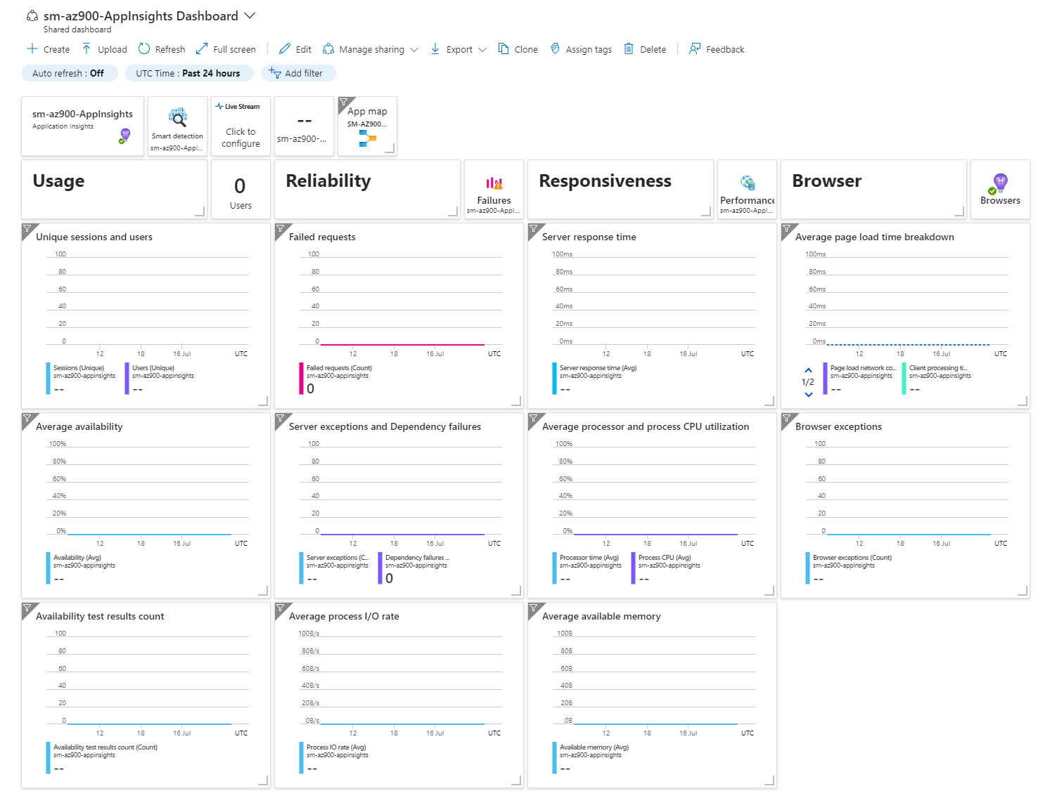
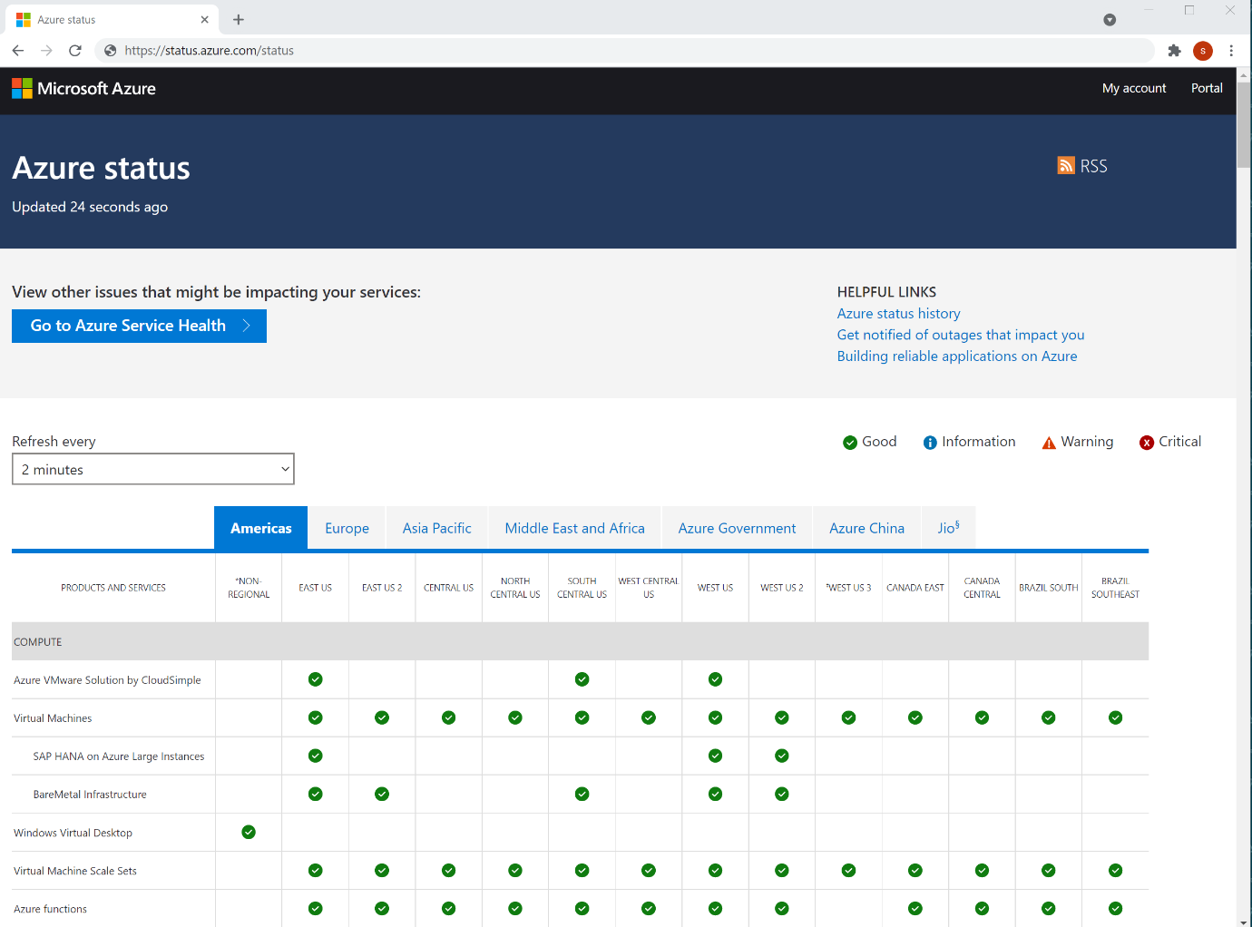
Figure 10.7 – Linking the Azure status page with Azure Service Health to view issues
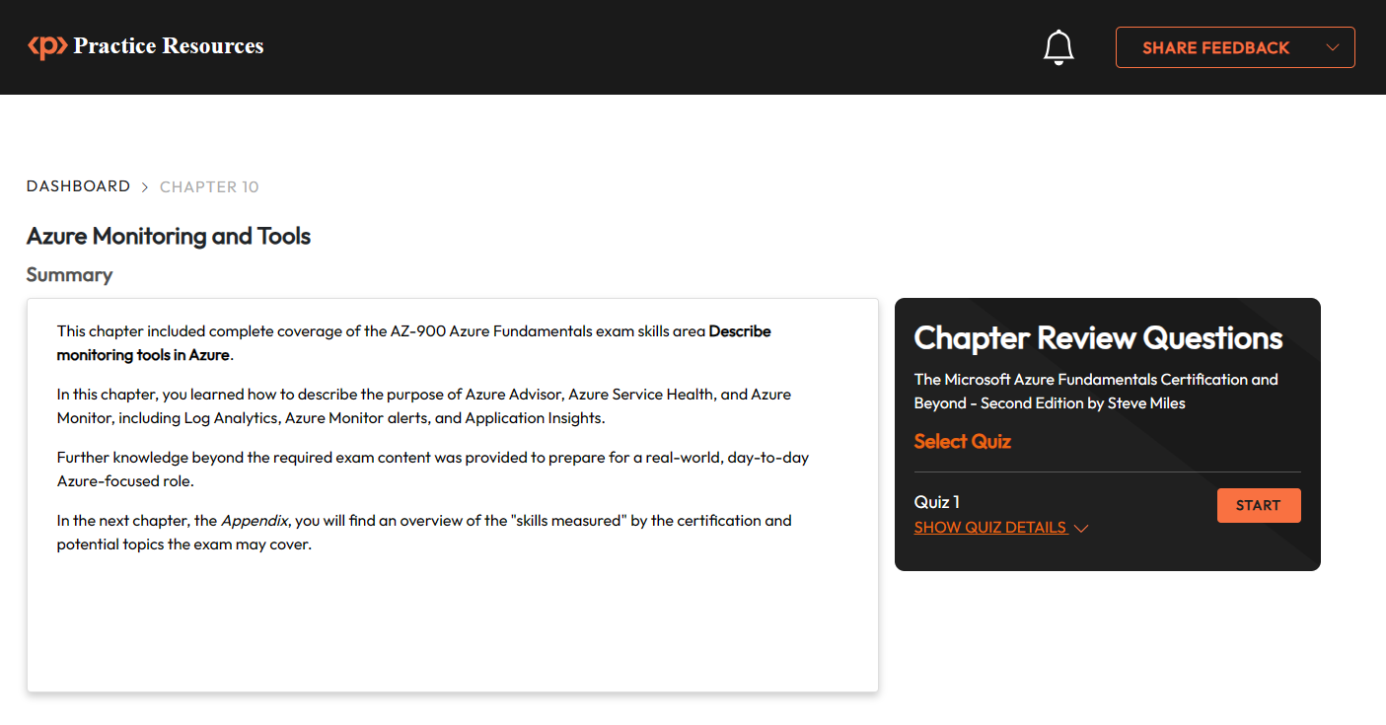
Figure 10.8 – Chapter Review Questions for Chapter 10

Chapter 11: Accessing the online practice resources
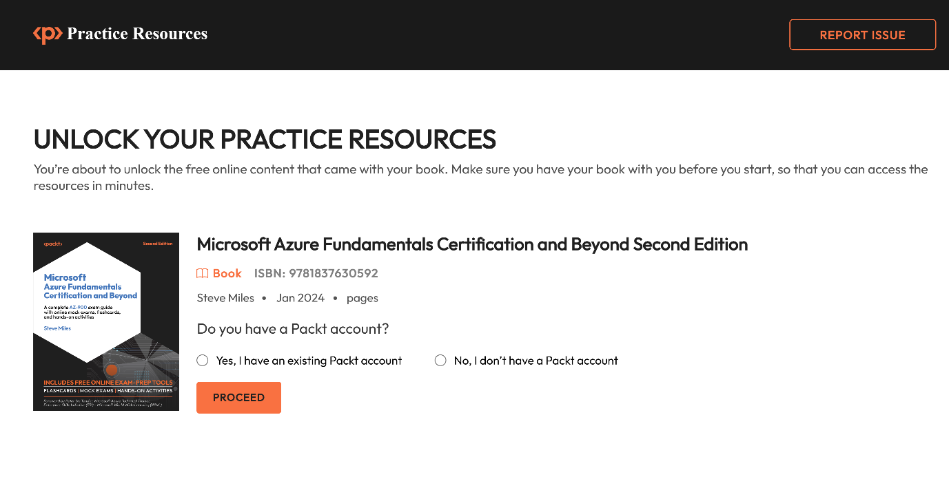
Figure 11.2 – Unlock page for the online practice resources
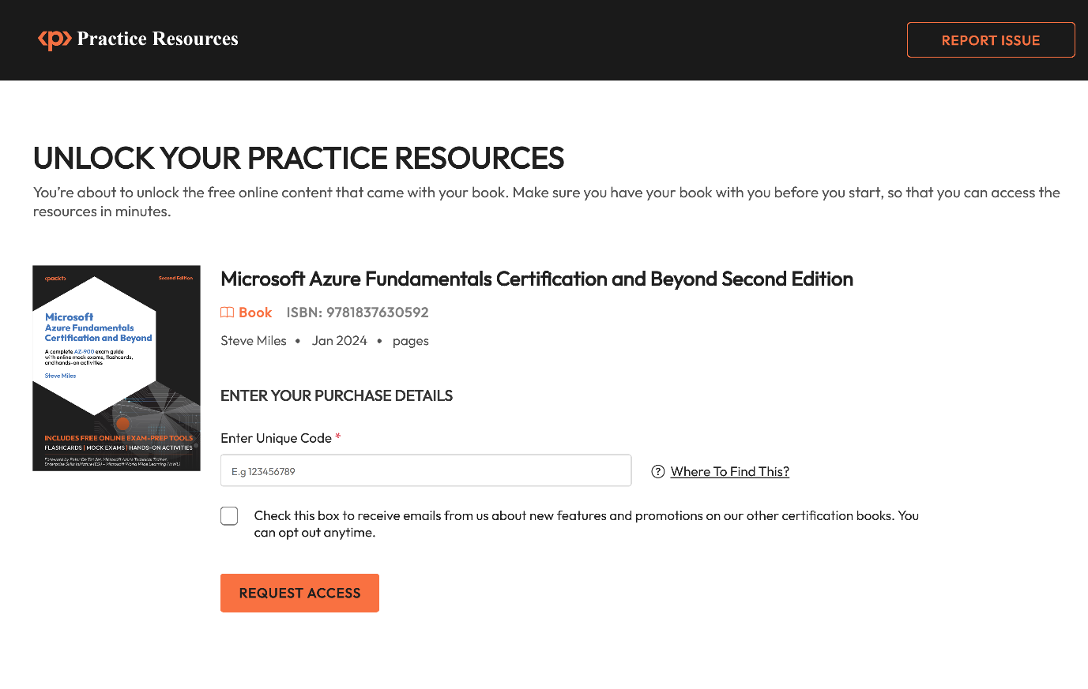
Figure 11.3 – Enter your unique sign-up code to unlock the resources
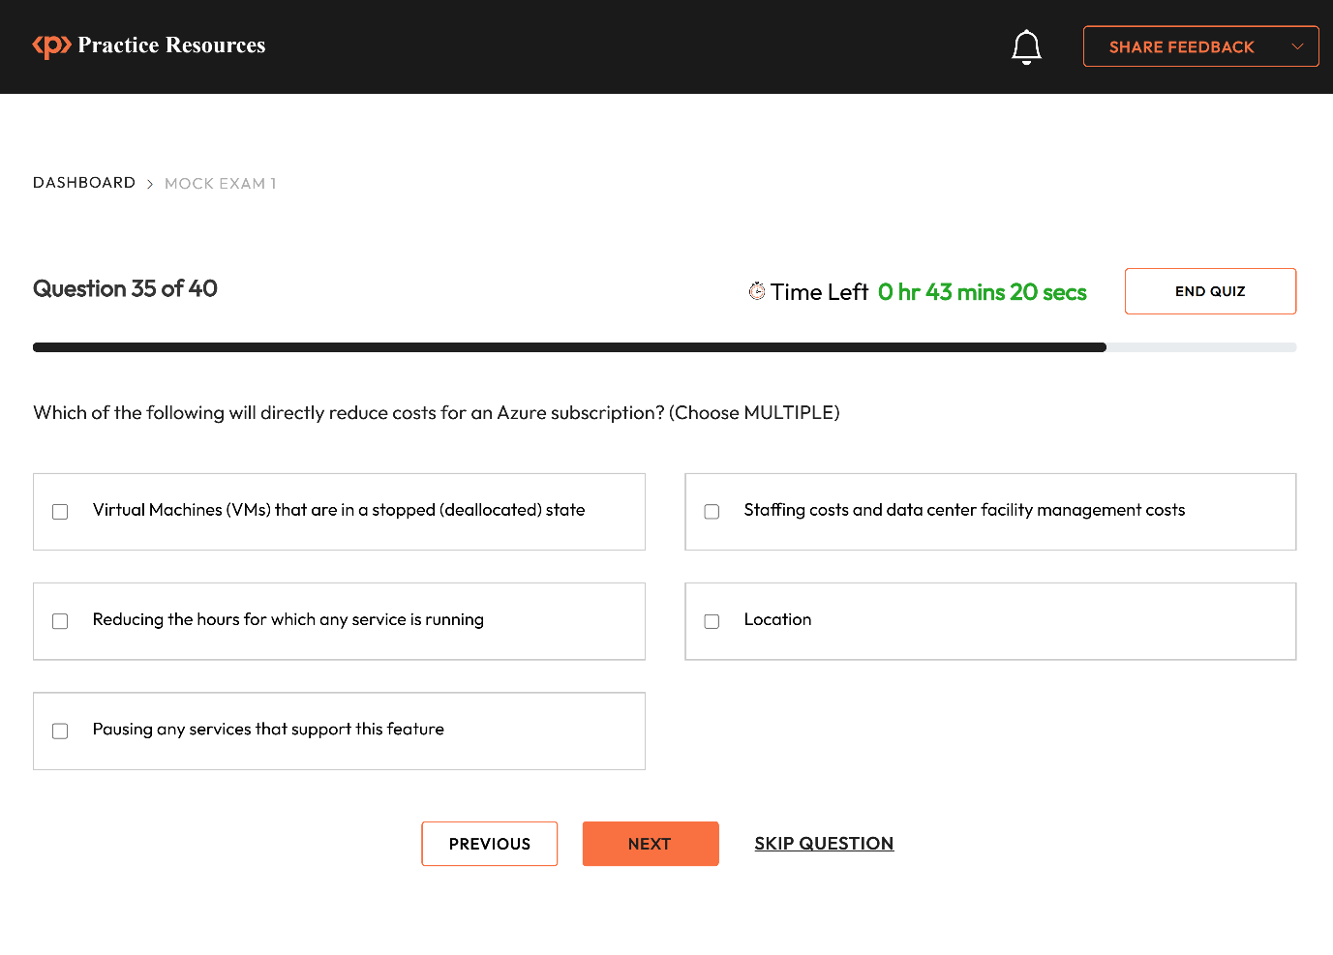
Figure 11.4 – Page that shows up after a successful unlock

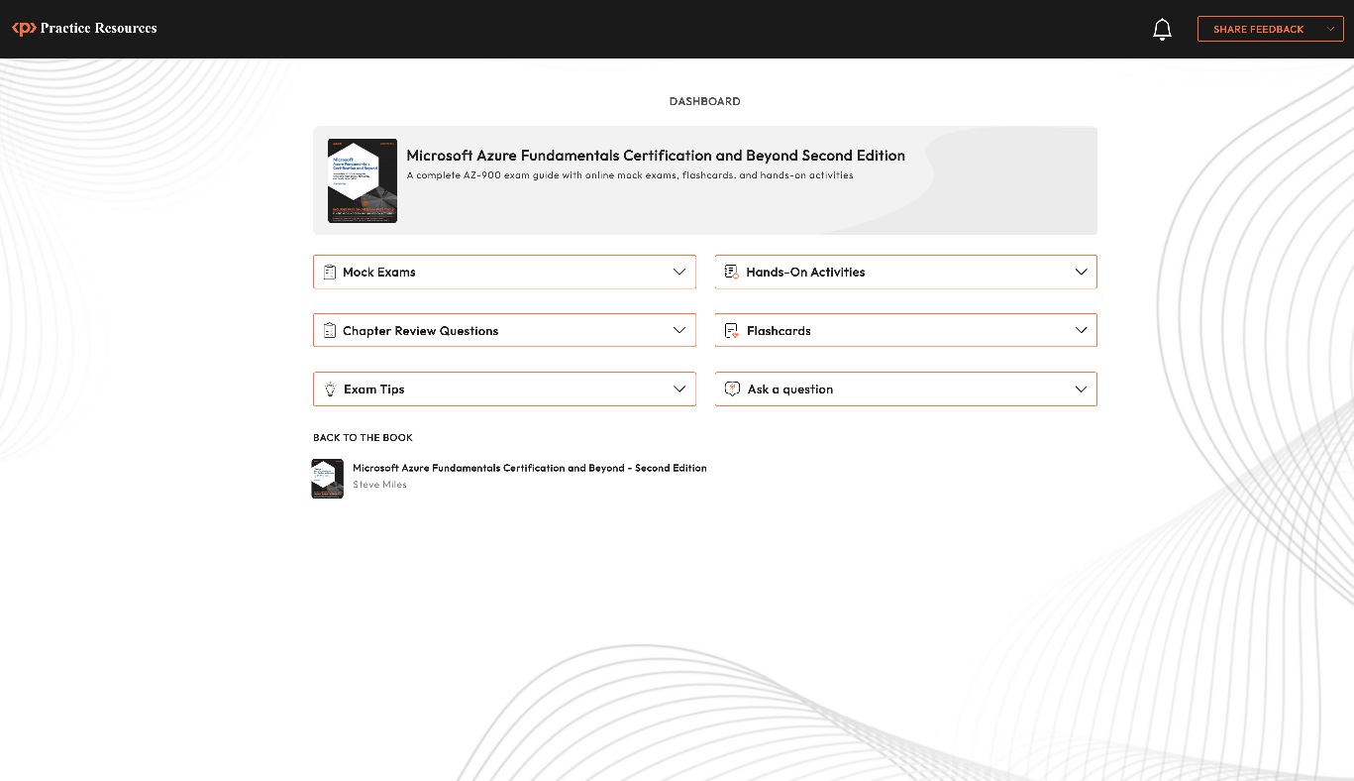
Figure 11.5 – Dashboard page for AZ-900 practice resources
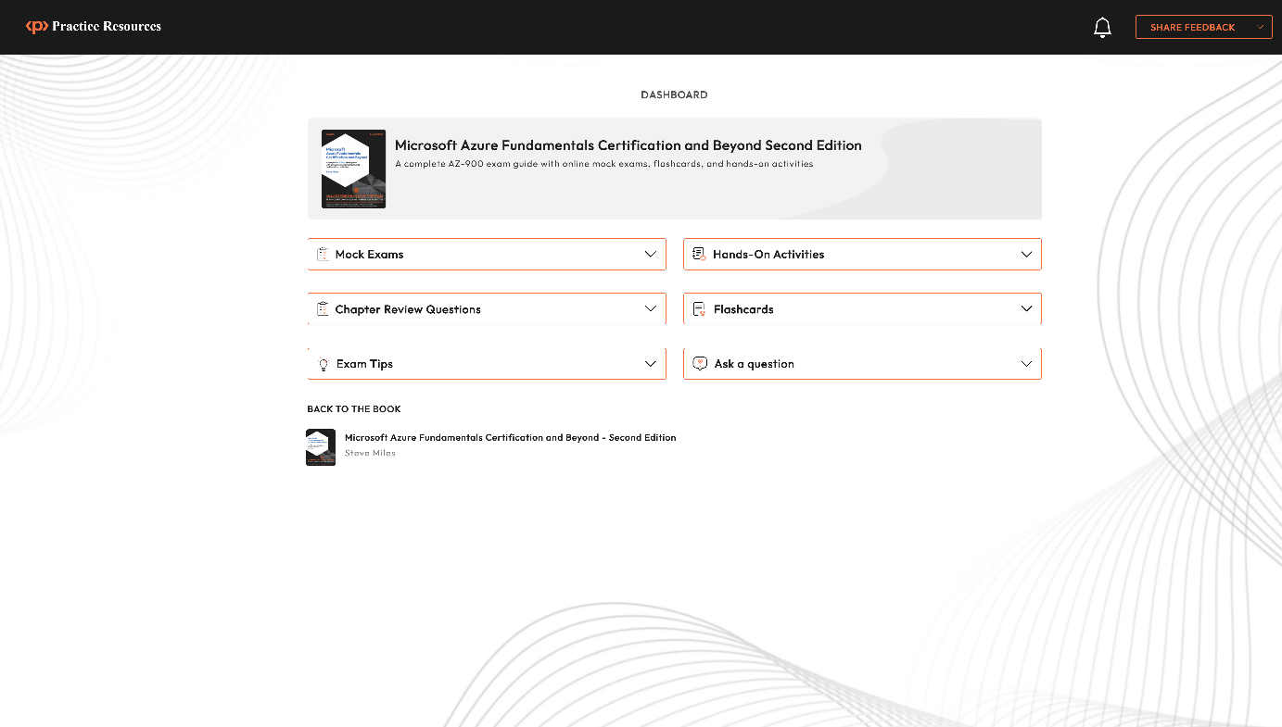
Figure 11.7 – Dashboard interface on a desktop device
Figure 11.8 – Practice Questions Interface on a desktop device
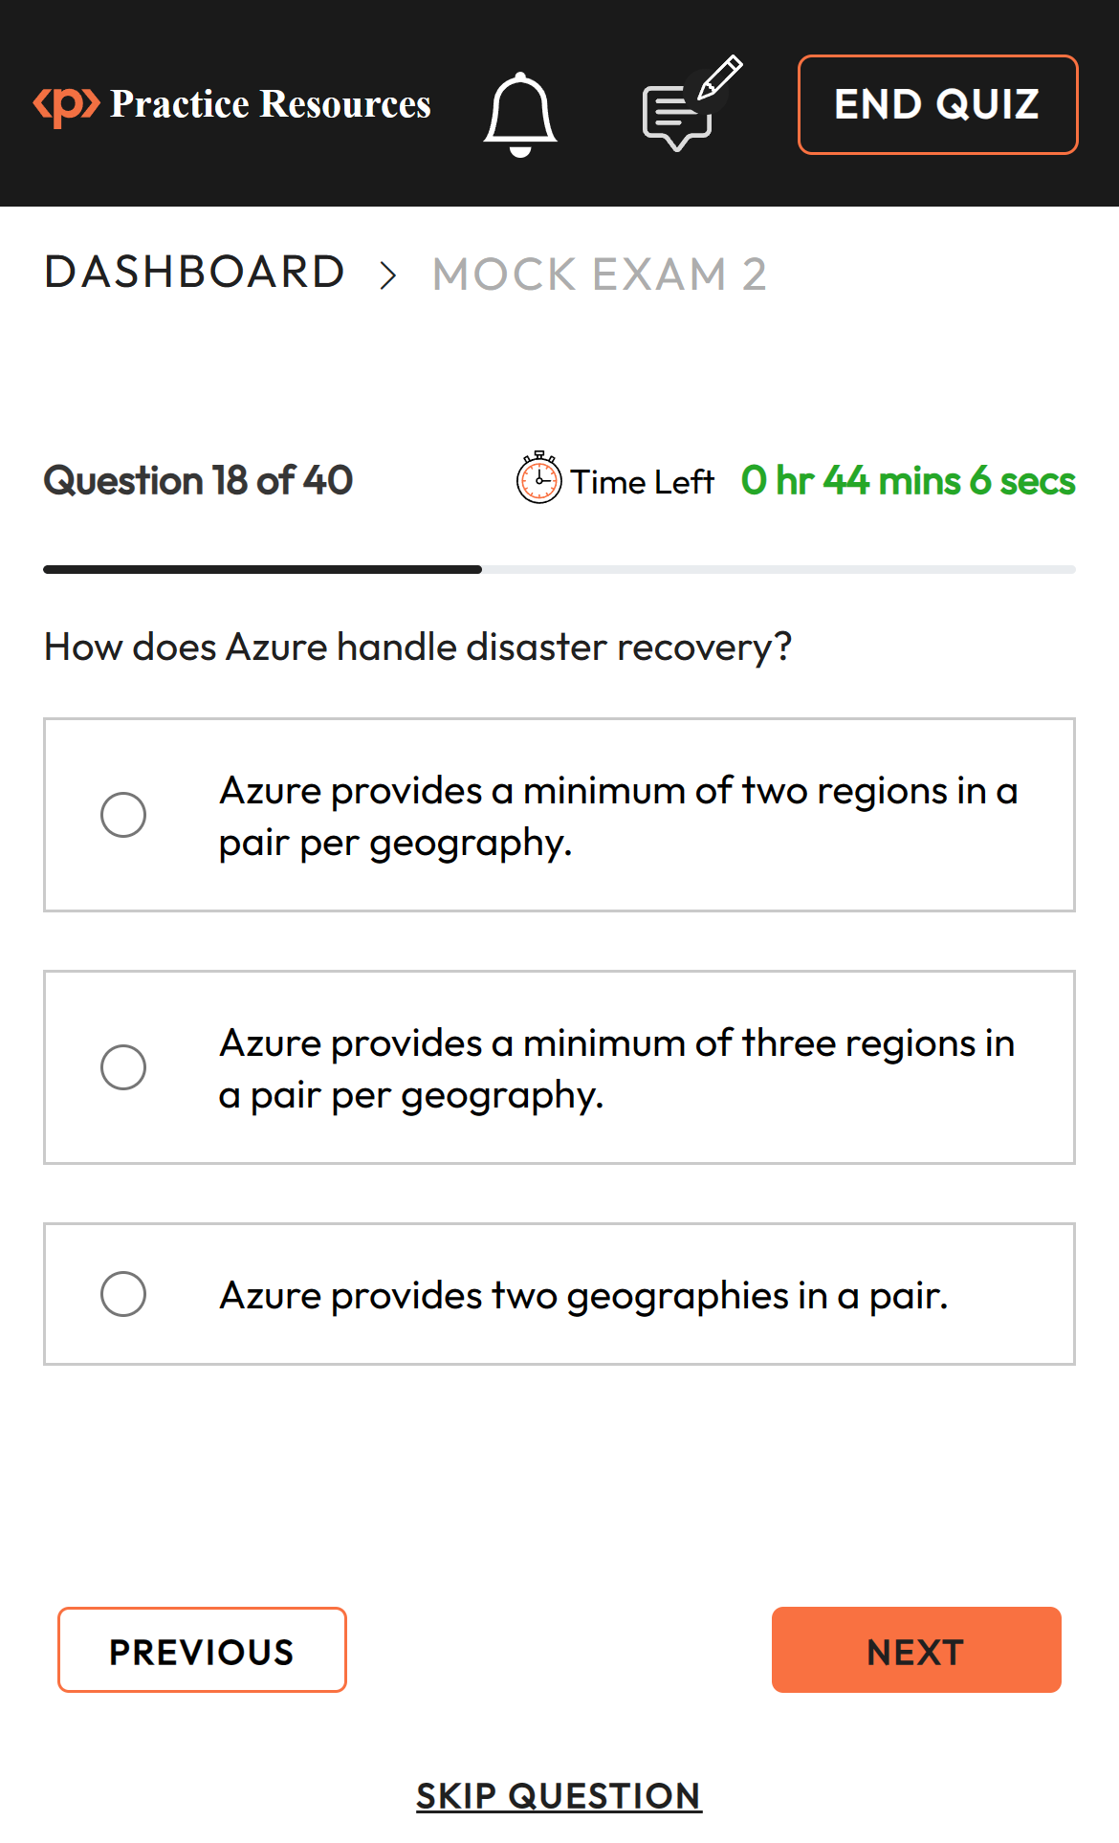
Figure 11.9 – Quiz interface on a mobile device

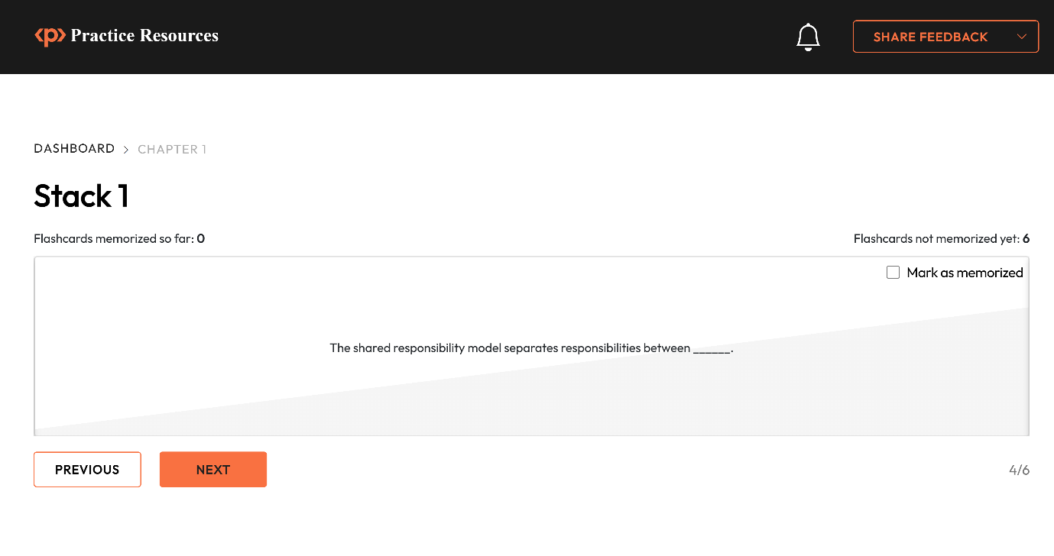
Figure 11.10 – Flashcards interface
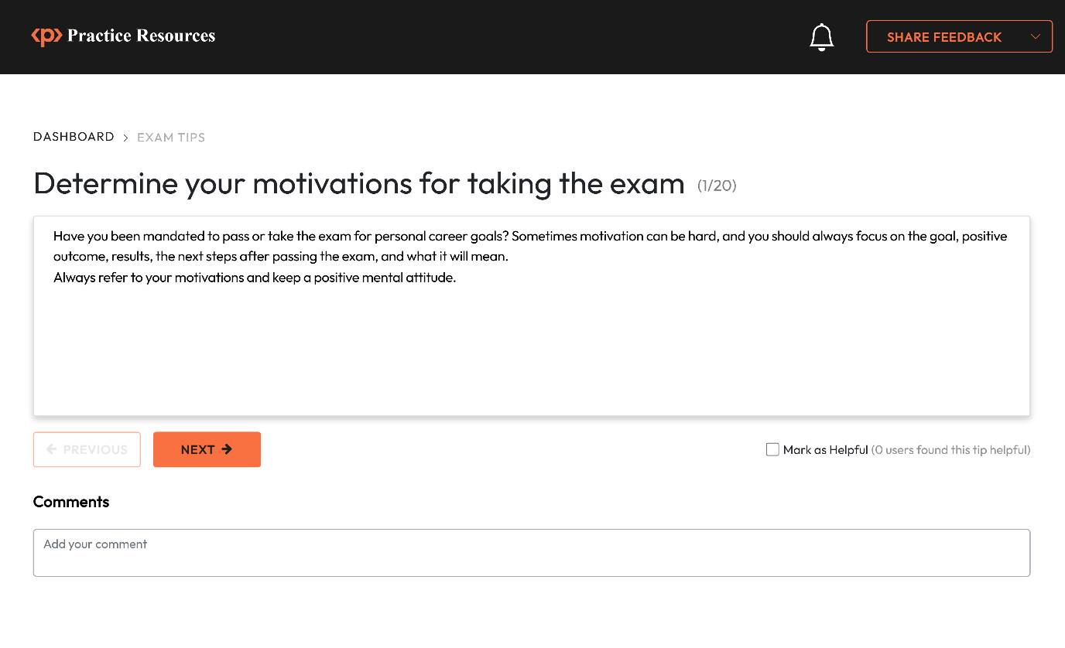
Figure 11.11 – Exam Tips Interface
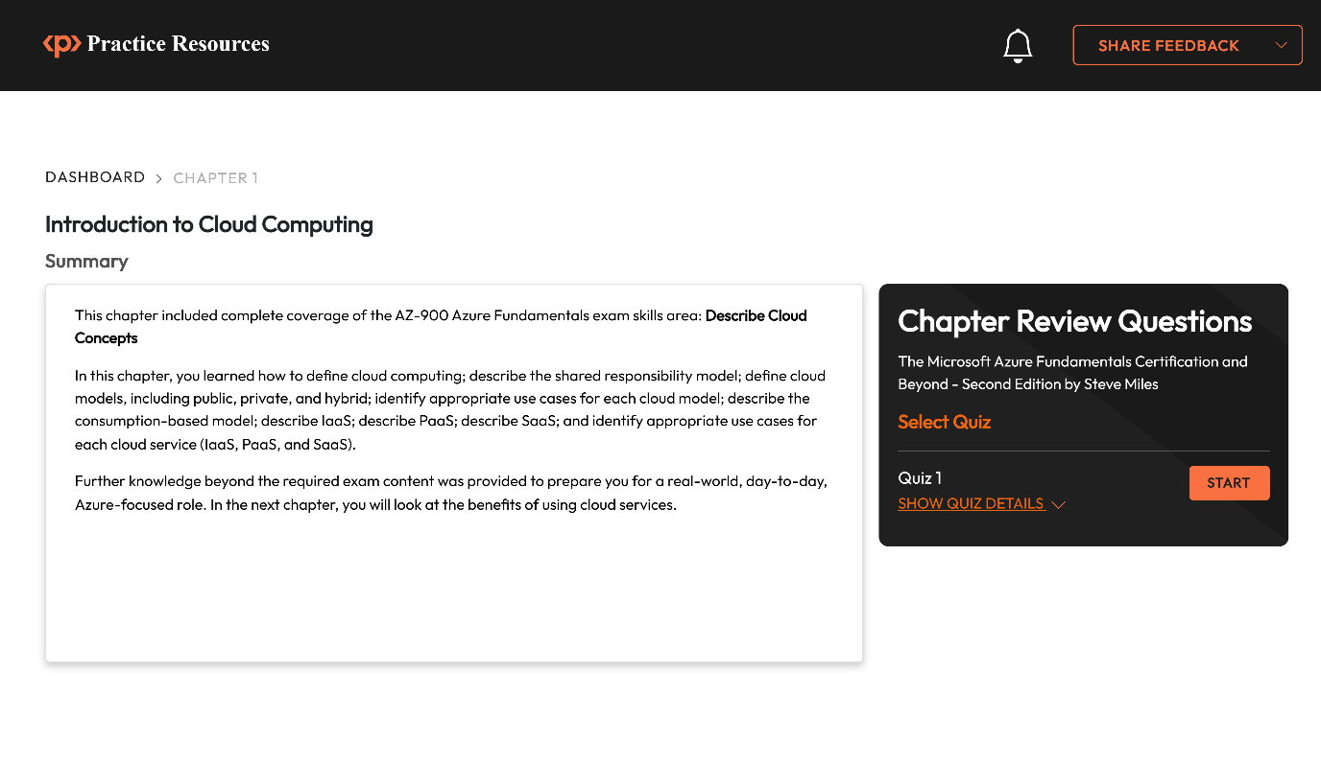
Figure 11.12 – Chapter Review Questions Page
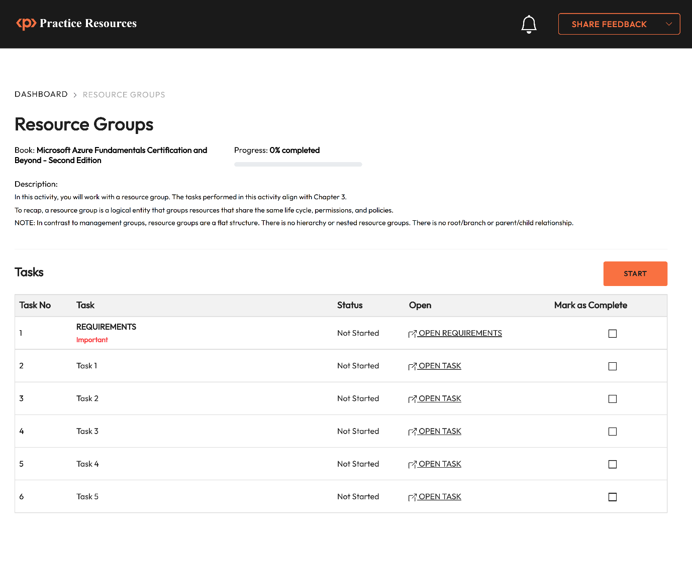
Figure 11.13 – Example of a hands-on activity
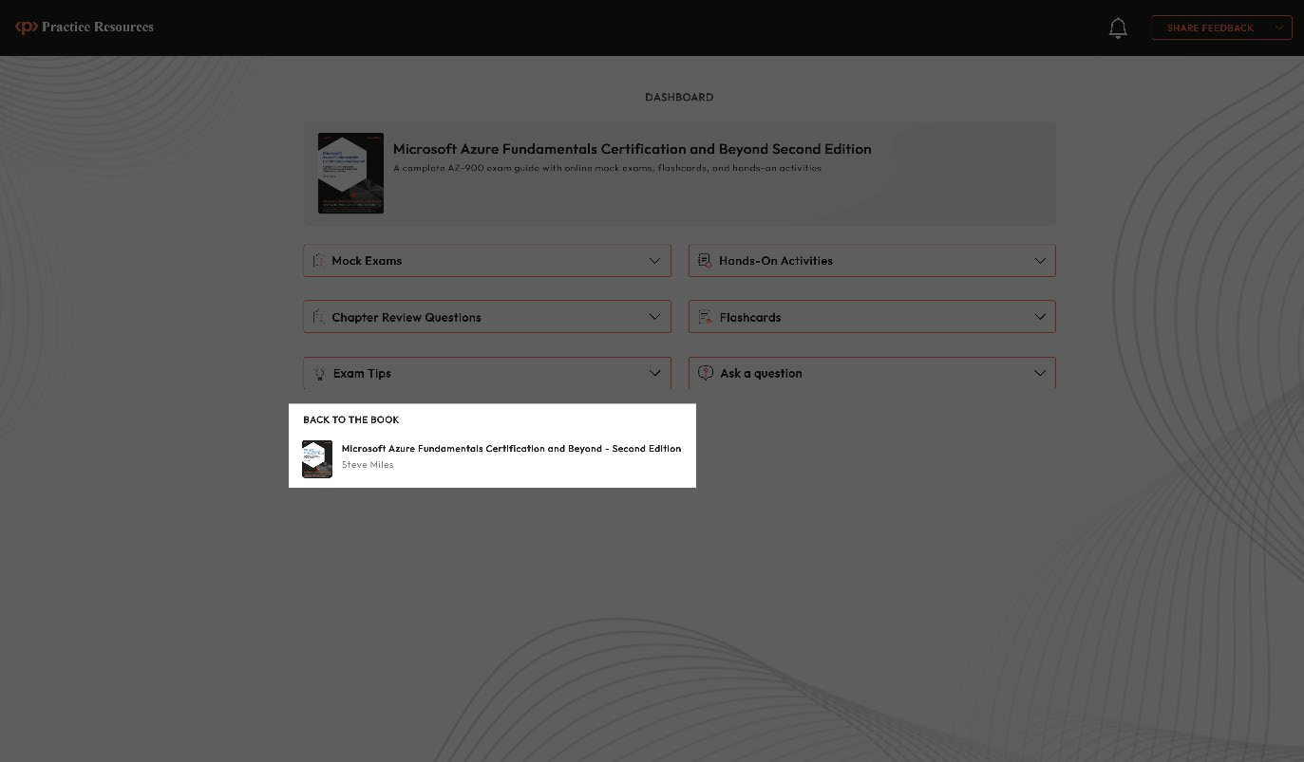
Figure 11.14 – Jump back to the book from the dashboard

