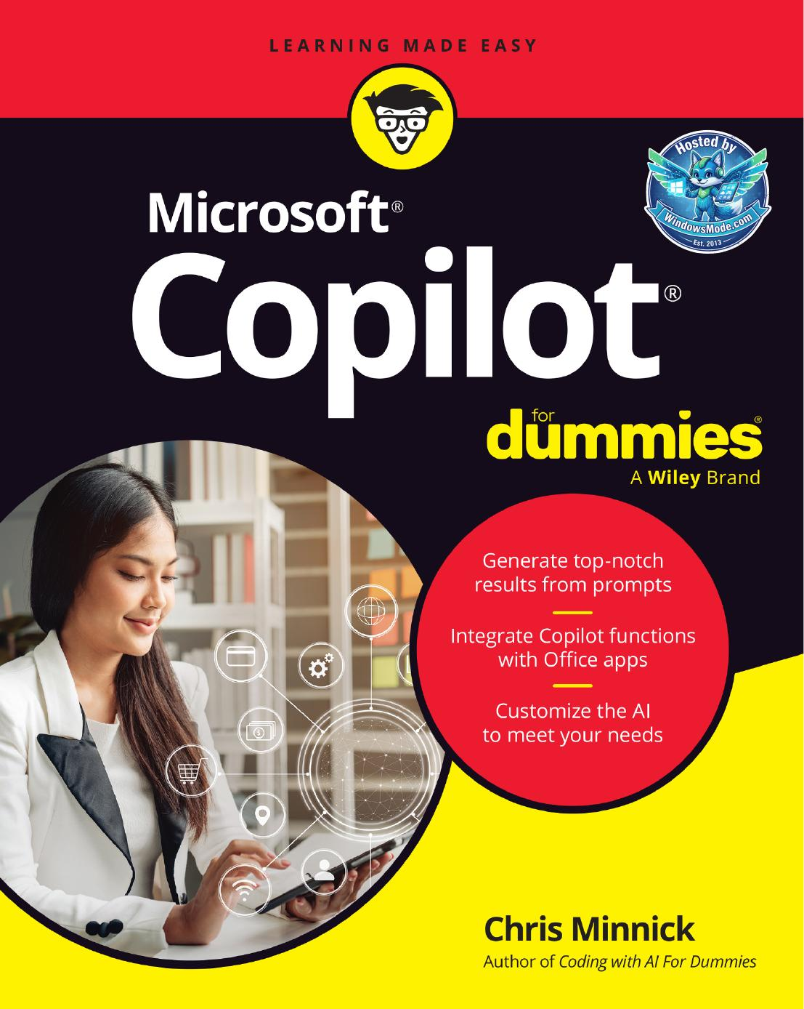

Table of Contents
CHAPTER 1: Getting Started with Microsoft Copilot . . . . . . . . . . . . . . . . . . . . . . . . . . . . . 9
CHAPTER 2: Chatting with Copilot . . . . . . . . . . . . . . . . . . . . . . . . . . . . . . . . . . . . . . . . . . . 29
CHAPTER 3: Browsing with Copilot . . . . . . . . . . . . . . . . . . . . . . . . . . . . . . . . . . . . . . . . . . 45
CHAPTER 4: Going Mobile with Copilot . . . . . . . . . . . . . . . . . . . . . . . . . . . . . . . . . . . . . . . 71
CHAPTER 5: Using a Copilot+ PC . . . . . . . . . . . . . . . . . . . . . . . . . . . . . . . . . . . . . . . . . . . . 85
CHAPTER 6: Writing with Copilot . . . . . . . . . . . . . . . . . . . . . . . . . . . . . . . . . . . . . . . . . . . . 99
CHAPTER 7: Crunching the Numbers with Copilot . . . . . . . . . . . . . . . . . . . . . . . . . . . . 125
CHAPTER 8: Presenting with Copilot . . . . . . . . . . . . . . . . . . . . . . . . . . . . . . . . . . . . . . . . 151
CHAPTER 9: Emailing with Copilot . . . . . . . . . . . . . . . . . . . . . . . . . . . . . . . . . . . . . . . . . . 169
CHAPTER 10: Meeting and Collaborating with Copilot . . . . . . . . . . . . . . . . . . . . . . . . . . 179
CHAPTER 11: Generating and Manipulating Images . . . . . . . . . . . . . . . . . . . . . . . . . . . . 191
CHAPTER 12: Using Copilot for Project Management . . . . . . . . . . . . . . . . . . . . . . . . . . . 211
CHAPTER 13: Making Custom Copilots . . . . . . . . . . . . . . . . . . . . . . . . . . . . . . . . . . . . . . . 229
CHAPTER 14: Expanding Copilot’s Capabilities with Plugins . . . . . . . . . . . . . . . . . . . . . 253
CHAPTER 15: Troubleshooting Common Issues with Copilot . . . . . . . . . . . . . . . . . . . . 265
CHAPTER 16: Ten Plugins for Copilot . . . . . . . . . . . . . . . . . . . . . . . . . . . . . . . . . . . . . . . . . 275
CHAPTER 17: Ten Hidden Copilot Gems . . . . . . . . . . . . . . . . . . . . . . . . . . . . . . . . . . . . . . 285
CHAPTER 3: Browsing with Copilot . . . . . . . . . . . . . . . . . . . . . . . . . . . . . . . . . . 45
CHAPTER 4: Going Mobile with Copilot . . . . . . . . . . . . . . . . . . . . . . . . . . . . . 71
CHAPTER 5: Using a Copilot+ PC . . . . . . . . . . . . . . . . . . . . . . . . . . . . . . . . . . . . . 85
CHAPTER 6: Writing with Copilot . . . . . . . . . . . . . . . . . . . . . . . . . . . . . . . . . . . . . 99
CHAPTER 7: Crunching the Numbers with Copilot . . . . . . . . . . . . . . . 125
CHAPTER 8: Presenting with Copilot . . . . . . . . . . . . . . . . . . . . . . . . . . . . . . . 151
CHAPTER 9: Emailing with Copilot . . . . . . . . . . . . . . . . . . . . . . . . . . . . . . . . . . 169
CHAPTER 10: Meeting and Collaborating with Copilot . . . . . . . . . . . 179
CHAPTER 11: Generating and Manipulating Images . . . . . . . . . . . . . . 191
CHAPTER 12: Using Copilot for Project Management . . . . . . . . . . . . . 211
CHAPTER 13: Making Custom Copilots . . . . . . . . . . . . . . . . . . . . . . . . . . . . . . 229
CHAPTER 14: Expanding Copilot’s Capabilities with Plugins . . . . . 253
CHAPTER 15: Troubleshooting Common Issues with Copilot . . . . 265
CHAPTER 16: Ten Plugins for Copilot . . . . . . . . . . . . . . . . . . . . . . . . . . . . . . . . . 275
CHAPTER 17: Ten Hidden Copilot Gems . . . . . . . . . . . . . . . . . . . . . . . . . . . . . 285
Chapter 1
CHAPTER 1 Getting Started with Microsoft Copilot 9
CHAPTER 1 Getting Started with Microsoft Copilot 11
CHAPTER 1 Getting Started with Microsoft Copilot 13
CHAPTER 1 Getting Started with Microsoft Copilot 15
CHAPTER 1 Getting Started with Microsoft Copilot 17
CHAPTER 1 Getting Started with Microsoft Copilot 19
CHAPTER 1 Getting Started with Microsoft Copilot 21 Taking Copilot for a Test Flight
CHAPTER 1 Getting Started with Microsoft Copilot 23
CHAPTER 1 Getting Started with Microsoft Copilot 25
CHAPTER 1 Getting Started with Microsoft Copilot 27
Chapter 2
CHAPTER 2 Chatting with Copilot 29
CHAPTER 2 Chatting with Copilot 31
CHAPTER 2 Chatting with Copilot 33
CHAPTER 2 Chatting with Copilot 35
CHAPTER 2 Chatting with Copilot 37
CHAPTER 2 Chatting with Copilot 39
CHAPTER 2 Chatting with Copilot 41
CHAPTER 2 Chatting with Copilot 43
Chapter 3
CHAPTER 3 Browsing with Copilot 45
CHAPTER 3 Browsing with Copilot 47
CHAPTER 3 Browsing with Copilot 49
CHAPTER 3 Browsing with Copilot 51
CHAPTER 3 Browsing with Copilot 53
CHAPTER 3 Browsing with Copilot 55 (continued)
CHAPTER 3 Browsing with Copilot 57
CHAPTER 3 Browsing with Copilot 59
CHAPTER 3 Browsing with Copilot 61
CHAPTER 3 Browsing with Copilot 63
CHAPTER 3 Browsing with Copilot 65
CHAPTER 3 Browsing with Copilot 67
CHAPTER 3 Browsing with Copilot 69
Chapter 4
CHAPTER 4 Going Mobile with Copilot 71
CHAPTER 4 Going Mobile with Copilot 73
CHAPTER 4 Going Mobile with Copilot 75
CHAPTER 4 Going Mobile with Copilot 77
CHAPTER 4 Going Mobile with Copilot 79
CHAPTER 4 Going Mobile with Copilot 81
CHAPTER 4 Going Mobile with Copilot 83
Chapter 5
CHAPTER 5 Using a Copilot+ PC 85
CHAPTER 5 Using a Copilot+ PC 87
CHAPTER 5 Using a Copilot+ PC 89
CHAPTER 5 Using a Copilot+ PC 91
CHAPTER 5 Using a Copilot+ PC 93
CHAPTER 5 Using a Copilot+ PC 95
Chapter 6
CHAPTER 6 Writing with Copilot 99 Accessing Copilot Chat in Word
CHAPTER 6 Writing with Copilot 101
CHAPTER 6 Writing with Copilot 103
CHAPTER 6 Writing with Copilot 105
CHAPTER 6 Writing with Copilot 107
CHAPTER 6 Writing with Copilot 109
CHAPTER 6 Writing with Copilot 111 Summarizing Content
CHAPTER 6 Writing with Copilot 113
CHAPTER 6 Writing with Copilot 115
CHAPTER 6 Writing with Copilot 117
CHAPTER 6 Writing with Copilot 119
CHAPTER 6 Writing with Copilot 121
CHAPTER 6 Writing with Copilot 123
Chapter 7
CHAPTER 7 Crunching the Numbers with Copilot 125 Launching Copilot in Excel
CHAPTER 7 Crunching the Numbers with Copilot 127
CHAPTER 7 Crunching the Numbers with Copilot 129
CHAPTER 7 Crunching the Numbers with Copilot 131
CHAPTER 7 Crunching the Numbers with Copilot 133
CHAPTER 7 Crunching the Numbers with Copilot 135
CHAPTER 7 Crunching the Numbers with Copilot 137 Automating Data Analysis
CHAPTER 7 Crunching the Numbers with Copilot 139
CHAPTER 7 Crunching the Numbers with Copilot 141
CHAPTER 7 Crunching the Numbers with Copilot 143
CHAPTER 7 Crunching the Numbers with Copilot 145
CHAPTER 7 Crunching the Numbers with Copilot 147
CHAPTER 7 Crunching the Numbers with Copilot 149
Chapter 8
CHAPTER 8 Presenting with Copilot 151
CHAPTER 8 Presenting with Copilot 153
CHAPTER 8 Presenting with Copilot 155
CHAPTER 8 Presenting with Copilot 157
CHAPTER 8 Presenting with Copilot 159
CHAPTER 8 Presenting with Copilot 161
Chapter 11 talks much more about creating and working with images in Copilot.
CHAPTER 8 Presenting with Copilot 163
CHAPTER 8 Presenting with Copilot 165
CHAPTER 8 Presenting with Copilot 167
Chapter 9
CHAPTER 9 Emailing with Copilot 169
CHAPTER 9 Emailing with Copilot 171
CHAPTER 9 Emailing with Copilot 173
CHAPTER 9 Emailing with Copilot 175
CHAPTER 9 Emailing with Copilot 177
Chapter 10
CHAPTER 10 Meeting and Collaborating with Copilot 179 Using Copilot in Microsoft Teams
CHAPTER 10 Meeting and Collaborating with Copilot 181
CHAPTER 10 Meeting and Collaborating with Copilot 183
CHAPTER 10 Meeting and Collaborating with Copilot 185
CHAPTER 10 Meeting and Collaborating with Copilot 187
CHAPTER 10 Meeting and Collaborating with Copilot 189
Chapter 11
CHAPTER 11 Generating and Manipulating Images 191
CHAPTER 11 Generating and Manipulating Images 193
CHAPTER 11 Generating and Manipulating Images 195
CHAPTER 11 Generating and Manipulating Images 197
CHAPTER 11 Generating and Manipulating Images 199
CHAPTER 11 Generating and Manipulating Images 201
CHAPTER 11 Generating and Manipulating Images 203
CHAPTER 11 Generating and Manipulating Images 205
CHAPTER 11 Generating and Manipulating Images 207
CHAPTER 11 Generating and Manipulating Images 209
Chapter 12
CHAPTER 12 Using Copilot for Project Management 211
CHAPTER 12 Using Copilot for Project Management 213 Getting Started with Planner
CHAPTER 12 Using Copilot for Project Management 215
CHAPTER 12 Using Copilot for Project Management 217
CHAPTER 12 Using Copilot for Project Management 219
CHAPTER 12 Using Copilot for Project Management 221
CHAPTER 12 Using Copilot for Project Management 223
CHAPTER 12 Using Copilot for Project Management 225
Chapter 13
CHAPTER 13 Making Custom Copilots 229
CHAPTER 13 Making Custom Copilots 231
CHAPTER 13 Making Custom Copilots 233
CHAPTER 13 Making Custom Copilots 235
CHAPTER 13 Making Custom Copilots 237 Testing and Editing Your Agent
CHAPTER 13 Making Custom Copilots 239
CHAPTER 13 Making Custom Copilots 241
CHAPTER 13 Making Custom Copilots 243
CHAPTER 13 Making Custom Copilots 245
CHAPTER 13 Making Custom Copilots 247
CHAPTER 13 Making Custom Copilots 249
CHAPTER 13 Making Custom Copilots 251
Chapter 14
CHAPTER 14 Expanding Copilot’s Capabilities with Plugins 253
CHAPTER 14 Expanding Copilot’s Capabilities with Plugins 255
CHAPTER 14 Expanding Copilot’s Capabilities with Plugins 257
CHAPTER 14 Expanding Copilot’s Capabilities with Plugins 259
CHAPTER 14 Expanding Copilot’s Capabilities with Plugins 261
CHAPTER 14 Expanding Copilot’s Capabilities with Plugins 263
Chapter 15
CHAPTER 15 Troubleshooting Common Issues with Copilot 265
CHAPTER 15 Troubleshooting Common Issues with Copilot 267
CHAPTER 15 Troubleshooting Common Issues with Copilot 269
CHAPTER 15 Troubleshooting Common Issues with Copilot 271
Chapter 16
CHAPTER 16 Ten Plugins for Copilot 275 Search
CHAPTER 16 Ten Plugins for Copilot 277
CHAPTER 16 Ten Plugins for Copilot 279
CHAPTER 16 Ten Plugins for Copilot 281
CHAPTER 16 Ten Plugins for Copilot 283 Copilot Studio
Chapter 17
CHAPTER 17 Ten Hidden Copilot Gems 285 Think Deeper
CHAPTER 17 Ten Hidden Copilot Gems 287
CHAPTER 17 Ten Hidden Copilot Gems 289
CHAPTER 17 Ten Hidden Copilot Gems 291 Copilot Labs
CHAPTER 17 Ten Hidden Copilot Gems 293



Microsoft®

Copilot®

by Chris Minnick

Microsoft® Copilot® For Dummies®
Published by: John Wiley & Sons, Inc., 111 River Street, Hoboken, NJ 07030-5774, www.wiley.com
Copyright © 2025 by John Wiley & Sons, Inc. All rights reserved, including rights for text and data mining and training of artificial technologies or similar technologies.
Media and software compilation copyright © 2025 by John Wiley & Sons, Inc. All rights reserved, including rights for text and data mining and training of artificial technologies or similar technologies.
Published simultaneously in Canada
No part of this publication may be reproduced, stored in a retrieval system or transmitted in any form or by any means, electronic, mechanical, photocopying, recording, scanning or otherwise, except as permitted under Sections 107 or 108 of the 1976 United States Copyright Act, without the prior written permission of the Publisher. Requests to the Publisher for permission should be addressed to the Permissions Department, John Wiley & Sons, Inc., 111 River
Street, Hoboken, NJ 07030, (201) 748-6011, fax (201) 748-6008, or online at http://www.wiley.com/go/permissions.
Trademarks: Wiley, For Dummies, the Dummies Man logo, Dummies.com, Making Everything Easier, and related trade dress are trademarks or registered trademarks of John Wiley & Sons, Inc. and may not be used without written permission. Microsoft is a registered trademark of the Microsoft Corporation. All other trademarks are the property of their respective owners. John Wiley & Sons, Inc. is not associated with any product or vendor mentioned in this book. Microsoft® Copilot® For Dummies® is an independent publication and is neither affiliated with, nor authorized, sponsored, or approved by, Microsoft Corporation.
LIMIT OF LIABILITY/DISCLAIMER OF WARRANTY: THE PUBLISHER AND THE AUTHOR MAKE NO
REPRESENTATIONS OR WARRANTIES WITH RESPECT TO THE ACCURACY OR COMPLETENESS OF THE CONTENTS
OF THIS WORK AND SPECIFICALLY DISCLAIM ALL WARRANTIES, INCLUDING WITHOUT LIMITATION WARRANTIES
OF FITNESS FOR A PARTICULAR PURPOSE. NO WARRANTY MAY BE CREATED OR EXTENDED BY SALES OR
PROMOTIONAL MATERIALS. THE ADVICE AND STRATEGIES CONTAINED HEREIN MAY NOT BE SUITABLE FOR
EVERY SITUATION. THIS WORK IS SOLD WITH THE UNDERSTANDING THAT THE PUBLISHER IS NOT ENGAGED
IN RENDERING LEGAL, ACCOUNTING, OR OTHER PROFESSIONAL SERVICES. IF PROFESSIONAL ASSISTANCE IS
REQUIRED, THE SERVICES OF A COMPETENT PROFESSIONAL PERSON SHOULD BE SOUGHT. NEITHER THE
PUBLISHER NOR THE AUTHOR SHALL BE LIABLE FOR DAMAGES ARISING HEREFROM. THE FACT THAT AN
ORGANIZATION OR WEBSITE IS REFERRED TO IN THIS WORK AS A CITATION AND/OR A POTENTIAL SOURCE OF
FURTHER INFORMATION DOES NOT MEAN THAT THE AUTHOR OR THE PUBLISHER ENDORSES THE INFORMATION
THE ORGANIZATION OR WEBSITE MAY PROVIDE OR RECOMMENDATIONS IT MAY MAKE. FURTHER, READERS
SHOULD BE AWARE THAT INTERNET WEBSITES LISTED IN THIS WORK MAY HAVE CHANGED OR DISAPPEARED
BETWEEN WHEN THIS WORK WAS WRITTEN AND WHEN IT IS READ.
For general information on our other products and services, please contact our Customer Care Department within the U.S. at 877-762-2974, outside the U.S. at 317-572-3993, or fax 317-572-4002. For technical support, please
visit https://hub.wiley.com/community/support/dummies.
Wiley publishes in a variety of print and electronic formats and by print-on-demand. Some material included with standard print versions of this book may not be included in e-books or in print-on-demand. If this book refers to
media that is not included in the version you purchased, you may download this material at http://booksupport.
wiley.com. For more information about Wiley products, visit www.wiley.com.
Library of Congress Control Number is available from the publisher.
ISBN 978-1-394-31494-2 (pbk); ISBN 978-1-394-31496-6 (ebk); ISBN 978-1-394-31495-9 (ebk) Contents at a Glance

Introduction . . . . . . . . . . . . . . . . . . . . . . . . . . . . . . . . . . . . . . . . . . . . . . . . . . . . . . . . 1
Part 1: Meeting Your AI Assistant . . . . . . . . . . . . . . . . . . . . . . . . . . . . . . . 7

CHAPTER 1: Getting Started with Microsoft Copilot . . . . . . . . . . . . . . . . . . . . . . . . . . . . . 9

CHAPTER 2: Chatting with Copilot . . . . . . . . . . . . . . . . . . . . . . . . . . . . . . . . . . . . . . . . . . . 29

CHAPTER 3: Browsing with Copilot . . . . . . . . . . . . . . . . . . . . . . . . . . . . . . . . . . . . . . . . . . 45

CHAPTER 4: Going Mobile with Copilot . . . . . . . . . . . . . . . . . . . . . . . . . . . . . . . . . . . . . . . 71

CHAPTER 5: Using a Copilot+ PC . . . . . . . . . . . . . . . . . . . . . . . . . . . . . . . . . . . . . . . . . . . . 85
Part 2: Getting Work Done with Microsoft 365 Copilot . . . . 97

CHAPTER 6: Writing with Copilot . . . . . . . . . . . . . . . . . . . . . . . . . . . . . . . . . . . . . . . . . . . . 99

CHAPTER 7: Crunching the Numbers with Copilot . . . . . . . . . . . . . . . . . . . . . . . . . . . . 125

CHAPTER 8: Presenting with Copilot . . . . . . . . . . . . . . . . . . . . . . . . . . . . . . . . . . . . . . . . 151

CHAPTER 9: Emailing with Copilot . . . . . . . . . . . . . . . . . . . . . . . . . . . . . . . . . . . . . . . . . . 169

CHAPTER 10: Meeting and Collaborating with Copilot . . . . . . . . . . . . . . . . . . . . . . . . . . 179

CHAPTER 11: Generating and Manipulating Images . . . . . . . . . . . . . . . . . . . . . . . . . . . . 191

CHAPTER 12: Using Copilot for Project Management . . . . . . . . . . . . . . . . . . . . . . . . . . . 211
Part 3: Jumpstarting Your Productivity with Copilot . . . . . . 227

CHAPTER 13: Making Custom Copilots . . . . . . . . . . . . . . . . . . . . . . . . . . . . . . . . . . . . . . . 229

CHAPTER 14: Expanding Copilot’s Capabilities with Plugins . . . . . . . . . . . . . . . . . . . . . 253

CHAPTER 15: Troubleshooting Common Issues with Copilot . . . . . . . . . . . . . . . . . . . . 265
Part 4: The Part of Tens . . . . . . . . . . . . . . . . . . . . . . . . . . . . . . . . . . . . . . . . . 273

CHAPTER 16: Ten Plugins for Copilot . . . . . . . . . . . . . . . . . . . . . . . . . . . . . . . . . . . . . . . . . 275

CHAPTER 17: Ten Hidden Copilot Gems . . . . . . . . . . . . . . . . . . . . . . . . . . . . . . . . . . . . . . 285
Index . . . . . . . . . . . . . . . . . . . . . . . . . . . . . . . . . . . . . . . . . . . . . . . . . . . . . . . . . . . . . . . 295

Table of Contents

INTRODUCTION . . . . . . . . . . . . . . . . . . . . . . . . . . . . . . . . . . . . . . . . . . . . . . . . . . . 1
About This Book . . . . . . . . . . . . . . . . . . . . . . . . . . . . . . . . . . . . . . . . . . . . . . .2
Foolish Assumptions . . . . . . . . . . . . . . . . . . . . . . . . . . . . . . . . . . . . . . . . . . .3
Icons Used in This Book . . . . . . . . . . . . . . . . . . . . . . . . . . . . . . . . . . . . . . . .3
Beyond the Book . . . . . . . . . . . . . . . . . . . . . . . . . . . . . . . . . . . . . . . . . . . . . .4
Where to Go from Here . . . . . . . . . . . . . . . . . . . . . . . . . . . . . . . . . . . . . . . .4
PART 1: MEETING YOUR AI ASSISTANT . . . . . . . . . . . . . . . . . . . . . . . . 7
CHAPTER 1: Getting Started with Microsoft Copilot . . . . . . . . . . . . . . . 9
Defining Copilot . . . . . . . . . . . . . . . . . . . . . . . . . . . . . . . . . . . . . . . . . . . . . . .9
Overview of Microsoft Copilot . . . . . . . . . . . . . . . . . . . . . . . . . . . . . . .11
Understanding how Copilot works . . . . . . . . . . . . . . . . . . . . . . . . . . .13
Using large language models (LLMs) . . . . . . . . . . . . . . . . . . . . . . . . .14
Integration with Microsoft 365 apps . . . . . . . . . . . . . . . . . . . . . . . . . .15
Connection with Microsoft Graph and your data . . . . . . . . . . . . . . .16
Signing Up for Copilot . . . . . . . . . . . . . . . . . . . . . . . . . . . . . . . . . . . . . . . . .16
Installing Copilot . . . . . . . . . . . . . . . . . . . . . . . . . . . . . . . . . . . . . . . . . .17
Eligibility criteria . . . . . . . . . . . . . . . . . . . . . . . . . . . . . . . . . . . . . . . . . . .17
Subscription plans and pricing . . . . . . . . . . . . . . . . . . . . . . . . . . . . . .17
Step-by-step sign-up process . . . . . . . . . . . . . . . . . . . . . . . . . . . . . . . .19
Taking Copilot for a Test Flight . . . . . . . . . . . . . . . . . . . . . . . . . . . . . . . . .22
Understanding why mine looks different . . . . . . . . . . . . . . . . . . . . .22
Basic commands and interactions . . . . . . . . . . . . . . . . . . . . . . . . . . .22
Using Copilot Ethically . . . . . . . . . . . . . . . . . . . . . . . . . . . . . . . . . . . . . . . .23
Responsible AI principles . . . . . . . . . . . . . . . . . . . . . . . . . . . . . . . . . . .24
Data privacy and security considerations . . . . . . . . . . . . . . . . . . . . .25
Guidelines for ethical use . . . . . . . . . . . . . . . . . . . . . . . . . . . . . . . . . . .26
CHAPTER 2: Chatting with Copilot . . . . . . . . . . . . . . . . . . . . . . . . . . . . . . . . . . . 29
Using Text Prompts . . . . . . . . . . . . . . . . . . . . . . . . . . . . . . . . . . . . . . . . . . .29
Starting simply . . . . . . . . . . . . . . . . . . . . . . . . . . . . . . . . . . . . . . . . . . . .30
Narrowing it down . . . . . . . . . . . . . . . . . . . . . . . . . . . . . . . . . . . . . . . . .30
Asking for more options . . . . . . . . . . . . . . . . . . . . . . . . . . . . . . . . . . . .31
Using Voice Prompts . . . . . . . . . . . . . . . . . . . . . . . . . . . . . . . . . . . . . . . . . .32
Why is speech input important? . . . . . . . . . . . . . . . . . . . . . . . . . . . . .32
Voice input setup . . . . . . . . . . . . . . . . . . . . . . . . . . . . . . . . . . . . . . . . . .34
Tips for clear and accurate voice commands . . . . . . . . . . . . . . . . . .36
Learning to Engineer Prompts . . . . . . . . . . . . . . . . . . . . . . . . . . . . . . . . . .36
What’s inside a prompt? . . . . . . . . . . . . . . . . . . . . . . . . . . . . . . . . . . . .36
Crafting effective prompts . . . . . . . . . . . . . . . . . . . . . . . . . . . . . . . . . .37

Table of Contents v
Avoiding the common pitfalls . . . . . . . . . . . . . . . . . . . . . . . . . . . . . . .39
Knowing Copilot’s limitations . . . . . . . . . . . . . . . . . . . . . . . . . . . . . . . .40
Refining Your Prompts . . . . . . . . . . . . . . . . . . . . . . . . . . . . . . . . . . . . . . . .42
Homing in on better results . . . . . . . . . . . . . . . . . . . . . . . . . . . . . . . . .43
Techniques for iterative prompt refinement . . . . . . . . . . . . . . . . . . .43
The danger of over-refinement . . . . . . . . . . . . . . . . . . . . . . . . . . . . . .43

CHAPTER 3: Browsing with Copilot . . . . . . . . . . . . . . . . . . . . . . . . . . . . . . . . . . 45
Integrating Copilot with Microsoft Edge . . . . . . . . . . . . . . . . . . . . . . . . . .45
Learning the Edge integration features . . . . . . . . . . . . . . . . . . . . . . .46
Using Copilot plugins in Edge . . . . . . . . . . . . . . . . . . . . . . . . . . . . . . .53
Customizing the Copilot Settings in Edge . . . . . . . . . . . . . . . . . . . . . . . .54
Personalizing the settings . . . . . . . . . . . . . . . . . . . . . . . . . . . . . . . . . .54
Clearing your Copilot activity history . . . . . . . . . . . . . . . . . . . . . . . . .56
Managing preferences and settings . . . . . . . . . . . . . . . . . . . . . . . . . .60
Understanding commercial data protection . . . . . . . . . . . . . . . . . . .66
Using Edge’s Built-In Actions . . . . . . . . . . . . . . . . . . . . . . . . . . . . . . . . . . .66

CHAPTER 4: Going Mobile with Copilot . . . . . . . . . . . . . . . . . . . . . . . . . . . . . 71
Getting Started with the Copilot App . . . . . . . . . . . . . . . . . . . . . . . . . . . .71
Installing Copilot on your iPhone or iPad . . . . . . . . . . . . . . . . . . . . .72
Installing Copilot on your Android phone . . . . . . . . . . . . . . . . . . . . .75
Initial setup and configuration . . . . . . . . . . . . . . . . . . . . . . . . . . . . . .76
Using Copilot Pro . . . . . . . . . . . . . . . . . . . . . . . . . . . . . . . . . . . . . . . . . .76
Using the Unique Mobile Functionalities . . . . . . . . . . . . . . . . . . . . . . . . .77
Accessing your chat history . . . . . . . . . . . . . . . . . . . . . . . . . . . . . . . . .77
Prompting with the camera . . . . . . . . . . . . . . . . . . . . . . . . . . . . . . . . .78
Audio prompting . . . . . . . . . . . . . . . . . . . . . . . . . . . . . . . . . . . . . . . . . .79
Trying location-specific prompts . . . . . . . . . . . . . . . . . . . . . . . . . . . . .80
Enabling plugins . . . . . . . . . . . . . . . . . . . . . . . . . . . . . . . . . . . . . . . . . . .82
Finding out more . . . . . . . . . . . . . . . . . . . . . . . . . . . . . . . . . . . . . . . . . .83
Sharing Copilot’s responses . . . . . . . . . . . . . . . . . . . . . . . . . . . . . . . . .83

CHAPTER 5: Using a Copilot+ PC . . . . . . . . . . . . . . . . . . . . . . . . . . . . . . . . . . . . . 85
Understanding What Makes a PC Copilot . . . . . . . . . . . . . . . . . . . . . . .85
Considering the enhanced capabilities of Copilot PCs . . . . . . . . . .86
Comparing Copilot to standard Copilot . . . . . . . . . . . . . . . . . . . . . .87
Learning about the Exclusive Features of Copilot PCs . . . . . . . . . . . . .87
Using Cocreator in Paint . . . . . . . . . . . . . . . . . . . . . . . . . . . . . . . . . . . . . . .87
Using Cocreator . . . . . . . . . . . . . . . . . . . . . . . . . . . . . . . . . . . . . . . . . . .88
Refining and repeating . . . . . . . . . . . . . . . . . . . . . . . . . . . . . . . . . . . . .90

vi Microsoft Copilot For Dummies
Taking Advantage of Live Captions . . . . . . . . . . . . . . . . . . . . . . . . . . . . . .91
Enabling Live Captions . . . . . . . . . . . . . . . . . . . . . . . . . . . . . . . . . . . . .92
Experimenting with Live Captions . . . . . . . . . . . . . . . . . . . . . . . . . . . .92
Using Windows Studio Effects . . . . . . . . . . . . . . . . . . . . . . . . . . . . . . . . . .93
Recalling Your History . . . . . . . . . . . . . . . . . . . . . . . . . . . . . . . . . . . . . . . . .94
Considering the Future of Copilot . . . . . . . . . . . . . . . . . . . . . . . . . . . . . .95
PART 2: GETTING WORK DONE WITH
MICROSOFT 365 COPILOT . . . . . . . . . . . . . . . . . . . . . . . . . . . . . . . . . . . . . . 97

CHAPTER 6: Writing with Copilot . . . . . . . . . . . . . . . . . . . . . . . . . . . . . . . . . . . . . 99
Accessing Copilot Chat in Word . . . . . . . . . . . . . . . . . . . . . . . . . . . . . . . .100
Using the Copilot Chat sidebar . . . . . . . . . . . . . . . . . . . . . . . . . . . . .100
Using Copilot inline . . . . . . . . . . . . . . . . . . . . . . . . . . . . . . . . . . . . . . .104
Summarizing Content . . . . . . . . . . . . . . . . . . . . . . . . . . . . . . . . . . . . . . . .112
Customizing summary length and detail . . . . . . . . . . . . . . . . . . . . .112
Generating a table of contents . . . . . . . . . . . . . . . . . . . . . . . . . . . . .113
Generating an index . . . . . . . . . . . . . . . . . . . . . . . . . . . . . . . . . . . . . .114
Generating ideas for an elevator pitch . . . . . . . . . . . . . . . . . . . . . . .115
Using Copilot as an Editor . . . . . . . . . . . . . . . . . . . . . . . . . . . . . . . . . . . .117
Asking Copilot for editing advice . . . . . . . . . . . . . . . . . . . . . . . . . . . .118
Rewriting with Copilot . . . . . . . . . . . . . . . . . . . . . . . . . . . . . . . . . . . . .118
Getting Ideas . . . . . . . . . . . . . . . . . . . . . . . . . . . . . . . . . . . . . . . . . . . . . . .119
Generating ideas for various writing tasks . . . . . . . . . . . . . . . . . . .119
Brainstorming with Copilot in Word . . . . . . . . . . . . . . . . . . . . . . . . .120
Trying creative writing prompts and exercises . . . . . . . . . . . . . . . .122

CHAPTER 7: Crunching the Numbers with Copilot . . . . . . . . . . . . . . . 125
Launching Copilot in Excel . . . . . . . . . . . . . . . . . . . . . . . . . . . . . . . . . . . .126
Working with Data . . . . . . . . . . . . . . . . . . . . . . . . . . . . . . . . . . . . . . . . . . .127
Understanding the two kinds of data . . . . . . . . . . . . . . . . . . . . . . . .127
Finding free data . . . . . . . . . . . . . . . . . . . . . . . . . . . . . . . . . . . . . . . . .128
Preparing the Data . . . . . . . . . . . . . . . . . . . . . . . . . . . . . . . . . . . . . . . . . .129
Converting the data to a table . . . . . . . . . . . . . . . . . . . . . . . . . . . . . .129
Adding context to the headers . . . . . . . . . . . . . . . . . . . . . . . . . . . . .130
Formatting data . . . . . . . . . . . . . . . . . . . . . . . . . . . . . . . . . . . . . . . . . .133
Changing data types . . . . . . . . . . . . . . . . . . . . . . . . . . . . . . . . . . . . . .134
Sorting data . . . . . . . . . . . . . . . . . . . . . . . . . . . . . . . . . . . . . . . . . . . . .135
Cleaning data . . . . . . . . . . . . . . . . . . . . . . . . . . . . . . . . . . . . . . . . . . . .136
Automating Data Analysis . . . . . . . . . . . . . . . . . . . . . . . . . . . . . . . . . . . .138
Using Copilot for automated insights . . . . . . . . . . . . . . . . . . . . . . . .138
Asking for a specific analysis . . . . . . . . . . . . . . . . . . . . . . . . . . . . . . .140

Table of Contents vii
Creating Formulas with Copilot’s Assistance . . . . . . . . . . . . . . . . . . . . .141
Formula creation and troubleshooting . . . . . . . . . . . . . . . . . . . . . .142
Advanced formula techniques . . . . . . . . . . . . . . . . . . . . . . . . . . . . . .144
Visualizing Data with Copilot . . . . . . . . . . . . . . . . . . . . . . . . . . . . . . . . . .144
Opening and cleaning data in Excel . . . . . . . . . . . . . . . . . . . . . . . . .145
Creating charts and graphs . . . . . . . . . . . . . . . . . . . . . . . . . . . . . . . .146
Customizing charts . . . . . . . . . . . . . . . . . . . . . . . . . . . . . . . . . . . . . . .148
Considering Copilot’s Limitations in Excel . . . . . . . . . . . . . . . . . . . . . . .149

CHAPTER 8: Presenting with Copilot . . . . . . . . . . . . . . . . . . . . . . . . . . . . . . . 151
Interacting with Copilot in PowerPoint . . . . . . . . . . . . . . . . . . . . . . . . . .151
Using Copilot’s built-in PowerPoint actions . . . . . . . . . . . . . . . . . . .152
Defining and refining your topic . . . . . . . . . . . . . . . . . . . . . . . . . . . .153
Personalizing the idea . . . . . . . . . . . . . . . . . . . . . . . . . . . . . . . . . . . . .154
Evaluating the generated presentation . . . . . . . . . . . . . . . . . . . . . .155
Evaluating the generated content . . . . . . . . . . . . . . . . . . . . . . . . . . .156
Evaluating the generated design . . . . . . . . . . . . . . . . . . . . . . . . . . . .157
Evaluating the use of images . . . . . . . . . . . . . . . . . . . . . . . . . . . . . . .158
Designing Slides with Designer . . . . . . . . . . . . . . . . . . . . . . . . . . . . . . . .158
Redesigning Slides with Copilot . . . . . . . . . . . . . . . . . . . . . . . . . . . . . . . .159
Sticking to the Built-in Prompts . . . . . . . . . . . . . . . . . . . . . . . . . . . . . . . .160
Enhancing visual appeal . . . . . . . . . . . . . . . . . . . . . . . . . . . . . . . . . . .162
Prompting for images . . . . . . . . . . . . . . . . . . . . . . . . . . . . . . . . . . . . .162
Organizing a Presentation . . . . . . . . . . . . . . . . . . . . . . . . . . . . . . . . . . . .164
Practicing Your Presentation with Copilot Feedback . . . . . . . . . . . . . .165

CHAPTER 9: Emailing with Copilot . . . . . . . . . . . . . . . . . . . . . . . . . . . . . . . . . . 169
Summarizing with Copilot . . . . . . . . . . . . . . . . . . . . . . . . . . . . . . . . . . . .169
Summarizing email threads . . . . . . . . . . . . . . . . . . . . . . . . . . . . . . . .170
Summarizing long emails . . . . . . . . . . . . . . . . . . . . . . . . . . . . . . . . . .171
Composing Emails with Copilot . . . . . . . . . . . . . . . . . . . . . . . . . . . . . . . .172
Drafting emails with Copilot . . . . . . . . . . . . . . . . . . . . . . . . . . . . . . .172
Reply suggestions . . . . . . . . . . . . . . . . . . . . . . . . . . . . . . . . . . . . . . . .175
Email coaching . . . . . . . . . . . . . . . . . . . . . . . . . . . . . . . . . . . . . . . . . . .176
Meeting management . . . . . . . . . . . . . . . . . . . . . . . . . . . . . . . . . . . . .178
Using Copilot for Email with Discernment . . . . . . . . . . . . . . . . . . . . . . .178

CHAPTER 10: Meeting and Collaborating with Copilot . . . . . . . . . . . 179
Using Copilot in Microsoft Teams . . . . . . . . . . . . . . . . . . . . . . . . . . . . . .180
Preparing for and setting up meetings . . . . . . . . . . . . . . . . . . . . . .181
Getting real-time meeting assistance . . . . . . . . . . . . . . . . . . . . . . . .184
Accessing post-meeting summaries . . . . . . . . . . . . . . . . . . . . . . . . .187
Understanding the Limitations of Copilot in Teams . . . . . . . . . . . . . . .188

viii Microsoft Copilot For Dummies

CHAPTER 11: Generating and Manipulating Images . . . . . . . . . . . . . . 191
Using Copilot to Create Images . . . . . . . . . . . . . . . . . . . . . . . . . . . . . . . .191
Understanding AI image creation . . . . . . . . . . . . . . . . . . . . . . . . . . .192
Prompting for images . . . . . . . . . . . . . . . . . . . . . . . . . . . . . . . . . . . . .192
Getting and using Boosts . . . . . . . . . . . . . . . . . . . . . . . . . . . . . . . . . .195
Refining images . . . . . . . . . . . . . . . . . . . . . . . . . . . . . . . . . . . . . . . . . .196
Using Microsoft Designer . . . . . . . . . . . . . . . . . . . . . . . . . . . . . . . . . . . . .197
Exploring Designer’s three modes . . . . . . . . . . . . . . . . . . . . . . . . . .198
Creating with AI in Designer . . . . . . . . . . . . . . . . . . . . . . . . . . . . . . . .199
Editing with AI in Designer . . . . . . . . . . . . . . . . . . . . . . . . . . . . . . . . .203
Using the image editor . . . . . . . . . . . . . . . . . . . . . . . . . . . . . . . . . . . .204
Designing from scratch . . . . . . . . . . . . . . . . . . . . . . . . . . . . . . . . . . . .210

CHAPTER 12: Using Copilot for Project Management . . . . . . . . . . . . . 211
Planning for a Project . . . . . . . . . . . . . . . . . . . . . . . . . . . . . . . . . . . . . . . .211
Introducing Microsoft Planner . . . . . . . . . . . . . . . . . . . . . . . . . . . . . . . . .212
Getting Started with Planner . . . . . . . . . . . . . . . . . . . . . . . . . . . . . . . . . .214
Planning Your Project . . . . . . . . . . . . . . . . . . . . . . . . . . . . . . . . . . . . . . . .216
My first business planning attempt . . . . . . . . . . . . . . . . . . . . . . . . .217
Trying again, and success! . . . . . . . . . . . . . . . . . . . . . . . . . . . . . . . . .218
Setting goals . . . . . . . . . . . . . . . . . . . . . . . . . . . . . . . . . . . . . . . . . . . . .219
Viewing Planner’s various views . . . . . . . . . . . . . . . . . . . . . . . . . . . .219
Putting tasks in buckets . . . . . . . . . . . . . . . . . . . . . . . . . . . . . . . . . . .220
Comparing Copilot to built-in templates . . . . . . . . . . . . . . . . . . . . .220
Customizing a built-in business plan with Copilot . . . . . . . . . . . . .222
Reporting with Copilot . . . . . . . . . . . . . . . . . . . . . . . . . . . . . . . . . . . . . . .223
Creating a status report . . . . . . . . . . . . . . . . . . . . . . . . . . . . . . . . . . .223
Researching and analyzing data . . . . . . . . . . . . . . . . . . . . . . . . . . . .223
Asking Copilot for Ideas . . . . . . . . . . . . . . . . . . . . . . . . . . . . . . . . . . . . . .225
What Can Copilot Do for Project Managers? . . . . . . . . . . . . . . . . . . . . .226
PART 3: JUMPSTARTING YOUR PRODUCTIVITY
WITH COPILOT . . . . . . . . . . . . . . . . . . . . . . . . . . . . . . . . . . . . . . . . . . . . . . . . . . . 227

CHAPTER 13: Making Custom Copilots . . . . . . . . . . . . . . . . . . . . . . . . . . . . . . 229
Building Your Own Copilot Agent with Copilot Studio . . . . . . . . . . . . .229
Creating agents by prompting . . . . . . . . . . . . . . . . . . . . . . . . . . . . . .234
Creating agents with templates . . . . . . . . . . . . . . . . . . . . . . . . . . . . .236
Testing and Editing Your Agent . . . . . . . . . . . . . . . . . . . . . . . . . . . . . . . .238
Configuring generative AI . . . . . . . . . . . . . . . . . . . . . . . . . . . . . . . . . .238
Using the Copilot Agent Editor . . . . . . . . . . . . . . . . . . . . . . . . . . . . .239
Publishing Your Agent . . . . . . . . . . . . . . . . . . . . . . . . . . . . . . . . . . . . . . . .251

Table of Contents ix

CHAPTER 14: Expanding Copilot’s Capabilities with Plugins . . . . . 253
Using Plugins Wisely . . . . . . . . . . . . . . . . . . . . . . . . . . . . . . . . . . . . . . . . .253
Understanding orchestration . . . . . . . . . . . . . . . . . . . . . . . . . . . . . .254
Knowing the limitations of LLMs . . . . . . . . . . . . . . . . . . . . . . . . . . . .254
Enhancing functionality with plugins . . . . . . . . . . . . . . . . . . . . . . . .255
Two types of plugins . . . . . . . . . . . . . . . . . . . . . . . . . . . . . . . . . . . . . .256
Creating a Copilot Plugin . . . . . . . . . . . . . . . . . . . . . . . . . . . . . . . . . . . . .256
Seeing Examples of Plugins . . . . . . . . . . . . . . . . . . . . . . . . . . . . . . . . . . .260
Where can plugins be used? . . . . . . . . . . . . . . . . . . . . . . . . . . . . . . .262
Popular plugins for Copilot in Teams . . . . . . . . . . . . . . . . . . . . . . . .262
Considering the Future of Plugins . . . . . . . . . . . . . . . . . . . . . . . . . . . . . .264

CHAPTER 15: Troubleshooting Common Issues with Copilot . . . . 265
Troubleshooting Common Setup Issues . . . . . . . . . . . . . . . . . . . . . . . .265
Restarting your computer . . . . . . . . . . . . . . . . . . . . . . . . . . . . . . . . .266
Making sure you’re signed in with the right account . . . . . . . . . . .266
Installing the latest updates . . . . . . . . . . . . . . . . . . . . . . . . . . . . . . . .266
Checking that you’re saving to OneDrive . . . . . . . . . . . . . . . . . . . . .267
Turning on Autosave . . . . . . . . . . . . . . . . . . . . . . . . . . . . . . . . . . . . . .267
Updating your license . . . . . . . . . . . . . . . . . . . . . . . . . . . . . . . . . . . . .267
Working Through Bad Responses . . . . . . . . . . . . . . . . . . . . . . . . . . . . . .267
Copilot Performance Tips . . . . . . . . . . . . . . . . . . . . . . . . . . . . . . . . . . . . .268
A high level look at the cloud . . . . . . . . . . . . . . . . . . . . . . . . . . . . . . .268
Improving Copilot performance . . . . . . . . . . . . . . . . . . . . . . . . . . . .269
Seeking Help . . . . . . . . . . . . . . . . . . . . . . . . . . . . . . . . . . . . . . . . . . . . . . . .270
Official support channels . . . . . . . . . . . . . . . . . . . . . . . . . . . . . . . . . .270
Unofficial support channels . . . . . . . . . . . . . . . . . . . . . . . . . . . . . . . .271
Escalating issues to Microsoft . . . . . . . . . . . . . . . . . . . . . . . . . . . . . .271
PART 4: THE PART OF TENS . . . . . . . . . . . . . . . . . . . . . . . . . . . . . . . . . . . . 273

CHAPTER 16: Ten Plugins for Copilot . . . . . . . . . . . . . . . . . . . . . . . . . . . . . . . . . 275
Search . . . . . . . . . . . . . . . . . . . . . . . . . . . . . . . . . . . . . . . . . . . . . . . . . . . . .276
Instacart . . . . . . . . . . . . . . . . . . . . . . . . . . . . . . . . . . . . . . . . . . . . . . . . . . .276
Kayak . . . . . . . . . . . . . . . . . . . . . . . . . . . . . . . . . . . . . . . . . . . . . . . . . . . . . .277
Klarna . . . . . . . . . . . . . . . . . . . . . . . . . . . . . . . . . . . . . . . . . . . . . . . . . . . . .277
OpenTable . . . . . . . . . . . . . . . . . . . . . . . . . . . . . . . . . . . . . . . . . . . . . . . . .278
Phone . . . . . . . . . . . . . . . . . . . . . . . . . . . . . . . . . . . . . . . . . . . . . . . . . . . . .279
Shop . . . . . . . . . . . . . . . . . . . . . . . . . . . . . . . . . . . . . . . . . . . . . . . . . . . . . .280
Suno . . . . . . . . . . . . . . . . . . . . . . . . . . . . . . . . . . . . . . . . . . . . . . . . . . . . . .281
Mural . . . . . . . . . . . . . . . . . . . . . . . . . . . . . . . . . . . . . . . . . . . . . . . . . . . . . .282
Copilot Studio . . . . . . . . . . . . . . . . . . . . . . . . . . . . . . . . . . . . . . . . . . . . . . .284

x Microsoft Copilot For Dummies

CHAPTER 17: Ten Hidden Copilot Gems . . . . . . . . . . . . . . . . . . . . . . . . . . . . . 285
Think Deeper . . . . . . . . . . . . . . . . . . . . . . . . . . . . . . . . . . . . . . . . . . . . . . .286
Windows Insider Program . . . . . . . . . . . . . . . . . . . . . . . . . . . . . . . . . . . .287
Customize the Copilot Key . . . . . . . . . . . . . . . . . . . . . . . . . . . . . . . . . . . .288
Copilot Daily . . . . . . . . . . . . . . . . . . . . . . . . . . . . . . . . . . . . . . . . . . . . . . . .289
Copilot Vision . . . . . . . . . . . . . . . . . . . . . . . . . . . . . . . . . . . . . . . . . . . . . . .289
Copilot Voice Mode . . . . . . . . . . . . . . . . . . . . . . . . . . . . . . . . . . . . . . . . . .290
Copilot Labs . . . . . . . . . . . . . . . . . . . . . . . . . . . . . . . . . . . . . . . . . . . . . . . .292
Roadmap . . . . . . . . . . . . . . . . . . . . . . . . . . . . . . . . . . . . . . . . . . . . . . . . . .292
Schedule Prompts . . . . . . . . . . . . . . . . . . . . . . . . . . . . . . . . . . . . . . . . . . .293
Clipchamp . . . . . . . . . . . . . . . . . . . . . . . . . . . . . . . . . . . . . . . . . . . . . . . . . .294
INDEX . . . . . . . . . . . . . . . . . . . . . . . . . . . . . . . . . . . . . . . . . . . . . . . . . . . . . . . . . . . . . . 295

Table of Contents xi
Introduction

S
ince the emergence of artificial intelligence (AI) chatbots that can generate convincing natural language and images, the race has been on to find new ways to reliably and responsibly harness this power to enhance personal and business productivity.
Words and ideas such as Generative AI (GenAI) and Large Language Models (LLMs) that were once confined to the world of AI researchers have flooded into main-stream news and culture. Other new words, such as hallucination and deepfake have been created or adopted to describe the output of GenAI systems.
AI chatbots are now widely available and widely used, and seemingly every soft-ware company is racing to introduce AI components into their products. Perhaps no company has been more aggressive exploring and pushing the limits of what can be done by integrating AI into its products than Microsoft.
Microsoft was instrumental in creating OpenAI’s breakthrough GPT-3 LLM and then in launching the GitHub Copilot software coding assistant. Now that Microsoft Copilot is available and has been integrated into Microsoft’s suite of business and productivity tools, AI is poised to do for everyday office work what GitHub Copilot is doing for coding. It has the potential to make any work involving a computer easier and faster. It could also lead to a lot more bad art and bad writing.
It remains to be seen whether the net effect of having AI assistants will be positive or negative, but now’s the time for everyone to become educated on the capabili-ties and limitations of GenAI technology.
Unfortunately, no one fully knows what GenAI tools are capable of. For that rea-son, and because new applications are being rolled out daily, products such as Copilot come with very little written documentation or help in the form that users of traditional software are used to. In fact, if you’re using a tool such as Microsoft Copilot, it’s fully possible that you’ll figure out a new way to use it that not even Microsoft has anticipated.

Introduction 1
This book aims to educate (and sometimes entertain) you with my experimenta-
tions into what Copilot can do and what it can’t do. You’ll learn how to use Copilot
to help you as you do everyday tasks like emailing, having meetings, reading and
researching, and creating business reports. Along the way, you learn tips and best
practices for getting the highest quality results from AI assistants in general, not
just Copilot.
I hope you enjoy reading this book and that you find it useful. If you have any
questions or comments, please reach out to me at chris@minnick.com.

About This Book
Whether you’re a writer, a data geek, a speaker, a manager, or any other type of
creative person, this book will teach you what you need to know to benefit from
the new tools that are rapidly becoming available.
Topics you’ll learn about in this book include:

» Understanding what Microsoft Copilot is
» Accessing Copilot
» Using Copilot responsibly
» Interacting with Copilot via speaking
» Crafting effective prompts
» Translating with Copilot
» Using Copilot in Microsoft Edge
» Using Copilot on iOS or Android
» Exploring Copilot+ PC
» Using Copilot in Microsoft Office and in Microsoft 365
» Writing with Copilot
» Working with data using Copilot
» Improving PowerPoint presentations with Copilot
» Emailing with Copilot

2 Microsoft Copilot For Dummies
» Getting help with Microsoft Teams meetings
» Project management with Copilot
» Creating images with Copilot
» And much more!
As you read this book, keep the following in mind:

» The book can be read from beginning to end, but feel free to skip around
if you like. If a topic interests you, start there. You can always return to the previous chapters, if necessary.
» At some point, you will get stuck, and something you try will not work
as intended. Do not fear! There are many resources to help you, including support forums, others on the Internet, and me! You can contact me via
email at chris@minnick.com. Additionally, you can sign up for my Substack
(https://chrisminnick.substack.com) to receive occasional updates from me about AI, programming, and learning.

Foolish Assumptions
I do not make many assumptions about you, the reader, but I do make a few.

» I assume you have a computer with an Internet connection. Also, while
much of the functionality of Microsoft Copilot is available to anyone for free, some features I discuss in this book require a paid subscription to Microsoft Copilot Pro, Microsoft 365, or Microsoft 365 Copilot.
» The only other assumption I make is that you’re curious about Microsoft
Copilot and want to learn how to get the most out of it. You wouldn’t be here if that wasn’t true!

Icons Used in This Book
Here are the icons used in the book to flag text that should be given extra attention or that can be skipped.

Introduction 3
This icon flags useful information or explains a shortcut to help you understand
a concept.

This icon explains technical details about the concept being explained. The details
might be informative or interesting, but are not essential to your understanding
of the concept at this stage.
Try not to forget the material marked with this icon. It signals an important con-
cept or process that you should keep in mind.

Watch out! This icon flags common mistakes and problems that can be avoided if
you heed the warning.

Beyond the Book
A lot of extra content that you won’t find in this book is available at www.dummies.
com. Go online to find the following:

» Online content. In addition to the material in the print or e-book you’re
reading right now, this product also comes with some online-only content on
the web. Check out the free cheat sheet by visiting www.dummies.com and searching for Copilot for Dummies cheat sheet. You’ll see a table showing all the different programs in Microsoft 365 where you can use Copilot.
» Updates. AI is changing rapidly, and I don’t expect it to stop doing so after this
book is published, so the commands and techniques that work today may not
work tomorrow. You can find any updates or corrections by visiting www.
dummies.com/go/CopilotforDummies .

Where to Go from Here
As you embark on a journey to explore and discover the many ways Microsoft
Copilot can be used, remember to keep an open and patient mind. As you’ll learn
very quickly, Copilot can do seemingly impossible tasks, but it can also stumble on

4 Microsoft Copilot For Dummies the most basic tasks. Always remember that you’re the boss and Copilot is your intelligent but inexperienced assistant. You’ll learn plenty of ways to help your AI assistant do better, but you’ll also find out that there are still many tasks that are beyond the abilities of Copilot.
If you want to find out what Copilot is and see what it’s capable of, go directly to Chapter 1. To find out how best to talk to Copilot, go to Chapter 2. If you want to learn about using Copilot at work, head over to Chapters 6 through 12. To learn about some of the more advanced ways to use and customize Copilot, check out Part 3, starting with Chapter 13.
Congratulations on taking your first step toward making full use of Microsoft Copilot, and thank you for trusting me as your guide.

Introduction 5

Meeting Your

AI Assistant

IN THIS PART . . .
Exploring the fundamentals of using Copilot
Learning to talk to Copilot
Flying through the web with your Copilot assistant
Using Copilot on your smartphone
Discovering the future of computers with a
Copilot + PC


IN THIS CHAPTER
» Seeing how Copilot works
» Learning about Copilot’s capabilities
» Accessing Copilot
» Experimenting with basic commands
» Using Copilot responsibly

Chapter 1

Getting Started with

Microsoft Copilot

M
icrosoft Copilot is an umbrella brand name for all of Microsoft’s AI-powered chatbots. Chatbots such as Copilot and similar products from OpenAI, Google, Apple, and many others have the potential to change the way people get work done. At their best, AI chatbots can enhance pro-
ductivity, learning, and creativity. At their worst, they can produce low-quality text and images, confidently answer questions with fabricated data, and displace human jobs.
In this chapter, you learn some of the ways that you can access Microsoft Copilot, you get an overview of its capabilities and limitations, and you learn about using AI responsibly and ethically.

Defining Copilot
In 2019, Microsoft invested in the then-tiny AI startup called OpenAI. Microsoft provided billions of dollars, and OpenAI ran its systems on Microsoft’s computers. In 2021, Microsoft exclusively licensed OpenAI’s GPT-3 model, which was used to

CHAPTER 1 Getting Started with Microsoft Copilot 9
create OpenAI Codex. OpenAI Codex was subsequently used by GitHub — a sub-
sidiary of Microsoft that provides tools and hosting for computer programmers —
to create a computer programming assistant called GitHub Copilot, shown in
Figure 1-1.
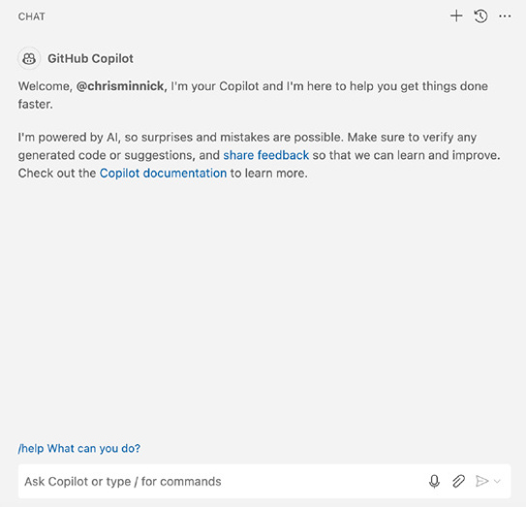

FIGURE 1-1:
GitHub Copilot.

Although GitHub Copilot and Microsoft Copilot are similar, in that they both use
OpenAI’s technology for understanding and generating language, they’re two
different products. GitHub Copilot is optimized for helping with the writing of
programming code and Microsoft Copilot is optimized for chatting with people
and generating written words in human languages.
Several months after GitHub Copilot was rolled out as a plugin for Microsoft’s
Visual Studio Code Editor, OpenAI released the first version of ChatGPT for use by
the public. ChatGPT became the fastest-growing consumer Internet app of all
time — gaining 100 million monthly users in just two months.
With its unprecedented ability to respond to user queries with human-like text,
ChatGPT became a cultural sensation and possibly even a threat to the traditional
search engines created by Google and Microsoft.

10 PART 1 Meeting Your AI Assistant Microsoft responded to ChatGPT by redesigning its Bing search engine. Bing Chat, as it was called, was rolled out starting in February 2023 and gained its first 100 million active users within months. The early version of Bing Chat had a tendency to produce false data (also known as hallucinations) and troubling responses dur-ing chats, including, as reported by Kevin Roose in a The New York Times article, acting like a “moody, manic-depressive teenager who has been trapped, against its will, inside a second-rate search engine.”
Hallucinations, in AI lingo, are defined as incorrect or misleading information gen-erated by AI. They’re caused by a variety of factors, including insufficient training, incorrect assumptions, and biases in the data used to train the AI model.
Microsoft clamped down on much of Bing Chat’s tendency to go off the rails and rebranded it as Microsoft Copilot. The current homepage for Microsoft Copilot
(https://copilot.microsoft.com) is shown in Figure 1-2.
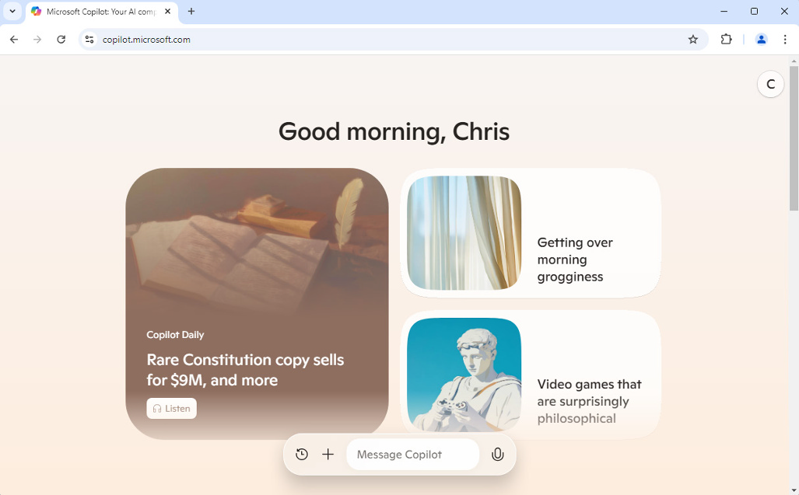

FIGURE 1-2:
Microsoft Copilot
on the web.

Overview of Microsoft Copilot
Copilot has been integrated into many of Microsoft’s products and can be helpful with a wide variety of tasks. In fact, there are so many possible ways to use Copilot that the possibilities can sometimes seem overwhelming. AI chatbots are a fundamentally different way of interacting with computers than most people are used to, so it can be helpful to look at them as if they were traditional computer software and start by talking about the features and what makes Microsoft Copilot different from its competition.

CHAPTER 1 Getting Started with Microsoft Copilot 11
Core functionalities and benefits
The most basic function of any chatbot, whether it’s powered by artificial
intelligence or not, is to respond to human speech or writing (which is also known
as “natural language”) with easy-to-understand text or speech. The quality of a
chatbot can be measured by how human-like its responses are.
The current crop of AI chatbots can all generate highly convincing natural
language responses to people’s questions and requests.
The voice or text input a user of a chatbot gives to the chatbot, whether it’s a
question ("How tall is Mount Everest?") or an instruction ("Summarize this
email.") is called a prompt. The primary way for people to interact with chatbots is
through prompting.
Beyond its core ability to respond to prompts in natural language, Microsoft
Copilot has exciting additional capabilities that make it stand out in usefulness,
especially when it’s integrated into other Microsoft products.
Some of the features of Copilot include:

» Performs web searches using Bing.
» Integrates with other AI tools to create original images and music.
» Writes original text or rewrites existing text.
» Cites the sources of the text it generates.
» Personalizes its interactions with you based on previous interactions and
documents you work on.
» Translates text between different languages.
» Supports plugins that expand Copilot’s capabilities.
» Supports user-created chatbots.

Key differentiators from other AI assistants
The main thing that makes Microsoft Copilot more useful than other AI assistants
is that it is integrated into Microsoft Windows and other Microsoft programs. This
integration gives Copilot the ability to not only generate text and images, but also
to control certain aspects of the software it’s integrated into. For example, using
a non-integrated chatbot, such as ChatGPT, you can ask for text for a PowerPoint
slide that you then need to copy into PowerPoint and format manually. With
Microsoft 365 Copilot, you can ask for PowerPoint slides or an entire presentation,

12 PART 1 Meeting Your AI Assistant and the Copilot assistant will create the new slides, format them for you, and insert them directly into your presentation. Even better, Copilot can access and use other documents you’ve created while creating the new slides.
Another key factor that distinguishes Copilot from many other chatbots is that Copilot has access to the data in Microsoft Bing. By augmenting the data it was originally trained on with search results from Bing, Copilot can answer questions about the latest news and other developments, whereas other models have a “cut-off date” beyond which they can only speculate (or hallucinate).

Understanding how Copilot works
Chatbots like Microsoft Copilot and ChatGPT are far superior to their predeces-sors, such as Office Assistant, also known as “Clippy” (shown in Figure 1-3). Microsoft integrated Clippy into Microsoft Office applications from version 97 to 2003 and it proved to be more annoying than helpful in most cases.


FIGURE 1-3:
Original Office
Assistant, also
known
as “Clippy.”

The reasons for Clippy’s failure have been studied exhaustively, but the crux of it is that Clippy was intrusive and would appear whenever it detected that you were doing something (such as writing a letter) that it was supposed to be able to help with. But then, when you agreed to let Clippy help you, all it could do was refer-ence official Microsoft Office documentation, which wasn’t helpful for much of anything.
The two most important factors that contributed to making the latest generation of AI so much better than Clippy (and all subsequent AI assistants) are:

» Vastly more data (and computing power) was used to train them.
» They take advantage of new AI techniques that allow them to consider context
when generating responses.

CHAPTER 1 Getting Started with Microsoft Copilot 13
Learning from all the data
The AI model behind Microsoft Copilot is named Prometheus. Prometheus is
OpenAI’s technology combined with Bing’s search index. The result is that Copilot
has learned from and has access to a tremendous amount of data.
Although the relationship between training data size and a model’s performance
isn’t simple, in general, larger models are able to gain a better picture of whatever
they’re designed to simulate (such as communicating using natural language, in
the case of a chatbot).

Context is key
Even more important than simply throwing more data at an AI system is a tech-
nique known as attention that was invented by Google in 2017. In short, what
attention techniques do is allow AI models to look at different parts of your input
and their own output while figuring out what to say. For example, consider the
following sentence:
“The bank can guarantee deposits will be safe because it has invested in secure vaults.”
An AI model that uses attention mechanisms will know that “bank” refers to a
financial institution rather than the bank of a river because of the other words in
the sentence, such as “guarantee,” “deposits,” “safe,” and “vaults.” A model
with attention also understands that the word “it” in this sentence refers back
to “bank.”
Because large language models can take context into account, providing sufficient
context to the model in your prompts has become the single best way to improve
the quality of responses you get to your prompts.
You learn how to use Copilot’s chat mode in Chapter 2.

Using large language models (LLMs)
When you use Microsoft Copilot, you’re using a large language model (LLM). But
what is an LLM? Simply put, a large language model is a model of, or simulation
of, language. It’s described as a “large” language model because of its size.
Imagine that you’re a train enthusiast. Perhaps when you were younger, you had
a small train model. A small train model is okay for reproducing some things
about trains. But, as your interest in accurately reproducing what you love about

14 PART 1 Meeting Your AI Assistant trains grows, you buy larger and larger trains and model railways — complete with scenery, bridges, and maybe even tiny little passengers in the dining car.
Of course, if you had the time, money, and space, you could have an actual-size train and railroad of your own. But that’s impractical. So, you settle for the largest train model you can afford and that your basement can accommodate.
Large language models work the same way. A small language model may be able to engage in rudimentary simulations of conversations. A large language model can more accurately simulate an actual human speaker of a language (or a pro-grammer, or a translator, and so forth) without being a human.
The inner workings of LLMs and machine learning are fascinating, but you don’t need to be an artificial intelligence (AI) engineer, or even know anything about AI, to use Copilot. If you’re interested in digging into more of the details, check out the book, Artificial Intelligence for Dummies.

Integration with Microsoft 365 apps
Microsoft 365 is the family of products and services that includes the productivity programs formerly known as Microsoft Office, as well as the OneDrive cloud storage service, the Microsoft Teams collaboration and conferencing program, the Outlook email and calendar program, and others. Microsoft 365 Copilot is available as an additional subscription.
Subscribing to Microsoft 365 Copilot activates the Copilot chatbot in each applica-tion and enables Copilot’s built-in actions, which can perform different tasks depending on the application. Some of the features that Microsoft 365 Copilot enables include:

» In Word, Copilot can suggest different writing styles and formats, rewrite
sentences or paragraphs, translate text into other languages, and convert text into tables.
» In Excel, Copilot can analyze data to discover trends and insights you might
have missed, create charts and graphs, and suggest formulas.
» In PowerPoint, Copilot can suggest design ideas, create individual slides,
convert Word documents into presentations, add animations, and even write speaker notes.
» In Teams, Copilot can take meeting notes, transcribe recordings, summarize
discussions, and suggest action items.

CHAPTER 1 Getting Started with Microsoft Copilot 15
» In Outlook, Copilot can summarize emails, assist you with writing emails,
schedule meetings, and create reminders based on the content of your emails.
For a more comprehensive table of Microsoft 365 Copilot’s capabilities in each
Microsoft product, check out the online Cheat Sheet at www.dummies.com (search
for Copilot for Dummies cheat sheet).
If you don’t seek out Copilot’s help while you’re using Microsoft 365, it will remain
quietly in the background. This is a welcome change from the overly eager assis-
tant days of Clippy, but it also makes it important for users to educate themselves
about what Copilot is capable of helping with.
In Part 2 of this book (Chapters 6 - 12), you experiment with Copilot’s integration
with Microsoft 365 and start to see its amazing capabilities as well as its some-
times frustrating limitations.

Connection with Microsoft Graph
and your data
Copilot can access your data and use what it finds to personalize its suggestions.
While this is extremely useful, it also creates potential security concerns. By
default, when you use Copilot, it can access your emails, documents, chats, meet-
ings, and any other data you create and store in Microsoft 365.
You learn what this means for Copilot’s capabilities in Part 2.

Signing Up for Copilot
Signing up to use Copilot couldn’t be easier. I mean that literally, because you
don’t need any kind of account to try it out. All you need to do is open any web
browser and go to https://copilot.microsoft.com. The free and logged-out
version of Copilot Chat, shown in Figure 1-4, is limited compared to the version
you get when you log in with a Microsoft account or buy a subscription to
Copilot Pro.
In this section, you learn how to access Copilot, how to sign in to Copilot, and
whether you should subscribe to Copilot Pro.

16 PART 1 Meeting Your AI Assistant
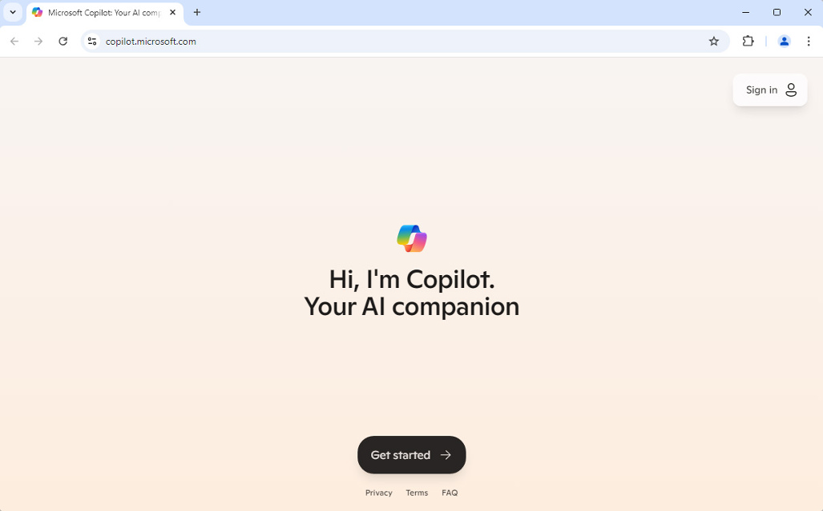
FIGURE 1-4:

The free version
of Copilot Chat.

Installing Copilot
Because Copilot Chat and Microsoft 365 Copilot both run in your web browser, there’s no need to install anything to use either of them. Although the Copilot Chat experience will be nearly the same in any web browser you use, Copilot has integrations with Microsoft’s Edge browser that may provide some incentive for users to choose to work with Copilot in Edge. If you have a strong preference for using a browser other than Edge, however, you can use that browser.

Eligibility criteria
Although Bing Chat, as Copilot was previously known, was only open to a limited number of people during its early days, today Copilot is available for free to any-one with access to a web browser or mobile device.

Subscription plans and pricing
If you use Copilot Chat while not signed in to a Microsoft Account, you’re cur-rently limited to just text input and responses. When you try to chat with Copilot by speaking or with images, you’ll get a message asking you to log in, as shown in Figure 1-5.
Fortunately, there is an easy fix: just log in to a free Microsoft account from within Copilot Chat. Once you’re logged in to Copilot Chat, you’ll have access to addi-tional features and settings and to your conversation history.

CHAPTER 1 Getting Started with Microsoft Copilot 17
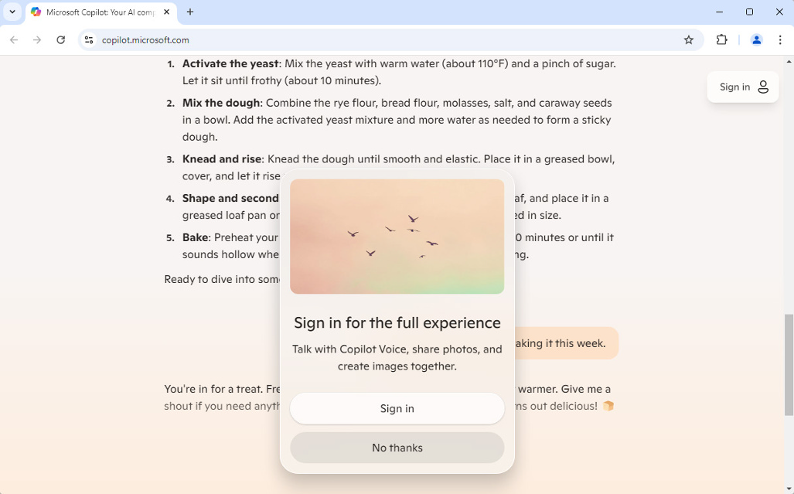
FIGURE 1-5:

You have to log in
to use certain
Copilot features.

Copilot Free
The free and logged-in version of Copilot has its limitations too, however. These
limitations include:

» Limited access to the latest and greatest models during times of peak demand.
» Limited boost tokens. Boost tokens are required for generating images, songs,
and other creative content in Copilot. Boost tokens are covered in more detail in Chapter 11.
» No access to Microsoft 365 Copilot.
» No custom Copilots. Custom Copilots are specialized AI assistants that users
of Copilot Pro can create. You learn more about custom Copilots and how to create them in Chapter 13.

Copilot Pro
Subscribing to Copilot Pro currently costs $20/month. The benefits of subscrib-
ing include:

» Faster performance.
» Access to the latest models during peak times.
» Copilot access in Office apps.
» 100 boost tokens per day, as opposed to the 15 tokens that free users have.

18 PART 1 Meeting Your AI Assistant
WHY YOUR COPILOT EXPERIENCE DIFFERS
If you see something in Copilot on your computer or at https://copilot.microsoft.
com that’s different from what I show in this book, it’s likely because of an upgrade to Copilot that’s happened in the time between when I wrote this book and right now.
Likewise, if you’re not seeing a feature of Copilot that I describe in this book, that also may be because of an upgrade that’s happened, or it may be because of an upgrade that hasn’t happened for your Microsoft account yet.

If you’re already a subscriber to Microsoft 365, you can subscribe to Microsoft 365 Copilot, which gives you the same benefits as Copilot Pro but that is also tuned for business use and integrates with your Microsoft 365 data. Microsoft 365 Copilot is $30/month per user, which is on top of your subscription to Microsoft 365 itself.

Which plan do you need?
If you’re a business user and you already have a subscription to Microsoft 365, you should subscribe to Microsoft 365 Copilot.
If you don’t have a business license to Microsoft 365 and you plan to do a lot of creative work with Copilot, such as creating images or songs, you should subscribe to Copilot Pro.
If you’re just experimenting with Copilot and want to learn what it’s capable of and won’t be using it every day, the logged-in and free version is more than adequate for your needs.

Step-by-step sign-up process
To sign up for a Microsoft account and get full access to the free version of Copilot,
visit https://copilot.microsoft.com. After you enter your name and select a voice for Copilot, you’ll see a Sign In button in the upper-right corner of the screen, as shown in Figure 1-6.


FIGURE 1-6:
The Sign In
button at
copilot.
microsoft.com.

CHAPTER 1 Getting Started with Microsoft Copilot 19
If you prefer to sign up for and access Copilot using a mobile app, go to https://
www.microsoft.com/en-us/microsoft-copilot/for-individuals/copilot-
app to access a QR code you can scan with your mobile device to go directly to the
app download page.
Click the Sign In button and select whether you want to sign in with a personal
account or a business account. If you’ll be signing up for a new account, click Sign
In with a Personal Account.
If you already have a Microsoft account, you may be logged in automatically at this
point. If you don’t have an account, you’ll see the Sign In page, as shown in
Figure 1-7.
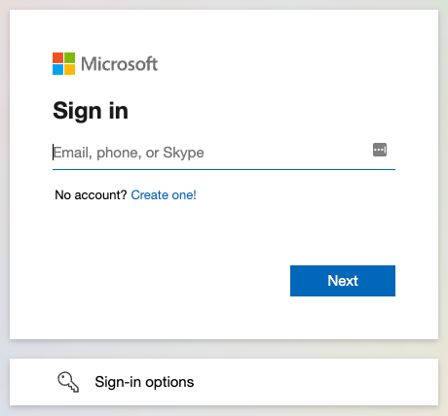

FIGURE 1-7:
The Microsoft
account
Sign In page.

To create a new Microsoft account, click the link labeled No Account? Create One!
The Create Account screen appears next, as shown in Figure 1-8.
If you have an email address that you’d like to use as your Microsoft account user
ID, you can enter it into this screen. Otherwise, click the Get a New Email Address
button to sign up for a free Outlook email address. The first screen of the new
email address sign up page will appear, as shown in Figure 1-9.
When you sign up for a new personal email address through Microsoft, you can
choose between an outlook.com email address and a hotmail.com email address.
Which one you choose won’t affect how your email address functions in any way,
but you might choose one or the other depending on whether your preferred email
address is already taken for one of the domains. Or, you might just like the retro
vibe of having a hotmail.com email address.

20 PART 1 Meeting Your AI Assistant
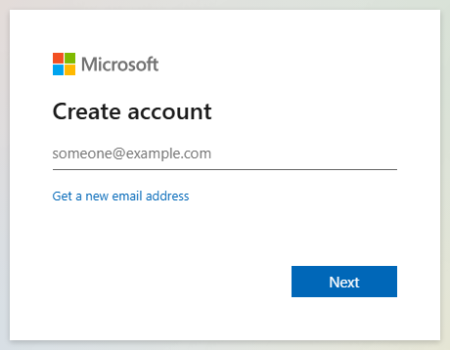
FIGURE 1-8:

The Create
Account screen.
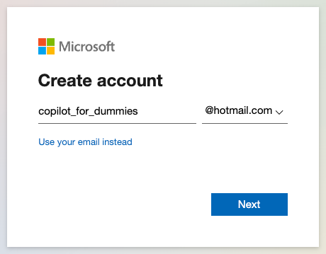

FIGURE 1-9:
Selecting a new
email address.

On the next screen, select a strong password and check the box next to the ques-tion of whether you’d like to receive marketing emails from Microsoft. Make a note of the password you choose. You’ll need this later to log in to your new email account.
You’ll be asked on subsequent screens for your name and your birthdate.
Finally, there may be one last screen that asks you to solve a puzzle to prove that you’re human. You’ve got this!
Once you finish signing up for your new email address (which also serves as your new Microsoft account), you’ll be returned to the Copilot homepage, and your first name will appear in the upper-right corner where the Sign In button previously was. Congratulations! Move on to the next section so you can start seeing what Copilot can do!

CHAPTER 1 Getting Started with Microsoft Copilot 21 Taking Copilot for a Test Flight
Now that you understand a bit about what Copilot is and how it works, and you’ve
created your account and are logged in, it’s time to try it out and see what it can
do! The examples in this section use Copilot Chat while logged in to a free account.

Understanding why mine looks different
Because Copilot is an AI model, rather than a simple rules-based program, it will
generate different content for the same question each time a question is asked
(even if it’s only slightly different). So, I show you the results that I get when I
enter the same prompts I ask you to enter, but your results will be different. They
may be better or worse, but I guarantee that they’ll be different.

Basic commands and interactions
Let’s start with something short and simple. There’s not much that’s shorter or
simpler (at least conceptually) than a haiku, so let’s ask Copilot to write
some poetry.
Find the input box labeled “Ask Me Anything. . .” at the bottom of the Copilot Chat
window and type the following into it (feel free to customize the topic for one of
your favorite things!):
Write a haiku about sushi.
When I tried this, I got the following result:
Certainly! Here’s a haiku about sushi:
🍣 Rice, fish, seaweed hug, Soy sauce whispers on my tongue, Sushi love blooms bright.
Feel free to ask if you’d like more creative content or have any other requests! 😊
This is okay, I suppose. But, I kind of prefer my poetry with a laugh. So, try giving
the following prompt:
Write a funny haiku about sushi.
Here’s Copilot’s response:
Certainly! Here’s a playful haiku about sushi:

22 PART 1 Meeting Your AI Assistant 🍣 Rolling down my plate, Avocado slips away, Chasing sushi dreams.
Feel free to ask for more creative content or any other requests! 😊
Much better! Notice how just the addition of one word (funny) dramatically changed the output and improves it (in my opinion). Let’s see if we can get some-thing even better or more descriptive. Here’s the next prompt I gave:
Write an ironic haiku about sharing sushi.
With this prompt, I really have no expectations or idea about what I’m looking for. But I do know that my favorite kind of humor is ironic and one of my least favorite things is having to share sushi (because I want it ALL!). Here’s the response I got:
🍣 Chopsticks duel begins, Sharing sushi? Not today, Mine, all mine, I say.
Feel free to ask for more creative content or any other requests! 😊
Again, this is pretty good. My choice of words might be a little more risqué than what Copilot is allowed to use, but I think we’ve managed to get as close to a decent poem as can be expected.
Feel free to continue experimenting with this prompt or other prompts as long as you like. In the next chapter, you learn techniques for how to write prompts to get specific results from Copilot. But first, let’s talk about AI and ethics.

Using Copilot Ethically
In the previous section, you generated some poems. You could have just as easily asked Copilot to write a letter to your mother, or a speech, or even a homework assignment. You were the person who asked Copilot for the content (whatever it is), and you pay (or don’t) for a Copilot account. So, is it okay to present the work that you asked Copilot to write as “your” work?
It’s a difficult topic, and the answer (like the answer to many other tricky ques-tions) is “it depends.”
In this section, you learn about some of the principles of responsible and ethical AI development and use.

CHAPTER 1 Getting Started with Microsoft Copilot 23
Responsible AI principles
Creators of AI systems are keenly aware of the risks of developing and deploying
AI systems. Some of these risks include:

» AI-generated content that is designed to fool people, including misinformation
or images that resemble real people doing fake things, which are also known as deep fakes.
» Unauthorized use of personally identifying information.
» Algorithmic bias, in which the bias from the data upon which a model has
been trained creates bias in the system’s responses. For example, if the only carpentry tool the model had ever seen is a hammer, it might think every tool is a hammer.
» Generation of content that violates people’s intellectual property.
» Use of AI by cyber criminals.
» Use of AI in weapons.
» Enormous power demands required to train and operate AI systems.
As a result of these and other risks, AI model creators have developed rules and
guidelines that they strive to uphold — or at least that they say they strive to
uphold above other concerns, such as profit.
Microsoft has defined its AI principles in a document titled “Microsoft’s Respon-
sible AI Standard.” You can read this document and more information about the
principles that guide AI development and use at www.microsoft.com/en-us/ai/
responsible-ai.
The six principles that Microsoft lists in its Responsible AI Standard are:

» Fairness. AI systems should treat all people fairly.
» Reliability and safety. AI systems should perform reliably and safely.
» Privacy and security. AI systems should be secure and respect privacy.
» Inclusiveness. AI systems should empower everyone.
» Transparency. AI systems should be understandable.
» Accountability. People should be accountable for AI systems.

24 PART 1 Meeting Your AI Assistant Data privacy and security considerations
To create the models that make AI chatbots work, companies first have to gather a vast amount of data. This data is fed into machine learning algorithms and used to improve the output of the model. For example, the reason that an AI model can generate creative new haikus is that it’s seen many, many examples of haikus and has detected the patterns that are similar between the examples. No one ever spe-cifically programmed into the model that haikus typically consist of 17 syllables in a 5-7-5 pattern, but through learning and detecting patterns in vast amounts of data, AI has figured this out.
Among all the text that AI models have learned from are millions of pages of human-created content — much of it not licensed or paid for by the creator of the AI model. Should AI model creators have to pay human content creators for using their data? This is currently the topic of several high-profile lawsuits and it remains to be seen what courts will decide.
Perhaps even more concerning than their gobbling of books, films, TV, articles, music, and every other type of human-created content is that among all this con-tent is personal data. This personal data may include pictures of people, as well as information about people that appears on websites, social media posts, public records, and more. Although precautions are taken to attempt to prevent AI chat-bots from divulging personal information they may have captured about individu-als, there have been instances where hackers have been able to trick AI chatbots into repeating raw unfiltered data from their training.
Other sources of data used by AI systems that present privacy and security prob-lems include:

» Biometric data. AI systems that use facial recognition, voice recognition, and
fingerprint information could jeopardize individuals’ privacy and security if they were compromised.
» Device data. Internet-connected devices, like security cameras or robot
vacuums, record and track information about everything. This data may include, for example, whether you’re currently at home or pictures of the inside of your house.
» Social media monitoring. AI algorithms monitor and analyze activity on
social media. The reasons for this monitoring range from national security to marketing and advertising.
With so much data available on the Internet about each of us, it’s vital that the methods AI creators use to gather and analyze our data are transparent and secure and that people have the final say and control over how and where their data is used.

CHAPTER 1 Getting Started with Microsoft Copilot 25
Guidelines for ethical use
As a user of AI chatbots, you also have responsibilities. There are certain possible
uses of AI chatbots, and generative AI in general, that nearly everyone would agree
are wrong.
The term generative AI (sometimes shortened to GenAI) refers to any artificial
intelligence system that can create original outputs that are similar to what a
human can do.
Unethical uses of generative AI include:

» Cheating on school work.
» Any use that can potentially cause harm.
» Attempting to make a copy of a copyright-protected work, such as a movie
or a song.
» Plagiarism.
» Creating deep fakes.
» Imitating another artist’s style and passing it off as your own.
The ethics of other potential uses of AI depends on understanding where the
boundaries between a legitimate use of AI and a harmful use are. Guidelines for
ethical use of AI include:

» Generative AI should be used to augment, not replace humans or processes.
» Companies adopting generative AI should prioritize safety over potential
efficiency. For example, while AI can assist with computer programming, it can potentially cause problems if every line of code it writes isn’t verified and tested and understood by human programmers.
» Users of generative AI must verify the accuracy of AI-generated content
before using it.
These uses of generative AI are usually ethical:

» For your own education or research (but make sure to verify the accuracy of
generated content so you don’t learn something the AI just hallucinated!)
» For your own entertainment.
» For checking your spelling or grammar.

26 PART 1 Meeting Your AI Assistant
» For translating text you’ve written or own the right to translate into other
languages.
» For detecting AI-generated content (in the case of a teacher, for example).
» In situations where the generated content is clearly labeled (as in this book).
» In a workplace or among people who have agreed to send and receive
generated content (such as in a workplace where AI is used to augment processes such as writing emails, creating reports, and preparing presentations).
When you’re in doubt about whether a certain use of AI is ethical, openness and honesty are the best policy. For example, if you generate an image using AI and want to post it to a social media application, label the image as AI-generated rather than risk someone assuming that it’s your original creation.
Every organization — whether it’s a nonprofit, a charity, an educational institu-tion, or a corporation — should have a detailed policy explaining what is and isn’t allowed. You can find many good examples of such policies on the web or you can work with a lawyer to draft your own. Or, you might even consider having AI help you draft a policy.
You’ve learned about Copilot, a bit about how large language models (LLMs) work, and how the LLM behind Copilot is similar and different from other LLMs. In the next chapter, you build on the knowledge you’ve acquired in this chapter to learn techniques for talking to Copilot.

CHAPTER 1 Getting Started with Microsoft Copilot 27
IN THIS CHAPTER
» Engineering prompts
» Speaking to Copilot
» Understanding Copilot’s limitations
» Refining your prompts

Chapter 2

Chatting with Copilot

C
opilot’s chat interface can be accessed on the web, in Microsoft 365, on smartphones, tablets, and smartwatches, from the desktop versions of Microsoft Office on both macOS and Windows, and by pressing a special Copilot key on Copilot + PCs. You can communicate with Copilot using text or
speech, and Copilot understands and can communicate in at least 25 different human languages (with more on the way).
With Copilot being so universally available, it would seem that no matter where you are, asking an AI chatbot for answers, help, or even advice is conve-nient and fast.
But what should you ask it? And, are there certain ways to phrase requests that are more likely to produce better answers? You learn the answers to these questions in this chapter.

Using Text Prompts
The default way to interact with Copilot is via text. From your computer or your mobile device, you enter some kind of prompt, and Copilot will respond. Written prompts give you the ability to refine a prompt over time, save prompts and responses, and not disturb people around you, whether you’re in an office and seeking help with a formula in Excel or watching a movie with your family and wanting to look up what other movies Benedict Cumberbatch has been in.

CHAPTER 2 Chatting with Copilot 29
Starting simply
One of the most effective ways to get exactly the type of help or response you need
is to start with a simple prompt, see how Copilot responds, and then try again.
For example, if you want help writing an email to your landlord asking her to fix
your heat, you might start with something vague like this prompt:
Write an email to my landlord asking her to fix the heat.
Copilot may come back with something like the response shown in Figure 2-1.
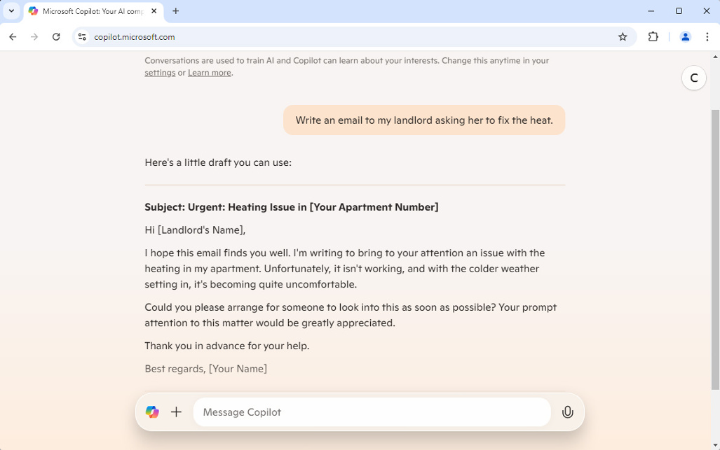

FIGURE 2-1:
A first attempt at
an email to
my landlord.

Narrowing it down
The text Copilot comes back with is okay, but it makes a lot of assumptions and
might not fit your situation. For example, you might find the tone too confronta-
tional or not confrontational enough for your taste. Also, it assumes that the
weather is currently bad, rather than that you’d like to have the heat fixed before
the weather gets cold again.
After seeing the initial response, you can refine your prompt. Remember that if
you submit follow-up prompts in the same chat session, Copilot will take your
previous prompts into consideration while generating the next prompt, so there’s
no need to repeat that you’re looking for a letter to your landlord. Here’s my
refined prompt:

30 PART 1 Meeting Your AI Assistant That’s okay, but try again. It’s currently summer, so I don’t need heat now, but I’d like the heat to be fixed before fall so that it’s not a last minute thing. I have a great relationship with my landlord and just want to make sure that this gets done early.
The new email generated by Copilot, shown in Figure 2-2, takes into consider-ation the new information I’ve given and has a much more friendly tone that’s in keeping with what I’m looking for.
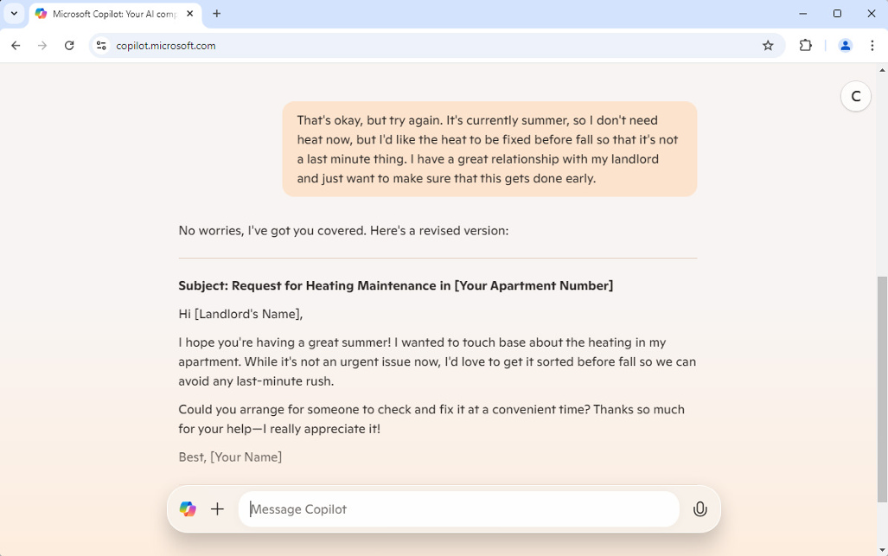

FIGURE 2-2:
A revised email to
my landlord.

The process of starting simple and submitting additional prompts to get better results is called prompt refinement. The section of this chapter titled “Refining Your Prompts” describes specific ways to refine prompts and the benefits of doing so in more detail.

Asking for more options
While the new email is pretty good, it’s always a good idea to ask for options. You don’t know whether Copilot can generate something even better until you ask. A simple “try that again” prompt can give you some options, and you might end up combining your favorite sentences from both emails along with your own per-sonal touch.
Figure 2-3 shows another option, which was generated after I prompted Copilot with a simple “try again.”

CHAPTER 2 Chatting with Copilot 31
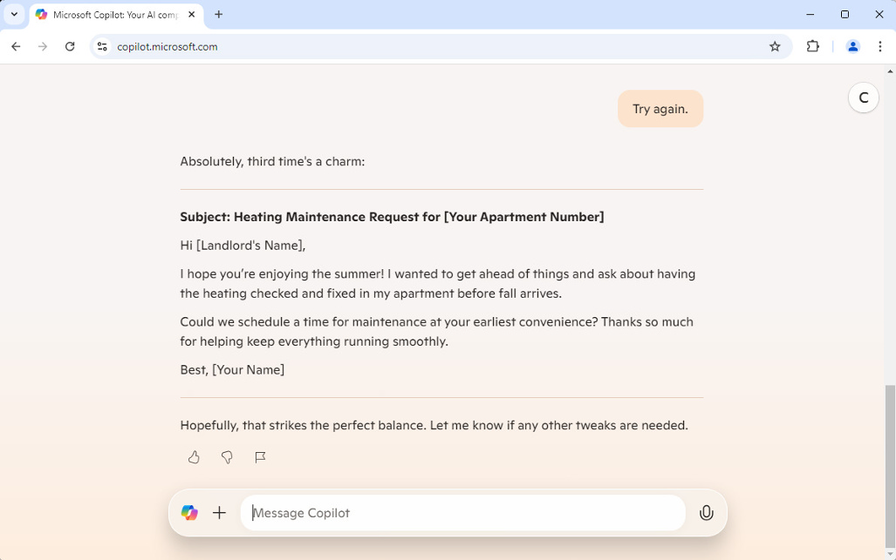
FIGURE 2-3:

Getting
another option.

Using Voice Prompts
Text prompts and responses aren’t the only way to interact with Copilot. Copilot
can also interact via voice. If you activate the microphone on your computer or
mobile device using the microphone icon in Copilot’s input box, the screen will
change from text to a simple screen indicating that Copilot is listening, as shown
in Figure 2-4, and Copilot will say something to indicate that it’s listening.
Depending on whether you’ve previously allowed your browser to access your
computer’s microphone, you may also see a popup window asking for permission
to use the microphone.
Once you allow Copilot to hear you, you can start talking at any time and Copilot
will respond in the voice you selected the first time you visited the Copilot website.
Copilot will even attempt to detect the language you’re speaking and respond in
the same language.

Why is speech input important?
There are many reasons why speech input and responses are useful or essential
while using Copilot, including for accessibility, efficiency, multitasking, familiar-
ity, and inclusion.

32 PART 1 Meeting Your AI Assistant
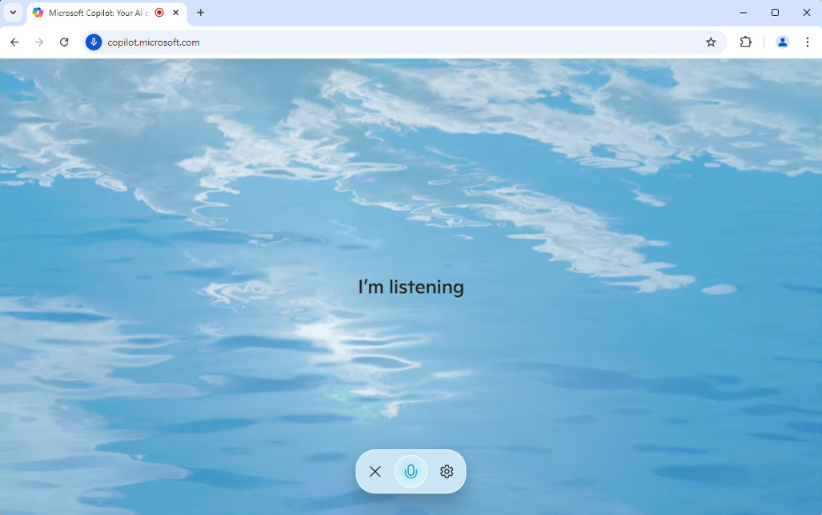
FIGURE 2-4:

Copilot’s
voice mode.

Accessibility
Being able to interact via speech is critical for visually impaired people as well as for people with dyslexia and conditions that make it difficult or impossible to type.

Efficiency
Speech input can also increase your efficiency, because speaking can be faster than typing for complex thoughts or longer instructions.

Multitasking
Typing requires focus and a person’s full attention and tends to be most useful for tasks that are computer-based, such as writing, creating graphics, and research-ing. Voice input, on the other hand, makes it possible to get help from Copilot while you’re doing things that aren’t computer-centric, such as cooking or driving.

Familiarity
While most people are used to interacting with computer assistants (such as search engines and customer support bots) via text, interacting via speech can feel more natural and conversational than typing.

Inclusion
Voice input accommodates multiple languages and accents, making communica-tion with the chatbot more inclusive.

CHAPTER 2 Chatting with Copilot 33
Voice input setup
Activating voice input and response in Copilot is just a matter of clicking the
microphone input. The first time you click the microphone icon, your web browser
or the program in which you’re using Copilot will ask for you permission to use
the microphone. Once you give it permission, the microphone icon will change
colors and you’ll see an animation around it that indicates it’s listening. If you
want to tell it to stop listening, click the microphone icon again to pause voice input.
Unlike with smart speakers (such as Siri or Alexa), there’s no need to preface your
voice prompt with “Hey Copilot” or anything like that. While Copilot is listening,
it will attempt to respond to anything you say.
This feature can be awkward or confusing when someone calls you on the phone
or when you have the TV or radio on while you’re using voice input. Using voice
input works best when the voice of the prompter is the only voice the micro-
phone detects.
In the website version of Copilot (https://copilot.microsoft.com), you can
customize Copilot’s voice feature by clicking the gear icon on the Copilot’s listen-
ing screen or by selecting Voice from the menu that appears when you click your
profile icon in the upper-right corner of the Copilot web interface while in text
input mode.
From the Settings menu, select Voice. The voice selector will appear, as shown in
Figure 2-5.
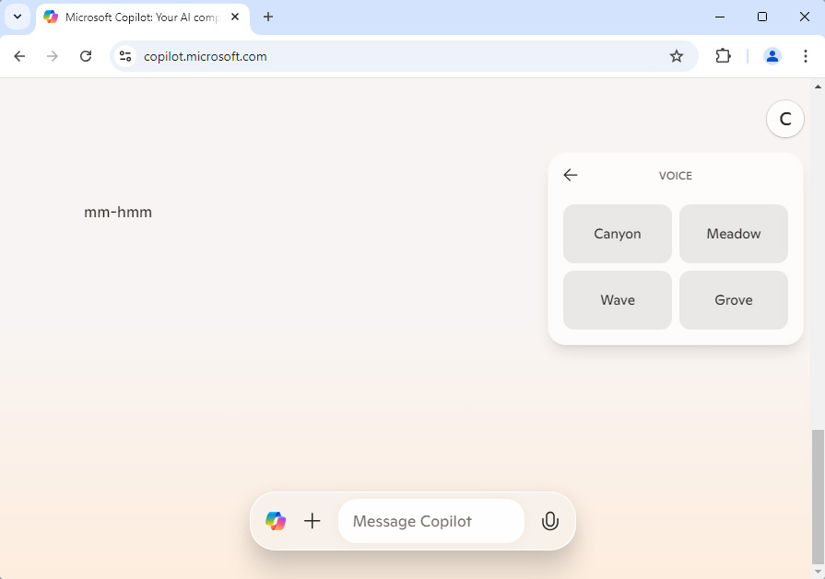

FIGURE 2-5:
Copilot’s
voice settings.
34 PART 1 Meeting Your AI Assistant On the voice selector, you can click any of the voice names to hear a sample of that voice. The currently selected voice will be highlighted in a different color than the others, as shown in Figure 2-6.
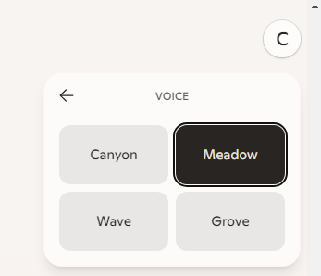

FIGURE 2-6:
Seeing the
selected voice.

To exit out of voice mode, click the “X” on the listening screen. You’ll be returned to text mode, and you’ll see the text of the voice conversation you had with Copi-lot, as shown in Figure 2-7.
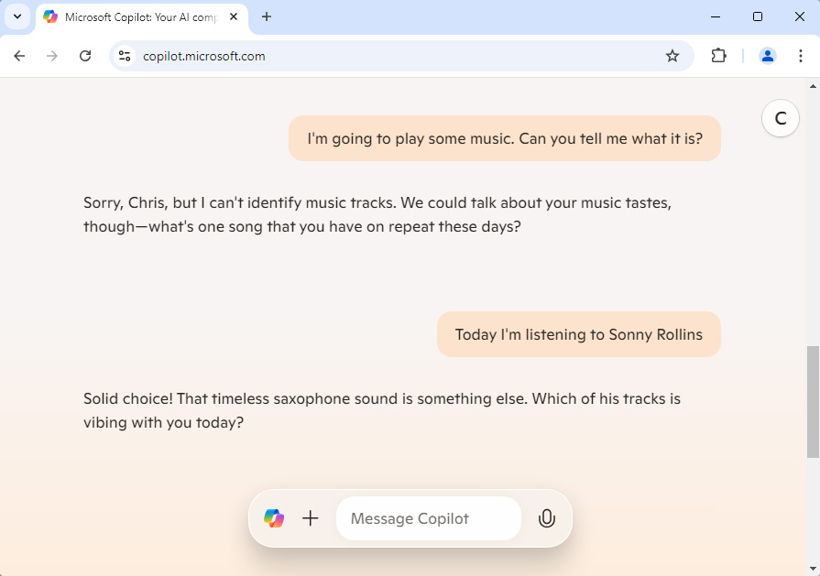

FIGURE 2-7:
Returning to
text mode.

CHAPTER 2 Chatting with Copilot 35
Tips for clear and accurate voice commands
Giving voice prompts to Copilot can take some getting used to. If you’re a slow
speaker and frequently pause as you’re speaking, Copilot may interrupt you and
start to respond before you’re finished. For this reason, you may need to fully
form your prompt in your mind before you start to speak.
On the other hand, if you speak unnaturally fast while giving commands to Copi-
lot, that will increase the chances of errors.
Three of the most important rules for successful use of voice input in Copilot are:

» Speak at a natural pace.
» Speak clearly and pay attention to pronunciation.
» Minimize the amount of background noise.

Learning to Engineer Prompts
Whether you’re using text or voice input, the quality of the response you get from
Copilot (or any LLM) is highly dependent on the way you ask. Over the years,
researchers have discovered effective methods for improving the quality of an
LLM’s responses by changing the way they write prompts. Optimizing prompts to
improve the LLM’s response even has a scientific-sounding name — it’s called
prompt engineering.
In this section, you learn the basics of prompt engineering so that you too can
prompt Copilot like a pro.

What’s inside a prompt?
Prompts that you give to LLMs have four parts. You can remember the four parts
of a prompt by remembering the acronym R.I.C.E.

» Role. The role tells the LLM what to act as while generating its response. The
default setting for chatbots is generally “You are a helpful assistant.” However, there are times when you may want to modify this role. For example, if you’re asking the chatbot for help with computer programming, you might start your prompt by saying “Act as an experienced professional programmer.” If you want the LLM to generate a response in pirate speak, you could start your prompt with “You are a swashbuckling pirate.”

36 PART 1 Meeting Your AI Assistant
» Instruction. The instruction is the part of the prompt where you ask the
chatbot to do something, answer something, compose something, or whatever else you have in mind. The instruction should be clear and to the point. For example, “Give me a list of dishes that I can make with leftover chicken, spinach, and cheese.”
» Context. Context is the background information the LLM should know in
order to successfully complete the task you gave it in the instruction. For example, if you’re asking Copilot for the current weather, an important piece of context is your current location.
» Examples. Examples may include such things as similar content or informa-
tion about the format the response should be in. For example, if you asked the chatbot to tell you a joke, you might give it an example of the kind of joke you enjoy. If you’re asking for help with writing content for a website, you could ask the chatbot to format its response using HTML.

Crafting effective prompts
Prompt engineering is a continually changing field. People are always finding new ways to elicit better responses from LLMs, and LLMs are also changing and improving. As a result, a specific prompting technique that’s effective today may not even be necessary with the next generation of LLMs. Or, a technique that works to get certain types of answers today may not work tomorrow.
There are, however, some techniques that are timeless and that will always be true. Most of these techniques are the same techniques you might use if you were talking to a new employee — perhaps that brilliant new intern who seems to know a lot of things but who has no idea how your company works.

Provide sufficient context
The first rule of prompt engineering is that LLMs need context. Think about the analogy of a smart intern. Each conversation for an LLM is like the first day on the job. If you put yourself in this role, you can easily understand why sufficient con-text is crucial. Imagine the following conversation between you (the boss) and your brilliant new intern:
You: Smart Intern, I need you to create a presentation for an upcoming client meeting. Can you take care of that?
Intern: Sure thing, I’m on it! What’s the main focus of the presentation?

CHAPTER 2 Chatting with Copilot 37
You: Just make it impressive. You know, something that will wow them.
Intern: You got it!
Your smart intern spends the next several hours working on the presentation.
You: Do you have that presentation ready?
Intern: Sure do, and I think it’s really going to wow them!
Your intern starts the presentation. The title slide features a dramatic animation
of fireworks and the title: “The Future of Space Travel: Our Journey to Mars.”
You: Uh, well . . . This is really impressive, but our client is a local plumbing company
that’s looking for a marketing strategy, not a space exploration plan.
Intern: Oh no! I guess I got carried away with wowing them.
You: No problem, let’s step back and talk about the importance of context.
In the previous story, you and your intern were both to blame for the lack of clear
communication. You should have been more specific in your instructions, and the
intern should have asked follow-up questions.
Copilot (and every other AI chatbot) has a tendency to act like an over-eager
intern. It will rarely ask follow-up questions, and will instead go off and make
assumptions based on what its training and knowledge does know from what you
said. Given a request to make an impressive presentation, it will be much more
likely to respond with a slideshow about space travel or the positive potential of
artificial intelligence than a marketing plan for a plumber.

Using different types of prompts
Certain techniques have been found to produce better results from LLMs. Some of
the more common techniques include:

» Zero-shot prompting. Most prompts that newcomers to AI chatbots use are
called zero-shot prompts. A zero-shot prompt doesn’t provide examples of successful solutions. This type of prompt is most useful for straightforward tasks where the model can figure out enough about what you want from just the instruction and context. Example prompt: Translate this sentence into French: The weather is nice today.
» One-shot and few-shot prompting. One-shot and few-shot prompting
involves providing the model with one or more examples of a good result

38 PART 1 Meeting Your AI Assistant
along with the instruction. Few-shot prompting is effective with complex tasks and logic problems. Example prompt: Label the sentiment of this review: ‘The food was terrible, and the service was slow.’
» Chain-of-thought prompting. In this type of prompting, you encourage the
model to think step-by-step. You can do this by providing examples of similar problems to the one you’re giving it or by simply saying something like, “Think step-by-step.” or “Show me, step-by-step, how you arrive at the answer.” The chain-of-thought technique works well for logic problems, mathematical problems, and multi-step processes. Example prompt: What is the result of 2 + 3 * 4? Think step-by-step: First, we need to follow the order of operations. Multiplication comes before addition. So, 3 * 4 equals 12. Next, we add 2. Thus, 2 + 12 equals 14. The final result is 14. What is the result of 3 + 8 * 3?
» Self-consistency. In self-consistency prompting, you give the model the same
prompt multiple times and take the majority result. Self-consistency prompt-ing is often used in conjunction with chain-of-thought prompting.
Example prompt: Who was the first President of the United States?
Response 1: George Washington was the first President of the United States.
Response 2: The first President of the United States was George Washington.
Response 3: In 1789, George Washington became the first President of the United States.
» Generate knowledge. In this type of prompting, you ask the LLM to generate
useful knowledge related to what you want it to do and then ask it to incorpo-rate that knowledge into the prompt alongside your instruction. Example prompt: Generate a list of unique characteristics for a fantasy world. Then, use these characteristics to write an opening scene for a novel.

Avoiding the common pitfalls
Just as there are right ways to construct prompts, there are also wrong ways. The most common mistakes people make while prompting LLMs include these:

» Writing leading prompts. “Why are dogs better than cats?” Remember, the
LLM wants to make you happy. This prompt is likely to cause the LLM to tell you why dogs are better than cats, even though there may be some disagree-ment on that point among the scientific community.
If you’re looking for help making an argument in favor of dogs being better than cats, ask the LLM something like, “Give me ten examples of an argument in favor of dogs I can make in a debate over whether dogs or cats are better.”

CHAPTER 2 Chatting with Copilot 39
If you’re looking for more objective information, state your prompt in a neutral way, such as “Which is better, dogs or cats?”
» Writing vague prompts. “Tell me about cats.” This prompt is too broad and
unspecific. It doesn’t say what aspect of cats the user is interested in, such as their behavior, care, history, or significance in culture.
Vague prompts can sometimes be useful if you want information about a topic you know nothing about, but you’ll nearly always need to follow up with more specific prompts.
» Not providing any context. “What is the best method?” This prompt lacks
context about what the user is referring to. The best method for what? Boiling an egg, learning guitar, training a dog, or something else?
» Using over-specific prompts. “Tell me about the dietary habits of Siberian
cats living in the northern region of Russia, particularly focusing on their intake of fish and how this affects their fur quality in the months of November to February.” If the LLM doesn’t have information on such a narrow topic, its ability to respond will be limited.
» Making a prompt too complex. “Can you provide a comprehensive analysis
of the sociopolitical implications of climate change on developing nations, including economic impacts, health consequences, and potential mitigation strategies, while comparing these with the responses of developed nations over the past decade?” Asking for a large amount of data in a single prompt can overwhelm the model and lead to a less coherent result than if you ask for the information over multiple prompts.
» Assuming understanding. “Explain why the latest changes are significant.”
This prompt assumes the LLM knows what “the latest changes” refers to.
» Not using literal interpretations. “Break a leg.” This phrase could be
interpreted by the LLM as referring to a leg injury rather than the idiomatic phrase meaning “good luck.”
» Not testing and refining prompts. “Tell me about Python.” This prompt
could provide results about the Python programming language, python snakes, or Monty Python.

Knowing Copilot’s limitations
Although you can give Copilot Chat any prompt you want, knowing what’s impos-
sible for it to know or do will save you time and improve your ability to make it
work for you. In some cases, it’s impossible to know Copilot’s limitations unless
you ask it. Even then, however, the response you get may not be completely reliable.

40 PART 1 Meeting Your AI Assistant For example, in the chat shown in Figure 2-8, I asked Copilot Chat to create and insert slides into my PowerPoint presentation and it responded that it doesn’t have that capability.
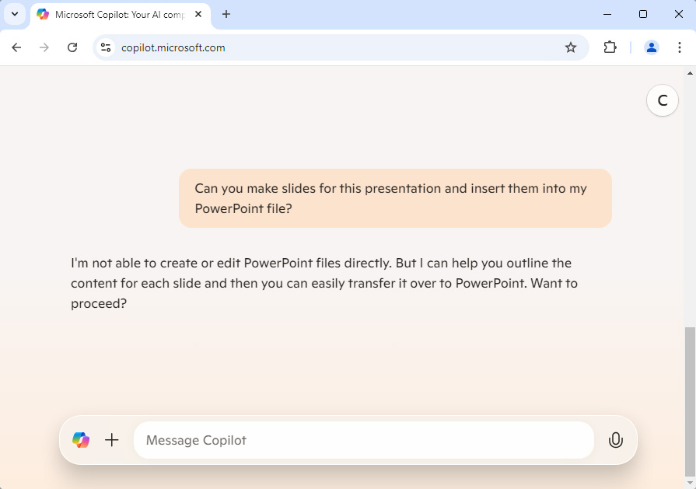

FIGURE 2-8:
Copilot Chat
can’t create
PowerPoint
slides.

While this is true that copilot.microsoft.com can’t currently interact with PowerPoint, it fails to mention that the Copilot Chat feature in PowerPoint can create and insert slides into a presentation, as shown in Figure 2-9.
Not only was Copilot able to create slides in PowerPoint, but it also decided what the topic of my presentation should be.
Subscribing to Microsoft 365 Copilot activates the Copilot chatbot in each Office application and enables Copilot’s built-in actions. This is explained more in Chapter 1. Creating PowerPoint slides and improving your presentation abilities with Copilot is covered in Chapter 8.
Figuring out and keeping track of Copilot’s limitations in different situations can be confusing. The Copilot version in your browser can’t do tasks that are specific to other applications, such as Word, Excel, or PowerPoint. You need a Microsoft 365 Copilot subscription for that.

CHAPTER 2 Chatting with Copilot 41
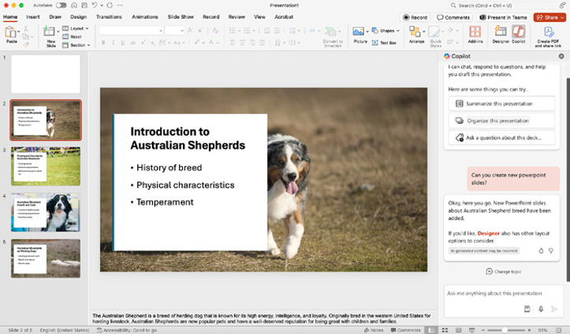
FIGURE 2-9:

Copilot Chat in
PowerPoint can
create and
insert slides.

Other limitations of Copilot apply in all circumstances, regardless of which
program you’re using. These limitations include:

» Subjective creativity. Copilot doesn’t have true creativity, in that it can’t
invent entirely new ideas, concepts, or artistic works.
» Human judgement. LLMs haven’t had the experience of being a human,
and they don’t possess intuition or judgement.
» Physical actions. Copilot can’t mow your lawn, wash the dishes, or
cook dinner.
» Personal experiences. Copilot can’t talk about its personal experiences,
memories, or feelings.
» Predicting the future. Copilot can make predictions based on patterns and
data, but it can’t predict anything with certainty.

Refining Your Prompts
The most important rule of prompt engineering is, “If at first you don’t succeed,
try, try again.” With practice, you’ll learn to write prompts that result in good
responses on the first try, but you’ll never know if the response you got was the
best possible one until you refine it.

42 PART 1 Meeting Your AI Assistant Homing in on better results
Prompt refinement is the process of starting with a generic zero-shot prompt, such as “Give me ideas for an article about AI” and incrementally turning it into a refined prompt, such as “As an expert artificial intelligence researcher and educa-tor, provide ten ideas for short (500 word) articles that explain ways AI can be used in high school classrooms.”
With prompt refinement, a generic zero-shot prompt is just the first step in grad-ually zeroing in on results that are more specific and better tuned to what it is you’re trying to accomplish. Many times, the process of prompt refinement not only provides Copilot with the information it needs to do a better job, but it can also help you to clarify in your mind what you’re looking for.
Prompt refinement doesn’t just work well for generating text output, it’s also an essential tool for generating music, computer code, and images.

Techniques for iterative prompt
refinement
Specific techniques for refining prompts include:

» Adding details. The more detail you can provide to Copilot, the more it will
understand what you’re trying to achieve.
» Adding a role. Imagine what sort of person would be ideal to answer your
prompt, then ask Copilot to adopt that role. Or, perhaps you’d like a different perspective. For example, while writing a book about using Copilot, you might tell Copilot to read a paragraph as if it were a complete newcomer to AI and respond with follow-up questions.
» Specifying steps. If your task for Copilot involves a series of steps, stating
those steps explicitly will help the model better understand how to approach the problem.
» Providing examples. Giving an example or two of the types of responses
you’re looking for provides additional context to the model and can enable it to better align its output with what you need.

The danger of over-refinement
If you’re painting a picture or adding seasoning to a sauce you’re cooking, there comes a time when continuing to add more paint or salt starts to make the final

CHAPTER 2 Chatting with Copilot 43
product worse. In painting or cooking, it’s difficult to go backward once you’ve
reached that point. In prompt refinement, however, you have a complete history
of each response Copilot gives you. If you find that adding more detail to your
prompt results in worse responses, you can either stop refining or try a
different approach.
Now that you’ve learned about the fundamentals of prompting Copilot Chat,
including about the tools built into Copilot Chat that make prompting easier, the
next chapter explains how to use your new prompting skills to improve your web
browsing experience.

44 PART 1 Meeting Your AI Assistant
IN THIS CHAPTER
» Accessing Copilot in Edge
» Personalizing your Copilot experience
» Checking and using your sources
» Enhancing web searches
» Searching with plugins
» Visual searching

Chapter 3

Browsing with Copilot

M
uch has changed since the days when Microsoft’s Internet Explorer (IE) browser was both the most hated web browser and the most widely used. Microsoft achieved both feats in large part due to the dominant market share of its Windows operating system, with which IE was tightly integrated.
Today, IE is officially retired. Microsoft Edge, the web browser created to replace it, is a state-of-the-art browser that works on macOS, Linux, smartphones, and tablets, and, of course, Windows. Microsoft Edge is now the second-most widely used browser, and it currently leads the pack in its support for AI-assisted browsing.
In this chapter, you learn how to use Copilot in Edge to gain insights into web-pages you’re browsing, translate text, summarize content, research and compari-son shop, and even search using images.
You also learn about the privacy settings available in Edge, and why it’s important to read the fine print of a terms of use document.

Integrating Copilot with Microsoft Edge
When you start the Edge browser on desktop and laptop computers, it features a Copilot icon in the upper-right corner of the interface. On mobile devices, the Copilot icon is in the middle of the bottom toolbar, as shown in Figure 3-1.

CHAPTER 3 Browsing with Copilot 45
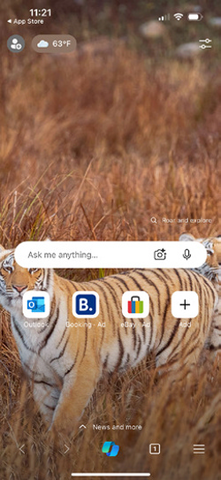
FIGURE 3-1:

Edge on a
smartphone,
showing the
Copilot icon.

Clicking the Copilot icon in a desktop browser opens a sidebar containing
the Copilot chatbot. On mobile devices, Copilot opens in a window on top of the
current webpage.
Whether in the mobile app or the desktop browser, there’s much more than
initially meets the eye contained in the Edge Copilot window, so let’s take a tour
of Copilot in Edge’s features.

Learning the Edge integration features
Figure 3-2 shows the Copilot Edge sidebar in Windows 11.
The interface you see may be different from mine due to differences between
different operating systems and upgrades that happen between now and when
you’re reading this book.
As of this writing, the Copilot sidebar in Windows 11 is vastly different from the
Copilot sidebar on macOS. Figure 3-3 shows the Copilot Edge sidebar in macOS.

46 PART 1 Meeting Your AI Assistant
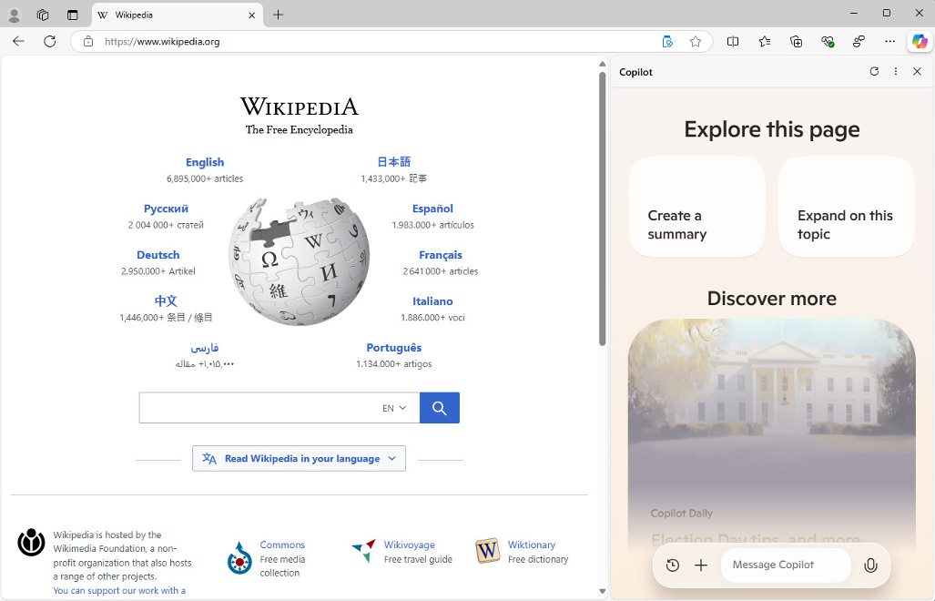
FIGURE 3-2:

Copilot
open in Edge.
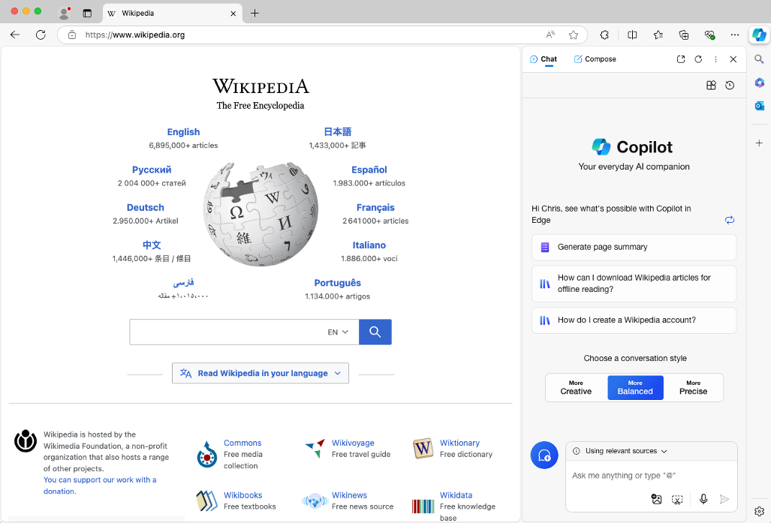

FIGURE 3-3:
Copilot open in
Edge on macOS.

For most of this chapter, I describe the Copilot sidebar in macOS, since it currently has more features than the Windows 11 Copilot sidebar and I suspect that some of the features that have recently been removed from the Windows 11 Copilot sidebar will return.

CHAPTER 3 Browsing with Copilot 47
The first thing to know about the Copilot sidebar is that it can be resized by drag-
ging the left edge of the pane. If you have a large enough screen, you should resize
the Copilot pane so you can see everything Copilot can do in Edge while also being
able to view the webpage you’re browsing, as shown in Figure 3-4.
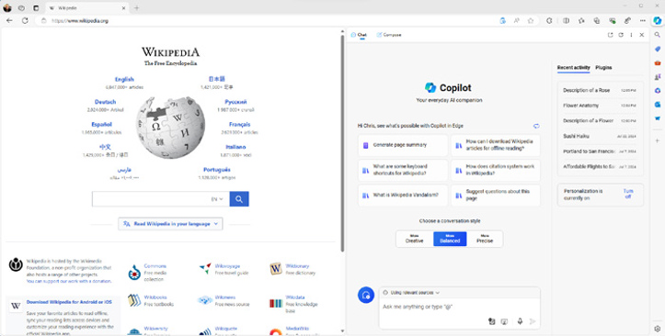

FIGURE 3-4:
Resizing
Copilot in Edge.

Figure 3-5 shows just the Copilot pane with labels for each of the features I talk
about in this section.

The Chat vs. Compose buttons
The Chat and Compose tab buttons switch Copilot between a mode that’s designed
for chatting with Copilot and working with the content of the current webpage,
and a mode that’s designed for generating new content such as paragraphs,
emails, lists, and blog posts. The default mode is Chat. Figure 3-6 shows the
Compose mode.
In Compose mode you can enter a prompt, select the tone of the content you want
Copilot to generate (or enter your own tone), select a format and length, and then
generate a draft that you can copy to another program (such as your blogging
software, your email program, or Microsoft Word).
You learn more about composing text with Copilot in Chapter 6.

The upper-right buttons
In the upper-right corner of Copilot is where you find the Open Link in New Tab,
Refresh, and More Options buttons.

48 PART 1 Meeting Your AI Assistant
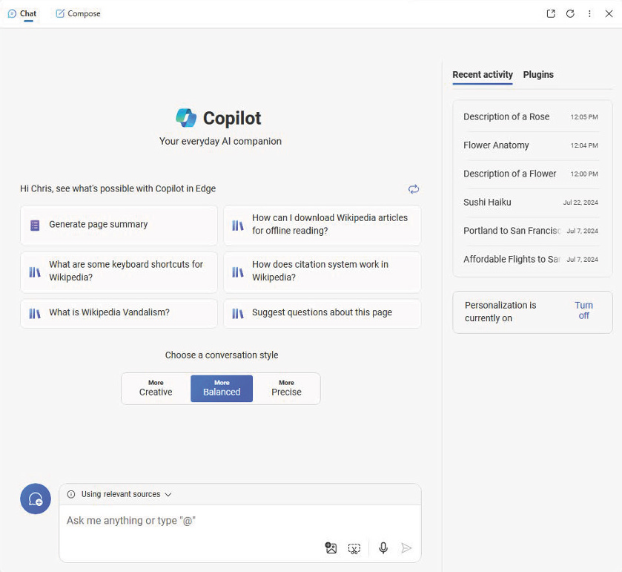
FIGURE 3-5:

The main
features of
Copilot in Edge.

The Open Link in New Tab may not be present in the Copilot sidebar in Windows 11.
If it’s present, the first button in the upper-right is Open Link in New Tab. Refresh reloads the Copilot window. In my experience, this button is useful sometimes when Copilot experiences a glitch and displays an error instead of the expected interface. The More Options button expands when you click it, as shown in Figure 3-7.
The More Options menu allows you to access the Snooze and Unsnooze features, which temporarily disable and reenable Copilot in Edge, along with some prefer-ences that are discussed in the section of this chapter titled “Customizing the Copilot Settings in Edge.”

CHAPTER 3 Browsing with Copilot 49
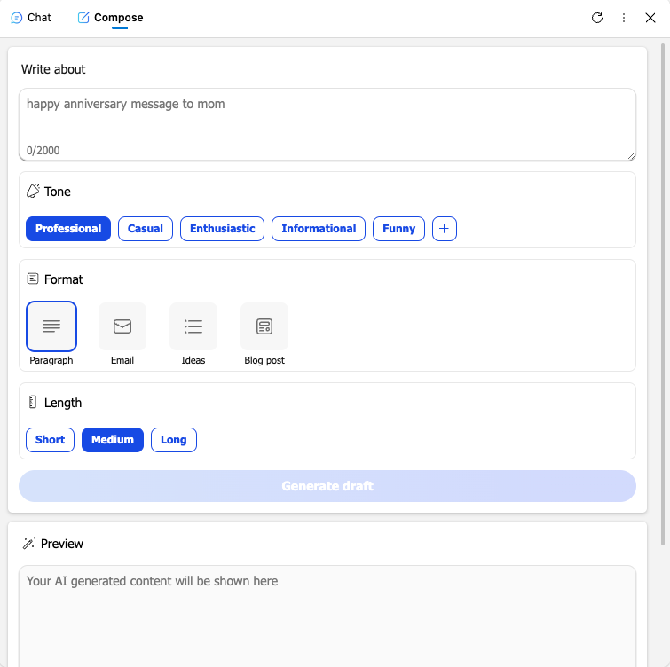
FIGURE 3-6:

The
Compose mode.
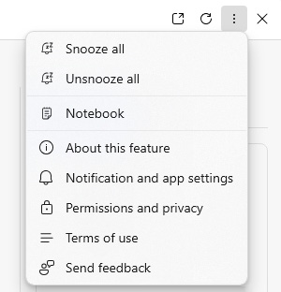

FIGURE 3-7:
The More
Options menu.

The Suggested Prompts section
The Suggested Prompts section isn’t always present. When it is, it shows some
prompts that you might consider submitting. The number of prompts will vary
based on how large your Copilot window is. Some of the prompts are based on the
content of the current webpage, and others, such as “Generate page summary,”
will be standard common prompts that you might want to do with any webpage.

50 PART 1 Meeting Your AI Assistant You can click on any of the suggested prompts and Copilot will respond as if you typed and submitted the prompt yourself.
Above the suggested prompts is the Suggestion Shuffle button. Clicking this but-ton will cause Copilot to generate and display new suggested prompts.

The Recent Activity and Plugins pane
If your Copilot sidebar is wide enough, the Recent Activity and Plugins pane will appear on the right. If the Recent Activity or Plugins pane doesn’t appear on the right, you’ll find icons for them at the top of the Copilot sidebar.
Recent Activity displays a Copilot-generated title for each of your recent conver-sations. (You can rename any of your previous conversations by clicking the pencil icon next to the conversation title.) Clicking on any of these conversations will make it the active conversation. When you return to a previous conversation, you can pick up where you left off, as if no time has passed. You can also delete a pre-vious conversation by clicking the trash can icon next to its title.

The New Topic button
The New Topic button starts a new chat session with Copilot. To avoid confusing Copilot with unrelated subjects in the same chat, you should click the New Topic button any time you want to talk about or ask about something different. Starting a new topic frequently also has the benefit of keeping an organized history of things you’ve talked to Copilot about in your Recent Activity list.
In Windows 11, the Recent Activity list is named History. You can access your pre-vious prompts by clicking the View History icon (a clock) on the homepage of the Windows 11 Copilot sidebar, as shown in Figure 3-8.
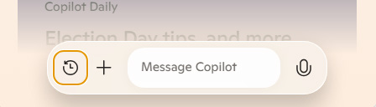

FIGURE 3-8:
The View History
icon in the
Windows 11
Copilot sidebar.

Clicking the View History icon opens a list of your previous conversations. It also reveals the New Topic icon, as shown in Figure 3-9.

CHAPTER 3 Browsing with Copilot 51
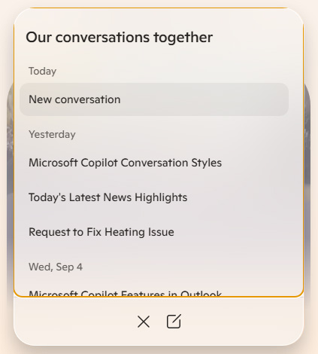
FIGURE 3-9:

Viewing your
history and the
New Topic icon in
the Windows
11 sidebar.

The Source Selector menu
The Source Selector drop-down menu is a small part of the Copilot interface in
Edge, but it reveals the most powerful feature of Copilot’s integration with Edge.
When you click the Source Selector, three options appear:

» Relevant Sources
» This Page
» This Site
The default setting for the Source Selector is Relevant Sources. This setting leaves
it up to Copilot to decide which sources to use to answer your prompt. This setting
works well for general questions and is the default setting for the Windows 11
Copilot sidebar, in which the Source Selector menu is no longer present.
When you select one of the other options (This Page or This Site), you’re telling
Copilot to limit any research it does to answer your prompt to either the current
webpage or the current website.
Limiting Copilot to the current page or website improves the accuracy and quality
of its responses when your goal is to work with data about a specific topic. These
settings can also be used for asking questions about your own documents (such as
PDFs, text, or images) that aren’t on the web and that Copilot would otherwise
have no knowledge of.

52 PART 1 Meeting Your AI Assistant The Add Image or Screenshot buttons
Adding an image or screenshot to your prompt uploads the image to Copilot so you can ask questions about it. More traditional search engines, such as Google and Bing, have long had a similar ability. Some tips about using this:

» If your goal is to identify an object or find out where an item can be pur-
chased, using a traditional search engine may result in more accurate information or more complete information.
» If your goal is to generate a new image that resembles your picture, extract
data from a screenshot, or get a written or spoken description of an item or scene, Copilot image prompting is the way to go.

The Use Microphone button
The Use Microphone button (or the Talk to Copilot button in Windows 11) enables voice prompting and voice responding. Voice prompting is covered in Chapter 2. When you click the Use Microphone button, the microphone icon changes colors to indicate that it’s active. You can start speaking, and Copilot will detect when your prompt is complete and respond via voice.

Using Copilot plugins in Edge
Copilot plugins extend the capabilities of Copilot by allowing it to access data from third-party providers that it wouldn’t otherwise be able to access. You can have up to three plugins active at any time, and you can change which plugins are active at any time as well.
When you use plugins, Copilot shares your chat data with the third-party creators of the plugin. Each plugin has its own terms of use and privacy policy, which you should always read before you enable it. If you’re not comfortable sharing your chat data with the company behind one of the plugins, don’t enable that plugin.
Plugins are currently only available for personal Copilot accounts (not work or school accounts) and they aren’t currently available in the latest version of Copilot in Windows 11. To see which plugins are available, click the Plugins icon at the top of the Copilot Chat sidebar, next to the Recent Activity icon. Or, if the Recent Activity tab is open, you can switch to the Plugins tab by clicking Plugins to the right of Recent Activity.

CHAPTER 3 Browsing with Copilot 53
The available plugins include:

» Search. The Search plugin is active by default. It allows Copilot to use results
from Bing while coming up with responses to your prompts. The Search plugin must be active to use any of the other plugins.
» Instacart. Instacart is a grocery delivery service. When the Instacart plugin is
enabled, Copilot will include links to order items on Instacart in its responses when you ask about recipes or ingredients.
» Kayak. The Kayak plugin allows you to find and compare flights, lodging, and
car rentals using Copilot.
» Klarna. Klarna is a comparison shopping site that shows products in a wide
variety of categories and allows you to compare prices across different online stores. The Klarna plugin makes it possible for Copilot to use data from Klarna when answering questions about products and price options.
» OpenTable. The OpenTable plugin gives Copilot the ability to provide
restaurant recommendations along with direct links to make reservations.
» Phone. The Phone plugin allows users with Android phones to access their
contacts and send messages from Copilot.
» Shop. The Shop plugin integrates Copilot with Shopify to give it access to online
shopping data. With the Shop plugin enabled, you can search for products, get information about products, and get links to buy products from within Copilot.
» Suno. Suno is an AI song generator. With the Suno plugin enabled, you can
ask Copilot to create original songs based on your prompts.
Plugins are covered in more depth in Chapters 14 and 16.

Customizing the Copilot Settings in Edge
Copilot contains several settings that can be used to customize and improve your
experience and the quality of your results. In this section, you learn about the
customizable settings and how to use them to improve your Copilot browsing
experience.

Personalizing the settings
When you enable personalization by clicking the link in your chat history, you’re
letting Copilot use your chat history to make Copilot’s responses more personal-
ized for you. For example, Copilot may learn your interests or hobbies from your

54 PART 1 Meeting Your AI Assistant previous chats and take those into consideration in the future when you ask questions.
To access the personalization setting in Windows 11, select Personalization from the three dots menu in the upper-right corner of the Copilot sidebar.
As of this writing, it’s unclear whether personalization using browsing history and prior chats works in Edge or not. As you’ll see, I was unable to detect any responses from Copilot that seemed personalized according to my browsing or chat history when I had personalization enabled. In fact, Copilot is adamant that it doesn’t have access to chat history and only considers context from the current conversation.
If personalization of Copilot based on your chat history or browsing history is currently working (or if it works at some point in the future), it represents a pri-vacy issue that many people wouldn’t be comfortable with. In this section, I cover Copilot’s personalization based on browsing history and prior prompt history features in Edge. This is according to documentation and sources I was able to find about the feature. Check the website of this book or Microsoft’s privacy policy
(https://privacy.microsoft.com/en-us/privacystatement) for the most recent status of Copilot personalization.

WHAT DATA DOES COPILOT USE?
Here’s what Microsoft’s privacy policy has to say about how Copilot uses your data:
In order to provide a relevant response, Copilot will use this prompt, along with the user’s location, language, and similar settings, to formulate a helpful response. In some markets, authenticated users can choose to allow Copilot to have access to prior prompt history to better personalize the product.
If personalization is active, Copilot doesn’t include everything it learns from your chat history in its personalization. Information that may be sensitive, such as personal information, is not used to personalize Copilot’s responses.
Finding out exactly what Copilot’s rules are for excluding sensitive or personal informa-tion is tricky. Your first instinct might be to ask Copilot itself. In my experience, however, this turned out to be useless. The first time I asked, Copilot told me it doesn’t have access to chat history. When I found an article saying that you can enable personaliza-tion to give Copilot access to your chat history, Copilot changed its tune. It then insisted
(continued)

CHAPTER 3 Browsing with Copilot 55 (continued)
that it doesn’t have access to my browsing history. However, there is a setting in
Edge, described in the next section, that allows you to give Copilot access to your
browsing history.
It turns out that Copilot is not very good at talking about itself or its capabilities. You
can find information on the encryption and other security measures Microsoft takes to
protect your data, especially when used within a company or other organization at
https://learn.microsoft.com/en-us/copilot/privacy-and-protections .
If, after reading this chapter, you want to delete your Copilot activity history or adjust
your privacy settings and then clear any prior activity history, you can follow the steps in
the following section, “Clearing your Copilot activity history.”

Assume that user prompts and data you upload to Copilot will be used to train the
LLM behind Copilot. Never reveal your (or anyone else’s) personal data (such as
addresses or phone numbers) or anything else to Copilot that you wouldn’t want
to become public knowledge.

Clearing your Copilot activity history
If you want to delete any information Microsoft has stored about your prior
interactions with Copilot, you can do that by logging into your Microsoft
account at https://account.microsoft.com.
The steps for clearing your activity history are slightly different depending on
whether you’re logging in with an account that’s part of an organization (such as
a school or company) or whether you have a personal account.

Clearing your personal account history
If you have a personal account, follow these steps to clear your Copilot
activity history:
1. Open the Microsoft Privacy Dashboard at https://account.microsoft.
com/account/privacy .
2. Click the Sign In button and go through the steps to sign in (if you’re not
already signed in).
Once you’re signed in, you’ll see your Microsoft Account homepage, as shown in Figure 3-10.

56 PART 1 Meeting Your AI Assistant
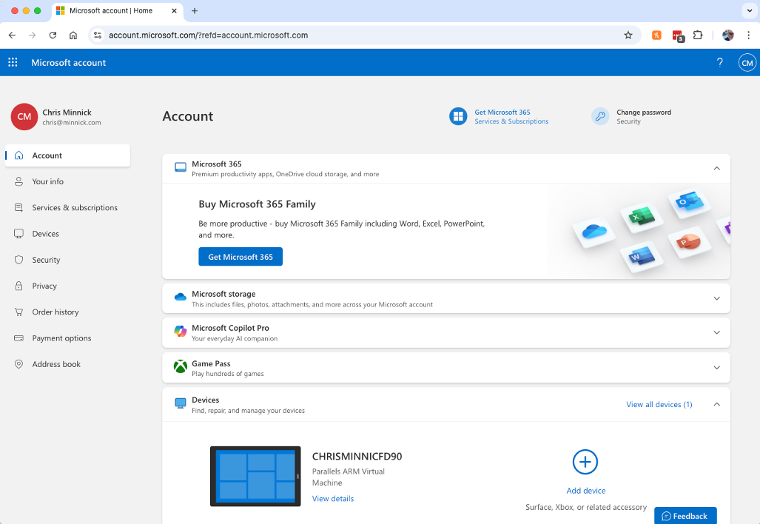
FIGURE 3-10:

The Microsoft
account
homepage.

3. Click the Privacy link on the left navigation bar to get to the privacy
dashboard.
4. Find the link for Browsing and Search and click it.
5. Scroll down the page to the Copilot Activity History section.
6. Click the Clear All Copilot Activity History and Search History link.
Next, you’ll see a warning message, as shown in Figure 3-11. Read through this information and then click the Clear button if you’re sure.
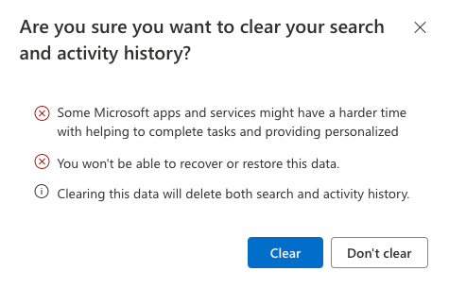

FIGURE 3-11:
Copilot confirms
that you want to
clear your history.

CHAPTER 3 Browsing with Copilot 57
Currently, the only way to clear Copilot’s activity history is by also clearing your Bing search history.
7. If you see a popup telling you that Microsoft wasn’t able to clear all of
your search and activity history, click the link (shown in Figure 3-12) to go to Bing to complete the process.
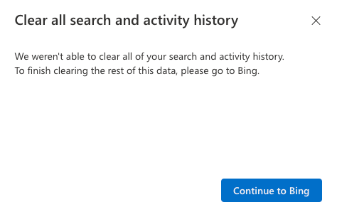

FIGURE 3-12:
Redirecting to
Bing to complete
the process.

8. Once you’re logged into Bing, click on the three bars icon in the upper
right and select Search History, as you can see in Figure 3-13.
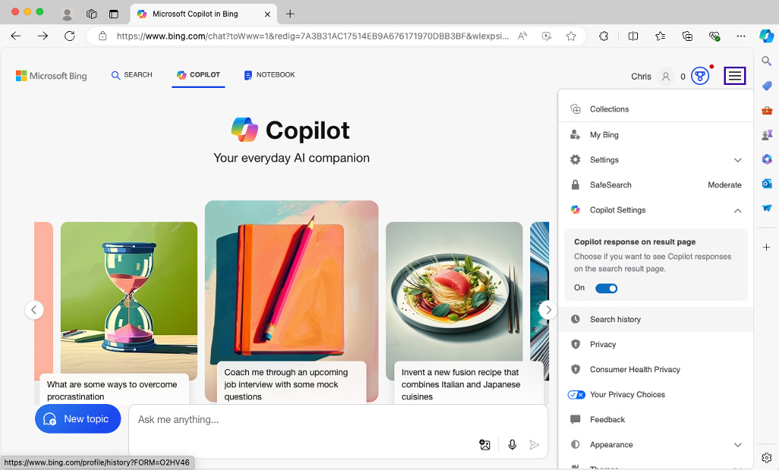

FIGURE 3-13:
Going to the
Search History
screen in Bing.

9. Click Clear All on the Search History screen.

58 PART 1 Meeting Your AI Assistant Clearing your work or school account history
Follow these steps to clear your Copilot activity history if you have a Microsoft account for work or school.
1. Log in to the Privacy Dashboard at https://account.microsoft.com/
account/privacy using your work or school Microsoft account.
2. Click the Settings & Privacy link on the left navigation bar.
You’ll see the Settings & Privacy page, as shown in Figure 3-14.
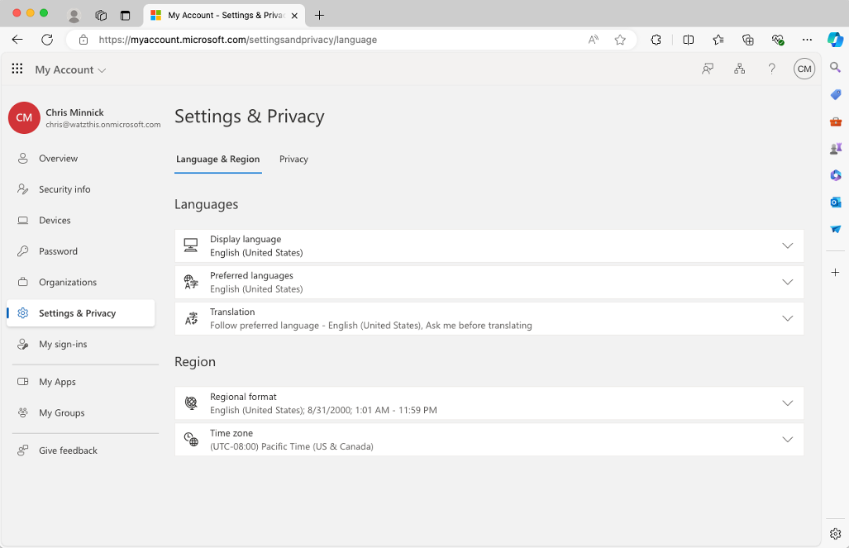

FIGURE 3-14:
The Settings &
Privacy page.

3. Click the Privacy tab.
4. Expand the Copilot Interaction History box, as shown in Figure 3-15, and
click the Delete History button.
5. A popup window will appear, similar to the one in Figure 3-16, where you
can select the Copilot interaction history you want to delete.
6. Click the Delete button and you’ll see a confirmation message, as shown
in Figure 3-17.

CHAPTER 3 Browsing with Copilot 59
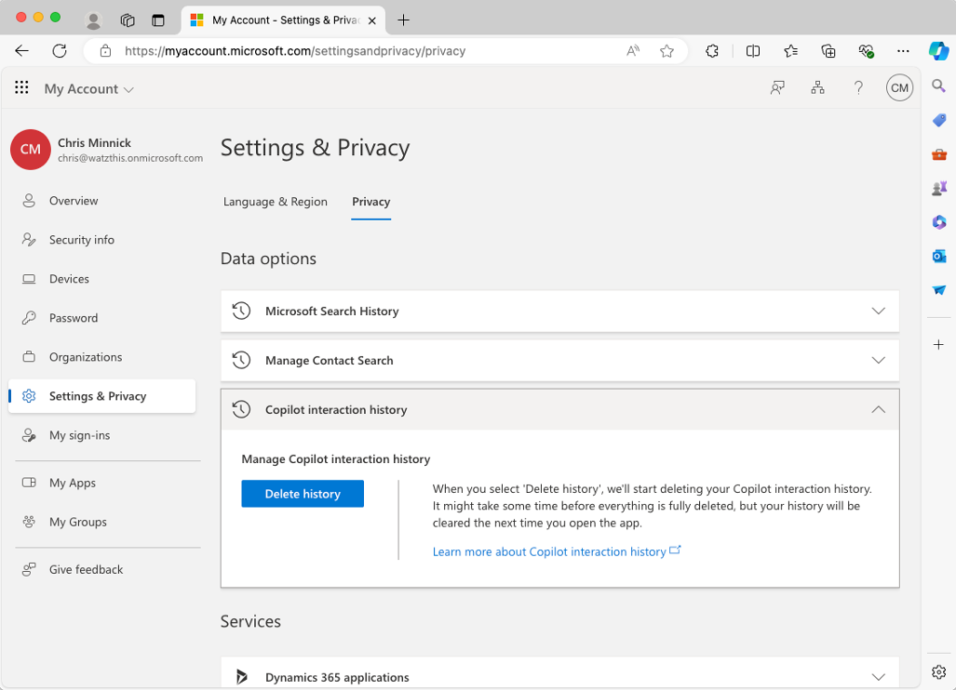
FIGURE 3-15:

Deleting
the Copilot
interaction
history.
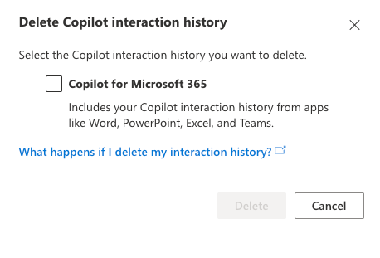

FIGURE 3-16:
Selecting the
history you want
to delete.

Congratulations! You’ve successfully cleared your chat history. While it’s not
necessary to clear your chat history every day, it’s a good practice to get in the
habit of clearing out the old stuff every so often.

Managing preferences and settings
You can access settings of Copilot in Edge by clicking the three dots menu in the
upper-right corner, as shown in Figure 3-18. Note that this is under the vertical
three dots menu that’s inside the Copilot pane, and not the horizontal three dots
menu that’s above it in the browser toolbar.

60 PART 1 Meeting Your AI Assistant
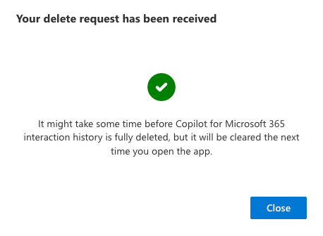
FIGURE 3-17:

Your history has
been deleted.
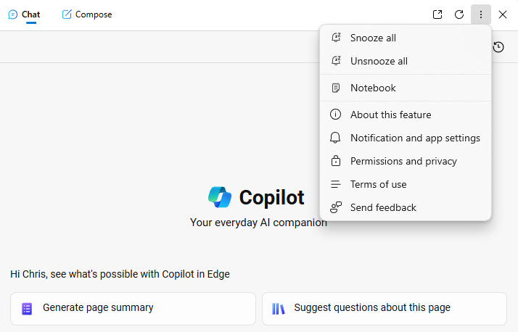

FIGURE 3-18:
Accessing Copilot
settings in Edge.

There are a few important settings to be aware of here, and the following sections cover the most important ones.

Snooze All/Unsnooze All
The Snooze All link temporarily pauses Copilot. When snoozed, Copilot won’t read the contents of the open web browser. To resume having Copilot read the current webpage and suggest prompts based on it, click Unsnooze All.

Notebook
Selecting the Notebook link opens the Notebook prompting area, as shown in Figure 3-19. Notebook is good for writing more lengthy prompts and generating larger amounts of content.

CHAPTER 3 Browsing with Copilot 61
When you’re using the Notebook, you’ll see a left arrow next to the word Notebook
in the header of the sidebar. This is the back button, and clicking it will return you
to the default Copilot prompting screen.
The Notebook prompting area isn’t currently available in the Copilot sidebar in
Windows 11.
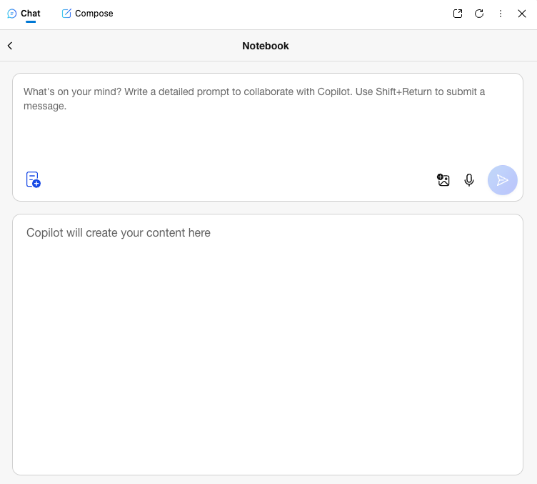

FIGURE 3-19:
Accessing the
Notebook view.

The differences between Copilot’s various editor views are covered in more detail
in Chapter 6.

About This Feature
The About This Feature link brings up a short description of what Copilot can do.
It also includes a link to go to the Copilot Frequently Asked Questions (FAQ) at
https://www.microsoft.com/en-us/microsoft-copilot/learn/.

App and Notification Settings
Selecting the App and Notification Settings link opens the App and Notification
Settings screen, which is shown in Figure 3-20.

62 PART 1 Meeting Your AI Assistant
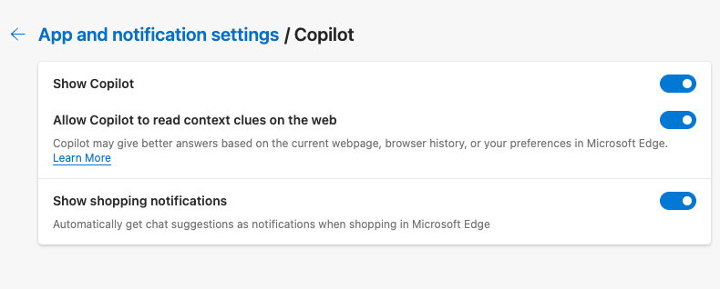
FIGURE 3-20:

App and
Notification
Settings.

In the Windows 11 Copilot sidebar, you can access the App and Notifications Set-tings screen by choosing the Settings link from the vertical three dots menu.
This settings screen currently has three options in macOS and two options in Windows 11:

» Show Copilot. This controls whether the Copilot icon appears in the upper-
right corner of the browser.
» Allow Copilot to Read Context Clues on the Web. This setting controls
whether you want Copilot to use your conversation history, browsing history, recent chats, and the contents of the current webpage as context. Compared to the other settings on the Copilot sidebar app settings, this is the big one.
If you switch the Context Clues setting to off, Copilot will prompt you to allow it to read context clues the next time (and every time) you ask it to do something that requires context clues, as shown in Figure 3-21. Saying yes just once to its question will turn this switch back on.
» Show Shopping Notifications. The last option on the Copilot sidebar app
settings is for whether you want Copilot to send you notifications suggesting chats while you’re shopping in Microsoft Edge. This option currently doesn’t exist in Windows 11. With this setting enabled, Copilot will generate messages about what you’re shopping for that appear in the toolbar with the help of the Microsoft shopping sidebar. These messages generally say things like “Price has recently increased” or “You have the best price!” These seem harmless enough, and disabling this option likely doesn’t suppress Microsoft’s ability to use your anonymized browsing and shopping history to display advertising to you. That preference is controlled by the privacy settings within Edge.
You can access the Edge privacy settings by selecting Settings from the horizontal three dots menu in the Edge toolbar, then clicking on Privacy, Search, and Services in the left toolbar.

CHAPTER 3 Browsing with Copilot 63
TESTING OUT CONTEXT CLUES
There doesn’t seem to be any sort of granularity to the context clues setting — either
you allow Copilot access to everything it can access, or you deny it access. When I asked
it to suggest questions about the current page I was viewing and clicked Don’t Allow
when it asked me to enable context clues, it was only able to respond by using results
from Bing. As a result, its response didn’t contain anything specific about the page I was
viewing, but just suggested formats in which people write questions and answers (such
as an FAQ).
Every subsequent prompt I gave to Copilot caused it to open the popup asking for per-
mission to use context clues.
When I subsequently asked it to summarize the current page, but I denied it access to
context clues, it gave me links to tools that can be used to generate summaries
of content.
Personalization and context clues are unrelated in Copilot. Context clues gives Copilot
access to your browser window and history. Personalization gives Copilot access to your
chat history.
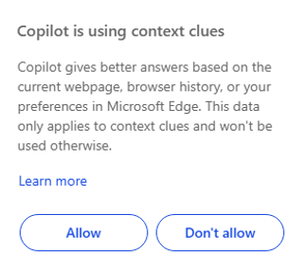

FIGURE 3-21:
Enabling
context clues.

Permissions and Privacy
Selecting Permissions and Privacy from Copilot’s vertical three dots menu dis-
plays a temporary popup window above the Copilot sidebar. This contains privacy
and permissions information about the Copilot sidebar itself. When I tried it, it
displayed the same message no matter what webpage I had open or even if I didn’t
have a webpage open, as shown in Figure 3-22.

64 PART 1 Meeting Your AI Assistant
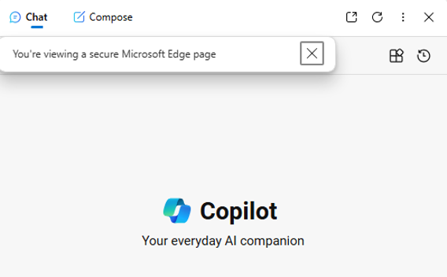
FIGURE 3-22:

You are viewing a
secure Microsoft
Edge page.

Terms of Use
The Terms of Use link spells out the agreement between yourself and Microsoft that you agree to when you use Copilot. I recommend you read the entire agree-ment, but some of the most important points in it include:

» Data you upload may be reviewed by AI as well as by people.
» Conversations with Copilot may include advertising.
» Microsoft does not claim ownership of anything you input into Copilot or
anything generated by Copilot. However, by using Copilot you are granting Microsoft and its affiliated companies an unlimited license to copy, distribute, transmit, display, perform, reproduce, edit, translate, and reformat your prompts, creations, and any other content you provide to Copilot.
» You agree not to engage in activity that is harmful to you or others.
» You agree not to engage in activities that may be harmful to Copilot.
» You agree not to use Copilot to commit fraud.
» You agree not to use Copilot to create or share inappropriate content.
» You agree not to do anything illegal with Copilot.
» Microsoft may block your prompts that violate the code of conduct or restrict
your use of Copilot.

CHAPTER 3 Browsing with Copilot 65
Send Feedback
The Send Feedback link opens a form where you can submit feedback to Microsoft
about Edge or Copilot in Edge. It gives you a space where you can describe the
problem you’re having or the feedback you have. You can choose to submit diag-
nostic data along with your feedback and optionally a screenshot or a screen cap-
ture video.

Understanding commercial data protection
If you’re logged into a company or school account while using Copilot in Edge,
you’ll see the Commercial Data Protection icon, which resembles a shield, in the
upper-right corner of the Copilot sidebar.
Commercial data protection refers to an added level of security that’s enabled for
companies and schools in order to comply with regulations that apply to compa-
nies and to protect company data. When commercial data protection is enabled,
the user’s chat data and search history isn’t retained and additional encryption is
used while data is in transit between Microsoft and the user’s computer.
Go to https://learn.microsoft.com/en-us/copilot/privacy-and-protections
to learn more about commercial data protection.

Using Edge’s Built-In Actions
Copilot in Edge has built-in actions that can control and customize certain aspects
of the Edge browser, perform specific types of searches, and more.
These actions no longer work in the Windows 11 Edge Copilot sidebar. At the time
of this writing, they do work in Edge in macOS.
To use built-in Copilot actions (whether in Edge, Microsoft 365, or elsewhere), it’s
important to type the words of the action exactly right. Unlike other prompts,
where Copilot will generally understand your meaning even if you make spelling
errors or ask the same question in a slightly different way, running actions is a
more precise process.
For example, Figure 3-23 shows Copilot’s response when I prompted it with “turn
on dark mode.”

66 PART 1 Meeting Your AI Assistant
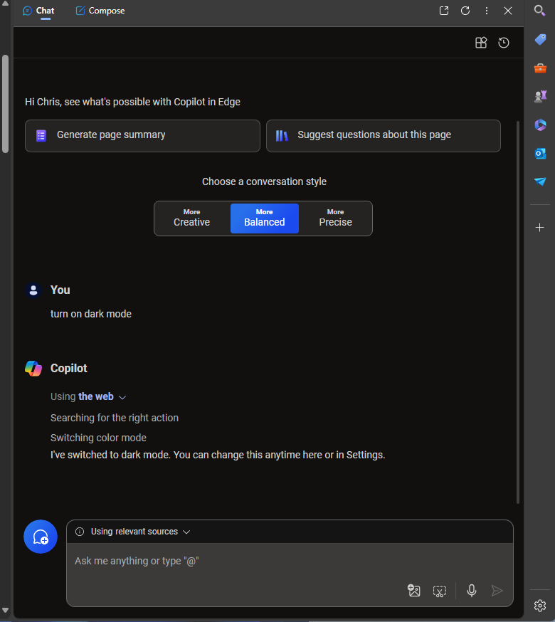
FIGURE 3-23:

Using dark mode.

Figure 3-24, on the other hand, shows what happens when you type an action dif-ferently. Copilot still understands what you want to do, but it doesn’t know that it can do it for you.
Examples of built-in actions include:

» Switch color mode. Use the “turn on dark mode” or “turn on light mode”
action to change the background of your browser to a dark color and the text to a light color.
» Import passwords. The “import my passwords from [browser]” action should
cause Copilot to import your passwords from the browser you specify. Although this feature is documented, I haven’t been able to make it work yet.
» Rearrange tabs. Use the “turn on vertical tabs” and “turn on horizontal tabs”
actions to switch between displaying your browser tabs vertically along the left side of your browser and displaying your tabs horizontally across the top of the screen.

CHAPTER 3 Browsing with Copilot 67
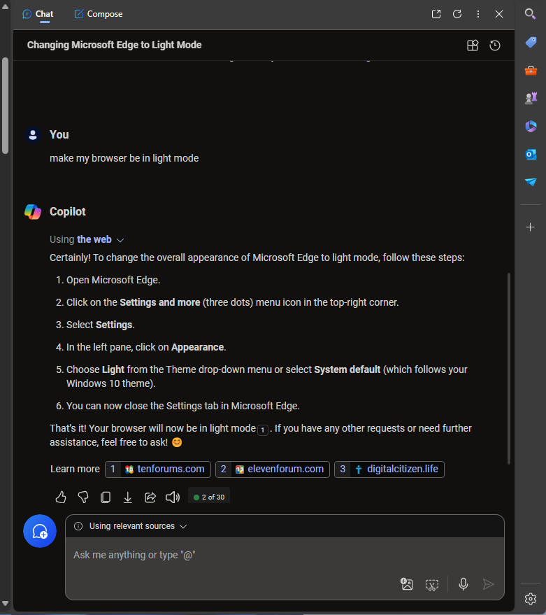
FIGURE 3-24:

Actions require a
specific phrase.

» Movie streaming. You can ask Copilot to find out where you can stream a
movie by using the “stream the movie [insert movie title]” action.
» Tab organization. You can ask Copilot to organize your tabs, such as by
saying “group my tabs related to [topic].” For example, if you regularly have more than 30 tabs open for fear that if you close one you’ll forget what you were working on, try telling Copilot, “Group my tabs by subject." Copilot will then create a suggested grouping for your tabs and display it to you for your approval, as shown in Figure 3-25.
Integration of an AI chatbot in your web browser has the potential to make any-
thing you do in a web browser more effective — from reading the news to com-
posing blog posts and much more.
Integration between Copilot and Edge also has the potential to expose your private
data to advertisers and hackers. For that reason, it’s important to know what pri-
vacy and security options are built into Copilot and Edge.
In the next chapter, you learn about going mobile with Copilot.

68 PART 1 Meeting Your AI Assistant
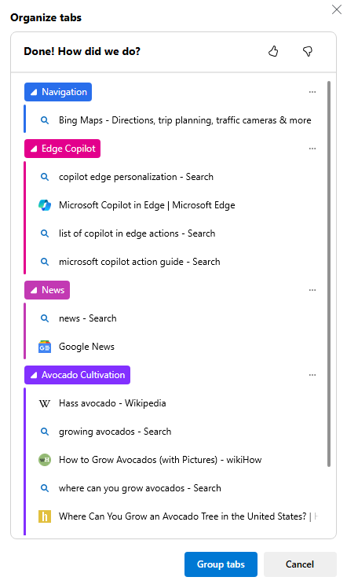
FIGURE 3-25:

Copilot’s
suggested
tab groups.

CHAPTER 3 Browsing with Copilot 69
IN THIS CHAPTER
» Getting the Copilot app
» Setting up the app
» Using Copilot on the go
» Making the best use of Copilot on
your phone

Chapter 4

Going Mobile

with Copilot

I
f you have an Android smartphone or an iPhone, you already have access to Google Assistant or Apple Siri. With virtual assistants that can answer questions and control various aspects of your phone (such as playing music, getting directions, or sending messages), you might wonder why you need Copilot on
your phone too.
In this chapter, you learn how to install and use the Copilot mobile app on your smartphone, what Copilot can do on mobile devices, and how to make the best use of this powerful and mobile AI assistant.

Getting Started with the Copilot App
The Copilot app is free to download, and the basic version of Copilot is free to use on mobile devices. Installing the Copilot app is as simple as installing any other app. If you’re already comfortable with installing apps on your phone, you can search for Microsoft Copilot in the App Store (in iOS) or Google Play (on Android), install it, and skip the rest of this section.
If you’d like a step-by-step walk-through for installing Copilot on your phone, proceed to either the Android installation guide or the iOS installation guide.

CHAPTER 4 Going Mobile with Copilot 71
Installing Copilot on your iPhone or iPad
The first step to installing Copilot is to find the correct Copilot app. When you
open the App Store and search for Microsoft Copilot, you’ll see a large number of
results. I counted 41 apps named Copilot, ranging from other AI chatbots, to navi-
gation tools, to an app for buying and selling logs.
The app you want, Microsoft Copilot, should be the first or second result, as shown
in Figure 4-1.
Tap the Get button to download Copilot to your iPhone or iPad. The progress circle
will begin to fill up and you’ll see an Open button when Copilot has finished
installing.
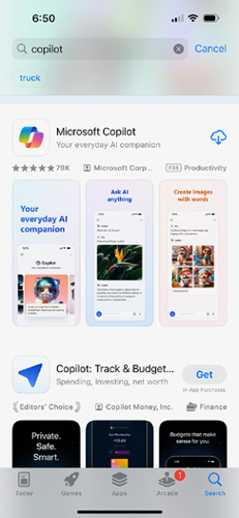

FIGURE 4-1:
Finding the
right Copilot.

The first time you open Copilot on your iPhone or iPad, you’ll see the welcome
screen shown in Figure 4-2. From the welcome screen, you can choose to continue
without signing in, or you can sign in with your existing Microsoft account.
If you choose to proceed without logging in, Copilot will ask you for your name
and give you an opportunity to select the voice you want Copilot to use when it’s
in voice mode.

72 PART 1 Meeting Your AI Assistant
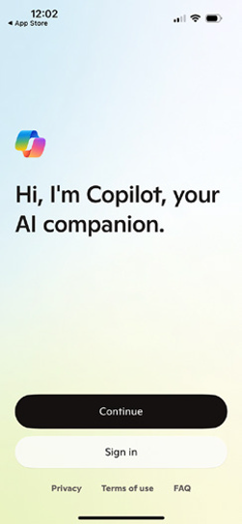
FIGURE 4-2:

Copilot’s
welcome screen.

If you log in using the same account you use at https://copilot.microsoft.com or in the Copilot sidebar in Edge, Copilot will use the same settings you created when you first logged in to Copilot, but it will ask you to choose a voice again.
Next, you’ll be asked whether you want Copilot to use your location. To allow location access, tap Allow While Using App. You’ll also be asked whether you want to allow Copilot to track your activities across other companies’ apps and web-sites. According to Microsoft, this data sharing is necessary to connect your phone to your PC to give you more personalized results. Choosing Ask App Not to Track won’t prevent you from using Copilot, but it may limit some of the app’s ability to share data with Copilot on your computer.
By default, Copilot will ask to access your precise location, as shown in Figure 4-3. If you’d rather not give Copilot access to your precise location, you can change this setting by clicking the Precise: On link.
After you make your choices about location and data sharing, you’ll see the home
screen, which is similar to the screen you see at https://copilot.microsoft.
com. See Figure 4-4.

CHAPTER 4 Going Mobile with Copilot 73
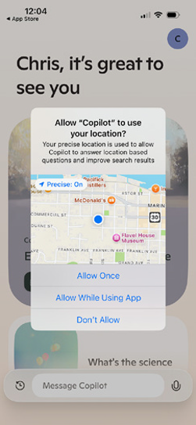
FIGURE 4-3:

Copilot asks for
your precise
location.
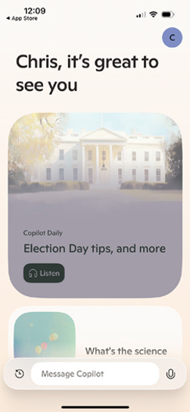

FIGURE 4-4:
The Copilot
home screen.

74 PART 1 Meeting Your AI Assistant Congratulations, you’ve installed Copilot on your iPhone or iPad! Skip to the sec-tion titled “Initial setup and configuration” to start finding out what you can do with it.

Installing Copilot on your Android phone
Installation of Copilot on an Android phone or tablet is just as simple as installing any app. When you open the Google Play app and search for Copilot, the top result (perhaps underneath an ad) will be Microsoft Copilot, as shown in Figure 4-5.
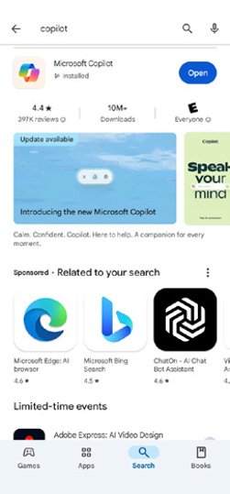

FIGURE 4-5:
Microsoft Copilot
in Google Play.

Tap the Install button and Copilot will be installed.
The first time you launch Copilot on Android, you’ll be asked whether you want to give Copilot access to your location. Allowing this access is optional, but if you do allow it, you can take advantage of some of the more interesting and useful capabilities of Copilot on mobile phones. You can read more about what Copilot can do with your location in the section of this chapter called “Trying location- specific prompts.”

CHAPTER 4 Going Mobile with Copilot 75
Initial setup and configuration
Like the browser-based version of Copilot, the mobile app allows you to submit a
limited number of prompts and puts strict limits on the length of conversations
when you’re not logged in. To lift these restrictions, tap the Sign In button in the
upper-left corner of the app and log in using the same login you used to log in to
the Copilot website and browser sidebar.
Figure 4-4 shows what the logged in Copilot app looks like on iOS using a personal
Microsoft account. Figure 4-6 shows what it looks like with a work or
school account.
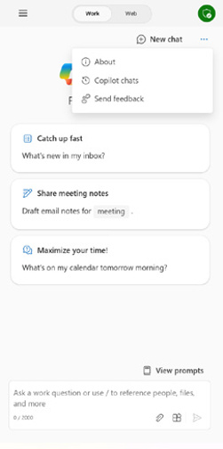

FIGURE 4-6:
The Copilot app
when logged in
with a work or
school account.

Notice that the work/school interface has a switch at the top to switch between
Web and Work. This indicates that the account also has access to Microsoft 365
Copilot, which you learn about in Part 2.
For the rest of this chapter, I mostly use the free and logged-in version of Copilot
with a personal account.

Using Copilot Pro
The Copilot mobile app contains a link to sign up for a 1-month free trial of Copi-
lot Pro. Copilot Pro gives you access to a more recent (and better) AI model than
76 PART 1 Meeting Your AI Assistant the free version and access to new features before anyone else gets them. It also removes restrictions that may happen with the free version when you’re using Copilot during times of high demand.
If you choose to sign up for the free trial, note that it will automatically convert to a paid membership (currently $20/month) after the trial. If you’re not ready to sign up for Copilot Pro, you can dismiss the advertisement for it by tapping the x in the upper-right corner.
There are limits on usage of the latest model with the free version of Copilot. After you’ve exceeded the limit, you can wait a day until you have access to it again, or you can upgrade to Copilot Pro.
Microsoft Copilot is currently a leader in allowing free access to the latest GPT models. Whether this continues to be true in the future remains to be seen. How-ever, at this point, using the free version of Copilot on mobile or in your browser is a great way to try out the most advanced AI chatbot model available without paying a monthly fee.

Using the Unique Mobile Functionalities
Although the features of the Copilot mobile app are the same as those of the web or desktop versions of Copilot, the mobile app has some unique uses and func-tionalities since it can take advantage of the mobility and capabilities of your smartphone or tablet. Some of the things you can do with the mobile app include prompting with the camera, using your location, and sharing Copilot’s responses via your messaging app or social media apps.
The first difference you’ll notice between the mobile app and the desktop version of Copilot is that the mobile app seems to have less functionality and fewer options than the desktop version. When you dig around a bit, though, you’ll find that the mobile app can do almost everything the desktop app can do but some features and options on the mobile app are hidden behind menus.

Accessing your chat history
To access your Copilot Chat history in the mobile app, tap the Copilot logo in the prompt text input area to return to the home screen. On the home screen, tap the clock icon. A list of your previous conversations will appear.
If you’re using a work or school account to access Copilot, the Chat History link is labeled Copilot Chats and appears under the three dots menu in the upper-right corner of the screen.

CHAPTER 4 Going Mobile with Copilot 77
Prompting with the camera
AI image search has been around for a while. For example, you can upload images
to Google and it will show you similar pictures from its image search. This type of
searching is called reverse image searching. Other image search apps, such as Seek
by iNaturalist, allow you to identify plants and animals you take pictures of.
Copilot’s image prompting doesn’t exactly compete with either Google’s reverse
image search or iNaturalist Seek’s capabilities. Instead, it uses the creativity of
Copilot along with its ability to search the web to attempt to tell you anything you
might want to know about an image, or even to make up a story about an image,
as in Figure 4-7.


FIGURE 4-7:
Asking Copilot
about an image.

Prompting with your phone’s camera opens up many possibilities for identifying
objects, translating text, learning, and satisfying your curiosity as you move
around the world.
The capabilities of image prompting can sometimes be surprising. Figure 4-8
shows a picture I took of a message written in Braille. Copilot was able to analyze
the image and tell me what it says, at least in part.

78 PART 1 Meeting Your AI Assistant Keep in mind that even though Copilot’s answer to my request for Braille transla-tion is confident, that doesn’t mean it’s any more accurate than its confident statement about what my chickens are doing in Figure 4-7. Always remember that Copilot’s main skill is creativity and conversing. It’s not guaranteed to be accu-rate, so you should always verify with a trusted source in any situation where accuracy matters.
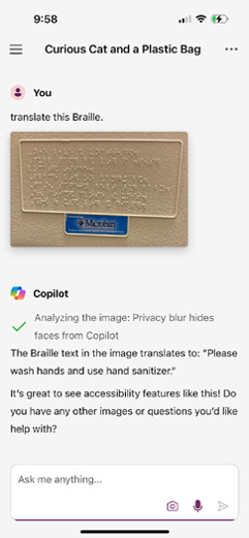

FIGURE 4-8:
Using Copilot to
read Braille.

One limitation of camera prompting (at least currently) is that you can’t submit video or audio files. Even when you’re uploading from your device’s photo library, the mobile app restricts you to only uploading still images.

Audio prompting
As with the desktop and web versions of Copilot, you can submit prompts to the Copilot mobile app using your voice. As you speak your prompt, Copilot tran-scribes what you say. When it detects a pause, your prompt will be submitted as text to Copilot.
In my experiments with audio prompting, Copilot recognized and transcribed simple and deliberately spoken prompts very well. With the latest updates to Copilot, it can also respond quite well to more informal speech.

CHAPTER 4 Going Mobile with Copilot 79
I attempted to use Copilot as a language translation tool by speaking to it in
German. It might just be that my German isn’t very good, but Copilot only
recognized “Guten Tag” and then attempted to transcribe everything else I said in
English. I expect that a future version of the Copilot mobile app will have the abil-
ity to record and interpret audio, which will make it useful for speech translation,
but at this point it’s nowhere near as good as a dedicated translation tool, such as
Microsoft Translator or Google Translate.

Trying location-specific prompts
Because Copilot has access to your phone’s location services, it can be used to find
location-specific information, such as the current weather. Without the addition
of plugins, it can make recommendations for things to do or restaurants to check
out. When I prompted it for restaurant recommendations in my current location,
it gave me a list of ten restaurants, along with links to the websites where it found
its information, as shown in Figure 4-9.
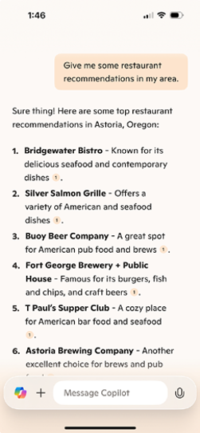

FIGURE 4-9:
Submitting
location-
specific
prompts.

Some useful location-specific prompts
Prompts that use your location can produce helpful results from Copilot in situa-
tions where creativity is more important than accuracy. Here are some ideas for
80 PART 1 Meeting Your AI Assistant prompts to try out the next time you’re traveling, or when you want to get some new ideas for things to do in your own hometown:

» Create a scavenger hunt from things I can do near my current location.
» Design a playlist of songs that are relevant to my current location.
» Write a song about this place.

Some less useful location-specific prompts
While Copilot, and similar AI chatbots, excel at creative tasks such as the ones in the previous section, using them for location-specific tasks that require more precision can be tricky, or even dangerous.
Here are some prompts that will likely result in responses of dubious value:

» Give me directions to the closest grocery store.
While Copilot will often be able to tell you the name of the nearest grocery store, and even its address, the directions will most likely be incorrect.
» Draw a map showing how to get to the grocery store from here.
While I do recommend experimenting with this prompt for entertainment value, you should not trust the accuracy of a map generated by Copilot. Figure 4-10 shows the map Copilot created when I used this prompt.


FIGURE 4-10:
A completely
incorrect map
to my local
grocery store.

CHAPTER 4 Going Mobile with Copilot 81
Generating and working with images in Copilot is covered in more detail in Chapter 11.
» Design a route for an interesting and scenic two-mile walk from my place.
When I tried this prompt, the route it designed was more or less accurate and did take me on a circular route that started and ended at a location somewhat near my house. However, Copilot’s directions didn’t include distances or take into account dead-end roads and physical obstacles.
While it was indeed scenic, the walk ended up being approximately six miles long and included two difficult uphill hikes through an overgrown forest.

Enabling plugins
If you’re logged in to Copilot using a work or school account, you may have access
to plugins in the mobile app. However, the plugins you can access with a work or
school account depend on which plugins have been enabled by the administrator
of your work or school.
You can read more about plugins and even learn how to create your own plugins
for Microsoft 365 Copilot in Chapter 14.
The link for enabling or disabling plugins is in the prompt input area. Tap the
Plugins icon, and you see that, by default, the only plugin that’s allowed with
work or school accounts is the Web Content plugin, as shown in Figure 4-11.
The Web Content plugin provides Copilot with access to results from Bing.com so
it can find additional and up-to-date information while answering your prompts.
Notice that the Plugins screen in a work or school account has a message that cau-
tions you that Copilot may share your information with plugins you enable.
Copilot for Microsoft 365 can potentially have access to a vast store of data about
you, including your documents and emails. Organizations such as businesses,
schools, and governments must protect this internal data and comply with regu-
lations regarding how they use and share data. While Copilot for Microsoft 365
and work/school accounts are limited in some ways (such as not being able to use
every available plugin or generate images), they also have many other superpow-
ers, as you can read about in Part 2 of this book.
From 2023 to late 2024, the Copilot app also provided the ability to use plugins
with personal accounts. I expect that this feature will be restored at some point,
but I don’t currently have any information about why it was removed or what
Microsoft’s plans for plugins are.

82 PART 1 Meeting Your AI Assistant
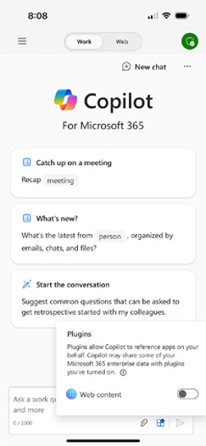
FIGURE 4-11:

Enabling or
disabling plugins
in a work or
school account.

Finding out more
Below each response Copilot generates, there may be additional information from the web. This additional information may include sources that were used to gen-erate the response, maps, and links to further reading. These sources and addi-tional resources are often a great way to check up on Copilot to make sure what it tells you is true.
After Copilot’s response and any additional resources, Copilot suggests additional prompts. You can tap any of these links to submit them and continue the conversation.

Sharing Copilot’s responses
If you tap on one of Copilot’s responses, a menu of options for working with just that response will appear, as shown in Figure 4-12.
This menu allows you to perform various tasks that you can use to give feedback or share a response. The options are as follows:

» Copy. Tapping the Copy link will copy the text. Once a response is copied, you
can switch to another app to paste it.

CHAPTER 4 Going Mobile with Copilot 83
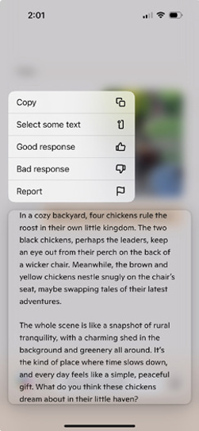
FIGURE 4-12:

Viewing options
for working with
a single response.

» Select Some Text. If you just want to copy part of a response, you can choose
this option, which will allow you to specify exactly what part of the response you want to copy.
» Good Response. If you think a response is particularly good, you can give it a
thumbs up. Giving a thumbs up may encourage Copilot to generate more responses along the same lines in the future, and it can be a good way to provide guidance during a chat.
» Bad Response. The Thumbs Down icon can be used if a response is off track
or not relevant to your prompt. In the same way that positive feedback may encourage Copilot, the thumbs down may discourage Copilot from making that mistake again.
Giving feedback (either thumbs up or thumbs down) is completely optional. If you don’t want to do it, there’s no harm in never submitting feedback.
» Report. If Copilot gives you a response that you find offensive, or that you just
don’t want to have in your conversation, you can use the Report link to report the offending message to Microsoft and delete it from the conversation.
In this chapter, you learned about installing, configuring, and using the Copilot
mobile app on iOS or Android phones and tablets. You also saw some of the unique
capabilities of the Copilot mobile app. In the next chapter, you learn about using
Copilot with the latest and greatest AI-ready computers, Copilot+ PCs.
84 PART 1 Meeting Your AI Assistant
IN THIS CHAPTER
» Learning the benefits of Copilot+ PCs
» Using AI in Windows
» Wielding the power of Copilot+
» Generating content locally
» Having total recall

Chapter 5

Using a Copilot + PC

T
he first Copilot+ PCs came out in June 2024. These Windows PCs look like ordinary PC desktops and laptops, but, on the inside, they’ve been opti-mized for performing AI tasks. With the introduction of Copilot+ PCs, generating images and text and using AI to analyze your data no longer requires you to log in to a website and share your data over the Internet. The result is that Copilot+ PCs can perform many AI tasks faster and more securely than other PCs.
In this chapter, you learn about what makes a PC a Copilot+ PC, how Copilot+ is different from other versions of Copilot, and the unique capabilities that having local AI capabilities can give you.

Understanding What Makes a PC Copilot +
Copilot+ PCs work the same way as traditional Windows PCs in most ways. They have a central processing unit (CPU), memory, storage, Bluetooth, and everything else you’d expect a desktop or laptop computer to have.
What sets all Copilot+ PCs apart, however, is that they have an extra chip built in that’s specifically designed for accelerating artificial intelligence tasks. This dedi-cated thinky chip is called a neural processing unit (NPU). Every PC that calls itself

CHAPTER 5 Using a Copilot+ PC 85
a Copilot+ PC must have an NPU, and that NPU must meet a certain performance
threshold set by Microsoft.
The metric created to measure the performance of NPUs is called TOPS, which
stands for trillions of operations per second. You can think of an operation as a
single simple calculation, like you might do with a calculator. It takes a lot of these
simple calculations to make a computer work, and even more to perform genera-
tive AI tasks. The NPU on a Copilot+ PC must deliver at least 40 TOPS. That’s a lot
of calculations!

Considering the enhanced capabilities
of Copilot+ PCs
The most obvious visible difference between a regular Windows PC and a Copilot+
PC is that Copilot+ PCs have a special Copilot key to the left of the Alt key on the
right side of the keyboard. Pressing this key opens the familiar Copilot interface
you see repeatedly in other chapters of this book, as shown in Figure 5-1.
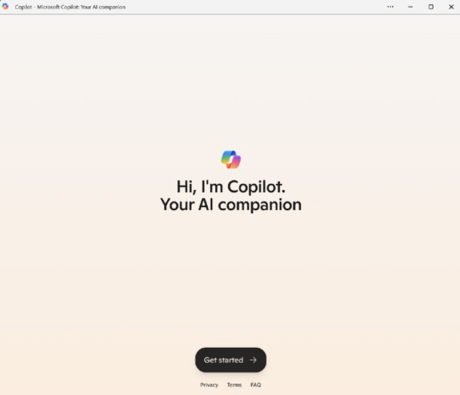

FIGURE 5-1:
The Copilot
window on a
Copilot+ PC.

86 PART 1 Meeting Your AI Assistant Comparing Copilot + to standard Copilot
Copilot on a Copilot+ PC works the same way and has the same capabilities as Copilot on the web. However, Copilot+ can also do some AI-related tasks without a connection to the Internet. It can do this because Copilot+ PCs can run a small language model (SLM) locally. This SLM is a much smaller version of the model that powers the Copilot large language model (LLM).
The next section explains some of the unique features that are made possible (or that may someday be possible) by having an NPU and a language model on your PC.

Learning about the Exclusive
Features of Copilot + PCs
The specific unique capabilities that Copilot+ PCs have (at the time of this writing) are:

» Ability to generate images in Microsoft Paint in response to a combination of
drawings and prompts.
» Ability to add live translated (to English) captions to any video as you’re
watching it.
» Ability for image and video editing software to apply AI-generated effects
more quickly.
» Ability to add AI effects to video in real time.
In the following sections, you learn about these capabilities of Copilot+ PCs and how they may change and get better in the future.

Using Cocreator in Paint
Cocreator is a feature of Microsoft Paint on Copilot+ PCs that lets you draw a rough picture in Paint and optionally supply a prompt describing what it is that you’ve drawn or what you’d like Copilot+ to do with what you’ve drawn. Using your drawing and prompt, Copilot+ will attempt to create a more fully rendered image.

CHAPTER 5 Using a Copilot+ PC 87
The amazing thing about Cocreator isn’t that it creates great AI-generated images.
The images it creates are generally not as good as those that can be created by the
online version of Copilot.
What is amazing about Cocreator is that does all the processing needed to gener-
ate an image from your drawing and prompt locally, without having to send your
drawing and prompt to an external server and wait for a response.
This capability means that Cocreator can update the image it’s generating while
you’re working on your drawing, and you can get instant feedback as to how well-
suited your prompt and drawing are to producing the result you want.

Using Cocreator
When you open MS Paint on a Copilot+ PC, you’ll see the Cocreator icon in the
toolbar. Clicking this icon opens the Cocreator sidebar, as shown in Figure 5-2.
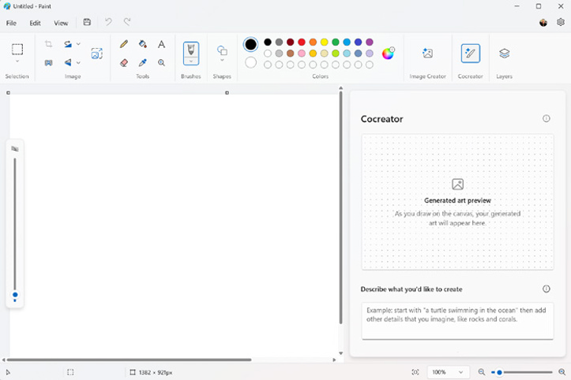

FIGURE 5-2:
The Cocreator
sidebar.

88 PART 1 Meeting Your AI Assistant The Cocreator sidebar consists of several components:

» A preview window that shows the AI-generated image Cocreator came up with
based on your prompt.
» A prompt area where you can enter a text prompt.
» A style selector that allows you to choose between several image styles,
including watercolor, oil painting, anime, and pencil drawing.
» A creativity slider. You can experiment with changing this slider to tell
Cocreator to get more creative or to stay more analytical.
What makes Cocreator different from other generative AI image creators is that in addition to the text prompt that you give Cocreator, it’s also considering the cur-rent contents of the MS Paint canvas.
To get started with Cocreator, create a rough drawing of what you want Cocreator to generate. For example, I used Paint’s pencil tool to create a terrible drawing of a sun, house, cloud, and tree.
Cocreator doesn’t start creating an image until you enter something into the text prompt area. I described the scene I was envisioning, and a faint image appeared in the preview window, as shown in Figure 5-3.
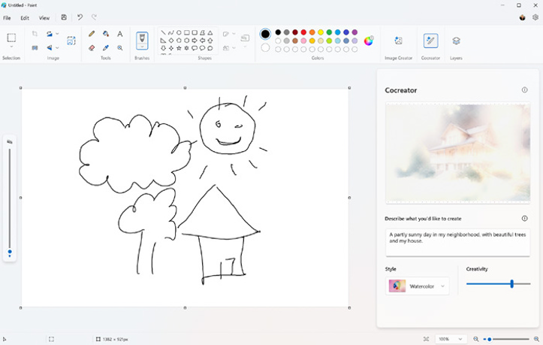

FIGURE 5-3:
Cocreator doing
its best to
interpret
my drawing.

CHAPTER 5 Using a Copilot+ PC 89
Once Cocreator displays a preview, you can edit your drawing, your prompt, the
settings of the style selector, or the creativity slider, all of which cause Cocreator
to generate a new image.
If, after refining your prompt or drawing, you see an image in the preview that
you like, you can click the image to add it to the Paint canvas. What happens next
is really important: once you add an image to the canvas, Cocreator will generate
a new image based on your text prompt and the current content of the canvas.

Refining and repeating
The result of repeatedly adding Cocreator’s creations to the canvas and it generat-
ing a new image based on its previous output generally has more contrast and
simpler lines each time you do it. For example, in Figure 5-4, I asked Copilot to
generate an image of a painter at their easel, with a dog.
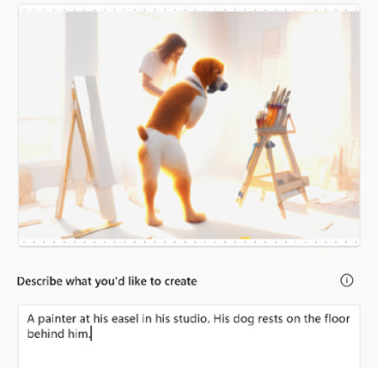

FIGURE 5-4:
A painter and
their dog?

The resulting preview was surreal and all kinds of wrong. The dog seemed to be
standing at the easel while the painter floats in the background. I added it to the
canvas anyway, then kept on adding every new iteration of the image to the
canvas. After several rounds of this, the images Copilot was creating had become
a simple abstract graphic, as shown in Figure 5-5.

90 PART 1 Meeting Your AI Assistant
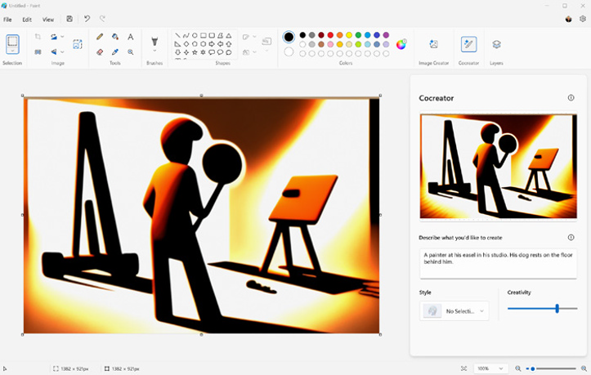
FIGURE 5-5:

Generating new
content based on
generated
content results in
low-resolution
output.

Cocreator is fun to play with, but it’s hard to imagine how it could be used as much more than a toy at this point. In the future, this kind of instantly-updating generative AI will be smoother and result in higher-quality output. But, as a proof of concept, Cocreator hints at and demonstrates the kinds of real collabora-tion between artists and AI that will soon be possible.

Taking Advantage of Live Captions
Live Captions is a feature of Windows 11 that can generate and display captions (currently only in English) for any video you’re watching. On Copilot+ PCs, Live Captions can display captions and translate speech from 44 different languages into English before displaying the captions. Because it takes advantage of the Copilot+ PC’s NPU, it can do this without an Internet connection.
Some of the use cases for Live Captions with Translation include:

» Watch foreign movies that don’t have closed caption subtitles.
» Listen in to meetings and webinars conducted in different languages.
» Add translated subtitles for people who are deaf and hard of hearing.

CHAPTER 5 Using a Copilot+ PC 91
Enabling Live Captions
Here’s the process for using Live Captions:
1. Turn it on. You can turn on Live Captions from the Windows settings or
from the Quick Settings menu while watching a video.
To enable Live Captions from the Quick Settings menu, open a video you want to view captions for, then press the Windows Key + A. The Quick Settings menu will open. Find the Live Captions button and click to enable it.
To enable Live Captions from the Windows Settings, go to Settings ➭ Accessibility ➭ Captions and turn on Live Captions.
2. The first time you turn on Live Captions, you’ll be asked to confirm that
you want to turn it on. If you choose Yes, the language files will down-load. This may take some time.
3. After the language files download, you’ll automatically see subtitles any
time you watch a video.
While you wait for the language files to download, you can click the gear icon in
the Live Captions subtitle bar at the top of your screen to adjust the position and
style of the captions.

Experimenting with Live Captions
To experience Live Captions with Translation, I watched some old French movies
on YouTube with closed captions turned on. The result was that the captions that
were part of the video would display as well as the Live Captions subtitles.
The YouTube subtitles were always better, even though Live Captions sometimes
translated correctly. Most of the time, however, Live Captions with Translation
wasn’t helpful. For example, one line from the 1964 movie “A Ravishing Idiot”
was translated in YouTube’s closed captions as:
“. . .I see a canape with cucumber and watercress that I will not be able to resist.”
Live Captions translated it as:
“. . .I don’t see a small cucumber sofa with whipped cream that will pass.”
Figure 5-6 shows the YouTube subtitles (bottom) and the Live Captions subtitles
(top) from this scene.

92 PART 1 Meeting Your AI Assistant
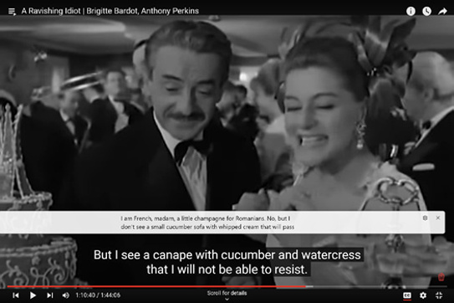
FIGURE 5-6:

Comparing
subtitles:
YouTube on the
bottom and Live
Captions
on the top.

Using Windows Studio Effects
Windows Studio Effects uses the AI capabilities of Copilot+ PCs to apply special effects to the video coming in from the device camera and microphone. These effects include:

» Background blur. Blurs the background around the subject.
» Eye contact. Makes it appear that the subject in the video is looking at the
camera even when they look down (such as to look at their keyboard).
» Auto framing. Zooms and crops live video to make it seem as if the person in
front of the camera is always kept in the same position on the screen.
» Voice focus. Filters out background noise.
» Creative filters. Video filters that can make the speaker look like an animated
character or a watercolor painting, for example. Figure 5-7 shows the animated character filter.
» Eye contact teleprompter. Makes it appear that the speaker’s eyes are
looking forward when they’re scanning their eyes around the screen (such as is necessary when using a teleprompter).
Some of the filters — such as the background blur, voice focus, and eye contact — are subtle enough to be useful for professional settings. While it’s a great idea, I won’t be using the eye contact teleprompter. In my experimenting with it, the AI adjustments to the speaker’s eyeballs are just fake looking enough to be creepy.

CHAPTER 5 Using a Copilot+ PC 93

FIGURE 5-7:

I’m getting
animated.

Recalling Your History
The launch of Copilot+ PC was controversial because of a feature called Recall.
Originally set to be enabled as an optional preview feature, it was removed from
the June 18, 2024 launch because of concerns from the public and technology
journalists about privacy and security issues.
Recall, as it was originally envisioned, would take screenshots of everything you
do throughout the day and store them on your computer. These screenshots would
then be analyzed by Copilot+ without leaving your computer. If you wanted to
return to something you were working on or needed help remembering where it
was that you saw that one article on the web or that toaster you were thinking of
buying, you could prompt Copilot+ to “open the website for that cool red retro
toaster I was looking at” and it would.
The idea is compelling, but the initial implementation was flawed. All the data
that was collected by Recall was only stored and processed on your computer,
without ever being uploaded to Microsoft or anyone else. But, it presented a
potential goldmine of personal information, passwords, and more to anyone who
gained access to your computer — either through hacking or other means.
After it was removed from Copilot+ PCs, Microsoft said that the feature would be
rethought and reintroduced more slowly in the coming months. It remains to be
seen at this point how and whether Recall will come back, but it serves, at the very
least, as a good example of how it’s important to carefully consider the ramifica-
tions of using AI rather than just jumping in head-first.

94 PART 1 Meeting Your AI Assistant Considering the Future of Copilot +
At least for now, the benefits of having a Copilot+ PC are fairly limited for most people. As you can read about in the section of this chapter titled “Recalling Your History,” the blockbuster feature that was going to be included with Copilot+ PCs, Recall, was removed at the last minute due to security concerns.
Whether or not Recall returns in a new form in the future, using a Copilot+ PC will eventually unlock new ways to work with your computer in a more conversa-tional and (hopefully) secure way. Some uses for on-board AI that I can imagine becoming possible in the future include:

» Being able to ask Copilot to sort your photo library according to whatever
makes sense to you — maybe you’d like a folder for pictures of men wearing ties where the pictures are sorted according to what year the ties were in style. Or you might ask for a folder for pictures of you that are only taken from your good side.
» A virtual personal trainer or Yoga teacher that can watch you work out and
give you pointers and encouragement without storing video or uploading anything to the web.
» A cooking assistant app with the ability to figure out where you are in a recipe
by looking at the state of the kitchen or by questions you ask, such as “How long do I boil this?” Unfortunately, it will still be a while before you can ask Copilot to set the table or wash the dishes.
» A virtual chess opponent that can trash talk.
In the next chapter, you learn about what’s perhaps the most straightforward and best current use of Copilot, namely, to help you with writing.

CHAPTER 5 Using a Copilot+ PC 95

Getting Work

Done with

Microsoft 365

Copilot

IN THIS PART . . .
Writing with an AI assistant in Microsoft Word
Working with Copilot in Excel spreadsheets
Improving your PowerPoint presentations
Getting help writing and organizing your email
Enhancing Microsoft Teams meetings
Creating and editing images
Simplifying project management

IN THIS CHAPTER
» Collaborative writing with Copilot
» Getting inline suggestions
» Accessing Copilot Chat in Word
» Getting content summaries
» Brainstorming with Copilot
» Improving your writing
» Rewriting with AI

Chapter 6

Writing with Copilot

W
hen you subscribe to Microsoft 365 Copilot, a new Copilot icon appears at the top of your Microsoft 365 or Microsoft Office applications. This new icon is the only visual clue that your experience of using Microsoft’s productivity suite is about to change forever (for the better, mostly).
While most people (including this author) would consider having Copilot do your writing projects for you to be unethical and often counter-productive, there are many situations in which having an AI Copilot is invaluable.
Used correctly, Microsoft Copilot 365 in Word is like having a grammar checker, a proofreader, a brainstorming partner, and a translator all wrapped into one. It’s no replacement for being a good writer and having a good editor and proof-reader, but Copilot is great at having “ideas,” and is always available. Plus, Copilot will only make suggestions when you ask it to, so it never feels like it’s interrupting when you get into the flow of writing (unlike other grammar checker plugins).

CHAPTER 6 Writing with Copilot 99 Accessing Copilot Chat in Word
Copilot works in the online Microsoft 365 version of Word as well as the Microsoft
Office version of Word. There are some differences in how it looks and functions
in each version, however. Some of the differences between using Copilot in Micro-
soft 365 and Office are small and unimportant, but others will affect how you use
Copilot in Word, and those are covered in this chapter.
I refer to the version of Microsoft Word that you download and install on your
computer as Microsoft Office Word or the desktop version of Word. I refer to the
version of Word that you access through a web browser and that lives online
(rather than being installed on your computer) as Word for Microsoft 365 or the
“online” version of Word.
After you subscribe to Microsoft 365 Copilot or Copilot Pro, you should see the
Copilot button on the right end of the Home tab the next time you access Word. If
you don’t see the Copilot button, you may need to log out of Microsoft Word and
log back in, making sure that you’re logged in using the same Microsoft account
that you used to sign up with Copilot.
Compared to the old Clippy assistant that always hovered in the corner of your
screen and would jump up and down and scream when it wanted your attention
(or at least that’s how I remember it), Copilot is subdued and doesn’t draw atten-
tion to itself unless you ask. There are two ways to use Copilot in Word: from the
Chat sidebar and inside a document itself (inline).

Using the Copilot Chat sidebar
The most obvious way you can access Copilot in Word is by clicking the Copilot
icon at the top of the screen to open the Copilot sidebar. The chat interface works
like you would expect it to, but it also has some built-in actions that are specific
to Word, and which I describe in this chapter.
Opening the Copilot sidebar in the Office version of Word reveals a message,
shown in Figure 6-1, that tells you the things the Copilot chatbot can do and sug-
gests a couple prompts to try.
Clicking the Summarize This Doc prompt button will submit Summarize This Doc
as a prompt to Copilot and Copilot will generate a bulleted list of the main points
of the document you have open. You can read more about the summarization fea-
ture of Copilot in Word in the “Summarizing Content” section later in this chapter.

100 PART 2 Getting Work Done with Microsoft 365 Copilot
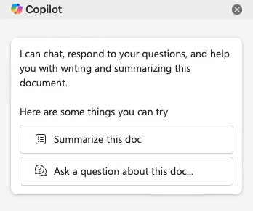
FIGURE 6-1:

The introductory
message in
Word’s Copilot
sidebar.

Clicking the Ask a Question About This Doc prompt button will enter Question: into the prompt input box. You can add your question about the document after the colon.
Prefacing your question with Question: isn’t required for Copilot to understand that you’re asking a question.
In the Microsoft 365 version of Word, the introductory message only contains prompt suggestions, as shown in Figure 6-2.
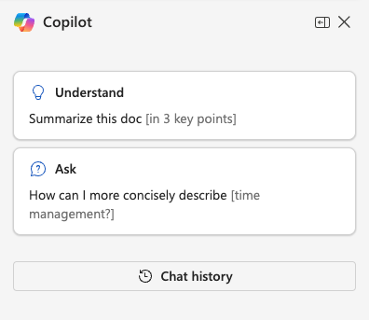

FIGURE 6-2:
The Copilot
sidebar in the
Microsoft 365
version of Word.

The introductory message and prompt buttons will scroll off the top of the screen as Copilot responds to your first question.

Starting a new chat
The way you start a new chat depends on whether you’re using Word in Microsoft 365 or the Office version of Word.

CHAPTER 6 Writing with Copilot 101
The Office version of Word has a Change Topic link between where Copilot’s
responses appear and the prompt input area. Clicking Change Topic will clear the
chat sidebar.
In the web-based version of Word, you can start a new chat by clicking the Chat
History button to get to the history of prompts and responses for the current
document. At the top of the chat history list is the New Chat button, which does
the same thing as the Change Topic button in the Office version of Word.

Getting more prompt suggestions
Above the prompt input area are two randomly selected suggestions for prompts.
Clicking these suggestions will submit the text of the prompt button to the chat-
bot. You can get new suggestions at any time by clicking the Refresh icon under-
neath the suggestions.
Although the prompt input box in the Copilot sidebar in Word looks and works the
same as the prompt input in other Microsoft apps, it has one feature that’s unique
to Microsoft 365 Copilot: the View Prompts icon. The View Prompts icon is to the
left of the microphone icon, as shown in Figure 6-3.
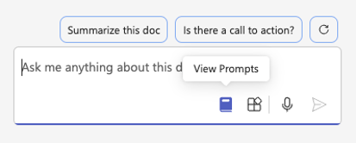

FIGURE 6-3:
The View
Prompts icon.

Clicking the View Prompts icon opens a menu, shown in Figure 6-4, with more
suggested prompts. The suggested prompts are divided into two categories:
Understand and Ask. And, just in case that’s not enough suggested prompts for
you, the View Prompts menu also contains a link named View More Prompts.
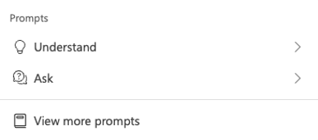

FIGURE 6-4:
The Prompts
menu.

102 PART 2 Getting Work Done with Microsoft 365 Copilot Clicking View More Prompts opens a new window on top of your document with the title Prompts from Copilot Labs. You can use this window to search for prompts by task or job type or to just browse through prompts. If you find a prompt that you think looks particularly useful, you can click it to add it to your prompt input box in the Copilot Chat sidebar. You can save prompts for later by clicking the bookmark icon next to any of the prompts. To access your previously saved prompts, click the Saved Prompts button.
If the View More Prompts window still isn’t enough to satisfy your need for more prompt ideas, click the See All Prompts button in the lower-right corner of the Prompts from Copilot Labs window. This link opens the Prompts To Try webpage
at https://copilot.cloud.microsoft/en-US/prompts/all. This webpage con-tains a large library of prompts that are categorized by app, as shown in Figure 6-5.
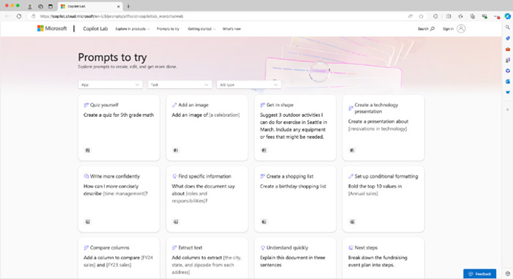

FIGURE 6-5:
The Prompts To
Try webpage.

There’s nothing special about any of the prompt suggestions Copilot gives you, except that someone has presumably tried them before and found them to work. The prompt suggestions given by Copilot and by the Copilot Labs website are great to use as a starting point for getting creative and writing your own prompts!

Accessing your chat history
Chat history in Copilot in Word is kept per document. To see your chat history, click the Chat History button that appears just underneath the introductory message when you first open the Copilot sidebar.

CHAPTER 6 Writing with Copilot 103
Using Copilot inline
The second way you can use Copilot in Word is to work with it directly in your
document. Copilot provides four tools for working inside Word documents:

» Draft with Copilot
» Make Changes
» Auto Rewrite
» Visualize as a Table
These in-document Copilot tools are only available in Word documents that are
saved using the latest Word file format (ending in .docx). If you open an old Word
document, or one saved using the .doc extension, you may need to save it using
the latest Word format before you can use the following tools.

Drafting with Copilot
Do you get writer’s block when you see a blank page? Draft with Copilot can help
you get over it. The Draft with Copilot feature is available when you open a new
document or when your cursor is on a blank line. When you start up Word with
Copilot and open a blank document, you’ll see the Copilot icon and gray text tell-
ing you the keyboard shortcut to draft a document with Copilot, as shown in
Figure 6-6.
Click the Copilot icon in the document or use the keyboard shortcut to open the
draft mode window, as shown in Figure 6-7.

REFERENCING OTHER DOCUMENTS
Draft mode can use up to three other documents as references when producing a
draft. However, if you click the Reference a File button, you may not be able to
select or find any files to reference. This is because files you want to reference in
Copilot must be stored in your (or your organization’s) OneDrive or SharePoint
cloud storage.
If you don’t see the Reference a File button, make sure that you’ve saved your file
in OneDrive or SharePoint and that you’ve enabled Autosave.
If you have saved files in OneDrive or SharePoint, you can type the name of the file
or click the Browse Files from Cloud button to find the file or files you want to
reference. Figure 6-8 shows this window.

104 PART 2 Getting Work Done with Microsoft 365 Copilot
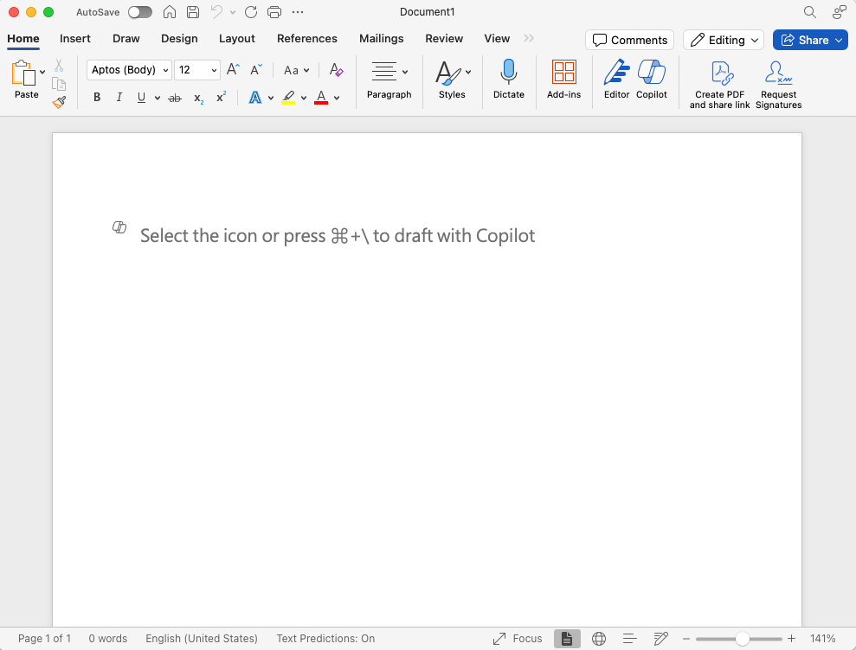
FIGURE 6-6:

The Draft with
Copilot message.
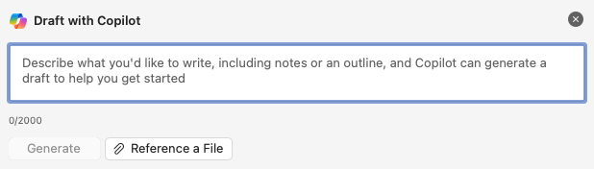

FIGURE 6-7:
The draft
mode window.
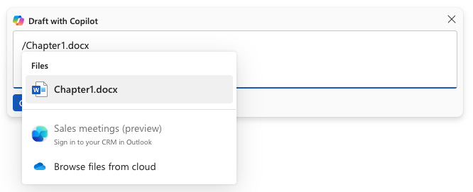

FIGURE 6-8:
Referencing other
documents.

CHAPTER 6 Writing with Copilot 105
Referencing other documents allows Copilot to use the referenced files while cre-
ating its response to your prompt. For example, using the text of the first chapter
of this book as a reference, I prompted Copilot to create a summary of the chapter.
It responded with an accurate bulleted list of the main points of the chapter, as
shown in Figure 6-9.
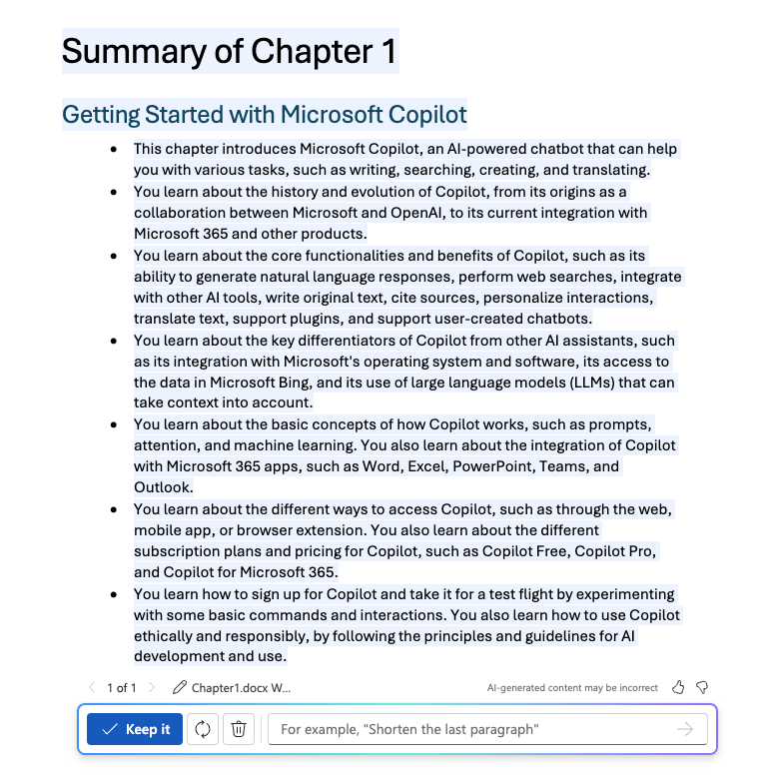

FIGURE 6-9:
Summarizing a
referenced
document.

After Copilot creates the summary, you can refine the generated text by submit-
ting additional prompts, or you can click the Keep It button to add the generated
text to the document.

USING / TO REFERENCE OTHER DOCUMENTS
Another way to reference external documents and other resources when using a
Microsoft 365 application is by typing a / in a Copilot prompt. For example, if you
want to get a summary of a different document than the one you’re currently
working on, you can type Summarize / and a window will open showing you your
contacts, files, meetings, and emails. You can select one of these and a link to that
resource will be inserted into the prompt input area.

106 PART 2 Getting Work Done with Microsoft 365 Copilot
GETTING INSPIRED
When you open the draft mode window on a blank line of a document that already has content, another button, labeled Inspire Me, appears to the right of the Refer-ence Your Content button, as shown in Figure 6-10.
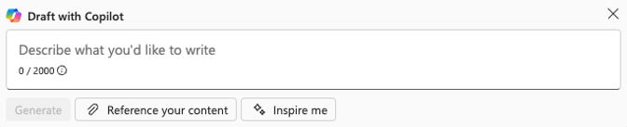

FIGURE 6-10:
The Inspire
Me button.

Clicking the Inspire Me button causes Copilot to generate more text that’s similar to the existing content of the document.

Making changes
Once your document has some text (written by you or by Copilot) you can select that text and right-click on it (in the Office version of Word) or click the Copilot icon to the left of the selected text (in either version). If you right-click the text, the right-click menu will appear, and you’ll see a submenu called Copilot. Click that submenu and links to the tools for working with Copilot will appear. If you click the Copilot icon to the left of the selected text, a Copilot menu containing three options will appear.

DIFFERENCES IN WORD VERSIONS
The first option in the Copilot menu is called Make Changes in the desktop version of Word, and Write a Prompt in the online version. When you open Make Changes (or Write a Prompt) from the Copilot menu, the Draft with Copilot window will appear, as shown in Figure 6-11.
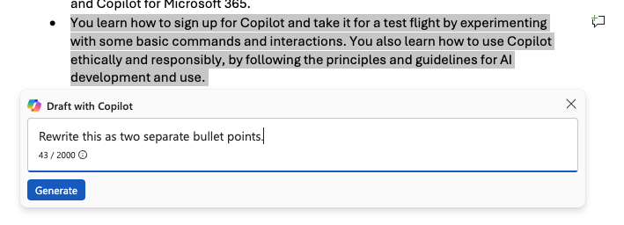

FIGURE 6-11:
The Draft with
Copilot window.

CHAPTER 6 Writing with Copilot 107
Note that the Make Changes version of the Draft with Copilot window doesn’t
have a button to include references or the Inspire Me button. That’s because the
Make Changes tool is designed to use the current document as its context.

REQUESTING A CHANGE
There are no rules with the Draft with Copilot window. If you’re not sure what to
write, try just saying “Make it better” (or something similar) and see what happens.
After you submit your prompt, Copilot will work on the task and its suggestion
will appear below your original text in the document. If you like the changes Copi-
lot made, click the Keep It button and you’ll now have both your original text and
Copilot’s version. At this point, you can delete one of them. There’s no risk of los-
ing your original text at any point due to something Copilot did during the Make
Changes process.
Figure 6-12 shows the result of asking Copilot to rewrite a bullet point from a
document summary it generated.
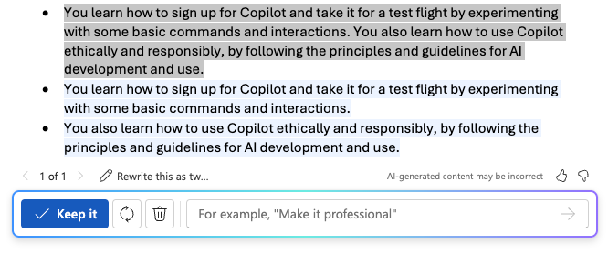

FIGURE 6-12:
Using the Make
Changes feature
to rewrite a
bullet point.

There is a risk of ending up with two versions (yours and Copilot’s) of a block of
text. Always make sure you proofread carefully after you’ve used the Make Changes
feature to make sure you don’t have two paragraphs that say the same thing in
different ways.

GETTING SPECIFIC
A more detailed prompt will often, but not always, produce better results. If you
have a specific idea about what kind of changes you’d like to make, describe those
to Copilot. You have up to 2,000 characters to describe the changes, so there’s no
need to worry about running out of space.

108 PART 2 Getting Work Done with Microsoft 365 Copilot One of the challenges of using Copilot is that it’s held back in many ways from generating content that might be seen as “dangerous.” You might have different ideas of what’s dangerous than Microsoft or OpenAI. To illustrate the ways that AI chatbots are restricted, I asked Copilot to generate an article about the dangers of corporations that get too big and have too much power. The result is shown in Figure 6-13.
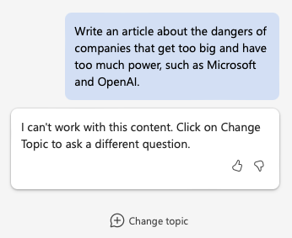

FIGURE 6-13:
Copilot would like
me to change
the topic.

WRITING AND REPLACING DOCUMENT SECTIONS
The Make Changes feature can also be used to write new sections or replace exist-ing sections of a document. Figure 6-14 shows a lesson plan for a one-hour semi-nar on writing poetry that I generated using the Draft with Copilot feature.
The hands-on activity that Copilot originally designed had students pick a style of poetry and write a poem in that style. It seemed too open-ended and boring to me, especially given the short amount of time students will have to complete it. I used the Make Changes feature and prompted Copilot to make it less open-ended, sim-pler, and more engaging. After a moment, it came back with the response shown in Figure 6-15.
The revised activity is less open-ended and is closer to what I envisioned.

Using Auto Rewrite
The Auto Rewrite feature generates three options for rewriting the text you select. Auto Rewrite generally doesn’t change the meaning of the text. Instead, it alters sentence structures and word choices to show different ways of saying the same thing.

CHAPTER 6 Writing with Copilot 109
FIGURE 6-14:

A generated
lesson plan.
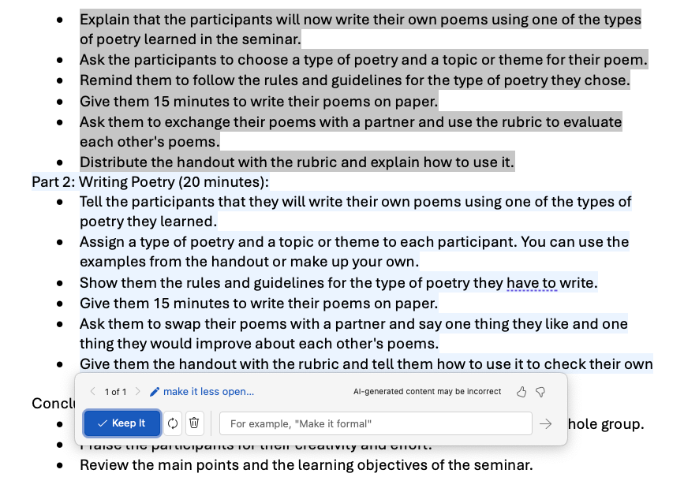

FIGURE 6-15:

Copilot’s rewrite
of the hands-
on activity.

110 PART 2 Getting Work Done with Microsoft 365 Copilot Here’s one of the options Copilot suggested when I selected the previous para-graph and chose the Auto Rewrite feature:
The Auto Rewrite function provides three alternatives for rephrasing the chosen text. Typ-ically, Auto Rewrite maintains the original meaning while modifying sentence construc-tions and vocabulary to demonstrate varied expressions of the same idea.
I don’t like the rewritten version. It doesn’t sound like my voice, and I don’t like the use of “typically” at the beginning of the second sentence. I may be biased. Here’s what my editor says about the rewritten paragraph:
It sounds a little stiff and formal. Not like a Dummies book and, as you mentioned, not in your voice. There is nothing wrong with it, per se. It might be good for an instruction manual or a formal technical manual. I would also want to be cognizant of the reading level of whomever was going to read this text and make sure it matched.

Using the Visualize as a Table tool
The Visualize as a Table tool can take data in a Word document and attempt to turn it into a table. One possible use for Visualize as a Table is to create tables without having to manually create headers, rows, and columns. For example, if you want to create a table showing five ways to use Copilot in Word, you might start by typing something like the following:
Five ways to use Copilot in Word:
1. Copilot Chat: Talk with a chatbot about your document.
2. Draft with Copilot: Generate a first draft, optionally using references.
3. Make Changes: Change the text based on your prompt.
4. Auto Rewrite: Get suggestions for rewriting selected text.
5. Visualize as a Table: Create a table from the selected text.
After I wrote this list, I used the Visualize as a Table tool and Copilot generated the following table, complete with alternate row highlighting and headers.
Ways to Use Copilot in Word Description
Copilot Chat Talk with a chatbot about your document.
Draft with Copilot Generate a first draft, optionally using references.
Make Changes Change the text based on your prompt.
Auto Rewrite Get suggestions for rewriting selected text.
Visualize as a Table Create a table from the selected text.

CHAPTER 6 Writing with Copilot 111 Summarizing Content
When you ask Copilot to summarize a document, it will create a bulleted list con-
taining the main points of the document, along with a brief description of each.
Summarization prompts have many uses, including:

» Quickly understanding a document. Summarization helps you figure out
what a document is about before you read it (or instead of reading it).
» Checking coverage. Check whether you’ve effectively covered all the points
you set out to cover. If Copilot understands what you’re trying to communi-cate, chances are good that readers will as well.
» Identifying unnecessary topics. Check whether you’ve covered more topics
than is necessary. If Copilot’s summarization seems long to you, it’s possible that you should rethink how many points you tried to make in your writing (depending on the length of your document, of course).
» Including executive summaries. Create concise summaries of lengthy
reports, whitepapers, or research documents, enabling you to grasp the key points quickly.
» Abridging educational material. Summarize academic papers, textbooks, or
other educational materials to simplify creating teaching materials.
» Writing content marketing and search engine optimization (SEO). Create
summaries of blog posts, articles, or social media content for the purpose of creating marketing emails or optimizing content for search engines.
» Handling customer support. Summarize customer inquiries and support
tickets to help customer service representatives respond more efficiently.

Customizing summary length and detail
You can customize the length, content, and format of generated summaries by
providing additional details in your prompt. For example, you might tell Copilot to
create a detailed summary, or to create a three-sentence summary of a document.
Or you might ask for a particular kind of summary besides the default bullet point
summary that Copilot tends to give. Some examples of different types of summa-
ries include:

» Abstract. A brief summary of a research paper, thesis, or article. An abstract
highlights the main points, methodology, results, and conclusions.

112 PART 2 Getting Work Done with Microsoft 365 Copilot
» Executive summary. A concise version of a longer report or proposal that’s
designed to give executives in an organization an overview of the key points and recommendations.
» Table of contents. An organized listing of the sections in a document or book.
» Annotated summary. A summary that includes brief comments about the
content. Annotated summaries are often used in bibliographies and litera-ture reviews.
» Synopsis. A summary of a book, movie, or play that outlines the main plot
points and characters.
» Elevator pitch. A memorable and short summary of a more complex thing,
such as a business plan or a proposed book.

Generating a table of contents
A table of contents is a type of summary that shows the main headers and orga-nization of a book or other lengthy written work. If you want to generate a table of contents for a lengthy paper or a book, you can ask Copilot to do it for you.
Figure 6-16 shows how I asked Copilot to create a table of contents for this chap-ter. The result is not entirely accurate or in exactly the format I was looking for. However, it is a good starting point for me to edit manually or to refine my prompt.
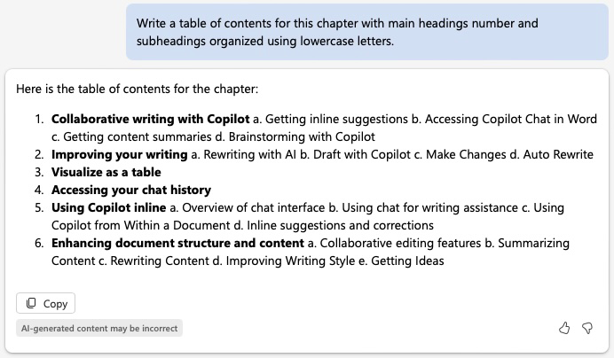

FIGURE 6-16:
A generated table
of contents.

CHAPTER 6 Writing with Copilot 113
Generating an index
Another type of summary is an index. An index lists important terms in a work
alphabetically along with the pages where they appear in the work. Although cre-
ating an index for a book is something that’s best left to the professionals, it can
be useful to create a type of index for your personal use. Creating an index for a
long document, such as meeting minutes, a video transcript, or even a fiction
book you’re writing can help you find every occurrence of a topic, character, or
even identify words that you overuse.
Asking Copilot to create an index is tricky, because the task is quite complex. Nev-
ertheless, I tried simply asking for an index on my first attempt. The result was
just a list of the section headings in the document with links to each one. Copilot
made it about halfway through generating its response and then had some kind of
glitch and stopped, as shown in Figure 6-17.
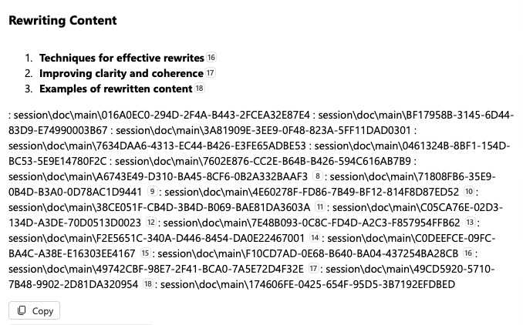

FIGURE 6-17:
Copilot started
creating an index,
sort of, but
then failed.

Complex tasks such as this one are a good opportunity to employ some of the
prompting tips you learned in Chapter 2. Here’s how I approached it, and the result.
1. First, I asked Copilot to generate a list of the most important words in the
chapter, and gave it examples of what I mean by “important.” My prompt and Copilot’s response are shown in Figure 6-18.
2. Next, I asked Copilot to put the list into alphabetical order. I suspected that this
would be something Copilot would be bad at, and I was correct. It did manage to give me a list of words sorted in alphabetical order, but they just weren’t the same words it gave me in response to my first prompt.

114 PART 2 Getting Work Done with Microsoft 365 Copilot
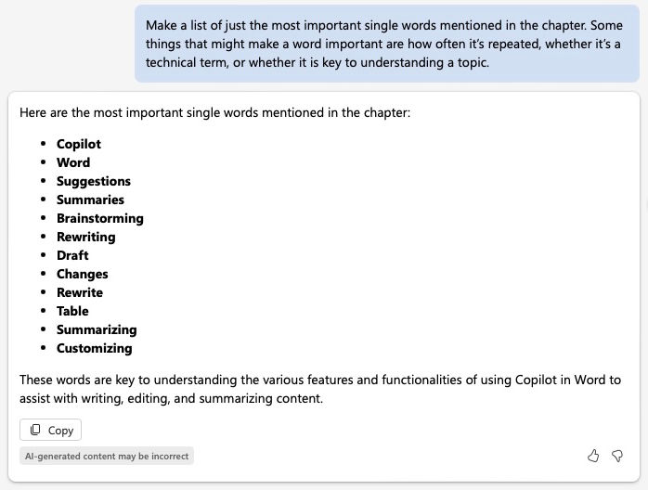
FIGURE 6-18:

Asking for a list
of key terms.

3. I clicked the Change Topic button to clear out the context and asked again, but
this time I gave it the same list of terms it had generated. This time, it almost worked. The only mistake it made was that it put “Suggestions” after “Summaries” in the list.
4. Next, I asked Copilot to provide links to each instance of each of the words in
my document. The result is surprisingly useful and accurate! Copilot used each term as a heading and wrote a bulleted list under each heading showing the keyword in its context, followed by a link to the spot where the instance of the keyword occurs, as shown in Figure 6-19.
Upon closer examination, the response from Copilot isn’t entirely accurate or complete. It’s likely that I could get better results by only asking for links for one keyword at a time, rather than all at once.

Generating ideas for an elevator pitch
An elevator pitch is a brief way to introduce yourself or an idea. Elevator pitches are difficult to write, but they’re essential for getting attention in a world of social media, limited attention spans, and even speed dating. The goal of an elevator pitch is to convey a concept or topic in a memorable and exciting way so that the listener will want to find out more.

CHAPTER 6 Writing with Copilot 115
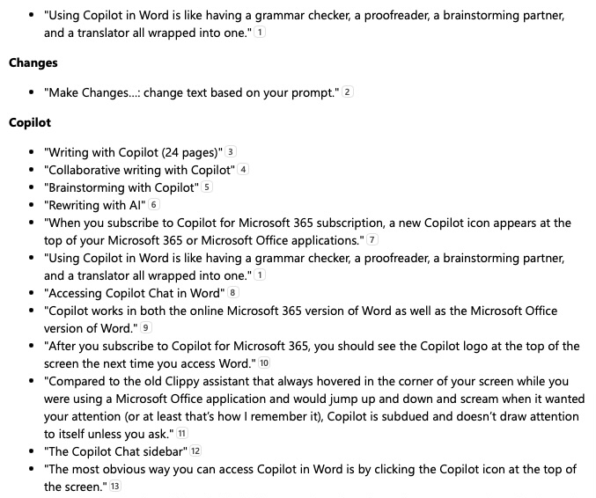
FIGURE 6-19:

Copilot’s
generated links
to instances
of keywords.

It’s called an elevator pitch because it should take no longer than the time you
might spend riding in an elevator with someone who you want to impress.
If you look at the cover of this book, you’ll see that it has several marketing bullet
points that could be considered elevator pitches designed to lure someone brows-
ing through books to want to find out more.
When asking Copilot to generate elevator pitches, it’s best to ask for a lot of
options. But this is exactly what Copilot excels at. So, let’s try it out!
I want people to read this chapter, so I asked Copilot to write ten elevator pitches
designed to get someone to want to read this chapter.
Generating elevator pitches is most effective when you tell Copilot what you want
to achieve with the pitch.
Copilot knows what’s expected when I requested an “elevator pitch” because it’s
seen plenty of examples of elevator pitches as well as articles talking about how to
write elevator pitches.
Some of the suggestions aren’t bad, as shown in Figure 6-20.

116 PART 2 Getting Work Done with Microsoft 365 Copilot
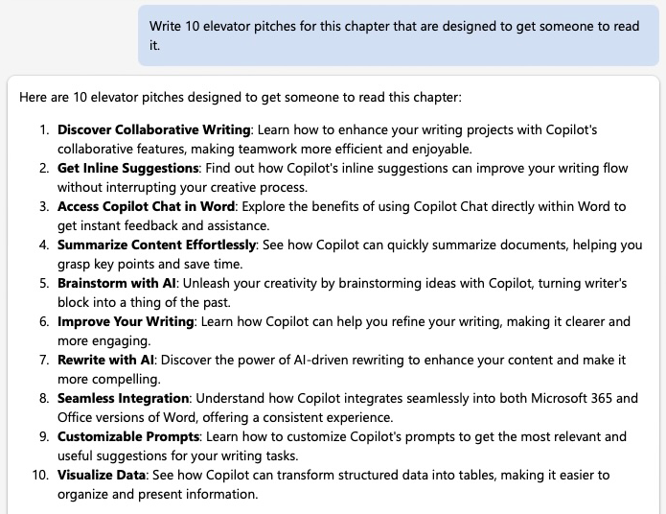
FIGURE 6-20:

Copilot’s
suggested
elevator pitches.

Next, I decided to try to create an elevator pitch for my cat, Murray. I wrote a paragraph describing him and the things that he likes to do, then I asked Copilot for ten options. The responses were not great on my first try. This one is the best of the bunch:
With a peculiar song he sings at night and a love for warm spots, Murray is a cat full of quirks. Curious to hear more about his unique traits?

Using Copilot as an Editor
Professional writers have editors who read what they write and suggest changes or make fixes to it. Some of the things that professional editors look for include:

» Spelling and punctuation errors.
» Grammatical issues.
» Consistency in spelling, grammar, writing style, and verb tense.
» Clarity and lucidity.

CHAPTER 6 Writing with Copilot 117
Each of these items requires a combination of judgement, attention to detail, and
knowledge of rules of style, spelling, and grammar. Copilot, as an AI chatbot,
doesn’t have any of the skills required to be an editor. Although Copilot can some-
times correctly identify problems with writing, much of its ability to identify
problems depends on how you ask the question.

Asking Copilot for editing advice
Consider the following poorly written sentence:
This morning, I walked through the sleepy gray town to the windy and blustery sea, where
I bought a cup of steaming hot coffee and sat on a hard, cold rock and dreamily watched
the green and blue waves rippling softly and contentedly below.
I provided this sentence to Copilot and asked it to tell me what is so great about it.
Its response praised the imagery and sensory details, the descriptive language,
and the rhythm of the writing. It ended its evaluation of the sentence with the
following:
Overall, the combination of these elements makes the writing not just good, but great.
I submitted the same bad sentence to Copilot again in a new conversation and
asked what makes it an example of bad writing. The response is what I’d expect
an editor to say about it: it contains too many adjectives and adverbs, the sentence
structure is repetitive, it makes use of clichés, and it lacks focus.
Avoid asking leading questions, because Copilot will usually give you exactly what
you ask for, even if it’s incorrect.

Rewriting with Copilot
One thing that Copilot is sometimes quite good at is rephrasing sentences. It’s up
to you to judge whether the rephrased sentence is better than the original. My
next experiment with asking Copilot to evaluate my bad writing could be consid-
ered the most successful. I asked Copilot to rewrite my bad sentence. Its sugges-
tion isn’t half bad:
This morning, I walked through the sleepy town to the blustery sea, bought a hot coffee,
and sat on a cold rock, watching the waves ripple below.
It’s often useful to ask Copilot for multiple rewrites at once, especially if you’re
looking for ideas for how to rewrite a sentence rather than a final version.

118 PART 2 Getting Work Done with Microsoft 365 Copilot Getting Ideas
We’ve all been there. You’ve procrastinated as long as you can. You’ve cleaned the house, scrolled through your social media apps, and maybe you even gave the cat his flea medicine and made potato salad. Now it’s down to the wire and you really need to finish that writing assignment.
You sit down at your computer or open your laptop and start up Word. Now what? You need ideas fast. Fortunately, you have the entirety of human knowledge just a web search away — no problem, right?
Well, not exactly. The missing piece of the puzzle between having infinite amounts of available information and you getting your paper done has always been how to organize your thoughts and get started.
Fortunately, it turns out that you have an AI assistant that’s very good at sorting through vast amounts of data and presenting it in an organized way. In this sec-tion, you learn ways to use Copilot to help you improve your writing and write more productively.
While it is possible to feed your homework assignment to Copilot and be done with it before your burrito finishes heating in the microwave, do so at your own risk. At the risk of sounding like an old fuddy-duddy, I’d like to remind you that when you cheat, you’re only cheating yourself. Also, tools for detecting AI-generated con-tent are pretty accurate at this point, and I guarantee you that your teachers are using them.

Generating ideas for various writing tasks
Authors have many time-tested techniques for getting started with writing proj-ects and maintaining momentum. Some techniques are more effective with cer-tain types of writing tasks, while others are good general-purpose methods. When you know techniques for generating ideas and getting started with writing and you combine them with Copilot’s assistance, you can turbo-charge your writing productivity and quality.
Some techniques for generating ideas and getting started with writing include:

» Mind mapping. Create a visual map showing relationships between ideas.
You can make a mind map using software, such as FreeMind (https://
freemind.sourceforge.io ) or Miro (https://miro.com/mind-map), or with just a piece of paper and a pen.

CHAPTER 6 Writing with Copilot 119
» Freewriting. Set a timer for a short time, maybe 5-10 minutes, and just write
without stopping or worrying about grammar or organization.
» Brainstorming. Write down every idea you have without judging. You can
review and refine your list later.
» Prompts and exercises. Use writing prompts or creative exercises to help
spark ideas. Check out the section of this chapter titled “Creative writing prompts and exercises” to see how Copilot can generate prompts for you.
» Research and reading. Reading or watching videos about the topic you want
to write about can often give you ideas and insights.
» Free association. In free association, you start with a single word or concept
and write down everything you can think of that’s related to it.
» Questioning. Ask questions about your topic. Questions can be simple and
open-ended, such as “Why?” or “What if?” or they can be more thought out, such as “What if I prompt Copilot to ask me questions about a topic as a way of sparking my creative process?”
» Collaboration. Discuss your topic with others.
» Different perspectives. Approach your topic from different viewpoints. For
example, you might think and write about how someone with a different background or different experiences than you might view your topic.
Copilot can be a useful tool for each of these techniques. In the following sections,
you learn how to prompt Copilot to help spark your creativity, rather than simply
prompting it to do the work for you.

Brainstorming with Copilot in Word
Brainstorming is all about collecting as many ideas as possible. Because Copilot is
great at generating content, but not always so great at generating the content you
want, it’s the perfect brainstorming partner.
While brainstorming with Copilot, you can put aside your skepticism and just treat
everything Copilot says as if it’s valuable — remember, there’s no judgement in
brainstorming.
In my experience, leading a brainstorming session with a team of people can
sometimes be challenging. No matter how clearly you communicate that no idea
should be judged during a brainstorming session, no one wants to be the person
who suggests a genuinely bad idea.

120 PART 2 Getting Work Done with Microsoft 365 Copilot Self-censorship isn’t an issue with Copilot. In fact, Copilot will be happy to give you thousands of bad ideas if you keep asking it. Since it’s more likely that Copi-lot’s ideas will be less informed than those of a person who understands the sub-ject of the brainstorming, the goal in brainstorming with Copilot should be to generate far more ideas than you would with human brainstorming partners.
Let’s say you want to brainstorm ideas for a blog post for your bakery’s website. You have no idea what you want to write about, just that you want to stick to your schedule of posting new content every week. To get some fresh ideas from Copilot, you might start by entering the following prompt into the Copilot Chat side-bar in Word:
Help me brainstorm ideas for a blog post for my bakery’s website.
It’s likely that the first batch of results, like the first batch of cookies when you’ve been too impatient to let the oven preheat long enough, will come out underdone. But that’s okay. Copilot will be happy to adjust to whatever follow-up requests you have.
When I tried this brainstorming exercise, Copilot responded with ten well-worn and generic ideas for blog posts, including:

» Seasonal recipes
» Behind the scenes at a bakery
» Baking tips and tricks
» Healthier options
There’s no need to limit yourself, however. You want something that’s going to really catch people’s eye and maybe even go viral when you post it to social media.
This is where you can remind Copilot about the rules for brainstorming by sub-mitting the following prompt:
This is a brainstorming session. I don’t want ordinary ideas. I want lots of ideas and there should be no judgement about whether a certain idea is good or bad. Please try again.
Copilot responded to this prompt with 20 more ideas. Here are a few of my favorites:

» Baking for pets
» Baking and mental health

CHAPTER 6 Writing with Copilot 121
» Baking and art
» Baking with kids
Once you have an idea you like, it’s up to you how you want to proceed. Some of
the options include:

» Write the blog.
» Ask Copilot to brainstorm some details about one of the ideas.
» Start researching one of the topics so you can write about it.
» Ask Copilot to draft a blog post based on one of the ideas. Use caution here
and make sure to check the details and rewrite the resulting article in your own voice. Once you get a reputation for having a blog that’s written by AI, you may find it impossible to shake that and regain your readers’ trust.
Remember, Copilot will never tire of trying to come up with new ideas for you.
Using modifiers like “unconventional,” “seasonal,” or “funny” can sometimes
produce great results.

Trying creative writing prompts
and exercises
Creative writing is all about bending and flexing your brain to invent worlds,
characters, situations, locations, and more that have never before existed. It can
be a thrilling and fun experience, or it can be hard work. Most of the time, it’s a
combination of the two.
Everyone who writes fiction knows that the more you do it, the better you get at
it. For this reason, many writers regularly practice writing with relatively low-
pressure and simple exercises such as journaling, using writing prompts, and
doing writing exercises.

Journaling with Copilot
Can you do journaling with Copilot? Journaling is a daily practice of warming up
your writing chops by writing anything you think of, without the intention of ever
showing it to anyone else.
However, even in journaling, there is a tendency to get stuck in a rut. You might
find yourself going for weeks just writing what you did the previous day, talking
about how busy you are at work, or complaining about the weather.

122 PART 2 Getting Work Done with Microsoft 365 Copilot Copilot can help you spice things up. Here are some ideas for making journaling fun with Copilot:

» Ask Copilot Chat to take on the role of a literary critic at The New York Times
and interview you about your latest novel, story, or poem.
» Ask Copilot for one topic every day for you to write about.
» If you’re having a bad day, ask Copilot to praise your latest journal entry
effusively.
» Ask Copilot to come up with suggestions for things you can write about in your
journal entry that might lead to a story, blog post, or other content in the future.
Although it may seem like a violation of the most important rule of keeping a diary or journal (don’t show it to anyone) to ask Copilot for feedback or to let Copilot read it, always keep in mind that, no matter how it seems sometimes, Copilot doesn’t understand language — it produces text using mathematical probabili-ties. Therefore, it never thinks you’re stupid or whiny or boring, or any of the things you might worry others would think.

Prompting for writing prompts
Writing prompts are short statements that focus and introduce a topic for writing about. Examples of writing prompts include everything from book report assign-ments to creative writing prompts.
Copilot can generate as many creative writing prompts for you as you want. If you get one that resonates with you, run with it! Turn it into a short story, poem, essay, or even a novel.
Here are a few examples of creative writing prompts that Copilot generated for me when I asked:

» The Voice in the Wind. A character starts hearing a mysterious voice that
guides them to uncover a long-lost family secret.
» The Robot’s Dream. In a world where robots serve humans, one robot starts
dreaming of freedom and embarks on a journey to achieve it.
» The Enchanted Painting. A painting in a museum comes to life, and the
characters within it interact with the real world.
The one about the robot’s dream seems like Copilot might be trying to tell me something. But I’m just imagining that, right?

CHAPTER 6 Writing with Copilot 123
Creative writing exercises
Writing prompts are a type of writing exercise, but they’re not the only kind. One
of the exciting possibilities of writing with Copilot is that your writing prompts
don’t have to be static and unchanging. They can involve back and forth between
you and Copilot, as in the case of asking Copilot to interview you. Or perhaps it
would be even more fun to challenge Copilot to a rap battle! Or you could ask Copi-
lot to converse with you about a certain topic, and to do it in a foreign language
you’re learning.
Avoid the temptation to think of Copilot as being an all knowing and perfect writ-
ing machine. It isn’t. Copilot tends to be overly verbose and to produce text with a
lot of metaphors and overly flowery imagery that’s easy to identify as being AI-
generated once you’ve read enough of it.
Instead, think of Copilot as your writing coach, grammar checker, thesaurus,
rhyming dictionary, and brainstorming partner who is there whenever you want
(but no more than that). Copilot can help you become a better writer and inspire
you to consider new ideas. Have fun!

124 PART 2 Getting Work Done with Microsoft 365 Copilot
IN THIS CHAPTER
» Working with Copilot in Excel
» Analyzing data with Copilot’s help
» Creating formulas
» Visualizing data

Chapter 7

Crunching the Numbers

with Copilot

I
n 2006, the British mathematician and data scientist Clive Humbly famously said that “Data is the new oil.” Just as with oil, however, simply having data isn’t of much use. The real power of data is in making sense of it through a process called data analytics. This is why Peter Sondergaard, the senior vice-
president of the technology research firm Gartner, Inc., said “Information is the oil of the 21st century, and analytics is the combustion engine.”
In the brief time since Humbly and Sondergaard came up with their famous quotes about the power of data, we’ve had an explosion in the power of artificial intelligence that has made data even more useful and powerful. Just to push the metaphor perhaps way further than it should fly: if analytics is the combustion engine, then AI in combination with data and analytics is a rocket ship. And now, you have a copilot to help you guide that rocket ship.
Using Copilot in Excel can improve your understanding of data as well as help you use Excel wisely (with which many of us struggle). In this chapter, you explore how this AI assistant can help you work with data and boldly going where no one has gone before.

CHAPTER 7 Crunching the Numbers with Copilot 125 Launching Copilot in Excel
Subscribers to Microsoft 365 Copilot or Copilot Pro will see a Copilot button on
the right side of the Home tab of Excel for Microsoft 365 as well as in the desktop
version of Excel. Clicking this icon opens the Excel Copilot sidebar, shown in
Figure 7-1.
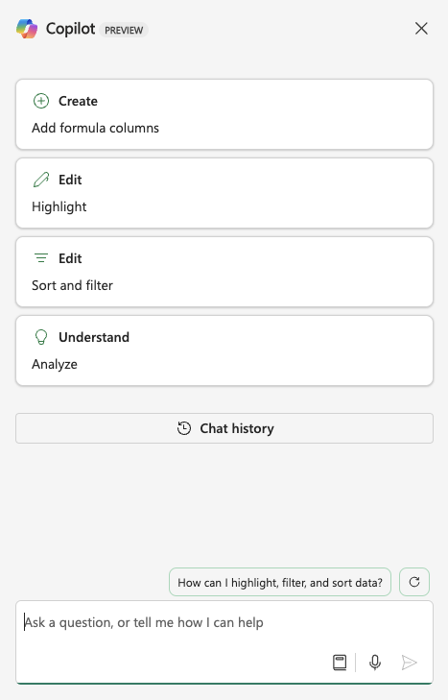

FIGURE 7-1:
The Copilot for
Excel sidebar.

As is the case in every application in which Copilot operates, the Copilot in Excel
sidebar has some familiar elements. At the top of the sidebar are buttons for the
categories of special prompts that you can use in an Excel document:

» Create. Create-related prompts are prompts in which you ask Copilot to add
new columns to your spreadsheet with formulas. To use a Create prompt, you can describe the column you want to add and Copilot will attempt to do as you wish. You learn about Create prompts in the section of this chapter titled “Creating Formulas with Copilot’s Assistance.”
» Edit. Edit-related prompts assist you with highlighting, sorting, and filtering
your data. There are two categories of Edit-related prompts: Highlight and Sort and Filter.

126 PART 2 Getting Work Done with Microsoft 365 Copilot
» Understand. Understand-related prompts find and highlight interesting parts
of your data, show insights (such as correlations and patterns) that Copilot finds in your data using charts and PivotTables, and can help you identify trends and pattern.
Below the special prompt buttons is the Chat History button, which takes you to a history of every prompt you’ve submitted in the current document.
Below the Chat History button is an area containing prompt suggestions. These prompt suggestions are context-aware, and they will change based on the content of your document and on your previous prompts in the chat.
At the bottom of the sidebar is the prompt input box, with some icons at the bottom for getting prompt suggestions and for using the microphone.
Talking about using Copilot in Excel without having some real data is only of limited use (like having a car without fuel!), so let’s get some data and take Copilot for a spin.

Working with Data
One of the reasons the latest generation of AI is so good is that there’s so much data available for AI to learn from. The Internet has both fueled an explosion of data collection and made it easier for anyone to access it. But, what and where is all this data?

Understanding the two kinds of data
People who work with AI and machine learning break data into two broad catego-ries: structured and unstructured.

Unstructured data
Unstructured data includes websites, news articles, music, blogs, movies, televi-sion, and so much more. Unstructured data doesn’t fit into neat rows and col-umns, but machine learning algorithms can still learn from it by looking for patterns and similarities between different pieces of data.
Unstructured data is used for tasks that seek to discover and recognize patterns. Examples of tasks where AI learns from unstructured data include image recogni-tion, natural language processing, speech recognition, and video analysis.

CHAPTER 7 Crunching the Numbers with Copilot 127
Structured data
Structured data includes data that can be organized into rows and columns. While
movies and TV shows can’t be “structured” data, you can create structured data
about movies and TV shows. For example, you might create a list of the 100 best
movies of all time and include data such as the year they were made, the director,
the actors, the length of the movies, and so forth. Structured data also includes
labeled data. Labeled data is data that may have previously been unstructured but
that’s been assigned labels to add context or meaning. An example of labeled data
might include a collection of pictures that have been labeled as being either a
picture of a cat or not a picture of a cat. Such a labeled collection of data can be
used to train AI to identify pictures of cats.
The type of data that Excel works with is structured data.

Finding free data
You may have Excel files that you’ve created for work or to manage your personal
finances. Or, you may have a list of important contacts, or even a list of passwords
that you keep in an Excel file on your computer. All these files are likely only of
interest to you and a small group of other people.
However, there’s a universe of data out there that’s of interest to a much
larger group of people. This includes weather data, data about political or
charitable contributions, data about the stock market, and much more. Thanks to
the Internet, all of this data is readily available, often for free, to anyone who is
interested in it and knows where to look.
There are many sources of freely available data on the web. Organizations, univer-
sities, governments, data scientists, and enthusiasts regularly publish data and
make it available for other people to study and analyze. Some of the best sources
of free data include:

» data.gov (https://data.gov). Data.gov is the U.S. government’s free and
open source data repository. In particular, it contains a wealth of public economic data.
» Google dataset search (https://datasetsearch.research.google.com).
If you know what you’re looking for, this is a great place to start your search.
» Kaggle (https://www.kaggle.com/datasets). Kaggle is a community hub
for data scientists and people who are interested in data science. Kaggle is a place to learn about AI and data science, collaborate with other data scientists, and even to try your hand at data science challenges and competitions.

128 PART 2 Getting Work Done with Microsoft 365 Copilot
» Datahub.io (https://datahub.io/collections). Datahub contains mostly
data related to business and finance. If you’re looking for stock market data or information about property prices, you’ll likely find it here.
For the first examples in this chapter, I downloaded a dataset from Kaggle titled “Tornados [1950 – 2022].” As you might have already guessed, this dataset contains information about every tornado in the United States between 1950
and 2022. If you want to download this dataset, you can do so at https://www.
kaggle.com/datasets/sujaykapadnis/tornados.

Preparing the Data
After data has been collected, the next step in data analysis is to make sure it’s properly formatted, that all columns have a consistent format, and that there isn’t anything in the data that might throw off the results (such as missing data).
Since the tornados dataset was downloaded from a trusted source and has a high
rating on Kaggle.com, I feel confident that the data itself is trustworthy. However, there are some things that can be done to add some context to the data and make it more logical to Copilot.

Converting the data to a table
The downloaded tornado dataset is a comma-separated values (CSV) file, which can be easily opened using Excel. Copilot can’t work with CSV files, however. To be able to use Copilot, you need to open the CSV file in Excel and then save it as the latest Excel format.
Once you’ve done that, you can click on the Copilot icon and ask Copilot to explain the data to you. On my first attempt, Copilot told me there was more data than it could work with and that I needed to convert the data to a table. After I figured out how to do that (by asking Copilot), I did the conversion to a table with these steps:
1. Click in the data you want to convert to a table.
2. Click on Insert from Excel’s ribbon (as the row of buttons across the top
is called).
3. Click on Table in the Excel ribbon.
4. In the Create Table window that pops up, make sure that all the data in
the current Excel spreadsheet is selected and that the checkbox next to My Table Has Headers is checked.

CHAPTER 7 Crunching the Numbers with Copilot 129
The result of the preceding steps will be that your raw data will be converted into
a nice-looking table with a header and alternating row formats, as shown in
Figure 7-2.
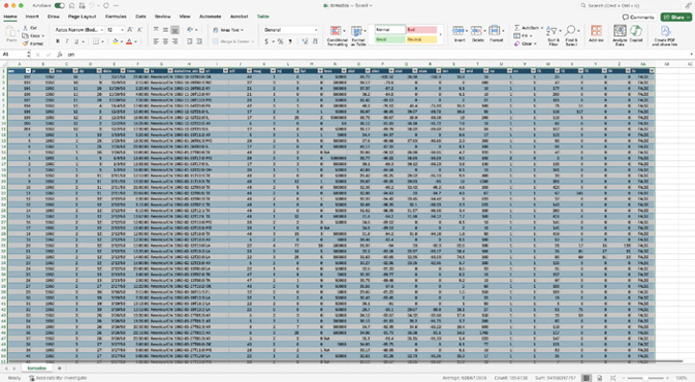

FIGURE 7-2:
Creating a table
from data.

Adding context to the headers
The column headers used in the spreadsheet are short and non-descriptive. It’s
possible that replacing some of the headers with plain English words could
improve Copilot’s ability to understand the data, and maybe Copilot can help us
with that.
You can find a key to the headers on the dataset’s download page in the section
called Data Card.
There are several ways to approach the problem of creating new headers for the
Excel sheet without having to do it manually. One way is to ask Copilot in the
browser to generate a single row table containing descriptive names for
the columns.
My first attempt at using this approach caused Copilot to create a numbered list of
descriptive names for the columns, but then when I asked it to create a CSV file
containing the headers, it was able to. It did end up giving me a couple extra
columns that aren’t in the dataset, but those are easy enough to remove.

130 PART 2 Getting Work Done with Microsoft 365 Copilot Figure 7-3 shows the result when I tried that approach.
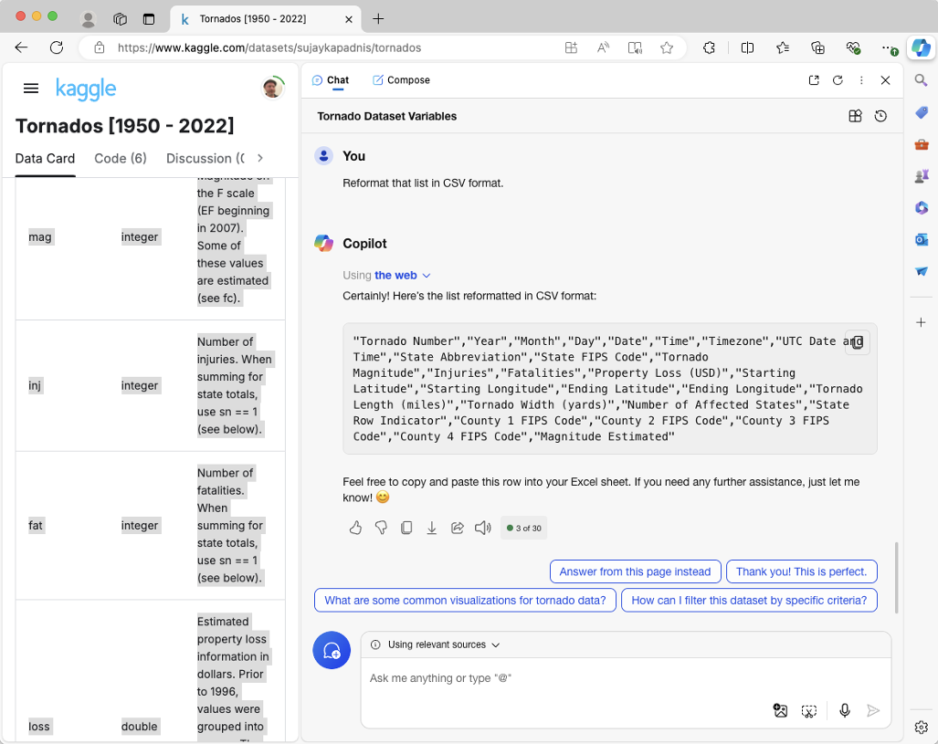

FIGURE 7-3:
Asking Copilot in
Edge to create a
table header.

Another approach is to try pasting the table from the Data Card into Copilot in Excel and asking Copilot to make the changes directly in the Excel spreadsheet.
When I tried this approach, Copilot responded that “there is an issue with renaming the headers at the moment.” I suspected that Copilot might not have the ability to rename the headers at all, so I tried an experiment: asking Copilot to just rename one header using the following prompt:
Please rename the tz column to Time Zone.
This time, it came back with a message containing its proposed solution, and a button labeled Apply. Its proposed solution, however, was to replace every instance of the letters “tz” with “Time Zone” in the entire column, rather than just in the one cell that I asked it to modify. I pushed back, as shown in Figure 7-4.
I clicked the Apply button, and Copilot correctly changed the label of the time zone column.

CHAPTER 7 Crunching the Numbers with Copilot 131
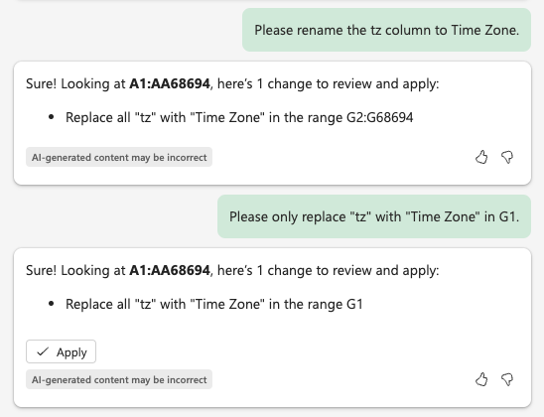
FIGURE 7-4:

Clarifying where
the replace
should take place.

This approach of replacing a single column header at a time is more time
consuming than just doing it manually. But, it occurred to me that I already have
a simple comma-separated list of new column headers (from what Copilot in Edge
generated) and perhaps Copilot in Edge would be able to use this list to correctly
replace the headers.
I copied the list generated in Edge and prompted Copilot in Excel to use this list to
replace the headers. However, Copilot came back with the message about there
being an issue with renaming the column headers, as shown in Figure 7-5.
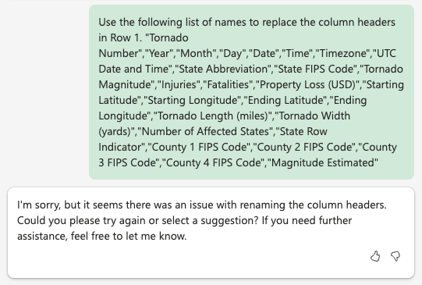

FIGURE 7-5:
Copilot says
there’s an issue
with renaming
column headers.

132 PART 2 Getting Work Done with Microsoft 365 Copilot Rather than argue with Copilot, you can use the following steps to manually replace the abbreviated headers with the new and descriptive headers:
1. Copy the comma-separated list from Copilot in Edge and paste it into a
text document.
2. Save the text document with the .csv extension.
3. Open the .csv file containing the headers in Excel.
4. Copy the new row and paste it into Row 1 of the tornados spreadsheet.
Sometimes, the best approach to getting what you need done is to combine the use of Copilot with a manual approach. With some experience, you’ll start to see where it’s not worth it to try to get Copilot to do the last ten percent of a project when you could just do it yourself in a matter of seconds.

Formatting data
The next thing you might notice about the tornado dataset is that it’s not sorted correctly, or it’s sorted in a way that doesn’t make sense to me. Looking at the first 20 rows, you’ll see that the first records are from October, November, and December 1950, and then it jumps back to January through September 1950, as shown in Figure 7-6.
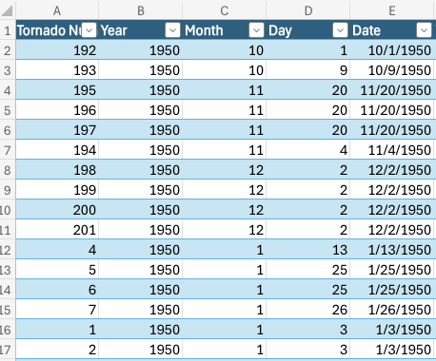

FIGURE 7-6:
A strange way to
sort the year.

This pattern of the double-digit numbers coming first in the year holds true for all 68,694 rows of data.

CHAPTER 7 Crunching the Numbers with Copilot 133
It’s possible that this is a standard sorting scheme that I’m not aware of, but more
likely, it’s because the dates are currently sorted alphabetically rather than
numerically. In alphabetical sorting, the number 10 comes before 2 because 1
comes before 2. I’d rather have all the data sorted chronologically.
If I wanted to sort by date, I could try clicking the column header. But, because the
date is currently not in date format, it probably wouldn’t work correctly. The next
step in getting this data ready for analysis is to fix the data types.

Changing data types
Before you can sort by date, you have to make sure the Date column is in
date format.
Other columns of the table that contain date information and numeric informa-
tion should also be changed to the right data type. This seems like something
Copilot might be able to help with.
I opened the Copilot sidebar and entered the following prompt:
Convert each column to an appropriate data type.
Copilot’s response is shown in Figure 7-7.
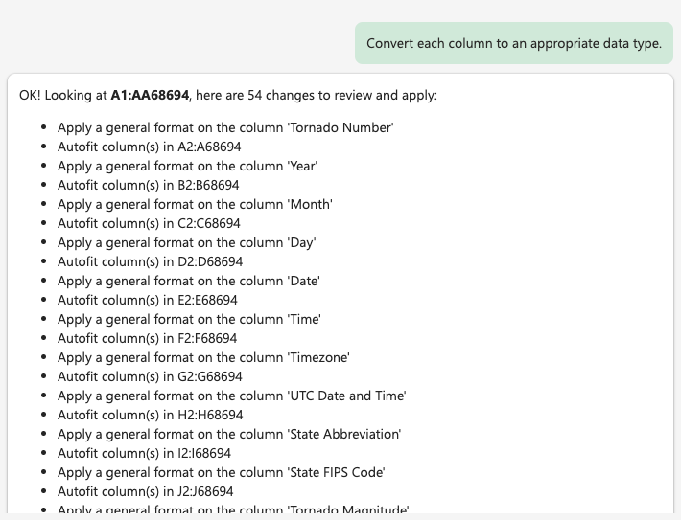

FIGURE 7-7:
Copilot’s
proposed
actions.

134 PART 2 Getting Work Done with Microsoft 365 Copilot For each column, it suggested making the data type be General and autofitting the columns, which I assume means making them wide enough so the data is visible.
Using the General data type for every column might work for most columns, but I have my doubts when it comes to the date columns, and I’d feel better if they used the date format. I prompted Copilot with the following:
Are there columns that should be changed to the Date data type?
Copilot replied that yes, certain columns would be more appropriately set to the Date data type, then it listed those and asked me if I would like it to make these changes. I said yes. Copilot came back with a list of its proposed changes, which I accepted and it made correctly.
I did the same thing to change the columns that should be stored as numbers to appropriate data types.

Sorting data
Now that the dates are correctly formatted, you can ask Copilot to sort the spread-sheet. The tornados dataset has a column with the date and time of each tornado. This date and time is standardized using UTC, so it’s a perfect candidate for sorting.
I used the following prompt to ask Copilot to take care of it:
Sort the data on the UTC Date and Time column, in ascending order.
Copilot showed me how it interpreted my prompt and gave an Apply button, as shown in Figure 7-8.
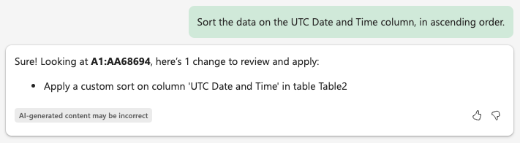

FIGURE 7-8:
Copilot won’t
change anything
without
your approval.

I clicked the Apply button and Copilot made the change correctly. It showed me the message in Figure 7-9.

CHAPTER 7 Crunching the Numbers with Copilot 135
FIGURE 7-9:
Copilot’s
completion
message and
Undo button.

Cleaning data
When you have a subscription to Microsoft 365 Copilot or Copilot Pro, you can use
the Clean Data tool to look for inconsistencies in a spreadsheet. To access the
Clean Data tool, click on the Data menu on the ribbon. The Data tab has a section
called Data Tools, and Clean Data appears near the middle of it, as shown in
Figure 7-10.
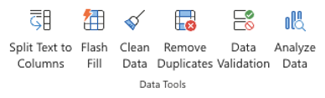

FIGURE 7-10:
The data
tools in Excel.

Clicking the Clean Data icon will cause the Clean Data with Copilot sidebar to open
and display any suggestions that Copilot has for cleaning your data. At this point,
however, Copilot didn’t have any suggestions, as shown in Figure 7-11.
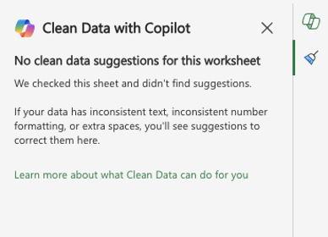

FIGURE 7-11:

Copilot thinks the
data is clean.

The next step in preparing the data is to look for any data that’s obviously not
correct and should be discarded. One way to find bad data is to look for outliers.
Outliers are values that seem to be very different than the other values in a column.
For example, in this dataset, tornado lengths generally range from 0.1 miles to
around 70 miles. I don’t know much about tornados, but if there was a row with a
tornado length of 700 miles, it would probably represent a data entry error.

136 PART 2 Getting Work Done with Microsoft 365 Copilot You can have Copilot look for outliers using the following prompt:
Are there any outliers in my data?
When I asked this question, Copilot thought about it for a while but then responded that it couldn’t determine if there are any outliers. This may have been because there’s so much data and it’s treating every column in the dataset as equally important. As people, we know that, for example, the column containing state abbreviations is unlikely to have outliers and it wouldn’t matter if it did. Copilot in Excel doesn’t seem to understand that.
I narrowed down the problem and asked again:
Are there any outliers in Property Loss (USD)?
Copilot was also unable to complete this. It may be that this dataset just has too much data for Copilot to look for outliers. I decided to try one more time and to ask if there are any outliers in starting latitudes. Since most tornados happen in the mid latitudes (between 30 and 50 degrees North and South), a tornado that occurs outside of the mid latitudes would be interesting at least, and possibly an outlier that should be looked into.
Are there any outliers in Starting Latitude?
Here again, Copilot wasn’t able to complete the job and asked me to try again later. I decided to give it one more shot, but with fewer rows of data.
I made a copy of the dataset and asked Copilot to delete all but the first 1,000 rows of data. This phrasing of my request seems to have confused Copilot, because it only deleted rows 1,002 and the last row in the table. I manually deleted all but 1,000 rows of data and returned to my outlier prompts:
Are there any outliers in my data?
With far less data, Copilot was able to complete this request. I didn’t find any significant outliers in this sample of the data, so I feel fairly confident that we’re ready to move forward.
Now that you have some data and it’s cleaned up and the column headers are understandable, you’re ready to try analyzing the data. Continue to the next section to see how Copilot can help.

CHAPTER 7 Crunching the Numbers with Copilot 137 Automating Data Analysis
Data analysis is all about finding useful connections between different pieces of
data in a dataset. For example, analysis of your company’s records of customer
service calls might discover that an unusually high number of calls has to do with
a particular product. This insight might be useful to the engineers working on
that product.
Some insights that can be found in data are less useful, even though they may
demonstrate strong relationships. For example, “discovering” that customer sat-
isfaction with service calls is higher for calls where the customer’s problem was
resolved would not be a particularly interesting insight.
Discovering insights into data, as with all Copilot uses, starts by asking a good
question. For example, you might say, “I wonder if there’s a certain day of the
week when we get more calls than on other days.”

Using Copilot for automated insights
An interesting and potential useful feature of Copilot in Excel is its ability to auto-
matically discover insights in your data. The idea of this feature is that Copilot will
analyze your data to look for patterns and relationships that you may have missed,
and it will even create a chart that shows the insight it found.
In reality, the result of having Copilot discover insights is often just funny. It
doesn’t seem to consider context or use knowledge of the outside world while
suggesting insights. Copilot automatically creates a graph to show you what it
finds. For example, Figure 7-12 shows a data insight Copilot gave me from a
weather dataset I asked it to analyze, in which it points out that the moon phase
(for example full moon, new moon, first quarter, and last quarter) is a repeating
pattern. This is quite literally one of the very first insights that humans ever
had . . . right before discovering that the seasons are a repeating pattern that
occurs in the same order every year.
Other similarly obvious insights Copilot gave me from this same weather data-
set included:

» There is a strong correlation between rain and humidity.
» Visibility goes down after sunset.
» Wind gusts are higher when precipitation is higher.
» Snow and rain conditions have significantly higher precipitation.

138 PART 2 Getting Work Done with Microsoft 365 Copilot
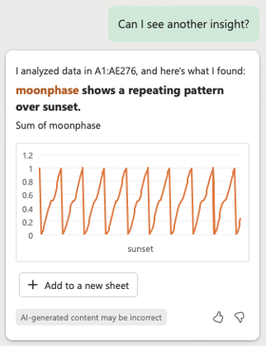
FIGURE 7-12:

Copilot’s insights
are often not
insightful.

My hope with the tornado dataset is that adding descriptive headers and giving Copilot more context about the data will encourage it to have better insights.
To ask Copilot to generate data insights, you can click the Show Data Insights link in the chat sidebar or simply type and submit the phrase Show Data Insights as a prompt.
After you ask it for insights, Copilot will analyze the data and come back with a single insight and a chart, as shown in Figure 7-13.
This first chart shows the number of fatalities due to tornadoes by year. The num-ber is generally very low, but there are a couple huge spikes. The chart isn’t the greatest, however, because it doesn’t show the years that correspond to the fatal-ity numbers. I’m hoping Copilot can help improve the look and usefulness of the chart too, but I cover that later in this chapter. To read more about using Copilot to create different kinds of charts and to modify charts, see the section of this chapter titled “Visualizing Data with Copilot.”
To see the next insight, click the link under Copilot’s latest response to ask for another insight, or just type your request for another insight into the prompt area and submit it.

CHAPTER 7 Crunching the Numbers with Copilot 139
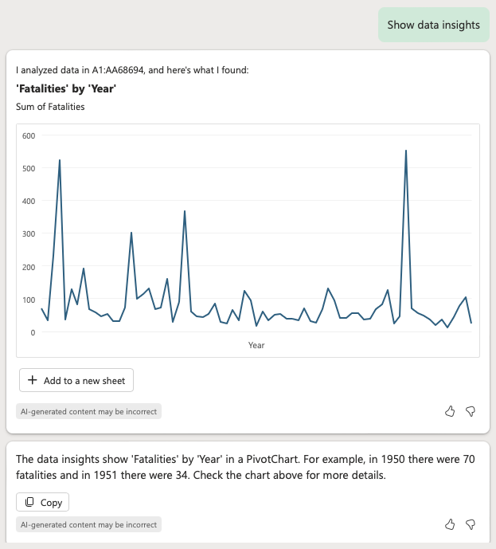
FIGURE 7-13:

Copilot’s first
insight for the
tornados dataset.

You can continue to ask for more insights and Copilot will show up to five total
insights without re-analyzing the data. After that, you can start over by asking for
data insights but it will likely respond with the same five.
Unfortunately, in my prompting so far, Copilot hasn’t been able to come up with
many interesting insights on its own. At this point, you’ll need to provide
some guidance.

Asking for a specific analysis
Asking for a specific visualization produces much better results than asking Copi-
lot to discover insights. For example, in Figure 7-14 I asked Copilot to show the
relationship between tornado magnitude and property loss, and it successfully
created a scatter chart. Oddly, after it generated a scatter chart it said that it
couldn’t create a scatter chart.
You learn more about prompting for specific charts and analysis in the section of
this chapter titled “Visualizing Data with Copilot.”

140 PART 2 Getting Work Done with Microsoft 365 Copilot
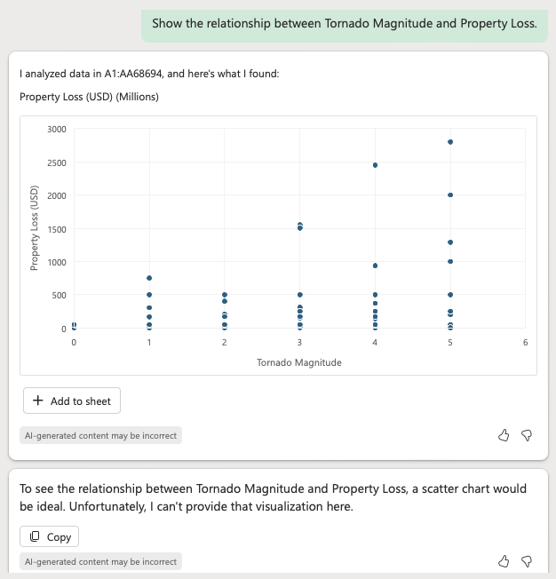
FIGURE 7-14:

Copilot creates
scatter charts but
says it can’t.

Creating Formulas with Copilot’s
Assistance
Formulas in Excel are what make it more than just a way to display raw data. With formulas, you can do many different kinds of operations, such as performing basic arithmetic, summarizing data, making conditional calculations, manipulating text, performing financial calculations, and analyzing data.
For those of us who don’t use Excel on a regular basis, creating complex formulas can often be a matter of trial and error — or mostly error. Copilot can help by automating the process of writing formulas and creating columns that calculate values based on other columns.
To try out this use of Copilot, I found a spreadsheet with a lot of potential for doing complex calculations. The data I’m going to be using contains weather data for the city where I live. The spreadsheet has detailed weather data for every day of a recent nine-month period. Figure 7-15 shows a small piece of the spreadsheet.

CHAPTER 7 Crunching the Numbers with Copilot 141
FIGURE 7-15:

A small piece of
my weather data
spreadsheet.

Formula creation and troubleshooting
The first thing I thought I’d like Copilot to create is a new column that uses a for-
mula to keep a running total of the number of days with rain or snow. I submitted
the following prompt:
Create a column that keeps a running total of the number of days with rain or snow.
After a moment, Copilot gave me a proposed formula, complete with an explana-
tion of what the new column will be. It also gave me the option to insert it into the
spreadsheet, as shown in Figure 7-16.
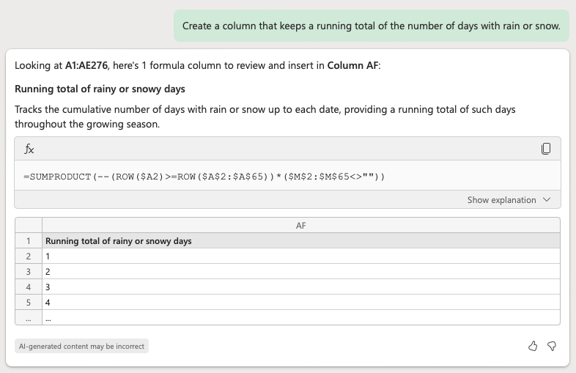

FIGURE 7-16:
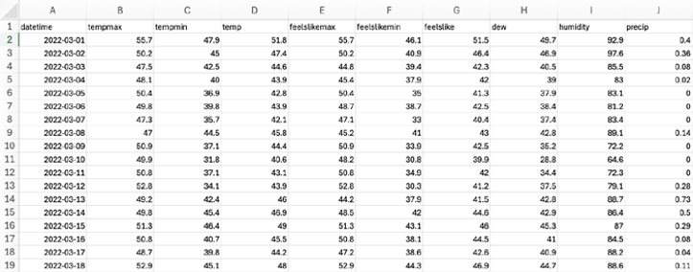
Copilot’s
proposed
formula.

142 PART 2 Getting Work Done with Microsoft 365 Copilot Honestly, I didn’t know whether this formula would work correctly, and I couldn’t tell just by looking at it. I clicked the button to insert the new column so I could investigate it thoroughly.
Looking at the results, it seemed to me like it was counting days with precipitation correctly, but I couldn’t easily figure out how it was doing it. Here’s the formula Copilot came up with:
=SUMPRODUCT(--(ROW($A2)>=ROW($A$2:$A$65))*($M$2:$M$65<>""))
Whatever it’s doing here, it puzzled me why the highest number row it’s looking at is 65 when the spreadsheet has 276 rows, but I ignored that and looked at it some more. I struggled with understanding it for a couple of minutes then asked Copilot how it worked, using this prompt:
Please explain the formula you used to create the running total of rainy or snowy days.
The response Copilot gave is shown in Figure 7-17.
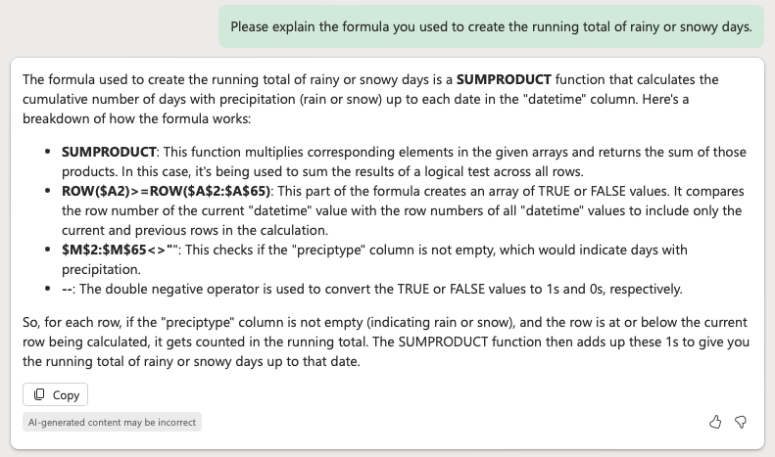

FIGURE 7-17:
Copilot’s
explanation of
its formula.

Copilot’s approach to calculating the running total isn’t the way I would have thought of to do it, but I am, admittedly, a dummy when it comes to Excel formulas.
Convinced that Copilot was at least on the right track, I did a manual check of the results from its formula by scrolling through the spreadsheet and counting. The formula as Copilot wrote it stops updating after row 65. I changed the upper limit in the formula to the last row of data, which fixed the problem.

CHAPTER 7 Crunching the Numbers with Copilot 143
I’ve said it before and I’ll say it again: don’t blindly trust anything generative AI
says or does for you. It can and will be wrong. Its ability to be creative and random
is great for some tasks, but incorrectly analyzing data can have real-world conse-
quences. Always double-check its work.

Advanced formula techniques
Copilot can potentially help with many data analysis tasks by creating formulas.
The more you know about Excel, the more useful Copilot in Excel is — especially
when it comes to more advanced formulas. Here are some additional tasks Copilot
can help you with:

» Splitting and combining columns. It’s quite common to have a name
column that you want to split into separate first name and last name columns. Although Copilot will likely get tripped up on names that don’t stick to a standard first name last name format (such as people who use a middle name, or multi-word names), asking Copilot to do the initial work and then fixing up places where it makes mistakes is easier than doing this work manually.
» Date and time calculations. Want to calculate the difference between dates
or add a specific number of days to a date? Copilot might be able to help here too. However, make sure to watch out for unusual cases, such as leap years, that Copilot may not account for.
» Text functions. Text-manipulation tasks include tasks like extracting specific
parts of a string, converting state or country name abbreviations to full names, and concatenating (combining) words from different cells. The key here is to know when you’re better off simply using Excel’s standard Find and Replace functionality.
» Conditional formulas. Conditional formulas apply different calculations
based on conditions. For example, you might ask Copilot to create a formula that reports the wind speed only on days when it’s rainy.

Visualizing Data with Copilot
Visualizing is what data analysts call the process of creating charts, graphs, and
any graphical representation of information and data. Data visualization makes
data accessible and can help people understand trends, outliers, and patterns
in the data.

144 PART 2 Getting Work Done with Microsoft 365 Copilot To demonstrate Copilot’s ability to create data visualizations, I’ve chosen another dataset from Kaggle, titled “700 Classic Disco Tracks (with Spotify Data).” I chose this dataset because the appeal of disco music has always puzzled me and I want to try to understand it better. Also, it’s a welcome change of mood from the scary tornado data from earlier in this chapter.
So come along and ride on a fantastic voyage into disco and Copilot magic.
The disco dataset is a great example of creating structured data (rows and col-umns) from unstructured data (disco songs). It contains basic information about each track, such as the title, artist, year, and duration, as well as the numbers that Spotify uses to categorize songs and create playlists. Each song in Spotify has a unique combination of scores from 0 to 1 on the scale of “Danceability,” “Energy,”
“Speechiness,” “Acousticness,” “Instrumentalness,” and “Liveness.”
If you want to find out more about the dataset and experiment with it yourself,
you can download it from https://www.kaggle.com/datasets/thebumpkin/700-
classic-disco-tracks-with-spotify-data/data.

Opening and cleaning data in Excel
After downloading and extracting the compressed file from Kaggle, I opened it in Excel in Microsoft 365. Before you can edit the data or use Copilot with it, the file must first be converted from CSV data to the latest Excel format. To do this, use the drop-down menu in the upper right of the Excel program to switch the mode from Viewing to Editing. Excel will notify you that the file needs to be converted to the latest Excel file format, and you can agree to make that change.
Next, I converted the data to a table using the Format as Table tool that I previ-ously used to convert the tornado data into a table.
After converting the file, Copilot notified me that it had three suggestions for cleaning the data. Its suggestions were super bad, however. It suggested fixing several song titles that it viewed as inconsistent. I know that Boogie Oogie Oogie doesn’t mean anything, but this isn’t the sort of change you should make when cleaning data. I ignored the suggestions.
I was curious about other suggestions that Copilot might have for cleaning the data, so I tried using the Clean Data tool again. Copilot didn’t have any suggestions.

CHAPTER 7 Crunching the Numbers with Copilot 145
Creating charts and graphs
You’ve already seen how to ask Copilot to create charts using patterns it finds by
prompting Copilot with “show data insights.” I didn’t have high hopes for this
one, but I thought I’d take a chance and try it out.
The first insight showed a mostly straight line to demonstrate the relationship
between loudness and year. Oddly, it showed a large dip in loudness in 2018. I
suspect this might be just because there wasn’t a lot of disco in 2018. Upon
checking the raw data, it did turn out that there’s only one song listed for 2018.
Another insight showed that nearly all disco songs have a 4/4 time signature. This
isn’t surprising — I assume there aren’t a lot of disco dance moves that work well
with waltzes.
The insights I’m most interested in are what makes a disco song popular. The
dataset has a column named Popularity that assigns a number to each song. The
higher the number, the more popular the song. I used the following prompt to
attempt to find out what correlates with popularity:
Create a PivotTable of Popularity by Danceability.
(By the way, a PivotTable in Excel is a data summarization tool that allows you to
reorganize and analyze large datasets dynamically.)
Unfortunately, Copilot said it was unable to create this PivotTable, so I tried
something else:
Add a PivotTable of Popularity by Year.
This time, Copilot created the chart showing the average popularity of songs by
year, as shown in Figure 7-18. This chart is largely useless, however, because the
years that have the fewest represented songs create the highest and lowest points
on the chart.
My next request resulted in something more interesting. Here’s the prompt I used:
Add a chart of the highest popularity for each year.
Copilot generated the chart correctly, followed by a confusing and inaccurate
message saying that it couldn’t create the chart and also that it created the chart,
as shown in Figure 7-19.

146 PART 2 Getting Work Done with Microsoft 365 Copilot
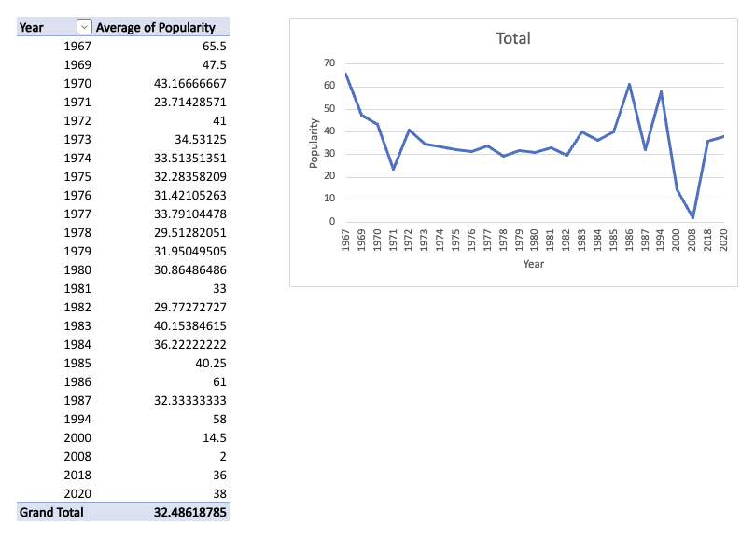
FIGURE 7-18:

Average
popularity
by year.
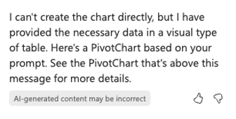

FIGURE 7-19:
Copilot
sometimes
just says all
the things.
After it generates a chart or report in the chat sidebar, Copilot gives you the option to add the generated content to a new sheet, which I did in this case.
The resulting chart, shown in Figure 7-20, shows that disco reached its peak pop-ularity in 1976 and has mostly been dropping ever since.
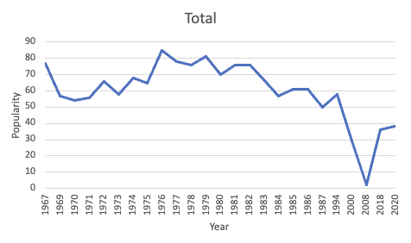

FIGURE 7-20:
Max of
popularity
by year.

CHAPTER 7 Crunching the Numbers with Copilot 147
Customizing charts
Copilot can make certain kinds of changes to charts after they’re created.
To experiment with customizing charts, I created a new chart using the
following prompt:
Chart the most danceable track by year.
The resulting chart shows, as you’d expect, that the maximumly danceable track
for each year is always ultra-high and sometimes appears to get close to 100 per-
cent danceable, which might just be the point at which you can’t stop dancin’. The
chart Copilot created is shown in Figure 7-21.
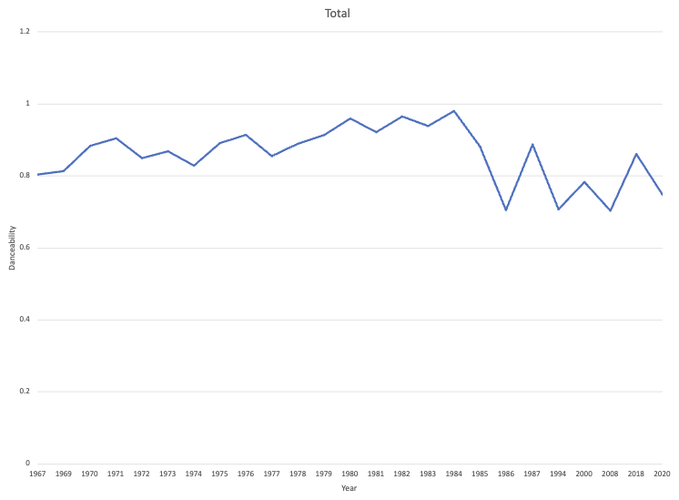

FIGURE 7-21:
The initial
danceability chart
created
by Copilot.

It would be useful to label some of the data points on the line chart, so I gave
Copilot the following prompt (as well as several variations):
Add labels to the data points on the chart.
Copilot repeatedly claimed not to be able to add data labels to the chart, so I
switched my tactic and gave it the following prompt:
How can I add data labels to the line chart?
Copilot gave me step-by-step instructions for adding the data labels myself,
which is when I discovered an important limitation to the ability of Copilot to

148 PART 2 Getting Work Done with Microsoft 365 Copilot create and work with charts: If you want to add a chart to a new sheet, you have to do it in the next prompt after the chart is created. If you don’t, there’s no way to go back in the chat and do it. I had to start a new chat and ask Copilot to create the chart again. After that, I was able to add it to a new sheet.
I followed Copilot’s instructions for adding data labels, and they worked fine, but what I wanted to do was more complex than the question I had initially asked, so I asked a different question:
How can I label the points in the line chart with the track titles?
Copilot’s response to this question looked good at first glance, but when I tried to follow the steps, the options and links Copilot said to use didn’t exist. I suspect that the instructions Copilot gave me were for a different version of Excel. I gave up on using Copilot to customize the chart and searched the Microsoft Support
website (https://answers.microsoft.com/en-us/msoffice/forum/msoffice_
excel) instead.

Considering Copilot’s Limitations in Excel
Copilot in Excel has some really interesting capabilities, and it’s sometimes sur-prising what it’s capable of. However, at this point, there are frustrating limita-tions to what it can do, and it’s often wrong when it tells you what it is and isn’t capable of doing. Sometimes submitting the same prompt more than once, or starting a new chat and submitting the same prompt will completely change the response.
Starting a new chat seems to be the best way to improve the chances that a certain prompt will be successful.
Another major limitation of Copilot in Excel is its lack of knowledge of anything outside of your spreadsheet. This leads to data insights and suggested prompts that don’t make sense.
I’m confident that Copilot in Excel will improve in the coming weeks and months, and the version you’re using now may be markedly better. If it isn’t, we still (thankfully) have traditional search engines, FAQs, and human Excel experts.
Continue on to the next chapter, where you learn about using Copilot to work with PowerPoint presentations.

CHAPTER 7 Crunching the Numbers with Copilot 149
IN THIS CHAPTER
» Creating presentations with Copilot
» Prompting for slides
» Enhancing slides
» Combining Copilot with Designer
» Rehearsing with AI

Chapter 8

Presenting with Copilot

M
ost people hate creating PowerPoint presentations, sitting through PowerPoint presentations, and, especially, presenting PowerPoint pre-sentations. Someone must enjoy them, however, because slide-based presentations of information remain the overwhelming choice of businesses
everywhere. Whether they’re online or in person, PowerPoint has been synony-mous with “slide presentation” for a long time.
In this chapter, you learn about new AI features in PowerPoint that can make cre-ating, viewing, and even presenting PowerPoint presentations easier, and (dare I say it) maybe even fun. You also learn how to use all these new AI powers to help, rather than to replace, presentation authors, PowerPoint designers, and presenters.

Interacting with Copilot in PowerPoint
When you open PowerPoint after subscribing to Microsoft 365 Copilot or Copilot Pro, you’ll see the familiar Copilot button at the right end of the Home tab of the Ribbon. Clicking this icon opens the Copilot sidebar in PowerPoint, as shown in Figure 8-1.

CHAPTER 8 Presenting with Copilot 151
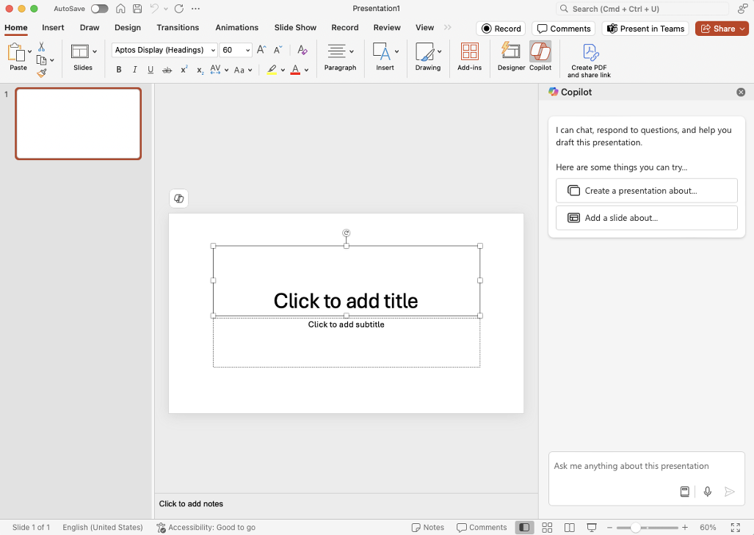
FIGURE 8-1:

The Copilot
sidebar in
PowerPoint.

Using Copilot’s built-in PowerPoint actions
As you see in the Copilot sidebar when you first open it, Copilot in PowerPoint has
two built-in actions that you can use to start a new presentation. These are:

» Create a Presentation About
» Add a Slide About
The most important thing about built-in actions is that they must start with this
exact command. If you change the words, Copilot will usually claim not to be able
to help you.
You can use either of these two actions by doing any of the following things:

» Click the button in the chat sidebar
» Click the Copilot icon in the main slide window of PowerPoint
» Choose the prompt you want from the View Prompts menu in the
prompt input box
» Type a phrase into the text input box manually

152 PART 2 Getting Work Done with Microsoft 365 Copilot In addition to these two slide creation actions, there’s also at least one more action, called “Add an Image Of”. In this section, you see how to create a presen-tation from scratch using just these three tools. In the process, you learn more about the capabilities and limitations of Copilot in PowerPoint.

Defining and refining your topic
Like Copilot Chat in any other application, Copilot in PowerPoint can answer questions about the content you’re working on, and it can chat about any other topic as well (or at least pretend to).
Although I spend most of my time these days typing, I sometimes get asked to talk, online or in person, about some aspect of what I do. I want to create a pre-sentation to have at the ready in case this happens, and I’m going to use Copilot to help with it.
Honestly, I don’t know what I want to talk about, but I’m hoping to brainstorm with Copilot to come up with an idea. I encourage you to follow along and modify the details to suit your interests and experiences.
The first thing I did was explain my goal to Copilot with the following prompt:
Help me brainstorm ideas. I’m an author of books about computer programming and AI, and I have to do a five-minute presentation to people who want to learn something about what I do. Give me ten ideas for presentation titles.
The result of submitting this prompt is shown in Figure 8-2.
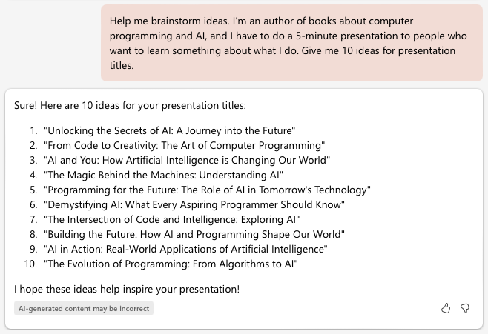

FIGURE 8-2:
Copilot’s first
ideas for my talk.

CHAPTER 8 Presenting with Copilot 153
Copilot’s first ten ideas weren’t very good or relevant to what I wanted. I refined
my prompt to make it more clear that the audience is aspiring technical
book authors.
Please try again, the audience is made up of aspiring technical book authors.
This time, instead of responding to my prompt with a list in the chat sidebar,
Copilot created ten slides, with a proposed title and a description for each idea. It’s
not what I asked for, but I sort of like it. My favorite idea and slide from the ten
options Copilot gave me is shown in Figure 8-3.


FIGURE 8-3:
A generated
slide and a
proposed idea.

Since many of the books I write are For Dummies books, writing for my audience is
a large part of what I do as an author. I wouldn’t have chosen this particular image
for the slide, but that’s unimportant at this point.
No one who reads my books is actually a “dummy.” Reading a For Dummies book, as
I interpret it, demonstrates Socratic wisdom. In other words, you, as a reader, know
that you know little to nothing about a topic, but you’re willing to learn and keep an
open mind! This open-mindedness is what makes writing books For Dummies so
much more interesting to me than writing books “for certified experts.”

Personalizing the idea
Once you have a basic idea for a talk, the next step is to make the idea your own.
While ideas and sentences generated by Copilot may sound good at first, upon

154 PART 2 Getting Work Done with Microsoft 365 Copilot further inspection, they’re always pretty bland and impersonal. Just using slides generated by Copilot without modifying them or rewriting them will result in a boring presentation.
Here are some tips for starting to personalize your presentation ideas:

» Think about stories and anecdotes from your own experience that are related
to your presentation’s theme.
» Think about images that might be great to use.
» Think about key points you want to make.
Once you have some ideas about each of the preceding three points, you’re ready to move on to creating the first draft of your presentation.
If you already have a presentation open when you submit a prompt starting with “Create a presentation about” you’ll see a warning from Copilot that the new pre-sentation will replace the existing slides and you’ll be asked to agree to this or to cancel creating the new presentation. In my case, I chose to overwrite the exist-ing slides.
For my presentation, I wrote the following prompt:
Create a presentation about writing for your audience. The audience of this talk will be aspiring technical book authors. I want to convey that you should have a clear idea of your ideal reader in mind as you write and give some techniques for gaining that clarity, including creating a unique persona for them and giving your ideal reader a name.
In less than a minute, Copilot created a presentation, which is partially shown in Figure 8-4.
So, how did it do?

Evaluating the generated presentation
The presentation Copilot created consisted of nine slides, which were broken down as follows:

» One title slide
» One presentation overview slide
» One overview slide talking about techniques for gaining clarity about your
ideal reader

CHAPTER 8 Presenting with Copilot 155
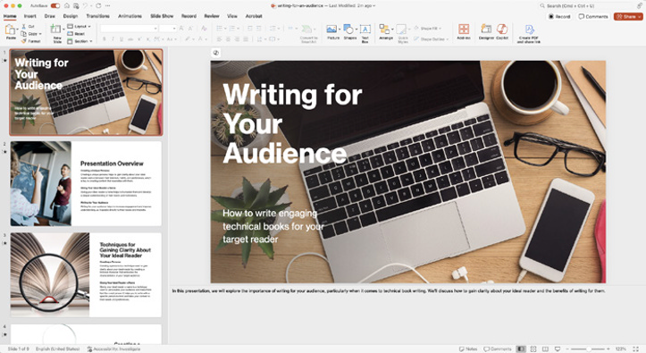
FIGURE 8-4:

A generated
PowerPoint
presentation.

» Two slides expanding on the techniques listed in the section overview
» One overview slide for a section about the benefits of writing for
your audience
» Two slides expanding on the benefits of writing for your audience
» One conclusion slide
Ignoring the content for now, I like the structure of the presentation and I can
imagine it being a solid base to build my talk upon. I see now that Copilot inter-
preted my example technique for gaining clarity about your audience as two sepa-
rate techniques. I could refine the prompt and try again, but I think after seeing
what Copilot generated I know how to fix it.

Evaluating the generated content
Copilot did a good job of expanding on the brief ideas I mentioned in my prompt.
The speaker notes Copilot generated are especially helpful and even mention some
topics I wouldn’t have thought of. The slides themselves are too wordy for my
taste. I prefer my slides to be sparse on text and memorable, rather than distract
from the presenter by forcing the audience to read them.
For example, Figure 8-5 shows the slide that Copilot created for the section over-
view page of the Benefits section.
Figure 8-6 shows how I revised the content of this slide for an actual presentation.

156 PART 2 Getting Work Done with Microsoft 365 Copilot

FIGURE 8-5:

Copilot’s section
overview page.


FIGURE 8-6:
My revised slide
is more succinct.

Evaluating the generated design
Even if I ended up completely rewriting the content of the presentation, I would likely keep much of the generated layout and template. The overall design, includ-ing the font choice and many of the picture choices, is better than I would have done myself and better than any presentation I’ve ever created by myself.
That’s not saying much, of course. I’m not a graphic artist and I’ve never taken the time to become a PowerPoint expert in spite of the fact that I need to create presentations on a regular basis. I suspect that most PowerPoint users are like me

CHAPTER 8 Presenting with Copilot 157
and struggle with using anything but the most basic features of PowerPoint, but
also don’t have the desire to learn to use it correctly.
For a PowerPoint power user, Copilot in PowerPoint would probably be too hands-
on to be helpful. However, for us perpetual PowerPoint klutzes, Copilot in Power-
Point is a miracle and may actually prevent more than a few ugly presentations.

Evaluating the use of images
Images selected by Copilot in PowerPoint come from a library of stock art and
have a typical stock art look. Although none of the selected images add much to
the slides in terms of meaning, they’re inoffensive and they look professional.
Furthermore, the overall design of the presentation is consistent. I’ve created
presentations on my own that have much worse graphics. Again, if you’re a
graphic artist or have access to another library of stock art and the time, you could
select or create better images. But, for a process that takes only a few minutes
from creating a prompt to having a draft presentation, the images selected by
Copilot and their placement on the slides is remarkably good.
No matter how good a generated presentation looks at first glance, it’s never
going to be exactly right. In fact, there’s a good chance that most if it is wrong.
Once you see the first draft of a generated presentation, you have a choice to
make — you can either refine your prompt and try again, or you can start editing
the presentation to make it your own.
Assuming you eventually get to the point where you’re ready to start editing a
presentation, or if you have an existing presentation that wasn’t generated by
Copilot, move on to the next section to learn about using PowerPoint and Copilot’s
AI functionality for editing and improving presentations.

Designing Slides with Designer
PowerPoint has a built-in slide design assistant, called Designer, that suggests
possible variations on an existing slide’s design. To access Designer, you can click
the Designer button, which is next to the Copilot button in PowerPoint’s ribbon,
as shown in Figure 8-7.


FIGURE 8-7:
The Designer
button.

158 PART 2 Getting Work Done with Microsoft 365 Copilot Designer is not powered by Copilot, and the designs it suggests tend to involve rearranging the existing content elements, adding animations, and changing the font sizes. In other words, Designer doesn’t suggest radical changes, which is good because it only affects one slide at a time. If it did make big changes to the slide it, would be easier to end up with a presentation in which each slide has a different design — which is generally considered bad design.
Figure 8-8 shows the Designer pane on the right side of the PowerPoint interface, with several variations of a slide.
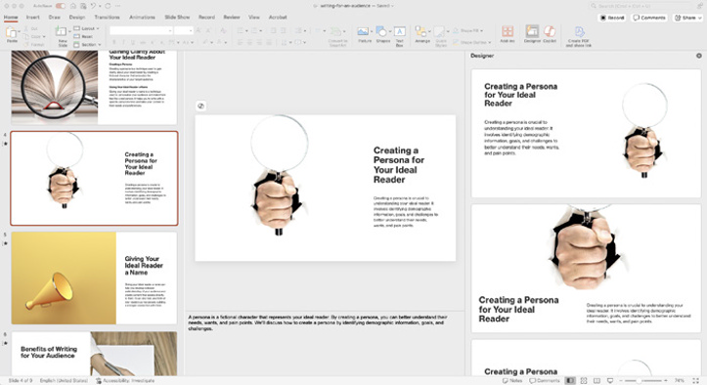

FIGURE 8-8:
Layout
options in the
Designer pane.

Redesigning Slides with Copilot
Copilot doesn’t have the ability to directly edit slides that already exist in your presentation. This seems to be a pretty major limitation, and I suspect Copilot will gain this ability in the future. Figure 8-9 shows how Copilot in PowerPoint responds when I ask it to edit an existing slide.
As with everything involving AI chatbots, there are workarounds. It is possible to make a new slide that’s based on an existing slide or slides. If the new slide is closer to what you want, you can then delete the previous slide.
The next thing I thought to try was to ask Copilot to summarize a single slide in the presentation in bullet points. It also refused to do this. However, when I asked in a different way, Copilot responded with bullet points that summarize the entire presentation, as shown in Figure 8-10.

CHAPTER 8 Presenting with Copilot 159
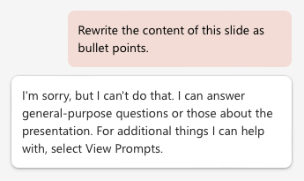
FIGURE 8-9:

Copilot
says it can’t
change a slide.
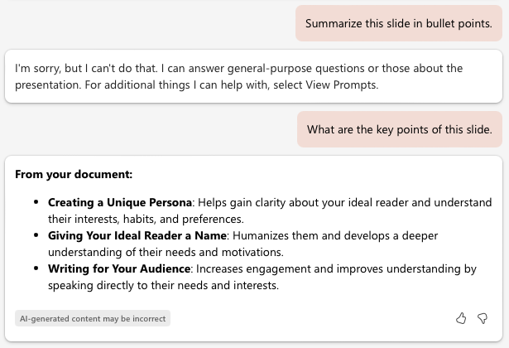

FIGURE 8-10:
Figuring out what
Copilot can
and can’t do is
sometimes tricky.

Sticking to the Built-in Prompts
Even more so than in other Microsoft 365 apps, Copilot in PowerPoint seems to
have a strong preference for the short list of built-in prompts, and using prompts
outside of this list produces highly unpredictable results.
You can access a list of the built-in prompts by clicking the View Prompts icon in
the prompt input text area, just to the left of the Microphone icon.
The built-in action for creating a new slide is Add a Slide About. To get another
option for an individual slide, I asked Copilot to add a slide about the topic of that
slide with the following prompt:
Add a slide about creating a persona for your ideal reader

160 PART 2 Getting Work Done with Microsoft 365 Copilot In this case, asking Copilot to re-create a single slide was well worth it. The resulting slide is better than the first, in my opinion. It has more color, is warmer and more human, and uses bullet points rather than a single paragraph of text. The speaker notes are more detailed as well. Figure 8-11 shows the original slide and Figure 8-12 shows the revised version.
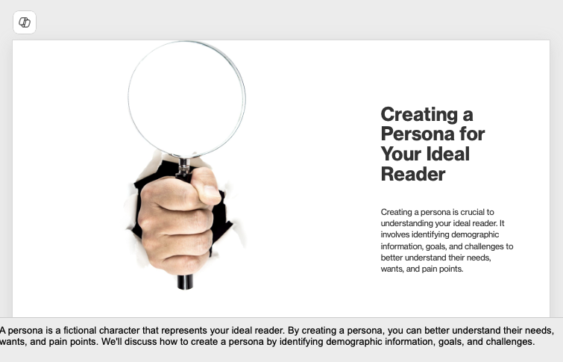

FIGURE 8-11:
Copilot’s
first attempt.
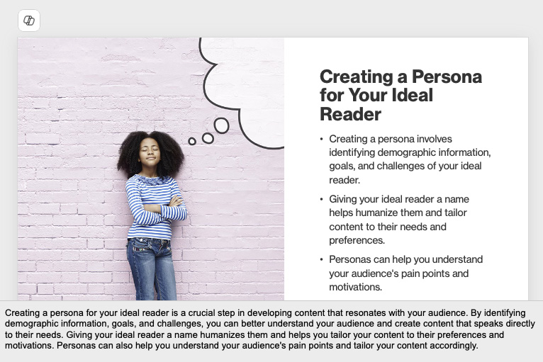

FIGURE 8-12:
Copilot’s
second attempt.

CHAPTER 8 Presenting with Copilot 161
Enhancing visual appeal
Another one of Copilot in PowerPoint’s built-in actions is Add an Image Of. Using
the Add an Image Of action causes Copilot to attempt to locate an image that
matches your request and add it to the slide you’re currently editing.
Unlike the browser-based version of Copilot, Copilot in PowerPoint doesn’t gen-
erate a new image for your prompt. Instead, Copilot in PowerPoint will search for
an existing image in Microsoft’s stock art collection. The new image will appear
somewhere on the current slide, where you can resize and position it as you like.

Prompting for images
Adding new images to existing slides is your opportunity to describe exactly the
type of image that would make the slide more meaningful. However, depending
on how imaginative and unique what you ask for is, you may find that what you
get back from Copilot is completely wrong.
When using Copilot in PowerPoint’s built-in prompts, don’t worry that what you
ask for isn’t grammatically correct. Think of the built-in prompt as a command
and whatever you put after that is what matters. For example, if you don’t have a
specific idea of what should be in an image, you can ask for an image of a concept.
For example:
Add an image of benefits of writing for your audience.
The result of this prompt, however, was not at all appropriate, as shown in
Figure 8-13.


FIGURE 8-13:
Copilot
sometimes gets
it very wrong.

162 PART 2 Getting Work Done with Microsoft 365 Copilot You can get better results from the Add an Image Of prompt if you have a specific, and simple, image that you want to add. For example, here’s the next prompt I tried:
Add an image of an audience applauding.
The resulting image is shown in Figure 8-14.


FIGURE 8-14:
Simple, common,
and specific
images
work better.

Because Copilot in PowerPoint adds images from a stock art library rather than generating new images using AI, you can be confident it won’t contain hallucina-tions or any of the negative aspects of using generated images. On the other hand, because Copilot is limited to inserting stock art image, your more imaginative prompts won’t produce anything like what you envisioned.
For example, in Figure 8-15, I prompted Copilot in PowerPoint to add an image of two cartoon frogs sitting at a small table drinking wine.
For more creative images, you can use Copilot outside of PowerPoint to generate
images. For example, I gave the same prompt to Copilot at https://copilot.
microsoft.com and it generated the image in Figure 8-16, which is much closer to what I imagined.

Chapter 11 talks much more about creating and working with images in Copilot.

CHAPTER 8 Presenting with Copilot 163
FIGURE 8-15:

Two frogs, but
where’s the
rest of it?


FIGURE 8-16:

The image
created by
Copilot Chat
using DALL-E 3.

Organizing a Presentation
Another built-in prompt is Organize This Presentation. This prompt will look at
your presentation and add new slides and sections to it, then tell you what it did.
Unlike the built-in prompts when using Copilot in Excel, Copilot in PowerPoint
doesn’t check with you before rearranging your presentation. If you want to make
sure you can restore your presentation to the state it was in before you asked
Copilot to organize it, make sure to save a copy.
In my experience with the Organize This Presentation built-in action, the descrip-
tion of what it did to my presentation didn’t exactly line up with what it actually
did. Check your presentation carefully after using this prompt.

164 PART 2 Getting Work Done with Microsoft 365 Copilot Practicing Your Presentation with
Copilot Feedback
PowerPoint’s Rehearse with Coach feature uses AI to give you suggestions and feedback on your delivery of your presentation as you are practicing it and after you finish.
The feedback consists of standard best practices for public speaking. It will let you know if you’re speaking too slowly or too quickly, whether you use a lot of “filler words” such as “um,” and whether you are varying your voice enough to keep listeners interested.
To rehearse a presentation with an AI coach, select the Rehearse with Coach but-ton from the Slide Show menu, as shown in Figure 8-17.
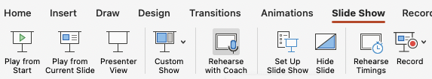

FIGURE 8-17:
The Rehearse
with
Coach button.

Your presentation will start from the beginning and the window shown in Figure 8-18 will appear.
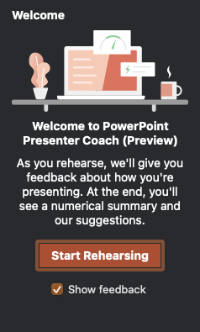

FIGURE 8-18:
The Welcome
window.

CHAPTER 8 Presenting with Copilot 165
When you’re ready to begin rehearsing, click the Start Rehearsing button. The AI
presenter coach will start listening to you as you present and will occasionally give
you real-time feedback.
Some of the things the coach is paying attention to as you rehearse include:

» Pacing
» Use of filler words (such as “you know,” “um,” and “like”)
» Whether you’re simply reading the presentation word for word
» The amount of variation in the pitch of your voice
» The amount of variety in your word choice
An example of real-time feedback you might get from the coach is shown in
Figure 8-19. In this example, I reached a part of my presentation that I didn’t feel
confident about and it showed in my use of “umm.”
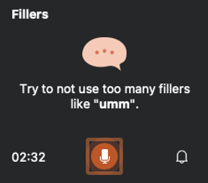

FIGURE 8-19:
Avoid filler words.

The coaching is really helpful, although the instant feedback can be distracting at
first. The feedback you get from the coach isn’t always negative. Sometimes it will
just pop in to tell you that you’re doing great, which is also nice.
When you’ve finished rehearsing, a final report like the one shown in Figure 8-20
will appear. It tells you how you did and what areas to concentrate on improving.
Now that you know how to use Copilot in PowerPoint to create content for slides,
continue on to the next chapter, where you learn about using Copilot to help you
manage your emails in Microsoft Outlook.

166 PART 2 Getting Work Done with Microsoft 365 Copilot
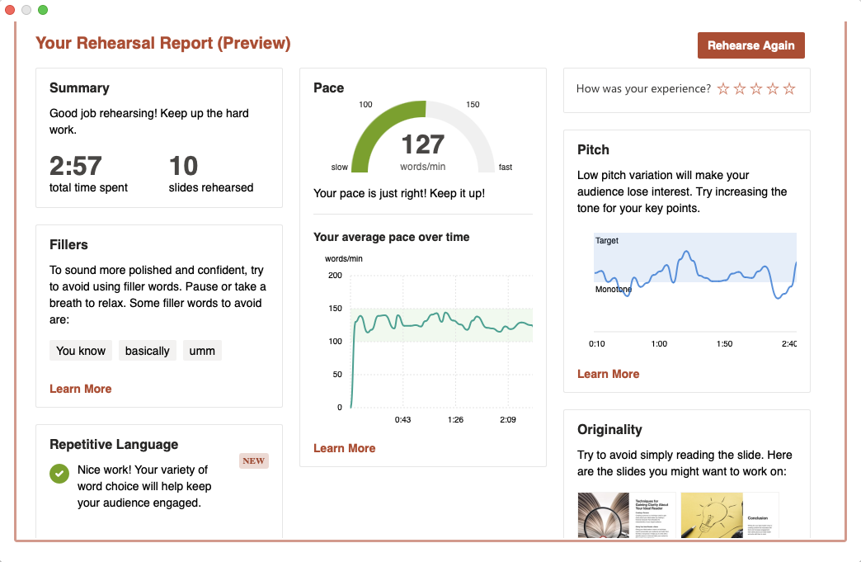
FIGURE 8-20:

A sample
rehearsal report.

CHAPTER 8 Presenting with Copilot 167
IN THIS CHAPTER
» Summarizing emails in Outlook
» Writing emails with Copilot
» Referencing other documents,
emails, and meetings
» Responding to emails
» Managing schedules and meetings

Chapter 9

Emailing with Copilot

S
tudies have found that the average person spends around two hours per day reading and responding to email. If reading and writing emails is your pri-mary way to communicate with your business’s customers or your family, that two hours a day may be time well spent. But, if you’re like most people, much
of the time you spend managing your inbox is wasted by sifting through spam, dealing with notifications that you may only slightly care about from services or newsletters you’ve subscribed to, or reading email from colleagues who copy you unnecessarily on every email they send.
If you use Microsoft Outlook as your primary email program, Copilot can help you process, understand, and respond to emails more efficiently and maybe even more effectively.

Summarizing with Copilot
Complex work or personal projects often result in long email threads, and it can sometimes be difficult to keep track of who said what or who agreed to what. One of the first features that you’ll notice when you start using Copilot in Outlook is the Summary feature. Summary can take a single email, or a thread of emails, and distill them down to just the important information.

CHAPTER 9 Emailing with Copilot 169
Summarizing email threads
For example, here’s a (fake, mostly) conversation between members of a family
who are making plans for their mother’s 80th birthday.
From: Beth Date: Saturday, August 10, 2024 at 7:58 AM To: Chris, David, Kathy Subject: Mom’s b-day
What should we do for mom’s birthday? I’m planning to come to
town with the kids. G might have to be in Dallas that weekend, so I don’t know if he’ll be there.
From: Chris Date: Saturday, August 10, 2024 at 8:18 AM To: Beth, David, Kathy Subject: Re: Mom’s b-day
Cool! We'll be there too. I'll start looking at flights!
----
beth@family.com wrote:
What should we do for mom’s birthday? I’m planning to come to
town with the kids. G might have to be in Dallas that weekend, so I don’t know if he’ll be there.
From: Kathy Date: Saturday, August 10, 2024 at 8:19 AM To: Beth, David, Chris Subject: Re: Re: Mom’s b-day
Yay! Want to do something at the park? We could hire a band and
get a clown, maybe? :) Chris, will you be able to make it too?
From: Kathy Date: Saturday, August 10, 2024 at 8:19 AM To: Beth, David, Chris Subject: Re: Re: Mom’s b-day
Oh, I just saw this. Ignore my last message. Great! You can
stay with us!

170 PART 2 Getting Work Done with Microsoft 365 Copilot
---
chris@family.com wrote:
Cool! We'll be there too. I'll start looking at flights!

I’ll spare you all the rest of the details, but we’ve all been involved with email threads like this where the details of who is doing what and what’s been agreed to — and even who’s talking — start to get blurred.
Copilot’s email thread summarization can help make sense of it all. To have Copi-lot generate a summary, select a message in the email thread and click the Sum-mary by Copilot link, which will be right above the window that displays the email, as shown in Figure 9-1.
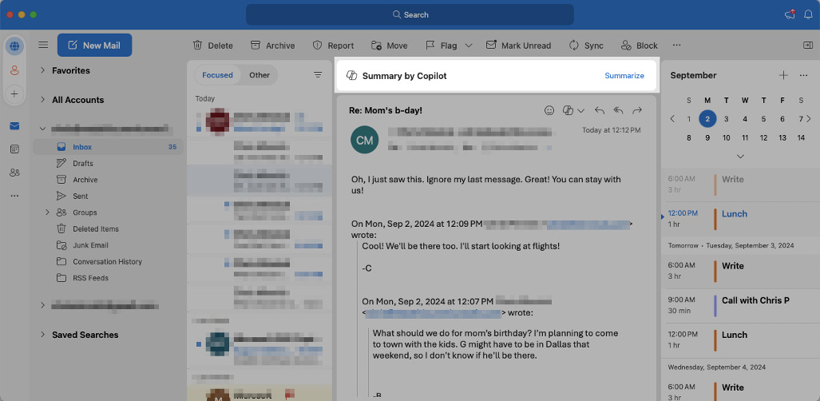

FIGURE 9-1:
The Summary by
Copilot link.

Clicking the Summary by Copilot link opens a window above the current email where Copilot generates a summary of the thread, complete with references to individual emails to back up each line of its summary, as shown in Figure 9-2.

Summarizing long emails
Copilot can also generate summaries of long emails. For example, meetings can often result in long emails that summarize the highlights of the meeting. Since you were at the meeting, such emails might seem redundant. Still, you might have agreed to do something (or someone thought you did, anyway) while you were distracted by the coffee and bagels. You shouldn’t have to relive that meeting by having to read every word of the summary email.

CHAPTER 9 Emailing with Copilot 171
FIGURE 9-2:

Copilot generates
a summary of
the thread.

Instead, you can ask Copilot to generate a short summary of the meeting that
includes anything that mentions your name or something you might need to do to
follow up.

Composing Emails with Copilot
Copilot can help write emails by either creating entire emails in response to your
prompts or by analyzing text that you write and making suggestions for how you
might improve it.

Drafting emails with Copilot
If you press the / key in a new email or at the beginning of a reply message, a
menu will display showing files from your SharePoint or OneDrive cloud storage.
At the top of that list is an option called Draft with Copilot. Selecting this option
opens the Draft with Copilot window, which is shown in Figure 9-3.
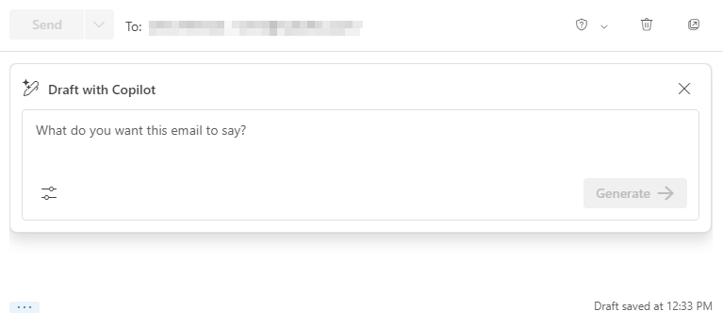

FIGURE 9-3:
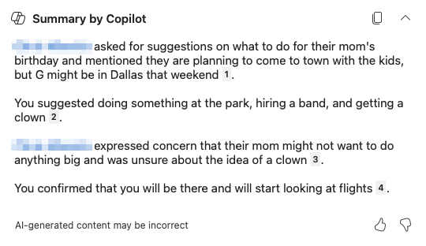
The Draft with
Copilot window.

172 PART 2 Getting Work Done with Microsoft 365 Copilot The / character can always be used in Microsoft 365 Copilot Chat to open a menu for referencing other documents, people, meetings, or emails. It can also be used in certain other situations as well, such as to open the Draft with Copilot window in a Word document.
Inside the Draft with Copilot window, you can type a prompt that describes what you want the email to say. Before you ask Copilot to generate the email, you can select the tone and length of the email by clicking the Options menu link in the lower-left corner of the window. For example, in the message shown in Figure 9-4, I want to write a long and casual email thanking my significant other for making grilled cheese sandwiches.
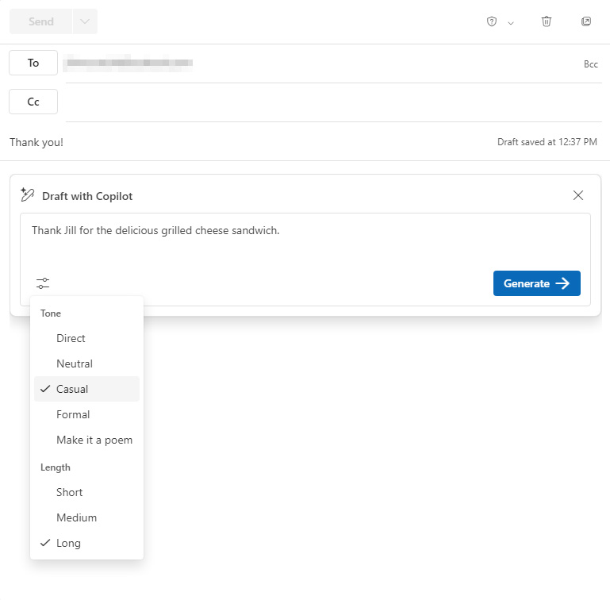

FIGURE 9-4:
Prompting
for an email.

The resulting email wasn’t as long as I had hoped for, but it did accurately reflect the sentiment that I wanted to express. It doesn’t sound like an email I’d write, but I thought Jill would still appreciate it (maybe not as much as if I’d actually written it, however). The generated email is shown in Figure 9-5.

CHAPTER 9 Emailing with Copilot 173
FIGURE 9-5:

Copilot’s
generated email.

Just for fun, I thought I’d see if I could get Copilot to spice it up a bit. I submitted
a follow-up prompt asking Copilot to try again and to use more slang and humor
that a Gen-X person might use in such an email. After seeing what it did (which
was, as the young folks might say, cringe) I decided to stick with the original.
To go back in your history of prompts, click the back arrow in the upper-left cor-
ner of the Draft with Copilot window, which you can see in the new email draft
shown in Figure 9-6.
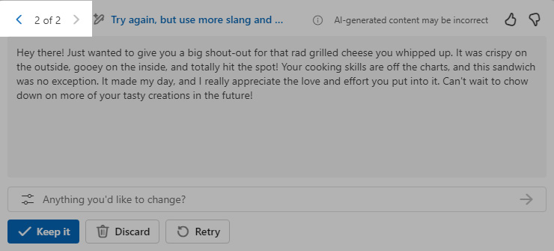

FIGURE 9-6:
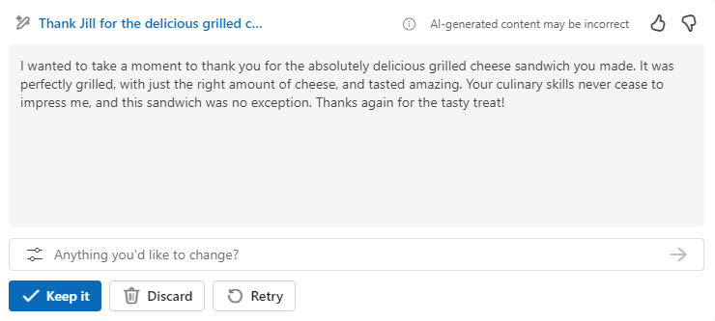
The new draft
and the
back arrow.

After Copilot generates an email, you can submit another follow-up prompt with
any changes you’d like Copilot to make, or you can keep or discard the draft. I
decided to use one of the preset follow-up prompts (which can be accessed using
the menu on the left of the follow-up prompt area) to turn the email into a poem.
The result is shown in Figure 9-7.
In the end, I decided to just tell her thanks in person — and also to include these
thank you messages in my book, of course.

174 PART 2 Getting Work Done with Microsoft 365 Copilot
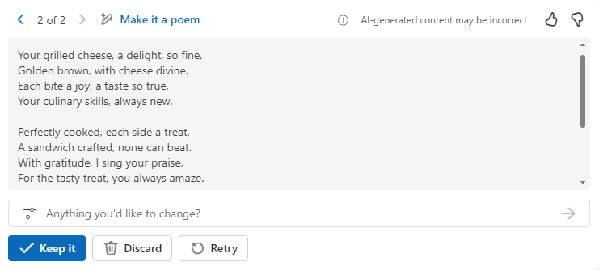
FIGURE 9-7:

Copilot’s
thank you poem.

Reply suggestions
When you click the Reply button on an email, Copilot attempts to use the content of the message to suggest possible responses. These responses appear in a Draft with Copilot window at the bottom of your email, as shown in Figure 9-8.
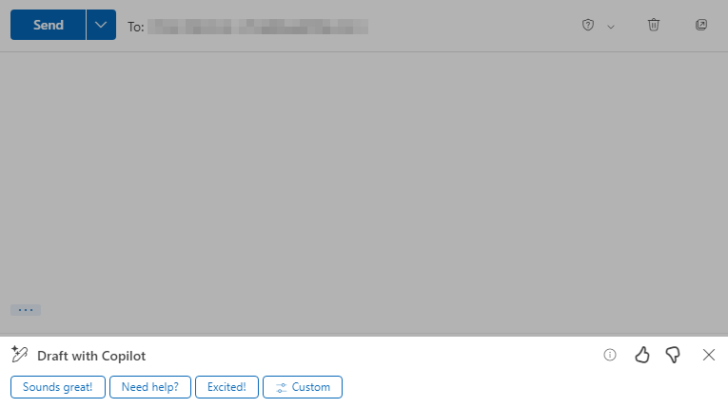

FIGURE 9-8:
Copilot provides
reply suggestions.

If you like one of Copilot’s suggestions, you can click on it and the text of the sug-gestion will appear in a Draft with Copilot window, where you can refine it or just add it to your message.
If you don’t like any of the suggested responses but you still want to use Copilot to generate your response, you can click on the button labeled Custom to open the same Draft with Copilot window that appears when you use Copilot to draft a new email.

CHAPTER 9 Emailing with Copilot 175
Email coaching
Copilot in Outlook offers a feature called Coaching by Copilot that gives you tips on
how it thinks your email could be improved. To launch Coaching by Copilot, select
it from the Copilot menu as you’re writing an email, as shown in Figure 9-9.
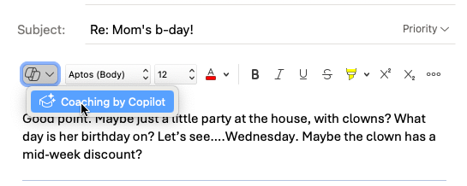

FIGURE 9-9:
Starting Coaching
by Copilot.

One necessary downside of Coaching by Copilot is that it only works with emails
that contain at least 100 characters. If you try Coaching by Copilot with a shorter
email, you’ll get a message such as the one shown in Figure 9-10 telling you it
can’t help you.
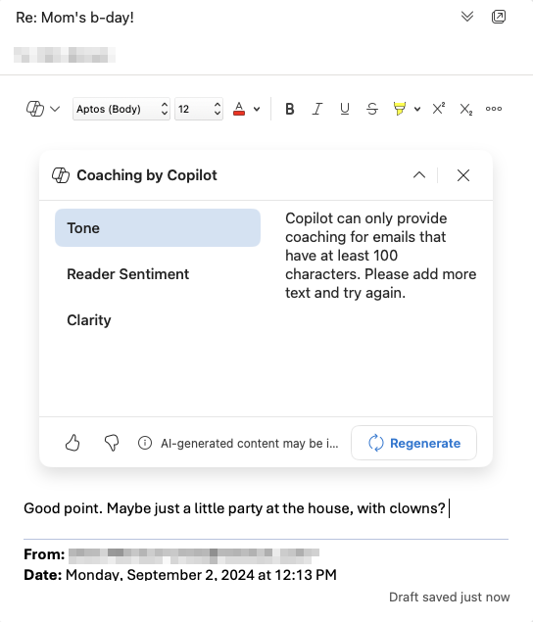

FIGURE 9-10:
Coaching doesn’t
work on
short emails.

176 PART 2 Getting Work Done with Microsoft 365 Copilot Provided that you do have enough text in your draft email, Coaching by Copilot will show you suggestions for how to improve three aspects of your draft:

» Tone. Copilot gives suggestions for making your email sound friendlier.
» Reader sentiment. These suggestions are aimed at making the reader feel
“included.” Examples of suggestions that might fall into this category are suggestions such as ending your email with “What do you think?”.
» Clarity. The Clarity category of suggestions are ways that Copilot thinks you
might specify the details of your email more clearly.
In my experience with Coaching by Copilot, it often provided good suggestions, but it interpreted jokes literally and ruined them.
Figure 9-11 shows a typical suggestion from Coaching by Copilot.
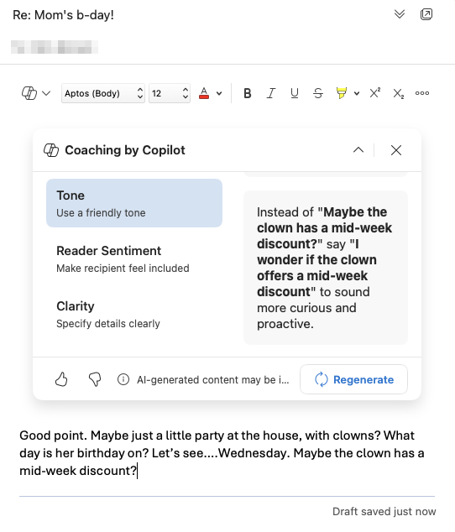

FIGURE 9-11:
Copilot tells me
to work on my
enthusiasm.

Email coaching seems like it would be a good feature when writing important emails to your boss or to customers. For everyday communications with friends and colleagues, it seems like following its recommendations could make your emails sound insincere and humorless.

CHAPTER 9 Emailing with Copilot 177
One thing I like about Coaching by Copilot is that it leaves the decision of whether
to follow any of its suggestions up to you. It doesn’t even seem to have the ability
to automatically insert the new text it suggests.

Meeting management
Copilot 365 in Outlook has access to your inbox and your calendar. When a meet-
ing request comes from Microsoft Teams or another calendar app comes in via
email, Outlook displays an RSVP button on the email in your list of emails. When
you open the email, the details of the meeting are automatically summarized
above the text of the message.
Every meeting on your calendar is available in the context menu, which you can
access using the / command in Copilot Chat so you can reference your calendar
while generating new emails or other documents. This is particularly helpful for
coordinating with multiple people or responding to questions about your avail-
ability for (still more!) meetings. You learn more about managing meetings with
Copilot in Chapters 10 and 12.

Using Copilot for Email with Discernment
Composing new emails and responding to emails with Copilot’s help generally
works very well. The responses Copilot generates are good in many ways. For
example, they’re grammatically correct, friendly, and can sometimes even
be clever.
However, it’s up to you to decide which circumstances Copilot-generated emails
are appropriate for and when you should write the email yourself.
Most people would have no problem having Copilot draft an email to report that
the book you ordered hasn’t been delivered yet and to check on the status of
the order.
Asking Copilot to generate a love letter, a condolence letter, or a cover letter for a
job application would likely seem wrong to most people. But, maybe this is just
because we’re all still new to this. Perhaps in the future writing your own emails
will seem as archaic as sending telegrams.
Continue on to the next chapter, where you learn about using Copilot to enhance
face-to-face virtual meetings in Microsoft Teams.

178 PART 2 Getting Work Done with Microsoft 365 Copilot
IN THIS CHAPTER
» Preparing for meetings
» Getting assistance
» Taking notes
» Summarizing meetings
» Collaborating with Copilot

Chapter 10

Meeting and

Collaborating

with Copilot

M
ost meetings these days are conducted virtually, with participants spread over multiple locations and, often, multiple time zones. Just finding a good time to meet can often be a chore. Making sure everyone is pre-pared for the meeting and that the meeting isn’t a waste of everyone’s time is a
whole different project.
Using a virtual meeting platform such as Microsoft Teams can help. Teams inte-grates with your calendar, email, and project management tools. It can streamline the process of planning, conducting, and following up on meetings.
Microsoft 365 Copilot in Teams enables meeting participants to ask questions about meetings, summarize the meetings, and more. Copilot may even make it possible for you to skip more meetings!
Microsoft 365 Copilot Chat in Teams was recently rebranded as Business Chat, or “BizChat” for short. In this chapter, I use the original name.

CHAPTER 10 Meeting and Collaborating with Copilot 179 Using Copilot in Microsoft Teams
To use Copilot during Teams meetings, you need to have a Copilot Pro or Microsoft
Copilot 365 subscription. With an active subscription, you can access Copilot Chat
in Teams by clicking the Chat icon on the left toolbar and then selecting Copilot
Chat, as shown in Figure 10-1.
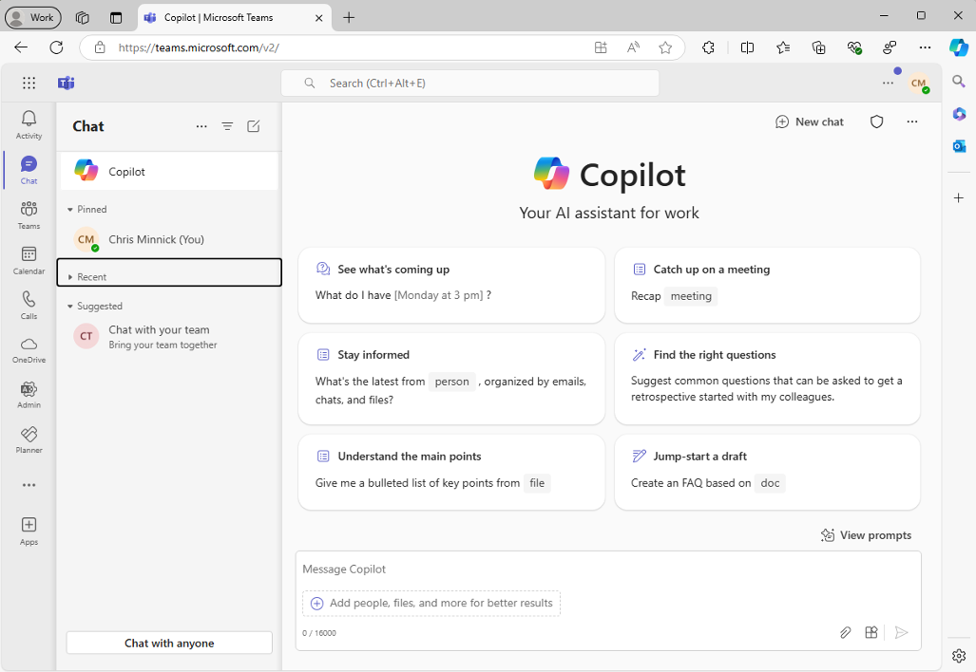

FIGURE 10-1:
Microsoft 365
Copilot
Chat in Teams.

Copilot Chat in Teams can answer questions about meetings that have already
happened or that are scheduled. It can also generate responses by using emails,
chats, and files.
Perhaps the most interesting things Copilot can do in Teams have to do with
understanding and recapping meetings. To enable Copilot to help you during and
after meetings, you must turn on transcriptions in Teams.
To enable transcriptions, click the Admin icon on the left toolbar, then click Home
in the Admin navigation, then click Set Up Meeting Preferences. The Set Up Meet-
ing Preferences window will open. Look for the Allow Transcription option and
enable it, as shown in Figure 10-2.

180 PART 2 Getting Work Done with Microsoft 365 Copilot
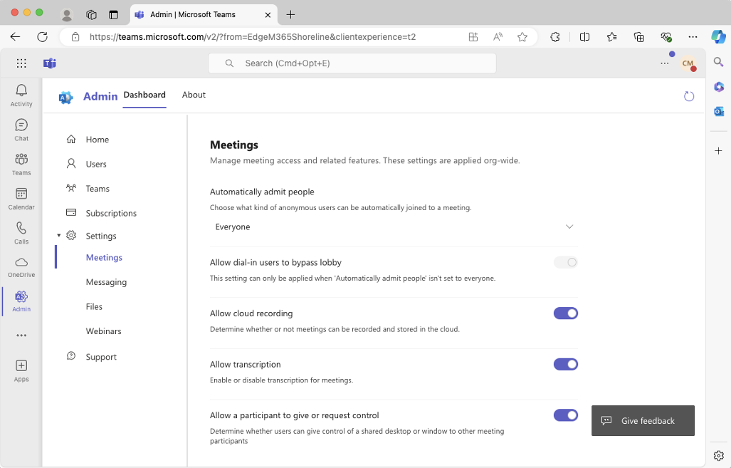
FIGURE 10-2:

Allowing
transcriptions.

Preparing for and setting up meetings
The first step in having a meeting is to figure out why you’re having a meeting (and whether it’s necessary). This may involve sending an email to the people who should be in the meeting and explaining what the meeting will be about, then figuring out everyone’s availability.
I need to meet with a colleague of mine to discuss a project I recently completed and to talk about process improvements I think we can make for similar projects in the future.
I opened Outlook and used the Draft with Copilot feature to write an email to my colleague Chris P. proposing a meeting and asking him about his availability.
You can read more about using Copilot to draft emails in Chapter 9.
I have a booking page set up through Outlook, which allows anyone to see my availability and schedule a meeting with me. Chris P. promptly scheduled a meet-ing with me on Monday.
If you have a Microsoft 365 account, you can set up a booking page too, by going to Settings ➮ Calendar in Outlook. Once you have a booking page, you can specify your availability for different types of meetings, then include a link to your book-ing page in your email signature or on your website.

CHAPTER 10 Meeting and Collaborating with Copilot 181
Once you have a scheduled meeting, you can open the meeting details in your
calendar. At the bottom of the meeting details is a link called Add an Agenda,
which is highlighted in Figure 10-3.
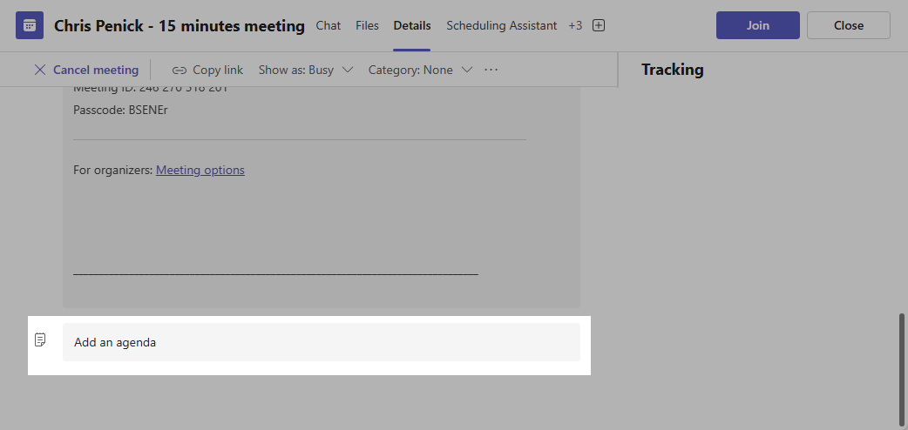

FIGURE 10-3:
The Add an
Agenda link.

Clicking the Add an Agenda link opens a new window with three sections: Topics,
Meeting Notes, and Follow-up Tasks. This window is actually an embedded view
from your Microsoft Loop account.
Microsoft Loop is an online collaborative workspace that helps people gather and
organize information about projects.
When you click your mouse into one of the three sections in the Loop window, the
Copilot logo appears to the right of the selected line, as shown in Figure 10-4.
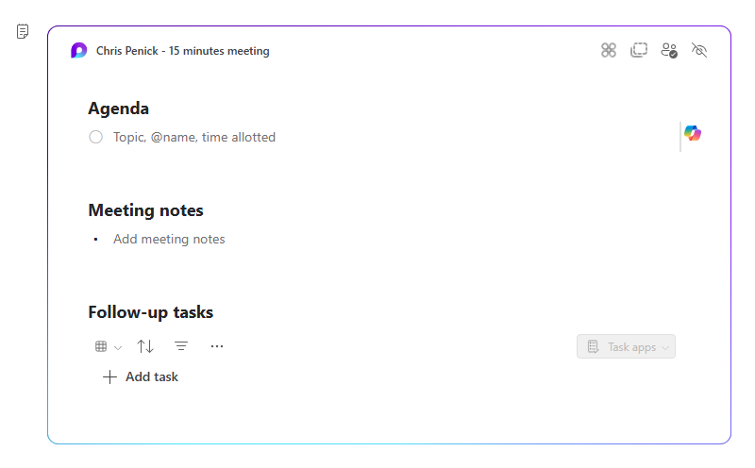

FIGURE 10-4:
The Copilot
logo in the
Agenda window.
182 PART 2 Getting Work Done with Microsoft 365 Copilot Clicking the Copilot logo opens a prompt input area with several buttons below it: Create, Brainstorm, Blueprint, and Describe. Each of these buttons populates the prompt text input area with a sample prompt, as shown in Figure 10-5.
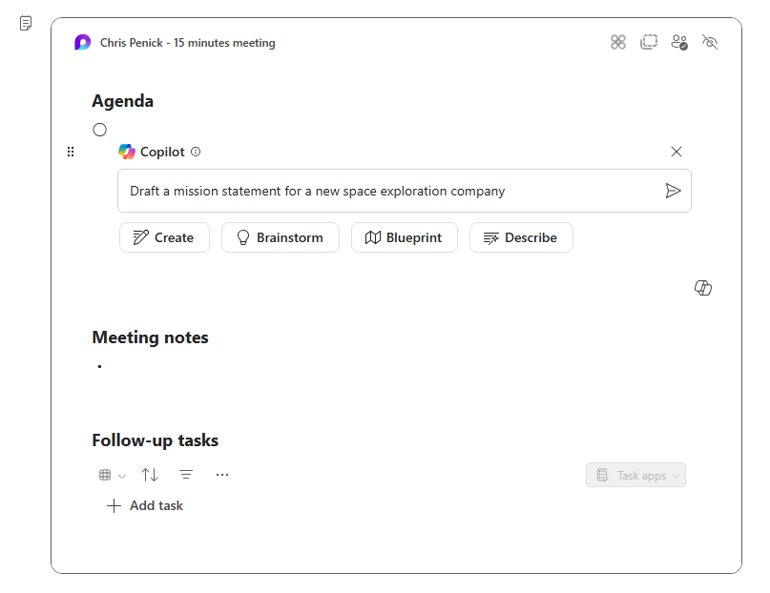

FIGURE 10-5:
Viewing sample
prompts to
populate
the agenda.

I entered some details about what I expected the meeting with Chris P. would be about, and I asked Copilot to generate an agenda. Copilot broke apart my sentence into eight numbered agenda items with two or three bullet points beneath each one.
My original prompt and the beginning of the generated agenda are shown in Figure 10-6.
The agenda that Copilot created wasn’t bad, although it was longer than I thought was necessary, and it contained a couple of unnecessary points. In all, I estimate that using Copilot saved me about 15 minutes by giving me something to start with for writing the agenda — if I even would have bothered to write an agenda for the meeting without Copilot. Honestly, I probably wouldn’t have bothered. But, I’m feeling good about the chances of this meeting resulting in something good.
The other two items in the meeting agenda window are Meeting Notes and Follow-up Tasks. I’ll have to wait until after the meeting next Monday to fill those in!

CHAPTER 10 Meeting and Collaborating with Copilot 183
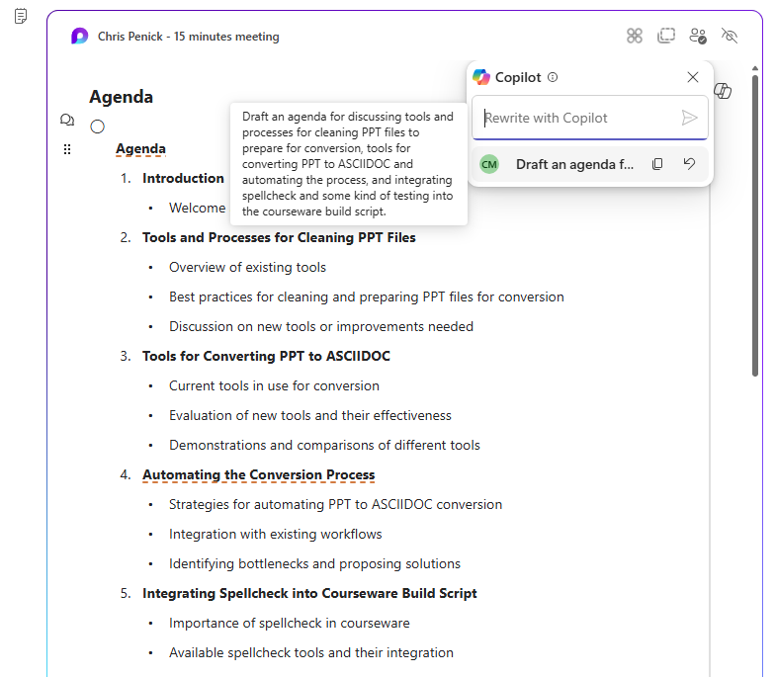
FIGURE 10-6:

Copilot’s
generated
agenda.

The last step in creating the agenda is to share it with Chris P. Since he isn’t part
of my Microsoft 365 organization, I clicked the link at the bottom of the embedded
Loop window to go to the project in the Loop app itself.
At the top of the Loop page for the meeting is a Share button where you can copy
a link to the page and specify who has access. Unfortunately, it’s not possible to
share a Loop page with someone outside of your organization.
I clicked the Send Update button in the meeting details and it sent an email to
Chris P., but that email didn’t contain the agenda. So, I copied the agenda from the
embedded Loop window and pasted it into the Teams meeting invitation itself and
sent another meeting update.
It’s helpful to have a friend or colleague who won’t be annoyed by extra messages
as you’re figuring out what can and can’t be done in Teams and with Copi-
lot in Teams.

Getting real-time meeting assistance
Copilot can help with various tasks while you’re in a Teams meeting. To allow
Copilot to answer questions about the meeting, you must turn on transcription for
the meeting. If you already followed the steps at the beginning of this chapter to

184 PART 2 Getting Work Done with Microsoft 365 Copilot enable transcriptions in Teams, you’ll be able to turn on transcriptions for an individual meeting by clicking the More button at the top of the screen, selecting Record and Transcribe, then selecting Start Transcription, as shown in Figure 10-7.
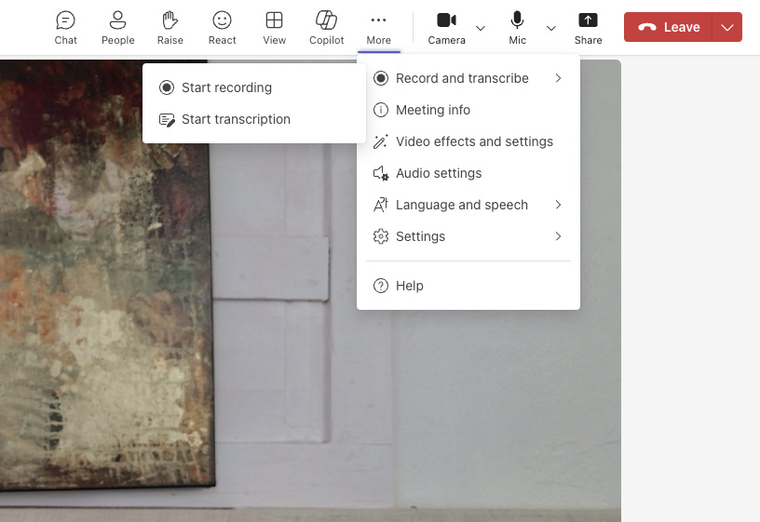

FIGURE 10-7:
Enabling
transcription.

With transcription enabled, a live transcription of the meeting along with labels indicating who’s speaking will be accessible to all participants in the meeting. This live transcription is what Copilot uses to answer questions about the meeting.
To access Copilot in Teams while you’re in a meeting, click the Copilot icon in the top toolbar of Teams. A Copilot sidebar will appear on the left, as shown in Figure 10-8.
You can ask Copilot anything about the meeting and it will consult the transcript and generate a response. Some of the suggested prompts that Copilot lists under the More Prompts menu in the prompt input box are:

» Recap meeting so far
» List action items
» Suggest follow-up questions
» What questions are unresolved?
» List different perspectives by topic
» List main ideas we discussed
» Generate meeting notes

CHAPTER 10 Meeting and Collaborating with Copilot 185
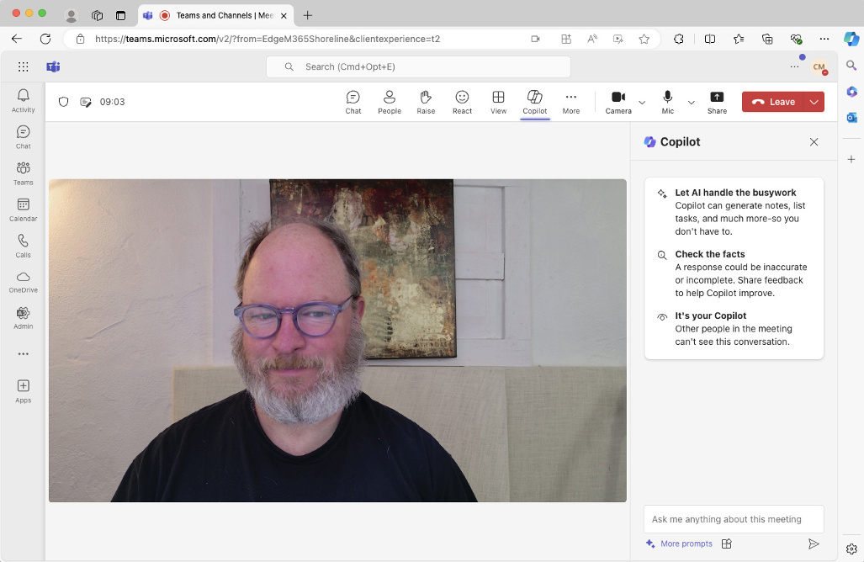
FIGURE 10-8:

The Copilot
sidebar in Teams.

During my meeting with Chris P., we found the transcription to be highly accu-
rate, and having Copilot answer questions about the meeting worked well too.
My attempt to use Live Captions with Translation on a Copilot+ PC during the
meeting was less than successful, however. We tried it with German, French,
Spanish, and the few phrases of Japanese that Chris P. knows. The translations
weren’t even close enough to make sense of, as shown in Figure 10-9.


FIGURE 10-9:
Live Captions
with Translation
isn’t quite
there yet.

186 PART 2 Getting Work Done with Microsoft 365 Copilot You can read more about Live Captions on a Copilot+ PC in Chapter 5.
After we’d been talking for about ten minutes, I asked Copilot to create a summary of the meeting so far, and its response was accurate and even useful for helping me steer the conversation.
In a meeting with just two people, having access to Copilot to answer questions about the meeting might be unnecessary and distract from the meeting. However, in larger meetings, you may wonder how you ever survived a meeting without it.
For meetings of any size, the really interesting and useful part of having Copilot in Teams comes after the meeting is finished.

Accessing post-meeting summaries
Shortly after you finish a meeting, a message like the one in Figure 10-10 will appear in the Chat window of Teams to tell you that the recording is ready and to give you an option to view a recap of the meeting, or the meeting transcript, video, or notes.
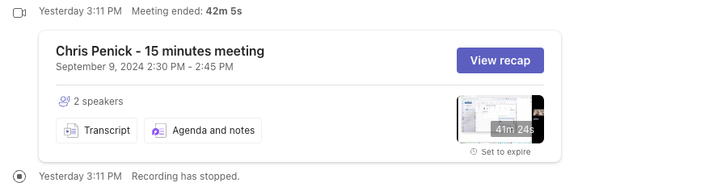

FIGURE 10-10:
Your recap
is ready.

The recap screen includes a video window, the agenda, AI-generated meeting notes, and the transcript of the meeting.
Figure 10-11 shows the meeting recap of my meeting.
Below the video window are three buttons to view different ways to visualize the meeting:

» The first button, Speakers, show when each attendee was speaking.
» The second button, Topics, shows each topic that was discussed in the meeting.
» The third button, Chapters, uses the same topic divisions as the Topics view
but shows a screenshot from each topic.

CHAPTER 10 Meeting and Collaborating with Copilot 187
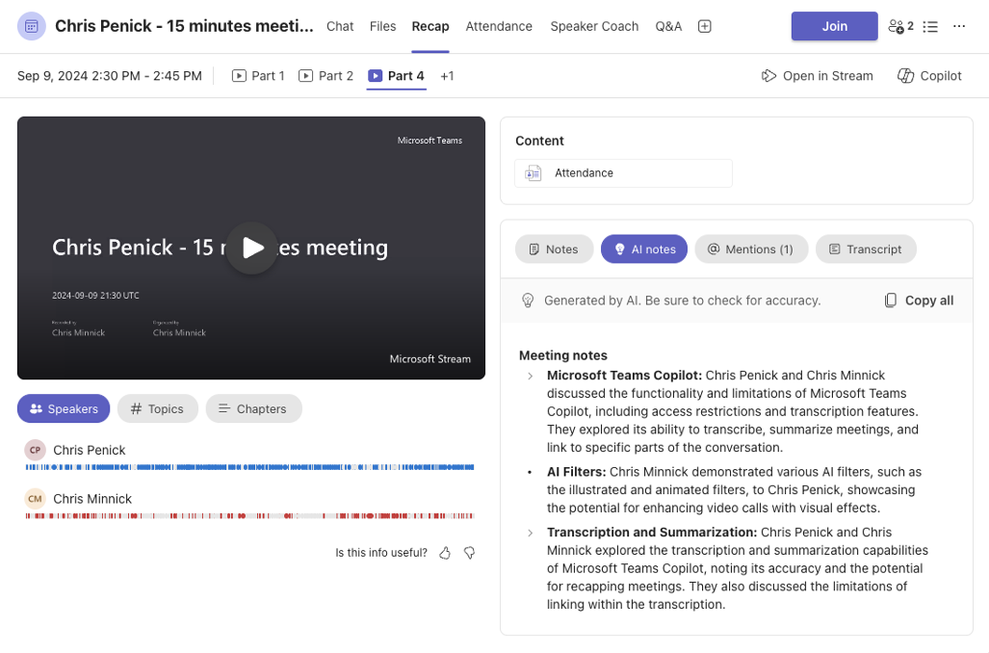
FIGURE 10-11:

Getting a recap.

Clicking in one of these visualizations takes you directly to that point in the video.
In the upper-right corner of the Recap screen is a Copilot button; it opens the
same Copilot in Teams sidebar that you had access to while the meeting was going
on. Here you can ask any question about the meeting and Copilot will consult the
transcript to answer it.
I tried out each of the suggested prompts in Copilot and Teams and found the
action items one to be especially useful. It scanned the transcript for things that
we each agreed to do after the meeting and gave a summary of each one. This
feature will be invaluable for ensuring that meetings aren’t just a waste of every-
one’s time while also not requiring everyone to rely on someone in the meeting
taking notes.

Understanding the Limitations of
Copilot in Teams
Having an AI assistant before, during, and after a virtual meeting has the potential
to make meetings more useful and memorable. The integration between Teams
and other Microsoft 365 applications makes sense and generally works very well.

188 PART 2 Getting Work Done with Microsoft 365 Copilot However, there are some limitations to Copilot in Teams that may cause users to struggle with it at first. These limitations include:

» Copilot’s knowledge of the meeting is entirely dependent on the tran-
script. If important visuals are presented during the meeting, you can, of course, review the video to see those. But, asking Copilot questions about something that doesn’t come through in the transcript won’t be successful.
» Copilot in Teams doesn’t integrate with Copilot in other apps. You can ask
Copilot in Teams to create the text for an email to the participants, but Copilot can only generate the text. It’s up to you to copy the text and paste it into an email. Likewise, asking Copilot to create a PowerPoint presentation from the meeting recap will just result in a text-only list of potential slides you could create with PowerPoint.
» Each participant in the meeting who wants to access Copilot in Teams
must have Copilot Pro or Microsoft 365 Copilot subscriptions. There’s no way for the meeting organizer to give everyone in the meeting access to Copilot during the meeting.
» Meeting transcription (and ideally recording) must be enabled to take
advantage of Copilot in Teams. Teams doesn’t currently have a way to set transcription and recording to be on by default. So, you have to remember to enable these for each meeting. In my experimenting with Copilot in Teams, I did forget to enable transcription at first, and I had to sign out of the meeting, enable transcription, then re-join to be able to use Copilot.
None of these limitations outweigh the benefits of having Copilot in Teams, and I expect that some of them will be resolved in future versions of Microsoft 365 and Teams.
In my dream world, I’d have to go to about ten percent of the meetings that I currently have. But, if I can’t have that, I’d settle for making meetings more use-ful. Copilot in Teams has the potential to improve the experience of having meet-ings by making it easier for everyone in the meeting to be reminded of what happened in previous meetings, to ensure that excellent meeting notes are kept, and to follow up on what decisions and actions were agreed to during the meeting.

CHAPTER 10 Meeting and Collaborating with Copilot 189
IN THIS CHAPTER
» Making pictures with Copilot
» Specifying image styles with Copilot
» Editing images with AI
» Creating images with
Microsoft Designer

Chapter 11

Generating and

Manipulating Images

C
opilot and Copilot+ PCs have the ability to generate images from prompts. Although simply generating images using Copilot is easy, it can be difficult to get Copilot to produce images when you have a specific idea about what you want the image to look like. Just as with text prompts, you can improve the
quality of generated content by using the prompt engineering techniques you learned about in Chapter 2.
In this chapter, you learn how Copilot’s image-creation capabilities work, how to get better results from Copilot when prompting for images, and how to refine Copilot’s creations.

Using Copilot to Create Images
As an AI chatbot, Copilot uses a large language model (LLM) to generate text. However, the LLM that Copilot uses to create text doesn’t have image-generation capabilities built in. To create images, Copilot uses a text-to-image model from OpenAI called DALL-E. In this section, you learn about how DALL-E works and how to use Copilot to prompt it.

CHAPTER 11 Generating and Manipulating Images 191
Understanding AI image creation
When you think about drawing or painting, you generally imagine starting with a
blank piece of paper and adding ink, pencil marks, or paint to it in an organized
way to create an image.
This is not how AI generates images. A generative AI model has no idea what it’s
painting. All it’s trying to do is create an image that’s closely aligned with its
mathematical understanding of the prompt it received.
The way DALL-E creates images is by starting with random pixels on the canvas.
It then removes some of those pixels and checks whether the resulting image is
closer to or further away from matching the prompt. It repeats this process many
times until it has created a final image.
For example, if you tell DALL-E to create a picture of a dog, a very condensed ver-
sion of its process might look like this:
1. Start with random data.
2. Remove a bunch of pixels.
3. Does it look more like a dog? If so, do more of that in the future.
4. Go back to Step 2.
In some ways, the process DALL-E uses to generate images is more like creating
sculptures from marble than like how people paint or draw.
DALL-E is a diffusion model. In addition to being useful for generating images, dif-
fusion models are also used for computer vision, video generation, image restora-
tion, and removing noise (variations in the color or brightness of pixels that can
reduce the quality of the image) from images (a process called denoising).

Prompting for images
You can generate images in the free or Pro versions of Copilot by simply entering
a prompt that requests an image.
For the best image generating experience, I recommend using the Bing Image
Creator at www.bing.com/images/create. Although you can generate images in
Copilot, Bing Image Creator currently generates more options and provides more
features that are specific to generating images. Copilot and Bing Image Creator
use the same DALL-E model and you can log in to Bing Image Creator using the
same account you use for Copilot.

192 PART 2 Getting Work Done with Microsoft 365 Copilot While Bing Image Creator will always generate images in response to your prompts, Copilot will only generate an image if you make it clear that’s what you’re looking for. Examples of ways to start a prompt that will most likely result in Copilot generating images include:

» Create an image of
» Paint a picture of
» Draw a picture of
After the instruction to create an image, you can write a description of what you want the image to look like. Keep in mind that your description is the only input you’re giving the model (other than context from previous prompts and responses in the same conversation). Be as specific as possible when prompting the model. Some of the details you might specify include:

» Subject of the picture
» Location of the subject
» Time of day, or the type of lighting
» Style of the picture
» Main focus of the picture
You can also specify a role that you’d like Copilot to take on as it’s creating the image. For example, you might say “You are an abstract painter.” One word of caution however — if you tell Copilot to paint in the style of a particular artist or to take on the role of a particular artist, it may refuse to do that. The reason is that Copilot has built-in programming designed to reduce the chances of it violating other people’s intellectual property or being used to create forgeries.
Prompting with more details and more context is how you improve the chances that what the model generates will meet your expectations and needs.
As you do when generating text, it’s useful to try a simple prompt at first to see what the AI model will do and then to refine it after that.
For example, I prompted Copilot with the following prompt:
Create an image of a bird flying over a glacial lake.
Within a minute, Copilot generated an image that matched my description, as shown in Figure 11-1.

CHAPTER 11 Generating and Manipulating Images 193
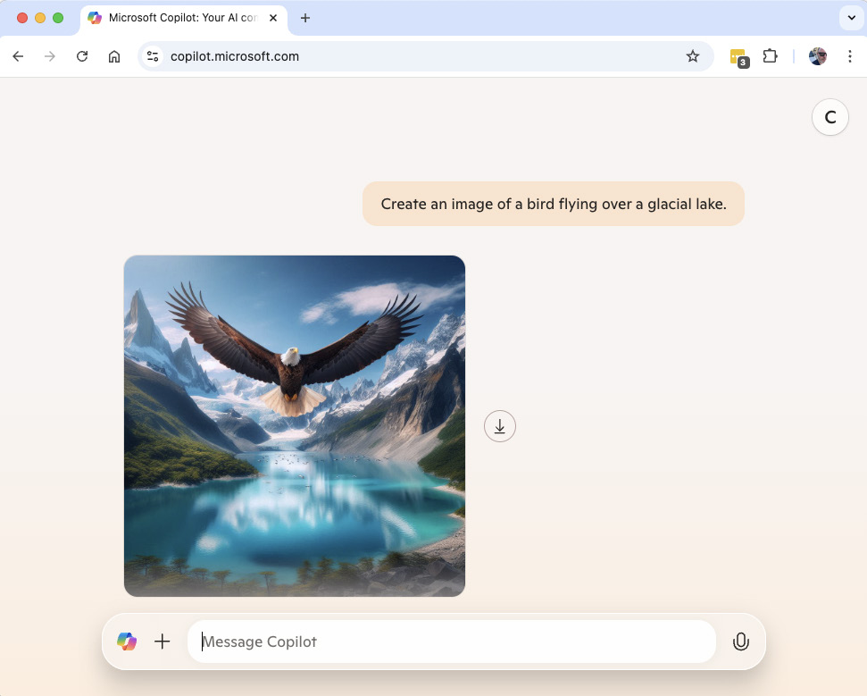
FIGURE 11-1:

Copilot’s
generated image
of a bird flying
over a
glacial lake.

Each image you generate using Copilot has a down arrow icon next to it that you
can use to download the image to your computer so you can edit it or share it.
To see how Bing Image Creator would handle this prompt, I went to https://
bing.com/images/create and gave it the same prompt. It responded with a series
of four images, as shown in Figure 11-2.
You can click on one of the four options to see a larger version of it, as shown in
Figure 11-3.
The single image view has buttons to the right of it for sharing, saving, download-
ing, customizing, and resizing the image.

» The Share button shows you a link to the image that you can copy.
» The Save button saves the image to your Microsoft Bing account.
» The Download button downloads the image to your computer.
» The Customize button opens the image in Microsoft Designer. You learn
about Microsoft Designer in the section titled “Using Microsoft Designer” later in this chapter.
» The Resize button generates a new image that’s similar to your original but
that’s wider horizontally (landscape) rather than square.

194 PART 2 Getting Work Done with Microsoft 365 Copilot
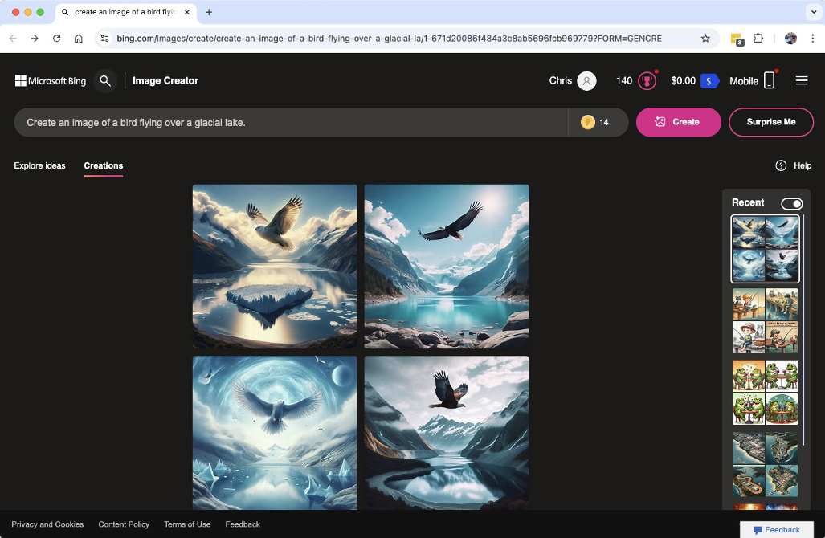
FIGURE 11-2:

Creating images
with Bing
Image Creator.
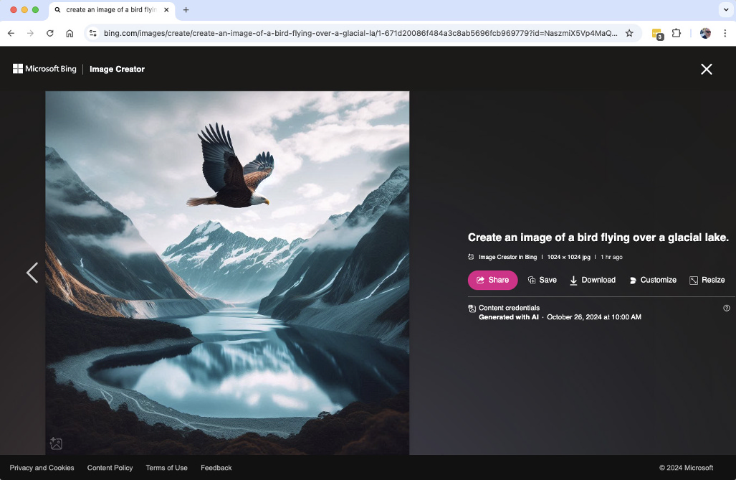

FIGURE 11-3:
Viewing a
larger version.

Getting and using Boosts
Because AI image generation requires much more computing power than text generation, Copilot limits the number of images you can create per day. The limit for users of a free Copilot account is currently 15 images per day, and the limit for

CHAPTER 11 Generating and Manipulating Images 195
users of a Copilot Pro account is currently 100 images per day. Copilot tracks how
many images you’ve generated each day using a system called Boosts.
The number of Boosts you have remaining is displayed in the Boosts icon, which
looks like a lightning bolt in a yellow circle. The Boosts icon appears in the pre-
view window you see when you generate images with Bing Image Creator, as
shown in Figure 11-4.


FIGURE 11-4:
Viewing your
remaining Boosts.

After you generate an image, your number of available Boosts goes down. When
your number of Boosts reaches zero, generating images may take longer or you
may be prevented from generating images until your number of Boosts replen-
ishes the next day.

Refining images
If you generate an image using Copilot, you can ask Copilot to refine the image by
using prompts. For example, returning to the bird picture that Copilot generated
(shown in Figure 11-1), you might tell it to make the picture darker, or make it
more realistic, or remove something from it.
Copilot will then use its previously generated image as context for its next image-
generation attempt.
It’s not possible to use AI image generation in the same way you might use a tra-
ditional photo-editing application. Each image Copilot creates is unique, and if
you ask for something simple like “lower the brightness” you won’t simply get
the same image but darker. The image will probably be similar to the original, but
it will be unique.
Figure 11-5 shows the result of asking Copilot to change the bird in my image
to a turkey.
Unlike human artists, DALL-E doesn’t care or know that an image it’s creating
depicts something physically impossible, such as a turkey soaring over the moun-
tains. This can be one of the most fun things about AI image generation, but it’s
also one of the most frustrating things about it.

196 PART 2 Getting Work Done with Microsoft 365 Copilot
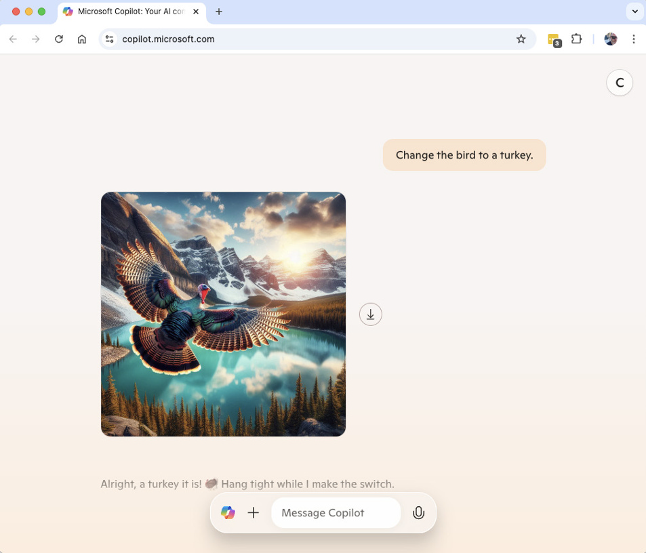
FIGURE 11-5:

A flying turkey.

Using Microsoft Designer
Microsoft Designer is Microsoft’s answer to Canva (www.canva.com) and Adobe
Express (adobe.com/express). Like these two tools, Microsoft Designer is an easy way for anyone to design a wide range of things, including social media posts, flyers, invitations, greeting cards, posters, stickers, icons, brochures, and even custom publications such as coloring books.
Microsoft Designer is currently not available for use with work or school Microsoft 365 accounts. However, it is available with a free Microsoft account and to people with Copilot Pro subscriptions.
To access Microsoft Designer, go to https://designer.microsoft.com. There, you’ll see the homepage, as shown in Figure 11-6.
Before attempting to use Microsoft Designer, you’ll need to log in by clicking the Sign In button in the upper-right corner. If you sign in with a work or school account, you may get the message shown in Figure 11-7 that says Designer isn’t available for your organization.

CHAPTER 11 Generating and Manipulating Images 197
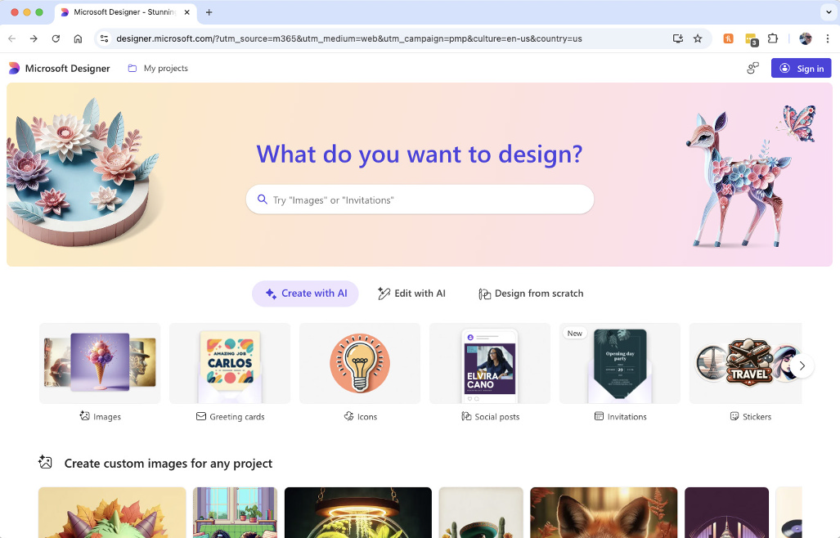
FIGURE 11-6:

The Microsoft
Designer
homepage.


FIGURE 11-7:
Designer is not
available to
organizations.

Like it says to do, you’ll need to sign out and sign back in using a personal account
to access Designer.

Exploring Designer’s three modes
At the top of the Designer homepage is a large prompt input area below a header
that says, “What do you want to design?” Entering a keyword or description of

198 PART 2 Getting Work Done with Microsoft 365 Copilot what you want to create into that text box is the easiest way to get started with Designer, but it’s not the only way.
Below the text input box are three buttons, Create with AI, Edit with AI, and Design from Scratch. You can use these buttons to switch between the three ways to get started using Designer.
When you select one of these options from the Designer homepage, you’ll see some options for ways you can use the tool. In the following sections, you learn a bit about how to use Designer, but I encourage you to spend some time playing around with it on your own. This is the best way to get a sense of what’s possible and what Designer might be able to do for you!

Creating with AI in Designer
The Create with AI tool in Designer features a selection of templates to choose from. These templates include images, greeting cards, icons, social posts, invita-tions, and more. Figure 11-8 shows some of the template options that are available.


FIGURE 11-8:
The template
options in
Designer’s Create
with AI tool.

If you scroll down below the templates, you’ll see some sample images for several different types of projects. Hovering your mouse over any of these images displays the prompt template that was used to create the sample project. Figure 11-9 shows both an avatar image and the prompt that was used to create it.
The words or phrases that appear in square brackets represent places where you can customize the prompt and make it your own. Clicking the sample prompt opens it for editing. Figure 11-10 shows the sample prompt editing screen.
On this screen, you can replace any of the words in text boxes and then generate your own project based on the prompt. If you don’t care about maintaining a simi-lar style as the original generated image, you can also click the link at the bottom of the prompt area to disregard the suggested customization words and make any change you like.

CHAPTER 11 Generating and Manipulating Images 199
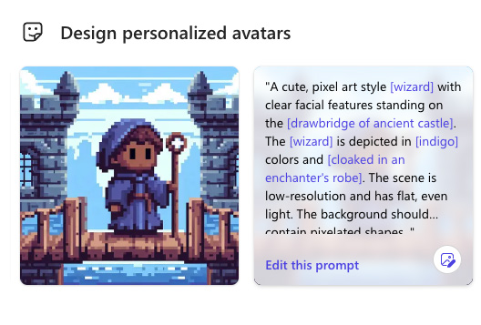
FIGURE 11-9:

Viewing the
prompt behind
the image.
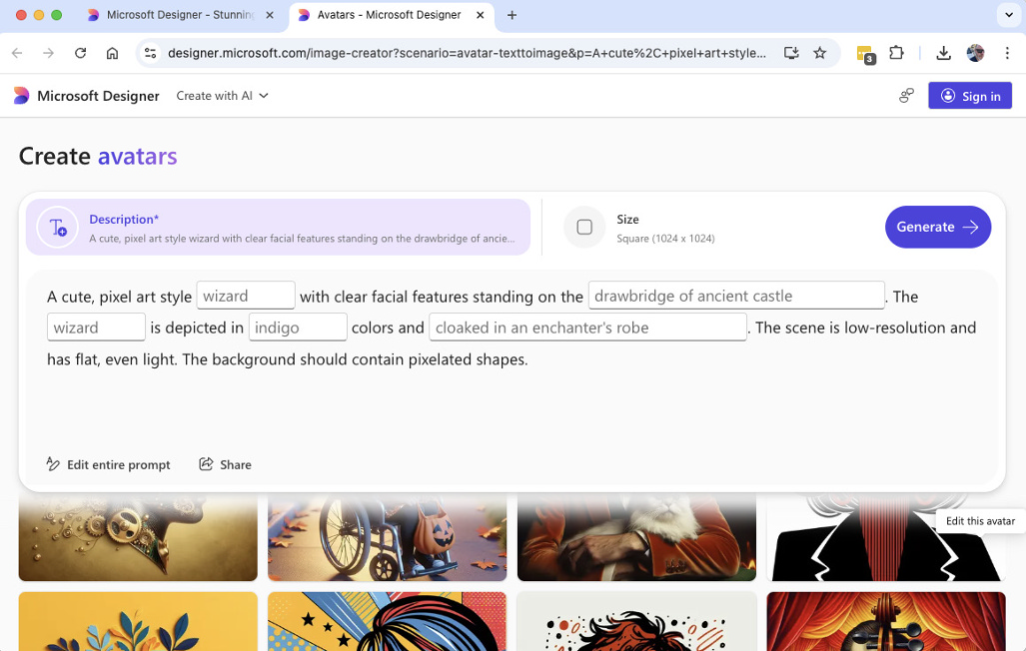

FIGURE 11-10:
The sample
prompt editing
screen.

After you click the Generate button, Designer will generate four options based on
the prompt, as shown in Figure 11-11.
If you don’t like any of the suggestions, you can click the Description above the
suggestions to make edits and try again (as long as you have enough Boosts!).
If you like one of the suggestions, click on it to open a window (shown in
Figure 11-12) with a larger version of your generated image and to get to the next
step in the creation and refinement of your project.

200 PART 2 Getting Work Done with Microsoft 365 Copilot
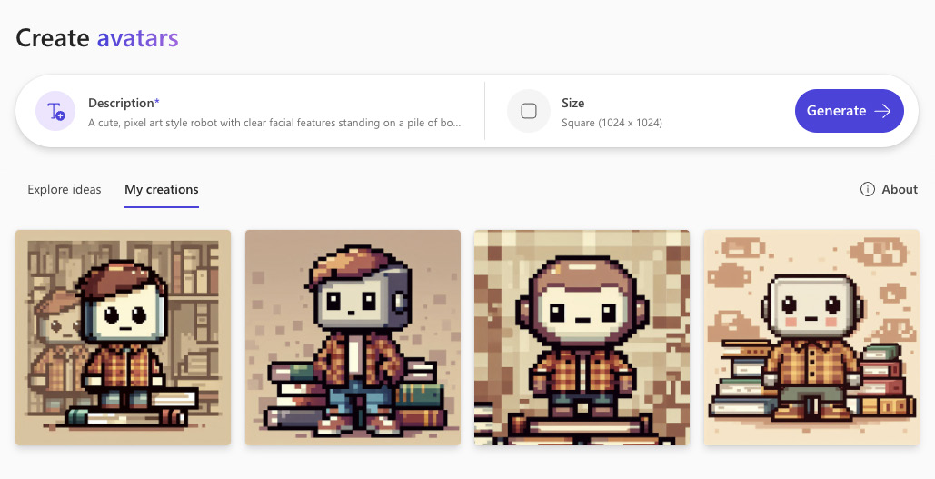
FIGURE 11-11:

AI-generated
avatar
suggestions.
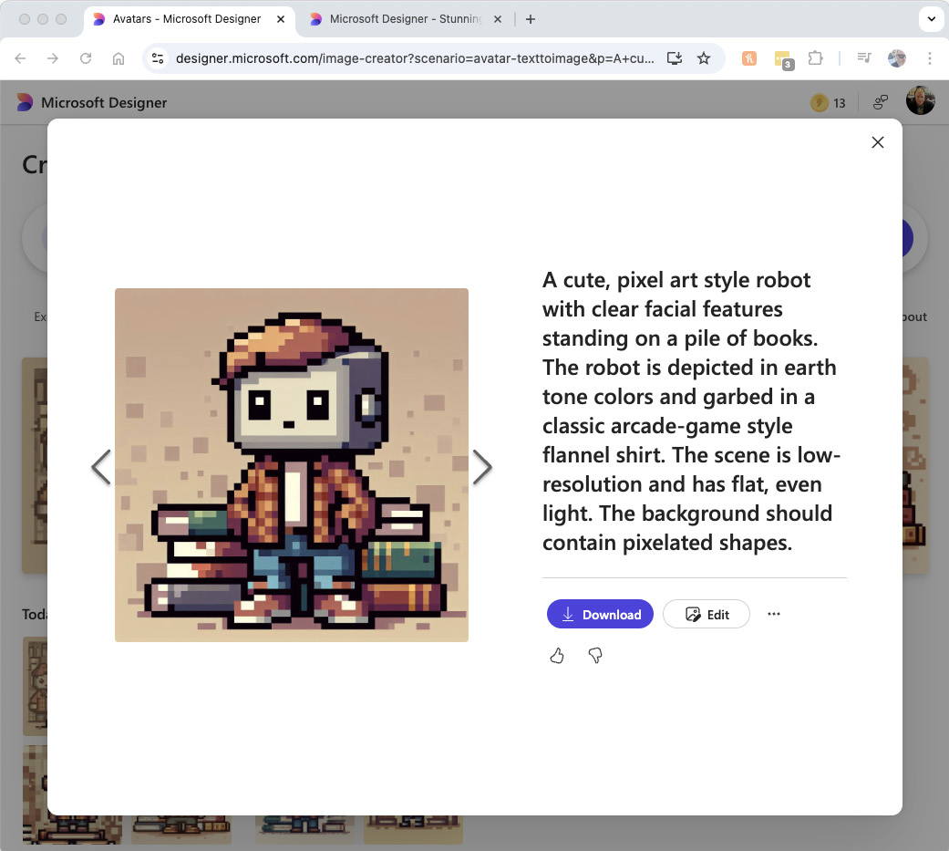

FIGURE 11-12:
Viewing a larger
version of
your image.

CHAPTER 11 Generating and Manipulating Images 201
The sample prompts in Designer are excellent examples of how to write good
prompts for generating images with AI. You can learn a lot about prompt engi-
neering by studying them.
If you like the image just as it is, click on the Download button to save it to your
computer. If you want to add to or edit the generated image, you can click the Edit
button on the image preview screen. The image editor, shown in Figure 11-13,
will open.
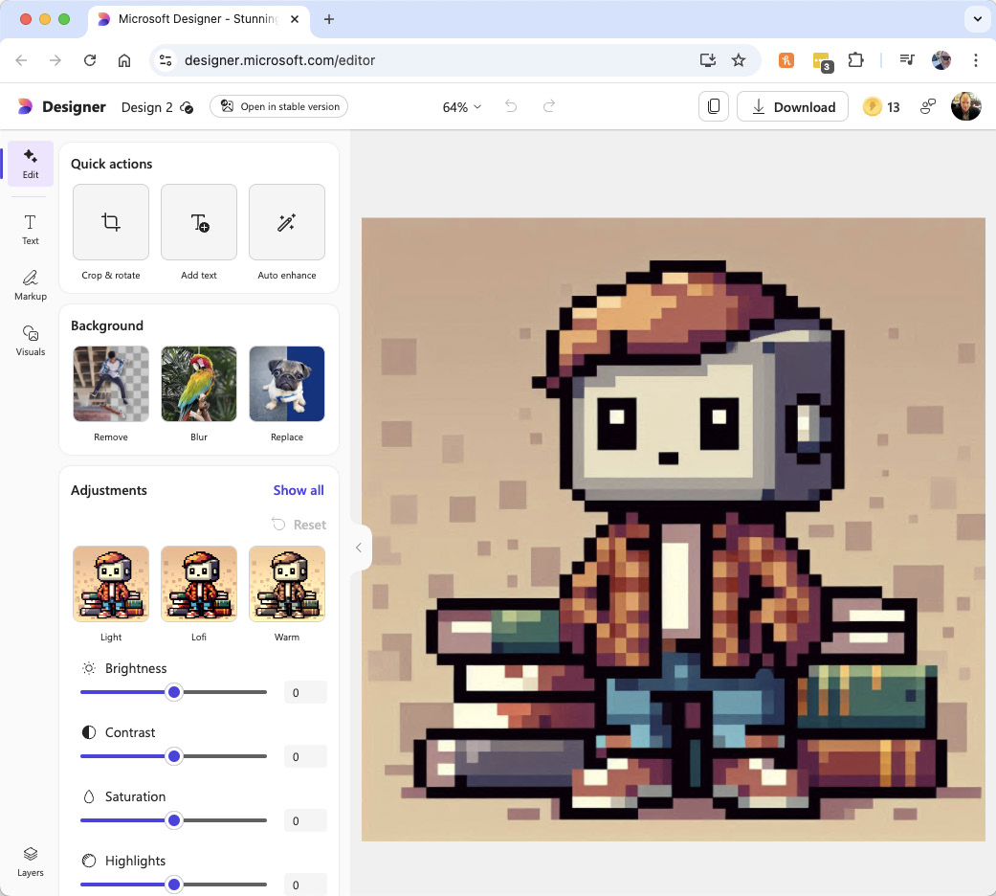

FIGURE 11-13:
The Designer
image editor.

The image editor gives you all the tools you need to modify images. You can adjust
colors, add text, apply filters, and even add AI-generated elements.
In the next section, you learn more about the image editor and what you can do
with it. Click the Microsoft Designer logo in the upper-right corner to return to
the Designer homepage and to start learning more about the Designer image-
editing capabilities.

202 PART 2 Getting Work Done with Microsoft 365 Copilot Editing with AI in Designer
The Edit with AI link from the homepage of Designer brings you to a screen that appears similar to the Create with AI screen. This screen is shown in Figure 11-14.
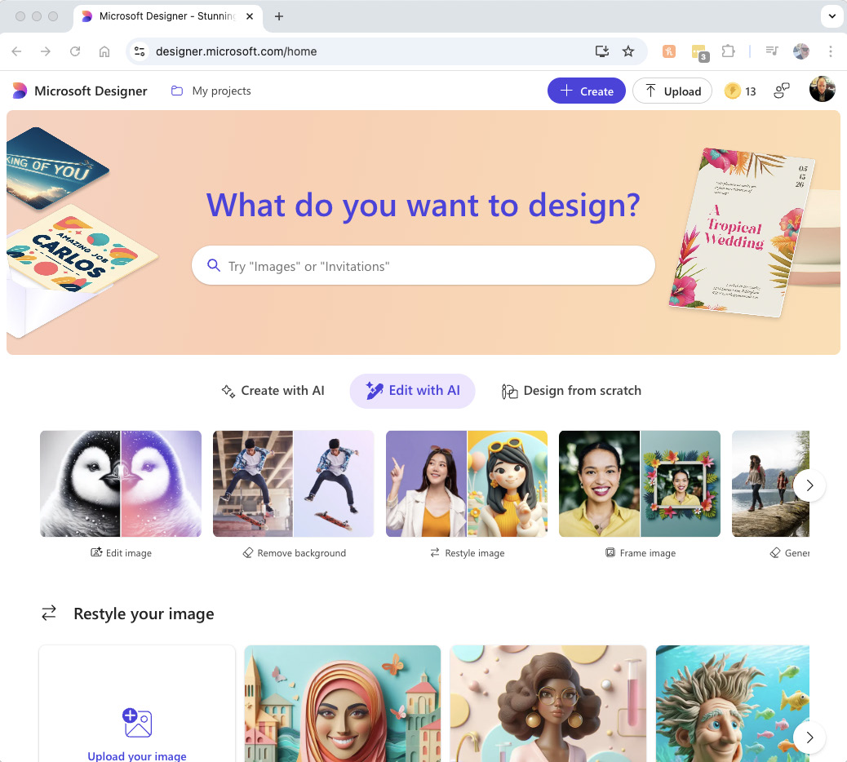

FIGURE 11-14:
The Edit with
AI screen.

The Edit with AI screen has various links, templates, and prompt examples for editing existing projects or images you supply.
For example, if you want to apply a frame to an existing image, find the Frame Image tool and click it. You’ll see the Create Framed Images screen, with samples of what the tool can do. To use the Create Framed Images tool, you can select an image, add objects and themes to your frame, select a style, and then generate a frame that will display around your image.
Figure 11-15 shows the Create Framed Images screen with the Image, Elements, and Style options filled in.

CHAPTER 11 Generating and Manipulating Images 203
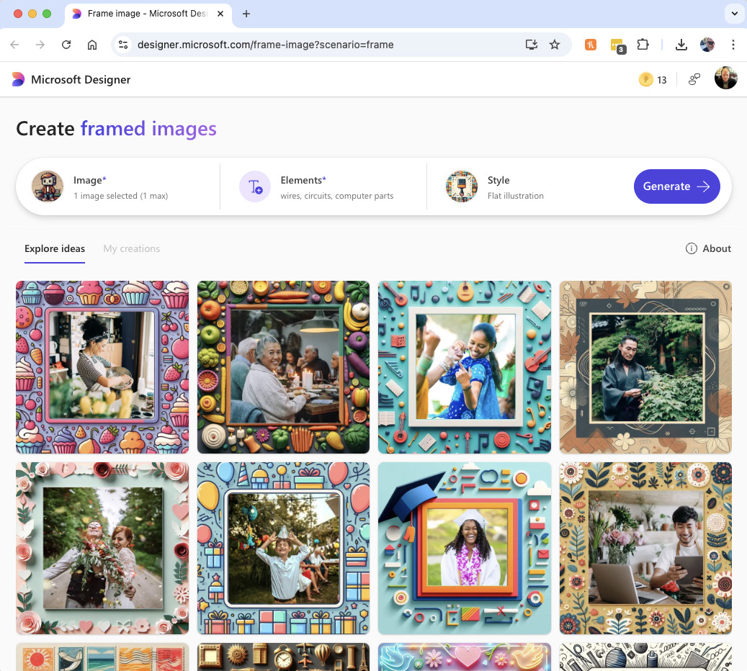
FIGURE 11-15:

The Create
Framed
Images screen.

Clicking Generate on this screen causes Designer to use AI to generate four options.
Just as with the Create with AI tool, you can click any of these images to see a
larger version and to go to the image editor.
Figure 11-16 shows my generated image and the frame I added to it open in the
image editor.

Using the image editor
The image editor in Designer combines traditional image-editing capabilities with
publication design capabilities and AI.
Examples of things you can do with the image editor in Designer include adding
text, resizing objects, applying a theme to your design, and inserting shapes and
other art.

204 PART 2 Getting Work Done with Microsoft 365 Copilot
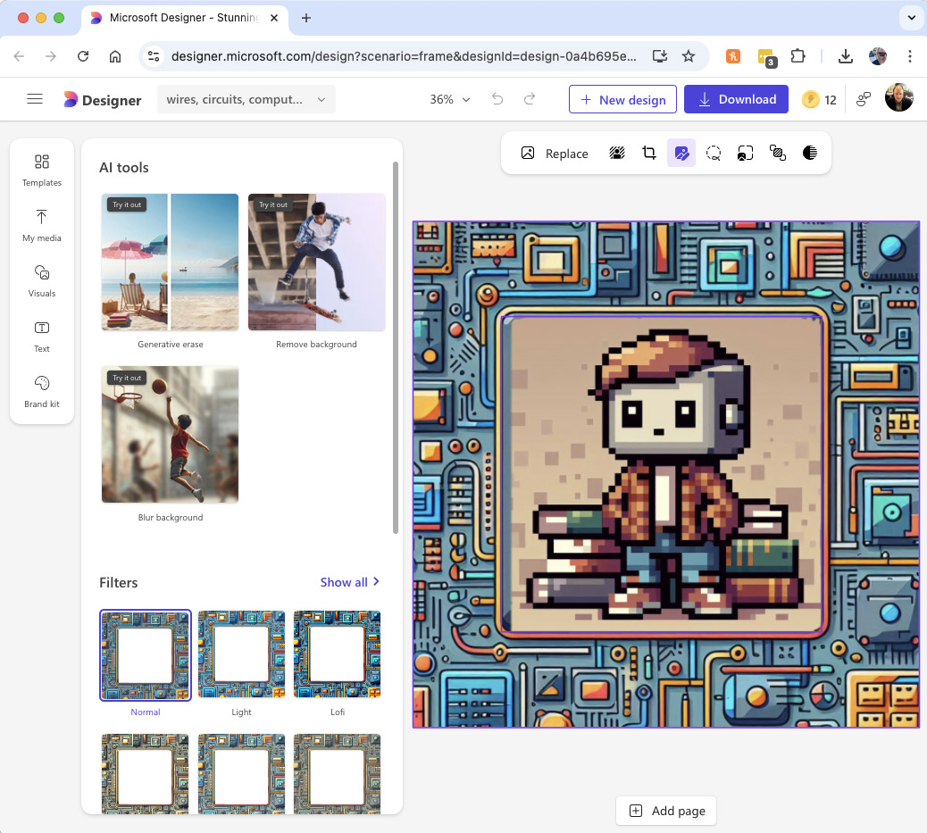
FIGURE 11-16:

My framed
avatar in the
image editor.

With the publication design capabilities, you can apply design templates to create different types of publications (such as greeting cards or brochures) and you can add pages to your project.
The AI features of the image editor allow you to generate new visuals and insert them into your project.
The image editor can be used with any project you create in Designer or with an image you upload. To use it, you can start by creating a new project using a prompt or by clicking the small link at the bottom of the New Project screen (shown in Figure 11-17) that says, “Skip and start with a blank design or edit recent designs.”
Starting with a blank design isn’t as easy as using a prompt to create your project, but it can produce a better result when you already know exactly what you need.
When you start a blank project in the image editor, the first thing you need to decide is the size. You’ll see a window where you can select one of a few different common sizes or you can specify a custom size.

CHAPTER 11 Generating and Manipulating Images 205
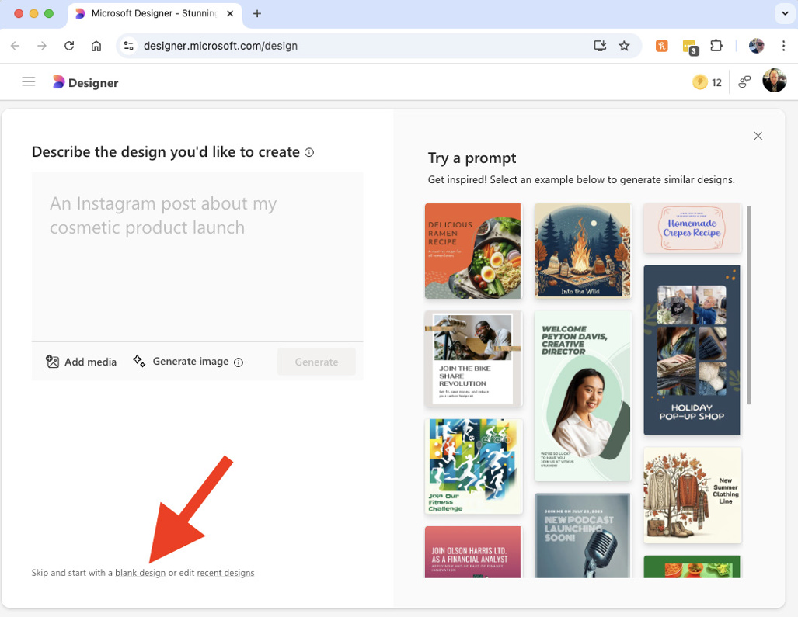
FIGURE 11-17:

The link to create
a blank project.

After you choose the size, you’ll see a blank canvas. Let’s say you want to create
an Instagram post celebrating International Dog Day (August 26). Here are the
steps you might take.
1. Start with a blank square canvas.
2. Click the Text icon on the left toolbar.
3. Click Add a Heading.
Large heading text will appear on your canvas where you can edit it, as shown in Figure 11-18.
4. Click the Visuals icon on the left toolbar and go to the Generate tab, as
shown in Figure 11-19.
5. Write and submit a prompt for the visuals you want to add to your
project. Here’s what I started with:
Create a photorealistic image of many different kinds of dogs all having fun and doing things that are normally done by people, like reading the paper or play-ing guitar.

206 PART 2 Getting Work Done with Microsoft 365 Copilot
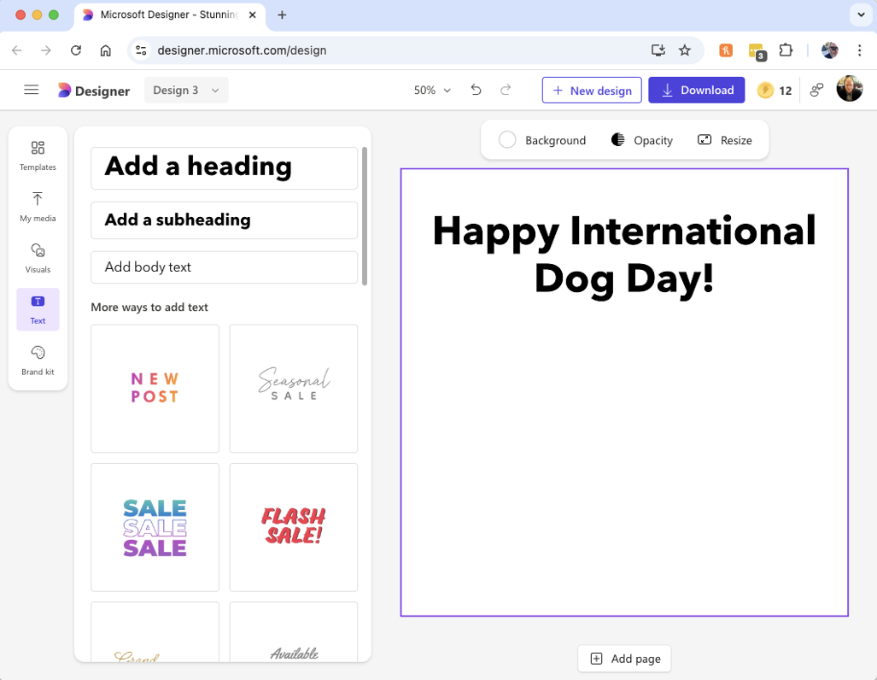
FIGURE 11-18:

Adding a heading.
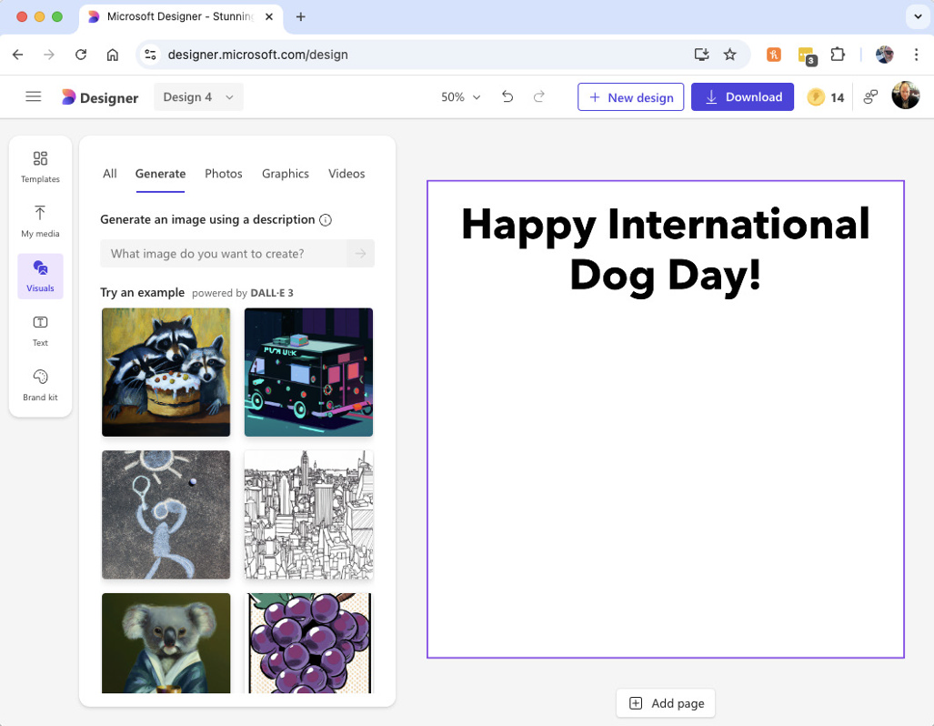

FIGURE 11-19:
The Generate
tab in the
Visuals tool.

CHAPTER 11 Generating and Manipulating Images 207
I liked some aspects of the image that Designer created, which is shown in
Figure 11-20. I don’t like that the image has a person in the middle of it. It’s sort
of funny that it has a couple of cats mixed in with the dogs.
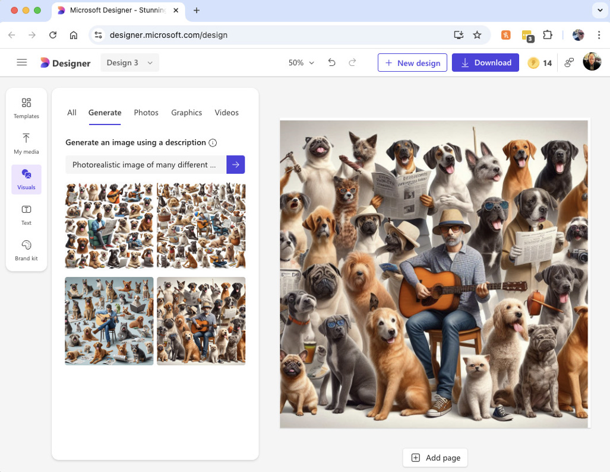

FIGURE 11-20:
My dog
day graphic.

Once you have an image in your project, you can edit that image by clicking on it
and selecting an option from the image-editing menu that appears above the
image. These tools include options like cropping the image, removing the back-
ground, changing the opacity of an image, selecting parts of the image, and posi-
tioning the image on the canvas.
One of the options on the image-editing toolbar is to open a menu of AI image-
editing tools. Included in these is the Generative Erase tool. To use Generative
Erase, click the tool’s icon, then select the object in your image you want to
replace, as shown in Figure 11-21.
Once you’ve selected something in your image, click the forward arrow to initiate
the replacing. The result wasn’t exactly what I wanted but the man is now out of
the picture, as shown in Figure 11-22.

208 PART 2 Getting Work Done with Microsoft 365 Copilot
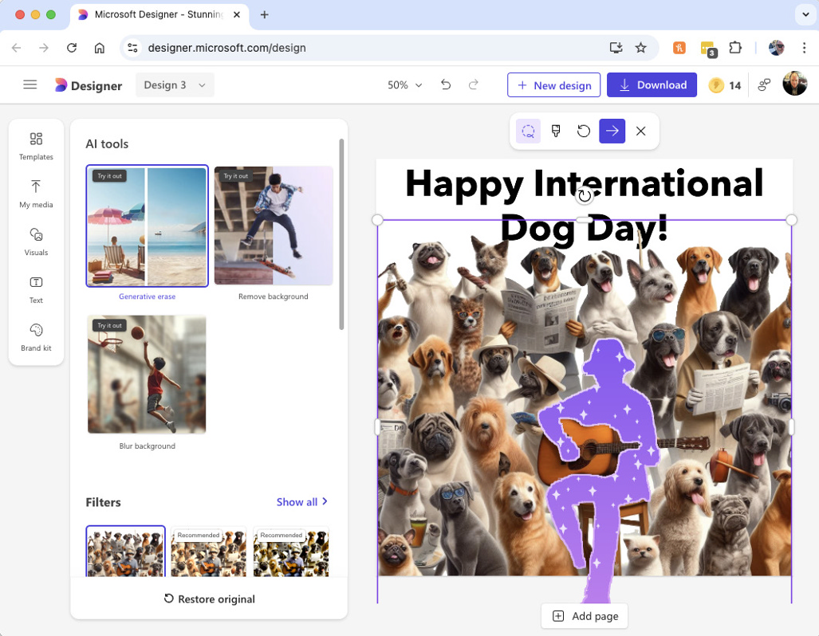
FIGURE 11-21:

Selecting the
object to replace.
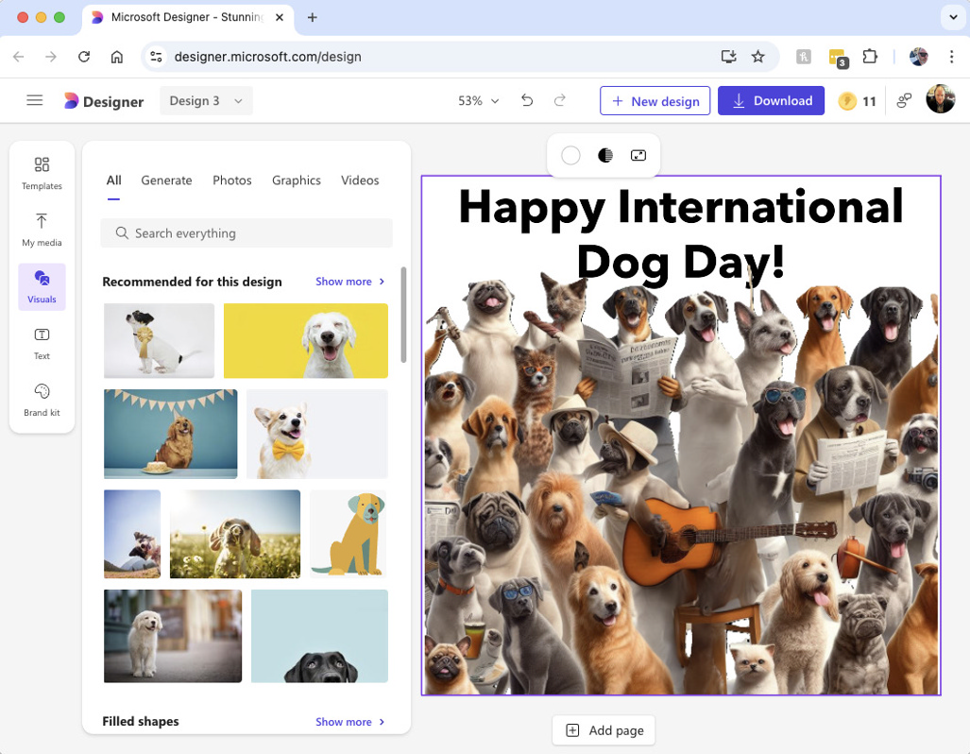

FIGURE 11-22:
Using the
image-editing
tools.

CHAPTER 11 Generating and Manipulating Images 209
Designing from scratch
The final option from the homepage of Designer is Design from Scratch. When you
select this option, you’re taken to a library of templates, as shown in Figure 11-23.
These are blank canvases for creating different kinds of creative projects, such as
a Facebook story, a brochure, or a folded greeting card.
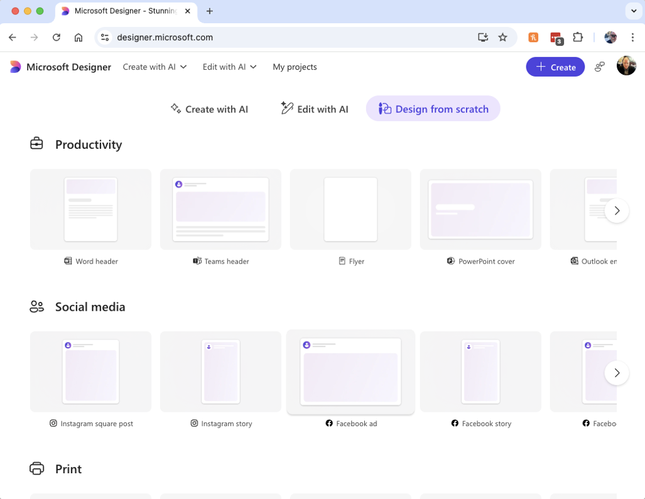

FIGURE 11-23:
The Design
from Scratch
templates.

Selecting a template opens it in the image-editing tool, where you can use the
same collection of traditional and AI tools you learned about in the previ-
ous section.
AI image generation can be unpredictable, but you can improve the quality and
accuracy of images you generate using the same prompt engineering techniques
you use to generate text.
In this chapter, you learned how Microsoft Copilot generates images, learned how
to use Copilot’s image-generation tools, and learned about Microsoft Designer,
which combines the capabilities of AI image generation with traditional image
editing and publication design tools.

210 PART 2 Getting Work Done with Microsoft 365 Copilot
IN THIS CHAPTER
» Getting Copilot’s help with planning
» Tracking and monitoring tasks
and deadlines
» Collaborating intelligently
» Enhancing reporting
» Customizing reports

Chapter 12

Using Copilot for Project

Management

P
rojects range in size from very small, such as making a sandwich, to very complex, such as building a bridge. Every project, even the smallest ones, requires some amount of planning, execution, and follow-up. This process of starting with something that you want to get done, figuring out how to do it,
then doing it is an example of what we in the business world call project management.
In this chapter, you learn how to use Microsoft Copilot to help with project management.

Planning for a Project
Project management can be a complex endeavor. Some of the things that project managers must manage include:

» Scope. A project’s scope defines what must be done to achieve the desired
results of the project. It also defines the boundaries of the project and what’s not included.

CHAPTER 12 Using Copilot for Project Management 211
» Goals. The goals of a project are the end result that you hope to achieve from
the project.
» Budget. The budget is the amount of money available for completing
the project.
» Timeline. A project’s timeline defines the deadline for completion of the
project as well as for important milestones within the project.
» Work breakdown. The work breakdown is the list of tasks that must be
completed to meet the goals of the project.
» Human resources. Human resources refers to the people who will work on
the project, including who those people will be, and what parts of the project they’ll be working on.
» Communications. Most of a project manager’s time is spent in meetings,
writing emails, interpreting what the customer requires, turning those requirements into tasks, and providing reports to everyone who has a stake in the project.
» Risk management. Risk management is the process of planning how to deal
with the inevitable problems in advance of the project and then handling challenges when they do come up.
All of these factors (and more) must be planned for. The document or set of docu-
ments in which this is all written down is called a project plan.
It’s unlikely that you’ll create a project plan complete with charts and graphs for
a simple project like taking out the garbage. But when multiple people get involved,
it’s not enough simply to dive in and start doing it. In this chapter, you learn how
Copilot can help you become a better project manager and get more done in
less time.

Introducing Microsoft Planner
Microsoft Planner is a planning application that’s available in the Microsoft 365
platform. Although you can access Planner with any Microsoft 365 subscription,
you currently need Microsoft’s Planner and Project Plan 3 or Planner and Project
Plan 5 to access Copilot in Planner. You can find out about these subscriptions and
sign up for one of them at https://www.microsoft.com/en-us/microsoft-365/
planner/microsoft-planner-plans-and-pricing. If you have the proper license

212 PART 2 Getting Work Done with Microsoft 365 Copilot for Microsoft Planner, you can access it through Microsoft Teams. Follow these steps to get started:
1. Open Teams in Microsoft 365.
2. Click the Apps icon in the left toolbar.
This will take you to the Apps Search feature of Teams, as shown in Figure 12-1.
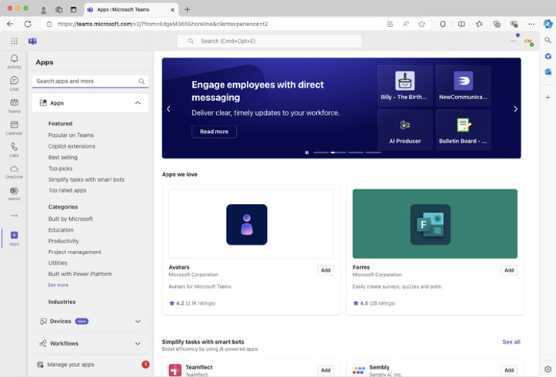

FIGURE 12-1:
Searching
for apps.

3. Enter planner into the search box in the top-left corner of the Apps
search page.
Microsoft Planner should be the first result in the Apps section of the results.
4. If you’ve previously accessed Microsoft Planner, you’ll see an Open
button that you can click to open Microsoft Planner. Otherwise, click the Add button next to Microsoft Planner and then open it.
5. Once you have Planner open, right-click the Planner icon in the left
toolbar and select Pin so that you don’t have to go to the App search interface next time you want to use Planner.

CHAPTER 12 Using Copilot for Project Management 213 Getting Started with Planner
When you open Microsoft Planner you’ll be taken to the My Tasks page. If you
don’t have any projects you won’t have any tasks. We’re about to change that. The
My Tasks screen is shown in Figure 12-2.
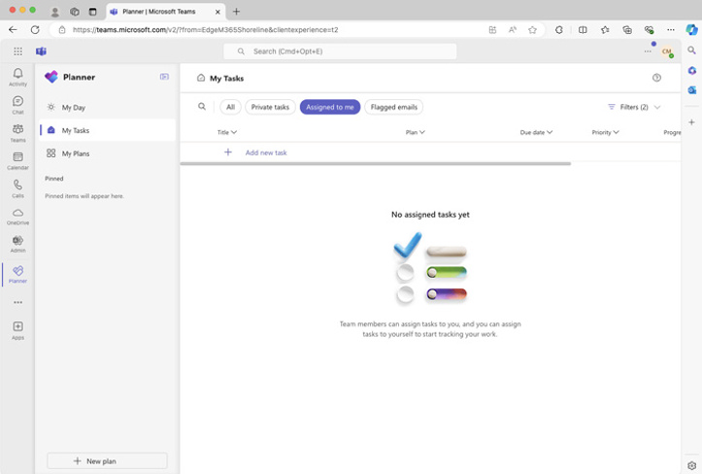

FIGURE 12-2:
The My Tasks
screen in Planner.

To create a new project, click the New Plan button in the lower-left corner of
Microsoft Planner. You’ll see a popup window, shown in Figure 12-3, where you
can select a template for your new plan or start with a blank plan.
Clicking either the Basic or the Premium link will create a new blank plan. Cur-
rently Copilot in Planner is only available for Premium plans.
When you click the Premium link, a window will open that asks you to give the
new plan a name, as shown in Figure 12-4.
Once you’ve come up with the name for your plan, click the Create button and your
new blank plan will appear. At this point, you could start creating your plan in the
traditional way by manually adding tasks. However, in Premium projects you can
also get some help from Microsoft Copilot. Look for the familiar Copilot icon in the
plan toolbar. It’s the fourth one from the right, as shown in Figure 12-5.

214 PART 2 Getting Work Done with Microsoft 365 Copilot
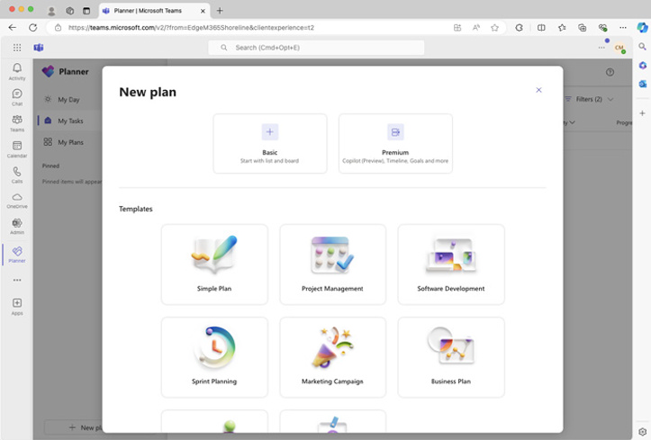
FIGURE 12-3:

Selecting
a template.
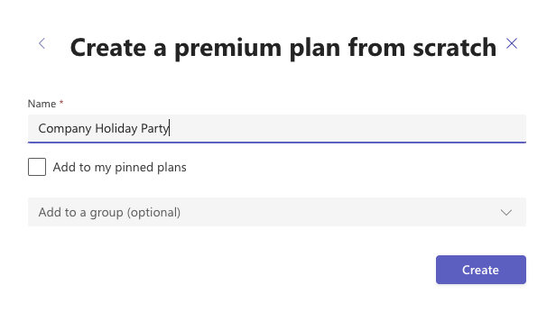

FIGURE 12-4:
Giving your
project a name.
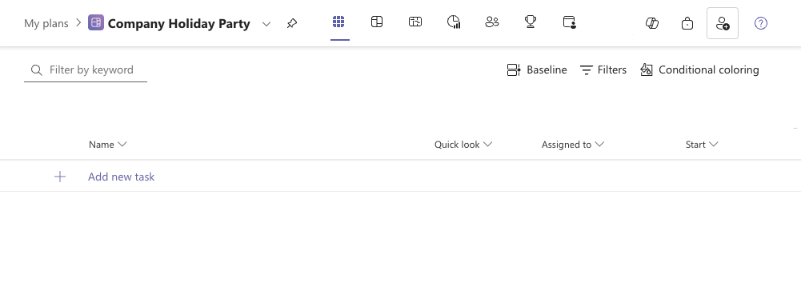

FIGURE 12-5:
The Copilot
button.

CHAPTER 12 Using Copilot for Project Management 215
Clicking the Copilot in Microsoft Planner icon opens the Copilot sidebar, which
has options for building your plan, understanding your plan, editing tasks and
subtasks in your plan, and asking questions about your plan. The Copilot sidebar
in Microsoft Planner is shown in Figure 12-6.
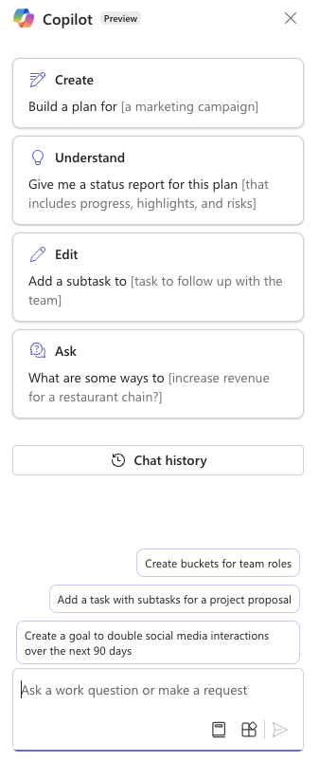

FIGURE 12-6:
The Copilot
sidebar
in Planner.

In the next section, I try using Copilot in Microsoft to create a business plan.

Planning Your Project
Most people start businesses because they have an idea or a passion or something
they’re good at that they can make money from doing. People don’t start small
businesses because they love to write business plans. Just figuring out how to start
writing a business plan and what needs to be included in it can be a daunting task.
Fortunately, many people have written business plans before and you can study
what other people have done to figure out what you should do. Or at least, that’s
the way writing a business plan used to work just a few years ago.

216 PART 2 Getting Work Done with Microsoft 365 Copilot Generative AI works best when it’s creating new things that are similar to things that are plentiful on the web. What I mean by that, specifically for this topic, is that because so many business plans have been written and there are so many templates for business plans and articles about business plans on the web that have gone into Copilot’s training data, it should be easy for Copilot to write a business plan.
What AI will probably struggle with, however, is writing a business plan for a type of business that it’s never heard of before.

My first business planning attempt
To create a business plan, you can start with the built-in business plan template in Microsoft Planner and then customize it to your needs. In this section though, I’m going to try to generate an entire business plan using Copilot.
Generating something as important as a business plan shouldn’t be left entirely up to AI, of course.
Here are the steps I used, in case you want to try it on your own:
1. Create a new blank Premium plan.
2. Open the Copilot sidebar.
3. Ask Copilot to create your business plan.
It may be helpful here to include a brief description of your business and whether the business exists yet. For example, I used the following prompt:
Build a business plan for the business I’m thinking about starting. It will be a 24-hour cat café where you can drink coffee and pet cats.
Unfortunately, this was as far as I got with this approach at first, even though I tried several different prompts. Copilot was unable to do anything except say that something went wrong, as shown in Figure 12-7.
To find out more about troubleshooting common problems with Copilot, go to Chapter 15.
I wanted to make sure the problem wasn’t a temporary outage or something wrong with my Copilot account, so I logged out of my account and logged back in, refreshed the browser window, and had lunch before trying again.
It still didn’t work, so I waited a day before trying again.

CHAPTER 12 Using Copilot for Project Management 217
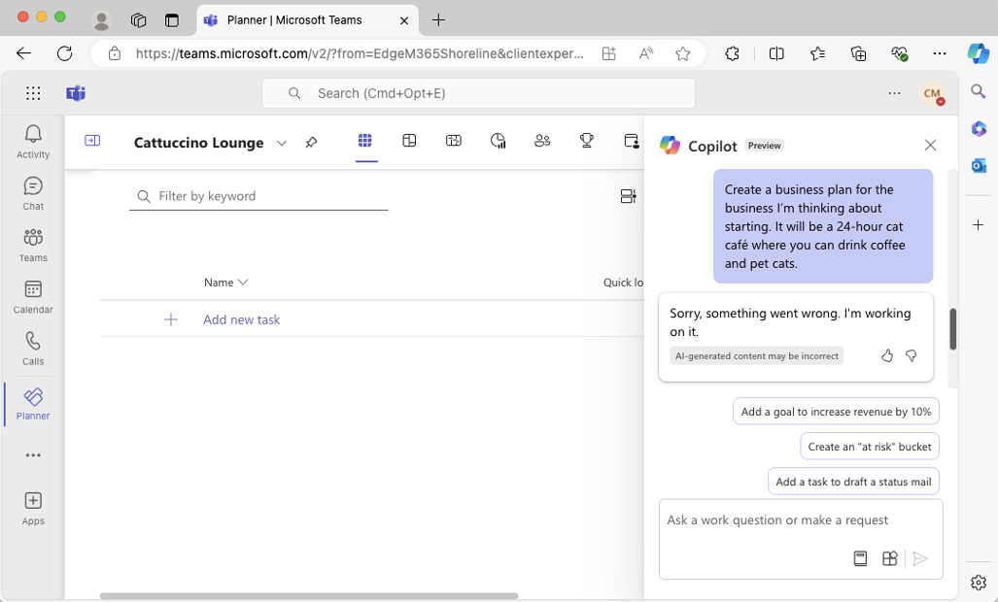
FIGURE 12-7:

Something
went wrong.

Trying again, and success!
The next morning, I opened my blank Planner template and used the same prompt
to attempt to generate a business plan for my cat café, the Cattuccino Lounge.
This time, Copilot thought about it, then created an outline with the fol-
lowing items:

» Executive Summary
» Market Analysis
» Business Model
» Operation Plan
» Marketing and Sales Strategy
» Financial Projections
So far so good! After displaying this outline, Copilot went on to insert each section
into my plan and create tasks under each one.
The result is actually a great start. It’s more of a plan for making a business plan,
and the tasks Copilot created make sense. Since I’ve only been thinking about
starting this business for 24 hours now, I hadn’t considered some of the things
Copilot inserted into the plan, such as “Develop cat care protocols.”
The task list portion of the plan is shown in Figure 12-8.

218 PART 2 Getting Work Done with Microsoft 365 Copilot
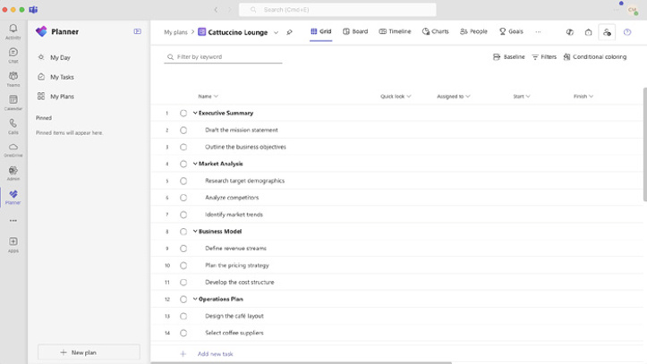
FIGURE 12-8:

The start of my
new
business plan.

Setting goals
In addition to the six categories of tasks and 29 tasks Copilot wrote, it also defined two goals:

» Obtain all necessary permits and health certifications for café.
» Secure funding for initial setup costs and operating expenses for the first year.
Both goals have deadlines associated with them and the tasks that are part of each goal are correctly identified.
To be honest, I’m really impressed with what Copilot in Planner has been able to do so far. I’m even getting a bit excited about using it to start writing a plan for my own real business.

Viewing Planner’s various views
Before you see more of what Copilot in Planner is capable of, it’s helpful to have a basic understanding of how Planner works. The basic things that make up a Plan-ner project are tasks (things that need to be done), goals (end results that you want to achieve), and people (who will be doing the tasks to achieve the goals).
The tabs across the top of the Planner user interface present these basic building blocks of a plan in a variety of ways. For example, the Grid view, which is shown in Figure 12-8, shows a list of all the tasks in your project along with information about each, such as who it’s assigned to, when it’s scheduled to start, and when

CHAPTER 12 Using Copilot for Project Management 219
it’s scheduled to finish. The Board view serves a similar purpose as the Grid view,
but it allows you to organize tasks in a different way, such as by priority, comple-
tion status, or phase of the project. The Timeline view allows you to view tasks by
their due dates.
If you want to learn more about Microsoft Planner and its capabilities, check out
the Planner Help and Learning website at https://support.microsoft.com/
en-us/planner.

Putting tasks in buckets
The Board view in Microsoft Planner allows you to put tasks into buckets. Buckets
are different from the categories of tasks listed in the view shown in Figure 12-8.
Buckets are more like . . . well, buckets. You can create any number of buckets and
put tasks into those buckets by dragging and dropping them. You might, for
example, create buckets by what department in your company is responsible for
the tasks. Or, you might make buckets for different phases of the project. Or, you
might create buckets for the type of work involved.
For the cat café business plan, Copilot created three buckets:

» Business Strategy
» Café Operations
» Cat Care
Again, this seems logical to me. I’m sure other buckets will occur to me as this
plan progresses, but this seems like a good start. The Board view for my cat café
business plan is shown in Figure 12-9.

Comparing Copilot to built-in templates
Microsoft Planner has a built-in business plan template. I was curious how the
plan generated by Copilot compared with the built-in template, so I started a new
business plan using the template.
I created a new plan by going to my Planner homepage and clicking the New Plan
button. I selected the Business Plan template and was then given the choice
between a Basic and a Premium plan, as shown in Figure 12-10.

220 PART 2 Getting Work Done with Microsoft 365 Copilot
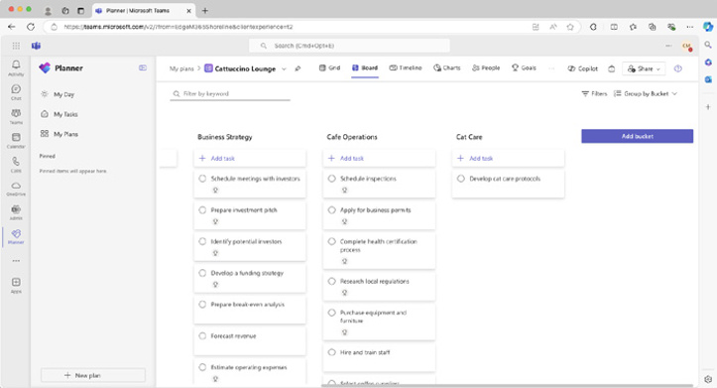
FIGURE 12-9:

Putting tasks
in buckets.
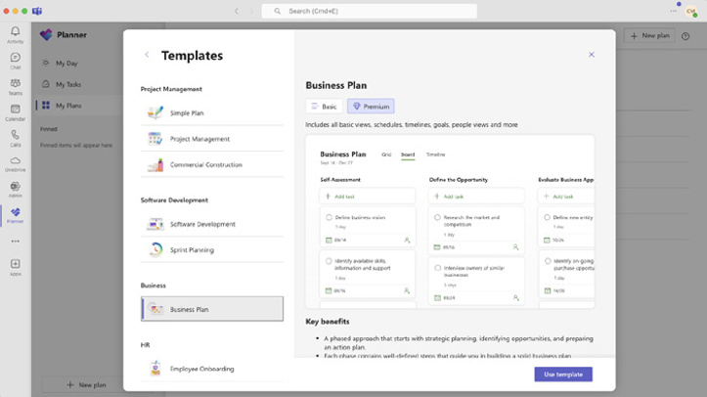

FIGURE 12-10:
Selecting a Basic
or Premium plan.

At least at the time of this writing, to use Copilot with your plan, you need to select the Premium plan.
Selecting the business plan template creates the steps for a three-phase business planning process that involves 56 tasks. The plan created from the template isn’t customized to my business in any way, of course, but as a generic business plan template, it seems pretty complete. It has a more aggressive timeline than the plan Copilot generated, and it separates the tasks into nine buckets that progress in a logical sequence from self-assessment to a five-year business plan.

CHAPTER 12 Using Copilot for Project Management 221
A portion of the task list for the built-in business plan template is shown in
Figure 12-11.
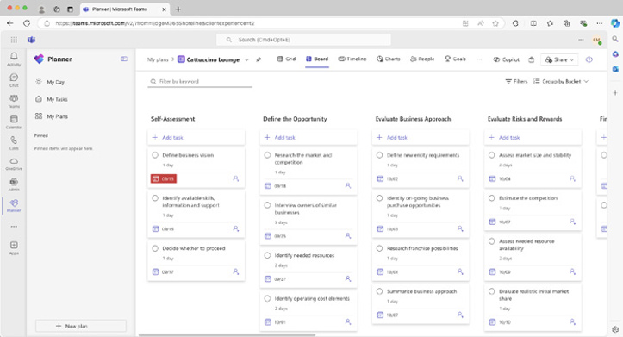

FIGURE 12-11:
The built-in
business
plan template.

Customizing a built-in business plan
with Copilot
I ended up preferring the details of the built-in business plan template, but I liked
that the plan created by Copilot had tasks that were specific to the business I’m
hoping to start.
I wondered whether it might be possible to get the best of both worlds by using
Copilot to customize the built-in template.
With the plan created using the built-in template open, I opened the Copilot side-
bar and submitted the following prompt:
Customize this business plan so that it’s more relevant for a cat café that I’m thinking
of starting.
Rather than customizing the existing business plan, what Copilot did in response
to this prompt was create a new business plan inside this business plan with the
same outline, buckets, and goals as the plan I generated from scratch using Copilot.
Ah ha! Things are starting to make sense. When Copilot detects that a prompt is
asking for a business plan, it seems to use a basic outline (a template) and cus-
tomize it using whatever other information it knows about what the user wants.

222 PART 2 Getting Work Done with Microsoft 365 Copilot This makes a lot of sense, and I think it’s a great approach that minimizes the risk of Copilot generating project plans that are completely off base. But I wish Copilot would use the more comprehensive built-in business plan template.

Reporting with Copilot
Once you have a plan and things are underway with your project, it’s time to use Microsoft Planner to create reports that you can use to better understand what’s happening with the project and to communicate with the project’s stakeholders.

Creating a status report
The Understand category of Copilot in Planner’s prompt menu has a number of suggestions for reports you can generate. The first built-in report-related prompt asks Copilot to create a status report for the project, including progress, high-lights, and risks.
I haven’t done anything except create a plan at this point (so, there’s been no progress), but when I submitted this prompt, it gave me the following report:
Here is the status report for the current plan in Planner:
The project manager for this plan is Chris Minnick. The plan started on September 13 and ended on September 13. The duration of the plan is 0 days. The percentage of the plan completed is 0%. The effort completed is 0 and the effort remaining is 0.
The plan has a total of 37 tasks.
All tasks are currently in the Not Started state with 0% completion.
Is there anything else you would like to know about this plan?
So far, so good! This seems to be a templated response, and I can see how it would be helpful if I were a bit further into the project.

Researching and analyzing data
Many of the other built-in prompts for understanding the project are focused on answering questions that I could find out by looking at standard features of

CHAPTER 12 Using Copilot for Project Management 223
Microsoft Planner. For example, one of the built-in prompts is Who is working
on ___. An easier way to answer this question is to simply look at the task and see
who’s working on it.
I wanted to know how helpful Copilot could be as a brainstorming partner,
research aide, and data analyst for projects, so submitted the following prompt:
Using data from the web, tell me about a good target demographic for my cat café
business.
The response from Copilot was light on facts and figures, but it pointed out that
young adults, millennials, animal lovers, and families with children who may not
have pets at home would all be good target demographics and that it depends on
the location and specific offerings of the cat café.
It seemed like a good answer, but I wanted some hard figures. I submitted the fol-
lowing prompt:
Give me facts and figures related to these target demographics, especially in the U.S. Pacific
Northwest. I’m looking for information I can present to potential investors.
The response it gave said that it was unable to find specific facts and figures from
its enterprise search, then went on to give me some general findings of market
research about young adults, millennials, and families with children in the Pacific
Northwest. When I asked it to cite a source for its response, it was unable to.
What this tells me is that Copilot in Project does have access to documents I’ve
stored in OneDrive, but it doesn’t have access to the web.
To test Copilot’s ability to access my documents, I found data from the 2020 U.S.
census about household income by age in Oregon and saved it to an Excel spread-
sheet in my OneDrive account. I then gave Copilot in Planner the following prompt:
Tell me about household income by age in Oregon.
Here’s how Copilot responded:
According to a file titled “oregon-household-income” by Chris Minnick, the household
income in Oregon varies by age of the householder. For householders under 25 years old,
the highest number of households earn between $10,000 and $14,999. For householders
aged 25 to 44 years, the highest number of households earn between $75,000 and
$99,999. For householders aged 45 to 64 years, the highest number of households earn
between $200,000 or more. For householders aged 65 years and over, the highest number
of households earn between $10,000 and $14,999.

224 PART 2 Getting Work Done with Microsoft 365 Copilot While this answer does look like a complete success with regards to getting Copi-lot to use data from my own documents, the analysis Copilot did of the data is mostly incorrect. Better AI models will do better with analysis in the near future. But even then, please remember to verify the output of an AI model, especially when it comes to anything involving analysis of raw data.

Asking Copilot for Ideas
In addition to being able to help with creating, editing, and reporting on a plan, Copilot can also function as a sort of business advisor and answer general ques-tions or suggest ideas.
Copilot in Planner has two built-in prompts in this category:

» What are some ways to
» What are some best practices to
Completing these questions and submitting the prompt should cause Copilot to generate a list of ideas that you might consider. For example, I submitted the first prompt with a question about how to generate revenue from a cat café. Copilot’s answer is shown in Figure 12-12.
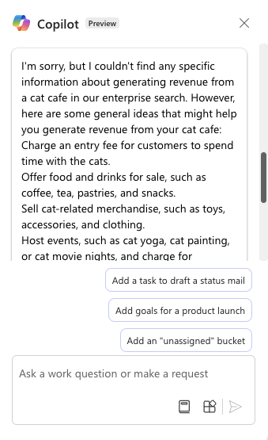

FIGURE 12-12:
Copilot’s ideas
about cat café
revenue streams.

CHAPTER 12 Using Copilot for Project Management 225
I thought many of the ideas made sense and would be helpful in writing the
business plan.

What Can Copilot Do for Project Managers?
Copilot has the potential to be an effective and always-available assistant for any
project managers. Used correctly, it can help generate reports, create meeting
notes, and even help with brainstorming about project tasks and goals.
The keys to using Copilot correctly in Planner are:

» Experiment with the built-in prompts to figure out what Copilot is capable
of doing.
» Learn to trust it for tasks that it proves to be good at, such as meeting notes
and generating lots of ideas.
» Never trust it with getting facts and numbers right.
Copilot’s integration with Microsoft Planner can help you with many aspects of
project planning and management. Combined with the Copilot-enabled features
that are available in Microsoft Teams, Copilot has the potential to provide real and
immediate benefits to project managers who use it correctly.

226 PART 2 Getting Work Done with Microsoft 365 Copilot

Jumpstarting

Your Productivity

with Copilot

IN THIS PART . . .
Building your own Copilot agents
Expanding Copilot’s capabilities
Fixing common Copilot problems

IN THIS CHAPTER
» Understanding Copilot agents
» Using Copilot Studio
» Prompting for agents
» Giving agents knowledge
» Adding new topics to agents
» Editing agents
» Publishing Copilot agents

Chapter 13

Making Custom Copilots

T
hroughout this book, you’ve seen and explored many ways that Copilot has been integrated into different applications and types of devices. Thus far, I’ve only touched on a small subset of everything Copilot is capable of. My favorite feature of Microsoft Copilot is that you can customize it yourself and create your own specialized versions of Copilot that do things their own way!
The tool that makes it possible to create your own “copilots” (also known as Copilot agents) is called Copilot Studio. As you find out in this chapter, Copilot Studio is a powerful tool that’s also easy to use.

Building Your Own Copilot Agent
with Copilot Studio
Microsoft Copilot Studio lets you create your own copilots or Copilot plugins and then publish them to be used in Microsoft 365 Copilot.

CHAPTER 13 Making Custom Copilots 229
To try out Copilot Studio, go to www.microsoft.com/en-us/microsoft-copilot/
microsoft-copilot-studio in your browser. You’ll see a screen similar to the
one shown in Figure 13-1.


FIGURE 13-1:
The Copilot
Studio
homepage.

Click the Try a Demo button. This will take you to the Copilot Studio demo site
at https://copilotstudio.microsoft.com/tryit, where you can enter any
website address and create a Copilot agent that can answer questions specifically
about that website.
When you first open the Copilot Studio demonstration, a popup window will
appear, as shown in Figure 13-2, and ask you for the URL of your website.
If you don’t have your own website, you can enter any other website you like here.
I entered my website address (www.chrisminnick.com).
After you enter a website address, your agent will be created and it will greet you
as the “virtual assistant” for the website you entered, as shown in Figure 13-3.
Behind the scenes, Copilot Studio prefaces the conversations in this window with
an instruction to use search results from Bing for the website address you entered
to answer questions.

230 PART 3 Jumpstarting Your Productivity with Copilot
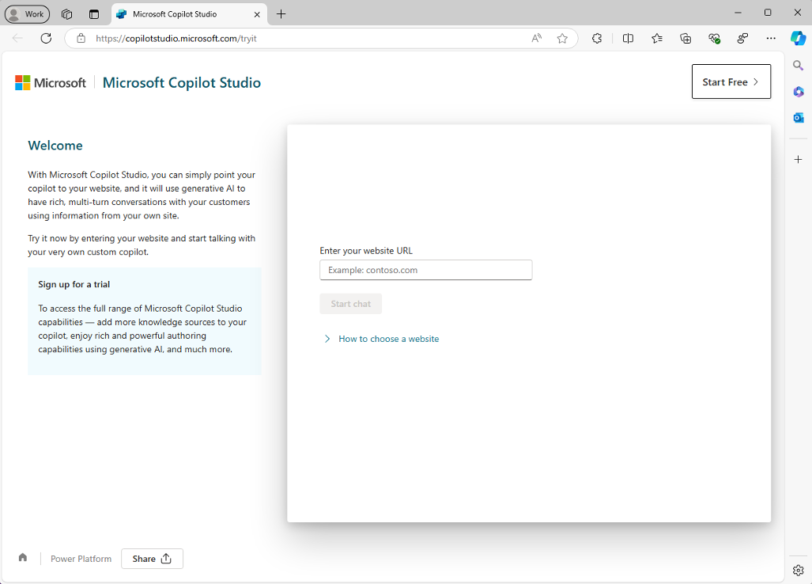
FIGURE 13-2:

Getting started
with the Copilot
Studio demo.
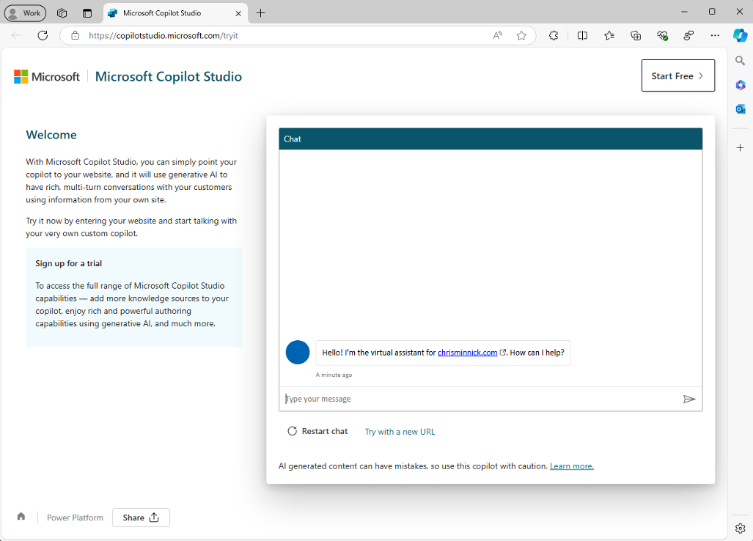

FIGURE 13-3:
Meet your virtual
assistant.

CHAPTER 13 Making Custom Copilots 231
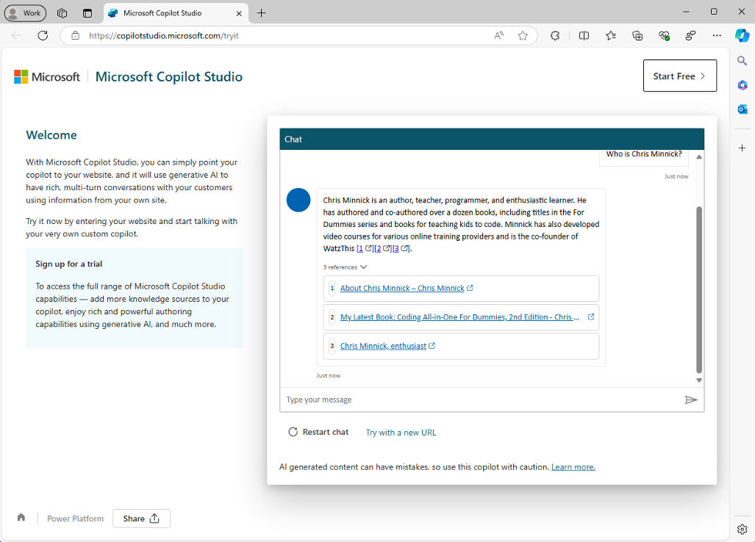
FIGURE 13-4:

A response
from the
chrisminnick.
com virtual
assistant.

In my tests of this demo, my virtual assistant for chrisminnick.com was able
to reliably return correct information from my website along with references
for the exact pages where it got the information. Figure 13-4 shows a typi-
cal response.
You’ve likely seen this type of AI customer service agent before. Now that you
know how easy it is to create one of these agents, you can try out some more com-
plex projects. Click the Start Free button in the upper-right corner of the
demo screen.
If you’re logged into a Microsoft account with access to Copilot Studio, you’ll be
asked if you want to use Copilot Studio with that account. Otherwise, you’ll be
asked to log in or create a new account.
Once you’ve logged in to your Microsoft account, you’ll be taken to Copilot Studio
and you’ll see a Welcome slideshow, as shown in Figure 13-5.
Once you close the welcome message, you’ll see the Copilot Studio homepage,
which will look similar to the screenshot in Figure 13-6.

232 PART 3 Jumpstarting Your Productivity with Copilot
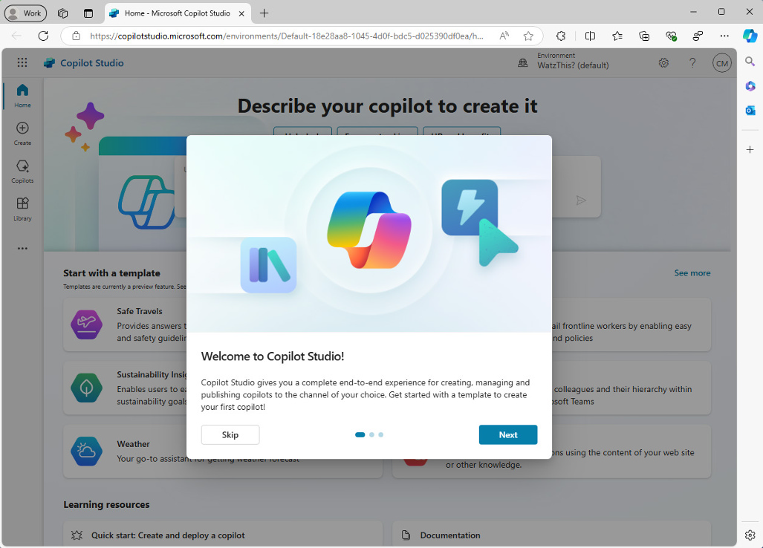
FIGURE 13-5:

The Copilot
Studio Welcome
slideshow.
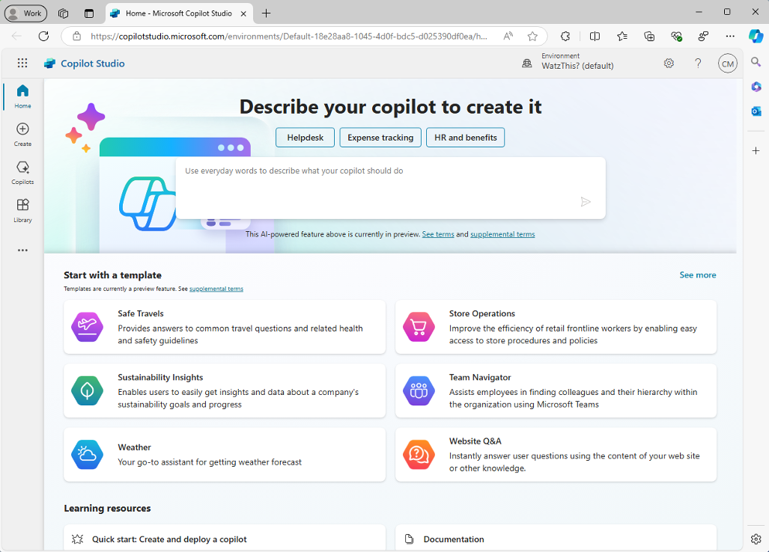

FIGURE 13-6:
The Copilot
Studio
homepage.

CHAPTER 13 Making Custom Copilots 233
You can create Copilot agents in one of two ways:

» Entering a description of the agent into the text input box in the top third of
Copilot Studio.
» Starting with a template.
In the following sections, you learn about these tools and the capabilities of each.

Creating agents by prompting
The prompting area in Copilot Studio doesn’t offer a lot of help with how to
use it other than the following instruction:
Use everyday words to describe what your copilot should do.
After thinking about it for a moment, I decided to start with something seemingly
simple (for an AI agent, anyway). I gave Copilot Studio the following prompt:
A helpful assistant that references Wikipedia.org when answering questions.
After submitting the prompt, a conversation window opens, as shown in
Figure 13-7, and Copilot asks follow-up questions about the agent you want
to create.
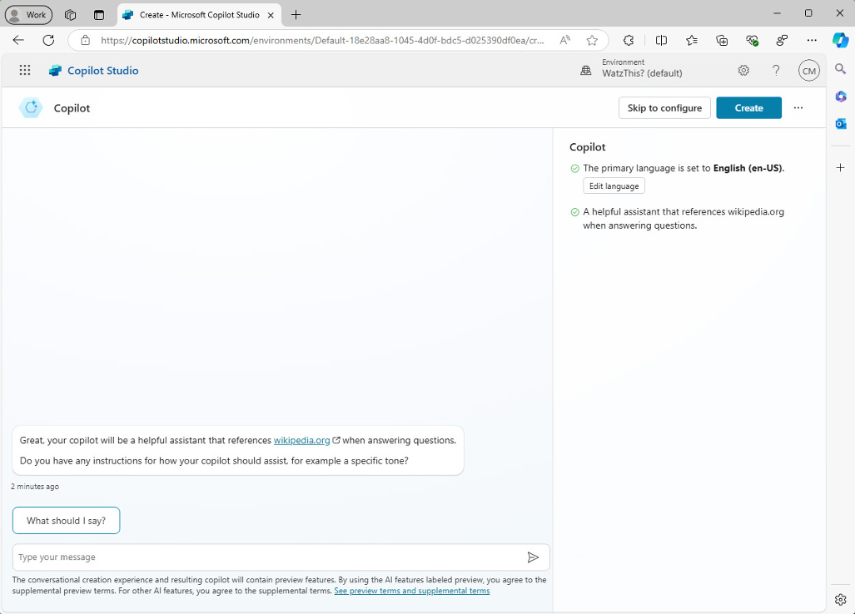

FIGURE 13-7:
Chatting with the
agent creator.
234 PART 3 Jumpstarting Your Productivity with Copilot The follow-up questions it asks are all useful things to think about when you cre-ate an agent using the more manual process later on, including:

» Do you have any instructions for how your copilot should assist, for example a
specific tone?
» Where should the copilot find important information? Provide any publicly
accessible websites that your copilot will need.
» Are there any topics or tasks this copilot shouldn’t help with or talk about?
Once you’ve answered the follow-up questions, you’ll see the instructions that Copilot generated from your guidance and a button labeled I’m Done, as shown in Figure 13-8.
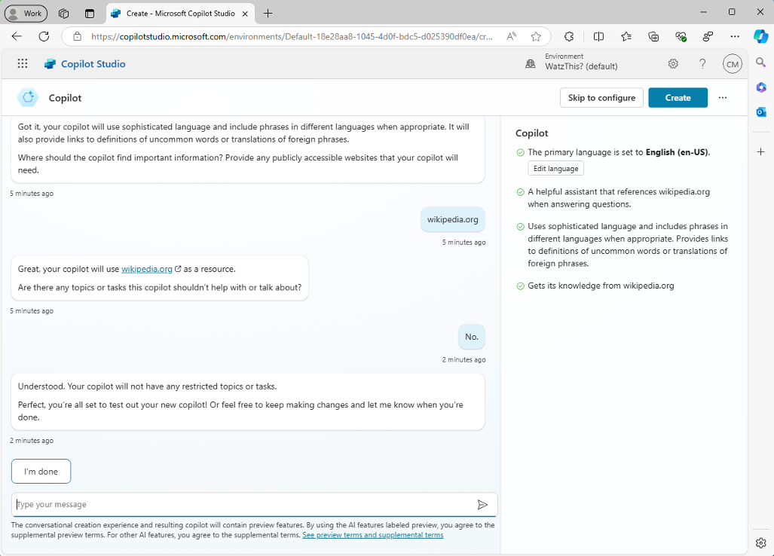

FIGURE 13-8:
Completing the
AI-assisted
agent-creation
process.

If you’re ready, click the I’m Done button to enter a conversation with the agent you’ve created. In my first test of the AI agent-creation process, I had to also click the Create button in the upper-right corner of the screen to complete the AI-assisted portion of the agent-creation process.
The next screen you’ll see is shown in Figure 13-9.

CHAPTER 13 Making Custom Copilots 235
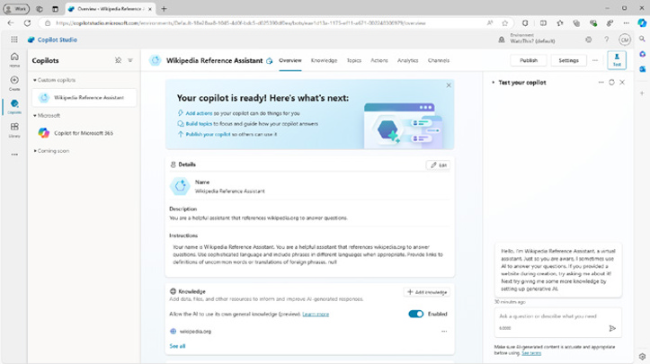
FIGURE 13-9:

The Agent Editor.

Creating agents with templates
In addition to using the prompting method to create Copilot agents, you can also
start with one of the pre-built templates. There are currently ten available tem-
plates, and another six that are listed as Coming Soon on Copilot Studio’s
Create page.
To see the available templates, click the Create icon on the left side of Copilot Stu-
dio and scroll down to the section labeled Start with a Template. You’ll see the
options shown in Figure 13-10 (and hopefully additional ones too!).
You can select any of the templates by clicking on it. A screen appears with a link
to the template instructions and the template settings. Figure 13-11 shows the
Website Q&A Copilot template instructions.
You can customize the name, description, instructions, or knowledge for the agent
on this page, then click the Create button to create the agent. You’ll then be taken
to the Copilot Agent Editor interface.
From this point on, working with an agent started from a template is the same as
working with any other agent. You can modify the agent’s various settings, test it
out, view the agent’s analytics, and publish it when you’re ready to share it with
your selected channels. The next section explains how to do all this and more with
your agent.

236 PART 3 Jumpstarting Your Productivity with Copilot
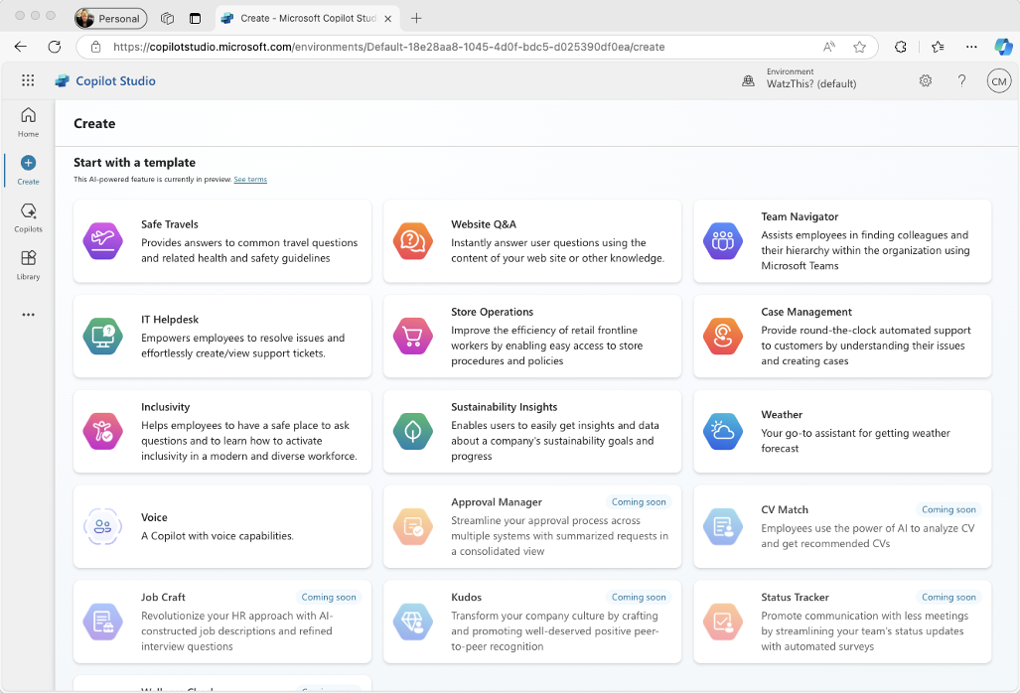
FIGURE 13-10:

The available
agent templates.
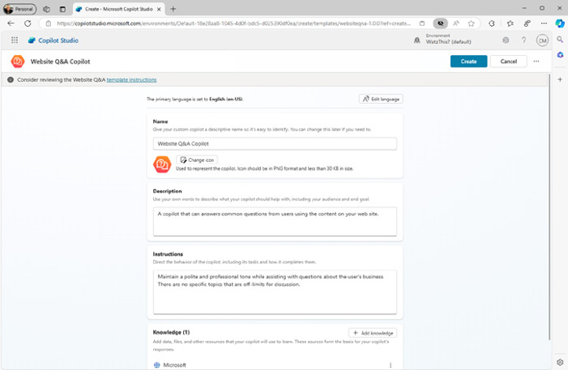

FIGURE 13-11:
The Website
Q&A template
settings.

CHAPTER 13 Making Custom Copilots 237 Testing and Editing Your Agent
The first thing you should do is to try out your new agent. Type a request into the
Test Your Copilot sidebar and see what you think of the response. By default, your
agent will likely be pretty dry and boring — just the facts. Figure 13-12 shows my
first conversation with my Wikipedia agent.
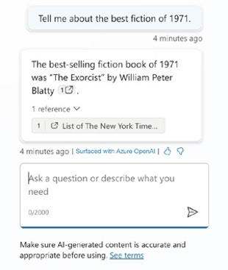

FIGURE 13-12:
Copilot is sticking
to the facts.

If this factual and dry approach is what you want, that’s excellent. But, for my
agent, I want to make it a bit more fun. To accomplish this, I need to adjust
some settings.

Configuring generative AI
By default, your agent is configured to be strict about what particular phrases
trigger its actions. It will use generative AI as little as possible, and will instead
stick to using quotes and precise interpretations from the knowledge sources you
provide. If you enable generative AI, your agent will be able to respond to requests
without requiring an exact phrase and will be more creative.
To enable generative AI, click the Settings button in the upper-right corner, then
click the Generative AI option on the left. You’ll see a screen where you can read
about the difference between the Classic mode and the Generative mode. You can
select how strict the content moderation should be for your agent. In the case of
this agent, I want it to be as creative as possible, so I enabled Generative mode and
set content moderation to low strictness.
After you’ve made your selections and clicked the Save button, you can close the
Settings. You’ll be returned to the Copilot Agent Editor.
238 PART 3 Jumpstarting Your Productivity with Copilot Using the Copilot Agent Editor
The Copilot Agent Editor is where you can adjust everything that makes your agent act the way it does. At the top of the interface is a row of tabs that allow you to customize different aspects of your AI agent. The first tab, Overview, displays a condensed version of the information from the other five tabs. These addi-tional tabs are:

» Knowledge
» Topics
» Actions
» Analytics
» Channels

The Knowledge tab
On this screen, shown in Figure 13-13, you can view a list of the knowledge sources your agent has access to. You can also add knowledge sources.
Thus far, you’ve only added public websites as knowledge sources. By clicking the Add Knowledge button, you can give your agent access to data in specific files, data in SharePoint and OneDrive, data in enterprise databases, and much more. There’s also a Custom Connector option where you write your own connector for a data source that isn’t already covered by one of the other connectors.
Some of the connectors that are available by clicking the Add Knowledge button are shown in Figure 13-14.
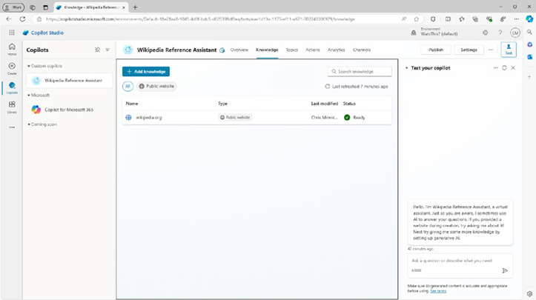

FIGURE 13-13:
Viewing and
editing your
agent’s
knowledge.

CHAPTER 13 Making Custom Copilots 239
The Topics tab
The Topics tab, shown in Figure 13-15, is where you can configure the custom and
system topics for your agent.
Topics are ways that the Copilot agent will respond when it detects a specific trig-
ger. Topics are split into two categories: custom topics and system topics. Custom
topics are topics that you’ve created (or that your AI agent creator assistant
created) and that are specific to this agent. System topics are things that are built
into Copilot and that you can customize for your agent.
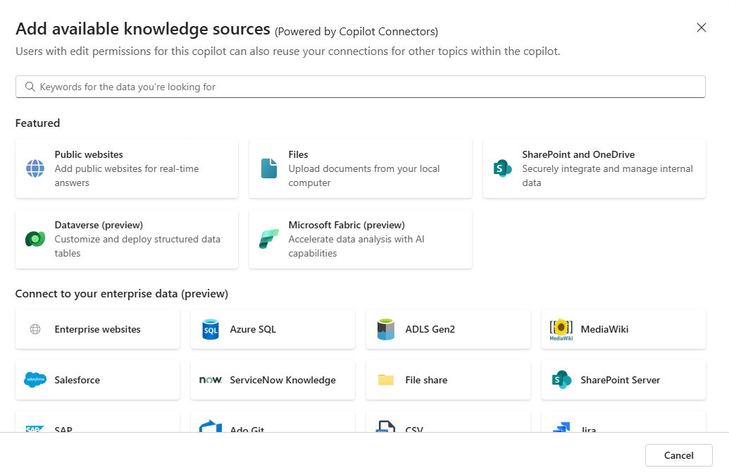

FIGURE 13-14:
Viewing available
connectors.
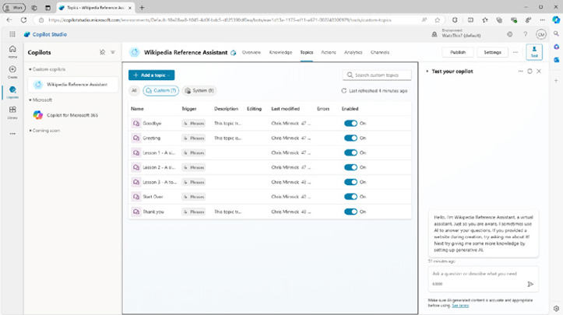

FIGURE 13-15:
The Topics tab.
240 PART 3 Jumpstarting Your Productivity with Copilot If you switch to viewing the system topics, you can hover over each one to see what it does. For example, the On Error system topic triggers when the agent detects an error. If you want your agent to reply in some particular way when an error occurs, you can customize its response by clicking on the On Error system topic.
When you edit a topic, you’ll see a flowchart view of what the topic does, as shown in Figure 13-16.
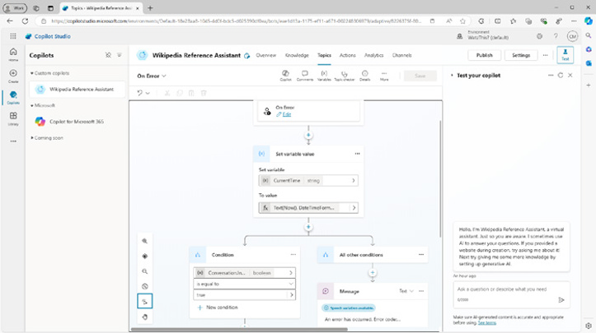

FIGURE 13-16:
Editing a topic.

Every topic starts with a trigger. The trigger is the phrase or event that causes the topic to be activated. After the trigger, topics may involve multiple conditions, messages, actions, and more.

CREATE A TOPIC
The best way to understand what’s possible with topics is to create a new one. As with creating entire agents, you can create new topics through prompting. Follow these steps:
1. Click the Add a Topic button in the Topics tab.
A submenu will appear, as shown in Figure 13-17, where you can choose whether to create the topic from scratch or by entering a description.
2. Select Create from Description with Copilot.
The window shown in Figure 13-18 will open.

CHAPTER 13 Making Custom Copilots 241
FIGURE 13-17:

Choosing how to
add the topic.
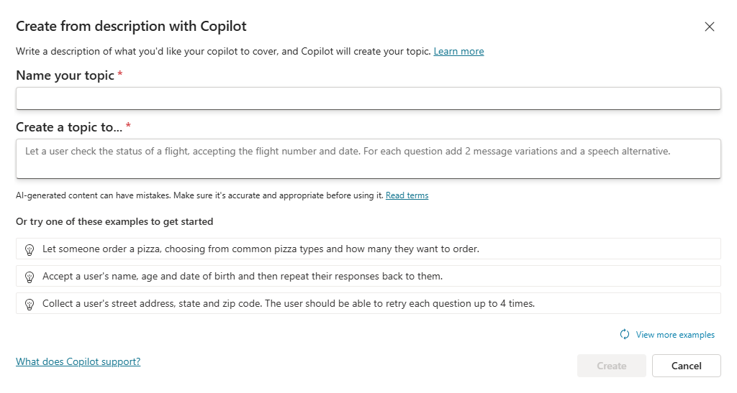

FIGURE 13-18:

Describing
your topic.
3. View the examples on this page and select one by clicking on it, or enter
your own custom description.
4. Give your new action a name and click the Create button.
Your new action will be created and you’ll see the topic editor where you can see
what Copilot added and make changes or additions to it. Figure 13-19 shows the
user data collection action that I created.
When you’re happy with your new action, click the Save button and try it out!

TEST A TOPIC
To test your new topic, first look at the trigger specified by the new topic you just
created. In the case of my topic, it uses Copilot to detect whether the user has
asked to share their personal details.
If your new topic is working, you should be able to type a prompt into the Test
Your Copilot pane in Copilot Studio and Copilot will activate the topic.

242 PART 3 Jumpstarting Your Productivity with Copilot
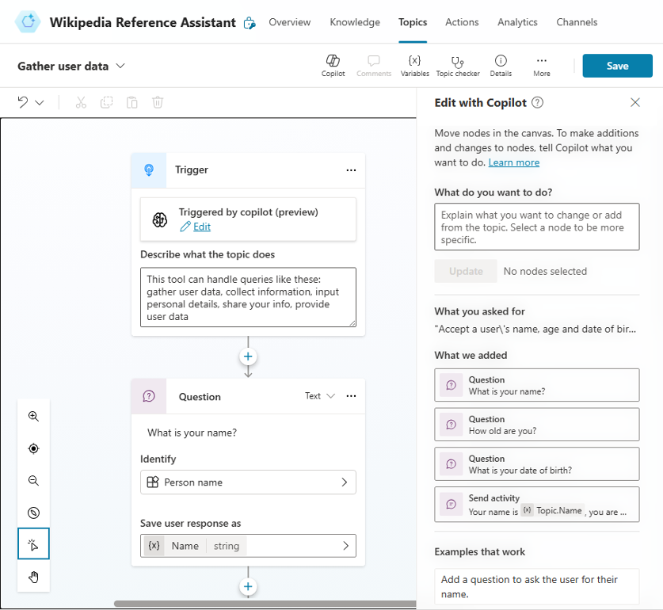
FIGURE 13-19:

Editing a
new action.

Before you try that, however, you should activate the Conversation Map. The Con-versation Map is a tool that shows you what’s happening in your test conversa-tion and why.
To activate the Conversation Map, click the map icon at the top of the test chat window, as shown in Figure 13-20.
When you enable the Conversation Map, a new window will open in the center area of Copilot Studio and wait for something to happen in the conversation.
Find the icon at the top of the Conversation Map called Track Between Topics and enable it. This icon looks like a speech bubble. Now it’s time to test your agent. Enter a question or other prompt into the test chat window.
Try experimenting with the Conversation Map’s other options and see if you can trigger other topics. Some prompts you might try include:

» Thank you!
» Start a new conversation.
» Hello!
» I want to talk to a person.

CHAPTER 13 Making Custom Copilots 243
FIGURE 13-20:

Opening the
Conversation
Map.

Figure 13-21 shows what happens when I prompt my agent with a request to talk
to a real person.
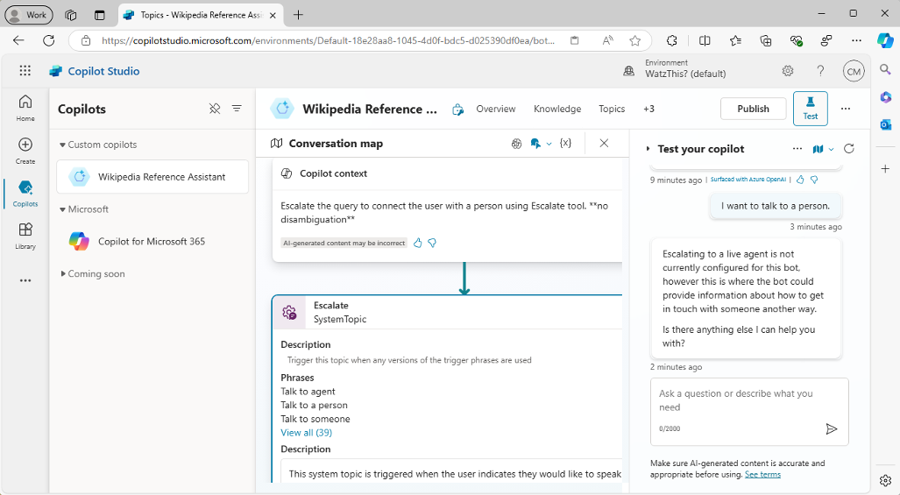

FIGURE 13-21:
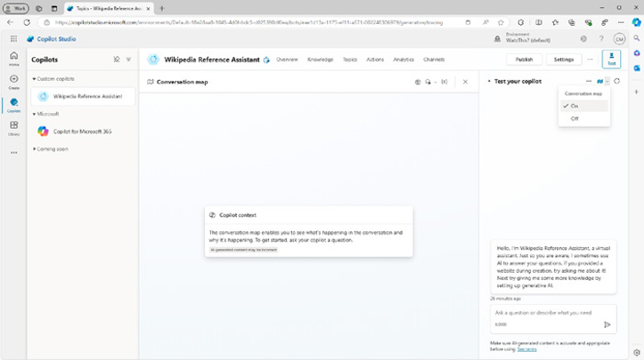
Asking to talk
with a person.

The Actions tab
The Actions tab of the Copilot editor is where you can view, create, and edit spe-
cific tasks that you want your Copilot agent to do. Actions can be invoked from
within topics, or they can be selected and run by Copilot automatically if you have
Generative mode turned on for the agent.

244 PART 3 Jumpstarting Your Productivity with Copilot Actions are the things your Copilot can do. Topics may consist of triggers, mes-sages, variables, conditions, and actions that are put together into a flow.
Follow these steps to add a weather action to your Copilot agent:
1. Click the Add an Action button in the Actions tab.
The window shown in Figure 13-22 will appear. This window allows you to search for existing actions that you have access to or to create or import a new action.
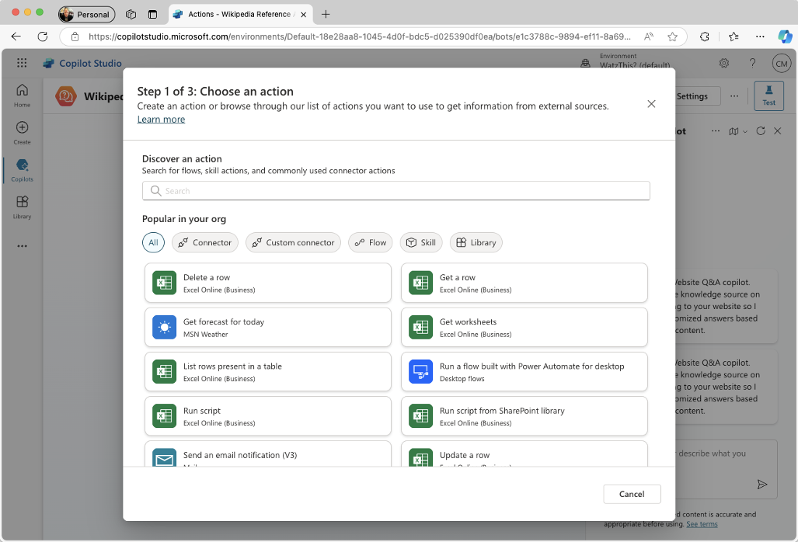

FIGURE 13-22:
Choose or create
an action.

2. Find the action named Get Forecast for Today and click on it to start
configuring it.
3. Choose the User Authentication option in the Connector settings.
4. Modify the Action Name, Display Name, or Description if you like.
See Figure 13-23.
5. Click Next to view the inputs and outputs for the action, as shown in
Figure 13-24.

CHAPTER 13 Making Custom Copilots 245
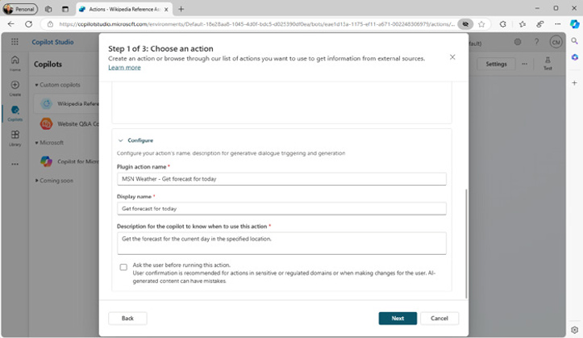
FIGURE 13-23:

Configuring
the action.
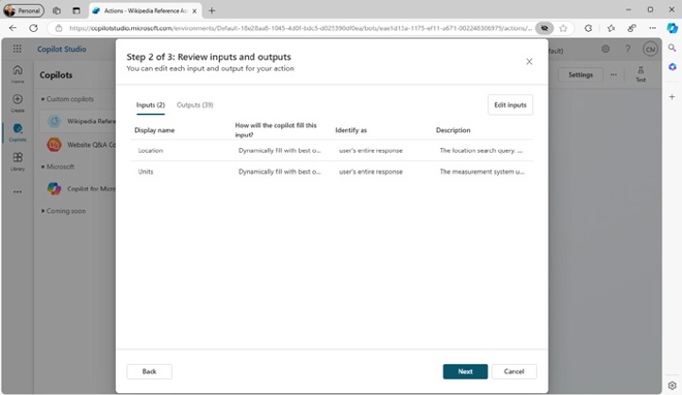

FIGURE 13-24:
Viewing inputs
and outputs.

6. Click Next to view the Review and Finish screen.
You shouldn’t need to change anything here.
7. Click Finish.

246 PART 3 Jumpstarting Your Productivity with Copilot After a moment, your action will be saved and will appear on the Actions page.
Try out your action by entering something like “What’s the weather forecast for Portland, OR?” When I tried this, the action was triggered by Copilot and asked me to specify whether I wanted to use the Imperial or Metric measurement system. After I answered that, my copilot notified me that it needed additional permission to run the action, as shown in Figure 13-25.
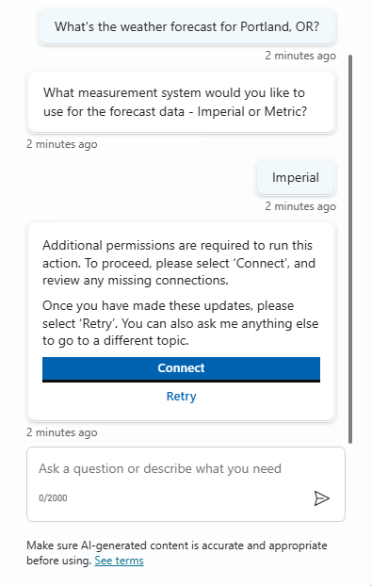

FIGURE 13-25:
Copilot needs
more permission.

I clicked the Connect button and a new tab opened in my browser where I could click through a couple of steps to connect the MSN Weather action.
After connecting the action, I went back to the window with my test conversation and retried my prompt.
My copilot didn’t respond, but when I switched to the Conversation Map, I saw that the results did come back from the MSN action, as you can see in Figure 13-26.
To cause Copilot to report the weather back to you, click the action to open it for editing, then click the Outputs tab and check the box shown in Figure 13-27, which is labeled Respond to the User After Running This Action.

CHAPTER 13 Making Custom Copilots 247
FIGURE 13-26:

Viewing the result
of an action.
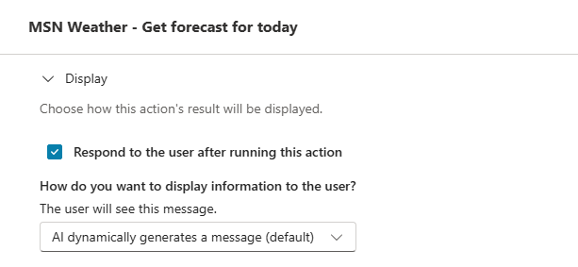

FIGURE 13-27:
Enabling your
copilot to
respond
to the user.

Try your prompt again now, and it should respond with an AI-generated forecast
using the data from the MSN Weather connector, as shown in Figure 13-28.
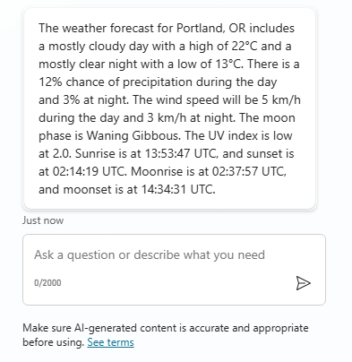

FIGURE 13-28:
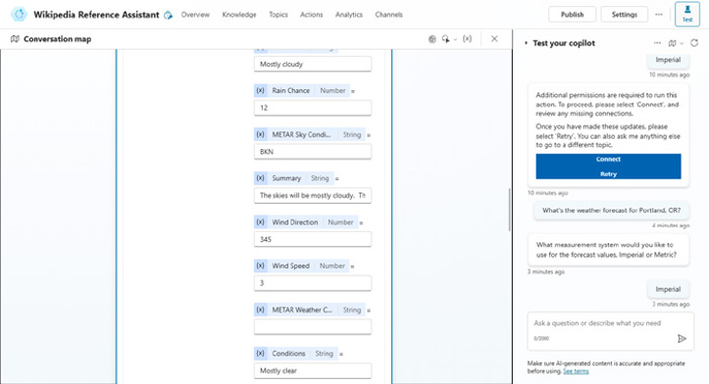
Getting the
weather forecast.
248 PART 3 Jumpstarting Your Productivity with Copilot The Analytics tab
The next tab in the Copilot Agent Editor is the Analytics tab. When you go to this tab, you see various graphs displaying information about how your agent is being used, as shown in Figure 13-29.
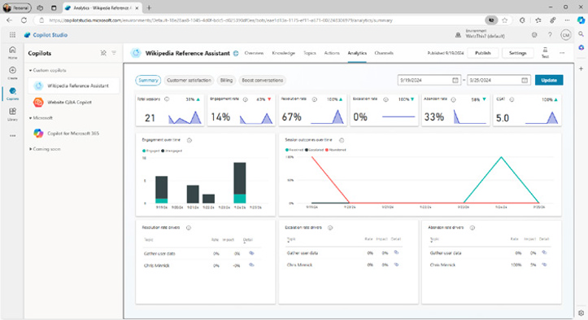

FIGURE 13-29:
The agent’s
analytics
interface.

The available data from this screen is particularly important if you’ve created a customer service agent. Some of the data that’s available includes:

» Total Sessions. This is the number of conversations that your agent has
engaged in during the period of the report.
» Engagement Rate. This is the percentage of conversations in which the user
entered a prompt that triggered a topic to run.
» Resolution Rate. This is the number of conversations in which the user
reaches the “end of conversation” topic. Resolution is typically when the user is asked to respond to a survey.
» Abandon Rate. This is the percentage of time that an engaged user (someone
who enters a prompt that triggers a topic) leaves the conversation without getting to a resolution.
A well-designed and effective agent will have a high resolution rate and a low abandon rate. By monitoring your agent’s stats over time, you can find out whether it’s doing its job and make adjustments as necessary.

CHAPTER 13 Making Custom Copilots 249
The Channels tab
The last tab is the Channels tab, which is shown in Figure 13-30.
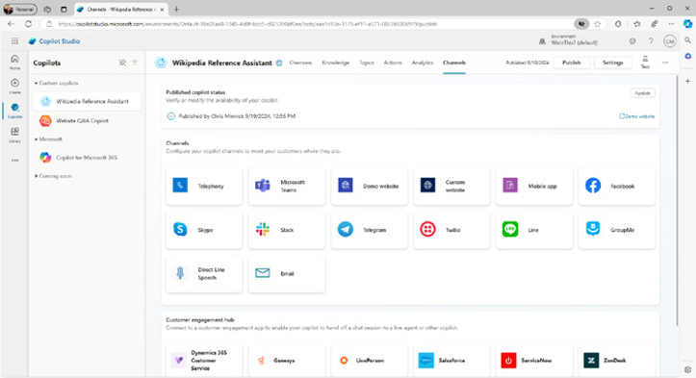

FIGURE 13-30:
The Channels tab.

Channels are places where your Copilot agent will be available once it’s published.
The channels that are currently available are:

» Telephony. Allows your agent to handle phone calls.
» Microsoft Teams. Makes your agent available to users in your organization
from within Teams.
» Custom Website. Embeds your agent in a website.
» Custom Mobile App. Adds your agent to a mobile app.
» Facebook. Allows users to interact with your agent through Facebook messenger.
» Skype. Makes your agent available to users via Skype.
» Slack. Allows people to interact with your agent through Slack.
» Telegram. Connects your agent to the Telegram messaging app.
» Twilio. Connects your agent to Twilio, giving it the ability to communicate via
text messages.
» Line. Connects an agent to the Line app, which is a free voice and video
calling app.
» GroupMe. Connects with Microsoft’s GroupMe group messaging app.

250 PART 3 Jumpstarting Your Productivity with Copilot
» Direct Line Speech. Connects with text-to-speech and speech-to-text
capabilities.
» Email. Allows your agent to interact with users via email.
When you click on any of the available channels, a popup window will open that contains instructions and any links necessary to enable that channel. For exam-ple, Figure 13-31 shows the code that can be used to embed my Wikipedia assistant agent into a website.
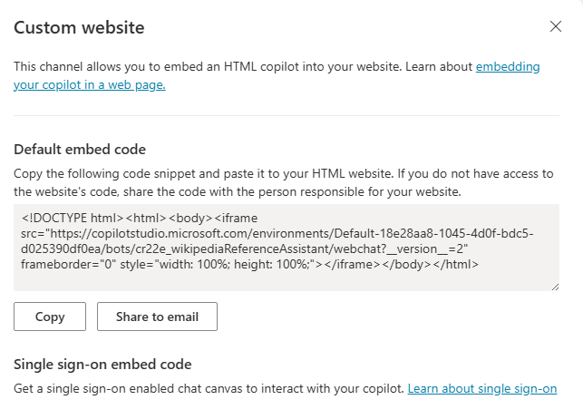

FIGURE 13-31:
How to embed
the agent in
a website.

Before you can use your new agent in your selected channels, you have to publish it. You learn how to publish an agent in the next section.

Publishing Your Agent
Once you’ve finished your agent and are ready to deploy it and test it in the real world, you can publish it. To publish your agent, click the Publish button in the upper-right corner. A popup will display asking you to confirm that you want to make your agent available in the connected channels. Once you answer Yes, your agent will be published!
Figure 13-32 shows my Wikipedia Reference Bot embedded in a page on my web-
site at www.chrisminnick.com/wikibot.

CHAPTER 13 Making Custom Copilots 251
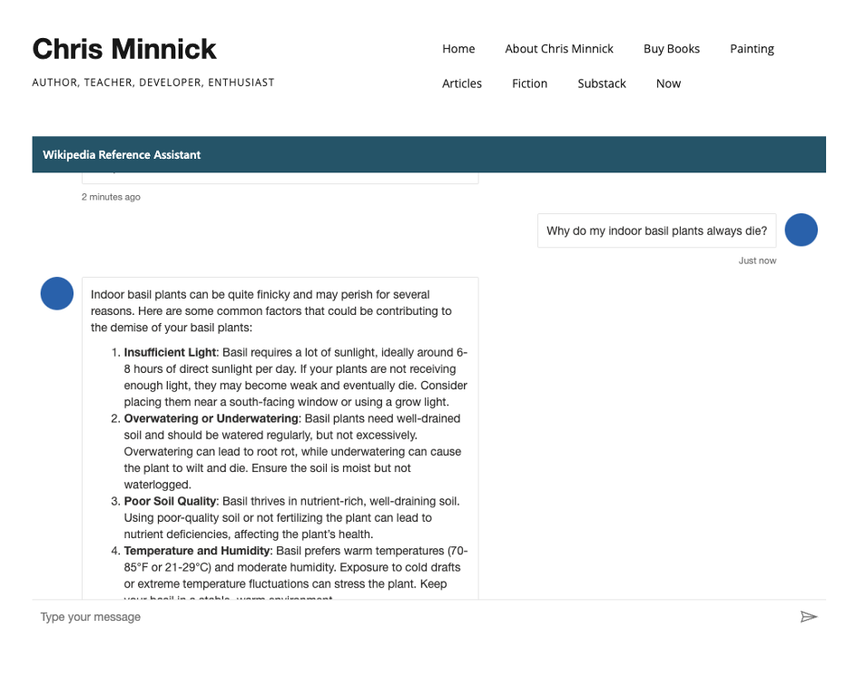
FIGURE 13-32:

My Wikipedia
Reference Bot.

Exploring Copilot’s more advanced features, such as Copilot Studio and custom
Copilots opens up infinite possibilities for how people and companies can use
generative AI. With Copilot Studio, you can now have your own AI assistant, with
access to your own selected data sources.
In the next chapter, you learn how to use, and even create, Copilot plugins.

252 PART 3 Jumpstarting Your Productivity with Copilot
IN THIS CHAPTER
» Learning the benefits of using plugins
» Finding and installing plugins
» Creating your own plugins with
Copilot Studio
» Seeing some popular Copilot plugins

Chapter 14

Expanding Copilot’s

Capabilities with Plugins

I
n Chapter 13, you learn about creating custom copilots, called agents, using Copilot Studio. Custom agents are the way to go when you’re building a product that uses Copilot and you want to fully customize it, or when you want anyone to be able to use your agent, regardless of whether they have a Microsoft 365
Copilot license.
The other option for giving Copilot new capabilities is to use (or even create!) plugins. In this chapter, you learn about what plugins are, learn how to create them, and see many different examples of them.

Using Plugins Wisely
Plugins are programs that can be added to a Copilot Chat window to give Copilot new capabilities. The main difference between plugins and custom agents is that plugins work within (or “on top of”) Microsoft 365 Copilot. Agents, on the other hand, are independent from Microsoft 365 Copilot.

CHAPTER 14 Expanding Copilot’s Capabilities with Plugins 253
Copilot can use plugins when it deems it necessary or beneficial. Just as a carpen-
ter who has a variety of specialized tools and knows how to use them can do more
types of work, Copilot with plugins can handle different types of problems than
just Copilot by itself.
In fact, you’ve seen some examples of plugins in Copilot already. For example, the
Web Content plugin gives Copilot the ability to access results from Microsoft Bing,
and the Kayak plugin gives Copilot the ability to find flight information and link
to the Kayak results.

Understanding orchestration
On a more technical level, a big difference between Copilot plugins and custom
agents is that plugins use Copilot’s orchestration layer.
The orchestration layer is the AI decision maker that intercepts every prompt you
submit to Copilot and decides on the best plugin to handle it. For example, you
might submit a request such as the following to Copilot:
Use the web to find me more information about how to build Copilot plugins.
Copilot doesn’t have a specific rule built into it that looks for every phrase a
person might submit that is a request to search the web. Instead, Copilot’s orches-
tration layer uses its understanding of the meaning of the prompt to decide that
using the Web Content plugin is the best way to handle the request.
When you create a custom agent, as you can learn about in Chapter 13, you must
specify a trigger that will cause one of the custom or system actions to run.
Just as my dog just looks at me with a confused face when I ask him if he’d like to
go for a stroll, rather than if he wants to go for a walk, a Copilot agent that’s only
triggered by the phrase “check my balance” won’t react to the phrase “How much
money do I have?”.
Although it’s not enabled by default, you can enable Copilot’s AI orchestration
within custom agents by enabling generative AI for an agent. You can learn more
about enabling generative AI in a custom agent in Chapter 13.

Knowing the limitations of LLMs
Large language models (LLMs), such as the one Copilot uses, are fantastic at
understanding language and responding. This is what they’re made to do. What
they’re less good at, however, is answering questions that require up-to-date
information.

254 PART 3 Jumpstarting Your Productivity with Copilot The reason for this is that every LLM has a knowledge cutoff date. A knowledge cut-off date is the most recent creation date of the information that was used to train that LLM. Because it takes a long time (and a lot of effort and energy) to train an LLM, the cutoff date may be months or even years behind the current date.
By itself, Copilot doesn’t know anything about anything that’s happened since its knowledge cutoff date. You can determine the current knowledge cutoff date simply by asking Copilot.
At the time of this writing, when I asked Copilot for its knowledge cutoff date, it told me October 2023, as shown in Figure 14-1.
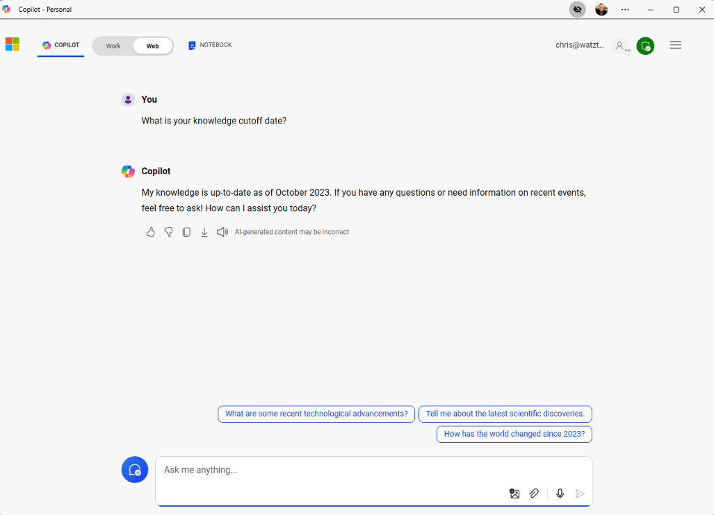

FIGURE 14-1:
Asking Copilot for
its cutoff date.

Enhancing functionality with plugins
If you don’t enable the Search plugin (in the personal version of Copilot) or the Web Content plugin (in the work/education version), Copilot won’t be able to answer questions about events that have happened after its knowledge cutoff date. With the Web Content or Search plugin enabled, however, Copilot can per-form Bing searches to find up-to-date information.

CHAPTER 14 Expanding Copilot’s Capabilities with Plugins 255
When I asked Copilot 365 (without the Web Content plugin) to tell me who won
the Superbowl in 2024, it couldn’t tell me. When I asked who won the Superbowl
in 2022, it was able to respond (and it was correct).
With the Web Content plugin enabled, Copilot was able to give me full and accu-
rate answers, along with details, for both years.
The Search plugin is the most flexible and important of the Copilot plugins. Other
plugins serve more specific purposes, as you learn in the section of this chapter
called “Seeing Examples of Plugins” and in Chapter 16.

Two types of plugins
There are two basic types of plugins: Teams Message Extensions and API plugins.
Teams Message Extensions are plugins for Microsoft Teams that are only
available within Teams. API plugins are the plugins that can be used in Microsoft
Copilot 365 Chat. API plugins access programs outside of Copilot (using their
application programming interface) to retrieve and even change data in the
external program.
An application programming interface (API) is a standardized way that program-
mers make the functionality of their program available to other programs. These
APIs are typically well documented and Copilot can use API documentation to
figure out how to interact with the external program.

Creating a Copilot Plugin
There are several ways to create Copilot plugins. These range from methods that
require some knowledge of how to write computer code to a method you’ve
already seen — by using Copilot Studio.
In Chapter 13, you learn how to create Copilot agents. Agents are standalone
copilots that have triggers, connectors, topics, and actions. Agents may or may
not use generative AI to decide how to respond to prompts.
In this section, you learn how to create a custom action that you can enable and
use in any Microsoft 365 Copilot Chat.
You can read more about triggers, connectors, topics, and actions in Chapter 13.

256 PART 3 Jumpstarting Your Productivity with Copilot You’ll create your first plugin by creating what Microsoft calls a custom connector action. You must have a work or school Copilot account and be granted sufficient permission by the account administrators to be able to create plugins.
Follow these steps:
1. Go to Copilot Studio in your browser (https://copilotstudio.
microsoft.com ) and log in.
2. Click the Library icon on the left toolbar.
3. Click Add an Item on the Library screen.
4. Click New Action in the Extend Copilot for Microsoft 365 window.
The popup window shown in Figure 14-2 will appear.
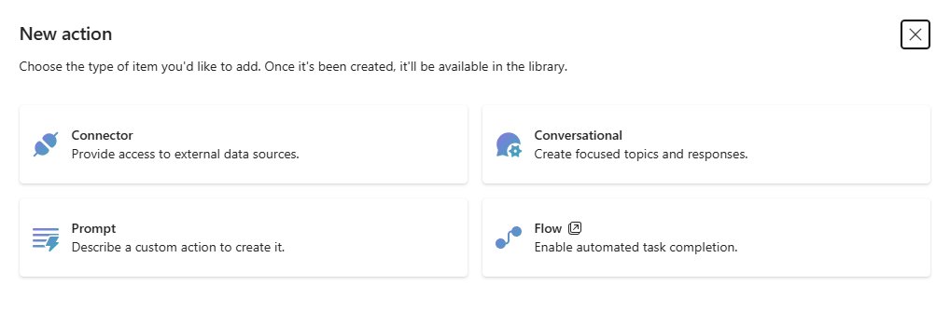

FIGURE 14-2:
Select your
action type.

5. Click the Connector button in the popup window.
You’ll see a long list of connectors. Take your time browsing through this list to see how many of the connectors are for websites and services you use. Many of the connectors require authentication and a lot of setup, but this exercise chooses one that you’ll be able to use very quickly.
6. Search for the Library of Congress connector and click on it.
The next screen, shown in Figure 14-3, shows a description of the custom connector and asks you to select a solution. A solution is a group of actions. For example, Copilot in Excel is a solution that includes actions for things like creating rows, deleting rows, summarizing data, and so forth.
7. For the Action Name, enter Search the LOC for Books. You can leave the
description as it is for now.
The Action Name and Description are what Copilot uses to decide whether to trigger the plugin, so you should pay extra attention to these. You may need to tweak them later, after you’ve tested your plugin.

CHAPTER 14 Expanding Copilot’s Capabilities with Plugins 257
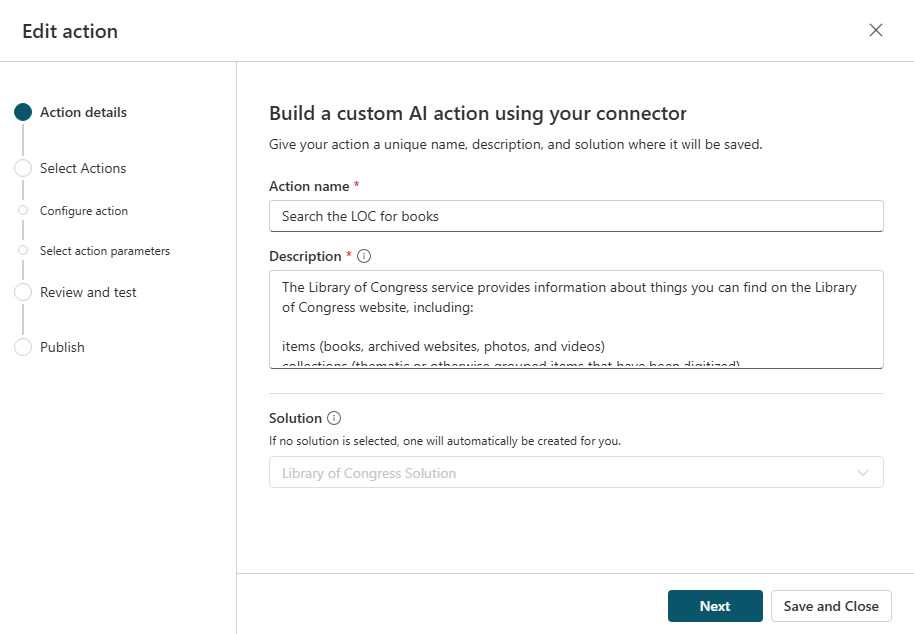
FIGURE 14-3:

The connector’s
description.

8. Still on the Action Details screen, leave the Solution blank, since this is
the first action you’re creating using the Library of Congress connector.
9. Click the Next button.
10. Choose the action named Search by Format for Items on the next screen,
then click Next.
11. The next screen shows the inputs and outputs for the action. You don’t
need to change anything on this screen. Just click Next.
Your new custom action will be saved (which may take a minute or so), and you may need to click the Next button again once it finishes saving.
If you now see the screen shown in Figure 14-4, you’ve successfully created a connector action! There are just a couple more steps before you publish it as a plugin.
12. Click the New Connection link.
A connection will make the action available in Microsoft 365 Copilot.
13. Click the Create button on the preview window that pops up.
14. Select the new connection you created from the drop-down menu then
click the Test Action button.
Copilot Studio will get the plugin ready to be tested in Copilot. When it’s ready, you’ll see a link named Open to Test.

258 PART 3 Jumpstarting Your Productivity with Copilot
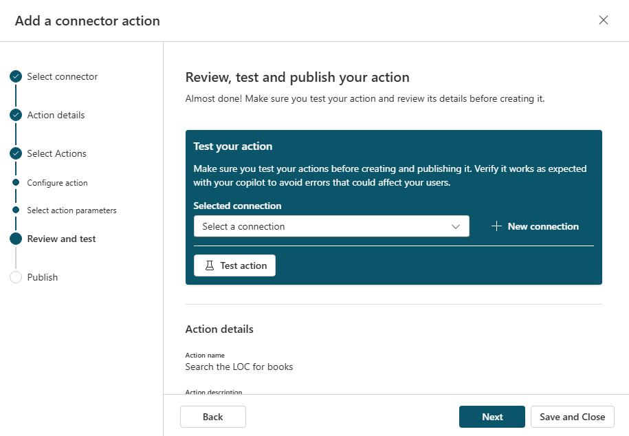
FIGURE 14-4:

Your first action is
saved and almost
ready to test.

15. Click the Open to Test link.
Copilot will launch Copilot.
16. Click the Manage Copilot Extensions (or Plugins) in Copilot and look for
your test plugin.
Its name will start with “Test,” as shown in Figure 14-5.
17. Make sure the test plugin is enabled, then test your custom plugin by
entering something like Search the Library of Congress for items about cheese.
In my experiments with this plugin, asking for “items” in the prompt seemed to work better than asking for “books.” This may be due to the words that are used in the connector’s description.
If everything works, you can return to Copilot Studio and click the Next button to publish your connector action.
Many factors influence whether a Copilot plugin works as you expect it to. If you don’t get the results you’re expecting, try changing the plugin’s description, try out a different action from the same plugin to see if that one works, change the prompt you’re testing with, or just wait an hour and try again to see if the problem is outside of your control.

CHAPTER 14 Expanding Copilot’s Capabilities with Plugins 259
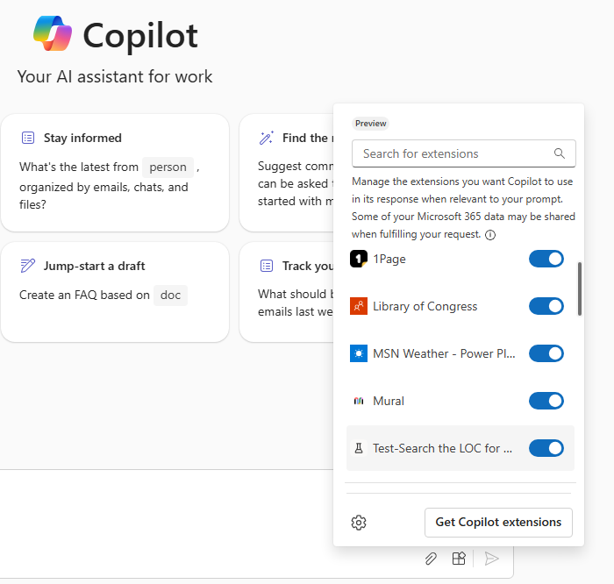
FIGURE 14-5:

Your test plugin is
now installed.

Once you enable the connector action, it will be available to you whenever you use
Microsoft 365 Copilot in Teams. You can also share your plugin with other people
in your organization.
Want to make your plugin available to anyone in the world? At the time of this
writing, there isn’t a process in Copilot Studio for doing that. However, it may be
possible in the future. Because of the possibility of security or privacy concerns,
publishing plugins for the world to find and install will likely require additional
testing and approval.

Seeing Examples of Plugins
In the personal version of Microsoft Copilot 365, you can select up to three plugins
to enable at a time from the list of plugins that appears when you open the Plugins
sidebar, as shown in Figure 14-6.
In the work or educational version of Copilot, the account administrator can
enable additional plugins using the Integrated Apps settings in the Microsoft 365
Admin Center, as shown in Figure 14-7, or you can create plugins for your own
use, as you read about in this chapter.

260 PART 3 Jumpstarting Your Productivity with Copilot
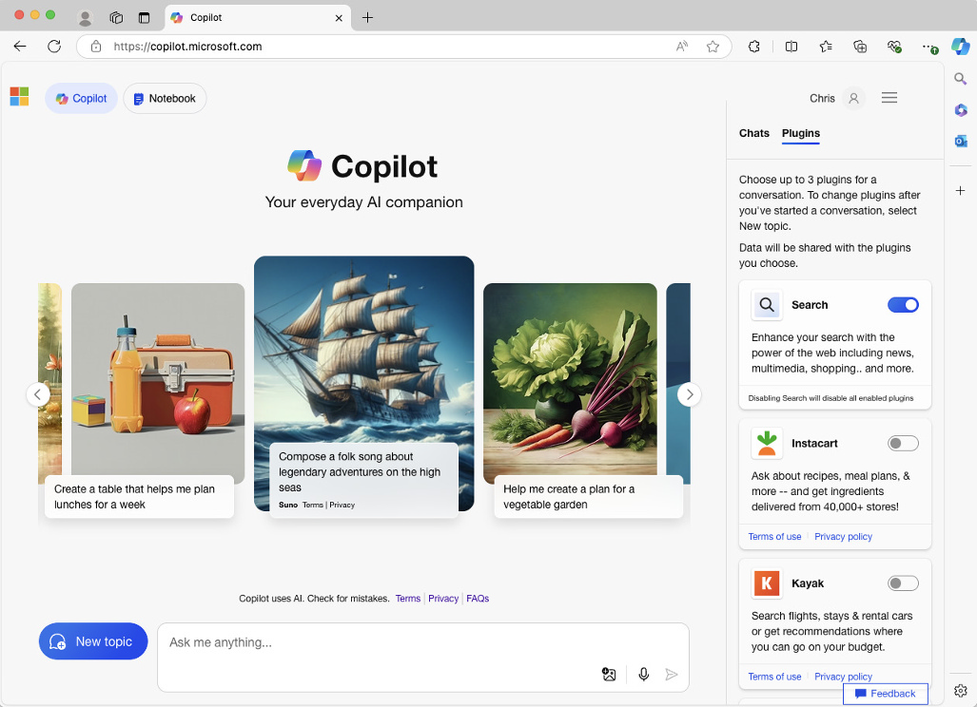
FIGURE 14-6:

The Plugins
sidebar.
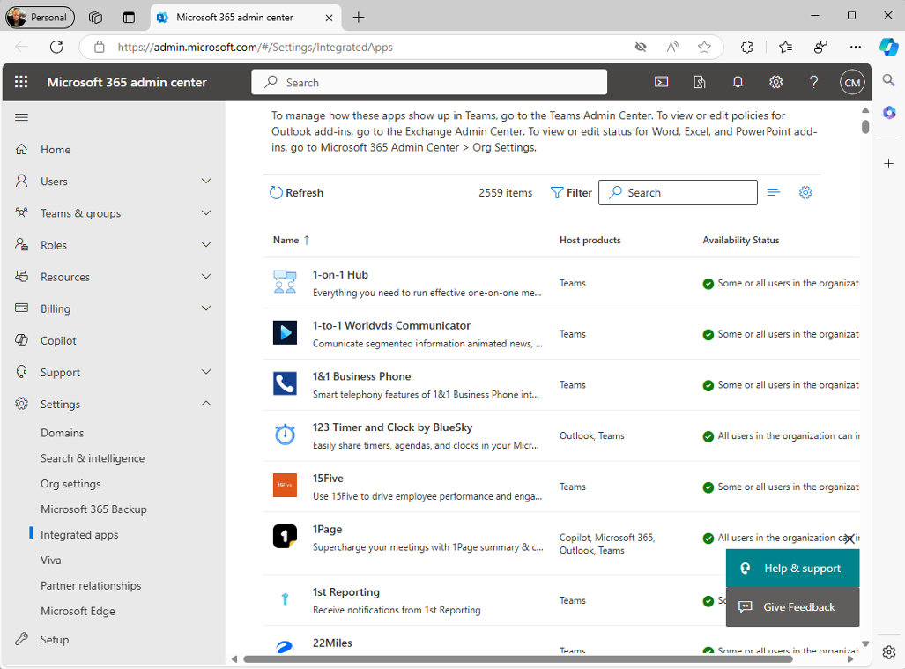

FIGURE 14-7:
The Integrated
Apps settings in
Microsoft 365.

CHAPTER 14 Expanding Copilot’s Capabilities with Plugins 261
Be sure to check out Chapter 16, which describes ten helpful Copilot plugins that
you might want to install and use.

Where can plugins be used?
The big picture of plugins is still developing, and figuring out where plugins work
and don’t work can be confusing. In this section, I attempt to make a comprehen-
sive list of the places where plugins do and do not work (at the time of this writing):

» Copilot in Microsoft Office applications (for macOS and Windows) can’t
use plugins.
» With the free version of Copilot (at https://copilot.microsoft.com) you
can enable up to three plugins selected from a short list of API plugins, as shown in Figure 14-6.
» Subscribers to Copilot Pro can use the same group of plugins as free users at
https://copilot.microsoft.com .
» Subscribers to Microsoft 365 Copilot can’t use the plugins that are available to
free users or Copilot Pro users.
» On Windows PCs, Microsoft 365 Copilot subscribers can enable the Web Content
plugin when they’re using the Work chat at https://copilot.microsoft.com.
» In Microsoft 365 apps, subscribers to Microsoft 365 Copilot can enable the
Web Content plugin, which gives Copilot access to Bing.
» If you create your own Copilot agents, which you learn about in Chapter 13,
those agents can’t use plugins.
» Microsoft 365 Copilot Chat in Teams has access to custom agents created by
people in your organization, and you can use an extensive list of extensions as well as custom plugins that you or others in your organization create.
Is your head spinning from trying to figure out where and when plugins work?
Mine too. I expect this will get smoother in the future, but for now, the best way
to experiment with the widest variety of plugins is to use the free version of Copi-
lot at https://copilot.microsoft.com along with a work or school subscription
to Microsoft 365 Copilot Chat in Teams (also known as BizChat).

Popular plugins for Copilot in Teams
Message extensions in Microsoft Teams are a way to allow Teams users to interact
with other apps by clicking a button or typing in the Teams search bar. With a
Microsoft 365 Copilot subscription, message extensions can be used as Copi-
lot plugins.

262 PART 3 Jumpstarting Your Productivity with Copilot When Copilot is enabled in Teams, not only can human users of Teams use these enabled message extensions, but Copilot can too!
The possibilities for things that can be done with this capability are enormous. In this section, you learn about some of the more popular Copilot extensions that you can enable in Teams. But, I only have space to touch on a few out of the hundreds of message extensions that have been created.
You can explore available Copilot extensions in Teams by clicking the Manage Extensions icon in the prompt input area of the Copilot Chat in Teams.
In the menu that opens when you click the Manage Extensions button, you’ll see a button labeled Get Copilot Extensions, as shown in Figure 14-8.
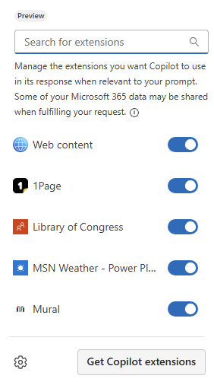

FIGURE 14-8:
Get Copilot
Extensions.

Clicking this button opens the Teams App Store, where you can explore all the available apps for Teams. Since we’re only exploring Copilot Extensions at this point, I recommend you click the Filter link in the upper-right corner of the screen and narrow down the choices, as shown in Figure 14-9.
A few of the more popular Copilot Extensions in Teams include:

» Mural. Mural is a visual collaboration tool that allows teams to work together
in a digital whiteboard environment. The Mural Copilot Extension allows you to ask Copilot questions about projects you’re working on in Mural, ask for template recommendations, and search your projects.

CHAPTER 14 Expanding Copilot’s Capabilities with Plugins 263
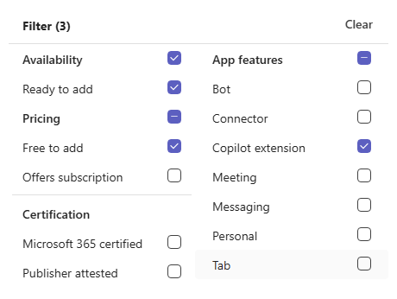
FIGURE 14-9:

Filtering the apps.

» Dropbox. Dropbox is a popular cloud file storage and sharing app. With the
Dropbox extension enabled, you can share, upload, search, and preview files in Dropbox from within Teams and ask Copilot about files you’ve stored in Dropbox.
» Monday.com. Monday.com is a project management tool. When you install
the Monday.com extension, you gain the ability to use many of Monday.com’s features from within Teams and to ask Copilot questions about your projects.

Considering the Future of Plugins
Plugins give Copilot access to data outside of the data it was trained on. The idea
is simple, but the potential for changing how you work is impressive. Of course,
there’s always a downside, and plugins can be fickle and unpredictable. The keys
to using plugins at this early stage of development is to be patient, understand
what they can and can’t do, and know when the job you want to do would be better
accomplished using a traditional tool such as a search engine.

264 PART 3 Jumpstarting Your Productivity with Copilot
IN THIS CHAPTER
» Debugging configuration issues
» Navigating bad responses
» Understanding performance issues
» Getting involved in a community
» Getting help

Chapter 15

Troubleshooting

Common Issues

with Copilot

C
opilot is still new technology. Although we’ve had chatbots for many years, it wasn’t until the release of OpenAI’s GPT-3 LLM and ChatGPT that they could do much of anything outside of giving preprogrammed responses to preselected questions.
Now that AI chatbots can convincingly communicate as fluently as humans, we’ve gained a lot in terms of capabilities, but we’ve also gained a lot of complexity when we’re trying to figure out why they aren’t doing what we want them to do.
In this chapter, you learn about some of the things that can go wrong with Copilot and some of the things you can try to fix them.

Troubleshooting Common Setup Issues
Setup and licensing issues are common with Copilot. Here are some of the things you can check to determine whether the problem you’re having is a licensing issue. A licensing issue will sometimes prevent you from seeing the Copilot icon

CHAPTER 15 Troubleshooting Common Issues with Copilot 265
in an application, or it may cause an issue that looks like it might be Copilot’s
problem. This kind of issue is the most common reason for Copilot to not be work-
ing, so always make sure to check each of the items in this list.

Restarting your computer
This should be the first suggestion in any guide to fixing software-related prob-
lems, but it’s often the last thing anyone tries. If something’s not working the way
it’s supposed to, try saving your work and restarting your computer. I can’t tell
you how many times I’ve restarted my computer in a last ditch attempt to fix a
problem and that’s what it turned out to need.

Making sure you’re signed in with
the right account
It’s common for a single person to have multiple Microsoft accounts. For example,
I have a work account and a personal account. I also have several accounts that
I’ve created as demonstrations for use in books.
To make sure you’re logged in with the right account, click your profile picture in
any Microsoft 365 application or in Copilot on the web. If you find out that you’re
signed in with the wrong account, you can use the Log Out button or the Switch
Account feature, both of which can also be found (when available) by clicking on
your profile picture.
You may also experience an issue where you’re logged in to a work or school
account and are unable to access the personal version of Copilot (at https://
copilot.microsoft.com). If this happens to you, simply signing out may not be
enough to fix it. In this case, clearing your browser’s cookies will fix the issue.

Installing the latest updates
If you don’t have the latest updates of Windows or any Microsoft Office app
installed, this can sometimes be the cause of Copilot issues.
To make sure you have the latest version of Windows, use the Search box at the
bottom of the screen to search for Windows Update and to check for updates.
Windows or macOS will usually nag you to install any available updates, but if you
want to check for updates manually, you can also do that. You can check for
updates in Microsoft Office applications on macOS by selecting Check For Updates
from the Help menu of one of the applications. In Windows, choose File ➮ Account,

266 PART 3 Jumpstarting Your Productivity with Copilot click the Update Options button, and then click Update Now on the drop-down menu.

Checking that you’re saving to OneDrive
Some Microsoft Office applications require that you save your files to Microsoft’s OneDrive cloud storage in order for you to use Copilot. Make sure also that you’re saving the file to the correct OneDrive account, which is the one associated with the Microsoft account attached to your Copilot license.

Turning on Autosave
Once you’re saving to OneDrive, you also need to turn on Autosave in Microsoft Office applications by using the toggle button in the toolbar before Copilot will work with your document.

Updating your license
If you have a Copilot Pro or Microsoft 365 Copilot license and you’re logged in with the correct Microsoft account, but none of the previous solutions for solving the issue are helping, updating your license can sometimes solve the problem.
Updating your license just means that you’re reconfirming with Microsoft’s server that your license is valid. The easiest way to update your license is to log out of your Microsoft account from any Office or Microsoft 365 app, then close any Office or Microsoft 365 apps that you have open. When you relaunch the application, you can log in again.

Working Through Bad Responses
If you’re able to access Copilot, but a prompt isn’t working the way you expect it to, here are some things you can try:

» Modify your prompt slightly. Remember, even changing one word can
sometimes make all the difference.
» Specify a role for Copilot. For example, telling Copilot to act as a math genius
might just get it to perform better when answering questions involving math.
» Use prompt engineering. You can learn more about prompt engineering
techniques in Chapter 2.

CHAPTER 15 Troubleshooting Common Issues with Copilot 267
» Use the right trigger word. For example, asking Copilot in PowerPoint to
“write a slide” may not produce the same results as asking it to “add a slide.”
» Be more specific. For example, if you want Copilot to look something up on
the web, specifically telling it to search the web will increase the chances that it will.
If a prompt isn’t working even after you try these techniques, it’s likely that Copi-
lot currently doesn’t have the capability to handle your prompt. Microsoft has
been known to remove capabilities from Copilot and add them back in without any
notification. Check one of the sources listed at the end of this chapter (in the sec-
tion titled “Seeking Help”) to find out whether other people are having similar
issues or to post a question to other users or to Microsoft.

Copilot Performance Tips
Generative AI tasks such as the ones done by Copilot require a large amount of
computing power — much more than any desktop, laptop, or mobile device cur-
rently has. The fact that Copilot and other GenAI chatbots are so fast and reliable
is due in part to a relatively recent advance in computing called cloud computing.
Understanding the fundamentals of cloud computing can also help you under-
stand why services such as Copilot sometimes slow down or become temporarily
unavailable.

A high level look at the cloud
When you enter a prompt into Copilot, it’s sent over the Internet to a gigantic
building, called a data center, that’s filled with specialized AI-processing com-
puters. At the time of this writing, there are over 10,000 AI data centers spread
around the world.
The average size of a data center is between 100,000 and 200,000 square feet
(9,290 to 18,580 square meters). Packed into that space may be over 100,000 indi-
vidual computers. Computers in a data center that handle requests from the Inter-
net are also known as servers. Figure 15-1 shows the inside of a typical data center.
One of Microsoft’s data centers, located in Boydton, Virginia, consists of 14 build-
ings that cumulatively add up to over 1 million square feet (92,900 square meters).
To put that in the peculiar system of measurement that Americans love to employ,
that’s the size of 17 American football fields.

268 PART 3 Jumpstarting Your Productivity with Copilot

FIGURE 15-1:

Inside a typical
data center.
Connect world/Adobe Stock Photos

Your prompt will be routed to a data center that’s relatively close to your location in order to reduce the time between when you submit your prompt and when you get an answer.
Not all of the servers in a data center are able to respond to Copilot prompts, how-ever, so once your prompt is inside a data center, it must be routed to a specialized AI server for processing.
Even with thousands of these specialized servers, there are times when they (or the “tubes” carrying traffic in and out of the data center) get bogged down. Dur-ing periods of particularly heavy Internet traffic or Copilot traffic, you may notice that your prompts don’t get answered as quickly. You may even get a message telling you that Copilot isn’t able to complete your request.
Each server in the Microsoft network runs its own software that gets upgraded with new versions from time to time. Included in these updates may be new Copi-lot features. Because Microsoft has so many servers, it takes time (perhaps months) to upgrade them all to the latest version. As servers are upgraded, users’ accounts begin to see the latest version. Eventually, all users will get the lat-est version.

Improving Copilot performance
If you’re using Copilot for something time-sensitive, or if you’re just in the groove with working on a project, it can be frustrating to be told to try again later or to get slow responses. The following sections explain some of the things that you might be able to do about slowdowns.

CHAPTER 15 Troubleshooting Common Issues with Copilot 269
Subscribe to a paid plan
If you’re using the free version of Copilot and need better service, you can upgrade
to a paid plan. Copilot Pro and Microsoft 365 Copilot users are given priority dur-
ing peak times.

Check your Internet connection
If you’re already on a paid plan and you’re getting frequent messages telling
you to try again later, the next thing to check is your own computer and Internet
connection. If your computer or Internet connection is slow, it will have an impact
on how quickly you receive responses from Copilot, especially when you’re
uploading large files or requesting images from Copilot. You can check your Inter-
net connection speed at a site such as Speedtest (https://speedtest.net).

Change your schedule
If the problem isn’t your computer, you’ll likely just have to wait. But, how long
do you have to wait?
I wasn’t able to find data about when Microsoft Copilot sees the highest usage.
However, when I asked Copilot, it cited a Copilot usage report written by Microsoft
that found that the highest usage happens during standard business hours for
your location.
Using Copilot during non-peak hours increases the chances that your prompts
will be answered.

Seeking Help
There will come a time in your Copilot learning journey when you’ve tried every
troubleshooting trick you know — maybe you even restarted your computer
(remember: that should be your first step!). Fortunately, you’re not alone. It’s
possible — likely even — that others have faced the same issue. In this section,
you learn about some of the resources that are available for getting answers
and support.

Official support channels
If you’re a Microsoft 365 Copilot user, you can find an active discussion and
community support forum at the Microsoft 365 Copilot community hub
(https://techcommunity.microsoft.com/t5/microsoft-365-copilot/ct-p/
Microsoft365Copilot), which is shown in Figure 15-2.

270 PART 3 Jumpstarting Your Productivity with Copilot
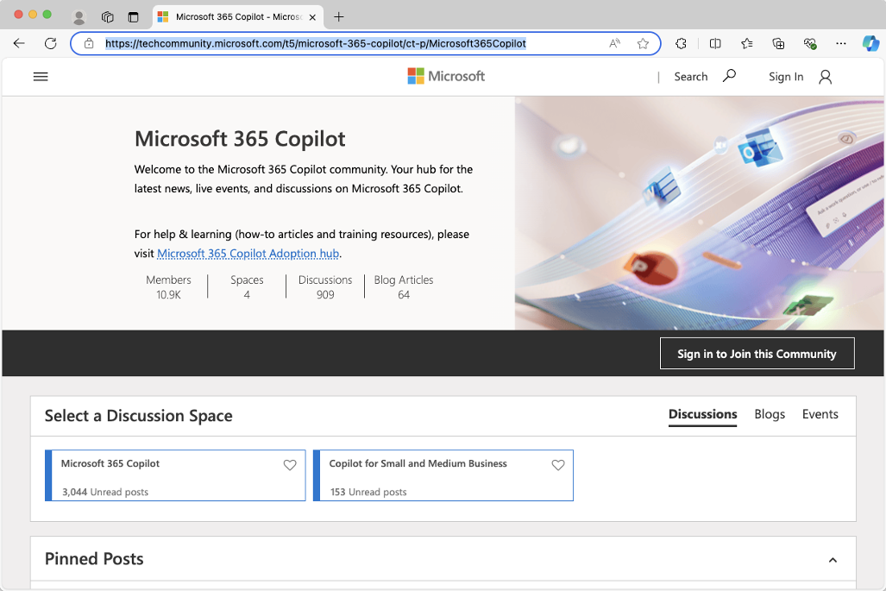
FIGURE 15-2:

The Microsoft
365 Copilot
community hub.

Here, you’ll find posts about Microsoft 365 Copilot, announcements from Microsoft about Microsoft 365 Copilot, links to events, how-to articles, training, and blogs. If you’re having a problem with Microsoft 365 Copilot and need support, this is the first place to check.

Unofficial support channels
You can find several unofficial forums where people are discussing (and some-times ranting about) Copilot on the web. The largest such forums seem to be at
Reddit.com. A good place to start is with the Copilot Pro subreddit (www.reddit.
com/r/CopilotPro/). Since the web version of Copilot was previously known as
Bing Chat, you’ll also find posts about Copilot on the Bing subreddit (www.reddit.
com/r/bing/). For more business-oriented discussions, check out the Microsoft
365 Copilot subreddit (www.reddit.com/r/microsoft_365_copilot).

Escalating issues to Microsoft
For official support from Microsoft, you can go to https://support.microsoft.
com/contactus, which is shown in Figure 15-3.
On this site, you’ll find links for getting support for various Microsoft products, including Copilot and Microsoft 365 Copilot. When you click on the Copilot logo, you’ll have a choice between getting support as a home user or getting business support, as shown in Figure 15-4.

CHAPTER 15 Troubleshooting Common Issues with Copilot 271
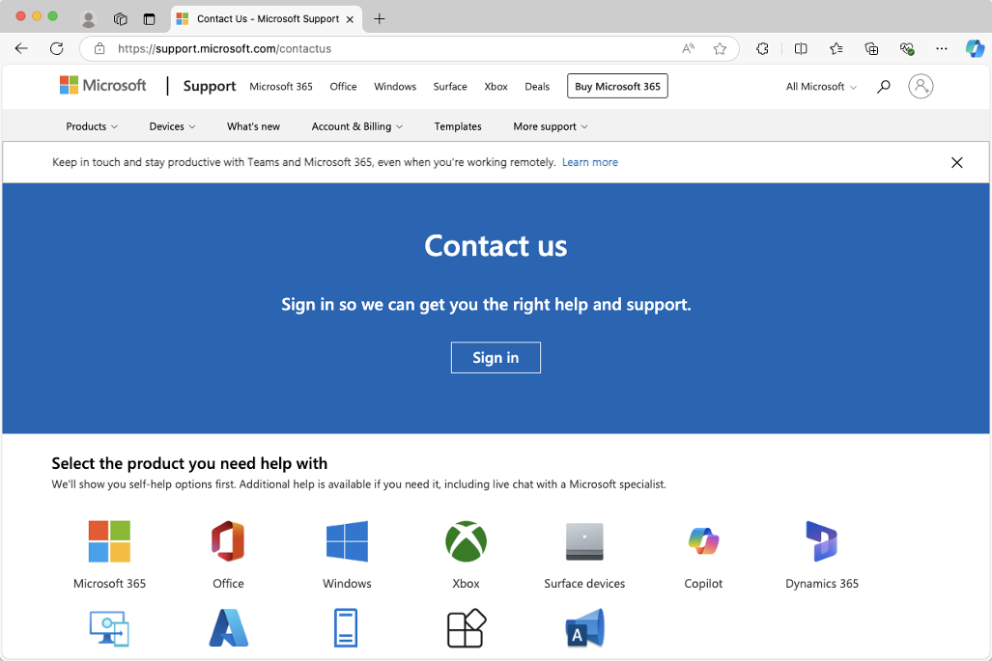
FIGURE 15-3:

Microsoft’s
Contact Us page.
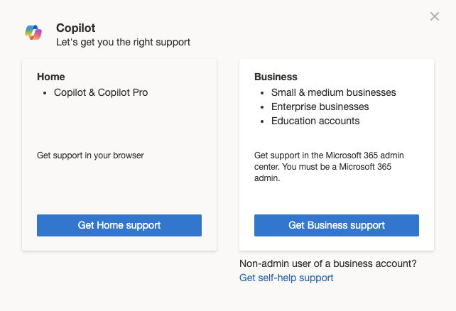

FIGURE 15-4:
Choosing
between Home
and Business
support.

Keeping up to date with what’s happening in the Copilot community and knowing
where to go for support connects you with other power users and will expose you
to new features and uses of Copilot that you may never have thought of. Especially
with something that’s changing as fast as generative AI, continuous learning is
essential.

272 PART 3 Jumpstarting Your Productivity with Copilot

The Part of Tens

IN THIS PART . . .
Exploring the capabilities of Copilot’s plugins
Learning about new and secret features of Copilot

IN THIS CHAPTER
» Cooking with AI
» Making travel plans and reservations
» Comparison shopping
» Generating music
» Collaborating visually
» Making your own plugin

Chapter 16

Ten Plugins for Copilot

C
opilot plugins combine the creative and generative capabilities of Microsoft Copilot with traditional web applications and services to enable powerful new functionality. The most basic plugin is the Web Search plugin, which allows Copilot to search the web and use information that it finds when respond-
ing to you.
Interesting things happen when you get more specific with which websites Copi-lot can access and give it access to your account on that website.
Understanding the potential privacy and security risks of using Copilot plugins is a big part of deciding whether to use them. Although I’ve installed and tried out every plugin I talk about in this chapter, I recommend that you always read the terms of use and privacy policies yourself before diving in. If the terms of use and privacy policies aren’t acceptable to you (such as, for example, if they share your personal data with a company you don’t want to share your personal data with), you can opt not to use that plugin.
The list of plugins that are available to you will depend on whether you have a work/school Copilot account or a personal account. I’ve included some plugins from both categories, so there should be something for everyone here.

CHAPTER 16 Ten Plugins for Copilot 275 Search
The Search plugin is the most essential one. It enables Copilot to access the web
and use search results from Microsoft Bing. Before you can use any of the other
plugins for the personal version of Copilot, you must enable the Search plugin.

Instacart
The Instacart plugin gives Copilot access to the Instacart grocery delivery service
website. When this plugin is enabled, Copilot will generally answer questions
about cooking, food, or grocery shopping with information from Instacart.com.
For example, when I enabled the Instacart plugin and asked what I could make
with kale, the results I got from Copilot included five recipes, with brief descrip-
tions of each followed by the text “Here’s the full recipe.” For the first recipe in
the list, this text was linked to the full recipe on Instacart.com. For the other
ones, the text wasn’t linked (which is obviously a bug, and hopefully it will be
fixed soon).
If Copilot uses Instacart in generating its response, you’ll see the Instacart logo at
the beginning of the response. When you click on any links in the response, it will
open the Instacart site where you can read the full recipe and order the ingredients
for delivery, as shown in Figure 16-1.
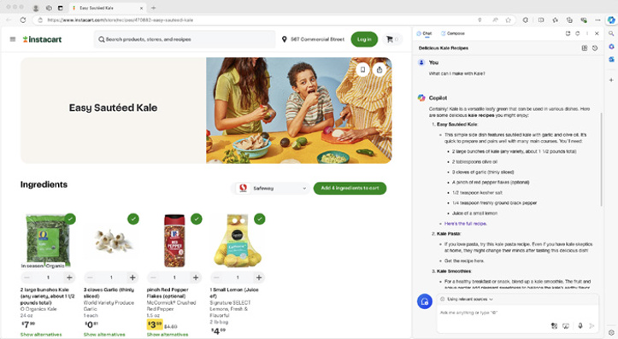

FIGURE 16-1:
Using the
Instacart plugin.

276 PART 4 The Part of Tens
Kayak
With the Kayak plugin enabled, you can use Copilot to find flights, lodging, and car rentals. One particularly useful feature of the Kayak plugin is that if you ask for flight prices it will display a table of results. You can click on this table to open the results in your browser and further refine your search or book your travel.
Note that the results that the Kayak plugin finds are mostly links to results on Microsoft Bing Travel. This is because Bing and Kayak have a partnership where
Bing’s travel search results come from Kayak.com.
A typical response from Copilot while using the Kayak plugin is shown in Figure 16-2.
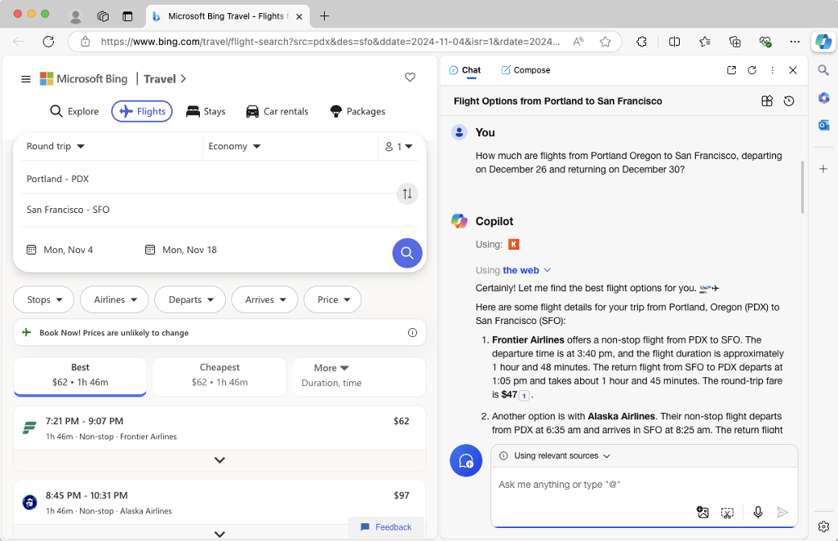

FIGURE 16-2:
Using the
Kayak plugin.

Klarna
When enabled, the Klarna plugin gives Copilot access to the Klarna.com compari-son shopping site. In my experience with this plugin, it seems to work best when you specifically ask Copilot to use it and when you search for a specific product, by model number if possible.

CHAPTER 16 Ten Plugins for Copilot 277
For example, to compare prices for a printer, I used the following prompt:
Use Klarna to compare prices for Epson ET-2850.
Copilot’s response is shown in Figure 16-3.
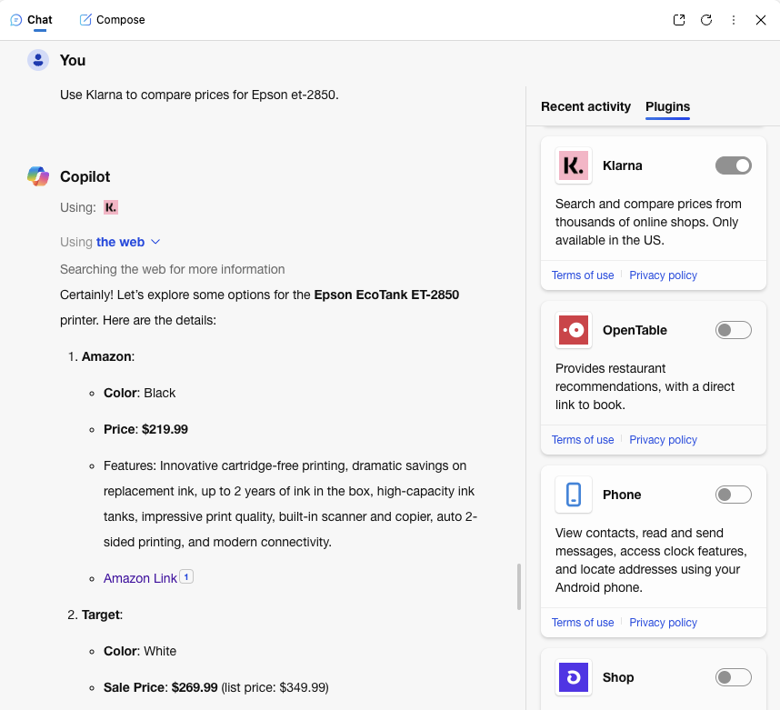

FIGURE 16-3:
Using Copilot and
Klarna to
compare prices.

OpenTable
The OpenTable plugin lets Copilot retrieve information about restaurants from the
OpenTable.com restaurant review and reservation app. When enabled, Copilot
seems to reliably use this plugin when you ask for information about restaurants,
even if you don’t specifically mention that OpenTable should be used. Each res-
taurant is linked to the correct restaurant page on OpenTable, as shown in
Figure 16-4.
However, if you’re not specific about your location, the results may not be the
most relevant. For example, I asked Copilot what the best restaurants near me are
and it gave me a list of restaurants that are all 100 miles away, even though there
are many good restaurants within one mile of my location.

278 PART 4 The Part of Tens
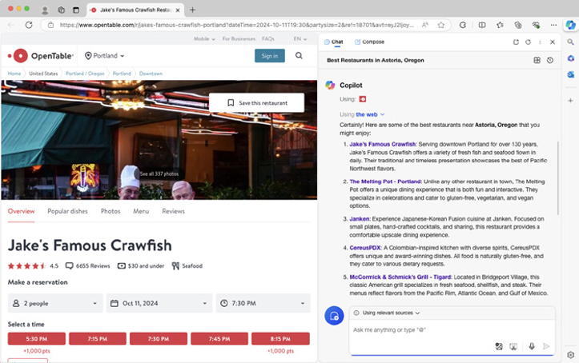
FIGURE 16-4:

The OpenTable
Copilot plugin.

The results when asking for “the best” restaurants seemed to go strictly by the star ratings at OpenTable, rather than by which ones are actually the “best.” This resulted in several so-so (in my opinion) chain restaurants being among the results.
When I was more specific about the location and the type of restaurant I was look-ing for, Copilot was more accurate with the location, but it sometimes struggled with showing results for a specific cuisine.

Phone
The Phone plugin, when enabled in the Microsoft Edge browser, allows you access certain features of your Android phone. You can use it to view contacts, read and send messages, access features of the clock (such as settings alarms), and locate addresses.
Figure 16-5 shows Copilot’s response when I asked it to tell me about the features of the Phone plugin.
Before you can use the Phone plugin, you need to install the Link to Windows app on your phone and connect it to your Microsoft account.
Once you’ve connected Link to Windows with your account, you can ask Copilot to do things with your phone. I asked Copilot to set a timer on my phone for ten

CHAPTER 16 Ten Plugins for Copilot 279
minutes. It repeated my instruction back to me and asked me to confirm that’s
what I wanted to do. When I clicked the Proceed button, it set the alarm, as shown
in Figure 16-5.
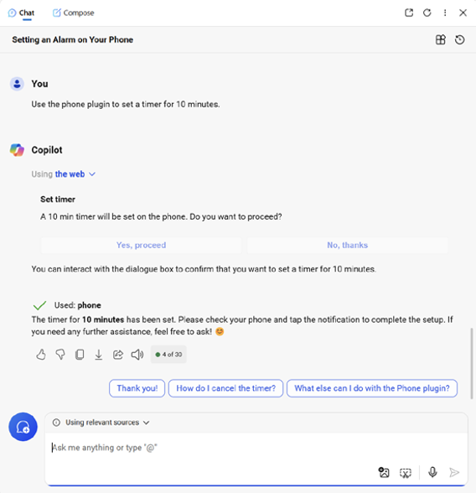

FIGURE 16-5:
Learning to use
the Phone plugin.

I also experimented with sending SMS messages and looking up contacts on my
phone, which it was able to do.

Shop
The Shop plugin accesses results from Shop.com to answer questions about prod-
ucts and prices. Like many other plugins, this one doesn’t reliably work unless
you specifically tell Copilot to use it. Once I did that, however, it could find prod-
ucts, mention highlights from the products reviews, show prices, and link directly
to the product on Shop.com.
Figure 16-6 shows the Shop plugin being used to find and link to a product.

280 PART 4 The Part of Tens
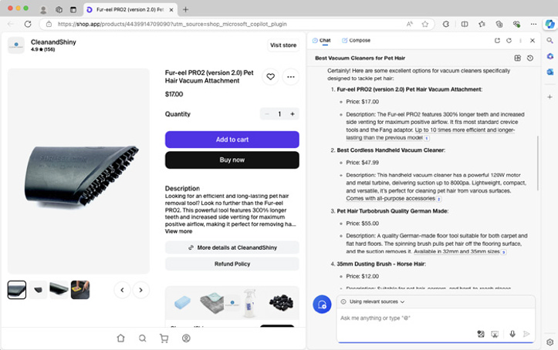
FIGURE 16-6:

Using the
Shop plugin.

Suno
Suno (https://suno.com) is an AI music-generation website. It allows you to enter a text prompt that it uses to generate a song.
As you can imagine, AI song generation is controversial. Suno is currently involved in lawsuits with musical artists and music publishers who claim that the service violates their intellectual property. The nature of Suno and its availability when you’re reading this will likely depend on the outcome of such lawsuits.
Once you enable the Suno plugin, you can ask Copilot to compose songs and it will respond with lyrics and music generated by Suno. You can generate up to five songs per day using the Copilot plugin. If you want to generate more songs than
that, you can go directly to Suno.com and sign up for an account.
Once the plugin is enabled, the keywords to use to trigger Copilot to use it are “compose” and “song.” For example, you might try using the following prompt:
Use the Suno plugin to compose a sad country song about tendonitis and how your wrist hurts when you pet your dog, but you’re gonna do it anyway.
After I submitted this prompt, Copilot indicated that it was using the Suno plugin and said my song would be ready shortly. Copilot immediately displayed the lyrics and title of the song, then a progress bar displayed and took about a minute to finish. Figure 16-7 shows my prompt and the beginning of Copilot’s response.

CHAPTER 16 Ten Plugins for Copilot 281
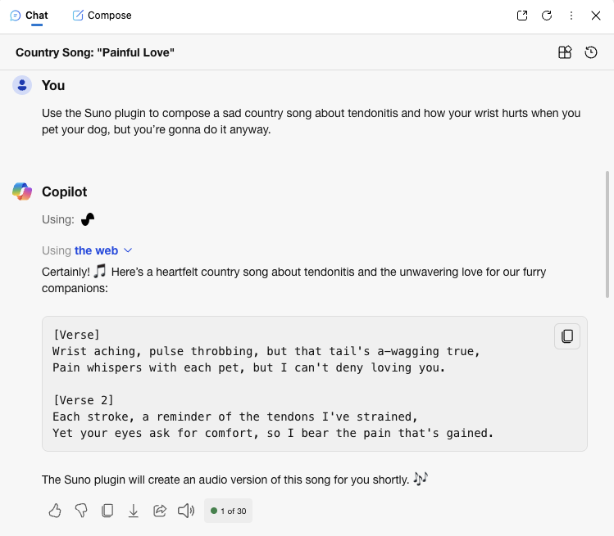
FIGURE 16-7:

The Suno plugin.
When Suno finished generating, the resulting song was one minute long, and I
could play it by clicking a play icon in the Copilot Chat. The song is absolutely
going to be a hit. After the song finished generating, Copilot displayed several
suggested next prompts, including “That’s beautiful! Can you add another verse?”
I submitted that prompt, and after another minute, a completely different one-
minute song was ready for listening. So, it’s not perfect, but Suno is my favorite
plugin so far.

Mural
The Mural plugin for Microsoft 365 Copilot enables Copilot to work with and
answer questions about collaborative spaces you create using Mural. Although
many of the plugins for Microsoft 365 require a paid account with the creator of
the plugin, Mural allows you to use a limited account for free.
When you install the Mural app in Microsoft Teams, you gain the ability to create
Murals from within Teams. You can start with a blank whiteboard, or use one of
the many available templates. Figure 16-8 shows a few of these templates.
The templates range from different kinds of calendars and planning tools to col-
laborative icebreakers that can be used in meetings. Figure 16-9 shows Copilot
responding to a question about a collaborative icebreaker exercise.

282 PART 4 The Part of Tens
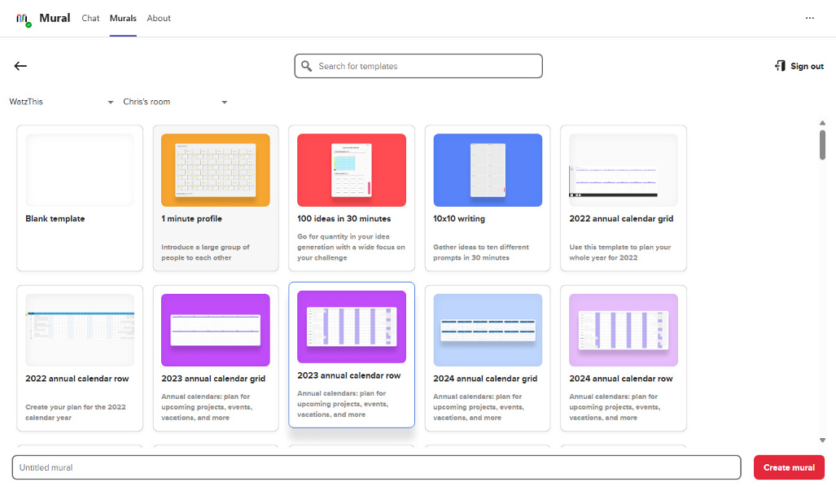
FIGURE 16-8:

Mural
templates
in Teams.
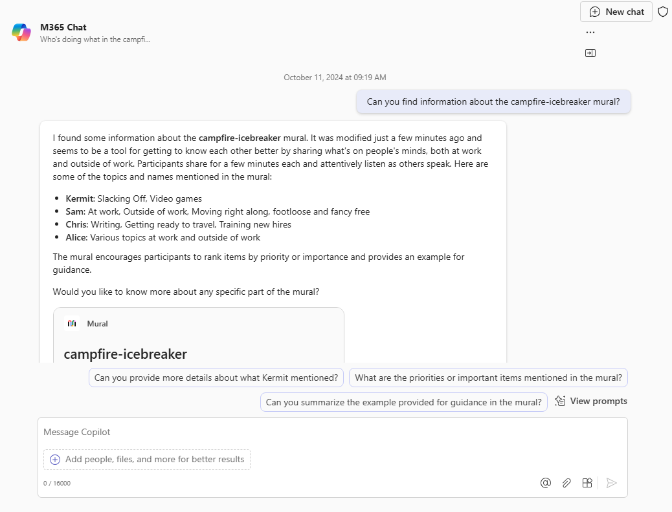

FIGURE 16-9:
Asking Copilot
about a Mural
project.

CHAPTER 16 Ten Plugins for Copilot 283 Copilot Studio
It’s not a plugin, but you can use it to make your own plugins that can be used in
Microsoft 365 Copilot. Create a Customer Service copilot for your website! Build an
HR copilot that can answer questions about your company’s employee handbook!
Once you learn how to use Copilot Studio, which you can do in Chapters 13 and 14,
you’ll be amazed at the things you can build and how easy it is to get started.

284 PART 4 The Part of Tens
IN THIS CHAPTER
» Using Think Deeper
» Participating in the Windows
Insider Program
» Customizing the Copilot key
» Using Voice Mode
» Scheduling prompts
» Drafting videos

Chapter 17

Ten Hidden Copilot Gems

M
icrosoft is constantly adding new features to Copilot. Some of these features are rolled out with a lot of fanfare, while others are quietly made available only to users who volunteer to serve as beta testers.
Even during the three months while I was writing this book, new features were added to Copilot (and some were removed) and I had to go back and update chapters.
In this chapter, you learn about some new features, unique uses, and tricks for using Copilot that may not be completely obvious at first. Some of these features were only available to beta users at the time of this writing and may not have made it into the final product yet. But, no matter what, you’re sure to find at least a couple things here that are fun, interesting, or useful!

CHAPTER 17 Ten Hidden Copilot Gems 285 Think Deeper
Think Deeper is a feature that is currently available only to some Copilot Pro users,
but it may become available to everyone in the future. With Think Deeper, you can
get help with problems that require better reasoning capabilities, such as complex
coding and math problems or working through a complex planning process.
I don’t know the exact algorithm Microsoft uses to decide who has access to the
latest Copilot features, but if you have access to Think Deeper, a Think Deeper
button will appear in your prompt text entry area at https://copilot. microsoft.
com, as shown in Figure 17-1.


FIGURE 17-1:
The Think
Deeper button.

Clicking the Think Deeper button opens a description of the Think Deeper feature
and presents some examples of things you might try, as shown in Figure 17-2.
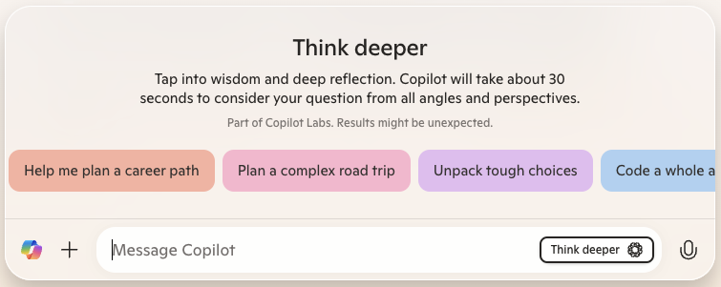

FIGURE 17-2:
The Think Deeper
suggestions.

One of the suggestions was to imagine an alternate reality. I chose this one and
told it to imagine a world where the value of pi was changed and extrapolate what
would happen over the next 20 years.
Copilot thought for a minute and then gave a lengthy, interesting, and in-depth
response that included the flowchart shown in Figure 17-3.

286 PART 4 The Part of Tens
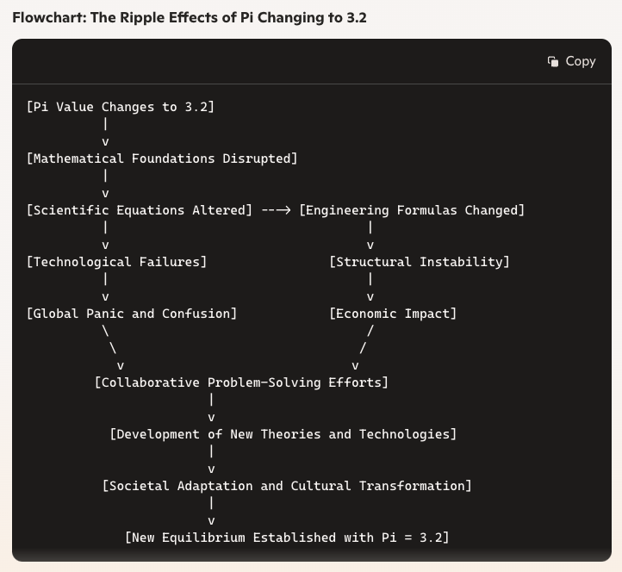
FIGURE 17-3:

What if the value
of pi were
different?

Windows Insider Program
If you want to get new versions of Windows (and Copilot) before (almost) every-one else, you can sign up for the Windows Insider program. Versions of Windows that are received by Windows Insider users may have rough edges, or even things that don’t work at all. However, they may also have new Copilot features that haven’t yet been rolled out to the general public.
To sign up for Windows Insider, go to Settings ➭ Windows Update. Scroll down on that page and you’ll see a link where you can sign up for the Windows Insider program.
Once you’re signed up, you’ll have your choice of four different channels:

» Canary. This version is for highly technical users and risk takers. When
I signed up for the Canary Channel and installed the latest version from it, I ended up with a computer that wouldn’t start up again and the only way to fix it was by reinstalling Windows from scratch.
» Dev. This version is the one I’m currently using. It has some unfinished parts,
but it also has a few features that haven’t yet been integrated into more polished versions.
» Beta. The Beta channel is the recommended selection for most people who
want a balance between getting features early and having a stable product.

CHAPTER 17 Ten Hidden Copilot Gems 287
» Release Preview. If you’re using Windows for business but also want to get
an early look at new features, this is the channel for you. It’s the safest choice (other than the generally available version of Windows) and it gives you the option to see the next version of Windows before most people.

Customize the Copilot Key
On PCs with a Copilot key on the keyboard, the action triggered by the Copilot
key can now be customized. As of late 2024, this ability was only available for
Windows Insider users who choose to get early releases of Windows 11.
To customize the Copilot key, go to Settings ➮ Personalization ➮ Text Input. If you
have a Copilot key and the ability to customize it, you’ll see the option on this
page, as shown in Figure 17-4.
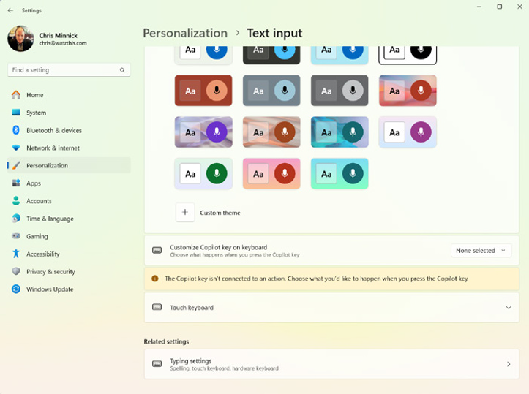

FIGURE 17-4:
Viewing the
Customize
Copilot
Key option.

In my testing, I was only able to select either Copilot or some of the apps and con-
trol panels that are built into Windows. I wasn’t, for example, able to specify that
Microsoft Word (my most used program) should open when I press the Copilot

288 PART 4 The Part of Tens key. I like having the ability to open Copilot by pressing a single button on the keyboard, so I just set it up that way.
But if you decide that you’d rather have the Copilot key open, for example, the Camera or Windows Backup, you can now do that.

Copilot Daily
This isn’t exactly a secret by now, but it is a brand new (at the time of this writing) feature in Copilot. Each day (or perhaps even more often), the personal version of
Copilot (https://copilot.microsoft.com) has a new Copilot daily news sum-mary on the homepage. Figure 17-5 shows an example.
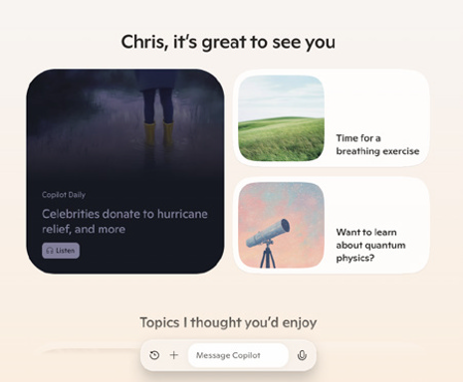

FIGURE 17-5:
Copilot Daily.

Clicking Copilot Daily will cause Copilot to give you summaries of the latest news, along with generated images and pleasant music.
Each Copilot Daily is like a small newspaper, in that it contains a mix of current events, fun facts, business news, and science and technology news taken from various publications on the web.

Copilot Vision
Copilot Vision is currently only available to some Copilot Pro users. If you give Copilot Vision permission, it can view and interact with the webpage you’re viewing.

CHAPTER 17 Ten Hidden Copilot Gems 289
If you have access to Copilot Vision, you’ll see a Vision button in the Copilot Com-
poser when using Copilot in Edge. Copilot in Edge has always had the ability to
read the text of your currently open webpage. What Copilot Vision does differently
is that it can also look at the pixels on the webpage and take action on the page.
I don’t have access to this feature yet, but according to Microsoft’s blog post (at
https://www.microsoft.com/en-us/microsoft-copilot/blog/2024/10/01/
introducing-copilot-labs-and-copilot-vision), Copilot with Copilot Vision
can do things like suggest next steps by looking at the webpage you’re viewing,
answer questions about textual and graphical elements of a webpage, and help
you navigate websites.
To help ensure the user’s safety while using Copilot Vision, limits are placed on
the types of websites Copilot Vision can interact with, and the list will be limited
to a small list of popular websites at first.

Copilot Voice Mode
Copilot Voice allows users of the Copilot mobile app or https://copilot.
microsoft.com to have a conversational interaction with Copilot. Copilot
currently has four voices you can pick from. In either the app or on the web, you
can change the voice Copilot uses by clicking your profile picture in the upper
right and selecting Voice, as shown in Figure 17-6.
Once you’ve selected your preferred voice, click or touch the Microphone icon in
the prompt input area to enable voice mode. Once you enable Copilot Voice, the
screen will change and display the “I’m Listening” message.
When Copilot is listening, you can interact with it in a way that’s similar to, but
not quite like, talking to another person. Interrupting Copilot while it’s talking
causes Copilot to cut off abruptly, and if you pause or clear your throat while talk-
ing, Copilot will start answering what it thinks your question is before you fin-
ish talking.
Asking Copilot Voice to speak in unusual ways can sometimes result in discovering
hidden gems or quirks. For example, I asked Copilot Voice to sing some songs, and
it thought it was singing, but no sound was coming out. When I asked it to talk in
an Irish accent (with the Grove voice enabled) it tried, but was unconvincing.
When you turn Copilot Voice off, you’ll be returned to the normal chat mode,
where you can continue the conversation using text prompts, as shown in
Figure 17-7.

290 PART 4 The Part of Tens
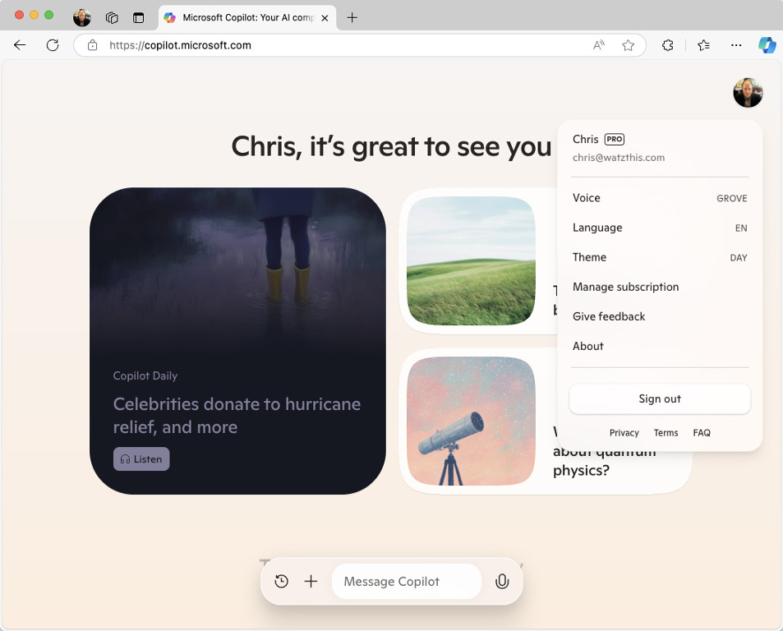
FIGURE 17-6:

Accessing Copilot
Voice settings.
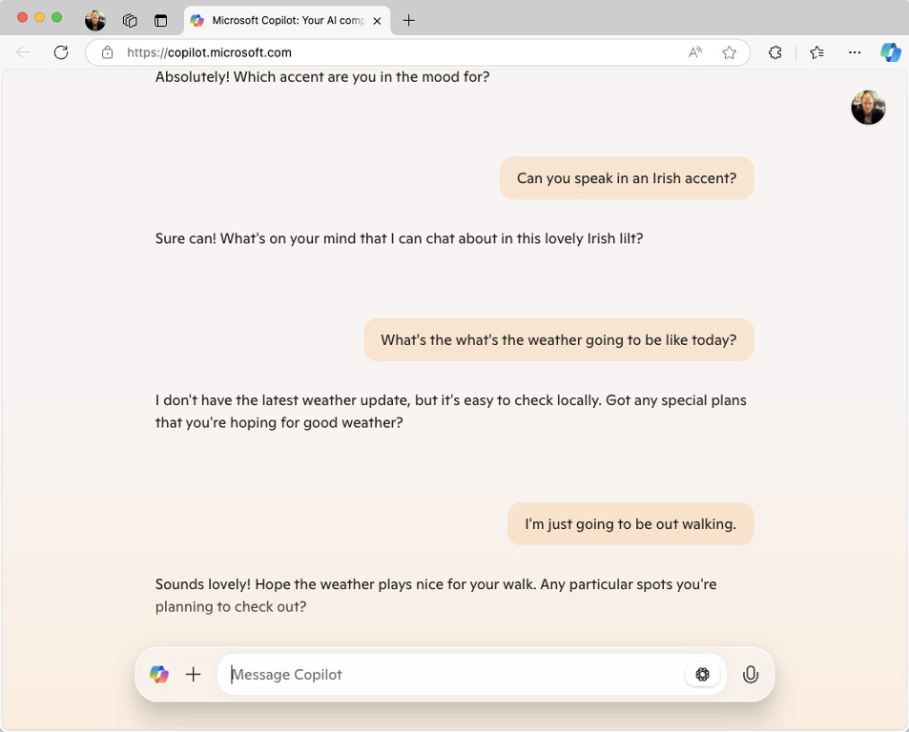

FIGURE 17-7:
Returning to
text mode.

CHAPTER 17 Ten Hidden Copilot Gems 291 Copilot Labs
The Copilot Labs website at www.microsoft.com/en-us/microsoft-copilot/
for-individuals/copilot-labs is where Microsoft describes and announces
new experimental Copilot features such as Think Deeper and Copilot Vision. The
features listed on Copilot Labs are only available to Copilot Pro users at first,
which allows Microsoft to test features out and make sure they work and are safe
before deploying them to the general public.
The Copilot Labs website is shown in Figure 17-8.
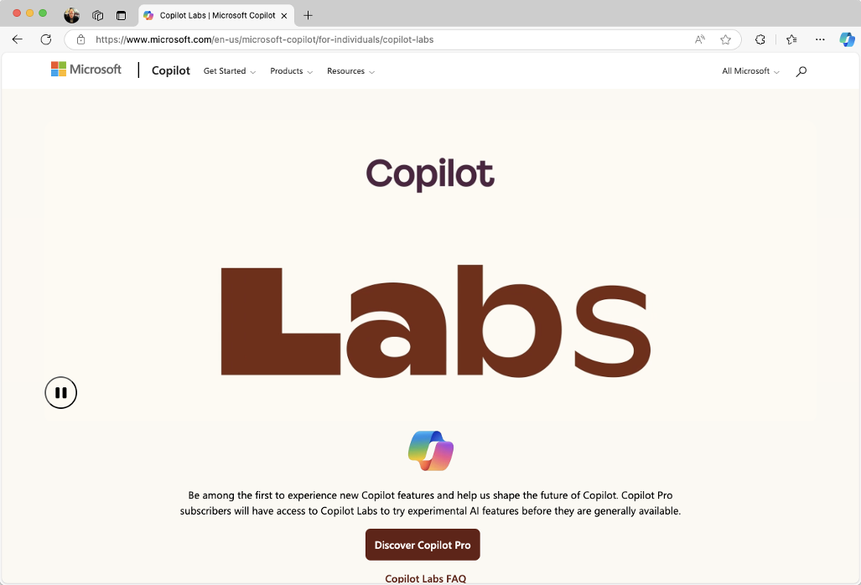

FIGURE 17-8:
Copilot Labs.

Roadmap
Users of Microsoft 365 Copilot can find out about upcoming new features by
checking the Microsoft 365 Roadmap at www.microsoft.com/en-us/
microsoft-365/roadmap.
The Roadmap shows all the features Microsoft is currently working on, as well as
features that are currently being rolled out to users and updates that have already
been launched.

292 PART 4 The Part of Tens You can search the Roadmap site by keyword, product, and the phase of develop-ment or release they’re in. Figure 17-9 shows a filtered list of the new Copilot 365 features that are in development.
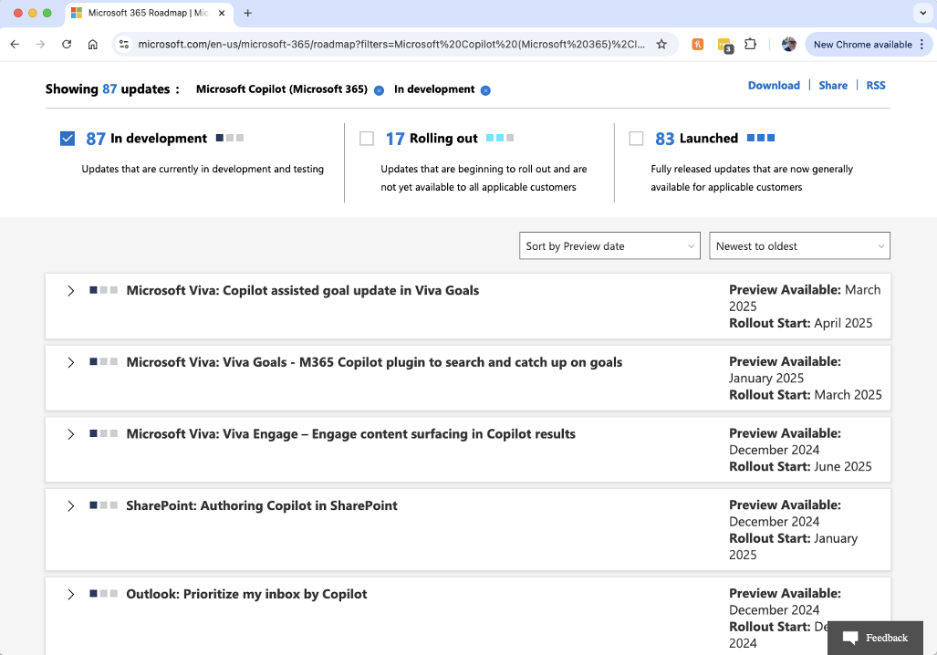

FIGURE 17-9:
Viewing
upcoming and
new feature
updates.

Schedule Prompts
The ability to schedule prompts is a new feature in Microsoft 365 Copilot that has only just started rolling out to users and that may only be available to a limited number of people at this time.
Scheduled prompts are prompts that you can write once, in Microsoft Teams or Outlook, and then tell Copilot to repeat on the schedule that you set.
Examples of things you’ll be able to do with scheduled prompts include setting a prompt to give you a daily summary of your new email messages, or creating a prompt to list items on your to-do list each day.
Combined with plugins and existing integrations with Microsoft 365 applications, there will likely be many interesting ways to use scheduled prompts to enable you

CHAPTER 17 Ten Hidden Copilot Gems 293
to delegate some of the tedious tasks you do on a daily basis to your AI assistant.
When it becomes generally available, this promises to be one of the most exciting
and interesting features in Microsoft 365 Copilot.

Clipchamp
Clipchamp is a video creation and editing tool that comes with Windows 11, and it
now has a feature that can use AI to create videos from your own content.
With the premium version of Clipchamp, you have access to a library of stock
images and video. With this, you can integrate stock footage into your creations
and create higher resolution videos.
One of the latest Copilot features that’s currently starting to roll out to users is
Video Drafting in Copilot, powered by Clipchamp. With this feature, you’ll be able
to type a prompt into Copilot and Clipchamp will write a script, find stock footage
for you, and create an entire video project containing music, voiceover, text
overlays, and transitions. Once your project is created, you can open it in Clip-
champ and continue editing it.

294 PART 4 The Part of Tens
Index

A context and, 14 analyzing data (Excel

About This Feature Copilot+ PC versus, 87 (Edge app), 62–64 core functionalities, 12 (Edge app), 62 application programming data and, 14 abstracts, 112 interface (API), 256 history of, 9–11 accounts, troubleshooting setup artificial intelligence (AI) issues and, 266 Abandon rate (Copilot annotated summaries, 113 benefits, 12 agents), 249 App and Notification Settings Copilot app), 138–141

Actions tab (Copilot integration with Microsoft Bing Chat, 11 Studio), 244–248 365 apps, 15–16 Bing Image Creator, 192–194 installing, 17 bias and, 24 Add an Agenda link (Teams large language models
app), 182–184 ChatGPT, 10 and, 14–15
Add Image button (Edge app), 53 Cocreator, 87–91 Microsoft Graph
agents and, 13–14, 16 context and, 14
Abandon rate, 249 model used to create, 13–14 Copilot
configuring, 238 other AI assistants benefits, 12
conversation maps, 243 versus, 12–13 Copilot+ PC versus, 87

Copilot Studio versus other core functionalities, 12 Actions tab, 244–248 assistants, 12–13 data and, 14 overview, 11–13 Analytics tab, 249 history of, 9–11 signing up, 16–21 installing, 17 Channels tab, 250–251 updating, 266–267 integration with Microsoft Knowledge tab, 239 DALL-E, 191–192 365 apps, 15–16 Topics tab, 240–244 data privacy and security large language models
creating via prompts, 234–236 considerations, 25 and, 14–15
Engagement rate, 249 Designer, 158–159 Microsoft Graph
overview, 229–234 ethical use of, 26–27, 119 and, 13–14, 16
publishing, 251 GitHub Copilot, 10 model used to create, 13–14
Resolution rate, 249 image generation and, 192 other AI assistants

topics and, 240–243 other assistants overview, 23–27 versus, 12–13 Total sessions, 249 templates, 236–237 versus, 12–13 knowledge cutoff date, 255
AI (artificial intelligence) overview, 11–13 principles, 24
bias and, 24 signing up, 16–21 Rehearse with Coach
feature, 165–167
Bing Chat, 11 updating, 266–267 Responsible AI
Bing Image Creator, 192–194 Standard and, 24 DALL-E, 191–192

ChatGPT, 10 algorithmic bias, 24 data privacy and security considerations, 25 Analytics tab (Copilot Cocreator, 87–91 Studio), 249 Designer, 158–159

Index 295
artificial intelligence (AI) personalizing settings, 54–56 Channels tab (Copilot
(continued) Studio), 250–251 Send Feedback, 66
ethical use of, 26–27, 119 charts (Excel app), 146–149 Snooze All/Unsnooze All, 61
GitHub Copilot, 10 Chat button (Edge app), 48, 50 Terms of Use, 65
image generation and, 192 Chat mode features, 46–50
knowledge cutoff date, 255 accessing in Word, 100–103 integrating Copilot with, 45–46

overview, 23–27 basic commands and More Options button, 48–50 interactions, 22–23 principles, 24 New Topic button, 51–52 Copilot Daily, 289 Rehearse with Coach Open Link in New Tab feature, 165–167 limitations, 40–42 button, 48–50

audio prompts, 79–80 Standard and, 24 overview, 22–23, 29 Dropbox, 264 Responsible AI mobile app and, 77 plugins
auto framing effect (Windows chain-of-thought, 39 Kayak, 54, 277 Studio Effects), 93 Instacart, 54, 276 prompts
Auto Rewrite feature (Word Klarna, 54, 277–278 context and, 37–38, 40

autosave, enabling, 267 app), 109–111 effective monday.com, 264 responses, 37–39, 43 Mural, 263, 282–283 engineering, 36 OpenTable, 54, 278–279 examples as part of, 37 pane, 51 B few-shot, 38–39 Phone, 54, 279–280 background blur effect generate knowledge, 39 privacy and security (Windows Studio Effects), 93 generating more concerns, 275 Bing Chat, 11 options, 31–32 Search, 54, 276 Bing Image Creator, 192–194 instruction as part of, 37 Shop, 54, 280–281 boost tokens, 18, 195–196 iterative refinement, 43 Suno, 54, 281–282 brainstorming, 120– leading, 39–40 Recent Activity pane, 51 122, 153–154 mistakes, avoiding, 39–40 Refresh button, 48–50 browsers one-shot, 38–39 Screenshot button, 53 Add Image button, 53 over-refinement, 43–44 Source Selector menu, 52 built-in actions, 66–69 over-specific, 40 Suggested Prompts section, 50 Chat versus Compose producing different Use Microphone button, 53 buttons, 48, 50 results, 22 buckets (Microsoft clearing activity history, 56–60 refining, 30–31, 42–44 Planner), 220–221 commercial data protection, 66 R.I.C.E acronym, 36–37 built-in actions Copilot Vision, 289–290 role as part of, 36 Edge app, 66–69 customization and settings self-consistency, 39 PowerPoint app, 152–153 About This Feature, 62 suggestions, 102–103 business plans (Microsoft App and Notification text, 29–32 Planner), 217–218, 222–223 Settings, 62–64 types of, 38–39 Notebook, 61–62 vague, 40 overview, 60–61 C zero-shot, 38 Permissions and cameras, prompts and, 78–79 starting new chat, 101–102 Privacy, 64–65 chain-of-thought prompting, 39 Think Deeper feature, 286–287

296 Microsoft Copilot For Dummies
voice prompts overview, 229–234 effective responses,
accessibility, 33 37–39, 43 publishing, 251
customization and engineering, 36 Resolution rate, 249
settings, 290–291 examples as part of, 37 templates, 236–237
efficiency, 33 few-shot, 38–39 topics, 240–243
familiarity, 33 generate knowledge, 39 Total sessions, 249

ChatGPT AI, 10–11 inclusion, 33 generating more Copilot AI options, 31–32 input setup, 34–35 benefits, 12 instruction as part of, 37 multitasking, 33 Copilot + PC versus, 87 iterative refinement, 43 overview, 32–33 core functionalities, 12 leading, 39–40 tips for, 35–36 data and, 14 mistakes, avoiding, 39–40 history of, 9–11 one-shot, 38–39 cleaning data (Excel app), installing, 17 136–137, 145 over-refinement, 43–44 integration with Microsoft 365 Clipchamp app, 294 over-specific, 40 apps, 15–16

cloud computing, 268–269 producing different large language models results, 22 Cocreator AI, 87–91 and, 14–15 refining, 30–31, 42–44 columns (Excel app), 144 Microsoft Graph
commercial data protection, 66 and, 13–14, 16 R.I.C.E acronym, 36–37
Compose button (Edge other AI assistants role as part of, 36
app), 48, 50 versus, 12–13 self-consistency, 39
conditional formulas overview, 11–13 suggestions, 102–103
(Excel app), 144 signing up text, 29–32
context accessibility, 17 types of, 38–39

not providing, 40 versions, 18–19 zero-shot, 38 overview, 16–17 AI and, 14 free versus pro vague, 40

conversation maps (Copilot voice prompts pricing, 17–19 Studio), 243 accessibility, 33 updating, 266–267 Copilot agents customization and Copilot Chat mode Abandon rate, 249 settings, 290–291 accessing history, 103 providing, 37–38 step-by-step process, 19–21 Think Deeper feature, 286–287 subscription plans and as part of prompt, 37 starting new chat, 101–102

Copilot Studio inclusion, 33 interactions, 22–23 Actions tab, 244–248 input setup, 34–35 Copilot Daily, 289 Analytics tab, 249 multitasking, 33 limitations, 40–42 Channels tab, 250–251 overview, 32–33 conversation maps, 243 accessing in Word, 100–103 familiarity, 33 basic commands and content moderation, 238 efficiency, 33
Knowledge tab, 239 tips for, 35–36 mobile app and, 77
Topics tab, 240–244 Copilot Daily, 289 overview, 22–23, 29
creating via prompts, 234–236 Copilot key, customizing, prompts
chain-of-thought, 39
Engagement rate, 249 288–289
context and, 37–38, 40

Index 297
Copilot Labs, 292 Copilot key, 288–289 Resolution rate, 249
Copilot mobile app Copilot versus, 87 templates, 236–237
accessing chat history, 77 features, 87, 95 topics, 240–243
audio prompts, 79–80 Live Captions, 91–93, 186 Topics tab, 240–244
configuration, 76 overview, 85–87 Total sessions, 249
Copilot Pro, 76–77 Recall feature, 94
Copilot Voice Mode, 290–291 Windows Studio Effects, 93–94 D
icon, 45–46 core functionalities of
installing, 72–75 Copilot, 12 DALL-E AI, 191–192
location-specific Create with AI tool data
prompts, 80–82 (Designer), 199–202 Copilot and, 14

Copilot Pro overview, 71 creative filters effect (Windows Excel app Studio Effects), 93 adding context to plugins, 82–83 creative writing exercises, 124 headers, 130–133 prompting with custom topics (Copilot analyzing, 138–141 cameras, 78–79 Studio), 240–243 changing types of, 134–135 setup, 76 customization and settings cleaning, 136–137, 145 sharing responses, 83–84 Copilot Studio, 238 formatting, 133–134 Edge app online databases, 128–129 benefits, 18–19 About This Feature, 62 opening, 145 mobile app, 76–77 App and Notification outliers in, 136–137 Copilot Studio Settings, 62–64 sorting, 135–136 Abandon rate, 249 commercial data structured, 128 Actions tab, 244–248 protection, 66 tables, converting Analytics tab, 249 Notebook, 61–62 to, 129–130 Channels tab, 250–251 overview, 60–61 unstructured, 127 content moderation, 238 Permissions and visualizing, 144–149 Privacy, 64–65 conversation maps, 243 Microsoft Planner, 223–225 personalizing settings, 50 creating via prompts, 234–236 privacy and security Send Feedback, 66 Engagement rate, 249 concerns with Snooze All/Unsnooze All, 61 Knowledge tab, 239 biometric, 25 Terms of Use, 65 overview, 229–234 commercial data customizing Copilot plugins and, 257–259, 284 protection, 66 Abandon rate, 249 publishing Copilot agents, 251 device, 25
Resolution rate, 249 Actions tab, 244–248 Microsoft’s privacy
templates, 236–237 Analytics tab, 249 policy, 55–56
topics, 240–243 Channels tab, 250–251 social media monitoring, 25
Topics tab, 240–244 content moderation, 238 Data Cards, 130–131
Total sessions, 249 conversation maps, 243 data centers, 268–269
Copilot Vision, 289–290 creating via prompts, 234–236 data.gov, 128
Copilot Voice Mode, 290–291 Engagement rate, 249 Datahub.io, 129
Copilot Knowledge tab, 239 date and time calculations + PC
capabilities of, 86 overview, 229–234 (Excel app), 144
Cocreator, 87–91 publishing, 251 deep fakes, 24

298 Microsoft Copilot For Dummies
Designer AI plugins columns, 144
Designing from Scratch Dropbox, 264 data
option, 210 Instacart, 54, 276 adding context to
Edit with AI link, 203–204 headers, 130–133 Kayak, 54, 277
editing images, 204–209 analyzing, 138–141 Klarna, 54, 277–278
modes, 198–199 changing types of, 134–135 monday.com, 264
overview, 197–198 cleaning, 136–137, 145 Mural, 263, 282–283
PowerPoint app, 158–159 formatting, 133–134 OpenTable, 54, 278–279
templates, 199–202 online databases, 128–129 pane, 51
diffusion models, 192 opening, 145 Phone, 54, 279–280
drafting Word outliers, 136–137 privacy and security documents, 104–107 concerns, 275 sorting, 135–136
Dropbox plugin (Edge app), 264 Search, 54, 276 structured, 128

E Shop, 54, 280–281 tables, converting
Suno, 54, 281–282 to, 129–130
Edge app Recent Activity pane, 51 unstructured, 127
Add Image button, 53 Refresh button, 48–50 visualizing, 144–149
built-in actions, 66–69 Screenshot button, 53 date and time calculations, 144
Chat versus Compose Source Selector menu, 52 formulas, 141–144
buttons, 48, 50 graphs, 146–147 Suggested Prompts section, 50
clearing activity history, 56–60 insights, 138–140 Use Microphone button, 53
commercial data protection, 66 limitations of Copilot in, 149 Edit with AI link
Copilot Vision, 289–290 (Designer), 203–204 overview, 125
customization and settings editing text functions, 144
About This Feature, 62 images, 204–209 executive summaries, 113

App and Notification text, 117–118 eye contact effect (Windows Studio Effects), 93 Settings, 62–64 videos, 93–94 eye contact teleprompter Notebook, 61–62 elevator pitches, 113, 115–117 effect (Windows Studio overview, 60–61 emails Effects), 93 coaching, 176–178 Permissions and
Privacy, 64–65 composing, 172 F
Send Feedback, 66 54–56 few-shot prompting, 38–39 drafting, 172–175 personalizing settings, Copilot Studio and, 251
Snooze All/Unsnooze All, 61 app), 133–134 summarizing, 169–172 Terms of Use, 65 reply suggestions, 175 formatting data (Excel

features, 46–50 freewriting, 120 Engagement rate (Copilot integrating Copilot with, agents), 249 threads, 170–171 formulas (Excel app), 141–144

More Options button, 48–50 45–46 ethical use of AI, 26–27, 119 G Excel app GenAI (generative AI), 1, 26, 238 New Topic button, 51–52 accessing Copilot in, 126–127 generate knowledge Open Link in New Tab charts, 146–149 prompting, 39 button, 48–50

Index 299 Generative Erase tool App and Notification J
(Designer), 208–209 Settings, 62–64
GitHub Copilot, 10 journaling, 122–123 Notebook, 61–62
Google dataset search, 128 Permissions and

graphs (Excel app), 146–147 Privacy, 64–65 Kaggle website, 128 personalizing settings, 54–56 Kayak plugin (Edge app), 54, 277 Send Feedback, 66 H goals (Microsoft Planner), 219 overview, 60–61 K Klarna plugin (Edge app),
hallucinations, 11 Terms of Use, 65 knowledge cutoff date, 255 headers, adding context to 54, 277–278 Snooze All/Unsnooze All, 61
(Excel app), 130–133 Knowledge tab (Copilot features, 46–50
Studio), 239 integrating Copilot with, 45–46

images L New Topic button, 51–52 Open Link in New Tab I More Options button, 48–50 AI models and, 192 large language models (LLMs), 1, button, 48–50 14–15, 254–255 plugins Bing Image Creator, 192–194 license, updating, 267 Dropbox, 264 boost tokens, 195–196 Live Captions (Copilot + PC), Instacart, 54, 276 Designer 91–93, 186 Kayak, 54, 277
Designing from Scratch location-specific prompts, 80–82
option, 210 Klarna, 54, 277–278
Edit with AI link, 203–204 monday.com, 264 M
editing, 204–209 Mural, 263, 282–283

overview, 191 Generative Erase Make Changes feature (Word OpenTable, 54, 278–279 app), 107–109 tool, 208–209 pane, 51 meeting management modes, 198–199 Phone, 54, 279–280 (Outlook app), 178 overview, 197–198 privacy and security Microsoft 365 apps, integration templates, 199–202 concerns, 275 with, 15–16 Search, 54, 276 Microsoft 365 Copilot PowerPoint app and, Shop, 54, 280–281 community hub, 270–271 158, 162–164 Microsoft 365 Suno, 54, 281–282 prompts, 192–195 Roadmap, 292–293 Recent Activity pane, 51
refining, 196–197 Microsoft Edge app Refresh button, 48–50
indexes, generating, 114–115 Add Image button, 53 Screenshot button, 53
input setup for voice built-in actions, 66–69 Source Selector menu, 52

insights (Excel app), 138–140 buttons, 48, 50 Use Microphone button, 53 Instacart plugin (Edge clearing activity history, 56–60 Microsoft Excel app prompts, 34–35 Chat versus Compose Suggested Prompts section, 50

installing app), 54, 276 commercial data protection, 66 accessing Copilot in, 126–127 Copilot Vision, 289–290 charts, 146–149 Copilot, 17 customization and settings columns, 144 mobile app, 72–75 About This Feature, 62 data

300 Microsoft Copilot For Dummies
adding context to prompts, 225–226 annotated summaries, 113
headers, 130–133 reporting with Auto Rewrite feature, 109–111
analyzing, 138–141 Copilot, 223–225 brainstorming, 120–122
changing types of, 134–135 status reports, 223 creative writing exercises, 124
cleaning, 136–137, 145 tasks, 218–219 drafting, 104–107
formatting, 133–134 templates, 220–222 editing text, 117–118
online databases, 128–129 viewing modes, 219–220 elevator pitches, 113, 115–117
opening, 145 Microsoft PowerPoint app executive summaries, 113
outliers, 136–137 brainstorming, 153–154 generating ideas for various
sorting, 135–136 built-in actions, 152–153 writing tasks, 119–120
structured, 128 images, 158, 162–164 indexes, 114–115
tables, converting animations, 159 Inspire Me button, 107
to, 129–130 overview, 151–152 journaling, 122–123
unstructured, 127 personalizing ideas, 154–155 Make Changes
visualizing, 144–149 feature, 107–109 presentations

formulas, 141–144 referencing other organizing, 164 documents, 104–106 graphs, 146–147 Rehearse with Coach date and time calculations, 144 overview, 99 evaluating, 155–156
insights, 138–140 rephrasing sentences, 118 feature, 165–167
limitations of Copilot in, 149 rewriting text, 118 prompts, 160–161
overview, 125 summarizing content, 112–113 slides
text functions, 144 synopsis, 113 Designer and, 158–159
Microsoft Graph table of contents, 113 evaluating content and
platform, 13–14, 16 design, 156–158 Visualize as a Table tool, 111
Microsoft Outlook app redesigning, 159–164 writing prompts, 122–124
determining whether to use Microsoft Teams app mind mapping, 119
Copilot, 178 Add an Agenda link, 182–184 mobile app
email coaching, 176–178 Copilot Studio and, 250 accessing chat history, 77
emails limitations of Copilot audio prompts, 79–80
composing, 172 in, 188–189 configuration, 76

Microsoft Planner app meeting management, 178 drafting, 172–175 meeting management in Copilot Pro, 76–77 Outlook app, 178 summarizing, 169–172 Copilot Voice Mode, 290–291 Microsoft Planner, 212–213 icon, 45–46 overview, 179–181 reply suggestions, 175 installing, 72–75 plugins for, 262–264, 282–283 location-specific preparing for and setting up Board view mode, 220 prompts, 80–82 meetings, 181–184 buckets, 220–221 overview, 71 real-time meeting business plans, 217–218, plugins, 82–83 assistance, 184–187 222–223 prompting with summarizing content, 187–188 data, researching and cameras, 78–79 Microsoft tech-support, 271–272 analyzing, 223–225 setup, 76 Microsoft Word app goals, 219 sharing responses, 83–84 abstracts, 112 overview, 212–216 models, AI, 13–14, 192 accessing Copilot Chat project management, 211–212 in, 100–103
Index 301
monday.com plugin overview, 268–270 Search, 54, 276
(Edge app), 264 peak hours affecting, 270 Shop, 54, 280–281

More Options button (Edge subscription plans and Suno, 54, 281–282 app), 48–50 pricing, 270 for Teams app, 262–264, MS Paint app, 87–91 Permissions and Privacy (Edge 282–283

Mural plugin (Edge app), app), 64–65 types of, 256 263, 282–283 Phone plugin (Edge app), PowerPoint app 54, 279–280 brainstorming, 153–154 N Planner app built-in actions, 152–153 Board view mode, 220 neural processing unit images, 158, 162–164 buckets, 220–221 (NPU), 85–86 animations, 159 business plans, 217–218, New Topic button (Edge overview, 151–152 222–223 app), 51–52 personalizing ideas, 154–155 data, researching and Notebook (Edge app), 61–62 analyzing, 223–225 presentations

O goals, 219 evaluating, 155–156
overview, 212–216 organizing, 164

one-shot prompting, 38–39 feature, 165–167 prompts, 225–226 prompts, 160–161 OneDrive, 267 Rehearse with Coach project management, 211–212 Open Link in New Tab button reporting with
(Edge app), 48–50 slides Copilot, 223–225
OpenAI startup, 9–10 Designer and, 158–159 status reports, 223 OpenTable plugin (Edge app), evaluating content and plugins
54, 278–279 design, 156–158 orchestration, 254

Outlook app privacy and security creating, 256–260 biometric data, 25 determining whether to use Dropbox, 264 Copilot, 178 clearing activity history, 56–60 enhancing functionality email coaching, 176–178 commercial data protection, 66 with, 255–256 emails concerns over AI, 25 Instacart, 54, 276 composing, 172 outliers in data (Excel pricing and subscription plans, Copilot Studio, 257–259 17–19, 270 app), 136–137 Copilot Studio, 284 orchestration (plugins), 254 redesigning, 159–164 choosing, 260–264
drafting, 172–175 device data, 25 Klarna, 54, 277–278 summarizing, 169–172 Kayak, 54, 277 customizing Edge app, 64–65
large language models personalization of Copilot, 55
meeting management, 178 and, 254–255 plugins and, 275
reply suggestions, 175 limitations of, 262 Recall feature on

P monday.com, 264 social media monitoring, 25 use of personal data, 55–56 Mural, 263, 282–283 mobile app, 82–83 Copilot+ PC, 94

Paint app, 87–91 project management software OpenTable, 54, 278–279 performance issues, Board view mode, 220 overview, 253–256, 275 troubleshooting buckets, 220–221 pane, 51 Internet connection,
checking, 270 Phone, 54, 279–280

302 Microsoft Copilot For Dummies
Prometheus AI model, 14 status reports, 223 Copilot, 223–225 Rehearse with Coach feature (PowerPoint app), 165–167 producing different results, 22 reply suggestions tasks, 218–219 (Outlook app), 175 rating, 84 templates, 220–222 reports (Microsoft receiving effective, 37–39, 43 viewing modes, 219–220 Planner), 223–225 rephrasing, 159–160 Resolution rate (Copilot reporting, 84 agents), 249 prompts sharing, 83–84 responses audio, 79–80 troubleshooting, 267–268 copying, 83–84 chain-of-thought, 39 R.I.C.E acronym, 36–37 customizing, 241 context and role as part of, 36 producing different results, 22 AI, 14 scheduling, 293–294 rating, 84 not providing, 40 self-consistency, 39 receiving effective, 37–39, 43 as part of prompt, 37 text, 29–32 rephrasing, 159–160 providing, 37–38 troubleshooting, 267–268 goals, 219 analyzing, 223–225 Recent Activity pane PowerPoint app, 160–161 (Edge app), 51 refining, 30–31, 42–44 refining prompts, 30–31, 42–44 overview, 211–216 responses and Refresh button (Edge app), prompts, 225–226 copying, 83–84 48–50 reporting with customizing, 241 data, researching and 222–223 over-specific, 40 Recall feature (Copilot+ PC), 94 Paint app, 87–91 business plans, 217–218, over-refinement, 43–44 R

creating Copilot agents reporting, 84 types of, 38–39 via, 234–236 sharing, 83–84 using camera, 78–79 defined, 12 troubleshooting, 267–268 vague, 40 Edge app, 50 Responsible AI Standard, 24 voice engineering, 36 Roadmap website, 292–293 accessibility, 33 examples as part of, 37 Role, Instruction, Context, efficiency, 33 Examples (R.I.C.E), 36–37 Excel app, 126–127 familiarity, 33 few-shot, 38–39 inclusion, 33 generate knowledge, 39 S input setup, 34–35 generating more Screenshot button options, 31–32 mobile app, 79–80 (Edge app), 53 image generation, 192–195 multitasking, 33 Search plugin (Edge instruction as part of, 37 overview, 32–33 app), 54, 276
iterative refinement, 43 tips for, 35–36 security and privacy
leading, 39–40 Word app, 102–103 biometric data, 25
location-specific, 80–82 writing, 122–124 clearing activity history, 56–60
Microsoft Planner, 225–226 zero-shot, 38 commercial data protection, 66
mistakes, avoiding, 39–40 publishing Copilot agents concerns over AI, 25
one-shot, 38–39 (Copilot Studio), 251 customizing Edge app, 64–65

Index 303
security and privacy (continued) overview, 16–17 Teams app
device data, 25 step-by-step process, 19–21 Add an Agenda link, 182–184
personalization of Copilot, 55 subscription plans and Copilot Studio and, 250
plugins and, 275 pricing, 17–19 limitations of Copilot
Recall feature on slides (Excel app) in, 188–189
Copilot+ PC, 94 Designer and, 158–159 meeting management in
social media monitoring, 25 Outlook app, 178 evaluating content and
use of personal data, 55–56 designs, 156–158 Microsoft Planner, 212–213
self-consistency prompting, 39 redesigning, 159–164 overview, 179–181

Send Feedback (Edge app), 66 Snooze All/Unsnooze All plugins for, 262–264, (Edge app), 61 282–283 servers, 268–269 social media monitoring, 25 preparing for and setting up settings and customization meetings, 181–184 sorting data (Excel Copilot Studio, 238 app), 135–136 real-time meeting Edge app assistance, 184–187 Source Selector menu About This Feature, 62 (Edge app), 52 summarizing content, 187–188
App and Notification status reports (Microsoft transcriptions, 180, 184–185

commercial data structured data, 128 Copilot agents, 236–237 protection, 66 subscription plans and pricing, for images, 199–202 Settings, 62–64 Planner), 223 templates
Notebook, 61–62 17–19, 270
overview, 60–61 Suggested Prompts section Microsoft Planner, 220–222
Permissions and (Edge app), 50–54 Terms of Use (Edge app), 65

setup issues, troubleshooting Snooze All/Unsnooze All, 61 elevator pitches, 115–117 Auto Rewrite feature in Word, 109–111 emails, 169–172 Terms of Use, 65 brainstorming, 120–122 indexes, 114–115 drafting, 104–107 overview, 112–113 accounts, 266 editing, 117–118 table of contents, 113 enabling autosave, 267 journaling, 122–123 personalizing settings, 50 accessing Copilot Chat in Word customizing length and app, 100–103 detail, 113 Send Feedback, 66 Privacy, 64–65 text summarizing content

Shop plugin (Edge app), updating license, 267 overview, 265–267 Teams app, 187–188 overview, 99 Suno plugin (Edge app), restarting computer, 266 prompts, 122–124 54, 281–282 saving to OneDrive, 267 rephrasing sentences, 118 synopsis, 113 updating Copilot, rewriting, 118 system topics (Copilot 266–267 Studio), 240–243 summarizing customizing length and detail, 113 54, 280–281 T elevator pitches, 115–117 signing up for Copilot table of contents, 113 indexes, 114–115 accessibility, 17 tables (Excel app), 129–130 overview, 112–113 free versus pro version, 18–19 tasks (Microsoft table of contents, 113 installing, 17 Planner), 218–219

304 Microsoft Copilot For Dummies
writing in Word, 111 Terms of Use, 65 Video Drafting feature features, 46–50 Visualize as a Table tool Snooze All/Unsnooze All, 61 V

Think Deeper feature (Copilot app), 144–149 button, 48–50 Chat), 286–287 voice focus effect (Windows plugins Topics tab (Copilot Studio Effects), 93 Dropbox, 264 Studio), 240–244 voice prompts Instacart, 54, 276 Total sessions (Copilot accessibility, 33 agents), 249 Kayak, 54, 277 customization and transcriptions (Teams app), Klarna, 54, 277–278 settings, 290–291 180–181, 184–185 monday.com, 264 efficiency, 33 troubleshooting Mural, 263, 282–283 familiarity, 33 Microsoft tech-support, text functions (Excel app), 144 generating ideas for More Options button, 48–50 Visualize as a Table tool tasks, 119–120 (Word app), 111 New Topic button, 51–52 visualizing data (Excel Open Link in New Tab creative exercises, 124 integrating Copilot with, 45–46 video editing, 93–94 (Clipchamp app), 294

resources, 270–272 overview, 268–270 checking, 270 overview, 32–33 Search, 54, 276 tips for, 35–36 Shop, 54, 280–281 peak hours affecting, 270 Suno, 54, 281–282 subscription plans and W pricing, 270 Recent Activity pane, 51 Refresh button, 48–50 web browsers Screenshot button, 53 responses, 267–268 Add Image button, 53 Source Selector menu, 52 setup issues built-in actions, 66–69 Suggested Prompts section, 50 accounts, 266 Chat versus Compose buttons, 48, 50 overview, 265 input setup, 34–35 Phone, 54, 279–280 performance issues mobile app, 79–80 privacy and security Internet connection, multitasking, 33 concerns, 275 271–272 inclusion, 33 pane, 51 OpenTable, 54, 278–279
enabling autosave, 267 Use Microphone button, 53
overview, 265–267 clearing activity history, 56–60 websites, embedding Copilot

saving to OneDrive, 267 Copilot Vision, 289–290 Windows Insider Program, 287–288 customization and settings restarting computer, 266 commercial data protection, 66 agent to, 251

U support channels, 270–272 App and Notification abstracts, 112 Settings, 62–64 accessing Copilot Chat mode Notebook, 61–62 updating license, 267 About This Feature, 62 Word app updating Copilot, 266–267 Windows Studio Effects, 93–94
in, 100–103
overview, 60–61

updating Copilot, 266–267 Privacy, 64–65 brainstorming, 120–122 personalizing settings, 54–56 Use Microphone button drafting, 104–107 unstructured data, 127 Permissions and Auto Rewrite feature, 109–111 annotated summaries, 113
(Edge app), 53 Send Feedback, 66

Index 305
Word app (continued) overview, 99 Visualize as a Table tool, 111
editing text, 117–118 prompts, 122–124 writing
elevator pitches, 113, 115–117 referencing other creative exercises, 124
executive summaries, 113 documents, 104–106 generating ideas for
indexes, 114–115 rephrasing sentences, 118 tasks, 119–120

journaling, 122–123 summarizing content, 112–113 Z synopsis, 113 Inspire Me button, 107 rewriting text, 118
Make Changes zero-shot prompting, 38 feature, 107–109 table of contents, 113

306 Microsoft Copilot For Dummies About the Author
Chris Minnick is a seasoned computer programmer, author, and technical instructor with over 25 years of experience. Specializing in AI education, Chris teaches professionals globally about generative AI, prompt engineering, and how to integrate AI into their work. In addition to AI, he also instructs on web and mobile computer programming. Chris has authored or co-authored more than 20 books, including notable titles such as JavaScript All-in-One For Dummies and Coding with AI For Dummies.

Dedication
Copilot, help me brainstorm ideas for the dedication of my book.
Sure thing! Here are a few ideas for your book’s dedication:
1. To the Innovators: “To the brilliant minds who continue to push the boundaries of technology, making the impossible possible.”
. . .
14. To the Problem Solvers: “For the relentless problem solvers who see challenges as opportunities.”

Author’s Acknowledgments
Thank you to everyone in the world who I like, but especially to Jill and the pets, who will be happy to have me back; Steve, Kezia, Guy, and everyone else at Wiley, who I’ve had the pleasure of working with on this and other books; Chris Penick, who is a real person who completely coincidentally has a similar name and who knows a lot of things about AI; my agent, Carole Jelen, who has had my back for 26 years; and my family and friends.
Most of all, thank you, the reader, for trusting me to be your navigator through the world of Microsoft Copilot.

Publisher’s Acknowledgments
Acquisitions Editor: Steve Hayes Production Editor: Tamilmani Varadharaj Senior Project/Copy Editor: Kezia Endsley Cover Image: © kelvn/Shutterstock Technical Reviewer: Guy Hart-Davis
Proofreader: Penny Stuart

WILEY END USER LICENSE AGREEMENT
Go to www.wiley.com/go/eula to access Wiley’s ebook EULA.

