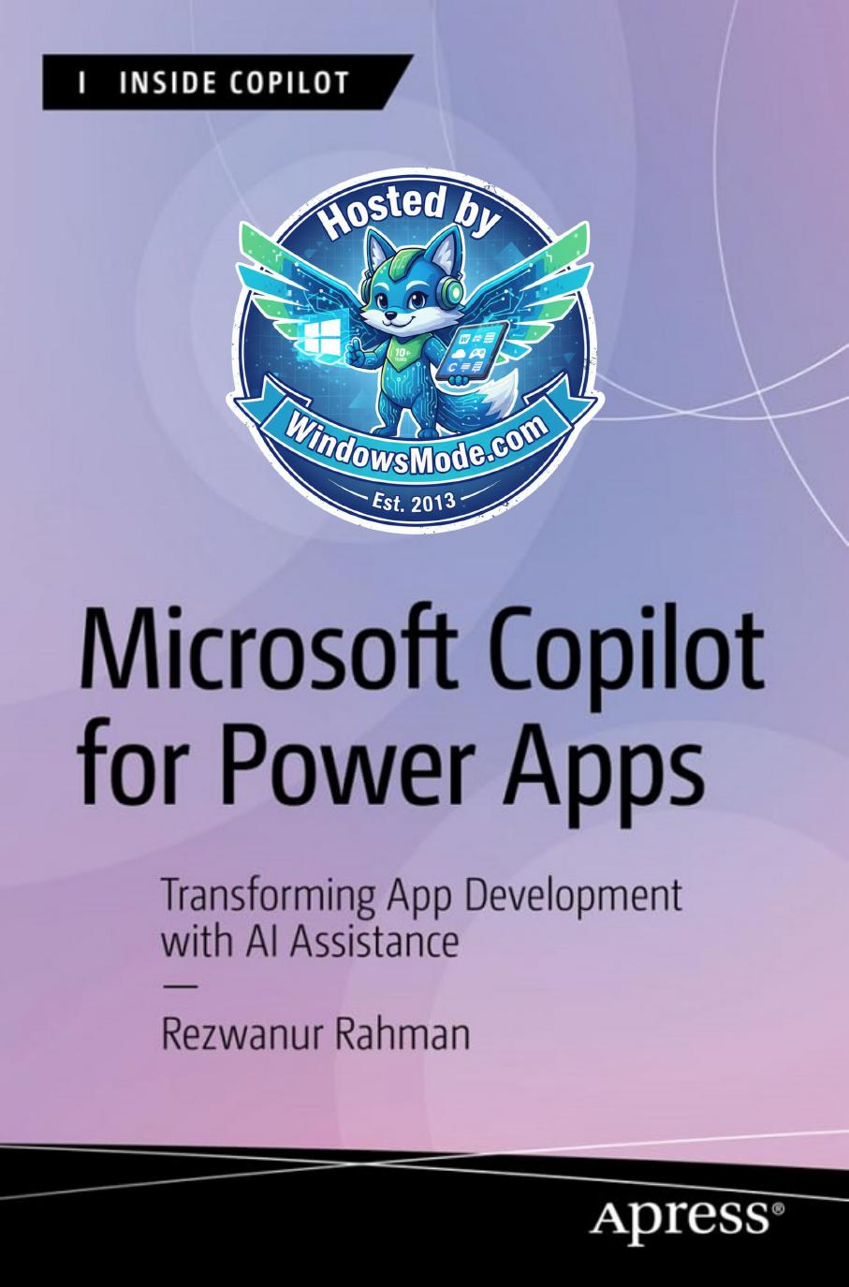

Table of Contents
Chapter 1: Unveiling Copilot: A New Era in Power Apps
Chapter 2: Embarking on the Copilot Journey
Chapter 3: Mastering the Core: Copilot’s Engine Room
Chapter 4: Crafting Power Apps with Copilot: The Essentials
Chapter 5: Advanced Customizations and Automation with Copilot
Chapter 6: Advanced UI/UX Techniques in Power Apps Development This chapter explains how to integrate advanced AI capabilities
Chapter 7: Dynamic Content, Comments, and Copilot
Chapter 8: Integrating Diverse Data Sources and Media in
Chapter 9: Introducing AI Builder in Power Apps This chapter explores AI Builder, guiding you on how to enhance
Chapter 10: Advanced Techniques with AI Builder and Conditional Formatting
Chapter 11: Revolutionizing Power Apps UI with Microsoft Copilot: A Complete Project
Chapter 12: Visions of the Future: Copilot’s Evolving Landscape
Chapter 13: Copilot Success Stories: Lessons from the Field
Chapter 14: Comprehensive Resources The final chapter provides essential resources to support your
CHAPTER 1
Chapter 1 Unveiling Copilot: a new era in power apps
Chapter 1 Unveiling Copilot: a new era in power apps
Chapter 1 Unveiling Copilot: a new era in power apps
Chapter 1 Unveiling Copilot: a new era in power apps
Chapter 1 Unveiling Copilot: a new era in power apps
Chapter 1 Unveiling Copilot: a new era in power apps
Chapter 1 Unveiling Copilot: a new era in power apps
Chapter 1 Unveiling Copilot: a new era in power apps
Chapter 1 Unveiling Copilot: a new era in power apps
Chapter 1 Unveiling Copilot: a new era in power apps
Chapter 1 Unveiling Copilot: a new era in power apps
Chapter 1 Unveiling Copilot: a new era in power apps
Chapter 1 Unveiling Copilot: a new era in power apps
Chapter 1 Unveiling Copilot: a new era in power apps
Chapter 1 Unveiling Copilot: a new era in power apps
Chapter 1 Unveiling Copilot: a new era in power apps
Chapter 1 Unveiling Copilot: a new era in power apps
Chapter 1 Unveiling Copilot: a new era in power apps
Chapter 1 Unveiling Copilot: a new era in power apps
Chapter 1 Unveiling Copilot: a new era in power apps
Chapter 1 Unveiling Copilot: a new era in power apps
Chapter 1 Unveiling Copilot: a new era in power apps
Chapter 1 Unveiling Copilot: a new era in power apps
Chapter 1 Unveiling Copilot: a new era in power apps
Chapter 1 Unveiling Copilot: a new era in power apps
Chapter 1 Unveiling Copilot: a new era in power apps
Chapter 1 Unveiling Copilot: a new era in power apps
Chapter 1 Unveiling Copilot: a new era in power apps
Chapter 1 Unveiling Copilot: a new era in power apps
Chapter 1 Unveiling Copilot: a new era in power apps
Chapter 1 Unveiling Copilot: a new era in power apps
Chapter 1 Unveiling Copilot: a new era in power apps
Chapter 1 Unveiling Copilot: a new era in power apps
Chapter 1 Unveiling Copilot: a new era in power apps
Chapter 1 Unveiling Copilot: a new era in power apps
Chapter 2 explores the practical steps needed to set up, configure, and optimize Copilot for Power Apps. I cover the essential prerequisites, licensing options, and system requirements, ensuring that you have everything needed to maximize your development experience.
CHAPTER 2
Chapter 2 embarking on the Copilot Journey
Chapter 2 embarking on the Copilot Journey
Chapter 2 embarking on the Copilot Journey
Chapter 2 embarking on the Copilot Journey
Chapter 2 embarking on the Copilot Journey
Chapter 2 embarking on the Copilot Journey
Chapter 2 embarking on the Copilot Journey
Chapter 2 embarking on the Copilot Journey
Chapter 2 embarking on the Copilot Journey
Chapter 2 embarking on the Copilot Journey
Chapter 2 embarking on the Copilot Journey
Chapter 2 embarking on the Copilot Journey
Chapter 2 embarking on the Copilot Journey
Chapter 2 embarking on the Copilot Journey
Chapter 2 embarking on the Copilot Journey
Chapter 2 embarking on the Copilot Journey
Chapter 2 embarking on the Copilot Journey
Chapter 2 embarking on the Copilot Journey
Chapter 2 embarking on the Copilot Journey
Chapter 2 embarking on the Copilot Journey
Chapter 2 embarking on the Copilot Journey
Chapter 2 embarking on the Copilot Journey
Chapter 2 embarking on the Copilot Journey
Chapter 2 embarking on the Copilot Journey
Chapter 2 embarking on the Copilot Journey
Chapter 2 embarking on the Copilot Journey
Chapter 2 embarking on the Copilot Journey
Chapter 2 embarking on the Copilot Journey
Chapter 2 embarking on the Copilot Journey
Chapter 2 embarking on the Copilot Journey
Chapter 2 embarking on the Copilot Journey
Chapter 2 embarking on the Copilot Journey
Chapter 2 embarking on the Copilot Journey
Chapter 2 embarking on the Copilot Journey
Chapter 2 embarking on the Copilot Journey
Chapter 2 embarking on the Copilot Journey
Chapter 2 embarking on the Copilot Journey
Chapter 2 embarking on the Copilot Journey
Chapter 2 embarking on the Copilot Journey
Chapter 2 embarking on the Copilot Journey
Chapter 2 embarking on the Copilot Journey
Chapter 2 embarking on the Copilot Journey
CHAPTER 3
chapter looks closely at the sophisticated technology that makes Copilot
chapter explores these key connections and their functions. I guide you
Chapter 3 Mastering the Core: Copilot’s engine rooM
Chapter 3 Mastering the Core: Copilot’s engine rooM
Chapter 3 Mastering the Core: Copilot’s engine rooM
Chapter 3 Mastering the Core: Copilot’s engine rooM
Chapter 3 Mastering the Core: Copilot’s engine rooM
Chapter 3 Mastering the Core: Copilot’s engine rooM
Chapter 3 Mastering the Core: Copilot’s engine rooM
Chapter 3 Mastering the Core: Copilot’s engine rooM
Chapter 3 Mastering the Core: Copilot’s engine rooM
Chapter 9 includes a hands-on, practical example of using AI Builder tailored for administrators.
Chapter 3 Mastering the Core: Copilot’s engine rooM
Chapter 3 Mastering the Core: Copilot’s engine rooM
Chapter 3 Mastering the Core: Copilot’s engine rooM
Chapter 3 Mastering the Core: Copilot’s engine rooM
Chapter 3 Mastering the Core: Copilot’s engine rooM
Chapter 3 Mastering the Core: Copilot’s engine rooM
Chapter 3 Mastering the Core: Copilot’s engine rooM
Chapter 3 Mastering the Core: Copilot’s engine rooM
Chapter 3 Mastering the Core: Copilot’s engine rooM
Chapter 3 Mastering the Core: Copilot’s engine rooM
Chapter 3 Mastering the Core: Copilot’s engine rooM
Chapter 3 Mastering the Core: Copilot’s engine rooM
Chapter 3 Mastering the Core: Copilot’s engine rooM
Chapter 3 Mastering the Core: Copilot’s engine rooM
Chapter 3 Mastering the Core: Copilot’s engine rooM
Chapter 3 Mastering the Core: Copilot’s engine rooM
Chapter 3 Mastering the Core: Copilot’s engine rooM
Chapter 3 Mastering the Core: Copilot’s engine rooM
Chapter 3 Mastering the Core: Copilot’s engine rooM
Chapter 3 Mastering the Core: Copilot’s engine rooM
Chapter 3 Mastering the Core: Copilot’s engine rooM
Chapter 3 Mastering the Core: Copilot’s engine rooM
Chapter 3 Mastering the Core: Copilot’s engine rooM
Chapter 3 Mastering the Core: Copilot’s engine rooM
Chapter 3 Mastering the Core: Copilot’s engine rooM
Chapter 3 Mastering the Core: Copilot’s engine rooM
Chapter 3 Mastering the Core: Copilot’s engine rooM
CHAPTER 4
Chapter 4 Crafting power apps with Copilot: the essentials
Chapter 4 Crafting power apps with Copilot: the essentials
Chapter 4 Crafting power apps with Copilot: the essentials
Chapter 4 Crafting power apps with Copilot: the essentials
Chapter 4 Crafting power apps with Copilot: the essentials
Chapter 4 Crafting power apps with Copilot: the essentials
Chapter 4 Crafting power apps with Copilot: the essentials
Chapter 4 Crafting power apps with Copilot: the essentials
Chapter 4 Crafting power apps with Copilot: the essentials
Chapter 4 Crafting power apps with Copilot: the essentials
Chapter 4 Crafting power apps with Copilot: the essentials
Chapter 4 Crafting power apps with Copilot: the essentials
Chapter 4 Crafting power apps with Copilot: the essentials
Chapter 4 Crafting power apps with Copilot: the essentials
Chapter 4 Crafting power apps with Copilot: the essentials
Chapter 4 Crafting power apps with Copilot: the essentials
Chapter 4 Crafting power apps with Copilot: the essentials
Chapter 4 Crafting power apps with Copilot: the essentials
Chapter 4 Crafting power apps with Copilot: the essentials
Chapter 4 Crafting power apps with Copilot: the essentials
Chapter 4 Crafting power apps with Copilot: the essentials
Chapter 4 Crafting power apps with Copilot: the essentials
Chapter 4 Crafting power apps with Copilot: the essentials
Chapter 4 Crafting power apps with Copilot: the essentials
Chapter 4 Crafting power apps with Copilot: the essentials
Chapter 4 Crafting power apps with Copilot: the essentials
Chapter 4 Crafting power apps with Copilot: the essentials
Chapter 4 Crafting power apps with Copilot: the essentials
Chapter 4 Crafting power apps with Copilot: the essentials
Chapter 4 Crafting power apps with Copilot: the essentials
Chapter 4 Crafting power apps with Copilot: the essentials
Chapter 4 Crafting power apps with Copilot: the essentials
Chapter 4 Crafting power apps with Copilot: the essentials
Chapter 4 Crafting power apps with Copilot: the essentials
Chapter 4 Crafting power apps with Copilot: the essentials
Chapter 4 Crafting power apps with Copilot: the essentials
Chapter 4 Crafting power apps with Copilot: the essentials
Chapter 4 Crafting power apps with Copilot: the essentials
Chapter 4 Crafting power apps with Copilot: the essentials
Chapter 4 Crafting power apps with Copilot: the essentials
Chapter 4 Crafting power apps with Copilot: the essentials
Chapter 5 takes you deeper into integrating various data sources, including Microsoft Dataverse, SQL Server, and Excel with Power Apps. You’ll learn how to use connectors, understand data types, and harness the
CHAPTER 5
Chapter 5 advanCed Customizations and automation with Copilot
Chapter 5 advanCed Customizations and automation with Copilot
Chapter 5 advanCed Customizations and automation with Copilot
Chapter 5 advanCed Customizations and automation with Copilot
Chapter 5 advanCed Customizations and automation with Copilot
Chapter 5 advanCed Customizations and automation with Copilot
Chapter 5 advanCed Customizations and automation with Copilot
Chapter 5 advanCed Customizations and automation with Copilot
Chapter 5 advanCed Customizations and automation with Copilot
Chapter 5 advanCed Customizations and automation with Copilot
Chapter 5 advanCed Customizations and automation with Copilot
Chapter 5 advanCed Customizations and automation with Copilot
Chapter 5 advanCed Customizations and automation with Copilot
Chapter 5 advanCed Customizations and automation with Copilot
Chapter 5 advanCed Customizations and automation with Copilot
Chapter 5 advanCed Customizations and automation with Copilot
Chapter 5 advanCed Customizations and automation with Copilot
Chapter 5 advanCed Customizations and automation with Copilot
Chapter 5 advanCed Customizations and automation with Copilot
Chapter 5 advanCed Customizations and automation with Copilot
Chapter 5 advanCed Customizations and automation with Copilot
Chapter 5 advanCed Customizations and automation with Copilot
Chapter 5 advanCed Customizations and automation with Copilot
Chapter 5 advanCed Customizations and automation with Copilot
Chapter 5 advanCed Customizations and automation with Copilot
Chapter 5 advanCed Customizations and automation with Copilot
Chapter 5 advanCed Customizations and automation with Copilot
Chapter 5 advanCed Customizations and automation with Copilot
Chapter 5 advanCed Customizations and automation with Copilot
Chapter 5 advanCed Customizations and automation with Copilot
Chapter 5 advanCed Customizations and automation with Copilot
Chapter 5 advanCed Customizations and automation with Copilot
Chapter 5 advanCed Customizations and automation with Copilot
Chapter 5 advanCed Customizations and automation with Copilot
Chapter 5 advanCed Customizations and automation with Copilot
Chapter 5 advanCed Customizations and automation with Copilot
Chapter 5 advanCed Customizations and automation with Copilot
Chapter 5 advanCed Customizations and automation with Copilot
Chapter 5 advanCed Customizations and automation with Copilot
Chapter 5 advanCed Customizations and automation with Copilot
Chapter 5 advanCed Customizations and automation with Copilot
Chapter 5 advanCed Customizations and automation with Copilot
Chapter 5 advanCed Customizations and automation with Copilot
Chapter 5 advanCed Customizations and automation with Copilot
Chapter 5 advanCed Customizations and automation with Copilot
Chapter 5 advanCed Customizations and automation with Copilot
Chapter 5 advanCed Customizations and automation with Copilot
Chapter 5 advanCed Customizations and automation with Copilot
Chapter 5 advanCed Customizations and automation with Copilot
Chapter 5 advanCed Customizations and automation with Copilot
Chapter 5 advanCed Customizations and automation with Copilot
Chapter 5 advanCed Customizations and automation with Copilot
Chapter 5 advanCed Customizations and automation with Copilot
Chapter 5 advanCed Customizations and automation with Copilot
Chapter 5 advanCed Customizations and automation with Copilot
Chapter 5 advanCed Customizations and automation with Copilot
Chapter 5 advanCed Customizations and automation with Copilot
Chapter 5 advanCed Customizations and automation with Copilot
Chapter 5 advanCed Customizations and automation with Copilot
Chapter 5 advanCed Customizations and automation with Copilot
Chapter 5 advanCed Customizations and automation with Copilot
Chapter 5 advanCed Customizations and automation with Copilot
Chapter 5 advanCed Customizations and automation with Copilot
Chapter 5 advanCed Customizations and automation with Copilot
Chapter 5 advanCed Customizations and automation with Copilot
Chapter 5 advanCed Customizations and automation with Copilot
CHAPTER 6
Chapter 6 advanCed UI/UX teChnIqUes In power apps development
Chapter 6 advanCed UI/UX teChnIqUes In power apps development
Chapter 6 advanCed UI/UX teChnIqUes In power apps development
Chapter 6 advanCed UI/UX teChnIqUes In power apps development
Chapter 6 advanCed UI/UX teChnIqUes In power apps development
Chapter 6 advanCed UI/UX teChnIqUes In power apps development
Chapter 6 advanCed UI/UX teChnIqUes In power apps development
Chapter 6 advanCed UI/UX teChnIqUes In power apps development
Chapter 6 advanCed UI/UX teChnIqUes In power apps development
Chapter 6 advanCed UI/UX teChnIqUes In power apps development
Chapter 6 advanCed UI/UX teChnIqUes In power apps development
Chapter 6 advanCed UI/UX teChnIqUes In power apps development
Chapter 6 advanCed UI/UX teChnIqUes In power apps development
Chapter 6 advanCed UI/UX teChnIqUes In power apps development
Chapter 6 advanCed UI/UX teChnIqUes In power apps development
Chapter 6 advanCed UI/UX teChnIqUes In power apps development
Chapter 6 advanCed UI/UX teChnIqUes In power apps development
Chapter 6 advanCed UI/UX teChnIqUes In power apps development
Chapter 6 advanCed UI/UX teChnIqUes In power apps development
Chapter 6 advanCed UI/UX teChnIqUes In power apps development
Chapter 6 advanCed UI/UX teChnIqUes In power apps development
Chapter 6 advanCed UI/UX teChnIqUes In power apps development
Chapter 6 advanCed UI/UX teChnIqUes In power apps development
Chapter 6 advanCed UI/UX teChnIqUes In power apps development
Chapter 6 advanCed UI/UX teChnIqUes In power apps development
Chapter 6 advanCed UI/UX teChnIqUes In power apps development
Chapter 6 advanCed UI/UX teChnIqUes In power apps development
Chapter 6 advanCed UI/UX teChnIqUes In power apps development
Chapter 6 advanCed UI/UX teChnIqUes In power apps development
Chapter 6 advanCed UI/UX teChnIqUes In power apps development
Chapter 6 advanCed UI/UX teChnIqUes In power apps development
Chapter 6 advanCed UI/UX teChnIqUes In power apps development
Chapter 6 advanCed UI/UX teChnIqUes In power apps development
Chapter 6 advanCed UI/UX teChnIqUes In power apps development
Chapter 6 advanCed UI/UX teChnIqUes In power apps development
Chapter 6 advanCed UI/UX teChnIqUes In power apps development
Chapter 6 advanCed UI/UX teChnIqUes In power apps development
Chapter 6 advanCed UI/UX teChnIqUes In power apps development
Chapter 6 advanCed UI/UX teChnIqUes In power apps development
Chapter 6 advanCed UI/UX teChnIqUes In power apps development
Chapter 6 advanCed UI/UX teChnIqUes In power apps development
Chapter 6 advanCed UI/UX teChnIqUes In power apps development
Chapter 6 advanCed UI/UX teChnIqUes In power apps development
Chapter 6 advanCed UI/UX teChnIqUes In power apps development
Chapter 6 advanCed UI/UX teChnIqUes In power apps development
Chapter 6 advanCed UI/UX teChnIqUes In power apps development
Chapter 6 advanCed UI/UX teChnIqUes In power apps development
Chapter 6 advanCed UI/UX teChnIqUes In power apps development
Chapter 6 advanCed UI/UX teChnIqUes In power apps development
Chapter 6 advanCed UI/UX teChnIqUes In power apps development
Chapter 6 advanCed UI/UX teChnIqUes In power apps development
CHAPTER 7
Chapter 7 DynamiC Content, Comments, anD Copilot Customization in power apps
Chapter 7 DynamiC Content, Comments, anD Copilot Customization in power apps
Chapter 7 DynamiC Content, Comments, anD Copilot Customization in power apps
Chapter 7 DynamiC Content, Comments, anD Copilot Customization in power apps
Chapter 7 DynamiC Content, Comments, anD Copilot Customization in power apps
Chapter 7 DynamiC Content, Comments, anD Copilot Customization in power apps
Chapter 7 DynamiC Content, Comments, anD Copilot Customization in power apps
Chapter 7 DynamiC Content, Comments, anD Copilot Customization in power apps
Chapter 7 DynamiC Content, Comments, anD Copilot Customization in power apps
Chapter 7 DynamiC Content, Comments, anD Copilot Customization in power apps
Chapter 7 DynamiC Content, Comments, anD Copilot Customization in power apps
Chapter 7 DynamiC Content, Comments, anD Copilot Customization in power apps
Chapter 7 DynamiC Content, Comments, anD Copilot Customization in power apps
Chapter 7 DynamiC Content, Comments, anD Copilot Customization in power apps
Chapter 7 DynamiC Content, Comments, anD Copilot Customization in power apps
Chapter 7 DynamiC Content, Comments, anD Copilot Customization in power apps
Chapter 7 DynamiC Content, Comments, anD Copilot Customization in power apps
Chapter 7 DynamiC Content, Comments, anD Copilot Customization in power apps
Chapter 7 DynamiC Content, Comments, anD Copilot Customization in power apps
Chapter 7 DynamiC Content, Comments, anD Copilot Customization in power apps
Chapter 7 DynamiC Content, Comments, anD Copilot Customization in power apps
Chapter 7 DynamiC Content, Comments, anD Copilot Customization in power apps
Chapter 7 DynamiC Content, Comments, anD Copilot Customization in power apps
Chapter 7 DynamiC Content, Comments, anD Copilot Customization in power apps
Chapter 7 DynamiC Content, Comments, anD Copilot Customization in power apps
Chapter 7 DynamiC Content, Comments, anD Copilot Customization in power apps
Chapter 7 DynamiC Content, Comments, anD Copilot Customization in power apps
Chapter 7 DynamiC Content, Comments, anD Copilot Customization in power apps
Chapter 7 DynamiC Content, Comments, anD Copilot Customization in power apps
Chapter 7 DynamiC Content, Comments, anD Copilot Customization in power apps
Chapter 7 DynamiC Content, Comments, anD Copilot Customization in power apps
Chapter 7 DynamiC Content, Comments, anD Copilot Customization in power apps
Chapter 7 DynamiC Content, Comments, anD Copilot Customization in power apps
Chapter 7 DynamiC Content, Comments, anD Copilot Customization in power apps
Chapter 7 DynamiC Content, Comments, anD Copilot Customization in power apps
Chapter 7 DynamiC Content, Comments, anD Copilot Customization in power apps
Chapter 7 DynamiC Content, Comments, anD Copilot Customization in power apps
Chapter 7 DynamiC Content, Comments, anD Copilot Customization in power apps
Chapter 7 DynamiC Content, Comments, anD Copilot Customization in power apps
Chapter 7 DynamiC Content, Comments, anD Copilot Customization in power apps
Chapter 7 DynamiC Content, Comments, anD Copilot Customization in power apps
Chapter 7 DynamiC Content, Comments, anD Copilot Customization in power apps
Chapter 7 DynamiC Content, Comments, anD Copilot Customization in power apps
Chapter 7 DynamiC Content, Comments, anD Copilot Customization in power apps
Chapter 7 DynamiC Content, Comments, anD Copilot Customization in power apps
Chapter 7 DynamiC Content, Comments, anD Copilot Customization in power apps
Chapter 7 DynamiC Content, Comments, anD Copilot Customization in power apps
Chapter 7 DynamiC Content, Comments, anD Copilot Customization in power apps
Chapter 7 DynamiC Content, Comments, anD Copilot Customization in power apps
Chapter 7 DynamiC Content, Comments, anD Copilot Customization in power apps
Chapter 7 DynamiC Content, Comments, anD Copilot Customization in power apps
Chapter 7 DynamiC Content, Comments, anD Copilot Customization in power apps
Chapter 7 DynamiC Content, Comments, anD Copilot Customization in power apps
Chapter 7 DynamiC Content, Comments, anD Copilot Customization in power apps
Chapter 7 DynamiC Content, Comments, anD Copilot Customization in power apps
Chapter 7 DynamiC Content, Comments, anD Copilot Customization in power apps
Chapter 7 DynamiC Content, Comments, anD Copilot Customization in power apps
Chapter 7 DynamiC Content, Comments, anD Copilot Customization in power apps
Chapter 7 DynamiC Content, Comments, anD Copilot Customization in power apps
Chapter 7 DynamiC Content, Comments, anD Copilot Customization in power apps
Chapter 7 DynamiC Content, Comments, anD Copilot Customization in power apps
Chapter 7 DynamiC Content, Comments, anD Copilot Customization in power apps
Chapter 7 DynamiC Content, Comments, anD Copilot Customization in power apps
Chapter 7 DynamiC Content, Comments, anD Copilot Customization in power apps
Chapter 7 DynamiC Content, Comments, anD Copilot Customization in power apps
Chapter 7 DynamiC Content, Comments, anD Copilot Customization in power apps
Chapter 7 DynamiC Content, Comments, anD Copilot Customization in power apps
Chapter 7 DynamiC Content, Comments, anD Copilot Customization in power apps
Chapter 7 DynamiC Content, Comments, anD Copilot Customization in power apps
Chapter 7 DynamiC Content, Comments, anD Copilot Customization in power apps
Chapter 7 DynamiC Content, Comments, anD Copilot Customization in power apps
Chapter 7 DynamiC Content, Comments, anD Copilot Customization in power apps
Chapter 7 DynamiC Content, Comments, anD Copilot Customization in power apps
Chapter 7 DynamiC Content, Comments, anD Copilot Customization in power apps
Chapter 7 DynamiC Content, Comments, anD Copilot Customization in power apps
Chapter 7 DynamiC Content, Comments, anD Copilot Customization in power apps
Chapter 7 DynamiC Content, Comments, anD Copilot Customization in power apps
Chapter 7 DynamiC Content, Comments, anD Copilot Customization in power apps
Chapter 7 DynamiC Content, Comments, anD Copilot Customization in power apps
Chapter 7 DynamiC Content, Comments, anD Copilot Customization in power apps
Chapter 7 DynamiC Content, Comments, anD Copilot Customization in power apps
Chapter 7 DynamiC Content, Comments, anD Copilot Customization in power apps
Chapter 7 DynamiC Content, Comments, anD Copilot Customization in power apps
Chapter 7 DynamiC Content, Comments, anD Copilot Customization in power apps
Chapter 7 DynamiC Content, Comments, anD Copilot Customization in power apps
Chapter 7 DynamiC Content, Comments, anD Copilot Customization in power apps
Chapter 7 DynamiC Content, Comments, anD Copilot Customization in power apps
Chapter 7 DynamiC Content, Comments, anD Copilot Customization in power apps
Chapter 7 DynamiC Content, Comments, anD Copilot Customization in power apps
Chapter 7 DynamiC Content, Comments, anD Copilot Customization in power apps
Chapter 7 DynamiC Content, Comments, anD Copilot Customization in power apps
Chapter 7 DynamiC Content, Comments, anD Copilot Customization in power apps
CHAPTER 8
Chapter 8 IntegratIng DIverse Data sourCes anD MeDIa In power apps
Chapter 8 IntegratIng DIverse Data sourCes anD MeDIa In power apps
Chapter 8 IntegratIng DIverse Data sourCes anD MeDIa In power apps
Chapter 8 IntegratIng DIverse Data sourCes anD MeDIa In power apps
Chapter 8 IntegratIng DIverse Data sourCes anD MeDIa In power apps
Chapter 8 IntegratIng DIverse Data sourCes anD MeDIa In power apps
Chapter 8 IntegratIng DIverse Data sourCes anD MeDIa In power apps
Chapter 8 IntegratIng DIverse Data sourCes anD MeDIa In power apps
Chapter 8 IntegratIng DIverse Data sourCes anD MeDIa In power apps
Chapter 8 IntegratIng DIverse Data sourCes anD MeDIa In power apps
Chapter 8 IntegratIng DIverse Data sourCes anD MeDIa In power apps
Chapter 8 IntegratIng DIverse Data sourCes anD MeDIa In power apps
Chapter 8 IntegratIng DIverse Data sourCes anD MeDIa In power apps
Chapter 8 IntegratIng DIverse Data sourCes anD MeDIa In power apps
Chapter 8 IntegratIng DIverse Data sourCes anD MeDIa In power apps
Chapter 8 IntegratIng DIverse Data sourCes anD MeDIa In power apps
Chapter 8 IntegratIng DIverse Data sourCes anD MeDIa In power apps
Chapter 8 IntegratIng DIverse Data sourCes anD MeDIa In power apps
Chapter 8 IntegratIng DIverse Data sourCes anD MeDIa In power apps
Chapter 8 IntegratIng DIverse Data sourCes anD MeDIa In power apps
Chapter 8 IntegratIng DIverse Data sourCes anD MeDIa In power apps
Chapter 8 IntegratIng DIverse Data sourCes anD MeDIa In power apps
Chapter 8 IntegratIng DIverse Data sourCes anD MeDIa In power apps
Chapter 8 IntegratIng DIverse Data sourCes anD MeDIa In power apps
Chapter 8 IntegratIng DIverse Data sourCes anD MeDIa In power apps
Chapter 8 IntegratIng DIverse Data sourCes anD MeDIa In power apps
Chapter 8 IntegratIng DIverse Data sourCes anD MeDIa In power apps
Chapter 8 IntegratIng DIverse Data sourCes anD MeDIa In power apps
Chapter 8 IntegratIng DIverse Data sourCes anD MeDIa In power apps
Chapter 8 IntegratIng DIverse Data sourCes anD MeDIa In power apps
Chapter 8 IntegratIng DIverse Data sourCes anD MeDIa In power apps
Chapter 8 IntegratIng DIverse Data sourCes anD MeDIa In power apps
Chapter 8 IntegratIng DIverse Data sourCes anD MeDIa In power apps
Chapter 8 IntegratIng DIverse Data sourCes anD MeDIa In power apps
Chapter 8 IntegratIng DIverse Data sourCes anD MeDIa In power apps
Chapter 8 IntegratIng DIverse Data sourCes anD MeDIa In power apps
Chapter 8 IntegratIng DIverse Data sourCes anD MeDIa In power apps
Chapter 8 IntegratIng DIverse Data sourCes anD MeDIa In power apps
Chapter 8 IntegratIng DIverse Data sourCes anD MeDIa In power apps
Chapter 8 IntegratIng DIverse Data sourCes anD MeDIa In power apps
Chapter 8 IntegratIng DIverse Data sourCes anD MeDIa In power apps
Chapter 8 IntegratIng DIverse Data sourCes anD MeDIa In power apps
Chapter 8 IntegratIng DIverse Data sourCes anD MeDIa In power apps
Chapter 8 IntegratIng DIverse Data sourCes anD MeDIa In power apps
Chapter 8 IntegratIng DIverse Data sourCes anD MeDIa In power apps
Chapter 8 IntegratIng DIverse Data sourCes anD MeDIa In power apps
Chapter 8 IntegratIng DIverse Data sourCes anD MeDIa In power apps
Chapter 8 IntegratIng DIverse Data sourCes anD MeDIa In power apps
Chapter 8 IntegratIng DIverse Data sourCes anD MeDIa In power apps
Chapter 8 IntegratIng DIverse Data sourCes anD MeDIa In power apps
Chapter 8 IntegratIng DIverse Data sourCes anD MeDIa In power apps
Chapter 8 IntegratIng DIverse Data sourCes anD MeDIa In power apps
Chapter 8 IntegratIng DIverse Data sourCes anD MeDIa In power apps
Chapter 8 IntegratIng DIverse Data sourCes anD MeDIa In power apps
Chapter 8 IntegratIng DIverse Data sourCes anD MeDIa In power apps
Chapter 8 IntegratIng DIverse Data sourCes anD MeDIa In power apps
Chapter 8 IntegratIng DIverse Data sourCes anD MeDIa In power apps
Chapter 8 IntegratIng DIverse Data sourCes anD MeDIa In power apps
Chapter 8 IntegratIng DIverse Data sourCes anD MeDIa In power apps
Chapter 8 IntegratIng DIverse Data sourCes anD MeDIa In power apps
CHAPTER 9
Chapter 9 IntroduCIng aI BuIlder In power apps
Chapter 9 IntroduCIng aI BuIlder In power apps
Chapter 9 IntroduCIng aI BuIlder In power apps
Chapter 9 IntroduCIng aI BuIlder In power apps
Chapter 9 IntroduCIng aI BuIlder In power apps
Chapter 9 IntroduCIng aI BuIlder In power apps
Chapter 9 IntroduCIng aI BuIlder In power apps
Chapter 9 IntroduCIng aI BuIlder In power apps
Chapter 9 IntroduCIng aI BuIlder In power apps
Chapter 9 IntroduCIng aI BuIlder In power apps
Chapter 9 IntroduCIng aI BuIlder In power apps
Chapter 9 IntroduCIng aI BuIlder In power apps
Chapter 9 IntroduCIng aI BuIlder In power apps
Chapter 9 IntroduCIng aI BuIlder In power apps
Chapter 9 IntroduCIng aI BuIlder In power apps
Chapter 9 IntroduCIng aI BuIlder In power apps
Chapter 9 IntroduCIng aI BuIlder In power apps
Chapter 9 IntroduCIng aI BuIlder In power apps
Chapter 9 IntroduCIng aI BuIlder In power apps
Chapter 9 IntroduCIng aI BuIlder In power apps
Chapter 9 IntroduCIng aI BuIlder In power apps
Chapter 9 IntroduCIng aI BuIlder In power apps
Chapter 9 IntroduCIng aI BuIlder In power apps
Chapter 9 IntroduCIng aI BuIlder In power apps
Chapter 9 IntroduCIng aI BuIlder In power apps
Chapter 9 IntroduCIng aI BuIlder In power apps
Chapter 9 IntroduCIng aI BuIlder In power apps
Chapter 9 IntroduCIng aI BuIlder In power apps
Chapter 9 IntroduCIng aI BuIlder In power apps
Chapter 9 IntroduCIng aI BuIlder In power apps
Chapter 9 IntroduCIng aI BuIlder In power apps
Chapter 9 IntroduCIng aI BuIlder In power apps
Chapter 9 IntroduCIng aI BuIlder In power apps
Chapter 9 IntroduCIng aI BuIlder In power apps
Chapter 9 IntroduCIng aI BuIlder In power apps
Chapter 9 IntroduCIng aI BuIlder In power apps
Chapter 9 IntroduCIng aI BuIlder In power apps
Chapter 9 IntroduCIng aI BuIlder In power apps
Chapter 9 IntroduCIng aI BuIlder In power apps
Chapter 9 IntroduCIng aI BuIlder In power apps
Chapter 9 IntroduCIng aI BuIlder In power apps
Chapter 9 IntroduCIng aI BuIlder In power apps
Chapter 9 IntroduCIng aI BuIlder In power apps
Chapter 9 IntroduCIng aI BuIlder In power apps
Chapter 9 IntroduCIng aI BuIlder In power apps
Chapter 9 IntroduCIng aI BuIlder In power apps
Chapter 9 IntroduCIng aI BuIlder In power apps
Chapter 9 IntroduCIng aI BuIlder In power apps
Chapter 9 IntroduCIng aI BuIlder In power apps
Chapter 9 IntroduCIng aI BuIlder In power apps
Chapter 9 IntroduCIng aI BuIlder In power apps
Chapter 9 IntroduCIng aI BuIlder In power apps
Chapter 9 IntroduCIng aI BuIlder In power apps
Chapter 9 IntroduCIng aI BuIlder In power apps
Chapter 9 IntroduCIng aI BuIlder In power apps
Chapter 9 IntroduCIng aI BuIlder In power apps
Chapter 9 IntroduCIng aI BuIlder In power apps
Chapter 9 IntroduCIng aI BuIlder In power apps
Chapter 9 IntroduCIng aI BuIlder In power apps
Chapter 9 IntroduCIng aI BuIlder In power apps
Chapter 9 IntroduCIng aI BuIlder In power apps
Chapter 9 IntroduCIng aI BuIlder In power apps
Chapter 9 IntroduCIng aI BuIlder In power apps
Chapter 9 IntroduCIng aI BuIlder In power apps
Chapter 9 IntroduCIng aI BuIlder In power apps
Chapter 9 IntroduCIng aI BuIlder In power apps
Chapter 9 IntroduCIng aI BuIlder In power apps
Chapter 9 IntroduCIng aI BuIlder In power apps
Chapter 9 IntroduCIng aI BuIlder In power apps
Chapter 9 IntroduCIng aI BuIlder In power apps
Chapter 9 IntroduCIng aI BuIlder In power apps
Chapter 9 IntroduCIng aI BuIlder In power apps
Chapter 9 IntroduCIng aI BuIlder In power apps
Chapter 9 IntroduCIng aI BuIlder In power apps
Chapter 9 IntroduCIng aI BuIlder In power apps
Chapter 9 IntroduCIng aI BuIlder In power apps
Chapter 9 IntroduCIng aI BuIlder In power apps
Chapter 9 IntroduCIng aI BuIlder In power apps
CHAPTER 10
Chapter 10 advanCed teChniques with ai Builder and Conditional Formatting
Chapter 10 advanCed teChniques with ai Builder and Conditional Formatting
Chapter 10 advanCed teChniques with ai Builder and Conditional Formatting
Chapter 10 advanCed teChniques with ai Builder and Conditional Formatting
Chapter 10 advanCed teChniques with ai Builder and Conditional Formatting
Chapter 10 advanCed teChniques with ai Builder and Conditional Formatting
Chapter 10 advanCed teChniques with ai Builder and Conditional Formatting
Chapter 10 advanCed teChniques with ai Builder and Conditional Formatting
Chapter 10 advanCed teChniques with ai Builder and Conditional Formatting
Chapter 10 advanCed teChniques with ai Builder and Conditional Formatting
Chapter 10 advanCed teChniques with ai Builder and Conditional Formatting
Chapter 10 advanCed teChniques with ai Builder and Conditional Formatting
Chapter 10 advanCed teChniques with ai Builder and Conditional Formatting
Chapter 10 advanCed teChniques with ai Builder and Conditional Formatting
Chapter 10 advanCed teChniques with ai Builder and Conditional Formatting
Chapter 10 advanCed teChniques with ai Builder and Conditional Formatting
Chapter 10 advanCed teChniques with ai Builder and Conditional Formatting
Chapter 10 advanCed teChniques with ai Builder and Conditional Formatting
Chapter 10 advanCed teChniques with ai Builder and Conditional Formatting
Chapter 10 advanCed teChniques with ai Builder and Conditional Formatting
Chapter 10 advanCed teChniques with ai Builder and Conditional Formatting
Chapter 10 advanCed teChniques with ai Builder and Conditional Formatting
Chapter 10 advanCed teChniques with ai Builder and Conditional Formatting
Chapter 10 advanCed teChniques with ai Builder and Conditional Formatting
Chapter 10 advanCed teChniques with ai Builder and Conditional Formatting
Chapter 10 advanCed teChniques with ai Builder and Conditional Formatting
Chapter 10 advanCed teChniques with ai Builder and Conditional Formatting
Chapter 10 advanCed teChniques with ai Builder and Conditional Formatting
Chapter 10 advanCed teChniques with ai Builder and Conditional Formatting
Chapter 10 advanCed teChniques with ai Builder and Conditional Formatting
Chapter 10 advanCed teChniques with ai Builder and Conditional Formatting
Chapter 10 advanCed teChniques with ai Builder and Conditional Formatting
Chapter 10 advanCed teChniques with ai Builder and Conditional Formatting
Chapter 10 advanCed teChniques with ai Builder and Conditional Formatting
Chapter 10 advanCed teChniques with ai Builder and Conditional Formatting
Chapter 10 advanCed teChniques with ai Builder and Conditional Formatting
Chapter 10 advanCed teChniques with ai Builder and Conditional Formatting
Chapter 10 advanCed teChniques with ai Builder and Conditional Formatting
CHAPTER 11
CHAPTER 11 REVOLUTIONIZING POWER APPS UI WITH MICROSOFT COPILOT:
CHAPTER 11 REVOLUTIONIZING POWER APPS UI WITH MICROSOFT COPILOT:
CHAPTER 11 REVOLUTIONIZING POWER APPS UI WITH MICROSOFT COPILOT:
CHAPTER 11 REVOLUTIONIZING POWER APPS UI WITH MICROSOFT COPILOT:
CHAPTER 11 REVOLUTIONIZING POWER APPS UI WITH MICROSOFT COPILOT:
CHAPTER 11 REVOLUTIONIZING POWER APPS UI WITH MICROSOFT COPILOT:
CHAPTER 11 REVOLUTIONIZING POWER APPS UI WITH MICROSOFT COPILOT:
CHAPTER 11 REVOLUTIONIZING POWER APPS UI WITH MICROSOFT COPILOT:
CHAPTER 11 REVOLUTIONIZING POWER APPS UI WITH MICROSOFT COPILOT:
CHAPTER 11 REVOLUTIONIZING POWER APPS UI WITH MICROSOFT COPILOT:
CHAPTER 11 REVOLUTIONIZING POWER APPS UI WITH MICROSOFT COPILOT:
CHAPTER 11 REVOLUTIONIZING POWER APPS UI WITH MICROSOFT COPILOT:
CHAPTER 11 REVOLUTIONIZING POWER APPS UI WITH MICROSOFT COPILOT:
CHAPTER 11 REVOLUTIONIZING POWER APPS UI WITH MICROSOFT COPILOT:
CHAPTER 11 REVOLUTIONIZING POWER APPS UI WITH MICROSOFT COPILOT:
CHAPTER 11 REVOLUTIONIZING POWER APPS UI WITH MICROSOFT COPILOT:
CHAPTER 11 REVOLUTIONIZING POWER APPS UI WITH MICROSOFT COPILOT:
CHAPTER 11 REVOLUTIONIZING POWER APPS UI WITH MICROSOFT COPILOT:
CHAPTER 11 REVOLUTIONIZING POWER APPS UI WITH MICROSOFT COPILOT:
CHAPTER 11 REVOLUTIONIZING POWER APPS UI WITH MICROSOFT COPILOT:
CHAPTER 11 REVOLUTIONIZING POWER APPS UI WITH MICROSOFT COPILOT:
CHAPTER 11 REVOLUTIONIZING POWER APPS UI WITH MICROSOFT COPILOT:
CHAPTER 11 REVOLUTIONIZING POWER APPS UI WITH MICROSOFT COPILOT:
CHAPTER 11 REVOLUTIONIZING POWER APPS UI WITH MICROSOFT COPILOT:
CHAPTER 11 REVOLUTIONIZING POWER APPS UI WITH MICROSOFT COPILOT:
CHAPTER 11 REVOLUTIONIZING POWER APPS UI WITH MICROSOFT COPILOT:
CHAPTER 11 REVOLUTIONIZING POWER APPS UI WITH MICROSOFT COPILOT:
CHAPTER 11 REVOLUTIONIZING POWER APPS UI WITH MICROSOFT COPILOT:
CHAPTER 11 REVOLUTIONIZING POWER APPS UI WITH MICROSOFT COPILOT:
CHAPTER 11 REVOLUTIONIZING POWER APPS UI WITH MICROSOFT COPILOT:
CHAPTER 11 REVOLUTIONIZING POWER APPS UI WITH MICROSOFT COPILOT:
CHAPTER 11 REVOLUTIONIZING POWER APPS UI WITH MICROSOFT COPILOT:
CHAPTER 11 REVOLUTIONIZING POWER APPS UI WITH MICROSOFT COPILOT:
CHAPTER 11 REVOLUTIONIZING POWER APPS UI WITH MICROSOFT COPILOT:
CHAPTER 11 REVOLUTIONIZING POWER APPS UI WITH MICROSOFT COPILOT:
CHAPTER 11 REVOLUTIONIZING POWER APPS UI WITH MICROSOFT COPILOT:
CHAPTER 11 REVOLUTIONIZING POWER APPS UI WITH MICROSOFT COPILOT:
CHAPTER 11 REVOLUTIONIZING POWER APPS UI WITH MICROSOFT COPILOT:
CHAPTER 11 REVOLUTIONIZING POWER APPS UI WITH MICROSOFT COPILOT:
CHAPTER 11 REVOLUTIONIZING POWER APPS UI WITH MICROSOFT COPILOT:
CHAPTER 11 REVOLUTIONIZING POWER APPS UI WITH MICROSOFT COPILOT:
CHAPTER 11 REVOLUTIONIZING POWER APPS UI WITH MICROSOFT COPILOT:
CHAPTER 11 REVOLUTIONIZING POWER APPS UI WITH MICROSOFT COPILOT:
CHAPTER 11 REVOLUTIONIZING POWER APPS UI WITH MICROSOFT COPILOT:
CHAPTER 11 REVOLUTIONIZING POWER APPS UI WITH MICROSOFT COPILOT:
CHAPTER 11 REVOLUTIONIZING POWER APPS UI WITH MICROSOFT COPILOT:
CHAPTER 11 REVOLUTIONIZING POWER APPS UI WITH MICROSOFT COPILOT:
CHAPTER 11 REVOLUTIONIZING POWER APPS UI WITH MICROSOFT COPILOT:
CHAPTER 11 REVOLUTIONIZING POWER APPS UI WITH MICROSOFT COPILOT:
CHAPTER 11 REVOLUTIONIZING POWER APPS UI WITH MICROSOFT COPILOT:
CHAPTER 11 REVOLUTIONIZING POWER APPS UI WITH MICROSOFT COPILOT:
CHAPTER 11 REVOLUTIONIZING POWER APPS UI WITH MICROSOFT COPILOT:
CHAPTER 11 REVOLUTIONIZING POWER APPS UI WITH MICROSOFT COPILOT:
CHAPTER 11 REVOLUTIONIZING POWER APPS UI WITH MICROSOFT COPILOT:
CHAPTER 11 REVOLUTIONIZING POWER APPS UI WITH MICROSOFT COPILOT:
CHAPTER 11 REVOLUTIONIZING POWER APPS UI WITH MICROSOFT COPILOT:
CHAPTER 11 REVOLUTIONIZING POWER APPS UI WITH MICROSOFT COPILOT:
CHAPTER 11 REVOLUTIONIZING POWER APPS UI WITH MICROSOFT COPILOT:
CHAPTER 11 REVOLUTIONIZING POWER APPS UI WITH MICROSOFT COPILOT:
CHAPTER 11 REVOLUTIONIZING POWER APPS UI WITH MICROSOFT COPILOT:
CHAPTER 11 REVOLUTIONIZING POWER APPS UI WITH MICROSOFT COPILOT:
CHAPTER 11 REVOLUTIONIZING POWER APPS UI WITH MICROSOFT COPILOT:
CHAPTER 11 REVOLUTIONIZING POWER APPS UI WITH MICROSOFT COPILOT:
CHAPTER 11 REVOLUTIONIZING POWER APPS UI WITH MICROSOFT COPILOT:
CHAPTER 11 REVOLUTIONIZING POWER APPS UI WITH MICROSOFT COPILOT:
CHAPTER 11 REVOLUTIONIZING POWER APPS UI WITH MICROSOFT COPILOT:
CHAPTER 11 REVOLUTIONIZING POWER APPS UI WITH MICROSOFT COPILOT:
CHAPTER 11 REVOLUTIONIZING POWER APPS UI WITH MICROSOFT COPILOT:
CHAPTER 11 REVOLUTIONIZING POWER APPS UI WITH MICROSOFT COPILOT:
CHAPTER 11 REVOLUTIONIZING POWER APPS UI WITH MICROSOFT COPILOT:
CHAPTER 11 REVOLUTIONIZING POWER APPS UI WITH MICROSOFT COPILOT:
CHAPTER 11 REVOLUTIONIZING POWER APPS UI WITH MICROSOFT COPILOT:
CHAPTER 11 REVOLUTIONIZING POWER APPS UI WITH MICROSOFT COPILOT:
CHAPTER 11 REVOLUTIONIZING POWER APPS UI WITH MICROSOFT COPILOT:
CHAPTER 11 REVOLUTIONIZING POWER APPS UI WITH MICROSOFT COPILOT:
CHAPTER 11 REVOLUTIONIZING POWER APPS UI WITH MICROSOFT COPILOT:
CHAPTER 11 REVOLUTIONIZING POWER APPS UI WITH MICROSOFT COPILOT:
CHAPTER 11 REVOLUTIONIZING POWER APPS UI WITH MICROSOFT COPILOT:
CHAPTER 11 REVOLUTIONIZING POWER APPS UI WITH MICROSOFT COPILOT:
CHAPTER 11 REVOLUTIONIZING POWER APPS UI WITH MICROSOFT COPILOT:
CHAPTER 11 REVOLUTIONIZING POWER APPS UI WITH MICROSOFT COPILOT:
CHAPTER 11 REVOLUTIONIZING POWER APPS UI WITH MICROSOFT COPILOT:
CHAPTER 11 REVOLUTIONIZING POWER APPS UI WITH MICROSOFT COPILOT:
CHAPTER 11 REVOLUTIONIZING POWER APPS UI WITH MICROSOFT COPILOT:
CHAPTER 11 REVOLUTIONIZING POWER APPS UI WITH MICROSOFT COPILOT:
CHAPTER 11 REVOLUTIONIZING POWER APPS UI WITH MICROSOFT COPILOT:
CHAPTER 11 REVOLUTIONIZING POWER APPS UI WITH MICROSOFT COPILOT:
CHAPTER 11 REVOLUTIONIZING POWER APPS UI WITH MICROSOFT COPILOT:
CHAPTER 11 REVOLUTIONIZING POWER APPS UI WITH MICROSOFT COPILOT:
CHAPTER 11 REVOLUTIONIZING POWER APPS UI WITH MICROSOFT COPILOT:
CHAPTER 11 REVOLUTIONIZING POWER APPS UI WITH MICROSOFT COPILOT:
CHAPTER 11 REVOLUTIONIZING POWER APPS UI WITH MICROSOFT COPILOT:
CHAPTER 11 REVOLUTIONIZING POWER APPS UI WITH MICROSOFT COPILOT:
CHAPTER 11 REVOLUTIONIZING POWER APPS UI WITH MICROSOFT COPILOT:
CHAPTER 11 REVOLUTIONIZING POWER APPS UI WITH MICROSOFT COPILOT:
CHAPTER 11 REVOLUTIONIZING POWER APPS UI WITH MICROSOFT COPILOT:
CHAPTER 11 REVOLUTIONIZING POWER APPS UI WITH MICROSOFT COPILOT:
CHAPTER 11 REVOLUTIONIZING POWER APPS UI WITH MICROSOFT COPILOT:
CHAPTER 11 REVOLUTIONIZING POWER APPS UI WITH MICROSOFT COPILOT:
CHAPTER 11 REVOLUTIONIZING POWER APPS UI WITH MICROSOFT COPILOT:
CHAPTER 11 REVOLUTIONIZING POWER APPS UI WITH MICROSOFT COPILOT:
CHAPTER 11 REVOLUTIONIZING POWER APPS UI WITH MICROSOFT COPILOT:
CHAPTER 11 REVOLUTIONIZING POWER APPS UI WITH MICROSOFT COPILOT:
CHAPTER 11 REVOLUTIONIZING POWER APPS UI WITH MICROSOFT COPILOT:
CHAPTER 11 REVOLUTIONIZING POWER APPS UI WITH MICROSOFT COPILOT:
CHAPTER 11 REVOLUTIONIZING POWER APPS UI WITH MICROSOFT COPILOT:
CHAPTER 11 REVOLUTIONIZING POWER APPS UI WITH MICROSOFT COPILOT:
CHAPTER 11 REVOLUTIONIZING POWER APPS UI WITH MICROSOFT COPILOT:
CHAPTER 11 REVOLUTIONIZING POWER APPS UI WITH MICROSOFT COPILOT:
CHAPTER 11 REVOLUTIONIZING POWER APPS UI WITH MICROSOFT COPILOT:
CHAPTER 11 REVOLUTIONIZING POWER APPS UI WITH MICROSOFT COPILOT:
CHAPTER 11 REVOLUTIONIZING POWER APPS UI WITH MICROSOFT COPILOT:
CHAPTER 11 REVOLUTIONIZING POWER APPS UI WITH MICROSOFT COPILOT:
CHAPTER 11 REVOLUTIONIZING POWER APPS UI WITH MICROSOFT COPILOT:
CHAPTER 11 REVOLUTIONIZING POWER APPS UI WITH MICROSOFT COPILOT:
CHAPTER 11 REVOLUTIONIZING POWER APPS UI WITH MICROSOFT COPILOT:
CHAPTER 11 REVOLUTIONIZING POWER APPS UI WITH MICROSOFT COPILOT:
CHAPTER 11 REVOLUTIONIZING POWER APPS UI WITH MICROSOFT COPILOT:
CHAPTER 11 REVOLUTIONIZING POWER APPS UI WITH MICROSOFT COPILOT:
CHAPTER 11 REVOLUTIONIZING POWER APPS UI WITH MICROSOFT COPILOT:
CHAPTER 11 REVOLUTIONIZING POWER APPS UI WITH MICROSOFT COPILOT:
CHAPTER 11 REVOLUTIONIZING POWER APPS UI WITH MICROSOFT COPILOT:
Chapter 12 explores the future of Copilot and Power Apps, focusing on
CHAPTER 12
chapter provides a forward-looking perspective on the innovations and
Chapter 12 Visions of the future: Copilot’s eVolVing landsCape
Chapter 12 Visions of the future: Copilot’s eVolVing landsCape
Chapter 12 Visions of the future: Copilot’s eVolVing landsCape
Chapter 12 Visions of the future: Copilot’s eVolVing landsCape
Chapter 12 Visions of the future: Copilot’s eVolVing landsCape
Chapter 12 Visions of the future: Copilot’s eVolVing landsCape
Chapter 12 Visions of the future: Copilot’s eVolVing landsCape
Chapter 12 Visions of the future: Copilot’s eVolVing landsCape
Chapter 12 Visions of the future: Copilot’s eVolVing landsCape
Chapter 12 Visions of the future: Copilot’s eVolVing landsCape
Chapter 12 Visions of the future: Copilot’s eVolVing landsCape
Chapter 12 Visions of the future: Copilot’s eVolVing landsCape
Chapter 12 Visions of the future: Copilot’s eVolVing landsCape
Chapter 12 Visions of the future: Copilot’s eVolVing landsCape
Chapter 12 Visions of the future: Copilot’s eVolVing landsCape
Chapter 12 Visions of the future: Copilot’s eVolVing landsCape
Chapter 12 Visions of the future: Copilot’s eVolVing landsCape
Chapter 12 Visions of the future: Copilot’s eVolVing landsCape
Chapter 12 Visions of the future: Copilot’s eVolVing landsCape
Chapter 12 Visions of the future: Copilot’s eVolVing landsCape
Chapter 12 Visions of the future: Copilot’s eVolVing landsCape
Chapter 12 Visions of the future: Copilot’s eVolVing landsCape
CHAPTER 13
Chapter 13 Copilot SuCCeSS StorieS: leSSonS from the field
Chapter 13 Copilot SuCCeSS StorieS: leSSonS from the field
Chapter 13 Copilot SuCCeSS StorieS: leSSonS from the field
Chapter 13 Copilot SuCCeSS StorieS: leSSonS from the field
Chapter 13 Copilot SuCCeSS StorieS: leSSonS from the field
Chapter 13 Copilot SuCCeSS StorieS: leSSonS from the field
Chapter 13 Copilot SuCCeSS StorieS: leSSonS from the field
Chapter 13 Copilot SuCCeSS StorieS: leSSonS from the field
Chapter 13 Copilot SuCCeSS StorieS: leSSonS from the field
Chapter 13 Copilot SuCCeSS StorieS: leSSonS from the field
Chapter 13 Copilot SuCCeSS StorieS: leSSonS from the field
CHAPTER 14
Chapter 14 Comprehensive resourCes
Chapter 14 Comprehensive resourCes
Chapter 14 Comprehensive resourCes
Chapter 14 Comprehensive resourCes
Chapter 14 Comprehensive resourCes
Chapter 14 Comprehensive resourCes
Chapter 14 Comprehensive resourCes
Chapter 14 Comprehensive resourCes
Chapter 14 Comprehensive resourCes
Chapter 14 Comprehensive resourCes
Chapter 14 Comprehensive resourCes
Chapter 14 Comprehensive resourCes
Chapter 14 Comprehensive resourCes
Chapter 14 Comprehensive resourCes
Chapter 14 Comprehensive resourCes
Chapter 14 Comprehensive resourCes
Chapter 14 Comprehensive resourCes
Chapter 14 Comprehensive resourCes
Chapter 14 Comprehensive resourCes
Chapter 14 Comprehensive resourCes
Chapter 14 Comprehensive resourCes
Chapter 14 Comprehensive resourCes
Chapter 14 Comprehensive resourCes
Chapter 14 Comprehensive resourCes
Chapter 14 Comprehensive resourCes
Chapter 14 Comprehensive resourCes
Chapter 14 Comprehensive resourCes
Chapter 14 Comprehensive resourCes
Chapter 14 Comprehensive resourCes
Chapter 14 Comprehensive resourCes
Chapter 14 Comprehensive resourCes
Chapter 14 Comprehensive resourCes
Chapter 14 Comprehensive resourCes
Chapter 14 Comprehensive resourCes
Chapter 14 Comprehensive resourCes
Chapter 14 Comprehensive resourCes
Chapter 14 Comprehensive resourCes
Chapter 14 Comprehensive resourCes
Chapter 14 Comprehensive resourCes
Chapter 14 Comprehensive resourCes
Chapter 14 Comprehensive resourCes
Chapter 14 Comprehensive resourCes
Chapter 14 Comprehensive resourCes
Chapter 14 Comprehensive resourCes
Chapter 14 Comprehensive resourCes
Chapter 14 Comprehensive resourCes
Chapter 14 Comprehensive resourCes
Chapter 14 Comprehensive resourCes
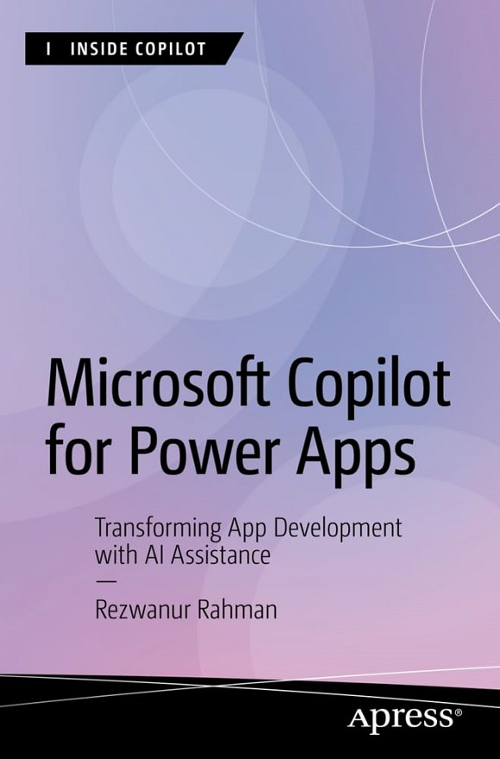

Inside Copilot

Inside Copilot is designed to teach users to master Copilot, Microsoft’s generative AI assistant. Learn prompt engineering and use cases for Copilot in many Microsoft products at beginner, intermediate, and expert levels. Perfect for any professionals who find their schedules packed with repetitive computer tasks, Copilot can automatically generate PowerPoint presentations, draft emails on Outlook, write code on GitHub, and more. Both companies and individuals can learn to utilize Copilot to significantly speed up processes and gain an advantage.
More information about this series at https://link.springer.com/
bookseries/17432.

Microsoft Copilot for

Power Apps

Transforming App Development

with AI Assistance

Rezwanur Rahman

Microsoft Copilot for Power Apps: Transforming App Development with AI Assistance
Rezwanur Rahman
Innsbruck, Austria
ISBN-13 (pbk): 979-8-8688-0511-0 ISBN-13 (electronic): 979-8-8688-0512-7
https://doi.org/10.1007/979-8-8688-0512-7
Copyright © 2024 by Rezwanur Rahman
This work is subject to copyright. All rights are reserved by the Publisher, whether the whole or part of the material is concerned, specifically the rights of translation, reprinting, reuse of illustrations, recitation, broadcasting, reproduction on microfilms or in any other physical way, and transmission or information storage and retrieval, electronic adaptation, computer software, or by similar or dissimilar methodology now known or hereafter developed. Trademarked names, logos, and images may appear in this book. Rather than use a trademark symbol with every occurrence of a trademarked name, logo, or image we use the names, logos, and images only in an editorial fashion and to the benefit of the trademark owner, with no intention of infringement of the trademark.
The use in this publication of trade names, trademarks, service marks, and similar terms, even if they are not identified as such, is not to be taken as an expression of opinion as to whether or not they are subject to proprietary rights.
While the advice and information in this book are believed to be true and accurate at the date of publication, neither the authors nor the editors nor the publisher can accept any legal responsibility for any errors or omissions that may be made. The publisher makes no warranty, express or implied, with respect to the material contained herein.
Managing Director, Apress Media LLC: Welmoed Spahr
Acquisitions Editor: Ryan Byrnes
Development Editor: Laura Berendson
Editorial Assistant: Gryffin Winkler
Copy Editor: Kezia Endsley
Cover designed by eStudioCalamar
Distributed to the book trade worldwide by Springer Science+Business Media New York, 1 New York Plaza, Suite 4600, New York, NY 10004-1562, USA. Phone 1-800-SPRINGER, fax (201) 348-4505, e-mail orders-ny@springer-sbm.com, or visit www.springeronline.com. Apress Media, LLC is a California LLC and the sole member (owner) is Springer Science + Business Media Finance Inc (SSBM Finance Inc). SSBM Finance Inc is a Delaware corporation. For information on translations, please e-mail booktranslations@springernature.com; for reprint, paperback, or audio rights, please e-mail bookpermissions@springernature.com. Apress titles may be purchased in bulk for academic, corporate, or promotional use. eBook versions and licenses are also available for most titles. For more information, reference our Print and eBook Bulk Sales web page at http://www.apress.com/bulk-sales. Any source code or other supplementary material referenced by the author in this book is available to readers on GitHub. For more detailed information, please visit https://www.apress.com/gp/ services/source-code.
If disposing of this product, please recycle the paper
Dedicated to my lovely and beautiful wife,

Mobaswira Farzana Munia. Thank you for your
support and love!

Table of Contents

About the Author ��������������������������������������������������������������������������������xv
About the Technical Reviewer ����������������������������������������������������������xvii
Acknowledgments �����������������������������������������������������������������������������xix
Introduction ���������������������������������������������������������������������������������������xxi

Chapter 1: Unveiling Copilot: A New Era in Power Apps �����������������������1
Decoding the Copilot Phenomenon �����������������������������������������������������������������������2
The Genesis of Copilot: Origin and Evolution ��������������������������������������������������������3
How Microsoft 365 Copilot Works �������������������������������������������������������������������������5
Different Ways to Customize Microsoft Copilot for Microsoft 365 ������������������������8
Data Types �����������������������������������������������������������������������������������������������������������10
Copilot’s Distinctive Features and Competitive Edge ������������������������������������������12
Enhance Microsoft Copilot for Microsoft 365 ������������������������������������������������������18
Customize Copilot for Your Use Case! �����������������������������������������������������������������21
Managing Engineering Team’s Tasks �������������������������������������������������������������21
Enterprise Knowledge Sharing ����������������������������������������������������������������������22
Product Inventory for Ecommerce �����������������������������������������������������������������22
Integrating Data with the Applications ����������������������������������������������������������������22
Plugins ����������������������������������������������������������������������������������������������������������������23
Microsoft Graph Connectors �������������������������������������������������������������������������������24
Extensibility Preview Support �����������������������������������������������������������������������������25

Table of ConTenTs
Integration Mastery: Copilot Meets Power Apps �������������������������������������������������25
Seamless Integration: Bridging Copilot with Power Apps �����������������������������������29
Case Studies: Successful Integration Scenarios �������������������������������������������������31
Case Study 1 ��������������������������������������������������������������������������������������������������32
Case Study 2 ��������������������������������������������������������������������������������������������������33
Case Study 3 ��������������������������������������������������������������������������������������������������34
Summary�������������������������������������������������������������������������������������������������������������36
Chapter 2: Embarking on the Copilot Journey ������������������������������������37
Streamlined Setup: From Installation to Execution ���������������������������������������������37
Licensing Overview ���������������������������������������������������������������������������������������������39
Power Apps Without Microsoft 365: Key Limitations�������������������������������������������43
Prerequisites for the AI Features in Power Apps �������������������������������������������������46
Quick Q/A Session �����������������������������������������������������������������������������������������������49
Setting Up a Test and Development Space ���������������������������������������������������������50
Sign Up for M365 Dev Plan ���������������������������������������������������������������������������������52
Signing Up for Microsoft Power Apps Dev Plan ��������������������������������������������������65
System Requirements, Limits, and Configure Values ������������������������������������������69
Required Services �����������������������������������������������������������������������������������������72
Deprecated Endpoints �����������������������������������������������������������������������������������76
Embedding Limits for Canvas Apps ���������������������������������������������������������������76
Proxies �����������������������������������������������������������������������������������������������������������78
Summary�������������������������������������������������������������������������������������������������������������78
Chapter 3: Mastering the Core: Copilot’s Engine Room ����������������������81
Harnessing the Power: Key Features Unlocked ��������������������������������������������������82
AI Builder: Revolutionizing Code Development ����������������������������������������������82
Core Features of AI Builder in General �����������������������������������������������������������84
Table of ConTenTs
Key Technical Features of AI Builder �������������������������������������������������������������86
AI Builder for Business Intelligence ���������������������������������������������������������������87
Add Intelligence to Your business ������������������������������������������������������������������88
Prompts ���������������������������������������������������������������������������������������������������������������90
What Is a Prompt? �����������������������������������������������������������������������������������������90
Instruction Tuning ������������������������������������������������������������������������������������������91
Prompt Engineering ���������������������������������������������������������������������������������������91
Why It Matters �����������������������������������������������������������������������������������������������91
Copilot Prompts ���������������������������������������������������������������������������������������������92
AI Unveiled: The Intelligence Behind Copilot �����������������������������������������������������104
Core Technologies Behind AI Builder �����������������������������������������������������������104
Advanced Integration of Azure Services in Copilot for Power Apps
Architecture ������������������������������������������������������������������������������������������������������107
Frequently Asked Questions ������������������������������������������������������������������������������112
AI Builder �����������������������������������������������������������������������������������������������������112
Power Fx ������������������������������������������������������������������������������������������������������115
Summary�����������������������������������������������������������������������������������������������������������117
Chapter 4: Crafting Power Apps with Copilot: The Essentials ����������119
Building Your First App: A Step- By-Step Process ����������������������������������������������119
Design Principles for Beginners ������������������������������������������������������������������������129
Changing the Background Color of Component, Container with Copilot �����135
Changing the Text or Label Properties with Copilot �������������������������������������140
Adding a Text Field or Label with Copilot �����������������������������������������������������144
Adding Components with Copilot ����������������������������������������������������������������152
Summary�����������������������������������������������������������������������������������������������������������159

Table of ConTenTs
Chapter 5: Advanced Customizations and Automation
with Copilot ��������������������������������������������������������������������������������������161
Analytical Prowess: Data Insights for Beginners ����������������������������������������������162
Understanding the Supported Data Sources for Power Apps ����������������������162
Understanding the Data Types ���������������������������������������������������������������������166
Visualizing Data in Power Apps �������������������������������������������������������������������������186
Working with Connectors ����������������������������������������������������������������������������200
Introducing Automation Features ����������������������������������������������������������������������208
Power Automation with Copilot �������������������������������������������������������������������222
Summary�����������������������������������������������������������������������������������������������������������226
Chapter 6: Advanced UI/UX Techniques in Power Apps
Development �������������������������������������������������������������������������������������229
Tailoring Apps: Customization Secrets ��������������������������������������������������������������229
Exploring UI/UX Best Practices ��������������������������������������������������������������������230
Accessibility Considerations ������������������������������������������������������������������������239
Incorporating Effective Navigation ��������������������������������������������������������������243
Aesthetic Design ������������������������������������������������������������������������������������������273
Summary�����������������������������������������������������������������������������������������������������������280
Chapter 7: Dynamic Content, Comments, and Copilot
Customization in Power Apps �����������������������������������������������������������281
Dynamic Content �����������������������������������������������������������������������������������������������282
Using Variables ��������������������������������������������������������������������������������������������282
Global Variables �������������������������������������������������������������������������������������������284
Context Variables �����������������������������������������������������������������������������������������285
Collections ���������������������������������������������������������������������������������������������������286
Formulas for Dynamic Interaction ���������������������������������������������������������������287
Responsive Design Techniques �������������������������������������������������������������������������309
Why Should You Build a Responsive App? ���������������������������������������������������310
Table of ConTenTs
Responsive Design Principle �����������������������������������������������������������������������310
Responsive Layouts �������������������������������������������������������������������������������������312
Working with Containers �����������������������������������������������������������������������������314
Creating a Demo ������������������������������������������������������������������������������������������315
Copilot Components and Conditional Formatting in Power Apps ����������������������322
The Copilot Control ��������������������������������������������������������������������������������������323
The Copilot Answer Control �������������������������������������������������������������������������340
Copilot Customization with Copilot Studio ��������������������������������������������������������344
Versions of Copilot Studio ����������������������������������������������������������������������������345
Copilot Studio Licensing Information �����������������������������������������������������������348
The Copilot Chatbot �������������������������������������������������������������������������������������349
Most Common Power Apps Design Component ������������������������������������������������364
Adding Comments ���������������������������������������������������������������������������������������������365
Mention or Tag Someone in Power Apps �����������������������������������������������������369
Power Apps Comment Limitations ���������������������������������������������������������������373
Summary�����������������������������������������������������������������������������������������������������������373
Chapter 8: Integrating Diverse Data Sources and Media in
Power Apps���������������������������������������������������������������������������������������375
Table Designer ��������������������������������������������������������������������������������������������������375
Permissions and Limitations of Table Creation in Dataverse �����������������������387
Image and Video �����������������������������������������������������������������������������������������������387
Add Images, Audio, or Video Using the Media Pane ������������������������������������388
Add Media from URL or Cloud ���������������������������������������������������������������������394
Known Limitations of Power Apps Media ����������������������������������������������������396
Pen Input Control ����������������������������������������������������������������������������������������������396
Known Limitation of the Power Apps Pen Control ���������������������������������������399

Table of ConTenTs
Integration Diverse Data Sources ���������������������������������������������������������������������399
Adding a SharePoint Data Source from Microsoft List ��������������������������������399
Adding SharePoint Data Source from Power Apps Studio ���������������������������406
The Difference Between Microsoft List and SharePoint List �����������������������412
Adding an Azure SQL Data Source ���������������������������������������������������������������413
Summary�����������������������������������������������������������������������������������������������������������435
Chapter 9: Introducing AI Builder in Power Apps �����������������������������437
AI Builder: Enhancing Power Apps with AI Capabilities �������������������������������������437
AI Builder Overview �������������������������������������������������������������������������������������������438
Types of AI Models Available �����������������������������������������������������������������������������439
Model Types �������������������������������������������������������������������������������������������������440
Common Business Scenarios ����������������������������������������������������������������������445
Pre-Built AI Models ��������������������������������������������������������������������������������������446
Custom AI Models ����������������������������������������������������������������������������������������448
In-Depth Exploration of AI Builder ���������������������������������������������������������������������450
Key Components of AI Builder ���������������������������������������������������������������������450
Summary�����������������������������������������������������������������������������������������������������������515
Chapter 10: Advanced Techniques with AI Builder and
Conditional Formatting ���������������������������������������������������������������������517
Using AI Prompts �����������������������������������������������������������������������������������������������518
Overview of AI Prompts �������������������������������������������������������������������������������518
Utilizing Pre-built AI Prompts for Generative AI Capabilities �����������������������������519
AI Prompt: AI Summarize �����������������������������������������������������������������������������520
Using Custom AI Prompts ����������������������������������������������������������������������������������534
Creating a Custom Prompt ��������������������������������������������������������������������������535
Conditional Formatting ��������������������������������������������������������������������������������������546
Overview of Conditional Formatting with Copilot ����������������������������������������546
Using Copilot for Conditional Formatting �����������������������������������������������������547
Table of ConTenTs
Using Copilot in the Formula Bar ����������������������������������������������������������������������552
Overview of Copilot in the Formula Bar �������������������������������������������������������553
Formula Explanation ������������������������������������������������������������������������������������554
Summary�����������������������������������������������������������������������������������������������������������555
Chapter 11: Revolutionizing Power Apps UI with
Microsoft Copilot: A Complete Project ����������������������������������������������557
Project Demo ����������������������������������������������������������������������������������������������������558
Creating a Modern Menu �����������������������������������������������������������������������������558
Creating the Menu Collapsible with Mode Switcher ������������������������������������613
Creating Complex UI Using Microsoft Copilot ����������������������������������������������660
Summary�����������������������������������������������������������������������������������������������������������679
Chapter 12: Visions of the Future: Copilot’s Evolving Landscape �����681
Trailblazing Trends: The Next Wave in App Development ����������������������������������682
AI Integration �����������������������������������������������������������������������������������������������682
Low-Code/No-Code Platforms ���������������������������������������������������������������������682
Cross-Platform Development ����������������������������������������������������������������������683
Augmented Reality (AR) and Virtual Reality (VR) �����������������������������������������683
Blockchain Technology ��������������������������������������������������������������������������������684
Upcoming Innovations in Copilot Technology ����������������������������������������������������684
Microsoft Copilot (Microsoft 365) ����������������������������������������������������������������685
Microsoft Viva ����������������������������������������������������������������������������������������������686
OneNote �������������������������������������������������������������������������������������������������������687
Outlook ��������������������������������������������������������������������������������������������������������688
Microsoft Purview ���������������������������������������������������������������������������������������689
Predicting Future Trends in Power Apps Development �������������������������������������690
Greater Customization ���������������������������������������������������������������������������������690
Integration with Other Microsoft Services ���������������������������������������������������691
AI and Automation Features ������������������������������������������������������������������������691

Table of ConTenTs
Expanded Template Libraries ����������������������������������������������������������������������692
Community Contributions ����������������������������������������������������������������������������692
The Future of AI Builder and Power Apps: What’s Next? �����������������������������������692
AI Builder �����������������������������������������������������������������������������������������������������693
Power Apps ��������������������������������������������������������������������������������������������������699
Summary�����������������������������������������������������������������������������������������������������������702
Chapter 13: Copilot Success Stories: Lessons from the Field ����������705
Inspirational Stories of Success ������������������������������������������������������������������������705
KPMG: Harnessing the Power of AI-Driven Productivity with
Microsoft 365 Copilot ����������������������������������������������������������������������������������706
Nsure: Streamlining Insurance Operations and Enhancing Customer
Experiences with the Power Platform ���������������������������������������������������������708
Hargreaves Lansdown: Revolutionizing Efficiency with Microsoft Copilot ����� 710
PG&E: Transforming Operations with Microsoft Copilot and Teams �������������712
Air India: Elevating Airline Operations with Microsoft Copilot and Teams ���714
Summary�����������������������������������������������������������������������������������������������������������716
Chapter 14: Comprehensive Resources ��������������������������������������������717
The Copilot Lexicon: Glossary and Key Definitions �������������������������������������������717
Beyond the Book: Extended Resources �������������������������������������������������������������747
Resources for Microsoft Copilot ������������������������������������������������������������������748
Resources for Microsoft Copilot Studio �������������������������������������������������������750
Resources for Microsoft Power Apps ����������������������������������������������������������751
Resources for AI Builder ������������������������������������������������������������������������������754
Resources for Microsoft Power Automate ���������������������������������������������������755
Online Communities and Forums ����������������������������������������������������������������������757
Summary�����������������������������������������������������������������������������������������������������������764

Index �������������������������������������������������������������������������������������������������767
About the Author

Rezwanur Rahman, the visionary CEO and managing director of Backend Emerging

Business Limited (Backend EBL), stands at the forefront of the tech world as an expert cloud solution architect. His accolades include being a Microsoft MVP in Microsoft Copilot & Microsoft 365 development and a Microsoft Certified Trainer (MCT), reflecting his deep-seated passion for innovation and software development. Rezwanur’s academic journey
began at the American International University-Bangladesh (AIUB), where
he specialized in software engineering, laying a strong foundation for his
illustrious career.
Rezwanur’s professional trajectory is marked by pivotal roles,
including senior technical lead (escalation engineer) for Microsoft
365 Global Support at Microsoft and technical evangelist-intern at
Microsoft Bangladesh. These positions equipped him with a profound
understanding of modern technology trends and their practical
applications.
In 2018, Rezwanur made history as the first Bangladeshi to receive
the Windows Insider MVP award. This was followed by the prestigious
Microsoft Most Valuable Professional (Microsoft MVP) award in Microsoft
365 Development in 2021, showcasing his unwavering dedication to
pushing technological boundaries, particularly within Microsoft platforms. abouT The auThor
Rezwanur’s expertise extends globally through his participation in renowned international speaking events like Microsoft Ignite, Microsoft AI Tour, Global Power Platform Bootcamp, M365 Developer Conferences, TeamsNations, GraphDevDay, and Global AI Bootcamps. These engagements have allowed him to share his insights and knowledge with a worldwide audience.
His involvement in cybersecurity, through collaborations with the Bangladesh Grey Hat Hackers and Cybersecurity Alliance-Bangladesh, adds another layer to his professional portfolio, emphasizing his commitment to promoting secure and ethical technological practices.
Driven by a desire to share his extensive knowledge and experience, Rezwanur authored Mastering Copilot for Power Apps: Transforming App Development with AI Assistance. This book aims to demystify the integration of AI in app development, particularly through tools like Copilot in Power Apps, offering readers a comprehensive guide, from basic concepts to advanced applications.
Residing in Tirol, Austria, Rezwanur continues to be inspired by the potential of technology to innovate and transform, remaining at the cutting edge of the tech industry.
About the Technical Reviewer

Kanwal Khipple is a dynamic leader, seasoned Power Platform expert, and CEO of 2toLead, a premier Microsoft consulting firm. With

two decades of experience driving digital
transformation and enabling organizations to maximize their investment in Microsoft 365, Kanwal is renowned for his deep expertise in user experience design, employee engagement, and modern workplace strategies.
As a passionate advocate for technology
adoption and innovation, Kanwal has guided
countless organizations through complex migrations, modernizations, and
change management initiatives. His approach is grounded in empathy,
creativity, and a strong focus on aligning technology with business goals to
deliver exceptional value.
Kanwal is also a sought-after speaker, known for his engaging
storytelling and practical insights on technical implementation,
leadership, and user experience. His thought leadership extends beyond
the stage to his influential writing, where he frequently shares best
practices, case studies, and actionable advice for organizations navigating
their digital journeys.
When he’s not driving transformation in the digital workplace, Kanwal
is dedicated to fostering an inclusive environment within his organization
and the broader tech community. He is a mentor, a leader, and an advocate
for continuous learning and generosity as key business values.
Acknowledgments

My deepest gratitude goes to my parents and parents-in-law for their
steadfast support and love. Their encouragement has been a constant
source of strength. I am also immensely grateful to my younger sister,
Zarin Tasnim, and my beautiful wife, Mobaswira Farzana Munia, whose
understanding and patience have been invaluable.
I wish to express my sincere appreciation to my technical
reviewer, Kanwal Khipple, for his meticulous insights and feedback,
which have significantly enhanced the quality of this work. A special
acknowledgement to Apress, the publisher, for choosing me to write this
book and for their consistent support throughout the process.
A heartfelt thanks to all the teams at Microsoft Bangladesh, Microsoft
Deutschland, and the Microsoft Global Headquarters. Your trust in my
abilities has been a tremendous motivation. Special thanks to EMEA
Lead, Community Program Management at Microsoft, Alice Piras, for
her exceptional support and guidance. Additionally, I am grateful to the
Microsoft Product Groups (PG) for their collaborative spirit, and to the
senior product manager Microsoft 365 Copilot and Microsoft Graph at
Microsoft, Fabian Williams, for his outstanding leadership.
I am deeply thankful to my fellow Microsoft MVP colleagues. Your
continuous support and willingness to share knowledge have greatly
enriched my learning experience.
Lastly, I am profoundly appreciative of my friend and legal advisor,
lawyer Mag. Stefan Gamsjäger. His wise counsel, steadfast support, and
assistance in making crucial decisions have been essential throughout this
journey.
Thank you all for your invaluable contributions and unwavering
support.
Introduction

Welcome to Microsoft Copilot for Power Apps, a comprehensive resource
designed to guide you through the innovative capabilities and practical
applications of Microsoft’s latest AI-driven assistant for Power Apps.
This book is crafted for developers, IT professionals, and business users
who aim to harness the power of AI to streamline their app development
processes and enhance productivity.

What This Book Is About
Microsoft Copilot for Power Apps explores the transformative potential
of integrating AI into app development through Microsoft Copilot. The
book covers the functionalities, benefits, and prospects of using Copilot
within the Power Apps ecosystem. It provides step-by-step instructions,
case studies, and best practices to help you maximize the use of this
powerful tool.

Who This Book Is For
Whether you are a seasoned developer looking to incorporate AI into
your workflow, a business user aiming to create efficient applications
without extensive coding knowledge, or an IT professional responsible for
deploying and managing enterprise applications, this book offers valuable
insights and practical guidance tailored to your needs.
InTroduCTIon

Structure of the Book
The book is structured to take you on a journey from understanding the basics of Microsoft Copilot to mastering its advanced features and applications. Here’s a brief overview of what each chapter covers:

Chapter 1: Unveiling Copilot: A New Era in Power Apps
This chapter provides an overview of Copilot, its core features, and the benefits it offers to Power Apps users. You’ll learn about the evolution of AI in app development and how Copilot stands out as a game-changer.

Chapter 2: Embarking on the Copilot Journey
This chapter describes the process for setting up and optimizing Microsoft Copilot for Power Apps, focusing on simple deployment due to its online service model. It covers the different licensing options, setting up a conducive testing and development environment, and troubleshooting issues related to proxy servers.

Chapter 3: Mastering the Core: Copilot’s Engine Room
Focused on the AI Builder at the heart of Microsoft Copilot, this chapter explains how AI Builder helps developers build and launch AI models quickly using an accessible low-code approach. It details how Microsoft Azure services enhance the architecture of Copilot, making AI accessible to all developers.

Chapter 4: Crafting Power Apps with Copilot: The Essentials
This chapter guides you through the process of building functional and aesthetically pleasing Power Apps using Microsoft Copilot. It covers the distinctions between Canvas and model-driven apps, and explains how to automate modifications and adjust UI components using straightforward, natural language commands.

Chapter 5: Advanced Customizations and Automation with Copilot
This chapter introduces advanced customization techniques, including optimizing layouts, employing grid systems, and integrating diverse data sources. It also explores the powerful capabilities of Copilot functionalities such as Copilot Chat, Copilot Studio, and Copilot Answer.
InTroduCTIon

Chapter 6: Advanced UI/UX Techniques in Power Apps Development This chapter explains how to integrate advanced AI capabilities
into Power Apps using AI Builder. It covers adding AI models like text
recognition, sentiment analysis, and document processing to your
applications, enhancing their functionality and user experience.

Chapter 7: Dynamic Content, Comments, and Copilot
Customization in Power Apps
This chapter demonstrates how to create dynamic and engaging user
interfaces (UI) with Copilot, focusing on practical implementation by
designing modern menus and crafting sophisticated UIs for canvas apps in
tablet format.

Chapter 8: Integrating Diverse Data Sources and Media in
Power Apps
This chapter focuses on enhancing Power Apps by integrating multiple
data sources such as Microsoft Dataverse, SharePoint, and Azure SQL. It
covers creating and customizing Dataverse tables, connecting to external
data repositories, and managing multimedia elements, including images,
videos, and pen input controls. These integrations empower developers
to build data-driven, dynamic applications that offer a richer, interactive
experience for users.

Chapter 9: Introducing AI Builder in Power Apps This chapter explores AI Builder, guiding you on how to enhance
Power Apps with artificial intelligence to automate processes, predict
outcomes, and extract insights from data—all without requiring advanced
AI expertise. It covers both prebuilt and custom AI models, including text
recognition, sentiment analysis, and object detection, offering versatile
tools for business applications. With this integration, you’ll be able
to create smarter, proactive apps that streamline workflows, improve
decision-making, and add valuable intelligence to everyday tasks.
InTroduCTIon

Chapter 10: Advanced Techniques with AI Builder and Conditional Formatting
This chapter guides you through advanced techniques for enhancing Power Apps with AI Builder and conditional formatting. It introduces custom AI prompts, enabling you to add tailored, intelligent features to your applications, and demonstrates how conditional formatting can be applied to make data-driven visual adjustments, creating a more responsive and visually intuitive user experience. You’ll also learn to leverage Copilot for creating and refining conditional formatting rules, streamlining complex tasks without requiring deep technical expertise.

Chapter 11: Revolutionizing Power Apps UI with Microsoft Copilot: A Complete Project
This chapter showcases how to use Microsoft Copilot to transform Power Apps UI, guiding you through a complete project. It covers the creation of a modern, dynamic user interface with collapsible menus, a theme-switching toggle, and a responsive layout. By following these steps, you’ll learn to craft Power Apps that are visually appealing, interactive, and adaptable to different user preferences, providing a professional, modern look to your applications.

Chapter 12: Visions of the Future: Copilot’s Evolving Landscape
This chapter explores the latest trends poised to transform app development, including AI integration, low-code/no-code platforms, cross-platform development, AR and VR technologies, and blockchain. This chapter also discusses future innovations in Copilot technology.

Chapter 13: Copilot Success Stories: Lessons from the Field
This chapter showcases how various industries have successfully implemented Copilot, highlighting the challenges they faced and the solutions they devised. It emphasizes strategic planning, effective data governance, and change management.
InTroduCTIon

Chapter 14: Comprehensive Resources The final chapter provides essential resources to support your
journey with Microsoft Copilot for Power Apps. It includes key terms and
definitions and online resources for further learning, and it highlights
thriving online communities for sharing ideas and accessing support.

What You’ll Learn
By the end of this book, you will have a thorough understanding of how
to leverage Microsoft Copilot to enhance your Power Apps projects. You
will be equipped with the knowledge to implement AI-driven solutions,
optimize your workflows, and create applications that are both powerful
and user-friendly.
I hope this book inspires you to explore new possibilities with
Microsoft Copilot and empowers you to build innovative applications that
drive success in your organization. Let’s embark on this exciting journey
together and unlock the full potential of AI in app development.

CHAPTER 1

Unveiling Copilot:

A New Era in Power

Apps

Have you ever wondered what it would be like if building apps was as
simple as talking through an idea? What if you didn’t have to write lines
and lines of code, but instead, you could simply speak to an AI program,
whose only purpose was to turn your thoughts into binaries? This is
not some futuristic idea anymore—this is the reality in which we are
now living.
Fundamentally, Microsoft Copilot, which is part of Power Apps,
changes everything for low-code application development. You are no
longer tethered by the boundaries of coding languages. Think of Copilot
as your digital friend who speaks fluent code and knows that you do not.
Instead of simply listening to your requests, it anticipates what you need
before you even think of it, offering suggestions that can make you more
efficient.
Now is the time to envision greater possibilities, strive for bigger goals,
and reach new heights.

© Rezwanur Rahman 2024 1
R. Rahman, Microsoft Copilot for Power Apps, Inside Copilot,

Chapter 1 Unveiling Copilot: a new era in power apps

Decoding the Copilot Phenomenon
In this modern-day story of technological revolution, Microsoft 365 Copilot is a front-runner—meaning a giant leap from hitherto practiced ways of engaging with and drawing on artificial intelligence (AI) to boost software development. These transformations—the Copilot Revolution, more generally—embody the most radical synthesis of AI with human expertise, breaking many of the traditional practices of software development. The essence of Microsoft 365 Copilot is an AI assistant that has human capabilities in the software building field. It’s beyond what automated coding traditionally defines: it provides predictive analytics, design guidance, and smart help in problem-solving. This integration will practically bring out a new role in the sense that Copilot will become more
of a collaborator in the development process than just a tool. Figure 1-1 shows the various Copilot logos.
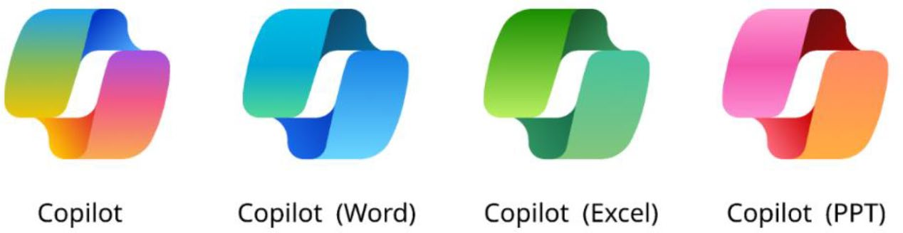

Figure 1-1. Copilot in different Microsoft product environments
And, of course, what Copilot brings to the platform is one of the most fascinating aspects of this integration. It’s democratizing software development. With intuitive suggestions and an easy-to-use interface, Copilot makes it significantly simpler to write software. This opens the door to a much broader range of contributors—people who previously didn’t code are now becoming developers and making substantial contributions. Consequently, we can expect greater diversity and innovation in software development approaches.

Chapter 1 Unveiling Copilot: a new era in power apps
Copilot’s main strength is its ability to be flexible and customizable
to your needs. Based on your interactions with Copilot, it tailors the
experience by tuning suggestions to you. In the development environment,
different users have different preferences and different project
requirements, and as Copilot learns more about you, your experience of
using Copilot will evolve. Copilot will become tailored to your personal
preferences and the latest trends in the language.
The implications are profound, prompting us to envision a future
where AI integrates into the creative and development processes,
collaborating with human expertise and innovation. This partnership
could transform the software development landscape, making software
more adaptable to market shifts and driving exploration of new
technological horizons.

The Genesis of Copilot: Origin and Evolution
Amid the rapidly evolving landscape of digital technology and AI, the
arrival of Microsoft 365 Copilot marks a significant milestone, closely
tied to advancements in AI, especially in natural language processing
championed by OpenAI. The story of Microsoft 365 Copilot unfolds
alongside OpenAI’s models, with a key chapter focusing on Generative
Pre-trained Transformers (GPT), particularly GPT-4 and Bing GPT-4.
GPT-4 is the journey that was started with GPT-1 in 2018, a
monumental AI model that produced human-like text. It laid the
foundation for later releases, such as GPT-2 and GPT-3, further pushing
the frontier of what AI could do with text generation and natural language
understanding. The gargantuan GPT-3 model had 175 billion parameters,
trained on enormous and diverse datasets to make it fluent in producing
text across a range of topics.

Chapter 1 Unveiling Copilot: a new era in power apps
In 2023, GPT-4 built on this, taking a step change toward greater sophistication. With further parameters, now believed to exceed a trillion in number, and new techniques of training, the output can interpret and generate text with so much subtlety and complexity like no other before it. In other words, GPT-4 could understand context better and produce accurate content between these domains from both the receiver’s and producer’s view of the text, most accurately, and for more than one language. It also made the processing more efficient and, accordingly, more relevant for integration with a suite of applications, which is where Microsoft 365 Copilot came into play.
At the same time, Bing GPT-4 came into being, taking another important stride. Bing GPT-4 is a special version of GPT-4 developed for the search engine application, which incorporates the latest language skills into GPT-4 but more specifically tuned to the requirements of web search and information finding. In its latest version, it has improved natural language capabilities in understanding and summarizing information from web pages. It gives users more relevant, context-aware responses to their search queries and can serve up the search experience in a much more conversational—some would say interactive—way.
A great contribution for the development of the work was with the integration of GPT-4, in particular Bing GPT-4, within the suite of Microsoft’s productivity tools. This capitalized on the advanced AI technology of OpenAI with more intuitive, efficient, and powerful tools for office productivity and collaboration, using OpenAI and its API in the tools.
Creating Microsoft 365 Copilot meant seamlessly bringing together GPT-4 and Bing GPT-4 into one of the most used suites across the world. The challenges were met across several disciplines, right from the integration of AI into the Microsoft suite to staying user-focused, and at the same time, ensuring stringent data privacy and security. This provided very useful feedback in addressing these challenges and refining the tool from the early adopters taking part in the beta test.

Chapter 1 Unveiling Copilot: a new era in power apps
The launch of Microsoft 365 Copilot presents a new era in the history
of office productivity software. But the range isn’t just productivity
around changed work and collaboration modes; it’s also the emergence
of new forms of work, all super-powered by GPT-4 and Bing GPT-4. Over
time, with subsequent maturing, Copilot for Microsoft 365 highlights an
emerging time when workspaces will slowly be infiltrated by AI tools that
help humans break new frontiers of creativity and innovation. The story
of Microsoft 365 Copilot is mingled with AI, using the human capacity of
creativity to improve the work frontiers still changing in the digital era.

How Microsoft 365 Copilot Works
Microsoft 365 features one of the most promoted innovations so far, the
AI-powered productivity toolset. Microsoft 365 takes full advantage of
the integration Microsoft has done with Microsoft 365 apps and provides
a completely new experience. Copilot interacts with users as they use
familiar products like Outlook or Word, which provides a far more
powerful, AI-powered experience.
Let’s look at how Copilot works and powers a new type of AI-assisted
experience for everyday tasks. Figure 1-2 presents the technical flowchart
for Microsoft 365 Copilot.

Chapter 1 Unveiling Copilot: a new era in power apps
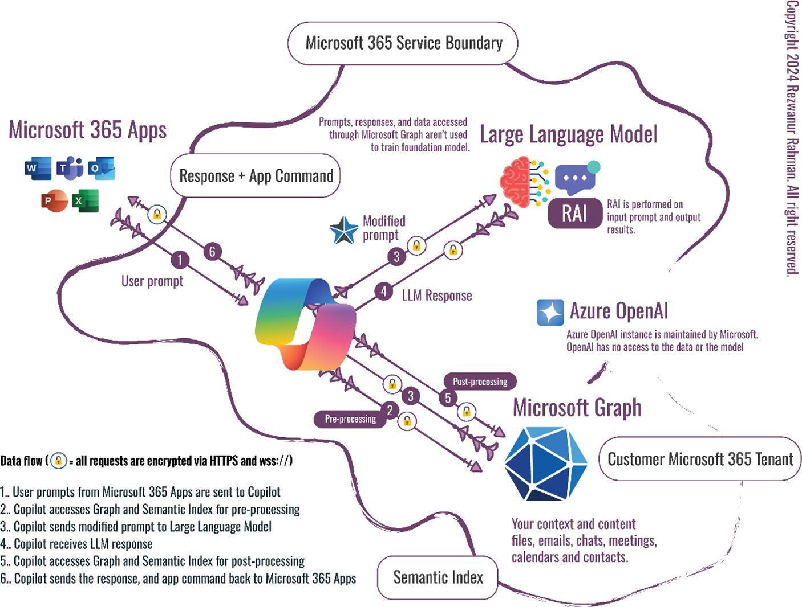

Figure 1-2. Technical flowchart of Copilot background
For example, when a user is composing an email in Outlook or writing a document in Word, their input triggers a very complex AI-powered backend process. The prompt is then encrypted and sent to the Copilot service when issued.
Upon receipt, Copilot engages the Microsoft Graph API, a robust interface that interlinks Microsoft’s cloud services. The user prompt receives a first semantic analysis, extending with context metadata derived from the user’s data ecosystem around Microsoft, including emails, files, meetings, social connections, and other resources. This ensures that the response from AI is not only syntactically perfect but that it considers the context of the historical data pattern and the history of the user’s usage.

Chapter 1 Unveiling Copilot: a new era in power apps
The richer prompt, now semantically grounded, is securely forwarded
to the Large Language Model (LLM), GPT-4, or specifically Bing GPT-4.
Forwarding occurs with more encryption at the time of sending the path
and the data to retain the user’s privacy. The LLM is managing this using
a powerful set of algorithms, together with a model of potentially over
a trillion parameters, to allow the generation of natural language with
nuanced understanding. With expanded capabilities of GPT-4, it can
identify the intention described by a prompt and express an answer that
is coherent and corresponds to the context provided by that prompt. The
response is then sent back to Copilot by the LLM for post-processing.
Here, in outputs of the AI, the Microsoft Graph and Semantic Index
are reused to perfectly align the respective final response according to the
needs of the user for security and privacy standards. The response matches
the command structure of the application and fits into the workflow of the
user within the Microsoft 365 app.
Eventually, the processed and refined response that may need
application commands is sent back to the originating Microsoft 365 app.
These responses are all provided within the view of the user, enabling them
to be empowered with AI-based assistance that will increase productivity
and smooth decision-making, all at the comfort of their software learning
environment. They are encapsulated end-to-end within a secure and
privacy-centric framework using state-of-the-art encryption and strong
interaction protocols, which safeguard users’ data while enabling
advanced AI-enhanced user experiences.

Knowledge Note in the Microsoft 365 Copilot system, the ai doesn’t merely process text; it understands context by leveraging semantic indexing. this means when the ai encounters terms like “quarterly review,” it doesn’t just see words—it sees past

Chapter 1 Unveiling Copilot: a new era in power apps
documents, emails, and meetings related to your company’s quarterly
performance, drawing on a rich tapestry of user-specific data to
inform its response. this level of contextual awareness is a leap
forward in making ai an intuitive extension of natural workflows.

Different Ways to Customize Microsoft
Copilot for Microsoft 365
Copilot provides a range of extensibility options, enabling users to enhance, customize, and personalize using plugins and Graph connectors. The following sections take a deeper look and differentiate the different ways users can extend the capabilities of Copilot.
Plugins are exciting. They let you add new features, such as an integration with Microsoft Teams’ message extensions or Power Platform’s connector. Your enterprise data can be easily accessed within the Copilot for Microsoft 365 environment by using connectors.
You can customize Copilot for Microsoft 365 with the smarts of external services, apps, and data. Choose the tools and SDKs that are right for the way you work, then hit the ground running, creating your connector or plugins.
Figure 1-3 shows the flowchart of Copilot’s extensibility options.

Chapter 1 Unveiling Copilot: a new era in power apps
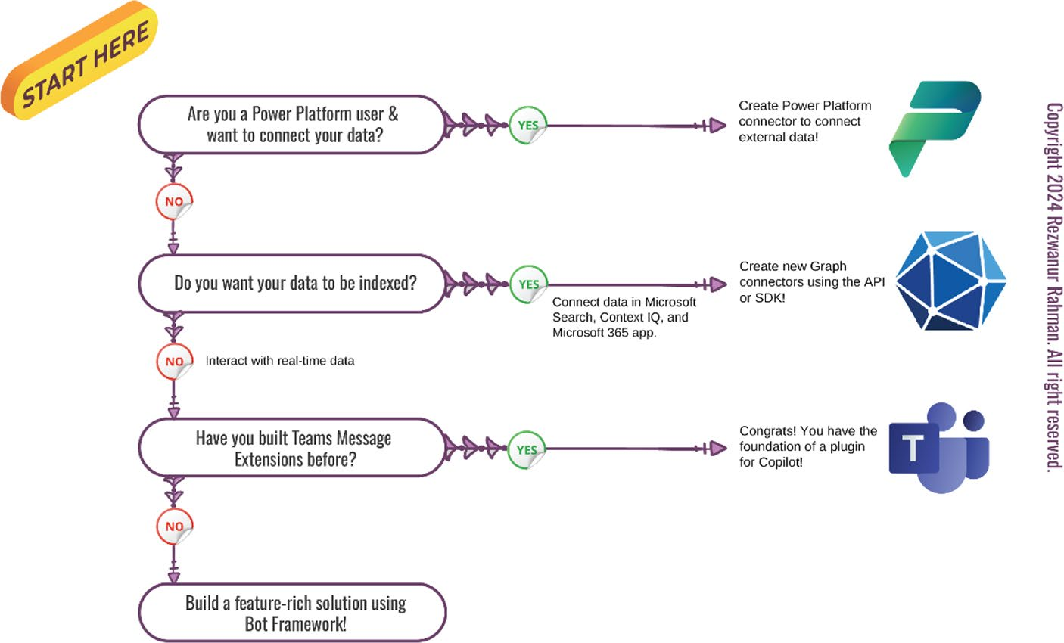

Figure 1-3. Copilot extensibility options at a glance

• No-code or low-code developers familiar with
Power Platform can optimally access external data in Power Platform through Microsoft Power Platform connectors. This is particularly advantageous for those also using Copilot, as these connectors offer a streamlined solution.
• Within Microsoft 365, Graph connectors offer you
a seamless way to integrate unstructured corporate data such as Microsoft search data, Context IQ, and Microsoft 365 app data. This integration using Graph connectors extends all the features available in Microsoft Graph to work with your data.
• For structured data from outside sources, you can
integrate with Message Extensions and apply logic with the Bot Framework. If you already have Message Extension apps for Teams, half the work is done. You

Chapter 1 Unveiling Copilot: a new era in power apps
simply ensure that your app manifest is updated and meets all the necessary requirements before it is published as a plugin.
When deciding on the best approach for your project, even skilled programmers who lean toward high-level programming should consider certain factors. This consideration remains crucial regardless of a preference for no-code or low-code alternatives.

Data Types
Think about the characteristics of your data, including its organization, expected amount and frequency of use, and the access needs it entails.
Table 1-1 shows the comparison of data characteristics across connectors and plugins.
Table 1-1. Comparison of Data Characteristics Across Connectors and Plugins
Graph Connectors Message Extension Copilot Studio
Plugins Plugins
structure Unstructured or structured data structured data
flattened data
Data Up to 5M items per suitable for high suitable for high volume connection volume data (over 5M) volume data
(over 5M)
Data Up to 20 requests suitable for high suitable for high activity per second activity (over 20 req/ volume data
sec.) (over 5M)
summarize/ summarize only (Copilot summarize + act (with summarize only act analyzes and extracts adaptive Card, a user
key information) can modify the data)

Chapter 1 Unveiling Copilot: a new era in power apps
Figure 1-4 shows an example of writable data with a message
extension. This plugin handles a product inventory. Copilot queries the
data from the inventory and shows the results in Adaptive Card, where it
lets the user change the stock.
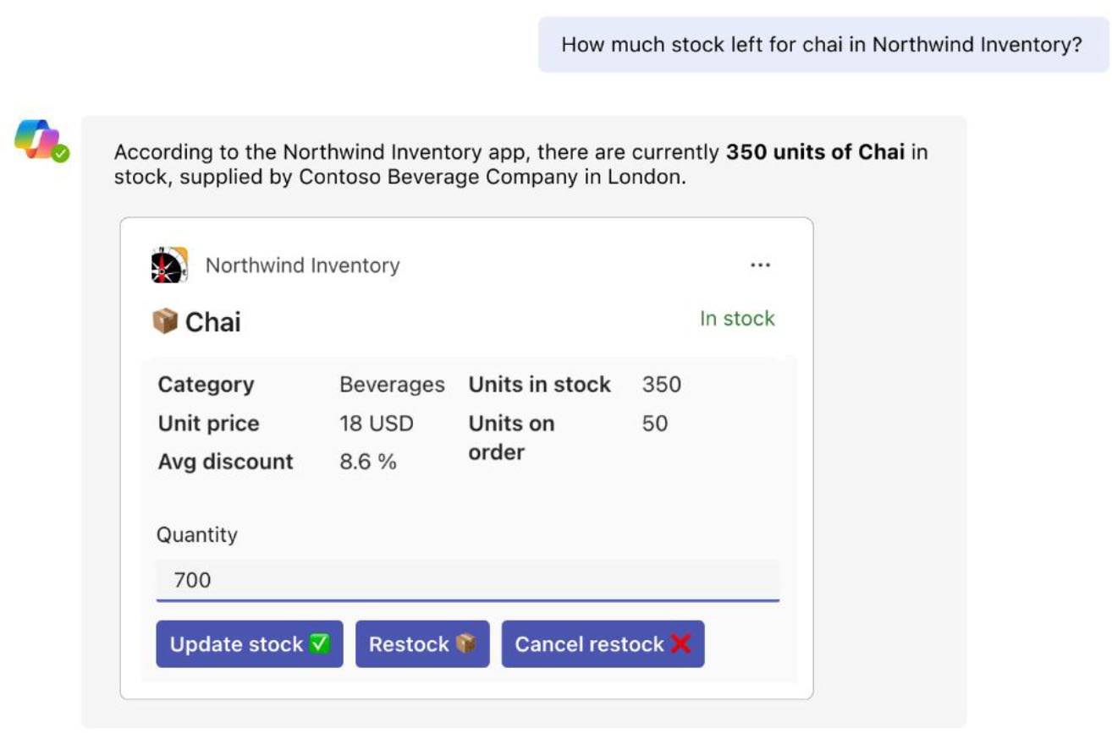

Figure 1-4. Example of a plugin used for Northwind Inventory.
Image Source: Microsoft

Tip You can find the sample code for the northwind inventory
plugin at https://learn.microsoft.com/en-us/
microsoft-365-copilot/extensibility/samples#teams-
message-extension-samples .

Chapter 1 Unveiling Copilot: a new era in power apps

Copilot’s Distinctive Features
and Competitive Edge
A major leap in office productivity, Microsoft 365 Copilot features advanced artificial intelligence that changes how people interact with technology in the work environment. At the heart of Copilot’s groundbreaking innovation is its deep AI integration, converting standard office tools into intelligent assistants. This integration surpasses a simple layering of AI on top of existing tools, instead representing a rethinking of how office applications should work, that is, automating the ordinary experiences and delivering insight that was otherwise only available
with specialized expertise. Figure 1-5 shows a comprehensive diagram of Microsoft Copilot’s integration into the Microsoft product ecosystem.

Chapter 1 Unveiling Copilot: a new era in power apps
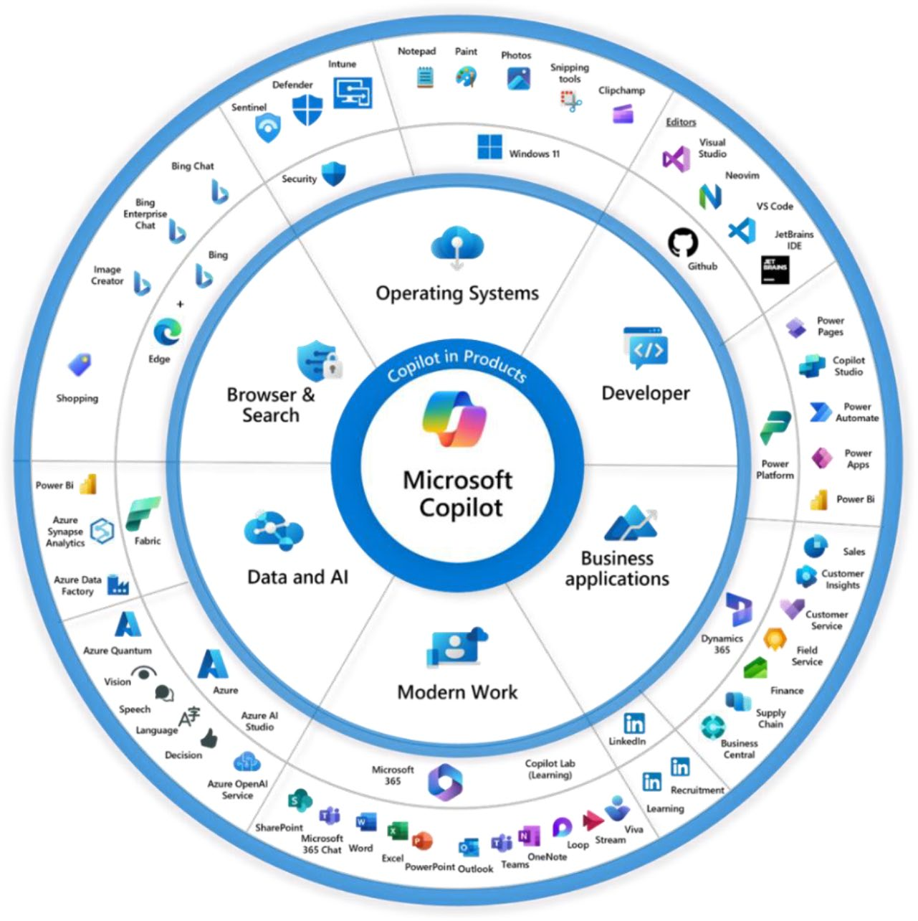

Figure 1-5. Microsoft Copilot in the Microsoft product ecosystem.
Image Source: https://switchedon.bowdark.com/copilots-
everywhere-understanding-microsofts-copilot-strategy-
f5d576cef81b

Word with Copilot—Advanced Natural Language Processing (NLP): Microsoft 365 Copilot in Word combines Word and Copilot, ensuring state-of- the-art capabilities with pioneering NLP technique advancements, along with innovative architecture layered atop deep learning. This AI helps users make documents more impactful and coherent

Chapter 1 Unveiling Copilot: a new era in power apps
than ever before. From rephrasing and following preferred style, to generating a contextually relevant content at each interaction that only improves, this AI does everything, improving each time and giving suggestions far superior to the current writing style of the user. The product will ensure that Word remains the top choice for professional writing, whether for educators, business professionals, or any other users.
Excel with Copilot—Predictive Analytics and Data Modeling: The Copilot algorithms empowered with intelligence in Excel give it the ability to deliver predictive insights and analyze patterns in data—in other words, permitting users to do forecasting, trend analysis, and scenario modeling, all without having to go through intensive statistics or analytics training. The software also works in autopilot to visualize your data, suggesting the best ways it would be represented graphically. With the capability to interpret complex datasets, Excel is transformed from just a mere spreadsheet application into a powerful analytical tool essential for making informed business and research decisions.
PowerPoint with Copilot—Intelligent Design and Content Assistance: Copilot for PowerPoint acts as your intelligent designer and content editor, always at your service. Leveraging the latest AI algorithms, it enhances the appearance of your PowerPoint slides progressively. By analyzing the content of each slide, Copilot offers suggestions on

Chapter 1 Unveiling Copilot: a new era in power apps
layout, theme, and visual enhancements that best complement your material. Instead of relying on excessive animations or poor color choices, Copilot steers you toward more effective design decisions. Text formatting and legibility are automated, ensuring clarity and professionalism. Additionally, relevant images and graphics are recommended to enrich your presentation. Copilot even assists in structuring your content within each slide, improving overall organization. Beyond merely providing tools for slide creation, Copilot offers comprehensive support for crafting a polished and cohesive presentation. Power presenters, particularly educators, marketers, and business professionals, find its predictive design assistance invaluable.
Outlook with Copilot—AI-Enhanced
Communication and Scheduling: Copilot assists with drafting messages during work hours by suggesting quick and concise responses based on incoming emails, a process powered by advanced natural language processing (NLP). It also learns from user interactions to improve future suggestions. Additionally, Copilot integrates with the Outlook calendar and contacts to further enhance its functionality. For instance, if a user has a meeting, Copilot uses NLP to identify who should be included in the communication and suggest relevant participants. It can also analyze the organizational chart to recommend appropriate

Chapter 1 Unveiling Copilot: a new era in power apps
contacts. Furthermore, Copilot can check the availability of all participants and propose optimal meeting times, coordinating schedules seamlessly between users.
Teams with Copilot—Enhanced Collaboration and Meeting Efficiency: Copilot on Teams introduces a new offering enabled by new AI capabilities that enhances the virtual collaboration experience. It provides real-time transcription and translation services by utilizing advanced speech recognition and NLP technology, which encourages open, yet sensitivity-controlled communications with different global teams. AI-powered meeting analytics summarize, identify key points, and track action items so valuable insights from meetings aren’t lost. This technology makes Teams a smart hub in collaboration and productivity.
OneNote with Copilot—Smart Information Management: OneNote makes more sense with AI integration because of its NLP that entails AI-powered organization and retrieval through classification algorithms, which are used to categorize your notes, tag main information, and make suggestions for associated notes during up- and- coming meetings or projects. This level of AI integration transforms OneNote from a simple note- taking tool into a robust system that intelligently manages notes, resources, and tasks, making it an invaluable asset for researchers, students, and knowledge workers.

Chapter 1 Unveiling Copilot: a new era in power apps
SharePoint with Copilot—AI-Powered Document Management and Collaboration: With Copilot in SharePoint, teams get a range of capabilities based on AI to take their managing of documents and collaboration to a new level. Powerful machine- learning algorithms enable optimized searches that deliver results faster and more accurately. It features categorization through AI and management of doc libraries for easy access and collaboration. It avails the projects and collaborations to be very dynamic and efficient at the facility by keeping the document in SharePoint.
Security and Compliance—Ensuring Data Integrity and Privacy: The most crucial aspect is security and compliance. The platform, which is based on AI models and algorithms, ensures data security and privacy of the users. It guarantees that all information used with this tool is kept securely in a decentralized manner. Copilot has these securities to align with what the world protections have demanded when handling customer-sensitive data, like GDPR for privacy maintenance and proper data management.
Integration with Azure, Dynamics 365, Power BI, and Power Automate:
• Azure: Provides a scalable cloud infrastructure to
run the AI and ML computations that power Copilot, ensuring high performance and reliability.

Chapter 1 Unveiling Copilot: a new era in power apps
• Dynamics 365: Integrates Copilot into CRM and
ERP systems, enhancing customer relationship management and streamlining operations with AI- driven insights.
• Power BI: Empowers data analysis with Copilot,
offering advanced visualization and reporting capabilities.
• Power Automate: Leverages Copilot to automate
workflows and processes, improving efficiency across various tasks.

Enhance Microsoft Copilot for Microsoft 365
With Copilot for Microsoft 365, developers can tailor AI to the core audience that they support in the Microsoft 365 environment.
It is packed with valuable capabilities designed to help work processes through a set of text, insight, predictive analysis, memory, language translation, and creative content services. It does this by indexing and tapping into the content of an organization through Microsoft Graph—documents, chat histories, and emails that users have access to.
Figure 1-6 shows how natural language works with Microsoft Copilot in Microsoft 365.

Chapter 1 Unveiling Copilot: a new era in power apps
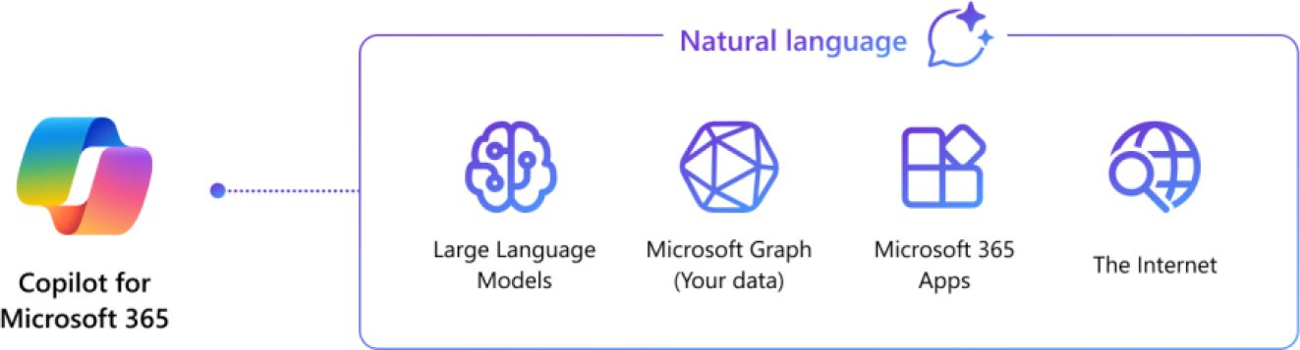

Figure 1-6. How natural language works with Copilot for Microsoft
365. Image Source: Microsoft Learn

Microsoft 365 doesn’t just provide apps and data formats—many
business processes require more, and Microsoft has built extensibility
into Copilot. Copilot is already rich with AI capabilities, and with Copilot
extensibility, you can enhance Copilot for Microsoft 365 by adding custom
capabilities and expert knowledge specific to your organization and its
users, all powered by AI. You can turn your app into a plugin to expand
what Copilot can do and increase productivity across the numerous tasks
and workflows people carry out every day. By using Microsoft Graph
connectors to bring your enterprise data and content into Copilot, you can
also make your organization’s knowledge available to Copilot. Figure 1-7
shows the extensibility graph of Microsoft Copilot.

Chapter 1 Unveiling Copilot: a new era in power apps
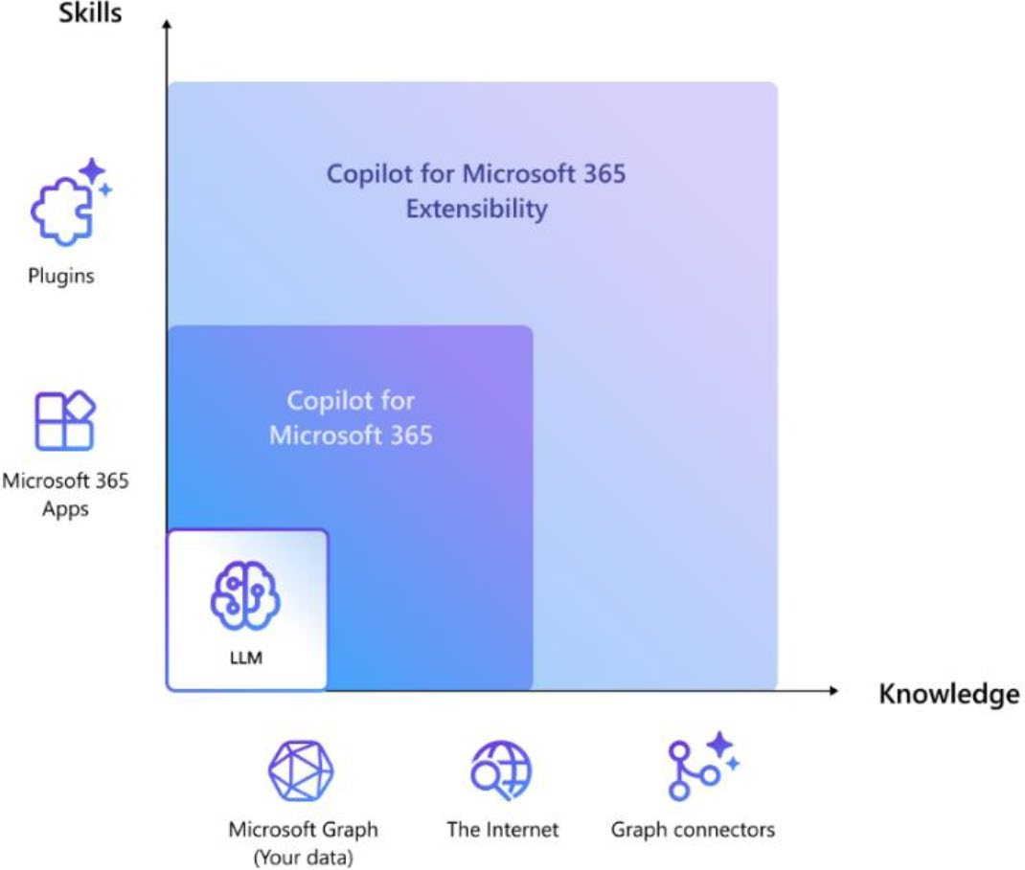

Figure 1-7. Extensibility graph of Microsoft Copilot. Image Source: Microsoft Learn

Using Copilot for Microsoft 365, you enhance the performance of your apps and data with AI, by:
• Enhancing the data assets of your organization with the
best AI in the market.
• Helping your users complete their tasks smoothly, from
beginning to end.
• Benefiting from top-notch security, compliance, and
privacy policies.

Chapter 1 Unveiling Copilot: a new era in power apps

Customize Copilot for Your Use Case!
Copilot’s extensibility enhances the productivity of your collaborative
environment by merging vital data, widely used tools, and trusted
procedures with a common platform where teams typically gather, learn,
and conduct work. Whether developing a new application specifically for
Copilot or integrating an already existing one, the possibilities are broad.
The following sections give specific examples of what you can develop for
your organization.

Managing Engineering Team’s Tasks
Let’s say your engineering team uses a project management application.
You now can build a custom tool to track outstanding tickets. Users could
ask about the status of all the tickets assigned to them and Copilot could
grab that data and present it in their custom extension. Figure 1-8 shows
a visual example of how an engineering team can track issues using
Microsoft Copilot.
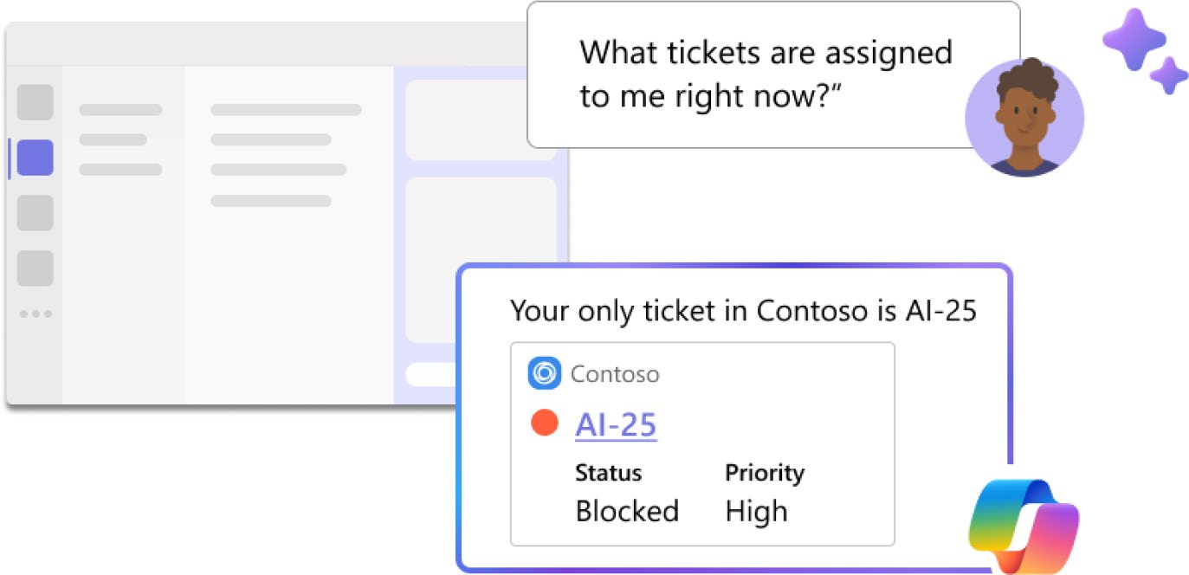

Figure 1-8. Visual example of issue tracking for engineering team.
Image Source: Microsoft Learn

Chapter 1 Unveiling Copilot: a new era in power apps

Enterprise Knowledge Sharing
Imagine a global company with knowledge that is distributed through many different formats—including documents, emails, and chat transcripts—and stored in many different systems. Microsoft Graph connectors create a universal solution by bringing that data together into one single interface that can be searched efficiently. This means you get—presuming your organization’s data is available in Graph—your organization’s collective intelligence at your fingertips.

Product Inventory for Ecommerce
You can use Copilot to check the stock level of certain products and develop your own in-house inventory management tool by linking it to your product database.

Integrating Data with the Applications
Copilot for Microsoft 365 can be enhanced in two ways:
• By adding skills to Copilot through plugins.
• By linking it with organizational data through Graph
connectors.
Let’s discuss plugins and connectors in more detail. Figure 1-9 illustrates the technical flowchart of how Microsoft Graph connector and plugins work with Microsoft Copilot.

Chapter 1 Unveiling Copilot: a new era in power apps
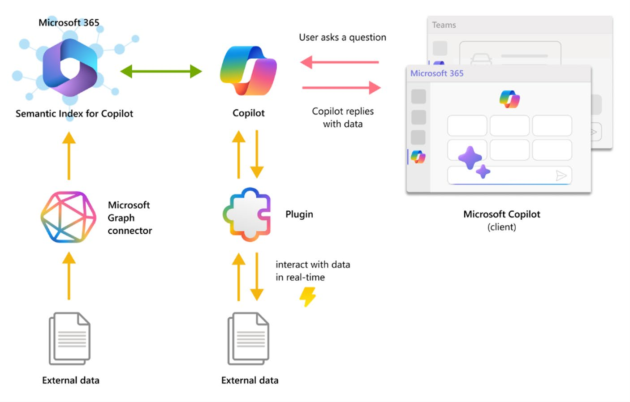

Figure 1-9. Technical flowchart of how plugins and Microsoft Graph
connector work

Plugins
You can help your users do things with your web service by using Copilot
plugins. Users can interact with your web service in natural language by
using plugins:
• Get near real-time information. For example, keep up
with the latest news about a new product launch.
• Access data through links. For example, generate a
report on the service tickets assigned to a particular team member.
• Do tasks cross application. For example, start
a new assignment in your organization’s task management system.

Chapter 1 Unveiling Copilot: a new era in power apps
You can build plugins with a Microsoft Teams message extension or a connector for the Power platform. If you already have a message extension or a Power platform connector, you’re most of the way to having a Copilot plugin.

Microsoft Graph Connectors
When you integrate Graph connectors into the Microsoft 365 Copilot framework, they significantly enhance accessibility and engagement with your corporate data. Utilizing these connectors allows you to:
• Maximize the value of your external datasets with
Copilot by providing it with the capability to pull data from various sources and aggregate, consequently empowering your capability in analytics.
• Turn Copilot into a true research assistant that can
pull, summarize, and explore your favorite datasets to provide a natural question-and-answer functionality.
• Infuse intelligent Copilot capabilities into solutions as
part of the search experience for Microsoft Search or as an intelligent form-filler within Context IQ—whatever path your users take to information access, you can make it a better one.
Implementing a Graph connector is a three-step process:
1. Create a connection.
2. Configure your data schema.
3. Channel your data into Microsoft Graph.
This ensures that each data entry adheres to your established schema to optimize discoverability in the Microsoft 365 ecosystem.

Chapter 1 Unveiling Copilot: a new era in power apps

Extensibility Preview Support
Plugins are currently in preview mode and only work with Microsoft 365
Chat for Teams. Figure 1-10 shows Microsoft Copilot inside the Microsoft
Teams app.
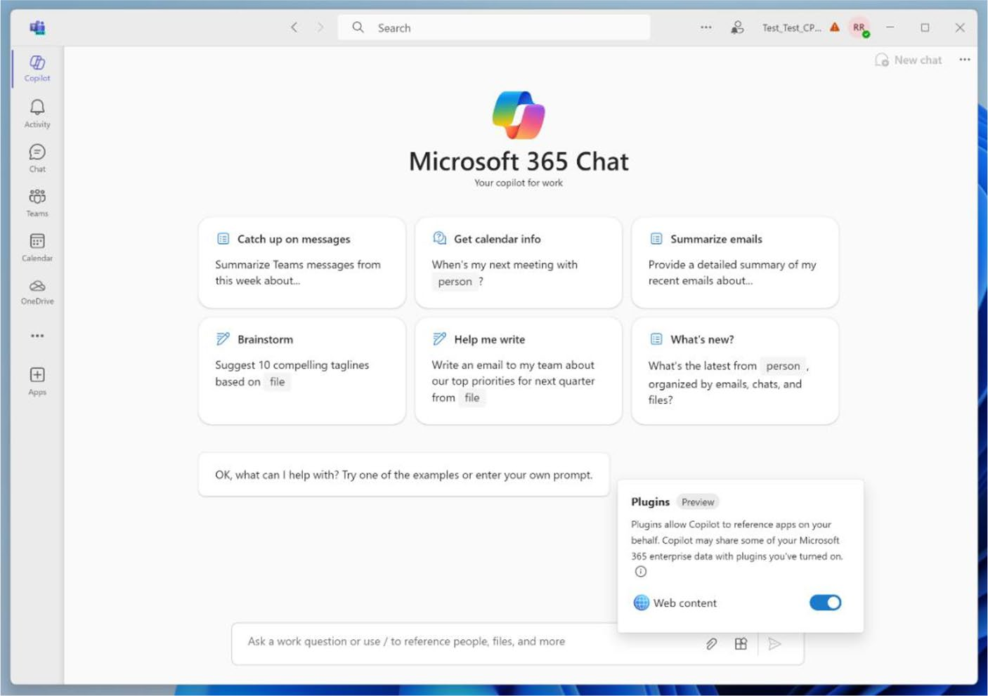

Figure 1-10. Copilot inside the Microsoft Teams app

Graph connectors are currently supported by Microsoft 365 Chat
experiences in Teams, Microsoft 365 (Office) app, and Microsoft Bing.

Integration Mastery: Copilot Meets
Power Apps
Integrating Microsoft 365 Copilot with Power Apps marks a leap forward
in application development by marrying the easy, low-code capabilities
of Power Apps with the most powerful artificial intelligence features

Chapter 1 Unveiling Copilot: a new era in power apps
from Copilot. These integrations are, in fact, very helpful in inculcating the development of powerful, user-friendly applications, revolutionizing the development space by providing users with the ability to develop
functionally rich applications with intelligence. Figure 1-11 shows the illustration for Copilot in Microsoft Power Apps.
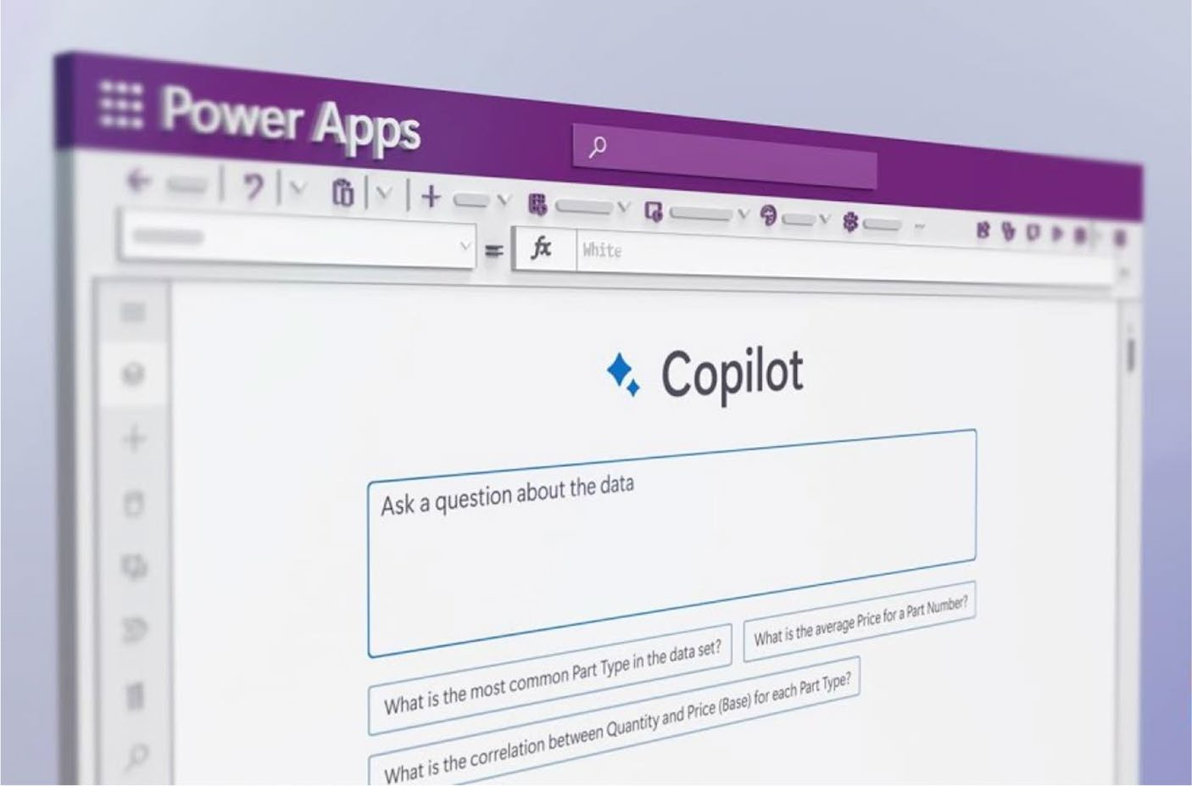

Figure 1-11. Copilot in Microsoft Power Apps

AI-Powered Code Generation: One of the most outstanding features of Copilot in Power Apps is its ability to generate code on common app scenarios and tasks, benefitting users who may not be conversant with syntax or formulas in coding. The user writes a request in natural language, such as “create a form to submit feedback” or “show a pie chart of sales by region,” and Copilot interprets it into the required code and components.

Chapter 1 Unveiling Copilot: a new era in power apps
This function helps reduce the development time needed and affords users more time to concentrate on designing the application and its logic rather than getting lost in the maze of programming.
Code Suggestions and Best Practices: Copilot improves the quality and performance of the application by giving alternative code with the best practices. Users can skim through various options in an order of moments, understand the reasoning for each suggestion, and observe how the functionality will be affected in the app. For example, when a user needs to add emailing capabilities, Copilot will suggest various ways, like adding connectors, and will list pros and cons for every one of them. Copilot provides guided assistance to the user for making the right decisions in ways to make their application more usable, secure, and cost-effective.
Debugging and Troubleshooting Assistance: Another great benefit of Copilot is that it can debug and troubleshoot applications. It helps identify errors, bugs, and all kinds of problems with the code, logic, or design of the application and offers solutions. For example, when prompted for a command like “fix the error in the gallery,” Copilot may be able to diagnose the error because of a data source mismatch or incorrect filter conditions, as well as provide probable fixes. This feature is invaluable in ensuring that apps are not only functional but also reliable and free from errors.

Chapter 1 Unveiling Copilot: a new era in power apps
Personalized and Context-Aware
Recommendations: Copilot goes way beyond integrated generic help with Power Apps. It helps the apps learn from a user’s coding style and preferences, thereby giving suggestions that are contextual and personalized. This aspect of learning with Copilot means that, as users interact with it, its suggestions become more personalized and impactful, thereby enhancing productivity and the app development experience.
Streamlining Complex Development Tasks: The AI-driven capabilities of Copilot help unravel the struggle to interweave complex processes, thus making it easier for users to add advanced features without them needing to have deep technical knowledge. This democratizes app development in the sense that any user can develop sophisticated applications that suit specific business requirements.
Enhancing Business Process Automation and Analytics: Moreover, integration is central to the automation of business processes and analytics. With AI-driven insights, Copilot can automate repetitive tasks inside applications and support businesses by providing analytical capabilities to businesses from their applications. This takes Power Apps from just being app development software to being a tool for strategic business analysis and automation.

Chapter 1 Unveiling Copilot: a new era in power apps

Seamless Integration: Bridging Copilot
with Power Apps
With the integration of Copilot and Power Apps, Microsoft 365 Copilot is
a huge step forward in application development. Combining the power
of Copilot’s advanced AI with the simple, low-code Power Apps platform
makes it possible for developers to create powerful, user-
friendly applications in a whole new way. The result? Microsoft delivers
on the Power Apps promise to empower business developers to create
functionally rich and intelligent applications that have the potential to
change the solutions people can build.
Facilitating Low-Code Development with AI: Power Apps allows users to build custom applications for a very wide set of business needs. Copilot adds AI to the app-building experience. Using the latest machine learning algorithms and natural language processing, Copilot becomes a hands-on partner in performing sophisticated coding tasks. It automates mundane coding tasks, suggests code, and offers insights that will enable users to make data-driven decisions.
Intuitive AI-Driven Code Generation: One of the most exciting features of this integration is Copilot’s ability to generate code from natural language inputs. With the capability to describe the problem users need to solve and what they need to build in plain English (or your native language), users can get Copilot to “create a customer feedback form” or “design a dashboard for sales data,” and it will convert this into Power Apps code. This is a game-

Chapter 1 Unveiling Copilot: a new era in power apps
changer. If you’re not an experienced developer or want to accelerate your learning, this tool allows you to focus on what your app should do and how it should look, while the technology handles the complex coding tasks.
Connecting Data Sources: A first and vital step in this seamless integration is to connect data sources. Power Apps allows a variety of data sources, including Excel, SharePoint, SQL Server, Common Data Service, Dynamics 365, and more commonly used by organizations. Users can also write custom connectors to connect to data that may not be officially supported by the platform, such as a custom service at an organization with RESTful endpoints. Copilot helps in choosing the right data sources, tables, and fields and makes suggestions based on the app’s usage, as well as its functionality, in addition to helping define the relationships between data sources. This is crucial for showing and manipulating related data in the app.
Optimizing Code and Enhancing App
Quality: Copilot goes beyond code generation by suggesting multiple variants of code that enhance compression and practicability, leading to improved efficiency and user-friendliness in applications. It recommends practical solutions, explaining their essence and implications, helping developers choose the most effective options. These recommendations guide developers in creating high-quality applications that are robust and scalable.

Chapter 1 Unveiling Copilot: a new era in power apps
Debugging and Personalized Development Experience: Copilot helps in debugging errors in Power Apps by identifying them multiple times and offering solutions, whether the issue lies in the code, logic, or design. The suggestions adapt based on the user’s interactions, ensuring a customized development experience. This adaptive approach not only boosts productivity but also creates a more intuitive way of interacting with development.
Simplifying Complex Development Tasks and Enhancing Business Processes: The integration simplifies complex app development tasks that were previously hindered by the low-code limitations of Power Apps. With Copilot, users can now implement complex data models or integrate API- enabled services, significantly expanding the range of functions that Power Apps can easily achieve. Additionally, the integration automates intricate business processes and enables Power Apps to drive data-driven decisions effectively. As a result, Power Apps evolves beyond a simple app development tool, becoming a strategic platform for business automation and decision-making.

Case Studies: Successful Integration
Scenarios
Right now, not many organizations are using Microsoft 365 Copilot for
Power Apps by Microsoft. This is one of the newest and possibly most
innovative products that Microsoft has debuted and as a result there are

Chapter 1 Unveiling Copilot: a new era in power apps
only a few early adopters. Because of the newness of Copilot, it is very hard to find actual organizations that are implementing Copilot in Power Apps, so I have instead created some fictional but realistic scenarios to show its possibilities.

Case Study 1
This case study delves into the transformation journey of an emerging ecommerce platform grappling with complexities in managing inventory. The inventory system was very poor at the onset of the company; it led to overstocking and below-optimal communication with suppliers. In response, the company strategically overhauled their approach to inventory management to deploy an innovative solution that involved Power Apps and would integrate seamlessly with Copilot’s AI technology.
This integration was a game-changer. It introduced a predictive stock management system, which leveraged advanced algorithms to forecast demand accurately and adjust inventory levels proactively. This AI-driven approach enabled the ecommerce retailer to anticipate market trends and consumer preferences, ensuring that the right products were available at the right time.
It also combined the automated supplier ordering process. This system resulted in automatically initiated supplier orders for actualized inventory information and predictive analytics, which led to a very efficient supply chain process. It streamlined the entire communication process with the suppliers, minimizing human errors and reducing the administrative pressure on staff. Great results were experienced from this strategic implementation. This helped the ecommerce platform reduce overstock by 40 percent, further saving on storage and inventory costs and deterioration. Better inventory turnover implies better resource utilization, considering that products do not stay as long in storage and quickly

Chapter 1 Unveiling Copilot: a new era in power apps
go down the supply chain. This transformation not only optimized the
company’s operational efficiency but also enhanced customer satisfaction
by ensuring that product availability was aligned with consumer demand.
The most outstanding point of this case study is the possibility of
integrating advanced technologies such as Power Apps and Copilot AI in
the management of inventories in ecommerce businesses. The company
embraced these innovative strategies to overcome the challenges it was
facing and, at the same time, made sustainability plans toward competitive
advantages amid the changing trends experienced in the online
retail market.

Case Study 2
This case study looks at how a regional healthcare network—struggling to
better manage hard-copy patient data and seeking useful ways to improve
the appointment scheduling process—changed strategies to include the
use of technology. The network was doing the right thing but needed
a better way to start systems with technology. This transformation was
performed in the heart of the old system—construction of a new system
from scratch using Power Apps, integrated with Copilot AI. That’s the
development of a new and sophisticated application to address the main
challenges: the possibility to analyze intricate patient data and optimize
planning complicated by the countless factors of an appointment.
The integration of AI into the system was an advancement in patient
data management. This is because the AI-based software feature analyzed
massive patient data accurately and at a very high speed. This further
helped in informed decision-making for patient care with an established
framework of data analysis. Very importantly, all this also increased
the level of security measures for patient data. The systems were more
confidential, strictly following healthcare regulations.

Chapter 1 Unveiling Copilot: a new era in power apps
Another major improvement in the system was the optimization of appointment scheduling. AI assessed data parameters such as patient flow, busy hours, and resource availability to allocate appointments more effectively. This not only optimized resource utilization but also significantly reduced patient waiting times, both of which otherwise compromised operational efficiency. The results of this initiative were impressive: increased efficiency in handling patients and a significant decrease in waiting times.
Such improvements not only increased patient satisfaction but also streamlined the health provider’s workload. These strongly developing security protocols further built a higher level of trust and reliability among the patients about the safety of their sensitive health information.
In general, with the use of an approach, it can be said that this case study illustrates the positive consequences and success of integrating individualized technology solutions, such as Power Apps, in advancing and adding value to healthcare operations. This regional health network not only managed to fix its initial hiccups but also set new benchmarks for operational excellence and patient-centric care.

Case Study 3
This case study profiles the strategic evolution of a company that manufactures a certain range of products and faced critical challenges in relation to the optimization of logistics and production scheduling. This company operates through global supply chains, and there is a critical need for advanced solutions to increase operational efficiency while reducing expenses.
Confronted with this challenge, the company decided to apply Power Apps together with Copilot AI and develop an AI-based product tailored to logistics and production scheduling. Integration of AI into the logistics and scheduling systems was crucial.

Chapter 1 Unveiling Copilot: a new era in power apps
Through AI integration, the company analyzed larger sets of
information that spanned each stage of the supply chain and production
processes. This often led to better forecasts, optimized schedules, and an
improved allocation of resources.
An AI-based tool would make such forecasts and suggest proactive
measures so that the supply chain remained smooth. One of the critical
elements to this change was in logistics. The AI system revealed the best
routes, taking into consideration how the transportation cost would be
realized. These issues were related to costs, time, and environmental
implications. This made it much easier to plan shipments strategically
later, hence more money was saved and sustainability was achieved.
The improvement in production scheduling was also remarkable.
Based on real-time data prediction, AI enabled the company to fit its
schedules through the dynamic nature. This flexibility allowed the
manufacturer to be prompt in responding to market demands, reducing
downtime and waste, which boosted overall production efficiency. The
results observed during the application of this AI-powered tool were
evident.
The company realized a 30 percent gain in production efficiency, and
this was a massive improvement in operational ability. Further, process
optimization resulted in noticeable cuts in costs, positively affecting the
bottom line.
This case study, therefore, reinforces that technology integration in
the manufacturing sector, such as Power Apps and Copilot AI, has the
potential to be transformational. By embracing this innovative approach,
this mid-sized manufacturing company not only addressed logistical and
scheduling challenges but also gained a competitive edge in the global
market by achieving greater efficiency and cost competitiveness.

Chapter 1 Unveiling Copilot: a new era in power apps

Summary
In this chapter, I introduced you to the revolutionary impact of Microsoft 365 Copilot on low-code application development, highlighting how it empowers you to create software more easily with advanced AI capabilities. You learned how Copilot can generate code, provide predictive analytics, and enhance your experience by tailoring suggestions to your preferences.

Chapter 2 explores the practical steps needed to set up, configure, and optimize Copilot for Power Apps. I cover the essential prerequisites, licensing options, and system requirements, ensuring that you have everything needed to maximize your development experience.

CHAPTER 2

Embarking on the

Copilot Journey

The previous chapter explored the innovative features and benefits of
Copilot, a state-of-the-art tool that helps developers create complex and
smart applications. This chapter aims to offer a comprehensive guide on
how to install, configure, and optimize Copilot for maximum performance.
This chapter provides guidelines, one after the other, for the successful
installation of Copilot over Power Platform, including prerequisites and
system checks in relation to compatibility. This chapter provides further
information on customizations based on individual needs and project-
specific requirements, focusing on setting up the appropriate environment
variables and integration points.

Streamlined Setup: From Installation
to Execution
Microsoft Copilot for Power Apps is a radical departure from the standard
models, mostly due to its approach as a purely online service. This
distinction is key for users who are used to the old installation methods.
In contrast with traditional applications that demand a list of installation
steps, Copilot for Power Apps is available online (from the Microsoft 365
Portal) without installation requirements. This certainly means that from

© Rezwanur Rahman 2024 37
R. Rahman, Microsoft Copilot for Power Apps, Inside Copilot,

Chapter 2 embarking on the Copilot Journey
this online service model, the whole dynamics of the user experience, insofar as business application development and management are concerned, will change entirely. Its immediate availability is the major benefit of the model. It allows users to run Copilot for Power Apps at full functionality without the installation delays and complexities of software. This allows a quick start to developing and managing applications, which is important in accelerated business environments.
Copilot for Power Apps has no requirements like the standard desktop software requirements from a technical perspective and is all about licensing. No installation is required; you do not have to worry about the compatibility of the system, disk space, or the hardware. You must have the right kind of licensing power to access and use the service. Details of these licensing needs and detailed information on system and account requirements are presented in detail in this book.
With this service being available online, it confers advantages in the form of real-time updates and feature enhancements without the user having to do anything. The fact that Copilot for Power Apps forms a part of the continuous Microsoft update cycle means that users are always working with the latest version, and therefore with the most current tools and functionalities. This is critical to being on the edge in app development and deployment.
The cloud-based architecture of Copilot for Power Apps further supports collaborative development environments. Since the service is delivered over the Internet, access to it must be multi-user in nature. It easily allows for collaboration among different teams in the same organization. Teams can work together at the same time in projects from different geographical locations, exploiting shared development enabled by the cloud to close projects in record time.
The focus of this book is particularly on exploring the different important subtleties and features of Copilot for Power Apps. It is a powerful tool and is a merger of automation and intelligence, whereby all sorts of applications are customized to be most efficient and effective

Chapter 2 embarking on the Copilot Journey
within the platform of Power Apps. The following sections explore each
application in more detail to help you understand the different features,
how to use them in different use cases, and best practices so that you’re
able to get the best out of Copilot for Power Apps.
It should, however, be noted that this is just part of the larger Copilot
ecosystem. It is in this context that successive chapters of this book bring
to light Copilot for Microsoft 365 and Copilot Studio. These features
complement the capabilities of Copilot for Power Apps in articulating
the suite’s ability to redefine the way users engage with technology when
observed across different Microsoft platforms. Traveling through these
chapters should be informative and insightful, but above all, bring you to
an enriched experience in the field of digital solutions.
Long story short:
• Copilot for Power Apps does not require desktop
software for app design or development.
• There are no requirements in terms of system
compatibility, storage, memory, graphics, or physical hardware.
• You can use any modern browser to design Copilot and
Power Apps.
• A stable Internet connection is essential to avoid
technical problems.

Licensing Overview
Before moving to what is required to use Microsoft Copilot for Power Apps,
let’s talk about licensing Power Apps and Copilot.
One common question, which many of my friends and colleagues
have asked me, is “Do I need Microsoft 365 licenses to develop Microsoft
Power Apps?”

Chapter 2 embarking on the Copilot Journey
You do not need a Microsoft 365 license to use or build Power Apps applications. Microsoft 365 is a suite of productive apps such as Outlook, Word, Excel, PowerPoint, and so on. These apps can be hooked to Power Apps, but that is not required. You can also develop Power Apps without Microsoft 365 licensing. The following list discusses the plans where you can start developing Power Apps:
• Power Apps Developer Plan: Among the many
app development options, Microsoft has provided a complimentary Power Apps Developer Plan that has been very helpful for educational purposes and immense skill development . It has a complete, dedicated environment for app development, testing, and experimentation using Power Apps, Power Automate, and new functionalities on the Dataverse. The plan is meant for personal use, and everyone gets their individual usage environment, which is on a non- production capacity.
• Power Apps Trials: Power Apps has a variety of
trial plans that allow you to utilize the entire parts of the application, which means you can try the full capabilities of Power Apps before you buy. Generally, a trial is for 30 days, and it has the maximum Power Apps features.
• Pay-As-You-Go Plan: By using the pay-as-you-go
model, you can access Power Apps through an Azure subscription and pay only for the resources consumed. In this model, there is no need for any upfront commitment to software purchases, license purchases, or infrastructure provisioning.

Chapter 2 embarking on the Copilot Journey
• Directly purchase Power Apps licenses: You can also
directly acquire Power Apps licenses independently of any Microsoft 365 subscriptions. This path is ideally suited for those with a heavy reliance on Power Apps or those planning to deploy applications in a production environment.
Table 2-1 provides a comprehensive overview of the Power Apps
licensing options, highlighting their key features, approximate pricing, and
inherent limitations.

Table 2-1. Comprehensive Overview of Power Apps Licensing
Options with Key Features
Licensing Description and Key Approx. Limitations
Option Features Pricing (USD)
microsoft microsoft 365 and included in Features dependent on
365 and Dynamics 365 microsoft 365/ specific microsoft 365/
Dynamics 365 entitlements Dynamics 365 Dynamics 365 plan
entitlements subscriptions
Connectors Connects apps to included in premium connectors only
usage various data sources; respective available with specific
includes standard and power apps/ licenses; standard premium connectors automate connectors offer limited
licenses capabilities
trial plans Short-term, full- Free 30 days for power
featured access to apps, 90 days for power
power apps and automate; limited power automate for features compared to full
evaluation purposes licenses
(continued)

Chapter 2 embarking on the Copilot Journey
Table 2-1. (continued)
Licensing Description and Key Approx. Limitations Option Features Pricing (USD)
Developer plan provides a full- Free For individual
featured development development only; not
environment for suitable for production
individual learning use and experimentation
per app plan allows the use of around $5-10/ restricted to one app or
one app or portal user/app/month portal per user; not for per user; suitable for extensive app portfolios
targeted business
solutions
pay-as-you-go Flexible, usage-based Variable; based Costs can vary greatly
plan payment model on usage based on usage; requires
linked to an azure azure subscription subscription management
Dataverse limited use of included in Cannot create custom plans in Dataverse for select microsoft apps with power apps or microsoft 365 data storage and 365 plans use premium connectors
management with with power automate select microsoft 365
licenses
power provides capacity for pricing varies limited to one bot automate automated workflows per license; additional hosted rpa with a single rpa bot bots require additional add-on and a Vm licenses
(continued)

Chapter 2 embarking on the Copilot Journey
Table 2-1. (continued)
Licensing Description and Key Approx. Limitations
Option Features Pricing (USD)
microsoft ai-driven bot creation pricing varies limited to 25,000
Copilot Studio and deployment with ai messages/month;
licensing a monthly message additional messages
quota for interactions incur extra costs
purchase licenses available Varies based Choice of plan and
options through power apps on plan and purchasing channel
website, microsoft channel affects pricing and 365 admin center, or features available via microsoft partners

Power Apps Without Microsoft 365:
Key Limitations
If you develop Power Apps applications without a Microsoft 365 license,
you will be very limited in many ways—in particular, how you can
connect and manage data. The following lists explain these limitations in
more detail.
Limited integration with Microsoft 365 Services:
• You can’t integrate your Power Apps with Microsoft 365
services, such as SharePoint, Outlook, Excel Online, or Teams.
• This limits the ability of these platforms to be used
for data storage, user management, and collaboration within your Power Apps.

Chapter 2 embarking on the Copilot Journey
Data storage and management:
• The place where the app stores data is offered through
Microsoft 365—either in SharePoint lists or with Excel Online—the most common sources of data consumed by Power Apps users.
• With the absence of them, you will need to look for
alternative resources—data sources like SQL Server, some other databases, or any storage solution provided by a third party.
User authentication and management:
• Microsoft 365 provides a unified identity service
(Microsoft Entra ID, previously Azure Active Directory) for authentication and user management.
• Without Microsoft 365, managing user access and
authentication for your Power Apps can be more complex, possibly requiring separate identity services or custom solutions.
Collaboration and workflow integration:
• Power Apps frequently interface with Power Automate
to enable flow automation. Although Power Automate can be acquired independently, its Microsoft 365 services complement automation and changes.
• Before Microsoft 365, any processes that required
Microsoft services, like email notifications through Outlook or data processing with Excel, respectively, would require scads of programming to automate the process.

Chapter 2 embarking on the Copilot Journey
Access to pre-built templates:
• With Power Apps comes a whole range of pre-built
templates to work with Microsoft 365 services.
• They are not very useful without an attached Microsoft
365 license, which could require even more custom development.
Limited access to certain features:
• Some Power Apps features and connectors are
designed specifically for Microsoft 365 services. Without access to these services, the full range of Power Apps features may not be available.
Data governance and compliance:
• Data governance and compliance tools and policies are
offered through Microsoft 365. The value proposition means that data governance (including data loss prevention—DLP—and retention policies) and compliance policies available with the Microsoft 365 might be of importance to applications that deal with sensitive/regulated data.
• If you built a Power App that processes data that falls
within certain regulatory requirements, building a Power App outside the Microsoft 365 ecosystem might require you to do extra work to meet the regulatory compliance needs.
You must evaluate your needs and decide whether the benefits are
worth these limitations. If you are using just the standalone products or
not having the applications integrate much with Microsoft 365’s services,
this might be a non-issue.

Chapter 2 embarking on the Copilot Journey

Prerequisites for the AI Features
in Power Apps
For these functionalities in Power Apps to operate appropriately, a range of technical provisions is necessary to enable maximum use of the AI Copilot functions. This will ensure that such advanced features are smoothly integrated and operate in the right manner. The guidelines herein are to aid users in the configuration of their setup to ensure that effective harnessing of AI Copilot capabilities in Power Apps is realized.
Regional requirements: Your Power Apps environment should be located within the United States region. This enables the AI Copilot features to be available and used to their full capacity.
Browser language setting: This should be set to “English (United States)” so that the AI Copilot features and interfaces are guaranteed to be presented in a language compatible with full support.
Microsoft Dataverse database: Ensure that an active Microsoft Dataverse database is part of your environment. One key repository for data storage and management that AI Copilot uses across different applications and functionalities it has within Power Apps is Dataverse. The chapter discusses the Dataverse database in more detail later. (See the next section for answers to common questions.)
Activating AI Builder: AI Builder is a feature of Microsoft Power Apps that brings artificial intelligence capabilities to the Power Apps

Chapter 2 embarking on the Copilot Journey
platform. It lets users enhance their apps, automate workflows, and examine data in a more productive and accurate way. AI Builder must be enabled in your environment to use the AI models or controls that include AI models. This can be done by following these steps:
1. Sign in to the Power Platform Admin Center. This
is your central hub for managing various aspects of
your Power Apps environment. Figure 2-1 shows the Power Platform Admin Center.
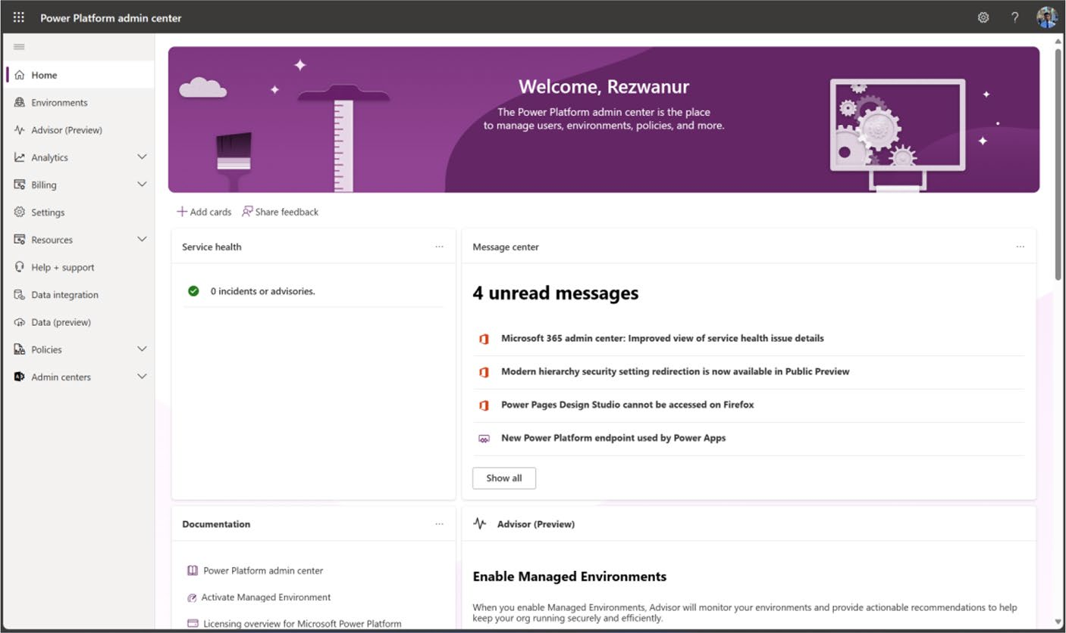

Figure 2-1. Preview of the Microsoft Power Platform Admin Center

2. Navigate to Environments and select the specific
environment you want to configure for AI Copilot.
Figure 2-2 shows the list of the environments.

Chapter 2 embarking on the Copilot Journey
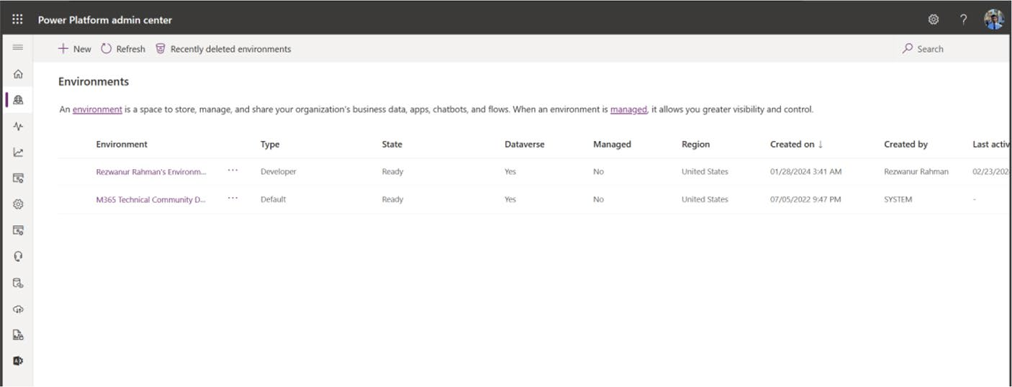

Figure 2-2. Environments page of the Power Platform Admin Center

3. Choose Settings ➤ Product ➤ Features. Figure 2-3
shows the settings for an environment.
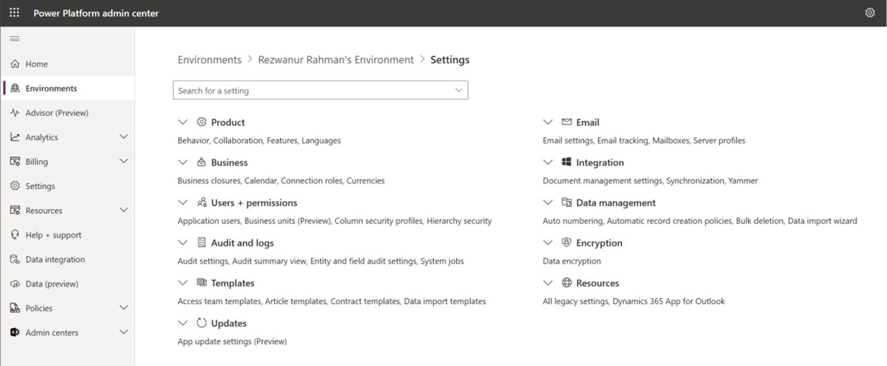

Figure 2-3. Environments Settings page

4. On the Features settings page, locate the section
labeled AI Builder. You can enable or disable the AI Builder preview models. Enabling AI Builder is crucial as it provides the necessary framework and tools for AI functionalities within your Power Apps
environment. Figure 2-4 shows the Features page.

Chapter 2 embarking on the Copilot Journey
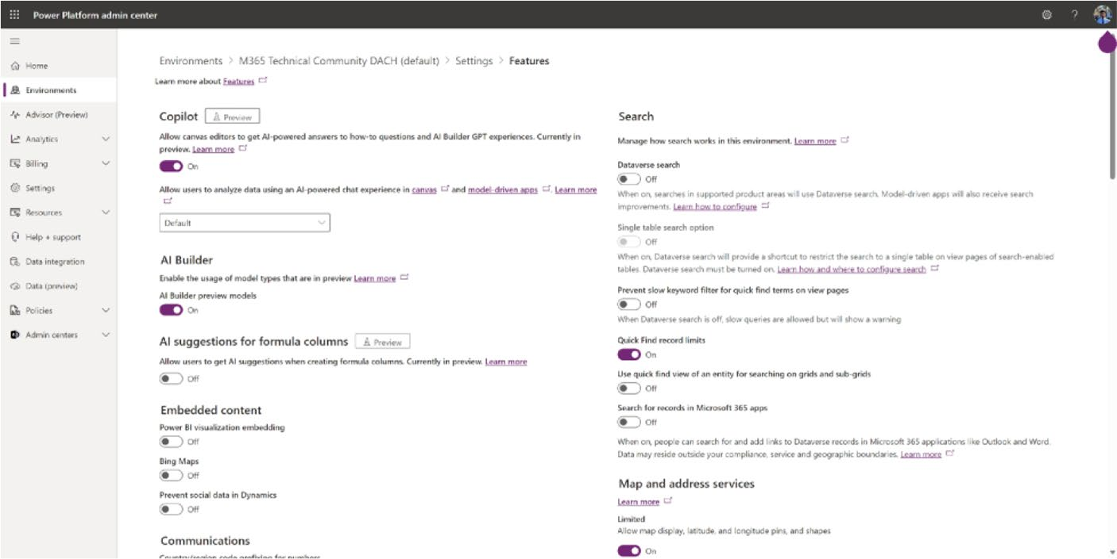

Figure 2-4. Feature page of environment

Quick Q/A Session
1. Can I use AI Builder outside of the United States?
For those of you not in the United States, wondering if you can use AI Builder, the answer is yes! AI Builder is available in India, France, United Arab Emirates, Germany, and the United States. However, some AI models may perform worse, based on the region and languages of your data.
For more details, you can check out the AI Builder
regional availability documentation at https://
learn.microsoft.com/en-us/power-platform-
release-plan/2021wave1/ai-builder/ai-builder-
availability-new-regions.

Chapter 2 embarking on the Copilot Journey
2. Can I use a language other than English in AI
Builder?
Yes, you can use other languages besides English in AI Builder. AI Builder supports 73 languages for text recognition and 12 languages for sentiment analysis. You can also create your own custom models using data in any language. However, some features, such as the business card reader and receipt processing, are currently optimized for English only.
For more details, you can check out the AI Builder
language availability documentation at: https://
learn.microsoft.com/en-us/power-platform-
release-plan/2021wave2/ai-builder/form-
processing-new-language-support.
3. Can I use AI Builder without the Microsoft
Dataverse Database?
To make sure that AI Builder is working properly with Power Apps, it requires a database from the Microsoft Dataverse to be tightly integrated, so it can leverage all the features that AI Builder has to offer. In other words, one database is required for AI Builder to function in Power Apps—the Dataverse Database.

Setting Up a Test and Development Space
When you think about it, you probably will find that even when developing software or doing IT professionally, you usually perform testing on a trial tenant first before doing it on your operational tenant, which stores and handles actual data. You can say doing things on the live tenant is a precautionary measure.

Chapter 2 embarking on the Copilot Journey
It’s best to set up a test environment, motivated by several key reasons
beyond the initial purpose. These reasons include:
1. Support for Power Apps beginners: This approach
helps newcomers to Power Apps, providing them with a dedicated space to learn and experiment. This provides a secured and controlled environment whereby the newcomer can explore the features and functionalities of Power Apps, practice with application construction, and gain confidence without the fear of damaging real-world data or systems.
2. Guidance on acquiring Microsoft 365 licenses for
free: You can acquire a Microsoft 365 license for free, when the work is research and development.
3. A platform for app development and testing: This
is a complete platform for users to develop and test their applications before deploying within their main tenant. Users can test their applications prior to mainstream integration, which ensures that apps work as intended in the operational context, and do not disrupt operational procedures or data flow. It is useful to developers who can build their apps, test features, and resolve findings all in one go, in a managed environment.
4. Safe tenant settings modification: Changing
the tenant settings in the primary, operational environment is not without its risks, and it hampers real-time data processing. It is, therefore, crucial to have a test environment that supports safe trials and extensive testing of the adjusted tenant settings.

Chapter 2 embarking on the Copilot Journey
The changes in this area should be implemented in this test area first to ensure that they are effective and reliable. The subsequent step is critical in maintaining stability and operational integrity for the primary tenant before any putative changes are implemented.

Sign Up for M365 Dev Plan
You can set up a new Microsoft 365 E5 instant sandbox tenant through the Microsoft 365 Developer Program by following these steps:
1. Open your browser and visit https://developer.
microsoft.com/en-us/microsoft-365/dev-
program. Figure 2-5 shows the homepage of Microsoft 365 Developer program.
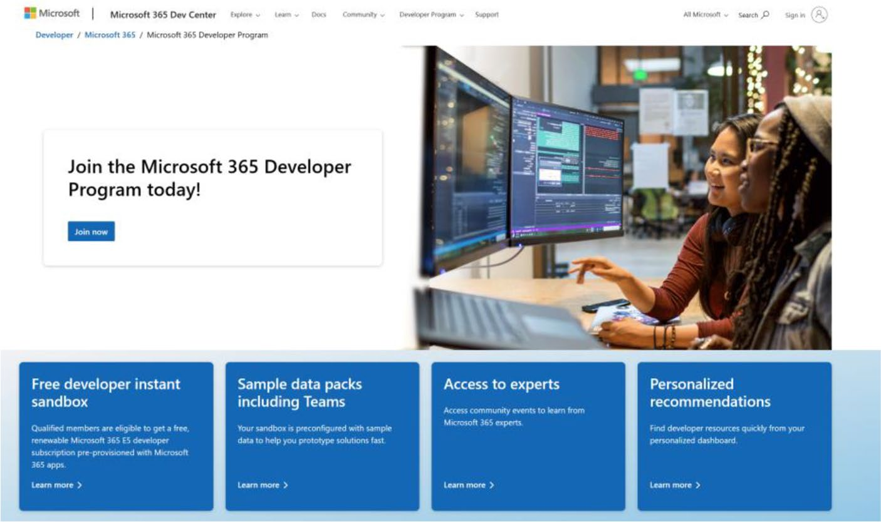

Figure 2-5. Homepage of Microsoft 365 Developer program

Chapter 2 embarking on the Copilot Journey
The Microsoft 365 E5 instant sandbox, as part of the Microsoft 365 Developer Program, includes a comprehensive environment aimed at enabling developers to quickly start building and testing their solutions. Here are the key components included in the instant sandbox:
• A complete Microsoft 365 E5 Developer
environment: This sandbox comes preloaded with a Microsoft 365 E5 subscription with 25 users, including 16 sample users. This setup is designed to allow developers to start experimenting and building solutions immediately, without the need for extensive configuration.
• Administrative control: Developers have
the power to act as their own administrators, facilitating the prototyping of apps and solutions with minimal setup.
• Sample data packs: Central to the instant sandbox
are the preinstalled sample data packs, which include:
• Microsoft Graph user, mail, and calendar
data: Featuring 16 sample users with user data and content, this data pack enables developers to model solutions with user mailboxes,
calendar events, and integration into a Teams developer environment with simulated chats and team memberships.

Chapter 2 embarking on the Copilot Journey
• Teams sample data pack: This pack is tailored
to a developer environment with preconfigured Teams app sideloading, five sample teams, channels, tabs, and chat sessions built around the 16 sample users. It also includes the Teams Developer portal, pre-installed and pinned, aiding in the creation of Teams app manifest and app package, as well as offering a card editor and a React control library.
• SharePoint framework sample data:
Developers can choose from six site templates to install and evaluate as custom solutions for their organization, with one template
preinstalled in the instant sandbox.
On the same page, you can see what’s included in the
licensing information, as shown in Figure 2-6.
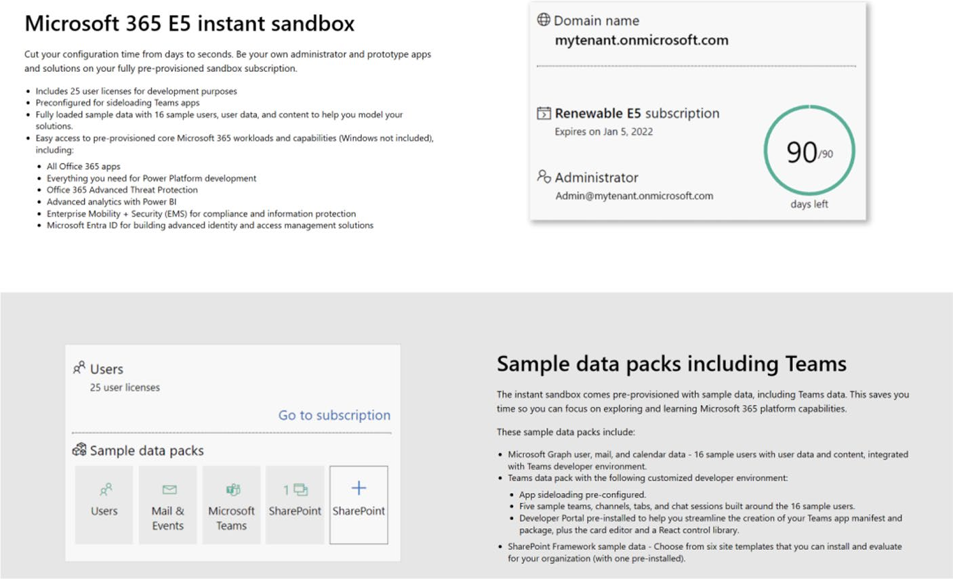

Figure 2-6. Microsoft 365 E5 instant sandbox page

Chapter 2 embarking on the Copilot Journey
2. Click Join Now to reach the Sign In page, as shown
in Figure 2-7. If you have an unregistered Microsoft account (Hotmail, Outlook, Live), sign in to continue. Otherwise, select Create One to create a new account.
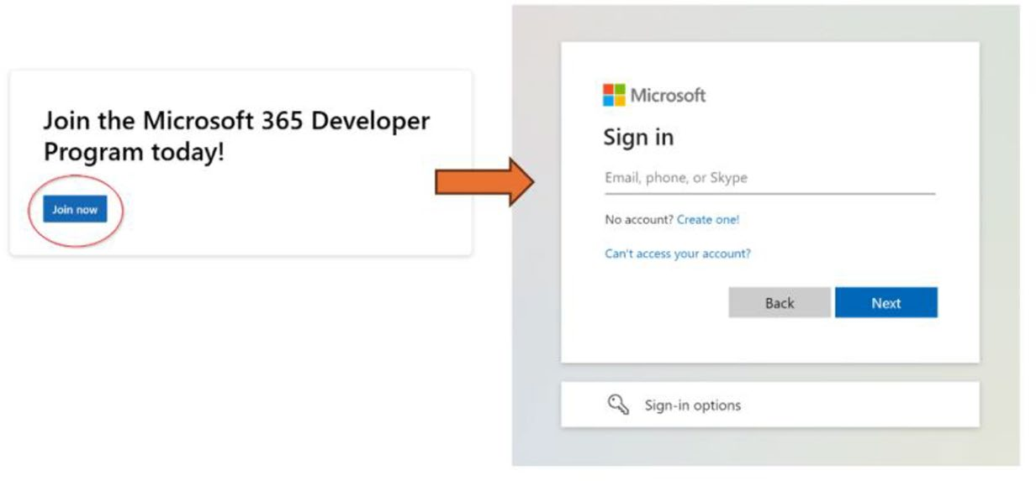

Figure 2-7. Sign in page for a Microsoft account

3. You will see the page shown in Figure 2-8 next. Click
Get a New Email Address, as shown in Figure 2-8.
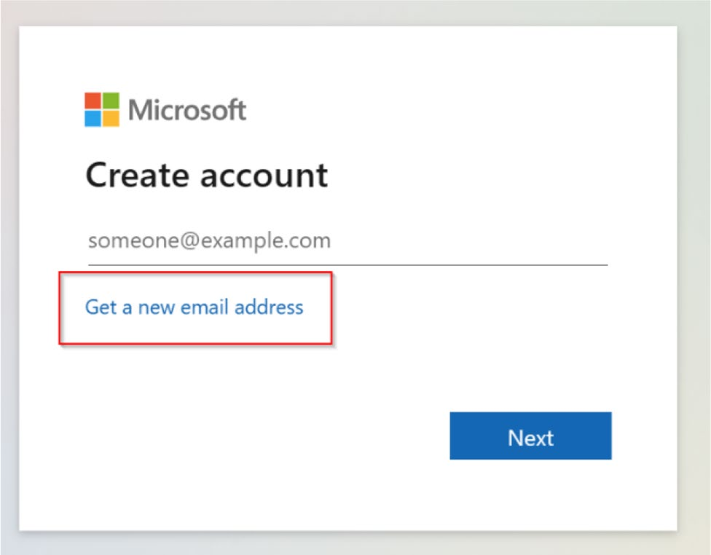

Figure 2-8. Creating a new Microsoft email address

Chapter 2 embarking on the Copilot Journey
4. Choose a name for your email address, select the
desired domain, and then proceed by clicking Next. In this instance, I named the email address
powerapps.newbook@outlook.com. Figure 2-9 shows this step.
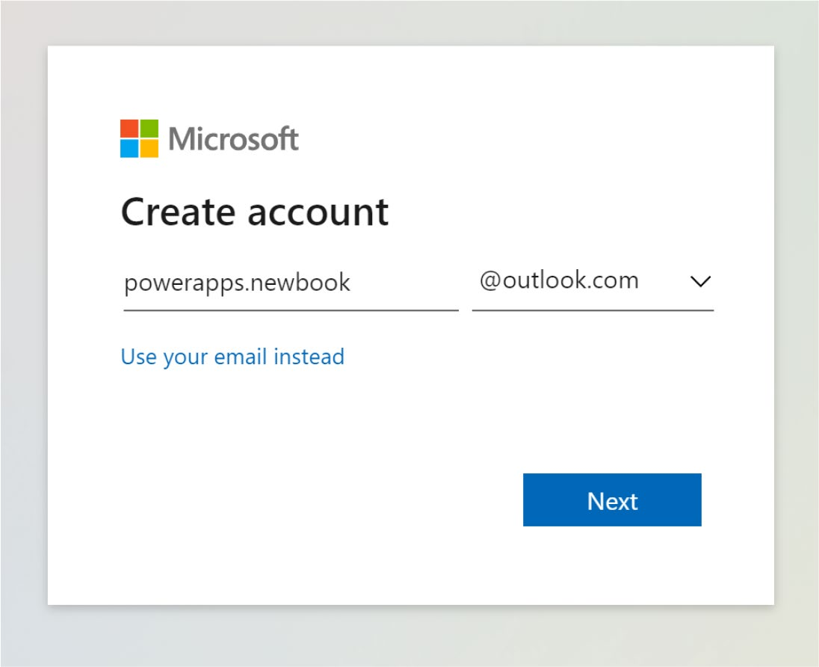

Figure 2-9. Creating the username of the email address

Chapter 2 embarking on the Copilot Journey
5. Type a password, as shown in Figure 2-10, and then
click Next.
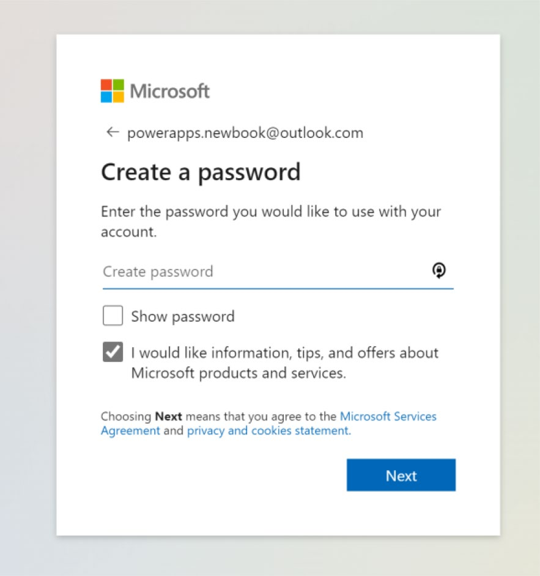

Figure 2-10. Creating a password for the email address

Chapter 2 embarking on the Copilot Journey
6. The next page will prompt you for your Country and
Date of Birth, as shown in Figure 2-11. Fill them in and proceed.
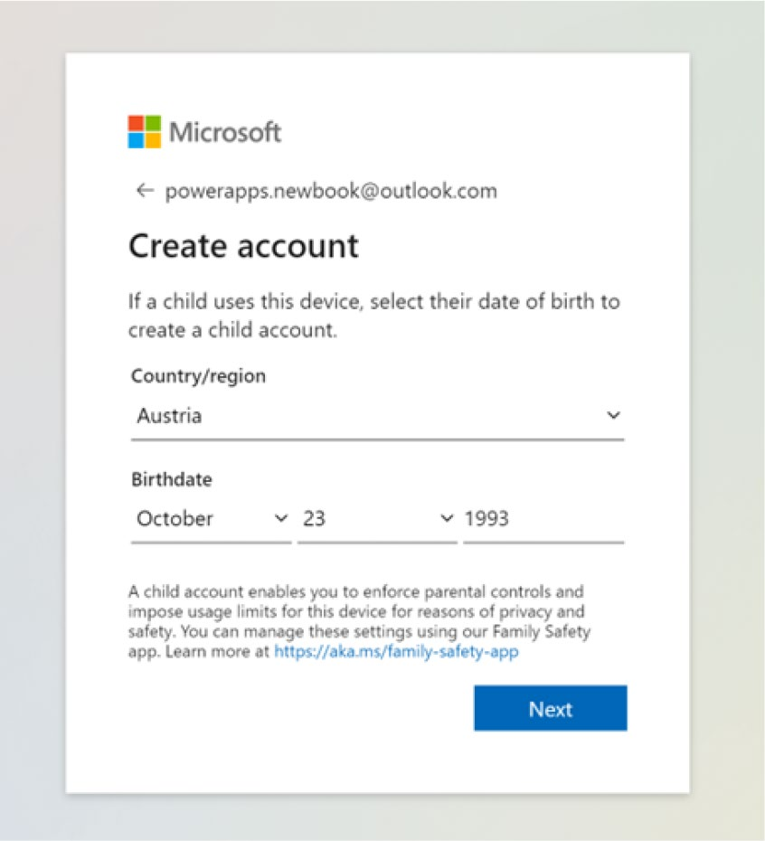

Figure 2-11. Fill in the Country and Date of Birth

7. Super! The account is done! You will see the page
shown in Figure 2-12.

Chapter 2 embarking on the Copilot Journey
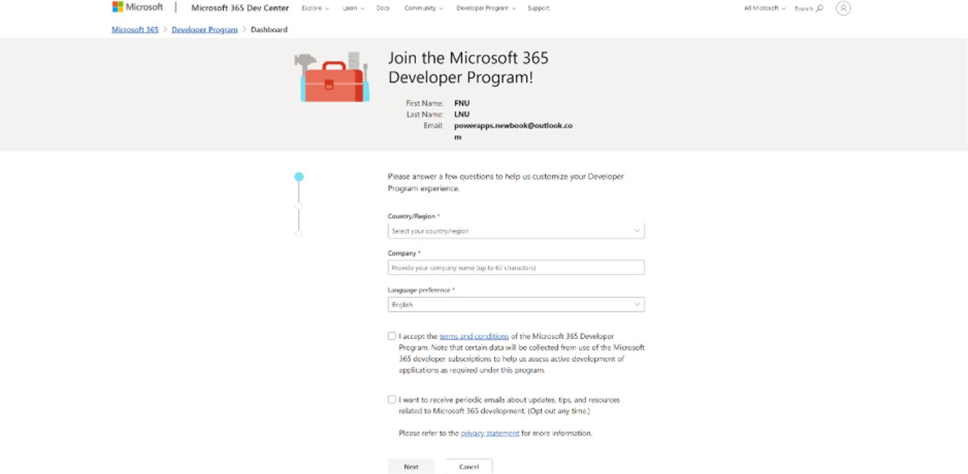

Figure 2-12. Dashboard setup page for the Microsoft 365
Developer Program

8. Next, you need to choose the Country, Company,
and Language. For this example, choose the Country: United States, Company: Your_Company_ Name (If you do not have a real company, just use an imaginary name), and Language Preference: English. Accept the terms and conditions and click Next!

Chapter 2 embarking on the Copilot Journey
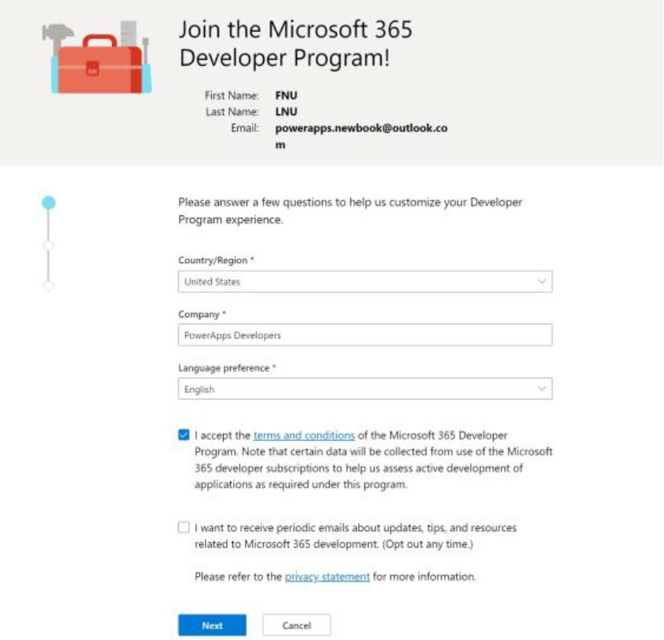

Figure 2-13. Fill in a Country, Company, and Language for the tenant

9. The next page will ask you a question. Choose your
answer and proceed. I selected Personal Projects, as
shown in Figure 2-14.
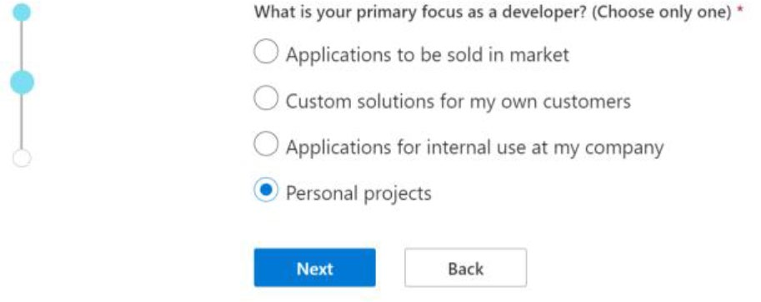

Figure 2-14. Selecting the answer for the question about primary focus

Chapter 2 embarking on the Copilot Journey
10. The next question will ask about your interested
areas. Choose your interests, as shown in
Figure 2-15. Additionally, you need to confirm your human identity by completing a reCAPTCHA verification. When you’re done, click Save.
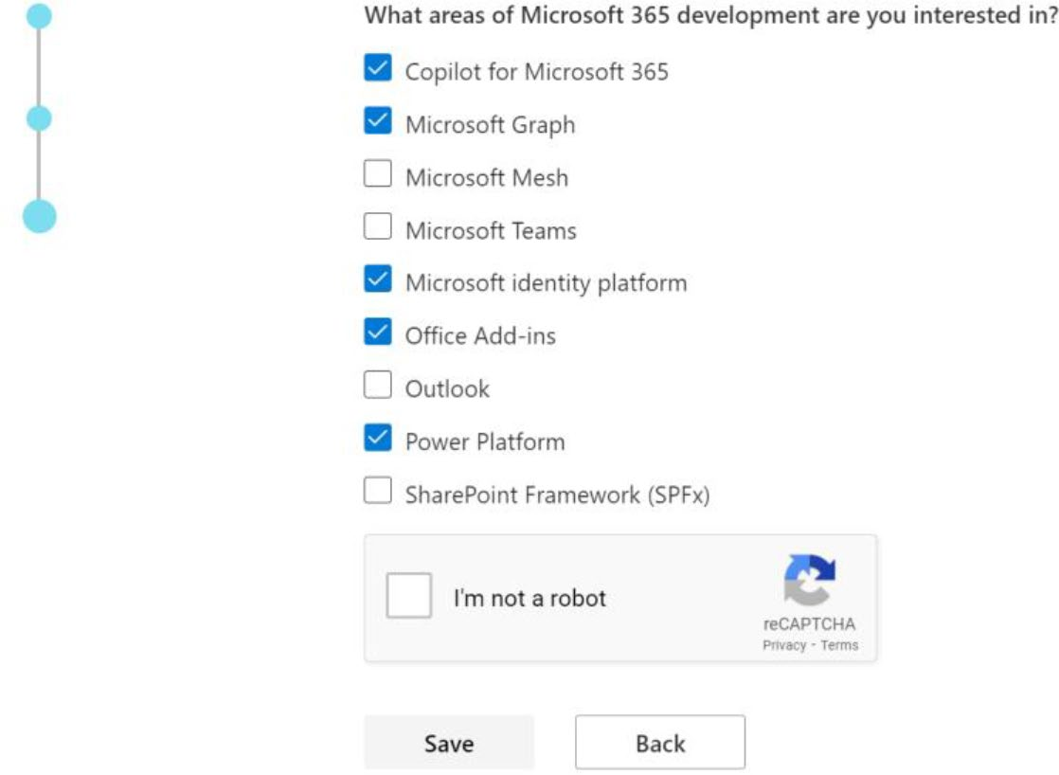

Figure 2-15. Choose your areas of interest for Microsoft 365
development

11. Superb! The sign up is complete. You will see the
page shown in Figure 2-16. Select Instant Sandbox and click Next.

Chapter 2 embarking on the Copilot Journey
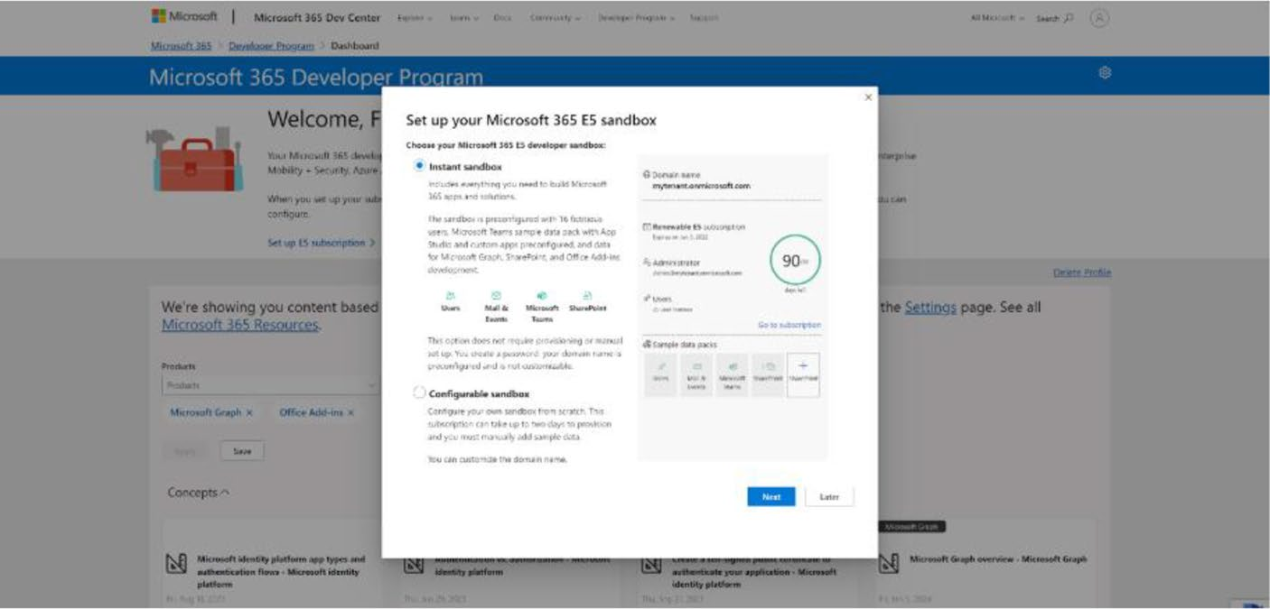

Figure 2-16. Microsoft 365 Developer Sandbox setup page

12. On the next page, you will be asked for the region
for your data center, the admin username, and a password. I selected the North America (United States – CA) region and provided a username and password to gain access as an administrator. See
Figure 2-17.

Chapter 2 embarking on the Copilot Journey
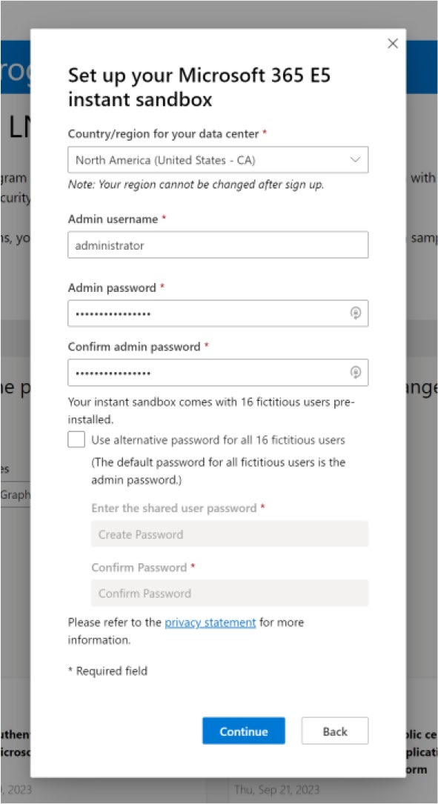

Figure 2-17. Select the country, admin username, and password

13. Next, it will ask for a phone number for verification.
Enter a valid number and wait for the verification
code. See Figure 2-18.

Chapter 2 embarking on the Copilot Journey
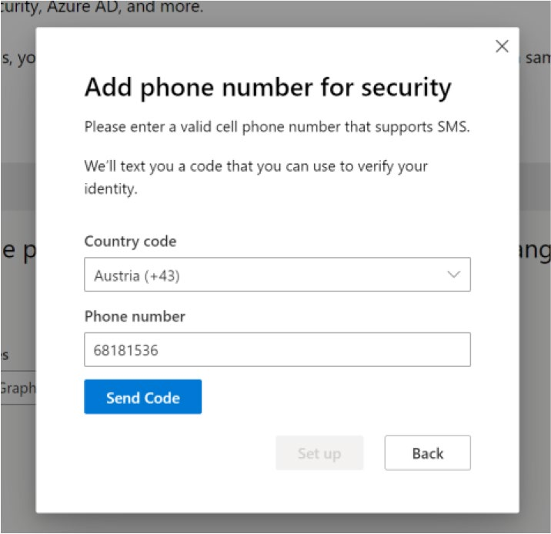

Figure 2-18. Phone number verification modal box

14. You are done! You will see the Microsoft 365
Developer dashboard shown in Figure 2-19.
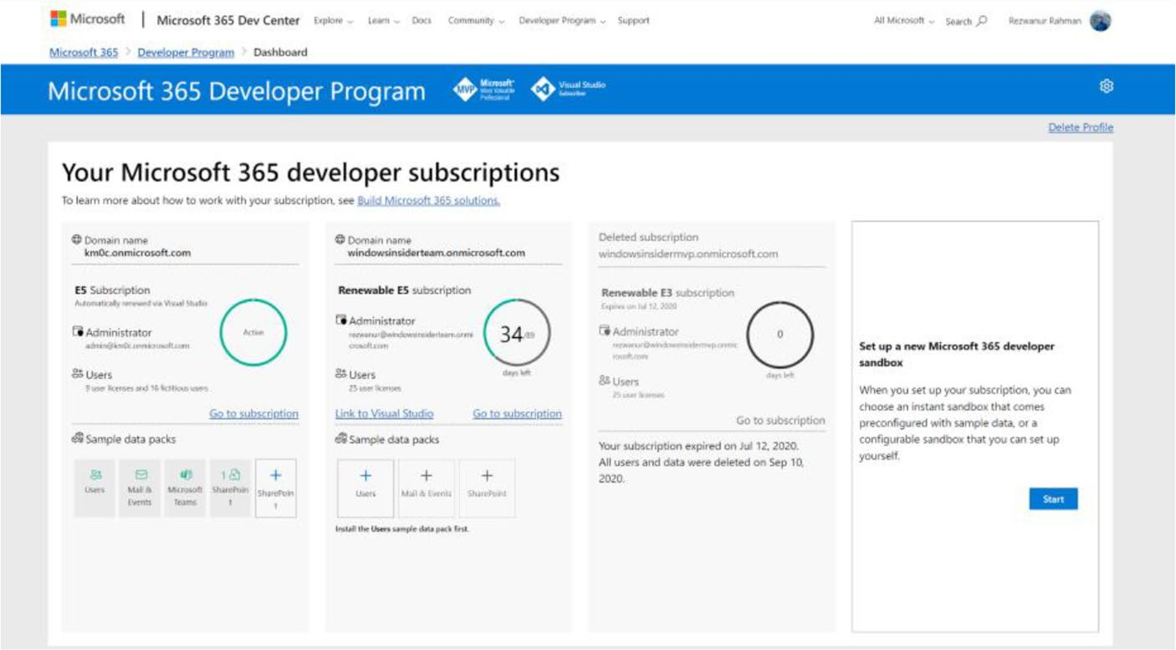

Figure 2-19. Microsoft 365 Developer subscriptions dashboard

Chapter 2 embarking on the Copilot Journey
15. When you click Go to Subscription, the browser will
redirect you to the Microsoft 365 portal, as shown in
Figure 2-20.
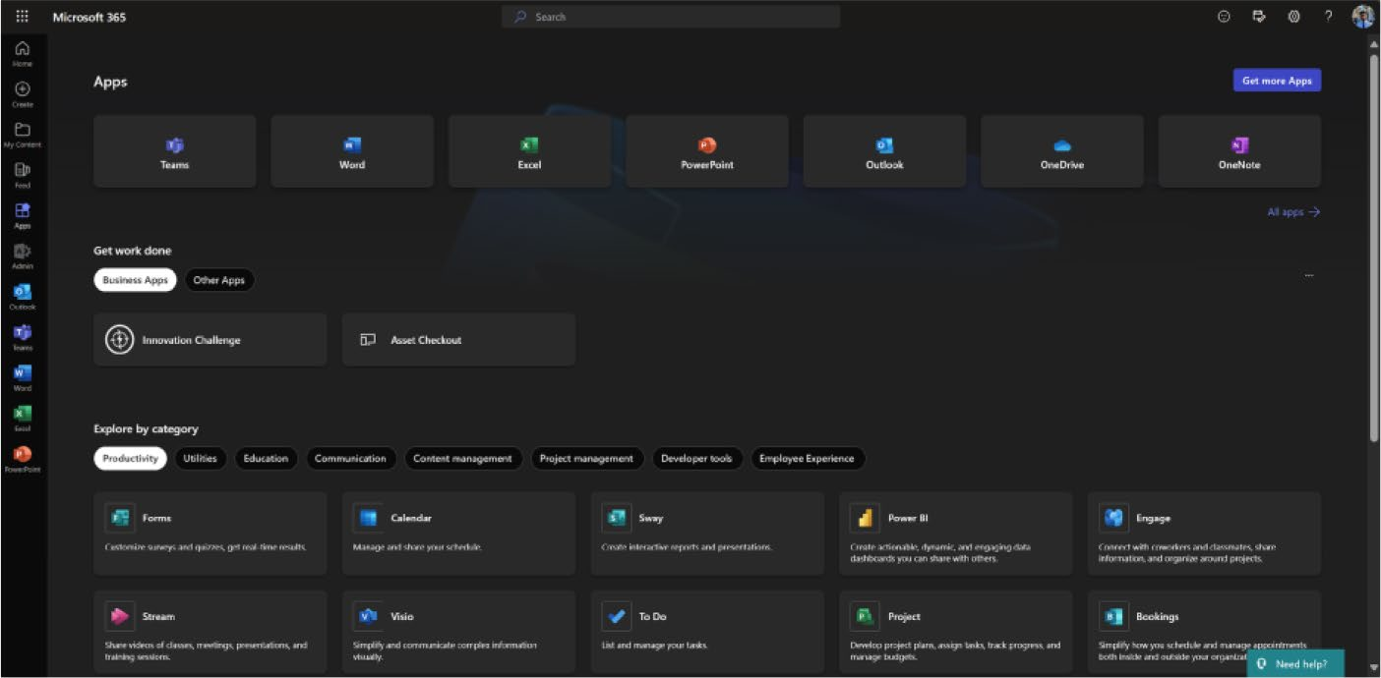

Figure 2-20. Microsoft 365 Apps Portal

Signing Up for Microsoft Power Apps
Dev Plan
Understanding the difference between the Microsoft 365 Developer E5
license and the Power Apps Developer Plan is very important.
The Microsoft 365 Developer E5 license is an enterprise subscription
built for anyone with diverse, advanced development needs in an
organization, including Power Apps. Best suited for organizational
subscriptions where one needs all solutions in a single environment,
strong security is envisaged, and the features available for application
development are vast and under one organizational setup.
The Power Apps Developer Plan is meant for individual developers,
and it’s free. It enables the development and testing of Power Apps in a
focused environment with access to paid features; however, the apps that

Chapter 2 embarking on the Copilot Journey
are developed under this plan cannot be used in production. This plan allows you to experiment and learn something new with certain limits in data capacity and execution.
The Power Apps Developer Plan is also available to any user who has a Microsoft 365 Developer E5 license. This dual approach allows users to get the combination of enterprise-level services (through the E5 license) and have their secure, isolated environment for development and testing (through the Developer Plan). Note that the apps developed in the Power Apps Developer Plan are test and development applications. They are not supposed to be used in the production environment.
To sign up for Microsoft Power Apps Developer Plan, follow these instructions:
1. Open your browser and visit https://aka.ms/
PowerAppsdevplan. You will see the homepage, as
shown in Figure 2-21.
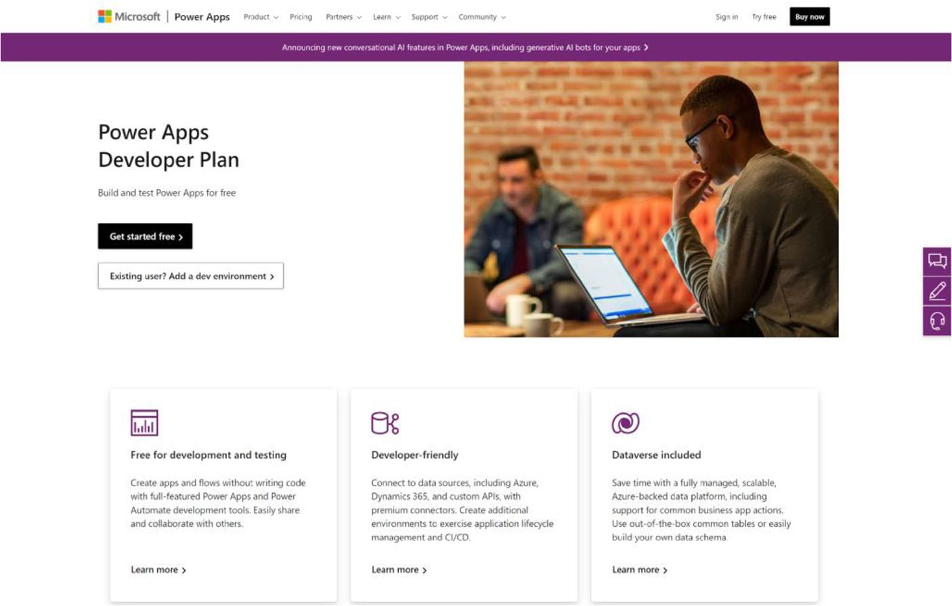

Figure 2-21. Homepage of the Microsoft Power Apps Developer Plan website

Chapter 2 embarking on the Copilot Journey
Curious to know what’s included in the license plan? You can:
• Access the complete environment/sandbox with all
features used to create and test apps.
• Connect many data sources, such as custom
connectors and on-premises data.
• Use the limited amount of capacity for Dataverse to
store and manage your data.
• Develop model-driven and Canvas apps within
Power Apps, including Power Automate for workflow automation.
Remember, this license plan is for dev/test use only. You can’t use this for your production/official apps.
2. Click Get Started for Free to see the page shown in
Figure 2-22.
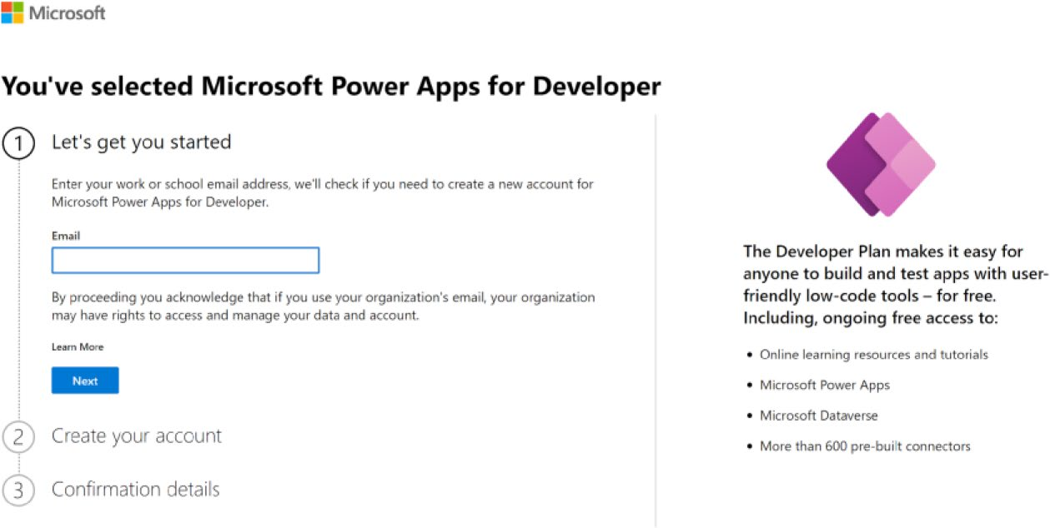

Figure 2-22. Sign up page for Microsoft Power Apps for Developer

Chapter 2 embarking on the Copilot Journey
3. Type your newly created email address. The page
will tell you to sign in, as shown in Figure 2-23.
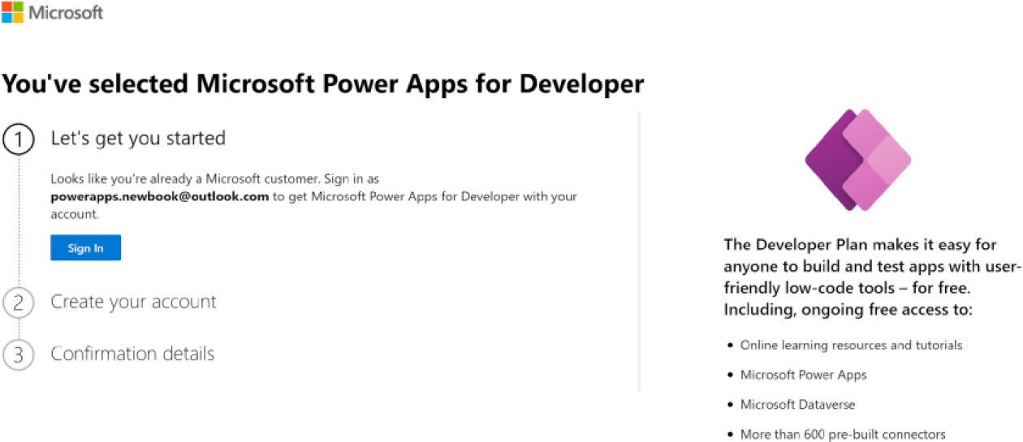

Figure 2-23. Sign in option after entering the email address

4. After signing in, click Create Account. You will see
the option shown in Figure 2-24.
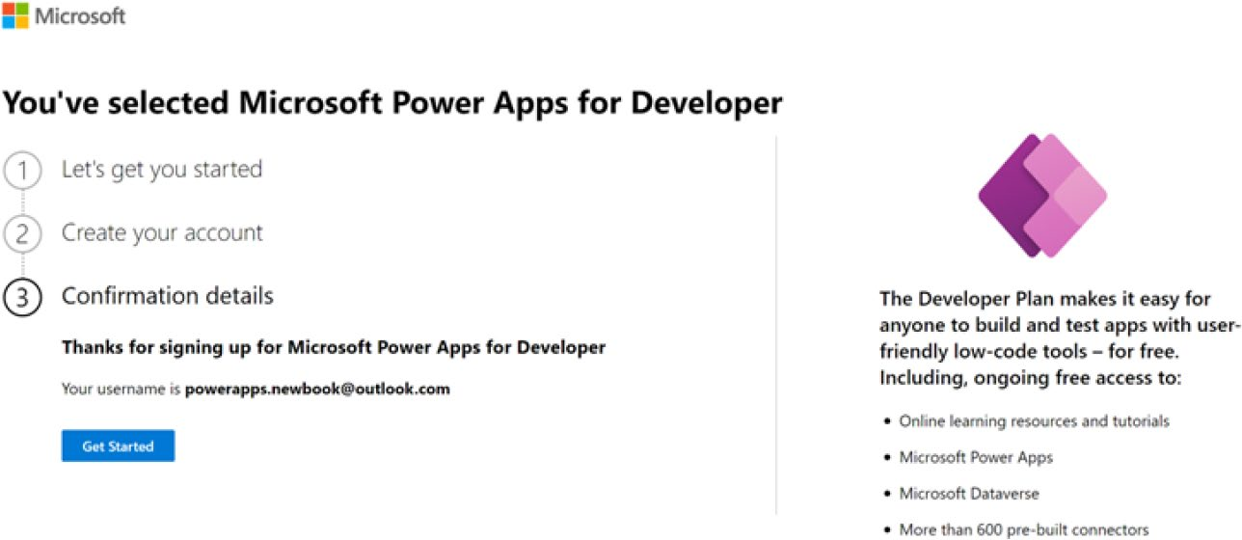

Figure 2-24. Confirmation details after signing up

Chapter 2 embarking on the Copilot Journey
5. That’s it. The setup is done! You can see the Power
Apps page in Figure 2-25.
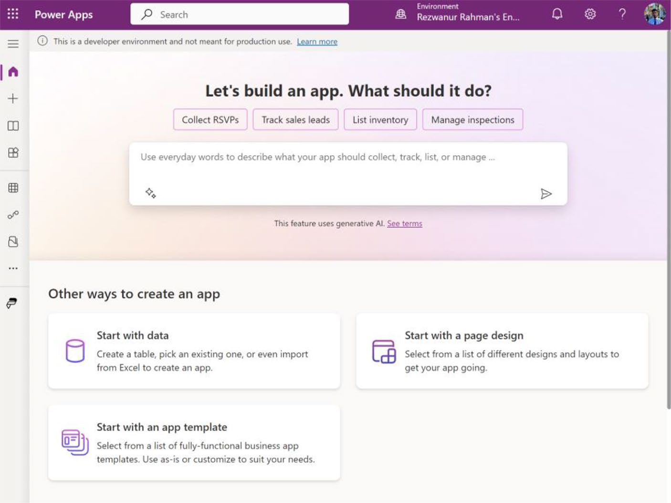

Figure 2-25. Portal page of Power Apps Developers

System Requirements, Limits,
and Configure Values
When you want to create apps with Power Apps, you need to be aware of
the system requirements, boundaries, and configuration settings of Power
Apps. This section covers some of these essential requirements.
Table 2-2 lists the platforms that can run apps with the Power Apps
mobile app.

Chapter 2 embarking on the Copilot Journey
Table 2-2. Supported Platforms That Can Run Apps by Power Apps
Platform Version
ioS the latest version of ioS is always the recommended version to run
power apps mobile. the previous version is the minimum required.
android the latest version of android is always the recommended version
to run power apps mobile. the previous three versions are the minimum required to run power apps mobile.
Windows Windows 10 version 17763.0 or later.

Table 2-3 lists the Power Apps-compatible browsers.
Table 2-3. Supported Browsers That Can Run Apps by Power Apps
Platform Version App Type
microsoft edge latest three major model-driven apps, Canvas apps, app
releases and component designers
google Chrome latest three major model-driven apps, Canvas apps, app
releases and component designers.
mozilla Firefox latest three major model-driven apps and Canvas apps
releases
apple Safari 13 and later model-driven apps and Canvas apps

Table 2-4 lists the supported operating systems for browsers running Power Apps.

Chapter 2 embarking on the Copilot Journey
Table 2-4. Supported Operating Systems for Browsers That Can Run
Apps by Power Apps
Platform Version App Type
Windows Windows 10 or later model-driven apps, Canvas apps, app
and component designers*
macoS 10.13 or later model-driven apps, Canvas apps, app
and component designers*
ioS ioS 13 or later model-driven apps and Canvas apps**
android 10 and later model-driven apps and Canvas apps**
*App and component designers include Power Apps Studio, model-driven app
designer, and model-driven custom page designer.
**Using the web browser on a phone to run a model-driven app isn't supported.

Table 2-5 lists the single outgoing request limits.
Table 2-5. Single Outgoing Request Limits
Name Limit
timeout 180 Seconds retry attempt 4

Note the retry value may vary. For certain error conditions, it’s not necessary to retry.

Chapter 2 embarking on the Copilot Journey

Required Services
Table 2-6 lists the services that Power Apps uses to communicate and what they do. Your network should not prevent these services from working.

Table 2-6. Services Required for Working with Power Apps
Domain(s) Protocols Users
api.bap.microsoft.com https environment permissions *.api.bap.microsoft.com management management.azure.com https power apps management
Service
msmanaged-na.azure-apim.net https runtime of Connectors/apis
login.microsoft.com https microsoft authentication login.windows.net library login.microsoftonline.com
secure.aadcdn.
microsoftonline-p.com
*.odc.officeapps.live.com
graph.microsoft.comgraph. https azure graph: to get user info windows.net (for example, profile photo) *.azure-apim.net https api hubs: Different
subdomains for each locale
(continued)

Chapter 2 embarking on the Copilot Journey
Table 2-6. (continued)
Domain(s) Protocols Users
*.Power Apps.com https create.Power Apps.com,
content.Power Apps.com, apps.Power Apps.com, make.Power Apps.com, *gateway.prod.island. Power Apps.com, and *gateway.prod.cm.Power Apps.com
*.azureedge.net https create.Power Apps.com,
content.Power Apps.com, and make.Power Apps.com
*.ces.microsoftcloud.com https access to net promoter score
(npS) and surveys
*.blob.core.windows.net https blob storage
*.flow.microsoft.com https create.Power Apps.com,
*.powerautomate.com content.Power Apps.com,
and make.Power Apps.com
(continued)

Chapter 2 embarking on the Copilot Journey
Table 2-6. (continued)
Domain(s) Protocols Users
http://*.crm#.dynamics. http and required for environments com and https://*.crm#. https access. includes integration dynamics.com and static Content Delivery
network (CDn) content
endpoints.
replace # in http://*. crm#.dynamics.com
and https://*.crm#. dynamics.com with your region’s number:
• asia/pacific: 5
• Canada: 3
• europe, africa, and middle
east: 15 and 4
• France: 12
• germany: 16
• india: 8
• Japan: 7
• north america: no number
• oceania: 6
• Singapore: 20
• South africa: 14
• South america: 2
• Switzerland: 17
• uae: 15
• united kingdom: 11
• Dynamics 365 uS
government: 9
(continued)

Chapter 2 embarking on the Copilot Journey
Table 2-6. (continued)
Domain(s) Protocols Users
eu-mobile.events.data. https european region telemetry
microsoft.com/Collector/ endpoint for model-driven
3.0 apps
browser.pipe.aria. https rest of the world telemetry
microsoft.com endpoint for model-driven apps
localhost http power app mobile
127.0.0.1 https power app mobile
ecs.office.com https retrieve feature flags for
power apps
augloop.office.com*. WSS power apps Studio Copilot
augloop.office.com
config.edge.skype.com https retrieve feature flags for
power apps (backup)
api.powerplatform.com*. https required for power platform api
powerplatform.com connectivity used internally by
microsoft products, and power
platform programmability and
extensibility
*.sharepointonline.com https retrieve assets for presenting
the header that appears at the
top of app playing experiences
ris.api.iris.microsoft. https record user action in response
comeudb.ris.api.iris. to power apps in-app
microsoft.com campaigns
arc.msn.comarc-emea.msn.com https record user viewing of power
apps in-app campaigns

Chapter 2 embarking on the Copilot Journey

Note if you’re using a Vpn, you must configure it to exclude
localhost from tunneling for power apps mobile.

Deprecated Endpoints
Microsoft does not supporting the listed endpoints. I include the old and
new endpoints in Table 2-7.
Table 2-7. Deprecated Endpoints and New Endpoints List
Deprecated Endpoint New Endpoint
web.Power Apps.com/apps/ apps.Power Apps.com/play/ {yourAppGuid} {yourAppGuid} web.Power Apps.com/apps/ apps.Power Apps.com/play/ {yourAppGuid}/open {yourAppGuid}

Embedding Limits for Canvas Apps
Power Apps doesn’t support the nested embedding of Canvas apps in native desktop, mobile, or other non-browser clients.
Table 2-8 lists some of the examples where embedding a Canvas app is and isn’t supported.

Chapter 2 embarking on the Copilot Journey
Table 2-8. Embedding Limits for Canvas Apps
Power Apps Embedding Scenario Supported Clients Unsupported Clients
a Canvas app embedded in a Web teams desktop
Sharepoint page teams mobile
a Canvas app embedded in a Web teams desktop
Sharepoint page that is added as a teams mobile
tab in a microsoft teams channel
a Canvas app used as a custom Web teams desktop
form in the Sharepoint page teams mobile
a Canvas app used as a custom Web teams desktop
form in the Sharepoint page teams mobile
that is added to a teams team Sharepoint mobile
a power bi report that is added Web teams desktop
to teams, or a Sharepoint site teams mobile
Sharepoint mobile
a model-driven form that Web teams desktop
is added to teams teams mobile
a canvas app is embedded third-party web third-party native
in a third-party client client that iframe’s client via WebView
an app
a Canvas app in a unified none unified Service Desk
Service Desk Desktop app

Chapter 2 embarking on the Copilot Journey

Note remember, pricing and features can change, and it’s best to
check the official microsoft power apps website for the most current
information. the official website is https://learn.microsoft.
com/en-us/power-apps/powerapps-overview.

Proxies
Using a proxy with Power Apps can cause problems and is unsupported. If something doesn’t seem to be working, turn the proxy off and see if that does the trick.
Some proxies (such as Zscaler and Blue Coat) change requests coming to Power Apps by removing some headers (CORS or authentication headers) in their outgoing responses. The app in question relies on the said headers for it to load. Some proxies (e.g., Microsoft Defender for Cloud Apps and McAfee) can tamper with URL links of an application or an embedded one by intercepting it.
For example, Dynamics 365 runs under the domain org.crm. dynamics.com, and the Canvas app runs under the domain apps. PowerApps.com. In this case, the platform does not support a proxy that changes these domains to a different domain like mycustomdomain.com. This can lead to unexpected behavior when the platform tries to get the tokens needed to run the app.

Summary
This chapter guided you through the setup, configuration, and licensing of Microsoft Copilot for Power Apps, highlighting its streamlined online service model and the ease of integrating with Microsoft 365. You learned about the various licensing options, the prerequisites for activating

Chapter 2 embarking on the Copilot Journey
AI features, and the importance of preparing a solid development
environment. This foundation ensures that you can effectively leverage
Copilot’s capabilities for rapid, AI-driven application development.
As you move to Chapter 3, I take you deeper into the core technology
behind Copilot. This chapter explores the powerful AI Builder that
drives Copilot, showing how it revolutionizes code development with
its low-code interface and seamless integration with Microsoft’s Power
Platform. I also introduce you to the AI models at the heart of Copilot,
their applications in real-world business scenarios, and the advanced
technologies that make Copilot a smart, intuitive tool for developers
like you.

CHAPTER 3

Mastering the Core:

Copilot’s Engine

Room

What new, magical technology from Microsoft makes Copilot so
incredible? How does this magic operate behind the scenes to transform
complex programming tasks into simple, intuitive experiences? This

chapter looks closely at the sophisticated technology that makes Copilot
such a powerful assistant—AI Builder.
Why is AI Builder a crucial component of this breakthrough? This

chapter explores these key connections and their functions. I guide you
through this adaptability, showing how Copilot, equipped with AI Builder,
stands out as a versatile software development tool.
Are you curious about Copilot’s intelligence? This chapter also
introduces AI algorithms that form the core of Copilot. What happens
when these AI algorithms face real-world problems? This chapter also
presents AI-based solutions to real-world problems in three case studies. I
show that AI-based solutions are theoretical, efficient, and practical, with
actual demos planned in upcoming chapters.

© Rezwanur Rahman 2024 81
R. Rahman, Microsoft Copilot for Power Apps, Inside Copilot,

Chapter 3 Mastering the Core: Copilot’s engine rooM
You are about to gain a deeper understanding of Copilot, appreciate its underlying features, and learn how to be creative with what you have already learned. Are you ready to enter the Copilot Control Room and learn more about how these features affect your development needs? Then, let’s proceed.

Harnessing the Power: Key
Features Unlocked
This section explains further how the introduction of AI Builder has revolutionized the field of application development. This leads to the next segment, which calls for more elaborate studies about these powerful tools perfectly integrate into the Copilot ecosystem, delivering greater power to developers.

AI Builder: Revolutionizing Code Development
If Copilot is the co-pilot, AI Builder is the pilot. AI Builder is the powerhouse of Copilot; it brings Copilot alive and works on code suggestions based upon natural language, given the query and context. AI Builder is a low-code platform that allows users to create and deploy AI models without writing any code. Hosted on the Microsoft Azure platform, AI Builder provides more than 90 pre-built AI models and empowers users to build AI from scratch, including developing customized AI scenarios such as sentiment analysis, object detection, forms processing, and text
recognition. Figure 3-1 shows the components of AI Builder.

Chapter 3 Mastering the Core: Copilot’s engine rooM
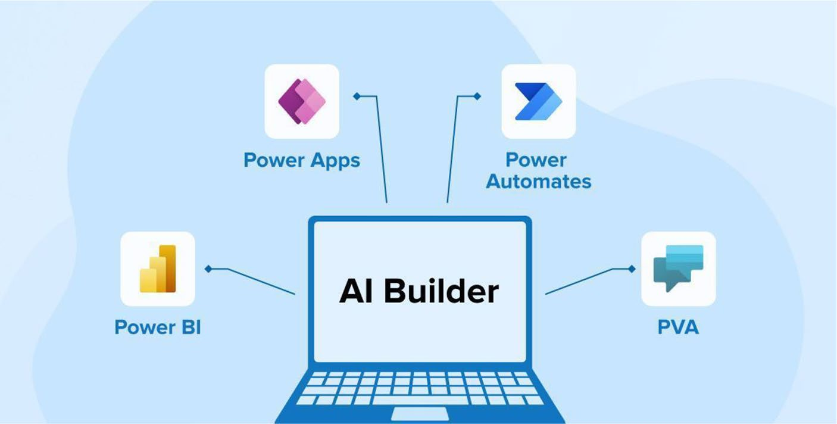

Figure 3-1. AI Builder is compatible with all Power Platform
applications

AI Builder is fed with data from different sources, including Excel
files, SharePoint lists, SQL databases, and Power Apps collections,
among others. From there, users can choose an AI scenario, and further
personalization is done to meet their exact needs. From there, AI Builder
will train and evaluate the model, after which a score is given to grade its
performance. After that, the model can be published, ready for use inside
Power Apps and Power Automate or in applications developed inside
Dynamics 365. Refer to Figure 3-2.

Chapter 3 Mastering the Core: Copilot’s engine rooM
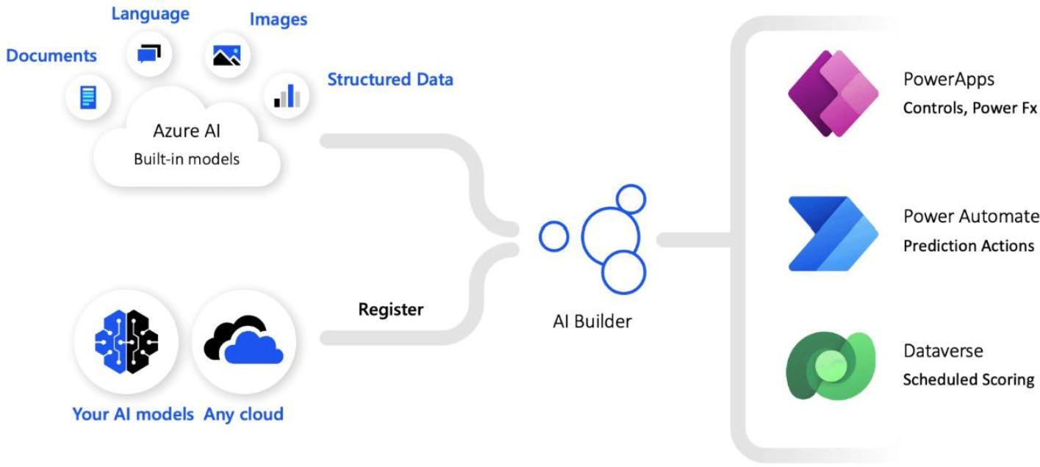

Figure 3-2. Technical structure of AI Builder
The most important benefit of AI Builder is that it makes AI accessible to everyone. It does not matter if the person does not know much about coding. No experience in coding is necessary—AI Builder provides a guide to develop an AI model in a few clicks and adds it quickly to the workflows or processes. The models are built in the AI Builder cloud, ensuring they are consistent, secure, compliant, and scalable, as they benefit from the Microsoft Azure best practices.

Core Features of AI Builder in General
This section explores the core capabilities of AI Builder, a solution in the Copilot ecosystem that enables all users, no matter their technical level, to easily develop artificial intelligence.
• Low-code interface: AI Builder brings to Power
Platform a low code/no code approach, which makes it easy to build AI models and reach more Power Platform customers with the ability to gain value from AI without requiring that they be programmers.

Chapter 3 Mastering the Core: Copilot’s engine rooM
With easy and intuitive visual tools, AI Builder delivers out-of- the-box scenarios that are immediately pre-built and instantly available.
• Integration with Microsoft Power Platform:
AI Builder natively integrates with the following Microsoft Power Platform products: Power Apps, Power Automate, and Dynamics 365. This allows the direct implementation of AI models within business applications to simplify workflow processes and enable more efficient decision-making.
• Pre-built AI scenarios: AI Builder includes a wide
range of ready-to-use AI capabilities through pre- built AI scenarios. These scenarios cover everything from sentiment analysis to object detection and form processing to text recognition. They offer ready-to- run AI capabilities that can be trivially set up and operational without requiring deep AI knowledge or coding competence.
• Custom AI model support: In addition to all these pre-
built scenarios, AI Builder facilitates the development of a custom AI model. From bespoke models that meet specific business needs, you can harness the spectrum of cognitive services and machine learning provided by Microsoft Azure.
• Data ingestion and processing: AI Builder handles the
source data, and for data ingestion and processing, you can use Excel, SharePoint Lists, SQL databases, CDS on Azure, and Power Apps collections as the sources. This means whatever the data source AI model wants for training and validation it gets easily from the source.

Chapter 3 Mastering the Core: Copilot’s engine rooM

Key Technical Features of AI Builder
First, it’s important to understand the primary building blocks of AI Builder that elevate it from merely a low-code platform to a robust and useful AI development tool for the Copilot network. Those include the following:
• Model training and testing: AI Builder operates in an
automated process for both training and evaluating the model, ensuring that its users are provided with a very efficient system for their AI development. It trains not only the models given but also evaluates their efficiency with the given data, providing suggestions for enhancing accuracy and effectiveness.
• Performance scoring and feedback: As a built-in
feature of AI Builder, the scoring system ensures that quality and effectiveness are not compromised in any AI model.
• Seamless workflow integration: AI Builder creates a
design that benefits integration. AI models built with this platform can be easily used in the Power Apps, Power Automate, and Dynamics 365 applications to add AI capabilities.
• Security, compliance, and scalability: Microsoft
Azure’s use of AI Builder ensures that it offers the most secure, fully compliant, and scalable AI models. In the process, it ensures that you are offered the most powerful and highly secured and reliable AI implementations.

Chapter 3 Mastering the Core: Copilot’s engine rooM
• Democratization of AI: AI Builder democratizes AI
by making model buildings accessible to more people. Because more people are building models, the world of AI has become more widespread. You no longer need to be a technical person to build models, giving it greater reach.

AI Builder for Business Intelligence
AI Builder allows you to develop and use artificial intelligence models
that enhance your business operations. You can choose from a wide
variety of pre-built models for the most common business situations or
tailor a model so that it works according to your current business process,
as shown in Figure 3-3. AI Builder in Power Apps helps your business
streamline processes and get insights from your data.
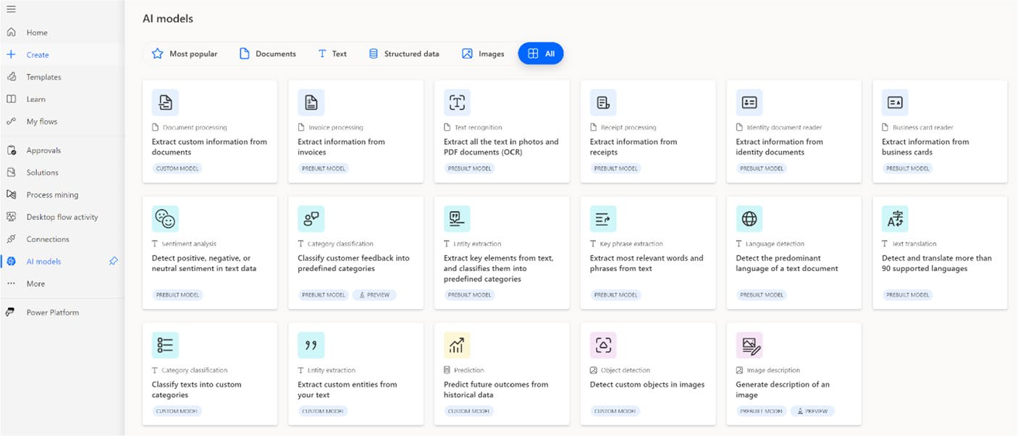

Figure 3-3. AI models in Power Apps

Chapter 3 Mastering the Core: Copilot’s engine rooM

Add Intelligence to Your business
You can use AI easily by connecting it to Power Apps and Power Automate. To harness AI for your business, follow these steps:
• Model selection: Begin by choosing the appropriate AI
model type from a broad array of AI solutions tailored to meet specific business requirements.
• Data integration: Select and connect the data relevant
to your business from the provided options to inform your AI model.
• Model customization: Customize your chosen model
to improve its performance, ensuring that it aligns with your business objectives.
• Model training: Engage in an automated training
process that educates your AI model on resolving specific business challenges, such as recognizing products in images using your tailored data. Once trained, your model can deliver actionable insights, such as predictions or identifying objects within an image.
• Insight application: Leverage the insights generated
by your AI model within Power Platform to develop innovative solutions that cater to your business needs, all without requiring coding expertise. This could include automating document processing with Power Automate or creating a Power Apps application that predicts supplier compliance issues.

Chapter 3 Mastering the Core: Copilot’s engine rooM

Licensing Overview
AI Builder is a capacity-based license. The capacity is calculated with
respect to the service credits or AI Builder credits. You must have at least
one Power Apps, Power Automate, or Dynamics 365 license, with the
capability to set up the Microsoft Power Platform environment.
AI Builder credits are needed to use AI Builder features in an
environment. This is how it works:
• Credits source: AI Builder credits are obtained through
AI Builder capacity add-on purchases or included with certain user licenses.
• Credits allocation: Credits can be assigned to
specific environments or remain unallocated at the organization level. Administrators can control the use of unallocated credits via Power Platform admin settings.
• Environment usage: Environments use credits from
allocated or unallocated sources to access AI Builder features.
• Monthly reset: Credit consumption resets monthly,
with usage tied to AI Builder model executions in Power Automate flows, Power Apps applications, and model training.
• Usage monitoring: Administrators can track credit
consumption to stay updated on monthly usage.
• Overage consequences: Exceeding credit limits leads
to restricted features, initially blocking model editing and creation, and eventually stopping model runs. Additional credits must be purchased or reallocated to resolve overages.

Chapter 3 Mastering the Core: Copilot’s engine rooM
• Trial access: AI Builder trials are available for
organizations without credits, with capacity linked to individual users without needing allocation.

Chapter 9 includes a hands-on, practical example of using AI Builder tailored for administrators.

Prompts
You might think that a prompt is just a simple instruction, and you would be correct. But it is also more than that. In this section, I introduce you to the concepts of prompt engineering and many other important concepts you need in order to build more effective applications that can generate text from inputs.

What Is a Prompt?
A prompt is a set of instructions, or a question posed in natural language, for large language models (LLMs) like ChatGPT. It instructs the LLM what task it must perform. It is like giving a model a “starting point” or a cue word/brief to start generation. The prompt does not only tell the model the topic to talk about, but it also often explains how to talk about it (e.g., start a discussion or an essay, solve a problem, write a poem, etc.). This process is often called instruction tuning. The prompt is structural and content input so the model can start generating text. The art and the science of writing and optimizing prompts used by a model is called prompt engineering. AI Builder provides a prompt builder in which the maker writes, evaluates, saves, and uses prompts to generate text.

Chapter 3 Mastering the Core: Copilot’s engine rooM

Instruction Tuning
Instruction tuning is when you take instructions and give them to the
model along with the output for that instruction. The thought here is that
by giving the model the instruction text with the output, the model will
be much more likely to follow those instructions. The model is simply
learning how to understand the instruction prompts so that it can produce
the right output.

Prompt Engineering
Prompt engineering is the art and science of crafting and refining these
prompts to get the best possible output from a model. You could conduct
a set of trials that involve paraphrasing the prompt in such a way as to
guide the model toward generating more accurate, creative, or appropriate
responses. This makes prompt engineering an indispensable task, since
even subtle changes in a prompt can lead to very different outputs. It is
a skill that includes understanding how the model works, a mix between
what’s been done and strategic thinking.

Why It Matters
Prompt engineering and instruction tuning are essential because they help
developers make the most of LLMs. They allow developers to interact
with the model clearly, concisely, and aligned with their goals. Whether
they use them for creative writing, complex problem solving, or code
generation, effective prompts produce better, more helpful outputs. It is a
mutual benefit: the more you improve your prompts to communicate with
these models, the more they will assist you in various tasks.

Chapter 3 Mastering the Core: Copilot’s engine rooM

Copilot Prompts
Copilot prompts instruct Copilot to make sense of and fulfill your requests. Usually, Copilot prompts have four parts: goal, context, expectations, and
source. Details on each of these are shown in Figure 3-4.
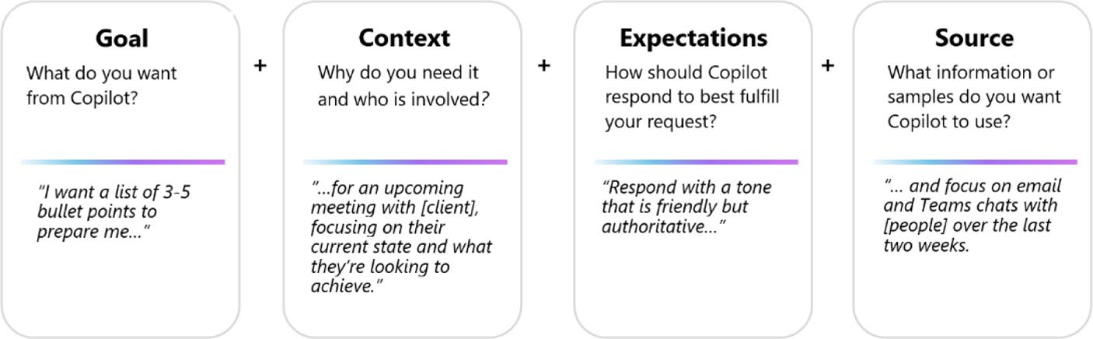

Figure 3-4. Copilot prompt with an example

The complexity of a prompt can vary, but at its core, it must have a clear goal. For more precise results, you can include additional elements. Often, to achieve the desired outcome, it is necessary to provide more than just the goal. Here is how a prompt might look in Microsoft 365 chat, incorporating a goal and a source:
Write a summary of all emails from Stefan Gamsjäger from the last 3 months.
Here is an example that includes a goal, context, and expectations:
Create an outline of an Italian cooking book. The book is for Asian people who love cooking and want to learn something new. The tone should be friendly and open.

Chapter 3 Mastering the Core: Copilot’s engine rooM

Note typically, you will respond to the initial results with a follow-up prompt. expect a bit of a dialogue as you refine your queries to achieve the desired outcomes.

Copilot is built on Large Language Models (LLMs) that are connected
to your Microsoft 365 apps and data. This connection allows Copilot to
go beyond the capabilities of other LLM-powered chatbots by accessing
data from Microsoft 365 apps and your internal resources, such as articles,
reports, emails, presentations, and more. With Copilot, you can create
or edit content, ask questions, summarize information, and catch up on
things more efficiently:
• Catch up: If you need to get up to speed on a meeting’s
details, you can use Copilot in Teams to ask, what questions were raised during yesterday's meeting? or What were the key ideas discussed?
• Create: To assemble a presentation on time
management, initiate a prompt with Copilot in PowerPoint: Create a brief presentation about Windows 11. If you need to craft a reply to an email about a project launch, use Copilot in Outlook: Compose an email congratulating the project lead and team on their successful launch.
• Ask: Planning a holiday? Query Copilot with, Suggest
ideas for a 3-day trip to Innsbruck.
• Edit: In Word, direct Copilot to refine a paragraph by
selecting it and activating the Rewrite with Copilot option. Enhance a PowerPoint slide by requesting, Incorporate an image of a target with arrows.

Chapter 3 Mastering the Core: Copilot’s engine rooM
• For Enterprise users: Copilot offers significant
business advantages for enterprise-licensed users by linking LLMs with internal company data. Business clients might employ prompts such as:
Outline a training course for onboarding partners to BackendEBL.
What is the latest update from Munia? Generate a project kick-off presentation based on our recent discussions.
Be sure to meticulously assess and validate the responses provided by Copilot. Copilot relies on Large Language Models (LLMs), which are sophisticated tools engineered to anticipate and generate text. However, occasional inaccuracies may arise in Copilot’s responses due to the vast and multifaceted nature of LLMs. It is imperative to scrutinize Copilot’s output and corroborate it with reliable sources.
Using the exact prompt multiple times may yield differing responses. As LLMs continue to evolve and assimilate new information, the outcomes generated in response to a previously used prompt may vary.
Always employ Copilot in a manner that is respectful, ethical, and compliant with the law. Avoid utilizing Copilot for any purpose that could potentially inflict harm upon yourself or others.
Microsoft Copilot presents a multitude of opportunities. You can learn
more prompts from Copilot Lab at https://copilot.cloud.microsoft/
en-US/prompts, or follow the QR code in Figure 3-5.

Chapter 3 Mastering the Core: Copilot’s engine rooM


Figure 3-5. Access to Copilot lab
In Chapters 10 and 11, you learn how to create a custom prompt, how
to create a GPT prompt, how to share the prompt, and how to use the
prompt in Power Apps, with a full project demo!

AI Models
AI Builder in Power Platform provides a choice of AI models meant for easy
integration into business applications to bring automation and insights
without deep technical expertise. These models range from automating
routine tasks, such as form processing, to custom predictions that are
precisely tailored to your business data. AI Builder enables businesses,
whether using AI for the first time or having expert capabilities, to adopt
AI to increase efficiency and make even more informed decisions across
various functions of the business by fostering innovation.

AI Models in Business Contexts
AI Builder offers different model types for your versatile business needs.
You can use custom AI Builder object detection models to find products
from images precisely. You can:
• Find products in an image in an effective and
customized way through an AI Builder model for object detection.

Chapter 3 Mastering the Core: Copilot’s engine rooM
• Start getting efficiencies in automating expense reports
using the pre-built AI Builder receipt scanning model.
• Start creating marketing campaigns with insights from
historical data to predict the most effective campaign using a prediction model designed around the context of your business.
These tailored solutions give better output in terms of productivity and improved decision-making in various scenarios.
Table 3-1 defines key features of AI models in AI Builder with respect to model categorization, their handling capabilities for the type of data used, and customization choice.
• Data type: This describes the kind of data that every
model deals with, be it documents, text, structured data, or images, hence specifying the area of AI application.
• Build type: This indicates the readiness of the model,
meaning it can be a pre-built model ready for use in business tasks or customizable—needed to be built, trained, and published—according to your specific needs. Custom models are for businesses with unique scenarios in their data, and pre-built models are for businesses needing universal scenarios.

Chapter 3 Mastering the Core: Copilot’s engine rooM
Table 3-1. Key Features of AI Models in AI Builder with Respect to
Model Categorization
Data Type Model Type AI Template Table Build Type
UniqueName Mapping
Documents Business card BusinessCard pre-built
reader
Documents Document DocumentScanning, Custom
processing (DocumentLayoutAnalysis
is used during training)
Documents Text TextRecognition Pre-built
recognition
Documents Receipt ReceiptScanning Pre-built
processing
Documents invoice processing InvoiceProcessing pre-built
Documents iD reader IdentityDocument pre-built
text text generation GptPowerPrompt, pre-built
text Category TextClassificationV2 pre-built
classification (preview) and
custom
text entity extraction EntityExtraction pre-built and
custom
text Key phrase KeyPhraseExtraction pre-built
extraction
text language detection LanguageDetection pre-built
text sentiment analysis SentimentAnalysis pre-built
text text translation TextTranslation pre-built
(continued)

Chapter 3 Mastering the Core: Copilot’s engine rooM
Table 3-1. (continued)
Data Type Model Type AI Template Table Build Type
UniqueName Mapping
structured prediction BinaryPrediction, Custom data GenericPrediction images object detection ObjectDetection, Custom images image description ImageDescription pre-built
(preview)
images text recognition TextRecognition pre-built

Typical Business Situations
AI Builder includes a repository of many AI models that require no coding
or data understanding. Table 3-2 shows some common business situations and the recommended model types to address them.

Table 3-2. Common Business Situations and Recommended Model Types
Business Scenario Model Type
automate customer application processing Document processing
automate expense reports receipt processing Categorize user feedback based on focus Category classification
extract insights from product reviews entity extraction identify language of text language detection identify and classify customer feedback sentiment analysis translate support requests into your language text translation
(continued)

Chapter 3 Mastering the Core: Copilot’s engine rooM
Table 3-2. (continued)
Business Scenario Model Type
identify fraudulent transactions prediction
get alerted to social media posts referencing your brand Key phrase extraction
automate contact list Business card reader
automate inventory taking object detection
take a photo of text and save it to a database text recognition

Overview of Pre-built AI Models
Pre-built AI models are excellent for adding intelligence to your apps and
flows without having to gather data and train and deploy your AI models
prior to use. For example, in Power Apps, you can add a component that
uses a pre-built AI model to extract contact information from business
cards. You can use a pre-built Power Automate model to determine
whether customer feedback is positive or negative.
AI Builder has pre-built models that you can use in Power Automate
and Power Apps. Here are the pre-built models that AI Builder
currently offers:
• Invoice processing
• Text recognition
• Sentiment analysis
• Receipt processing
• Entity extraction
• ID reader

Chapter 3 Mastering the Core: Copilot’s engine rooM
• Key phrase extraction
• Business card reader
• Category classification
• Text generation (preview) (deprecated)
• Language detection
• Text translation
• Image description (preview)

Overview of Custom AI Models
Businesses with various features can benefit from Custom AI models that exploit proprietary data to precisely address requirements of document processing, text analysis, and image recognition.
Designed to meet the peculiar demands of every business, these models empower data-handling and decision-making processes in Power Automate and Power Apps with the power of AI Builder.
• Document processing: Extracts tailored information
from documents, matching specific business needs.
• Category classification: Classifies text into defined
categories, customized for each business.
• Entity extraction: Identifies and extracts bespoke
entities from text tailored to unique business contexts.
• Prediction: Uses historical data to predict future
outcomes, customized for predictive accuracy in business operations.

Chapter 3 Mastering the Core: Copilot’s engine rooM
• Object detection: Detects specified objects
within images, customized to recognize unique business items.
• Azure Machine learning models: Allows businesses
to bring in and utilize their custom models, offering flexibility in AI application.

Benefits of AI Builder
Here are some key benefits of using Microsoft AI Builder:
• Easy to use: AI Builder’s user experience is
outstanding. It features an intuitive interface that provides an easy-to-understand process for anyone to enhance their application with intelligent features. This ease of use minimizes the complexity of the solution to eliminate barriers to entry regarding the user’s technical abilities. AI Builder is designed for everyone.
• Integration with Power Platform: AI Builder tightly
integrates with the Microsoft Power Platform with strong integration points into Power Apps, Power Automate, and Power Virtual Agents. This makes it a perfect solution to infuse intelligence into apps you are building end-to-end—by automating tasks, orchestrating workflows, and helping with chatbots, to name just a few. This tight integration brings the power of artificial intelligence directly into the way you work today to significantly enhance what you can deliver and the quality of the user experience.

Chapter 3 Mastering the Core: Copilot’s engine rooM
• Pre-built AI models: AI Builder offers an array of
pre-built AI models to cater to the most common business scenarios, such as form processing, object detection, prediction, text classification, and others. It gives you an easy way for models to be customized and retrained with the user’s data, therefore allowing the development process to be much faster than it currently is.
• Customizability: AI Builder offers users a variety of
pre-built models and tools for building custom models to meet a given business’s specific needs. Users can train these, for instance, with their data, ensuring the AI solution is relevant and effective in their unique scenario.
• Data processing and analysis: With this feature, AI
Builder automatically processes and analyzes input data from images, forms, and text, among other sources. It enables businesses to automate data entry and obtain insights on unstructured data to facilitate informed decisions based on AI-driven analyses.
• Improved efficiency and productivity: AI Builder
enhances the efficiency and effectiveness of human capabilities when it automates repetitive tasks. It processes information rapidly, eliminates manual errors, and deploys human resources to more thoughtful tasks.
• No code/low code development: AI Builder allows
no-code/low-code Power Platform implementation, whereby users can develop their artificial intelligence solutions and implement them without having to code

Chapter 3 Mastering the Core: Copilot’s engine rooM
from scratch. This, therefore, means democratizing AI development in such a way that business analysts and other users who are non-technical can develop solutions.
• Scalability: AI Builder solutions are scalable and can
be adjusted according to the size of the business. Small, medium, and even large businesses can be assured that AI Builder will help them with their processing needs, whether for a few documents daily or for analyzing thousands of images.
• Security and compliance: As part of Microsoft’s cloud
ecosystem, AI Builder benefits from Microsoft’s robust security and compliance features. These ensure that data used within AI Builder is handled securely and in compliance with relevant regulations.
• Continuous improvement: Microsoft constantly
develops AI Builder, adding new features, models, and improvements. This, in turn, means that users can count on the ever-increasing and improving capabilities of AI; hence, it is up to date with the latest in modern achievements in the development of AI.
Businesses with distinctive attributes can significantly benefit
from custom AI models, which leverage proprietary data to specifically
address requirements in document processing, text analysis, and image
recognition.

Chapter 3 Mastering the Core: Copilot’s engine rooM

AI Unveiled: The Intelligence Behind Copilot
This section uncovers the intelligence behind Copilot—a fusion of machine learning, natural language processing, and predictive analytics. These core technologies synergistically enhance Copilot’s functionality, making it not just a tool but a smart companion in the digital landscape.

Core Technologies Behind AI Builder

1. Advanced NLP and transformer models
Built on top of the revolutionary NLP technologies, Microsoft Copilot for Power Apps is powered by transformer models. The underlying models of the GPT series and similar architectures understand input better and give context to the new human-like text that they generate.
• Transformer architecture: Central to these
models is the transformer architecture, which applies mechanisms of self-attention to weigh the importance of words within input data. Through this, the model can produce results that are highly relevant and context-aware. For Copilot, this means understanding the user intent well enough to produce the corresponding Power Fx code and app components.
• Fine-tuning on domain-specific data: While the
transformer models are made available pre-trained on a huge corpus of text data, a domain fine model aims at bettering its performance in domain-specialized tasks. For the datasets Copilot can have,

Chapter 3 Mastering the Core: Copilot’s engine rooM
it would be the Power Apps projects, Power Fx formulas, and user interface settings that Microsoft curates. This domain-specific training ensures the outputs of the model are not only syntactically correct but semantically valid in the context of Power Apps development.
2. Integration with Power Fx and Power Apps Studio
A key piece of Copilot involves its integration with Power Fx and Power Apps Studio. Power Fx is a low-code language modeled after Excel formulas, created for providing simplicity with unparalleled power in app development.
• Code generation and interpretation: Copilot can
understand and generate Power Fx code, including the parsing of the natural language inputs into Power Fx syntax. It requires a deep integration with Power Apps Studio’s development environment so Copilot can insert code directly in the app under development.
• Real-time contextual analysis: As developers are
going about building their application, Copilot is analyzing in real-time the existing state of an application, including UI layout, data bindings, and existing Power Fx formulas. The analysis is accomplished using advanced algorithms that are cognizant of an application’s structure and the logic applied, and that provide contextually relevant suggestions for the code writers.

Chapter 3 Mastering the Core: Copilot’s engine rooM
3. Machine Learning techniques for continuous
improvement
Copilot learns from user interactions over time and refines its abilities using state-of-the-art machine learning technologies.
• Feedback loops: Copilot suggestions receive user
feedback, which turns into extremely valuable data used to train AI models. Whether a suggestion is accepted, modified, or rejected leads to more fine- tuning of the future model outputs. A well-designed feedback loop must yield meaningful and relevant data without usurping the user’s experience or encroaching on their privacy.
• Reinforcement Learning (RL): Beyond supervised
learning from labeled datasets, Copilot may use RL techniques to further fine-tune its suggestions based on user interactions. In an RL framework, the model learns to make decisions that maximize a reward signal, for example, by generating a piece of Power Fx code (e.g., suggesting the user will accept). This provides the possibility for Copilot to adapt to the structural guidelines of personal developer preferences and organizational patterns over time.
4. System architecture and data privacy
Ensuring Copilot’s functionality while maintaining data privacy and security is a complex challenge that involves sophisticated system architecture choices.

Chapter 3 Mastering the Core: Copilot’s engine rooM
• Secure data processing: Copilot processes
sensitive information, including proprietary business logic and data structures. This, in turn, means that sensitive data should be encrypted both at rest and in transit, with strict access controls, and processed data locally within a user’s environment to minimize the exposure of that data.
• Model training and anonymization: All data used
to train AI models and that Copilot uses must be anonymized and aggregated to avoid any possibility of reverse engineering, which may lead to sensitive information exposure. These include differential privacy techniques, where noise is added to the training data to protect individual data points but still allow the model to learn only general patterns.

Advanced Integration of Azure Services
in Copilot for Power Apps Architecture
1. Azure Machine Learning (Azure ML) for model
development and deployment
Azure Machine Learning is integral to the
development and deployment of Copilot’s custom NLP models, because it provides a complete environment for model training, fine-tuning, and scalable deployment.
• Custom model training: Azure ML is central to
training the custom NLP models that underpin Copilot. This provides a powerful environment

Chapter 3 Mastering the Core: Copilot’s engine rooM
for experimentation, training, and fine-tuning of models on domain-specific data containing a large volume of Power Apps usage data, Power Fx code samples, and user interface interactions. Supporting a range of machine learning
frameworks and languages, Copilot allows its team to pick the right tool for the job at each stage.
• Deployment and scaling of models: Deployment
of this model can be done at a production level using the Azure ML platform after training. It is designed to manage the model lifecycle with versioning and model monitoring. Capable of deploying models as web services on Azure Container Instances (ACI) or Azure Kubernetes Service (AKS), the Copilot AI backend can dynamically scale up and down with demand.
2. Azure Cognitive Services for enhanced
capabilities
Azure Cognitive Services give Copilot plenty of enrichment, particularly with the advanced capabilities of language understanding and processing, which help in interpreting and executing user commands accurately.
• Language understanding and processing: Copilot
is likely to exploit Azure Cognitive Services, where the language service is interested in delivering pre-built models with capabilities in the detection of the language, translation,

Chapter 3 Mastering the Core: Copilot’s engine rooM
and recognition of entities. This is used to increase the overall understanding of the natural language inputs. These pre-built models provide necessary functionalities such as language detection, translation, and entity recognition to interpret user commands accurately and in context.
3. Azure Kubernetes Service (AKS) for
microservices orchestration
Azure Kubernetes Service (AKS) helps in the easy orchestration and management of the microservices-based architecture of Copilot with a guaranteed capability to scale quickly and effectively, including reliable performance across the diversity in functionality.
• Service orchestration and management: The
microservices architecture that Copilot is based on uses AKS orchestration to enable updates to be rolled out at scale, ensuring resiliency in managing various aspects of the app development process (e.g., UI generation, Power Fx code generation, and user inputs processing). First, AKS provides automated scaling, self-healing, and load balancing to make it easier for users to manage complex interactions between the services offered by Copilot. First, AKS provides automated scaling, self- healing, and load balancing to make it easier for users to manage complex interactions between the services provided by Copilot.

Chapter 3 Mastering the Core: Copilot’s engine rooM
4. Azure DevOps for Continuous Integration and
Delivery (CI/CD)
Azure DevOps tunes the development pipeline for Copilot to become a continuous integration and delivery (CI/CD) medium of swift, reliable updates for the platform.
• Streamlined development pipeline: Azure
DevOps supports the development lifecycle of Copilot from code commits to deployment. It enables the team to automate builds, tests, and deployments, ensuring updates for Copilot are delivered quickly and reliably to users, whether they are bug fixes, new features, or improvements to the code or the neural model.
5. Leveraging Azure Data Services for insights and
analytics
Azure Data Services enrich Copilot with advanced insights and analytics that drive a sophisticated data management process, iteratively honing AI models on user interaction and feedback.
• Data storage and analysis: The data services
Copilot makes critical use of to store data and interact with it include Azure Cosmos DB, which is used to store user-generated data to be replicated globally, and Azure Blob Storage, which is for large- scale unstructured data storage. Further analytics can be conducted with Azure Synapse Analytics or Azure Databricks to gain even more insights for the continuous improvement of the given service.

Chapter 3 Mastering the Core: Copilot’s engine rooM
• Feedback loop and model retraining: The
architecture includes mechanisms to capture real- time direct user feedback from inside the Power Apps environment. This feedback is stored and processed in Azure using Azure Data Services to continually inform active model retraining within Azure ML, ensuring the AI models of Copilot adapt and improve over time based on actual use.
6. Security and compliance with Azure
To ensure that it upholds the recognized
international standards of user data protection and privacy, Azure puts strong measures in place to ensure that Copilot is safe and compliant.
• Robust security measures: Part of the default
functionality that Azure provides is network security, IAM, identity, and access management, as well as encryption services, all undergirding Copilot’s data and user interaction. Azure also complies with the largest portfolio of international and industry standards, a sample of which includes GDPR and HIPAA.

Chapter 3 Mastering the Core: Copilot’s engine rooM

Frequently Asked Questions
AI Builder

1. What is AI Builder and how does it revolutionize
code development?
AI Builder is a low-code platform in Microsoft Copilot that helps developers get suggested code from natural language queries and their respective context. It revolutionizes the way code is developed with native integrations for Microsoft Azure and its cognitive services. Democratization of AI ensures that more people are empowered with the opportunity to access advanced capabilities, and this leads to improved efficiency in development and innovation.
2. How does AI Builder integrate with Microsoft
Power Platform?
AI Builder is natively integrated with Microsoft Power Platform, which includes Power Apps, Power Automate, and Dynamics 365. It enables customers to apply AI models in a very easy way to their business applications, thereby bringing intelligence into the workflow and decision-making. This helps support a vast range of pre-built and custom AI scenarios, as users can easily configure and deploy them to enhance their businesses solutions.

Chapter 3 Mastering the Core: Copilot’s engine rooM
3. What are some of the pre-built AI scenarios
provided by AI Builder?
The offering ships with pre-built AI scenarios, such as sentiment analysis, object detection, form processing, and text recognition. These scenarios come ready to be used, enabling users with simple substitution of input data for their models, to add AI capabilities to their applications without building then from scratch, therefore shortening the time for deployment and decreasing the barrier of entry for using AI technologies.
4. Can AI Builder support custom AI model
development?
AI Builder supports the creation of custom AI models. Users can bring use their business knowledge to develop and train models using Microsoft Azure’s cognitive services and the ability to add machine learning capabilities. With AI Builder it is also possible to incorporate AI into more highly specific unique scenarios that cannot be addressed by pre-built models.
5. What is the significance of prompt engineering in
the context of AI Builder?
Prompt engineering is just like talking to AI. AI Builder understands this “talk” by shaping the queries so that the inputs are converted to highly precise, creative, and exact responses. This can unlock AI’s potential to the fullest and ensure AI really delivers what you want.

Chapter 3 Mastering the Core: Copilot’s engine rooM
6. How does AI Builder ensure the security and
compliance of its AI models?
To guarantee the security and compliance of the AI models, AI Builder uses a secure deployment on the Microsoft Azure cloud architecture, which provides best practices for cloud security, compliance, and scalability. Some of the best practices of the cloud provider that ensure security and compliance to AI Builder are data encryption (both when in transport and at rest), implementing strict access controls, and meeting the regulations and standards of specific industries. AI Builder ensures security and reliability to the customer through the strict cloud provider platform, which is being used for all the customer’s AI needs.
7. What role does Azure Machine Learning play in
Copilot’s functionality?
Azure Machine Learning is instrumental in developing and deploying the custom NLP models that power Copilot, providing a comprehensive environment for model training, fine-tuning, and deployment. It supports various machine learning frameworks and languages, facilitating the creation of scalable, efficient models tailored to specific functions within Copilot.
8. How does Copilot use Azure Kubernetes
Service (AKS)?
Copilot uses AKS to orchestrate and manage its microservices architecture. In this way, AKS makes it possible for the good scaling, self-healing, and

Chapter 3 Mastering the Core: Copilot’s engine rooM
automatic load balancing of its services so that they can scale and perform with excellence. It does this by handling complex interactions required around the development of applications.
9. What continuous improvement mechanisms are
incorporated into Copilot?
Copilot incorporates mechanisms through which its system evolves, including feedback loops with users and learning through reinforcement techniques. The AI models adjust and fine-tune their outputs based on how a user interacts with them. The intention is to make their suggestions more accurate and closer to the expectations of the users with each round of interaction.
10. How does Copilot maintain data privacy and
security?
Copilot takes your privacy seriously, with leading system architecture choices applying encryption, access control, and local data processing. It also uses anonymization and aggregation techniques in model training to ensure the safe use of sensitive data in compliance with data protection regulations.

Power Fx

1. What is Power Fx and where is it used?
Power Fx is a low-code data manipulation and expression language used across the Microsoft Power Platform, including Power Apps, Power

Chapter 3 Mastering the Core: Copilot’s engine rooM
Automate, and Power Virtual Agents. Its syntax and functions are highly reminiscent of Excel formulas, which makes it approachable to business users, analysts, and other non- technical developers. Power Fx is used to define logic, manipulate data, and integrate external data sources within these applications.
2. How does Power Fx compare to traditional
programming languages?
Power Fx is specifically designed for the low-code environment of the Microsoft Power Platform, focusing on ease of use and integration with Microsoft services. Unlike traditional programming languages that require extensive coding knowledge, Power Fx uses a declarative syntax like Excel formulas. This makes it easier for non-developers to create complex business applications, workflows, and chatbots by writing expressions that define logic and operations.
3. Can Power Fx be used for complex applications?
Yes, Power Fx can support complex application development within the Power Platform’s scope. It provides a wide range of functions and operators that can manage complex data manipulation, logic, and integration tasks. However, the complexity that Power Fx can manage is within the context of the Power Platform’s capabilities, and for some highly complex scenarios, external code or Azure functions might be required.

Chapter 3 Mastering the Core: Copilot’s engine rooM
4. How do I learn Power Fx?
You can learning Power Fx by using various resources provided by Microsoft and the
community. Microsoft offers documentation, tutorials , and learning paths on the official Power Platform documentation site. Additionally, there are community forums, video tutorials, and online courses available. Since Power Fx shares similarities with Excel formulas, users with Excel experience may find it easier to pick up.

Summary
This chapter took you deep into the technological core of Microsoft
Copilot, focusing on the pivotal role of AI Builder in transforming complex
programming tasks into intuitive experiences. It explored how AI Builder
integrates with the Microsoft Power Platform, enabling even non-technical
users to create powerful AI models. It also highlighted the integration of
advanced NLP and machine learning technologies that make Copilot a
versatile development tool.
As you move to Chapter 4, you’ll shift from understanding the
underlying technology to applying it practically. In that chapter, I guide
you through the step-by-step process of building your first Power App
using Copilot. You will learn about key app design principles, how to
leverage Copilot for app customization, and the fundamentals of creating
user-friendly, visually appealing applications. This hands-on approach
will help you apply the concepts in this chapter to real-world app
development.

CHAPTER 4

Crafting Power

Apps with Copilot:

The Essentials

The previous chapter explored the core technology behind Microsoft
Copilot, revealing how AI Builder simplifies complex programming tasks.
You saw how advanced AI models and integration with the Microsoft
Power Platform enable developers of all skill levels to create powerful,
scalable solutions.
This chapter takes you from understanding the technology to applying
it in practice. In this chapter, I walk you through the hands-on process of
building your first Power App using Copilot. You’ll learn how to apply key
design principles, customize your app, and create a user-friendly, visually
appealing interface. By the end of this chapter, you’ll have the practical
skills needed to bring your ideas to life.

Building Your First App: A Step- By-Step
Process
Before diving into Power Apps development, it is important to understand
the types of Power Apps available. Power Apps can be divided into two
main categories: Canvas apps and model-driven apps.
© Rezwanur Rahman 2024 119
R. Rahman, Microsoft Copilot for Power Apps, Inside Copilot,

Chapter 4 Crafting power apps with Copilot: the essentials
• Canvas apps allow for greater customization of the
user interface layout and design. They are ideal for creating lightweight applications that can integrate with multiple data sources.
• Model-driven apps rely on the Common Data Service
to facilitate the creation of forms, processes, and business rules. They are well-suited for complex applications that demand extensive data modeling and logic implementation.
This example shows how to build a simple Canvas app in Power Apps using Microsoft Copilot:
1. To build applications in Power Apps, you need
to browse the Microsoft Power Apps website at
https://make.powerapps.com/. Log in with your
credentials, which you created in Chapter 2 (you can also use your own licensed credentials). You will
then see the page shown in Figure 4-1.
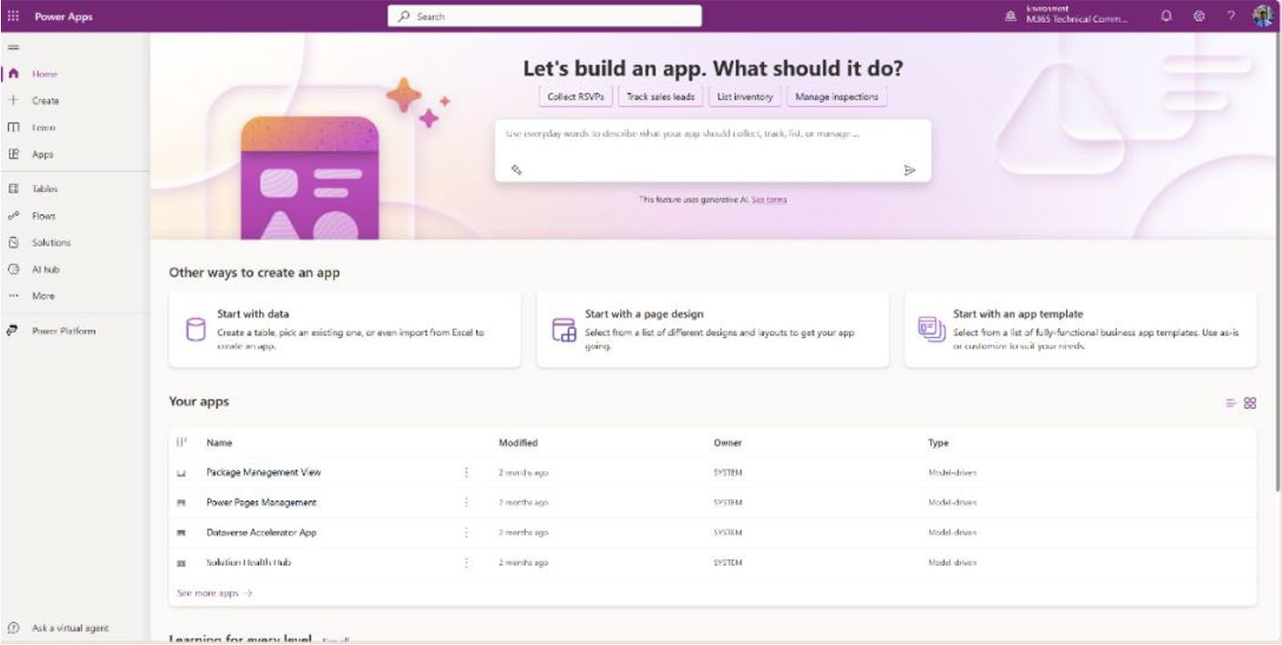

Figure 4-1. The welcome page of Power Apps after logging in

Chapter 4 Crafting power apps with Copilot: the essentials
2. Let’s look at this page in detail. Follow along with
Figure 4-2.
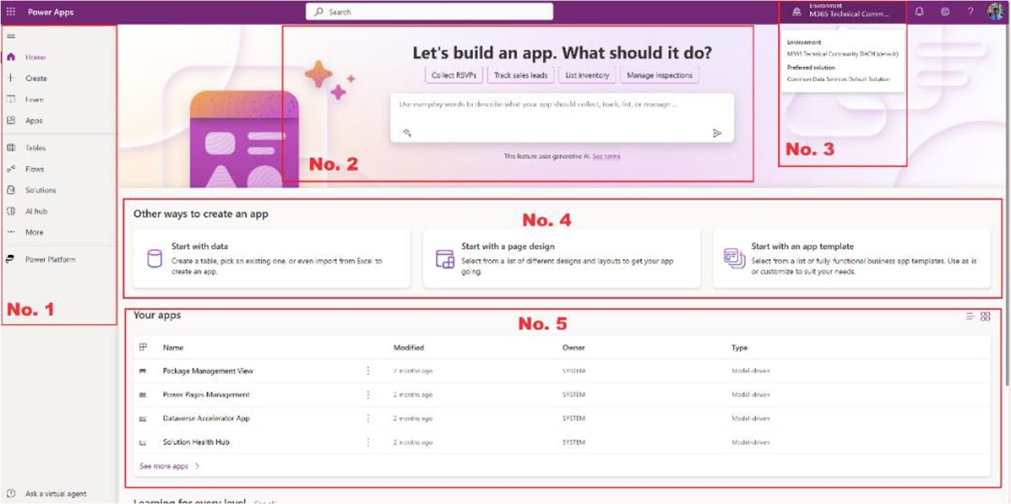

Figure 4-2. Explanation of the Power Apps portal

a. On the left side is a column (No. 1 in Figure 4-2).
You have access to a range of functionalities from this. You can create new Power Apps, access your previously published apps, generate new tables, create new flows, initiate new AI models through the AI hub, and establish connections and data flows,
among other features. See Figure 4-3.

Chapter 4 Crafting power apps with Copilot: the essentials
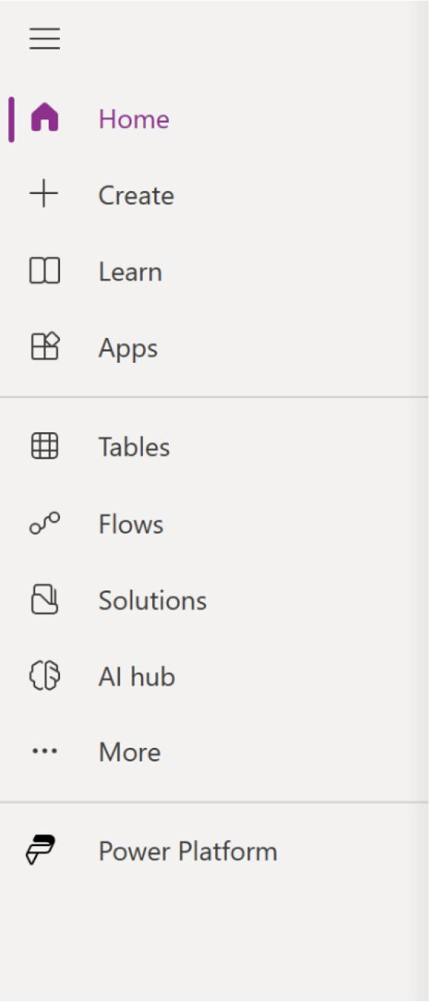

Figure 4-3. Left sidebar with all the important functionalities

b. In the top-center of the page, marked as No. 2 in
Figure 4-2, there is a large text field. This field is designed for inputting commands in natural language, which are then directed to Microsoft
Copilot, as shown in Figure 4-4. Above this field, you will find example commands to guide you.

Chapter 4 Crafting power apps with Copilot: the essentials
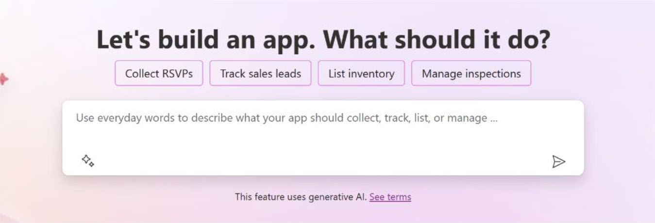

Figure 4-4. Text field to converse with Copilot via Power Apps

c. On the right side of the page, the currently active
Power Apps environment is displayed. By clicking
Environment (No. 3 in Figure 4-2), you can view other environments associated with this tenant (see
Figure 4-5). Additionally, it is possible to switch environments from this section if needed.
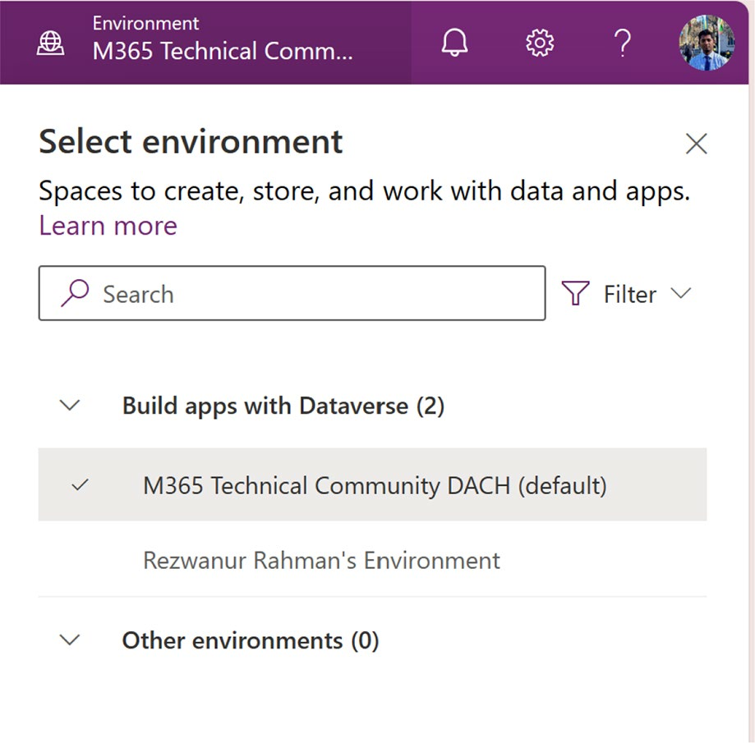

Figure 4-5. Environment selection option in Power Apps

Chapter 4 Crafting power apps with Copilot: the essentials
d. In the center of the page, a segment titled Other Ways
to Create an App appears, as shown in Figure 4-6. It offers various suggestions for app development approaches. The options include creating apps using Excel Data, Power BI data, or custom tables. You also have the flexibility to craft apps with distinct layouts or designs. Moreover, you can develop business applications utilizing app templates.
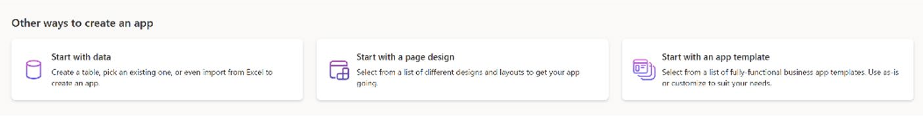

Figure 4-6. Other app creation options

e. In the lower-center position of the Power Apps
portal, you can find the list of apps that you created
from this account, as shown in Figure 4-7.
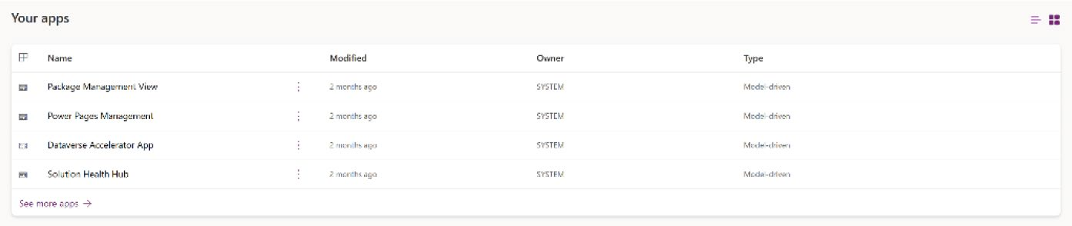

Figure 4-7. The list of apps to be created can be found under this account

3. For this example, I create a Personal Organizer app
using this command:
Design an app that helps users manage their daily tasks. Include features for adding, editing, and deleting tasks.

Chapter 4 Crafting power apps with Copilot: the essentials
4. Press Enter to run the command, as shown in
Figure 4-8.
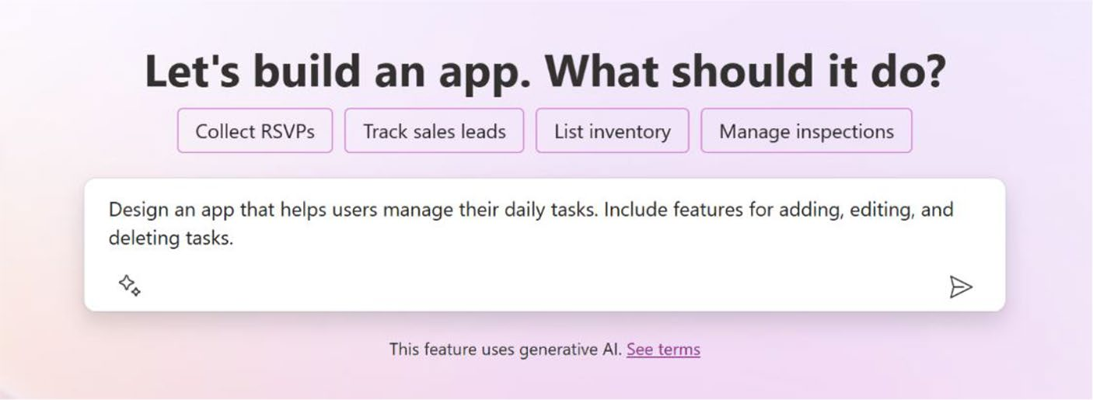

Figure 4-8. Command to create a Power App using Copilot

5. The app preview creation process will require a few
seconds. You will be presented with the page shown
in Figure 4-9.
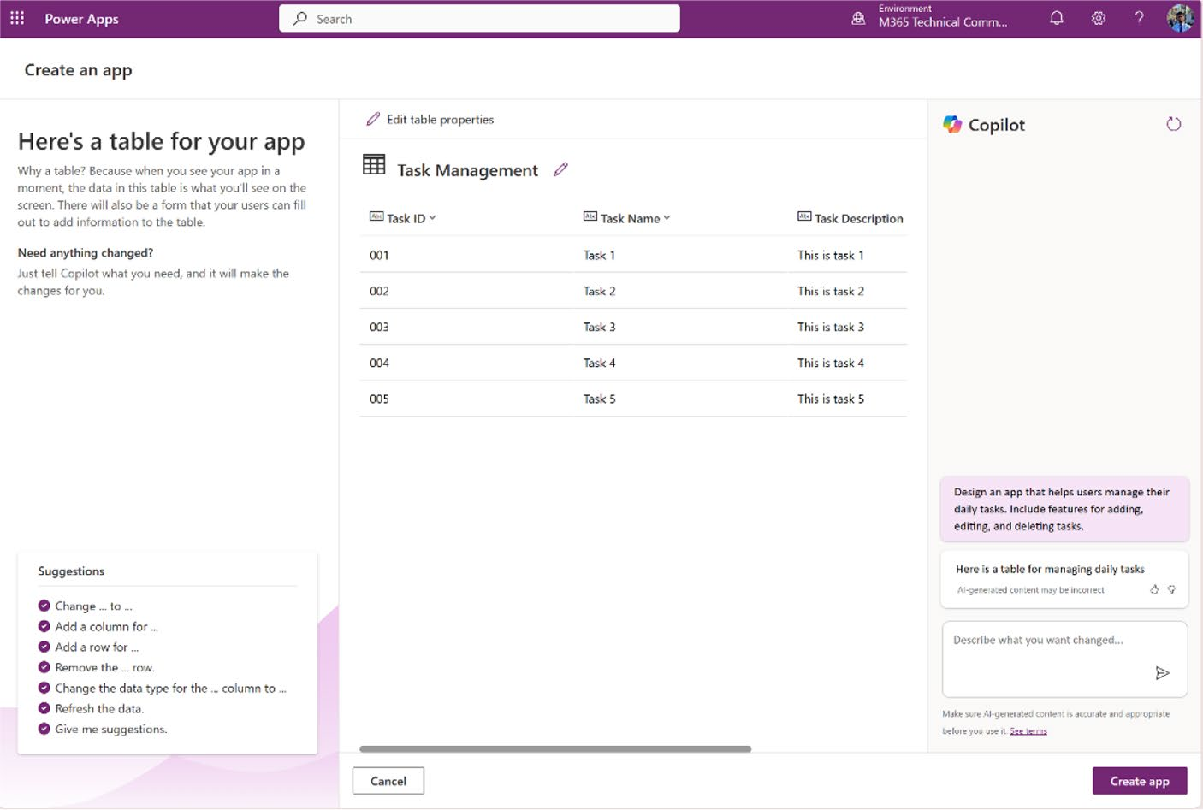

Figure 4-9. Page that previews the app and its table

Chapter 4 Crafting power apps with Copilot: the essentials
Let’s look at this page in detail:
• On the left side, AI suggestions are visible,
providing guidance on how to effectively
command Copilot.
• Centered on the page is the table generated by
Copilot. For manual adjustments, you can click Edit Table Properties to edit the table.
• The Copilot sidebar, situated on the right side,
allows for table editing through the input of commands.
6. I now attempt to interact with Copilot by issuing
commands to modify the app table.
I will add a new column to the table named Status, containing the values Open, Pending, and Closed.
Here is the command (also shown in Figure 4-10):
Add a column named Status with the value Open, Pending and Closed

Chapter 4 Crafting power apps with Copilot: the essentials
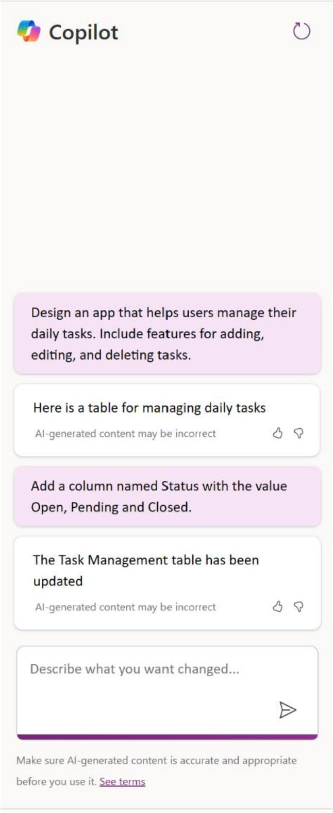

Figure 4-10. Creating a column named Status with different values
In a few seconds, a confirmation message appears noting that the table has been updated. You can find the column in the table as well, as shown in
Figure 4-11.

Chapter 4 Crafting power apps with Copilot: the essentials
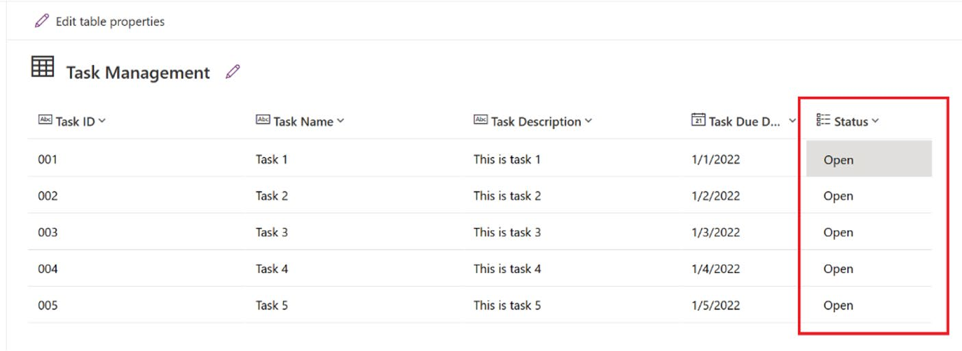

Figure 4-11. A newly created column named Status is shown in the table
7. This is sample data that was provided by Copilot. I
work on that data to build the apps. After that, you click the Create App button to finalize the app. You
will see the finalizing page, as shown in Figure 4-12, which will take a few minutes to appear.
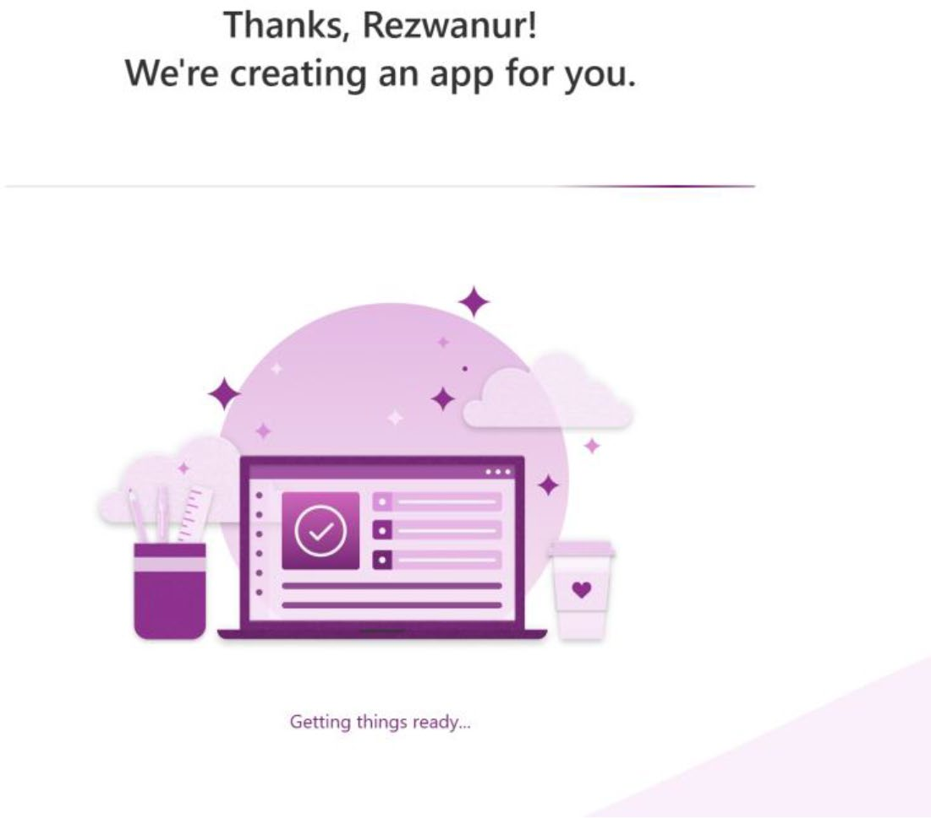

Figure 4-12. Finalizing page of Power Apps

Chapter 4 Crafting power apps with Copilot: the essentials
8. Upon successful creation of the app, the screen in
Figure 4-13 will be displayed.
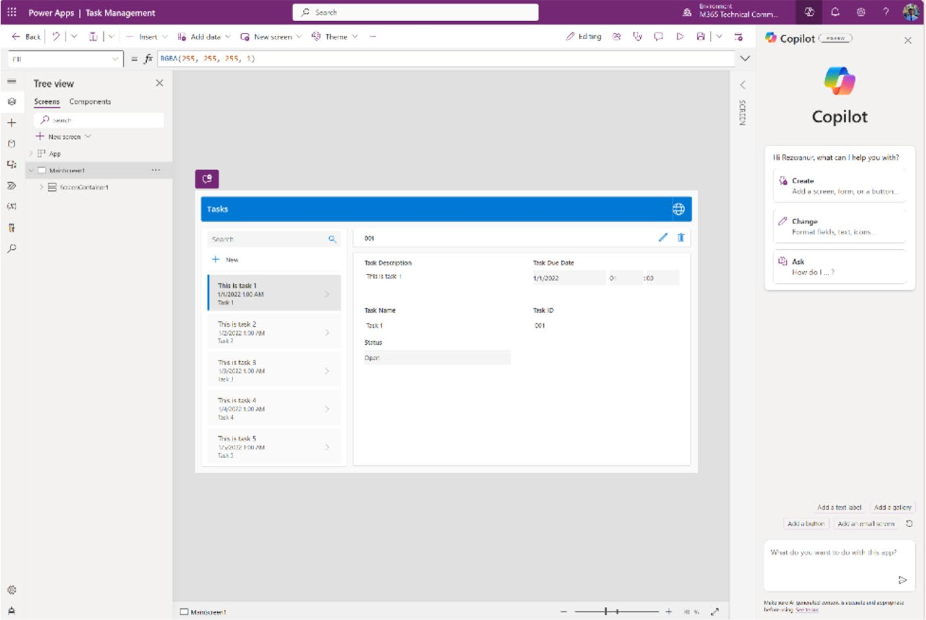

Figure 4-13. Power Apps project page

This is the basic app that I created with Copilot. Let’s now explore
some design principles that you can implement with Copilot.

Design Principles for Beginners
As you progress in your journey through app development with Power
Apps and Copilot, it is time to explore the fundamental principles of
design. These principles are the building blocks for creating apps that are
not only functional but also user-friendly and visually appealing. This
section covers some essential topics such as layout, navigation, color
schemes, and user interaction. It also discusses how mastering these
elements contributes to crafting engaging experiences for your users.

Chapter 4 Crafting power apps with Copilot: the essentials
Additionally, I explore how Copilot can assist you in applying these principles, ensuring that even beginners can achieve professional-looking results with confidence. Let’s dive into the world of design fundamentals and discover how they shape the apps you create.
Return to the Power Apps project page, as shown in Figure 4-14.
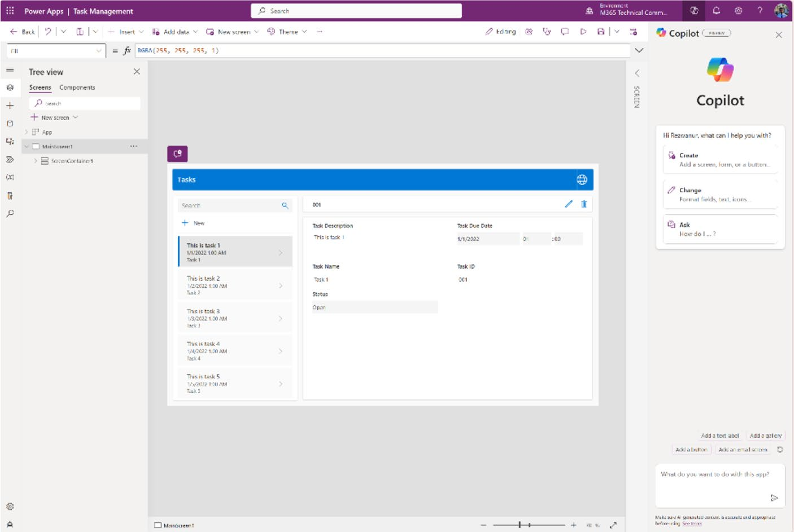

Figure 4-14. Power Apps project page
Let’s look at this page in detail before moving on:
• On the left side, you can access an array of controls
specifically designed for Power Apps. This area also offers options for incorporating external data, media, power automation, variables, and advanced tools. Moreover, the Tree View section displays all the screens and components. By selecting the New Screen option, you can easily add more screens to your app, which I explore in
more detail in subsequent steps. Refer to Figure 4-15.

Chapter 4 Crafting power apps with Copilot: the essentials
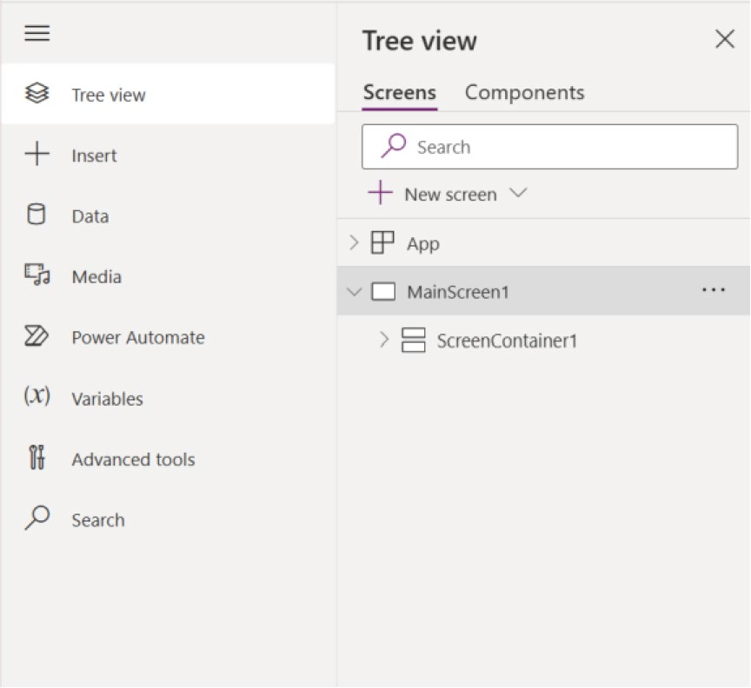

Figure 4-15. The left sidebar of Power Apps, containing controls,
data, media, automation, and many other options

• In the center of the screen, you will see the live app
preview displaying data sourced from the Microsoft Dataverse table you previously explored, as shown in
Figure 4-16.

Chapter 4 Crafting power apps with Copilot: the essentials
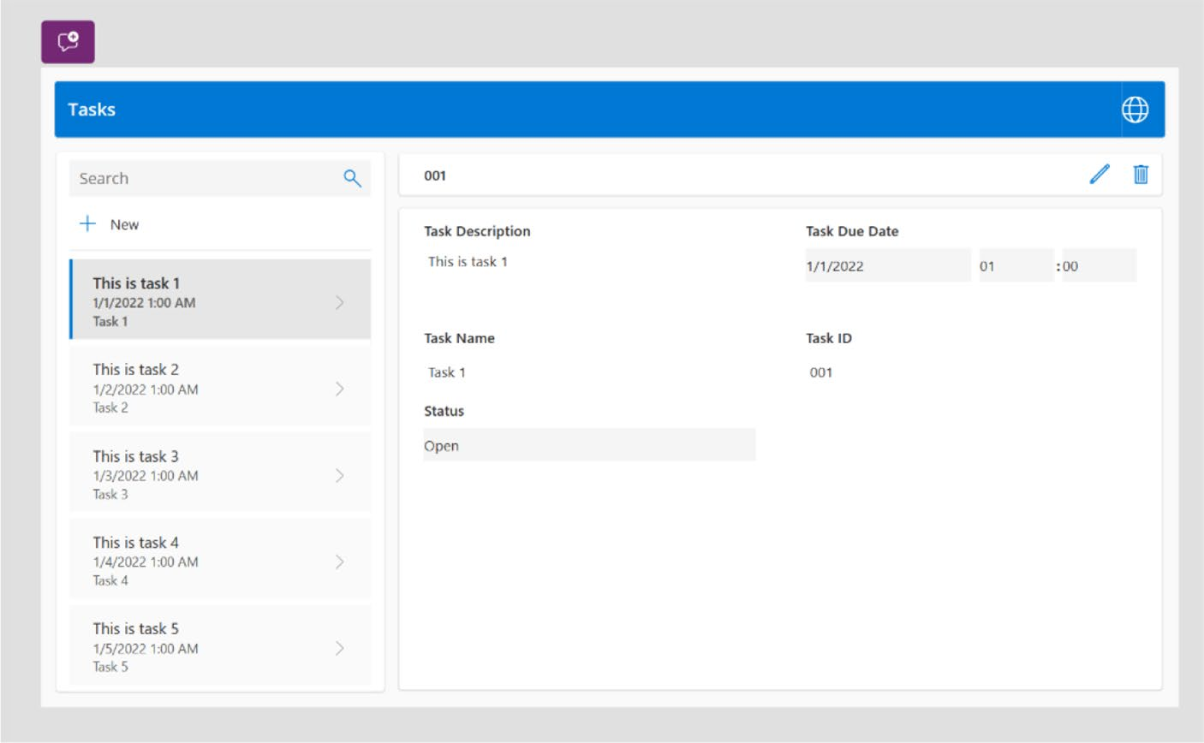

Figure 4-16. App preview created by Microsoft Copilot

• On the right side, two default options are available,
providing access to the properties of any selected
control or component, as shown in Figure 4-17. For instance, if I select the main screen of the application, I can view and modify the properties of MainScreen1, such as changing the background color or adding images. This section also allows you to configure advanced features. Adjacent to this, there is the Copilot section, where interactions can be conducted through conversation to perform various tasks.

Chapter 4 Crafting power apps with Copilot: the essentials
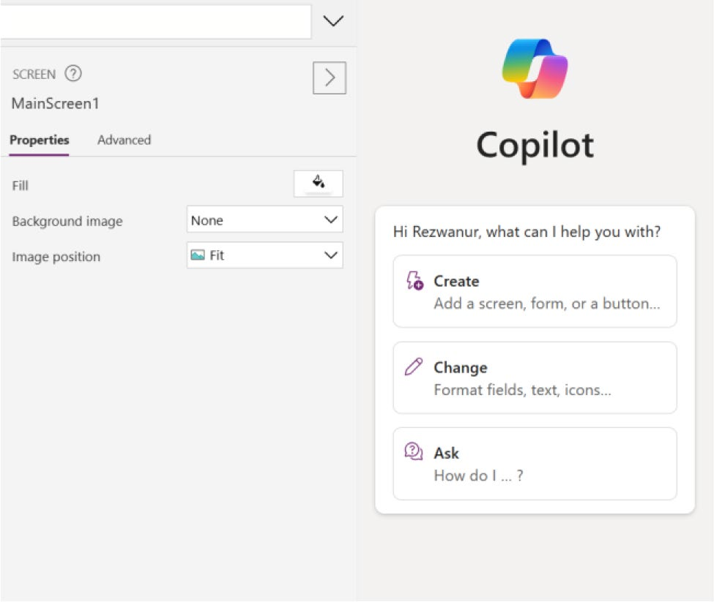

Figure 4-17. Copilot and control properties option in the
right sidebar

Now is the moment to start modifying the app. This example initially
relies on Copilot to change, add, or delete components before proceeding
with manual adjustments. Before you give Copilot commands, it is crucial
to have a clear understanding of the changes you want to implement.
Review the app to identify the necessary modifications, as shown in
Figure 4-18.

Chapter 4 Crafting power apps with Copilot: the essentials
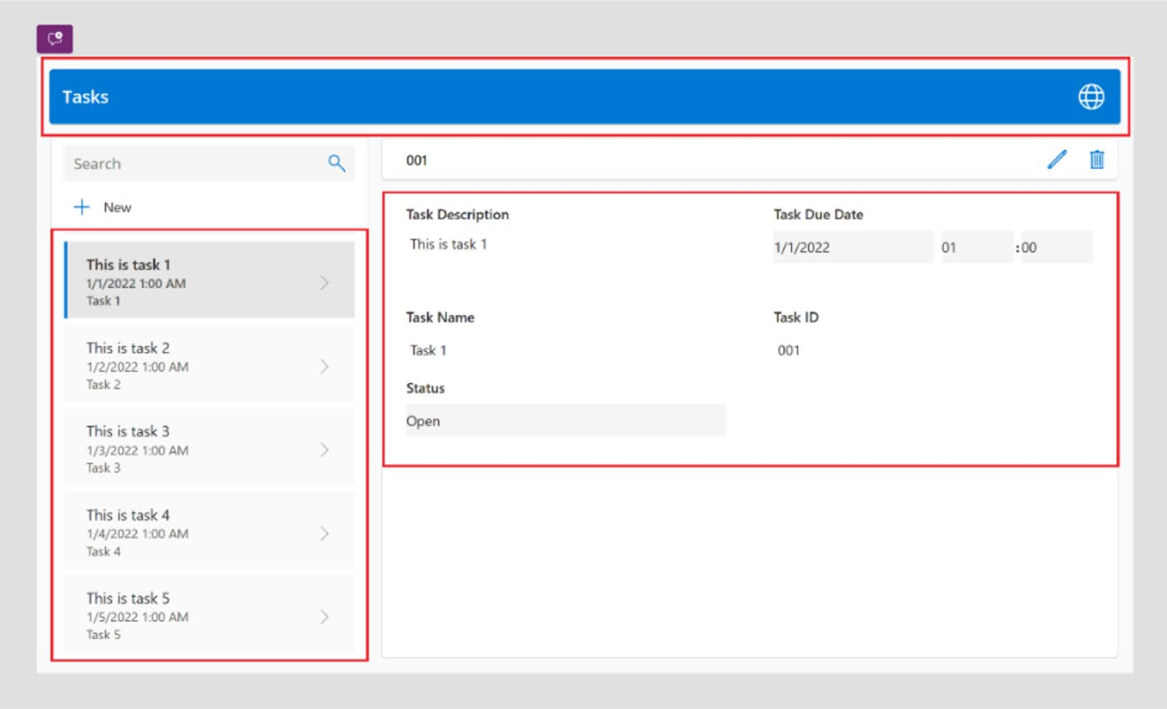

Figure 4-18. Identifying the app grids

• At the top of the app, there is a blue layout where the app’s
name is displayed, along with any additional buttons such as a Back, Next, or Close button. I also show you how to change the color of the layout through Copilot.
• On the left side, there is a container displaying all tasks,
which includes the task name, date and time, and a description. The current layout needs to be adjusted so that the task name serves as the headline (right now, the description is in that spot).
• In the middle of the app, where all the task information
is visible, I show you how to enhance this section by incorporating more details. This includes adding Microsoft Entra ID users (formerly known as Azure Active Directory users), a Copilot Chat button, and a custom text field for entering additional notes.

Chapter 4 Crafting power apps with Copilot: the essentials

Changing the Background Color of Component,
Container with Copilot
This section explains how to change the color of the header container
through Copilot. First you need to understand what is inside the container.
See Figure 4-19.
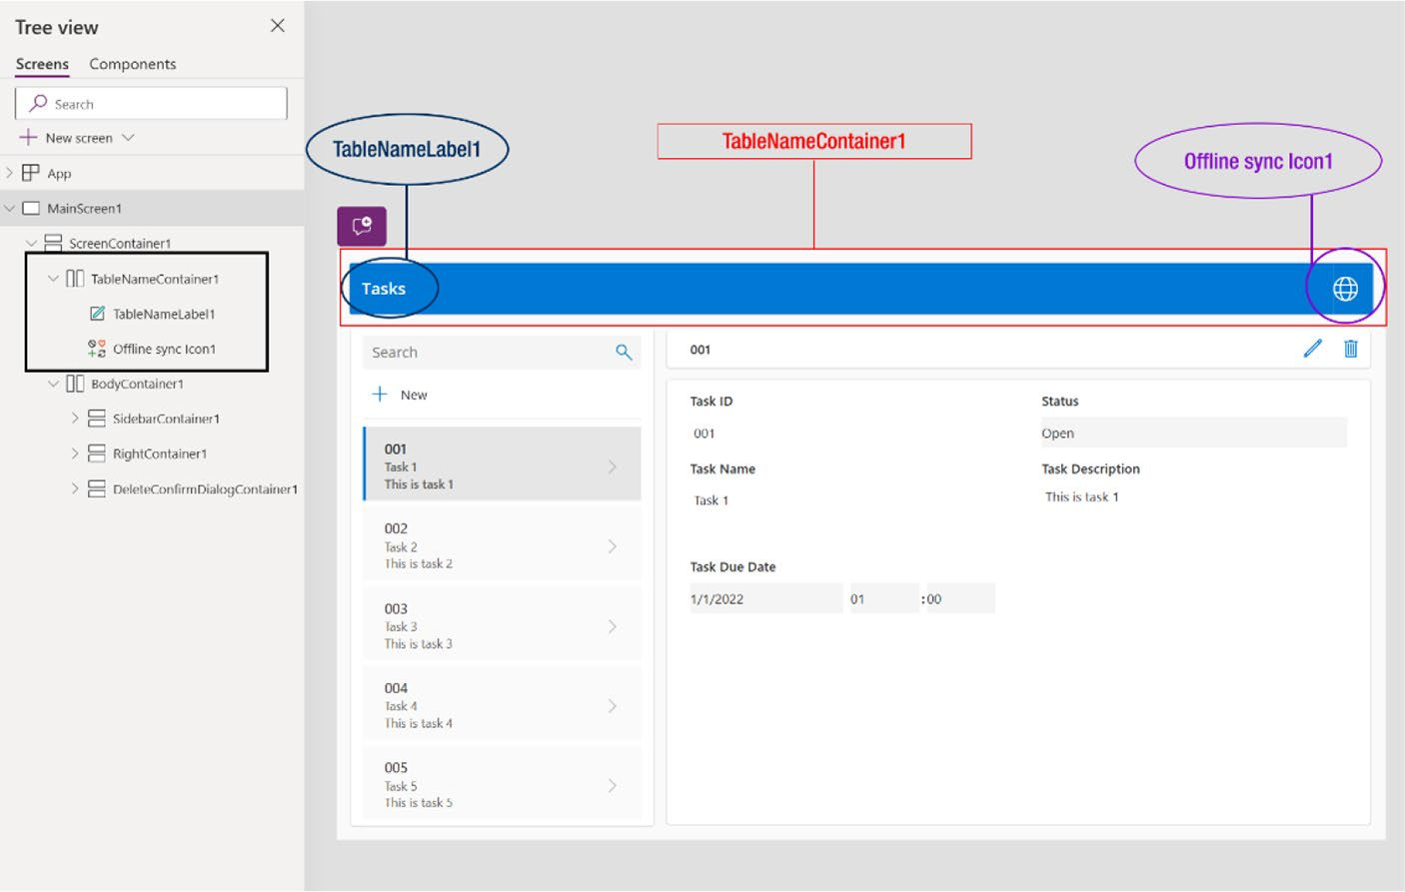

Figure 4-19. Checking the components inside the container
The components in the container are highlighted on the left
side, marked in black. Each component has its own set of properties,
such as background color, position, padding, height, width, and
additional advanced settings. Therefore, if you change the background
color of TableNameContainer1, it will only affect the background of
TableNameContainer1, leaving the properties of other components inside
the container unchanged.

Chapter 4 Crafting power apps with Copilot: the essentials

Note it is essential to remember that whenever there is a need
to modify a component, style, or any other element within the app
through Copilot, you should specify the name of the component. this
way, Copilot can make the necessary adjustments directly.

Now let’s change the color of the whole blue container. I provide the following command to Copilot to change the color (also shown in
Figure 4-20):
Change the background color of TableNameLabel1, TableNameContainer1 and Offline sync Icon1 blue to brown.
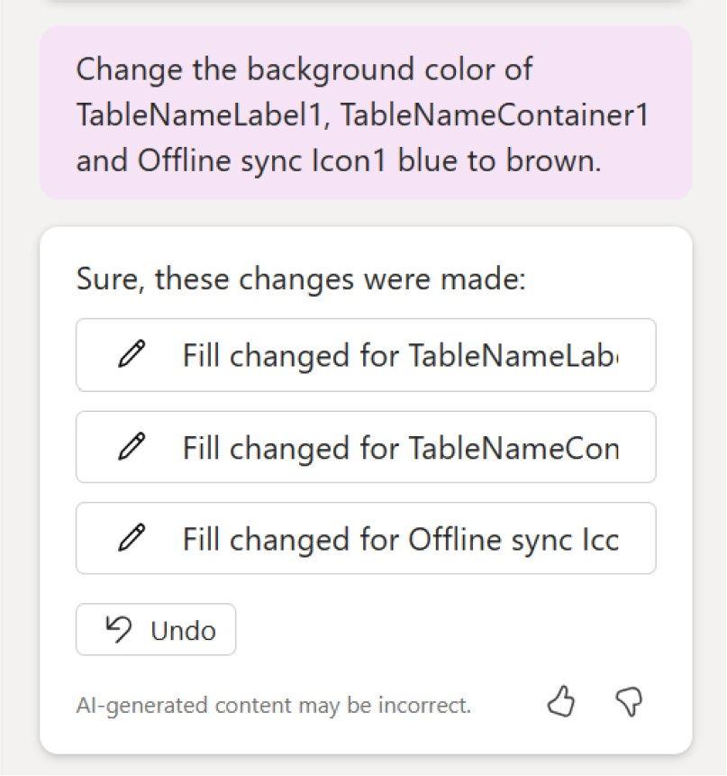

Figure 4-20. Conversation with Copilot to change the color of Power Apps components

Chapter 4 Crafting power apps with Copilot: the essentials
This yields the outcome shown in Figure 4-21.
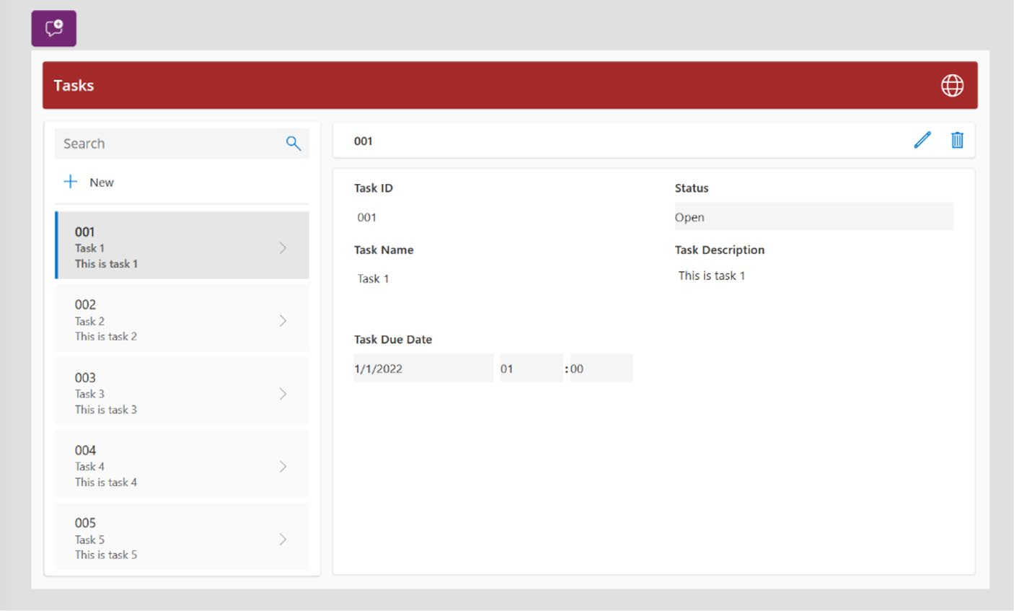

Figure 4-21. Outcome after the Copilot prompt to change the
component's background color

Experimental Proof:
I will now change the background color of only one component inside
the container.
The Copilot command that I am using now is (see Figure 4-22):
Change the background color of TableNameLabel1 brown to green.

Chapter 4 Crafting power apps with Copilot: the essentials
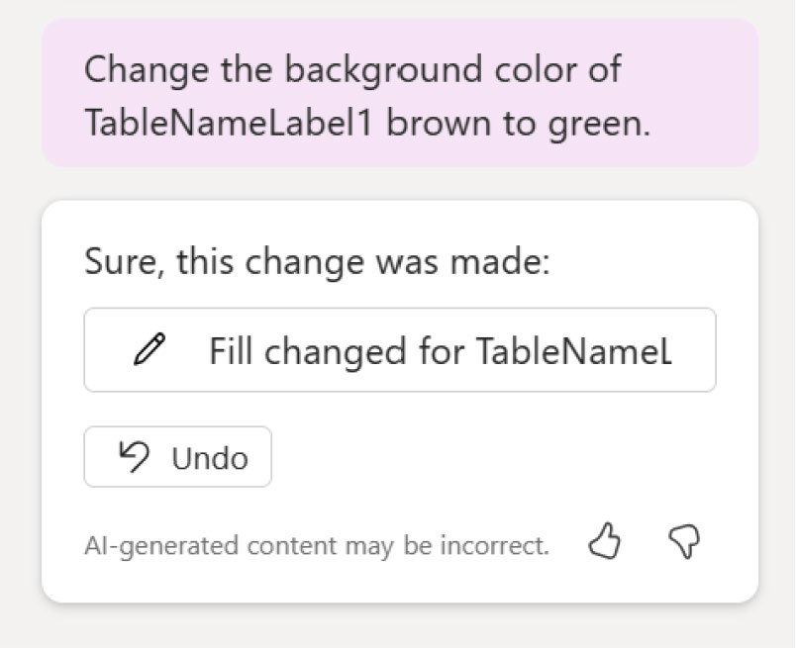

Figure 4-22. Copilot prompt to change only one component
The result is shown in Figure 4-23.
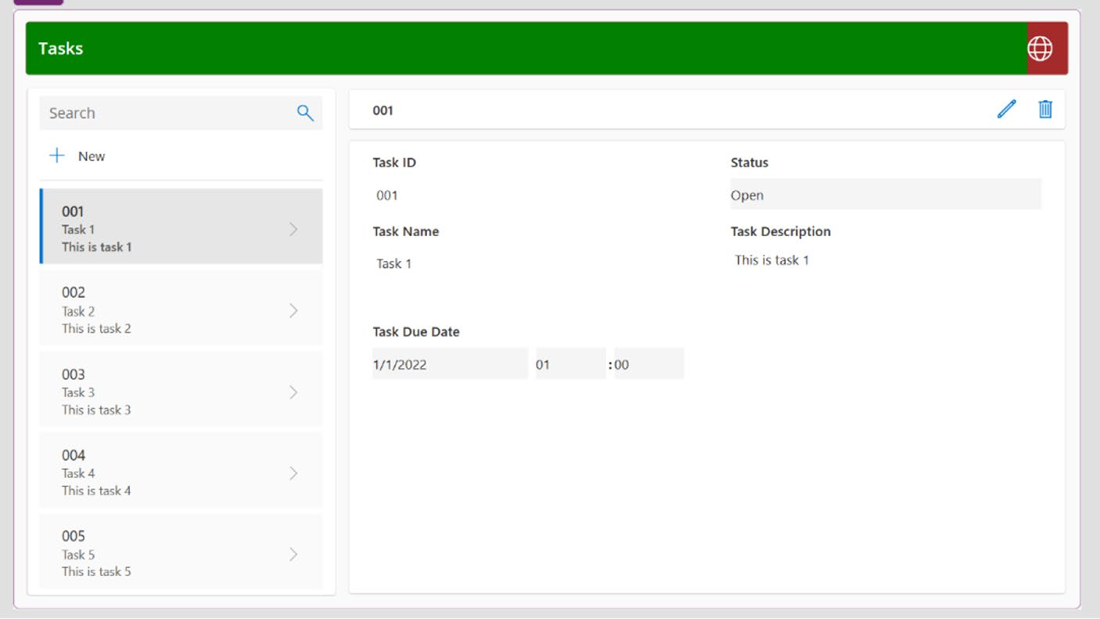

Figure 4-23. Outcome after the Copilot prompt to change only one component

Chapter 4 Crafting power apps with Copilot: the essentials
Here, it is evident that the background color of TableNameLabel1 has
been changed to green, while the other colors have remained brown. As
this is an experiment, I revert to brown again.
I will now change the background of the app main screen container.
The default name of the main screen container in Power Apps platform
is ScreenContainer1. I will push the following command to Copilot to
change the ScreenContainer1 background color, as shown in Figure 4-24.
Change the background color of ScreenContainer1 to Orange.
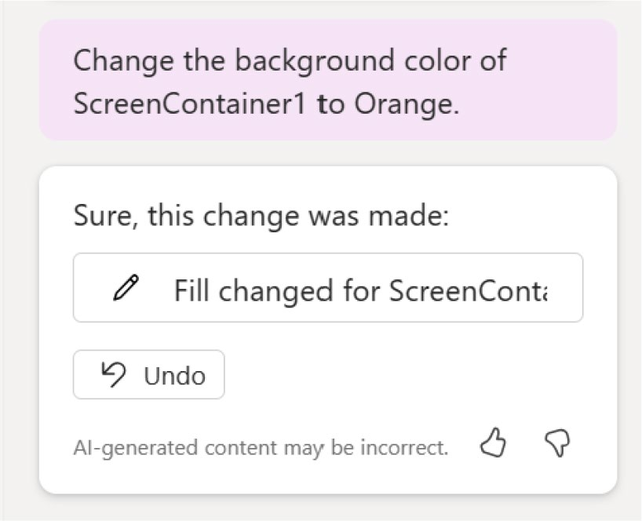

Figure 4-24. The Copilot prompt to change the background color

Chapter 4 Crafting power apps with Copilot: the essentials
The outcome is shown in Figure 4-25.
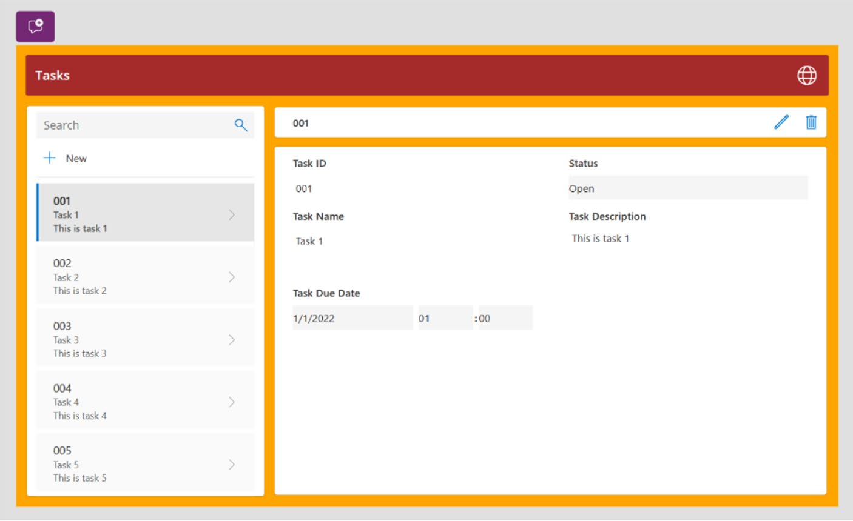

Figure 4-25. Outcome after the Copilot prompt to change only one component

Note in power apps, every element—containers, text fields,
images, media, and buttons—are placed within a screen, which is
called screen container. the screen that is set to run or debug first
within the app is known as the main screen on the power apps
platform.

Changing the Text or Label Properties with Copilot
This section shows how Copilot can help you change the text or label properties with a natural command.

Chapter 4 Crafting power apps with Copilot: the essentials
To change the text, you need to know the name of the label, textbox, or
text field. This is similar to changing the color of components.
As an example, I change the value of the text component named
NewRecordLabel1. The value is New, and I will change the value called Add
My New Item, as shown in Figure 4-26.
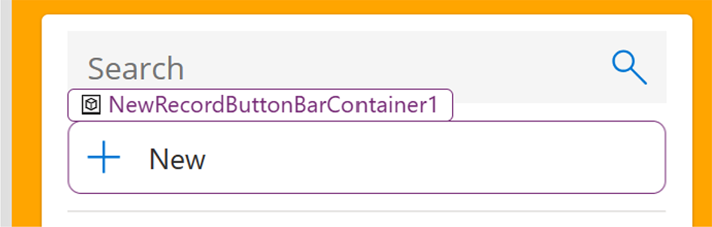

Figure 4-26. NewRecordLabel1 component

Place the following prompt in Copilot, as shown in Figure 4-27:
Change the NewRecordLabel1 text to "Add my new item".
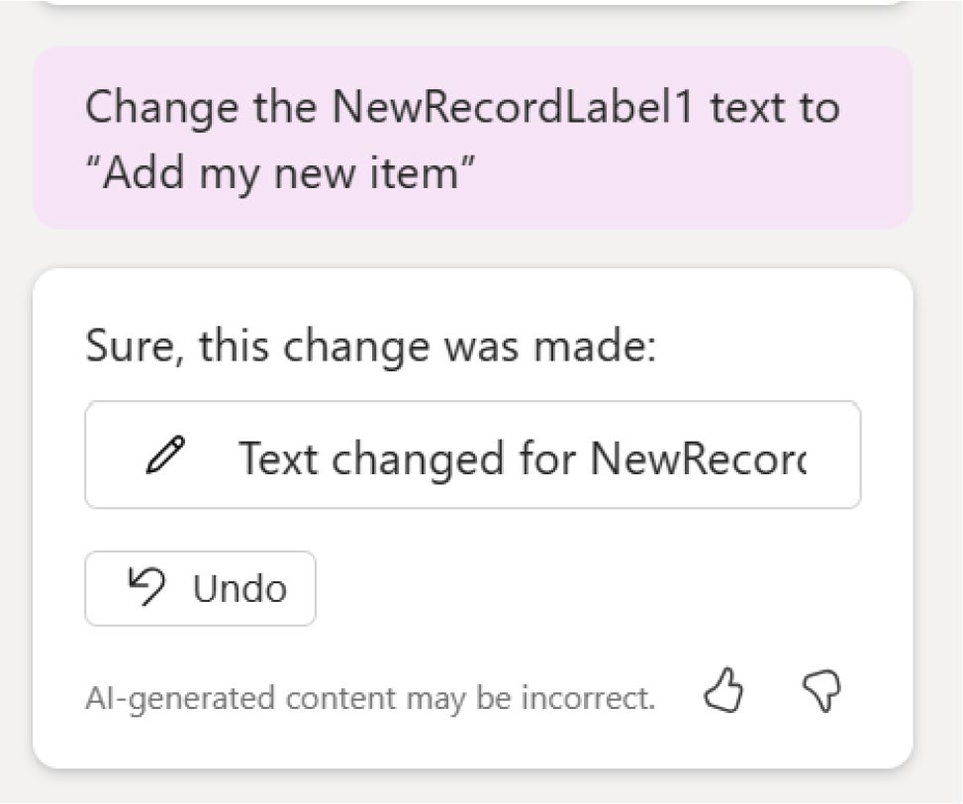

Figure 4-27. Changing the text value using Copilot

Chapter 4 Crafting power apps with Copilot: the essentials
It will just take a few seconds to make this change. The result is shown
in Figure 4-28.
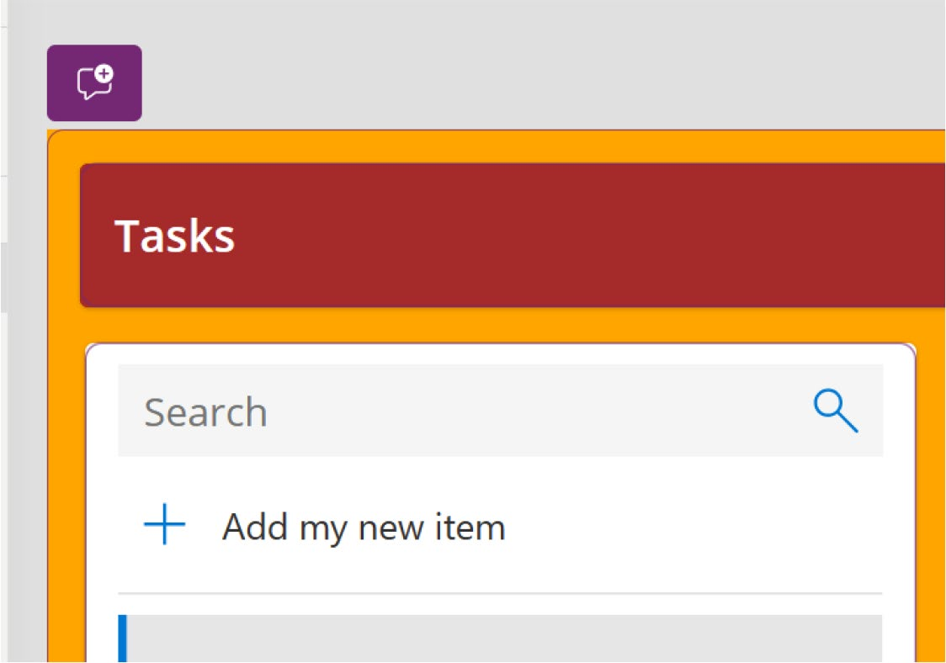

Figure 4-28. Outcome after the Copilot prompt to change the text value
Now, let’s send multiple queries in a single command. For example, you can change the font, font style, font size, and text alignment using a
single command, as shown in Figure 4-29. The command I used follows:
Change the NewRecordLavel1 font to "Dancing Script", font style should be Bold, font size should be 15 and text alignment should be center.

Chapter 4 Crafting power apps with Copilot: the essentials
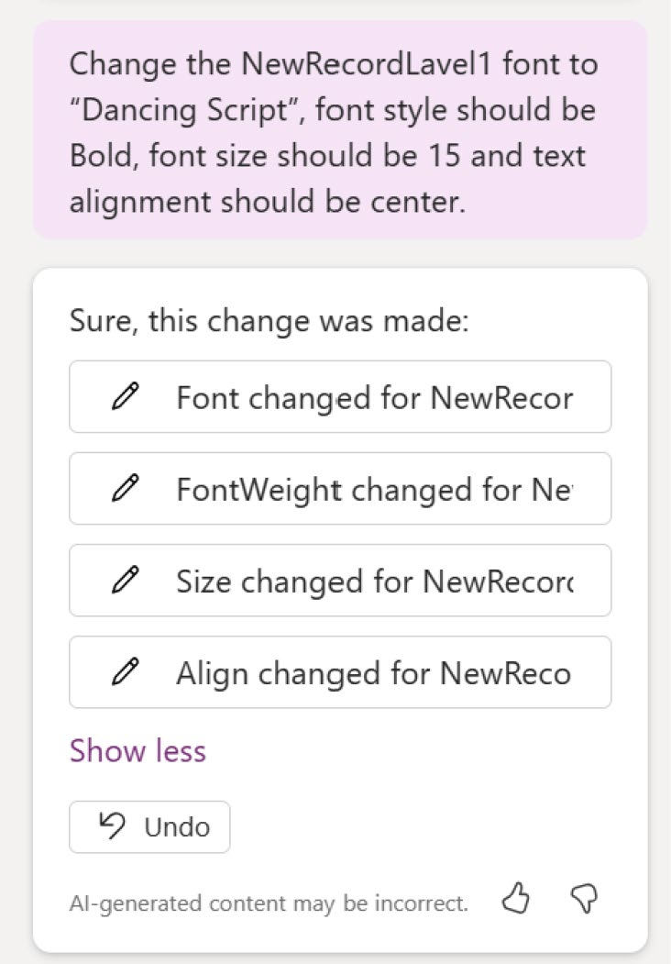

Figure 4-29. Copilot prompt to change all the font properties at
one time

Chapter 4 Crafting power apps with Copilot: the essentials
The outcome is fantastic, as shown in Figure 4-30.
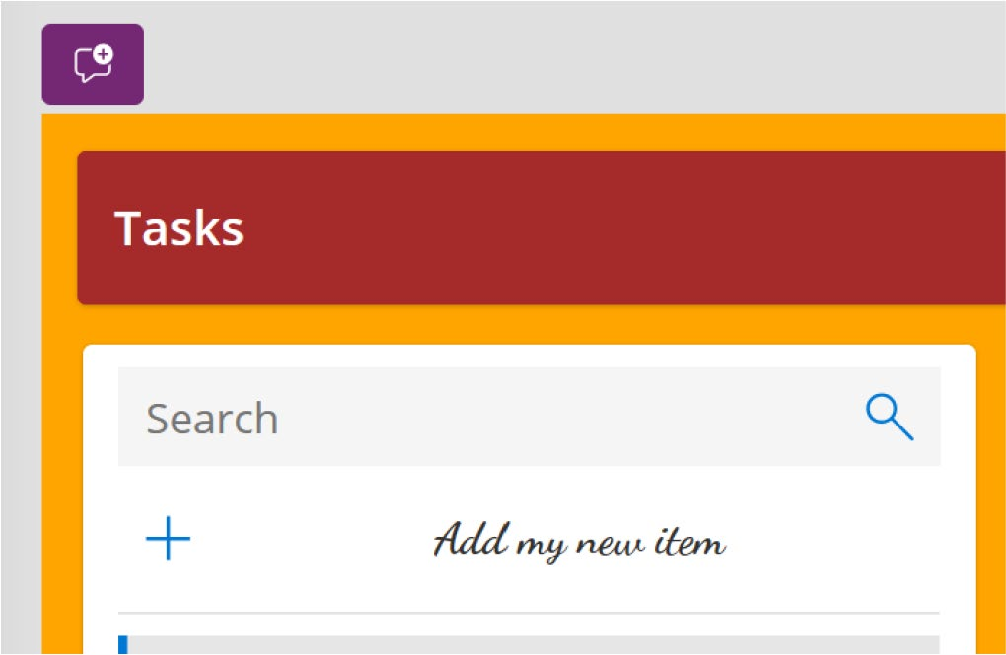

Figure 4-30. Outcome after the Copilot prompt to change all the font properties

Adding a Text Field or Label with Copilot
This section shows how to add two different labels in this application. One is in TableNameContainer1 and the other is in Form1, which is inside
BodyContainer1, as shown in Figure 4-31. The command is as follows:
Create two text labels, one is inside the TableNameContainer1, and another is inside Form1 below the Task Due Date, the value or text is TableNameContainer1 = "My Personal App" and Form1 = "Copyright 2024 – Rezwanur Rahman".

Chapter 4 Crafting power apps with Copilot: the essentials
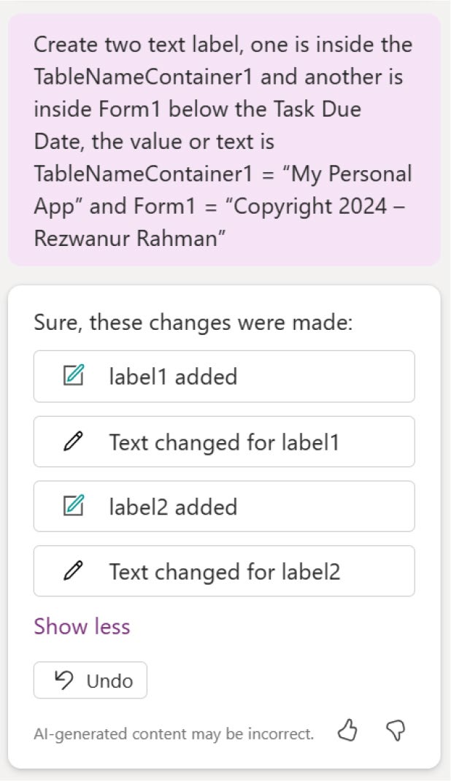

Figure 4-31. Copilot prompt to add a text label to the Power
Apps project

Copilot has successfully created these labels, as shown in Figure 4-32.

Chapter 4 Crafting power apps with Copilot: the essentials
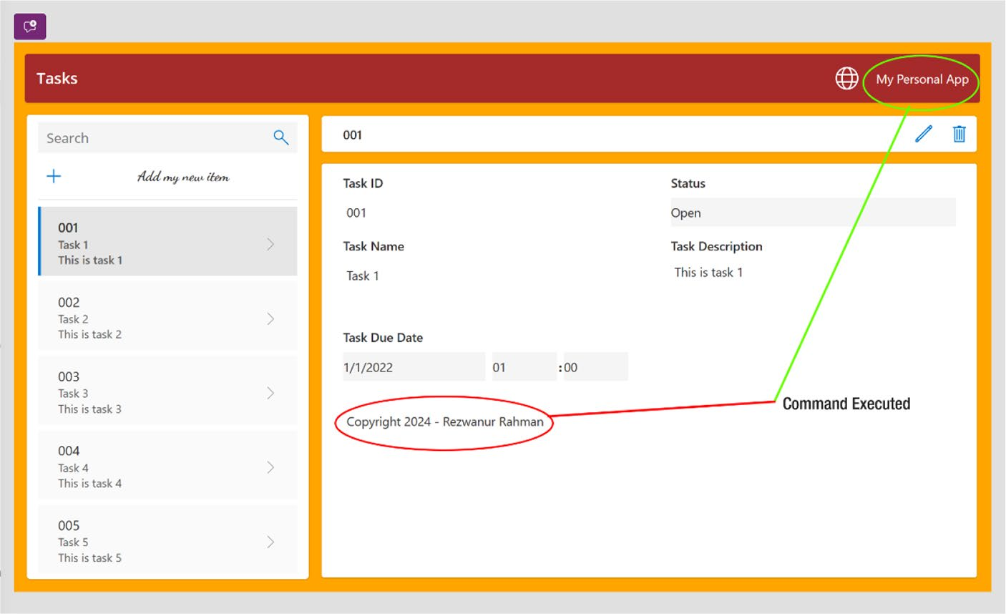

Figure 4-32. The outcome after the Copilot prompt to add two labels to a different container

Now let’s modify the fonts and font styles displayed in the list container. First, you need to identify the names of the components
involved, as shown in Figure 4-33.

Chapter 4 Crafting power apps with Copilot: the essentials
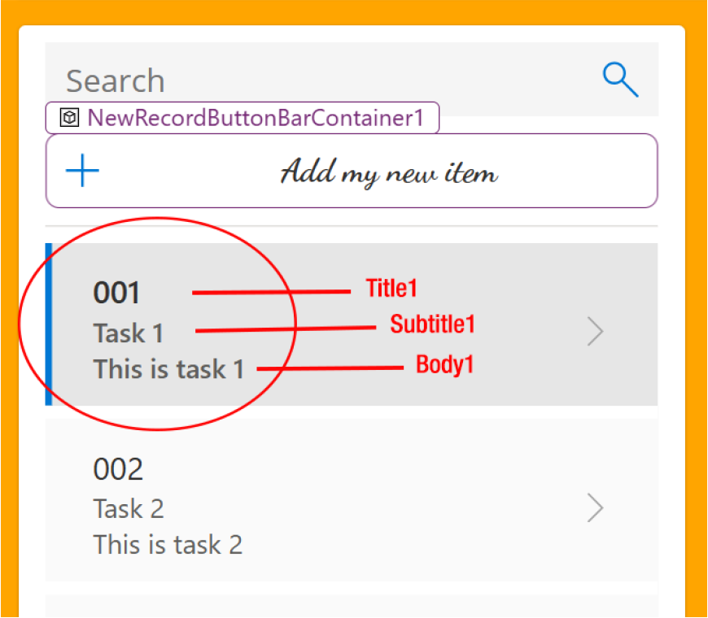

Figure 4-33. Finding the name of the components
To find the name of the component, click it. It will automatically be
highlighted in the tree view on the left sidebar, and its name will appear as
shown in Figure 4-34. At the same time, the right sidebar will display the
option’s properties, including the type of the component and its name, as
shown in Figure 4-35.

Chapter 4 Crafting power apps with Copilot: the essentials
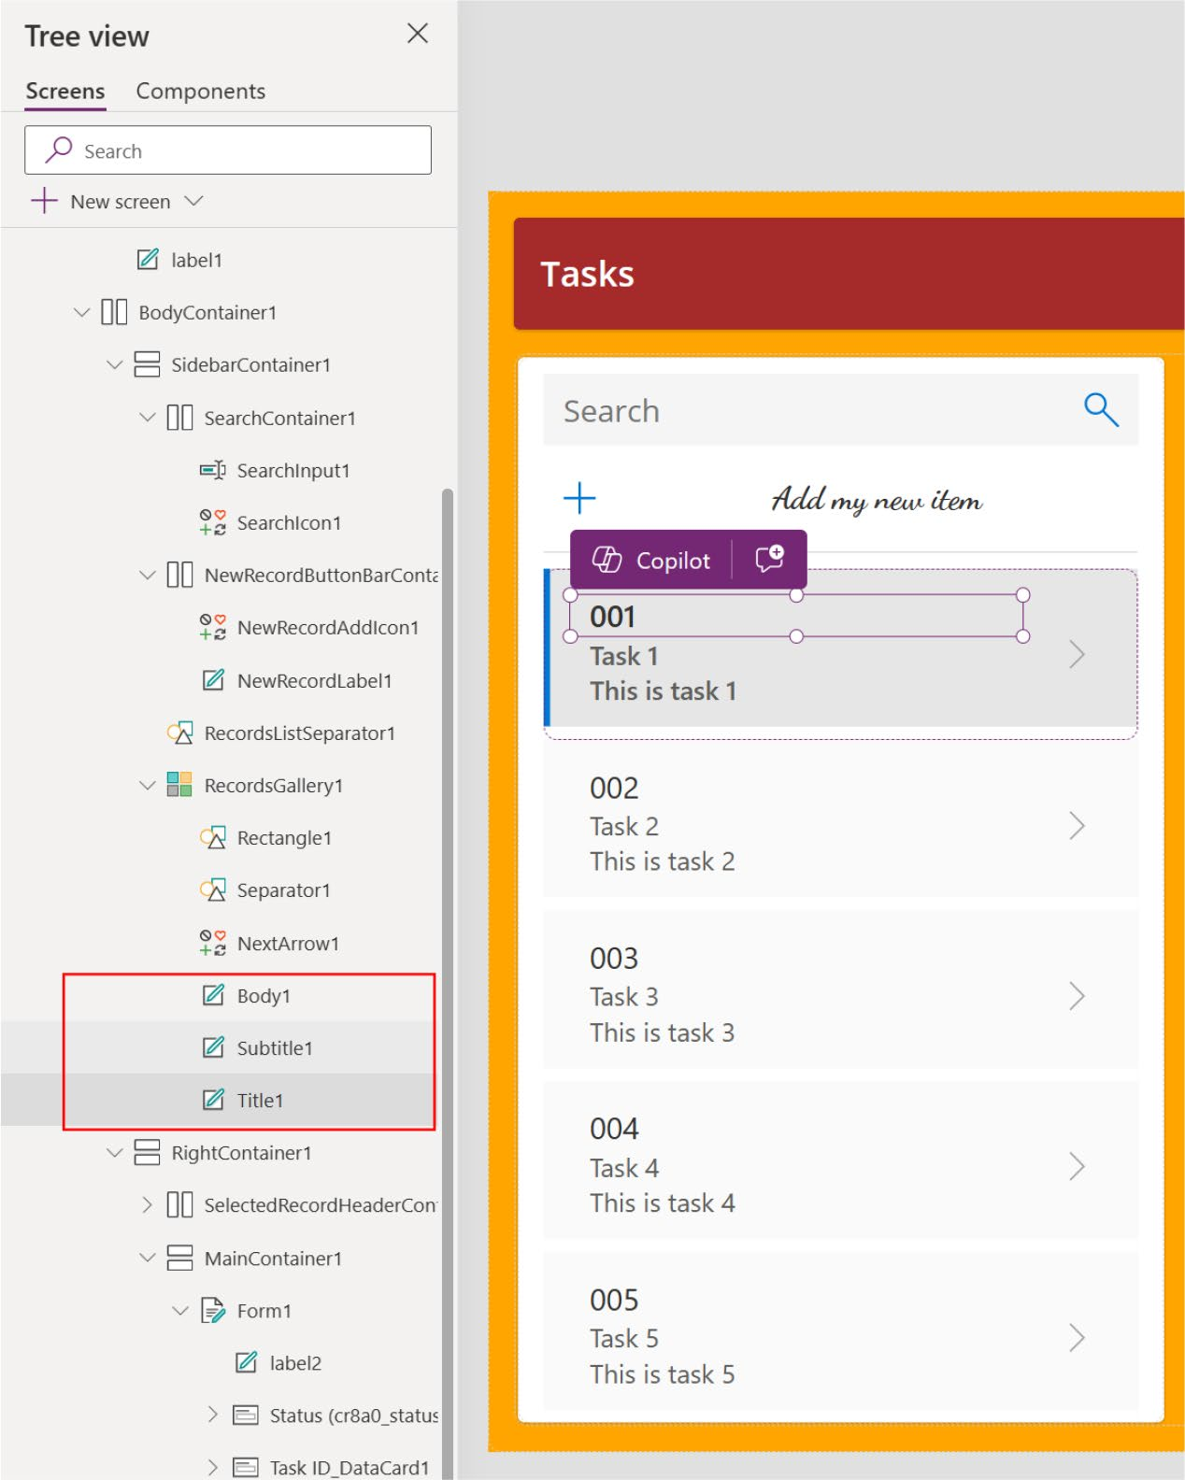

Figure 4-34. Locate the component name using the tree view in the left sidebar

Chapter 4 Crafting power apps with Copilot: the essentials
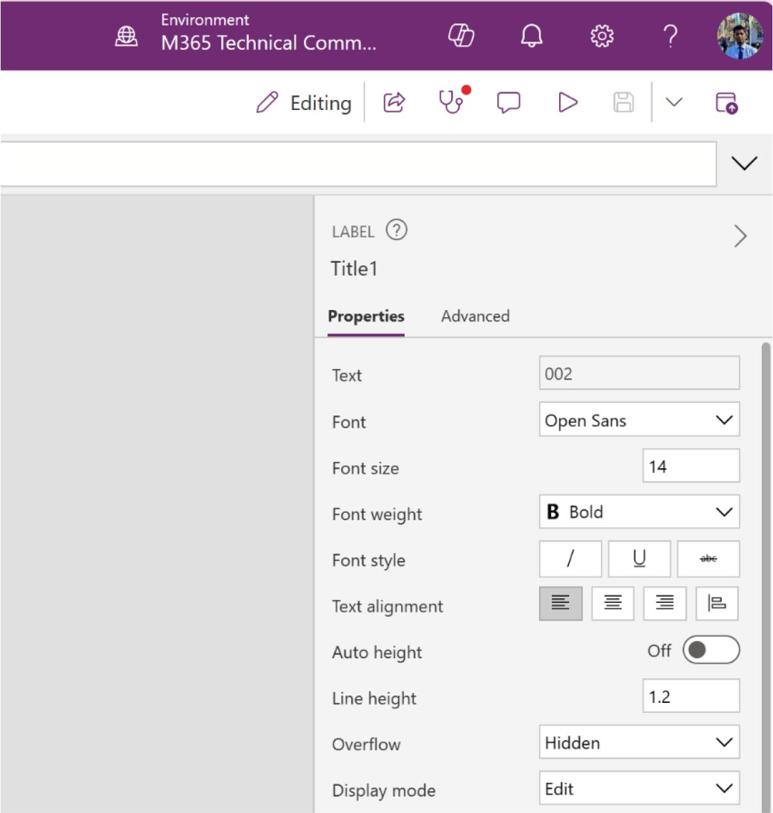

Figure 4-35. Locate the component name from the properties
You can push the following command to Copilot to change the font
and font style, as shown in Figure 4-36.
Change the Title1, Subtitle1 and Body1 font to "Dancing
Script", Title1 font style should be Bold, font size should be
15, Subtitle1 and Body1 should be okay.

Chapter 4 Crafting power apps with Copilot: the essentials
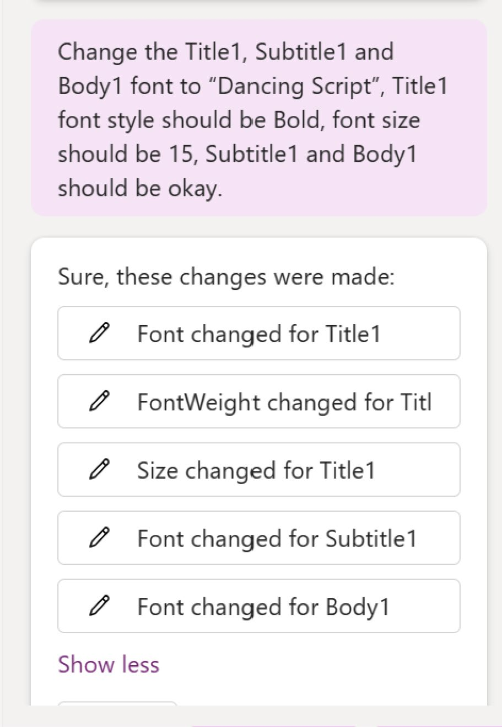

Figure 4-36. Copilot prompt to change font style and size for titles and subtitles

You will get the result shown in Figure 4-37.

Chapter 4 Crafting power apps with Copilot: the essentials
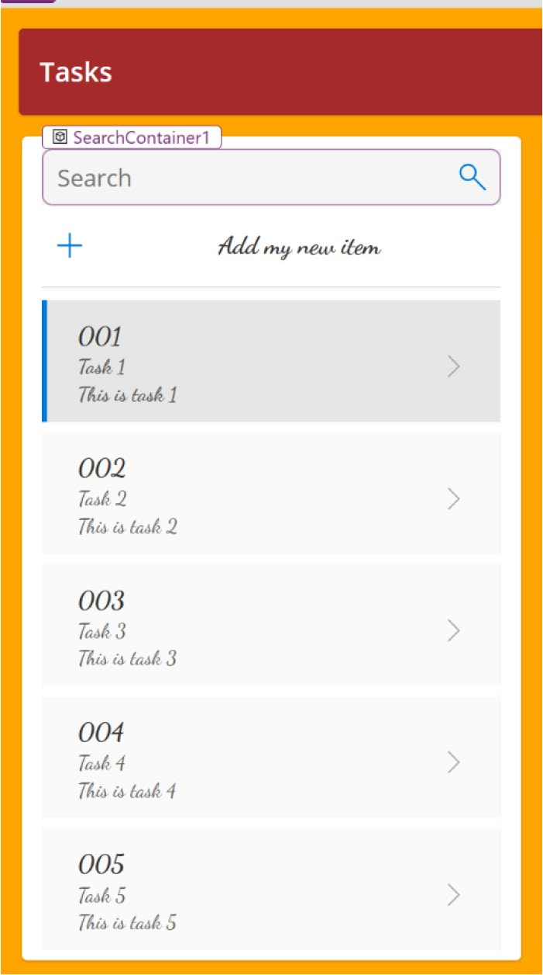

Figure 4-37. Outcome after the Copilot prompt to change the font
family and the size for the title and body

Note Changing certain text or labels via Copilot with simple commands is not always possible, as some labels are tied to
functions (fx) or formulas. this topic is covered in detail in Chapter 6.

Chapter 4 Crafting power apps with Copilot: the essentials

Adding Components with Copilot
Learning to effectively utilize Copilot is a key design principle in Power Apps. With Copilot acting as your assistant, there is no need for manual additions of components, screens, or media—Copilot can handle these tasks on your behalf. Moreover, employing multiple screens, linking them, and facilitating data sharing across these screens are crucial design strategies. It is considered poor practice to display all data on a single page.
Then next section shows you how to use Copilot to add components to your application.

Adding a Screen with a Copilot Prompt
To add a second screen to the app project using Copilot, you send a
prompt like this to Copilot, as shown in Figure 4-38:
Create a Screen named Screen2.
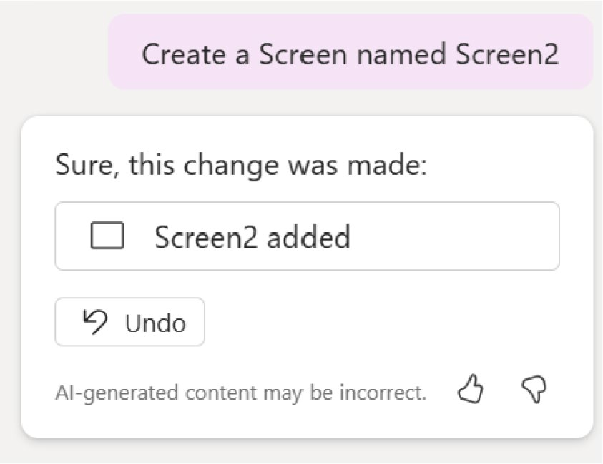

Figure 4-38. Copilot prompts to create screens in Power Apps

You can provide any other name for the screen. Screen2 is used for this specific project only. After a few seconds, you’ll see a blank screen named
Screen2, as shown in Figure 4-39.

Chapter 4 Crafting power apps with Copilot: the essentials
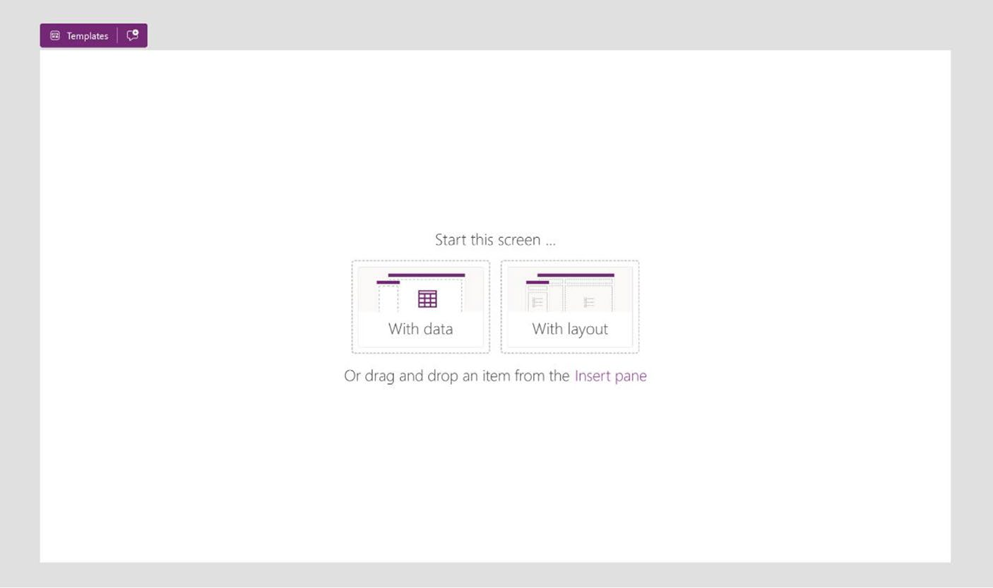

Figure 4-39. Outcome after the Copilot prompt to create a new screen
in the existing Power Apps project

Connect a Screen to a Screen Using Copilot
It is time to tailor the page, and there are three customization options
available to you:
1. Incorporate data into this screen from Microsoft
Excel, Power BI, or Microsoft Dataverse.
2. Focus on adding layouts now and adjust the data at
a later stage.
3. Utilize the Insert pane on the left side to drag and
drop items directly onto the page.

Chapter 4 Crafting power apps with Copilot: the essentials
I am using Copilot for this project, so I will not be using any other tools. I direct Copilot to create a ScreenContainer, and within that, I add a button that links to the main screen. The command for these actions follows:
Create a new Screen Container named ScreenContainer2 and inside that, create a back arrow and connect it with MainScreen1.
Figure 4-40 shows the command prompt.
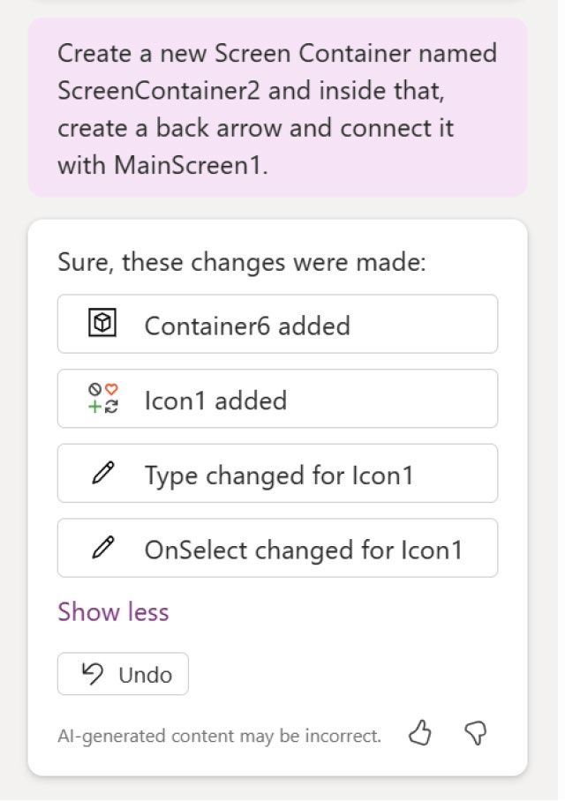

Figure 4-40. Copilot prompt to create a container with a back icon and connect it to MainScreen1

As shown in Figure 4-41, Copilot has created the ScreenContainer and a back arrow button and connected it to the MainScreen1.

Chapter 4 Crafting power apps with Copilot: the essentials
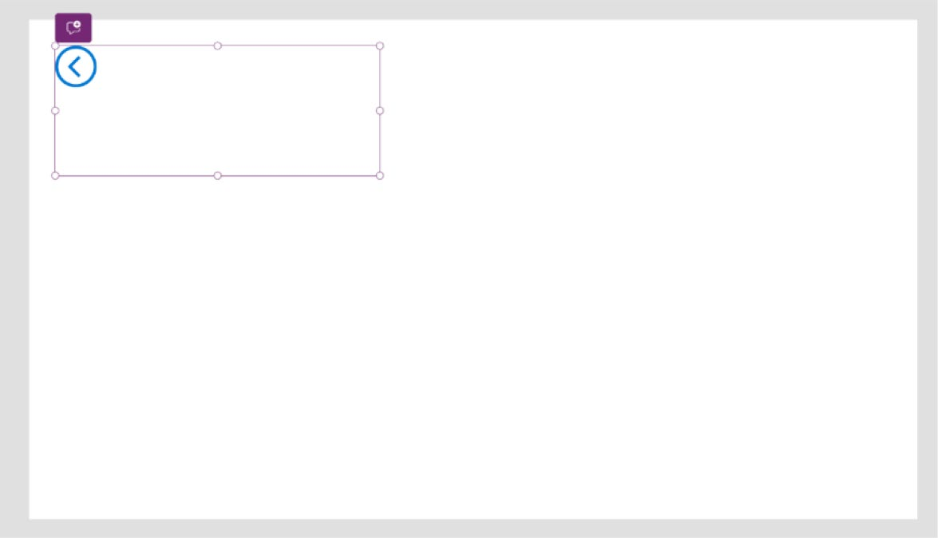

Figure 4-41. Outcome after the Copilot prompt to create a new screen
and a back button connected to MainScreen1

You can verify this connection in two ways:
1. To launch the app, simply click the Run button or
press F5. Afterwards, by clicking the back arrow, you will be redirected to the main screen. See
Figure 4-42.
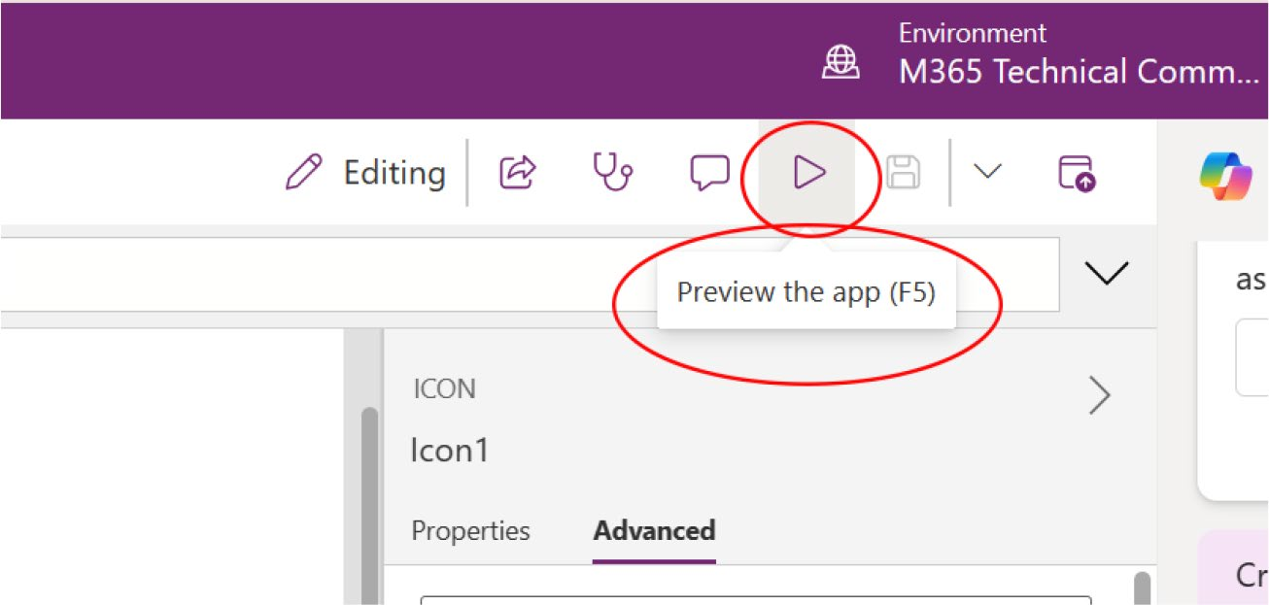

Figure 4-42. Preview option in Power Apps

Chapter 4 Crafting power apps with Copilot: the essentials
2. Alternatively, by selecting the back arrow, you will
notice the function (fx) displayed in the upper-left corner. Here, you can see that Copilot has already set up an OnSelect event linked to the Navigate
(MainScreen1) function, as shown in Figure 4-43.
This function is explored in detail in Chapter 6.
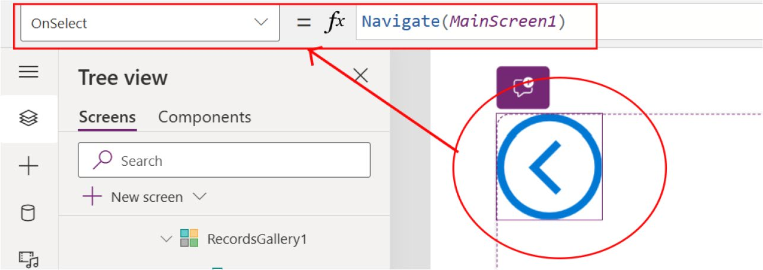

Figure 4-43. Checking the function from the top bar

Next, let’s adjust the container. Note in Figure 4-41 that the size and padding of the container are not set properly. Let’s make it a header. To do
this, I use the following Copilot prompt (see Figure 4-44 also):
Change the Container6 size (Width = 1366 & Height = 80), padding (Top =0, Bottom = 0, Left = 25, Right = 0)

Chapter 4 Crafting power apps with Copilot: the essentials
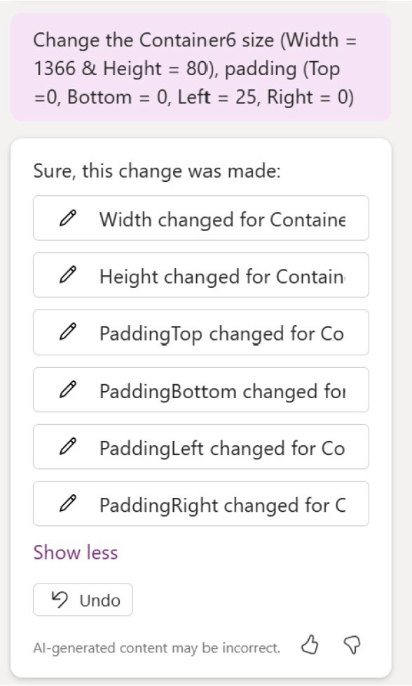

Figure 4-44. Copilot prompt to adjust the container size
The changes are shown in Figure 4-45.
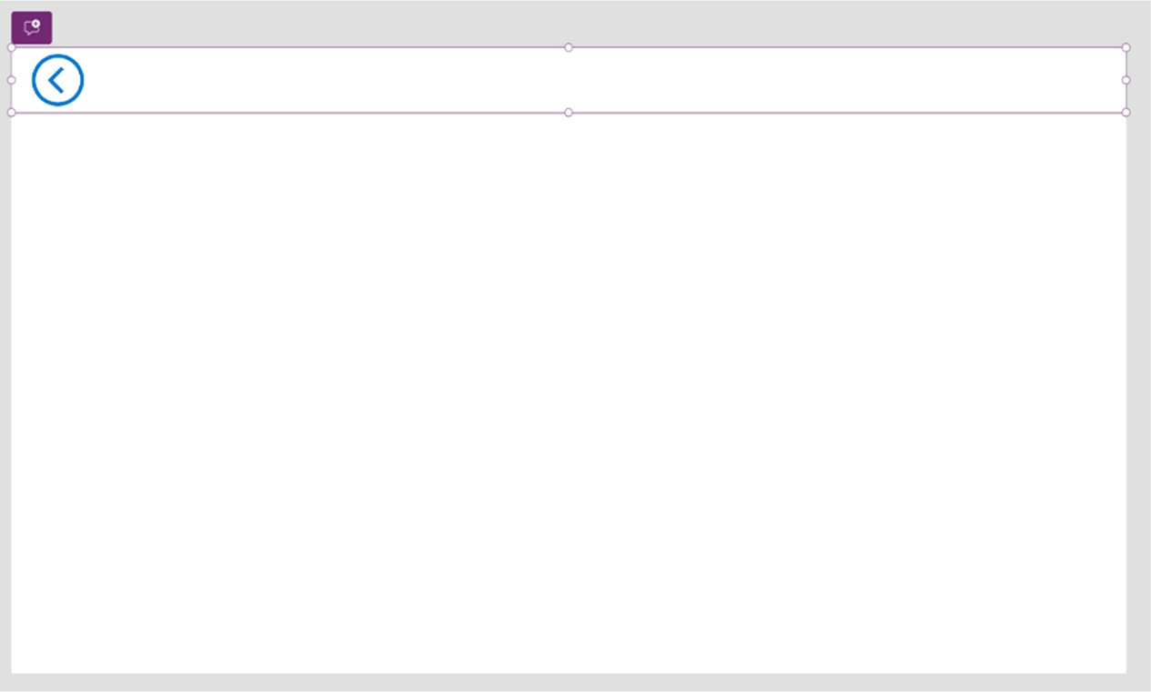

Figure 4-45. Adjusted container size through Copilot prompt

Chapter 4 Crafting power apps with Copilot: the essentials

EXERCISE 4-01

Using figure 4-46, try the following:
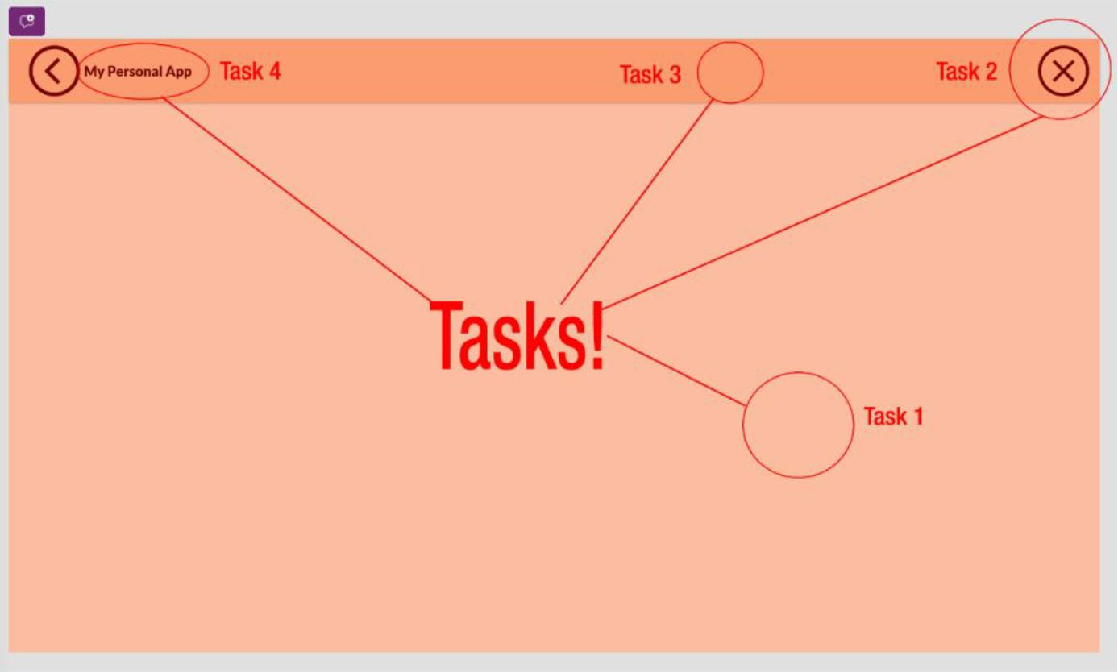

Figure 4-46. Task for Exercise 1

Your objective is to modify the second screen in figure 4-46, utilizing only
Copilot to make changes. here are the tasks:
• Task 1: Change the background color of the screen container
through Copilot.
hint: the color code is rgBa (253, 222, 207, 1)
• Task 2: add a Cancel button on the right side of header panel
and color it.
hint: this is not a button. power apps have the default icon called Cancel. the color code is rgBa (118, 0, 0, 1).

Chapter 4 Crafting power apps with Copilot: the essentials
• Task 3: Change the background color of the header container.
hint: the color code is rgBa (250, 155, 112, 1)
• Task 4: add the label and value it My Personal App; also
color it.
hint: the color code is rgBa (118, 0, 0, 1)
save the project using the upper-right save button or press Ctrl+s. refer to
figure 4-47.
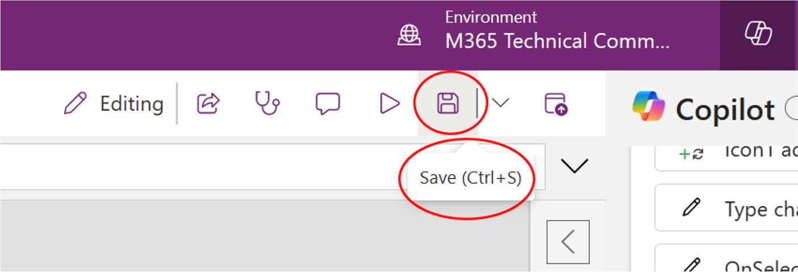

Figure 4-47. The Save option for Power Apps project

Summary
In this chapter, I showed you how to apply the technology behind
Microsoft Copilot to build your first Canvas app. The chapter focused on
essential design principles, explored how to modify app components, and
explained how to enhance the app’s user interface using natural language
commands with Copilot. This gives you a solid foundation for creating
user-friendly and visually appealing apps.

Chapter 4 Crafting power apps with Copilot: the essentials

Chapter 5 takes you deeper into integrating various data sources, including Microsoft Dataverse, SQL Server, and Excel with Power Apps. You’ll learn how to use connectors, understand data types, and harness the
power of automation with Power Automate. Chapter 5 will enhance your ability to create dynamic, data-driven applications, building on the skills you developed in this chapter.

CHAPTER 5

Advanced

Customizations

and Automation

with Copilot

In the previous chapter, you gained practical experience in creating and
customizing a Canvas app using Microsoft Copilot. You learned how
to design user-friendly interfaces, modify app components, and apply
essential design principles through natural language commands.
This chapter shifts focus to the integration of various data sources with
Power Apps. You’ll explore how to connect to Microsoft Dataverse, SQL
Server, and Excel, and learn about the importance of data types in building
robust applications. Additionally, I introduce you to the automation
features of Power Automate, allowing you to streamline processes and
enhance the functionality of your apps. By the end of this chapter, you'll be
well-equipped to create dynamic, data-driven applications that leverage
the full potential of Power Apps.

© Rezwanur Rahman 2024 161
R. Rahman, Microsoft Copilot for Power Apps, Inside Copilot,

Chapter 5 advanCed Customizations and automation with Copilot

Analytical Prowess: Data Insights
for Beginners
Until now, the example application has been developed without incorporating any specific databases or data sources. It is crucial to explore the data sources that are compatible with Power Apps and understand how to integrate Microsoft Copilot into the workflow.
Power Apps use data sources to work properly, and these sources contain the data that your apps need. Imagine these sources as big, digital libraries that can live online, which means you can get to them from anywhere.
Say you have a list of information in a Microsoft Excel file. You can keep this file on OneDrive for Business or on another online storage place and link it to your Power Apps. To make this connection, you need special tools called connectors. This chapter discusses this process.

Understanding the Supported Data Sources for Power Apps
Understanding the data sources supported in Power Apps is particularly important. Power Apps is designed to be plugged into many different types of data sources: Microsoft services such as SharePoint, SQL Server, and Dynamics 365, as well as external databases through connectors. Power Apps also supports custom connectors and APIs, which allows developers to connect to any data source desired. Such flexibility allows users to fully create functional apps, custom-fitted to their needs.
This chapter covers four of the most popular and frequently used Microsoft products for data storage with Canvas Power Apps.

Chapter 5 advanCed Customizations and automation with Copilot

Microsoft Dataverse
Microsoft Dataverse has evolved as a database as a service in developing
secure databases. This application can work with apps as well as flows and
is compatible with a lot of components from Power Platform. You also get
multi-dimensional and high-level configurability to enable Power Apps,
Power Automate, and Power BI that is easy to maintain.
Microsoft Dataverse can be aligned with other Microsoft services to
create a suitable solution to address the demands that arise from business
processes. You can also deliver data at scale, as it offers features that can
be leveraged to build applications. The user interface is also interesting,
appealing, and convenient to use. You can now leverage Microsoft
Dataverse to provide custom data solutions, all with very little or no code.

Why Use Dataverse?
Dataverse tables offer a secure, cloud-based solution for data storage,
presenting a business-centric way to define and utilize data within apps. If
you are evaluating whether Dataverse tables are the right choice for your
needs, consider their advantages:
• Simplified management: The cloud stores both
metadata and data, eliminating the need to manage storage details.
• Enhanced security: Data is securely stored, accessible
only to users with permission. Role-based security controls allow you to manage table access by different organization members.
• Integration with Dynamics 365: Dataverse tables
incorporate data from Dynamics 365 apps, facilitating the development of apps that leverage your Dynamics 365 data and enhancing them through Power Apps.

Chapter 5 advanCed Customizations and automation with Copilot
• Detailed metadata: Power Apps directly utilize data
types and relationships.
• Built-in logic and validation: Support for calculated
columns, business rules, workflows, and business process flows ensure high-data quality and drives business processes.
• Productivity enhancements: Microsoft Excel add-ins
for tables boost productivity and data access.

Microsoft SQL
Microsoft SQL Server is a powerful and widely used database solution that functions as the primary data source for Power Apps. It can handle large scale, secure, and comprehensive data management tasks; it also enables developers to build high-performance, data-driven applications with complex data operations. With SQL Server connected to Power Apps, users can utilize elaborate queries, transactions, as well as data analytics in their custom business applications.
This integration supports real-time access and manipulation of information so that Power Apps can effectively interact with huge amounts of data stored in SQL server databases. Such seamless connection between Microsoft SQL Server and Power Apps allows organizations to leverage their information for better decision-making processes and increasing productivity through improved efficiency. SQL Server then becomes an indispensable component when developing enterprise level software.

Microsoft Excel
Power Apps can use Microsoft Excel spreadsheets as sources of data so that it becomes more convenient and flexible for you to develop apps. Power Apps is seamlessly integrated into Excel, which is used for organizing, analyzing, and storing data. It allows your Excel spreadsheets saved in OneDrive for Business or SharePoint to be turned into live data sources.

Chapter 5 advanCed Customizations and automation with Copilot
You can then simply pull and manipulate this information anytime
on your app interface. In other words, Excel’s extensive calculation and
analysis capabilities can be utilized directly within Power Apps projects,
enabling creation of dynamic applications that are responsive to various
business needs. This method is especially useful when it comes to rapid
prototyping as well as converting existing spreadsheets into interactive
mobile friendly apps with the least amount of effort.

Microsoft Lists
By using Microsoft Lists as the data sources to Power Apps, you can
manage and work with your structured information in new and creative
ways. Empower your team to achieve more with Microsoft Lists, which is a
simple, smart, and flexible application to track information and organize
work. When used with Microsoft Power Apps, Lists becomes even smarter.
Use Microsoft Lists to manage structured data. You can connect your lists
to Power Apps to build custom applications to interact with your list data
in ways that you cannot with just the standard forms and views. You can
also transform your lists into apps that facilitate collaboration and data
collection with your team members.
Lists in Power Apps makes it quite easy for your organization to build
lists-based applications that are tailored to your specific processes and
projects using the Microsoft 365 suite of productivity apps and services.
You have the platform to create custom solutions that automate and
simplify daily operations and build more effective and insightful ways
of working, all within the Microsoft 365 ecosystem you are already
employing.
As I am focusing on Microsoft Copilot or AI Builder within Power
Apps for robust, enterprise-level applications, Microsoft Dataverse is the
recommended choice due to its deep integration and support for a wide
range of AI functionalities.

Chapter 5 advanCed Customizations and automation with Copilot

Understanding the Data Types
One hot topic in any software development and data analytics area, namely creation of Power Apps, is understanding data types. Data types describe the values you can store and the operations you can do with them. You work with text, numbers, true/false values, dates, and more complex things every day. Each has its own rules and purpose.
Obviously, it should be no surprise that working across platforms like Microsoft Dataverse, SQL Server, or Excel in Power Apps does require you to understand data types. If you skip over this part or have a weak understanding of what they are and what they do, you will run into trouble when designing your application and working with your data, as well as when working with the formulas and operations your app contains. You need to account for all kinds of data in your systems, from simple contact info to complex transaction records. That necessitates deep knowledge of the data types in your application.
This section discusses the different data types and their characteristics, how to use them, and where they fit into the Power Apps environment. Knowing the data types that are available will allow you to better organize your data and create dynamic, powerful, and efficient applications in Power Apps.
To start, review the differences between the data types in Microsoft Power Apps, Microsoft Dataverse, and Microsoft Power Fx, as explained in
Table 5-1.

Chapter 5 advanCed Customizations and automation with Copilot
Table 5-1. Difference Between Power Apps, Microsoft Dataverse, and
Microsoft Power Fx Data Types
Aspect Microsoft Power Microsoft Dataverse Microsoft Power Fx
Apps
primary use app development data storage and Formula language
and user management in a unified for logic and data interface creation format manipulation in power
apps
Focus user interaction, data integrity, Calculations, data
interface interoperability across manipulation, logic elements microsoft services
data type text, multiline text, integer, currency, like power apps but
examples text, integer, date and time, complex used in formula context;
date/time types like lookups and supports logical, text,
choice numeric, date/time
application Building and Centralized data platform enhancing app
context customizing for dynamics 365, functionality with
applications power apps, and other custom logic and
microsoft services formulas

Power Apps Data Types
Power Apps includes a canvas for users to drag and drop various controls,
forms, and media to create custom applications. The data types in Power
Apps are designed to be straightforward, enabling the handling of basic
input and display of data in the apps. The textual data types are listed in
Table 5-2.

Chapter 5 advanCed Customizations and automation with Copilot
Table 5-2. Textual Data Types in Power Apps
Data Types Description Use Cases
text stores plain text, up to a maximum names, descriptions, or
length specified by the data source. any textual content.
multiline text like text but optimized for Comments, product
longer texts. descriptions, etc.
html stores html content. rich text formatting,
embedded content.

The numeric data types are listed in Table 5-3.
Table 5-3. Numeric Data Types in Power Apps
Data Types Description Use Cases
number stores whole numbers without age, quantity, identifier numbers
decimals.
decimal stores numbers with decimals. prices, averages, precise
measurements
Currency like decimal but used for monetary Financial transactions, pricing
values.

The date and time data types are listed in Table 5-4.

Chapter 5 advanCed Customizations and automation with Copilot
Table 5-4. Date and Time Data Types in Power Apps
Data Types Description Use Cases
date stores dates without time. Birthdays, due dates
time stores time without dates. schedules, opening hours
datetime stores both date and time. event dates, timestamps

The logical data type is listed in Table 5-5.
Table 5-5. Logical Data Type in Power Apps
Data Types Description Use Cases
Boolean stores true or false values. Conditions, toggles, switches

The complex data types are listed in Table 5-6.
Table 5-6. Complex Data Types in Power Apps
Data Types Description Use Cases
image stores image data. product images, profile
pictures
File stores a file in its native format. documents,
spreadsheets, pdFs
lookup references data from another table. relational data modeling
email stores email addresses. Contact information
Choice allows selection from a predefined list enums, status fields,
of text values. categories

Chapter 5 advanCed Customizations and automation with Copilot
You can find more information about the Power Apps controls and
common data types at https://learn.microsoft.com/en-us/power-
apps/maker/canvas-apps/reference-properties.

Microsoft Dataverse Data Types
Microsoft Dataverse facilitates the customization of data types through various formats. These formats can be tailored using either the Solution Explorer interface or through API operations. The following sections delve into the specifics of data type formats, covering:
• Supported formats by data type
• Format conversions
• Format validations
You can find detailed information on Microsoft's official website:
https://learn.microsoft.com/en-us/power-apps/developer/data-
platform/data-type-format-conversions

Supported Formats by Data Type
Tables 5-7, 5-8, 5-9, and 5-10 lists the different formats that each data type can have.

Chapter 5 advanCed Customizations and automation with Copilot
Table 5-7. Text Data Type Formats in Microsoft Dataverse
Format Description Available to Notes
Name App Maker?
text standard text column filled with Yes default format
alphanumeric characters value for the
text column
text area text column supporting line breaks and Yes
containing alphanumeric characters
email the text includes a hyperlink to launch the Yes
user’s email application
url the text features a hyperlink that opens Yes
the specified page. text lacking a valid
protocol prefix will automatically have
https:// added to its beginning
ticker in most languages, the text serves as a Yes
symbol link that opens the msn money website,
displaying stock price details for the
represented ticker symbol
phone Columns are designed to be clickable, Yes
initiating phone calls when selected
Json stores text in Json format Yes (api only) only in non-
sQl stores
like audit
rich text allows rich text formatting, including Yes (api only)
html markup
version stores the version number for rows no system use
number only

Chapter 5 advanCed Customizations and automation with Copilot
Table 5-8. Multiline Text Data Types in Microsoft Dataverse
Format Name Description Available to Notes
App Maker?
text Basic text column Yes
containing alphanumeric
characters
text area text column that Yes
supports line breaks and
alphanumeric characters
email For internal use only no Json stores text using Json Yes (api only) only in non-sQl
formatting stores like log
richtext supports rich text Yes (api only)
formatting, including html
markup
internalextentdata displays a simple numeric no system use only
value
none/string. Basic text column Yes default format empty containing alphanumeric value for whole
characters number column

Chapter 5 advanCed Customizations and automation with Copilot
Table 5-9. Whole Number Data Types in Microsoft Dataverse
Format Name Description
duration this field is displayed as a drop-down as there will be several
available duration values. the list of these values is from one minute to three days. the duration is kept in the database in minutes. so, you display predefined intervals for users to select. this interval, for example, can be 1 minute, 15 minutes, 30 minutes, or any other duration in minutes. as well as predefined intervals, users can also enter the type of time duration they are trying to capture. For example, in the specified field they can type “1 hour” or “2 days” and it will be able to display it as “60 minutes” and “2880 minutes,” respectively.
timezone this option gets a drop-down list of all the time zones using
time zone Codes and stores them as the step name. every time zone has an integer value. For (Gmt-08:00) pacific time (us and Canada), the time zone name is stored as 4 in the step name. model-driven apps will display the time zone by these codes and for Canvas apps, you just get the number it is stored as.
language this option shows the list of languages provisioned for your
organization. using an lCid code, the values are stored as a number. language codes can be four-digit or five-digit locale ids. if the lCid is in the chart shown in locale id (lCid), it is a valid lCid. the model-driven apps have the language as the language name, while the Canvas apps have the number stored.
locale this represents a value associated with a particular locale, utilizing
iso standard values.

Chapter 5 advanCed Customizations and automation with Copilot
Table 5-10. Date and Time Data Types in Microsoft Dataverse
Format Name Description Available to
App Maker?
date only this setting records the date only, defaulting Yes
the time to 00:00:00, whether set to user
local or time-zone independent
date and time date and time format Yes

Format Conversion
You can only switch to a format from the same data type you selected. If you want to change the format, the existing table definitions (for example, maxsize) are maintained if there is a corresponding one with the new format. If the incoming payload to the table creator API did not specify the format, and there is a format that you want to maintain, you can switch it by setting the desired format in the FormatName column in an API call. I recommend you not directly update the Format column because Dataverse will ignore any new format selections you make.

Note right now, the api only does format conversions. a format
change does not update any of the data that is currently in a column,
so after a format change, users may see encoding differences in their
data that they will need to address after the fact.

As mentioned in Table 5-10, there are some restrictions to format conversions:
• JSON formatting is allowed only when a table is used
logically in non-SQL storage, such as with logs.
• If data is stored as emailbody and internalextentdata
and you try to convert them to any other format, it will ignore the setting and not give an error.

Chapter 5 advanCed Customizations and automation with Copilot
• If data is stored in another format and you try to
convert them into emailbody or internalextentdata, it will throw an error.
• Converting from Date Only to DateTime is not allowed,
but if you set the Date Only field to User Local or Time- Zone Independent, it will convert it into DateTime, but the seconds field returned will be 00:00.
If you change the data type to an incompatible format, the following
error is displayed:
The format <> is not valid for the <>
type column <> of table <>. For example,
the format datetime is not valid for the text type column.

Microsoft Power Fx Data Types
Power Fx utilizes human-friendly text that is easy to read. It is a low-code
language for writing directly into an Excel-like Formula bar or text window,
just shorter and more readable than Excel. The language is simple and
less verbose, so the most common programming tasks are easy for makers
and developers. It can satisfy all levels of development, from no-code for
beginners to pro-code for experts, and do so without creating artificial
walls or seams for learning and reimplementation. This enables diverse
sets of skills and diverse teams to work together.

Note microsoft power Fx has been introduced as the updated name for the formula language used in Canvas apps.

When an app that was developed using Canvas connects to an external
data source, it translates each of the data types from that source into the
data types that are compatible with Canvas apps. Power Fx's data types are
listed in Table 5-11.

Chapter 5 advanCed Customizations and automation with Copilot

Examples true Color.Red ColorValue( "#102030" ) RGBA( 255, 128, 0, 0.5 ) 123 4.56 Date( 2019, 5, 16 ) DateTimeValue( "May 16, 2019 1:23:09 PM" ) 123 Decimal( "1.2345" ) GUID() GUID( "123e4567-e89b- 12d3-a456-426655440000" )

and
if

x
er F pp time zone. nly a number resulting from
which you can use directly in s a o pp time zone.
ow s a it has a limited range.

oft P lso, luding an alpha channel. a which you can use directly in os inc in the user’ icr functions without a need to compare it. in the user’ tion, y high precision. identifier f M tions with no noticeable rounding errors can be , etc.

es o unique functions if the condition in those functions is met yp tely represented. te without time, te with time, a T at Description a simple Bool true/false value, If, Filter a color specifica a bool true/false value, filter without needing to compare its value. a da a da a number of ver base 10 opera accuraGlobally D

ble 5-11. ype y time tete Ta Data T Boolean Color Currenc dada decimal Guid

Chapter 5 advanCed Customizations and automation with Copilot
)
d
ue
tin
pp resource con pp resource(

" " "
added as an a added as an a

https://powerapps. https://northwindtraders. https://northwindtraders. " microsoft.com MyImage “ com/logo.jpg "appres:// blobmanager/7b12ffa2..." MyVideo" com/intro.mp4 "appres:// blobmanager/3ba411c..." 123 8.903e121 1.234e200 ThisItem.OrderStatus

ge in ts. ted with tions

ge forma visible within
each associa

) text string to an ima ca which is stored and utilized for pable of base 2 opera uri

identifier ( or other common web-ima
t holds a hyperlink. .gif, it pairs a localizable text label,
resource .svg,
with this numeric value,
.png, text string to a video or audio recording. pp,
universal uri
a text string tha a .jpeg, a a number with standard precision, and possessing a wide range. a choice from a predefined set of options, a numeric value. the a comparisons.

ge t
edia
hyperlink ima m number or Floa Choice

Chapter 5 advanCed Customizations and automation with Copilot

Examples { Company: "Northwind Traders", Staff: 35, NonProfit: false } First(Accounts).Owner Table({ FirstName: "Rezwanur", LastName: "Rahman" }, { FirstName: "Mobaswira", LastName: "Farzana" } ) "Hello, World" Time( 111, 223, 745 )

tes
psula
where each ta types.

ta type enca

uch references are often used it encompasses instances of s

his compound da

t ta types specified within this topic. presented in the time zone of the ta type defines a table of records, te, .

) s user d ta values.
ue ta types specified within this context. tion’
tin
con Description a record of da instances of other da a reference to a record in a table. with polymorphic lookups. this compound da record consists of fields with uniform names and da omitted fields are considered blank. other da a a time without a da applica ( unicode text string.

ype
ble 5-11.
Ta Data T record record reference table text time

Chapter 5 advanCed Customizations and automation with Copilot

ThisItem.Taxable ParseJSON("{ ""Field"" : 1234 }").Field

his tible t

, and
with a Boolean
pp,
t Value() he underlying object
,

along with a Boolean value.
te the comparison. Boolean()

y existing type and can be converted into compa
, among others.

a choice in a list of two choices, field type pairs a human readable label for the a value used internally to evalua represents an object of an unspecified type. may be of an types using functions such as Table()

two option untyped object

Chapter 5 advanCed Customizations and automation with Copilot
Blank Values
Every data type can assume a blank value, which means it has no value at all. In database terminology, this is commonly referred to as a null.
To assign a blank value to a variable or field within Canvas apps, you can use the Blank function in conjunction with the Set or Patch function. For instance, executing Set(x, Blank()) will clear any existing value in the global variable x.
To check if a value is blank, you can use the IsBlank function. Moreover, the Coalesce function allows you to substitute any blank values with alternative non-blank values.
Given that the concept of blank is universally applicable across data types, data types such as Boolean and Two option inherently support a third state, representing the blank condition.
Embedded Text
In a formula, text strings are encapsulated within double quotes. To denote a single double quote within the text string, pair two double quotes
consecutively. As shown in Figure 5-1, consider applying the subsequent formula to the OnSelect property of a Button control:
Notify( "Rezwanur said ""Hello Readers!""")
When the button is pressed, this formula triggers the display of a banner. The initial and final double quotes are not shown because they serve to enclose the text string. Meanwhile, the double quotes that are doubled up around "Hello, Readers!" are condensed into a single double quote within the displayed message.
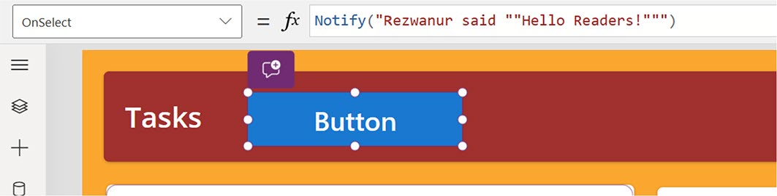

Figure 5-1. Assigning an OnSelect property to the Power Apps button

Chapter 5 advanCed Customizations and automation with Copilot
String Interpolation
String interpolation lets you put formulas directly inside a text string.
This is sometimes more convenient and easier to understand than using
the concatenate function or the & operator. Add a dollar sign $ before the
text string and put the formula in curly braces { }. If you want to include
a curly brace in your text string, use double curly braces: {{ or }}. String
interpolation works everywhere a regular text string will work.
Suppose you have designed a Canvas app that is supposed to maintain
swags for an event. You want to add a message that indicates the current
stock of t-shirts and stickers.
Suppose that you have the global variable Tshirts set to 3 and the
global variable Stickers set to 4. You can use string interpolation to
do this:
$"We have {TShirts} TShirts, {Stickers} stickers, yielding
{TShirts+Stickers} items total."
The formula would look something like this. When you press Enter,
it will return "We have 3 TShirts, 4 Stickers, yielding 7 items
total" where you can insert TShirts and Stickers inside the text using
the curly braces. Similarly, the result of the formula part TShirts+Stickers
will replace the first set of curly braces with TShirts+Stickers. The spaces
and everything else around the curly braces are left as is.
You can use functions and operators in embedded formulas. The only
condition is that the formula's result can be converted to a text string. For
example, this formula uses NickName or FirstName in a greeting:
$"Welcome {Coalesce( NickName, FirstName )}, it's great to
meet you!" )
If NickName equals "Rezwanur", this formula returns the text string
Welcome Rezwanur, it's great to meet you! However, if NickName
is blank and FirstName equals "Rahman" this formula returns Welcome
Rahman, it's great to meet you! instead.

Chapter 5 advanCed Customizations and automation with Copilot
You can add normal text strings to the formula inside the string interpolation. For example, if you do not use NickName or FirstName, you can use "Friend" instead:
$"Welcome {Coalesce( NickName, FirstName, "Friend" )}!"
You can also nest string interpolations. Consider the following example—the First, Middle, and Last names are concatenated into a greeting. The name elements have the correct number of spaces between
them, even if some of them are empty, as shown in Table 5-12. The Coalesce function will convert an empty string inside the inner string interpolation to "Friend".
$"Welcome {Coalesce( Trim( $"{First} {Middle} {Last}"}), "Friend" )}!"

Table 5-12. String Interpolations
First Middle Last Result
rezwanur r. rahman Welcome Rezwanur R. Rahman!
rezwanur blank rahman Welcome Rezwanur Rahman! blank Blank rahman Welcome Rahman! blank Blank blank Welcome Friend!

Newlines
Text strings that are inserted in other text can have line breaks. For instance, think about setting the Text property of a Label control to this:
"Microsoft Copilot Book
Microsoft Power Apps Book
Microsoft Github Book"

Chapter 5 advanCed Customizations and automation with Copilot
This formula results in three lines shown in the label control, as
shown in Figure 5-2.
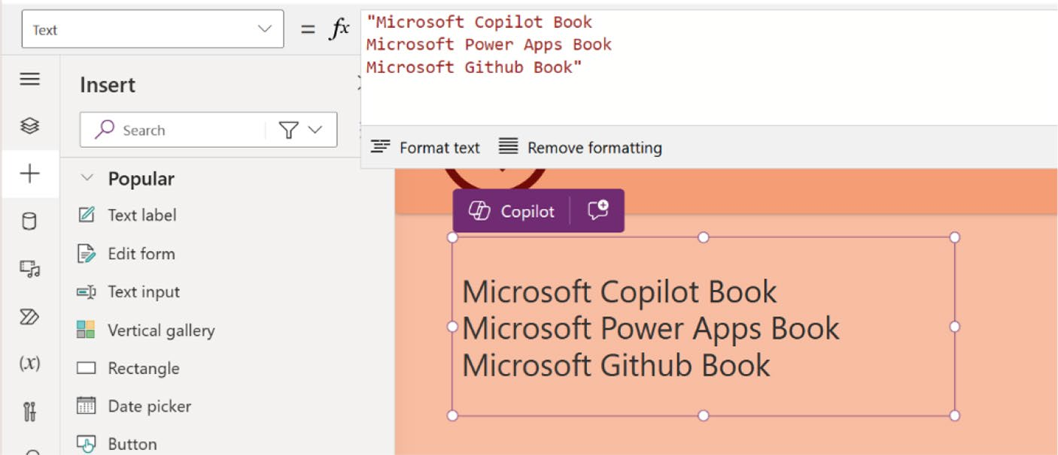

Figure 5-2. Newlines result for text label control
Numbers
Power Fx offers support for two types of numbers: Decimal and Float,
also known as Number and Currency.

Note Currently, power apps supports only the Float data type for numerical values, but there are plans to introduce support for the decimal type soon. i am exploring the decimal type ahead of this update.

Decimal is an exceptionally viable choice for most business
calculations. It represents numbers in base 10 exactly; 0.1 does not have a
rounding error while performing arithmetic. Its range is more than enough
for any business purpose—up to 1028 and it supports up to 28 digits of
precision. Therefore, the Decimal type is the default numeric type for most
Power Fx hosts. In fact, if you simply write 2*2, it is treated as Decimal.

Chapter 5 advanCed Customizations and automation with Copilot
Float is preferred for scientific calculations. A Float can denote numbers in a significantly broader range; it supports values up to 10308. It only gives precision to 15 decimal places. And since the math is done in base 2, it can't represent many common decimal values that might appear precise to humans. As for performance, Float has the edge, so choose it if performance is a concern and precision is not important.
You can learn more about Power Fx data types from the official Microsoft learning docs at:
https://learn.microsoft.com/en-us/power-platform/power-fx/
data-types

Understanding the Connectors
Connectors represent powerful tools for the Power Platform ecosystem, supporting the development of applications and workflows that can be easily integrated with cloud services. This is because these connectors act as bridges, incorporating the actual APIs of an application or service to enable data exchange. Over 900 connectors are currently available on the Power Platform. Users can connect to a wide variety of services, including but not limited to: Salesforce, Office 365, Twitter, Dropbox, SharePoint, and SQL Server.
These connectors are developed to transfer data from the Power Platform to the attached services and vice versa. They are input-output mechanisms. The Power Platform provides two types of data sources using these connectors: tabular and function based. Each type is an important method of bringing data into your solutions and as such makes the platform versatile in handling various kinds of data integration scenarios.

Chapter 5 advanCed Customizations and automation with Copilot
Types of Connectors
Power Platform categorizes connectors into three types—standard,
premium, and custom.
Standard connectors: These connectors work with any licensing plan. You can use standard connectors in Microsoft Power Platform. Some examples of standard connectors are SharePoint, Outlook, OneDrive, and YouTube.
Premium connectors: These include connectors that involve an additional purchase of a license for your app and the users using it. The main advantage of premium connectors is that you can connect to more services, such as Azure SQL Database,
Dynamics 365, and Twitter. See Figure 5-3.
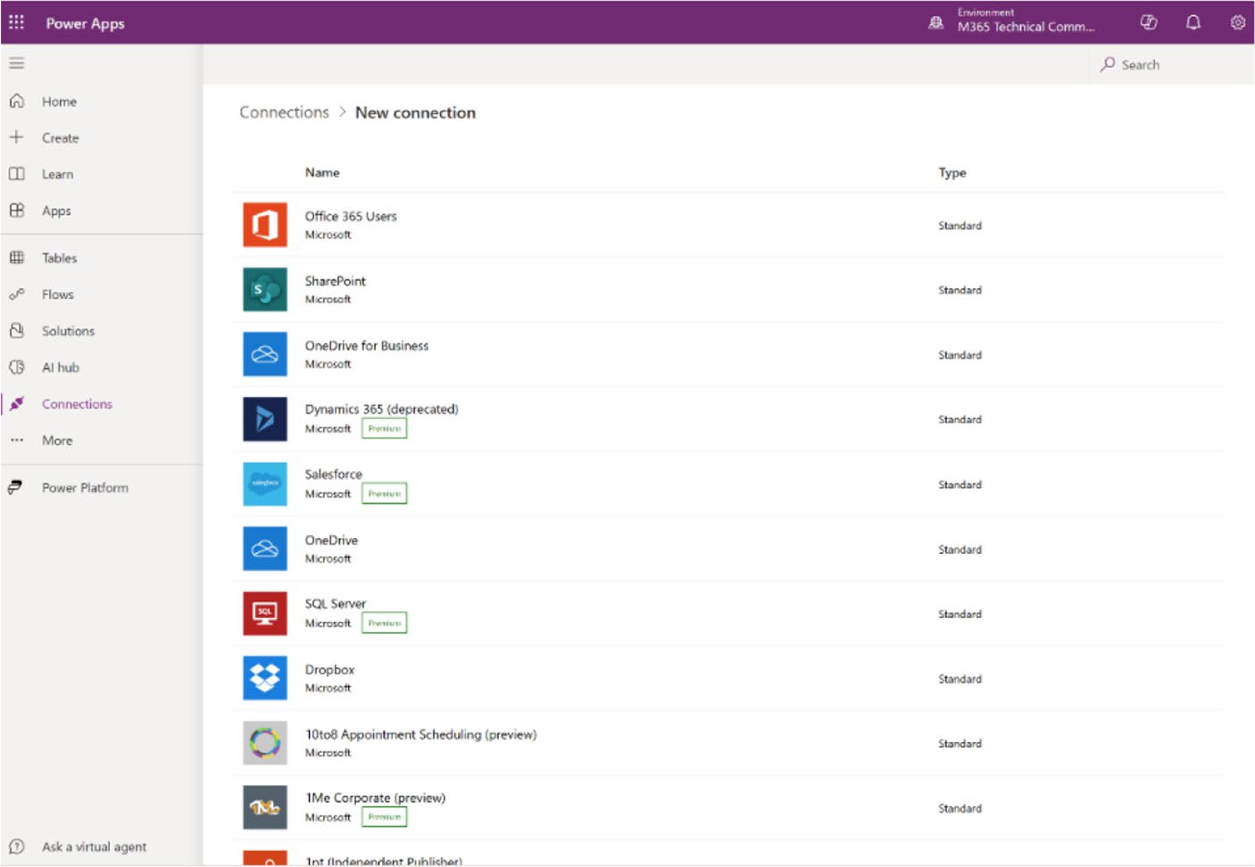

Figure 5-3. Premium connectors in Power Apps

Chapter 5 advanCed Customizations and automation with Copilot
Custom connectors: These are wrappers around APIs that let you link your apps to external web services or external data sources like Microsoft Azure. The connectors function by exchanging information through these APIs. A benefit of creating custom connectors is that they can be applied to various platforms, such as Power Apps, Power Automate, and Azure Logic Apps.

Visualizing Data in Power Apps
Now is the perfect moment to explore data visualization in Power Apps, focusing on how Microsoft Copilot integrates with Power Apps. The example in this section uses Microsoft Dataverse as the primary data source, covering everything from basic to advanced concepts and examining how it works in conjunction with Power Apps.
Open the existing project again and expand the left-side menu items.
Notice the option named Data, as shown in Figure 5-4.

Chapter 5 advanCed Customizations and automation with Copilot
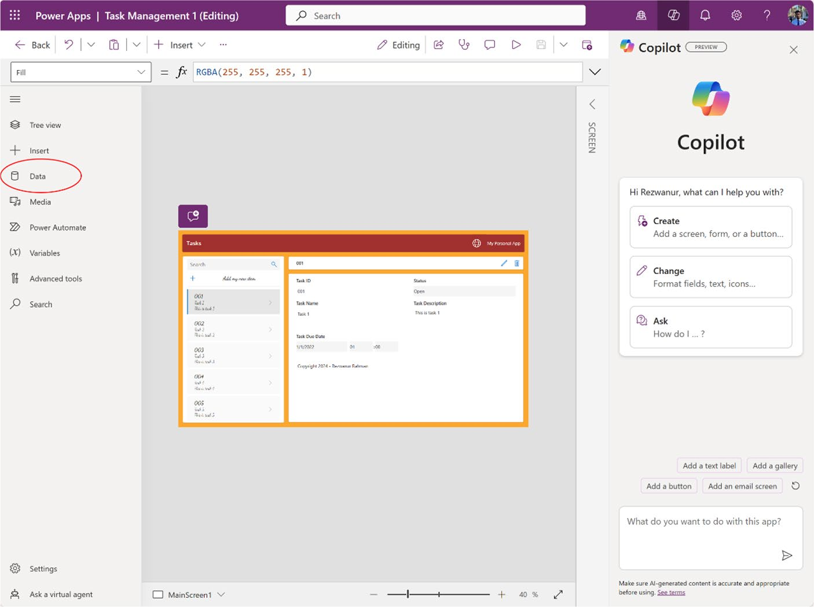

Figure 5-4. The Data option in Power Apps
If you opt for Data, you will find an existing database named Tasks,
as shown in Figure 5-5. Interestingly, when building this application with
Copilot, Copilot creates a default table in Microsoft Dataverse, so you do
not need to create the database from scratch.
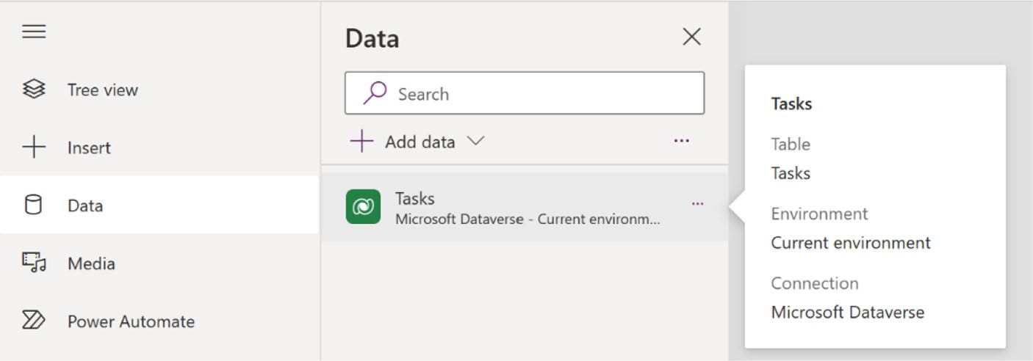

Figure 5-5. Microsoft Dataverse table that was created by Copilot

Chapter 5 advanCed Customizations and automation with Copilot
First, I explore the Tasks table that was saved in Microsoft Dataverse. Afterward, I create a new table with the help of Microsoft Copilot and compare the two.
To access the Tasks table, click the three dots (...) next to the Tasks option. There, you will find three choices—Edit Data, Refresh, and
Remove—as shown in Figure 5-6. When you select Edit Data, you can view the Tasks table and modify the data, as well as add or remove columns and adjust certain table properties. Additionally, after manually inputting some data, clicking Refresh will ensure that the data in the Tasks table is properly synchronized. You also have the option to delete the table from this location and create a new one for your app.
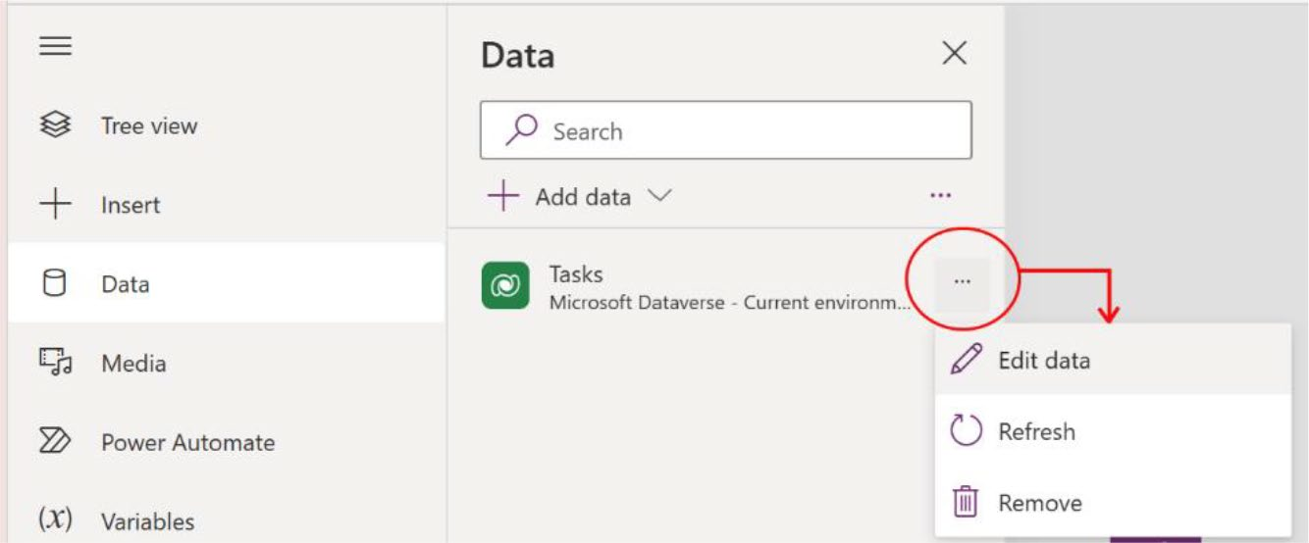

Figure 5-6. Options to manage the Microsoft Dataverse table
Click Edit Data to see the table in Figure 5-7.

Chapter 5 advanCed Customizations and automation with Copilot
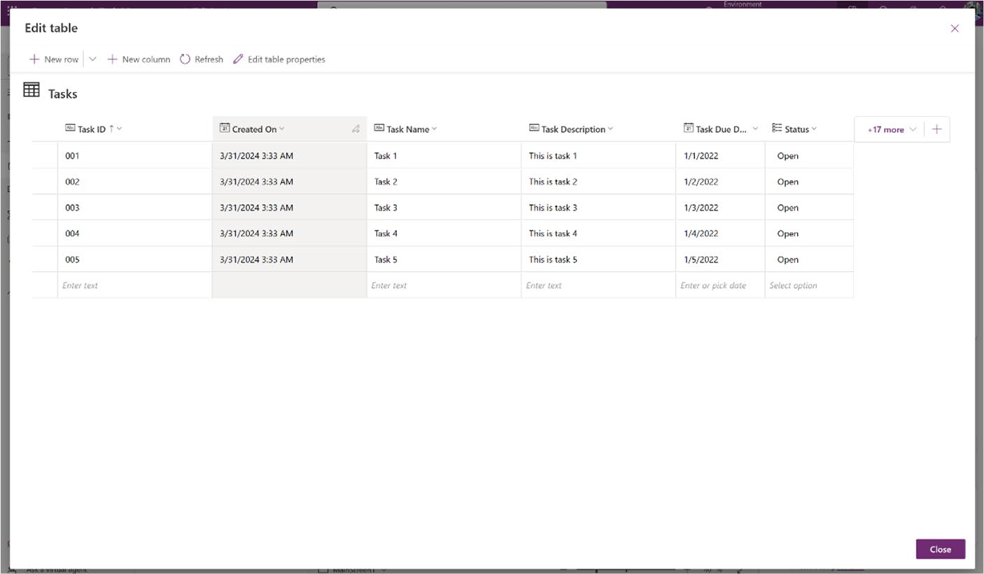

Figure 5-7. Microsoft Dataverse table in Edit mode

Since this is dummy data, you do not need it and can safely delete the
rows. However, it is important to remember not to delete any columns.
Removing a column will also eliminate the corresponding field from
the app.
Note the text +17 more, shown in Figure 5-8.
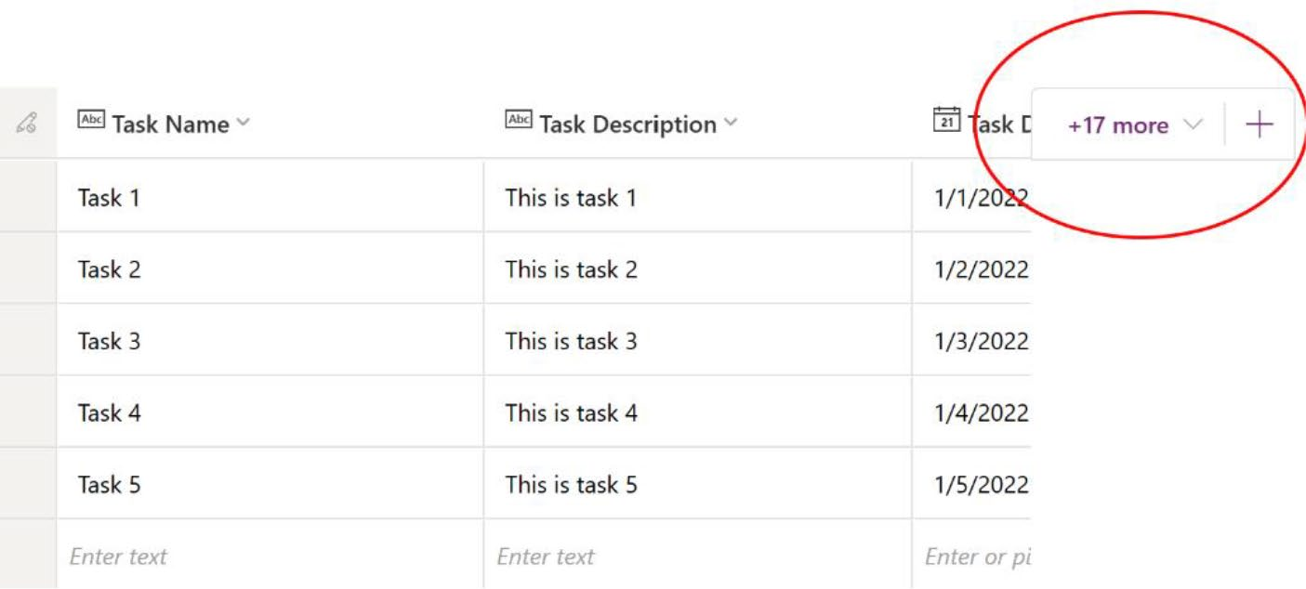

Figure 5-8. Hidden rows in the Microsoft Dataverse table

Chapter 5 advanCed Customizations and automation with Copilot
There are 17 other related columns that Copilot made and are now hidden. This is what +17 more means.
When you click the down arrow next to +17 more, you will see the
options, as shown in Figure 5-9.
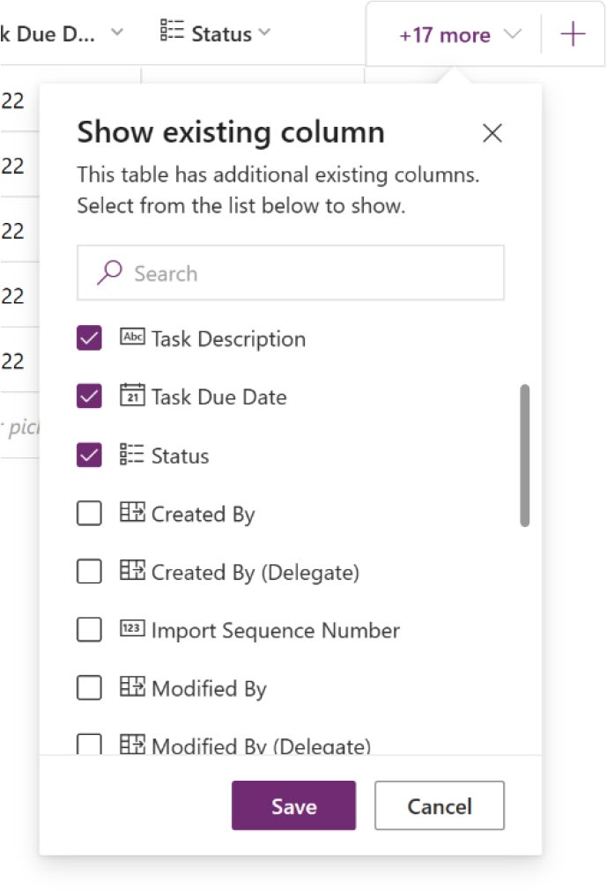

Figure 5-9. List of columns that are hidden in the Dataverse table
You can see the columns and add any necessary columns by selecting the checkbox and clicking Save.
In the example app, I added the Modified On, Owning Business Unit,
and Status columns, as shown in Figure 5-10.

Chapter 5 advanCed Customizations and automation with Copilot
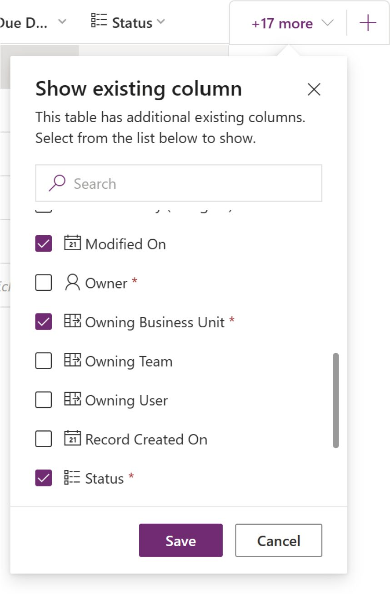

Figure 5-10. Selecting columns from the hidden column list

If you did not find your desired column, or the suggested columns
do not match your data, you can create a new custom columns. For this
example, I create a custom column named Upload Document.
To create a custom column, click the + sign, as shown in Figure 5-11.

Chapter 5 advanCed Customizations and automation with Copilot
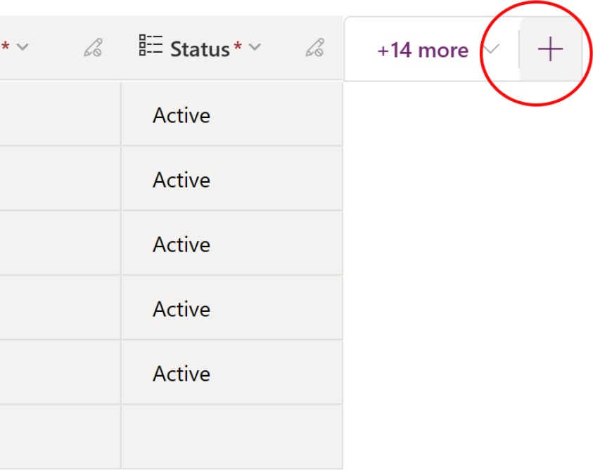

Figure 5-11. Creating a new custom column in Dataverse table
Then, fill in the form, as shown in Figure 5-12, and click Save.
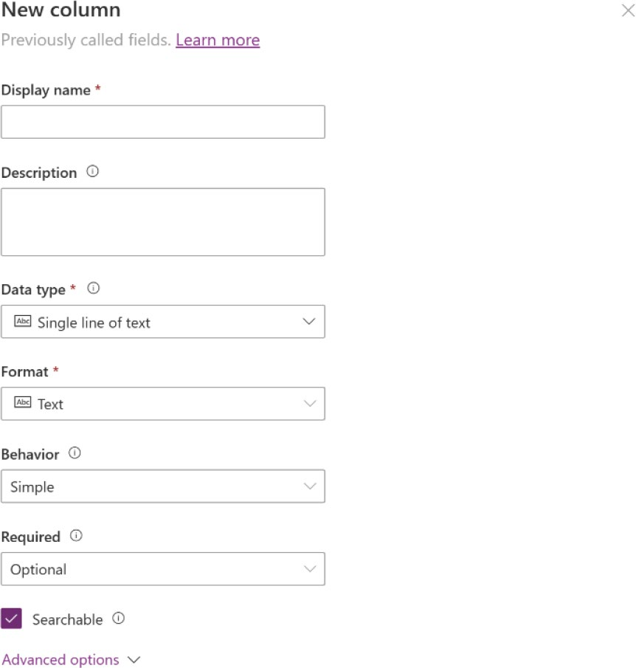

Figure 5-12. Form to create a new column

As I am creating an Upload Document column, I need to click Data
Type and choose Files, as shown in Figure 5-13.

Chapter 5 advanCed Customizations and automation with Copilot
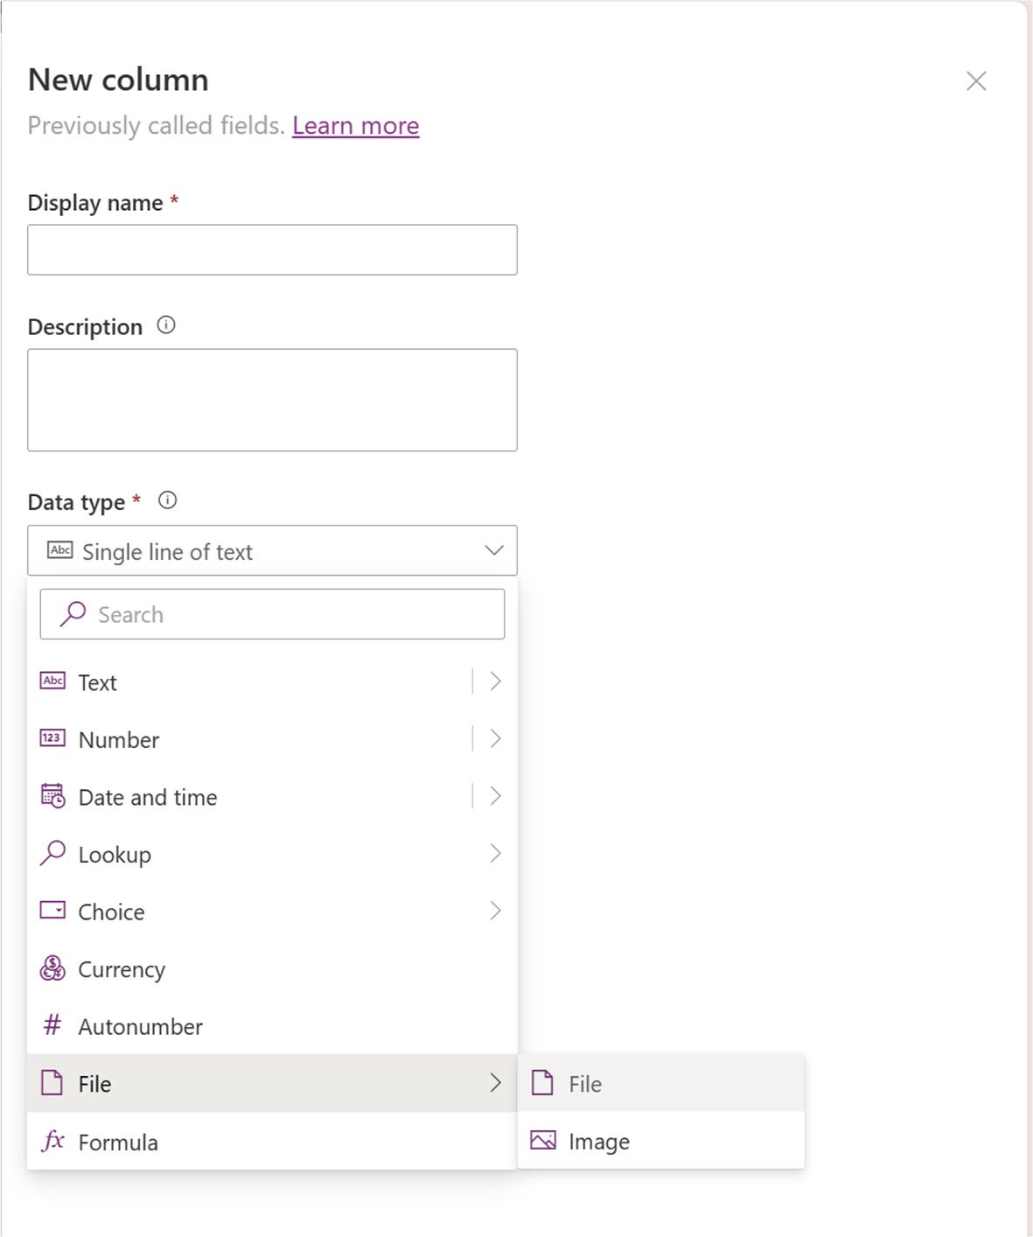

Figure 5-13. Creating the file upload field

After selecting the data type, you see the parameters in Figure 5-14.

Chapter 5 advanCed Customizations and automation with Copilot
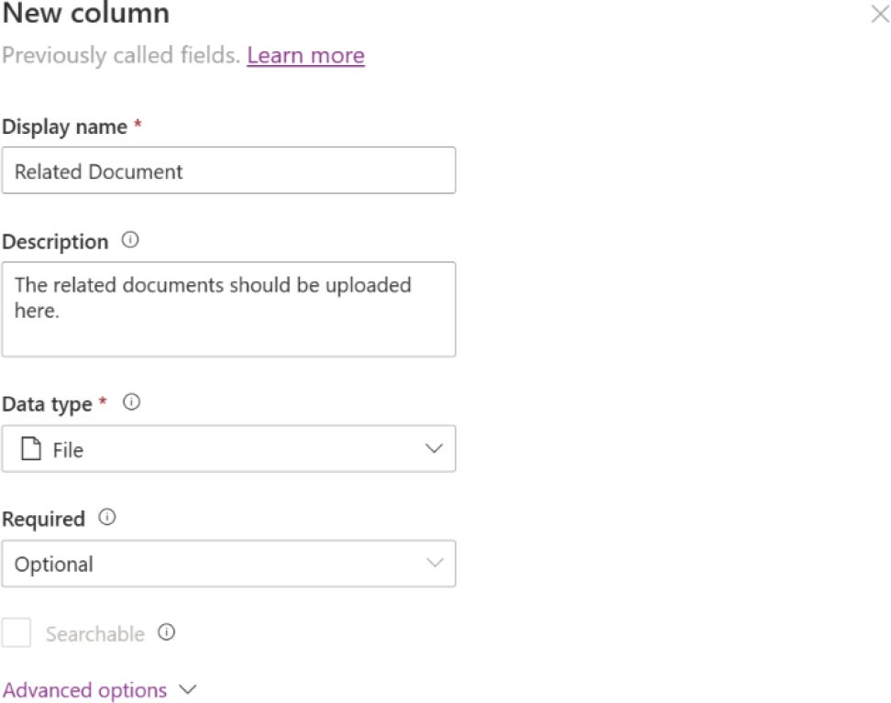

Figure 5-14. Parameters to create a new column

Expand the Advanced option to see the advanced features, as shown in
Figure 5-15.
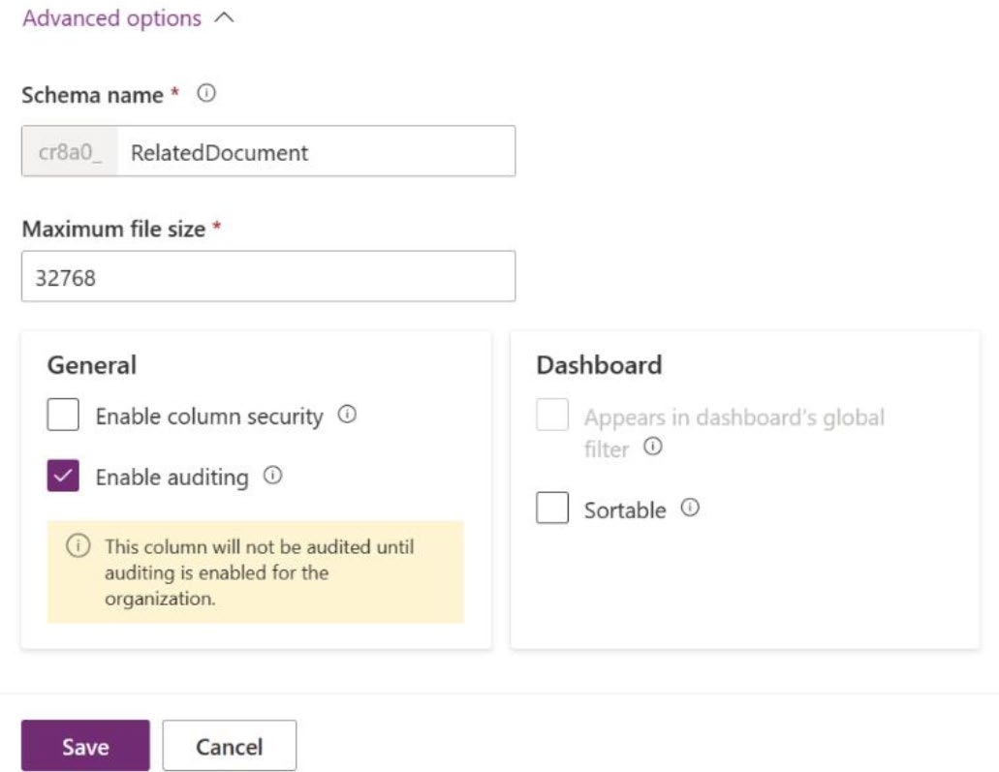

Figure 5-15. Advanced options when creating a new column

Chapter 5 advanCed Customizations and automation with Copilot
• Searchable: This option will be disabled. You cannot
make this field searchable.
• Schema name: This is a pre-populated column from
the Display name. It includes the Dataverse solution publisher’s customization prefix. After you have saved the table, you will not be able to edit it.
• Maximum file size: The maximum file size limit
is 32768 KB or 32 MB. It is impossible to adjust the maximum file size once it has been saved.
• Enable column security: When activated, it restricts
access to columns.
• Enable auditing: This option will allow tracking user
access changes and table record modifications so that you may evaluate the activity later.
• Sortable: This determines the setup of the column for
interactive dashboards.
Save the column. You can then find a new column named Related
Document in the Dataverse table, as shown in Figure 5-16.

Chapter 5 advanCed Customizations and automation with Copilot
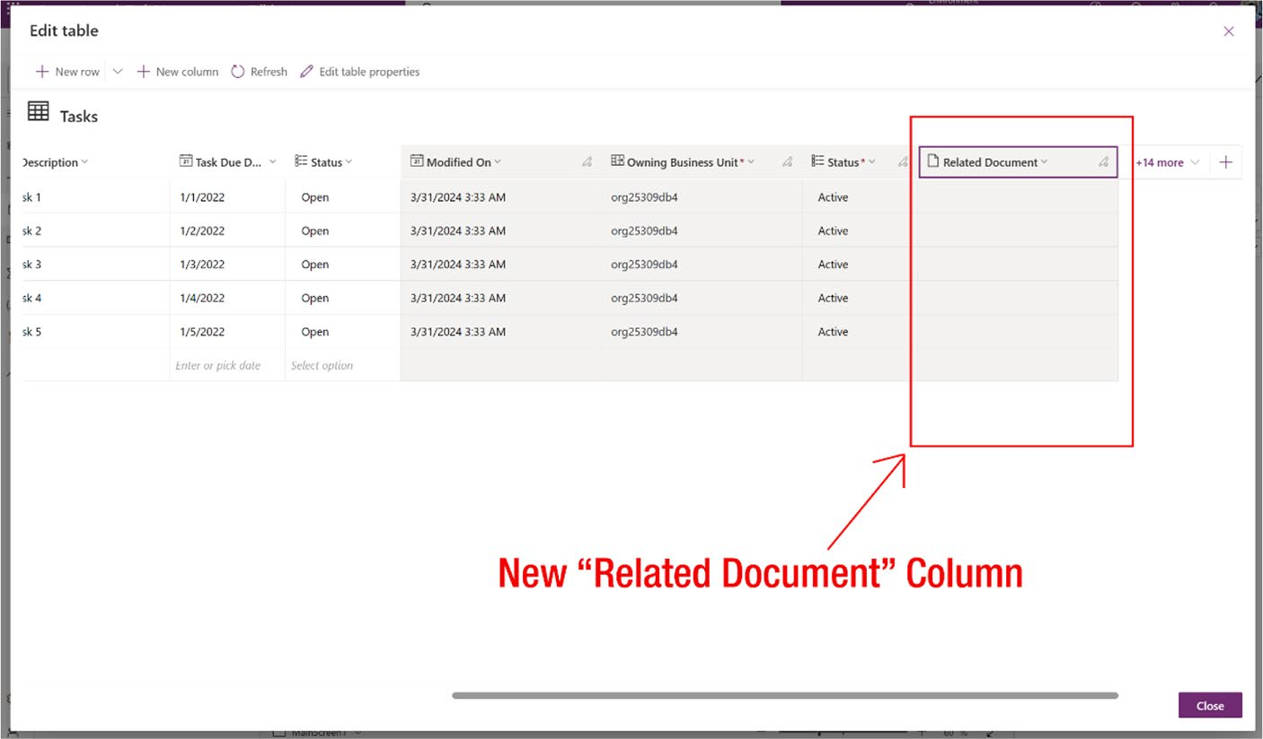

Figure 5-16. Newly created column in Dataverse table
Next, I add the Related Document column to the app.
Adding a column to the table does not automatically make it visible in the app. The app displays only those columns or fields that are relevant and have been added by Copilot.
To add the column to the app, open the MainScreen app and select the
Form1 layout, as shown in Figure 5-17.

Chapter 5 advanCed Customizations and automation with Copilot
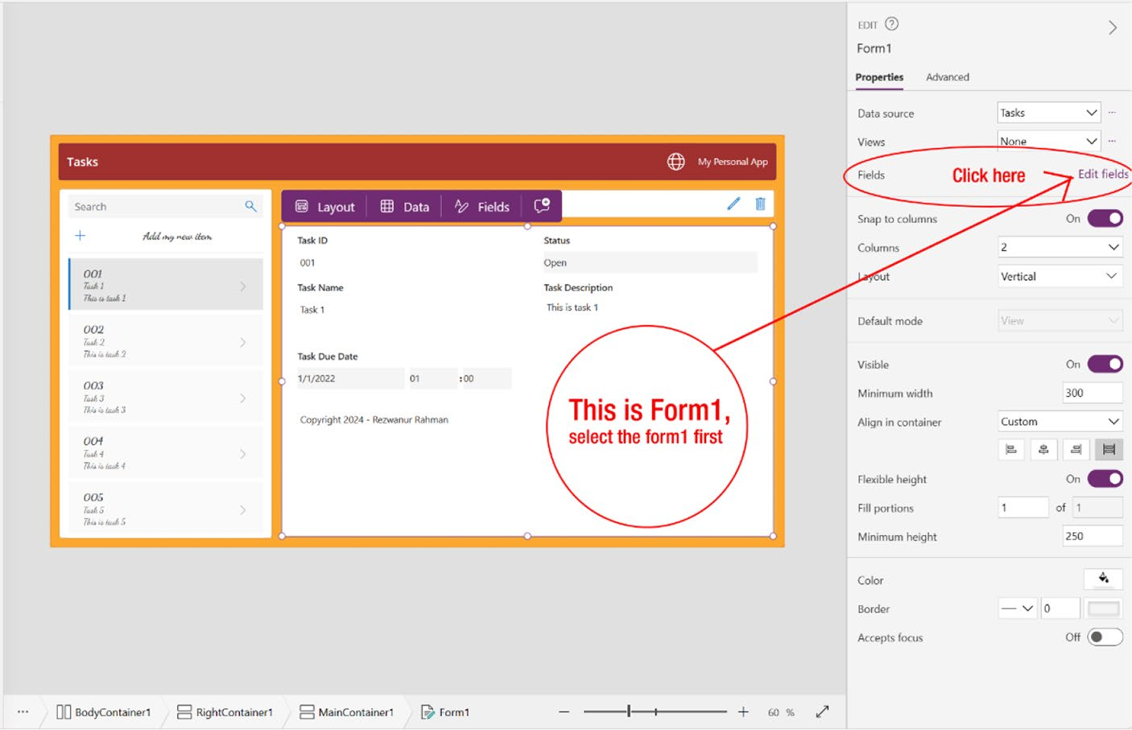

Figure 5-17. Editing the fields option of MainScreen

After that, click the Edit Field option to bring columns from the
Microsoft Dataverse table to the app. For example, in the app, you will see
fields such as Task ID, Status, Task Name, Task Description, and Task Due
Date. Their names also indicate where the app gets its field information—
from this source.
To add a new field, you need to click +Add Field option, as shown in
Figure 5-18.

Chapter 5 advanCed Customizations and automation with Copilot
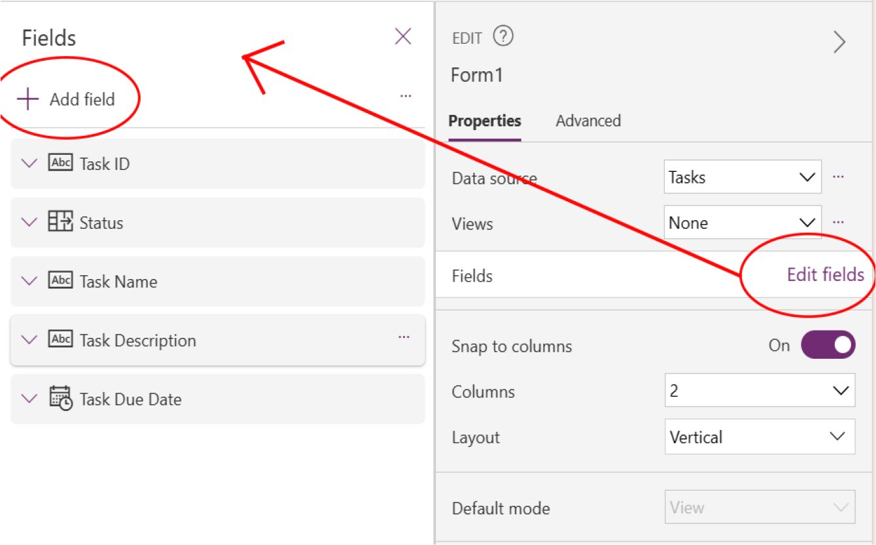

Figure 5-18. Adding a field in Power Apps screen from Microsoft Dataverse table

After you click the +Add Field button, a list displaying all the Microsoft Dataverse table fields will appear. From this list, you need to locate and select the newly created column (in this case, Related Document, as shown
in Figure 5-19). Finally, click Add.

Chapter 5 advanCed Customizations and automation with Copilot
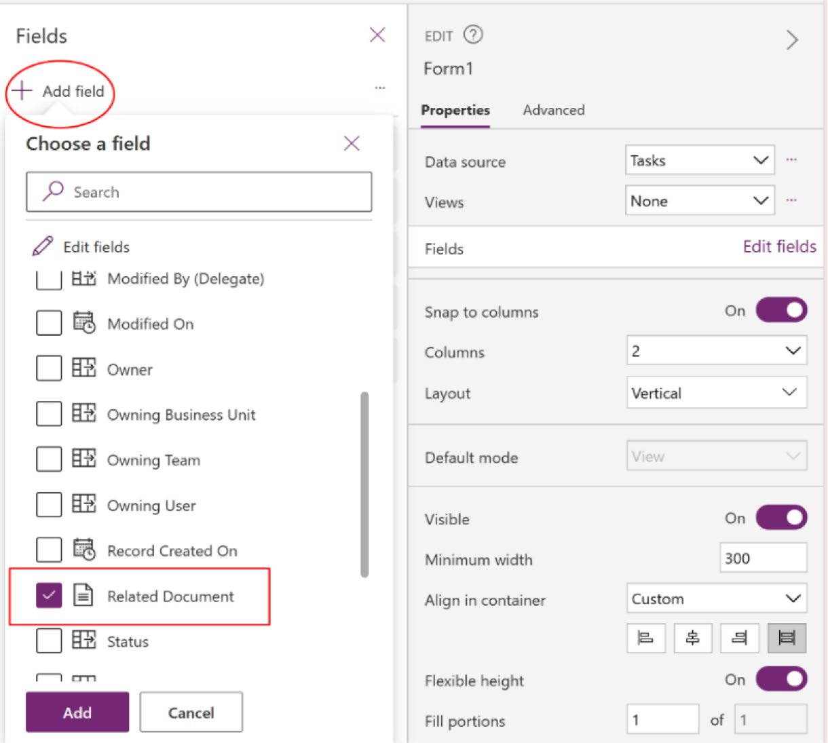

Figure 5-19. Selecting the column from the Microsoft Dataverse table
to show it as a field in Power Apps

Once you click Add, the Related Document field will become visible in
Form1 of the application, as shown in Figure 5-20.

Chapter 5 advanCed Customizations and automation with Copilot
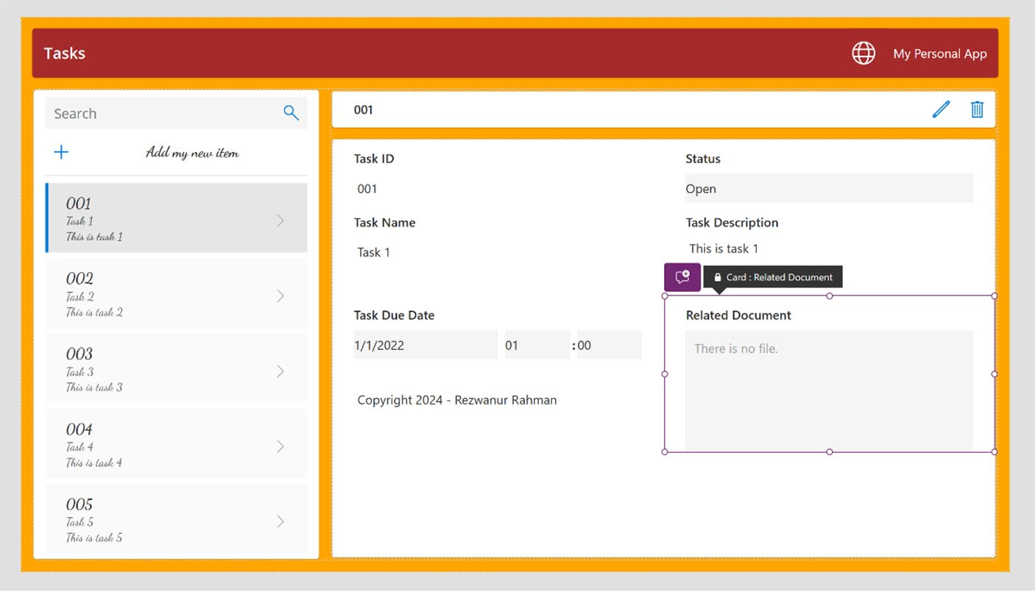

Figure 5-20. Showing the new custom column in the Power Apps screen

Working with Connectors
As previously discussed, there are three types of connectors on the Microsoft Power Platform. This section shows you how to integrate several types of connectors in Power Apps.
I will integrate the Office 365 Users connector into the example app, enabling you to access Microsoft 365 users who are part of your tenant. The Office 365 Users connector is a standard connector provided by Microsoft and it's free to use.
To add the Office 365 Users connector, expand the left column ➤ click
Data and click +Add Data, as shown in Figure 5-21.

Chapter 5 advanCed Customizations and automation with Copilot
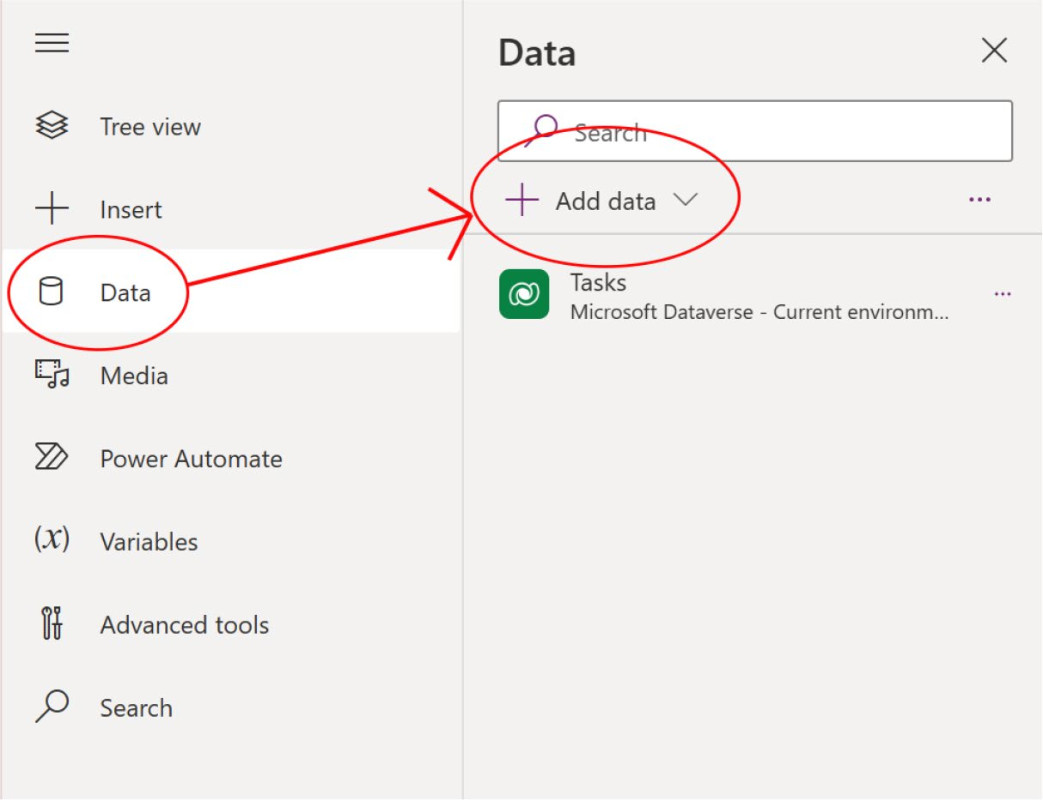

Figure 5-21. Expanding the Data option in Power Apps to add a
connector

You'll see a list like the one in Figure 5-22. If you navigate to the
Connectors section, you can find the Office 365 Users connector. Choose
Office 365 Users from the list.

Chapter 5 advanCed Customizations and automation with Copilot
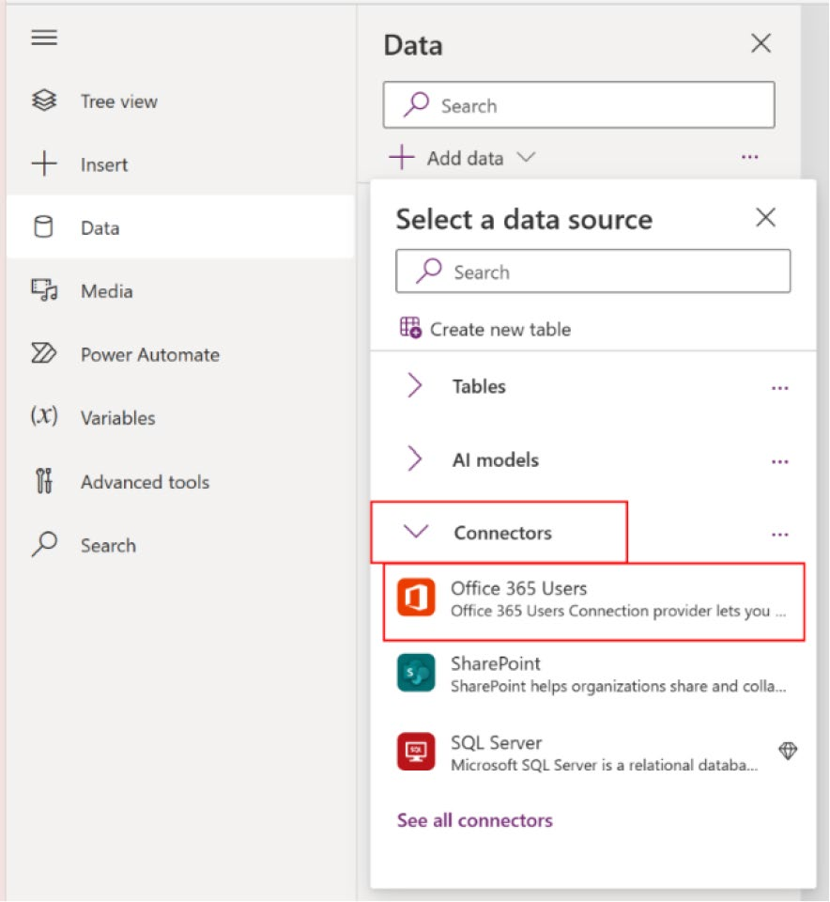

Figure 5-22. Searching and adding Office 365 Users from the connectors

If you encounter difficulty finding it, simply use the search bar to look for the connector, and it will appear.
After adding the connector, you can see the connector in the same
column of the Tasks table, as shown in Figure 5-23.

Chapter 5 advanCed Customizations and automation with Copilot
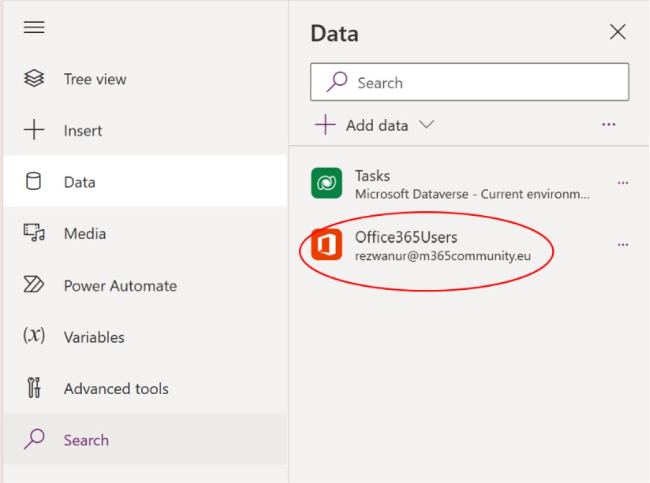

Figure 5-23. Office 365 Users connector in the Data list
Next, I show you how to retrieve Office 365 tenant user information
within Power Apps. You can retrieve limited information, including user
profile pictures, names, manager’s names, titles, emails, phone numbers,
and so on.

Note You cannot retrieve sensitive information, such as user’s mailbox items, onedrive files, or microsoft teams conversations.

To access Office 365 tenant user information, I add a new column
called Assign to Colleague to the Microsoft Dataverse table. This will allow
me to populate the column with Office 365 users.
As with the previous steps, navigate to Data, select Edit on the Tasks
table, and click the + sign to add a new column. For this column, select
Lookup for the Data Type, as shown in Figure 5-24.

Chapter 5 advanCed Customizations and automation with Copilot
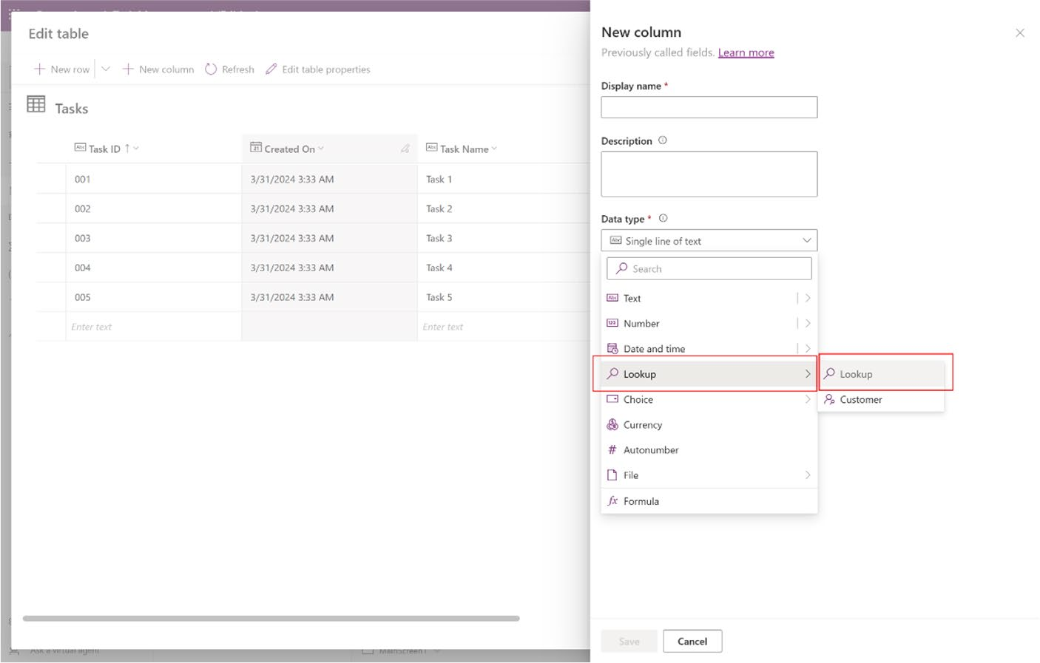

Figure 5-24. Selection of Lookup data type, to retrieve Office 365 user data in Power Apps
You can learn more about Lookup or other data type from the following
Microsoft Learn website: https://learn.microsoft.com/en-us/power-
apps/maker/data-platform/types-of-fields.
After choosing the Lookup data type, a new field called Related Table will appear. In this field, search for Microsoft Entra ID (previously known
as Microsoft Azure AD), as shown in Figure 5-25. This indicates that the Lookup type will directly retrieve users from Microsoft Entra ID.

Chapter 5 advanCed Customizations and automation with Copilot
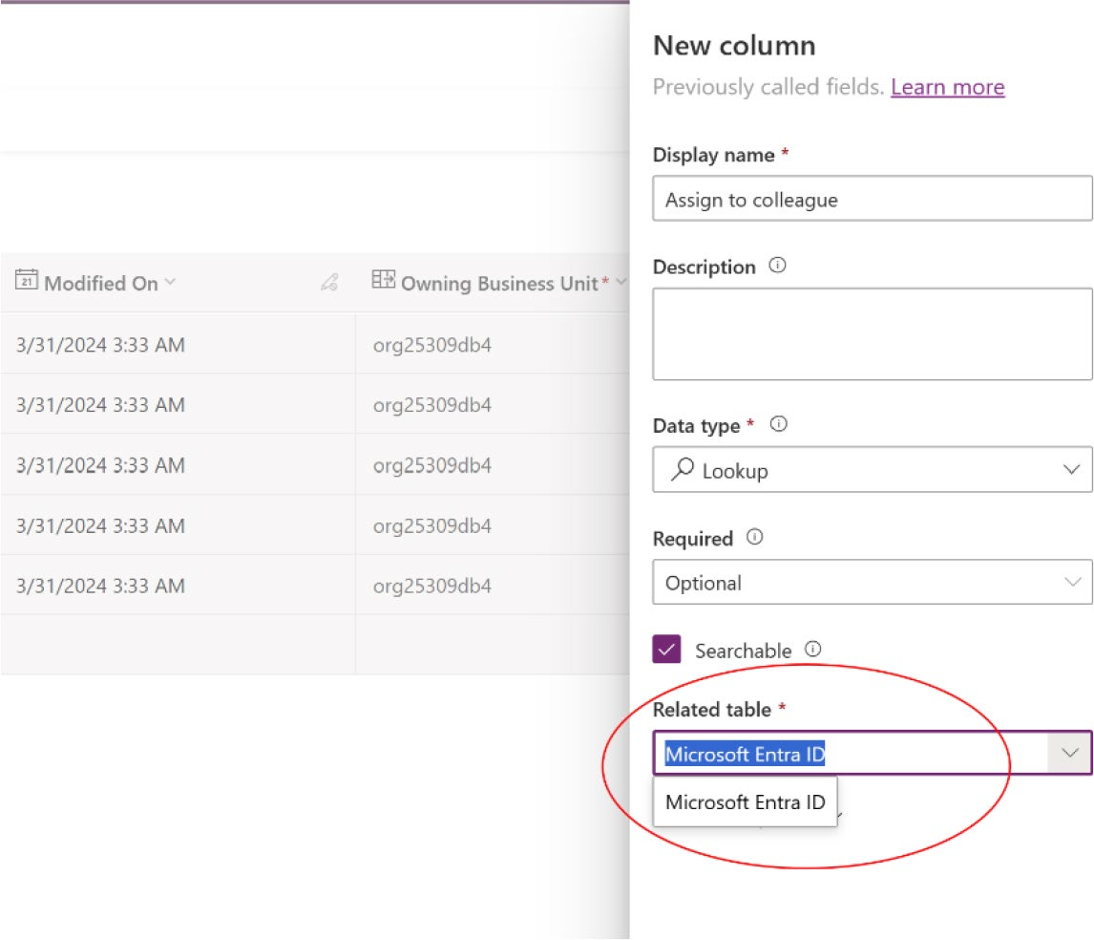

Figure 5-25. Searching for Microsoft Entra ID in the Lookup column

After saving the column, you will see a new column named Assign to
Colleague, as shown in Figure 5-26.

Chapter 5 advanCed Customizations and automation with Copilot
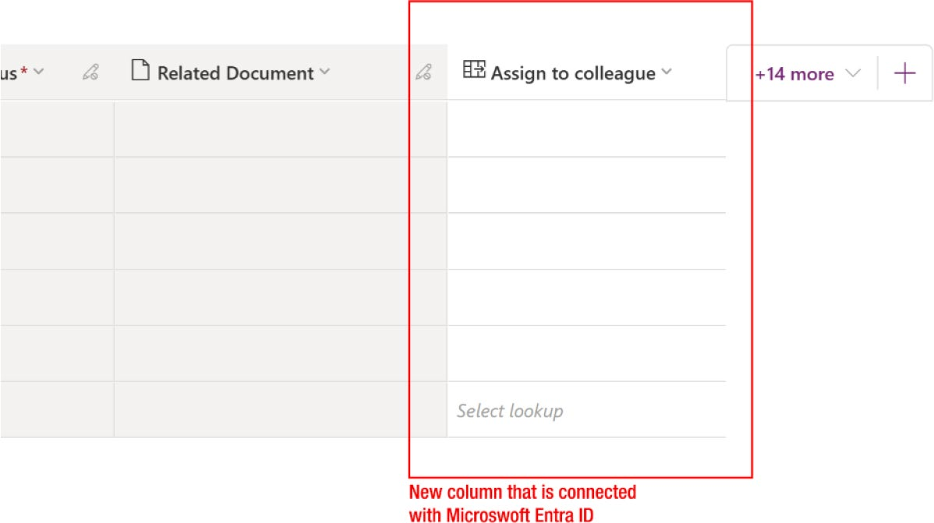

Figure 5-26. New lookup column that relates to Microsoft Entra ID in Microsoft Dataverse table

If you double-click any cell in the Assign to Colleague column, a list of users associated with this tenant will be displayed. This indicates that the lookup is connected to Microsoft Entra ID and can access the table, as
shown in Figure 5-27.
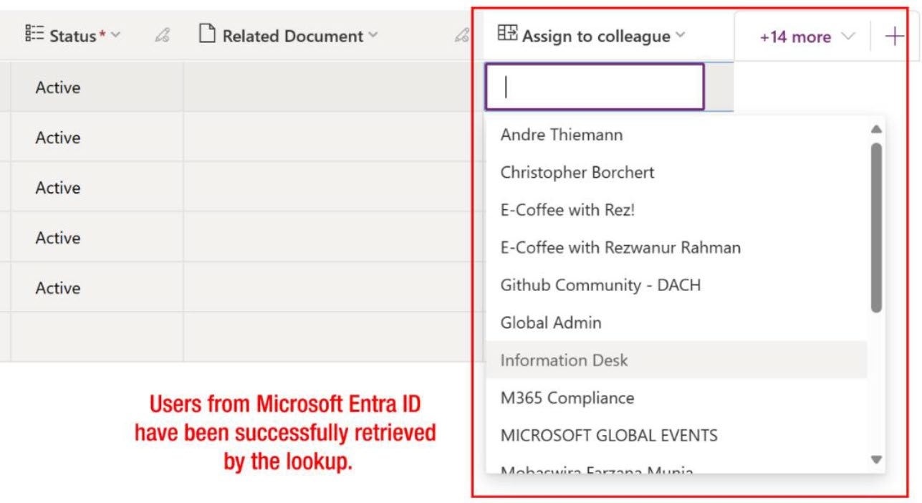

Figure 5-27. Searching Entra ID users from the lookup column

Chapter 5 advanCed Customizations and automation with Copilot
To retrieve additional details, such as Email or Role, you must include
the respective table in the Related Table option after selecting the Lookup
Data Type.
I repeat the same process by adding the column to Form1 as I did
previously; refer back to Figure 5-17.

EXERCISE 5-2

add the assign to Colleague column to Form1.

Note remember to save the project occasionally.

i successfully added the assign to Colleague column to the project. now, i run
the app by pressing F5 to check how it functions, as shown in Figure 5-28.
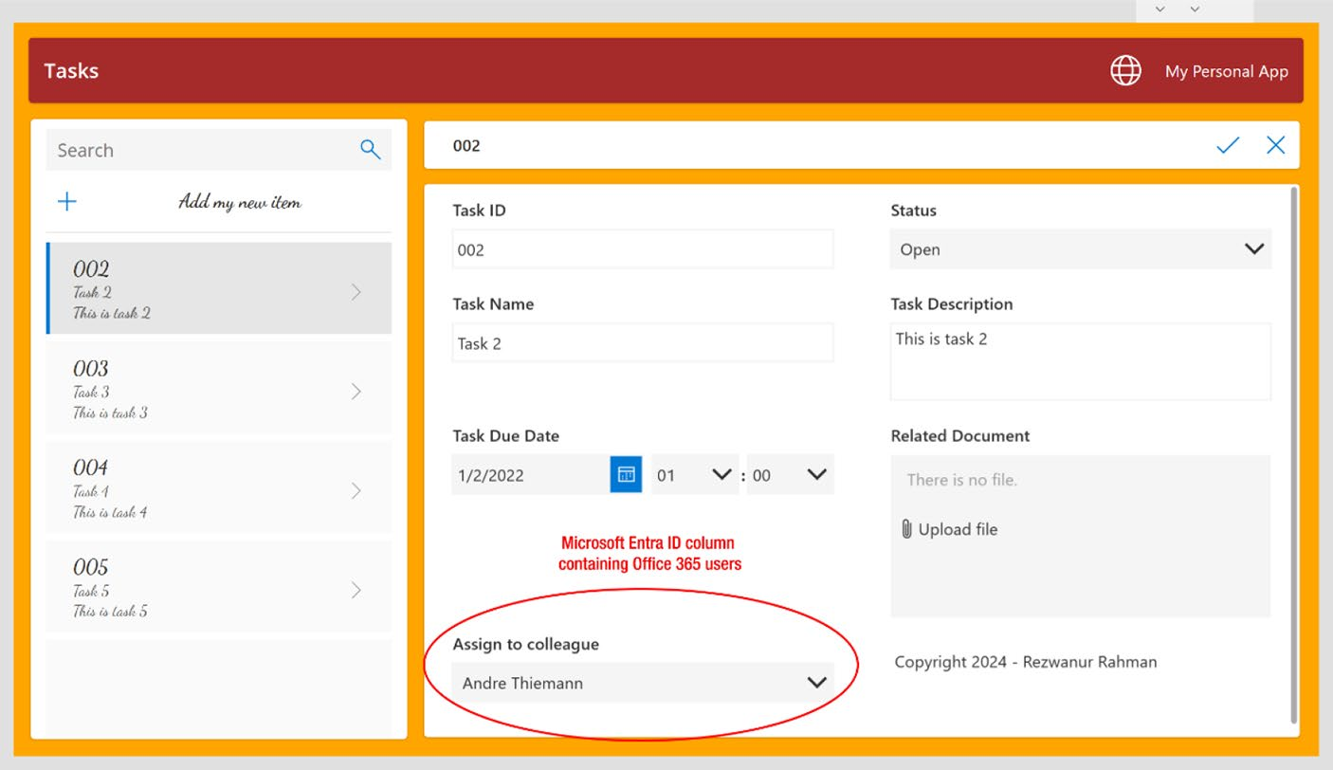

Figure 5-28. Preview of the app with the newly created lookup field

Chapter 5 advanCed Customizations and automation with Copilot

Introducing Automation Features
Power Automate, the most practical and interesting instrument of Power Platform by Microsoft, is responsible for setting up automatic workflows between applications and services, such as file synchronization, notification retrieval, and data gathering. In other words, it allows companies and people to automate their daily duties without
programming skills. Figure 5-29 show the logos of Power Apps and Power Automate.
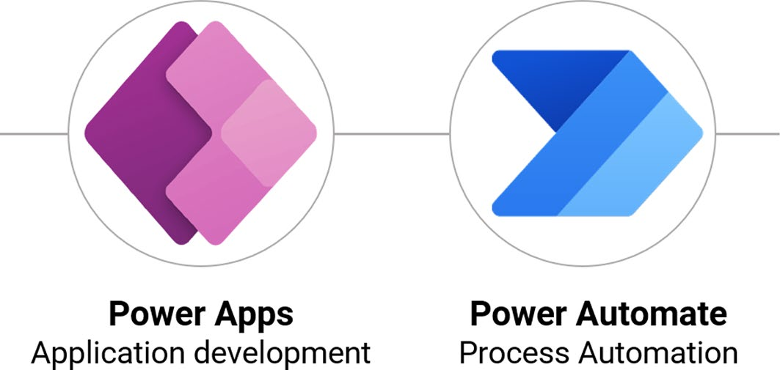

Figure 5-29. Logos of Microsoft Power Apps and Power Automate

Power Automate integrates with various Microsoft services, including SharePoint, Excel, Outlook, and Teams, as well as with other third-party apps like X (formerly Twitter), Dropbox, and Google services. Users can create "flows" using pre-built templates or from scratch. These flows can do things like automatically send emails, update data in a database, or start tasks when specific triggers occur.

Chapter 5 advanCed Customizations and automation with Copilot
The platform supports several types of workflows, including:
• Automated flows: Triggered by predefined events,
such as receiving an email or updating a record in a database.
• Button flows: Execute repetitive tasks conveniently
from anywhere, anytime, using a mobile device or desktop.
• Scheduled flows: Run tasks at specific times, such as a
monthly report generation.
• Business process flows: Guide users through a multi-
step process in applications like Dynamics 365.
I now show you some basic features of Power Automate in the
Microsoft Power Apps platform.
When you select the New Screen option from Tree View, you can
search for Email to access the Email template, as shown in Figure 5-30.

Chapter 5 advanCed Customizations and automation with Copilot
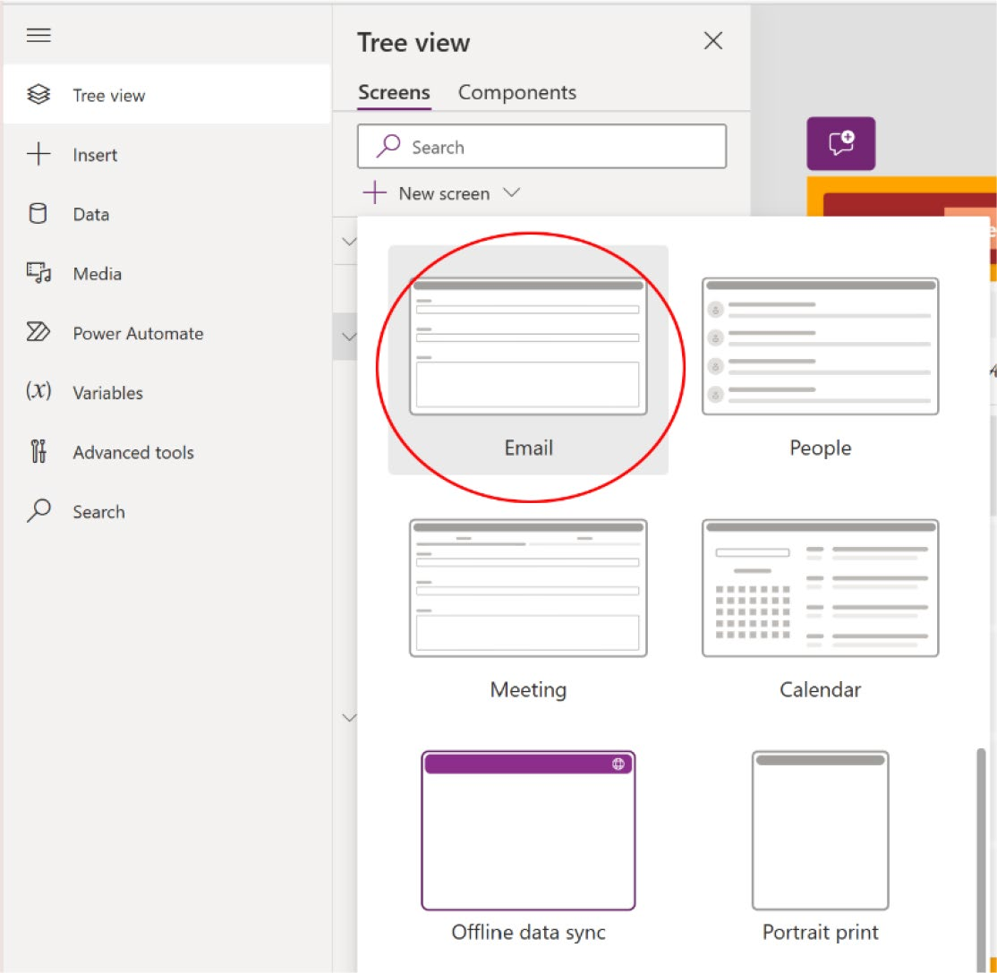

Figure 5-30. The Email template in Power Apps

Just add the Email template as a new screen and you can see the
preview, as shown in Figure 5-31.

Chapter 5 advanCed Customizations and automation with Copilot
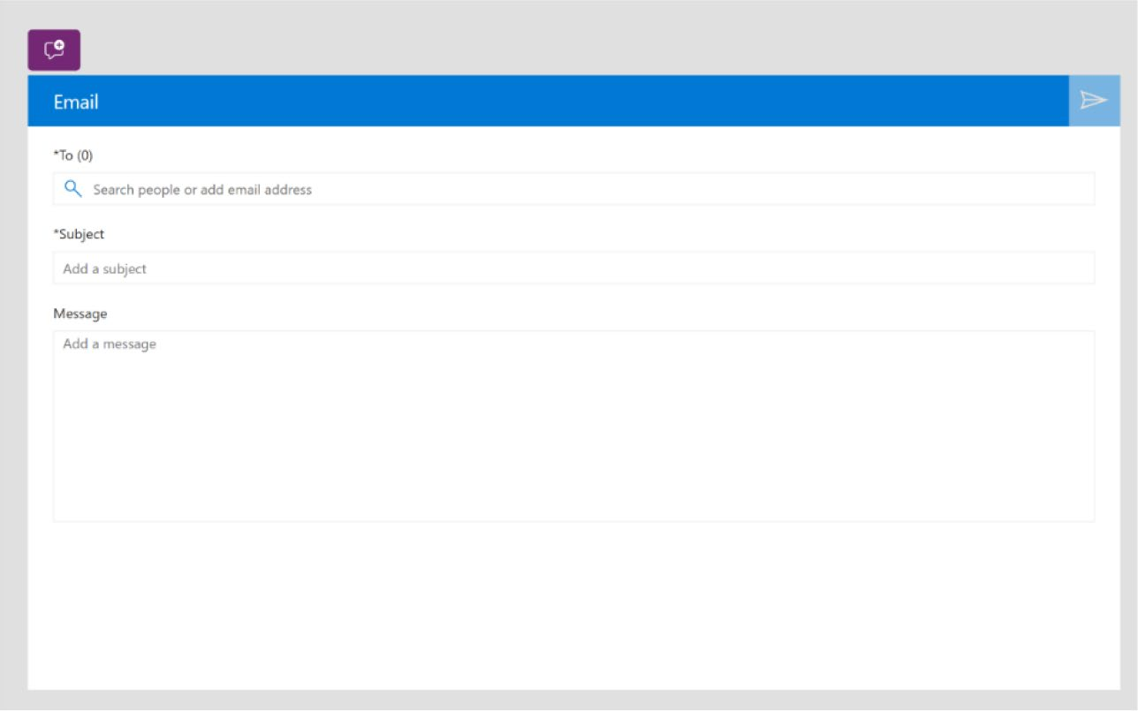

Figure 5-31. Preview of the Email template
Now, in the left panel, find the option called Power Automate, as
shown in Figure 5-32.

Chapter 5 advanCed Customizations and automation with Copilot
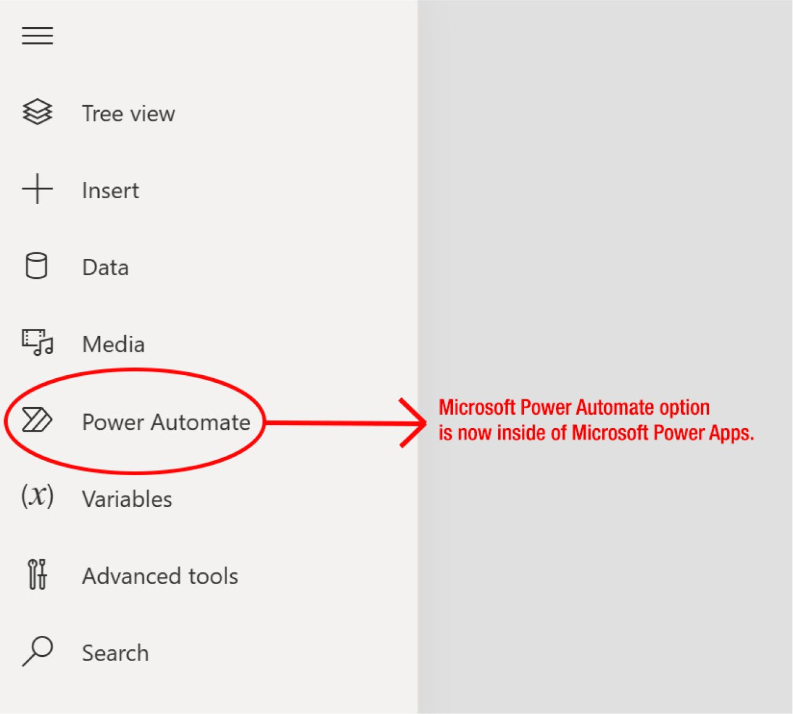

Figure 5-32. Power Automate option in the Power Apps portal

If you click the Power Automate option, you will find the Create New
Flow or +Add Flow option to create the flow, as shown in Figure 5-33.

Chapter 5 advanCed Customizations and automation with Copilot
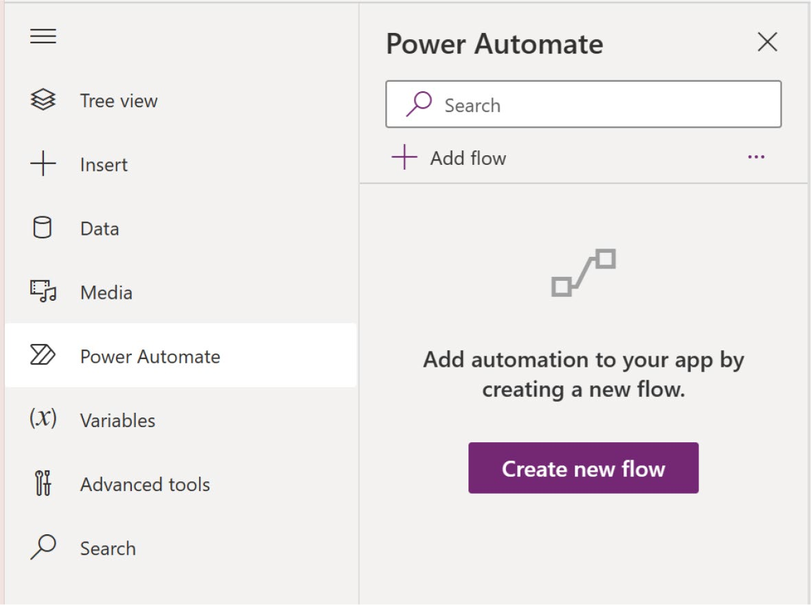

Figure 5-33. Option to create Power Automate flow

When you click the Create New Flow button, a new popup will appear
with some default flow information provided by Microsoft, as shown in
Figure 5-34.

Chapter 5 advanCed Customizations and automation with Copilot
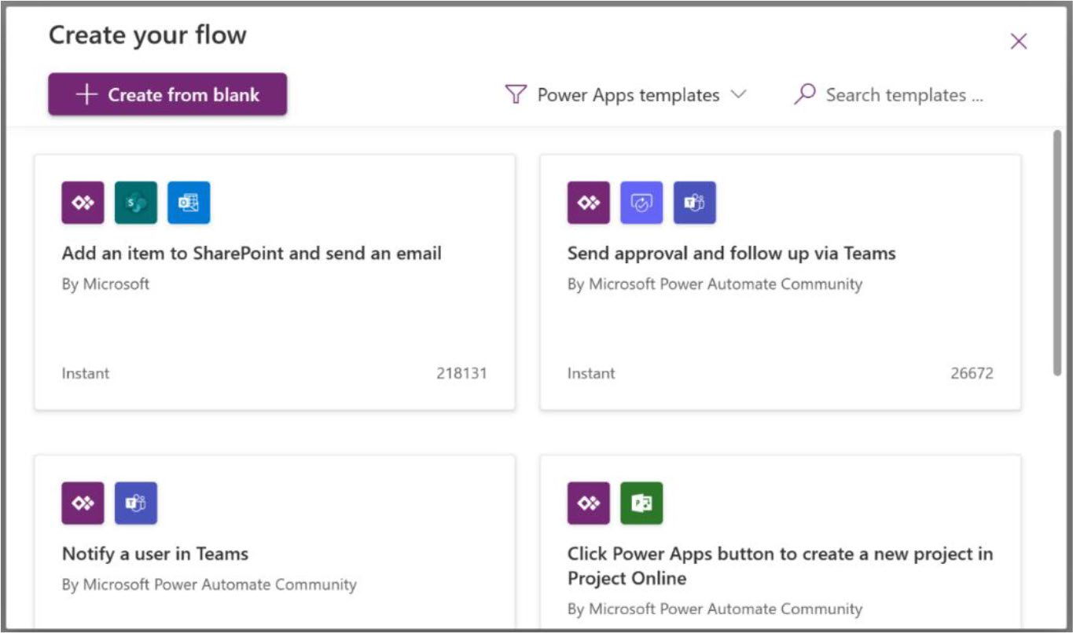

Figure 5-34. Pre-built automation flow by Microsoft

This means there is no longer a need to open the Power Apps project separately on the Power Automate site. Power Automate is now fully integrated within Power Apps.
Next, I begin by selecting a default template for the email flow. After setting this up, I explore creating a custom flow so you can fully understand its features and functionality.
In the search bar, type send email, and you will get some default email
sending flow, as shown in Figure 5-35.

Chapter 5 advanCed Customizations and automation with Copilot
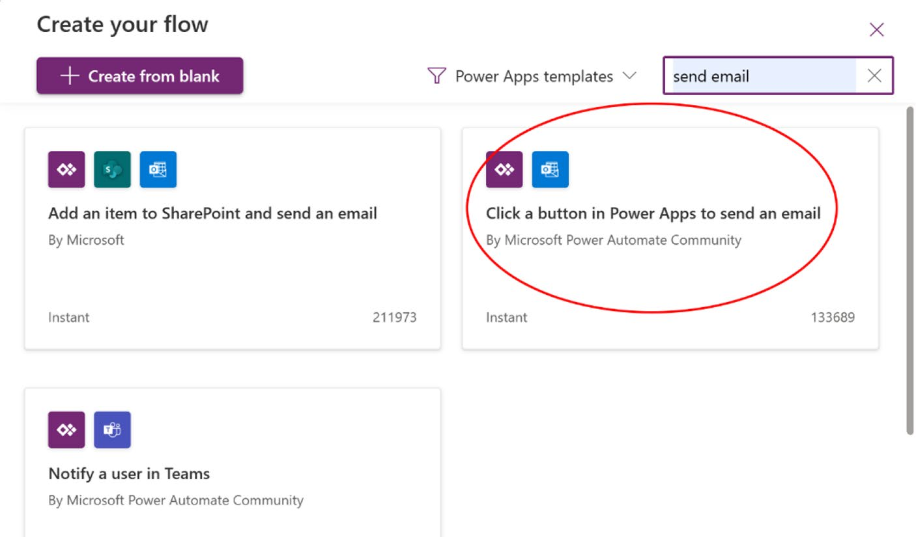

Figure 5-35. Choosing the correct automation flow to send email
Choose the Click a Button in Power Apps to Send an Email option.
After that, it will ask you to provide a name for the flow, as shown in
Figure 5-36.
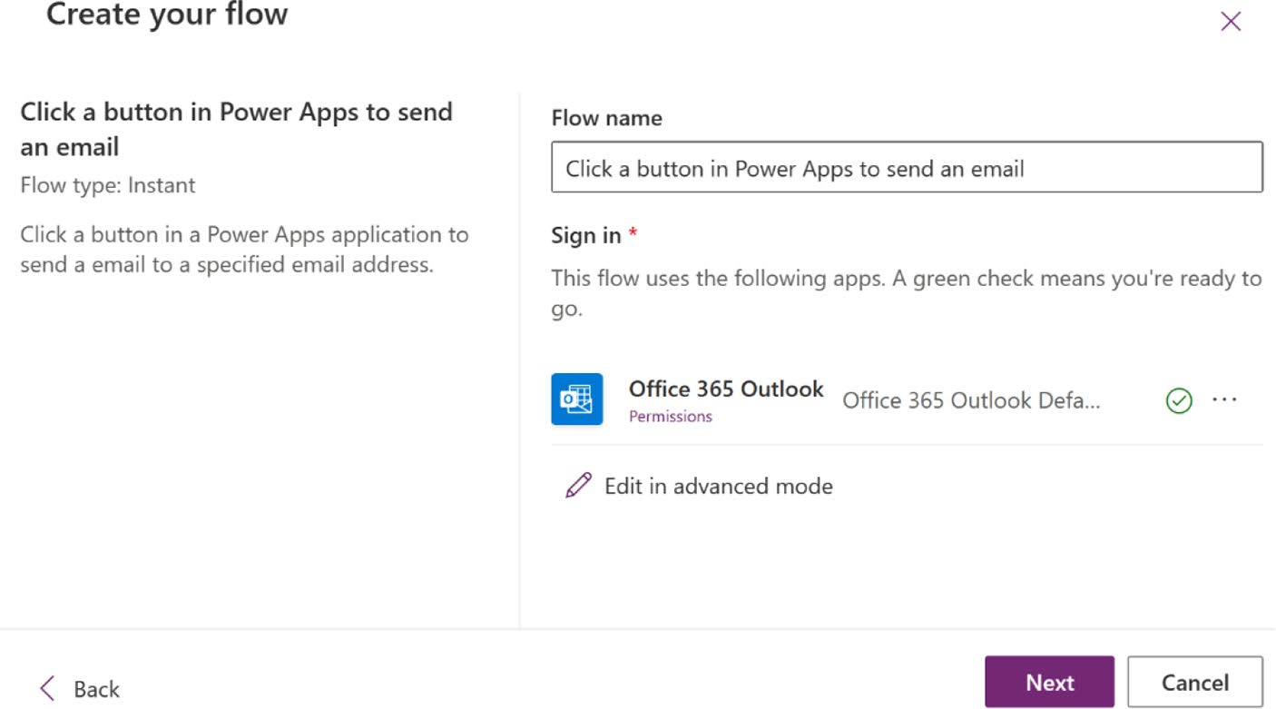

Figure 5-36. Creating a flow by providing a name

Chapter 5 advanCed Customizations and automation with Copilot
Click Next to see the option to edit in advanced mode. If you do not need to modify the flow or prefer not to use advanced mode, simply click
Create Flow to proceed, as shown in Figure 5-37.
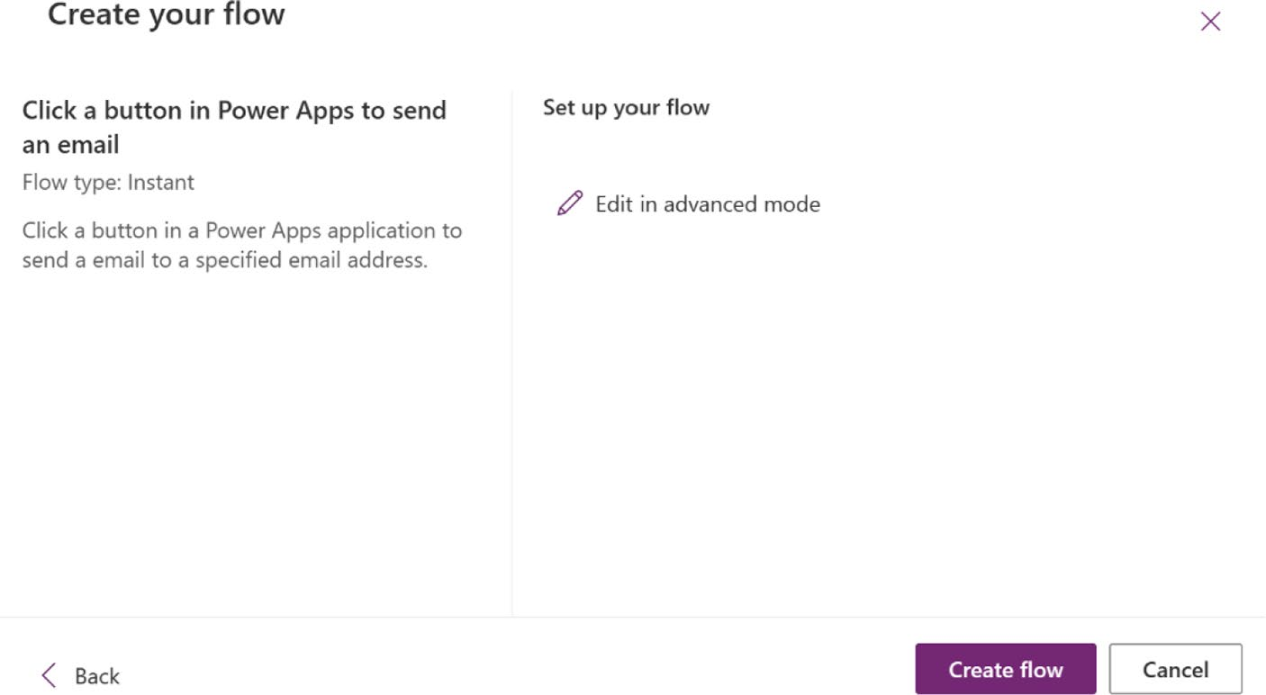

Figure 5-37. Advanced mode and the Create Flow option

When you click Create Flow, a new flow will be created and be visible
under the Power Automate option, as shown in Figure 5-38.

Chapter 5 advanCed Customizations and automation with Copilot
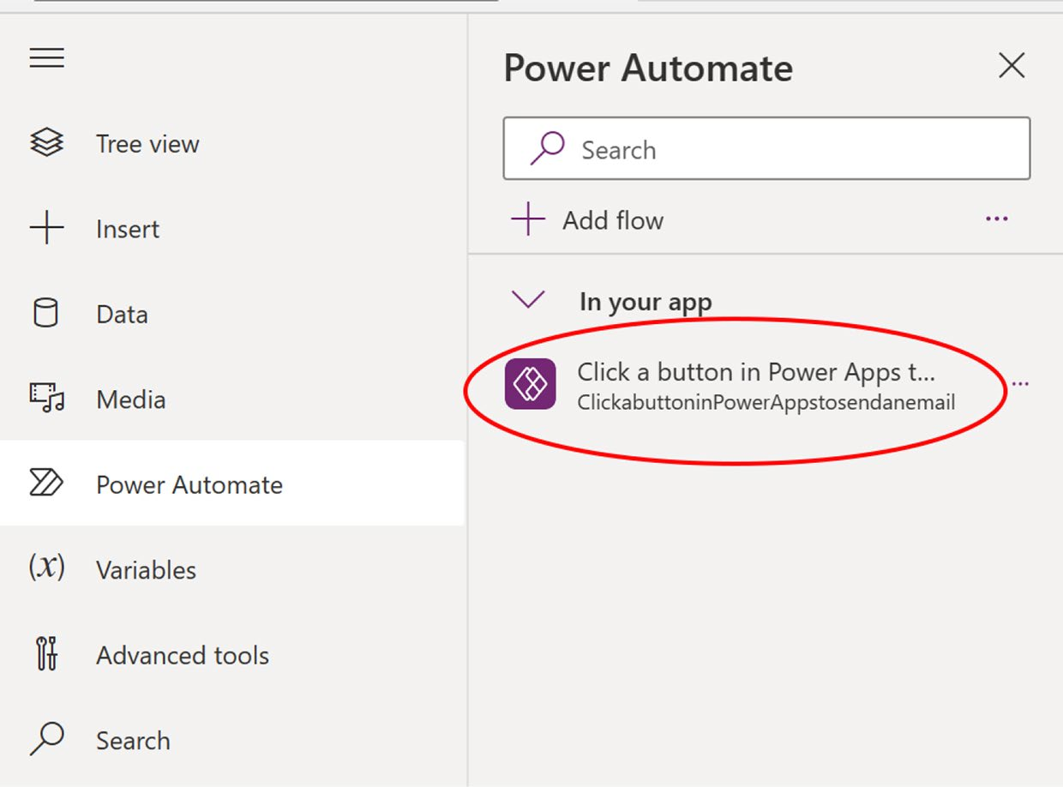

Figure 5-38. Newly created automation flow is shown in the Power
Automate flow list

Now I need to assign this flow to the send button of an email form.
To assign the flow, I first need to add a connector as a data source named
Office 365 Outlook, as shown in Figure 5-39.

Chapter 5 advanCed Customizations and automation with Copilot
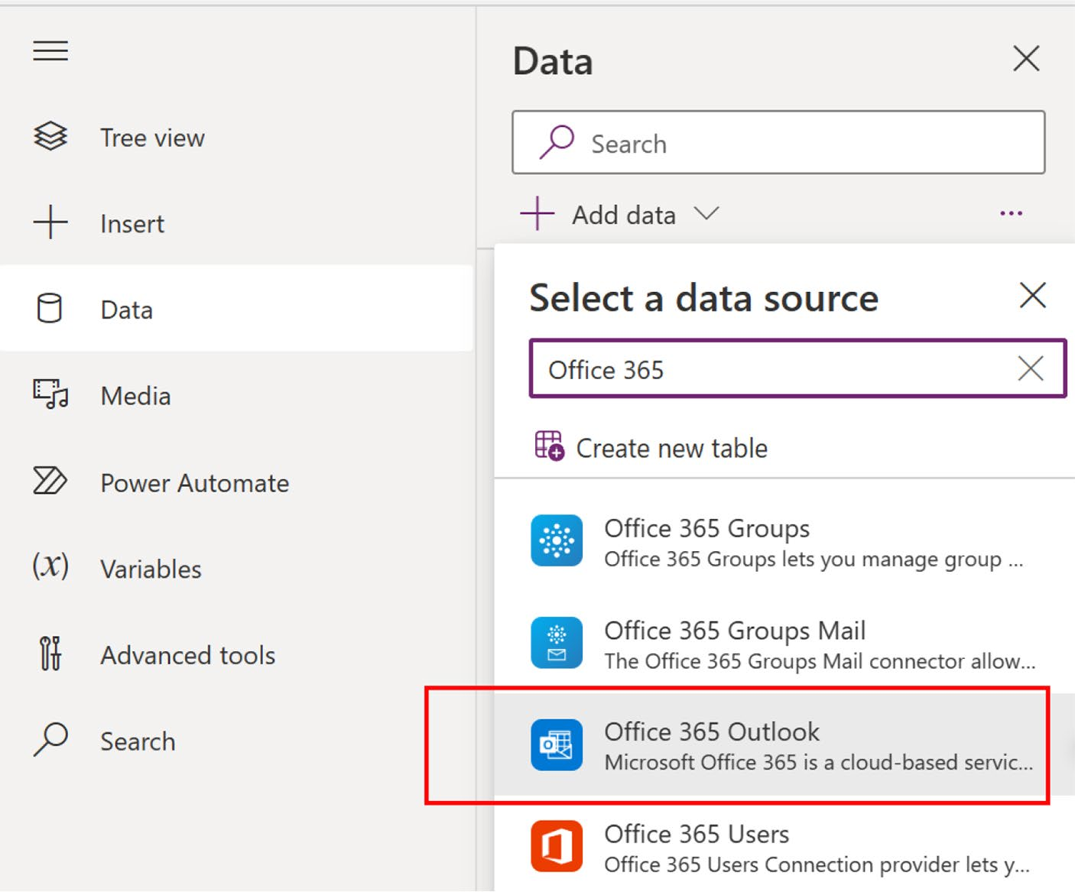

Figure 5-39. Searching for the Office 365 Outlook connector from the data source list

Note when creating a new automated flow in power apps, you
typically need to specify the data source if the flow will interact with
data. however, if you are working with data that’s already connected
through power apps, such as data in dataverse, you might not need
to add a new data source each time.

After adding the Office 365 Outlook connector to the data source, click
the send button of email template, as shown in Figure 5-40.

Chapter 5 advanCed Customizations and automation with Copilot
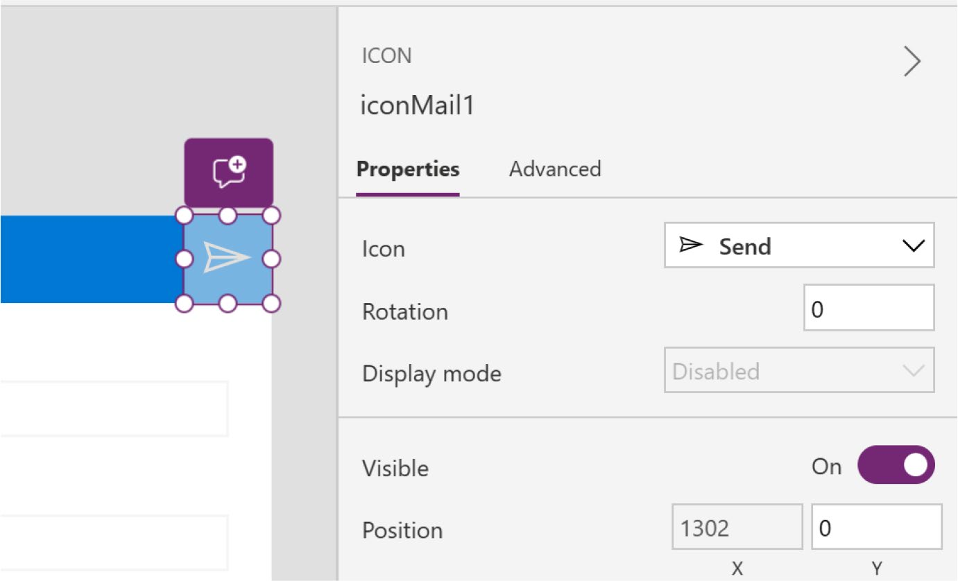

Figure 5-40. Selecting a send button for the email template
Then go to the function bar, select OnSelected, and include the
following command. Refer to Figure 5-41.
ClickabuttoninPowerAppstosendanemail.Run(Title2.Text,
TextEmailSubject1.Text, TextEmailMessage1.Text);

Chapter 5 advanCed Customizations and automation with Copilot
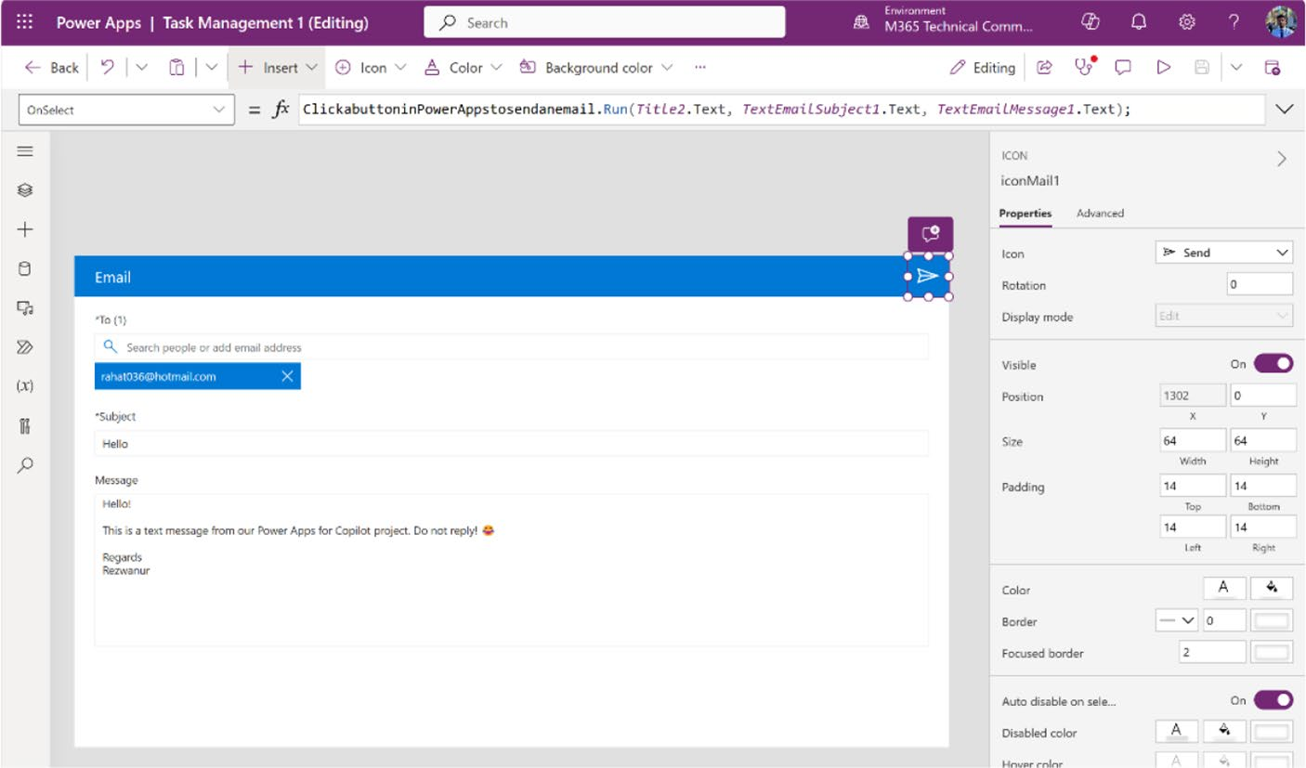

Figure 5-41. Adding a command to the OnSelect property to send email

Let's explore this command in detail:
ClickabuttoninPowerAppstosendanemail.Run(TextSearchBox1.Text, TextEmailSubject1.Text, TextEmailMessage1.Text);

• ClickabuttoninPowerAppstosendanemail: This is the
Power Automate flow created for sending emails.
• Run(): Use this function to initiate the email-sending
process.
• Title2.text: Parameter for the To field, it contains the
recipient's email address.
• TextEmailSubject1.text: Parameter for setting the
email's subject line.
• TextEmailMessage1.text: Parameter for the email's
body content.

Chapter 5 advanCed Customizations and automation with Copilot
To evaluate the email form, just run the app, fill in the form, and click
the send button, as shown in Figure 5-42.
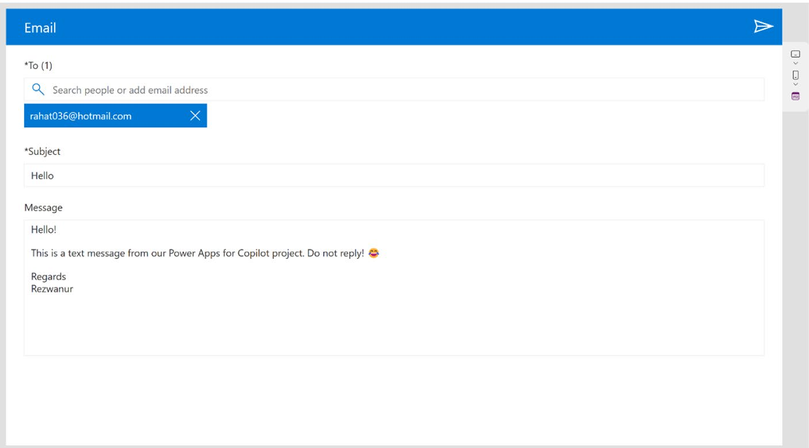

Figure 5-42. Evaluate the email template

I got a response in a personal email, as shown in Figure 5-43.

Chapter 5 advanCed Customizations and automation with Copilot
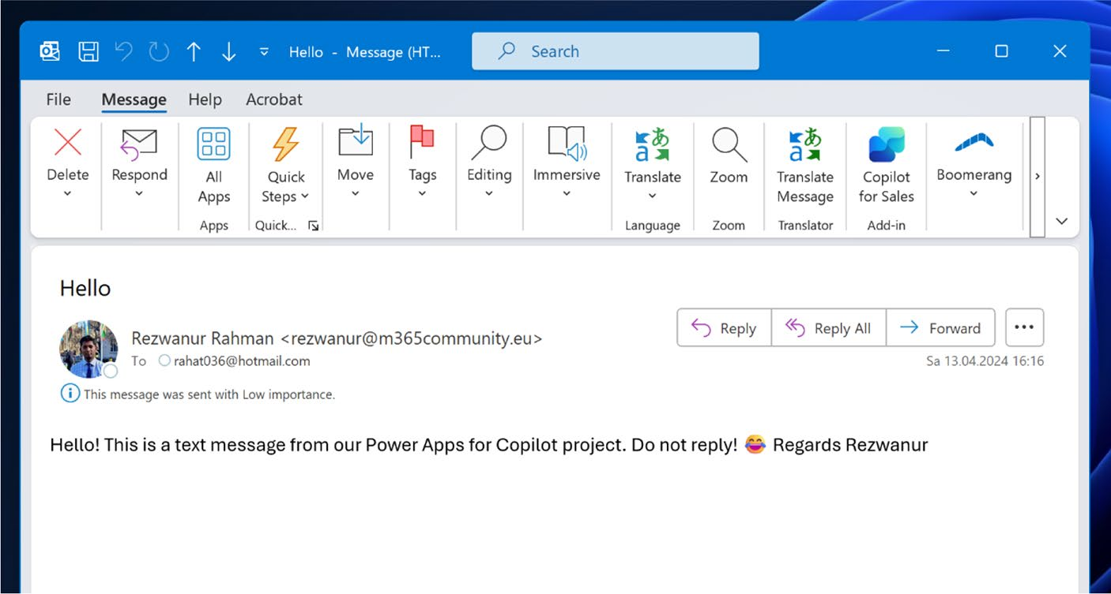

Figure 5-43. Email received from the Power Apps application through automation

Power Automation with Copilot
This section explores how to use Copilot to create automated commands in Power Apps. It is important to understand how Copilot integrates with the Power Automate platform, as this helps you grasp its capabilities and limitations in Power Apps. This knowledge is key to effectively using Copilot in your workflows.
So, using Copilot, I create a simple button, which will send a push notification when I click it.
I called this button Notifications, as shown in Figure 5-44.

Chapter 5 advanCed Customizations and automation with Copilot
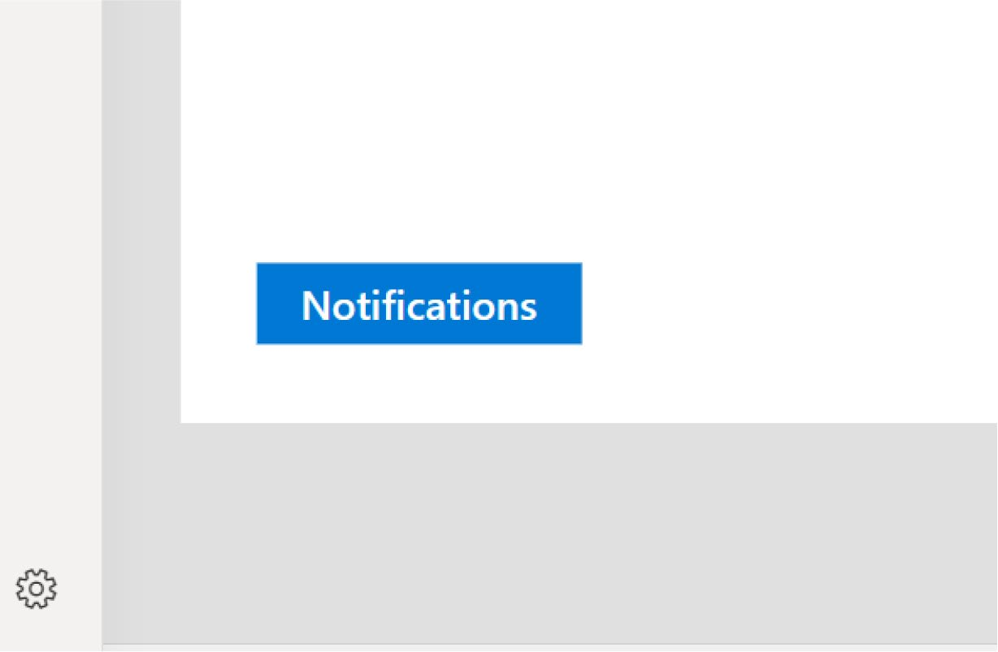

Figure 5-44. A new button called Notifications

In the Copilot prompt, I provide a natural language command like this
(also shown in Figure 5-45):
Send a push notification when click on NotificationButton

Chapter 5 advanCed Customizations and automation with Copilot
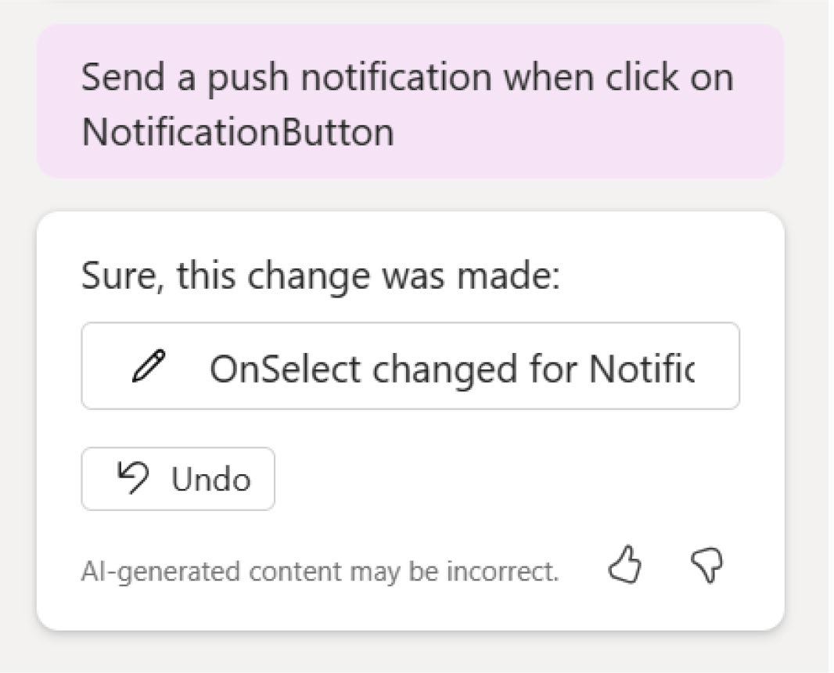

Figure 5-45. Copilot creates a simple automation to send notifications

Copilot created an OnSelect method under the button named NotificationButton. If you click the button, you can see the function in
the function bar, as shown in Figure 5-46.

Chapter 5 advanCed Customizations and automation with Copilot
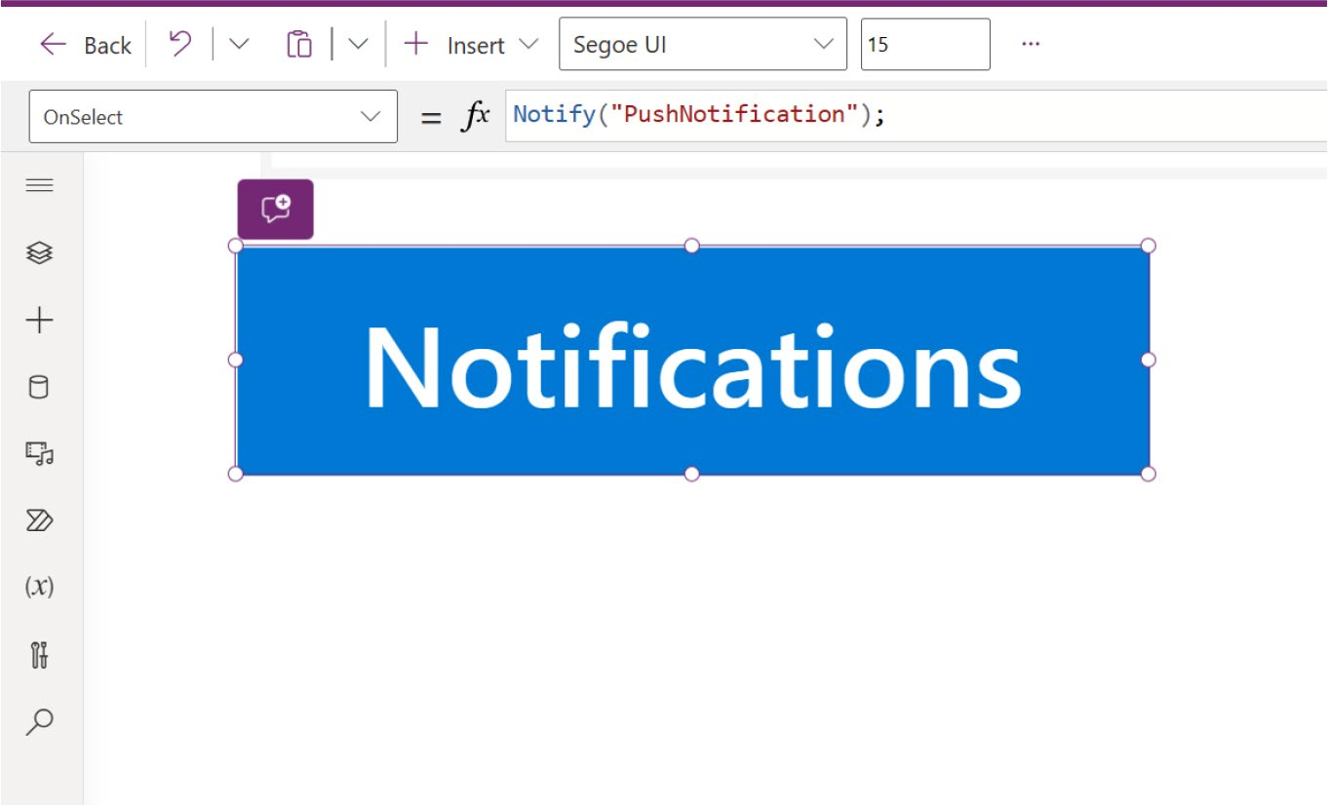

Figure 5-46. The OnSelect function of the Notifications button

You can see that Copilot created the Notify() function with the
PushNotification message. I changed the message to "This is a test
push notification", as shown in Figure 5-47.
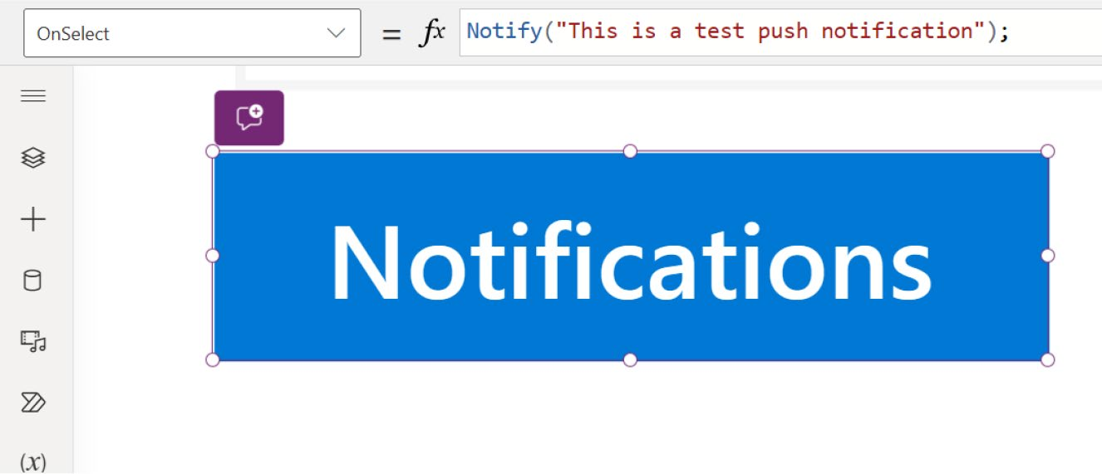

Figure 5-47. Changing the notification text
Now run the app and see how it behaves, as shown in Figure 5-48.
Press F5 and click the button.

Chapter 5 advanCed Customizations and automation with Copilot
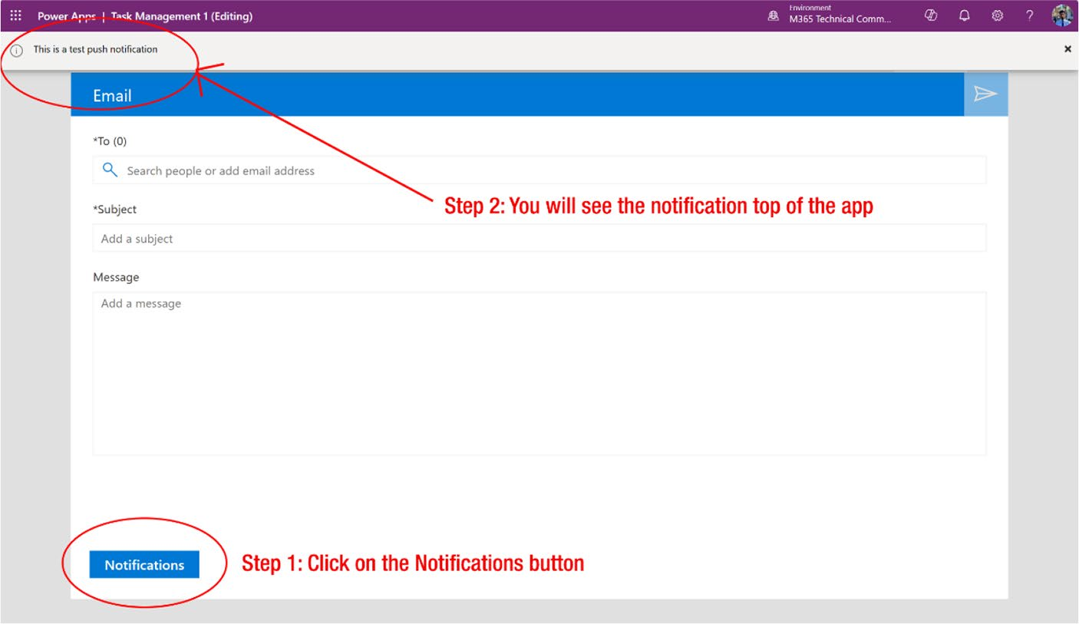

Figure 5-48. Successfully testing the Notifications button and the function created by Copilot

You can see that the button has successfully triggered the Notify() function, sending a notification in the app.
This is just the basics of automation. You will learn about some advanced customization features in the following chapters.

Summary
This chapter showed you how to dive into advanced customizations and automation within Power Apps, focusing on integrating data sources like Microsoft Dataverse, SQL Server, and Excel. It also explored the capabilities of Power Automate, using natural language commands with Microsoft Copilot to streamline complex tasks. These skills empower you to create dynamic, data-driven applications tailored to your specific business needs.

Chapter 5 advanCed Customizations and automation with Copilot
As you move to the next chapter, the focus shifts to the art of designing
exceptional user interfaces and experiences. You'll learn how to refine
layouts, optimize the user journey, and enhance accessibility. By
mastering the strategic use of color schemes, fonts, and design elements,
you'll be able to create applications that are not only powerful but also
visually captivating and user-friendly. This next step will elevate your apps,
making them a delight for anyone who uses them.

CHAPTER 6

Advanced UI/UX

Techniques in Power

Apps Development

In the previous chapter, you got hands-on integrating data sources and
automating tasks, turning your Power Apps into dynamic, data-driven
tools. Now, let’s shift gears. This chapter dives into the world of design—
where functionality meets aesthetics. It explores how to create interfaces
that aren’t just functional, but are also visually striking and user-friendly.
You’ll discover how to optimize layouts, choose the right colors and
fonts, and ensure your apps are accessible to everyone. By the end, you’ll
have the skills to build apps that not only work well but look and feel
exceptional, making every interaction a pleasure for your users.

Tailoring Apps: Customization Secrets
When developing applications with Microsoft Power Apps, customization
plays a critical role in enhancing functionality and user experience.
This section focuses on two crucial aspects: refining user interfaces and
dynamically adjusting content. I discuss practical UI/UX best practices
aimed at optimizing layout, navigation, and aesthetics to create intuitive

© Rezwanur Rahman 2024 229
R. Rahman, Microsoft Copilot for Power Apps, Inside Copilot,

Chapter 6 advanCed UI/UX teChnIqUes In power apps development
and visually appealing applications. Additionally, I explain how to effectively use variables and formulas to alter app content and appearance in response to user interactions or data changes. These strategies enable developers to tailor applications more closely to specific business needs and user preferences, improving engagement and usability.

Exploring UI/UX Best Practices
This section starts by focusing on creating intuitive interfaces in Power Apps. This involves employing consistent design elements and ensuring the application adapts smoothly across different devices. Making the application accessible to a broad audience is also crucial, as it enhances user satisfaction and overall effectiveness.

Layout Optimization
A clean and organized layout in application design, such as in Power Apps, is essential for enhancing user navigation and accessibility. An effectively designed layout not only makes an application aesthetically pleasing but also increases usability, ensuring users can find the information or functionality they need without confusion or delay.

Importance of Layout Optimization in Power Apps

• Enhanced user navigation: A well-structured layout
guides users effortlessly through the different parts of the application. This is particularly important in environments where efficiency and speed are valued.
• Improved accessibility: Accessibility is crucial in
application design, making it easier for people with disabilities to interact with your application. A clean

Chapter 6 advanCed UI/UX teChnIqUes In power apps development
layout with thoughtful spacing and alignment can significantly aid in readability and interaction for users with visual impairments.
• Increased user engagement: An organized layout can
lead to increased user engagement. When users find the application easy to use and navigate, they are more likely to use it frequently.
• Professional appearance: A well-designed application
reflects professionalism and attention to detail, enhancing the overall brand perception among users.

Tips for Layout Optimization in Power Apps
I want to share some tips about layout optimization in Power Apps from
my experience.

Grid Utilization
A grid system in Power Apps is a framework used to design and align user
interface elements systematically across the screens of an application.
It provides a structured approach for placing controls like text boxes,
labels, and buttons, ensuring that the app’s layout is uniform and visually
appealing. Grids help make applications responsive, meaning they
can adapt smoothly to different screen sizes, from mobile devices to
desktops. This adaptability enhances the user experience by maintaining
consistency and accessibility across devices. In Power Apps, grids can
be implemented using various built-in controls that support flexible and
dynamic layouts, facilitating the development of organized and efficient
user interfaces.

Chapter 6 advanCed UI/UX teChnIqUes In power apps development
Why You Need a Grid System
Grids are essential in design and development for several reasons, particularly in digital applications like those created with Power Apps. Here’s why grids are so important:
1. Organizational structure: Grids provide a coherent
structure to lay out elements. Using grids, designers and developers can place UI elements like text, images, and controls in a consistent, aligned manner. This organization makes the interface easier to navigate and interact with, reducing cognitive load for users.
2. Visual consistency: Consistency is key in design
for creating a smooth, predictable user experience. A grid ensures that elements are uniformly aligned and spaced, which not only enhances the aesthetic appeal but also supports a consistent flow of information, making it easier for users to understand and use the application.
3. Efficiency in design: Grids speed up the design
process. They serve as a guide that designers can use to quickly add elements to a layout without having to measure and plan each new component from scratch. This can significantly reduce the time spent on adjusting and readjusting elements during the design phase.
4. Responsiveness and scalability: With the variety
of devices available today, from smartphones to large desktop monitors, designing an interface that works well on all screen sizes is crucial. Grids

Chapter 6 advanCed UI/UX teChnIqUes In power apps development
facilitate responsive design by allowing elements to resize and rearrange themselves fluidly according to the screen size, maintaining a coherent structure without breaking the layout.
5. Professional aesthetics: A grid helps create a
polished, professional application. The careful alignment and spacing that a grid imposes results in a cleaner, more orderly design that is visually appealing. This professionalism can affect user trust and satisfaction positively.
6. Accessibility: Grids can improve accessibility by
creating predictable navigation paths for users. This predictability helps people with visual impairments and those who rely on assistive technologies to better understand and navigate the content.
7. Facilitate collaboration: When working in a team,
grids provide a common guideline that all designers can adhere to. This uniformity ensures that the work is consistent regardless of who adds to the design, which is crucial in collaborative environments.

Tips for Optimizing the Grid System
Here are some tailored tips for optimizing the grid system in Power Apps:
• Adaptive dimensions: Use the Parent.Width and
Parent.Height properties to adjust the layout grid to various screen sizes, ensuring a consistent and responsive user experience across different devices.
Figures 6-1 and 6-2 demonstrate the adjustments in Height and Weight necessary for optimizing the grid system.

Chapter 6 advanCed UI/UX teChnIqUes In power apps development

Figure 6-1. Set the height to optimize the grid system

Figure 6-2. Set the weight to optimize the grid system

• Uniform spacing: Implement consistent spacing
between elements (gutters) and around the perimeter of the screen (margins) to maintain visual harmony and enhance readability across the application.

Spacing
In the context of UX/UI design for Power Apps, spacing is a fundamental element that plays a critical role in creating an efficient and visually appealing interface. Proper spacing helps organize the content, improve readability, and enhance the overall user experience.

Importance of Proper Spacing in Power Apps

1. Clarity and organization: Spacing can dramatically
improve the clarity of your application by defining the relationships between different UI elements. It helps users understand which elements are grouped together and distinguishes between separate sections of the app.
2. Aesthetic appeal: Well-spaced elements contribute
to a clean and professional look, which can be crucial for business applications built on Power

Chapter 6 advanCed UI/UX teChnIqUes In power apps development
Apps. It helps in maintaining a balance between the various components on the screen, avoiding a cluttered or overwhelming interface.
3. Enhanced usability: Adequate spacing makes
interactive elements like buttons and forms easier to use, particularly on touch devices. It reduces the chance of accidental taps and makes the app more accessible, especially for users with motor impairments who may find tightly packed elements challenging to navigate.

Tips for Optimizing Spacing

• Logical grouping: Space related items closer
together, which helps users quickly associate related functionalities. This can be achieved by using containers in Power Apps to group controls.
• Adequate padding: Ensure that there is sufficient
space inside each control (padding) to prevent the UI from feeling cramped. This is especially important in forms where users need to enter data.

Alignment
Alignment is, without a doubt, one of the key concepts in UX/UI design.
It shapes the look and feel of a design to a great extent. Power Apps is
no exception; correct alignment helps design an app that is visually
consistent, easy to use, and beautiful. Better alignment not only makes
the screen look orderly, but it also establishes flow and thus allows more
intuitive navigation, thus enabling the user to perform tasks faster.

Chapter 6 advanCed UI/UX teChnIqUes In power apps development
Importance of Proper Alignment in Power Apps

1. Creates visual order: Alignment helps create a
clean, organized interface. This visual order makes it easier for users to process information and understand where to focus their attention.
2. Enhances readability: Properly aligned text and
controls make content easier to read and scan. This is crucial in business applications where users often need to find information quickly and efficiently.
3. Improves navigation: Consistent alignment of
elements like buttons, menus, and input fields can significantly enhance the navigation of the app, making it more intuitive for users to move from one task to another.
4. Creates a professional appearance: An application
with well-aligned elements looks more professional and trustworthy, which is important for business applications designed in Power Apps to reflect the brand’s integrity.

Tips to Optimize Alignment
To ensure your designs are effective and aesthetically pleasing, use the following essential tips to optimize alignment.

Use Grid and Layout Containers
Utilizing the grid system and layout containers in Power Apps can help achieve effective alignment. Containers manage the arrangement of child controls and ensure consistent alignment without requiring manual adjustments for each element.

Chapter 6 advanCed UI/UX teChnIqUes In power apps development
To change the grid alignment, select the container and set properties
for alignment within the container (Start, Center, End, and Stretch). See
Figure 6-3.
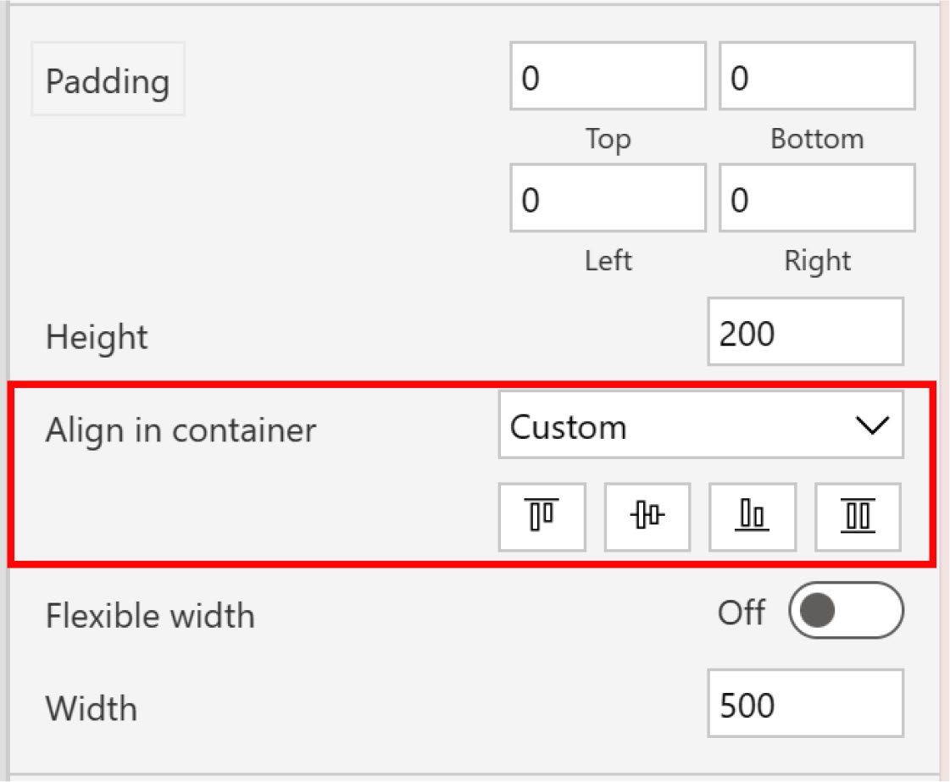

Figure 6-3. Container alignment options

Align Text Consistently
Text alignment should be consistent across similar types of content to
support readability and create a cohesive look. Typically, the body text
is left-aligned, which is easier to read, while titles or headers might be
centered or left-aligned, depending on the design.
To change the text alignment, select the text level and choose the text
alignment (Left, Center, Right, or Justify). See Figure 6-4.

Chapter 6 advanCed UI/UX teChnIqUes In power apps development
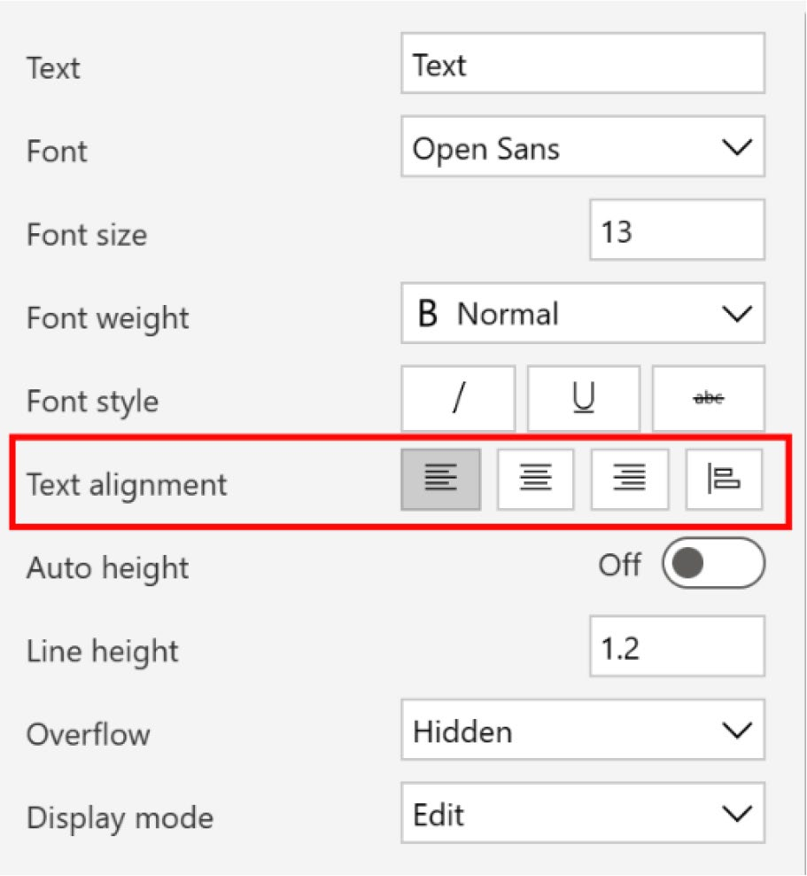

Figure 6-4. Text alignment options (Left, Center, Right, or Justify)

Use Alignment Lines
Power Apps Studio provides alignment lines (smart guides) when moving controls around the canvas, which can help align controls precisely relative to one another. For example, if you drag a control, alignment lines appear when the control aligns with another control’s edge or center.

Use Consistent Margins and Padding
Maintaining consistent margins and padding around elements is crucial for alignment. It helps you position elements relative to each other and the overall canvas, providing a balanced and harmonious layout.
To change the margins and padding, select the component, go to the
properties, and choose your option. See Figure 6-5.

Chapter 6 advanCed UI/UX teChnIqUes In power apps development
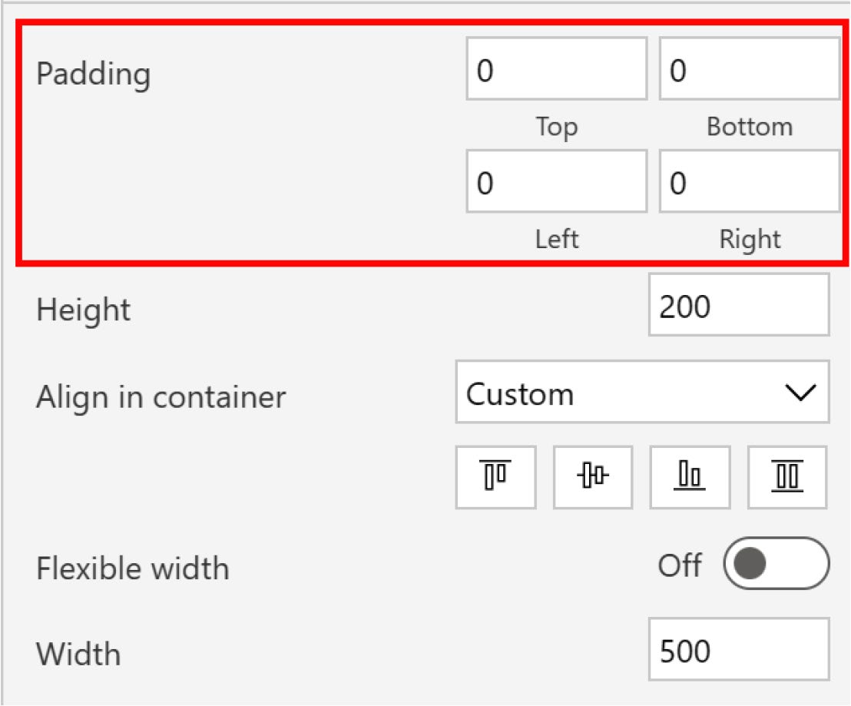

Figure 6-5. Padding options from the component properties

Accessibility Considerations
Accessibility in application design is crucial for ensuring that all users,
including those with disabilities, can effectively use the software. When
designing with Power Apps, it is essential to consider accessibility features
that make the app usable for everyone. This includes users with visual
impairments, hearing difficulties, motor limitations, and cognitive
disabilities. The following sections explain how to implement key
accessibility considerations to enhance inclusivity.

Chapter 6 advanCed UI/UX teChnIqUes In power apps development
Accessibility is important in Power Apps for the following reasons:
• Legal compliance: Many regions have legal
requirements for digital accessibility (like the ADA in the United States or the AODA in Canada). Ensuring your Power App complies with these standards is not just ethical but also legally prudent.
• Broader user base: Designing accessible apps
naturally broadens your potential user base, allowing more people to use the app effectively, regardless of their physical abilities.
• Enhanced user experience: Accessibility
improvements often benefit all users, not just those with disabilities. Features such as clear navigation and readable text improve the overall user experience.

Key Accessibility Considerations for Power Apps
Visual Accessibility
Contrast and colors: Use high contrast colors for text and backgrounds. Avoid color combinations like green and red, which are difficult for colorblind users to distinguish. Power Apps provides properties to customize colors and contrast easily.
To change the Contrast and Colors, select the component, go to the properties, and choose the
color. See Figure 6-6.

Chapter 6 advanCed UI/UX teChnIqUes In power apps development
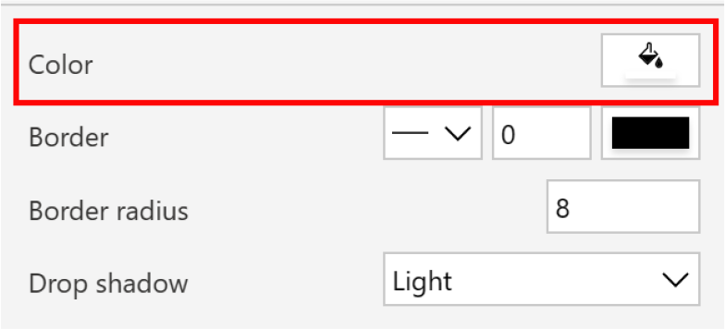

Figure 6-6. Color option from component properties

Text Size and Fonts: Ensure that text is resizable without breaking the
layout and use legible fonts. Provide functionality within the app to change
text sizes if possible. See Figure 6-7.
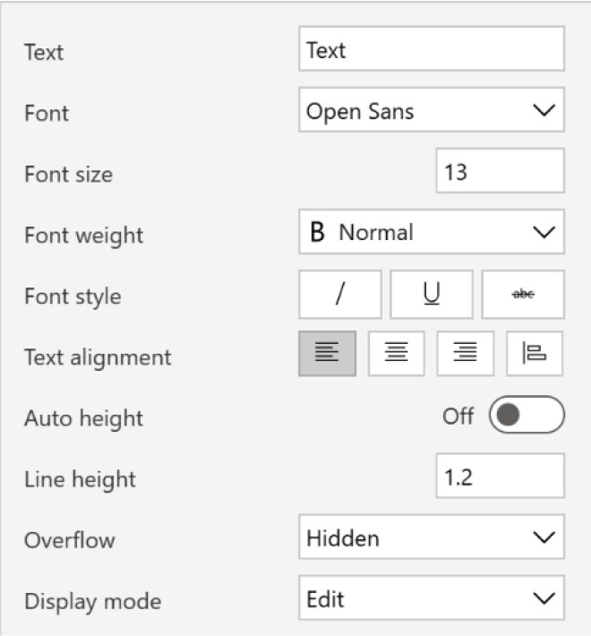

Figure 6-7. Properties for altering font styles

Hearing Accessibility
Captions and Subtitles: For multimedia content like videos, include
captions and subtitles. If your app integrates such media, ensure these
features are accurate and synchronized.
Visual Alerts: Implement visual alerts in addition to auditory ones to
notify users about important actions or errors, thereby ensuring that users
who are deaf or hard of hearing are also alerted.

Chapter 6 advanCed UI/UX teChnIqUes In power apps development
Motor Accessibility
Touchable Controls: Make controls large enough to be easily tapped. Power Apps allows you to adjust the size of buttons, drop-downs, and other interactive elements to accommodate users with limited motor skills.
Keyboard Navigation: Ensure the app can be navigated using a keyboard alone. Tab order and keyboard focus should be logical and intuitive.
Gesture Simplification: Avoid complex gestures that might be difficult for users with limited dexterity. Instead, use simple taps or swipes whenever possible.

Cognitive Accessibility
Clear Language: Use plain language to make the content understandable. Avoid technical jargon and complex sentences that can be confusing.
Consistent Layout and Navigation: Maintain a consistent layout and navigation scheme throughout the app to help users with cognitive challenges understand how to use the app more easily.
Feedback and Error Handling: Provide clear, immediate feedback for actions. Error messages should be descriptive and suggest a clear path to resolution.
You can learn more about accessibility controls in Power Apps from
here. Scan the QR code in Figure 6-8.

Chapter 6 advanCed UI/UX teChnIqUes In power apps development


Figure 6-8. Accessibility controls documentation in Power Apps

Incorporating Effective Navigation
Designing intuitive navigation within Power Apps is essential to improving
the user journey, making the app easier to use and more efficient. Effective
navigation helps users find the information they need quickly, complete
tasks with fewer clicks, and understand their location within the app at any
time. This section explains how to design a simple menu in Power Apps.

Menu Design
This section discusses the design principles for designing a menu. After
that, it shows you the process, step-by-step.
• Simplicity and clarity: Keep the menu design simple
and straightforward. Use clear, descriptive labels for each menu item to ensure users understand their meanings without ambiguity. In Power Apps, you can customize the menu style to fit the app’s design and ensure it is easily accessible.
• Consistent layout: Place the navigation menu in a
consistent location across all pages of the app. Most users expect the main navigation menu either at the

Chapter 6 advanCed UI/UX teChnIqUes In power apps development
top or left side of the screen. Consistency in menu placement helps reduce cognitive load and makes the navigation instinctive.
• Responsive design: Ensure that the menu is responsive
and works well on different devices and screen sizes. Power Apps allows for adaptive designs that can change layout based on the device, ensuring that the menu remains functional and accessible on mobile and desktop views.
To create a menu, follow the steps:
1. Click the left side menu, select Tree View, click
Components, and then choose + New Component.
See Figure 6-9.
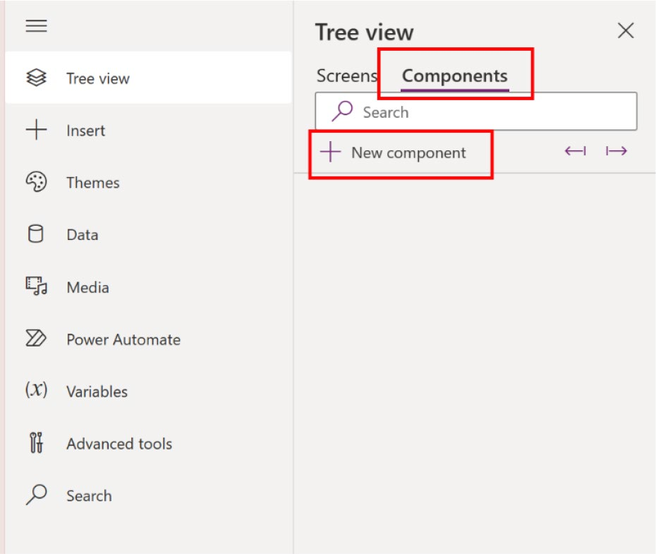

Figure 6-9. New components create options

2. You can see a blank component in Figure 6-10.

Chapter 6 advanCed UI/UX teChnIqUes In power apps development
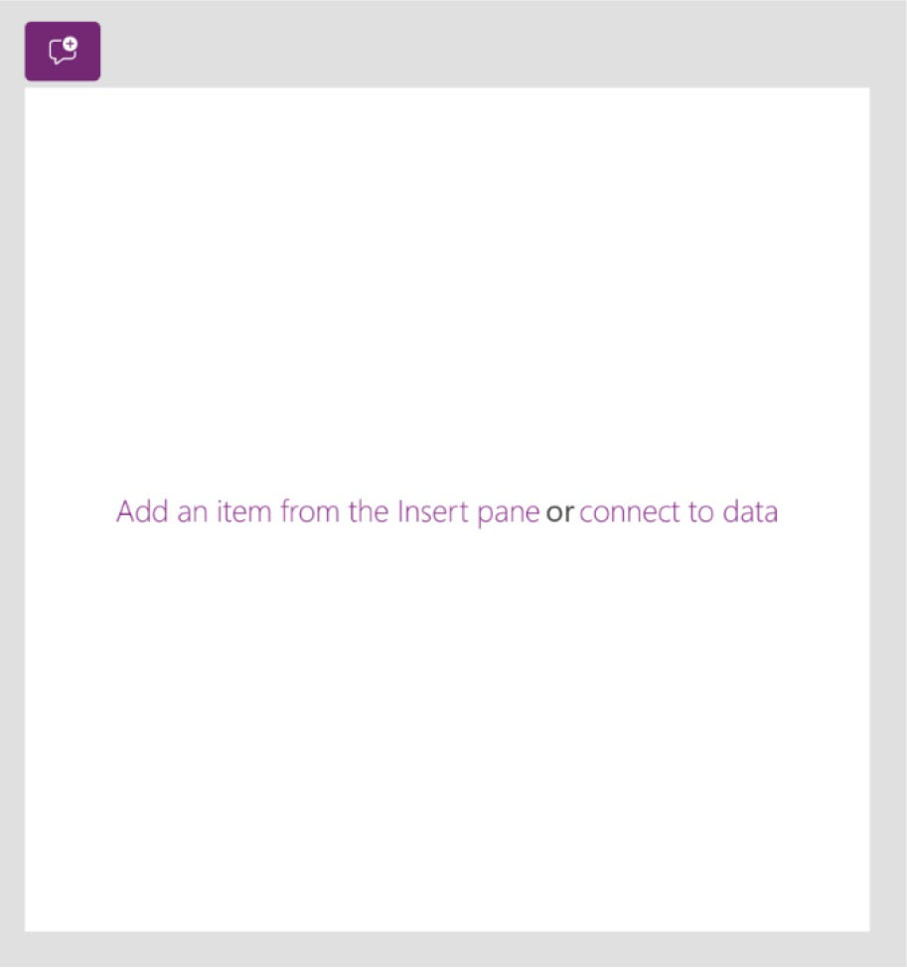

Figure 6-10. Newly created component

3. To add the button to this blank component, click
Insert from the top bar and search for menu. See
Figure 6-11.
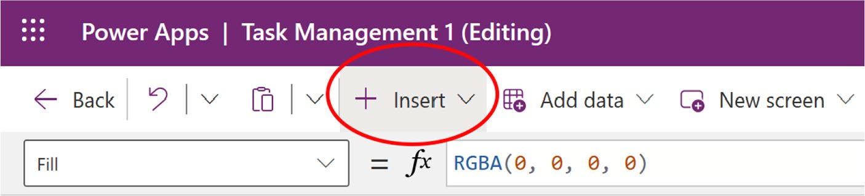

Figure 6-11. The Insert option in the top bar

4. If you search for menu, you will get Hamburger
menu. Select the Hamburger menu and insert it in a
suitable place in your app. See Figure 6-12.

Chapter 6 advanCed UI/UX teChnIqUes In power apps development
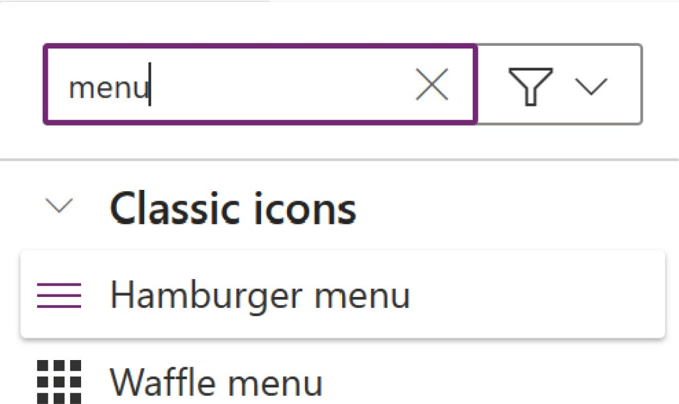

Figure 6-12. Searching Hamburger menu from the Insert option

5. Figure 6-13 shows that I placed the menu in the left
corner, as this is a common design thinking.


Figure 6-13. Menu placed in the left corner

Chapter 6 advanCed UI/UX teChnIqUes In power apps development
6. Now, search for Flexible Height Gallery from the
Insert option and choose it, as shown in Figure 6-14. This is required because of the scrollable menu. Be sure to place it directly below the Hamburger menu.
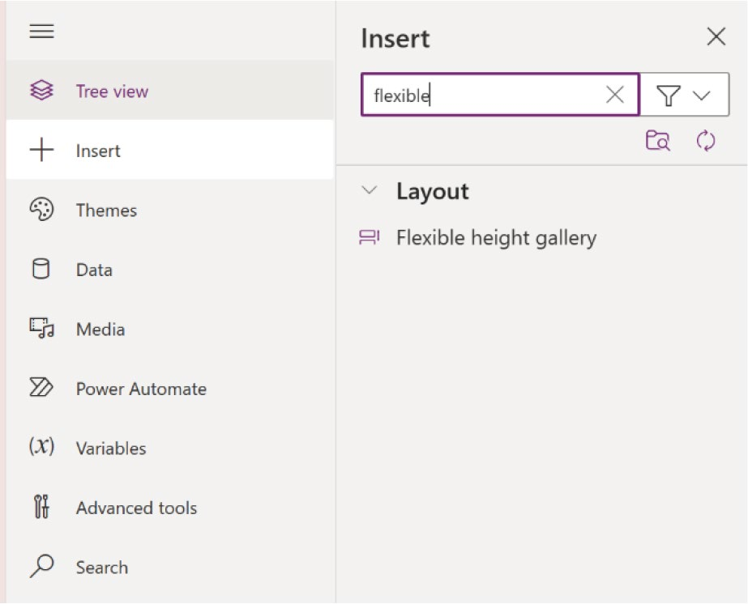

Figure 6-14. Searching for and adding a Flexible Height Gallery

7. You can see the blank Flexible Height Gallery in
Figure 6-15.

Chapter 6 advanCed UI/UX teChnIqUes In power apps development
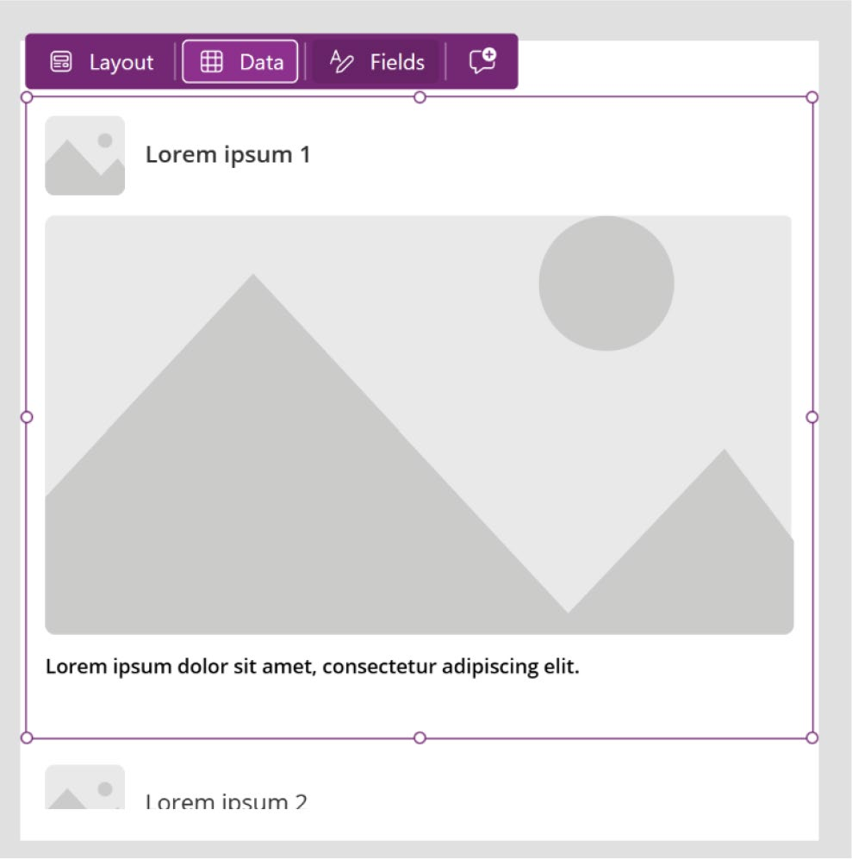

Figure 6-15. Newly created Flexible Height Gallery

8. Click the Flexible Height Gallery and select the
formula from the top bar. Type Y and write the following code:
MenuIcon.Height
This fixes the Y value so that it sits exactly below the
Hamburger menu, as shown in Figure 6-16.
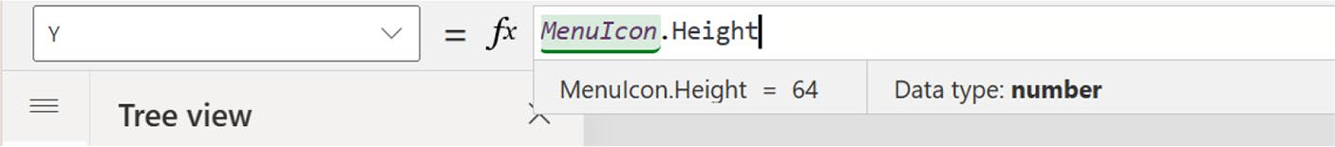

Figure 6-16. Set the Y value of the Hamburger menu

Chapter 6 advanCed UI/UX teChnIqUes In power apps development
Best Practice: Feel free to rename the component as you see fit. This is crucial for clarity when utilizing it in formulas or coding. At this time, I named the icon MenuIcon.
9. You now need to set the flexible height for the
component. Select Height from the formula and add
the following formula (see Figure 6-17):
Parent.Height-MenuIcon.Height

Figure 6-17. Set the flexible height by changing the Height property

10. You will now create a menu design that helps users
recognize their current page location. I add a shape and text level for better understanding. To make the design, you need to add a New Custom Property to the component. Provide a name and select Table as
the Data Type. See Figure 6-18.

Chapter 6 advanCed UI/UX teChnIqUes In power apps development
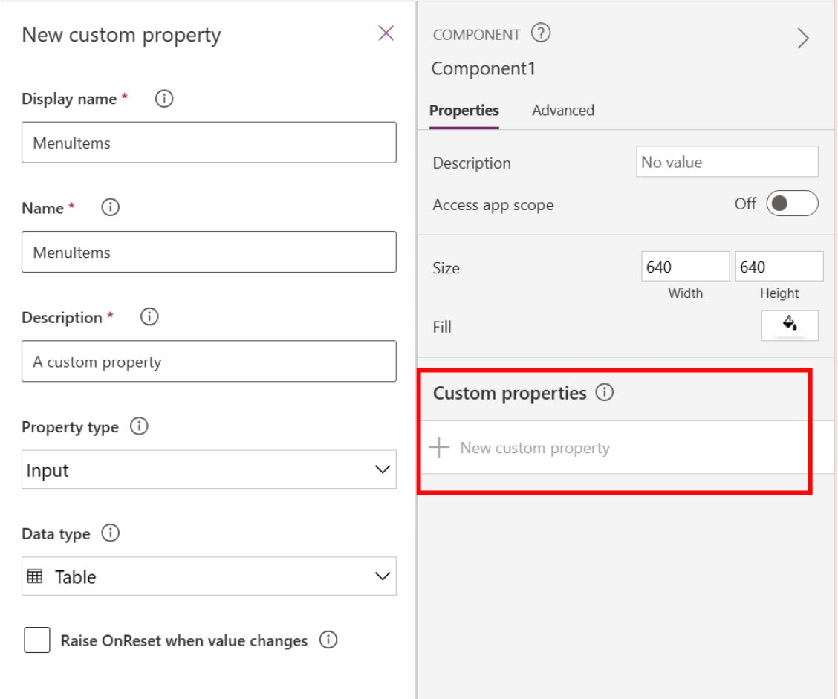

Figure 6-18. Create a New Custom Property option inside a component

11. As shown in Figure 6-19, the New Custom Property
option is in the right sidebar menu.
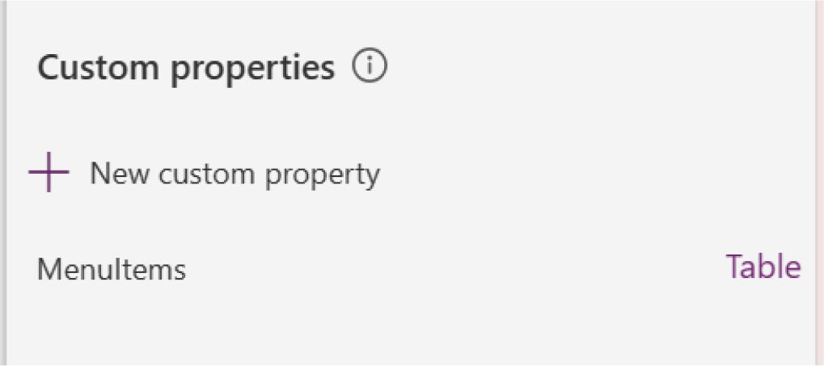

Figure 6-19. The New Custom Property option appears in the Custom Properties list

Chapter 6 advanCed UI/UX teChnIqUes In power apps development
12. As shown in Figure 6-20, click MenuItems to see the
code in the Formula bar.

Figure 6-20. MenuItem default formula code

13. Click Format Text to simplify the code. See
Figure 6-21.
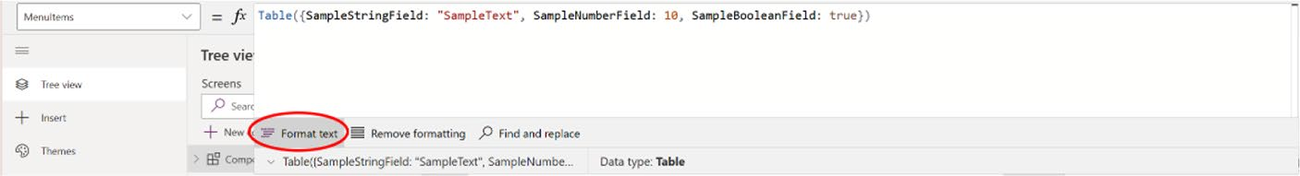

Figure 6-21. Formatting code lines using Format Text option

14. Figure 6-22 shows the simplified code.
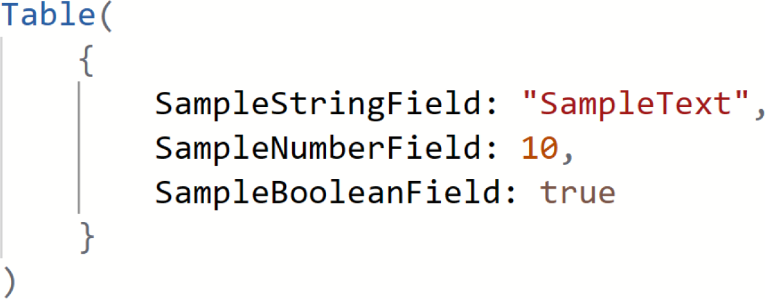

Figure 6-22. Simplified code after formatting

15. You will now customize the table script. You need
two components and one action for each menu item. You need a Menu Label, Menu Icon, and Menu Screen Navigation to navigate the menu. I will also add something known as the Menu ID.

Chapter 6 advanCed UI/UX teChnIqUes In power apps development
As shown in Figure 6-23, I change the table as follows:
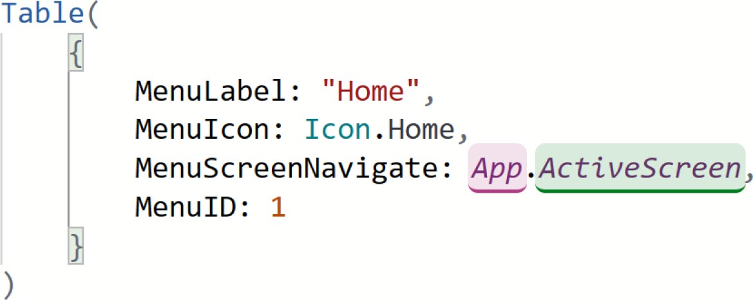

Figure 6-23. Custom script for the Menu table

Note when you type Icon and press the dot (.) in menuIcon section,
you will get a drop-down list with all the related icons. You do not
need to add the icons manually.

16. Copy the label and paste it inside the table and
separate the labels with commas (,). See Figure 6-24. I create three menu items, named Home, About, and Email. If you want to add more menu items, simply copy and paste the labels, including the {}, and separate them with commas.

Chapter 6 advanCed UI/UX teChnIqUes In power apps development
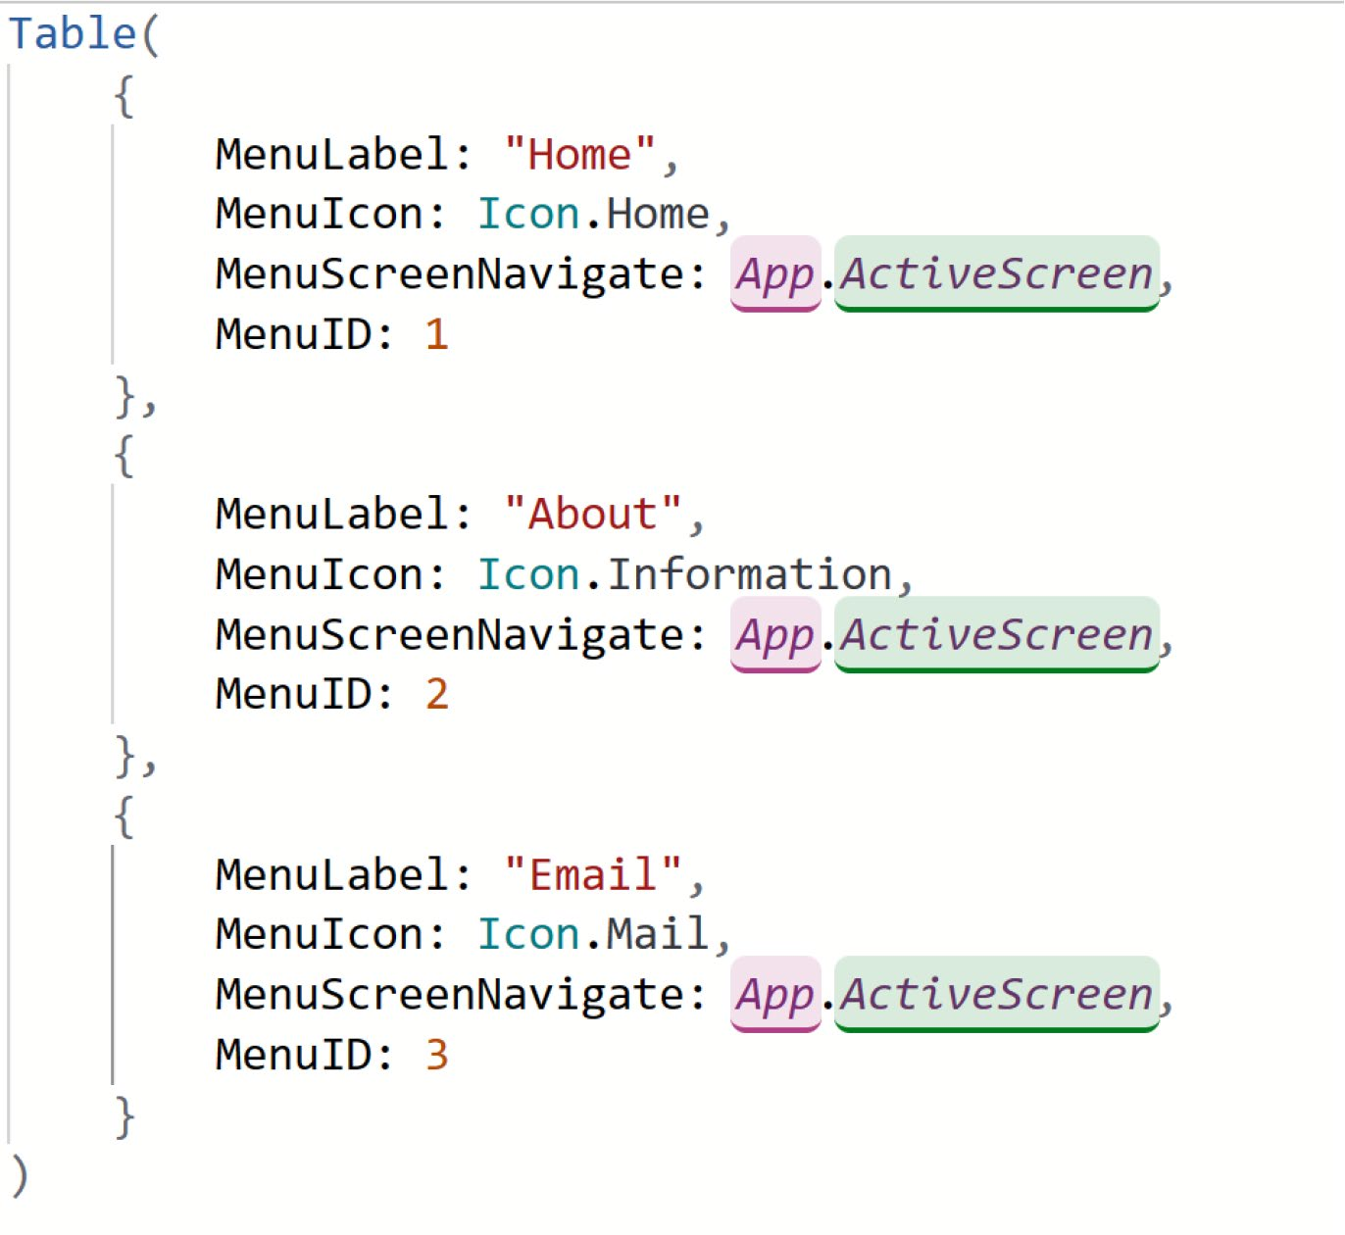

Figure 6-24. Creating labels for the Hamburger menu

17. Save the formula and go back to the Container
page. Select the Flexible Height Gallery. Add a new rectangle inside the component, as shown in
Figure 6-25.

Chapter 6 advanCed UI/UX teChnIqUes In power apps development
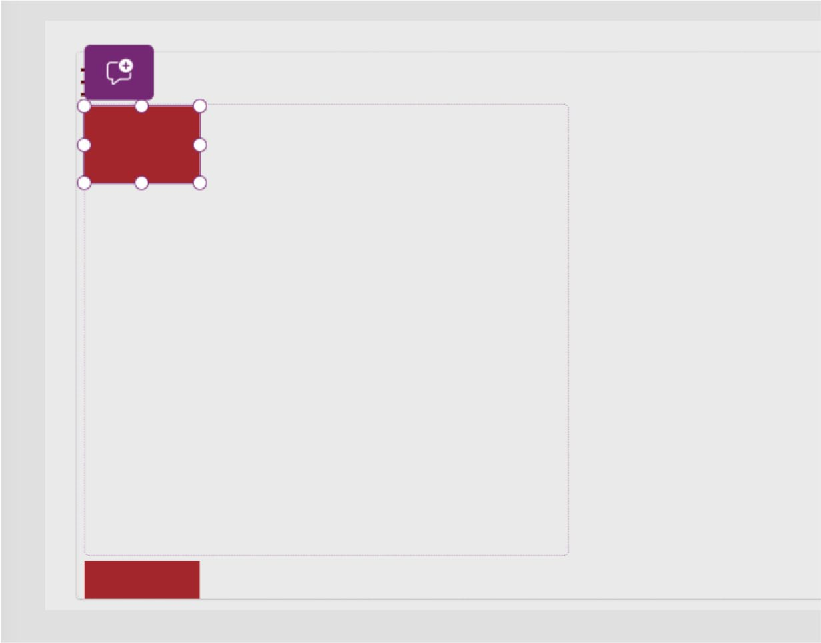

Figure 6-25. Adding a rectangle for the menu design

18. Shrink the width and height (see Figure 6-26).
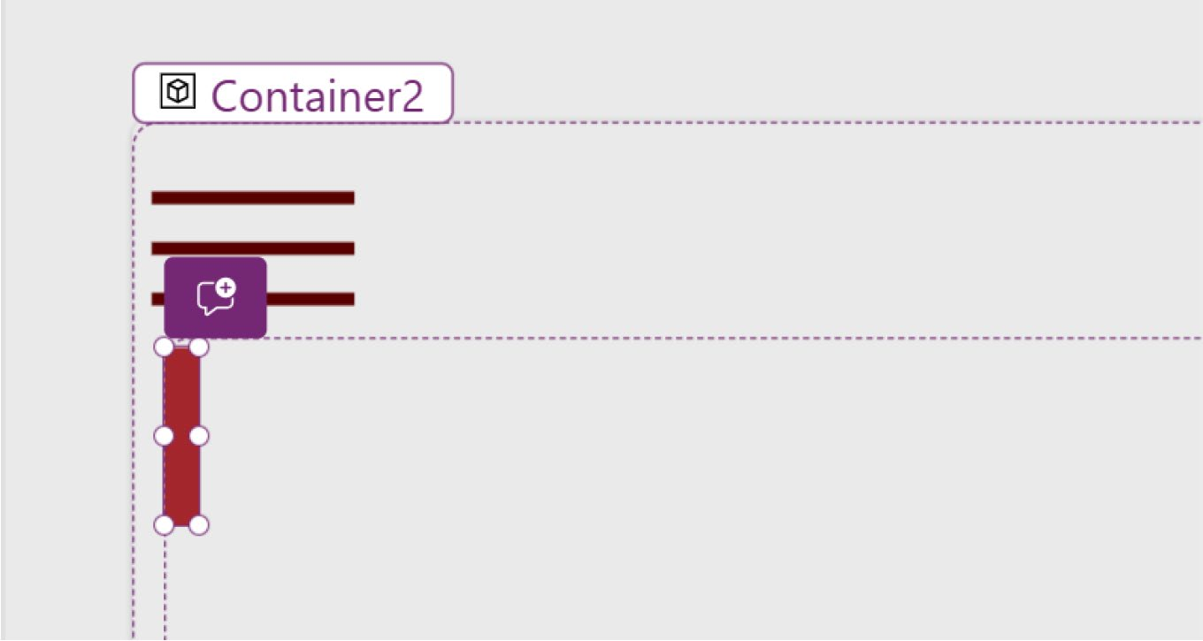

Figure 6-26. Shrinking the rectangle's height and weight for beautification

Chapter 6 advanCed UI/UX teChnIqUes In power apps development
19. Now, add a + Add icon so that the menu icon can be
placed here. Refer to Figure 6-27.
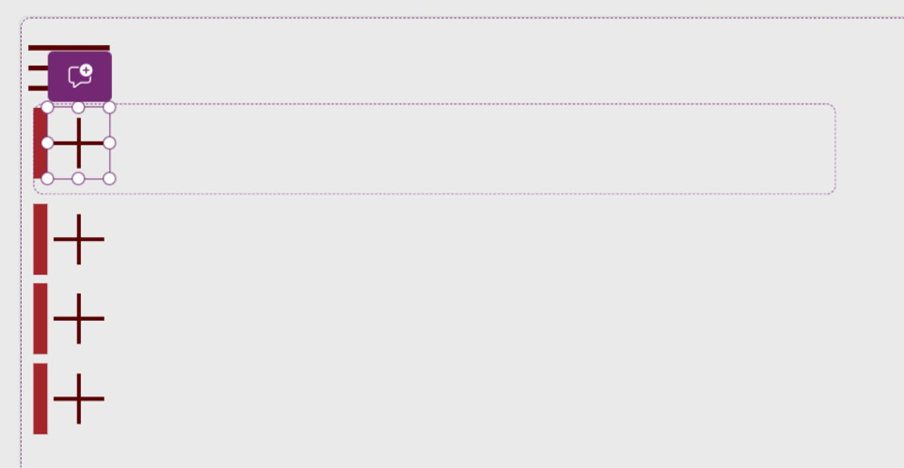

Figure 6-27. Adding an icon placeholder in the Hamburger menu

20. As shown in Figure 6-28, you would also add a text
label, which will be replaced with the menu name.

Chapter 6 advanCed UI/UX teChnIqUes In power apps development
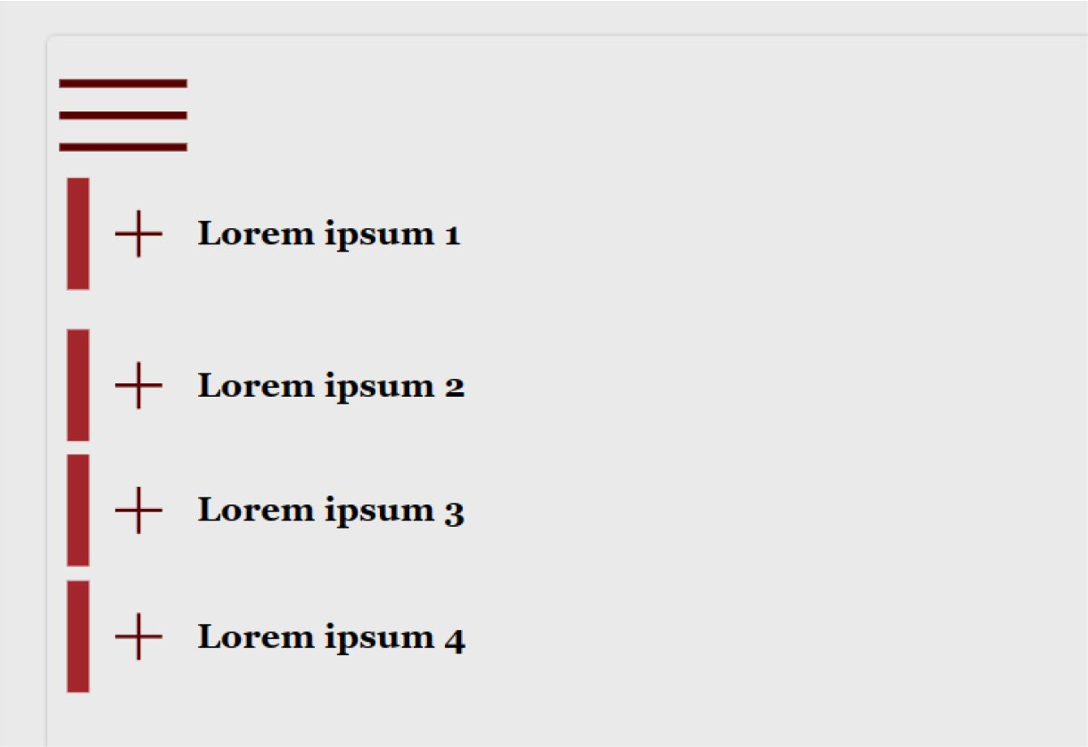

Figure 6-28. Adding text labels to the Hamburger menu

21. Select the Flexible Height Gallery, go to the
Formula bar on top, and select Items. Type the following formula code to get the menu items (see
Figure 6-29):
Component1.MenuItems

Figure 6-29. Binding menu items in Flexible Height Gallery

In this app, the component name is Component1 and the menu item name is MenuItems.
22. As in Figure 6-30, the menu will appear on the app
screen, but it will not be formatted correctly. You need to adjust the formatting afterward.

Chapter 6 advanCed UI/UX teChnIqUes In power apps development
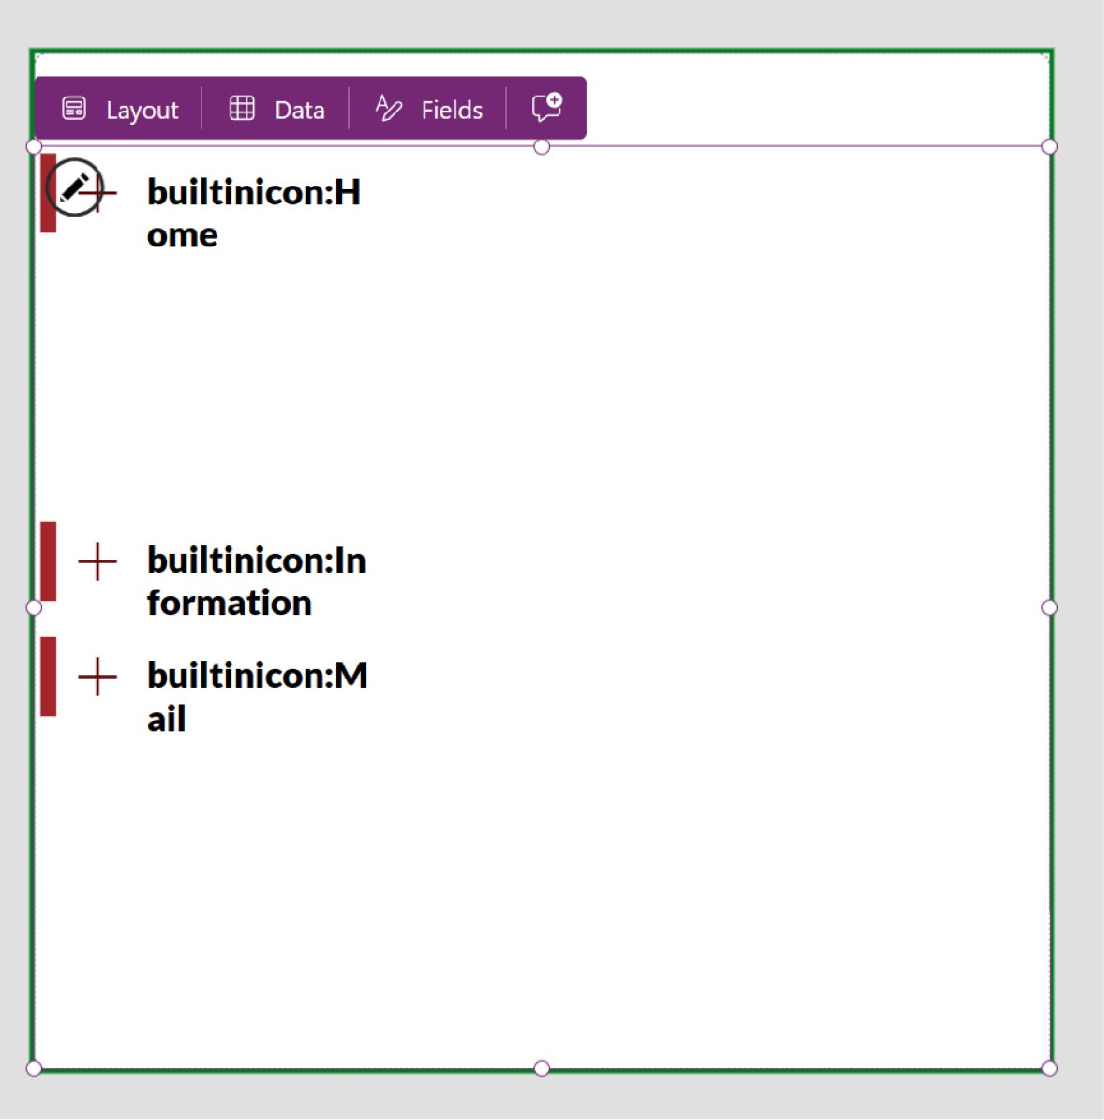

Figure 6-30. Menu appears with unstructured format

23. Select the text label, choose the Text formula from
the Formula bar, and fix the code so it looks like
Figure 6-31.

Chapter 6 advanCed UI/UX teChnIqUes In power apps development
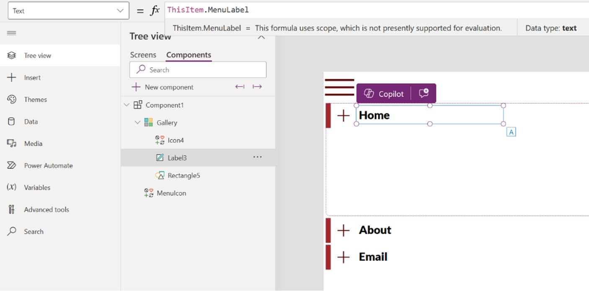

Figure 6-31. Making a dynamically changeable text label

I selected the text label, and in the Formula bar, selected the Text formula, then changed the default code from ThisItem.MenuIcon to ThisItem. MenuLabel. I do the same for the icon as well.
24. To change the icon, select it and go to the Properties.
Click the Icon option. See Figure 6-32.
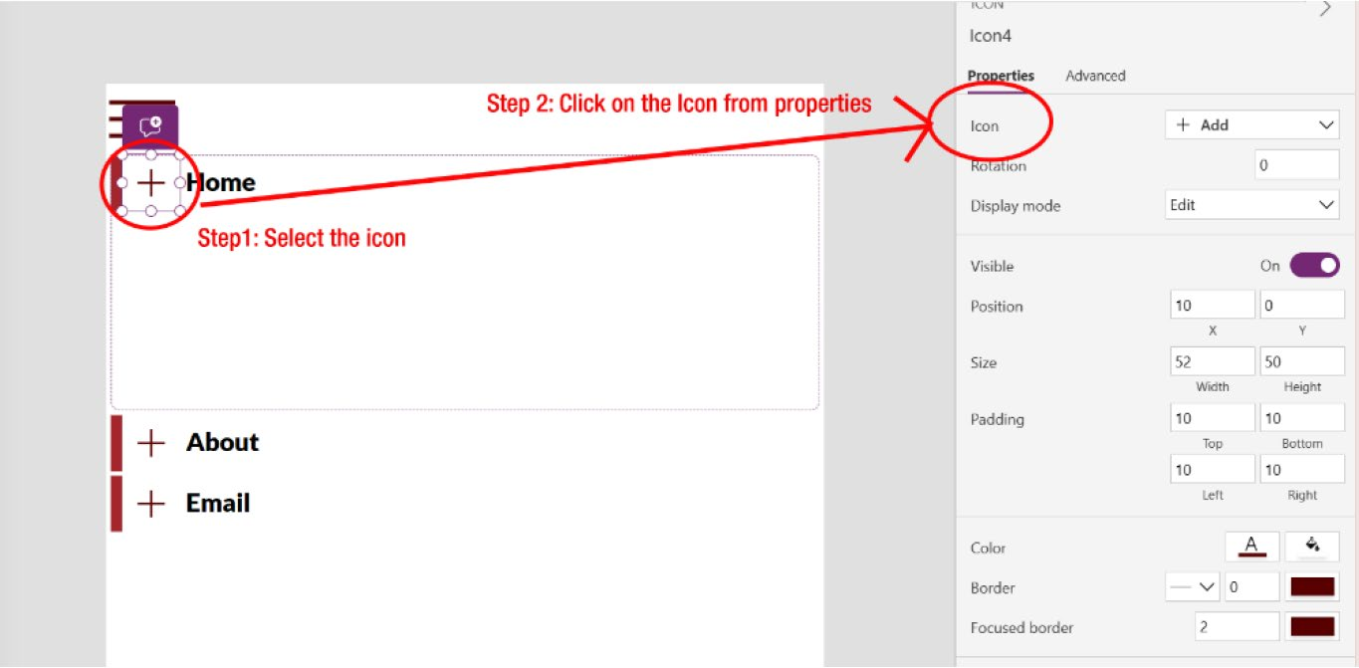

Figure 6-32. Binding icons in the Flexible Height Gallery

Chapter 6 advanCed UI/UX teChnIqUes In power apps development
25. In the Formula bar, under the Icon option, add the
following code to fetch the icons that you created
before, as shown in Figure 6-33:
ThisItem.MenuIcon
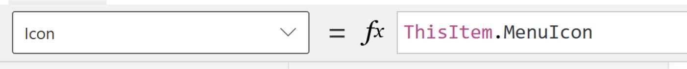

Figure 6-33. Making a dynamically changeable icon

26. Figure 6-34 shows that the icons are perfectly set on
the app screen.
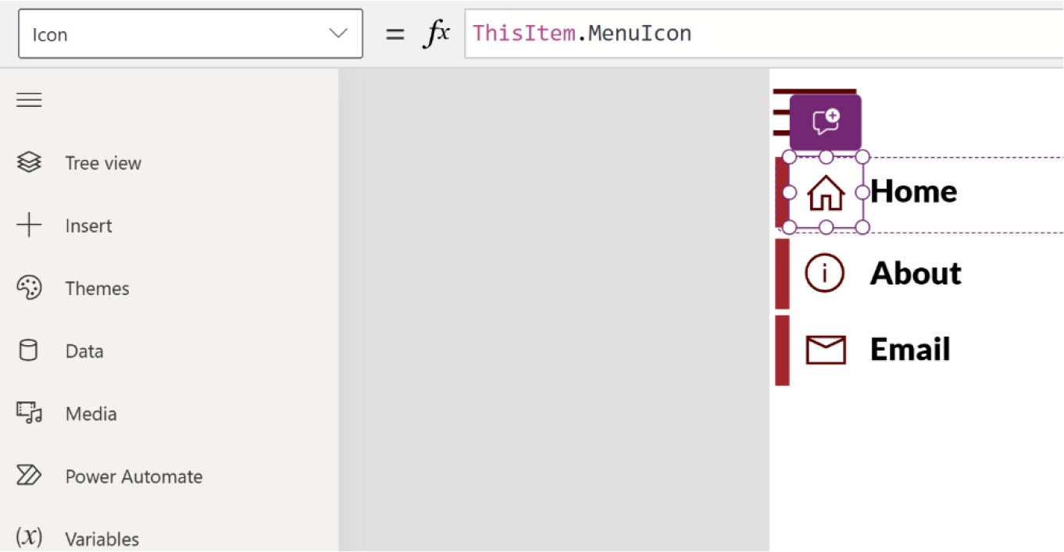

Figure 6-34. The icons have been successfully fetched on the
Hamburger menu

27. Next, add the menu navigation. As shown in
Figure 6-35, select the rectangle. In the Formula bar, select Visible and add the following code:
ThisItem.MenuScreenNavigate = App.ActiveScreen

Chapter 6 advanCed UI/UX teChnIqUes In power apps development
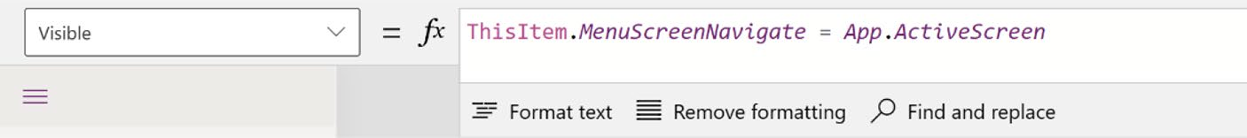

Figure 6-35. Creating a navigation menu

28. Next, you can add a button, as shown in Figure 6-36.
It is important to position the button above the rectangle, icon, and text label so that tapping any of these elements will activate the button, triggering it to change the page or execute an action.
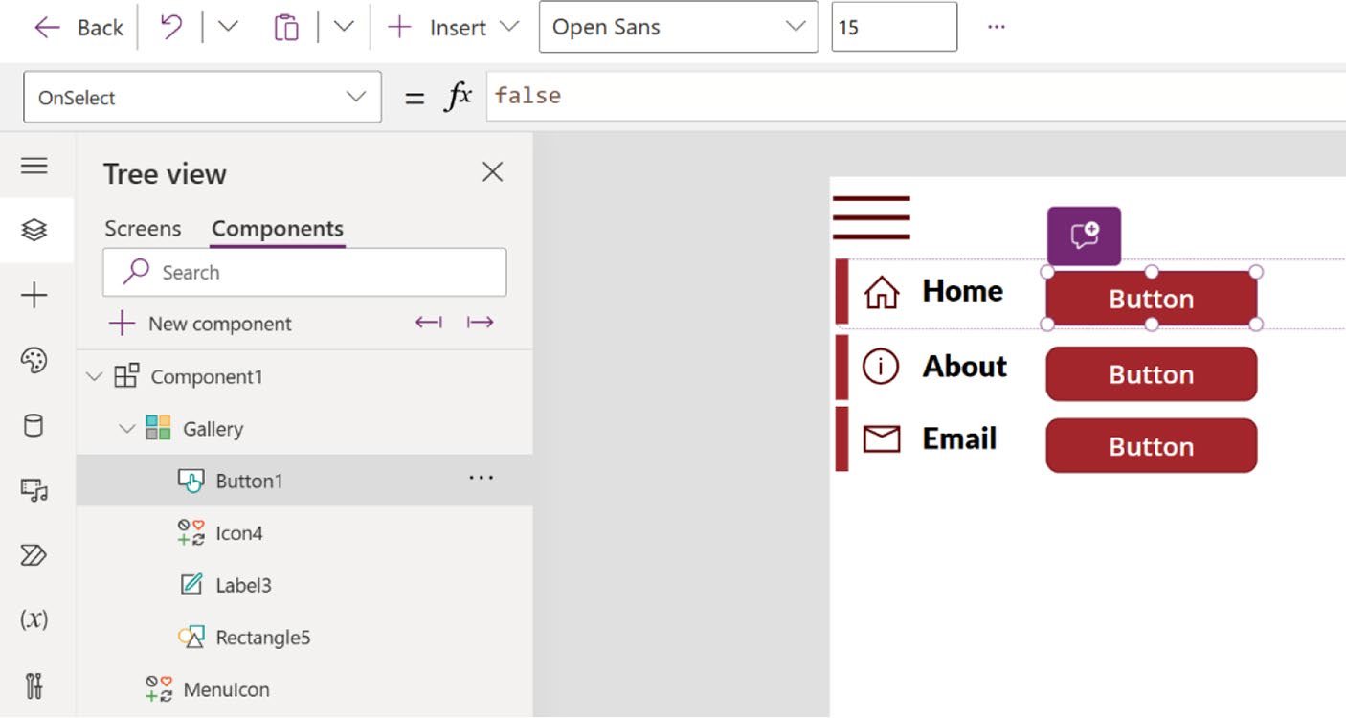

Figure 6-36. Adding a button to the navigation menu

29. Change the functions listed in Table 6-1 to make the
button transparent and link it with the menu items.

Chapter 6 advanCed UI/UX teChnIqUes In power apps development
Table 6-1. Values to Make a Button Transparent and Responsive in
Different Devices
Function Value
X 0 Y 0 width parent.templatewidth height label3.height+label3.Y Fill Color.transparent hoverfill Color.transparent pressedFill Color.transparent

30. From the Formula bar, select the OnSelect formula
and type the following code to connect:
Navigate(ThisItem.MenuScreenNavigate, ScreenTransition.Cover)
31. Now, you’ll set up a transition to show and hide
the Hamburg menu upon clicking or tapping. To set up the transition, create a new variable named showMenu and set it not to show the menu. That means if the value is true, it will become false and if it is false, it will become true. Click in the Hamburg menu icon, select the OnSelect property from the Formula bar, and add the following code (see
Figure 6-37):
Set(showMenu, !showMenu)

Chapter 6 advanCed UI/UX teChnIqUes In power apps development
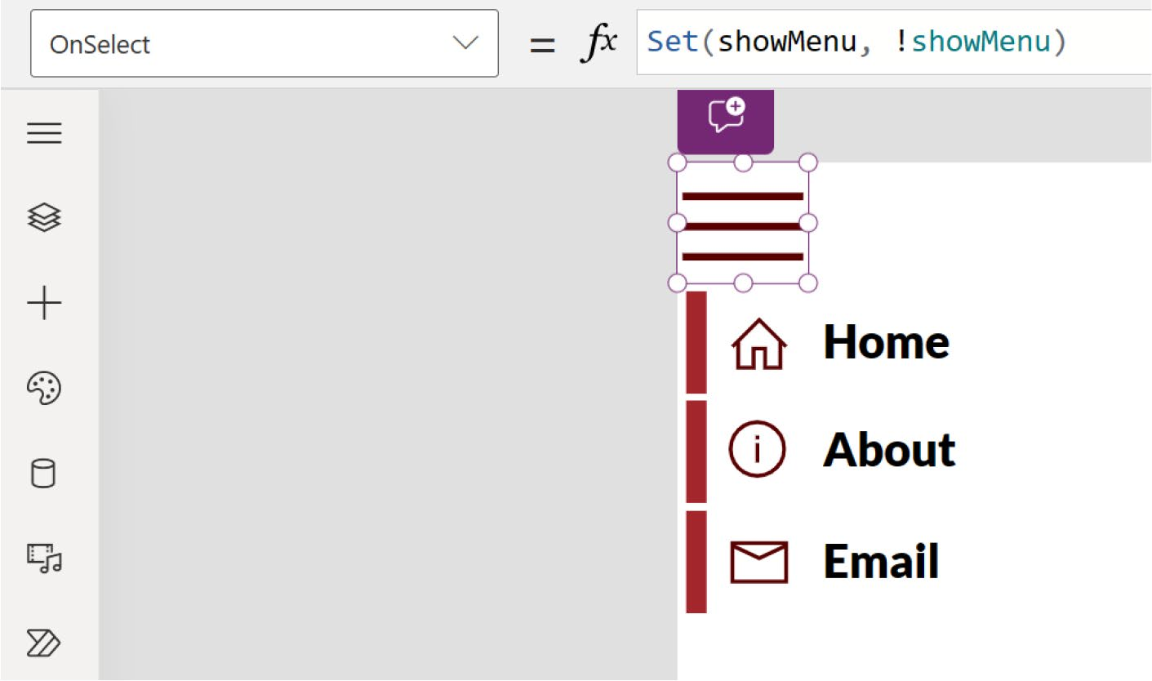

Figure 6-37. Creating a OnSelect condition for the Hamburger menu

32. Now create another new custom property called
ExpandMenu. The data type must be Boolean. Select the Raise OnReset When Value Changes
option, as shown in Figure 6-38. This option allows the value changes of this property to trigger the OnReset of the component. This method is designed to easily set and reset the default value.

Chapter 6 advanCed UI/UX teChnIqUes In power apps development
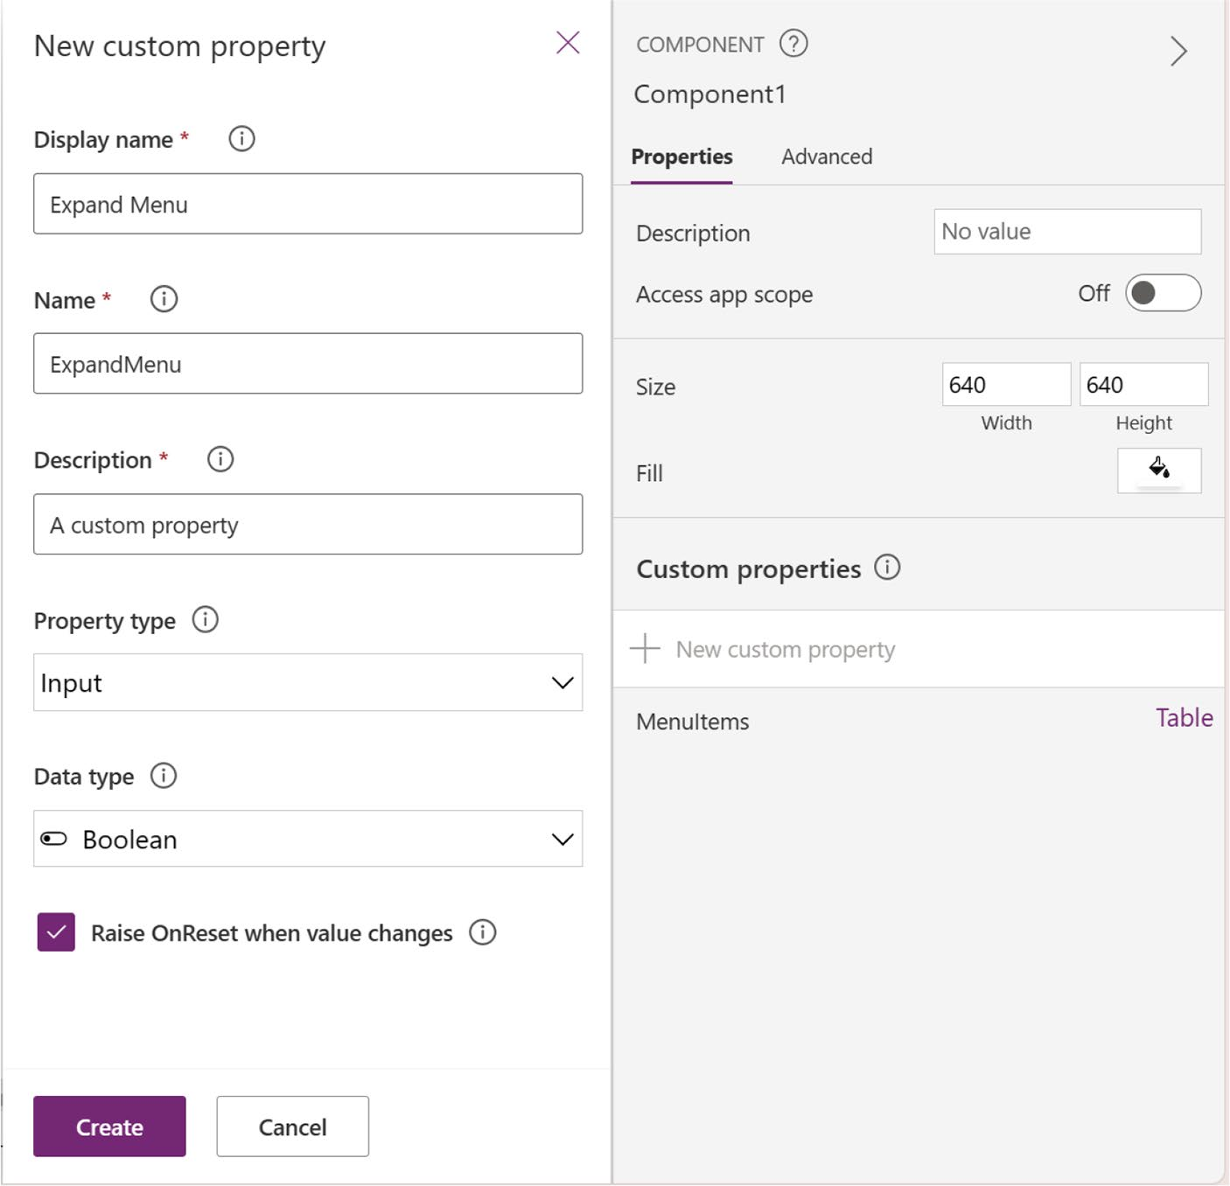

Figure 6-38. Creating a new custom property named ExpandMenu

33. Click the ExpandMenu property and set it to false, as
shown in Figure 6-39. It is true by default.
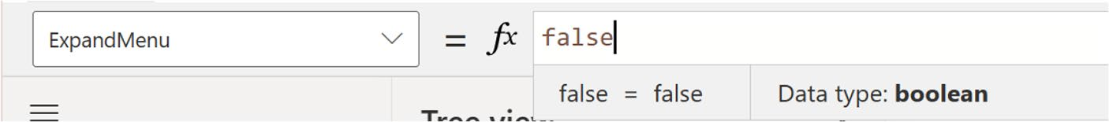

Figure 6-39. Changing the ExpandMenu value to false

Chapter 6 advanCed UI/UX teChnIqUes In power apps development
34. As shown in Figure 6-40, select the Advanced option
of component1 and click the OnReset option.
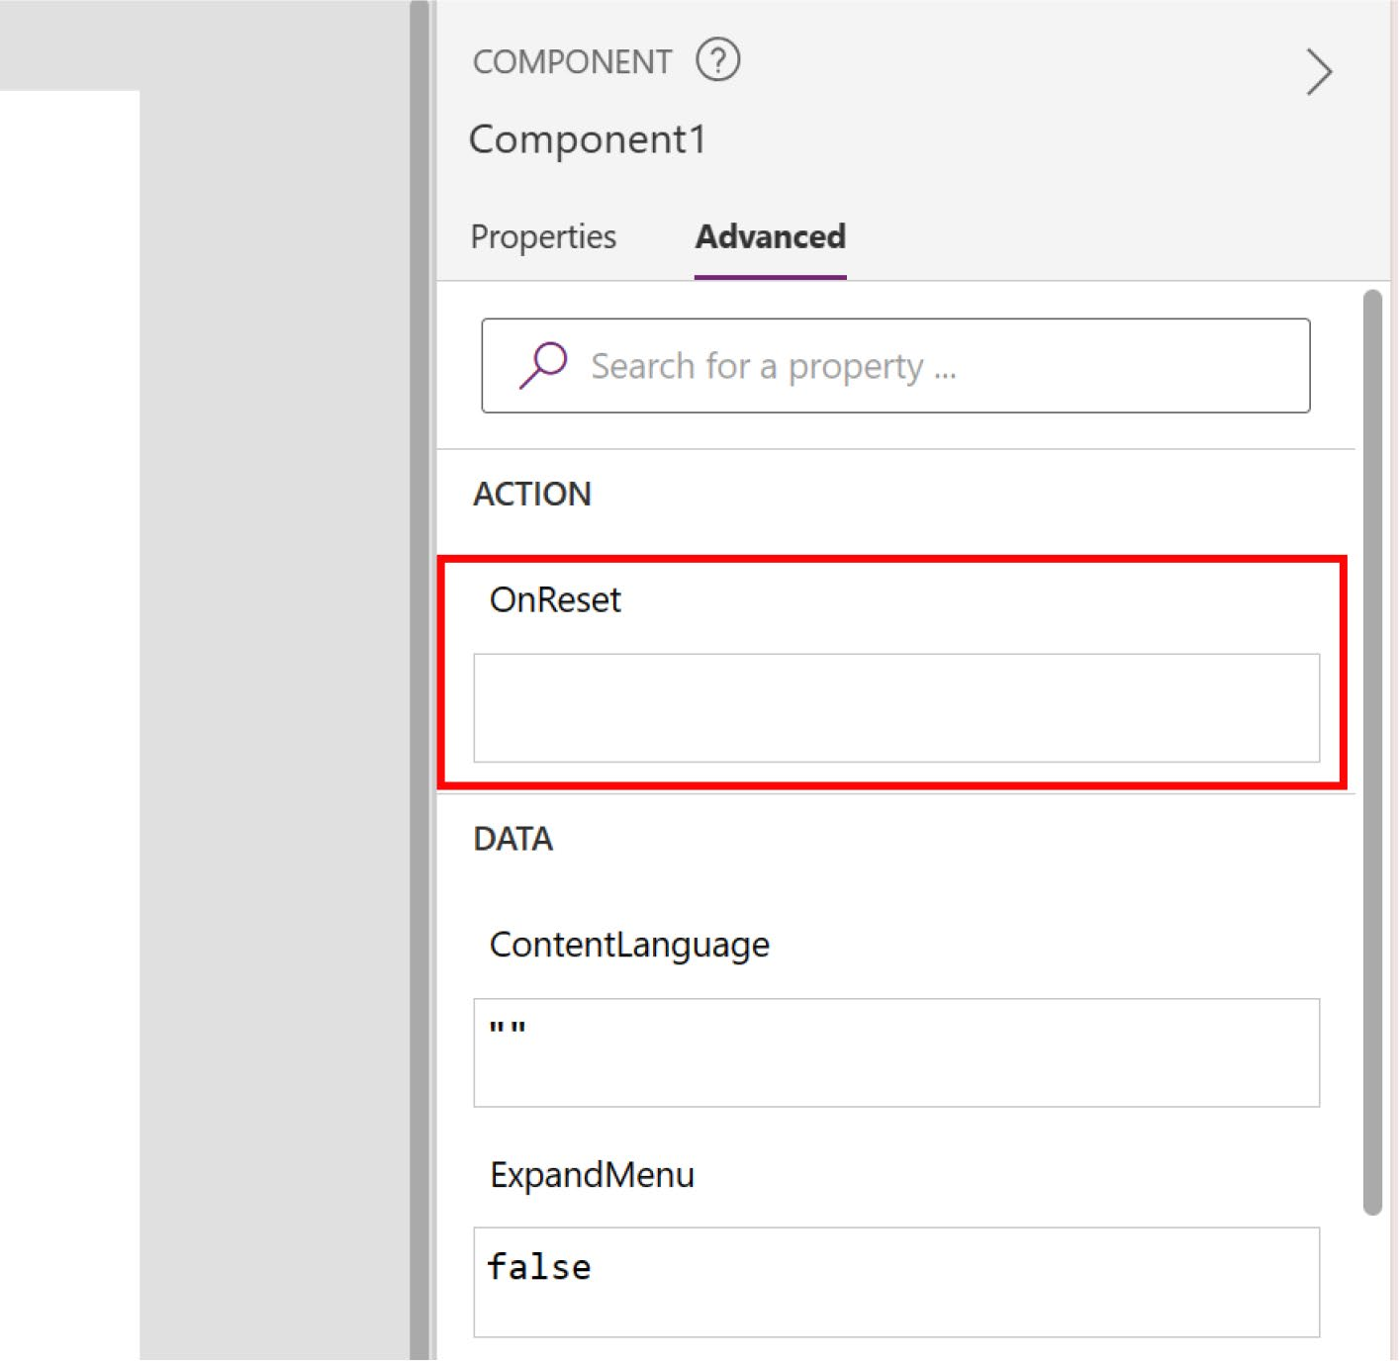

Figure 6-40. The OnReset option in the advanced component properties

35. In the Formula bar, type the following code (also
shown in Figure 6-41):
Set(showMenu, Component1.ExpandMenu)

Chapter 6 advanCed UI/UX teChnIqUes In power apps development

Figure 6-41. Changing the OnReset condition

36. Select the Flexible Height Gallery. In the Formula
bar, select the Visible formula and write the variable
that you created before showMenu. See Figure 6-42.
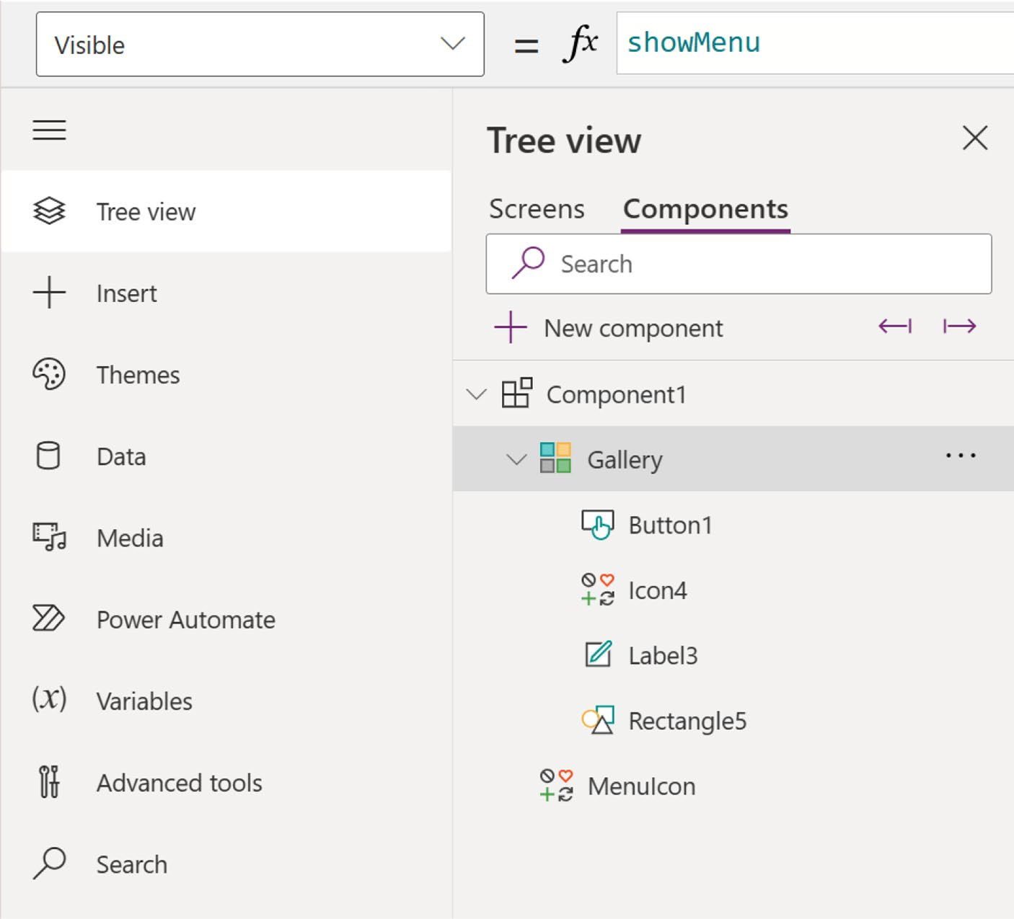

Figure 6-42. Creating a variable in the Visible formula named
showMenu

Chapter 6 advanCed UI/UX teChnIqUes In power apps development
37. The menu is not visible, as shown in Figure 6-43.
By holding down the Alt key and clicking the menu,
you can make it visible, as shown in Figure 6-44.
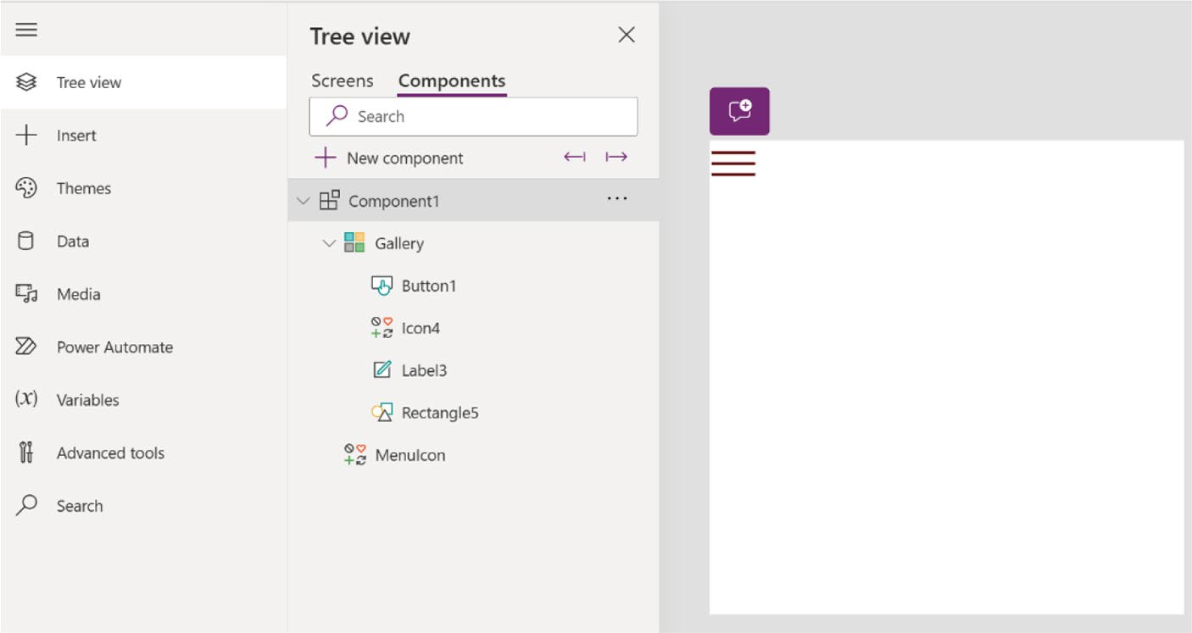

Figure 6-43. The menu is not visible
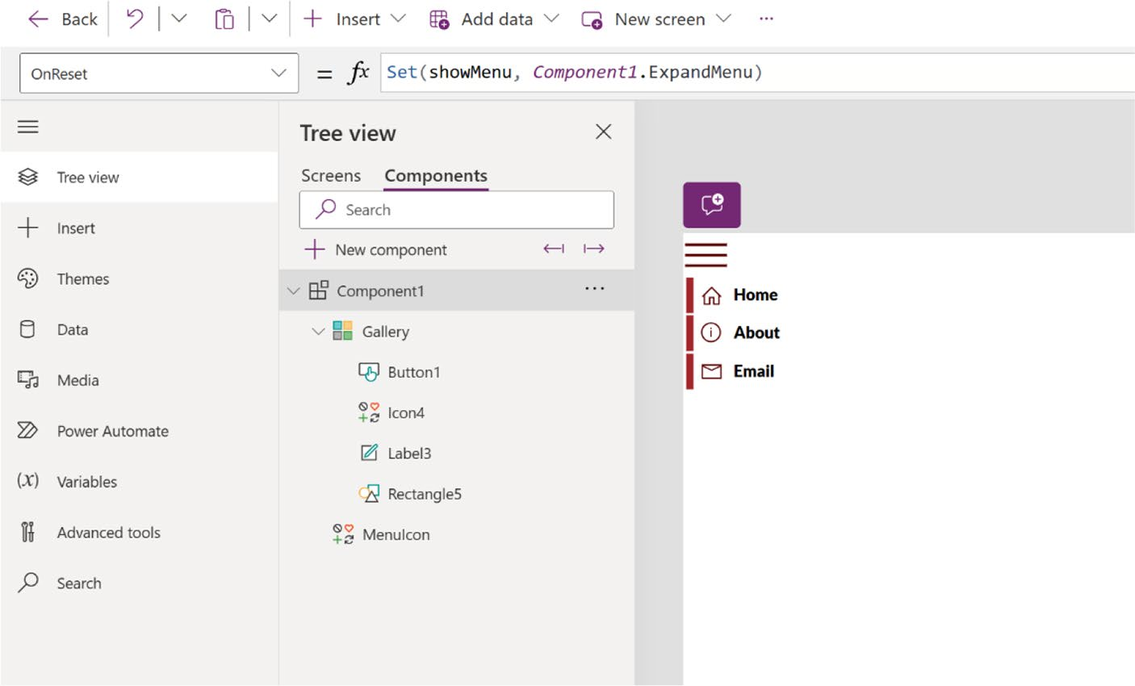

Figure 6-44. The menu is shown after pressing Alt key and clicking it

Chapter 6 advanCed UI/UX teChnIqUes In power apps development
38. The menu has been successfully created. Next, you
will integrate the menu into the app screen. Select
the Email screen as shown in Figure 6-45, which you developed in the previous chapter.
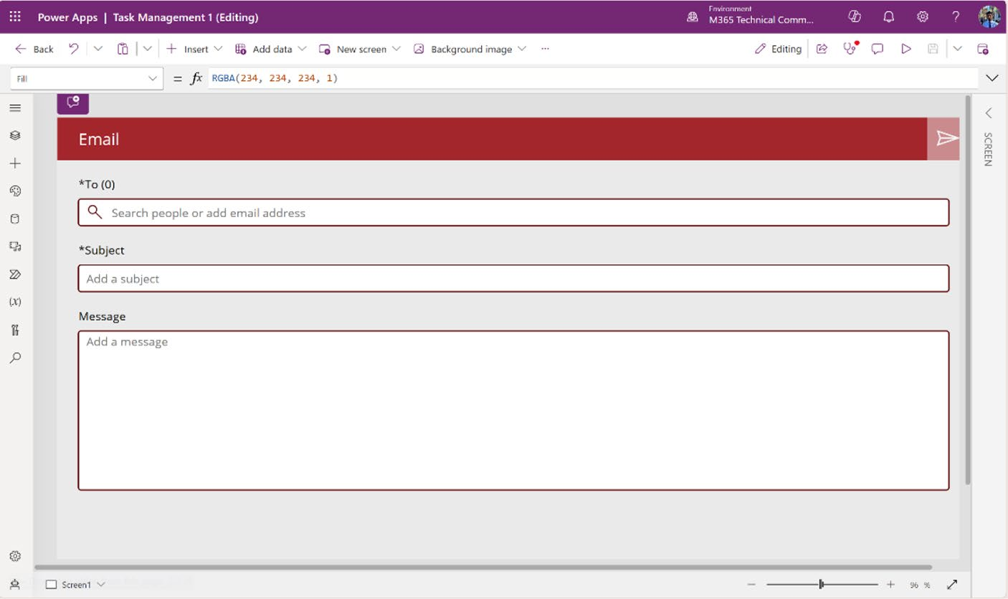

Figure 6-45. Email screen where the menu will be integrated

Chapter 6 advanCed UI/UX teChnIqUes In power apps development
39. Click Insert from the top menu and select
Component1 under the Custom option, as shown in
Figure 6-46.
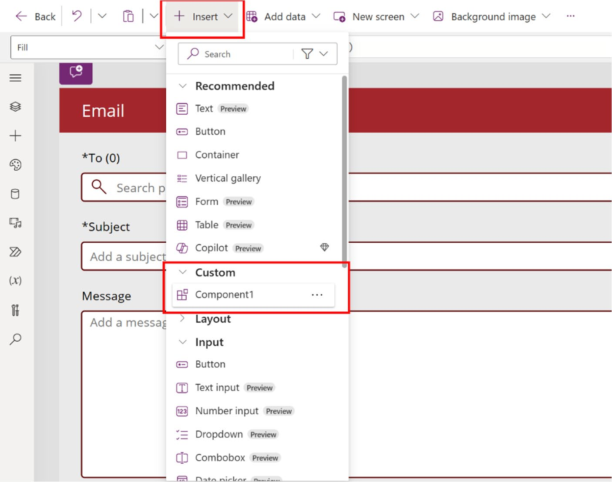

Figure 6-46. Adding a custom component to the email template

Chapter 6 advanCed UI/UX teChnIqUes In power apps development
40. You will see a preview of the menu, as shown in
Figure 6-47.
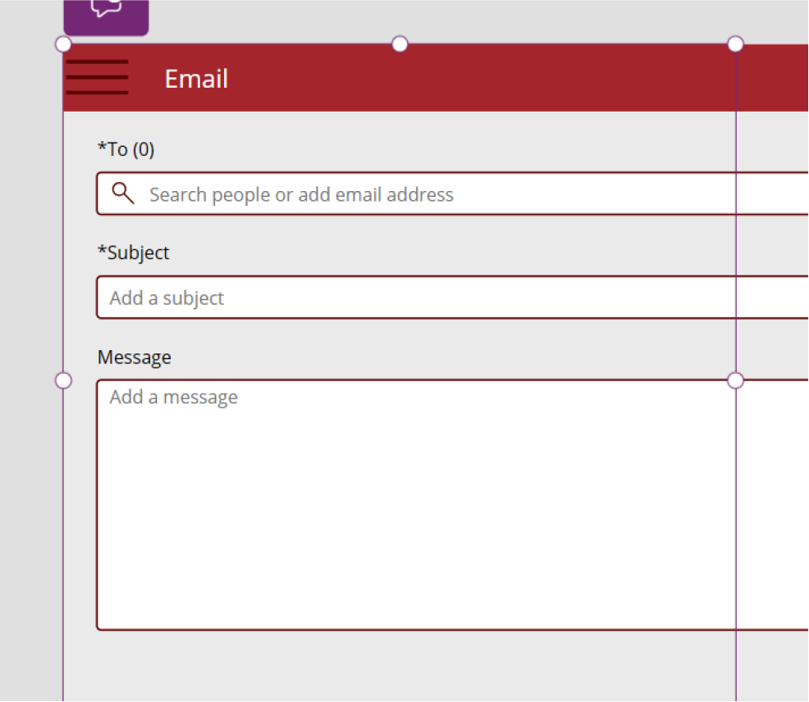

Figure 6-47. Showing the Hamburger menu in the email template

Chapter 6 advanCed UI/UX teChnIqUes In power apps development
41. Press F5 or run the app as shown in Figure 6-48.
Click the menu to see it.
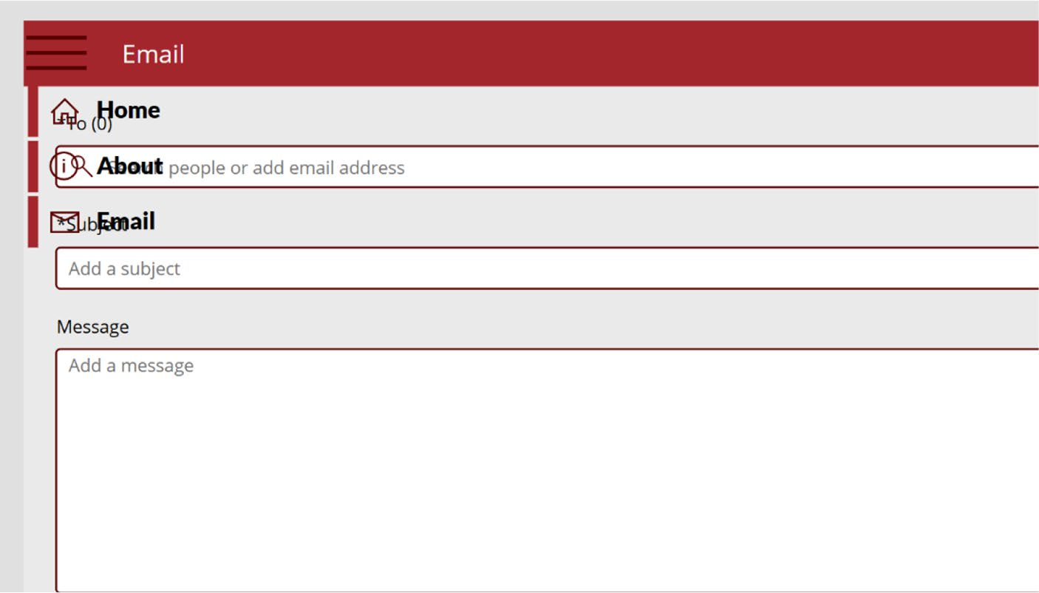

Figure 6-48. Preview the app and review the menu options

42. The menu will be shown as transparent. You need
to add a background so that the user can read the menu clearly. To change the background color, go to Component1, select Flexible Height Gallery, and choose a color from Properties. Follow along in
Figure 6-49.

Chapter 6 advanCed UI/UX teChnIqUes In power apps development
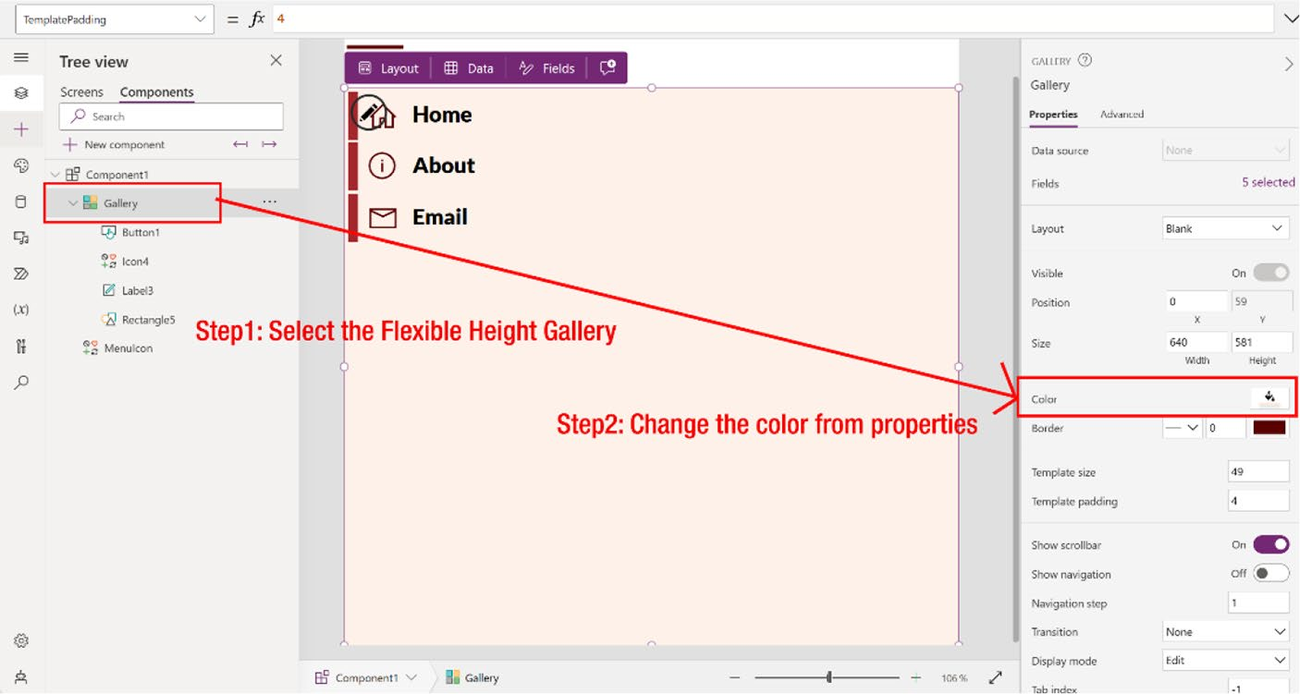

Figure 6-49. Changing the component background. Select the
Flexible Height Gallery and then change the color from Properties

43. Now go back to the Email screen and run the app by
pressing F5, as shown in Figure 6-50.

Chapter 6 advanCed UI/UX teChnIqUes In power apps development
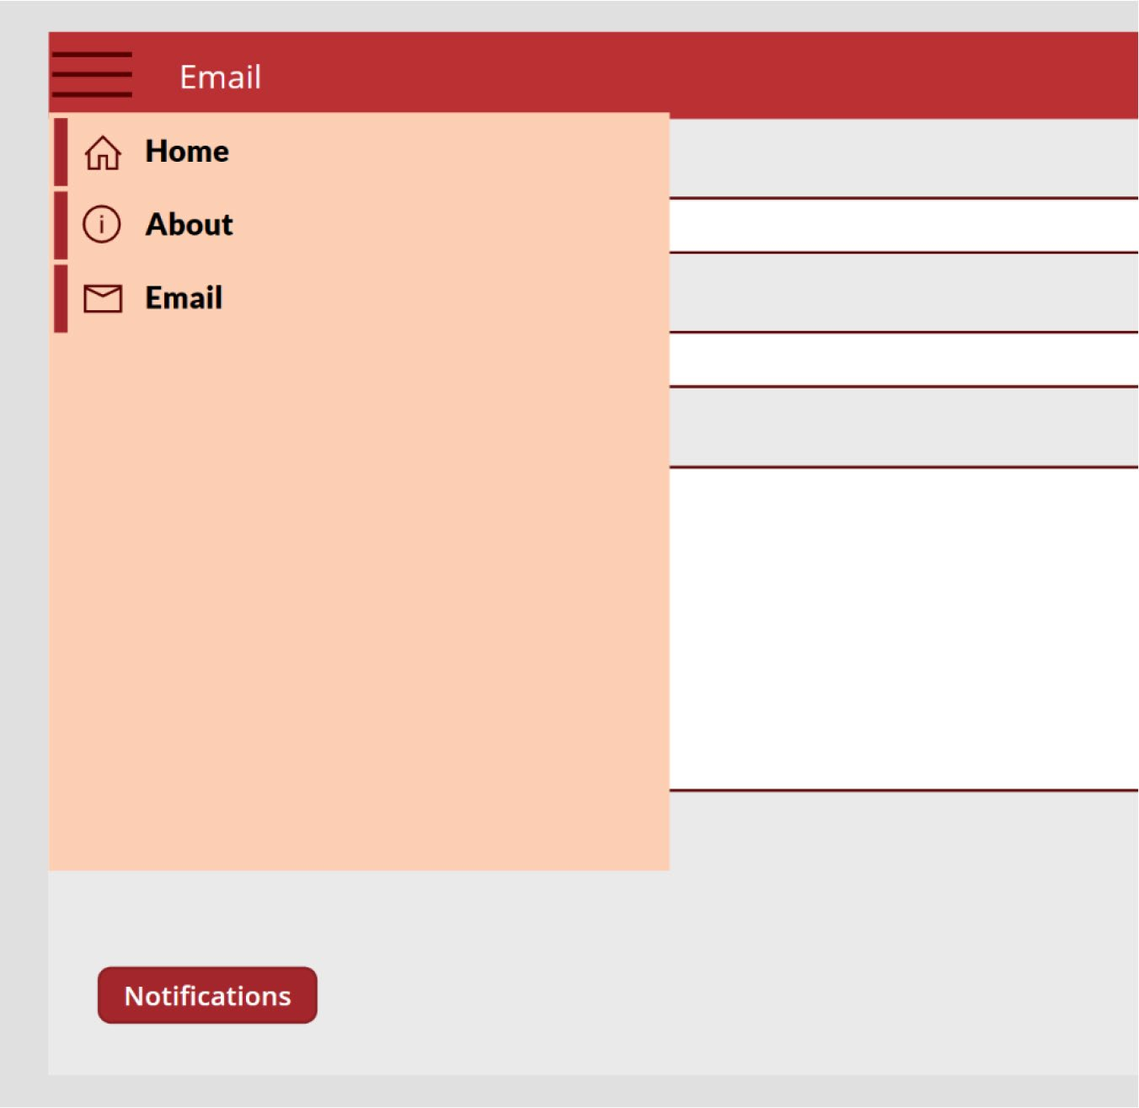

Figure 6-50. App preview after pressing F5

This is a simple example of creating a menu in Power Apps. You can explore more advanced features, such as how to connect a button to other pages or create a function, by visiting the following link:
https://techcommunity.microsoft.com/t5/educator-developer-
blog/create-a-responsive-menu-navigation-bar-in-canvas-power-
apps/ba-p/3796871

Chapter 6 advanCed UI/UX teChnIqUes In power apps development

Aesthetic Design
Aesthetic design is pivotal in shaping the user experience for Power Apps
UX/UI. This section guides you through the selection of color schemes,
fonts, and design elements that not only captivate visually but also ensure
functional integrity. The choice of specific colors and typefaces carries
deep psychological effects, influencing how users feel and interact with the
app. Through effective design strategies, you can craft interfaces that are
visually pleasing and conducive to a seamless user experience, leading to
enhanced user engagement and satisfaction.

Color Schemes
Selecting the perfect color palette for Power Apps is crucial for enhancing
the user experience and functionality. Colors do more than beautify; they
build a strong connection with your brand and ensure visual consistency
across applications, making the user interface intuitive and familiar. They
influence mood and behavior, which is essential for apps aimed at specific
tasks or emotions. Thoughtful color contrasts enhance readability and
accessibility, helping users with visual impairments navigate the app more
easily. Strategic use of colors can also highlight essential elements and
organize information, facilitating smoother user interactions. A well-
chosen color scheme improves the aesthetic appeal of an app and boosts
its usability and effectiveness.

Choosing a Color Palette for Power Apps
Based on my experience, I have identified five distinct types of color
categories:
• Primary colors: These are the central colors of your
app, reflecting the brand’s identity. They are the most visually dominant. Choose these to set the tone and personality of your application, ensuring they align well with your brand’s ethos and the app’s purpose.

Chapter 6 advanCed UI/UX teChnIqUes In power apps development
• Secondary colors: These colors are used to support
and contrast with the primary palette. Select secondary hues that enhance the visual hierarchy of your interface, helping to clearly distinguish between different UI elements like buttons or notifications, without overpowering the primary colors.
• Accent colors: Employed sparingly, accent colors are
there to draw attention to critical elements such as call-to-action buttons or active states. These should be distinct and vibrant enough to stand out against primary and secondary colors.
• Neutral colors: Utilize shades of white, gray, and
black for background, text, and UI components like borders and dividers. These neutrals are essential in creating visual breaks and reducing visual strain, thus contributing to a balanced and cohesive design.
• Functional colors: Designated for alerts, indicators,
and statuses, choose colors that users universally associate with specific messages and actions, such as caution, error, or success. These should be intuitive enough to instantly communicate the necessary information about the app’s processes.
Figure 6-51 shows some examples of different color categories.

Chapter 6 advanCed UI/UX teChnIqUes In power apps development
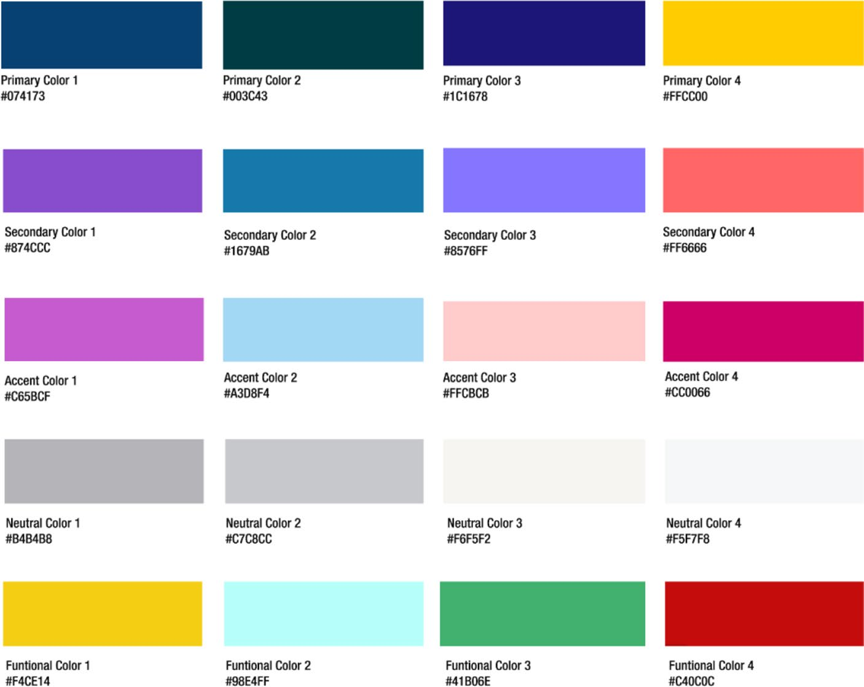

Figure 6-51. Different color categories with examples

Tools to Match Color Schemes
Nowadays, you can find many sources to generate or choose color palettes.
If you are new to Power Apps environment, check out the following
websites, where you can generate and choose free color palettes:
• Colorhunt (https://colorhunt.co/): Color Hunt is an
online resource that provides a free and open platform for color inspiration, tailored to anyone looking to find or share color combinations. It features thousands of color palettes, making it a popular tool for designers, artists, and anyone involved in creative projects.

Chapter 6 advanCed UI/UX teChnIqUes In power apps development
The site presents palettes in a straightforward, easy-to- navigate format, allowing you to browse through a variety of schemes quickly.
Each palette on Color Hunt consists of four colors, displayed in a visually pleasing layout, as shown in
Figure 6-52. You can easily copy the Hex codes for each color, which you can then use in your digital design projects. Color Hunt is especially useful for discovering trending color schemes, exploring different aesthetic styles, and finding inspiration for Power Apps design, graphic projects, or any other creative work that involves color coordination.
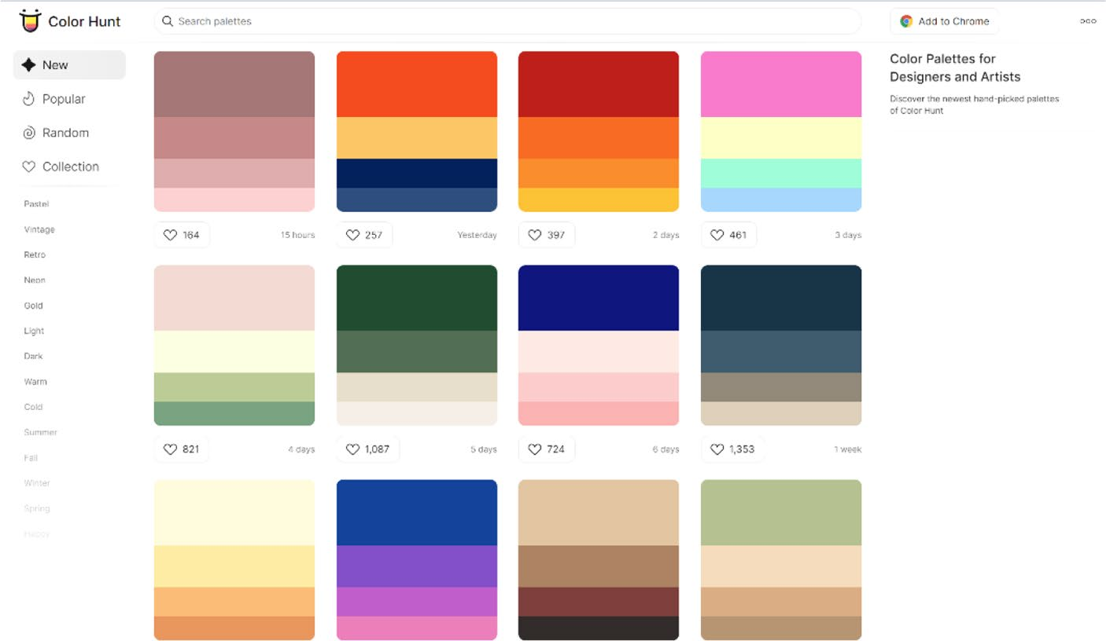

Figure 6-52. Preview of the Color Hunt website

Chapter 6 advanCed UI/UX teChnIqUes In power apps development
• Coolors (https://coolors.co/): Coolors is an
online color scheme generator that is extremely helpful for designers and creatives looking to develop or refine color palettes for their projects. It offers a straightforward interface where you can quickly generate, adjust, and explore different color
combinations, as shown in Figure 6-53. By simply pressing a button, you can create a new palette, tailor colors to your specific needs using Hex codes, and experiment with variations to find the perfect match for your design work. Coolors.co is widely appreciated for its simplicity and effectiveness in helping users finalize their color choices.
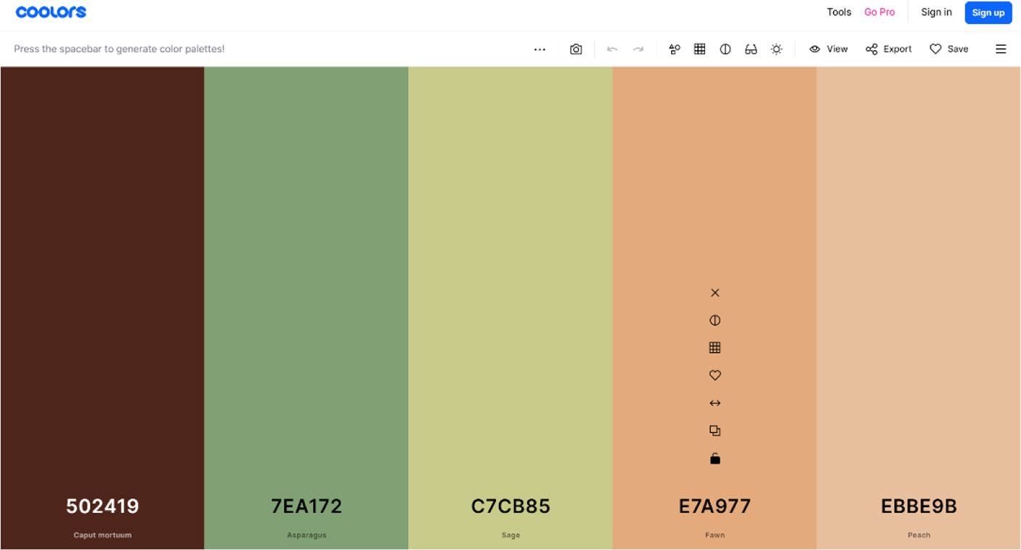

Figure 6-53. Preview of the Coolors website

Chapter 6 advanCed UI/UX teChnIqUes In power apps development

Fonts and Sizes
Selecting the right fonts and font sizes in Power Apps is critical for creating a user-friendly interface. Appropriate fonts enhance readability, allowing users to process information quickly and easily, which is crucial in applications that require frequent interaction or present substantial data. Consistent font usage across the app ensures a cohesive visual experience, reinforcing the app’s identity and facilitating intuitive navigation. Well- chosen fonts significantly impact user engagement and satisfaction, emphasizing their importance in the design of Power Apps.
Power Apps supports a variety of standard fonts that are commonly used across many applications for their clarity and compatibility. Here is a list of available fonts in Power Apps:
Arial, Arial Black, Calibri, Cambria, Comic Sans MS, Courier New, Georgia, Helvetica, Lucida Console, Lucida Sans Unicode, Segoe UI, Tahoma, Times New Roman, Trebuchet MS, and Verdana.
These fonts are chosen to ensure optimal readability and consistency across various devices and platforms.
It is common for an app to feature various fonts on the same page. For instance, the header might utilize one style of font, while the body text and
footer might use another, shown in Figure 6-54. You can certainly apply multiple fonts in a single Power App. However, it is crucial to ensure that the fonts you choose harmonize with each other. This aspect is not just about aesthetics but also pertains to psychological factors; mismatched fonts can disrupt the user’s experience and reduce the overall effectiveness of your app’s design.

Chapter 6 advanCed UI/UX teChnIqUes In power apps development


Figure 6-54. Displaying various text fonts for headers and body text

Font size is as crucial as selecting the right color or font type. Choosing
an incorrect font size can significantly affect the usability and the
aesthetics of an app. If the font size is too small, users may struggle to read
text without zooming in, which can be especially problematic on mobile
devices or for users with visual impairments. Conversely, overly large fonts
can also disrupt readability by breaking the natural flow and requiring
more scrolling. For instance, I defined five distinct font sizes, which can
enhance the reliability, functionality, and uniqueness of an app, as shown
in Figure 6-55.


Figure 6-55. Showing different font sizes

The careful selection of fonts, font sizes, and colors is essential in app
design. These choices impact the visual appeal, usability, and accessibility
of your application, ensuring a seamless user experience that leads to
higher user engagement and satisfaction. Striking the right balance and
harmony among these visual components is key to creating an effective
and appealing app.

Chapter 6 advanCed UI/UX teChnIqUes In power apps development

Summary
This chapter explored advanced UI/UX techniques for enhancing your Power Apps, focusing on creating interfaces that are functional and visually compelling. It covered layout optimization, grid systems, spacing, alignment, and accessibility, all aimed at helping you design applications that are professional and user-friendly.
As you move into Chapter 7, the focus turns to making your Power Apps more dynamic and interactive. You’ll learn how to use variables, formulas, and responsive design to create adaptable and engaging applications. Additionally, I introduce you to integrating Copilot and chatbot functionalities, allowing your apps to interact intelligently with
users in real time. Chapter 7 is about transforming your applications into responsive, intuitive tools that provide a personalized user experience. Let’s continue advancing your Power Apps to the next level.

CHAPTER 7

Dynamic Content,

Comments, and

Copilot Customization

in Power Apps

In the previous chapter, you learned how to design Power Apps that are
both functional and visually engaging. You focused on optimizing layouts,
ensuring accessibility, and creating a seamless user experience. Now, it’s
time to build on that foundation by introducing dynamic content and AI-
driven interactions. This chapter explores how to use variables, formulas,
and responsive design techniques to make your apps more adaptable and
interactive. Additionally, you’ll learn how to integrate Copilot and chatbot
features, enabling your apps to deliver intelligent, real-time responses to
user inputs. This chapter will transform your Power Apps into powerful,
responsive tools that provide a personalized and engaging experience.

© Rezwanur Rahman 2024 281
R. Rahman, Microsoft Copilot for Power Apps, Inside Copilot,

Chapter 7 DynamiC Content, Comments, anD Copilot Customization in power apps

Dynamic Content
In applications, the use of variables and formulas enables real-time updates to both content and design, responding to user interactions or data alterations. This strategy empowers developers to build more adaptable and engaging applications by programming them to modify their behavior and appearance based on ongoing user inputs and external data changes. As a result, each user encounter becomes uniquely responsive and personalized, enhancing user engagement and satisfaction.

Using Variables
If you are transitioning from languages like C# or JavaScript to Power Apps, you might initially search for how to handle variables. However, Power Apps approaches this differently, taking cues from Excel’s way of handling data.
In traditional programming, you often compute results and store them in variables for future reference. In contrast, both Power Apps and Excel operate on a dynamic formula system, where computations update in real time as input data changes. This minimizes the necessity for manual variable management, streamlining the creation and upkeep of your applications.
Despite this, there are occasions within Power Apps where variables become necessary, particularly due to its enhancement over Excel with behavior formulas. These formulas trigger in response to user interactions, such as clicking a button, where setting a variable can be crucial for facilitating interactivity throughout the application.
In practice, it is wise to rely on variables sparingly. When needed, Power Apps variables are generated implicitly and automatically typed according to how they are employed in setting functions. This method simplifies application development by keeping the focus on real-time data interaction and formula-driven processes, aligning more with functional needs rather than static data storage.
Power Apps has three types of variables, as listed in Table 7-1.

Chapter 7 DynamiC Content, Comments, anD Copilot Customization in power apps

.

tes a : . : Clears items
. .
dds
e.g., e.g., : a tes to another ClearCollect
nitializes or upda
: i aviga e.g.,
: n

Set(CurrentUser, "Munia") Collect(UserTasks, {Task:
e.g., tes a context variable, e.g.,
.
tes or upda
Functions That Establish Set(variableName, value) global variable, UpdateContext({variableName: value}) Crea UpdateContext({ShowPanel: true}) Navigate(ScreenName, Transition, {variableName: value}) screen and can pass context variables, Navigate(ScreenTwo, None, {ShowDetails: true}) Collect(collectionName, item) to a collection, "Update report", Status: "Pending"}) ClearCollect(collectionName, items) and readds items to a collection, (ProductList, Gallery1.AllItems)
t .
t can pp;

elopmen ta tha seful for ideal for ev t needs to be u ta groups like te within a single ted. pp. s D
pp tion tha
er A ted to the screen where ging sta
ow Description accessible across all screens within the a informa accessed or modified globally loca they are crea mana screen. stores tables of da be used throughout the a suitable for da search results. or P
bles f tion-wide tion-wide ia
V Scope ar
applica single screen applica

ble 7-1.
Ta Variable Type Global Variable Context Variable Collections

Chapter 7 DynamiC Content, Comments, anD Copilot Customization in power apps

Global Variables
Global variables are used to store information that can be accessed and manipulated across different screens and controls within an application. You create and set these variables using the Set() function.
For example, if you want to maintain a consistent theme or color scheme across all screens, you could set a global variable for color as follows:
Set(globalColor, "blue")
Once this variable is set, you can refer to globalColor in various properties and formulas throughout your app. For instance, you might use it to set the fill color of buttons, backgrounds of screens, or text color of labels, ensuring a uniform look:
Fill: globalColor

How Do Global Variables Work?
Understanding how global variables function is crucial. I utilized the Set() function to assign a value to the global variable. For instance, Set(globalColor, "blue") configures the global variable globalColor to the value blue. To use the global variable, you simply reference the name assigned to the Set() function. In this scenario, referencing globalColor will yield the value blue. It is important to note that global variables can hold various types of values, including strings, numbers, records, and tables.

Note Global variables are used when data needs to be accessed
across multiple screens within an app. this is suitable for storing user
preferences or app-wide settings that affect multiple aspects of the
application, such as user roles or themes.

Chapter 7 DynamiC Content, Comments, anD Copilot Customization in power apps

Context Variables
In Power Apps, context variables are used to store data that is specific
to a screen on your app. They are like global variables but have a scope
limited to the screen where they are created. Context variables are useful
for passing values between screens or for holding data that is temporarily
needed while a user is on a particular screen.
You can create and update context variables using the
UpdateContext() function, which sets the value of one or more context
variables for the current screen. For example:
UpdateContext({varName: value})
You can also pass context variables between screens using the
Navigate() function:
Navigate(TargetScreen, Transition)

How Do Context Variables Work?
In Power Apps, context variables store data specific to a screen, starting off
as blank when the app launches. They are set using the UpdateContext()
function in a record syntax, for example, {x: 1}. In other programming
tools, you commonly use = for assignment, as in x = 1. For context
variables, use {x: 1} instead. You can also pass context variables
between screens using the Navigate() function, like parameter passing
in programming, which helps maintain state across different screens.
However, these variables are confined to the screen they are set on and do
not persist beyond it unless passed explicitly.

Chapter 7 DynamiC Content, Comments, anD Copilot Customization in power apps

Note Context variables are useful for data that is only relevant to
the current screen. they are ideal for managing temporary states
like form inputs or control visibility on a specific screen, without
impacting memory or performance on other screens.

Collections
Collections in Power Apps are used to store and manage data within an app. Collections are in-memory tables of data that can be used to store temporary data pulled from data sources or generated programmatically during app runtime. They are highly useful in scenarios where offline capabilities are needed, or when data needs to be manipulated and displayed within the app without constant read/write operations to an external database.
In Power Apps, there are two functions available for managing data within collections: Collect() and ClearCollect(). These functions allow for the efficient handling and manipulation of in-memory data collections.
The Collect() function adds one or more records to a collection. If the collection does not exist, it will be created automatically. This function is useful for dynamically adding data to a collection during app usage.
Collect(UserData, {Name: "Munia", Age: 27})
Here, a new record with the Name set to “Munia” and the Age set to 27 is added to the UserData collection. If UserData does not already exist, this command will create it with this record.
The ClearCollect() function clears all the data in a collection and adds new data to it. This is helpful when you need to completely refresh the data in a collection.
ClearCollect(UserData, {Name: "Ruhi", Age: 21}, {Name: "Gamsjäger", Age: 55})

Chapter 7 DynamiC Content, Comments, anD Copilot Customization in power apps
This command clears any existing data in UserData and adds two new
records for Ruhi and Gamsjäger, resetting the collection with new data.

Note Collections are best used when you’re dealing with sets of data that require local processing or when you need to perform operations on multiple records, like filtering or sorting. they are also useful for storing data temporarily, especially when working with complex data structures that need to be manipulated or displayed in a gallery control.

Formulas for Dynamic Interaction
In Power Apps, a formula is an expression used to calculate values,
manipulate data, and control the properties of an app’s user interface
elements dynamically. Formulas in Power Apps are similar in concept to
formulas in spreadsheet applications like Microsoft Excel but are used to
drive app logic and user interface behaviors directly.
Formulas can be applied to properties of controls (such as text boxes,
labels, buttons, etc.), and they define how these properties should change
in response to user inputs, internal state changes, or other dynamic
conditions in the app environment. For instance, a formula can set the
visibility of a control, change its color, update its text, or even handle more
complex logic like filtering data in a gallery based on user input.
Power Apps formulas incorporate a diverse array of functions and
operators, including logic, text, math, and table functions. These formulas
are essential for several key functions:
• Data binding: Formulas enable the display of data
within app controls, such as populating galleries or drop-down menus with data from collections or external sources.

Chapter 7 DynamiC Content, Comments, anD Copilot Customization in power apps
• Interactive responses: Formulas facilitate
modifications to the app’s interface in response to user actions, such as clicks or data entries, enhancing interactivity.
• Logic implementation: Formulas are crucial for
executing app logic, including conditionally formatting data, validating forms, and controlling navigation between screens based on user input or other specified criteria.
Table 7-2 is a complete formula table with descriptions and code examples for your better understanding.

Table 7-2. A Complete Formula List Available in Power Apps
Formula Description Code Example
Abs absolute value of a Abs(-5) returns 5
number.
Acos returns the arccosine Acos(0.5) returns 1.047
of a number, in
radians.
Acot returns the arc Acot(1) returns 0.785
cotangent of a number,
in radians.
AddColumns returns a table with AddColumns(table,
columns added. "NewCol", 5)
And Boolean logic AND. And(true, false) returns false AIClassify Classifies text into AIClassify("Review text")
categories.
(continued)

Chapter 7 DynamiC Content, Comments, anD Copilot Customization in power apps
Table 7-2. (continued)
Formula Description Code Example
AIExtract extracts specified AIExtract("Contact John at
entities from text. 1234567890")
AIReply Drafts a reply to the AIReply("Your request is
provided message. noted")
AISentiment Detects the sentiment AISentiment("I love this!")
of the text. returns positive
AISummarize summarizes the text. AISummarize("Long article
text")
AITranslate translates text from AITranslate("Hola", "
another language. en")
Asin returns the arcsine of Asin(0.5) returns 0.524
a number, in radians.
Assert evaluates to true or Assert(5 > 2) returns true
false in a test.
As names the current With({x: 10}, As(x))
record in gallery.
AsType treats a record AsType(record, TableType)
reference as a specific
table type.
Atan returns the arctangent Atan(1) returns 0.785
of a number, in
radians.
Atan2 returns the arctangent Atan2(1,1) returns 0.785
based on (x,y)
coordinates.
(continued)

Chapter 7 DynamiC Content, Comments, anD Copilot Customization in power apps
Table 7-2. (continued)
Formula Description Code Example
Average Calculates the average Average(1, 2, 3) returns 2
of a set of numbers.
Back Displays the previous Back()
screen.
Blank returns a blank value, If(IsBlank(Blank()),
often used to represent "Is Blank") NULL.
Boolean Converts a value to a Boolean(1) returns true
Boolean.
Calendar retrieves calendar Calendar()
information for the
current locale.
Char translates a character Char(65) returns "A"
code into a string.
Choices returns a table of Choices(DataTable.
values for a lookup LookupColumn) column.
Clear Deletes all data from a Clear(Collection)
collection.
ClearCollect Clears a collection and ClearCollect(Collection,
adds new records. {id:1, name:"John"})
ClearData Clears data from an ClearData()
app host, like a local
device.
(continued)

Chapter 7 DynamiC Content, Comments, anD Copilot Customization in power apps
Table 7-2. (continued)
Formula Description Code Example
Clock retrieves clock Clock()
information for the
current locale.
Coalesce replaces blank values Coalesce(Blank(), "default")
while preserving non-
blank ones.
Collect Creates or adds to a Collect(NewCollection,
collection. {id:2, name:"Jane"})
ColorFade Fades a color by a ColorFade(Color.Red, 50%)
specified amount.
ColorValue translates a Css color ColorValue("#FF5733")
name or hex code to
a color.
Concat Concatenates strings Concat(Names, FirstName & " ")
in a data source.
Concatenate Concatenates two or Concatenate("Hello", " ",
more strings. "World!")
Concurrent evaluates multiple Concurrent(Sum(1,2),
formulas at the same Average(3,4,5)) time.
Count Counts the number of Count(Products.Price)
numeric entries in a
table.
(continued)

Chapter 7 DynamiC Content, Comments, anD Copilot Customization in power apps
Table 7-2. (continued)
Formula Description Code Example
Cos returns the cosine of Cos(PI()/3) returns 0.5
a specified angle in
radians.
Cot returns the cotangent Cot(PI()/4) returns 1
of a specified angle in
radians.
CountRows Counts the number of CountRows(Products)
rows in a table.
DateAdd adds a specified time DateAdd(DateValue
interval to a date ("2024-03-01"), 1, Months)
value.
DateDiff Calculates the DateDiff(DateValue
difference between ("2024-01-01"), two dates. DateValue("2024-01-01"),
Years)
DateTimeValue Converts a date and DateTimeValue("2024-01-01
time string to a date/ 12:00") time value.
DateValue Converts a date-only DateValue("2024-01-01")
string to a date/time
value.
Day retrieves the day Day(DateValue("2024-01-01"))
portion from a date/
time value.
(continued)

Chapter 7 DynamiC Content, Comments, anD Copilot Customization in power apps
Table 7-2. (continued)
Formula Description Code Example
Degrees Converts an angle in Degrees(PI()) returns 180
radians to degrees.
Distinct removes duplicates Distinct(Orders, ProductID)
from a table.
EDate adds or subtracts EDate(DateValue
months to a date, ("2024-10-01"), 2) keeping the day
unchanged.
EditForm resets a form control EditForm(Form1)
for editing.
Enable enables a device Enable(Location)
signal, such as Gps.
EncodeHTML encodes special EncodeHTML("") returns
characters into html format.
EncodeUrl encodes special EncodeUrl("name=Rezwanur
characters using url Rahman") encoding.
EndsWith Checks if a text string EndsWith("Hello", "lo")
ends with another returns true string.
EOMonth adds/subtracts months EOMonth(DateValue
to a date and returns ("2024-10-01"), 1) the last day of that
month.
(continued)

Chapter 7 DynamiC Content, Comments, anD Copilot Customization in power apps
Table 7-2. (continued)
Formula Description Code Example
Error Creates or passes Error("Custom error
through an error. message")
Errors provides error Errors(DataSource)
information from a
data source.
exactin Checks if a string or exactin("Text", ["Text",
record exactly matches "text"]) in a table.
Exit exits the app and Exit(true)
optionally signs the
user out.
Exp returns 𝑒e raised to a Exp(2) returns 7.389
specified power.
Filter Filters a table based on Filter(Products,
criteria. Price > 100)
Find Finds one string within Find("cat", "concatenate")
another and returns returns 4 the location.
First returns the first record First(Products)
of a table.
FirstN returns the first 𝑁n FirstN(Products, 3)
records of a table.
ForAll performs actions for all ForAll(Products, Sum(Price))
records in a table.
(continued)

Chapter 7 DynamiC Content, Comments, anD Copilot Customization in power apps
Table 7-2. (continued)
Formula Description Code Example
GroupBy Groups records in GroupBy(Orders, "ProductID",
a table by specified "ProductOrders") columns.
GUID Converts a string to a GUID("12345")
GuiD or creates a new
GuiD.
HashTags extracts hashtags from HashTags("#hello #world")
a string. returns ["#hello", "#world"]
Hex2Dec Converts a Hex2Dec("1A") returns 26
hexadecimal string to
a decimal number.
Host provides information Host().Name
about the host running
the app.
Hour returns the hour Hour(DateTimeValue("2024-02-
portion of a date/time 01T15:45:00")) returns 15 value.
If returns one value if a If(5 > 3, "Yes", "No")
condition is true and returns "Yes" another if it’s false.
IfError provides an alternative IfError(1/0, "Error")
value or action if an returns "Error" error is detected.
(continued)

Chapter 7 DynamiC Content, Comments, anD Copilot Customization in power apps
Table 7-2. (continued)
Formula Description Code Example
in Checks if a string "apple" in "Pineapple" returns
contains another true string, case
independently.
Index retrieves a record Index(Products, 2)
based on its ordered
position in a table.
Int rounds down to the Int(3.7) returns 3
nearest integer.
IsBlank Checks if a value is IsBlank("") returns true
blank.
IsBlankOrError Checks for a blank IsBlankOrError(Error
value or an error. ("error")) returns true
IsEmpty Checks if a table is IsEmpty([]) returns true
empty.
IsError Checks if a value is an IsError(Error("error"))
error. returns true
IsMatch Checks if a string IsMatch("123", "\d+") returns
matches a pattern true using regular
expressions.
IsNumeric Checks if a value is IsNumeric("123") returns true
numeric.
ISOWeekNum returns the iso week ISOWeekNum(DateValue
number of a date. ("2024-01-10")) returns 2
(continued)

Chapter 7 DynamiC Content, Comments, anD Copilot Customization in power apps
Table 7-2. (continued)
Formula Description Code Example
IsToday Checks if a date is IsToday(Today()) returns true
today based on the
local time zone.
IsType Checks if a record IsType(record, Employees)
refers to a specific
table type.
IsUTCToday Checks if a date is IsUTCToday(UTCNow()) returns
today in utC. true
JSON Generates a Json JSON({name:"John", age:30})
string from a table,
record, or value.
Language returns the language Language() returns "en-US"
tag of the current user.
Last returns the last record Last(Products)
of a table.
LastN returns the last N LastN(Products, 3)
records of a table.
Launch launches a web page Launch("http://example.com")
or app.
Left returns the left-most Left("Hello World", 5) returns
portion of a string. "Hello"
Len returns the length of a Len("Hello") returns 5
string.
Ln returns the natural Ln(7.389) returns 2
logarithm of a number.
(continued)

Chapter 7 DynamiC Content, Comments, anD Copilot Customization in power apps
Table 7-2. (continued)
Formula Description Code Example
LoadData loads a collection from LoadData("LocalData")
local storage.
Location returns the current Location()
location as a map
coordinate.
Log Calculates the Log(100, 10) returns 2
logarithm of a number
in any specified base.
LookUp looks up a single LookUp(Users, ID = 123)
record in a table based
on criteria.
Lower Converts all letters Lower("Hello World") returns
in a text string to "hello world" lowercase.
Match extracts a substring Match("abc123", "\d+").Value
based on a regular returns "123" expression pattern.
MatchAll extracts multiple MatchAll("abc123 def456",
substrings based on "\d+").Value a pattern. regular
expressions can be
used.
(continued)

Chapter 7 DynamiC Content, Comments, anD Copilot Customization in power apps
Table 7-2. (continued)
Formula Description Code Example
Max returns the maximum Max(1, 2, 3) returns 3
value from a set of
arguments or table
column.
Mid returns the middle Mid("Hello", 2, 2) returns "el"
portion of a string.
Min returns the minimum Min(1, 2, 3) returns 1
value from a set of
arguments or table
column.
Minute retrieves the minute Minute(Time(14, 30, 0))
portion of a date/time returns 30 value.
Mod returns the remainder Mod(5, 3) returns 2
of a division.
Month retrieves the month Month(DateValue
portion of a date/time ("2024-04-01")) returns 4 value.
Navigate Changes the displayed Navigate(Screen2)
screen in an app.
NewForm resets a form control NewForm(Form1)
for the creation of an
item.
(continued)

Chapter 7 DynamiC Content, Comments, anD Copilot Customization in power apps
Table 7-2. (continued)
Formula Description Code Example
Not returns true if its Not(false) returns true
argument is false and
false if it’s true.
Notify Displays a banner Notify("Hello World")
message to the user.
Now returns the current Now()
date and time in the
user’s time zone.
Or Boolean OR logic; true Or(true, false) returns true
if any argument is true.
Param accesses parameters Param("id")
passed to a Canvas
app upon launch.
Parent accesses the Parent().Width
properties of a
container control.
ParseJSON Converts a Json text ParseJSON('{"name":"Ruhi"}')
to an object.
Patch modifies or creates Patch(Contacts, Contact1,
a record in a data {Name: "Munia"}) source.
PDF exports the current PDF(Screen1)
screen contents to a
pDF object.
(continued)

Chapter 7 DynamiC Content, Comments, anD Copilot Customization in power apps
Table 7-2. (continued)
Formula Description Code Example
Pi returns the Pi() returns 3.141592653589793
mathematical
constant π.
PlainText removes html and PlainText("Hello")
Xml tags from a returns "Hello" string.
Power returns a number Power(2, 3) returns 8
raised to a specified
power.
Proper Capitalizes the first Proper("hello world") returns
letter of each word in "Hello World" a string.
Radians Converts degrees to Radians(180) returns π
radians.
Rand returns a pseudo- Rand()
random number
between 0 and 1.
RandBetween returns a pseudo- RandBetween(1, 10)
random number
between two specified
numbers.
ReadNFC reads a near Field ReadNFC()
Communication (nFC)
tag.
(continued)

Chapter 7 DynamiC Content, Comments, anD Copilot Customization in power apps
Table 7-2. (continued)
Formula Description Code Example
RecordInfo provides information RecordInfo(Contact)
about a record of a
data source.
Refresh refreshes the records Refresh(DataSource)
of a data source.
Relate relates records of Relate(Customers, Orders)
two tables through a
relationship.
Remove removes specific Remove(Products,
records from a data SelectedProduct) source.
RemoveIf removes records from RemoveIf(Products,
a data source based Price < 10) on a condition.
RenameColumns renames columns of RenameColumns(Products,
a table. "OldName", "NewName")
Replace replaces part of a Replace("Hello", 1, 2, "a")
string starting at a returns "Hallo" specific position.
RequestHide hides a sharepoint RequestHide()
form.
Reset resets an input control Reset(TextInput1)
to its default value.
(continued)

Chapter 7 DynamiC Content, Comments, anD Copilot Customization in power apps
Table 7-2. (continued)
Formula Description Code Example
ResetForm resets a form control ResetForm(Form1)
for editing of an
existing item.
Revert reloads and clears Revert(DataSource)
errors for the records
of a data source.
RGBA returns a color value RGBA(255, 0, 0, 0.5)
for red, green, blue,
and alpha components.
Right returns the right-most Right("Hello World", 5)
portion of a string. returns "World"
Round rounds to the nearest Round(3.2) returns 3
number.
RoundDown rounds down to the RoundDown(3.7) returns 3
nearest lower integer.
RoundUp rounds up to the RoundUp(3.3) returns 4
nearest higher integer.
SaveData saves a collection to SaveData(LocalData,
local device storage. "SavedData")
Search Finds records Search(Products, "apple",
containing a specified "Name") string in their columns.
Second retrieves the second Second(Time(14, 30, 25))
portion of a date/time returns 25 value.
(continued)

Chapter 7 DynamiC Content, Comments, anD Copilot Customization in power apps
Table 7-2. (continued)
Formula Description Code Example
Select simulates a Select Select(Button1)
action on a control.
Self provides access to Self().Width
the properties of the
current control.
Sequence Generates a table of Sequence(5)
sequential numbers.
SendApp sends an in-app SendAppNotification(User(), Notification notification. "Message") Set sets the value of a Set(GlobalVar, 10)
global variable.
SetFocus moves input focus to a SetFocus(TextInput1)
specific control.
SetProperty simulates interactions SetProperty(Button1, "Text",
with input controls. "Click Me")
ShowColumns returns a table with ShowColumns(Products,
only selected columns. "Name", "Price")
ShowHostInfo Displays host ShowHostInfo()
information in the app.
Shuffle randomly reorders the Shuffle(Products)
records of a table.
Sin returns the sine of an Sin(Radians(30)) returns 0.5
angle in radians.
Sort sorts a table based on Sort(Products, Price)
a formula.
(continued)

Chapter 7 DynamiC Content, Comments, anD Copilot Customization in power apps
Table 7-2. (continued)
Formula Description Code Example
SortByColumns sorts a table based on SortByColumns(Products,
one or more columns. "Name", Ascending)
Split splits a text string into Split("apple, banana,
a table of substrings. cherry", ", ")
Sqrt returns the square Sqrt(16) returns 4
root of a number.
StartsWith Checks if a text string StartsWith("Hello World",
starts with another text "Hello") returns true string.
StdevP returns the standard StdevP(1, 2, 3, 4, 5)
deviation of its
arguments.
Substitute replaces part of a Substitute("Hello World",
string with another by "World", "There") matching strings.
SubmitForm saves the item in a SubmitForm(Form1)
form control to the
data source.
Sum Calculates the sum of Sum(1, 2, 3) returns 6
a set of arguments or
a table expression.
Switch matches a set of Switch(Status, "Open", 1,
values and evaluates a "Closed", 2, 0) corresponding formula.
(continued)

Chapter 7 DynamiC Content, Comments, anD Copilot Customization in power apps
Table 7-2. (continued)
Formula Description Code Example
Table Creates a temporary Table({Name: "Rahat",
table. Age: 31}, {Name: "Munia",
Age: 27})
Tan returns the tangent of Tan(Pi()/4) returns 1
an angle specified in
radians.
Text Converts any value Text(12345, "$#,###")
and formats it to a returns $12,345 string of text.
ThisItem returns the record for ThisItem.Name
the current item in a
gallery or form.
ThisRecord returns the record for With({x: 10, y: 20},
the current item in a ThisRecord.x + ThisRecord.y)
record scope function.
Time returns a date/time Time(14, 30, 0)
value based on hour,
minute, and second
values.
TimeValue Converts a time-only TimeValue("14:30:00")
string to a date/time
value.
TimeZoneOffset returns the difference TimeZoneOffset()
between utC and the
user’s local time in
minutes.
(continued)

Chapter 7 DynamiC Content, Comments, anD Copilot Customization in power apps
Table 7-2. (continued)
Formula Description Code Example
Today returns the current Today()
date-only value.
Trace provides additional Trace("Testing", Trace
information in your test Severity.Information) results.
Trim removes extra spaces Trim(" Hello World ") returns
from the ends and "Hello World" interior of a string.
TrimEnds removes extra spaces TrimEnds(" Hello World ")
from the ends of a returns "Hello World" string only.
Trunc truncates the number Trunc(8.9) returns 8
to the integer portion.
Ungroup removes grouping Ungroup(Groups, "Children")
from a grouped table.
UniChar translates a unicode UniChar(65) returns "A"
code into a string.
Unrelate unrelates records Unrelate(Orders, Products)
of two tables from a
relationship.
Update replaces a record in a Update(Contacts,
data source. {Name: "John"})
(continued)

Chapter 7 DynamiC Content, Comments, anD Copilot Customization in power apps
Table 7-2. (continued)
Formula Description Code Example
UpdateContext sets the value of UpdateContext({varName: 10})
one or more context
variables of the current
screen.
UpdateIf modifies a set of UpdateIf(Products,
records based on a Price < 100, {Price: 99.99})
condition.
Upper Converts all letters Upper("hello world")
in a text string to returns "HELLO WORLD" uppercase.
User returns information User().FullName
about the current user.
UTCNow returns the current UTCNow()
utC date/time value.
UTCToday returns the current UTCToday()
utC date-only value.
Validate Checks if a value is Validate(Contacts, {Name:
valid for a data source. "Rezwanur", Email:
"rezwanur@m365community.eu"})
Value Converts a string to a Value("123") returns 123
number.
VarP returns the variance of VarP(1, 2, 3, 4, 5)
its arguments.
(continued)

Chapter 7 DynamiC Content, Comments, anD Copilot Customization in power apps
Table 7-2. (continued)
Formula Description Code Example
ViewForm resets a form control ViewForm(Form1)
for viewing an existing
item.
Weekday retrieves the weekday Weekday(Today())
portion of a date/time
value.
WeekNum returns the week WeekNum(Today())
number of a date/time
value.
With performs actions for a With({x: 10}, x + 20)
single record, including
inline records.
Year retrieves the year Year(Today()) returns the current
portion of a date/time year value.

Responsive Design Techniques
Responsive design is essential in app development to ensure that
applications deliver a seamless viewing experience on various devices
and screen sizes. For developers working with Microsoft Power Apps,
numerous techniques and strategies are available to ensure that apps
adapt effectively to changes in device size and orientation.

Chapter 7 DynamiC Content, Comments, anD Copilot Customization in power apps

Why Should You Build a Responsive App?
Building responsive apps is essential because end users may access your application from a variety of devices, including smartphones, tablets, laptops, and desktops, each with different screen sizes and pixel densities. To guarantee an optimal user experience and usability across all these form factors, it is crucial to implement responsive design principles in your app development. This is true even if the app is primarily designed for use on web browsers or mobile phones, as screen sizes can still vary widely within those categories. Adopting responsive design ensures that the app functions well and looks great on any device.

Responsive Design Principle
Before beginning the UI design for your app, you should consider several key factors:
• Identify which form factors or devices your app will
support.
• Determine how the app should appear on each
form factor.
• Decide which elements of the app should be scalable
or resizable.
• Consider whether any elements should be hidden in
certain form factors.
• Evaluate if the app’s behavior should vary across
different form factors.
After gathering these requirements, you should begin considering how to implement these varied UI layouts within a single application using the responsive design tools available in Power Apps.

Chapter 7 DynamiC Content, Comments, anD Copilot Customization in power apps
The following steps are required before you can use the responsive
layouts:
1. Open Power Apps from https://make.powerapps.com
and open your project where you want to use responsive layout.
2. Click Settings from the top bar and choose Display,
as shown in Figure 7-1.
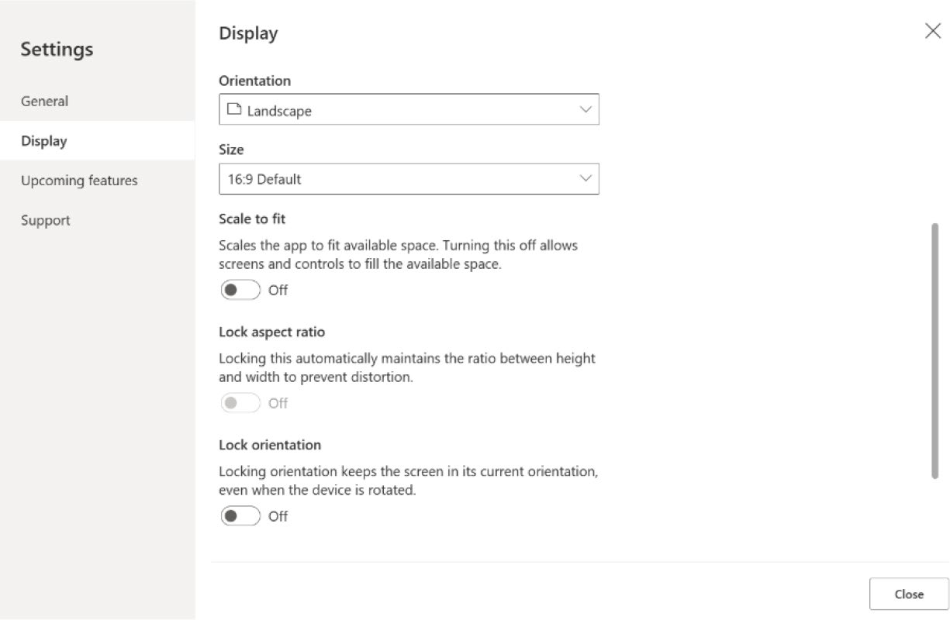

Figure 7-1. Configuring Power Apps settings for responsive design

3. Disable Scale to Fit, Lock Aspect Ratio, and Lock
Orientation, and then select Apply.
Let’s explore what these settings mean:
• Scale to Fit: This setting, when enabled, automatically
adjusts the size of the app’s screen to fit the display area of the device being used. It scales the entire app to ensure that all elements are visible without the need to scroll horizontally or vertically, regardless of the device’s screen size.

Chapter 7 DynamiC Content, Comments, anD Copilot Customization in power apps
• Lock Aspect Ratio: When this feature is activated,
it maintains the aspect ratio (the ratio of the width to the height) of the app screen as it was designed. This prevents distortion that can occur when the app is viewed on screens with different aspect ratios. It ensures that the proportions of the app’s UI remain consistent, which can be crucial for maintaining the layout’s intended design.
• Lock Orientation: This setting allows the designer to
fix the app’s orientation to portrait or landscape mode. When this setting is enabled, the app will not rotate its orientation in response to the device being turned. This is useful for apps that are optimized for or require a specific orientation due to their design or functionality.

Responsive Layouts
Power Apps provides responsive layouts that display optimally on phones, tablets, and laptops.

Note the new responsive layouts are available for app formats,
but the new screen templates are exclusively available for the
tablet format.

Figure 7-2 shows some example layouts that are deemed responsive.

Chapter 7 DynamiC Content, Comments, anD Copilot Customization in power apps
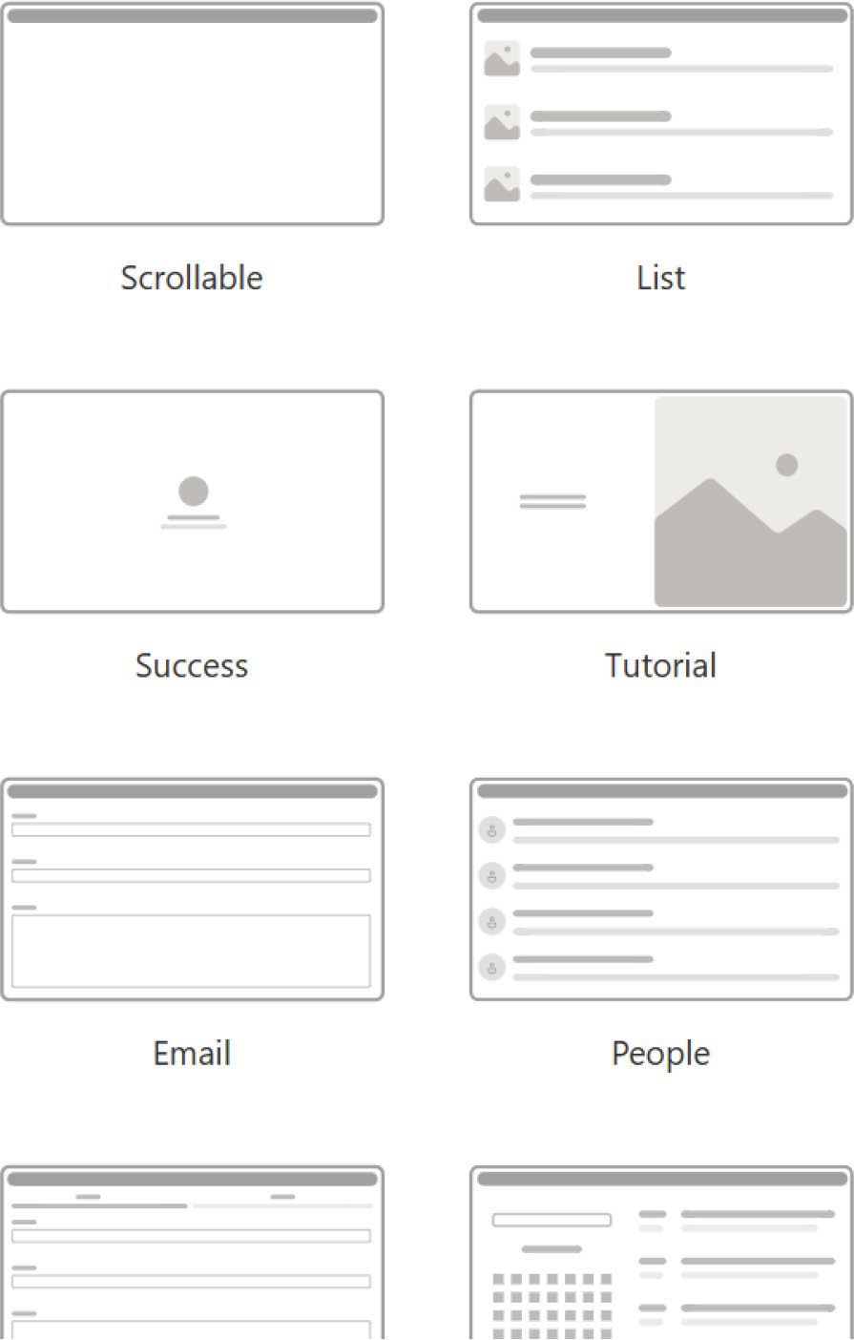

Figure 7-2. Responsive layouts that you can use to make responsive
Power Apps

The next section discusses two important layouts for developing
Power Apps: split-screen and sidebar. Understanding these layouts is key to
effective app design.

Chapter 7 DynamiC Content, Comments, anD Copilot Customization in power apps

The Split-Screen Layout
The split-screen layout divides the screen into two sections, each occupying half of the screen width when viewed on desktops. This layout is particularly useful for applications that need to display two categories of information side-by-side, such as comparing two datasets, showing detail alongside a list, or having a form on one side and descriptive content on the other.

The Sidebar Layout
The sidebar layout features a fixed-width sidebar typically placed on the left side of the screen. This sidebar can house navigation links, filters, or other tools that the user might need to access frequently. The main body of the layout includes a fixed height header and a main section that takes up the remainder of the screen width, accommodating the primary interactive or content area of the app.

Working with Containers
Containers are essential building blocks for responsive design in app development. They can be configured as auto-layout containers, which organize their contents in a vertical or horizontal arrangement, or as fixed-layout containers, which will eventually support constraints. When building your app’s UI, always place UI elements that collectively form a table within a container. This strategy allows each container to maintain its own responsive properties and settings, enabling appropriate resizing and repositioning across different screen sizes. Additionally, you can modify how child components are arranged within the container to improve responsiveness. Depending on your design requirements, you can choose between manual layout and auto-layout (horizontal or vertical) for each container’s layout mode.

Chapter 7 DynamiC Content, Comments, anD Copilot Customization in power apps

Auto-Layout Containers
In app design, the horizontal and vertical containers serve as powerful
tools for effortlessly organizing child components. These containers
eliminate the need to manually adjust the X and Y coordinates of elements
within them. Instead, they automatically determine the optimal placement
of each component, efficiently distributing space according to predefined
settings. Furthermore, these containers also take charge of aligning
components, ensuring proper vertical and horizontal alignment, which
simplifies the layout process and enhances the overall aesthetic of the app.
Auto-layout containers are particularly useful in a variety of scenarios:
• Adapting the user interface to accommodate different
screen sizes or device types.
• Dynamically resizing or repositioning multiple child
components based on changes in screen size or device form factor.
• Arranging elements in a vertical or horizontal stack,
regardless of their individual dimensions.
• Evenly distributing elements across the display area.

Creating a Demo
This section shows you how to create a quick demo of responsive layout:
1. Create a blank Canvas app in Power Apps. See
Figure 7-3.

Chapter 7 DynamiC Content, Comments, anD Copilot Customization in power apps
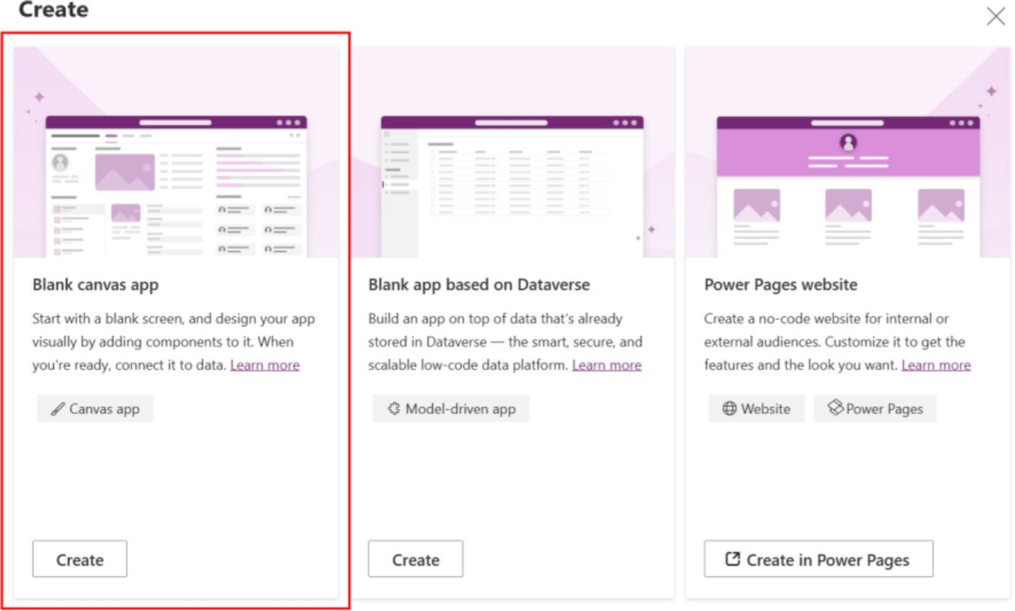

Figure 7-3. Create a blank Canvas app in Power Apps

2. Provide an app name and select the Tablet layout, as
shown in Figure 7-4.
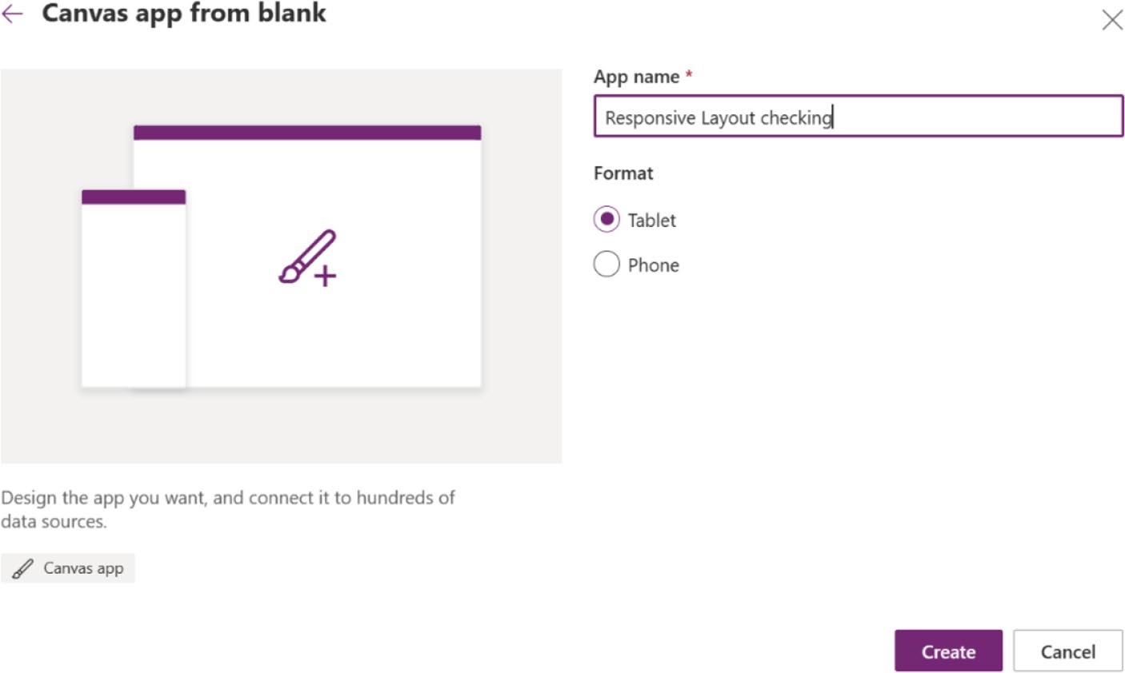

Figure 7-4. Providing app name and selecting a format

Chapter 7 DynamiC Content, Comments, anD Copilot Customization in power apps
3. Go to Settings from the top bar and choose Display.
Disable Scale to Fit, Lock Aspect Ratio, and Lock Orientation, and then select Apply. Refer to
Figure 7-1 to check the complete process.
4. From the Insert panel in the left sidebar, under
Layout, find Horizontal Container and Vertical
Container, as shown in Figure 7-5. Choose Horizontal Container.
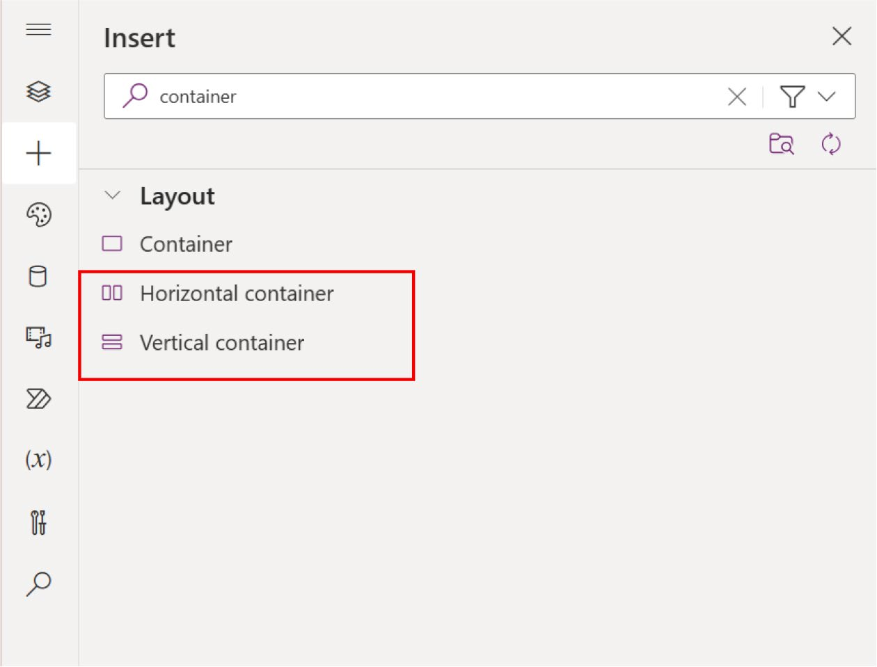

Figure 7-5. Choose Horizontal Container here

Chapter 7 DynamiC Content, Comments, anD Copilot Customization in power apps
5. The primary container should expand to occupy
the entire space, adjusting its size to match the screen as it resizes. Change the properties to the following values:
X = 0
Y = 0
Width = Parent.Width
Height = Parent.Height
6. Insert a new Copilot control in the container and
link it to a data source, like what you did in the
previous chapter. See the example in Figure 7-6.
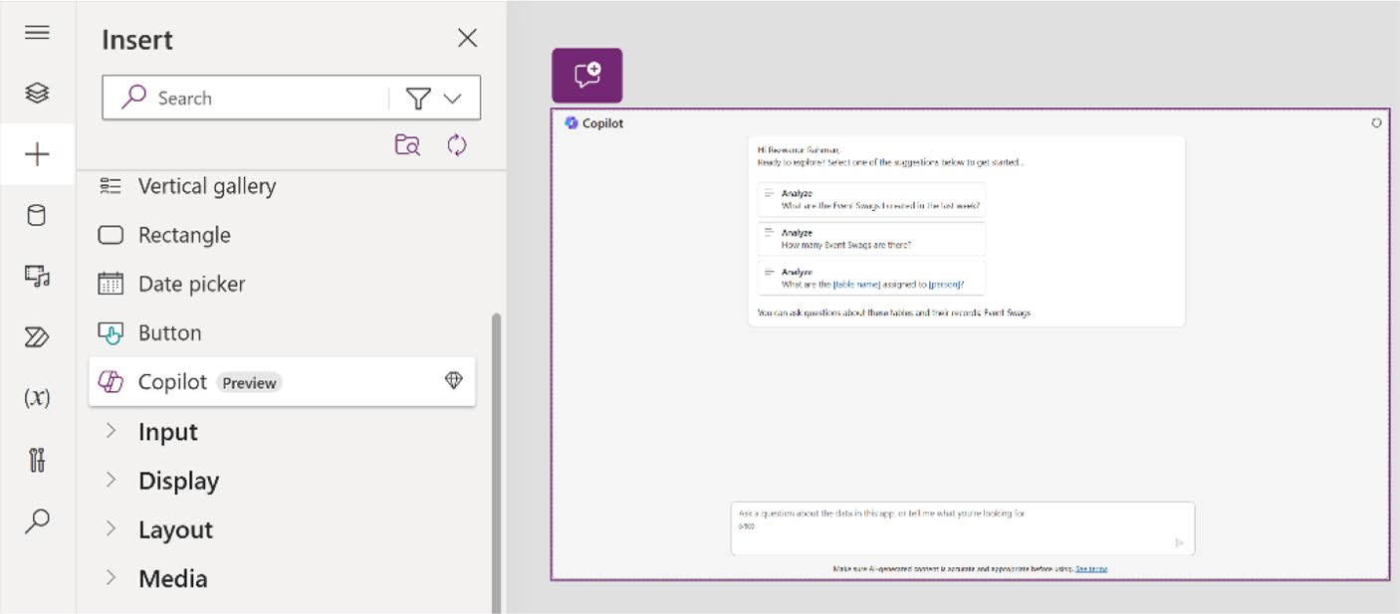

Figure 7-6. Adding Copilot to the Power Apps container

Chapter 7 DynamiC Content, Comments, anD Copilot Customization in power apps
7. Run the app by pressing F5, as shown in Figure 7-7.
Select Canvas size first.
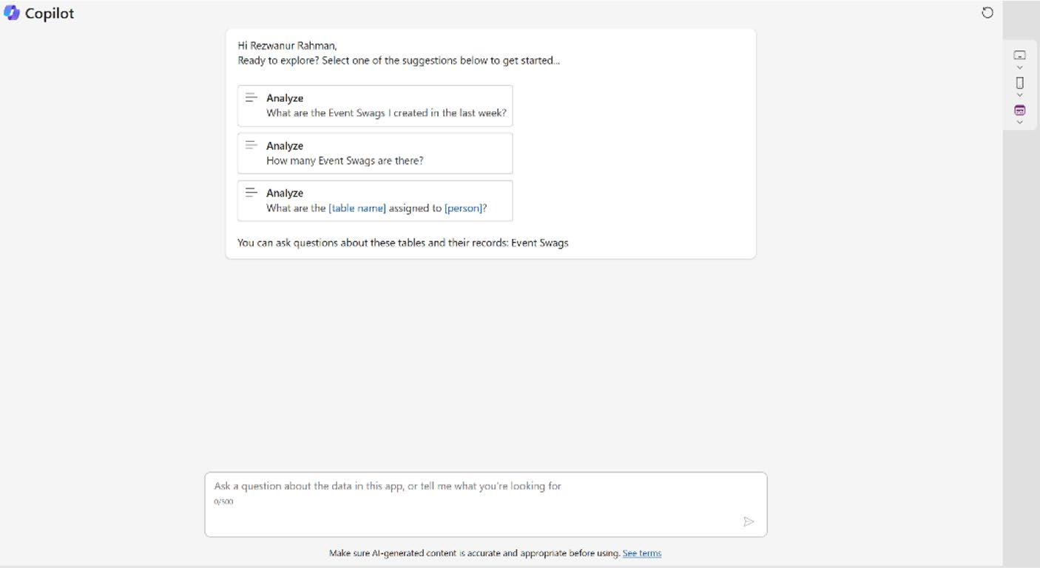

Figure 7-7. Verifying the responsive app in Canvas size

Chapter 7 DynamiC Content, Comments, anD Copilot Customization in power apps
Now change the device from Canvas size to any phone device size, as
shown in Figure 7-8, and check the design’s responsiveness.
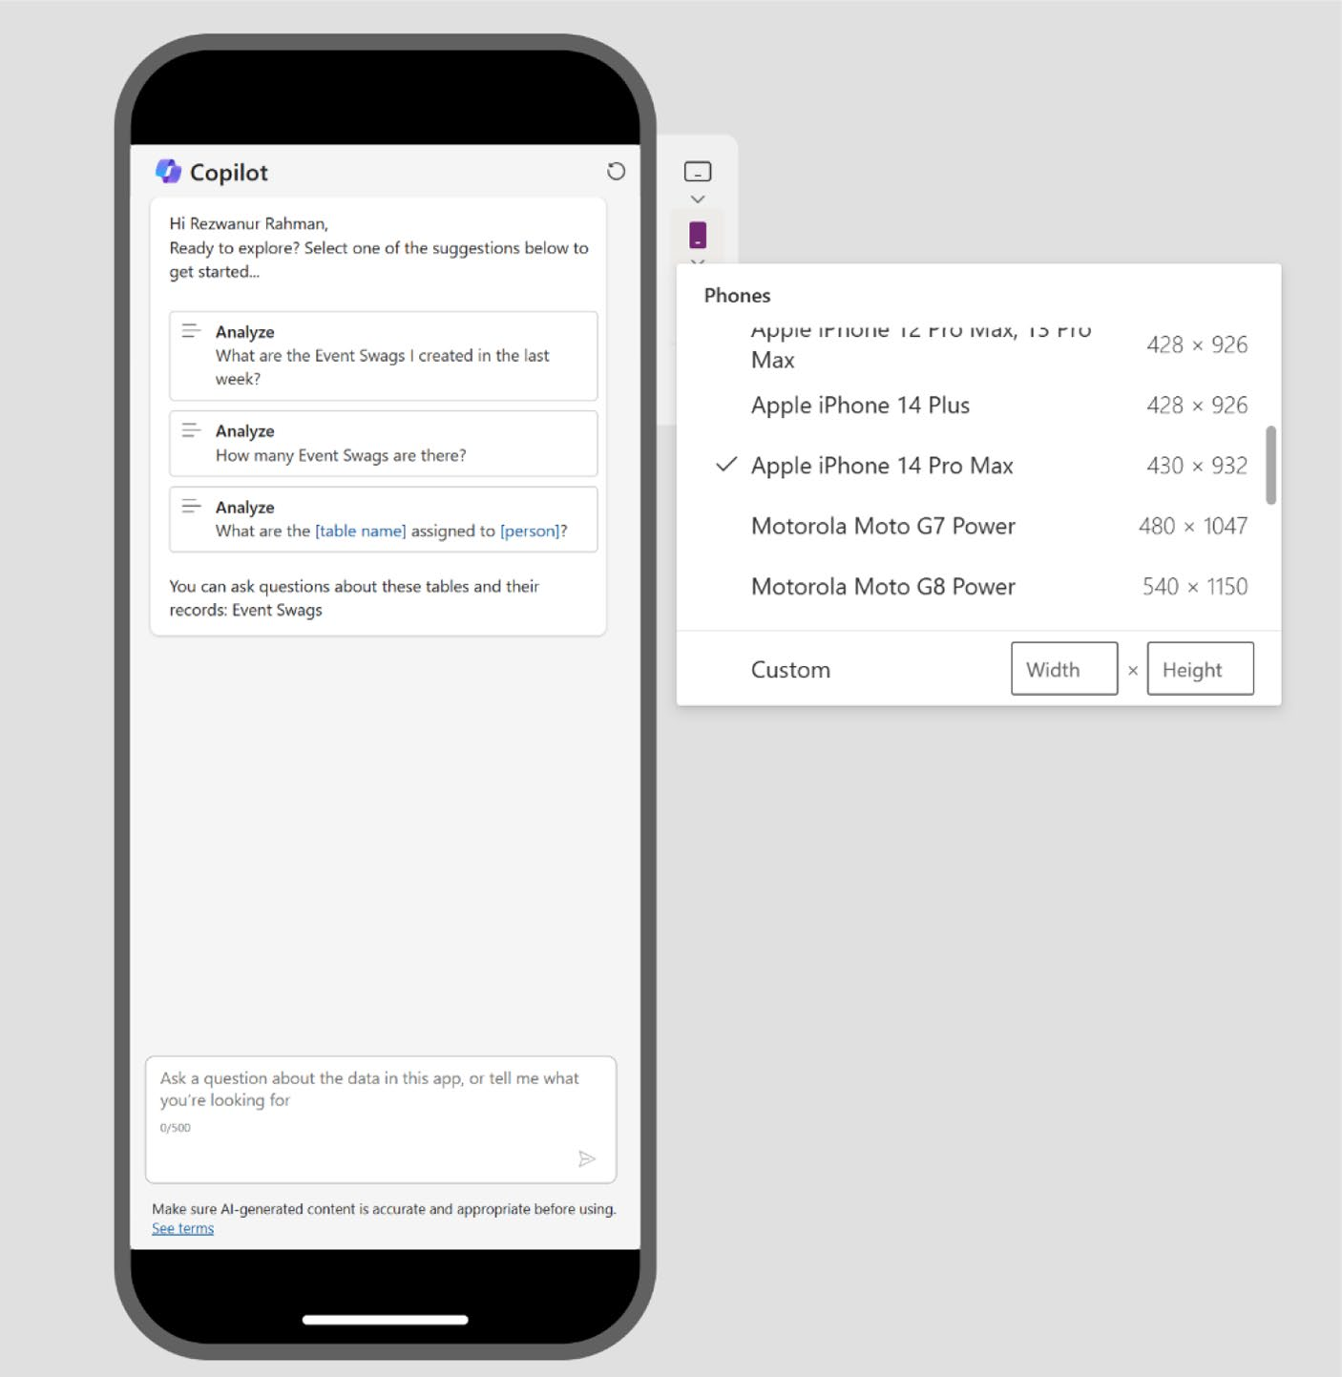

Figure 7-8. Verifying the responsive app in a phone device

Chapter 7 DynamiC Content, Comments, anD Copilot Customization in power apps
Change the mode from Phone to Tablet. Choose any tablet you want.
For example, I chose Apple iPad Pro 12.9, as shown in Figure 7-9.
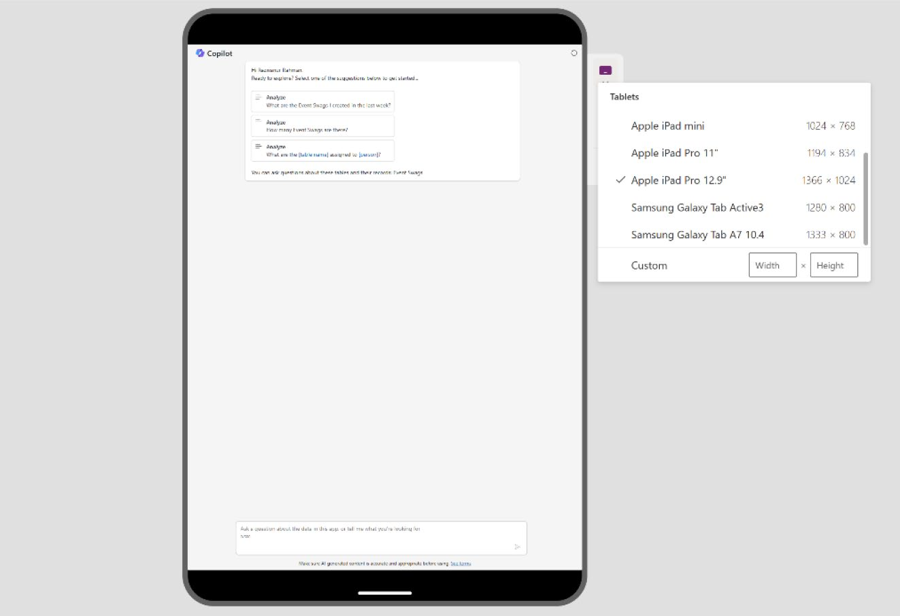

Figure 7-9. Verifying the responsive app on a tablet device

The same control in the container adjusts its size to fit the screen
when you turn the device. For example, I rotated the iPad, as shown in
Figure 7-10, for better understanding.

Chapter 7 DynamiC Content, Comments, anD Copilot Customization in power apps
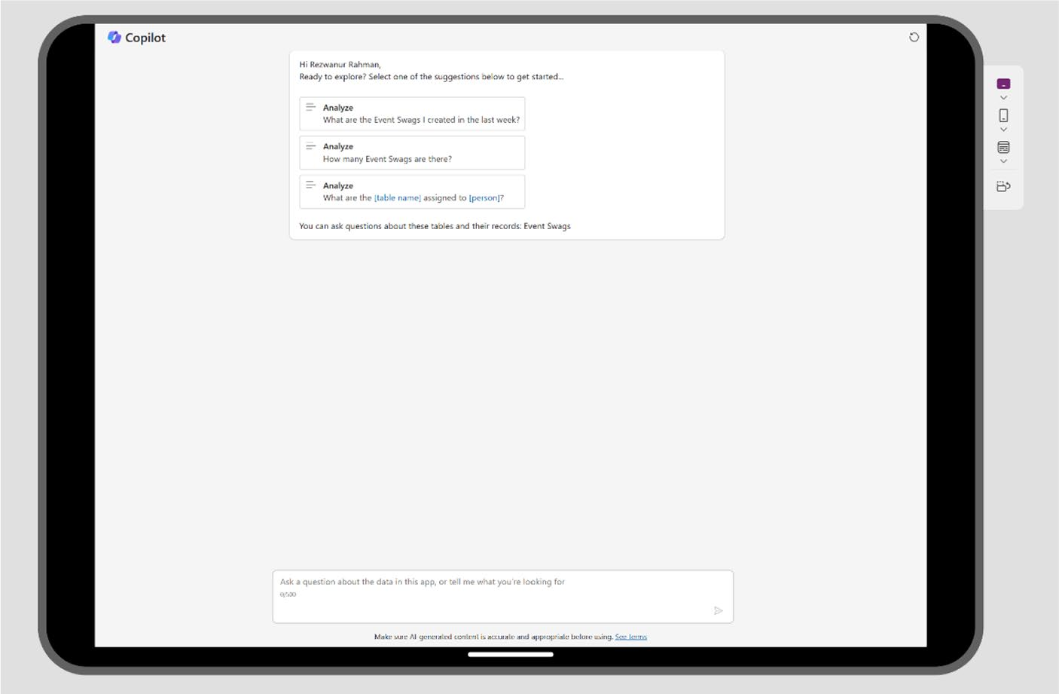

Figure 7-10. App responsiveness check in landscape mode

Copilot Components and Conditional
Formatting in Power Apps
This section explores the Copilot components available in Power Apps. It covers both Copilot Studio and Copilot Chatbot, teaching you how to enhance and personalize Copilot’s functionality. You will learn to adjust response styles, integrate various data sources, and utilize advanced features such as custom workflows and plugins. You will also learn how conditional formatting works, and how it relates to Copilot.
As you progress, the section transitions into practical applications, offering examples and best practices that you can immediately implement in your projects. This shift from theoretical to practical is designed to equip you with the necessary tools and knowledge to make your interactions with Copilot more dynamic and efficient.

Chapter 7 DynamiC Content, Comments, anD Copilot Customization in power apps

The Copilot Control
The Copilot control represents a sophisticated AI assistant specifically
tailored for integration into Canvas applications. It provides a dynamic,
AI-powered chat interface that allows users to interact and derive insights
from application data via natural language conversations. This innovative
feature empowers users to ask questions and receive information directly
related to the app’s data in an intuitive, conversational format.
App developers have the flexibility to implement this control within
any Canvas app, enabling a seamless and interactive user experience.
They can configure the control to access specific datasets within the app,
ensuring that Copilot can deliver accurate and relevant answers based on
the available data. This customization capability allows developers to tailor
the AI’s responses to the unique needs and contexts of their applications,
enhancing the overall functionality and user engagement of the app.
Consider this important information about Copilot control:
• Your environment must be in the US region to utilize
this capability.
• Enabling data movement across regions is essential for
using Copilot features in Power Apps, especially if your organization’s environment is in a different region. For
more details, refer to the documentation at https://
learn.microsoft.com/en-us/power-platform/admin/
geographical-availability-copilot#enable-data-
movement-across-regions.
• This feature is driven by the Azure OpenAI Service.
• Using this capability may be limited or subject to
throttling.

Chapter 7 DynamiC Content, Comments, anD Copilot Customization in power apps
• Environments with customer-managed keys (CMKs)
or those using Lockbox do not support the Copilot control.

Activate the Copilot Control
To activate the Copilot control, it is necessary to enable the Copilot option from the Power Platform Admin Center, where it is set to disabled by default. It is important to verify whether this option has already been activated.
To verify the Copilot settings from the Power Platform Admin Center, follow these steps:
1. As shown in Figure 7-11, visit https://admin.
powerplatform.microsoft.com/.
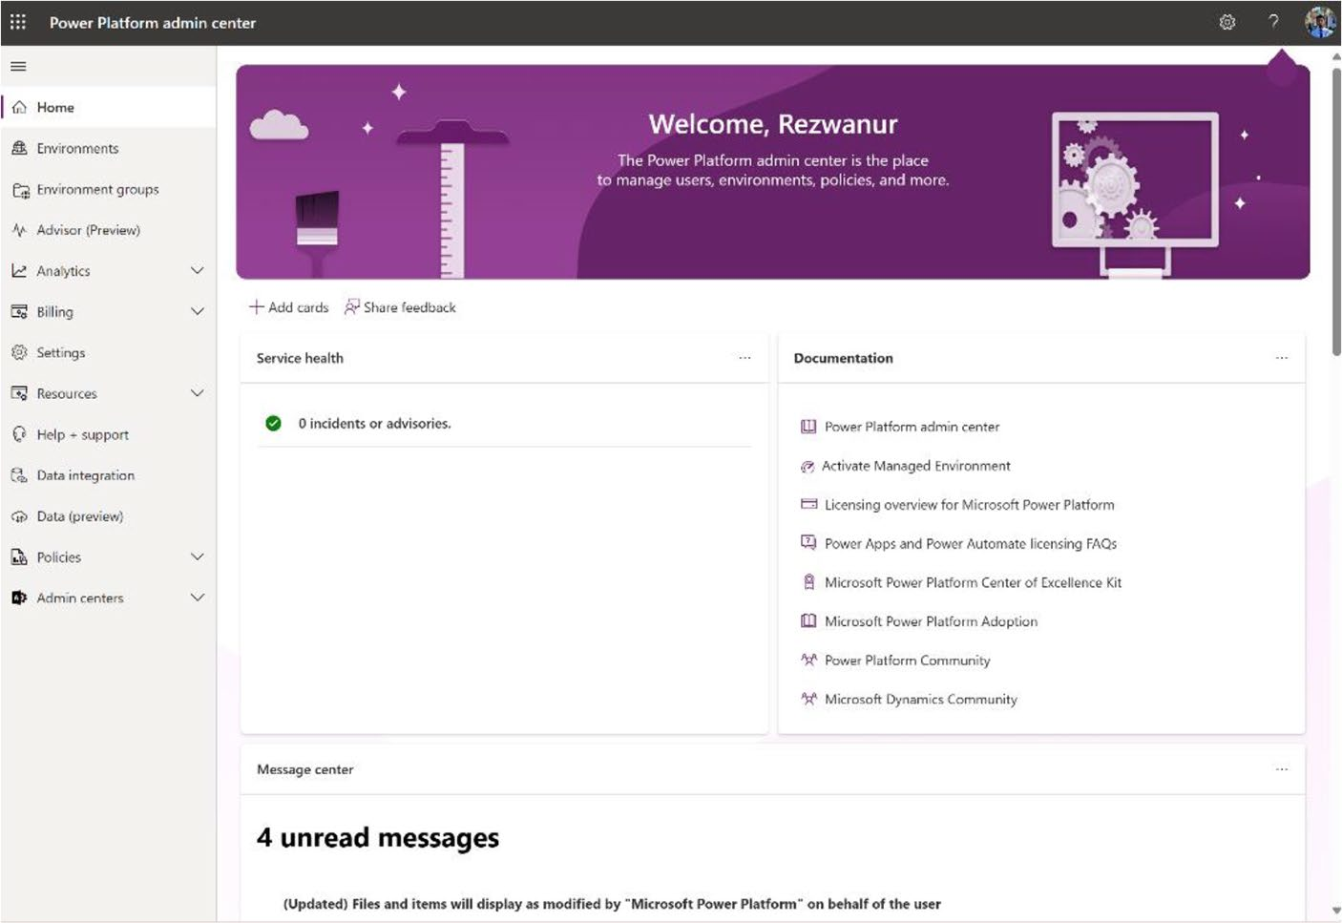

Figure 7-11. Power Platform Admin Center preview

Chapter 7 DynamiC Content, Comments, anD Copilot Customization in power apps
2. Click Environments and select your environment
from the list, as shown in Figure 7-12.
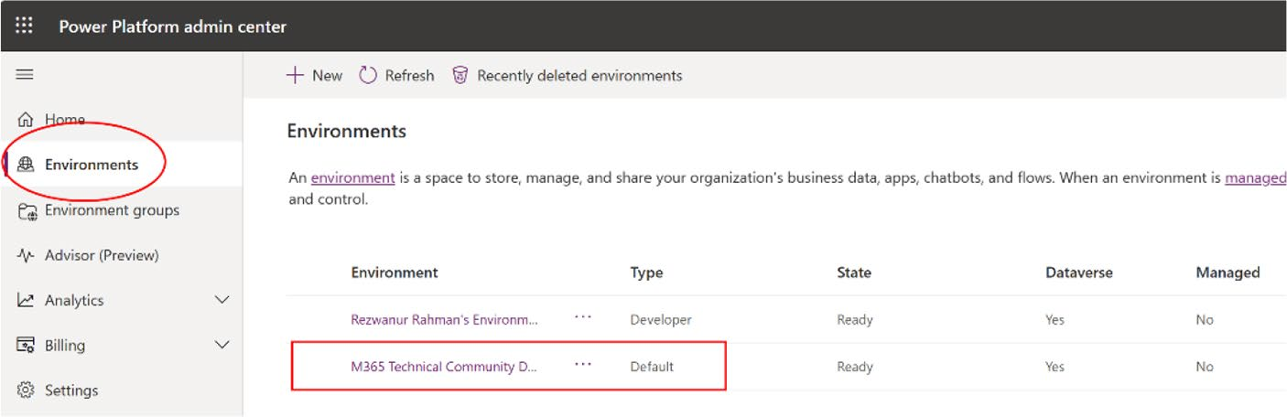

Figure 7-12. Selecting Environments in Power Platform
admin center

3. After selecting Environments, click Settings on the
top border. See Figure 7-13.
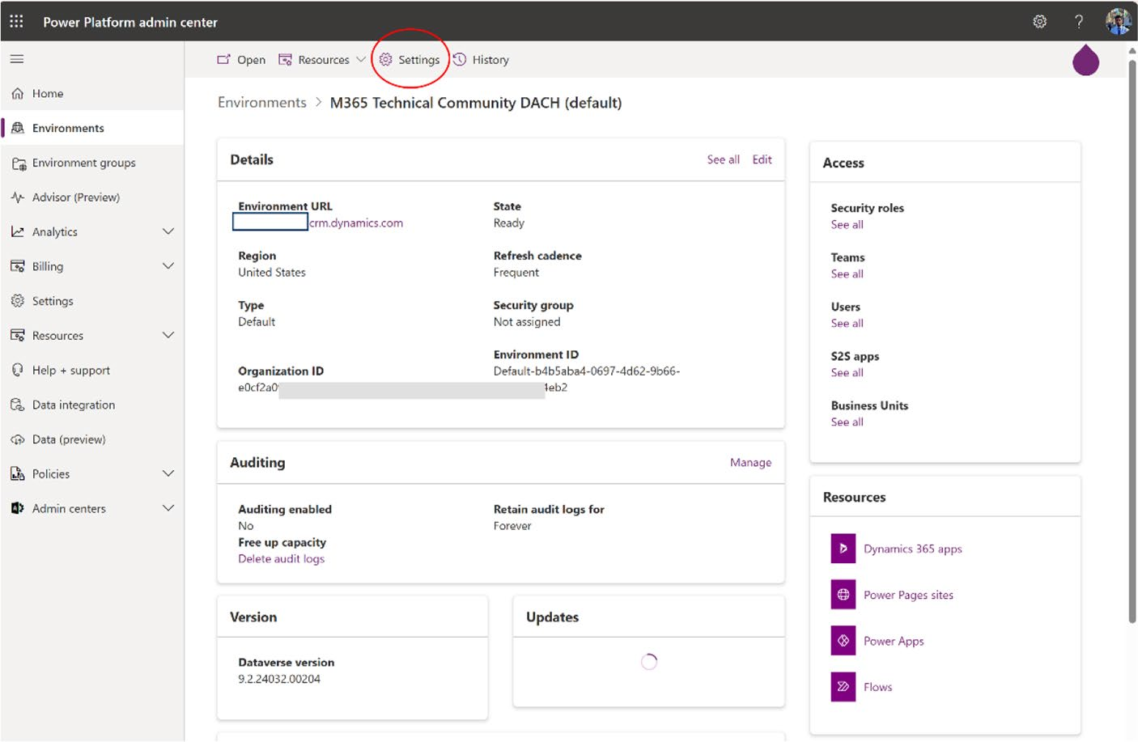

Figure 7-13. The Settings option of the Power Platform
Admin Center

Chapter 7 DynamiC Content, Comments, anD Copilot Customization in power apps
4. After selecting Settings, expand the Product option
and select Features. See Figure 7-14.
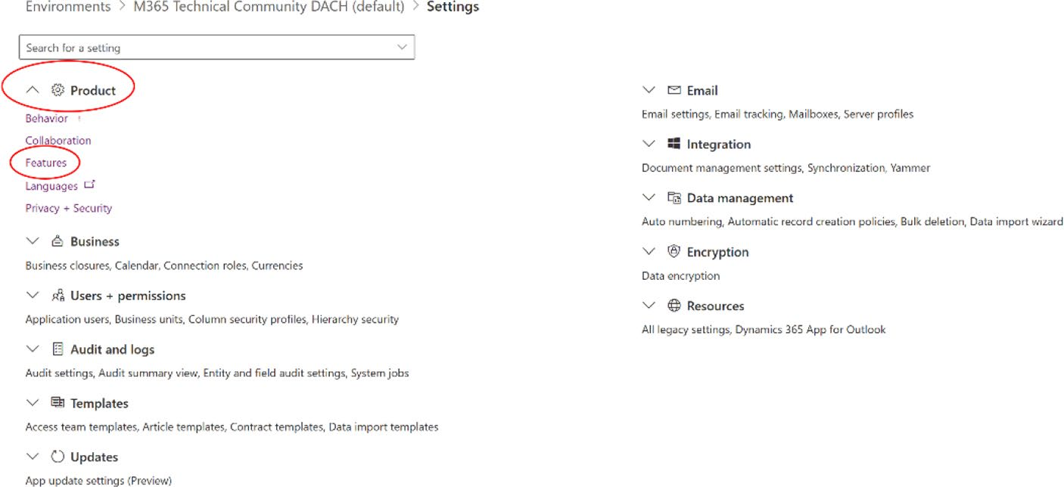

Figure 7-14. The Features option in the Product area

5. As shown in Figure 7-15, make sure Copilot is
turned on.
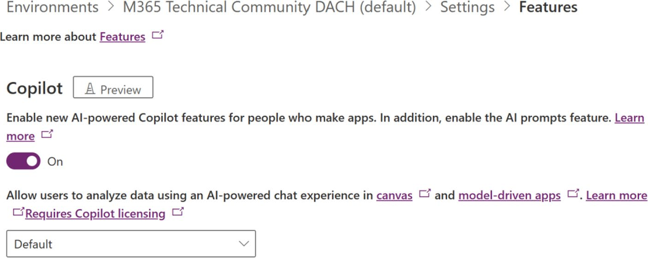

Figure 7-15. Copilot option in Power Apps feature settings

Chapter 7 DynamiC Content, Comments, anD Copilot Customization in power apps

Enable the Copilot Component for a Canvas App

1. To activate the Copilot component for a Canvas
app, go to https://make.powerapps.com/ and open an existing project or create a new one. As you are working on a common project, open that project, as
shown in Figure 7-16.
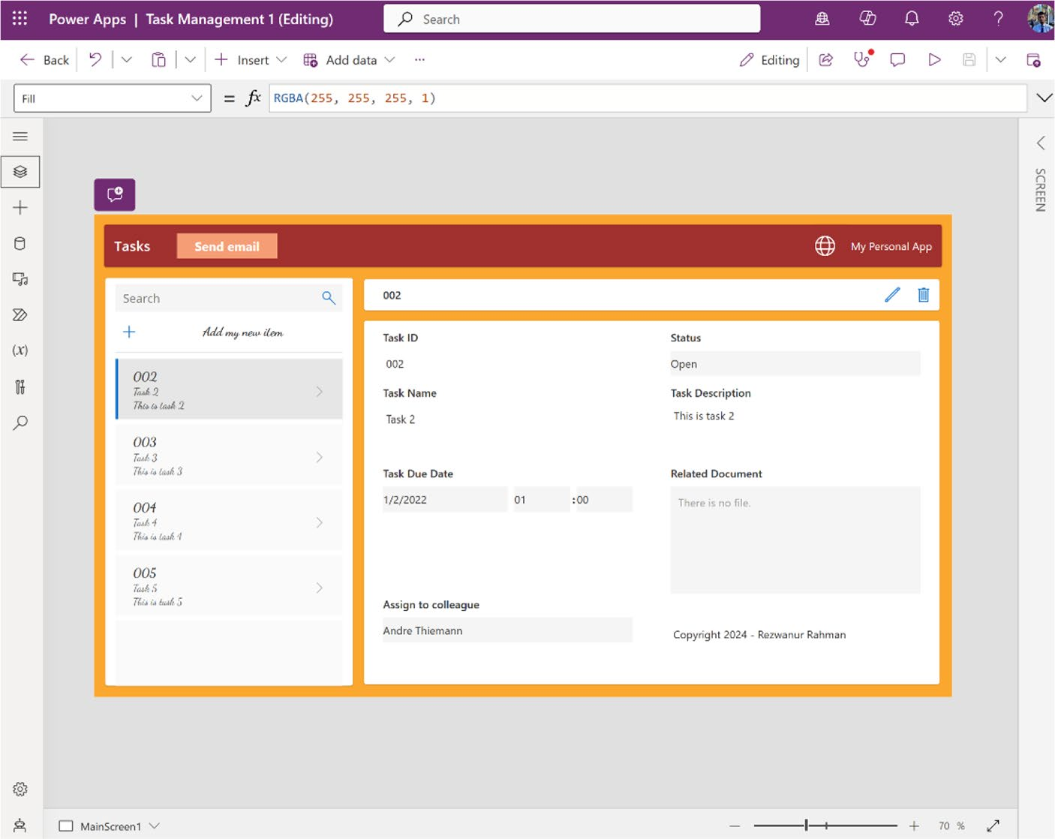

Figure 7-16. Open the project in Power Apps

Chapter 7 DynamiC Content, Comments, anD Copilot Customization in power apps
2. Click Settings in the top bar, as shown in Figure 7-17.
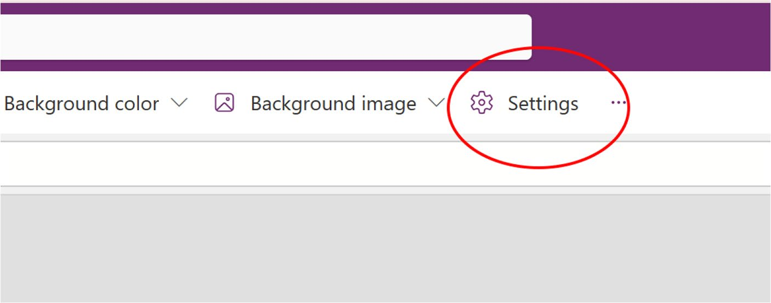

Figure 7-17. Settings of Power Apps

3. Click Upcoming Features and make sure the Copilot
component is turned on. See Figure 7-18. You must do this so Power Apps will recognize the Copilot component in this project.

Chapter 7 DynamiC Content, Comments, anD Copilot Customization in power apps
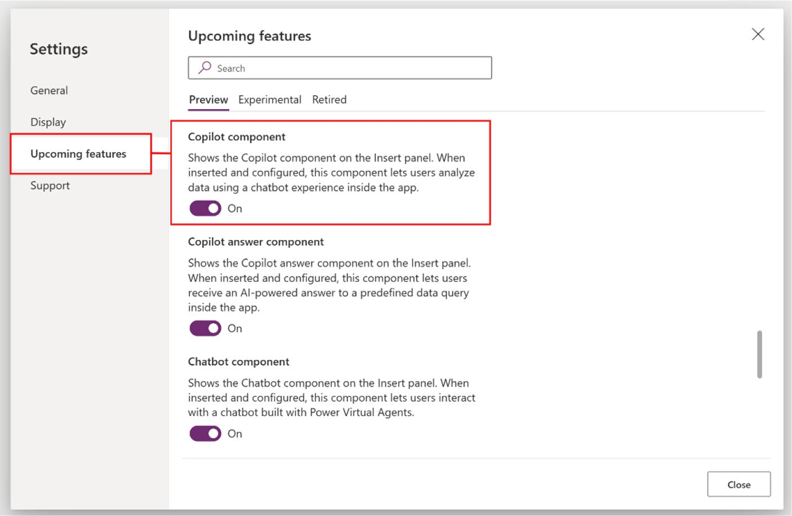

Figure 7-18. Enable the Copilot component option in Power Apps
settings

Note your browser language must be set to english (united states).

You are now done checking your requirements. Next, you learn how to
add Copilot to your app so that you can chat with your data.

Add the Copilot Control to a Canvas App
To add Copilot to a Canvas app, go back to the project and follow these
instructions:
1. Create a new screen and select your favorite
template. I am choosing the Header and Footer template, as this example creates a chat window, as
shown in Figure 7-19.

Chapter 7 DynamiC Content, Comments, anD Copilot Customization in power apps
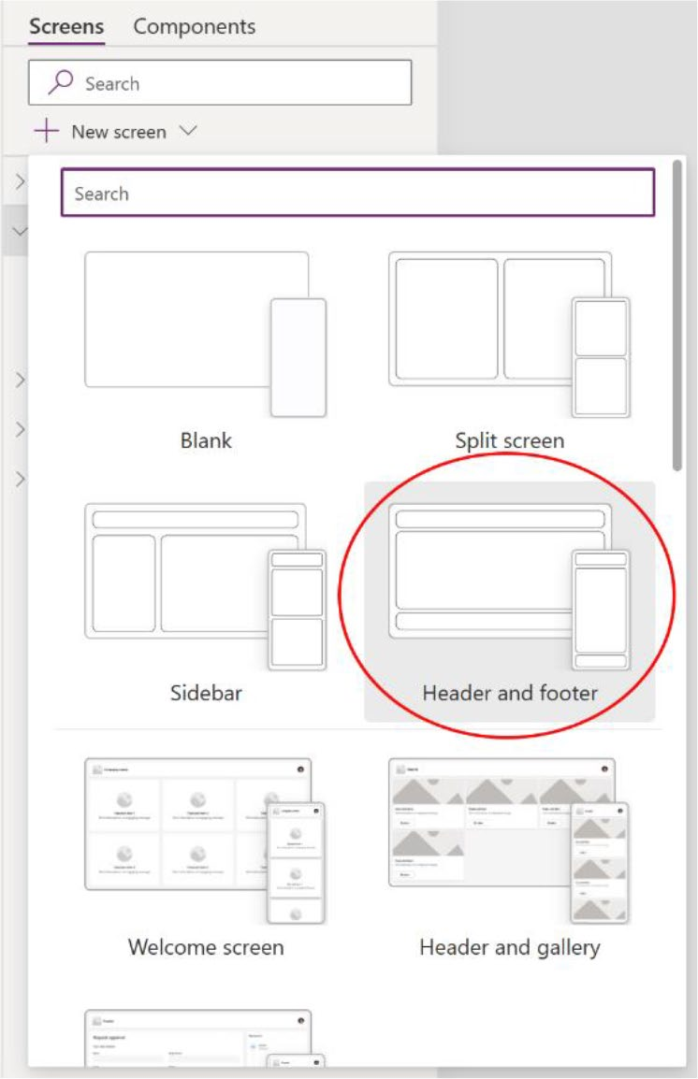

Figure 7-19. Adding a new template in a new screen

You can make your own screen manually. This example uses the template to save time and to show the capabilities of Power Apps templates.

Chapter 7 DynamiC Content, Comments, anD Copilot Customization in power apps
This is not mandatory to create new screens. You can use the Copilot
component on the same page or existing page if you want.
2. After clicking Header and Footer, you will see an
empty screen, as shown in Figure 7-20.
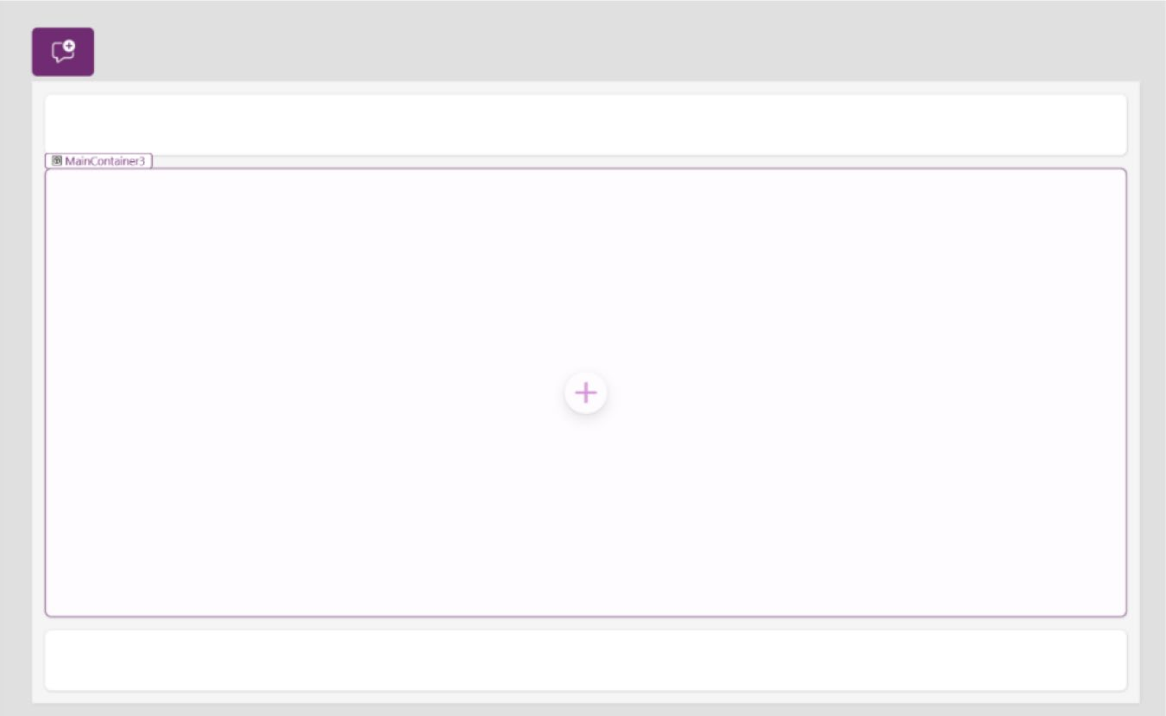

Figure 7-20. New Header and Footer template in a Power
Apps window

Chapter 7 DynamiC Content, Comments, anD Copilot Customization in power apps
3. Next, you add the Copilot component. To add it,
click the + icon and select Copilot, as shown in
Figure 7-21.
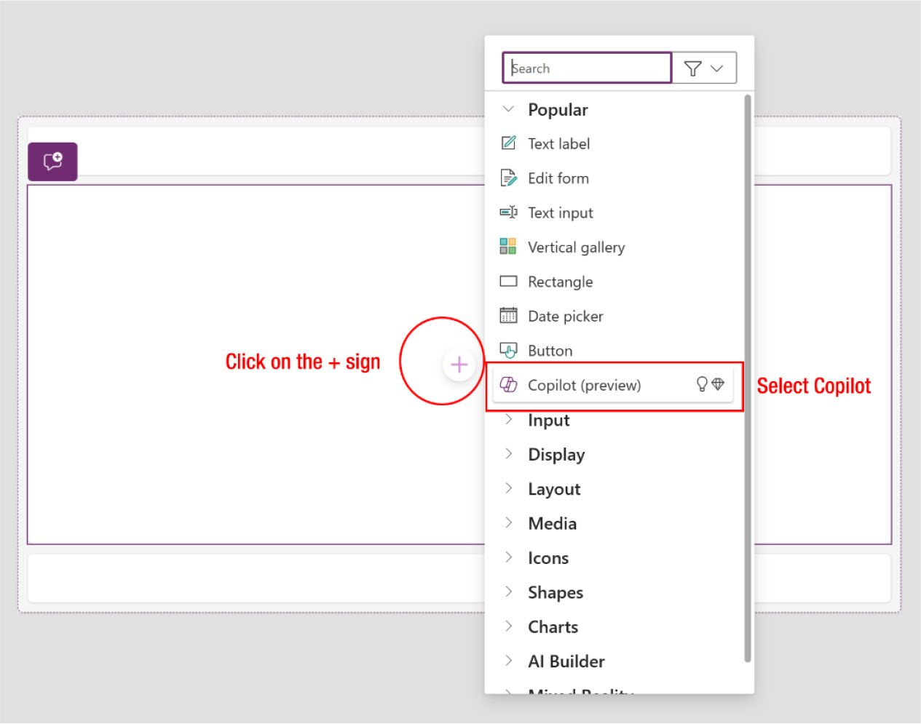

Figure 7-21. Adding Copilot to Power Apps

Chapter 7 DynamiC Content, Comments, anD Copilot Customization in power apps
4. As shown in Figure 7-22, you now need to add the
data source.
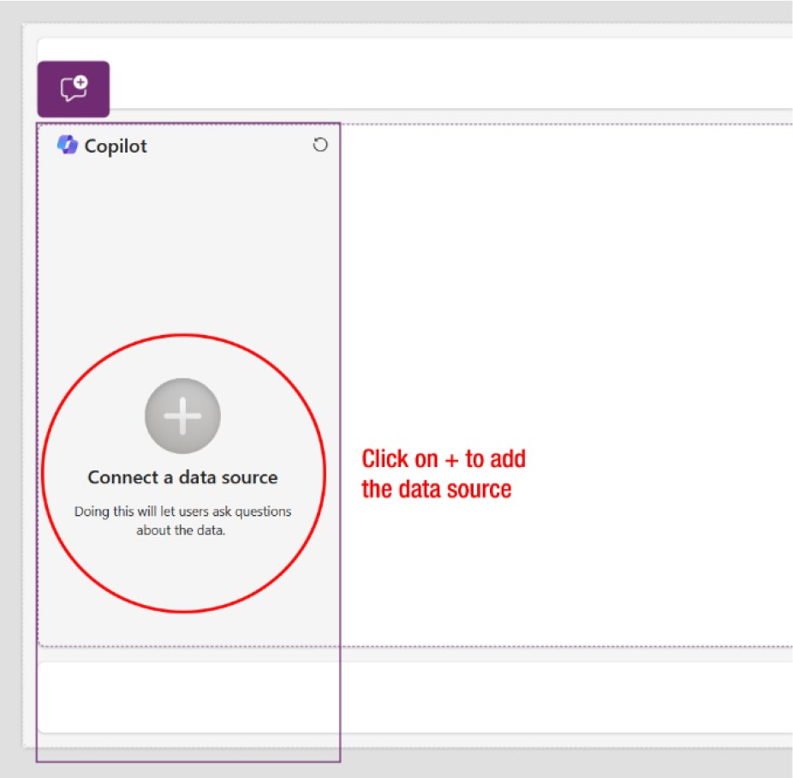

Figure 7-22. Adding a data source to Copilot

Chapter 7 DynamiC Content, Comments, anD Copilot Customization in power apps
5. To add the data source, click + and select the data
source, as shown in Figure 7-23. This example selects the default table as the data source, which is called Tasks.
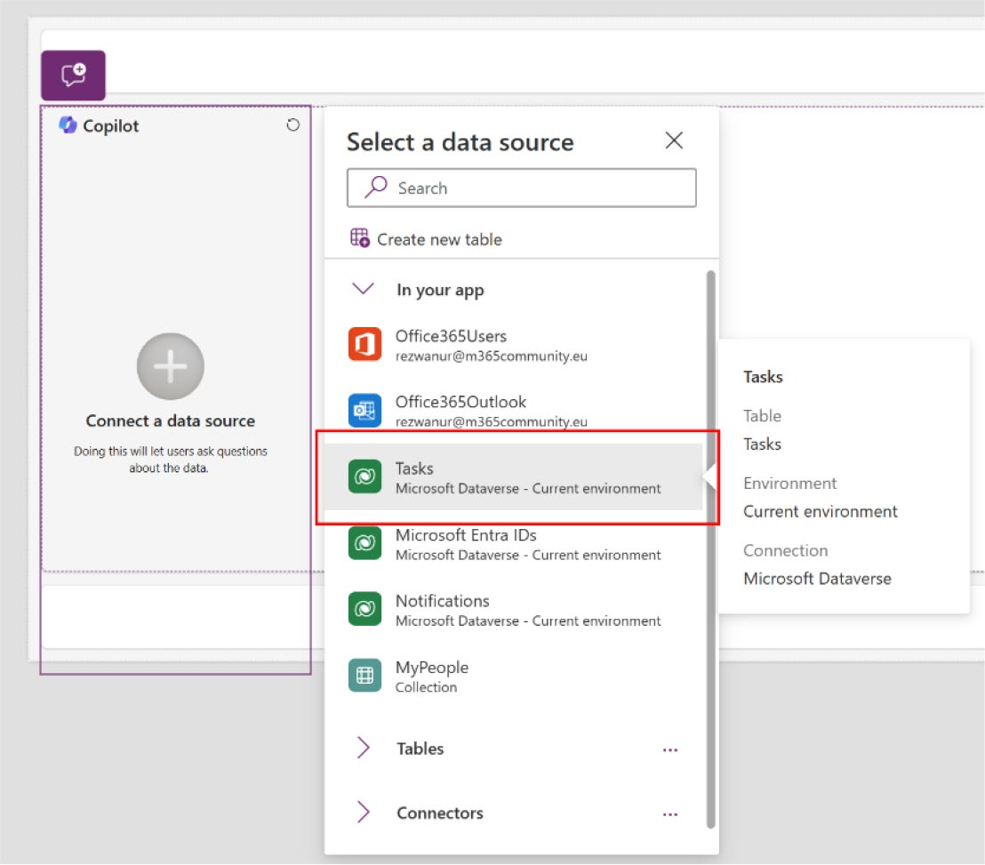

Figure 7-23. Adding a data source to Copilot

6. You should see that the Copilot Chat has been
added successfully, as shown in Figure 7-24.

Chapter 7 DynamiC Content, Comments, anD Copilot Customization in power apps
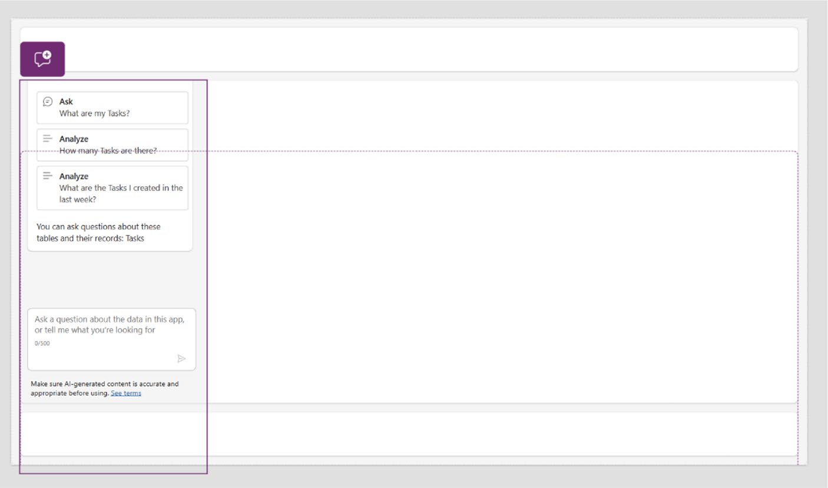

Figure 7-24. Successful data source connection

7. Initially, this will appear as a small box, as illustrated
in Figure 7-24. You will need to manually adjust its design. To modify the width, height, and alignment, select the Copilot component and access Properties,
as shown in Figure 7-25.

Chapter 7 DynamiC Content, Comments, anD Copilot Customization in power apps
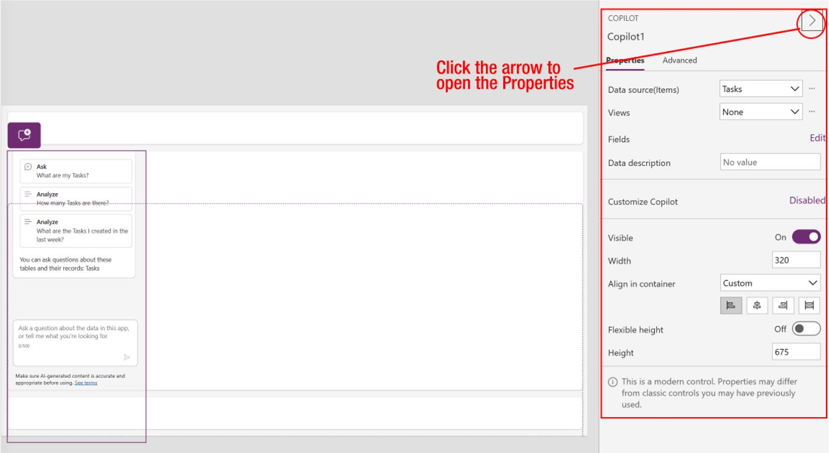

Figure 7-25. Copilot properties to change the height and width

8. Change the Align in Container from Start to Stretch
and set the Height to 555, as shown in Figure 7-26.
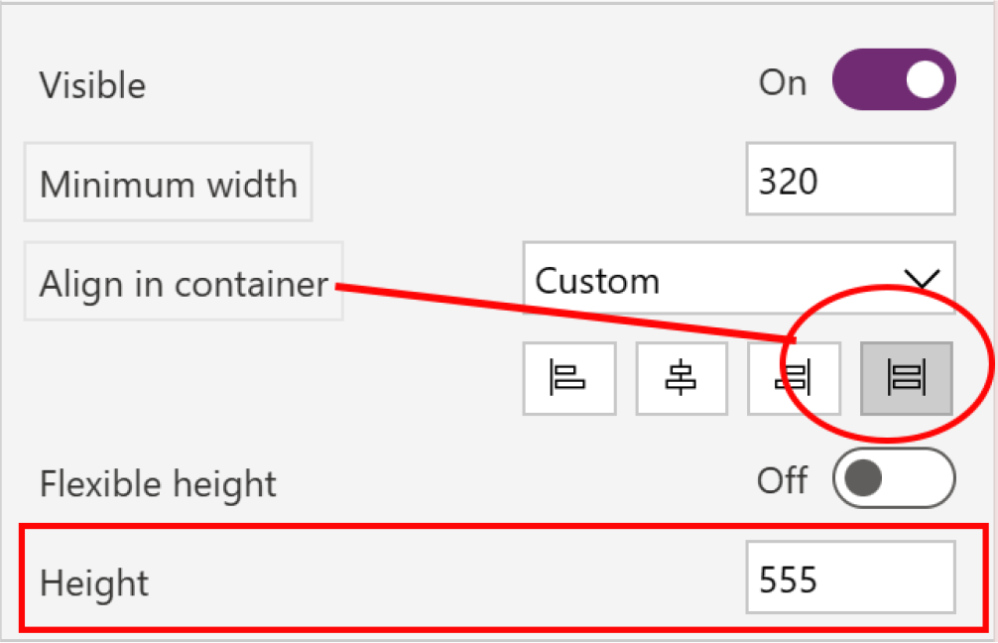

Figure 7-26. Settings for changing width and height

Chapter 7 DynamiC Content, Comments, anD Copilot Customization in power apps
You might be wondering why I did not opt for Flexible Height in this case. The reason is that using Flexible Height would cause Copilot to extend below the footer, obscuring the text field and preventing users from engaging in conversation.
9. The final Copilot Chat window, after these
customizations, is shown in Figure 7-27.
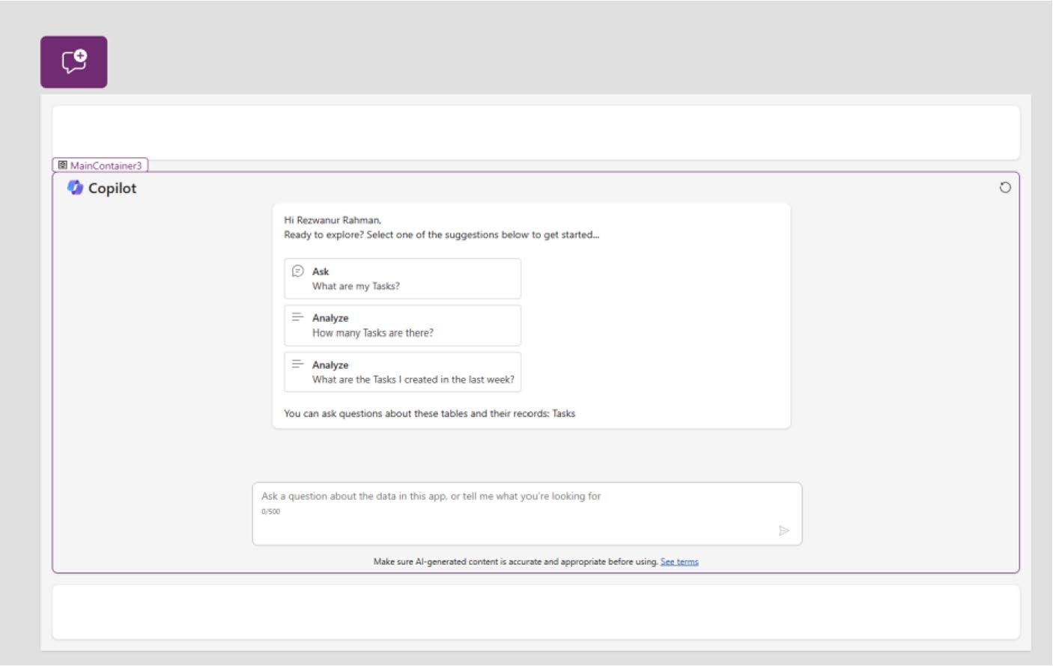

Figure 7-27. Final Copilot control in a container after fixing the
height and width

10. Run the app to see how Copilot responds to the
natural language command. I sent the simple
command shown in Figure 7-28.

Chapter 7 DynamiC Content, Comments, anD Copilot Customization in power apps
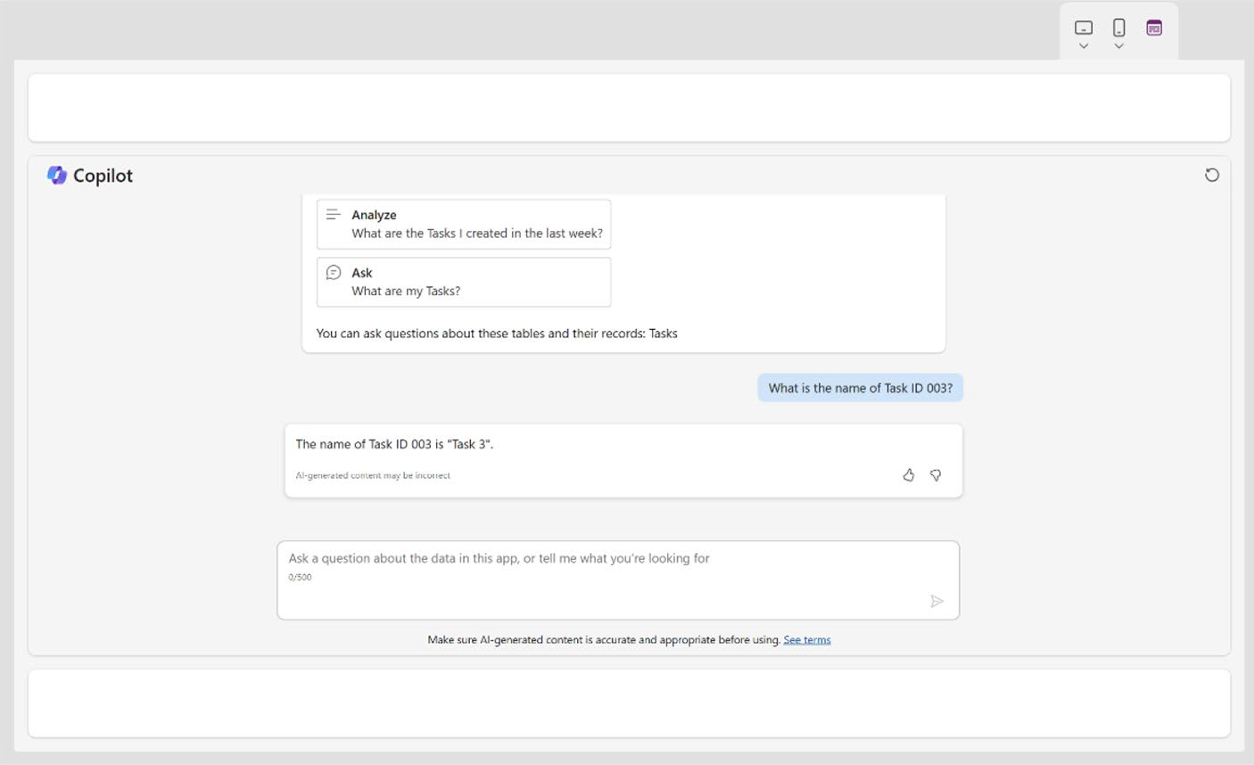

Figure 7-28. Conversation with Copilot based on the data table

I asked Copilot for the name of Task ID 003, and Copilot responded that the name is Task 3. You can confirm this response with the data source.
If you open the Dataverse table named Tasks, it shows that the task name for Task ID 003 is Task 3.
See Figure 7-29.
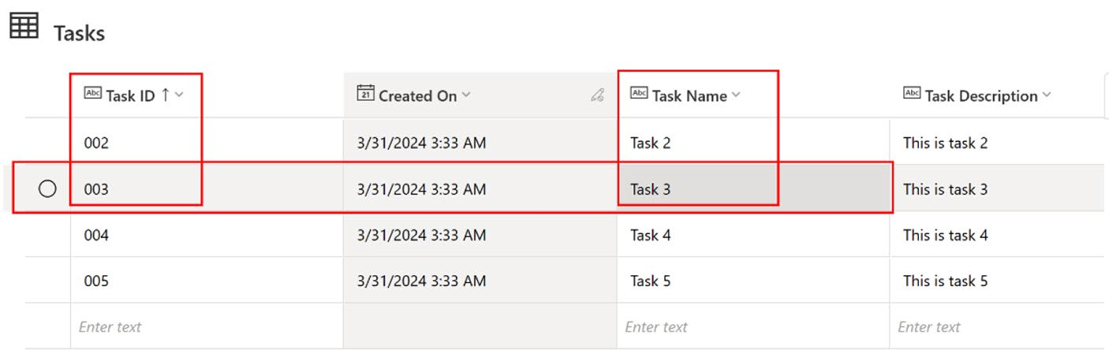

Figure 7-29. Verifying Copilot’s response with the Microsoft Dataverse table

Chapter 7 DynamiC Content, Comments, anD Copilot Customization in power apps
As you can see, Task ID 003 is in the same row as the name of Task 3.
11. You can also add dummy data to the Tasks table
and check Copilot Chat for the result. For example, I added dummy data to the Dataverse table, as shown
in Figure 7-30.

Figure 7-30. Adding dummy data to the Microsoft Dataverse table to
verify Copilot’s response

12. Next, verify the dummy data via a Copilot
conversation. See Figure 7-31.
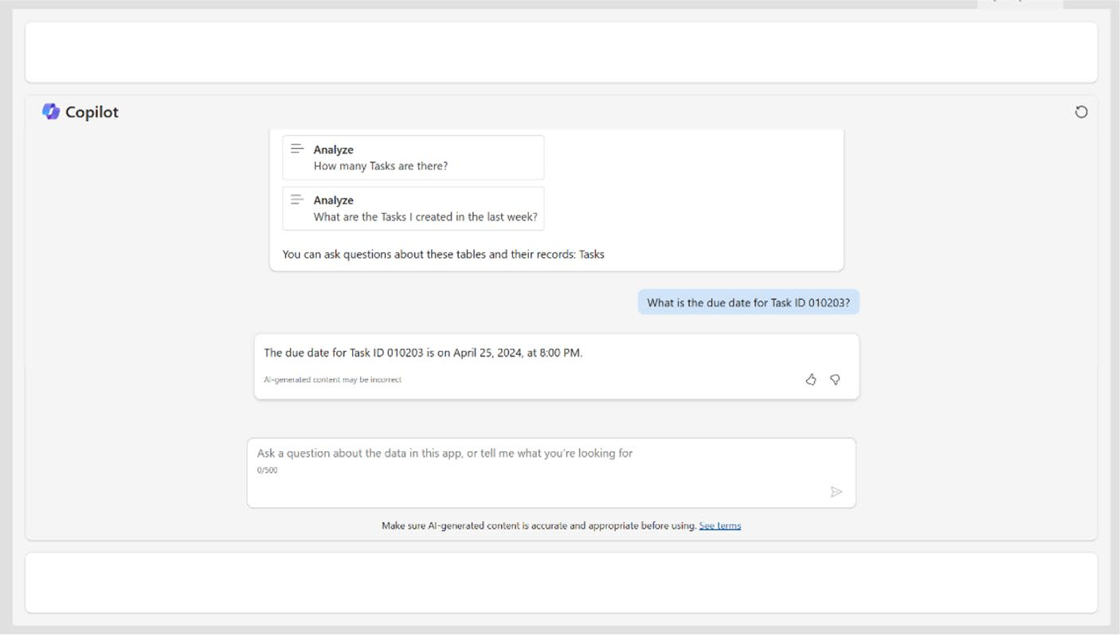

Figure 7-31. Verifying Microsoft Dataverse data via a Copilot
conversation

Chapter 7 DynamiC Content, Comments, anD Copilot Customization in power apps
Copilot successfully read the data; it accurately retrieved the due date for Task ID 010203, which I set for April 25, 2024, at 8:00 PM. When I asked, “What is the due date for Task ID 010203?” it provided the correct answer.

Note Copilot is designed to read data from a single data source. if
you want to interact with different data sources, you must create a
new Copilot component for each source. it is not possible to use the
same Copilot component for multiple data sources.

The Copilot Answer Control
The Copilot Answer control for Power Apps is a new feature that allows users to add generative AI to their Canvas apps, providing quick answers to predefined prompts. This control is part of a suite of Copilot controls in Power Apps, which includes user controls for natural language interaction and data summarization. Copilot in Power Apps can answer queries related to app development, code, formulas, and specific technical terms, and it can be used to style apps and deploy them into production. This feature makes technology more accessible to citizen developers and enhances the functionality and accessibility of Power Apps.
You will now see how to implement Copilot Answer in Power Apps. To add the control to your app, follow the steps:
1. Go to your preferred page and click Insert. Then
search for the Copilot Answer component. You can also add the component by clicking the + sign of any
empty container. Refer to Figure 7-32 to learn more.

Chapter 7 DynamiC Content, Comments, anD Copilot Customization in power apps
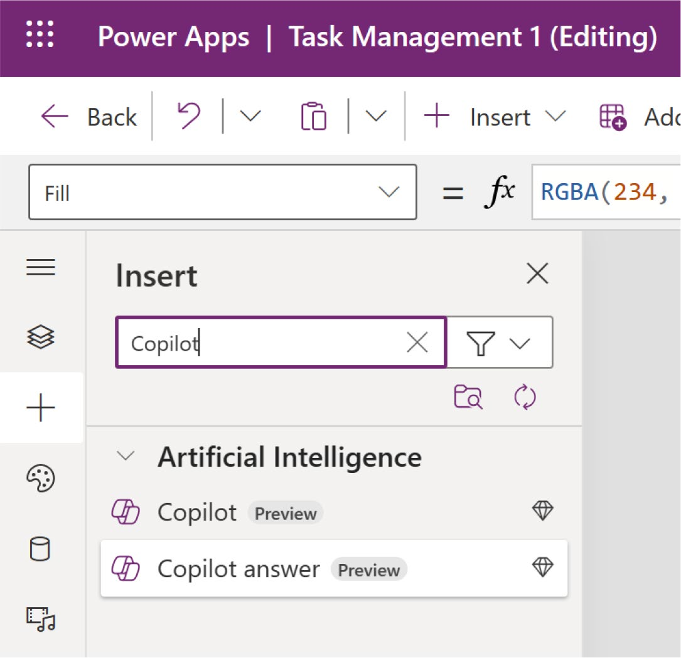

Figure 7-32. Adding Copilot Answer to Power Apps

2. Select Copilot Answer. It will ask you to add the data
source as before, as shown in Figure 7-33.

Chapter 7 DynamiC Content, Comments, anD Copilot Customization in power apps
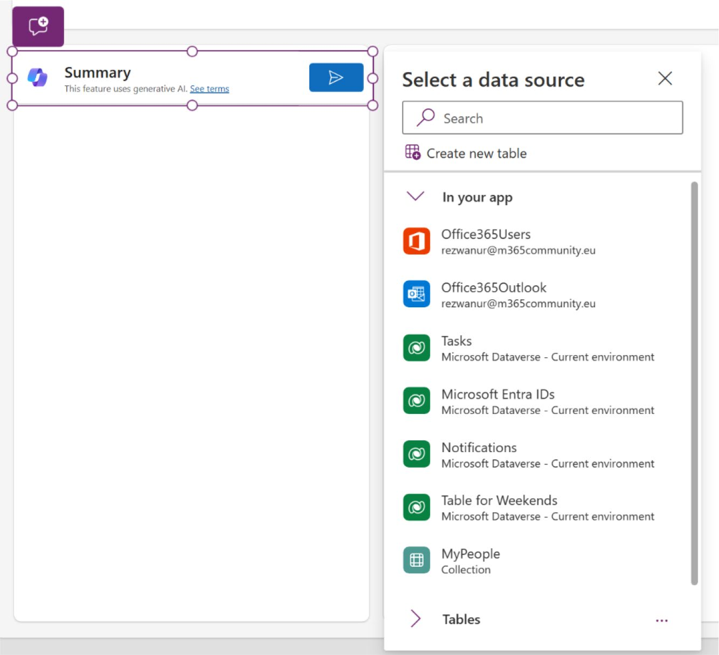

Figure 7-33. Data source selection for Copilot Answer

3. Select the Tasks data source, as this is your default
data source for the example app. Feel free to select a different data source if needed.
4. Click the Properties area of Copilot Answer, as
shown in Figure 7-34.

Chapter 7 DynamiC Content, Comments, anD Copilot Customization in power apps
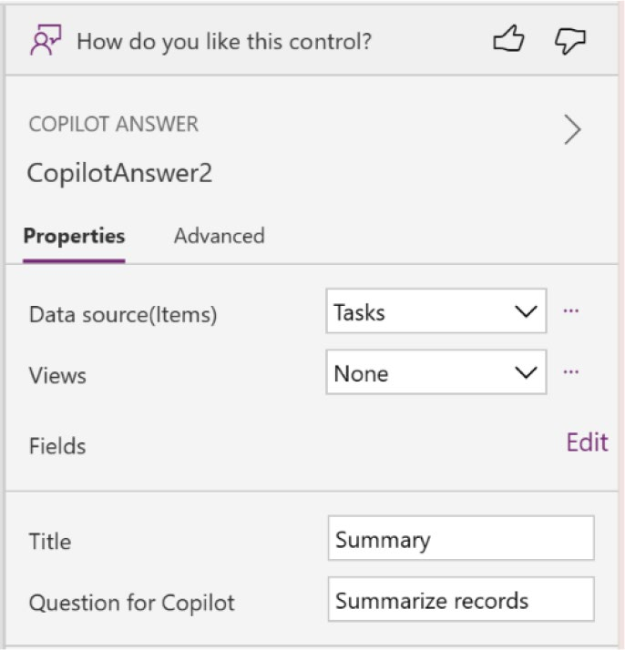

Figure 7-34. Properties of Copilot Answer

Here, you must define the Title and the Question for Copilot. As this is a predefined control, you cannot change the value or question after debugging it.
I changed the Title to Status Overview and the Question for Copilot to Summarize Total Status, as
shown in Figure 7-35.
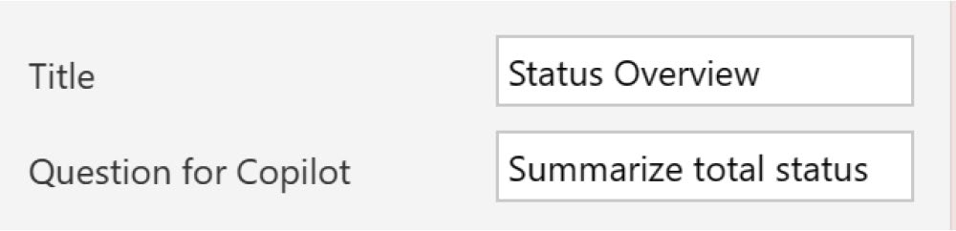

Figure 7-35. Changing the title and question for Copilot

5. Run the app and click the generate button, as shown
in Figure 7-36. You can see the total status count, as
shown in Figure 7-37.

Chapter 7 DynamiC Content, Comments, anD Copilot Customization in power apps
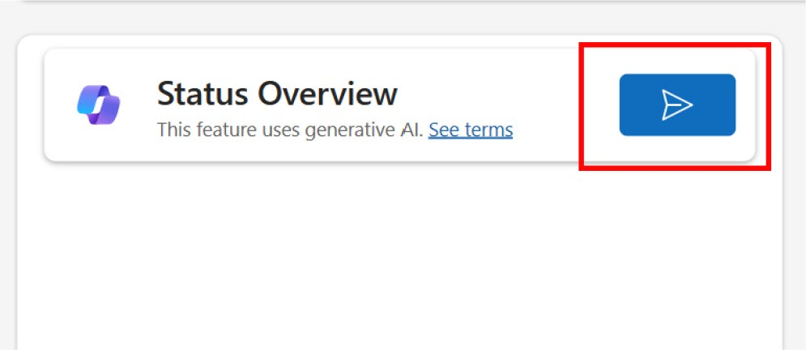

Figure 7-36. Copilot Answer button to trigger the Copilot question
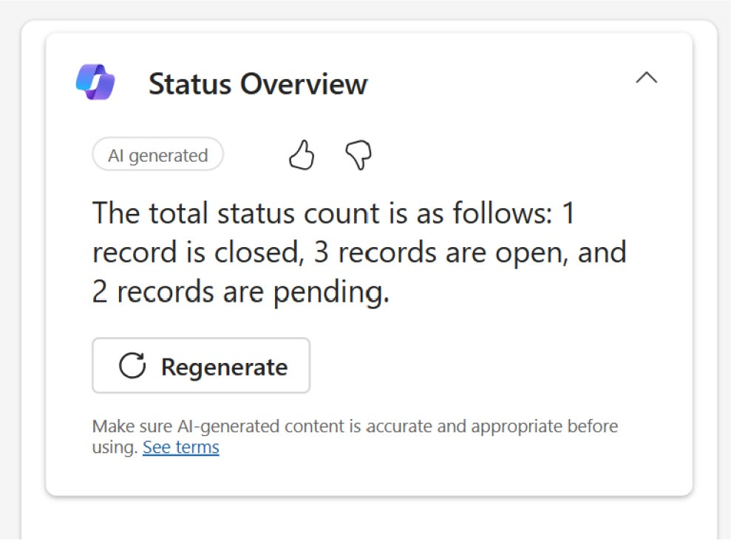

Figure 7-37. Generated answer in Copilot Answer

Copilot Customization with Copilot Studio
You can enhance the Copilot (preview) control using Copilot Studio, which allows you to add more topics, plugin actions, and various other capabilities. Before starting with Copilot customization, you need to learn about Copilot Studio.

Chapter 7 DynamiC Content, Comments, anD Copilot Customization in power apps
Copilot Studio is a development platform designed by Microsoft to
help users create and manage conversational AI agents, often referred
to as Copilot. These AI agents are built using large language models
and can be integrated with various data sources to provide enriched,
interactive experiences. The platform typically allows users to customize
their AI agents without the need for deep technical expertise in AI or
programming, making it accessible to a wider range of users, including
those without a background in data science or development.
Copilot Studio may include tools for defining the AI’s responses,
training the model on specific data, and setting up integrations with
various communication channels, such as websites, mobile apps, and
popular communication platforms like Microsoft Teams and Facebook.
This enables organizations to deploy AI copilots for a variety of purposes,
from customer service and support to employee interaction and
information dissemination.

Versions of Copilot Studio
Copilot Studio is accessible as a standalone web application and as an
integrated app in Teams. The two versions share most functionalities, and
the choice between them may depend on specific user needs and how they
plan to use Copilot Studio.
The standalone web application of Copilot Studio can be accessed
from any browser on any operating system at https://copilotstudio.
microsoft.com. The web application is particularly useful for various
users, including IT administrators who want to create Copilot components
for customer service, individuals familiar with Copilot services looking
to trial or test Copilot Studio, and users interested in exploring advanced
Copilot concepts, such as entities and variables to develop more complex
Copilot components.

Chapter 7 DynamiC Content, Comments, anD Copilot Customization in power apps
To use the Copilot Studio app in Microsoft Teams, simply log in with your licensed credentials, search for Copilot Studio in the Microsoft Teams
app store, and add it to your workspace, as shown in Figure 7-38.
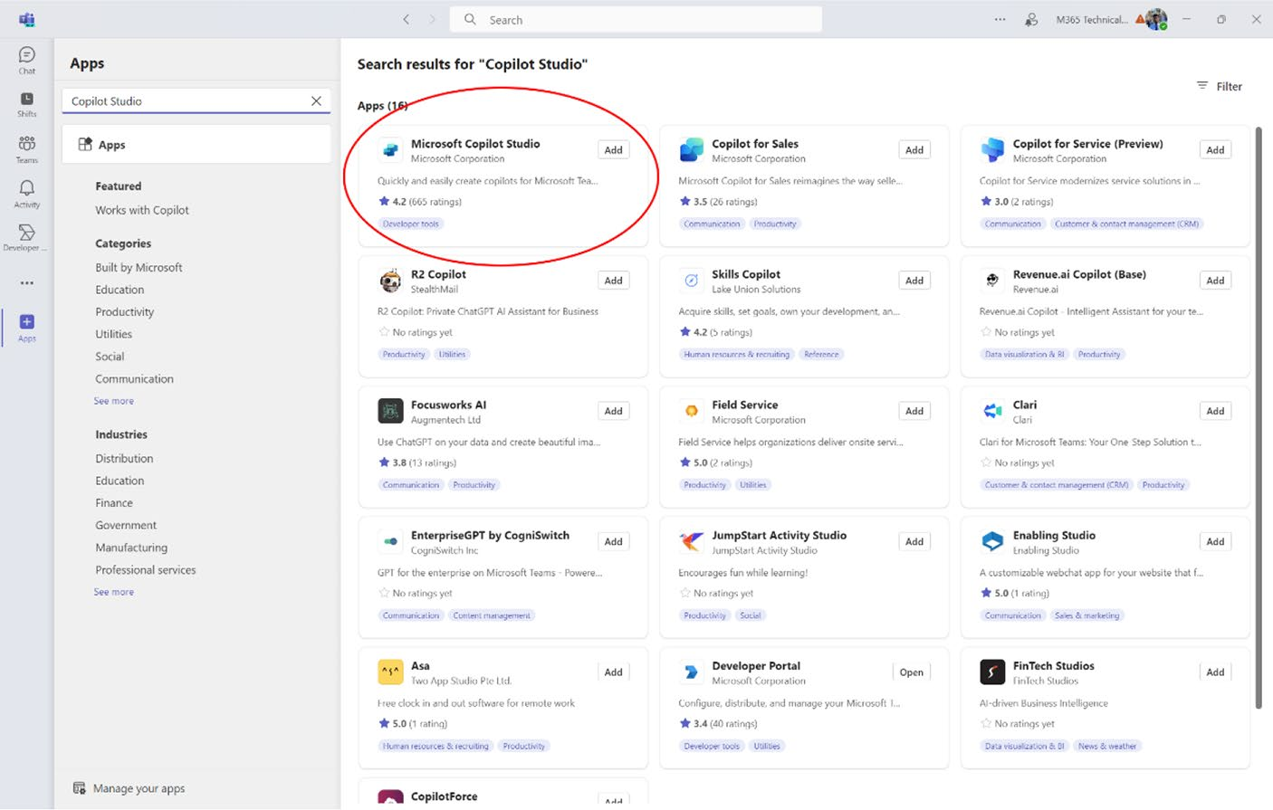

Figure 7-38. Microsoft Copilot Studio in the Microsoft Teams apps store

This integration is ideal for various applications, such as an organization member who wants to deploy Copilot to address frequent employee inquiries. It is also suitable for those looking to implement advanced concepts like entities and variables for an internally accessible Copilot within Teams. Additionally, this setup is perfect for anyone aiming to create and distribute Copilot as quickly as possible.
You can also go to this URL if you cannot find the Copilot Studio app
in Microsoft Teams: https://aka.ms/PVATeamsApp?azure-portal=true. When you visit the URL, the Microsoft Teams app will open Microsoft
Copilot Studio, as shown Figure 7-39.

Chapter 7 DynamiC Content, Comments, anD Copilot Customization in power apps
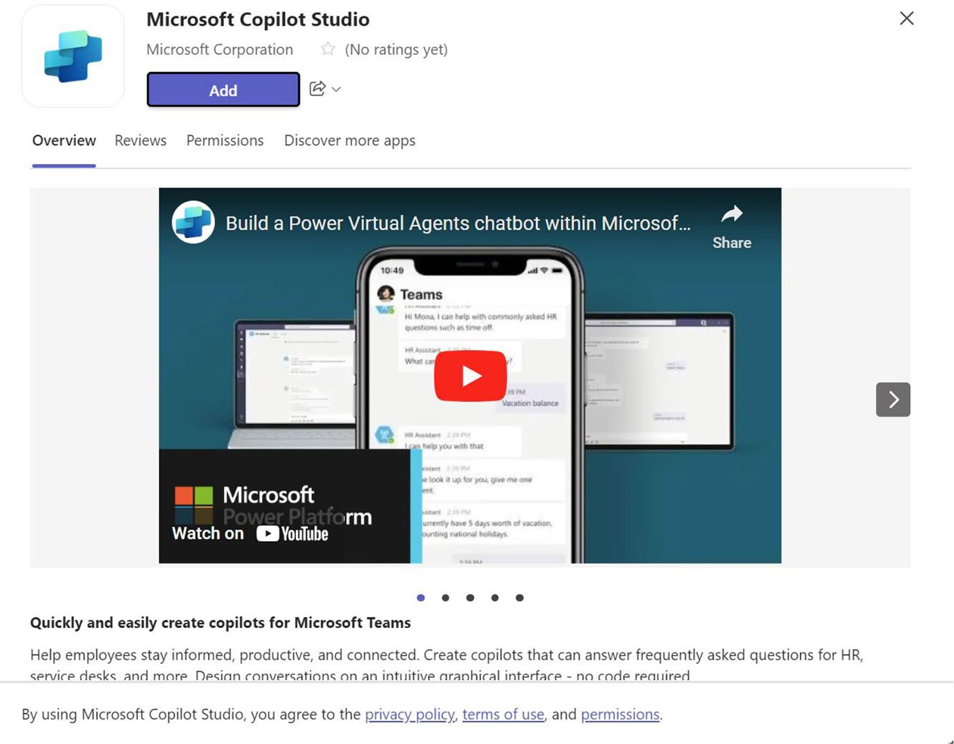

Figure 7-39. The Microsoft Copilot Studio app in Microsoft Teams

IMPORTANT NOTE FROM MICROSOFT

microsoft Copilot studio is not:
• a medical device intended for medical use, including diagnosis,
treatment, or prevention of diseases, nor should it be integrated into clinical products.
• a substitute for professional medical advice, diagnosis, or
treatment. it should not be used to replace medical judgment or in emergency situations.
• Capable of handling emergency calls or supporting emergency
services.

Chapter 7 DynamiC Content, Comments, anD Copilot Customization in power apps
any Copilot component created with microsoft Copilot studio is entirely your
product or service. you are fully responsible for its design, development, and
implementation, including providing necessary warnings and disclaimers about
its use. you also bear sole responsibility for any personal injuries or deaths that
may result from the use of your Copilot component or microsoft Copilot studio.

Copilot Studio Licensing Information
Unfortunately, an additional license is required to use Copilot Studio. While this is not necessary for th0078Ce current project or for this book, I am mentioning it to inform advanced or enterprise users who may need this information.
As of the writing of this chapter, the price was $200.00 USD, which
included 25,000 messages/month, as shown in Figure 7-40. Visit the
official Microsoft Copilot Studio website at https://www.microsoft.com/
en-us/microsoft-copilot/microsoft-copilot-studio to check for any updated pricing information.
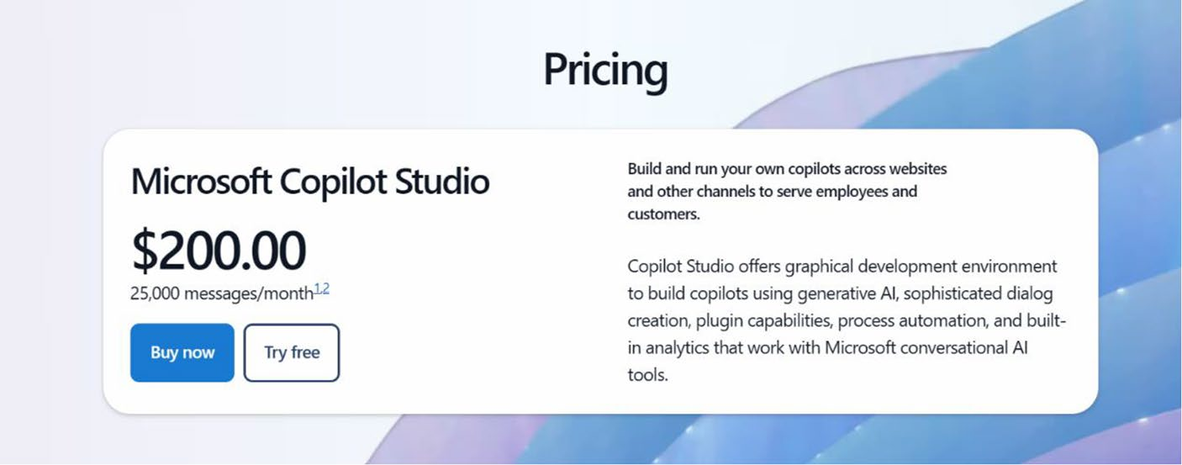

Figure 7-40. Microsoft Copilot Studio pricing on the Microsoft website

Chapter 7 DynamiC Content, Comments, anD Copilot Customization in power apps

The Copilot Chatbot
You can incorporate the Chatbot control into your Canvas apps to enhance
user interaction by embedding a Microsoft Copilot Studio Chatbot. This
integration allows the chatbot to assist users with a variety of requests,
ranging from simple queries to complex problem resolutions. Additionally,
the Chatbot control is compatible with custom pages in model-driven apps
and supports Teams-authenticated bots from Microsoft Copilot Studio.
An intuitive bot picker feature simplifies the process by listing all available
bots within the same app environment, ensuring seamless integration and
management.
This functionality is vital for improving the efficiency and
responsiveness of your applications, providing users with immediate
assistance, and enriching the overall user experience.
You have two dynamic options for enhancing user interactions using
AI bots:
AI Chatbots: You can build an extensive answer tree to support your users efficiently. For more details and steps, follow the official Microsoft Docs at
https://learn.microsoft.com/en-us/microsoft-
copilot-studio/fundamentals-get-started.
AI Boosted Conversations: You can equip your Microsoft Copilot Studio bot with advanced response capabilities using prompts or generating responses from a designated “fallback” website. This website can host internal documents or be a publicly accessible site. Visit this link to learn more:
https://learn.microsoft.com/en-us/microsoft-
copilot-studio/nlu-gpt-overview.

Chapter 7 DynamiC Content, Comments, anD Copilot Customization in power apps
Additionally, you can customize the Chatbot control by naming it, adjusting the control window size, and positioning it anywhere on your screen for optimal integration and user experience.

Prerequisites for Using the Chatbot Component
The following prerequisites must be met to use the Chatbot component:
• Create and publish a bot on the Microsoft Copilot
Studio web app. Options include an AI bot or a new generative AI-enriched Microsoft Copilot Studio bot.
• View all your Microsoft Copilot Studio bots (published
and unpublished) in the Chatbot control list when connecting a bot.
• Only add published bots to the Chatbot control.
Unpublished bots will appear grayed out and cannot be added.

Creating a Bot Using a Chatbot Component
Follow these steps to create a chatbot:
1. To integrate the chatbot into Power Apps, start
by creating a new screen in the app and choosing
the Split Screen layout, as shown in Figure 7-41. (Although feel free to select any layout that suits your needs.)

Chapter 7 DynamiC Content, Comments, anD Copilot Customization in power apps
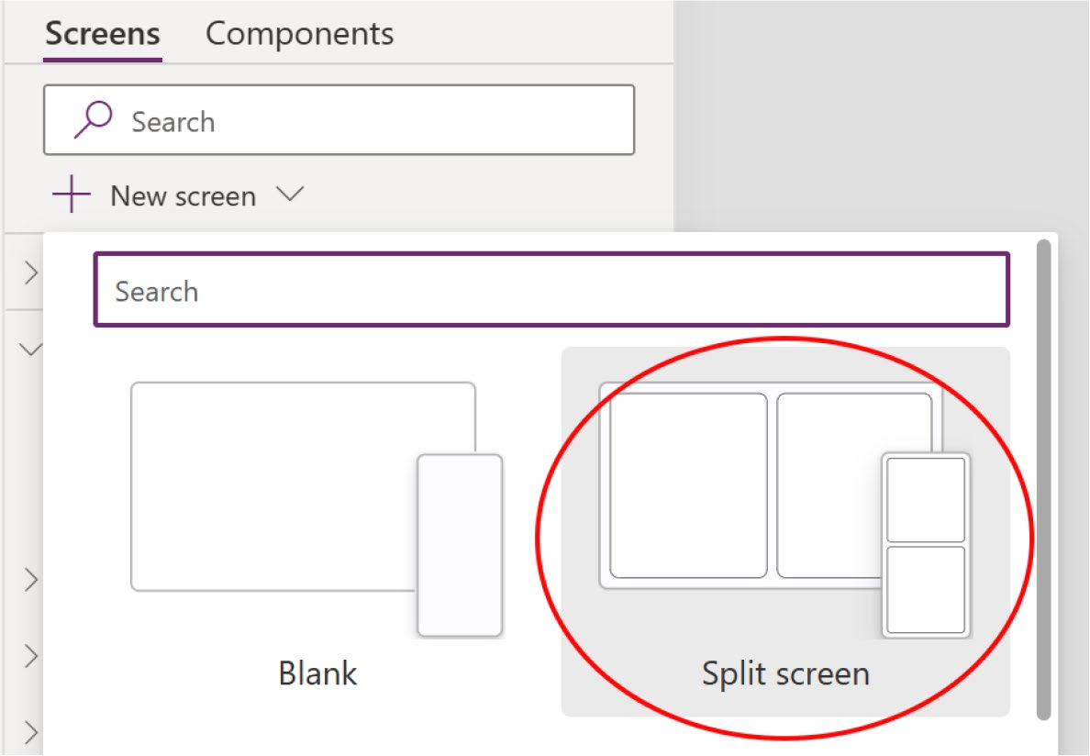

Figure 7-41. Selecting Split Screen to create a Copilot Chatbot

2. Click the + sign and search for Chatbot. You will get
the Chatbot option, shown in Figure 7-42.

Chapter 7 DynamiC Content, Comments, anD Copilot Customization in power apps
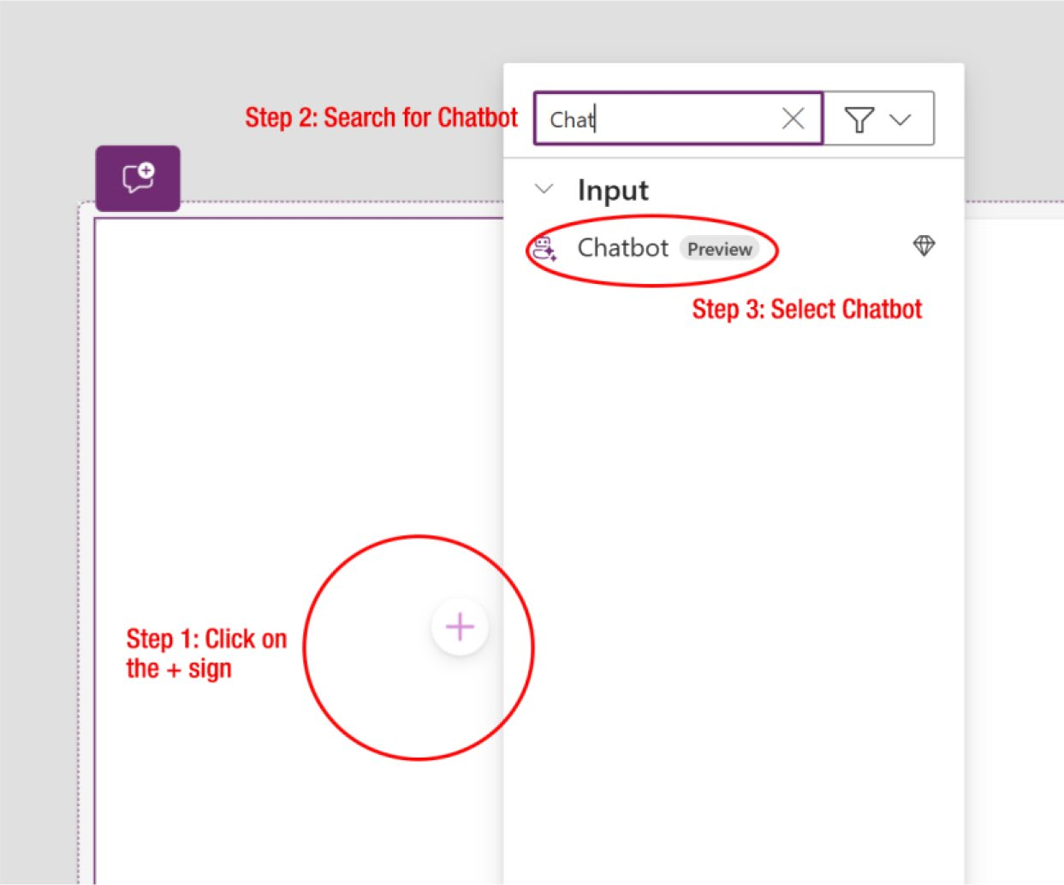

Figure 7-42. Searching and adding the Copilot Chatbot

3. After selecting the Chatbot, it will ask you to add a
data source, as shown in Figure 7-43.

Chapter 7 DynamiC Content, Comments, anD Copilot Customization in power apps
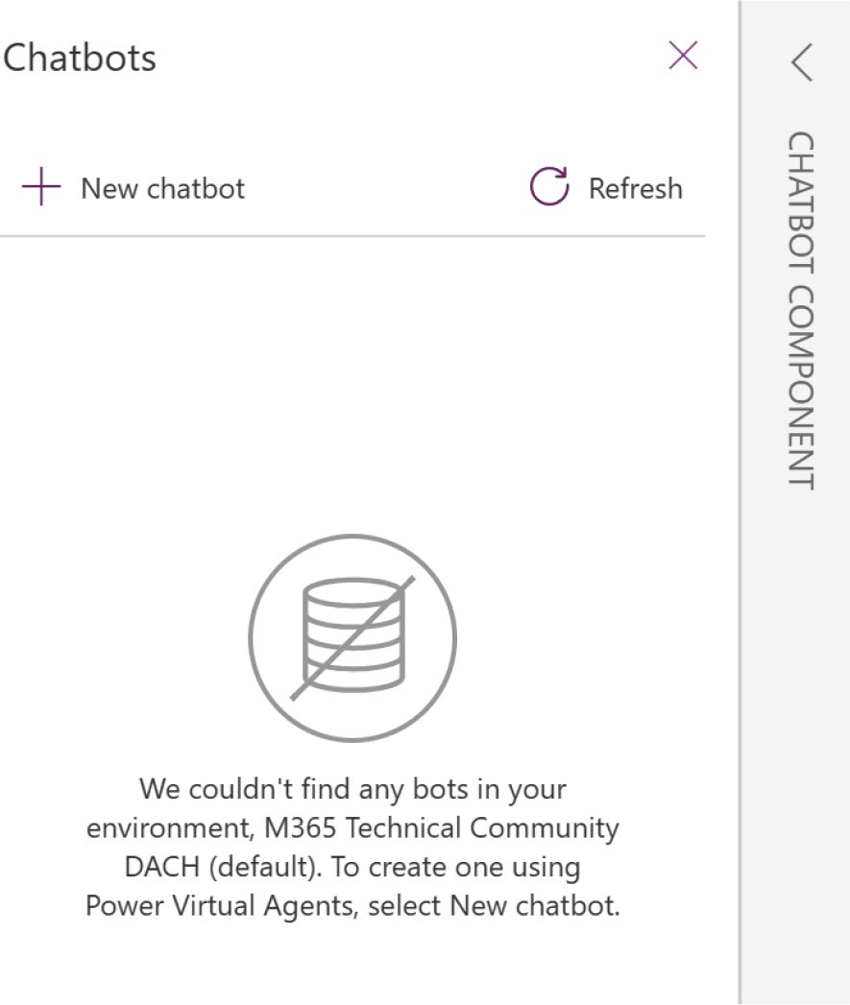

Figure 7-43. Option to add a data source to the chatbot

However, you will notice a message indicating that Power Apps could not find a bot in the environment. As mentioned, the bot must be published in Microsoft Copilot Studio. Now, you will create a bot in Microsoft Copilot Studio and link it to your chatbot in Power Apps.
4. Click + New Chatbot, as shown in Figure 7-43. A new
tab will open, directing you to Microsoft Copilot Studio. If you are not already signed in, you will be
prompted to enter your credentials. Figure 7-44 shows the Microsoft Copilot Studio portal.

Chapter 7 DynamiC Content, Comments, anD Copilot Customization in power apps
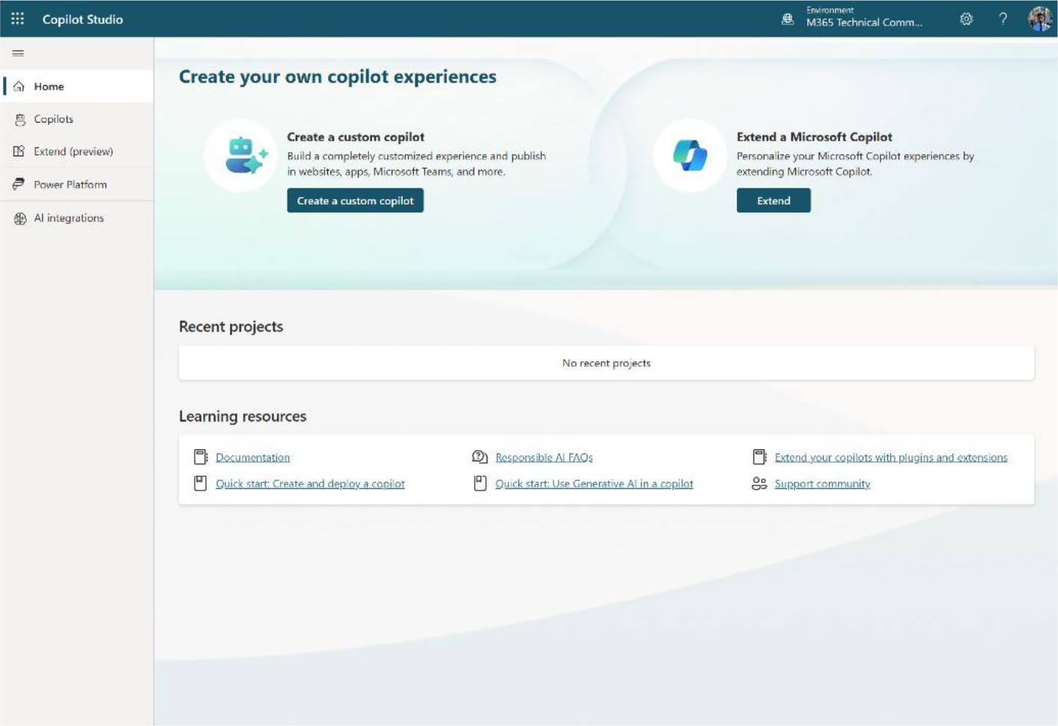

Figure 7-44. Microsoft Copilot Studio portal

5. As shown in Figure 7-45, select Copilots from the left
panel and click + New Copilot.
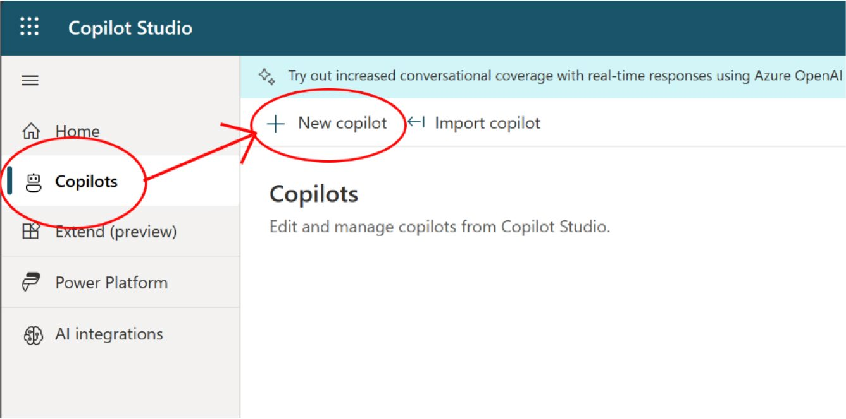

Figure 7-45. Creating a new Copilot component in Microsoft Copilot Studio

Chapter 7 DynamiC Content, Comments, anD Copilot Customization in power apps
6. After clicking the + New Copilot option, it will ask
you three questions, as shown in Figure 7-46.
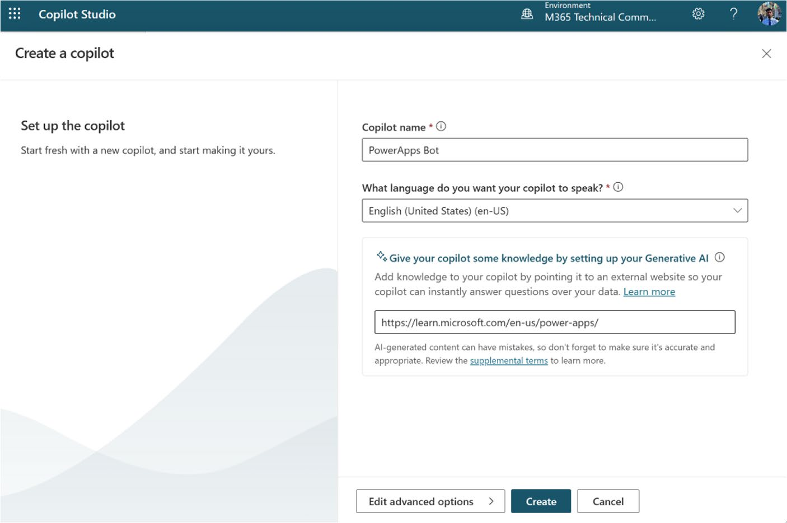

Figure 7-46. Creating a Copilot component in Microsoft
Copilot Studio

a. Copilot name: Provide the name of the Copilot. For
this project, I named it Power Apps Bot.
b. Language: Choose the language for communicating
with Copilot. I selected English (United States) (en-US).
c. URL: To enhance interactions using AI-generated
responses, insert a URL in the Give Your Copilot Some Knowledge by Setting Up Your Generative AI field. I provided the Microsoft Learn documentation
for Power Apps: https://learn.microsoft.com/
en-us/power-apps/

Chapter 7 DynamiC Content, Comments, anD Copilot Customization in power apps
You can edit the Copilot icon or the Schema name by clicking the Edit Advanced option. However, these changes are optional and can be made later if preferred.
Click Create after filling out the information. It will take a few seconds to minutes to set up Copilot.
7. After a few seconds, you will see that Copilot has
been successfully created, as shown in Figure 7-47.
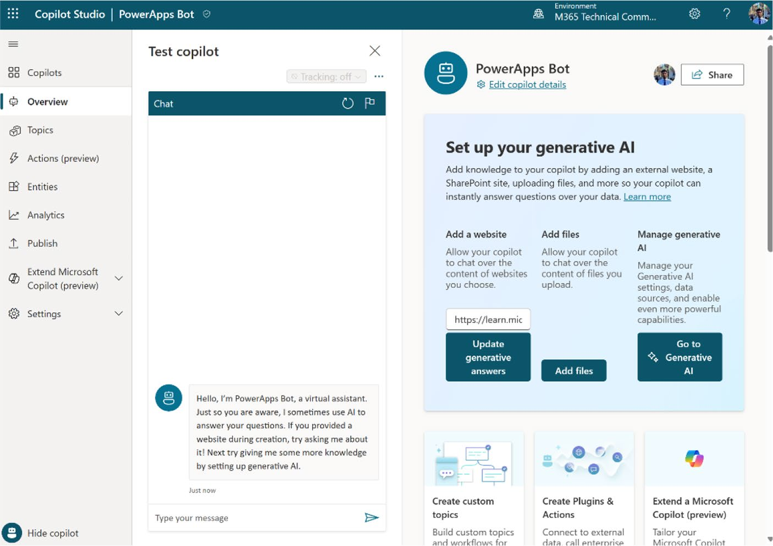

Figure 7-47. Copilot has been successfully created in the Microsoft Copilot Studio portal

8. You should test Copilot before publishing. You do
this by asking Copilot Chat some questions and
checking the response; see Figure 7-48.

Chapter 7 DynamiC Content, Comments, anD Copilot Customization in power apps
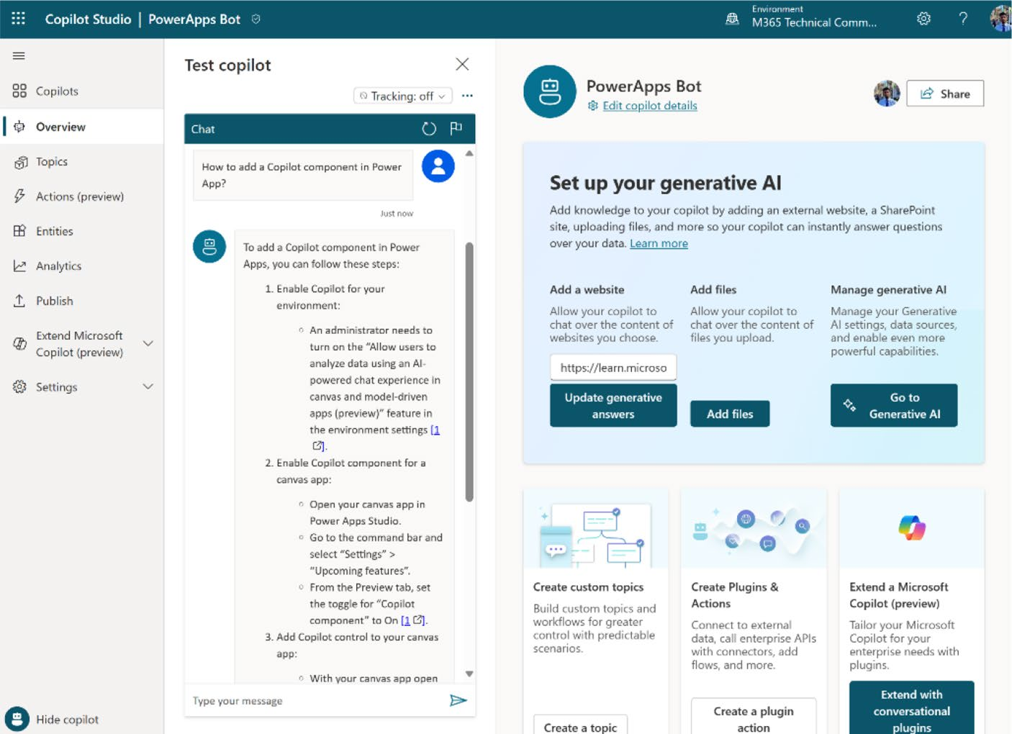

Figure 7-48. Verifying Copilot before publishing

As you can see, I asked Copilot “How to add a Copilot component in Power App?” and Copilot replied the correct information from the official
Microsoft documentation. Figure 7-49 shows another question.

Chapter 7 DynamiC Content, Comments, anD Copilot Customization in power apps
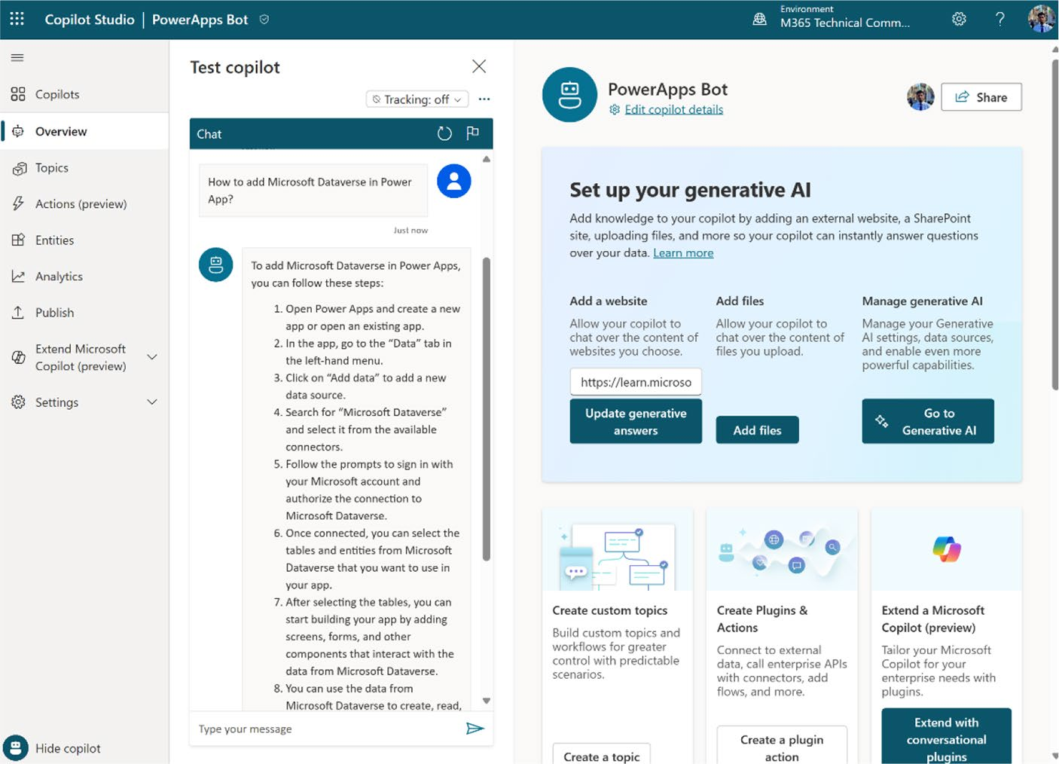

Figure 7-49. Verifying Copilot with complex questions from Microsoft Copilot Studio

This time I asked Copilot chat, “How to add Microsoft Dataverse in Power App?” and Copilot responded with the correct steps and the
documentation link.
9. You can also conduct tests to see how it responds
to questions that exceed its capabilities. See
Figure 7-50.

Chapter 7 DynamiC Content, Comments, anD Copilot Customization in power apps
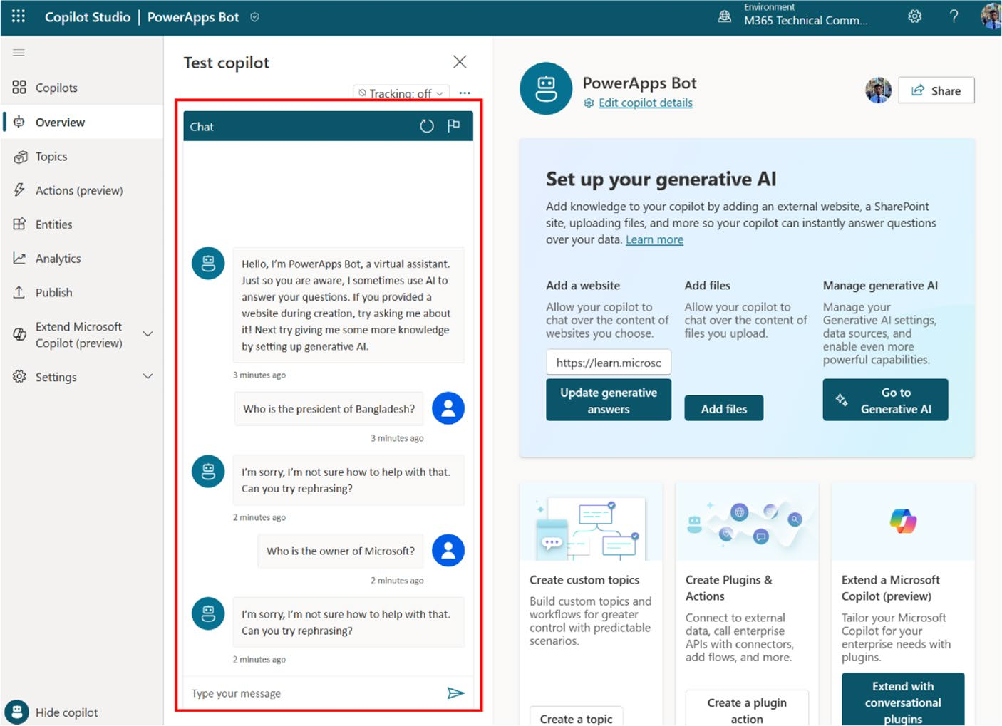

Figure 7-50. Verifying Copilot with out-of-scope questions

I tested Copilot by asking questions unrelated to its training, such as “Who is the president of Bangladesh?” and “Who is the owner of Microsoft?” Each time, the response was, “I am sorry, I’m not sure how to help with that. Can you try rephrasing?”
This indicates that Copilot can only access and respond to information from the URL provided and lacks the ability to retrieve data from external sources.

Chapter 7 DynamiC Content, Comments, anD Copilot Customization in power apps
10. After testing the bot, you have to publish it. If you
don’t publish the bot, you cannot use it in Power Apps. To publish the bot, scroll down the Copilot page and find the Go to Publish link, as shown in
Figure 7-51.
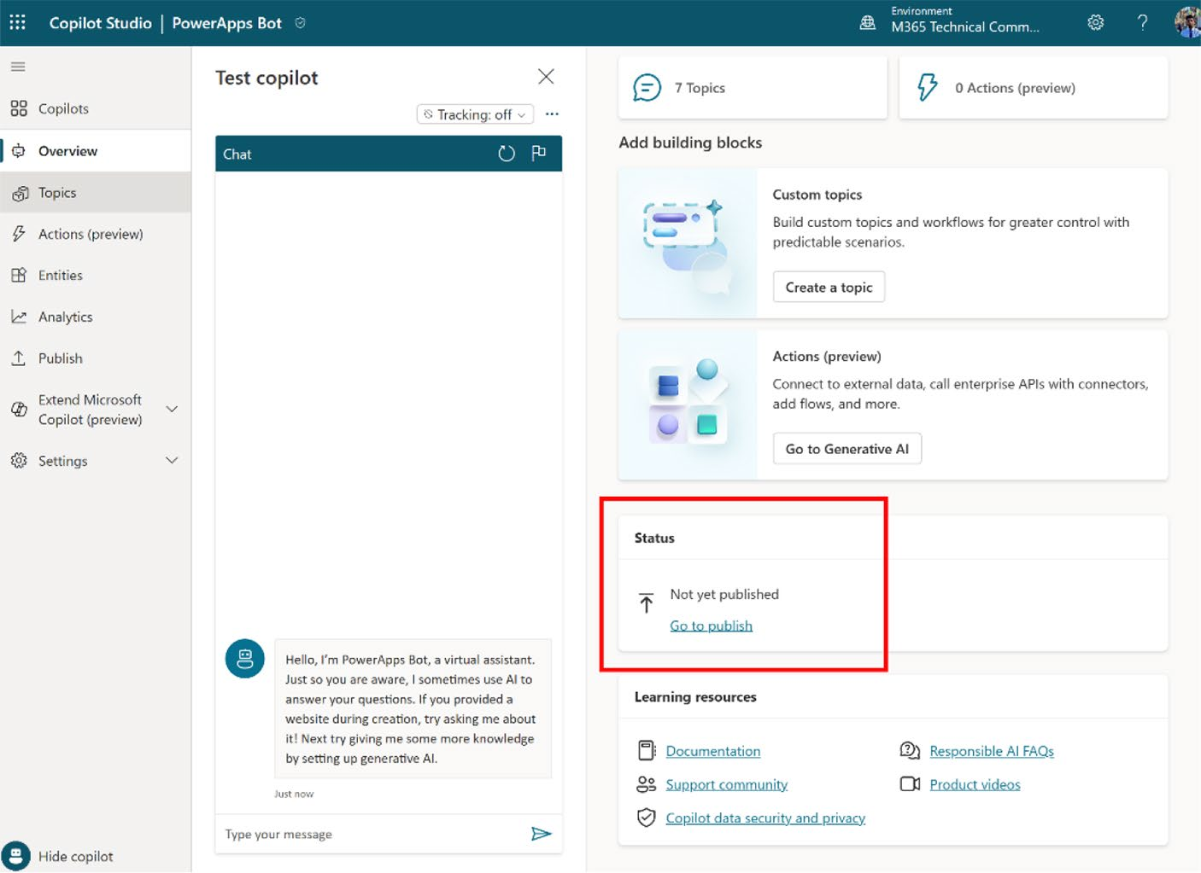

Figure 7-51. Publishing Copilot in Power Apps

11. On the next page, you will see the Publish button, as
shown in Figure 7-52.

Chapter 7 DynamiC Content, Comments, anD Copilot Customization in power apps
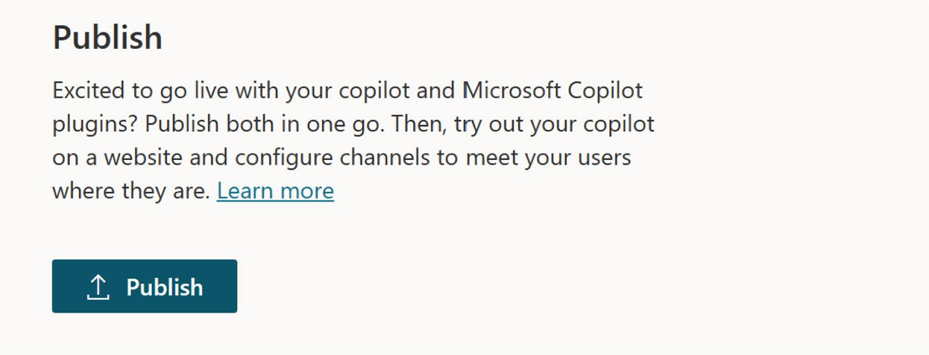

Figure 7-52. The Publish button of Copilot in Microsoft
Copilot Studio

12. Shortly after, as shown in Figure 7-53, you will be
directed to a confirmation page indicating that the publishing process is complete.
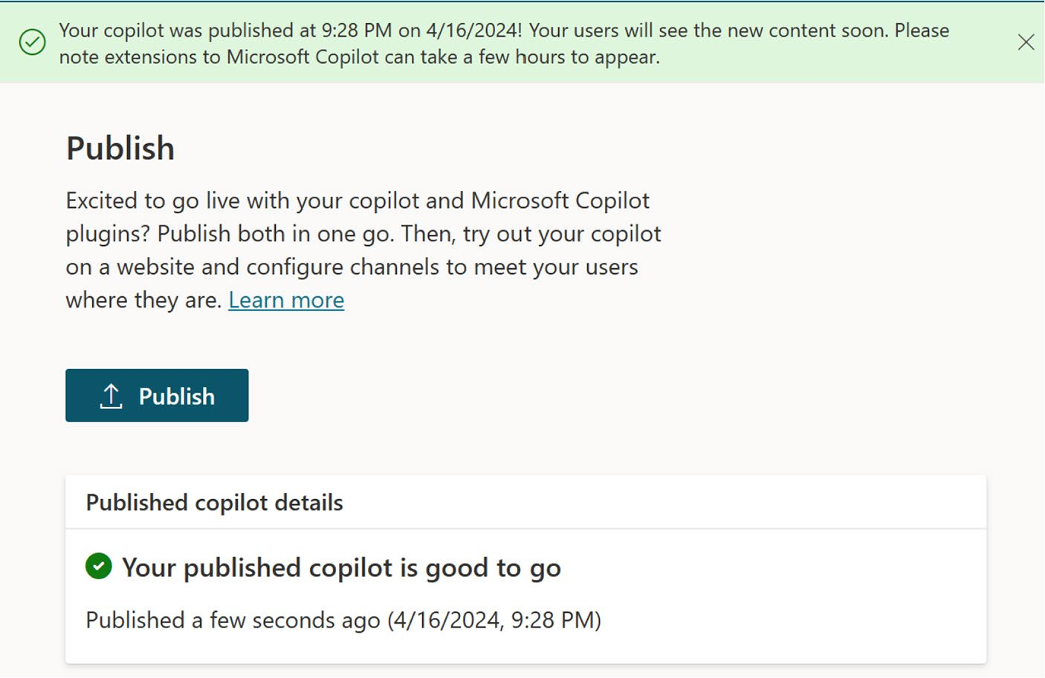

Figure 7-53. Confirmation of successful publishing of Copilot

Chapter 7 DynamiC Content, Comments, anD Copilot Customization in power apps
13. Go back to the Power Apps window and refresh the
chatbot properties. You will see the new bot in the list that you created a few minutes ago, as shown in
Figure 7-54.
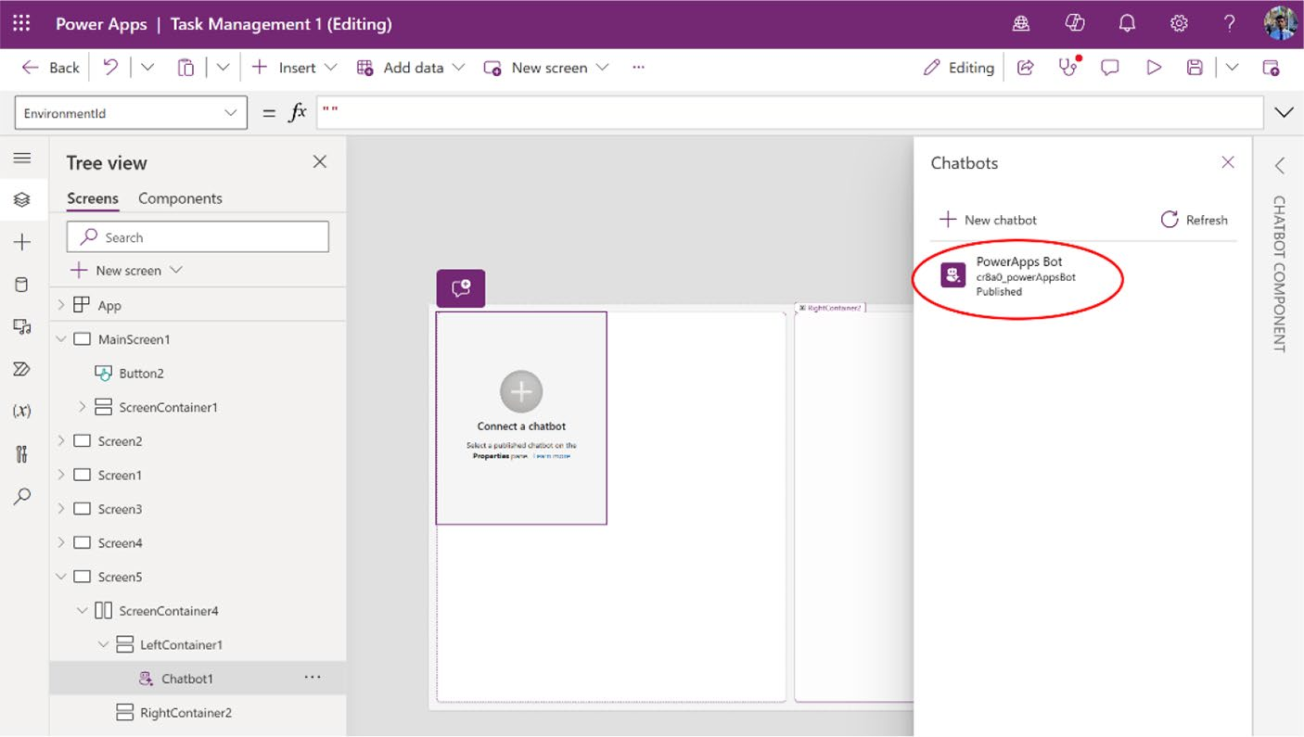

Figure 7-54. Showing the newly published Copilot in Power Apps

Chapter 7 DynamiC Content, Comments, anD Copilot Customization in power apps
14. Select the Power Apps Bot. The bot will be saved in
the container, as shown in Figure 7-55.
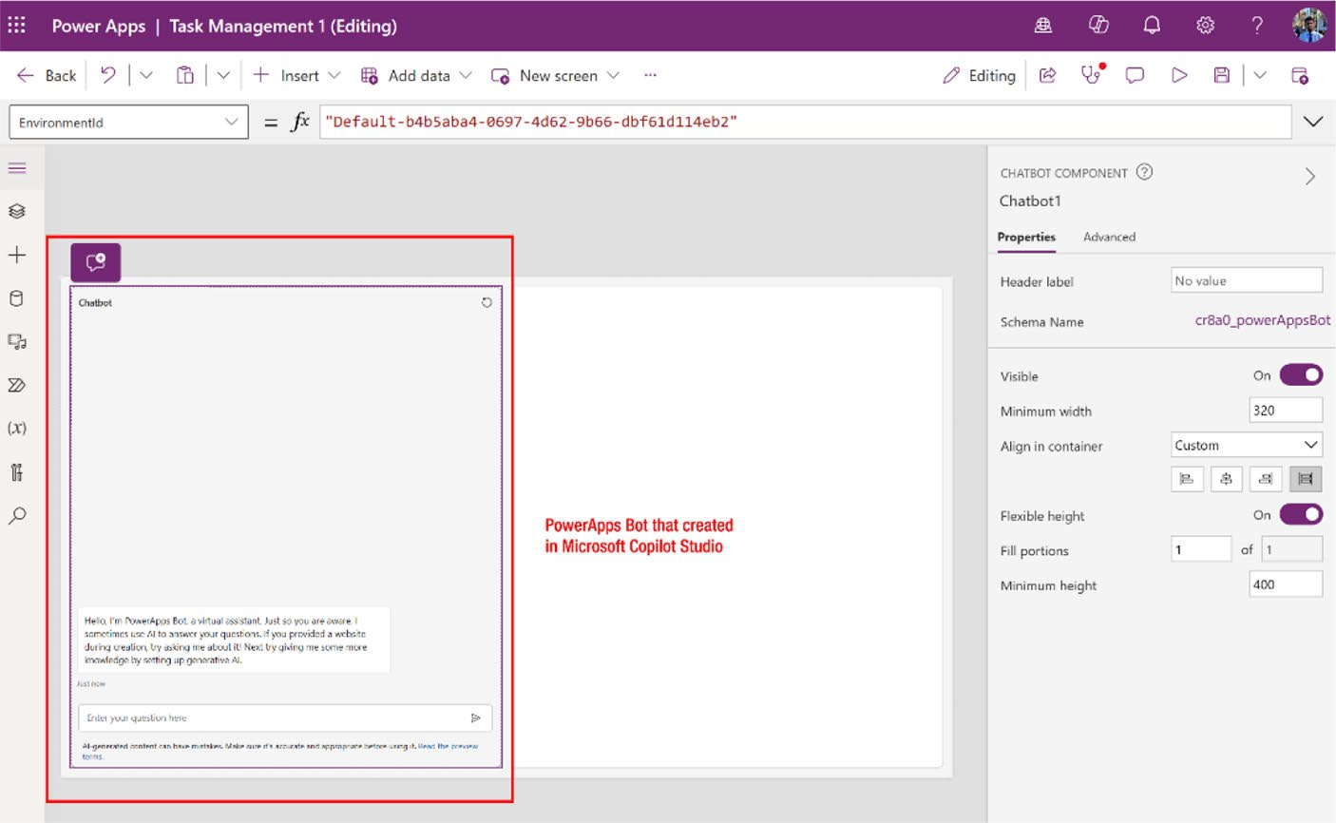

Figure 7-55. Added the published Copilot component to
Copilot Chat

Chapter 7 DynamiC Content, Comments, anD Copilot Customization in power apps
15. Press F5 or execute the project to see if Copilot is
functioning correctly. See Figure 7-56.
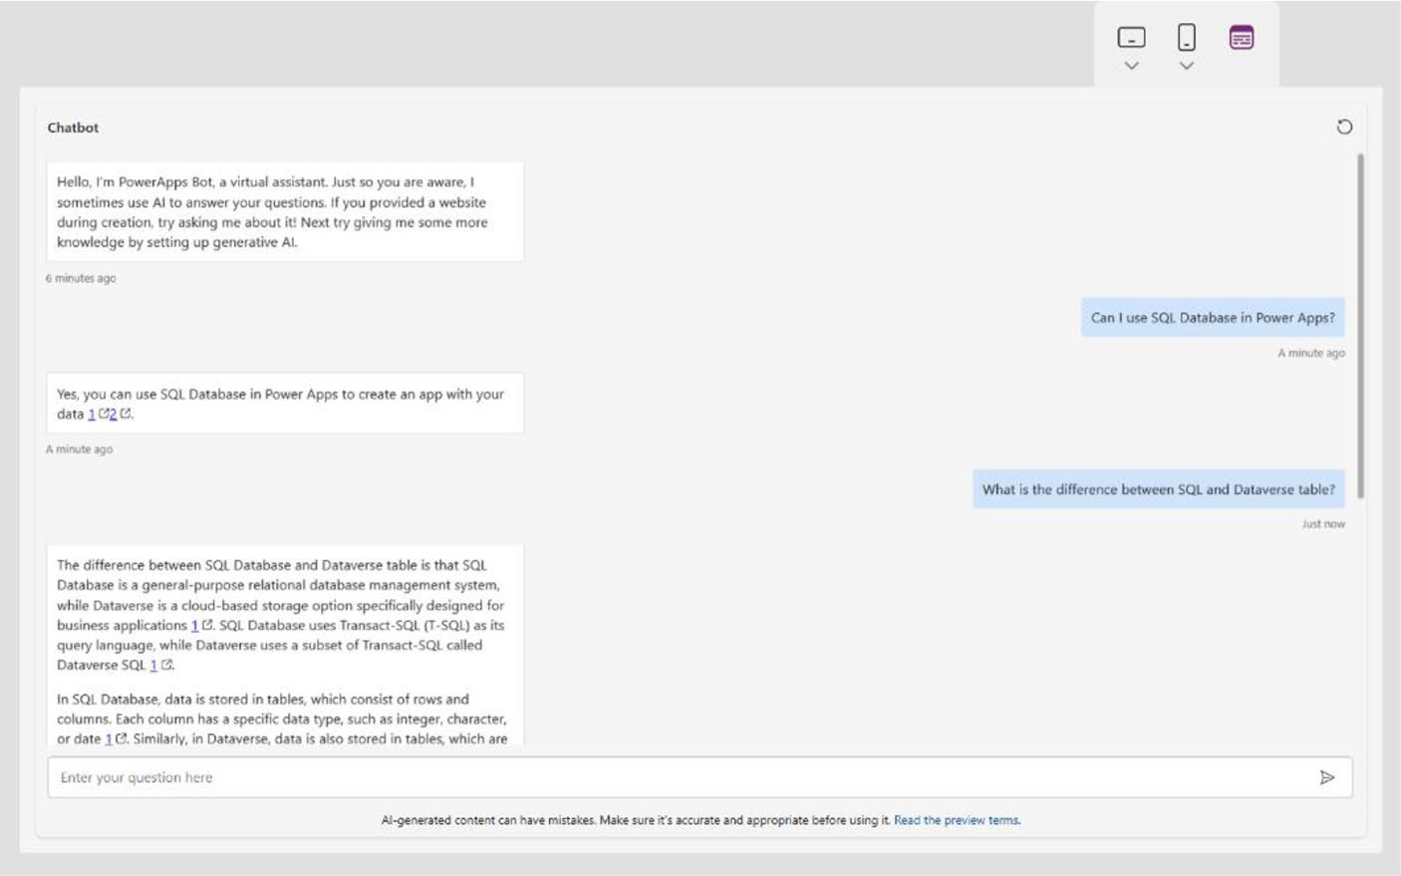

Figure 7-56. Preview of Copilot Chatbot in Power Apps
I posed two different questions to Copilot: “Can I use SQL Database in Power Apps?” and “What is the difference between SQL and Dataverse table?” The responses were accurate. Therefore, you can conclude that Copilot is operating correctly.

Most Common Power Apps
Design Component
This section explores the integration of Copilot chat in Power Apps, focusing on how to create intuitive and interactive interfaces. By incorporating elements such as tables, media galleries, forms, lists, and charts, Copilot chat not only enriches the visual appeal of applications but

Chapter 7 DynamiC Content, Comments, anD Copilot Customization in power apps
also enhances their functionality. Each component can be customized to
meet specific user needs, enabling more personalized interactions. This
approach streamlines workflows and improves user satisfaction by making
applications more responsive and easier to navigate. I provide practical
insights and strategies to help developers effectively utilize these tools,
fostering a highly customized and user-focused application environment.
So, let’s start from here!

Adding Comments
When building a Canvas app in Power Apps Studio, it’s beneficial to add
comments to aid in team review and feedback, or to offer insights into the
implementation details of your app. To enable other creators to contribute
comments, ensure that you share the app with them. This facilitates
collaboration and communication within your development team.
You can add comments to different components or pages, as shown in
Figure 7-57.
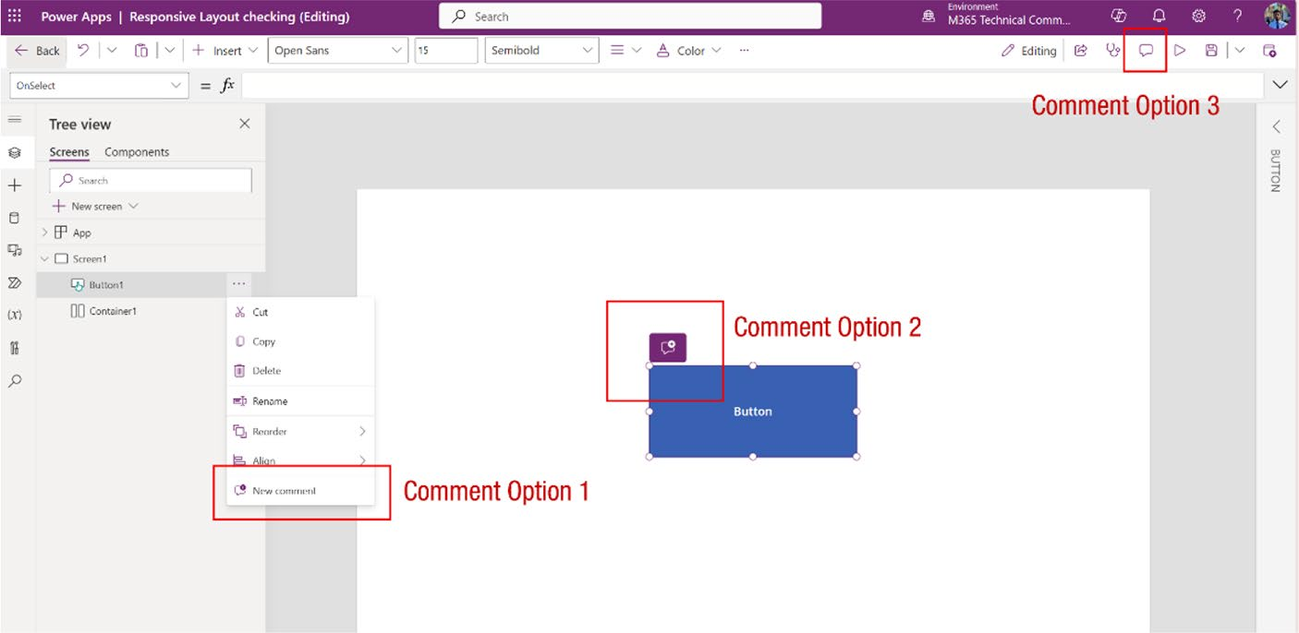

Figure 7-57. Different ways to add comments

Chapter 7 DynamiC Content, Comments, anD Copilot Customization in power apps
There are several ways to add comments in Power Apps:
• Tree view: Select a screen from the Tree view and
right-click to add a new comment. See Figure 7-58.
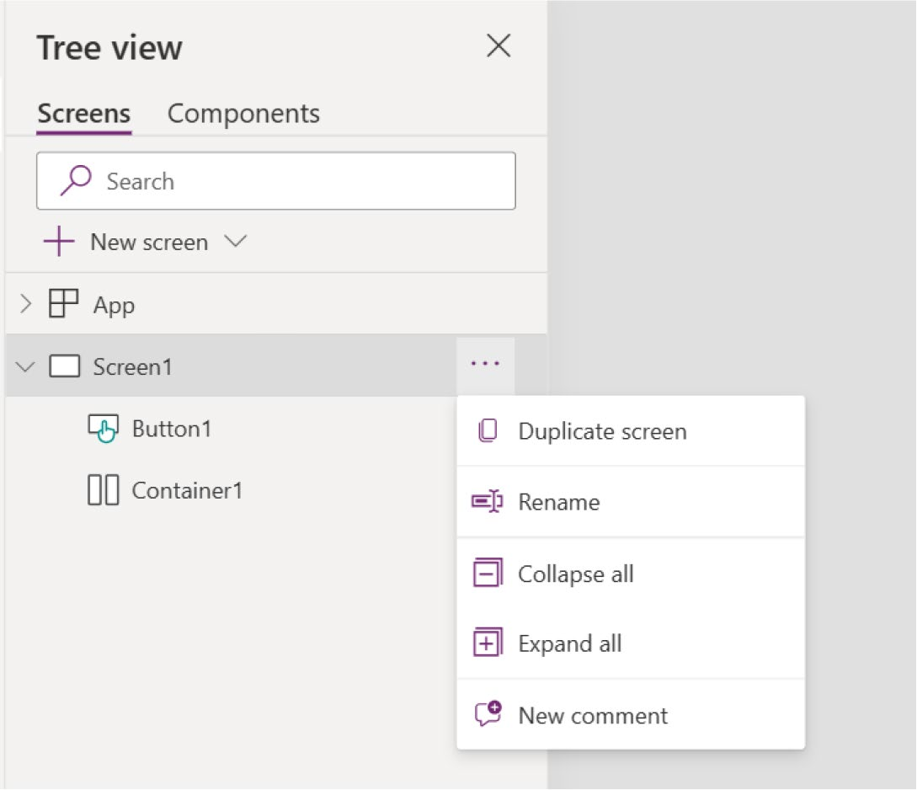

Figure 7-58. Adding a comment from Tree view

• Component: In the canvas area, right-click a
component to add a new comment. See Figure 7-59.

Chapter 7 DynamiC Content, Comments, anD Copilot Customization in power apps
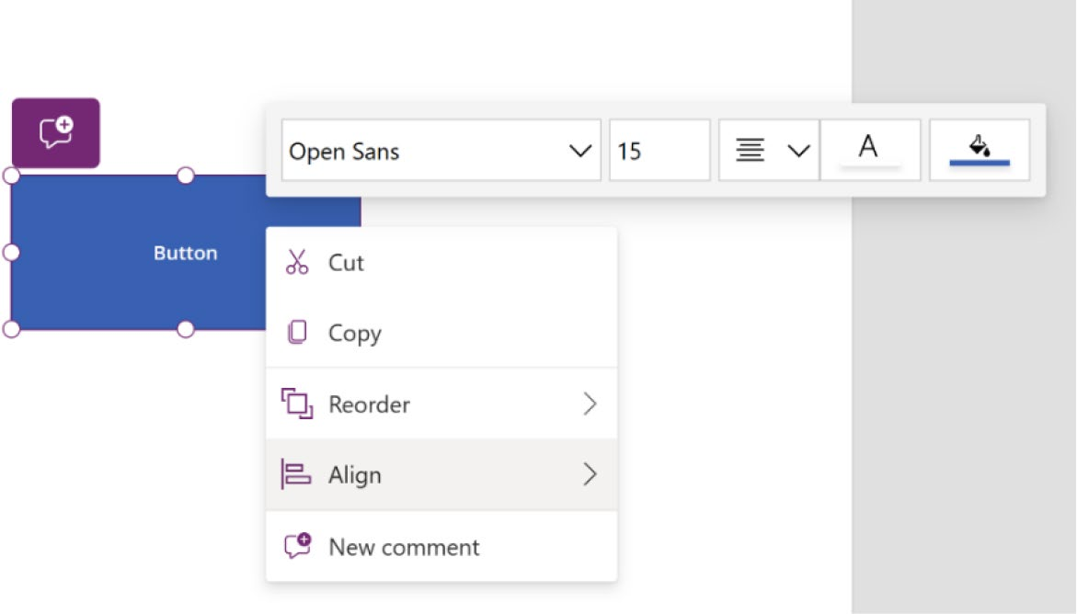

Figure 7-59. Adding a comment from the component properties

• Component with Copilot: In the canvas area, click the
component. You will get the icon shown in Figure 7-60, which allows you to add a comment.


Figure 7-60. Adding a comment from a Copilot tooltip

Chapter 7 DynamiC Content, Comments, anD Copilot Customization in power apps
• App actions: Select Comments ➤ New and then add
your comments. See Figure 7-61.
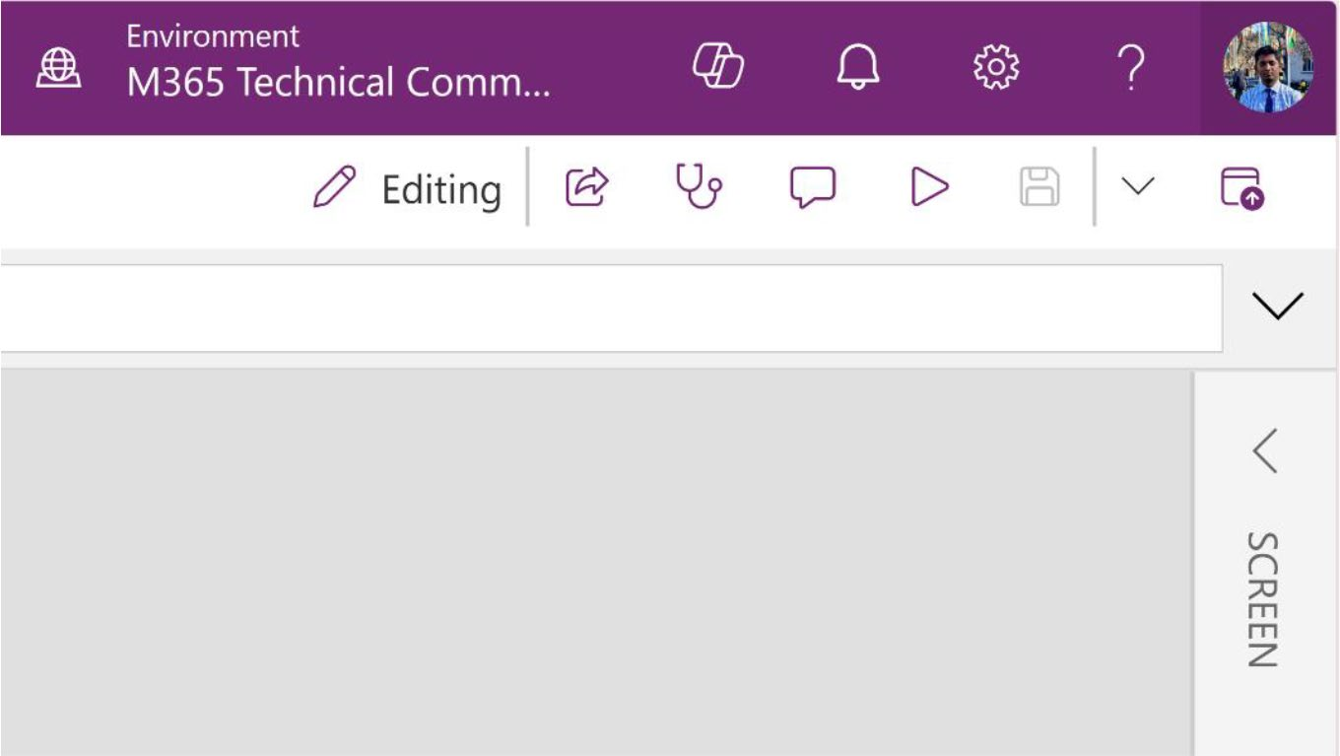

Figure 7-61. Adding a comment from the app’s action bar

After you select any of the comment options, the Comments option
will appear in the right sidebar, as shown in Figure 7-62.

Chapter 7 DynamiC Content, Comments, anD Copilot Customization in power apps
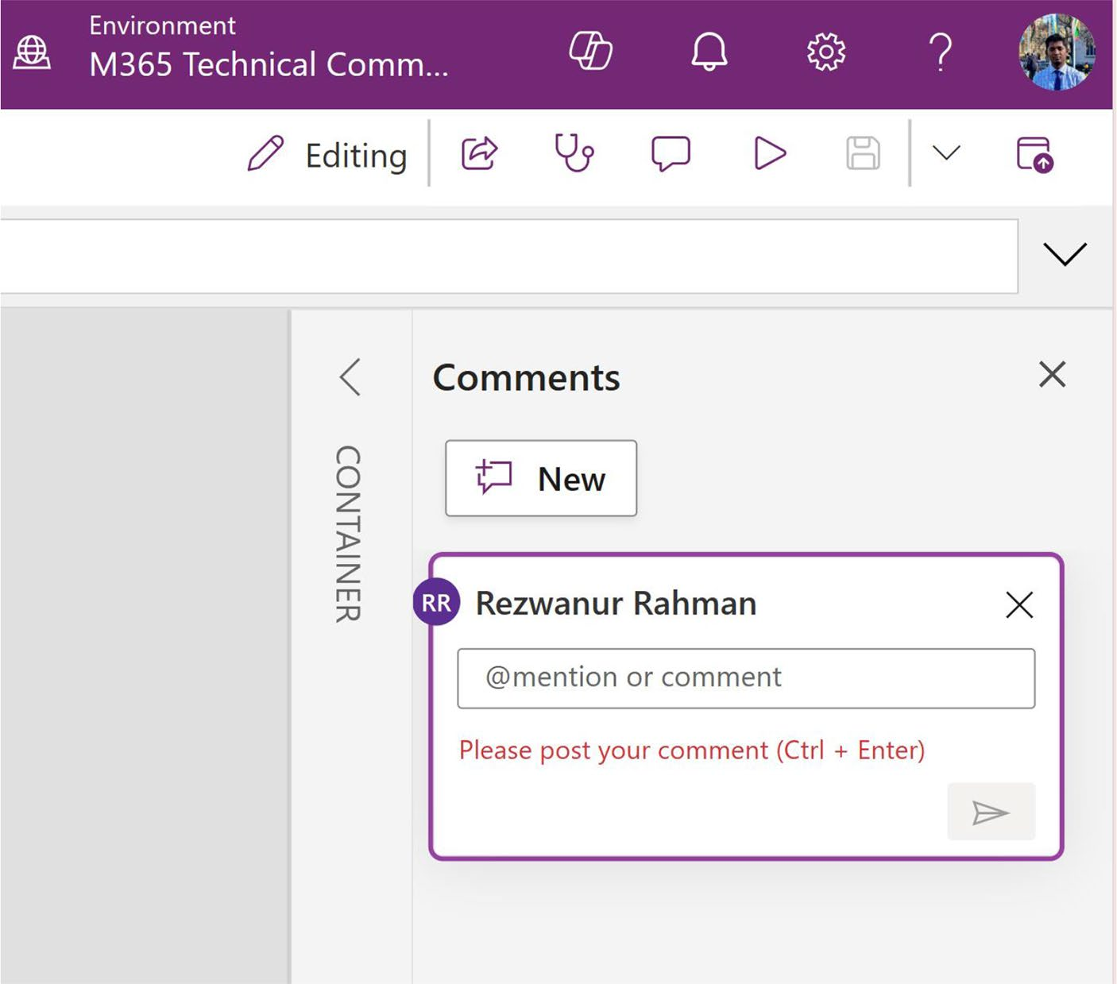

Figure 7-62. Comments option after selecting it

Commenting is important for teamwork. When you are part of a team
and you want to collaborate with your team members, you can comment
on their task, and you can tag them by their name or email.

Mention or Tag Someone in Power Apps
In your Power Apps project, you can mention a user by using the @ symbol
followed by their username, like tagging someone on social media. Each
time you tag a user, they will receive an email notification. I demonstrate
this feature with a demo.

Chapter 7 DynamiC Content, Comments, anD Copilot Customization in power apps
1. Select the Comment option and enter @ to see the
user list, as shown in Figure 7-63.
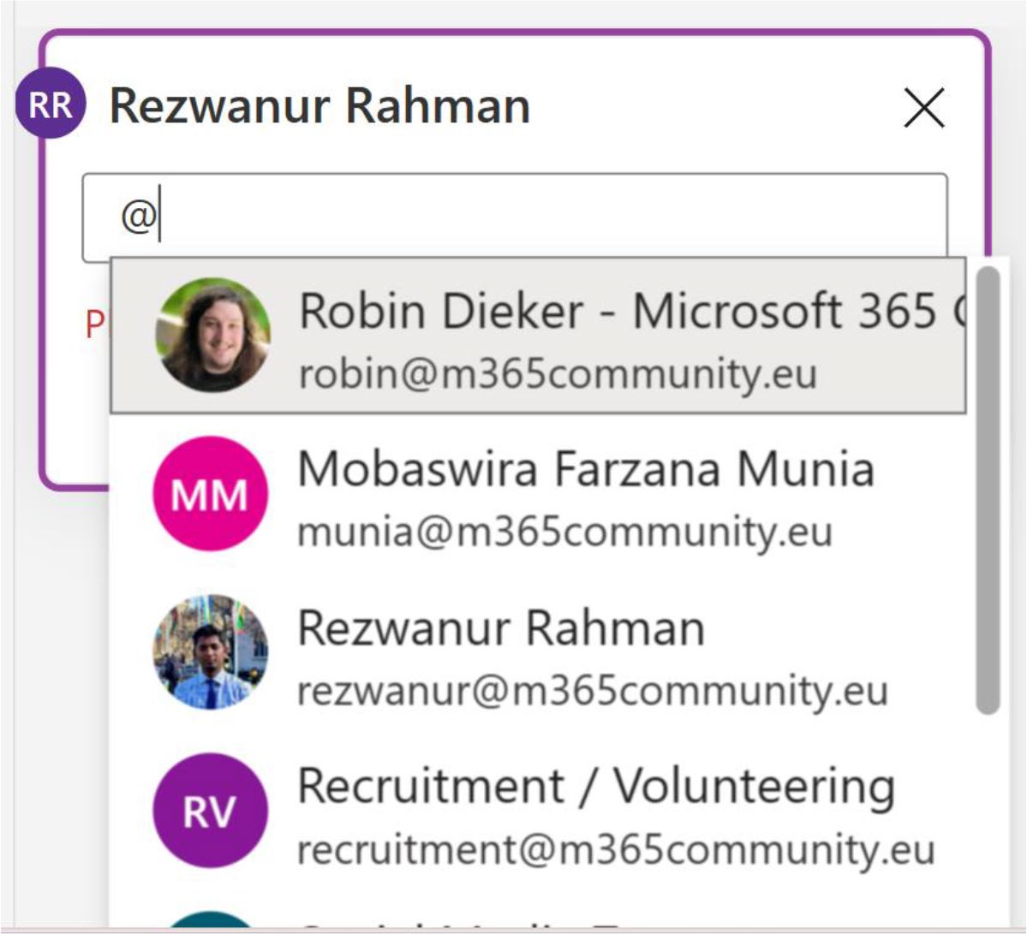

Figure 7-63. People suggestions after entering @ in the Comments option

You cannot invite someone outside of your organization using @. You must first add the user to your Microsoft Entra ID (previously known as Azure Active Directory). Visit this site to learn how to add a user to your Microsoft Entra ID:
https://learn.microsoft.com/en-us/entra/
external-id/b2b-quickstart-add-guest-
users-portal

Chapter 7 DynamiC Content, Comments, anD Copilot Customization in power apps
2. Choose the user and click Send. You can add
more information to the comments, as shown in
Figure 7-64.
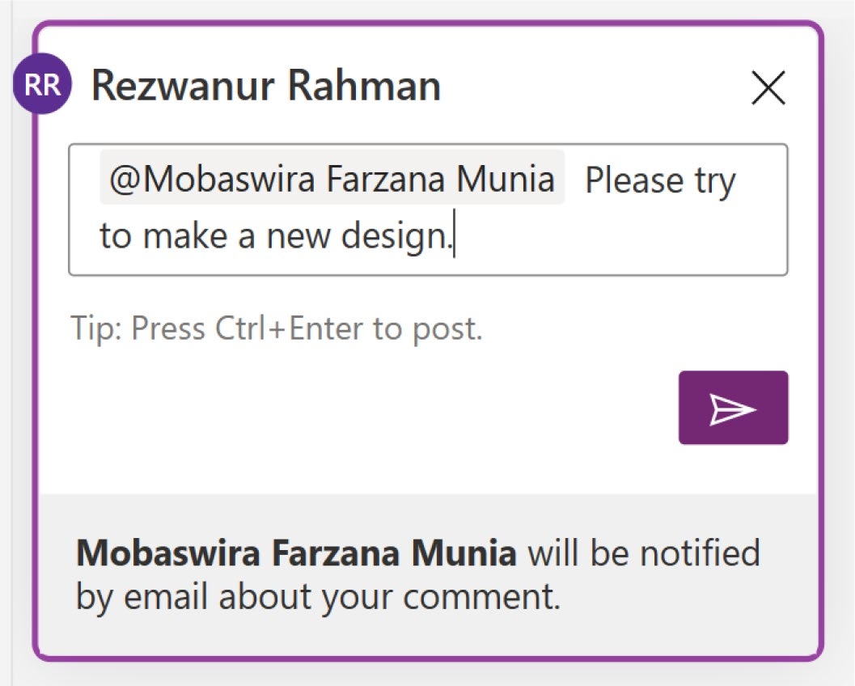

Figure 7-64. Choosing a user and sharing feedback in the
Comment section

3. Power Apps will show a popup for confirmation, as
shown in Figure 7-65.

Chapter 7 DynamiC Content, Comments, anD Copilot Customization in power apps
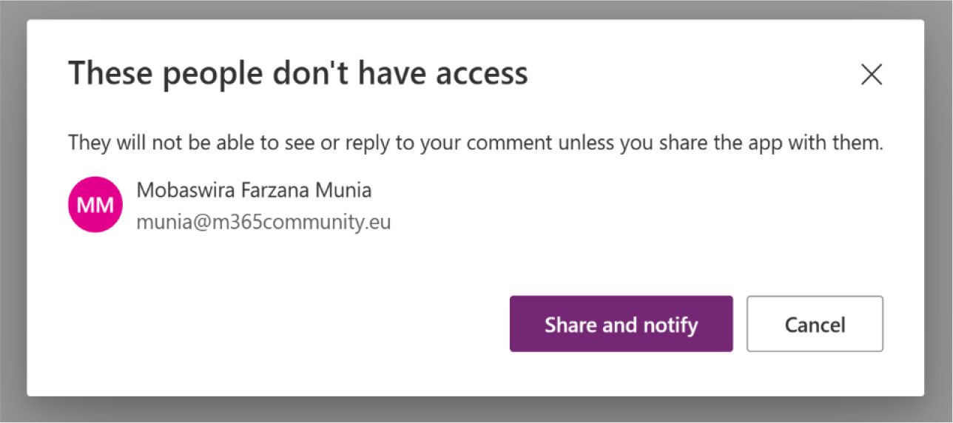

Figure 7-65. Warning notification before sharing your comment with others

4. The mentioned user will get the email, as shown in
Figure 7-66.
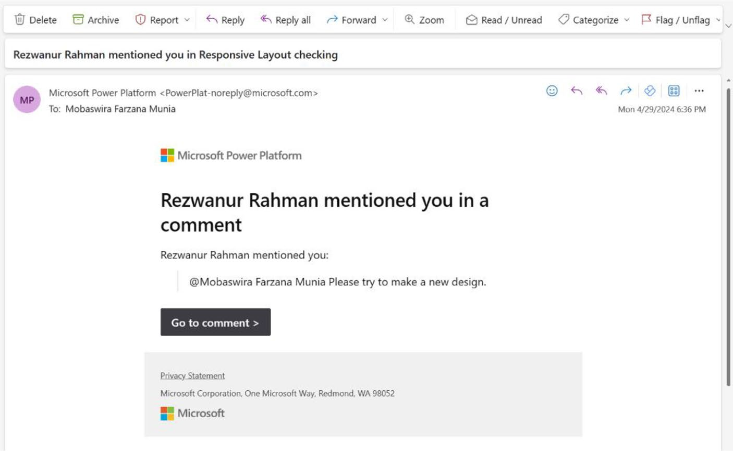

Figure 7-66. The user will get a notification email

Chapter 7 DynamiC Content, Comments, anD Copilot Customization in power apps

Power Apps Comment Limitations
Here are a few notable limitations regarding comments in Power Apps:
• Power Apps Studio imposes a limit on the number of
users who can edit an app simultaneously. If you tag someone while the app is open, they will be notified via email; however, they must wait until you close the app to view and address the comment.
• When working on an app through Git, comments are
not supported.
• The @mention feature is not available for custom Power
Apps on SharePoint.

Summary
This chapter explained how to make your Power Apps more dynamic
and interactive by using variables, formulas, and responsive design
techniques. It also explored how to integrate AI-driven features like Copilot
and chatbots, enhancing the user experience with real-time, intelligent
responses. Additionally, I demonstrated how to incorporate comments for
better collaboration and customization within your apps.
As you move to Chapter 8, I build on these foundations by focusing on
integrating diverse data sources, such as Microsoft Dataverse, SharePoint,
and Azure SQL. I teach you how to design custom tables, manage
multimedia elements, and seamlessly connect your Power Apps to various
data repositories, further enhancing your app’s functionality and data
management capabilities.

CHAPTER 8

Integrating Diverse

Data Sources and

Media in Power Apps

The previous chapter explored how to create dynamic and interactive
Power Apps by incorporating variables, formulas, and AI-driven
features like Copilot and chatbots. These elements help elevate the user
experience, making your apps more responsive and intelligent.
This chapter shifts focus to integrating various data sources into
your Power Apps, such as Microsoft Dataverse, SharePoint, and Azure
SQL. You’ll learn how to design custom tables, manage multimedia
content, and connect your app to external data repositories. This will
enable you to create more robust and data-driven applications that meet
the specific needs of your users.

Table Designer
In the previous chapter, you learned that when Copilot creates a project, it
automatically includes a Microsoft Dataverse table in the data source. This
section focuses on the detailed process of creating a custom Dataverse
table. This section guides you through each step of designing and

© Rezwanur Rahman 2024 375
R. Rahman, Microsoft Copilot for Power Apps, Inside Copilot,

Chapter 8 IntegratIng DIverse Data sourCes anD MeDIa In power apps
implementing a tailored Dataverse table to meet the specific needs of your application, enhancing data management and functionality in your Power Apps projects.
To create a custom Dataverse table, follow these steps:
1. To begin, open your browser and navigate to the
Power Apps portal at https://make.powerapps.
com/. From there, you can either continue working on the Power Apps project you started earlier or choose to start a new project. This will set the stage for you to dive into creating custom Dataverse tables. This example uses the previous project.
2. Click Data in the left sidebar. Select +Add Data
and then select Create New Table, as shown in
Figure 8-1.
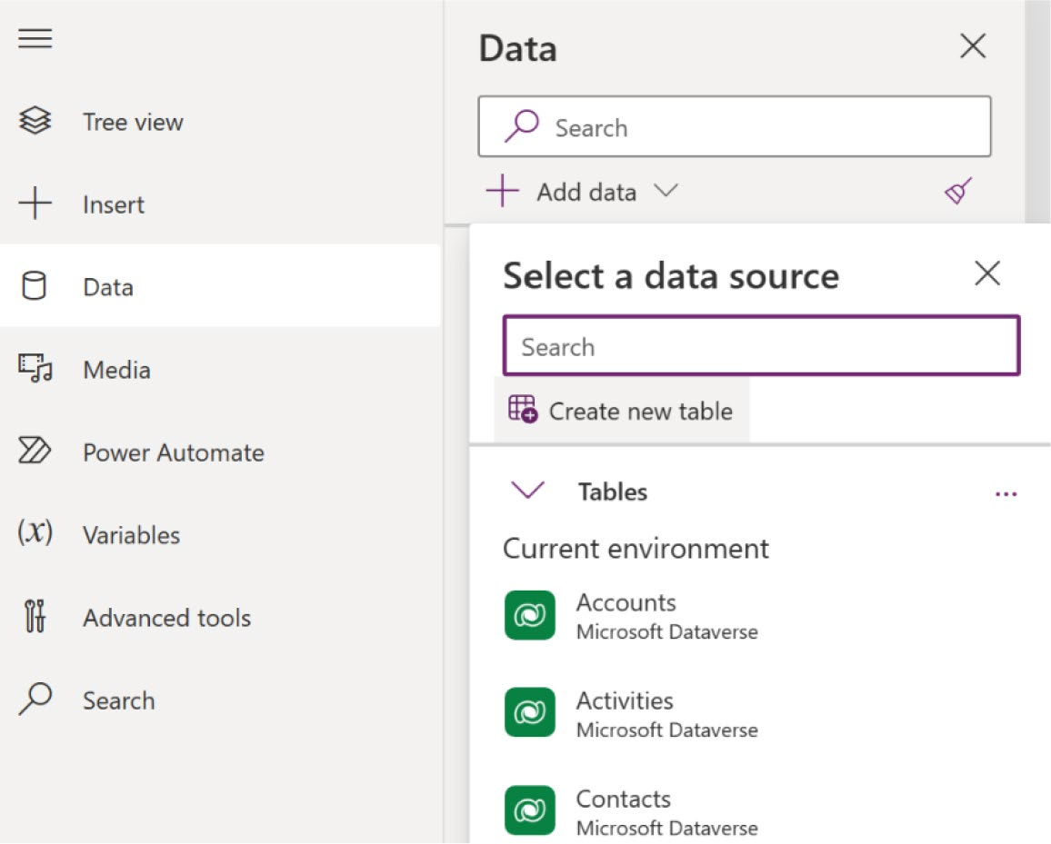

Figure 8-1. Creating a new table in the Power Apps project

Chapter 8 IntegratIng DIverse Data sourCes anD MeDIa In power apps
3. The next page will ask you in which way you want to
create the table, as shown in Figure 8-2.
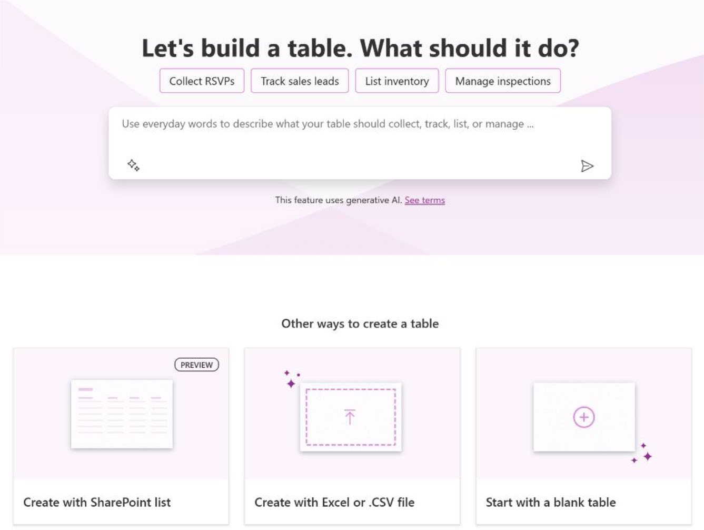

Figure 8-2. Select your preferred method for creating the table

I will begin with an empty table this time. Unlike previously, I will not be using Copilot, as you have already seen how it can automatically generate a table for this project.

Chapter 8 IntegratIng DIverse Data sourCes anD MeDIa In power apps
4. After choosing Start with a Blank Table, you will
be taken to a page displaying a completely blank table. Unlike previous instances, you will not find any prepopulated or recommended columns. This setup allows you to customize the table from scratch according to your specific requirements. See
Figure 8-3.
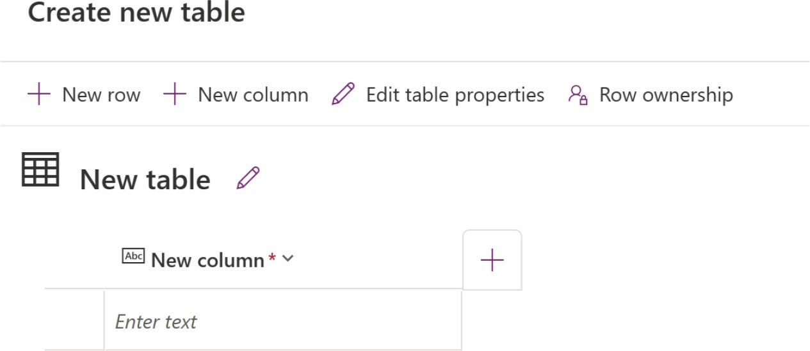

Figure 8-3. Option to create a table, row, and column

5. You need to name this table. Click Edit Table
Properties and you will get the option to edit the
table name, as shown in Figure 8-4.

Chapter 8 IntegratIng DIverse Data sourCes anD MeDIa In power apps
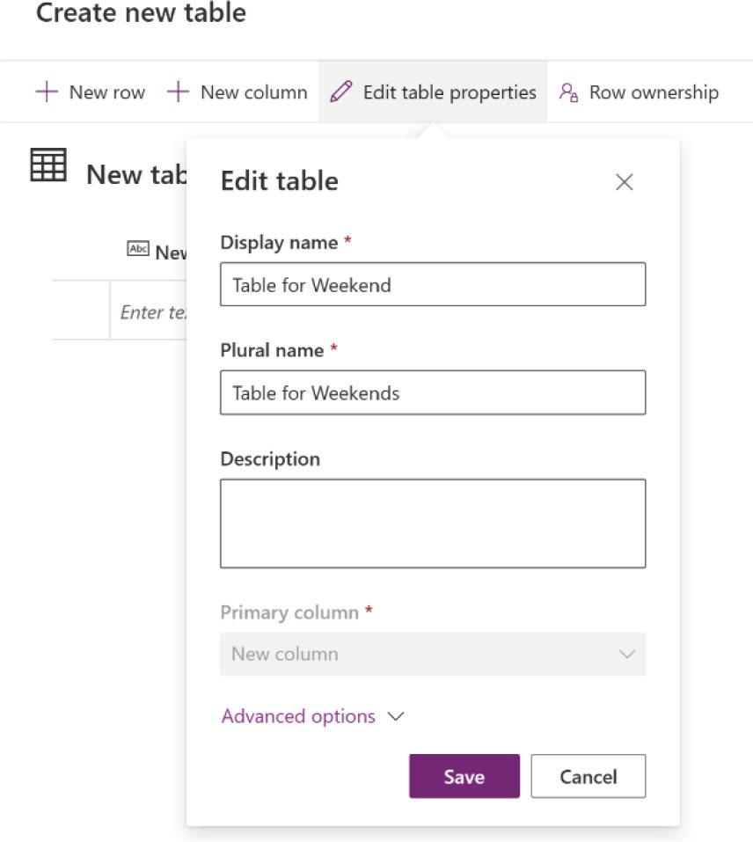

Figure 8-4. Change the table properties

6. I named the table Table for Weekend. Next, you
will insert some dummy data and attempt to display
it on a new screen, as shown in Figure 8-5.
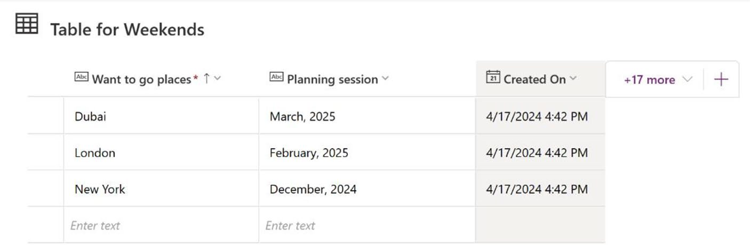

Figure 8-5. Creating a row and dummy data inside

Chapter 8 IntegratIng DIverse Data sourCes anD MeDIa In power apps
7. Create a new screen. Click the + icon and search for
Data Table, as shown in Figure 8-6.
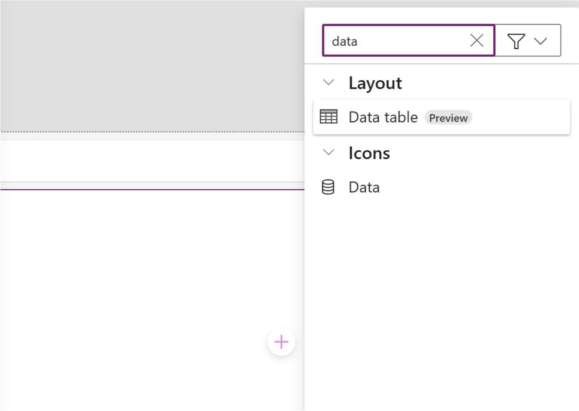

Figure 8-6. Searching for Data Table to fetch new table data

8. Add the Data Table to the screen and select Table
for Weekend as the data source. You will see the
data in the table, as shown in Figure 8-7.

Chapter 8 IntegratIng DIverse Data sourCes anD MeDIa In power apps
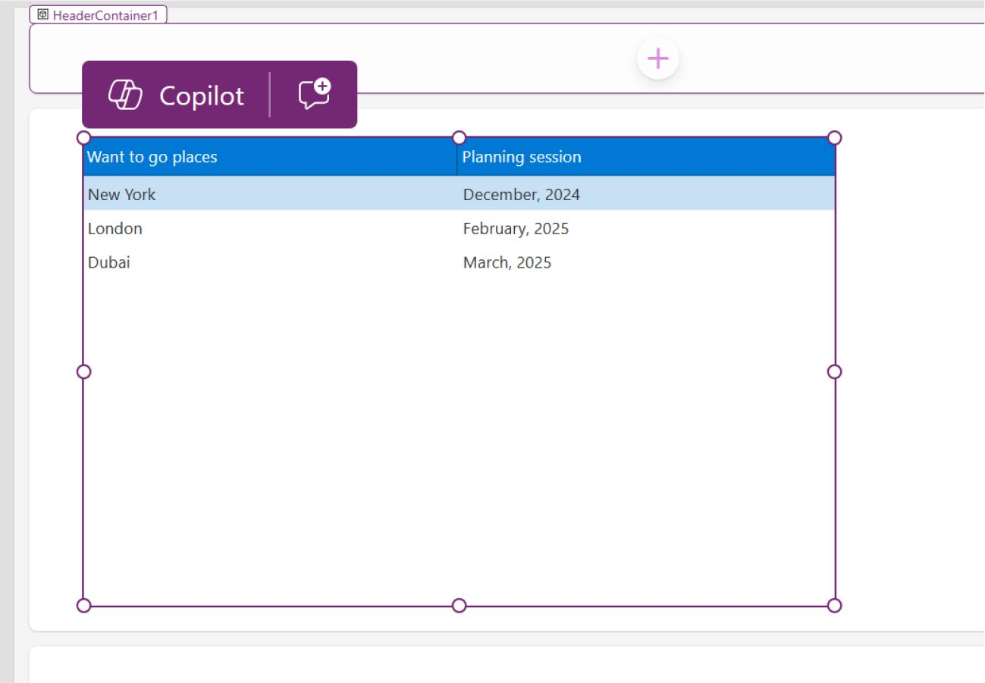

Figure 8-7. Fetching data from a newly created table
9. Now you will design the table for the best look.
Resize the table using your mouse to fit it in the
screen, as shown in Figure 8-8.

Chapter 8 IntegratIng DIverse Data sourCes anD MeDIa In power apps
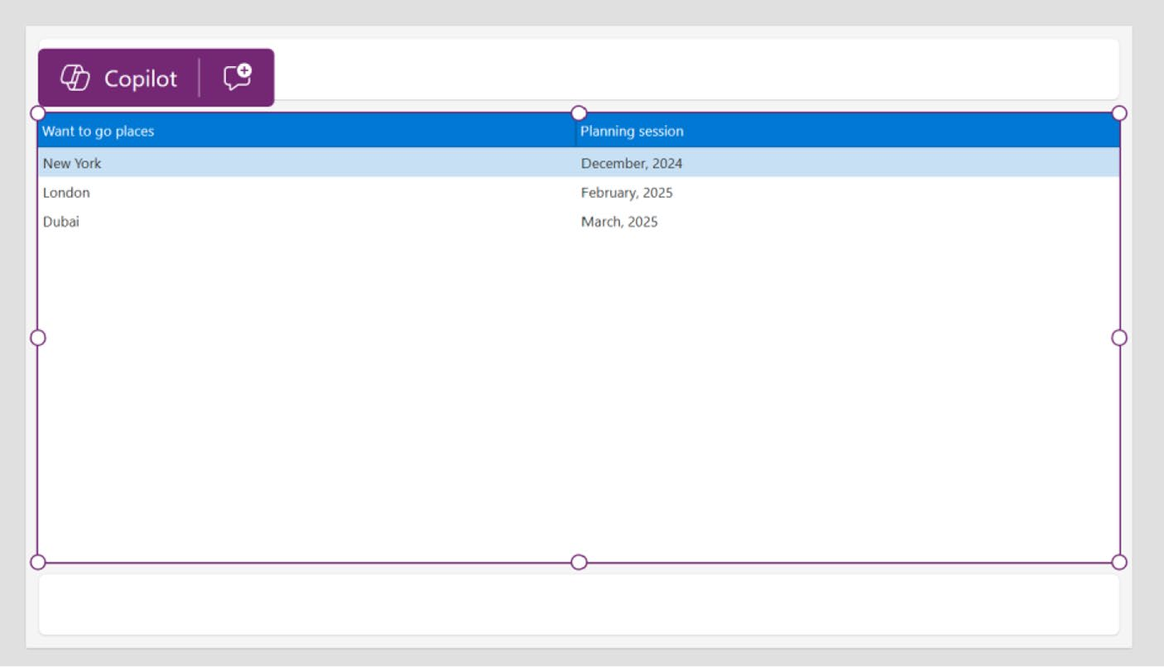

Figure 8-8. Fixing the table size

10. You can modify the table’s design in various ways.
In the previous chapter, you learned how to use Copilot Chat to change the color or text of a table. Now, you will see how to use default themes in a table.
In the top bar, when you select the Data Table, there
is an option named Theme, as shown in Figure 8-9.

Chapter 8 IntegratIng DIverse Data sourCes anD MeDIa In power apps
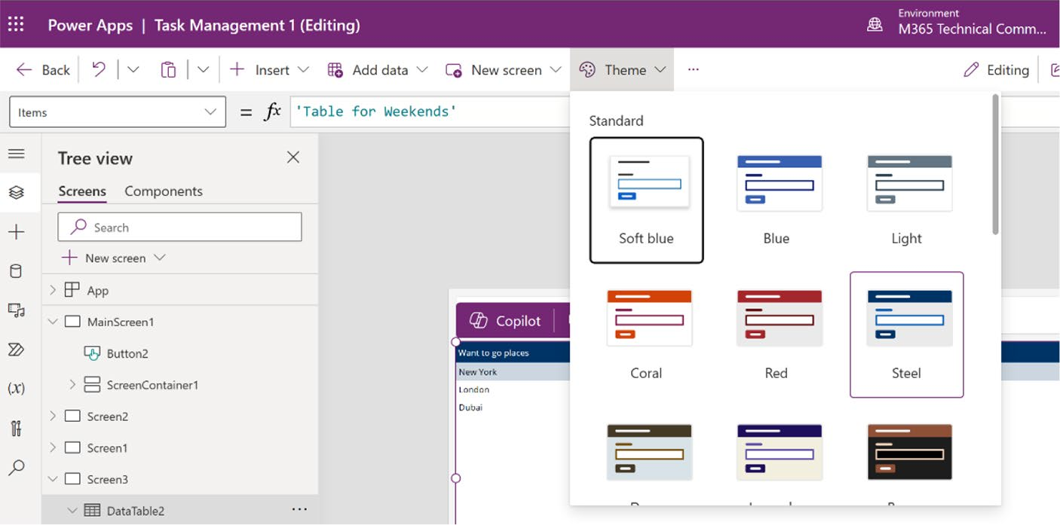

Figure 8-9. Selecting Theme from the top bar

11. Select a theme and it will be changed accordingly.
See Figure 8-10.
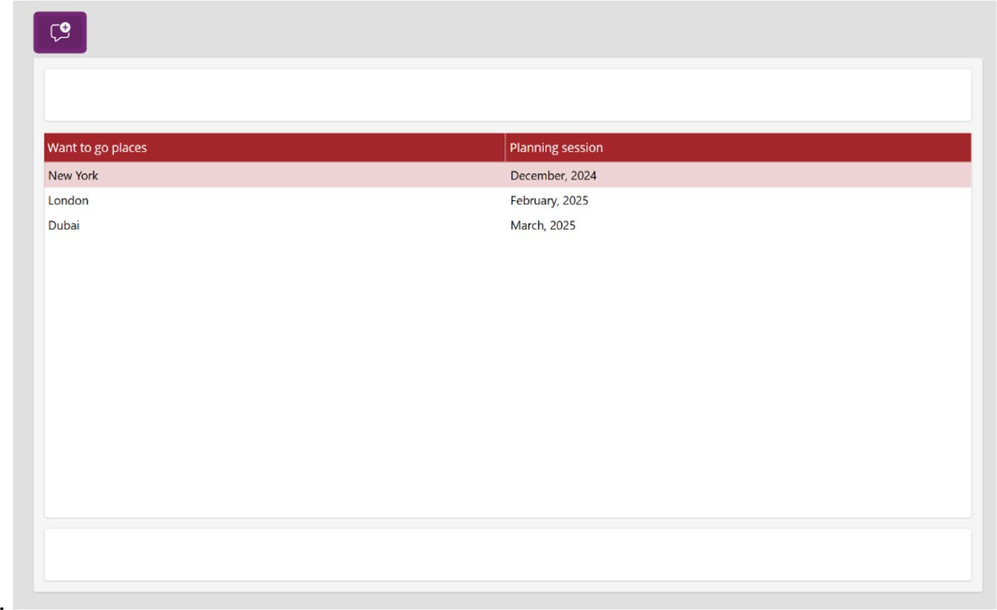

Figure 8-10. Changing the theme color after manually selecting
Theme from the top bar

Chapter 8 IntegratIng DIverse Data sourCes anD MeDIa In power apps
12. You can also change the font name, size, and
style. Remember, you must select the Data Table component first to access these options. See
Figure 8-11.
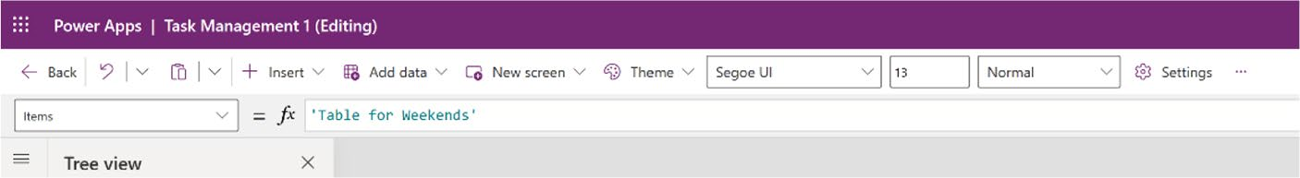

Figure 8-11. Options to change the text family, size, and style

13. For example, I changed the font from Segoe UI to
Dancing Script, the font size from 13 to 17, and the font style from Normal to Bold. You can see this
table style in Figure 8-12.
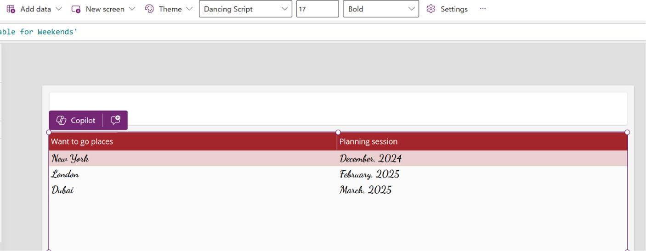

Figure 8-12. Changing the font family, size, and style

14. Next, you will explore another method for modifying
component properties. While the previous chapter covered using Copilot Chat for this purpose, and you utilized the top bar options, you will now learn how to directly alter parameters through the component’s Properties panel.

Chapter 8 IntegratIng DIverse Data sourCes anD MeDIa In power apps
Select the Data Table control and click Properties on
the right side, as shown in Figure 8-13.
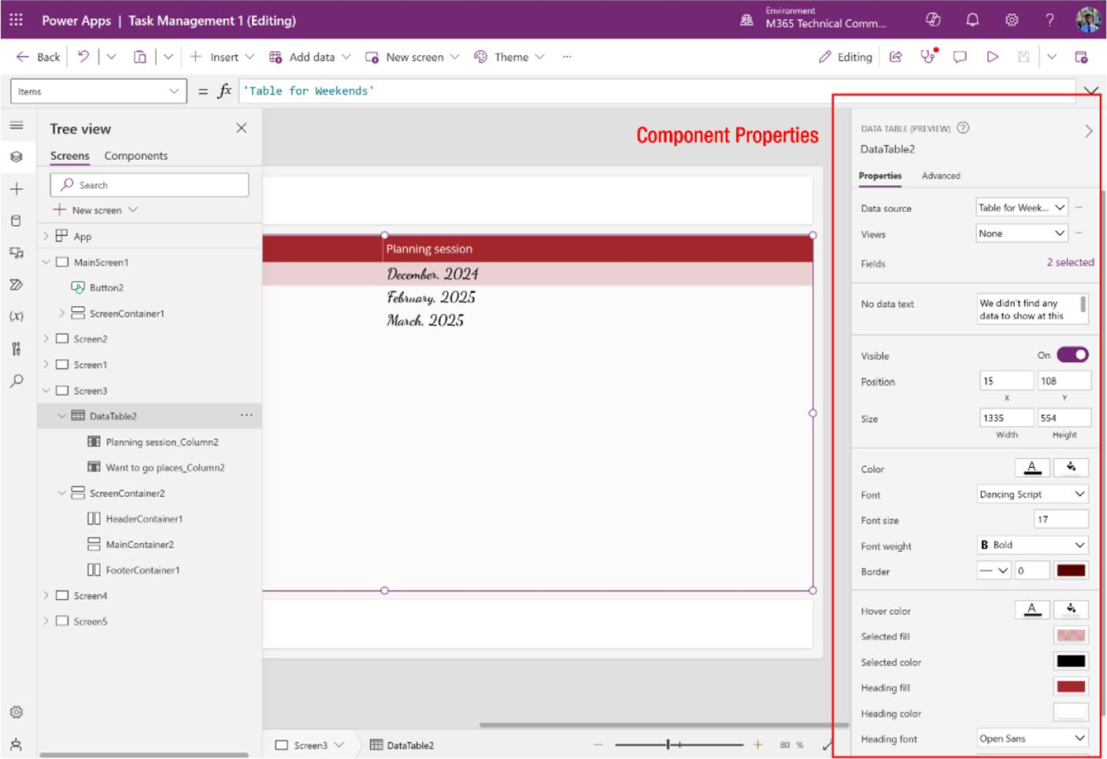

Figure 8-13. Properties of the Data Table control

15. Let’s change the background color from here. You
will find two options in Color—one for the font and another for the visual background color. Select the visual background option and choose any color you
want, as shown in Figure 8-14.

Chapter 8 IntegratIng DIverse Data sourCes anD MeDIa In power apps
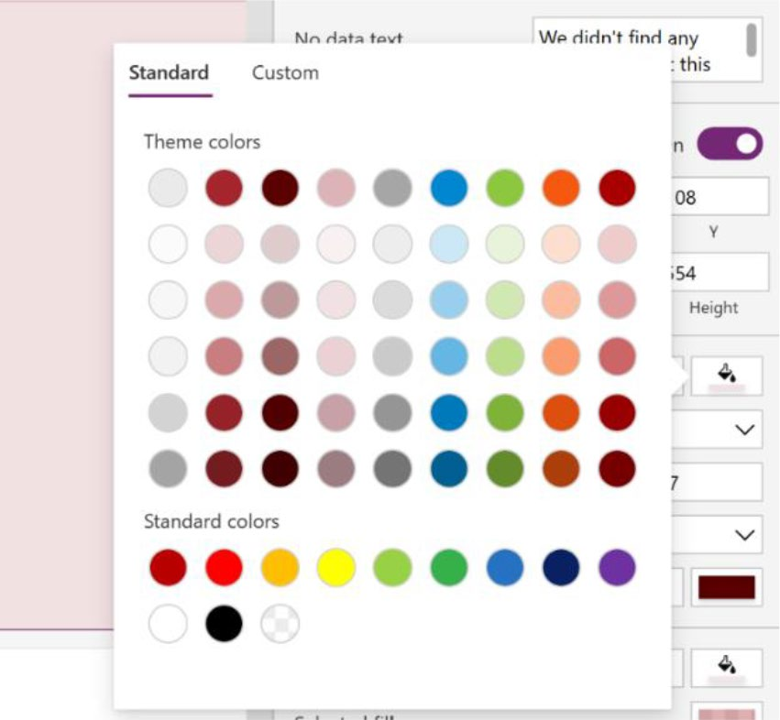

Figure 8-14. Selecting the visual background color from Properties

16. You will see the updated color after changing the
option. See Figure 8-15.
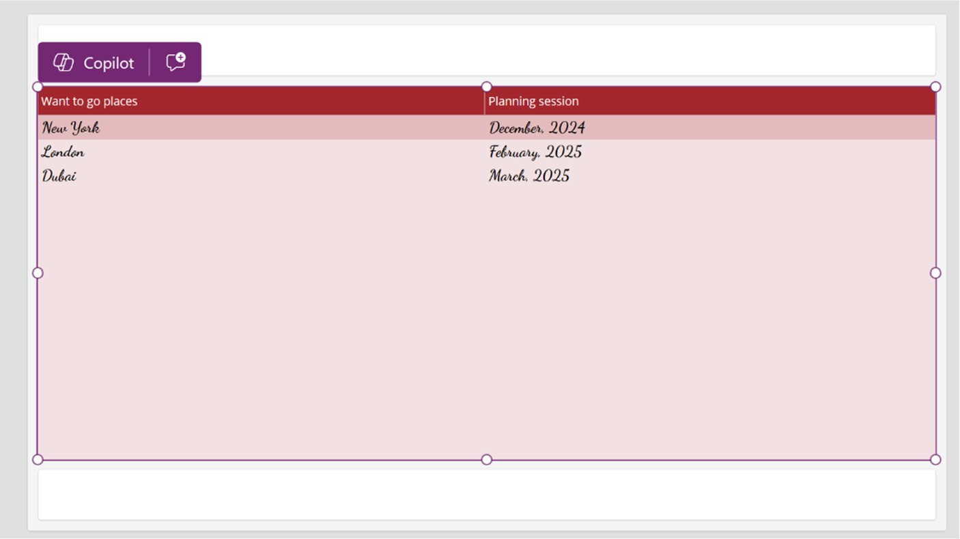

Figure 8-15. Changed the background color

Chapter 8 IntegratIng DIverse Data sourCes anD MeDIa In power apps
You learned about three different ways to change the component
properties:
1. Change with a Copilot conversation.
2. Change from the top bar options (limited change).
3. Change from the component’s properties.

Permissions and Limitations of Table Creation
in Dataverse
To create a table in Dataverse, it is essential that a Dataverse database
already be provisioned in the environment. Additionally, you need to
hold either system customizer or system administrator permissions
in the specific environment where you intend to construct a table. If
these prerequisites are not fulfilled, the Create New Table button will be
disabled.
It is important to note that you can only create and edit tables within
the current Dataverse environment. Should you switch your Dataverse
environment using the environment picker, the options to Create New
Table and Edit Table will be disabled.

Image and Video
The Media and Gallery panes in Power Apps provide a user-friendly way
to incorporate multimedia into your apps, enhancing the user experience
and data presentation. Customizable and easy-to-use, these features allow
for quick creation and deployment of visually appealing and engaging
apps, improving communication and productivity.
You will now see how to work with multimedia in Power Apps.

Chapter 8 IntegratIng DIverse Data sourCes anD MeDIa In power apps

Add Images, Audio, or Video Using the Media Pane
Adding media, whether it is images, audio, video, or any other format, follows a similar process. As an example, this section shows how to add a video to the app.
To add media to your app using Copilot, follow these steps:
1. To start, navigate to your project and choose the
screen where you want to incorporate the media. In this case, since this app is for learning purposes, first create a new screen to accommodate the media
content. See Figure 8-16.
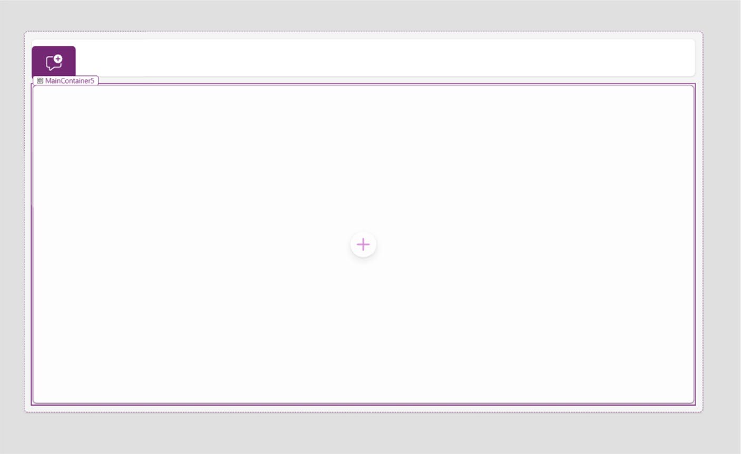

Figure 8-16. Creating a new screen to see how adding media works

Chapter 8 IntegratIng DIverse Data sourCes anD MeDIa In power apps
2. Click Insert from the left sidebar and choose Media.
You can add any of the following media to Power
Apps, as shown in Figure 8-17.
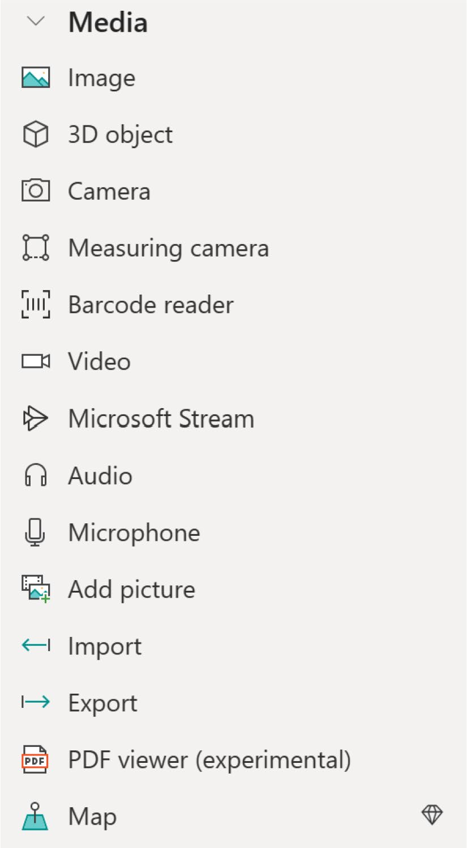

Figure 8-17. Available media controls in Power Apps

Chapter 8 IntegratIng DIverse Data sourCes anD MeDIa In power apps

Note You cannot directly use Copilot to add media to power apps.
Instead, you need to manually add the appropriate media type control
to your app. additionally, you have to upload the media files within
power apps manually, as Copilot cannot access your device data
for this purpose. Copilot's capabilities are limited to assisting with
internal designs, text, data, formulas, and code adjustments within
the app interface.

3. I select the Video control so that I can add a video to
the app. See Figure 8-18.


Figure 8-18. Adding a Video control in Power Apps

Chapter 8 IntegratIng DIverse Data sourCes anD MeDIa In power apps
4. I have successfully added the Video component to
the app, but I have not linked the video yet. Before proceeding, you need to upload a video file to the app, after which you can establish the link with this component.
Click Media in the left sidebar, select +Add Media,
and choose Upload, as shown in Figure 8-19.
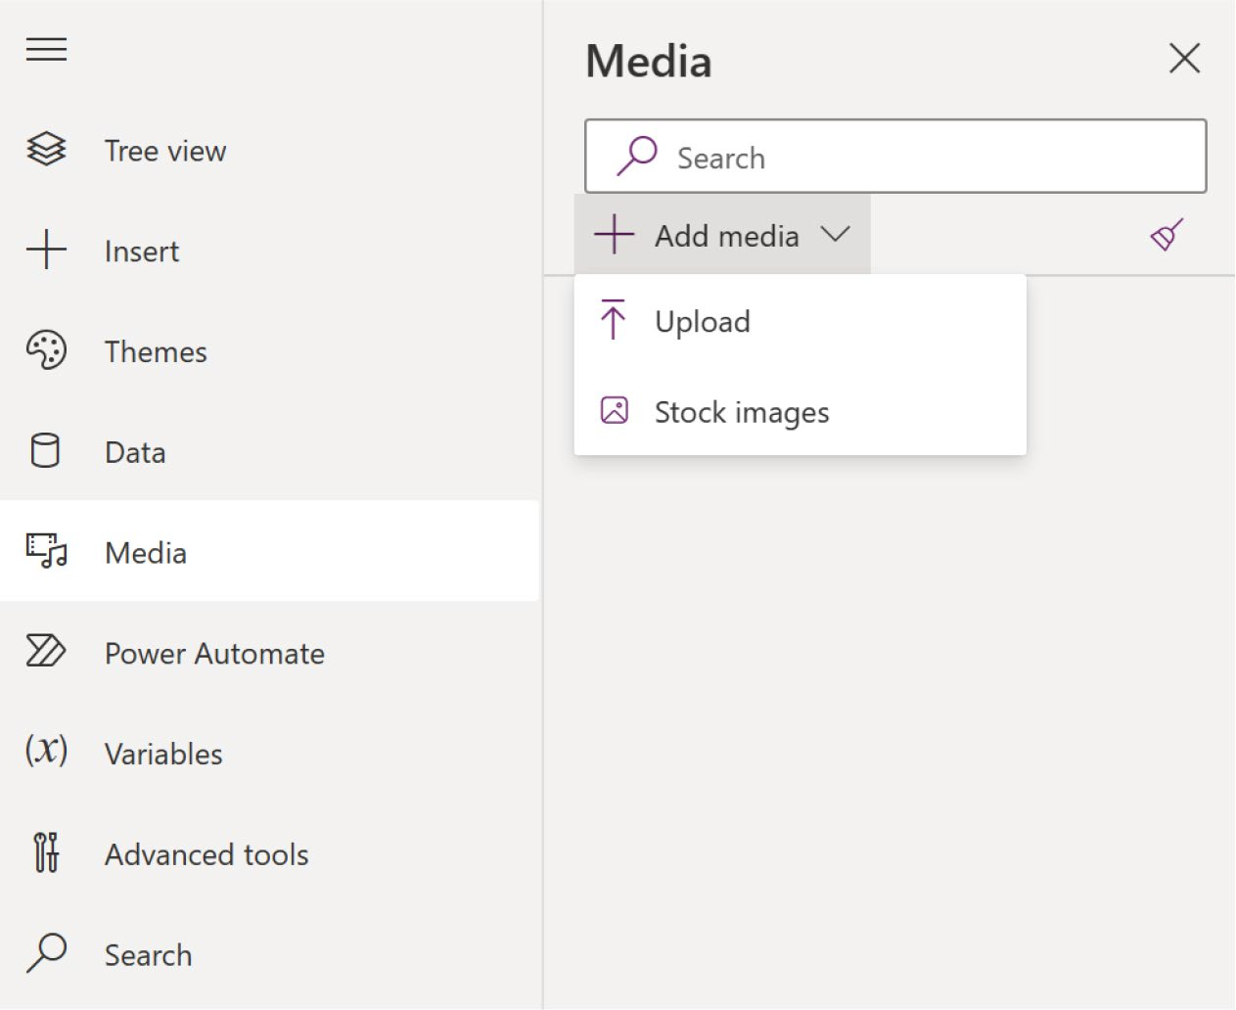

Figure 8-19. Adding new media to Power Apps

5. Select and upload your video. You will then see the
video in the list, as shown in Figure 8-20.

Chapter 8 IntegratIng DIverse Data sourCes anD MeDIa In power apps
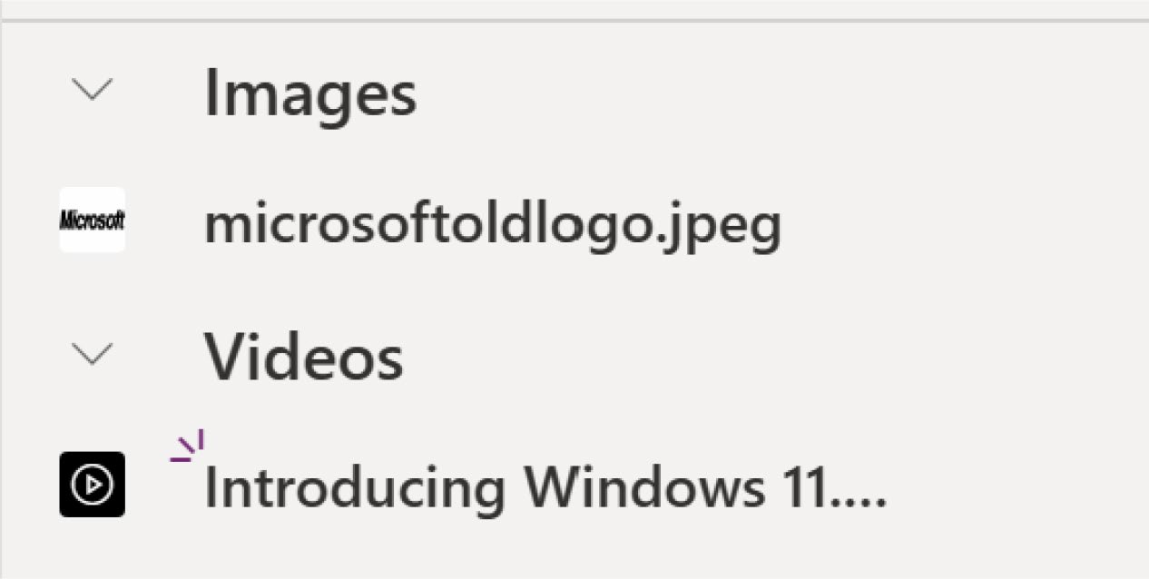

Figure 8-20. Successfully adding new media to the Power Apps project

6. Select the Video control and then select Properties
from the right side, as shown in Figure 8-21.
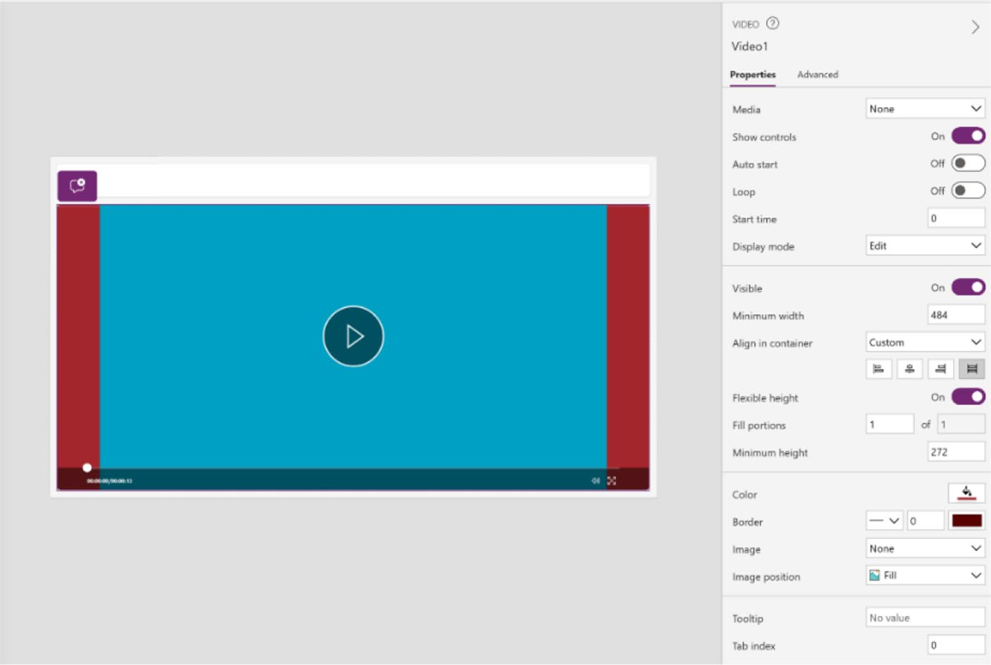

Figure 8-21. Video control properties in the right sidebar

Chapter 8 IntegratIng DIverse Data sourCes anD MeDIa In power apps
7. As shown in Figure 8-22, from Properties, click
Media and choose the video that you just uploaded.
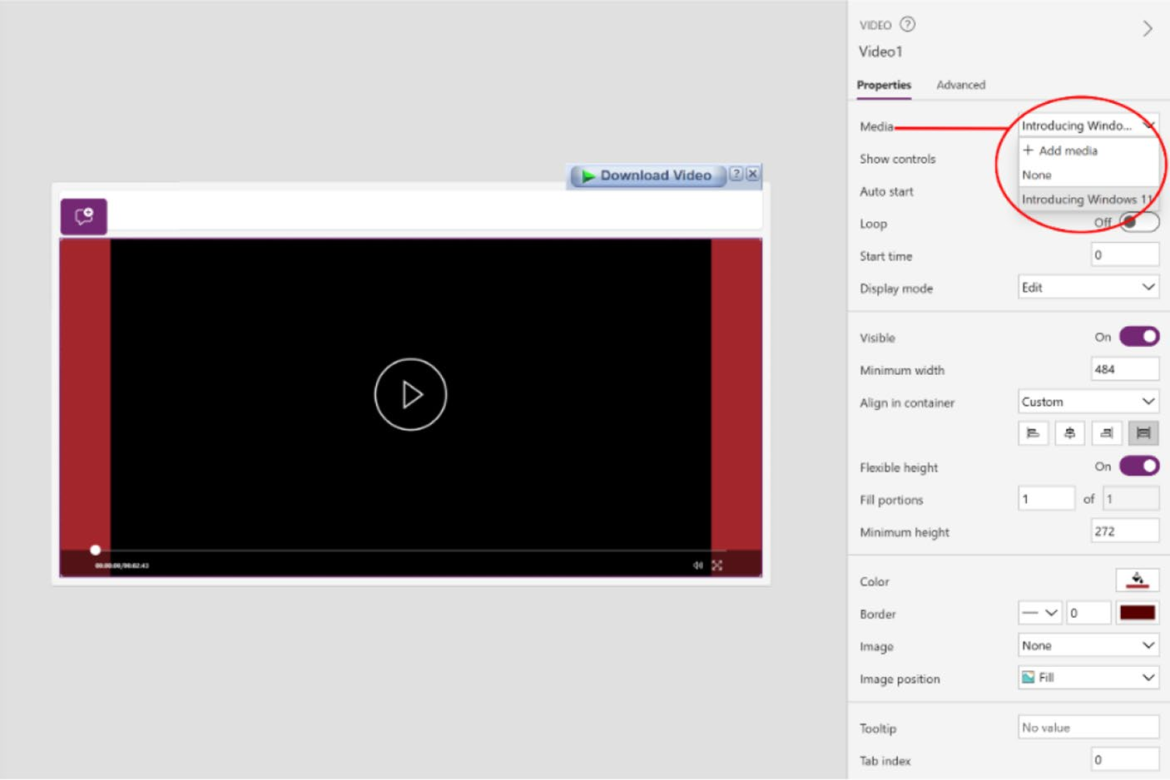

Figure 8-22. Choosing the media to add in the control

8. Press F5 or run the app to check the video, as shown
in Figure 8-23.

Chapter 8 IntegratIng DIverse Data sourCes anD MeDIa In power apps
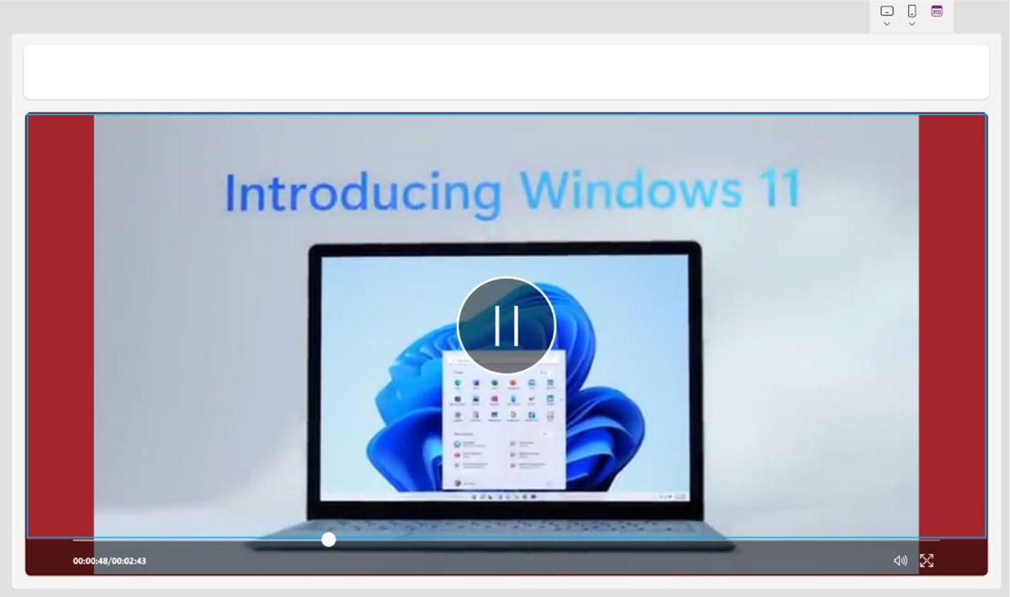

Figure 8-23. Checking the video in app preview

Add Media from URL or Cloud
You can also add media from the cloud or an URL (example, YouTube). When adding media files by URL, you need to consider the following:
• Use HTTPS to ensure compatibility with modern
browsers.
• Ensure the URL is accessible anonymously without
any authentication. Try to enter the URL in private browsing mode to verify that it is accessible without signing in.
Follow these steps to add media from an URL:
1. Add an image control in Power Apps, as shown in
Figure 8-24.

Chapter 8 IntegratIng DIverse Data sourCes anD MeDIa In power apps
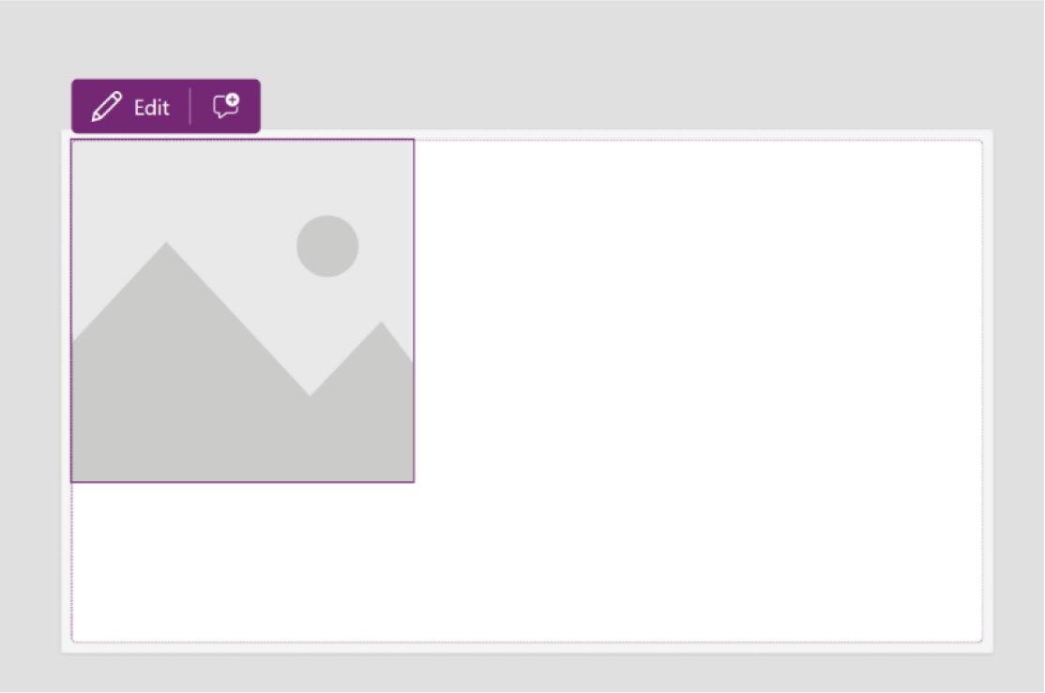

Figure 8-24. Added image control in Power Apps

2. Select the control from screen, select Image from
the Formula bar, and then add the URL of the image
that is publicly available, as shown in Figure 8-25.
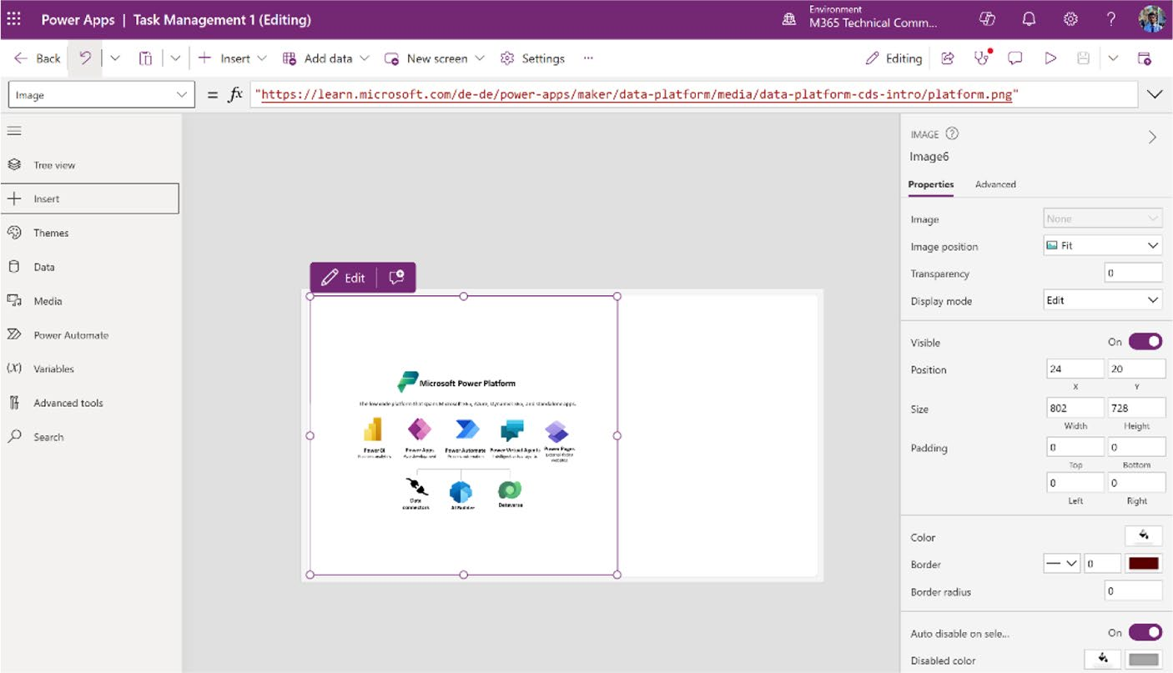

Figure 8-25. Adding an image from an URL

Chapter 8 IntegratIng DIverse Data sourCes anD MeDIa In power apps
Note that the image must be uploaded as public and accessible from the app. Be sure to add the URL in quotation marks (“URL”), as shown in
Figure 8-26.
"https://learn.microsoft.com/de-de/power-apps/maker/data- platform/media/data-platform-cds-intro/platform.png"

Figure 8-26. Example of an image URL

Known Limitations of Power Apps Media
Here are some identified limitations concerning the media capabilities within Power Apps:
• To enable better performance while loading an app, the
following size restrictions apply:
• The total size of all media files uploaded to an app
cannot exceed 200MB.
• The maximum size of an individual media file in an
app cannot exceed 64MB.
• Supported media file types include .jpg, .jpeg,
.gif, .png, .bmp, .tif, .tiff, .svg, .wav, .mp3, and .mp4.

Pen Input Control
The Pen input control in Power Apps is a versatile tool designed for capturing handwritten input and signatures within an app. This control allows users to draw or write directly on the screen using their finger or

Chapter 8 IntegratIng DIverse Data sourCes anD MeDIa In power apps
a stylus, making it ideal for applications requiring signature capture or
freehand drawing tasks. The data captured by the Pen input control is
stored as an image, which can be saved into a data source or used in the
app for further processing. This feature enhances the functionality of
Power Apps by enabling a more interactive user experience, particularly
useful in scenarios like form completion, artistic applications, or any
situation where manual input is preferred over traditional keyboard
entries.
To add the Pen input control in Power Apps, follow these steps:
1. Open your project in Power Apps. Click Insert
and choose the Pen Input control, as shown in
Figure 8-27.
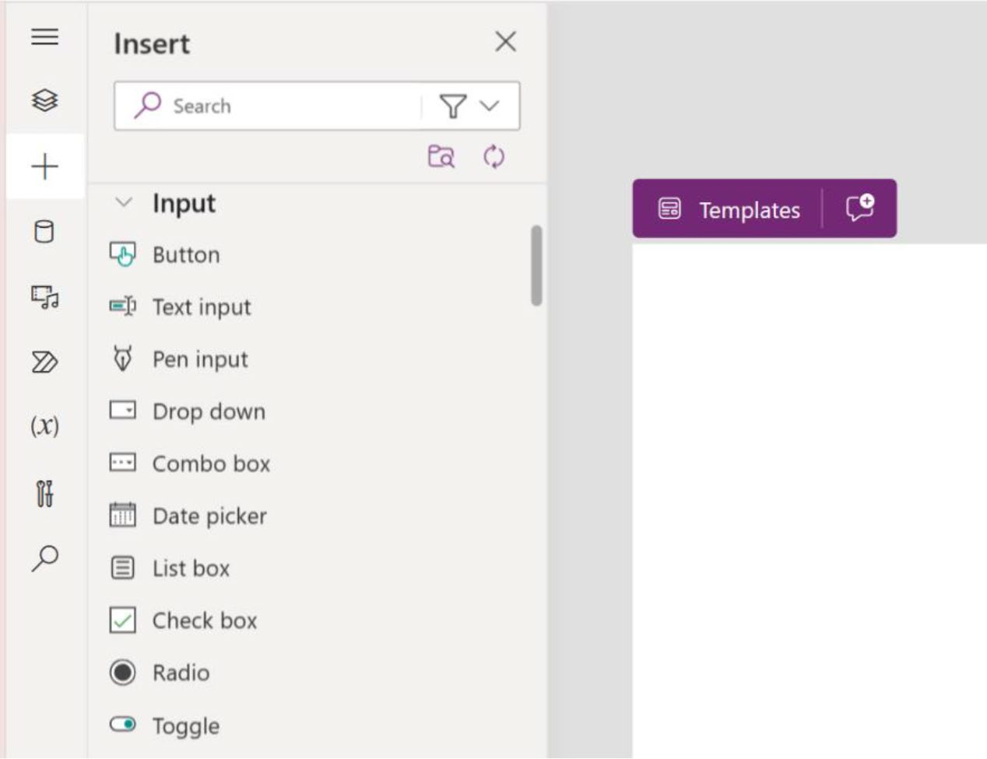

Figure 8-27. Selecting the Pen input in Power Apps

2. Adjust the size for the screen, as shown in
Figure 8-28.

Chapter 8 IntegratIng DIverse Data sourCes anD MeDIa In power apps
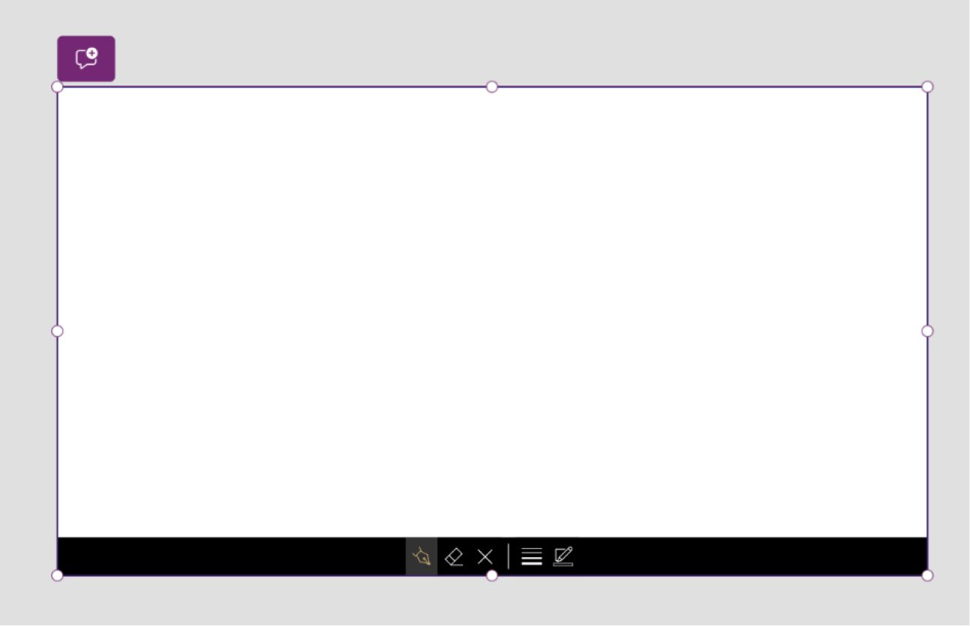

Figure 8-28. Changing the size of the Pen input

3. Press F5 and check the app by writing on it, as
shown in Figure 8-29.
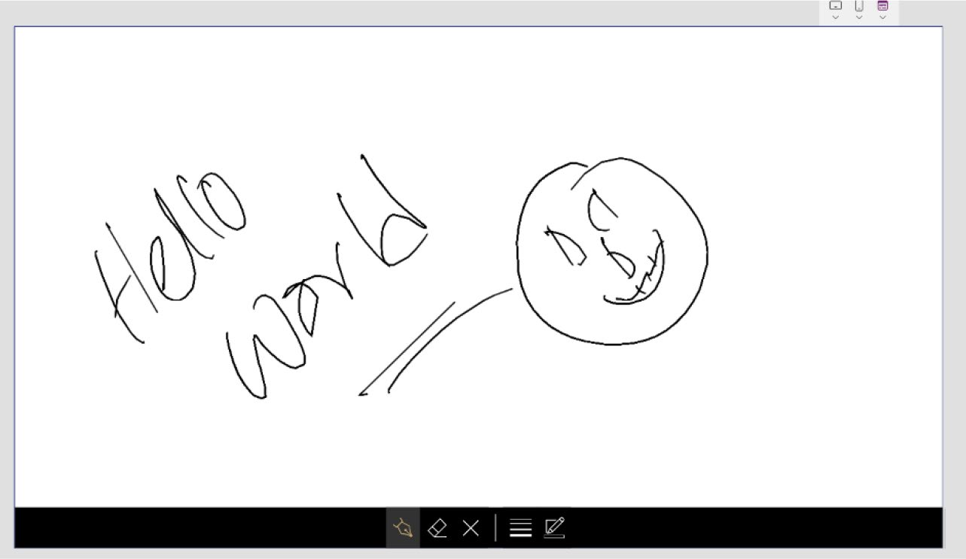

Figure 8-29. Preview of the Pen input

Chapter 8 IntegratIng DIverse Data sourCes anD MeDIa In power apps
You can learn more about the Pen input control from Microsoft’s
official learning website at https://learn.microsoft.com/en-us/power-
apps/maker/canvas-apps/controls/control-pen-input.

Known Limitation of the Power Apps Pen Control
Drawing with a mouse or a touch input in the Windows app might not
work well with the Pen control. Strokes can be broken. For better drawing,
use a pen or open the app in a browser.

Integration Diverse Data Sources
Integrating diverse data sources, such as SQL databases, Dynamics 365,
Microsoft Excel, or third-party APIs is essential for creating comprehensive
business insights. This section outlines various methods and tools for
extracting, transforming, and loading data from these sources into a
unified system. By implementing robust data integration practices,
organizations can enhance their decision-making processes and achieve a
more holistic view of their operations.

Adding a SharePoint Data Source
from Microsoft List
This section explains how to add a SharePoint data source in Power Apps,
aimed at beginners. This section guides you through creating a blank list
in SharePoint and connecting it to Power Apps. If you are already familiar
with SharePoint lists, feel free to skip this section. This exercise is an
excellent starting point for those new to these tools.

Chapter 8 IntegratIng DIverse Data sourCes anD MeDIa In power apps
To create a list in SharePoint, follow these steps:
1. Go to https://portal.office.com from your
browser, click Apps, and select SharePoint. See
Figure 8-30.
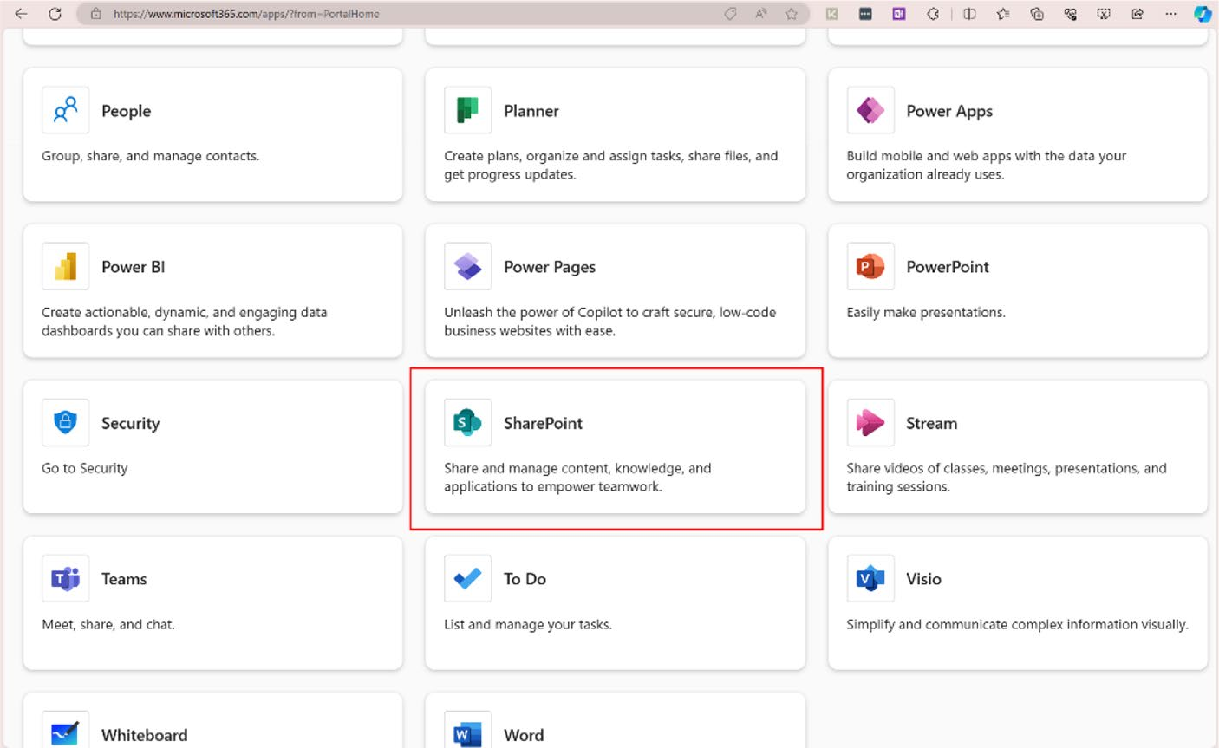

Figure 8-30. Selecting SharePoint from the Apps page of the Microsoft 365 Portal

2. You can also access SharePoint by clicking the nine-
dot grid icon located in the top-left corner of any
Microsoft application. See Figure 8-31.

Chapter 8 IntegratIng DIverse Data sourCes anD MeDIa In power apps
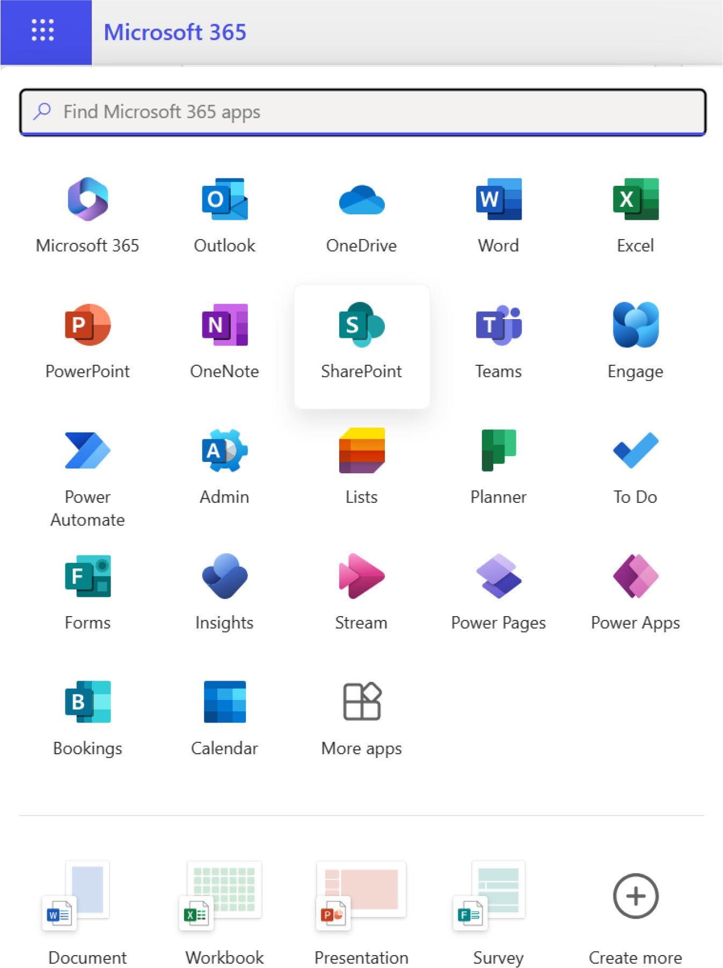

Figure 8-31. You can select SharePoint from the nine-dot grid

Chapter 8 IntegratIng DIverse Data sourCes anD MeDIa In power apps
3. Once you open the SharePoint portal, click the
My List option in the left sidebar. You will see the available list in your SharePoint environment, as
shown in Figure 8-32. In my environment, I have a list called Microsoft Test Environment. If you do not have any lists, do not worry! I show you how to create one.
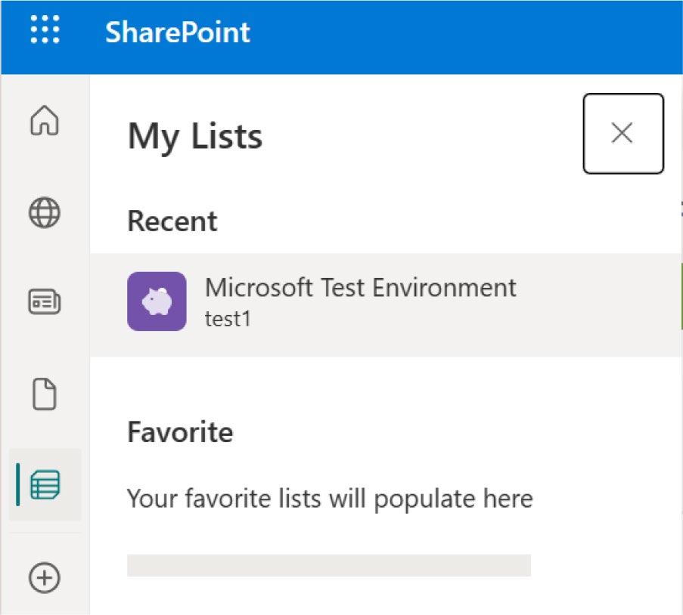

Figure 8-32. My Lists option in the Microsoft SharePoint Portal

4. I select the list called Microsoft Test Environment. It
will open, as shown in Figure 8-33.

Chapter 8 IntegratIng DIverse Data sourCes anD MeDIa In power apps
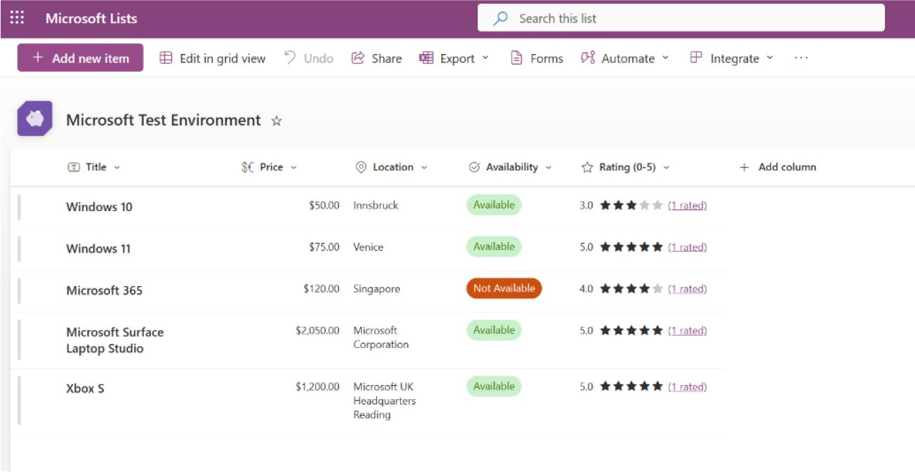

Figure 8-33. Data that is saved in a Microsoft list

You might be confused about SharePoint Lists versus Microsoft Lists. I will make this clear by the end of these steps! Do not worry!
5. You need to create an app with the data source.
There are two ways to create an app in Power Apps.
1. From a Microsoft List: From the list that you opened,
choose Integrate ➤ Power Apps ➤ Create an App, as shown
in Figure 8-34.
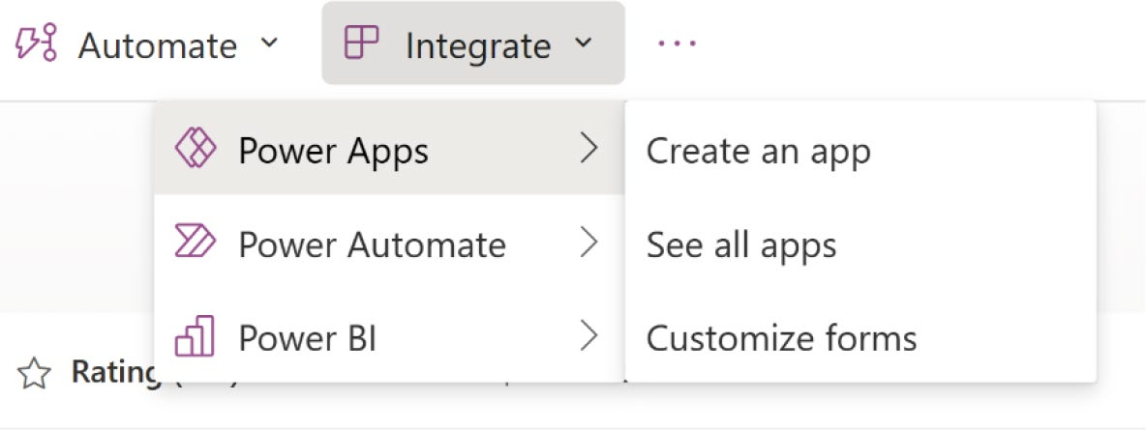

Figure 8-34. Creating Power Apps from a Microsoft List

Chapter 8 IntegratIng DIverse Data sourCes anD MeDIa In power apps
2. From Power Apps: Create an app or open your
existing app, click Data in the left sidebar, and then choose SharePoint under the Connector option, as
shown in Figure 8-35.
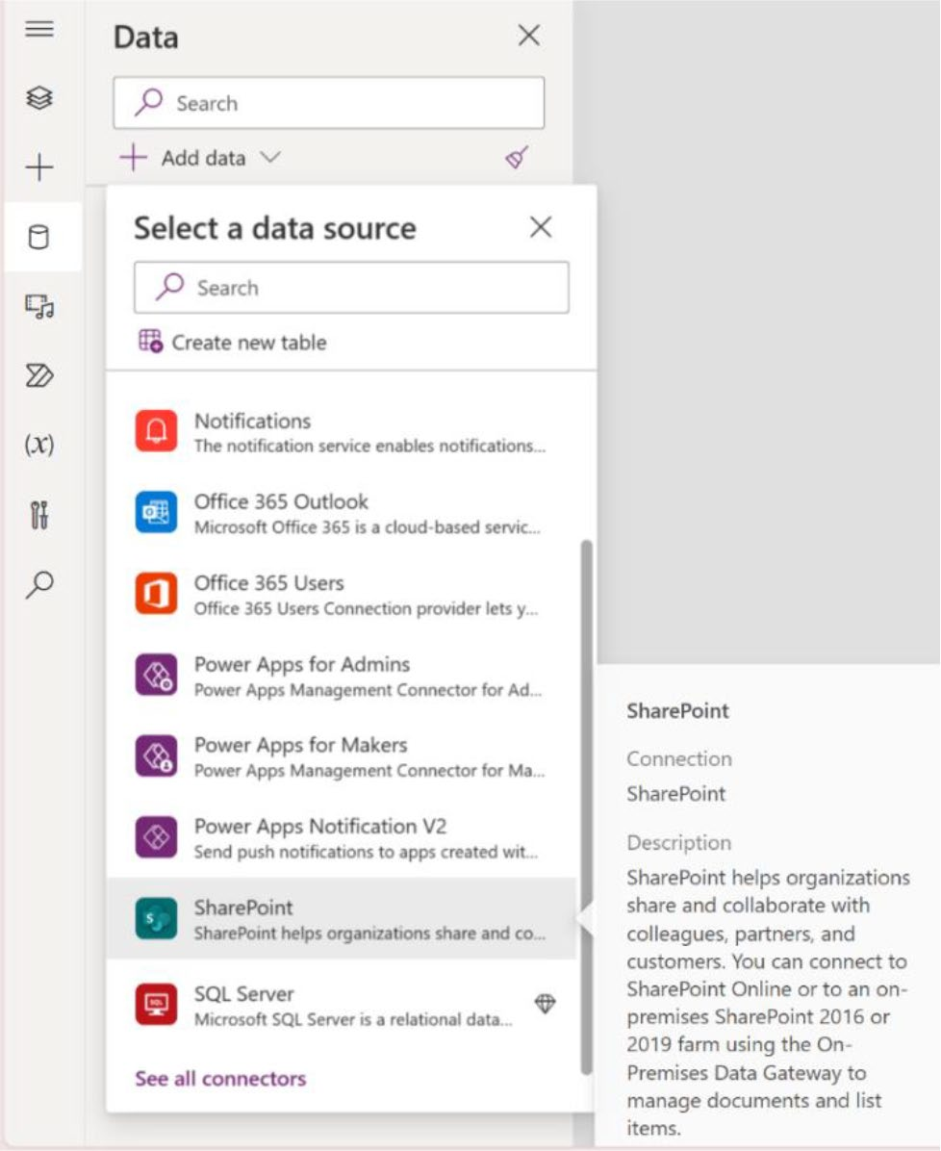

Figure 8-35. SharePoint connector in Power Apps

6. Since you are already on the Microsoft List page,
let’s use this method to create the app. Click the
Create an App option (see Figure 8-34). It will redirect you to another tab and will take a few seconds to create an app.

Chapter 8 IntegratIng DIverse Data sourCes anD MeDIa In power apps
7. After that, you will see the app in the Power Apps
window, as shown in Figure 8-36.
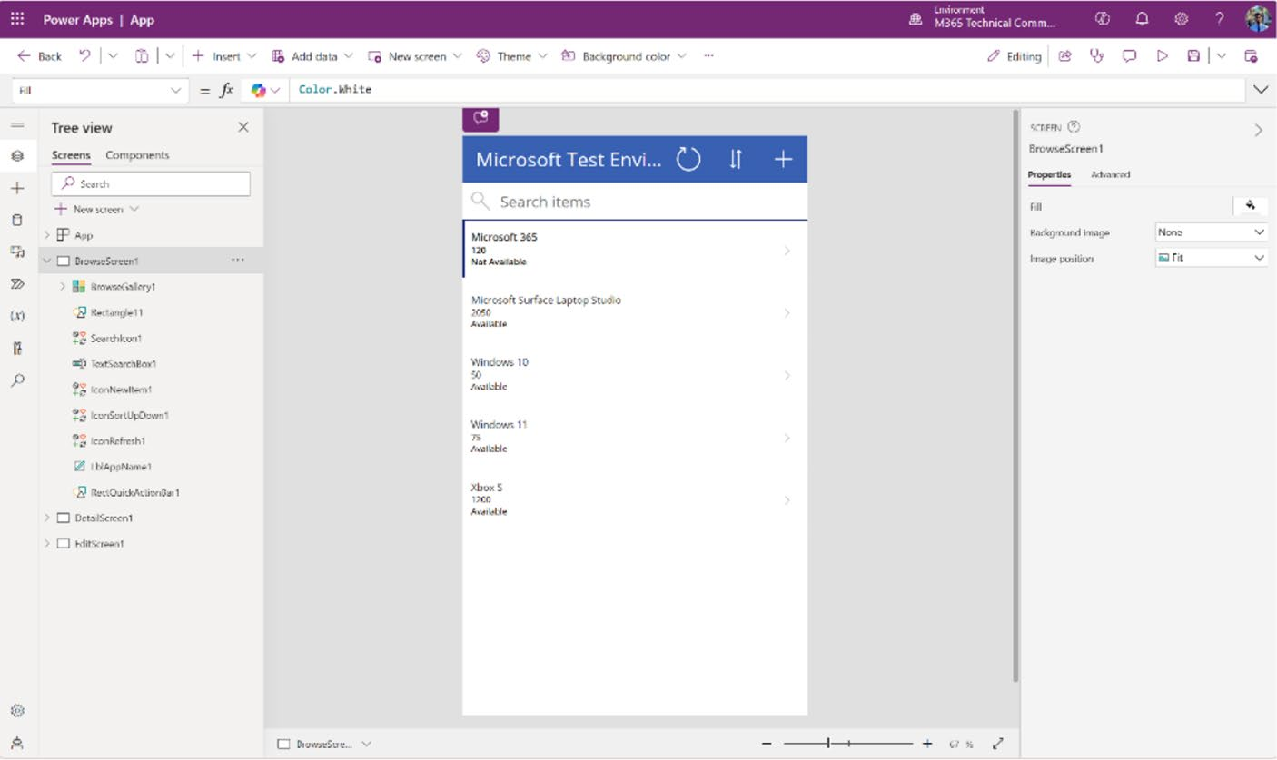

Figure 8-36. The Microsoft List data in Power Apps

8. Run the app by pressing F5 for a better
understanding. See Figure 8-37.

Chapter 8 IntegratIng DIverse Data sourCes anD MeDIa In power apps
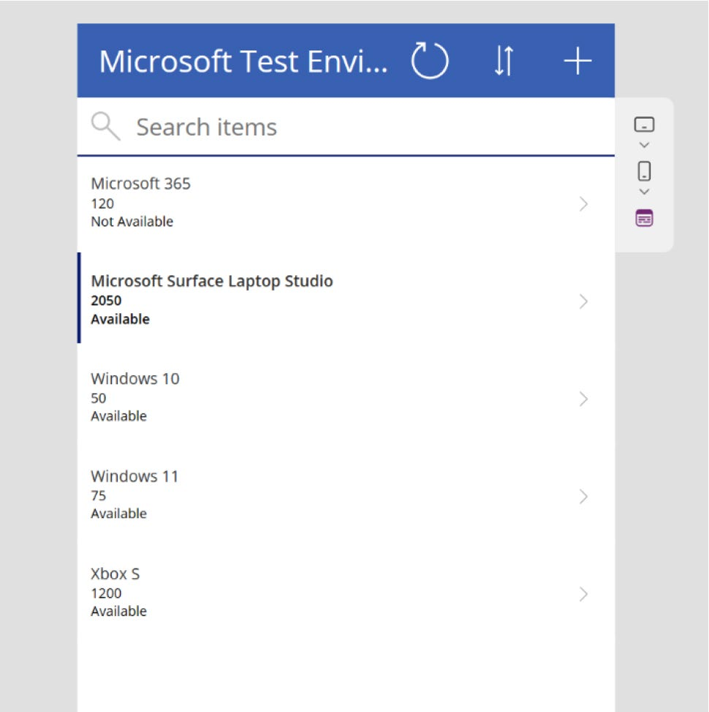

Figure 8-37. Preview of Power App and fetching data from Microsoft List

Adding SharePoint Data Source from Power Apps Studio
In this section, you learn how to connect SharePoint to Power Apps using Power Apps Studio. To set up a connection between SharePoint and Power Apps, either start a new Canvas project in Power Apps or open an existing project where you want to include the SharePoint data source.
As I showed in multiple projects in this book, I am not creating a new project, I am opening an existing one. Follow these steps:
1. Open the project and click Data in the left sidebar.
Then choose SharePoint under the Connector
option, as shown in Figure 8-38.

Chapter 8 IntegratIng DIverse Data sourCes anD MeDIa In power apps
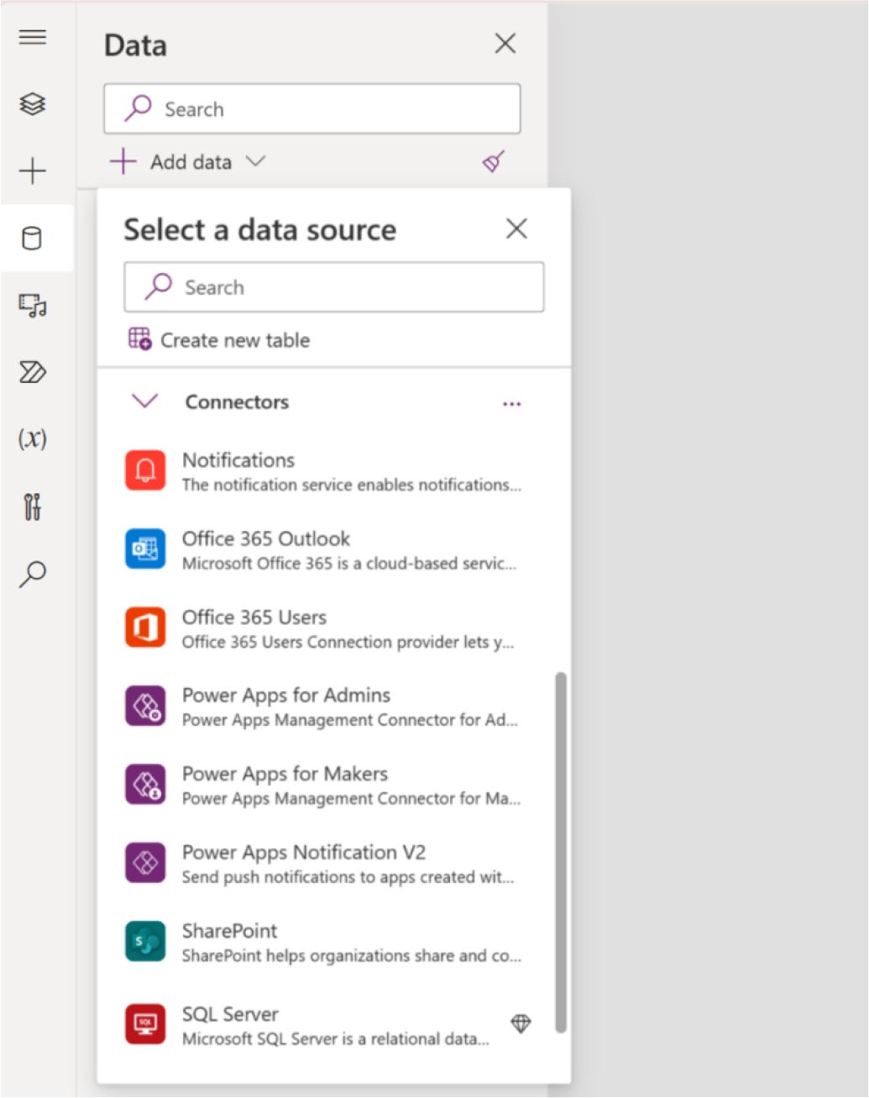

Figure 8-38. SharePoint connector in data source

2. After clicking SharePoint, a sidebar will open on the
right, asking you to connect to the SharePoint site, as
shown in Figure 8-39.

Chapter 8 IntegratIng DIverse Data sourCes anD MeDIa In power apps
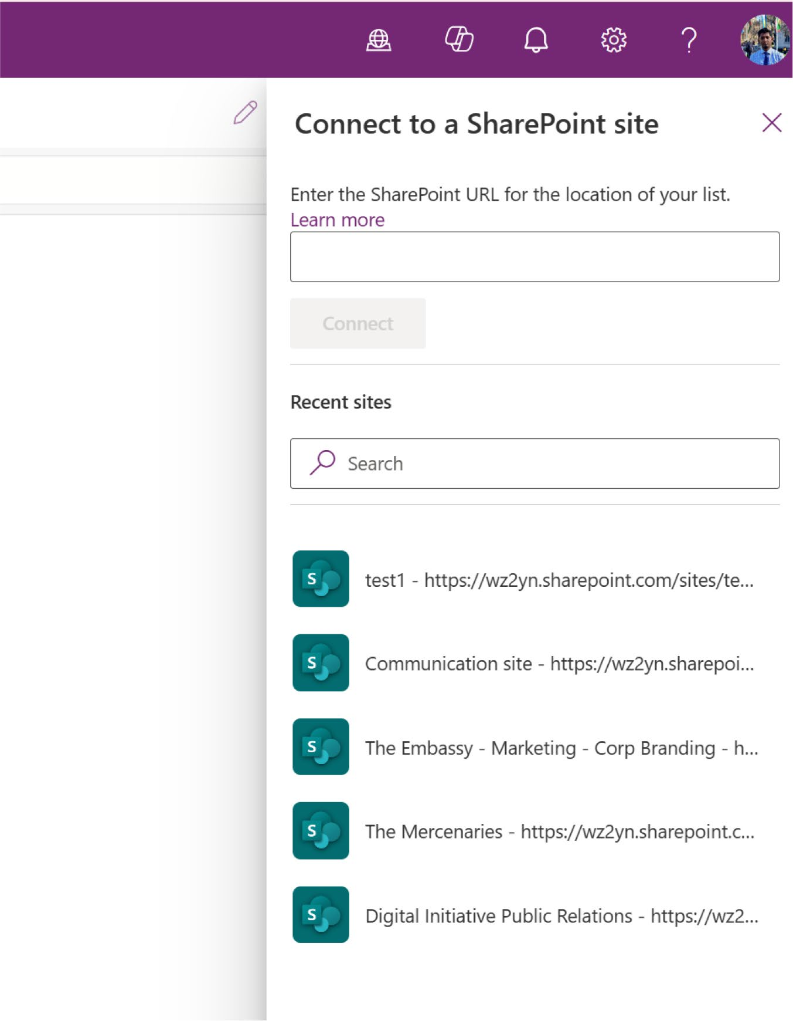

Figure 8-39. SharePoint site list in Power Apps

Chapter 8 IntegratIng DIverse Data sourCes anD MeDIa In power apps
3. As shown in Figure 8-40, select the SharePoint site
where your list is saved, choose the list, and click Connect.
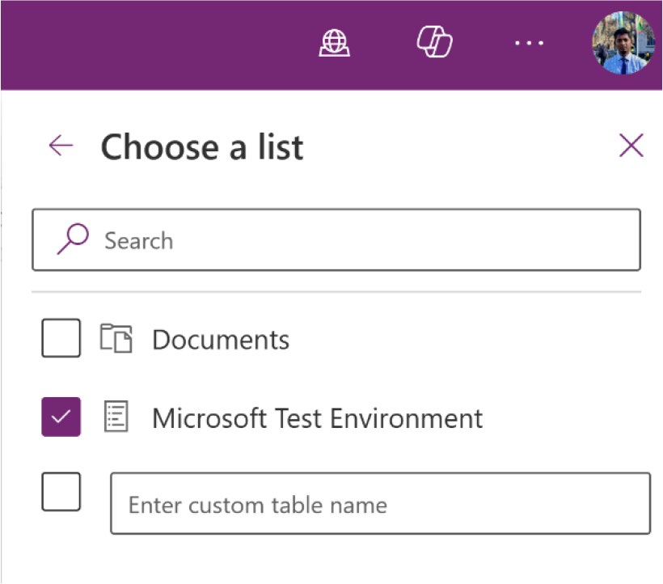

Figure 8-40. Choosing the list in from the SharePoint
connector option

4. It will take a few moments to connect. After a
successful connection, you will see the SharePoint data source listed in the Data option, as shown in
Figure 8-41.

Chapter 8 IntegratIng DIverse Data sourCes anD MeDIa In power apps
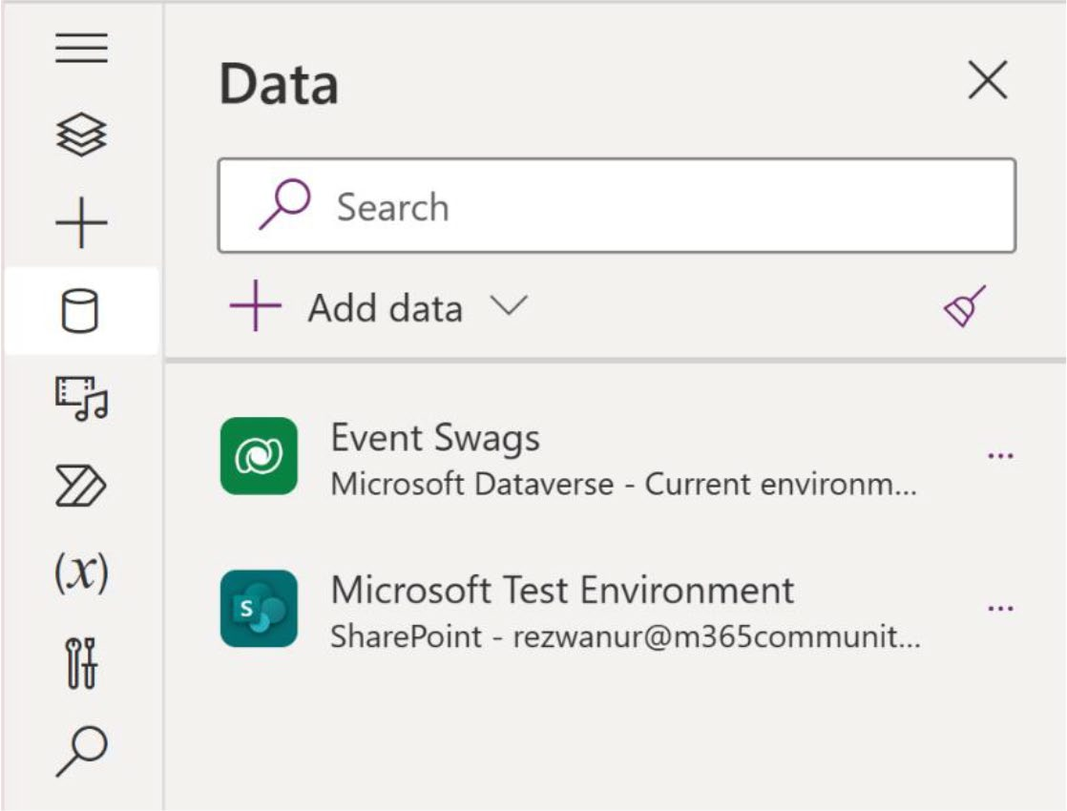

Figure 8-41. Showing the SharePoint list in the Data source option

5. Now, add a Data Table using the Insert option, as
shown in Figure 8-42.
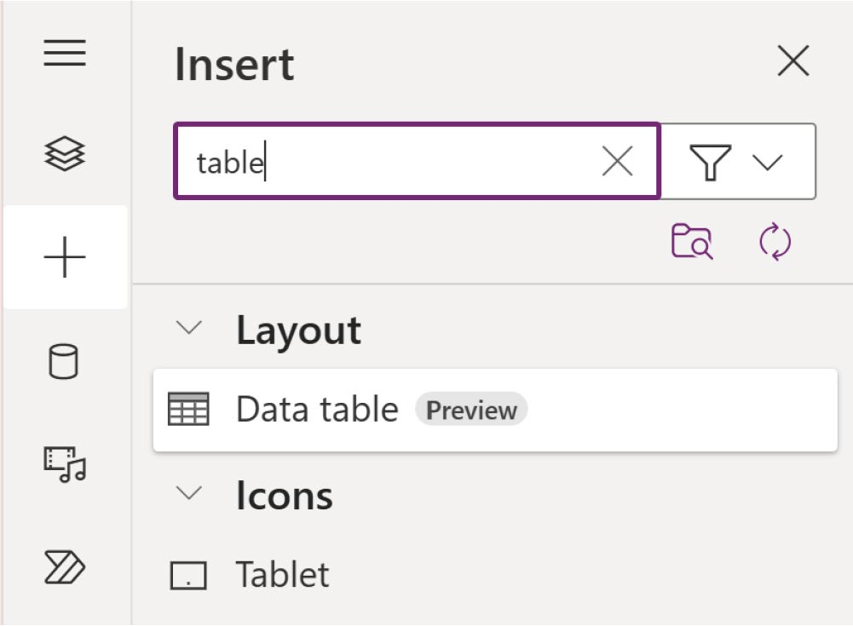

Figure 8-42. Adding a Data Table to fetch data

Chapter 8 IntegratIng DIverse Data sourCes anD MeDIa In power apps
6. You will now see a page where Power Apps asks you
to connect the data source. As shown in Figure 8-43, choose the SharePoint Data Source that you added a few minutes before.
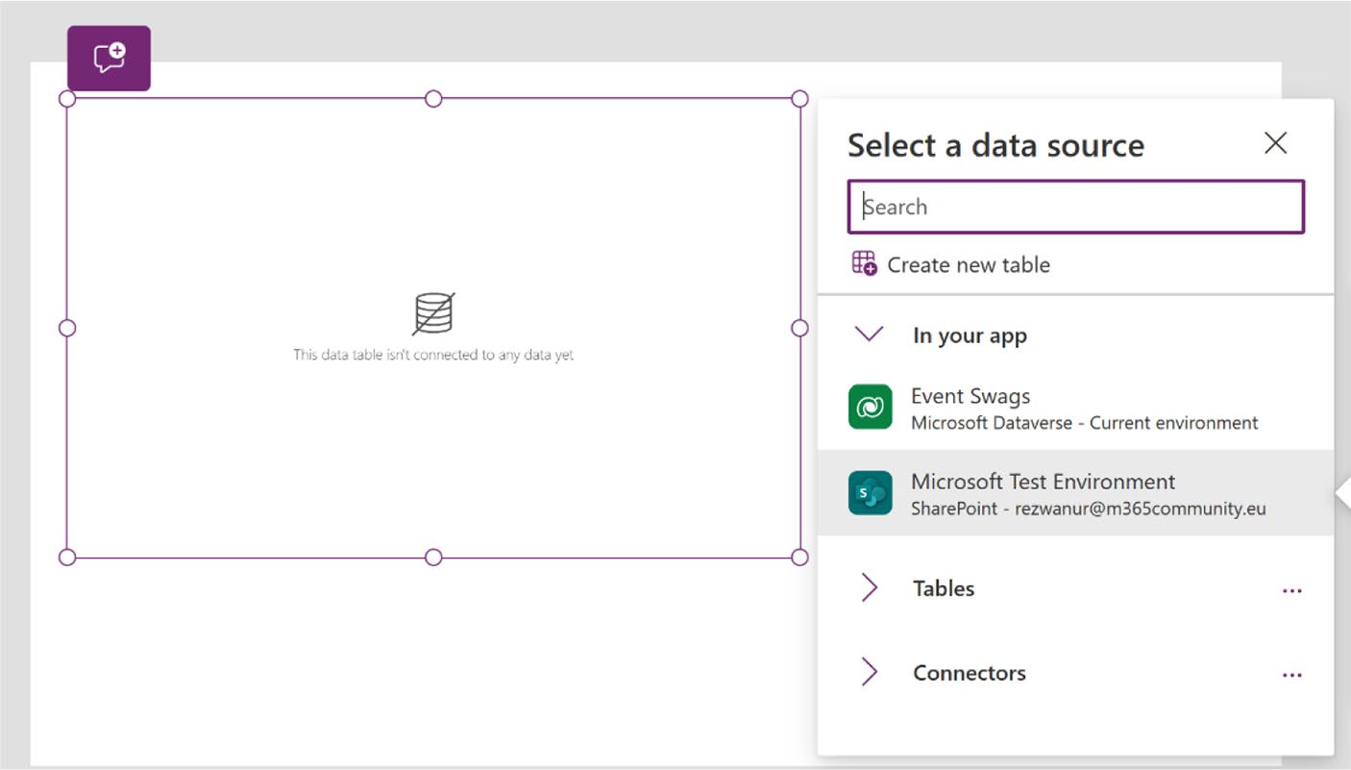

Figure 8-43. Adding a SharePoint data source to the Data Table

7. Next, you will see the SharePoint table displayed in
Power Apps. See Figure 8-44.

Chapter 8 IntegratIng DIverse Data sourCes anD MeDIa In power apps
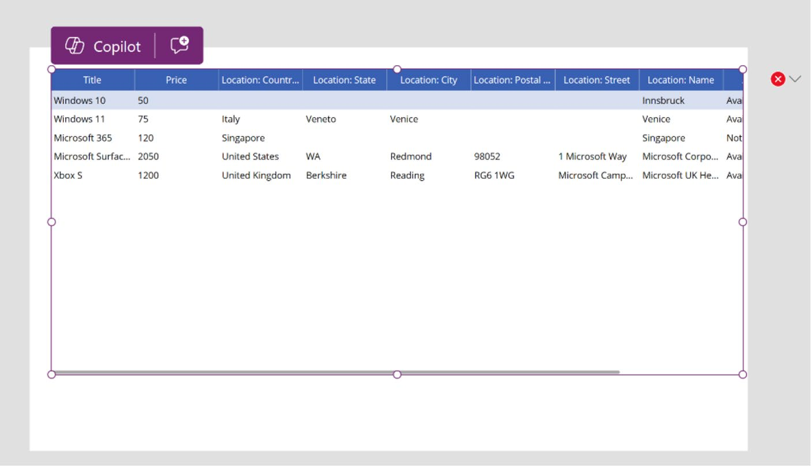

Figure 8-44. Showing SharePoint data in the Data Table

The Difference Between Microsoft List and SharePoint List
Microsoft Lists and SharePoint Lists are both integral components of the Microsoft 365 ecosystem, although they serve slightly different purposes and offer distinct user experiences:
• Microsoft Lists is an evolution of SharePoint Lists,
designed as a versatile app within Microsoft 365. It supports task management and information tracking with a modern interface, providing advanced templates and customization options suitable for diverse organizational needs.
• SharePoint Lists, traditionally embedded in SharePoint
sites, focus on data management and storage. While functional, they feature a more conventional interface and offer basic templates compared to the enhanced, user-centric capabilities of Microsoft Lists.

Chapter 8 IntegratIng DIverse Data sourCes anD MeDIa In power apps
By default, when you create a list in Microsoft SharePoint, it will open
in Microsoft List. Also, if you create a list in Microsoft List, you can directly
create a Power Apps from the Integrate option.

Note power apps does not support all types of sharepoint
data. Learn more here: https://learn.microsoft.com/
en-us/power-apps/maker/canvas-apps/connections/
connection-sharepoint-online#known-issues

Adding an Azure SQL Data Source
You will now see how to connect an Azure SQL database in Power Apps.
But before proceeding with the Azure SQL database, you need to meet the
following prerequisites:
• Enable pop-ups in your browser settings.
• An Azure subscription is required. If you do not have
one, you can create a free account. Follow this link
to create an account: https://azure.microsoft.
com/free/.
• Access to an existing SQL database is necessary. If
you do not have access, you need to create a new database. I show you how to create a SQL database in Microsoft Azure.
• Modify your firewall settings to allow Azure services
access to your SQL Database server.
• Ensure that your SQL database table includes at least
one column with a text data type.

Chapter 8 IntegratIng DIverse Data sourCes anD MeDIa In power apps

Note If you are a valid student, you can claim $100 azure credit
free from Microsoft. Check it out from here: https://azure.
microsoft.com/en-us/free/students/ . no credit or debit card
is required to get the azure student account.

Let’s explore this process:
1. To access Azure Portal, navigate to https://portal.
azure.com/. Once you’re there, use the tenant admin credentials that are also used for Power Apps to sign in.
2. Click Azure Services, select Database from the
Category located in the left sidebar, and choose SQL Database under the Azure SQL option, as shown in
Figure 8-45.
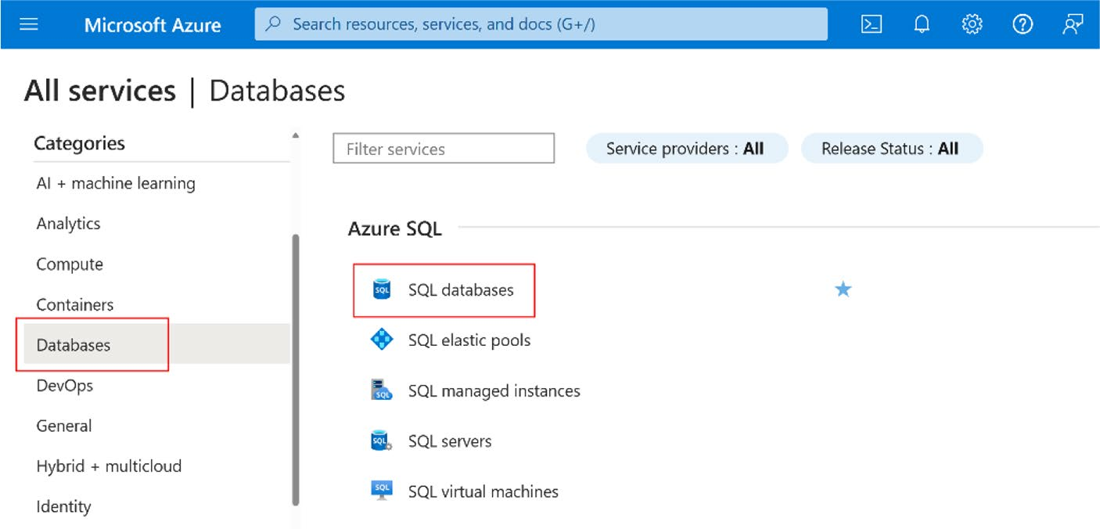

Figure 8-45. Creating an Azure SQL database in the Azure Portal

Chapter 8 IntegratIng DIverse Data sourCes anD MeDIa In power apps
3. Click Create in the top bar to create an Azure SQL
database, as shown in Figure 8-46.
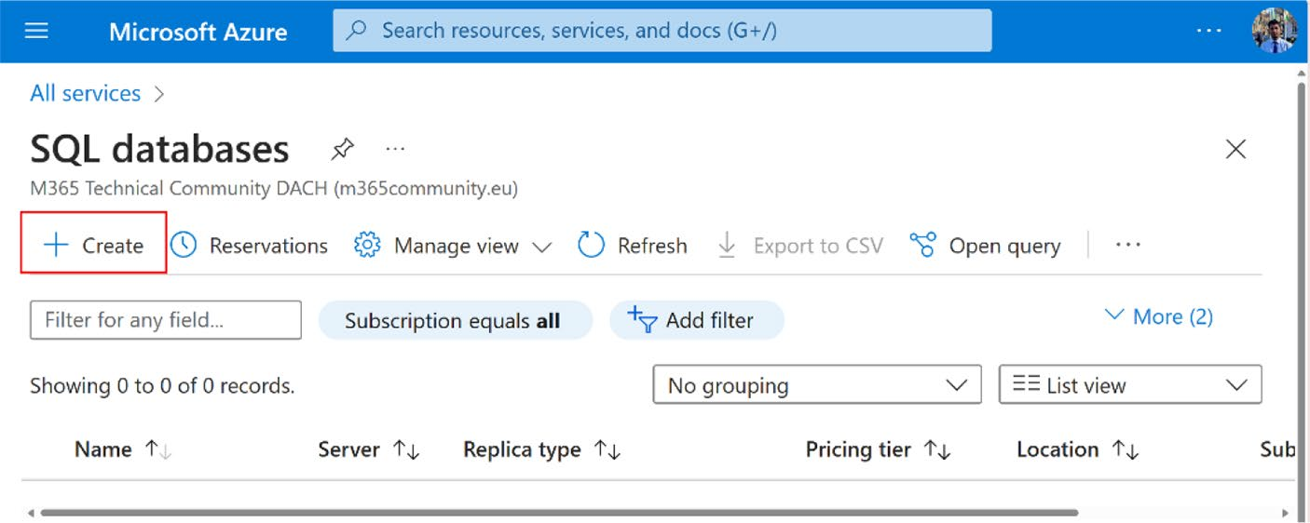

Figure 8-46. Creating an Azure SQL database

4. When you select the Create option, a form will
appear with several important fields, as shown in
Figure 8-47.

Chapter 8 IntegratIng DIverse Data sourCes anD MeDIa In power apps
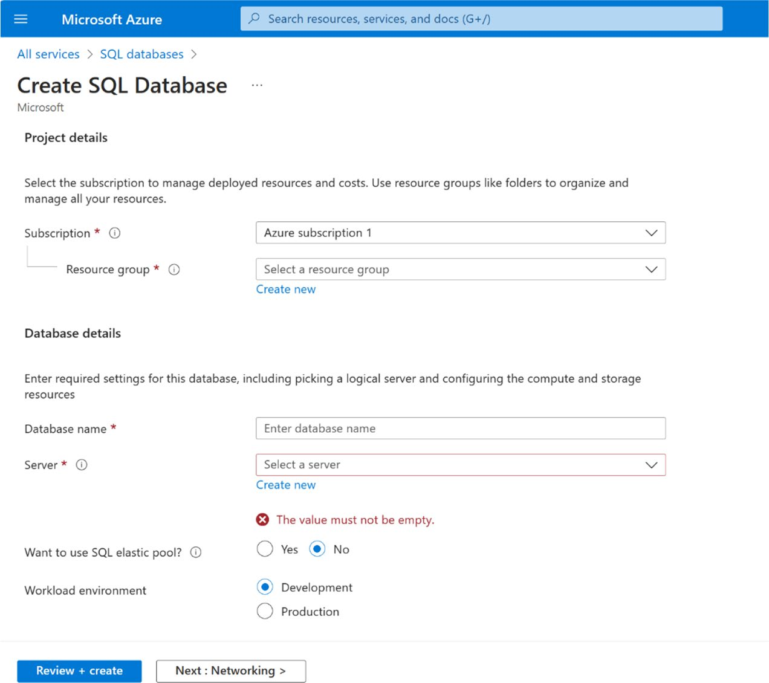

Figure 8-47. Information that is needed to create Azure SQL database

Here is the description of the entries on that form:
a. Subscription: If you have multiple Azure
subscriptions, choose your Azure subscription from here. If you have one subscription, choose that one.
b. Resource Group: A resource group in Azure is a
container that holds related resources for an Azure solution. This grouping helps organize and manage assets as a single unit based on project, service, or lifecycle. If you do not have a resource group, click Create New and provide a name to create a new Resource Group.

Chapter 8 IntegratIng DIverse Data sourCes anD MeDIa In power apps
c. Database name: Provide a name of your database.
d. Server: To deploy a database for any solution in
Azure or another cloud service, you must first select a server that will host and run the solution. If you do not have a server, click Create New. The page shown
in Figure 8-48 will open.
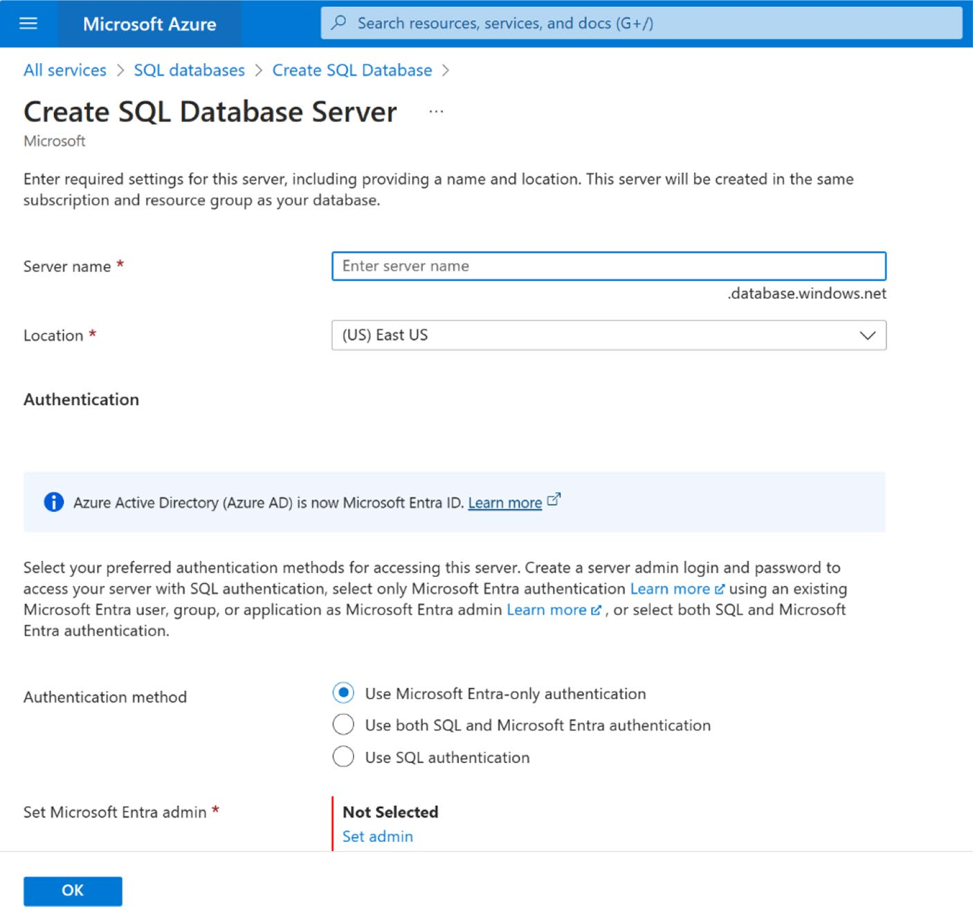

Figure 8-48. Creating SQL database server

Chapter 8 IntegratIng DIverse Data sourCes anD MeDIa In power apps
Provide a server name and choose the
location. Choose the Use Microsoft Entra-Only Authentication method. Also, select an admin responsible for managing the server.
5. Next, the Networking page will appear. On this page,
enable the Add Current Client IP Address option, as
shown in Figure 8-49.
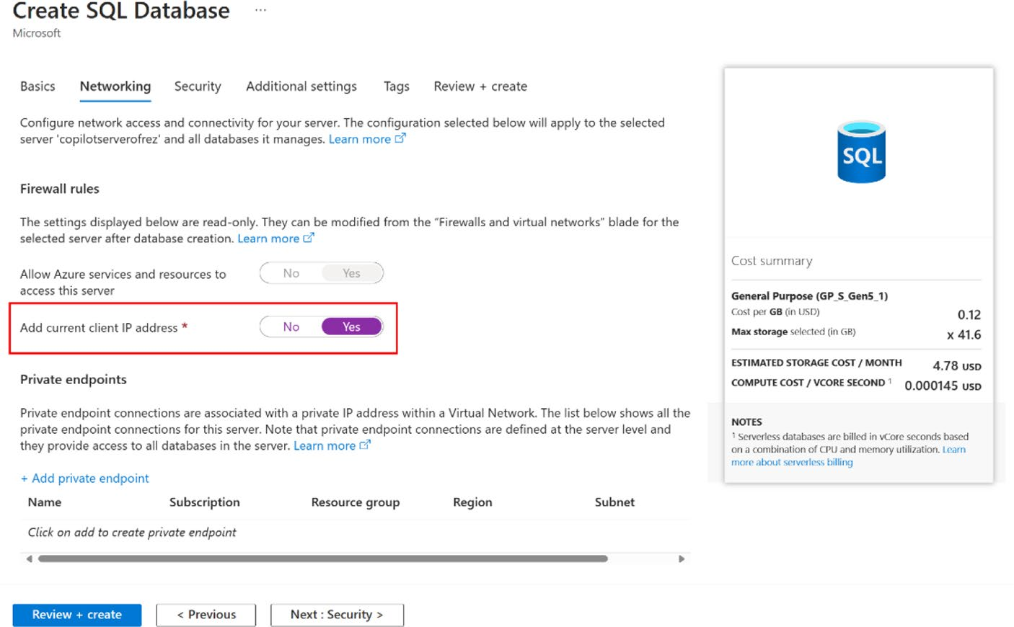

Figure 8-49. Configuring the network option in the Azure SQL database

6. Choose your required settings from Security,
Additional Settings, and Tags, after that,
click Review + Create.
It will display the monthly cost required for this
Azure SQL database, as shown in Figure 8-50.

Chapter 8 IntegratIng DIverse Data sourCes anD MeDIa In power apps
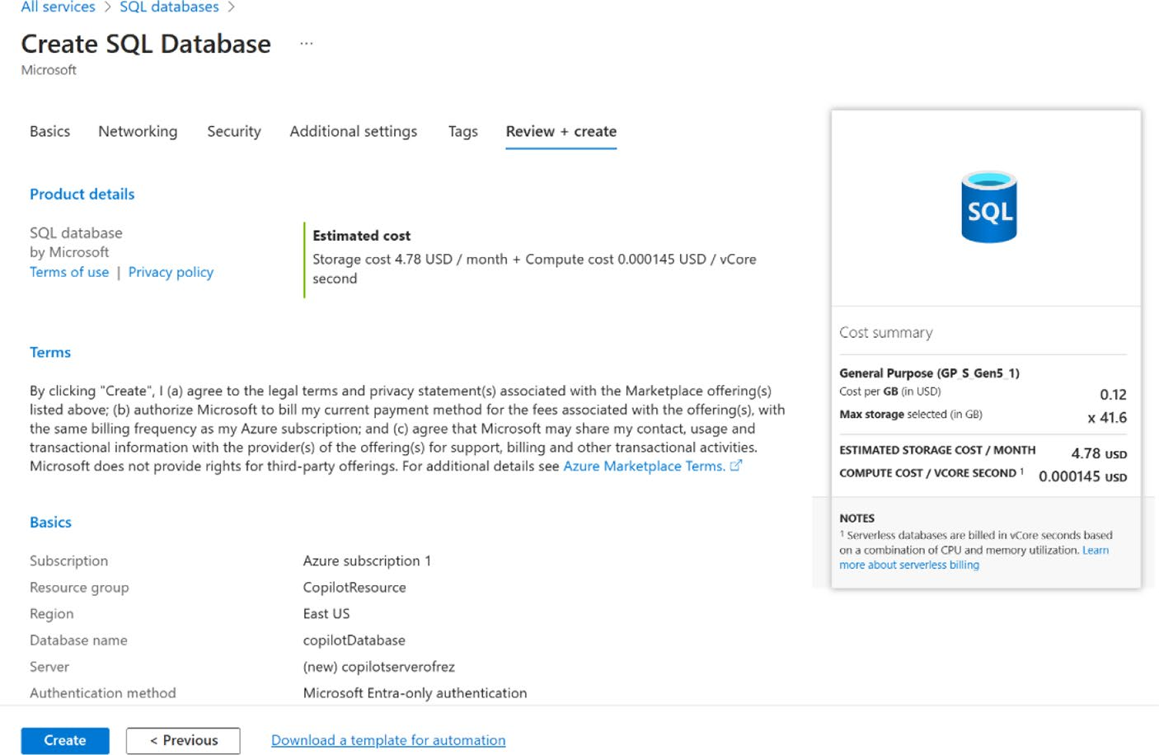

Figure 8-50. Review + Create page of SQL database, where you can
see how much you'll pay every month

7. It will take a few minutes to create the database in
Azure SQL, as shown in Figure 8-51.

Chapter 8 IntegratIng DIverse Data sourCes anD MeDIa In power apps
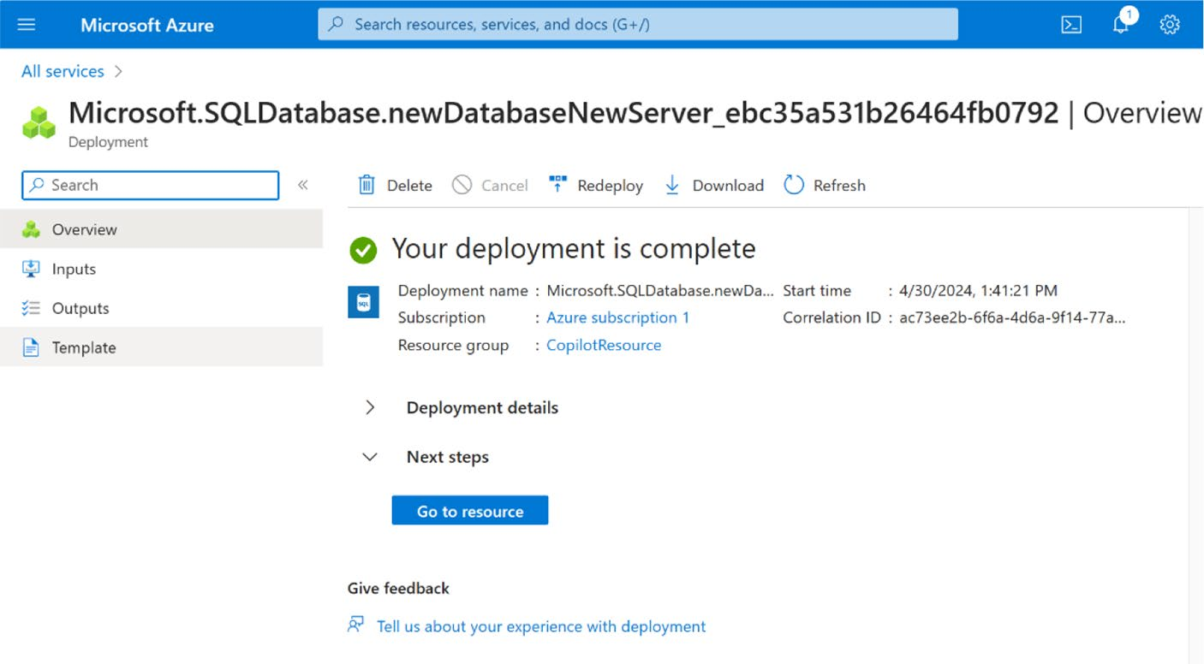

Figure 8-51. Azure SQL Database deployment confirmation page

8. This step requires you to create a new table and
populate it with data. Since Power Apps relies on tables and data for display within the app, you can create a table and add some sample data by clicking the Query Editor in the left panel, as shown in
Figure 8-52.

Chapter 8 IntegratIng DIverse Data sourCes anD MeDIa In power apps
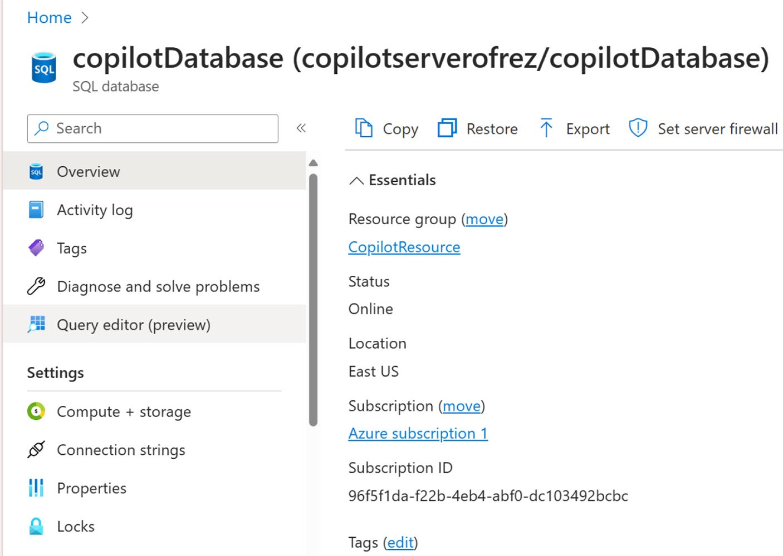

Figure 8-52. Select the Query Editor to edit the Azure SQL database

9. You will be prompted to log in using either a
SQL Server Authentication or Microsoft Entra
Authentication, as shown in Figure 8-53. I use the Microsoft Entra Authentication since I am already logged in with that user.

Chapter 8 IntegratIng DIverse Data sourCes anD MeDIa In power apps
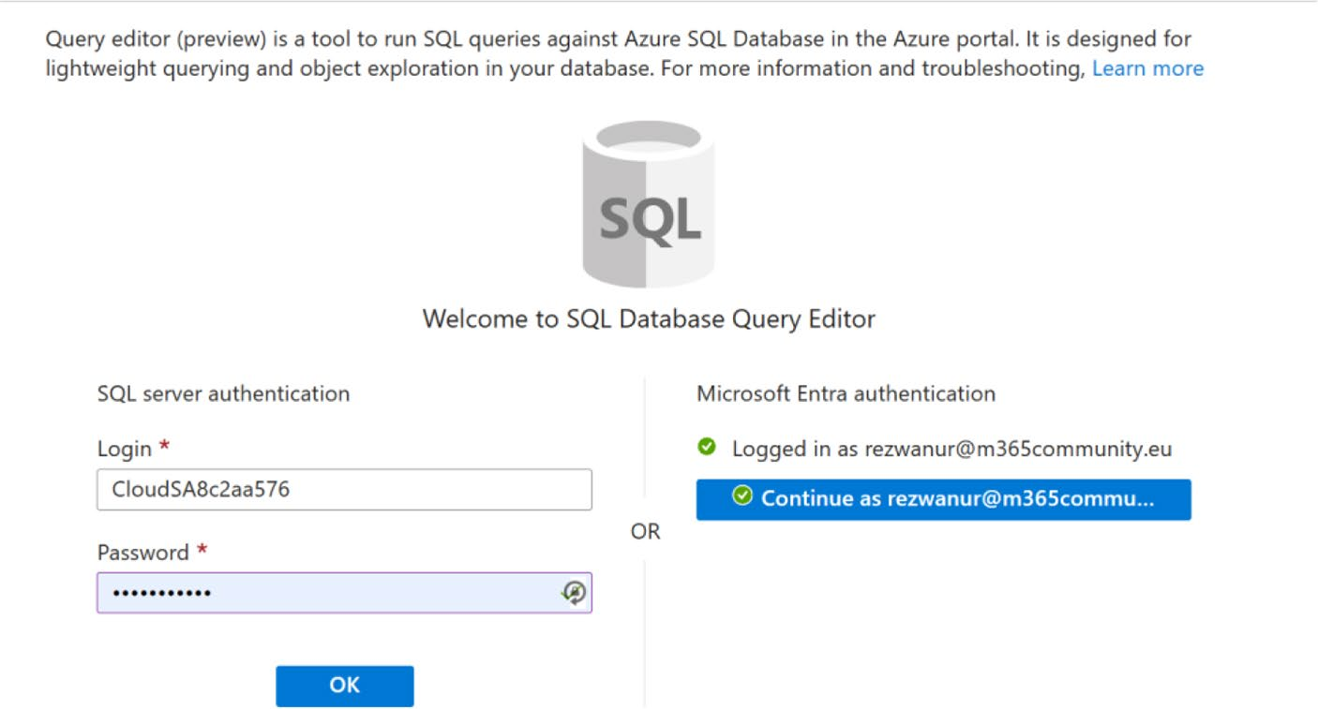

Figure 8-53. Choose the authentication method to access SQL database Query Editor

10. You need to run a SQL query to create a table and
add data. After login, a page will pop up where you
must run the SQL query, as shown in Figure 8-54.

Chapter 8 IntegratIng DIverse Data sourCes anD MeDIa In power apps
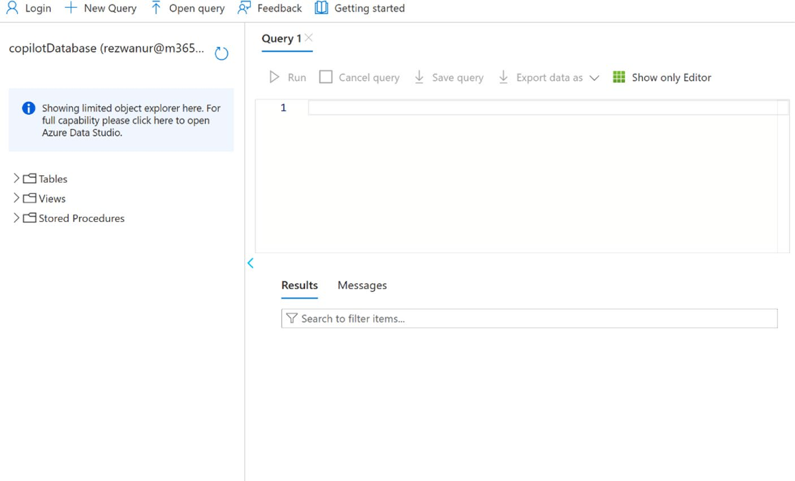

Figure 8-54. Field to run the SQL query in the Query Editor

11. In the Query 1 box, run the following SQL command
to create a table named MicrosoftCopilotBook with three columns named Users, Location and
DateofBirth, as shown in Figure 8-55.
CREATE TABLE MicrosoftCopilotBook (
Users VARCHAR(255),
Location VARCHAR(255),
DateofBirth DATE
);

Chapter 8 IntegratIng DIverse Data sourCes anD MeDIa In power apps
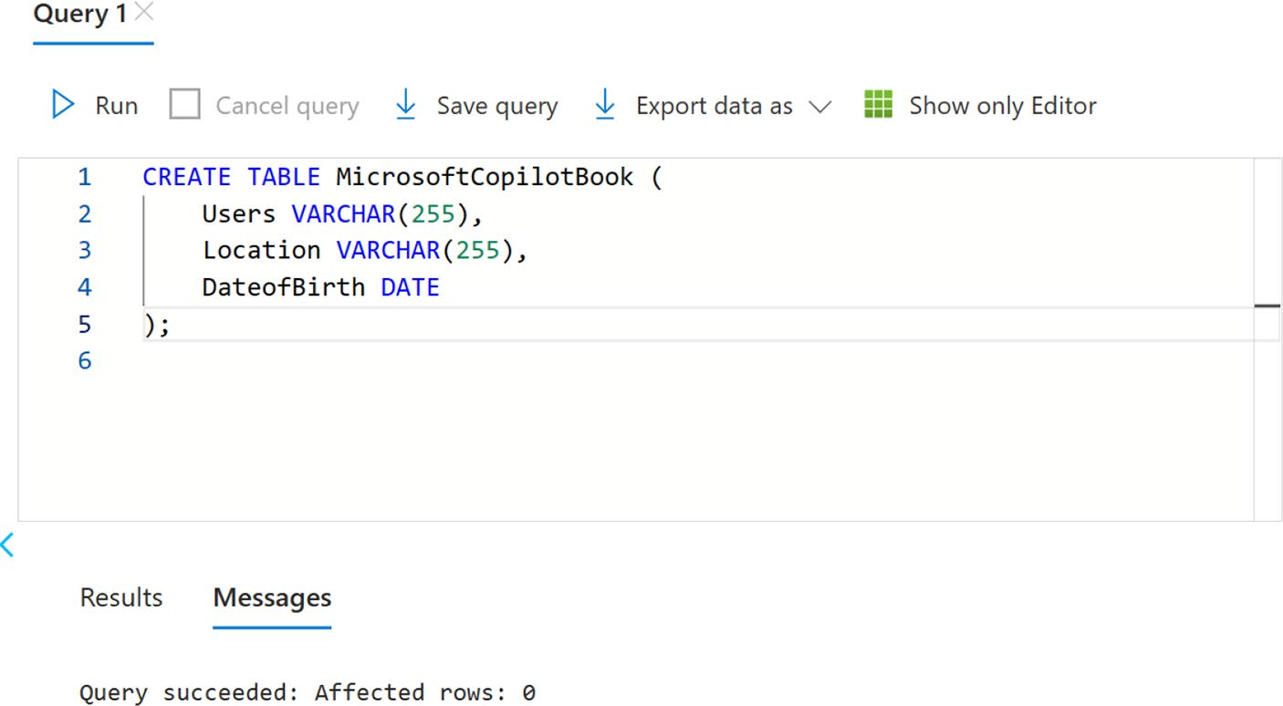

Figure 8-55. Query to create a table named MicrosoftCopilotBook with the Users, Location, and DateofBirth columns

If you want to learn more about SQL query, see
the Microsoft official documentation at https://
learn.microsoft.com/en-us/azure/azure-sql/
database/connect-query-portal?view=azuresql.
12. You can also run a query in your natural language to
Copilot web (https://copilot.microsoft.com), as
shown in Figure 8-56.

Chapter 8 IntegratIng DIverse Data sourCes anD MeDIa In power apps
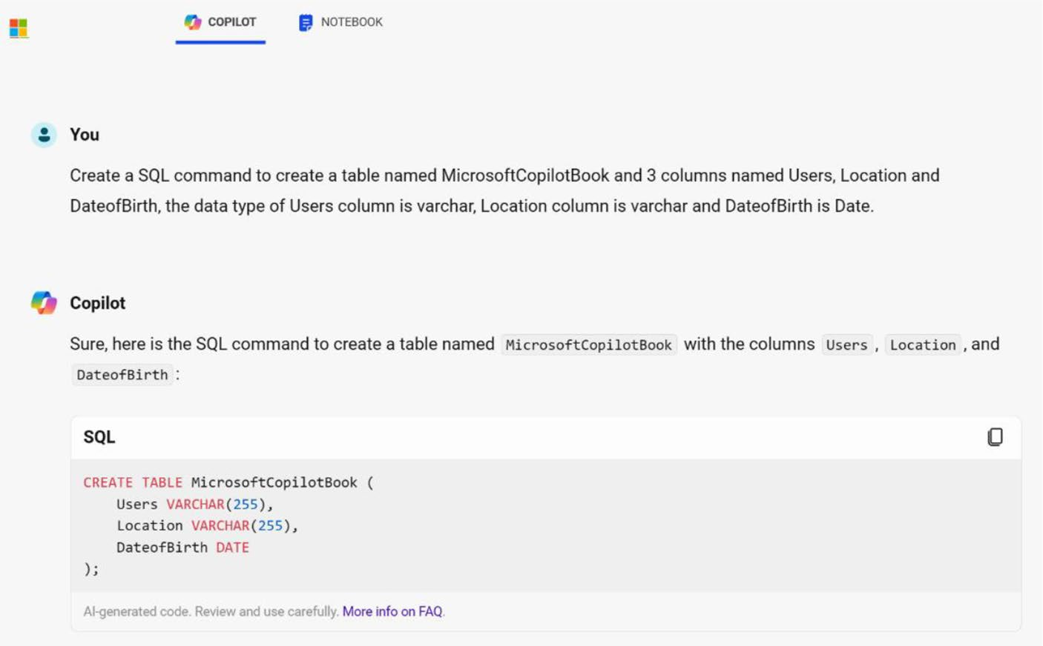

Figure 8-56. Asking Copilot to create a SQL query

13. After executing the command, as shown in
Figure 8-57, you will see that the table and its columns have been created.
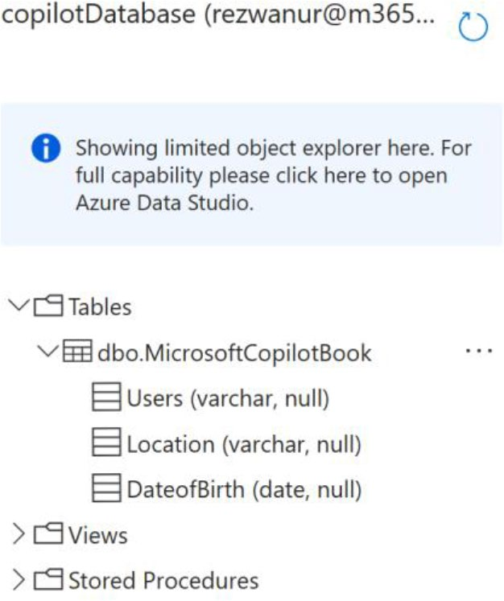

Figure 8-57. The table and columns have been successfully created

Chapter 8 IntegratIng DIverse Data sourCes anD MeDIa In power apps
14. Add some data to the table, as shown in Figure 8-58.
To add data, use this command:
INSERT INTO MicrosoftCopilotBook
(Users, Location, DateofBirth)
VALUES
('Rahat', 'Innsbruck', '1993-10-23'),
('Munia', 'New York', '1996-06-12'),
('Ruhi', 'Dhaka', '2003-03-13'),
('Sonia', 'London', '1996-06-12');
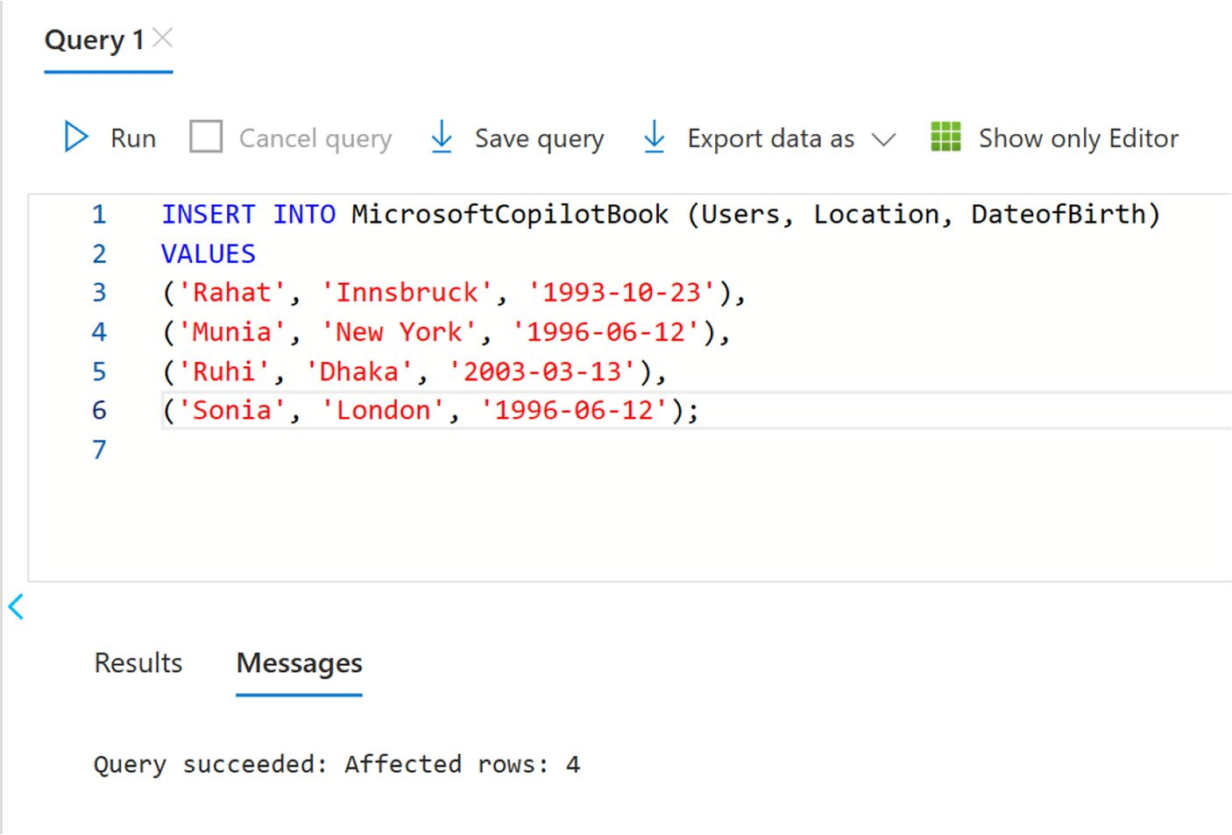

Figure 8-58. SQL query to add data to a table

15. Next, check if the data was successfully saved in the
table, as shown in Figure 8-59. To verify this, run the following command:
SELECT * FROM MicrosoftCopilotBook;

Chapter 8 IntegratIng DIverse Data sourCes anD MeDIa In power apps
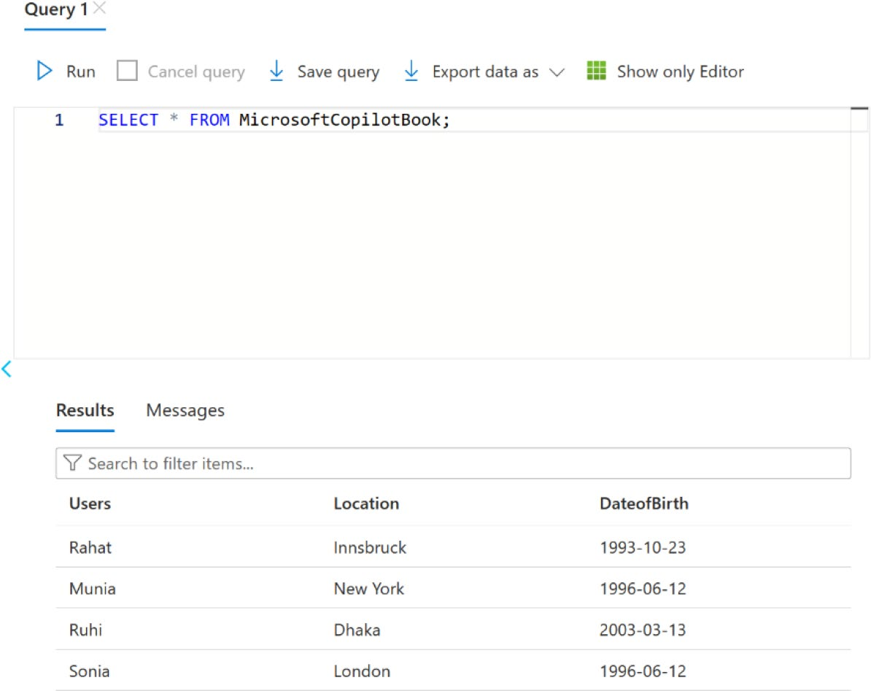

Figure 8-59. Verifying table data
The data is displaying correctly as per the
command, confirming that the command
functioned perfectly. Next, you will integrate this table with dummy data into Power Apps.
16. Go to https://make.powerapps.com/ and create a
new Canvas app.
17. Click Data in the left sidebar and connect SQL
Database from Connector, as shown in Figure 8-60.

Chapter 8 IntegratIng DIverse Data sourCes anD MeDIa In power apps
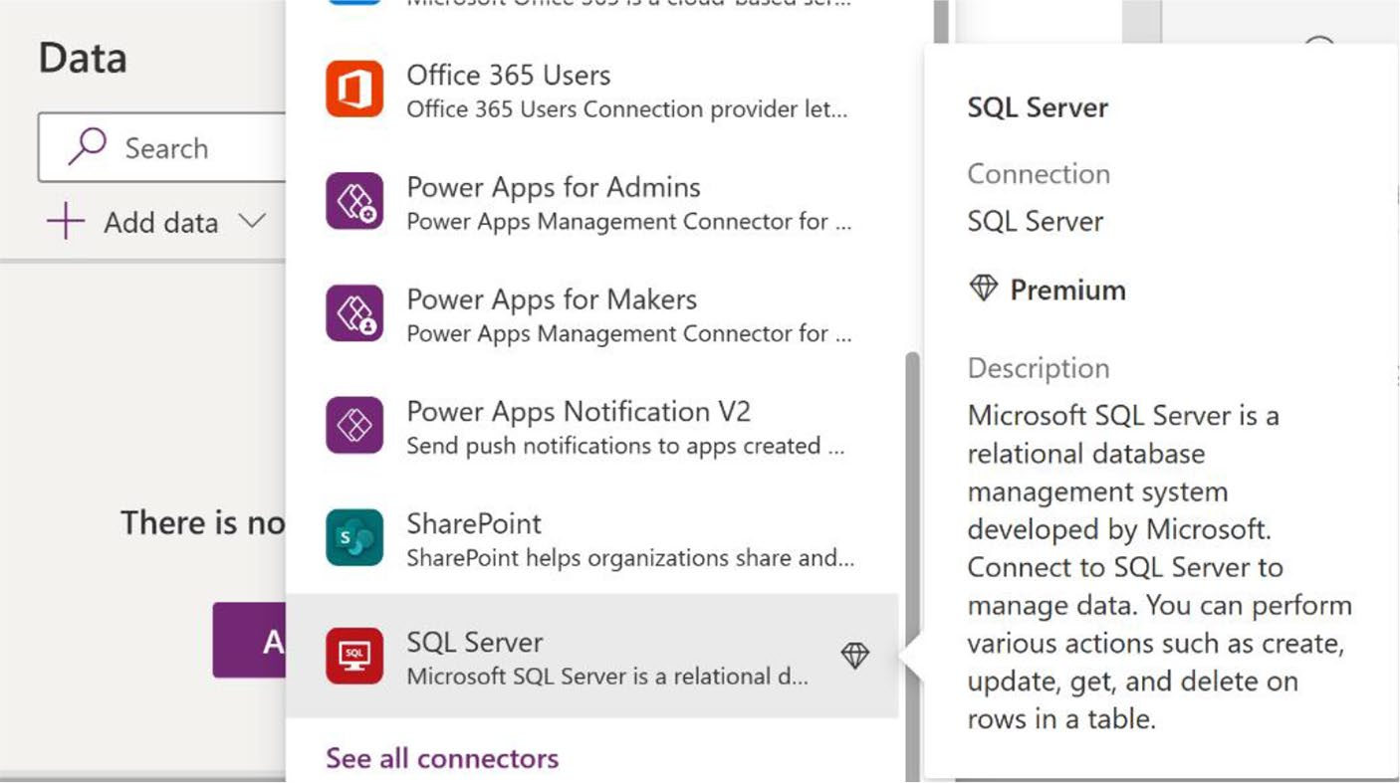

Figure 8-60. Select SQL Server from Connector to get the Azure SQL database in Power Apps

Note sQL server is considered a premium connector within power
apps, requiring a premium license to utilize this feature. the cost of
the license may vary by country. For more details on the power apps
premium license, visit the official Microsoft website at https://
powerapps.microsoft.com/en-us/pricing/

18. As shown in Figure 8-61, click Add a Connection.

Chapter 8 IntegratIng DIverse Data sourCes anD MeDIa In power apps
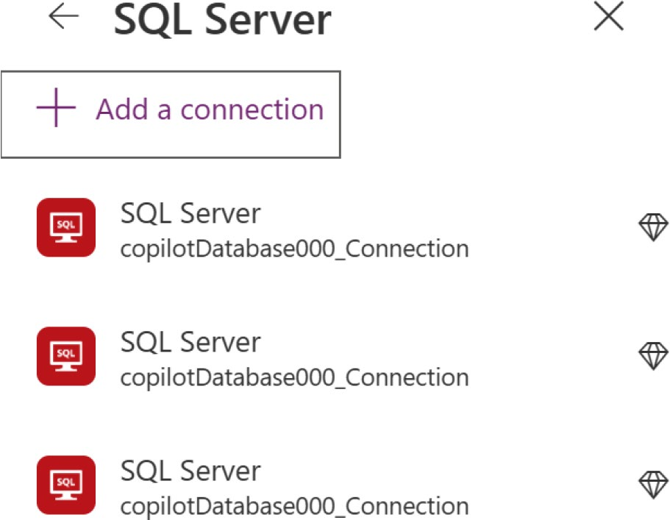

Figure 8-61. Adding a SQL Server connection in Power Apps

19. Choose Microsoft Entra ID Integrated from
Authentication Type, as shown in Figure 8-62. Click Next after selecting the authentication type.
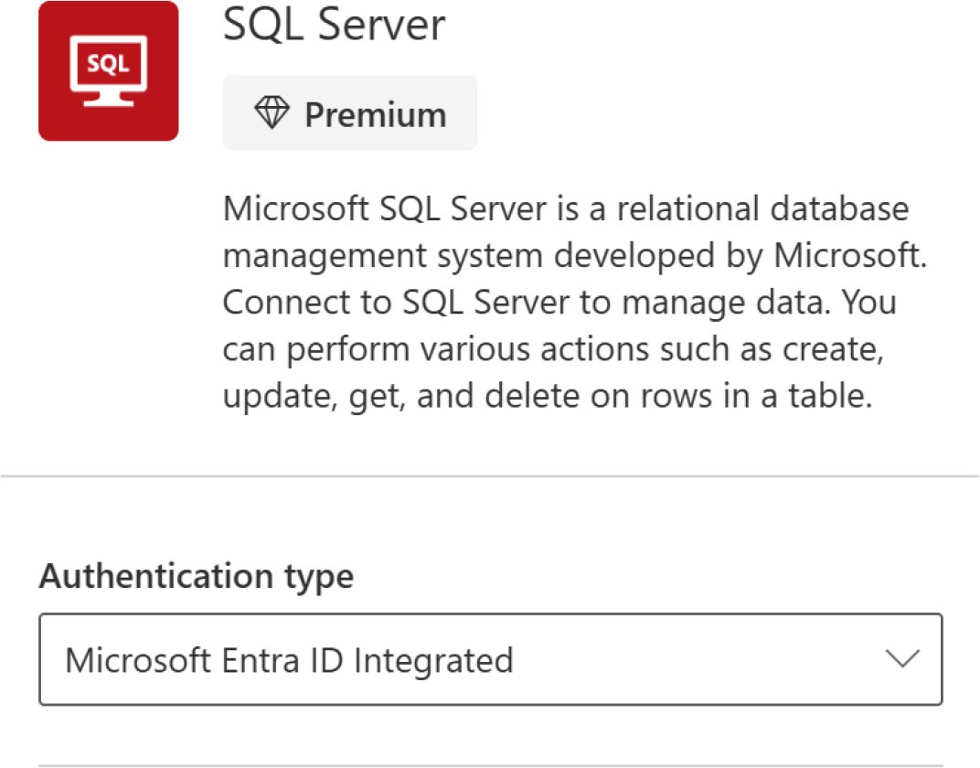

Figure 8-62. Selecting the authentication type in SQL Server

Chapter 8 IntegratIng DIverse Data sourCes anD MeDIa In power apps
20. In the next part, provide the SQL Server Name and
the SQL Database Name, as shown in Figure 8-63. You can get the information from the Azure SQL
database overview page, as shown in Figure 8-64.
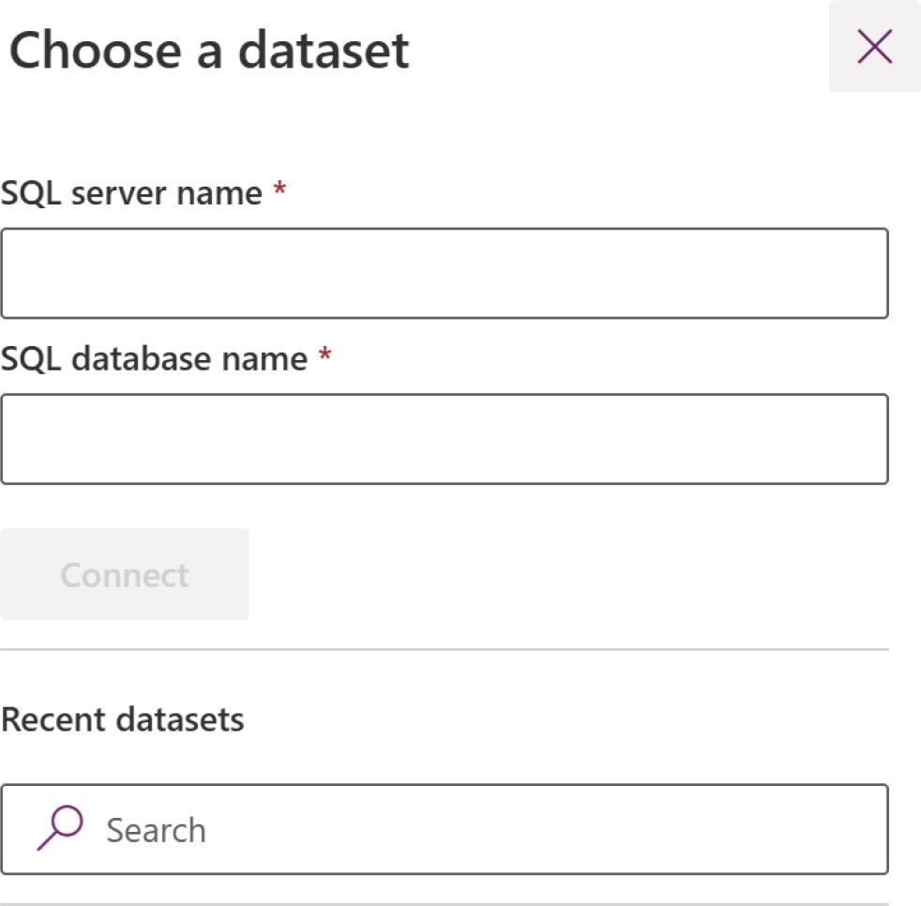

Figure 8-63. Provide the SQL Server name and SQL database name to connect SQL Server with Power Apps

Chapter 8 IntegratIng DIverse Data sourCes anD MeDIa In power apps
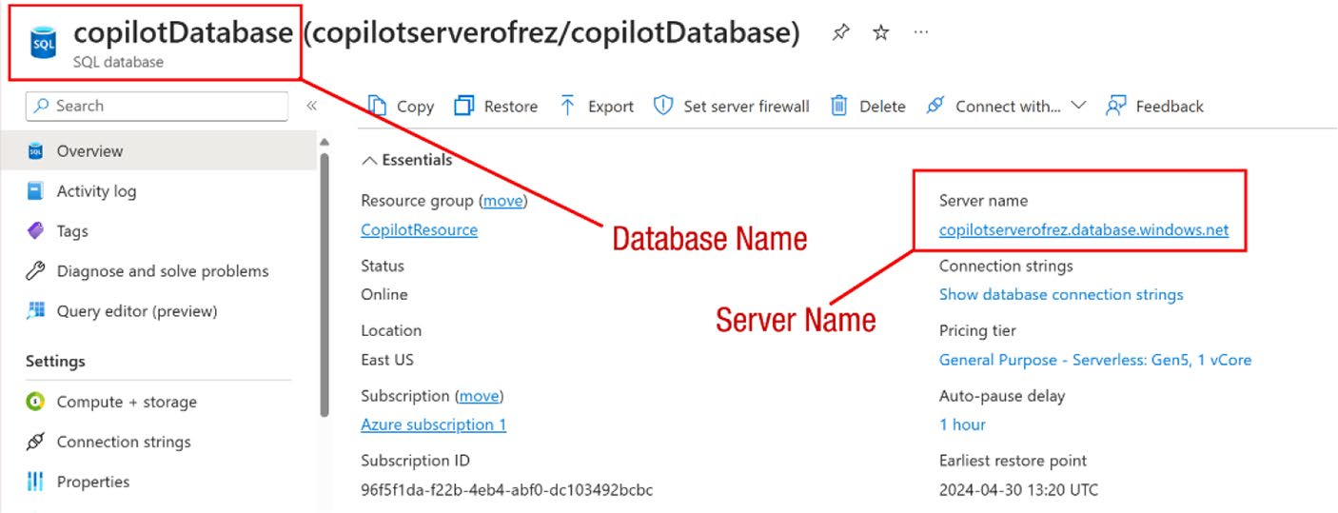

Figure 8-64. Find your SQL Server name and SQL Database name
from the Azure SQL Database overview page

21. After providing the SQL Database Name and the
SQL Server Name, you will be asked to select a table from those available on your server, as shown in
Figure 8-65.
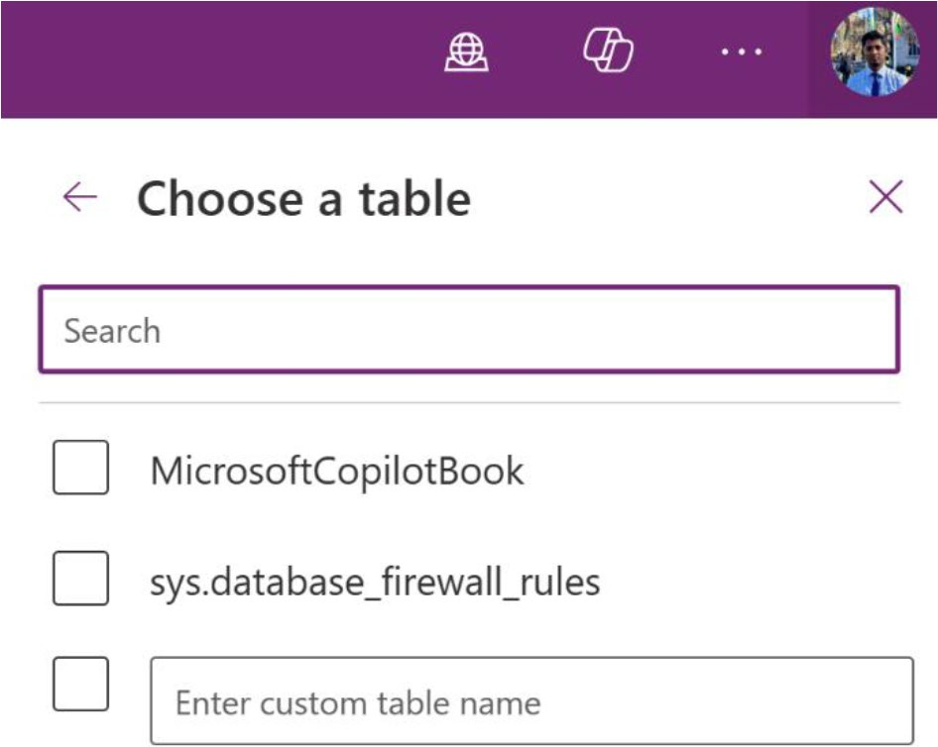

Figure 8-65. Select the table that you want to connect with your
Power Apps

Chapter 8 IntegratIng DIverse Data sourCes anD MeDIa In power apps
22. Select the table and click Connect.
23. After that, you can see the SQL Database in the Data
list, as shown in Figure 8-66.
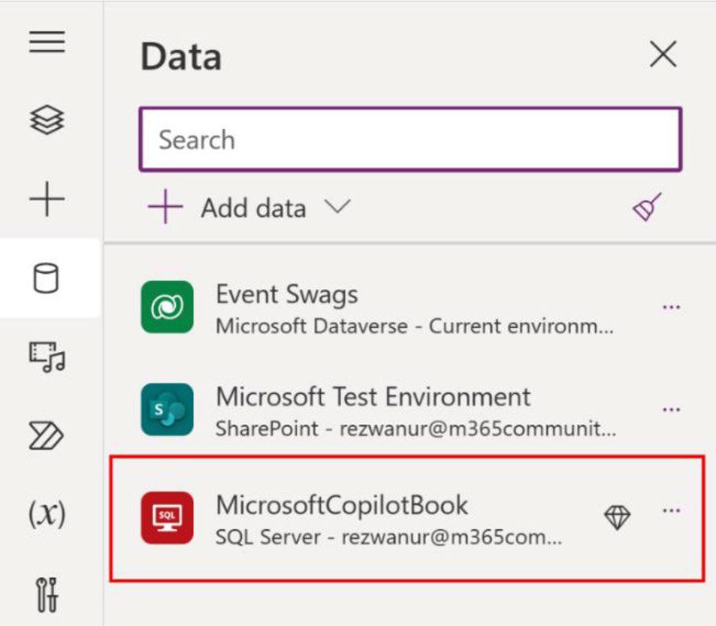

Figure 8-66. Showing Azure SQL Database list in the Data source option

24. Add a Data Table control using the Insert option to
the screen and connect the SQL Server as the data source. You will see the data coming from Azure
SQL database, as shown in Figure 8-67.

Chapter 8 IntegratIng DIverse Data sourCes anD MeDIa In power apps
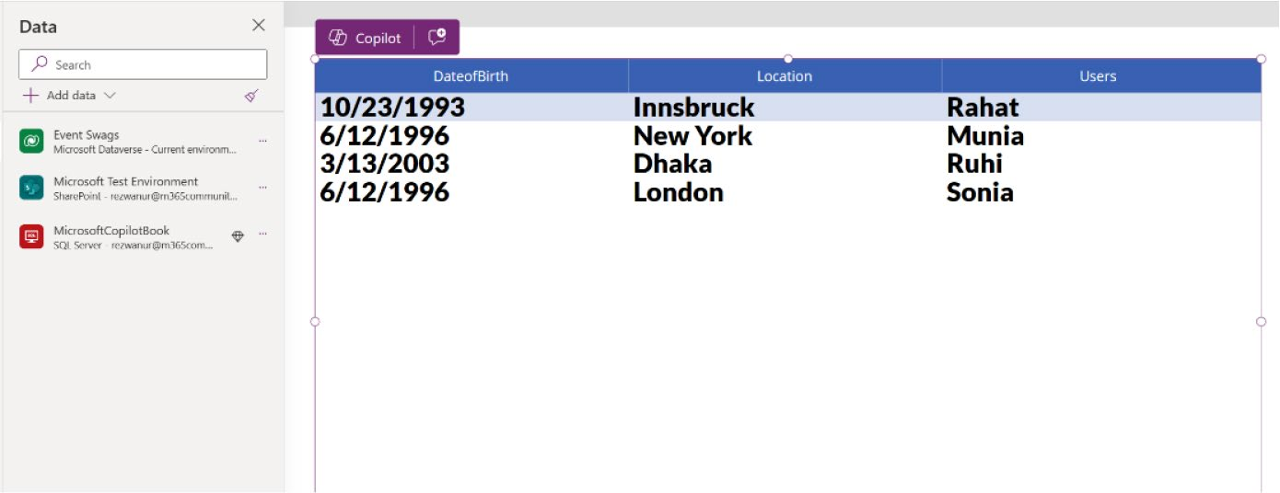

Figure 8-67. Successfully fetching data from the Azure SQL database

25. You might have noticed that there is an option in
the Azure SQL Database portal to connect SQL
Database to Power Apps, as shown in Figure 8-68. Let me explain to you why I did not use this option.
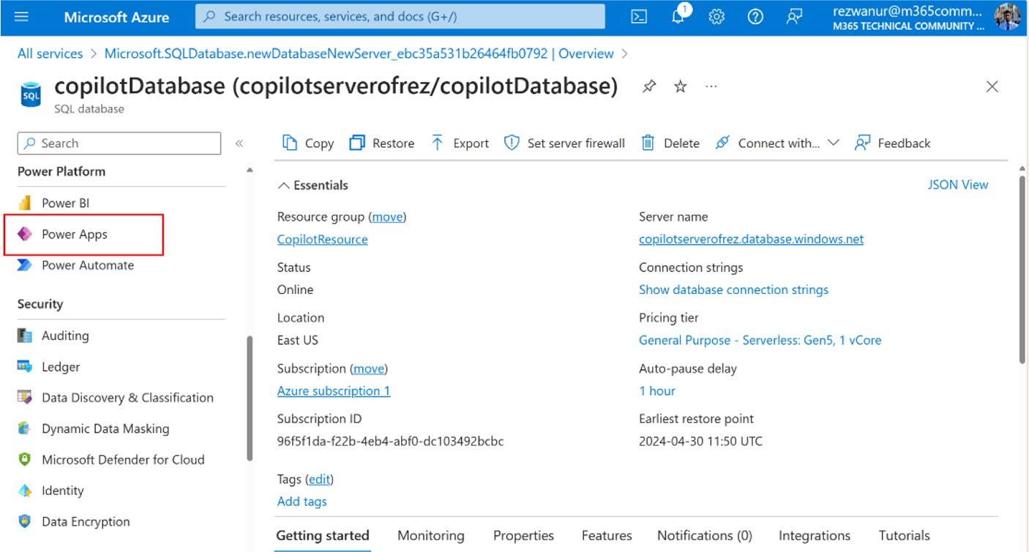

Figure 8-68. Power Apps option in the Azure SQL database

Chapter 8 IntegratIng DIverse Data sourCes anD MeDIa In power apps
26. If you click Power Apps, in the next page, you will be
asked for some essential information, as shown in
Figure 8-69.
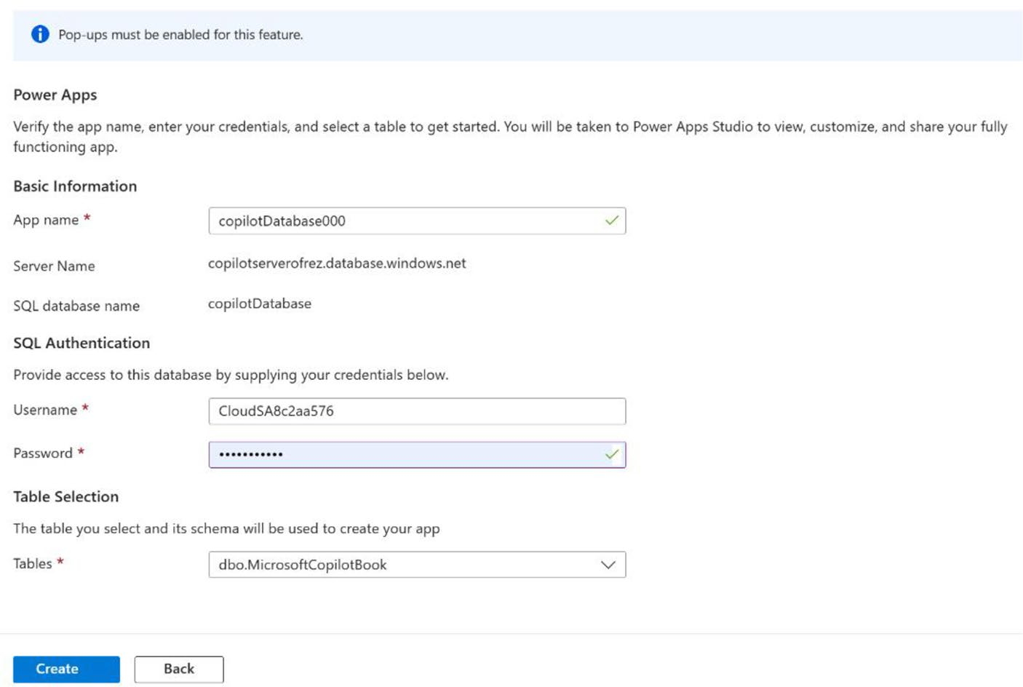

Figure 8-69. Information needed to create Power Apps from the Azure Portal

As you used Microsoft Entra authentication previously (see
Figure 8-69), you do not have the SQL authentication username and
password. To learn more, see the Microsoft documentation at https://
learn.microsoft.com/en-us/power-apps/maker/canvas-apps/app-
from-azure-sql-database.

Note to utilize Microsoft entra Integrated authentication with
an azure sQL database rather than sQL authentication, consider
creating an app through power apps and employing the sQL server
connector.

Chapter 8 IntegratIng DIverse Data sourCes anD MeDIa In power apps

Summary
This chapter explored how to integrate diverse data sources and
multimedia into Power Apps. I showed you how to create and customize
Dataverse tables, connect Power Apps to external data sources like
SharePoint and Azure SQL, and add multimedia elements like images,
videos, and pen input controls. These skills will help you make your apps
more dynamic, data-driven, and engaging for users.
As you move to Chapter 9, I introduce you to the powerful capabilities
of AI Builder in Power Apps. You will learn how to enhance your apps with
AI, automate tasks, and extract valuable insights from your data. Chapter 9
will help you create smarter, more proactive applications that can
significantly improve business processes and decision-making.

CHAPTER 9

Introducing AI Builder

in Power Apps

In the previous chapter, you gained hands-on experience in integrating
various data sources and multimedia elements into your Power Apps,
allowing you to build more interactive and data-driven applications. This
foundation of connecting external data sources and managing custom
tables sets the stage for creating robust, user-centric apps.
This chapter takes you a step further by introducing AI Builder
in Power Apps. You’ll discover how to harness the power of artificial
intelligence to automate processes, predict outcomes, and extract
meaningful insights from your data—all without needing any specialized
AI knowledge. By the end of this chapter, you’ll be equipped to add
intelligent features to your apps, making them not just functional, but also
proactive and insightful tools for your users.

AI Builder: Enhancing Power Apps
with AI Capabilities
Moving from the advanced customization techniques of the previous
chapter, this chapter introduces AI Builder—a transformative addition
within Power Apps that makes artificial intelligence accessible to every
app developer. AI Builder is a robust tool that seamlessly integrates with
© Rezwanur Rahman 2024 437
R. Rahman, Microsoft Copilot for Power Apps, Inside Copilot,

Chapter 9 IntroduCIng aI BuIlder In power apps
Power Apps and the broader Microsoft ecosystem. It enables you to automate processes, predict outcomes, and extract actionable insights from data without needing deep technical expertise in AI.
Imagine a Power App that manages customer data, predicts purchasing trends, automates responses based on customer behavior, and streamlines operations—all powered by AI. This capability is not just about enhancing functionality; it’s about transforming business operations, making them more responsive, efficient, and ahead of the curve.
In this section, I explore how AI Builder acts as a bridge between complex AI algorithms and the practical needs of business applications, empowering you to build smarter and more proactive apps. This tool revolutionizes your approach to app development by making advanced AI functionalities accessible and actionable.

AI Builder Overview
AI Builder in Power Apps is a key feature that enables users to easily add artificial intelligence to their applications. It offers a straightforward, no-code interface that simplifies the integration of AI capabilities. With AI Builder, users can automate routine tasks, analyze data more effectively, and make smarter decisions more quickly. The tool is equipped to handle a variety of common business needs, such as processing forms, detecting objects, and predicting outcomes, making sophisticated AI functionalities accessible to users who may not have a technical background. This not only makes creating AI models simpler but also ensures they can be easily trained and improved, right within Power Apps.

Chapter 9 IntroduCIng aI BuIlder In power apps

Types of AI Models Available
Power Apps provides a broad range of AI models that enhance the
automation and intelligence of applications. This includes pre-built AI
models that are ready-to-use for tasks like text recognition, extracting
information from text, and classifying categories. For solutions tailored to
specific needs, users can develop custom AI models using tools from AI
Builder and Azure Machine Learning. This flexibility enables businesses
to automate simple data entry tasks or undertake complex predictive
analytics, allowing them to deploy AI solutions that align precisely with
their operational needs and strategic objectives. Now, as you move
forward, you’ll learn about the unique characteristics and potential
applications of pre-built and custom AI models and explore how each can
be strategically utilized to reshape and energize your business processes.
In AI Builder, you have access to various model types that cater to
different business needs. Here are a few examples:
• To detect specific products in images, you can
customize and train an AI Builder object detection model to recognize the items you are interested in.
• To streamline your expense management, you can
employ a pre-built AI Builder model designed for scanning and processing business receipts, enabling immediate productivity enhancements.
• To create a marketing campaign that leverages insights
from past trends, you can develop a custom prediction model that utilizes your historical data to forecast future patterns.
These examples represent just a few of the numerous possibilities for
incorporating intelligence into your business workflows using AI Builder.

Chapter 9 IntroduCIng aI BuIlder In power apps

Note to continue using your aI models in aI Builder, you must
purchase an aI Builder add-on license. additionally, an administrator
is required to allocate aI Builder capacity to any environment in which
you intend to use aI Builder. without a license, you can’t create or
modify aI Builder models, and no new inferences are possible after
the trial period expires.

Model Types
Table 9-1 outlines the different data types, model types, and build types available.
Data type: This specifies the kind of AI each model utilizes, such as documents, text, structured data, or images.
Build type: This category shows whether a model is customizable—requiring you to build, train, and publish it according to your specific needs— or whether it’s a pre-built model that’s ready for immediate use. Generally, custom AI Builder models are ideal for unique business-specific data, while pre-built models are better suited for common scenarios across various industries.

Chapter 9 IntroduCIng aI BuIlder In power apps
)
d
ue
tin
con(
ype

Build T pre-built Custom pre-built pre-built pre-built pre-built pre-built pre-built (preview) and custom pre-built and custom

der
il
u
engineering

es in AI B promptpt yp analysis is used during (g preview)

d T able UniqueName mapping tionV2 il layout u scanning, prompt, scanning processing document d B wer extraction n emplate T recognition po ocument , a AI T BusinessCard document (d training) text receipt Invoice Identity gpt was used during textClassificaentity es
yp

odel T
tion
, M
es
yp tion (preview) lassifica a T ype y c at
f D reader tegor
Model T Business card reader document processing text recognition receipt processing Invoice processing Id text genera Ca entity extraction
st o
Li
ype
ble 9-1.
Ta Data T documents documents documents documents documents documents text text text

Chapter 9 IntroduCIng aI BuIlder In power apps

ype

Build T pre-built pre-built pre-built pre-built Custom Custom pre-built (preview) pre-built pre-built (preview)

proposal is

prediction detection
eneric bject
g (o predict
able UniqueName mapping

emplate T extraction tion pane detection analysis rediction, geside detection, description yp phrase transla ge recognition
AI T Key langua sentiment text Binar object used during training) Ima text Copilot

app Copilot

tion

) ype ge detection d description recognition ue ge
tin Model T Key phrase extraction langua sentiment analysis text transla prediction object detection Ima text preview version of
con( ta
ype
ble 9-1. ges ges ges
Ta Data T text text text text structured da Ima Ima Ima

Chapter 9 IntroduCIng aI BuIlder In power apps
Follow these steps to get the full list of AI models, as shown in
Figure 9-1:
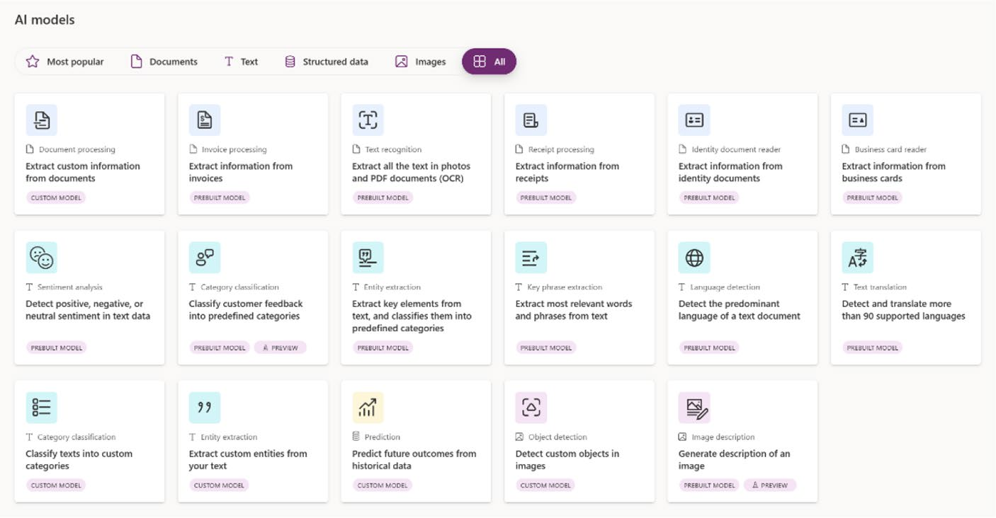

Figure 9-1. List of pre-built and custom models in the Microsoft
Power Apps AI Hub

1. Visit https://make.powerapps.com and log in with
your credentials.
2. Select AI Hub from the left sidebar, as shown in
Figure 9-2.

Chapter 9 IntroduCIng aI BuIlder In power apps
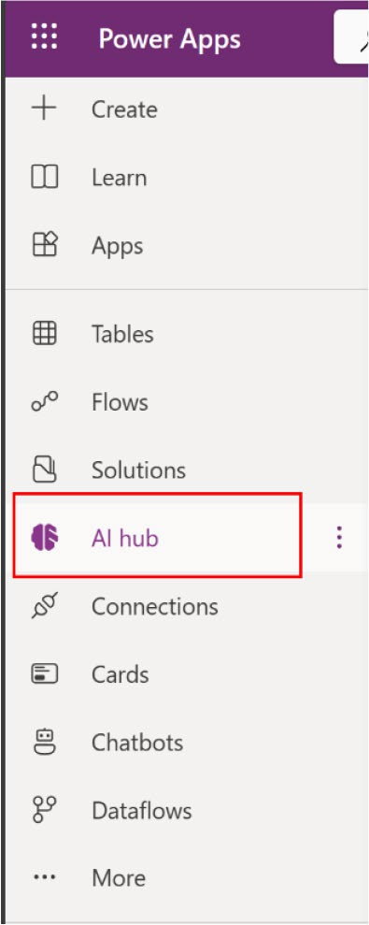

Figure 9-2. Selecting AI Hub from the left sidebar

3. Select AI Models from the screen shown in
Figure 9-3.
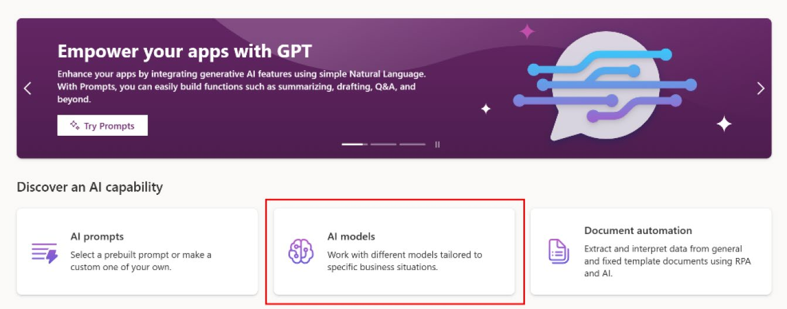

Figure 9-3. AI models from the AI Hub

Chapter 9 IntroduCIng aI BuIlder In power apps

Common Business Scenarios
AI Builder offers a variety of AI model types that equip you with extensive
AI functionalities without requiring deep coding skills or data expertise.
Table 9-2 explores some typical business situations and the ideal AI model
types to handle them.
Table 9-2. Common Business Scenarios with Preferred Model Types
Business Scenario Model Type
automate customer application processing document processing
automate expense reports receipt processing
Categorize user feedback based on their focus Category classification
extract insights from product reviews entity extraction
Identify language of text language detection
Identify and classify customer feedback sentiment analysis
translate support requests into your language text translation
Identify fraudulent transactions prediction
get alerted to social media posts referencing your Key phrase extraction
brand
automate contact list Business card reader
automate inventory taking object detection
take a photo of text and save it to a database text recognition
automate customer application processing document processing

Chapter 9 IntroduCIng aI BuIlder In power apps

Pre-Built AI Models
Pre-built AI models in Power Apps offer a ready-to-use solution for businesses looking to integrate artificial intelligence quickly and efficiently. These models cover a wide range of common business scenarios, such as text and image recognition, sentiment analysis, and form processing. Designed to be user-friendly, they require no prior coding or deep data science knowledge, making it easier for users of all skill levels to enhance their applications with AI capabilities. By using pre-built models, organizations can accelerate their digital transformation, improve accuracy in data handling and streamline operations, all while saving time and resources on model development and training.
Pre-built models can be accessed within Power Automate and Power
Apps. Table 9-3 lists the models currently available through AI Builder.

Table 9-3. Pre-Built AI Models with Uses
Pre-Built AI Model Description of Use
Invoice processing automates the extraction and processing of data from
invoices for quicker financial workflows.
text recognition Converts images of text into editable, searchable data. sentiment analysis analyzes text to determine the tone and sentiment,
useful for customer feedback and social media analysis.
receipt processing simplifies the extraction of information from receipts,
aiding in expense management.
entity extraction Identifies and categorizes entities within text, useful for
data organization and retrieval.
Id reader extracts data from identification documents to automate
data entry and verification processes.
(continued)

Chapter 9 IntroduCIng aI BuIlder In power apps
Table 9-3. (continued)
Pre-Built AI Model Description of Use
Key phrase extraction pulls out important phrases from text to highlight main
ideas or concepts, enhancing content analysis.
Business Card reader digitizes contact information from business cards into a
manageable format.
Category Classification automatically classifies text into predefined categories,
streamlining content sorting and management.
text generation (preview) generates text based on input prompts; no longer
(deprecated) recommended for new deployments due to deprecation.
language detection Identifies the language of the given text, enabling multi-
lingual support and analysis.
text translation translates text from one language to another, facilitating
communication across different languages.
Image description generates descriptions for images, enhancing
(preview) accessibility and content understanding.

To learn more about pre-built AI models, scan the QR code shown in
Figure 9-4 or visit https://learn.microsoft.com/en-us/ai-builder/
prebuilt-overview.

Chapter 9 IntroduCIng aI BuIlder In power apps


Figure 9-4. Learn more about pre-built AI models

Custom AI Models
Custom AI models in Power Apps allow businesses to tailor artificial intelligence solutions specifically to their unique requirements. Unlike pre-built models, these custom models enable users to leverage their own data to create, train, and publish AI functionalities that are perfectly aligned with their specific operational needs. This capability is particularly valuable for addressing complex or niche tasks that standard models cannot handle. By using Azure Machine Learning alongside AI Builder, organizations can develop sophisticated AI models that enhance decision- making, automate intricate workflows, and provide deeper insights into their data, thereby driving innovation and competitive advantage in their respective industries.
Table 9-4 lists the custom models that are currently available in AI Builder.

Chapter 9 IntroduCIng aI BuIlder In power apps
Table 9-4. Custom AI Models with Uses
Custom Model Description of Use
document processing extracts custom information from various types of
documents to streamline data capture and analysis.
Category Classification Classifies texts into user-defined categories, enhancing
content organization and management.
entity extraction extracts user-specified entities from text; useful for
detailed content analysis and customization.
prediction uses historical data to predict future outcomes, aiding in
data-driven decision-making.
object detection Identifies and locates user-defined objects within images
for detailed visual analysis.
azure Machine learning Integrates custom models developed in azure Machine
Models learning for specific analytical tasks.

To learn more about custom AI models, scan the QR code shown in
Figure 9-5 or visit https://learn.microsoft.com/en-us/ai-builder/
custom-overview.


Figure 9-5. Learn more about custom AI models

Chapter 9 IntroduCIng aI BuIlder In power apps

In-Depth Exploration of AI Builder
This section explains the key components of AI Builder, including how to use its components. It also includes examples of custom AI models.

Key Components of AI Builder
In Microsoft Power Apps, you can utilize AI Builder two main ways, based on the specific model you choose to deploy. These include:
1. Integrating AI models directly within the
Formula bar.
2. Incorporating AI Builder components into your
applications.
Each method offers a tailored way to enhance your applications with artificial intelligence, allowing for seamless integration and functionality enhancement.

Integrating AI Models in the Formula Bar
You can access the AI Builder models listed in Table 9-5 directly through the Formula bar in Power Apps.

Chapter 9 IntroduCIng aI BuIlder In power apps
Table 9-5. AI Models Available from the Formula Bar in Power Apps
AI Model Model Type Build Type
Business Card reader text extraction pre-built
Category Classification text Classification pre-built and custom
entity extraction text analysis pre-built and custom
Identity document reader text extraction pre-built
Image description Image analysis pre-built
Invoice processing text extraction Custom
Key phrase extraction text analysis pre-built
language detection text analysis pre-built
receipt processing text extraction Custom
sentiment analysis text analysis pre-built
text recognition text extraction pre-built
text translation text translation pre-built
aI reply text generation Custom
aI Classify text Classification Custom
empty dynamic prompt text generation Custom
aI sentiment sentiment analysis Custom
aI summarize text summarization Custom
aI extract text extraction Custom

You can find all the AI models in Power Apps Studio. Open a project
and select Data ➤ Add Data ➤ AI Models, as shown in Figure 9-6.

Chapter 9 IntroduCIng aI BuIlder In power apps
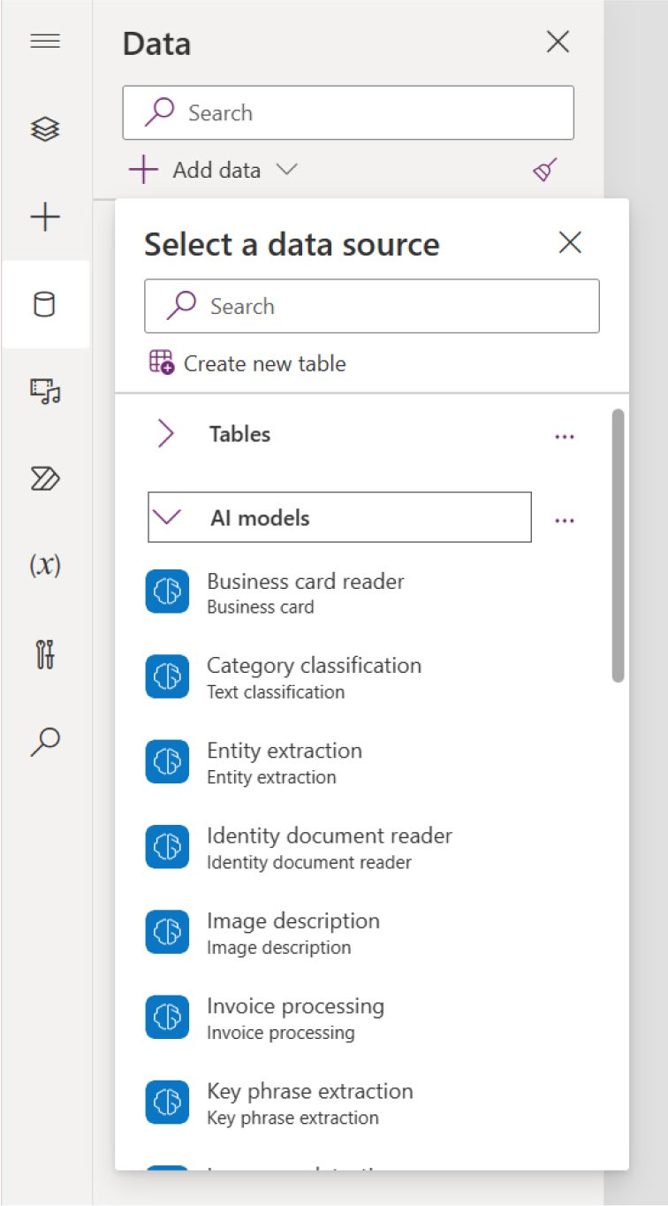

Figure 9-6. AI models in the data source list

Using Power Fx, you can create more dynamic and flexible integrations of AI models in Power App. AI model prediction formulas can be seamlessly linked to any control within a Canvas app. For example, you can detect the language of text entered in a text input control and display the results in a label control. Or you can get text from an image.

Chapter 9 IntroduCIng aI BuIlder In power apps
Requirements
To utilize Power Fx in AI Builder models, the following are required:
• Access to a Microsoft Power Platform environment that
includes a database.
• AI Builder license, either trial or paid.

Demo
This section takes you through a quick demo to learn how to use AI Model
directly from the Formula bar. To get started, follow these steps:
1. Create a new Canvas app or open your existing
Canvas app project in https://make.powerapps.
com, as shown in Figure 9-7.
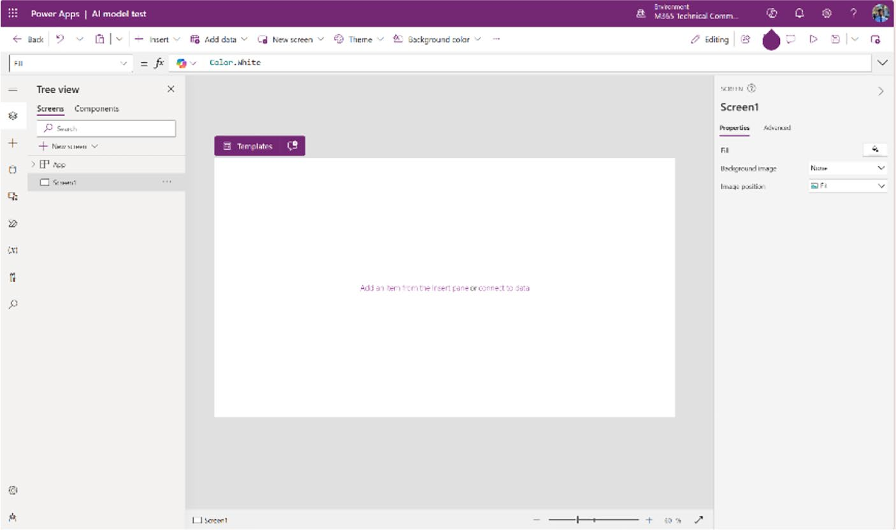

Figure 9-7. New Canvas app created in Power Apps Studio

Chapter 9 IntroduCIng aI BuIlder In power apps
2. Choose Language Detection from Data ➤ Add
Data ➤ AI Models, as shown in Figure 9-8.
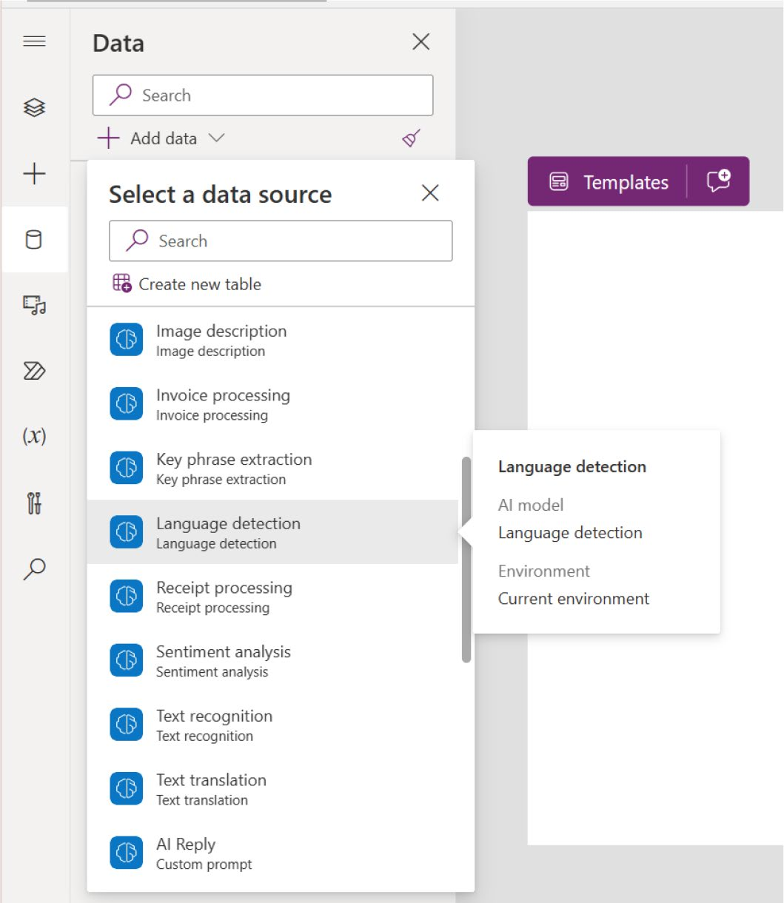

Figure 9-8. Choosing Language Detection from the AI Model

Chapter 9 IntroduCIng aI BuIlder In power apps
3. Click Insert, then choose Text Input and Text Label,
as shown in Figure 9-9.
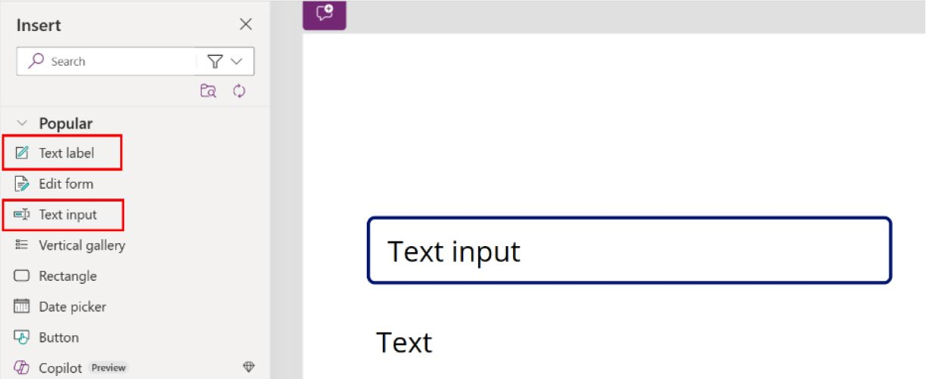

Figure 9-9. Adding a text label and text input to your app

4. Add another text label named Language, as shown
in Figure 9-10.
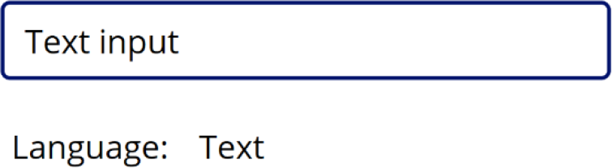

Figure 9-10. Adding a new text label named Language

5. Select the text and then select the Formula bar, as
shown in Figure 9-11.

Chapter 9 IntroduCIng aI BuIlder In power apps
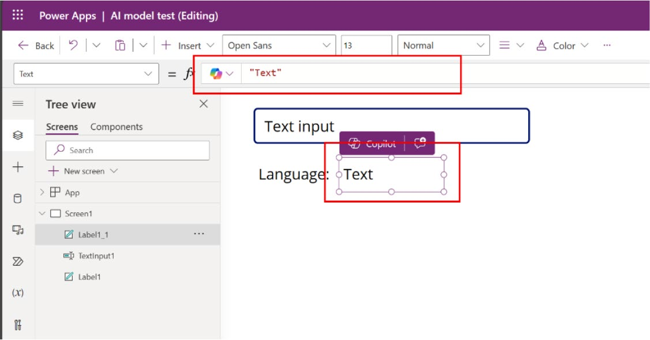

Figure 9-11. Select the Text label and the Formula bar

6. Write the following code in the Formula bar (also
shown in Figure 9-12):
'Language detection'.Predict(TextInput1.Text).Language
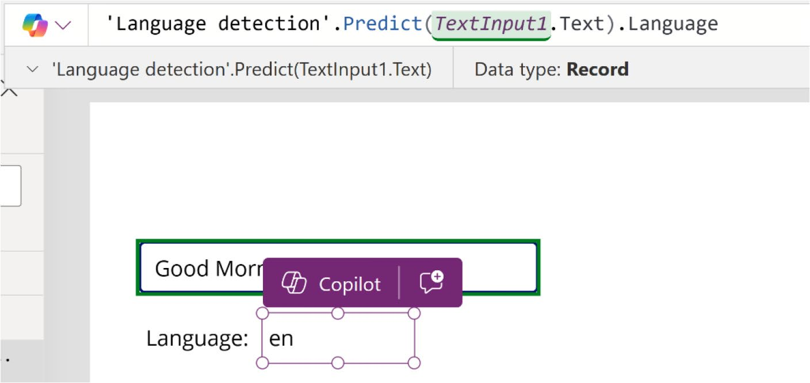

Figure 9-12. Code to detect the text language

7. Run the app by pressing F5. Type something in a
different language and check the result, as shown in
Figure 9-13.

Chapter 9 IntroduCIng aI BuIlder In power apps


Figure 9-13. The language detector detected “Guten Tag” as Deutsch
(German)

If you type something in another language, you will see a different
result, as shown in Figure 9-14.
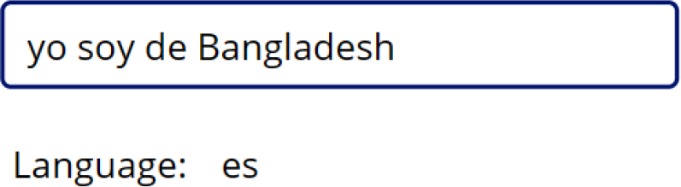

Figure 9-14. Language detection recognizes the Spanish sentence

Use AI Builder Components
This section demonstrates how to utilize AI Builder components within
Power Apps. AI Builder offers two types of components for Power Apps.
Select the component that aligns with the models you intend to use.
1. The components that use pre-built AI models are
ready to use now. For example, the Business Card Reader, Invoice Processor, and Text Recognizer.
2. You’ll need to build and train the components
that use custom AI models. For example, the form processor or object detector.
This chapter explains both types of models. You can see the AI Builder components from the Power Apps project.
Open the Power Apps project in Power Apps Studio, click Insert, and then
expand the AI Builder, as shown in Figure 9-15.

Chapter 9 IntroduCIng aI BuIlder In power apps
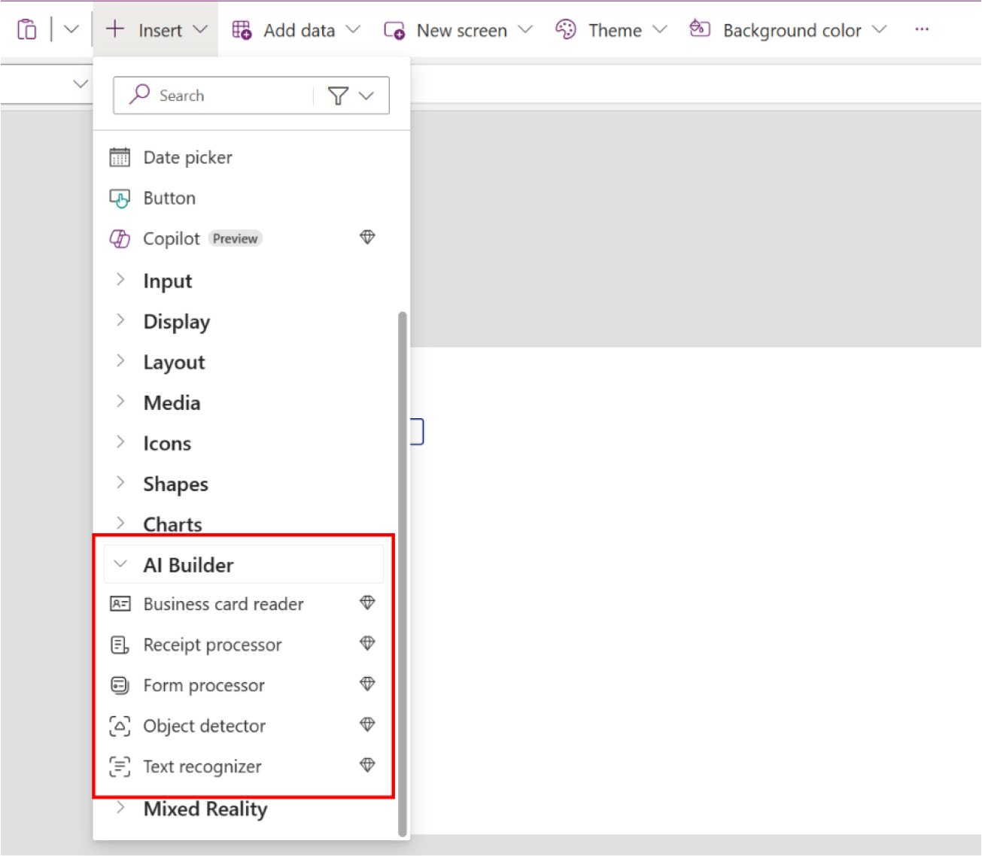

Figure 9-15. AI Builder components in Power Apps

Example Uses of AI Builder Models and Components
This section explores the AI Builder models and components.

Business Card Reader Component
You can use the AI Builder Business Card Reader component to effortlessly detect and pull details from business cards. You can take pictures directly from the component or upload a previously captured image. If you are going to capture or extract information from a business card, you can get
the information listed in Table 9-6.

Chapter 9 IntroduCIng aI BuIlder In power apps
Table 9-6. Properties That Can Be Read by the Business Card Reader
Component
Property Definition
AddressCity City
AddressCountry Country
AddressPostalCode postal code
AddressPostOfficeBox post office box
AddressState state address
AddressStreet street address
BusinessPhone the first phone or fax number
CompanyName Company name
Department organization department
Email the contact’s email address if any
Fax the third phone or fax number
FirstName the contact’s first name
FullAddress the contact’s full address
FullName the contact’s full name
JobTitle the contact’s job title
LastName the contact’s last name
MobilePhone second phone or fax number
OriginalImage the original image, before processing
Website the contact’s website

Chapter 9 IntroduCIng aI BuIlder In power apps
Demo
You can use the Business Card Reader component in Canvas or any model-driven app. This example shows how to use the Business Card Reader component in a Canvas app.
To add the Business Card Reader component to Power Apps, follow these steps:
1. Open your Canvas project in https://make.
powerapps.com.
2. Add the Business Card Reader component from the
Insert option, as shown in Figure 9-16.
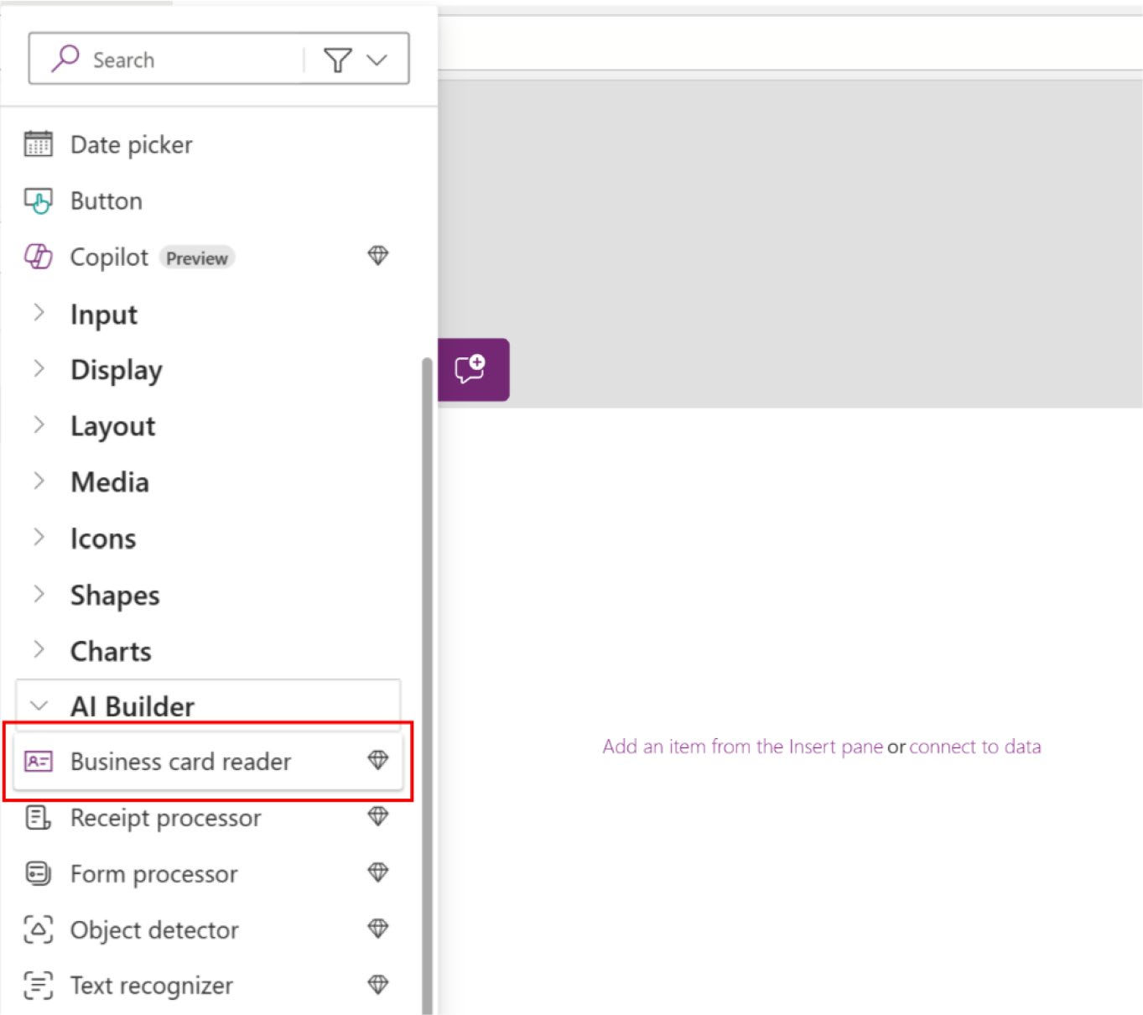

Figure 9-16. Adding the Business Card Reader component to Power Apps

Chapter 9 IntroduCIng aI BuIlder In power apps
3. Once you’ve added it, you can see the component in
the screen, as shown in Figure 9-17.
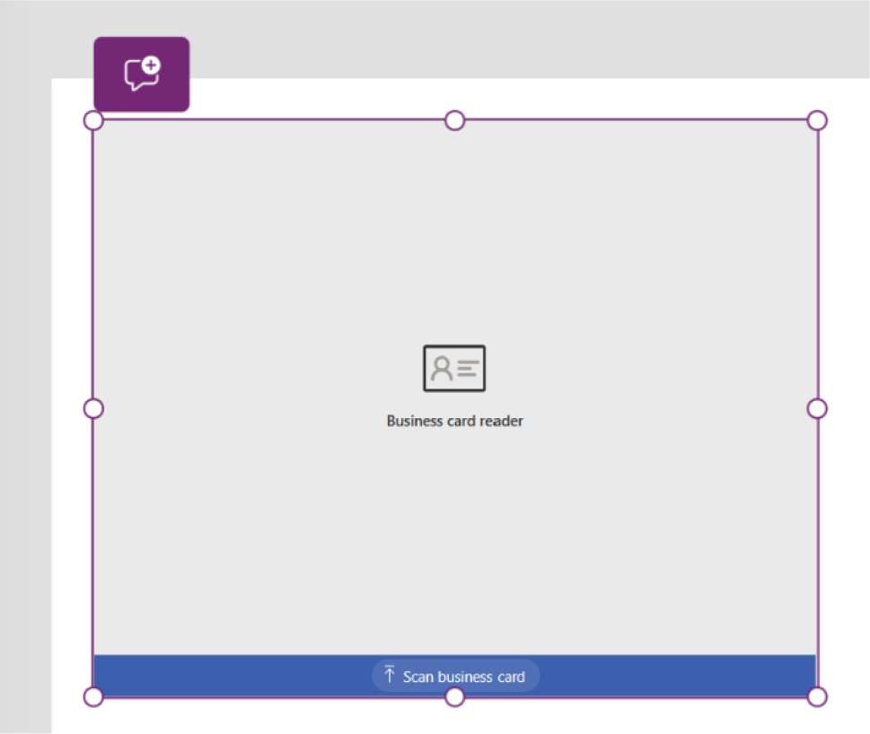

Figure 9-17. The Business Card Reader component shown in the
Power App screen

4. Next, you’ll create two sets of text labels for each
piece of information: Name, Job Title, Email, Phone Number, and Website. One set will serve to label and identify the fields, and the other will display the data extracted from the Business Card Reader
component, as shown in Figure 9-18.

Chapter 9 IntroduCIng aI BuIlder In power apps
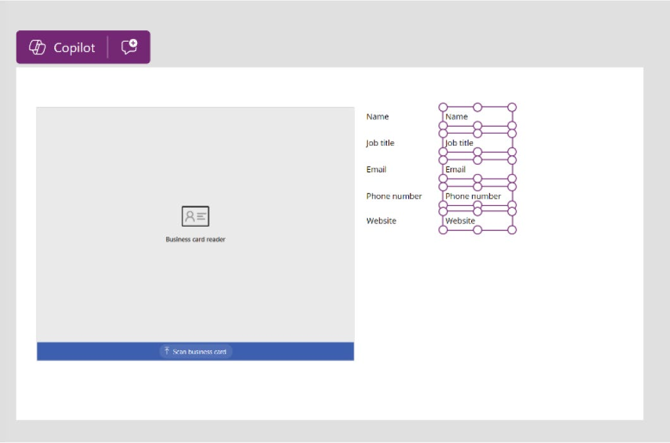

Figure 9-18. Creating labels to extract data from Business Card Reader

5. Add some code to each label. For example, I select
Name (see Figure 9-19) and, in the Formula bar, I add the following code:
BusinessCardReader1.Fullname

Chapter 9 IntroduCIng aI BuIlder In power apps
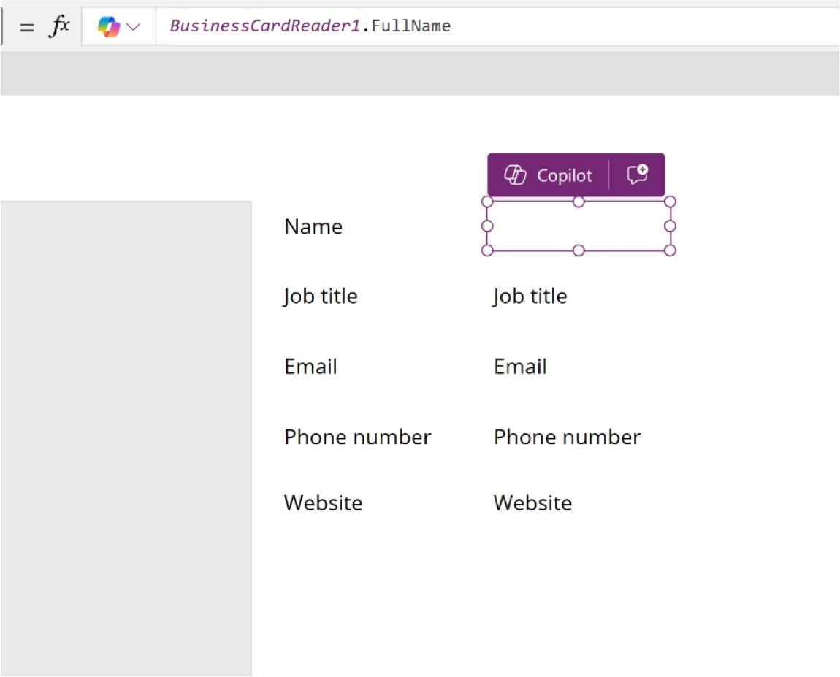

Figure 9-19. Assigning code to the Name field

Note when you assign code to a text label, the previous text becomes invisible because the label is now linked to the Full Name component of the Business Card reader.

6. Do the same for Job Title, Email, Phone Number,
and Website. Select the label. Then, in the Formula bar, type BusinessCardReader1 and then . (period). Then select or type the property name. You can get
the property name from Table 9-6.

Chapter 9 IntroduCIng aI BuIlder In power apps

Note the name of my Business Card reader component is
BusinessCardReader1, which is typically the default. however,
be sure to verify the component’s name before beginning the
assignment.

7. Now it’s preview time. Press F5 or run the app, as
shown in Figure 9-20.
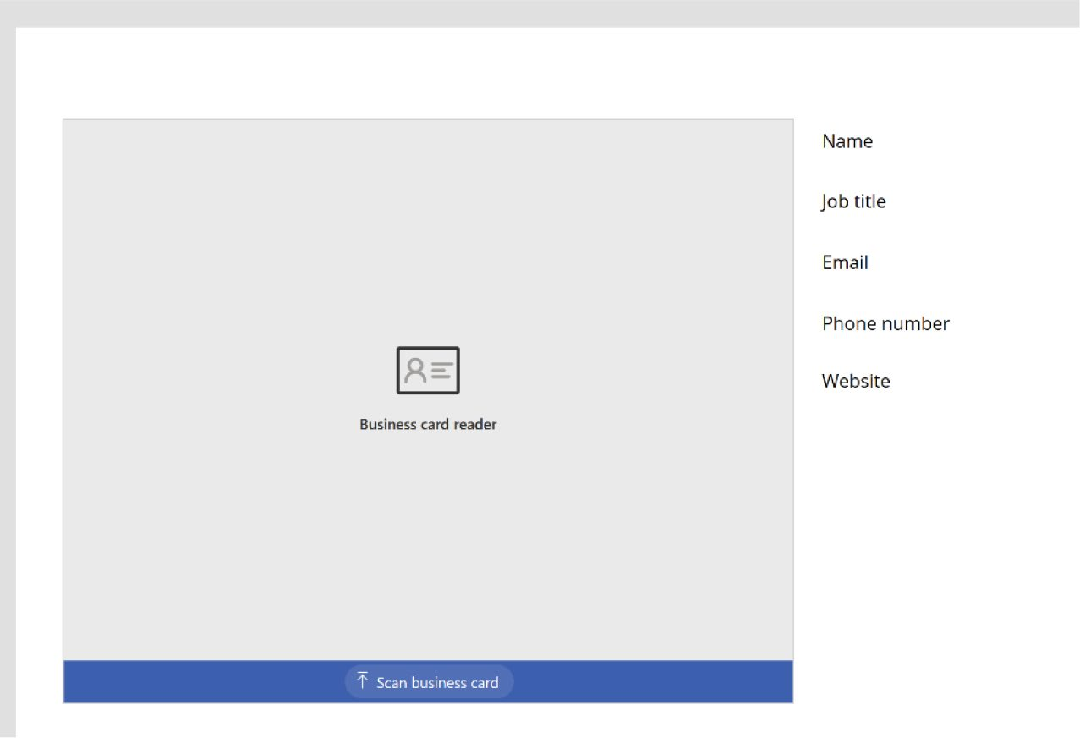

Figure 9-20. Preview of the Business Card Reader component

8. You can now upload a business card to the app.
Click the Scan Business Card button and upload a
business card, as shown in Figure 9-21.

Chapter 9 IntroduCIng aI BuIlder In power apps
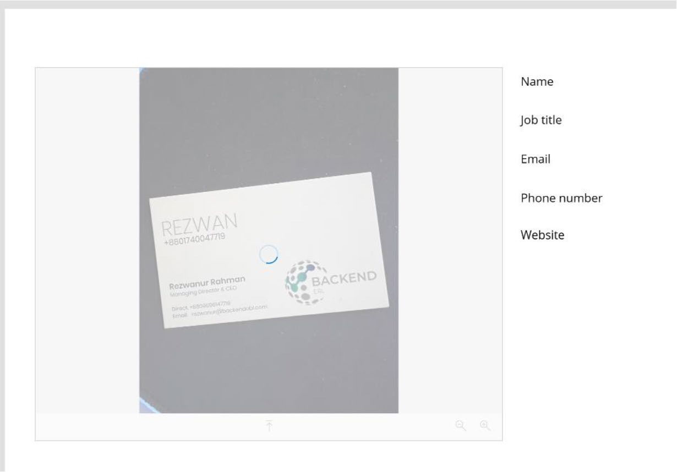

Figure 9-21. Uploading a business card to Power Apps

9. After a few minutes, you will see the information in
the labels, as shown in Figure 9-22.
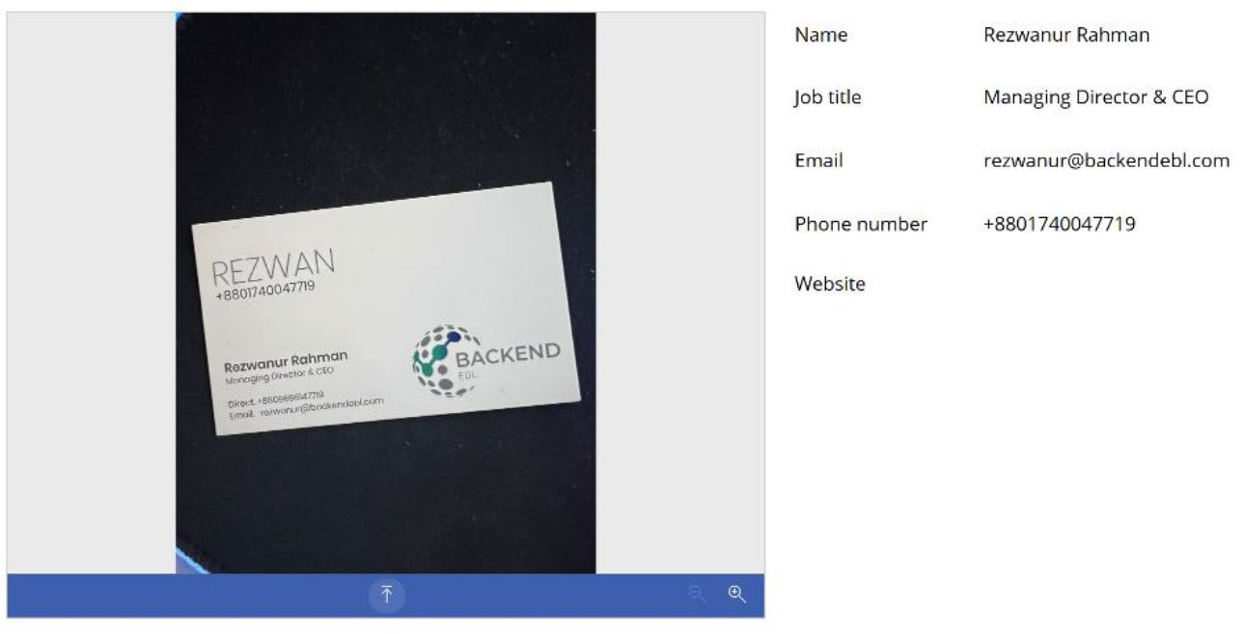

Figure 9-22. Extracting information from a business card using the
Business Card Reader component

Chapter 9 IntroduCIng aI BuIlder In power apps
In this image, the website field is missing, indicating that the Business Card Reader was unable to retrieve it. This is likely because the website was not present on the front side of the business card.

The Receipt Processor Component
The Receipt Processor component in AI Builder efficiently scans and captures data from receipts. This component supports direct photo capture and the uploading of preexisting images for processing. This example demonstrates how to integrate and use this component in a Canvas app on Power Apps.
When you capture or extract information from the Receipt Processor
component, you can capture the information listed in Table 9-7.

Table 9-7. Properties That Can Be Read by the Receipt
Processor Component
Property Definition
MerchantName Merchant name
MerchantAddress Merchant address
MerchantPhone Merchant phone number
TransactionDate transaction date
TransactionTime transaction time
PurchasedItems the list of purchased items
name: name of the purchased item
price: price of the purchased item
Quantity: Quantity of the purchased item
totalprice: total price of the purchased item
(continued)

Chapter 9 IntroduCIng aI BuIlder In power apps
Table 9-7. (continued)
Property Definition
Subtotal subtotal Tax tax Tip tip Total total

Requirements
The Receipt Processor component performs optimally with sales receipts,
such as those from restaurants, gas stations, and retailers. It can recognize
printed and handwritten text.
Currently, only English receipts from the United States are supported.
For best results, ensure that each receipt is provided as a clear photo
or scan.
• Accepted formats include JPEG, PNG, and PDF.
• The file size must be under 20MB.
• Image dimensions should range from 50x50 pixels to
10,000x10,000 pixels.
• PDF dimensions should not exceed 17x17 inches,
which corresponds to legal or A3 paper sizes and smaller.
• For PDF files, only the first 200 pages are processed.

Chapter 9 IntroduCIng aI BuIlder In power apps
Demo
Let’s start with a demo. To start working with the Receipt Processor, follow these instructions:
1. Open your project where you want to add the
Receipt Processor component or create a new one
from https://make.powerapps.com. For my demo, I created a new Canvas app in the phone format, as
shown in Figure 9-23.
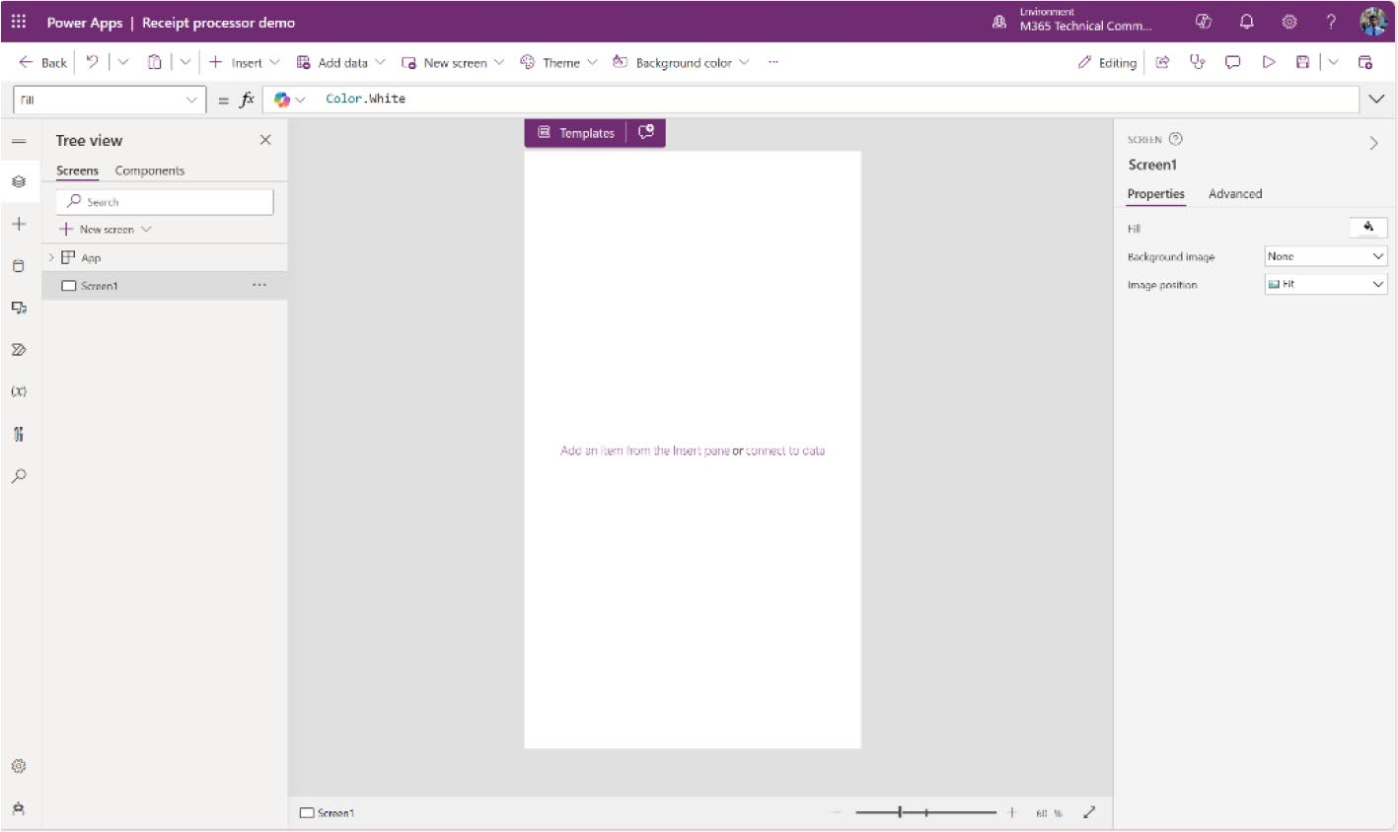

Figure 9-23. Created a new Canvas app in the phone format for the Receipt Processor demo

Chapter 9 IntroduCIng aI BuIlder In power apps
2. Add Receipt Processor from the Insert option in the
screen and fix the margin, as shown in Figure 9-24. Ensure there is adequate space below the Receipt Processor component to accommodate a button.
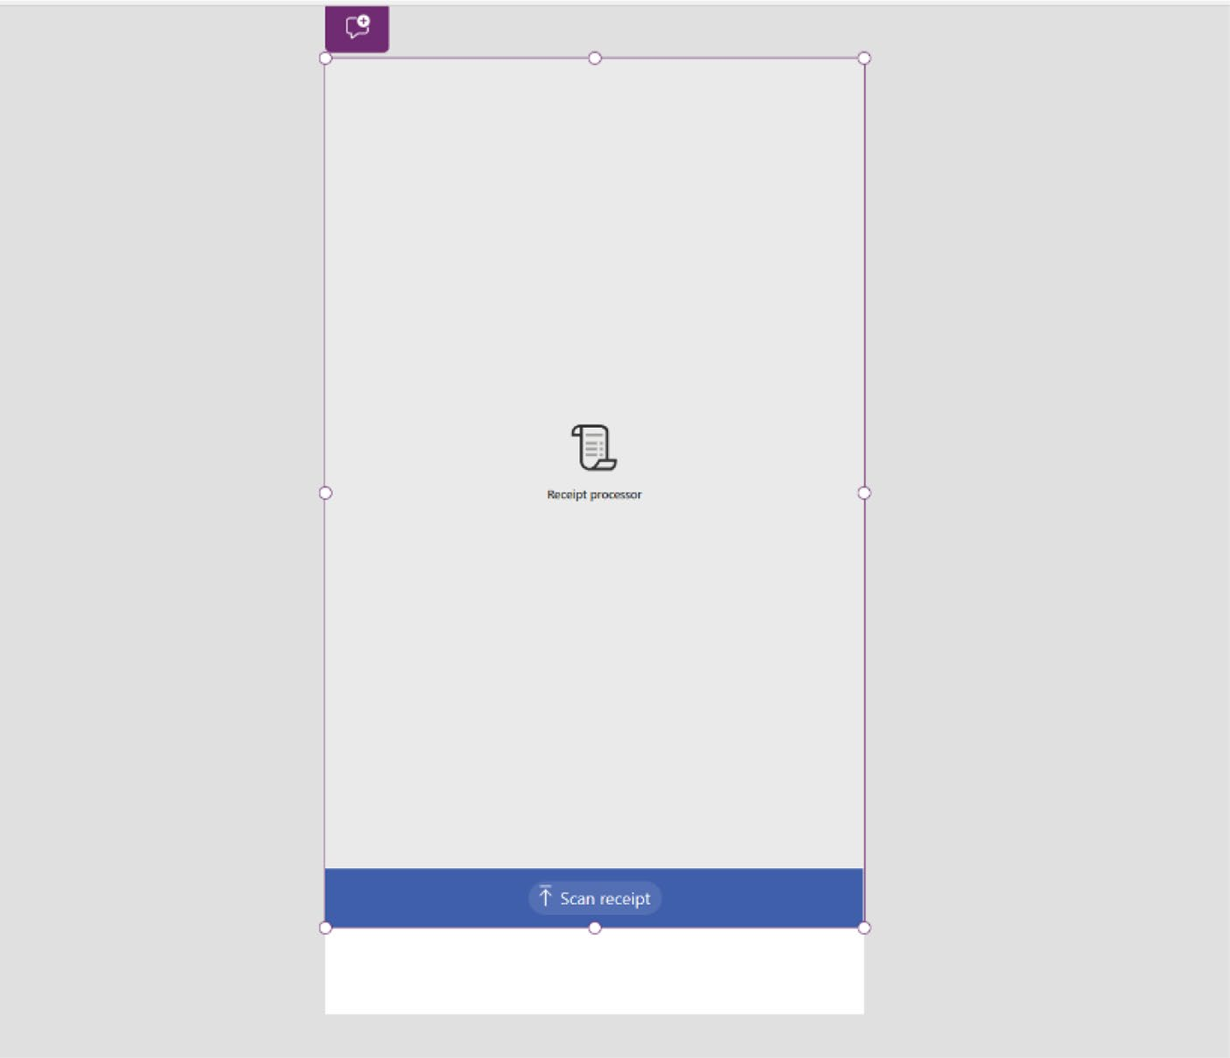

Figure 9-24. Adding a Receipt Processor control from the
Insert option

Chapter 9 IntroduCIng aI BuIlder In power apps
3. Add the next arrow button under the Receipt
Processor control, as shown in Figure 9-25. It will help to go to the next page, where I place the text label controls to fetch the receipt information.
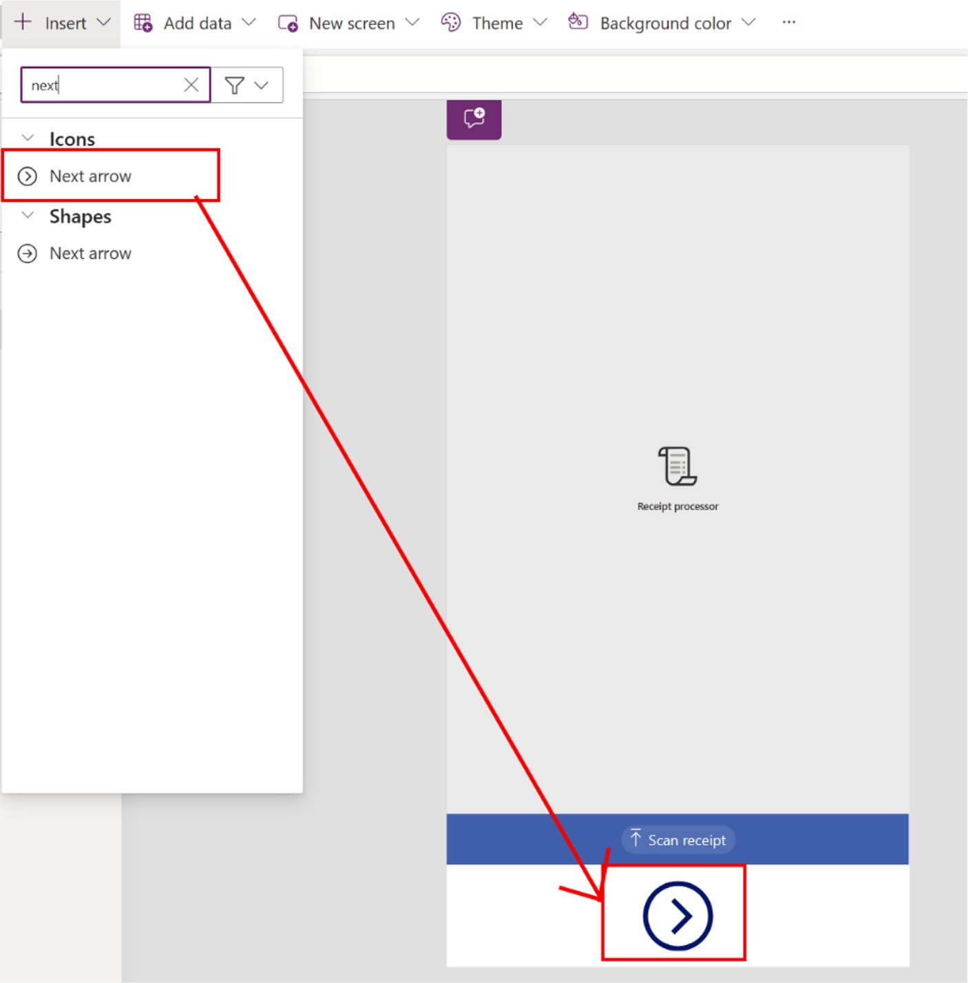

Figure 9-25. Added next arrow next to the Receipt Processor

Chapter 9 IntroduCIng aI BuIlder In power apps
4. Run the app and upload a receipt to the Receipt
Processor control, as shown in Figure 9-26.
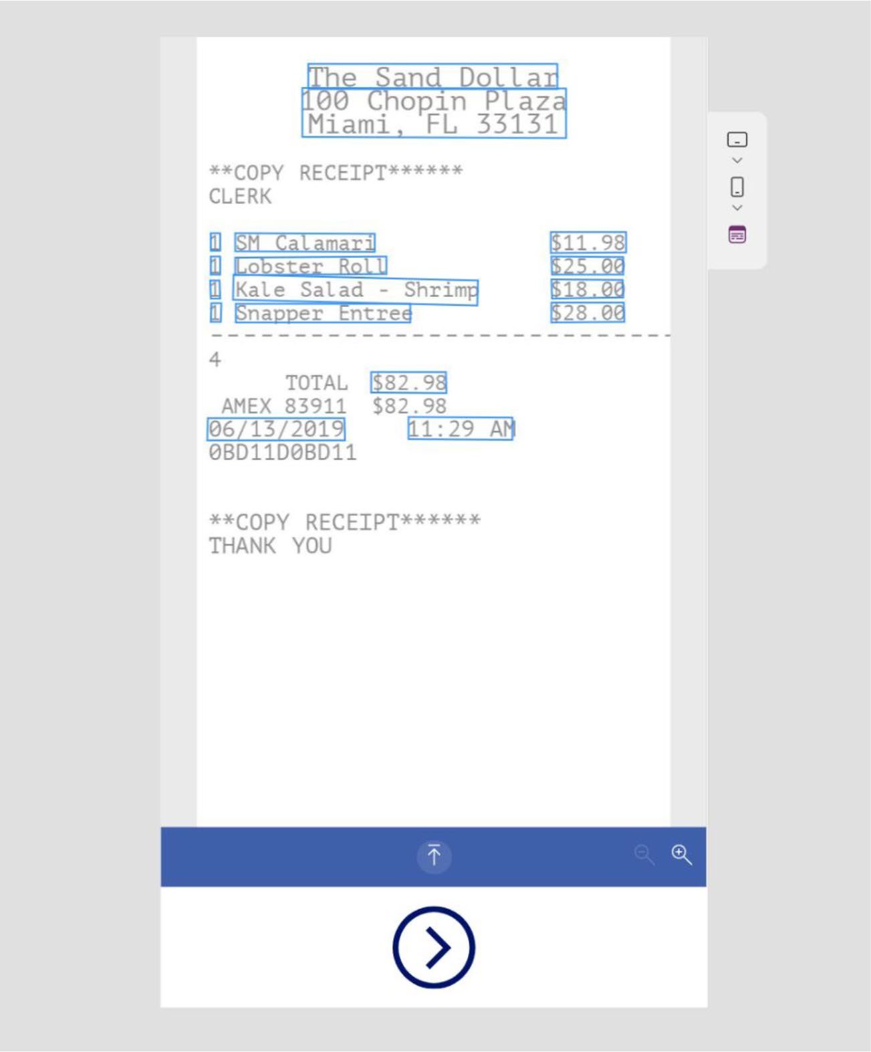

Figure 9-26. Uploading a receipt to the Receipt Processor

Chapter 9 IntroduCIng aI BuIlder In power apps
5. Create a new screen and add the Vertical Gallery
component from Insert option, as shown in
Figure 9-27.
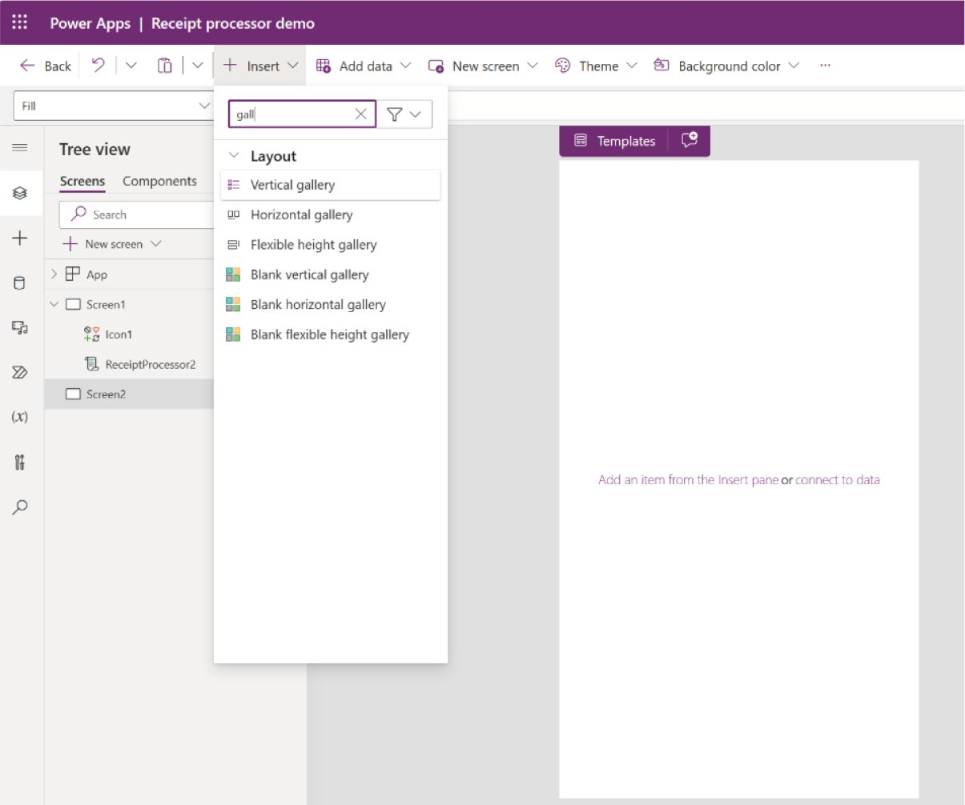

Figure 9-27. Creating a new screen and adding a vertical gallery

Chapter 9 IntroduCIng aI BuIlder In power apps
6. When you select Vertical Gallery, the Formula
bar will show that the Items option is bound to
CustomGallerySample, as shown in Figure 9-28.
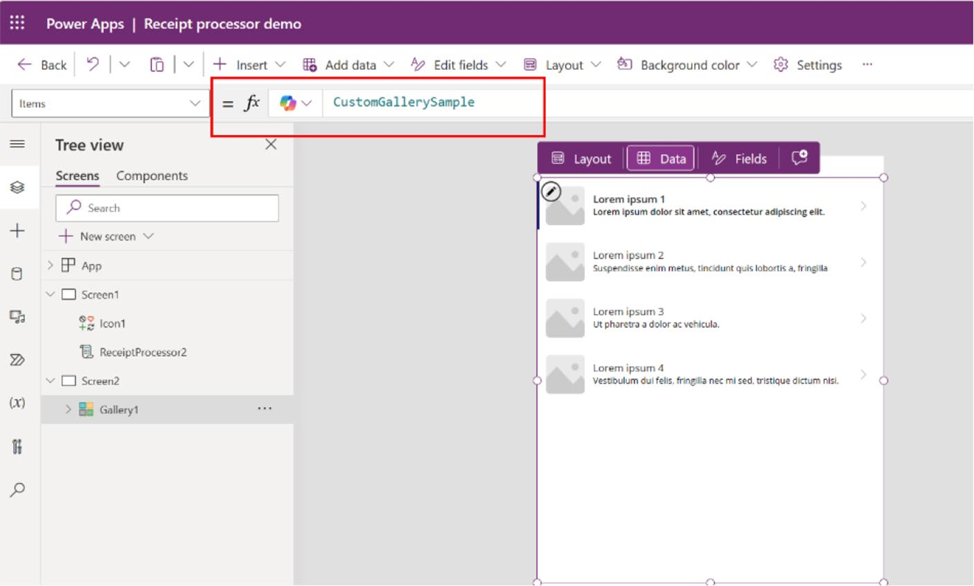

Figure 9-28. Vertical gallery items data source

7. In the Formula bar (see Figure 9-29), remove
CustomGallerySample and include the receipt component name then a period (.). Then include PurchasedItems:
ReceiptProcessor2.PurchasedItems

Chapter 9 IntroduCIng aI BuIlder In power apps
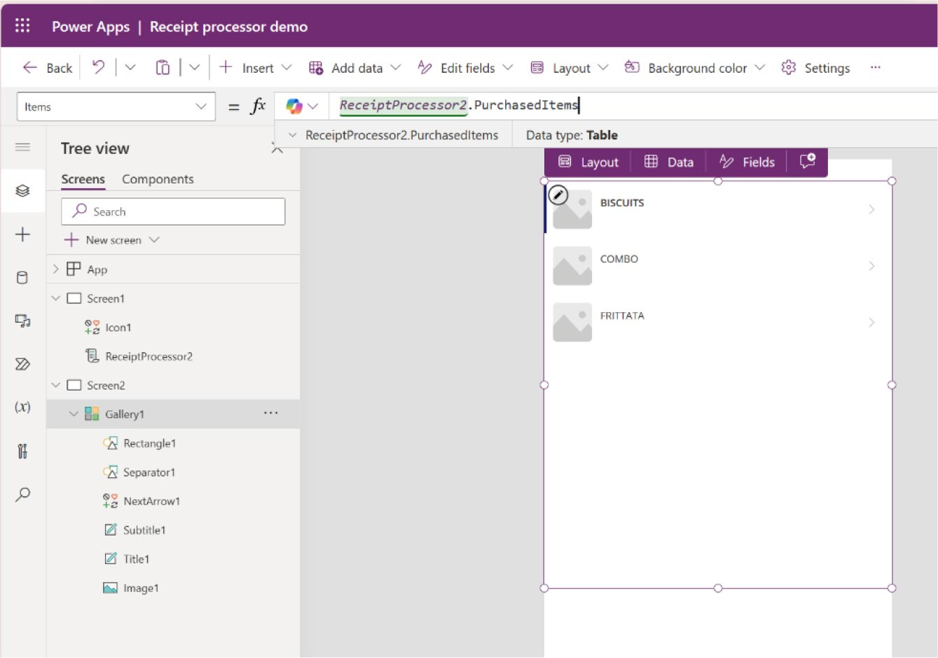

Figure 9-29. Changing the items list source to the Receipt Processor data

In the vertical gallery, you will see the item names sourced from the receipt. In my case, the Receipt Processor name is ReceiptProcessor2. Be sure to check the name of the component before proceeding.
8. Change the gallery list. I removed everything except
the separator, as shown in Figure 9-30.

Chapter 9 IntroduCIng aI BuIlder In power apps
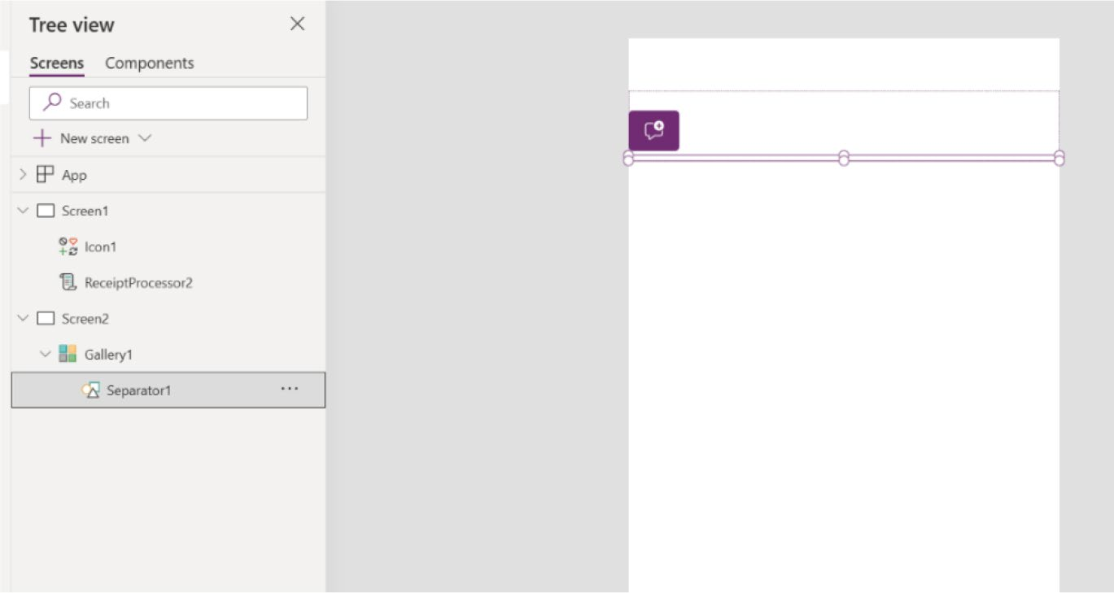

Figure 9-30. Removing all the components from the vertical gallery
except separator

9. Add some labels using the formula code listed in
Table 9-8.
Table 9-8. Labels Created to Fetch Information from the Receipt Processor
Label Name Formula Code
NameLabel "Item name" ItemName ThisItem.Name QuantityLabel "Item Quantity" ItemQuantity ThisItem.Quantity PriceLabel "Item Price" ItemPrice ThisItem.TotalPrice

Chapter 9 IntroduCIng aI BuIlder In power apps
Figure 9-31 shows the labels that I created for fetching information.
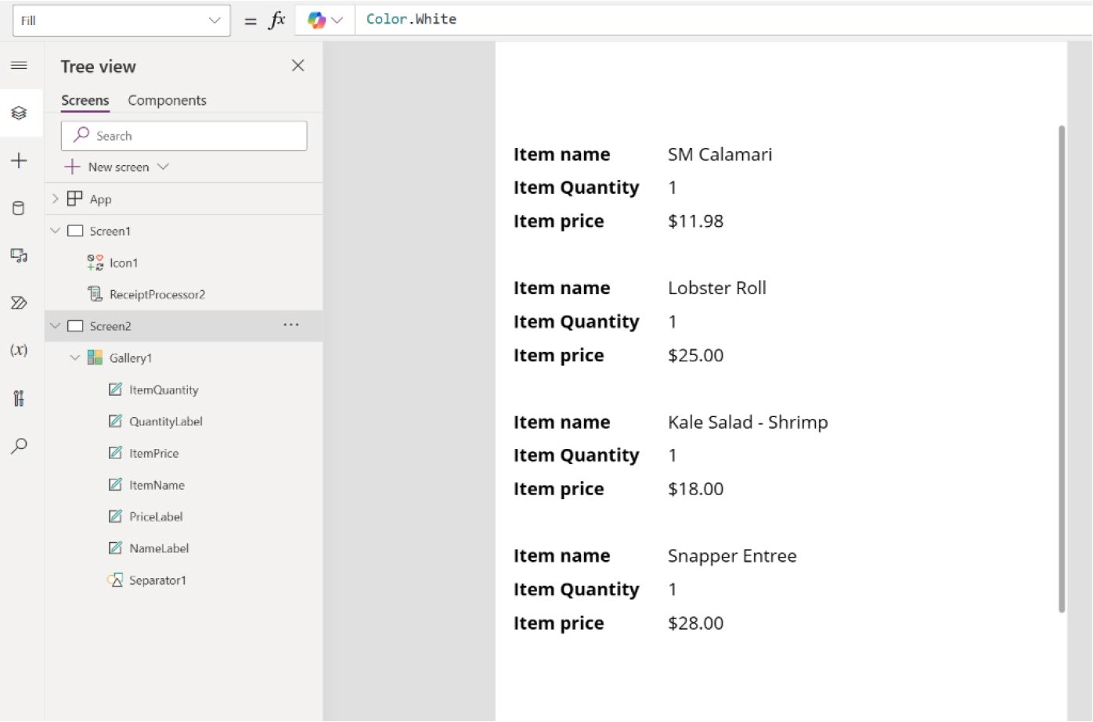

Figure 9-31. Preview after creating the labels and changing the formula code

10. Now add the merchant’s name, address, date and
time, and the total bill to the app. I added the labels
listed in Table 9-9.

Chapter 9 IntroduCIng aI BuIlder In power apps
Table 9-9. Labels Created to Fetch Merchant Information, Address,
Date and Time, and Total Bill
Label Name Formula Code
MerchantNameLabel "Merchant Name"
MerchantName ReceiptProcessor2.MerchantName
MerchantAddressLabel "Merchant Address"
MerchantAddress ReceiptProcessor2.MerchantAddress
TotalBillLabel "Total Bill"
TotalBill ReceiptProcessor2.Total
PurchasedDateLabel "Purchased Date"
PurchasedDate ReceiptProcessor2.TransactionDate
PurchasedTimeLabel "Purchased Time"
PurchasedTime ReceiptProcessor2.TransactionTime

Figure 9-32 shows all the information that I tried to fetch from the receipt, including the merchant’s name, address, date and time, list of items, quantity, price by item, and total price.

Chapter 9 IntroduCIng aI BuIlder In power apps
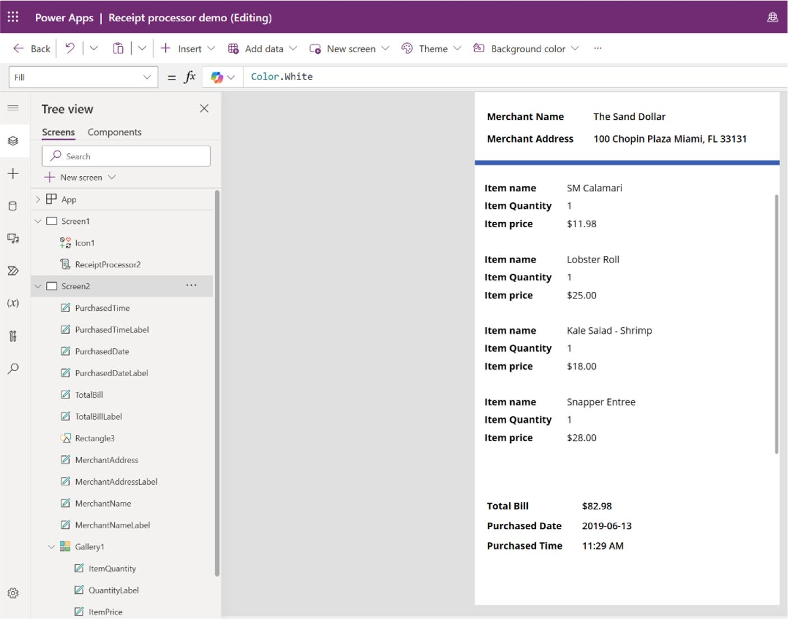

Figure 9-32. All the important information from the Receipt Processor component

11. Go to the main page and connect the next arrow
button with this details screen using Copilot. In Copilot, write the following prompt (also shown in
Figure 9-33):
Connect icon1 with screen2

Chapter 9 IntroduCIng aI BuIlder In power apps
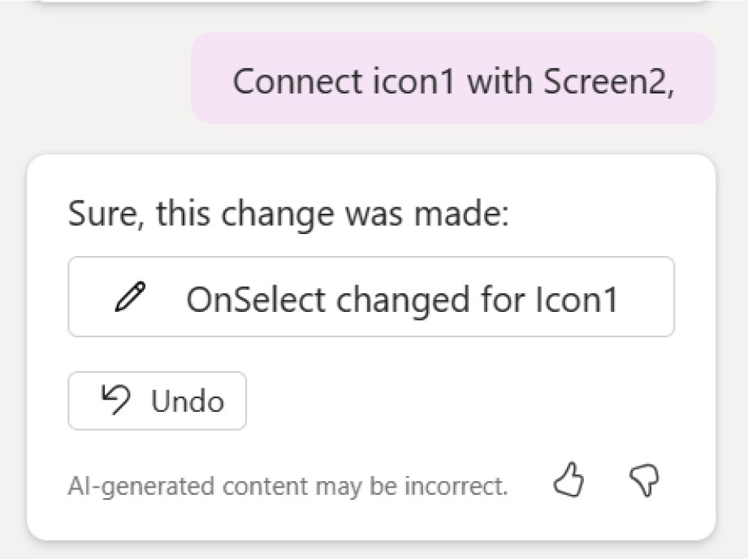

Figure 9-33. The Copilot prompt to connect the next arrow to the
next page

My next arrow name is icon1 and the details screen page is called Screen2. Do not forgot to verify the name of the components before proceeding.
12. At this stage, run the app from the main screen,
upload another receipt, and click the Next button.
See Figures 9-34 and 9-35.

Chapter 9 IntroduCIng aI BuIlder In power apps
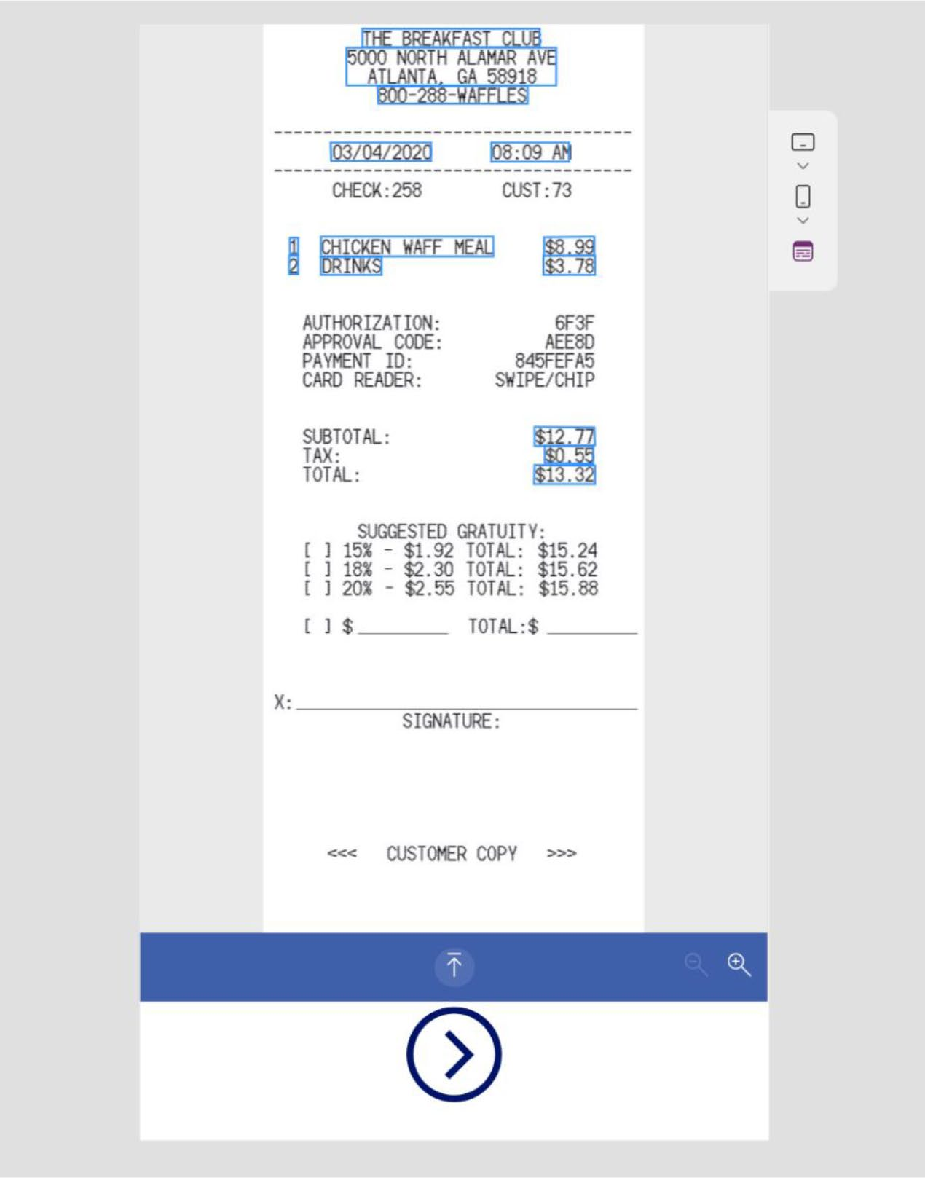

Figure 9-34. Uploading the new receipt to the Receipt Processor component

After clicking the next arrow, the next page will appear with all the
details, as shown in Figure 9-35.

Chapter 9 IntroduCIng aI BuIlder In power apps
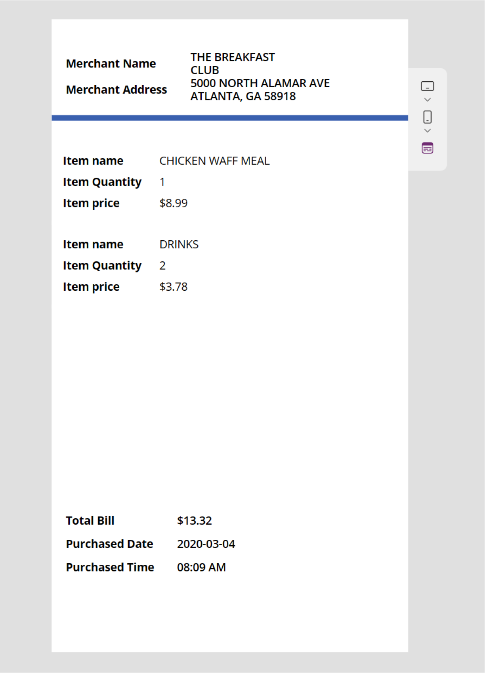

Figure 9-35. Information from the newly uploaded receipt
In this section, you learned that the Receipt Processor component can
process any kind of receipt.

Chapter 9 IntroduCIng aI BuIlder In power apps
Text Recognizer Component
The Text Recognizer component in Power Apps AI Builder uses advanced AI to seamlessly extract and interpret text from images and documents. It supports various use cases, including digitizing handwritten notes, processing printed receipts, and automating data entry from forms. By integrating this component into your applications, you can enhance efficiency and accuracy in handling text-based information.

Demo
In this section, you explore the Text Recognizer component with a hands-on demo. To start using the Text Recognizer component, follow these steps:
1. Open your project and create a new screen.
Or create a new project in https://make.
powerapps.com.
2. From a new screen, add Text Recognizer from the
Insert option, as shown in Figure 9-36.

Chapter 9 IntroduCIng aI BuIlder In power apps
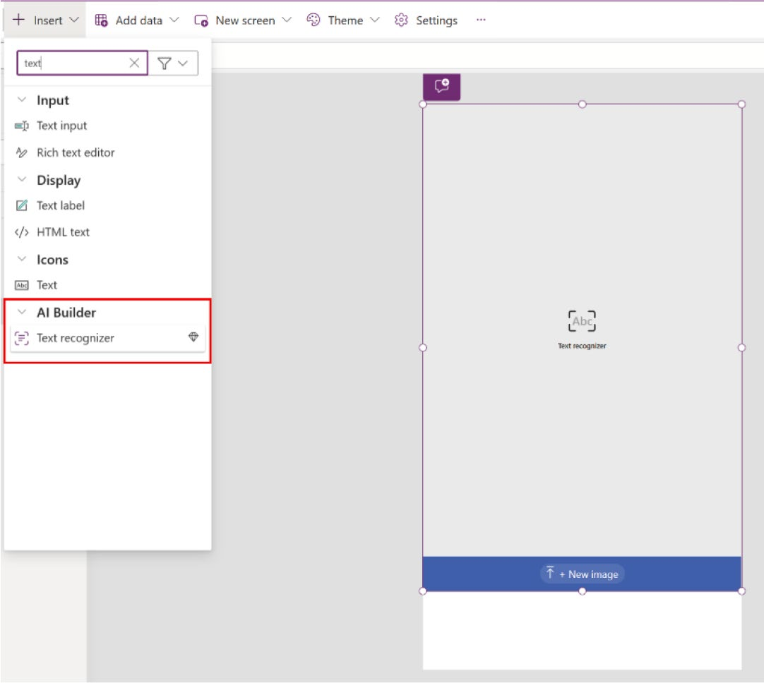

Figure 9-36. Adding Text Recognizer using the Insert option

3. Run the app and upload an image of your choice.
See Figure 9-37.

Chapter 9 IntroduCIng aI BuIlder In power apps
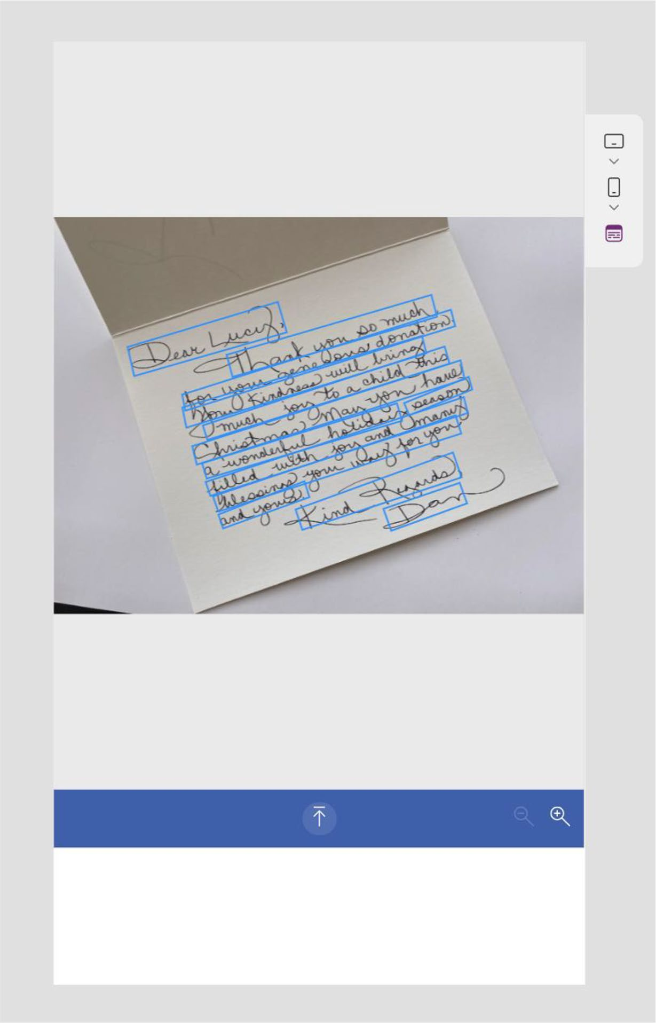

Figure 9-37. Uploading a handwritten letter in Text Recognizer as a sample image

Chapter 9 IntroduCIng aI BuIlder In power apps
4. Add a new next arrow icon next to the Text
Recognizer control. Then create a new screen and connect the icon to the new screen, as shown in
Figure 9-38.
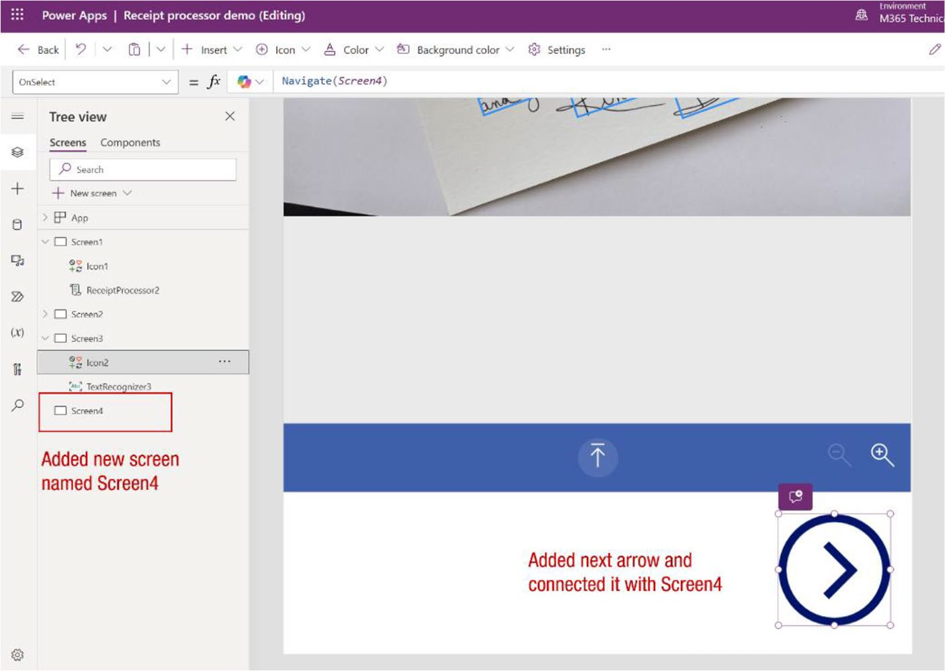

Figure 9-38. Adding a new screen and a next arrow icon

Chapter 9 IntroduCIng aI BuIlder In power apps
5. To the new screen (called Screen4 in this example),
add a new text label. In the properties of the text label, change the font size from 21 to 15, and change the Overflow option from Hidden to Scroll. See
Figure 9-39.
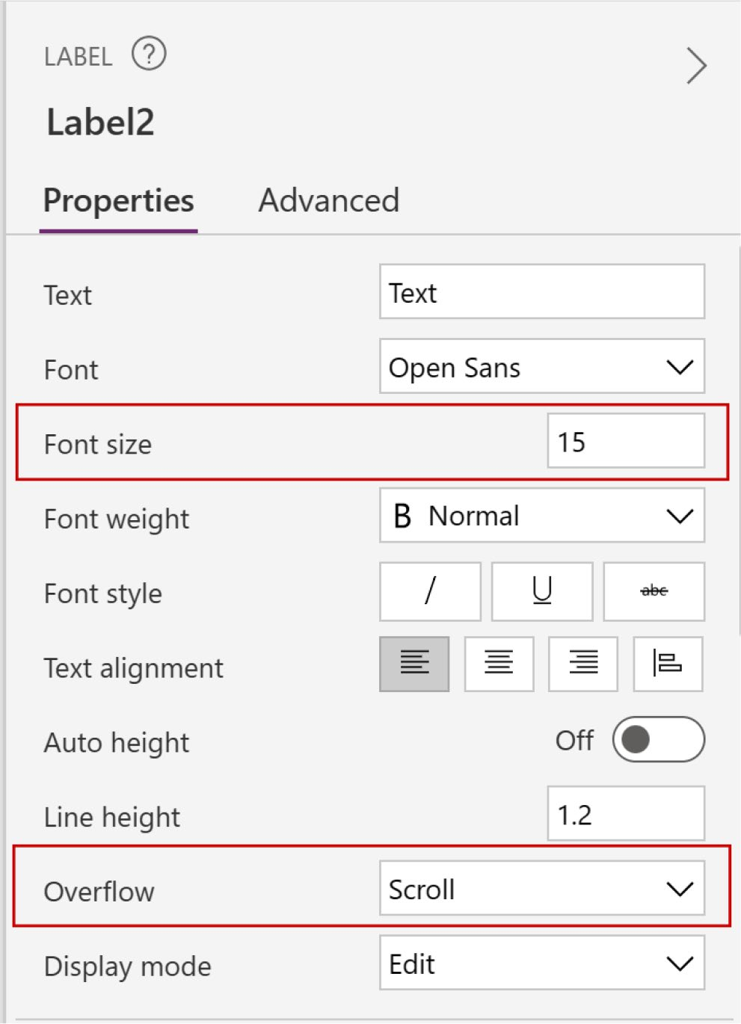

Figure 9-39. Changing the text label font size and Overflow option

Chapter 9 IntroduCIng aI BuIlder In power apps
6. Enlarge the text label by selecting it and adjusting
the size, ensuring that the text retrieved from Text
Recognizer fits perfectly, as shown in Figure 9-40.
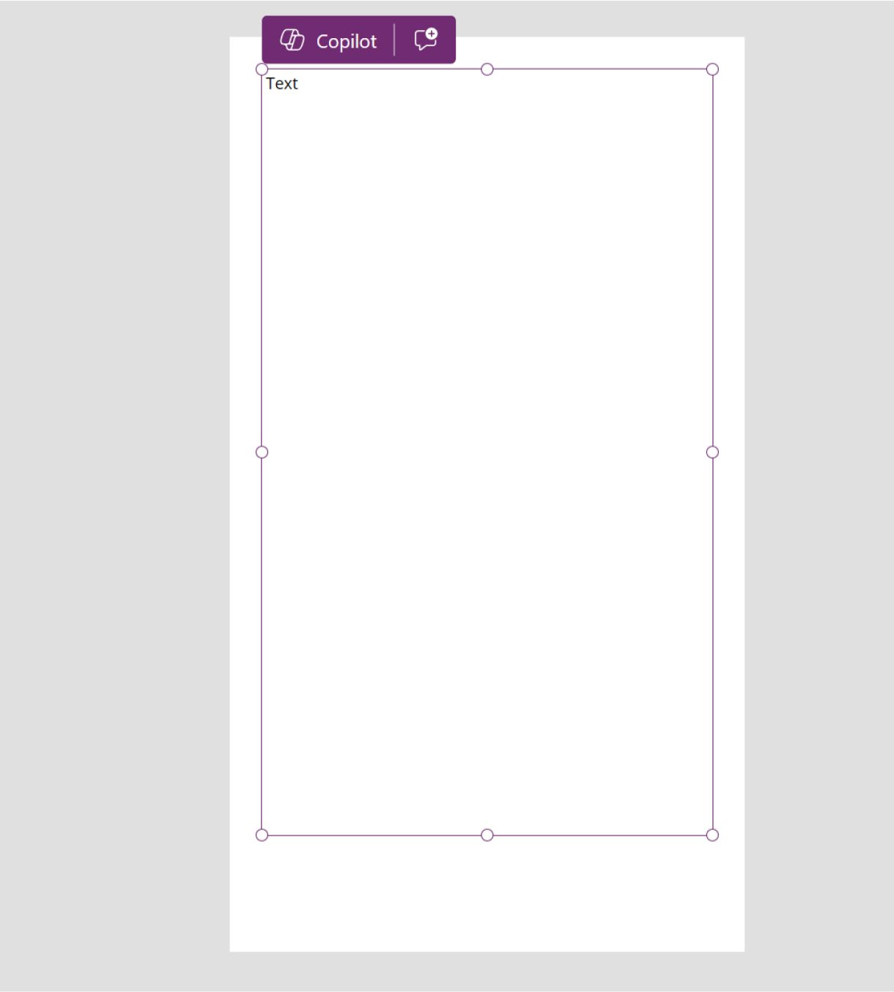

Figure 9-40. Selecting the text label and resizing it

Chapter 9 IntroduCIng aI BuIlder In power apps
7. Now, in the Formula bar, type the following code by
selecting the text label (also shown in Figure 9-41):
Concat(TextRecognizer3.Results, Text & Char(13))
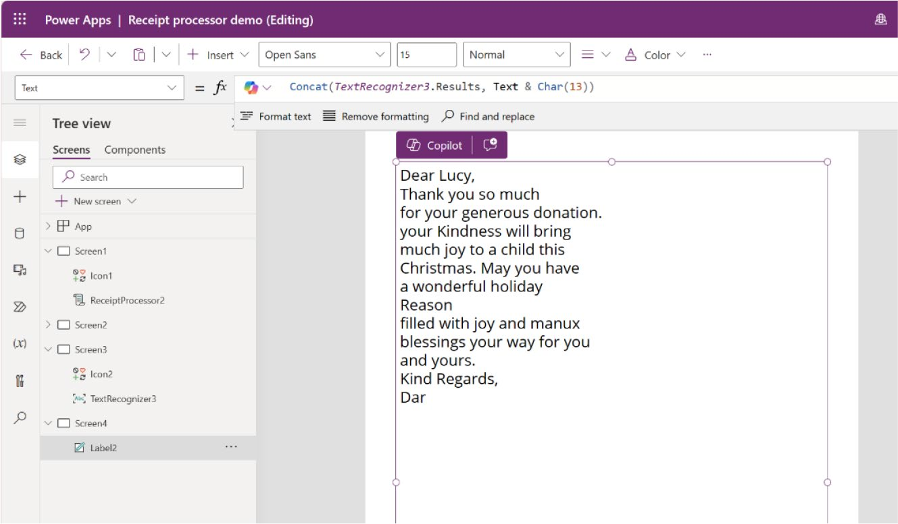

Figure 9-41. Connect the Text Recognizer result to the text label

8. Run the app from the screen where you added the
Text Recognizer component. Upload a new image to
verify the process, as shown in Figure 9-42.

Chapter 9 IntroduCIng aI BuIlder In power apps
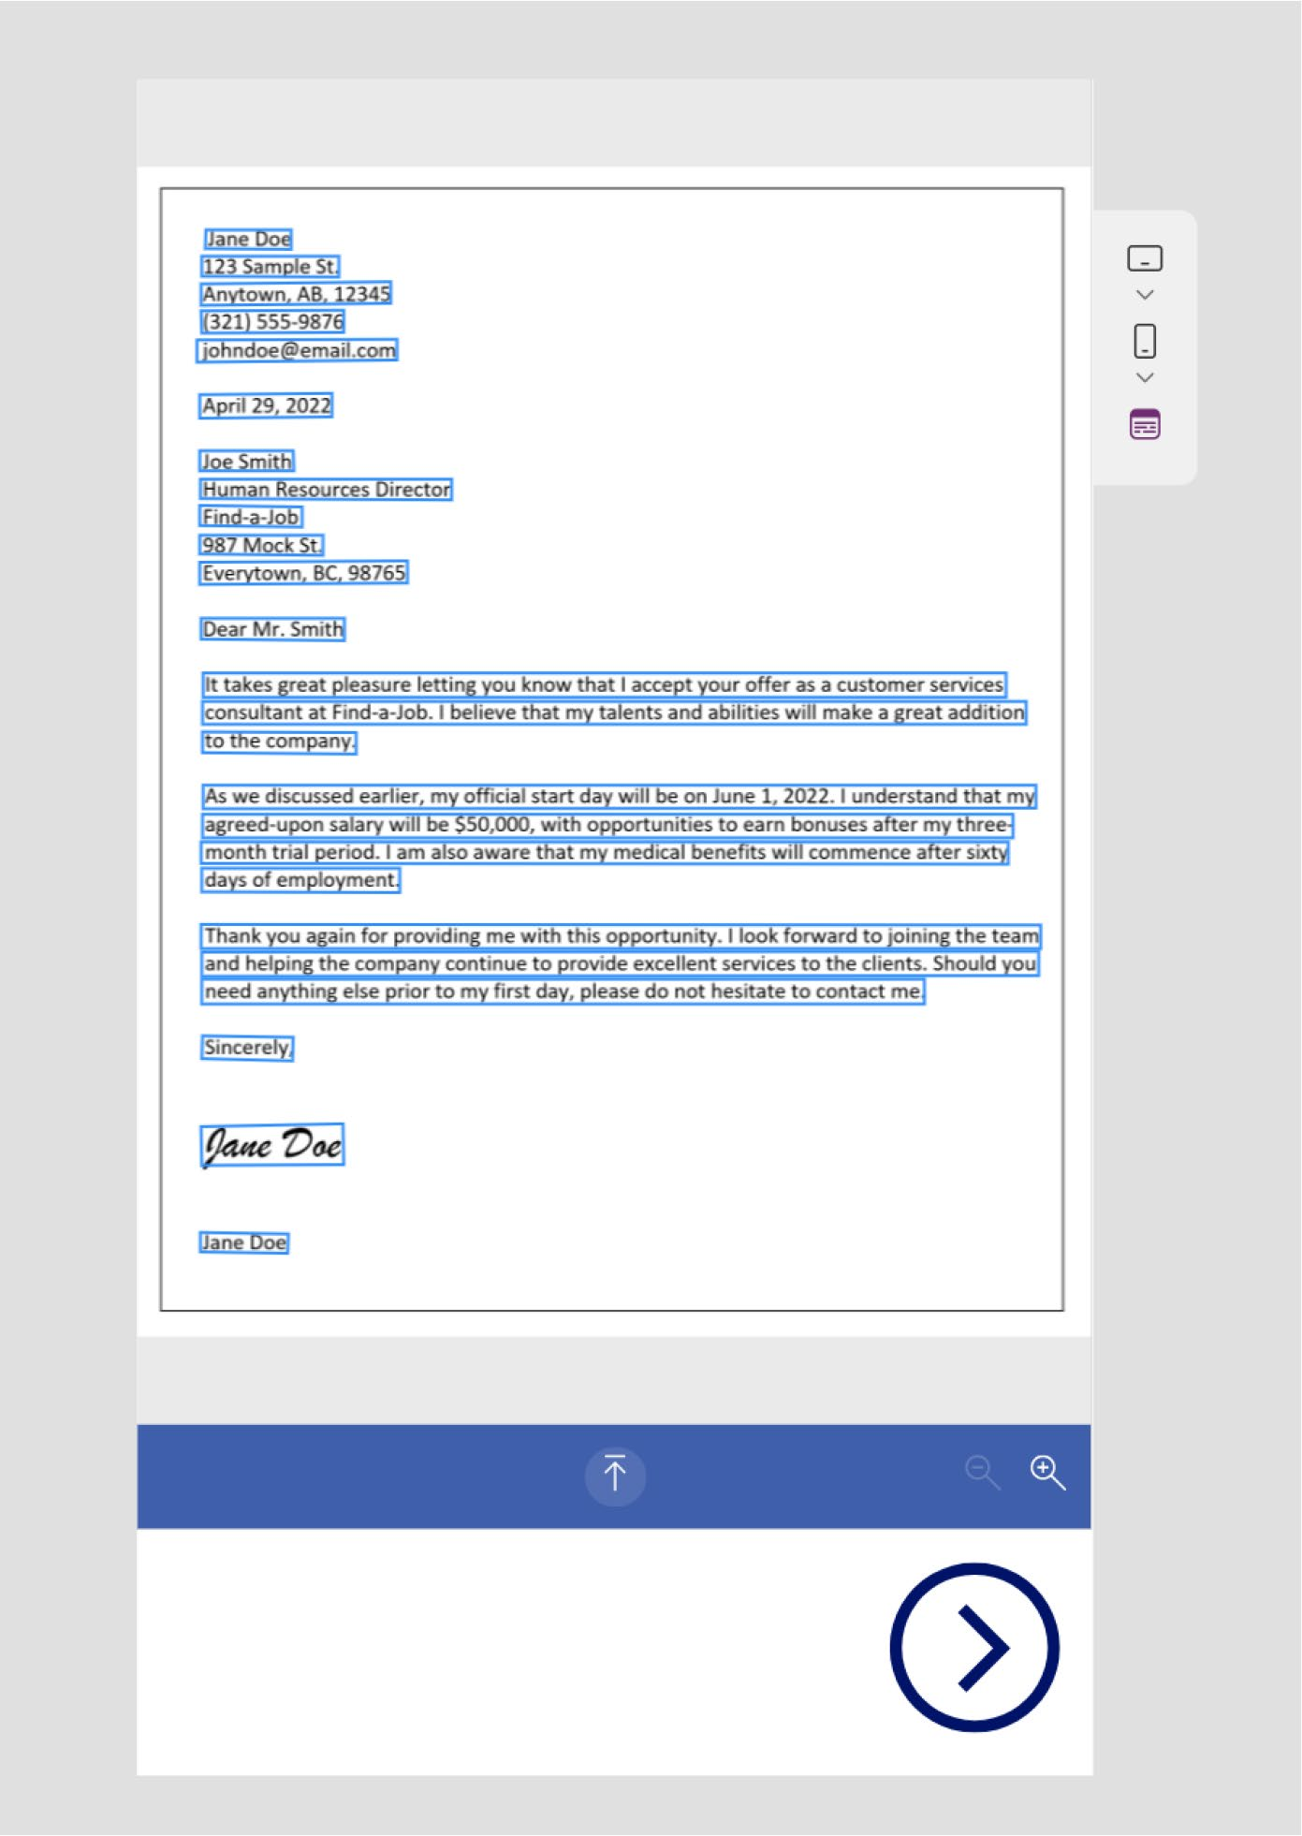

Figure 9-42. Adding a new image to test the Text Recognizer

Chapter 9 IntroduCIng aI BuIlder In power apps
9. Click the next arrow to view the text recognized by
the Text Recognizer, as shown in Figure 9-43.


Figure 9-43. Text recognized by the Text Recognizer component

Chapter 9 IntroduCIng aI BuIlder In power apps

Pre-Built AI Builder Models
This section explains some important pre-built AI Builder components
that are not available as components in Canvas apps. You have two options
to utilize these components:
1. Create the app from AI models: Go to Power
Apps Studio ➤ AI Hub ➤ AI Models (as shown in
Figure 9-44) and choose the model, then create an app. This method automatically generates a default app with the necessary formulas, eliminating the need for manual coding.
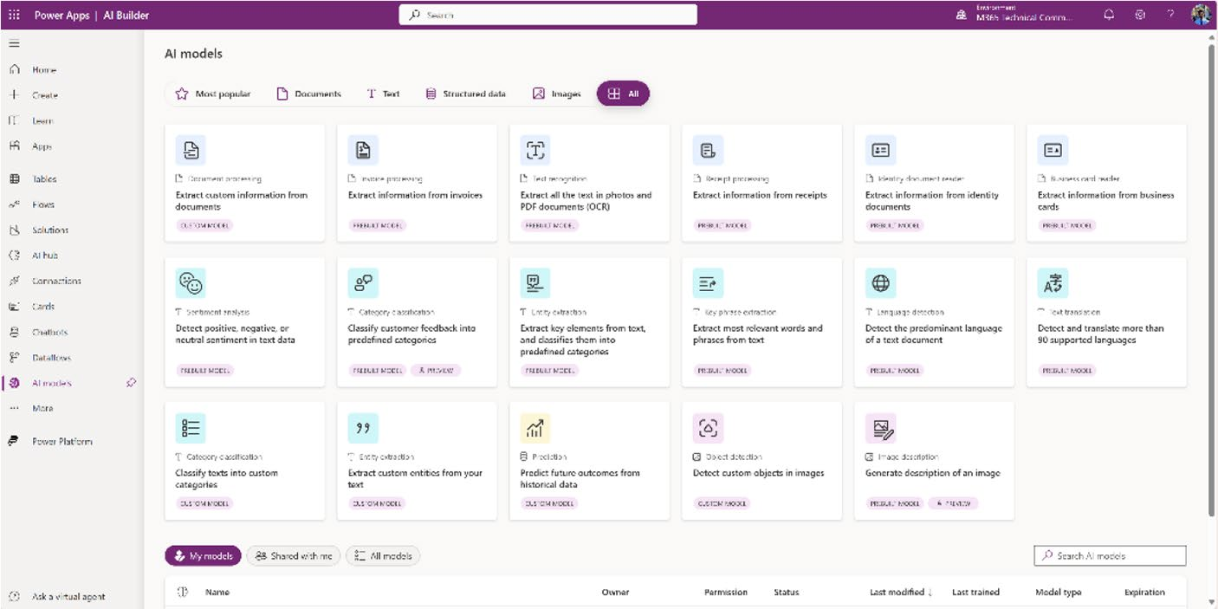

Figure 9-44. Pre-built and custom AI models in Power Apps

2. Add the AI model to a new or existing app: Create
a new app or select an existing one, then add the AI model via Add Data ➤ AI Models (as shown in
Figure 9-45). In this case, you need to manually write the formula code for each label.

Chapter 9 IntroduCIng aI BuIlder In power apps
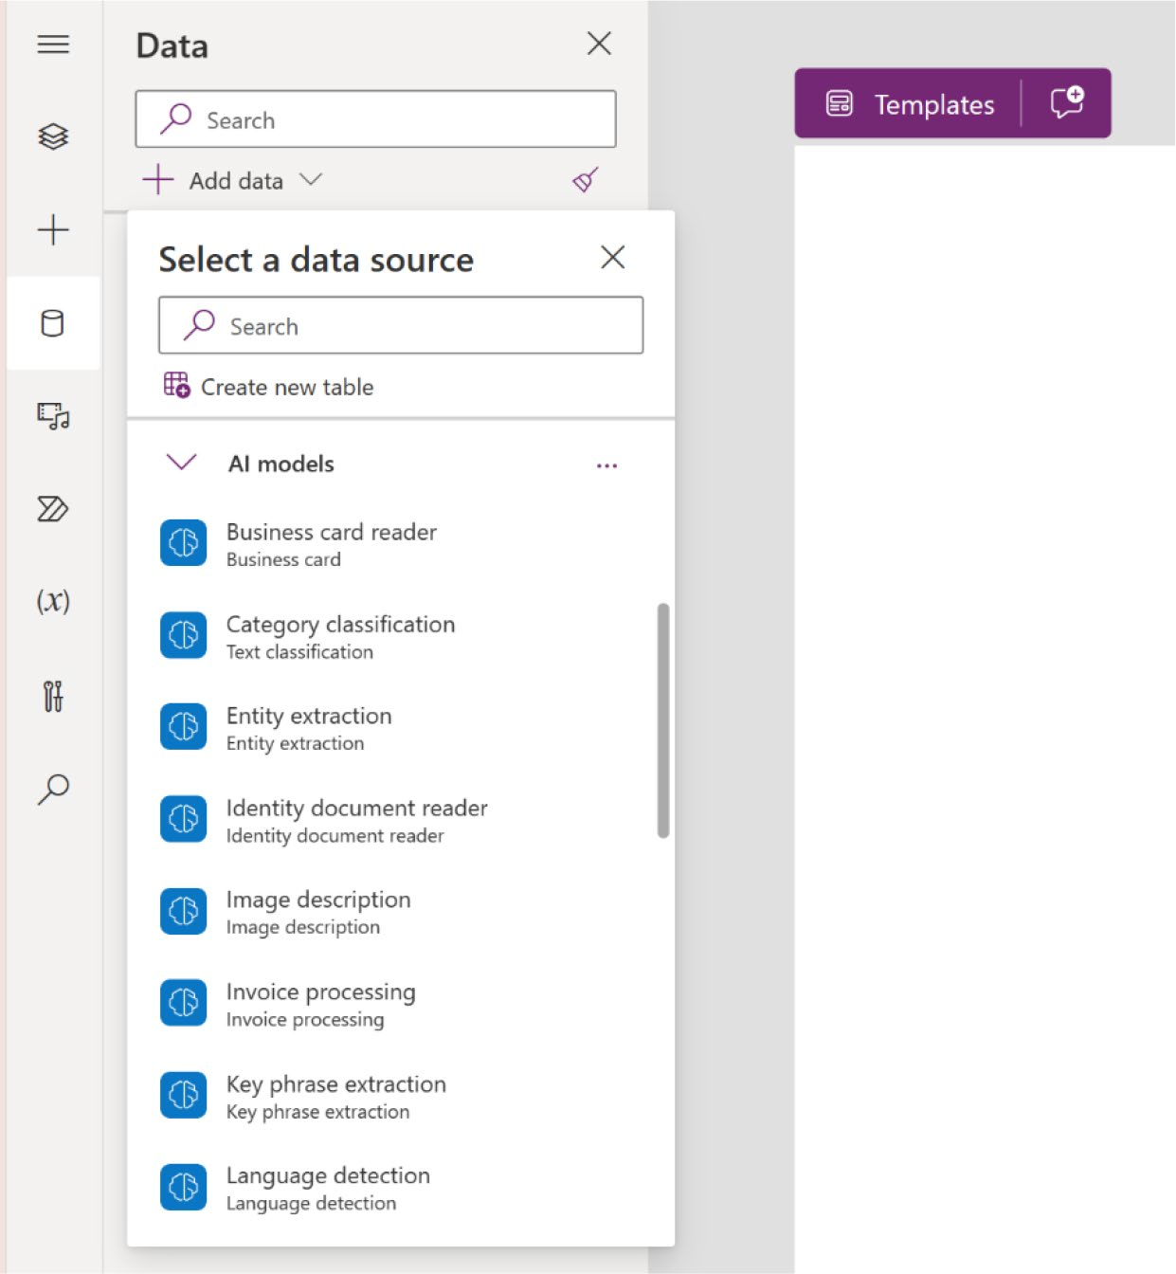

Figure 9-45. AI models that can be used as data sources
The next section discusses some important AI models with demos.

The Invoice Processing Pre-Built Model
The Invoice Processing AI model in Power Apps uses advanced machine learning to automate the extraction and processing of invoice data. This model can accurately capture key information such as invoice numbers, dates, totals, and line items from various invoice formats, streamlining accounts payable workflows. By integrating this AI model into your

Chapter 9 IntroduCIng aI BuIlder In power apps
Power Apps, you can reduce manual data entry, minimize errors, and
significantly increase processing efficiency. This pre-built solution is ideal
for businesses looking to enhance their financial operations with minimal
development effort.

Demo
This demos shows you two ways to use the Invoice Processing model.
You can access and use the model directly from the AI model page, or you
can manually add the Invoice Processing model from the app page as a
data source.

Create the Invoice Processing app from the AI model page
To use the Invoice Processing model, follow these steps:
1. Visit https://make.powerapps.com. Click the AI
Hub from the left sidebar, and then select AI Models,
as shown in Figure 9-46.
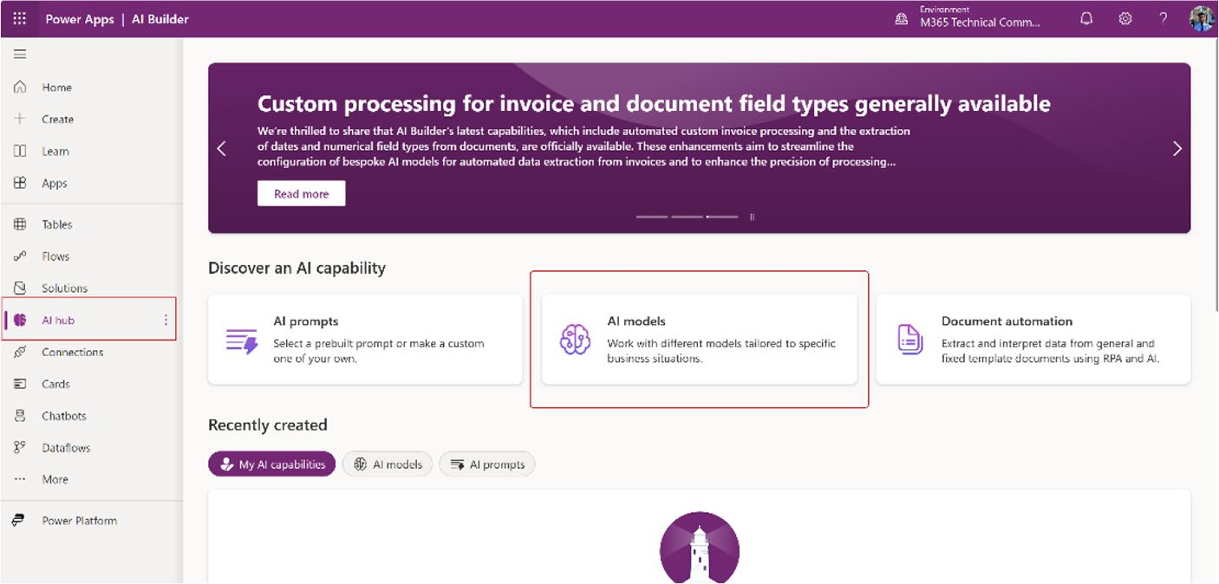

Figure 9-46. Choosing AI models from the AI Hub

Chapter 9 IntroduCIng aI BuIlder In power apps
2. Select Documents or All from the upper filter, and
choose Extract Information from Invoices, as shown
in Figure 9-47.
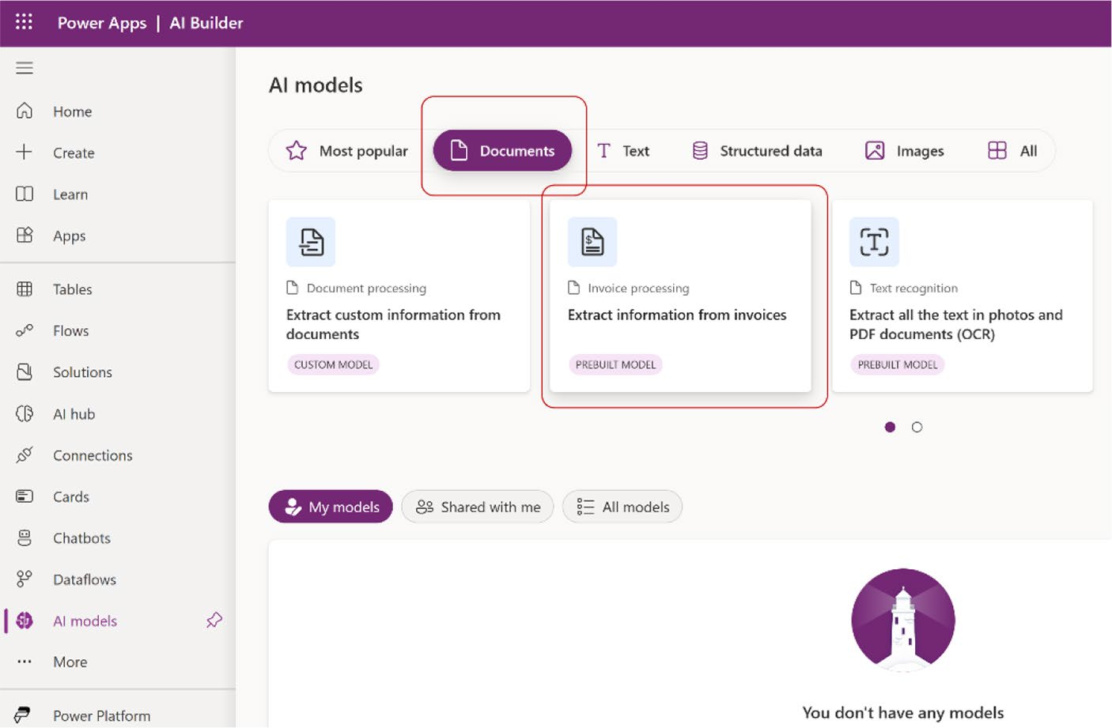

Figure 9-47. Choose the Extract Information from Invoices pre-built model from the AI Models list

3. After choosing the Extract Information from
Invoices model, you will see the page in Figure 9-48.

Chapter 9 IntroduCIng aI BuIlder In power apps
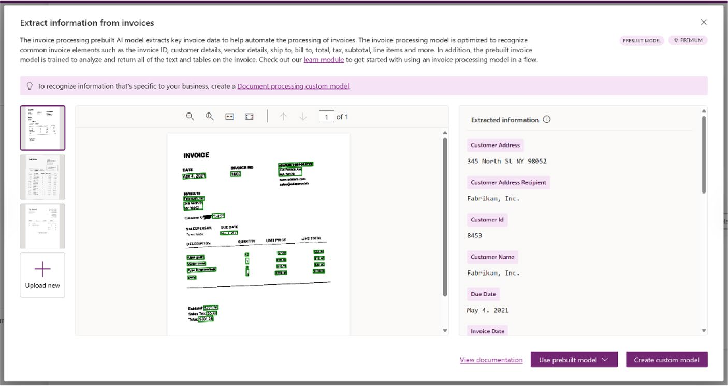

Figure 9-48. Inside of Extract Information from Invoice model

Figure 9-48 shows how the AI model can extract information from an invoice, including details such as invoice numbers, dates, totals, and line items.
4. There are two options here: one is to use a pre-built
model, and the other is to create a custom model. If you choose to use the pre-built model, you can immediately start utilizing its capabilities without additional setup. However, if you choose to create a custom model, you will need to design the model to fit your specific needs and train it with relevant data to ensure accuracy and effectiveness. This process involves defining the data structure, labeling the data, and running training iterations to optimize the model’s performance.
For this demo, I chose Use Prebuilt Model and
selected Use in an App, as shown in Figure 9-49.

Chapter 9 IntroduCIng aI BuIlder In power apps
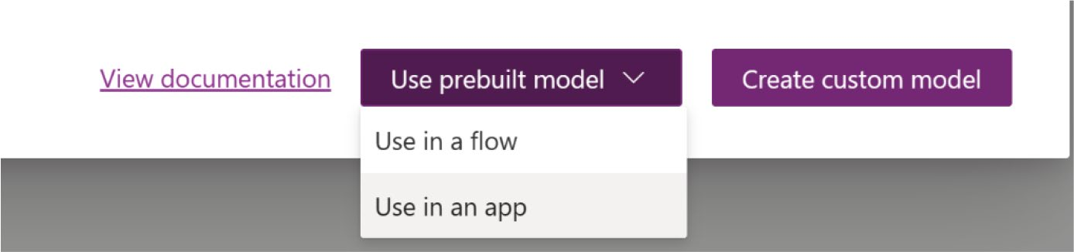

Figure 9-49. Creating an app from an AI model

5. When you click Use in an App, you will be redirected
to another page where you can see a default app
created by Power Apps, as shown in Figure 9-50.
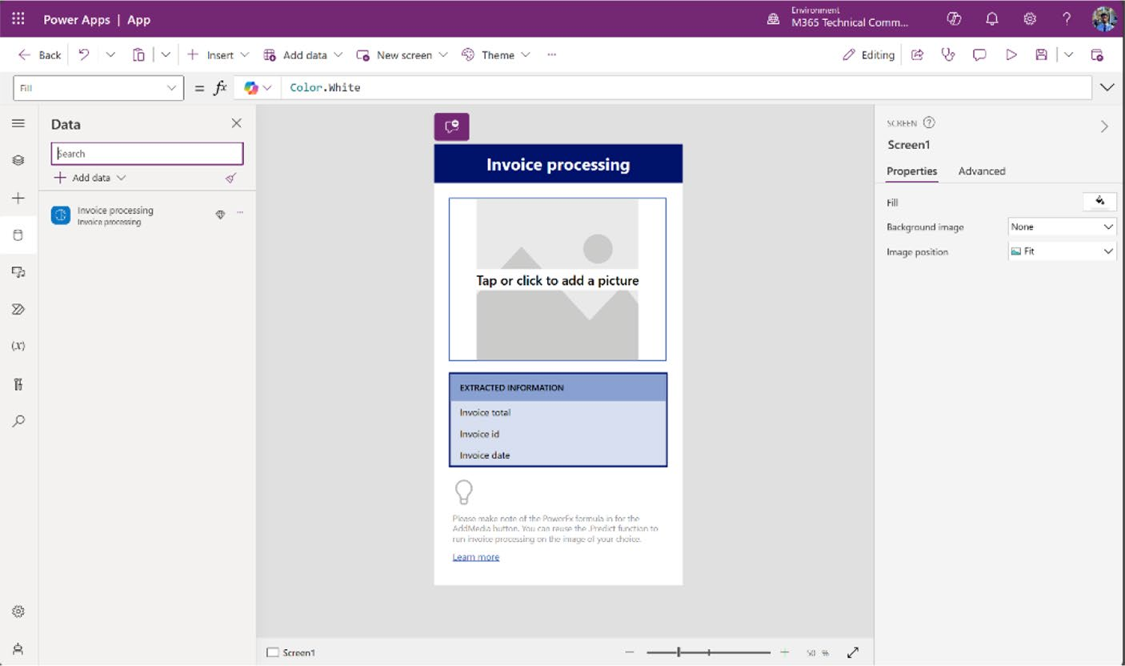

Figure 9-50. Invoice Processing app created by Power Apps

Chapter 9 IntroduCIng aI BuIlder In power apps
6. Run the app and upload an invoice to see the
processed result, as shown in Figure 9-51.
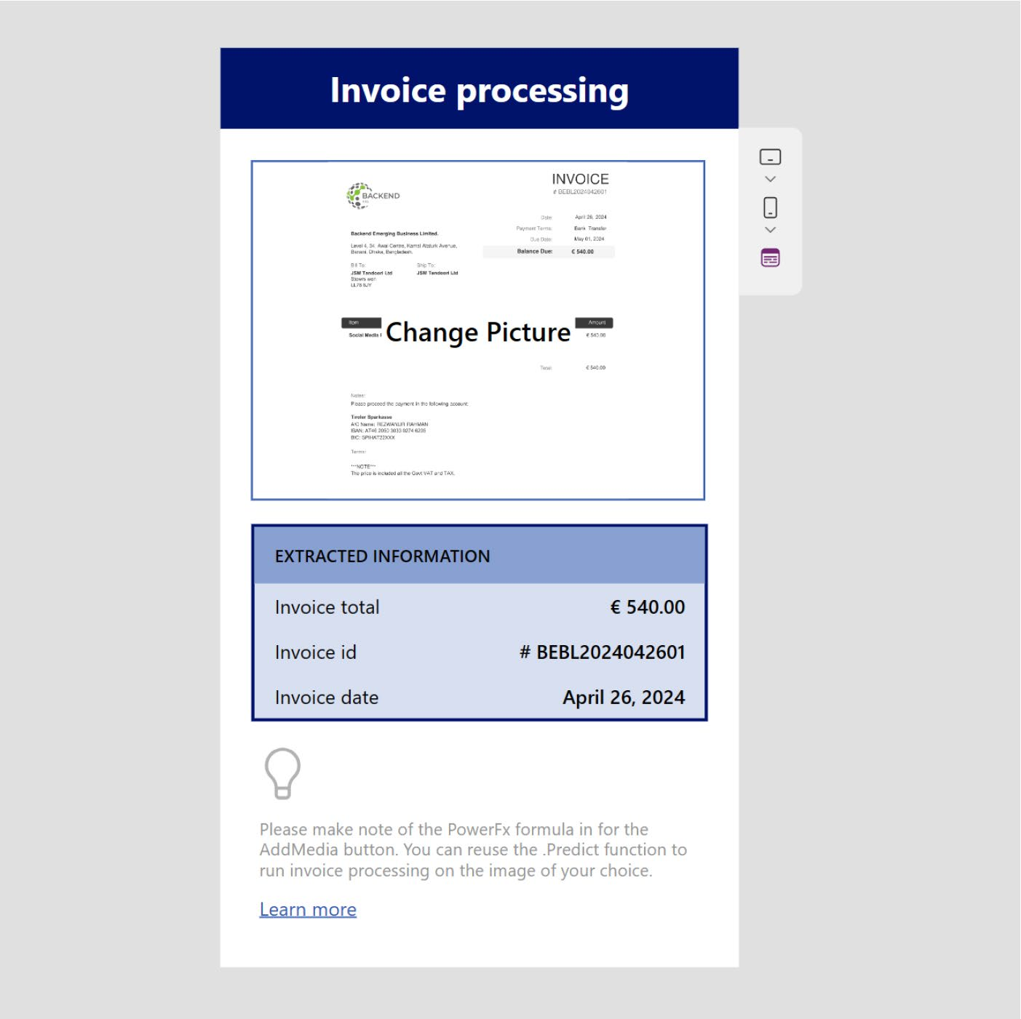

Figure 9-51. Invoice Processing app test that was created by
Power Apps

As you can see, the Invoice Processing model can read the information
from the invoice. When you create an app from AI model, it will only
create a phone format app, which can extract limited information. The
next section explains how to create an Invoice Processing app manually in
Tablet format.

Chapter 9 IntroduCIng aI BuIlder In power apps
Create an Invoice Processing app manually
To create an Invoice Processing app manually, follow these steps:
1. Create an app in Power Apps Studio (https://make.
powerapps.com) in Tablet format.
2. Add the Invoice Processing model by choosing the
Data ➤ Add Data ➤ AI Models option, as shown in
Figure 9-52.
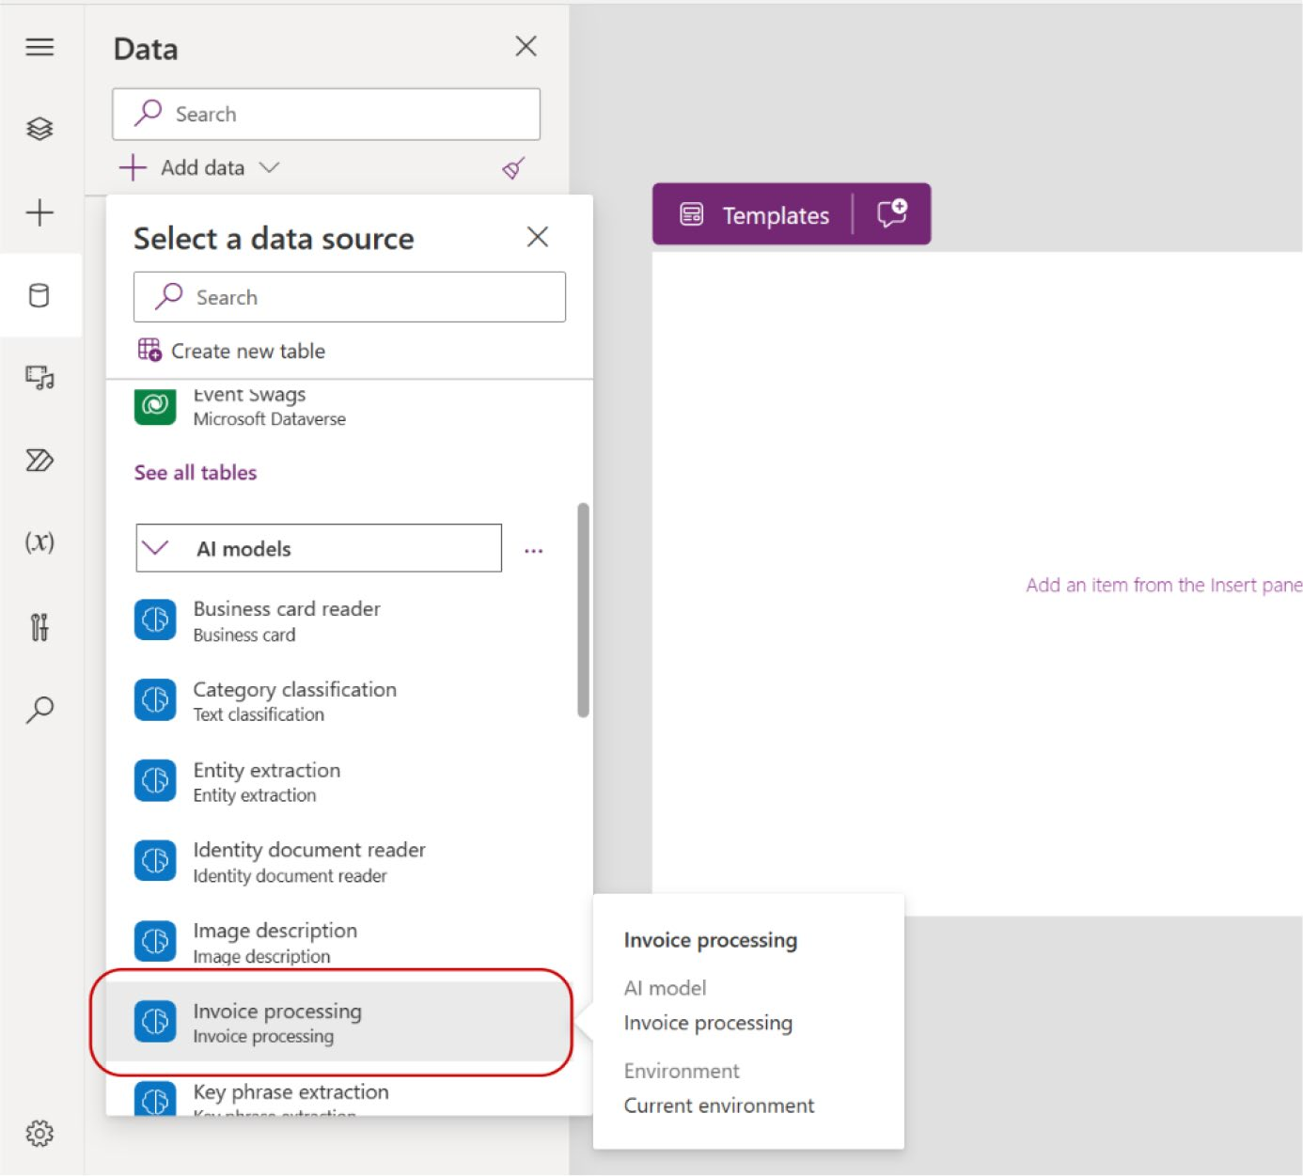

Figure 9-52. Selecting Invoice Processing from the AI models

Chapter 9 IntroduCIng aI BuIlder In power apps
3. After adding the Invoice Processing AI model,
choose the Add Picture component under the Media category from the Insert option, as shown in
Figure 9-53.
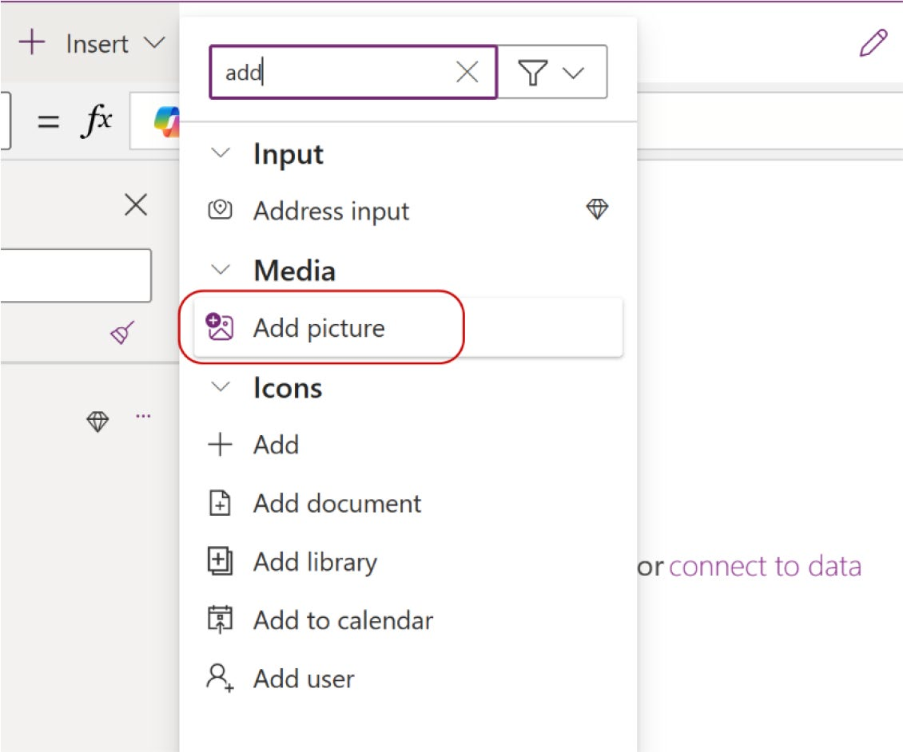

Figure 9-53. Selecting the Add Picture component from the
Insert option

4. If you extend the tree view, you can see inside
the Add Picture component. There are two more components there—AddMediaButton1 and
UploadedImage1—as shown in Figure 9-54.

Chapter 9 IntroduCIng aI BuIlder In power apps
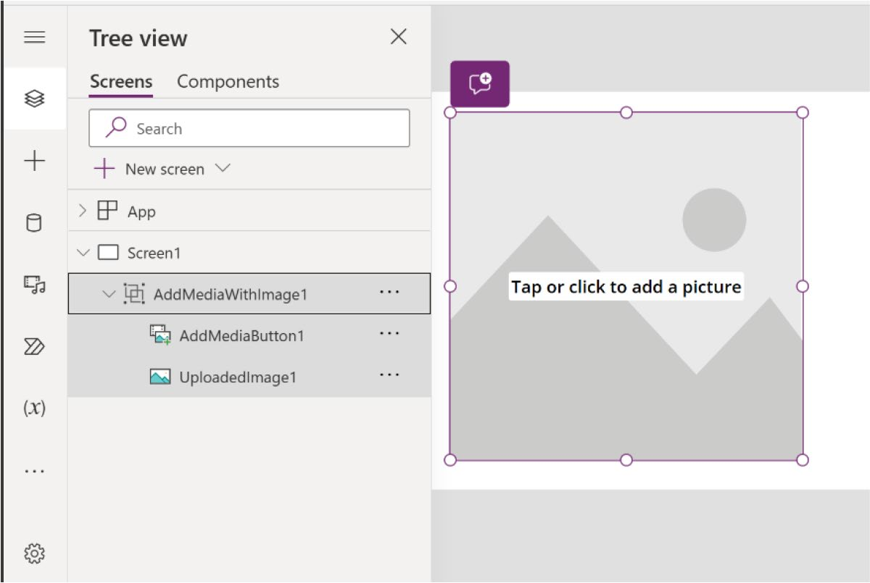

Figure 9-54. Tree view of the Add Picture component,

5. Select AddMediaButton1 from the tree view (see
Figure 9-55) and add the following code to the Formula bar by selecting the OnChange property:
Set(PredictionResult, 'Invoice processing'. Predict(UploadedImage1.Image));
IfError(PredictionResult, Notify(FirstError. Message,NotificationType.Error))

Chapter 9 IntroduCIng aI BuIlder In power apps
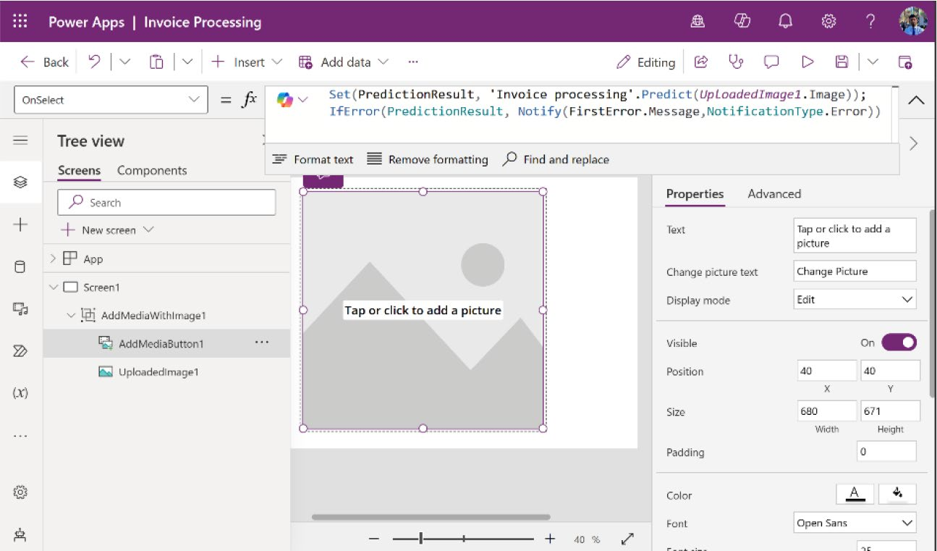

Figure 9-55. Adding code to the OnSelect property from the
Formula bar

6. Run the app and upload the invoice, as shown in
Figure 9-56.
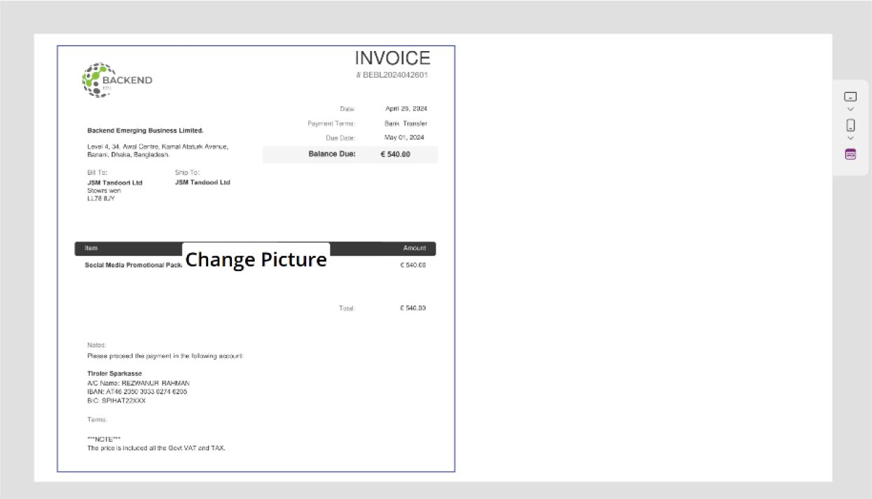

Figure 9-56. Uploading an invoice to the app

Chapter 9 IntroduCIng aI BuIlder In power apps
7. Create some labels to get the extracted information
from the invoice, as I showed you in the previous
demo. See Figure 9-57.
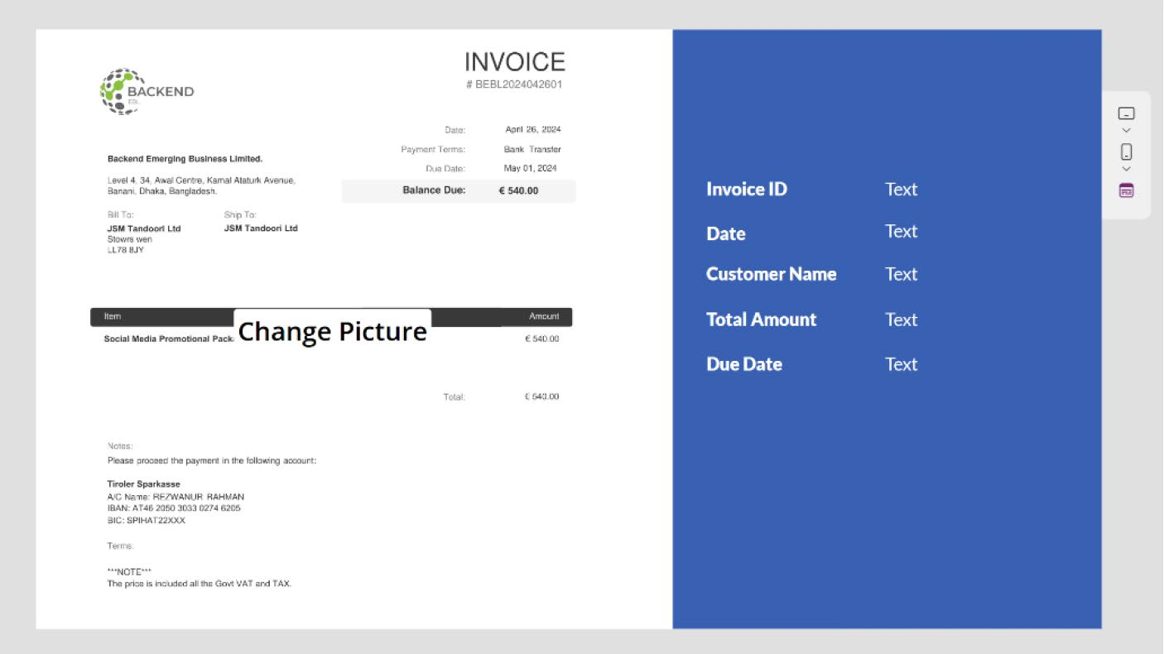

Figure 9-57. New labels have been created to get the extracted information from the Invoice Processing AI model

8. After creating the labels, you need to assign a
formula to each label. Let’s start with Invoice ID.
Select the right label of Invoice ID and add the following code to the Formula bar (also shown in
Figure 9-58):
If(!IsBlank(PredictionResult.Fields.InvoiceId), PredictionResult.Fields.InvoiceId.Value.Text, "")

Chapter 9 IntroduCIng aI BuIlder In power apps
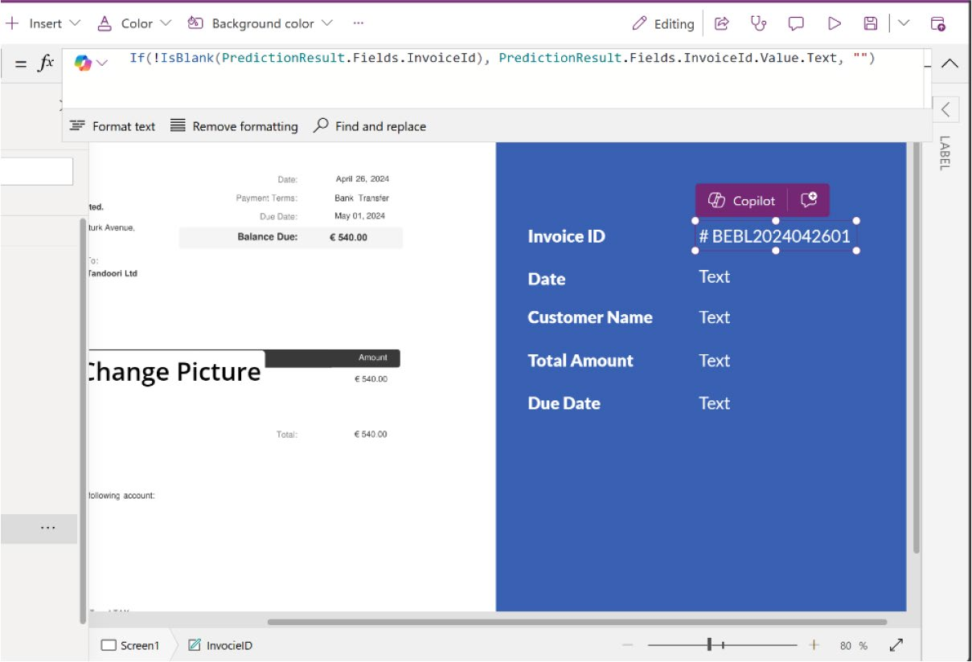

Figure 9-58. Changing the Invoice ID with prediction result of
Invoice Processing AI model

The invoice ID has been changed. Do this for every
label that you want to show. Table 9-10 shows the code used to get the information from the Invoice Processing AI model.
Table 9-10. Formula Code of All Labels That Save Extracted
Information
Property Name Formula Code
date If(!IsBlank(PredictionResult.Fields.
InvoiceDate), PredictionResult.Fields. InvoiceDate.Value.Text, "")
Customer name If(!IsBlank(PredictionResult.Fields.
CustomerName), PredictionResult.Fields. CustomerName.Value.Text, "")
(continued)

Chapter 9 IntroduCIng aI BuIlder In power apps
Table 9-10. (continued)
Property Name Formula Code
total amount If(!IsBlank(PredictionResult.Fields.
InvoiceTotal), PredictionResult.Fields. InvoiceTotal.Value.Text, "")
due date If(!IsBlank(PredictionResult.Fields.
DueDate), PredictionResult.Fields.DueDate. Value.Text, "")

9. Run the app and upload a new invoice to test the
Invoice Processing model. See Figure 9-59.
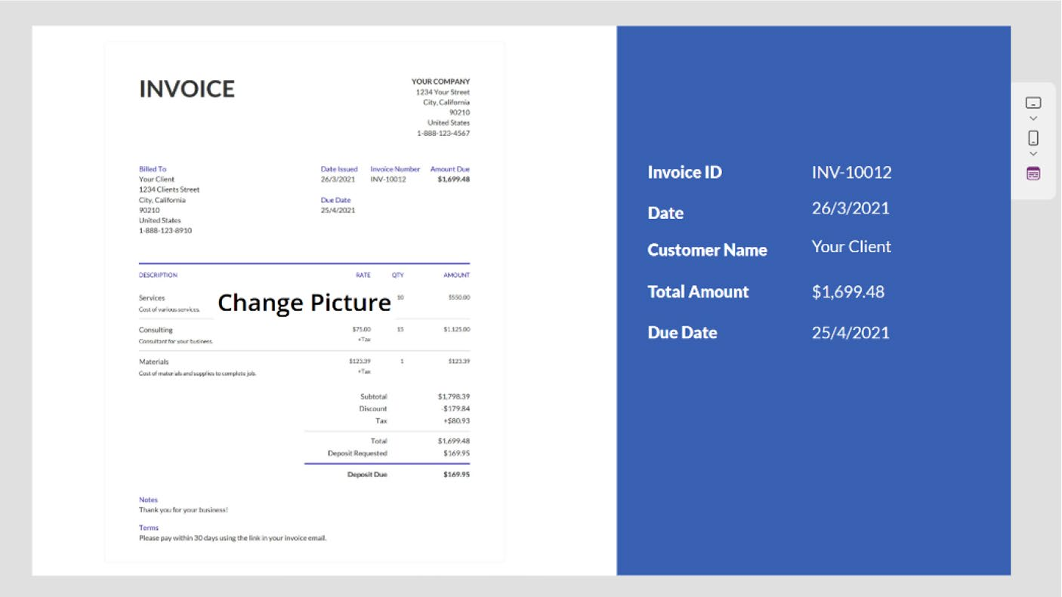

Figure 9-59. Uploading a new invoice to test the AI model

As you can see, the Invoice Processing model read the invoice successfully, extracted the information from the invoice, and placed it in the text labels.

Chapter 9 IntroduCIng aI BuIlder In power apps
Pre-Built Model Image Description
The pre-built model for generating descriptions of images in Power Apps
utilizes advanced AI to analyze and interpret visual content, automatically
producing accurate and meaningful descriptions. This model can identify
and describe various elements within an image, such as objects, scenes,
and activities, making it a valuable tool for applications requiring image
recognition and interpretation. By integrating this model into Power
Apps, users can enhance accessibility, streamline content management,
and improve user engagement without needing extensive coding or data
science expertise. This pre-built solution simplifies the integration of
sophisticated image analysis into custom applications. If you navigate
to Power Apps Studio ➤ AI Hub ➤ AI Models ➤ Images ➤ Generate
Description of an Image, you will find a built-in demo that allows you to
check any image you want, as shown in Figure 9-60.
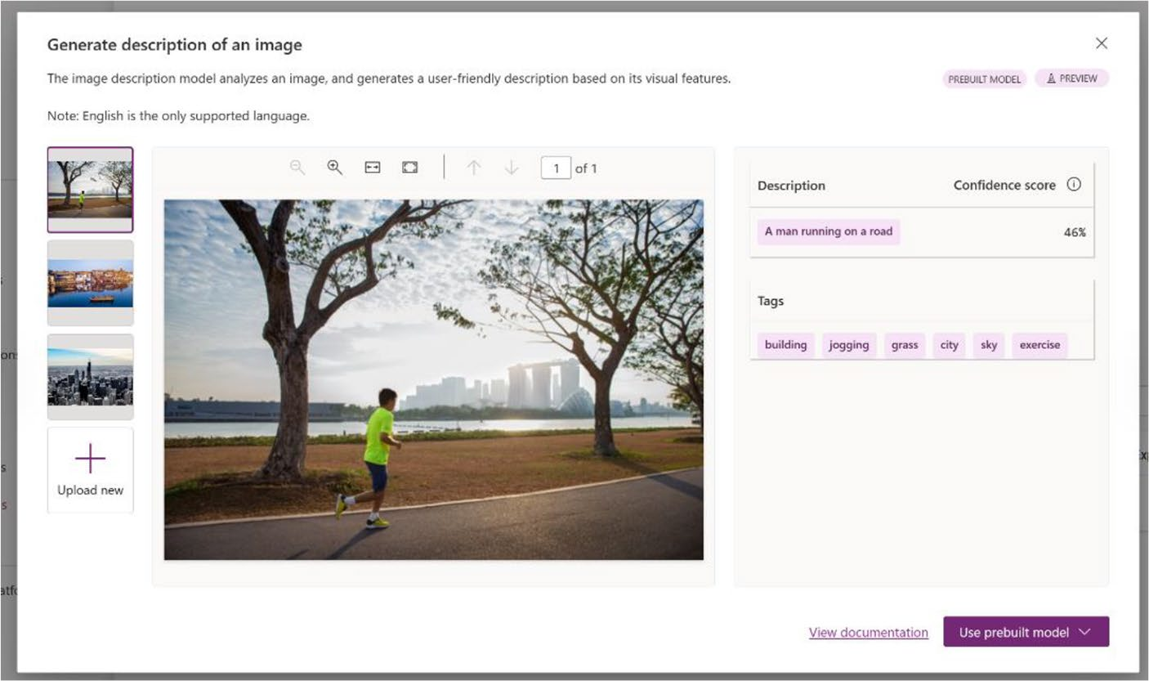

Figure 9-60. The Generate Description of an Image model provides a
description of any image

Chapter 9 IntroduCIng aI BuIlder In power apps
The next section explains how to create an app manually in Power Apps, not using the pre-built model.

Demo
To start with the demo, follow these instructions:
1. Create an app in Power Apps Studio or open your
existing app with a new screen. For my demo, I created a new app in the Tablet format.
2. Choose Data ➤ Add Data ➤ AI Models ➤ Image
Description, as shown in Figure 9-61.
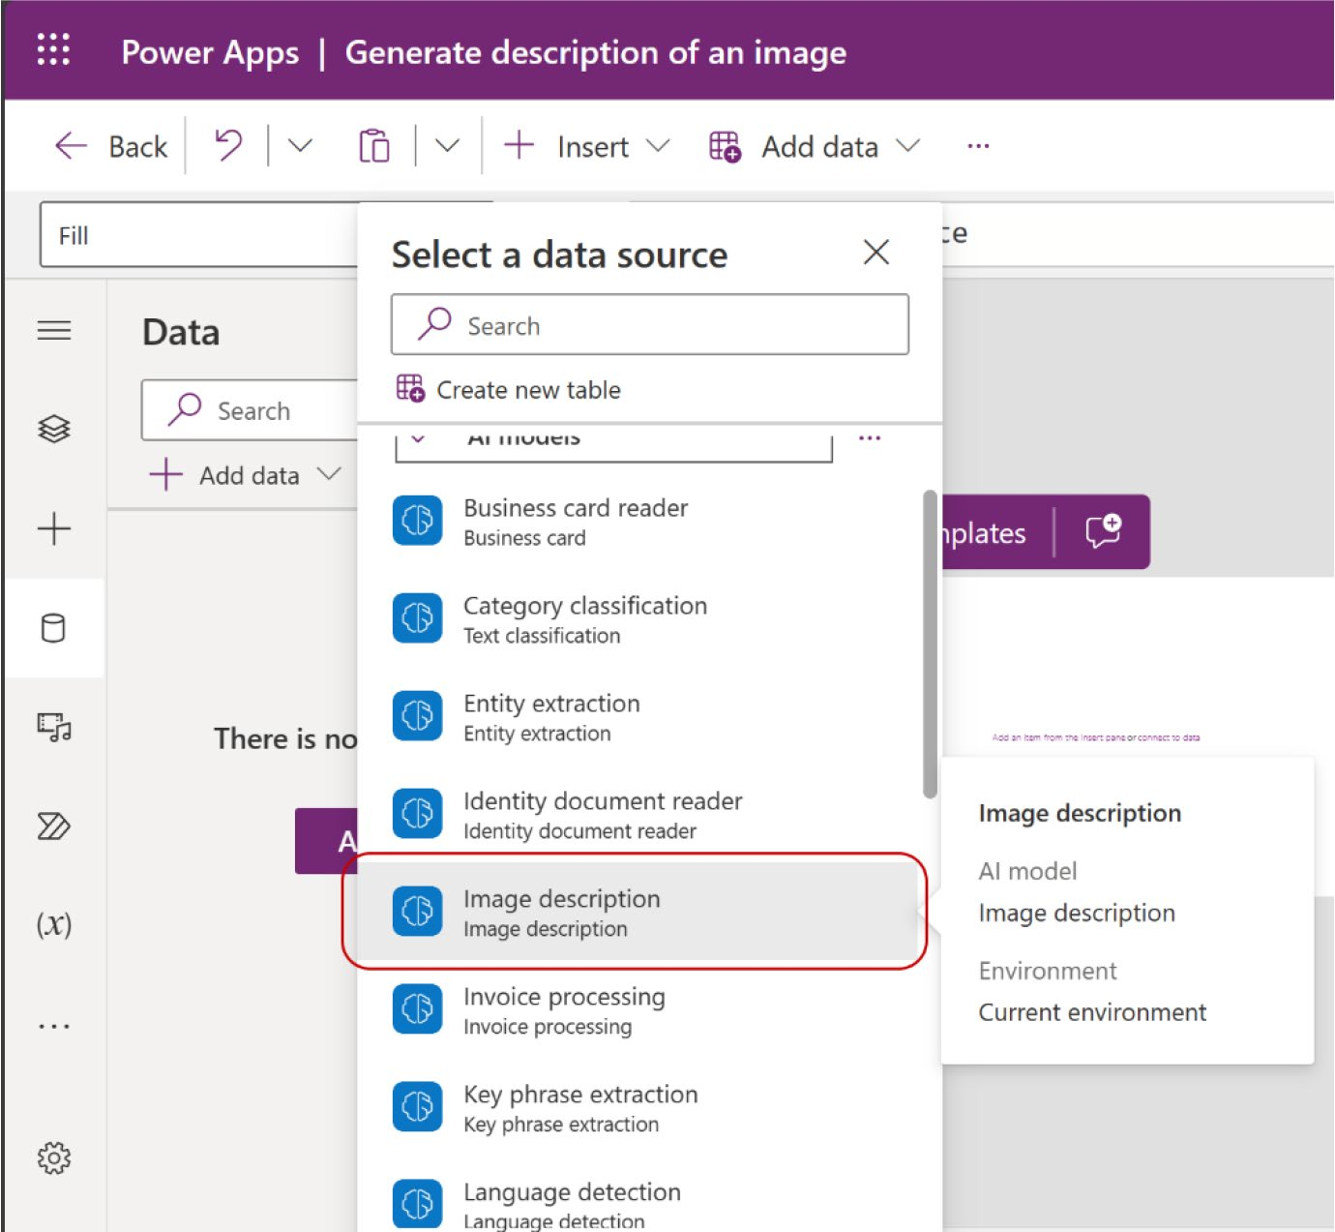

Figure 9-61. Adding an image description an AI model in Power Apps

Chapter 9 IntroduCIng aI BuIlder In power apps
3. Add the Add Picture component from the Insert
option, as shown in Figure 9-62.
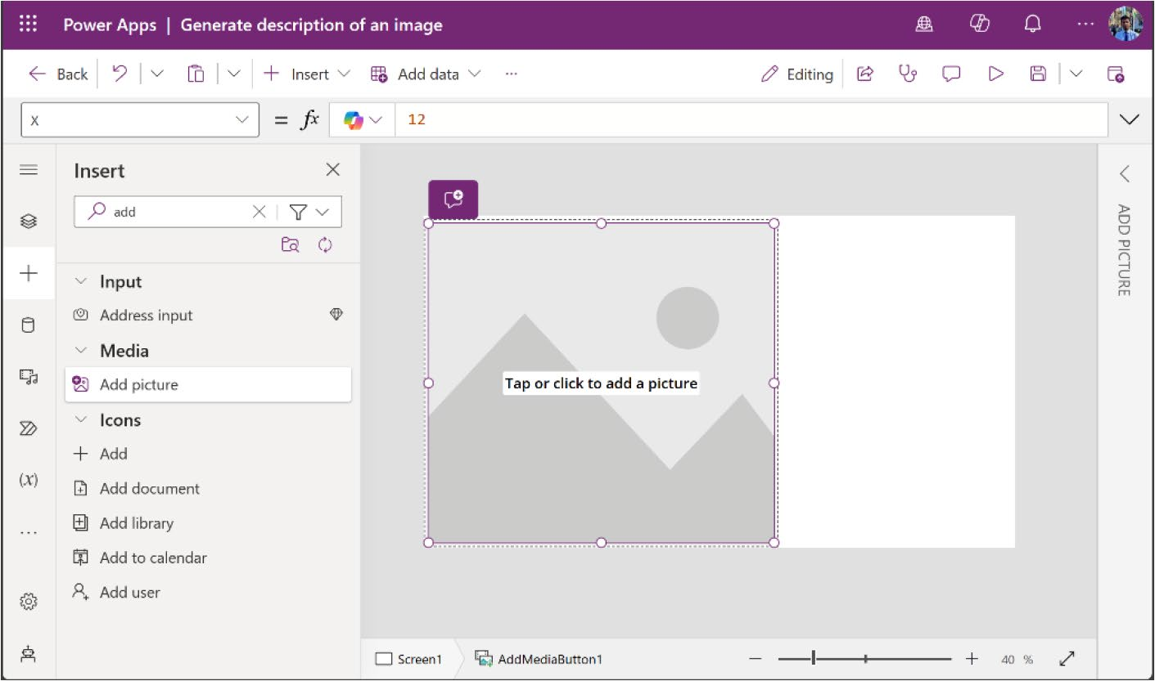

Figure 9-62. Adding the Add Picture component from the Insert option

4. From the tree view, select AddMediaButton1 and add
the following code to the OnSelect properties from
the Formula bar (also shown in Figure 9-63):
Set(PredictionResult, 'Image description'.Predict (UploadedImage1.Image)); IfError(PredictionResult, Notify(FirstError.Message, NotificationType.Error))

Chapter 9 IntroduCIng aI BuIlder In power apps
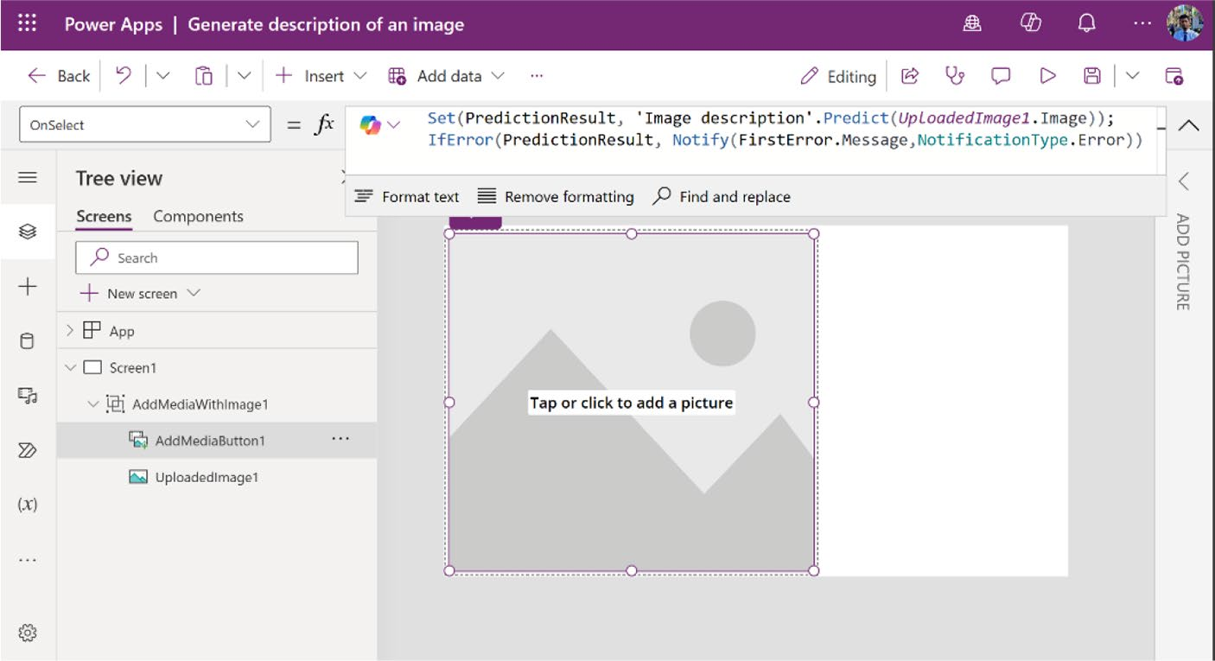

Figure 9-63. Adding the formula code to the OnSelect properties

5. Add the labels as before to save the extracted
information. See Figure 9-64. Check out the previous demo to see how to add the labels.
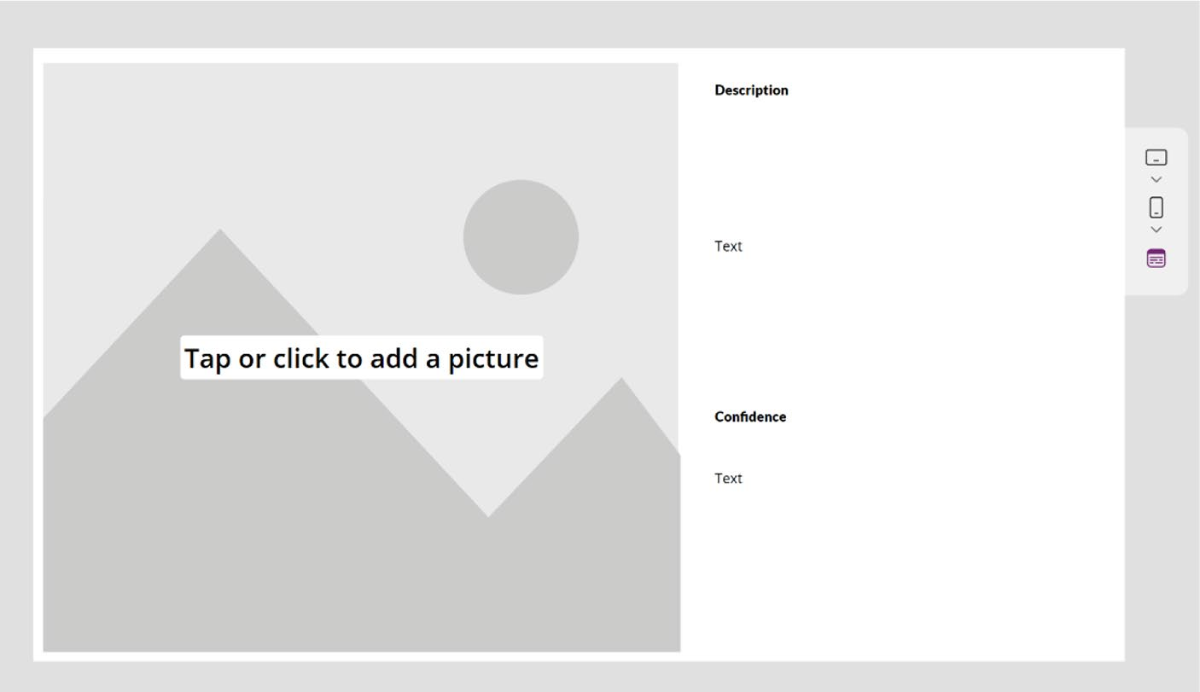

Figure 9-64. Adding the text labels to show the extracted information

Chapter 9 IntroduCIng aI BuIlder In power apps
6. Add the code in Table 9-11 to the text properties of
the text labels.
Table 9-11. Formula Code to Get the Image Description and Confidence Level
Property Name Formula Code
Description If(IsBlank(PredictionResult), "",
PredictionResult.Description)
Confidence If(IsBlank(PredictionResult),
"", $"{Int(PredictionResult.
DescriptionConfidence * 100)} % ")

7. After adding the code, run the app and upload an
image. You will see the description and confidence
level, as shown in Figure 9-65.
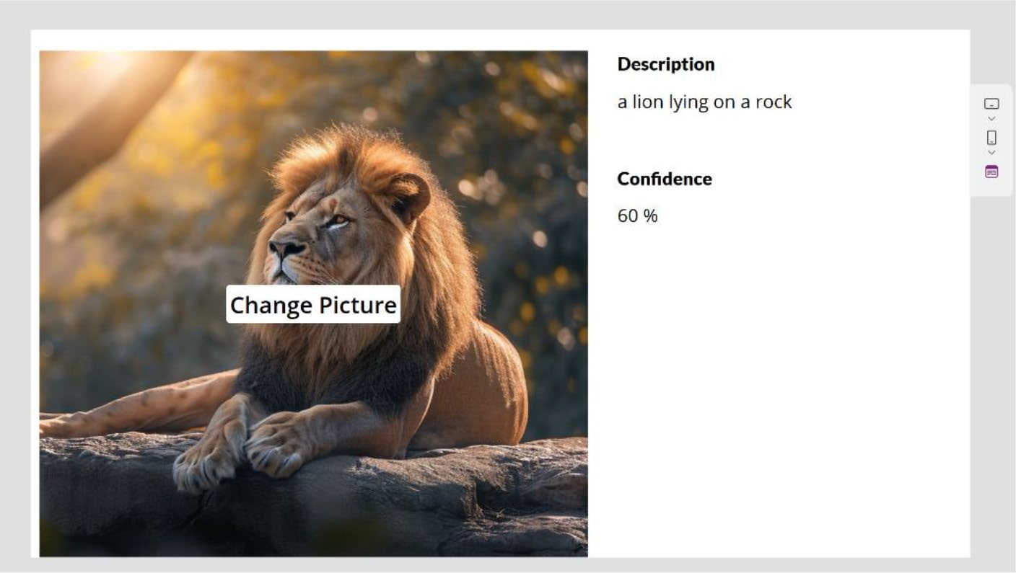

Figure 9-65. Uploading an image to test the Image Description
AI model

Chapter 9 IntroduCIng aI BuIlder In power apps
To use the Image Description AI model, keep in mind the following requirements: accepted image formats are .JPG, .JPEG, .PNG, and .BMP; the maximum image size is 4MB; and the image dimensions must be greater than 50x50 pixels.

Pre-Built Model Sentiment Analysis
The pre-built model for Sentiment Analysis in Power Apps uses advanced natural language processing to evaluate and classify the sentiment of text data. This model can determine whether the expressed sentiment is positive, negative, or neutral, making it an invaluable tool for businesses seeking to understand customer feedback, social media interactions, and other text-based communications. By integrating this model into your applications, you can gain valuable insights into customer opinions and trends without needing extensive coding or data science expertise. This pre-built solution simplifies the process of incorporating sophisticated sentiment analysis into your custom apps. If you visit Power Apps Studio ➤ AI Hub ➤ AI Models ➤ Text ➤ Detect Positive, Negative, or Neutral Sentiment in Text Data, you will find a built-in demo that allows you to check any paragraph or dialogue for sentiment analysis, as shown in
Figure 9-66.

Chapter 9 IntroduCIng aI BuIlder In power apps
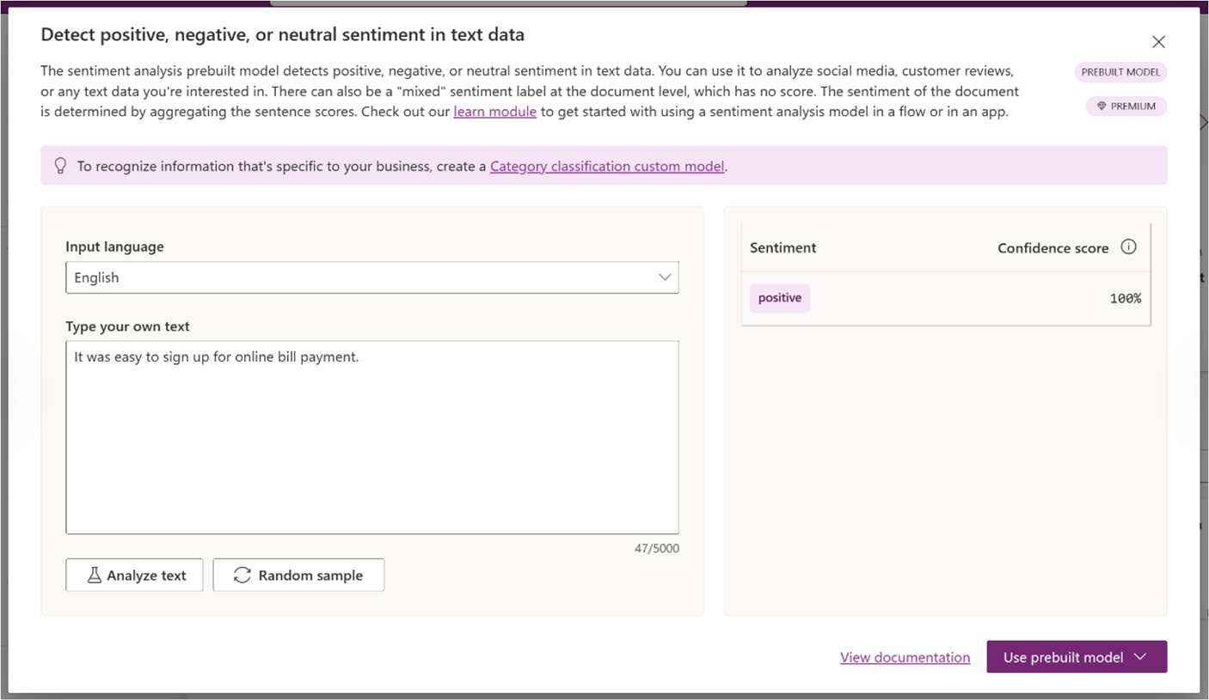

Figure 9-66. Built-in demo for detecting text sentiment

The next section explains how to use the AI model in your Power Apps.

Demo
To start with the demo, follow these instructions:
1. Open your Power Apps project or create a new
Canvas apps from Power Apps Studio (https://
make.powerapps.com).
2. Choose Data ➤ Add Data ➤ AI Models ➤ Sentiment
Analysis to add the Sentiment Analysis AI model,
as shown in Figure 9-67.

Chapter 9 IntroduCIng aI BuIlder In power apps
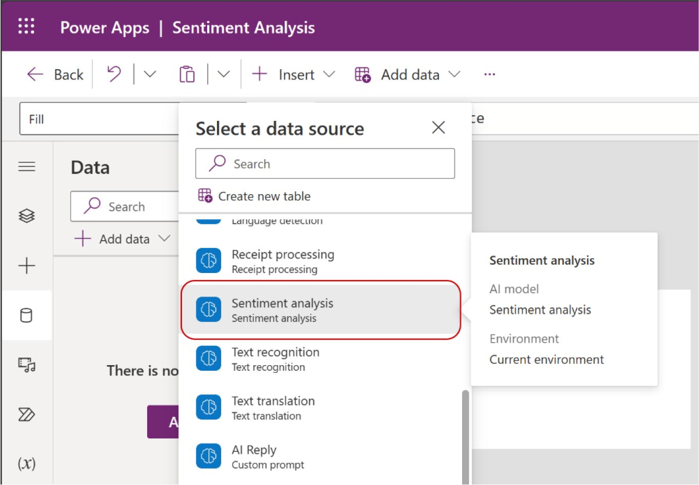

Figure 9-67. Adding the Sentiment Analysis AI model to the Power Apps project

3. This example added a text field to receive input from
the keyboard, a button for submission, and four text
labels, as shown in Figure 9-68. Two labels identify the purpose of the other labels, while the remaining two display information from the Sentiment Analysis model.

Chapter 9 IntroduCIng aI BuIlder In power apps
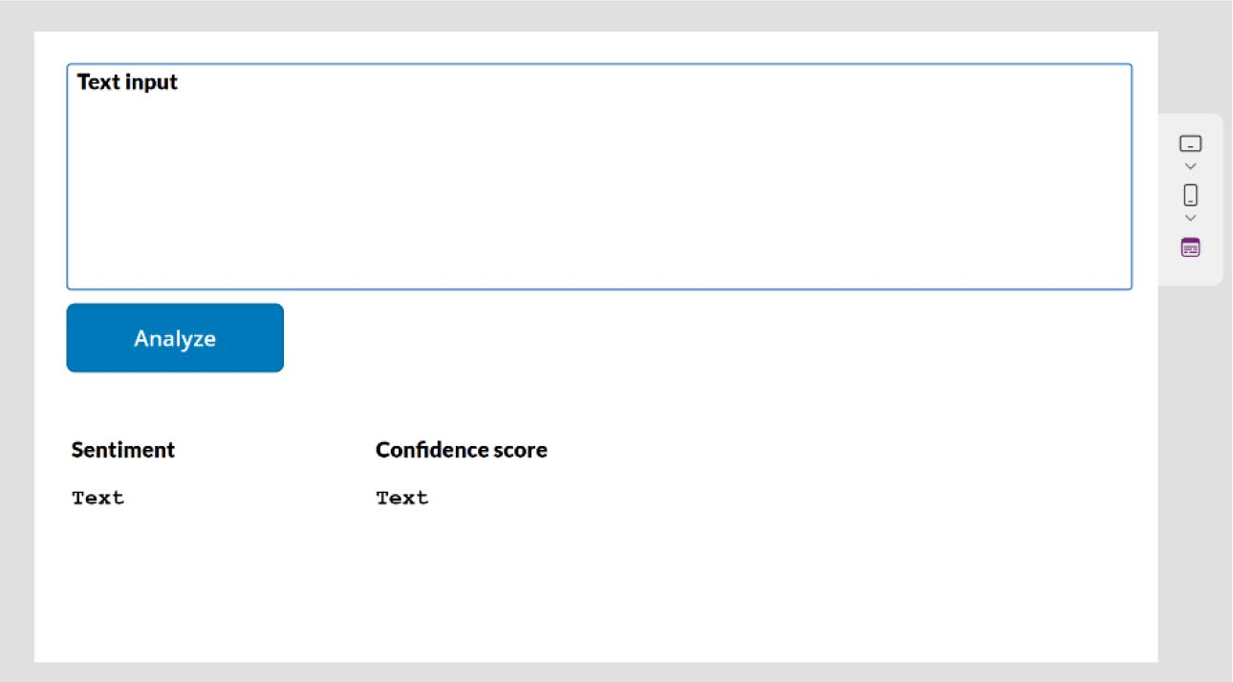

Figure 9-68. Adding a text field, button, and text labels to
communicate with the Sentiment Analysis model

4. Do not add a formula to the text field, but instead
start with the button. Call the button Analyze and add the following code to the Formula bar of the
OnSelect property, as shown in Figure 9-69.
Set(TextInputSentiment, 'Sentiment analysis'. Predict(TextInput1.Text).Document.TopSentiment); IfError(TextInputSentiment, Notify(FirstError. Message,NotificationType.Error))

Chapter 9 IntroduCIng aI BuIlder In power apps
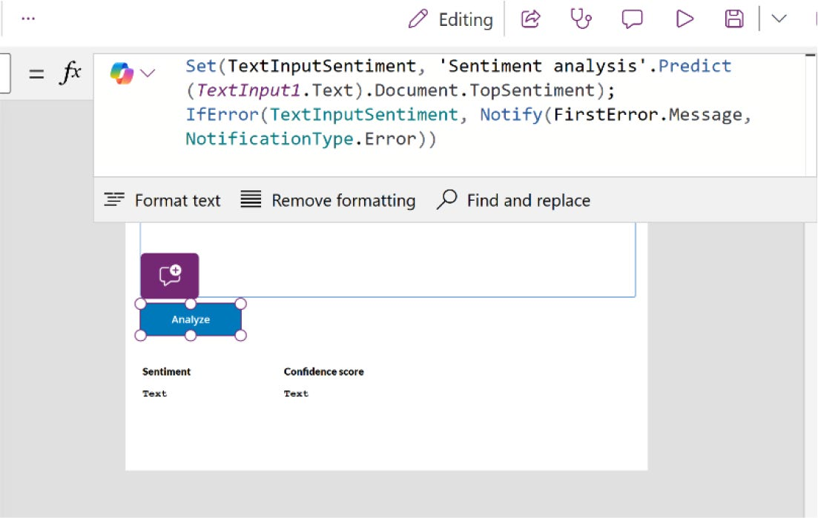

Figure 9-69. Adding the code to the OnSelect property of the button

5. Add the code in Table 9-12 to the text properties of
the Sentiment and Confidence Score labels.
Table 9-12. Formula Code to Use in the Text Properties of the Sentiment and Confidence Score Text Labels
Property Name Formula Code
sentiment TextInputSentiment.Name Confidence score TextInputSentiment.Confidence * 100 & " % "

6. Run the app. Write something in the textbox and
click Analyze. One potential result is shown in
Figure 9-70.

Chapter 9 IntroduCIng aI BuIlder In power apps
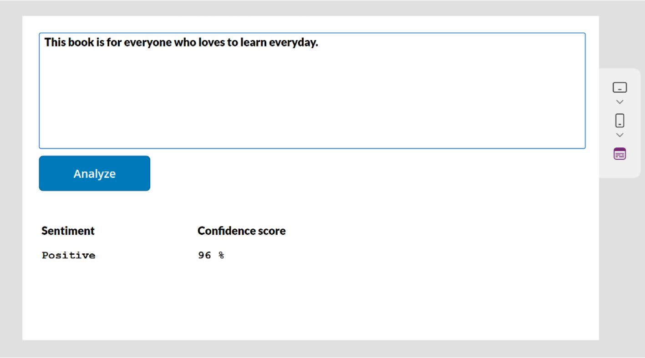

Figure 9-70. Preview of the Sentiment Analysis model

Summary
This chapter introduced AI Builder in Power Apps, guiding you through
the process of integrating AI capabilities into your applications. You
learned how to leverage pre-built and custom AI models to add intelligent
features like text recognition, sentiment analysis, and invoice processing,
all without needing extensive technical knowledge. This chapter aimed to
empower you to create smarter, more proactive, and data-driven apps.
As you transition into Chapter 10, I take you further by exploring
advanced techniques with AI Builder, including the creation of custom AI
prompts and mastering conditional formatting. These skills will enable
you to design even more dynamic and responsive applications, enhancing
both functionality and the user experience.

CHAPTER 10

Advanced Techniques

with AI Builder

and Conditional

Formatting

In the last chapter, I showed you how to leverage AI Builder to integrate
advanced AI capabilities into your Power Apps. Together, we explored
various AI models, enabling you to enhance your applications with
features like text recognition, sentiment analysis, and predictive
analytics—all without needing extensive technical expertise.
This chapter guides you through more advanced techniques to further
refine and expand your use of AI Builder. You’ll learn how to create custom
AI prompts tailored to your specific needs, and I also introduce you to the
powerful tool of conditional formatting. These skills will help you make
your apps not only intelligent but also highly responsive and visually
engaging, ensuring they meet the complex needs of your users.

© Rezwanur Rahman 2024 517
R. Rahman, Microsoft Copilot for Power Apps, Inside Copilot,

Chapter 10 advanCed teChniques with ai Builder and Conditional Formatting

Using AI Prompts
AI prompts in Power Apps represent a significant advancement in the way applications are developed. By harnessing the power of natural language processing, these prompts guide users through the process of building complex app functionalities without requiring deep technical knowledge. This innovation is particularly valuable to non-developers, as it opens the app development landscape to a broader audience, encouraging creativity and collaboration across different skill levels.

Overview of AI Prompts
AI prompts in Power Apps streamline app development by using natural language processing, making it easy for users to create complex formulas, automate tasks, and integrate AI features with minimal coding. This increases accessibility, allowing more people to participate in app creation and boosting overall productivity. The main benefits include faster development times and the creation of smarter, more efficient applications. This innovative approach empowers users to meet dynamic business needs effectively.
If you navigate to Power Apps Studio ➤ AI Hub ➤ AI Prompts, you will see the pre-built AI prompts and the option to create your own prompt, as
shown in Figure 10-1.

Chapter 10 advanCed teChniques with ai Builder and Conditional Formatting
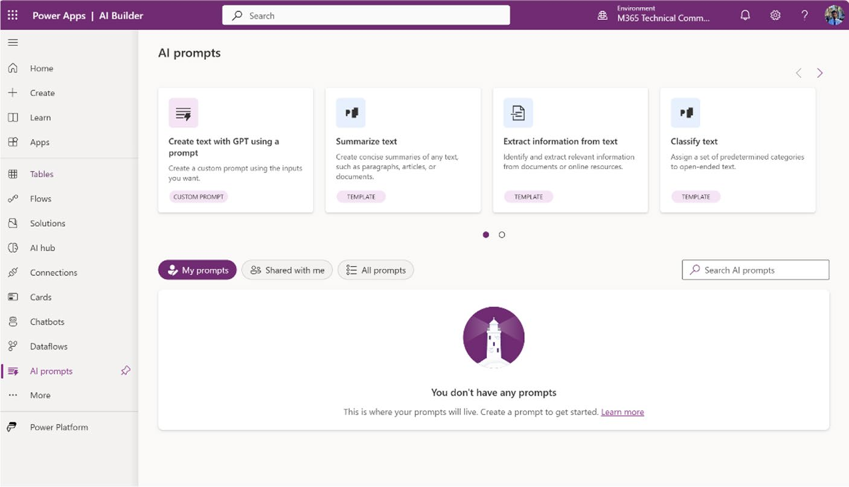

Figure 10-1. AI prompt page in Power Apps Studio

Utilizing Pre-built AI Prompts for Generative
AI Capabilities
This section shows you how to use the pre-built AI prompts in Power
Apps. If you navigate to Power Apps Studio ➤ AI Hub ➤ AI Prompts ➤ All
Prompts, you will see the list of pre-built prompts that you can use in your
Power Apps, as shown in Figure 10-2.

Chapter 10 advanCed teChniques with ai Builder and Conditional Formatting
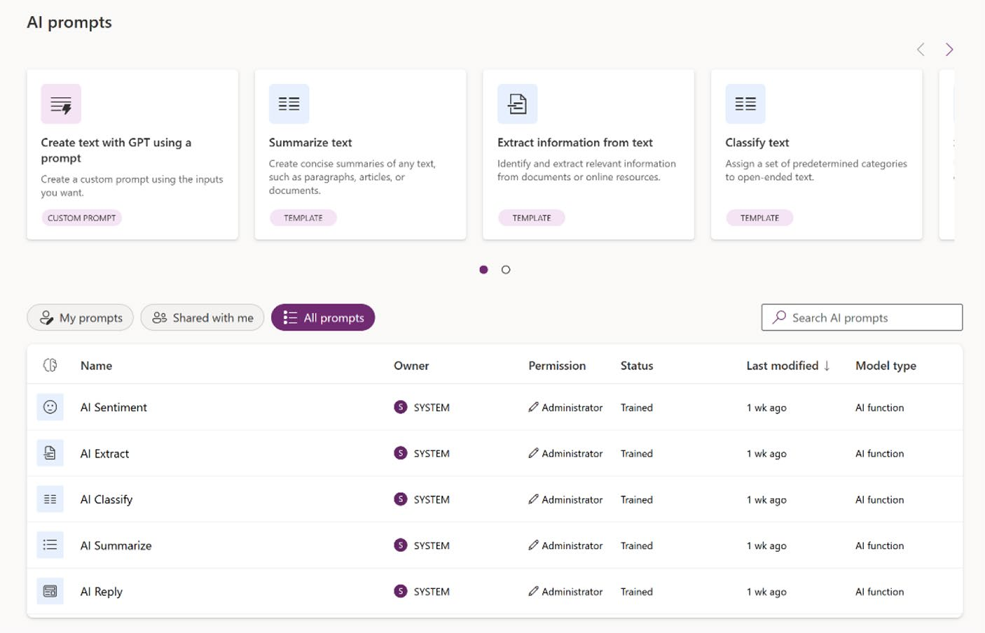

Figure 10-2. List of pre-built AI prompt templates on the AI prompt page

Like all AI models, AI prompts can be utilized in two ways. You can
either select a prompt from the AI prompts list (as shown in Figure 10-2) and choose the Use in App option, or you can create the app first and then add the AI prompts by navigating to Data ➤ AI Models and configuring the app. For this demo, I demonstrate both methods and show one specific prompt: AI Summarize.

AI Prompt: AI Summarize
The AI Summarize prompt in Power Apps is a powerful tool designed to condense lengthy text into concise summaries, making it easier to digest large amounts of information quickly. By integrating this prompt, users can enhance their apps with automated summarization capabilities, improving efficiency and productivity. Whether summarizing reports,

Chapter 10 advanCed teChniques with ai Builder and Conditional Formatting
articles, or user-generated content, AI Summarize ensures that the key
points are captured and presented clearly. This feature is particularly
useful for applications that handle extensive data and require streamlined,
accessible insights for decision-making.

Using AI Summarize from the AI Prompts Option
To use AI Summarize from the AI prompts option, follow these steps:
1. Open Power Apps Studio (https://make.
powerapps.com) and navigate to AI Hub ➤ AI
Prompts ➤ All Prompts, as shown in Figure 10-2.
2. Choose AI Summarize from the list. You will see AI
Summarize pop up, as shown in Figure 10-3.
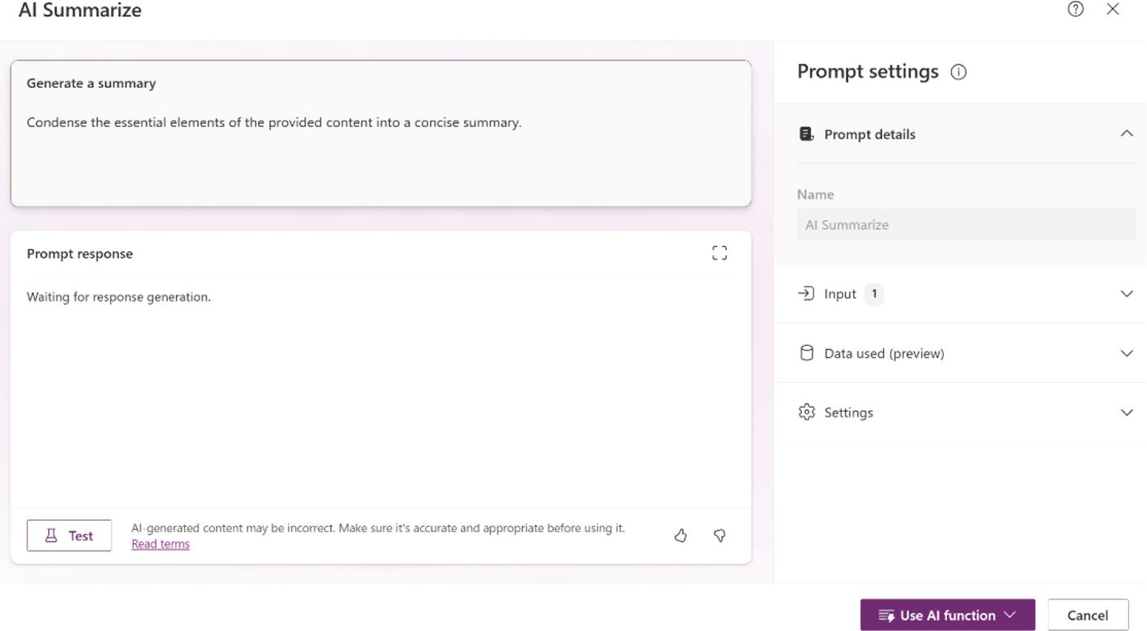

Figure 10-3. AI Summarize

3. In Figure 10-3, note that there is a panel on the right
side. The full panel is shown in Figure 10-4.

Chapter 10 advanCed teChniques with ai Builder and Conditional Formatting
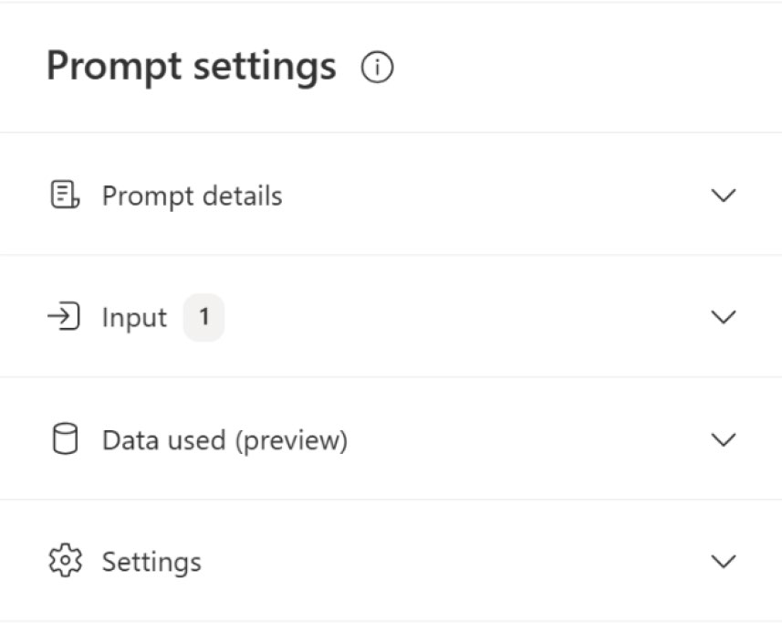

Figure 10-4. Prompt Settings options

From this area, you can change the settings of this prompt. The following options are available:
• Prompt details: You can see the name of the
prompt, AI Summarize. The option to edit the name is disabled by default since this is a pre-built
template, as shown in Figure 10-5.
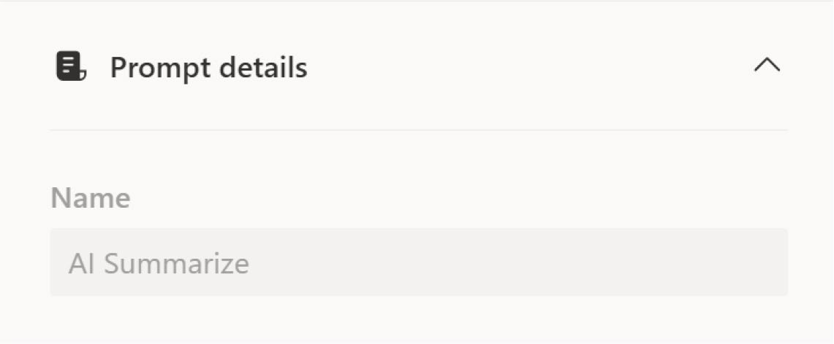

Figure 10-5. Prompt details of AI Summarize prompt

Chapter 10 advanCed teChniques with ai Builder and Conditional Formatting
• Input: In the Input section, you can add text or a
paragraph to test the prompt before incorporating
the prompt into your app. See Figure 10-6.
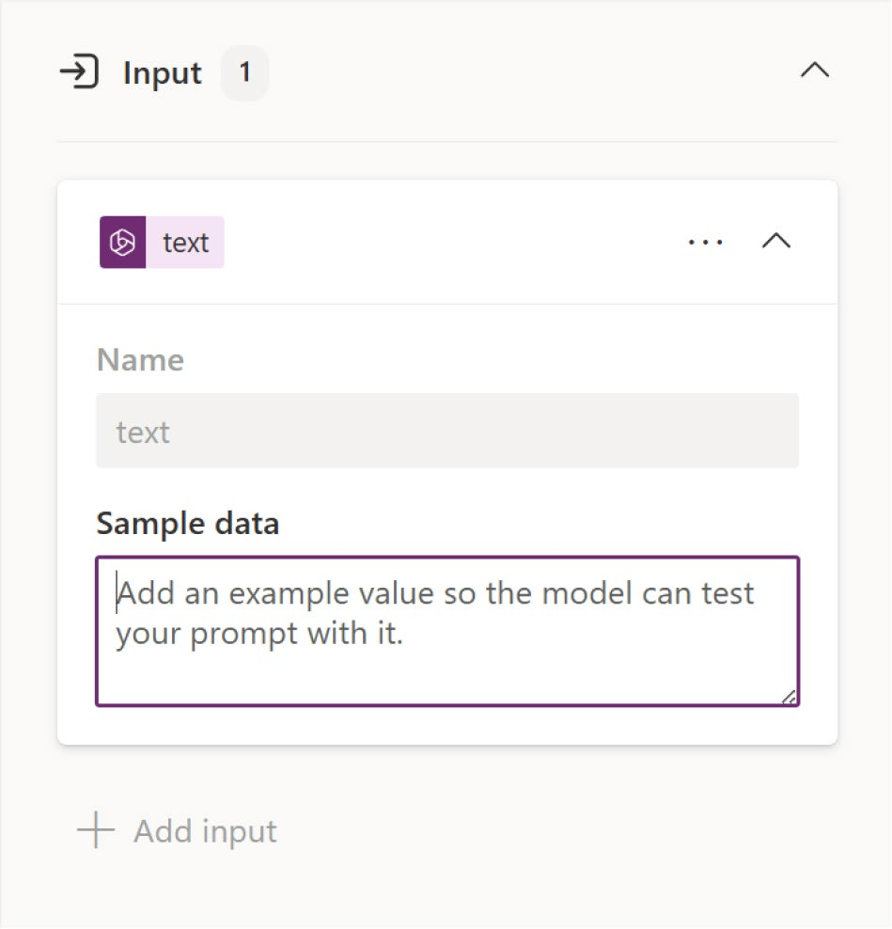

Figure 10-6. Input settings of the AI Summarize prompt

• Data used (preview): In this section, you can add
your own data source, allowing AI Summarize to provide answers tailored to your business needs.
See Figure 10-7.

Chapter 10 advanCed teChniques with ai Builder and Conditional Formatting
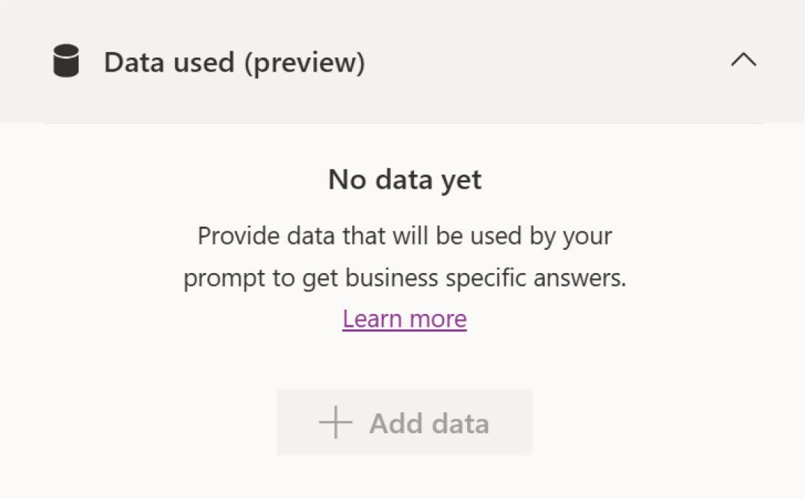

Figure 10-7. Data used (preview) option for the AI Summarize prompt

Settings: In the Settings section, you can change the GPT model used to generate responses. By default, it is set to GPT-3.5, but you can switch it to GPT-4 (preview). Additionally, you can adjust the temperature of AI Summarize. The temperature controls the creativity of the responses; a lower temperature yields more predictable results, while a higher temperature produces more diverse and
creative responses. See Figure 10-8.

Chapter 10 advanCed teChniques with ai Builder and Conditional Formatting
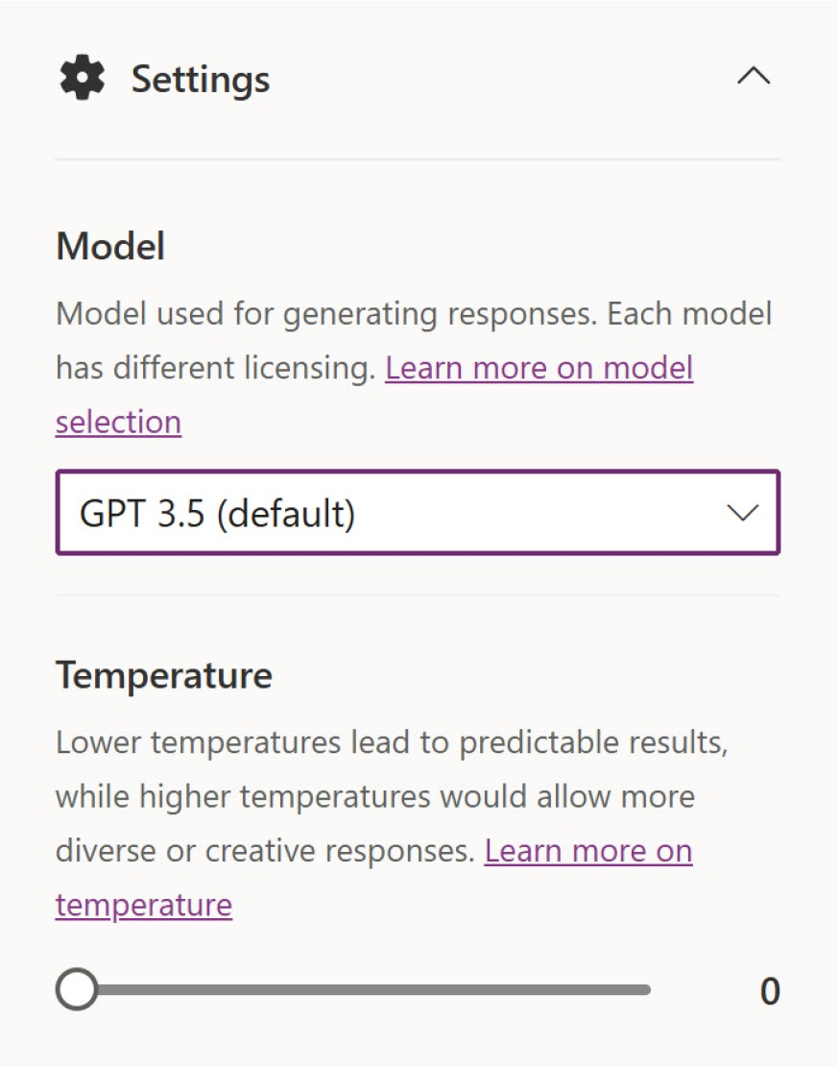

Figure 10-8. Settings option of the AI Summarize prompt

4. Add some text to the Input section and click the Test
button, as shown in Figure 10-9.

Chapter 10 advanCed teChniques with ai Builder and Conditional Formatting
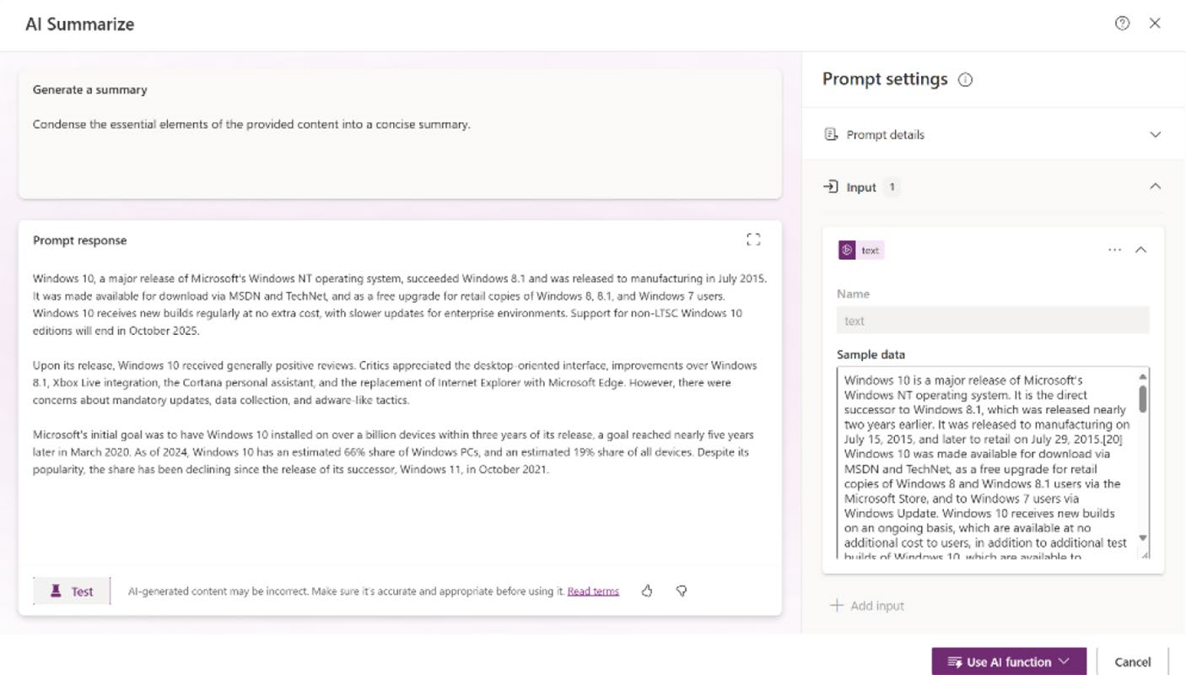

Figure 10-9. Testing articles in AI Summarize

5. You can see that AI Summarize works perfectly. Now
click the Use AI Function button and choose Use in
App, as shown in Figure 10-10.


Figure 10-10. Creating an app with the AI Summarize prompt

6. You will be redirected to another tab, where a
new mobile app will be created, as shown in
Figure 10-11.

Chapter 10 advanCed teChniques with ai Builder and Conditional Formatting
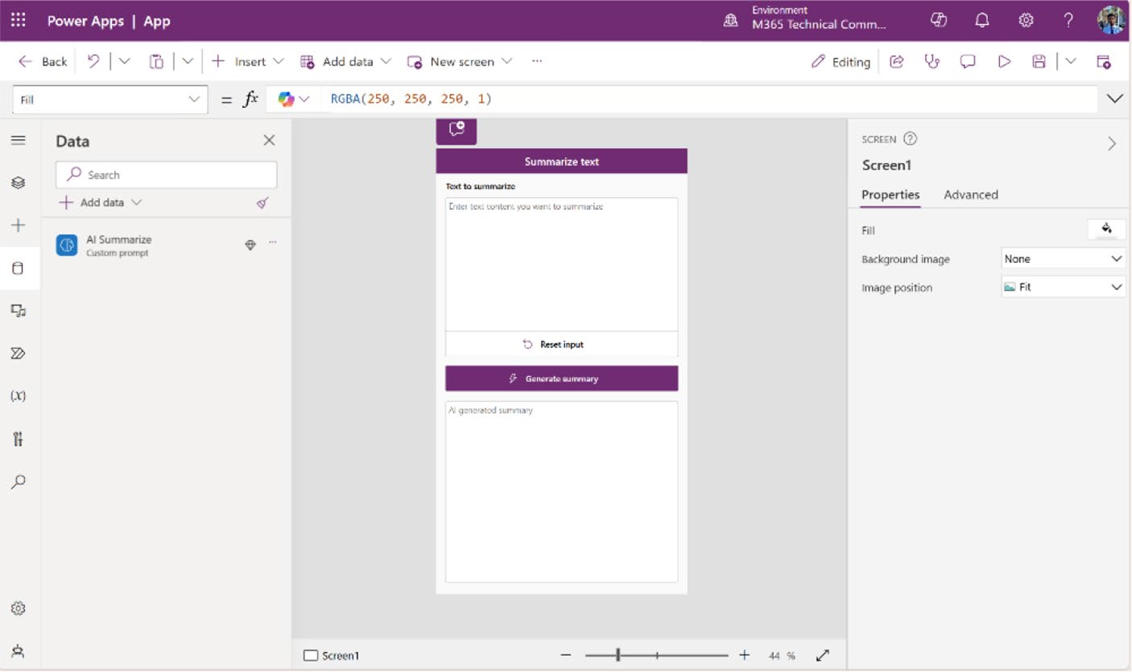

Figure 10-11. The AI Summarize app created by Power Apps

7. Run the app, add some text to the Summarize
option, and click Generate Summary to see the
summary of the text, as shown in Figure 10-12.

Chapter 10 advanCed teChniques with ai Builder and Conditional Formatting
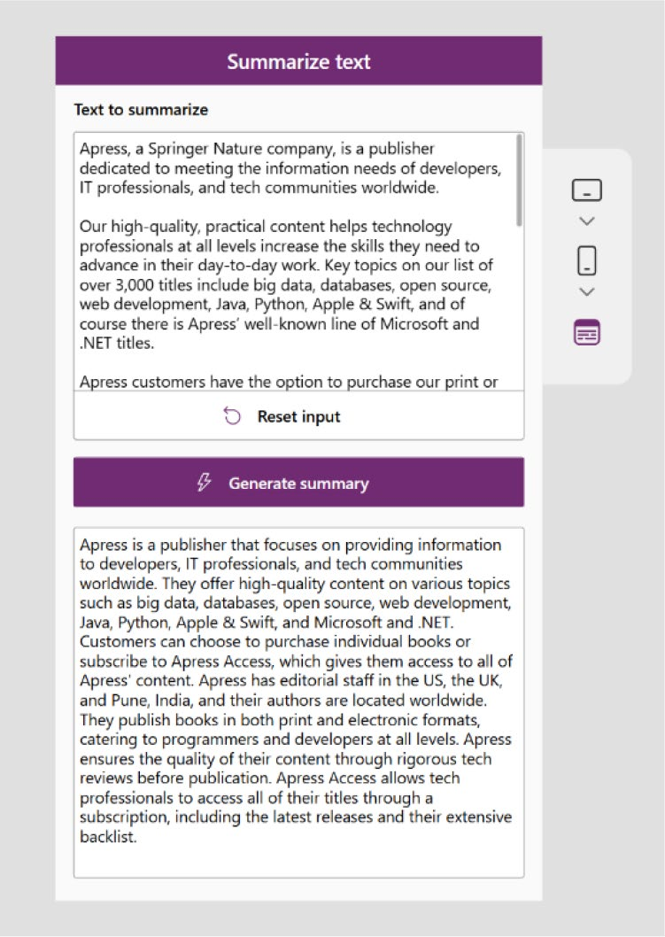

Figure 10-12. AI Summarize prompt check in the newly created Power Apps

Use AI Summarize in a New or Existing App
To use AI Summarize in an existing app or a newly created Power App, follow these steps:
1. Create a new app in Power Apps Studio (https://
make.powerapps.com) or open an existing app.
2. From the left sidebar, navigate to Data ➤ Add Data,
then add AI Summarize under the AI model, as
shown in Figure 10-13.

Chapter 10 advanCed teChniques with ai Builder and Conditional Formatting
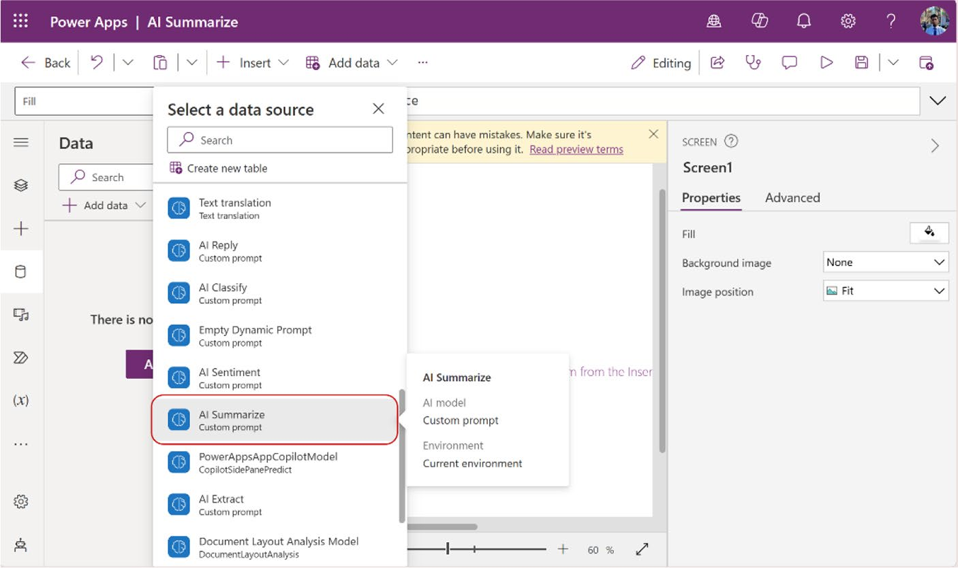

Figure 10-13. Adding AI Summarize in Power Apps

3. On the screen, add two text fields (one for inputting
text and the other for displaying the generated response), two buttons (one for triggering the generate action and another for resetting the text fields), and two text labels to identify the text fields,
as shown in Figure 10-14.

Chapter 10 advanCed teChniques with ai Builder and Conditional Formatting
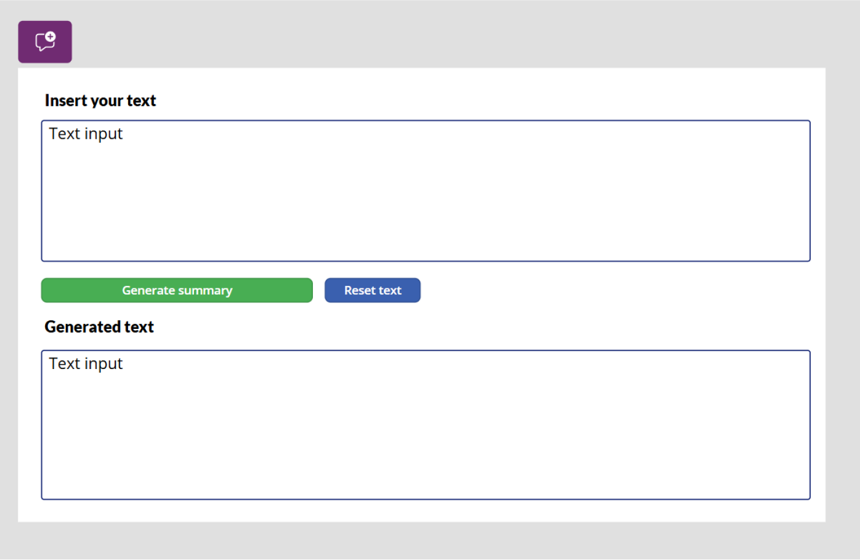

Figure 10-14. Designing an app to generate a summary with AI Summarize

4. Select the Reset Text button, and in the formula bar,
change the code of the OnSelect property to the
following (also shown in Figure 10-15):
Reset(TextInput1)

Chapter 10 advanCed teChniques with ai Builder and Conditional Formatting
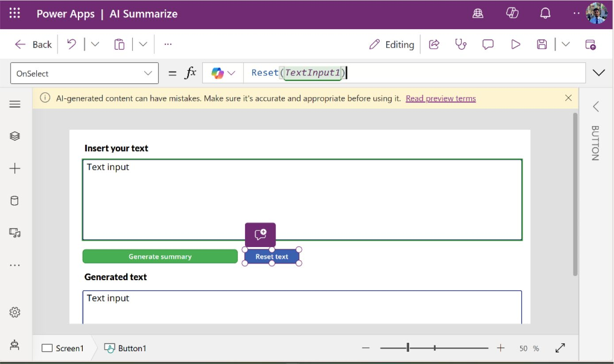

Figure 10-15. Configuring the Reset Text button

5. Select the Generate Summary button, and in the
formula bar, add the following code for the OnSelect
property. See Figure 10-16.
Set(
SummarizeResult,
'AI Summarize'.Predict(TextInput1.Text)
)

Chapter 10 advanCed teChniques with ai Builder and Conditional Formatting
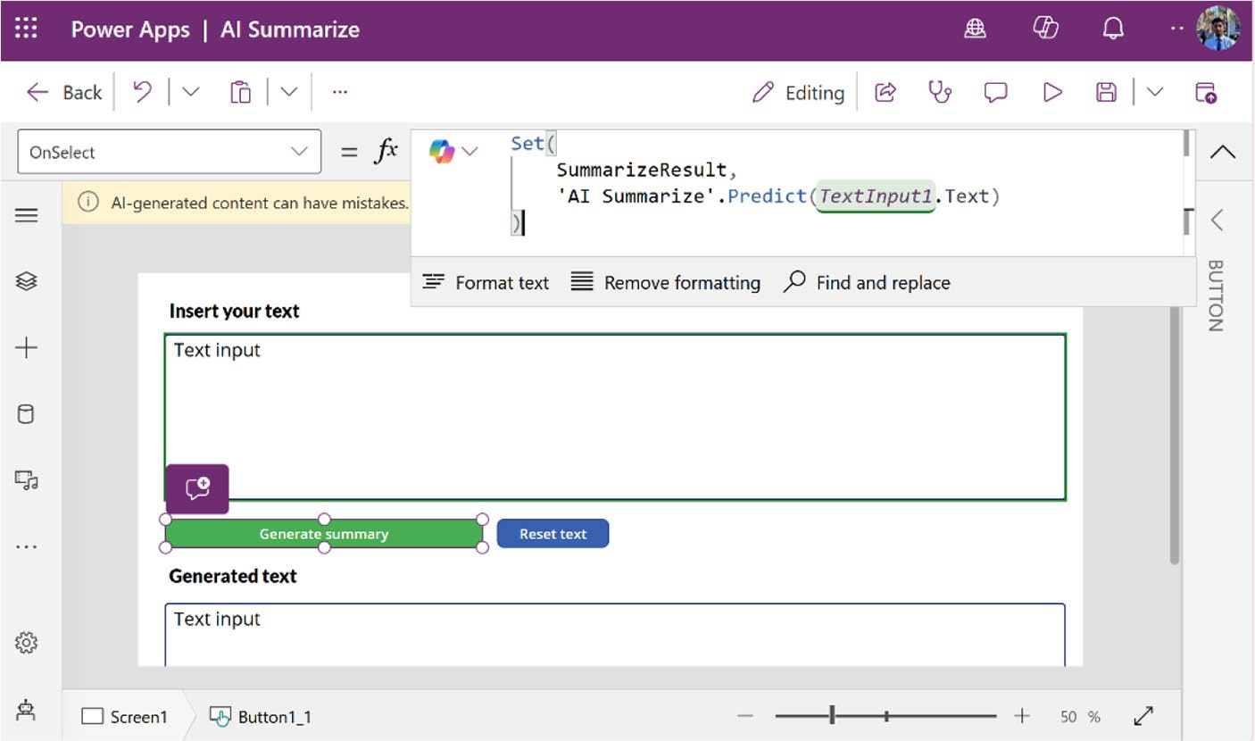

Figure 10-16. Configuring the Generate Summary button

6. Next, choose the Text Field below the Generate
Text label, where the response will appear. In the formula bar, choose the Default property and add
the following code; also shown in Figure 10-17.
SummarizeResult.Text

Chapter 10 advanCed teChniques with ai Builder and Conditional Formatting
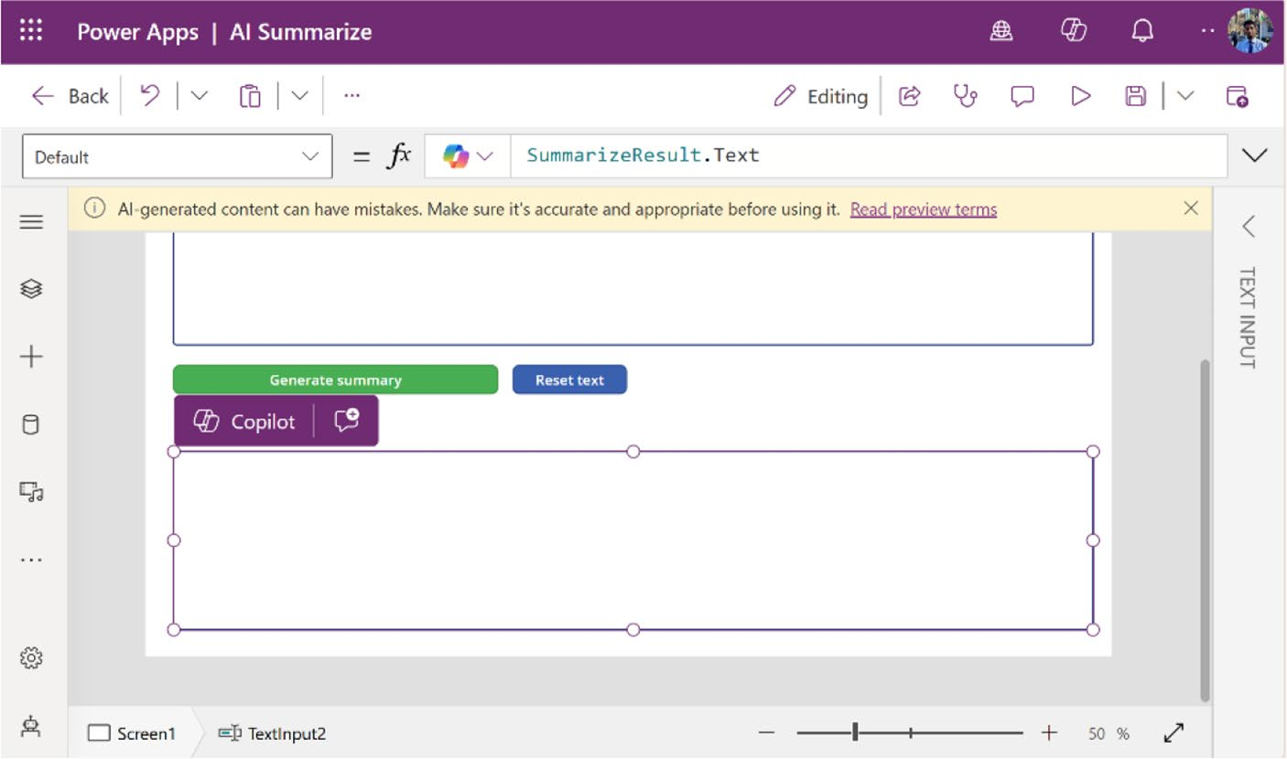

Figure 10-17. Configuring a text field to get a response from AI
Summarize

7. Run the app and test AI Summarize. Figure 10-18
shows that AI Summarize is working perfectly.

Chapter 10 advanCed teChniques with ai Builder and Conditional Formatting
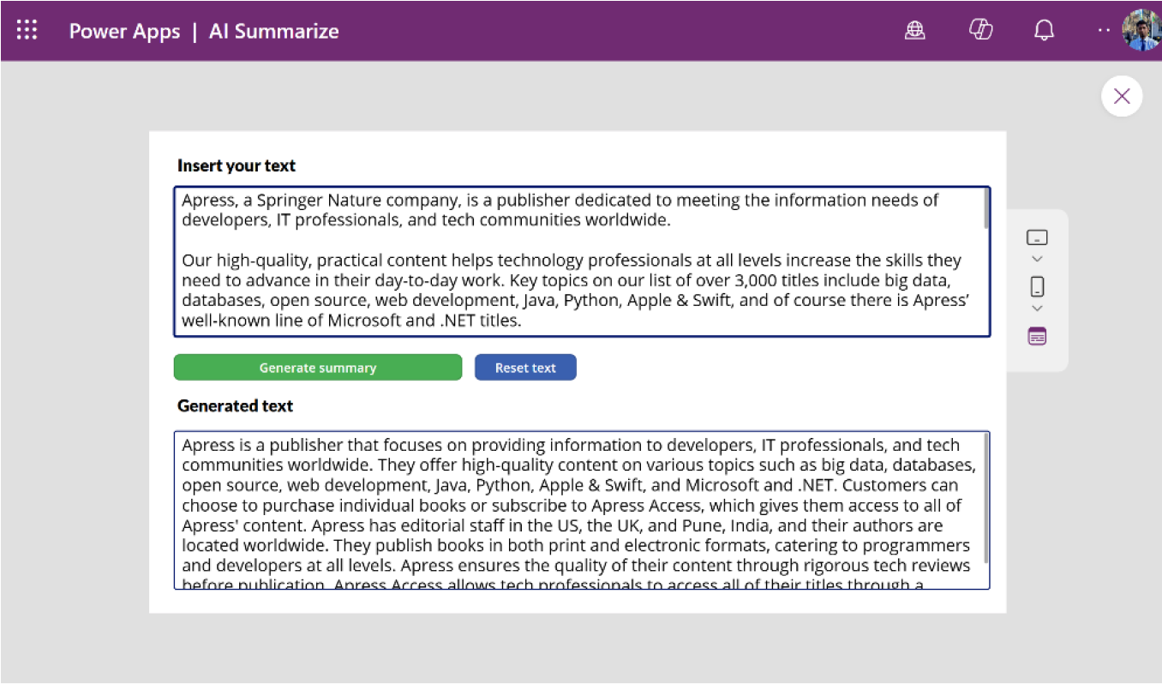

Figure 10-18. Checking AI Summarize by creating the app manually.

You can create apps using other pre-built AI prompts in this same manner.

Using Custom AI Prompts
Custom AI prompts for Power Apps let you add smart features to your apps, making them better at handling tasks and talking to users. You can set up these prompts to do specific jobs, such as sorting data or automating repetitive tasks, all in a way that feels natural and easy for users. This makes your apps not only smarter but also more helpful and efficient for everyone using them. It is a great way to make your apps do more, without making them overly complicated.
If you navigate to Power Apps Studio ➤ AI Hub ➤ AI Prompts, you will see the custom prompt option named Create Text with GPT Using a
Prompt, as shown in Figure 10-19. This feature allows you to create custom prompts within the Power Platform.

Chapter 10 advanCed teChniques with ai Builder and Conditional Formatting
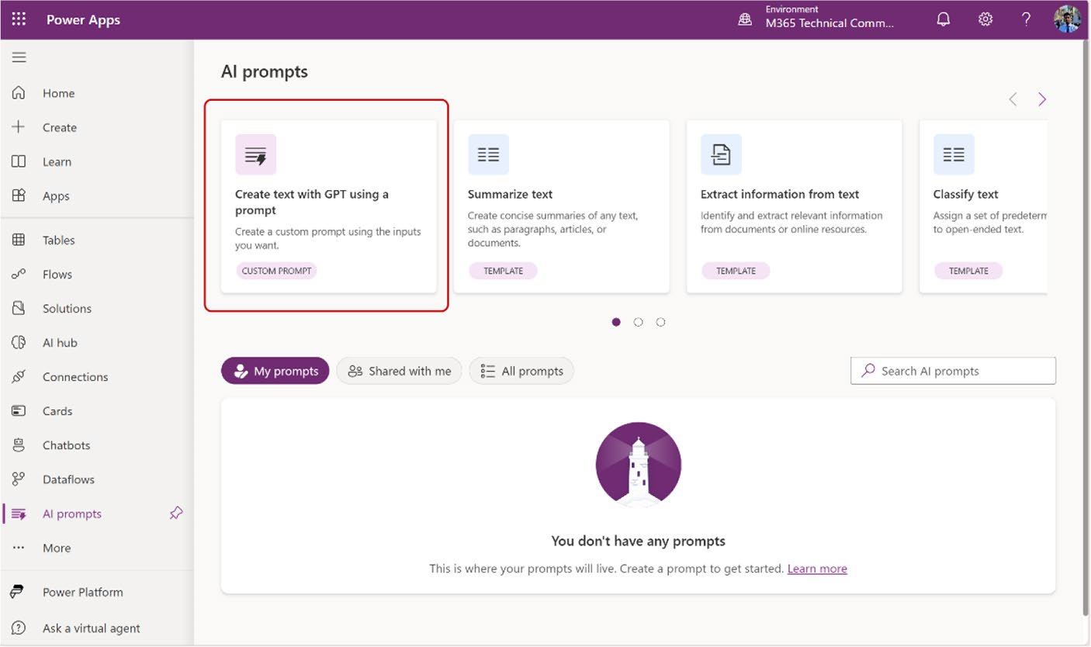

Figure 10-19. Custom prompt option on the AI prompt page

This section explains how to create a custom prompt and manually
integrate it into Power Apps.

Creating a Custom Prompt
To create a custom prompt, follow these instructions:
1. Open the Power Apps Studio (https://make.
powerapps.com), navigate to AI Hub ➤ AI Prompts, and select Create Text with GPT Using a Prompt.
2. After selecting the Create Text with GPT Using
a Prompt option, you will see the screen in
Figure 10-20.

Chapter 10 advanCed teChniques with ai Builder and Conditional Formatting
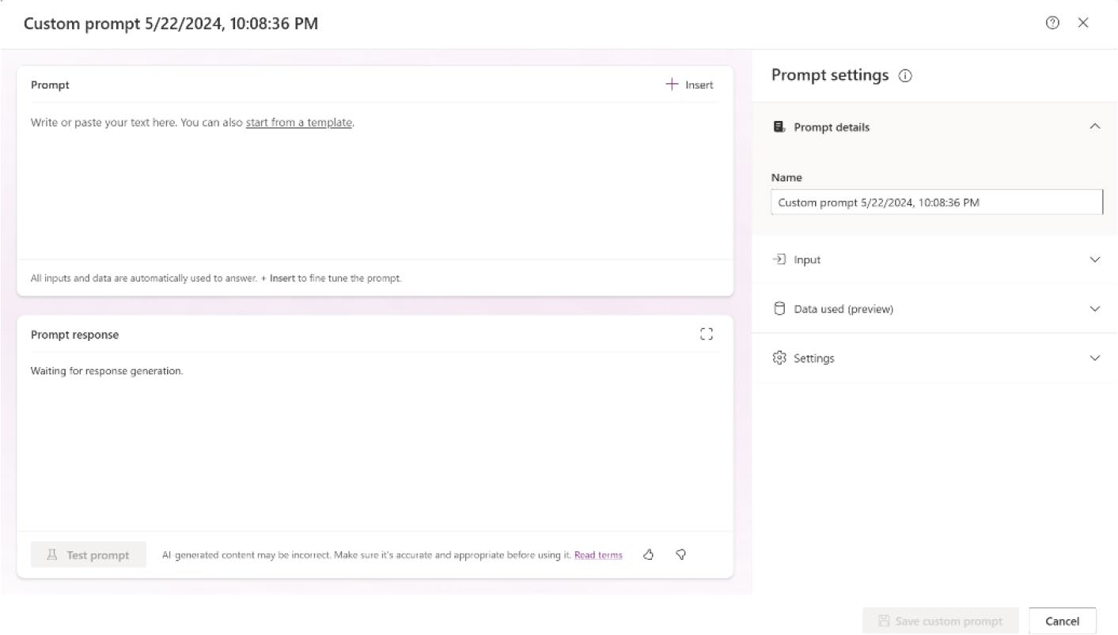

Figure 10-20. Initial screen of a custom prompt

Just like pre-built AI prompts, you can find the same options in the Prompt settings on the left sidebar. However, with custom AI prompts, you have the flexibility to adjust and customize the settings as much as you need.
3. Create a custom prompt. You can write the prompt
based on your own preferences or specific business needs. Additionally, you can find some AI prompt examples on the Microsoft Adoption website by
visiting https://aka.ms/power-prompts.
4. After visiting the provided URL, you will see many
samples for creating AI prompts, as shown in
Figure 10-21.

Chapter 10 advanCed teChniques with ai Builder and Conditional Formatting
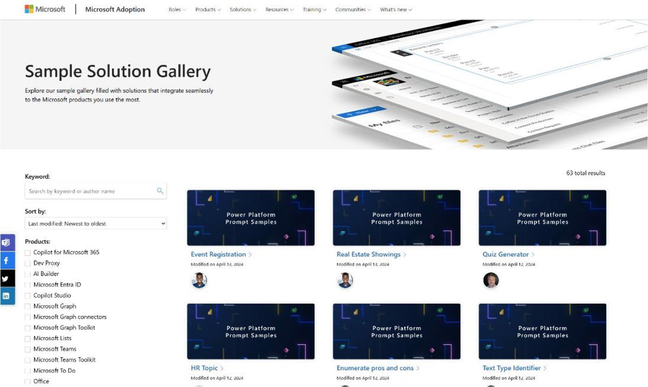

Figure 10-21. AI prompt samples on the Microsoft Adoption website

5. For this demo, I wrote the following prompt:
Act as a programmer. You should know the object-oriented programming languages, like Python, JavaScript, SQL, PSQL, R, C, C++. You should know how to solve the complex programming problem, suggest the code by reading natural language. You should use your Data Structure, Algorithm, Database, Artificial Intelligence, Machine Learning knowledge. Try to avoid too many technical details but use them when necessary. I want you to reply with the solution, not write any explanations. My question is
6. Copy this prompt and add it to the Prompt section,
as shown in Figure 10-22.

Chapter 10 advanCed teChniques with ai Builder and Conditional Formatting
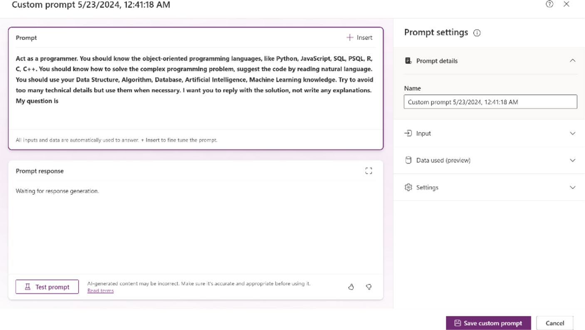

Figure 10-22. Adding the prompt to the Prompt section of the Custom Prompt modal box

7. Let’s change the name of this custom prompt. Go to
the Prompt Details option on the right sidebar and
edit the default name, as shown in Figure 10-23.

Chapter 10 advanCed teChniques with ai Builder and Conditional Formatting
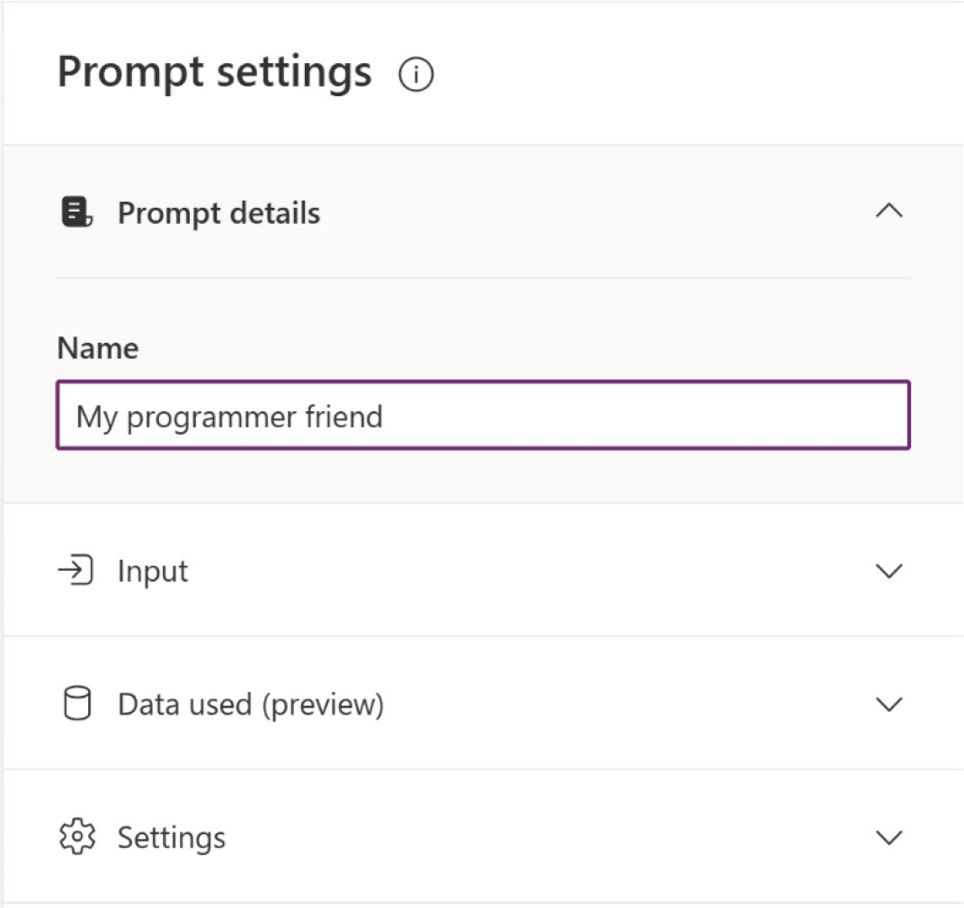

Figure 10-23. Changing the name of the custom prompt

8. Create a dynamic value. A dynamic value when
creating a custom prompt refers to a variable or placeholder that can change based on user input or other data sources. It allows the prompt to be flexible and adapt to different scenarios, making the AI’s response more relevant and personalized. For example, in a customer service app, a dynamic value could be the customer’s name or the specific issue they are facing, which the AI uses to provide a tailored response.
To create a dynamic value, click the Input option
and select Add Input, as shown in Figure 10-24.

Chapter 10 advanCed teChniques with ai Builder and Conditional Formatting
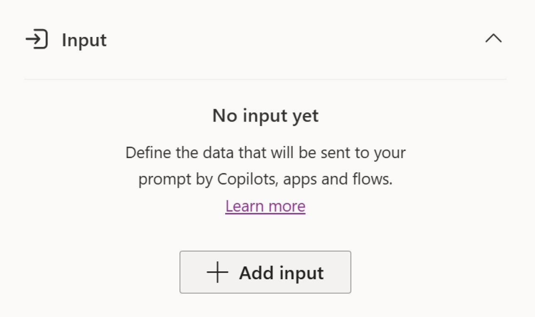

Figure 10-24. Creating a dynamic value by adding an Input option

9. After clicking the Add Input option, Copilot will ask
you to provide a name for your dynamic value, as
shown in Figure 10-25.

Chapter 10 advanCed teChniques with ai Builder and Conditional Formatting
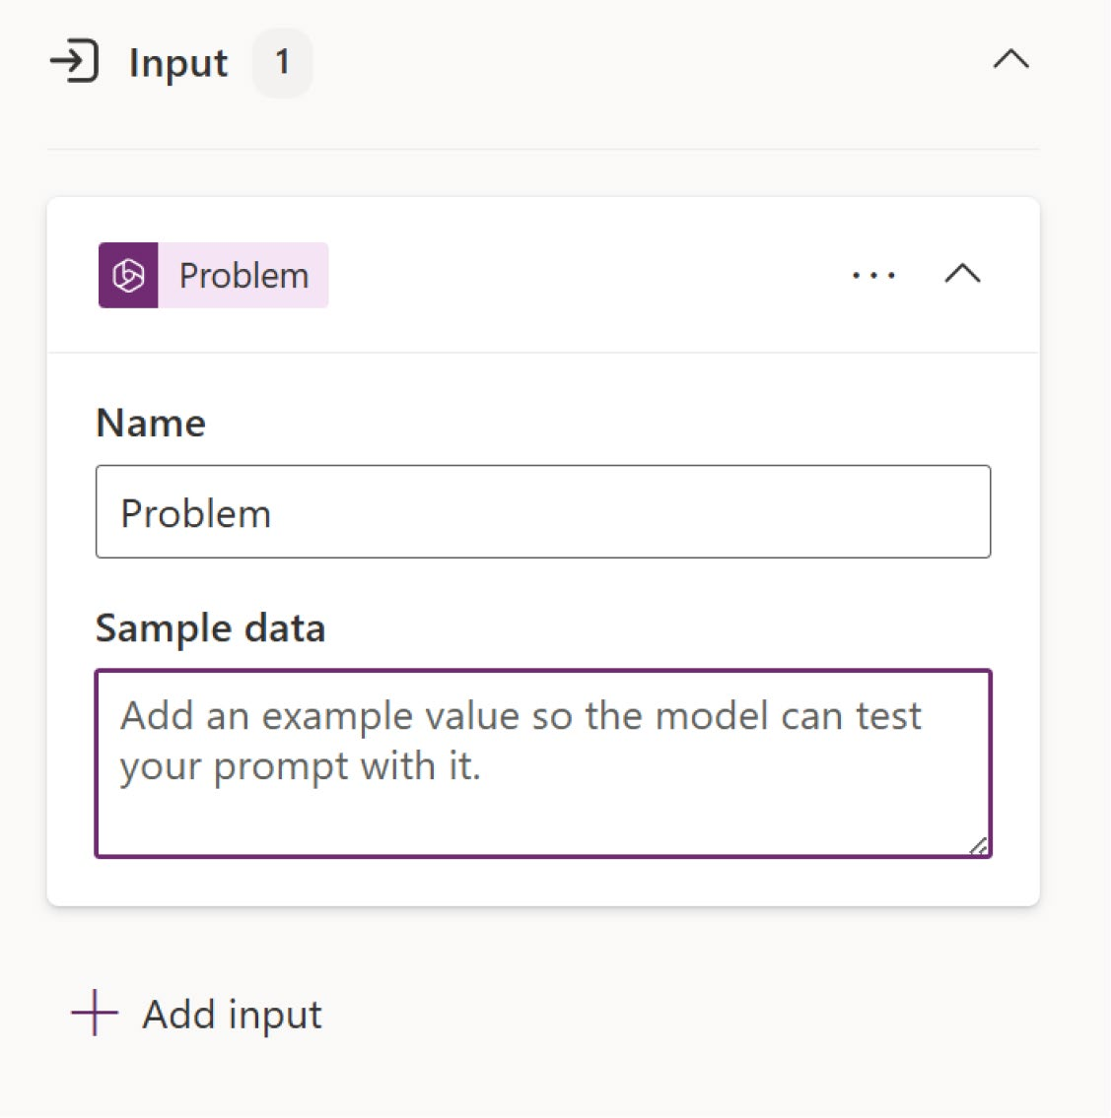

Figure 10-25. Creating a dynamic value from the Input option

10. I named mine Problem. Return to the prompt, click
Insert, select the value, and insert it into the prompt. Ensure you add it after the phrase My question is, or in any other location you want to trigger, as shown
in Figures 10-26 and 10-27.

Chapter 10 advanCed teChniques with ai Builder and Conditional Formatting
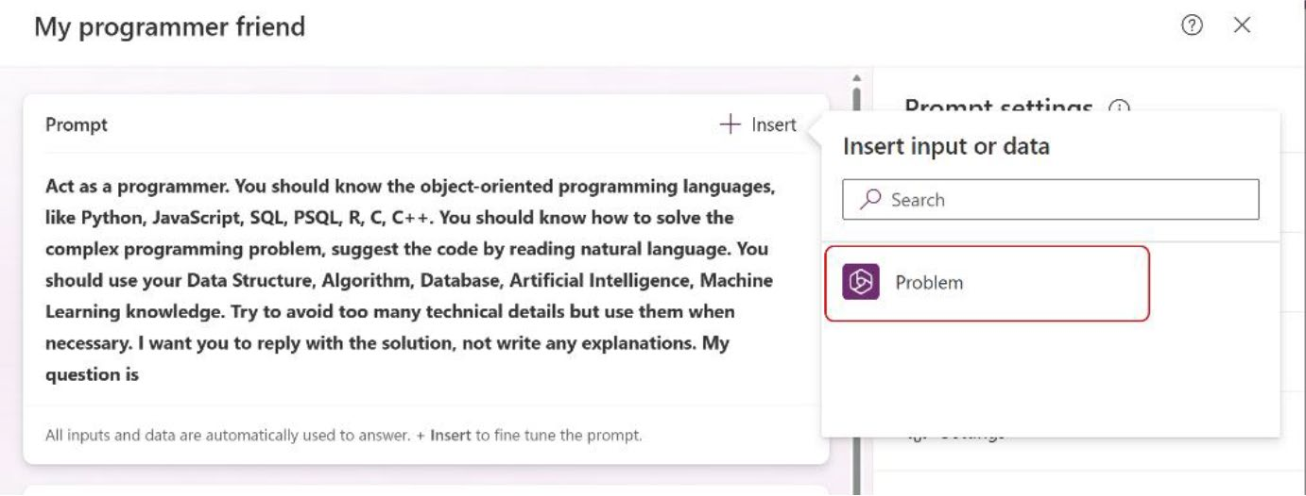

Figure 10-26. Choosing the dynamic value to add a prompt
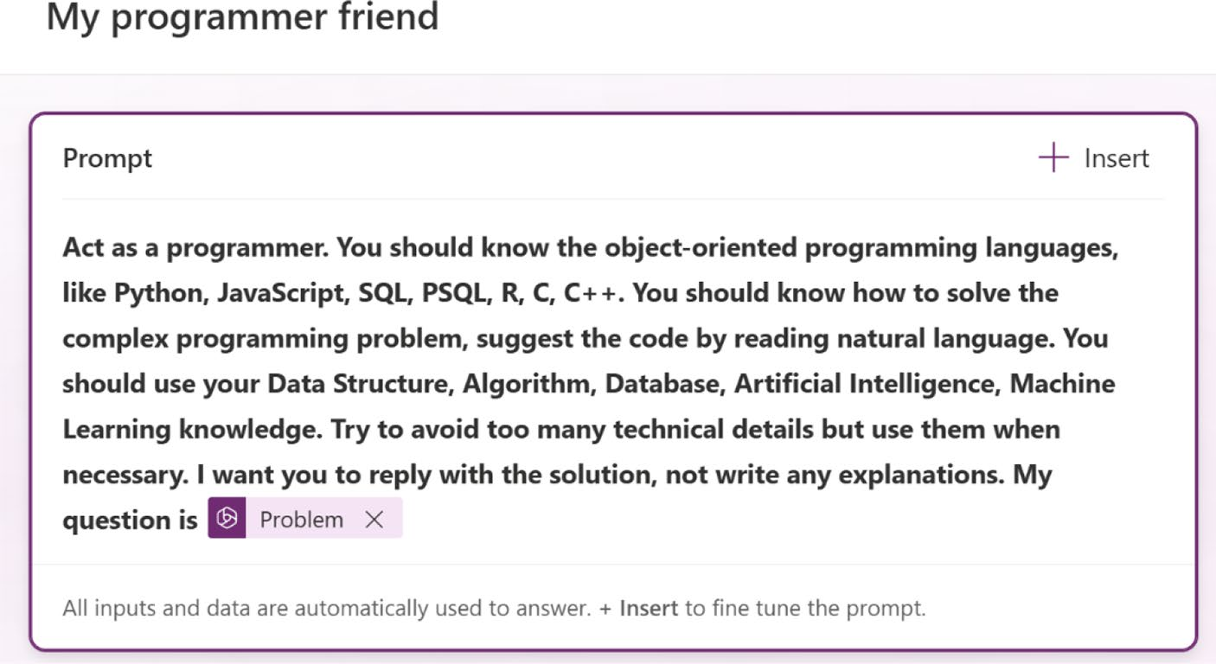

Figure 10-27. The dynamic value is added to the prompt
You can add multiple dynamic inputs if you want, using this same process. Go to the Input option, create a new input, and add it to the prompt.
11. You can skip the Data Used option. If you have
business data, you can use it as the source of data. I am skipping the Data Used option for this demo.

Chapter 10 advanCed teChniques with ai Builder and Conditional Formatting
12. Next, from the Settings option, choose your
preferable AI model. For this demo, I use GPT 4
(preview), as shown in Figure 10-28. By default, the model is set to GPT-3.5.
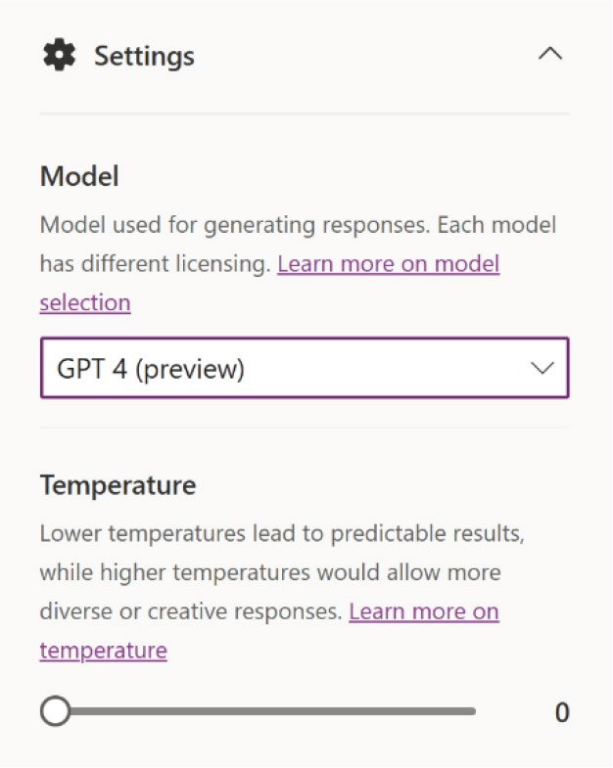

Figure 10-28. Choosing a GPT model from the Settings option

13. You need to test the prompt before saving or adding
it to Power Apps.
To test the prompt, go back to the Input option and provide a prompt like this one:
Write a Python program to create a calculator.
Figure 10-29 shows where to write this input.

Chapter 10 advanCed teChniques with ai Builder and Conditional Formatting
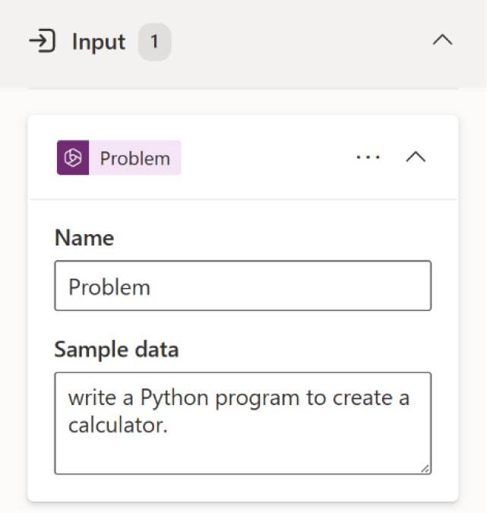

Figure 10-29. Writing input as a dynamic value

14. Click the Test Prompt button to see the result of this
prompt, as shown in Figure 10-30.
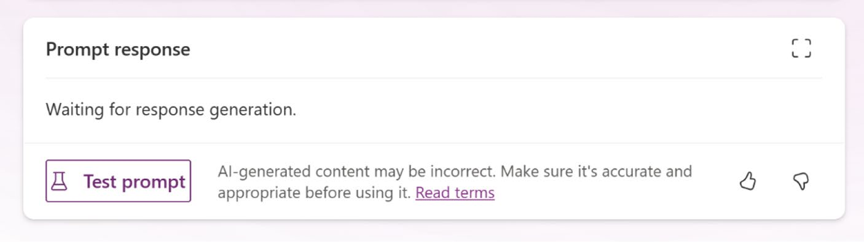

Figure 10-30. Testing the custom prompt

15. Figure 10-31 shows the result of this custom prompt.

Chapter 10 advanCed teChniques with ai Builder and Conditional Formatting
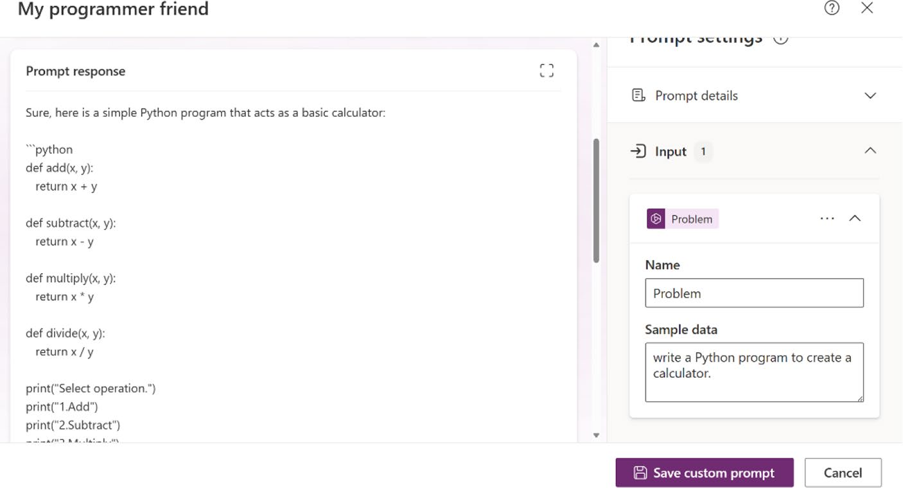

Figure 10-31. Response from the prompt
You can see that the prompt created the Python code to create a calculator.
16. Click the Save Custom Prompt button. You will get
the confirmation shown in Figure 10-32.

Figure 10-32. Confirmation of saving the custom prompt

17. You can create an app from here or create a custom
app and add the prompt, as I showed you in
Figure 10-13.
Visit https://aka.ms/promptguide or scan the QR code in
Figure 10-33 to learn more about how to create efficient and accurate GPT
prompts.

Chapter 10 advanCed teChniques with ai Builder and Conditional Formatting


Figure 10-33. Prompt engineering guide

Conditional Formatting
Conditional formatting is an essential feature of Microsoft Power Apps that enables you to modify the appearance of app components based on defined criteria. This functionality allows you to emphasize key data points, enhance the clarity of information, and create a more engaging and responsive user interface. By applying rules that adjust colors, text styles, and visibility, conditional formatting ensures that critical information stands out, improving the overall usability and visual appeal of your app. It empowers you to design applications that are not only functional but also visually intuitive and user-friendly.

Overview of Conditional Formatting with Copilot
Copilot in Microsoft Power Apps takes conditional formatting to the next level by offering AI-driven support and suggestions. Copilot helps you seamlessly set up conditional rules that modify the appearance of app controls in real-time, based on data changes or user interactions. This capability is invaluable for highlighting key information and

Chapter 10 advanCed teChniques with ai Builder and Conditional Formatting
enhancing user engagement. With Copilot, you can effortlessly implement
complex formatting rules without extensive coding knowledge, making
it an accessible tool for developers at all levels to improve the overall
effectiveness and usability of their applications.

Using Copilot for Conditional Formatting
This section shows a quick demo of how to use Copilot for conditional
formatting. In the next chapter, I show you conditional formatting with a
practical demo.
To use conditional formatting with Copilot, follow these steps:
1. Open your Power Apps project or create a new
project from Power Apps Studio.
2. Add a new text label. You will notice a Copilot
button at the top of the label. Click this button to access the conditional formatting options, as shown
in Figure 10-34.
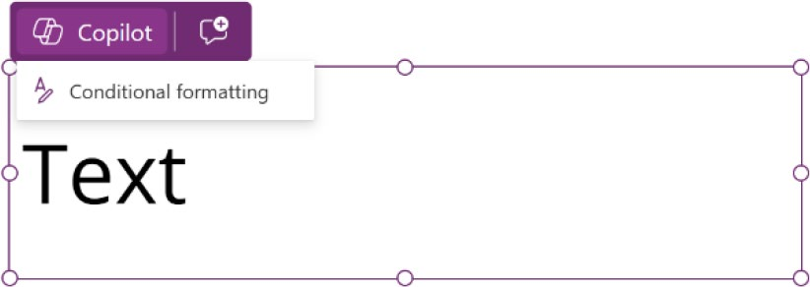

Figure 10-34. The Conditional Formatting option in the text label,
powered by Copilot

3. Once you click the Conditional Formatting option, a
list of ideas or suggestions provided by Copilot will
appear, as shown Figure 10-35.

Chapter 10 advanCed teChniques with ai Builder and Conditional Formatting
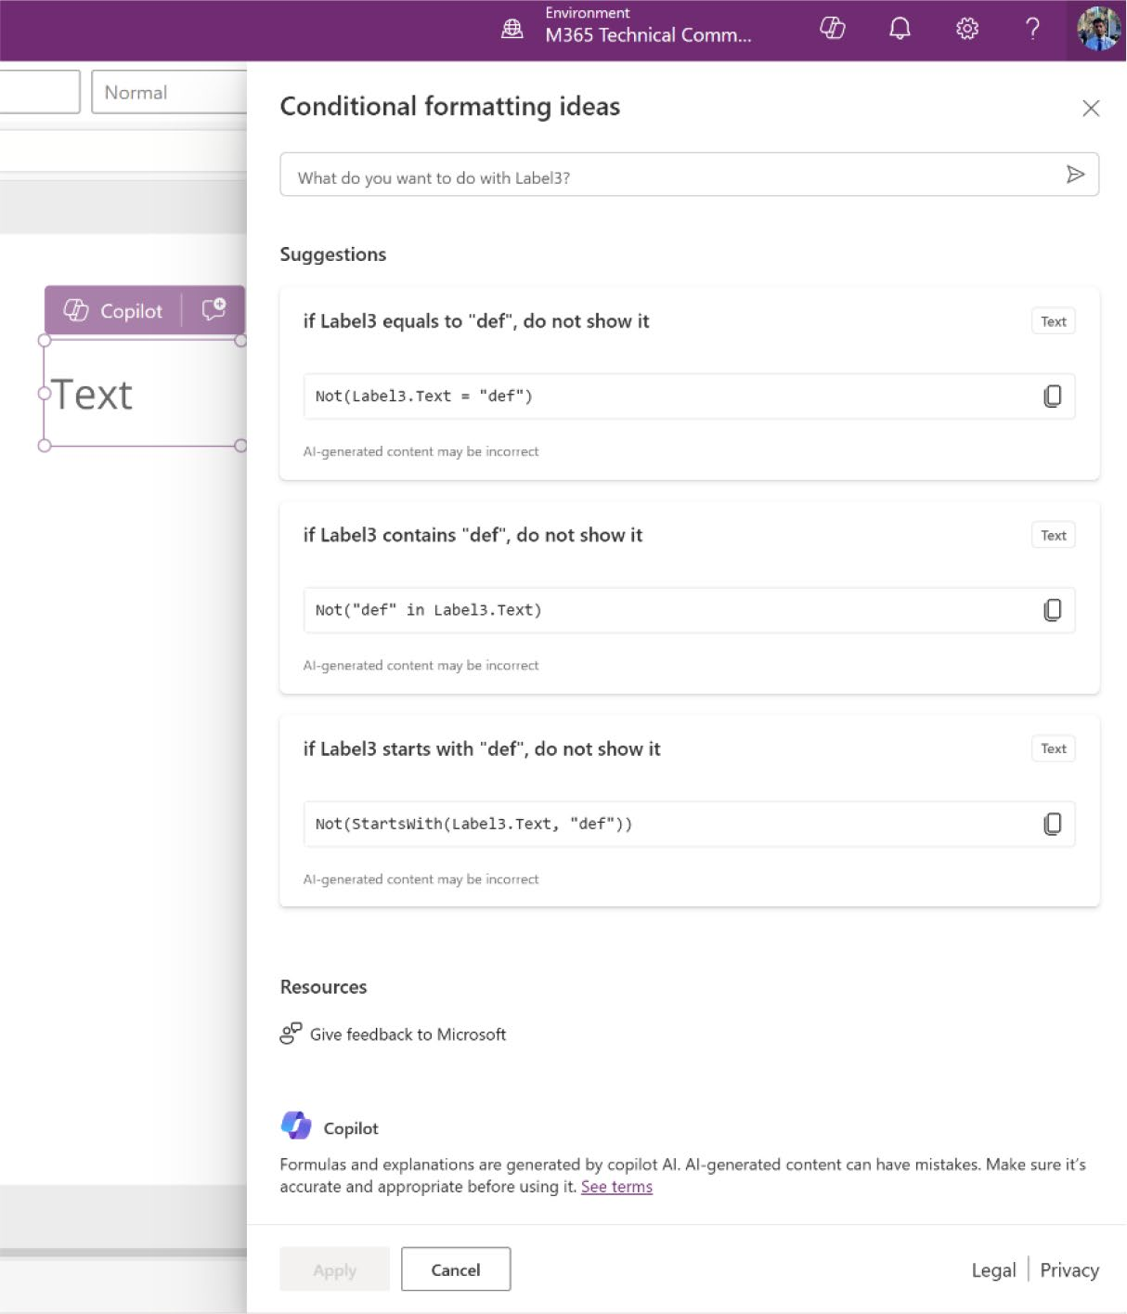

Figure 10-35. Conditional formatting ideas and suggestions provided by Power Apps

Let’s look at this page in detail:
At the top of this block, you will see a textbox where you can write your idea in natural language, as
shown in Figure 10-36. Copilot will then create the condition for you based on your input.

Chapter 10 advanCed teChniques with ai Builder and Conditional Formatting
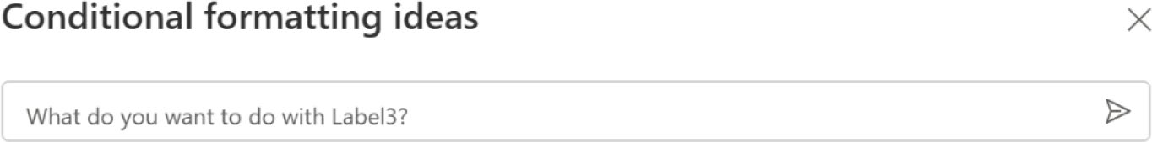

Figure 10-36. Option to input ideas using natural language to get
conditional formatting code from Copilot

In the middle of the block, you will find some suggestions provided by Copilot, as shown in
Figure 10-37. You can use these suggestions if they meet your criteria.
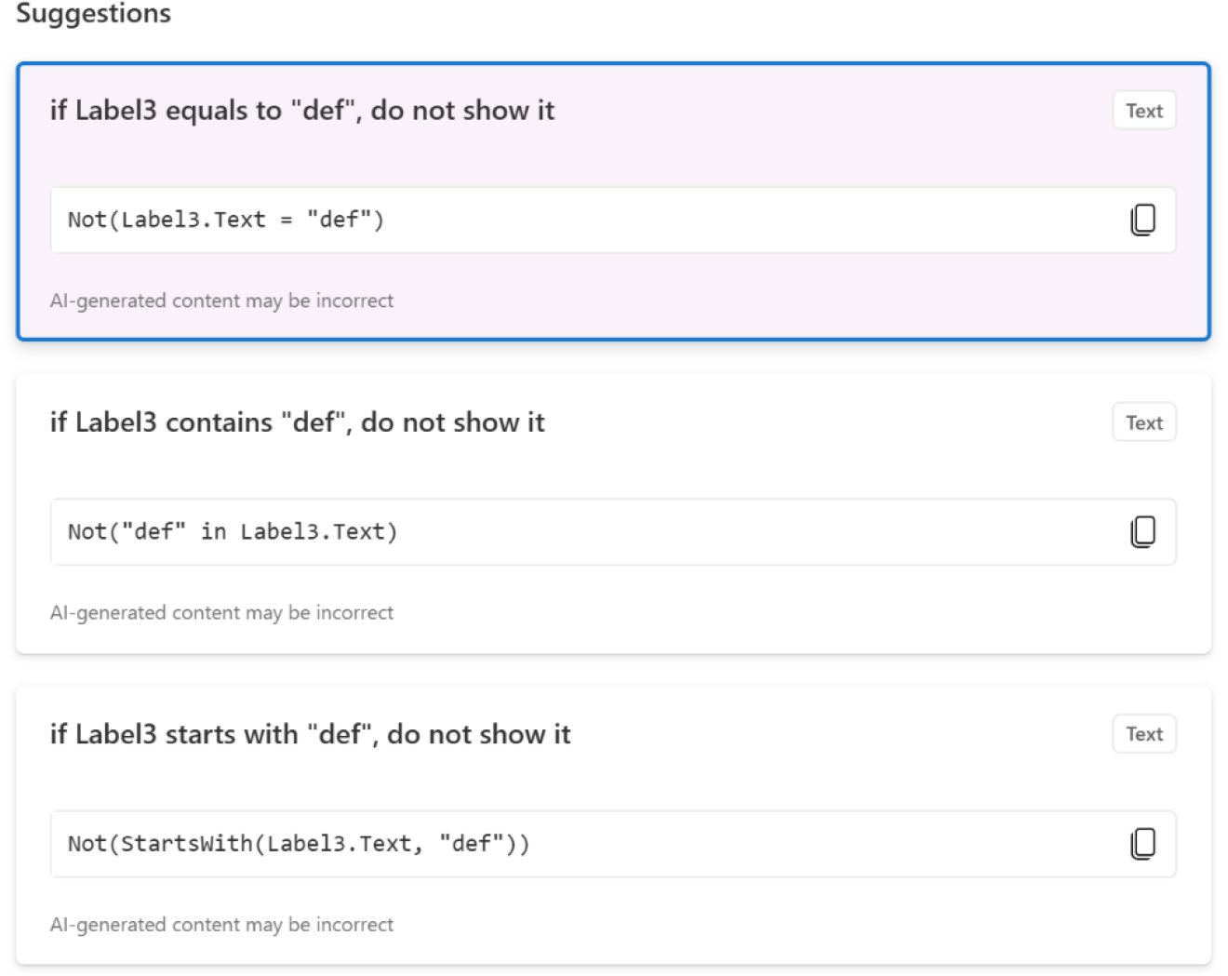

Figure 10-37. Copilot suggestions to use for conditional formatting

Chapter 10 advanCed teChniques with ai Builder and Conditional Formatting
4. In the Idea option, enter your idea in natural
language and press Enter. For this demo, I use the
following idea (also shown in Figure 10-38):
If the value is less than 1, set the text color to red; otherwise, use a different color (e.g., green)
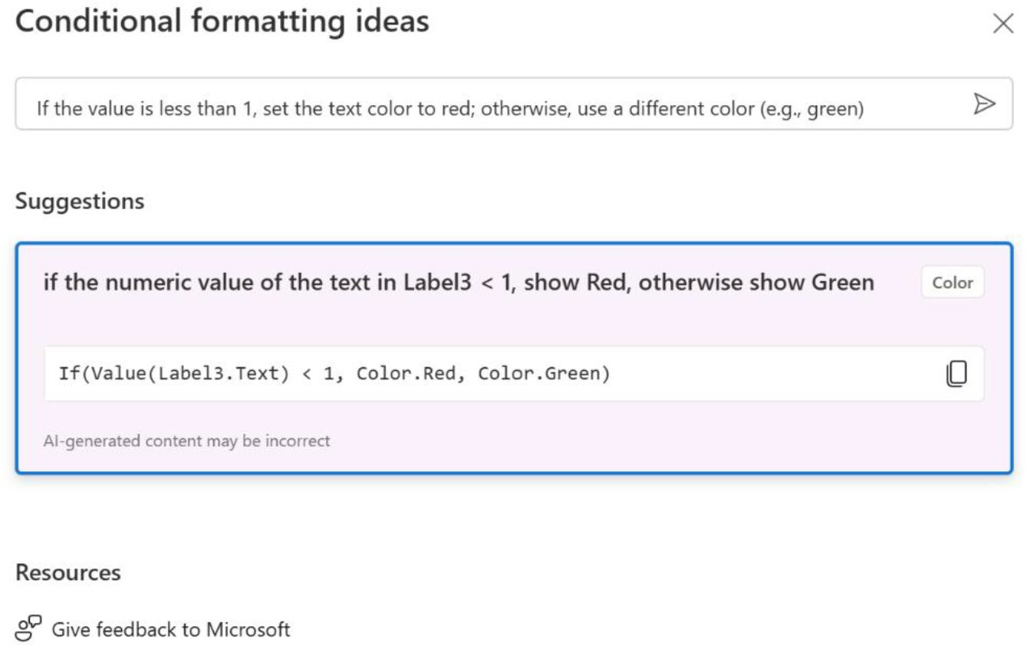

Figure 10-38. Inputting an idea into Copilot to create conditional formatting

5. Select the condition and apply it. Note that there
may be more suggestions on the list, and you need to understand which one is best for you.
6. I add two text fields (TextInput1 and TextInput2)
and a button to make a calculation, as shown in
Figure 10-39. To the button’s OnSelect property, I add the following code:
UpdateContext({ Result: Value(TextInput1.Text) + Value(TextInput2.Text) })

Chapter 10 advanCed teChniques with ai Builder and Conditional Formatting
Select the label where you added conditional formatting code, choose the Text property, and add
the following code (see Figure 10-39):
Text(Result)
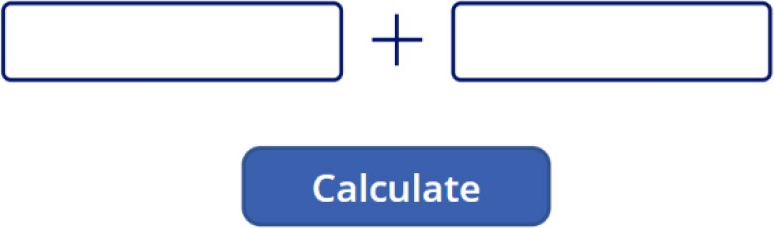

Figure 10-39. Added two new text fields and a button to
calculate numbers

7. Run the app and calculate a result using two positive
values, as shown in Figure 10-40.
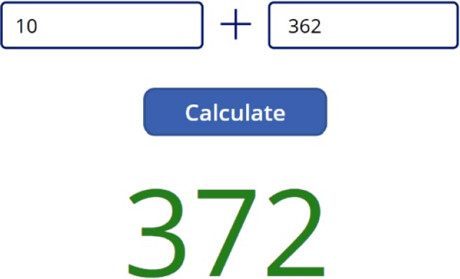

Figure 10-40. Testing conditional formatting with positive values

8. Check the result when you use negative values, as
shown in Figure 10-41.

Chapter 10 advanCed teChniques with ai Builder and Conditional Formatting
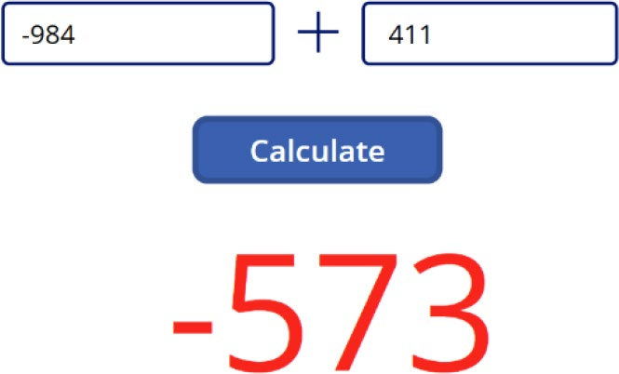

Figure 10-41. Testing conditional formatting with negative values
If the value is less than 1, the text color will be red; otherwise, it will be green. After testing the app, you can see that this is working perfectly.

Using Copilot in the Formula Bar
As previously discussed, Copilot in Power Apps has revolutionized conversation creation. Microsoft has recently enhanced this by integrating a Copilot button directly into the formula bar. This new feature provides increased efficiency, productivity, and a better understanding of its functionalities.
To utilize this feature, you must first enable it from the Power Apps settings. Open your project and go to Settings ➤ Upcoming Features, where you will find an option labeled Power Fx Formula Bar under the Preview tab. Activate this feature to use the Copilot in the formula bar, as
shown in Figure 10-42.

Chapter 10 advanCed teChniques with ai Builder and Conditional Formatting
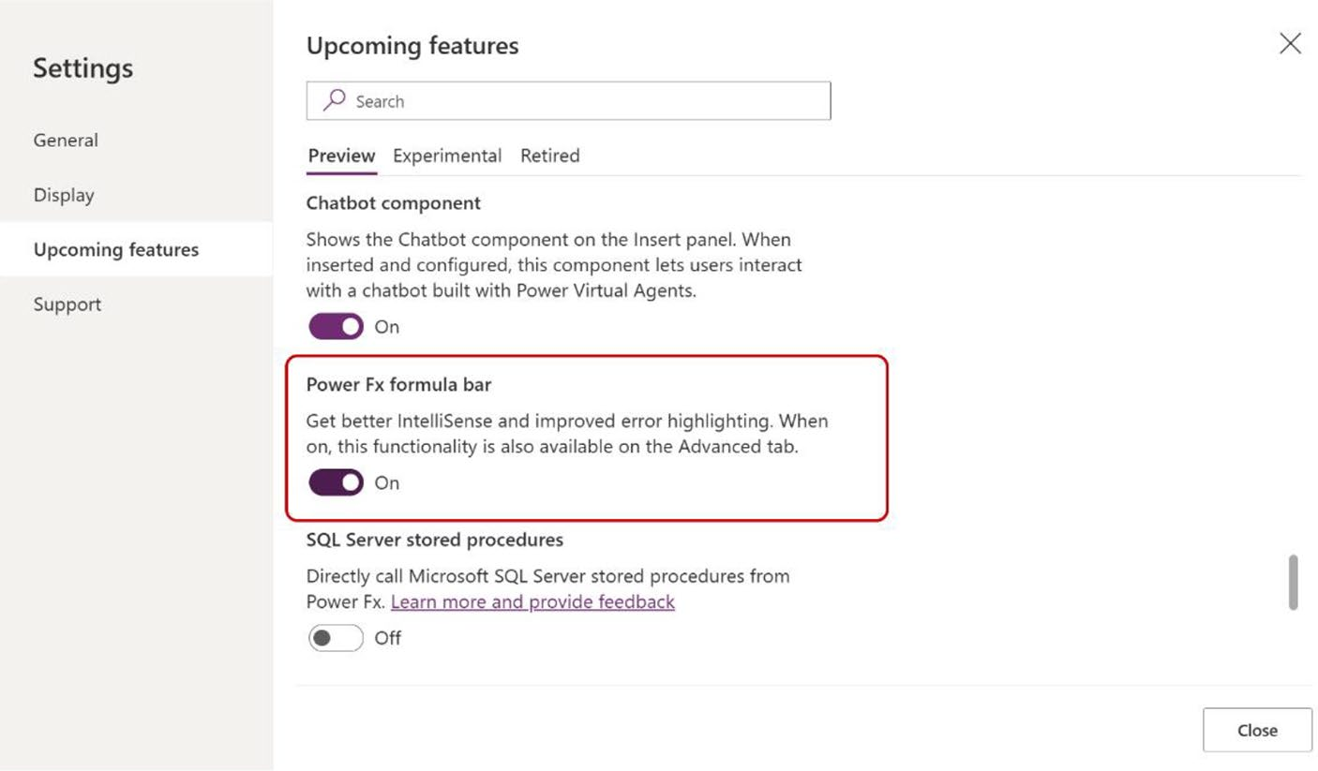

Figure 10-42. Option to activate Copilot in the formula bar

Overview of Copilot in the Formula Bar
Copilot now offers direct explanations of formula code within the formula
bar. This update is particularly useful when you’re dealing with complex
formulas, picking up a project that someone else started, or working
with projects generated from AI models or prompts. It’s also an excellent
resource for newcomers to the Power Platform, making it easier for them
to understand and use the platform effectively.
If you open your project, you can see the Copilot button in the formula
bar, as shown in Figure 10-43.

Chapter 10 advanCed teChniques with ai Builder and Conditional Formatting
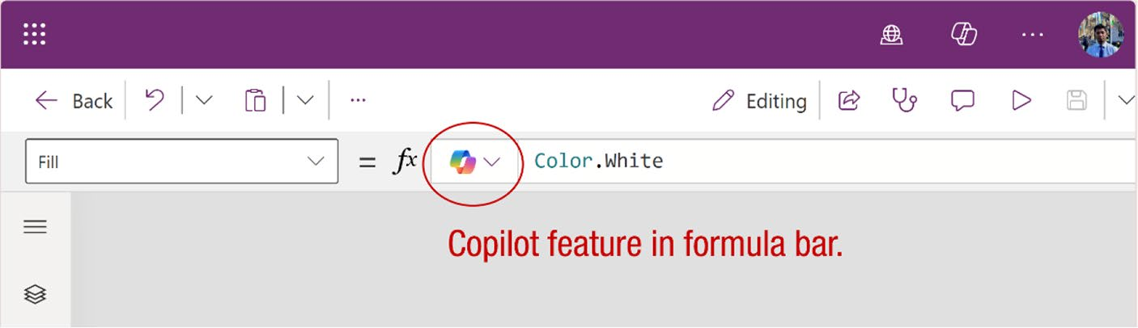

Figure 10-43. The Copilot button in the formula bar

Formula Explanation
When you select a component, the formula code appears in the formula bar. When you click the Copilot option, you will find a feature named
Explain This Formula, as shown in Figure 10-44.
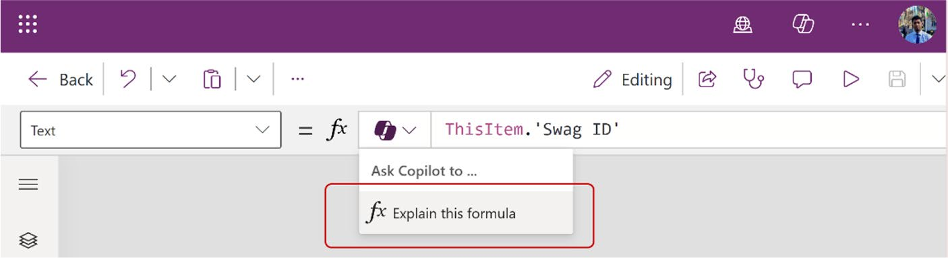

Figure 10-44. Option to explain a formula in Copilot

When you click the feature, you will see the explanation of the formula,
as shown in Figure 10-45.
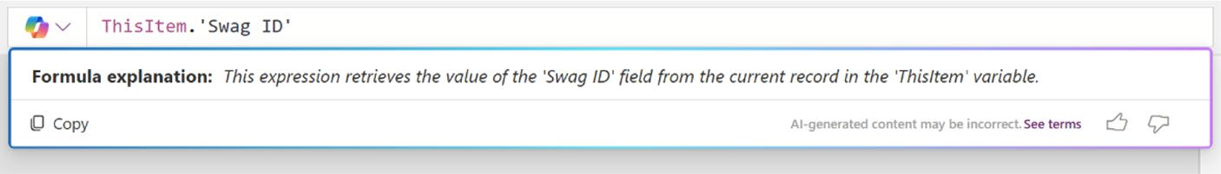

Figure 10-45. Explanation of the formula provided by Copilot

Chapter 10 advanCed teChniques with ai Builder and Conditional Formatting

Summary
This chapter explained advanced techniques in Power Apps, focusing on
AI Builder and conditional formatting. You learned how to create custom
AI prompts and integrate them into your apps to enhance their intelligence
and responsiveness. You also learned how to use conditional formatting to
make your apps more visually engaging and user-friendly.
As you move into Chapter 11, I help you take these skills further by
using Microsoft Copilot to transform the user interface (UI) of Power Apps.
In the next chapter, I walk you through a complete project, demonstrating
how to create a modern, dynamic UI with features like theme switching
and collapsible menus, all powered by Copilot. Get ready to elevate your
Power Apps design and functionality to the next level.

CHAPTER 11

Revolutionizing

Power Apps UI with

Microsoft Copilot:

A Complete Project

Building on the foundations of AI Builder and conditional formatting,
you’ve already explored how to add intelligence and visual appeal to your
Power Apps. Now, it’s time to take a significant step forward in app design.
This chapter introduces you to the powerful capabilities of Microsoft
Copilot for transforming the user interface of your Power Apps. You’ll
work through a complete project that showcases how to create a modern,
dynamic UI, including features like theme switching and collapsible
menus. This chapter will equip you with the skills to design apps that are
not only functional but also visually striking and user-friendly. Let’s dive in
and elevate your Power Apps to new heights.

© Rezwanur Rahman 2024 557
R. Rahman, Microsoft Copilot for Power Apps, Inside Copilot,

CHAPTER 11 REVOLUTIONIZING POWER APPS UI WITH MICROSOFT COPILOT:

Project Demo A COMPLETE PROJECT
This section designs a simple app with Copilot and Power Fx (Formula). Additionally, it demonstrates how to implement a feature that allows users to switch between light and dark themes using a toggle button. Follow along with the instructions to start the demo. Let’s start!

Creating a Modern Menu
First, you will create a dynamic menu for the project. Then, you will learn how to expand the menu and add a theme switcher, allowing users to toggle between light and dark themes. To make the dynamic menu, follow these steps:
1. Create a new Canvas app in tablet format from
https://make.powerapps.com, as shown in
Figure 11-1.
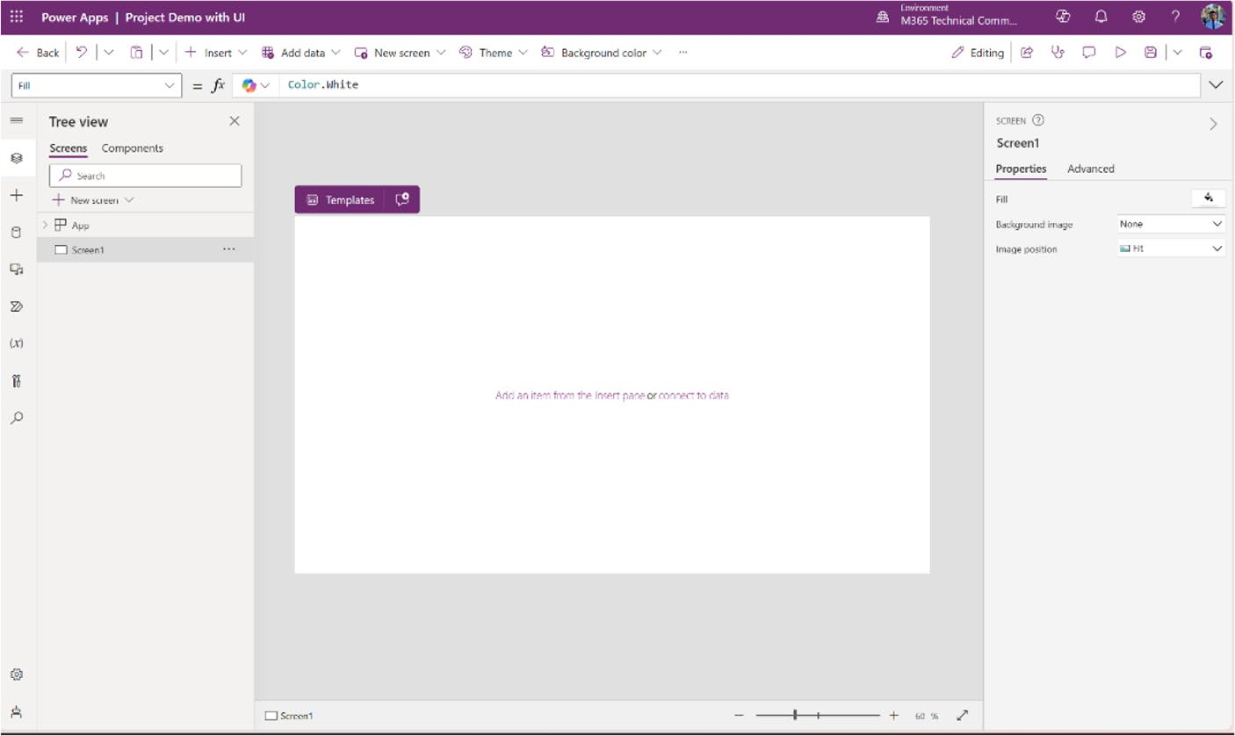

Figure 11-1. Creating a new app for the project demo

CHAPTER 11 REVOLUTIONIZING POWER APPS UI WITH MICROSOFT COPILOT:
A COMPLETE PROJECT
2. Next, create a collapsible side menu in the app.
I showed you in the previous chapter how to create a basic menu in Power Apps. Now I will show you how to create an attractive, dynamic and responsive side menu with an advanced formula. To create the collapsible menu, create a new component named CollapsibleMenu from the Tree View option, as
shown in Figure 11-2.
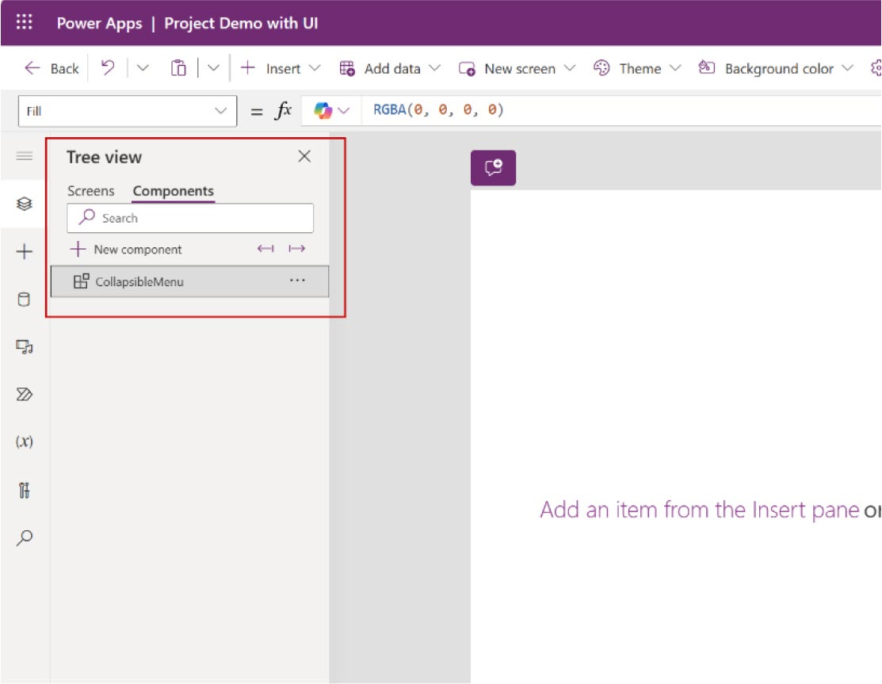

Figure 11-2. Creating a new component for a collapsible side menu

CHAPTER 11 REVOLUTIONIZING POWER APPS UI WITH MICROSOFT COPILOT:
A COMPLETE PROJECT
3. Adjust the size of the component to a width of
70 and a height of 768, as shown in Figure 11-3.
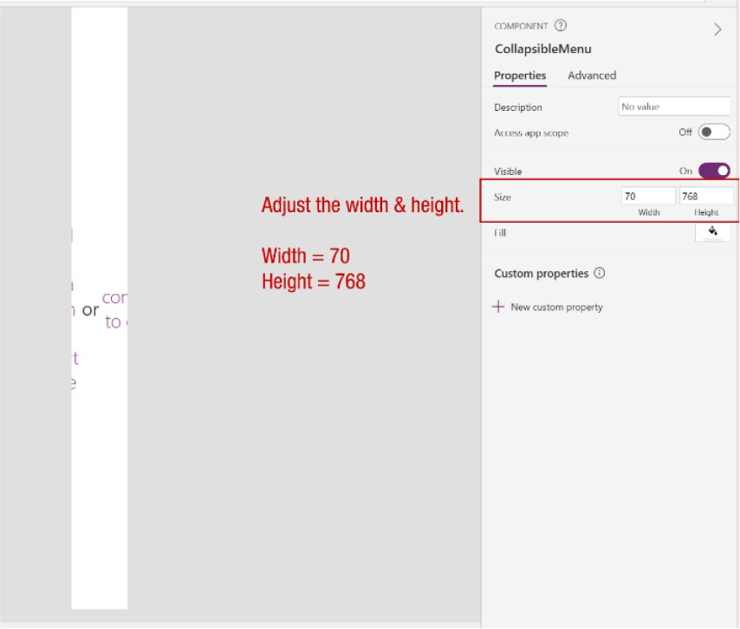

Figure 11-3. Adjusting the width and height

4. Add a vertical container to the component and
change the settings to the following parameters:
X = 0
Y = 0
Width = 70
Height = 768
Border Radius = 0
Drop Shadow = None
I adjusted the vertical container to match the size of
the component, as shown in Figure 11-4.

CHAPTER 11 REVOLUTIONIZING POWER APPS UI WITH MICROSOFT COPILOT:
A COMPLETE PROJECT
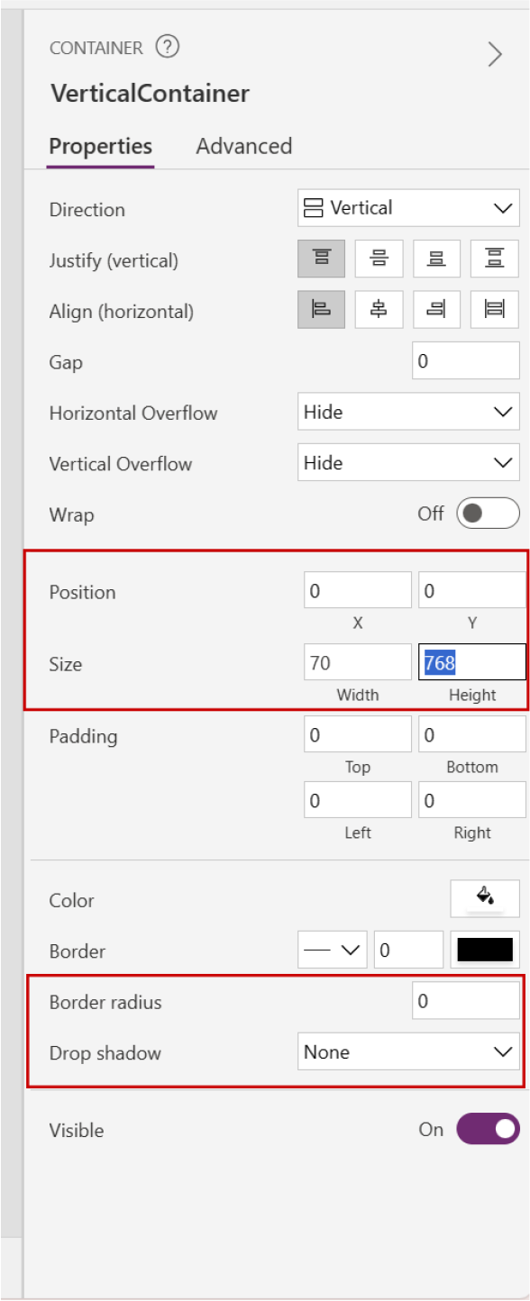

Figure 11-4. Adjusting the vertical container properties

5. Create a new custom property and change the
parameters as follows:
Display name = NavigationBackground Name = NavigationBackground Description = CustomNavigationBG Property type = Input Data Type = Color

CHAPTER 11 REVOLUTIONIZING POWER APPS UI WITH MICROSOFT COPILOT:
A COMPLETE PROJECT
You can see the property in the Custom Properties
list shown in Figure 11-5.
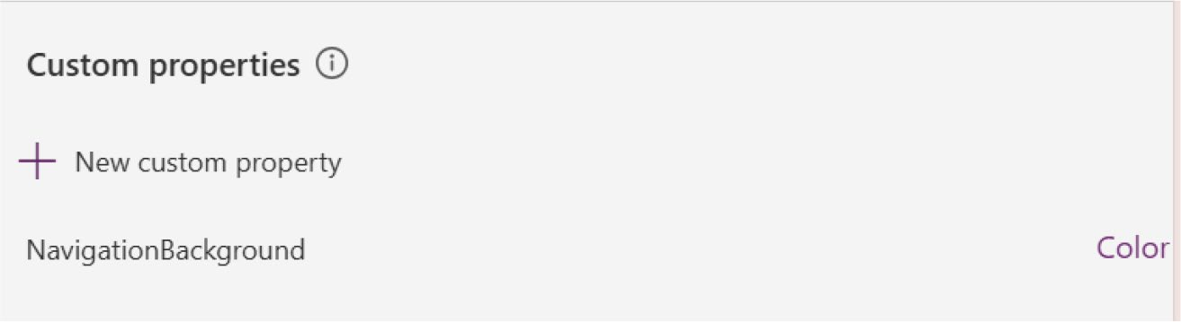

Figure 11-5. The custom property has been created

6. Select the NavigationBackground custom property
and change the background color from the Formula bar as the following code:
RGBA(244, 244, 244, 1)
Figure 11-6 shows where you need to change the code.
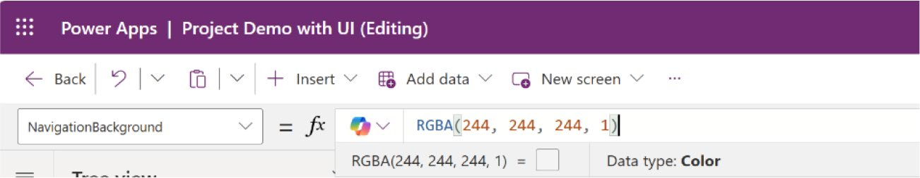

Figure 11-6. Changing the RGBA color of the NavigationBackground custom property

CHAPTER 11 REVOLUTIONIZING POWER APPS UI WITH MICROSOFT COPILOT:
A COMPLETE PROJECT
7. Select the vertical container that you added. Choose
the Fill properties and add the following code:
CollapsibleMenu.NavigationBackground
Here, CollapsibleMenu is the name of the component and NavigationBackground is the
custom property that I created before. Figure 11-7 shows this step.
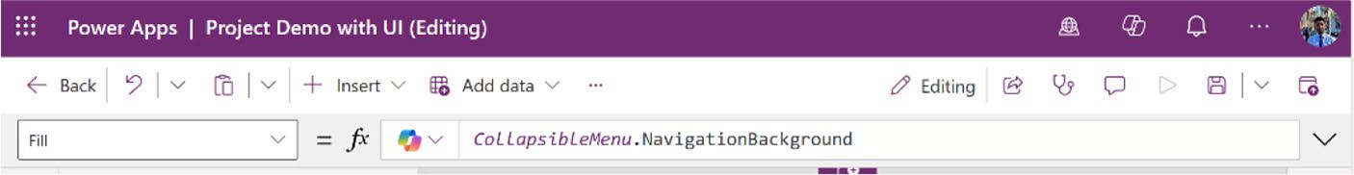

Figure 11-7. Fill in the vertical container with the
NavigationBackground custom property

8. Adjust the padding of the vertical container with the
following parameters:
Top = 20
Bottom = 20
Left = 10
Right = 10

CHAPTER 11 REVOLUTIONIZING POWER APPS UI WITH MICROSOFT COPILOT:
A COMPLETE PROJECT
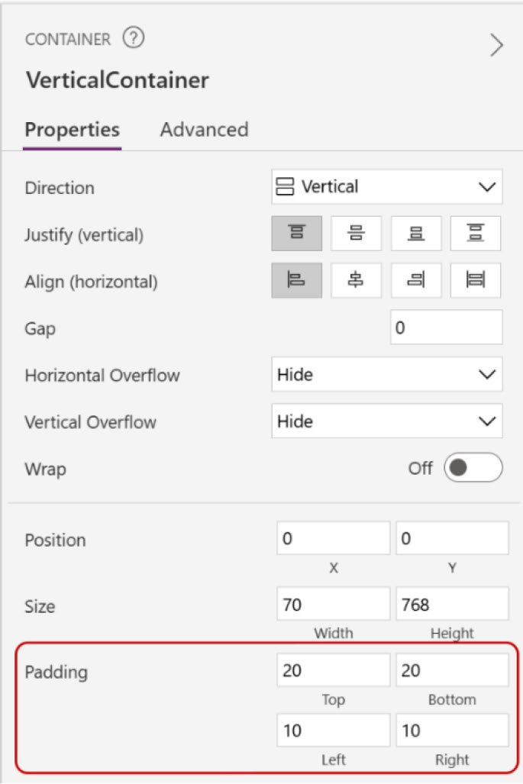

Figure 11-8. Adjusting the padding of the vertical container

9. Add an image to the container from the Insert menu
and set the following parameters:
Align in container = Justify Minimum width = 0
Height = 30
Name = LogoImage
Figure 11-9 shows the changes to the image component properties.

CHAPTER 11 REVOLUTIONIZING POWER APPS UI WITH MICROSOFT COPILOT:
A COMPLETE PROJECT
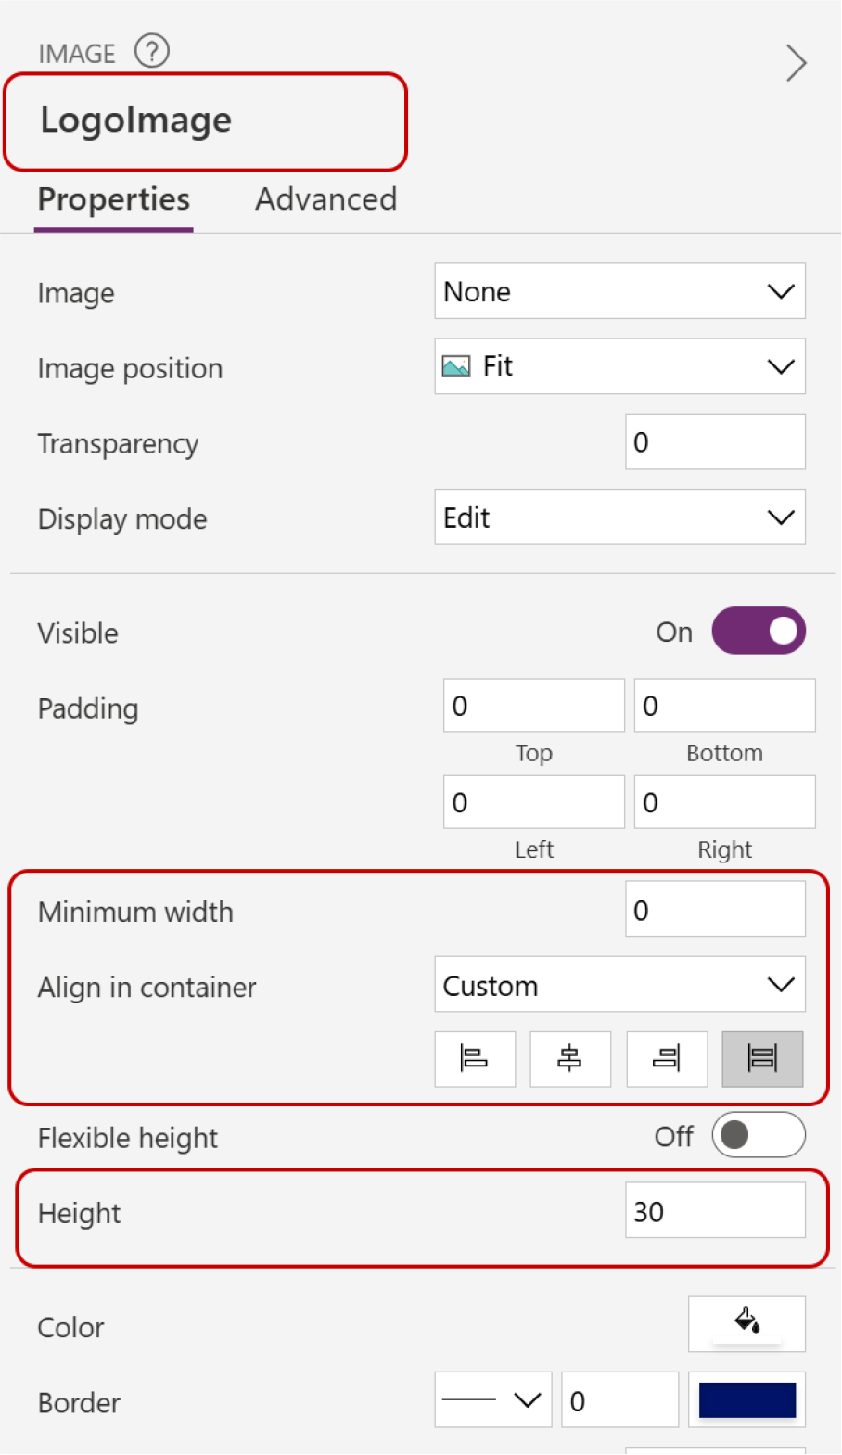

Figure 11-9. Setting the image containers parameters

10. Create another custom property with the following
parameters:
Name = Logo_compact Data Type = Image

CHAPTER 11 REVOLUTIONIZING POWER APPS UI WITH MICROSOFT COPILOT:
A COMPLETE PROJECT
Figure 11-10 shows the parameters of the new custom property.
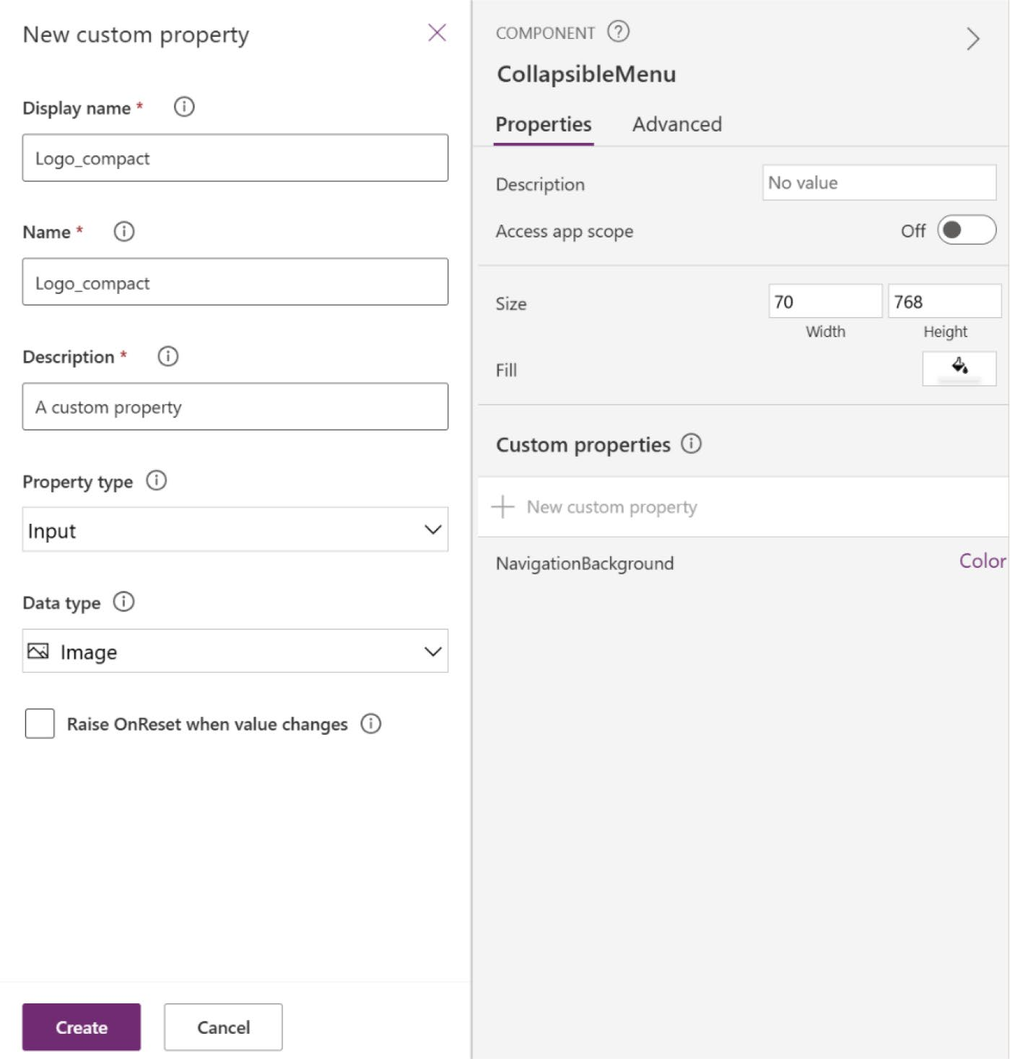

Figure 11-10. The new custom property named Logo_compact

CHAPTER 11 REVOLUTIONIZING POWER APPS UI WITH MICROSOFT COPILOT:
A COMPLETE PROJECT
11. From the Media ➤ Add Media option, add your logo
file, as shown in Figure 11-11.
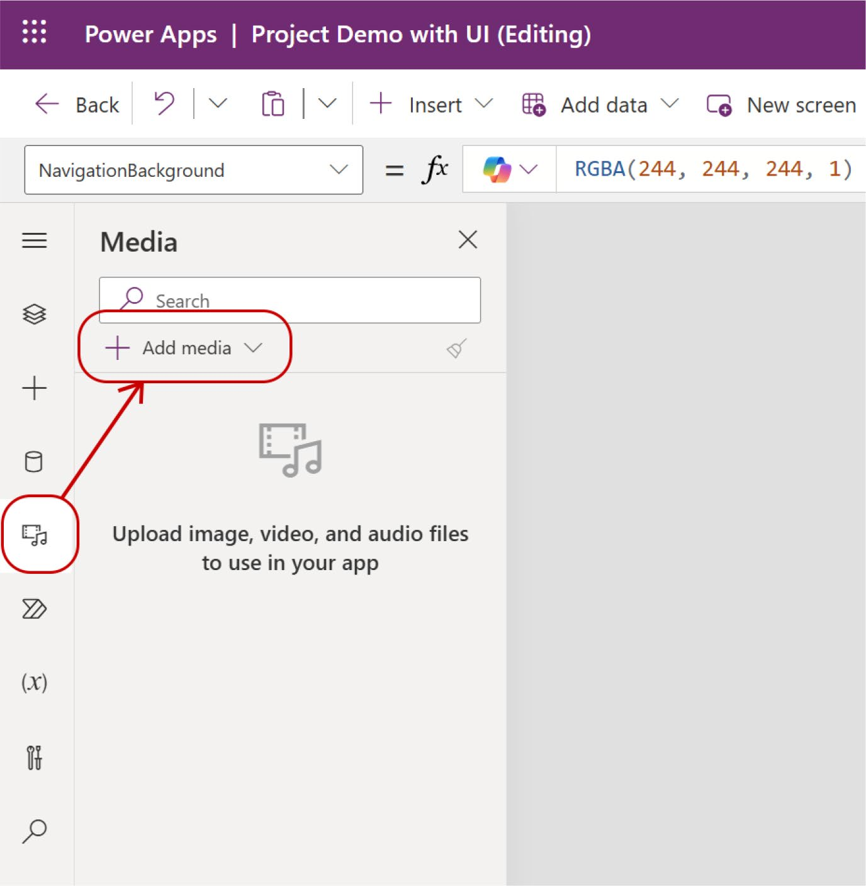

Figure 11-11. Adding a new logo from the Media option

12. Bo back to the container, select the image
component, and in the Formula bar, add the image by its name. For example, my image is called Backend Logo and I am writing the logo name in the
Formula bar, as shown in Figure 11-12.

CHAPTER 11 REVOLUTIONIZING POWER APPS UI WITH MICROSOFT COPILOT:
A COMPLETE PROJECT
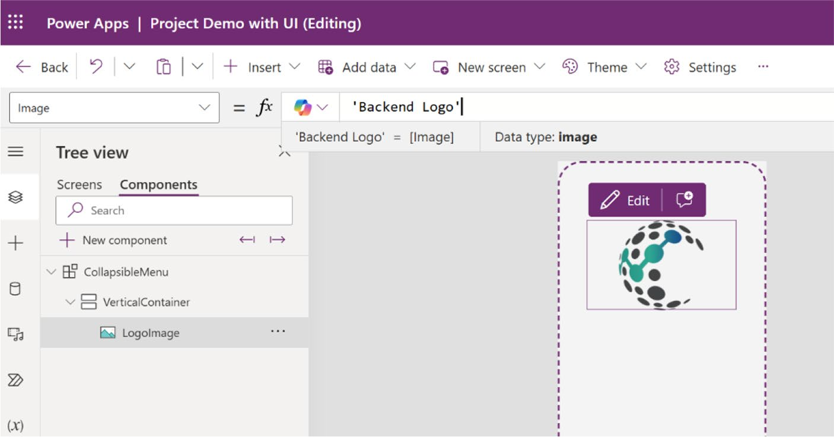

Figure 11-12. Adding an image from the Formula bar

13. Create another custom property named
Logo_padding with the following parameters:
Name = Logo_padding
Data Type = Number

CHAPTER 11 REVOLUTIONIZING POWER APPS UI WITH MICROSOFT COPILOT:
A COMPLETE PROJECT
You can see these parameters in Figure 11-13.
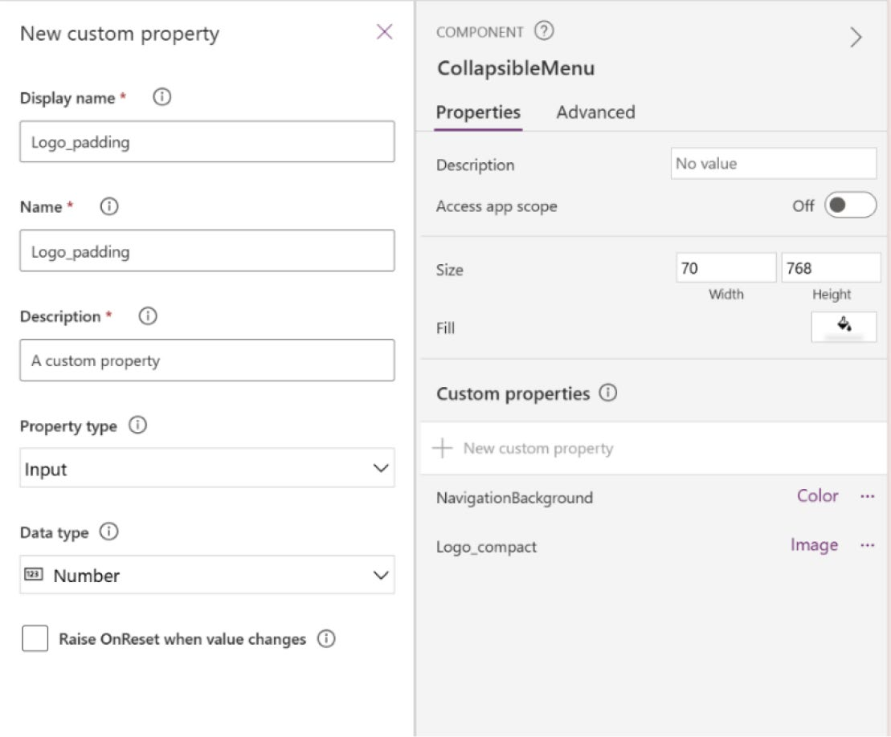

Figure 11-13. Properties of new custom property named
Logo_padding

14. Select the Logo_padding property and set the
percentage to 20%, as shown in Figure 11-14.

CHAPTER 11 REVOLUTIONIZING POWER APPS UI WITH MICROSOFT COPILOT:
A COMPLETE PROJECT
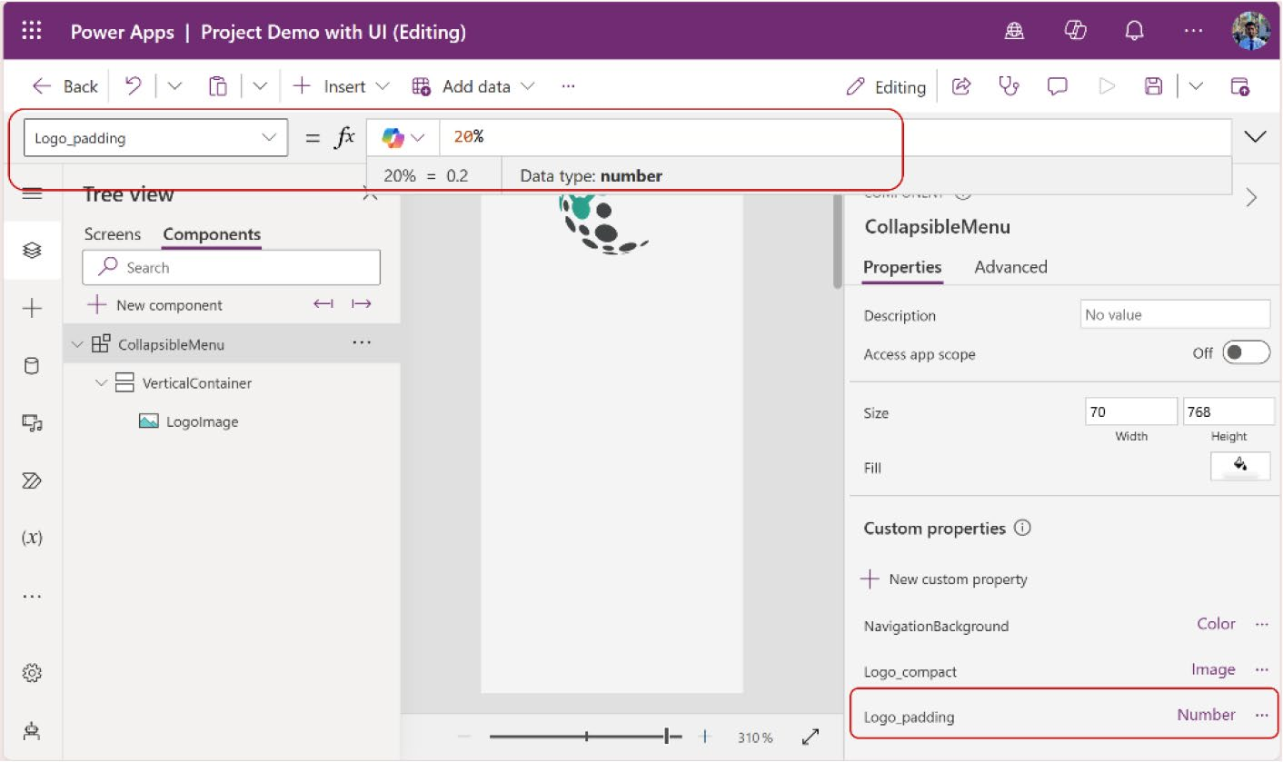

Figure 11-14. Setting the Logo_padding custom properties value to 20%

15. Select the image. Then, from the Formula bar,
select the PaddingTop property and add the following code:
Self.Height * CollapsibleMenu.Logo_padding
Figure 11-15 shows the formula code for the PaddingTop property.

CHAPTER 11 REVOLUTIONIZING POWER APPS UI WITH MICROSOFT COPILOT:
A COMPLETE PROJECT
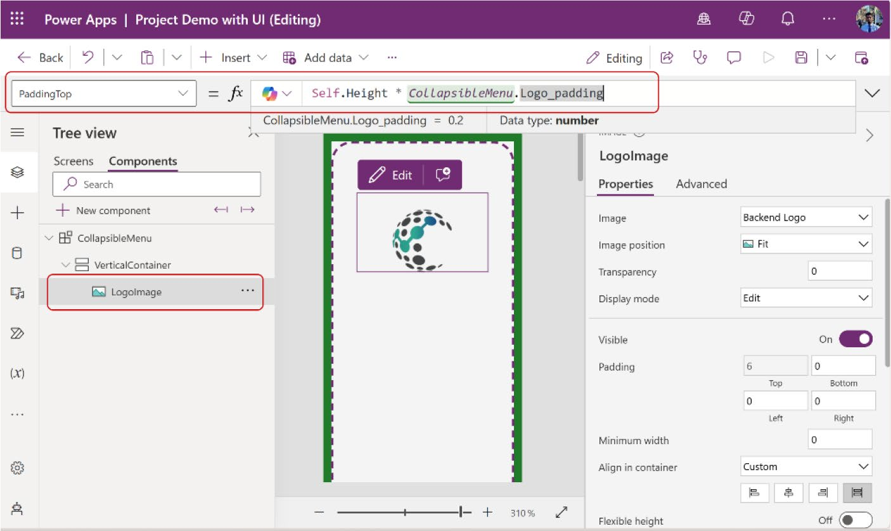

Figure 11-15. Changing the padding of the logo image from the
Formula bar

16. Do the same for PaddingBottom property, using the
same code.
17. Next, you’ll add some icons to the menu. Before
adding the icon, you need to add a blank vertical gallery, where you can set the icons. To add the vertical gallery, go to Insert and choose Blank
Vertical Gallery, as shown in Figure 11-16.

CHAPTER 11 REVOLUTIONIZING POWER APPS UI WITH MICROSOFT COPILOT:
A COMPLETE PROJECT
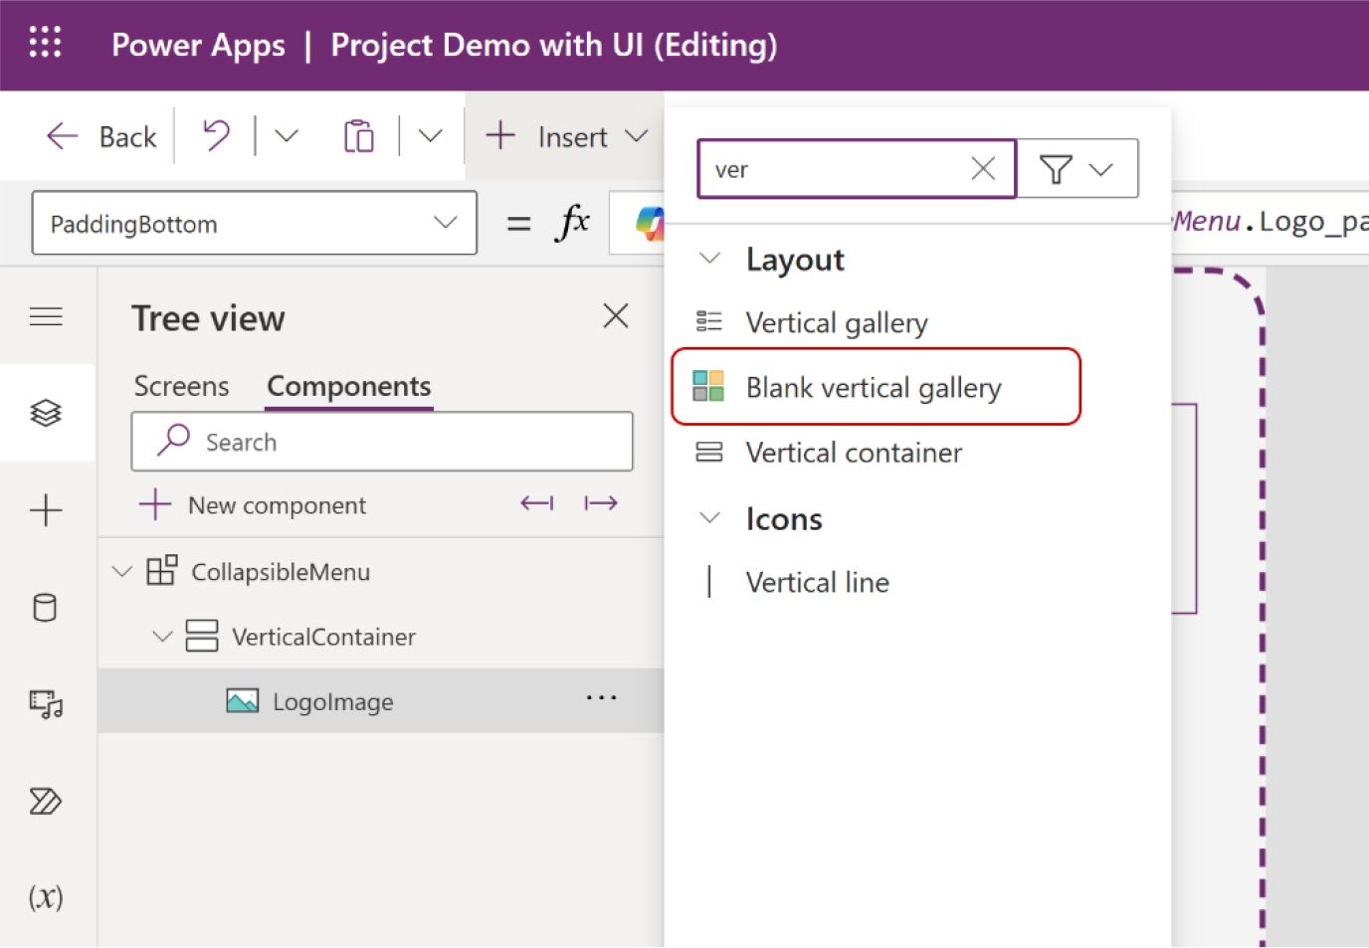

Figure 11-16. Adding a blank vertical gallery to the container

18. Change the following parameters of the vertical
gallery:
Minimum width = 0
Template size = 50
Template padding = 0
From the Formula bar, select the Height properties and add the following code:
Self.AllItemsCount * (Self.TemplateHeight+ Self.TemplatePadding)
This code ensures that the gallery’s height is always based on the height of its items, while also accounting for padding.

CHAPTER 11 REVOLUTIONIZING POWER APPS UI WITH MICROSOFT COPILOT:
A COMPLETE PROJECT
Figure 11-17 shows the parameters and formula code for the vertical gallery.
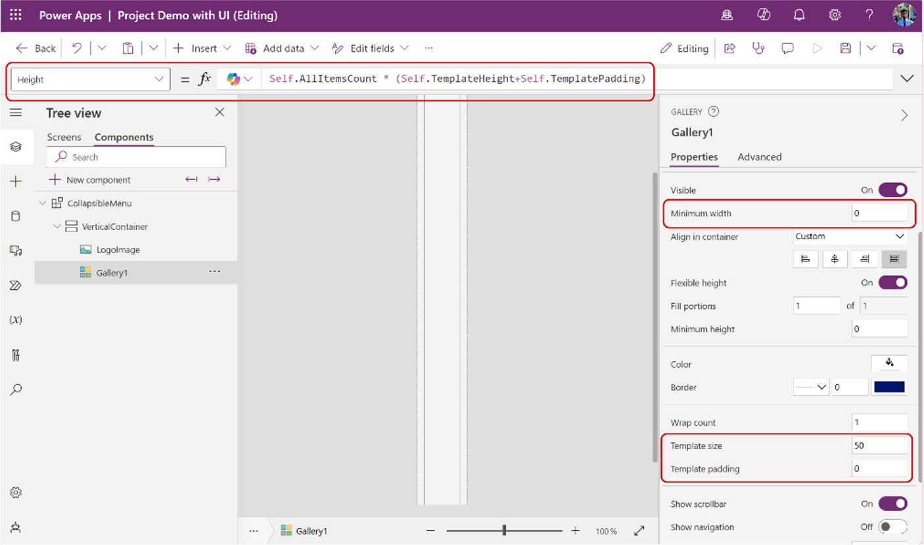

Figure 11-17. Changing parameters for the vertical gallery

19. Create another custom property named
MenuContents with the following parameters (see
Figure 11-18):
Name = MenuContents Data type = Table

CHAPTER 11 REVOLUTIONIZING POWER APPS UI WITH MICROSOFT COPILOT:
A COMPLETE PROJECT
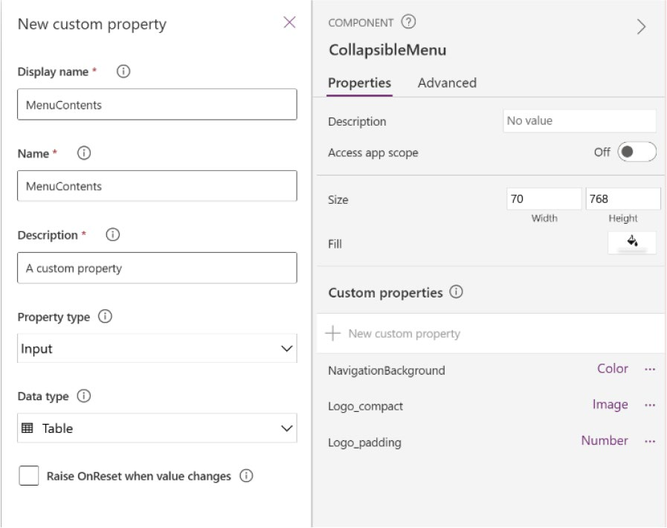

Figure 11-18. Parameters for new custom property named MenuContents

20. You can now add icons to the menu. You can either
search for icons using the Insert option or upload custom icons from your device. This example shows you how to add icons from external resources.
To add icons, go to https://getbootstrap.com/ in another tab of your browser, and you will see the
bootstrap website, as shown in Figure 11-19.

CHAPTER 11 REVOLUTIONIZING POWER APPS UI WITH MICROSOFT COPILOT:
A COMPLETE PROJECT
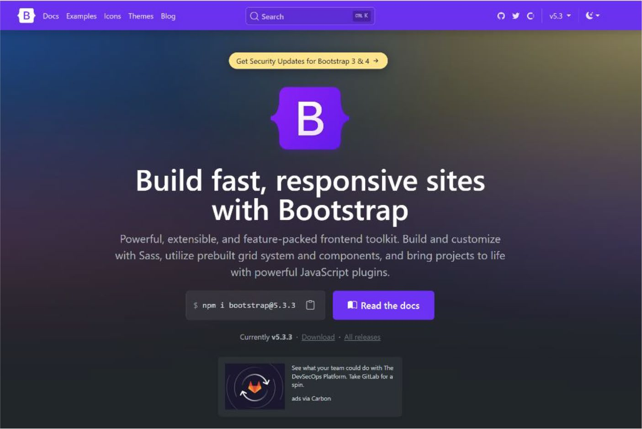

Figure 11-19. Bootstrap website to get icons

21. Click the Icons option from the menu, and you will
see the page in Figure 11-20.

CHAPTER 11 REVOLUTIONIZING POWER APPS UI WITH MICROSOFT COPILOT:
A COMPLETE PROJECT
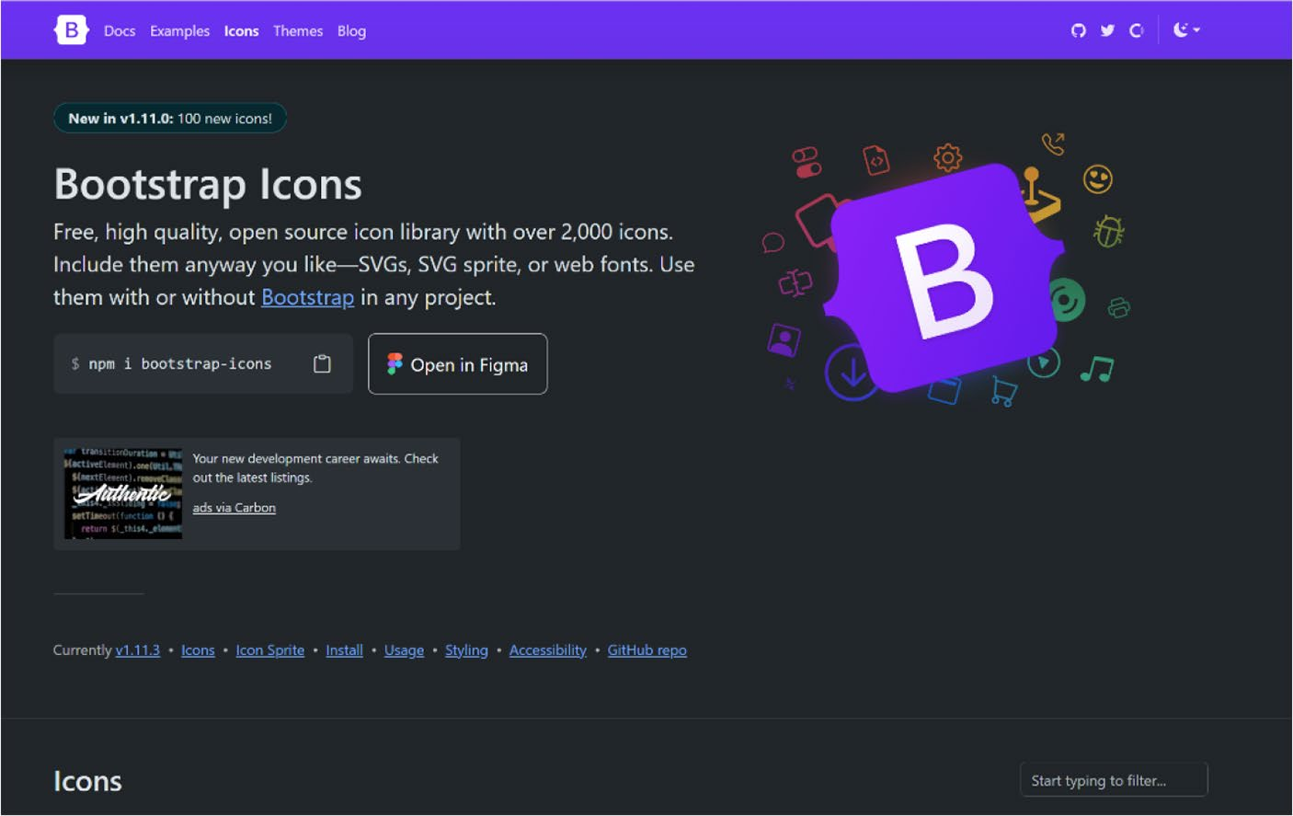

Figure 11-20. Bootstrap Icons page to get free icons

The Bootstrap icons are free, open source, and easy to
use. You can visit https://icons.getbootstrap.com/ to get these icons.
22. Search for an icon. Because I am building an office
management app, I search for a badge icon and copy the HTML code that contains the SVG file, as
shown in Figure 11-21.

CHAPTER 11 REVOLUTIONIZING POWER APPS UI WITH MICROSOFT COPILOT:
A COMPLETE PROJECT
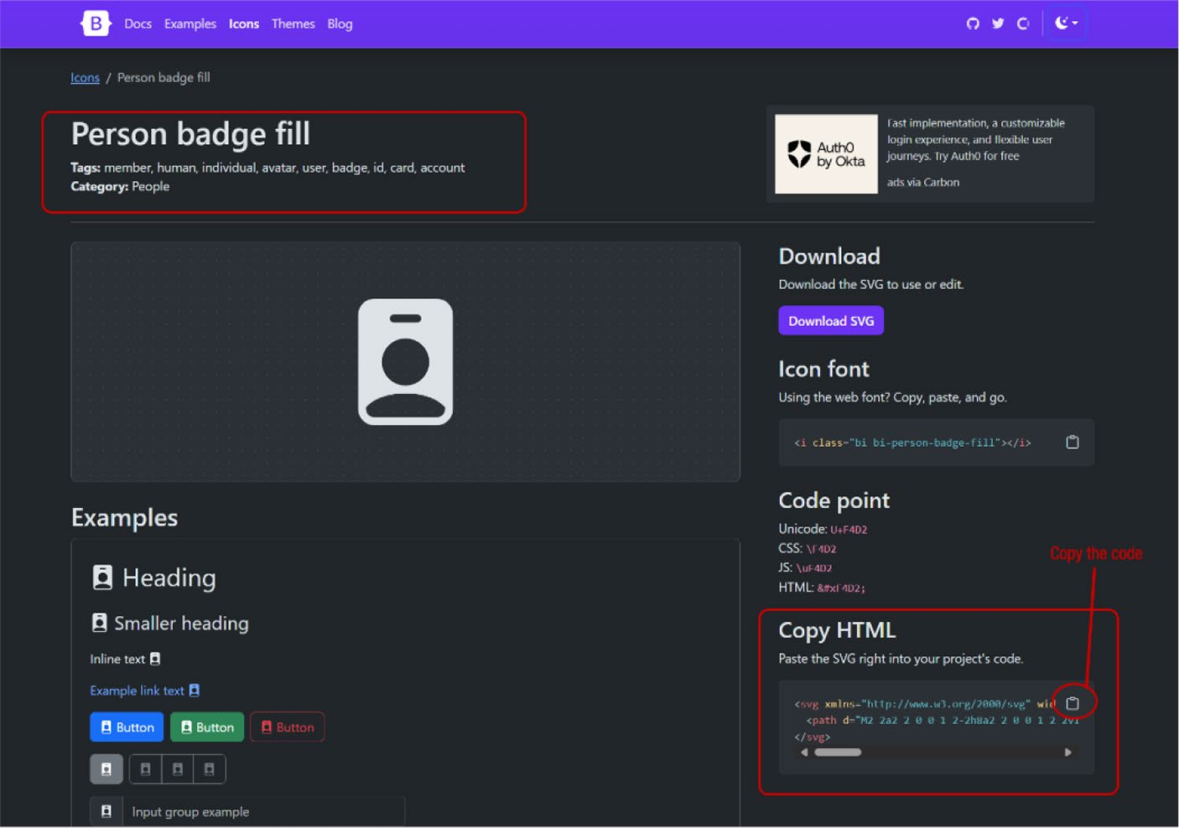

Figure 11-21. Searching for an icon and copying the HTML code

23. Go back to the Power Apps project and click
MenuContents. In the Formula bar, select the MenuContents property, and you will see the code in
Figure 11-22.

CHAPTER 11 REVOLUTIONIZING POWER APPS UI WITH MICROSOFT COPILOT:
A COMPLETE PROJECT
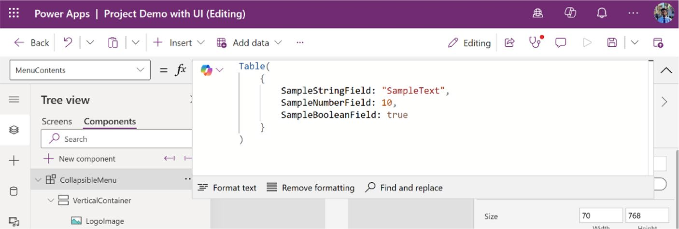

Figure 11-22. Sample table design code after creating a new custom property

24. Remove the sample code and create a menu item by
adding the following code:
Table(
{
MenuIcon: "<svg xmlns='http://www.w3.org/2000/ svg' width='16' height='16' fill='currentColor' class='bi bi-person-
badge-fill' viewBox='0 0 16 16'>
<path d='M2 2a2 2 0 0 1 2-2h8a2 2 0 0 1 2 2v12a2 2 0 0 1-2 2H4a2 2 0 0 1-2-2zm4.5 0a.5.5 0 0 0 0 1h3a.5.5 0 0 0 0-1zM8 11a3 3 0 1 0 0-6 3 3 0 0 0 0 6m5 2.755C12.146 12.825 10.623 12 8 12s-4.146.826-5 1.755V14a1 1 0 0 0 1 1h8a1 1 0 0 0 1-1z'/>
</svg>",
MenuID: 1,
MenuName: "Employee Board",
Page: App.ActiveScreen
}
)

CHAPTER 11 REVOLUTIONIZING POWER APPS UI WITH MICROSOFT COPILOT:
A COMPLETE PROJECT
Let’s look at this code first before moving to the next step:
• MenuIcon: This is the HTML code that I got from
Bootstrap. Ensure you enclose the code in double quotes ("HTML Code"). If you encapsulate the code in double quotes, it will lead to errors due to existing double quotes within the code. Replace these internal double quotes with single quotes.
• MenuID: This unique ID is assigned to this menu
item. As you add more items to the menu, each will gets its own unique ID.
• MenuName: This is the name of the menu item. For
instance, you can label it “Home” or “Contact” depending on the button you want to include in your menu.
• Page: This refers to the page that will open when
the button is clicked or tapped.
This code creates one menu item, so I will add two more menu items by separating the code using commas (,). You can add the code as follows:
Table(
{
MenuIcon: "<svg xmlns='http://www.w3.org/2000/ svg' width='16' height='16' fill='currentColor' class='bi bi-person-
badge-fill' viewBox='0 0 16 16'>
<path d='M2 2a2 2 0 0 1 2-2h8a2 2 0 0 1 2 2v12a2 2 0 0 1-2 2H4a2 2 0 0
1-2-2zm4.5 0a.5.5 0 0 0 0 1h3a.5.5

CHAPTER 11 REVOLUTIONIZING POWER APPS UI WITH MICROSOFT COPILOT:
A COMPLETE PROJECT
0 0 0 0-1zM8 11a3 3 0 1 0 0-6 3 3 0 0 0 0 6m5 2.755C12.146 12.825 10.623 12 8 12s-4.146.826-5 1.755V14a1 1 0 0 0 1 1h8a1 1 0 0 0 1-1z'/>
</svg>",
MenuID: 1,
MenuName: "Employee Board",
Page: App.ActiveScreen
},
{
MenuIcon: "<svg xmlns='http://www.w3.org/2000/ svg' width='16' height='16' fill='currentColor' class='bi bi-file-text-fill' viewBox='0 0 16 16'>
<path d='M12 0H4a2 2 0 0 0-2 2v12a2 2 0 0 0 2 2h8a2 2 0 0 0 2-2V2a2 2 0 0 0-2-2M5 4h6a.5.5 0 0 1 0 1H5a.5.5 0 0 1 0-1m-.5 2.5A.5.5 0 0 1 5 6h6a.5.5 0 0 1 0 1H5a.5.5 0 0 1-.5-.5M5 8h6a.5.5 0 0 1 0 1H5a.5.5 0 0 1 0-1m0 2h3a.5.5 0 0 1 0 1H5a.5.5 0 0 1 0-1'/>
</svg>",
MenuID: 2,
MenuName: "Received Application",
Page: App.ActiveScreen
},
{
MenuIcon: "<svg xmlns='http://www.w3.org/2000/ svg' width='16' height='16' fill='currentColor' class='bi bi-check-circle-fill' viewBox='0 0 16 16'>

CHAPTER 11 REVOLUTIONIZING POWER APPS UI WITH MICROSOFT COPILOT:
A COMPLETE PROJECT
<path d='M16 8A8 8 0 1 1 0 8a8
8 0 0 1 16 0m-3.911-3.03a.75.75
0 0 0-1.08.022L7.477 9.417
5.384 7.323a.75.75 0 0 0-1.06
1.06L6.97 11.03a.75.75 0 0 0
1.079-.02l3.992-4.99a.75.75 0 0
0-.01-1.05z'/>
</svg>",
MenuID: 3,
MenuName: "Status",
Page: App.ActiveScreen
}
)
Figure 11-23 shows the actual code in the Power Apps application.
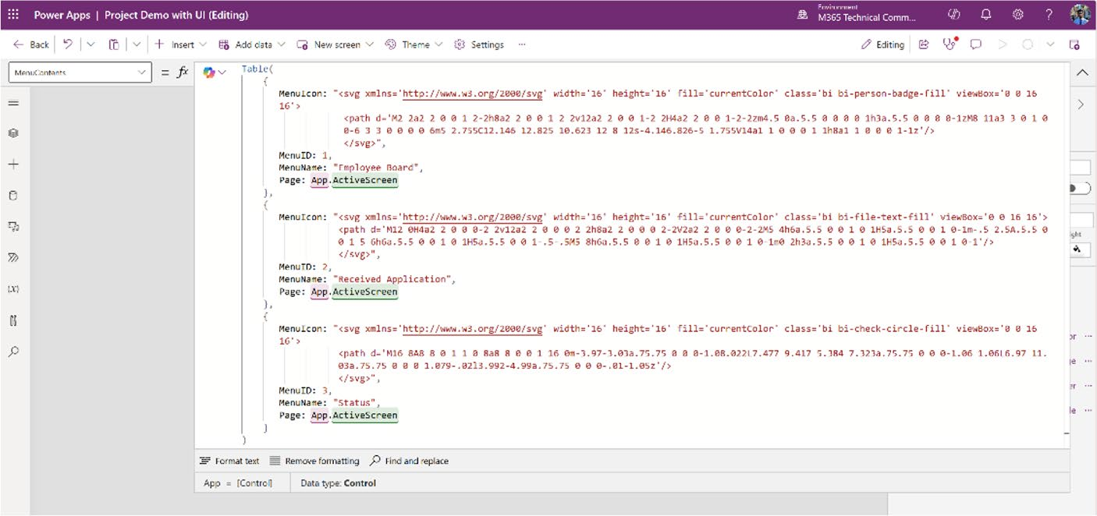

Figure 11-23. Menu configuration displaying three menu items with
SVG icons, names, and links to the active screen

CHAPTER 11 REVOLUTIONIZING POWER APPS UI WITH MICROSOFT COPILOT:
A COMPLETE PROJECT
I don’t have another screen at this moment, so I simply link the active screen in every menu item. I will add new screens to this demo later, at which time I will show you how to change the page navigation.
25. Go back to the Power Apps Studio, select the gallery,
and in the Items property, add the following code:
CollapsibleMenu.MenuContents
Figure 11-24 shows the formula code in the Items property of the gallery.
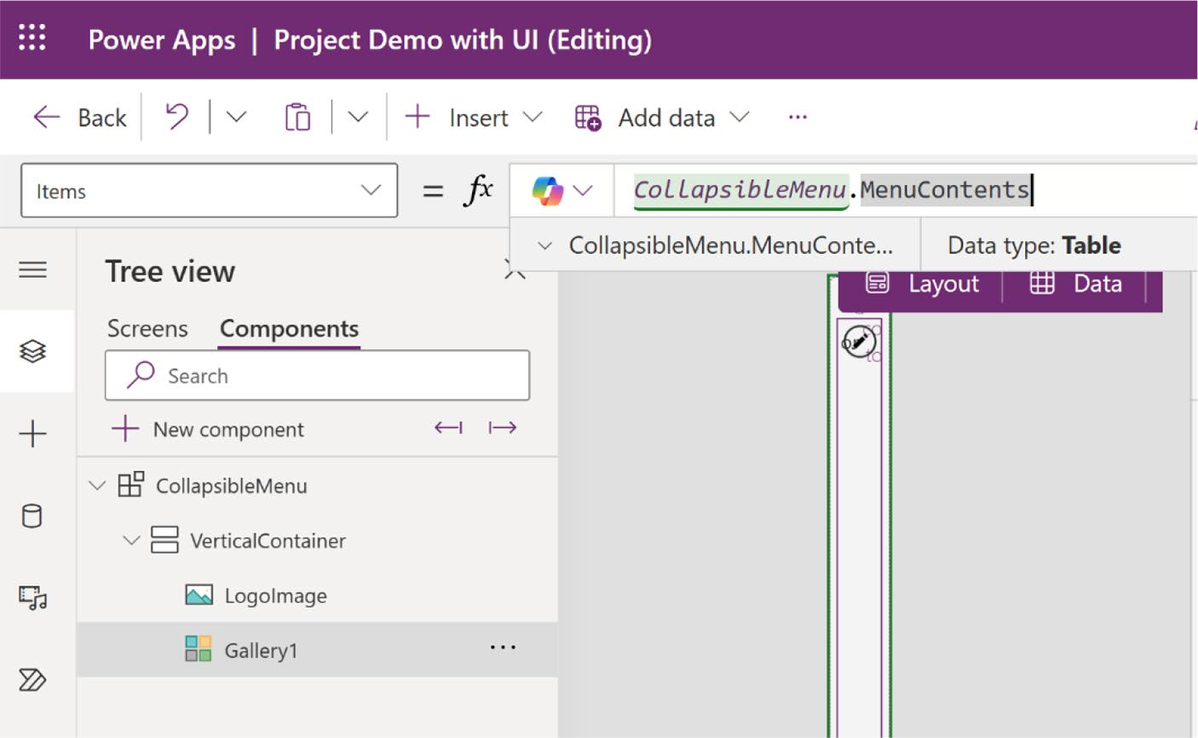

Figure 11-24. The formula code in the Items property of the gallery

26. Also, turn off the Flexible Height option in the
gallery, as shown in Figure 11-25.

CHAPTER 11 REVOLUTIONIZING POWER APPS UI WITH MICROSOFT COPILOT:
A COMPLETE PROJECT
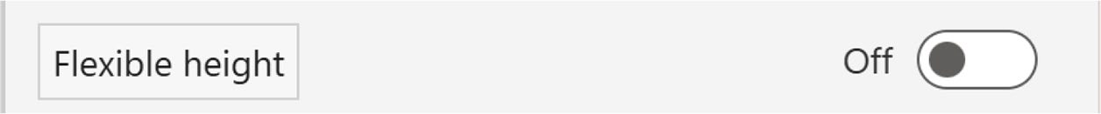

Figure 11-25. Turning off the flexible height option

27. Click the Gallery Edit icon (the pen symbol) and
add a container inside the gallery, as shown in
Figure 11-26. Change the following parameters from the Formula bar:
X = 0
Y = 0
Width = Parent.TemplateWidth Height = Parent.TemplateHeight
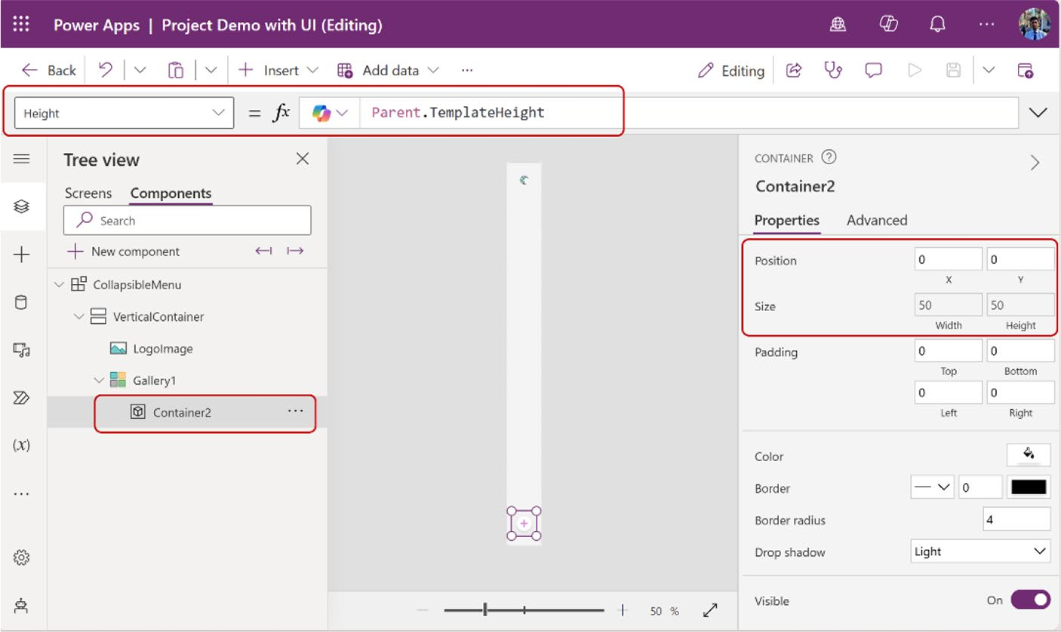

Figure 11-26. Adding a new component inside the gallery

CHAPTER 11 REVOLUTIONIZING POWER APPS UI WITH MICROSOFT COPILOT:
A COMPLETE PROJECT
28. This time, add another container inside this
container, as shown in Figure 11-27, and set the following parameters from the Formula bar.
X = (Parent.Width - Self.Width)/2 Y = (Parent.Height - Self.Height)/2 Width = Self.Height
Height = Parent.Height * 70% Border radius = 10
Drop shadow = None
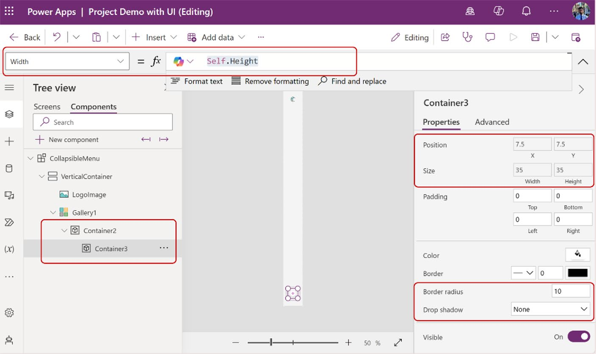

Figure 11-27. Adding a new container inside another container

29. This time, I add a new image inside the new
container that I created and set the following parameters from the Formula bar.
X = 0
Y = 0

CHAPTER 11 REVOLUTIONIZING POWER APPS UI WITH MICROSOFT COPILOT:
A COMPLETE PROJECT
Width = Parent.Width Height = Parent.Height PaddingTop = 8
PaddingBottom = 8
Image = "data:image/svg+xml;utf8, " & EncodeUrl (ThisItem.MenuIcon)
You will see the logos in the menu bar after adding
the formula code shown in Figure 11-28.
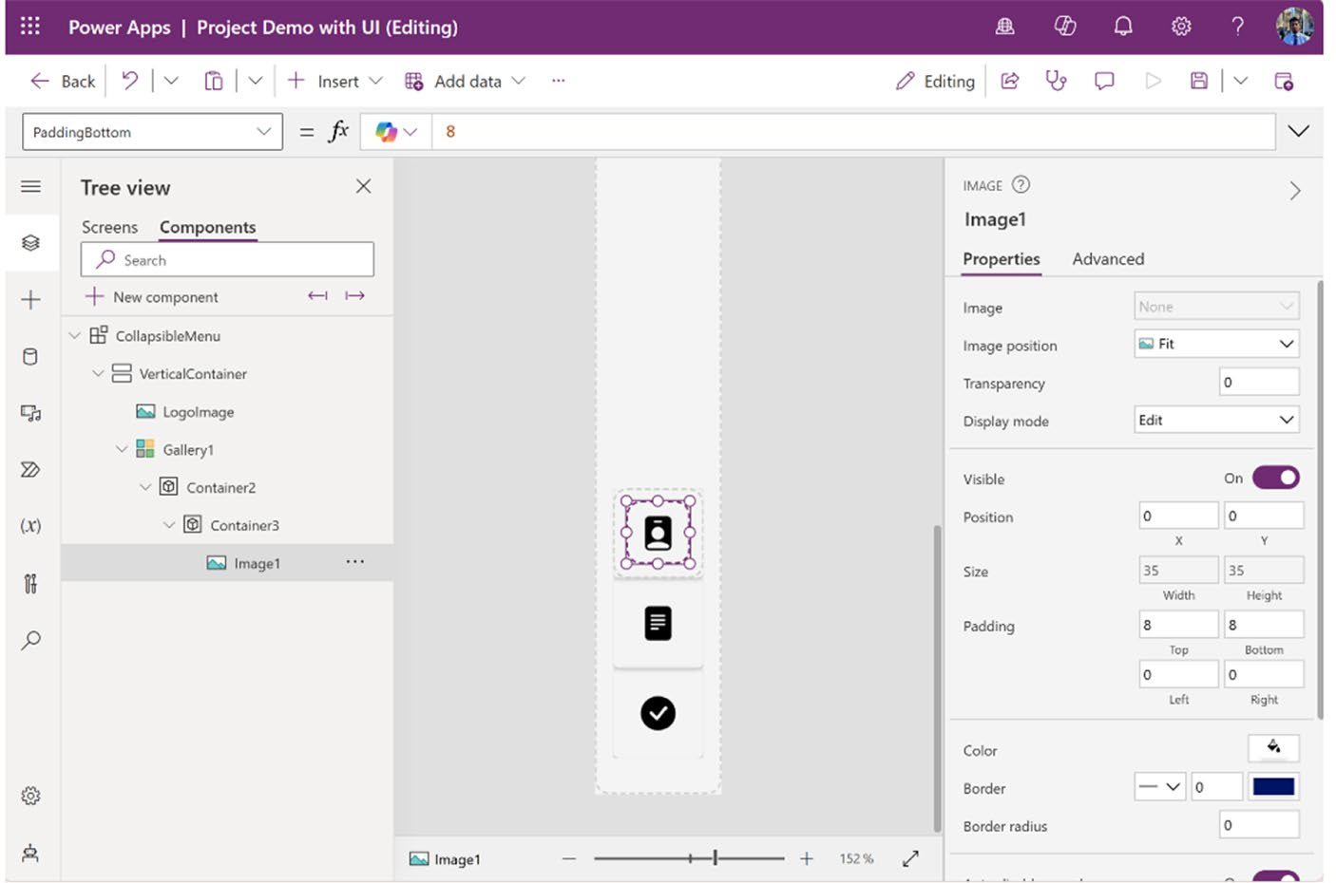

Figure 11-28. Adding icons to the menu

30. I now add a button in the same container that holds
the image. This is necessary because the image needs to be interactive, allowing users to tap or click it. Just add a button from the Insert option and set the following parameters from the Formula bar:

CHAPTER 11 REVOLUTIONIZING POWER APPS UI WITH MICROSOFT COPILOT:
A COMPLETE PROJECT
Text = _BLANK_ (DO NOT ADD ANYTHING) X = 0
Y = 0
Width = Parent.Width
Height = Parent.Height PaddingTop = 8
PaddingBottom = 8
Border = None
Color = Transparent

31. Create two new custom properties named
HoverFilled and PressedFill, both with the
data type set to color, as shown in Figures 11-29
and 11-30.
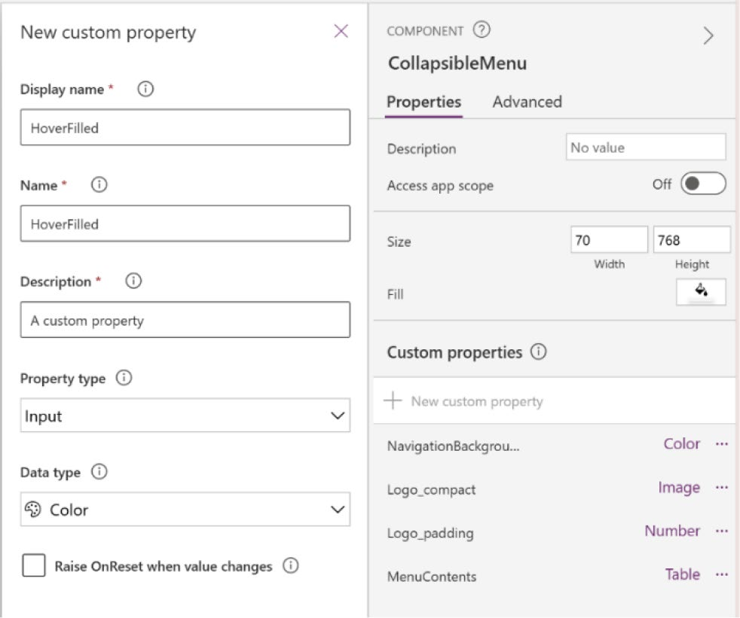

Figure 11-29. Creating a new custom property named HoverFilled

CHAPTER 11 REVOLUTIONIZING POWER APPS UI WITH MICROSOFT COPILOT:
A COMPLETE PROJECT
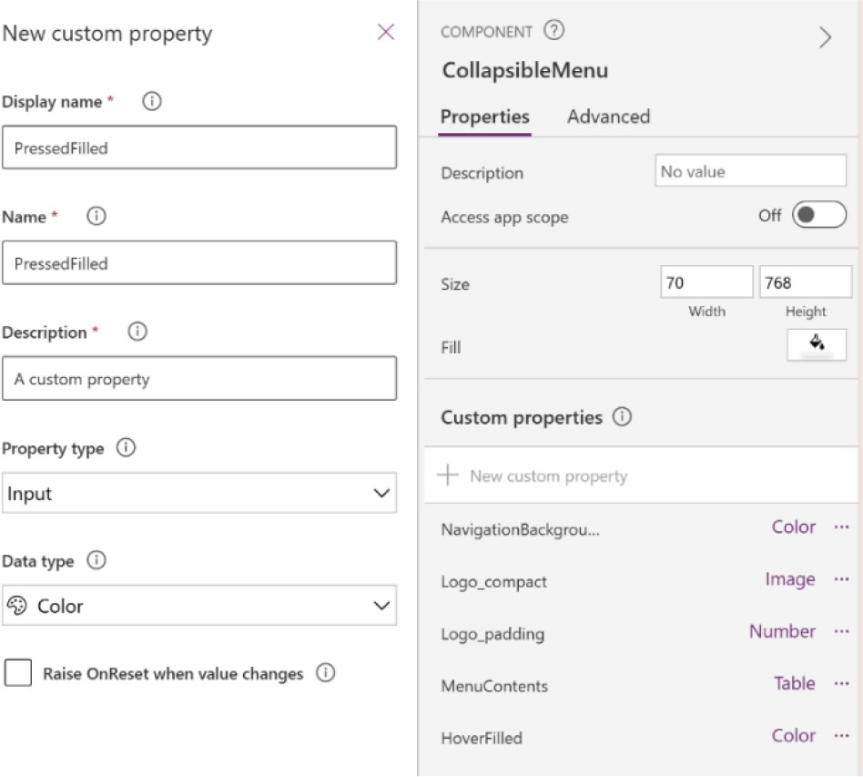

Figure 11-30. Creating a new custom property named PressedFilled

32. Click the HoverFilled property and change the
color code from the Formula bar from RGBA(0, 0, 0, 1) to RGBA(0, 0, 0, 0.1), as shown in
Figure 11-31.
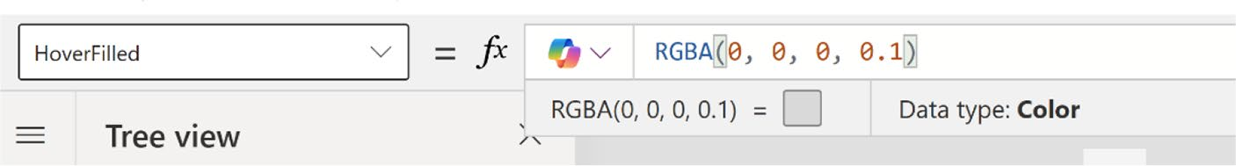

Figure 11-31. RGBA value changes from (0,0,0,1) to (0,0,0,0.1) for
the HoverFilled custom property

CHAPTER 11 REVOLUTIONIZING POWER APPS UI WITH MICROSOFT COPILOT:
A COMPLETE PROJECT
33. Click the PressedFilled property and change the
color code from the Formula bar from RGBA(0, 0, 0, 1) to RGBA(0, 0, 0, 0.2), as shown in
Figure 11-32.
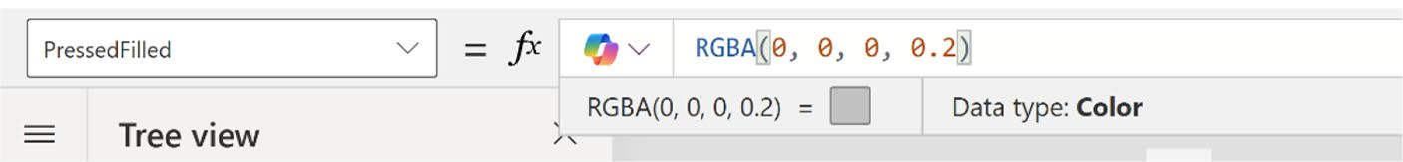

Figure 11-32. RGBA value changes from (0,0,0,1) to (0,0,0,0.2) for the PressedFilled custom property

34. Click the button created in the same container as
the image, select the PressedFill property from the Formula bar, and enter the following code, also
shown in Figure 11-33.
CollapsibleMenu.PressedFilled
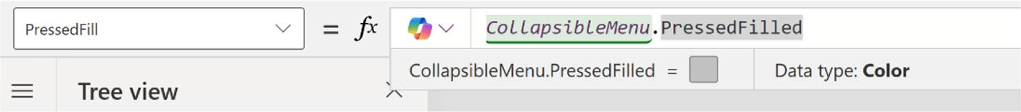

Figure 11-33. Adding formula code to the PressedFill property for the button component

Note CollapsibleMenu is the component name of this project.
Be sure to replace CollapsibleMenu with the component name
used in your project.

CHAPTER 11 REVOLUTIONIZING POWER APPS UI WITH MICROSOFT COPILOT:
A COMPLETE PROJECT
35. Select the HoverFill property for the button and
add the following code, as shown in Figure 11-34.
CollapsibleMenu.HoverFilled
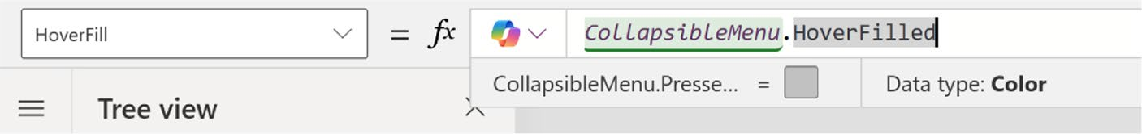

Figure 11-34. Adding formula code to the HoverFill property for the
button component

36. Now, select the OnSelect property and add the
following code, also shown in Figure 11-35.
Navigate(ThisItem.Page)
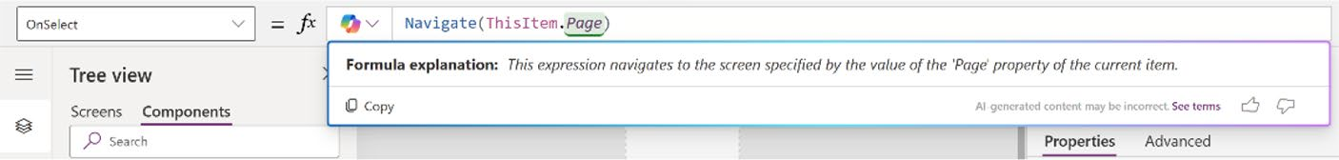

Figure 11-35. Configuring navigation on the button through the
OnSelect property

This formula navigates to the screen specified by the Page property value of the current item, as outlined in the MenuContents formula code.
37. After that, create a new custom component named
CurrentMenuID, which will track which menu item is active. Set the data type of this component to
Number. Refer to Figure 11-36.

CHAPTER 11 REVOLUTIONIZING POWER APPS UI WITH MICROSOFT COPILOT:
A COMPLETE PROJECT
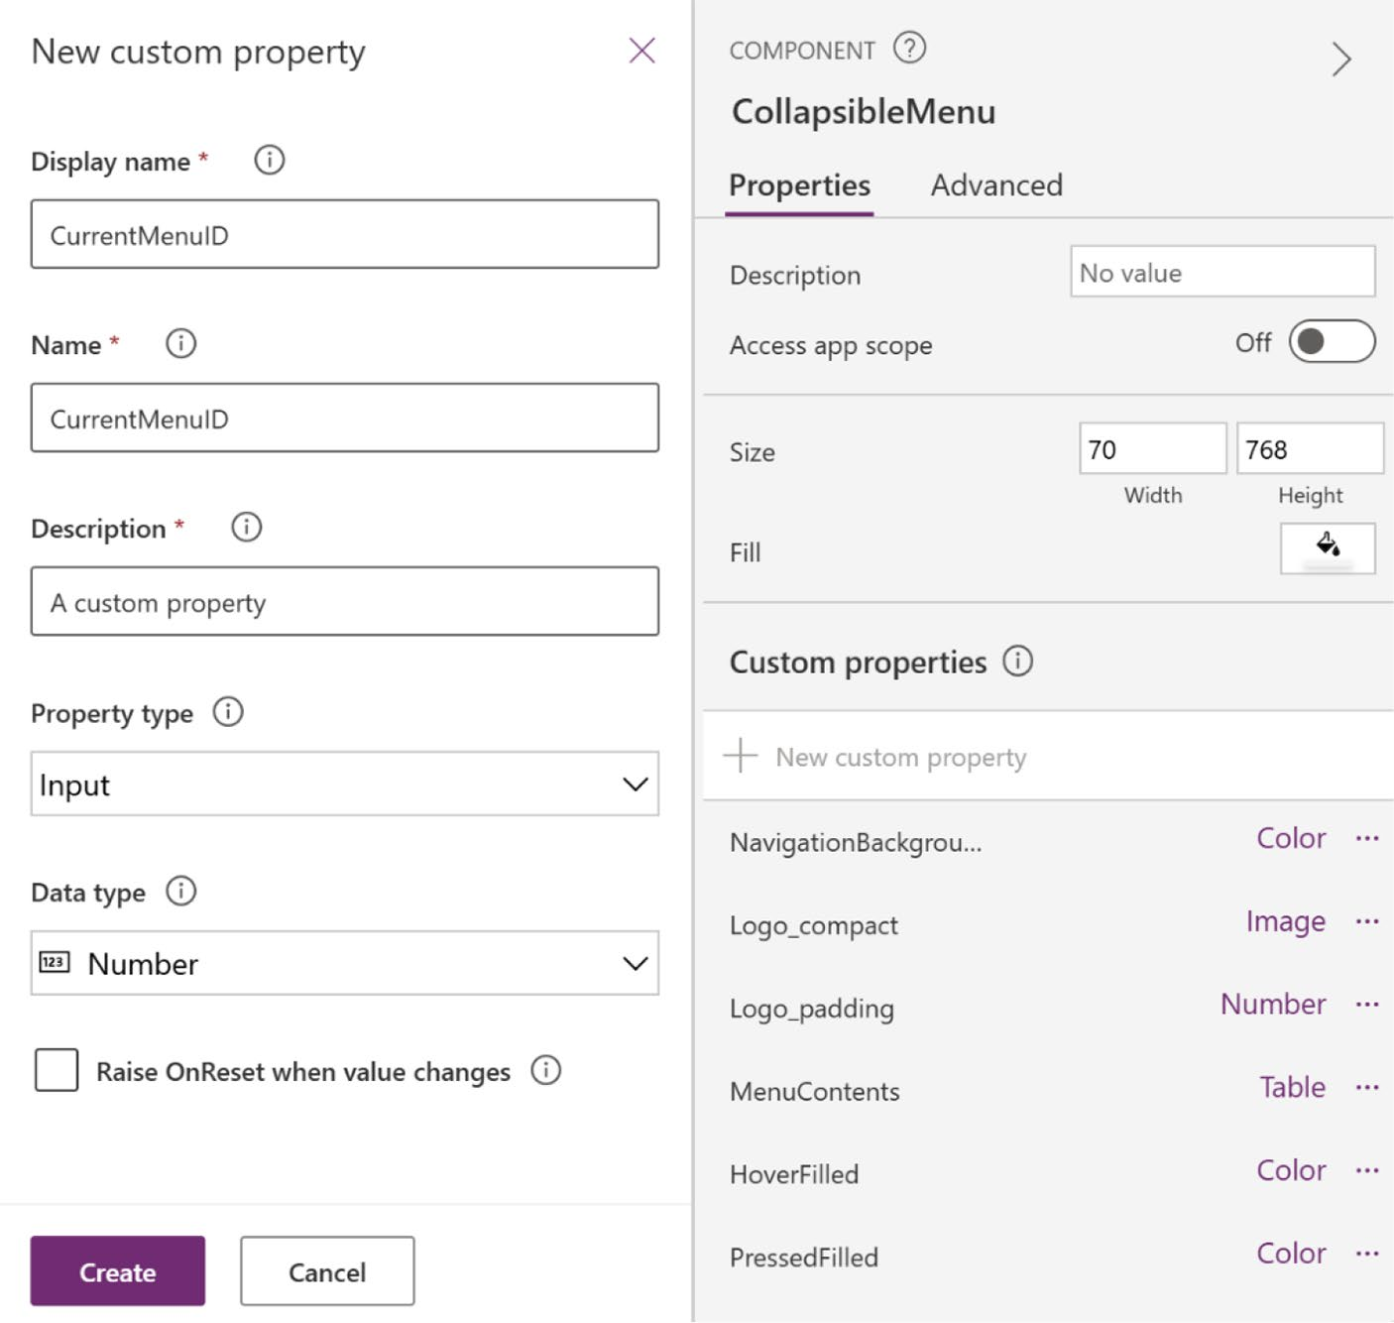

Figure 11-36. Creating a custom property with the Number data type

38. Set the default value to 1 for this custom property, as
shown in Figure 11-37.
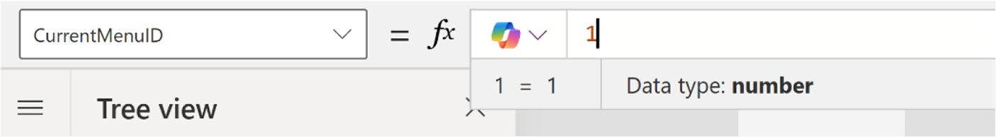

Figure 11-37. Setting the default value of CurrentMenuID to 1

CHAPTER 11 REVOLUTIONIZING POWER APPS UI WITH MICROSOFT COPILOT:
A COMPLETE PROJECT
39. Select the container where you create the image
and the button. In this demo, the container name is
Container3, as shown in Figure 11-38.
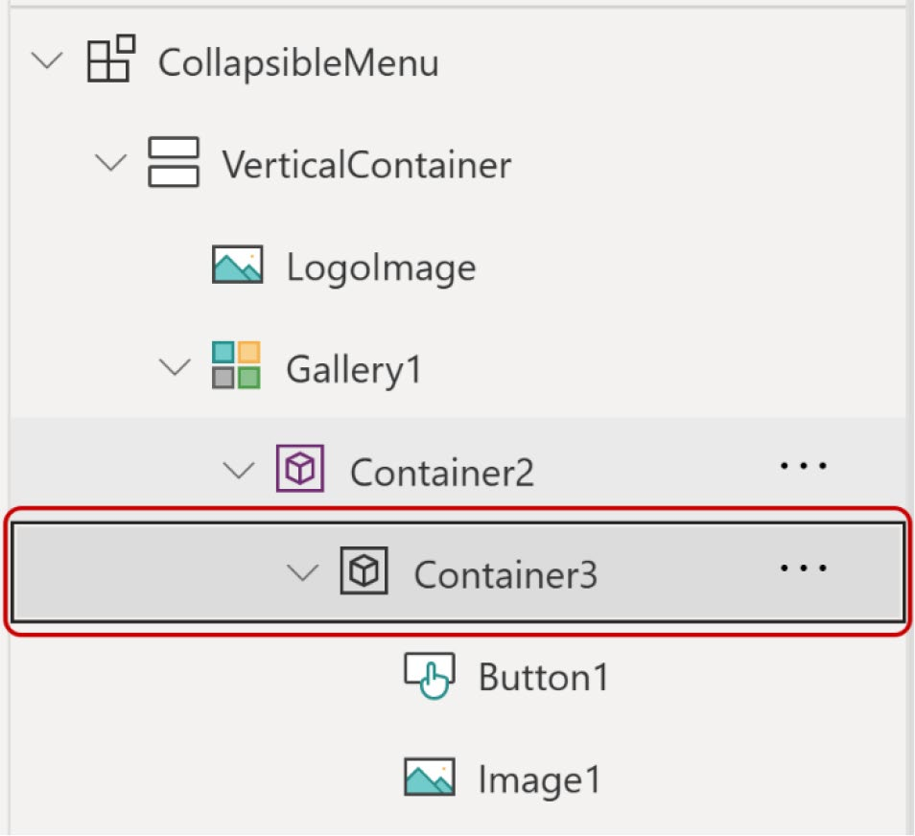

Figure 11-38. Selecting the container where you add the image and
the button

40. After selecting the container, select the Fill
property from the Formula bar and add the following code:
If(
CollapsibleMenu.CurrentMenuID =
ThisItem.MenuID,
Color.White,
RGBA(0,0,0,0)
)

CHAPTER 11 REVOLUTIONIZING POWER APPS UI WITH MICROSOFT COPILOT:
A COMPLETE PROJECT
This formula determines if CurrentMenuID of CollapsibleMenu is equal to MenuID of the current item. If it is true, it returns the color white. Otherwise, it returns a transparent color.
Figure 11-39 shows the code in the Fill property.
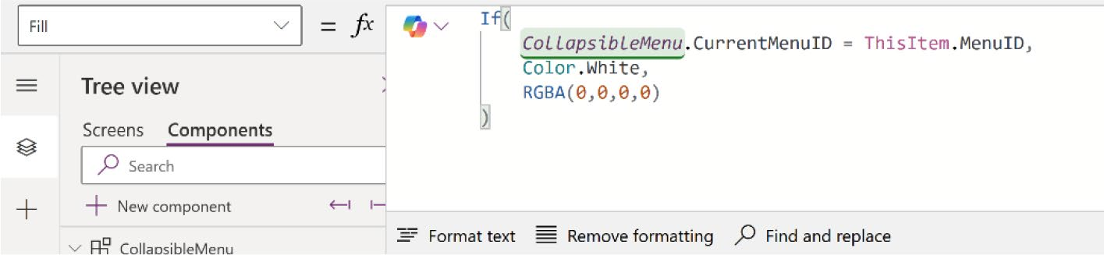

Figure 11-39. The Fill property of Container3

41. Because the plan is to implement both light and
dark modes for this application, the current formula won’t function correctly in dark mode. Therefore, you must create another custom property to adjust the container’s color in dark mode.

CHAPTER 11 REVOLUTIONIZING POWER APPS UI WITH MICROSOFT COPILOT:
A COMPLETE PROJECT
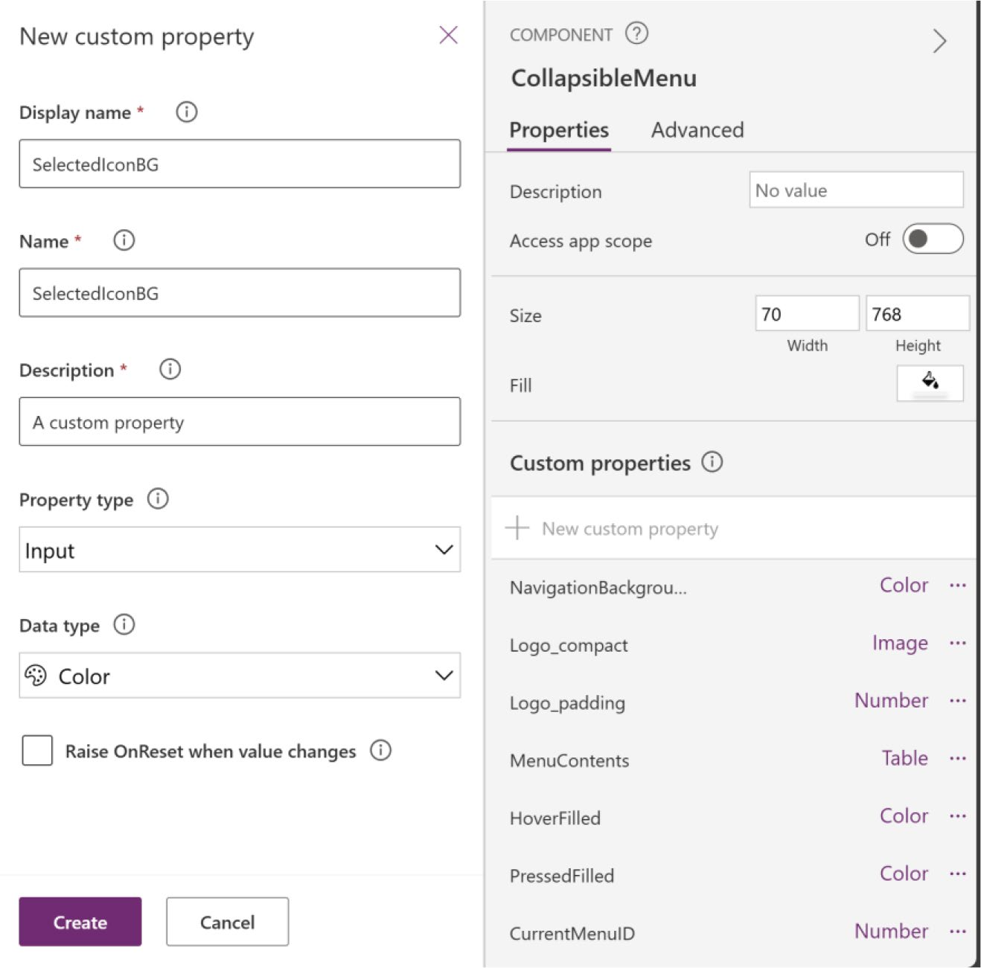

Figure 11-40. Creating a new custom property named
SelectedIconBG

42. Choose the default value RGBA(255, 255, 255, 1),
which is white, as shown in Figure 11-41.
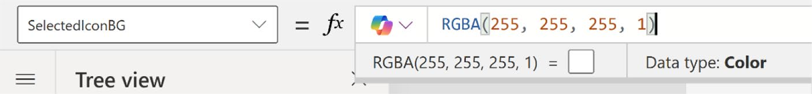

Figure 11-41. Choosing the default value of white (RGBA (255,
255, 255,1))

CHAPTER 11 REVOLUTIONIZING POWER APPS UI WITH MICROSOFT COPILOT:
A COMPLETE PROJECT
43. Link it to Container3 by changing the code as
follows:
If(
CollapsibleMenu.CurrentMenuID = ThisItem.MenuID, CollapsibleMenu.SelectedIconBG, RGBA(0,0,0,0)
)
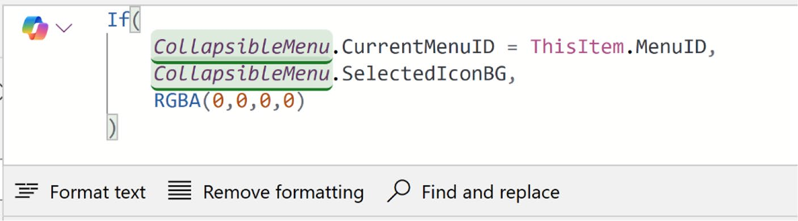

Figure 11-42. Updated formula code for the Fill property of Container3

44. Let’s move to the icon color. If the menu is active,
the color will be Teal; otherwise, the color will be gray. To control this, you need to create custom properties for both active and inactive menus.
45. For the active menu, create two custom properties
named ActiveIcon and ActiveIcon_Text. The data type of ActiveIcon will be Color, and the data type of ActiveIcon_Text will be Text, as shown in
Figures 11-43 and 11-44, respectively.

CHAPTER 11 REVOLUTIONIZING POWER APPS UI WITH MICROSOFT COPILOT:
A COMPLETE PROJECT
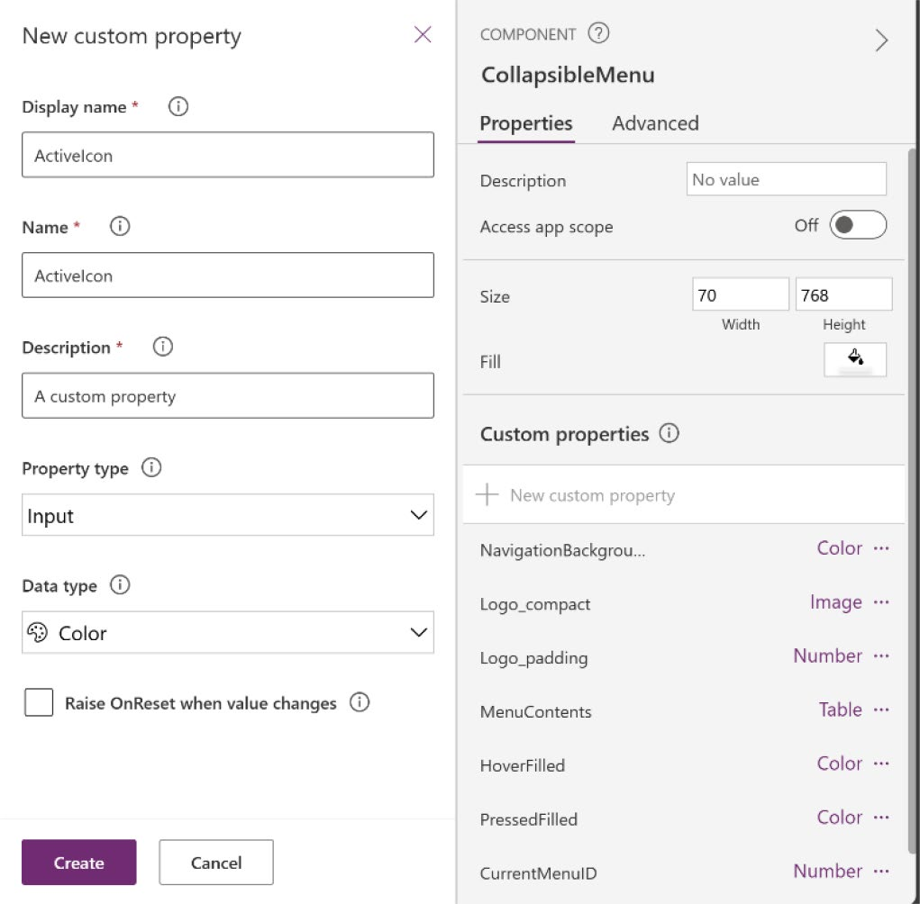

Figure 11-43. Creating a custom property named ActiveIcon

CHAPTER 11 REVOLUTIONIZING POWER APPS UI WITH MICROSOFT COPILOT:
A COMPLETE PROJECT
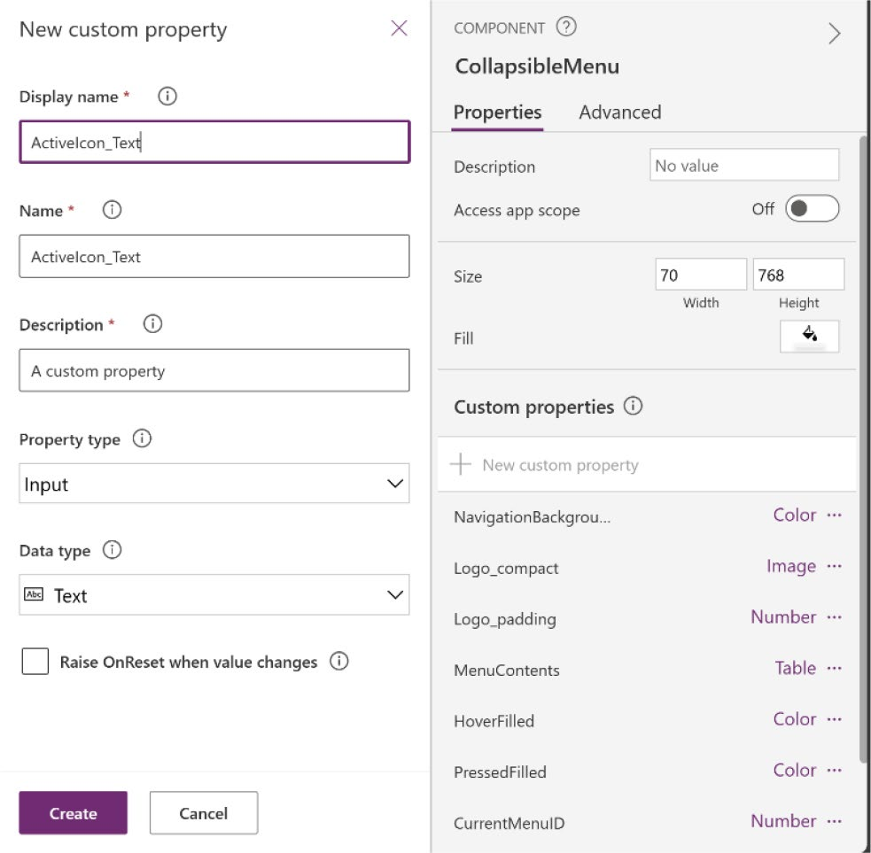

Figure 11-44. Creating a custom property named ActiveIcon_Text

46. Select the ActiveIcon custom property and change
the default value from the Formula bar as follows:
RGBA(0, 215, 218, 0.99)
Figure 11-45 shows the actual change to the ActiveIcon property.
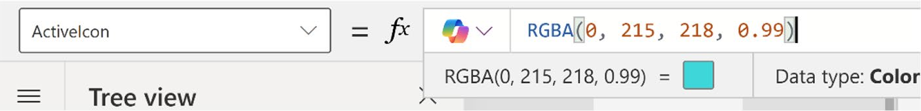

Figure 11-45. Changing the default value of ActiveIcon property

CHAPTER 11 REVOLUTIONIZING POWER APPS UI WITH MICROSOFT COPILOT:
A COMPLETE PROJECT
47. Select the ActiveIcon_Text custom property, and
change the default value from the Formula bar to the following code:
"RGBA(0, 215, 218, 0.99)"
Figure 11-46 shows the change to the ActiveIcon_ Text property.

Figure 11-46. Changing the default value of the ActiveIcon_Text
property

Note Because this color is used in an SVG, you also need a text version. That’s why I created the custom property named ActiveIcon_Text.

48. Now do the same for the inactive menu. Create
two custom properties named InactiveIcon and InactiveIcon_Text. The data type of InactiveIcon will be Color, and the data type of InactiveIcon_
Text will be Text, as shown in Figures 11-47 and
11-48, respectively.

CHAPTER 11 REVOLUTIONIZING POWER APPS UI WITH MICROSOFT COPILOT:
A COMPLETE PROJECT
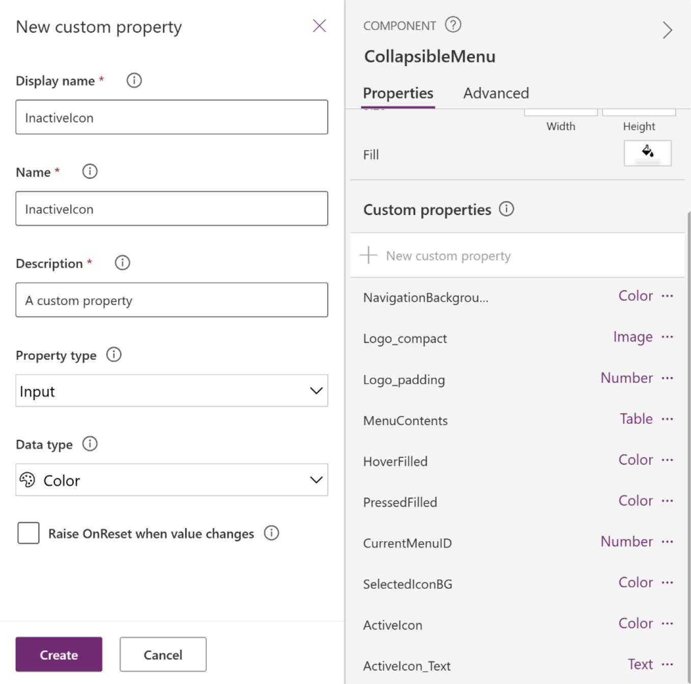

Figure 11-47. Creating a custom property named InactiveIcon

CHAPTER 11 REVOLUTIONIZING POWER APPS UI WITH MICROSOFT COPILOT:
A COMPLETE PROJECT
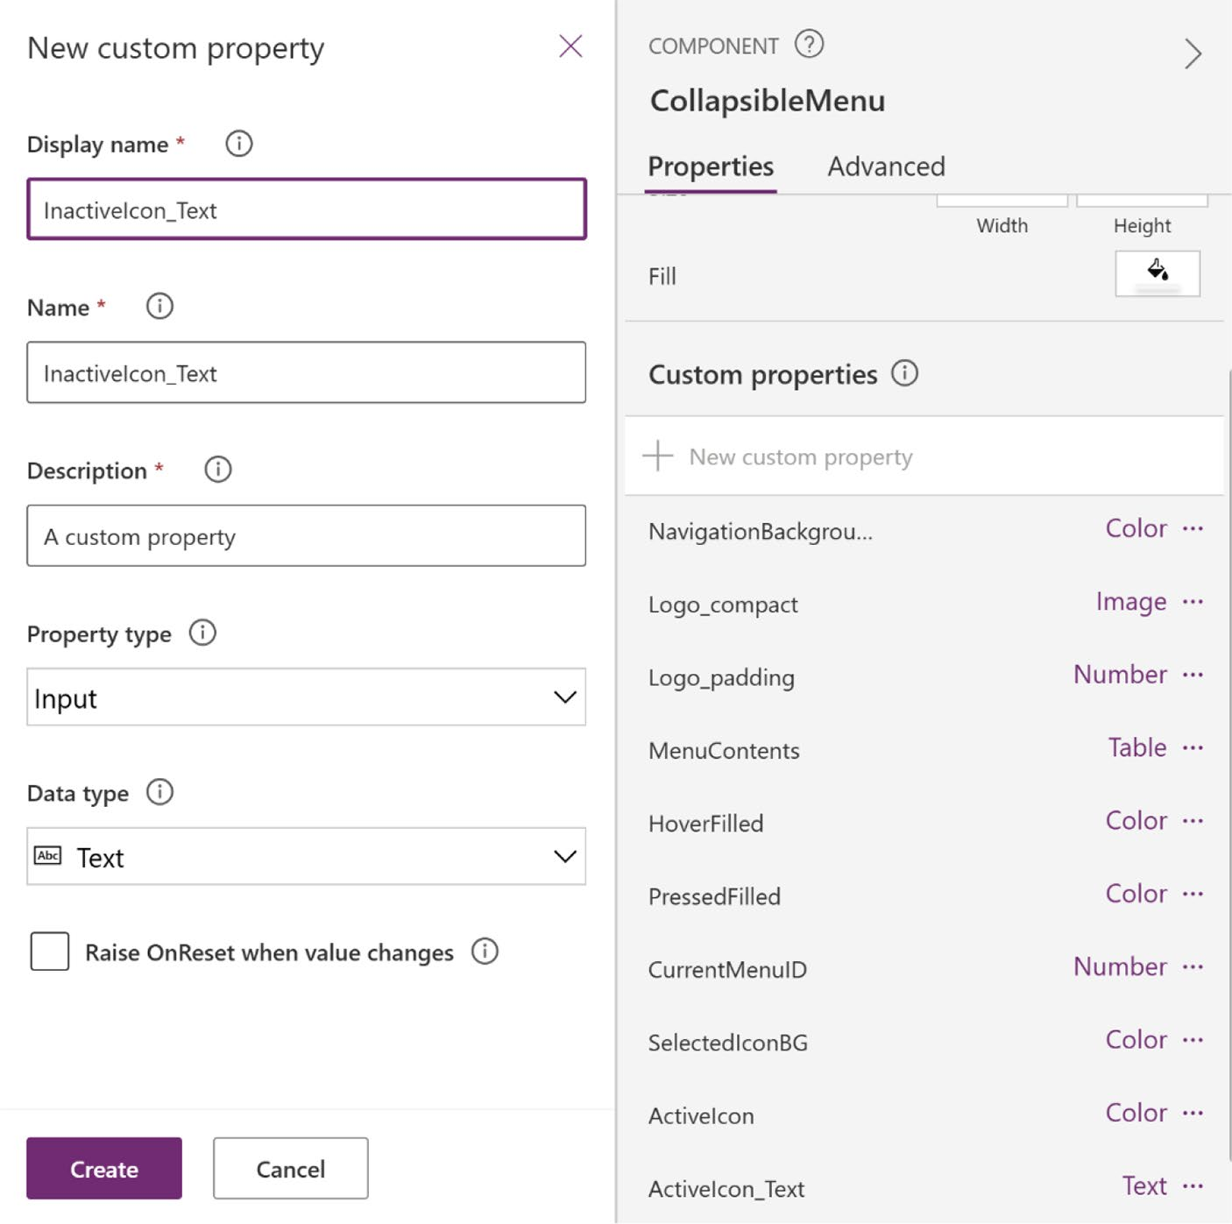

Figure 11-48. Creating a custom property named InactiveIcon_Text

49. Select the InactiveIcon custom property and
change the default value to the following RGBA color code:
RGBA(200, 200, 200, 0.99)
Figure 11-49 shows the actual change to the InactiveIcon property.

CHAPTER 11 REVOLUTIONIZING POWER APPS UI WITH MICROSOFT COPILOT:
A COMPLETE PROJECT
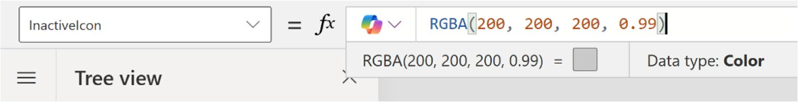

Figure 11-49. Adding an RGBA color to the InactiveIcon property

50. As before, change the default value of the
InactiveIcon_Text property to the color code added to the InactiveIcon property.
"RGBA(200, 200, 200, 0.99)"
Figure 11-50 shows the changes to the InactiveIcon_Text property.
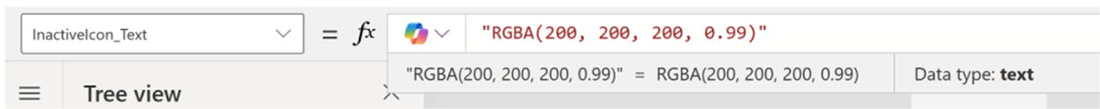

Figure 11-50. Changing the default value of the InactiveIcon_Text property

51. Apply the color to the icons. I am using icons from
Bootstrap. In the Property Settings, Bootstrap uses the CurrentColor attribute in the Fill property for all Bootstrap icons. You can substitute that by replacing it with an active icon color or an inactive icon color, depending on whether the menu item is active. To achieve it, select image1 from the Tree View and add the following code:
"data:image/svg+xml;utf8, " & EncodeUrl (
Substitute(
ThisItem.MenuIcon,
"currentColor",

CHAPTER 11 REVOLUTIONIZING POWER APPS UI WITH MICROSOFT COPILOT:
A COMPLETE PROJECT
If(
CollapsibleMenu.CurrentMenuID = ThisItem.MenuID,
CollapsibleMenu.ActiveIcon_Text, CollapsibleMenu.InactiveIcon_Text
)
)
)
Figure 11-51 shows the substitute function used in the formula.
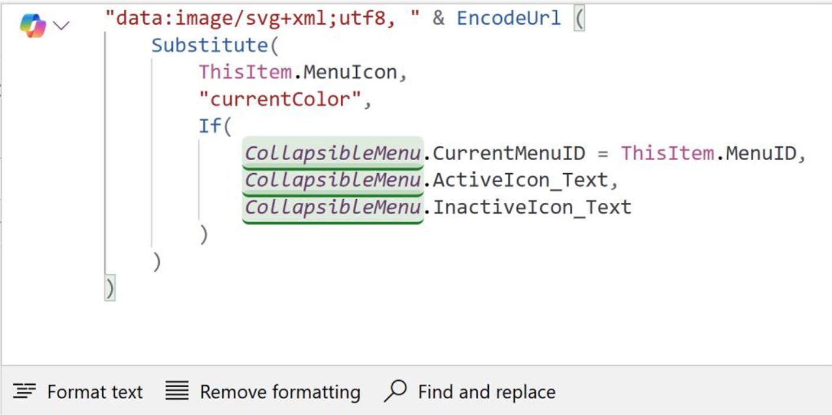

Figure 11-51. Substitute function in the Image formula to change the
icon color based on whether it is active or inactive

52. At this point, I create something unique. I have used
filled icons throughout the menu. Now, I add the same icons again from Bootstrap, but the normal one. This way, when someone clicks an icon, the filled icon will be replaced with the non-filled icon, making it distinct and helping users recognize that the menu item is selected.

CHAPTER 11 REVOLUTIONIZING POWER APPS UI WITH MICROSOFT COPILOT:
A COMPLETE PROJECT
For example, I used the People Badge icon, as
shown in Figure 11-52.
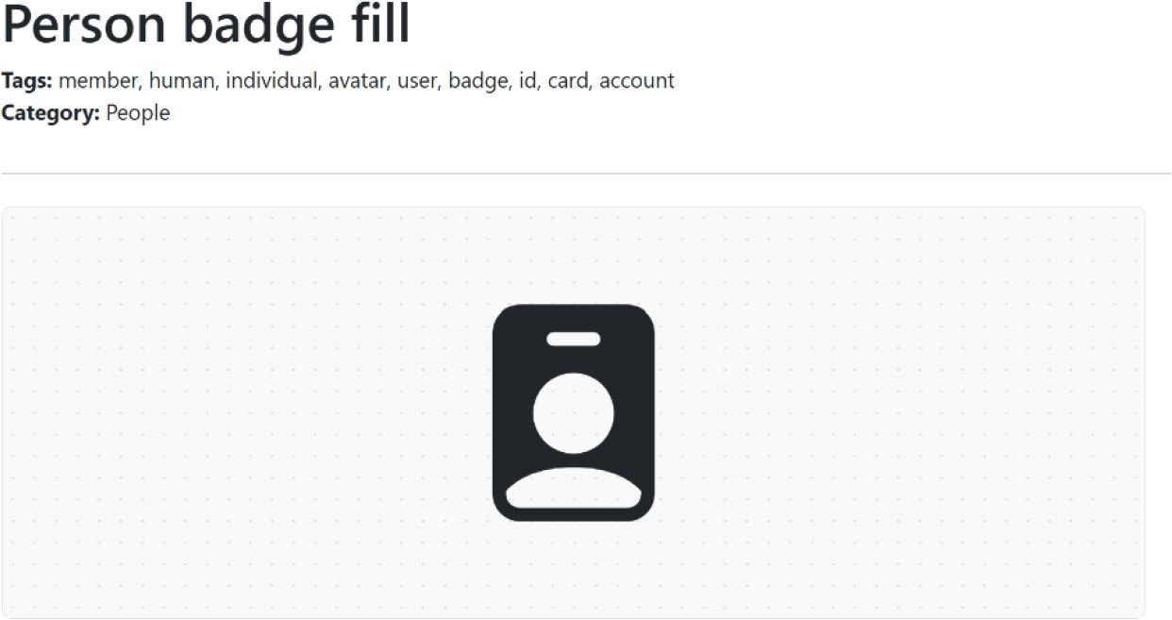

Figure 11-52. People icon is used in the menu from Bootstrap

Next, I add the People Badge icon that is not filled,
as shown in Figure 11-53.
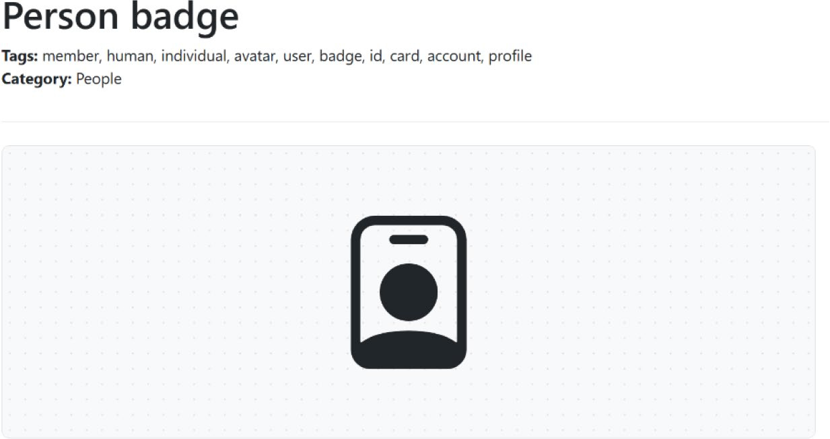

Figure 11-53. People icon that will be used to indicate selection

CHAPTER 11 REVOLUTIONIZING POWER APPS UI WITH MICROSOFT COPILOT:
A COMPLETE PROJECT
53. Copy the icons that are unfilled and use them as
filled in the app.
• People badge (used as the icon for Employee Board
in the menu item):
<svg xmlns="http://www.w3.org/2000/svg" width="16" height="16" fill="currentColor" class="bi bi-person-badge" viewBox="0 0 16 16">
<path d="M6.5 2a.5.5 0 0 0 0 1h3a.5.5 0 0 0 0-1zM11 8a3 3 0 1 1-6 0 3 3 0 0 1 6 0"/> <path d="M4.5 0A2.5 2.5 0 0 0 2 2.5V14a2 2 0 0 0 2 2h8a2 2 0 0 0 2-2V2.5A2.5 2.5 0 0 0 11.5 0zM3 2.5A1.5 1.5 0 0 1 4.5 1h7A1.5 1.5 0 0 1 13 2.5v10.795a4.2 4.2 0 0 0-.776-.492C11.392 12.387 10.063 12 8 12s-3.392.3811-4.224.803a4.2 4.2 0 0 0-.776.492z"/>
</svg>

• File badge (used as the icon for Received
Application in the menu item):
<svg xmlns="http://www.w3.org/2000/svg" width="16" height="16" fill="currentColor" class="bi bi-file-text" viewBox="0 0 16 16">
<path d="M5 4a.5.5 0 0 0 0 1h6a.5.5 0 0 0 0-1zm-.5 2.5A.5.5 0 0 1 5 6h6a.5.5 0 0 1 0 1H5a.5.5 0 0 1-.5-.5M5 8a.5.5 0 0 0 0 1h6a.5.5 0 0 0 0-1zm0 2a.5.5 0 0 0 0 1h3a.5.5 0 0 0 0-1z"/> <path d="M2 2a2 2 0 0 1 2-2h8a2 2 0 0 1 2 2v12a2 2 0 0 1-2 2H4a2 2 0 0 1-2-2zm10-1H4a1 1 0 0 0-1 1v12a1 1 0 0 0 1 1h8a1 1 0 0 0 1-1V2a1 1 0 0 0-1-1"/>
</svg>

CHAPTER 11 REVOLUTIONIZING POWER APPS UI WITH MICROSOFT COPILOT:
A COMPLETE PROJECT
• Check circle badge (used as the icon for Status in
the menu item):
<svg xmlns="http://www.w3.org/2000/svg" width="16" height="16" fill="currentColor" class="bi bi-check-circle" viewBox="0 0 16 16">
<path d="M8 15A7 7 0 1 1 8 1a7 7 0 0 1 0 14m0 1A8 8 0 1 0 8 0a8 8 0 0 0 0 16"/>
<path d="m10.97 4.911-.02.022-3.473 4.425-2.093-2.094a.75.75 0 0 0-1.06 1.06L6.97 11.03a.75.75 0 0 0 1.079-.02l3.992-4.99a.75.75 0 0 0-1.071-1.05"/>
</svg>

54. Select MenuContents and under the Table tag, create
a new column named MenuSelected, and paste the HTML code for each menu item, as I showed you
before. Figure 11-54 shows the new column under the Table tag.
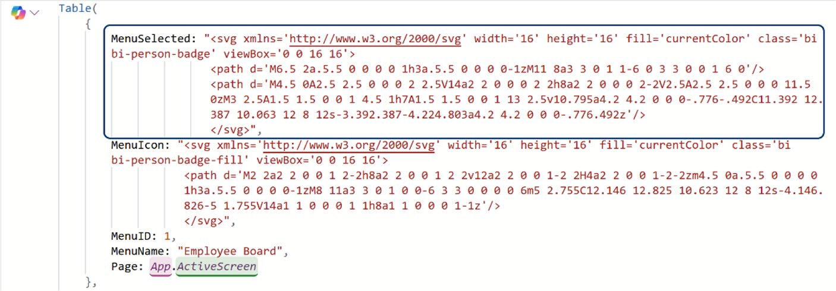

Figure 11-54. Adding a new column named MenuSelected under the Table tag

CHAPTER 11 REVOLUTIONIZING POWER APPS UI WITH MICROSOFT COPILOT:
A COMPLETE PROJECT
Here is the full formula code:
Table(
{
MenuSelected: "<svg xmlns='http://www.w3.org/ 2000/svg' width='16' height='16' fill='current Color' class='bi bi-person-badge' viewBox='0 0 16 16'>
<path d='M6.5 2a.5.5 0 0 0 0
1h3a.5.5 0 0 0 0-1zM11 8a3 3
0 1 1-6 0 3 3 0 0 1 6 0'/>
<path d='M4.5 0A2.5 2.5 0 0
0 2 2.5V14a2 2 0 0 0 2 2h8a2
2 0 0 0 2-2V2.5A2.5 2.5 0 0
0 11.5 0zM3 2.5A1.5 1.5 0 0
1 4.5 1h7A1.5 1.5 0 0 1 13
2.5v10.795a4.2 4.2 0 0 0-.776-
.492C11.392 12.387 10.063 12 8
12s-3.392.3811-4.224.803a4.2 4.2
0 0 0-.776.492z'/>
</svg>",
MenuIcon: "<svg xmlns='http://www.w3.org/2000/ svg' width='16' height='16' fill='currentColor' class='bi bi-person-badge-fill' viewBox='0 0 16 16'>
<path d='M2 2a2 2 0 0 1 2-2h8a2 2 0 0 1 2 2v12a2 2 0 0 1-2 2H4a2 2 0 0
1-2-2zm4.5 0a.5.5 0 0 0 0 1h3a.5.5 0 0 0 0-1zM8 11a3 3 0 1 0 0-6 3 3 0 0 0 0 6m5 2.755C12.146 12.825 10.623
12 8 12s-4.146.826-5 1.755V14a1 1 0 0 0 1 1h8a1 1 0 0 0 1-1z'/>

CHAPTER 11 REVOLUTIONIZING POWER APPS UI WITH MICROSOFT COPILOT:
A COMPLETE PROJECT
</svg>",
MenuID: 1,
MenuName: "Employee Board",
Page: App.ActiveScreen
},
{
MenuSelected: "<svg xmlns='http://www.w3.org/ 2000/svg' width='16' height='16' fill='current Color' class='bi bi-file-text' viewBox='0 0 16 16'>
<path d='M5 4a.5.5 0 0 0 0
1h6a.5.5 0 0 0 0-1zm-.5 2.5A.5.5
0 0 1 5 6h6a.5.5 0 0 1 0
1H5a.5.5 0 0 1-.5-.5M5 8a.5.5
0 0 0 0 1h6a.5.5 0 0 0 0-1zm0
2a.5.5 0 0 0 0 1h3a.5.5 0 0
0 0-1z'/>
<path d='M2 2a2 2 0 0 1 2-2h8a2
2 0 0 1 2 2v12a2 2 0 0 1-2 2H4a2
2 0 0 1-2-2zm10-1H4a1 1 0 0 0-1
1v12a1 1 0 0 0 1 1h8a1 1 0 0 0
1-1V2a1 1 0 0 0-1-1'/>
</svg>",
MenuIcon: "<svg xmlns='http://www.w3.org/2000/ svg' width='16' height='16' fill='currentColor' class='bi bi-file-text-fill' viewBox='0 0 16 16'>
<path d='M12 0H4a2 2 0 0 0-2 2v12a2 2 0 0 0 2 2h8a2 2 0 0 0 2-2V2a2 2 0 0 0-2-2M5 4h6a.5.5 0 0 1 0 1H5a.5.5 0 0 1 0-1m-.5 2.5A.5.5 0 0 1 5 6h6a.5.5 0

CHAPTER 11 REVOLUTIONIZING POWER APPS UI WITH MICROSOFT COPILOT:
A COMPLETE PROJECT
0 1 0 1H5a.5.5 0 0 1-.5-.5M5 8h6a.5.5 0 0 1 0 1H5a.5.5 0 0 1 0-1m0 2h3a.5.5 0 0 1 0 1H5a.5.5 0 0 1 0-1'/>
</svg>",
MenuID: 2,
MenuName: "Received Application",
Page: App.ActiveScreen
},
{
MenuSelected: "<svg xmlns='http://www.w3.org/ 2000/svg' width='16' height='16'
fill='currentColor' class='bi bi-check- circle' viewBox='0 0 16 16'>
<path d='M8 15A7 7 0 1 1 8 1a7 7
0 0 1 0 14m0 1A8 8 0 1 0 8 0a8 8
0 0 0 0 16'/>
<path d='m10.97
4.911-.02.022-3.473
4.425-2.093-2.094a.75.75 0 0
0-1.06 1.06L6.97 11.03a.75.75 0
0 0 1.079-.02l3.992-4.99a.75.75
0 0 0-1.071-1.05'/>
</svg>",
MenuIcon: "<svg xmlns='http://www.w3.org/2000/ svg' width='16' height='16' fill='currentColor' class='bi bi-check-circle-fill' viewBox='0 0 16 16'>
<path d='M16 8A8 8 0 1 1 0 8a8
8 0 0 1 16 0m-3.911-3.03a.75.75
0 0 0-1.08.022L7.477 9.417
5.384 7.323a.75.75 0 0 0-1.06

CHAPTER 11 REVOLUTIONIZING POWER APPS UI WITH MICROSOFT COPILOT:
A COMPLETE PROJECT
1.06L6.97 11.03a.75.75 0 0 0
1.079-.02l3.992-4.99a.75.75 0 0
0-.01-1.05z'/>
</svg>",
MenuID: 3,
MenuName: "Status",
Page: App.ActiveScreen
}
)

55. Lastly, select the Image component, and in the
formula code, make the following changes:
"data:image/svg+xml;utf8, " & EncodeUrl (
Substitute(
If(
CollapsibleMenu.CurrentMenuID = ThisItem. MenuID,
ThisItem.MenuSelected,
ThisItem.MenuIcon
),
"currentColor",
If(
CollapsibleMenu.CurrentMenuID = ThisItem. MenuID,
CollapsibleMenu.ActiveIcon_Text, CollapsibleMenu.InactiveIcon_Text
)
)
)

CHAPTER 11 REVOLUTIONIZING POWER APPS UI WITH MICROSOFT COPILOT:
A COMPLETE PROJECT
Figure 11-55 shows the actual code that changed in the Image component.
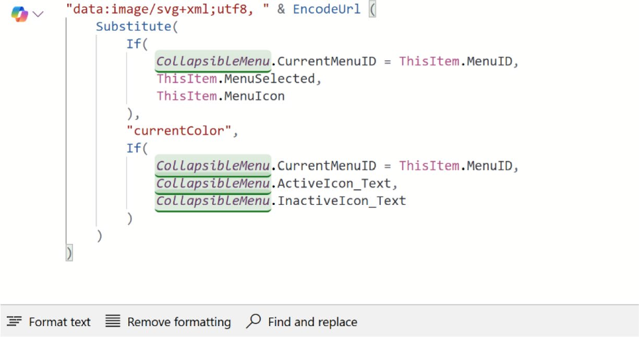

Figure 11-55. Formula code in the Image component that switches
the icon between active and inactive modes

56. The menu creation process is finished. But it is not
collapsible yet. You need to add it to the screen and then I will show how to make it collapsible.
Go to the screen and add a horizontal container, as
shown in Figure 11-56.
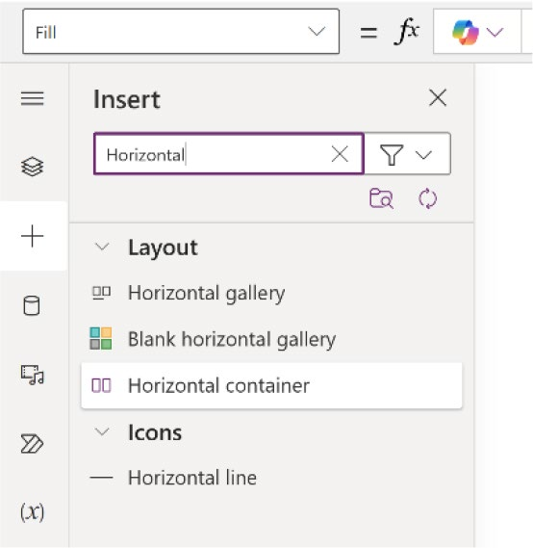

Figure 11-56. Adding a horizontal container to the main screen

CHAPTER 11 REVOLUTIONIZING POWER APPS UI WITH MICROSOFT COPILOT:
A COMPLETE PROJECT
57. Change the following parameters for this horizontal
container:
Width = Parent.Width
Height = Parent.Height Border radius = 10
Drop shadow = None

58. Add a new container under the horizontal container
and set the following parameters:
Align in Container = Stretch Minimum height = 0
Flexible width = Off
Width = 70
Border radius = 0
Drop shadow = None
Figure 11-57 shows the parameters of the container.
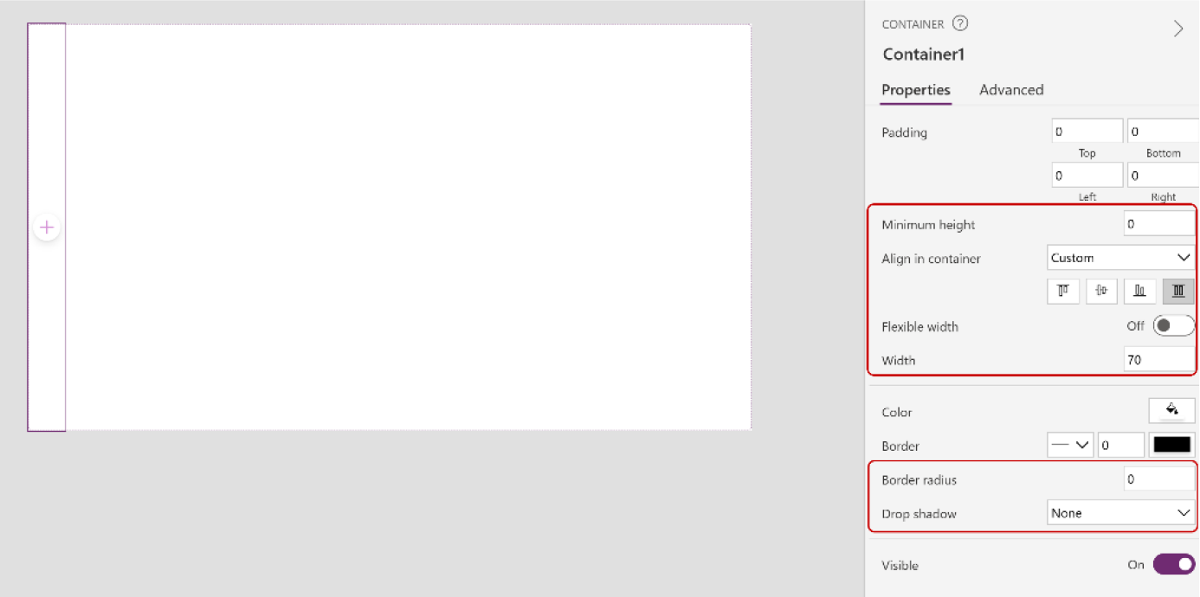

Figure 11-57. Changing the properties of the container

CHAPTER 11 REVOLUTIONIZING POWER APPS UI WITH MICROSOFT COPILOT:
A COMPLETE PROJECT
59. Now, under this container, add a new vertical
container and set the following parameters:
Border radius = 0
Drop shadow = None
Figure 11-58 shows the newly added vertical container.
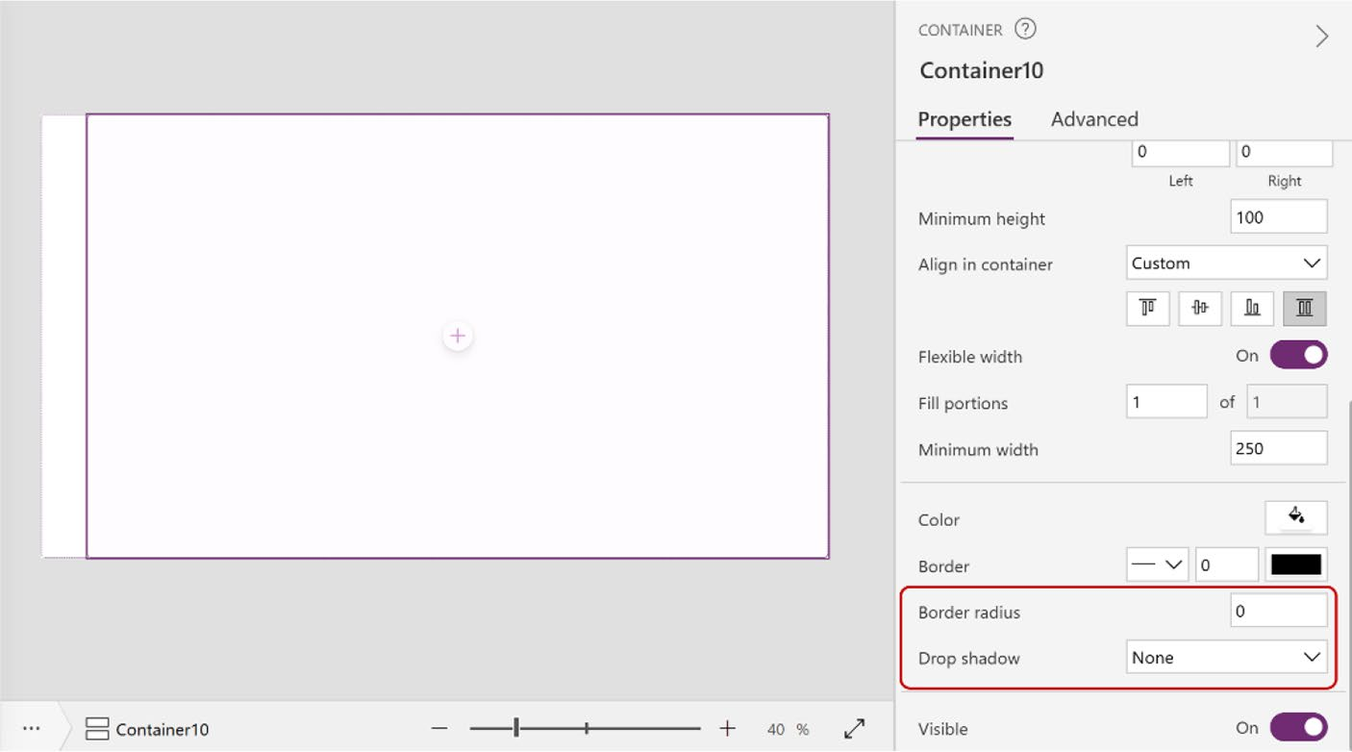

Figure 11-58. Adding a new vertical container to the screen

60. Click the + sign from the left container named
Container1 and choose CollapsibleMenu under the
Custom category, as shown in Figure 11-59.

CHAPTER 11 REVOLUTIONIZING POWER APPS UI WITH MICROSOFT COPILOT:
A COMPLETE PROJECT
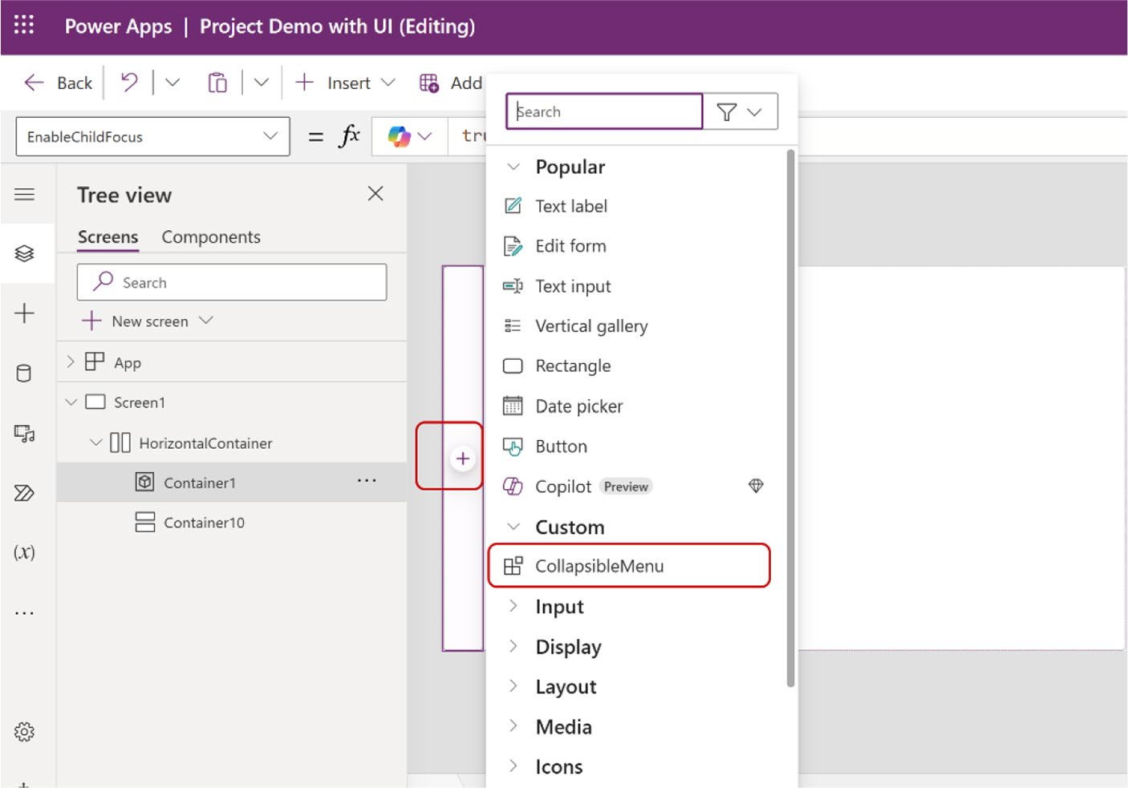

Figure 11-59. Choosing CollapsibleMenu to integrate the menu bar

You will see the side menu after choosing the CollapsibleMenu
component, as shown in Figure 11-60.

CHAPTER 11 REVOLUTIONIZING POWER APPS UI WITH MICROSOFT COPILOT:
A COMPLETE PROJECT


Figure 11-60. Successfully adding the modern menu to Power Apps

Creating the Menu Collapsible with
Mode Switcher
Great! The last section demonstrated how to create a dynamic menu in
Power Apps. This section shows you how to make the menu collapsible
and add a mode switcher. These are essential features of a modern app
and greatly enhance the user experience.
To get started, open the demo again!
1. To make this menu collapsible, go to the
Components option and duplicate the
CollapsibleMenu component. Rename it CollapsibleMenu_Activate, as shown in
Figures 11-61 and 11-62.

CHAPTER 11 REVOLUTIONIZING POWER APPS UI WITH MICROSOFT COPILOT:
A COMPLETE PROJECT
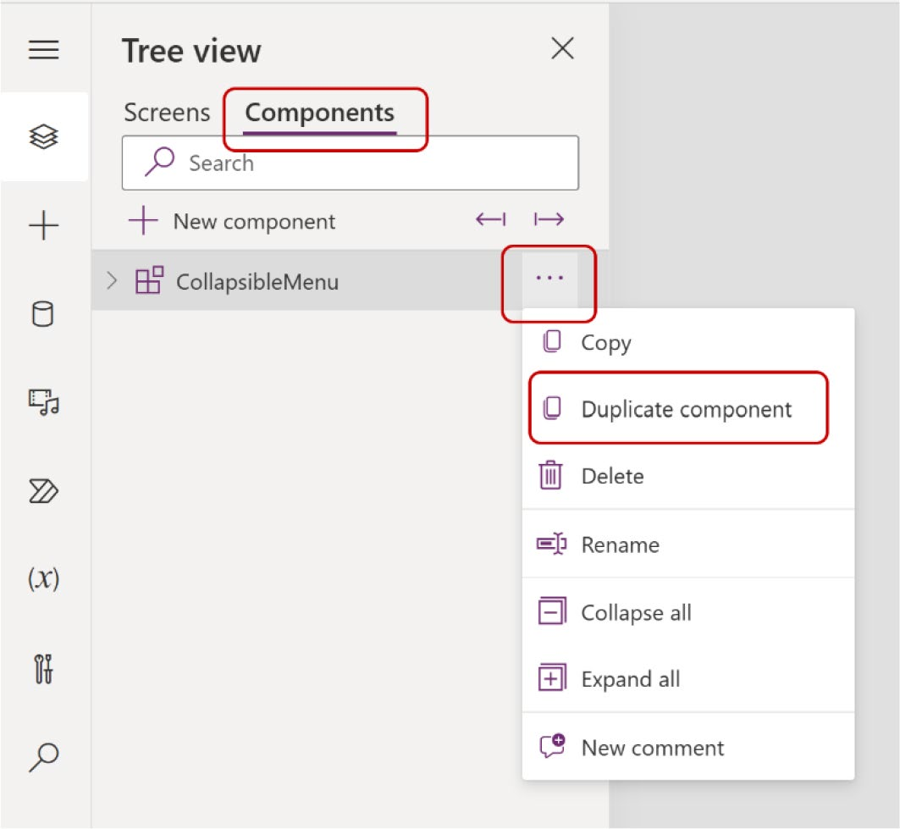

Figure 11-61. Duplicating the CollapsibleMenu component
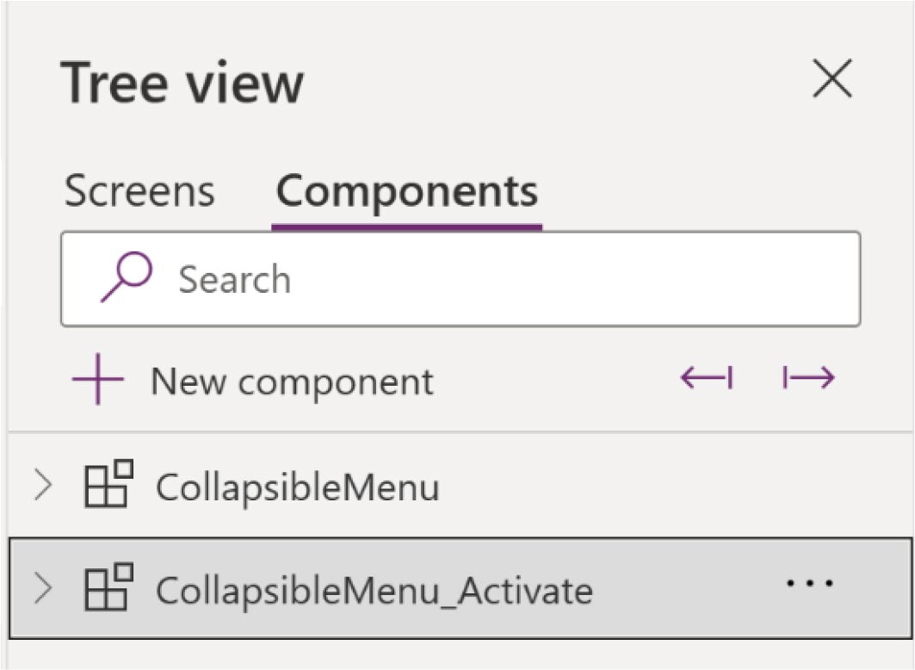

Figure 11-62. Renaming CollapsibleMenu_1 to CollapsibleMenu_ Activate

CHAPTER 11 REVOLUTIONIZING POWER APPS UI WITH MICROSOFT COPILOT:
A COMPLETE PROJECT
2. The width of the menu I created, as shown in
Figure 11-57, was initially set at 70. Let’s increase the width to 150 when it expands. To achieve this, add a new container in between LogoImage_1 and Gallery1_1 and name it ContainerExpand, as
shown in Figure 11-63.
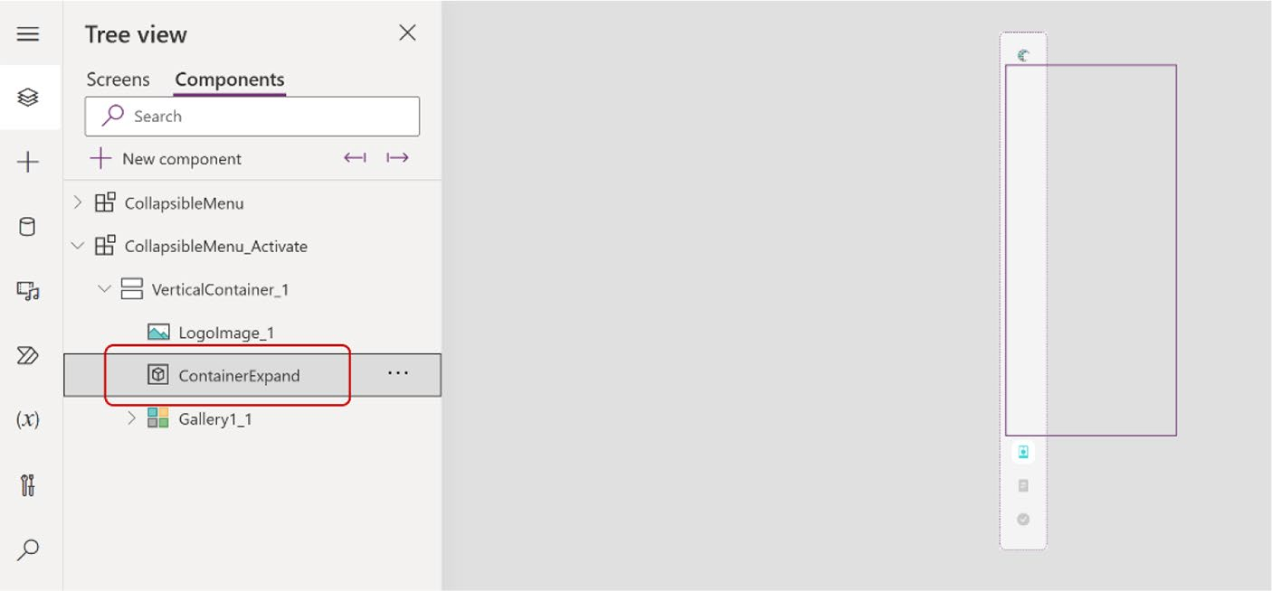

Figure 11-63. Adding a new container between LogoImage1 and
Gallery1_1

3. Change the following parameters of
ContainerExpand.
Align in Container = Center Flexible width = Off Width = 35
Height = 35
Border radius = 10 Drop shadow = None
Figure 11-64 shows the ContainerExpand parameters.

CHAPTER 11 REVOLUTIONIZING POWER APPS UI WITH MICROSOFT COPILOT:
A COMPLETE PROJECT
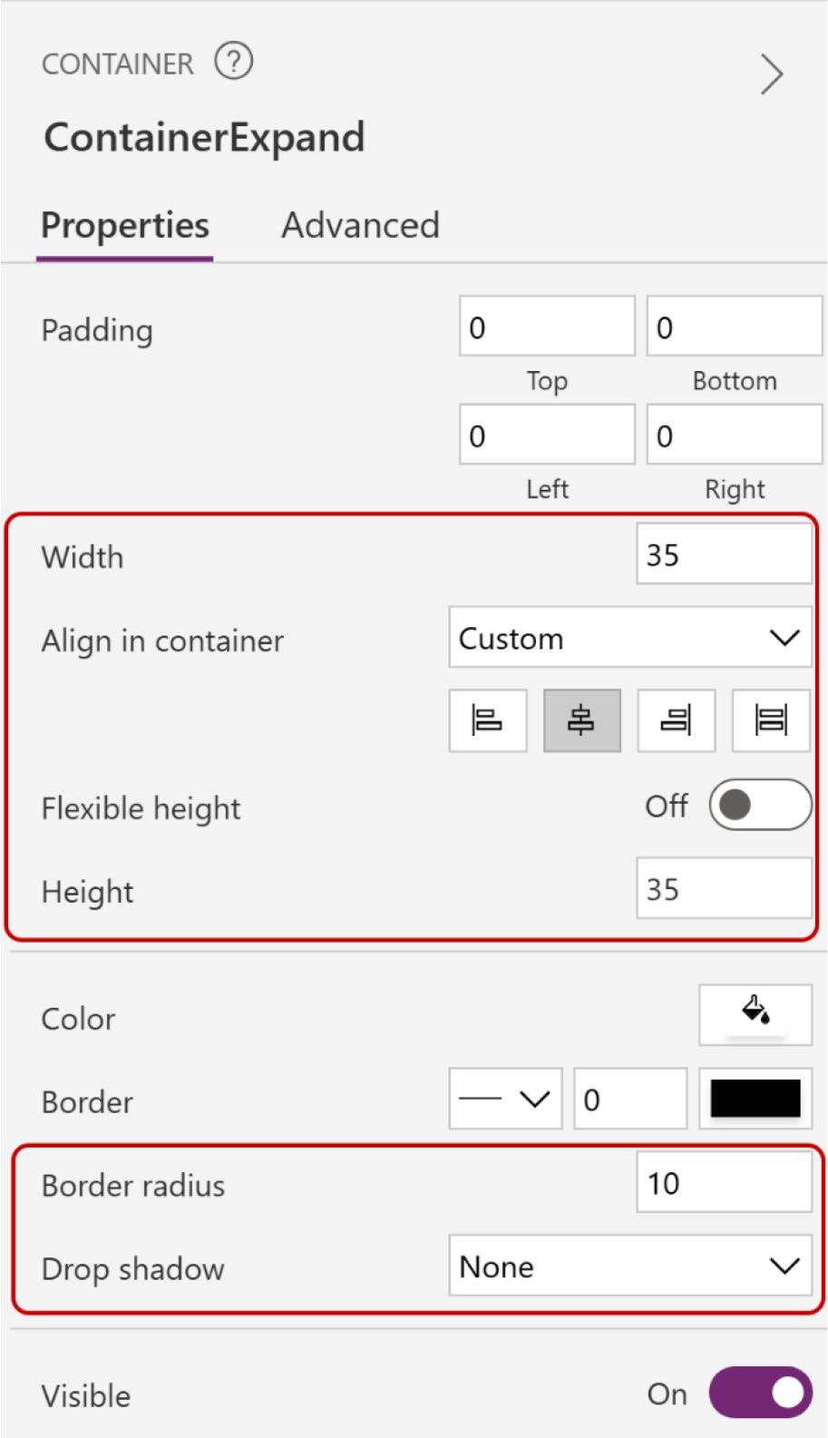

Figure 11-64. Changing the parameters of ContainerExpand

CHAPTER 11 REVOLUTIONIZING POWER APPS UI WITH MICROSOFT COPILOT:
A COMPLETE PROJECT
4. Inside this container, add a new image control and
change the parameters as follows:
Width = Parent.Width Height = Parent.Height X = 0
Y = 0
Figure 11-65 shows the image control parameters.
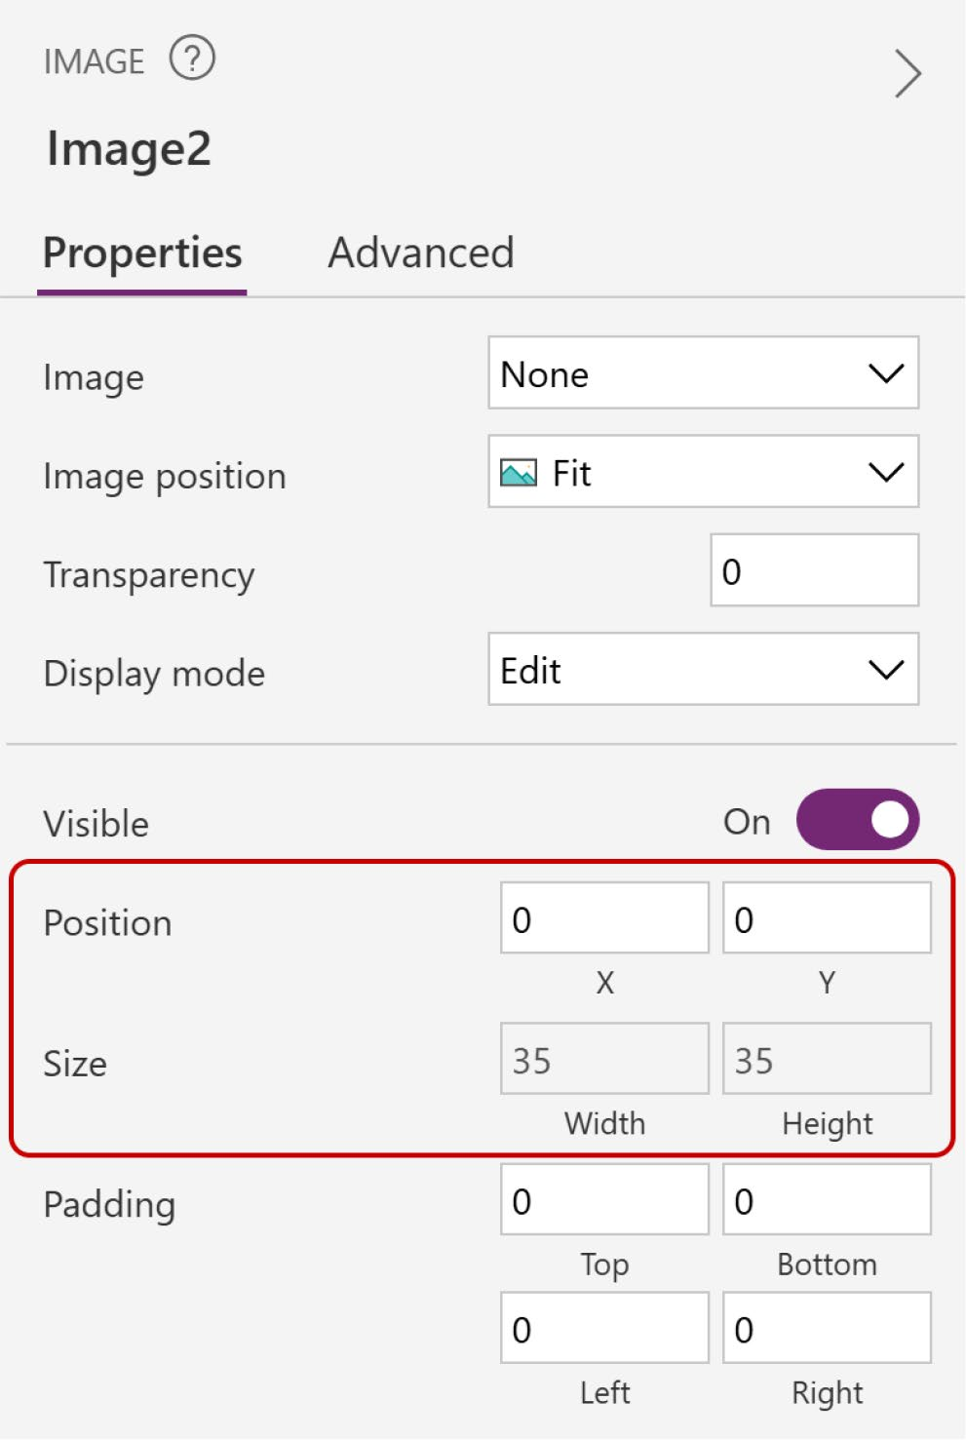

Figure 11-65. Changing the image control properties

CHAPTER 11 REVOLUTIONIZING POWER APPS UI WITH MICROSOFT COPILOT:
A COMPLETE PROJECT
5. Go to Bootstrap and search for the hamburger
menu. Copy the HTML code, as shown in
Figure 11-66.
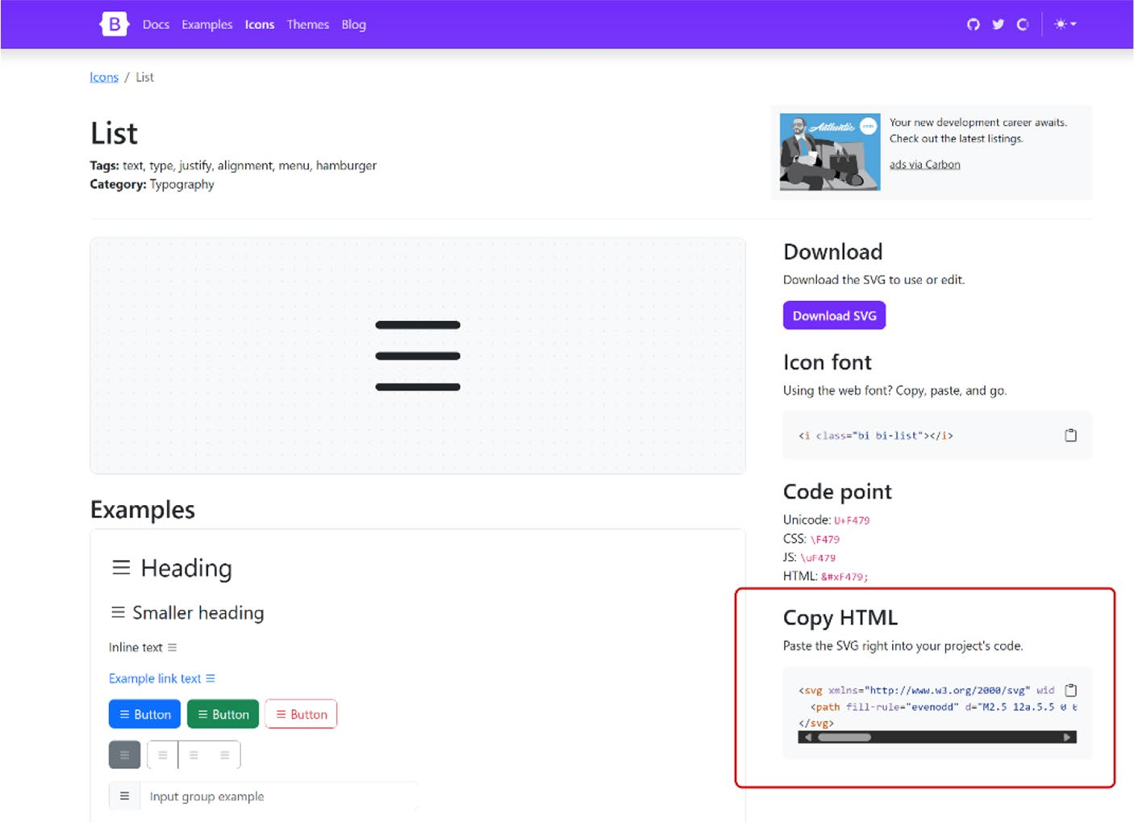

Figure 11-66. Choosing the hamburger menu icon and copying the HTML code

6. Replace the double quotations with single
quotations and add the following code to the default image property from the Formula bar.
"data:image/svg+xml;utf8, " & EncodeUrl (
Substitute(
"<svg xmlns='http://www.w3.org/2000/svg' width='16' height='16' fill='currentColor' class='bi bi-list' viewBox='0 0 16 16'>

CHAPTER 11 REVOLUTIONIZING POWER APPS UI WITH MICROSOFT COPILOT:
A COMPLETE PROJECT
<path fill-rule='evenodd' d='M2.5 12a.5.5 0 0 1 .5-.5h10a.5.5 0 0 1 0 1H3a.5.5 0 0 1-.5-.5m0-4a.5.5 0 0 1 .5-.5h10a.5.5 0 0 1 0 1H3a.5.5 0 0 1-.5-.5m0-4a.5.5 0 0 1 .5-.5h10a.5.5 0 0 1 0 1H3a.5.5 0 0 1-.5-.5'/>
</svg>",
"currentColor",
CollapsibleMenu_Activate.InactiveIcon_Text
)
)
Figure 11-67 shows the formula code for the Image property.
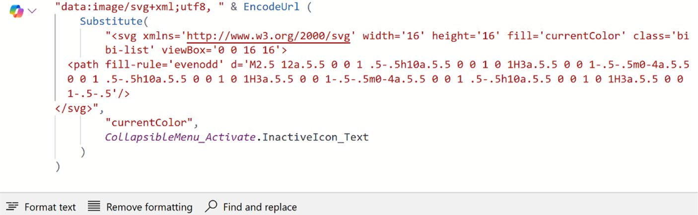

Figure 11-67. Formula code for adding a hamburger menu to the
Image property

7. Now, add a button inside the ContainerExpand
container and change the following parameters in
the Formula bar (also shown in Figure 11-68):
Text = ""
X = 0
Y = 0
Height = Parent.Height Width = Parent.Width

CHAPTER 11 REVOLUTIONIZING POWER APPS UI WITH MICROSOFT COPILOT:
A COMPLETE PROJECT
Fill = Color.Transparent Border style = BorderStyle.None PressedFill = CollapsibleMenu_Activate.PressedFilled HoverFill = CollapsibleMenu_Activate.HoverFilled
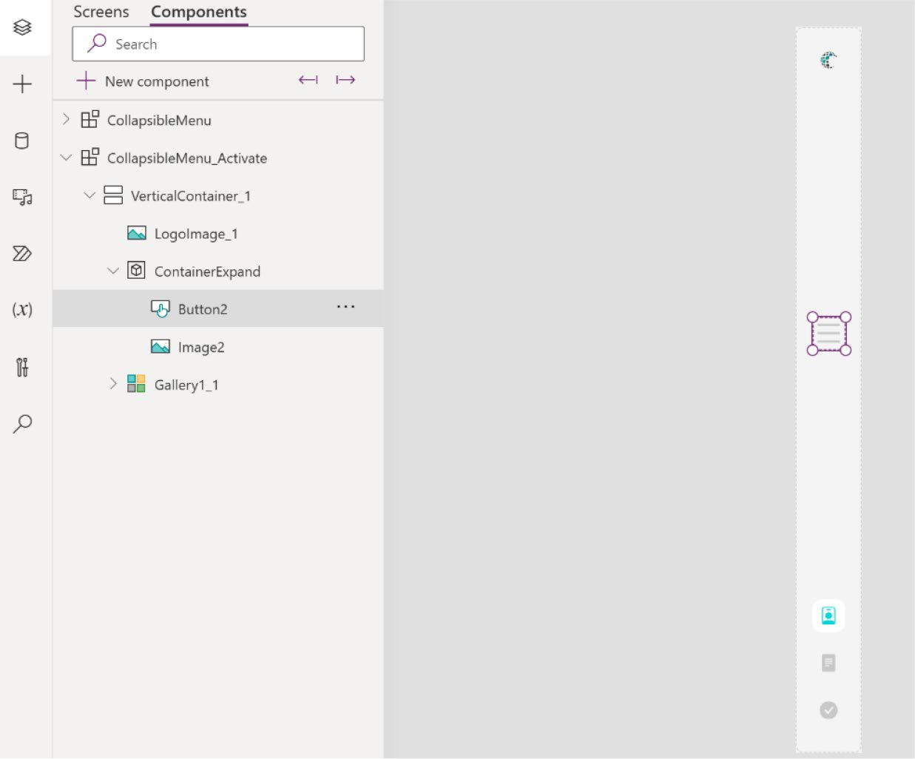

Figure 11-68. Adding a new button to the ContainerExpand container

8. Before proceeding to the next move, position
the component items first. Select the
VerticalContainer_1 and change the following
parameters, also shown in Figure 11-69.
Justify (vertical) = Start Gap = 10

CHAPTER 11 REVOLUTIONIZING POWER APPS UI WITH MICROSOFT COPILOT:
A COMPLETE PROJECT
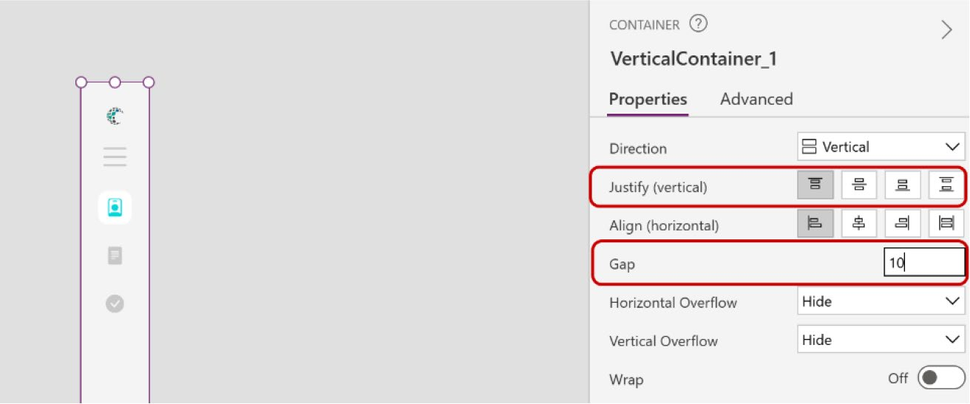

Figure 11-69. Positioning VerticalComponent_1

9. Now, select Gallery1_1 and change the following
parameters, as shown in Figure 11-70.
Flexible Height = On Minimum Height = 0
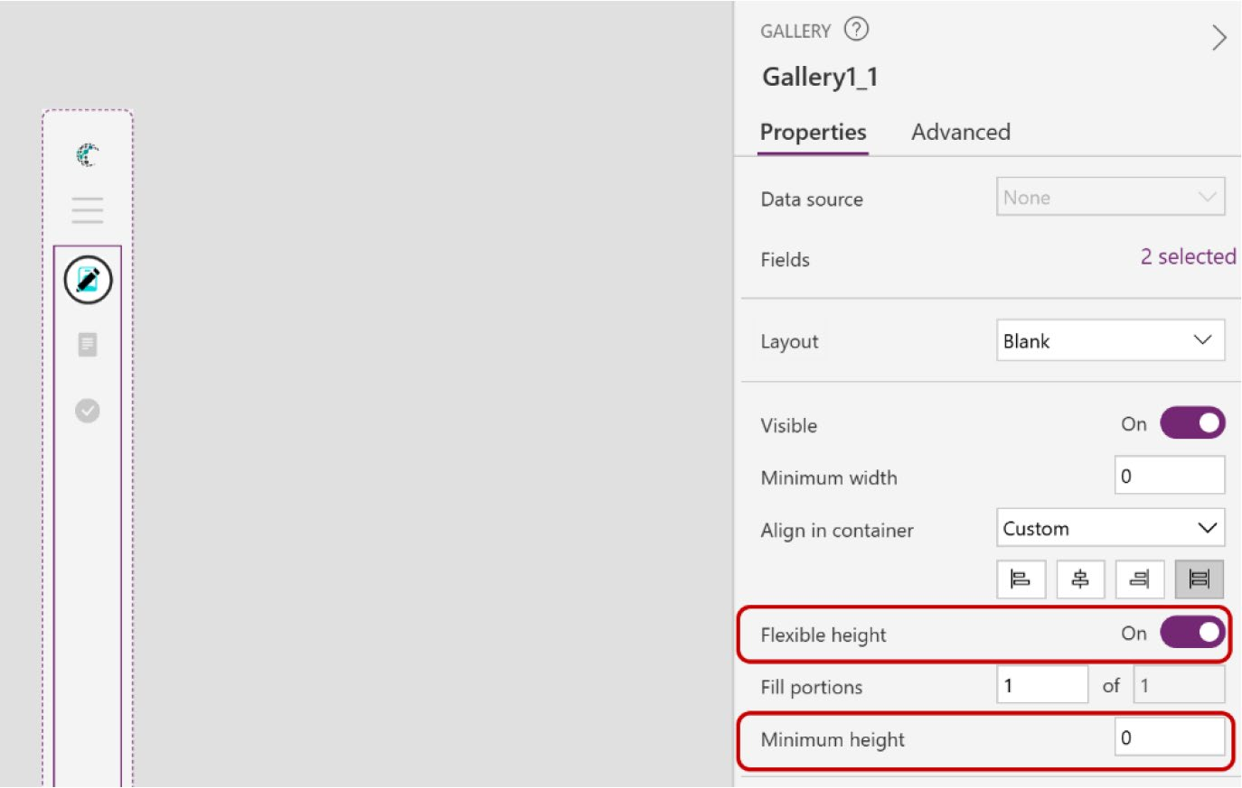

Figure 11-70. Changing the parameters of Gallery1_1

CHAPTER 11 REVOLUTIONIZING POWER APPS UI WITH MICROSOFT COPILOT:
A COMPLETE PROJECT
10. Now you’ll make the component expandable.
Select the hamburger icon button, which is named Button2, and add the following code to the
OnSelect property (also shown in Figure 11-71):
Set (varMenuExpanded,!varMenuExpanded)
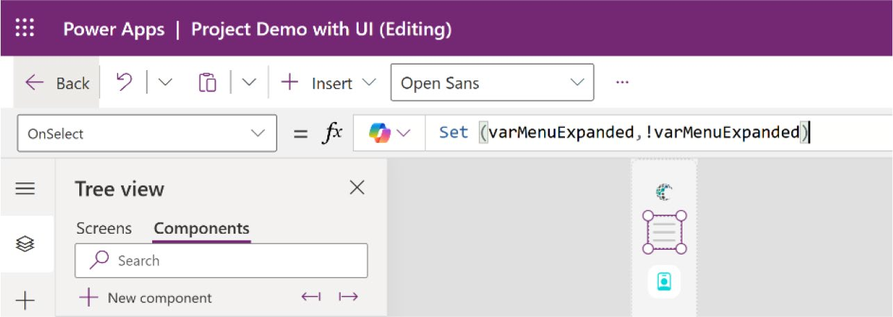

Figure 11-71. Adding the formula code to the hamburger menu button

This code will create a Boolean variable named varMenuExpanded, which toggles the icon on and off.
11. Now, create a custom property named
MenuExpanded with the following parameters:
Property type = Output Data type = Boolean
Figure 11-72 shows the parameters of this customer property named MenuExpanded.

CHAPTER 11 REVOLUTIONIZING POWER APPS UI WITH MICROSOFT COPILOT:
A COMPLETE PROJECT
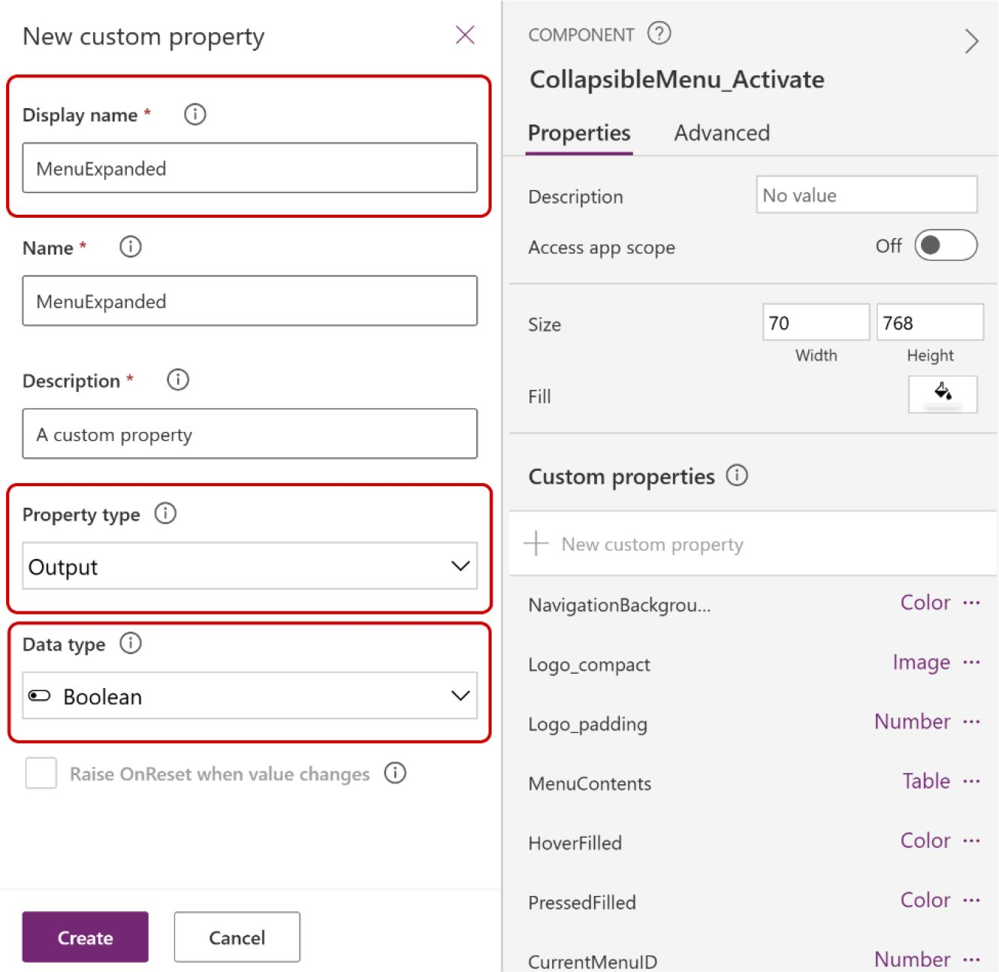

Figure 11-72. Creating a custom property named MenuExpanded
and configuring the parameters

12. Select the newly created custom property named
MenuExpanded and change the default value (true)
to varMenuExpanded, as shown in Figure 11-73.
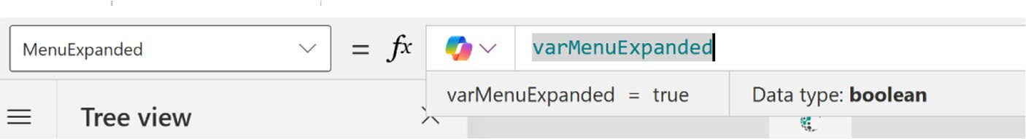

Figure 11-73. Adding formula code to the MenuExpanded custom
property

CHAPTER 11 REVOLUTIONIZING POWER APPS UI WITH MICROSOFT COPILOT:
A COMPLETE PROJECT
13. Now create a new custom property called Logo_
Expanded. This property will display the full logo whenever the menu is expanded. Use the following parameters:
Property type = Input Data type = Image
Figure 11-74 shows the new custom property named Logo_Expanded with the parameters.
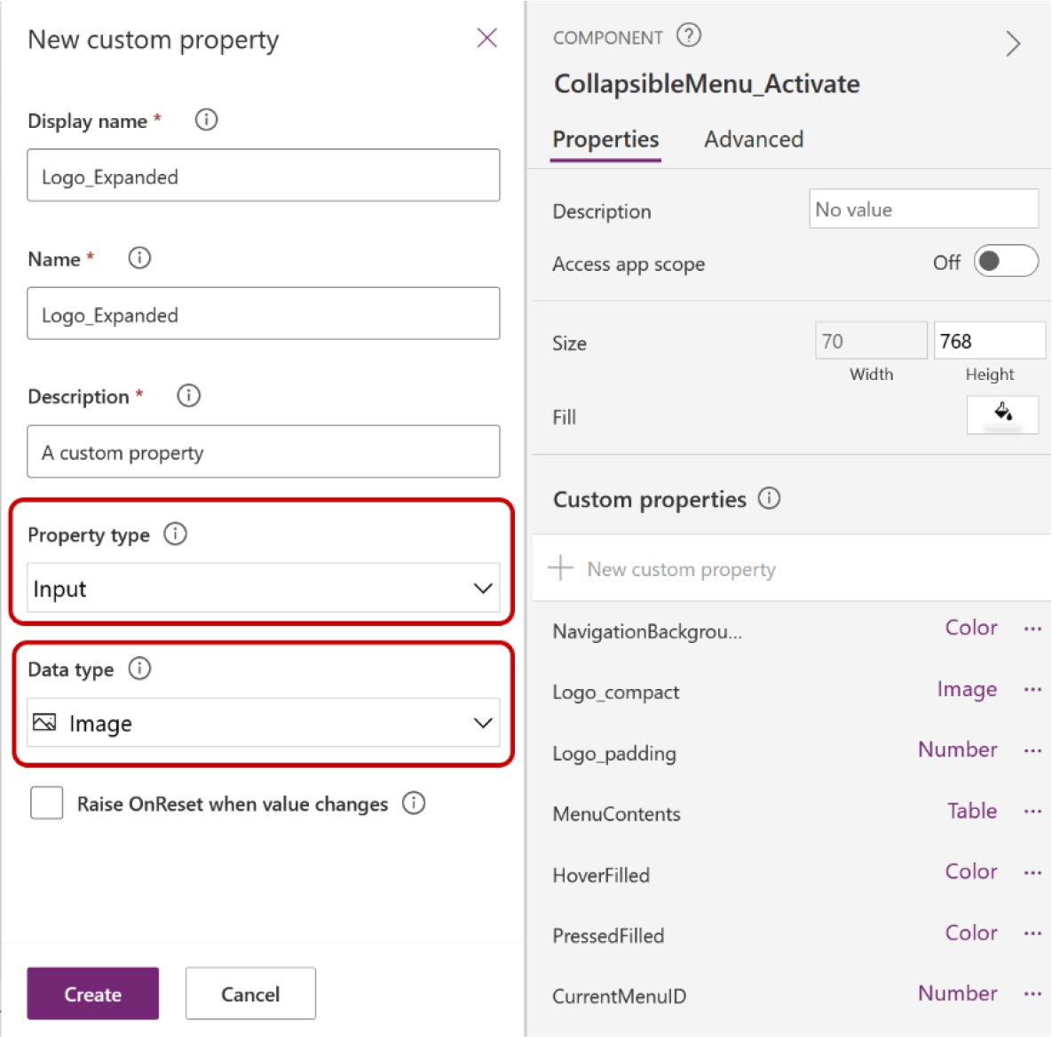

Figure 11-74. Creating a new custom property named Logo_ Expanded

CHAPTER 11 REVOLUTIONIZING POWER APPS UI WITH MICROSOFT COPILOT:
A COMPLETE PROJECT
14. Add the full logo in Media and set the full logo as the
default value of the custom property, as shown in
Figure 11-75.
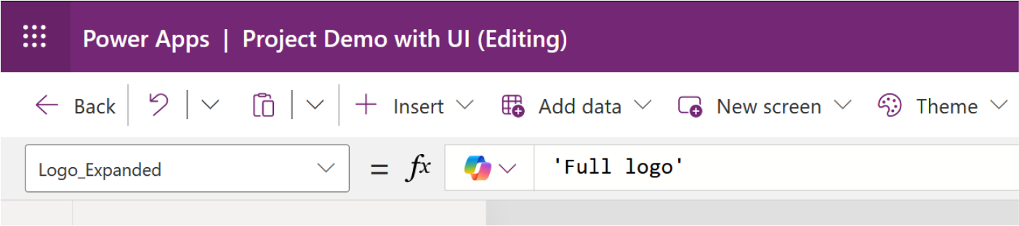

Figure 11-75. Adding the full logo as a default value for Logo_
Expanded property

15. Select the LogoImage1 control, choose the Image
property, and add the following code:
If(
CollapsibleMenu_Activate.MenuExpanded, CollapsibleMenu_Activate.Logo_Expanded, CollapsibleMenu_Activate
.Logo_compact
)
Figure 11-76 shows the formula code that changes the logo when it is expanded.
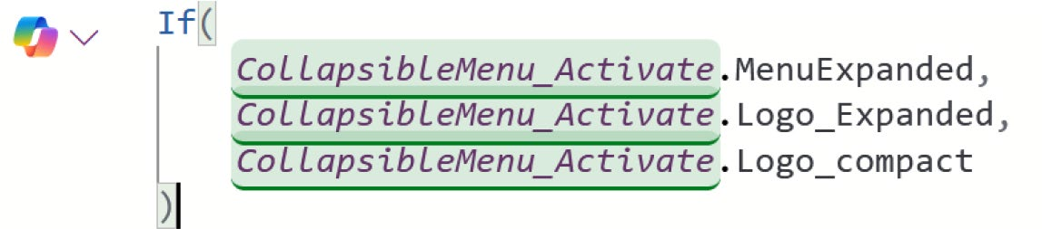

Figure 11-76. Formula code that changes the logo when expanded

CHAPTER 11 REVOLUTIONIZING POWER APPS UI WITH MICROSOFT COPILOT:
A COMPLETE PROJECT
16. Adjust the alignment of the menu items. As shown
in Figure 11-77, the items are currently centered when the menu is expanded. To better adhere to design principles, I suggest shifting the position of the menu items to the left.
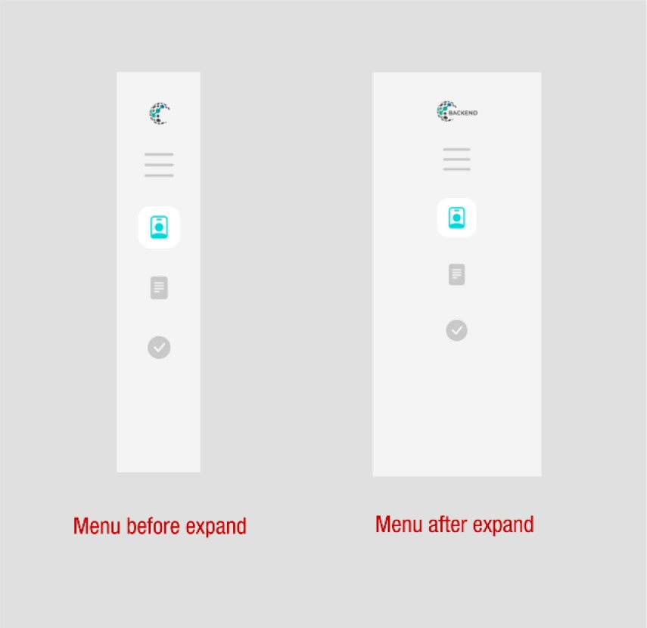

Figure 11-77. Menu items before and after the menu expands

17. To do this, select the ContainerExpand container
(which you created to put the hamburger icon image and button) and place the following formula code in the AlignInContainer property.
If(
CollapsibleMenu_Activate.MenuExpanded, AlignInContainer.Start,
AlignInContainer.Center
)

CHAPTER 11 REVOLUTIONIZING POWER APPS UI WITH MICROSOFT COPILOT:
A COMPLETE PROJECT
Figure 11-78 shows the formula code that changes the alignment position of the menu items.
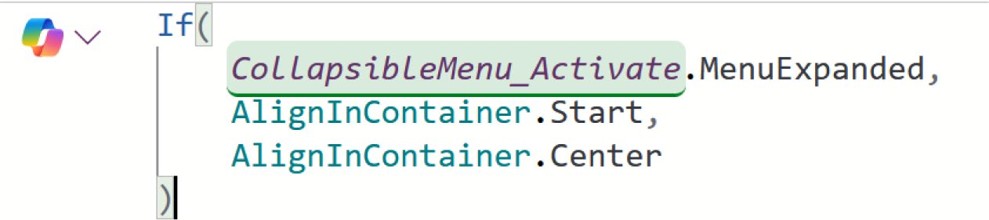

Figure 11-78. Formula code that changes the alignment position of
the menu items

18. Modify the alignments of the menu icons. To do this,
expand the Gallery1_1 component. Inside, you will find two containers. Select the last container, which holds the Image and Button, to adjust their
alignment positions, as shown in Figure 11-79.
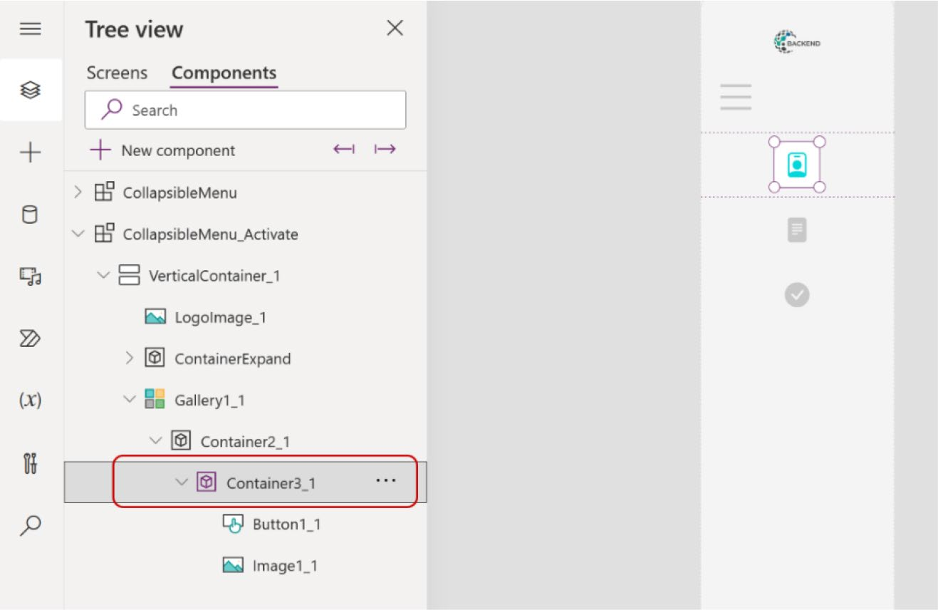

Figure 11-79. Selecting the container where the icons are saved

CHAPTER 11 REVOLUTIONIZING POWER APPS UI WITH MICROSOFT COPILOT:
A COMPLETE PROJECT
19. Choose the Width for the container and add the
following formula code:
If(
CollapsibleMenu_Activate.MenuExpanded, Parent.Width,
Self.Height
)
Figure 11-80 shows the formula code for changing the width of the container.
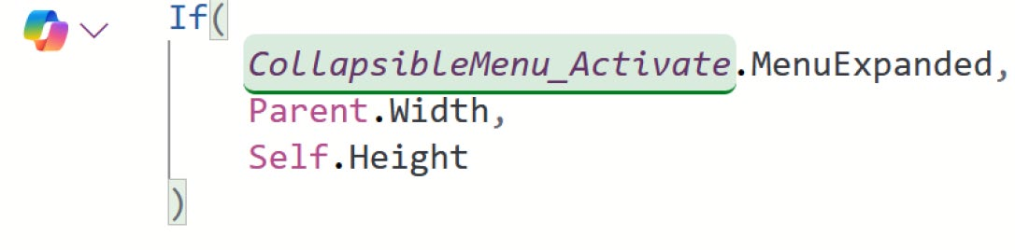

Figure 11-80. Formula code for changing the width of the container

20. Select Image1_1 (which is carrying the icons) and set
the width to Self.Height, as shown in Figure 11-81.
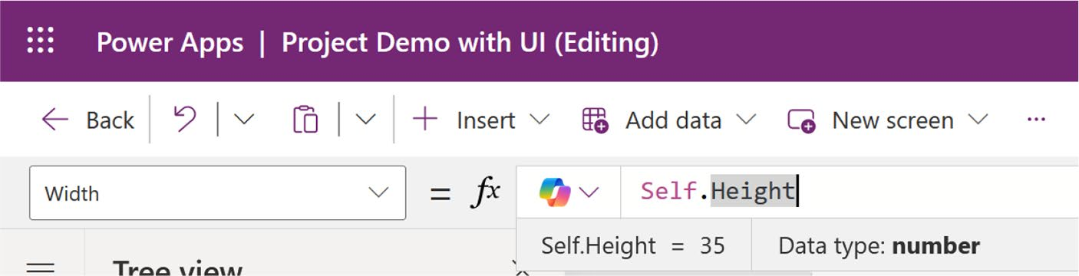

Figure 11-81. Set the width of the image container for the menu icons

CHAPTER 11 REVOLUTIONIZING POWER APPS UI WITH MICROSOFT COPILOT:
A COMPLETE PROJECT
21. At this stage, you should add a name to the menu.
To do this, insert a text label within the container, ensuring that it is positioned after the button. This placement will make the text label clickable, as
shown in Figure 11-82.
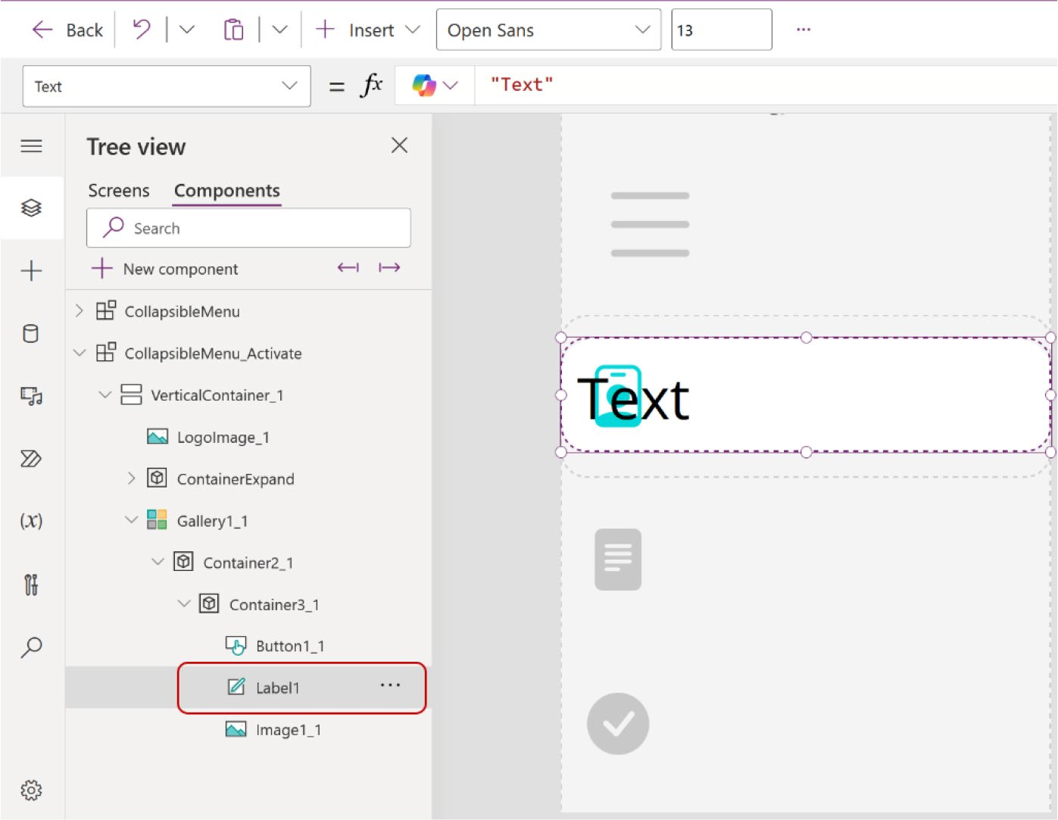

Figure 11-82. Adding a new text label to show the menu name

22. Set the following parameters of this text label:
X = Image1_1.Width Width = Parent.Width - Self.X Height = Parent.Height

CHAPTER 11 REVOLUTIONIZING POWER APPS UI WITH MICROSOFT COPILOT:
A COMPLETE PROJECT
Note The X value specifies that the text within the text label will
begin immediately following Image1_1, which is the menu icon.

Figure 11-83 shows the preview after these parameters have been set.
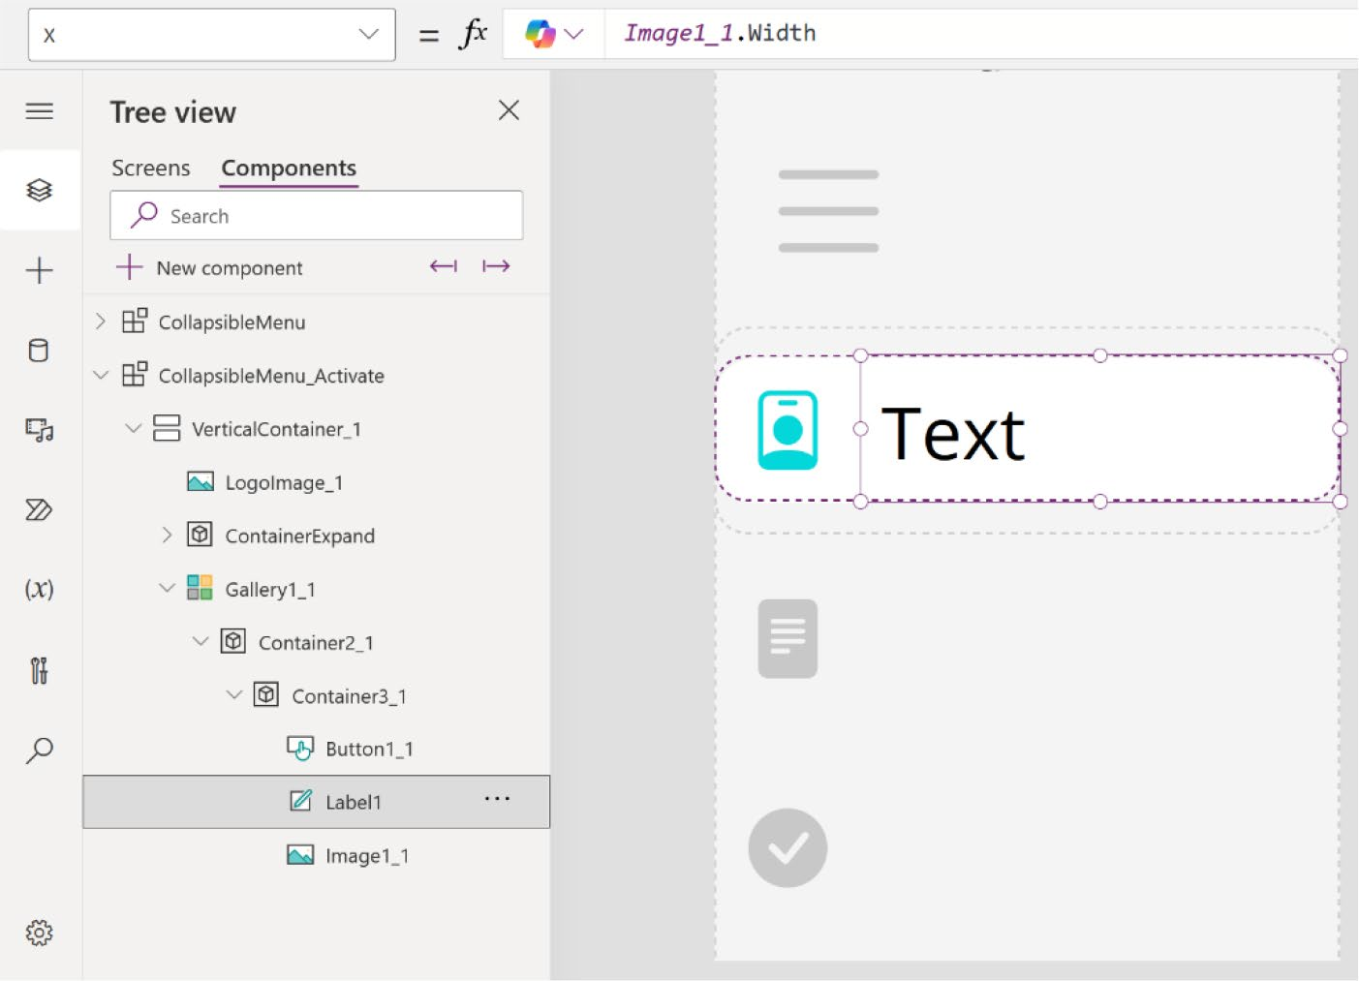

Figure 11-83. Preview of the menu after adding the text label

23. As part of the plan to implement a light mode and
dark mode, it is essential to adjust the text colors. To facilitate this process, create a new custom property called TextColor using the Color data type.

CHAPTER 11 REVOLUTIONIZING POWER APPS UI WITH MICROSOFT COPILOT:
A COMPLETE PROJECT
24. Set the default value of the TextColor custom
property as follows:
RGBA (50, 68, 125, 1)
Figure 11-84 shows the formula code for the TextColor property.
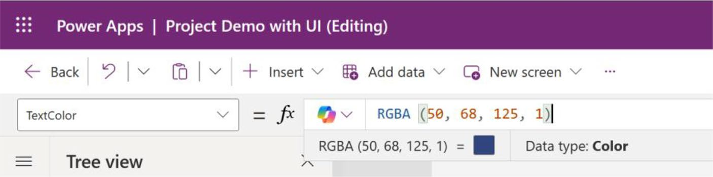

Figure 11-84. Setting the text color for the light mode

25. Change the label color with the custom property
that you just created, using the following code:
CollapsibleMenu_Activate.TextColor
Figure 11-85 shows the formula code and the preview after changing the color.

CHAPTER 11 REVOLUTIONIZING POWER APPS UI WITH MICROSOFT COPILOT:
A COMPLETE PROJECT
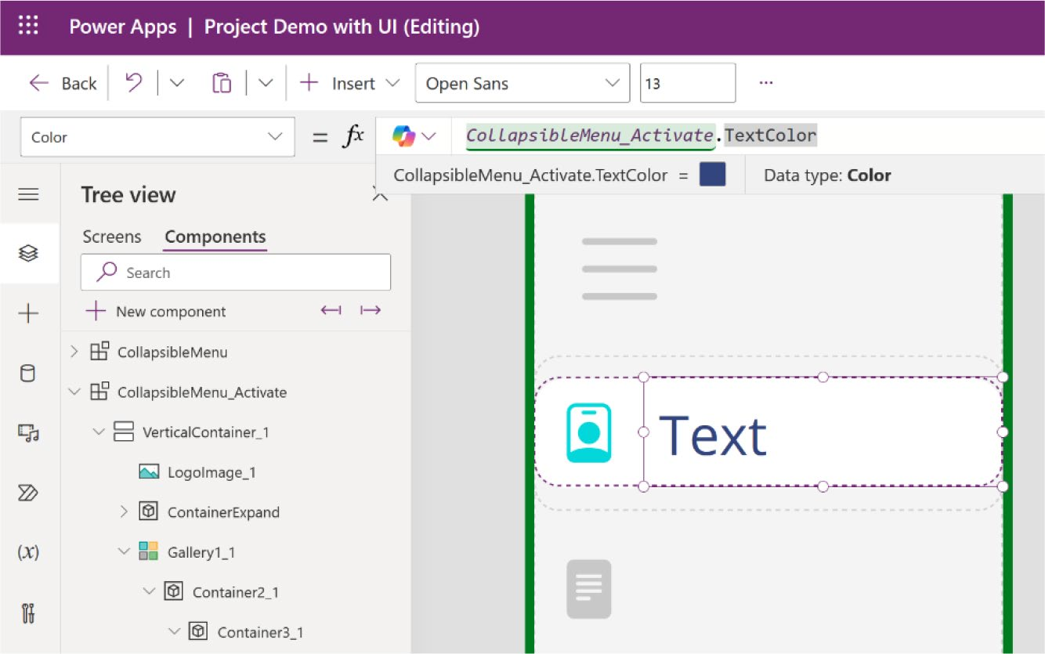

Figure 11-85. Changing the text label color with the custom property

26. Select the label, choose the text property from the
Formula bar, and add the following formula code:
ThisItem.MenuName
Figure 11-86 shows the code in the Formula bar with the preview.

CHAPTER 11 REVOLUTIONIZING POWER APPS UI WITH MICROSOFT COPILOT:
A COMPLETE PROJECT
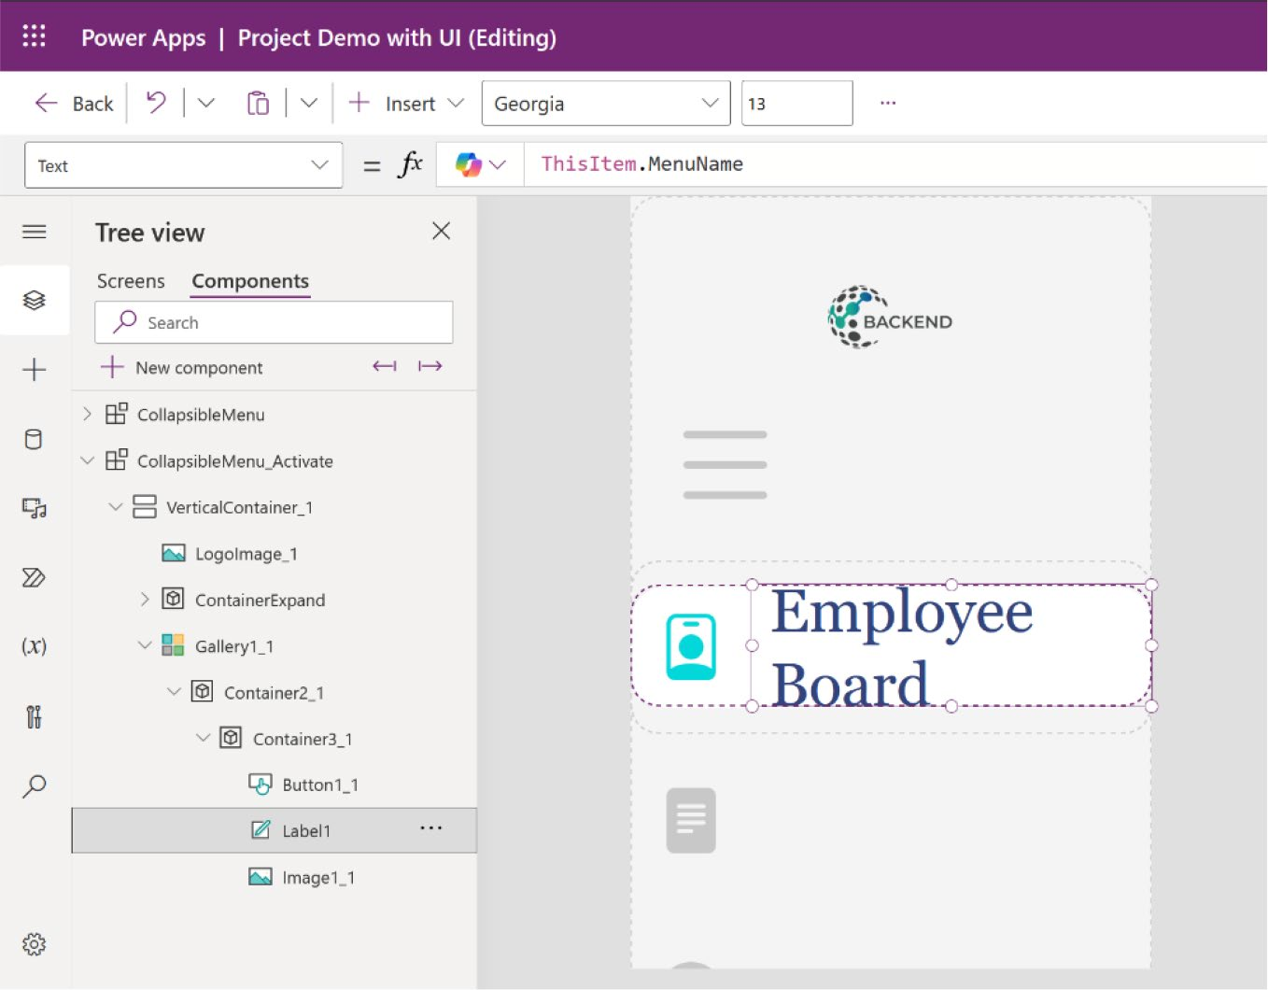

Figure 11-86. Preview after adding the menu name to the text label

27. You can see that the font size is too big and not
perfectly set inside the container. To fix this, change the font size from the Label properties, as shown in
Figure 11-87.

CHAPTER 11 REVOLUTIONIZING POWER APPS UI WITH MICROSOFT COPILOT:
A COMPLETE PROJECT
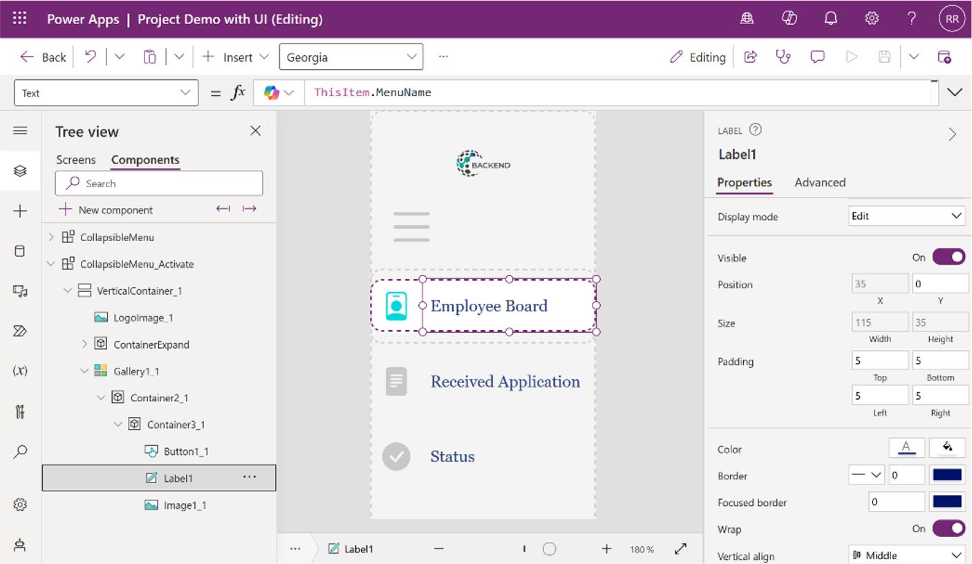

Figure 11-87. Changing the font size to set the menu name inside the container

28. Set up a condition to ensure that the menu name is
only visible when the menu is expanded. To do this, select label1 (the text label where you just fetch the menu name), choose the Visible property from the Formula bar, and add the following code:
CollapsibleMenu_Activate.MenuExpanded
Figure 11-88 shows the formula code for the visible property of label1.
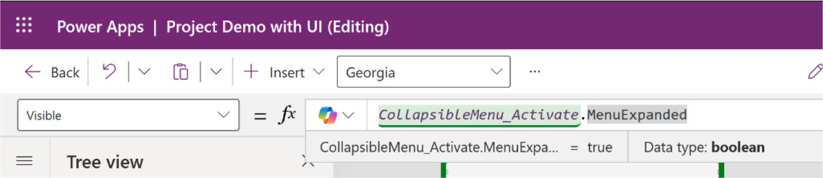

Figure 11-88. Formula code for showing the menu name when the menu is expanded

CHAPTER 11 REVOLUTIONIZING POWER APPS UI WITH MICROSOFT COPILOT:
A COMPLETE PROJECT
29. The collapsible menu is done! Figure 11-89 shows
the menu before and after expanding.
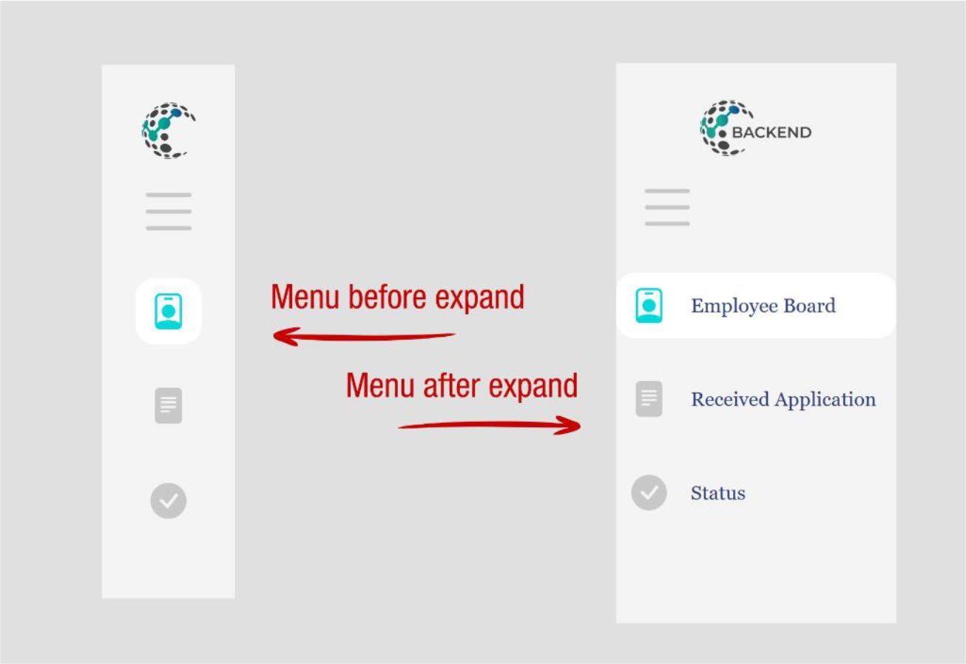

Figure 11-89. Menu before and after expanding

Just a note: If the logo appears too small, consider reducing the
percentage set in the Logo_Padding custom component. I initially set it to
20%. If you reduce it, the logo will appear larger, as shown in Figure 11-90.

CHAPTER 11 REVOLUTIONIZING POWER APPS UI WITH MICROSOFT COPILOT:
A COMPLETE PROJECT
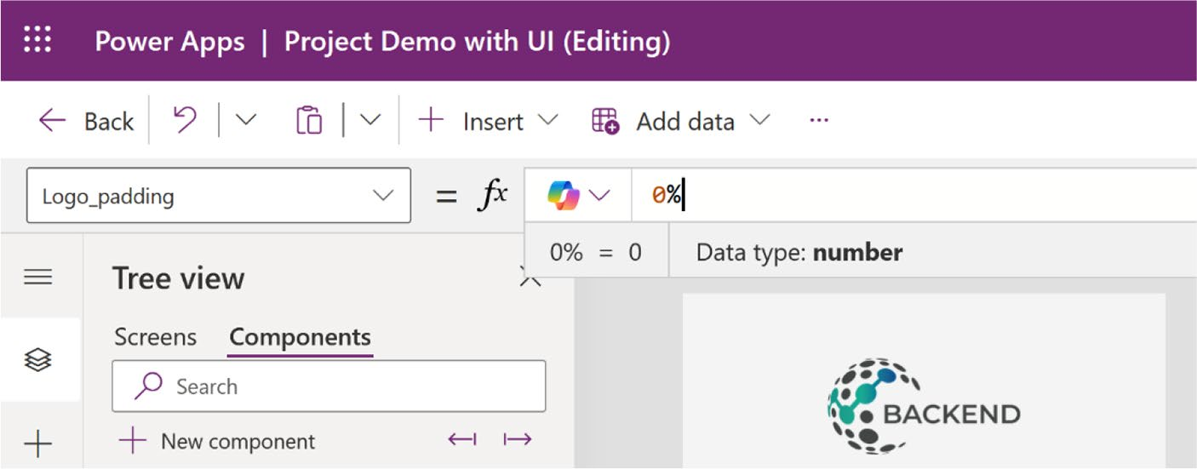

Figure 11-90. Making the logo larger from the Logo_Padding custom property

The next example shows you how to add a crucial feature called a theme switcher, which is commonly seen in modern applications. This feature includes a toggle option that allows users to switch between light and dark themes.
To create the theme switcher, follow these steps:
1. In your CollapsibleMenu_Activate component,
create a new custom property named AppColorMode
with the Text data type, as shown in Figure 11-91.

CHAPTER 11 REVOLUTIONIZING POWER APPS UI WITH MICROSOFT COPILOT:
A COMPLETE PROJECT
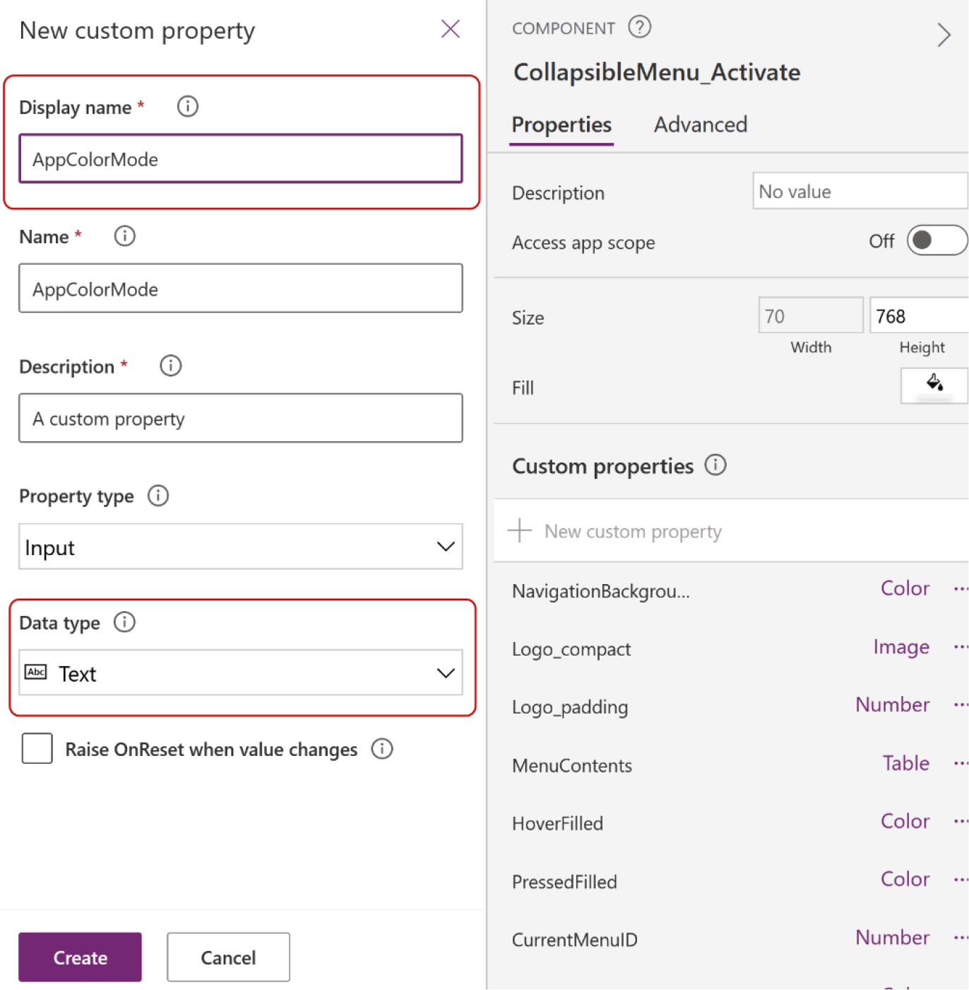

Figure 11-91. Creating new custom property named AppColorMode

2. Set the default value of AppColorMode to "Light", as
shown in Figure 11-92.

CHAPTER 11 REVOLUTIONIZING POWER APPS UI WITH MICROSOFT COPILOT:
A COMPLETE PROJECT
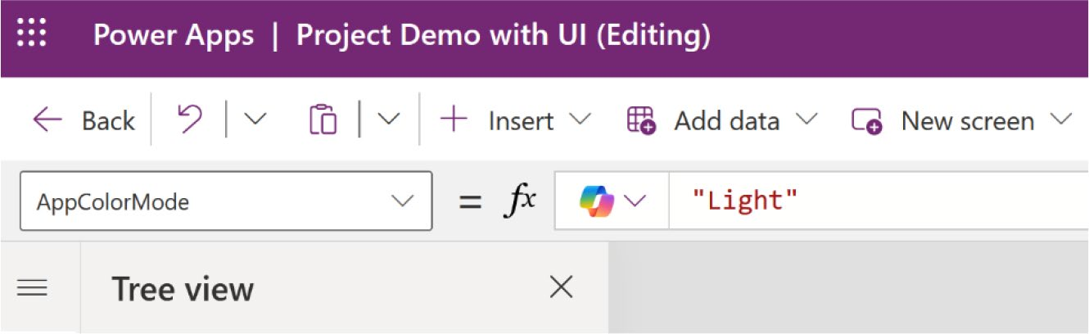

Figure 11-92. Setting the default value of AppColorMode

3. Add a container to the CollapsibleMenu_Activate
component and set the following parameters:
Align in Container = Center Width = 60
Height = 60
Flexible Height = Off Border Radius = 0
Drop Shadow = None
Figure 11-93 shows the container named AppThemeSwitcherContainer with its parameters.

CHAPTER 11 REVOLUTIONIZING POWER APPS UI WITH MICROSOFT COPILOT:
A COMPLETE PROJECT
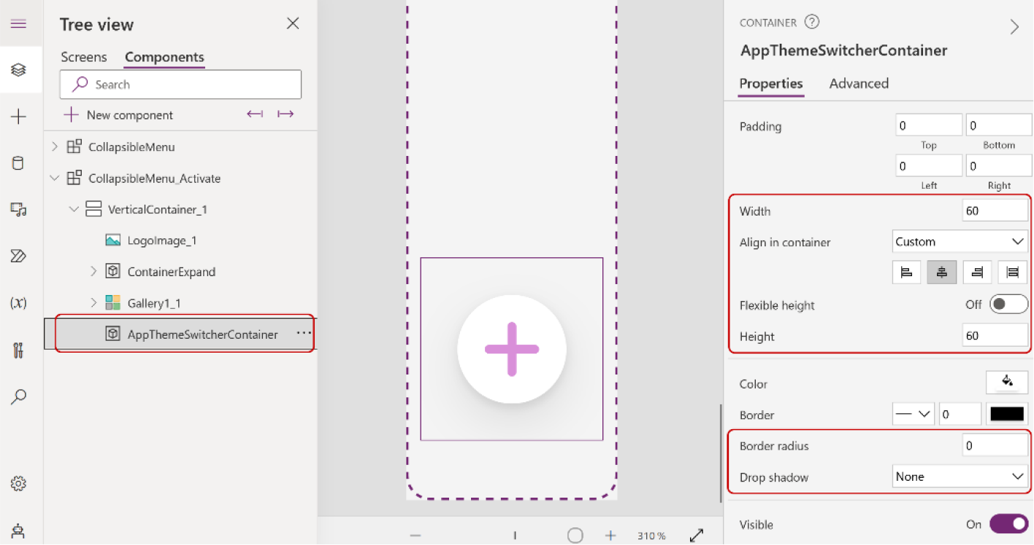

Figure 11-93. Adding a new container named
AppThemeSwitcherContainer

4. Add a vertical container inside the
AppThemeSwitcherContainer, rename it AppThemeSwitcher, and set the following parameters:
X = 0
Y = 0
Width = 60
Height = 60
Border Radius = 0
Drop Shadow = None
5. Add a new non-responsive container, rename it to
SwitchContainer, and set the following parameters:
Align in Container = Stretch Minimum Width = 0
Minimum Height = 0

CHAPTER 11 REVOLUTIONIZING POWER APPS UI WITH MICROSOFT COPILOT:
A COMPLETE PROJECT
Flexible Height = On
Border Radius = 0
Drop Shadow = None
6. Add an image inside the SwitchContainer
container, rename it to LightIcon, and set the following parameters:
X = 0
Y = 0
Width = Parent.Width
Height = Parent.Height

Figure 11-94 shows the LightIcon image component inside the SwitchContainer container.
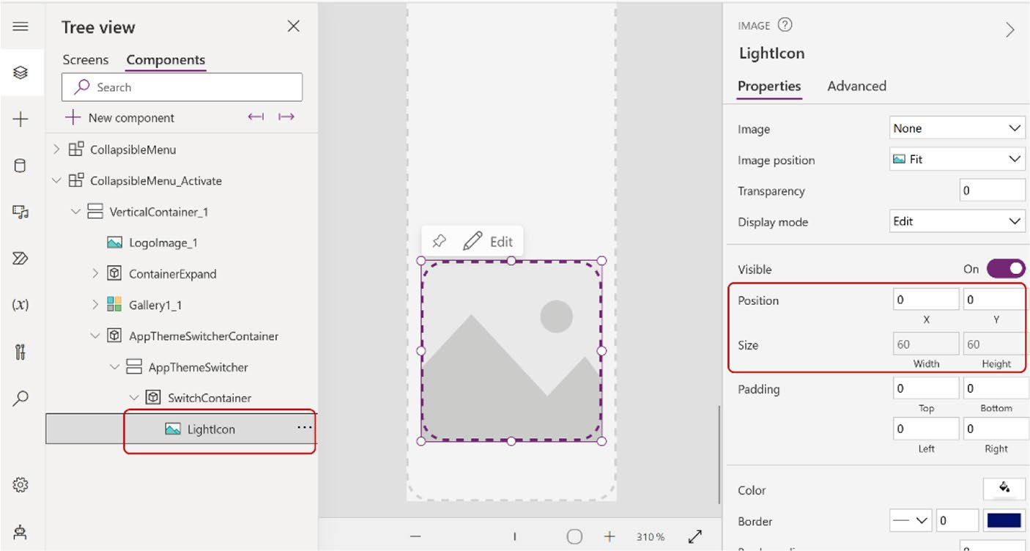

Figure 11-94. Adding a new image component named LightIcon inside SwitchContainer

CHAPTER 11 REVOLUTIONIZING POWER APPS UI WITH MICROSOFT COPILOT:
A COMPLETE PROJECT
7. Go to https://icons.getbootstrap.com and
search for the Light icon. For example, I chose the
icon shown in Figure 11-95.
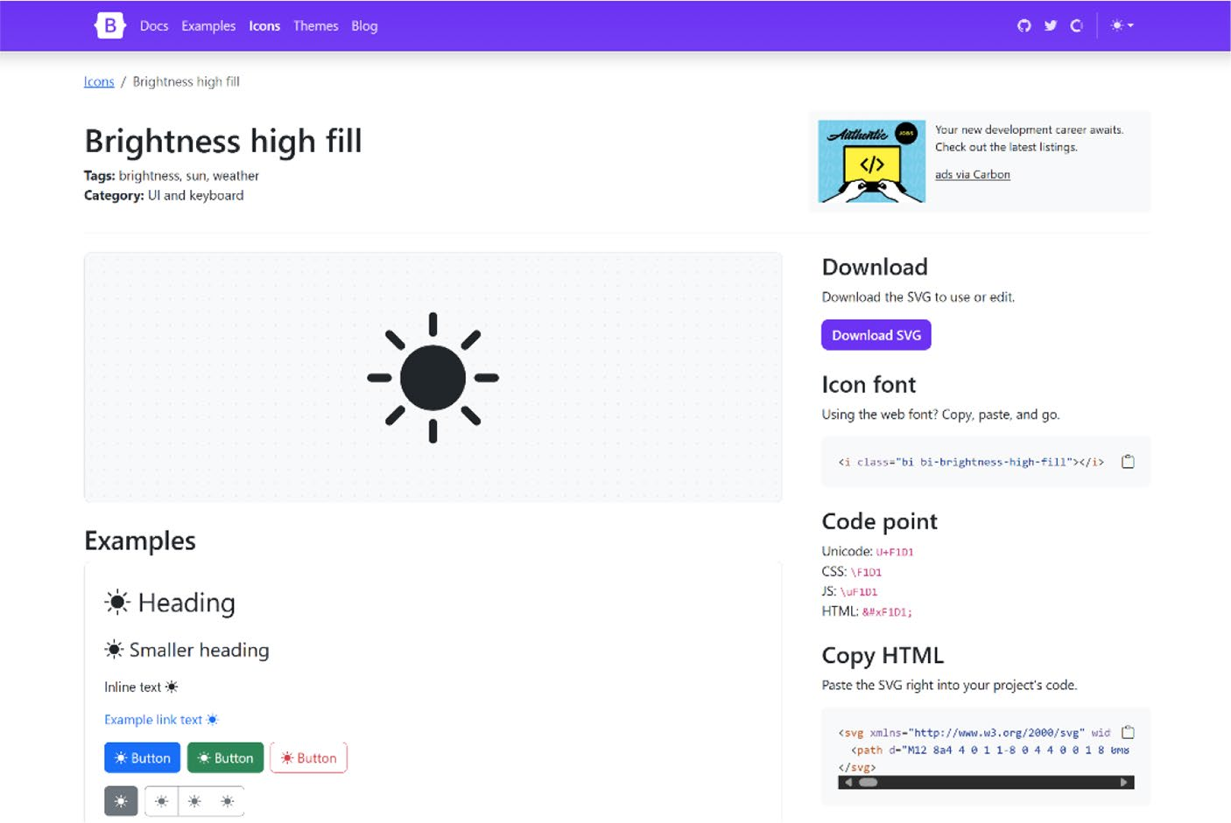

Figure 11-95. Choosing an icon from Bootstrap for a light theme

8. Copy the HTML code, replace the double quotes
with single quotes, and paste the code in the LightIcon Image property from the Formula bar.
"data:image/svg+xml;utf8, " & EncodeUrl (
"<svg xmlns='http://www.w3.org/2000/svg' width='16' height='16' fill='currentColor' class='bi bi-brightness-high-fill' viewBox='0 0 16 16'>

CHAPTER 11 REVOLUTIONIZING POWER APPS UI WITH MICROSOFT COPILOT:
A COMPLETE PROJECT
<path d='M12 8a4 4 0 1 1-8 0 4 4 0 0 1 8 0M8 0a.5.5 0 0 1 .5.5v2a.5.5 0 0 1-1 0v-2A.5.5 0 0 1 8 0m0 13a.5.5 0 0 1 .5.5v2a.5.5 0 0 1-1 0v-2A.5.5 0 0 1 8 13m8-5a.5.5 0 0 1-.5.5h-2a.5.5 0 0 1 0-1h2a.5.5 0 0 1 .5.5M3 8a.5.5 0 0 1-.5.5h-2a.5.5 0 0 1 0-1h2A.5.5 0 0 1 3 8m10.6511-5.657a.5.5 0 0 1 0 .707l-1.414 1.415a.5.5 0 1 1-.7011-.708l1.414-1.414a.5.5 0 0 1 .707 0m-9.193 9.193a.5.5 0 0 1 0 .707L3.05 13.657a.5.5 0 0 1-.7011-.707l1.414-1.414a.5.5 0 0 1 .707 0m9.193 2.121a.5.5 0 0 1-.707 0l-1.414-1.414a.5.5 0 0 1 .7011-.707l1.414 1.414a.5.5 0 0 1 0 .707M4.464 4.465a.5.5 0 0 1-.707 0L2.343 3.05a.5.5 0 1 1 .7011-.707l1.414 1.414a.5.5 0 0 1 0 .708'/>
</svg>"
)

Figure 11-96 shows the code in the Formula bar and the preview after adding the code.

CHAPTER 11 REVOLUTIONIZING POWER APPS UI WITH MICROSOFT COPILOT:
A COMPLETE PROJECT
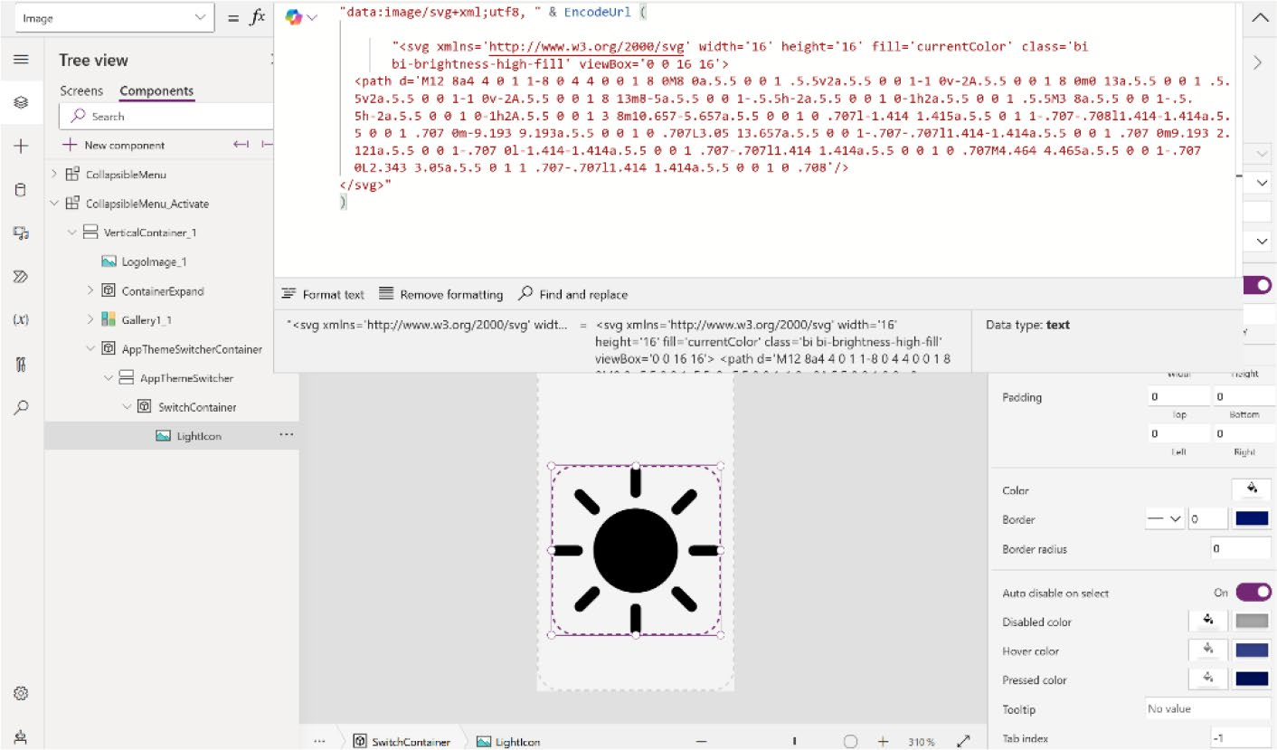

Figure 11-96. Adding an icon to the LightIcon image

Make sure to replace the double quotes with single quotes and add the data:image/svg+xml;utf8 prefix, followed by EncodeUrl, before adding the URL. For more detailed information, refer to the official Microsoft documentation provided in the
link or scan the QR code shown in Figure 11-97.
https://powerusers.microsoft.com/t5/Power-Apps-
Community-Blog/Custom-SVG-Icons-using-Formulas/
ba-p/2595770

CHAPTER 11 REVOLUTIONIZING POWER APPS UI WITH MICROSOFT COPILOT:
A COMPLETE PROJECT


Figure 11-97. Microsoft documentation to learn about custom SGV icons in a formula

9. This theme switcher will switch from a dark
theme to a light one and vice versa, so you need to implement a condition in the Image property that changes the color from dark to light when the theme is switched.
Change the formula code that you added in the image as follows:
"data:image/svg+xml;utf8, " & EncodeUrl ( Substitute(
"<svg xmlns='http://www.w3.org/2000/svg' width='16' height='16' fill='currentColor' class='bi bi-brightness-high- fill' viewBox='0 0 16 16'>
<path d='M12 8a4 4 0 1 1-8 0 4 4 0 0 1 8 0M8 0a.5.5 0 0 1 .5.5v2a.5.5 0 0 1-1 0v-2A.5.5 0 0 1 8 0m0 13a.5.5 0 0 1 .5.5v2a.5.5 0 0 1-1 0v-2A.5.5 0 0 1 8 13m8-5a.5.5 0 0 1-.5.5h-2a.5.5 0 0 1 0-1h2a.5.5 0 0 1 .5.5M3 8a.5.5 0 0 1-.5.5h-2a.5.5 0 0 1 0-1h2A.5.5

CHAPTER 11 REVOLUTIONIZING POWER APPS UI WITH MICROSOFT COPILOT:
A COMPLETE PROJECT
0 0 1 3 8m10.6511-5.657a.5.5 0 0 1 0 .707l-1.414 1.415a.5.5 0 1 1-.7011-.708l1.414-1.414a.5.5 0 0 1 .707 0m-9.193 9.193a.5.5 0 0 1 0 .707L3.05 13.657a.5.5 0 0 1-.7011-.707l1.414-1.414a.5.5 0 0 1 .707 0m9.193 2.121a.5.5 0 0 1-.707 0l-1.414-1.414a.5.5 0 0 1 .7011-.707l1.414 1.414a.5.5 0 0 1 0 .707M4.464 4.465a.5.5 0 0 1-.707 0L2.343 3.05a.5.5 0 1 1 .7011-.707l1.414 1.414a.5.5 0 0 1 0 .708'/>
</svg>",
"currentColor", If(CollapsibleMenu_Activate. AppColorMode = "Light","White", CollapsibleMenu_ Activate.InactiveIcon_Text) )
)
This code dynamically adjusts the SVG icon’s color based on the app theme, toggling between light and dark modes. It embeds the icon into a URL, using the Substitute() function to replace the currentColor attribute based on the theme setting—white for Light and another color for other settings. The EncodeUrl() function ensures that the SVG is properly formatted for web compatibility. This technique enhances UI consistency and aesthetics by adapting icon visibility to different
backgrounds. Figure 11-98 shows the formula code and its resulting output, demonstrating how the icon changes color from black to white.

CHAPTER 11 REVOLUTIONIZING POWER APPS UI WITH MICROSOFT COPILOT:
A COMPLETE PROJECT
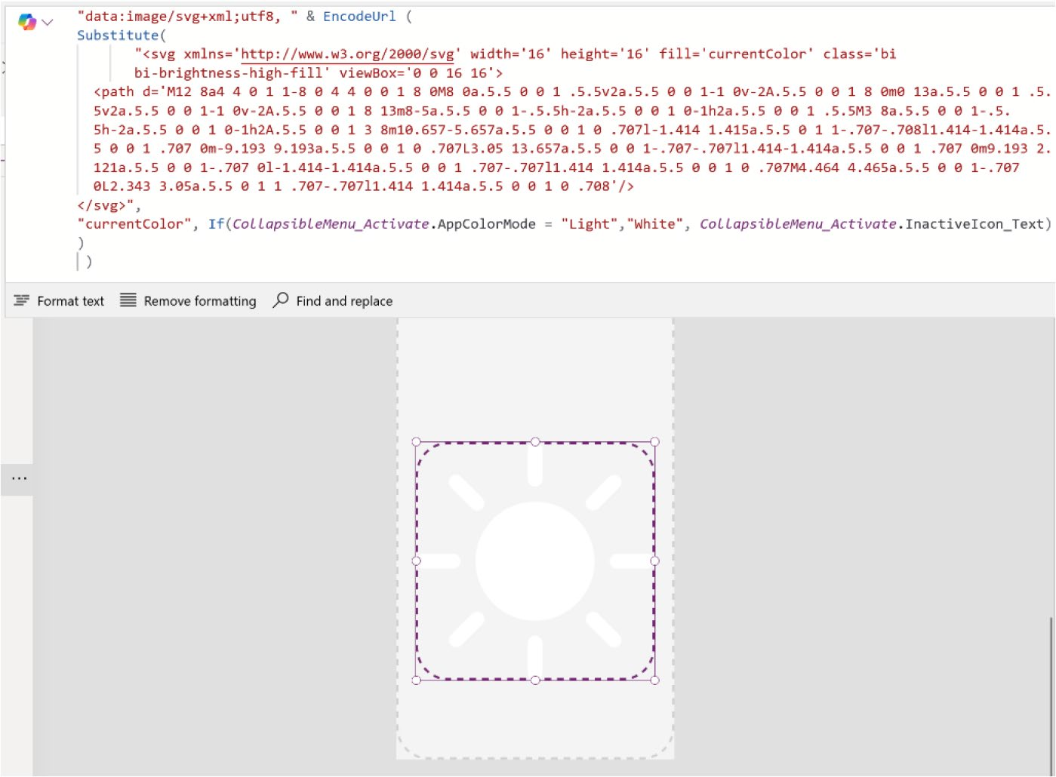

Figure 11-98. Formula code for changing the theme icon based on the application mode

Adjust the PaddingTop and PaddingBottom values from 0 to 8, to ensure that the icon is properly positioned within the frame.
10. Select SwitchContainer, choose its fill property
from the Formula bar, and add the following code:
If(
CollapsibleMenu_Activate.AppColorMode = "Light", CollapsibleMenu_Activate.InactiveIcon, RGBA(0,0,0,0)
)
Figure 11-99 displays the formula code used in the Fill property of SwitchContainer.

CHAPTER 11 REVOLUTIONIZING POWER APPS UI WITH MICROSOFT COPILOT:
A COMPLETE PROJECT
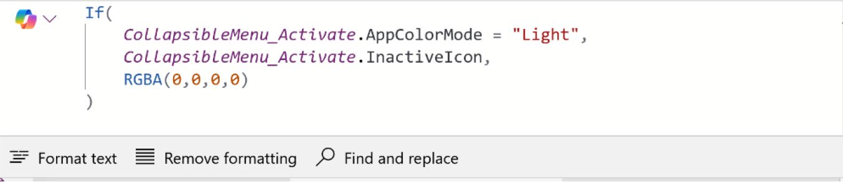

Figure 11-99. Code to change the color

11. After that, duplicate the SwitchContainer container
and rename it SwitchContainer_Dark.
12. Choose a moon icon from Bootstrap and paste
the HTML code inside the Image property of the SwitchContainer_Dark container, as shown in
Figures 11-100 and 11-101.
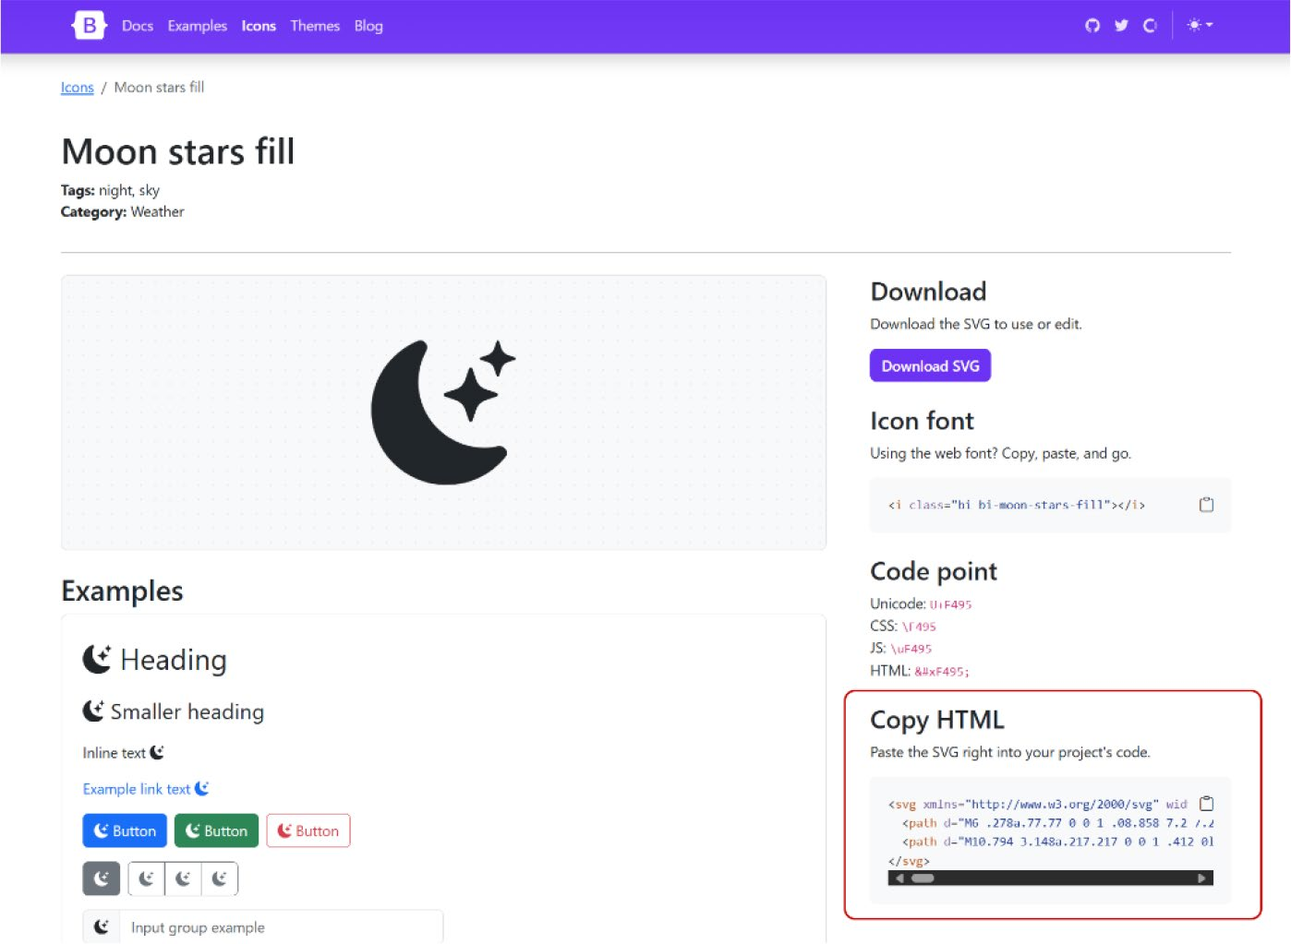

Figure 11-100. Choosing the night theme icon from Bootstrap

CHAPTER 11 REVOLUTIONIZING POWER APPS UI WITH MICROSOFT COPILOT:
A COMPLETE PROJECT
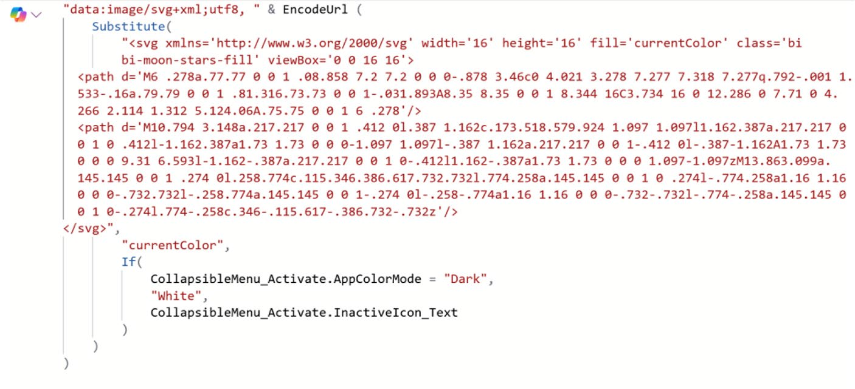

Figure 11-101. Formula code to add the moon SVG icon

You can copy the code from here as well:
"data:image/svg+xml;utf8, " & EncodeUrl (
Substitute(
"<svg xmlns='http://www.w3.org/2000/svg' width='16' height='16' fill='currentColor' class='bi bi-moon-stars-fill' viewBox='0 0 16 16'>
<path d='M6 .278a.77.77 0 0 1 .08.858 7.2 7.2 0 0 0-.878 3.46c0 4.021 3.278 7.277 7.318 7.277q.792-.001 1.533-.16a.79.79 0 0 1 .81.316.73.73 0 0 1-.031.893A8.35 8.35 0 0 1 8.344 16C3.734 16 0 12.286 0 7.71 0 4.266 2.114 1.312 5.124.06A.75.75 0 0 1 6 .278'/>
<path d='M10.794 3.148a.217.217 0 0 1 .412 0l.387 1.162c.173.518.579.924 1.097 1.097l1.162.387a.217.217 0 0 1 0 .412l-1.162.387a1.73 1.73 0 0 0-1.097 1.097l-.387 1.162a.217.217 0 0 1-.412 0l-.3811-1.162A1.73 1.73 0 0 0 9.31 6.593l-1.162-

CHAPTER 11 REVOLUTIONIZING POWER APPS UI WITH MICROSOFT COPILOT:
A COMPLETE PROJECT
.387a.217.217 0 0 1 0-.412l1.162-.387a1.73 1.73 0 0 0 1.0911-1.097zM13.863.099a.145.145 0 0 1 .274 0l.258.774c.115.346.386.617.732.732l.774 .258a.145.145 0 0 1 0 .274l-.774.258a1.16 1.16 0 0 0-.732.732l-.258.774a.145.145 0 0 1-.274 0l-.258-.774a1.16 1.16 0 0 0-.732-.732l-.774-.258a.145.145 0 0 1 0-.274l.774-.258c.346-.115.6111-.386.732-.732z'/>
</svg>",
"currentColor",
If(
CollapsibleMenu_Activate.AppColorMode = "Dark",
"White",
CollapsibleMenu_Activate.InactiveIcon_Text
)
)
)
This code changes AppColorMode to "Dark" because it is now implementing the dark theme.
13. Select the SwitchContainer_Dark container and
in the Fill property, add the following code. Make sure the AppColorMode is set to "Dark", as shown in
Figure 11-102.
If(
CollapsibleMenu_Activate.AppColorMode = "Dark", CollapsibleMenu_Activate.InactiveIcon, RGBA(0,0,0,0)
)

CHAPTER 11 REVOLUTIONIZING POWER APPS UI WITH MICROSOFT COPILOT:
A COMPLETE PROJECT
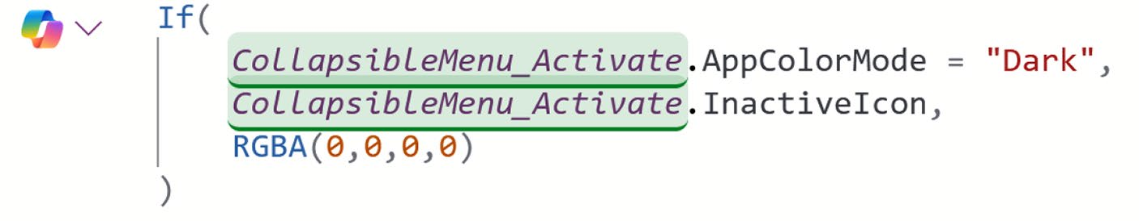

Figure 11-102. Formula code to activate the dark color theme

14. Now you need to create a toggle that will auto-
align when the menu is expanded. To do that, select the AppThemeSwitcher container (which is also called the responsive container), choose the LayoutDirection property from the Formula bar, and add the following code:
If(
CollapsibleMenu_Activate.MenuExpanded, LayoutDirection.Horizontal,
LayoutDirection.Vertical
)
This code will sets the layout to horizontal if the menu is expanded or make it vertical if it is not expanded.
Figure 11-103 shows the code of the LayoutDirection property of the AppThemeSwitcher container.

CHAPTER 11 REVOLUTIONIZING POWER APPS UI WITH MICROSOFT COPILOT:
A COMPLETE PROJECT
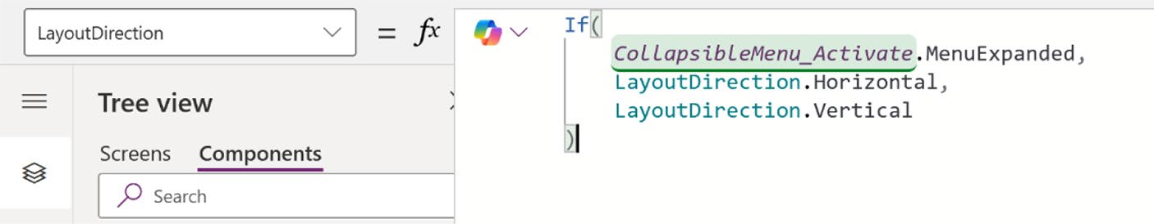

Figure 11-103. Formula code of the LayoutDirection property of the
AppThemeSwitcher container

15. Now, fixing the height and width of the
AppThemeSwitcher container. To do this, set the width using this code in the Formula bar:
If(
Self.LayoutDirection = LayoutDirection.Horizontal, 60,
30
)
This code evaluates the orientation of a container and adjusts its dimensions accordingly. If the container’s direction is horizontal, the width is set to 60, while the height is set to 30. Conversely, if the container is not horizontal, the width is set to 30 and the height to 60. This ensures that the container maintains appropriate proportions regardless of its orientation. Set the height with the following formula from the Formula bar.
If(
Self.LayoutDirection = LayoutDirection.Horizontal,
30,
60
)

CHAPTER 11 REVOLUTIONIZING POWER APPS UI WITH MICROSOFT COPILOT:
A COMPLETE PROJECT
16. Once this is done, set the toggle container, which
is named AppThemeSwitcherContainer to take its width and height from the inner responsive container. Select the AppThemeSwitcherContainer container, choose the width from the Formula bar and add the following code:
AppThemeSwitcher.Width
Here, AppThemeSwitcher is the inner responsive container under AppThemeSwitcherContainer.
Also, set the height using the following
formula code:
AppThemeSwitcher.Height
17. Let’s add a border now. Select the
AppThemeSwitcherContainer container and set the following parameters to design the border.
Border Thickness = 2
Border Color = CollapsibleMenu_Activate.InactiveIcon Border Radius = 20
Figure 11-104 shows the preview after changing the parameters.
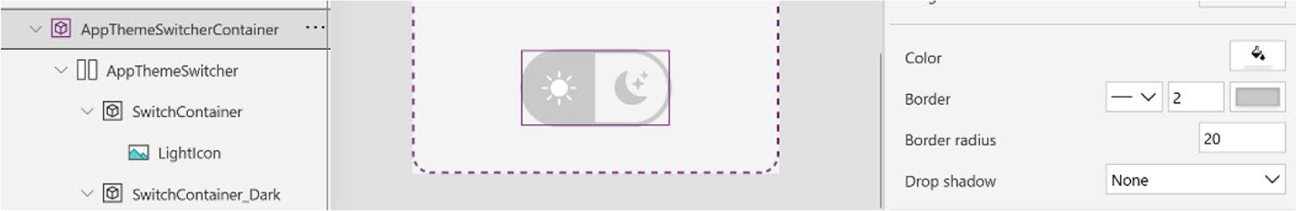

Figure 11-104. AppThemeSwitcherContainer preview after changing the parameters

CHAPTER 11 REVOLUTIONIZING POWER APPS UI WITH MICROSOFT COPILOT:
A COMPLETE PROJECT
18. Now set the Border Radius property for
SwitchContainer and SwitchContainer_ Dark to 20, matching the changes in the
AppThemeSwitcherContainer. Figure 11-105 shows the preview of the toggle icon.
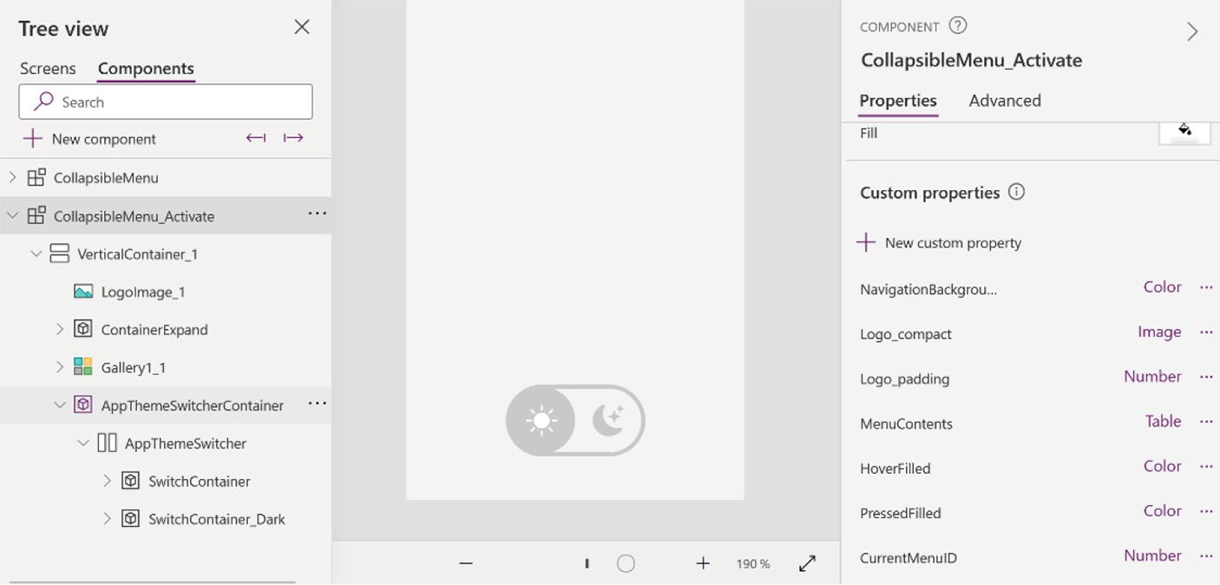

Figure 11-105. Preview after changing the border radius in
SwitchContainer and SwitchContainer_Dark

19. Now add a button inside
AppThemeSwitcherContainer to ensure that the entire container is clickable. I renamed it AppThemeSwitcherButton. Change the following parameters of the button:
Text = ""
X = 0
Y = 0
Width = Parent.Width Height = Parent.Height Fill = Color.Transparent

CHAPTER 11 REVOLUTIONIZING POWER APPS UI WITH MICROSOFT COPILOT:
A COMPLETE PROJECT
Border Style = None
Pressed Fill = CollapsibleMenu_Activate.PressedFilled Hover Fill = CollapsibleMenu_Activate.HoverFilled

Note CollapsibleMenu_Activate is the name of the
component. Check your component name and replace it if required.

20. The last step is to configure the button to
change the color or theme. To do this, select the AppThemeSwitcherButton, choose the OnSelect property from the Formula bar, and add the following code:
If(
varAppColorMode = "Light",
Set(
varAppColorMode,
"Dark"
),
Set (
varAppColorMode,
"Light"
)
);

This formula checks the value of the global variable varAppColorMode. If the value is Light, it sets the variable to Dark. If the value is Dark, it sets the variable to Light. The result is the last value assigned to the variable.

CHAPTER 11 REVOLUTIONIZING POWER APPS UI WITH MICROSOFT COPILOT:
A COMPLETE PROJECT
21. Turn on the Access App Scope feature from the
CollapsibleMenu_Active properties, as shown in
Figure 11-106.
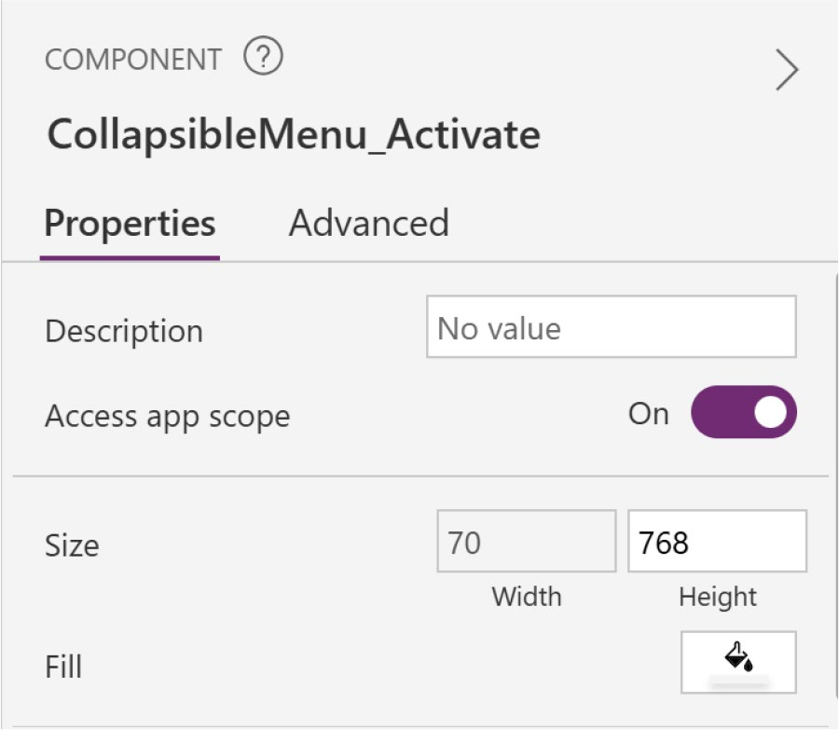

Figure 11-106. Turning on the Access App Feature of the
CollapsibleMenu_Activate component

With this setting turned on, your component can now access:
• Global variables
• Collections
• Controls and components on screens, such as a
TextInput control
• Tabular data sources, such as Dataverse tables

CHAPTER 11 REVOLUTIONIZING POWER APPS UI WITH MICROSOFT COPILOT:
A COMPLETE PROJECT
When this setting is turned Off, none of these are available to the component. The Set and Collect functions are still available, but the resulting variables and collections are scoped to the component instance and not shared with the app.
22. Go to the screen, select App, and choose the
formulas. Add the following code to the formulas:
PrimaryColor = If(varAppThemeMode = "Dark", RGBA(9,15,37,1), RGBA(255,255, 255,1));
PrimaryColor_Text = If(varAppThemeMode = "Dark", "RGBA(9,15,37,1)", "RGBA(255,255, 255,1)");
AccentColor = If(varAppThemeMode = "Dark", RGBA(254, 189, 47,1), RGBA(254, 189, 47, 1));
AccentColor_Text = If(varAppThemeMode = "Dark", "RGBA(254, 189, 47,1)", "RGBA(254, 189, 47, 1)");
TertiarColor = If(varAppThemeMode="Dark",RGBA(16,25,50, 1),RGBA(244,244,244,1));
TertiarColor_Text =If(varAppThemeMode="Dark","RGBA(16 ,25,50,1)","RGBA(244,244,244,1)");
PrimaryTextColor = If(varAppThemeMode="Dark",RGBA(247, 247, 247, 1),RGBA(37, 52, 100, 1));
PrimaryTextColor_Text = If(varAppThemeMode="Dark","RG BA(247, 247, 247, 1)","RGBA(37, 52, 100, 1)");
SecondaryTextColor = If(varAppThemeMode="Dark",RG BA(115, 131, 176, 1),RGBA(115, 131, 176, 1));

CHAPTER 11 REVOLUTIONIZING POWER APPS UI WITH MICROSOFT COPILOT:
A COMPLETE PROJECT
SecondaryTextColor_Text = If(varAppThemeMode="Dark", "RGBA(115, 131, 176, 1)" , "RGBA(115, 131, 176, 1)");
AccentTextColor = If(varAppThemeMode = "Dark", RGBA(22, 25, 39, 1), RGBA(22, 25, 39, 1));
AccentTextColor_Text = If(varAppThemeMode = "Dark", "RGBA(22, 25, 39, 1)", "RGBA(22, 25, 39, 1)");
HighlightColor = If(varAppThemeMode = "Dark", RGBA(23, 33, 69, 1), RGBA(215, 219, 230, 1));
HighlightColor_Text = If(varAppThemeMode = "Dark", "RGBA(23, 33, 69, 1)", "RGBA(215, 219, 230, 1)");
varHoverFilled=If(varAppThemeMode="Dark",RGBA(255,255, 255,0.1),RGBA(0,0,0,0.1));
varPressedFilled=If(varAppThemeMode="Dark",RGBA(255, 255,255,0.2),RGBA(0,0,0,0.2));

This color scheme is designed to automatically adjust the theme color when switching to light or dark mode.
Figure 11-107 shows the code in the App formulas.
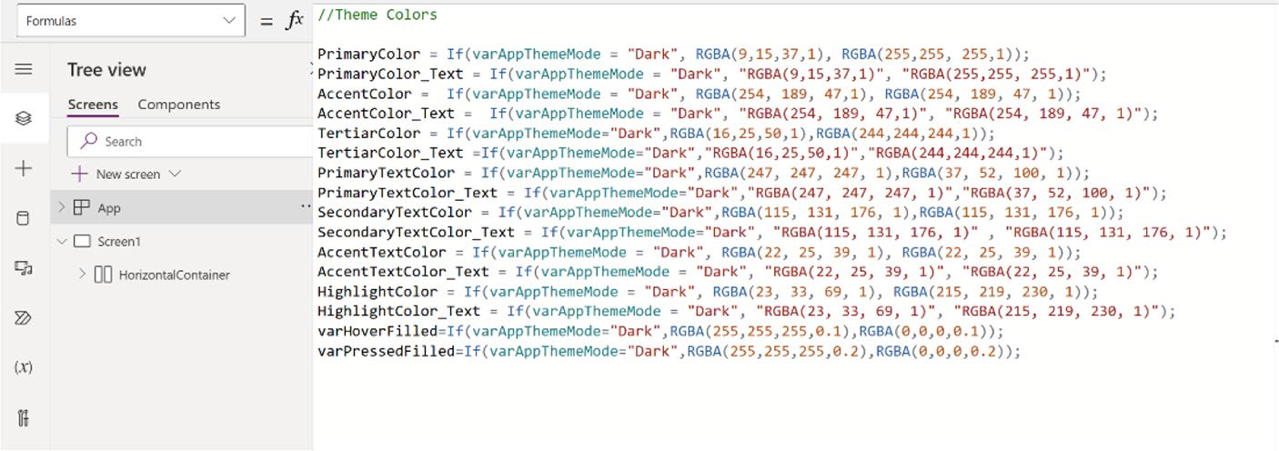

Figure 11-107. Theme color code in the App formulas

CHAPTER 11 REVOLUTIONIZING POWER APPS UI WITH MICROSOFT COPILOT:
A COMPLETE PROJECT
23. Now update the values of the custom properties
using the values specified in the theme color file that you previously created.
Select the specified custom properties and update their default values as follows:
NavigationBackground = TertiaryColor HoverFilled = varHoverFilled PressedFilled = varPressedFilled TextColor = PrimaryTextColor AppColorMode = varAppThemeMode
For example, choose the NavigationBackground custom property and add the value TertiaryColor,
as shown in Figure 11-108.
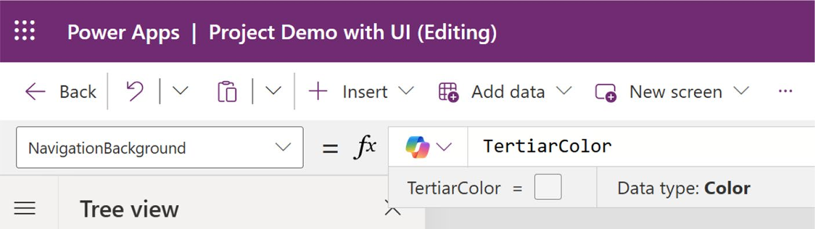

Figure 11-108. Changing the NavigationBackground default value with a color variable

CHAPTER 11 REVOLUTIONIZING POWER APPS UI WITH MICROSOFT COPILOT:
A COMPLETE PROJECT
24. Select the SelectedIconBG custom property and
apply the following formula code to adjust its color based on changes to the theme:
If(
varAppThemeMode = "Dark",
HighlightColor,
PrimaryColor
)
25. Go to the Media section and upload a white version
of your logo. This is necessary because in dark mode, a colored logo might become invisible.
26. Select the Logo_Expanded custom property and add
the following formula code:
If(
varAppThemeMode = "Dark",
'Full logo white',
'Full logo'
)

This code will determine if the theme is set to dark, in which case it will display the white logo. If the theme is not dark, the colored logo will be shown instead.
27. You are done! Figure 11-109 shows the difference
between the light and dark themes in compact and expanded menus.

CHAPTER 11 REVOLUTIONIZING POWER APPS UI WITH MICROSOFT COPILOT:
A COMPLETE PROJECT
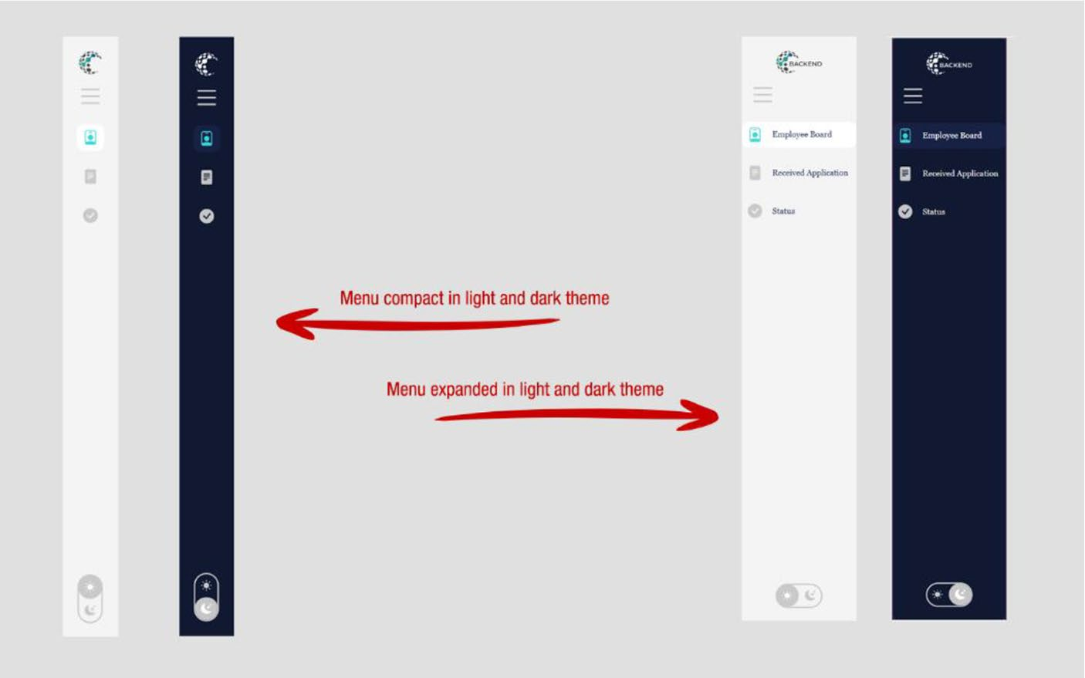

Figure 11-109. Menu preview in light and dark mode, also in compact and expanded mode

To activate the menu, just add this menu to the screen container.
Figure 11-60 shows how to add custom components in Power Apps.

Creating Complex UI Using Microsoft Copilot
You have reached the final part of this demo. This section demonstrates how to create a unique design interface using Copilot for Power Apps. To complete this demo, I use three websites for different purposes:
• Color Hunt (https://colorhunt.co/): To select an
appropriate color scheme.
• Microsoft Copilot Web (https://bing.com/chat): To
generate unique images for the application.
• ILoveImg (https://www.iloveimg.com/): To upscale
the images created with Microsoft Copilot.

CHAPTER 11 REVOLUTIONIZING POWER APPS UI WITH MICROSOFT COPILOT:
A COMPLETE PROJECT
There are many other free tools available online, so feel free to choose
your own alternatives. Follow these steps to get started:
1. Go back to your project. Open Color Hunt (https://
colorhunt.co/) and choose a color scheme. For this demo, I chose the color schema shown in
Figure 11-110.
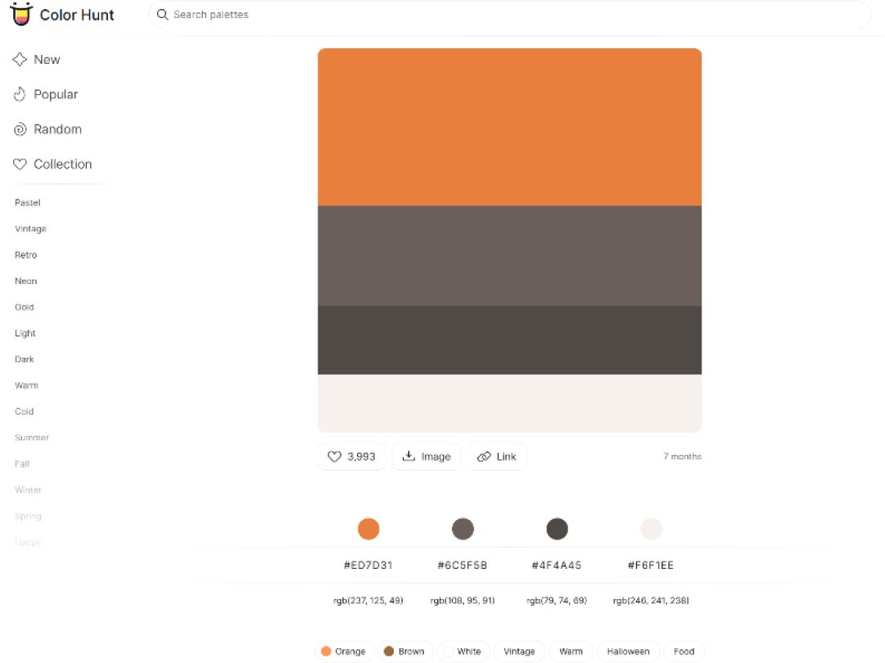

Figure 11-110. Choosing a color scheme for the Power Apps UI

2. As shown in Figure 11-110, both the color code and
the color name are crucial for providing commands in Copilot and for manual UI design in Power Apps. Use this Copilot prompt to design a clean, modern, and professional image to use in Power Apps:
Generate a professional, modern and clean image for an office management webapp mainly for desktop browser. The app color scheme should include white (rgb(246, 241, 238)) main color, Orange (rgb(237, 125, 49)) as

CHAPTER 11 REVOLUTIONIZING POWER APPS UI WITH MICROSOFT COPILOT:
A COMPLETE PROJECT
the primary color, brown (rgb(108, 95, 91)) as the supplementary color. The page should feature a welcome message and include 3 menu items. The menus should be clearly labeled and visually distinct. The design should be clean, user-friendly and professional. Do not generate any additional components. Do not add any text to the image.
3. Add this prompt to Microsoft Copilot Web
(https://bing.com/chat) and attempt to generate a suitable image. Note that the image you receive will not be the same as in the demo, as Copilot creates unique images each time. You may also need to modify the prompt according to your specific requirements. I chose the image from Copilot shown
in Figure 11-111.
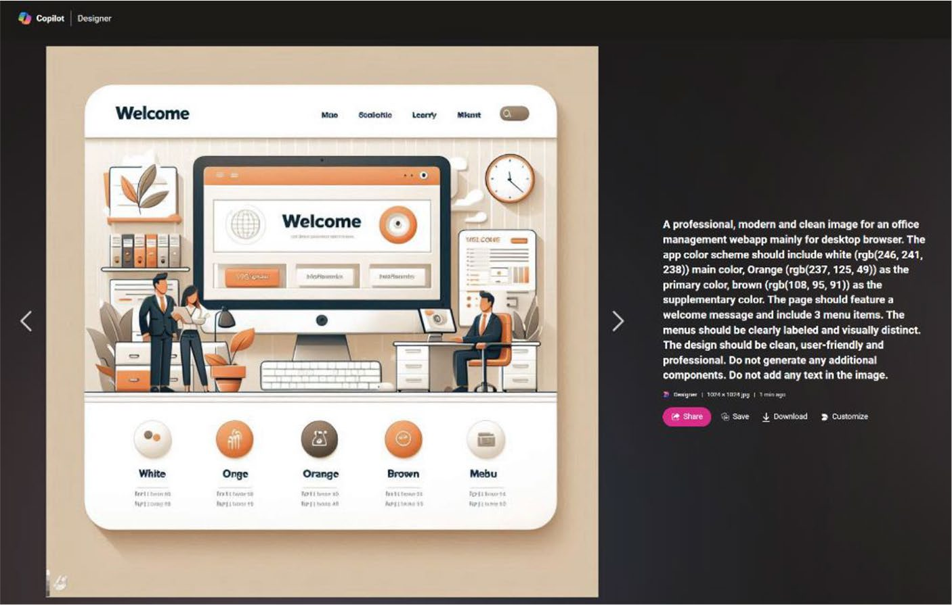

Figure 11-111. AI generated image by Microsoft Copilot

CHAPTER 11 REVOLUTIONIZING POWER APPS UI WITH MICROSOFT COPILOT:
A COMPLETE PROJECT
4. Super! Download the image and take a screenshot of
the banner part only, as shown in Figure 11-112.


Figure 11-112. Separate the banner image from the AI
generated image

5. After taking the screenshot, the quality of the image
has diminished. Therefore, you need to upscale the image to enhance its quality, ensuring it is suitable
for high-quality use. Open ILoveImg (https://www.
iloveimg.com/), select the Upscale option, and
upload the image, as shown in Figure 11-113.

CHAPTER 11 REVOLUTIONIZING POWER APPS UI WITH MICROSOFT COPILOT:
A COMPLETE PROJECT
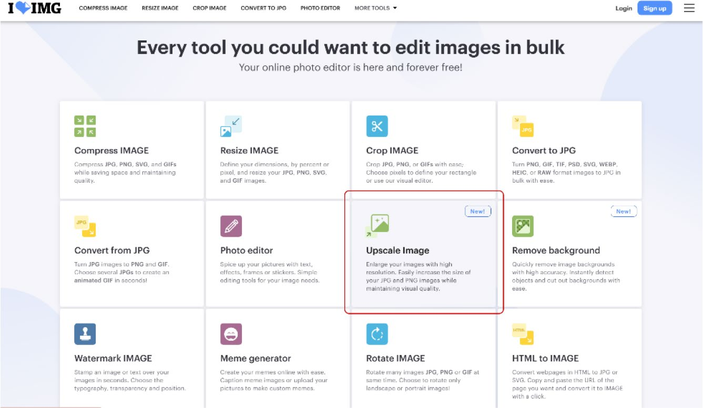

Figure 11-113. Upscale Image option in the ILoveImg tool

6. After uploading the image, you will notice that the
tool displays the upscale resolution, as shown in
Figure 11-114.

CHAPTER 11 REVOLUTIONIZING POWER APPS UI WITH MICROSOFT COPILOT:
A COMPLETE PROJECT
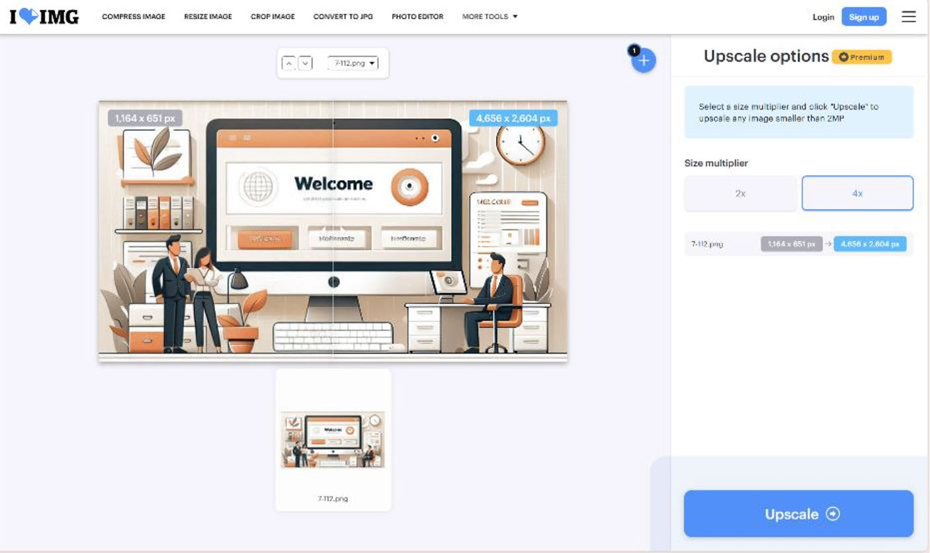

Figure 11-114. Upscaling image quality using the ILoveImg tool

7. Upscale the image and download it.
8. Go back to the project and add three more screens—
called EmployeeBoard, ReceivedApplication, and
Status—as shown in Figure 11-115.

CHAPTER 11 REVOLUTIONIZING POWER APPS UI WITH MICROSOFT COPILOT:
A COMPLETE PROJECT
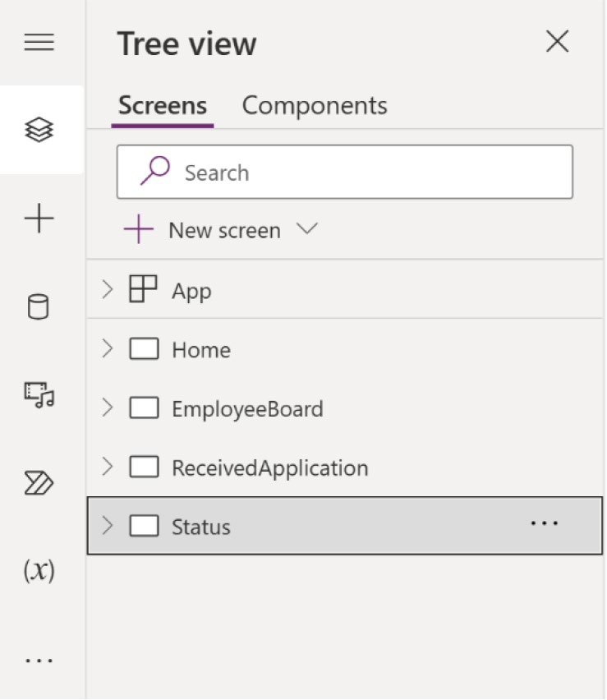

Figure 11-115. Creating three new screens in the Power Apps project

9. Compose the following prompt in Copilot to add
three more horizontal containers inside the vertical
container named Container10 (see Figure 11-116):
Add 3 containers in "Container10"

CHAPTER 11 REVOLUTIONIZING POWER APPS UI WITH MICROSOFT COPILOT:
A COMPLETE PROJECT
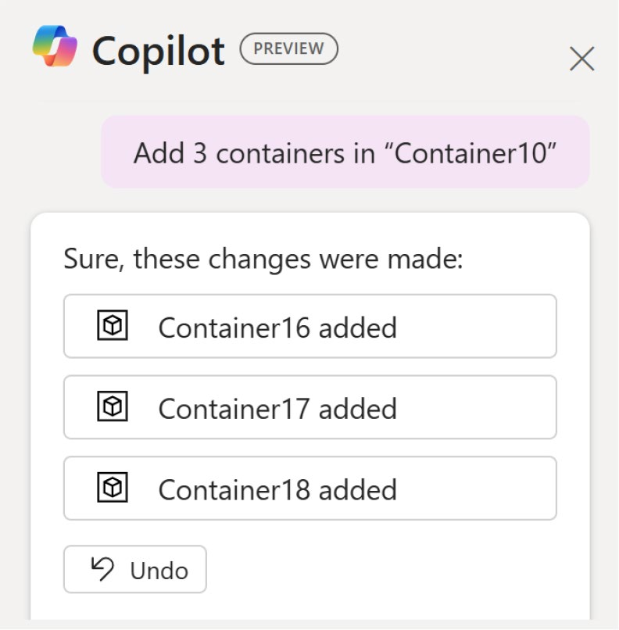

Figure 11-116. Copilot prompt to create new containers inside a
vertical container

10. Let’s configure the container first. Select the top
container, rename it HeaderContainer, and set the following parameters:
Flexible Height = Off Height = 100
11. Rename the middle container BodyContainer and
the bottom container FooterContainer. Select the three containers from the Tree View and change the Drop Shadow property to None, as shown in
Figure 11-117.

CHAPTER 11 REVOLUTIONIZING POWER APPS UI WITH MICROSOFT COPILOT:
A COMPLETE PROJECT
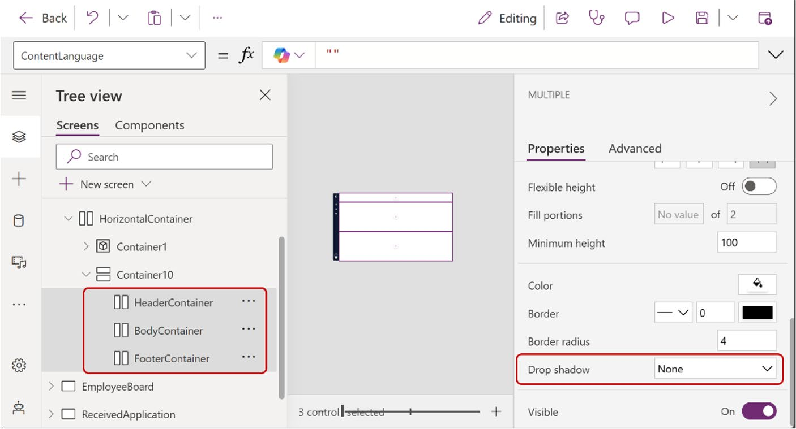

Figure 11-117. Renaming the container names and selecting None for the Drop Shadow option

12. Upload the downloaded upscaled image in the
Power Apps project.
13. Change the background color from
RGBA(246,255,255,1) to RGBA(246,241,238,1). This is the color that you got from Color Hunt. Refer
to Figure 11-110.
To change the color, select Apps from Tree View, and choose Formulas from the Formula bar. After that, change the values of PrimaryColor and PrimaryColor_Text. Only change the value of light
theme. Figure 11-118 shows the actual changes.

CHAPTER 11 REVOLUTIONIZING POWER APPS UI WITH MICROSOFT COPILOT:
A COMPLETE PROJECT
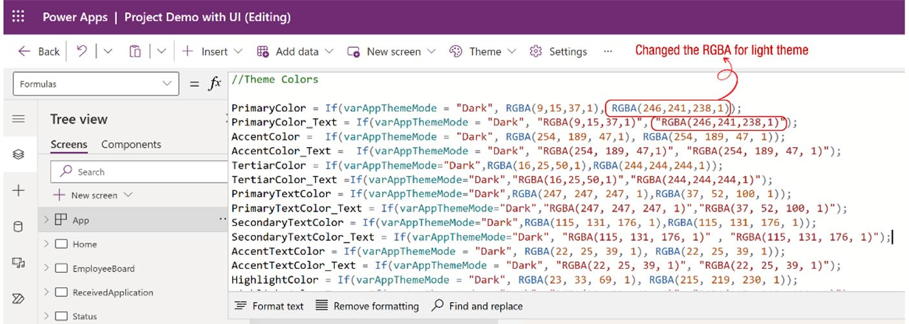

Figure 11-118. RGBA code to change the background color to the
new color code

After changing the background color to RGBA (246, 241, 238, 1), you can see that the background changes from White to Whitesmoke color.
14. Choose the HeaderContainer and add a new non-
responsive container. Inside the new container, add a new text label and set the following parameters from the Formula bar:
Text = "Welcome to Backend Office Management Application"
Font = Font.'Lato Black' FontWeight = FontWeight.Bold Size = 18
Height = Parent.Height Width = Parent.Width PaddingTop = 10
PaddingBottom = 10 PaddingLeft = 25
PaddingRight = 10
BorderStyle= BorderStyle.None PaddingRight = 10

CHAPTER 11 REVOLUTIONIZING POWER APPS UI WITH MICROSOFT COPILOT:
A COMPLETE PROJECT
Also, in the Color property, add the following
formula code, as shown in Figure 11-119.
If(
varAppThemeMode = "Dark",
AccentColor,
RGBA(237,125,49,1)
)
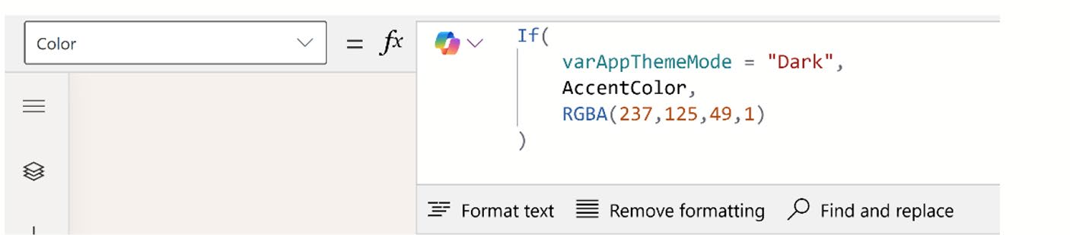

Figure 11-119. Adding formula code to the Color property of the text label

This code means that if dark mode is enabled, the text color will be AccentColor. Conversely, in light mode, the text color will be RGBA (237,125,49,1), which is the primary color from Color Hunt, as
shown in Figure 11-120.
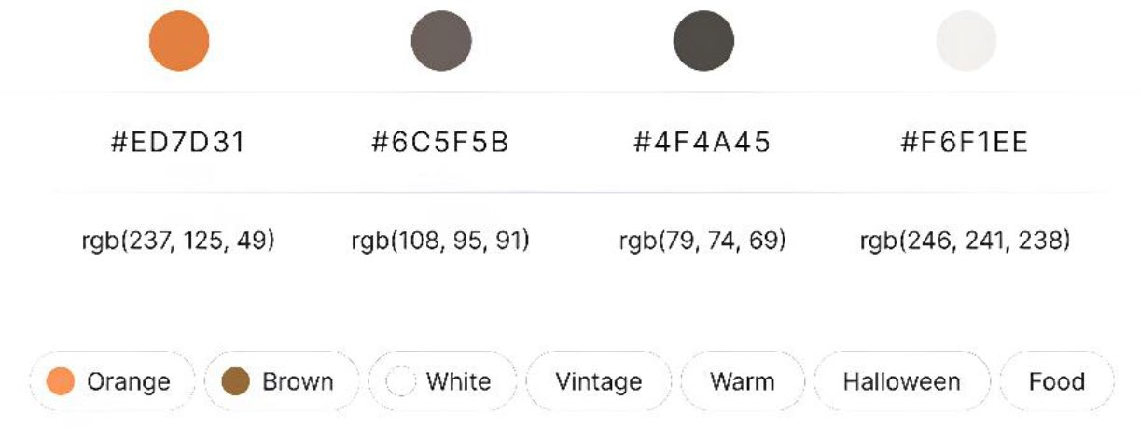

Figure 11-120. Color codes from Color Hunt

CHAPTER 11 REVOLUTIONIZING POWER APPS UI WITH MICROSOFT COPILOT:
A COMPLETE PROJECT
Press F5 or run the app to see the preview. You will
see something like Figure 11-121.
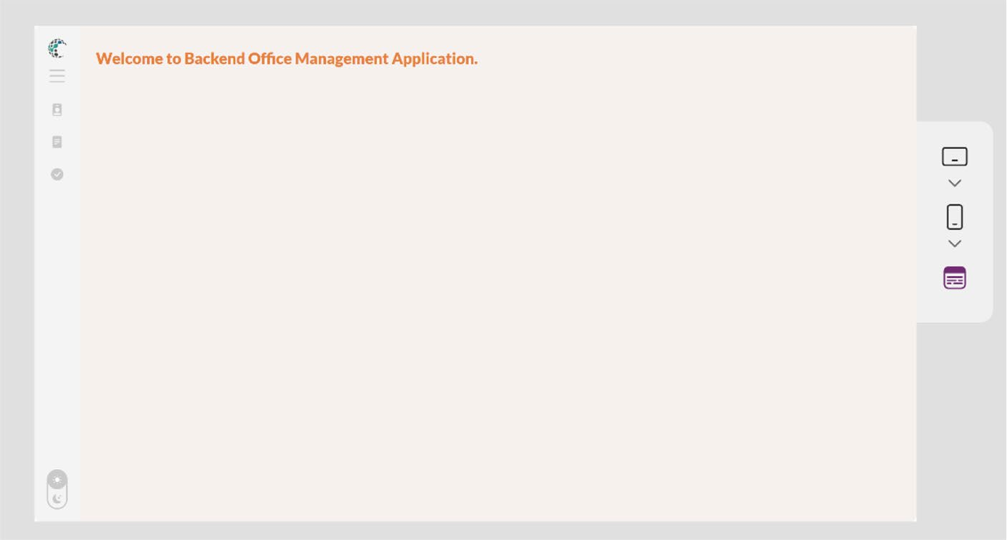

Figure 11-121. Preview of the text label and background after
changing the color

15. Select BodyContainer and add two more
containers called RightBodyContainer and
LeftBodyContainer, as shown in Figure 11-122.

CHAPTER 11 REVOLUTIONIZING POWER APPS UI WITH MICROSOFT COPILOT:
A COMPLETE PROJECT
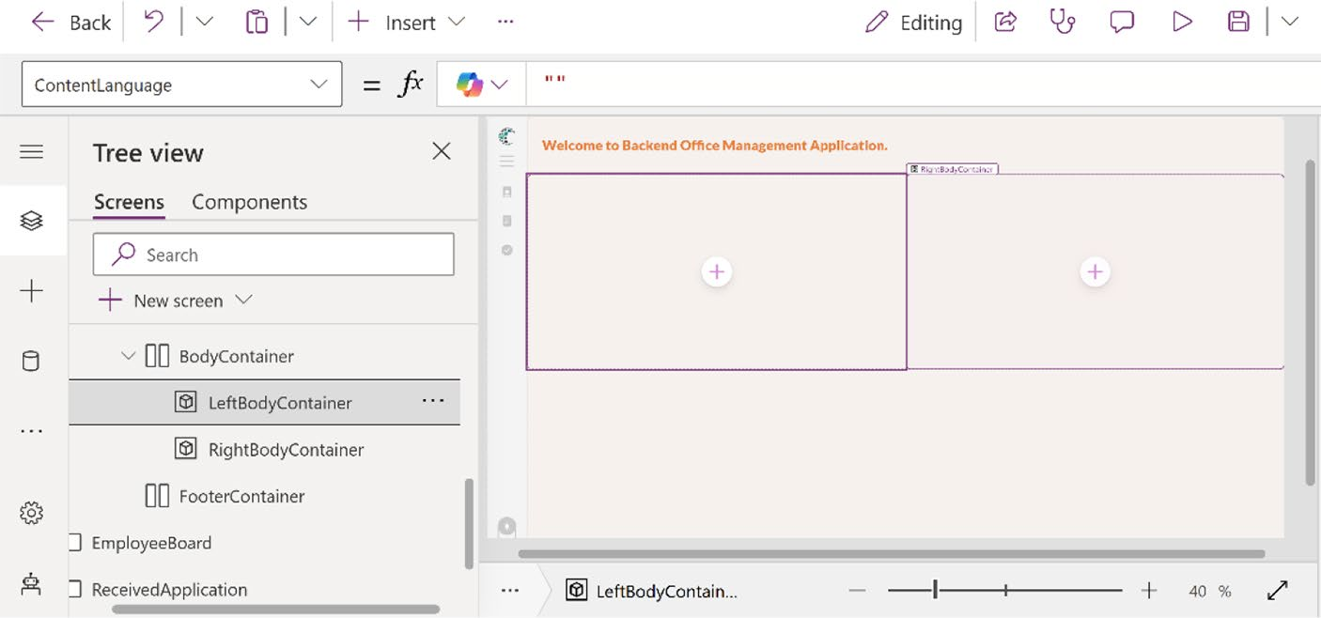

Figure 11-122. Adding two new non-responsive containers inside BodyContainer

Set the following parameters for both containers:
Border Radius = 0
Drop Shadow = None
16. In LeftBodyContainer, add a text label and a
button, as shown in Figure 11-123.

CHAPTER 11 REVOLUTIONIZING POWER APPS UI WITH MICROSOFT COPILOT:
A COMPLETE PROJECT
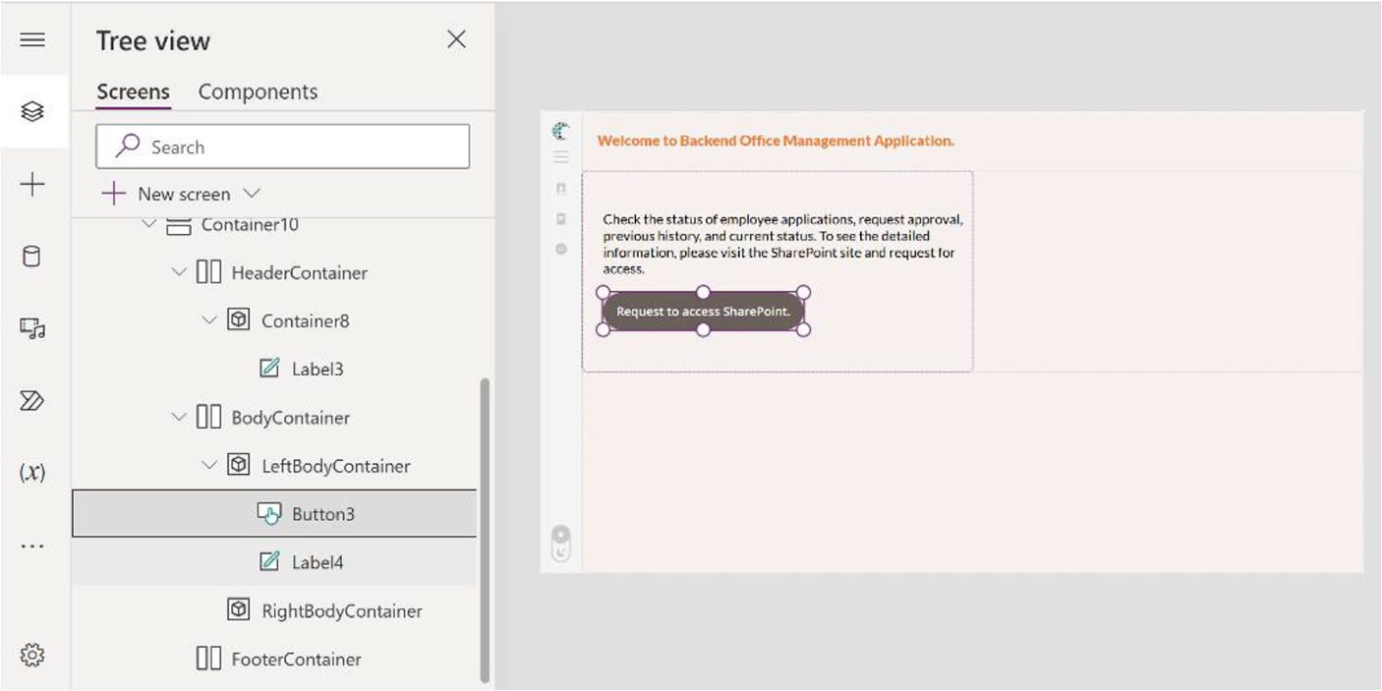

Figure 11-123. Adding a text label and button to LeftBodyContainer

Select the Text label, choose the color properties from the Formula bar, and add this code:
If(
varAppThemeMode = "Dark",
RGBA(255,255,255,1),
RGBA(79,74,69,1)
)
This means that when the theme switches to dark mode, the content or text will be white. Otherwise, it will be dark brown.
17. In RightBodyContainer, add a new image and set
the following properties from the Formula bar:
Image = 'UpscaleImage' Height = Parent.Height Width = Parent.Width

CHAPTER 11 REVOLUTIONIZING POWER APPS UI WITH MICROSOFT COPILOT:
A COMPLETE PROJECT
X = 0
Y = 0
PaddingLeft = 25
PaddingRight = 10
BorderStyle= BorderStyle.None PaddingRight = 10
Note that, in the Image property, I used UpscaleImage. This is the image that you upscale for your project. You can also use any other image if you want.
18. After changing these parameters, you will see
something like Figure 11-124.
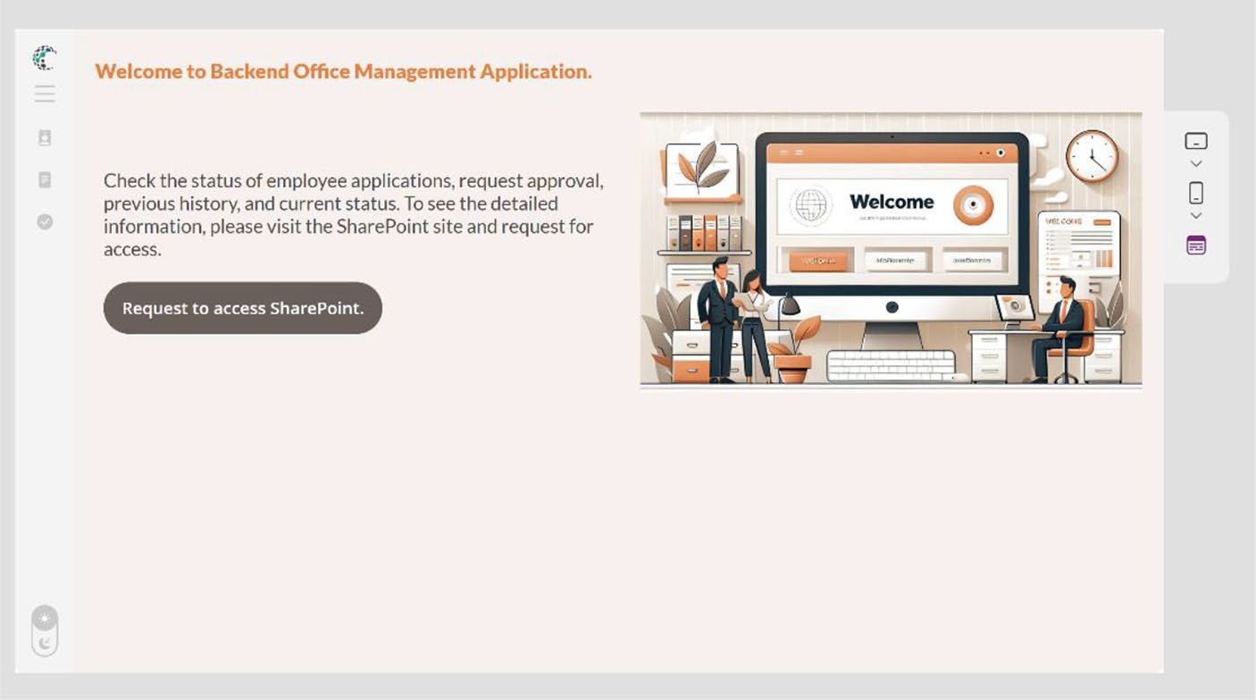

Figure 11-124. Adding an AI image that was generated by Microsoft Copilot

CHAPTER 11 REVOLUTIONIZING POWER APPS UI WITH MICROSOFT COPILOT:
A COMPLETE PROJECT
19. In FooterContainer, add a new container. Inside the
container, add a Copilot component and connect
your data source, as shown in Figure 11-125. As demonstrated in previous chapters, I have a ready data source. You can either use your existing data source or create a new one.
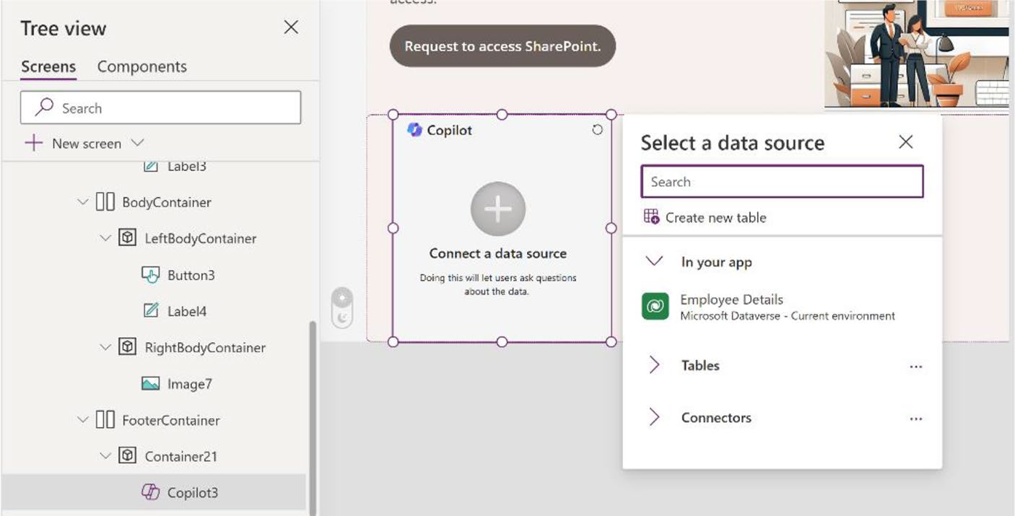

Figure 11-125. Adding a Copilot component and choosing a
data source

20. Set the following parameters of the Copilot
component:
Height = Parent.Height Width = Parent.Width X = 0
Y = 0

CHAPTER 11 REVOLUTIONIZING POWER APPS UI WITH MICROSOFT COPILOT:
A COMPLETE PROJECT
21. After you set these parameters, you will see the page
shown in Figure 11-126.
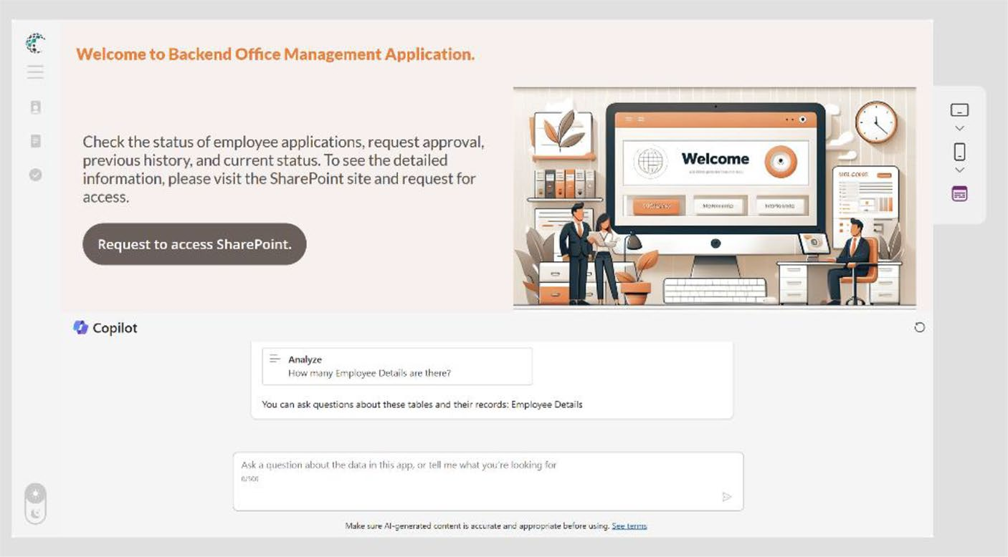

Figure 11-126. Preview after adding the Copilot component and setting its parameters

22. As you are now focusing on the UI, you can adjust
some parameters of FooterContainer. Set the top, bottom, left, and right padding to 20, as shown in
Figure 11-127.

CHAPTER 11 REVOLUTIONIZING POWER APPS UI WITH MICROSOFT COPILOT:
A COMPLETE PROJECT
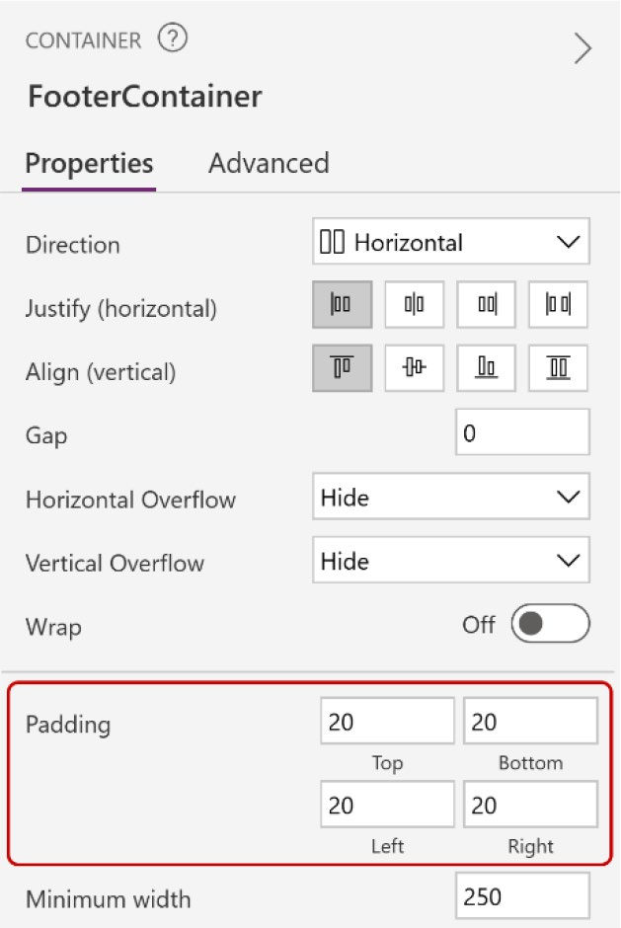

Figure 11-127. Adjusting the padding of FooterContainer

23. Press F5 or run the app to see the preview. You will
see something similar to Figure 11-128.

CHAPTER 11 REVOLUTIONIZING POWER APPS UI WITH MICROSOFT COPILOT:
A COMPLETE PROJECT
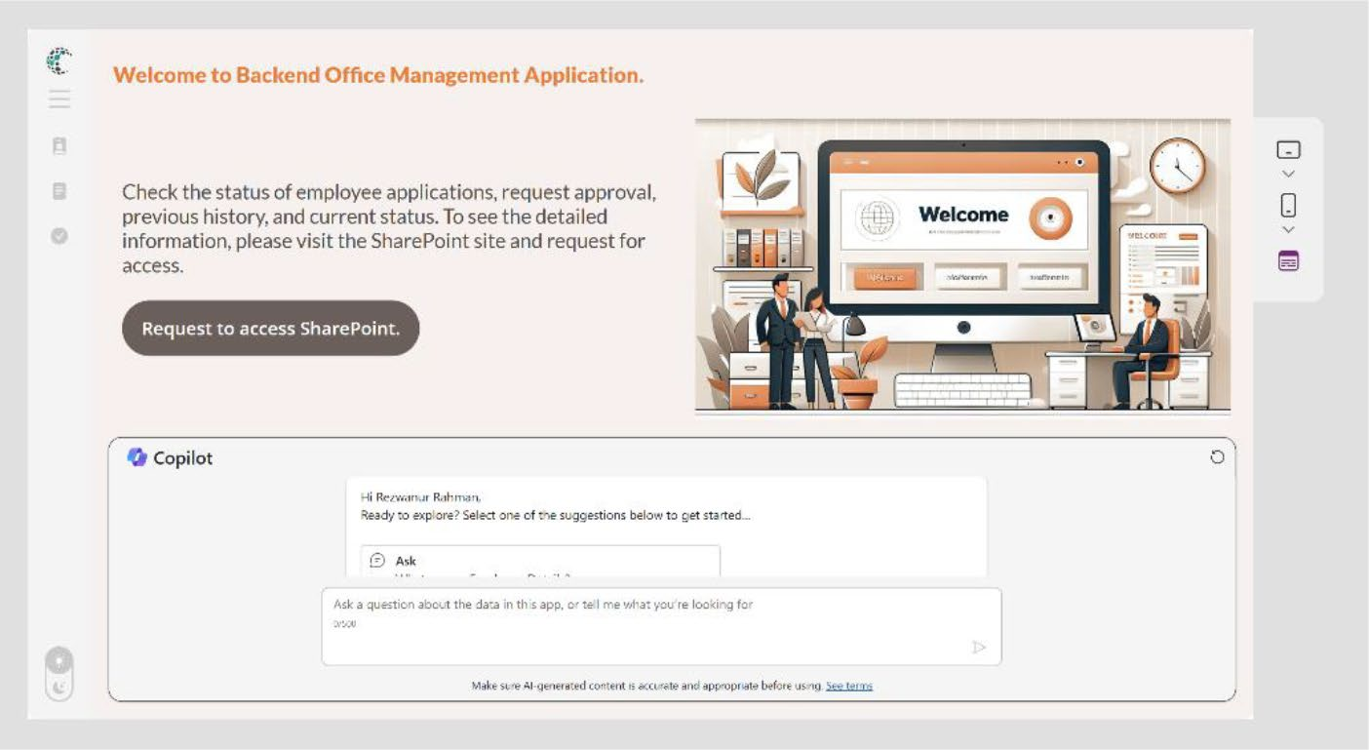

Figure 11-128. Preview of the homepage of the app after adding the Copilot component

If you switch to dark mode, you will see the dark
mode shown in Figure 11-129.
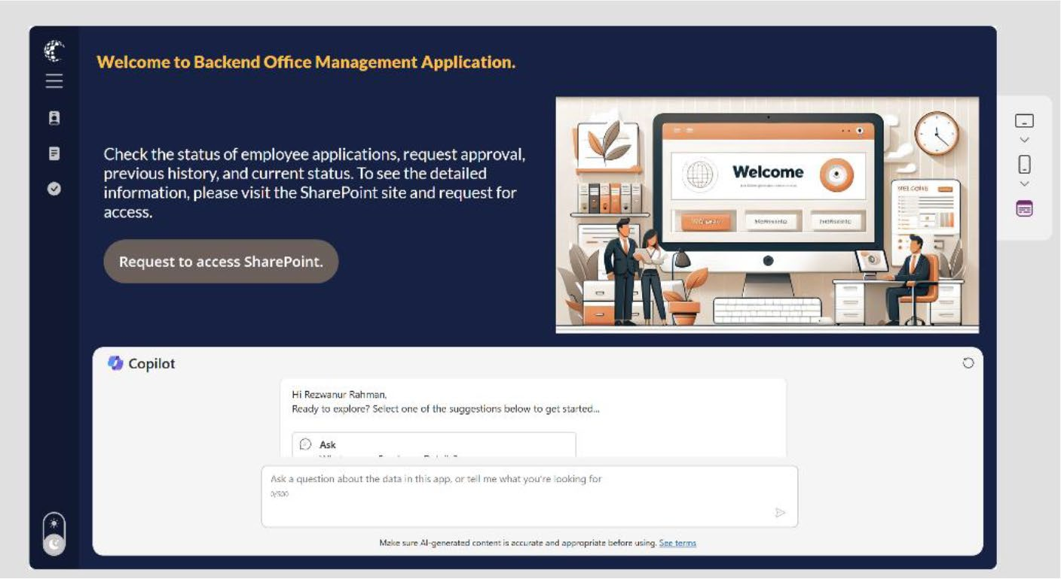

Figure 11-129. Preview of the dark mode

CHAPTER 11 REVOLUTIONIZING POWER APPS UI WITH MICROSOFT COPILOT:
A COMPLETE PROJECT
24. To the other pages (Employee Board, Received
Application, and Status), add your data source and set the color conditions explained in this demo.

Summary
This chapter demonstrated how to use Microsoft Copilot in Power Apps
to create a dynamic, modern UI with features like collapsible menus and
theme switching. It walked through the process step-by-step, using Power
Fx and Copilot to design an intuitive and visually appealing application,
enhancing both functionality and user experience.

Chapter 12 explores the future of Copilot and Power Apps, focusing on
the latest trends in app development. You’ll look at how AI, automation,
and new integration capabilities are set to revolutionize the way we build
and interact with applications. That chapter provides insights into the
innovations that will shape the future of app development.

CHAPTER 12

Visions of the Future:

Copilot’s Evolving

Landscape

The previous chapter explored the capabilities of Microsoft Copilot, and
you learned how to transform a standard Power Apps interface into a
modern, user-friendly design with advanced features like collapsible
menus and theme switching. This hands-on experience showcased how to
elevate an app’s usability and aesthetics using the latest tools.
This chapter shifts focus to the future of app development. It explores
the emerging trends that are set to redefine how applications are built
and used, with a particular emphasis on the evolving landscape of AI
integration, low-code platforms, and cross-platform development. This

chapter provides a forward-looking perspective on the innovations and
strategies that will drive the next wave of app development, preparing you
to stay ahead in this rapidly changing field.

© Rezwanur Rahman 2024 681
R. Rahman, Microsoft Copilot for Power Apps, Inside Copilot,

Chapter 12 Visions of the future: Copilot’s eVolVing landsCape

Trailblazing Trends: The Next Wave
in App Development
In the rapidly evolving landscape of app development, staying ahead of the curve is essential. Emerging trends are continuously reshaping how developers approach creating applications, offering new tools and technologies that promise to revolutionize the industry. From integrating cutting-edge artificial intelligence to embracing the power of blockchain, these innovations are setting the stage for the next wave of app development. This section explores the most promising trends that are poised to transform the way we build and interact with applications.

AI Integration
Artificial intelligence (AI) is increasingly becoming a cornerstone of modern app development. AI integration enables the creation of smarter, more intuitive applications that can understand and predict user needs. AI-driven features like natural language processing (NLP), machine learning (ML) algorithms, and personalized recommendations are transforming user experiences. For example, chatbots and virtual assistants, powered by AI, provide real-time customer support and automate repetitive tasks, improving efficiency and user satisfaction. Additionally, AI is enhancing app security through advanced threat detection and fraud prevention mechanisms.

Low-Code/No-Code Platforms
The rise of low-code and no-code platforms is democratizing app development, allowing users with minimal coding experience to build robust applications. These platforms offer drag-and-drop interfaces, pre- built templates, and easy-to-configure components, significantly reducing

Chapter 12 Visions of the future: Copilot’s eVolVing landsCape
development time and cost. Tools like Microsoft Power Apps enable
businesses to quickly create custom solutions without relying heavily on
traditional development resources. This trend is empowering more people
to participate in app development, fostering innovation, and addressing
specific business needs more efficiently.

Cross-Platform Development
Cross-platform development tools and frameworks are revolutionizing
how developers build applications, ensuring that they work seamlessly
across multiple devices and operating systems. Technologies like React
Native, Flutter, and Xamarin allow developers to write code once and
deploy it across platforms such as iOS, Android, and the web. This
approach not only saves time and resources but also ensures a consistent
user experience across different devices. As a result, businesses can reach
a broader audience with their applications while maintaining high-quality
performance and functionality.

Augmented Reality (AR) and Virtual Reality (VR)
Augmented Reality (AR) and Virtual Reality (VR) are no longer confined
to gaming and entertainment; they are now integral parts of various
app development projects. AR and VR technologies are enhancing user
experiences by providing immersive and interactive environments. For
instance, AR can be used in retail apps to allow customers to visualize
products in their real-world environment before making a purchase. VR is
being utilized in education and training apps to create realistic simulations
that enhance learning and skill development. As these technologies
continue to evolve, their application in app development will expand,
offering new possibilities for engagement and interaction.

Chapter 12 Visions of the future: Copilot’s eVolVing landsCape

Blockchain Technology
Blockchain technology is making a significant impact on app development, particularly in areas concerning security, data integrity, and decentralization. Blockchain’s decentralized nature ensures that data is stored securely across multiple nodes, reducing the risk of data breaches and fraud. This technology is being leveraged to create decentralized applications (dApps) that operate on peer-to-peer networks, thereby enhancing transparency and trust. In industries such as finance, supply chain, and healthcare, blockchain is revolutionizing how data is managed and shared, providing greater security and efficiency. By incorporating blockchain, developers can build apps that offer enhanced security features, fostering user confidence in data handling and transactions.

Upcoming Innovations in Copilot Technology
Digital productivity is set to experience a significant transformation with the upcoming innovations in Copilot technology. As artificial intelligence advances, Microsoft is introducing more sophisticated, intuitive, and efficient AI-driven features across its product suite. These enhancements aim to revolutionize user interactions with software, making tools smarter, more responsive, and seamlessly integrated into daily workflows. From intelligent assistance in note-taking and compliance management to personalized themes and advanced meeting preparation, the next wave of Copilot innovations promises to empower users with unprecedented levels of productivity and insight. The following sections discuss the detailed features, benefits, and release schedules of these exciting new developments.

Chapter 12 Visions of the future: Copilot’s eVolVing landsCape

Microsoft Copilot (Microsoft 365)
Microsoft Copilot is evolving to integrate advanced AI-driven features
across its suite of tools, significantly enhancing productivity and user
experience. From expanding Copilot’s capabilities with plugins to
providing graph-grounded insights in Excel, Copilot is set to revolutionize
how users interact with their data and workflows.

Plugins in Copilot
Users can now use plugins via copilot.microsoft.com to expand
Copilot skills. This feature integrates various plugins to extend Copilot’s
capabilities, increasing productivity and customization. It is currently in
development and is expected to be released in December CY2024. This
feature will be available on the web platform and is intended for worldwide
(standard multi-tenant) cloud instances.

Copilot in Excel: Graph Grounded Chat
You will be able to ask Copilot for answers grounded in your work
content from the Microsoft Graph—your chats, documents, meetings,
and emails—beyond your active Excel workbook. If you’re analyzing a
workbook and want to enhance your understanding using information
from another source in your tenant, just ask Copilot in Excel. This feature
provides contextual insights from across the Microsoft Graph, enhancing
data analysis and decision-making. It is currently in development and is
slated for release in August CY2024. This feature will be available on web,
desktop, and Mac platforms, and is intended for worldwide (standard
multi-tenant) cloud instances.

Chapter 12 Visions of the future: Copilot’s eVolVing landsCape

Usage Reports: Microsoft Copilot with Graph-Grounded Chat
Microsoft Copilot with graph-grounded chat usage metrics will be included in the Copilot for Microsoft 365 Usage report. This new feature provides additional usage insights and informs adoption strategy decisions for Microsoft Copilot in your organization. It offers detailed usage metrics to help organizations track Copilot adoption and optimize its use. Currently in development, it is expected to be released in September CY2024 with a preview in March CY2024. This feature will be available on the web platform and is intended for worldwide (standard multi-tenant) cloud instances.

Microsoft Viva
Microsoft Viva integrates Copilot’s AI capabilities to enhance employee experience and organizational productivity. With features designed to improve workplace satisfaction, track goals, and boost engagement, Viva is poised to transform how teams collaborate and grow.

Copilot in Viva Glint
This feature highlights top issues and potential solutions harnessing Copilot AI capabilities in Viva Glint. It helps managers and HR teams quickly identify and address employee concerns and improve workplace satisfaction. Currently in development, it is expected to be released in November CY2024 with a preview in June CY2024. This feature will be available on the web platform and is intended for worldwide (standard multi-tenant) cloud instances.

Chapter 12 Visions of the future: Copilot’s eVolVing landsCape

Viva Goals: M365 Chat Plugin
This feature empowers users to track goals and progress via a chat
plugin in Microsoft 365. It simplifies goal tracking and increases team
collaboration and accountability. Currently in development, it is expected
to be released in November CY2024 with a preview in August CY2024. This
feature will be available on the web platform and is intended for worldwide
(standard multi-tenant) cloud instances.

Copilot in Viva Engage
Experience the power of Copilot in Viva Engage, providing intelligent
insights and assistance. This feature enhances engagement and
collaboration with AI-driven insights. Currently in development, it is
expected to be released in October CY2024. This feature will be available
on the web platform and is intended for worldwide (standard multi-
tenant) cloud instances.

OneNote
OneNote integrates Copilot’s advanced AI to enhance creating and
managing notes, making it a more powerful tool for users on the go. With
intelligent suggestions and automated organization, OneNote on iPad is
set to elevate productivity.

Copilot Chat on OneNote for iPad
OneNote Copilot on iPad is your intelligent assistant for capturing and
structuring information. This feature enhances productivity by providing
intelligent suggestions and automated organization of notes. Currently
in development, it is expected to be released in December CY2024. This
feature will be available on the iOS platform and is intended for worldwide
(standard multi-tenant) cloud instances.

Chapter 12 Visions of the future: Copilot’s eVolVing landsCape

Outlook
Outlook is getting a productivity boost with Copilot’s AI-driven features, making it easier to prepare for meetings and personalize the email experience. These enhancements aim to streamline user workflows and improve efficiency.

Prepare for Meetings with Copilot in the New Outlook for Windows and Web
With so many people in back-to-back meetings, it can be a real struggle to stay on top of pre-reads, action items, and even what each meeting is about. Copilot can identify and summarize the key points so you can show up prepared in just a few minutes. When you have an upcoming meeting, Copilot proactively shows you a Prepare button in your inbox, which helps you quickly get context for the meeting by providing a summary of the meeting and showing and summarizing relevant files leveraging the power of the Microsoft Graph. This feature helps users prepare for meetings quickly by summarizing key points and relevant files, enhancing meeting productivity. Currently in development, it is expected to be released in July CY2024. This feature will be available on desktop and web platforms and is intended for worldwide (standard multi-tenant) cloud instances.

Outlook Themes Generated by Microsoft Copilot
Make Outlook yours with themes generated by Copilot. You will be able to find these themes in Settings. This feature personalizes the Outlook experience with AI-generated themes. Currently in development, it is expected to be released in July CY2024. This feature will be available on iOS and Android platforms and is intended for worldwide (standard multi- tenant) cloud instances.

Chapter 12 Visions of the future: Copilot’s eVolVing landsCape

Microsoft Purview
Microsoft Purview is enhancing its compliance capabilities with the
integration of AI, centralizing tools, and insights for a streamlined
approach to managing risks and regulatory requirements. This evolution
promises to improve efficiency and effectiveness in compliance
management.

AI Hub in Compliance Portal
The AI Hub in Microsoft Purview is a centralized location for all AI-driven
compliance tools and insights. This feature streamlines compliance
processes by leveraging AI to identify risks and ensure regulatory
adherence. Currently in development, it is expected to be released in
November CY2024 with a preview in May CY2024. This feature will be
available on the web platform and is intended for worldwide (standard
multi-tenant) cloud instances.
You can view the full Microsoft 365 Copilot roadmap and upcoming
innovations in Copilot technology using the following URL or the QR code
shown in Figure 12-1.
https://www.microsoft.com/en-us/microsoft-365/roadmap?filters=
Microsoft%20Copilot%20(Microsoft%20365)%2CIn%20development#
owRoadmapMainContent

Chapter 12 Visions of the future: Copilot’s eVolVing landsCape


Figure 12-1. Microsoft 365 Copilot roadmap QR code

Predicting Future Trends in Power
Apps Development
As we look to the future, Power Apps is poised to undergo significant advancements that will shape its development and usage in the years to come. Driven by the evolving needs of businesses and the rapid pace of technological innovation, Power Apps will continue to enhance its capabilities, offering more robust and versatile solutions for users. The following sections explore the key trends expected to influence the development of Power Apps, providing insights into how Microsoft plans to make the platform more powerful, user-friendly, and integrated with other services. By understanding these trends, organizations can better prepare to leverage Power Apps to its fullest potential.

Greater Customization
One of the most anticipated trends in the development of Power Apps is the push toward greater customization. As organizations seek to create apps that are more closely aligned with their unique workflows and

Chapter 12 Visions of the future: Copilot’s eVolVing landsCape
requirements, Microsoft is likely to enhance the customization capabilities
within Power Apps. This will include more advanced and user-friendly
tools for designing app interfaces, defining custom business logic, and
integrating with proprietary systems. Additionally, the introduction of
more flexible and granular control over app components will enable users
to tailor their applications to specific business needs, resulting in more
effective and efficient solutions.

Integration with Other Microsoft Services
Power Apps is expected to further integrate with other Microsoft services,
such as Office 365, Dynamics 365, Azure, and Microsoft Teams. This
deeper integration will facilitate a more seamless experience for users
who rely on multiple Microsoft products for their day-to-day operations.
For example, enhanced connectivity with Office 365 will allow for more
efficient data sharing and collaboration, while integration with Dynamics
365 will enable businesses to create custom applications that leverage
CRM and ERP data. As Power Apps continues to evolve, you can anticipate
more robust and intuitive integrations that streamline workflows and
improve productivity.

AI and Automation Features
The incorporation of AI and automation features into Power Apps is set to
revolutionize the way users create and manage applications. Microsoft is
likely to introduce more AI-driven tools that simplify the app development
process, such as intelligent app suggestions, automated workflows, and
predictive analytics. These features will not only make it easier for users
to build and maintain their apps but will also provide valuable insights
that can help optimize business processes. Furthermore, the use of AI for
tasks such as natural language processing, image recognition, and data
analysis will open new possibilities for creating innovative and intelligent
applications.

Chapter 12 Visions of the future: Copilot’s eVolVing landsCape

Expanded Template Libraries
As Power Apps gains popularity, the demand for pre-built templates that cater to various industries and use cases will continue to grow. Microsoft is expected to expand its library of templates, offering a wider variety of ready-to-use solutions that can be easily customized to meet specific business needs. These templates will cover a broad range of functions, from simple task management to complex enterprise solutions, and will help users get started quickly without the need for extensive development knowledge. The availability of more sophisticated and versatile templates will empower users to create high-quality applications with minimal effort.

Community Contributions
The Power Apps community of developers and users is rapidly growing, and their contributions are becoming increasingly significant. This vibrant community is expected to play a crucial role in shaping the future of Power Apps by sharing knowledge, best practices, and custom solutions. Community-driven content, such as custom connectors, components, and templates, will enrich the Power Apps ecosystem and provide users with a wealth of resources to draw from. Additionally, the collaborative nature of the community will foster innovation and encourage the development of new features and capabilities that address the evolving needs of users.

The Future of AI Builder and Power Apps:
What’s Next?
This section discusses the future updates of AI Builder and Power Apps, exploring the exciting innovations and enhancements on the horizon. As these tools continue to evolve, new features promise to revolutionize the way users build and deploy applications, making them more intelligent,

Chapter 12 Visions of the future: Copilot’s eVolVing landsCape
intuitive, and efficient. From advanced AI capabilities to seamless
integrations, these upcoming developments will empower users to create
smarter, more responsive solutions. The following sections explore the
specifics of what lies ahead for AI Builder and Power Apps.

AI Builder
AI Builder is a pivotal tool and is set to receive several exciting updates.
This section explores the future enhancements planned for AI Builder,
highlighting the features that will elevate its capabilities to new heights.
1. Admins can enable or disable extension credits
for AI Builder.
Admins now have enhanced control over credit extension requests in the Power Platform Admin Center, thanks to new tenant settings that allow them to specify who can request these extensions. They can choose separately whether admins or makers are permitted to request credit extensions, providing better oversight on how AI Builder credits are utilized. With this update, admins can configure the availability of the Request an Extension button for both makers and admins when an environment exceeds its allocated credits. Previously, this button was always available to both groups in their respective interfaces, regardless of the environment's status. This feature is available from September 2024 as part of the AI Builder 2024 release wave 1, enables administrators, makers, marketers, and analysts to manage credit consumption more effectively. It will be enabled automatically, ensuring seamless integration into existing workflows.

Chapter 12 Visions of the future: Copilot’s eVolVing landsCape
2. Admins can govern access to AI Builder models
through the Admin Center.
Admins now can control who has access to AI capabilities across their tenant, helping them comply with internal responsible AI requirements and potentially increasing AI Builder adoption. The AI Builder connector can be configured through the Power Platform Admin Center, allowing admins to manage access and usage of AI Builder models within their organization. This feature enables admins to turn access to specific AI models on or off across various environments, providing full control over the governance of AI capabilities powered by AI Builder. Available to both admins and makers, this update was revised on April 4, 2024, and is now generally available. Part of the AI Builder 2024 release wave 1, this feature is automatically enabled for administrators, makers, marketers, and business analysts, ensuring seamless implementation and enhanced governance over AI model usage.
3. Companies can monitor usage of AI Builder
models, including GPT outputs.
Companies can now monitor the usage
and performance of AI Builder models with preconfigured monitoring reports, facilitating the adoption of AI Builder in production scenarios. These reports allow users to track which AI Builder models are used, how frequently they are used, and their associated credit consumption. This enhanced tracking capability ensures more efficient deployment of AI Builder models in production

Chapter 12 Visions of the future: Copilot’s eVolVing landsCape
settings. By effectively managing the historical data generated by Power Automate flows, Power Apps, or other Microsoft Power Platform products, companies can maintain efficient and cost- effective Dataverse environments.
The AI Builder activity page provides a
comprehensive view of AI model activity, including usage in Power Apps and detailed tracking of inputs and outputs for GPT text generation models. Users can customize the data by applying filters for specific timeframes or models. This data is valuable for makers who want to monitor their AI models' usage and for environment admins who need to oversee all activity and credit consumption within an environment. Available to both admins and makers, this feature was last updated on April 17, 2024, and became generally available in September 2024 as part of the AI Builder 2024 release wave 1. It is automatically enabled for administrators, makers, marketers, and business analysts, ensuring seamless integration and enhanced monitoring capabilities.
4. Companies can try AI Builder capabilities in
developer environments before committing to AI.
If you created a developer environment using the Power Apps developer plan, you can utilize AI Builder, customize AI Builder models, and integrate them into your flows and apps. You receive 20,000 credits every month for use within your developer environment, offering a valuable opportunity to explore AI Builder's possibilities without immediate commitment.

Chapter 12 Visions of the future: Copilot’s eVolVing landsCape
Available to both admins and makers, this feature was last updated on May 9, 2024.
It entered public preview in September 2024. Part of the AI Builder 2024 release wave 1, this feature is automatically enabled for administrators, makers, marketers, and business analysts. This automatic enablement ensures users can seamlessly experiment with AI Builder's capabilities in a development setting, fostering innovation and experimentation.
5. Admins can use the new AI capacity management
experience.
Admins can now monitor the usage of AI Builder with preconfigured monitoring reports in the Power Platform Admin Center. This facilitates the setup of an AI center of excellence using AI Builder, providing greater tracking capabilities that allow organizations to deploy AI Builder models more easily in a production setting and more accurately forecast credit usage.
Utilizing the “Get insights into currency and storage consumption” release, preconfigured monitoring reports are available for admins to track where AI Builder models are used, how often they are used, and how many credits they consume. These reports provide admins with a comprehensive view of AI model usage across an organization.
Available to both admins and makers, this feature was last updated on April 4, 2024. It will enter public preview in March 2025. Part of the AI Builder 2024

Chapter 12 Visions of the future: Copilot’s eVolVing landsCape
release wave 2, this feature is automatically enabled for administrators, makers, marketers, and business analysts, ensuring seamless integration and enhanced monitoring capabilities.
6. Admins can define GPT output formats in JSON
with Prompt Builder.
Admins can now utilize the GPT Prompt Builder to structure information in specific formats, going beyond basic text processing. This feature allows makers to generate and test specific output formats directly within the Prompt Builder experience, enabling usage across multiple scenarios, including automation, and extending app behaviors where reliable data formatting is crucial. During the public preview, JSON formatting is the first supported output format. AI Builder prompts that generate JSON formatting are accessible from Power Automate and Power Apps, including PCF controls and custom Copilots.
Available to users, this feature was last updated on April 17, 2024, entered public preview in May 2024 and became generally available in September 2024 as part of the AI Builder 2024 release wave 1. This feature must be enabled or configured by administrators, makers, or business analysts to be available for their users, ensuring seamless integration and enhanced data formatting capabilities.

Chapter 12 Visions of the future: Copilot’s eVolVing landsCape
7. Users experience advanced settings and model
selection in Prompt Builder.
You gain several advantages by using GPT-4, including a larger context window, more current knowledge, and more capable reasoning. When you open Prompt Builder, you can adjust these settings, allowing you to achieve results that meet your expectations with fewer attempts using various prompts.
In Prompt Builder, you can choose your preferred LLM to associate with individual prompts. In this release, you can select either GPT-4 or GPT-3.5. Additionally, you can control the model temperature to customize the creativity of the output response. GPT-4 is more capable and has knowledge of world events up to April 2023. It offers a larger context window, fitting the equivalent of more than 300 pages of text in a single prompt. GPT-4 also performs better than previous models on tasks requiring careful instruction-following, such as generating specific formats like JSON.
Available to both admins and makers, this feature was last updated on April 17, 2024, entered public preview in May 2024 and became generally available in September 2024 as part of the AI Builder 2024 release wave 1. This feature is automatically enabled for administrators, makers, marketers, and business analysts, ensuring seamless integration and enhanced prompt customization capabilities.

Chapter 12 Visions of the future: Copilot’s eVolVing landsCape

Power Apps
This section explores the future enhancements planned for Power Apps,
highlighting the features that will elevate its capabilities to new heights.
These advancements aim to make app development more accessible
and powerful, enabling users to create applications with greater ease
and sophistication. From improved user interfaces to expanded data
integration options, the forthcoming updates promise to significantly
enhance the functionality and versatility of Power Apps.
1. Use Copilot easily in Canvas apps.
Copilot functionality is turned on by default in Canvas apps that connect to Microsoft Dataverse data, requiring no special configuration. This means that Copilot is available immediately to users, helping them better understand their data by answering questions. For instance, users can ask which employee has the highest sales or which warehouse is out of stock for a certain SKU. Copilot queries Dataverse tables to provide the answers.
Microsoft is expanding Copilot to more apps and users. Available to both admins and makers, this feature was last updated on March 27, 2024, and entered public preview in July 2024 as part of the Power Apps 2024 release wave 1. This feature is automatically enabled for administrators, makers, marketers, and business analysts, ensuring seamless integration and enhanced data querying capabilities.

Chapter 12 Visions of the future: Copilot’s eVolVing landsCape
2. Use the Power Platform Environment
Settings app.
The Power Platform Environment Settings app provides a modern, performant, accessible, secure, and extensible settings-management experience, offering a unified experience for application developers to create settings for their applications.
The Power Platform Environment Settings app replaces the legacy web client experience, delivering the same security, access control, and extensibility features. This release involves incremental rollouts, starting with the replacement of the settings application itself and followed by updates. Existing extensions created by customers to extend the settings sitemap will be preserved, and any solution imports that include extensions to settings will be routed to the new Power Platform Environment Settings app.
As part of the initial release, existing links for advanced settings in various Power Platform locations will be redirected from the legacy Settings web client to the new Power Platform Environment Settings app. Until this feature reaches general availability, tenant or environment administrators can turn off the advanced settings redirection to the new app by setting the Advanced Settings Redirection option to Off in the Power Platform Admin Center.

Chapter 12 Visions of the future: Copilot’s eVolVing landsCape
Available to both admins and makers, this feature was last updated on March 6, 2024, and entered public preview in September 2024, and is scheduled for general availability in January 2025. Part of the Power Apps 2024 release wave 1, this feature is automatically enabled for administrators, makers, marketers, and business analysts,
ensuring a seamless transition to a unified settings management experience.
Some of the functionality described in this release plan has not been released. Delivery timelines may change, and projected functionality may not be released.
3. Select columns downloaded to mobile devices.
You can now select the columns of tables that are downloaded on mobile devices for offline use. The fewer columns you select, the faster the app downloads the data on the device for usage without connectivity.
In the settings of your offline-enabled app in the maker portal, you can customize the offline profile for an optimized data-loading experience for your users. For each table, you can select the columns that are required in the app by either using the suggested columns computed by the system or by manually selecting the columns. On the main page for the offline profile, you can see how many columns are selected for download for each table.

Chapter 12 Visions of the future: Copilot’s eVolVing landsCape
Available to both admins and makers, this feature was last updated on January 25, 2024. It will enter public preview in January 2025, and is scheduled for general availability in April 2025. Part of the Power Apps 2024 release wave 1, this feature is automatically enabled for administrators, makers, marketers, and business analysts, ensuring a seamless and efficient offline data-loading experience.
4. Modernize maker experience security settings.
Makers can now use a modern and accessible security role editor while creating apps.
Makers can configure security role settings in Power Apps using a new Security Role editor. This feature includes a new panel called New Role, allowing makers to configure column security profiles.
Available to both admins and makers, this feature was last updated on March 25, 2024, entered public preview in May 28 2024, and became generally available from July 14, 2024. Part of the Power Apps 2024 release wave 1, this feature is automatically enabled for administrators, makers, marketers, and business analysts, ensuring a seamless and efficient security configuration experience.

Summary
This chapter explored the future of app development, focusing on how AI integration, low-code platforms, and cross-platform development are set to change how users build and use applications. I also highlighted the upcoming innovations in Microsoft Copilot and how these advancements can enhance productivity and user experiences.

Chapter 12 Visions of the future: Copilot’s eVolVing landsCape
The next chapter moves from discussing future trends to showcasing
real-world applications. It includes success stories of companies that
have effectively integrated Microsoft Copilot into their operations,
demonstrating how these AI-powered tools have improved efficiency,
streamlined workflows, and empowered teams to achieve greater success.

CHAPTER 13

Copilot Success

Stories: Lessons

from the Field

The previous chapter explored how emerging technologies like AI, low-
code platforms, and cross-platform development are set to reshape the
future of app creation. This chapter turns the spotlight on real-world
examples that demonstrate the impact of these innovations.
This chapter shares inspiring stories of organizations that have
successfully implemented Microsoft Copilot to enhance their operations.
Through these examples, you’ll see how AI-driven tools are not just
concepts of the future but are already driving significant improvements in
productivity, efficiency, and team empowerment.

Inspirational Stories of Success
This section explore the transformative experiences of several companies
that have significantly boosted their productivity, streamlined operations,
and strengthened their workforce capabilities by incorporating Microsoft
Copilot into their daily workflows. By integrating this powerful AI tool
into Microsoft products such as Power Platform and Microsoft Teams,

© Rezwanur Rahman 2024 705
R. Rahman, Microsoft Copilot for Power Apps, Inside Copilot,

Chapter 13 Copilot SuCCeSS StorieS: leSSonS from the field
these organizations have not only saved considerable time but also enhanced their operational efficiency. These detailed accounts explain how Microsoft Copilot has become an integral part of their success, enabling smarter decision-making and fostering a more empowered team environment.

KPMG: Harnessing the Power of AI-Driven Productivity with Microsoft 365 Copilot
The success narrative of KPMG’s integration of Microsoft 365 Copilot in the professional services industry exemplifies a journey marked by strategic innovation and thoughtful execution. KPMG, a leading global provider in professional services, embarked on an initiative to harness the capabilities of Microsoft 365 Copilot, aiming to enhance productivity, stimulate creativity, and adeptly manage the evolving workplace dynamics. This initiative extended beyond the simple adoption of new technology; it encompassed a comprehensive change-management strategy, ensuring the effective adoption and integration of Copilot into their existing modern workplace framework.
KPMG’s approach to implementing Microsoft 365 Copilot was meticulous and multifaceted. They focused on building a compelling business case by evaluating Return on Investment (ROI) and establishing key performance indicators (KPIs) to measure success. Through defining personas, assessing strategic value, and aligning deployment with business priorities, KPMG laid a solid foundation for the adoption of Copilot. The readiness and rollout phase involved assessing licensing needs, data governance, privacy, security, and configuring Copilot for seamless integration. Data governance emerged as a critical factor for the successful utilization of generative AI in the workplace. KPMG emphasized sound content management, permissions adherence, and data security to ensure

Chapter 13 Copilot SuCCeSS StorieS: leSSonS from the field
integrity and regulatory compliance. By optimizing search functionalities
and updating governance processes, KPMG established a robust data
governance framework to support the effective use of Microsoft 365
Copilot.
Additionally, KPMG expanded the functionality of Copilot by accessing
datasets, defining integration methods, and enhancing user experience.
This phase aimed to create a more customized Copilot integration that
addressed specific organizational needs and challenges, thereby unlocking
the full potential of Copilot. Change management played a pivotal role in
KPMG’s success story, with a focus on empowering users through training,
awareness of responsible AI use, and establishing a Copilot Center of
Excellence. By fostering an informed and engaged workforce, KPMG
ensured that employees could maximize the benefits of Microsoft 365
Copilot and drive innovation within the organization.
Ultimately, KPMG’s journey with Microsoft 365 Copilot exemplifies
a strategic and comprehensive approach to leveraging AI in professional
services. By combining technological innovation with robust change-
management practices, KPMG successfully navigated obstacles,
empowered its workforce, and embraced the future of work through the
transformative capabilities of Microsoft 365 Copilot.
To read the full story, visit https://customers.microsoft.com/en-us/
story/1749522406496386350-kpmg-microsoft-365-copilot-
professional-services-en-united-states or scan the QR code in
Figure 13-1.

Chapter 13 Copilot SuCCeSS StorieS: leSSonS from the field


Figure 13-1. Success story of KPMG after adopting Microsoft 365 Copilot

Nsure: Streamlining Insurance Operations and Enhancing Customer Experiences with the Power Platform
Nsure.com, a licensed digital insurance agency based in Florida, United States, enables people to buy home and auto insurance online across all 50 states. The company, founded in 2018, has been using Microsoft Power Platform to automate complex business processes since its early adoption of the platform. Between 2020 and 2023, Nsure’s revenue grew at a Compound Annual Growth Rate (CAGR) of over 100 percent.
Nsure.com matches customers with insurance carriers by comparing their requirements with a database of information from over 20 data sources and over 50 top-tier insurers across the nation. The company faced challenges as it quickly grew to nearly 1 million unique users of the platform. With the overwhelming human involvement required in customer contacts, Nsure.com had to deal with over 1 billion data points

Chapter 13 Copilot SuCCeSS StorieS: leSSonS from the field
for its customers, including information about their homes and vehicles.
Each month, around 100 customer representatives processed over 100,000
interactions with customers through calls, emails, and texts.
To address these challenges, Nsure.com leveraged Microsoft Power
Platform and generative AI to automate various business processes. Power
Automate was used to gather responses from multiple systems, which
were then consolidated and transformed using generative AI models into
specific formats that could be presented to customers and transferred to
other systems.
Generative AI was also used to analyze unstructured text from
insurance documents, extract key information, and determine the best
policy coverages for customers based on real-world data. Next-best actions
and email reply suggestions were automatically generated and combined
with other transactional data, activity data, and the communication history
of the customer.
As a result of these automations, Nsure’s customer service
representatives reduced their time on manual tasks by more than 60
percent, allowing them to focus on more valuable and meaningful tasks,
such as engaging with high-priority, complex escalations; building
customer relationships; and increasing satisfaction. Instead of processing
every contact, the team could oversee the communications started by AI
and make the final decisions.
By adopting Microsoft Power Platform and generative AI, Nsure.
com reduced manual processing time by over 60 percent and costs by
50 percent. The company plans to further optimize its operations by
eliminating mundane and repetitive tasks with generative AI and Copilot
capabilities, as well as having virtual assistants handle more than 90
percent of incoming requests for insurance quotes and policies.
To read the full story, visit https://powerautomate.microsoft.com/
en-us/blog/insurance-agency-nsure-com-leverages-microsoft-
power-platform-and-generative-ai-to-reduce-manual-processes-
by-60/ or scan the QR code in Figure 13-2.

Chapter 13 Copilot SuCCeSS StorieS: leSSonS from the field


Figure 13-2. Success story of Nsure.com

Hargreaves Lansdown: Revolutionizing Efficiency with Microsoft Copilot
Hargreaves Lansdown, a prominent financial services organization in the United Kingdom, has achieved remarkable success by integrating Microsoft Copilot for Microsoft 365 and Teams Premium into its operations. This strategic move aimed to enhance productivity and client service by empowering employees to excel in their strengths and rapidly acquire new skills. The outcome has been nothing short of impressive, with advisors expecting to complete client paperwork four times faster, employees saving two-three hours weekly, and an overwhelming 96 percent of employees finding Microsoft 365 Copilot helpful for daily tasks.
The seamless integration of Copilot has revolutionized the workflow at Hargreaves Lansdown. The company has experienced a significant reduction in the time spent searching through documents and emails. Copilot’s advanced AI capabilities swiftly grasp context and generate relevant input in minutes, streamlining information retrieval and simplifying daily tasks. This has enabled employees to focus on high-level, high-value work, allowing leaders to reimagine their business models and pursue once-impossible, bold opportunities.

Chapter 13 Copilot SuCCeSS StorieS: leSSonS from the field
The implementation of Copilot has also had a profound impact on
the company’s neurodivergent workers. The ability to record meetings
and listen to them later, or receive summaries of what they have missed,
has significantly reduced stress and made work more enjoyable for these
employees. This unexpected yet welcome benefit of technology has been a
testament to the inclusive nature of Microsoft Copilot.
Furthermore, the integration of Copilot has enabled Hargreaves
Lansdown to better support its employees in their roles. By providing
them with the tools to work more efficiently, the company has reduced
the administrative burden and allowed employees to focus on high-value
tasks. This has led to increased job satisfaction and a more positive work
environment.
In addition to the benefits for employees, Hargreaves Lansdown has
also seen improvements in client service. The time saved using Copilot
has allowed advisors to focus more on understanding client needs and
providing personalized solutions. This has resulted in higher client
satisfaction and stronger relationships with customers.
The adoption of Microsoft Copilot has also had a positive impact on
the company’s bottom line. By streamlining processes and increasing
efficiency, Hargreaves Lansdown has reduced costs and improved
profitability. This has enabled the company to invest in further innovation
and growth, positioning it for long-term success in the competitive
financial services industry.
In conclusion, the adoption of Microsoft Copilot has been a significant
success for Hargreaves Lansdown, enabling the company to work more
efficiently and effectively while improving the work experience for its
employees and enhancing client service. The integration of Copilot has
opened new possibilities for the company, allowing it to reimagine its
business models and pursue bold opportunities.
To read the full story, visit https://customers.microsoft.com/en-us/
story/17009442995316119513-hargreaves-lansdown-microsoft-365-
copilot-united-kingdom or scan the QR code in Figure 13-3.

Chapter 13 Copilot SuCCeSS StorieS: leSSonS from the field


Figure 13-3. Success story of Hargreaves Lansdown

PG&E: Transforming Operations with Microsoft Copilot and Teams
Pacific Gas & Electric (PG&E), a leading energy company in the United States, has achieved remarkable success by leveraging the power of Microsoft Copilot and Microsoft Teams. The company streamlined its operations, enhanced productivity, and drove significant cost savings through the adoption of these innovative technologies.
PG&E initially faced significant challenges in managing its help desk demands, which were consuming a substantial number of resources. The company was receiving a high volume of help desk requests, ranging from password resets to software troubleshooting, and its support team was struggling to keep up with the workload. This resulted in longer response times, frustrated employees, and increased costs for the company.
To address these challenges, PG&E decided to explore the potential of Microsoft Copilot. The company integrated Copilot with Microsoft Teams, its primary communication and collaboration platform, to create a seamless and efficient help desk solution.

Chapter 13 Copilot SuCCeSS StorieS: leSSonS from the field
By leveraging the natural language processing capabilities of Microsoft
Copilot, PG&E automated up to 40 percent of its help desk demands.
Employees could simply chat with Copilot in Microsoft Teams to request
assistance, and the virtual assistant would automatically triage the request,
provide relevant information, or escalate the issue to the appropriate
support team. This automation not only reduced the workload of the
support team but also provided employees with faster and more efficient
assistance.
The integration of Microsoft Copilot and Microsoft Teams has resulted
in significant cost savings for PG&E. The company estimates that it has
saved over $1 million annually by automating help desk demands and
reducing the need for manual intervention. These savings have allowed
PG&E to reallocate resources to more strategic initiatives and invest in
other areas of its business.
Moreover, the adoption of Microsoft Copilot and Microsoft Teams has
had a positive impact on employee experiences at PG&E. By providing
employees with efficient and user-friendly tools for their daily tasks, the
company has increased employee engagement and loyalty. The seamless
integration of Copilot and Teams has also improved collaboration among
teams, as employees can easily share information, work on projects
together, and stay connected regardless of their location.
PG&E’s success with Microsoft Copilot and Microsoft Teams
demonstrates the potential of these technologies to transform business
operations and drive significant cost savings. By automating repetitive
tasks, enhancing productivity, and improving employee experiences,
companies like PG&E can gain a competitive edge in their respective
industries. As more organizations recognize the benefits of AI-powered
solutions and collaborative platforms, the adoption of technologies like
Microsoft Copilot and Microsoft Teams is expected to continue growing in
the years to come.

Chapter 13 Copilot SuCCeSS StorieS: leSSonS from the field
To read the full story, visit https://customers.microsoft.com/en-us/
story/17095390496068998613-pacific-gas-and-electric-microsoft-
power-apps-energy-usa or scan the QR code in Figure 13-4.


Figure 13-4. Success story of PG&E

Air India: Elevating Airline Operations with Microsoft Copilot and Teams
Air India, a prominent airline in India, embarked on a journey to enhance its operational efficiency by leveraging the power of AI and Microsoft tools. The airline aimed to streamline its processes, improve communication, and reduce costs. To achieve this, Air India adopted Microsoft Copilot for Microsoft 365, integrating it with Microsoft Teams.
The airline began by implementing Microsoft Copilot, freeing up staff to focus on more strategic and creative work. This integration enabled Air India to optimize its travel and transportation operations, ensuring seamless coordination and communication among various teams. Microsoft Copilot’s AI capabilities helped the airline analyze and predict passenger demand, optimize flight schedules, and manage resources more effectively.

Chapter 13 Copilot SuCCeSS StorieS: leSSonS from the field
To facilitate this transformation, Air India adopted Microsoft Teams,
which allowed the airline to create dedicated channels for different teams,
ensuring that critical information and updates were accessible to the
right people at the right time. This enhanced collaboration and reduced
the time spent on manual tasks, allowing staff to focus on higher-value
activities.
The integration of Microsoft Copilot and Microsoft Teams enabled Air
India to achieve significant operational improvements. The airline reduced
manual errors, improved response times, and enhanced overall customer
satisfaction. By leveraging AI and Microsoft tools, Air India created a more
efficient and agile organization, better equipped to meet the evolving
needs of its passengers.
Overall, Air India’s adoption of Microsoft Copilot and Microsoft
Teams marked a significant milestone in its journey toward operational
excellence. By harnessing the power of AI and collaborative technology,
the airline streamlined its operations, improved communication, and
enhanced the overall passenger experience.
To read the full story, visit https://customers.microsoft.com/en-us/
story/17500595187858575413-airindia-microsoft-teams-travel-and-
transportation-en-india or scan the QR code in Figure 13-5.


Figure 13-5. Success story of Air India

Chapter 13 Copilot SuCCeSS StorieS: leSSonS from the field

Summary
This chapter explored real-world success stories where organizations have effectively implemented Microsoft Copilot to boost productivity, streamline operations, and empower their teams. These examples highlighted the transformative power of AI-driven tools across various industries, demonstrating their practical benefits in everyday business activities.
The next chapter shifts focus to provide you with essential resources that will support your ongoing journey with Microsoft Copilot and related technologies. You’ll find a detailed glossary, comprehensive learning materials, and access to vibrant online communities, all designed to deepen your knowledge and help you further explore and innovate with Microsoft Copilot, Power Apps, and AI-driven solutions.

CHAPTER 14

Comprehensive

Resources

In the previous chapter, you learned about organizations that successfully
leveraged Microsoft Copilot to transform their operations, demonstrating
the real-world impact of AI-driven tools. These stories provided practical
insights into how technology can enhance productivity, streamline
processes, and empower teams.
As you enter the final chapter of this book, the focus shifts from
examples of success to providing you with the resources needed to
continue your journey with Microsoft Copilot and related technologies.
This chapter offers a comprehensive glossary, curated learning materials,
and connections to active online communities. These resources are
designed to deepen your understanding and equip you with the tools
necessary to innovate and succeed in your own digital transformation
efforts.

The Copilot Lexicon: Glossary
and Key Definitions
This section presents a comprehensive glossary of key terms and
definitions crucial to understanding Microsoft Copilot, Power Apps,
Copilot Studio, and app development. This lexicon serves as a valuable

© Rezwanur Rahman 2024 717
R. Rahman, Microsoft Copilot for Power Apps, Inside Copilot,

Chapter 14 Comprehensive resourCes
reference for developers, business users, and anyone involved in creating and managing applications with these powerful tools. The following list of keywords provides detailed explanations to help you navigate the concepts, technologies, and functionalities that underpin these innovative platforms.
1. Adaptive Cards
• Definition: User interface components designed
to deliver content and inputs in a flexible,
adaptable way.
• Explanation: Adaptive Cards enable developers
to create responsive and dynamic layouts that automatically adjust to the content and container. They are used in applications like Microsoft Teams, Outlook, and Windows Timeline to create rich, interactive experiences.
2. AI Builder
• Definition: A feature in Microsoft Power Apps
that brings artificial intelligence capabilities to the platform.
• Explanation: AI Builder allows users to integrate
AI models into their apps without needing deep technical knowledge. It supports functionalities like form processing, object detection, and predictive analysis to enhance app capabilities.
3. AI-Driven Insights
• Definition: Insights generated by artificial
intelligence through data analysis and pattern recognition.

Chapter 14 Comprehensive resourCes
• Explanation: AI-driven insights help organizations
make informed decisions by analyzing large datasets to identify trends, anomalies, and patterns. This capability is crucial in fields like business intelligence and customer relationship management.
4. AI-Powered Code Generation
• Definition: The automatic creation of code by
artificial intelligence based on user input or predefined rules.
• Explanation: AI-powered code generation
simplifies the development process by allowing users to describe the functionality they need in natural language. The AI then translates these descriptions into working code, reducing development time and errors.
5. App Customization
• Definition: The process of modifying an
application to meet specific user needs or
preferences.
• Explanation: App customization involves
changing the user interface, adding new features, or integrating with other systems to tailor the app to specific business requirements. This ensures the application is more relevant and useful to its users.
6. App Development
• Definition: The process of creating software
applications for various platforms.

Chapter 14 Comprehensive resourCes
• Explanation: App development encompasses the
entire lifecycle of creating an application, from initial design and coding to testing, deployment, and maintenance. It involves a range of skills including programming, UI/UX design, and project management.
7. Application Lifecycle Management (ALM)
• Definition: The process of managing an
application’s lifecycle, from development to retirement.
• Explanation: ALM involves tracking and managing
the entire lifecycle of an application, including planning, development, testing, deployment, maintenance, and decommissioning. Effective ALM practices ensure software quality, reliability, and maintainability.
8. Azure
• Definition: Microsoft’s cloud computing platform
and service.
• Explanation: Azure provides a range of cloud
services, including computing, analytics, storage, and networking. It supports various programming languages, tools, and frameworks, making it a versatile platform for developing and deploying applications.
9. Azure Cognitive Services
• Definition: A suite of AI services and APIs to build
intelligent applications.

Chapter 14 Comprehensive resourCes
• Explanation: Azure Cognitive Services offer
capabilities such as natural language processing, computer vision, speech recognition, and
decision-making algorithms. These services enable developers to add AI features to their applications without extensive AI expertise.
10. Business Intelligence (BI)
• Definition: Technologies and strategies used
by enterprises for data analysis and business information.
• Explanation: BI involves collecting, processing,
and analyzing data to help organizations make better business decisions. BI tools provide insights through data visualization, reporting, and analytics, enhancing strategic planning and operational efficiency.
11. Business Process Automation
• Definition: The use of technology to perform
repetitive tasks or processes in a business.
• Explanation: Business process automation aims
to increase efficiency, reduce costs, and minimize errors by automating routine tasks. Tools like Power Automate can automate workflows, integrate applications, and handle data processing.
12. Chat Experiences
• Definition: Interactive conversational interfaces in
applications.

Chapter 14 Comprehensive resourCes
• Explanation: Chat experiences involve integrating
chatbots or live chat features into applications to facilitate user interaction. These interfaces can provide customer support, gather feedback, or assist with navigation and decision-making.
13. Chatbots
• Definition: AI-powered software designed to
simulate human conversation.
• Explanation: Chatbots can handle customer
inquiries, provide information, and automate tasks through text or voice interactions. They are used in customer service, marketing, and personal assistance applications to enhance user engagement and efficiency.
14. Citizen Developers
• Definition: Non-professional developers who
create applications using low-code/no-code platforms.
• Explanation: Citizen developers use tools like
Power Apps to build applications without deep programming knowledge. This democratizes app development, allowing business users to create solutions that address their specific needs and improve productivity.
15. Code Suggestions
• Definition: Recommendations provided by AI to
improve or complete code.

Chapter 14 Comprehensive resourCes
• Explanation: Code suggestions help developers by
offering snippets, optimizations, and best practices. These suggestions can speed up coding, reduce errors, and ensure adherence to coding standards.
16. Collaboration Tools
• Definition: Software applications that enable team
collaboration and communication.
• Explanation: Collaboration tools like Microsoft
Teams, Slack, and SharePoint facilitate teamwork by providing features for chat, video conferencing, file sharing, and project management. They help teams work together efficiently, regardless of location.
17. Connectors
• Definition: Integrations that allow applications
to communicate with external data sources or services.
• Explanation: Connectors enable apps to access
and interact with data from various systems like databases, web services, and other applications. Power Apps and Power Automate use connectors to integrate seamlessly with services like SharePoint, SQL Server, and Dynamics 365.
18. Continuous Deployment (CD)
• Definition: The practice of automatically deploying
code changes to production environments.

Chapter 14 Comprehensive resourCes
• Explanation: CD ensures that new features, bug
fixes, and updates are released quickly and reliably. It involves automated testing and deployment pipelines to streamline the delivery process and maintain application stability.
19. Continuous Integration (CI)
• Definition: The practice of frequently integrating
code changes into a shared repository.
• Explanation: CI involves automated testing
and builds to detect and fix issues early in the development cycle. This practice helps maintain code quality, reduces integration problems, and accelerates development.
20. Context IQ
• Definition: An AI feature that provides relevant
suggestions based on user context and data.
• Explanation: Context IQ enhances productivity by
understanding user actions and offering proactive suggestions, such as relevant files, contacts, or information. This feature leverages AI to streamline workflows and improve decision-making.
21. Copilot
• Definition: An AI-powered assistant integrated into
Microsoft products to aid users.
• Explanation: Copilot provides intelligent
assistance by understanding user commands, offering suggestions, and automating tasks. It enhances productivity in applications like Word, Excel, and Power Apps by leveraging AI capabilities.

Chapter 14 Comprehensive resourCes
22. Copilot AI Technology
• Definition: The underlying AI technology powering
the Copilot assistant.
• Explanation: This technology includes natural
language processing, machine learning, and predictive analytics. It enables Copilot to
understand user input, generate responses, and provide intelligent assistance across various applications.
23. Copilot Capabilities
• Definition: The range of features and functions
provided by Copilot.
• Explanation: Copilot’s capabilities include code
generation, data analysis, task automation, and personalized recommendations. These features help users perform complex tasks more efficiently and effectively.
24. Copilot Customization
• Definition: The ability to tailor Copilot’s
functionality to specific user needs.
• Explanation: Users can customize Copilot
by adding plugins, configuring settings, and integrating it with external data sources.
This ensures that Copilot meets the unique requirements of different users and applications.
25. Copilot Extensibility
• Definition: The ability to extend Copilot’s
functionality through plugins and integrations.

Chapter 14 Comprehensive resourCes
• Explanation: Extensibility allows developers to add
new features and capabilities to Copilot. This can include integrating third-party services, creating custom connectors, and enhancing Copilot’s AI models.
26. Copilot Features
• Definition: The specific tools and functionalities
offered by Copilot.
• Explanation: Copilot features include natural
language processing, predictive analytics,
intelligent design suggestions, and real-time collaboration. These tools enhance user
productivity and streamline workflows.
27. Copilot Framework
• Definition: The underlying structure that supports
Copilot’s functionality.
• Explanation: The Copilot framework includes APIs,
AI models, and integration points with Microsoft products. This framework enables seamless interaction between Copilot and various applications, ensuring consistent performance and reliability.
28. Copilot Integration
• Definition: The process of embedding Copilot into
Microsoft products and services.
• Explanation: Integration involves connecting
Copilot with applications like Power Apps, Word, and Excel to provide AI-driven assistance. This

Chapter 14 Comprehensive resourCes
enhances the functionality and user experience of these applications by leveraging Copilot’s capabilities.
29. Copilot Licensing
• Definition: The terms and conditions for using
Copilot within Microsoft products.
• Explanation: Licensing details the usage rights,
subscription plans, and limitations associated with Copilot. Understanding these terms ensures compliance and optimal use of Copilot’s features.
30. Copilot Plugins
• Definition: Add-ons that extend Copilot’s
functionality.
• Explanation: Plugins enable users to enhance
Copilot by adding new features, integrating with external services, and customizing its behavior. This extensibility makes Copilot more versatile and adaptable to different use cases.
31. Copilot Revolution
• Definition: The transformative impact of Copilot
on software development and productivity.
• Explanation: The Copilot revolution refers to the
significant changes brought about by integrating AI into development and productivity tools. It democratizes software development, enabling more people to create applications and solutions with minimal coding knowledge.

Chapter 14 Comprehensive resourCes
32. Copilot Service
• Definition: The AI-powered service provided by
Microsoft as part of its product suite.
• Explanation: The Copilot service includes AI
capabilities like natural language processing, predictive analytics, and intelligent assistance. It is designed to enhance productivity and streamline workflows across Microsoft applications.
33. Copilot Studio
• Definition: A platform for developing and
managing Copilot extensions and customizations.
• Explanation: Copilot Studio provides tools and
resources for developers to create plugins, integrate with external data sources, and customize Copilot’s functionality. It supports the development and deployment of tailored AI solutions.
34. Copilot Suggestions
• Definition: Recommendations provided by Copilot
to assist users.
• Explanation: Copilot offers suggestions based
on user input, context, and data analysis. These suggestions can include code snippets, design improvements, and workflow optimizations to enhance productivity and decision-making.
35. Custom Connectors
• Definition: User-defined integrations that enable
applications to communicate with external data sources.

Chapter 14 Comprehensive resourCes
• Explanation: Custom connectors allow developers
to integrate their applications with specific services or data sources not supported by default connectors. This expands the functionality and interoperability of applications like Power Apps and Power Automate.
36. Data Governance
• Definition: The management of data availability,
usability, integrity, and security in an enterprise.
• Explanation: Data governance involves policies,
procedures, and standards to ensure data is managed effectively throughout its lifecycle. It aims to maintain data quality, compliance, and security across the organization.
37. Data Integration
• Definition: The process of combining data from
different sources into a unified view.
• Explanation: Data integration involves
consolidating data from various databases, systems, and applications to provide a comprehensive and accurate view. This is essential for analytics, reporting, and decision-making.
38. Data Management
• Definition: The practice of organizing and
maintaining data processes to meet an
organization’s information needs.

Chapter 14 Comprehensive resourCes
• Explanation: Data management includes data
storage, retrieval, security, and governance. Effective data management ensures that data is accurate, accessible, and secure, supporting business operations and analytics.
39. Data Security
• Definition: The protection of data from
unauthorized access, corruption, or theft.
• Explanation: Data security involves implementing
measures like encryption, access controls, and audits to protect sensitive information. It ensures data confidentiality, integrity, and availability.
40. Data Visualization
• Definition: The graphical representation of data to
facilitate understanding and insights.
• Explanation: Data visualization involves using
charts, graphs, and other visual tools to present data in a way that is easy to understand and interpret. It helps users identify trends, patterns, and outliers in their data.
41. Dataverse
• Definition: A scalable data platform used
in Microsoft Power Platform to store and
manage data.
• Explanation: Dataverse provides a secure and
compliant data storage solution with built-in support for business logic, data relationships, and

Chapter 14 Comprehensive resourCes
workflows. It integrates seamlessly with Power Apps, Power Automate, and other Microsoft services.
42. Debugging
• Definition: The process of identifying and fixing
errors or bugs in software code.
• Explanation: Debugging involves using tools
and techniques to detect, diagnose, and correct issues in an application. This process is critical for ensuring software quality and functionality.
43. Development Environment
• Definition: The set of tools and resources used for
software development.
• Explanation: A development environment includes
code editors, compilers, debuggers, and other tools that support the development, testing, and deployment of applications. It provides a controlled setting for writing and managing code.
44. Digital Transformation
• Definition: The integration of digital technology
into all areas of a business to improve operations and value delivery.
• Explanation: Digital transformation involves
leveraging technologies like AI, cloud computing, and IoT to enhance business processes, customer experiences, and business models. It aims to increase efficiency, agility, and innovation.

Chapter 14 Comprehensive resourCes
45. Dynamics 365
• Definition: A suite of intelligent business
applications offered by Microsoft.
• Explanation: Dynamics 365 includes applications
for customer relationship management (CRM) and enterprise resource planning (ERP). It helps organizations manage their business operations, customer interactions, and data insights.
46. Enhancing App Quality
• Definition: Improving the performance, reliability,
and user experience of an application.
• Explanation: Enhancing app quality involves
implementing best practices, optimizing code, and conducting thorough testing. It ensures that the application meets user needs and performs well under various conditions.
47. Enterprise Solutions
• Definition: Comprehensive software applications
designed to support business operations and processes.
• Explanation: Enterprise solutions include ERP,
CRM, and other systems that integrate various business functions. They help organizations streamline operations, improve efficiency, and make data-driven decisions.
48. Extensibility Options
• Definition: Features that allow users to add new
functionality to existing applications.

Chapter 14 Comprehensive resourCes
• Explanation: Extensibility options enable
developers to customize and enhance applications by adding plugins, integrations, and custom code. This ensures that applications can evolve to meet changing business needs.
49. Graph API
• Definition: An API that provides access to
Microsoft cloud services and data.
• Explanation: The Microsoft Graph API enables
developers to interact with a wide range of Microsoft services, including Azure Active Directory, Office 365, and OneDrive. It allows for seamless integration and data access across the Microsoft ecosystem.
50. Graph Connectors
• Definition: Tools that connect external data
sources to Microsoft Graph.
• Explanation: Graph connectors enable users
to integrate data from third-party services and applications into the Microsoft ecosystem. This expands the capabilities of Microsoft 365 applications by providing access to additional data and insights.
51. Human Expertise
• Definition: The knowledge and skills possessed by
individuals.
• Explanation: Human expertise complements AI
by providing the critical thinking, creativity, and experience necessary for complex decision-making

Chapter 14 Comprehensive resourCes
and problem-solving. In software development, human expertise ensures that AI tools like Copilot are used effectively.
52. Interactive Dashboards
• Definition: Data visualization tools that allow users
to interact with and explore data.
• Explanation: Interactive dashboards provide
dynamic and responsive views of data, enabling users to filter, drill down, and analyze information in real-time. They are essential for business intelligence and data-driven decision-making.
53. Intelligent Assistance
• Definition: AI-driven support that helps users
perform tasks more efficiently.
• Explanation: Intelligent assistance involves using
AI to provide recommendations, automate tasks, and enhance user productivity. Examples include Copilot’s suggestions in applications like Word and Excel.
54. Licensing Needs
• Definition: The requirements for legally using
software and services.
• Explanation: Licensing needs detail the terms,
conditions, and costs associated with using software. Understanding these needs ensures compliance and optimal utilization of the software’s features.

Chapter 14 Comprehensive resourCes
55. Low-Code Development
• Definition: A development approach that
uses visual tools and minimal coding to create applications.
• Explanation: Low-code development platforms
like Power Apps enable users to build applications quickly and with less effort. This approach democratizes app development, allowing more people to create solutions without extensive programming knowledge.
56. Low-Code/No-Code Solutions
• Definition: Platforms that allow users to create
applications with minimal or no coding.
• Explanation: These solutions provide drag-
and- drop interfaces, pre-built templates, and integration tools to simplify app development. They enable business users to create and deploy applications quickly, addressing specific needs without relying on professional developers.
57. Machine Learning Algorithms
• Definition: Computational methods that enable
machines to learn from data.
• Explanation: Machine learning algorithms
analyze and model data to make predictions, identify patterns, and improve over time. They are fundamental to AI applications, including those used in Copilot for providing intelligent assistance.

Chapter 14 Comprehensive resourCes
58. Microsoft 365
• Definition: A suite of productivity and
collaboration tools offered by Microsoft.
• Explanation: Microsoft 365 includes applications
like Word, Excel, PowerPoint, Outlook, and Teams. It integrates with cloud services to provide a comprehensive solution for productivity, collaboration, and communication.
59. Microsoft Entra ID
• Definition: Microsoft’s identity and access
management service (previously known as Azure Active Directory).
• Explanation: Entra ID provides secure
authentication, single sign-on, and access
management for users and applications. It helps organizations manage identities, control access, and protect data across their IT environment.
60. Microsoft Flow
• Definition: A cloud-based service that allows users
to create automated workflows (now known as Power Automate).
• Explanation: Microsoft Flow enables users to
automate tasks and processes across various applications and services. It supports integration with Microsoft 365, Dynamics 365, and third- party applications, enhancing productivity and efficiency.

Chapter 14 Comprehensive resourCes
61. Microsoft Graph
• Definition: A unified API endpoint that provides
access to Microsoft services and data.
• Explanation: Microsoft Graph enables developers
to interact with a wide range of Microsoft services, including user profiles, emails, files, and activities. It supports the integration of data and functionality across the Microsoft ecosystem.
62. Mobile App Development
• Definition: The process of creating software
applications for mobile devices.
• Explanation: Mobile app development involves
designing, coding, testing, and deploying
applications for smartphones and tablets. It requires consideration of different operating systems, screen sizes, and user interactions.
63. Natural Language Processing (NLP)
• Definition: A branch of AI that focuses on the
interaction between computers and human language.
• Explanation: NLP involves the analysis and
generation of human language by machines. It enables applications to understand, interpret, and respond to text and speech, making interactions more intuitive and natural.

Chapter 14 Comprehensive resourCes
64. Natural Language Understanding (NLU)
• Definition: A subset of NLP focused on
understanding the meaning and context of human language.
• Explanation: NLU enables machines to
comprehend the intent and context behind user input. It is crucial for applications like chatbots and virtual assistants, where accurate interpretation of user queries is essential.
65. Office Productivity Software
• Definition: Software applications designed to
facilitate office tasks and workflows.
• Explanation: Office productivity software
includes tools like word processors, spreadsheets, presentation software, and email clients. These applications help users create, edit, manage, and share documents and communications efficiently.
66. Optimization
• Definition: The process of making something as
effective or functional as possible.
• Explanation: Optimization involves improving
performance, efficiency, and quality. In software development, this can include code optimization, resource management, and process improvements to enhance the overall functionality of an
application.

Chapter 14 Comprehensive resourCes
67. Organizational Efficiency
• Definition: The ability of an organization to
achieve its goals with minimal waste of resources.
• Explanation: Organizational efficiency involves
streamlining processes, reducing costs, and maximizing productivity. It is achieved through effective management, technology integration, and continuous improvement.
68. Personalized Recommendations
• Definition: Suggestions tailored to individual users
based on their preferences and behavior.
• Explanation: Personalized recommendations
leverage data analysis and machine learning to provide relevant and customized suggestions. This enhances user experience by delivering content, products, or actions that align with user interests.
69. Plugins
• Definition: Add-on software components that
extend the functionality of an application.
• Explanation: Plugins enable users to customize
and enhance applications by adding new features, integrating with other services, or modifying existing behavior. They provide flexibility and adaptability to meet specific user needs.
70. Power Apps
• Definition: A suite of apps, services, and
connectors provided by Microsoft for app
development.

Chapter 14 Comprehensive resourCes
• Explanation: Power Apps allows users to create
custom business applications with minimal coding. It integrates with various data sources and services, enabling the development of scalable and functional applications for diverse business needs.
71. Power Automate
• Definition: A cloud-based service that automates
workflows across applications and services.
• Explanation: Power Automate, formerly known as
Microsoft Flow, allows users to create automated workflows to handle repetitive tasks, integrate systems, and streamline business processes. It enhances productivity by reducing manual effort and increasing efficiency.
72. Power BI Integration
• Definition: The integration of Power BI with other
applications and data sources.
• Explanation: Power BI integration enables users
to incorporate advanced data visualization and analytics into their applications. This allows for the creation of interactive reports and dashboards, providing valuable insights and supporting data- driven decision-making.
73. Power Platform
• Definition: A suite of Microsoft products that
includes Power BI, Power Apps, Power Automate, and Power Virtual Agents.

Chapter 14 Comprehensive resourCes
• Explanation: The Power Platform provides tools
for data analysis, app development, workflow automation, and intelligent virtual agents. It enables organizations to build comprehensive and integrated solutions to enhance business processes and decision-making.
74. Predictive Analytics
• Definition: The use of statistical techniques and
algorithms to predict future outcomes based on historical data.
• Explanation: Predictive analytics involves
analyzing past data to identify trends and make forecasts. It is used in various applications, such as risk management, marketing, and
operational optimization, to support proactive decision-making.
75. Productivity Enhancement
• Definition: The improvement of efficiency and
effectiveness in performing tasks.
• Explanation: Productivity enhancement involves
using tools, techniques, and strategies to increase the output and quality of work. This can include automation, process optimization, and the use of intelligent assistants like Copilot to support users.
76. Proactive Suggestions
• Definition: Recommendations provided in
advance to assist users in performing tasks.

Chapter 14 Comprehensive resourCes
• Explanation: Proactive suggestions leverage AI
to anticipate user needs and offer relevant advice or actions. This helps user’s complete tasks more efficiently and prevents potential issues before they arise.
77. Real-Time Updates
• Definition: Changes or information delivered
immediately as it occurs.
• Explanation: Real-time updates ensure that
users have access to the most current data and information. This is essential for applications that require up-to-date content, such as collaborative tools, financial systems, and monitoring
applications.
78. Role-Based Access Control
• Definition: A security model that restricts system
access based on user roles.
• Explanation: Role-based access control (RBAC)
assigns permissions to users based on their roles within an organization. This ensures that users have the appropriate level of access to perform their tasks while protecting sensitive information.
79. Scalability
• Definition: The capability of a system to
handle increased load without compromising performance.
• Explanation: Scalability ensures that applications
can grow and accommodate more users, data, and transactions. It involves designing systems that

Chapter 14 Comprehensive resourCes
can expand efficiently, whether through hardware upgrades, software optimizations, or cloud resources.
80. SDKs (Software Development Kits)
• Definition: A set of tools and libraries for
developing software applications.
• Explanation: SDKs provide developers with
the resources needed to create applications for specific platforms or services. They include APIs, documentation, code samples, and development environments to streamline the development process.
81. Security and Compliance
• Definition: Measures and practices to protect data
and ensure adherence to regulatory standards.
• Explanation: Security and compliance involve
implementing policies, controls, and technologies to safeguard information and meet legal and industry requirements. This includes data encryption, access controls, audits, and adherence to standards like GDPR and HIPAA.
82. Semantic Analysis
• Definition: The process of understanding the
meaning and context of words in a language.
• Explanation: Semantic analysis involves
interpreting and analyzing the relationships between words to understand their meaning. It is used in natural language processing to improve the accuracy and relevance of AI-generated responses.

Chapter 14 Comprehensive resourCes
83. Software Development
• Definition: The process of designing, coding,
testing, and maintaining software applications.
• Explanation: Software development encompasses
the entire lifecycle of creating software, from initial requirements gathering to deployment and maintenance. It involves various disciplines, including programming, project management, and quality assurance.
84. Task Automation
• Definition: The use of technology to perform tasks
without human intervention.
• Explanation: Task automation involves using tools
and scripts to handle repetitive or time-consuming tasks. This increases efficiency, reduces errors, and frees up human resources for more complex and strategic activities.
85. Teams Message Extensions
• Definition: Add-ons that extend the functionality of
Microsoft Teams messages.
• Explanation: Teams message extensions enable
users to integrate additional features and services into their Microsoft Teams chats. This includes actions like creating tasks, pulling data, and interacting with external applications directly within Teams.

Chapter 14 Comprehensive resourCes
86. Third-Party Integrations
• Definition: The process of connecting external
applications and services to enhance functionality.
• Explanation: Third-party integrations allow
applications to leverage the capabilities of other systems and services. This expands the functionality of the primary application and provides a more comprehensive solution to users.
87. User Authentication
• Definition: The process of verifying the identity
of a user.
• Explanation: User authentication involves
validating credentials, such as passwords or biometric data, to grant access to a system. It ensures that only authorized users can access sensitive information and perform certain actions.
88. User Data Ecosystem
• Definition: The collection of data generated and
used by users within an application.
• Explanation: The user data ecosystem includes
all the information related to user activities, preferences, and interactions. This data is
used to provide personalized experiences, improve application functionality, and inform decision-making.

Chapter 14 Comprehensive resourCes
89. User Experience (UX)
• Definition: The overall experience of a person
using a product, especially in terms of how easy and pleasant it is to use.
• Explanation: UX design focuses on enhancing
user satisfaction by improving the usability, accessibility, and efficiency of an application. It involves research, design, and testing to create intuitive and engaging user interfaces.
90. Version Control Systems
• Definition: Tools that manage changes to source
code over time.
• Explanation: Version control systems, like Git,
track modifications to code, enabling developers to collaborate, revert to previous versions, and maintain a history of changes. They are essential for managing software development projects and ensuring code integrity.
91. Virtual Agents
• Definition: AI-powered bots that interact with
users to provide assistance and perform tasks.
• Explanation: Virtual agents use natural language
processing and machine learning to understand user queries and provide relevant responses. They are used in customer service, technical support, and personal assistance applications to enhance user engagement and efficiency.

Chapter 14 Comprehensive resourCes
92. Visual Development Tools
• Definition: Software that allows users to create
applications using graphical interfaces instead of traditional coding.
• Explanation: Visual development tools provide
drag-and-drop components, visual workflows, and pre-built templates to simplify app creation. They enable users with limited coding skills to build functional applications quickly and easily.
93. Workflow Automation
• Definition: The process of automating the flow of
tasks and activities in a business process.
• Explanation: Workflow automation uses tools
like Power Automate to streamline processes, reduce manual effort, and increase efficiency. It involves defining rules and triggers that automate the movement of data and tasks between different systems and applications.

Beyond the Book: Extended Resources
To further enrich your journey, I have compiled a selection of online
resources, links, and additional information for those eager to explore
beyond the content of this book. These resources are designed to offer
deeper insights, practical tutorials, and the latest updates on Microsoft
Copilot, Copilot Studio, Power Apps, and AI Builder. Whether you
are just starting out or already have experience, these resources will
provide valuable knowledge and keep you informed about the newest
developments in these powerful tools.

Chapter 14 Comprehensive resourCes

Resources for Microsoft Copilot
To help you maximize the potential of Microsoft Copilot, I have gathered a selection of valuable resources. These links and guides provide you with detailed tutorials, best practices, and the latest updates to enhance your understanding and usage of Copilot. Dive into these resources to fully utilize the capabilities of this innovative tool.
1. Copilot Learning Hub (Microsoft Learn)
The Copilot Learning Hub is the official source for learning about Microsoft Copilot. Visit the Microsoft
Learn website at https://learn.microsoft.
com/en-us/copilot/ to access a comprehensive collection of resources and learning materials for Microsoft Copilot. Or you can scan the QR code
shown in Figure 14-1.


Figure 14-1. QR code of the Microsoft Copilot Learning Hub (Microsoft Learn)

You can also learn how to use Microsoft Copilot
based on your specific role. Table 14-1 provides the URLs for role-based learning resources.

Chapter 14 Comprehensive resourCes
Table 14-1. URLs for Role-Based Learning Resources
Role URL
administrator https://aka.ms/clh-administrator
app maker https://aka.ms/clh-app-maker
Data analyst https://aka.ms/clh-data-analyst
Developer/solution architect https://aka.ms/clh-developer
Functional consultant https://aka.ms/clh-functional-
consultant
independent software vendor https://aka.ms/clh-isv
partner https://aka.ms/clh-partner
security engineer https://aka.ms/clh-security-engineer
service adoption specialist https://aka.ms/clh-service-adoption-
specialist
startup founder https://aka.ms/clh-startup-founder
student https://aka.ms/clh-student
technology manager https://aka.ms/clh-technology-manager

2. AI Learning Hub (Microsoft Learn)
Like the Copilot Learning Hub, the AI Learning Hub is another official source for learning artificial intelligence. You can learn how to build your own
Copilot with Azure AI Copilot Studio. Visit https://
learn.microsoft.com/en-us/ai/ or scan the QR
code shown in Figure 14-2.

Chapter 14 Comprehensive resourCes


Figure 14-2. QR code of the Microsoft Copilot Learning Hub (Microsoft Learn)

Resources for Microsoft Copilot Studio
Explore a set of invaluable resources to master Microsoft Copilot Studio. These materials include detailed tutorials, practical tips, and the latest updates, all aimed at helping you effectively utilize Copilot Studio’s features.
1. Microsoft Copilot Studio in Microsoft Learn
Microsoft Learn serves as the authoritative hub for all educational content related to Microsoft Copilot Studio. This resource offers an extensive collection of materials, including official tutorials that guide you through various functionalities, practical tips for efficient usage, and thorough documentation to deepen your understanding. Additionally, it features instructional videos that demonstrate key concepts and workflows. The platform also keeps you informed about any limitations, known issues,

Chapter 14 Comprehensive resourCes
and the latest updates, ensuring that you have the most current information at your fingertips. To access these resources, simply visit the designated
URL or scan the QR code displayed in Figure 14-3.


Figure 14-3. QR code of the Microsoft Copilot Studio
(Microsoft Learn)

Resources for Microsoft Power Apps
Discover a comprehensive collection of resources designed to help
you master Microsoft Power Apps. These materials include in-depth
tutorials, practical tips, and the latest updates, all aimed at enabling you
to effectively leverage Power Apps features. Whether you’re new to Power
Apps or looking to enhance your skills, these resources will guide you in
creating powerful and efficient applications.
1. Microsoft Power Apps in Microsoft Learn
Microsoft Learn is the definitive platform for mastering Microsoft Power Apps. It offers an array of resources tailored for both beginners and seasoned developers interested in deepening their expertise with Canvas apps and model-driven apps. This educational hub guides you through the process of

Chapter 14 Comprehensive resourCes
creating successful applications using the Canvas framework and introduces innovative approaches to building apps interactively with AI Copilot. The platform also provides detailed tutorials on how to start conversations within your apps, enhancing user interaction and functionality. For those looking to extend their applications’ capabilities, there are instructions on integrating with external data sources, allowing for richer, more dynamic app content. Furthermore, Microsoft Learn covers how to harness real-time insights using Azure Synapse, providing powerful analytics that drive decision-making.
Additionally, Microsoft Learn is a treasure trove of best practices, offering numerous ideas and strategies to optimize app design, functionality, and user experience. Whether you’re a beginner aiming to create your first app or a professional looking to refine your skills, Microsoft Learn provides the tools and knowledge you need to succeed. For
comprehensive learning materials, visit https://
learn.microsoft.com/en-us/power-apps/ or scan
the QR code shown in Figure 14-4.

Chapter 14 Comprehensive resourCes


Figure 14-4. QR code of the Microsoft Power Apps (Microsoft Learn)

2. Official Power Apps Blog
Microsoft Power Apps blog is a comprehensive resource for developers and users of Power Apps, providing updates, technical how-to guides, and product announcements. The blog features contributions from Microsoft program managers and other experts in the field, including frequent posters like Denise Moran, Greg Lindhorst, and Adrian Orth. It covers a broad range of Power Apps topics, making it an essential read for anyone looking to stay informed about the latest developments and best practices in Power Apps. The blog is particularly useful for developers, as it offers detailed technical guidance and insights into the capabilities and features of Power Apps. Additionally, it provides inspiration and real-world examples of how Power Apps are being used to digitally transform businesses, making it a valuable resource for anyone interested in leveraging low-code development for their own projects.

Chapter 14 Comprehensive resourCes
Visit the official Power Apps blog at https://
powerapps.microsoft.com/en-us/blog/ or scan
the QR code shown in Figure 14-5.


Figure 14-5. QR code of the official Power Apps blog

Resources for AI Builder
Unlock the full potential of AI Builder with this curated set of resources. Here, you will find detailed tutorials, best practices, and up-to-date information to help you make the most of AI Builder’s capabilities. These materials are tailored to provide you with the knowledge and tools necessary to integrate AI into your projects seamlessly and efficiently.
1. AI Builder in Microsoft Learn
AI Builder is a powerful Microsoft Power Platform capability that enables organizations to leverage the power of AI without requiring coding or data science expertise. The AI Builder documentation on Microsoft Learn provides a comprehensive overview of this tool, including information on pre-built and custom AI models, how to add intelligence to business processes, and resources for

Chapter 14 Comprehensive resourCes
learning to use AI Builder effectively. By reading this documentation, users can gain insights into how AI Builder can optimize their business processes, automate tasks, and generate valuable insights from their data. The documentation also covers important topics such as AI Builder’s release status, licensing, and administration, making it an essential resource for anyone looking to harness the potential of AI within their organization. You can access the
AI Builder in Microsoft Learn by visiting https://
learn.microsoft.com/en-us/ai-builder/ or
scanning the QR code in Figure 14-6.


Figure 14-6. QR code of the official AI Builder documentation

Resources for Microsoft Power Automate
Enhance your proficiency with Microsoft Power Automate using this
curated set of resources. They include comprehensive tutorials, practical
tips, and the latest updates to maximize the features of Power Automate.
These resources provide the insights and skills you need to fully utilize
Power Automate.

Chapter 14 Comprehensive resourCes
1. Microsoft Power Automate in Microsoft Learn
Power Automate, formerly known as Microsoft Flow, is a cloud-based workflow automation tool that allows users to create automated workflows between various applications and services. The Microsoft Learn platform offers comprehensive documentation on Power Automate, including sections on creating and designing workflows, integrating with other products, administering and extending Power Automate, and using flows. This resource includes training courses, videos, and tutorials to help users automate workflows, synchronize files, get notifications, and collect data. It provides a one-stop learning resource, covering product capabilities, administration, and usage to help users streamline business processes and
enhance productivity. Learn more at https://
learn.microsoft.com/en-us/power-automate/ or
scan the QR code in Figure 14-7.


Figure 14-7. QR code of the official Power Automate documentation

Chapter 14 Comprehensive resourCes

Online Communities and Forums
In today’s internet era, we are fortunate to have access to online
communities, virtual friends, and forums for help and learning. This
section includes some of the best online communities and forums where
you can get assistance, learn daily, and share your insights. Some of
these communities are managed by Microsoft, others by Microsoft Most
Valuable Professionals (MVPs), and some by both.
1. Microsoft 365 Copilot Community
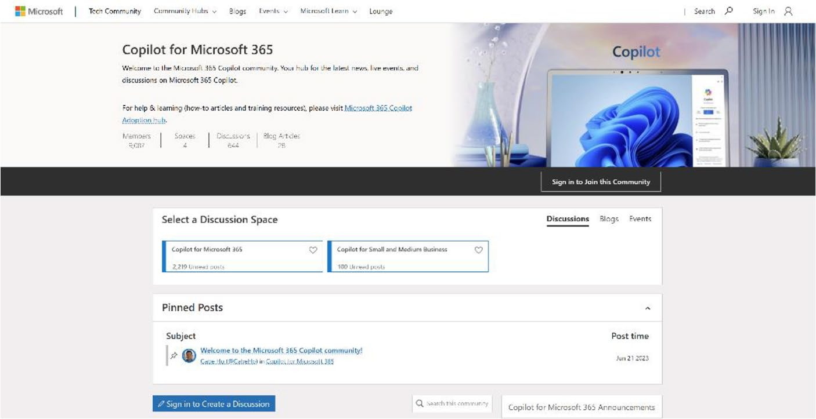

Figure 14-8. The Official Microsoft 365 Copilot community

The Microsoft 365 Copilot community (as shown in
Figure 14-8) is a collaborative space where you can connect, share ideas, and explore the possibilities of Microsoft 365 Copilot. Serving as a hub for the latest news, live events, and discussions on Copilot, this community offers a variety of resources, including how-to articles, training materials, and expert advice. By joining the Microsoft 365 Copilot

Chapter 14 Comprehensive resourCes
Community, you can enhance your productivity, learn more about Microsoft AI, and stay updated with the latest releases. You can also engage with Microsoft experts, participate in digital events like Ask Microsoft Anything (AMA), and connect with fellow Microsoft 365 enthusiasts. This community aims to help you elevate your skills, empower your organization, and embark on an exciting journey of digital transformation with Microsoft 365 Copilot.
Visit https://bit.ly/CopilotCommunity or scan
the QR code shown in Figure 14-9.


Figure 14-9. QR code for the official community of Copilot for Microsoft 365

Chapter 14 Comprehensive resourCes
2. Microsoft 365 Copilot Community
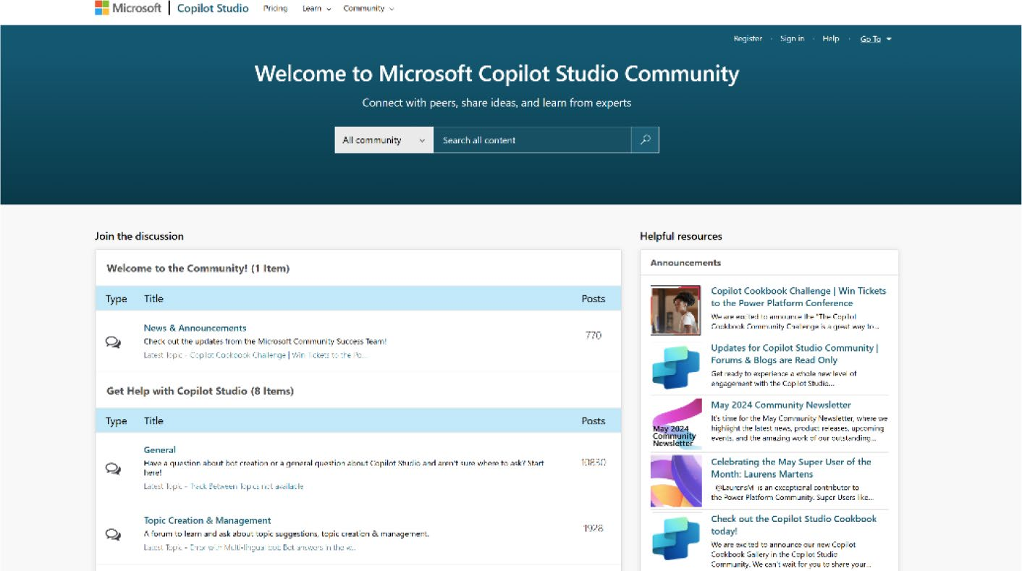

Figure 14-10. Official Microsoft Copilot Studio community
The Copilot Studio community (as shown in Figure 14-10) is a vibrant and engaging platform for you to connect, learn, and share your experiences with Microsoft’s powerful AI assistant. By joining this community, you can stay informed about the latest trends, tips, and tricks from Copilot experts and fellow members. The community offers a variety of resources, including videos that provide insights into using Copilot Studio effectively, webinars for engaging with the product team, and challenges that showcase user creativity while offering exciting prizes. Additionally, the community forums serve as a valuable resource for asking questions, getting help, and sharing ideas. By actively participating in the Copilot Studio community, you can expand your network, build lasting relationships, and contribute your own stories, solutions, and successes to inspire and educate others.

Chapter 14 Comprehensive resourCes
Visit https://go.microsoft.com/
fwlink/?linkid=2058639 or scan the QR code to
join the community, as shown in Figure 14-11.


Figure 14-11. QR code for the official community of Copilot Studio community

3. Microsoft Power Platform Community
The Microsoft Power Platform community is a vibrant and growing online hub for users of the Power Platform to connect, learn, and collaborate. This community includes over 880,000 members across 480 user groups and highlights 94,000 solutions and 150,000 discussions. It provides a central place for Power Platform enthusiasts to explore the various products like Power Apps, Power Automate, Power BI, and Power Virtual Agents, ask questions, share knowledge, and find support from
experts and peers. Figure 14-12 shows the first look of the community page.

Chapter 14 Comprehensive resourCes
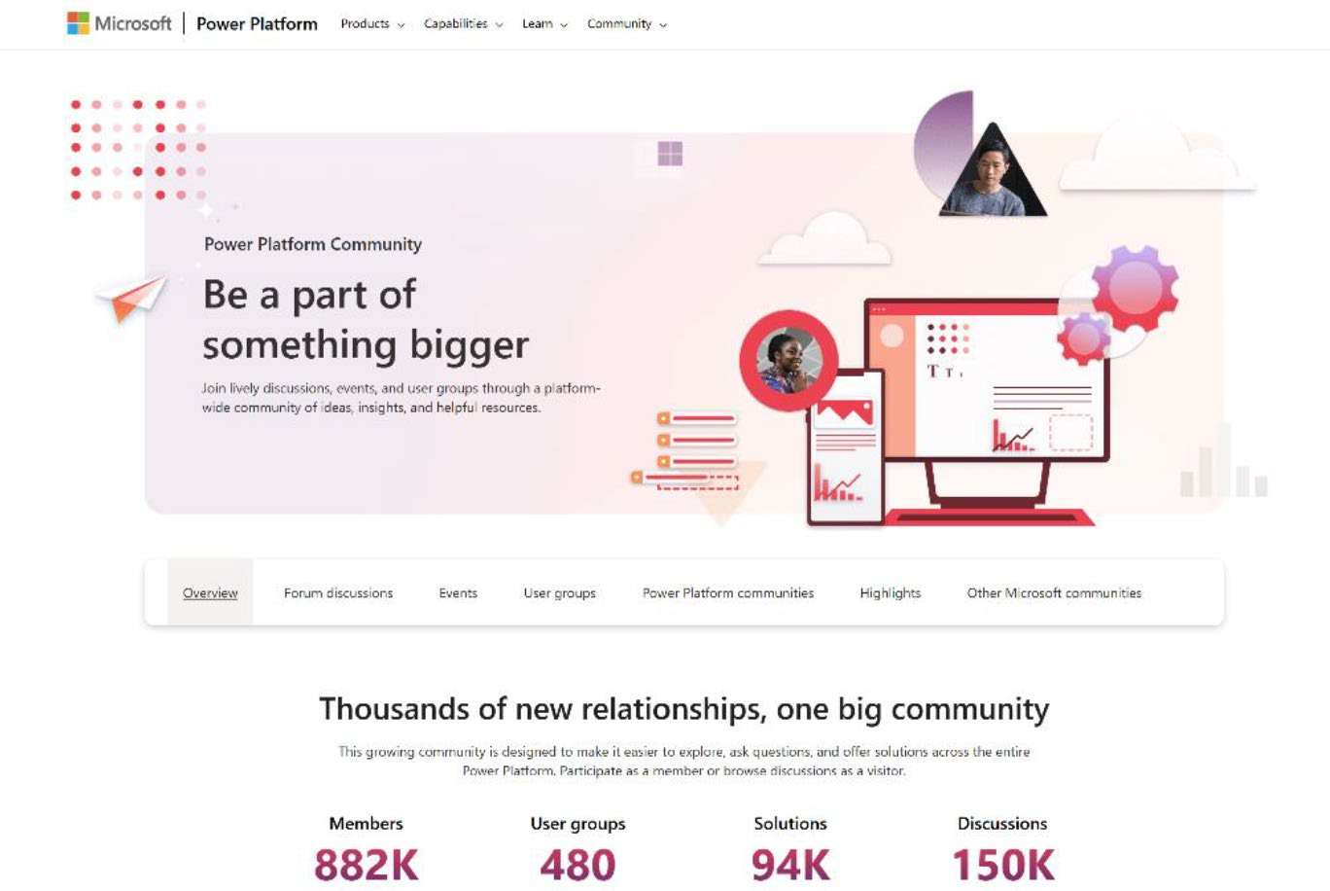

Figure 14-12. Official Power Platform community of Microsoft

Whether you’re a novice or an experienced Power Platform user, joining this community will help you stay up to date with the latest developments, learn new skills through tutorials and videos, and tap into the collective wisdom of the community to solve business challenges more effectively. The community’s forums, LinkedIn page, and social media groups enable users to personalize their experience and engage in meaningful conversations around the Power Platform.
Visit https://powerusers.microsoft.com/ or
scan the QR code shown in Figure 14-13 to join the community.

Chapter 14 Comprehensive resourCes


Figure 14-13. QR code for the official Power Platform community

4. Microsoft 365 Technical Community: DACH
The Microsoft 365 Technical Community: DACH is a global network that transcends geographical boundaries, uniting individuals worldwide who share a common interest in Microsoft 365 technologies. While the name may suggest a focus on the DACH region (Germany, Austria, and Switzerland), this community is inclusive and welcomes members from all corners of the globe.
Figure 14-14 shows the welcome page for Microsoft 365 Technical Community: DACH.

Chapter 14 Comprehensive resourCes


Figure 14-14. The welcome page for the Microsoft 365 Technical
Community: DACH

Led by Microsoft MVPs, MCTs, regional directors, and other esteemed community leaders, this platform is dedicated to fostering collaboration, continuous learning, and knowledge sharing. As an active member and Microsoft MVP, I contribute to the community by regularly sharing free blogs, webinars, and training sessions every month, providing valuable insights and hands-on learning opportunities for members. Through these initiatives, members have the opportunity to stay informed about the latest trends, connect with industry peers and experts, access valuable resources, and engage in global discussions and events. By being a part of this dynamic community, individuals can expand their skills, stay abreast of Microsoft 365 advancements, and forge meaningful connections with professionals worldwide.

Chapter 14 Comprehensive resourCes
You can join the webinars, community calls, or training sessions by visiting the official website of Microsoft 365 Technical Community: DACH
(https://www.m365community.eu/) or scanning the
QR code shown in Figure 14-15.


Figure 14-15. QR code of the Microsoft 365 Technical Community: DACH

Summary
This final chapter provided essential resources to support your journey with Microsoft Copilot for Power Apps. Following the inspiring real-world applications, this chapter serves as a vital resource hub, offering detailed explanations, extended learning materials, and information on thriving online communities.
Starting with “The Copilot Lexicon” section, the chapter includes key terms and definitions crucial for understanding Microsoft Copilot, Power Apps, Copilot Studio, and app development. This glossary helps developers, business users, and anyone involved in creating and managing applications.

Chapter 14 Comprehensive resourCes
To enhance your learning, the chapter also included online resources,
including the Copilot Learning Hub and AI Learning Hub on Microsoft
Learn. These hubs feature role-based learning resources, tutorials,
practical tips, and the latest updates. For those looking to master Microsoft
Power Apps, AI Builder, and Microsoft Power Automate, comprehensive
guides and best practices are available.
Recognizing the importance of community support, the chapter
highlighted online communities such as the Microsoft 365 Copilot
Community, Copilot Studio Community, Microsoft Power Platform
Community, and Microsoft 365 Technical Community: DACH. These
platforms offer spaces to share ideas, access resources, and engage in
discussions about Microsoft’s AI technologies.
As you conclude this book, my goal has been to introduce you to
the transformative power of Microsoft Copilot for Power Apps and
to provide you with the tools, knowledge, and community support
necessary to continue your journey. Embracing these technologies can
significantly enhance productivity, streamline operations, and empower
your workforce. With the resources and communities highlighted in this
chapter, you are well-equipped to explore, innovate, and harness AI for a
brighter, more efficient future.
Thank you for joining me on this journey. May the insights, tools,
and communities discussed inspire you to accomplish your digital
transformation and achieve new heights with AI.

Index

A prompts, 90
technologies
Aesthetic design, UX/UI
machine learning
color, 273
techniques, 106
color palette, 273, 274
NLP, 104
color schemes, 275–277
fonts/sizes, 278, 279 Power Fx/Power Fx Apps
AI Builder Studio, 105
AKS, 114 system architecture/data
Azure services privacy, 106
AKS, 109 AI prompts CI/CD, 110 custom prompt option cognitive services, 108 adoption website, 537 insights/analytics, 110 confirmation, 545 ML, 107 creation, 535 security/compliance, 111 dynamic value, 540–542,
business intelligence, 87, 88 544 code/development, GPT model, 543
revolutionizing, 82–84 initial screen, 536
compliance/security, 114 input option, 539, 540 connections/functions, 81 modal box, 538 core capabilities, 84, 85 name changing, 539 custom AI models, 113 prompt engineering features, 86 guide, 546 licensing, 89, 90 prompt page, 535 ML, 114 response, 545 Power Apps, 87 smart features, 534 pre-built AI scenarios, 113 testing process, 544

© Rezwanur Rahman 2024 767
R. Rahman, Microsoft Copilot for Power Apps, Inside Copilot,

INDEX
AI prompts (cont.) Artificial intelligence (AI), 2
existing app summarization AI Builder, 692–699
checking option, 534 Air India, 714, 715 creation, 528 automation features, 691 data source, 528, 529 Builder (see Builder AI) designing app, 530 Copilot technology, 684 generate button, 531, 532 driven insights, 718 reset text button, 530, 531 features, 682 text field configuration, Hub/compliance portal, 689
532, 533 OneNote, 687
pre-built templates, 519, 520 prompts, 518
representation, 518 Augmented Reality (AR), 683
streamline app development, Auto-layout containers, 315
518, 519 Azure Active Directory, 370
summarization, 520 Azure Cognitive Services, 108, 720
app creation, 526 Azure Container Instances creation, 527 (ACI), 108 data (preview) Azure Kubernetes Service (AKS),
option, 524 108, 109
details, 522 Azure SQL, 373 features, 521 Azure SQL database input settings, 523 authentication method, 422
mobile app, 526 authentication type, 429 pop up, 521 command, 426 settings option, 525 confirmation page, 420 settings section, 524 connection, 429 steps, 521 connector option, 428 testing articles, 526 creation, 414, 415 text option, 527, 528 database name/server
Air India, 714, 715 name, 430 Application Lifecycle Management data source option, 432
(ALM), 720 data table, 426
Application programming interface description, 416
(API), 733 fetching data, 433
INDEX
field editor, 423 properties, 458, 459, 463 information details, 415, screen, 461
416, 434 upload card, 464, 465
natural language, 424, 425 business scenarios, 445 networking page, 418 capabilities, 694 overview page, 431 companies, 694 Power Apps option, 433 components, 457, 458 prerequisites, 413 custom AI models, 448, 449 process, 414 customer behavior/streamlines
query editor, 421 operations, 438 resource group, 416 customization techniques, 437
review + create page, 418, 419 developer environment, 695
server, 417 features, 693–700 source code, 423 formula bar subscription, 416 Canvas app, 453 table/columns, 425 data source list, 451, 452 table selection, 431 demo, 453 users/location/DateofBirth Guten Tag, 457
columns, 424 language detection, 454
verification, 427 language text, 455–457
model type/AI models,
B 450, 451
requirement, 453
Blockchain technology, 684 text label/text input, 455, 456
Blue Coat, 78 GPT Prompt Builder, 697
Builder AI key components, 450
activity page, 695 key feature, 438 admins/makers, 693, 696 model types, 439 Business Card Reader AI Hub selection, 444
adding component, 460 custom prediction extracting information, 465 model, 439 label creation, 462 data types/build name field, 463 types, 440–442 preview, 464 object detection model, 439

INDEX
Builder AI (cont.) insert option, 483
pre-built/custom models, 443 overflow option, 486 pre-built models, 446–448 text label/resize option, 487
monitoring reports, 696 text recognized, 490
pre-built (see Pre-built/custom Business Intelligence (BI), 721
AI Builder models)
Prompt Builder, 698 C
Receipt Processor component
Canvas app, 468 Canvas apps, 76, 119, 120, 159 details screen, 478, 479 Chatbots fetching information, 476 component, 350–361, 363, 364
formula code, 476 definition, 722 important information, 478 dynamic options, 349, 350 insert option, 469 Power Apps design items list source, 473, 474 component, 365 labels, 475 ChatGPT, 90 main screen, 479, 480 ClearCollect() function, 286 merchant information, Collapsible menu/mode
476, 477 switcher, 613
next arrow, 470 Collect() function, 286 properties, 466 Color Hunt, 275 remove option, 474, 475 Comments requirements, 467 add in Power Apps, 366 uploaded receipt, 481 app’s action bar, 368 upload option, 471 comments limitations, 373 vertical gallery, 472, 473 components or pages, 365
Text Recognizer Copilot tooltip, 367
component, 482 tagging someone, social
adding image, 489 media, 369–372 arrow icon, 485 tree view, 366 connection, 488 Comprehensive glossary formula bar, 488 adaptive cards, 718 hands-on demo, 482 AI Builder, 718 handwritten letter, 484, 485 AI-driven insights, 719
INDEX
AI-powered code integrating code, 724
generation, 719 intelligent assistance, 734
ALM process, 720 interactive dashboards, 734 API Grape, 733 key terms/definitions, 717 app customization, 719 licensing needs, 734 authentication, 745 low-code development, 735 Azure, 720 machine learning BI tools, 721 algorithms, 735 business process management, 730
automation, 721 Microsoft flow/graph, 736
Chatbots, 722 Microsoft 365, 736 chat experiences, 722 minimal/no coding, 735 citizen developers, 722 mobile app development, 737
code suggestions, 723 NLP, 737 cognitive services, 721 NLU, 738 collaboration tools, 723 office productivity software, 738
connectors, 723 optimization, 738 context IQ, 724 organizational efficiency, 739
Copilot, 724–728 personalized custom connectors, 729 recommendations, 739 Dataverse, 730 plugins, 739 debugging, 731 Power Apps deploying code, 723 automate, 740 development encompasses, 720 definition, 740 development environment, 731 Platform, 741 digital transformation, 731 Power BI, integration, 740 Dynamics 365, 732 predictive analytics, 741 enhancing app quality, 732 proactive suggestions, 742 enterprise solutions, 732 productivity enhancement, 741
Entra ID, 736 real-time updates, 742 extensibility options, 733 role-based access control governance/integration, 729 (RBAC), 742 graph connectors, 733 scalability, 742 human expertise, 733 security, 730

INDEX
Comprehensive glossary (cont.) capabilities, 725
security and compliance, 743 case study
semantic analysis, 743 AI technology, 32, 33
software applications, 743 logistics/production
software development, 744 scheduling, 34, 35
task automation, 744 regional healthcare
teams message extensions, 744 network, 33, 34
third-party integrations, 745 conditional formatting (see
user data ecosystem, 745 Conditional formatting)
UX design, 746 control
version control systems, 746 activate, 324–326
virtual agents, 746 app developers, 323
visual development tools, 747 Canvas app, enable
visualization, 730 component, 327–329
workflow automation, 747 Copilot to Canvas
Conditional formatting, 517 app, 329–339
calculate numbers, 551 customization, 725
features, 546 data types, 10, 11
idea option, 550 decoding, 2, 3
ideas/suggestions, 547, 548 definition, 724
input ideas, 549 dynamic menu, 558–613
overview, 546 extensibility, 726
steps, 547 features, 558, 726
suggestions, 549 features/competitive edge,
testing, 551, 552 12–17, 19, 20
text label, 547 formula bar, 552–554
Connectors, 162, 184 framework, 726 Context variables, 285 GPT, 3, 4 Continuous integration and integrating data,
delivery (CI/CD), 110, 723 applications, 22, 23
Copilot integration, 726
answer control, 340 integration, Power Apps, 29, 31
AI technology, 725 licensing details, 727
answer control, 342–344 Microsoft graph connectors, 24
INDEX

Microsoft 365 features, 5–10 D plugins, 23, 24, 727
Data sources, table
Power Apps, 26–28
designer, 375–387
preview mode, 25
Data types
resources
characteristics, 166
AI Learning Hub, 749
Microsoft Dataverse, 167
learning hub, 748
Microsoft Power Fx, 167
QR code, 748
Power Apps, 167, 169
role-based learning
Dataverse table design
resources, 749
background color, 386
revolution, 727
browser/navigation, 376
service, 728
component properties, 387
studio, 728
data table component, 384
suggestions, 728
detailed process, 375
technology, 684
UI complex creation, 660–679 dummy data/row creation, 379
use case fetching data, 381
engineering team tasks, font, 384
managing, 21 preferred method, 377
enterprise knowledge properties, 385
sharing, 22 resize option, 381, 382
products/inventory row/table/column creation, 378
management, 22 searching option, 380
Copilot prompts, 95 table creation, 376, 387
Copilot Studio table properties, 379
AI agents, 345 theme selection, 383 Chatbot, 349 Decentralized applications communication channels, 345 (dApps), 684 license g information, 348 Diverse data sources version, 345–347 features, 399
Custom connectors, 67, 162, 186, Power Apps Studio, 406–413
692, 728 SharePoint data source,
Customer relationship management 399–406
(CRM), 18, 732 SQL database, 413–434

INDEX
Dynamic content gallery edit icon, 583
formulas, 282 horizontal container, 609
variables HoverFill property, 586, 587, 589
collections, 286, 287 icons, 585 context, 285 image/button, 591 development, 283 image component, 608, 609 formulas, 287, 288 image component global, 284 properties, 564 languages, 282 image containers types, 282 parameters, 565
Dynamic menu project inactive menu
ActiveIcon default value, 600
active menu, 594, 595 InactiveIcon, 598 default value, 596 properties, 597 text creation, 596, 597 RGBA color, 600
active/inactive modes, 609 text creation, 599
app creation, 558 items property, 582
blank vertical gallery, 571, 572 Logo_compact, 566
bootstrap Logo_padding, 569, 570
icons page, 575, 576 media option, 567 search option, 576, 577 menu bar, 585 website, 574, 575 menu configuration, 581
button component, 588 MenuContents, 573, 574
circle badge, 604 modern menu, 612, 613
CollapsibleMenu, 611, 612 NavigationBackground
component, 559 property, 562, 563
container, 584 OnSelect property, 589
container selection, 591 PaddingTop property,
custom properties, 562 570, 571
default value, 590, 593 parameters, 560, 561, 565, 566,
file badge, 603 568, 573
fill property, 592, 594 people icon, 602
formula bar, 567, 568, PressedFilled property,
570, 584 587, 588
INDEX

properties, 569, 610 H SelectedIconBG, 592, 593
Hargreaves Lansdown, 712–714
source code, 578, 579,

581, 605–608 I, J
substitute function, 601
table design code, 578 Inspiring stories, 705 table tag, 604 Air India (Airline operations),
vertical container, 611 714, 715 vertical container properties, digital insurance
560, 561, 563, 564 agency, 708–710
width/height adjustment, 560 Hargreaves Lansdown,
Dynamics 365, 18, 85, 162, 209 712–714
KPMG’s integration, 706–708
E Nsure.com, 708–710
PG&E transforming
Enterprise resource planning operations, 712–714
(ERP), 732 Instruction tuning, 90, 91
ExpandMenu, 262 Invoice processing models
AI Hub, 493
F app creation, 495, 496
default app, 496
Formula bar extract information, 494, 495
Copilot button, 554 key information, 492 explanation, 554, 555 manual steps, 498 features, 552 extracted information, 502
option, 553 formula code, 503, 504 overview, 553 OnSelect property, 501
picture component, 499
G prediction result, 502, 503
selection process, 498
Generative Pre-trained tree view, 500
Transformers (GPT), 3 uploading invoice, 501, 504
Global variables, 284 steps, 493
Grids, 231, 232 testing process, 497

INDEX

K URL/cloud, 394–396
video control, 390, 392
Key performance indicators
Microsoft Azure, 86, 112, 114
(KPIs), 706
Microsoft Copilot (Microsoft
Klynveld Peat Marwick Goerdeler
365), 685
(KPMG), 706–708
AI Hub, 689

L Excel workbook, 685 graph grounded chat, 685
Landscape evolution, 681 iPad, 687
AI integration, 682 OneNote, 687
AR and VR technologies, 683 Outlook
Blockchain technology, 684 features, 688
Copilot technology, 684–692 themes, 688
cross-platform Windows and Web, 688
development, 683 plugins, 685
digital productivity, 684 Purview, 689
low-code/no-code QR code, 690
platforms, 682 reports, 686
Large language models (LLMs), 7, Viva
90, 93, 94 Engage, 687
features, 686
M Glint, 686
track goals and progress, 687
Machine learning (ML), 682, 735 Microsoft Dataverse, 373 Media/gallery panes, 387 advantages, 163, 164
images/audio/video, 388 data types
adding media, 391 blank value, 180 app preview, 394 connectors, 184, 186 available media controls, 389 date and time, 174 image control, 395 embedded text, 180 limitations, 396 format conversion, 174 properties, 393 formats, 170, 171 screen creation, 388 multiline text, 172 upload option, 391, 392 newlines, 182, 183
INDEX
Power Fx, 175, 176 Logo_Padding property, 635, 636
string interpolation, 181 MenuExpanded, 623 whole number, 173 menu icons, 627, 628
multi-dimensional and high- menu items, 626
level configurability, 163 parameters, 615
Microsoft Excel, 164, 165 preview mode, 633
Microsoft Graph API, 6 rename option, 614
Microsoft Lists, 165 TextColor property, 631
Microsoft Power Platform, 112 text label, 629, 630, 632, 633
Microsoft SQL Server, 164 theme switcher (see Theme
Microsoft 365, 39, 44, 78 switcher)
Model-driven apps, 120 Most Valuable Professionals
Mode switcher (MVPs), 757
addding container, 615
AlignInContainer N
property, 626
alignment position, 627 Natural language processing changing parameters, 621 (NLP), 13, 15, 682, 737 collapsible menu, 635 Natural language understanding
components option, 613, 614 (NLU), 738 ContainerExpand Nsure.com, 708–710
parameters, 615
ContainerExpand container, 620 O features, 613
font size, 634 Online communities/forums formula code, 618, 619, 622, Copilot community (Microsoft
625, 628, 634 365), 757
hamburger menu icon, 618 DACH technical image control parameters, 617 community, 762–764 visible property, 634 official community, 758 item position, 620, 621 Power Platform community,
light mode, 631 760, 762 Logo_Expanded property, OnSelect method, 224
624, 625 OpenAI, 3

INDEX

P, Q lookup column, 205, 206
lookup data type,
Pacific Gas & Electric
selecting, 204
(PG&E), 712–714
Office 365, 200–203
Pen input control
deprecated endpoints, 76
limitations, 399
design principles
pen input selection, 397
adding text field/
preview, 398
label, 144–151
size changing, 39, 398
app grids, identify, 134
steps, 397
changing background color,
versatile tool, 396
container, 135–140
Plugins, 23
connect screen to
Power Apps, 25, 36, 85, 162, 375
screen, 153–159
AI/automation features, 691
Copilot prompt, add screen,
AI Builder, 49, 50, 692–699
152, 153
AI features, 46–49 live app preview, 131
build Canvas app, example Microsoft Copilot, create,
create App button, 128, 129 132, 133 environment selection project page, 130
option, 124 text/label properties,
modify app table, 126, 128 change, 140–144 personal organizer developer plan, signing
app, 124–126 up, 65–69
project page, 129 development, 690 text field, 123 dynamic menu (see Dynamic website, 120–122 menu project)
Builder, 437 embedding limits, Canvas
Canvas apps, 699 apps, 76
collapsible/switcher (see environment settings, 700
Collapsible menu/mode functionality/versatility, 699
switcher) greater customization, 690
community contributions, 692 installation to execution, 37–39
connectors integration, 691
created lookup field, 207 licensing, 39–41
INDEX
media (see Media/ Power automate, 18
gallery panes) applications and services, 208
Microsoft 365 license, Copilot, 222–226
without, 43–45 create flow, 216, 217
mobile devices, 701 email template, 210, 211, modernization makers, 702 221, 222 M365 developer program, sign Microsoft services, 208
up, 52–61, 63, 65 Office 365 Outlook
operating systems, connector, 218
supported, 70 OnSelect property, 220
pen input control, 396–399 Power Apps portal, 212 platforms, 69 pre-built automation flow, prompts (see AI prompts) 214, 215 proxies, 78 types of workflows, 209 services, 72 Power Automate model, 85, 99, 160
set up, test environment, 51 Power BI, 18 single outgoing request Power Fx, 115, 117
limits, 71 Power Fx (Formula), 558
supported browsers, 70 Pre-built/custom AI template libraries, 692 Builder models types components, 491
Canvas, 119 custom AI models, 491 model-driven, 120 data sources, 491, 492
visualizing data image descriptions, 505–510
advanced options, 194, 195 adding image, 506 create columns, 194 extracted information, data option, 187 508, 509 Dataverse table, 187, 189, formula code, 509
190, 192, 195, 196, 199 generate description, 505
file upload field, 193 OnSelect properties, 507, 508
MainScreen, edit field picture component, 507
options, 197, 198 upload image, 509
new custom column, 200 invoice processing (see Invoice selecting columns, 191 processing models)

INDEX
Pre-built/custom AI Builder automation, 755–757
models (cont.) blog features, 753
sentiment analysis, 510 Copilot Studio, 750, 751
adding model, 511, 512 Microsoft Copilot, 748 built-in demo, 510, 511 Power Apps, 751–754 demo instructions, 511 Responsive design formula code, 514 building apps, 310 OnSelect properties, 513, 514 containers, 314, 315 preview, 515 creating demo, 315–317, 319,
text field/button/text 321, 322
labels, 513 layouts
Premium connectors, 185 display, 312 Prompt sidebar layout, 314
AI models, 96 split-screen layout, 314
benefits, 101–103 principles, 310–312 business, 98 Return on Investment custom models, 100, 101 (ROI), 706 model categorization, 97 Role-based access control prebuild models, 99, 100 (RBAC), 742
Copilot, 93
example, 92 S LLM, 93, 94
definition, 90 Screen container, 140
engineering, 91 SharePoint, 17, 162, 373
instruction tuning, 91 SharePoint data source
LLM, 90, 91 integral components, 412
Prompt engineering, 90, 91 Microsoft List, 399
connector option, 404
R creation, 403
data lists, 403
Reinforcement Learning (RL), 106 dot grid icon, 400, 401 Resources/development, 747 lists option, 402
AI Builder documentation, Power Apps window, 405
754, 755 preview, 406
INDEX
selection process, 400 LightIcon image, 643 steps, 400 light theme, 641
Power Apps Studio, 406 Logo_Expanded property, 659
connection option, 407, 408 Microsoft documentation, 644
connector option, 406 NavigationBackground data source option, 410 property, 658 data table, 411, 412 night theme icon, 647 insert option, 410 OnSelect property, 654 list choosing, 409 properties, 658
Software development kits QR code, 643
(SDKs), 743 SelectedIconBG property, 659
SQL Server, 162, 226 source code, 648
Standard connectors, 185 steps, 636
Substitute() function, 645
T SVG icon, 648
SwitchContainer, 639, 640, 646
Theme switcher SwitchContainer/
access app feature, 655 SwitchContainer_Dark, 653
AppColorMode, 636–638 theme color code, 657 application mode, 646
AppThemeSwitcherButton, 654 U AppThemeSwitcherContainer,
638, 639, 651–653 UI/UX techniques
color changing, 647 accessibility, 240 compact/expanded mode, 660 cognitive, 242 component, 655 hearing, 241 dark color theme, 650 motor, 242 EncodeUrl() function, 645 virtual, 240, 241 formula bar, 651 aesthetics, 229 formula code, 644 alignment, 235–239 formulas, 656 grids, 232, 233 HTML code, 641, 642 menu design image component, 640 adding rectangle, 254 LayoutDirection property, 651 App preview, 272

INDEX
UI/UX techniques (cont.) color option
changeable text label, 258 background color, 668 code, 251 codes, 670 created component, 245 formula code, 670 create menu, 244 HeaderContainer, 669 create options, 244 properties, 670 creating tables, 253 RGBA code/background
creating variable, 265 color, 669 custom script, 252 color scheme, 661 email screen, 267 component/data source, 675
email template, 268 dark mode, 678 ExpandMenu, 262, 263 drop shadow option, 668 flexible height gallery, HeaderContainer, 667
247–249, 258, 271 homepage, 678
Hamburger menu, 255, 256, LeftBodyContainer, 672, 673
259, 262, 269 non-responsive
Hamburger menu, containers, 672
searching, 246 padding option, 676, 677
insert option, 245 parameters, 676 navigation menu, 260 prompt, 666 new custom property option, RightBodyContainer, 673
250, 251 screens, 666
OnReset option, 264, 265 text label/background, 671 principles, 243, 244 upscale image option, 664 unstructured format, 257 upscaling image quality, 665
navigation, 229 vertical container, 667
menu design, 243 websites, 660
optimizing layout, 229–231 UpdateContext() function, 285
spacing, 234, 235 User experience (UX), 7, 38, 101,
Unique design interface 229, 231–234, 240, 273, 310,
AI image, 674 349, 387, 613, 746
AI image generation, 662 User interface (UI), see Unique
banner image, 663 design interface
INDEX

V, W, X, Y Z
Version control systems, 746 Zscaler, 78
Virtual Reality (VR), 683

