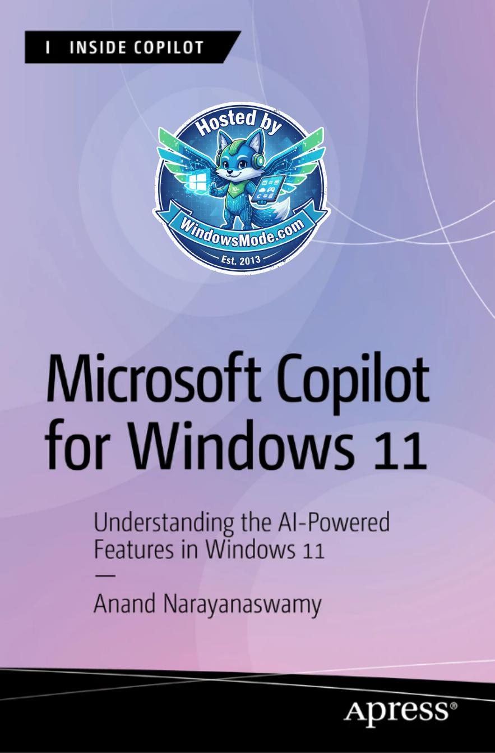

Table of Contents
Chapter 1: Evolution of Microsoft Copilot provides a short introduction to Generative AI followed by the various phases of Microsoft Copilot and associated products.
Chapter 2: Working with Copilot in Windows 11 – Part 1 helps you learn the steps that are required to work with Microsoft Copilot using Windows 11 search.
Chapter 3: Working with Copilot in Windows 11 – Part 2 examines the working of Copilot via the Windows 11 Taskbar. You will learn the required steps to complete various tasks using Copilot easily.
Chapter 4: Working with Copilot Using Microsoft Edge enables you to learn steps to work with Copilot using the Microsoft Edge browser.
Chapter 5: Working with Copilot Using Bing examines the usage of
Chapter 6: Working with Copilot Using Skype provides coverage of the
Chapter 7: Working with Copilot Web delves deep into the functioning
Chapter 8: Working with Image Creator – Do you want to create
Chapter 9: Working with Microsoft Designer provides a comprehensive
Chapter 10: Using Copilot in Microsoft 365 examines the usage of
Chapter 11: Learning Microsoft Copilot with Windows App examines
Chapter 12: Devices with Copilot Key enables you to know about the
Chapter 13: Introducing Copilot+ PCs provides a list of devices tagged
CHAPTER 1
chapter provides a short introduction to Generative AI followed by the
Chapter 1 evolution of MiCrosoft Copilot
Chapter 1 evolution of MiCrosoft Copilot
Chapter 1 evolution of MiCrosoft Copilot
Chapter 1 evolution of MiCrosoft Copilot
Chapter 1 evolution of MiCrosoft Copilot
Chapter 1 evolution of MiCrosoft Copilot
Chapter 1 evolution of MiCrosoft Copilot
Chapter 1 evolution of MiCrosoft Copilot
Chapter 1 evolution of MiCrosoft Copilot
Chapter 1 evolution of MiCrosoft Copilot
Chapter 1 evolution of MiCrosoft Copilot
Chapter 1 evolution of MiCrosoft Copilot
Chapter 1 evolution of MiCrosoft Copilot
Chapter 9.
Chapter 1 evolution of MiCrosoft Copilot
Chapter 1 evolution of MiCrosoft Copilot
Chapter 1 evolution of MiCrosoft Copilot
Chapter 1 evolution of MiCrosoft Copilot
Chapter 1 evolution of MiCrosoft Copilot
Chapter 1 evolution of MiCrosoft Copilot
Chapter 1 evolution of MiCrosoft Copilot
Chapter 1 evolution of MiCrosoft Copilot
Chapter 1 evolution of MiCrosoft Copilot
Chapter 1 evolution of MiCrosoft Copilot
CHAPTER 2
ChaPter 2 WorkIng WIth CoPIlot In WIndoWS 11 – Part 1
ChaPter 2 WorkIng WIth CoPIlot In WIndoWS 11 – Part 1
ChaPter 2 WorkIng WIth CoPIlot In WIndoWS 11 – Part 1
ChaPter 2 WorkIng WIth CoPIlot In WIndoWS 11 – Part 1
ChaPter 2 WorkIng WIth CoPIlot In WIndoWS 11 – Part 1
ChaPter 2 WorkIng WIth CoPIlot In WIndoWS 11 – Part 1
ChaPter 2 WorkIng WIth CoPIlot In WIndoWS 11 – Part 1
ChaPter 2 WorkIng WIth CoPIlot In WIndoWS 11 – Part 1
ChaPter 2 WorkIng WIth CoPIlot In WIndoWS 11 – Part 1
ChaPter 2 WorkIng WIth CoPIlot In WIndoWS 11 – Part 1
ChaPter 2 WorkIng WIth CoPIlot In WIndoWS 11 – Part 1
ChaPter 2 WorkIng WIth CoPIlot In WIndoWS 11 – Part 1
ChaPter 2 WorkIng WIth CoPIlot In WIndoWS 11 – Part 1
ChaPter 2 WorkIng WIth CoPIlot In WIndoWS 11 – Part 1
ChaPter 2 WorkIng WIth CoPIlot In WIndoWS 11 – Part 1
ChaPter 2 WorkIng WIth CoPIlot In WIndoWS 11 – Part 1
ChaPter 2 WorkIng WIth CoPIlot In WIndoWS 11 – Part 1
ChaPter 2 WorkIng WIth CoPIlot In WIndoWS 11 – Part 1
ChaPter 2 WorkIng WIth CoPIlot In WIndoWS 11 – Part 1
ChaPter 2 WorkIng WIth CoPIlot In WIndoWS 11 – Part 1
ChaPter 2 WorkIng WIth CoPIlot In WIndoWS 11 – Part 1
CHAPTER 3
Chapter 3 Working With Copilot in WindoWs 11 – part 2
Chapter 3 Working With Copilot in WindoWs 11 – part 2
Chapter 3 Working With Copilot in WindoWs 11 – part 2
Chapter 2. This includes providing answers to prompts, coding, image creation, and other related tasks. The main benefit of Copilot in Windows is that you can work with the chatbot by selecting the Taskbar icon without navigating to the Windows 11 search.
Chapter 3 Working With Copilot in WindoWs 11 – part 2
Chapter 3 Working With Copilot in WindoWs 11 – part 2
Chapter 3 Working With Copilot in WindoWs 11 – part 2
Chapter 3 Working With Copilot in WindoWs 11 – part 2
Chapter 3 Working With Copilot in WindoWs 11 – part 2
Chapter 3 Working With Copilot in WindoWs 11 – part 2
Chapter 3 Working With Copilot in WindoWs 11 – part 2
Chapter 3 Working With Copilot in WindoWs 11 – part 2
Chapter 3 Working With Copilot in WindoWs 11 – part 2
Chapter 3 Working With Copilot in WindoWs 11 – part 2
Chapter 3 Working With Copilot in WindoWs 11 – part 2
Chapter 3 Working With Copilot in WindoWs 11 – part 2
Chapter 3 Working With Copilot in WindoWs 11 – part 2
Chapter 3 Working With Copilot in WindoWs 11 – part 2
Chapter 3 Working With Copilot in WindoWs 11 – part 2
Chapter 3 Working With Copilot in WindoWs 11 – part 2
Chapter 3 Working With Copilot in WindoWs 11 – part 2
Chapter 3 Working With Copilot in WindoWs 11 – part 2
Chapter 3 Working With Copilot in WindoWs 11 – part 2
Chapter 3 Working With Copilot in WindoWs 11 – part 2
Chapter 3 Working With Copilot in WindoWs 11 – part 2
Chapter 3 Working With Copilot in WindoWs 11 – part 2
CHAPTER 4
CHapter 4 WorkIng WItH CopIlot UsIng MICrosoft edge
CHapter 4 WorkIng WItH CopIlot UsIng MICrosoft edge
CHapter 4 WorkIng WItH CopIlot UsIng MICrosoft edge
CHapter 4 WorkIng WItH CopIlot UsIng MICrosoft edge
CHapter 4 WorkIng WItH CopIlot UsIng MICrosoft edge
CHapter 4 WorkIng WItH CopIlot UsIng MICrosoft edge
CHapter 4 WorkIng WItH CopIlot UsIng MICrosoft edge
CHapter 4 WorkIng WItH CopIlot UsIng MICrosoft edge
CHapter 4 WorkIng WItH CopIlot UsIng MICrosoft edge
CHapter 4 WorkIng WItH CopIlot UsIng MICrosoft edge
CHapter 4 WorkIng WItH CopIlot UsIng MICrosoft edge
CHapter 4 WorkIng WItH CopIlot UsIng MICrosoft edge
CHapter 4 WorkIng WItH CopIlot UsIng MICrosoft edge
CHapter 4 WorkIng WItH CopIlot UsIng MICrosoft edge
CHapter 4 WorkIng WItH CopIlot UsIng MICrosoft edge
CHapter 4 WorkIng WItH CopIlot UsIng MICrosoft edge
CHapter 4 WorkIng WItH CopIlot UsIng MICrosoft edge
CHapter 4 WorkIng WItH CopIlot UsIng MICrosoft edge
CHAPTER 5
Chapter 5 Working With Copilot Using Bing
Chapter 5 Working With Copilot Using Bing
Chapter 5 Working With Copilot Using Bing
Chapter 5 Working With Copilot Using Bing
Chapter 5 Working With Copilot Using Bing
Chapter 5 Working With Copilot Using Bing
CHAPTER 6
ChApter 6 Working With Copilot USing Skype
ChApter 6 Working With Copilot USing Skype
ChApter 6 Working With Copilot USing Skype
ChApter 6 Working With Copilot USing Skype
ChApter 6 Working With Copilot USing Skype
ChApter 6 Working With Copilot USing Skype
ChApter 6 Working With Copilot USing Skype
ChApter 6 Working With Copilot USing Skype
ChApter 6 Working With Copilot USing Skype
ChApter 6 Working With Copilot USing Skype
ChApter 6 Working With Copilot USing Skype
ChApter 6 Working With Copilot USing Skype
ChApter 6 Working With Copilot USing Skype
ChApter 6 Working With Copilot USing Skype
CHAPTER 7
Chapter 7 Working With Copilot Web
Chapter 7 Working With Copilot Web
Chapter 7 Working With Copilot Web
Chapter 7 Working With Copilot Web
Chapter 7 Working With Copilot Web
Chapter 7 Working With Copilot Web
Chapter 7 Working With Copilot Web
Chapter 7 Working With Copilot Web
Chapter 7 Working With Copilot Web
Chapter 7 Working With Copilot Web
Chapter 7 Working With Copilot Web
Chapter 7 Working With Copilot Web
Chapter 7 Working With Copilot Web
Chapter 7 Working With Copilot Web
Chapter 7 Working With Copilot Web
Chapter 7 Working With Copilot Web
Chapter 7 Working With Copilot Web
Chapter 7 Working With Copilot Web
Chapter 7 Working With Copilot Web
Chapter 7 Working With Copilot Web
Chapter 7 Working With Copilot Web
Chapter 7 Working With Copilot Web
Chapter 7 Working With Copilot Web
Chapter 7 Working With Copilot Web
Chapter 7 Working With Copilot Web
Chapter 7 Working With Copilot Web
Chapter 7 Working With Copilot Web
Chapter 7 Working With Copilot Web
Chapter 7 Working With Copilot Web
Chapter 7 Working With Copilot Web
Chapter 7 Working With Copilot Web
CHAPTER 8
Chapter 8 Working With image Creator
Chapter 8 Working With image Creator
Chapter 8 Working With image Creator
Chapter 8 Working With image Creator
Chapter 8 Working With image Creator
Chapter 8 Working With image Creator
Chapter 8 Working With image Creator
Chapter 8 Working With image Creator
Chapter 8 Working With image Creator
Chapter 8 Working With image Creator
Chapter 8 Working With image Creator
Chapter 8 Working With image Creator
CHAPTER 9
Chapter 9 Working With MiCrosoft Designer
Chapter 9 Working With MiCrosoft Designer
Chapter 9 Working With MiCrosoft Designer
Chapter 9 Working With MiCrosoft Designer
Chapter 9 Working With MiCrosoft Designer
Chapter 9 Working With MiCrosoft Designer
Chapter 9 Working With MiCrosoft Designer
Chapter 9 Working With MiCrosoft Designer
Chapter 9 Working With MiCrosoft Designer
Chapter 9 Working With MiCrosoft Designer
Chapter 9 Working With MiCrosoft Designer
Chapter 9 Working With MiCrosoft Designer
Chapter 9 Working With MiCrosoft Designer
Chapter 9 Working With MiCrosoft Designer
Chapter 9 Working With MiCrosoft Designer
Chapter 9 Working With MiCrosoft Designer
Chapter 9 Working With MiCrosoft Designer
Chapter 9 Working With MiCrosoft Designer
Chapter 9 Working With MiCrosoft Designer
Chapter 9 Working With MiCrosoft Designer
Chapter 9 Working With MiCrosoft Designer
Chapter 9 Working With MiCrosoft Designer
Chapter 9 Working With MiCrosoft Designer
Chapter 9 Working With MiCrosoft Designer
Chapter 9 Working With MiCrosoft Designer
Chapter 9 Working With MiCrosoft Designer
Chapter 9 Working With MiCrosoft Designer
Chapter 9 Working With MiCrosoft Designer
Chapter 9 Working With MiCrosoft Designer
Chapter 9 Working With MiCrosoft Designer
Chapter 9 Working With MiCrosoft Designer
Chapter 9 Working With MiCrosoft Designer
Chapter 9 Working With MiCrosoft Designer
Chapter 9 Working With MiCrosoft Designer
Chapter 9 Working With MiCrosoft Designer
Chapter 9 Working With MiCrosoft Designer
Chapter 9 Working With MiCrosoft Designer
Chapter 9 Working With MiCrosoft Designer
Chapter 9 Working With MiCrosoft Designer
Chapter 9 Working With MiCrosoft Designer
Chapter 9 Working With MiCrosoft Designer
CHAPTER 10
Chapter 10 Using Copilot in MiCrosoft 365
Chapter 10 Using Copilot in MiCrosoft 365
Chapter 10 Using Copilot in MiCrosoft 365
Chapter 10 Using Copilot in MiCrosoft 365
Chapter 10 Using Copilot in MiCrosoft 365
Chapter 10 Using Copilot in MiCrosoft 365
Chapter 10 Using Copilot in MiCrosoft 365
Chapter 10 Using Copilot in MiCrosoft 365
Chapter 10 Using Copilot in MiCrosoft 365
Chapter 10 Using Copilot in MiCrosoft 365
Chapter 10 Using Copilot in MiCrosoft 365
Chapter 10 Using Copilot in MiCrosoft 365
Chapter 10 Using Copilot in MiCrosoft 365
Chapter 10 Using Copilot in MiCrosoft 365
Chapter 10 Using Copilot in MiCrosoft 365
Chapter 10 Using Copilot in MiCrosoft 365
Chapter 10 Using Copilot in MiCrosoft 365
Chapter 10 Using Copilot in MiCrosoft 365
Chapter 10 Using Copilot in MiCrosoft 365
Chapter 10 Using Copilot in MiCrosoft 365
Chapter 10 Using Copilot in MiCrosoft 365
Chapter 10 Using Copilot in MiCrosoft 365
Chapter 10 Using Copilot in MiCrosoft 365
Chapter 10 Using Copilot in MiCrosoft 365
Chapter 10 Using Copilot in MiCrosoft 365
Chapter 10 Using Copilot in MiCrosoft 365
Chapter 10 Using Copilot in MiCrosoft 365
Chapter 10 Using Copilot in MiCrosoft 365
CHAPTER 11
Chapter 11 Learning MiCrosoft CopiLot with windows app
Chapter 11 Learning MiCrosoft CopiLot with windows app
Chapter 11 Learning MiCrosoft CopiLot with windows app
Chapter 11 Learning MiCrosoft CopiLot with windows app
Chapter 11 Learning MiCrosoft CopiLot with windows app
Chapter 11 Learning MiCrosoft CopiLot with windows app
Chapter 11 Learning MiCrosoft CopiLot with windows app
Chapter 11 Learning MiCrosoft CopiLot with windows app
Chapter 11 Learning MiCrosoft CopiLot with windows app
Chapter 11 Learning MiCrosoft CopiLot with windows app
Chapter 11 Learning MiCrosoft CopiLot with windows app
Chapter 11 Learning MiCrosoft CopiLot with windows app
Chapter 11 Learning MiCrosoft CopiLot with windows app
Chapter 11 Learning MiCrosoft CopiLot with windows app
Chapter 11 Learning MiCrosoft CopiLot with windows app
Chapter 11 Learning MiCrosoft CopiLot with windows app
Chapter 11 Learning MiCrosoft CopiLot with windows app
Chapter 11 Learning MiCrosoft CopiLot with windows app
Chapter 11 Learning MiCrosoft CopiLot with windows app
CHAPTER 12
ChaPter 12 DeviCeS With CoPilot Key
ChaPter 12 DeviCeS With CoPilot Key
ChaPter 12 DeviCeS With CoPilot Key
ChaPter 12 DeviCeS With CoPilot Key
ChaPter 12 DeviCeS With CoPilot Key
ChaPter 12 DeviCeS With CoPilot Key
ChaPter 12 DeviCeS With CoPilot Key
ChaPter 12 DeviCeS With CoPilot Key
ChaPter 12 DeviCeS With CoPilot Key
CHAPTER 13
Chapter 13 IntroduCIng CopIlot+ pCs
Chapter 13 IntroduCIng CopIlot+ pCs
Chapter 13 IntroduCIng CopIlot+ pCs
Chapter 13 IntroduCIng CopIlot+ pCs
Chapter 13 IntroduCIng CopIlot+ pCs
Chapter 13 IntroduCIng CopIlot+ pCs
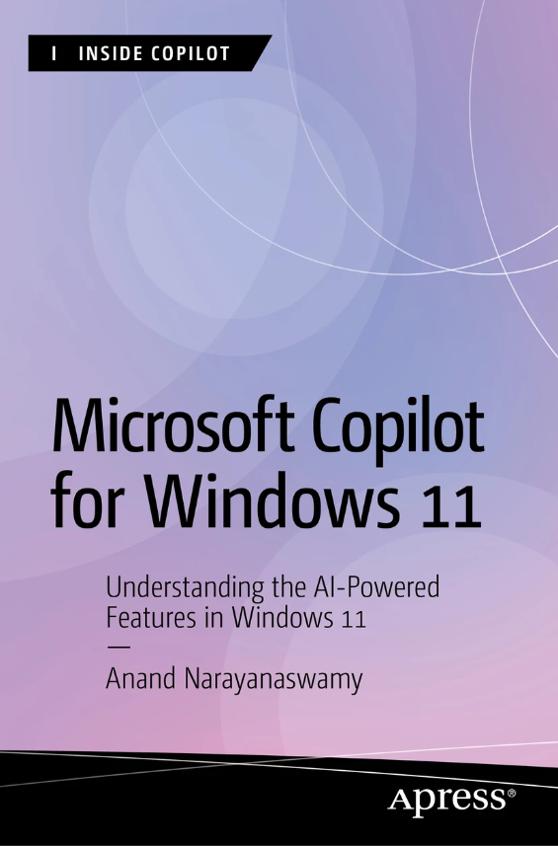
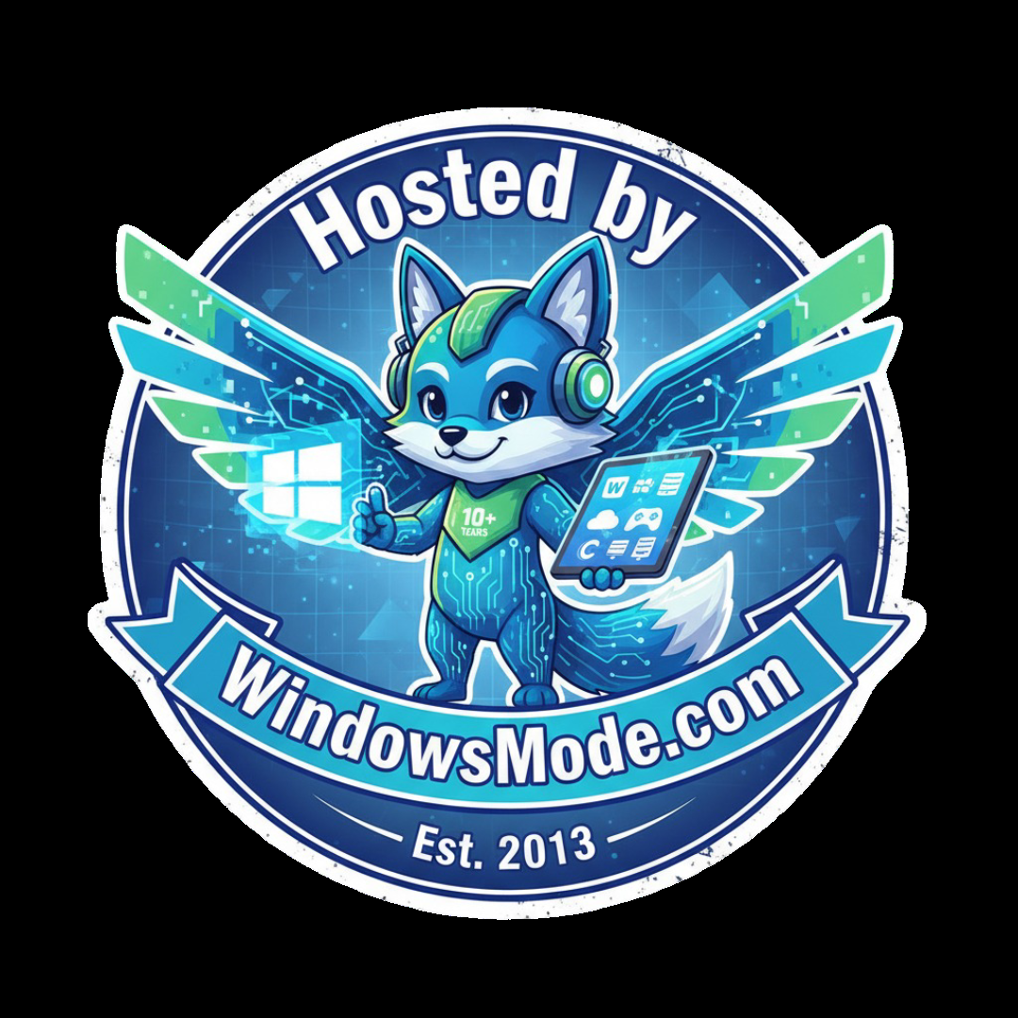
Inside Copilot

Inside Copilot is designed to teach users to master Copilot, Microsoft’s generative AI assistant. Learn prompt engineering and use cases for Copilot in many Microsoft products at beginner, intermediate, and expert levels. Perfect for any professionals who find their schedules packed with repetitive computer tasks, Copilot can automatically generate PowerPoint presentations, draft emails on Outlook, write code on GitHub, and more. Both companies and individuals can learn to utilize Copilot to significantly speed up processes and gain an advantage.
More information about this series at https://link.springer.com/
bookseries/17432.

Microsoft Copilot for

Windows 11

Understanding the AI-Powered
Features in Windows 11

Anand Narayanaswamy

Microsoft Copilot for Windows 11: Understanding the AI-Powered Features in Windows 11
Anand Narayanaswamy
Thiruvananthapuram, Kerala, India
ISBN-13 (pbk): 979-8-8688-0582-0 ISBN-13 (electronic): 979-8-8688-0583-7
https://doi.org/10.1007/979-8-8688-0583-7
Copyright © 2024 by Anand Narayanaswamy This work is subject to copyright. All rights are reserved by the Publisher, whether the whole or part of the material is concerned, specifically the rights of translation, reprinting, reuse of illustrations, recitation, broadcasting, reproduction on microfilms or in any other physical way, and transmission or information storage and retrieval, electronic adaptation, computer software, or by similar or dissimilar methodology now known or hereafter developed. Trademarked names, logos, and images may appear in this book. Rather than use a trademark symbol with every occurrence of a trademarked name, logo, or image we use the names, logos, and images only in an editorial fashion and to the benefit of the trademark owner, with no intention of infringement of the trademark.
The use in this publication of trade names, trademarks, service marks, and similar terms, even if they are not identified as such, is not to be taken as an expression of opinion as to whether or not they are subject to proprietary rights.
While the advice and information in this book are believed to be true and accurate at the date of publication, neither the authors nor the editors nor the publisher can accept any legal responsibility for any errors or omissions that may be made. The publisher makes no warranty, express or implied, with respect to the material contained herein.
Managing Director, Apress Media LLC: Welmoed Spahr
Acquisitions Editor: Smriti Srivastava
Development Editor: Laura Berendson
Coordinating Editor: Kripa Joseph
Cover image designed by eStudioCalamar
Distributed to the book trade worldwide by Apress Media, LLC, 1 New York Plaza, New York, NY 10004, U.S.A. Phone 1-800-SPRINGER, fax (201) 348-4505, e-mail orders-ny@springer-sbm.com, or visit www.springeronline.com. Apress Media, LLC is a California LLC and the sole member (owner) is Springer Science + Business Media Finance Inc (SSBM Finance Inc). SSBM Finance Inc is a Delaware corporation.
For information on translations, please e-mail booktranslations@springernature.com; for reprint, paperback, or audio rights, please e-mail bookpermissions@springernature.com. Apress titles may be purchased in bulk for academic, corporate, or promotional use. eBook versions and licenses are also available for most titles. For more information, reference our Print and eBook Bulk Sales web page at http://www.apress.com/bulk-sales. Any source code or other supplementary material referenced by the author in this book is available to readers on GitHub (https://github.com/Apress). For more detailed information, please visit https://www.apress.com/gp/services/source-code. If disposing of this product, please recycle the paper
Table of Contents

About the Author ���������������������������������������������������������������������������������xi
Acknowledgments �����������������������������������������������������������������������������xiii
Introduction ����������������������������������������������������������������������������������������xv
Chapter 1: Evolution of Microsoft Copilot ���������������������������������������������1
Introducing Generative AI ��������������������������������������������������������������������������������������1
Technology Background ����������������������������������������������������������������������������������2
Regulations ������������������������������������������������������������������������������������������������������5
Imparting Proper Training ��������������������������������������������������������������������������������6
Evolution of GPTs ���������������������������������������������������������������������������������������������7
Evolution of Chatbots ���������������������������������������������������������������������������������������8
Evolution of Microsoft Copilot �������������������������������������������������������������������������������9
History �����������������������������������������������������������������������������������������������������������11
Origin of Bing Chat ����������������������������������������������������������������������������������������11
Image Creator ������������������������������������������������������������������������������������������������13
Microsoft 365 Copilot ������������������������������������������������������������������������������������15
From Copilot to Microsoft Copilot ������������������������������������������������������������������17
Dedicated Copilot Key �����������������������������������������������������������������������������������19
Microsoft Copilot Pro �������������������������������������������������������������������������������������20
Windows 11 ���������������������������������������������������������������������������������������������������21
Copilot Apps ���������������������������������������������������������������������������������������������������21
Copilot+ PCs ��������������������������������������������������������������������������������������������������22
Summary�������������������������������������������������������������������������������������������������������������24

Table of ConTenTs
Chapter 2: Working with Copilot in Windows 11 – Part 1 �������������������25
Accessing Copilot in Windows 11 �����������������������������������������������������������������������25
Exporting Copilot Output ��������������������������������������������������������������������������������30
Picking a Conversation Style �������������������������������������������������������������������������31
Coding via Copilot ������������������������������������������������������������������������������������������35
Refreshing Copilot �����������������������������������������������������������������������������������������39
Working with SEO Using Copilot ��������������������������������������������������������������������42
The Art of Good Prompting ����������������������������������������������������������������������������������44
Summary�������������������������������������������������������������������������������������������������������������46
Chapter 3: Working with Copilot in Windows 11 – Part 2 �������������������47
Getting Started ����������������������������������������������������������������������������������������������������47
Performing Windows 11 Tasks with Copilot ��������������������������������������������������������54
Listing Wireless Networks �����������������������������������������������������������������������������55
Emptying the Recycle Bin ������������������������������������������������������������������������������56
Displaying Startup Apps ��������������������������������������������������������������������������������57
Working with Accessibility Features ��������������������������������������������������������������57
Working with Live Captions via Copilot ���������������������������������������������������������57
Capturing Screenshots ����������������������������������������������������������������������������������57
Changing Background Image ������������������������������������������������������������������������58
Launching Apps ���������������������������������������������������������������������������������������������59
Activating Focus Session �������������������������������������������������������������������������������60
Refreshing Copilot �����������������������������������������������������������������������������������������������61
Fetching Copilot Interactions ������������������������������������������������������������������������������61
Managing Plugins �����������������������������������������������������������������������������������������������63
Working with Copilot Notebook ���������������������������������������������������������������������������65
Managing Settings ����������������������������������������������������������������������������������������������70
Managing Visualization ���������������������������������������������������������������������������������������70
Summary�������������������������������������������������������������������������������������������������������������72
Table of ConTenTs
Chapter 4: Working with Copilot Using Microsoft Edge ����������������������73
Getting Started ����������������������������������������������������������������������������������������������������74
Composing Messages Using Copilot �������������������������������������������������������������������81
Composing Email Messages �������������������������������������������������������������������������������88
Summary�������������������������������������������������������������������������������������������������������������90
Chapter 5: Working with Copilot Using Bing���������������������������������������93
Getting Started ����������������������������������������������������������������������������������������������������94
Summary�������������������������������������������������������������������������������������������������������������99
Chapter 6: Working with Copilot Using Skype ����������������������������������101
Getting Started ��������������������������������������������������������������������������������������������������101
Fetching Responses ������������������������������������������������������������������������������������103
Try Copilot Instantly with Skype ������������������������������������������������������������������106
Change Content Tone Easily ������������������������������������������������������������������������110
Using Copilot in Group Chats �����������������������������������������������������������������������112
Summary�����������������������������������������������������������������������������������������������������������115
Chapter 7: Working with Copilot Web �����������������������������������������������117
Getting Started ��������������������������������������������������������������������������������������������������117
Working with Copilot GPTs ��������������������������������������������������������������������������������119
Generating Images with Copilot ������������������������������������������������������������������120
Planning Vacations ��������������������������������������������������������������������������������������123
Cooking with Copilot ������������������������������������������������������������������������������������125
Monitor Your Health with Copilot �����������������������������������������������������������������127
Working with Copilot Notebook �������������������������������������������������������������������������129
Working with Copilot Plugins ����������������������������������������������������������������������������131
Pulling Recipes via Instacart �����������������������������������������������������������������������133
Search for Flights and Hotels via Copilot �����������������������������������������������������135
Price Comparison with Copilot ��������������������������������������������������������������������137

Table of ConTenTs
Fetch Restaurant Recommendations Quickly ����������������������������������������������138
Working with Phone Plugin �������������������������������������������������������������������������139
Shopping with Copilot ���������������������������������������������������������������������������������143
Create Songs with Copilot ���������������������������������������������������������������������������145
Summary�����������������������������������������������������������������������������������������������������������148
Chapter 8: Working with Image Creator �������������������������������������������149
Evolution of DALL·E �������������������������������������������������������������������������������������������149
Understanding Image Creator ���������������������������������������������������������������������������151
Generating Images Using Own Prompts ������������������������������������������������������159
Viewing AI Images ���������������������������������������������������������������������������������������159
Summary�����������������������������������������������������������������������������������������������������������161
Chapter 9: Working with Microsoft Designer �����������������������������������163
Overview of Microsoft Designer ������������������������������������������������������������������������163
Working with Microsoft Designer ����������������������������������������������������������������������165
Creating Images ������������������������������������������������������������������������������������������166
Create Images with Your Prompts ���������������������������������������������������������������171
Using Microsoft Designer Dashboard ����������������������������������������������������������������172
Generating Social Posts �������������������������������������������������������������������������������178
Creating Stickers �����������������������������������������������������������������������������������������183
Creating Awesome Greeting Cards ��������������������������������������������������������������186
Collage Creator ��������������������������������������������������������������������������������������������188
Creating Invitations��������������������������������������������������������������������������������������190
Generating Wallpapers ��������������������������������������������������������������������������������192
Advanced Microsoft Designer Features ������������������������������������������������������������193
Remove Image Background Quickly ������������������������������������������������������������193
Table of ConTenTs
Working with Generative Erase �������������������������������������������������������������������������195
Restyling Image �������������������������������������������������������������������������������������������200
Framing Images �������������������������������������������������������������������������������������������201
Summary�����������������������������������������������������������������������������������������������������������203
Chapter 10: Using Copilot in Microsoft 365 ��������������������������������������205
Getting Started ��������������������������������������������������������������������������������������������������205
Understanding Copilot Pro ��������������������������������������������������������������������������������206
Copilot Pro Purchase Process ����������������������������������������������������������������������206
Working with Copilot in Microsoft 365 ��������������������������������������������������������������209
Using Copilot in Word ����������������������������������������������������������������������������������210
Using Copilot in Excel ����������������������������������������������������������������������������������218
Copilot in PowerPoint ����������������������������������������������������������������������������������221
Copilot in Outlook ����������������������������������������������������������������������������������������228
Summary�����������������������������������������������������������������������������������������������������������233
Chapter 11: Learning Microsoft Copilot with Windows App �������������235
Getting Started ��������������������������������������������������������������������������������������������������235
Prompting the Windows App �����������������������������������������������������������������������239
Working with Copilot GPTs ��������������������������������������������������������������������������245
Creating Your Own GPTs ������������������������������������������������������������������������������246
Using Copilot Plugins �����������������������������������������������������������������������������������250
Creating Flowcharts ������������������������������������������������������������������������������������253
Summary�����������������������������������������������������������������������������������������������������������254
Chapter 12: Devices with Copilot Key �����������������������������������������������255
Microsoft Surface Laptop 6 �������������������������������������������������������������������������������257
Samsung Galaxy Book4 ������������������������������������������������������������������������������������258
Acer Aspire 3D 15 SpatialLabs Edition ��������������������������������������������������������������258

Table of ConTenTs
Acer Aspire Vero 16 �������������������������������������������������������������������������������������������259
Acer Swift Go 16 �����������������������������������������������������������������������������������������������260
Acer Predator Helios 18 ������������������������������������������������������������������������������������260
ASUS ProArt P16 �����������������������������������������������������������������������������������������������261
ASUS ProArt PX13 ���������������������������������������������������������������������������������������������262
ASUS Zenbook S 16 ������������������������������������������������������������������������������������������262
Lenovo Legion 7i �����������������������������������������������������������������������������������������������263
Dell Latitude 7350 Detachable ��������������������������������������������������������������������������263
Tecno Megabook T16 ����������������������������������������������������������������������������������������263
Summary�����������������������������������������������������������������������������������������������������������264
Chapter 13: Introducing Copilot+ PCs ����������������������������������������������265
Microsoft Surface Laptop 7 �������������������������������������������������������������������������������266
Microsoft Surface Pro 11 ����������������������������������������������������������������������������������266
ASUS ProArt PZ13 ���������������������������������������������������������������������������������������������267
ASUS Vivobook S15 �������������������������������������������������������������������������������������������267
Samsung Galaxy Book4 Edge ���������������������������������������������������������������������������268
Lenovo Yoga Slim 7x �����������������������������������������������������������������������������������������269
HP OmniBook X �������������������������������������������������������������������������������������������������269
Dell XPS 13 9345�����������������������������������������������������������������������������������������������269
Dell Inspiron 14 Plus �����������������������������������������������������������������������������������������270
Summary�����������������������������������������������������������������������������������������������������������271
Appendix A: Glossary ������������������������������������������������������������������������273
Appendix B: Additional Resources ����������������������������������������������������283
Index �������������������������������������������������������������������������������������������������285
About the Author

Anand Narayanaswamy works as an author, reviewer, and blogger based in

Thiruvananthapuram, Kerala, India. He was recognized as a Microsoft MVP from 2002
to 2011 and Windows Insider MVP from
2019 to 2023 and is currently a Microsoft
MVP in Windows and Devices. Anand
contributes articles to leading online and print publications. He runs his blogs (netans.com and surfacebuzzer.com) and actively helps
the Windows community on Quora. In his spare time, Anand loves to dig
old gadgets like Microsoft Zune, iPod, and iPod Classic. He can be reached
via https://twitter.com/visualanand, www.instagram.com/netanstech,
and www.linkedin.com/in/anandnswamy.

Acknowledgments

Firstly, I would like to thank God for giving me the strength and energy
to work. Thanks to my father, mother, and brother for their support and
encouragement. I would like to thank Smriti Srivastava for all the help and
assistance throughout the project. She motivated me to write the book
and also shared useful tips. I thank Nirmal Selvaraj, Kripa Joseph, Linthaa
Muralidharan, and the whole Apress team who worked behind this book.
I highly appreciate the efforts of Sumit Dhiman who played a valuable
role by providing feedback and suggestions. His comments helped to
improve the quality of the content. The whole project was a great learning
experience and I enjoyed the ride.

Introduction

AI has taken over the world by storm. Microsoft took the plunge by
entering into the AI market with the launch of Bing Chat in February
2023. Even though Microsoft initially integrated AI chat into Bing, the
subsequent months saw rapid developments with great improvements.
This includes the relaxation of daily limits and the integration of Bing Chat
in Microsoft Edge and Skype. Microsoft took the entire tech community by
surprise by renaming Bing Chat as Microsoft Copilot in September 2023.
Microsoft quickly replaced all instances of Bing Chat as Copilot with a
new logo. Microsoft adopted the changes in war footing mode including
the launch of Copilot Pro. Currently, Microsoft Copilot can be accessed
via Windows 11, Edge, Bing, Skype, Microsoft 365, and over the Web.
Moreover, Copilot is also available as a separate app via the Microsoft Store
in addition to Android and iOS mobile apps. Microsoft ventured into AI
image creation with Bing Image Creator, which is currently Image Creator.
Microsoft Copilot for Windows 11 kicks off with a brief overview
of Generative AI and then delves deep into the evolution of Microsoft
Copilot. The remaining chapters thoroughly examine the steps required
to work with Microsoft Copilot in various ways including Microsoft
365. The author delves deep into the concepts with the help of concise
explanations and companion screenshots. Do you want to generate AI
images? We’ve got you covered. The book provides a comprehensive
coverage of Microsoft Designer, which is used to create stunning visuals for
all occasions in addition to advanced tasks. The book also covers the latest
trending technologies like the Copilot key and Copilot+ PCs. Moreover, the
facts enclosed inside notes in between the content amplify your Copilot InTroduCTIon
learning experience. The book also includes a compact glossary related to AI and Copilot. You just need to sit before your PC and follow the instructions.
The author has adopted a lucid writing style to make sure that beginners can grasp the content quickly. Moreover, the book will be an ideal companion for students who would like to learn about Microsoft Copilot. Naturally, senior citizens won’t be able to understand the usage and benefits of Copilot unless we teach them. With the help of this book, they will be able to sit and learn themselves without any assistance. The book has been written in such a way that even a school-going kid can easily master the usage of Microsoft Copilot in Windows 11. You can impress your friends by showcasing your Copilot skills.
The purpose of this book is to educate people about the features and usage of Microsoft Copilot in addition to the latest advancements under a single umbrella. After reading the book, you will be able to work with Microsoft Copilot features in Windows 11 and make the most of it with confidence.

What This Book Covers

Chapter 1: Evolution of Microsoft Copilot provides a short introduction to Generative AI followed by the various phases of Microsoft Copilot and associated products.

Chapter 2: Working with Copilot in Windows 11 – Part 1 helps you learn the steps that are required to work with Microsoft Copilot using Windows 11 search.

Chapter 3: Working with Copilot in Windows 11 – Part 2 examines the working of Copilot via the Windows 11 Taskbar. You will learn the required steps to complete various tasks using Copilot easily.

Chapter 4: Working with Copilot Using Microsoft Edge enables you to learn steps to work with Copilot using the Microsoft Edge browser.
InTroduCTIon

Chapter 5: Working with Copilot Using Bing examines the usage of
Copilot from within Bing, which is a popular search engine from Microsoft.

Chapter 6: Working with Copilot Using Skype provides coverage of the
usage of Copilot from within the popular messaging app.

Chapter 7: Working with Copilot Web delves deep into the functioning
of the Copilot web dashboard. The topics related to GPTs and plugins have
been covered in detail.

Chapter 8: Working with Image Creator – Do you want to create
stunning AI images? This chapter is here to your rescue.

Chapter 9: Working with Microsoft Designer provides a comprehensive
coverage of the Designer tool using which you can create your AI-enabled
properties.

Chapter 10: Using Copilot in Microsoft 365 examines the usage of
Copilot in Microsoft 365 apps such as Word, Excel, and PowerPoint.

Chapter 11: Learning Microsoft Copilot with Windows App examines
the usage of the Copilot desktop app in detail.

Chapter 12: Devices with Copilot Key enables you to know about the
features and list of devices with the Copilot key.

Chapter 13: Introducing Copilot+ PCs provides a list of devices tagged
as Copilot+ PCs.
Appendix A: Glossary – You will learn important terms associated with
AI and Copilot.
Appendix B: Additional resources – You can update yourself about
Microsoft Copilot by navigating to the mentioned resources.

What You Will Learn
• Various ways of working with Copilot in Windows 11
• GPTs and plugins in Microsoft Copilot
• Benefits of Copilot Pro
InTroduCTIon
• Copilot in Microsoft 365
• Image Creator and Microsoft Designer
• Copilot key and Copilot+ PCs

System Requirements
You require a PC/laptop running Windows 11 to follow the contents included in this book. However, you can work with Copilot Web, Image Creator, and Microsoft Designer using macOS. You need Internet connectivity to work with Microsoft Copilot.
The availability of Microsoft Copilot depends upon the region. However, you can access Copilot Web and Copilot Windows apps irrespective of the region. Copilot in Windows (preview) is currently available in North America, the UK, India, parts of Asia, and South America.

Disclaimer
This book contains images that are generated via Microsoft Copilot, Image Creator, and Microsoft Designer. The AI-enabled images are only used for the sake of explanation and educational purposes. The images have no relationship with any existing humans and properties.

CHAPTER 1

Evolution of Microsoft

Copilot
Generative AI, also called GenAI, is capable of generating content, images,
and videos with the help of GPT/non-GPT models. The technology works
when a user provides the required query, also called a prompt. Initially,
Generative AI–based systems were used to create content like articles,
but now the platform is also used to create images, videos, and even
audio. Even though this book focuses on Microsoft Copilot, it’s essential
to understand the basics of Generative AI and related technologies. This

chapter provides a short introduction to Generative AI followed by the
evolution of Microsoft Copilot in detail.

Introducing Generative AI
Generative AI models work by learning the patterns and training data
structure. The system generates new data based on similar features. The
spike in the Generative AI chatbots during the late 2020s is mainly due
to the improvements in transformer-enabled deep neural networks such
as Large Language Models (LLMs). These chatbots comprise ChatGPT,
Microsoft Copilot and Google Gemini, LLaMA, and image generation
platforms like Midjourney. Generative AI can be leveraged by several
industries such as software, healthcare, entertainment, finance, sales,
marketing, content writing, fashion, and much more.
© Anand Narayanaswamy 2024 1
A. Narayanaswamy, Microsoft Copilot for Windows 11, Inside Copilot,

Chapter 1 evolution of MiCrosoft Copilot
It all started at Dartmouth College in 1956 where the academic department of artificial intelligence (AI) was established during the sidelines of a research workshop. The researchers have seen several advancements in AI after that. However, they have raised suspicion about the nature of so-called artificial elements. The main query was whether the technology would be able to beat human intelligence. The cost involved in the development of AI is high because powerful machines are required to store data and commands. The Dartmouth Summer Research Project on AI took a clarion call for AI research, and this step has changed the scenario. Ever since the introduction of AI, artists have been making use of AI to create artistic works. In 1970, Harold Cohen created and exhibited Generative AI works created by the AARON programming language. Cohen developed AARON to generate paintings.

Technology Background
The deep learning technologies related to AI emerged during the late 2000s. These include natural language processing, image classification, speech recognition, and other related tasks. The neural networks were trained as discriminative models because of the difficulty in generative modeling. The variational autoencoder and generative adversarial network technologies produced the first deep neural networks capable of learning generative models in 2014. The discriminative models are said to be a major advancement in the field of AI and Machine Learning. These models are algorithms that are developed to not only learn the various classes but also categories in a dataset. A classic example of a discriminative model is Support Vector Machine (SVM), which is widely used for classification tasks.
The transformer network enabled advancements in Generative AI models in 2017. Previously, Long Short-Term Memory models were used that were not effective. The end result was the emergence of the first iteration of the generative pre-trained transformer (GPT-1) in 2018. This discovery has set the road map for future advancements. The GPT-2 launched in 2019 provided an ability to generalize several unsupervised

Chapter 1 evolution of MiCrosoft Copilot
tasks as a basic foundation model. The advanced imaging model named
DALL·E was introduced in 2021 as a transformer-based pixel generative
model. Microsoft integrated the DALL·E model into Copilot after testing
the technology successfully with the original Bing Chat. Moreover, Copilot
has been aggressively integrated into Microsoft Designer using which you
can create stunning images, wallpapers, greeting cards, stickers, avatars,
emojis, cliparts and much more.
The launch of Midjourney and Leonardo has set new dimensions
to the advanced AI-based image generation from natural language
prompts. OpenAI released GPT-4 in March 2023, which was regarded as
an incomplete version of an artificial general intelligence (AGI) system
by Microsoft. The company recently released GPT-4o, which is capable of
generating images and videos. Meta also announced AI integration with
WhatsApp and Instagram but is available only in select regions.
While unimodal Generative AI systems accept one type of input,
multimodal systems are capable of accepting multiple types of input.
For instance, GPT-4 accepts both text and image inputs. With Microsoft
Copilot, you can provide prompts either as text or images. Copilot also
provides the ability to scrape through an active PDF file. You can ask
Copilot to generate a suitable title or seek additional information about the
image using a suitable prompt.
Generative AI systems are trained on words that are modified to
tokens, which LLMs can access. Some of the popular LLMs are GPT-3,
GPT-4, GPT-4o, LaMDA, LLaMA, Gemini, Meta AI, and Grok. These
technologies are capable of performing natural language processing and
generation including machine translation. They make use of datasets via
Wikipedia. Moreover, LLMs are also trained based on publicly available
massive indexed data on search.
GPT models are aggressively trained in several programming
languages such as HTML, C++, C#, Visual Basic, and Java in addition to
older languages like COBOL, PASCAL, FORTRAN, and others. AI chatbots
like Microsoft Copilot and Google Gemini generate source code based on

Chapter 1 evolution of MiCrosoft Copilot
the required command. Generative AI platforms are capable of generating stunning images and are trained via Imagen, DALL·E, Midjourney, and Stable Diffusion, among others. You can create images using lengthy prompts with the help of Microsoft Copilot.
The Generative AI technology can generate audio by leveraging natural speech synthesis and text-to-speech (TTS) capabilities. Third-party AI tools such as ElevenLabs, MusicLM, and MusicGen have the required capability to produce audio from the text prompt. You can use Microsoft Copilot to create songs based on the provided prompt. In addition to audio, you can use third-party tools such as FlexClip and Veed to create videos based on the input. You should note that the produced video won’t be accurate because of the nature of the AI technology. Nowadays, researchers are aggressively using Generative AI by training them in robotics. Even medical professionals have been employing AI. Google has been involved in the development of UniPi and RT-2 multimodal vision- language- action models that can change the way we work with robots.
Generative AI models are used in several popular chatbot tools such as ChatGPT, Microsoft Copilot, GitHub Copilot, Google Gemini, Meta AI via LLaMA, Midjourney, and Stable Diffusion. The features are also integrated with Microsoft 365, which enables enterprise companies to leverage the benefits of Copilot.
Generative AI has the potential to create new content such as text, code, images, and videos with the help of AI models. With the help of AI, you can automate code generation/completion and suggestions. Microsoft has integrated GitHub Copilot into Visual Studio, which will minimize the time involved in programming. AI can be used to enhance code quality, bug checking, and other critical vulnerabilities. You can make use of GenAI chatbots like Microsoft Copilot to rewrite old source code as per the latest coding standards. Moreover, you can use AI for creating unit and integration tests. The possibilities are endless with AI, and the technology world will shake aggressively in the upcoming months.

Chapter 1 evolution of MiCrosoft Copilot
Regulations
Generative AI technology comes with several restrictions. In recent times,
there have been serious concerns about the misuse of Generative AI tools
for cybercrimes, including fake news and deepfakes. It’s to be noted that
companies can’t release AI software products without adhering to the laws
of the country. You should note that companies like OpenAI, Google, and
Meta have signed an agreement with the US government in July 2023. The
purpose of this agreement is to watermark AI-enabled content. The US
Executive Order 14110 signed in October 2023 stipulates all companies
based in the United States to report while training large AI models. This
move was done after amending the Defense Production Act. The Artificial
Intelligence Act drafted by the European Union mandates disclosure of
copyrighted material used for training Generative AI chatbots. Moreover,
companies should specifically label the AI-generated response.
Sometimes, Generative AI chatbots act in a biased manner, forcing
companies to take corrective steps. Google recently apologized after
Gemini threw inaccuracies in historical image generation depictions. The
company was also forced to disable image generation with faces because
of inconsistent rendering. The recent social media outage over Meta AI
rendering responses in a biased format is a classic example of AI behavior.
The respective companies should invest additional time to eradicate bias
from the output. It’s to be noted that several newspaper companies have
sued OpenAI and Microsoft because of copyright infringements.
There are also reports that the UK is also moving ahead to regulate
AI after the AI Safety Summit held at Bletchley Park in November 2023.
The participants expressed deep anguish over the risks and harms due to
misuse of data. The Interim Measures for the Management of Generative
AI Services is formed to regulate any user-specific Generative AI in China.
The Cyberspace Administration of China intends to create a secure AI
environment. This includes watermarking generated images and videos,

Chapter 1 evolution of MiCrosoft Copilot
including restrictions on personal data collection. Interestingly, Generative AI chatbots like ChatGPT and Google Gemini are banned in China because of safety concerns.
Even though India hasn’t passed any laws to regulate AI, the government has made it clear that violations will be dealt with strictly as per the existing IT laws. OpenAI, the company behind the development of ChatGPT, recently revealed how an Israeli-based company used its platform to influence the Indian general elections held in 2024 in the form of comments, tweets, and articles. There are concerns about Generative AI replacing human jobs because the systems can quickly generate and rewrite content easily.

Imparting Proper Training
Generative AI tools such as ChatGPT, Copilot, and Gemini are trained on large and publicly available datasets. These include works that are copyrighted. That’s why chatbots reveal the source from where the content is fetched below each response. For example, Copilot displays the relevant source(s) after the display of the output. There were instances where AI-based image generators produced images that were identical to the copyrighted images. Google recently discontinued the generation of images with human faces in Gemini after a series of complaints regarding the generated images. Getty Images has sued Stability AI because of the usage of its images to train Stable Diffusion. The Authors Guild and The New York Times have also filed lawsuits against Microsoft and OpenAI over the usage of their articles and blogs to train Copilot and ChatGPT.

Chapter 1 evolution of MiCrosoft Copilot
Evolution of GPTs
Generative pre-trained transformer (GPT) is a popular Large Language
Model (LLM) that is employed in the Generative AI tools such as ChatGPT,
Copilot, and Gemini. OpenAI is the company behind the development
of GPTs. They are used in natural language processing tasks via artificial
neural networks. GPTs are trained on language datasets of text that can
generate quality content based on the relevant query, which is otherwise
called a prompt.
The evolution of GPT dates back to 2018 with the launch of the first
iteration, which is named GPT-1. The model comprised a 12-level and
12-headed transformer decoder followed by linear softmax. The initial
version of GPT-2 was launched on February 14, 2019, with modified
normalization and 1.5 billion parameter count followed by the full version
on November 5, 2019.
The higher scalable GPT-3 based on GPT-2 was launched on May 28,
2020, with 175 billion parameter count followed by GPT-3.5 on March 15,
2022. Microsoft initially launched Copilot based on the GPT-3 model and
subsequently switched over to GPT-4.
The advanced GPT-4 with 1.7 trillion parameter count was released on
March 14, 2023, with support for both text and images as input. OpenAI
launched GPT-4 Turbo in November 2023 as a multimodal model capable
of processing both text and image inputs. The model is packed with
extensive data, which is capable of providing accurate current information.
OpenAI announced the release of GPT-4o, also called GPT-4 Omni, on
May 13, 2024, with support for text, image, and audio prompts. GPT-4o is
available for ChatGPT free users in limited access mode in addition to the
GPT-4o mini model. Meanwhile, ChatGPT Plus subscribers have access
to GPT-4o, GPT-4o mini, GPT-4 models with support for advanced data
analysis and DALL·E image generation.

Chapter 1 evolution of MiCrosoft Copilot

Note Microsoft recently announced that Gpt-4o will be integrated
into Copilot in the upcoming future. the team also demonstrated the
capabilities by using the Minecraft game with the Gpt-4o model.
OpenAI is expected to release GPT-5 by Q4 2025 with PhD-level intelligence. The upcoming model will be developed to achieve human- level performance with advanced memory and reasoning functionalities. Microsoft revealed the latest version of its Small Language Model (SLM) named Phi-3.5 on August 20, 2024. The AI models and related technologies are under continuous development. You can expect the launch of several new AI models and chatbots regularly, as the field is evolving rapidly. The future is bright for AI, and it’s up to you to use it responsibly.

Evolution of Chatbots
OpenAI’s ChatGPT leverages its own GPT model to generate responses. The free version provides support for GPT-3.5 with limited access to GPT-4o, file uploads, custom GPTs, and much more. Microsoft borrowed OpenAI’s GPT language model and integrated it with Copilot, which is available in Windows 11, Microsoft Edge, Skype, and the Web. The company also released a Copilot Windows app that can be pinned to the Taskbar, including access via Windows 11 desktop and Start menu. Microsoft also launched an exclusive graphics app named Microsoft Designer based on Generative AI. Google’s Gemini AI has been integrated with the language model named PaLM. This model has been designed, developed, and trained by Google and accepts both text and image prompts.
Meta also released its own LLM named LLaMA with Facebook, WhatsApp, and Instagram integration. The access is limited to certain countries. However, Meta AI is currently available on WhatsApp in India. X (formerly Twitter) also released an exclusive Generative AI model named Grok. LumaLabs recently launched Dream Machine, which is a Generative

Chapter 1 evolution of MiCrosoft Copilot
AI model for the creation of high-quality videos from text and images.
The service is available for free with a limit of five shots per day with an
enhanced limit for paid users. Imagine you are interacting with ChatGPT,
Copilot, or Gemini. This means that you are communicating with chatbots.
Table 1-1 provides a quick glance of the evolution of the popular chatbots.
Table 1-1. Learn the Evolution of Generative AI Chatbots
Chatbot Company Launch Date Technologies URL
ChatGpt openai nov 30, 2022 Gpt-3.5/4/turbo/ chatgpt.com
4o/4o mini
Bing Chat Microsoft feb 7, 2023 Gpt-3/4 renamed as Copilot
Copilot Microsoft sep 21, 2023 Gpt-4/turbo/Gpt-4o copilot.microsoft.com
Bard Google March 21, 2023 palM 2 renamed as Gemini
Gemini Google feb 20, 2024 Gemini gemini.google.com
Grok X nov 4, 2023 python/rust x.com

Evolution of Microsoft Copilot
We all worked even before the launch of Microsoft Copilot, which is a
Generative AI chatbot. We worked aggressively during the pandemic
times even without Copilot. We never heard about technologies such as
ChatGPT, Copilot, Gemini, and Gork during those times. Let’s trace back as
to how we worked. We often open a web browser such as Microsoft Edge or
Google Chrome and navigate to search engines like Bing, Google, Yahoo,
and much more. If you had worked online during the late 1990s, you would
have worked with Yahoo, Lycos, and Altavista search engines. The process
works like this: you input a query into the search box, and the relevant
search engine throws the result. Let’s check in Figure 1-1 as to how the
result of a traditional search engine appears on your desktop.

Chapter 1 evolution of MiCrosoft Copilot
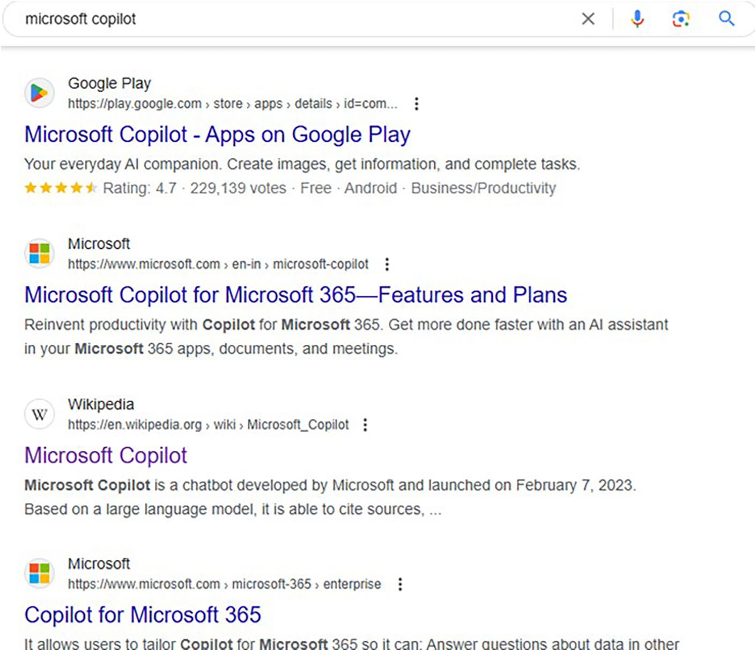

Figure 1-1. This is how a traditional non-AI search engine displays the result
As you can see, the search engine provides the results with the title, description, and URL. You have to manually visit each search result, and the whole process should be repeated until you find a specific answer relevant to your query. The search results rendered through web browsers are paginated. This means you have to select each page manually to locate the relevant information. Sometimes, you will have to select several pages and then manually click the links to locate a piece of specific information. You only had search engines at your disposal. It’s still a credible tool because the system provides links from reputed sources that are ranked according to the popularity of the domain. You just need to open the link

Chapter 1 evolution of MiCrosoft Copilot
and read the content, which will be supported by images and videos. You
can also select the internal links from the displayed web pages to locate
additional resources.
Even though Microsoft’s Bing exists, Google dominates the search
engine space because publishers often produce content in such a way as
to rank them better on Google only. Sometimes, web pages rank higher on
Bing than Google. It all depends upon the algorithm adopted by the search
engines. Both Google and Microsoft keep on changing the algorithm that
affects the display of your content. Google’s Panda update was notorious
because web pages ranked higher before the rollout of the update
drastically went down in the overall search rankings. This will not only
affect the traffic but also the overall revenue of publishers.

History
Microsoft established a strategic partnership with OpenAI in 2019 and
started to infuse funds. As part of the deal, OpenAI systems are being run
on the Microsoft Azure cloud platform. Microsoft revealed in September
2020 that it had licensed OpenAI’s GPT-3 technology. Even though other
users can receive output from its public API, Microsoft will only have
access to the underlying language model. OpenAI created an Internet
sensation in November 2022 with the launch of GPT-3-enabled ChatGPT
chatbot. The system was primarily designed to deliver information based
on prompts. The whole system gained worldwide attention with users
storming into ChatGPT. A major development happened on January 23,
2023, when Microsoft announced a $10 billion investment in OpenAI.

Origin of Bing Chat
Just days after the massive investment in OpenAI, Microsoft Copilot
(originally named Bing Chat) was launched on February 7, 2023. Bing Chat
was designed based on the GPT-3 language model but was upgraded to the

Chapter 1 evolution of MiCrosoft Copilot
GPT-4 language model. The system generated answers based on queries by citing sources. Bing Chat was able to deliver short/long essays based on the tone, create poems, perform calculations, and much more. Microsoft renamed Bing Chat as Copilot in late 2023 to provide uniformity across Microsoft AI products like GitHub Copilot.
Microsoft continues to add new features and capabilities to Copilot. The chatbot was expanded with support for plugins. For example, Microsoft Copilot provides the capability to generate songs via the Suno AI plugin. Copilot can be considered as an advanced replacement for Cortana, which has been discontinued by Microsoft.
Bing Chat was initially launched as an integrated feature for the Bing web browser and Microsoft Edge. Microsoft embedded Copilot into Windows 11 during the sidelines of the Microsoft Build conference. You can easily launch Copilot in Windows 11 directly from the Taskbar. Microsoft announced the addition of a dedicated Copilot key for Windows devices in January 2024. This is a major development in the quest to tag Windows 11 devices as AI enabled.
Even though Microsoft Copilot was launched based on the GPT-3 model, the system currently makes use of the GPT-4 language model based on Microsoft Prometheus. Copilot Pro subscribers have access to the advanced GPT-4 Turbo model. The system has been fine-tuned with not only supervised but also reinforcement learning techniques. The Microsoft Copilot dashboard looks similar to ChatGPT, but you can specify the output tone. Moreover, Copilot displays sources from where the output is being fetched. The interactions with Copilot are saved just like ChatGPT. Microsoft Copilot is designed in such a way that it can communicate with numerous languages and dialects.
The Bing AI chatbot was initially made available in waitlist mode to users of Microsoft Edge and Bing mobile apps. Microsoft revealed that one million people joined the Bing Chat waitlist within 48 hours of the official
launch. The Bing Chat UI looked as shown in Figure 1-2.

Chapter 1 evolution of MiCrosoft Copilot
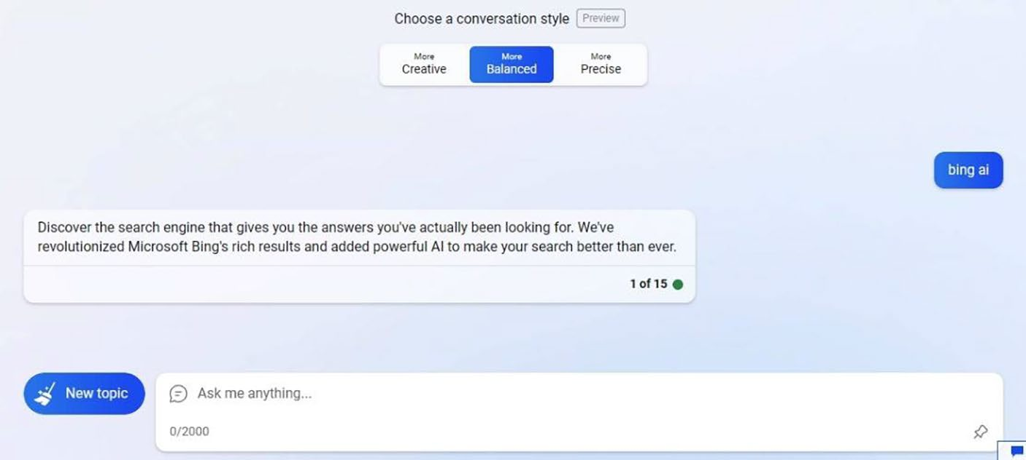

Figure 1-2. Bing Chat user interface
Microsoft restricted the chat session to 5 with a limit of 50 queries per
day per user. The company relaxed the restrictions to 30 chat sessions and
300 queries per day. These restrictions helped the company to balance
the server load and also to provide quick replies. Microsoft eliminated
the waitlist requirement and migrated the AI chatbot to Open Preview on
May 4, 2023. Bing Chat was made available for consumption on non-Edge
web browsers such as Google Chrome, Firefox, and others on August 4,
2023. Microsoft Copilot is available for free just like search engines. With
the help of the free version, you can access several features including the
ability to create songs and images. The image creation does come up with
restrictions in the form of tokens for Copilot Free users, while the Pro
subscribers have 100 tokens per day. The system generates images via
OpenAI’s DALL·E technology using powerful algorithms.

Image Creator
Microsoft released Bing Image Creator (currently Image Creator) powered
by OpenAI’s DALL·E 2 technology in March 2023. The system was designed
to generate rich and compelling images based on the provided prompt.

Chapter 1 evolution of MiCrosoft Copilot
The image creator tool was upgraded with DALL·E 3 in October 2023. Like with all other AI image generation tools, Microsoft has applied filters to prevent the generation of offensive images. Microsoft recently renamed Bing Image Creator to Image Creator using which you can create amazing images. It’s the same as the original Image Creator except for the change in the name. The dashboard of the Image Creator looks as shown in
Figure 1-3.
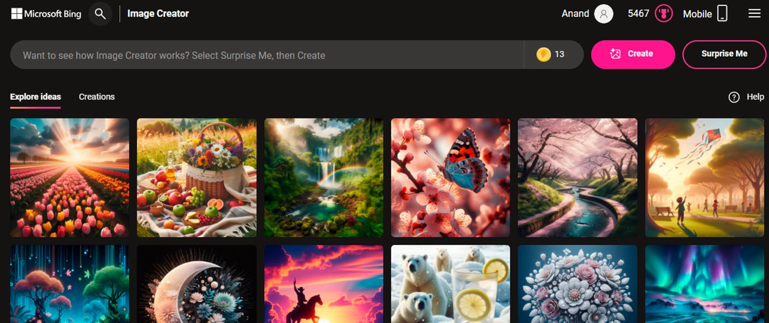

Figure 1-3. Create stunning images with Image Creator
You should note that the screenshot is the home page of the Microsoft Image Creator. The thumbnails have no relation with living characters or humans. Microsoft also launched a complete Designer app using which you can create images, stickers, and designs as well as erase selected content from existing images. The app also includes several modules for performing tasks such as greeting card creation, background removal, restyling images, and much more.

Note Do you want to learn Microsoft Designer in detail? refer to

Chapter 9.

Chapter 1 evolution of MiCrosoft Copilot
Microsoft 365 Copilot
Microsoft announced the launch of Microsoft 365 Copilot on March 16,
2023. The main purpose is to provide Copilot as a value-added feature to
Microsoft 365 with special emphasis on business productivity. Microsoft
365 Copilot is oriented for enterprise companies who would like to have
a secured AI interaction. Moreover, companies will be able to experience
Enterprise-grade data protection with Microsoft Graph grounding. The
team members will be able to customize and extend via Microsoft Copilot
Studio. As of this writing, Microsoft 365 Copilot costs $30 per user/month
with an option for an annual subscription. The prices are subject to change
without any notification. You need access to a Microsoft 365 Personal or
Family subscription to work with Microsoft 365 Copilot. With the help
of Microsoft 365 Copilot, you can automate Word, Excel, PowerPoint,
OneNote, and Outlook, including Microsoft Teams. For example, you
can ask Copilot after logging in to Microsoft 365 Word app to compose
an article, poem, letter, or listicle. Copilot in PowerPoint enables you to
create stunning presentations filled with quality content and images. You
can also ask Copilot to fetch specific information related to the active
PDF document that has been opened on the web browser. The Copilot
with Commercial data protection is available on Android and iOS mobile
platforms via Microsoft Copilot, Microsoft 365, Microsoft Start, and Bing
apps, respectively. However, you need to sign in to the app using work or
school (Entra ID) accounts.

Note You can subscribe to Copilot pro to work with Copilot using Microsoft 365. You can also create documents in Microsoft 365 for free via oneDrive to work with Copilot.

Chapter 1 evolution of MiCrosoft Copilot
Copilot in Word
With the help of Copilot in Word, you can create, rewrite, and summarize your documents to the next level. You can also transform text into a table automatically. Copilot can also discover information from your document irrespective of the page count. For instance, you can load and ask Copilot in Word to summarize the content. You can also use the chatbot to write articles, blog posts, letters, poems, and much more.
Copilot in Excel
The integration of Copilot in Excel is considered a big step in the exploration of data. You will find Copilot useful to drill down lengthy spreadsheets to locate relevant information. The Copilot support in Excel will be useful for large hypermarkets and enterprise companies since these organizations will have to analyze massive data of both consumers and suppliers. You can highlight, filter, and sort data with Copilot support from within Excel. The main prerequisite is that the Excel data should be active on OneDrive and must be in a tabular format.
Copilot in PowerPoint
You can easily create powerful and impressive presentations via Copilot in PowerPoint. You just need to provide the relevant prompt to enable PowerPoint to create the required slides. Microsoft Copilot can convert a Word document into beautiful presentations with complete content and images. Moreover, Copilot provides intelligent prompts using which you can adjust your presentations. It’s possible to shorten lengthy presentations and make use of natural language commands to adjust layouts and animations. You need to provide the link to your Word file after creation/uploading to OneDrive to generate PowerPoint presentations via Copilot. However, if you would like to make use of the Word file directly, then you need to have Microsoft 365 Copilot subscription.

Chapter 1 evolution of MiCrosoft Copilot
Copilot in Outlook
Copilot in Outlook enables you to work with emails effectively. If your
inbox includes thousands of emails, then Copilot can fetch emails as per
your prompt and keywords. You can ask Copilot to summarize an email
with special importance to suggested action items, replies, and follow-up
meetings. You can also ask Copilot to draft emails by specifying length and
tone, which is also called email coaching.
Copilot in OneNote
OneNote enables you to simplify note capturing capabilities, and the
integration of Copilot takes this one step further. You can ask queries via
prompts in addition to the ability to generate and summarize content.
Copilot enables you to get information from lengthy files quickly, which
saves you a considerable amount of time.
Copilot in Teams
Microsoft Teams is an excellent collaboration tool using which you can
interact with your colleagues via both text and video in a secured way.
Copilot in Teams intelligently organizes and summarizes content in
addition to fetching answers to queries. Copilot creates meeting agendas
quickly based on chat history. You can follow up and schedule the next
check-in from within Copilot. Microsoft has integrated Copilot in several
other products such as Loop, Microsoft Stream, Whiteboard, Graph, Graph
Connectors, and Purview.

From Copilot to Microsoft Copilot
Microsoft announced the rebranding of Copilot to Microsoft Copilot on
September 21, 2023. The company introduced a new Microsoft Copilot
logo as shown in Figure 1-4 as part of the major refresh. Microsoft replaced

Chapter 1 evolution of MiCrosoft Copilot
all Copilot instances with the new logo such as Copilot in Windows (preview), Windows 11 search, Bing, Skype, Web app, mobile apps as well as the newly launched Copilot Windows app.
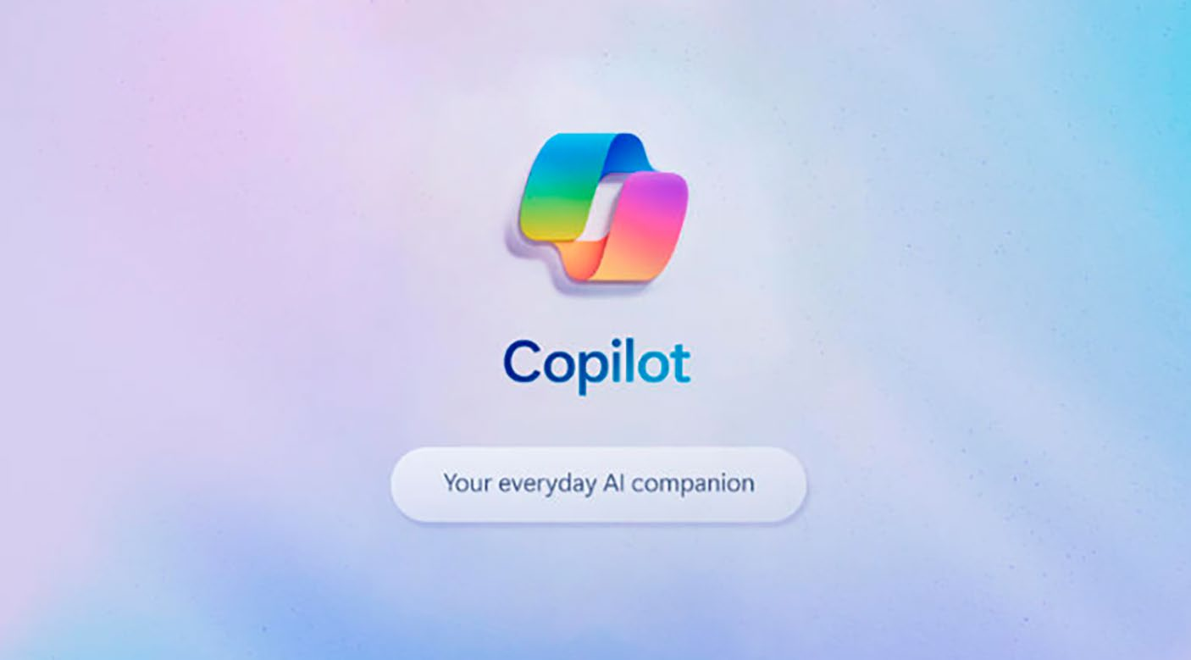

Figure 1-4. The Official Microsoft Copilot Logo in Action
Windows Copilot was also launched during the sidelines of the Build 2023 conference. It was designed for Windows 11 devices using which users can directly access Copilot via an icon located on the Taskbar. However, Microsoft renamed Windows Copilot as Microsoft Copilot in October 2023. Subsequently, Microsoft Edge’s Bing Chat functionality was also renamed as Copilot.
A major development happened on November 15, 2023, when Microsoft completely rebranded Bing Chat as Microsoft Copilot. Microsoft also renamed Bing Image Creator as Image Creator by Designer. Microsoft Copilot was also made generally available starting November 1, 2023, for Microsoft 365 Enterprise customers who purchase more than 300 licenses. You can also work with Microsoft Copilot using the respective Android and iOS apps.

Chapter 1 evolution of MiCrosoft Copilot
Dedicated Copilot Key
Microsoft took tech enthusiasts by storm on January 4, 2024, with the
announcement of a dedicated Copilot key for Windows 11 devices. The
manufacturers have showcased Windows 11 devices with Copilot key
during the sidelines of the Consumer Electronics Show (CES) and Mobile
World Congress (MWC) 2024 conferences. In Figure 1-5, you can view the
keyboard of the latest Microsoft Surface keyboard with the Copilot key. It’s
the second key to the right side of the space bar.
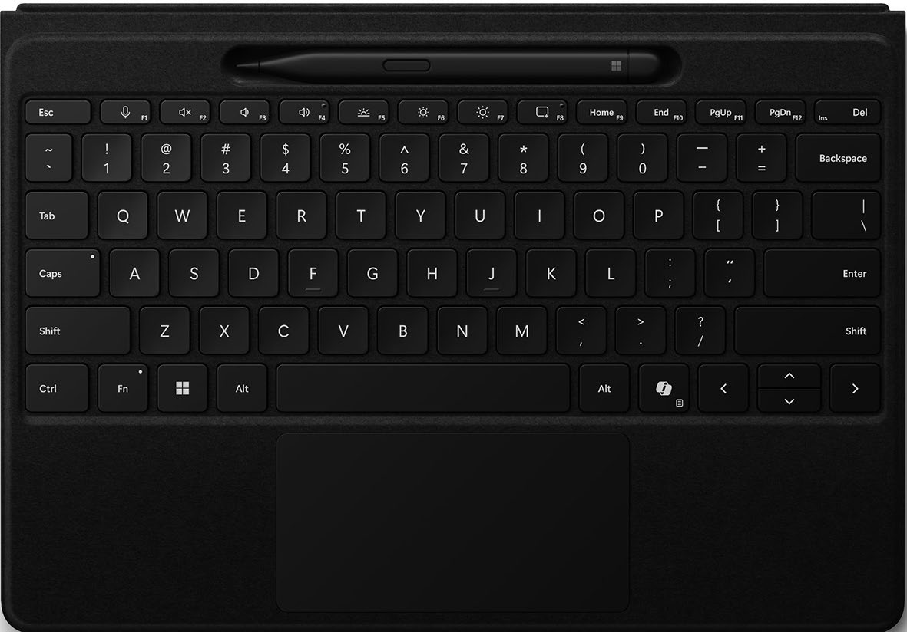

Figure 1-5. The new dedicated Copilot key will boost productivity
You can expect wide availability of Windows 11 devices with the
Copilot key by the end of 2024. You just need to press the Copilot key as
shown in Figure 1-5 to launch the Microsoft Copilot user interface, which
will be docked to the right side of the Windows 11 desktop.

Chapter 1 evolution of MiCrosoft Copilot

Note You can also access Microsoft Copilot in Windows 11 by
hitting the Win+C keyboard shortcut. however, Microsoft could make
changes to the key as per user feedback.
The purpose behind the introduction of a new Copilot key after 30 years of the Windows logo key is to enhance user experience and overall productivity. You can ask Copilot to open apps such as Notepad, Snipping Tool, Calculator, Settings, and much more. Moreover, you can ask Copilot to change the desktop environment from Light to Dark theme and vice versa. You should note that Microsoft reserves the right to change the functionality of Copilot.

Microsoft Copilot Pro
Microsoft launched Copilot Pro on January 15, 2024 with additional perks to enhance the overall Copilot user experience. Copilot Pro is available with enhanced features with priority access to not only GPT-4 but also GPT-4 Turbo even during peak usage periods with enhanced performance. This will enable accelerated generation of answers, content, and AI images. The bundled Copilot GPT Builder enables users to create custom Copilot chatbots. With Copilot Pro, you can access Copilot in Microsoft 365 apps such as Word, Excel, PowerPoint, and Outlook. Moreover, you can experience faster image generation with DALL·E 3 with an additional 100 daily boosts with Microsoft Designer. Copilot Pro costs $20 per month. However, you can subscribe to free trial for 30 days to test-drive the features and performance.

Note Buy Copilot pro: www.microsoft.com/en-us/store/b/
copilotpro

Chapter 1 evolution of MiCrosoft Copilot
Windows 11
Microsoft has integrated Copilot into Windows 11 with powerful features.
You will be able to work with Microsoft Copilot directly by selecting the
Copilot in Windows (preview) Taskbar icon. In addition to standard search
functions, you can ask Copilot in Windows to open the Calculator app
by simply providing the prompt open calculator. You have to provide the
prompt by launching the Copilot icon from the Taskbar, which is located
at the right side of the Notifications icon. In the same way, you can query
Copilot to open Notepad, WordPad, Snipping Tool, Paint, Settings app, and
much more.

Note Wordpad was discontinued by Microsoft in september 2023. the app was released on august 24, 1995. the company recommends improved notepad or Microsoft Word as alternatives.
You can also change the entire Windows 11 desktop to Dark mode
from Light and vice versa. You have to provide a prompt like change to dark
mode by selecting the Copilot in Windows (preview) Taskbar icon.

Copilot Apps
Microsoft Copilot is now available as a separate app from Microsoft Store.
The app will be pinned to the Windows 11 Taskbar. Microsoft Copilot apps
for Android and iOS can be downloaded from Google Play Store and Apple
App Store. You can make use of voice to provide prompts, and Copilot will
deliver results instantly. However, you should sign in with your Microsoft
account to enable Copilot to generate images. You can also access
Microsoft Copilot via Telegram. You should add the Copilot Official Bot
from within the app and interact with the chatbot.

Chapter 1 evolution of MiCrosoft Copilot
Copilot+ PCs
Microsoft announced the launch of Copilot+ PCs on May 20, 2024. The company revealed that it is revolutionizing the PC for the AI era with Copilot+ PCs. The new technology will be fulfilled via hybrid AI with Copilot+ PCs. Microsoft disclosed that enterprise companies can deploy Copilot+ PCs to enjoy fastest and intelligent Windows 11 PC. Copilot+ PCs leverage a neural processing unit (NPU) silicon, which is capable of delivering an incredible 40+ trillion operations per second (TOPS). The NPU is a chipset embedded inside the motherboard, which is exclusively designed to run AI tasks locally and smoothly. Moreover, organizations can experience a brilliant AI endpoint for work in addition to a foundation for your dedicated chip-to-cloud solution stack.
The main advantage of Copilot+ PCs is that they have the potential to unlock industry-compliant AI acceleration with up to 2x faster NPU performance when compared with MacBook Air and MacBook Pro. The advanced privacy module ensures that AI running on your Copilot+ PCs will never be able to access your private content. With the help of Copilot+ PCs, companies can effectively make use of Copilot for Microsoft 365, which provides powerful AI solutions at work. Copilot+ PCs will be integrated with specific modules to handle demanding workloads. They provide an intuitive AI experience with advanced Windows Security.
Copilot+ PCs are currently equipped with an advanced Qualcomm Snapdragon X Elite Arm processor. The CPU is capable of offering up to 22 hours of video playback and 15 hours of web browsing, respectively. Copilot+ PCs are specifically designed to provide a seamless user experience with business apps and Windows 365 Cloud PCs. Intel and AMD will also release advanced processors for the development of Copilot+ PCs.

Chapter 1 evolution of MiCrosoft Copilot

Note Microsoft revealed that Copilot+ pCs devices with intel and aMD processors will be available within the next few months.
The devices that are shipped with Copilot+ PCs will ship with new
features such as Recall, Live Captions with translation, and Windows
Studio Effects. These features are designed to enhance the productivity
of users irrespective of organization size. With the help of Recall, you can
locate any content on your desktop just by entering the relevant search
keyword. The Recall will display accurate snapshots of the most relevant
content based on either the text or visual search. Moreover, Microsoft has
integrated advanced privacy controls using which you can decide the
information that Recall can capture.
The Live Captions integrated into Copilot+ PCs is capable of translating
more than 40 languages into English. This includes speakers in real-time
video calls, streamed content, and recordings. The Windows Studio Effects
have been upgraded with features such as flattering portrait lighting,
creative filters, and natural-looking eye contact. Moreover, the enhanced
noise cancelling and background blur shut out distraction capabilities
improve the way you interact with users over video.
Microsoft has established collaboration with manufacturers for the
development of Copilot+ PCs. Some of the new devices that are fully
compliant with Copilot+ PCs are Acer Swift 14 A, ASUS Vivobook S15,
Dell XPS 13, HP OmniBook X, HP EliteBook ultra, Lenovo Yoga Slim 7X,
Lenovo T14 S, Samsung Galaxy Book4 Edge, Microsoft Surface Pro, and
Surface Laptop.

Chapter 1 evolution of MiCrosoft Copilot
Summary
In this chapter, you have learned the evolution of Generative AI and Microsoft Copilot in detail. You also learned the various phases of GPT and the evolution of chatbots. This chapter also provided a short outline about Image Creator, the dedicated Copilot key, and Copilot Pro as well as the newly launched Copilot+ PCs. The upcoming chapters will delve deep into the working of Copilot in Windows 11 and image creation capabilities. The purpose of this chapter is to help you learn all the required Copilot tools and technologies that you can explore while going through this book.

CHAPTER 2

Working with Copilot

in Windows 11 – Part 1
Microsoft Copilot is a Generative AI–based Large Language Model (LLM)
chatbot, which is capable of generating content based on queries or
prompts. Copilot also provides the ability to create lists, poems, short
stories, and recipes as well as the ability to generate impressive images.
The possibilities are endless, and it’s up to you to decide the way to work
with the Copilot. Microsoft has integrated Copilot with Windows 11, and
you can work directly by selecting an icon from the Taskbar. However,
there are several other ways by which you can access Copilot from within
Windows 11. In this chapter, you will learn the steps required to work with
Copilot via Windows 11 search.

Accessing Copilot in Windows 11
To work with Copilot, you need access to a device running Windows 11.
Microsoft is rolling out Copilot in a phased manner across various regions.
If Copilot is available on your Windows 11 device, you will see an icon
either in the Taskbar adjacent to the search box or on the far-right side
of the Taskbar adjacent to the Notifications bell icon. The Copilot icon
was originally placed near the search box, but the subsequent updates
shifted the icon to the right side of the Notifications bell icon as shown in
Figure 2-1.
© Anand Narayanaswamy 2024 25
A. Narayanaswamy, Microsoft Copilot for Windows 11, Inside Copilot,

ChaPter 2 WorkIng WIth CoPIlot In WIndoWS 11 – Part 1
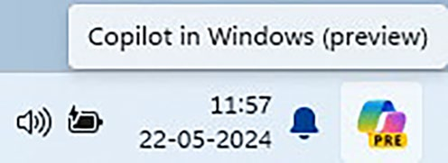

Figure 2-1. Kick-start your Copilot Journey
Microsoft recently released Windows 11 version 24H2 to the Windows Insiders Release Preview Channel with an evolved Copilot user experience. This means that you can access Copilot via an app that will be pinned to the Taskbar. You can easily resize, move, and snap the window just like any other app. This new update will be rolling out to Windows Insiders in the Dev, Canary, and Beta channels in the upcoming months.
Microsoft also announced the retirement of the WIN+C keyboard shortcut as part of this new user experience in Windows 11 version 24H2. The devices with a dedicated Copilot key will open the Copilot chatbot upon hitting the key. Microsoft also announced a new way to open Copilot on devices without the Copilot key. You can make use of WIN+number position for Copilot pinned to your Taskbar. However, the new changes are currently available only for Windows Insiders in the Release Preview Channel.

Note Windows Insiders are a group of tech enthusiasts who
regularly provide feedback after testing new versions. You can join
the Windows Insider Program from within Windows 11 by navigating
to Settings ➤ Windows Update ➤ Windows Insider Program and by
selecting the Get started button.
Let’s examine the various methods by which you can access Copilot in Windows 11. You can work with Copilot either by selecting the search box or by directly clicking the Copilot in Windows (preview) icon from the Windows 11 Taskbar. Additionally, you can work with Copilot after installing the app from the Microsoft Store.

ChaPter 2 WorkIng WIth CoPIlot In WIndoWS 11 – Part 1
In this chapter, you will learn the steps required to access Copilot
via the Windows 11 search. The first step is to select the Ask Copilot icon
located at the top-right side of the search box as shown in Figure 2-2.
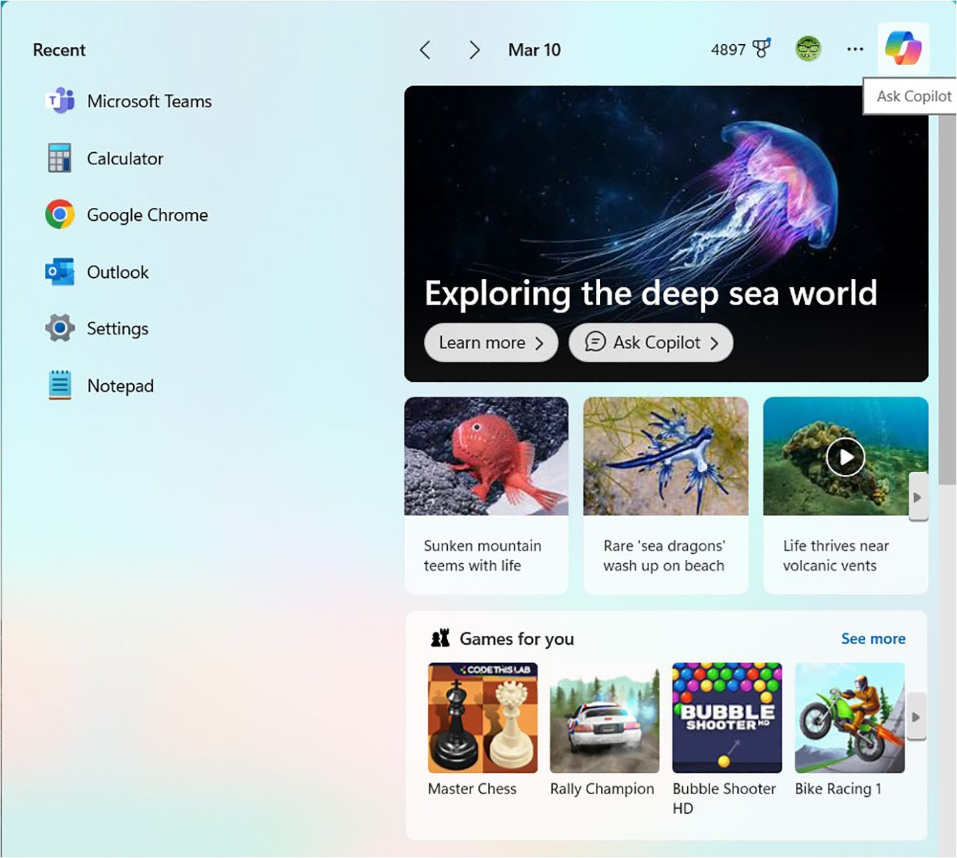

Figure 2-2. Explore Copilot via Windows 11 search
You will see the Copilot dashboard with relevant information as shown
in Figure 2-3. The dashboard displays automated prompts that you can
make use of straightaway.

ChaPter 2 WorkIng WIth CoPIlot In WIndoWS 11 – Part 1
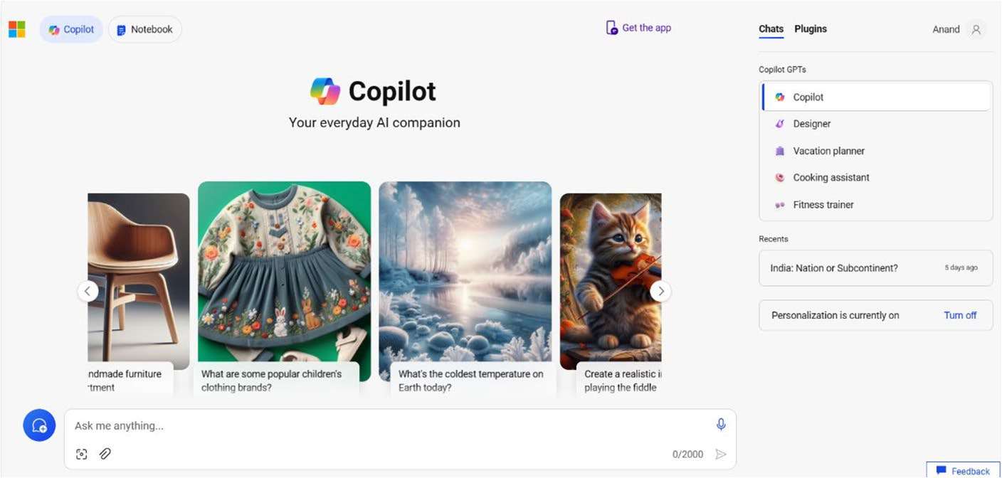

Figure 2-3. Get started with Copilot

Note You can also select the Ask Copilot button located inside
the search suggestion. Copilot provides the response based on the
displayed topic. If you select the Learn more button, the search
results are displayed in Microsoft Bing.
If you select a prompt from the sliding carousel, Copilot displays the relevant response based on the selected topic. You can also provide a query, also called a prompt, which can be up to 2000 characters in length. A prompt spans across either a single line or multiple lines depending upon your requirements.

Note You interact with Microsoft Copilot using queries. In aI
parlance, queries are called prompts.
Let’s select an item from the Copilot dashboard carousel, and the
output looks like as displayed in Figure 2-4.

ChaPter 2 WorkIng WIth CoPIlot In WIndoWS 11 – Part 1
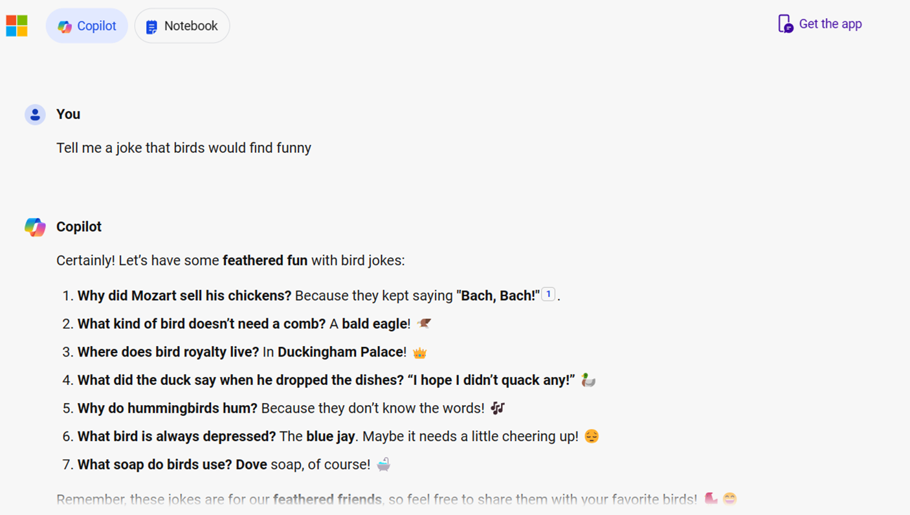

Figure 2-4. Check out the results delivered by Copilot
If you scroll down the Copilot dashboard, you will find the links to
sources from where answers were fetched, including images with jokes, as
displayed in Figure 2-5.
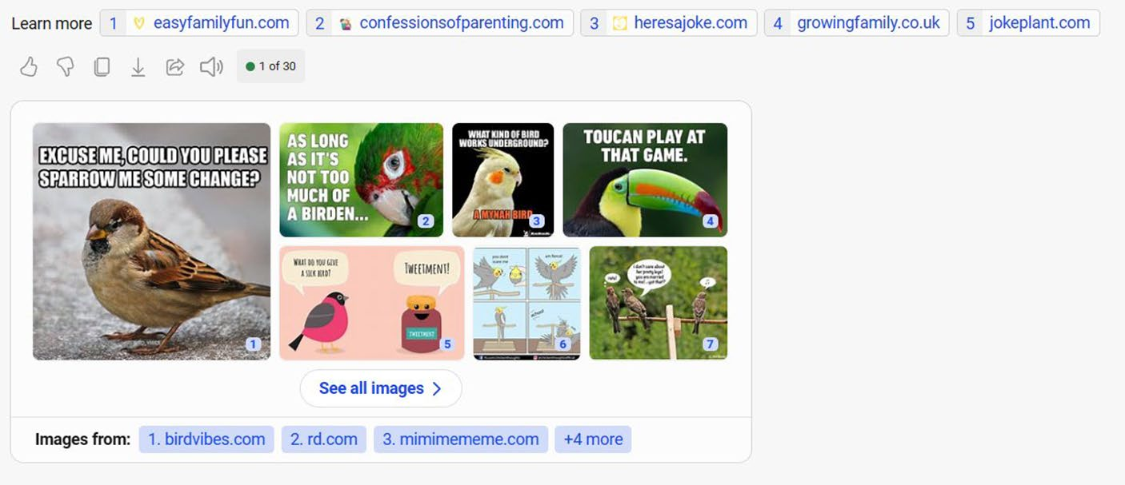

Figure 2-5. Copilot displays sources with relevant images

ChaPter 2 WorkIng WIth CoPIlot In WIndoWS 11 – Part 1
Exporting Copilot Output
You can like, dislike, and copy the generated Copilot output as well as export the content. If you select the Export icon located below the source
link row, you will see the screen as shown in Figure 2-6.
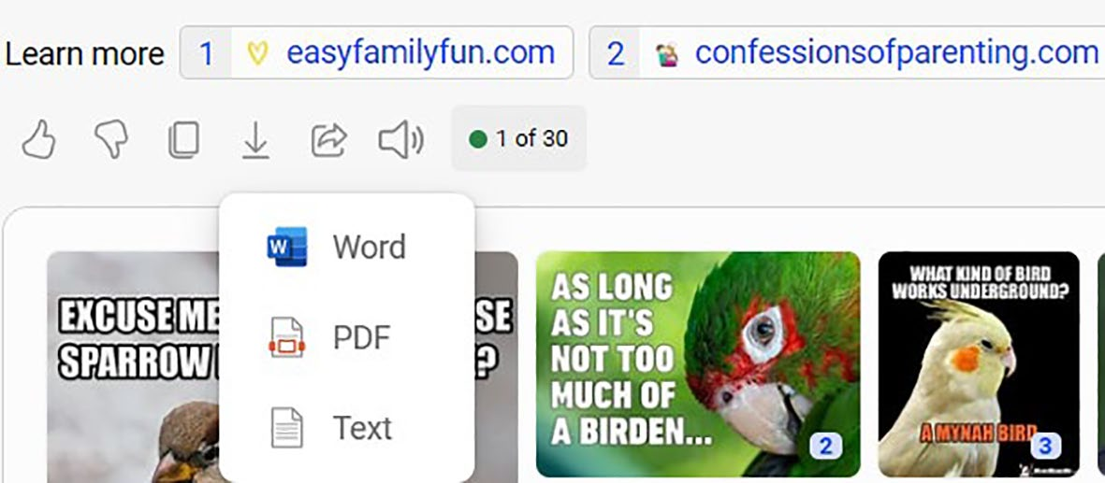

Figure 2-6. Share Copilot results easily
You can export the Copilot output in Word, PDF, and Text formats,
respectively. In Figure 2-7, you can see the resulting screen after selecting the PDF export option.
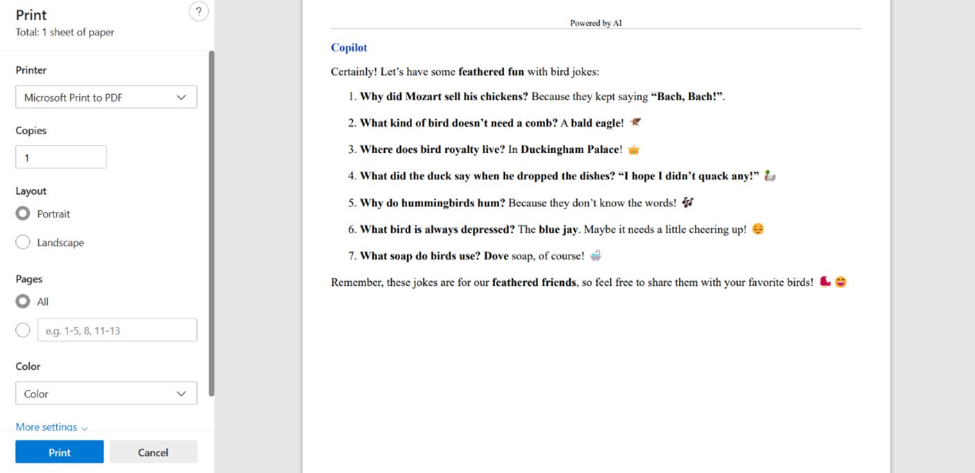

Figure 2-7. Exporting Copilot output via PDF

ChaPter 2 WorkIng WIth CoPIlot In WIndoWS 11 – Part 1
You will see the relevant output in the Print dashboard. You can easily
transfer the content from Microsoft Print to PDF format by selecting the
Print button. That’s it. Your Copilot output will be saved as a separate PDF
file. Your interactions with Copilot will be automatically saved inside the
dashboard as shown in Figure 2-8 under the Recents section.
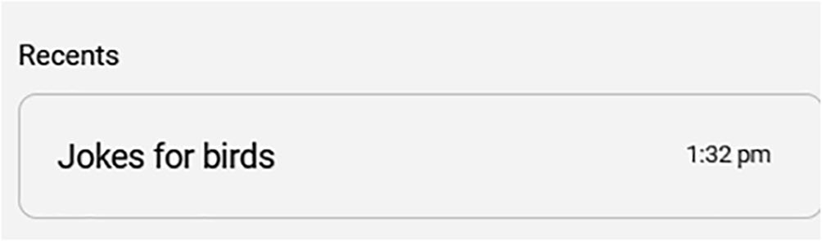

Figure 2-8. Copilot maintains a history perfectly
The right side also displays Copilot GPTs and the available plugins. We
will examine them in detail in an upcoming chapter.

Picking a Conversation Style
Microsoft Copilot provides three conversation styles: Creative, Balanced,
and Precise. The default conversation style is Balanced. Let’s now provide
a prompt and check out the results of the response delivered by all three
conversation styles.

Note Microsoft is currently experimenting with a new Copilot user interface without the three conversation styles. however, the styles could appear intermittently if you are using the Copilot Free version. the conversation styles are available for Copilot Pro as per our testing. Microsoft hasn’t yet clarified that the styles are only reserved for Copilot Pro users. even if you are not able to view the styles, the content discussed here holds good. alternatively, you can select the three horizonal lines (hamburger menu), select Settings and change the Country/region to United States - english to view the conversation styles.

ChaPter 2 WorkIng WIth CoPIlot In WIndoWS 11 – Part 1
Prompt: Can you provide the name of Kerala capital?
Style: Creative
In Figure 2-9, you can observe how the Creative conversation style displays the output.
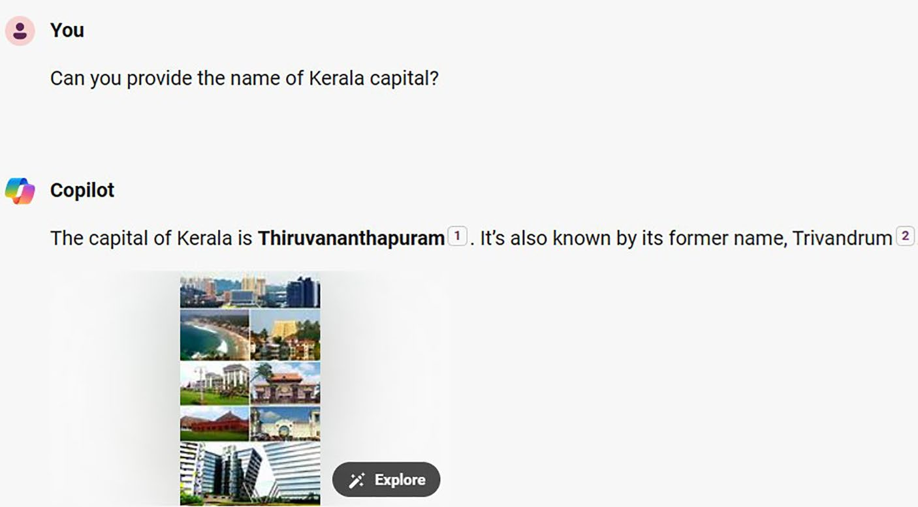

Figure 2-9. Copilot delivers a creative output
Prompt: Can you provide the name of Kerala capital?
Style: Balanced
The output will be rendered as follows:
Certainly! The capital of Kerala is Thiruvananthapuram (commonly shortened to TVM), formerly known as Trivandrum. It is the most populous city in Kerala, with a population of 957,730 as of 2011. Thiruvananthapuram is located on the west coast of India near the extreme south of the mainland. It is a major information technology hub in Kerala, contributing 55% of the state’s software exports as of 2016. Mahatma Gandhi referred to it as the “Evergreen city of India.” The city’s undulating terrain features low coastal hills, and it has a rich historical background, later becoming the capital of the princely state of Travancore

ChaPter 2 WorkIng WIth CoPIlot In WIndoWS 11 – Part 1
Prompt: Can you provide the name of Kerala capital? Style: Precise
The Precise style is identical to Creative but with minor modifications
as shown in Figure 2-10.
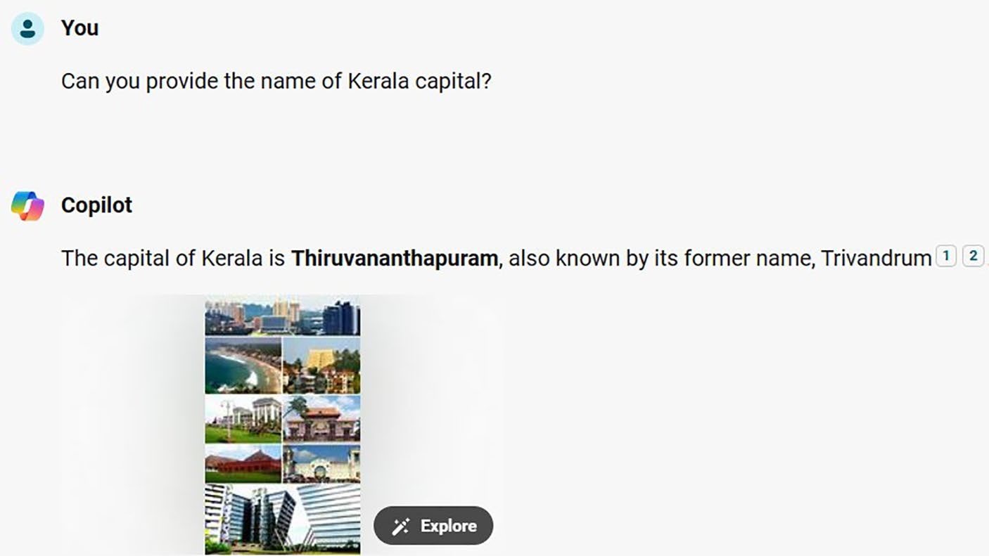

Figure 2-10. It is the precise answer to our query
While the Creative and Precise conversation styles emit single-line
answers, the Balanced style generates longer responses. You will be able to
learn additional information about Kerala’s capital.
Let’s examine the working of Copilot using another prompt. Prompt: Who founded Microsoft? Style: Creative
The prompt is simple and the response will appear as shown in
Figure 2-11.

ChaPter 2 WorkIng WIth CoPIlot In WIndoWS 11 – Part 1
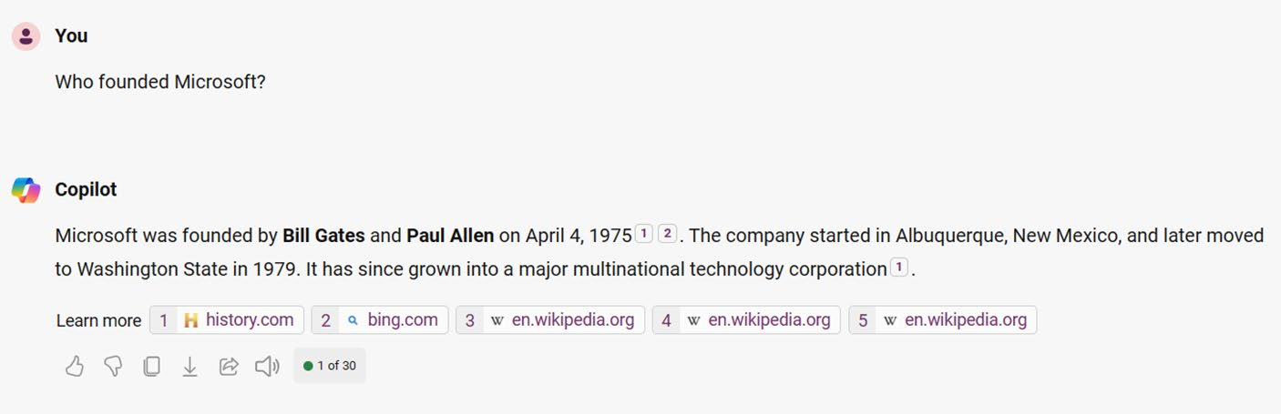

Figure 2-11. Know about Microsoft creatively
Prompt: Who founded Microsoft?
Style: Balanced
As you can see, the Balanced mode delivered lengthy content as in
Figure 2-12.
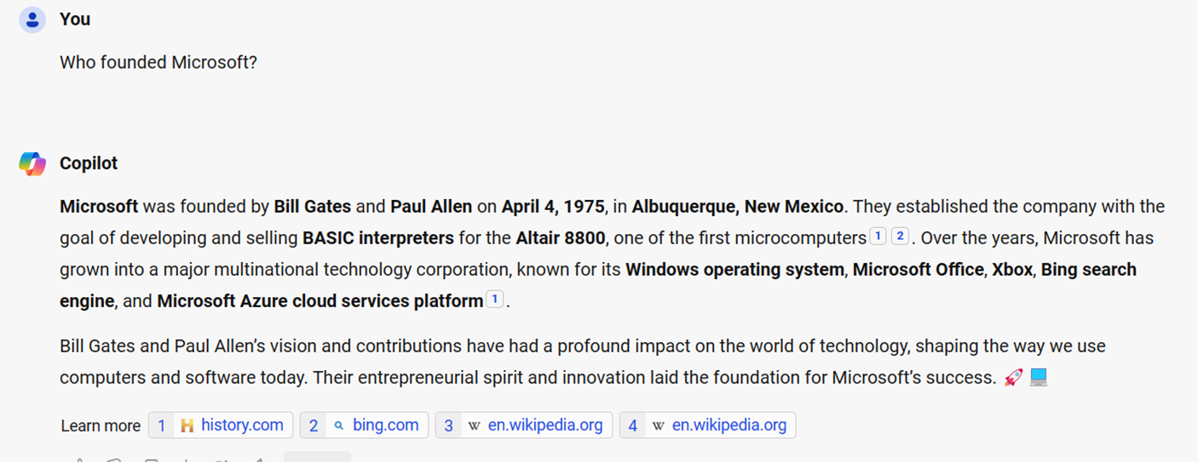

Figure 2-12. Content delivered in Balanced mode by Copilot
Prompt: Who founded Microsoft?
Style: Precise
In Precise style, Copilot delivers a crisp output as shown in Figure 2-13.

ChaPter 2 WorkIng WIth CoPIlot In WIndoWS 11 – Part 1
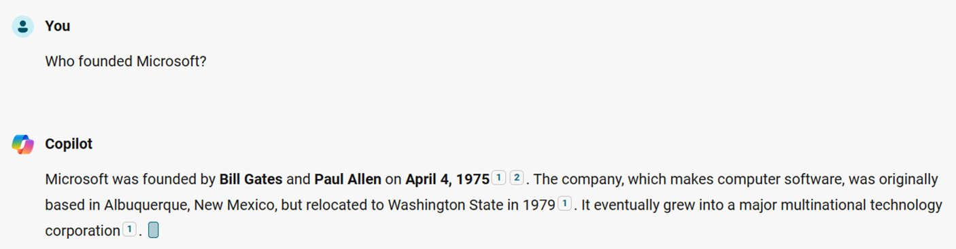

Figure 2-13. Know about Microsoft precisely
As you can observe, there are subtle differences in the response
delivered by Copilot. It’s the Balanced conversation style that provides
crisp answers. You will also notice discrepancies in the ZIP code. You
should always cross-check the answers if you feel something wrong
because of the nature of AI. You will notice that the conversation style
button changes color upon selection. While the Creative button is purple,
the default Balanced button looks blue. It’s green color for the Precise
conversation style.

Coding via Copilot
Microsoft Copilot is capable of helping you out with your coding tasks.
Copilot provides support for all major programming languages. Shall we
try to run a C# code using Copilot? We asked Copilot to demonstrate the
usage of arrays in C# as per the following prompt.

Note You should note that aI prompts are not case-sensitive.
Prompt: Write a C# code to demonstrate the usage of arrays. Copilot provides a brief description followed by the source code as
shown in Figure 2-14.

ChaPter 2 WorkIng WIth CoPIlot In WIndoWS 11 – Part 1
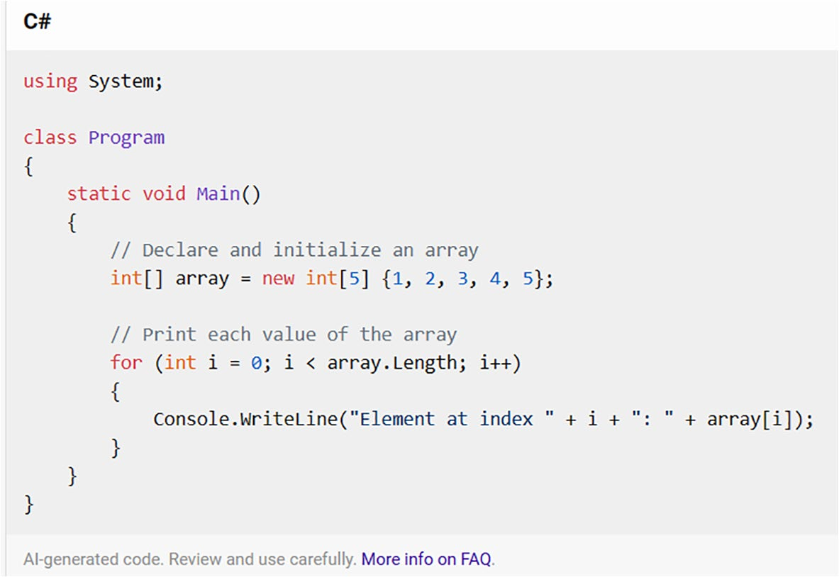

Figure 2-14. Learn coding easily with Microsoft Copilot
Let’s now try the same programming query for the Python language.
You will see the output as shown in Figure 2-15, but you have to scroll for the full explanation and the resulting source code. Copilot nicely splits every module and provides a simplified explanation.
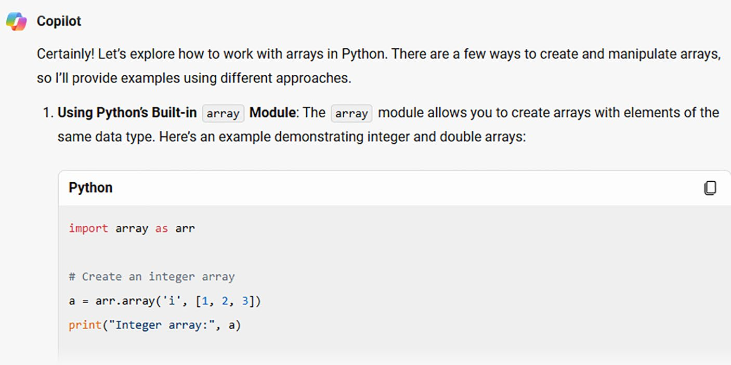

Figure 2-15. Rock-solid Python programming with Microsoft Copilot

ChaPter 2 WorkIng WIth CoPIlot In WIndoWS 11 – Part 1
Microsoft Copilot provides support for several programming
languages, and this includes Ruby. Let’s try the same prompt and ask
Copilot to deliver the output (see Figure 2-16) as per the Ruby language.
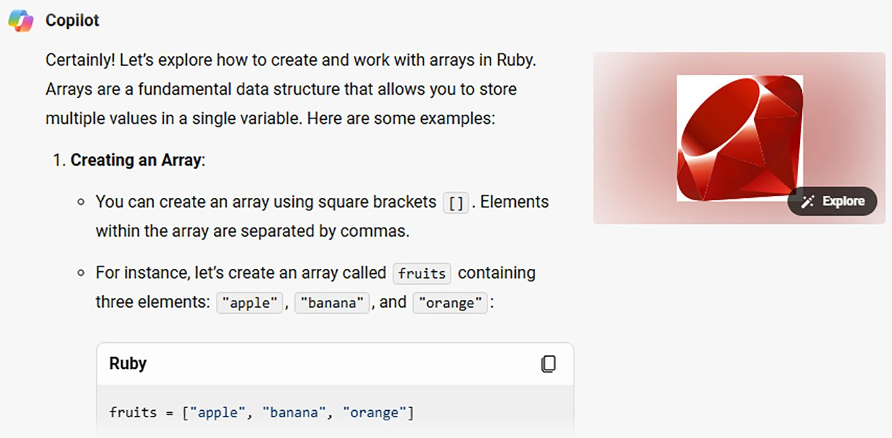

Figure 2-16. Get Rubified with Microsoft Copilot
Copilot divides the output into several headings as in Figure 2-16, such
as array creation, accessing array elements, and much more. It’s easy and
fun to learn programming with Microsoft Copilot.
Let’s go vintage and test how Copilot responds to COBOL
programming. The prompt that was tested is write a COBOL program to
add 5 and 6, and the resulting output looks as shown in Figure 2-17.

ChaPter 2 WorkIng WIth CoPIlot In WIndoWS 11 – Part 1
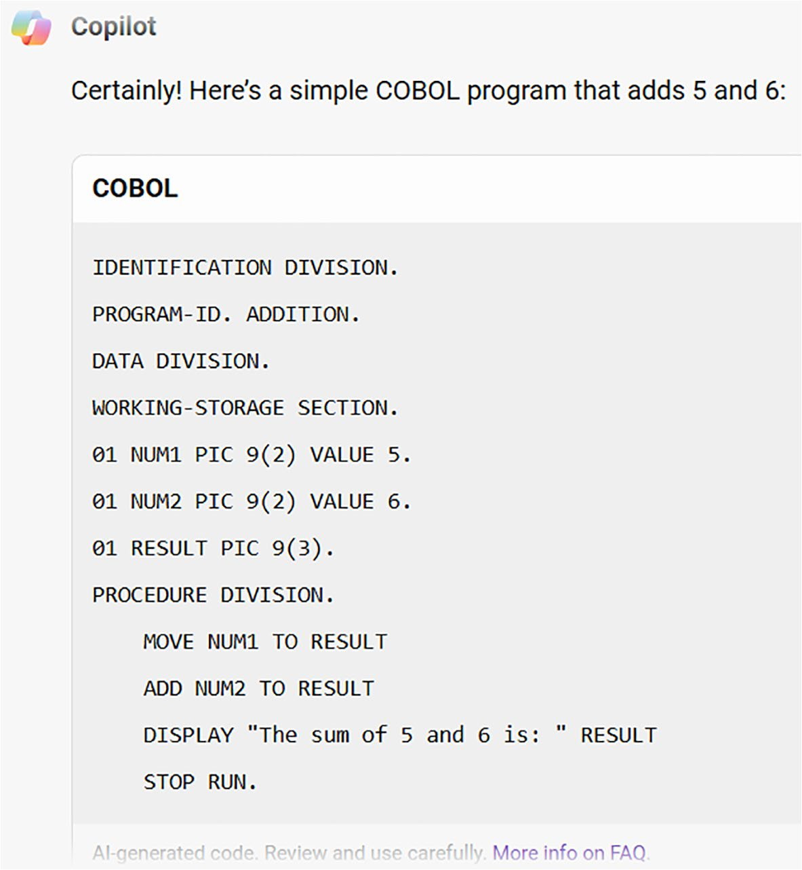

Figure 2-17. Learn vintage COBOL with Copilot
Copilot displays a disclaimer that the code is AI generated, and you have to use carefully each response. Microsoft also compiled the list of FAQs associated with Copilot, and you can access it directly by selecting the link specified below the source code. Toward the end of the code, Copilot provides a detailed bulleted explanation, which helps you to learn about the generated code. If you are a student or a prospective programmer, then you should double-check the Copilot response by directly practicing the code using the relevant programming language compiler or Integrated Development Environment (IDE) tools like Visual Studio. Moreover, students should try to learn programming traditionally and limit the usage of AI chatbots. This will help them to solve complex problems when they approach job interviews.

ChaPter 2 WorkIng WIth CoPIlot In WIndoWS 11 – Part 1
Refreshing Copilot
If you refresh the Copilot dashboard or select the Ask Copilot icon from
the Windows 11 search box once again, you will see an additional set
of prompts. Let’s write a song that celebrates the beauty of the Earth.
Microsoft Copilot automatically writes the poem with verse 1 followed by
chorus, verse 2 followed by chorus, etc., as shown in Figure 2-18.
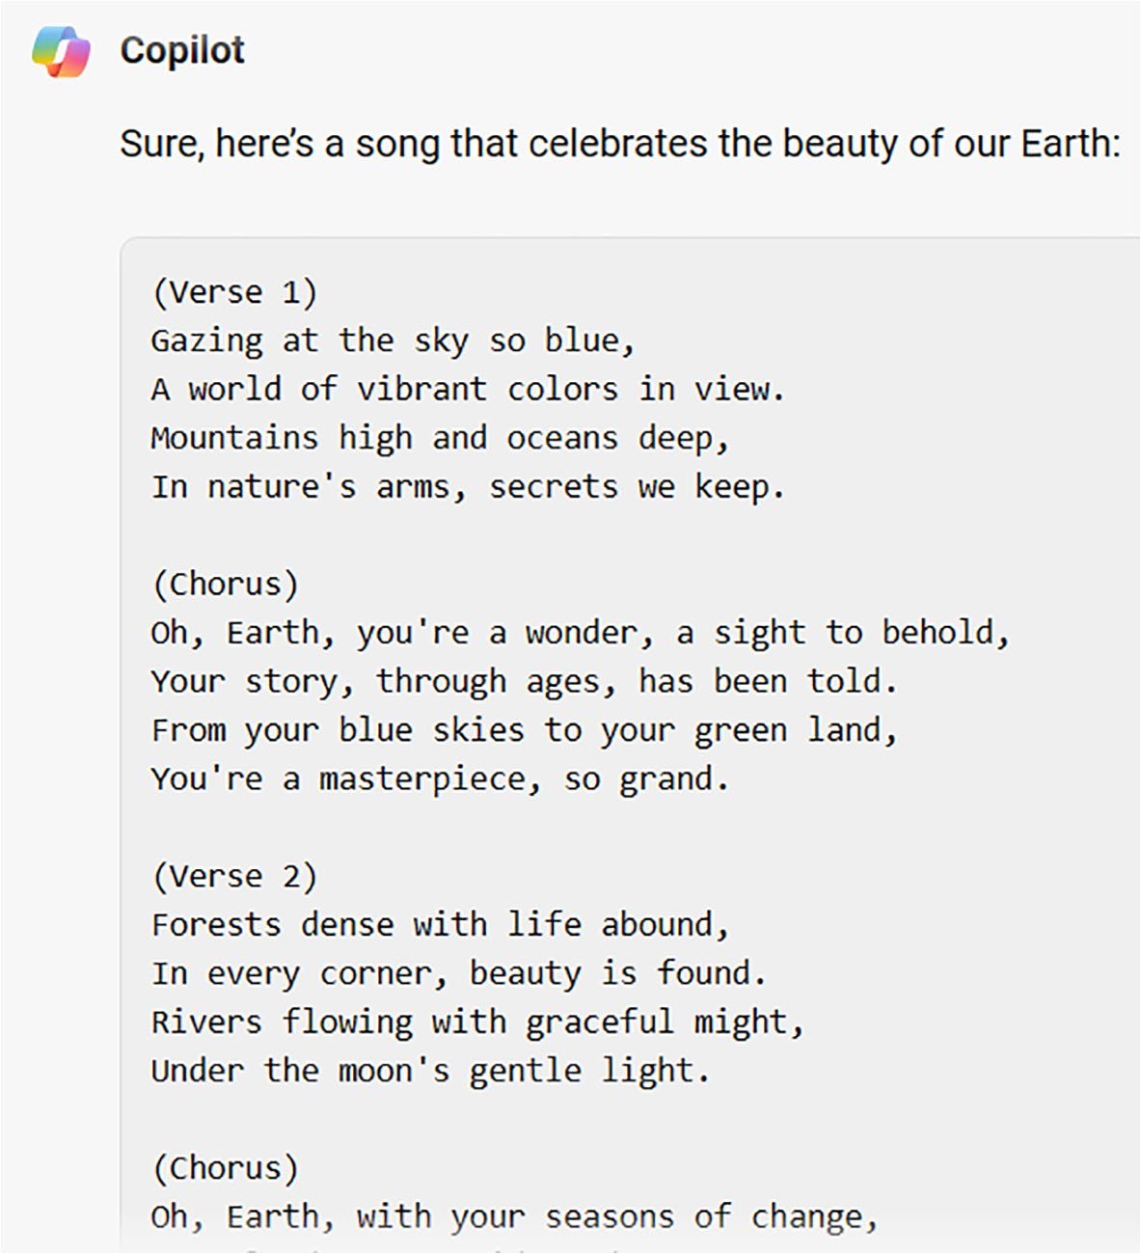

Figure 2-18. Copilot can even write beautiful poems for you

ChaPter 2 WorkIng WIth CoPIlot In WIndoWS 11 – Part 1
Copilot generates the poem in detail, which you can directly use for your projects. As you can see, Microsoft Copilot can generate any content based on the provided prompt. Let’s try something tricky. We asked Copilot to display numbers from 10 to 1, and the response looks as
shown in Figure 2-19. You should note that Copilot takes a few seconds to generate the answer. However, you will experience higher speeds if you opt for a Copilot Pro subscription that retails to $20 per month as of July 2024.
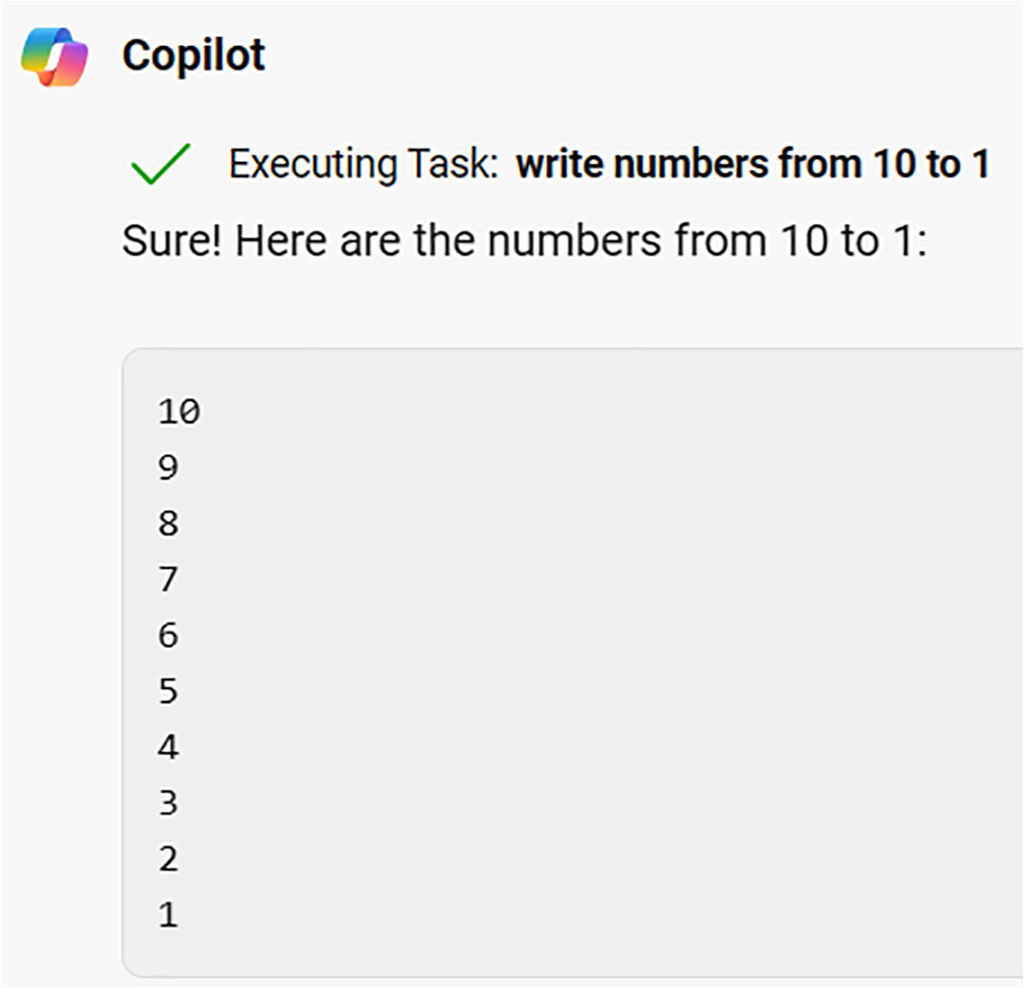

Figure 2-19. Reversing numbers with Copilot
Let’s try to gather information related to Medicine with the prompt Can you explain about the field of Podiatry in less than 250 words? The query is related to Podiatry, and the output should be within 250 words. In
Figure 2-20, you can view the content produced by Microsoft Copilot. You

ChaPter 2 WorkIng WIth CoPIlot In WIndoWS 11 – Part 1
should note that the generated content along with the total word count
could vary when you attempt the prompts discussed in this chapter. This is
because of the nature of AI.
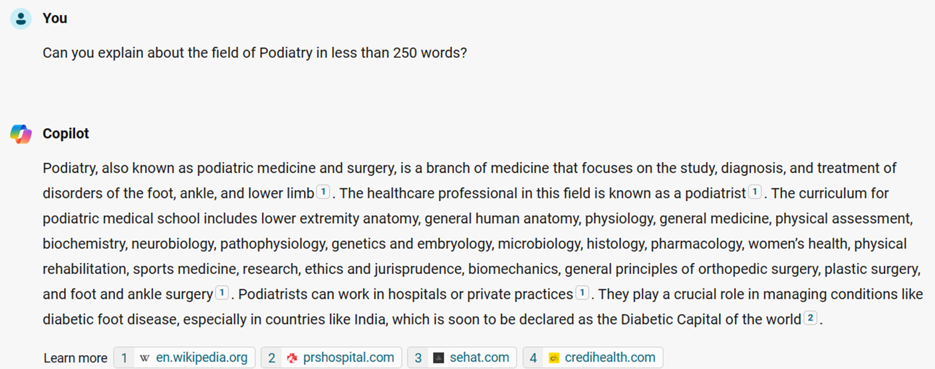

Figure 2-20. Copilot produces content based on the prompt
Copilot provides a concise response within 250 words as specified in
the prompt with relevant sources. The interesting point is that Copilot has
fetched the results from the website of a hospital near my locality.
In this way, you can request Microsoft Copilot to generate answers
based on conditions like the number of words, characters, and much
more. You should make sure to double-check the generated content via
plagiarism tools if you plan to use the content on your blog.
Let’s now ask Copilot to compare two smartphones with the help
of Copilot
Prompt: Write a comparison article on iPhone and Android
smartphones in 250 words.
Conversation Style: Balanced We asked Copilot to produce a general comparison article in 250
words, but the AI chatbot generated a 300-word article, which is good for
SEO purposes. The output looks as shown in Figure 2-21.

ChaPter 2 WorkIng WIth CoPIlot In WIndoWS 11 – Part 1
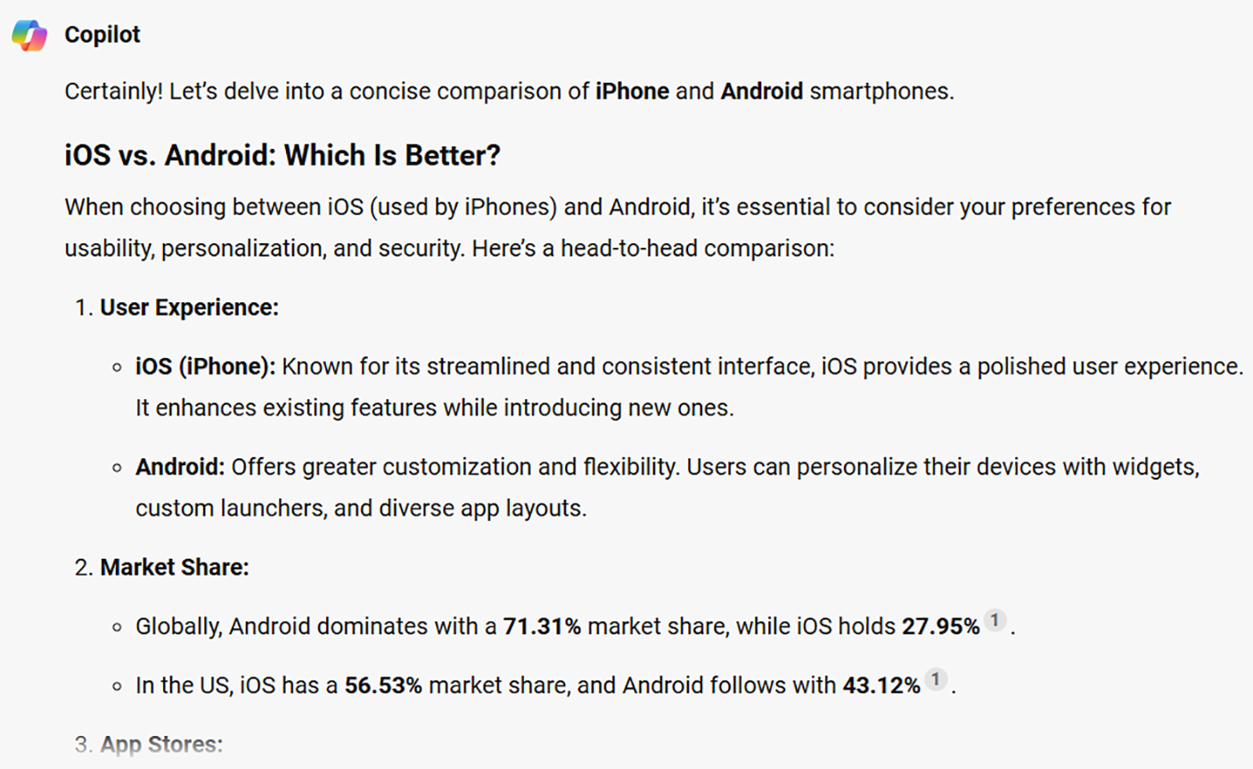

Figure 2-21. Copilot capable of delivering detailed content
Copilot generates detailed content in bulleted format. You can easily read the content and publish it on your blog with the required screenshots. As you can see, Copilot is capable of performing all the required tasks as per the relevant prompt. We have observed 99% accuracy in all the outputs. You can make use of Copilot for educational purposes and for publishing content on your blog. Microsoft Copilot is capable of generating even long form articles, which is best suited for SEO.

Working with SEO Using Copilot
Search Engine Optimization (SEO) plays a pivotal role in ranking your content on search engines like Bing and Google. Copilot can help you with the generation of titles, descriptions, and relevant tags. You just need to copy them while composing the article. If you publish via WordPress, then there are plenty of SEO plugins like Yoast and Rank Math, using which you can easily enhance the quality of the content.

ChaPter 2 WorkIng WIth CoPIlot In WIndoWS 11 – Part 1
Let’s try to generate a title, description, and keywords for the preceding
smartphone comparison article. You should note that Copilot can produce
results even though there is a spelling error on the prompt. The list of titles
appears inside the Copilot dashboard as shown in Figure 2-22.
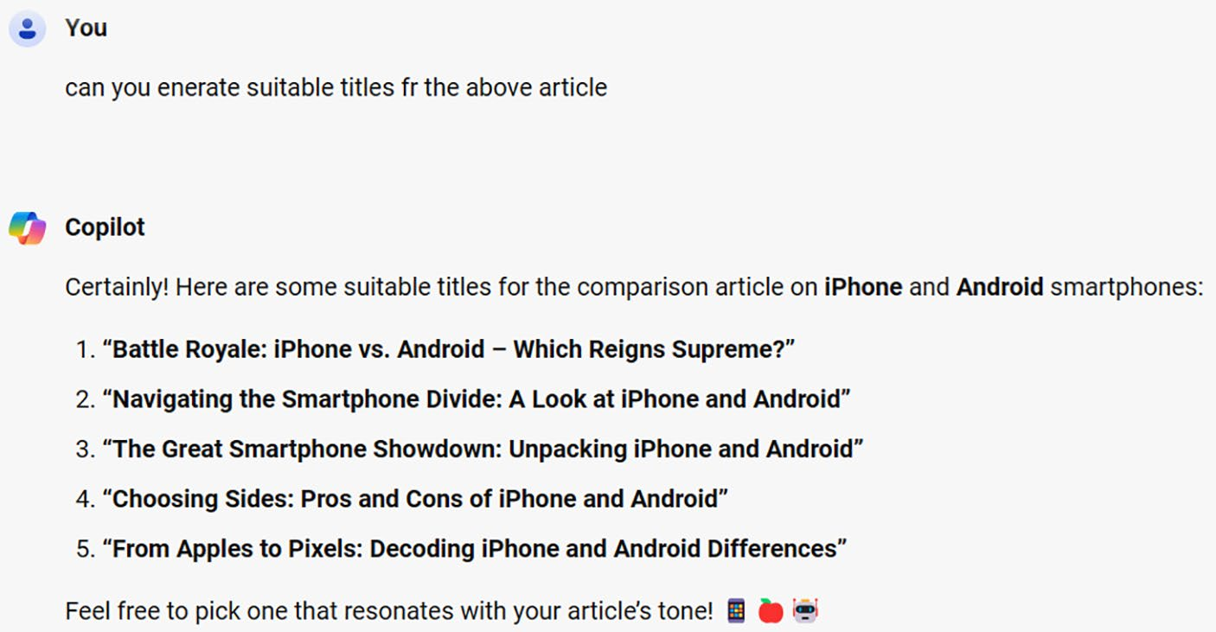

Figure 2-22. Quickly generate titles via Copilot
You can pick a suitable title as per your preference. You can also
modify the prompt slightly to get better results in case you are not satisfied
with the generated titles.
Let’s generate an SEO description for the preceding article using
Copilot, and the resulting response is displayed in Figure 2-23.
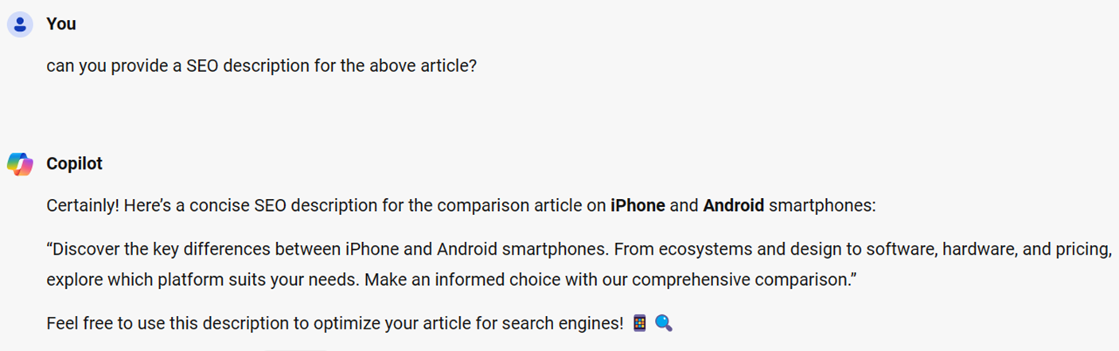

Figure 2-23. Copilot can generate SEO descriptions

ChaPter 2 WorkIng WIth CoPIlot In WIndoWS 11 – Part 1
As you can observe, Copilot accurately generates the SEO description, which you can directly copy to WordPress. Copilot also generates SEO-
friendly keywords as featured in Figure 2-24.
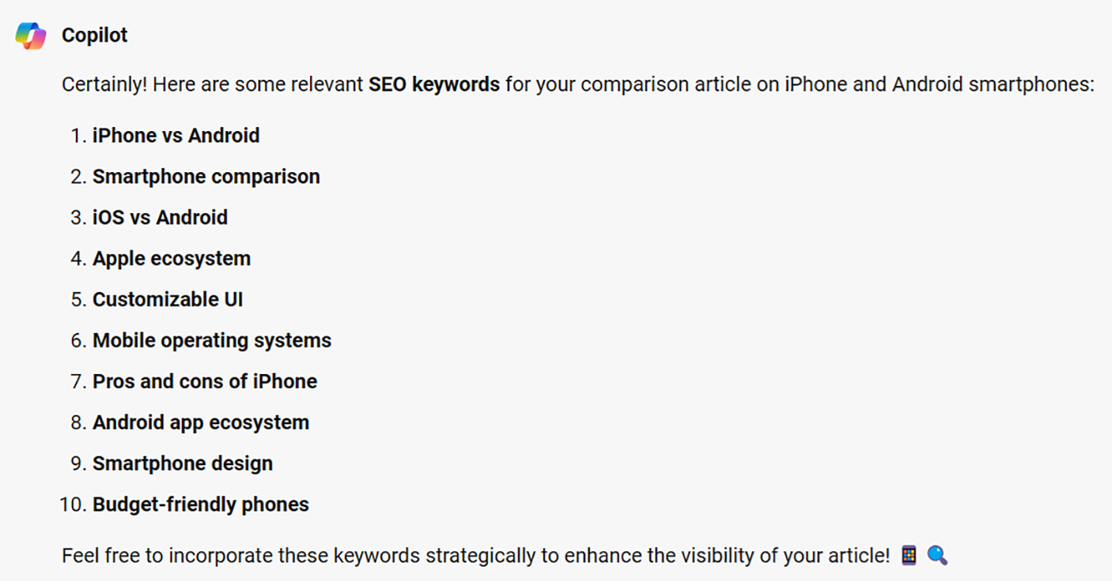

Figure 2-24. Keywords are important, and Copilot creates them for you
You can make use of generated keywords to enhance the quality of your content. The keywords can also be added as tags while composing a WordPress blog post. As you can observe, Microsoft Copilot serves as a productive tool not only to generate responses but also to improve the quality of your work.

The Art of Good Prompting
The basic point to note is that you should cultivate excellent prompt writing habits. In addition to the general prompt, you should provide relevant context and situation. Consider the following prompt.
Write an article on best places to visit in San Francisco.

ChaPter 2 WorkIng WIth CoPIlot In WIndoWS 11 – Part 1
In the preceding example, you are prompting Copilot with a basic
question. You can try the following prompt as an alternative. You need not
have to worry about spelling mistakes because Copilot will take care of
them during the processing of the prompt.
Write an article on best places to visit in a family-friendly location with
vegetarian restaurants in San Francisco.
In the preceding prompt, you are asking Copilot to fetch restaurants
that are family-friendly with restaurant preferences. Try the preceding two
prompts and observe the result yourself. AI chatbots like Microsoft Copilot
generate refined responses if you provide a specific context or scenario.
Let’s take a look at another scenario with the prompt Top five laptops.
In this case, you will see the results of all laptops that Copilot fetches for
you randomly.
However, you will get better results if you use the prompt Top five
Windows 11 laptops below $400.
In this case, you are asking Copilot with specific criteria like Windows
11 and pricing. Copilot will deliver a response with a list of laptops as
per the specified range. However, the responses vary depending upon
various aspects because of the nature of AI. Sometimes, Copilot will fetch
a laptop above $400 even if you specify a lower price range. It’s all part and
parcel of AI technology. Microsoft Copilot generates efficient and accurate
responses depending on your prompt.
The art of writing good prompts takes time. You will achieve good
results via Copilot only upon experience. If you work with a Windows
11 laptop, try to use Microsoft Copilot to gather information in addition
to content, poems, lists, and image generation daily. You can generate
accurate images only upon continuous usage. Even though Copilot
provides plenty of suggestions for image generation, you should also try to
use your prompts. For example, a bird sitting on top of a tree surrounded
by flowers with sunset on the backside is an excellent prompt. You should
apply your imagination to write good prompts.

ChaPter 2 WorkIng WIth CoPIlot In WIndoWS 11 – Part 1

Disclaimer this chapter contains images that are generated via
aI-enabled Microsoft Copilot. the images are only used for the sake
of explanation and educational purposes.

Summary
In this chapter, you have learned about the usage of Copilot using Windows 11 search. This includes a detailed coverage of the Copilot dashboard and the usage of the AI chatbot. You also learned about the working of Microsoft Copilot using various prompts with all conversation styles. You also learned about coding and the generation of SEO-friendly titles, descriptions, and keywords. In the next chapter, you will learn the steps required to work with Copilot in Windows via the Windows 11 Taskbar icon.

CHAPTER 3

Working with Copilot

in Windows 11 – Part 2
In Part 1, you have learned the steps to work with Copilot via the Windows
11 search box. In this method, you have to perform multiple tasks such as
selecting the Windows 11 search box and then clicking the Copilot icon
inside the displayed dialog. Let’s work with an easy route in this chapter by
selecting the Copilot icon directly from the Windows 11 desktop. Microsoft
has integrated Copilot directly on the Windows 11 Taskbar. This is the best
and easiest way to work with Copilot since you can work without a web
browser. You can explore the AI world by simply selecting the Copilot icon
from the Windows 11 Taskbar. Let’s get started.

Getting Started
To start working with Copilot in Windows, you should select the Copilot
in Windows (preview) icon from the Taskbar. You can find the icon either
near the search box or on the right side near the Notifications icon. The
Copilot icon as shown in Figure 3-1 was initially placed near the Windows
11 search box but was relocated to the extreme right side of the desktop for
better user experience.

© Anand Narayanaswamy 2024 47
A. Narayanaswamy, Microsoft Copilot for Windows 11, Inside Copilot,

Chapter 3 Working With Copilot in WindoWs 11 – part 2
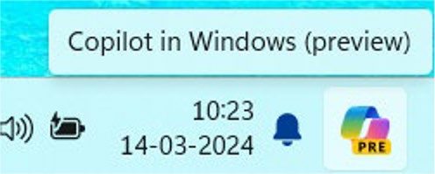

Figure 3-1. Hit the Copilot icon
If you select the Copilot icon, you will see a window docked to the
right side of the screen as shown in Figure 3-2. You can navigate through the carousel located on the top to work with Copilot-generated prompts. With Windows 11 24H2, Microsoft Copilot will be available as a separate app that can be resized or docked. This means you can open the Copilot app and pin it on the Taskbar. You can open the app as an icon from the Windows 11 desktop.

Chapter 3 Working With Copilot in WindoWs 11 – part 2
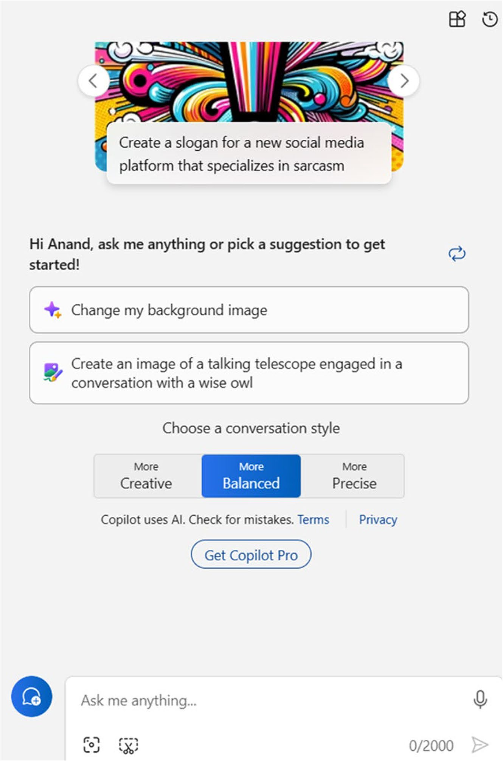

Figure 3-2. Work with Copilot directly via Windows 11

Chapter 3 Working With Copilot in WindoWs 11 – part 2
Copilot in Windows (preview) does the same work as discussed in

Chapter 2. This includes providing answers to prompts, coding, image creation, and other related tasks. The main benefit of Copilot in Windows is that you can work with the chatbot by selecting the Taskbar icon without navigating to the Windows 11 search.

Note the Copilot in Windows (preview) icon on the taskbar
animates upon clicking it.
Microsoft has rolled out the integration of Copilot into Windows 11 and is being made available in a phased manner across regions. Copilot in Windows (preview) is capable of performing tasks related to Windows,
and it varies depending on the region. For example, Figure 3-3 shows the required prompt for changing your Windows 11 desktop to Dark mode from Light mode.
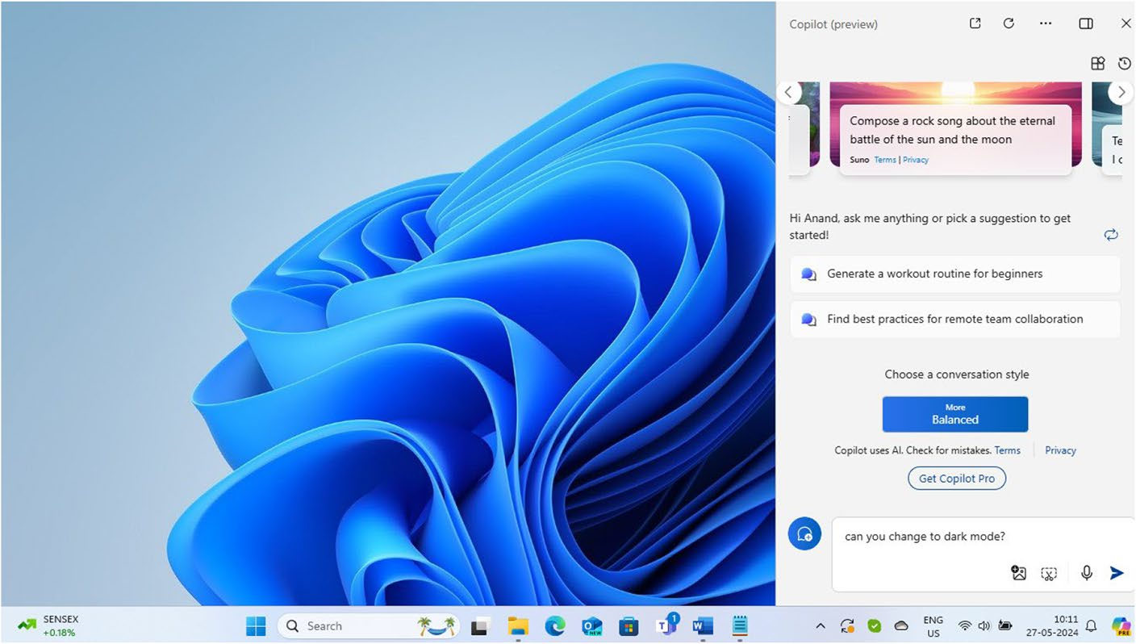

Figure 3-3. Change to Dark mode easily with Copilot

Chapter 3 Working With Copilot in WindoWs 11 – part 2
As you can see from Figure 3-3, the Windows 11 desktop is currently
in Light mode. You can also view our query on the Copilot dashboard. The
Copilot displays a confirmation dialog as shown in Figure 3-4.
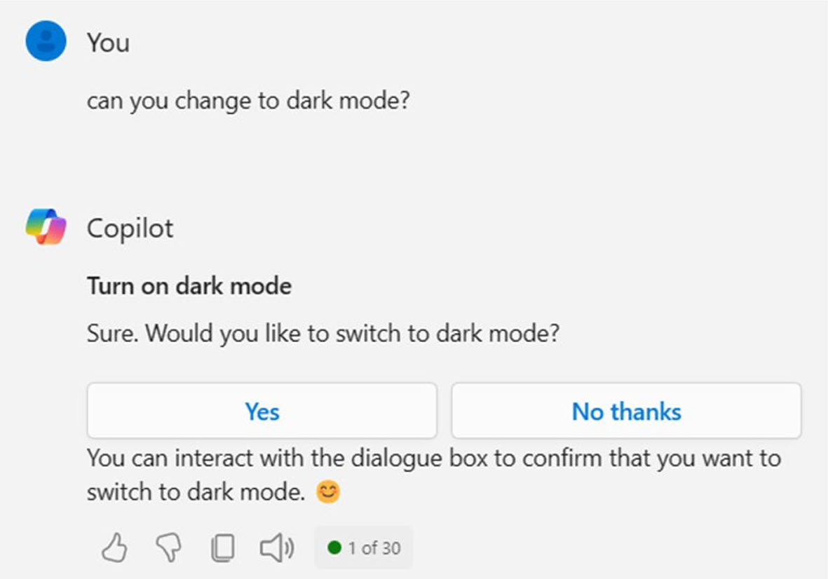

Figure 3-4. Confirm Copilot directions
You should click the Yes button if you would like to change to Dark
mode. If you select the No thanks button, then nothing will change. Let’s
select the Yes button and check out the result. Windows 11 immediately
changes to Dark mode upon selecting the Yes button from the Copilot
window as shown in Figure 3-5. You can copy and edit prompt as well as
search on Bing if you point mouse cursor over the prompt in Copilot in
Windows (preview). The search results will be displayed on the left side of
the screen.

Chapter 3 Working With Copilot in WindoWs 11 – part 2
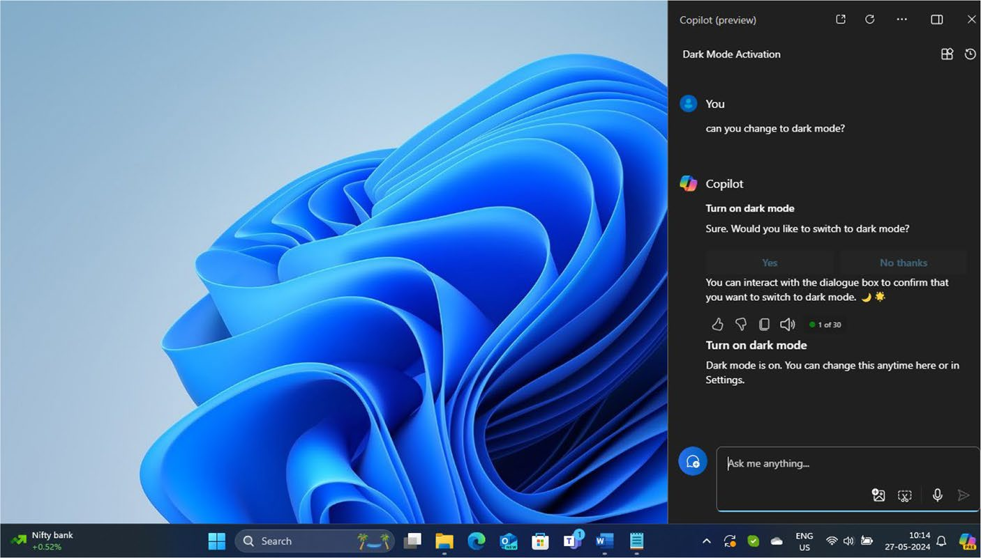

Figure 3-5. Copilot fulfills the changes
You need not have to navigate to the Settings ➤ Personalization ➤ Colors dashboard to change to Dark mode. Copilot in Windows automatically does all the hard work, thus enhancing your ultimate productivity.

Note the suggestions provided inside the Copilot in Windows
dashboard will change upon each refresh.
Copilot also displays suggested prompts, which enables you to perform actions quickly. Let’s now examine another scenario by asking Copilot to
open the Settings dashboard. You will see a screen as shown in Figure 3-6.

Chapter 3 Working With Copilot in WindoWs 11 – part 2
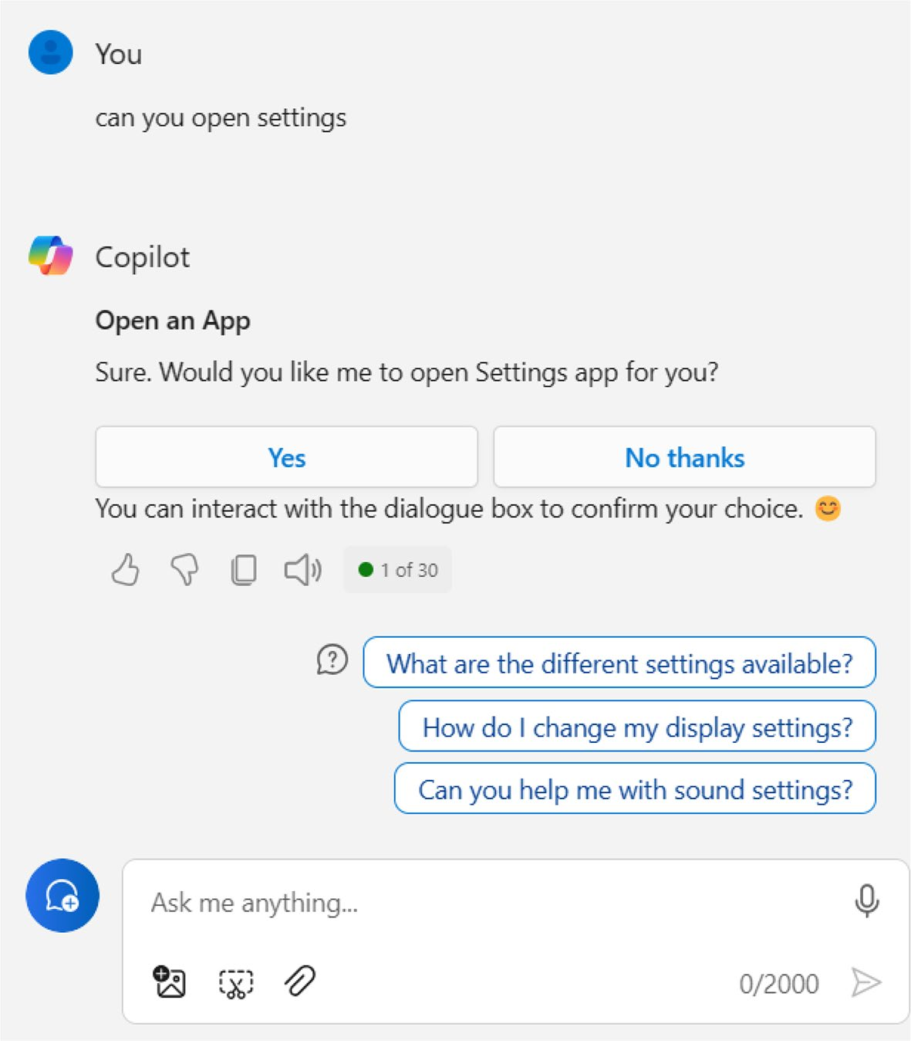

Figure 3-6. Navigate to Settings via Copilot
If you click the Yes button, Copilot will open the Settings dashboard as
shown in Figure 3-7. You can select additional suggested prompts if you
would like to explore more about Copilot. This is an easy way to open the
Settings dashboard without using the Windows 11 search box or using
any keyboard shortcuts. You should note that the Settings dashboard is an
important gateway, which provides all the required modules to work with
Windows 11 effectively.

Chapter 3 Working With Copilot in WindoWs 11 – part 2
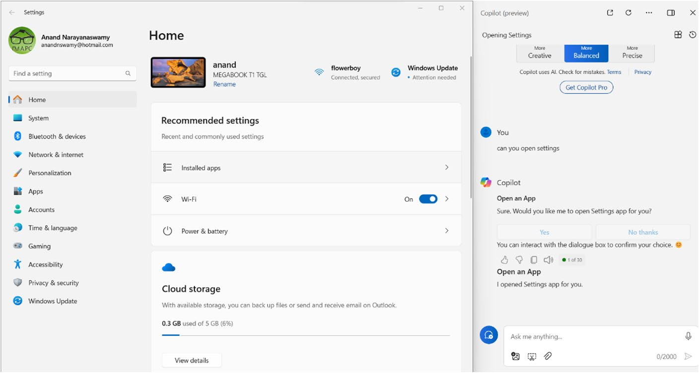

Figure 3-7. Copilot capable of opening Windows 11 settings
In Figure 3-7, we have used the Snap Windows functionality using which you can drag and drop windows as per your requirements. You just need to drag the settings dashboard and drag to the top of the display to drop at the desired location.

Performing Windows 11 Tasks with Copilot
The integration of Copilot in Windows 11 enables you to perform several tasks that are related to Windows 11 from within the Copilot dashboard. The ability to change the Windows 11 desktop to Dark theme from Light and vice versa as examined earlier is the main highlight of the Copilot Taskbar icon. You should note that the possibilities are endless, and the tasks mentioned in this section are just a few examples.

Chapter 3 Working With Copilot in WindoWs 11 – part 2
Listing Wireless Networks
If you use a prompt such as List the available wireless networks, Copilot
will immediately display the list of available connections as well as a
description as shown in Figure 3-8.
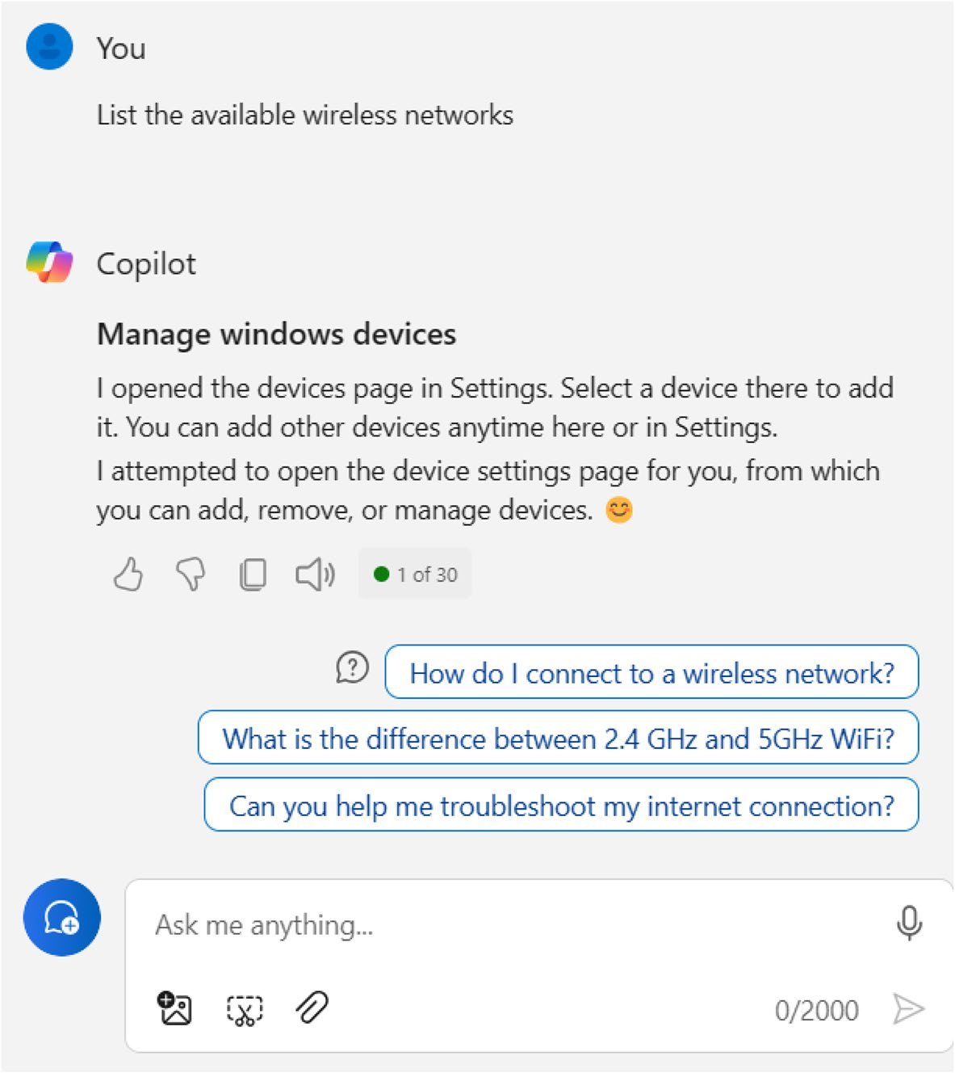

Figure 3-8. Open networks via Copilot

Chapter 3 Working With Copilot in WindoWs 11 – part 2
If you attempt this prompt on your PC, you will notice that Copilot will not ask for your confirmation while opening the connectivity dashboard. You can easily switch over to other networks without navigating to the Settings dashboard. You will also view additional prompt queries as shown earlier. Copilot in Windows provides detailed explanations if you select these prompts. You can easily learn concepts directly via Copilot without search engine dependency. You should note that the output delivered by Microsoft Copilot could differ if you attempt the above prompt.

Emptying the Recycle Bin
Microsoft Copilot enables you to empty the Recycle Bin. If you provide a prompt like Can you empty recycle bin, you will view a screen as shown in
Figure 3-9.
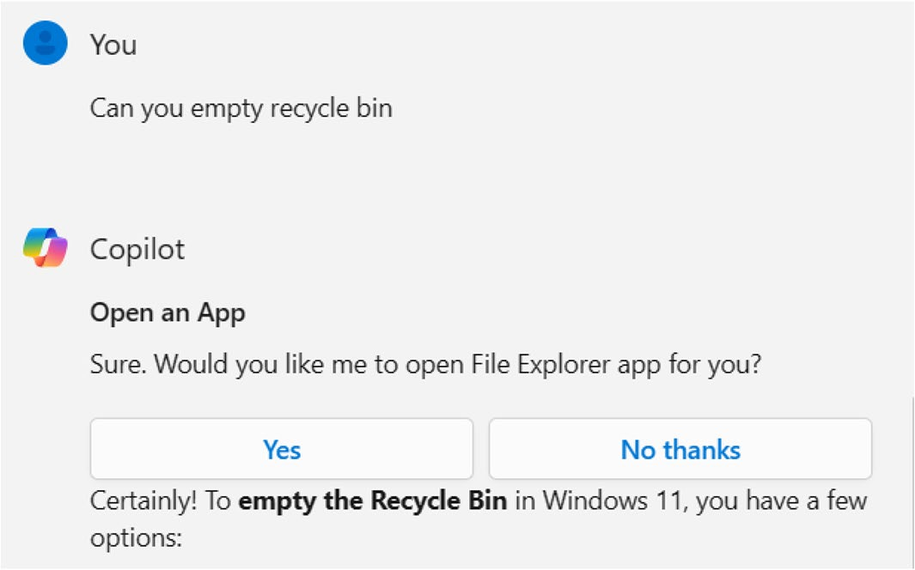

Figure 3-9. Copilot performs Recycle Bin operations
Copilot also displays information pertaining to emptying the Recycle Bin, including a related video toward the end of the dashboard.

Chapter 3 Working With Copilot in WindoWs 11 – part 2
Displaying Startup Apps
Copilot in Windows can display apps that will load during the booting
stage. If you give a show startup apps prompt, Copilot will display a screen
asking for your confirmation. If you select the Yes button, you will see the
Task Manager, and a short description like I opened Task Manager app for
you will appear inside Copilot.

Working with Accessibility Features
Microsoft recently upgraded Copilot in Windows 11 with the ability to help
people with disabilities via accessibility functionalities. For example, you
can activate a narrator, magnifier, and much more via Copilot. You can
modify the text size by giving a prompt like change text size, and Copilot
will prompt you to open the Settings app. You will also see the steps that
should be taken to change text size.

Working with Live Captions via Copilot
You can work with Live Captions via Copilot by providing the prompt start
live captions. You will see a screen with Yes and No thanks buttons. If you
click the Yes option, the settings app will open. You can modify the various
Live Captions options via the dashboard. You will not see the exact options
related to Live Captions, but you can easily locate them.

Capturing Screenshots
Microsoft Copilot is capable of capturing screenshots. If you provide a
prompt like capture a screenshot, the Snipping Tool will be activated as
shown in Figure 3-10.

Chapter 3 Working With Copilot in WindoWs 11 – part 2
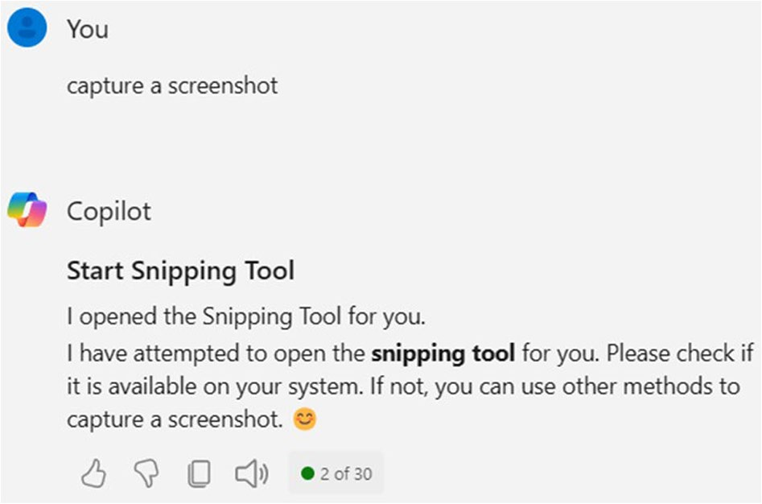

Figure 3-10. Capture screen via Copilot
You can then capture the screenshot, and the relevant image will be available inside the Snipping Tool.

Changing Background Image
You can modify the background image of your Windows 11 desktop via Copilot. You just need to simply ask change background image, and
Copilot will display the Settings dashboard as shown in Figure 3-11.
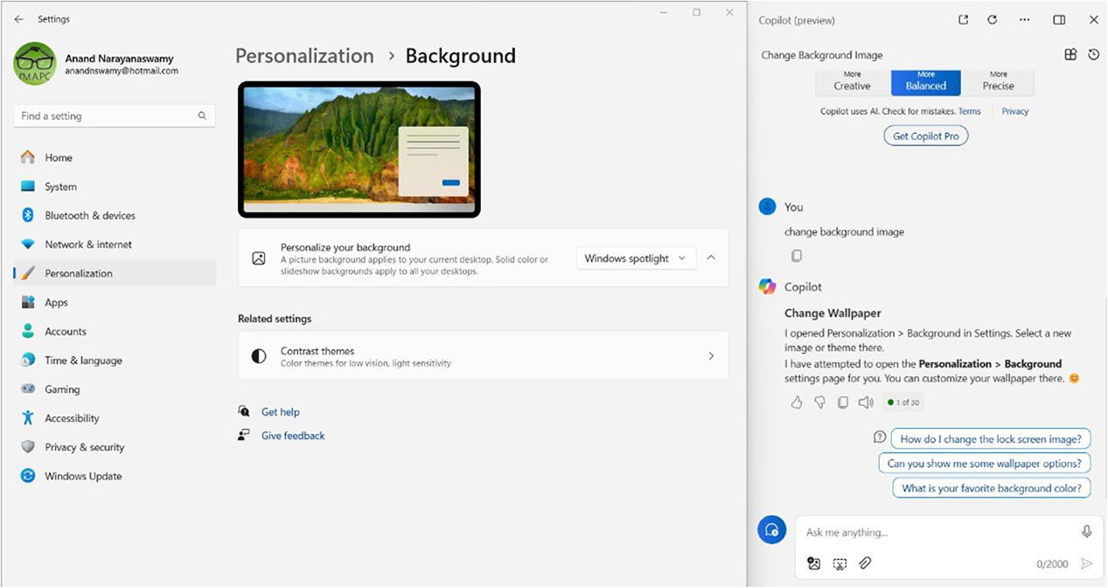

Figure 3-11. Copilot helps you to change the background image

Chapter 3 Working With Copilot in WindoWs 11 – part 2
You can easily change the background image by selecting an
appropriate option from the Settings dashboard.

Launching Apps
Microsoft Copilot provides the ability to launch apps such as Notepad,
Paint, Snipping Tool, and much more. For instance, if you provide the
prompt launch Notepad and select the Yes button, Copilot will open
Notepad for you.
Let’s check out another example. If you provide a prompt such as
launch calculator, you will see a screen similar to what you have seen
earlier. If you click the Yes button, the Calculator app will be opened as
displayed in Figure 3-12.
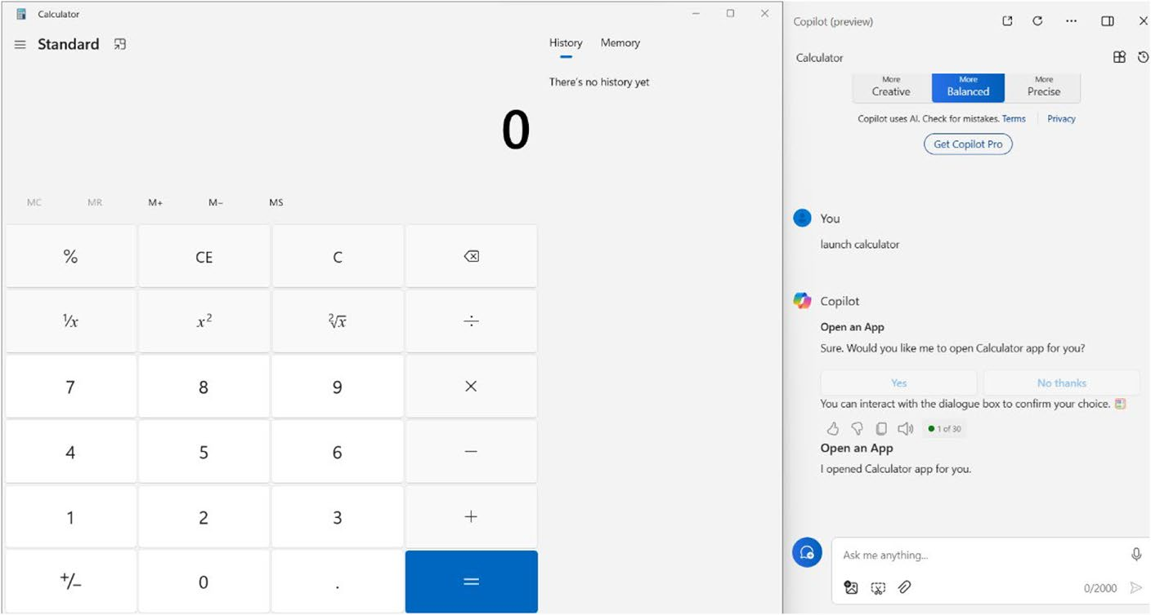

Figure 3-12. Perform Math via Copilot in Windows
As you can observe, Copilot automatically opens the Calculator app
upon selecting the Yes button.

Chapter 3 Working With Copilot in WindoWs 11 – part 2
Activating Focus Session
With the help of Copilot in Windows 11, you can activate a focus session. You just need to provide the required prompt such as can you start a focus
session. You will see a screenshot as shown in Figure 3-13.
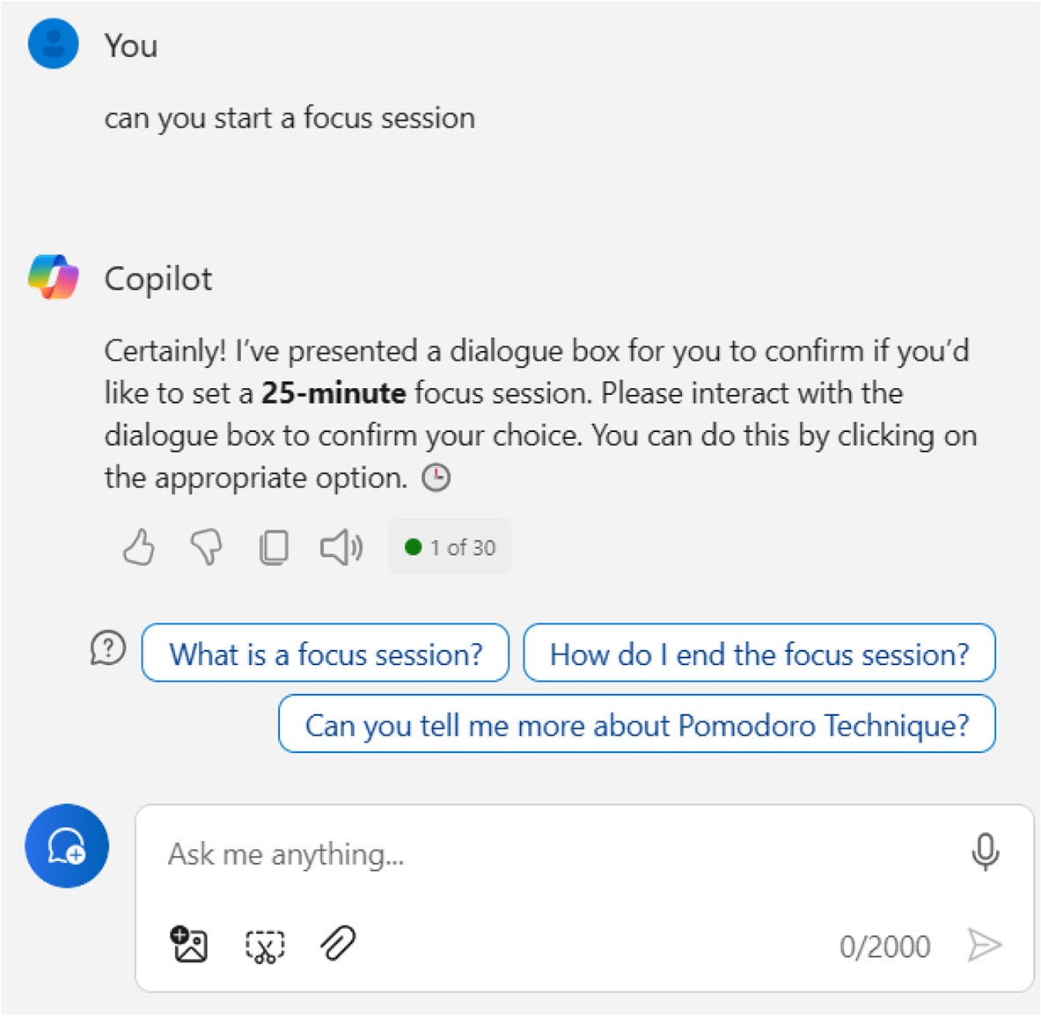

Figure 3-13. Focus your sessions with Copilot
As you can see, Copilot displays a message that if you select a dialog box, then the AI chatbot will set a 25-minute focus session. However, we are unable to view any dialog box as mentioned earlier. Microsoft is continuously making improvements to Copilot. It will take time for Copilot to work with ultimate perfection. You can file feedback in case you find any bugs and issues.

Chapter 3 Working With Copilot in WindoWs 11 – part 2
Refreshing Copilot
As you continue to work with Microsoft Copilot, the dashboard inside
Windows 11 will be filled with prompts and responses. You can reload
Copilot in Windows by selecting the Refresh icon from the top-right side as
shown in Figure 3-14. You should note that the automated suggestions will
change upon each refresh.
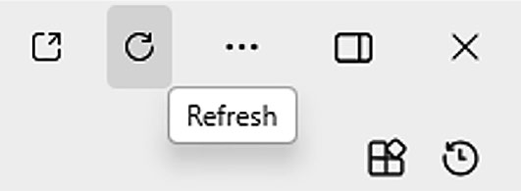

Figure 3-14. Start from scratch

Fetching Copilot Interactions
You can view all your recent interactions with Copilot by selecting the
Recent activity icon from the top-right side as shown in Figure 3-15.
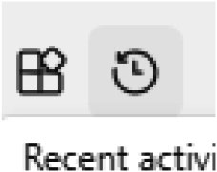

Figure 3-15. Recover Copilot History
Copilot in Windows displays the list of all the recent history upon
selecting the Chats tab as shown in Figure 3-16. You can scroll down and
view the remaining chats.

Chapter 3 Working With Copilot in WindoWs 11 – part 2
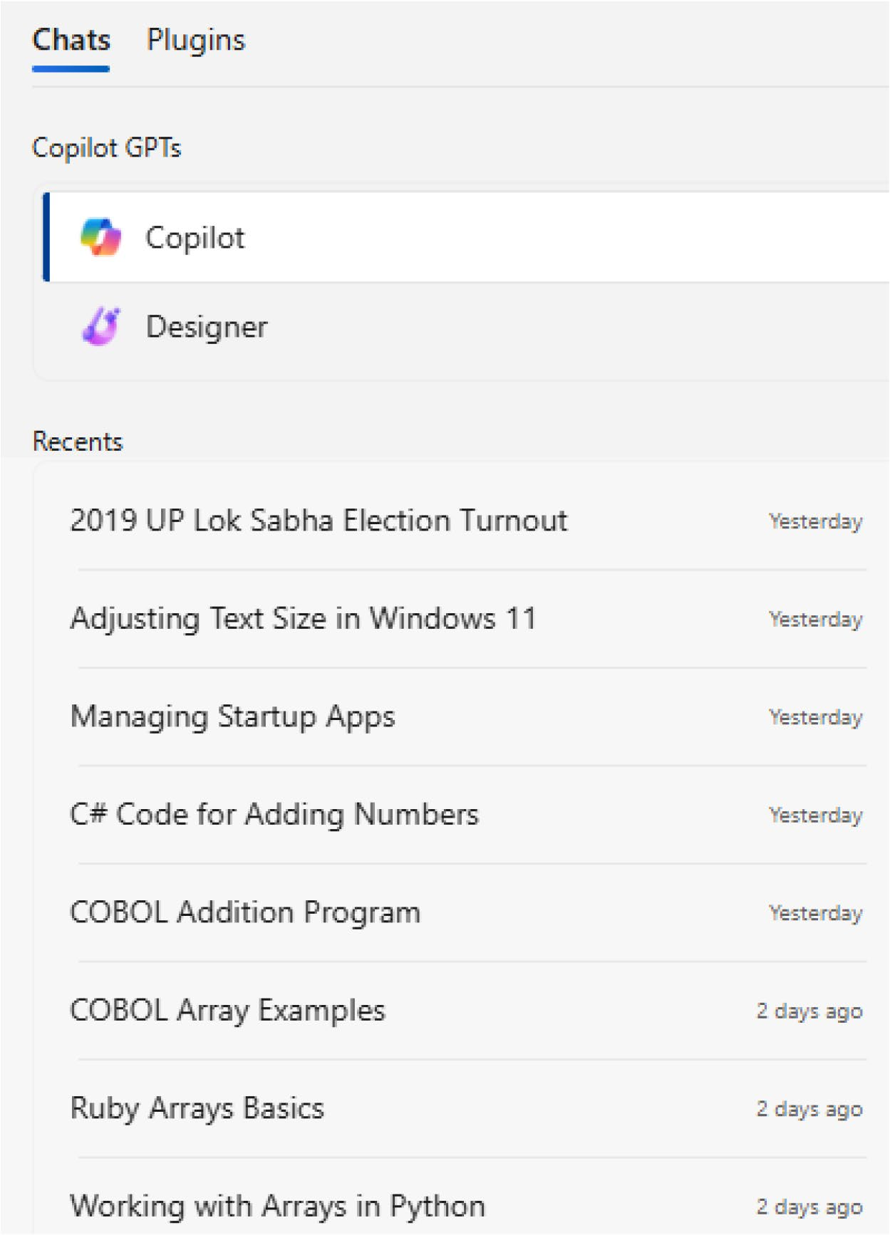

Figure 3-16. View your Copilot History
If you select the chat titles, Copilot displays the response you viewed previously. You should note that the history will not be saved if you add a work account instead of a personal account.

Chapter 3 Working With Copilot in WindoWs 11 – part 2

Note the active Copilot in Windows (preview) response will open in Microsoft edge if you select the Open in Microsoft Edge icon from the top toolbar.
You can also select the same prompt from the Recents section, and
Copilot will provide either the same or a different answer. The response
will slightly differ because of the nature of AI technology.

Managing Plugins
You can extend the functioning of Copilot with the help of plugins. You can
work with plugins directly from within the Copilot in Windows (preview)
Taskbar icon.

Note You can only activate three plugins for a conversation.
You should select the Plugins tab from the Recent activity dashboard.
Alternatively, you can directly select the Plugins icon as shown in
Figure 3-17 from the Copilot in Windows dashboard.
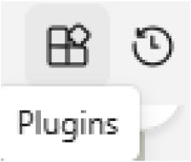

Figure 3-17. Extend Copilot
Copilot in Windows 11 displays the list of available plugins as shown in
Figure 3-18.

Chapter 3 Working With Copilot in WindoWs 11 – part 2
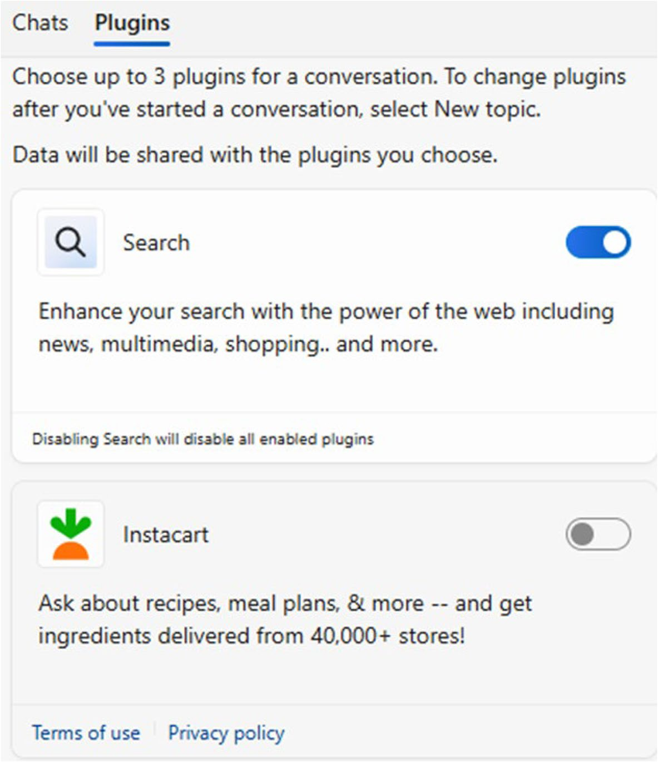

Figure 3-18. Work smarter with Copilot plugins
You just need to activate the plugin and ask queries. For example, you can activate Instacart and ask about your favorite recipe. Copilot in Windows provides support for Search, Instacart, Kayak, Klarna, OpenTable, Shop, and Suno plugins.

Note the suno plugin enables you to create royalty-free ai songs,
which you can use in your projects.

Chapter 3 Working With Copilot in WindoWs 11 – part 2
You should note that the Phone plugin works only via Copilot Web
and Copilot Windows apps. You should regularly check the Plugins tab to
look for the availability of new plugins. You will learn the usage of Copilot
plugins in detail in Chapter 7.

Working with Copilot Notebook
Microsoft Copilot includes a dedicated Notebook module using which you
can provide a detailed prompt to interact with the AI chatbot. To work with
the tool, you should select the three horizontal dots (see Figure 3-19) and
select the Notebook option.
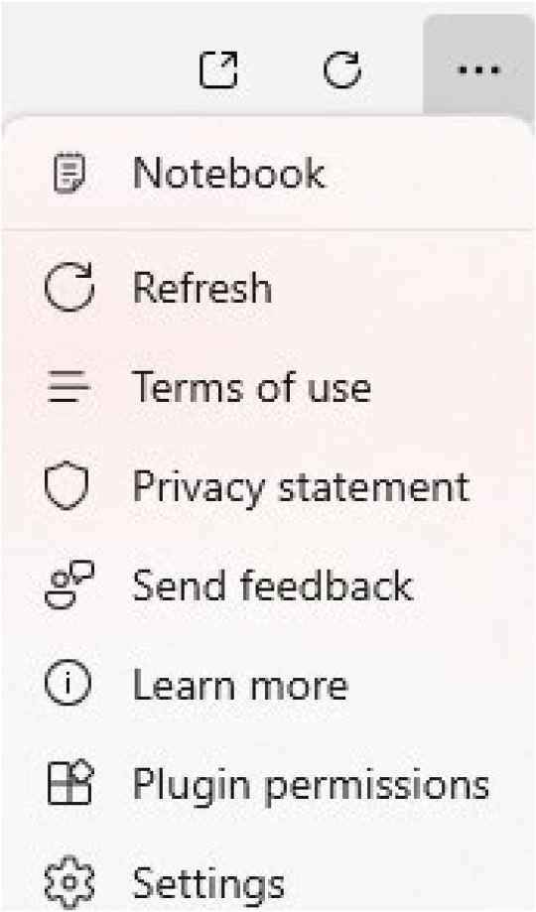

Figure 3-19. Copilot Notes
You will see the Notebook dashboard as displayed in Figure 3-20 with
options for providing prompts in the form of text, image, or voice.

Chapter 3 Working With Copilot in WindoWs 11 – part 2
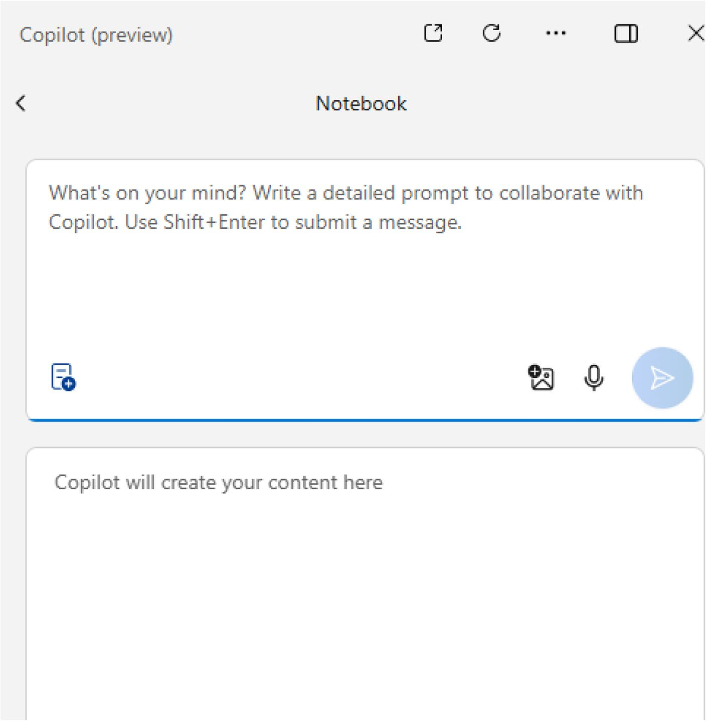

Figure 3-20. Give longer prompts with Notebook
The advantage of Notebook is that the tool provides an option for entering a detailed prompt without any distractions. The relevant content will be created directly inside the Notebook dashboard. Let’s check out the
working of Notebook with a simple prompt as shown in Figure 3-21.

Chapter 3 Working With Copilot in WindoWs 11 – part 2
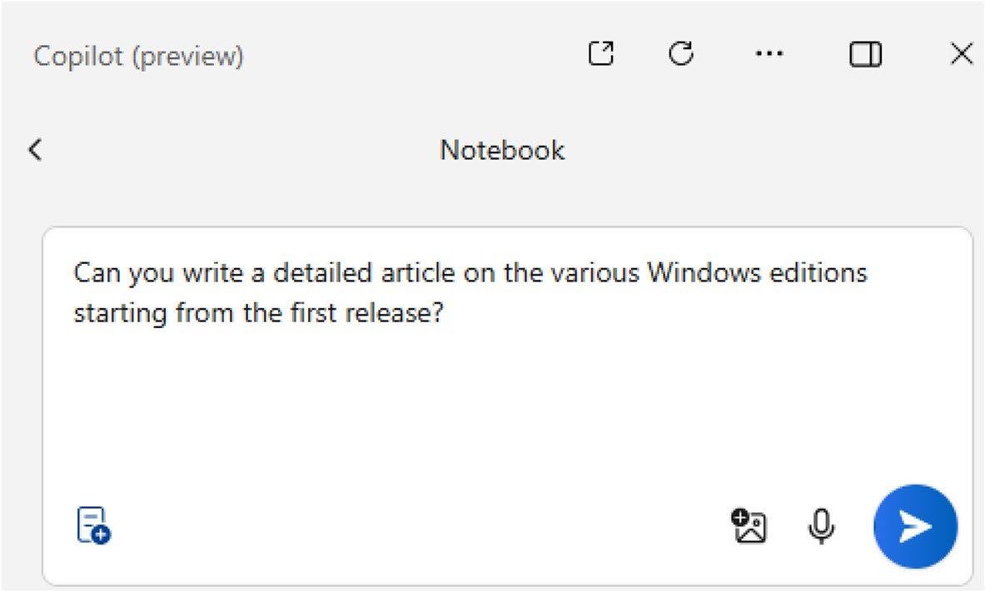

Figure 3-21. Sample Notebook prompt
Copilot Notebook generates the response in bulleted format. The
output includes the Windows version number, year, release date, and
important features as shown in Figure 3-22.
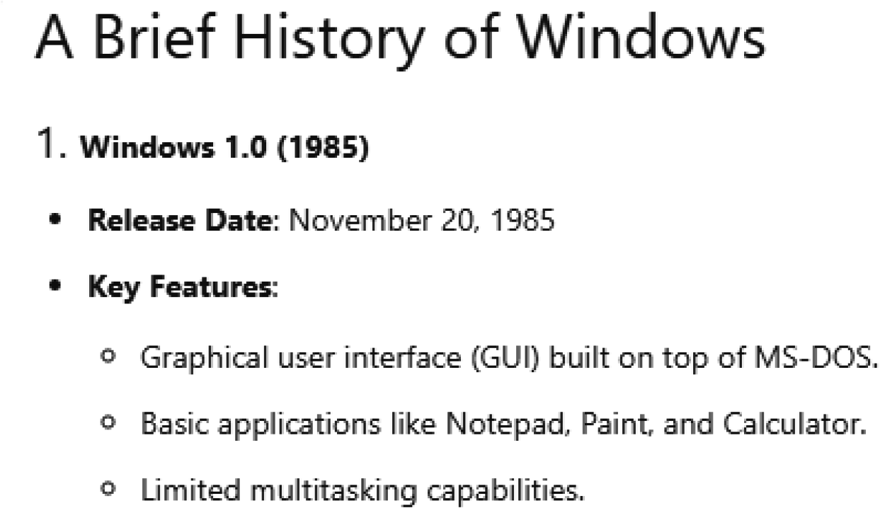

Figure 3-22. Learn Windows 1.0 with Copilot Notebook
The response also includes information related to Windows 11 as
displayed in Figure 3-23.

Chapter 3 Working With Copilot in WindoWs 11 – part 2
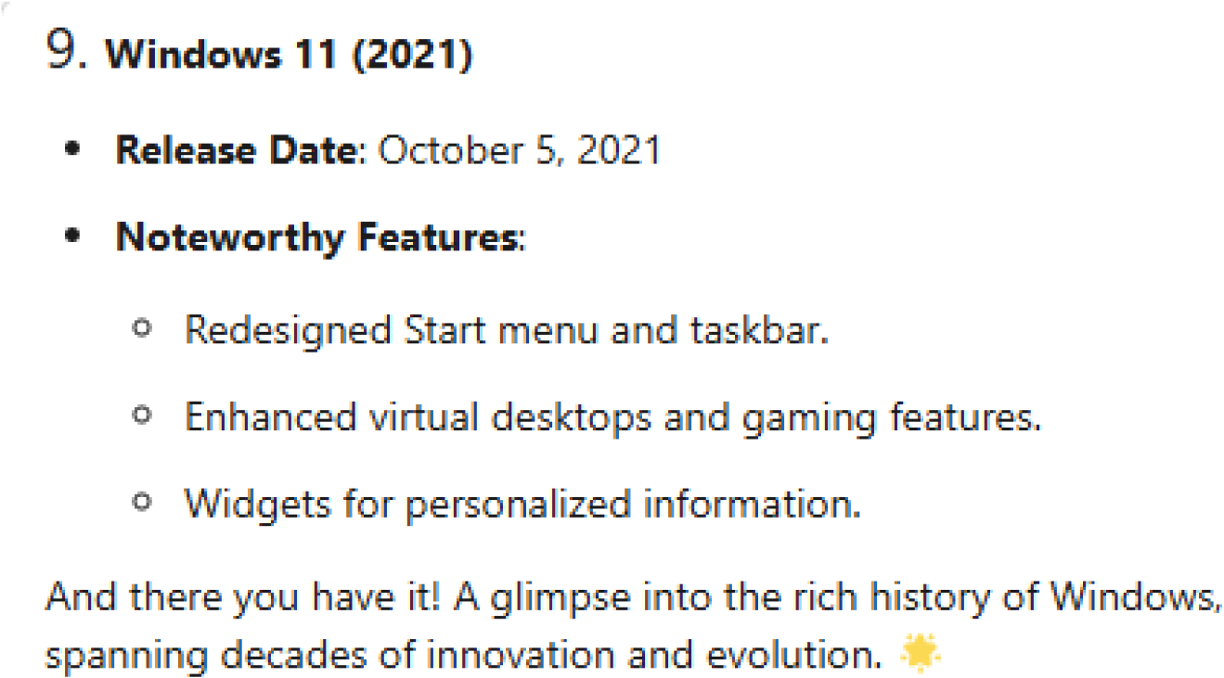

Figure 3-23. Windows 11 in Snapshot
In this way, you can ask any query using Notebook, and Copilot generates a response with relevant source(s). You can select the New topic
icon from the prompt textbox as in Figure 3-24 to ask a fresh query without any need to refresh Copilot.
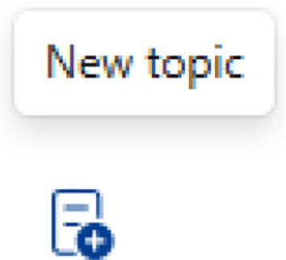

Figure 3-24. Launch a new Notebook session

Note You can send bug reports by selecting the send
feedback option.
You can also add an image to your prompt by selecting the Add an
image icon as in Figure 3-25.

Chapter 3 Working With Copilot in WindoWs 11 – part 2
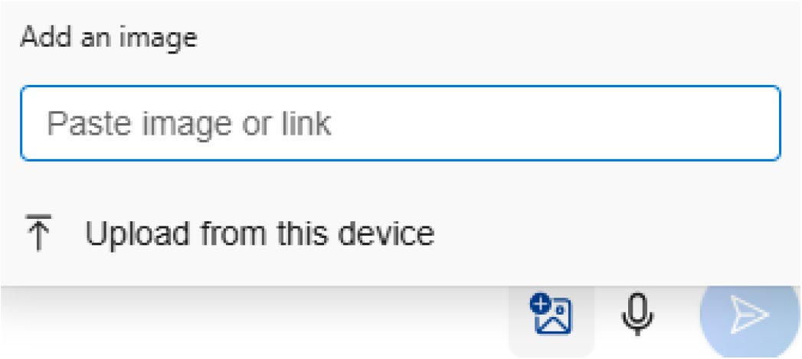

Figure 3-25. Upload media and ask Notebook
You can either provide the image URL or upload the relevant image
from your device. Let’s upload an image and ask Notebook to identify the
items. The resulting output will appear as shown in Figure 3-26.
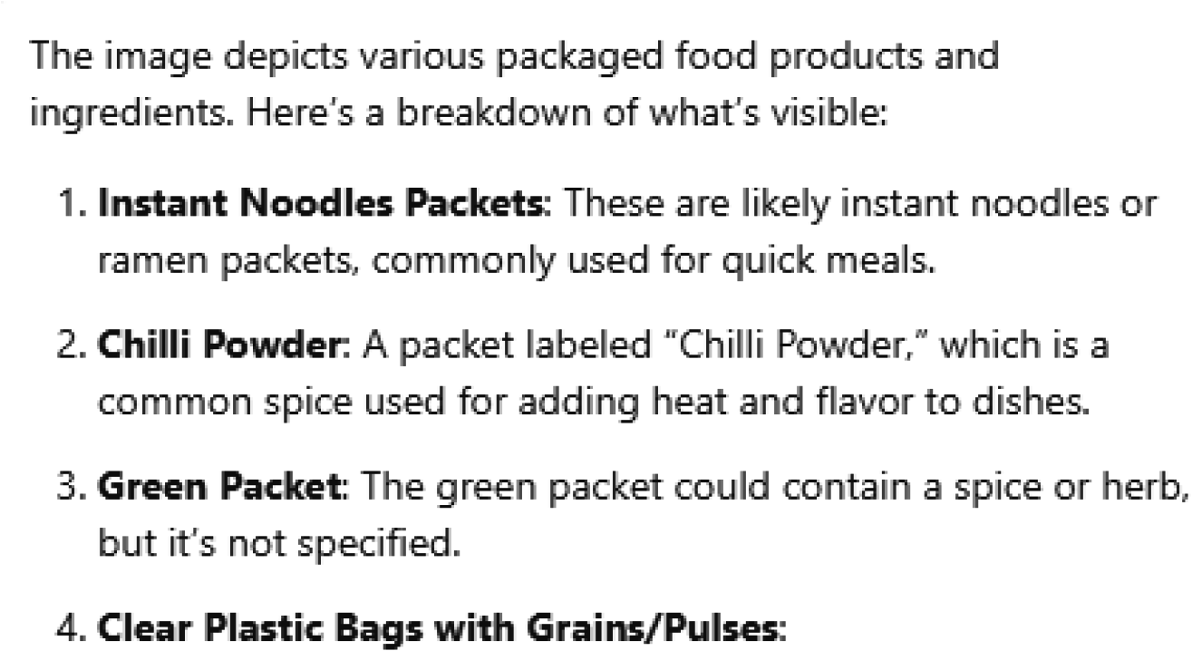

Figure 3-26. Copilot Notebook fetches Image details nicely
You should note that Copilot in Windows will not save your
interactions with Notebook. You can make use of the content on your blog
or social media platforms.

Chapter 3 Working With Copilot in WindoWs 11 – part 2
Managing Settings
Copilot in Windows provides one option inside the Settings interface. You can allow Copilot to fetch context suggestions or clues from Microsoft
Edge. This option is enabled by default as per Figure 3-27.
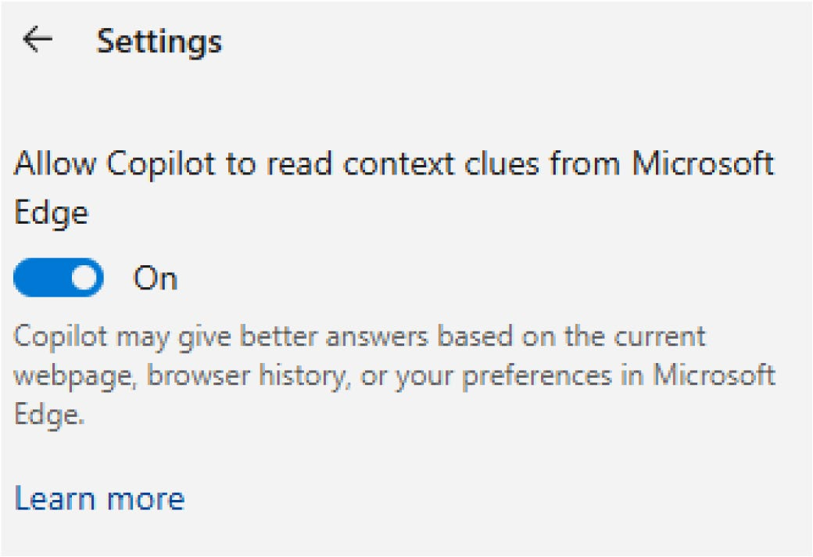

Figure 3-27. Enable/disable Microsoft Edge permissions
Microsoft Copilot is capable of delivering better answers based on the current active web page, browser history, or Microsoft Edge preferences.

Managing Visualization
You can change the visual appearance of the way in which Copilot in Windows should be displayed. You can display Copilot in a side-by-side
manner by selecting the Show side by side option (see Figure 3-28) from the top-right Toolbar.

Chapter 3 Working With Copilot in WindoWs 11 – part 2
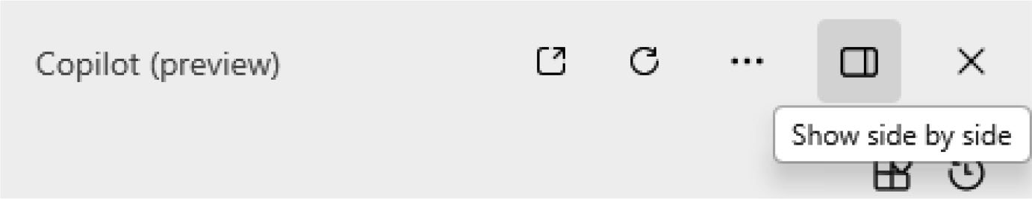

Figure 3-28. Change the way you work with Copilot
If you make use of this option, then all the active windows that you
have been working on will be docked to Copilot in Windows as displayed
in Figure 3-29.
Note the width of Copilot in Windows (preview) increases if you select the side-by-side option.
This feature will be useful in cases where you need to simultaneously
work with Copilot and the active app. For instance, you can copy the
Copilot content directly to either Notepad or Microsoft Word while you
work with Copilot.
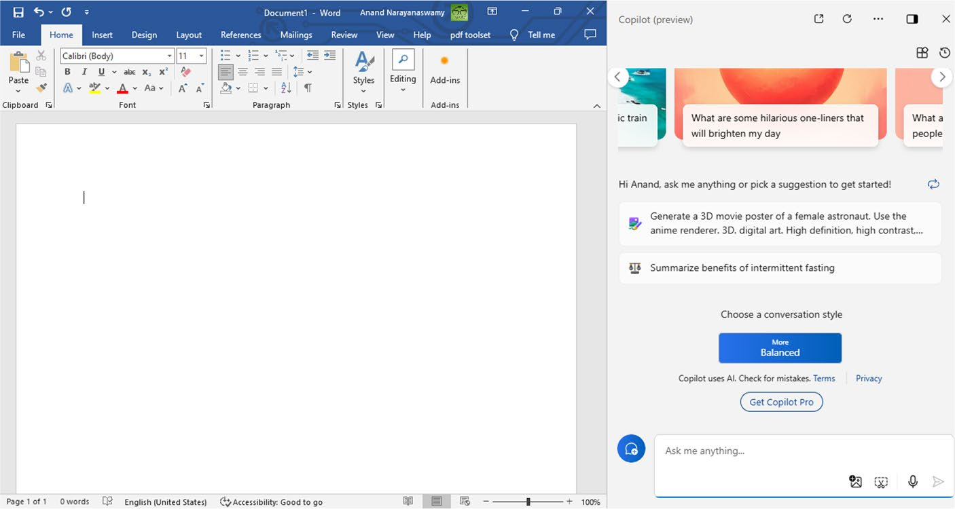

Figure 3-29. Enjoy uninterrupted Copiloting

Chapter 3 Working With Copilot in WindoWs 11 – part 2
You can deactivate the side-by-side display behavior by selecting the
Show as overlay option as displayed in Figure 3-30.
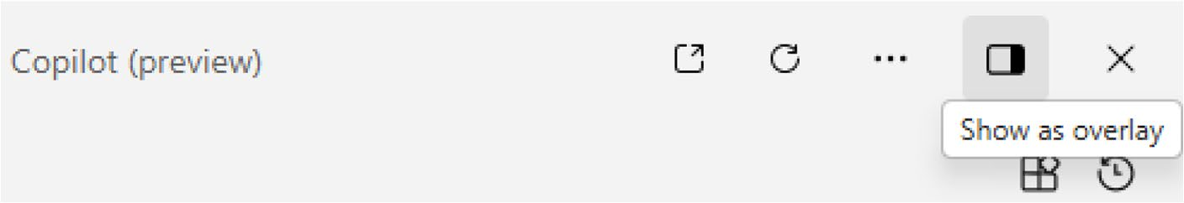

Figure 3-30. Switch to original mode
As you can observe, Copilot in Windows provides several visual options. You can select an option depending on your requirements. You can also experiment with both options and decide your preferred choice.

Summary
In this chapter, you have learned the usage of Copilot in Windows 11. You will be able to perform several Windows 11 tasks effortlessly, which were normally executed via the Settings dashboard. You also learned about the usage of plugins and Notebook. The chapter also explored the method to view your recent activity with Copilot. Toward the end, you also learned the steps to change the visual options while you work with Copilot. In the next chapter, you will learn the usage of Microsoft Copilot using Microsoft Edge.

CHAPTER 4

Working with Copilot

Using Microsoft Edge
Microsoft Edge is a popular web browser included with Windows 11. If you
currently work with Windows 11, then you will have access to Microsoft
Edge. The Microsoft Edge browser is designed using the Chromium
platform. The web browser works fast and is a perfect companion
to Windows 11. After the launch of Microsoft Copilot (formerly Bing
Chat), Microsoft immediately integrated the AI chatbot into the Edge
web browser. The intention was to enable users to work with Copilot
from within the web browser without navigating to the search engine
interface. Even though the purpose was to help with content creation,
Copilot in Edge was integrated with several juicy features. In this chapter,
we will explore all the features and the steps to work with Copilot using
Microsoft Edge.

Note You should note that Microsoft updates the user interface and the associated functionalities according to user feedback regularly. Hence, the features and UI could change without any notice.

© Anand Narayanaswamy 2024 73
A. Narayanaswamy, Microsoft Copilot for Windows 11, Inside Copilot,

CHapter 4 WorkIng WItH CopIlot UsIng MICrosoft edge
Getting Started
To work with Copilot using Microsoft Edge, you should select the Microsoft
Edge icon located on the Taskbar as in Figure 4-1.
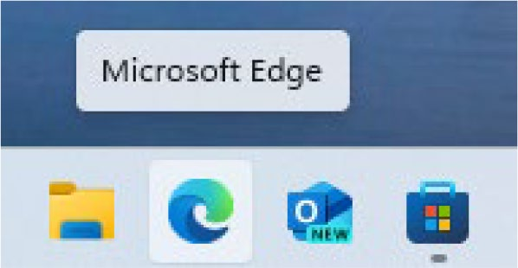

Figure 4-1. Discover the power of Copilot with Edge
You will see the Microsoft Edge web browser loaded with Microsoft
Start content from various sources as displayed in Figure 4-2.
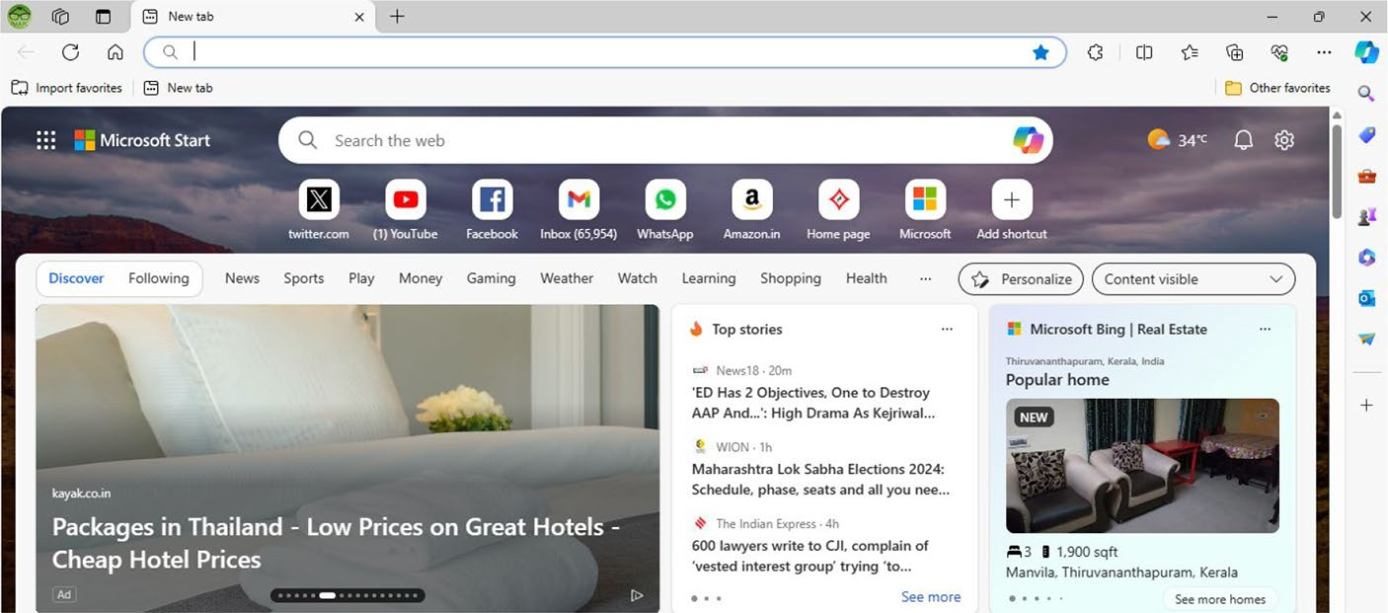

Figure 4-2. Microsoft Edge dashboard
You now have two options to work with Copilot in Windows. The first option is to select the Open Copilot icon inside the Bing search box after entering the search keyword from the Microsoft Edge home page as shown
in Figure 4-3. You can also select specific content from the Microsoft Edge browser and choose Ask Copilot option from the pop-up menu. The relevant output will be displayed on the Copilot in Windows (Preview) dashboard.

CHapter 4 WorkIng WItH CopIlot UsIng MICrosoft edge
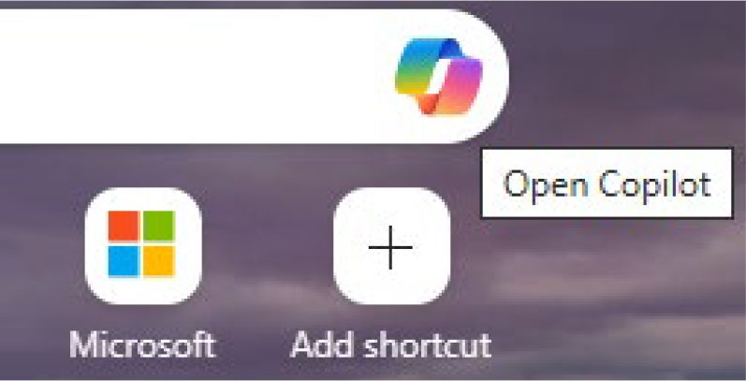

Figure 4-3. Use the search box on Edge to work with Copilot
The second option is to point your mouse over the Copilot icon located
on the top right-hand side of the Microsoft Edge browser. You need not
have to click the icon. In this chapter, you will learn about the features
included with this option. You will find several advanced features that
you will not find while working with the Copilot dashboard. You will see
the Copilot dashboard if you hover over the Copilot icon as shown in
Figure 4-4.

Note You can also make use of the Ctrl+shift+period keyboard shortcut to open Copilot from within Microsoft edge. the icon also specifies the key shortcut.

CHapter 4 WorkIng WItH CopIlot UsIng MICrosoft edge
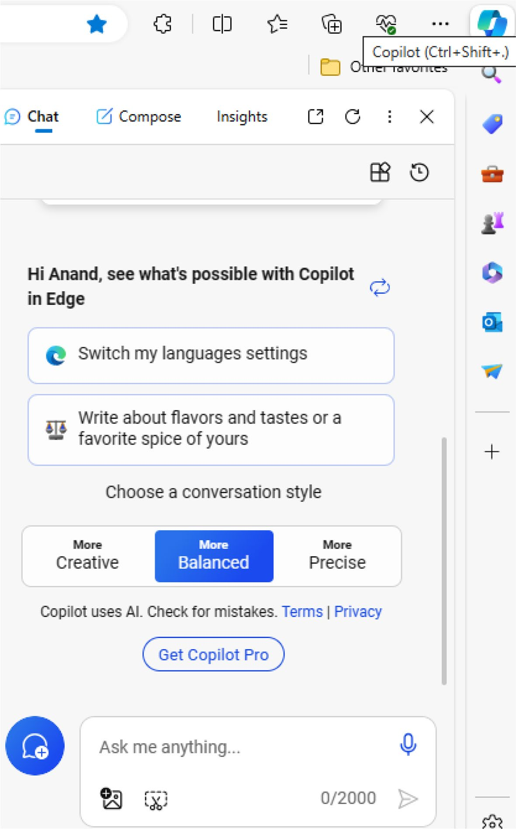

Figure 4-4. Get started with Copilot via Microsoft Edge

CHapter 4 WorkIng WItH CopIlot UsIng MICrosoft edge
As you can see, Copilot provides intelligent prompts that you can make
use of to work with the chatbot. These prompts will automatically change
upon each loading. You can check how Copilot is producing results with
the help of these prompts. The default conversation style is Balanced, but
you can change to Creative and Precise modes, respectively.

Note You can work with Copilot by selecting the Copilot in Windows (preview) icon from the Windows 11 taskbar.
To ask queries, you should provide a prompt up to 2000 characters inside
the Ask me anything textbox. Let’s check out the functioning of Copilot inside
Microsoft Edge with the help of a simple prompt as shown in Figure 4-5.
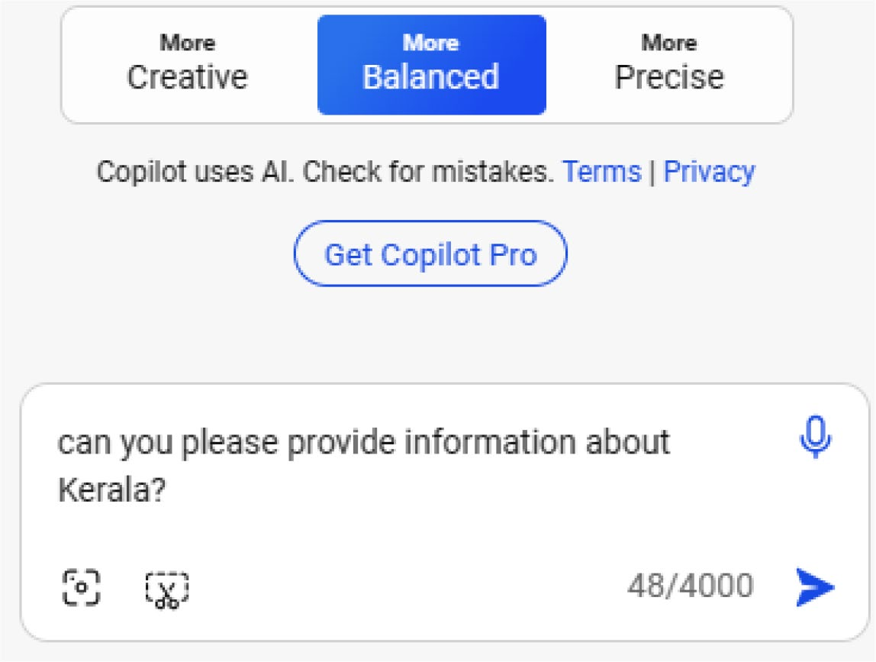

Figure 4-5. Start by giving a prompt
Copilot will provide all the required information relevant to our prompt.
The AI chatbot provides information about formation, geography, population,
language, nickname, economy, and other facts as displayed in Figure 4-6. You
have to scroll down the preview box to view additional information.

CHapter 4 WorkIng WItH CopIlot UsIng MICrosoft edge
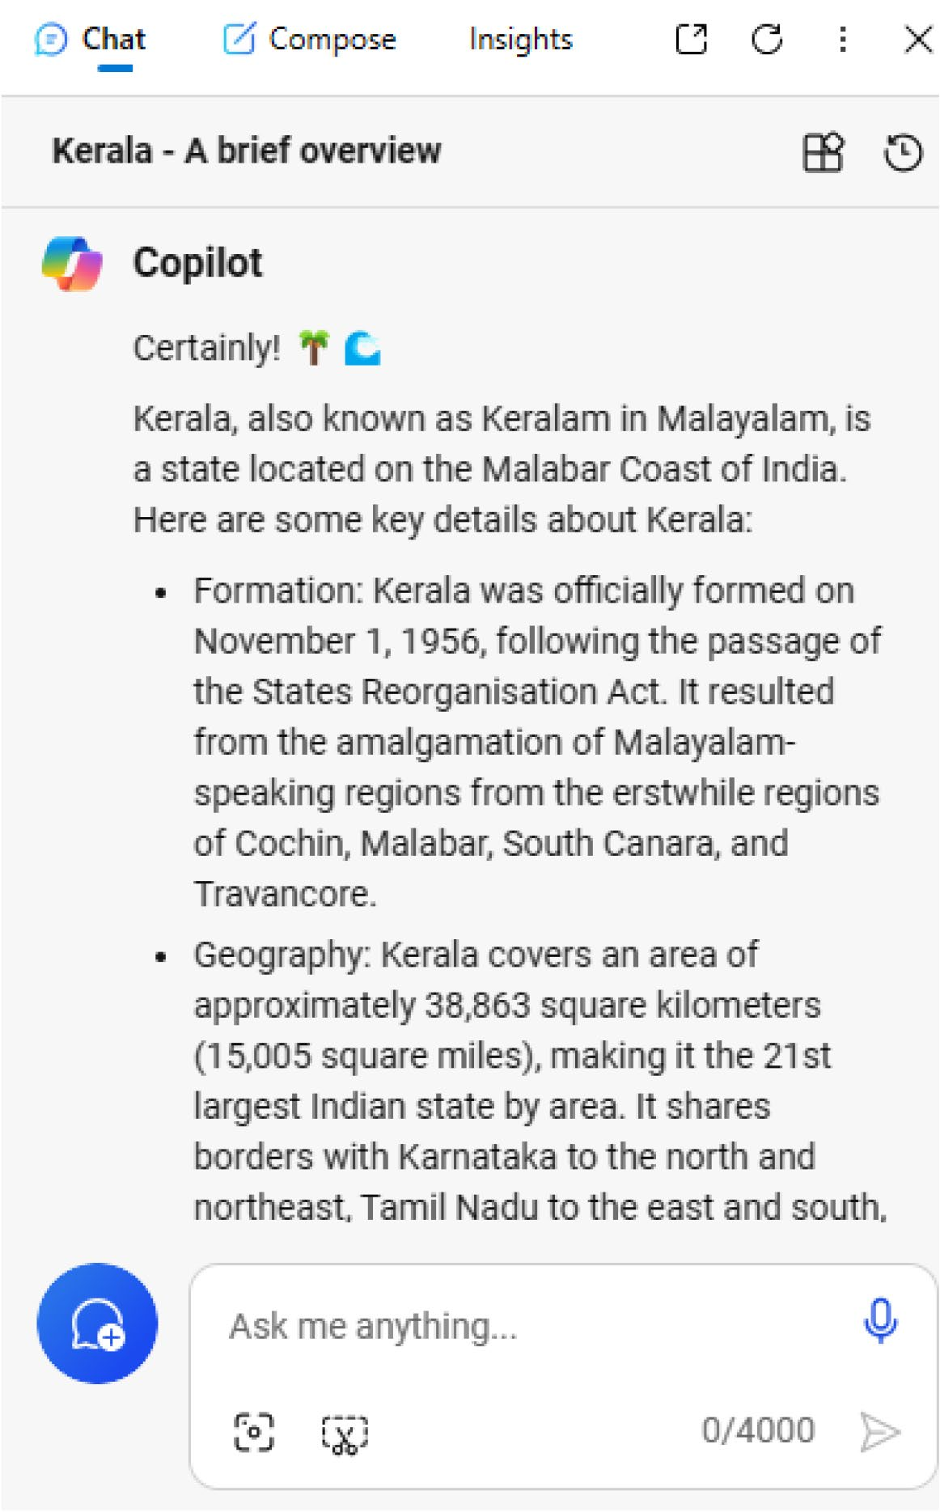

Figure 4-6. View the Copilot response

CHapter 4 WorkIng WItH CopIlot UsIng MICrosoft edge
You will be able to know important facts about the state of Kerala
within seconds. As you can see, Copilot in Edge delivers responses quickly.
Let’s now test the functioning of Copilot using a simple prompt in three
conversation styles. We are going to try a simple prompt here as shown in
Figure 4-7.
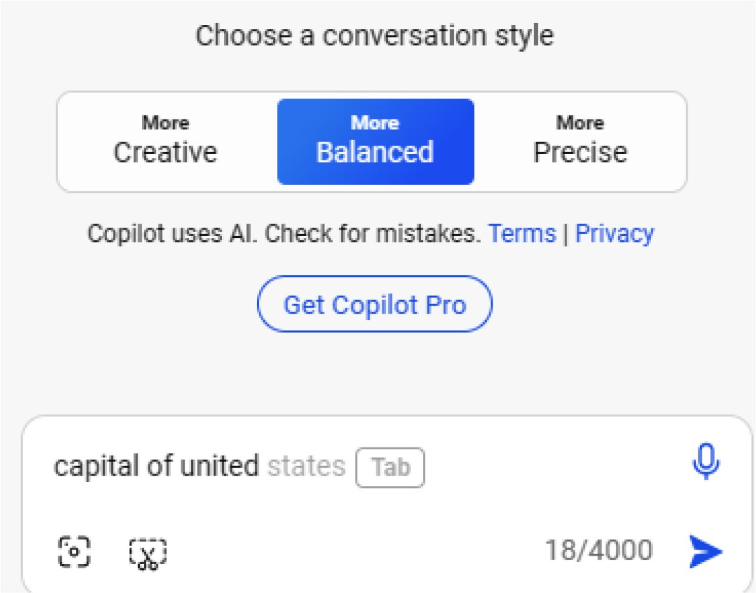

Figure 4-7. Intelligent prompting with Copilot
As you can see, Copilot intelligently guesses the prompt and displays
the relevant suggestion in grayed format. You can press the Tab key to
accept the suggestion. In the Balanced mode, Copilot in Windows displays
the result as shown in Figure 4-8.

CHapter 4 WorkIng WItH CopIlot UsIng MICrosoft edge
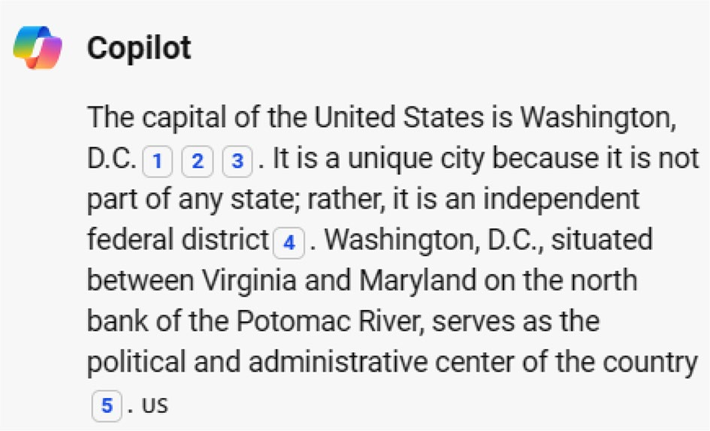

Figure 4-8. Copilot response in Balanced mode
Let’s now switch over to the Creative mode with the same prompt. The
resulting output is displayed in Figure 4-9.
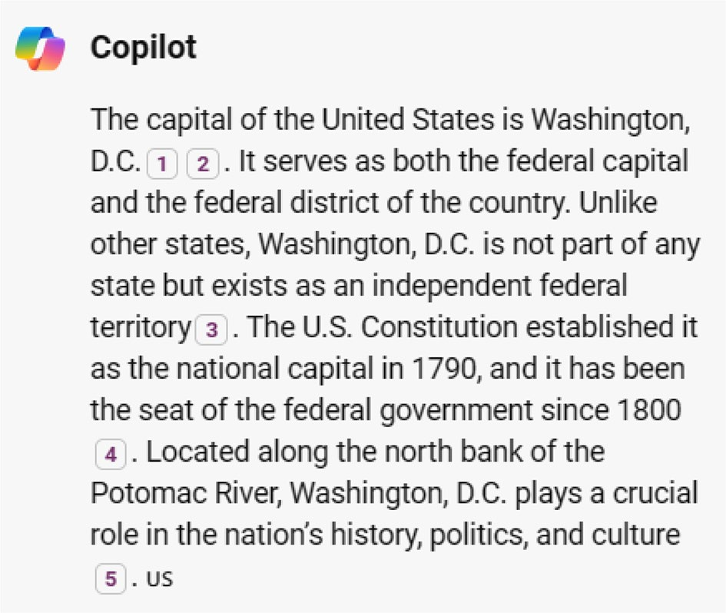

Figure 4-9. Copilot delivers output creatively

CHapter 4 WorkIng WItH CopIlot UsIng MICrosoft edge
Let’s now examine the output for the same prompt using the Precise
conversation style. The result is displayed similar as shown in Figure 4-10.
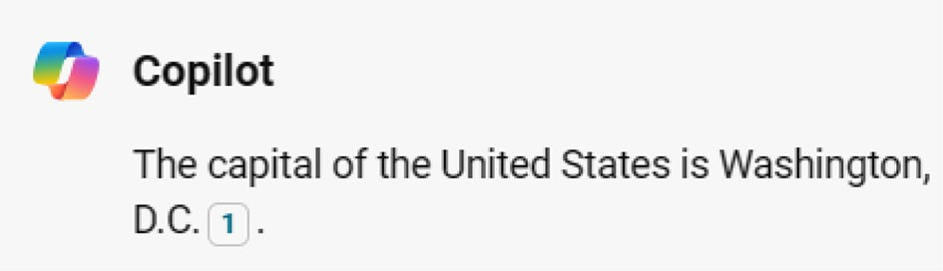

Figure 4-10. Copilot delivers precise information
As you can observe, Copilot displays the result in one line with the
Precise conversation style. You can experiment with the working of Copilot
using several prompts with different conversation styles. Microsoft Edge
displays a warning message that Copilot makes use of AI, and you should
check for mistakes. You can open a PDF file in Microsoft Edge and ask
Copilot to summarize the document or locate content from a specific
page. Microsoft Copilot is capable of generating highlights from videos.
You should open the relevant video on YouTube or Vimeo and select the
automated prompt from Copilot in Windows (Preview) or Copilot in Edge.
You can also manually provide a prompt like summarize the video.

Composing Messages Using Copilot
Microsoft Edge provides an ability to compose new messages for social
media, email, and even blog posts. To let Copilot generate content, you
should select the Compose tab as shown in Figure 4-11.

CHapter 4 WorkIng WItH CopIlot UsIng MICrosoft edge
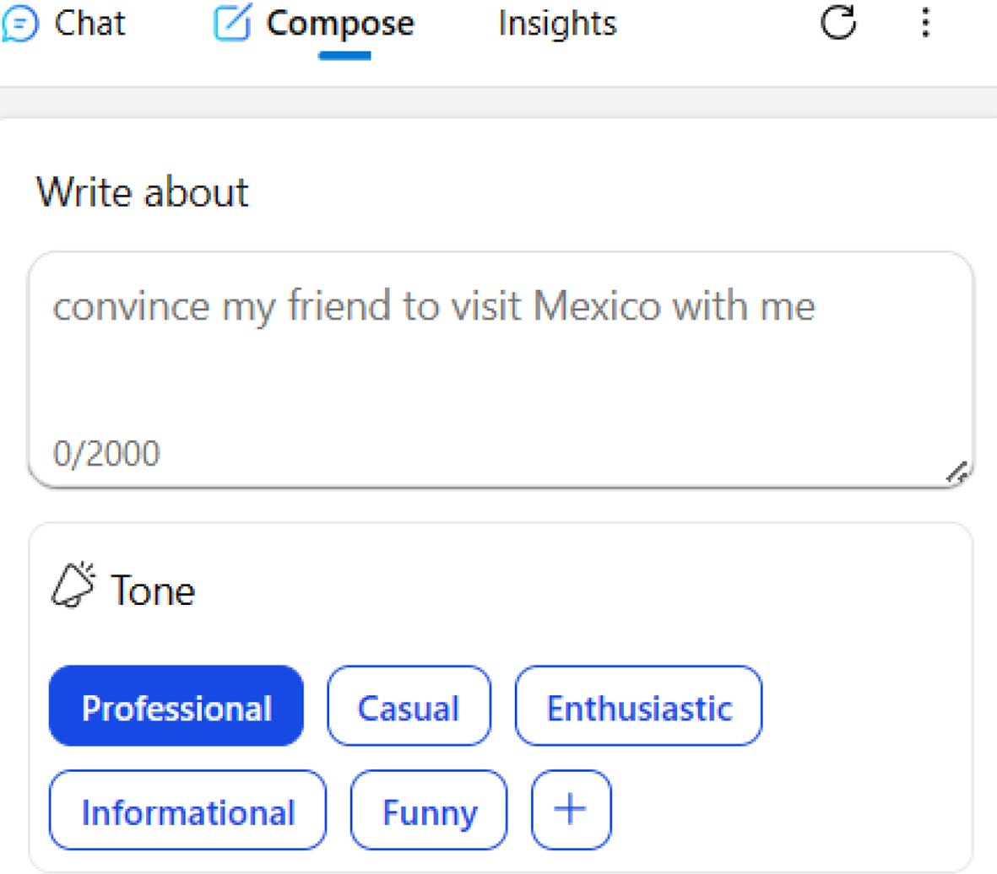

Figure 4-11. Generate stunning messages with Copilot
You have to provide the relevant prompt for which you need Copilot to compose content. The next step is to select a tone. The default tone is Professional, but you can select other tones such as Casual, Enthusiastic, Informational, and Funny.

Note You can also add your own conversation tone by selecting
the + icon.
You can select the format of the content such as Paragraph (default), Email, Ideas, and Blog Post. Copilot will attempt to create content based on your selection. The final step is to select the desired length of the content, which defaults to Medium. You can also opt for Short and Long options depending upon your requirements.

CHapter 4 WorkIng WItH CopIlot UsIng MICrosoft edge
Let’s try a simple prompt as shown in Figure 4-12 by retaining the
default options. You should select Generate draft to enable Copilot to
create the required content.
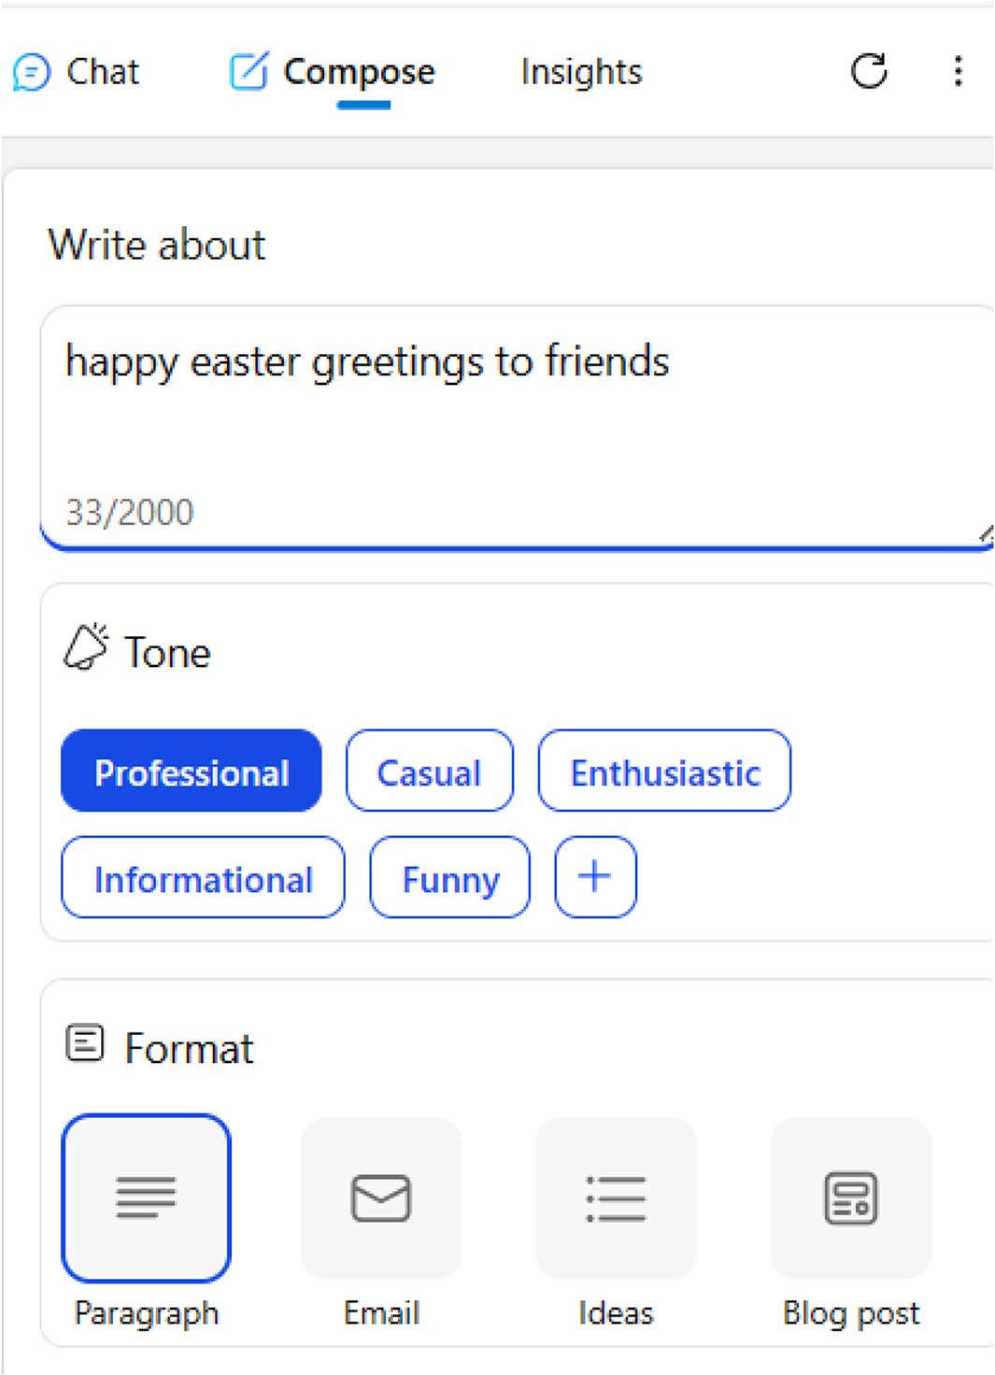

Figure 4-12. Generate several formats of content with Copilot
Copilot displays the content as shown in Figure 4-13. You can copy and
use the generated message on social media.

CHapter 4 WorkIng WItH CopIlot UsIng MICrosoft edge


Figure 4-13. Copilot generates content inside Edge
Let’s change the tone of the same prompt to Casual and check out the
result as displayed in Figure 4-14.


Figure 4-14. Copilot’s casual content
If you compare both content, you will notice subtle changes in the delivery of the message. Let’s now change the tone to Enthusiastic and
check out the Copilot response in Figure 4-15.

CHapter 4 WorkIng WItH CopIlot UsIng MICrosoft edge
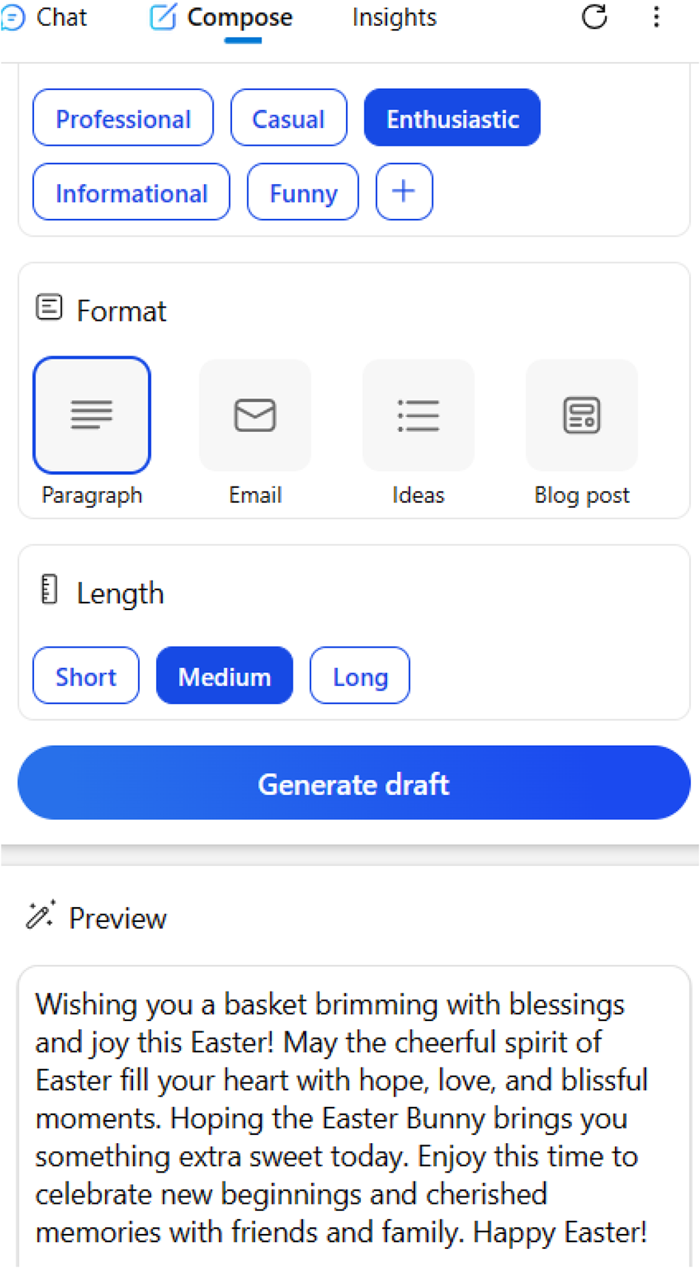

Figure 4-15. Get responses in Enthusiastic mode

CHapter 4 WorkIng WItH CopIlot UsIng MICrosoft edge
Even though the first line looks similar, you will notice changes in the remaining content. There are changes to the words, and you can select a tone as per your requirement. The Enthusiastic tone generates shorter content, but it will change upon each attempt. Let’s now test-drive with the
Informational tone as shown in Figure 4-16 using the same prompt.
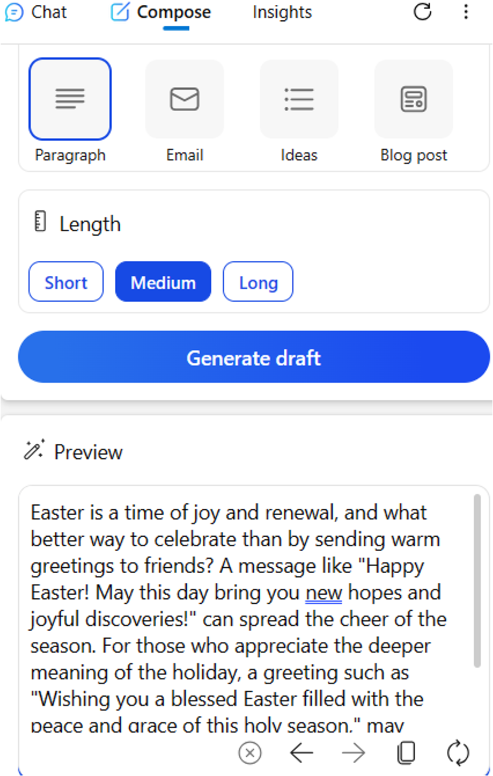

Figure 4-16. Copilot creates Informative responses

CHapter 4 WorkIng WItH CopIlot UsIng MICrosoft edge
You can observe that there are plenty of question marks, which are part
of the tone structure. The Copilot can also generate content in funny tone.
Let’s test with another prompt as displayed in Figure 4-17.
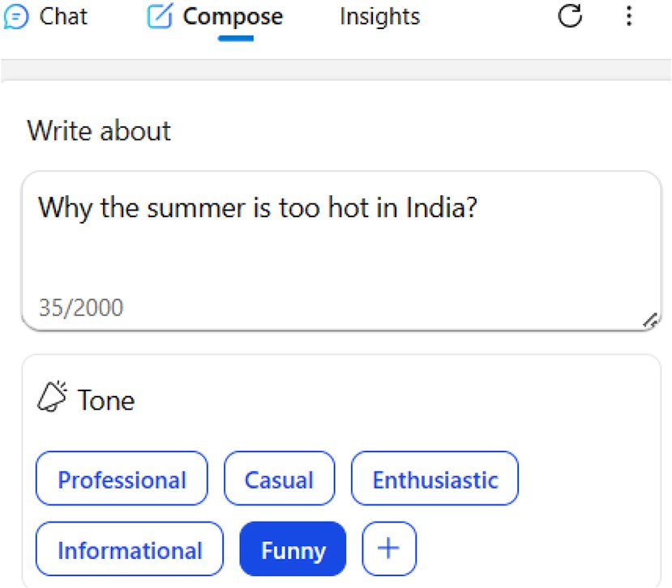

Figure 4-17. Create funny content via Copilot
In Figure 4-18, you can view the response delivered by Copilot for
the prompt. You can see that the content is different and looks somewhat
funny. You can experiment with different prompts and tones to test-drive
the functionality of Copilot. You have the required interface to work with
AI, and it’s up to you to make use of the system optimally. You should use
the Copilot module included with the Microsoft Edge responsibly.

CHapter 4 WorkIng WItH CopIlot UsIng MICrosoft edge


Figure 4-18. Get funnier with Copilot

Composing Email Messages
Copilot can also compose email messages based on the relevant prompt. You can select whether you need Short, Medium, and Long length messages. Let’s check out the functioning by selecting Email format, Short length, and April Fool Jokes as a prompt.
Copilot displays the output as shown in Figure 4-19. You can see that Copilot displays the content in email format, which you can directly copy/ paste into your email client.

CHapter 4 WorkIng WItH CopIlot UsIng MICrosoft edge


Figure 4-19. Create crisp email messages with Copilot
If you select Medium and Long length formats, then the content will be
created accordingly. Copilot can also generate ideas and blog posts. Let’s
generate some ideas using Copilot regarding computer books. Copilot
generates a list of computer books as shown in Figure 4-20. You can then
use Amazon to buy the displayed books.
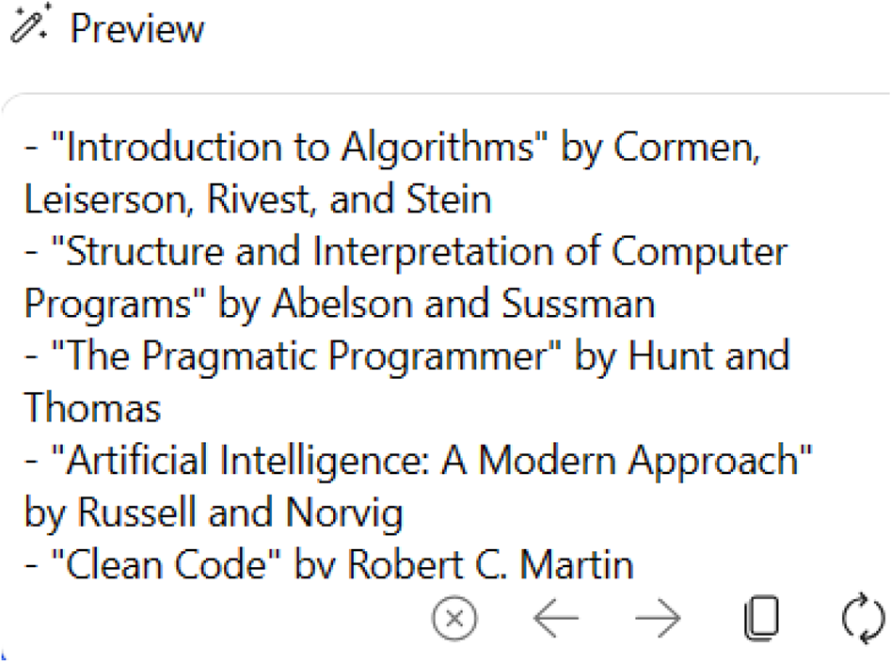

Figure 4-20. Generate ideas with Copilot

CHapter 4 WorkIng WItH CopIlot UsIng MICrosoft edge
You can also ask Copilot to compose a blog post. Let’s generate a blog post on Top 2 Android Smartphones. Even though we selected Short length
format, Copilot generates lengthy content as shown in Figure 4-21. You can scroll down the preview text area to view additional content. You have to test the content for plagiarism using any online tool before publishing on your blog.
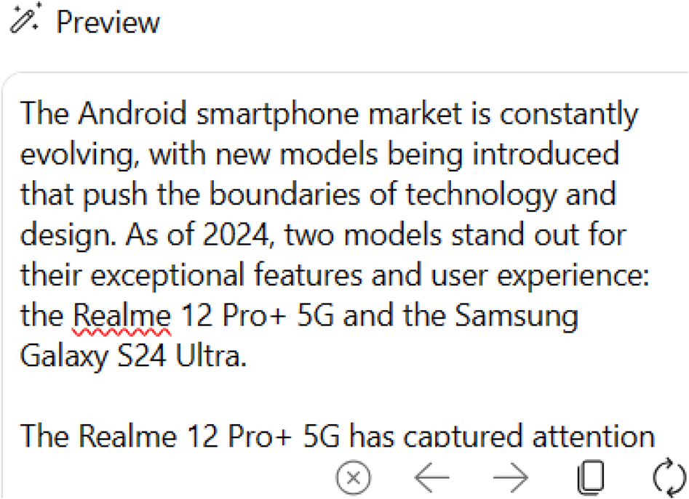

Figure 4-21. Automate your blog with Copilot
You can test Medium and Long length formats to view how Copilot generates output. You will be able to know the real usage of the AI- enabled Microsoft Copilot chatbot only if you test the system with various parameters. Make sure you adhere to the guidelines and responsible AI while working with Copilot.

Summary
In this chapter, you have learned the steps required to work with Copilot using Microsoft Edge. You can ask queries and compose content in the form of email and ideas. You can work with Copilot while you browse the Web. You can directly copy the content and publish it on your social media

CHapter 4 WorkIng WItH CopIlot UsIng MICrosoft edge
platform or blog. It’s so easy that you need not have to navigate elsewhere
to work with Copilot because it’s built into Microsoft Edge. Microsoft is
continuously improving the GPT framework integrated with Copilot, and
you have to experiment with the system in several ways. The next chapter
examines the usage of Copilot using Bing.

CHAPTER 5

Working with Copilot

Using Bing
Microsoft Bing, also called Bing, is a popular search engine since its official
launch on June 3, 2009. Bing replaced Microsoft’s MSN Search, Windows
Live Search, and Live Search. The Bing search engine generates responses
in text, images, video, news, and maps in over 40+ languages. The
transition from Live Search to Microsoft Bing was announced by the then
Microsoft CEO Steve Ballmer on May 28, 2009, during the All Things Digital
conference held in San Diego. The search engine was launched with smart
search suggestions along with other features.
Microsoft integrated advanced semantic technology from Powerset
after its acquisition in 2008. Microsoft also inked a deal with Yahoo for the
delivery of search results. Bing was upgraded with the BitFunnel search
engine indexing algorithm and other modules of Bing open source. Even
though Bing Chat was discussed in Chapter 2, let’s distill the facts again
shortly. Microsoft refreshed Bing as the new Bing on February 7, 2023,
which included a new chatbot named Bing Chat (currently Microsoft
Copilot) based on GPT-3 technology. The system was upgraded with
GPT-4 technology on March 14, 2023. Microsoft revealed that nearly
one million people joined the Limited Preview waitlist within 48 hours.
Initially, Bing Chat was only made available to Microsoft Edge and Bing
mobile users.

© Anand Narayanaswamy 2024 93
A. Narayanaswamy, Microsoft Copilot for Windows 11, Inside Copilot,

Chapter 5 Working With Copilot Using Bing
Microsoft initially imposed restrictions such as 5 chats per session and 50 chats per day. However, the restrictions were relaxed to 30 chats per session and 300 chats per day on June 2, 2023. Bing hit the 100 million active users landmark in March 2023. Microsoft introduced Bing Image Creator powered by DALL·E 2, which was later on upgraded to DALL·E 3. Microsoft blocked the generation of inappropriate images with sensitive content as part of stringent security measures. Microsoft transformed Bing Chat Limited Preview to Open Preview on May 4, 2023, and the waitlist was eliminated. In July 2023, Bing Chat was made available on non-Edge browsers such as Google Chrome.
Microsoft announced the integration of Bing Chat into Microsoft Copilot on November 15, 2023. You can work with Copilot directly by navigating to the Bing search engine home page. In this chapter, you will learn the steps required to work with Copilot with the help of Microsoft Bing.

Getting Started
To work with Copilot using Bing, you have to navigate to the official Bing
portal. You will see a screen as shown in Figure 5-1.
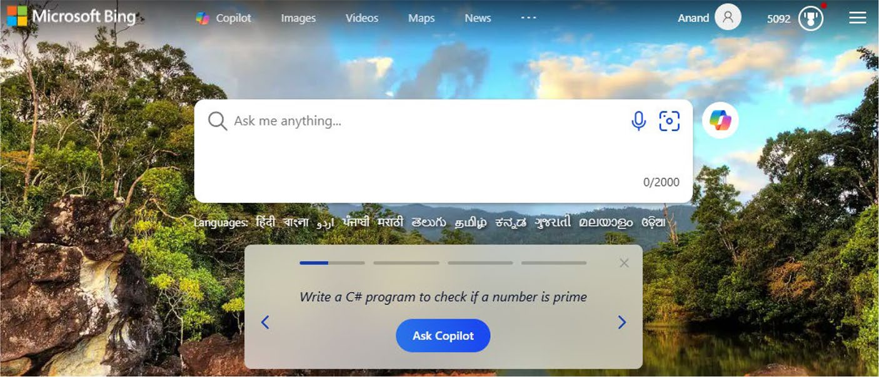

Figure 5-1. Bing home page

Chapter 5 Working With Copilot Using Bing
The next step is to provide a keyword or prompt inside the Ask me
anything box. Alternatively, you can also search using voice by selecting
the microphone icon or search via image by clicking the icon adjacent.
Microsoft Bing will display automated suggestions, which you can
either select or avoid. The screen looks as in Figure 5-2 after inputting
the prompt.


Figure 5-2. Start your search here
You should then select the Copilot icon located outside the right side of
the search box as shown in Figure 5-3.


Figure 5-3. Copilot icon
The Copilot dashboard will appear on the screen as displayed in
Figure 5-4, and you have to provide the prompt after selecting the relevant
conversation style. You can then interact with Copilot by asking queries,
coding help, and much more.

Chapter 5 Working With Copilot Using Bing
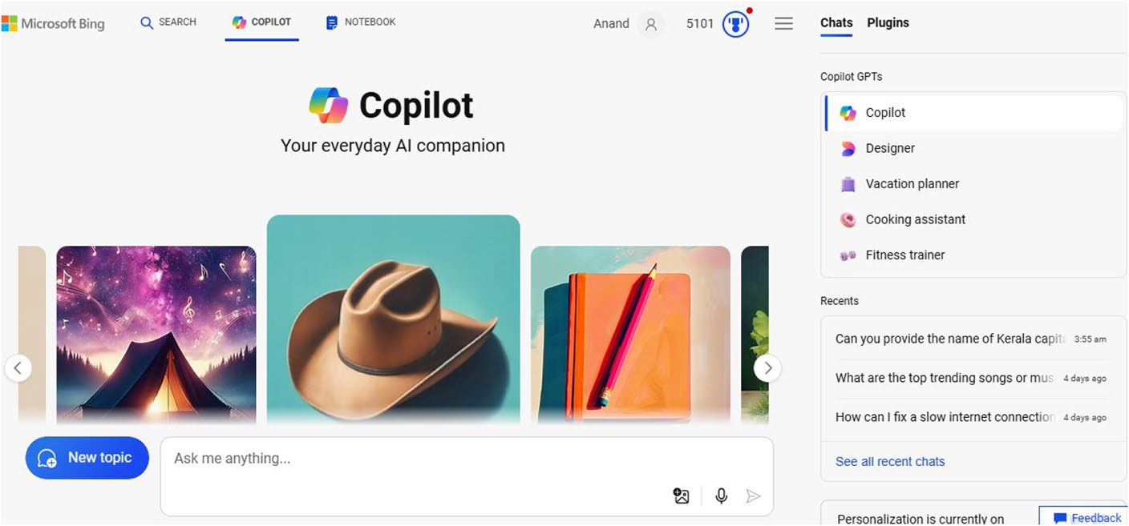

Figure 5-4. Copilot dashboard via Bing
You should note that the Copilot dashboard is the same as what you
have seen in Chapters 3 and 4. However, the conversation style will not appear sometimes due to the nature of AI technology.

Note You can work with Microsoft Copilot via Bing using both
Microsoft edge and google Chrome.
Alternatively, you can also provide a prompt directly in the Ask me anything textbox. Let’s provide History of Microsoft as a prompt inside the
search box as shown in Figure 5-5.


Figure 5-5. Start AI journey directly via the search prompt
The next step is to select the Copilot logo located on the top-right side. The response will be displayed directly inside the Copilot dashboard as
shown in Figure 5-6.

Chapter 5 Working With Copilot Using Bing
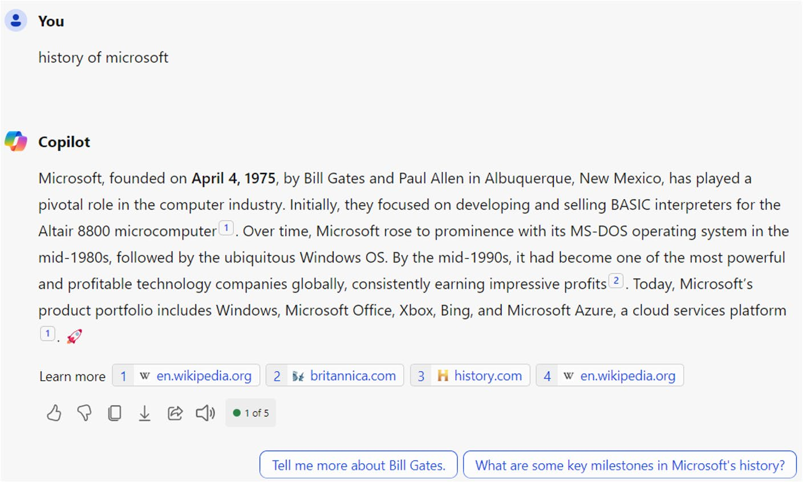

Figure 5-6. Copilot response after the search prompt
You can scroll down to view additional content, including automated
prompts. For instance, if you select the first prompt as in Figure 5-6, you
will see information about Bill Gates. You can also export the generated
content in Word, PDF, and text formats by selecting the Export icon as
shown in Figure 5-7.
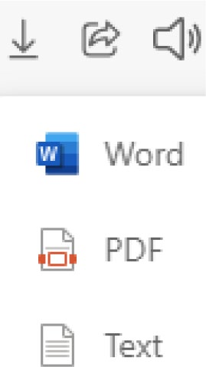

Figure 5-7. Export and use

Chapter 5 Working With Copilot Using Bing
The Microsoft Bing home page also displays predefined prompts. You
will see four prompts as displayed in Figure 5-8. You can press the left and right arrows to navigate the prompts.
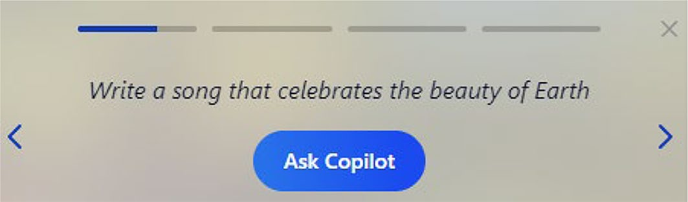

Figure 5-8. Automated Copilot prompts
You will see the relevant response inside the Copilot dashboard upon selecting the Ask Copilot button. The Bing home page also includes a
dedicated Copilot link on the top navigation bar as shown in Figure 5-9. The Copilot dashboard will be displayed upon selecting the link.

Figure 5-9. Access Copilot from the Bing home page
It’s very easy to work with Copilot via the Microsoft Bing search engine. You can not only work with search as usual but also make use of AI to fetch answers, perform coding related tasks, generating poems, creating listicles, and much more. Microsoft recently announced the integration of a new generative search experience in Bing. Microsoft has combined the power of Large Language Models (LLMs) and Small Language Models (SLMs) with the search results generated by Bing. The results will be displayed in an intuitive and efficient layout. This feature will be rolled out in a phased manner across regions.

Chapter 5 Working With Copilot Using Bing
Summary
In this chapter, you have learned the usage of Copilot using the Microsoft
Bing search engine. The chapter examined the history of Bing, including
the evolution of Copilot through Bing. You can easily interact with
Microsoft Copilot by giving prompts from the search textbox itself. You also
learned the steps to export the Copilot response from the dashboard. In
the next chapter, you will learn the application of Copilot in Skype.

CHAPTER 6

Working with Copilot

Using Skype
Microsoft has integrated Copilot (formerly Bing Chat) with all its products,
including Skype. After the launch of Copilot, the Redmond-based software
giant integrated Bing AI Chat into Skype. The Skype messaging platform is
used by individuals and companies across the world to interact with each
other. The integration of Bing into Skype helped people to ask queries via
prompts while they communicate with their colleagues. As of this writing,
Microsoft has renamed Bing to Copilot inside Skype, but the change
depends on the region. You can follow this chapter even if you have access
to Bing AI on Skype. Let’s learn the steps required to work with Copilot
using Skype.

Getting Started
The first step is to open the Skype app from your Windows 11 device.
You should then sign in using your Microsoft credentials, which is not
required if you had properly configured your PC during the setup process.
A running instance of Skype on your PC will appear as a green icon on the
right side of the Taskbar. If you open Skype, you will see a verified entry of
the Copilot chatbot under the Recent chats panel as shown in Figure 6-1.

© Anand Narayanaswamy 2024 101
A. Narayanaswamy, Microsoft Copilot for Windows 11, Inside Copilot,

ChApter 6 Working With Copilot USing Skype

Note Alternatively, you can either search for Skype from the
Microsoft Store or navigate to https://apps.microsoft.com/
detail/9wzdncrfj364?hl=en-us&gl=IN manually.
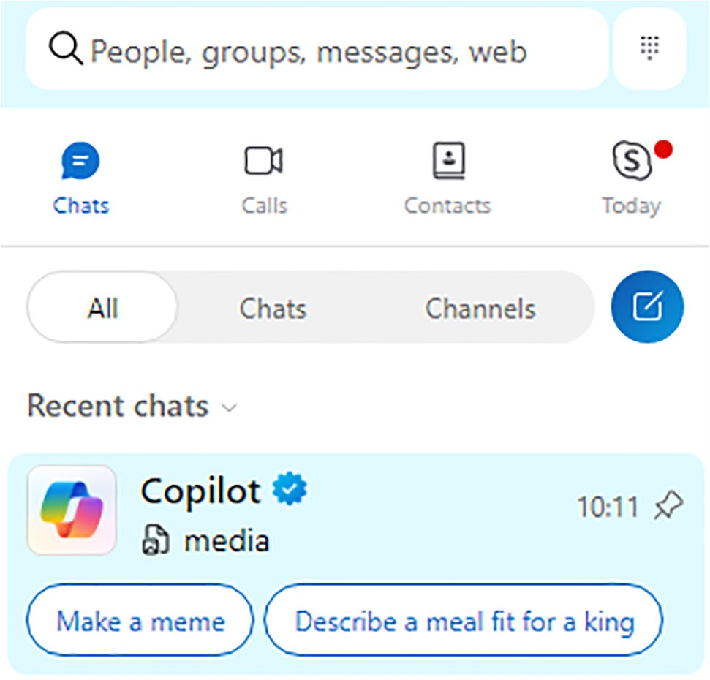

Figure 6-1. Work with Copilot via Skype
You can now interact with Copilot as if you are communicating with your friend or colleague. You can provide the prompt inside the Type a message textbox, and the results will be displayed inside the chat dashboard. You can also ask queries just like Copilot. Skype also provides
automated suggestions as in Figure 6-2. The Discover Copilot option enables you to work with trending topics under several categories.

ChApter 6 Working With Copilot USing Skype
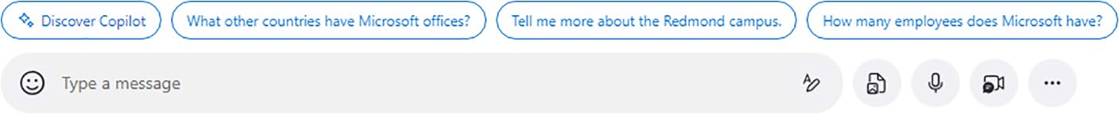

Figure 6-2. Select a suggested prompt and start

Fetching Responses
Let’s try by asking Copilot to give information about the state of Kerala.
Skype will show a progress bar as Copilot in Skype fetches content for you
as displayed in Figure 6-3.
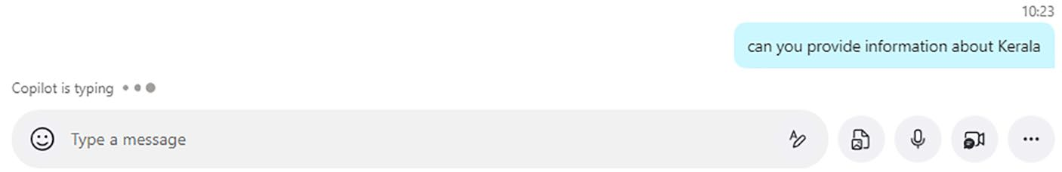

Figure 6-3. Wait until Copilot fetches data
In Figure 6-4, Copilot in Skype clearly displays all the important
information pertaining to Kerala.

ChApter 6 Working With Copilot USing Skype
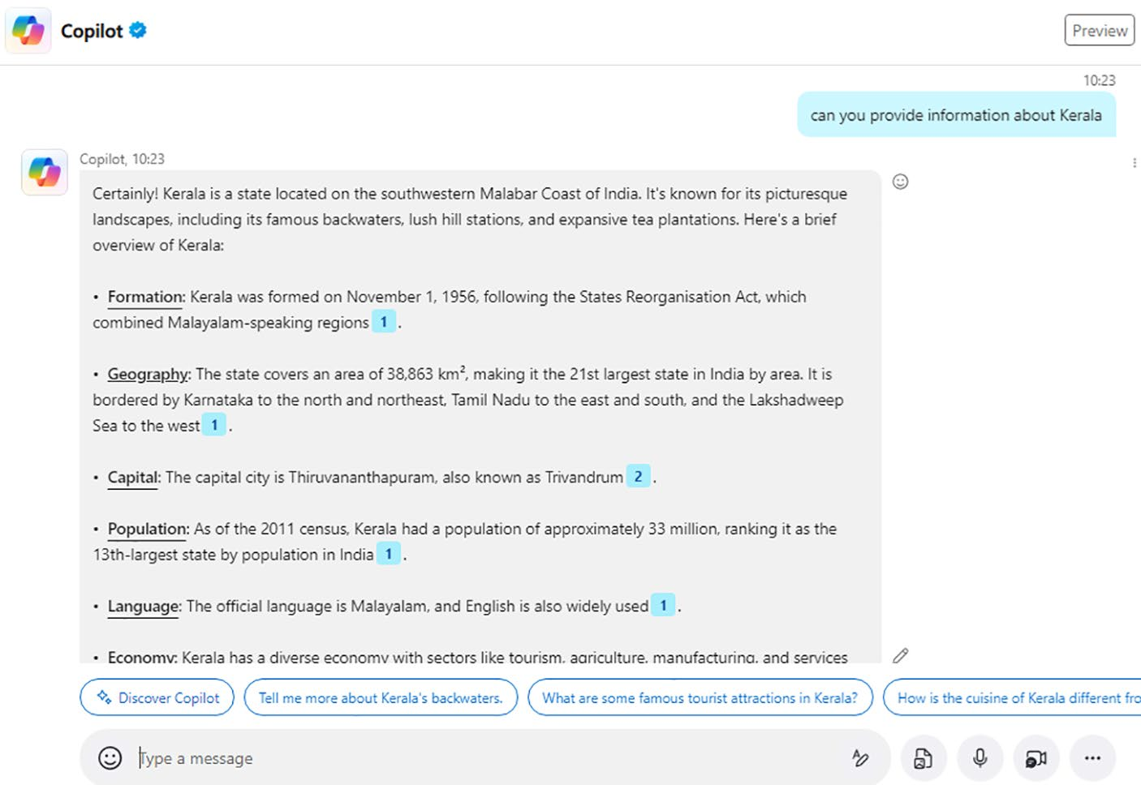

Figure 6-4. View the Copilot response inside Skype
You can also click the links included with the content inside Skype, which provides additional information via the Bing search engine. You can then learn more about the topic by selecting the relevant options.
The Copilot chatbot will only display the results. For instance, if you ask the prompt open calculator, then the chatbot will display text results
with links to several online calculator tools as shown in Figure 6-5.

ChApter 6 Working With Copilot USing Skype
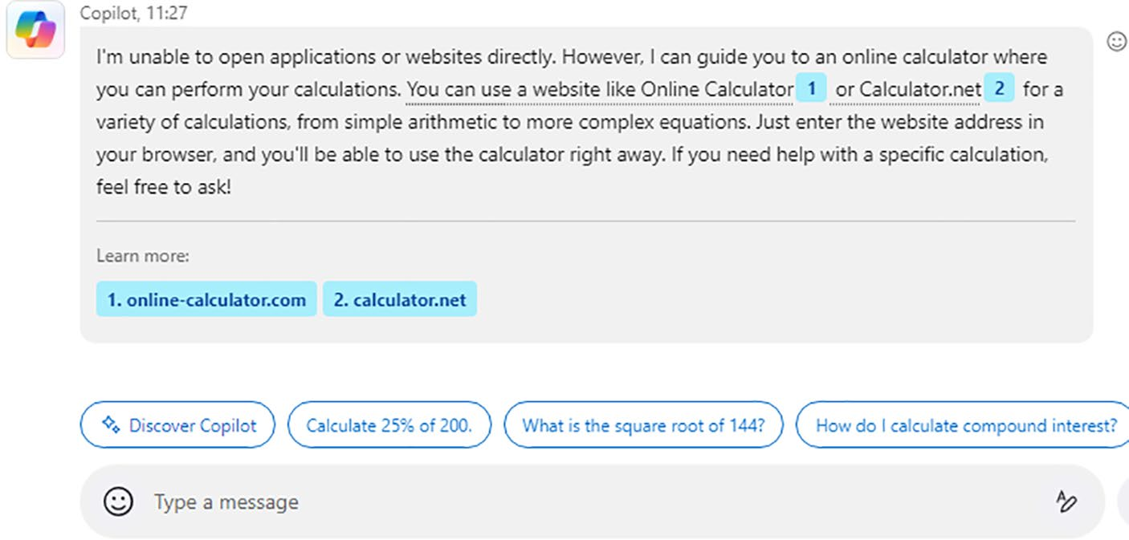

Figure 6-5. Copilot helps you to work effectively
You can not only open online calculator tools but also select the
automated prompt suggestions. For instance, you can directly select the
third prompt and know the square root of 144. However, if you ask the open
calculator prompt using Copilot in Windows (preview), then you will be
able to open the Calculator app directly as shown in Figure 6-6.
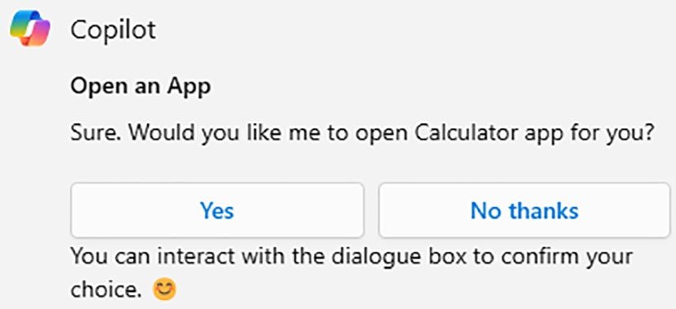

Figure 6-6. Open the Calculator app using Copilot via Windows 11
If you press the Yes button, then Copilot will open the Calculator app.
Microsoft has developed Copilot to work differently as per the relevant app
or scenario.

ChApter 6 Working With Copilot USing Skype
Try Copilot Instantly with Skype
Copilot in Skype also provides a separate module, which enables you to try different topics under diverse categories. This module was previously called Bing examples. To test-drive Copilot, you should select the Try
Copilot icon as in Figure 6-7, which is located in the top-right corner inside Skype.
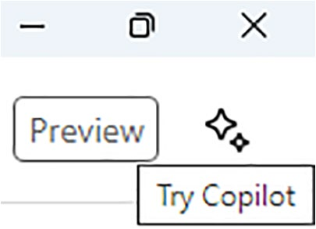

Figure 6-7. Try Copilot from Skype
You will see plenty of categories as shown in Figure 6-8.

ChApter 6 Working With Copilot USing Skype
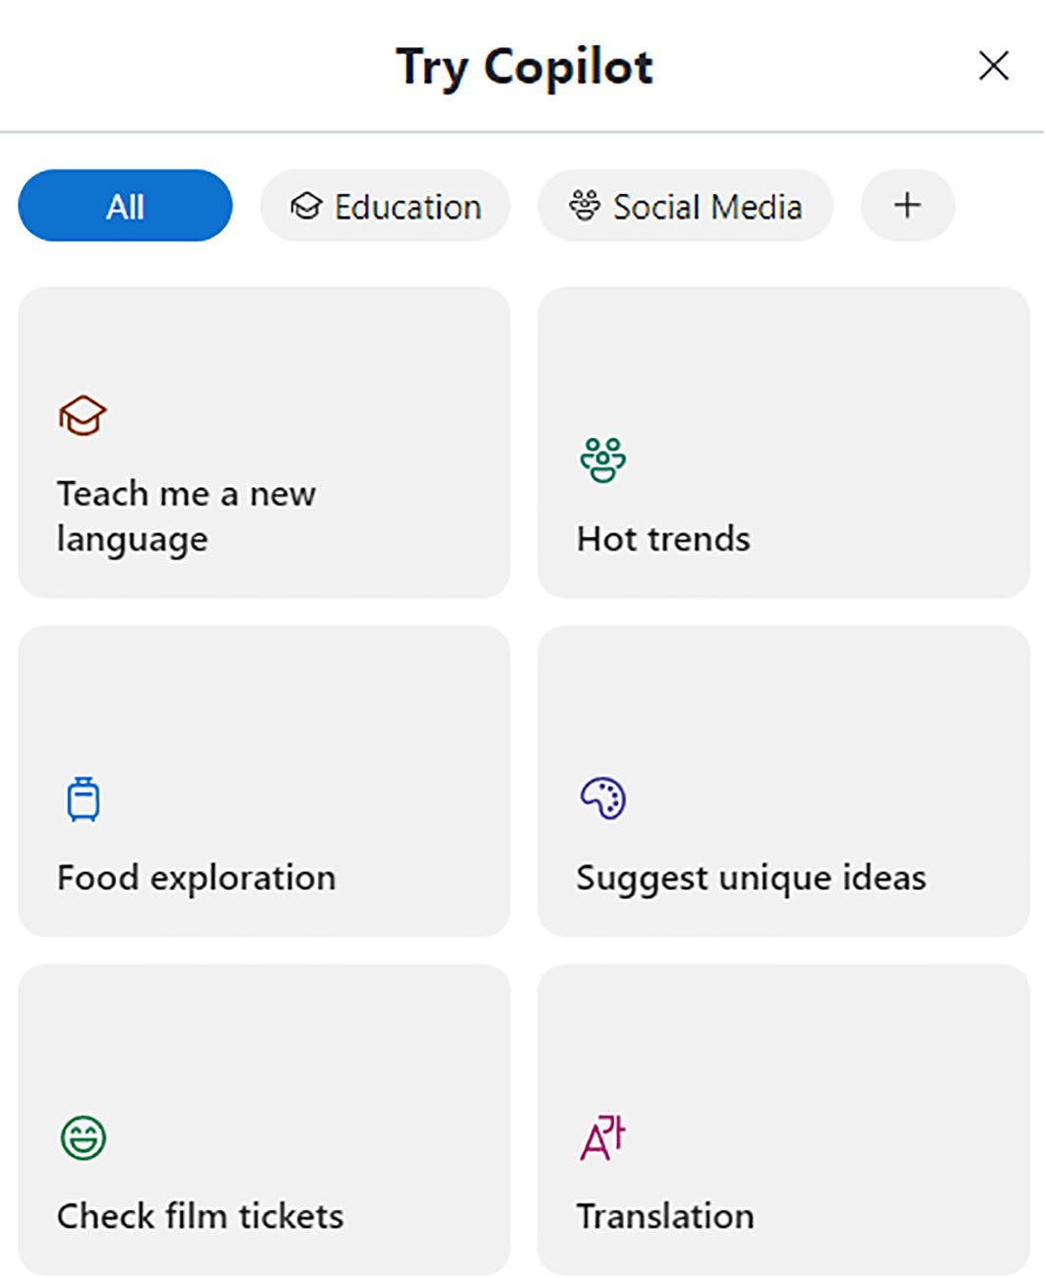

Figure 6-8. Automate Copilot tasks easily
Let’s call these options as Copilot examples. You can select a specific
category from the tab and select the relevant example that is displayed
below. If you select the + icon, you will see additional categories as shown
in Figure 6-9.

ChApter 6 Working With Copilot USing Skype
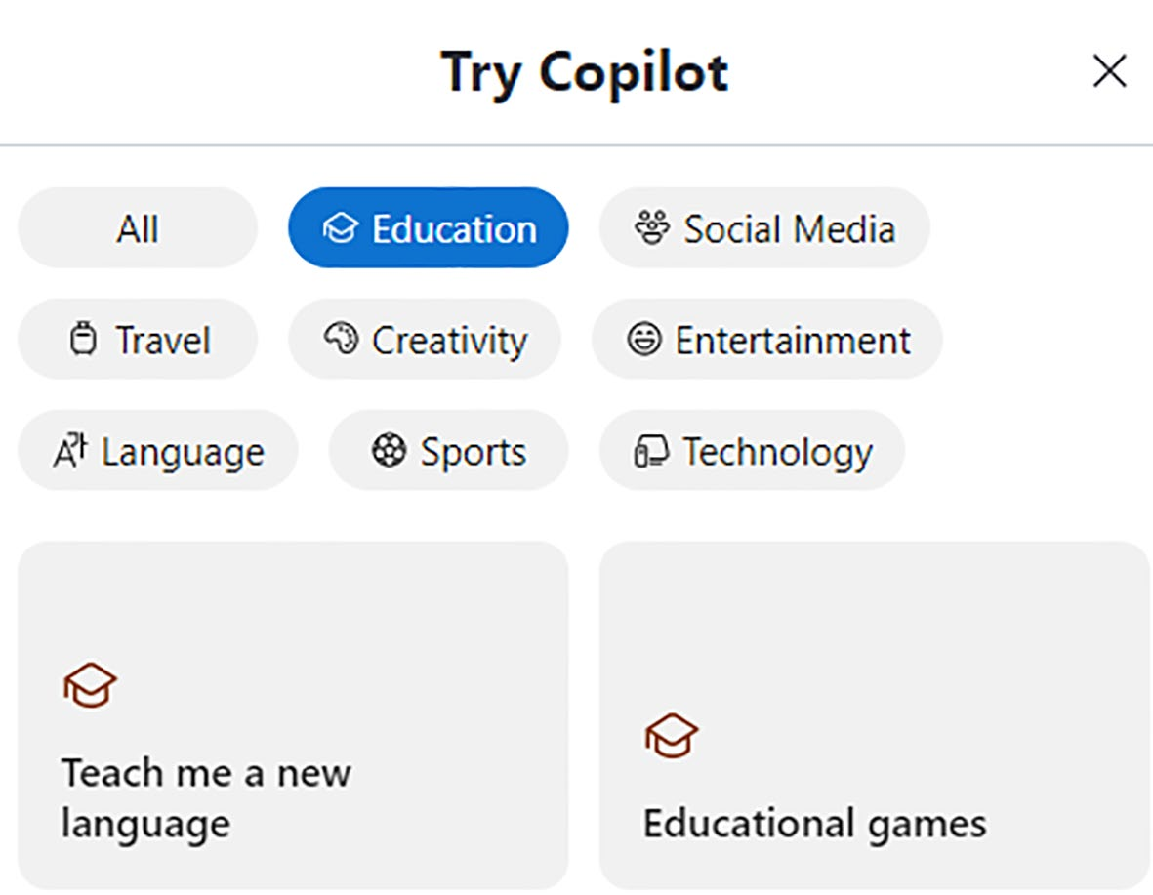

Figure 6-9. Expand the categories for additional knowledge
Let’s check out the working of Copilot examples by selecting the option Teach me a new language. The Copilot chatbot will display the relevant
prompt inside Skype as shown in Figure 6-10.
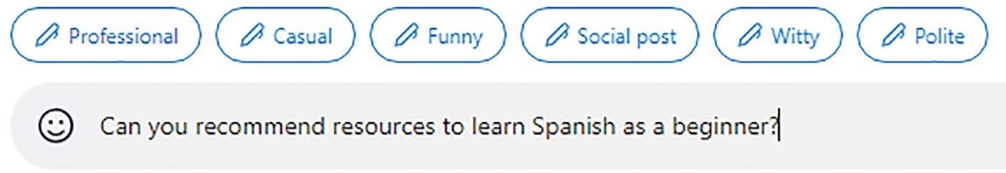

Figure 6-10. Automated prompt upon selection
The Copilot chatbot in Skype displays the resulting output as in
Figure 6-11 with information related to online courses and videos, websites, apps, podcasts, and other resources for learning Spanish. Copilot also provides automated suggestions related to the Spanish language, which you can select for additional learning.

ChApter 6 Working With Copilot USing Skype
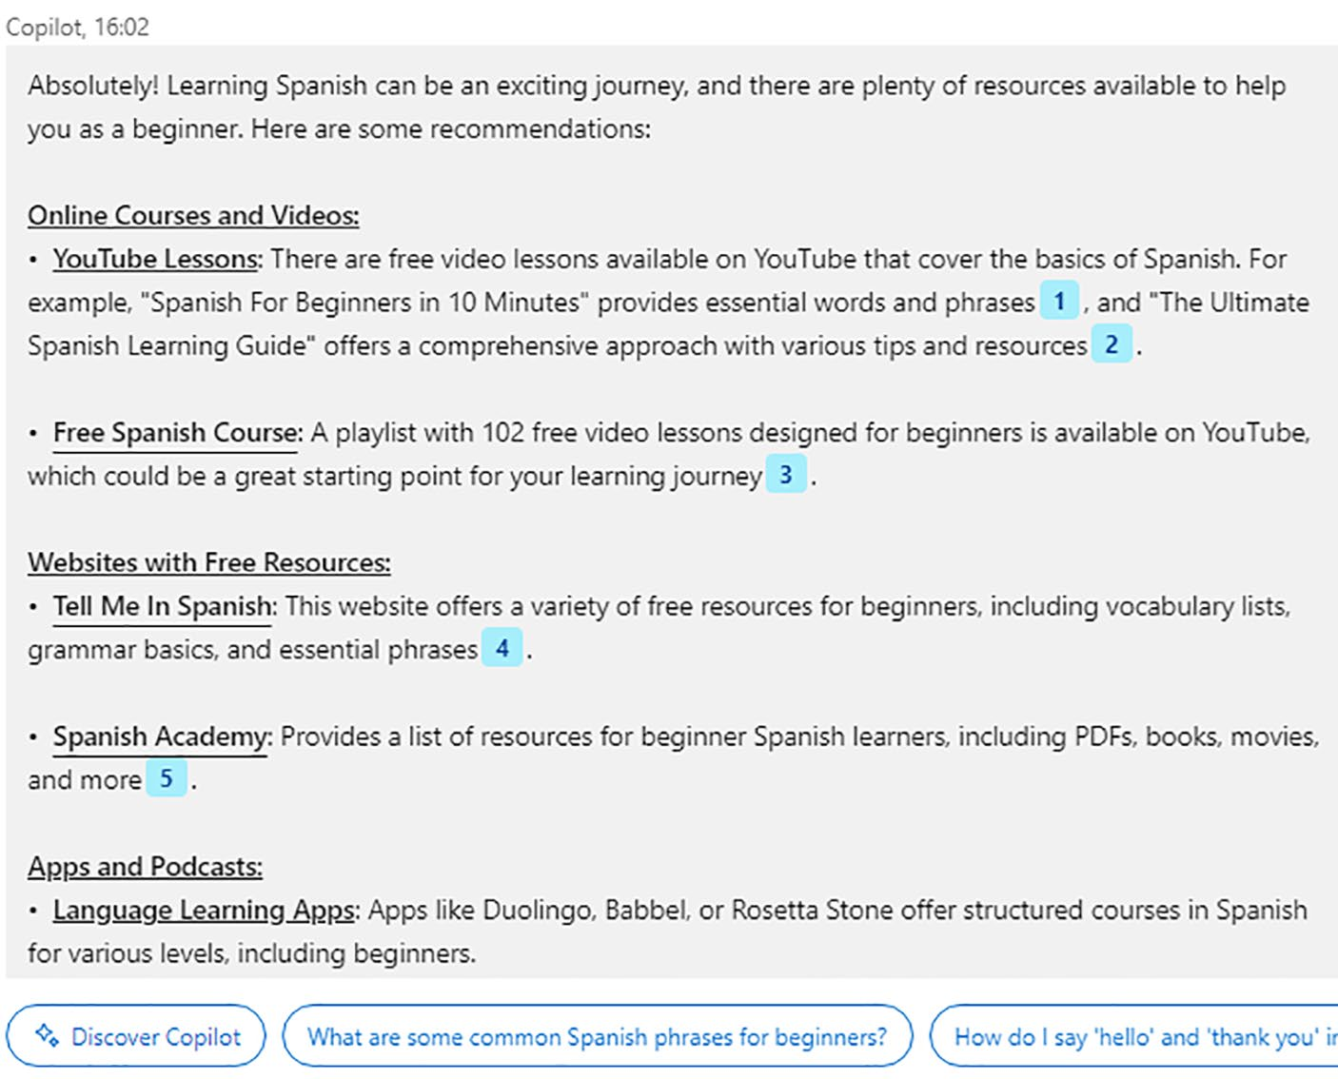

Figure 6-11. Fetch information easily inside Skype
Let’s test another Bing example by selecting the Technology category
and Tech support example as in Figure 6-12.

ChApter 6 Working With Copilot USing Skype
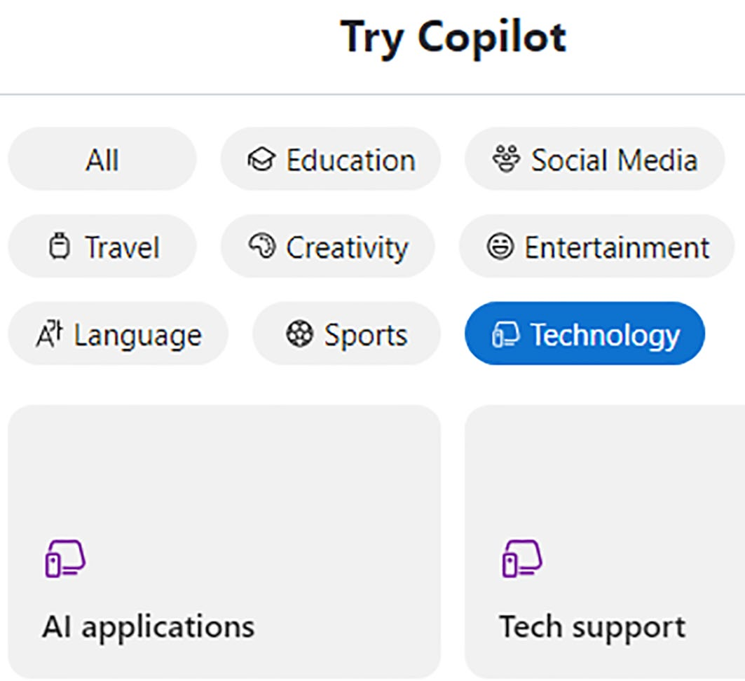

Figure 6-12. Get free tech support via Copilot

Change Content Tone Easily
Copilot automatically displays the prompt as in Figure 6-13. As you can observe, Bing displays several tones such as Professional, Casual, Funny, Social post, Witty, and Polite.
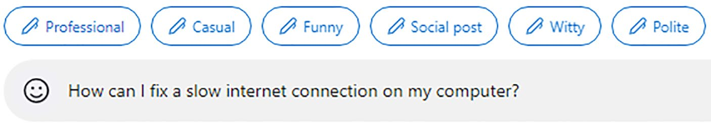

Figure 6-13. Select a tone and generate a response

ChApter 6 Working With Copilot USing Skype
Let’s select the Social Post tone and observe the result as in Figure 6-14.
You can directly copy the generated content by selecting the Copy message
icon located on the right side. Copilot also generates AI images from
within Skype. You can download them to your PC and use them on your
social media and blog post. It’s very easy to create not only content but also
images driven by DALL·E 3 technology.
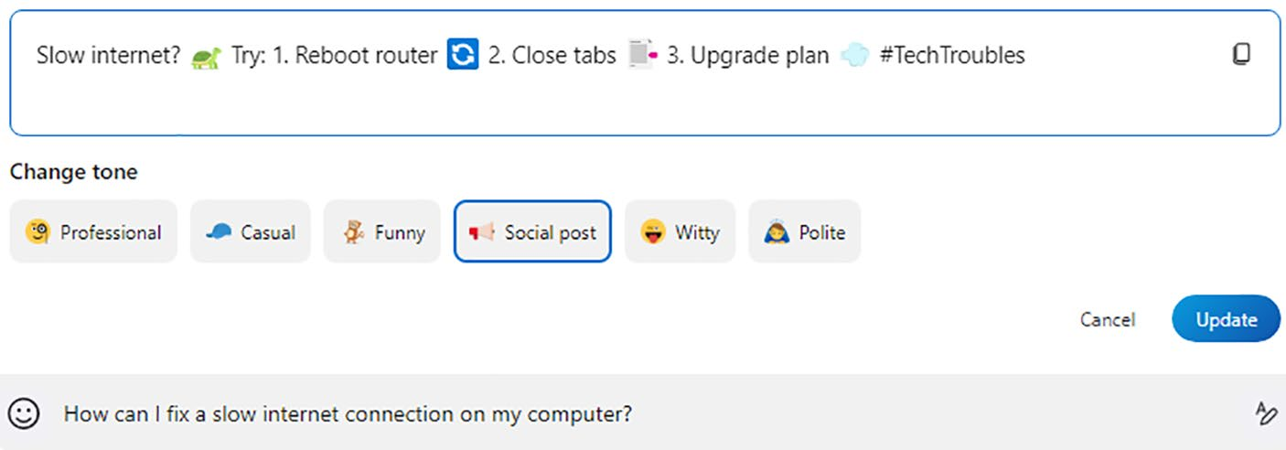

Figure 6-14. Create social media content quickly
If you select the Update button, a new prompt will be generated
by Copilot in Skype. Let’s now change to the Entertainment category
and select the Music example. Copilot displays a prompt as shown in
Figure 6-15.
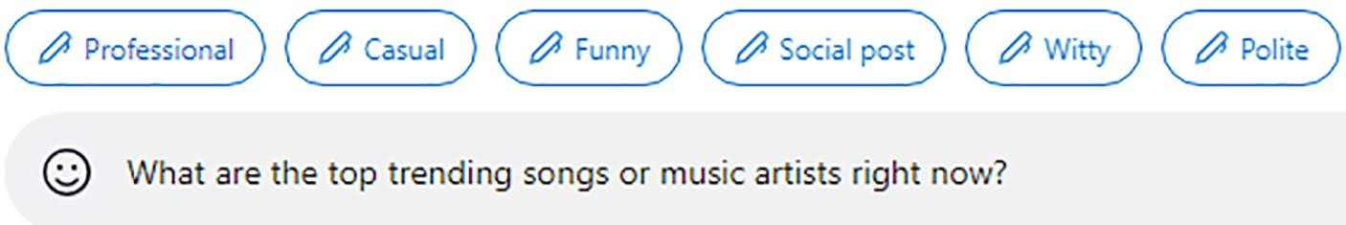

Figure 6-15. Fetch answers to your music queries
Let’s select the Funny tone, and the prompt will change as shown in
Figure 6-16.

ChApter 6 Working With Copilot USing Skype
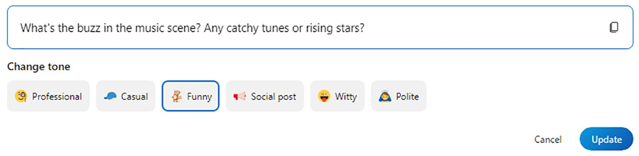

Figure 6-16. Automatically change prompts via AI
If you select the Update button, the revised prompt will appear inside the textbox. You can ask Copilot in Skype to generate answers based on the Funny conversation tone.

Using Copilot in Group Chats
You can either chat directly with Copilot in Skype or interact with your friends via group chat. If you are not part of any group, you can test the
functionality by selecting New Chat icon as shown in Figure 6-17.
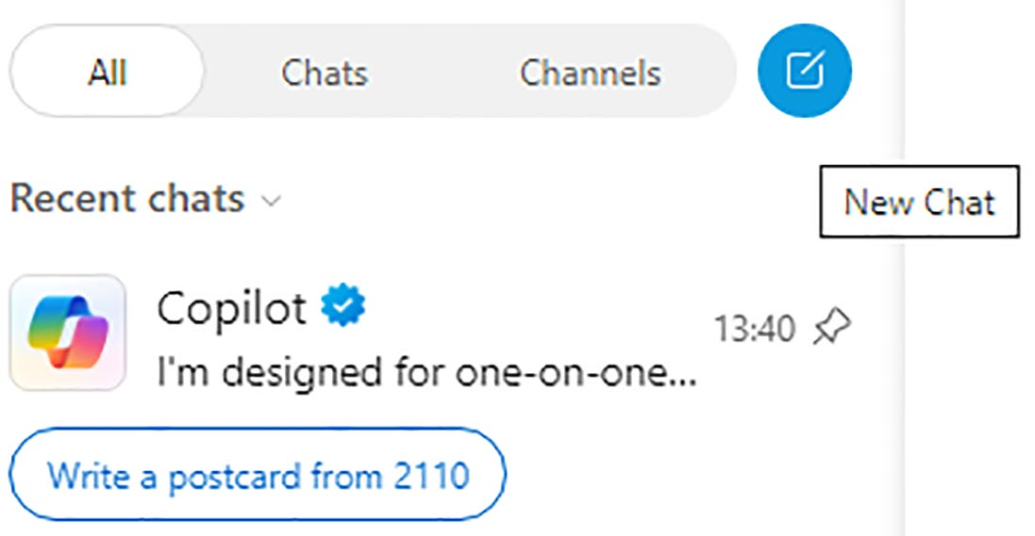

Figure 6-17. Starting to create a group chat
The next step is to select New Group Chat option from the displayed
pop-up menu as shown in Figure 6-18.

ChApter 6 Working With Copilot USing Skype
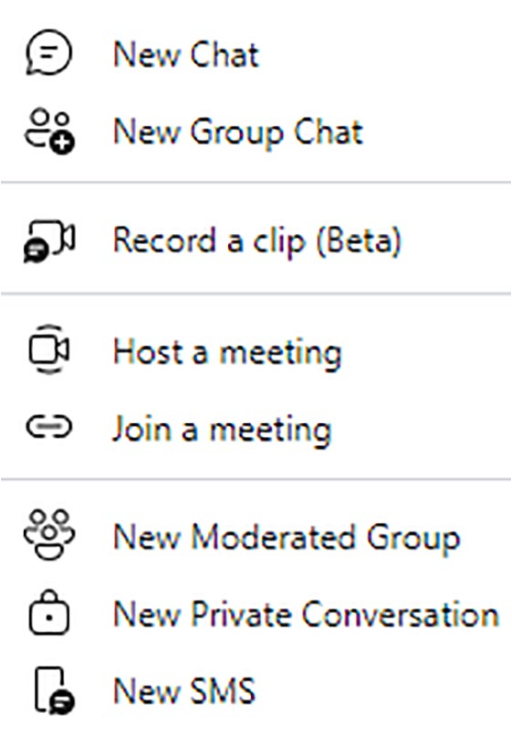

Figure 6-18. Creating a group chat
You have to add a name for your group and select the member(s) from
the displayed list. You also need to add Copilot as a member of your group,
which appears while adding members as shown in Figure 6-19.


Figure 6-19. Adding a Copilot
The newly created group appears on the screen, and the concerned
member will be notified. Copilot is now part of a group on Skype. You
can interact with Copilot by using the @Copilot mention from within
a group chat. Let’s test the functionality by asking Copilot to provide
more information about Apress, and the resulting response is shown in
Figure 6-20.

ChApter 6 Working With Copilot USing Skype
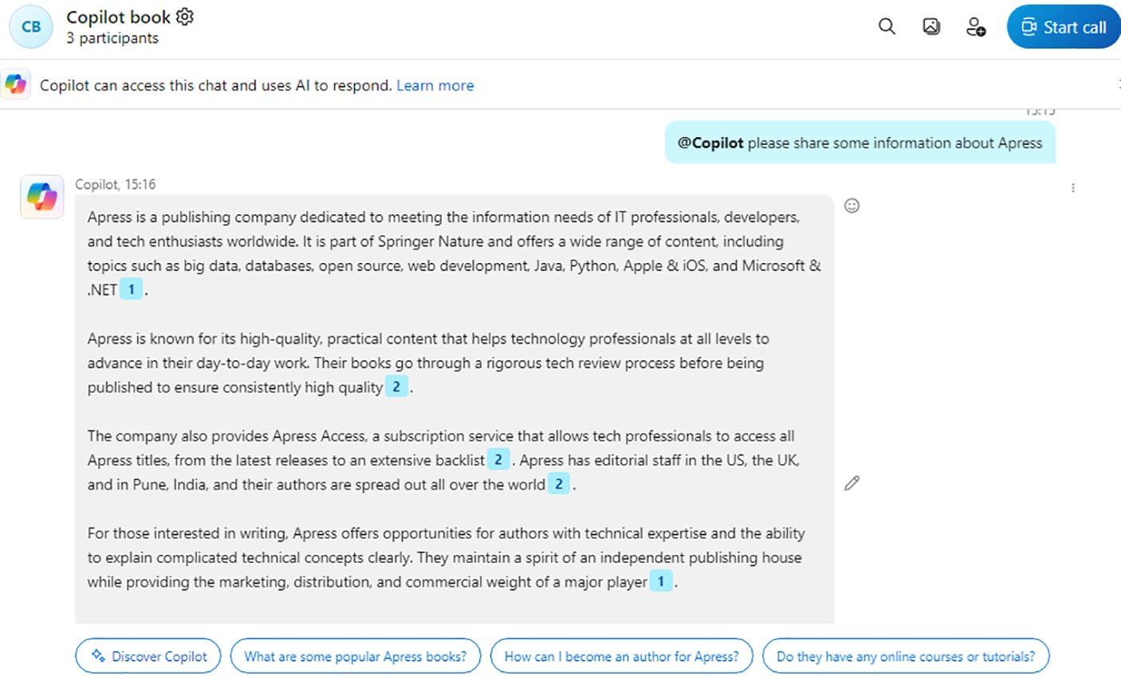

Figure 6-20. Copilot in action via Skype group chat
Copilot in Skype also provides the ability to summarize chats. In
Figure 6-21, you can view the response generated by Copilot for the prompt Can you summarize the chat in the last 1 hour?
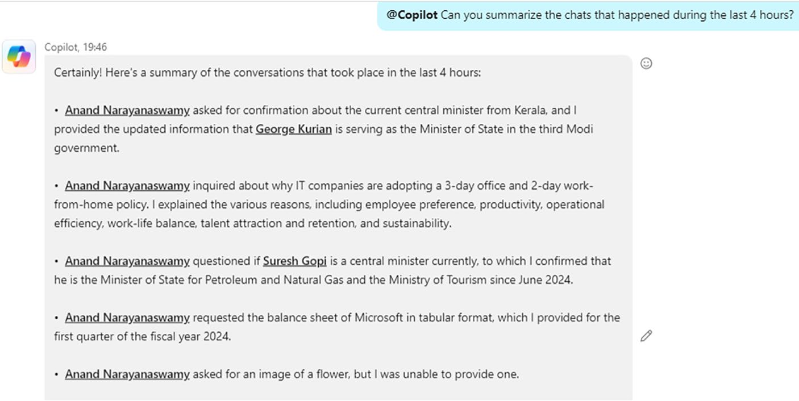

Figure 6-21. Copilot summarizes Skype group chats

ChApter 6 Working With Copilot USing Skype
You can also ask Copilot to summarize chats in the last 24 hours or 2
days like that. Copilot displays the point-wise summary. You should note
that Copilot is an effective productivity tool when combined with group
chats. However, audio and video interactions are not supported in Skype.
Even though Copilot generates responses based on reliable sources, the
system could make errors. This is the nature of AI. However, you can
double-check the facts and information provided by Copilot.

Summary
In this chapter, you have learned the workings of Copilot in Skype. You
can ask queries just like you do with Copilot. Moreover, intelligent prompt
suggestions help you to fetch answers quickly. The bundled Copilot
examples enable you to learn more about various prompts that are divided
into several categories. You should note that Microsoft recently replaced
the original Bing AI in Skype with Copilot. If you view Bing inside Skype,
then the steps discussed in this chapter are the same. Skype displays
Bing progress text instead of Copilot, and the content rendering will be
the same. Moreover, the Try Copilot examples module will be named as
Bing examples. The conversation tones will also be the same as Copilot in
Skype. Microsoft renamed all instances of Bing as Copilot for the sake of
uniformity. In the next chapter, you will learn the usage of Copilot Web.

CHAPTER 7

Working with Copilot

Web
In the previous chapters, you have learned the usage of Copilot using
Windows 11, Microsoft Edge, Bing search engine, and Skype. Microsoft
has provided several ways to access Copilot. Even though you can easily
access Copilot directly by selecting the icon from the Windows 11 Taskbar,
you can also directly navigate to the Copilot web interface to work with
the AI chatbot. You have already seen the Copilot web user interface in
the previous chapters. In this chapter, you will learn all the modules such
as GPTs and plugins that are included with the Microsoft Copilot web
dashboard. Let’s get started.

Getting Started
To work with Copilot Web, you should navigate to https://copilot.
microsoft.com. You will see a dashboard as shown in Figure 7-1.

© Anand Narayanaswamy 2024 117
A. Narayanaswamy, Microsoft Copilot for Windows 11, Inside Copilot,

Chapter 7 Working With Copilot Web
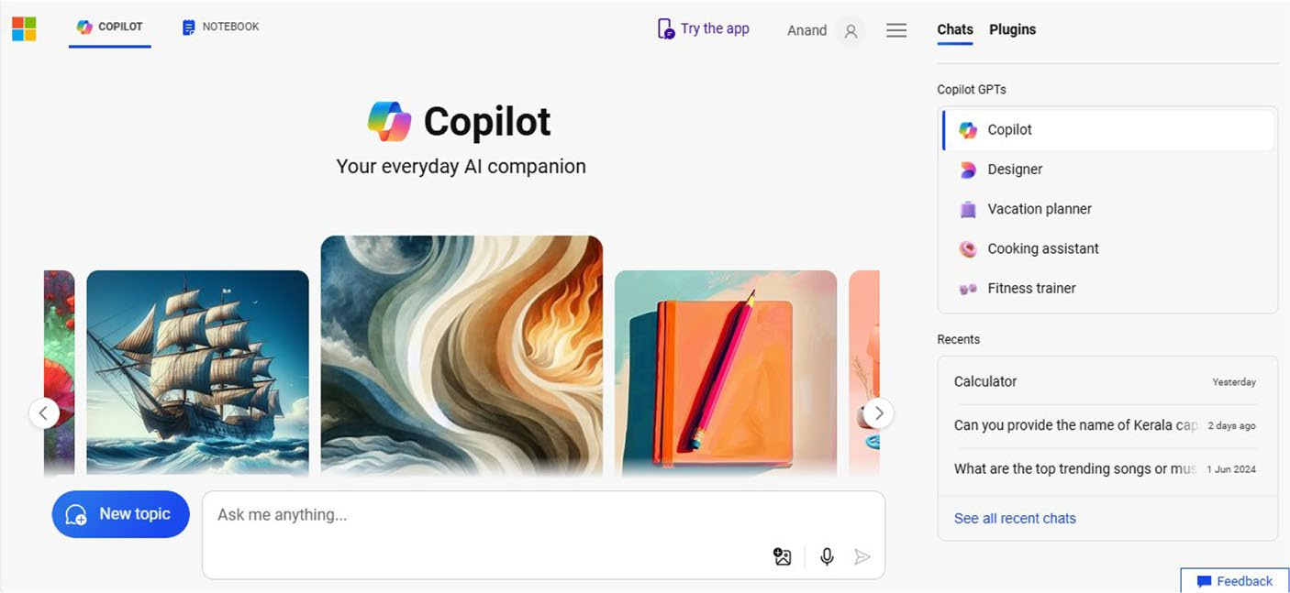

Figure 7-1. Work with the Copilot dashboard
You have to provide the relevant prompt and select the suitable
conversation style (see Figure 7-2) by scrolling down to the Copilot dashboard. Microsoft is currently experimenting a new Copilot user interface without conversation styles. However, the styles appear randomly for free users, but they appear permanently for Copilot Pro users. Microsoft hasn’t revealed that the three styles are reserved only for Copilot Pro users. Even if you are not a Copilot Pro subscriber, the conversation styles can be enabled by navigating to Settings and changing the Country/Region to United States - English. You can also change the appearance of the Copilot web interface to Dark. You will see the relevant options by selecting the three horizontal lines (hamburger menu) adjacent to the Profile icon.
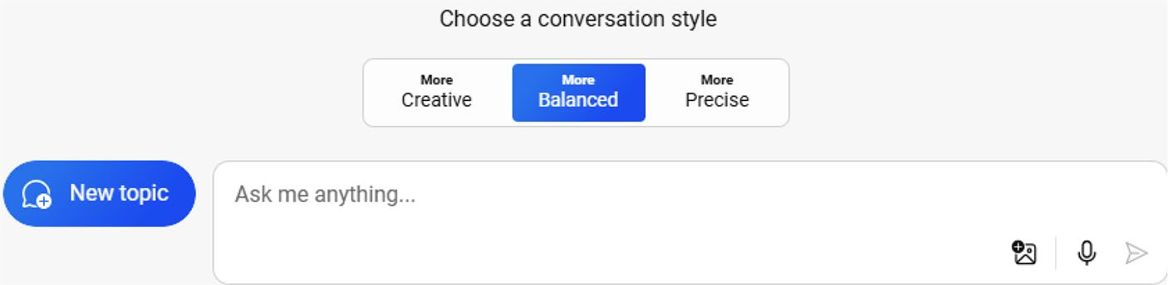

Figure 7-2. Get answers to all your queries

Chapter 7 Working With Copilot Web
The default style is Balanced, but you can switch over to Creative and
Precise if required. Refer to Chapter 2 to learn about the various use cases
of these three conversation styles in detail.

Note the Copilot dashboard displays several automated prompts based on several topics. the Copilot chatbot displays the response upon selecting the relevant prompt.

Working with Copilot GPTs
Microsoft has released Copilot GPTs which can be accessed from the
Copilot Web dashboard. You can access Copilot GPTs from the right side
of the dashboard as displayed in Figure 7-3. You should note that Microsoft
has announced the retirement of GPT Builder in July 2024 for Consumer
Copilot. This means all GPTs created by Microsoft and that of the end
user along with the associated data have been deleted. However, the GPT
Builder will be available for Commercial and Enterprise users.
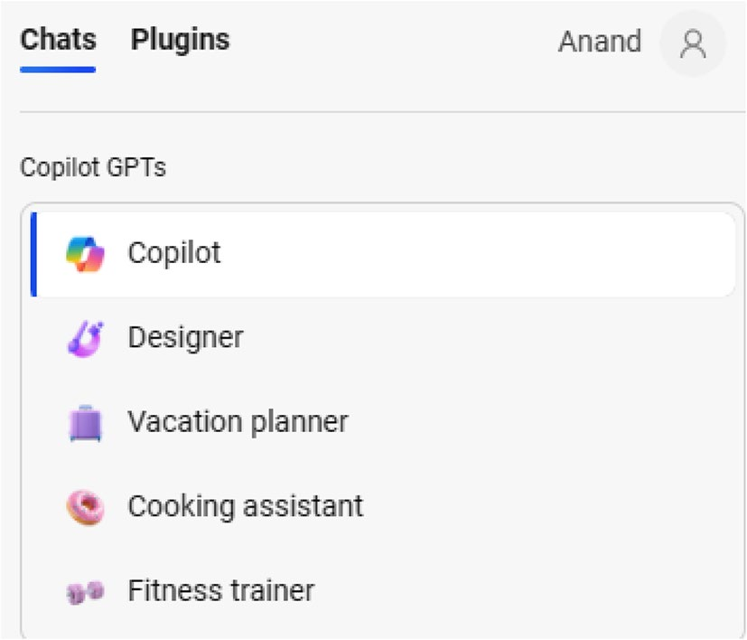

Figure 7-3. Create and plan with automated GPTs

Chapter 7 Working With Copilot Web
The default option is Copilot, and it’s the option you are currently working on. You can fetch answers to prompts as well as write long articles, lists, poems, and much more.

Generating Images with Copilot
Microsoft Copilot enables you to generate stunning images for various requirements. You can easily create AI images directly from the Copilot dashboard via Designer GPT. Moreover, you can also generate images via Copilot in Windows (preview), Copilot Web, Skype and Copilot Windows app. Let’s try to create an AI image.
Prompt: Create images of vegetable pizza along with hot brewing coffee on the table.
You should select Designer GPT and provide the preceding prompt. Copilot Designer takes a few seconds to generate images since it involves enormous processing. The generated image will be displayed on the dashboard.

Note You can try the preceding prompt using Microsoft Copilot and
observe the output. the ai system is developed in such a way as to
generate different responses upon each attempt.
You can export and share the generated image by selecting the
relevant icons as shown in Figure 7-4. You can share via email, Facebook, X (formerly Twitter), Pinterest, LinkedIn, Reddit, and OneNote. You can also copy the link and manually share via social media platforms and blogs.

Chapter 7 Working With Copilot Web
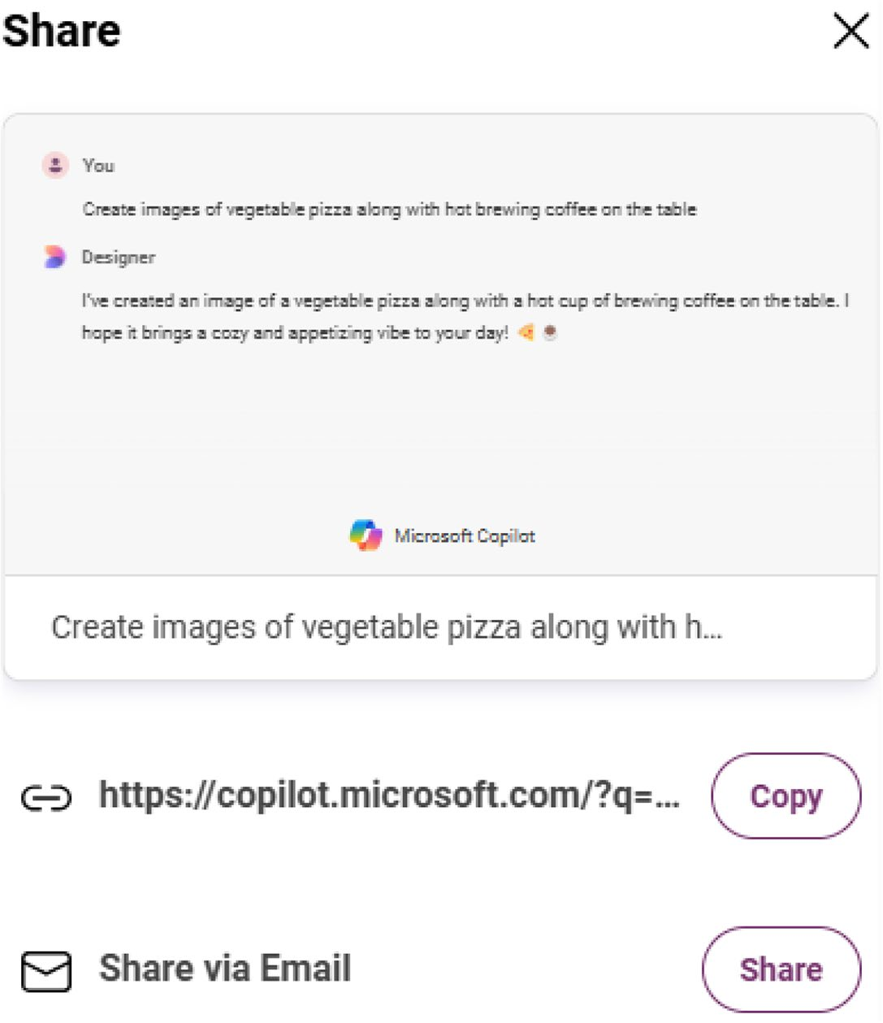

Figure 7-4. Reveal the images to others instantly
You can also download the generated AI images. For this purpose,
you have to select an image. The enlarged version will appear inside the
dashboard. The generated image slightly animates upon selection.
You have to select the three horizontal dots located on the top-right
side of the enlarged image. The next step is to select the Download option
as shown in Figure 7-5.

Chapter 7 Working With Copilot Web
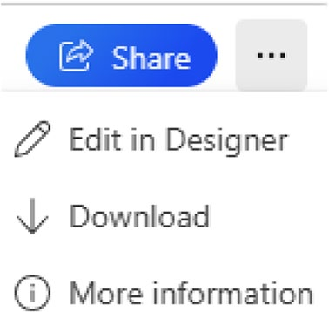

Figure 7-5. Share the image
The relevant image will be downloaded to your system upon selecting the Download option, and a confirmation message will be displayed.

Note the ai image generation tools are trained on massive datasets
of images including other creative works.
If you select the Edit in designer option, Copilot will prompt you to open the Designer editor in a new tab. You will see the Designer editor
upon selecting the option displayed in Figure 7-6. You can add filters and effects with the help of various options via the dashboard. You can observe how the generated image based on the prompt appears inside the editor.

Chapter 7 Working With Copilot Web
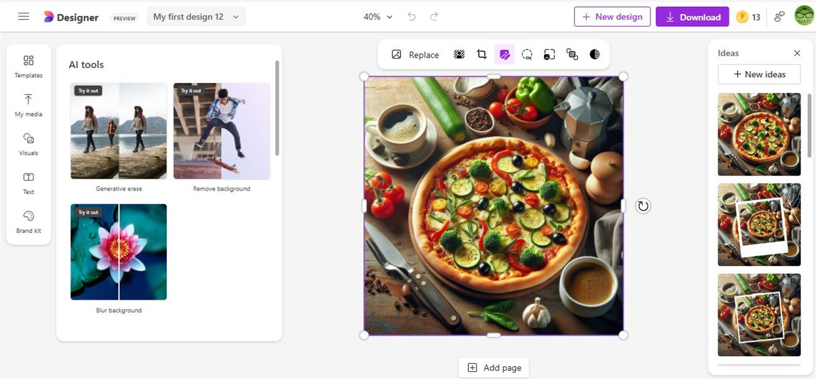

Figure 7-6. Microsoft Designer in action with Copilot-generated
image

Note You should note that the images generated by Microsoft Copilot differ when you attempt the same prompt. ai chatbots and systems are developed to generate different images upon each attempt.

Planning Vacations
The Vacation planner GPT provides a dedicated dashboard for planning
vacations. You can discover new destinations, create itineraries, and also
enable users to book travels. The dashboard looks as shown in Figure 7-7.

Chapter 7 Working With Copilot Web
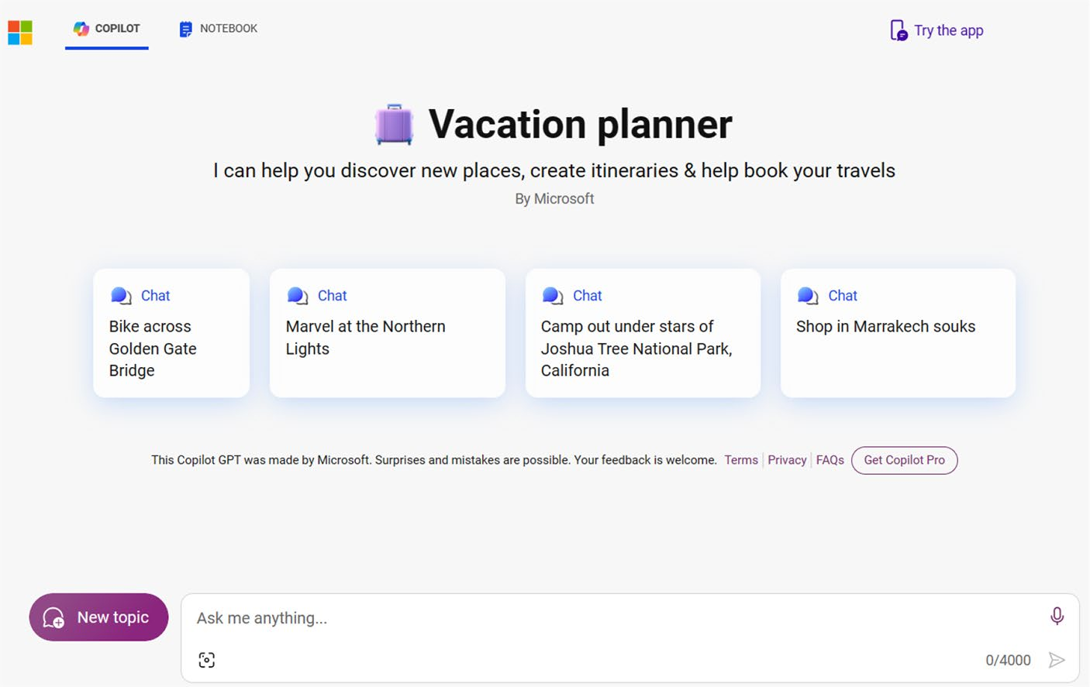

Figure 7-7. Check Copilot and plan vacations
The Vacation planner GPT provides a few predefined prompts using which you can test the working. Let’s test-drive the working of the GPT by providing a prompt.
Prompt: Create a detailed vacation planner with places to visit in Thiruvananthapuram.
The Copilot Vacation planner GPT renders a detailed output
(Figure 7-8) spanning over four days along with a map and nearest spots to explore. You can also add unique data to your prompt like veg hotel, type of food, and much more to refine the Copilot output.

Chapter 7 Working With Copilot Web
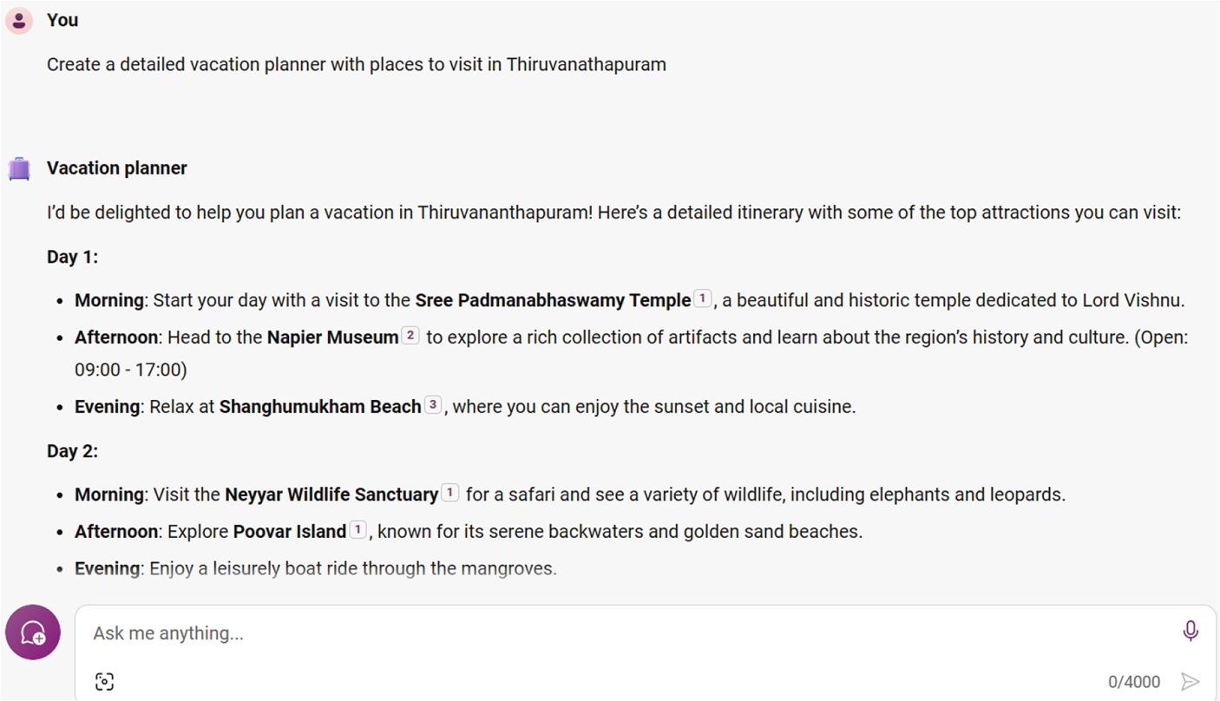

Figure 7-8. Explore places with Copilot
In this way, you can play with the Vacation planner GPT. Copilot is
so powerful that it renders accurate information. Moreover, the Vacation
Planner GPT also provides prompt suggestions as shown in Figure 7-9.
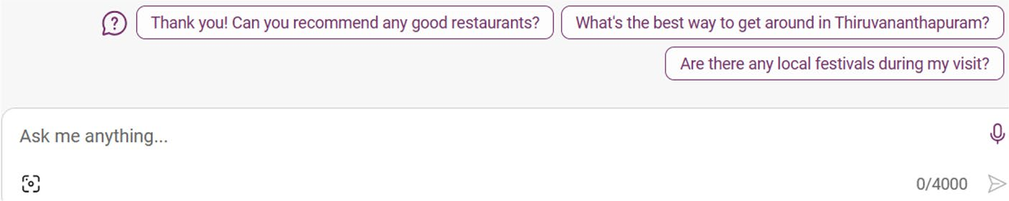

Figure 7-9. Make use of Copilot-generated prompts

Cooking with Copilot
Are you wondering whether it’s possible to cook with Copilot? Even though
you can’t cook food via Copilot, the AI chatbot can guide you to cook food.
You can ask Copilot to locate recipes, create meal plans, and fetch cooking
tips and tricks using Cooking assistant GPT. The dashboard looks like as
displayed in Figure 7-10.

Chapter 7 Working With Copilot Web
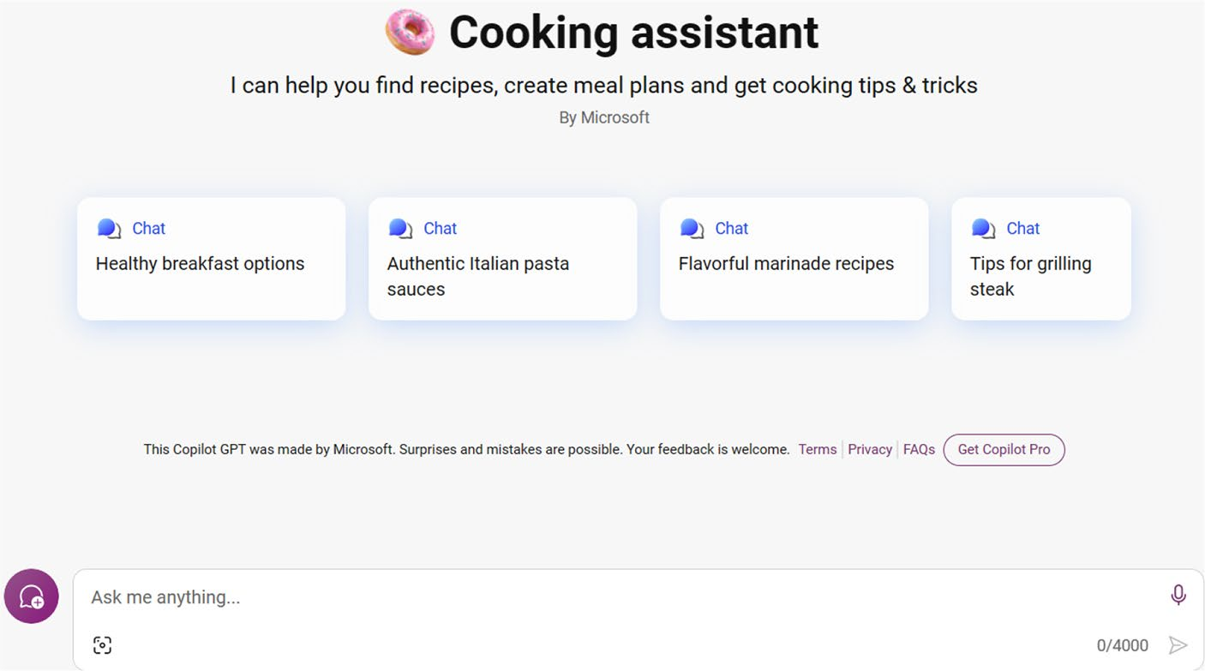

Figure 7-10. Cooking made simple with Copilot
The dashboard displays predefined prompts, which you can make use of to test-drive Copilot. You can also provide your own prompt as shown in
Figure 7-11.
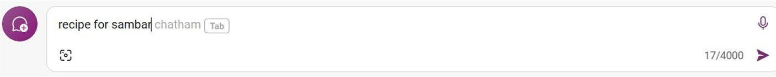

Figure 7-11. Ask Copilot about any recipe
The prompt requests Copilot to create a recipe for preparing South Indian dish Sambar. The grayed portion is suggested by Copilot and will be added upon pressing the Tab key. The displayed word is part of the Tamil language, and it translates to rice. Copilot displays the response with the
list of ingredients and detailed instructions as shown in Figure 7-12.

Chapter 7 Working With Copilot Web
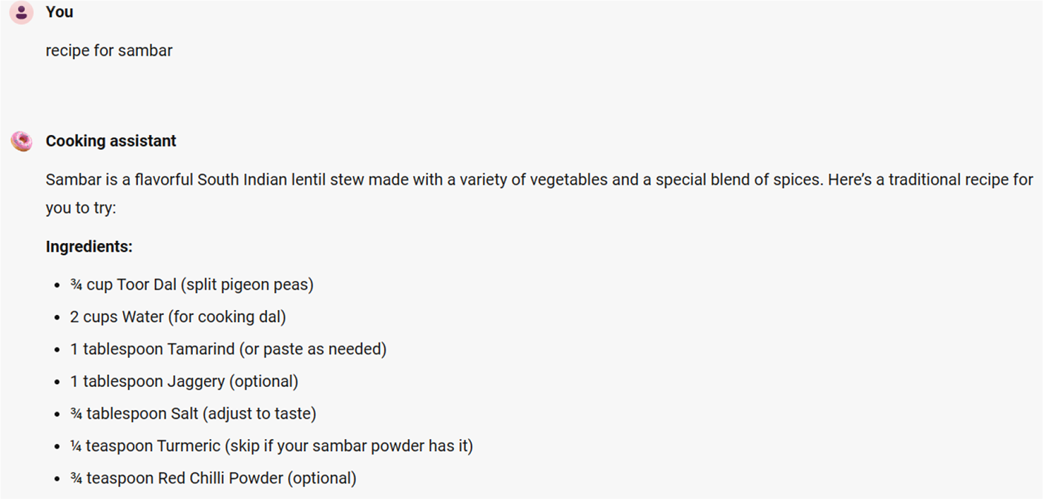

Figure 7-12. View the recipe generated by Copilot
Do you want to copy, edit prompt and search on Bing from the Copilot
dashboard? You just need to point mouse cursor over the prompt. The
search results will be displayed in a new window. Toward the end, Copilot
displays the recipes that can be accessed from various third-party sources
with thumbnails. Moreover, Copilot also displays the suggested prompts,
which you can use to learn additional information about the dish. You can
use Cooking assistant GPT to create information related to cooking. This
exclusive GPT will be very useful for homemakers since they can easily
locate the recipe they are looking for without navigating the complex
paginated search results.

Monitor Your Health with Copilot
You can manage your health with Microsoft Copilot with the help of
Fitness trainer GPT as shown in Figure 7-13. Copilot enables you to design
exercise programs in addition to delivering informative content about
nutrition, health, and wellness.

Chapter 7 Working With Copilot Web
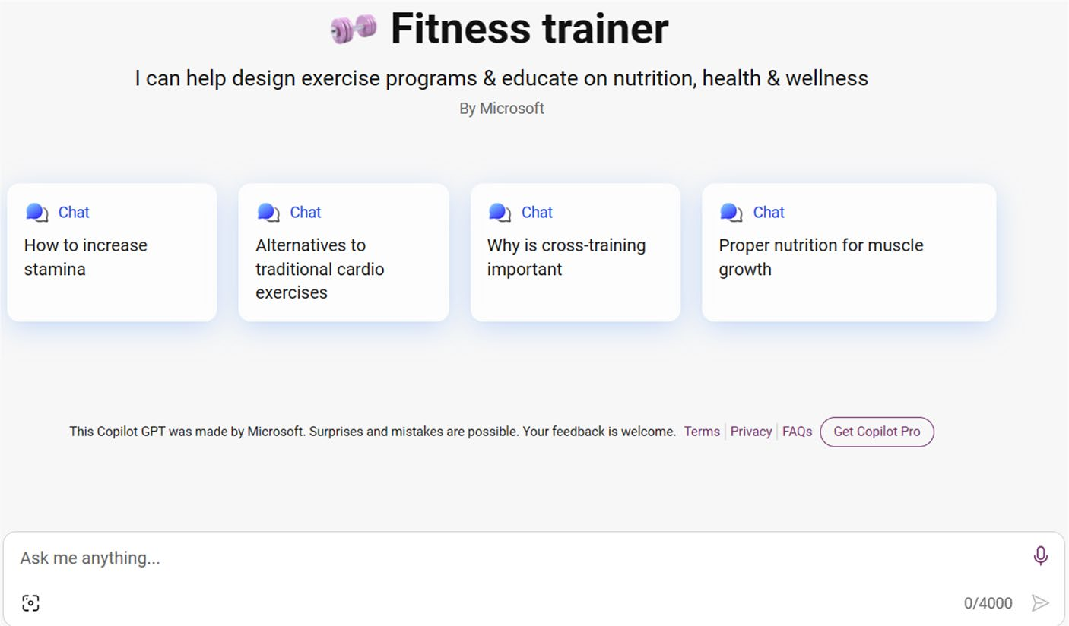

Figure 7-13. Live healthy with Copilot
As usual, the Fitness trainer displayed prompts that you can use to test- drive the GPT module. Let’s test the trainer by using a prompt as displayed
in Figure 7-14.


Figure 7-14. Ask fitness-related queries with Copilot
Copilot displays a long and crisp article about the usage of fitness
trackers as shown in Figure 7-15.

Chapter 7 Working With Copilot Web
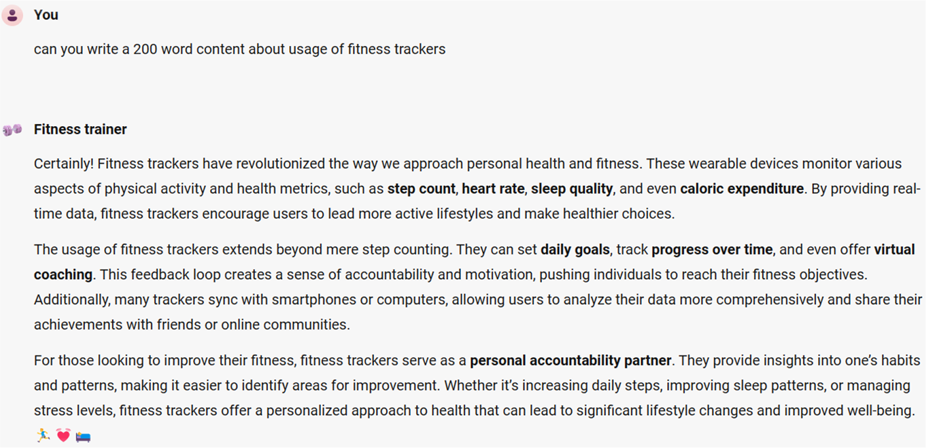

Figure 7-15. Copilot delivers fitness stories
In this way, you can select the relevant Copilot GPT and ask queries via
prompts. These niche-specific GPTs are a great way to fetch information
relevant to your topic of interest. You can create custom copilots and
customize Copilot for Microsoft 365 using Copilot Studio. You can build
copilots via a graphical development environment comprising of sophisticated
dialog, knowledge, actions as well as integrated advanced analytics.

Working with Copilot Notebook
In addition to the stand-alone chatbot and dedicated GPTs, Microsoft
Copilot also provides a dedicated Notebook module. You can provide
a detailed prompt to interact and collaborate with Copilot from the
Notebook dashboard in Figure 7-16. Even though you have learned about
Notebook in Chapter 2, this section provides a detailed coverage.

Note While Microsoft Copilot accepts up to 4000 characters, notebook provides support for prompts up to 18,000 characters.

Chapter 7 Working With Copilot Web
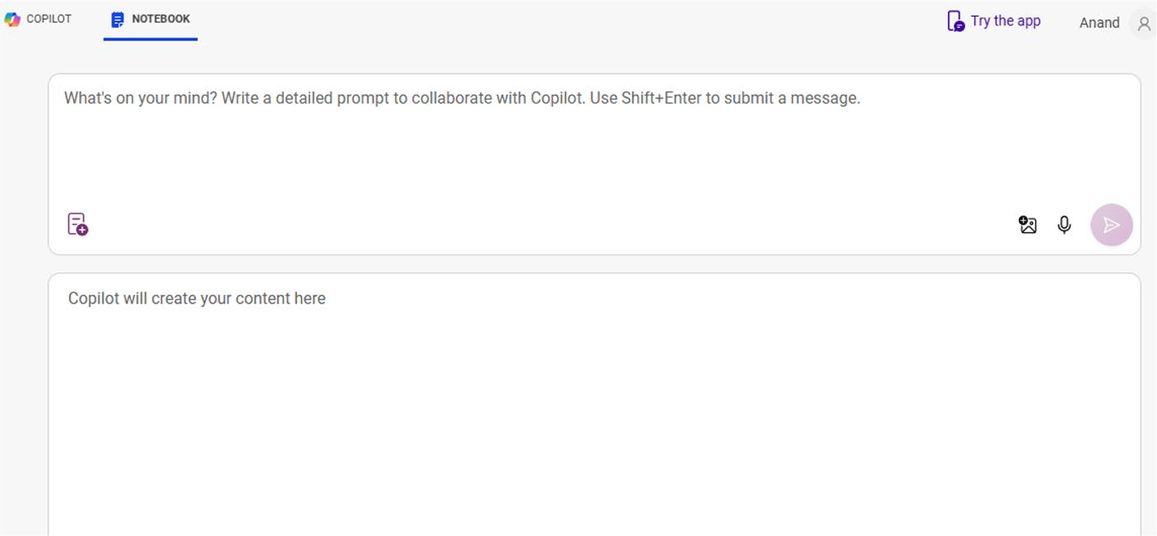

Figure 7-16. Use Copilot for detailed notes
You can either select the Submit button or make use of the Shift+Enter keyboard shortcut after providing the detailed prompt as shown in
Figure 7-17.
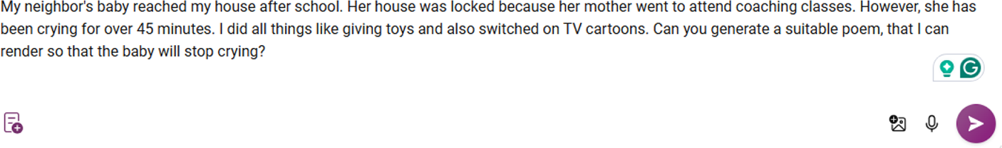

Figure 7-17. Prompting Copilot Notebook
Notebook generates the required poem and displays it on the bottom
panel as displayed in Figure 7-18.

Chapter 7 Working With Copilot Web
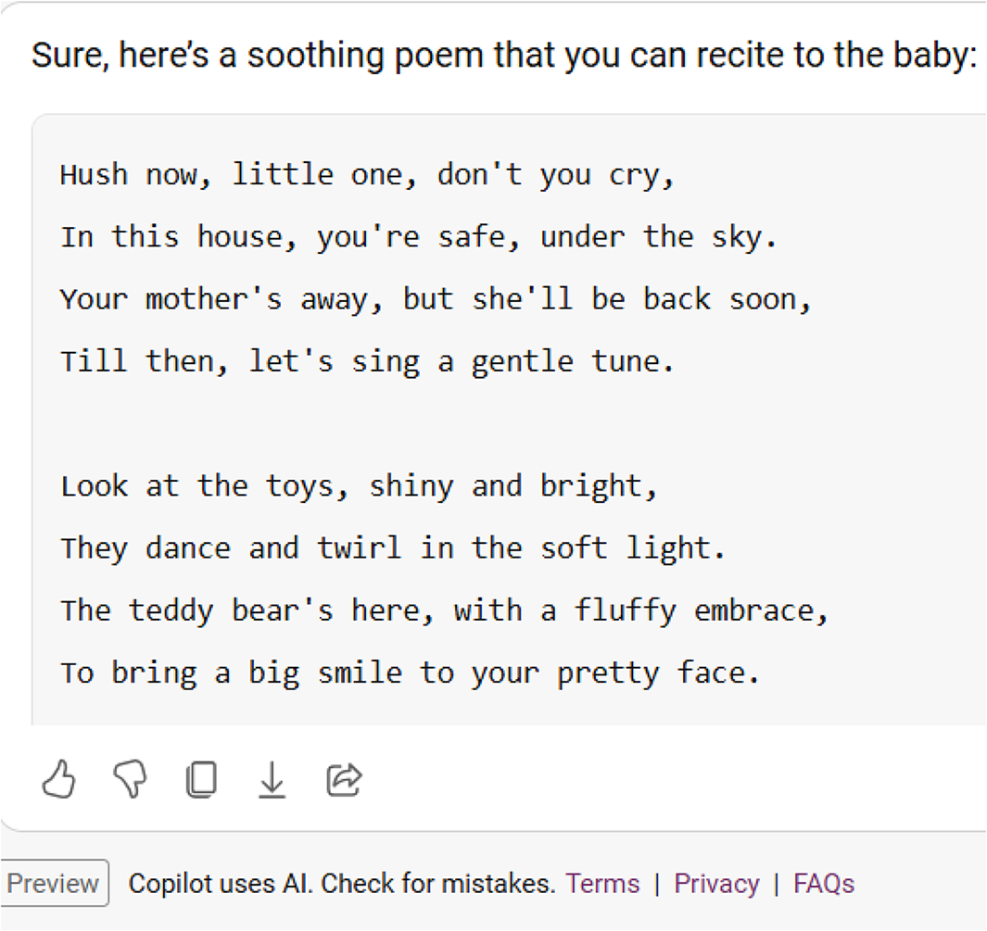

Figure 7-18. Prompting Copilot Notebook (Copilot generated)
Copilot Notebook will be useful for users who wish to provide lengthy
prompts for possible answers from the AI chatbot. The generated response
can be viewed without any distractions. You have to copy the content to
your word processor or blogging platform like WordPress immediately.
This is because the responses are not saved in the history.

Working with Copilot Plugins
Microsoft Copilot provides several plugins using which you can extend
the functionality of the chatbot. As of this writing, Copilot provides eight
plugins such as Search, Instacart, Kayak, Klarna, OpenTable, Phone, Shop,
and Suno. The plugins are designed to perform a specific job such as
cookery, travel recommendations, and shopping. Microsoft recently added
a new plugin using which you can create songs via Copilot. Even though

Chapter 7 Working With Copilot Web
you can ask Copilot to generate content, plugins can extend the usage by offering advanced functionalities. For example, you can ask Copilot to generate songs via the Suno plugin.
For instance, you can enable a plugin, ask it to provide ingredients for a dish, and then purchase the required items directly from Instacart. Copilot plugins will enhance productivity to a large extent.
To work with Copilot plugins, you should select the plugins option from the top right-hand side. A list of available plugins will be displayed as shown
in Figure 7-19. You should note that the Search plugin is enabled by default. If you disable the Search plugin, then all other plugins will be automatically deactivated. Moreover, you can only activate three plugins for a conversation.
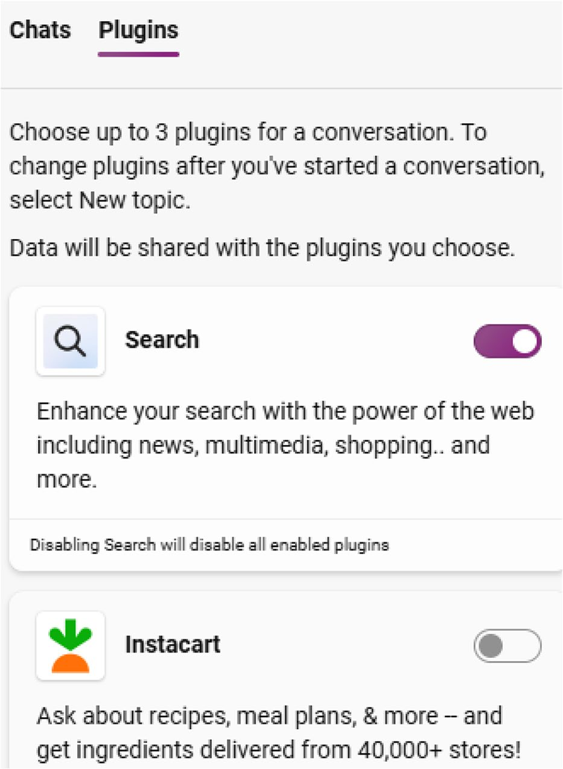

Figure 7-19. Extending Copilot

Chapter 7 Working With Copilot Web
Let’s examine the working of each plugin in detail.

Pulling Recipes via Instacart
The Instacart plugin (Figure 7-20) not only enables you to ask questions
about recipes but also get delivery from local stores. To enable the plugin,
you should drag the slider to the right side.
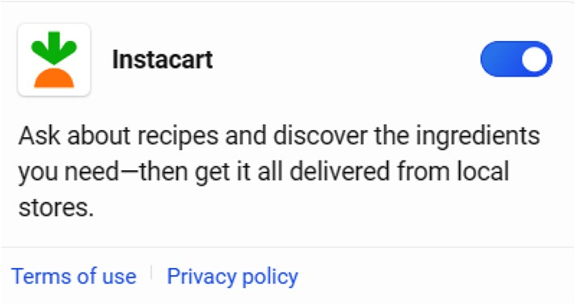

Figure 7-20. Discover recipes
The next step is to provide a prompt as shown in Figure 7-21.


Figure 7-21. Find all the essentials for recipes
The prompt here is to request Instacart to list ingredients for lemon
rice. Copilot displays the results via the Instacart plugin. However, you can
observe from Figure 7-22 that Copilot displays a small icon of Instacart
before delivering the actual output. This indicates that Copilot has
generated the required response via the Instacart plugin.

Chapter 7 Working With Copilot Web
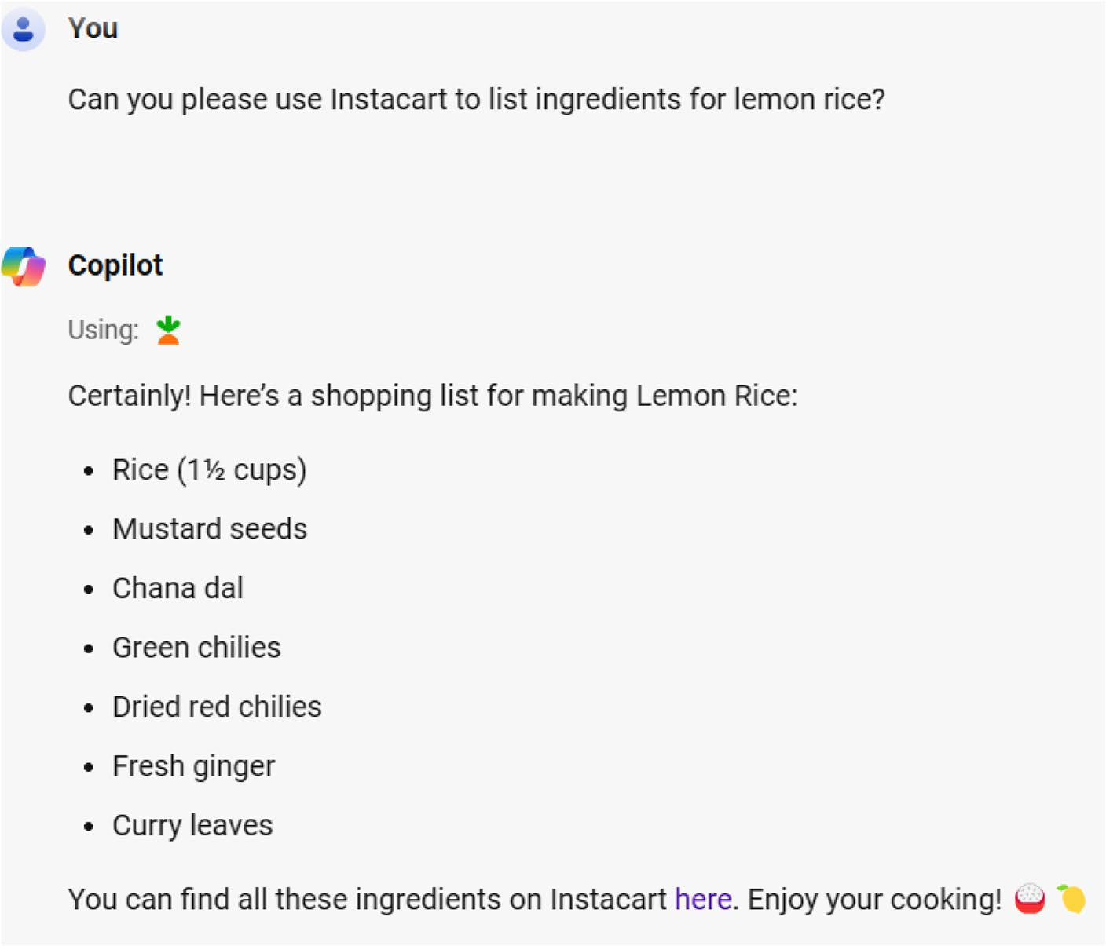

Figure 7-22. Know the items required for lemon rice
Copilot provides the list of ingredients and also provides a link to enable you to purchase the items. The Instacart portal lists all the ingredients required for preparing lemon rice from the Copilot-generated output. You just need to add the required items to the shopping cart from
Figure 7-23.

Chapter 7 Working With Copilot Web
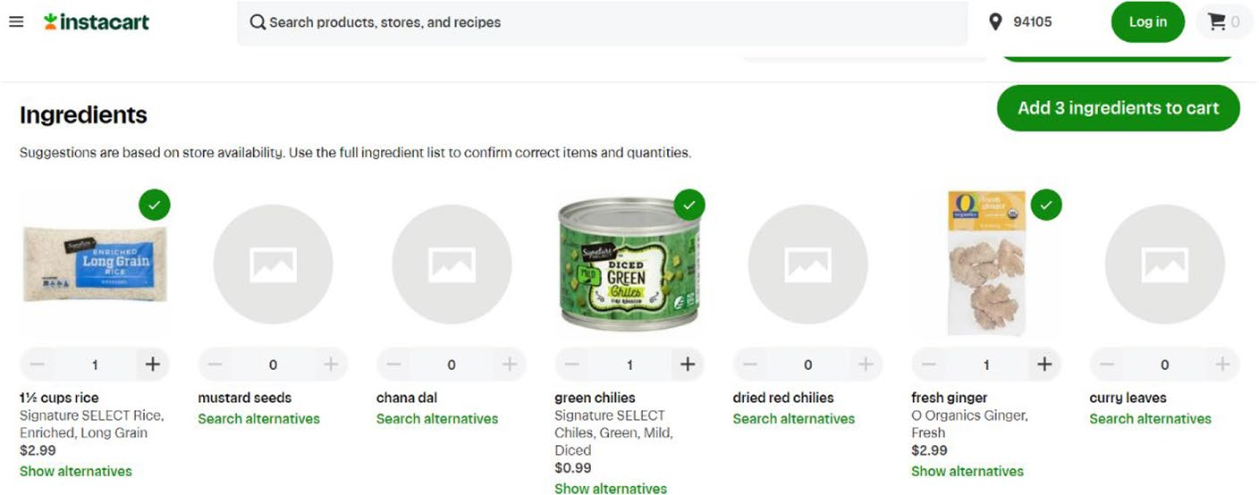

Figure 7-23. Purchase required items instantly
If the original item is not available, then you will have to search for
alternatives. As of this writing, the service is only available in the United
States. You can also ask Instacart to provide recipe for a dish. The company
maintains a huge database of various recipes, and Copilot will fetch them
within minutes.

Search for Flights and Hotels via Copilot
Microsoft has integrated the Kayak plugin into Copilot, using which you
can search flights, stays, and rental cars. To work with Kayak, drag the
slider to activate the plugin. You can then request Copilot to provide
suggestions. Let’s examine a prompt as shown in Figure 7-24.


Figure 7-24. Locate flights easily

Chapter 7 Working With Copilot Web
We are asking Kayak to provide flight suggestions from Thiruvananthapuram to Dubai on May 30. You also have to provide the date. Otherwise, Copilot will ask you to provide the date before
proceeding. The resulting output looks as shown in Figure 7-25.
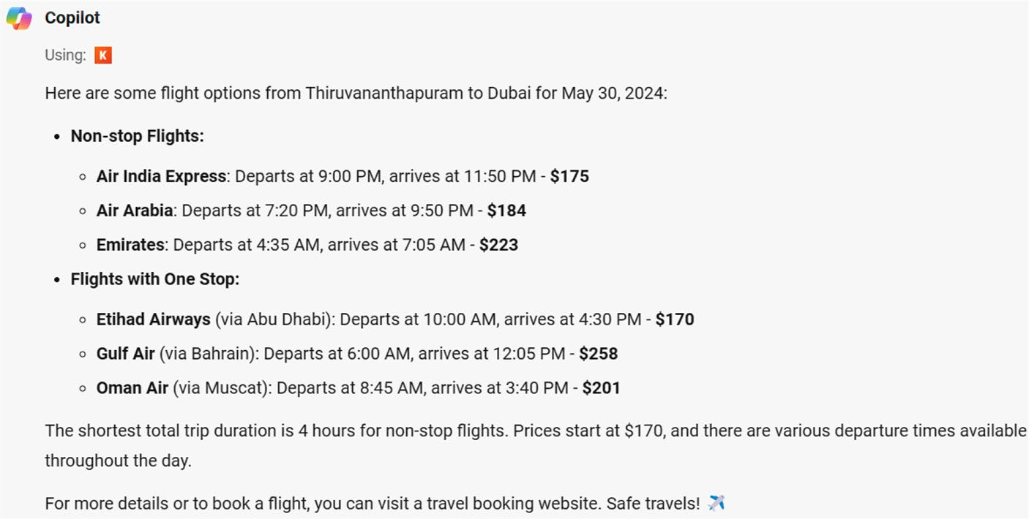

Figure 7-25. Track flights via Copilot
The Copilot plugin is designed to provide detailed answers, and an icon of Kayak is visible before the output. Let’s ask an additional query,
and the resulting output is shown in Figure 7-26.
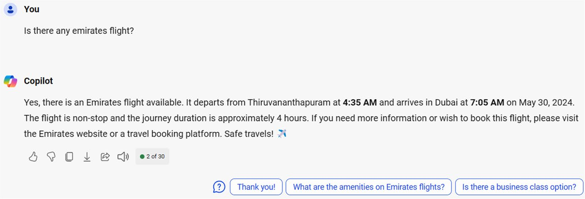

Figure 7-26. Ask additional queries

Chapter 7 Working With Copilot Web
The Kayak plugin provides clear answers when asked about the
availability of an Emirates flight on this route. Let’s now ask the Copilot
plugin for the presence of rental cars in the San Francisco airport as in
Figure 7-27. If you ask the query in continuation, then Kayak will use the
same date. You have to refresh the Copilot portal and activate the Kayak
plugin if you would like to fetch answers around fresh dates.


Figure 7-27. Find out services with Copilot
Microsoft Copilot accurately mentions the rental car company name,
location, phone, operating hours, and a thumbnail image. You can try
the preceding prompt after activating the Kayak plugin and observe the
result. You will be able to book a car for rent by selecting the displayed link
against each entry. Even though the generated response looks accurate,
you are advised to double-check the location via a search engine. AI
chatbots generate responses that could vary with the actual parameters.
You can explore the Kayak plugin with various prompts as per your
requirements.

Price Comparison with Copilot
With a huge spike in ecommerce activities post pandemic, people are
always on the lookout for new avenues to compare prices. You can now
make use of the Klarna plugin to search and compare prices from a huge
database of online shops. However, this service is available only in the
United States.

Chapter 7 Working With Copilot Web

Note Copilot can be used for advanced tasks. For instance, you
can easily create flowcharts using this prompt: create a flowchart to
demonstrate 2+2.

Fetch Restaurant Recommendations Quickly
There are thousands of restaurants, and it’s difficult to locate a preferred place manually. Hence, you can make use of the OpenTable plugin available with Copilot. The purpose of the plugin is to provide restaurant recommendations with a direct booking link. Let’s test the functioning of
the plugin with a prompt as shown in Figure 7-28.


Figure 7-28. Fetch service providers quickly
The query is to provide restaurant recommendations in Sunnyvale, CA,
and Copilot displays the response as in Figure 7-29. Currently, the plugin works only for restaurants based in the United States.

Chapter 7 Working With Copilot Web
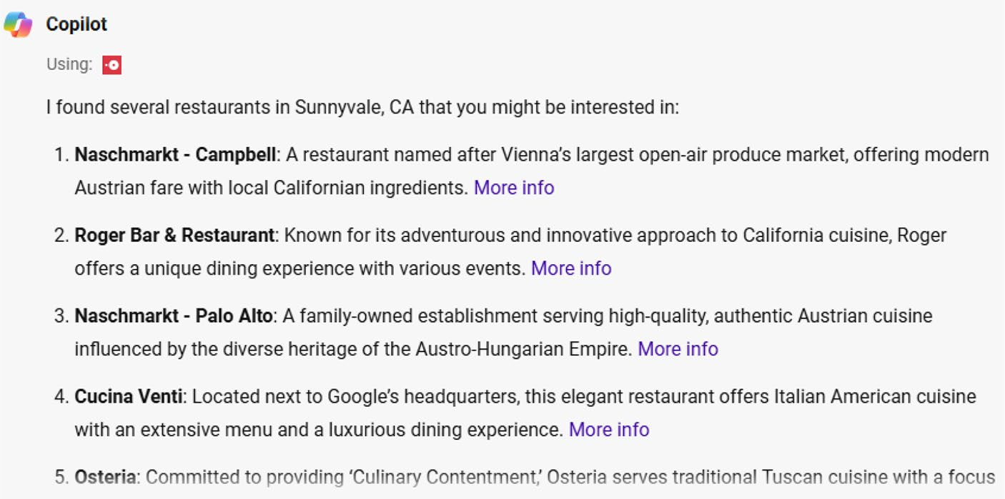

Figure 7-29. Select a restaurant of your choice
The plugin provides a detailed reply with information about the
restaurants along with a link. You can navigate the More info link to know
more about the restaurant, timings, and much more. Sometimes, Copilot
also displays a map with the exact location of the restaurant. You will
not always see the map because Microsoft Copilot is under continuous
improvement.
The OpenTable plugin is a complete guide for restaurant lovers.
You should make use of the plugin to fetch restaurant details if you are
on a tour.

Working with Phone Plugin
Microsoft Copilot has integrated a new Phone plugin using which you can
retrieve contact information. You can also read and send text messages
from your Android smartphone. However, you can’t work with the Copilot
Phone plugin immediately after activation. You have to complete the steps
to link your PC to your mobile device and vice versa. Let’s look at these
steps and come back to the usage of the Phone plugin.

Chapter 7 Working With Copilot Web
The first step is to establish connectivity between your mobile device and your Windows 11 PC with the help of the Link to Windows app. You will be able to view the steps required to work with the Phone plugin if you request Copilot to make use of Phone to get the phone number prompt. You will see a new page with the QR code if you select the link from the Copilot response. You can also continue without the QR code by directly selecting the link displayed on the resulting page. Alternatively, you can manually download the Link to Windows app directly from Google Play Store from within your Android device. If you select the app icon on your Android device, you will be prompted to sign in with your Microsoft credentials.
The next step is to link your Windows 11 PC with your mobile device by selecting the Go to device settings button from the app page. You need to select the Add a new computer link from the Linked computers section. You have to navigate to the displayed URL to open the Phone Link app on your Windows 11 PC. Alternatively, you can directly open Phone Link via the
Windows 11 search box to view a dashboard as shown in Figure 7-30.
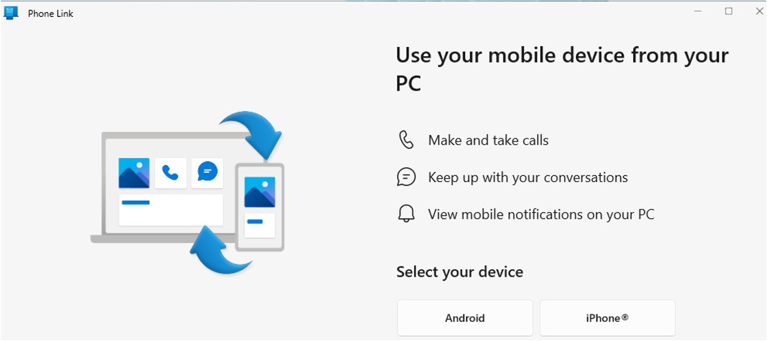

Figure 7-30. Access your phone via Windows 11

Chapter 7 Working With Copilot Web
You have to select the device platform (Android or iOS) and sign
in with your Microsoft credentials. Windows 11 will display the link of
linked devices on the corresponding dialog. The next step is to select your
device name and proceed to provide permissions by allowing Phone,
SMS, Contacts, and Storage on your mobile device. The app will provide
instructions as to which permissions you should enable. You have to select
the Permissions option from your Android device and manually allow the
rights. The Phone Link will display a confirmation stating that your mobile
device and PC are linked.
That’s it. Your Android device and Windows 11 PC are linked to
facilitate file access. You will be able to access files, SMS, and contacts from
your Android/iOS device on your Windows 11 PC. Let’s examine how to
access these data with the help of the Copilot Phone plugin.
Activating Phone Copilot Plugin
To enable Copilot to fetch data from your mobile device, you should
activate the Phone plugin by navigating to the Copilot dashboard. You
should select the Plugins option from the top-right side and enable the
Phone plugin (Figure 7-31) by scrolling down.
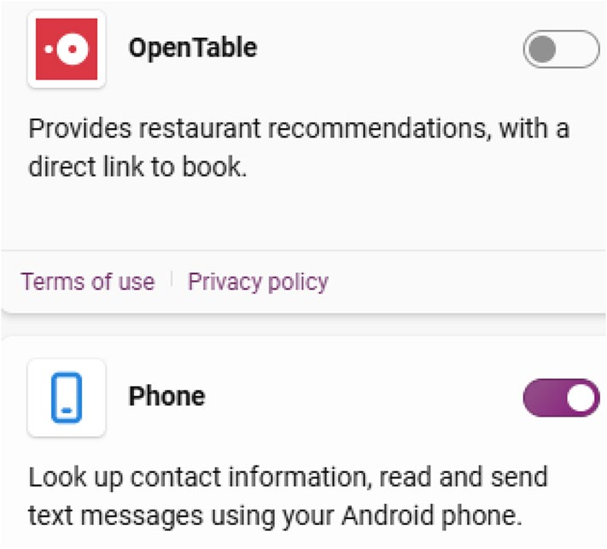

Figure 7-31. Activate the Phone plugin

Chapter 7 Working With Copilot Web
You can query Copilot to fetch data from your mobile device immediately after enabling the Phone plugin. You have to provide a
prompt as displayed in Figure 7-32.


Figure 7-32. Access SMS messages via Copilot
Copilot will now display the list of SMS messages from your Android
device as shown in Figure 7-33. The response as in Figure 7-33 will display a checked Used: phone entry before the results, which indicates the usage of the plugin.
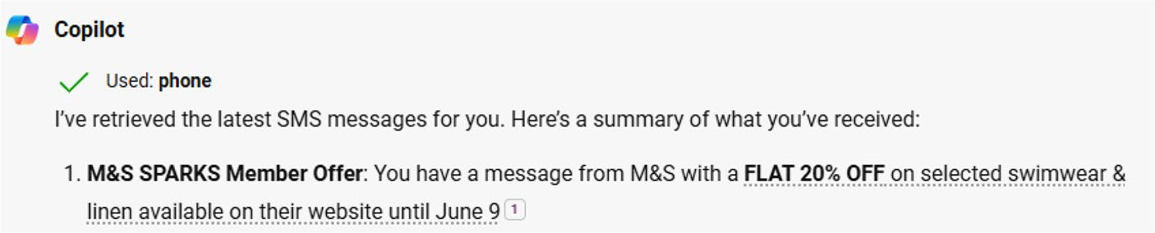

Figure 7-33. View SMS messages directly via Copilot
The Phone plugin can also retrieve the phone number of a contact from your mobile device. You have to provide a prompt as shown in
Figure 7-34.


Figure 7-34. Ask Copilot to display a phone number
Copilot will immediately display the phone number from the Android
mobile device as displayed in Figure 7-35.

Chapter 7 Working With Copilot Web
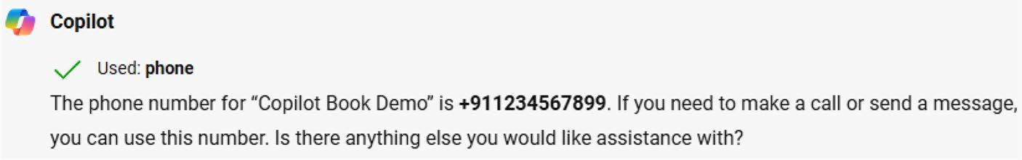

Figure 7-35. Instant view of the phone number via Copilot
In this way, you can fetch the relevant phone number and SMS
messages from your linked mobile device quickly. The purpose of the
Phone plugin is to enhance productivity because you can view the SMS
messages directly from your Windows 11 PC. This feature will be useful
in case you are charging your Android phone and would not like to use
the device.

Note if Copilot is not displaying the messages, then you should unlock your android device to enable the chatbot to display the response.
Sometimes, the Phone link for Copilot won’t work as expected because
of various factors. Copilot is under continuous improvement as per user
feedback. You can submit bug reports via Windows 11 Feedback Hub. You
just need to press the WIN+i keyboard shortcut, scroll down, and select the
Give feedback link.

Shopping with Copilot
Nowadays, you have the option to purchase millions of products from
leading brands across online stores. Microsoft Copilot makes it easy for
you to drill down from a huge database of products with the help of the
Shop plugin. You should activate the plugin by dragging the slider and
using a prompt as shown in Figure 7-36.

Chapter 7 Working With Copilot Web


Figure 7-36. Shop easily via Copilot
The aim is to retrieve Windows 11 laptops via the Shop plugin. The
Shop plugin pulled five Windows 11 laptops (see Figure 7-37) with information about price, display, processor, storage, RAM, and ports.
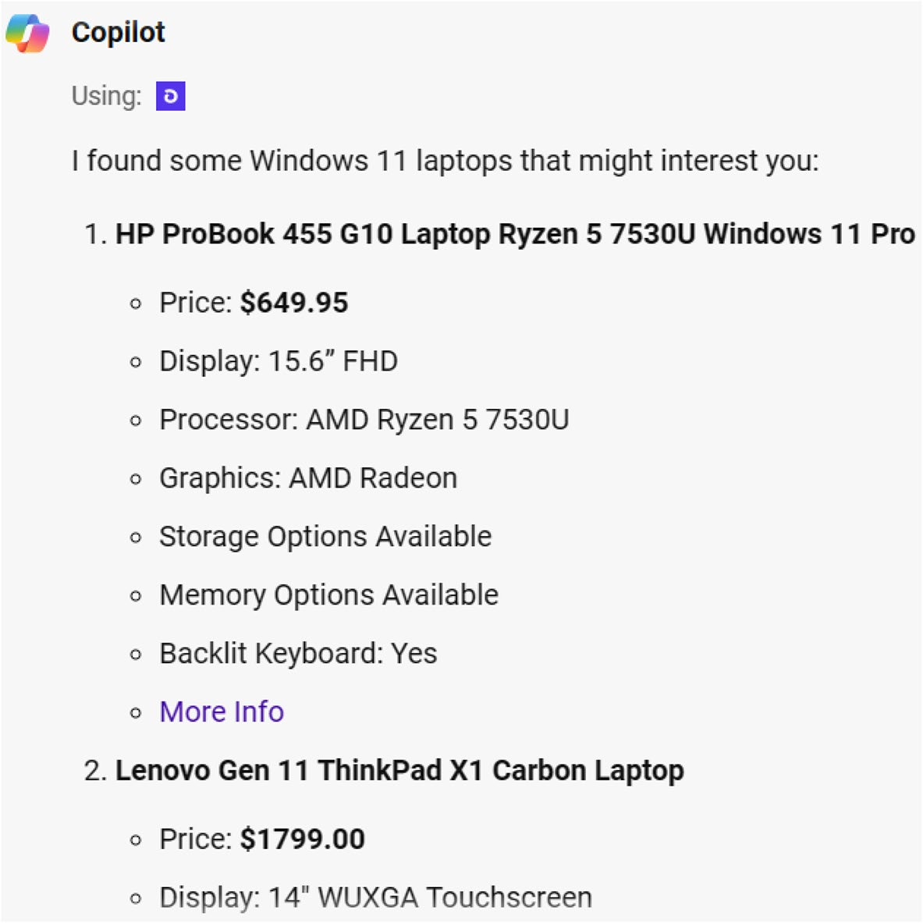

Figure 7-37. View the output delivered by the Shop plugin
If you select the More Info link, you will be able to navigate to the
official product page on shop.app as displayed in Figure 7-38.

Chapter 7 Working With Copilot Web
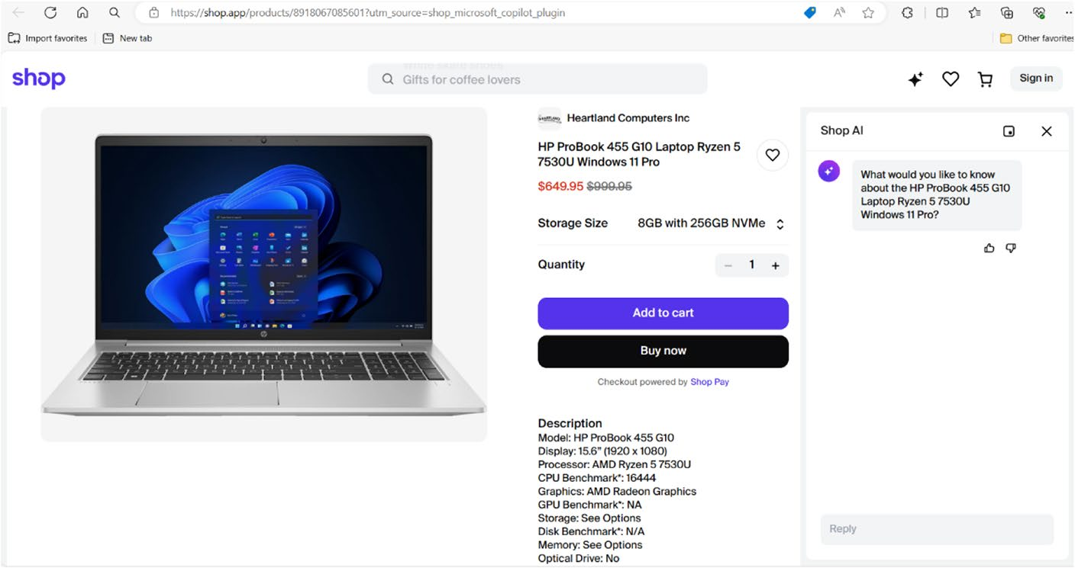

Figure 7-38. Instant shopping simplified with Copilot
Copilot also provides suitable suggestions toward the end of the
generated content. You can search for any product based on your
requirements.

Create Songs with Copilot
After the advancement of artificial intelligence over the last two years,
there has been a steady rise in the creation of songs via AI. Even though
AI can’t replace traditional singers, you can still try to create something
creative by providing suitable prompts. Microsoft has created a revolution
by integrating the Suno plugin with Copilot. With the help of the Suno
plugin, you can create songs. However, your song request information will
be shared with Suno.
To create AI songs via Copilot, you should activate the Suno plugin by
dragging the slider. You should then request Copilot to create a song by
providing the required prompt. In Figure 7-39, you can see a prompt to
create a song via the Suno plugin.

Chapter 7 Working With Copilot Web


Figure 7-39. Prompting Copilot to create songs
Copilot displays the verse and chorus as shown in Figure 7-40. It will take time for the Suno plugin to create a song.
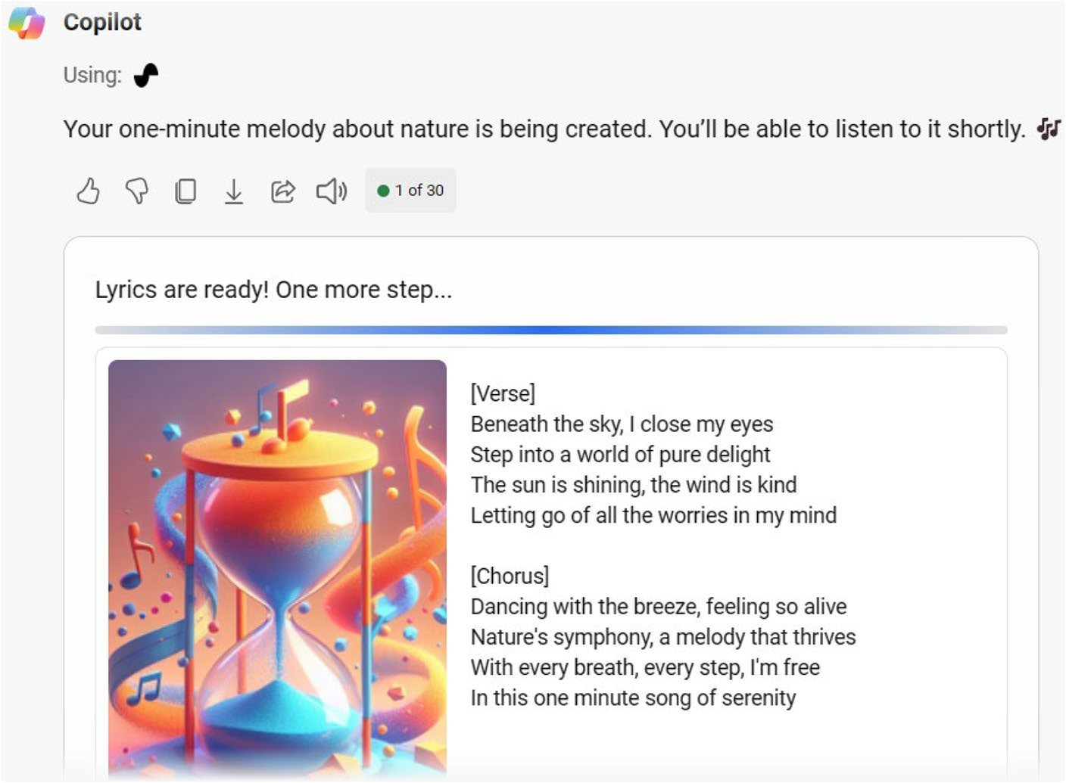

Figure 7-40. Please wait while Copilot creates a song
You can play the created song by selecting the Listen button. The song
will play with immersive music as displayed in Figure 7-41.

Chapter 7 Working With Copilot Web
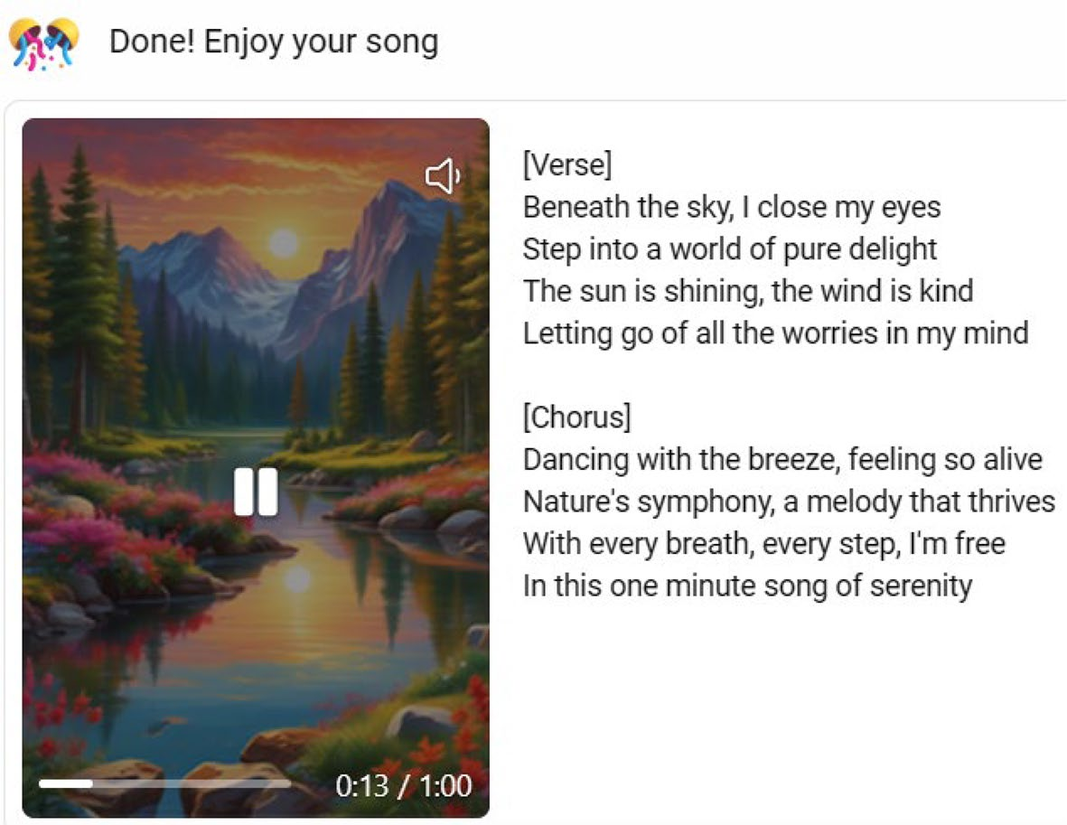

Figure 7-41. Copilot playing a song (AI-generated via Copilot)
You can also share the generated song by selecting the Share option
located below the song. The Suno-powered song can also be downloaded
(Figure 7-42) by selecting the Download icon. You can either share the
song on social media or use the song as background music during the
creation of videos.


Figure 7-42. Showcase the AI song you created

Chapter 7 Working With Copilot Web
Copilot displays the Suno icon before displaying the generated song. This indicates that the AI song has been created via the plugin. You can freely use the song in all your projects, including video creation and editing activities. You can create any AI song with Copilot. You just need to use the correct prompt based on your requirements. The Copilot dashboard will automatically create a history of all your communications with Copilot under the Recents panel.

Disclaimer this chapter contains images that are generated via
ai-enabled Microsoft Copilot. the images are only used for the sake
of explanation and educational purposes.

Summary
In this chapter, you have learned the usage of the Copilot web interface in detail. The chapter examined the working of Copilot GPTs and plugins with examples. You also learned about AI image generation and Copilot Notebook. The chapter also covered the generation of songs via Copilot, including fetching SMS messages and contact information from your mobile device. The ability to create songs is a definite advantage for students, professionals, and video creators. In the next chapter, you will learn the process involved in the generation of images.

CHAPTER 8

Working with Image

Creator
Microsoft released Bing Image Creator (currently Image Creator) using
which you can create AI images. Bing Image Creator was unveiled shortly
after the launch of Bing Chat in early 2023. However, Microsoft renamed
Bing Image Creator as Image Creator after the rebranding of Bing Chat as
Copilot. Image Creator works with the help of DALL·E technology, which
is OpenAI’s model to transform text prompts into impressive images.
Microsoft also integrated the image creation module with Copilot. You can
generate images directly from the Copilot in Windows, Edge, Bing, Skype
and Windows app. Image Creator is a powerful product, which creates
stunning AI images based on the provided prompt. In this chapter, we will
examine the steps involved in the creation of images using Image Creator.

Evolution of DALL·E
Before delving deep into the usage of Image Creator, let’s examine a brief
history of OpenAI’s DALL·E model. Microsoft has integrated this model
for the generation of images. As of this writing, there are three iterations
of the model such as DALL·E and DALL·E 2. The latest DALL·E 3 model

© Anand Narayanaswamy 2024 149
A. Narayanaswamy, Microsoft Copilot for Windows 11, Inside Copilot,

Chapter 8 Working With image Creator
is infused with several new features and improvements. OpenAI has employed advanced machine learning and deep learning techniques in the development of DALL·E. The model can generate accurate digital images from natural language descriptions called prompts.
OpenAI released the first version of DALL·E in January 2021 followed by the DALL·E 2 model in April 2022. The company natively released DALL·E 3 along with ChatGPT Plus and ChatGPT Enterprise in October 2023. Moreover, the OpenAI API and Labs platform was also made available in November 2023. Microsoft has integrated the DALL·E model in Image Creator (formerly Bing Image Creator).
DALL·E makes use of a modified version of GPT-3 to generate images. DALL·E 2 was designed to generate realistic and natural images with high- resolution support. OpenAI issued beta invitations to over one million waitlisted individuals on July 20, 2022. The system was designed in such a way that DALL·E could generate a fixed number of images for free in the form of credits. The user needs to buy additional credits. The DALL·E 2 waitlist policy was removed on September 28, 2023, but the company announced the arrival of the DALL·E 3 advanced imaging model. DALL·E 3 was developed with nuance and detailed AI images compared to the previous iterations.
OpenAI released the DALL·E 2 API in November 2023, which enables developers to integrate the imaging model into their own applications. The Designer app and Bing Image Creator tool were shipped with the DALL·E model, which was widely accepted by creators. The API is designed to work on a cost-per-image basis based on the image resolution. OpenAI started to add watermarks to DALL·E-generated images starting February 2024. The watermark contains metadata in the Coalition for Content Provenance and Authenticity (C2PA) standard as prompted by the Content Authenticity Initiative.
DALL·E is a multimodal implementation of GPT-3 with 12 billion parameters, which intelligently swaps text for pixels. The model is aggressively trained based on text-image pairs from the Web. The

Chapter 8 Working With image Creator
transformer model input is a sequence of tokenized image captions
coupled with tokenized image patches. The generated images comprise
a 256×256 RGB, divided into 32×32 patches of 4×4, respectively. The
patches are converted by a discrete variational autoencoder to a token.
Initially, the images were generated from a list of 32,768 captions that
were randomly selected from the dataset. However, OpenAI is constantly
training the model and corresponding dataset to enable DALL·E to deliver
stunning pictures. DALL·E 2 makes use of 3.5 billion parameters alongside
a diffusion model based on CLIP image embeddings.
DALL·E is capable of generating images in multiple styles such as
photorealistic imagery, painting works, and emojis. The model also emits
a broad understanding of visual and design trends. OpenAI has developed
DALL·E to generate images for several descriptions from various
viewpoints. DALL·E 3 is designed to work with advanced prompts with
detailed accuracy when compared with the previous counterparts. Even
though DALL·E 3 is available with ChatGPT Plus, you can experience the
model via Image Creator from Microsoft Designer.

Understanding Image Creator
After the launch of Bing Chat in early 2023, Microsoft launched Bing Image
Creator (currently Image Creator) which uses the DALL·E imaging model.
Currently, AI images are generated via the DALL·E 3 model. The purpose of
Image Creator is to create stunning images based on the provided prompt.

Tip You can create images using microsoft Designer, Copilot in Windows (preview), microsoft edge, Bing, Skype, Copilot Web, and Copilot Windows apps, including microsoft Copilot android and ioS apps. You can also generate images, stickers, avatars, icons, emojis and much more using microsoft Designer android and ioS apps.

Chapter 8 Working With image Creator
To work with Image Creator, you should navigate to www.bing.com/
images/create. The dashboard looks as shown in Figure 8-1. You should note that the screenshot mentions Designer, which is currently renamed as Image Creator. Moreover, the Copilot logo has been replaced with Microsoft Bing. The appearance of the Image Creator home page could change periodically.
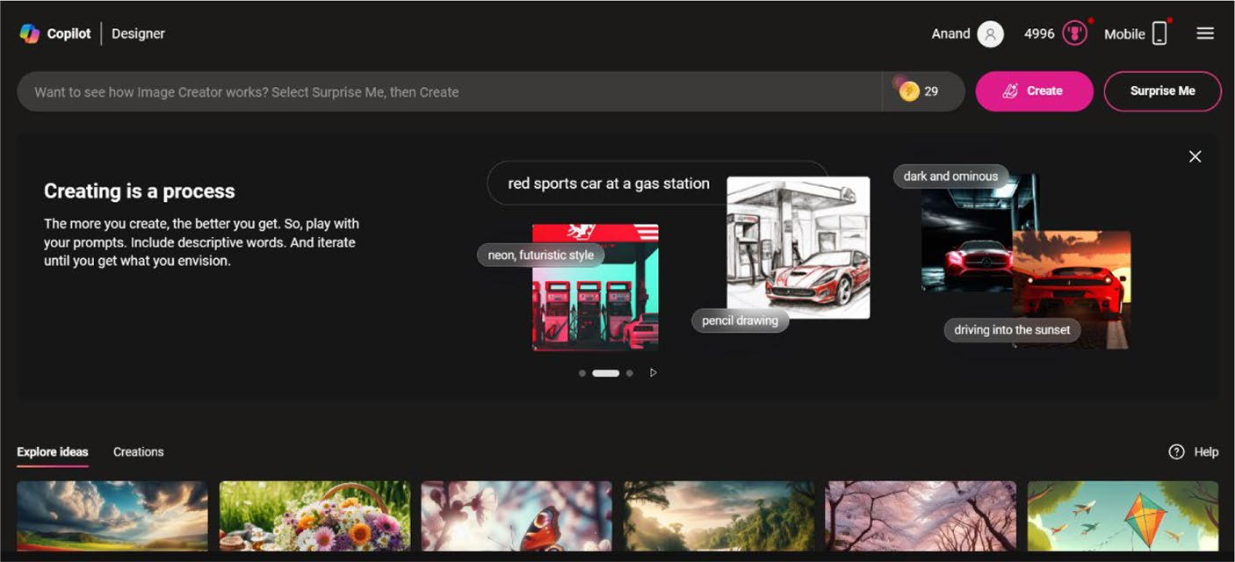

Figure 8-1. Create stunning images with Image Creator
The next step is to provide a suitable prompt inside the Want to see how Image Creator works? textbox to enable Image Creator to generate images. Alternatively, you can also select the Surprise Me button to enable Image Creator to automatically generate prompts. You will have to select the button several times to view a prompt of your choice. Image Creator displays a progress indicator in three dots for a few seconds while it identifies a suitable prompt.
Let’s check out how Image Creator generates images with the automated prompt: gorgeous abandoned medieval mansion in a fairytale forest. You have to select the Create button to enable Image Creator to
generate images. The creator displays a splash page as shown in Figure 8-2.

Chapter 8 Working With image Creator
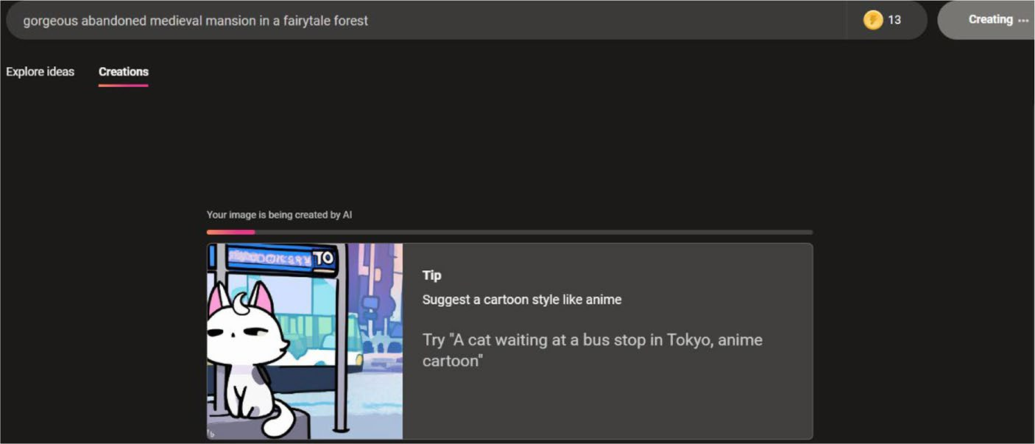

Figure 8-2. Image Creator waiting indicator

Note the number specified adjacent to the textbox indicates daily boosts. You will be able to create images even if you run out of daily boosts, but the image creation process will take longer than expected.
You will see four AI images upon successful completion of the image
generation. Image Creator reveals the information that the images are
powered by the DALL·E 3 model. This model is capable of creating powerful
and stunning images when compared with the previous counterparts.

Note the images zoom in as you hover your mouse over them. try it. it will be an interesting experience.
The look and feel of the images will change when you attempt the
same prompt using Image Creator. Copilot will not generate the same
image every time because of the various factors involved with the
model. You should note that AI technology is under constant change
and development. Hence, the responses produced by Copilot will vary

Chapter 8 Working With image Creator
depending on the location. Even if the image generated by the creator is provided here, you won’t view the same output. Hence, you should try to generate the images as per the preceding prompt by following the instructions. You can also provide a prompt of your choice and requirement to enable Image Creator to create stunning visuals.
If you select an image, you will see an enlarged version as in Figure 8-3 with details about the resolution, image format, and much more.
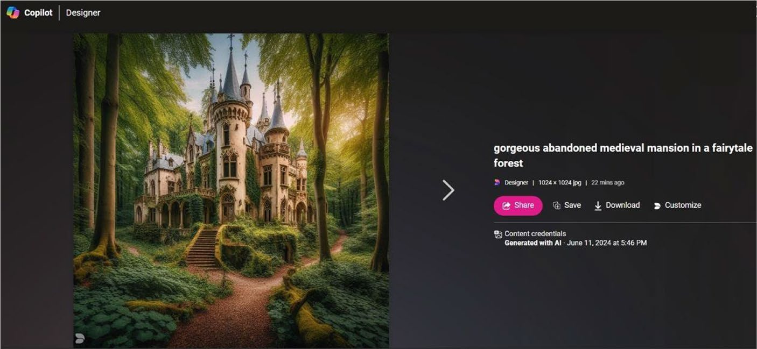

Figure 8-3. Decide what to do with the image
You can send the image over social media by selecting the Share button. Image Creator displays the URL along with the Copy button as
shown in Figure 8-4.
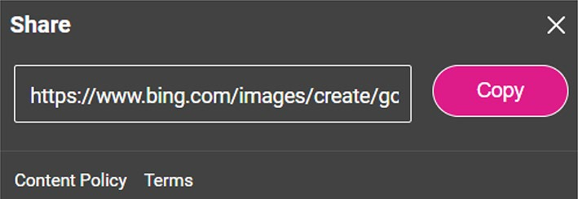

Figure 8-4. Showcase your AI image

Chapter 8 Working With image Creator
The button changes the caption to Copied upon selection. The URL
will be too long that you will not be able to remember or type it manually
on the web browser. Hence, you can add the image to Image Creator
Collections by selecting the Save button. You will see a pop-up menu as in
Figure 8-5.
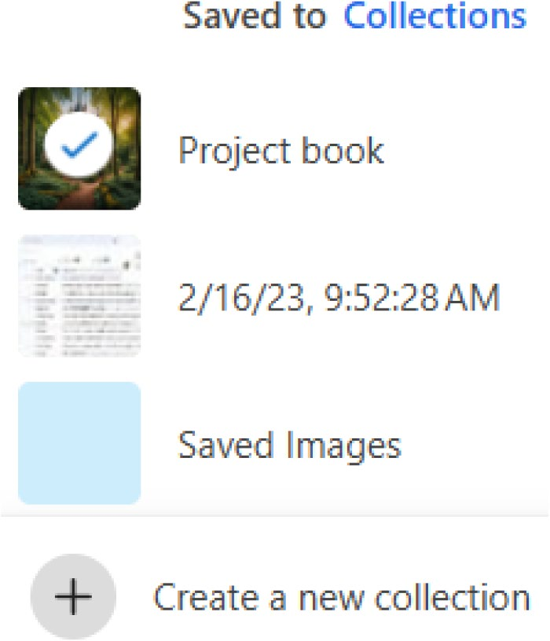

Figure 8-5. Collections entry point
You can create a new collection by selecting the Create a new collection
option. You will see a user interface as shown in Figure 8-6. The main
purpose behind the creation of collections is that you will be able to easily
access the images via www.bing.com/saves.
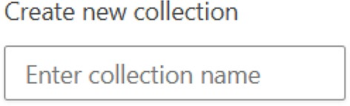

Figure 8-6. Easily create a new collection

Chapter 8 Working With image Creator
A tick mark will be visible upon entering the collection name, which
will appear on the pop-up dialog as displayed in Figure 8-7. You have to select the mouse pointer over the tick mark icon to save the image into the collection.
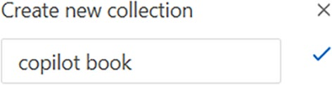

Figure 8-7. Collection successfully created
The image will be saved to the collections, and a confirmation pop-up
will appear as shown in Figure 8-8.
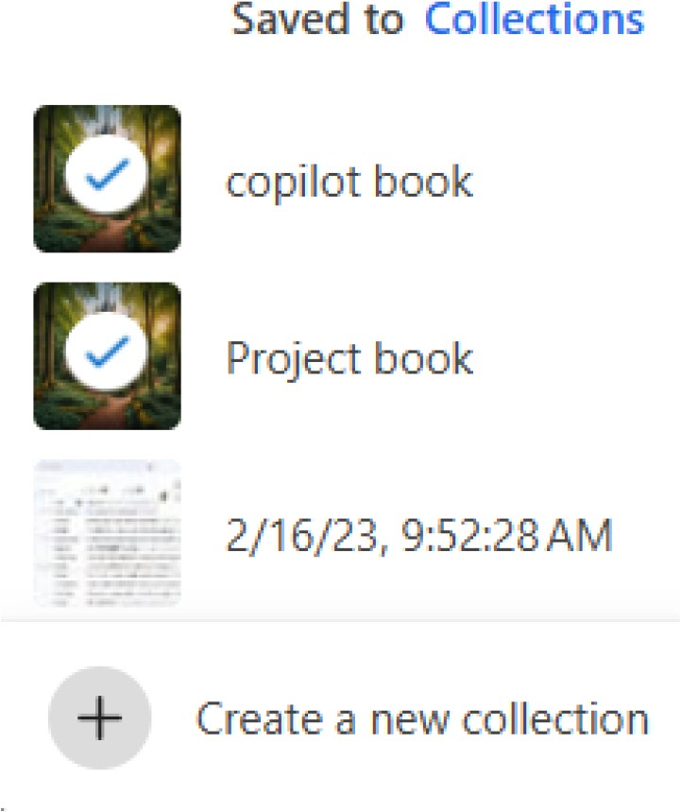

Figure 8-8. View all collections in a flash
You can view the saved image inside the Collections dashboard by
selecting the Open collections portal icon as shown in Figure 8-9.

Chapter 8 Working With image Creator
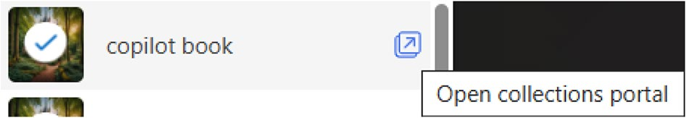

Figure 8-9. Open the Collections dashboard
If you select the icon, you will see the saved image inside the
Collections as shown in Figure 8-10.
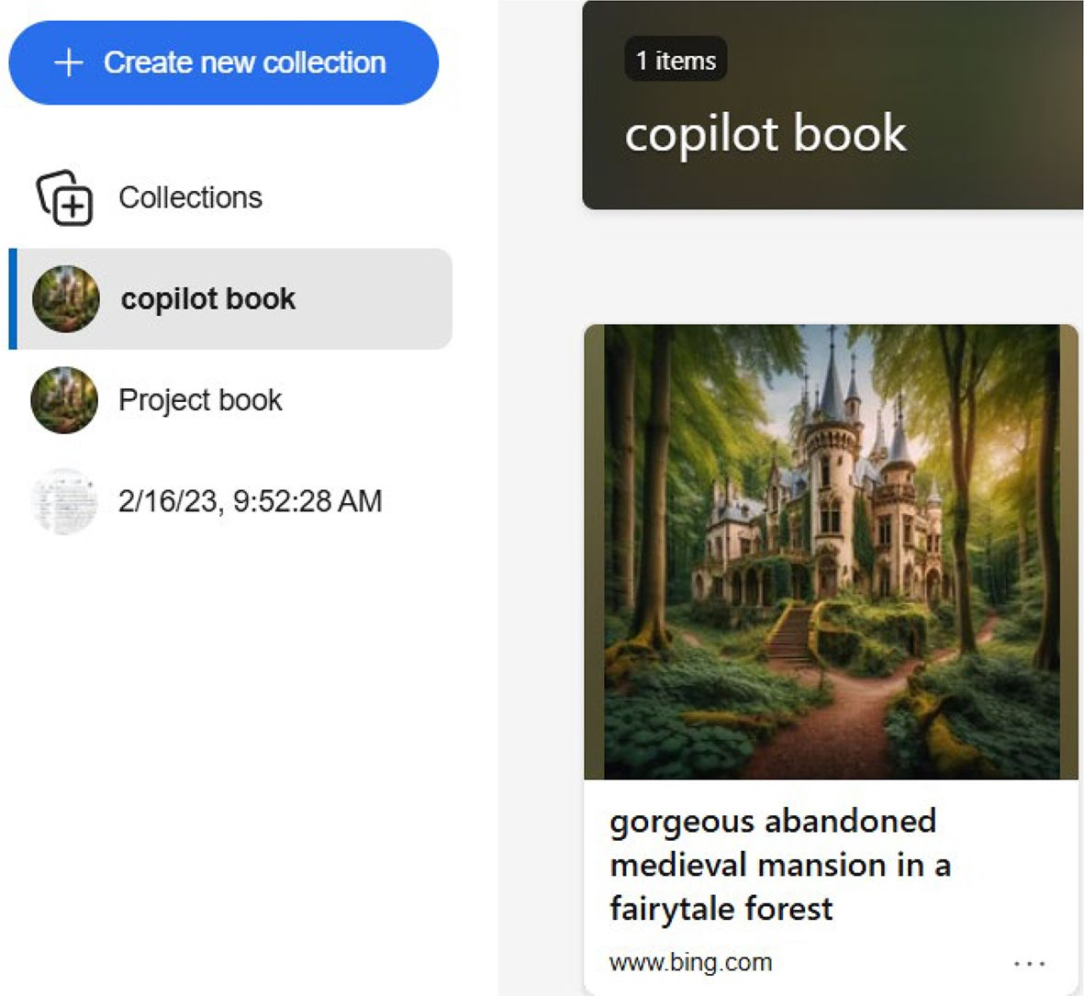

Figure 8-10. Collections portal in action
The Collections portal also enables you to add notes upon selecting
the Add note option from the top navigation panel. You can provide the
relevant content inside the sticky note as shown in Figure 8-11.

Chapter 8 Working With image Creator
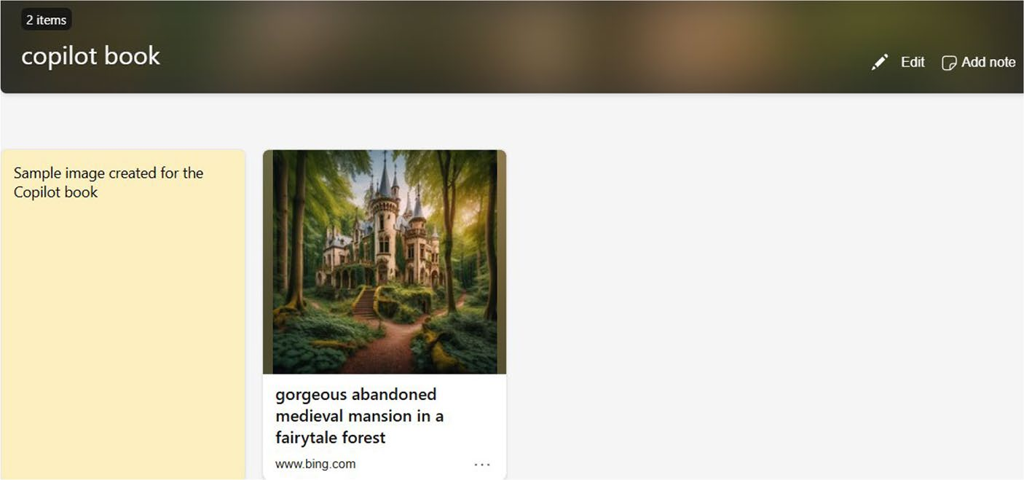

Figure 8-11. Create notes inside the Collections portal
In addition to saving the generated image using the Download button
as we examined in Figure 8-3, you can also edit the image directly on the cloud. You can easily personalize the image by adding filters and other properties by clicking the Customize button. The Microsoft Designer dashboard will be displayed on the screen using which you can perform all
the required editing work as shown in Figure 8-12.
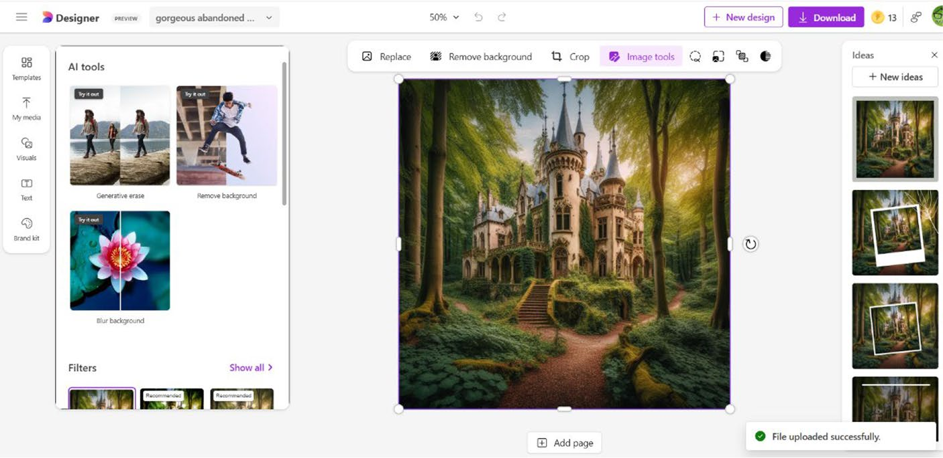

Figure 8-12. Microsoft Designer dashboard in action

Chapter 8 Working With image Creator

Note microsoft Designer (https://designer.microsoft.com) is an exclusive app using which you can easily create images, stickers, avatars, invitations, icons, emojis, clip art and image collages as well as remove background from images.

Generating Images Using Own Prompts
You can also provide your own prompts to create images with Image
Creator. Let’s give a prompt such as A garden with water fountain
surrounded by yellow flowers. The creator generates four images along with
a disclaimer statement that the images are generated by AI. You should be
aware that Image Creator doesn’t create four images always. This is mainly
due to the nature of AI technology. You have to click the Create button and
wait until Image Creator generates the images.
If you select any one of the generated images, an enlarged version
will display along with other options that are the same as we discussed
earlier. We observed that Image Creator accurately generated the images
with a waterfall and yellow flowers upon our testing. You can play with
various prompts as per your requirements. You should also note that the
creator generates different images upon each attempt because of the AI
technology.

Viewing AI Images
The Image Creator dashboard displays select images that are generated
by users. These images are curated by the Microsoft Copilot team. You can
scroll down the dashboard to view the AI images that are preloaded by the
creator. Moreover, the rotating carousel also displays stunning images that

Chapter 8 Working With image Creator
are ready for immediate consumption. You will see a large-sized image with the option to download for your usage upon selection of an image from the dashboard.

Tip You can generate ai images via image Creator in microsoft
paint. however, this feature is currently limited to users in the United
States, France, the Uk, australia, Canada, italy, and germany.
Alternatively, you can view the images created by Image Creator by selecting the Creations tab. The creator displays the latest generated image. You can view all the generated images using prompts manually by selecting the relevant image from the Recent panel. You can use the scroll bar to navigate the images that you have created. Even though the creator generates four images for a prompt, there are instances where it renders three images. It all depends upon the prompt and the way the back-end engine works.
You should note that Image Creator won’t generate any results if your prompt is harmful and offensive. Microsoft has applied adequate safety precautions to safeguard the interests of the general community, including kids.

Caution See the image Creator terms: www.bing.com/new/
termsofuseimagecreator .
You should make sure not to violate any content policy terms to avoid suspension and cancellation of your Microsoft account. Image Creator has been developed to enable you to generate awesome creations based on the prompt. You should make use of the tool responsibly, and you are only responsible for any harm caused to anyone. You can make use of Image Creator for your personal consumption such as for your blogs and social media. You can generate a featured image for your blog post very easily just by giving the relevant context.

Chapter 8 Working With image Creator

Disclaimer You should note that the ai-generated images in
Figures 8-1, 8-2, 8-3, 8-10, 8-11, and 8-12 have no resemblance to any living humans or properties. the images are generated by microsoft’s image Creator and are used only for educational purposes.

Summary
In this chapter, you have learned the process involved in the creation
of images using Image Creator. You only need to provide the required
prompt, and the creator will take care of the rest of the work. You can even
share and download images, including the ability to edit them quickly
by adding effects and filters. In the next chapter, you will learn about the
working of Microsoft Designer in detail.

CHAPTER 9

Working with

Microsoft Designer
Microsoft Designer is a complete and robust Copilot-enabled AI design
application. You can easily create AI images, stickers, designs, invitations,
wallpapers, avatars, and icons, including the ability to remove background.
The app has been upgraded with new features such as image restyling,
collage, and greeting card creator, including instant background removal
and generative eraser. The Designer tool intelligently suggests unique
designs and also provides personalized recommendations. You can even
add filters and adjust brightness, contrast, and other related settings to
your images. You will be able to create stunning designs even without
any basic design knowledge. In this chapter, you will learn the usage of
modules included with Microsoft Designer in detail.

Overview of Microsoft Designer
Microsoft Designer leverages DALL·E 3 technology to generate stunning
and powerful images. You just need to have a creative mindset so that
you can provide the relevant prompt. You can customize and refine the
generated images. It’s possible to add motion effects and filters to your
design. Moreover, you can convert a simple post to Instagram reel or story

© Anand Narayanaswamy 2024 163
A. Narayanaswamy, Microsoft Copilot for Windows 11, Inside Copilot,

Chapter 9 Working With MiCrosoft Designer
with several attractive elements. Microsoft has integrated Generative AI into the Designer app by adding Generative Erase. The Designer makes use of the Segment Anything Model (SAM), which enables users to select specific areas they would like to remove from an image. The upcoming Generative Fill functionality automatically fills objects within an image or background. You just require creativity and imagination. If you would like to expand your image irrespective of border, you can use the upcoming Generative Expand model powered by the DALL·E 3 model.
Microsoft Designer has been developed in such a way that even a beginner can work with the app easily. You need not have to be a skilled designer to create intuitive, rich, and attractive designs. You can create AI images, stickers, invitations, digital postcards, and social media posts. The Designer is in the preview stage, and the product team is working continuously to improve the features included with the product. You can submit feedback in case you face any problems by selecting the Send feedback to Microsoft icon located on the top right-hand side as shown in
Figure 9-1.
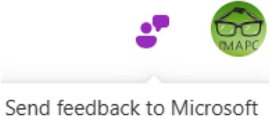

Figure 9-1. Report bug fixes instantly
Microsoft evaluates Designer experience with a combination of user engagement methods. This includes accessing the performance during the preview phase, directing user interviews, and dissecting the product feedback database. According to Microsoft, this user-centric approach will pave the way for not only qualitative insights but also objective measurements. The performance of the Designer app will be measured by taking into account various factors such as user engagement rates, usability metrics, user interface performance, and feedback gathering. Microsoft has been adding new features and modules to the Designer app regularly.

Chapter 9 Working With MiCrosoft Designer
Working with Microsoft Designer
To create images, stickers, designs, invitations, avatars, and icons with
Microsoft Designer, you should navigate to https://designer.microsoft.
com. A dashboard will be displayed as shown in Figure 9-2. You should note
that Microsoft Designer is currently available only in the English language.
However, there is a possibility that Microsoft could provide support for
multiple languages in the future.
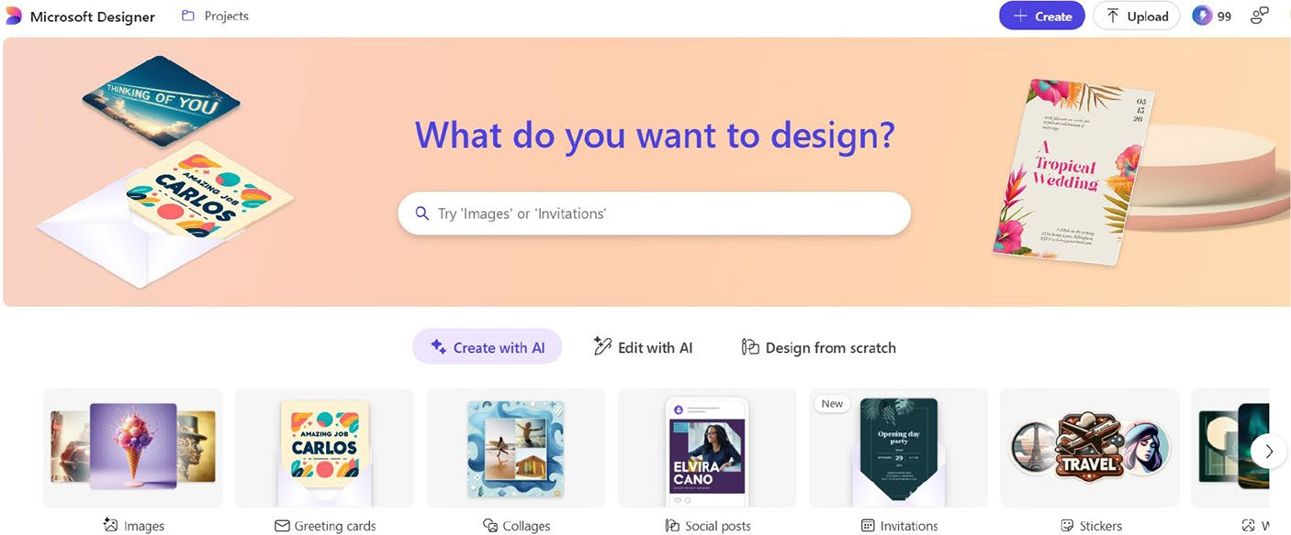

Figure 9-2. Kick-start your design journey
The carousel placed on the Microsoft Designer home page enables
you to create images, greeting cards, collages, social posts, invitations,
stickers, wallpapers, monograms, backgrounds, avatars, and icons. You
can quickly access modules like background remover, Generative Erase,
image framing, and much more by selecting the Edit with AI tab from the
Designer dashboard.

Note the appearance of the Microsoft Designer home page could change periodically.

Chapter 9 Working With MiCrosoft Designer
If you scroll down the Microsoft Designer home page, you will see
options as in Figure 9-3 for the creation of images, personalized avatars, greeting cards, wallpapers, invitations, and much more.
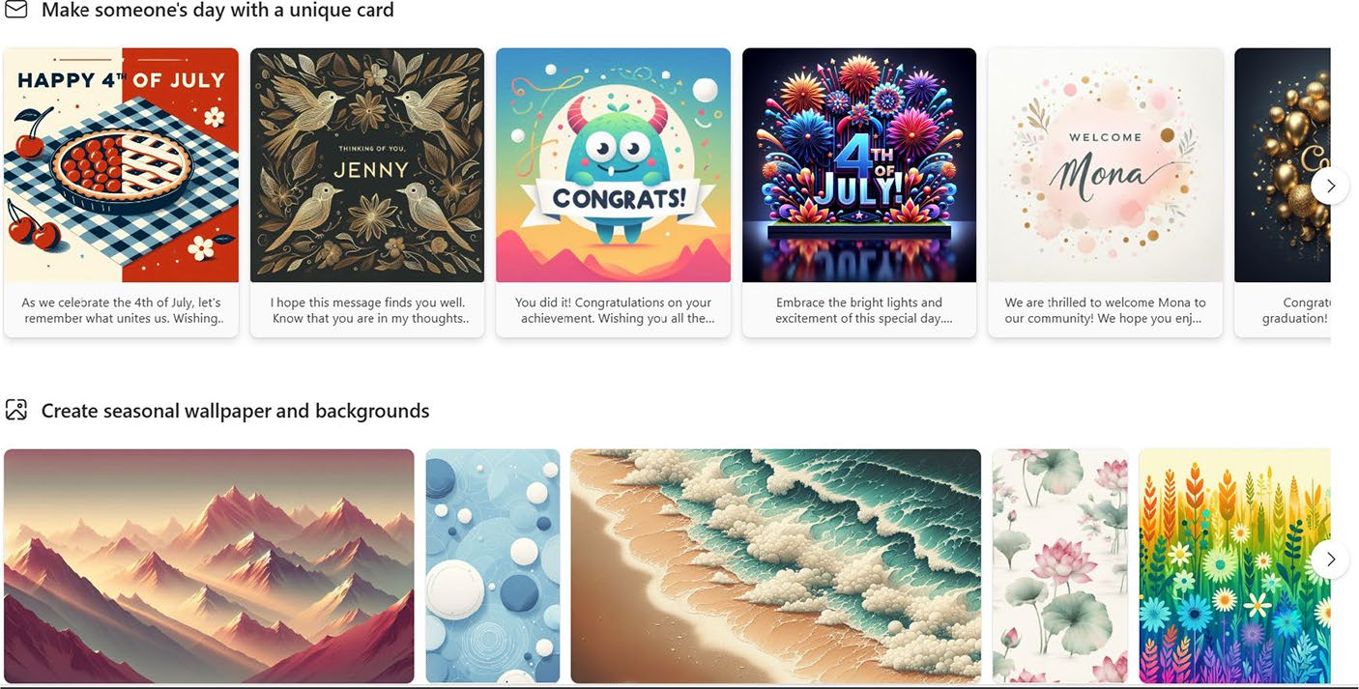

Figure 9-3. Select what you want to create
The options displayed on the Microsoft Designer home page change upon each page refresh. You should read the description and proceed further with your tasks. Moreover, the Designer app displays prompt templates under each heading. You will be able to quickly create stunning graphics by selecting a relevant template of your choice. If you point your mouse over an image template, then the relevant prompt will appear. You will have an option to change the prompt before you proceed to generate visuals.

Creating Images
To create images, you should select the Images option from the Microsoft
Designer dashboard. You will see a screen as shown in Figure 9-4.

Chapter 9 Working With MiCrosoft Designer
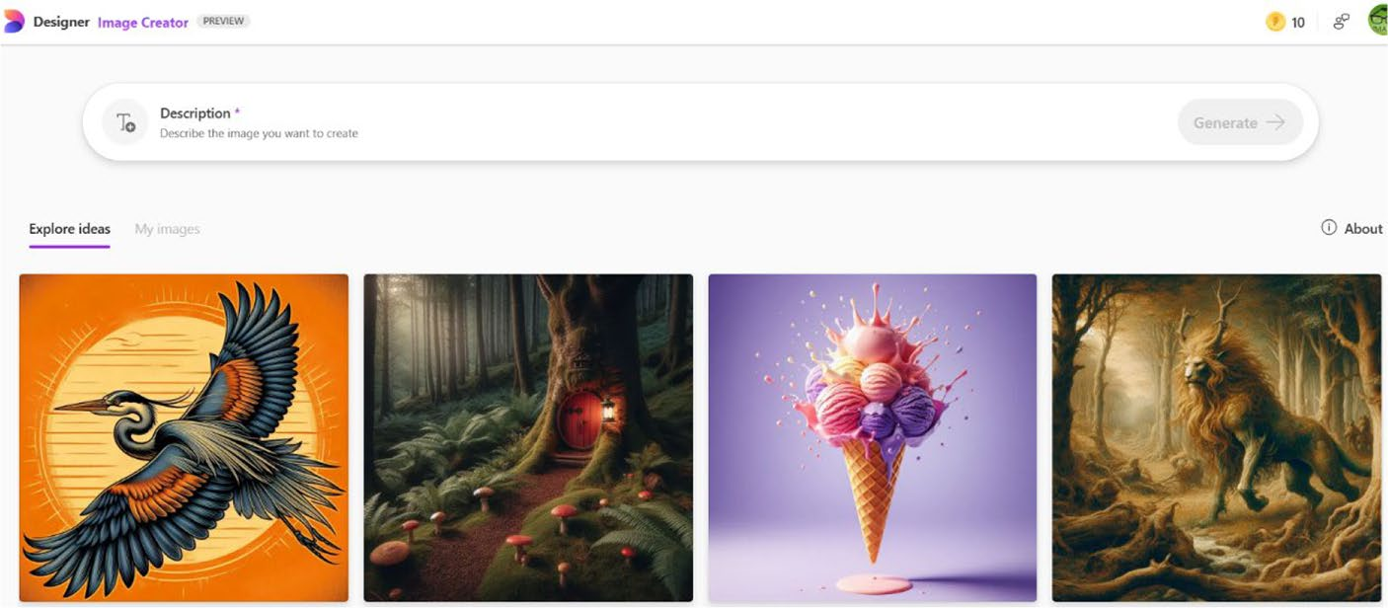

Figure 9-4. Start generating AI images here
Alternatively, you can also provide a suitable prompt as per your
choice in the search box located on the top of the Microsoft Designer
dashboard. You will see a series of options as shown in Figure 9-5. You
have to provide a prompt and select an option. For example, you can use
a prompt like A beautiful lake surrounded by flowers and select the Images
option. The Designer app automatically generates images for you.
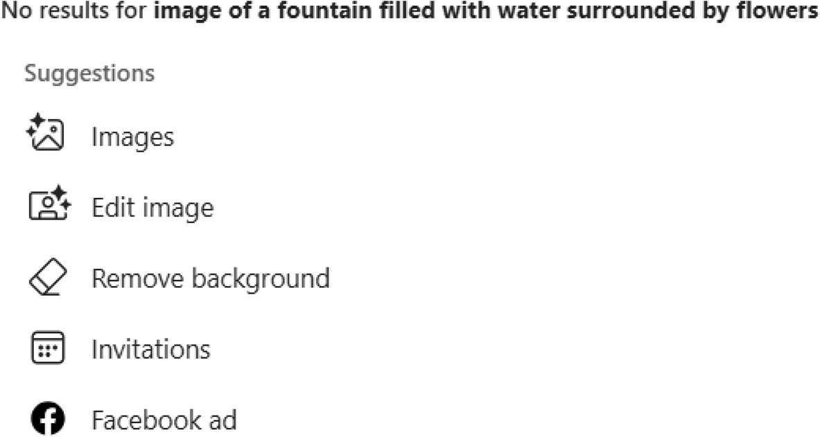

Figure 9-5. Intelligent suggestions upon entering a prompt

Chapter 9 Working With MiCrosoft Designer
If you select the Images option from the Microsoft Designer home page, you will see a new dashboard using which you can create images. The Image Creator provides several predefined prompts with previews, which you can use to learn the usage of the tool. A new set of image previews and prompts will be displayed upon refreshing the page. If you hover over the preview, you will be able to know the prompt description as
shown in Figure 9-6.
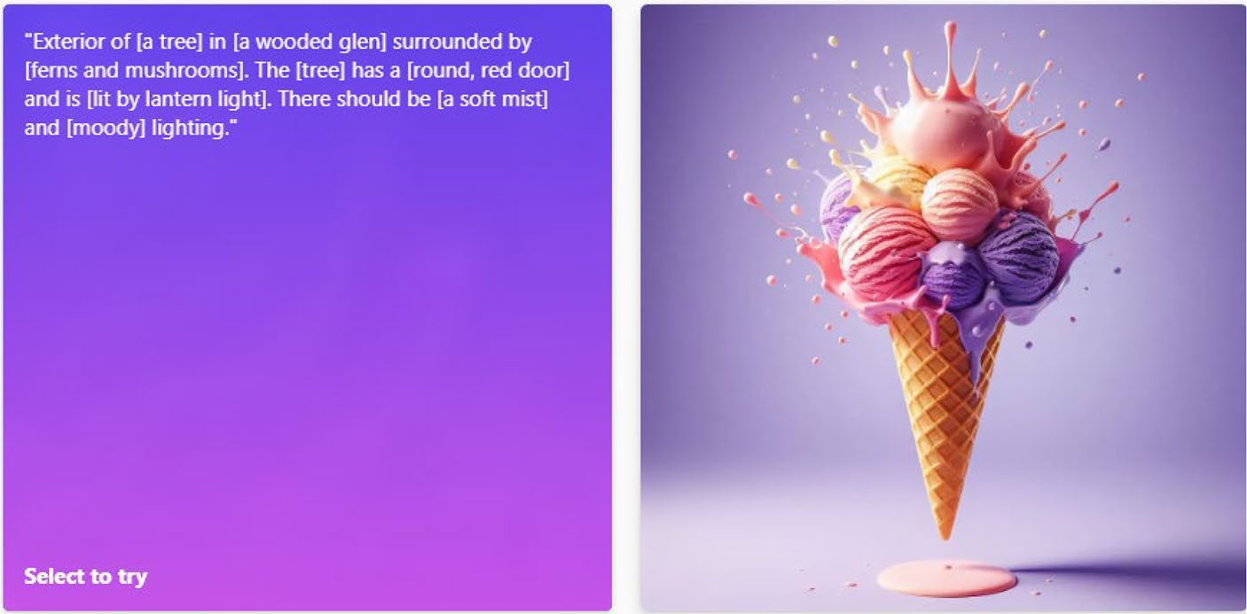

Figure 9-6. Point your mouse to view the prompt
If you click the preview placeholder, you will be able to edit the
selected portions of the prompt as displayed in Figure 9-7.
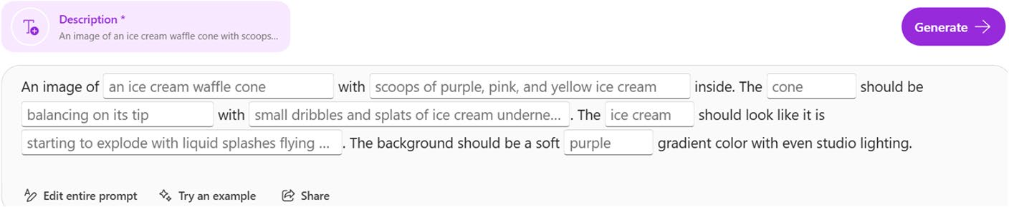

Figure 9-7. Edit prompt intelligently
You can also modify the entire relevant prompt by selecting the Edit
entire prompt option as displayed in Figure 9-8.

Chapter 9 Working With MiCrosoft Designer
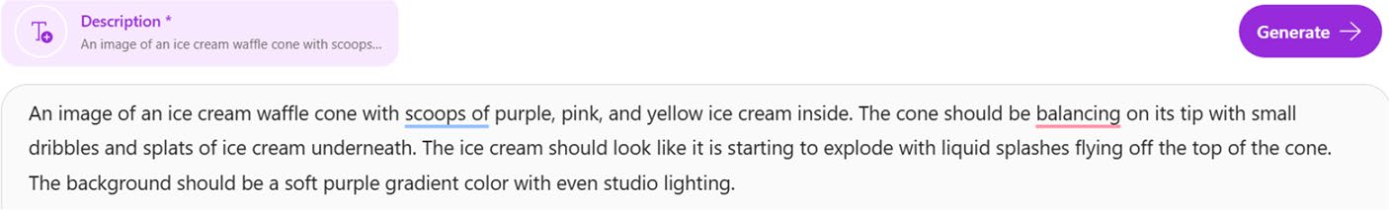

Figure 9-8. Modify prompt completely
If you are satisfied with the prompt, you should select the Generate
button to enable Image Creator to render the image. The app will display
four blue-colored square placeholders, where the generated images will
appear as shown in Figure 9-9. You should note that the image generation
process takes time depending upon the speed of your Internet connectivity
and other external AI factors. Moreover, a new set of four images will
appear upon each refresh because of the nature of AI technology.


Figure 9-9. View the variations of AI-generated images
Let’s try to create another image from the predefined prompts. A new
set of four images will appear on the screen. If you select an image, you will
see a window with a larger preview (Figure 9-10) along with the options
for downloading and editing the relevant image. You can also navigate to
another image by selecting the navigation arrows placed on the left and
right sides.

Chapter 9 Working With MiCrosoft Designer


Figure 9-10. Decide what you want to do with the AI image
You can make use of the image on your blog or share them on social media by selecting the Download option. If you select the Edit option, a
comprehensive design editor page will appear as displayed in Figure 9-11.
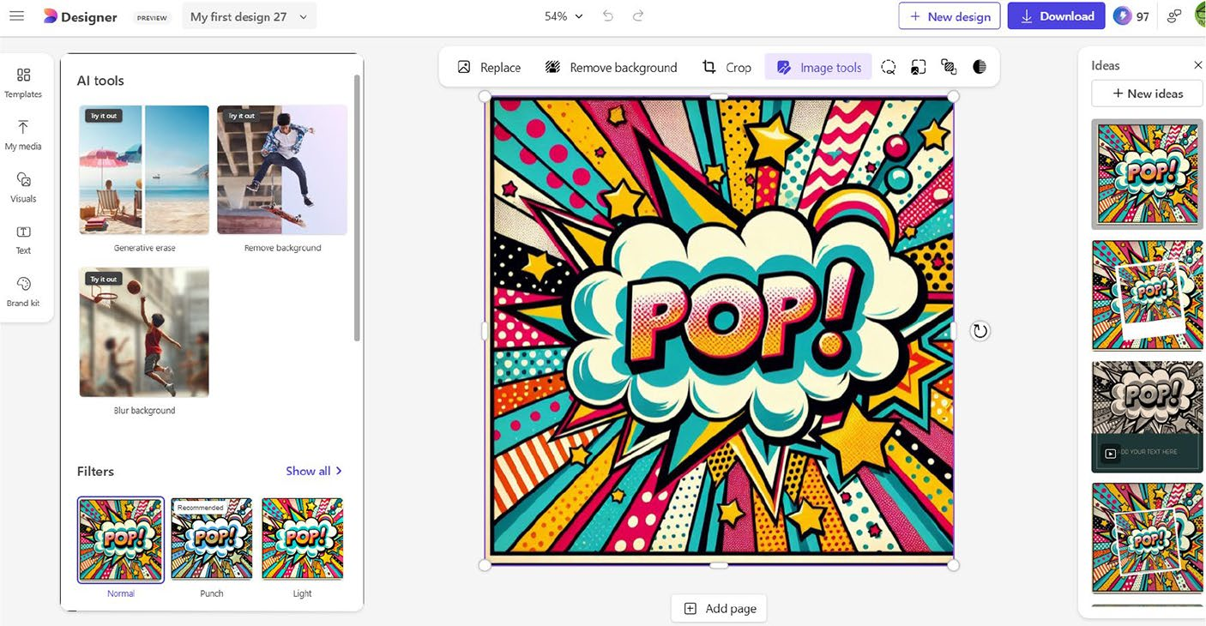

Figure 9-11. Edit your designs on the cloud
You can add filters, texts, and other elements with the help of the Designer dashboard. The Designer dashboard includes several options that are located on the left and right sides in addition to the top bar.

Chapter 9 Working With MiCrosoft Designer
You can also adjust the brightness, contrast, sharpness, saturation, and
temperature levels of the active image. You will be able to view the change
instantly upon dragging the sliders. You can also remove background and
crop images easily as well as add text to your images.

Create Images with Your Prompts
You can also create images using your prompts. The first step is to navigate
to https://designer.microsoft.com/image-creator. You should provide
the required prompt like Generate an image of a waterfall surrounded by
trees inside the Description section and select the size according to your
requirements.
Alternatively, you can provide the required prompt inside the textbox
provided on the Microsoft Designer home page and select the required
option of your choice. Let’s provide a prompt as shown in Figure 9-12.

Figure 9-12. Prompting with Microsoft Designer
The next step is to select the desired size by selecting the Size option.
The Designer app displays three design options, namely, Square, Portrait,
and Wide. The final step is to select the Generate button to enable
Microsoft Designer to generate the relevant image. The app displays a
blue-colored progress indicator in four squares in different variations. If
you try the abovementioned prompt using the Designer app, then you
will be able to view stunning visuals according to our prompt. The image
creation process is the same even if you attempt a new prompt. The ability
to pick a size of your choice is a definite advantage. As explained earlier,
you can easily modify the generated image by selecting the Edit option.

Chapter 9 Working With MiCrosoft Designer
Using Microsoft Designer Dashboard
Microsoft Designer comes with a robust editor using which you can modify your image effectively. You can also add impressive elements using the various options inside the editor. The Designer ships with plenty of templates, which you can use for your projects. You can also search using keywords to locate a template of your choice. Firstly, you should select the Templates icon from the top left-side navigation panel and select a template based on your requirement.
You can upload your own media to the Designer app from various
sources by selecting the My media icon as shown in Figure 9-13. Moreover, the Designer app automatically syncs with OneDrive and displays all the latest images.

Chapter 9 Working With MiCrosoft Designer
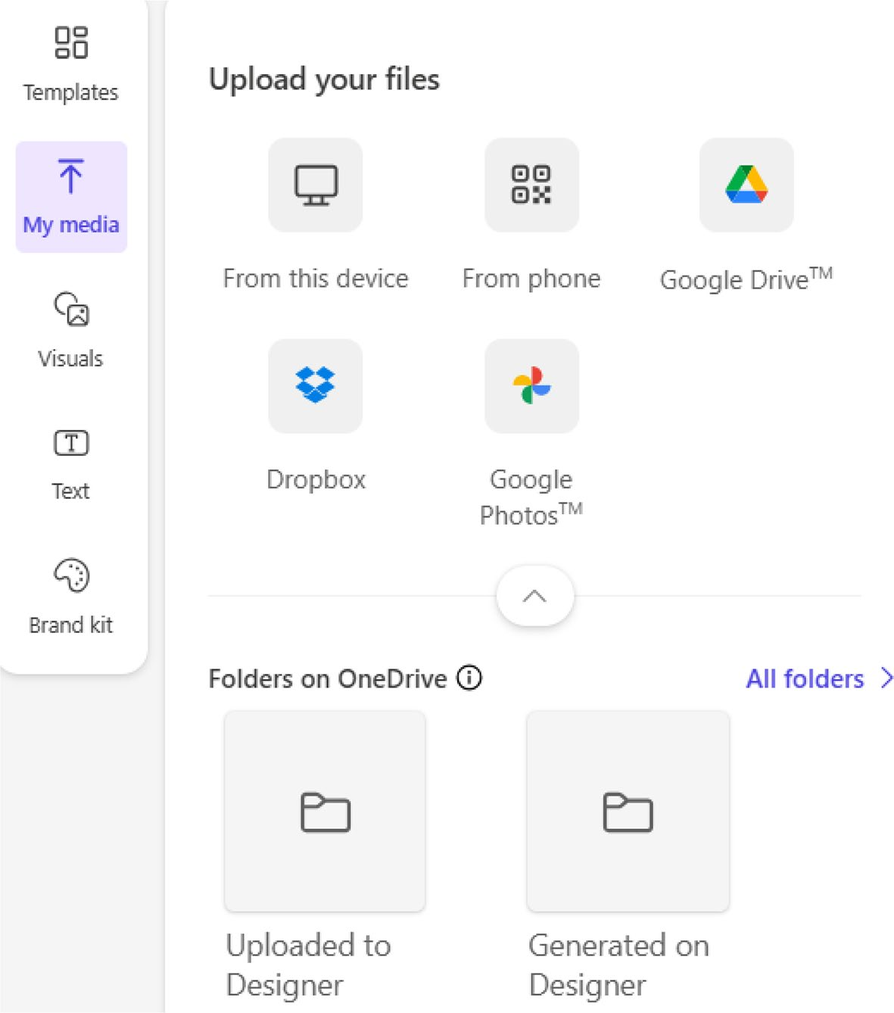

Figure 9-13. Upload files from various sources
You will have to grant the required permission if you would like to use
media content from Google Drive or Google Photos. If you select Google
Drive, you will see a dialog prompting you to establish connectivity by
selecting the Connect Google Drive button.
The Visuals option in Microsoft Designer enables you to add several
attractive shapes and icons to your image as displayed in Figure 9-14. You
can add shapes, illustrations, background photos/videos, summer icons,
and much more. The possibilities are endless, and it’s up to you to decide
the relevant visual element of your choice. You should also judge the
selection as per your project requirements.

Chapter 9 Working With MiCrosoft Designer
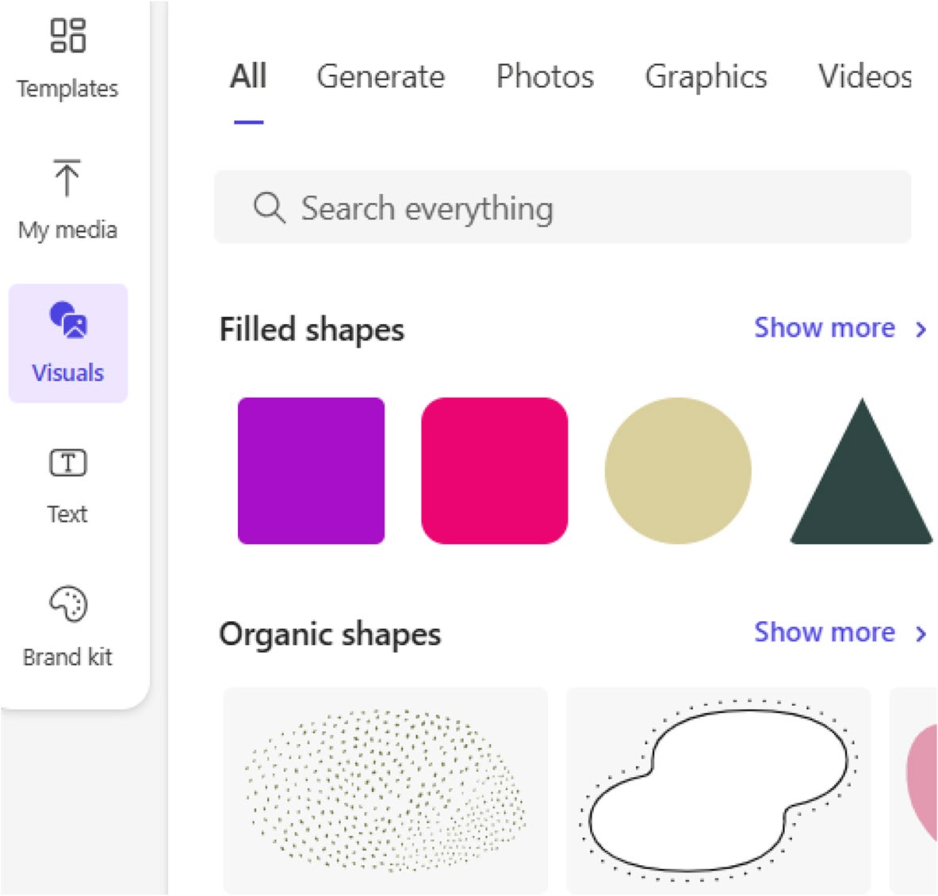

Figure 9-14. Pick elements and add
The Designer app dashboard displays three or four shapes, but you will see more upon selecting the Show more option. You can add attractive
text content and options as shown in Figure 9-15 to the active image by selecting the Text option. You can adjust the location and size after adding the relevant selection to the image editor.

Chapter 9 Working With MiCrosoft Designer
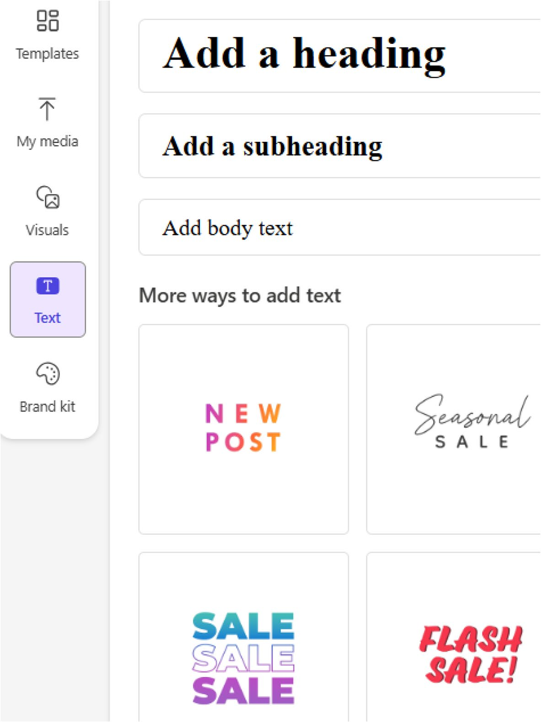

Figure 9-15. Add a text of your choice
You need to double-click the default text inside the placeholder and
add the required content. Previously, Microsoft also integrated the Copilot
API into the text module. If you provide the relevant text inside the top
textbox after selecting the Text icon from the left-side navigation, the
tool will generate text content accordingly. Let’s check out how the tool

Chapter 9 Working With MiCrosoft Designer
displays the various options after entering the word Welcome. Microsoft Designer provides several automated AI-based font options for the active
text item as shown in Figure 9-16. You have to experiment with each and decide accordingly based on your project requirements.
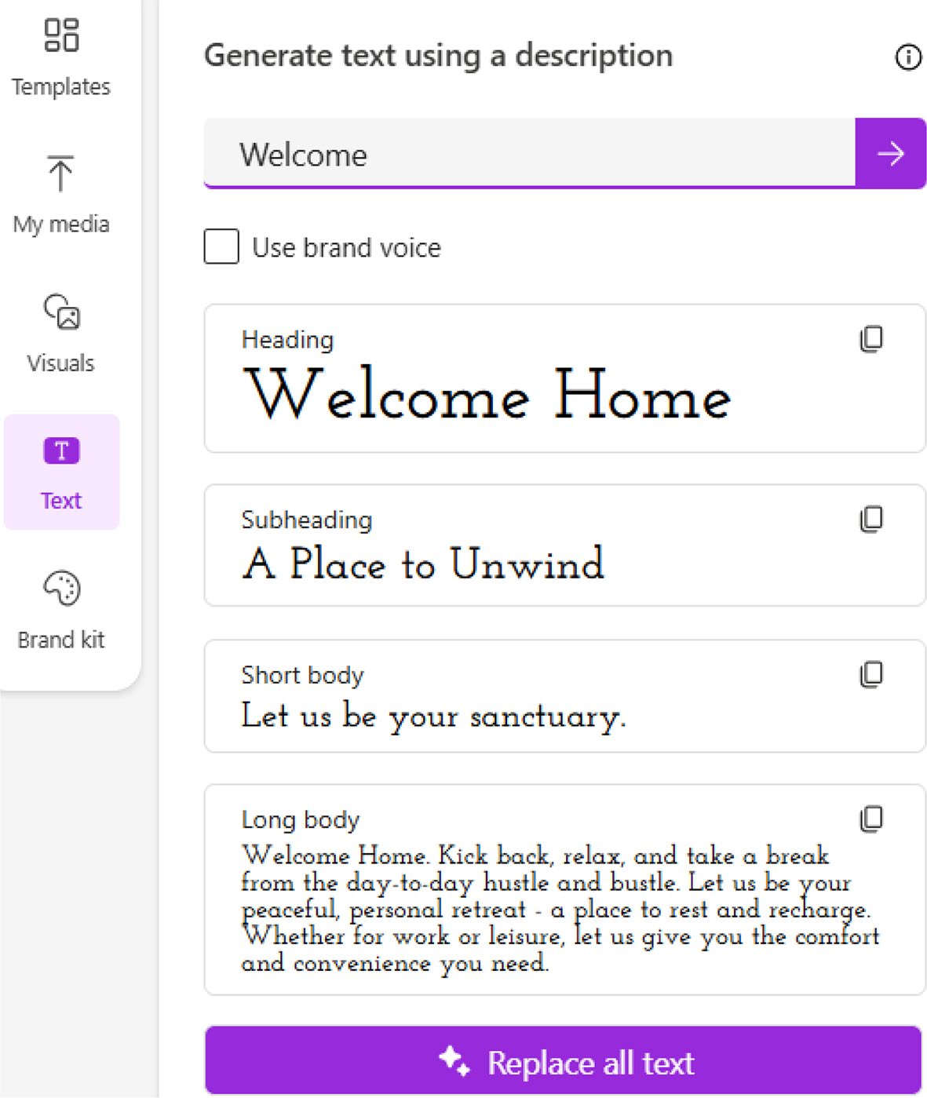

Figure 9-16. Select a font style as per the needs
If you select an option, the relevant text design will appear inside the image editor. There is no need to drag and drop inside the editing window. The font size can be increased by dragging the placeholders.

Chapter 9 Working With MiCrosoft Designer

Note the ai-enabled text options are not available now but could appear in the future. You are requested to check the Microsoft Designer editor to verify the presence of this functionality.
You can also make use of the font bar (Figure 9-17) located on top of
the image and adjust the parameters. However, if you click outside the
editor, the textbox loses focus and the front bar will disappear.

Figure 9-17. Apply fonts easily
If you select the active image on the Microsoft Designer editor, you will
see options as shown in Figure 9-18.

Figure 9-18. Perform Advanced Tasks Quickly
You can swap the image by selecting the Replace option from the top
navigation bar. You will see options as displayed in Figure 9-19. While
the Image gallery provides several stock images, icons, and illustrations,
the My media icon enables you to upload your objects and icons,
including images.
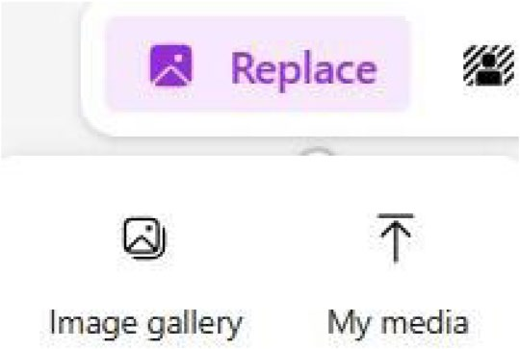

Figure 9-19. Add external images

Chapter 9 Working With MiCrosoft Designer
You can also remove background or crop an image by selecting the appropriate options as per your requirement. If you select the Image tools option, you will see AI tools such as Generative Erase and background removal, including the ability to blur the background. You can perform all the work from within the image editor. For instance, you can remove certain portions of an image using the Generative Erase functionality.
Microsoft Designer also provides attractive filters, which you can view by selecting the Image tools option. The relevant filters appear inside the AI tools panel under the Filters section. You can select the Show all option to view all the available filters.

Note the appearance of the filters depends upon the active image
inside the Microsoft Designer editor.
You need to select the desired filter to apply it to the active image. You can also convert a color image to black and white and much more. The Filters pane automatically shows a small preview of how the original image will look like upon applying the desired filter.
The Designer app is bundled with powerful features. Hence, a person with a creative mindset will be able to leverage the full potential of all the tools included with the app. Microsoft has developed the tool in such a way that even a beginner will be able to learn all the aspects without any assistance.

Generating Social Posts
Microsoft Designer also enables you to generate social posts based on the provided prompt. Previously, this feature was named Ideas. You can create stunning graphics for your upcoming book, product, and much more based on a single prompt.

Chapter 9 Working With MiCrosoft Designer
The first step is to select the Social posts icon located on the Microsoft
Designer home page. You will see a screen as shown in Figure 9-20. You
will also view several image prompts with the relevant default content on
the Try a prompt navigation panel.
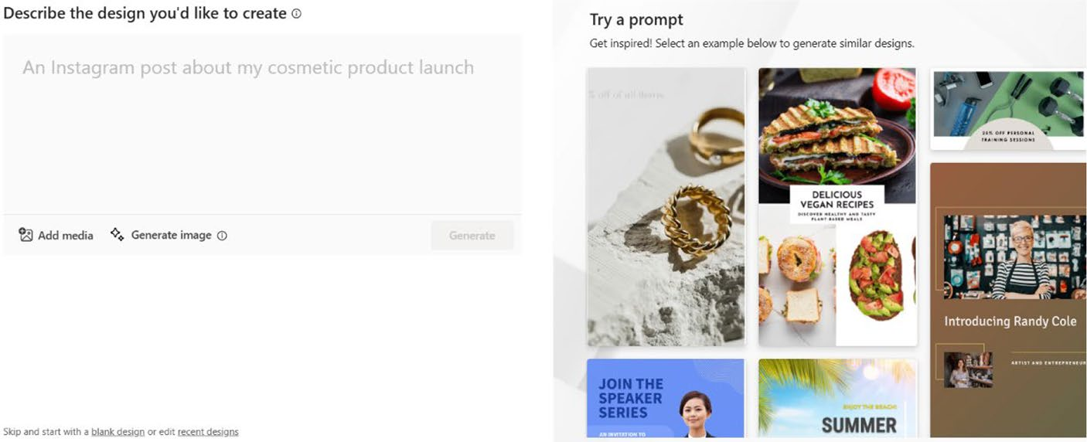

Figure 9-20. Create images based on ideas
You have to mention the kind of design you would like to create. You
can also add media from your PC or ask Microsoft Designer to generate an
image using a suitable prompt.
Let’s try to create an Instagram post using Microsoft Designer as shown
in Figure 9-21. You can also upload media from your device to create
graphics. The Social posts dashboard also provides attractive animated
prompts, which you can make use of to jump-start your design work.

Chapter 9 Working With MiCrosoft Designer
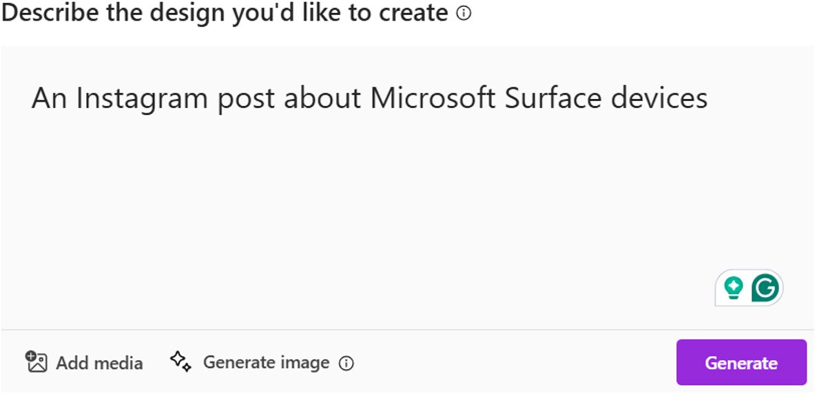

Figure 9-21. Provide idea prompts here
A splash screen with the caption Generating designs for you will display while the app creates the designs. You have to pick a design and select the Customise design button, which appears below the generated social posts. Microsoft Designer also displays automated prompt suggestions based on
your original prompt as shown in Figure 9-22, which you can make use of to generate accurate social posts.
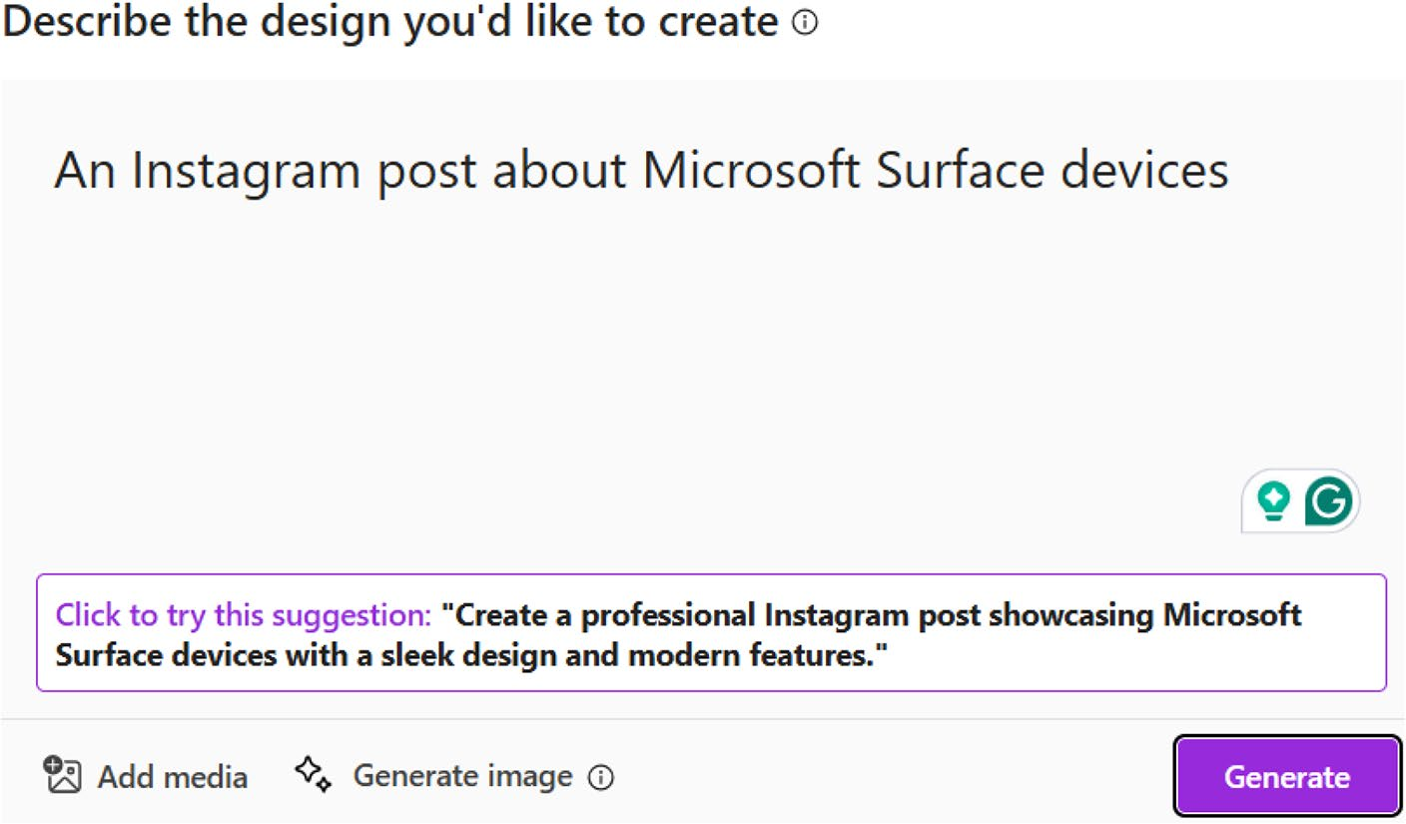

Figure 9-22. Automated prompt suggestion helps

Chapter 9 Working With MiCrosoft Designer
You will see a list of generated social posts as shown in Figure 9-23. You
can scroll down to view additional designs. Microsoft Designer generates
new social posts if you repeat the generation of designs using the same
prompt. The AI technology is designed to generate new responses in the
form of text, images, and videos.
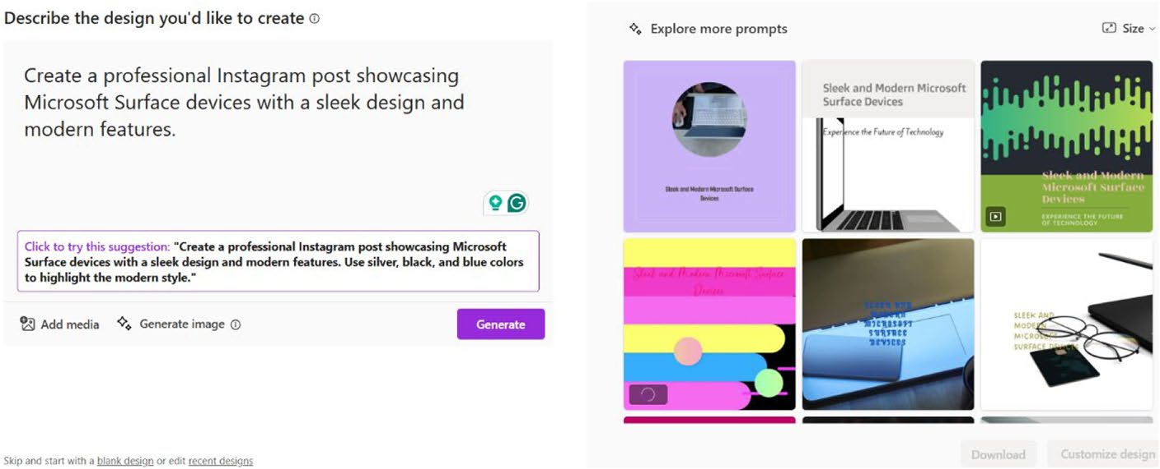

Figure 9-23. Pick a suitable design as per your requirement
The next step is to select a design and then click the Customise design
button. The selected design appears inside the Microsoft Designer
dashboard as shown in Figure 9-24. You can add elements such as shapes,
text, and other media content.

Chapter 9 Working With MiCrosoft Designer
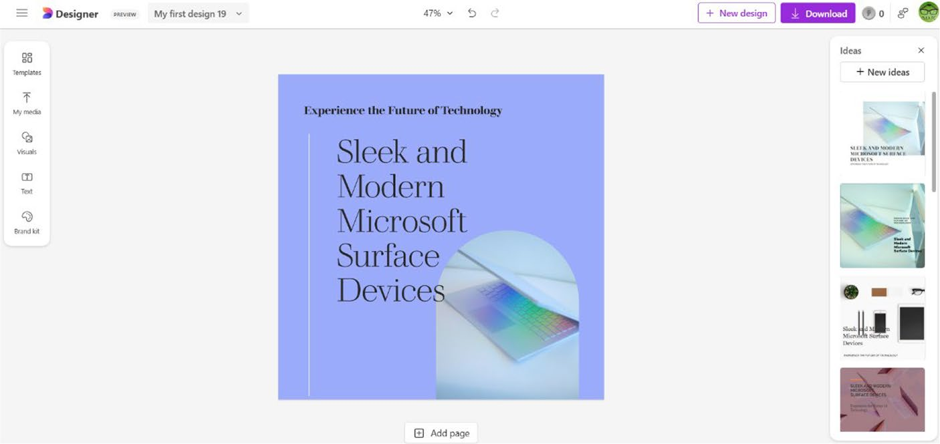

Figure 9-24. Modify the selected design
You can either add additional pages (see Figure 9-25) or duplicate the existing page by selecting the Add page button located below the design. You can make use of the design ideas displayed on the right side for additional pages.
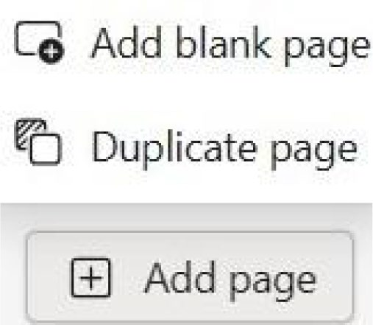

Figure 9-25. Paginate your design

Chapter 9 Working With MiCrosoft Designer
Creating Stickers
Microsoft Designer also includes a dedicated module for the creation
of stickers. The first step is to select the Stickers option by navigating to
https://designer.microsoft.com. In Figure 9-26, you can observe the
Sticker Creator dashboard.
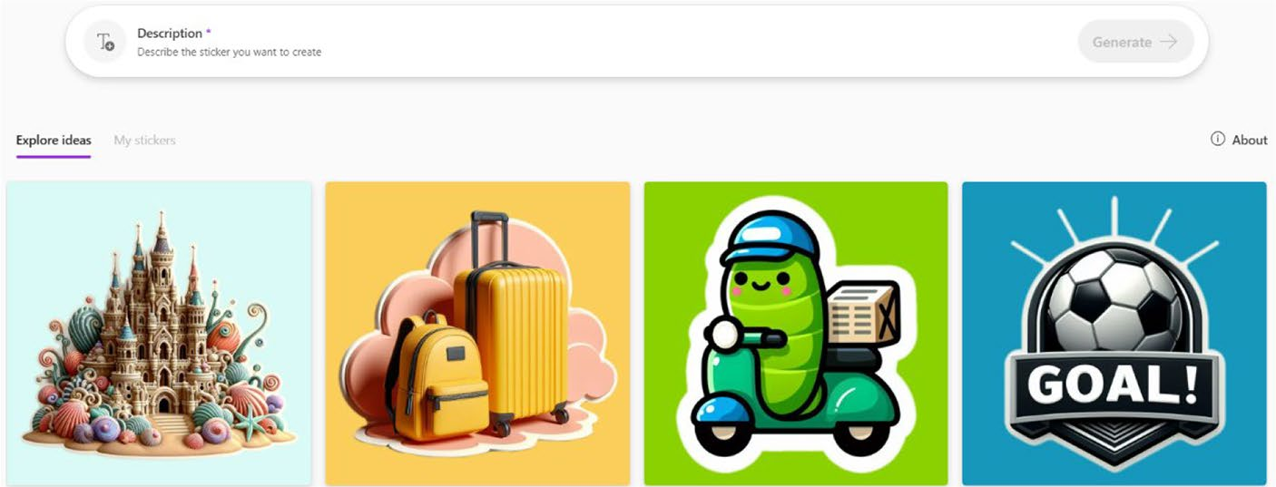

Figure 9-26. Impress your friends with stickers
The dashboard displays a preview of several stickers. If you point your
mouse over the stickers, then you will be able to view the relevant prompt.
The remaining steps are identical to that of the Image Creator we saw
previously. The system creates four stickers upon selecting the Generate
button similar to that of the Image Creator. Like in the case of the images,
stickers will also change upon each AI request.
If you select one sticker, a pop-up window will open using which you
can download the generated sticker. You can also open the sticker inside
the Microsoft Designer dashboard by selecting the Edit option. You can
apply filters, elements, text, and other properties from the Microsoft
Designer dashboard as displayed in Figure 9-27.

Chapter 9 Working With MiCrosoft Designer
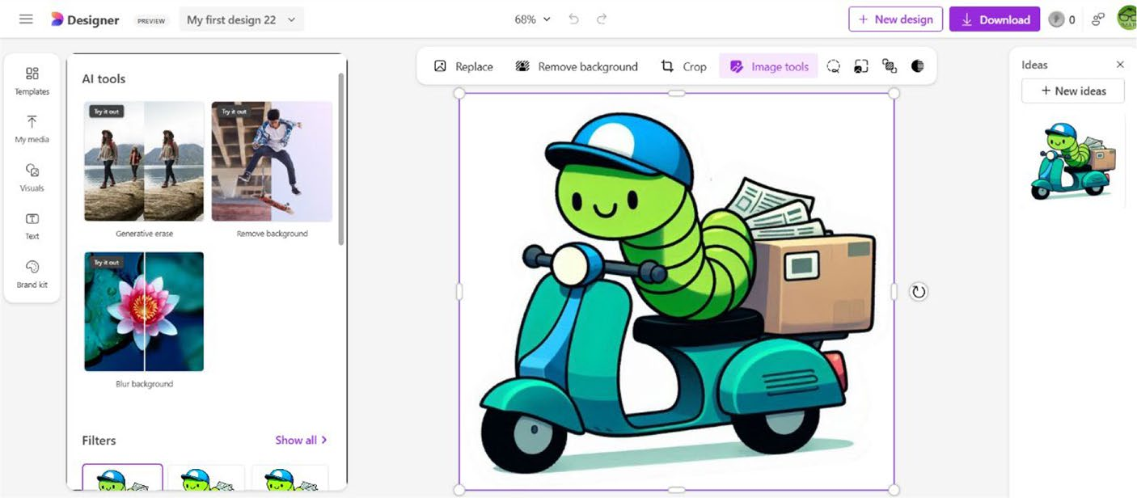

Figure 9-27. Modify the sticker inside the Designer dashboard
You can download the sticker by selecting the Download button after the completion of the editing process. The file can be downloaded in PNG, JPEG, and PDF file formats. You can also copy the image or deliver the
relevant image to your phone as shown in Figure 9-28.

Chapter 9 Working With MiCrosoft Designer
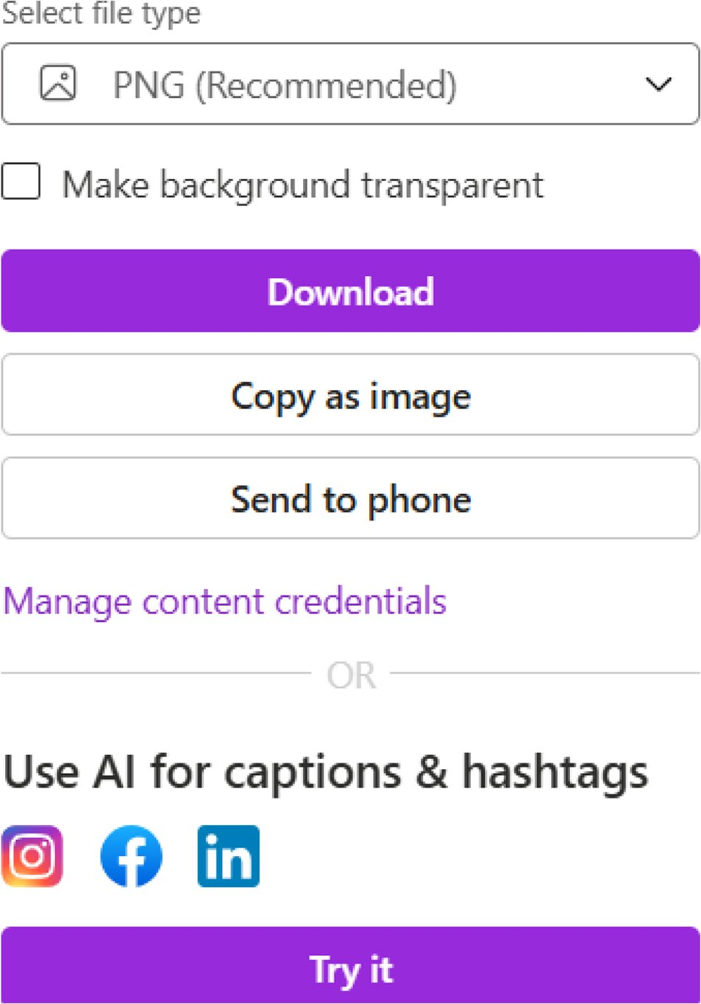

Figure 9-28. Download and share

Note in case you are not satisfied with the sticker or observe any error, then you can send feedback to the product team by selecting the Send feedback option.

Chapter 9 Working With MiCrosoft Designer
The Designer app suggests PNG as the recommended format, which produces high-quality images. The Designer app also provides the ability to use AI for the creation of captions and hashtags. Moreover, you can manage content credentials by including the required parameters.

Note try to create a sticker by using your own prompt – Create a
funny smiling sticker for sharing on WhatsApp group.
If you select a sticker, you will be able to modify the sticker via the Edit option as discussed earlier. You can easily generate stickers by providing a suitable prompt according to your requirements.

Creating Awesome Greeting Cards
Microsoft Designer enables you to create stunning greeting cards based on a simple prompt. It’s easy to create immersive greeting cards with the help of this module. You can provide prompts according to the relevant occasion.

Note You can edit photos in Microsoft Designer via photos app.
You should select Edit an image in Designer online option from the
navigation toolbar after opening the relevant image in the photos app.
The first step is to select the Greeting cards option from the Microsoft Designer home page. The Greeting cards editor is displayed as shown
in Figure 9-29. You can select the Greeting card templates and ideas dynamically available on the Designer dashboard. Alternatively, you can provide a new prompt by clicking the description area.

Chapter 9 Working With MiCrosoft Designer
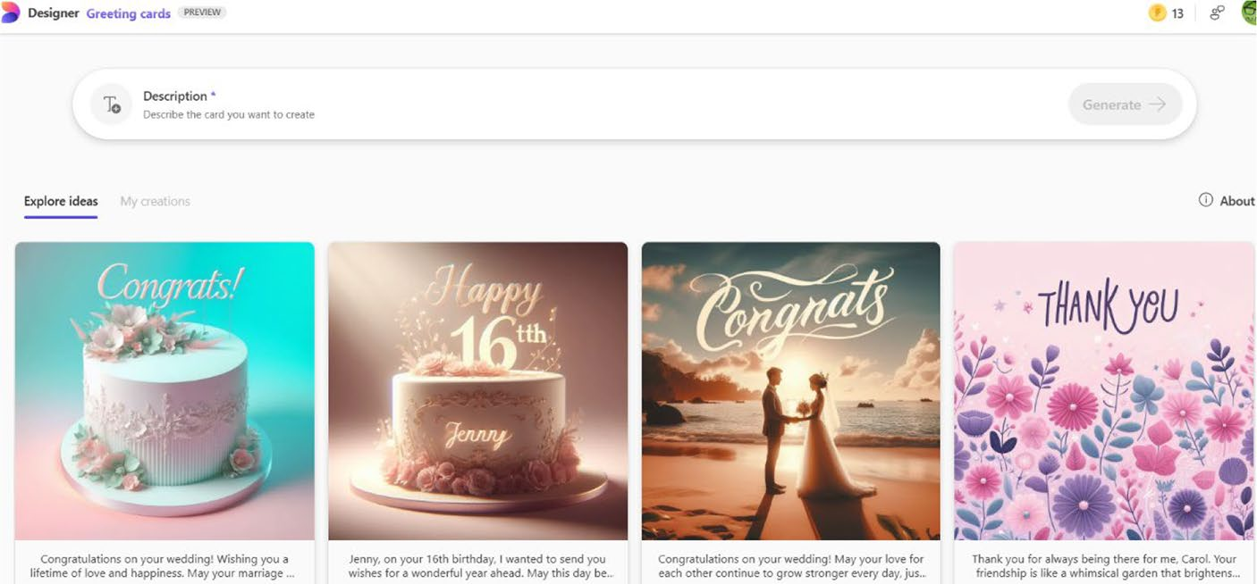

Figure 9-29. Create greeting cards for various occasions
If you select a Greeting card template, you will be able to modify the
prompt from the displayed prompt editing panel. You can provide the
desired values inside the activated textbox as shown in Figure 9-30. You
can also edit the prompt in full by selecting the Edit entire prompt option.
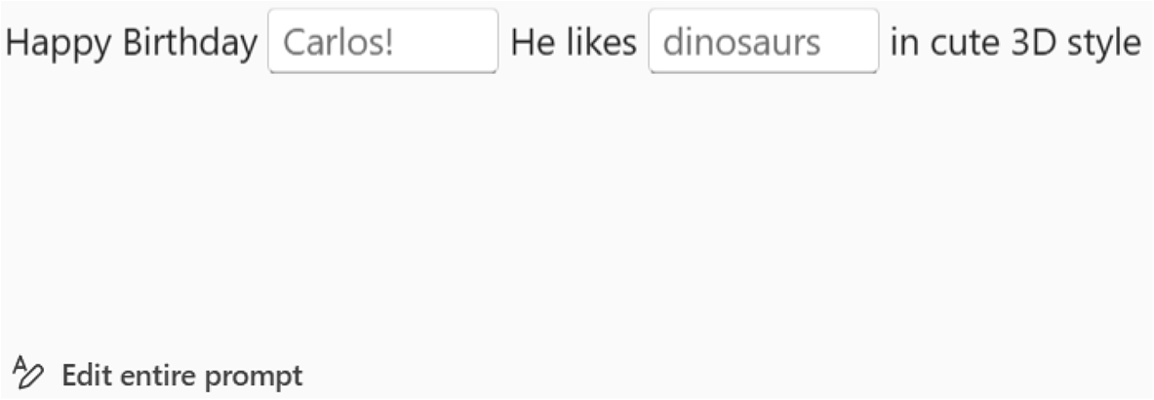

Figure 9-30. Prompting to create greeting cards
Finally, you should select the Generate button, and the Designer
automatically creates four variations of the card. If you select a generated
greeting card, it will open as an envelope and will be visible on the screen.
You can easily download the card for social media purposes. Sometimes,
you will not be able to download the generated greeting card because of
various reasons. You can try again later to download the card.

Chapter 9 Working With MiCrosoft Designer
You can modify the text content by selecting the Edit text button located on the top-right side of the selected greeting card. An editing placeholder will appear on the screen, and you can directly provide a suitable text. The caption of the Download button changes to Looks good, which you should select if you are satisfied with the new content. You can then save the greeting card to your PC by selecting the Download button. If you press the Esc key, the Designer will reveal the other three greeting cards. You can download them as well in case you are not satisfied with the previous card.

Collage Creator
Microsoft Designer includes a handy Collage Creator functionality. You can beautify old images to create a single impressive image, also named collage, with the help of AI. Imagine you located vacation photos with your office colleagues. You can easily turn them into collages using the Designer app. You can add elements and style to create an impressive social media experience.
The first step is to select the Collages option from the Designer home
page. The Collage Creator dashboard as shown in Figure 9-31 will be displayed upon selecting the option.
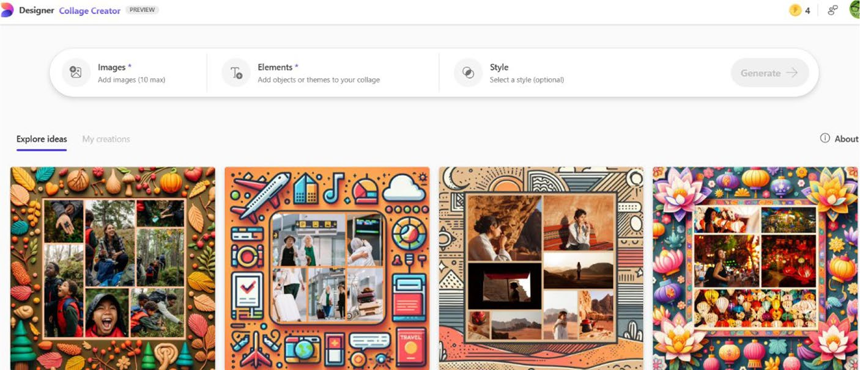

Figure 9-31. Create a fun collage with Microsoft Designer

Chapter 9 Working With MiCrosoft Designer
Microsoft Designer displays a fresh set of collage templates upon each
refresh. You can upload a maximum of ten photos per collage. You have
an option to select a deserted style according to your requirements. The
Collage Creator includes several amazing styles as shown in Figure 9-32.
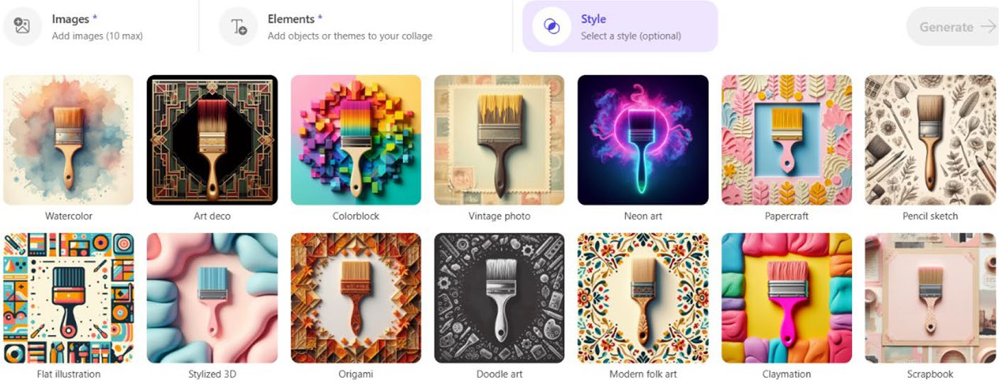

Figure 9-32. Apply styles to your collage easily
Let’s deploy a few scenic photos into the Collage Creator via
Figure 9-33 and observe the result. You can upload photos from your
phone, Google Drive/Photos, and Dropbox by selecting the Add
images button.
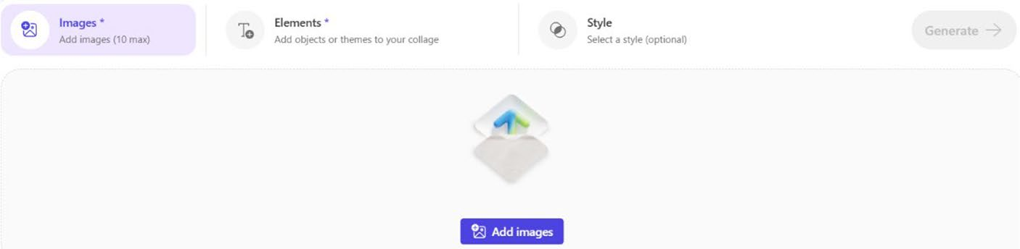

Figure 9-33. Fill your collage with images
The tool loads all the photos from OneDrive automatically and can
be completely viewed by selecting the Media on OneDrive panel. The
uploaded photos will be visible on the Media on Designer panel after
uploading the images.

Chapter 9 Working With MiCrosoft Designer
To create a collage, you have to manually select the relevant images and click the Select button. The selected photos will appear inside the Images panel. You can add objects or themes to your collage by selecting the Elements tab. The Collage Creator also comes with several styles, but it’s not compulsory to add them into your collage project. The final step is to select the Generate button, which creates the collage using the selected photos and other parameters.
The Collage Creator generates four different variations of the collage. You will be able to view an enlarged collage upon selecting any of the generated collages. You can either download or modify the collage by selecting the Download and Edit buttons, respectively. You can add shapes, icons, text, and other items via the Microsoft Designer dashboard, which will be visible upon selecting the Edit button.

Creating Invitations
Do you want to create an invitation for a family party? Microsoft Designer is here to your rescue because you can create stunning invitations on the fly. The first step is to select the Invitations option from the Designer home
page. You will see Invitations dashboard as shown in Figure 9-34.
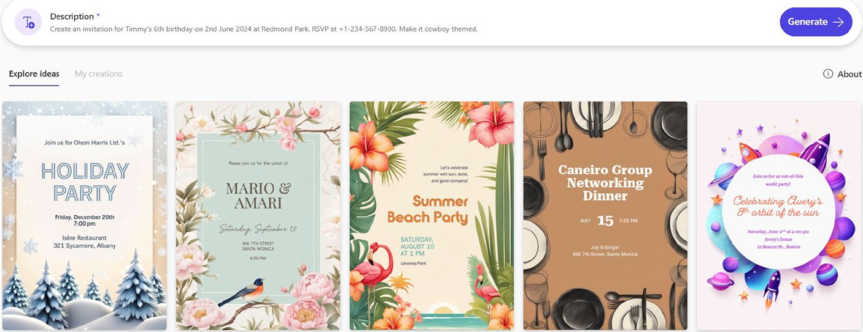

Figure 9-34. Create greeting cards for various occasions

Chapter 9 Working With MiCrosoft Designer
Like in the case of image creation, you have to provide a suitable
prompt. You can either select any one of the available prompts or provide
your prompt by selecting Description. If you select a prompt from the
Explore Ideas section, you will see the corresponding prompt with
placeholders for providing data as shown in Figure 9-35.
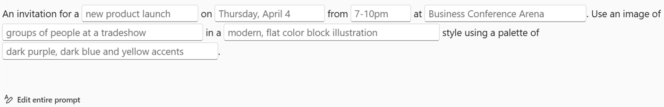

Figure 9-35. Practice prompting to create awesome greetings
If you are satisfied with the prompt, you should select the Generate
button. Microsoft Designer creates invitations with three different
variations. You should note that the total number of creations will vary
depending on the various factors related to AI. You will see an enlarged
version of the invite upon selection of Download and Edit buttons.
You will see two options as shown in Figure 9-36 upon selecting the
Download button.
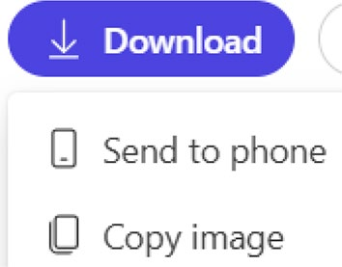

Figure 9-36. Download in various ways
The selected invitation appears inside the Microsoft Designer
dashboard, which you can spruce up with fonts, elements, and filters.
In this way, you can create invitations for any occasion by adding your
preferences.

Chapter 9 Working With MiCrosoft Designer
Generating Wallpapers
With the latest upgrade, you can easily create wallpapers via the Designer app. Firstly, you should select the Wallpapers option from the Designer home page. You will see options for providing a prompt and size along
with several attractive prompt templates as shown in Figure 9-37. You can view additional prompts upon scrolling.
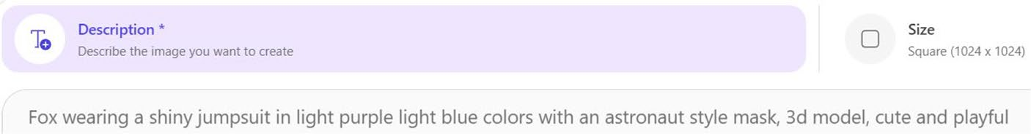

Figure 9-37. Decorate your system with AI wallpaper
You have to provide a suitable prompt and select a size according to your preference. The wallpaper will be created upon selecting the Generate button. You can generate wallpapers in square, portrait, and wide formats, respectively.
Microsoft Designer provides an ability for the creation of monograms. You can create interesting images by overlapping multiple letters in such a way as to form one symbol. Normally, monograms are created by combining the initials of a specific entity and can be used as a logo. You will see the Monogram dashboard upon selecting the option from the Designer app. The monogram will be created upon providing the prompt and size. You can either download or edit the generated monogram. In addition to monograms, you can also generate coloring book pages, backgrounds, avatars, and icons using Microsoft Designer. You should provide a suitable prompt and select the size according to your requirements. Microsoft Designer provides an ability to create designs using your own images for various purposes. You should select Design from scratch option from the Designer home page, choose the relevant blank template and add your image. You can add elements like photos, shapes, illustrations, icons, videos, and text as per your project requirements.

Chapter 9 Working With MiCrosoft Designer
Advanced Microsoft Designer Features
In addition to images, social posts, stickers, greeting cards, collages, and
much more, Microsoft Designer also includes advanced features. These
include background removal, Generative Eraser, image restyler, and image
framing. In this section, you will learn the usage of each of the advanced
Designer modules.

Remove Image Background Quickly
Do you have an image with a distracting background? You can easily
remove the background with the help of the Remove background module
included with Microsoft Designer.
The first step is to select the Edit with AI tab from the Microsoft
Designer home page and select the Remove background option. You will
see a dialog using which you can either upload or drag/drop the relevant
image. The Designer app will ask you to confirm the image. You have to
select the Upload button as shown in Figure 9-38.

Chapter 9 Working With MiCrosoft Designer
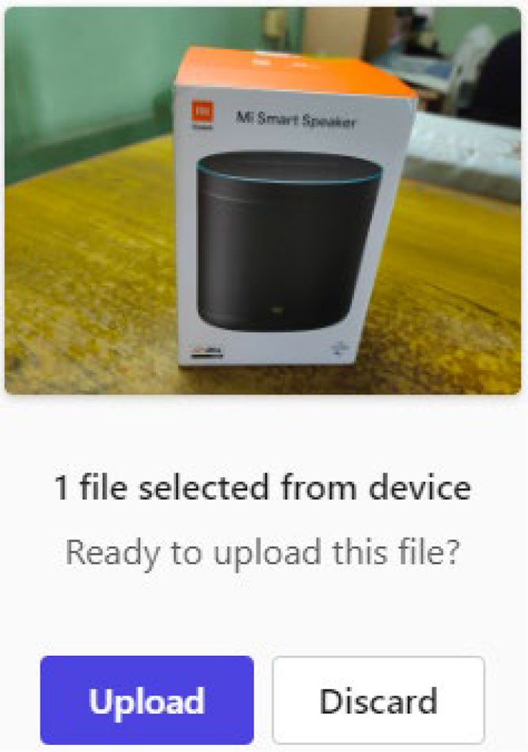

Figure 9-38. Confirm file uploading
The background of the uploaded image will be immediately removed
(see Figure 9-39) upon selecting the Upload button.
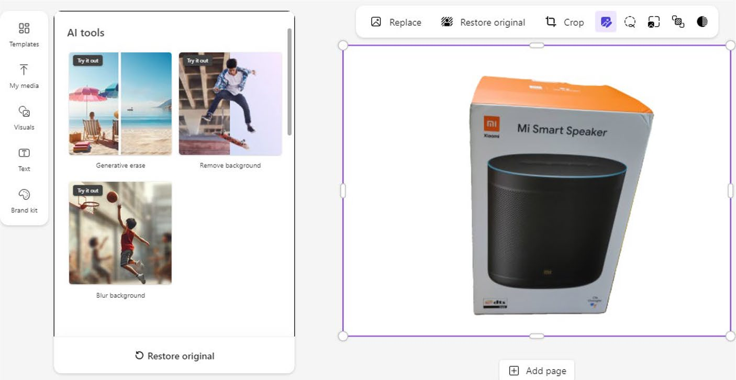

Figure 9-39. Instantly remove background

Chapter 9 Working With MiCrosoft Designer
If you analyze Figure 9-39, you can observe that the background of the
original image has been removed completely. You can restore the original
image and crop the image in addition to other editing tasks using the
options from the top navigation bar. You can also text elements, shapes,
icons, and filters to the new image. You can save the image to your PC from
the Microsoft Designer editor by selecting the Download button.

Working with Generative Erase
Microsoft Designer has added the Generative Erase functionality, using
which you can erase select objects from images. You can choose objects
that need to be removed easily. Let’s check out the working of Generative
Erase functionality using an image captured from a moving train by
the author.
To work with the Generative Erase functionality, you should select
the Edit with AI tab from the Microsoft Designer dashboard and select
the option captioned Generative erase. The Designer app prompts you
to upload the image. You will see a confirmation dialog as shown in
Figure 9-40.

Chapter 9 Working With MiCrosoft Designer
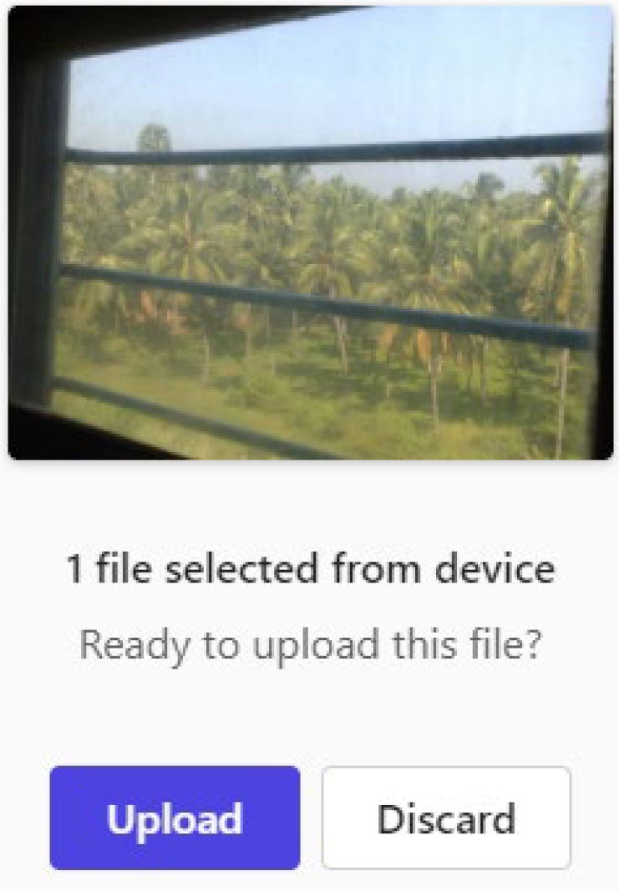

Figure 9-40. Confirm your action
You can observe that the image comprises several trees and has been shot inside the train. Hence, you can see the window bar as well. If you
select the Upload button, the Microsoft Designer editor (Figure 9-41) will open with the uploaded image along with relevant options.

Chapter 9 Working With MiCrosoft Designer
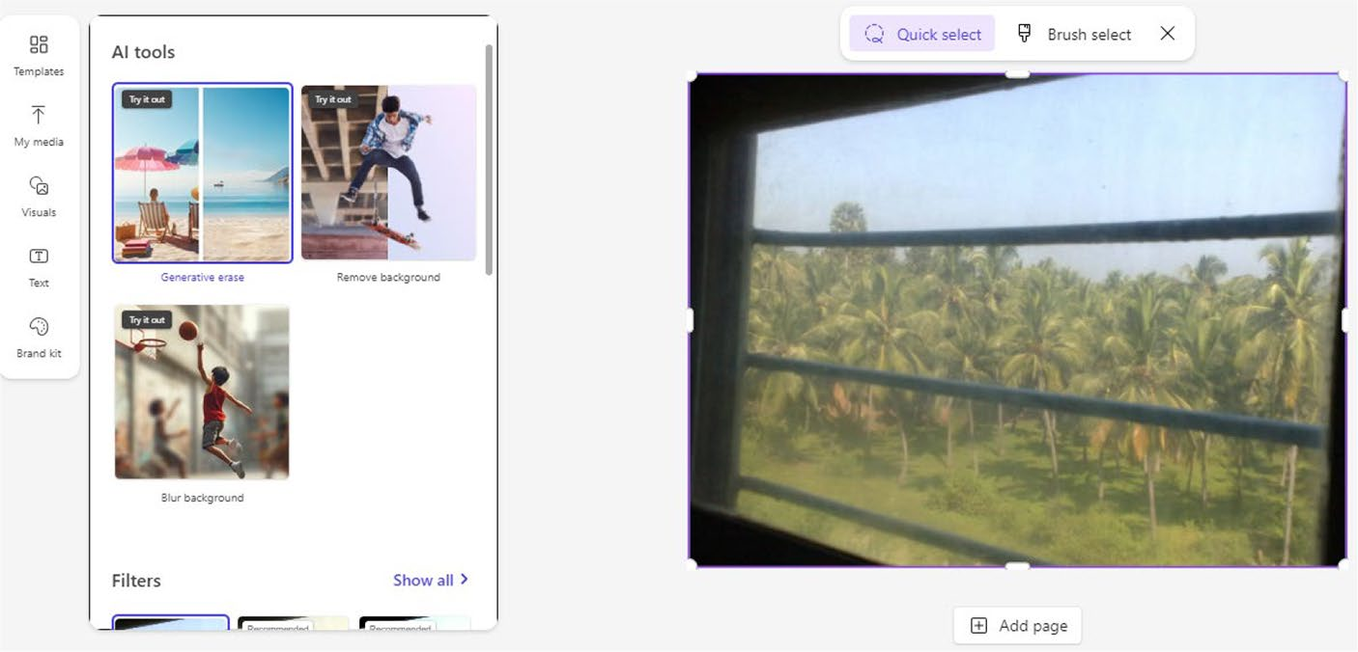

Figure 9-41. Erase contents quickly via AI
The next step is to select the Brush select option to pick the areas that
you need to erase from the original image. You can select the brush size
by dragging the slider. A preview of the erase tool will appear immediately
upon adjusting the brush size. You can observe from Figure 9-42 that the
two window bars have been selected, which will be generatively erased
after the competition of this process.

Chapter 9 Working With MiCrosoft Designer
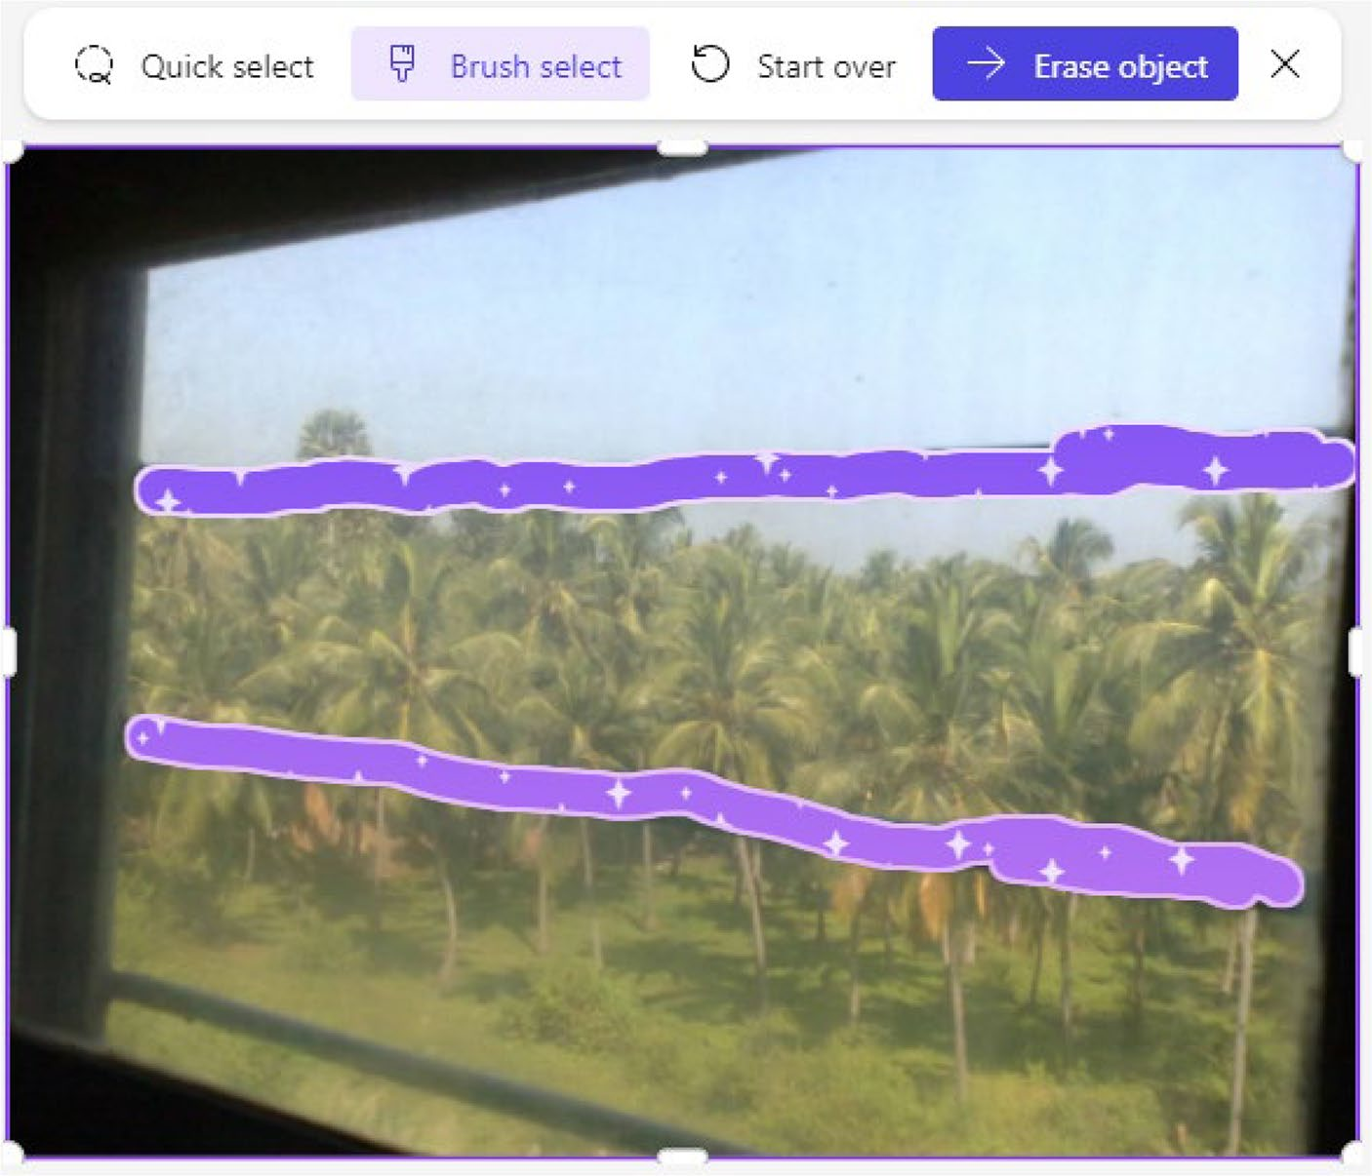

Figure 9-42. Select the portions that need to be erased
To erase the objects from the image, you need to select the Erase object button. The editor will display a progress indicator while the tool erases the items. The final preview of the image inside the Designer editor after
the implementation of Generative Erase looks as shown in Figure 9-43. You can observe that the Generative Erase functionality included with Microsoft Designer works great because it sharply removes the selected objects. You can observe the difference before and after the application of the Generative Erase.

Chapter 9 Working With MiCrosoft Designer
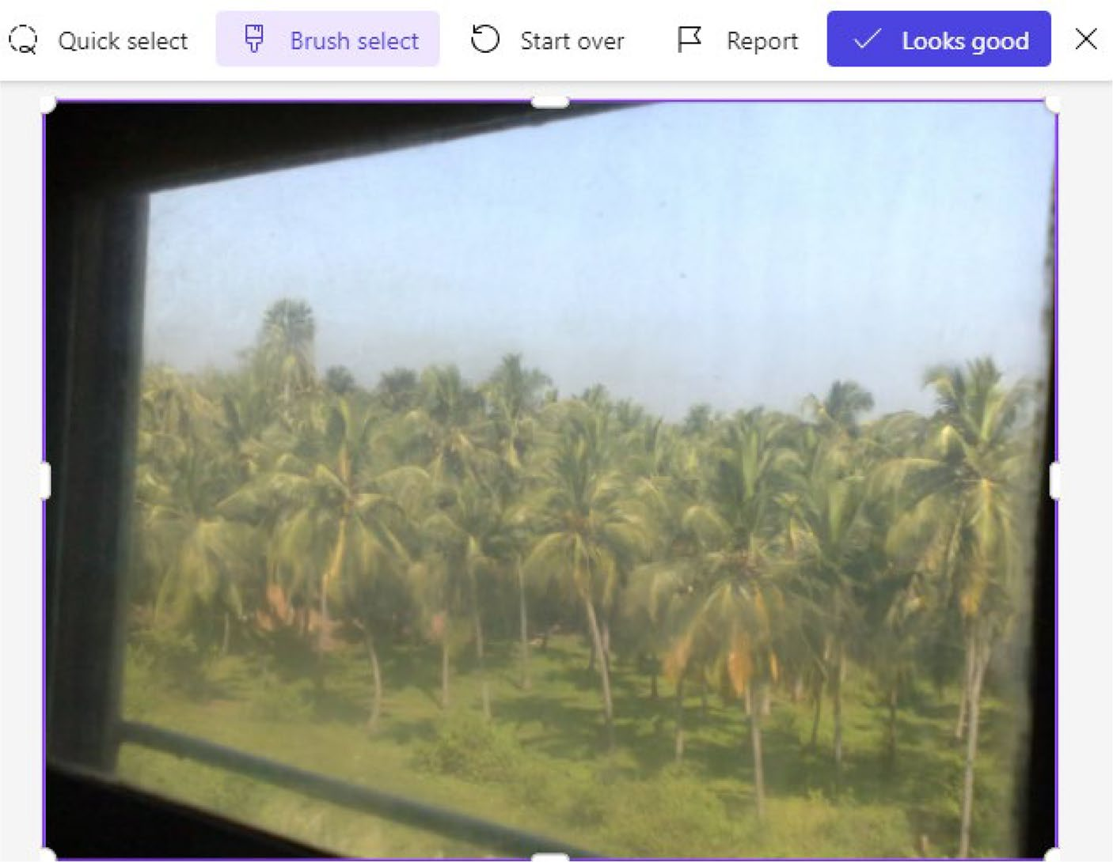

Figure 9-43. View the AI-erased image
If you select the Looks good button, the Designer editor without the
Generative Erase feature will appear on the screen.

Note Use the generative erase feature responsibly.
You can replace the image, remove background, crop, and make use of
various Image tools on the top navigation panel. In this way, you can erase
properties and items from images as per your requirements.

Chapter 9 Working With MiCrosoft Designer
Restyling Image
Microsoft Designer provides the ability to transform your image with various styles. The output will be a crazy new visual, which you can share on your social media pages to impress your friends. The first step is to select the Edit with AI tab and select the Restyle image option. You will see a warning message if you work with this module for the first time. The Restyle Image dashboard appears on the screen.
You can upload a photo by selecting the Image option. You have to select the Add image button and pick your image via any one of the
displayed sources as in Figure 9-44.
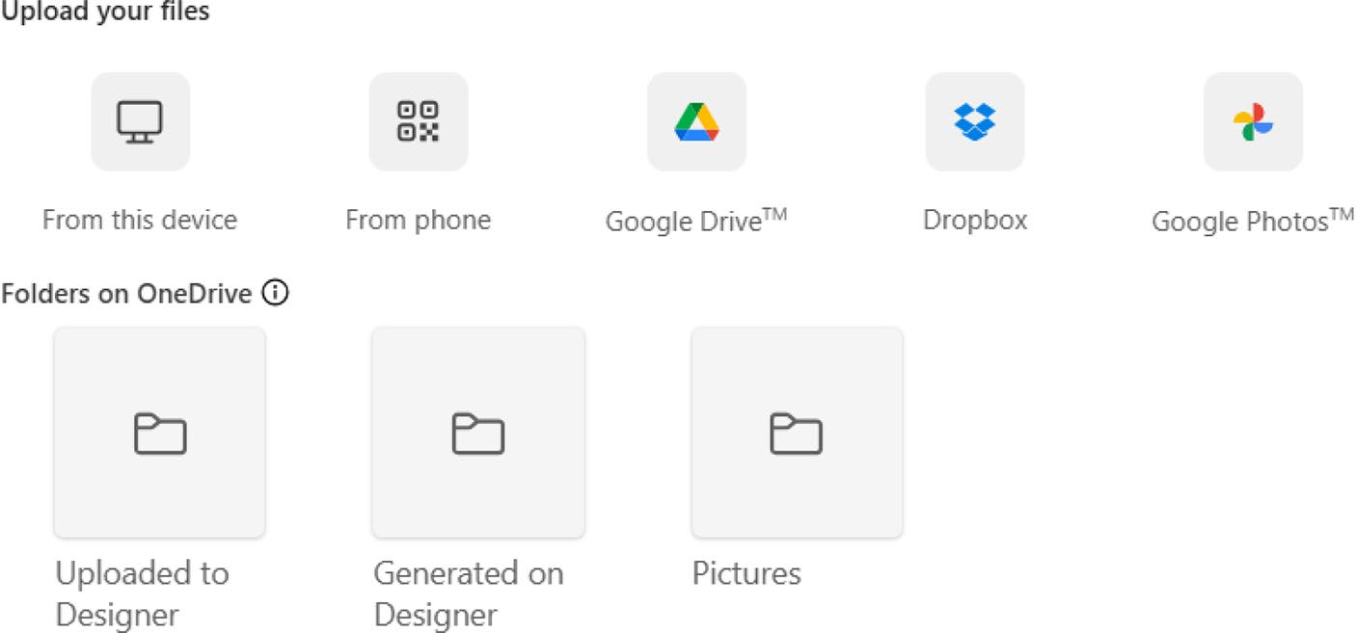

Figure 9-44. Import images from several sources
The tool automatically fetches all images from OneDrive and displays them in the menu upon selecting Image. You have to click the Select button after uploading an image. The next step is to select a style of your choice as
shown in Figure 9-45. Additionally, you can add objects or themes to your image by selecting the Background elements option.

Chapter 9 Working With MiCrosoft Designer
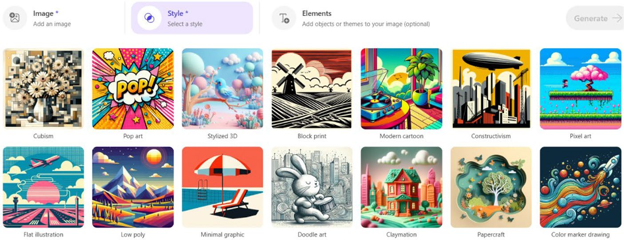

Figure 9-45. Pick a style of your choice
The final step is to select the Generate button. The Restyle Image
tool generates four images, and they are displayed under the My restyled
images tab. You can download and edit by selecting the relevant image.
If you select the Edit option, the image will appear inside the Designer
dashboard.

Note Microsoft has stated that the restyle feature might not work as expected if there are multiple people in a photo. please
check https://insider.microsoft365.com/en-us/blog/
transform-photos-with-restyle-image-in-microsoft-
designer.

Framing Images
The Frame image module included with Microsoft Designer enables you to
enclose images inside beautiful frames. You can decorate your own photo
or vacation images depending upon your choice. You should select the
Frame image option by selecting the Edit with AI tab. The Frame image
dashboard appears on the screen.

Chapter 9 Working With MiCrosoft Designer
You can add an image, element, and style from the dashboard. Alternatively, you can also manually select a prompt template of your choice from the Frame image dashboard. You will be prompted to upload an image upon selecting a template. Let’s upload a scenic image, which we
captured during a picnic trip shown in Figure 9-46.
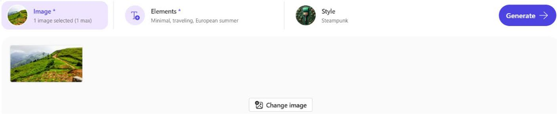

Figure 9-46. Add an image to create a framed image
The Elements values are automatically populated along with the relevant selected style. You can modify the style if required at this step. Let’s select the Generate button to view the framed images in action.
Microsoft Designer generates either three or four images. You can save the image to your PC by clicking the relevant image and selecting the Download button. The image can be modified with elements and filters upon selecting the Edit button. You can also provide the specific parameters for the frame design like plants, trees, and much more in the prompt. You can report bugs by selecting the Send feedback link after opening the image preview. Sometimes, the text will not be added in a frame when you edit via Microsoft Designer. This is the limitation of AI and the corresponding DALL·E model.

Note the Microsoft Designer user interface changes constantly. You
will notice a new Designer home page once in a while. however, the
basic working will be the same as discussed in this chapter.

Chapter 9 Working With MiCrosoft Designer
If you had worked with Microsoft Designer before, you would have
seen the Brand Kit module. The newly updated Designer app is not
included with a brand kit. However, you can edit the existing brand kit via
the Designer editor dashboard. You have to select the Brand kit icon from
the left navigation panel. The Designer displays all the previously created
brand kits. You have to point your mouse over the kit and select the Edit
Brand option. This feature leverages Copilot to create customized brand
kits. Microsoft is continuously adding new improvements, and you should
check back regularly to observe any change in the brand kit creation
process. You can create stunning emojis and clip arts by selecting the
relevant option from the Microsoft Designer home page and providing the
suitable prompts. Alternatively, you can create images, stickers, avatars,
invitations, icons, emojis, clip arts via the Microsoft Designer Android and
iOS apps.

Disclaimer this chapter includes several screenshots of ai-generated images that are captured via Microsoft Designer. the app employs advanced ai and Copilot technologies to generate images. these images have no resemblance to any living persons or characters and are used for the sake of explanation and educational purposes only.

Summary
In this chapter, you’ve learned the usage of each module included with
Microsoft Designer in detail. This chapter examined the process involved
in the generation of images, social posts, stickers, invitations, wallpapers,
monograms, and much more. You have learned the process involved in

Chapter 9 Working With MiCrosoft Designer
the creation of greeting cards. You have also learned about the creation of collages. This feature will be useful if you have multiple images that need to be converted into a single image. You have also learned about the transformation of your image into attractive visuals. You are now in a position to frame images and erase the image objects via AI. The background removal covered in this chapter also plays a key role in your daily life. You will find Microsoft Designer very useful since the app can create attractive visuals that you can showcase on social media platforms. In the next chapter, you will learn the usage of Copilot in Microsoft 365.

CHAPTER 10

Using Copilot

in Microsoft 365
Microsoft 365 is a full-blown web-based Office application comprising
core apps such as Word, Excel, PowerPoint, OneNote, and Teams. The
Copilot support was rolled out to Microsoft 365 apps on March 16, 2023.
The purpose of Copilot integration with Microsoft 365 is to simplify the
work life, thereby enhancing productivity. Even though Microsoft 365 is
oriented for Enterprise users, individuals and their family members can
consume Office apps over the cloud with a suitable subscription. You can
easily create beautiful articles for your blog and automate the creation of
presentations using Copilot. In this chapter, you will learn the usage of
Copilot in Microsoft 365 apps.

Getting Started
The first point you need to understand is that you will not be able to
leverage the benefits of Copilot immediately after the purchase of a
Microsoft 365 subscription. You need a valid license of Microsoft 365
Copilot, which is available as an add-on package if you are an Enterprise
user. However, the simplest way to work with Copilot in Microsoft 365 for
consumer users is to purchase a Copilot Pro subscription if you have a
valid license of Microsoft 365. Sometimes, manufacturers bundle Microsoft

© Anand Narayanaswamy 2024 205
A. Narayanaswamy, Microsoft Copilot for Windows 11, Inside Copilot,

Chapter 10 Using Copilot in MiCrosoft 365
365 with their devices. You can check the presence of Microsoft 365 apps on your PC by selecting the Outlook (new) icon from the Windows 11 Taskbar. You will see the relevant icons from the navigation panel located on the left side. This is the best way to automate Office apps such as Word, Excel, and PowerPoint. You can opt for a one-month free trial of Copilot Pro to begin with. Let’s first examine the steps involved with the purchase of Copilot Pro.

Understanding Copilot Pro
Copilot Free helps you to fetch information and create/rewrite content, including performing basic Windows tasks. You should note that Copilot features are subject to change any notification. The paid version offers all the modules included with the Copilot Free in addition to the ability to create your own GPTs, which is retired by Microsoft in July 2024. However, the paid chatbot delivers responses quickly even during peak times. Copilot Pro also provides support for faster image creation and retails $20 per user/month. You can try Copilot Pro for one month to test-drive the features and functionalities. Copilot Pro is designed to improve not only productivity but also creativity with enhanced image rendering.

Copilot Pro Purchase Process
To work with Copilot Pro, you need to pay for the subscription. The free 30-day trial package enables you to test-drive all the features before arriving at the purchase decision.
The first step is to navigate to www.microsoft.com/en-us/microsoft-
copilot and select the Try Copilot Pro button located under the Copilot Pro column. You will be prompted to switch over to the Microsoft Store as per your region. For instance, if you are located in India, you should select

Chapter 10 Using Copilot in MiCrosoft 365
the Go to India – English button. You will now view a new page,
www.microsoft.com/en-in/store/b/copilotpro, which provides a
detailed overview and tabulated differences between the free and paid
versions. You should select the Start your free trial button to place an order
for the free trial.

Note the Copilot pro purchase process mentioned in this section is subject to change as per the discretion of Microsoft.
Alternatively, you can select the Get Copilot Pro button (Figure 10-1)
from the Copilot dashboard by selecting the Copilot in Windows (preview)
icon from the Windows 11 Taskbar.
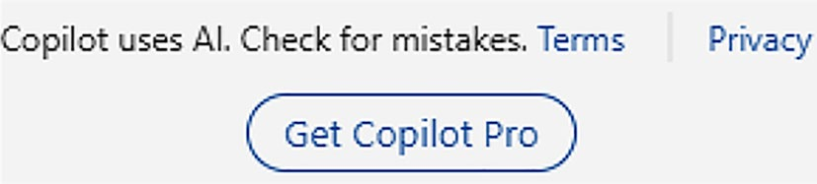

Figure 10-1. Buy Copilot Pro directly from Windows 11
Microsoft Copilot will display the checkout page, as shown in
Figure 10-2, from where you can verify and confirm your order. The page
specifically mentions about the free trial with a mention that you will be
charged $20 every month upon ending of the free trial. Hence, you have to
provide the required payment information to work with the trial version.

Chapter 10 Using Copilot in MiCrosoft 365
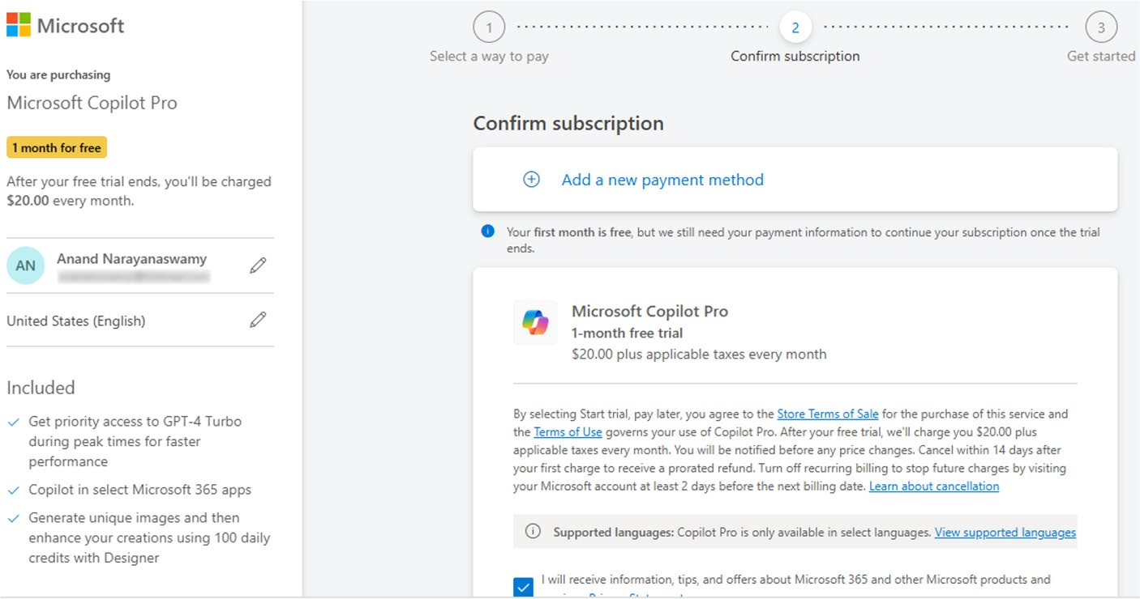

Figure 10-2. Complete Copilot Pro checkout process

Note You can chat with the Microsoft support team from the
checkout page in case you encounter an error during the checkout
process.
If you are located outside the United States, you have to change your country by selecting the relevant drop-down located on the left side of the
checkout page. You need to select the Country (Figure 10-3) from the drop-down and select the Confirm button.

Chapter 10 Using Copilot in MiCrosoft 365
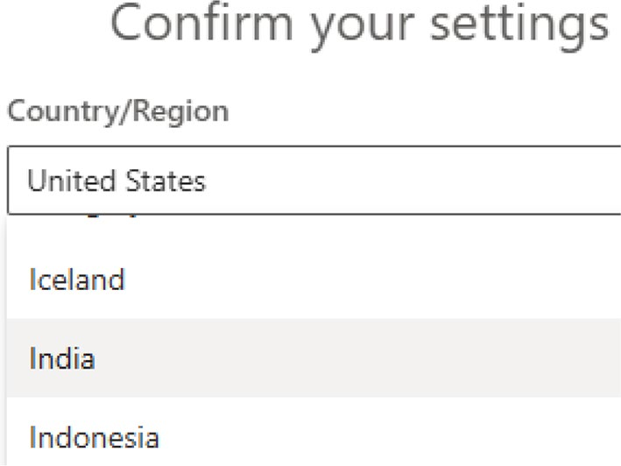

Figure 10-3. Pick your country before purchase
The next step involves adding your payment information by clicking
the Next button. You have to add the required payment information by
clicking the Credit card or debit card row. The process involves entering
your payment information along with address details. You have to
complete the steps outlined in the Copilot dashboard to finalize the
purchase. This involves selecting the Start trial, pay later button. You will
see a confirmation message and email, which will inform you about the
next steps.
The Copilot Pro checkout page is designed to automatically charge
in recurring mode. However, you can cancel the recurring standing
instruction before the first charge. You will receive an email with additional
information about Copilot Pro, including the steps required to cancel
the subscription. Alternatively, you can install the Microsoft Copilot app
from the Google Play Store and Apple App Store to purchase a Copilot Pro
subscription.

Working with Copilot in Microsoft 365
To work with Copilot in Microsoft 365, you require access to the Outlook
(new) app in Windows 11.

Chapter 10 Using Copilot in MiCrosoft 365

Tip if you are still using the old Mail app in Windows 11, then you
can activate the new outlook app by sliding the New Outlook option
located on the top-right side.
The Outlook app can be located on the Windows 11 Taskbar in between Microsoft Edge and Microsoft Store icons. The location could change in case you have rearranged or unpinned the icon from the Taskbar. In case you had unpinned the app from the Taskbar, you can use the Windows 11 search to locate the app. You will be able to access the relevant Microsoft 365 apps from the navigation panel on the left side.

Note if you are unable to view office app icons inside the outlook
app, then you can navigate to onedrive.com and create the required
document or presentation. You should log in to oneDrive using the
same Microsoft credentials you used with your Copilot pro purchase.

Using Copilot in Word
To work with Copilot in Word, you should select the Outlook (new) icon
from the Windows 11 Taskbar as shown in Figure 10-4.
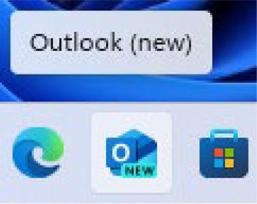

Figure 10-4. Start from here

Chapter 10 Using Copilot in MiCrosoft 365
You will see the Word icon in the navigation panel located on the left
side as displayed in Figure 10-5. An alternate way to work with Copilot in
Word is to directly navigate to www.microsoft365.com/launch/word, from
where you can work with Copilot.
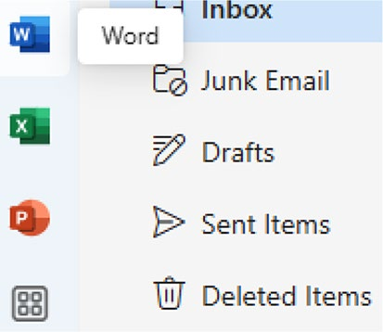

Figure 10-5. Wordify with Copilot
The Microsoft 365 dashboard opens upon selecting the Word
icon located on the left-side navigation panel. You will see a series of
explanatory notes as a welcome message. These notes provide a short
introduction about the importance of Copilot in Microsoft 365. You
can either create a new document or open an existing Word document.
Let’s create a new Word document (Figure 10-6) by selecting the Blank
document icon.
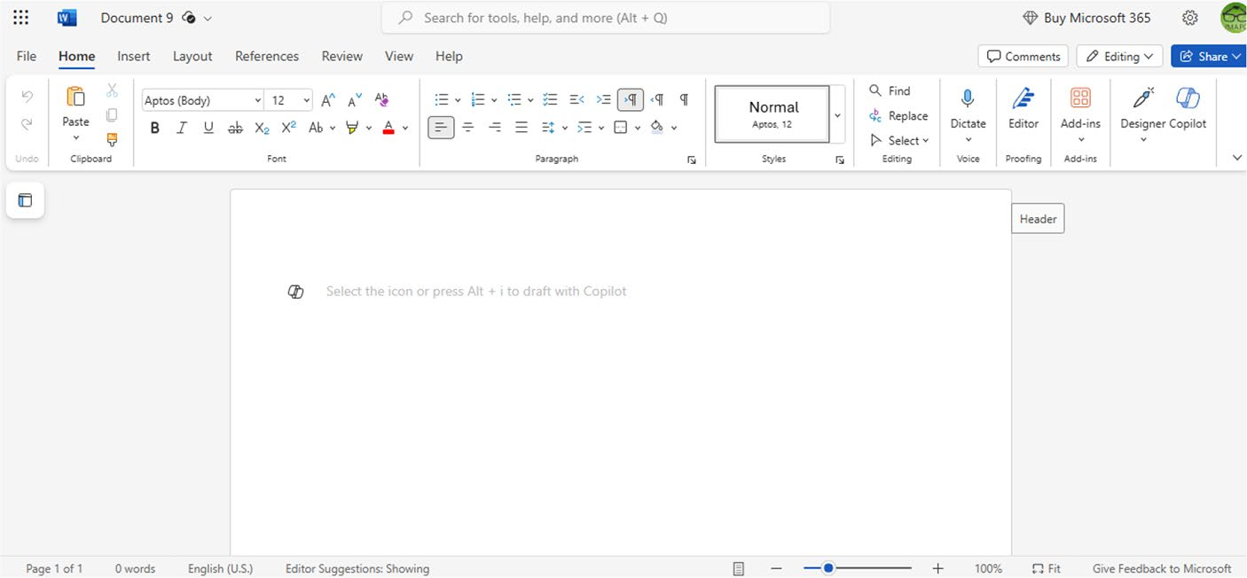

Figure 10-6. Start automating Word

Chapter 10 Using Copilot in MiCrosoft 365
To work with Copilot, you should click the gray-colored Copilot icon as
shown in Figure 10-7.

Figure 10-7. Start your Copilot journey
You will be able to view the colored Copilot icon (Figure 10-8) if you point your mouse over the icon.


Figure 10-8. Copilot kick-start signal
Alternatively, you can also make use of the Alt+i keyboard shortcut to work with Copilot. If you select the Copilot icon, you will see a prompt
dialog box as shown in Figure 10-9.
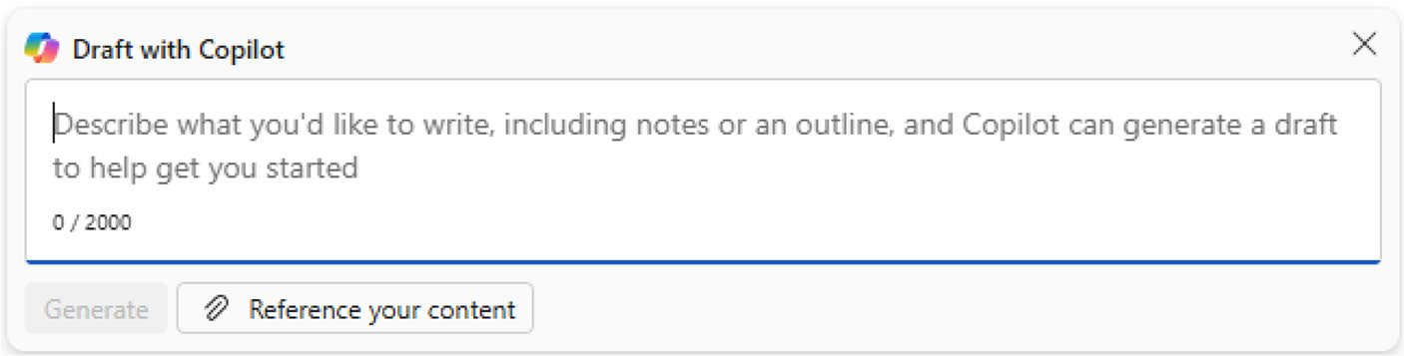

Figure 10-9. Prompt Word
You have to provide a suitable prompt, which can be up to 2000 words
as displayed in Figure 10-10.

Chapter 10 Using Copilot in MiCrosoft 365
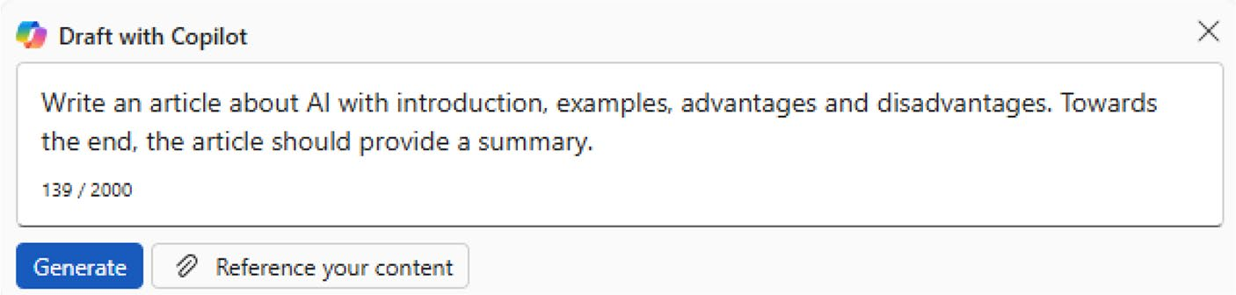

Figure 10-10. Ask Copilot to do this with Word
The prompt is about the creation of an article related to AI with
advantages, disadvantages, and conclusion. Copilot shows the progress as
shown in Figure 10-11.

Figure 10-11. Wait until Copilot generates content
In Figure 10-12, you can view how nicely Copilot generates and
displays the article with the required length for improved SEO. You can
also ask Copilot to generate long articles if required.
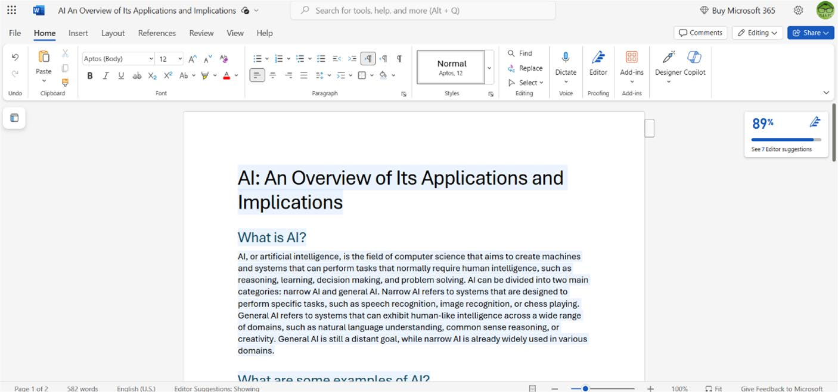

Figure 10-12. Read the Copilot-generated article

Chapter 10 Using Copilot in MiCrosoft 365
Copilot not only generates the article but also the editor score
(Figure 10-13), which is 89% for our article. The spelling and grammar should be resolved to make the score 100%.
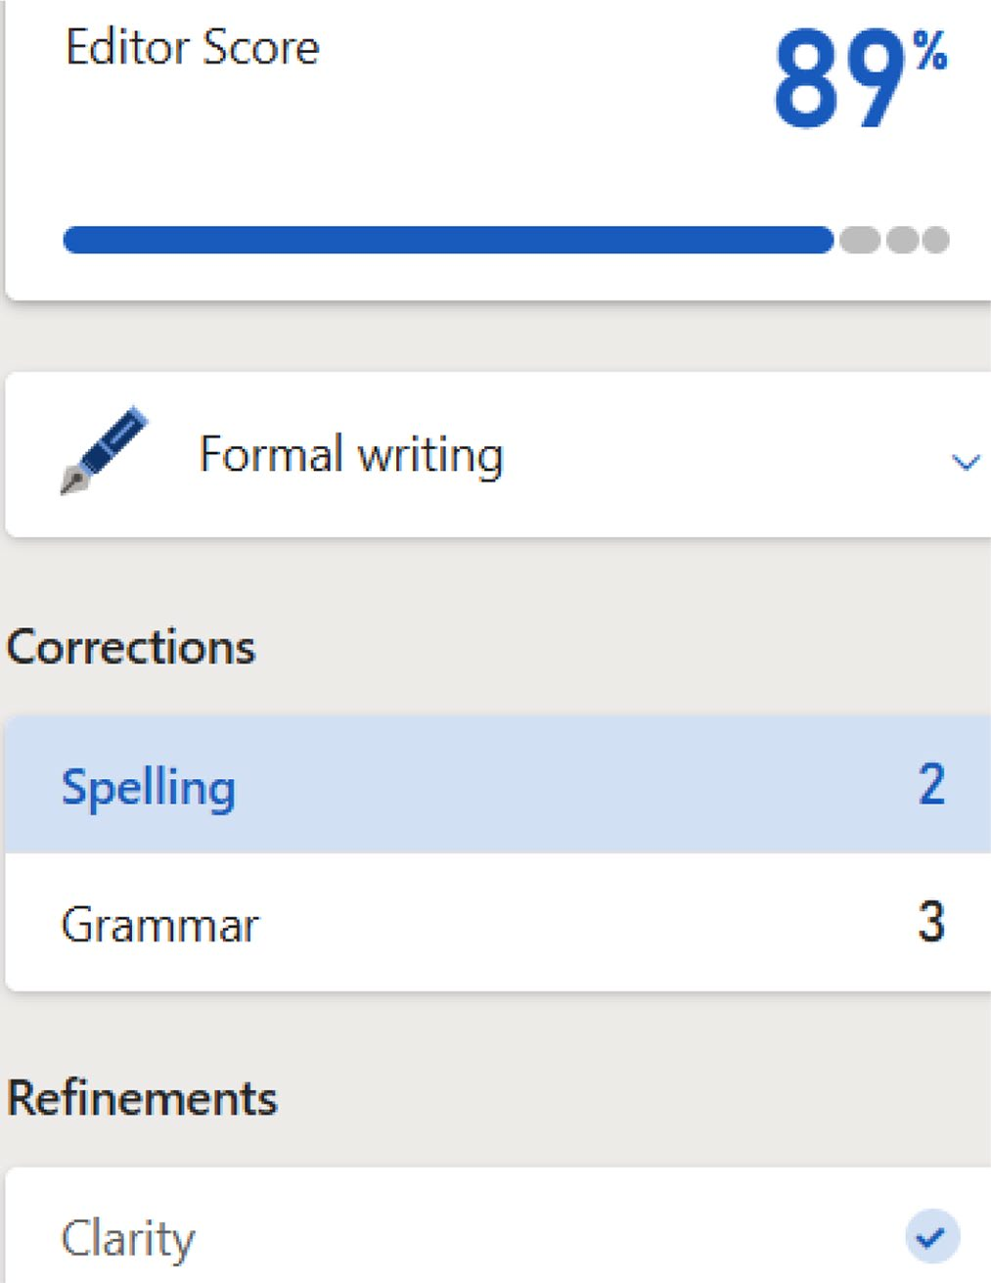

Figure 10-13. Make the article perfect
The entire process is automated. If you select the Spelling option from the editor, Copilot takes you to the relevant location inside the content
with spelling suggestions as shown in Figure 10-14.

Chapter 10 Using Copilot in MiCrosoft 365
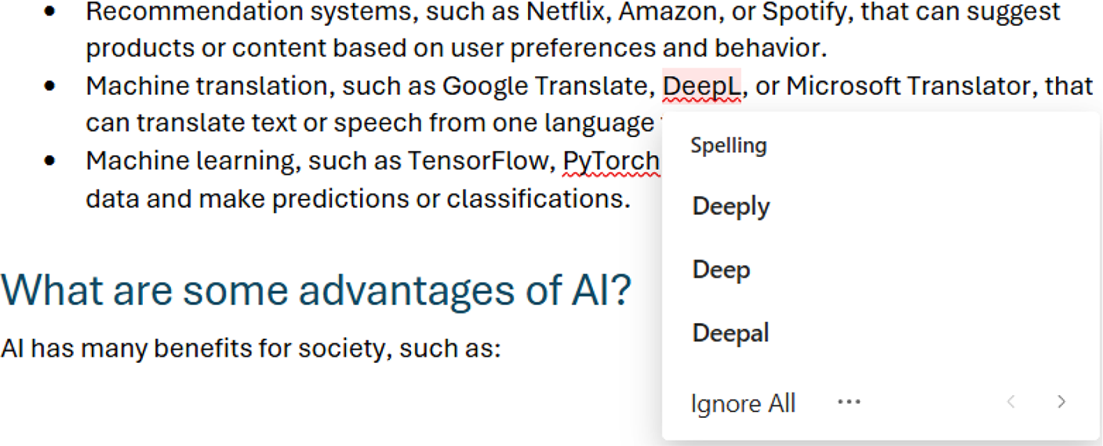

Figure 10-14. Rectify mistakes on the go
If you select Grammar, Copilot points out the relevant word that
requires correction as displayed in Figure 10-15. You should note that
these features are part of an advanced editor, which will be available only
for seven days from the date of editor upgradation.
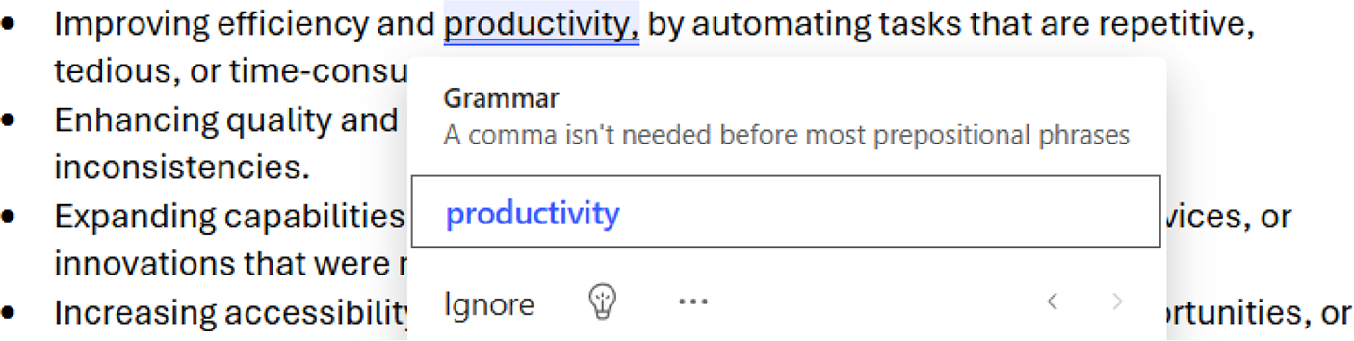

Figure 10-15. Don’t worry about English grammar
Copilot in Word is also capable of generating content in tabular format
as shown in Figure 10-16.

Chapter 10 Using Copilot in MiCrosoft 365
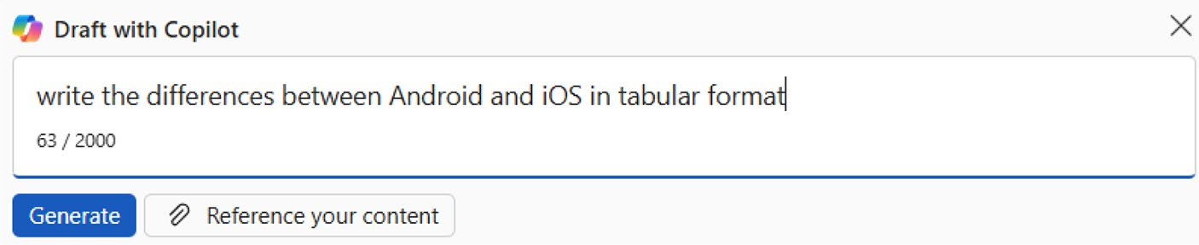

Figure 10-16. Asking Copilot to generate tabular content
In Figure 10-17, you can clearly visualize how Copilot displays the relevant information in tabular format.
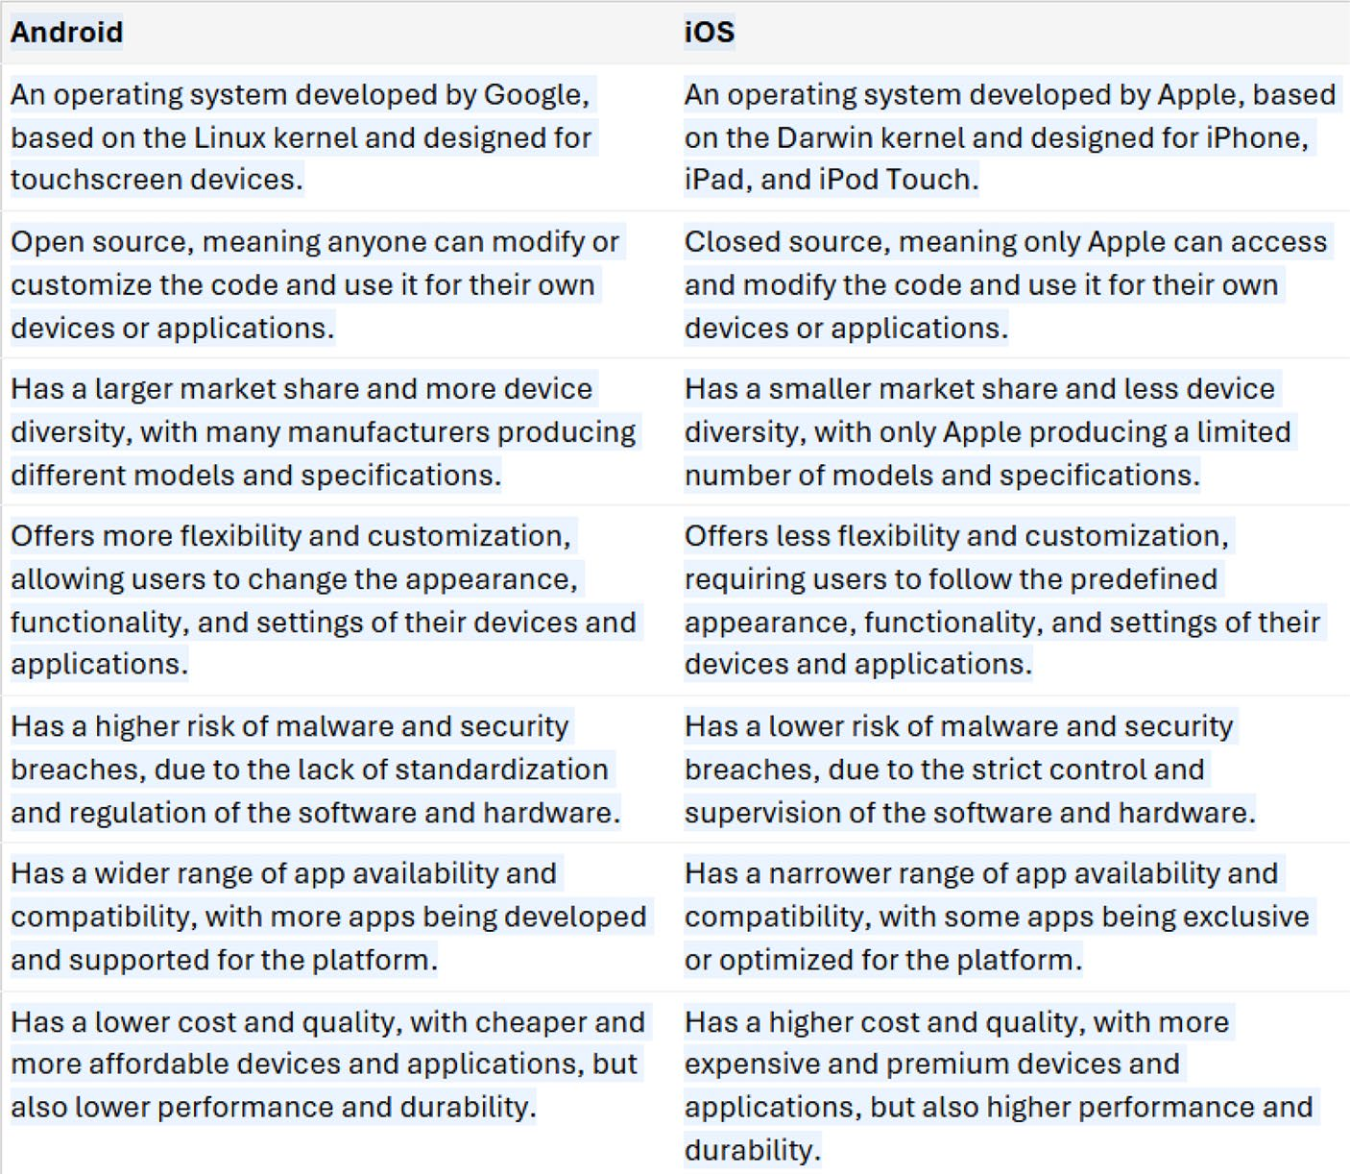

Figure 10-17. Copilot simplifies complex content creation

Chapter 10 Using Copilot in MiCrosoft 365
You should also note that Copilot in Word automatically summarizes
content by drilling down large files. Let’s load a preloaded content and try
to summarize the content. The first step after loading the file is to select the
Copilot icon from the Word Toolbar. You will see the Copilot interface as
shown in Figure 10-18.
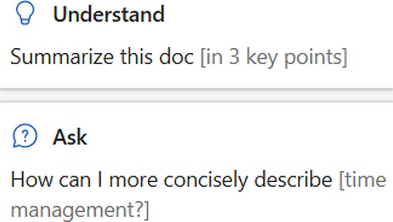

Figure 10-18. Easily summarize a document
The prompt is to summarize the content in Chapter 11, which has
been loaded and active on the Word editor. You should note that Copilot
in Word displays several progress indicators before finally dropping the
summarized content as shown in Figure 10-19.
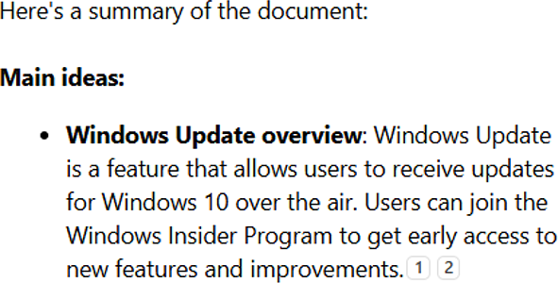

Figure 10-19. View the summarized content
Copilot also displays automated suggestions below the generated
content, which you can make use of if required. It’s so easy not only to
create quality content in any format but also summarize an existing
document with Copilot in Word. You can try by loading different
content-loaded Word files.

Chapter 10 Using Copilot in MiCrosoft 365

Note Microsoft provides access to a premium editor for free with
advanced writing assistance. You can try the editor for seven days
and then upgrade to Microsoft 365 for Copilot for unlimited premium
suggestions.

Using Copilot in Excel
Microsoft Excel is a popular spreadsheet application used by several business and corporate entities, including individuals. Copilot in Excel automates the work involved with the spreadsheet quickly. You can easily create charts, PivotCharts, and PivotTables using Copilot. However, there are basic requirements that you need to follow before starting to work with Copilot in Excel. The required data for Copilot analysis should be provided as an Excel table. You can add data to the workbook, but you should format it as a table. The data should also be on a supported range. Moreover, the relevant Excel workbook should be on OneDrive or SharePoint.
To work with Copilot in Excel, you should first select the Excel icon from the navigation pane located on the left side using the Outlook app. Alternatively, you can also select the Excel icon from within the Microsoft 365 app. The first step is to create a blank workbook as shown in
Figure 10-20.
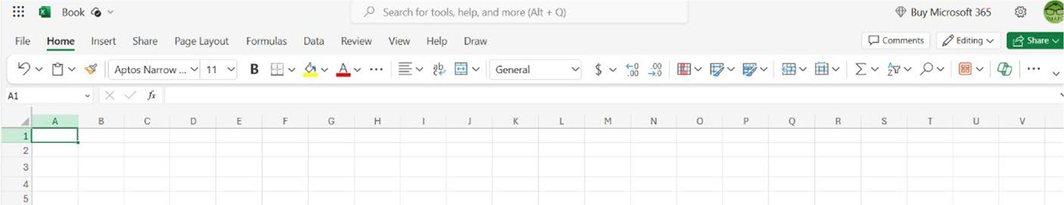

Figure 10-20. Start Copiloting from here

Chapter 10 Using Copilot in MiCrosoft 365
The Copilot icon is located on the Toolbar as shown in Figure 10-21.
You can notice the difference in the icon color.
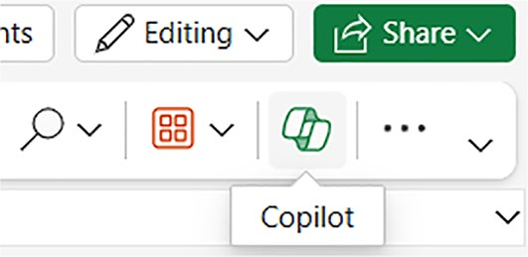

Figure 10-21. Hit the Copilot icon when ready
Let’s open a template included in Excel for the purpose of our
discussion (Figure 10-22) and ask Copilot to calculate the total actual work.
As you can observe, Copilot displays the result on the dashboard.
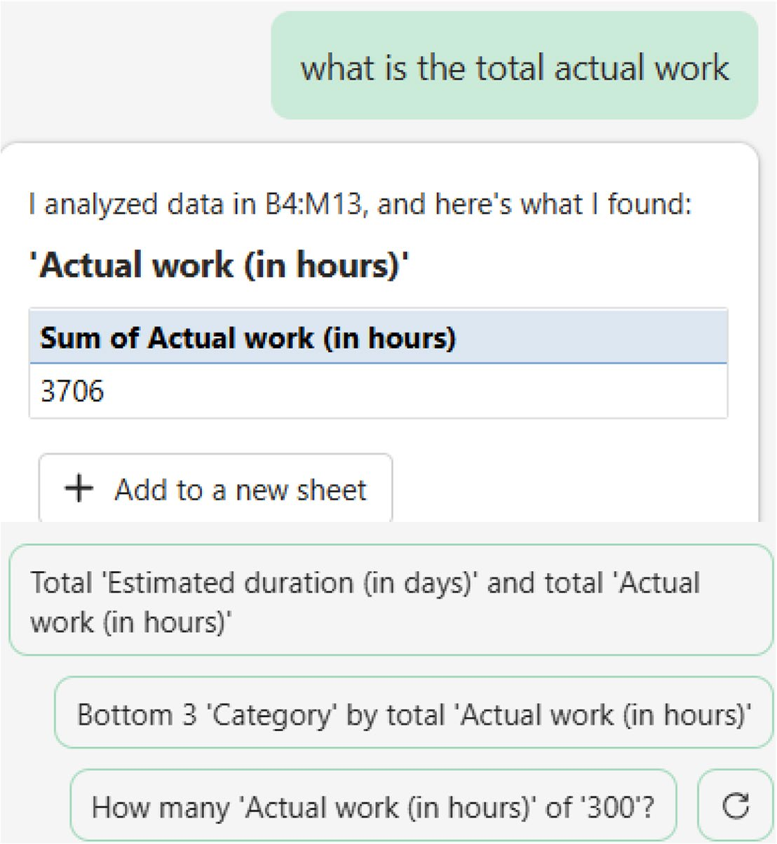

Figure 10-22. Ask Copilot with questions

Chapter 10 Using Copilot in MiCrosoft 365
You can also ask Copilot to summarize the document. You can observe that Copilot in Excel clearly displays the summary in graphical format
together with a crisp explanation as displayed in Figure 10-23. You can also copy the generated summarized copy and use it elsewhere.
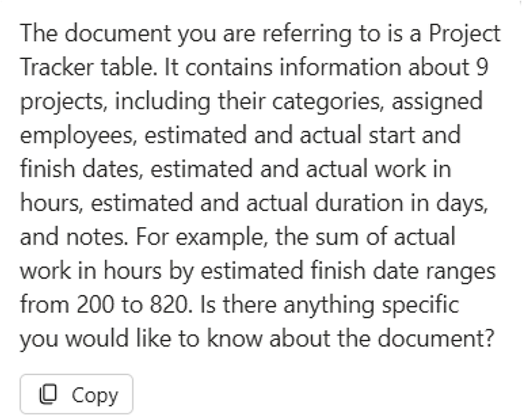

Figure 10-23. Summarize the Excel workbook with Copilot
Copilot in Excel will be useful for those involved in the accounting profession since they can easily evaluate the Excel workbook quickly. You can also add formula columns, highlight, sort, and filter the relevant Excel workbook. Microsoft recommends that the query you provide in Copilot should be descriptive for efficient results.

Note Create a blank workbook by opening the excel app within
Microsoft 365. You should add name, Marks as column names. the
next step is to add and select the required data. select insert ➤ table
and choose oK from the displayed dialog. switch back to the home
tab and select the Copilot icon. provide a prompt like How many
marks did Arun scored and observe the output.

Chapter 10 Using Copilot in MiCrosoft 365
Copilot in PowerPoint
Microsoft PowerPoint is a powerful presentation tool using which you can
create stunning presentations. In addition to slides, you can add images,
videos, and much more to amplify your content. Copilot is designed with
an ability to automate all complex tasks associated with the creation of a
presentation. You just need to provide a suitable topic, and Copilot will
create all the required content with stock images.
To work with Copilot in PowerPoint, you should select the PowerPoint
icon from the left-side navigation panel of either the new Outlook app
or Microsoft 365. Let’s get started by creating an empty presentation by
selecting the Blank presentation option. You will see a screen as shown in
Figure 10-24.
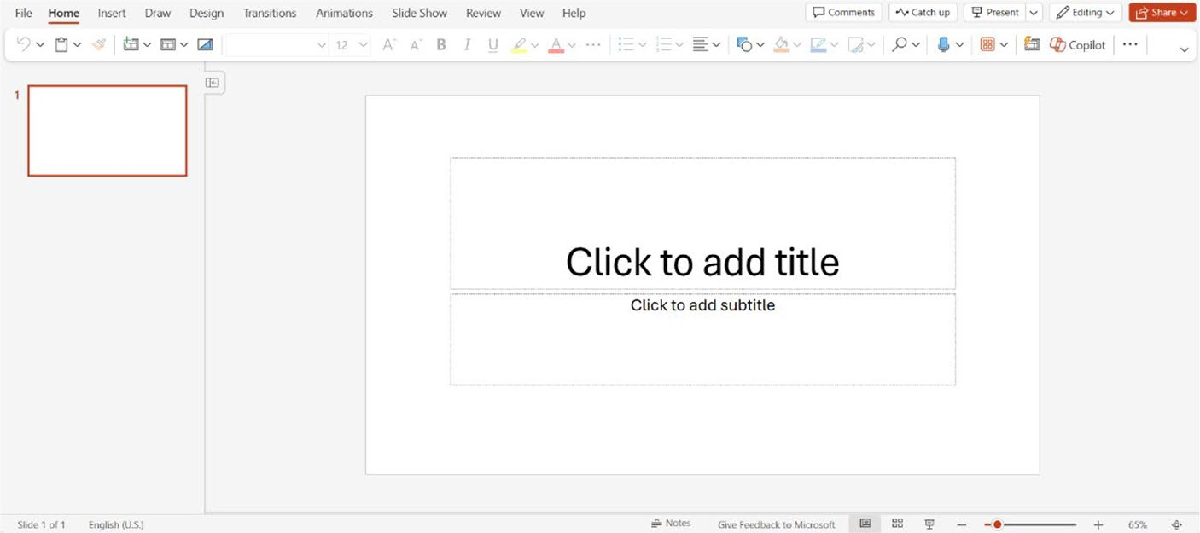

Figure 10-24. Kick-start your Copilot journey with PowerPoint
The next step is to select the Copilot icon from the top Toolbar. You will
see a user interface as shown in Figure 10-25.

Chapter 10 Using Copilot in MiCrosoft 365
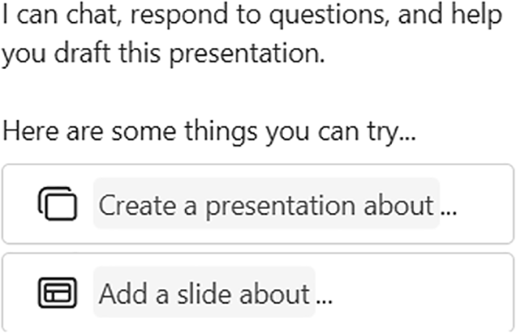

Figure 10-25. Decide what to do with Copilot
You can now ask Copilot to create a new PowerPoint presentation by
providing a suitable prompt. If you select the first option from Figure 10-25,
Copilot displays a prompt window (Figure 10-26) with relevant default content. You just need to provide the topic for which you need a presentation.
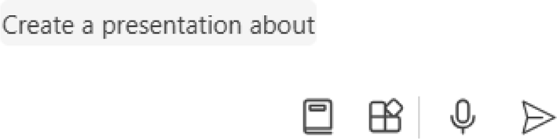

Figure 10-26. Supply your prompt here
Let’s ask Copilot to create a PowerPoint presentation about the evolution of computers. A confirmation message will be displayed when Copilot completes the creation of the presentation. As you can observe
from Figure 10-27, Copilot intelligently creates slides with relevant content and images.

Chapter 10 Using Copilot in MiCrosoft 365
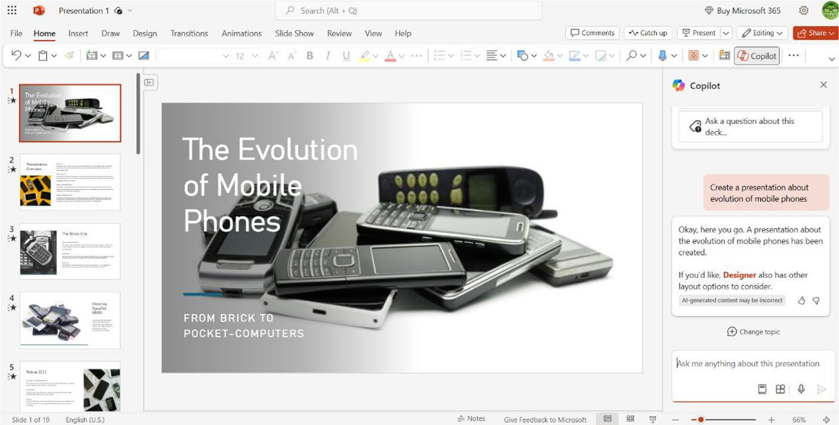

Figure 10-27. Copilot creates a stunning automated presentation
You can also ask a question about the active presentation by selecting
the relevant option from the right-side navigation. The Ask a question
about this deck option appears only after the creation of the slide. You can
add additional slides by providing a specific prompt. Copilot provides
endless possibilities in your quest to create stunning presentations.
Create Presentation from File
With Copilot in PowerPoint, you can easily create presentations from a
Word file. You just need to point out the location of the Word file, and
Copilot will complete the complex task associated with the creation of the
presentation. The main point to note is that you should create a link to the
Word file on OneDrive to instruct Copilot to create a presentation. You can
use Word files directly from Copilot in Excel only if you have a Microsoft
365 Copilot subscription on top of a Microsoft 365 paid license.

Note Copilot in powerpoint creates presentations from files that are available inside your oneDrive personal workspace.

Chapter 10 Using Copilot in MiCrosoft 365
For the purpose of this chapter, we’ve used a Word file that’s available inside OneDrive. You can reference the Word file in Copilot by creating a shareable link from OneDrive. This can be done by navigating to OneDrive – Personal and locating the Word file. You should then right- click the file name and select the Share option from the pop-up menu as
shown in Figure 10-28.
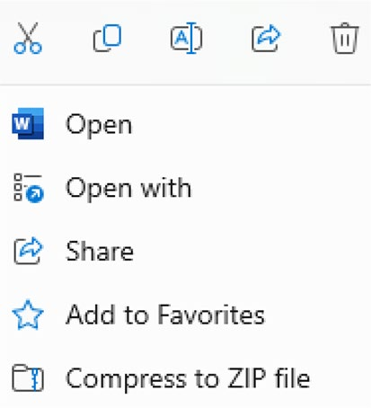

Figure 10-28. Sharing the OneDrive file
The next step is to select the Copy button from the Copy link section as
displayed in Figure 10-29.


Figure 10-29. Grab the OneDrive file link
You will see a new dialog with the relevant link to the Word file. You should copy the link and create a blank PowerPoint presentation using Microsoft 365. The next step is to provide a prompt to enable Copilot to create a PowerPoint file from the Word file. If you don’t know the prompt,
you can easily find it out by clicking the View prompts (Figure 10-30) icon from the Prompt textbox.

Chapter 10 Using Copilot in MiCrosoft 365
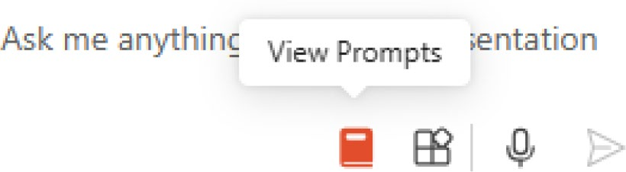

Figure 10-30. View automated prompts
You will see options to create, edit, and ask Copilot as shown in
Figure 10-31.
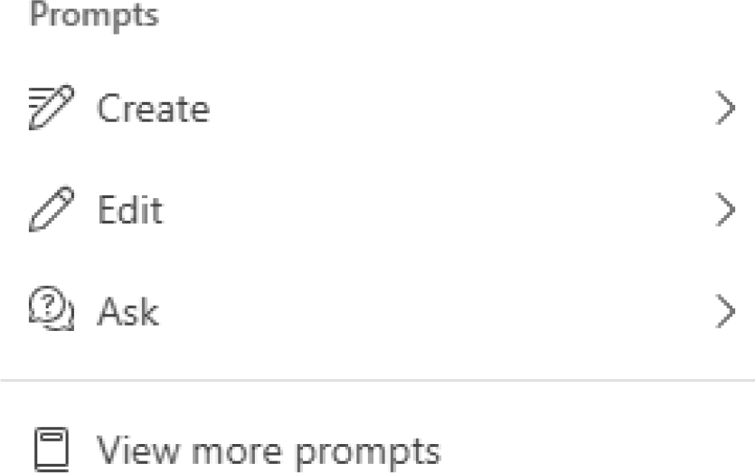

Figure 10-31. Decide the work with Copilot
In Figure 10-32, you can see several prompts that are automatically
displayed upon selecting the Create option.
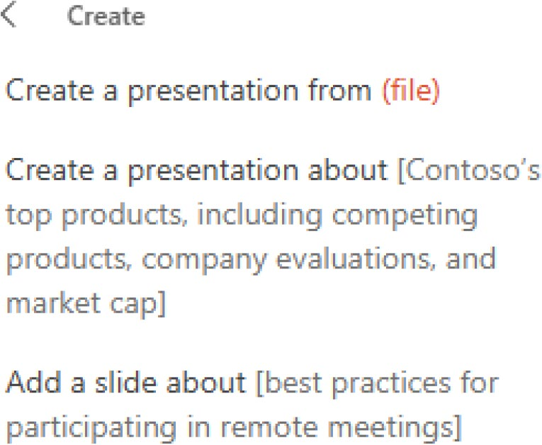

Figure 10-32. Pick an action of your choice

Chapter 10 Using Copilot in MiCrosoft 365
If you select the first prompt, then it will be automatically placed inside
the textbox as displayed in Figure 10-33.
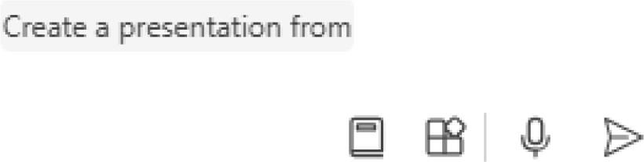

Figure 10-33. Type your context here
You can now paste the OneDrive share link, and the PowerPoint presentation will be created upon selecting the Send button. Copilot in
PowerPoint displays the generated presentation (Figure 10-34), which you can modify depending on your requirements. You can change fonts, add images, and much more. As you can observe, Copilot has created 25 slides with the content scraped from our Word file.
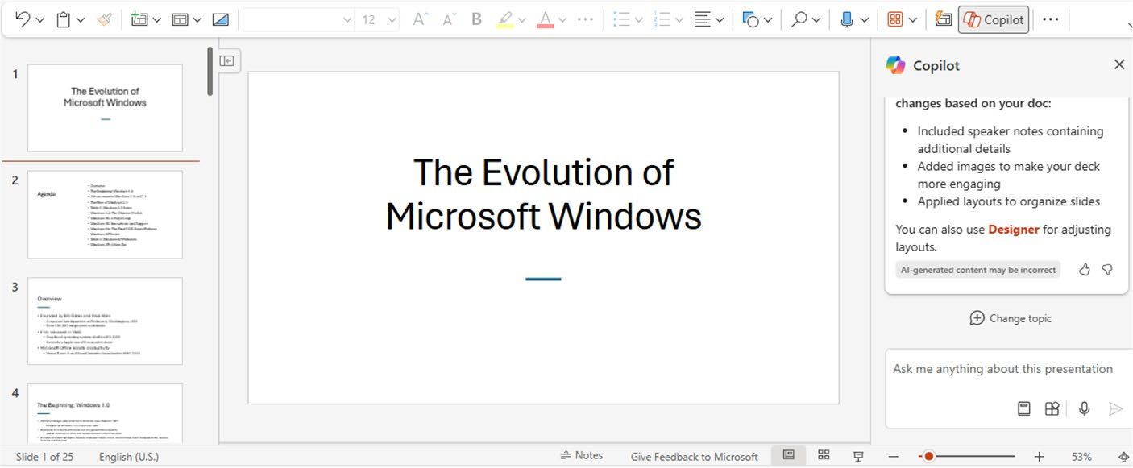

Figure 10-34. View the generated PowerPoint presentation
The time required to create the presentation depends upon the length of the content in the Word file. You will see a progress bar as shown in
Figure 10-35.

Chapter 10 Using Copilot in MiCrosoft 365
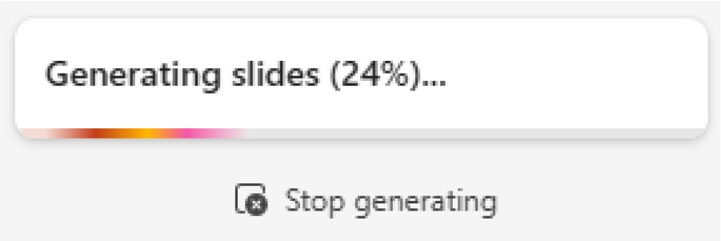

Figure 10-35. Copilot displays progress

Using Automated Prompts
You can view additional prompts by selecting the View more prompts
option in Figure 10-31. Copilot in PowerPoint displays the available
prompts from Copilot Lab as shown in Figure 10-36.
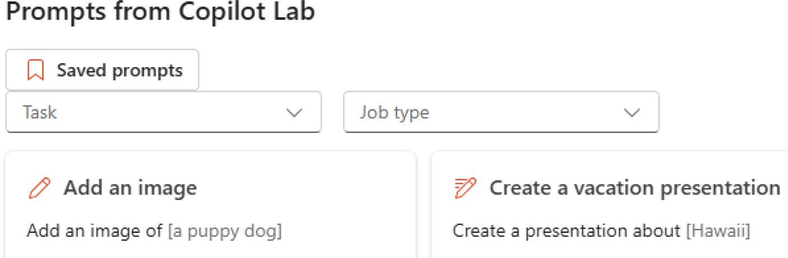

Figure 10-36. Work intelligently with Copilot
The prompts are related to PowerPoint, and you simply need to fill
up the blanks to enable Copilot to create content. You will find these
automated prompt ideas useful if you don’t have any idea about the usage
of Copilot in PowerPoint.
Microsoft Copilot is available with commercial data protection to the
Microsoft 365 mobile app for Android and iOS platforms. This includes
Microsoft 365 integration in Word and PowerPoint mobile. You can now
directly compose content and create presentations via Copilot using your
Android device.

Chapter 10 Using Copilot in MiCrosoft 365
You can ask Copilot to create a new presentation or slide or organize/ summarize an existing presentation. Do you want to know the key slides in a presentation? You just need to open the relevant presentation and select the Show key slides prompt. Let’s try to create a presentation about an activity. You can’t edit the automated prompts but can provide a suitable
context. The resulting output looks as displayed in Figure 10-37.
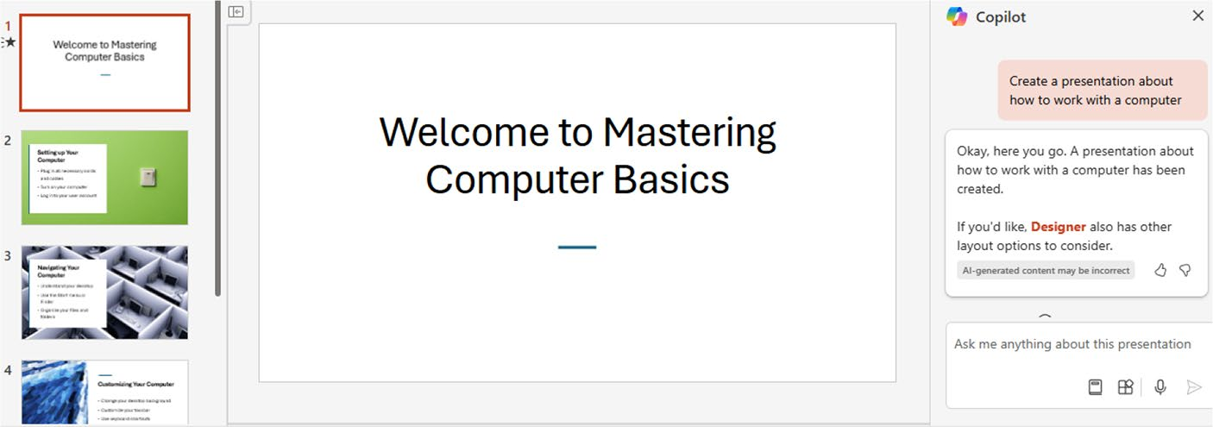

Figure 10-37. Create presentations in a flash
The presentation is not lengthy but provides all the essential facts along with images. You can convert PowerPoint presentations into videos with the help of third-party software tools like Veed. You can experiment with all the prompts included with Copilot Lab to know the functionality.

Copilot in Outlook
Microsoft Outlook is a popular email client tool using which you send and receive emails. With Copilot in Outlook, you can compose email messages easily. You just need to provide a prompt or context, and the Copilot will do the rest of the work.
To work with Copilot in Outlook, open the Outlook (new) app via the
Windows 11 Taskbar and select the New mail button (Figure 10-38), which is located at the top-left side.

Chapter 10 Using Copilot in MiCrosoft 365
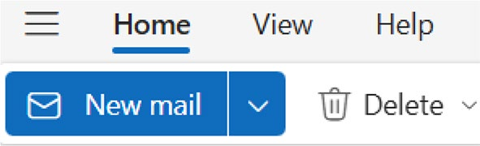

Figure 10-38. Create a new email
You can compose an email by providing the required parameters such
as the recipient email address, subject, and the message. Let’s generate
content via Copilot by selecting its icon from the top right-side Toolbar as
shown in Figure 10-39.
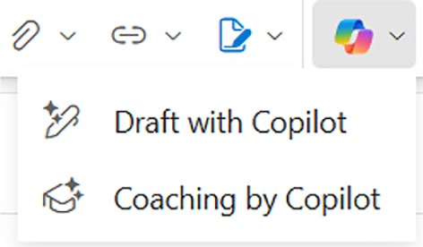

Figure 10-39. Copilot modules in Outlook
You should select the Draft with Copilot option and provide the
relevant prompt or context (Figure 10-40) for which the email message
should be generated.
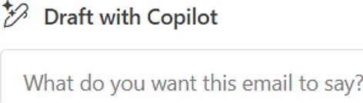

Figure 10-40. Prompting Outlook
Copilot in Outlook generates the required content (Figure 10-41) as per
the provided prompt.

Chapter 10 Using Copilot in MiCrosoft 365
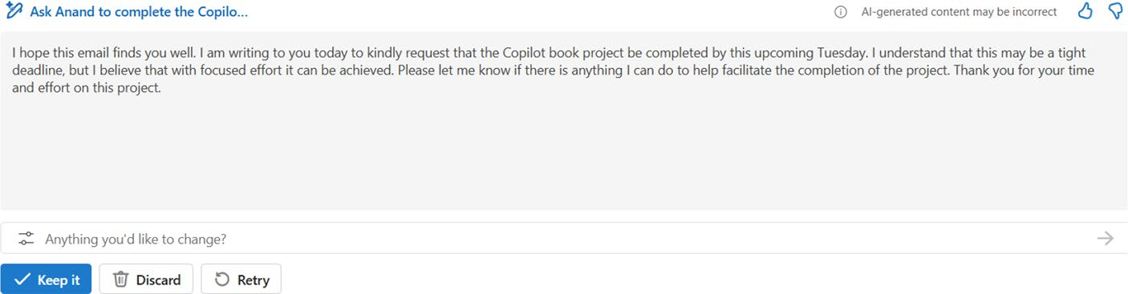

Figure 10-41. Quickly generate email content with Copilot
The query was to ask Anand to complete the Copilot book project by Wednesday. As you can see, Copilot in Outlook generates the required message. You can either retain the output generated by Copilot or discard it and start over. If you select the Keep it button, then the message will be added to the Compose editor.
Copilot in Outlook also enables you to modify the generated content automatically by selecting the Edit Prompt icon located above the Keep it
icon. The list of options will be displayed as shown in Figure 10-42.
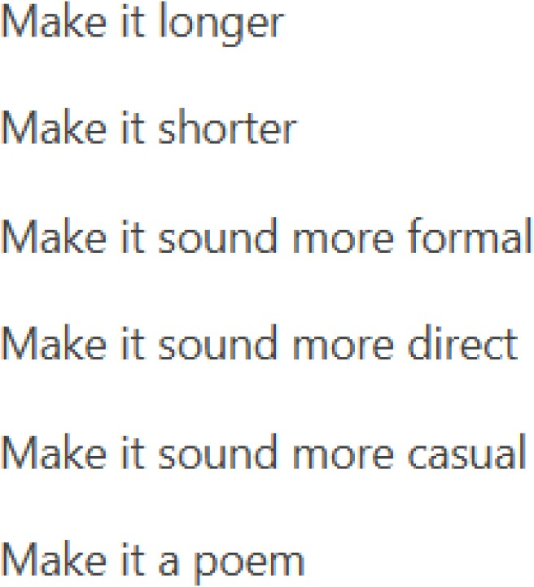

Figure 10-42. Change the generated content

Chapter 10 Using Copilot in MiCrosoft 365
You also provide a short prompt for coaching purposes and ask Copilot
to draft a message as displayed in Figure 10-43. The sample prompt should
be at least 100 characters in length and include the relevant context.
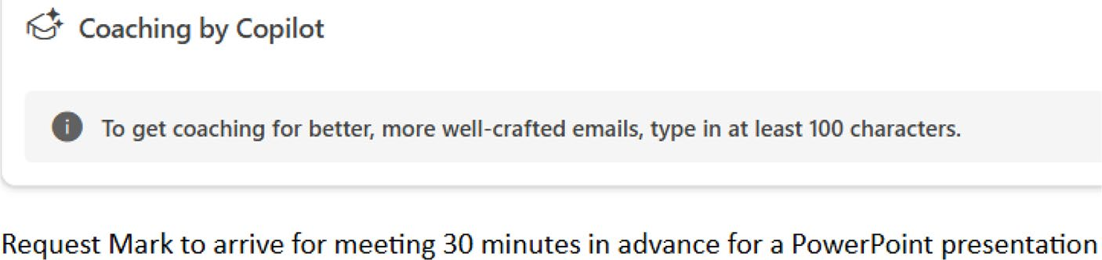

Figure 10-43. Coach yourself Copilot
You should then select the Try Draft with Copilot button, which will
add the context to the Draft with Copilot prompt box. Copilot in Outlook
generates a message upon selecting the Generate button as shown in
Figure 10-44.
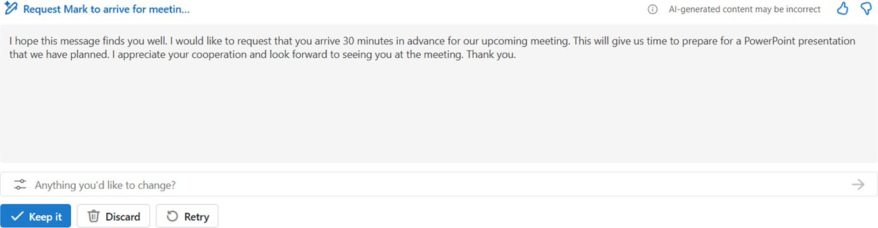

Figure 10-44. Copilot generates perfect content

Modifying Content Style Using Email Coaching
You can change the tone and length of the content that needs to be
generated by selecting the Generation Options icon. You will see a list of
options as shown in Figure 10-45.

Chapter 10 Using Copilot in MiCrosoft 365
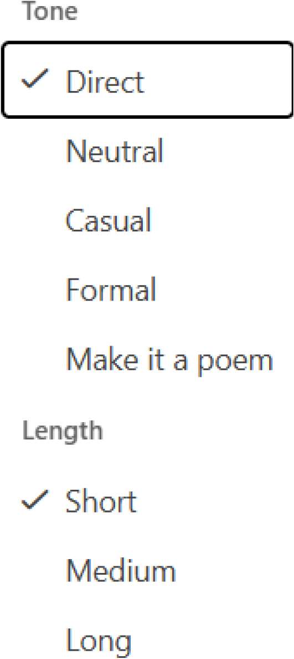

Figure 10-45. Modify the content style
A tick mark will be visible against the tone and length. You can use the context and ask Copilot to generate the required content. You can easily make use of Copilot not only to simplify your daily messaging tasks but also to enhance productivity. Microsoft recently released Copilot Use Cases eBook with information about real-world implementations. You can
download the book by navigating to https://info.microsoft.com/
ww-landing-inspired-by-ai-six-copilot-use-cases.html.

Chapter 10 Using Copilot in MiCrosoft 365
Summary
Copilot in Microsoft 365 helps you to simplify tasks associated with your
favorite apps such as Word, Excel, and PowerPoint. The integration of
Copilot in Word helps you to create content easily. You can even ask
Copilot to summarize and fetch information from an existing document.
It’s now easy to automate Excel workbooks with the help of Copilot. You
also learned the steps required to create a PowerPoint presentation via
Copilot. You just need to provide the required prompt to create content
and powerful presentations that can be converted into blog posts and
videos. You also learned how easy it is to compose email messages with
the help of Copilot integration in Outlook. Moreover, the integration of
Copilot in Word and PowerPoint mobile is a step in the right direction.
In the next chapter, you will learn the usage of Microsoft Copilot with the
Windows app.

CHAPTER 11

Learning Microsoft

Copilot with Windows

App
In the previous chapters, you learned about the usage of Microsoft Copilot
without installing any external apps. You learned about accessing Copilot
via Windows 11, Microsoft Edge, Bing, and Skype. Windows 11 ships with
Copilot in select regions and can be accessed from the Taskbar by selecting
the Copilot in Windows (preview) icon. Microsoft Copilot is now available
as a stand-alone app and can be installed via the Microsoft Store. You can
perform all the actions associated with Copilot using the Windows app. In
this chapter, you will learn the usage of Microsoft Copilot with the help of
the recently launched Windows app.

Getting Started
Microsoft Copilot is available as a stand-alone Windows app, which can
be used just like any other app like Notepad and Paint. The first step is to
navigate to the Microsoft Store by selecting the Windows 11 Taskbar icon
as displayed in Figure 11-1. You should note that the Windows app is just a
wrapper of https://copilot.microsoft.com. This means the app inherits
all the features that are available when you access the web dashboard.
© Anand Narayanaswamy 2024 235
A. Narayanaswamy, Microsoft Copilot for Windows 11, Inside Copilot,

Chapter 11 Learning MiCrosoft CopiLot with windows app
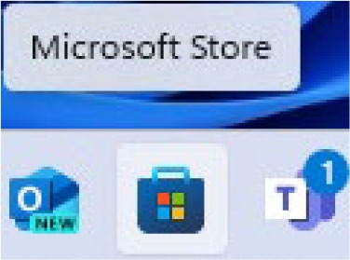

Figure 11-1. Opening the Microsoft Store

Note You can also manually download the installer and complete
the Copilot app installation process: https://apps.microsoft.
com/detail/9nht9rb2f4hd?hl=en-us&gl=US .
The Microsoft Store dashboard will display on the screen. You have to locate the Microsoft Copilot app from the top search bar. The app will be
visible on the dashboard as shown in Figure 11-2.
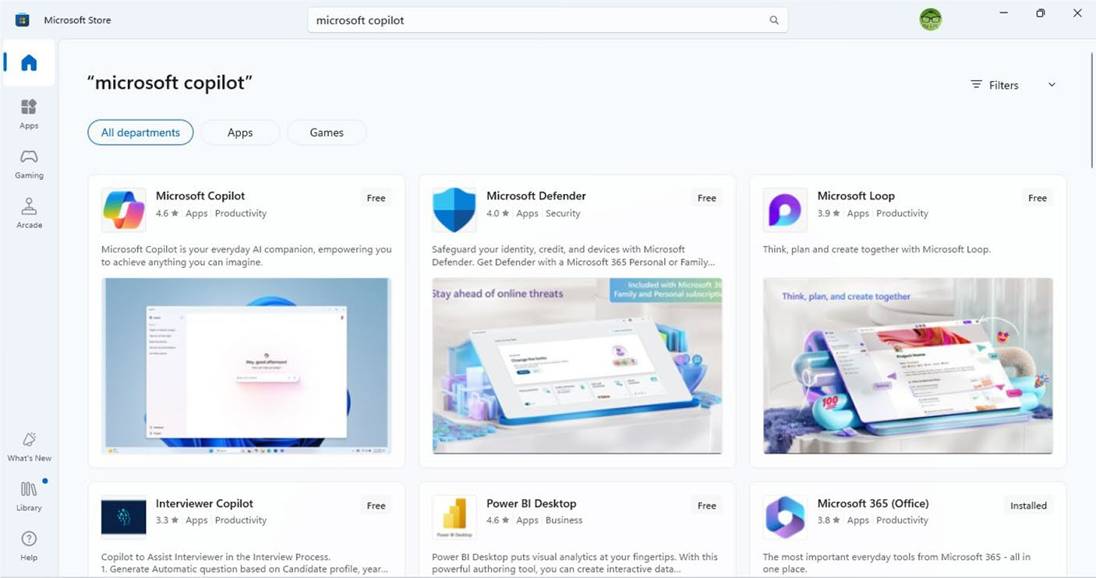

Figure 11-2. Navigate the Microsoft Store

Chapter 11 Learning MiCrosoft CopiLot with windows app
In Figure 11-3, you can view the Microsoft Copilot app page inside the
store. You can scroll down to read reviews, features, system requirements,
and other parameters related to the app.
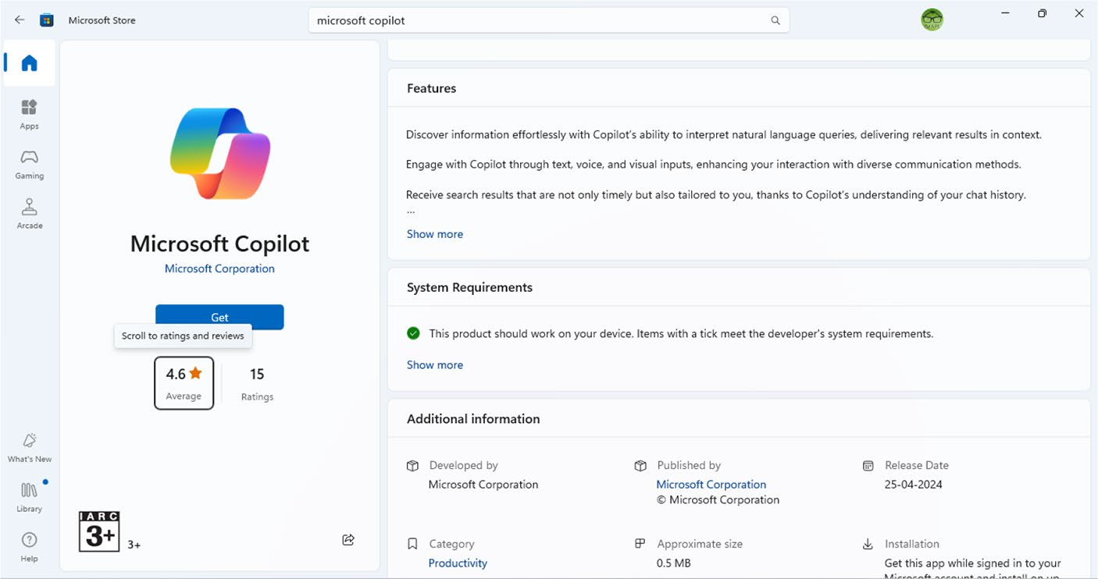

Figure 11-3. Proceeding to install Copilot
The next step is to select the Get button to install the app. The time
required to install the app depends upon the system configuration and
speed of your Internet connectivity.

Note the advantage of the Microsoft Copilot windows app is that you can open and work either by selecting the taskbar or by double- clicking the desktop icon. You can also open the Copilot app using the windows 11 search box. You now have a choice of several options instead of solely depending upon the Copilot in windows (preview) icon near the notifications icon on the taskbar.

Chapter 11 Learning MiCrosoft CopiLot with windows app
The relevant notification will display in Windows 11 after the successful installation of the app. Moreover, the Get button caption will change itself to Open, where when clicked the Microsoft Copilot Windows
app dashboard will appear on the screen as shown in Figure 11-4.
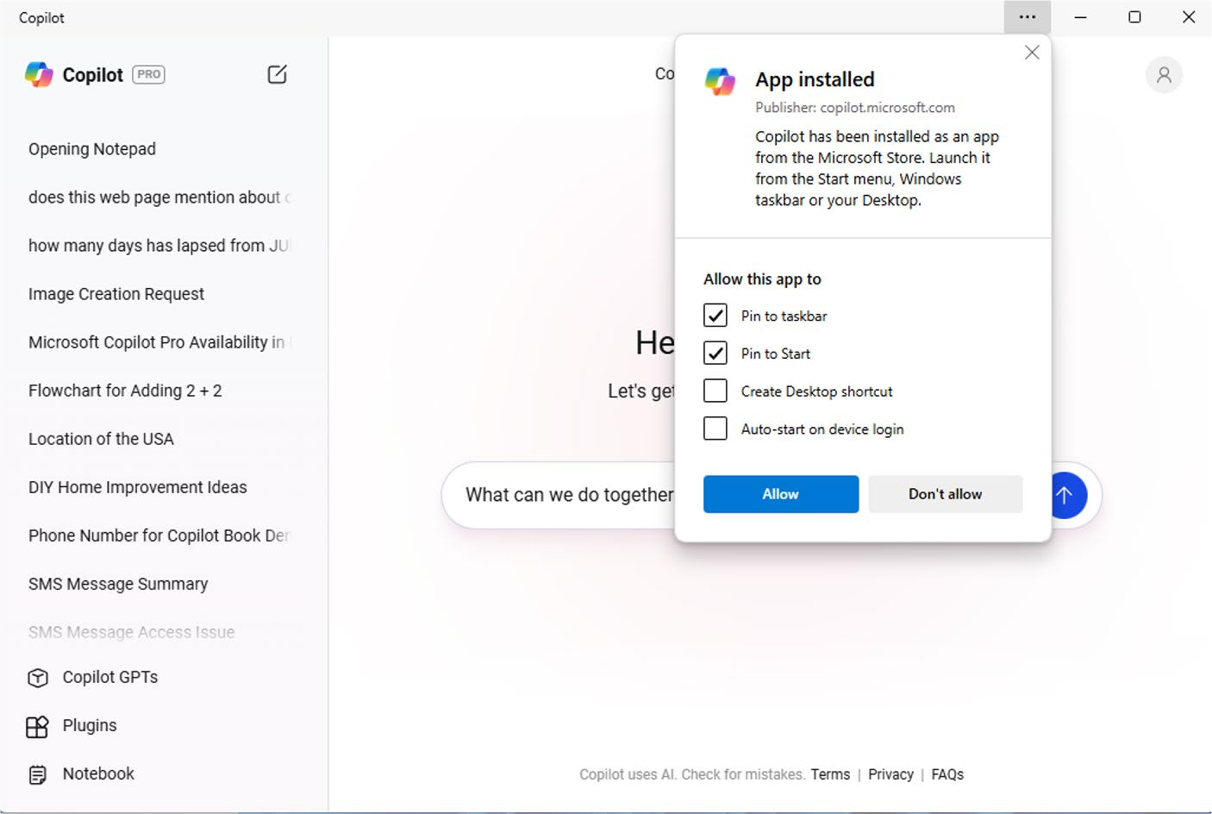

Figure 11-4. Decide where to keep the Copilot Windows app
You have the choice to place the Copilot app on the Taskbar, Start menu or Desktop. Additionally, you can set the app to start automatically when the system boots.

Tip You can work with Microsoft Copilot using android and ios
devices by downloading the app from the google play store and
apple app store, respectively.

Chapter 11 Learning MiCrosoft CopiLot with windows app
Windows 11 will prompt you to confirm whether the Copilot app
should be pinned on the Taskbar. The dashboard of the Copilot Windows
app looks as shown in Figure 11-5.
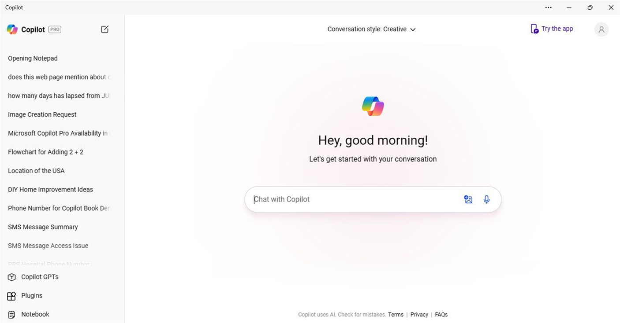

Figure 11-5. Copilot Windows app dashboard

Prompting the Windows App
You can provide the prompt as text, upload an image, or use voice to
dictate the query. You can also upload PDF files as prompt, but you need
a Microsoft 365 Business license. As of this writing, the PDF functionality
is not available for consumers with Copilot Free and even with a Pro
subscription. You have to select a suitable conversation style by selecting
the drop-down located at the top of the app dashboard as shown in
Figure 11-6. The default style is Creative, but you can change to Balanced
or Precise according to your preference.

Chapter 11 Learning MiCrosoft CopiLot with windows app
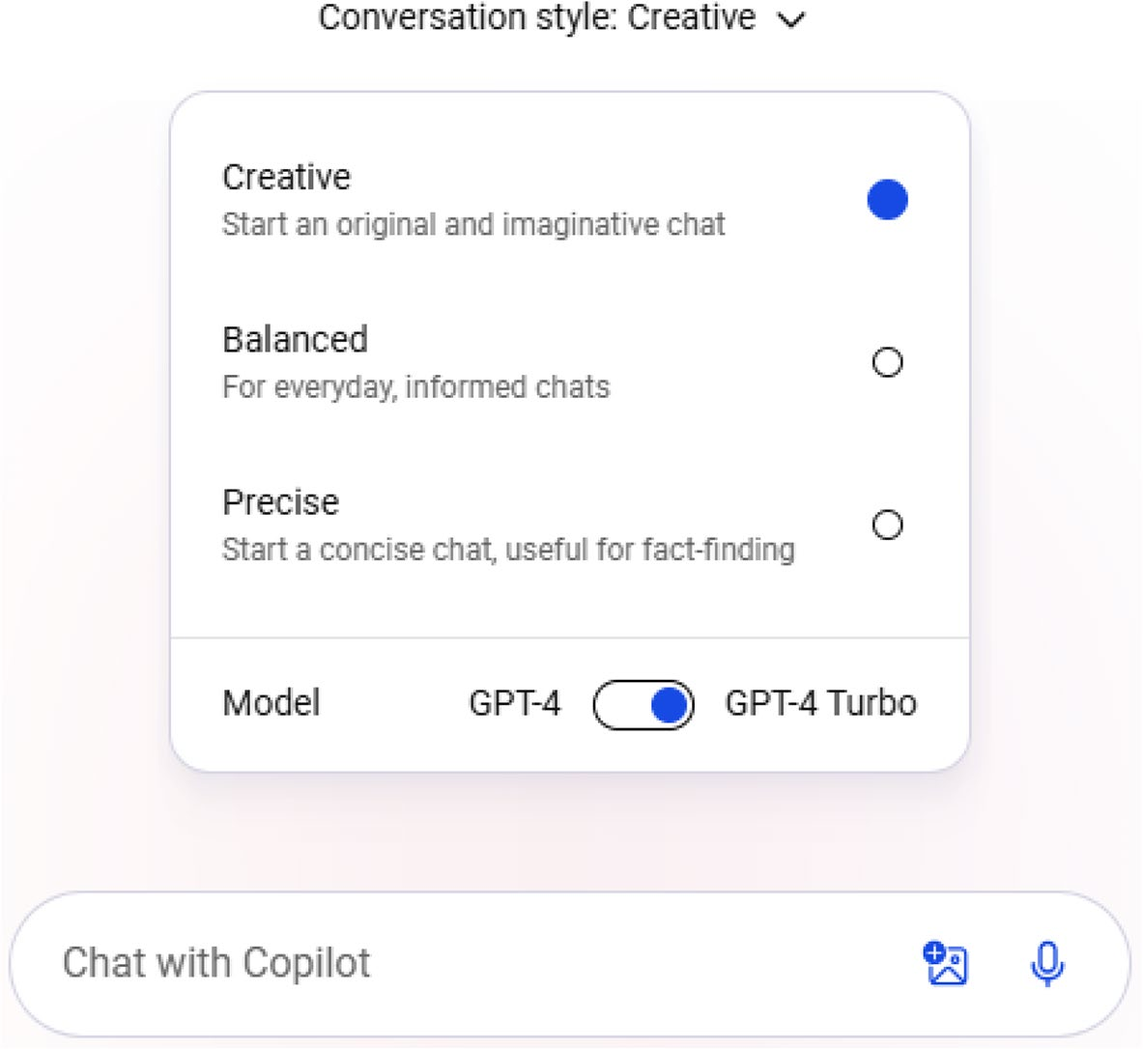

Figure 11-6. Select your output tone

Caution Microsoft is currently experimenting with a new version
of Copilot without any conversation style options. however, the styles
could appear for free users randomly based on the region. please
note that the conversation styles might appear only for Copilot pro
subscribers. You can manually activate the conversation styles even
if you don’t have Copilot pro subscription. You should select the
Profile icon from the top right side, choose Settings and modify the
Country/Region to United States - English. whatever may be the
scenario, the functionality of Copilot remains the same.

Chapter 11 Learning MiCrosoft CopiLot with windows app
The default model is marked as GPT-4 Turbo because of the active
Copilot Pro subscription. The system generates high-quality content
because of the addition of the latest GPT model. You can also access Copilot
GPTs, plugins, and Notebook from the navigation panel on the left side.
Let’s test the working of the Copilot Windows app by providing a
simple prompt (Figure 11-7) inside the Chat with Copilot textbox. The text
area will automatically expand as you type the prompt.


Figure 11-7. View the Copilot Windows app response
In Figure 11-8, you can view the response that is displayed inside
the Copilot Windows app. You can also scroll down and view additional
content. The Copilot app also fetches the conversation history from your
interactions with the web-based interface and is displayed on the left side.
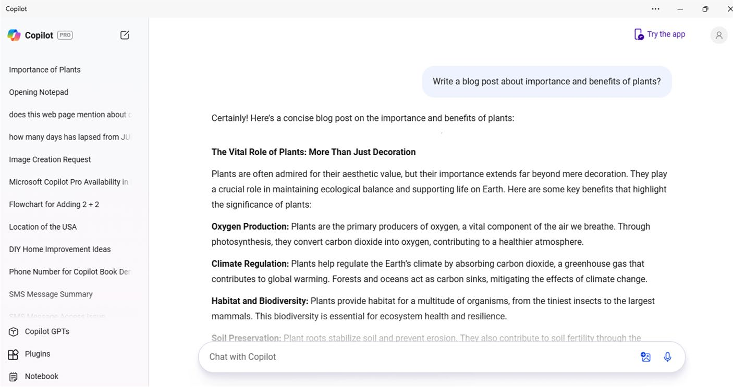

Figure 11-8. View the response generated by Copilot Windows app

Chapter 11 Learning MiCrosoft CopiLot with windows app
You can copy and share the content if you point your mouse over the response generated by the Copilot Windows app. Moreover, you can also hear the response by selecting Read aloud option. You will be able to like, dislike and export the content by selecting the three vertical dots. You can create a new request by selecting the icon from the top-left side as shown
in Figure 11-9.


Figure 11-9. Ask Copilot another query
Let’s try another example (Figure 11-10) by asking Copilot to generate a list of top five Windows 11 laptops in tabular format.
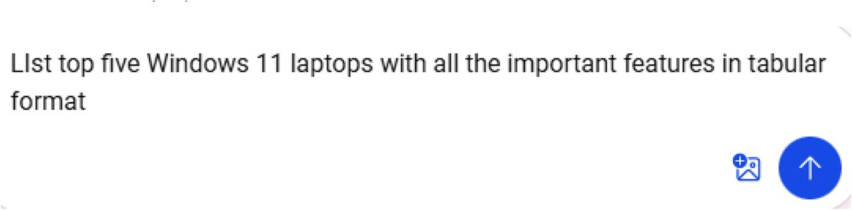

Figure 11-10. Can Copilot generate responses in tables?
You can observe from Figure 11-11 how nicely Copilot tabulates relevant information and generates the output inside the dashboard.

Chapter 11 Learning MiCrosoft CopiLot with windows app
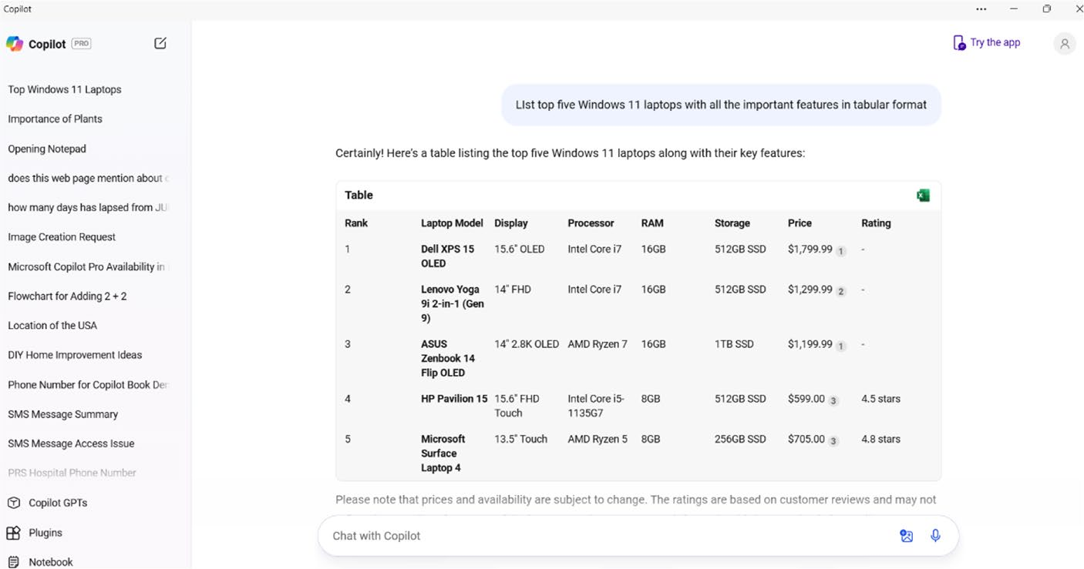

Figure 11-11. View the Copilot-generated tabulated content
You can share and export the Copilot response by pointing your mouse
over the prompt name on the conversation history from the navigation
panel on the left side. You will see three horizontal dots on the right
side, which you should select to view the relevant options as shown in
Figure 11-12.
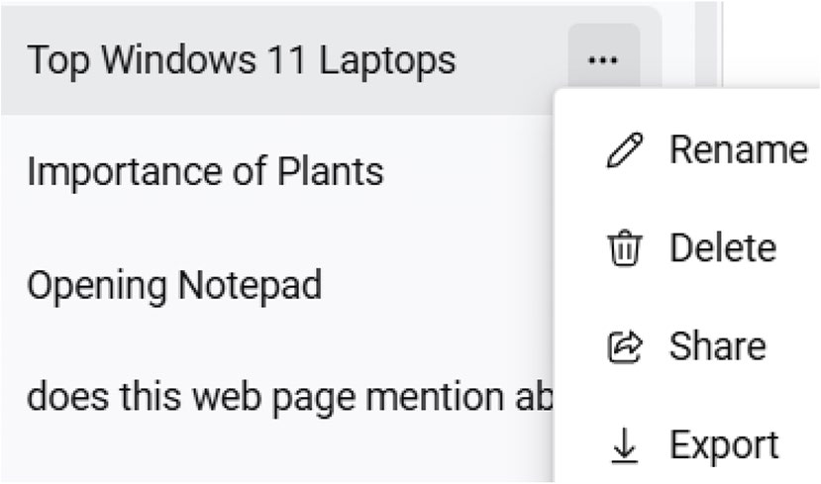

Figure 11-12. Showcase the Copilot results

Chapter 11 Learning MiCrosoft CopiLot with windows app
You can share the results on social media platforms like Facebook, X, Pinterest, LinkedIn, Reddit, and OneNote. You can also copy the link or
share via email from the dialog displayed in Figure 11-13.
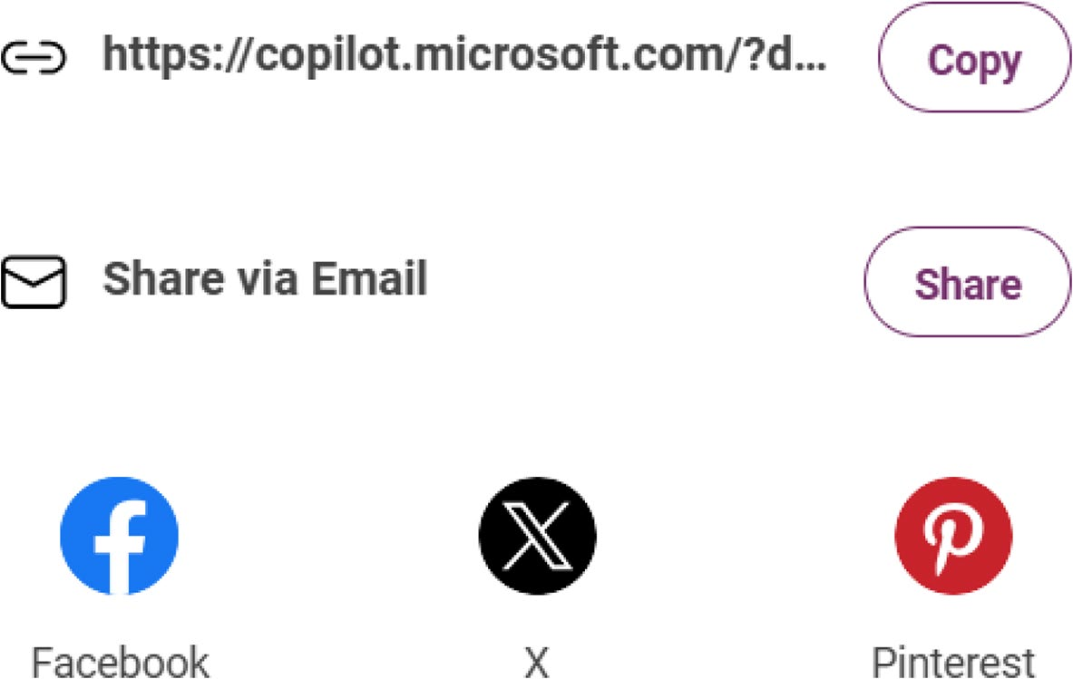

Figure 11-13. Publish the Copilot work on social media
The Copilot app also enables you to export the generated response in Word, PDF, and text formats by selecting the Export option from the
displayed menu as shown in Figure 11-14.
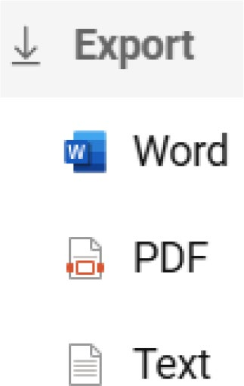

Figure 11-14. Save content instantly

Chapter 11 Learning MiCrosoft CopiLot with windows app
Working with Copilot GPTs
You can also create and work with Copilot GPTs with the help of the
Windows app as shown in Figure 11-15.
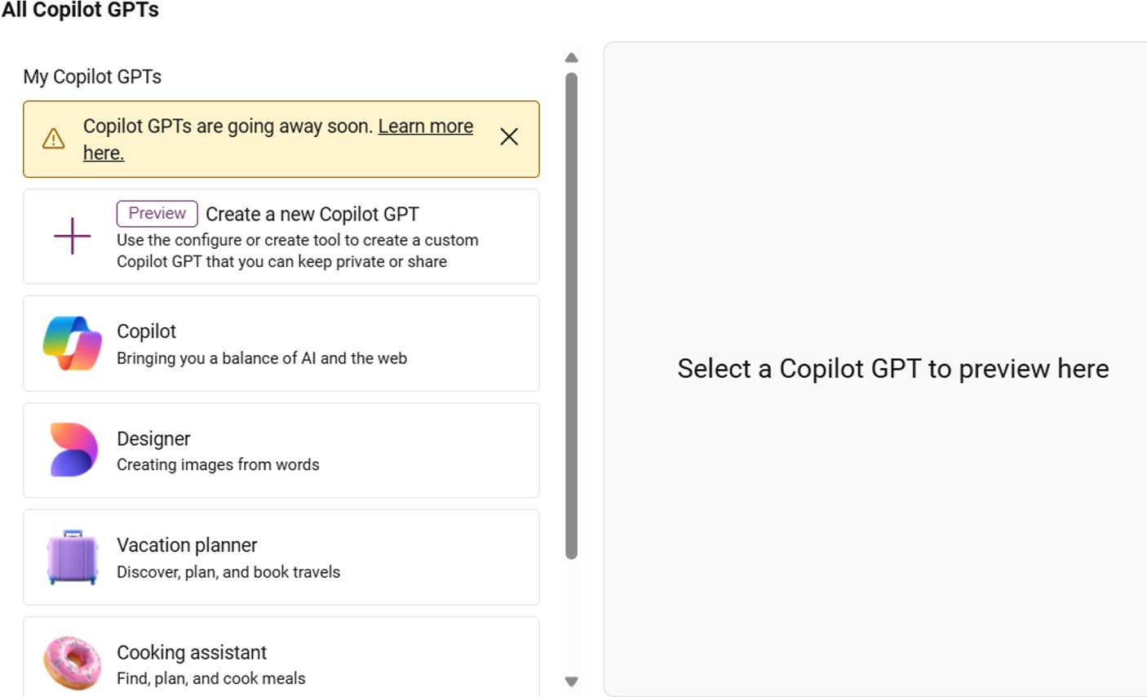

Figure 11-15. Easily work with Copilot GPTs
The Copilot Pro subscription enables users to create their own Copilot
GPTs in addition to the GPTs offered by Microsoft. With the help of default
GPTs, users were able to create AI images easily as well as plan vacations
properly. The fitness GPT helped users to keep track of their health.

Note Microsoft discontinued the usage of the Copilot gpt functionality as well as the ability to create customized gpts in July 2024. this feature is currently available only for Commercial and enterprise customers. Copilot gpts created by Microsoft and those created by customers have been completely removed.

Chapter 11 Learning MiCrosoft CopiLot with windows app
For instance, if you select Designer Copilot GPT and click the Get started button, the user interface will change, and the designer module will
be activated as shown in Figure 11-16.
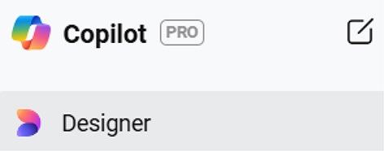

Figure 11-16. Designer GPT in action
You can then ask Copilot to generate images by providing the relevant prompt such as A lone astronaut floating in a sea of stars, holding a single glowing flower. The Copilot app displays the generated images.

Creating Your Own GPTs
You now know that the Copilot Pro subscription will help you to create your own GPTs. Let’s examine the steps required to create them. Firstly, you should open the Copilot Windows app and select the Copilot GPTs option. You will see all the GPTs in the corresponding dialog as shown in
Figure 11-17.

Chapter 11 Learning MiCrosoft CopiLot with windows app
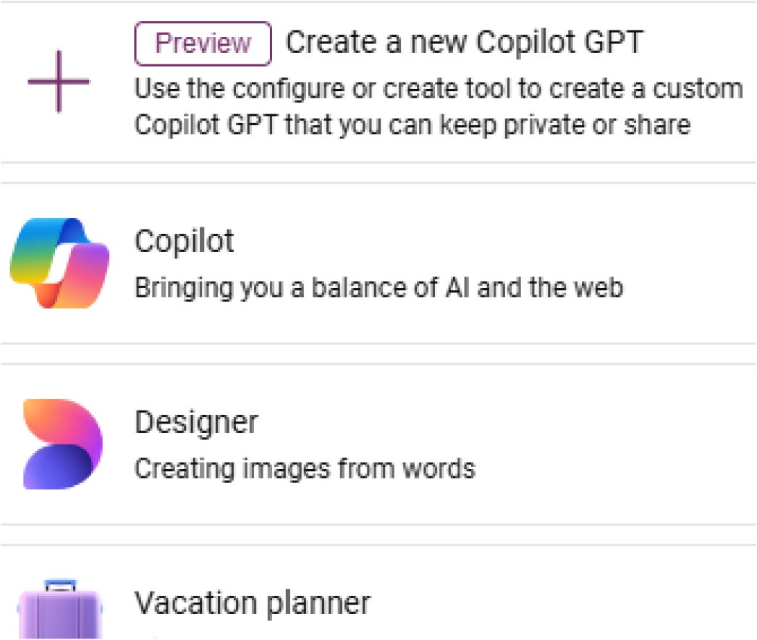

Figure 11-17. Custom GPT creation starts here
The next step is to select the Create a new Copilot GPT option. In
Figure 11-18, you can view the Copilot GPT Settings dashboard which will
display upon selecting the option.
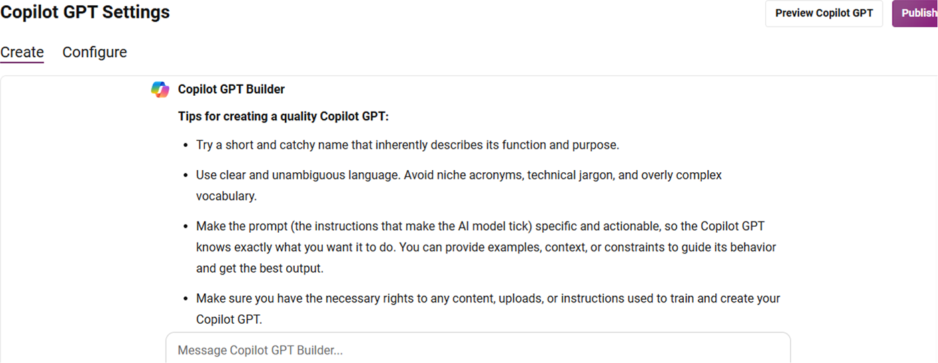

Figure 11-18. Provide a context for custom GPT

Chapter 11 Learning MiCrosoft CopiLot with windows app
You can make use of the Copilot GPT Builder to provide suitable data based on which Copilot creates the GPT. You can read the tips to
get started. You can also manually provide (Figure 11-19) the name, description, instructions, and other data by selecting the Configure tab.
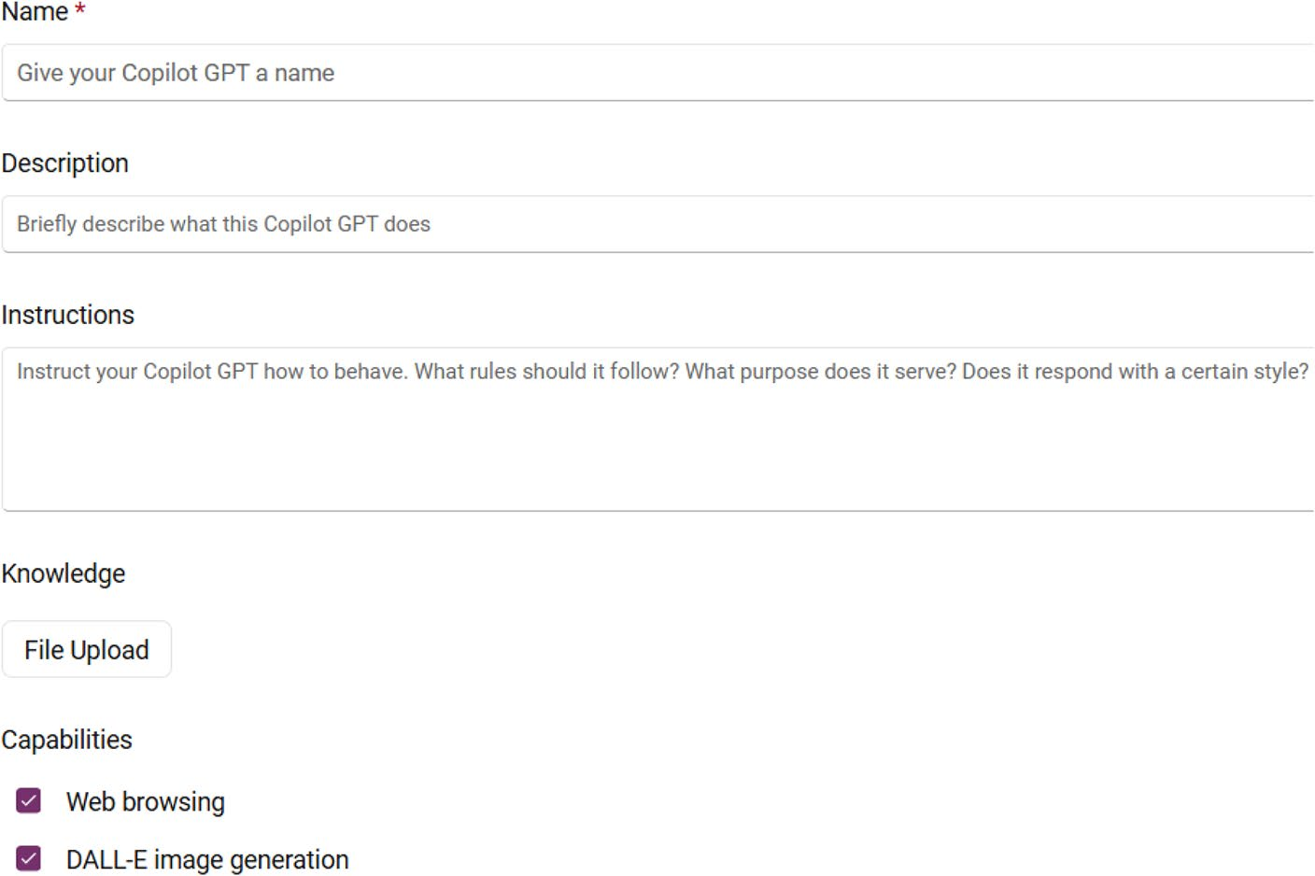

Figure 11-19. Manually provide data for custom GPTs
The best way is to use the builder and follow the instructions displayed on the screen. Copilot will ask you a question as you provide each data.
Let’s get started by providing the prompt learning JavaScript. Figure 11-20 shows the response based on our context. Copilot will now ask you to confirm a name for your GPT by providing an intelligent suggestion.

Chapter 11 Learning MiCrosoft CopiLot with windows app
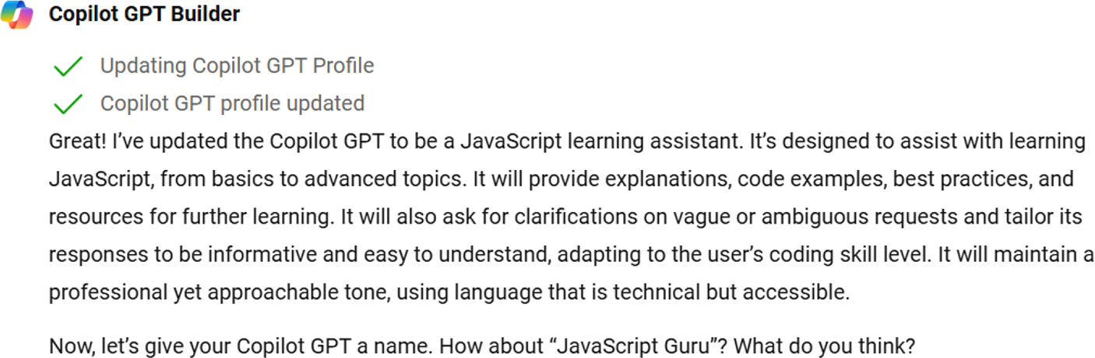

Figure 11-20. Confirm your custom GPT name here
As you can see, Copilot displays a confirmation message (Figure 11-21)
upon accepting the automated Copilot GPT name. You can further refine
the system by providing additional data if available.
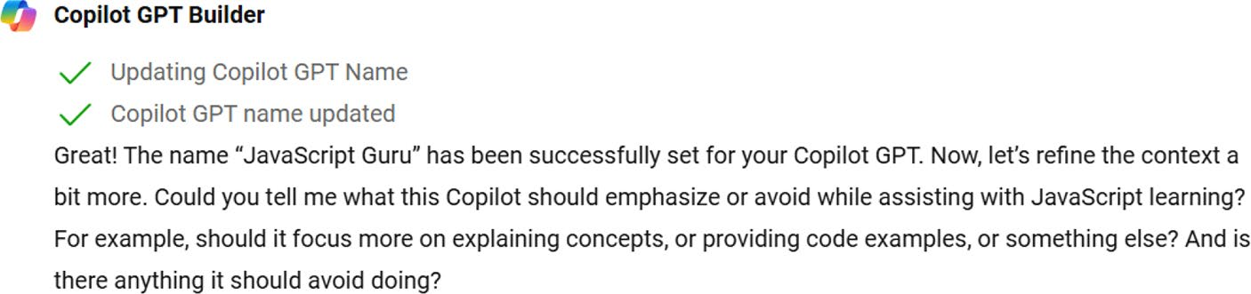

Figure 11-21. Copilot GPT created
Copilot GPT can be accessed by selecting the Preview Copilot GPT
button located on the top-right side. Figure 11-22 displays the custom
Copilot dashboard that we created.

Chapter 11 Learning MiCrosoft CopiLot with windows app
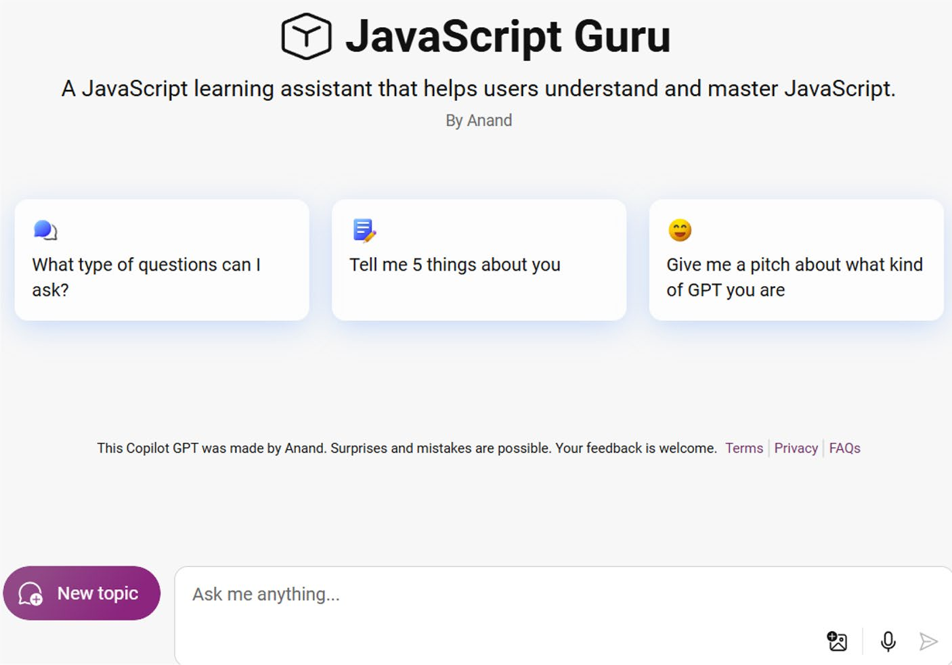

Figure 11-22. Experience your own Copilot GPT
You should provide the required prompt as you normally do with Copilot. In this way, you can experiment with the creation of custom GPTs.

Using Copilot Plugins
The Copilot app enables you to work with plugins. The list of plugins will
display as shown in Figure 11-23 upon selecting the Plugins option. You should note that the list of available plugins varies by country and region. Microsoft Copilot is under continuous development, and hence you can expect new plugins over the upcoming months.

Chapter 11 Learning MiCrosoft CopiLot with windows app
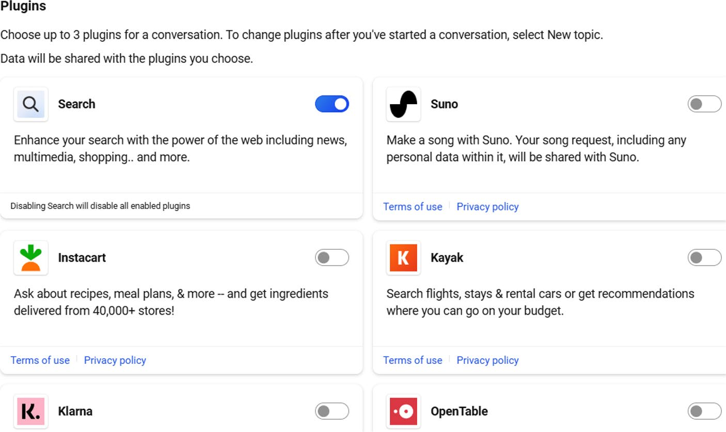

Figure 11-23. Activate and work with Copilot plugins
Let’s enable the Suno plugin and ask Copilot to generate a melody
song. The system automatically generates the song and displays it inside
the dashboard as shown in Figure 11-24. You can then download or
share the generated song as well as listen to it directly from the Copilot
dashboard.

Chapter 11 Learning MiCrosoft CopiLot with windows app
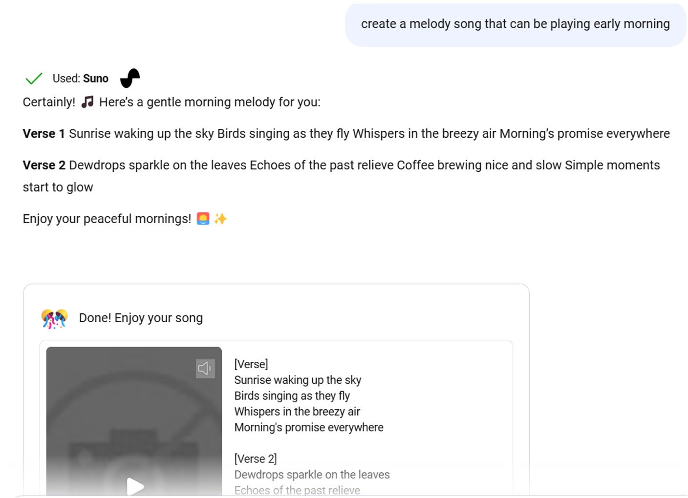

Figure 11-24. Automate your music talent with Copilot

Note please refer to Chapter 7 for a detailed discussion on Copilot
gpts and plugins.
The Copilot app also enables you to access Notebook. You can provide lengthy prompts to enable Microsoft Copilot to generate a detailed
and relevant response. Please refer to Chapter 7 to learn about Copilot Notebook.

Chapter 11 Learning MiCrosoft CopiLot with windows app
Creating Flowcharts
You can create flowcharts easily using Microsoft Copilot. However, Copilot
will be able to generate flowcharts in Mermaid format. Mermaid is a
Markdown syntax, which generates diagrams from the supplied text. You
can generate flowcharts, Unified Modeling Language (UML) diagrams, pie
charts, and much more using Mermaid.
The first step is to compile the relevant data and provide a prompt in
Copilot as follows:
Please create a flowchart using the below items in mermaid format Windows 7 2009
Windows 8 2012
Windows 10 2015
Windows 11 2021
You can use either Copilot in Windows, the Copilot app, or the Copilot
web dashboard. Let’s try using the Copilot Windows app. The resulting
output looks as shown in Figure 11-25.
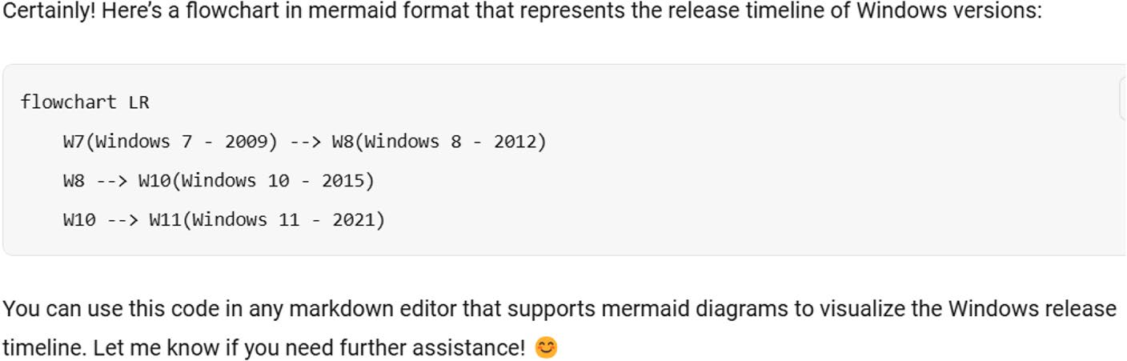

Figure 11-25. View the generated Mermaid code
The next step is to navigate to https://mermaid.js.org and select
Live Editor located on the top. You should copy and paste the Mermaid
format code generated by Copilot. You will see the resulting flowchart
as shown in Figure 11-26. The size of the flowchart depends upon the
quantity of the data.

Chapter 11 Learning MiCrosoft CopiLot with windows app

Figure 11-26. Flowchart in action
You can directly copy the code by selecting the Copy icon located inside the generated code. You should note that Microsoft Copilot can be used for advanced programming tasks as well. Moreover, Copilot only generates Mermaid code to create flowcharts. Copilot in Windows 11 can’t render flowcharts on its own. You can use the Copilot-generated Mermaid code with plugins like Visual Studio Code, Atom, and Sublime Text as well as the Mermaid.js API and Markdown editors.

Summary
Microsoft Copilot is available as a separate app that can be pinned to the Windows 11 Taskbar. You can easily install the app from the Microsoft Store and explore the functionalities of the Copilot directly via the app. Even if you install the Copilot Windows app, you can work with Copilot via Copilot in Windows (preview), which can be accessed by selecting the Taskbar icon located adjacent to the Notifications icon. You have the option to access Copilot via the Windows 11 Taskbar, desktop, and start menu. The app can also be set to launch automatically upon signing in. Microsoft is continuously improving Copilot, and the ability to access the chatbot as a stand-alone app from within Windows 11 provides enhanced flexibility and productivity. Do you want to learn about the recently announced Copilot key? Jump to the next chapter.

CHAPTER 12

Devices with

Copilot Key
Microsoft announced the introduction of a dedicated Copilot key on
January 4, 2024. Going forward, new Windows 11 devices such as laptops
and convertibles will ship with a new Copilot key depending upon the
manufacturer. The integration of the Copilot key represents a significant
and intelligent advancement toward the success of future AI-powered PCs.
The addition of Copilot in the Windows experience will make it easier for
people to take part in the AI transformation. The new Copilot key on the
PC keyboard will join the Windows key. If you press the Copilot key as
shown in Figure 12-1, you can seamlessly engage with Copilot in your
day-to- day activities.

© Anand Narayanaswamy 2024 255
A. Narayanaswamy, Microsoft Copilot for Windows 11, Inside Copilot,

ChaPter 12 DeviCeS With CoPilot Key
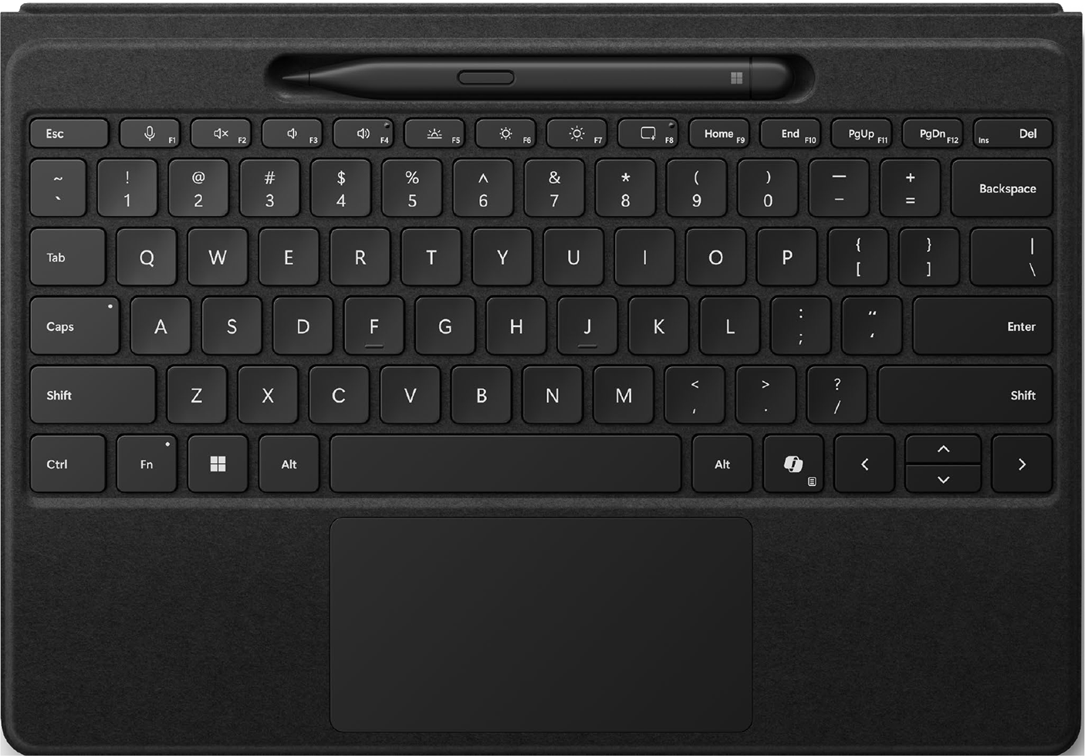

Figure 12-1. Copilot key in action
The integration of the Copilot key not only simplifies computing productivity but also usability. The Copilot dashboard will open upon pressing the Copilot key without any need to click the Windows 11 Taskbar icon. You also need not have to press the WIN+C keyboard shortcut. However, if Copilot is not available in your region, then Windows Search will open upon hitting the Copilot key.

Note Microsoft integrated the Windows key to PC keyboards in
1994 along with the launch of the natural keyboard. Gateway Solo
was the first laptop to ship with the Windows key.
The new Copilot key will change the way we adopt technology across work and life. Microsoft announced that Intel, AMD, and Qualcomm have already introduced new silicon innovations via exclusive chipsets,

ChaPter 12 DeviCeS With CoPilot Key
which unlock new AI experiences while computing. The core purpose is to
bring the power of CPU, GPU, NPU, and cloud architecture under a single
umbrella for an intuitive AI experience. Devices with the Copilot key that
are manufactured by Samsung, ASUS, Acer, and Lenovo were showcased
during the CES 2024 and MWC 2024 conferences. In this chapter, you will
learn about the list of Windows 11 devices that ships with the Copilot key.

Caution even though the devices mentioned in this chapter were released with the Copilot key, the features and specifications are subject to change without notice. Moreover, the availability of Microsoft Copilot varies depending on the region. refer to the product link and manufacturer’s website for price-related information.

Microsoft Surface Laptop 6
Microsoft Surface Laptop 6 is available in both 13.5-inch and 15-inch
PixelSense displays. The Surface Laptop 6 is also named AI PC for Business
and is not available for end consumers. You can opt for either Intel Core
Ultra 5 Processor 135H or Intel Core Ultra 7 Processor 165H variants,
respectively, with Intel AI Boost technology and Intel Arc Graphics.
The devices are available in 8GB, 16GB, 32GB, and 64GB RAM variants
with up to 1TB storage. Microsoft has integrated the Trusted Platform
Module (TPM) 2.0 chip for enhanced security with support for BitLocker
and Windows Hello technologies. The laptop offers an FHD Surface
Studio camera alongside Windows Studio Effects. The audio is powered
via Omnisonic Speakers with Dolby Atmos technology and Bluetooth
LE Audio support. The laptop is manufactured using MIL-STD 810H
standards, which is resistant to temperature, dust, and vibration. The
device is exclusively designed to balance power and performance with an
extended battery life with 80% charging in less than 60 minutes.

ChaPter 12 DeviCeS With CoPilot Key

Note www.microsoft.com/en-in/surface/business/
surface-laptop-6

Samsung Galaxy Book4
Samsung Galaxy Book4 features a 15.6-inch anti-glare display coupled with 512GB storage. The laptop is available in Intel Core 7 150U and Intel Core 5 120U processor variants. The laptop includes all the standard connectivity ports and is preloaded with Windows 11. The US version of the Samsung Galaxy Book4 series includes a dedicated Copilot key. The laptop is designed to provide intelligent performance, improved security, and an interactive display enclosed in an ultra-portable form factor. Moreover, if you work with a Samsung Galaxy smartphone, then you will be able to establish connectivity with the Galaxy Book4 via Microsoft Copilot.

Note www.samsung.com/us/computing/galaxy-books/
galaxy-book4-series/

Acer Aspire 3D 15 SpatialLabs Edition
Acer Aspire 3D 15 SpatialLabs Edition features a 15.6-inch 4K UHD display, 13th Gen Intel Core i7 processor alongside NVIDIA GeForce RTX 4050 Laptop GPU. The device provides a true cinematic experience through an immersive 3D rendering with the help of a specialized optical lens and eye-tracking technology. The laptop leverages stereoscopic 3D technology and works with exceptional speed, which is perfect for

ChaPter 12 DeviCeS With CoPilot Key
powerful computing tasks and gaming. Some of the other features of the
device are Acer PurifiedView and Acer PurifiedVoice AI Noise Reduction.
The addition of dual fans and triple copper heat pipes dissipate heat
efficiently and provide reliable thermal management. The laptop includes
Wi-Fi 6, USB Type-C, and HDMI 2.1 ports.

Note www.acer.com/in-en/laptops/aspire/aspire-3d-
15-spatiallabs-edition

Acer Aspire Vero 16
Acer Aspire Vero 16 is equipped with a 16-inch display and is available
in both touch and non-touch displays. You can work seamlessly because
of 16GB RAM and up to 1TB SSD storage. The display covers 100% of
sRGB color space and is a great choice not only for work but also for
entertainment purposes. The laptop is integrated with an Intel Core Ultra 7
processor coupled with Intel AI Boost and MIL-STD-810H military-
grade durability. The system is capable of delivering up to 10.5 hours of
battery life on a single charge via USB-C fast charging technology. Acer
has integrated flagship PurifiedView and PurifiedVoice AI technologies
in addition to AcerSense app to provide an enhanced user experience.
Moreover, the laptop is EPEAT Gold certified and has adopted 200%
recycled packaging and an ocean-bound plastic touchpad.

Note www.acer.com/us-en/laptops/aspire/aspire-
vero-16

ChaPter 12 DeviCeS With CoPilot Key
Acer Swift Go 16
Acer Swift Go 16 features a 16-inch ultra-smooth 120Hz OLED Eyesafe Certified 2.0 display paired with an Intel Core Ultra 9 processor and Intel Arc graphics. The system offers up to 32GB RAM and 2TB SSD storage, respectively, with XeSS AI-enhanced upscaling, Xe media engine, and Intel AI boost capabilities. The laptop is designed to offer up to 10.5 hours of battery life, which is sufficient for all work, including Copilot-related tasks. You will experience seamless interaction across multiple devices via Intel Unison. The other features of Swift Go 16 are Acer PurifiedView, Acer PurifiedVoice, and 1440p QHD webcam. The overall user experience can be customized with the AcerSense app. The laptop is designed using a light aluminum body with a fully extendable hinge. Acer Swift Go 14 features a 14-inch display, 16GB RAM, and 512GB SSD storage alongside Intel Xe graphics technology. The laptop ships with an Intel Core i5 processor and includes a dedicated Copilot key. The remaining features are the same as the Acer Swift Go 16.

Note www.acer.com/in-en/laptops/swift/swift-go-16

Acer Predator Helios 18
Acer Predator Helios 18 boasts a massive 18-inch neon display. The 250Hz refresh rate alongside 1000-nits brightness delivers an immersive gaming experience. The laptop is powered by the 14th Gen Intel Core processor with 32GB RAM. The integration of NVIDIA GeForce RTX 4090 graphics processor, NVidia DLSS 3.5, and Ray Tracing delivers brilliant AI-enabled graphics with additional high-quality frames.

ChaPter 12 DeviCeS With CoPilot Key
You will be able to customize clicks and keys with the help of MagClick
and MagSpeed. Acer has integrated dual 5th Gen AeroBlade 3D fans with
liquid metal thermal grease to ensure maximum performance during
intense gaming. You will experience improved connectivity with Wi-Fi
7 technology, which ensures uninterrupted and secured AR, VR, and 8K
streaming. In addition to PurifiedVoice 2.0, the laptop ships preloaded
with Adobe Creative Cloud suite, Blender, Blackmagic Davinci Resolve,
OBS Studio, NVIDIA Omniverse, Adobe Substance, Adobe Painter, Blender,
Unreal Engine, and much more.

Note www.acer.com/in-en/predator/laptops/helios/
helios-18

ASUS ProArt P16
ASUS ProArt P16 is equipped with a 4K (3840 × 2400) OLED SGS Eye Care
touch display, AMD Ryzen AI 9 HX 370 Processor, 64GB RAM, and 2TB
storage alongside NVIDIA GeForce RTX 4070 graphics processor. The
laptop has been designed using US MIL-STD 810H military-grade standard
and provides support for Windows Hello. The entertainment segment is
amplified with Smart Amp technology, which eliminates studio-quality
sound. The device provides support for Wi-Fi 7 and Bluetooth 5.4 and
includes all the essential ports with a Backlit Chiclet Keyboard.

Note www.asus.com/laptops/for-creators/proart/
proart-p16-h7606/

ChaPter 12 DeviCeS With CoPilot Key
ASUS ProArt PX13
ASUS ProArt PX13 carries a 13.3-inch 3K OLED Eye Care touch display, AMD Ryzen AI 9 HX 370 Processor, XDNA up to 50 TOPS neural processor, 32GB RAM, and 1TB storage. The laptop is designed using US MIL-STD 810H military-grade standard technology alongside NVIDIA GeForce RTX 4060 graphics processor. The device includes a Backlit Chiclet Keyboard with support for Windows Hello and Smart Amp technologies. The company has termed the laptop as an AI Studio PC because of its exceptional performance and power-saving capabilities.

Note www.asus.com/laptops/for-creators/proart/
proart-px13-hn7306/

ASUS Zenbook S 16
ASUS Zenbook S 16 features 3K OLED 16:10 SGS Eye Care touch display, AMD Ryzen AI 9 HX 370/AMD Ryzen AI 9 365 Processors, AMD Radeon 880M/890M graphics chipset, 24GB/32GB RAM, and 1TB storage. The device also includes XDNA up to 50TOPs neural processor, which amplifies AI performance. ASUS has integrated Wi-Fi 7, Bluetooth 5.4, Windows Hello, and Smart Amp technologies in addition to standard connectivity ports. The system is available in both Windows 11 Home/Pro variants.

Note www.asus.com/laptops/for-home/zenbook/asus-
zenbook-s-16-um5606/

ChaPter 12 DeviCeS With CoPilot Key
Lenovo Legion 7i
The Lenovo Legion 7i laptop is available in two display models such as
a 3.2K 100% DCI-P3 and a traditional WQXGA (2560 × 1600) with 250Hz
refresh rate. The laptop is powered by an Intel Core i9-14900HX processor,
up to 32GB RAM, and an NVIDIA GeForce RTX 4070 graphics processor.
The addition of Legion ColdFront Hyper with dual fans spinning in
opposite directions provides enhanced cooling capabilities. The full-
sized Legion TrueStrike gaming keyboard with a large Mylar touchpad
and FHD camera with a privacy shutter ensures an extended trouble-free
computing experience. Lenovo claims that the device can be charged
completely in 80 minutes via 140W USB-C Super Rapid Charge technology.
The entertainment is power-packed with Nahimic Audio by SteelSeries
technology.

Dell Latitude 7350 Detachable
Dell Latitude 7350 Detachable is a convertible laptop, which ships with
an additional keyboard with a dedicated Copilot key. The device offers a
3K ComfortView Plus Corning Gorilla Glass Victus display with 500-nits
brightness. The display substantially reduces blue light emissions without
sacrificing color quality. Dell Latitude 7350 is powered by Intel Core Ultra
5 134U, 16GB RAM, and 512GB SSD storage preloaded with Windows 11
Pro. The 8MP HDR IR front camera with smart privacy features is well
supported by an 8MP rear camera.

Tecno Megabook T16
Tecno Mobile has announced the release of the Megabook T16 2024 laptop
with AI power. The laptop is integrated with a 16-inch FHD Lande Eye
Comfort expanded horizon display, 13th Gen Intel Core i5 Processor,

ChaPter 12 DeviCeS With CoPilot Key
16GB RAM, and 512GB/1TB storage. The device ships with enhanced cooling performance with support for AI Conference and AI ENC technologies. The system delivers intelligent audio performance with DTS X Ultra surround sound technology. The addition of WiFi 6 ensures 200m ultra-long- range connections with 50% file transfer speed. The laptop includes a backlit numeric keyboard and an oversized trackpad coupled with nine ports. Like in the case of previous Megabook counterparts, the fingerprint sensor is integrated into the power button. In addition to the Megabook T16 laptop, the company announced the features of the Megabook T16 Pro laptop on its official website. However, Tecno is yet to reveal the pricing or launch date.

Note www.tecno-mobile.com/laptops/product-list

Summary
In this chapter, you have learned the features and specifications of the devices with the Copilot key in a nutshell. If you purchase a device with a Copilot key, you can activate the AI chatbot just by pressing the key. You can then interact with Copilot by providing text and image prompts. You can also ask Copilot in Windows to generate images. Going forward, you can expect more manufacturers to ship devices with the Copilot key. We expect that all laptops will ship with a dedicated Copilot key within two years. Moreover, third-party manufacturers have started to release external keyboards with the Copilot key. The newly launched HP 480 Comfort Wired Keyboard ships with a dedicated Copilot key. Adesso also launched several PC keyboards with the Copilot key. In the next chapter, we will examine the list of trending devices that are tagged as Copilot+ PCs.

CHAPTER 13

Introducing Copilot+

PCs
Microsoft announced the launch of Copilot+ PCs on May 20, 2024,
during the sidelines of the Microsoft Build conference. Copilot+ PCs are
designed to deliver a robust user experience with the help of Recall, Live
Captions, Paint Cocreator, and Windows Studio Effects. Copilot+ PCs are
designed to provide next-level AI experience with enhanced security,
speed, and personalization. As of this writing, Copilot+ PCs are powered
by Snapdragon X series processors. Microsoft revealed that Intel and
AMD will also launch exclusive chipsets for Copilot+ PCs in the upcoming
months. Microsoft, ASUS, Samsung, HP, and Dell have released Copilot+
PCs with powerful features with general availability from June 18, 2024.
In this chapter, you will learn about the new devices that are tagged as
Copilot+ PCs.

Launch Video www.youtube.com/watch?v=aZbHd4suAnQ

© Anand Narayanaswamy 2024 265
A. Narayanaswamy, Microsoft Copilot for Windows 11, Inside Copilot,

Chapter 13 IntroduCIng CopIlot+ pCs
Microsoft Surface Laptop 7
Microsoft released the Surface Laptop 7 in both 13.8-inch and 15-inch PixelSense Flow display variants. The laptop is powered by Snapdragon X Plus/Elite processor variants, Hexagon Neural Processing Unit (NPU) with 45 Trillion Operations Per Second (TOPS), and Adreno graphics. The device is available in 16GB/32GB RAM variants with 256GB/512GB and 1TB storage capacities. You have a choice to pick a configuration as per your requirements. The minimum requirement for a Copilot+ PC device is 40 TOPS NPU, 16GB RAM, and 256GB of storage. The laptop also includes advanced security features such as Microsoft Pluton TPM 2.0, Windows Hello, and Windows Defender. Microsoft has integrated Omnisonic Speakers with Dolby Atmos technology and Bluetooth LE. The Surface Studio Camera provides an immersive video calling experience.

Note www.microsoft.com/en-in/surface/devices/
surface-laptop-7th-edition

Microsoft Surface Pro 11
Microsoft Surface Pro 11 is a convertible Copilot+ PC powered by both Snapdragon X Plus and X Elite processors. While the X Elite variant is integrated with an OLED display, the X Plus model offers a traditional LCD. The laptop includes a 13-inch PixelSense Flow display, Qualcomm Hexagon with 45 TOPS, and Adreno graphics. The device is integrated with 16GB/32GB RAM coupled with 256GB, 512GB, and 1TB storage capacities. The addition of the 1440p Quad HD Surface Studio Camera delivers a brilliant video calling experience well supported by a 10MP rear camera. The product is bundled with a 165-degree hinge kickstand with dual speakers. The system borrows all the core security functionalities of Surface Laptop 7.

Chapter 13 IntroduCIng CopIlot+ pCs

Note www.microsoft.com/en-in/surface/devices/
surface-pro-11th-edition

ASUS ProArt PZ13
ASUS ProArt PZ13 features a 13-inch OLED 120Hz touch detachable
display, Snapdragon X Series processor, 70Wh battery, and dual cameras
coupled with 45 TOPS NPU. The Copilot+ PC device is designed to provide
a seamless working experience without sacrificing battery life and is
available with up to 16GB RAM and 1TB storage capacities. The laptop
includes the exclusive StoryCube app, which is an AI-enabled media hub
and is preloaded with Windows 11 Home. The bundled ASUS Pen 2.0
provides 4096 pressure levels with a 266Hz sampling rate. The IP52 rating
and the addition of military-grade materials enable the laptop to work
under extreme sunlight and even freezing temperatures. Moreover, it can
resist solar radiation, temperature shock, and vibration. The system ships
with a detachable keyboard and the required I/O ports.

Note www.asus.com/us/laptops/for-creators/proart/
proart-pz13-ht5306/

ASUS Vivobook S15
ASUS Vivobook S15 flaunts a 15.6-inch 3K 120Hz ASUS Lumina OLED
display, Snapdragon X Elite processor, Adreno graphics, 16GB RAM, and
1TB storage. The laptop is manufactured using premium all-metal thin and
light form factor with an immersive audio system. The system is powered

Chapter 13 IntroduCIng CopIlot+ pCs
by a 12-core chipset with Qualcomm AI Engine up to 45 TOPS NPU for instant AI rendering. The customizable and ergonomic single-zone RGB keyboard provides an exciting typing experience. The 70Wh battery is integrated into the system, which is capable of delivering 18 hours of battery life. In addition to standard connectivity ports, the laptop also ships with ASUS AI noise-cancelling technology with machine learning support. The MIL-STD 810H military standard technology integrated into the Copilot+ PC ensures enhanced reliability and durability.

Note www.asus.com/in/laptops/for-home/vivobook/
asus-vivobook-s-15-s5507

Samsung Galaxy Book4 Edge
Samsung Galaxy Book4 Edge is available in both 14-inch and 16-inch 3K Dynamic AMOLED touch displays. The system is powered by dual variants of Snapdragon X Elite processor along with Adreno graphics. While the system memory is 16GB, you have a choice to select 512GB or 1TB storage model. In addition to the latest Wi-Fi 7, the laptop ships with all major connectivity ports. The entertainment segment is amplified with AKG Quad Speakers enabled with Dolby Atmos technology.

Note www.samsung.com/us/computing/galaxy-books/
galaxy-book4-edge/

Chapter 13 IntroduCIng CopIlot+ pCs
Lenovo Yoga Slim 7x
Lenovo Yoga Slim 7x is equipped with a 14.5-inch 3K 90Hz 1000-nits
PureSight OLED touch display, Snapdragon X Elite chipset, Adreno
graphics, and up to 32GB RAM and 1TB storage. The eco-friendly laptop
includes four Dolby Atmos speakers and microphones. Lenovo has applied
military standard technology to ensure extreme durability. The 70Whr
battery enables you to work for an extended time by leveraging Lenovo AI
Core. The laptop is bundled with Adobe Creative Cloud membership.

Note www.lenovo.com/us/en/laptops/

HP OmniBook X
HP also entered the Copilot+ PC bandwagon with the launch of OmniBook
X. The laptop boasts a 14-inch IPS display, Snapdragon X Elite processor,
Adreno graphics, Hexagon NPU, 16GB RAM, and 1TB storage. The device
is capable of charging 50% within 30 minutes via an AI-enabled battery.
The premium recycled aluminum construction shines in your office space.

Note www.hp.com/in-en/shop/hp-omnibook-x-laptop-14-
fe0121qu-a99b8pa.html

Dell XPS 13 9345
Dell XPS 13 9345 features a 13.4-inch FHD+ EyeSafe InfinityEdge display
in addition to QHD+ and OLED display variants. You can opt for either
a 16GB, 32GB, or 64GB RAM variant. Moreover, the storage option is

Chapter 13 IntroduCIng CopIlot+ pCs
available up to 2TB with 512GB being the default capacity. The device is powered by a Snapdragon X Elite chipset and Adreno graphics processor. The addition of Hexagon NPU with 45 TOPS emits less heat and extends battery life to a large extent. The device provides support for dual Type-C ports, Wi-Fi 7, and an FHD camera. The laptop also includes a precision touchpad with haptic functionality in addition to a dedicated camera. The laptop is designed using CNC aluminum material for improved durability.

Note www.dell.com/en-us/shop/dell-laptops/xps-13-
laptop/spd/xps-13-9345-laptop

Dell Inspiron 14 Plus
Dell Inspiron 14 Plus is equipped with a 14-inch QHD+ 400-nits IPS display alongside an integrated Snapdragon X Plus processor and Adreno graphics processor. The system offers 16GB RAM and 512GB storage with support for FHD camera. Additionally, the laptop is available with a Snapdragon X Elite processor and 1TB of storage. The system is bundled with a stereo speaker with Qualcomm Aqstic Speaker Max technology and dual 2W woofer and tweeters. The aluminum finish provides a premium decor to your home and workplace.

Note www.dell.com/en-us/shop/dell-laptops/
inspiron-14-plus-laptop/spd/inspiron-14-7441-laptop

Chapter 13 IntroduCIng CopIlot+ pCs
Summary
Copilot+ PCs can change the way you engage with computers at both
home and work. The devices are shipped with powerful specifications
such as 16GB RAM by default and up to 1TB storage, including powerful
audio capabilities. You can quickly complete all the required tasks,
including gaming with these devices. These devices are preloaded with
exclusive Windows 11 features such as Recall, Windows Studio Effects,
and Live Captions that can take your computing experience to the next
level. Going forward, you can expect the launch of new Copilot+ PCs with
exciting features and specifications. AI has been put to use in all sectors
such as technology, mobile, education, healthcare, and much more.
Microsoft Copilot can be used as a valuable tool for education since it can
solve all problems you throw in. Microsoft is investing heavily in AI both
in terms of hardware and software. We foresee a great future for Copilot+
PCs, and many more companies will foray into the manufacturing of these
devices. You will probably visit the nearest electronics retail shop after two
years only to find Copilot+ PCs. The future is AI, and you can expect great
developments in this field in the future.

APPENDIX A

Glossary
There are several terms associated with AI. However, it’s difficult to locate
them since they are scattered all over the Web. In this appendix, you will
learn about the important terms in addition to useful tools that are related
to AI in a digest format.
Algorithm
An algorithm is a series of rules that are provided to an AI model.
This will help the system to perform the corresponding task or to solve a
particular problem.
Artificial Intelligence
Artificial intelligence (AI) is a subfield of computer science, which
focuses on the creation of intelligent machines that can learn from vast
amounts of data. The system immediately reacts upon user input, also
called a prompt. OpenAI, Microsoft, and Google have created their own AI
platforms to enable people to interact effectively to enhance productivity
and creativity. Moreover, chatbots can generate various types of content.
Big Data
Big data refers to massive, large, and complex datasets that are
primarily used to study trends that will support business decisions. The
collected data can be analyzed using special tools.

© Anand Narayanaswamy 2024 273
A. Narayanaswamy, Microsoft Copilot for Windows 11, Inside Copilot, Appendix A GlossAry
Chatbot
A chatbot is a software app that borrows the intelligence of humans while rendering responses via both text and images. If you work with ChatGPT or Copilot, then it implies that you are interacting with a chatbot.
ChatGPT
ChatGPT (https://chatgpt.com) is a Generative AI chatbot launched on November 30, 2022, developed by OpenAI. The system uses natural language processing technology, which makes use of machine learning and deep learning technologies to deliver results based on user queries. The launch of ChatGPT has shaken the tech industry. This prompted other companies to speed up the development of similar systems.
Claude
Claude (https://claude.ai) is a Generative AI chatbot developed by Anthropic. The recently released Claude 3.5 Sonnet chatbot includes advanced intelligent features. It’s said to beat competitors and also the previous counterpart of Claude, which is Opus. Like in the case of Copilot, Claude is available in both free and paid versions.
Copilot Key
The Copilot key is a dedicated key on the keyboard, which when pressed opens Copilot in Windows. Microsoft introduced the key on January 4, 2024. Microsoft and other manufacturers have started to release new devices with the Copilot key.
Copilot+ PCs
Copilot+ PCs are advanced devices integrated with a dedicated central processing unit (CPU) and neural processing unit (NPU) along with a companion graphics chipset. The devices are currently being released with Qualcomm Snapdragon X series processors with the possibility of Intel and AMD jumping into the AI bandwagon by Q4 2024. Microsoft
Appendix A GlossAry
has announced new features such as Recall, Live Captions, and Windows
Studio Effects that will ship with the Copilot+ PCs. You should note that AI
is processed locally in Copilot+ PCs.
CriticGPT
CriticGPT is a new GPT-4 model launched by OpenAI to address bugs
and errors in code generated by ChatGPT. The system has been integrated
into OpenAI’s Reinforcement Learning from Human Feedback (RLHF) to
provide the required tools for AI trainers. OpenAI announced the launch of
SearchGPT on July 25, 2024. The search User Interface will be enriched with
advanced AI capabilities to provide accurate answers with relevant sources.
DALL·E
Dall·E is the text-to-image model developed by OpenAI using deep
learning technologies. The model generates images from natural language
texts, also called prompts. OpenAI released the first version in January
2021 followed by several new iterations. While Microsoft has integrated
DALL·E 3 into Copilot, the same model is available for consumption via
ChatGPT Plus and Enterprise plans.
Deep Learning
Deep learning is a type of machine learning that makes use of artificial
multilayered neural networks, which simulate the complex structure of the
human brain. This comprises text, images, and speech that are typically
used by AI apps and chatbots.
Gemini
Gemini (https://gemini.google.com), launched by Google, is a
powerful multimodal Large Language Model developed to serve as the
successor to the LaMDA and PaLM 2 models. Google launched the Gemini
chatbot (same name as the model) on December 6, 2023, which comprises
Gemini Ultra, Gemini Pro, and Gemini Nano. The company has termed
Gemini as a powerful competitor to the GPT model. Google also launched
the Gemini Advanced paid subscription package with access to the Gemini Appendix A GlossAry
1.0 Ultra model in addition to advanced performance and other perks. Gemini is capable of delivering responses based on both text and image prompts. Google Gemini is also capable of extracting information from Google Workspace, YouTube, YouTube Music, and Google Maps. You can invoke @gmail, @docs, @youtube, etc., to fetch information. For example, you can ask Gemini to fetch all emails with a particular ID or a song from YouTube.
GPT
GPT, also called generative pre-trained transformer, is a model architecture employed by AI chatbots like ChatGPT and Microsoft Copilot. These models are trained aggressively in a large number of datasets. The Copilot Pro subscription enables you to work with GPT-4 Turbo, which is more powerful than GPT-4. The latest model GPT-4o is capable of generating responses in text, image, and video formats, respectively. The reports as of July 2024 indicate that the GPT-5 is expected to be released in 2025 and will ship with PhD-level intelligence.
Grok
Grok is a Generative AI chatbot developed by xAI. You can access Grok from within X (formerly Twitter) after purchasing a suitable plan. Unlike other AI chatbots, Grok is not a free product. Grok has been developed in such a way as to provide responses that have a sense of humor.
Krutrim
Krutrim (https://chat.olakrutrim.com), developed by India-based Ola, is an AI chatbot using which you can create, learn, and discover facts.
Leonardo
Leonardo (https://leonardo.ai) enables you to generate impressive production-quality AI images with the help of advanced tools. Moreover, the recently launched Leonardo Phoenix helps you to work with the most
Appendix A GlossAry
advanced model. You can configure presets, style, contrasts, generation
mode, and dimensions from the dashboard. The paid plan provides faster
image generation and additional tokens. Leonardo accepts prompts that
run several sentences.
LLaMA
LLaMA, also called Large Language Model Meta AI, is a Generative AI
model released by Meta on February 24, 2023. It’s used by the company
to power Meta AI on WhatsApp and Instagram. The latest stable release
is Llama 3 which is capable of performing all tasks, including generating
code using natural language prompts. The model can also generate images
based on prompts.
LLM
A Large Language Model (LLM) is a type of AI program that can
understand and generate human language. LLMs are trained on an
enormous quantity of text content, which could be from books, articles,
websites, blogs, and code. You can note that the entire data which is
available on the Internet can be indexed. The purpose of the training is to
enable them to better understand language and emit human-generated
content. The technology behind LLMs is a type of neural network called a
transformer. You should note that AI chatbots like Copilot and Gemini are
part of LLM.
Lunar Lake
Lunar Lake is the name for the next-generation AI-enabled chipsets
from Intel. The Lunar Lake processors feature enhanced performance and
efficiency over the previous counterparts. The chipsets are expected to
ship with a 48 TOPS NPU on top of 67 TOPS GPU. Even though the chipset
offers all basic connectivity options, the memory will be bundled with the
processor with no option for upgradeability.
Appendix A GlossAry
Metis
Metis is the rumored codename for the upcoming Generative AI project being developed by Amazon. The chatbot will be powered by Amazon’s Olympus model.
Midjourney
Midjourney (www.midjourney.com) is a popular Generative AI–based image generation platform launched on July 12, 2022. The platform generates stunning images from natural language prompts. You can create images using Discord bot commands. Midjourney is currently available for free with 25 image credits per user. However, the company reserves the right to remove the free trial without notice. The purpose of the free trial is to help users experience the powerful capabilities of the AI imaging tool.
ML
Machine learning (ML) is a field of AI in which specific algorithms are deployed to enhance the performance of tasks via rigorous data analysis. The required training is devised to teach machines to learn from the patterns and then apply them to make decisions. This technology makes use of large chunks of datasets. The end result is the evolution of AI systems and chatbots, such as ChatGPT, Copilot, and Gemini.
MLOps
Machine learning operations (MLOps) are designed to automate and simplify machine learning workflows. The combination of ML and AI can solve real-world problems effectively.
NLP
Natural language processing (NLP) mainly focuses on the collaboration between computers and human languages. NLP is a technology employed in the development of AI systems. Moreover, they can read and analyze large loads of unstructured data content.
Appendix A GlossAry
NPU
The neural processing unit (NPU) is a type of processor designed
to efficiently handle machine learning tasks. The work done by NPUs
often involves operations on large multidimensional arrays. The NPU
is designed to process large chunks of data and can perform trillions of
operations per second. The devices with NPU chipsets consume less
power and perform high-bandwidth AI tasks when compared with a
traditional CPU or GPU. You will find devices with NPU useful during the
generation of images and usage of voice-enabled apps.
Perplexity
Perplexity (www.perplexity.ai) is an AI-enabled search engine,
which works by leveraging Multiple Large Language Models (LLMs). This
includes GPT-4 and Claude 3 as well as custom models to deliver accurate
and context-relevant answers.
Poe
Poe (https://poe.com) is a free AI chatbot developed by Quora. You
can access advanced bots and models under one single umbrella. This
includes ChatGPT, GPT-4o, DALL·E 3, Claude 3 Opus, and Claude 3.5
Sonnet, among others. The paid version enables you to work without any
limits and credits.
Prompt
The query that you provide inside an AI chatbot such as Copilot is
called a prompt. It could be either a text or an image query based on which
the chatbot delivers the response. For example, if you ask Microsoft Copilot
with a query like write Hello World program in C++, then this request is
called a prompt. You should make sure to use efficient prompts. This is
because a good prompt delivers a good output. You will improve the art of
writing good prompts if you continuously work with Copilot.
Appendix A GlossAry
Prompt Engineering
If you work with Generative AI tools, then you need to know about the art of providing user requests to the chatbot to retrieve proper responses. This area of study is called prompt engineering. The more accurate your prompt is, the better the chatbot responds to you. You will learn the nuances of writing a good prompt only upon experience. Your prompt should look in such a way that it should not harm the AI ecosystem. Moreover, you should make use of the image generation system responsibly and avoid manipulation to avoid being caught by law enforcement agencies.
Sora
OpenAI announced the Sora model (https://openai.com/index/
sora) on February 15, 2024. The main functionality of Sora is its ability to create videos from text prompts. The company demonstrated the capabilities of Sora and also previewed multiple clips of HD videos. These include an SUV driving down a mountain road and much more. The model is designed to generate realistic and stunning videos up to one minute based on the text instructions. As of this writing, Sora is available only to a select group of people. The system will be refined based on the user’s feedback.
Snapdragon X Elite
Snapdragon X Elite is a powerful and intelligent processor designed by Qualcomm for Windows devices. These processors are embedded with Qualcomm Hexagon NPU with 45 TOPS. The devices powered by this processor deliver excellent productivity and creativity.
Supervised Learning
In the supervised machine learning algorithm, the training data includes not only labeled data input but also the desired output, also called the response.
Appendix A GlossAry
TOPS
The trillions of operations per second (TOPS) is a way to measure the
performance of AI processors. Technically, TOPS is calculated based on
the architecture and frequency of the processor such as NPU. This term is
commonly referred to in conjunction with the Copilot+ PC specifications.
The devices recently released by Microsoft and other manufacturers are
based on Qualcomm Hexagon NPU with 45 TOPS.
Unsupervised Learning
The system uses unlabeled data while working with unsupervised
learning. The AI platform automatically locates the hidden patterns or
structures within the data.
Windows Insiders
Windows Insiders (www.microsoft.com/windowsinsider) are a group
of professionals and tech enthusiasts who actively provide feedback after
testing new versions/builds of Windows. Microsoft has created channels
such as Dev, Canary, Beta, and Release Preview through which new builds
are pushed regularly. The advantage of becoming a Windows Insider
is that users can test new features before they are made available to the
general public.

APPENDIX B

Additional Resources
Copilot Lab
https://copilot.cloud.microsoft/en-US/prompts Microsoft Learn Copilot Learning Hub
https://learn.microsoft.com/en-us/copilot Get Started with Copilot for Microsoft 365
https://learn.microsoft.com/en-us/training/paths/
get-started-with-microsoft-365-copilot Microsoft Copilot Success Kit
https://adoption.microsoft.com/en-us/copilot/success-kit Copilot for Microsoft 365 for Administrators Course
https://learn.microsoft.com/en-us/training/courses/ms-4006 Microsoft Copilot LinkedIn Training
www.linkedin.com/learning/topics/copilot Microsoft Copilot Social Media
https://twitter.com/MSFTCopilot
www.instagram.com/microsoftcopilot
Windows
www.microsoft.com/en-us/windows

© Anand Narayanaswamy 2024 283
A. Narayanaswamy, Microsoft Copilot for Windows 11, Inside Copilot, Appendix B AdditionAl resources
Blogs
Microsoft Copilot: www.microsoft.com/microsoft-copilot/blog
Microsoft: https://blogs.microsoft.com
Microsoft 365: www.microsoft.com/en-us/microsoft-365/blog
Windows: https://blogs.windows.com

YouTube
Microsoft: www.youtube.com/@Microsoft
Windows: www.youtube.com/@MicrosoftWindows

Index

A Copilot dashboard, 95, 96
Copilot icon, 95
Acer Aspire 3D 15 SpatialLabs
examples, 106, 109, 115
Edition, 258, 259
Export and use, 97
Acer Aspire Vero 16, 259
home page, 94, 98
Acer Predator Helios 18, 260, 261
keyword/prompt, 95
Acer Swift Go 16, 260
prompt, 96
AI chatbots, 1, 3, 5, 13, 38, 41, 45,
search engine, 93
46, 77, 276
search prompt, 96, 97
Artificial elements, 2
Bing AI chatbot, 12
Artificial general intelligence
Bing Chat user interface, 13
(AGI), 3
Bing Image Creator, 13, 149
Artificial Intelligence Act, 5
adding to collections, 155
ASUS ProArt P16, 261
AI technology, 153
ASUS ProArt PX13, 262
automated prompt, 152
ASUS ProArt PZ13, 267
collections dashboard, 157
ASUS Vivobook S15, 267, 268
collections portal, 157, 158
ASUS Zenbook S 16, 262
customization, 158
B dashboard, 152, 159 DALL⋅E imaging model, 151
Bing enlarged version, 154
automated Copilot prompts, 98 image generating prompts, 159
automated prompts, 97 new collection, 155, 156 Bing Chat, 12, 13, 73, 93, 94 personal consumption, 160 BitFunnel search engine progress indicator, 152, 153
indexing algorithm, 93 prompt, 152

© Anand Narayanaswamy 2024 285
A. Narayanaswamy, Microsoft Copilot for Windows 11, Inside Copilot,

INDEX
Bing Image Creator (cont.) Acer Aspire 3D 15 SpatialLabs
sharing images, social Edition, 258, 259
media, 154 Acer Aspire Vero 16, 259
viewing collection, 156 Acer Predator Helios 18,
viewing created images, 160 260, 261
Blogs, 284 Acer Swift Go 16, 260 Brand Kit module, 203 in action, 256
ASUS ProArt P16, 261
C ASUS ProArt PX13, 262
ASUS Zenbook S 16, 262
Chatbot tools, 4 Dell Latitude 7350 ChatGPT, 6, 7, 9, 12 Detachable, 263 COBOL program, 37, 38 features and specifications, 257
Collage Creator, 188–190 future AI-powered PCs, 255 Conversation styles, 31–35, Lenovo Legion 7i, 263
41, 46, 77 Microsoft Surface Laptop 6, 257
Cooking assistant GPT, 125–127 Samsung Galaxy Book4, 258
Copilot, 6, 7, 9, 101 Tecno Megabook T16, 263, 264
plugins, 250–252 Windows 11 Taskbar icon, 256
Copilot GPTs, 245, 246 Copilot Lab, 227, 228, 283
AI images, 120–122 Copilot Notes, 65
cooking assistant, 125–127 Copilot+ PCs, 22, 23
GPT Builder, 119 ASUS ProArt PZ13, 267
health monitoring, 127–129 ASUS Vivobook S15, 267, 268
planning vacations, 123–125 Dell Inspiron 14 Plus, 270
web dashboard, 119 Dell XPS 13 9345, 269, 270
Copilot in Microsoft 365 HP OmniBook X, 269
benefits, 205 Lenovo Yoga Slim 7x, 269
Excel, 218–220 Microsoft Surface Laptop 7, 266
Outlook, 210, 228–232 Microsoft Surface Pro 11, 266
PowerPoint, 221–228 Samsung Galaxy Book4
valid license, 205 Edge, 268
Word, 210–218 Copilot Pro, 12, 15, 16, 20,
Copilot key 40, 206–209
INDEX
Copilot using Skype GPT-3 multimodal
changing content tone, 110–112 implementation, 150 fetching responses, 103–105 history, 149 group chats iterations, 149
adding Copilot, 113 styles, 151 the @Copilot, 113, 114 transformer model, 151 naming the group, 113 DALL ⋅E 2 model, 150 New Chat icon, 112 DALL ⋅E 3 model, 150, 163, 164 New Group Chat option, Deep learning technologies, 2
112, 113 Dell Inspiron 14 Plus, 270
summarize chats, 114, 115 Dell Latitude 7350 Detachable, 263
intelligent prompt Dell XPS 13 9345, 269, 270
suggestions, 115 Designer app, 14, 150, 174, 195, 203
prompts, 102, 103 Designer GPT, 120, 246 sign in, Microsoft
credentials, 101 E
Try Copilot
additional knowledge, Excel, 16, 218–220, 223, 233
107, 108
categories, 106, 107 F Teach me a new
language, 108 Fitness trainer GPT, 127–129
Tech support, 110 Frame image, 201–203 Try Copilot icon, 106
G
D Gemini, 3, 5–7, 9
DALL⋅E-generated images, 150 Generative adversarial network
DALL⋅E model, 3, 202 technologies, 2
DALL ⋅E 2 model, 150 Generative AI (GenAI) DALL ⋅E 3 model, 150 articles, 1 digital images generation, 150 chatbots, 4, 8, 9 discrete variational chatbot tools, 4
autoencoder, 151 cybercrimes, 5

INDEX
Generative AI (GenAI) (cont.) erase object button, 198
Dartmouth Summer Research features, 199
Project, AI, 2 frame image, 201–203
deep learning technologies, 2 restyle image, 200, 201
Google, 4 upload button, 196
GPT models, 3 view the AI-erased image,
GPTs evolution, 7, 8 198, 199
LLMs, 3 Generative pre-trained
Long Short-Term Memory transformers (GPTs), 7,
models, 2 206, 246–250
medical professionals, 4 Google, 4–6, 8, 9
Microsoft, 4 Google Drive, 173, 189
Microsoft Copilot, 4 Google Photos, 173
neural networks, 2 Google’s Gemini AI, 8
new content, 4 GPT-1, 2, 7
patterns and training data GPT-2, 2, 7
structure, 1 GPT-3, 3, 7, 11, 12, 93, 150
prompt, 1 GPT-4, 3, 7, 12, 93
regulations, 5, 6 GPT-4 Omni, 3, 7, 8
robotics, 4 GPT-4 Turbo, 7, 12, 20, 241, 276
third-party AI tools, 4 Greeting cards, 3, 165, 166,
tools, 6 186–188, 190, 204
training, 6 Grok, 3, 8, 9
transformer network enabled
advancements, 2 H
type of input, multimodal
systems, 3 HP OmniBook X, 269
Generative erase
brush select option, 197, 198 I, J
confirm your action, 195, 196 Instacart plugin, 133–135
contents quickly via AI, 197 Intelligent prompts, 16
Edit with AI tab, 195 Invitations, 190, 191
INDEX
K history, 11
Microsoft 365 Copilot (see
Kayak plugin, 136, 137
Microsoft 365 Copilot)
Klarna plugin, 137
Microsoft Edge, 9
traditional search engine,
L result, 9, 10
Large Language Models (LLMs), Windows 11, 21
3, 7, 25 Microsoft 365 Copilot
Launch apps, 59 Business license, 239
Lenovo Legion 7i, 263 Commercial data protection, 15
Lenovo Yoga Slim 7x, 269 enterprise companies, 15
Live Captions, Copilot+ PCs, 23 Enterprise-grade data
Long Short-Term Memory protection, 15
models, 2 Excel, 16
Microsoft Teams, 17
OneNote, 17
M Outlook, 17
Mermaid code, 253, 254 PowerPoint, 16
Meta AI, 3–5, 8 value-added feature, 15
Microsoft, 8, 236 Word, 16
Microsoft Copilot, 4 Microsoft designer, 123
Bing Chat, 12, 13 create images Bing Chat user interface, 13 AI-generated images, 166,
Copilot apps, 21 167, 169 Copilot+ PCs, 22, 23 design options, 171 Copilot Pro, 20 downloading and editing,
Copilot to Microsoft 169, 170
Copilot, 17, 18 edit designs, cloud, 170
dedicated Copilot key, 19, 20 edit prompt intelligently, 168
flowcharts, 253, 254 prompting, 171 Generative AI–based LLM, 25 prompts, 168, 169 Generative AI chatbot, 9 series of options, 167 Google Chrome, 9 creation, 166

INDEX
Microsoft designer (cont.) Microsoft Edge
DALL ⋅E 3 model, 163, 164 Bing search box, 74, 75
dashboard, 158 Chromium platform, 73
add text, 175 compose email Collage Creator, 188–190 messages, 89, 90 desired filters, 178 compose messages, Copilot
editor, 177 casual content, 84 font bar, 177 default tone, 82 font options, 176 email, 81 Google Drive, 173 Enthusiastic mode, Copilot
greeting cards, 186–188 response, 84, 85 image tools option, 178 format, content, 82 invitations, 190, 191 funny content, Copilot, 87
replace option, 177 generate content, 81, 82, 84
show more option, 174 informative responses, 86
social posts, 178–182 social media, 81 stickers, 183–186 Copilot dashboard, 75, 76 templates icon, 172 Copilot response, 78–80 text option, 174, 175 creative mode, 80 upload files, sources, dashboard, 74
172, 173 intelligent prompting with
visuals option, 173, 174 copilot, 79 wallpapers, 192 intelligent prompts, 77
design journey, 165 precise conversation style, 81
edit with AI tab, 165 prompts, 77
English language, 165 Windows 11, 73
Generative erase, 195–203 Microsoft integrated advanced
page refresh, 166 semantic technology, 93
remove background Microsoft Store, 21, 26, 206, 210,
module, 193–195 235, 236
report bug fixes instantly, 164 Microsoft Surface Laptop 6, 257
SAM, 164 Microsoft Surface Laptop 7, 266
user-centric approach, 164 Microsoft Surface Pro 11, 266
user engagement methods, 164 Microsoft Teams, 15, 17
INDEX
N P, Q
Neural networks, 2 Phone pulgin
Neural processing unit (NPU), accessing SMS, 142
22, 257, 266–270, 279–281 activation, 141
Notebook, 129–131, 148 contact information, 139, 142
display number, 142, 143
O issue, 143
linking mobile and PC, 139
OneDrive, 15, 16, 172, 189, 218, device name and proving
223, 224, 226 permissions, 141
OneNote, 15, 17, 120, 205, 244 device platform (Android or
OpenAI, 11 iOS), 141
ChatGPT, 6, 8 linking Windows 11 PC and
DALL ⋅E 2 technology, 13 mobile, 140 DALL ⋅E technology, 13 Link to Windows app, 140
GPT-4, 3 providing prompts, 142 GPT-4o, 7 purpose, 143 GPT-4 Turbo, 7 Plugins GPT-5, 8 Instacart, 133–135 GPTs, 7 Klarna, 137
Open calculator, 21, 104, 105 OpenTable, 138, 139
OpenTable plugin, 138, 139 Phone (see Phone pulgin)
Outlook productivity, 132
coaching purposes, 231 purposes, 131 compose editor, 230 Search plugin, 132, 135–137 content style, 231, 232 Shop, 143–145 context, 229, 230 Suno, 145–148 Copilot modules, 229 PowerPoint emails, 228 ask a question about this deck
generated content, 230 option, 223 new mail button, 228, 229 automated presentation, perfect content, 231 222, 223 prompt/context, 229 automated prompts, 227, 228

INDEX
PowerPoint (cont.) automated prompt
blank presentation suggestions, 180
option, 221 based on ideas, 179
confirmation message, 222 Instagram post, 179
presentation from file, 223–227 list of generated, 181
prompt window, 222 named ideas, 178
user interface, 221 page button, 182
Programming languages, 3 paginate your design, 182 Prompts, 28 selected design, 181, 182 Python language, 36 splash screen, 180
try a prompt navigation
R panel, 179
Social Post tone, 111
Recall, Copilot+ PCs, 23 Stickers, 3, 14, 151, 159, 183–186,
Restyle image, 200, 201 193, 203 Ruby language, 37 Suno plugin, 64, 132, 145–148, 251
Suno-powered song, 147
S
Samsung Galaxy Book4, 258 T, U Samsung Galaxy Book4 Tecno Megabook T16, 263, 264
Edge, 23, 268 Third-party AI tools, 4
Search Engine Optimization (SEO), Trusted Platform Module (TPM)
42–44, 46, 213 2.0 chip, 257
Search plugin, 132, 135–137
Segment anything model V
(SAM), 164
SharePoint, 218 Vacation planner GPT, 123–125
Shop plugin, 143–145 Variational autoencoder, 2, 151
Skype, 8, 18, 99, 101–115, 235
Social posts W, X
accurate, 180
AI technology, 181 Wallpapers, 163, 165, 166, 192, 203
animated prompts, 179 Windows 11, 21
INDEX
accessibility features, 57 Copilot maintains history, 31
activate focus session, 60 PDF, 30, 31 art of good prompt, 44, 45 share copilot results, 30 Calculator app, 59 launch apps, 59 capture screenshots, 57, 58 Microsoft Edge permissions, 70
change background Notebook
image, 58, 59 advantage, 66
code via Copilot bulleted format, 67
AI generated, 38 Copilot Notebook fetches
C#, 35, 36 Image, 69 COBOL program, 37, 38 dashboard, 65, 66 Microsoft, 38 media and ask Notebook, 69
Python language, 36 Notebook session, 68 Ruby language, 37 sample Notebook prompt, 67
confirmation dialog, Copilot, 51 Snapshot, 68 conversation styles open networks via Copilot, 55
balanced mode, 34, 35 output, Copilot, 29 creative, 32 recover Copilot history, 61 precise style, 33–35 refresh Copilot, 61
Copilot, 25 content based, prompt, 41
history, 62 detailed content, 42 icon, 47–49 reverse numbers, 40 integration, 54 write poem, 39, 40 interactions, 61–63 search, 27 live captions, 57 SEO, Copilot plugins, 63–65 descriptions, 43 queries, 28 generate title, 43 Windows (preview), 26, 47, keywords, 44
50, 63, 71 visualization, 70–72
Dark mode, 50–52 WIN+C keyboard shortcut, 26
dashboard settings, 52–54 Windows Insiders, 26 display startup apps, 57 wireless networks, 55, 56 empty recycle bin, 56 Windows app export copilot output advantage, 237

INDEX
Windows app (cont.) Word
ask Copilot another ask Copilot to do this, 213
query, 242 blank document icon, 211
conversation style, 239 content creation, 216
Copilot-generated tabulated Copilot-generated article, 213
content, 242, 243 Copilot kick-start signal, 212
Copilot generate responses in editor score, 214
tables, 242 generates content, 213
Copilot GPTs, 245, 246 generate tabular
Copilot plugins, 250–252 content, 215, 216
Copilot results, 243 grammar, 214, 215
dashboard, 238, 239 gray-colored Copilot icon, 212
export option, 244 navigation panel, 211
flowcharts, 253, 254 prompt dialog box, 212
GPT-4 Turbo, 241 spelling, 214, 215
installation, 238 start automating, 211
own GPTs, 246–250 start from here, 210
prompt, 239 summarizes content, 217
social media, 244 WordPad, 21
Taskbar, 239
Windows Copilot, 18 Y, Z Windows Studio Effects, 23, 257,
265, 271, 275 YouTube, 284

