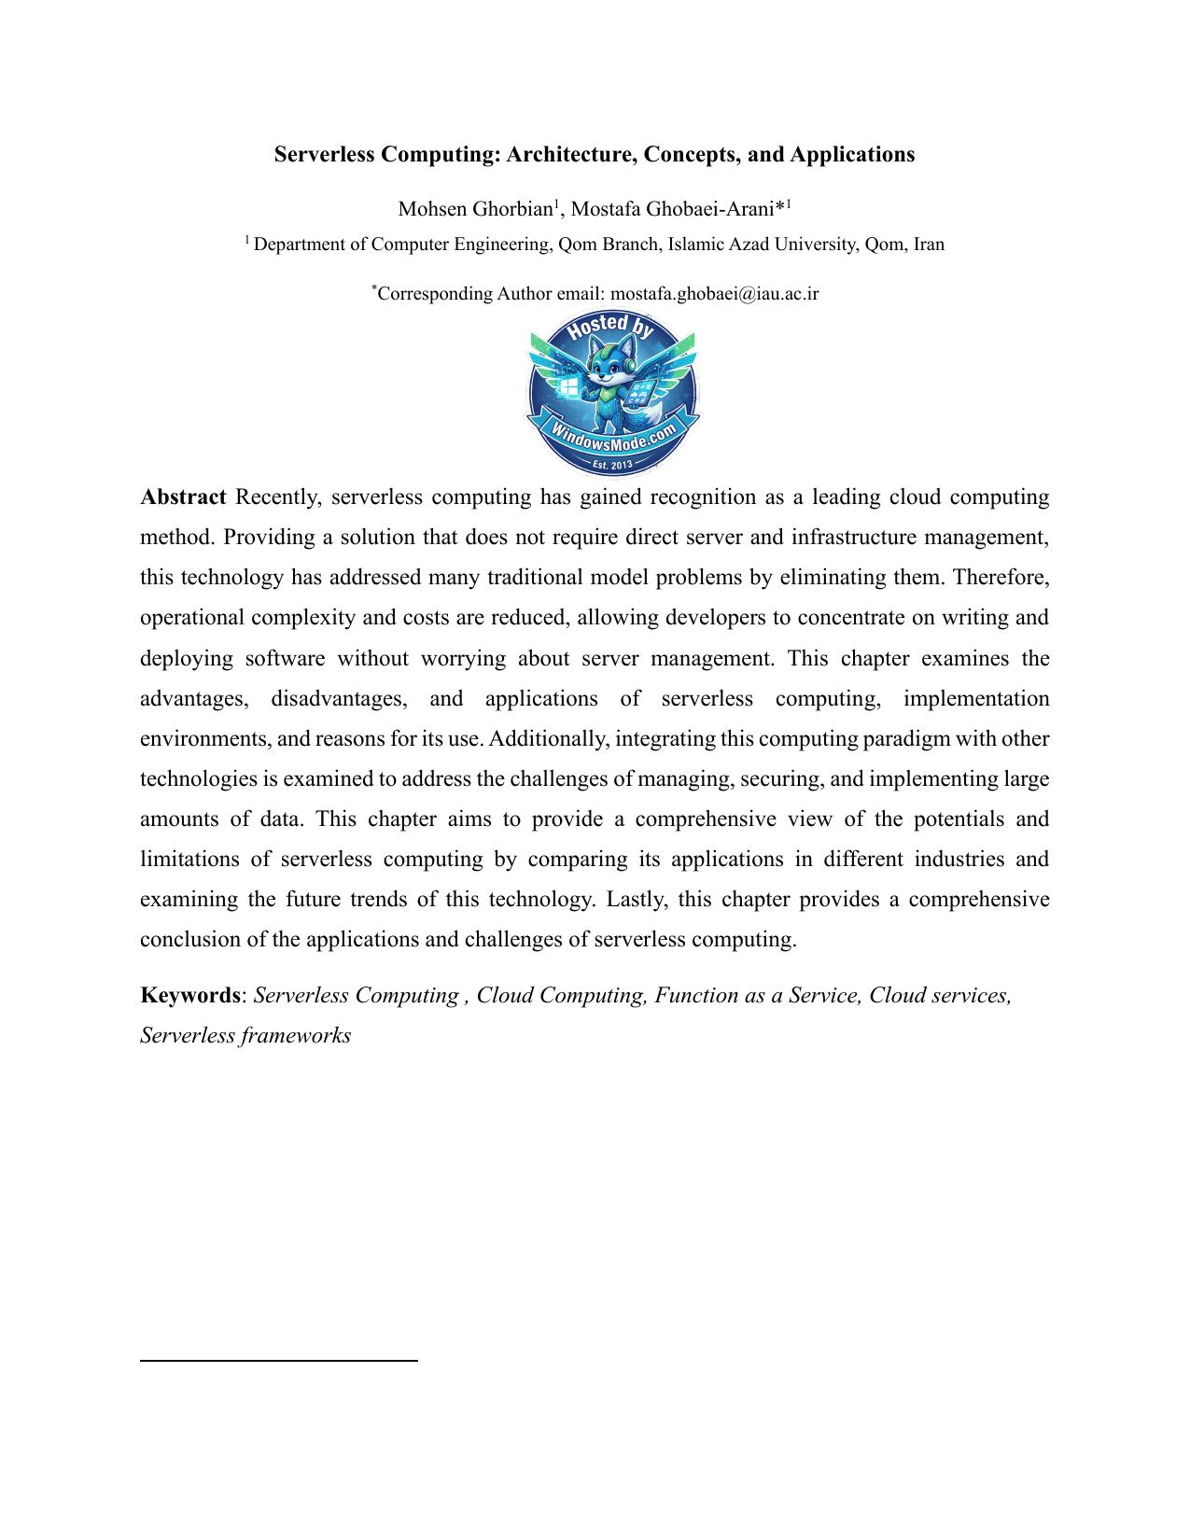

Serverless Computing: Architecture, Concepts, and Applications

Mohsen Ghorbian1 1 , Mostafa Ghobaei-Arani\*

1 Department of Computer Engineering, Qom Branch, Islamic Azad University, Qom, Iran



\*Corresponding Author email: mostafa.ghobaei@iau.ac.ir

Abstract Recently, serverless computing has gained recognition as a leading cloud computing method. Providing a solution that does not require direct server and infrastructure management, this technology has addressed many traditional model problems by eliminating them. Therefore, operational complexity and costs are reduced, allowing developers to concentrate on writing and deploying software without worrying about server management. This chapter examines the advantages, disadvantages, and applications of serverless computing, implementation environments, and reasons for its use. Additionally, integrating this computing paradigm with other technologies is examined to address the challenges of managing, securing, and implementing large amounts of data. This chapter aims to provide a comprehensive view of the potentials and limitations of serverless computing by comparing its applications in different industries and examining the future trends of this technology. Lastly, this chapter provides a comprehensive conclusion of the applications and challenges of serverless computing.

Keywords: Serverless Computing , Cloud Computing, Function as a Service, Cloud services, Serverless frameworks

1. Introduction

In recent years, serverless computing has emerged as a transformative paradigm in cloud computing. This innovative approach overcomes many challenges associated with traditional server-based models by eliminating the need to manage servers and infrastructure. Thus, operational complexity and efficiency are reduced, allowing developers to concentrate on writing and deploying code without worrying about server management. Serverless computing solves problems related to capacity management and resource allocation by providing automatic scaling and resource optimization [1,2]. This results in lower costs since users only pay for real-time code execution. More straightforward development and deployment tools significantly reduce development time, and coordination and integration with other systems are improve. Using serverless computing, developers can concentrate on innovation and improving software quality while increasing the security of their code and data due to increased infrastructure security provided by cloud service providers [3,4]. Flexibility facilitates software management and updates, improves real-time processing capabilities and rapid response to events, and simplifies meeting changing business needs. Serverless computing maximizes resource utilization and reduces environmental impact through small and modular functions. Additionally, this model provides extensive support from major cloud providers, providing access to technology for businesses of all sizes and allowing for easy scalability [5]. As serverless computing reduces the costs associated with maintaining and updating infrastructure, it improves productivity and enables businesses to grow and develop. Serverless computing is rapidly increasing due to the many challenges associated with traditional computing. One of the main challenges is managing servers and infrastructure, which requires high technical expertise and considerable time. Traditionally, scaling is handled manually, increasing expenses and additional resources. It is also wasteful to pay fees based on fixed capacity, even when resources are not fully utilized [6]. One of the obstacles to bringing products to market is the longer development and deployment times associated with traditional computing. Furthermore, it is the sole responsibility of development teams to ensure infrastructure security, which can lead to increased security complexity. In light of these challenges, serverless computing has emerged as an efficient and optimal method of increasing productivity and reducing costs [7]. This chapter will examine the advantages, disadvantages, and applications of serverless computing, the implementation environment and reasons for using it. As part of this chapter, we explain how serverless computing benefits business processes, productivity, cost reductions, and customer service levels compared to traditional processing approaches. Furthermore, the integration process of this computing paradigm with other technologies that can address the challenges related to the implementation of this technology, such as big data management, data security, and complex implementation, is examined, and the leading challenges in this field are also examined. Lastly, the chapter provides a comprehensive summary of the potential and limitations of serverless computing by comparing its applications in different industries and offering a glimpse into its future applications.

This chapter structure is as follows: As a starting point, the second part thoroughly examines the necessary prerequisites, such as an Overview of Serverless Computing, Serverless Computing Architecture, Serverless Computing Concepts, and Applications of Serverless Computing. The third part of this chapter describes Serverless Development Environments. The fourth part of the chapter compares serverless computing with traditional computing. The fifth section comprehensively examines Integrating Serverless Computing with Other Technologies. The sixth section examines Future Trends in Serverless Computing. As the last step, the seventh section concludes this explanation.

2. Overview of Serverless Computing

Serverless computing is one of the newest and most state-of-the-art data processing and management paradigms in cloud computing environments. It allows developers to develop applications more efficiently and faster by eliminating the need to manage servers. This computing paradigm was supported by major cloud computing providers such as Amazon Web Services (AWS), Google Cloud, and Microsoft Azure [8,9]. It lets developers focus on coding and optimization rather than worrying about hardware and software infrastructure. In addition to providing a ready and scalable infrastructure, serverless computing helps developers respond to customer needs more quickly and efficiently by removing many management and operational challenges from their shoulders. In serverless computing, unlike traditional models that require the purchase, installation, and management of servers, computing resources are allocated dynamically and based on demand rather than requiring the purchase, installation, and management of servers. The costs for any programs are only calculated when running, and users are not charged when they are not used [10]. This paradigm using an economic model of "pay-as-you-go" has significantly reduced operating costs and increased organizational productivity. Additionally, serverless computing can adapt quickly to changes in workloads and data volumes due to its ability to scale automatically. A significant feature of serverless computing is its simplicity and speed in developing and deploying applications [11]. Developers can quickly develop and deploy applications to production environments using serverless cloud services without managing complex infrastructure. This feature is especially attractive for startups and small businesses with limited resources. Furthermore, this computing model, in conjunction with modern tools and frameworks, facilitates software development and reduces the time to market [12]. Serverless computing also helps increase applications' reliability and availability by providing advanced features such as automatic scaling management and synchronization with different load distribution types. Hence, using these features, applications may continue to operate continuously and uninterrupted, irrespective of a sudden increase in workload or an infrastructure issue. The importance of these features is especially evident when it comes to critical applications and services that require high levels of availability [13]. Serverless computing, combined with new technologies such as blockchain, Internet of Things (IoT), and artificial intelligence (AI), enables the creation of intelligent and complex applications and systems. This combination allows businesses to make better decisions and provide better customer services using big data and advanced analytics. Overall, serverless computing has revolutionized the way applications are developed and managed and dramatically changed the future landscape of the IT world by providing new features and capabilities [14].

2.1 Serverless Computing Architecture

The serverless computing architecture is a new approach to designing and implementing software programs, eliminating the need to manage servers and physical infrastructure. In this model, developers are only required to write and deploy their code, while cloud service providers handle all infrastructure requirements. This approach includes several components: serverless functions, API gateways, managed database services, and file and data management services [15]. The components of this system are designed to scale and adjust to changing workloads automatically. One of the main components of serverless computing architecture is serverless functions. These functions are small pieces of code that execute only when requested. These functions are usually invoked by API gateways or specific events, such as changes to the database or file uploads. Their main advantage is that they are automatically scalable and do not require manual resource management. This type of serverless function is offered by cloud service providers, including AWS Lambda, Azure Functions, and Google Cloud Functions, which offer developers a wide range of possibilities [16]. Table 1 compares three services providing serverless functions (AWS Lambda, Azure Functions, and Google Cloud Functions) based on ten different parameters.

Table 1. Comparing the main features of Serverless Functions from AWS Lambda, Azure Functions, and

Google Cloud Functions

Parameter AWS Lambda Azure Functions Google Cloud Functions

• 15 minutes • 5 minutes (can be • 9 minutes (can be increased to

Execution Time Limit increased to 60 minutes in 60 minutes in 2nd Generation)

Premium Plan)

Memory • 128 MB to 10 GB • 128 MB to 14 GB • 128 MB to 16 GB

Supported • Node.js, Python, Ruby, • JavaScript, C#, F#, Java, Node.js, Python, Go, Java,

Programming Java, Go, .NET, Python, TypeScript, .NET, Ruby, PHP

Languages PowerShell PowerShell

• Based on the number of • Based on the number of • Based on the number of

Pricing requests and execution requests and execution requests and execution duration

duration duration

Versioning and Traffic • Yes • Yes • Yes

Management

• Yes (Amazon S3, • Yes (Azure Event Grid, • Yes (Google Cloud Storage,

Event and Trigger DynamoDB, Kinesis, Storage, Service Bus, etc.) Pub/Sub, Firestore, etc.)

Support SNS, SQS, etc.)

• AWS CloudWatch • Azure Monitor and • Google Cloud Monitoring and

Monitoring and Logging Application Insights Logging

Local Development and • Yes (AWS SAM Local) • Yes (Azure Functions • Yes (Functions Framework)

Debugging Core Tools)

• Yes (Integration with • Yes (Integration with • Yes (Integration with Google

Integration with Other AWS services like RDS, Azure services like SQL Cloud services like BigQuery,

Services API Gateway, etc.) Database, Cosmos DB, Cloud SQL, etc.)

etc.)

Security and Identity • AWS IAM, AWS KMS, • Azure AD, Key Vault, • IAM, Secret Manager, VPC

Management VPC Integration VNET Integration Service Controls

The API gateway is another key component of the serverless computing architecture responsible for managing the flow of requests and responses between users and serverless functions. API Gateways of cloud providers usually provide features such as authentication, rate limiting, and traffic management. These features make communication between customers and services optimal and secure. Another aspect of serverless computing is managed database services, which allow developers to store and manage their data without managing and maintaining database servers. These services include Amazon DynamoDB, Google Firestore, and Azure Cosmos DB [17]. These databases can handle a large volume of data with high performance, which is particularly important for applications requiring rapid and reliable responses. They are also automatically scalable and can handle large amounts of data. The serverless computing architecture also includes file and data management services, including object storage services such as Amazon S3, Google Cloud Storage, and Azure Blob Storage. These services can store and access large amounts of data in a highly secure and reliable manner. Additionally, these services are commonly integrated into serverless functions and other cloud services to optimize and automate data management processes. Serverless computing architecture provides a dynamic and scalable infrastructure for developing and running software applications by combining these components and services. By eliminating infrastructure and management concerns, developers can focus on innovation and improving user experience while reducing costs, speeding up development, and improving application performance [18]. Figure 1 illustrates the serverless computing architecture.

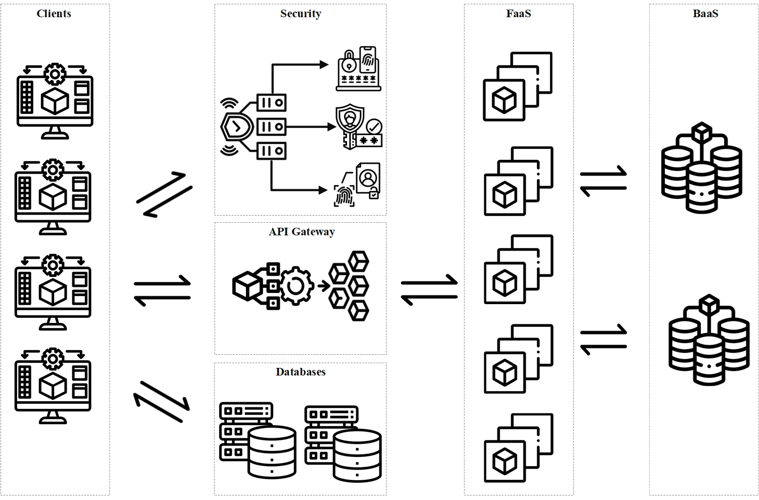

Figure 1. the serverless computing architecture.

2.2 Serverless Computing Concepts

Serverless computing is one of the most advanced computing technology models, making the program development process faster and more efficient. This model incorporates several key concepts that contribute to optimizing performance and costs. Among these concepts, we can mention "Cold Start," "Function Placement," "Pricing Models," "Auto Scaling," and "Scheduling." These concepts all play an integral role in improving efficiency and reducing costs [19]. The following will provide a detailed analysis of each of these cases.

• Cold Start: The term "cold start" describes situations in which a serverless function is

invoked for the first time or after a period of inactivity, and there are no active instances of

the function in memory when it is called. In this case, the system must restart the execution

environment, which includes loading the necessary code and settings. In cases where fast

and real-time performance is required, a cold start may cause response time delays and

negatively impact the user experience. A cloud service provider may use warm start or pre-

warming methods to minimize the effects of cold start [20].

• Function Placement: "Function placement" refers to deciding where to execute serverless

functions in the cloud infrastructure based on factors including proximity to the end users,

server load, costs, and security requirements. The location of functions can significantly

affect the performance and cost of a system. For example, if functions are executed near

end users, response times can be reduced. Furthermore, properly distributing load among

servers can prevent bottlenecks, and resources can be utilized more efficiently. Advanced

techniques, such as machine learning, can be used to predict load patterns and optimize

where functions are executed [21].

• Pricing: "Pricing" in serverless computing refers to pricing models usually determined

based on resource usage, such as function execution time, memory consumption, and

number of requests. By designing serverless pricing models, users pay for only the

resources they use, which minimizes costs. Various pricing models may be offered,

including fixed fees per function execution, variable fees based on memory usage and

execution time, and volume discounts for large users. Understanding pricing models is

essential for optimizing costs and managing budgets, as miscalculations can result in

unexpected expenditures [22].

• Auto-scaling: "auto-scaling" refers to a system's ability to adjust resources automatically

based on the current load demand. In serverless environments, function instances are

created and removed according to the volume of requests. Auto-scaling ensures optimal

system performance and reduces costs by only utilizing resources when required. Hence,

various algorithms are used to perform auto-scaling based on criteria such as request rate,

resource utilization, and load prediction. Auto scaling can be performed horizontally

(increasing or decreasing the number of instances) or vertically (increasing or decreasing

the resource capacity of each instance) [23].

• Scheduling: "scheduling" refers to allocating resources and scheduling functions in

serverless environments. It includes determining priorities, allocating limited resources,

and optimizing the utilization of limited resources. By implementing effective scheduling,

productivity can be increased and delays reduced. Resource management in complex

environments involves advanced algorithms such as real-time scheduling and multi-

objective optimization. Hence, functions are scheduled using real-time scheduling

according to their priority and deadline to ensure critical functions are performed at the

right time. Additionally, optimized resources can reduce costs and boost overall system

efficiency [24].

Combining these concepts can result in improved performance, reduced costs, and increased scalability when running serverless applications. Based on several parameters, it can be helpful to better understand the performance and effects of serverless computing concepts such as cold start, function placement, pricing, auto-scaling, and scheduling. Table 2 shows the main parameters for comparing these concepts, including their advantages, disadvantages, objectives, and applications.

Table 2. A comparison of the main concepts based on advantages, disadvantages, objectives, and

applications.

Parameter Cold Start Function Placement Pricing Auto Scaling Scheduling

Advantages • Cost savings during • Optimized • Pay-as-you-go • Automatic • Optimal

idle times performance based model resource adjustment resource • Improved resource on function execution • Optimized costs based on needs allocation management location • Increased • Increased

• Reduced response efficiency and efficiency and latency resource utilization reduced latency

Disadvantages • Delay during initial • Complexity in • Complexity in • May not suffice • Requires

startup deciding function cost calculation during peak loads complex • Negative impact on execution location • Potential for • Requires algorithms for user experience • Requires advanced unexpected costs advanced resource

techniques for algorithms for load management optimization prediction • Issues with

prioritizing and

scheduling

functions

Objectives • Cost reduction • Improved system • Cost reduction • Maintaining • Optimized

• Improved system performance • Optimized system performance resource usage efficiency during idle • Reduced response resource usage • Enhanced • Reduced times latency resource efficiency latency and

increased

efficiency Applications • Applications with • Distributed systems • All serverless • Applications with • Complex

intermittent usage • When reducing applications variable workloads systems • When cost response latency is • When cost • When automatic requiring reduction is a priority crucial optimization is a resource adjustment optimal resource

priority is needed management

• Applications

with critical

timing needs

2.3. Applications of Serverless Computing

The serverless computing paradigm has played a significant role in the evolution of various industries. This approach allows businesses to focus on development and innovation without being required to manage servers, as it provides capabilities such as automatic scaling, reduced infrastructure costs, and improved productivity. Various industries, including e-commerce, healthcare, media and entertainment, financial services, transportation and logistics, and education, can benefit from serverless computing by optimizing processes, increasing speed and efficiency, and improving customer service [25]. In the following, each of these applications will be examined in detail.

• Electronic commerce: In the e-commerce industry, serverless computing plays a vital role

in optimizing the online shopping experience. This technology allows businesses to interact

with their customers more effectively and on a larger scale. For instance, product

recommendation systems based on user behavior and purchase history can provide more

accurate and timely recommendations. Additionally, serverless computing can assist in

managing transactions and processing payments, increasing speed and reducing business

operational costs [26].

• Healthcare: Serverless computing provides smart and efficient healthcare services. Using

this technology, hospitals and medical centers can analyze medical data in real-time, which

can assist in diagnosing diseases more quickly and providing appropriate treatment to

patients. Moreover, serverless computing can be a powerful tool for monitoring patients'

conditions and providing immediate alerts [27].

• Media and entertainment: In the media and entertainment industry, serverless computing

assists in creating and managing multimedia content. This technology is helpful for video

and music streaming services, which can process and deliver content around the world

using this technology. By reducing infrastructure costs and increasing flexibility, these

services can provide better services to their users. Moreover, serverless computing can

assist organizations in creating and managing interactive applications and online games

[28].

• Financial services: By utilizing serverless computing in the financial services industry,

banks and financial institutions can improve the efficiency and security of their services.

Financial data can be analyzed, transactions can be managed, and intelligent banking

services can be provided using this technology. This results in faster, more accurate

transaction processing, lower costs, and improved customer satisfaction [29].

• Transportation and logistics: Serverless computing can improve supply chain

management processes and goods transportation in the transportation and logistics industry.

By utilizing this technology, shipping companies can collect and analyze data in real-time

regarding the location and condition of goods, which improves planning and reduces costs.

In addition, serverless computing can be an effective tool for improving fleet management

systems and delivering better customer service [30].

• Education: Serverless computing can assist in creating and managing online educational

systems. By utilizing this technology, educational institutions can offer courses on demand

and online, increasing access to education and improving the learning experience for

students. Additionally, serverless computing can analyze educational data and evaluate

student performance, improving training processes and providing personalized training

[31].

Table 3 compares serverless computing applications in different industries (e-commerce, healthcare, media and entertainment, financial services, transportation, logistics, education, and training) based on criteria such as benefits, challenges, and key applications.

Table 3. A compare serverless computing applications in different industries

Industry Benefits Challenges Key Applications

• Enhanced online shopping • Complexity in managing • Product recommendation experience big data systems

E-commerce

• High scalability • Data security and privacy • Transaction management • Reduced operational costs • Payment processing • Smart healthcare services • Patient privacy protection • Faster disease diagnosis • Real-time medical data • Security of sensitive data • Immediate alerts

Healthcare

analysis • Personal health apps

• Patient status monitoring

• Reduced infrastructure costs • Managing high volumes • Video and music streaming

Media and • Increased flexibility of content • Online game management Entertainment • Better user services • Need for extensive user • Interactive apps

support

• Increased security and • Countering security • Financial data analysis efficiency threats • Transaction management

Financial Services

• Faster transaction processing • Customer privacy • Smart banking services • Reduced costs protection • Improved supply chain • Managing large datasets • Real-time tracking and

Transportation and management • Need for coordination analysis of goods Logistics • Reduced operational costs with various systems • Fleet management

• High flexibility • Improved planning • Increased access to • Managing educational • Online learning systems education data • Educational data analysis

Education • Enhanced learning • Data security and privacy • Student performance

experience evaluation • Reduced costs

3. Serverless Development Environments

The serverless computing development and implementation environment provides developers with tools and platforms to develop and deploy their code without managing server infrastructure. These environments include open-source platforms such as Apache OpenWhisk, Kubeless, Fission, Knative, and OpenFaaS, which are run on Kubernetes and Docker and support a variety of programming languages. Furthermore, closed-source platforms such as AWS Lambda, Google Cloud Functions, Azure Functions, IBM Cloud Functions, and Oracle Functions are managed and integrated with other cloud services. Figure 2 shows these environments, including both open and closed-source environments. These environments provide automatic scaling capabilities, event management, and integration with various services, simplifying and speeding up the development and implementation process. However, the installation, configuration, infrastructure management, and costs associated with increasing the volume of requests can also present challenges, including the complexity of installation and configuration [32]. The following will examine open-source development environments in detail.

• Apache OpenWhisk: This platform allows developers to execute small functions in

response to various events using a distributed architecture. It is a serverless, event-driven

computing platform. The OpenWhisk platform is based on Kubernetes and Docker and is

supported by various programming languages, including JavaScript, Python, Swift, and

Java. As the platform utilizes the combination and coordination of functions, it can build

complex chains of operations and perform automatic scaling.

• Kubeless: This platform is an open-source serverless framework that runs on Kubernetes

and allows developers to run their functions natively using Kubeless. It fully integrates

with Kubernetes, enhancing its functionality management and scalability capabilities. In

addition to supporting Python, Node.js, Ruby, PHP, and other programming languages,

Kubeless also supports handling events and binding them to functions.

• Fission: This open-source serverless platform is built on Kubernetes and designed to

develop and run small functions. This platform enables users to develop and run code

quickly and supports various programming languages, including Python, Node.js, Go, etc.

Fission is event-driven and can respond to HTTP requests, schedulers, and Kafka

messages. Fission is easy to use and fast to develop and implement.

• Knative: This open-source platform for building and running serverless applications on

Kubernetes allows developers to run serverless applications with high performance on

Kubernetes. In addition to supporting several languages for developing functions, Knative

includes several managed services, such as Knative Serving for executing functions and

Knative Evening for managing events.

• OpenFaaS (Open Function as a Service): This is an open-source platform for building

and running serverless functions on Kubernetes and Docker. It allows developers to easily

create and manage their functions using a straightforward user interface. In addition to

supporting Python, Node.js, Go, Ruby, and Java, functions can be designed to respond to

HTTP requests and a scheduler, among other events. One of the outstanding features of

OpenFaaS is the ability to automate scaling and use Prometheus for monitoring and scaling

functions [33].

The following will examine close-source development environments in detail.

• AWS Lambda: AWS Lambda is one of the most popular serverless services provided by

Amazon Web Services. The service allows developers to run their code without having to

manage servers, and the code is executed in response to events such as changes in S3,

updates in DynamoDB, and messages sent to SQS. Lambda scales automatically and

supports multiple languages such as Python, JavaScript (Node.js), Java, C#, Go, and Ruby.

Full integration with other AWS services, such as API Gateway, S3, and CloudWatch, is

one of the prominent features of this service.

• Google Cloud Functions (GCF): GCF is a serverless service from Google Cloud Platform

that allows developers to run their code as independent functions. Consequently, these

functions are automatically scaled and respond to events such as HTTP requests, changes

in Cloud Storage, and Pub/Sub messages. In addition to supporting multiple languages,

including Node.js, Python, Go, and Java, Cloud Functions is compatible with other Google

Cloud services such as Firestore, Pub/Sub, and Stackdriver.

• Microsoft Azure Functions: Microsoft Azure Functions is a serverless service that allows

developers to write code as small functions and execute those functions automatically in

response to events. The service can respond to events such as HTTP requests, Service Bus

messages, and changes to Azure Blob Storage and automatically scales. In addition to

supporting languages such as C#, JavaScript (Node.js), Python, Java, and PowerShell,

Azure Functions integrates with other Azure services, including Cosmos DB, Event Grid,

and Application Insights [34].

• IBM Cloud Functions: IBM Cloud Functions is a serverless service built based on Apache

OpenWhisk. It allows developers to write and execute their code as small functions. IBM

Cloud Functions can respond to multiple events and scale automatically. In addition to

supporting JavaScript (Node.js), Python, Swift, and Java languages, it integrates with IBM

Cloudant, IBM Message Hub, and IBM Watson services.

• Oracle Functions: This serverless service from Oracle Cloud is based on the Fn Project.

It allows developers to run their functions based on events and integrate with other Oracle

Cloud services. With Oracle Functions, users can write functions in JavaScript, Python,

Go, Java, and Ruby, which scale automatically. In addition to Oracle Object Storage, Oracle

Autonomous Databases, and Oracle Event Hub, this service is well integrated with other

Oracle Cloud services [35].

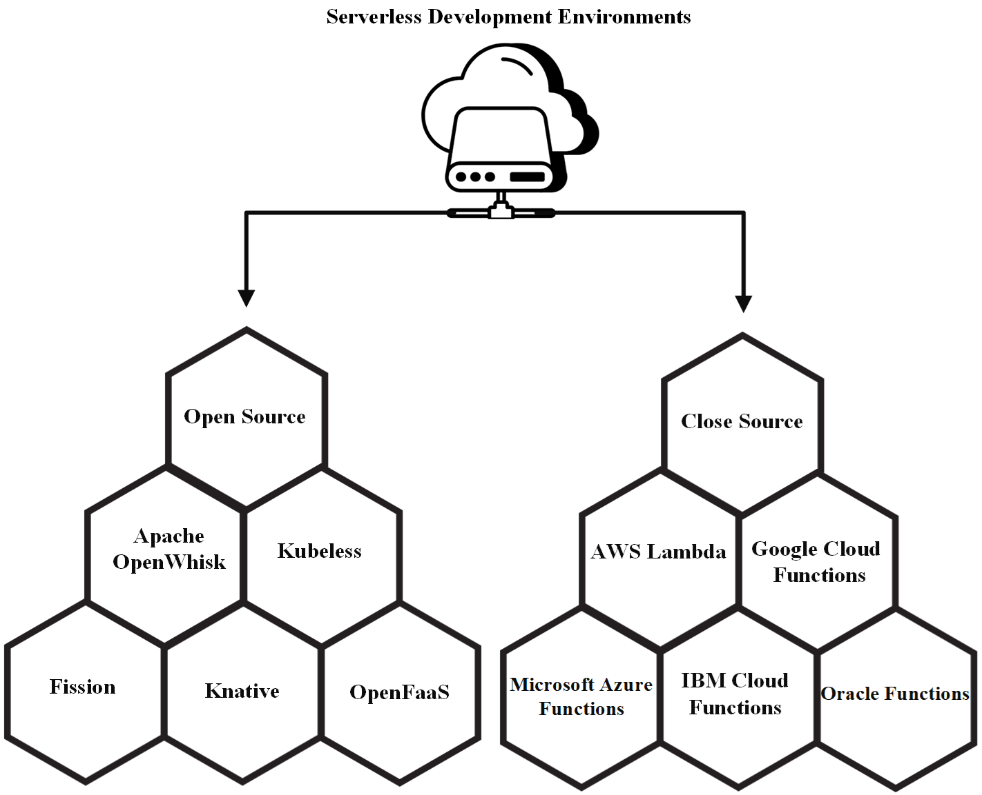

Figure 2. Serverless Development Environments: open source and closed source

Depending on the project's requirements and existing infrastructure, these open-source and closed-source platforms can be an appropriate choice based on their features and benefits. The development team can select these tools based on workload, programming language, scalability, and Kubernetes knowledge.

4. Serverless Computing vs. Traditional Computing

Comparing serverless computing with traditional computing involves two different approaches. Information technology (IT) teams are traditionally responsible for configuring, maintaining, updating, and scaling the servers and infrastructure necessary to run applications. The process typically requires a high degree of technical expertise and significant human resources and is usually time-consuming and expensive. Alternatively, serverless computing significantly reduces these complications by allowing developers to write and upload their code to cloud environments instead of configuring or managing the supporting infrastructure directly. As a result, organizations can be more productive and drastically reduce infrastructure management costs by automatically configuring, scaling, and managing the required infrastructure as needed [36]. Figure 3 illustrates the differences between serverless computing and traditional computing architectures. The following will examine this difference in detail.

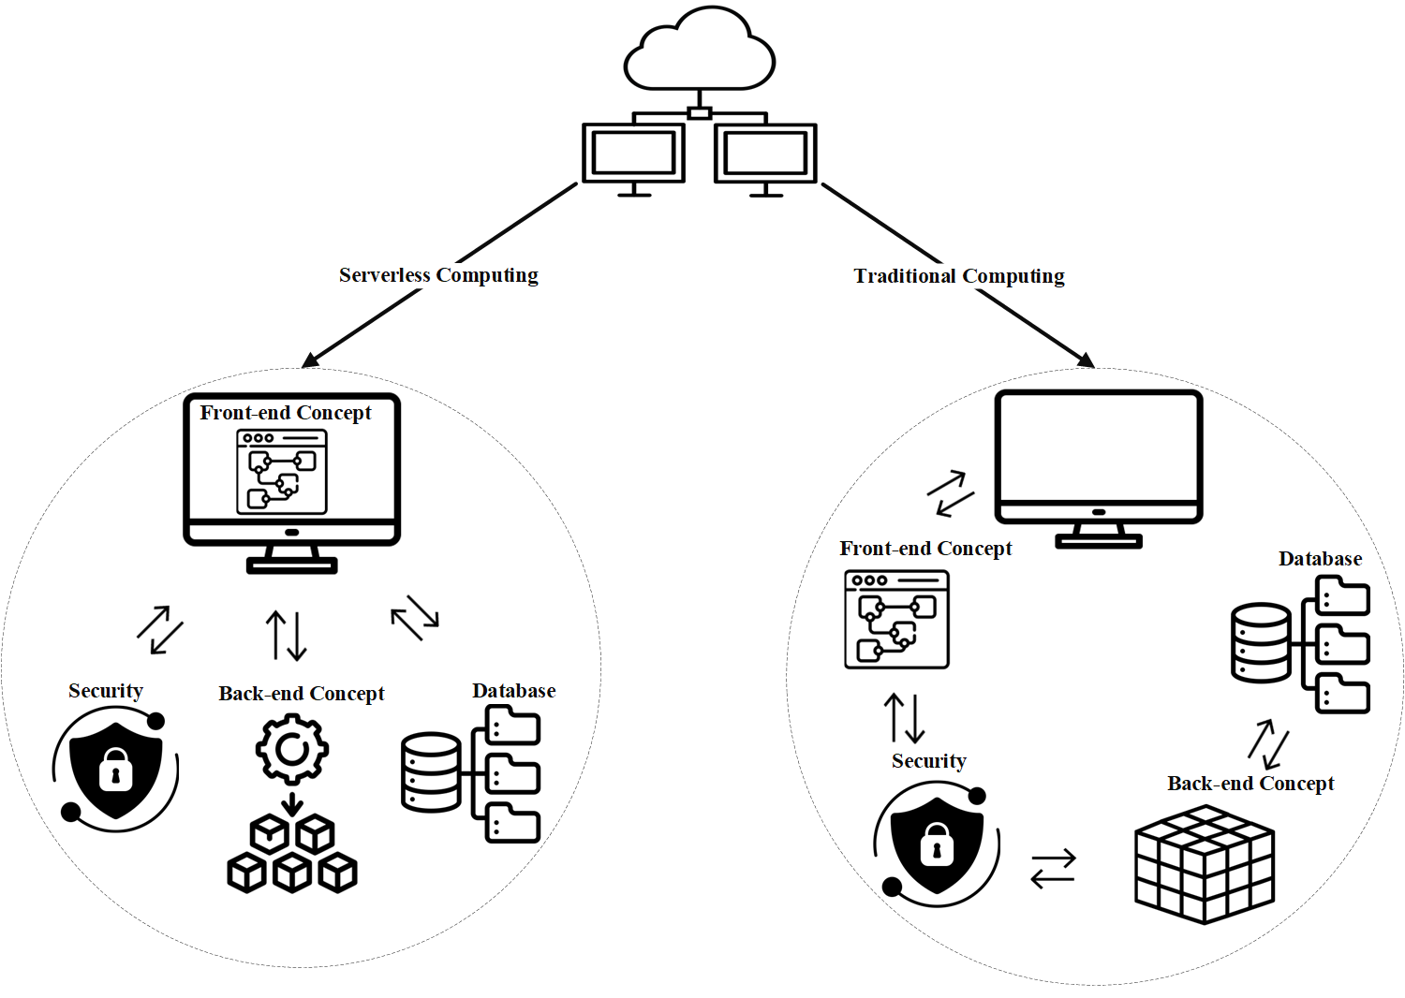

Figure 3. Comparison of serverless computing and traditional computing architectures.

• Infrastructure management: A traditional computing model entails infrastructure

management by information technology (IT) teams, who are responsible for configuring,

maintaining, updating, and scaling servers. In contrast, serverless computing transfers these

tasks to cloud service providers, which require significant technical expertise and human

resources. Developers simply upload their code to the serverless service, and the service

manages and scales the infrastructure automatically.

• Costs: A traditional computing model typically involves a fixed cost. Organizations must

purchase and maintain servers and related infrastructure, regardless of whether fully

utilized. These costs include maintenance costs for hardware, electricity, cooling, and

manpower. On the other hand, serverless computing uses a pay-as-you-go model, in which

fees are incurred only when a particular code is executed. With this model, organizations

can significantly reduce costs, especially for programs that run irregularly or in low

volumes.

• Scalability: The scaling process for a traditional computing system is complex and time-

consuming. IT teams must add server resources and make necessary adjustments, which

can be time-consuming and costly. With serverless computing, scaling occurs

automatically and on demand. Serverless services can be easily and quickly scaled up or

down based on changing workloads without requiring manual intervention [37].

• Development time: A traditional computing requires much time and energy to set up and

configure the infrastructure. Typically, developers are responsible for setting up

development and production environments and troubleshooting compatibility issues. In

contrast, serverless computing reduces these issues. Developers can focus on writing code

and deploy and manage their code using the tools available in cloud services. Doing so

reduces the development time, and the product is delivered to the market more quickly.

• Security: In the traditional computing, security issues are typically the responsibility of

the organization's information technology and security teams. These teams ensure that

security updates are made, configurations are secure, and systems are continuously

monitored, which requires a considerable amount of time and resources. In serverless

computing, service providers are responsible for basic security. They keep their

infrastructure secure and apply security updates automatically. Nevertheless, developers

are still responsible for their code and data security [38].

• Flexibility: Traditional computing requires management of servers and infrastructure,

which makes them less flexible. Changes and scaling are typically time-consuming and

complex. On the other side, serverless computing provides greater flexibility. In serverless

computing, developers can quickly add new functions, implement changes, and respond to

business requirements. Serverless services adapt quickly to changes and allow high-scale

code execution without manual intervention.

• Maintenance and support: In traditional computing, maintenance and support require

considerable resources and time. In serverless computing, these tasks have been transferred

to service providers responsible for maintaining and updating the infrastructure so

developers can focus on improving and developing their applications instead of fixing

systems and fixing problems. Security and software updates should also be performed on

time. In this model, IT teams can reduce their workload and increase efficiency [39].

Table 4 compares serverless computing and traditional computing based on parameters related to pricing model, server management, scalability, uptime, suitable applications, configuration and setup, security, startup time, programming language support, updates and maintenance, infrastructure control, performance, resource utilization, and response time.

Table 4. A compare serverless computing and traditional computing

Parameter Serverless Computing Traditional Computing

Pricing Model • Pay-as-you-go • Fixed and variable costs

• Automatically managed by the • Manually managed by the IT

Server Management

service provider team • Automatic scalability • Manual scalability requiring

Scalability

planning

• Very high (guaranteed by • Depends on IT team and

Uptime

provider SLAs) infrastructure • Event-driven and intermittent • Long-running and complex

Suitable Applications

tasks applications • Minimal configuration and setup • Extensive configuration and setup

Configuration and Setup

required needed

• Shared responsibility (provider • Complete responsibility on IT

Security

and user) team

Startup Time • Quick and immediate • Can be time-consuming

• Multiple popular languages • Limited to infrastructure

Programming Language Support

capabilities

• Automatic and managed by the • Managed by the IT team

Updates and Maintenance

provider

Control over Infrastructure • Limited • Complete

• May vary depending on traffic • Predictable and controlled

Performance

• Optimized for lower consumption • Requires precise resource

Resource Utilization

management

• May vary • Typically, fixed and predictable

Response Time

5. Integrating Serverless Computing with Other Technologies

Integrating serverless computing with emerging technologies such as blockchains, IoTs, and artificial intelligence (AI) can yield significant performance, scalability, and cost reductions. By integrating serverless computing with these technologies, developers can take advantage of each technology's unique capabilities and develop innovative solutions. The following will provide a detailed analysis of each of these technologies.

• Integration with blockchain: Integrating serverless computing with blockchain can

facilitate decentralized and secure transactions. Serverless functions can serve as

intermediaries between users and blockchain networks, for example, to record transactions,

execute smart contracts, and monitor blockchain status. This integration allows for high

scalability and low costs, as functions are executed just when needed, reducing permanent

servers' fixed costs. Further, serverless computing facilitates processing transactions and

delivering results to users more quickly and efficiently [40].

• Integration with the Internet of Things (IoT): The serverless computing approach is

naturally compatible with the Internet of Things (IoT), as many IoT devices need to process

small amounts of data and react to various events on a timely basis. A serverless function

can process incoming data from IoT devices, execute application logic, and store results.

In this model, developers can develop IoT applications that are scalable and efficient since

computing resources are dynamically allocated according to device needs. In addition,

serverless computing can quickly respond to changes in the number of connected devices

necessary to handle IoT workload [41].

• Integration with artificial intelligence (AI): Implementing complex algorithms and

machine learning models at a large scale is possible through the effective combination of

artificial intelligence and machine learning (ML) with serverless computing. Using

serverless functions to process data, run artificial intelligence models, and present results

to users or other systems is possible. This integration is particularly useful for applications

requiring real-time data analysis, such as image recognition, audio analysis, and prediction.

The developers can divide their AI models into small, discrete functions and run them in

parallel, which increases processing speed and reduces costs [42].

A significant benefit of integrating serverless computing with these technologies is the increased level of security that can be achieved. As part of blockchain, serverless functions can serve as secure intermediaries for smart contract execution, ensuring that transactions are executed securely and transparently. In the Internet of Things, serverless functions can analyze incoming data and identify security threats in real-time. Hence, using artificial intelligence, these functions can implement sophisticated security models to detect intrusions and attacks, thereby assisting in protecting data and systems. Despite the many benefits, integrating serverless computing with these technologies presents challenges. These challenges include concurrency management in blockchains, bandwidth and latency issues in the Internet of Things, and the need for high computing resources in artificial intelligence. To address these challenges, developers must utilize appropriate architectures and best programming practices. Advanced techniques such as sharding in blockchain, data compression in IoT, and optimizing AI models can help improve performance and reduce problems. Additionally, the integration process can be optimized if the right cloud service provider is chosen and the native capabilities of each platform are utilized.

6. Future Trends in Serverless Computing

The field of serverless computing is rapidly evolving and expanding, and future predictions and trends predict significant changes and numerous innovations. The adoption and use of serverless computing in various organizations and businesses is one of today's most significant trends. The advantages of flexibility, scalability, and cost reduction have led many companies to utilize this computing model. The use of serverless computing is expected to become an integral part of software development in the near future, and many applications and services will be developed using this technology. Serverless computing is also being improved and developed regarding tools and services. Cloud service providers such as Amazon Web Services, Google Cloud, and Microsoft Azure are constantly upgrading their platforms with new features and capabilities. Among the features included are advanced management and monitoring tools, performance optimization, and enhanced security. In addition, more developers are developing and managing serverless functions using open-source frameworks and libraries, increasing efficiency and reducing implementation complexity. In addition, serverless computing is increasingly integrating with advanced technologies such as artificial intelligence, machine learning, and the Internet of Things. By incorporating these technologies, more innovative and efficient solutions can be developed. For example, serverless functions can run machine learning models and process IoT data, facilitating data analysis and real-time decision-making. The development of more complex and intelligent systems is predicted to occur as a result of these trends in the future. A significant challenge to address in the future is improving management and reducing cold start delays. As serverless computing use increases, the need for faster startup times of functions will become increasingly apparent. Various techniques are considered, including preheating functions, using lighter containers, and optimizing computing infrastructure. These improvements will help reduce delays and improve the user experience.

7. Conclusion

Serverless computing has solved many problems in traditional models by providing a solution that does not require direct management of servers and infrastructure. In this way, operational complexity and efficiency are enhanced, allowing developers to focus on writing and deploying code rather than managing servers. This article examines the advantages, disadvantages, and applications of serverless computing, the environments in which it can be implemented, and the reasons for its use. By comparing its applications in several industries and analyzing its future trends, this paper strives to analyze the potential and limitations of serverless computing comprehensively. The article also discusses technological developments in integrating serverless computing with other technologies, as well as recent trends that demonstrate the effectiveness of this technology.

References

[1] Li, Y., Lin, Y., Wang, Y., Ye, K. and Xu, C., 2022. Serverless computing: state-of-the-art, challenges and opportunities. IEEE Transactions on Services Computing, 16(2), pp.1522-1539.

[2] Ghobaei-Arani, M. and Ghorbian, M., 2023. Scheduling mechanisms in serverless computing. In Serverless Computing: Principles and Paradigms (pp. 243-273). Cham: Springer International Publishing.

[3] Li, Z., Guo, L., Cheng, J., Chen, Q., He, B. and Guo, M., 2022. The serverless computing survey: A technical primer for design architecture. ACM Computing Surveys (CSUR), 54(10s), pp.1-34.

[4] Baldini, I., Castro, P., Chang, K., Cheng, P., Fink, S., Ishakian, V., Mitchell, N., Muthusamy, V., Rabbah, R., Slominski, A. and Suter, P., 2017. Serverless computing: Current trends and open problems. Research advances in cloud computing, pp.1-20.

[5] Pérez, A., Moltó, G., Caballer, M. and Calatrava, A., 2018. Serverless computing for container-based architectures. Future Generation Computer Systems, 83, pp.50-59.

[6] Al-Ali, Z., Goodarzy, S., Hunter, E., Ha, S., Han, R., Keller, E. and Rozner, E., 2018, July. Making serverless computing more serverless. In 2018 IEEE 11th International Conference on Cloud Computing (CLOUD) (pp. 456-459). IEEE.

[7] Kounev, S., Abad, C., Foster, I., Herbst, N., Iosup, A., Al-Kiswany, S., Hassan, A.A.E., Balis, B., Bauer, A., Bondi, A. and Chard, K., 2021. Toward a definition for serverless computing.

[8] Van Eyk, E., Toader, L., Talluri, S., Versluis, L., Uță, A. and Iosup, A., 2018. Serverless is more: From paas to present cloud computing. IEEE Internet Computing, 22(5), pp.8-17.

[9] McGrath, G. and Brenner, P.R., 2017, June. Serverless computing: Design, implementation, and performance. In 2017 IEEE 37th International Conference on Distributed Computing Systems Workshops (ICDCSW) (pp. 405-410). IEEE.

[10] Rajan, R.A.P., 2018, December. Serverless architecture-a revolution in cloud computing. In 2018 Tenth International Conference on Advanced Computing (ICoAC) (pp. 88-93). IEEE. [11] Ghorbian, M., Ghobaei-Arani, M. and Esmaeili, L., 2024. A survey on the scheduling mechanisms in serverless computing: a taxonomy, challenges, and trends. Cluster Computing, pp.1-40.

[12] Kelly, D., Glavin, F. and Barrett, E., 2020, October. Serverless computing: Behind the scenes of major platforms. In 2020 IEEE 13th International Conference on Cloud Computing (CLOUD) (pp. 304-312). IEEE.

[13] Yu, T., Liu, Q., Du, D., Xia, Y., Zang, B., Lu, Z., Yang, P., Qin, C. and Chen, H., 2020, October. Characterizing serverless platforms with serverlessbench. In Proceedings of the 11th ACM Symposium on Cloud Computing (pp. 30-44).

[14] Golec, M., Gill, S.S., Parlikad, A.K. and Uhlig, S., 2023. HealthFaaS: Ai-based smart healthcare system for heart patients using serverless computing. IEEE Internet of Things Journal, 10(21), pp.18469-18476.

[15] Schleier-Smith, J., Sreekanti, V., Khandelwal, A., Carreira, J., Yadwadkar, N.J., Popa, R.A., Gonzalez, J.E., Stoica, I. and Patterson, D.A., 2021. What serverless computing is and should become: The next phase of cloud computing. Communications of the ACM, 64(5), pp.76-84.

[16] Patros, P., Spillner, J., Papadopoulos, A.V., Varghese, B., Rana, O. and Dustdar, S., 2021. Toward sustainable serverless computing. IEEE Internet Computing, 25(6), pp.42-50.

[17] Stigler, M. and Stigler, M., 2018. Understanding serverless computing. Beginning serverless computing: developing with Amazon web services, Microsoft Azure, and Google Cloud, pp.1-14.

[18] Kulkarni, A., 2023. Amazon Athena: Serverless Architecture and Troubleshooting. International Journal of Computer Trends and Technology, 71(5), pp.57-61.

[19] Khatri, D., Khatri, S.K. and Mishra, D., 2024. Intelligent Framework in a Serverless Computing for Serving using Artificial Intelligence and Machine Learning. International Journal of Advanced Computer Science & Applications, 15(5).

[20] Vahidinia, P., Farahani, B. and Aliee, F.S., 2022. Mitigating cold start problem in serverless computing: A reinforcement learning approach. IEEE Internet of Things Journal, 10(5), pp.3917-3927.

[21] Mahmoudi, N., Lin, C., Khazaei, H. and Litoiu, M., 2019, November. Optimizing serverless computing: Introducing an adaptive function placement algorithm. In Proceedings of the 29th Annual International Conference on Computer Science and Software Engineering (pp. 203-213).

[22] Tütüncüoğlu, F. and Dán, G., 2023. Joint resource management and pricing for task offloading in serverless edge computing. IEEE Transactions on Mobile Computing.

[23] Tari, M., Ghobaei-Arani, M., Pouramini, J. and Ghorbian, M., 2024. Auto-scaling mechanisms in serverless computing: A comprehensive review. Computer Science Review, 53, p.100650.

[24] Wu, S., Tao, Z., Fan, H., Huang, Z., Zhang, X., Jin, H., Yu, C. and Cao, C., 2022. Container lifecycle‐aware scheduling for serverless computing. Software: Practice and Experience, 52(2), pp.337-352.

[25] Shafiei, H., Khonsari, A. and Mousavi, P., 2022. Serverless computing: a survey of opportunities, challenges, and applications. ACM Computing Surveys, 54(11s), pp.1-32.

[26] Athreya, S., Kurian, S., Dange, A. and Bhatsangave, S., 2022, June. Implementation of Serverless E-Commerce Mobile Application. In 2022 2nd International Conference on Intelligent Technologies (CONIT) (pp. 1-5). IEEE.

[27] Kumari, A., Behera, R.K., Sahoo, B. and Misra, S., 2022, July. Role of serverless computing in healthcare systems: Case studies. In International Conference on Computational Science and Its Applications (pp. 123-134). Cham: Springer International Publishing.

[28] Samea, F., Azam, F., Rashid, M., Anwar, M.W., Haider Butt, W. and Muzaffar, A.W., 2020. A model-driven framework for data-driven applications in serverless cloud computing. Plos one, 15(8), p.e0237317.

[29] Koschel, A., Klassen, S., Jdiya, K., Schaaf, M. and Astrova, I., 2021, July. Cloud computing: serverless. In 2021 12th International Conference on Information, Intelligence, Systems & Applications (IISA) (pp. 1-7). IEEE.

[30] Ouyang, R., Wang, J., Xu, H., Chen, S., Xiong, X., Tolba, A. and Zhang, X., 2023. A Microservice and Serverless Architecture for Secure IoT System. Sensors, 23(10), p.4868. [31] Ghorbian, M. and Ghobaei-Arani, M., 2024. Function offloading approaches in serverless computing: A Survey. Computers and Electrical Engineering, 120, p.109832.

[32] Yussupov, V., Soldani, J., Breitenbücher, U., Brogi, A. and Leymann, F., 2021. Faasten your decisions: A classification framework and technology review of function-as-a-service platforms. Journal of Systems and Software, 175, p.110906.

[33] Ghorbian, M., Ghobaei-Arani, M. and Asadolahpour-Karimi, R., 2024. Function Placement Approaches in Serverless Computing: A Survey. Journal of Systems Architecture, p.103291.

[34] Mohanty, S.K., Premsankar, G. and Di Francesco, M., 2018, December. An evaluation of open source serverless computing frameworks. In IEEE International Conference on Cloud Computing Technology and Science (pp. 115-120). IEEE.

[35] Aslanpour, M.S., Toosi, A.N., Cicconetti, C., Javadi, B., Sbarski, P., Taibi, D., Assuncao, M., Gill, S.S., Gaire, R. and Dustdar, S., 2021, February. Serverless edge computing: vision and challenges. In Proceedings of the 2021 Australasian computer science week multiconference (pp. 1-10).

[36] Gadepalli, P.K., Peach, G., Cherkasova, L., Aitken, R. and Parmer, G., 2019, October. Challenges and opportunities for efficient serverless computing at the edge. In 2019 38th Symposium on Reliable Distributed Systems (SRDS) (pp. 261-2615). IEEE.

[37] Jonas, E., Schleier-Smith, J., Sreekanti, V., Tsai, C.C., Khandelwal, A., Pu, Q., Shankar, V., Carreira, J., Krauth, K., Yadwadkar, N. and Gonzalez, J.E., 2019. Cloud programming simplified: A berkeley view on serverless computing. arXiv preprint arXiv:1902.03383.

[38] Ghorbian, M. and Ghobaei-Arani, M., 2024. A survey on the cold start latency approaches in serverless computing: an optimization-based perspective. Computing, 106(11), pp.3755-3809.

[39] Martins, H., Araujo, F. and da Cunha, P.R., 2020. Benchmarking serverless computing platforms. Journal of Grid Computing, 18(4), pp.691-709.

[40] Golec, M., Chowdhury, D., Jaglan, S., Gill, S.S. and Uhlig, S., 2022, May. Aiblock: Blockchain based lightweight framework for serverless computing using ai. In 2022 22nd IEEE International Symposium on Cluster, Cloud and Internet Computing (CCGrid) (pp. 886-892). IEEE.

[41] Tari, M., Ghobaei-Arani, M., Pouramini, J. and Ghorbian, M., 2024. Auto-scaling mechanisms in serverless computing: A comprehensive review. Computer Science Review, 53, p.100650.

[42] Grzesik, P., Augustyn, D.R., Wyciślik, Ł. and Mrozek, D., 2022. Serverless computing in omics data analysis and integration. Briefings in bioinformatics, 23(1), p.bbab349.