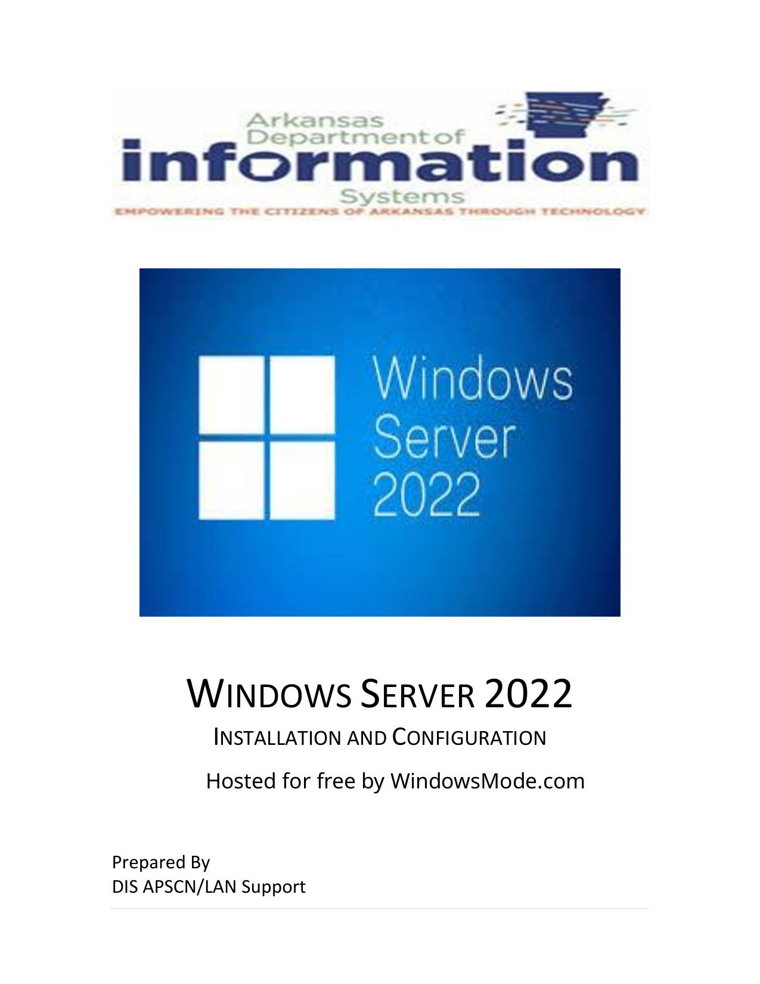

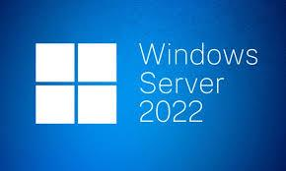

WINDOWS SERVER 2022



INSTALLATION AND CONFIGURATION

Hosted for free by WindowsMode.com

Prepared By

DIS APSCN/LAN Support

Table of Contents

Intro to Windows Server 2022 – Installation and Configuration…………………………….……….1 Table of Contents………………………………………………………………………………………….…….…….2 - 3 Windows Server 2022 Requirements.................................................................................4 Windows Server 2022 Glossary of Terms......................................................................5 - 8 Virtualization Rights….........................................................................................................9 Pre-Installation Requirements & Installation…..........................................................10 - 14 Windows Server Licensing Editions...........................................................................11 - 12 Server Initial Configuration...............................................................................................15 Product Activation – SLMGR (CMD / PS)….................................................................16 - 17 Disable IPV6 via Registry Editor……...................................................................................17 Disable Windows Firewall.................................................................................................19 Domain Services and Active Directory Setup.............................................................23 - 25 Additional DNS Configuration…….....................................................................................25 Reverse Lookup Zones......................................................................................................26 Stale Record Scavenging...................................................................................................27 DNS Forwarders................................................................................................................28 DIS DNS Forwarders & OpenDNS Servers…......................................................................29 DHCP Installation and Configuration…….....................................................................30 -32 WINS Installation and Configuration................................................................................32 Windows Server Update Services (WSUS)........................................................................34 Configuring WSUS after Installation..........................................................................34 - 40 WSUS Group Policy....................................................................................................39 - 40 Basic Active Directory Structure for K12...........................................................................41 Single Site Active Directory Networks.............................................................................. 41 Create Shares and Home Directories.........................................................................43 - 47 Creating User Template....................................................................................................48 Creating New User using Template...........................................................................48 - 51 Creating Faculty & Student Batch File for Active Directory – Mass Import...............52 - 53 Logon Scripts – Batch File Method............................................................................55 - 58 Implementing Shadow Copies...................................................................................57 - 61 Implementing Volume Based Quota Limits……………………………………………………………….....64 Directory Level Quota Limits Using File Server Resource Manager..................................65 Install File Server Resource Manager.................................................…............................64 Configure Quota Templates……………………………………………………….………………………………..64 Apply Quota Template to Directory…………………………………………………………………………..…65 Fine-Grained Password Policies (ACT-723) ...............................................................66 - 68 Some Common K12 Group Policies……………………………………………………………………..…69 - 79 Retain Security Event Log for 90 Days Group Policy……………………………………….…………….69 Auto-Backup and Clear Event Logs (At Least Windows Vista)……………………………….………70 Security Event Auditing – Security Event Log Contents……………………………………………..….71 Group Policy for Logon Banner…………………………………………………………………………………….72 Locking Screen Saver Group Policy.............................................................................…...73 Folder Redirection Group Policy……………………………………………………………….……………74 - 75 Restrict Computers to Faculty Use Only……………………………………………………………..….76 - 77 Refresh Group Policy Settings with GPUDATE.EXE………………………………….……………..77 - 79 How To Check Applied Group Policy Setting on a Domain Computer (GUI).…….……………79 How To Check Applied Group Policy Setting on a Domain Computer (CMD) Rsop.msc…80 Troubleshooting Windows Sever 2022…………………………………………………………….…….81 - 96 Disabling the Shutdown Event Tracker…………………………………………………………………………81 Set Time Source to DIS / NTP Time Servers……………………………………………………….………….82 Active Directory Maintenance……………………………………………………………………………….……..83 Steps to Check Active Directory Replication in Windows Server (GUI)……………………83 - 85 Steps to Check Active Directory Replication in Windows Server (CMD) Repadmin..85 - 88 Testing / Diagnose The Health Of Active Directory Domain Controllers, DNS Servers, AD Replication, And Other Adds Infrastructure Services (CMD) - Dcdiag……………………..…….89 Delete Dead / Tomb-Stoned Domain Controller from Active Directory………………………..90 Removing the Server from the Active Directory Site………………………………………………….…90 Removing the Server from the File Replication Service………………………………….………91 - 92 Removing the Server from Active Directory Sites and Services…................................……92 Removing the Server from Active Directory Users and Computers…………………….….92 - 93 Manually Seize FSMO Roles…………………………………………………………….…………………….93 - 94 How to Rest the Directory Service Restore Mode Administrator Account Password…….95 How to create a Bootable USB (GUI).…………………………………………………………………..……….96 How to create a Bootable USB (PS).……………………………………..……….…………...……….97 - 100 Windows Server Backup (GUI) – Install Windows Server Backup……….……………………….100 Windows Server Backup (PS) Install-WindowsFeature Windows-Server-Backup………..100 Windows Server Backup – Manual Backup….…………………………………………...……….101 - 104 Windows Server Backup – Scheduled Backups ……………………….……………....……….104 - 107 Windows Server Backup – Restore Backup.………………………………................……….107 - 112 Backup DHCP Scopes – Exporting & Importing DHCP Scopes (CMD) Netsh….…….112 - 115 Exporting DHCP Scopes (CMD) Netsh…………………………………………………………………112 - 113 Install DHCP using (PS) Install-WindowsFeature DHCP -IncludeManagementTools…....113 Importing DHCP Scopes (CMD) Netsh……………………………………………….……………….113 - 115 Microsoft Lifecycle Policy – End Of Life Date (mainstream support).………………….……….115

This document is DIS’ recommended method for implementing a Windows Server 2022 and Active Directory (AD) Environment within a K12 network.

WINDOWS SERVER 2022 REQUIREMENTS

Component Requirement

• Minimum: 1.4GHz (x64 processor)

• Recommended: 2GHz or faster

Processor

Note: Processor performance depends not only on the clock frequency of the processor, but also on the number of processor cores and the size of the processor cache

• Minimum: 512 MB RAM or greater

Memory • 2 Gb for Server with Desktop Experience

• Recommended: 6GB RAM or greater

• Maximum (64-bit systems): 4TB (Standard and Datacenter editions)

• Minimum: 32GB or greater • Recommended: 80GB or greater

Available Disk

Space Note: Computers with more than 16GB of RAM will require more disk

space for paging, hibernation, and dump files. Be aware that 32 GB should be considered an absolute minimum value for a successful install

Drives DVD-ROM drive / Mountable USB Drive (ISO) \* See pages 96 -100

• Super VGA (800 x 600) or higher-resolution monitor

Display and • Keyboard

Peripherals • Microsoft Mouse or compatible pointing device

• Internet Access

•Uninterruptible Power Supply (UPS)

Note: make sure the power to your server is correctly distributed and

Power

shielded against surges

Arkansas Department of Information Systems – APSCN LAN Support Printed on 5/14/2024

WINDOWS SERVER 2022 GLOSSARY OF TERMS

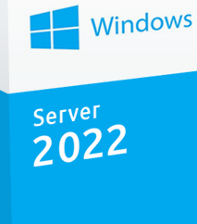

TERMS DEFINITION

Windows Server Windows Server is a group of operating systems designed by

Microsoft that supports enterprise-level management, data storage, applications, and communications. In a technical sense, a server is an instance of a computer program that accepts and responds to requests made by another program, known as a client. Examples: Application, Proxy, Mail, Web, DHCP, FTP & VPN Servers

Active Directory Active Directory (AD) is a directory service that Microsoft developed for

the Windows domain networks. It is included in most Windows Server operating systems as a set of processes and services. Initially, Active Directory was only in charge of centralized domain management. Starting with Windows Server 2008, however, Active Directory became an umbrella title for a broad range of directory-based identity-related services.

Active Directory A server running Active Directory Domain Services (AD DS) is called a Domain Services domain controller (DC). It authenticates and authorizes all users and

computers in a Windows domain type network assigning and enforcing

Domain security policies for all computers & installing or updating software. For

Controller ex., when a user logs into a computer that is part of a Windows domain,

Active Directory checks the submitted password and determines whether the user is a system administrator or normal user. Also, it allows management and storage of information, provides

authentication and authorization mechanisms, and establishes a framework to deploy other related services: Certificate Services, Active Directory Federation Services, Lightweight Directory Services and Rights Management Services.

Arkansas Department of Information Systems – APSCN LAN Support Printed on 5/14/2024

TERMS DEFINITION

Organizational An organizational unit (OU) is a subdivision within an Active

Unit Directory into which you can place users, groups, computers, and

other organizational units. You can create organizational units to mirror your organization's functional or business structure. Each domain can implement its own organizational unit hierarchy.

Groups Groups are used to collect user accounts, computer accounts, and

other groups into manageable units. Working with groups instead of with individual users helps simplify network maintenance and administration. There are two types of groups in Active Directory: Distribution Group used to create email distribution lists. A Security Group provides a logical grouping of objects and the group itself can be used as a security principal in an Access Control List (ACL)

Group Policy Group Policy is a feature of the Microsoft Windows NT family of

operating systems that controls the working environment of user accounts and computer accounts. Group Policy provides centralized management and configuration of operating systems, applications, and users' settings in an Active Directory environment. A version of Group Policy called Local Group Policy ("LGPO" or "LocalGPO") also allows Group Policy Object management on standalone and non-domain computers.

Group Policy A Group Policy Object (GPO) is a collection of settings that define

Object what a system will look like and how it will behave for a defined

group of users. Microsoft provides a program snap-in that allows you to use the Group Policy Microsoft Management Console (MMC)

IP Address An Internet Protocol address (IP address) is a numerical label

assigned to each device connected to a computer network that uses the Internet Protocol for communication. An IP address serves two principal functions: host or network interface identification and location addressing.

Firewall A technological barrier designed to prevent unauthorized or

unwanted communications between computer networks or hosts.

Arkansas Department of Information Systems – APSCN LAN Support Printed on 5/14/2024

TERMS DEFINITION

Dynamic Host The Dynamic Host Configuration Protocol (DHCP) is a network Configuration management protocol used on UDP/IP networks whereby a DHCP

Protocol server dynamically assigns an IP address and other network

configuration parameters to each device on a network so they can communicate with other IP networks. A DHCP server enables computers to request IP addresses and networking parameters automatically from the Internet service provider (ISP), reducing the need for a network administrator or a user to manually assign IP addresses to all network devices. In the absence of a DHCP server, a computer or other device on the network needs to be manually assigned an IP address. DHCP can be implemented on networks ranging in size from home networks to large campus networks and regional Internet service provider networks. A router or a residential gateway can be enabled to act as a DHCP server. Most residential network routers receive a globally unique IP address within the ISP network. Within a local network, a DHCP server assigns a local IP address to each device connected to the network.

Domain Name The Domain Name System (DNS) is a hierarchical decentralized

System naming system for computers, services, or other resources

connected to the Internet or a private network. It associates various information with domain names assigned to each of the

participating entities. Most prominently, it translates more readily memorized domain names to the numerical IP addresses needed for locating and identifying computer services and devices with the underlying network protocols. By providing a worldwide, distributed directory service, the Domain Name System is an essential component of the functionality on the Internet, that has been in use since 1985.The Domain Name System delegates the responsibility of assigning domain names and mapping those names to Internet resources by designating authoritative name servers for each domain. Network administrators may delegate authority over sub-domains of their allocated name space to other name servers. This mechanism provides distributed and fault tolerant service and was designed to avoid a single large central database.

Arkansas Department of Information Systems – APSCN LAN Support Printed on 5/14/2024

TERMS DEFINITION

Server Manager Server Manager is a management console in Windows Server that

helps IT professionals’ provision and manage both local and remote Windows-based servers from their desktops, without requiring either physical access to servers, or the need to enable Remote Desktop protocol (rdP) connections to each server.

Sysvol The System Volume (Sysvol) is a shared directory that stores the

server copy of the domain's public files that must be shared for common access and replication throughout a domain. The Sysvol folder on a domain controller contains the following items:

Net Logon shares. These typically host logon scripts and policy objects for network client computers.

User logon scripts for domains where the administrator uses Active Directory Users and Computers.

Windows Group Policy & File system junctions.

File replication service (FRS) staging folder and files that must be available and synchronized between domain controllers.

RAID RAID (Redundant Array of Independent Disks, originally

Redundant Array of Inexpensive Disks) is a data storage virtualization technology that combines multiple physical disk drive components into one or more logical units for the purposes of data redundancy, performance improvement or both.

Virtualization In computing, virtualization means to create a virtual version of a

device or resource, such as a server, storage device, network or even an operating system where the framework divides the resource into one or more execution environments. Even something as simple as partitioning a hard drive is considered virtualization because you take one drive and partition it to create two separate hard drives. Devices, applications, and human users can interact with the virtual resource as if it were a real single logical resource.

Arkansas Department of Information Systems – APSCN LAN Support Printed on 5/14/2024

Virtualization RIGHTS

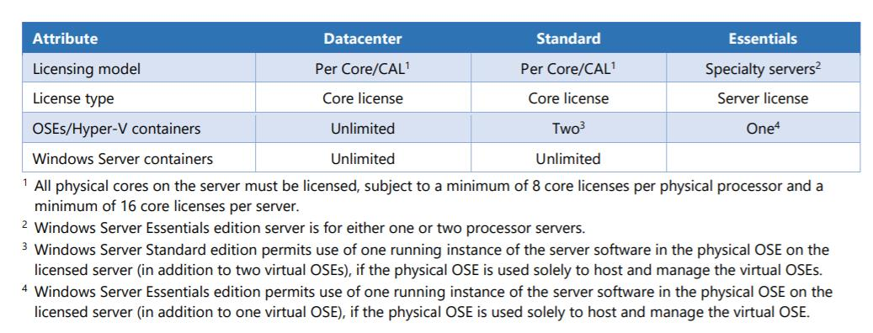

• Datacenter Edition – When all physical cores on the server are licensed,

Windows Server Datacenter edition provides rights to use unlimited operating

system environments (OSEs) or Hyper-V containers and unlimited Windows

Server containers on the licensed server. Recommended for businesses that

have highly virtualized environments.

• Standard Edition – When all physical cores on the server are licensed, Windows

Server Standard edition provides rights to use two Operating System

Environments (OSEs) or Hyper-V containers and unlimited Windows Server

containers on the licensed server. Recommended for businesses that require

minimal virtualization & scalability.

\*\*For example, a 2-processor server with 8 cores per processor requires 16 core

licenses (in other words, one 16-pack of core licenses or eight 2-packs of core

licenses) and gives rights to two OSEs or two Hyper-V containers. In the case of

this example, for each additional two OSEs or two Hyper-V containers the

customer wishes to use, an additional 16 core licenses must be assigned to the

server.

Arkansas Department of Information Systems – APSCN LAN Support Printed on 5/14/2024

# PRE-INSTALLATION REQUIREMENTS

• Microsoft Windows Server 2022 DVD (with Service pack IF applicable).

• 1 NAT IP Address (Statically Assigned)

• Bootable USB Drive / DVD (At least 8Gb USB Drive / Blank Dual Layer DVD-R)

\*\*For Assistance with creating a Bootable USB Drive skip to page 96 - 100

\*\*Certain Servers will have to have SCSI/RAID Controller Drivers.

\*\*RAID Configuration & Logical Drives should be configured before server

installation.

INSTALLATION

1. Purchase Windows Server Edition / Download .ISO & Activation Key

For ESS Agreement logon onto - Microsoft Volume Licensing Service Center

(VLSC)<https://www.microsoft.com/Licensing/servicecenter/default.aspx>

2. Insert the appropriate Windows Server 2022 installation media into your

server and reboot (DVD-ROM / Bootable USB)

3. After restarting the server, boot to the DVD-ROM / USB. Wait for Setup to

display a dialog box.

4. When prompted for an installation language and other regional options,

make your selection, and press Next.

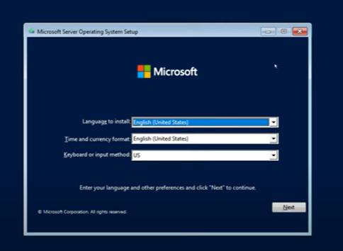

Arkansas Department of Information Systems – APSCN LAN Support Printed on 5/14/2024

5. Next, press Install Now to begin the installation process.

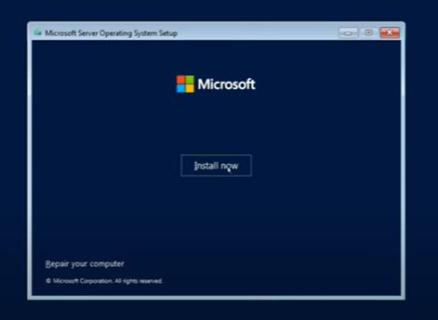

WINDOWS SERVER LICENSING EDITIONS Choose from two primary editions of Windows Server, based on the size of your organization as well as virtualization and datacenter requirements:

• Datacenter Edition is ideal for highly virtualized and software-defined datacenter

environments.

• Standard Edition is ideal for customers with low density or non-virtualized

environments.

\*\*All physical cores on the server must be licensed, subject to a minimum of 8 core licenses per physical processor and a minimum of 16 core licenses per server.

\*\*CALs are required for every user or device accessing a server. See the [Product Terms](https://www.microsoft.com/en-us/licensing/product-licensing/products) for details.

Windows Server 2022 Datacenter and Standard utilize a core-based licensing model, meaning the number of core licenses needed depends on whether licensing is based on on-premises or cloud/hybrid environments.

Licensing is based on physical cores for on-premises environments. The number of core licenses required is equivalent to the number of physical cores on the server, with a minimum of 8 core licenses per physical processor and 16 core licenses per server.

Arkansas Department of Information Systems – APSCN LAN Support Printed on 5/14/2024

Licensing for cloud/hybrid environments is based on virtual machines. The number of core licenses needed is equivalent to the number of virtual cores in the virtual machine, with a minimum of 8 core licenses per virtual machine. Subscription licenses or active Software Assurance are necessary for licensing by virtual machine on the cloud/hybrid environments.

6. Select the proper edition of Windows Server 2022 that is to be installed and

press Next.

• Note - Choose Desktop Experience for Operating System with GUI

(Graphical User Interface)

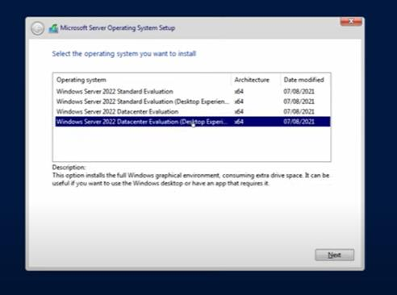

7. Read and accept the license terms by clicking to select the checkbox and

pressing Next.

Arkansas Department of Information Systems – APSCN LAN Support Printed on 5/14/2024

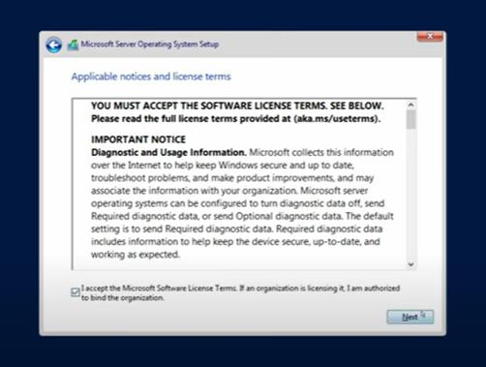

8. In the "Which type of installation do you want?" window, click the only

available option – Custom: Install Windows only (Advanced).

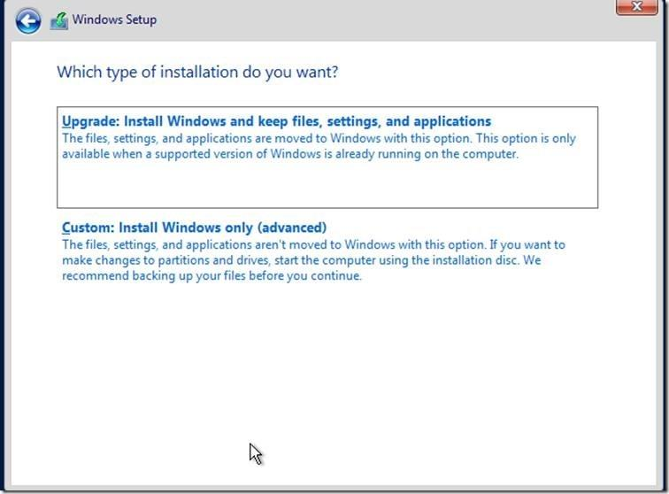

9. Select the disk that you will be installing Windows Server 2022 onto and then

click New to create a partition that Windows Server 2022 will be installed on.

Arkansas Department of Information Systems – APSCN LAN Support Printed on 5/14/2024

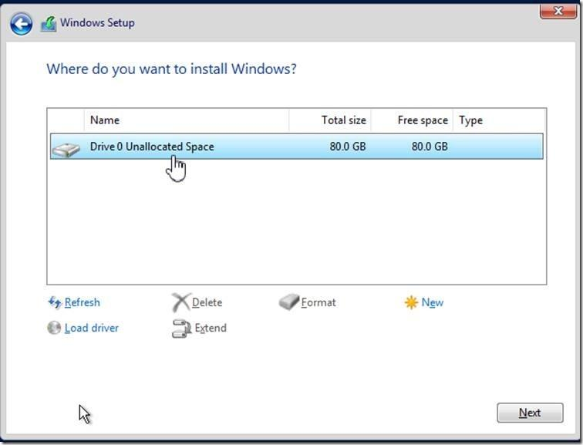

10. In the “Size:” entry box, enter the size of the partition and press Next.

\*\*The size format is in megabytes. MB \* 10240 = Size to be entered. \*\* Example 10240MB x 10 = 102.4 GB Drive, Recommend at least 250GB C:/

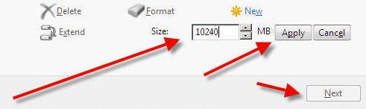

11. You will see the following screen while the installation files are copied to the

server. The server will reboot to complete the installation (leave media inserted)

.

\*\*See notes on partition types:

\*\* When creating new partitions, if it's over 2 TB or if it UEFI Boot it

recommended to be GPT.

You don't usually have to worry about partition style - Windows automatically

uses the appropriate disk type. Most PCs use the GUID Partition Table (GPT)

disk type for hard drives and SSDs. GPT is more robust and allows for volumes

bigger than 2 TB. The older Master Boot Record (MBR) disk type is used by 32-Arkansas Department of Information Systems – APSCN LAN Support Printed on 5/14/2024

bit PCs, older PCs, and removable drives such as memory cards. To convert a

disk from MBR to GPT or vice versa, you first must delete all volumes from

the disk, erasing everything on the disk.

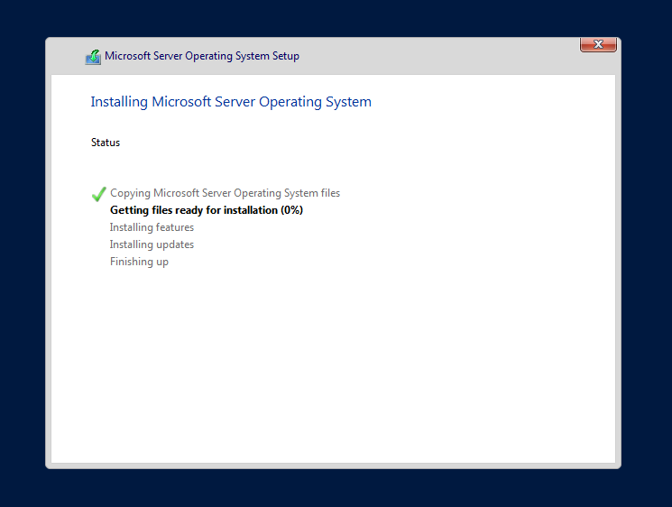

11. Once the server has completed the setup, it will notify you that the password

needs to be set. This password MUST meet Microsoft password complexity requirements. It will require a minimum password length of 8 characters and three out of the four following:

• Create complex Password / Password Phrase • Uppercase letters of European languages (A through Z, with

diacritic marks, Greek and Cyrillic characters)

• Lowercase letters of European languages (a through z, sharp-s,

with diacritic marks, Greek and Cyrillic characters)

• Base 10 digits (0 through 9) • Non-alphanumeric characters (special characters): (~!@#$%^&\*\_-

+=`|\(){}[]:;"'<>,.?/) Currency symbols such as the Euro or British Pound are not counted as special characters for this policy setting.

\*\*Do Not Use Default Passwords for the Administrator Account such as Password1 / Password123 & etc.

Arkansas Department of Information Systems – APSCN LAN Support Printed on 5/14/2024

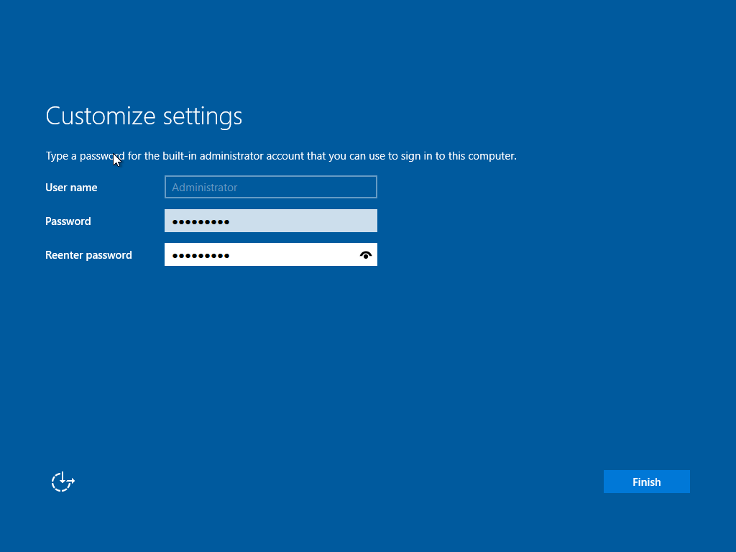

12. Once the password is successfully changed, the server will login to the initial

desktop and Server Manager will start up automatically.

SERVER INITIAL CONFIGURATION

1. On the Server Manager screen, click on Local Server.

2. Activate Windows and insert key. (Must Have an Internet Connection)

Click Product ID and enter windows license key (MAK)

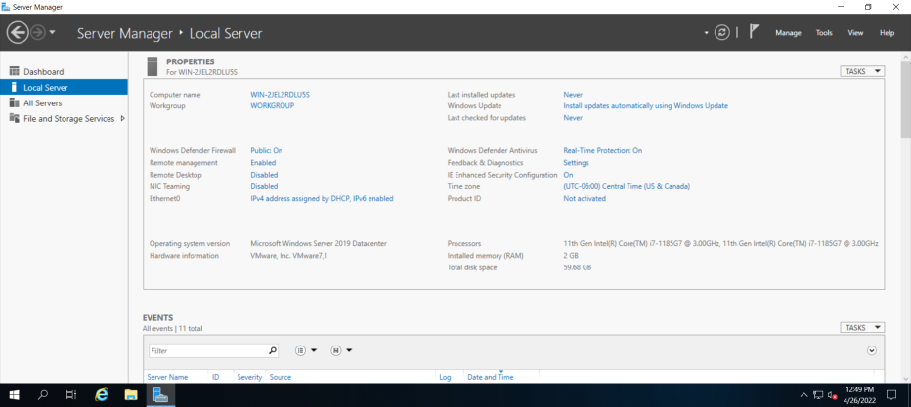

Arkansas Department of Information Systems – APSCN LAN Support Printed on 5/14/2024

\*Note if activation is not available, then you can manually activate using

command SLMGR command. Open command prompt and enter the following.

Command: slmgr -ipk XXXXX-XXXXX-XXXXX-XXXXX-XXXXX (Product Key)

Replace X with your product key.

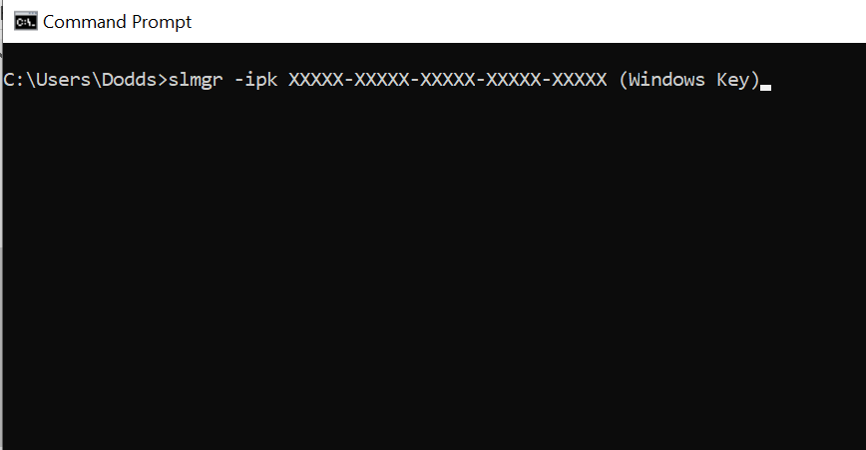

Powershell Command:

slmgr.vbs /ipk XXXXX-XXXXX-XXXXX-XXXXX-XXXXX - Install a new key.

Replace X with your product key.

3. Change Computer Name – Use a good naming convention for asset management

\*\*Example – Building Name + Device = Admin-DC1, HS-DC1, MS-AS1 etc.

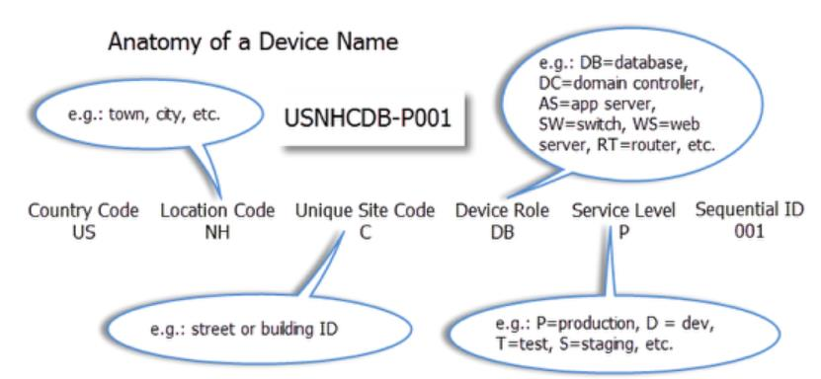

4. Set Time zone – Correct Time Zone (Central Time)

5. Enable Remote Desktop for Remote Management

\*\*Click – allow connections only from computers running remote desktop with

network level authentication (recommended)

6. Configure Networking and change to Static IP and disable IPv6 by unchecking the

option for TCP/IPv6.

7. Enable Windows Updates.

Arkansas Department of Information Systems – APSCN LAN Support Printed on 5/14/2024

8. Download and Install updates.

9. Turn off IE Enhanced Security Configuration for Administrators only.

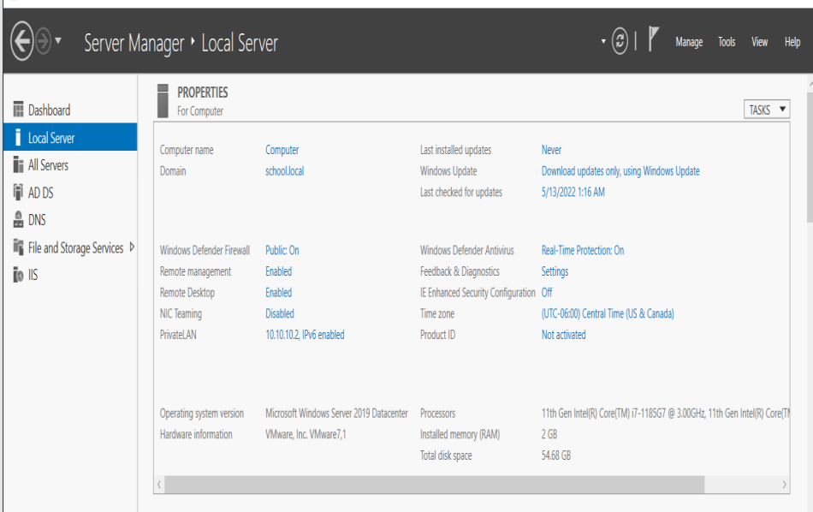

DISABLE IPV6 VIA REGISTRY EDITOR

\*\*Recommended To Be Done

1. Open the Registry Editor by moving your mouse over the bottom-left Windows

Key  or click Keyboard Key  and type REGEDIT and press Enter

2. Expand the following Key Structure in the Registry Editor:

HKEY\_LOCAL\_MACHINE

|---System

|---CurrentControlSet

|---Services

|---Tcpip6

|---Parameters

3. Right-Click on the Parameters Key and click New > DWORD (32-Bit) Value.

Arkansas Department of Information Systems – APSCN LAN Support Printed on 5/14/2024

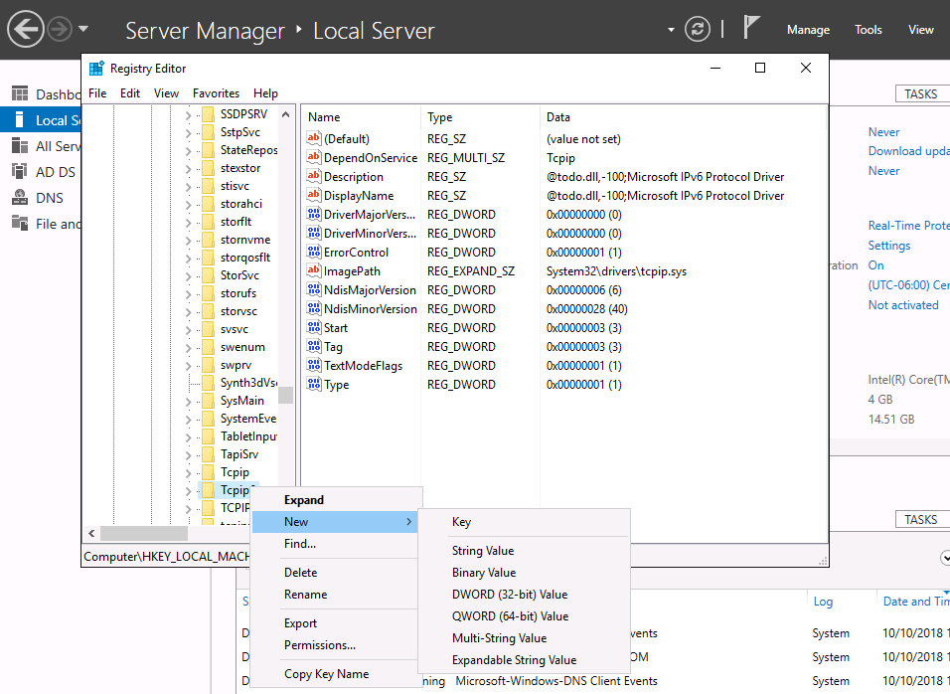

4. Type in the name DisabledComponents and press Enter. (name is case sensitive)

5. Double-click on the newly created key and enter ffffffff (8 f’s) for the value data

in Hexadecimal mode.

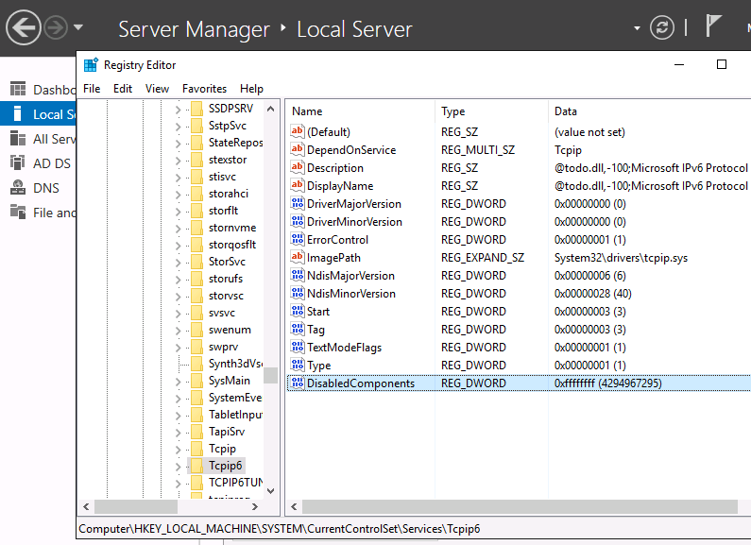

6. Close the Registry Editor

DISABLE WINDOWS FIREWALL

Arkansas Department of Information Systems – APSCN LAN Support Printed on 5/14/2024

7. Open the Windows Firewall with Advanced Security by moving your mouse over

the bottom-left Windows Key  or click Keyboard Key  and type FIREWALL

and press Enter

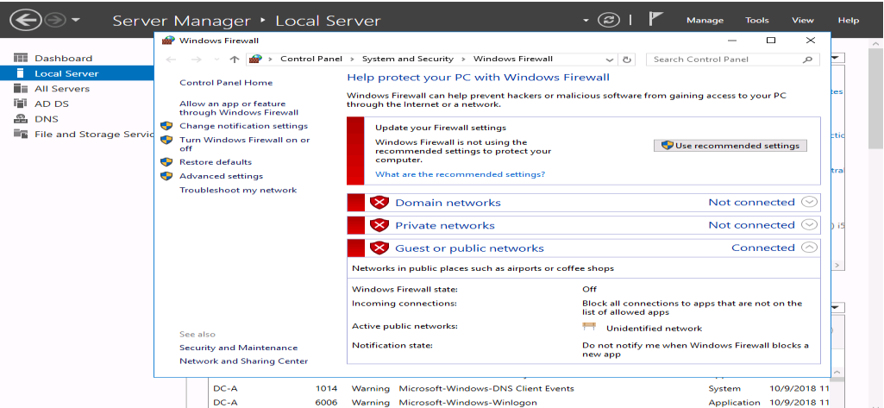

1. Choose Advance Setting

2. In the middle of the screen you will find an “Overview” section, at the bottom of

this section click Windows Firewall Properties.

3. Turn off the Firewall state for Doman Profile and Private Profile

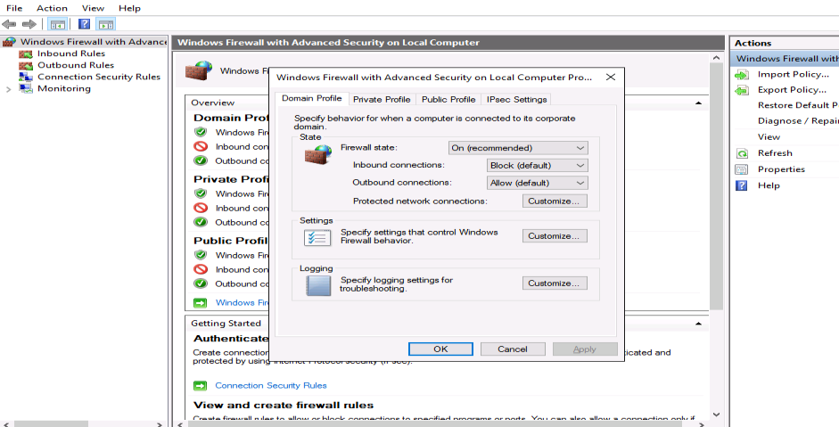

\*\*It is highly recommended that the Firewall be enabled on DIS Router if you are not using a third-party firewall. If you do not have any firewall appliance, you may wish to leave the windows firewall enabled. Adjust the scopes of the Inbound/Outbound rules to meet application requirements.

\*\* Recommended to create inbound / outbound rules, allow specific ports & programs thru firewall instead of just turning off firewalls

Arkansas Department of Information Systems – APSCN LAN Support Printed on 5/14/2024

# DOMAIN SERVICES AND ACTIVE DIRECTORY SETUP

\*\*Before starting this section, make sure that your server has a statically assigned IP address and that the DNS IP Address in the TCP/IP settings are pointing to itself.

We do not have to pre-install the DNS Server Role or pre-create our DNS Zone. When the Active Directory Domain Services Role is installed the DNS Server Role will be automatically installed and configured with the DNS zone specified during the Active Directory installation.

1. Launch Server Manager.

2. Click Manage and then select Add Roles and Features.

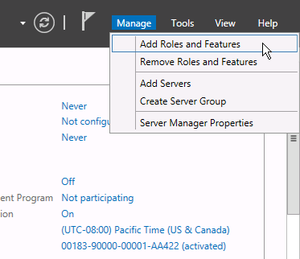

3. On the Before You Begin screen, click Next.

4. On the Select Installation type screen, select Role-based or Feature-based

installation and click Next.

5. On the Select Destination server screen, click Next.

6. Check the box to the left of Active Directory Domain Services.

Arkansas Department of Information Systems – APSCN LAN Support Printed on 5/14/2024

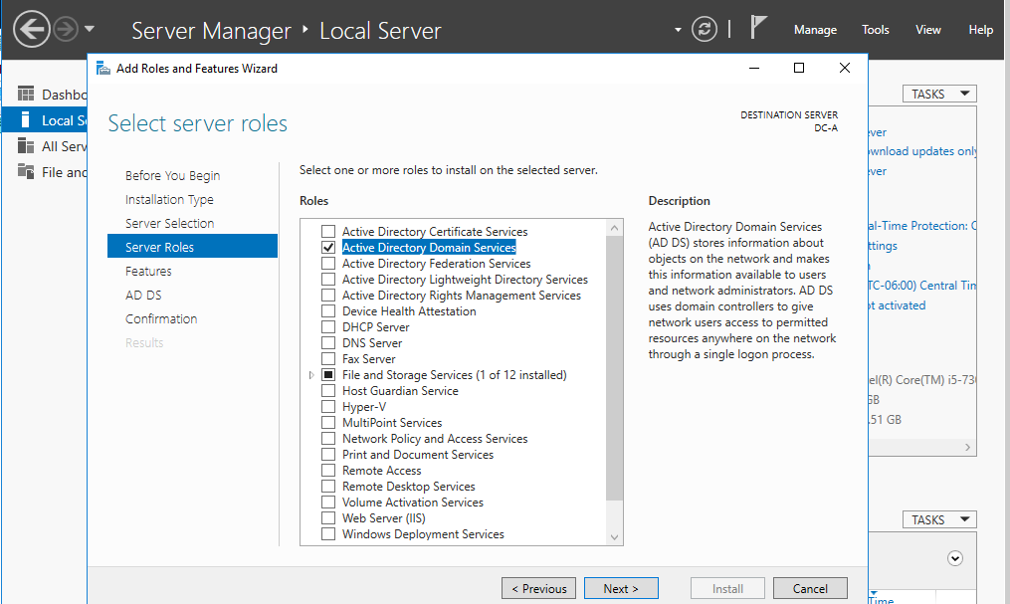

7. On the Add Roles and Features Wizard dialogue box, click Add Features.

8. Click Next for rest of the screens, and then click Install.

9. When the installation is finished, click Close.

10. Promote the Server to be a Domain Controller by clicking the Notifications icon

(Flag Icon) and then selecting Promote this Server to a Domain Controller

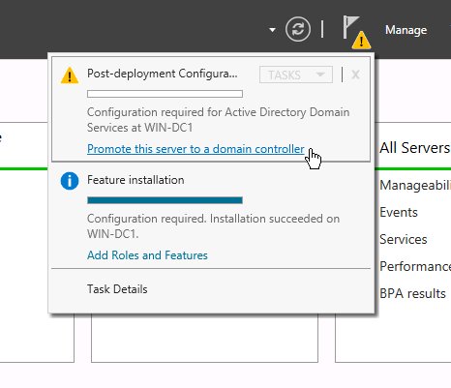

Arkansas Department of Information Systems – APSCN LAN Support Printed on 5/14/2024

.

11. On the Deployment Configuration screen, select Add a new forest. Type the

DNS name for the new domain in Root Domain Name and click Next.

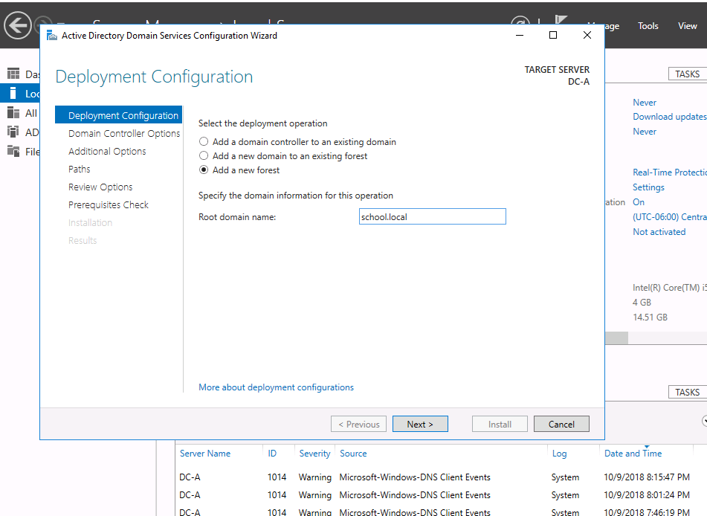

\*\*DIS recommends you type your abbreviated school district name followed by .local e.g. school.local. DO NOT end your domain name with .com, .net, .org, .edu, or any other domain name that are resolvable on the internet.

\*\*This domain name is for INTERNAL resolution only.

\*\*This step and those following assume this is the first Domain Controller in a new domain, tree, and forest.

12. For the Forest Functional Level and the Domain Functional Level, select

Windows Server 2022 and click Next.

\*\*If any previous versions of Windows Server Operating (2012 or 2016 R2 ) are present in the domain or will be introduced as Domain Controllers, select the corresponding Forest and Domain Functional level.

\*\*Windows Server 2012 End-of-life mainstream support October 10, 2023 \*\*Windows Server 2016 End-of-life mainstream support January 12, 2027 \*\*Windows Server 2019 End-of-life mainstream support January 09, 2029 \*\*Windows Server 2022 End-of-life mainstream support October 04, 2031

Arkansas Department of Information Systems – APSCN LAN Support Printed on 5/14/2024

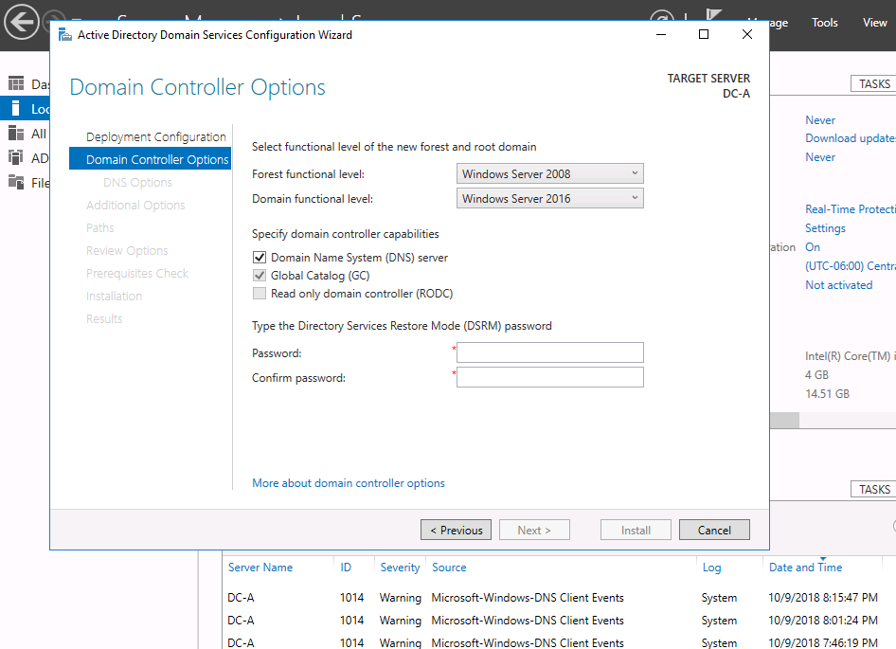

13. Under Domain Controller Capabilities, make sure that DNS and Global Catalog

options are selected.

14. Under Directory Services Restore Mode (DSRM) Password, enter in a complex

password that is UNIQUE to this server and is NOT your normal administrator password and click Next.

15. On the DNS Options screen click Next.

\*\*Ignore the Parent zone delegation warning on top of the screen. It will be created during initial AD installation.

16. On the Additional Options screen click Next.

17. On the Location for Database, Log Files and SYSVOL screen click Next.

18. On the Review Options screen click Next.

Arkansas Department of Information Systems – APSCN LAN Support Printed on 5/14/2024

19. On the Prerequisites Check screen, review warnings and errors if any. Click

install to start Domain Controller promotion.

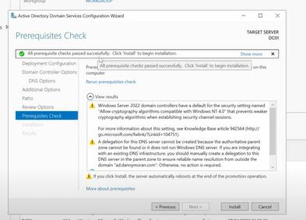

20. When the Active Directory installation finishes, the server will automatically

restart.

ADDITIONAL DNS CONFIGURATION

REVERSE LOOKUP ZONES

21. Log into the server when the server has completely booted back up.

22. Launch Server Manager, click on Tools and select DNS from the drop down list.

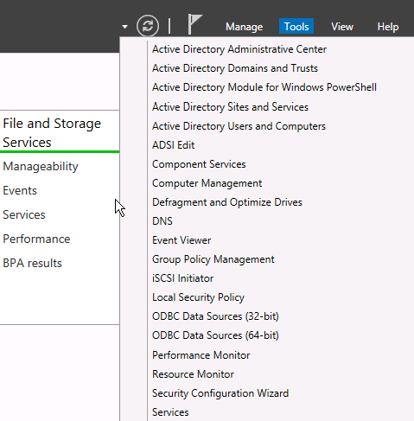

Arkansas Department of Information Systems – APSCN LAN Support Printed on 5/14/2024

23. Expand your server name, right-click on Reverse Lookup Zones and click New

Zone.

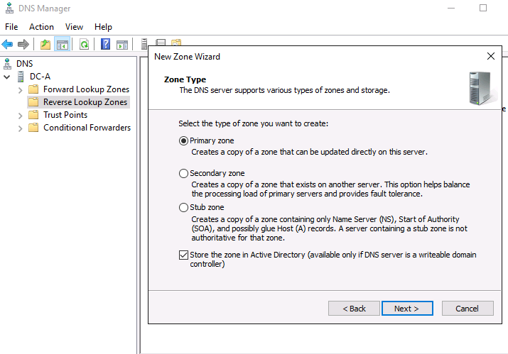

24. On the Zone Type screen, take the defaults and click Next.

25. For the Active Directory Zone Replication Scope, select To all DNS Servers

running on domain controllers in this domain and click Next.

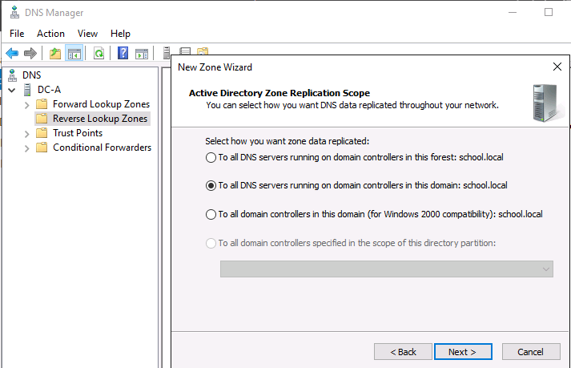

26. Select IPv4Reverse Lookup Zone and click Next.

27. For the reverse zone name, enter the first two/three octets of your IP range

and click Next.

Arkansas Department of Information Systems – APSCN LAN Support Printed on 5/14/2024

\*\*If IP range spans multiple “class C subnets” ONLY enter the first two octets e.g. if the IP range is 10.10.0.0 to 10.10.1.255, then you would only enter 10.10

28. On the Dynamic Update screen, take the default and click Next.

29. Click Finish to create the new zone.

\*\*Steps 23 through 26 must be completed for Public and Private IP subnets being used in the Active Directory environment.

STALE RECORD SCAVENGING

30. Within the DNS Manager, right-click on your DNS server and click Set

Aging/Scavenging for All Zones.

31. Check the box Scavenge stale resource records and then click OK.

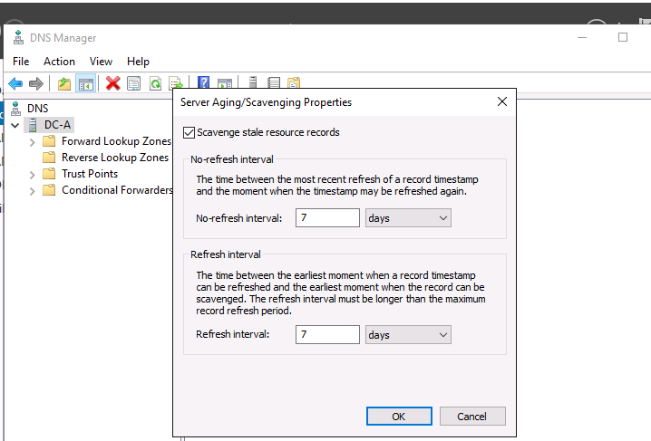

32. When prompted with the Server Aging/Scavenging Confirmation box, check

the Apply these settings to the existing Active Directory-integrated zones option and then click OK.

\*\*Steps 30 and 32 must be completed on each DNS server.

Arkansas Department of Information Systems – APSCN LAN Support Printed on 5/14/2024

\*\*Static IP Address & DNS Servers must be assigned to the network adapter (not a loopback address 127.0.0.1)

\*\*The correct method is "Self First" (As Preferred DNS), then other DCS as alternates \*\*Warning – Do Not Point Windows Server DNS to OpenDNS Virtual Appliance Servers

Example

DC1 – IP Address 10.10.10.6

DC2 – IP Address 10.10.10.7

\*\*When promoting a new server into an existing Forrest or domain, the new server will have to point to another DC first and can then be changed after the server has been successfully promoted

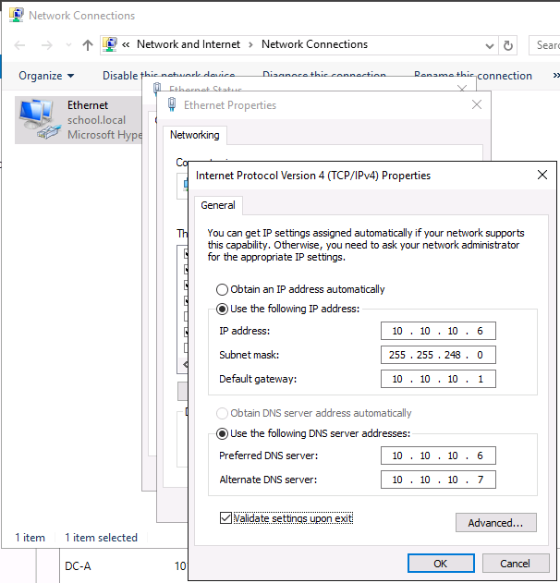

DNS FORWARDERS

By setting the DNS Forwarders to DIS DNS servers, your server will not have to perform a full DNS resolution of a requested domain name. Rather, it will query the DNS servers at DIS for the specified DNS entry and, if cached, the DIS DNS servers will return the results from its local cache. If the DIS DNS Server does not have the result in its cache, it will perform the full lookup of the DNS Name and return the results to your DNS server to be delivered to your client.

With Windows Server 2022, should the DIS DNS Servers become unavailable, your DNS server will default to use the DNS Root Hint servers on the Internet for DNS resolution.

\*\*Exception Cisco Umbrella (OpenDNS Server) – Do Not Use DNS Root Hint

Arkansas Department of Information Systems – APSCN LAN Support Printed on 5/14/2024

1. Within the DNS Manager, right-click your server and click Properties.

2. Click the Forwarders tab and then click the Edit button. Add the appropriate

Forwarders for your windows environment.

3. Enter your DIS DNS Servers / OpenDNS Server as specified below and click OK.

\*\*OpenDNS Servers are used for Cisco Umbrella Content Filtering

DIS DNS Servers

DNS = 170.94.156.195, 170.94.156.196 Little Rock DNS Servers

DNS = 66.204.1.66 Fayetteville POP DNS Server

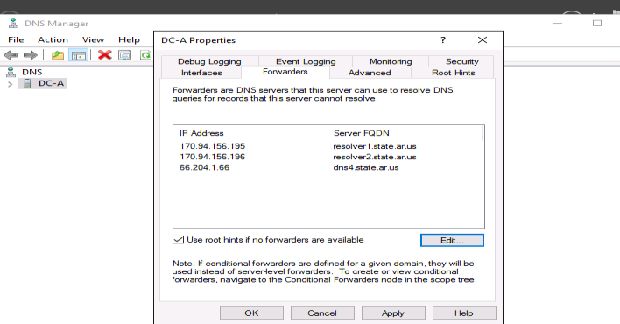

\*\*Please remove all old state DIS DNS Servers (165.29.X.X and 170.211.X.X)

OpenDNS Servers – Cisco Umbrella (OpenDNS)

DNS = 208.67.222.222, 208.67.220.220, 208.67.222.220, 208.67.220.222

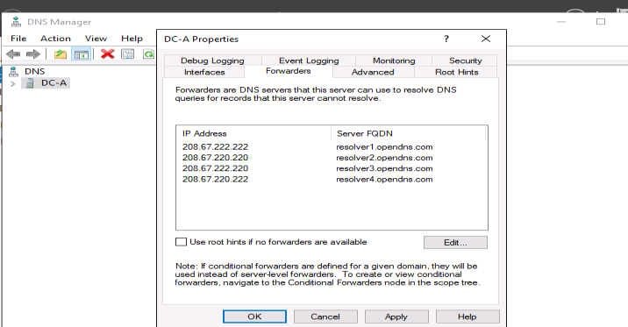

\*\*Warning – Do Not Point Forwarders to OpenDNS Virtual Appliance Servers

\*\*Do Not Use Google DNS Servers 8.8.8.8, 8.8.4.4 - (Lockdown Browser)

\*\*Uncheck – Use root hints if no forwarders are available (Do Not Use)

4. Click Apply and then OK.

5. Close the DNS Manager

Arkansas Department of Information Systems – APSCN LAN Support Printed on 5/14/2024

# DHCP INSTALLATION AND CONFIGURATION

1. Launch Server Manager.

2. Click Manage and then select Add Roles and Features.

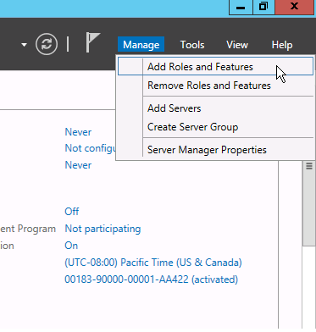

3. On the Before You Begin screen, click Next.

4. On the Select Installation type screen, select Role-based or Feature-based

installation and click Next.

5. On the Select Destination server screen, click Next.

6. On the Select server roles screen, select the DHCP Server role, click on Add

Features and click Next.

7. Click Next for rest of the screens, and then click Install.

8. When the installation is finished, click Close.

9. Configure the DHCP Server installation by clicking the Notifications icon (Flag

Icon) and then selecting Complete DHCP configuration.

Arkansas Department of Information Systems – APSCN LAN Support Printed on 5/14/2024

10. On the Description screen click Next.

11. On the Authorization screen, click Commit.

12. Now that DHCP Server role has been installed, we will configure it in DHCP

Manager by clicking on Tools and selecting DHCP from the drop-down list.

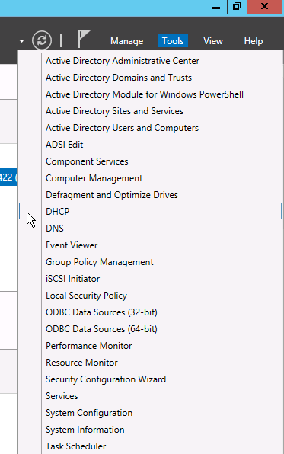

13. Expand the server node and IPv4 node until you see Server Options, Policies.

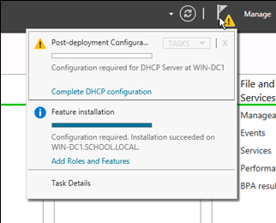

14. Right click on IPv4 and select New Scope.

15. On the Scope Name screen enter the Scope name and description you want

to use for this scope e.g. IP NAT POOL

16. On the IP Address Range screen type in the starting and ending IP address

for this scope along with the subnet mask. This is the range of IP addresses this DHCP server will be issuing. Click Next.

Arkansas Department of Information Systems – APSCN LAN Support Printed on 5/14/2024

\*\*It is recommended to leave a few numbers at the start of the scope for static assignment e.g. if the IP range is 10.10.10.0 - 10.10.11.255 enter 10.10.10.101 for the Starting IP Address and 10.10.11.254 for the Ending IP Address to leave 100 IP’s at the beginning of your IP range for static assignment.

17. On the Exclusion screen enter the IP addresses you want to be excluded from

the DHCP range defined in the previous step and then click Next.

18. On the Lease time screen take the default values unless required otherwise

and Click Next.

19. On the Configure DHCP options screen select No, I will configure these

options later and click Next and then Finish to close the wizard.

20. Right click Server Options and select Configure Options. From the list

opened select the following options:

- 003 Router --- Gateway Address for devices - 006 DNS Server --- On premises DNS Servers typically DCs - 015 DNS Domain Name --- Domain name e.g. school.local - 044 WINS/NBNS Server --- On premises WINS Servers - 046 WINS/NBT Node Type --- Recommended to be configured as 0x8

21. Right-click IPv4 and select Properties. Under the Advanced tab, for Conflict

Detection Attempts, change this value to 3.

22. Also, under Advanced tab click on the Bindings button and verify that the

only network adapter checked is the adapter that is on the same subnet the DHCP server will be serving IP addresses for.

23. Once all the settings are done, right click on the newly created scope and

select Activate for the DHCP server to start giving out IP numbers.

WINS INSTALLATION AND CONFIGURATION

1. Launch Server Manager.

Arkansas Department of Information Systems – APSCN LAN Support Printed on 5/14/2024

2. Click Manage and then select Add Roles and Features.



3. On the Before You Begin screen, click Next.

4. On the Select Installation type screen, select Role-based or Feature-based

installation and click Next.

5. On the Select Destination server screen, click Next.

6. On the Select server roles screen, click Next.

7. On the Select features screen, select WINS Server, click on Add Features, and

then click Next and then click Install.

8. Add the WINS IP addresses to each respective network cards in all servers.

9. If multiple WINS servers are being deployed, they need to be added as

replication partners under WINS manager.

10. Open up WINS Manager by selecting Tools in the Server Manager and then

selecting WINS from the drop-down list.

11. Expand the respective WINS Server and click on Replication Partners.

12. Right-click Replication Partners and select New Replication Partner.

13. Enter the respective server name that will be replicating with this WINS

server and close WINS manager.

\*\*Steps 12 and 13 needs to be repeated for all WINS servers in the domain.

Arkansas Department of Information Systems – APSCN LAN Support Printed on 5/14/2024

WINDOWS SERVER UPDATE SERVICES (WSUS)

Microsoft Windows Server Update Services (WSUS) enables information technology administrators to deploy latest Microsoft product updates to systems running Microsoft products. By using Windows Server Update Services, you can fully manage the distribution of updates that are released through Microsoft Update to computers in your network.

For Windows Server 2022, WSUS requires the following:

• At least Microsoft Internet Information Services (IIS) 6.0 • At least Microsoft .Net Framework 2.0 • WSUS 4.0 Management Console requires at least Windows 8 • 1GB of free space on system partition.

\*\*You will want to have a WSUS server at each physical site that is behind a router. The reason is that you do not want to have computers go across the WAN connection to get their updates.

CONFIGURING WSUS AFTER INSTALLATION

1. Launch Server Manager.

2. Click Manage and then select Add Roles and Features.

3. On the Before you begin page, click Next.

4. On the Select Installation type screen, select Role-based or Feature-based

installation and click Next.

5. On the Select Destination server screen, click Next.

6. On the Select Server roles page, select Windows Server Update Services.

7. In the Add Roles and Features dialog box that pops up, click Add Features,

and then click Next.

8. On the Select features page, leave the default selections, and then

click Next.

\*\*WSUS only requires the default Web Server role configuration. If you are prompted for additional Web Server role configuration while setting up

Arkansas Department of Information Systems – APSCN LAN Support Printed on 5/14/2024

WSUS you can safely accept the default values and continue setting up WSUS.

9. On the Windows Server Update Services page, click Next.

10. On the Select Role Services page, leave the default selections unless an

external SQL Server database is being used, and then click Next.

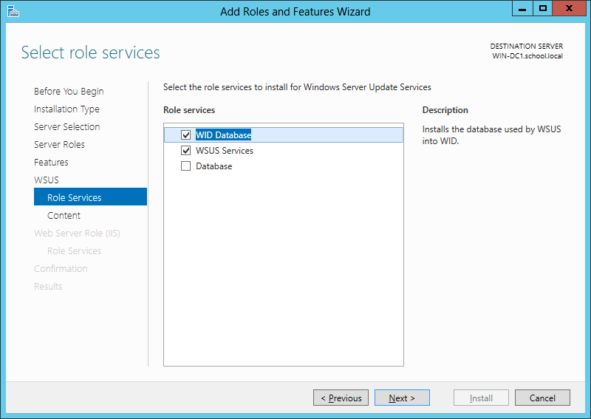

11. On the Content location selection page, type a valid location to store the

updates e.g. D:\WSUS and then click Next.

\*\*You must have at least 200GB of free disk space, on the volume selected to store updates locally.

12. On the Web Server Role (IIS) page, click Next.

13. On the Select role services page, leave the default selections, and then

click Next.

14. On the Confirm installation selections page, review the selected options,

and then click Install.

15. On the Installation progress page, make sure that the installation succeeded,

and then click Close.

16. Now that WSUS role is installed, it will be configured by clicking on Tools and

selecting Windows Server Update Services from the drop-down list.

Arkansas Department of Information Systems – APSCN LAN Support Printed on 5/14/2024

17. On the Complete WSUS Installation dialog box appears, click Run.

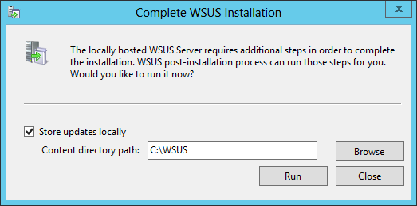

18. In the Complete WSUS Installation dialog box, click Close when the

installation successfully finishes.

19. The Windows Server Update Services Wizard appears and on the Before you

Begin page, click Next.

20. Read the instructions on the Join the Microsoft Update Improvement

Program page and evaluate if you want to participate or not. If you do not want to participate, Uncheck the box and click Next.

21. On the Choose Upstream Server page, select Synchronize from Microsoft

Update and click Next.

\*\*If you are synchronizing from another WSUS server from within the district, be sure to enter the proper port number that WSUS is running on remotely.

22. On Specify Proxy Server settings, leave the default values, unless these

settings are required for your environment and then click Next.

23. On the Connect to Upstream Server, click Start Connecting to retrieve the

current updated list of products available.

24. When the initial product file download is completed, click Next.

25. On the Choose Languages page, verify that English is the ONLY selected

language and then click Next.

26. On the Choose Products page, choose the Microsoft products running in

your environment that will require updates and click Next.

Arkansas Department of Information Systems – APSCN LAN Support Printed on 5/14/2024

27. On the Choose Classifications page, it is recommended to select everything

EXCEPT Drivers and click Next.

28. On the Set Sync Schedule page, select Synchronize automatically and set

this to off-peak usage hours e.g. 11:00pm and then click Next.

29. Click Finish on the next screen to complete the configuration wizard.

30. On the Update Services management console screen, expand your WSUS

Server and click Options.

31. In the Options pane, select Update Files and Languages. Uncheck the

Download update files to this server only when the updates are approved and click OK.

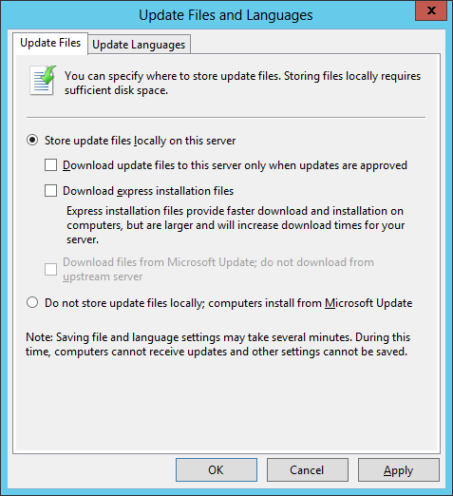

\*\*If you choose to manually approve updates, your workstations will not have to wait until after the next WSUS Sync with Microsoft to get the updates.

32. In the Options pane, select Automatic Approvals.

33. Select the Default Automatic Approval Rule and click Edit.

34. In the Step 2 box, click on Critical Updates, Security Updates.

Arkansas Department of Information Systems – APSCN LAN Support Printed on 5/14/2024

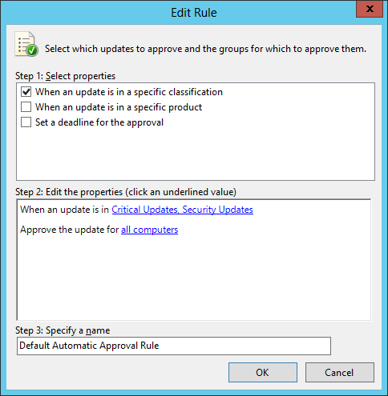

35. Select all classification items EXCEPT drivers and click OK.

\*\*Some districts choose not to select Feature Packs. These include items such as Silver Light and Desktop Search.

36. Verify that Default Automatic Approval Rule is checked. Click Apply and OK

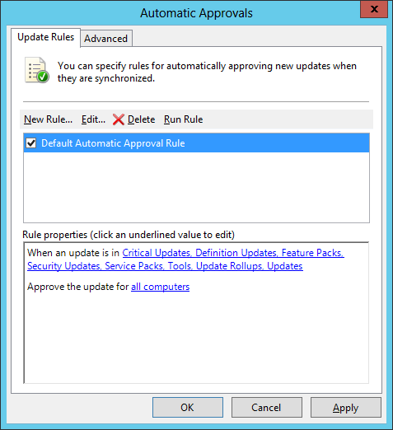

Arkansas Department of Information Systems – APSCN LAN Support Printed on 5/14/2024

# WSUS GROUP POLICY

1. Launch Server Manager.

2. Click on Tools and select Group Policy Management from the drop-down list.

3. Expand Forest: yourdomain.local.

4. Expand Domains and then expand yourdomain.local and navigate to Group

Policy Objects.

5. Right-click on the Group Policy Objects and then select New.

6. Name the new group policy WSUS Policy and click OK.

7. Expand Group Policy Objects. Right-click the newly created WSUS Policy and

click Edit to open the Group Policy Editor.

8. Expand Computer Configuration > Policies > Administrative Templates >

Windows Components and select Windows Update.

9. Double-click on Configure Automatic Updates, change Not Configured to

Enabled and select option 4 – Auto Download and schedule install under Configure automatic updating drop-down menu.

10. Set the desired scheduled install day and time.

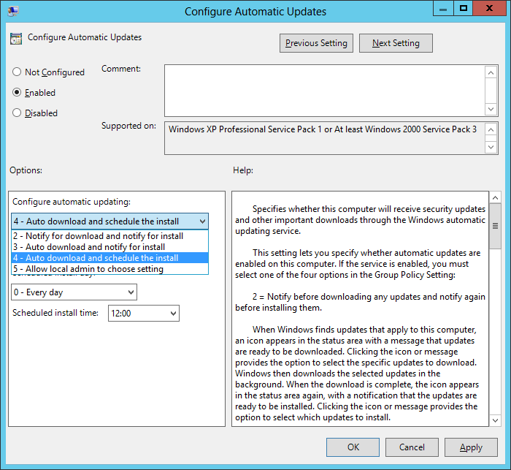

Arkansas Department of Information Systems – APSCN LAN Support Printed on 5/14/2024

11. Click the Next Setting button to change to Specify Intranet Microsoft Update

Services Location window.

12. Change Not Configured to Enabled and in both entry, boxes enter

http://YourWsusServername:8530 and then click OK.

13. Click the Next Setting button to change to Automatic Updates detection

frequency window.

14. Change Not Configured to Enabled, leave the default value for Interval

(hours) and then click OK.

15. Double-click on Allow Automatic Updates immediate installation, change

Not Configured to Enabled and then click OK.

16. Double-click on No auto-restart for scheduled Automatic Updates

installations, change Not Configured to Enabled and then click OK.

17. Double-click on Reschedule Automatic Updates Scheduled Installations.

18. Change Not Configured to Enabled, change the startup (minutes) to any

value between 1 – 5 (recommended) and then click OK.

19. Close the Group Policy Management Editor.

20. Drag and Drop WSUS Policy on the Workstations OU to link the policy to

everything residing under Workstations.

\*\*It is recommended to have a separate Group Policy for Domain Servers and Domain workstations to avoid automatic restart on servers.

Arkansas Department of Information Systems – APSCN LAN Support Printed on 5/14/2024

BASIC ACTIVE DIRECTORY STRUCTURE FOR K12

SINGLE SITE ACTIVE DIRECTORY NETWORKS

1. Launch Server Manager.

2. Click on Tools and select Active Directory Users and Computers from the

drop-down list.

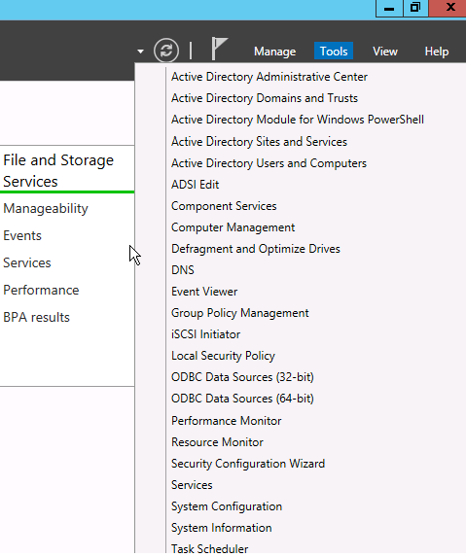

3. Right-click on YourDomain.LOCAL, click New, then Organizational Unit (OU).

4. Enter Faculty as the name of the new Organizational Unit then click Next.

\*\*Uncheck the Protect container from accidental deletion box before selecting Next if you do NOT want to automatically protect the OU from being deleted or moved.

Arkansas Department of Information Systems – APSCN LAN Support Printed on 5/14/2024

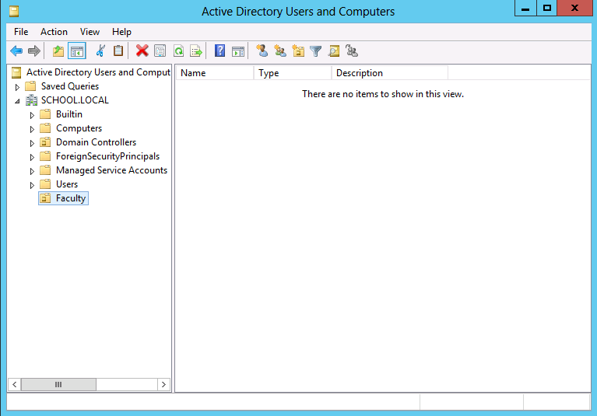

\*\*Repeat Steps 2 and 3 for Organizational Units required in your Active Directory environment e.g. Students, Domain Computers, Domain Servers, and Custom Security Groups.

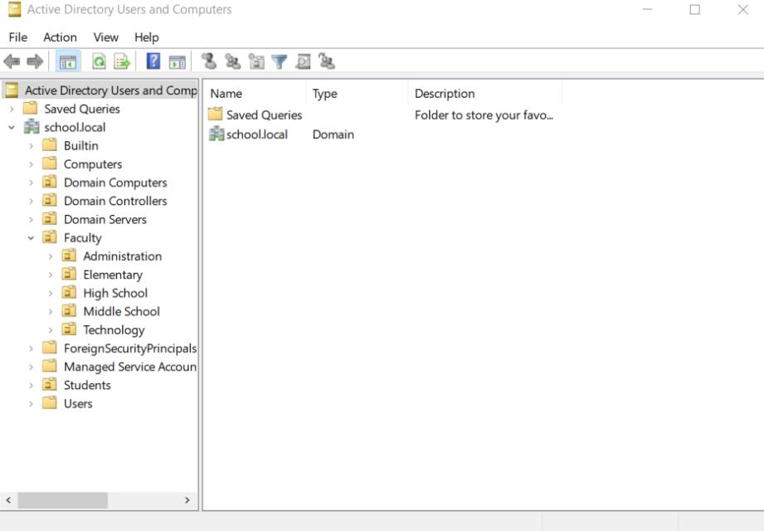

Arkansas Department of Information Systems – APSCN LAN Support Printed on 5/14/2024

Now that we have our basic OU structure setup, we need to create our security groups. It is best to use security groups to assign permissions rather than assigning permissions to network shares using individual accounts. It is much easier to find where someone is getting incorrect access to something if access to files and shares is based off security groups.

5. Right-click on the Custom Security Groups OU then click New Group.

6. Name this group Faculty and click OK.

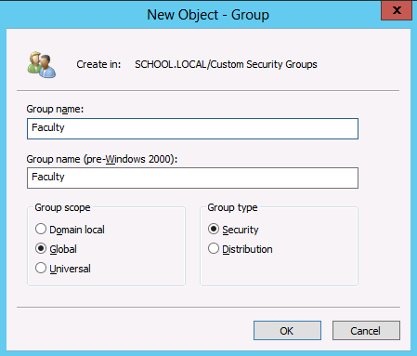

\*\*Repeat Steps 4 and 5 for all Custom Security Groups required in your Active Directory environment e.g. Students, Journalism, YearBook, and Technology etc.

\*\*If you are running Active Directory over multiple sites (behind more than one router), you would want to create an OU for each site, place Workstations, Faculty, and Students OU’s under that Site OU. You can delegate campus level technicians to be able to have the authority to maintain user accounts, computer accounts, etc. that reside only in their campus’ OU.

CREATE SHARES AND HOME DIRECTORIES

The first thing we need to do before we can create our user template is to create a network share for the home directories.

1. Open Computer and browse to the volume that will hold the faculty

home-directories.

Arkansas Department of Information Systems – APSCN LAN Support Printed on 5/14/2024

\*\*It is recommended that Faculty and Student Home folders be stored on individual volumes. Do not place them on the same volume or on the DATA volume.

2. Create a new folder called Faculty-Homes.

3. Right click on the Faculty-Homes folder and click Properties.

4. Select on the Sharing tab and click the Advanced Sharing button.

5. Select the Share this folder check box.

6. For the share name type Faculty-Homes$.

\*\*When sharing folders or drives with Windows, if a dollar sign ($) character is added to the end of a share name, the share name does not appear in a browsed list of available shares on the server.

7. Click on the Permissions button.

8. Select Everyone and click Remove.

9. Click Add. In the name box enter Domain Admins, Administrators,

Faculty, and each separated by a semi-colon. Click the Check Names button and then click OK.

\*\*If a name or group is misspelled or not found in the Directory, you will be prompted to correct the spelling or to distinguish the proper group, should the same text exist within multiple groups.

10. Give Domain Admins and Administrators both Full Control.

11. Give the Faculty group Change rights, they will receive Read

automatically.

12. Click on the Caching button. Select No files or programs from this

shared folder will be available offline.

\*\*Unless required, it is NOT recommended to allow offline file-caching for any network shares as these files will be synced at every log off for every user using the share.

13. Click OK, Apply, and then OK until all property windows are closed.

Arkansas Department of Information Systems – APSCN LAN Support Printed on 5/14/2024

14. Select the Security tab and click the Advanced button.

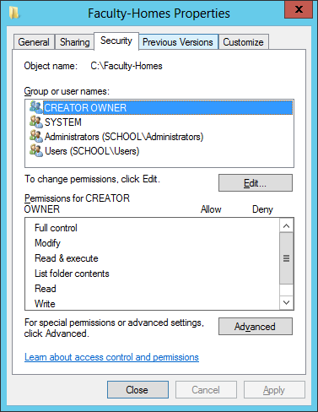

15. On the Advanced Security Settings page, click on Disable inheritance.

\*\*By Default, all folders created have “Inheritance” turned on which means that the folder inherits its rights from its parent folder. The easiest way to distinguish this is to notice that the Allow or Deny selection boxes will be grayed out for a user or group that is getting rights through inheritance.

Arkansas Department of Information Systems – APSCN LAN Support Printed on 5/14/2024

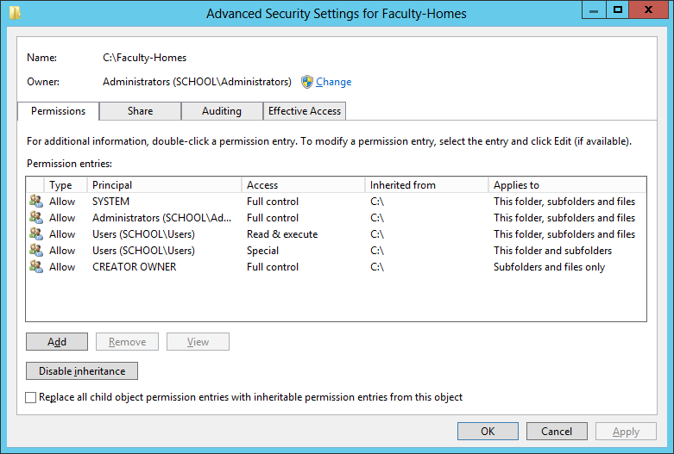

16. A dialog box prompting that permission inheritance from the parent

folder is being blocked will popup.

17. Select Convert inherited permissions into explicit permissions on this

object.

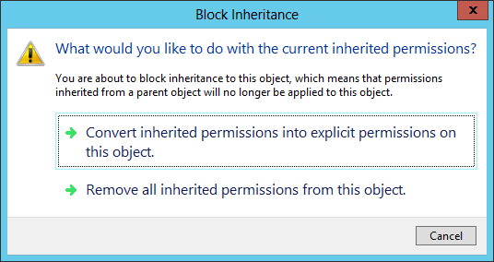

18. Click Apply and then OK to return to the Faculty-Homes Properties

screen.

19. Your permissions to Faculty-Homes should now look like the following

screen.

Arkansas Department of Information Systems – APSCN LAN Support Printed on 5/14/2024



20. Click on Edit button and remove all Groups from the list except

Administrators group.

21. Click on Add, enter Domain Admins and click OK.

22. Click on Domain Admins, then under Permissions for Domain Admins

check Full Control under Allow section. Click Apply and OK.

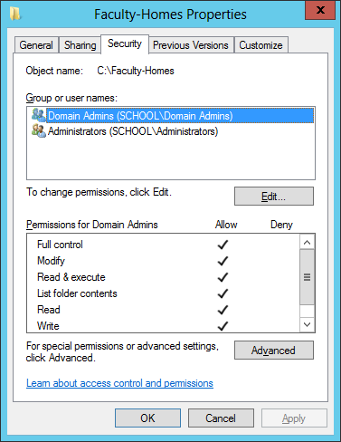

Arkansas Department of Information Systems – APSCN LAN Support Printed on 5/14/2024

# CREATING USER TEMPLATE

Now that the network share to store home directories is set up, User template will be created using the following steps:

23. Launch Server Manager, click on Tools and select Active Directory Users

and Computers from the drop-down list.

24. Right click on the Faculty OU, select New, and then User.

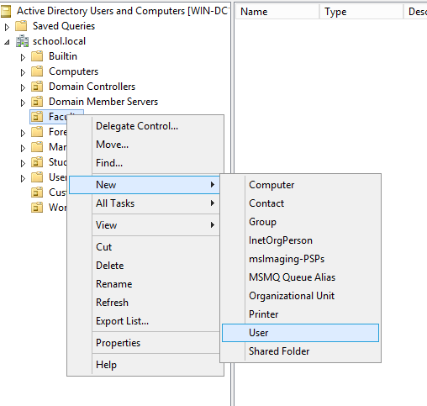

25. In the information screen fill it out as shown in this screen and then click

Next.

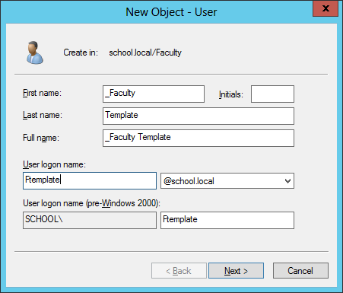

\*\*An underscore before the first name places the template at top of the list within the Organizational Unit.

Arkansas Department of Information Systems – APSCN LAN Support Printed on 5/14/2024

26. Enter a password for the template account that meets the minimum

password requirements. Make sure User much change password at next logon and Account is disabled are checked and click Next.

\*\*It is recommended that a template account is ALWAYS disabled after creation.

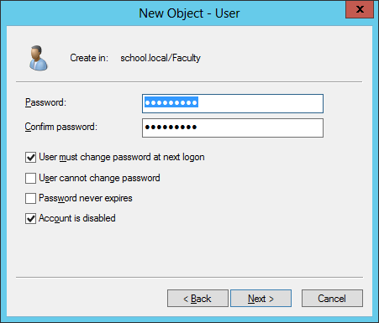

Now that the template account is set up, it needs to be configured for login script, home directory path, and make sure that this template is a member of the required security group(s) by following these steps:

27. Right-click on the \_Faculty Template account and click Properties.

28. Click on the Member Of tab and then click on Add.

29. In the Select Groups box, type Faculty and click Check Names. Add any

additional security group this template needs to be a member of and then click OK.

30. Click on the Profile tab and in the Logon Script text box, enter logon.bat

31. Under the Home folder section, click the radio button next to Connect.

32. Select the drive letter to be used for user’s home directory when it is

mapped.

33. In the To: text box enter \\servername\Faculty-Homes$\%username%

Arkansas Department of Information Systems – APSCN LAN Support Printed on 5/14/2024

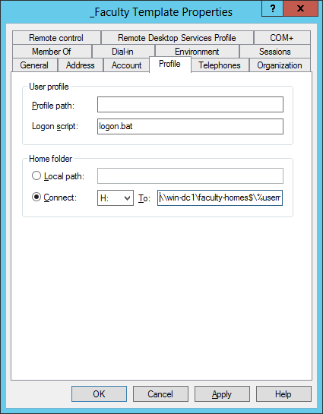

34. Click Apply and then OK.

\*\*The %username% in the home directory path will automatically change to the login id of the user.

35. This will create a new subfolder called FTemplate under Faculty-Homes

folder with the proper rights.

CREATING NEW USER USING TEMPLATE

To create a new account based off the template, use the following steps:

1. Right click on the \_Faculty Template account and click Copy.

2. In the Information screen fill it out the information for the New User and

then click Next.

Arkansas Department of Information Systems – APSCN LAN Support Printed on 5/14/2024

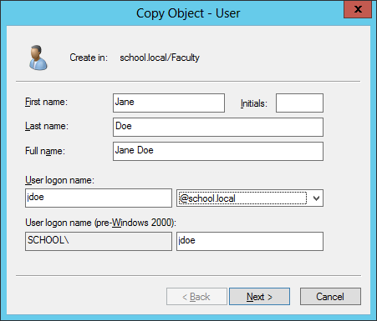

3. Make sure that the Account is disabled box is Unchecked when creating

a real user account. Click Next and then Finish to complete the creation.

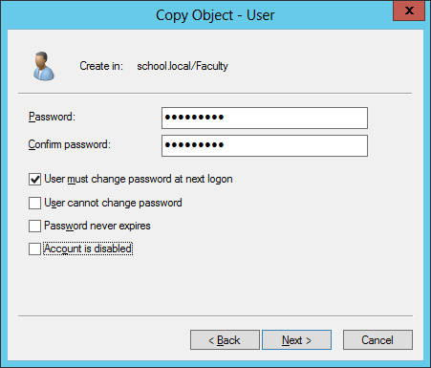

Arkansas Department of Information Systems – APSCN LAN Support Printed on 5/14/2024

CREATING FACULTY & STUDENT BATCH FILE FOR ACTIVE DIRECTORY – MASS IMPORT

Script for Active Directory (AD) Name Importing

\*\*Notes: Must be revised for the domain!!! (school.local)

Student Script: (Column F)

="dsadd user " & CHAR(34) & "CN=" & PROPER(A1) & " " & PROPER(B1) & ",OU=" & C1 & ",OU=Students,DC=school,DC=Local" & CHAR(34) & " -samid " & PROPER(A1) & "." & PROPER(B1) & " -upn " & Lower(D1) & "@school.local -fn " & PROPER(A1) & " -ln " & PROPER(B1) & " -display " & CHAR(34) & PROPER(A1) & " " & PROPER(B1) & CHAR(34) & " -pwd " & E1 & " -mustchpwd Yes -memberof

CN=Students,OU=Students,DC=school,DC=Local"

Faculty Script: (Column F)

="dsadd user " & CHAR(34) & "CN=" & PROPER(A1) & " " & PROPER(B1) & ",OU=" & C1 & ",OU=Faculty,DC=school,DC=Local" & CHAR(34) & " -samid " & PROPER(A1) & "." & PROPER(B1) & " -upn " & Lower(D1) & "@school.local -fn " & PROPER(A1) & " -ln " & PROPER(B1) & " -display " & CHAR(34) & PROPER(A1) & " " & PROPER(B1) & CHAR(34) & " -pwd " & E1 & " -mustchpwd Yes -memberof

CN=Faculty,OU=Faculty,DC=school,DC=Local"

SPREAD SHEET DATA EXAMPLE

A1 B1 C1 D1 E1 F1

FIRST STUDENT LAST OU =CONCATENATE(A1,".",B1) Password

NAME / NAME Graduation (default)

Year FACULTY

SCRIPT

John STUDENT Smith STUDENT John.Smith Password1$

2019 SCRIPT

Jane Smith FACULTY Jane.Smith Password1$ FACULTY

High School SCRIPT

SPREAD SHEET REFERENCE GUIDE

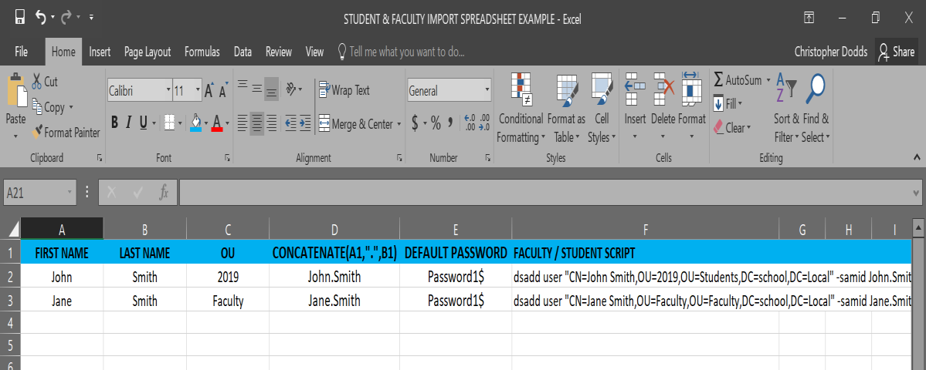

Arkansas Department of Information Systems – APSCN LAN Support Printed on 5/14/2024

1. Create Organizational Units (OU’s) in Active Directory (AD) new accounts.

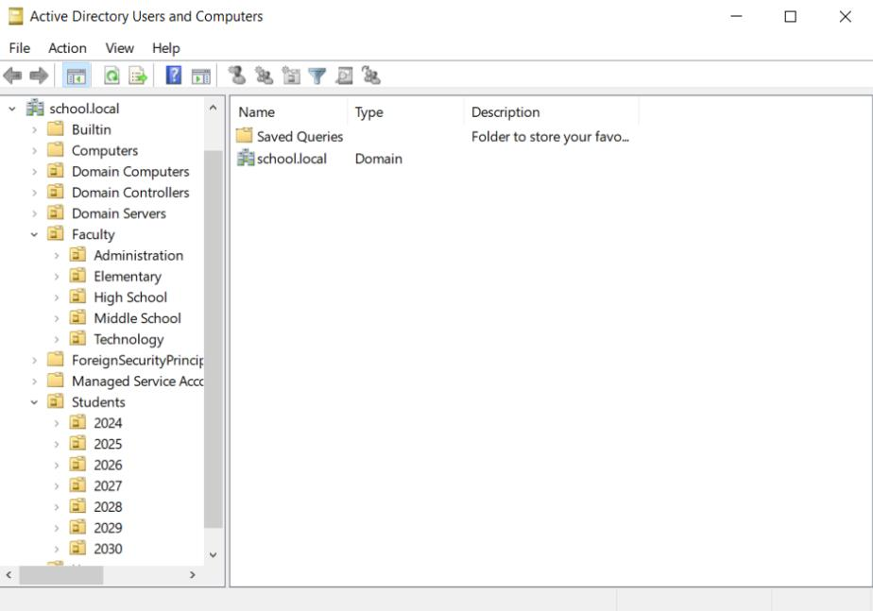

2. Student Graduation Year Reference Guide

\*\*Add graduation year versus grade level for data management

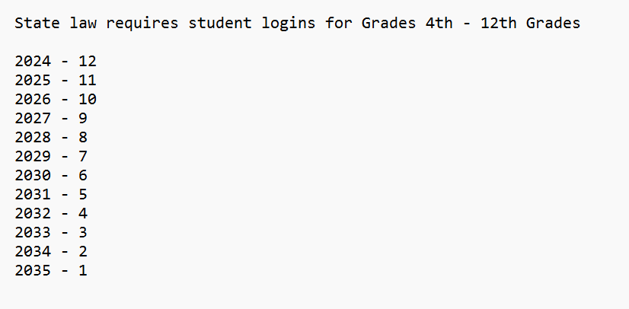

3. Export Student / Faculty File from Cognos (excel csv.)

4. Open Excel Spreadsheet with Student / Faculty Data & Copy Data into

Correct Columns (A, B, C, D, E & F) \*\*Data must be texted to columns and all special characters removed



Arkansas Department of Information Systems – APSCN LAN Support Printed on 5/14/2024

5. Copy Data from Column F and save to New Text Document (.txt)

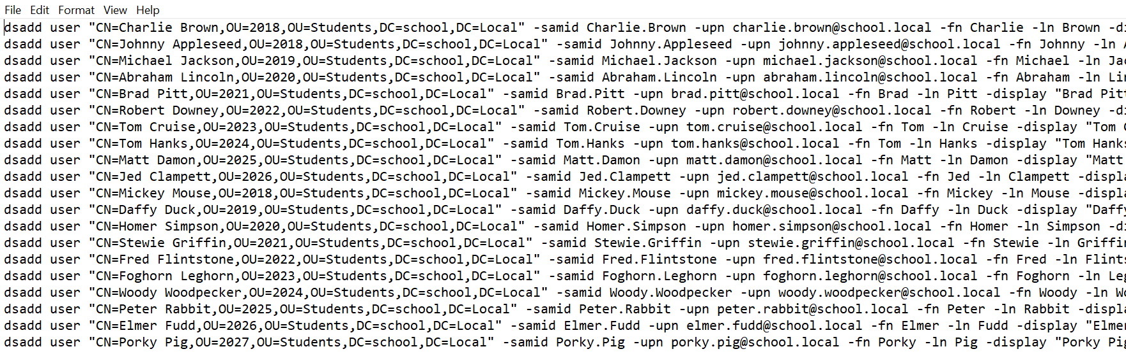

6. Rename texted document to batch file (.bat) and Change Save as type: All

Files

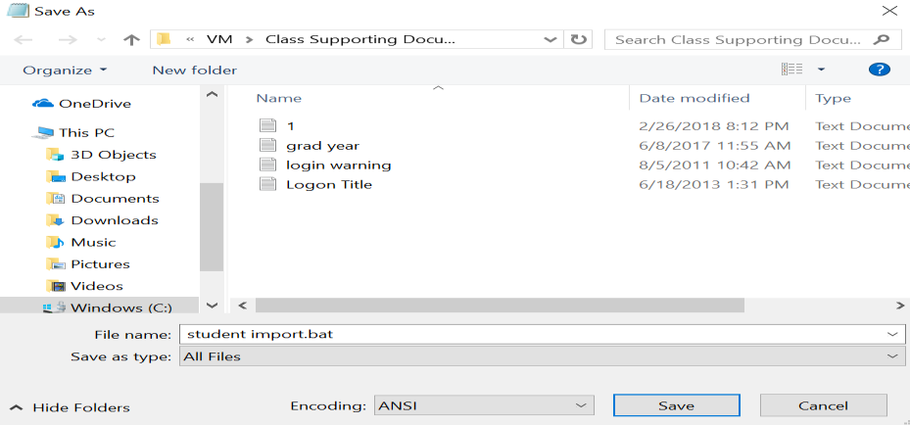

7. Open Command Prompt (Run As Administrator) Change Directories to Batch

file and Run

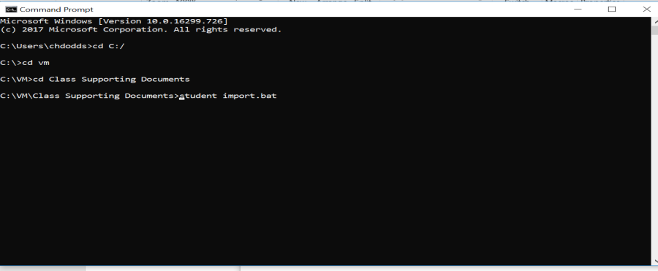

8. Once Batch file successfully runs open Active Directory Users and Computers

& new user accounts should be in their perspective OU’s \*\*Use Refresh if accounts don’t appear in Active Directory OU’s

Arkansas Department of Information Systems – APSCN LAN Support Printed on 5/14/2024

LOGON SCRIPTS – BATCH FILE METHOD

By default, Windows does not know what shares users need access to or what drive letters they need to be mapped to. By creating a simple batch file logon script, this can be accomplished easily. All logon scripts should be saved in the \\DOMAINNAME\NETLOGON folder.

A batch file is nothing more than a series of DOS commands. The main command in a basic batch file logon script would be the NET USE command. For instance, if you have a server named DC1 and it has a share name of APPS, the following command will map this drive as N: for the user, when the logon script runs.

NET USE N: \\DC1\APPS

You can use the REM to remark out anything that you type after the REM. This is helpful for documenting what each command is doing in your logon script. REM Statements MUST be on their own line. They are shown on the same line in this example.

A logon script example would look like the following:

\*DO NOT ADD THE REM STATEMENTS\*

LOGON.BAT

@ECHO OFF

NET USE N: /D REM Disconnects mapped N drive NET USE O: /D REM Disconnects mapped O drive NET USE P: /D REM Disconnects mapped N drive

NET USE N: \\DC1\Apps /Persistent:NO REM Map Apps share on server DC1 to N

NET USE O: \\DC1\Faculty-Apps /Persistent:NO REM Map Faculty-Apps share on server DC1 to O

NET USE P: \\DC1\Student-Apps /Persistent:NO REM Map Student-Apps share on server DC1 to P

REM Copy All Icon Files in Shared Folder to Users’ Desktop – Overwrite any items that are duplicates.

Xcopy “\\server\sharename\desktopicons\\*.\*” “%USERPROFILE%\DESKTOP” /C /E /S /Y

REM Start BGInfo

\\%USERDNSDOMAIN%\netlogon\bginfo.exe \\%USERDNSDOMAIN%\netlogon\bginfo-settings.bgi /timer:0 /accepteula

Arkansas Department of Information Systems – APSCN LAN Support Printed on 5/14/2024

REM Rename Mapped Drives in My Computer

Wscript.exe \\%userdnsdomain%\netlogon\rename-mapped-drives.vbs

:END

EXIT

VBScript to rename mapped network drives. Example: In My Computer from “Apps on ‘DC1’ (O:)” to “Apps (O:)”.

Before After

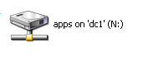

Rename-Mapped-Drives.VBS

index-56_2.png

‘------Script Start

On Error Resume Next

Dim UserName

Set oShell = CreateObject("Shell.Application")

Set objNetwork = CreateObject("WScript.NetWork")

Username = objNetwork.UserName

UserName = UCase(Left(UserName,1)) & LCase(Right(UserName,Len(UserName)-1))

mDrive = "M:"

oShell.NameSpace(mDrive).Self.Name = Username & " - Home Directory" mDrive = "N:"

oShell.NameSpace(mDrive).Self.Name = "Apps"

mDrive = "O:"

oShell.NameSpace(mDrive).Self.Name = "Faculty Apps"

mDrive = "P:"

oShell.NameSpace(mDrive).Self.Name = "Student Apps"

mDrive = "W:"

oShell.NameSpace(mDrive).Self.Name = Username & " - Web Space" mDrive = "Y:"

oShell.NameSpace(mDrive).Self.Name = "Student Home Directories" mDrive = "Z:"

oShell.NameSpace(mDrive).Self.Name = "Faculty Home Directories"

‘------ Script End

Arkansas Department of Information Systems – APSCN LAN Support Printed on 5/14/2024

As you may notice, there is a section for Windows 9X Clients and a section for NT-based clients. NT-based clients include the Operating Systems Windows NT Workstation 4.0 up to Windows XP, as well as Server 2003.

We placed the following command at the beginning to check and see if what type of OS is on the workstation that the user is logging in with by using the OS variable built into NT based clients.

IF “%OS%”==”Windows\_NT” GOTO NTClients

Some of the other variables that are available are %LOGONSERVER%, %COMPUTERNAME% and %USERNAME%. These commands can be placed in the login script and can also be run from a DOS prompt to check the validity of your syntax.

\*\*All login scripts need to be placed in the NETLOGON folder \\DomainName\NETLOGON. Anything placed in this folder is replicated to ALL domain controllers.

IMPLEMENTING SHADOW COPIES

CLIENT USAGE SCENARIOS

Shadow copy usage scenarios for both client and IT administrators are relatively straightforward. Three common scenarios of data loss due to human error are:

▪ Accidental file deletions.

▪ Accidental overwrites of a file (for example, forgot to perform ‘Save as’).

▪ File corruption.

Shadow Copies of Shared Folders provides an end user-accessible tool that restores documents by accessing point-in-time shadow copies of documents and folders stored on network shares. Local volume recovery support of an end user’s computer, for example, is not supported. The network file share must have the Volume Shadow Copy service enabled on a Windows Server 2003-based computer.

Shadow Copies of Shared Folders is transparent to end users when they store files on the network file server. Only when an end user needs to replace a lost or damaged file with a prior version will they activate the client user interface (UI) through Windows Explorer. Shadow Copies of Shared Folders also enables users to see network folder contents at specific points in time.

Arkansas Department of Information Systems – APSCN LAN Support Printed on 5/14/2024

# WHAT SHADOW COPIES OF SHARED FOLDERS CAN DO

Shadow Copies of Shared Folders helps end users:

▪ Recover files without assistance from the help desk.

▪ Recover files that were not saved using the “Saved as” command.

▪ Recover files that were corrupted and not recovered with the file recovery

capabilities of Windows XP Professional or Microsoft Office XP.

Shadow Copies of Shared Folders creates a safety net for end users by providing an easily and readily available previous version of a file. In this way, Shadow Copies of Shared Folders helps end users to:

▪ Manage their own files.

▪ Fix mistakes without rebuilding the file or calling the help desk.

▪ Save time and money for the business.

IT USAGE SCENARIOS

The most common scenario for recovering lost or corrupted files is a request by the end user to the IT help desk to find an archived version. If the organization has an archiving system in place, this request usually means a costly and time-intensive search of archived media, which in many instances is a tape back-up. This situation creates several problems:

▪ Potential loss of business agility or revenue if the lost document is time- or

context-sensitive.

▪ Increased unproductive time for end user.

▪ Increased cost to help desk and IT support services.

Shadow Copies of Shared Folders enables end users to view the contents of shared folders as they existed at specific points in time and recover those files by themselves. This eliminates administrators having to restore accidentally deleted or overwritten files. Implementing Shadow Copies of Shared Folders for routine file recovery scenarios can help to:

▪ Reduce demand on busy administrators; for example, by reducing restore-from-

tape requests.

Reduce the cost of recovering single or multiple files. Table 1 below presents a summary of how end users, IT departments, and organizations can benefit by implementing Shadow Copies of Shared Folders.

Arkansas Department of Information Systems – APSCN LAN Support Printed on 5/14/2024

Table 1: Benefits of Using Shadow Copies of Shared Folders

Benefit End IT Company

User Department

Saves lost time by not having to rebuild file ✓ ✓ Empowers users to manage their own files ✓ ✓ Saves critical data and information ✓ ✓ Saves money by avoiding data loss ✓ Avoids loss of revenue by retaining critical data ✓ Reduces end users’ dependence on IT ✓ ✓ administrators

HOW SHADOW COPY WORKS

The shadow copy feature in Windows Server works by making a block-level copy of any changes that have occurred to files since the last shadow copy. Only the changes are copied, not the entire file.

As a result, previous versions of files do not usually take up as much disk space as the current file, although the amount of disk space used for changes can vary, depending on the application that changed the file.

For example, some applications rewrite the entire file when a change is made, but other applications add changes to the existing file. If the entire file is rewritten to disk, then the shadow copy contains the entire file. Therefore, consider the type of applications in your organization, as well as the frequency and number of updates, when you determine how much disk space to allocate for shadow copies.

\*\*Shadow copies DO NOT eliminate the need to perform regular backups, nor do shadow copies provide protection from media failure. In addition, shadow copies are not permanent. As new shadow copies are taken, old shadow copies are purged when the size of all shadow copies reaches a configurable maximum, or when the number of shadow copies reaches 64, whichever is sooner. Therefore, shadow copies might not be present for as long as end users expect them to be. End user needs and expectations should be considered when shadow copies are configured.

\*\*Windows Vista and later have the Shadow copy client installed by default

Arkansas Department of Information Systems – APSCN LAN Support Printed on 5/14/2024

# IMPLEMENTING SHADOW COPIES

1. On the server go to File manager and then select Computer.

2. Right-click on the volume that you would like to enable Shadow Copies and

then click Properties.

3. Click on the Shadow Copies tab.

4. Select the volume(s) from the list shadow copies needs to be enabled on and

then click Enable.

5. On the Enable Shadow Copies dialog box that pops up check Do not show

this message again and click Yes.

6. Click on the volume that you enabled Shadow Copies for then click the

Settings button.

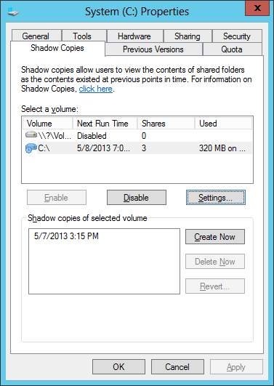

Arkansas Department of Information Systems – APSCN LAN Support Printed on 5/14/2024



7. Click the Schedule button.

8. By default, the only two options for a snapshot are every day at 7AM and

12PM, Mon - Friday. Adjust this schedule to meet the district’s needs or create a new schedule per requirement.

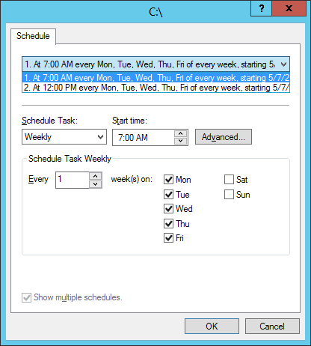

9. Click OK twice to return to the Shadow Copies Settings window.

10. Click OK to return to Computer.

Arkansas Department of Information Systems – APSCN LAN Support Printed on 5/14/2024

# IMPLEMENTING VOLUME BASED QUOTA LIMITS

VOLUME LEVEL QUOTA LIMITS USING PROPERTIES

\*\*Quota limits are based off volumes. Quota limits are, when applied, are for all users that save data on the volume. It is recommended that volumes containing Faculty and Student home folders be on separate volumes. This will allow different quota limits on volumes.

1. On the server go to File manager and then select Computer.

2. Right click on the volume that Quota limits need to be enabled and then

select Properties and click on the Quota tab.

3. Check the box next to Enable Quota Management.

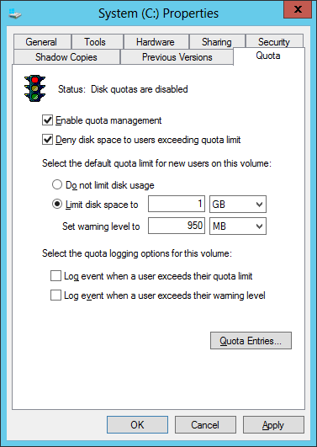

\*\*It is recommended to enable Deny Disk Space to Users Exceeding Quota Limit.

4. Select the radio button next to Limit disk space to. Set the limit and warning

level to meet district’s needs. You can set the log options to meet your needs.

5. Click Apply and OK.

To view user’s current disk utilization, click on the Quota Entries button from within the window.

Arkansas Department of Information Systems – APSCN LAN Support Printed on 5/14/2024

# DIRECTORY LEVEL QUOTA LIMITS USING FILE SERVER RESOURCE MANAGER

INSTALL FILE SERVER RESOURCE MANAGER

1. Launch Server Manager.

2. Click Manage and then select Add Roles and Features.



3. On the Before You Begin screen, click Next.

4. On the Select Installation type screen, select Role-based or Feature-based

installation and click Next.

5. On the Select Destination server screen, click Next.

6. On the Select Server roles page expand File and Storage Services to view the

options below.

7. Expand File and iSCSI Services, select File Server Resource Manager.

8. In the Add Roles and Features dialog box hat pops up, click Add Features and

then click Next.

9. Click Next for rest of the screens, and then click Install.

Arkansas Department of Information Systems – APSCN LAN Support Printed on 5/14/2024

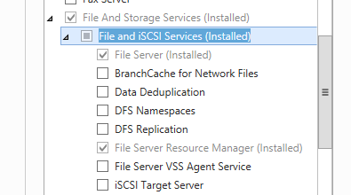

10. When the installation is finished, click Close and restart the server.

CONFIGURE QUOTA TEMPLATES

11. Now that File Server Resource Manager role is installed, it will be configured by

clicking on Tools and selecting File Server Resource Manager from the drop

down list.

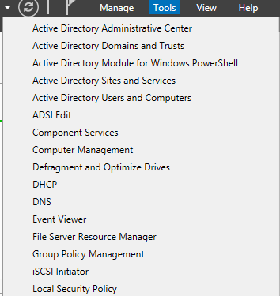

12. Expand Quota Management in the left-hand pane and click on Quota

Templates.

13. Under the Actions pane (far right) click Create Quota Template.

14. Enter a template name, such as Faculty Home Directory Limits or Student Home

Directory Limits.

15. Enter the limit size and select either Hard quota or Soft quota.

16. Email notifications to either the user or network administrative staff can be

enabled by clicking on the Add button in the Notification threshold section.

17. Click OK to save the Quota Template.

Arkansas Department of Information Systems – APSCN LAN Support Printed on 5/14/2024

# APPLY QUOTA TEMPLATE TO DIRECTORY

18. Under the Quota Management section of the left pane, click on Quotas.

19. Right-click Quotas and select Create Quota.

20. Click the Browse button to select the directory that you wish to apply the quota

limit to.

21. Select the following quota type:

Create quota on path – This will apply the space limitation to ALL files and

folders within the parent directory.

\*\*This option should be used for folders such as Yearbook Staff or Multimedia

class where multiple users save to the same folder.

Auto apply template and create quotas on existing and new subfolders – This

will apply the template to the subfolders within the parent folder.

\*\*This option should be used for applying limits on home directory folders and

is automatically applied to any new folders created. This method would allow

you to have your Faculty-Homes and Student-Homes parent folders both on

their own volume or you can also place them on the Data volume with the rest

of your network shares.

22. Select the Quota Template to be used from the drop-down menu under Derive

properties from this quota template and click Create.

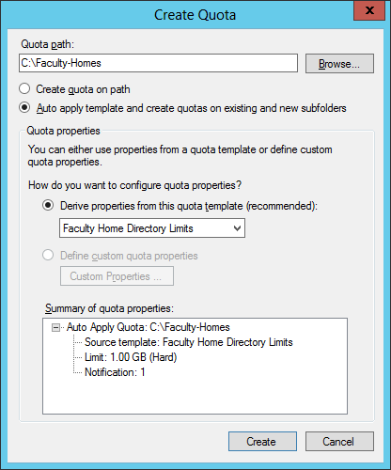

Arkansas Department of Information Systems – APSCN LAN Support Printed on 5/14/2024

FINE-GRAINED PASSWORD POLICIES (ACT-723)

One of the nice features introduced in Windows Server 2022 AD DS is the ability to configure fine grained password policies through GUI.

Fine grained password policies allow Network Administrators to configure multiple password policies within a single domain which can be used to apply different restrictions for password and account lockout policies to different sets of users and groups.

Policy Name Faculty Password Policy Students Password Policy

Precedence 1 1

Group Name Faculty/Staff Students Minimum Password Length 8 8

Enforce Password History 5 (Recommended) 5 (Recommended)

Minimum Password Age 1 1

Maximum Password Age 90 180

To configure fine-grained password policies as per the table above (ACT723 - K12 State Security Policies), use the following steps:

1. Launch Server Manager.

2. Click on Tools and select Active Directory Administrative Center (ADAC) from

the drop-down list.

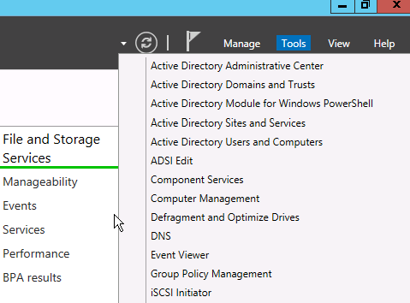

Arkansas Department of Information Systems – APSCN LAN Support Printed on 5/14/2024

3. When ADAC opens, change the view from List view to Tree View

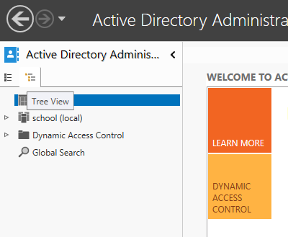

4. Expand the Domain name and navigate to System and then Password Settings

Container.

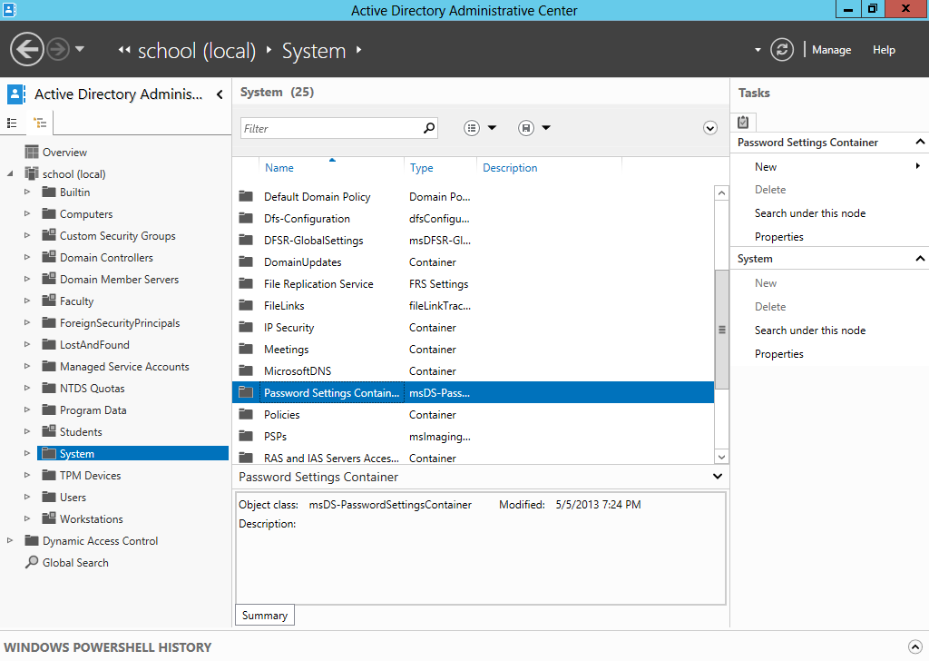

Arkansas Department of Information Systems – APSCN LAN Support Printed on 5/14/2024

5. Right-click on Password Settings Container, select New and then Password

Settings.

6. Specify the password policy settings for each of the required policies referenced

in table.

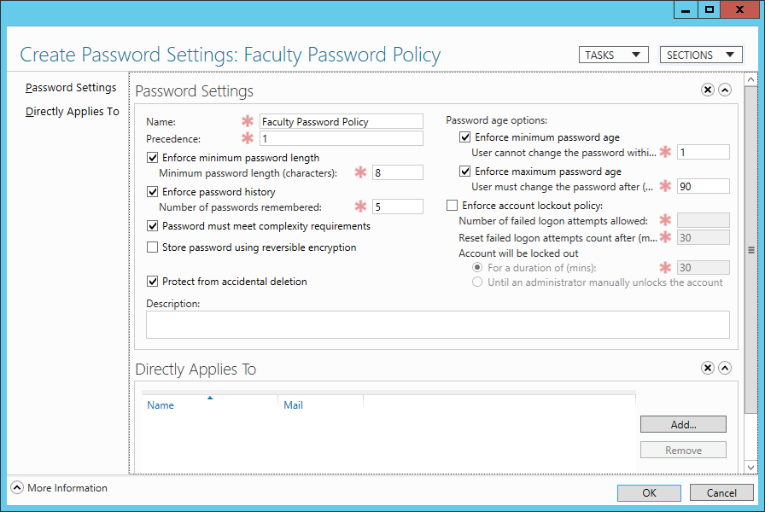

7. After the attributes for the password policy has been filled in, click Add to link

created policy to the required security group and click on OK twice.

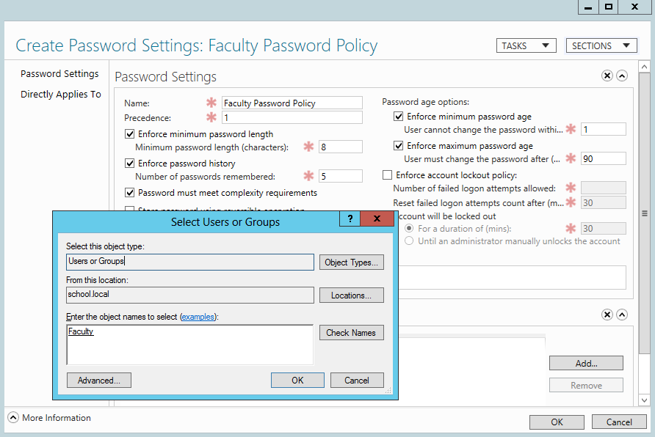

\*\*Repeat steps 5 – 7 for Students password policy

Arkansas Department of Information Systems – APSCN LAN Support Printed on 5/14/2024

SOME COMMON K12 GROUP POLICIES

RETAIN SECURITY EVENT LOG FOR 90 DAYS GROUP POLICY

1. Launch Server Manager.

2. Click on Tools and select Group Policy Management from the drop-down list.



3. Expand Forest: yourdomain.local.

4. Expand Domains and then expand yourdomain.local and navigate to Default

Domain Policy.

5. Right-click the Default Domain Policy and click Edit.

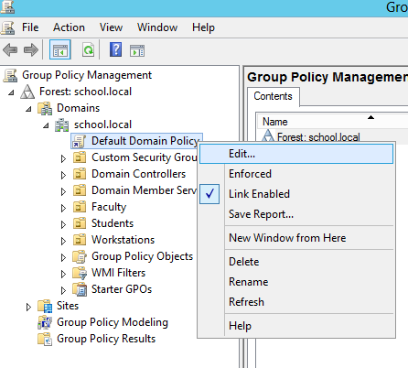

Arkansas Department of Information Systems – APSCN LAN Support Printed on 5/14/2024

6. Expand Computer Configuration > Policies > Windows Settings > Security

Settings and select Event Log.

7. Set the policy setting Retain Security Log to 90 days. You will automatically

prompted to change the Retention method to days. Click OK.

8. Set the Maximum Security Log Size to 131072 kilobytes (128MB).

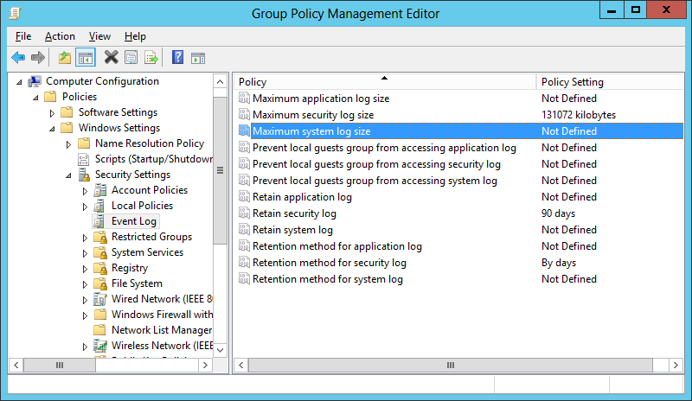

AUTO-BACKUP AND CLEAR EVENT LOGS (AT LEAST WINDOWS VISTA)

9. Expand Computer Configuration > Policies > Administrative Templates >

Windows Components > Event Log Service and select Security.

10. Enable the Backup log automatically when full setting.

11. Close the Group Policy Management Editor.

Arkansas Department of Information Systems – APSCN LAN Support Printed on 5/14/2024

SECURITY EVENT AUDITING – SECURITY EVENT LOG CONTENTS

1. Launch Server Manager.

2. Click on Tools and select Group Policy Management from the drop-down list.

3. Expand Forest: yourdomain.local.

4. Expand Domains and then expand yourdomain.local and navigate to Default

Domain Policy.

5. Right-click the Default Domain Policy and click Edit.

6. Expand Computer Configuration > Policies > Windows Settings > Security

Settings > Local Policies and select Audit Policy.

7. Enable auditing for the following Policy Settings:

a. Audit Account Logon Events – (Success AND Failure) b. Audit Account Management – (Success) c. Audit logon event – (Success AND Failure) d. Audit policy change – (Success)

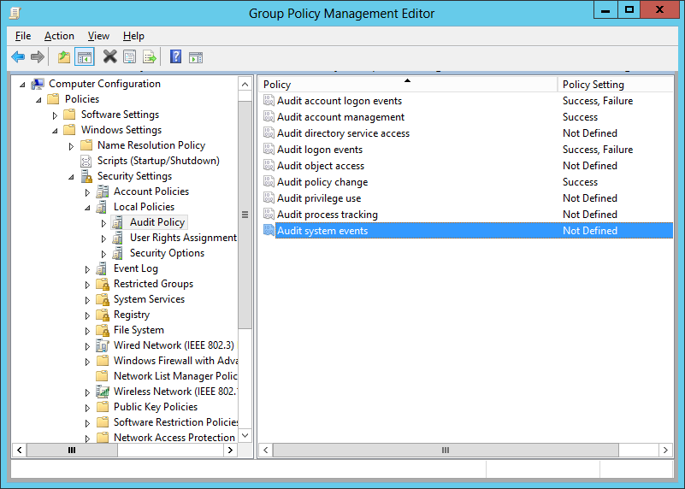

8. Close the Group Policy Management Editor.

Arkansas Department of Information Systems – APSCN LAN Support Printed on 5/14/2024

# GROUP POLICY FOR LOGON BANNER

1. Launch Server Manager.

2. Click on Tools and select Group Policy Management from the drop-down list.

3. Expand Forest: yourdomain.local.

4. Expand Domains and then expand yourdomain.local and navigate to Default

Domain Policy.

5. Right-click the Default Domain Policy and click Edit.

6. Expand Computer Configuration > Policies > Windows Settings > Security

Settings > Local Policies and select Security Options.

7. Navigate to the following options and enable them:

a. Interactive logon: Message text for users attempting to log on. b. Interactive logon: Message title for users attempting to log on.

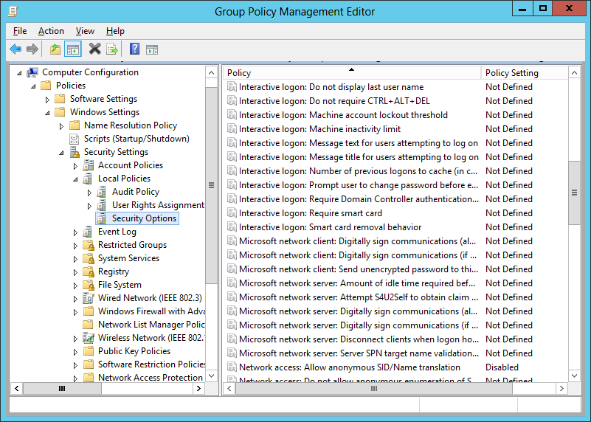

8. Close the Group Policy Management Editor.

Arkansas Department of Information Systems – APSCN LAN Support Printed on 5/14/2024

# LOCKING SCREEN SAVER GROUP POLICY

1. Launch Server Manager.

2. Click on Tools and select Group Policy Management from the drop-down list.

3. Expand Forest: yourdomain.local.

4. Expand Domains and then expand yourdomain.local and navigate to Default

Domain Policy.

5. Right-click the Default Domain Policy and click Edit.

6. Expand User Configuration > Policies > Administrative Templates > Control

Panel and select Personalization.

7. Set the Enable Screen Saver policy to Enabled.

8. Set the Password Protect the Screen Saver policy to Enabled.

9. Set the Screen Saver timeout to Enabled and to a recommended time of 900

seconds (15 minutes).

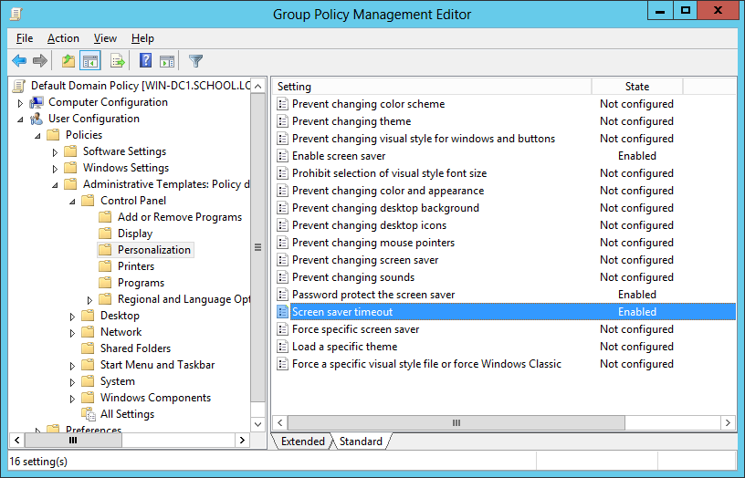

10. Close the Group Policy Management Editor.

Arkansas Department of Information Systems – APSCN LAN Support Printed on 5/14/2024

# FOLDER REDIRECTION GROUP POLICY

1. Launch Server Manager.

2. Click on Tools and select Group Policy Management from the drop-down list.

3. Expand Forest: yourdomain.local.

4. Expand Domains and then expand yourdomain.local and navigate to Group

Policy Objects.

5. Right-click on the Group Policy Objects and then select New.

6. Name the new group policy Folder Redirection Policy and click OK.

7. Expand Group Policy Objects. Right-click on the newly created Folder

Redirection Policy and click Edit to open the Group Policy Editor.

8. Expand User Configuration > Policies > Windows Settings and select Folder

Redirection.

9. Right click on Documents and click Properties.

10. Change the setting to Basic – Redirect everyone’s folder to the same

location and set the Target folder location to Redirect to the user’s home directory.

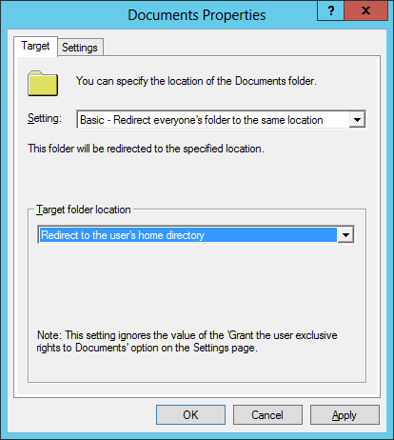

Arkansas Department of Information Systems – APSCN LAN Support Printed on 5/14/2024

11. Click the Settings tab and check the box Also apply redirection policy to

Windows 2000, Windows 2000 Server…

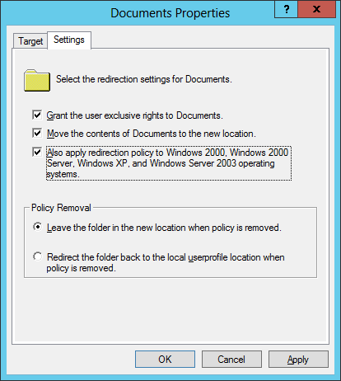

12. Click Apply and if prompted to also redirect Pictures, Music, etc. to the Home

Directory, click Yes. Click OK.

13. Close the Group Policy Management Editor.

Arkansas Department of Information Systems – APSCN LAN Support Printed on 5/14/2024

# RESTRICT COMPUTERS TO FACULTY USE ONLY

This policy can be used to restrict access for students to log on to faculty machines. This policy will be based off the Faculty User group and can be adjusted to meet the group of users that meets your needs.

1. Launch Server Manager.

2. Click on Tools and select Active Directory Users and Computers from the

drop down list.

3. Create a security group called Faculty Use Only Computers under Custom

Security Groups Organization Unit (OU).

4. Under Server Manager, click on Tools and select Group Policy Management

from the drop down list.

5. Expand Forest: yourdomain.local.

6. Expand Domains and then expand yourdomain.local and navigate to Group

Policy Objects.

7. Right-click on the Group Policy Objects and then select New.

8. Name the new group policy Faculty Use Only Computers and click OK.

9. Expand Group Policy Objects and select the newly created Faculty Use Only

Computers policy.

10. In the right-hand pane, click on the Scope tab. Under Security Filtering list,

select Authenticated Users and then click the Remove button.

11. Click the Add button, enter the group name Faculty Use Only Computers and

then click the OK.

12. Right-click on the newly created Faculty Use Only Computers policy and

select Edit.

13. Expand Computer Configuration > Policies > Windows Settings > Security

Settings > Local Policies and select User Rights Assignment.

14. In the right-hand window, double-click on Allow log on locally. Arkansas Department of Information Systems – APSCN LAN Support Printed on 5/14/2024

15. Check the box for Define these policy settings.

16. Click the Add User or Group button and add Domain Admins,

Administrators, and Faculty to the list. Click Apply and OK.

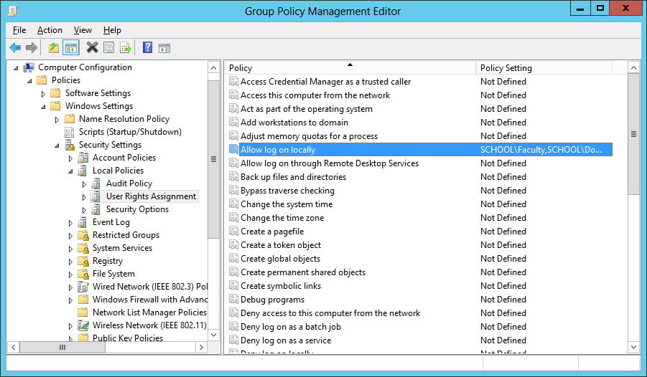

17. Close the Group Policy Management Editor and link the policy to Faculty

Workstations OU.

\*\*Once this policy is created and applied, add computers to the Faculty Use Only Computers security group to apply the policy. A reboot is required after the computer is added to and removed from the group to enforce/remove the policy.

REFRESH GROUP POLICY SETTINGS WITH GPUPDATE.EXE

Syntax

Gpupdate [/target:{computer|user}] [/force] [/wait:value] [/logoff] [/boot]

Parameters

/target:{computer|user}

Processes only the computer settings or the current user settings. By default,

both the computer settings and the user settings are processed. /force

Ignores all processing optimizations and reapplies all settings. The Group Policy

engine on the client tracks versions of the GPOs that are applied to the user and

Arkansas Department of Information Systems – APSCN LAN Support Printed on 5/14/2024

computer. By default, if none of the GPO versions change and the list of GPOs

remains the same, the Group Policy engine will not reprocess policy. This option

overrides this optimization and forces the Group Policy engine to reprocess all

policy information.

/wait:value

Number of seconds that policy processing waits to finish. The default is 600

seconds. 0 means "no wait"; -1 means "wait indefinitely." /logoff

Logs off after the refresh has completed. This is required for those Group Policy

client-side extensions that do not process on a background refresh cycle but that

do process when the user logs on, such as user Software Installation and Folder

Redirection. This option has no effect if there are no extensions called that

require the user to log off.

/boot

Restarts the computer after the refresh has completed. This is required for those

Group Policy client-side extensions that do not process on a background refresh

cycle but that do process when the computer starts up, such as computer

Software Installation. This option has no effect if there are no extensions called

that require the computer to be restarted.

/?

Displays help at the command prompt.

Examples

The following examples show how you can use the gpupdate command:

• gpupdate

• gpupdate /target:computer

• gpupdate /force /wait:100

• gpupdate /boot

UPDATE GROUP POLICY SETTINGS FROM GROUP POLICY MANAGEMENT CONSOLE

A new feature introduced with Windows Server 2022 is that from within the Group Policy Management Console. The update process also notifies how many computer objects will be affected by the update operation.

This can be accomplished by Right-clicking an Active Directory Organization Unit (OU) select Group Policy Update.

Arkansas Department of Information Systems – APSCN LAN Support Printed on 5/14/2024

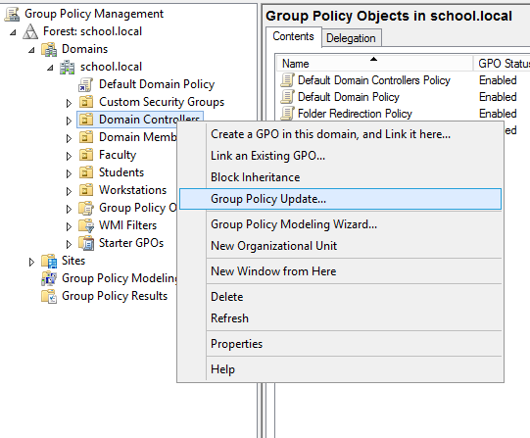

HOW TO CHECK GROUP POLICY SETTINGS ON A DOMAIN COMPUTER (GUI)

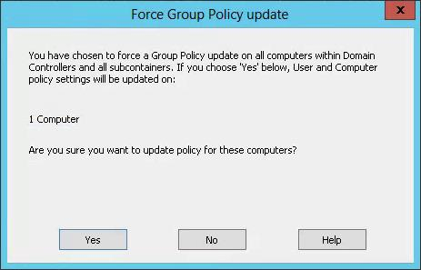

1. Open the Resultant Set of Policy utility by moving your mouse over the bottom-

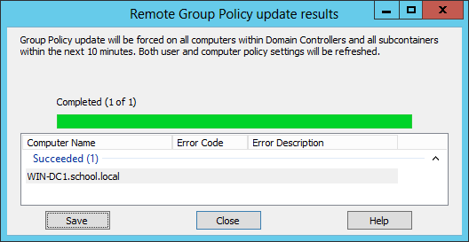

left Windows Key  or click Keyboard Key  and type rsop.msc and press Enter

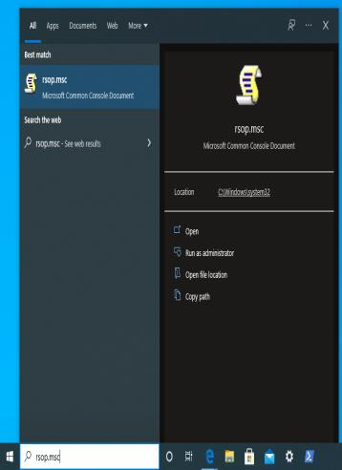

2. To check & verify applied group policy’s, expand Computer & User

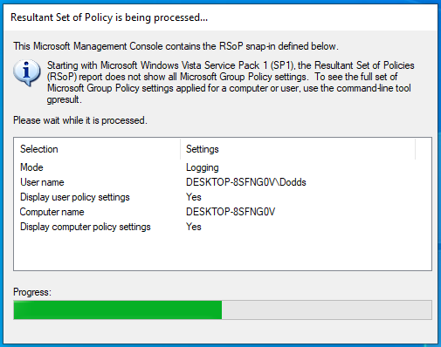

Configurations

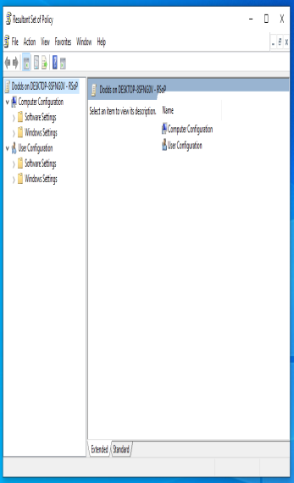

Arkansas Department of Information Systems – APSCN LAN Support Printed on 5/14/2024

HOW TO CHECK GROUP POLICY SETTINGS ON A DOMAIN COMPUTER (CMD)

To view all the policies applied to the user account you are currently logged in

with, you would use the following command:

1. Open Command Prompt CMD

2. Type Command “GPRESULT /SCOPE USER /V”

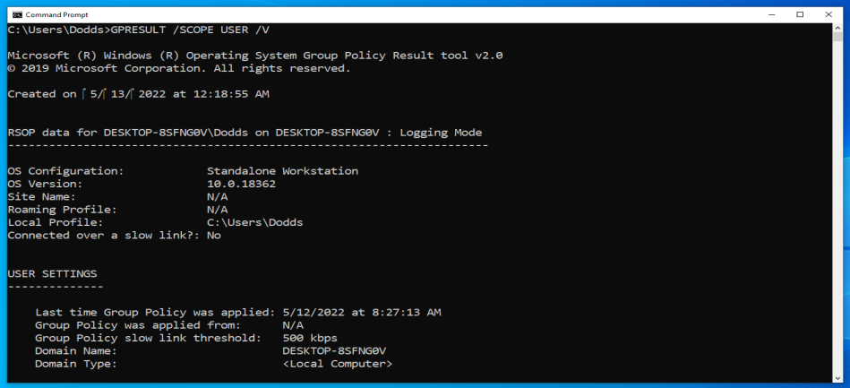

Arkansas Department of Information Systems – APSCN LAN Support Printed on 5/14/2024

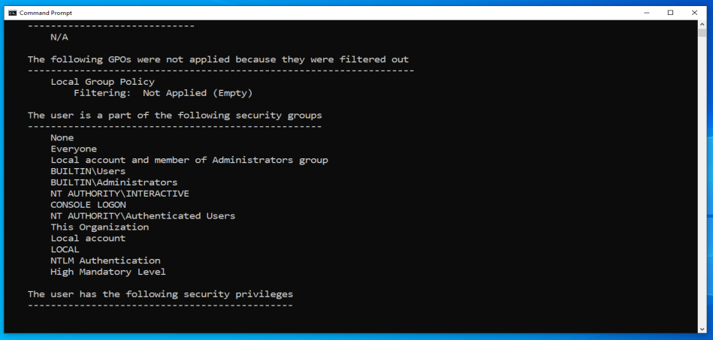

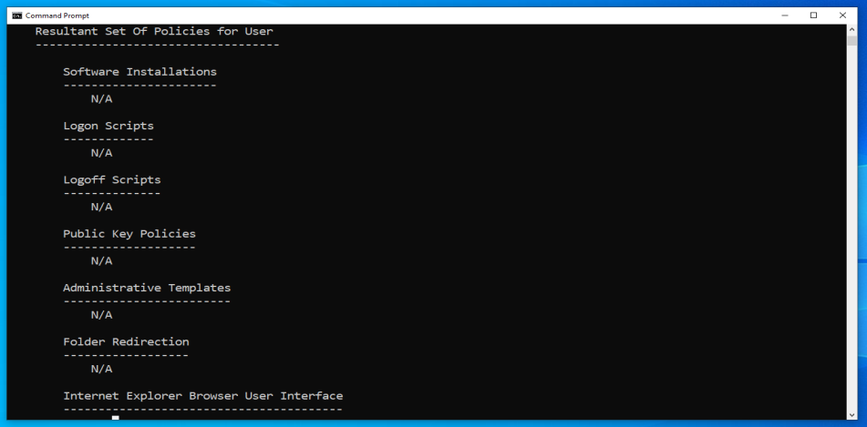

TROUBLESHOOTING WINDOWS SERVER 2022

DISABLING THE SHUTDOWN EVENT TRACKER

To turn off the Shutdown Event Tracker, navigate to the following key in your registry:

HKLM\SOFTWARE\Policies\Microsoft\Windows NT\Reliability

\*\*Creation of the Reliability is required

Create a new DWORD with the following values:

Value Name: ShutdownReasonOn

Value: 0 (HEX)

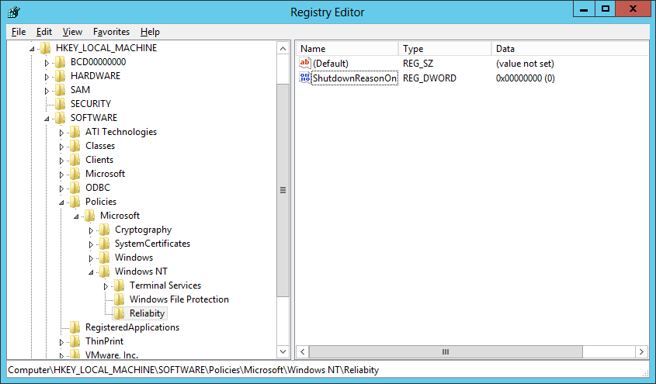

\*\*The change will take place immediately no reboot is required.

Arkansas Department of Information Systems – APSCN LAN Support Printed on 5/14/2024

SET TIME SOURCE TO DIS / NTP TIME SERVER

• First, locate your PDC Server. Open command prompt on any server and type:

netdom /query fsmo

• Log in to your PDC Server and open the command prompt.

• Stop the W32Time service

net stop w32time

• Configure the external time sources, type:

w32tm /config /syncfromflags:manual /manualpeerlist:”165.29.1.11,170.94.1.1”

• Make your PDC a reliable time source for the clients. Type:

w32tm /config /reliable:yes

• Start the w32time service:

net start w32time

• The windows time service should begin synchronizing the time. You can check

the external NTP servers in the time configuration by typing:

w32tm /query /configuration

\*\*Check the Event Viewer for any errors.

\*\*DIS Time Servers - dsn1.state.ar.us, dns2.state.ar.us, dns3.state.ar.us \*\*NTP Time Servers - time.windows.com, time.nist.gov, us.pool.ntp.org

Arkansas Department of Information Systems – APSCN LAN Support Printed on 5/14/2024

# ACTIVE DIRECTORY MAINTENANCE

STEPS TO CHECK ACTIVE DIRECTORY REPLICATION IN WINDOWS SERVER (GUI)

Check Active Directory objects replication between these two Domain Controller.

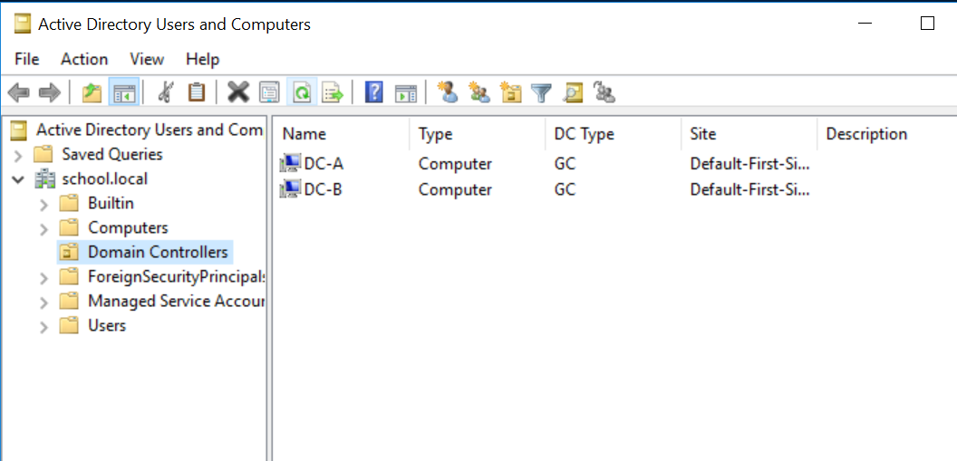

1. Launch Server Manager.

2. Click on Tools and select Active Directory Sites and Services from the drop-

down list.



Active Directory sites and services is a primary console used to replicate the AD

objects between the Domain Controllers. We can also manage the objects

represent the sites and servers which reside in those sites. Site links are

automatically created as and when we add any new Domain Controller in our

environment.

3. Expand and Left Click Sites, Default-First-Site-Name, Servers

Arkansas Department of Information Systems – APSCN LAN Support Printed on 5/14/2024

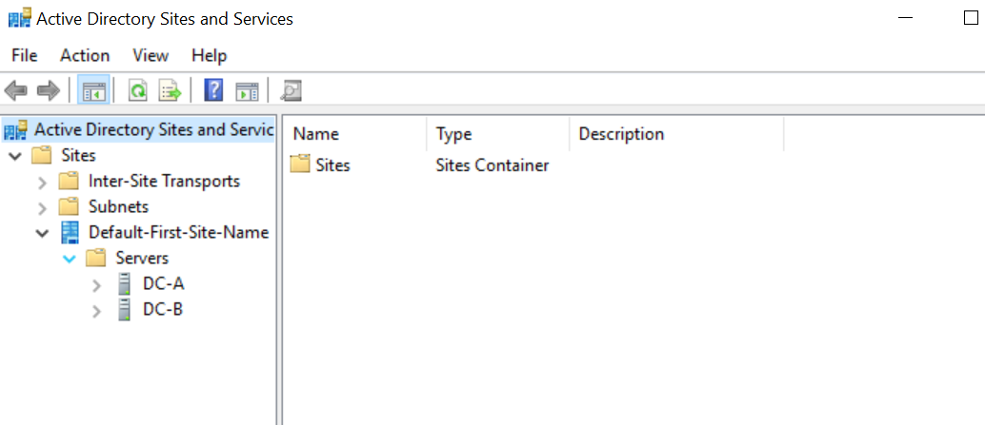

4. To forcefully replicate AD, open Active Directory sites and services console,

click on DC-B than right click on NTDS Settings. Under the NTDS Settings “Click

on Replicate configuration from the selected DC“. Through this option, we pull

the information from the selected DC (FYI, replication is of 2 types i.e. Pull and

Push).

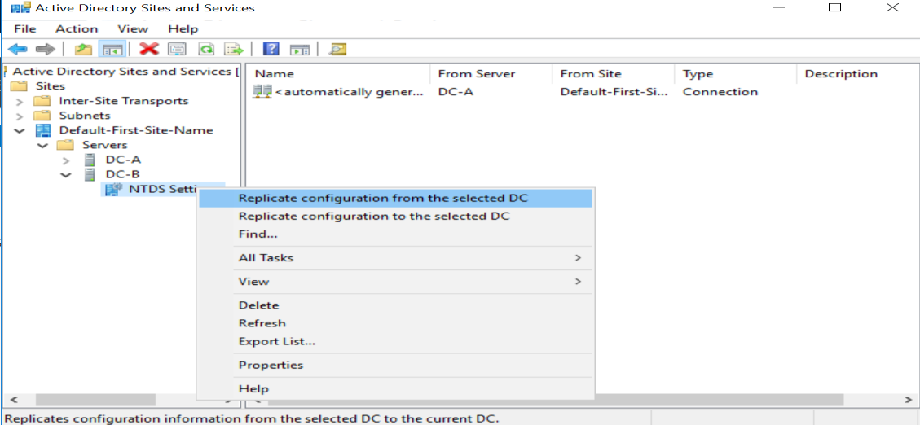

5. It opens the confirmation dialogue box which tells that Active Directory

Domain Services are replicated the connections. Click on OK. If you see any error

or if Additional Domain Controller is recently promoted, then you need to wait

for some time (about 30 minutes if intra-site and about two to four hours if

inter-site) before you try to do forceful AD replication.

Arkansas Department of Information Systems – APSCN LAN Support Printed on 5/14/2024

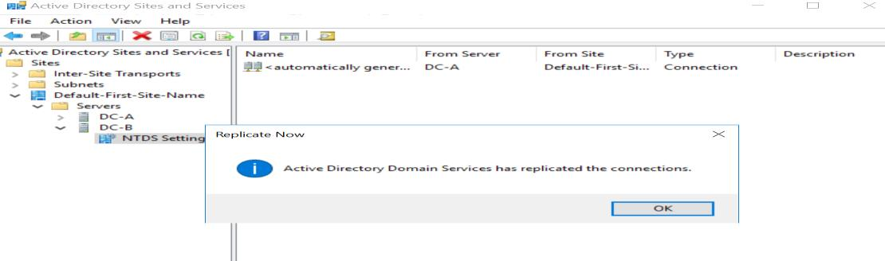

6. The preferred method to replicate AD as it’s only going to replicate Data

between Domain Controllers that we select. It would not start replication

between all the DCs which consumes most of the bandwidth and can create

congestion in the environment.

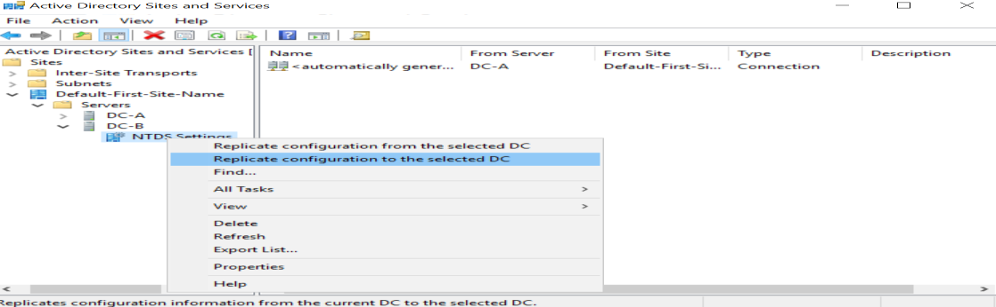

STEPS TO CHECK ACTIVE DIRECTORY REPLICATION IN WINDOWS SERVER (CMD) REPADMIN

1. Open Command Prompt CMD (run as administrator)

2. The first command that we are run is “Repadmin /replsummary” to check the

current replication health between the domain controllers. The “/replsummary”

operation quickly and concisely summarizes replication state and relative health

of a forest.

\*\*After running the command, it shows some information which was in two

parts – Source DSA and Destination DSA.

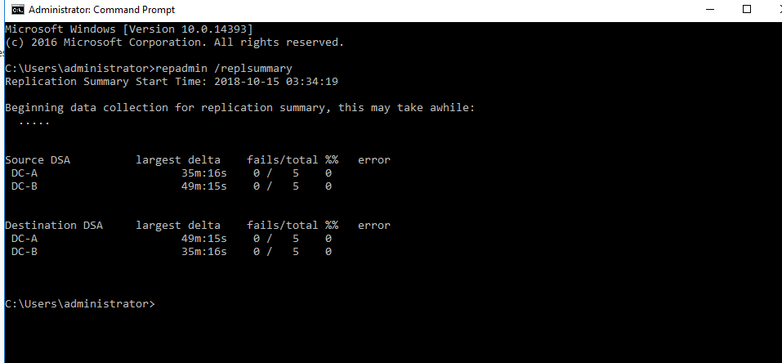

Arkansas Department of Information Systems – APSCN LAN Support Printed on 5/14/2024

We can see that both servers are listed in both sections, the reason behind this is the Active Directory uses multi-master domain model. Active Directory can be updated from any writable Domain Controller except the Read-only Domain Controller. The RODC would only be listed in Destination DSA section.

3. The second command is “Repadmin /Queue” shows the elements are remaining in the queue to replicate. It Displays inbound replication requests that the Domain Controller needs to issue to become consistent with its source replication partners.

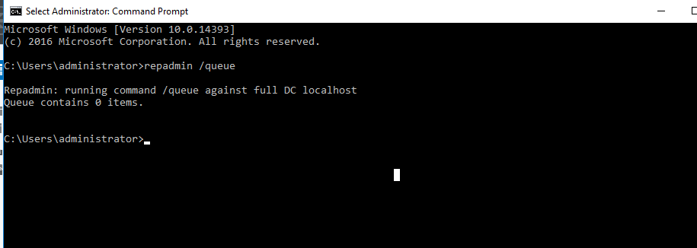

4. The Third command is “Repadmin /Showrepl displays the replication status when the specified domain controller last attempted to implement inbound replication of Active Directory partitions. It helps to figure out the replication topology and replication failure.

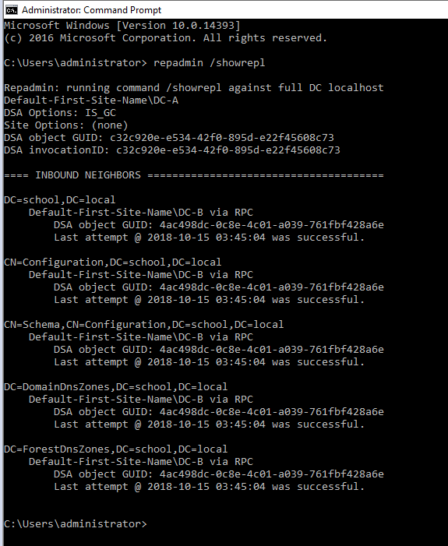

Arkansas Department of Information Systems – APSCN LAN Support Printed on 5/14/2024

5. The Fourth command is “Repadmin /syncall” it Synchronizes a specified domain controller with all replication partners. We recommend you not to run this command in the big environment because it forcefully replicates Active Directory objects between all the domain controller which leads to excessive load on the network and can result in network congestion.

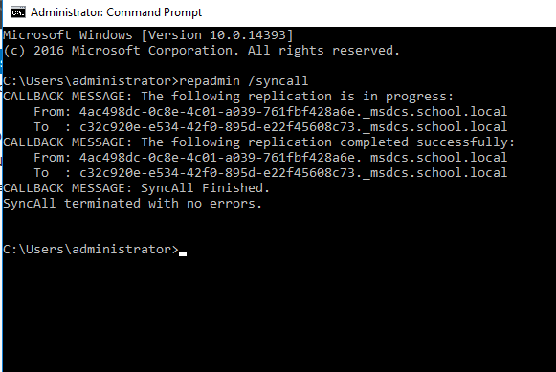

6. Repadmin /KCC this command forces the KCC (Knowledge Consistency Checker) on targeted domain controller(s) to immediately recalculate its inbound replication topology. It checks and creates the connections between the Domain Controllers. By default, KCC runs in the background every 15 minutes to check if new connection is established between DCs or not.

\*\*By running the command, we are forcing DCs to check if new Domain Controller is found in the environment and if yes then add connection to the same.

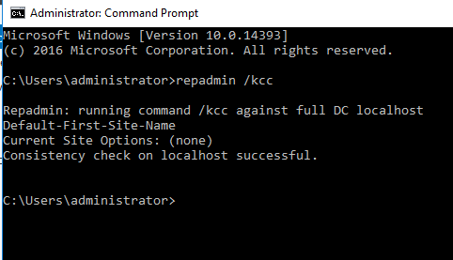

Arkansas Department of Information Systems – APSCN LAN Support Printed on 5/14/2024

7. Repadmin /replicate starts the immediate replication of the specified directory partition to the destination domain controller from the source DC.

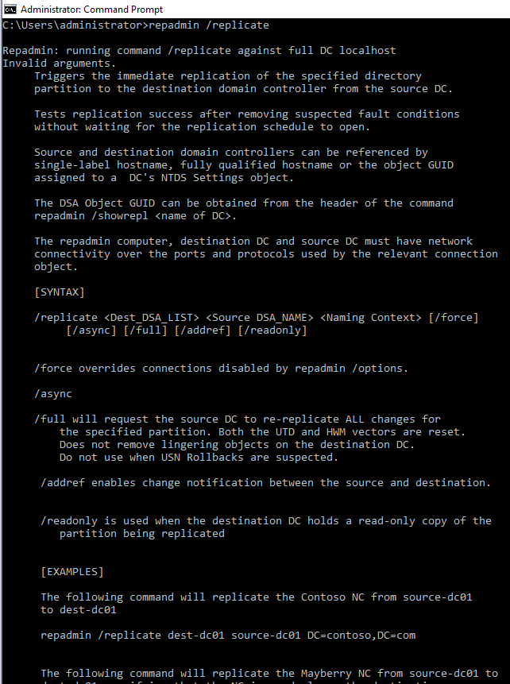

\*\*The replication tools listed above are used to check AD replication and to Replicate AD using GUI mode and from command prompt.

Arkansas Department of Information Systems – APSCN LAN Support Printed on 5/14/2024

TESTING / DIAGNOSE THE HEALTH OF ACTIVE DIRECTORY DOMAIN CONTROLLERS, DNS SERVERS, AD REPLICATION, AND OTHER ADDS INFRASTRUCTURE SERVICES (CMD)

1. From the Domain Controller, open a command prompt

2. Run Command

dcdiag

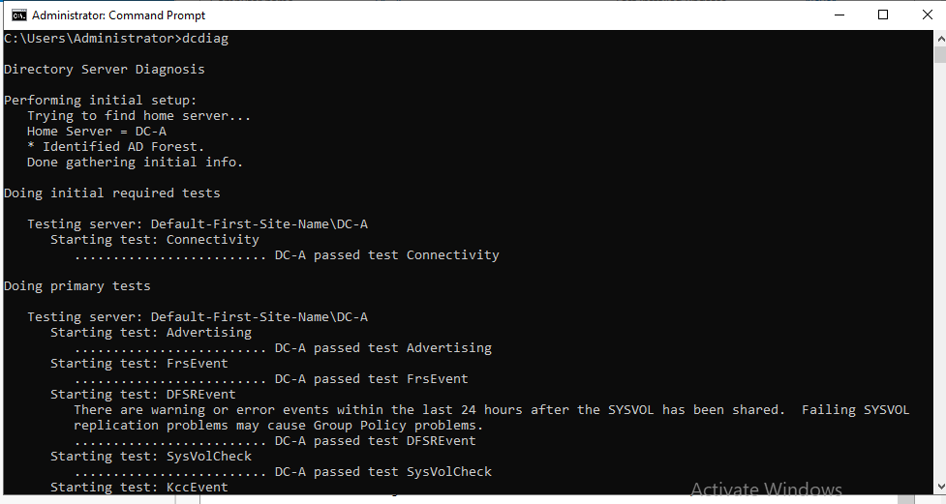

\*\* It is recommended to run the Dcdiag test on the domain controller itself,

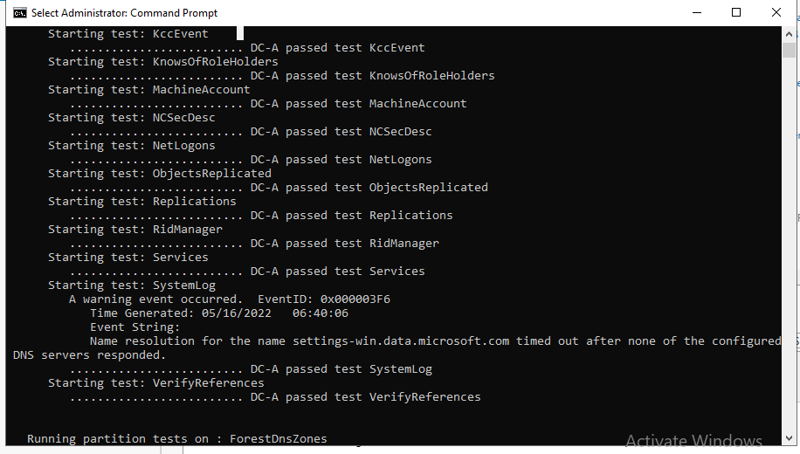

and not remotely

\*\*The Dcdiag utility can perform up to 30 different tests related to the AD

domain infrastructure, DNS, FSMO roles, etc.

Arkansas Department of Information Systems – APSCN LAN Support Printed on 5/14/2024

DELETE DEAD/TOMB-STONED DOMAIN CONTROLLER FROM ACTIVE DIRECTORY

1. From another Domain Controller within the domain, open a command prompt

and type ADSIEDIT.MSC

2. In the ADSI Edit window, click Action > Connect To.

3. In the Select a Well Known Naming Context drop-down menu, select

Configuration, and click OK.

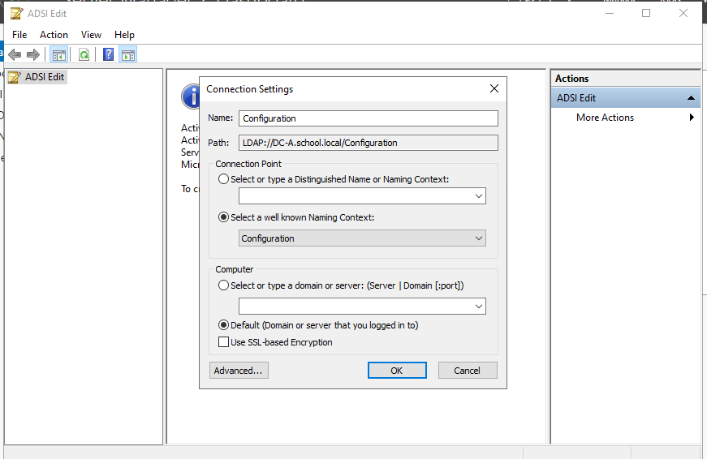

.

REMOVING THE SERVER FROM THE ACTIVE DIRECTORY SITE

4. Navigate to

Configuration\CN=Configuration\CN=Sites\CN=\CN=Servers\CN=

rverName>, where and corresponds to the location

of the dead domain controller.

5. Right-Click on CN=NTDS Settings and click Delete, when prompted to delete the

container and everything in it, click Yes.

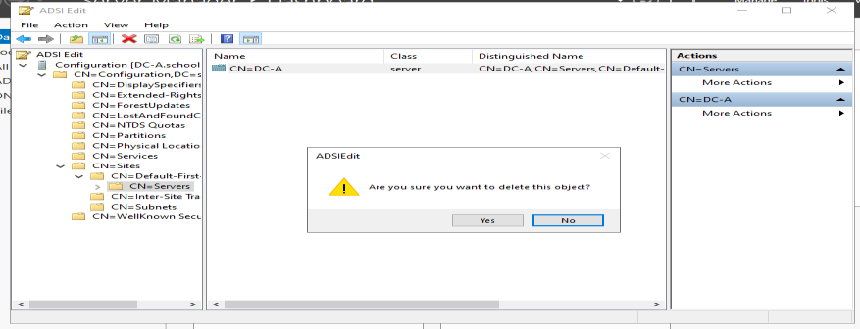

6. Right-Click CN=Server Name that you are removing and click Delete. Click Yes to

confirm the delete.

Arkansas Department of Information Systems – APSCN LAN Support Printed on 5/14/2024

# REMOVING THE SERVER FROM THE FILE REPLICATION SERVICE

7. In the ADSI Edit window, click on ADSI Edit in the left-hand pane.

8. Click Action > Connect To.

9. In the Select a Well Known Naming Context drop-down menu, select Default

naming context, and click OK.

10. Navigate to Configuration\CN=System\CN=File Replication Service\CN=Domain

System Volume(SYSVOL share)\CN= where

correstpond to the location of the dead domain controller.

11. Right-click the CN=, and select Delete.

12. Click Yes to delete the object.

REMOVING THE SERVER FROM ACTIVE DIRECTORY SITES AND SERVICES

13. Open Active Directory Sites and Services.



14. Expand Sites.

15. Expand the AD Site that the dead Domain Controller was a member of.

16. Expand the dead Domain Controller.

17. Right-click NTDS Settings and click Delete.

18. When prompted, click Yes.

Arkansas Department of Information Systems – APSCN LAN Support Printed on 5/14/2024

19. You will receive the Confirm Subtree Deletion box as shown below. Check the

Use Delete Subtree server control option and click Yes.

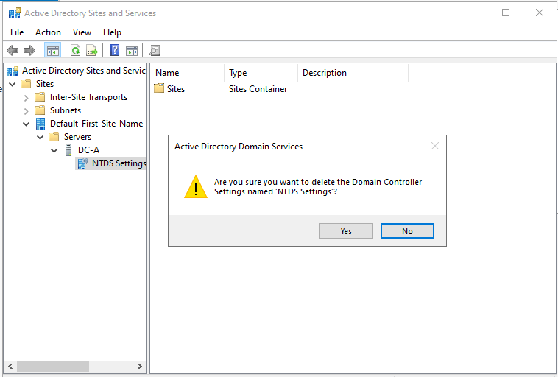

20. Close Active Directory Sites and Services.

REMOVING THE SERVER FROM ACTIVE DIRECTORY USERS AND COMPUTERS

21. Open Active Directory Users & Computer.



22. Browse to the Domain Controller Computer object, right-click and select Delete.

23. When prompted to confirm the deletion, select Yes.

24. Another confirmation box will pop up.

25. Check the box next to “This Domain Controller is permanent...” and click Delete.

Arkansas Department of Information Systems – APSCN LAN Support Printed on 5/14/2024

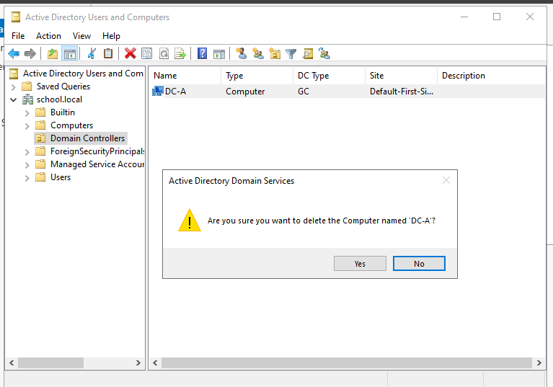

26. Close Active Directory Users & Computers

\*\*DNS may need to be verified to make sure that there are not any records tied to the server that was removed from the domain.

MANUALLY SEIZE FSMO ROLES

To seize the FSMO roles by using the Ntdsutil utility, follow these steps:

• Log on to a Windows Server-based member computer or Domain controller that

is located in the forest where FSMO roles are being seized.

\*\*It is recommend that you log on to the domain controller that you are assigning FSMO roles to.

\*\*The logged-on user should be a member of the Enterprise Administrators group to transfer schema or domain naming master roles, or a member of the Domain Administrators group of the domain where the PDC emulator, RID master and the infrastructure master roles are being transferred.

• Open the Command Prompt utility by moving your mouse over the bottom-left

Windows Key  or click Keyboard Key  and type cmd, run as a administrator

and press Enter

• On the Command Prompt type ntdsutil, and then click ENTER.

• Type roles, and then press ENTER.

• Type connections, and then press ENTER.

Arkansas Department of Information Systems – APSCN LAN Support Printed on 5/14/2024

• Type connect to server “servername”, and then press ENTER.

\*\*Servername is the name of the domain controller FSMO role is being transferred to.

• At the server connections prompt, type q, and then press ENTER.

• Type seize role, where role is the role that you want to seize.

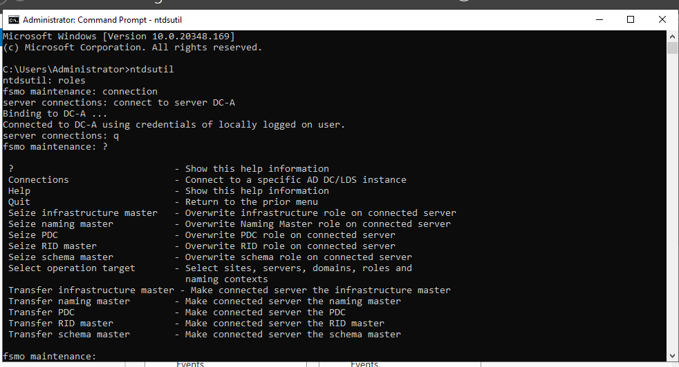

\*\*For a list of roles that you can seize, type ? at the fsmo maintenance prompt, and then press ENTER, or see the list of roles at the end of this section. For example, to seize the RID master role, type seize rid master. The one exception is for the PDC emulator role, whose syntax is seize pdc, not seize pdc emulator.

• At the fsmo maintenance prompt, type q, and then press ENTER.

• Type q, and then press ENTER to quit the Ntdsutil utility.

Arkansas Department of Information Systems – APSCN LAN Support Printed on 5/14/2024

# HOW TO RESET THE DIRECTORY SERVICES RESTORE MODE ADMINISTRATOR ACCOUNT PASSWORD

24. Click, Start, click Run, type ntdsutil, and then click OK.

25. At the Ntdsutil command prompt, type set dsrm password.

26. At the DSRM command prompt, type one of the following lines:

a. To reset the password on the server on which you are working, type:

reset password on server null

\*\*The null variable assumes that the DSRM password is being reset on the local computer. Type the new password when you are prompted.

\*\*No characters appear while you type the password.

b. To reset the password for another server, type:

reset password on server servername

\*\*where servername is the DNS name for the server on which you are resetting the DSRM password.

c. Type the new password when you are prompted.

27. At the DSRM command prompt, type q.

28. At the Ntdsutil command prompt, type q to exit.

Arkansas Department of Information Systems – APSCN LAN Support Printed on 5/14/2024

HOW TO CREATE A BOOTABLE USB DRIVE FROM ISO TO INSTALL WINDOWS SERVER 2022 (GUI)

1. Purchase Windows Server Edition / Download .ISO & Activation Key

For ESS Agreement logon onto - Microsoft Volume Licensing Service Center

(VLSC)<https://www.microsoft.com/Licensing/servicecenter/default.aspx>

2. Download & install software to a computer to burn ISO – [Rufus,](https://rufus.ie/en/) etc.

3. Install at least 8Gb USB Drive / Blank Dual Layer DVD-R into computer.

4. Open Software & Configure Options and Click Start to copy ISO to USB / DVD

• Configure Boot Selection – Choose the downloaded Windows Server

2022 iso file

• Configure Partition select Scheme GPT • Configure Target System select UEFI (non CSM) • File System – select NTFS

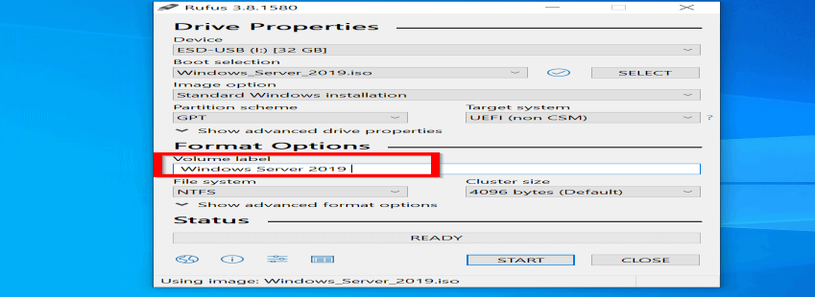

5. After Completion, Install USB Drive / DVD Disc into Server, and boot to drive.

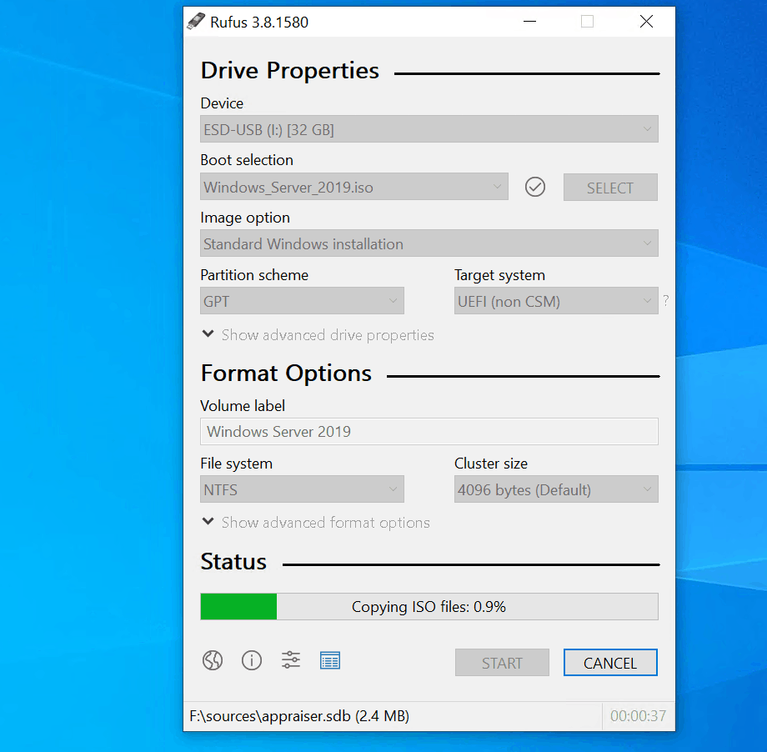

\*\*Must Disable Secure Boot in Server Bios to Install Software

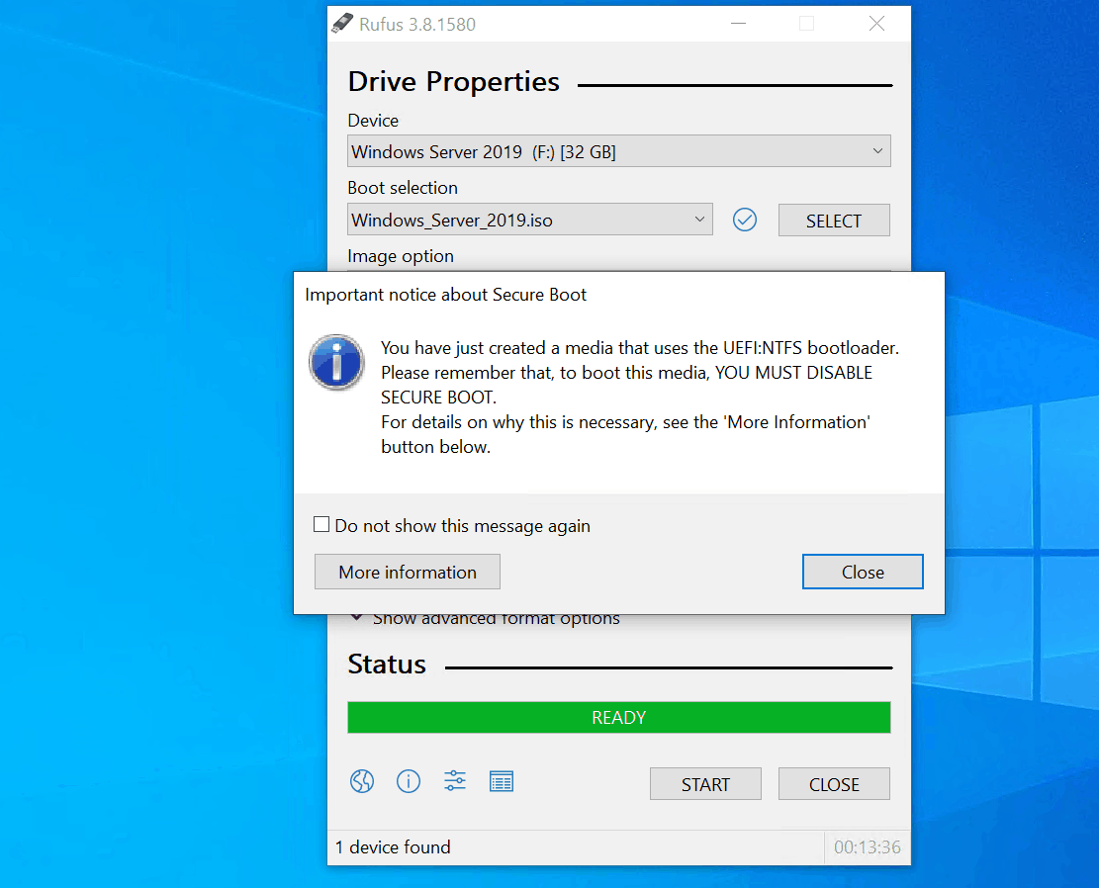

Arkansas Department of Information Systems – APSCN LAN Support Printed on 5/14/2024

HOW TO CREATE A BOOTABLE USB DRIVE FROM ISO TO INSTALL WINDOWS SERVER 2022 (PS)

1. Purchase Windows Server Edition / Download .ISO & Activation Key

For ESS Agreement logon onto - Microsoft Volume Licensing Service Center

(VLSC)<https://www.microsoft.com/Licensing/servicecenter/default.aspx>

2. Download Windows Server 2022 ISO to a computer

3. Install at least 8Gb USB Drive into computer.

\*\*must follow steps 4 – 15 to prepare USB Drive for ISO

4. Create a variable for the file location on computer (windows server 2022 iso)

$isopath = 'C:\Users\Public\Downloads\WindowsServer2022.iso'

5. Open the Powershell utility by moving your mouse over the bottom-left

Windows Key  or click Keyboard Key  and type powershell, run as a

administrator and press Enter

\*\* Before we can format the USB drive, we need to establish the disk number

Windows has assigned it. Run the command below to list all the USB drives

attached to your computer:

6. Run Command

Get-Disk | Where-Object BusType -eq USB | Format-Table -AutoSize

\*\* I know that my USB drive is called ‘Patriot Memory’, so it is disk number ‘2’.

Let’s create an object ($usb) for disk ‘2’. You should replace -eq 2 with the

number of your USB drive.

7. Run Command

$usb = Get-Disk | Where-Object Number -eq 2

\*\*Now, we’re going to delete all the data on the USB drive using Clear-Disk. Type

Y and press ENTER to confirm you want to delete all data on the drive. This is a

good time to double-check that you have the correct disk number!

8. Run Command

$usb | Clear-Disk -RemoveData

Arkansas Department of Information Systems – APSCN LAN Support Printed on 5/14/2024

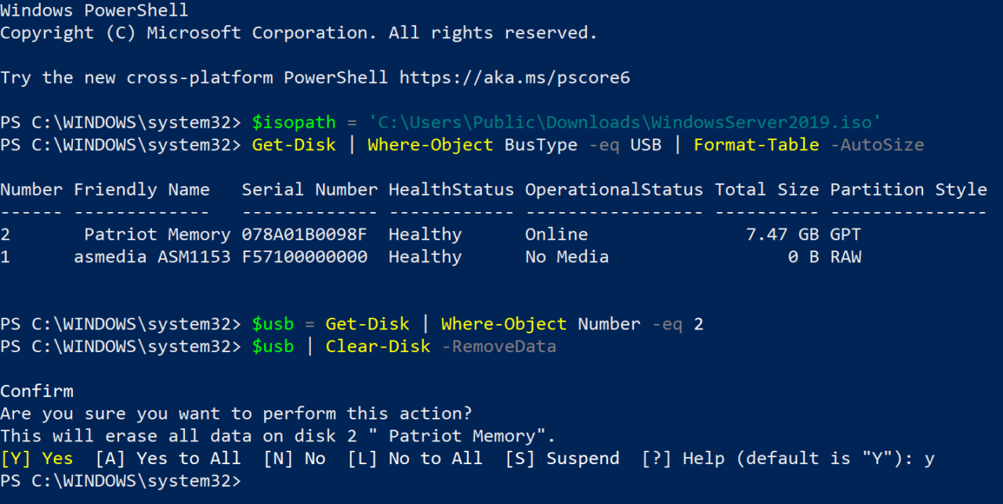

9. Format the USB drive

Now let’s make sure the disk is configured with a GUID Partition Table so that we

can use it to boot UEFI systems.

10. Run Command

$usb | Set-Disk -PartitionStyle GPT

\*\* Create a new volume on the drive using New-Partition. When prompted in

the Format USB Drive dialog, format the volume using FAT32. You must use

FAT32. Optionally, give the drive a volume name in the Volume label field. Click

Start to format the USB drive. Click OK in the warning dialog to confirm that

formatting the drive will erase all data.

11. Run Command

$volume = $usb | New-Partition -UseMaximumSize -AssignDriveLetter

\*\* Close the Format USB Drive dialog once formatting is complete.

12. Copy the Windows Server 2022 media files to the USB drive

\*\*Now that we have configured the USB drive so that it can be used to boot our

server hardware, all that’s left to do is copy the Windows Server media files to

the USB drive. Let’s start by mounting the downloaded Windows Server .iso file

to a drive in Windows

13. Run Command

$mount = Mount-DiskImage -ImagePath $isopath -StorageType ISO

\*\*Windows will assign the new mounted drive a letter. We can use Get-Volume

to get the assigned drive letter:

14. Run Command

$drive = ($mount | Get-Volume).DriveLetter

Arkansas Department of Information Systems – APSCN LAN Support Printed on 5/14/2024

\*\*Now, let’s copy the entire contents of the mounted .iso file to the UBB disk

using Copy-Item:

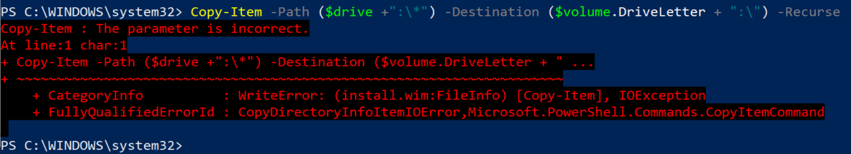

15. Run Command

Copy-Item -Path ($drive +":\\*") -Destination ($volume.DriveLetter + ":\") -

Recurse

\*\*If Copy-Item exits with an error, it’s because it failed to copy the largest file,

install.wim, to the USB drive. FAT32 has a file limit of 4GB and install.wim might

be larger than the limit. To solve the problem, we can use the Windows 10 DISM

tool to split the install.wim file into two smaller files: install.swm and

install2.swm.

16. Windows 10 DISM tool

First, we’ll need to create the two new files on our local disk. In this example, I’ve

chosen to create them in C:\Users\Public\Downloads. Note that you may need

to replace ‘f’ in ‘f:\sources\install.wim’ with a different drive letter. Windows

might have assigned a different drive letter to your mounted .iso file. You can

check the drive letter Windows assigned by opening File Explorer (WIN+E).

17. Run Command

dism /Split-Image /ImageFile:f:\sources\install.wim

/SWMFile:C:\Users\Public\Downloads\install.swm /FileSize:4096

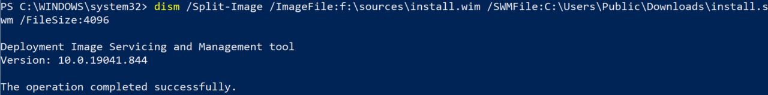

18. Now, let’s copy the two new files, install.swm and install2.swm, to our USB drive:

19. Run Commands

Copy-Item -Path C:\Users\Public\Downloads\install.swm -Destination

($volume.DriveLetter + ":\sources\install.swm")

Copy-Item -Path C:\Users\Public\Downloads\install2.swm -Destination

($volume.DriveLetter + ":\sources\install2.swm")

Arkansas Department of Information Systems – APSCN LAN Support Printed on 5/14/2024

20. Finally, all that’s left to do is to unmount the Windows Server .iso file from our

local device using Dismount-DiskImage:

21. Run Command

Dismount-DiskImage -ImagePath $isopath

22. After Completion, Install USB Drive into Server, and boot to drive.

\*\*Must Disable Secure Boot in Server Bios to Install Software

Windows Server Back Up (Feature) – Install Windows Server Backup

The first step, you need to install Windows Server Backup on your Windows Server 2022. You can do it via Server Manager (GUI) or PowerShell (PS) by executing.

Open PowerShell, run cmdlet Install-WindowsFeature Windows-Server-Backup

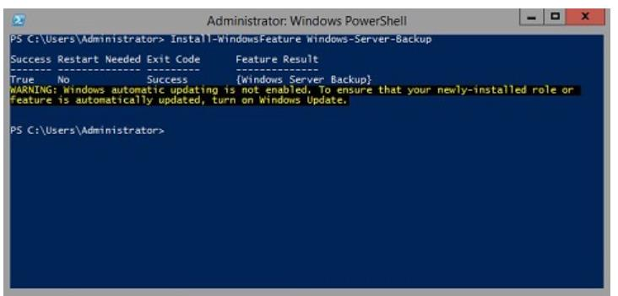

To do so using Server Manager (GUI):

1. Open Server Manager and click Add Roles and Features.

2. Under Select installation type, click Next. Under Select destination server,

select the server, and then click Next.

3. Under Select server roles, click Next. Under Select features, select Windows

Server Backup, and then click Next

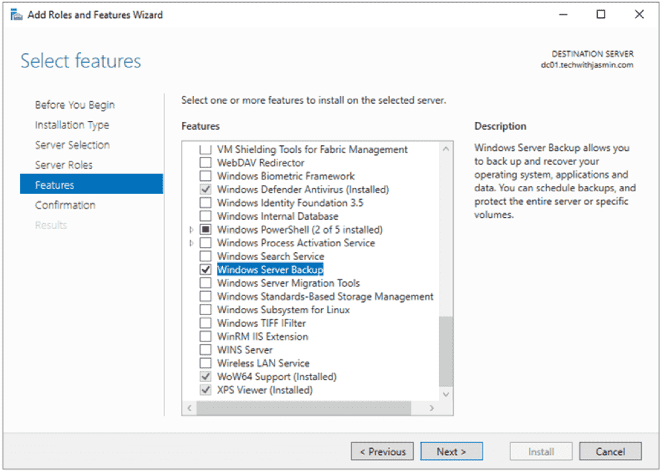

Arkansas Department of Information Systems – APSCN LAN Support Printed on 5/14/2024

4. Under Under Confirm installation selections, click Install, and wait until the

feature is installed.

5. Once done, click Close.

Windows Server Backup – Manual Backup

Start a manual backup whenever you feel that a copy of your system is required, for instance, when you are planning major changes.

To configure a manual backup in Windows Server 2022:

1. Open Server Manager on Windows Server 2022.

2. Click Tools in the top right corner of the window, and then select Windows

Server Backup.

3. Right-click Local Backup and then select Backup Once.

4. Under Backup Options, select Different options, and click Next. Choose this

option if you have not created a scheduled backup or want to specify a location

or items for this backup that are different from the scheduled backup.

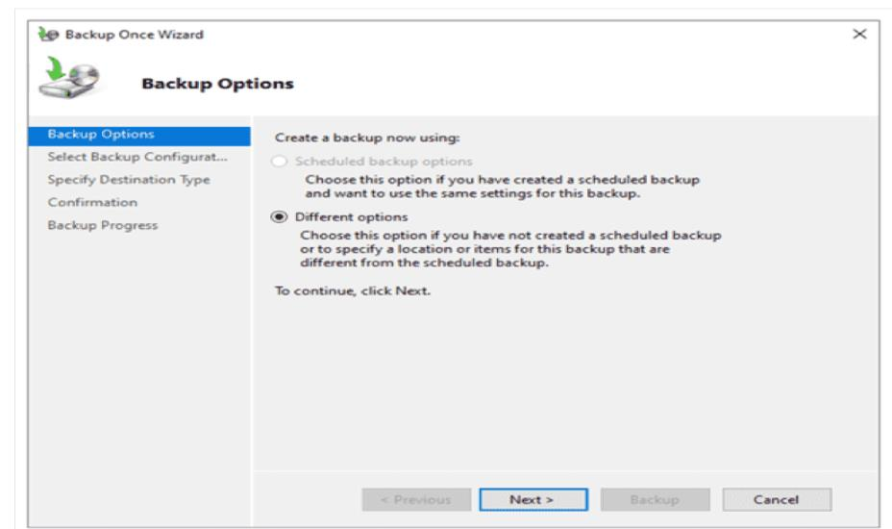

5. Select the type of configuration you want to schedule: Full server

(recommended) or Custom. The full server backup will back up all your server

data, applications, and system state. Use the custom backup to select what you

want to back up.

Arkansas Department of Information Systems – APSCN LAN Support Printed on 5/14/2024

6. Under Specify Destination Type, choose the type of storage to back up, and click

Next. There are two options available: Local drives or Remote shared folders. For

demonstration purposes, I use a remote shared folder.

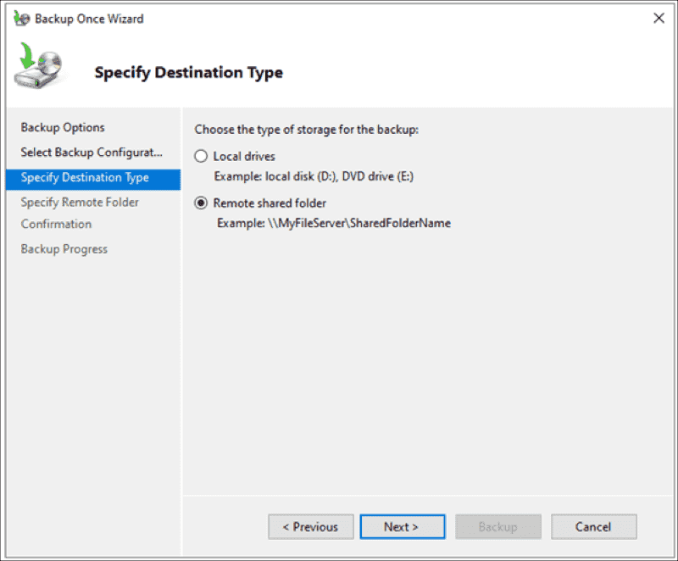

7. Under Specify Remote Folder, enter a location, and click Next.

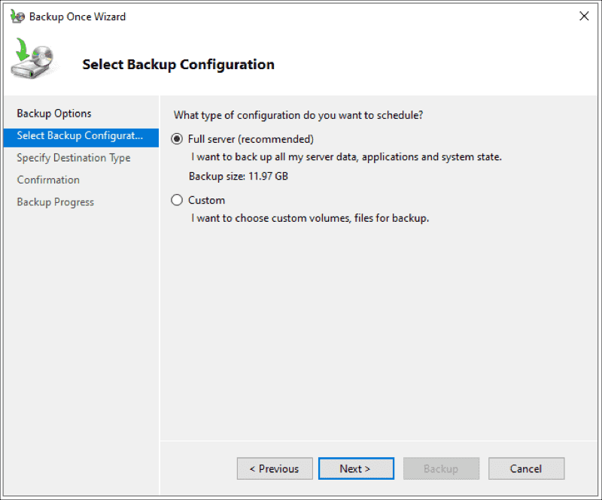

Arkansas Department of Information Systems – APSCN LAN Support Printed on 5/14/2024

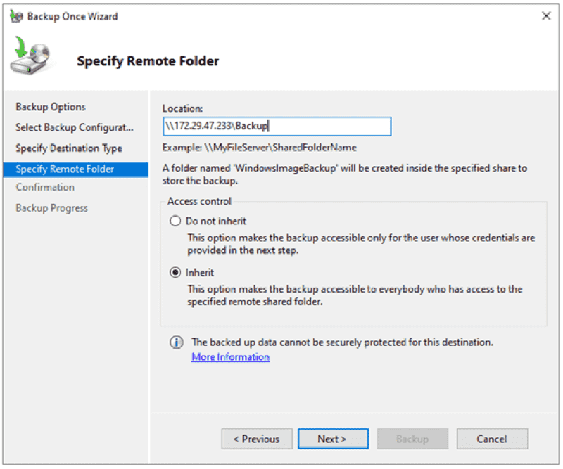

8. Under Confirmation, click Backup.

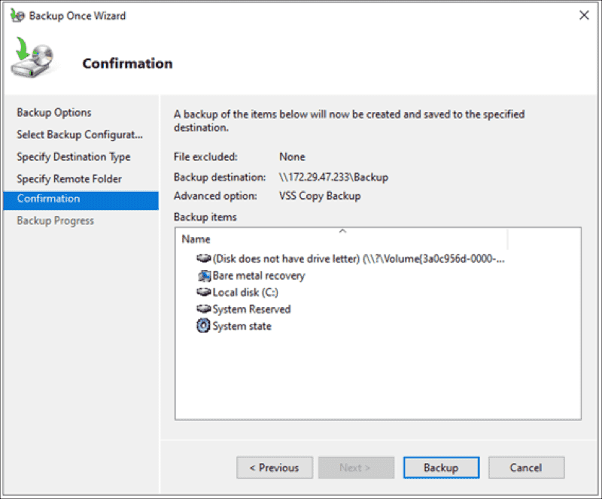

9. Wait until the backup is done.

Arkansas Department of Information Systems – APSCN LAN Support Printed on 5/14/2024

10. Once a backup is done, you will see the status message: Successful.

Windows Server Backup – Scheduled Backup

Scheduled backups are convenient and ensure that your data is regularly backed up without requiring manual intervention. To create a backup schedule, you should decide what to back up, when, and how often to back up your server, and where to store the backups. Here is how.

1. Open Server Manager on Windows Server 2022.

2. Click Tools in the top right corner of the window and select Windows Server

Backup.

3. Right-click Local Backup and select Backup Schedule.

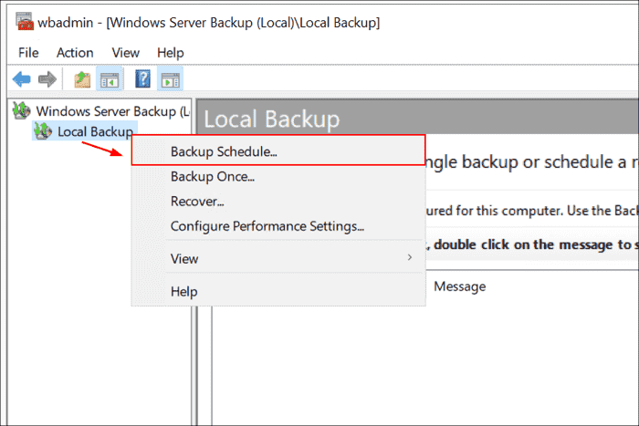

Arkansas Department of Information Systems – APSCN LAN Support Printed on 5/14/2024

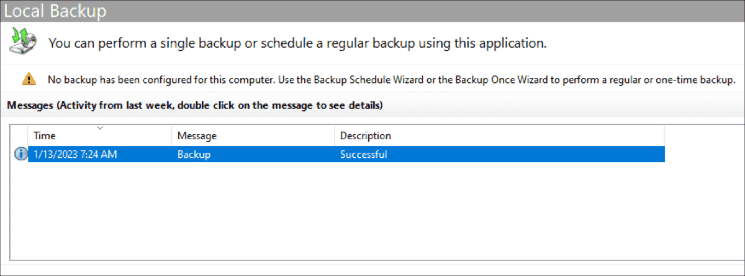

4. Click Next.

5. Select the type of configuration you want to schedule: Full server

(recommended) or Custom. The full server backup will back up all your server data, applications, and system state. Use the custom backup to select what you want to back up.

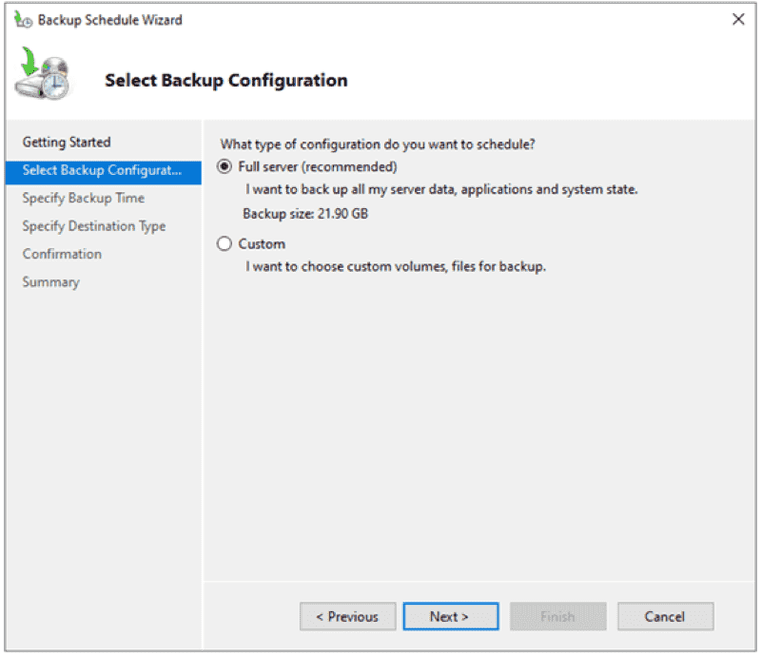

6. Under How often and when you want to run backups, click Once a day, pick a

time, and then click Next. You can also choose whether you want to run a backup more than once a day.

\*Pick a time of the day after normal business hour to do backups

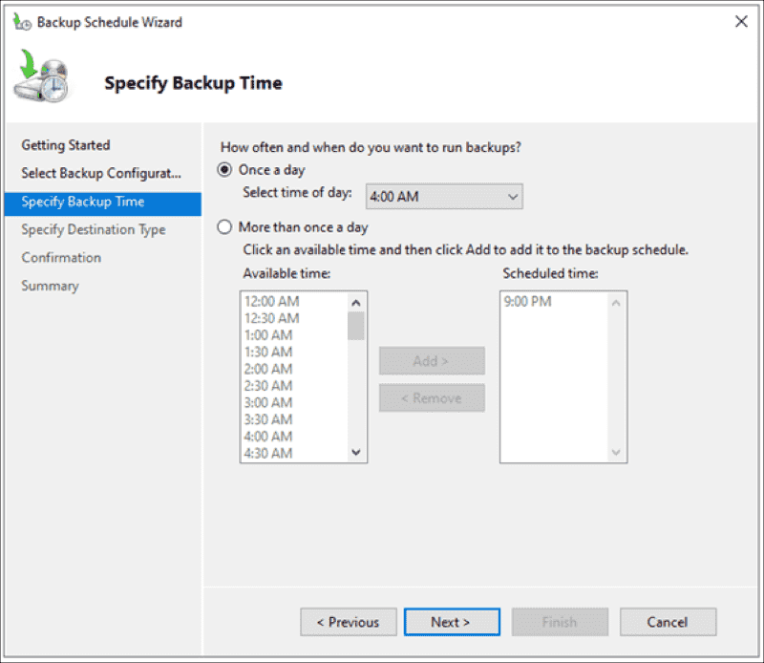

Arkansas Department of Information Systems – APSCN LAN Support Printed on 5/14/2024

7. Under Specify Destination Type, select Back up to a shared network folder, and

click Next. You can also choose:

\*Back up to a hard disk that is dedicated to backups (recommended) \*Back up to a volume

\* Back up off-site

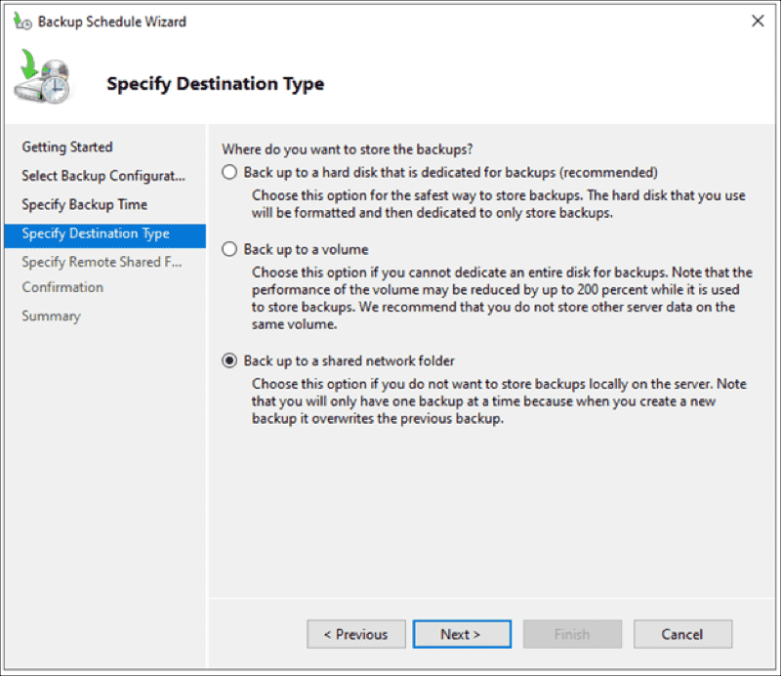

\*Note that you use a remote shared folder as the storage destination for

scheduled backups. Each backup will erase the previous backup, and only the

latest backup will be available.

8. Under Specify Remote Share Folder, add a remote location, and click Next.

\*Note: To schedule backups, you will need to provide usernames and passwords.

\*Note: Do not use the administrator account & password, create a backup service user account in active directory and set the password not to expire. Example (sabackup)

Arkansas Department of Information Systems – APSCN LAN Support Printed on 5/14/2024

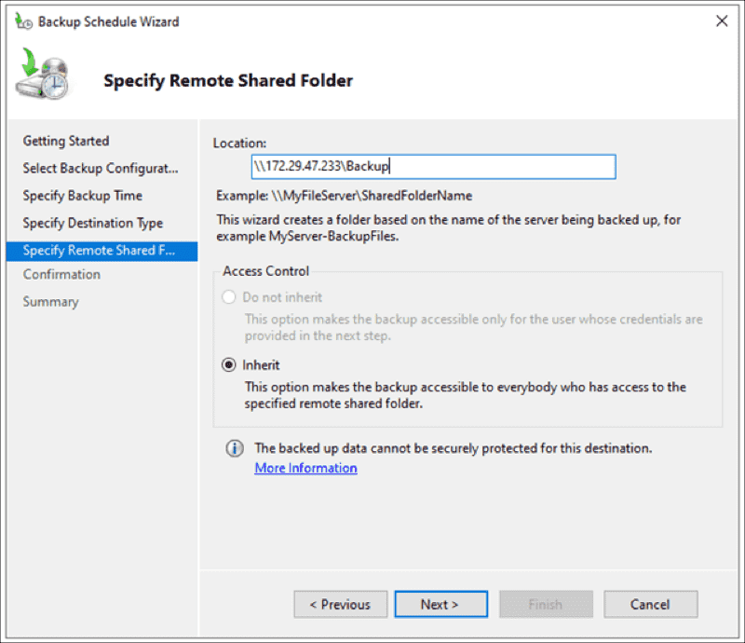

9. Under Confirmation, click Finish.

10. Click Close to close the window. You will see that a new scheduled backup is

configured on the server.

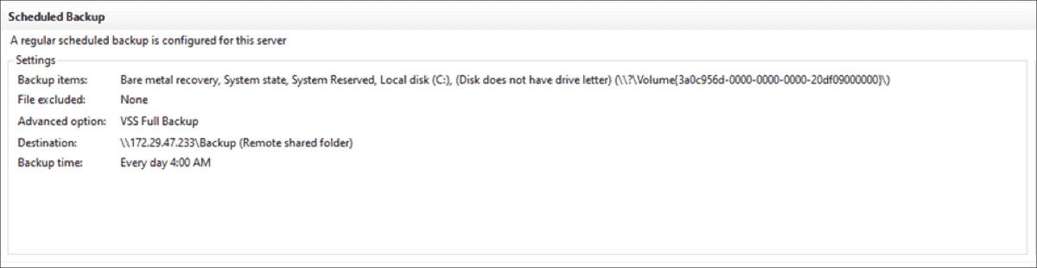

Windows Server Backup – Restore A Backup

In case of any issues with your Windows Server, you will need to restore your data. I'll show you how to restore the system image backup (full backup). You can apply the same procedure to other backups as well.

1. Open Server Manager on your Windows Server 2022.

2. Click Tools in the top right corner of the window, and then select Window Server

Backup

3. Right-click Local Backup, and then click Recover.

4. Under Getting Started, select the location where the backup is stored, and click

Next. As I did a backup to a remote location, I'll choose A backup stored on

another location.

Arkansas Department of Information Systems – APSCN LAN Support Printed on 5/14/2024

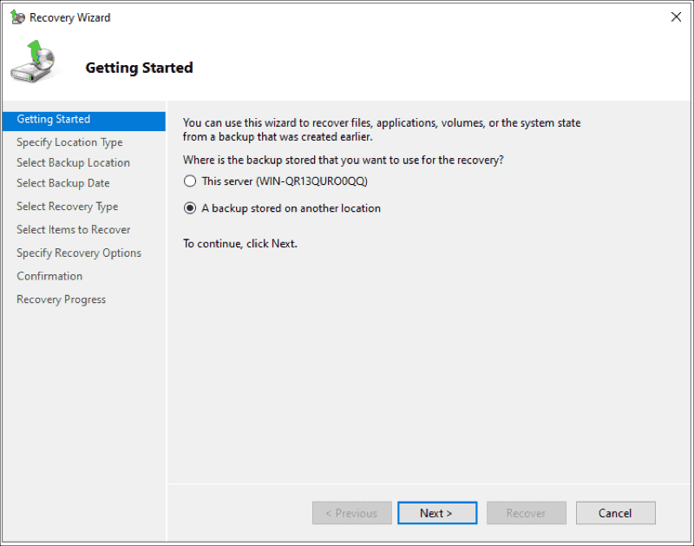

5. Under Specify Location Type, select the location type, and click Next. In my case

it is a Remote shared folder.

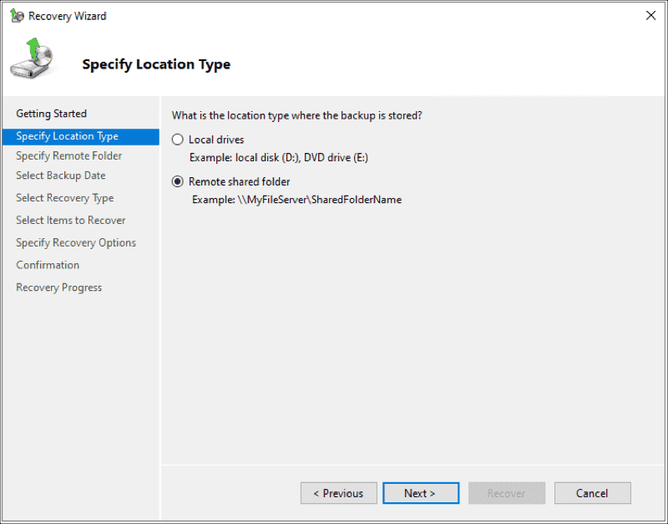

6. Under Specify Remote Folder, type the backup path, and click Next

Arkansas Department of Information Systems – APSCN LAN Support Printed on 5/14/2024

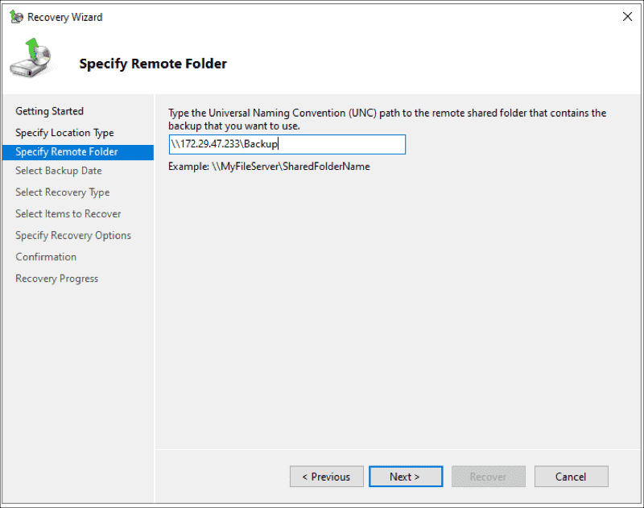

7. Under Select Backup Date, select the date of the backup you want to use for

recovery, and click Next.

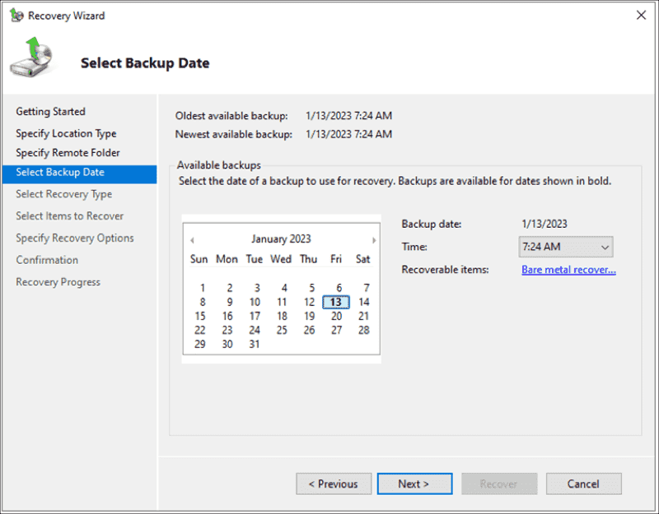

8. Under Select Recovery Type, select what you want to recover, and click Next.

You can choose files and folders, volumes, applications, and system states.

Arkansas Department of Information Systems – APSCN LAN Support Printed on 5/14/2024

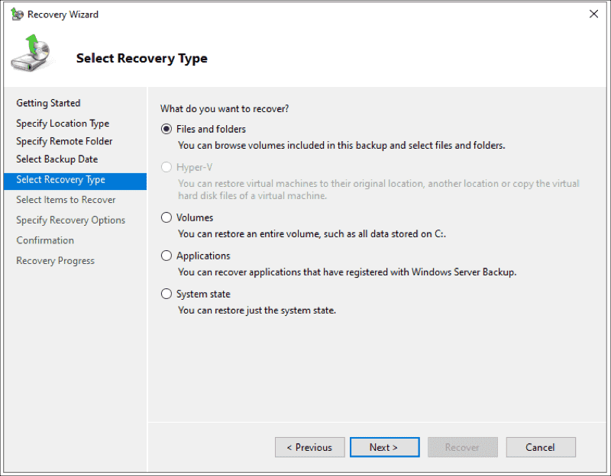

9. Under Select Items to Recover, browse the tree, and select the files and folders

you want to recover.

Under Choose Recovery Options, select the recovery

destination, and click Next.

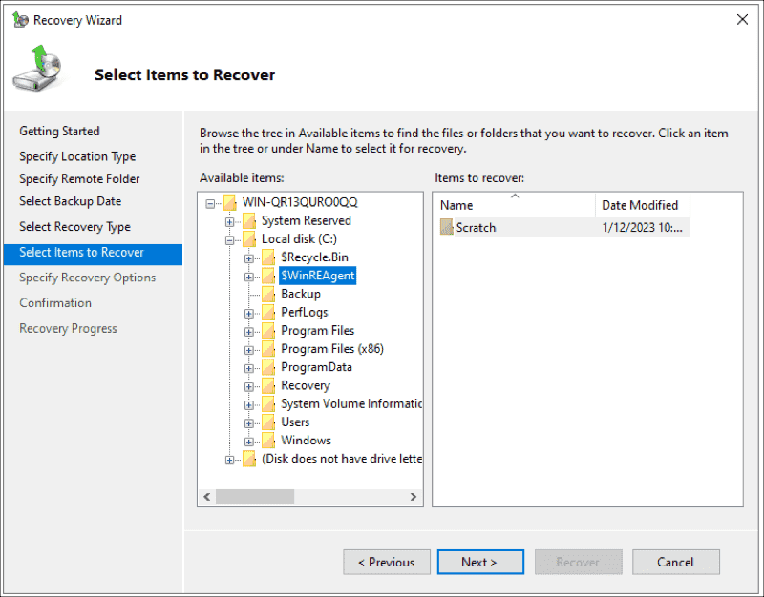

10. Under Choose Recovery Options, select the recovery destination, and click

Next.

Arkansas Department of Information Systems – APSCN LAN Support Printed on 5/14/2024

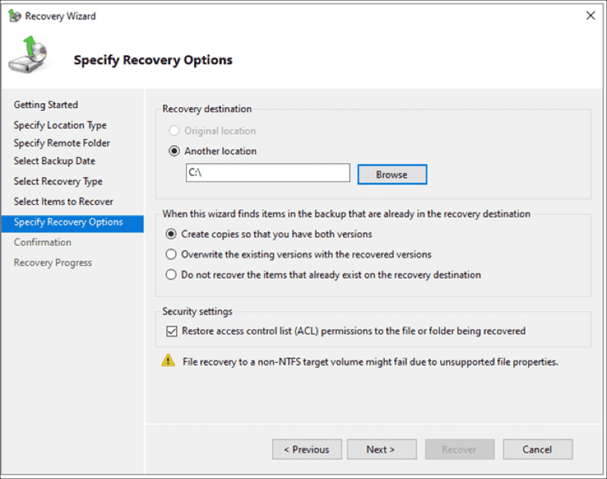

11. Confirm by clicking Recover

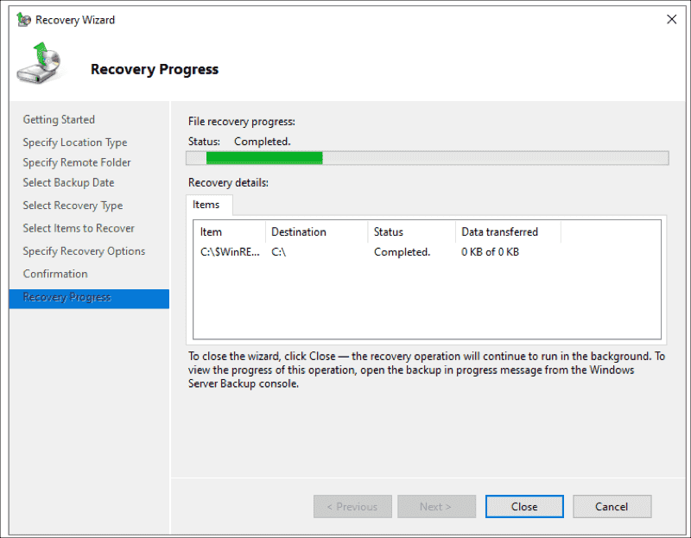

12. You're done. Go to the location where you restored the data and access it.

Windows Server Backup is a native backup feature integrated into Windows Server

2022 and lower. It includes basic backup functionalities and helps you manually

Arkansas Department of Information Systems – APSCN LAN Support Printed on 5/14/2024

back up your system image, data, and application, or perform backups according

to schedule.

Backup DHCP Scopes – Exporting & Importing DHCP Scopes (CMD) Netsh

Exporting and Importing DHCP Database on Windows Server

This will tell you how to export or import a copy of a DHCP database. This is handy

for backups or moving to a new server.

\*Note – If you have multiple DHCP Scopes and VLAN’s this is a recommended

practice to backup DHCP databases

Exporting DHCP Database

1. Login to the DHCP server with appropriate credentials

2. Open Command Prompt CMD (run as administrator)

3. Type Command netsh dhcp server export c:\dhcp.txt all

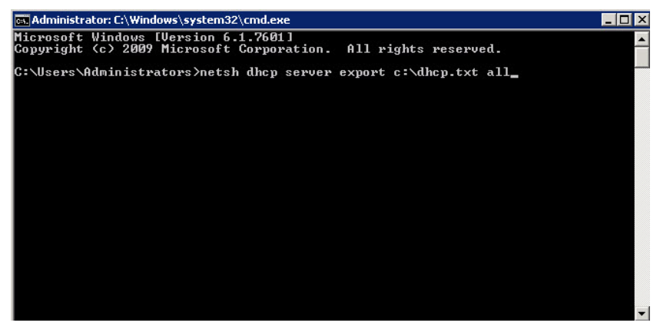

4. Then press enter. You can change the path and filename to suit your needs.

5. You should see confirmation after a short bit – Command completed

successfully.

Arkansas Department of Information Systems – APSCN LAN Support Printed on 5/14/2024

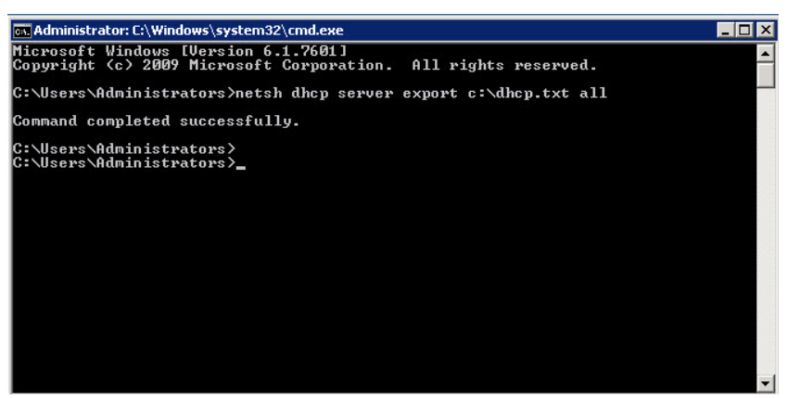

Importing DHCP Database

1. Login to the new DHCP server, statically assign ip address, open server manager

console, click on Add Roles and install the DHCP role.

2. To add DHCP using Server Manager, select Add Roles and Features, and then

select DHCP in the Roles list.

3. To add the DHCP role using the command line, open Windows PowerShell (PS)

(Admin), and type the following cmdlet:

Install-WindowsFeature DHCP -IncludeManagementTools Then press enter.

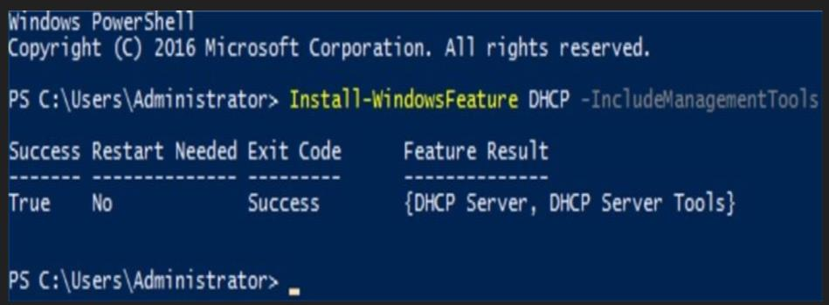

4. Copy text document dhcp.txt all to the root of C: on new server.

\*Note: Since we are importing a database, don’t configure any settings after installing DHCP role

\*Note: Do not import the database onto the new server until you have gone to your old DHCP server and either disabled the DHCP Server service, deactivated the scopes or Unauthorized it.

Arkansas Department of Information Systems – APSCN LAN Support Printed on 5/14/2024

5. Login to the DHCP server with appropriate credentials

6. Open Command Prompt CMD (run as administrator)

7. Type Command netsh dhcp server import c:\dhcp.txt all, then press enter

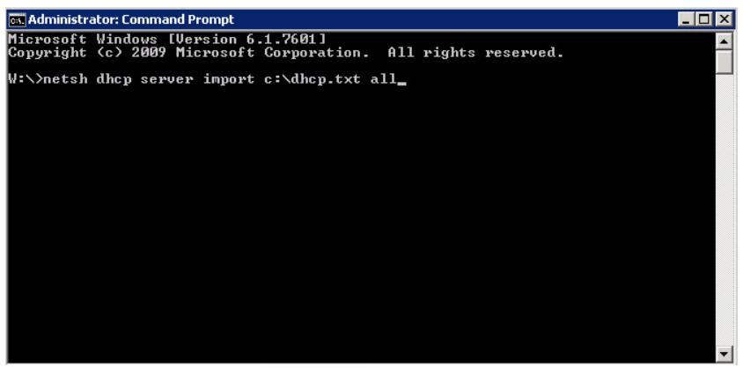

You can change the path and filename to whatever you are using. Make sure to copy the file you exported to the root of C: on the new server.

8. You should get a message saying the command completed successfully.

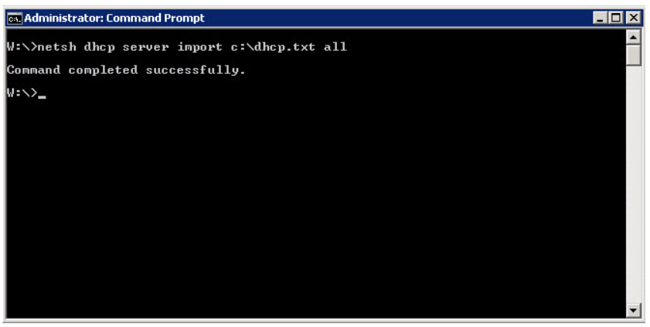

9. Open DHCP Console and verify that the scopes have been imported successfully.

You may have to refresh console and verify all network adapter bindings, that the server has been authorized and scope options are correct.

Arkansas Department of Information Systems – APSCN LAN Support Printed on 5/14/2024

10. Right-click on the server node in the DHCP console and select Authorize to

accomplish this authorization. You need Enterprise Admin privileges to authorize DHCP.

11. Verify the DHCP Server started.

Microsoft Lifecycle Policy – End Of Life Date (mainstream support)

Windows Server version Edition End Of Life Date

Windows Server 2022 Datacenter October 14, 2031

Standard October 14, 2031

Windows Server 2019 Datacenter January 9, 2029

Standard January 9, 2029

Windows Server 2016 Datacenter January 12, 2027

Standard January 12, 2027

Windows Server 2012 R2 Datacenter October 10, 2023

Standard October 10, 2023

<https://learn.microsoft.com/en-gb/lifecycle/>

<http://support.microsoft.com/default.aspx?scid=kb;en-us;322672>

Active Directory, Microsoft, MS-DOS, Visual Basic, Visual Studio, Windows, Windows NT, Active Directory, and Windows Server are either registered trademarks or trademarks of Microsoft Corporation in the United States and/or other countries.

This product contains graphics filter software; this software is based, in part, on the work of the Independent JPEG Group.

All other trademarks are property of their respective owners.

Arkansas Department of Information Systems – APSCN LAN Support Printed on 5/14/2024