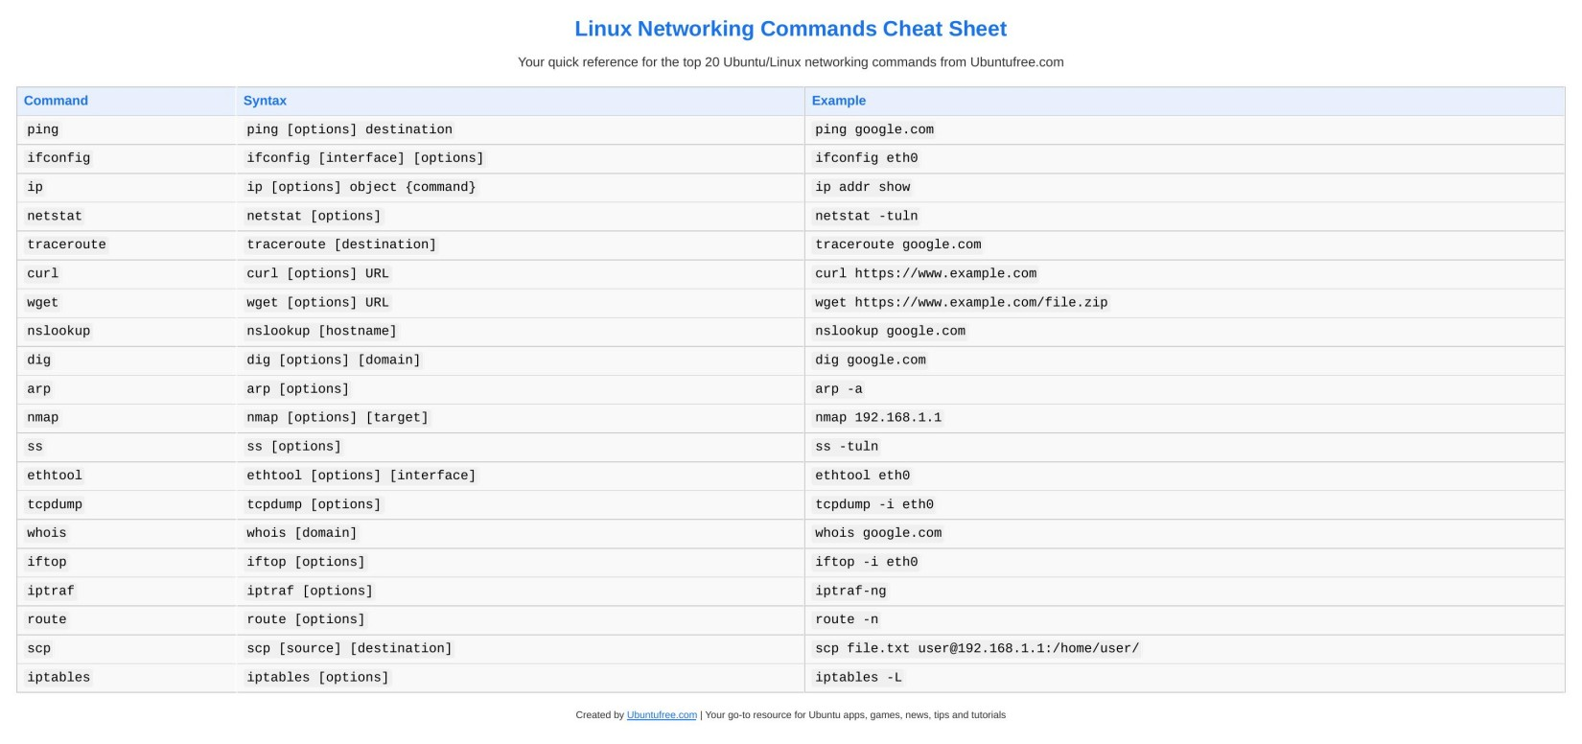

Linux Networking Commands Cheat Sheet

Your quick reference for the top 20 Ubuntu/Linux networking commands from Ubuntufree.com

Command Syntax Example

ping ping [options] destination ping google.com ifconfig ifconfig [interface] [options] ifconfig eth0 ip ip [options] object {command} ip addr show netstat netstat [options] netstat -tuln traceroute traceroute [destination] traceroute google.com curl curl [options] URL curl https://www.example.com wget wget [options] URL wget https://www.example.com/file.zip nslookup nslookup [hostname] nslookup google.com dig dig [options] [domain] dig google.com arp arp [options] arp -a nmap nmap [options] [target] nmap 192.168.1.1 ss ss [options] ss -tuln ethtool ethtool [options] [interface] ethtool eth0 tcpdump tcpdump [options] tcpdump -i eth0 whois whois [domain] whois google.com iftop iftop [options] iftop -i eth0 iptraf iptraf [options] iptraf-ng route route [options] route -n scp scp [source] [destination] scp file.txt user@192.168.1.1:/home/user/ iptables iptables [options] iptables -L

[Created by Ubuntufree.com](https://www.ubuntufree.com/) | Your go-to resource for Ubuntu apps, games, news, tips and tutorials