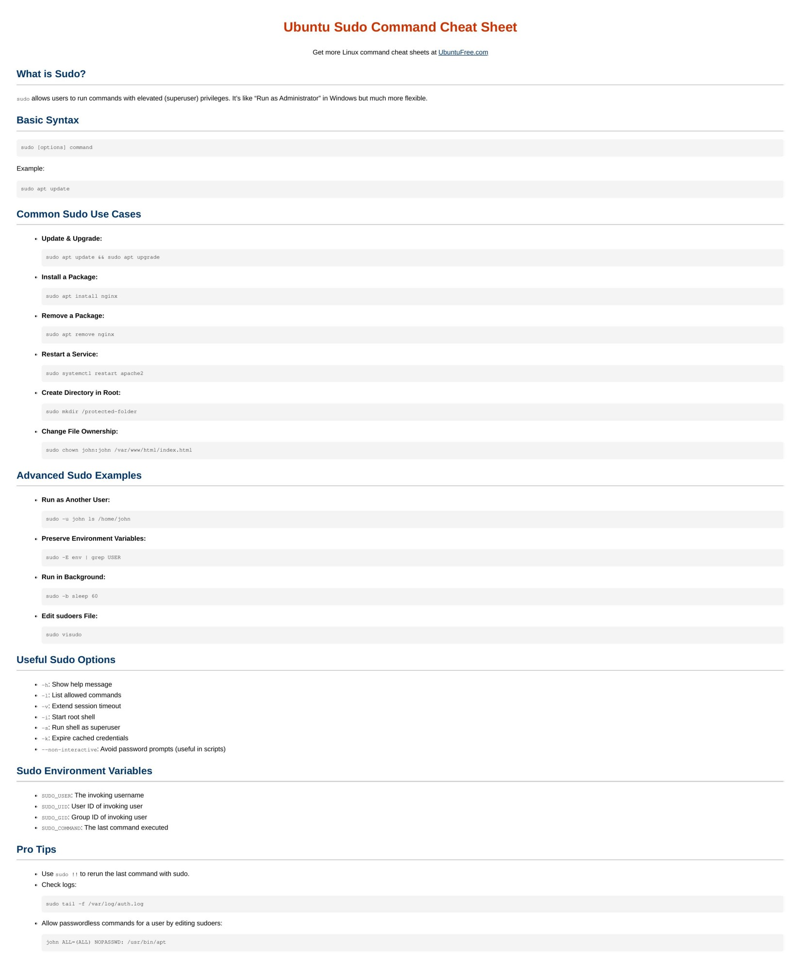

# Ubuntu Sudo Command Cheat Sheet

[Get more Linux command cheat sheets at UbuntuFree.com](https://www.ubuntufree.com/)

What is Sudo?

sudo allows users to run commands with elevated (superuser) privileges. It’s like “Run as Administrator” in Windows but much more flexible.

Basic Syntax

sudo [options] command

Example:

sudo apt update

Common Sudo Use Cases

Update & Upgrade:

sudo apt update && sudo apt upgrade

Install a Package:

sudo apt install nginx

Remove a Package:

sudo apt remove nginx

Restart a Service:

sudo systemctl restart apache2

Create Directory in Root:

sudo mkdir /protected-folder

Change File Ownership:

sudo chown john:john /var/www/html/index.html

Advanced Sudo Examples

Run as Another User:

sudo -u john ls /home/john

Preserve Environment Variables:

sudo -E env | grep USER

Run in Background:

sudo -b sleep 60

Edit sudoers File:

sudo visudo

Useful Sudo Options

-h: Show help message

-l: List allowed commands

-v: Extend session timeout

-i: Start root shell

-s: Run shell as superuser

-k: Expire cached credentials

--non-interactive : Avoid password prompts (useful in scripts)

Sudo Environment Variables

SUDO_USER: The invoking username

SUDO_UID : User ID of invoking user

SUDO_GID : Group ID of invoking user

SUDO_COMMAND : The last command executed

Pro Tips

Use sudo !! to rerun the last command with sudo.

Check logs:

sudo tail -f /var/log/auth.log

Allow passwordless commands for a user by editing sudoers:

john ALL=(ALL) NOPASSWD: /usr/bin/apt